
Concur Expense: Workflow – General Information
Setup Guide

Last Revised: October 14, 2023
Applies to these SAP Concur solutions:
 Expense
 Professional/Premium edition
 Standard edition
 Travel
 Professional/Premium edition
 Standard edition
 Invoice
 Professional/Premium edition
 Standard edition
 Request
 Professional/Premium edition
 Standard edition
Table of Contents
Section 1: Permissions 1
Section 2: Workflow Guides 1
Section 3: Overview 1
Workflow Basics 2
Required Workflow Steps 2
Expense Report Workflow 2
Cash Advance Workflow 2
Policy vs Group 3
Assigned to Policy – Expense Report Workflow 3
Assigned to Group – Cash Advance Workflow 3
Terminology 3
General Workflow Terminology 3
Approver Terminology 4
Default Workflows 5
Default Expense Report Workflows 5
Default Cash Advance Workflow 6
Section 4: How the System Determines Which Approver to Use 6
Exception - Approver Has Already Approved 8
Approver Made Inactive 8
Via the UI 8
Via an Import Job 9
Section 5: User Experience – Approval Flow Page 10
Approve & Forward Feature 11
Report Returned to the Employee 12
Returning a Part of a Report – Using the Split Expense Report Feature 12
Section 6: Overview - Understanding Workflow Rules and the Condition Editor 12
Conditional Expressions and the Condition Page 13
Workflow Rules and Exchange Rates 16
Workflow Rule Approval Actions 17
Workflow Rule Approval Action Order 18
Workflow Rule Limitations 18
Section 7: Workflow Configuration Overview 19
Section 8: Accessing the Workflow Tool 20
Section 9: Workflow Procedures 21
Procedure: Creating a New Workflow 21
Getting Started 21
Using the General Page 22
Using the Steps Page 29
Using the Step Rules Page 33
Procedure: Configuring Workflow Event Notifications and External Validation Steps 37
Configuring an event notification 38
Configuring an external validation step 40
Section 10: Editing and Deleting Workflows, Properties, and Steps 43
Overview 43
Procedures: Editing and Deleting 44
Editing Workflow Properties 44
Editing and Reordering Workflow Steps 45
Editing Workflow Rules and Actions 46
Deleting a Workflow or Workflow Steps 46
Section 11: Approval and Payment Statuses 47
Overview 47
Default Approval Statuses 47
Procedures: Approval Statuses 49
Accessing the Expense Report Approval Status Tab 50
Adding an Approval Status 50
Editing an Approval Status 51
Deleting an Approval Status 51
Understanding Payment Statuses 52
Section 12: Workflow Settings 53
Accessing the Settings Tab 53
Changing Expense Report Settings 54
Changing Authorization Request Settings 55
Changing Cash Advance Settings 56
Section 13: Reason Category and Codes 57
Overview 57
What the Processor Sees 58
Creating the Reason Code 58
Modifying a Reason Code 59
Deleting a Reason Code 60
Section 14: Payment Confirmation (Workflow Step) 61
Overview 61
How It Works 61
Configuration 62
Section 15: Hold for Receipt Image (Workflow Step) 62
Overview 62
Employee Notification 63
Expense Processor 63
Configuration 63
Section 16: Confirmation Agreements 63
Overview 63
How It Works 64
User Experience 64
Expense Report Submit 64
Expense Report Approval 65
Procedures 65
Accessing the Confirmation Agreement Tab 65
Creating a Confirmation Agreement 66
Activating the Confirmation Agreement Feature 67
Editing a Confirmation Agreement 70
Deleting a Confirmation Agreement 70
Section 17: Split Expense Report on Approval 70
Returning Selected Expenses 71
Processor 74
Eligible Expenses 74
Returning all Expenses 75
Configuration 75
Section 18: Auto-Issuance Step for Cash Advance Request 75
Overview 75

Revision History
Date | Notes / Comments / Changes
October 14, 2023 | In the Workflow Procedures > Procedure: Creating a New Workflow > Using the Steps Page section, added the Native Integration selection to the Role field description, and added the Integration Type field.
June 9, 2023 | Added a note to the Accessing the Workflow Tool section.
November 1, 2022 | Removed references to faxing as part of the fax feature decommissioning on November 1, 2022.
September 17, 2022 | Removed Section 2: Two User Interfaces for Concur Expense End Users  Minor edits
March 21, 2022 | In the Workflow Rule Approval Actions section, added a note in the table for the Change Approver action, indicating the Change Approver action is not applicable to any processor step.
August 27, 2021 | Added information about the Auto-Issuance Step for Cash Advance Request workflow that automates the issuance of a cash advance to the requestor.
April 15, 2021 | Added information about the new Automatically assign authorized approvers setting on the Workflows tab of the Workflows page.
March 20, 2021 | Added new Data Object, Travel Reservation Exception, to the condition editor table in the Condition Page section.  Created a new Procedure: Creating a Workflow with Reason Code and Air Comparison Fare in the Workflow Procedures section.  Created a new Procedure: Creating External Validation Steps and Workflow Event Notifications section in the Workflow Procedures section.
February 18, 2021 | Added three new Data Objects, Any Previous approvers, Any Previous approvers (excluding adhoc), and Report Approvals to the condition editor table in the Condition Page section.  Updated the description for Force Evaluation in the Using the Step Rules Page section.
January 7, 2021 | Updated the copyright; no other changes; cover date not updated
December 5, 2020 | Updated the sentence about when a company does not use the time-out feature in the Approver Made Inactive > Via the UI section.
August 25, 2020 | Removed years-old beta UI artifact for no longer planned A&F functionality.
July 10, 2020 | Added a note to the How the System Determines Which Approver to Use section: “Changes to Default Approvers after the report has been submitted will not be considered for that workflow instance. Default Approvers/Expense Approvers are assigned on the Submit action and will not be re-evaluated on the actual approval steps.”
July 1, 2020 | Updated information about the existing UI and NextGen UI; made modifications throughout; cover revision date updated
April 9, 2020 | Renamed the Authorization Request check box to Request on the guide’s title page; cover date not updated
January 2, 2020 | Updated the copyright; no other changes; cover date not updated
December 7, 2019 | Removed reference(s) to legacy Budget Insight feature. Clients who want to use budget functionality are recommended to implement the new Budget product that SAP Concur released last year.
June 18, 2019 | Added Information about Pending External Validation
June 8, 2019 | Clarified the description of the Can exit step with blocking exceptions field.
April 26, 2019 | Added a note about the safeguard which prevents a person from both submitting and approving the same report.
April 13, 2019 | Added Budget Approver to terminology table.  Update the description of the Can exit setup with blocking exceptions field in the Using the Steps Page procedure to include information for allowing processors to change expense types and clear any resulting Audit Rules exceptions.
February 11, 2019 | Added an example note regarding rerouting the report to the approver's approver: "NOTE: For example, if the current step is a MANAGER step then a MANAGER step will be added…"
January 4, 2019 | Updated the copyright; no other changes; cover date not updated
October 26, 2018 | Added information about the existing UI and NextGen UI; cover revision date updated
October 18. 2018 | Added a note to the Terminology section: "For Company Bill Statement reports, all approval steps use the statement reports default approver as specified on the User Administration page, not the expense report default approver nor the (Expense) default approver 2."
August 8, 2018 | Added the following note to the Approval Time Expired Action row: "Workflow rules are executed after the expense report arrives in that workflow step..."
June 22, 2018 | Updated the Approver Made Inactive section to clarify the difference in system behavior between when changes are made in the UI versus when they are made using an import job.
April 4 2018 | Changed the check boxes on the front cover; no other changes; cover date not updated
February 20 2018 | Updated guide name in references to the Expense: Payment Confirmation Import Specification guide.
January 9 2018 | Updated the copyright; no other changes; cover date not updated
June 5 2017 | Correction added: Workflow Name must be unique.
December 14 2016 | Changed copyright and cover; no other content changes.
December 5 2016 | Added a note to clarify the description of the Change Approver approval action.
November 30 2016 | Added information about when Send Back Expense? check box does not appear for the approver or processor
July 8 2016 | Updated the graphics of the Settings tab to reflect that the settings Display expense report approval links to approvers on My Concur and Display cash advance approval links to approvers on My Concur have been relabeled Display Approve button on Approvals page.
May 13 2016 | Updated instances of he/she to they.
January 24 2016 | Changed references to the import/extract guides; no other changes
Older revision history has been removed.

Workflow – General Information
NOTE: Multiple SAP Concur product versions and UI themes are available, so this content might contain images or procedures that do not precisely match your implementation. For example, when SAP Fiori UI themes are implemented, home page navigation is consolidated under the SAP Concur Home menu.

Permissions
A company administrator may or may not have the correct permissions to use this feature. The administrator may have limited permissions, for example, they can affect only certain groups and/or use only certain options (view but not create or edit).
If a company administrator needs to use this feature and does not have the proper permissions, they should contact the company's SAP Concur administrator.
Also, the administrator should be aware that some of the tasks described in this guide can be completed only by SAP. In this case, the client must initiate a service request with support.

Workflow Guides
Refer to these guides when configuring and maintaining workflows.
Setup Guide | Description
Concur Expense: Workflow - General Information | Read this guide for general information about expense and cash advance workflows.
Concur Expense: Workflow - Authorized Approvers | Read this guide if the company uses authorized approvers but only after reading the Concur Expense: Workflow - General Information Setup Guide.  NOTE: Authorized approvers apply only to expense workflows – not cash advance workflows.
Concur Expense: Workflow - Cost Object Approvals | Read this guide if the company uses cost object approvals but only after reading the Concur Expense: Workflow - General Information Setup Guide.  NOTE: Cost object approvals apply only to expense workflows – not cash advance workflows.

Overview
The workflow feature is very flexible, allowing each company to design workflows specifically tailored to its unique needs. Using the Workflows tool in Expense Admin, the administrator can add, edit, and delete expense report or cash advance workflows as well as manage the steps and rules associated with them.

Workflow Basics
A workflow defines how an expense report or cash advance request is routed – for approval and processing – through the system after it is submitted by an employee. Here is an example of a basic expense report workflow.
After an employee submits an expense report:
Step 1: It is routed to the first approver, who reviews and approves it.
Step 2: It is routed to the second approver, who reviews and approves it.
Step 3: It is routed to the Expense processor, who reviews and approves it.
Step 4: The expense report data is extracted from Concur Expense and then imported to the company's financial system for posting to the company's general ledger and for reimbursement to the employee.
Step 5: Optionally, information on payments can be imported from the financial system so that the employee has confirmation of payment.
Some workflow steps are required; some are optional.

Required Workflow Steps

Expense Report Workflow
An expense report workflow always consists of at least three steps:
Step | Description
Report Submitted | An employee submits an expense report.
Processing Payment | The expense report approver approves the report for payment.
Workflow Complete (Terminal Step) | The employee is reimbursed, and the workflow is complete.

Cash Advance Workflow
A cash advance workflow always consists of at least three steps:
Step | Description
Cash Advance Request Submit | An employee submits a cash advance request.
Cash Advance Approval | The cash advance approver approves issuance of the cash advance.
Cash Advance Reviewed | The cash advance administrator marks the request as either issued or not issued.

Policy vs Group

Assigned to Policy – Expense Report Workflow
During the configuration process of an expense report workflow, the administrator assigns the workflow to a policy. This allows a company to have different workflows for different policies. For example, a company may have one policy (and workflow) for travelers and a different policy (and workflow) for non-travelers – accommodating the needs to these two types of Concur Expense users.

Assigned to Group – Cash Advance Workflow
During the configuration process of a cash advance workflow, the administrator assigns the workflow to a group (rather than a policy). Once assigned, all of the features of the workflow become active for all employees belonging to that group – regardless of policy.
- For more information about cash advances, refer to the Concur Expense: Cash Advance Setup Guide. For more information about groups, refer to the Shared: Group Configurations Setup Guide.

Terminology

General Workflow Terminology
Term | Description
Workflow rule | A set of criteria that, when met, activates a workflow step, for example, skipping the second approver if the report total is less than 1000 USD  Each workflow step can have multiple workflow rules.  A workflow rule consists of a condition and one or more actions. The condition is an expression that examines the data from an expense report, cash advance request, or employee data for the employee, makes comparisons, and then evaluates whether it is true or false.  - If true, the system performs the action defined by the rule.  - If false, the system does not perform the action.
Role | Identifies the person who is responsible for moving the expense report or cash advance request to the next step  There is also a System role, when used indicates that the report/advance was moved to the next step automatically without human interaction.

Approver Terminology
Term | Description
Approver | Approver is a general term that identifies any employee who has the authority to approve expense reports or cash advance requests.
Budget Approver | Budget approvers approves expense report transactions.  - For more information, refer to the Shared: Budget Setup Guide.
Default Approver  Default Approver 2 | Generally, every employee is assigned a default approver. When an employee submits a report or request, it is automatically sent to the default approver for review and approval. If an employee does not have a default approver, the employee may be prompted to select an approver (depending on configuration) or prompted to contact an administrator for assistance.  These default approvers display for Concur Expense:  - Expense Approver  - Cash Advance Approver  The default approver role may be set in User Administration, with the employee import, or by the employee in Profile > Expense Approvers.  NOTE: Whether an employee can select their own approver – while submitting or in Profile – is configurable.  Second default approver:  The admin can design the workflow to send the request to the first default approver and then to the second default approver.  If the workflow includes the second default approver, then the field for the second default approver appears in Profile. All permissions and restrictions that apply to the first default approver also apply to the second default approver.  NOTE: For Company Bill Statement reports, all approval steps use the statement reports default approver as specified on the User Administration page, not the expense report default approver nor the (Concur Expense) default approver 2.
Authorized approver | Authorized approvers can approve specific kinds of expense reports. They are subject to limits that specify which report amounts they can approve and/or whether they can approve a report that has a specific exception level.  - For more information about authorized approvers, refer to the Concur Expense: Workflow - Authorized Approvers Setup Guide.
Cost object approver | A cost object is any accounting-related data (cost center, department, product, project code, etc.) for which a separate cost measurement should be recorded. For example, assume that the client defines the cost center to be the cost object. Further assume that an expense report contains expenses that are assigned to two different cost centers – Sales and Training. When the report is submitted, it goes through a Training workflow and a Sales workflow at the same time.  On the report, the expenses that apply to Training are highlighted for Training approvers; the expenses that apply to Sales are highlighted for Sales approvers.  A cost object approval step can be based on either:  - Level: This type of approval is defined by each approver's sequential position in the approval process. For example, it moves from a junior manager to a senior manager to the company CFO.  - Limit: This type of approval is based on the amount that an approver is authorized to approve (also known as signing authority). The cost object moves only as far as the first approver with an approval limit (signing authority) equal to or greater than the cost object amount.  TIP: A COA setting in the Settings tab lets you filter the COA view to only those items relevant to the user.  - For more information about authorized approvers, refer to the Concur Expense: Workflow - Cost Object Approval Setup Guide.

Default Workflows
Concur Expense provides default workflows for each type of workflow. The default workflows can be copied and then used "as is" or modified to meet the company's particular needs.
The tables below list the default steps. The Role column defines the type of user that takes action at this step. If no approvers are involved, then the role is System and the report/advance is moved to the next step automatically without human interaction.

Default Expense Report Workflows
The default expense report workflows are:
- CES Standard Report Workflow: This workflow – by default – has the approval time expired action set to Send to the Approver's Approver after 10 days (calendar days - not business days). It does not display any skip steps to the employee, and only allows the approver to add approval flow steps.
The default steps are:
Step Order | Step Name | Role
1 | Report Submitted | Employee
2 | Manager Approval | Expense Approver
3 | Approval for Processing | Expense Processor
4 | Prepayment Validation | System
5 | Processing Payment | System
- Exception-Based Report Workflow: Same as the CES Standard Report Workflow except that the Manager Approval step has an existing workflow rule that states if a report exception level is less than 50, then skip this step.

Default Cash Advance Workflow
The default cash advance workflow contains the following steps:
Step Order | Step Name | Role
1 | Cash Advance Request Submit | System
2 | Cash Advance Approval | Cash Advance Approver
3 | Cash Advance Reviewed | Cash Advance Administrator
4 | Cash Advance Complete | System
Only approval steps can be added to this type of workflow. The administrator cannot reorder any of these steps unless they have added one or more approval steps; the approval steps can be reordered.

How the System Determines Which Approver to Use
The process described below applies to expense reports and cash advances.
- IMPORTANT! The process is significantly different if the company uses authorized approvers or cost object approvers for expense reports. For more information, refer to the Concur Expense: Workflow - Authorized Approvers Setup Guide or the Concur Expense: Workflow – Cost Object Approvers Setup Guide.
The workflow is set at the point the report/advance is submitted for approval. If the report/advance has been sent back to the user, the workflow is reset to the beginning when the user resubmits the report/advance. Concur Expense uses the workflow configuration to create steps that the report/advance will follow and fills in each step with an approver based on the default approver assigned to the user in the previous step. If no default approver exists, then the approver remains blank for that step and the user in the prior step will be asked to select an approver.
Changes to Default Approvers after the report has been submitted will not be considered for that workflow instance. Default Approvers/Expense Approvers are assigned on the Submit action and will not be re-evaluated on the actual approval steps.
When an employee submits a report or advance:
- Concur Expense checks to see if a default approver has been assigned to the employee. If yes, then that person is the assigned approver for the next workflow step.
This step can be affected by workflow actions like Change Approver, which sends the report to a specific approver if certain conditions are met.
- Concur Expense checks to see if users can choose their own approvers:
- Yes: If the employee is permitted to select their approver, then:
- The user may edit the default approver in the profile.
- If no default approver is assigned to the next workflow step, then the employee is prompted to select one when the employee clicks Submit.
- If a default approver has been assigned, then the default approver's name appears but the employee can select a different approver if desired.
- No: If the employee is not permitted to select their approver, then:
- If a default approver has been assigned, then the report is routed to that person.
- If a default approver has not been assigned, then the employee is notified that there is no valid approver and to contact the Concur Expense administrator.
- Optional: If the step in the workflow involves a processor and not an approver, then no prompt for an approver is displayed.
- If the Prompt for approver when an expense report is submitted option is selected in User Administration or Profile > Profile Settings > Expense Preferences
– and –
If the Allow users to select their own approver for expense reports option is selected on the workflow Settings tab (as described in Workflow Settings in this guide)
– then –
the Approval Flow page is displayed when the employee clicks Submit
- if -
the step does not include a processor, which prevents the choosing of an approver for that step.
If so, the user can review and optionally modify the selected approver. The employee must click Submit again on the Approval Flow page.
When the approver approves the report, the approver for the next approval step is set as the default approver for the current approver. Again, this default approver may be modified by workflow actions.
- If the default approver for the next step is not set, the current approver is prompted to select an approver.
- If the Prompt for approver when an expense report is submitted option is selected in User Administration or Profile > Expense Preferences, then the Approval Flow page is displayed – allowing the approver to review and optionally modify the selected approvers or add ad-hoc steps (if allowed). The approver must click Approve again on the Approval Flow page.
- If a processor is set for the next step, the Approval Flow page is not displayed.
Workflow rule actions that change the approver are not executed until the report/advance arrives at that workflow step. This means that the approver displayed on the Approval Flow page up to that point may not be the person who approves the report in the end.

Exception - Approver Has Already Approved
Note the following exception to the process described above: If the administrator selects the Skip approval step if approver has already approved setting (described in Procedure: Creating a New Workflow), then Concur Expense skips subsequent occurrences of the same approver if that approver previously approved the report/ advance.
Note the following:
- This setting does not apply if an approver approved the report/advance, then the report/advance was sent back the user. When the user resubmits the report, the workflow is reset to the beginning and the previous approval is not saved.
- The approver must actually approve the report. The subsequent "skips" do not occur if the original approval has timed out, has been skipped, or was delegate approved.
- Ad-hoc steps are not skipped even if the approver previously approved the report/advance.
- This does not apply cost object approvals. Its process handles this situation differently.
- For more information about authorized approvers, refer to the Concur Expense: Workflow - Cost Object Approval Setup Guide.

Approver Made Inactive

Via the UI
If an approver is made inactive or the approver role is removed from the user while a report/advance is pending action by that approver, Concur Expense immediately takes the company's time-out action. Meaning, Concur Expense handles the report as shown in the Approval Time Expired Action list.
If the company does not use this time-out feature, then the report is sent back to the employee.

Via an Import Job
If an approver is made inactive or the approver role is removed from the user while a report/advance is pending action by that approver, Concur Expense handles the report based on the value selected in the Approval Time Expired Action list regardless of the value selected in the Expire After This Many Days list.
If the company does not use this time-out feature, in other words ‘No Action’ is selected, then the expense report will remain in approver’s queue and no action will be taken.

Approval Time Expired Action
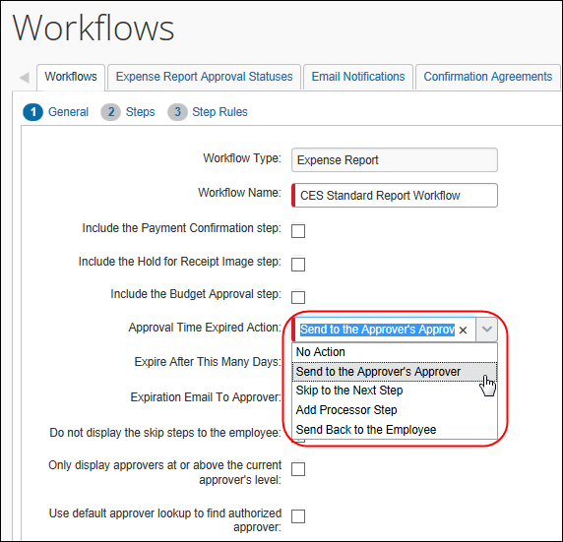

User Experience – Approval Flow Page
The administrator can allow Concur Expense users to select their own approvers. In addition, the administrator can allow users (employees and approvers) to rearrange workflow steps.
If a processor is set for any workflow step, the Approval Flow page will not be displayed.
Whether or not employees or approvers are allowed to edit a workflow, employees can access the Approval Flow page.
- If employees are allowed to edit their own workflow, then this page contains Add Approval Step links, so the user can add or remove ad-hoc approver steps from the list. Workflow steps from the configured workflow cannot be removed.
- If employees do not have the proper permissions, the fields are all read-only.
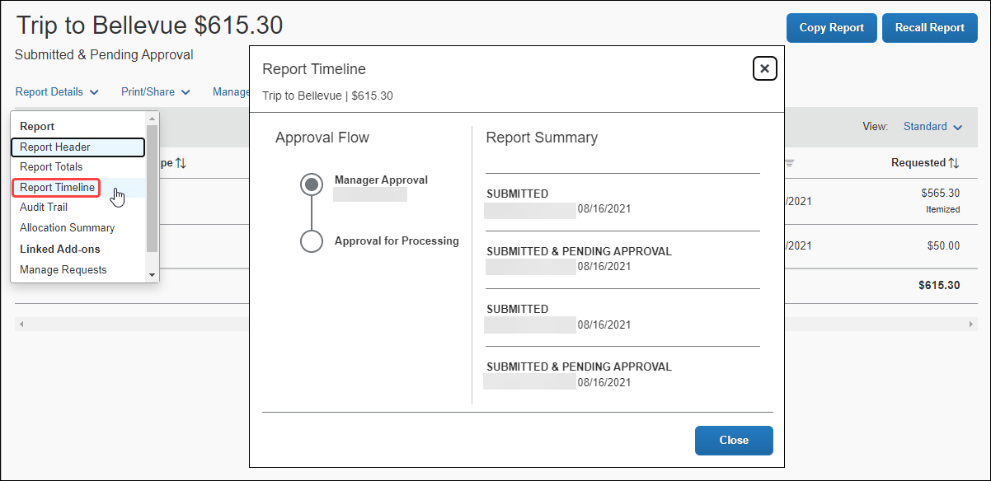
For the most part, there are three types of edits. The type(s) allowed, and the behavior displayed, depends on the permissions granted the user. The options are:
- Edit the selected approver for a step
- Add a new step/approver
- Delete an existing ad-hoc step
Note the following exceptions:
- By default, skip steps, such as a workflow rule that skips the step, are not displayed to the employee or approver. There is a setting the administrator can use (as described in Workflow Procedures in this guide):
- To never show skippable steps unless they occur
– or –
- To evaluate them at display time and then show/hide them based on the result of the evaluation
When skippable steps are displayed, some of these steps may be displayed in parentheses as Concur Expense may not be able to determine the skip status at display time.
- Steps that actually occurred (past steps) are always displayed.
- The Concur Expense Processor always has editable rights to this page.
- System steps are not displayed to the employee, approver, or processor.
As a control and compliance safeguard, a user may not both submit and approve the same expense report. This is true even when acting as a delegate or proxy.
In the event that the configured workflow causes a situation where the approver may not approve a report, there are three paths forward for the expense report:
• the report will eventually time out, if the timeout has been configured, and move forward in the workflow based on the timeout action that has been configured; or
• another approver acting as the delegate approver for the assigned approver may approve the report on behalf of that assigned approver; or
• a processor may approve the report, if configuration allows the processor to access reports assigned to the approver queue.

Approve & Forward Feature
The administrator can set an option so that the Approve & Forward button appears for approvers.

- Refer to Procedure: Creating a New Workflow in this guide. The administrator sets the Steps Can Be Added By option to Approver Only or Both Employee and Approver on the Workflow page.
When the approver clicks the Approve & Forward button, the Approve & Forward Report window appears.
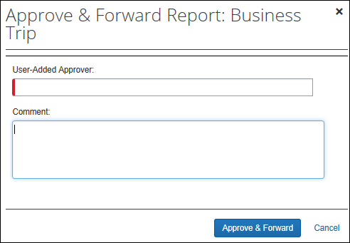
The approver selects the next approver, enters a comment, and clicks Approve & Forward. The report is approved and then moves to the next approver.
If the delegate is allowed to approve reports, then they are also allowed to approve and forward. That is, the Approve & Forward button is available to the delegate.

Report Returned to the Employee
If the expense report is sent back to the employee and the employee resubmits the report, the workflow is reset to the current workflow settings. Depending on the current workflow settings, the employee may have to make the desired changes again. After resubmission the workflow goes through all the approval steps again and does not retain any approval information from prior to being sent back.

Returning a Part of a Report – Using the Split Expense Report Feature
The Split Expense Report feature lets the approver send one or more expenses back to the employee instead of the entire report. Refer to Split Expense Report on Approval in this document for more information.

Overview - Understanding Workflow Rules and the Condition Editor
During the configuration process, once you have created the workflow steps, you can attach rules to each step. A workflow rule consists of two parts:
- A conditional expression: The if portion of an if / then statement, such as, "if the report total is greater than 12,000 USD"
- An action or actions: The then portion of an if / then statement, such as, "then send an email to HR and generate an exception"
The system compares the expense report, cash advance data, or employee data to the conditional expression (if one exists) for each step of the workflow process. If the criteria are met, the system activates the resulting action.
Keep the following in mind:
- Workflow rules execute at the beginning of the step – before any human interaction. If not met, then the report/advance goes on to the next workflow step or waits for an approver to move it along by approving it or activating other approval-related actions, such as Send Back to Employee, partially approve, and so on.
- A workflow step can have multiple rules applied to it, so if one rule is false, it checks for the next rule and resulting action, and so on until one of the rules is met. An option is available to force all rules to be reviewed before moving on to the next step.

Conditional Expressions and the Condition Page
A typical rule for "breakfast of 20.00 USD or more" is:
Expense Type equals Breakfast) and (Claimed Amount is greater than or equal to 20.00 USD)
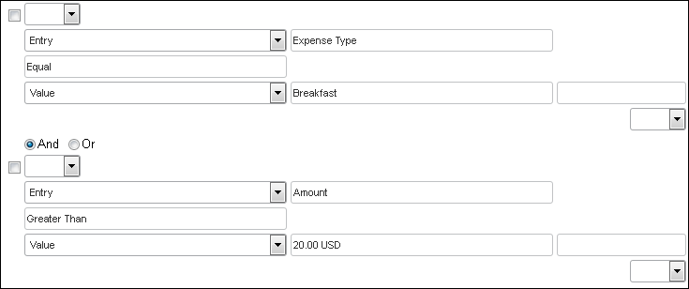
To set up a workflow rule, the administrator uses a condition editor. This section explains the condition editor.
Keep the following in mind when creating or editing conditional expressions.
- There is no limit to the number of conditions that exist in an expression.
- It is comprised of two conditions, separated by and.
- Most conditions are comprised of a field then an operator, then a value. For example:
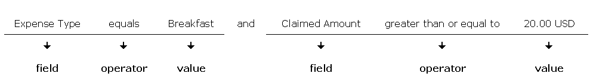
- A field consists of a data object (essentially a database table) and fields in that data object (essentially a database column). The field selected defines the data type of the condition (number, text, date, and so on).
- An operator is one of several pre-defined comparison operators (equals, not equals, is greater than, and so on). The list of operators changes depending on the type of data being compared.
- A value is a constant, and like the field, can be of any data type. The data type of the value must match the data type of the field.
- If the condition uses a second field, its data type must match that of the first field.
- When a conditional expression is composed of multiple conditions, each condition is separated by either and or or.
- Parentheses are optional and are used to define order of operation for the and / or operators. If the parentheses are omitted, and/or operations are carried out left to right. There is no precedence of and over or. The evaluation of the expression simply proceeds from left to right.
- If a conditional expression contains parentheses, the count of left parentheses must match the count of right parentheses. You can use up to three parentheses for both left and right sides.
- Example of correct placement of parentheses and total left/right count:
(Condition 1) and (Condition 2)
- Examples of incorrect parentheses even though total left/right count matches:
Condition1 ) And ( Condition2
Condition1 ) And ( Condition2 ) Or ( Condition3
( Condition1 )) And ( Condition2
Simple Condition Example
Cash Advance Balance Is Greater Than 1000
The condition looks at the cash advance balance and sees whether it is greater than 1000.
- If true, it performs an action the administrator designates.
- If false, it continues on the normal workflow process.
Complex Condition Example
The conditional expression can be a single condition as in the above example or it can be a complex expression involving multiple conditions connected by and / or operators and parentheses, such as the following example that contains four conditions:
Report Date Is Greater Than 9/30/09 and (Employee Group Equals GermanGroup or Employee Group Equals FrenchGroup) and Report Total Is Greater Than EuropeBudget AmountRemaining

Condition Page
The Condition page in the Workflows tool is similar to the Condition Editor page used in the Audit Rules tool and Expense Processor.
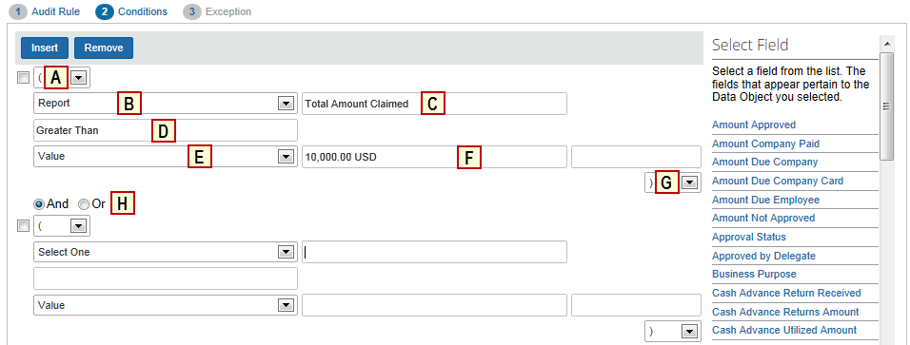
Each condition appears on three lines in the condition editor. The table below describes the condition editor.
Field | Description
A: Left Parenthesis | Select zero to three parentheses, depending on the complexity of the condition.
B: Data Object | The choices that appear in this list are based on the type of workflow (expense report or cash advance request):  - Agency  - Any Previous approvers  - Any Previous approvers (excluding adhoc)  - Cash Advance (for cash advance workflows only)  - Company Card  - Employee  - Entry  - Entry Allocation  - Entry Attendee  - Report  - Report Approvals  - Report Exception  - Travel Reservation Exception
C: Field / Value | Select an item from the helper pane that appears. The information that appears in this pane is based upon the selection made in the Data Object list.
D: Operator | Select an item from the helper pane that appears. The information that appears in this pane is based upon previous choices.
E: Data Object | The system provides the option that best suits the previous choices. Change it if necessary.
F: Field / Value | Select an item from the helper pane that appears. The information that appears in this pane is based upon the selection made in the Data Object list.
G: Right Parenthesis | Select zero to three parentheses, depending on the complexity of the condition.
H: And / Or | Select either option to join the current condition to the next condition; this line appears when there are multiple conditions, and only between conditions, never after the final condition.
- Refer to the Concur Expense: Audit Rules Setup Guide for more general information about the condition editor fields.

Workflow Rules and Exchange Rates
By default, workflow rules evaluate amounts only in the currency (or currencies) identified in the rule. If the client uses multiple reimbursement currencies, then the client must use the Exchange Rates feature in order for the system to evaluate against the additional reimbursement currencies.
Using the Exchange Rates feature, the system "converts" (for the purpose of evaluation) the amount in other reimbursement currencies to the currency identified in the rule. The Exchange Rates feature must be activated and the proper rates must be imported.
- For more information about reimbursement currencies and the Exchange Rates feature, refer to the Concur Expense: Currency Admin Setup Guide.

Workflow Rule Approval Actions
Workflow Rule Approval Actions occur once an approver approves an item, at a specific step in the workflow. The approval actions are:
Approval Action | Description
Change Approver | Routes the report/advance to another approver when the conditions are met  The administrator selects the approver on this page. Once rerouted, the report/advance continues in the same workflow as the original workflow.  NOTE: Even when an expense's approval step has a Change Approver rule and meets the conditions of the rule, the Approval Flow window initially displays the name of the "changed from" approver – not the "change to" approver. The system cannot know the name of the "changed to" approver until after the report enters the approval step and the system is able to evaluation the conditions of the change approver rule.  NOTE: The Change Approver action is not applicable to any processor step.
Generate Exception  (expense report workflow) | Displays a message to the employee, approver, and/or processor
Send Back to Employee  (expense report workflow) | Sends the report/advance back to the employee  Note the following:  - This action resets the workflow process so that the original workflow process begins again once the user resubmits the report. None of the previous approvals are retained.  - The administrator can enter a message for this step to explain why the report/advance was returned.  NOTE: The administrator cannot view this comment from the Report comments.  - If an action that the system performs during a step of the workflow process sets the approval status of the report/advance to Send Back to Employee, then the system views the workflow as complete. In such instances, the system always sends a "workflow step complete" notification email to the affected user. However, if the employee has marked the email notification check box, the system sends a default alternate "report returned" email to the employee regardless of their preference settings. The email notifications can be configured on the Workflow Email Notifications page in Concur Expense.  - Refer to the Concur Expense: Workflow Email Notifications Setup Guide for details.  The system logs all of the completed steps in the history of the report, for the user to view.
Send Email | Sends an email notification to an employee designated here  The administrator indicates who receives the email as well as the text in the Subject line and body of the email.  Examples:  - If the report exceeds 5000 USD, then send a notification email to the controller.  - If the expense type is for relocation expenses, then send a notification to the head of Human Resources.
Skip Step | Skips the current step if the condition is met, and moves to the next step in the workflow  Note the following:  - The administrator can enter a message for this to explain why Concur Expense skipped the step.  - The administrator can view this comment from the Report comments.
Reject  (cash advance workflows) | Rejects the cash advance request  The employee cannot resubmit the cash advance once an approver has rejected it.

Workflow Rule Approval Action Order
The actions occur in the following order:
- All exceptions and email actions
- Any one of the following, if added to the condition:
- Skip this workflow step
- Change approver
- Send back to employee

Workflow Rule Limitations
There are a few limitations built into Concur Expense to avoid creating illogical workflow rules as outlined in this section.
A single workflow rule can contain only one of these actions:
- Skip step
- Change approver
- Send back to employee
A workflow rule can contain multiple instances of these actions:
- Generate an exception
- Send email
For example, the company can have a rule that skips the workflow step when the report total is less than 25 USD and then send an email. However, the administrator cannot create a rule that skips this workflow step and changes the approver.

Workflow Configuration Overview
When creating custom report/advance workflows, you should perform these steps in the following order.
These steps are discussed briefly here and in detail later in this guide.
- Create any custom approval statuses that you may use in the workflow.
- Refer to Approval Statuses in this guide.
- Determine the type of workflow you want by reviewing these general workflow concepts:
General concept | Description
Centralized approval workflow | With this type of workflow, the employee can view the name of their default approver but cannot select a different approver.  In this case, when the employee submits a report/ advance, it is automatically routed to the default approver.
Decentralized workflow  or  Employee-directed Approval | Where the employee selects their approver:  - The employee selects from a list of approvers.  - The employee might be assigned a default approver but the employee can select a different approver if desired.  - The employee can change the workflow steps and add additional steps using the Approvals Flow page.
Approver-directed approval | Like the decentralized workflow, the approver – but not the employee – can route the employee's expense report to another approver.
Approval time expired | After a certain number of days (calendar days - not business days) that an expense report is not approved, the expense report can be routed to another approver, skipped, sent to the processor, or sent back to the employee.  NOTE: This feature is only applicable to expense report workflows.
To use an authorized approvers list | A list of approvers whose authority is defined by upper limits or exceptions  - For more information, refer to the Concur Expense: Workflow – Authorized Approvers Setup Guide.
To use cost object approval | Approval flow based on cost objects, such as cost centers or departments  - For more information, refer to the Concur Expense: Workflow – Cost Object Approval Setup Guide.
- Create a workflow by copying an existing workflow.
- Make the desired changes to the copy. Add additional steps, change configuration settings, and create workflow rules if desired.
- Assign the report workflow to a policy; assign the advance workflow to a group.

Accessing the Workflow Tool
To access Workflow:
Click Administration > Expense > Workflows. The Workflows tab on the Workflows page appears.
Users with the Expense Configuration Administrator (Restricted) role can access (view but not edit) the Workflow Configuration page in Concur Expense.
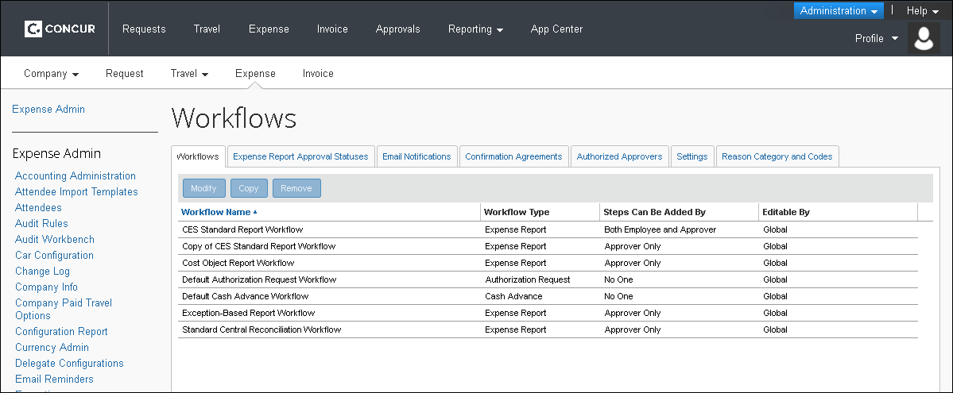
The following information appears.
Column | Description
Workflow Type | Displays the type of workflow  NOTE: You cannot use one type of workflow to create another type of workflow. For example, you cannot copy an expense report workflow in order to create a cash advance workflow.
Steps Can Be Added By | Displays who can add steps to the workflow while it is in process
Editable By | Displays the group(s) that can edit this workflow

Workflow Procedures

Procedure: Creating a New Workflow
To create a new workflow, you must copy an existing workflow and make the desired edits. You cannot create a workflow without copying an existing workflow, nor can you create a workflow by copying a different type of workflow. For example, you cannot use an expense report workflow to create a cash advance workflow.

Getting Started
To get started:
- On the Workflows tab, select the desired workflow and click Copy.
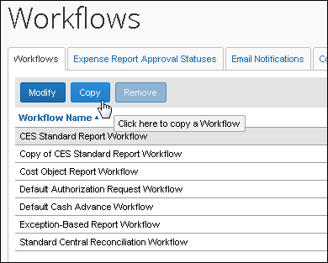
The General page appears.
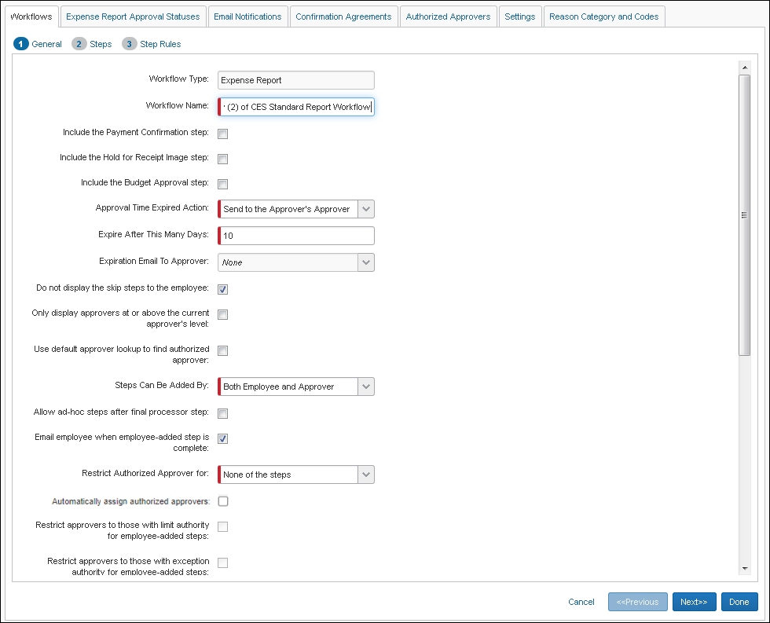
- IMPORTANT! The fields that appear on this page differ depending on whether the workflow is for expense reports or cash advances.

Using the General Page
To continue creating a workflow:
- On the General page, complete all required fields.
Field | Description
Workflow Type | This field is read-only. It identifies the type of workflow that you chose to copy.
Workflow Name | Type a new name for the workflow. This name must be unique.
Include the Payment Confirmation step  (expense report workflows) | Select this check box to use this step.  - Refer to Payment Confirmation (Workflow Step) in this guide.
Include the Hold for Receipt Image step  (expense report workflows) | Select this check box to use this step.  - Refer to Hold for Receipt Image (Workflow Step) in this guide.
Include the Budget Approval step  (expense report workflows) | Select this check box to use this step.  - Refer to the Concur Expense: Budget Setup Guide.
Approval Time Expired Action  (expense report workflows) | Select one of the following to define the action to take when an approver has not approved an expense report for the defined number of days:  - No action; the No Action option means that there is no time limit for an approver to approve an expense report  - Reroute the report to the approver's approver; if there is no such approver, then route to the Expense Processor  NOTE: For example, if the current step is a MANAGER step then a MANAGER step will be added, or if the current step is a MANAGER1 step, then a MANAGER1 step will be added, and so on.  - Skip this step and go to the next step  NOTE: If the expense report reaches the step via a Timeout action, skip rules are ignored – this ensures an approver reviews the report, and it does not proceed through workflow without this basic approval.  - Send to the processor by adding that as an additional step  - Send back to the employee  NOTE: A scheduled job for this action is run daily, by default, to check for the timeouts each day and reroute reports according to the defined action. The scheduled job can be seen and edited using the Import/Extract Administrator tool. Depending on your company's implementation of Concur Expense, you may have to submit a service request to SAP Concur support for assistance with this task.  NOTE: Workflow rules are executed after the expense report arrives in that workflow step.  When there are multiple managers approving the report and there are step rules to change an approver configured, then the Approval timeout action will be applied only if the system can resolve the manager for that step.  If the system cannot resolve the manager for that step (for example there is no manager or in the case of an Authorized Approver scenario), then the system will insert a Processor step between the current workflow step and the next workflow step. The step rules will not be applied until the Processor approves the report.
Expire After This Many Days  (expense report workflows) | Enter the number of days (calendar days - not business days) the approver has before the action (as defined in the Approval Time Expired Action field) takes place. This is the number of days from the date the report is placed into the approver's pending approval work queue. Once this many days have passed, the approval request is expired the next time the scheduled job is run.  If you have selected the Include the Hold for Receipt Image step and if you enter a number of days in this field, then this is the number of days the expense report will be held in this status without receipts. However, once the number of days has been reached, the report is not rerouted as defined in the Approval Time Expired Action field. Instead, the report is returned to the employee.
Expiration Email to Approver | You may elect to send an email notification on expiration of the workflow step, or None (the default).  The following choices are available when alerting the approver:  - None: (Default behavior) Send no notification to the approver  - Default Expense Report Pending Notification: Alert the approver by sending the standard email notification that the report they are responsible for approving is pending notification  - Default Expense Report Status Change Notification: Alert the approver by sending the standard email notification that the status of the report or cash advance has changed  - Any other configured email notification: Additional email notification formats may be configured under Workflow – Email Notifications
Do not display the skip steps to the employee  (expense report workflows) | If there are workflow steps that can be skipped, then the employee does not see that those steps are part of the workflow on the Approval Flow page in Concur Expense. The system determines whether a step is skipped based on the workflow rules and the skip step rule action defined at the step level.  If you clear this option, then any step with a skip step action is displayed in parentheses.
Only display approvers above the current approver's level  (expense report workflows) | This field applies only if authorized approver is activated.  - Refer to the Concur Expense: Workflow – Authorized Approvers Setup Guide.
Steps Can Be Added By  (expense report workflows) | Select to indicate whether employees and/or approvers can add steps during the workflow process using the Approval Flow page in Concur Expense.  Note the following:  - If the Allow users to select their own approver for expense reports field on the workflow Settings tab is not selected, then the employee does not see this option.  - The Expense processor can always add approvers on this page.  - If this option is set to either Approver Only or Both Employee and Approver, then the Approve & Forward button appears for approvers.
Allow ad-hoc steps after final processor step | Select this option to enable the user to add additional steps to a workflow following the processor workflow process. When selected, the Add button is removed from the approval step.  NOTE: This option is typically used to allow the processor to add an ad-hoc approver step for another approver review, then a second step to return it to the processor for final review before payment.
Email employee when employee-added step is complete  (expense report workflows) | Select this option to notify the employee when the step they added has an action taken on it.  This field is only available if you have chosen an option in the Steps Can Be Added field.
Use default approver lookup to find authorized approver | This field applies only if authorized approver is activated.  We recommend that clients do not use this setting in tandem with the Automatically assign authorized approvers setting.  - Refer to the Concur Expense: Workflow – Authorized Approvers Setup Guide.
Restrict Authorized Approver for  Restrict approvers to those with limit authority for employee-added step  Restrict approvers to those with exception authority for employee-added step | These fields apply only to expense report workflows and if the authorized approver feature is activated.  - Refer to the Concur Expense: Workflow – Authorized Approvers Setup Guide.
Automatically assign authorized approvers | This field applies only if authorized approver is activated.  Use this setting to ensure that all authorized approval steps have an assigned Authorized Approver for the expense report, without user action.  Important considerations before enabling this setting:  - If there are multiple possible Authorized Approvers that could be assigned to a specific Authorized Approver workflow step, the system will order the choices alphabetically by last name, followed by first name (if there is more than one person with the same last name) and then select the first choice from the alphabetized list.  - Enabling this setting is not recommended when there might be large numbers of possible approvers for some workflow steps. In this situation, the user needs to select the appropriate approver for the report rather than sending all reports to the alphabetically-first approver.  - The individual Expense Preferences page setting, Prompt … For an approver when an expense report is submitted, will display the approval flow to the user for review during the submit process when checked. This can encourage the user to verify that the appropriate approver is assigned to each step prior to submitting the expense report.  - Use of this feature is optimized by configuring the workflow to allow users to edit approvers, so this is strongly recommended. Refer to the Approver Editable By setting (Workflow (tab) > Steps > Add Workflow Step).  - Clients who currently use the pre-existing setting, Use default approver lookup to find authorized approver, should choose to either retain that setting or use this new setting instead. We recommend that these two settings are not used in tandem.  - Refer to the Concur Expense: Workflow – Authorized Approvers Setup Guide.
Editable By Group(s) | Select the group rights that an administrator must have in order to modify this workflow.
Allow employee to recall reports  (expense report workflows) | Select this check box to allow the employee (or their delegate or proxy) to recall a report after it is submitted.  The Recall button appears in Concur Expense when the report is opened, allowing the user to recall the report.  Recall is allowed up to the point that the report is ready for extract to the financial systems.
Allow employee to recall cash advances  (cash advance workflows) | Select this check box to allow the employee (or their delegate or proxy) to recall a cash advance after it is submitted.  The Recall button appears in Concur Expense when the cash advance is opened, allowing the user to recall the cash advance.  Recall is allowed if the cash advance is in one of these states: Pending Approval, Pending Administrator.
Skip approval step if approver has already approved | Select this check box to have Concur Expense skip subsequent occurrences of the same approver if that approver previously approved the report/advance.  NOTE: This setting applies to each individual workflow instance. If the report/advance is sent back to the user, on resubmit it will begin a new instance of the workflow. Any approvals from the previous workflow instance will not be retained.  - Refer to Exception - Approver Has Already Approved in this guide.
Cost Object Hierarchy Type  (expense report workflows) | This field applies only to cost object approvals.  - Refer to the Concur Expense: Workflow – Cost Object Approval Setup Guide.
Submit Confirmation Agreement | Select the confirmation agreement that will be displayed when the user submits the report/advance.  - Refer to Confirmation Agreements in this guide.
Approval Confirmation Agreement | Select the confirmation agreement that will be displayed when the approver approves the report/advance.  - Refer to Confirmation Agreements in this guide.
Approval Request Notification | Select the notification that is to be sent to the approver when the report/advance is submitted by the employee.  Company-specific email notifications are configured on the Workflow Email Notifications page.  - Refer to the Concur Expense: Workflow Email Notifications Setup Guide.
Status Change Notification | Select the notification that is to be sent to the submitter when the workflow status of the report/advance changes.  Company-specific email notifications are configured on the Workflow Email Notifications page.  - Refer to the Concur Expense: Workflow Email Notifications Setup Guide.
Sent Back Notification | Select the notification that is to be sent to the submitter when the report/advance is sent back to them.  Company-specific email notifications are configured on the Workflow Email Notifications page.  - Refer to the Concur Expense: Workflow Email Notifications Setup Guide.
Courtesy Email Notification  (expense report workflows) | Select the notification that is to be sent to a user's default approver if that person is not the first approver in the workflow or if another approver was selected by the user for the first step in the workflow (if the company allows users to select approvers).  Company-specific email notifications are configured on the Workflow Email Notifications page.  - Refer to the Concur Expense: Workflow Email Notifications Setup Guide.
- Click Next. The Steps page appears.
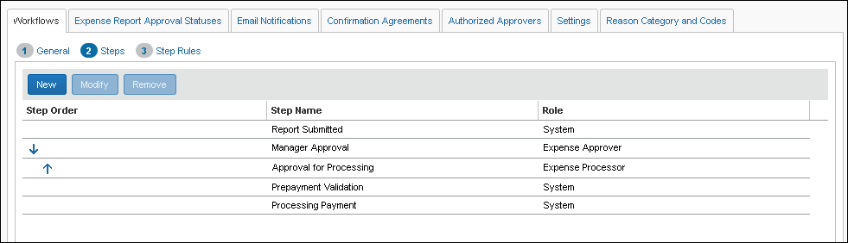

Using the Steps Page
To create a new step:
- On the Steps page, click New. The Add Workflow Step page appears.
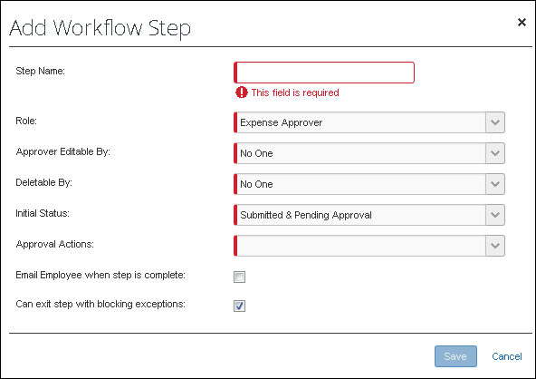
The fields that appear (and the options in the fields) on this page differ depending on whether the workflow is for expense reports or cash advances. It also differs for cost object approvals.
- Complete all required fields.
Field | Description
Step Name | Type any alphanumeric name for the workflow step.  This name appears to the employee on the Approval Flow page in Concur Expense, so it is important to make this name clear for the employee.
Role | The roles that appear in this list differ depending on whether the workflow is for expense reports or cash advances. Cost object approvers also have a separate role.  Select the role that represents the person responsible for this step.  NOTES:  - If you select System, then the step is fully automated and no employee intervention is required. The page refreshes and only the applicable fields appear.  - If you select an approver role, the system displays a multiple selection list of actions to the approver in the Approval Actions field. (See the field description below.)  - The Authorized Approver option appears only for expense report workflows. Do not select the Authorized Approver option unless your company is using that feature.  - For more information, refer to the Concur Expense: Workflow – Authorized Approvers Setup Guide.  - Budget Approver appears as an option if Budget has been enabled.  - For more information, refer to the Concur Expense: Budget Setup Guide.  - If you select Default Approver 2 (that is, you add a Default Approver 2 step to the workflow), then the second default approver field appears in the profiles of the users associated with this workflow. Consider configuring the step to skip in order to manage those times when the second default approver field is either inadvertently or intentionally left blank in the user's profile.  - Native Integration appears as an option if the Funds and Grants Integration with Concur Solutions is enabled.  - For more information, refer to the Shared: Funds and Grants Integration with Concur Solutions Setup Guide for Professional Edition.
Approver Editable By  (expense report workflows) | Select who can edit the selected approver field for this step on the Approval Flow page in Concur Expense – the employee, approver, or both.  Note the following:  - The global setting on the workflow Settings tab overrides your selection in this field. For example:  - If the Allow users to select their own approver for expense reports field on the Settings tab is not selected  – and –  - If you have Employee or Both Employee and Approver selected here  – then –  - The employee is not allowed to select an approver; the field appears as read-only to the employee.  - The approver can still select approvers, even if the global setting is not selected.
Deletable By  (expense report workflows) | Select who can delete this step on the Approval Flow page in Concur Expense – the employee, approver, or both.
Integration Type | The Integration Type field only appears when Native Integration is selected in the Role field. The Native Integration role and the Integration Type field only appear if the Funds and Grants Integration with Concur Solutions is enabled.  - For more information, refer to the Shared: Funds and Grants Integration with Concur Solutions Setup Guide for Professional Edition.
Initial Status | Select the approval status that represents the expense report or cash advance status at the time the step begins, such as Pending Approval. The employee can see this status.
Approval Actions | The options that appear here differ depending on the type of workflow and the selection made on the Role field.  From the Approval Actions list, select an action that an approver can make to a report/advance that is awaiting approval. The actions you specify here are visible to the approver in Concur Expense. The approver decides which action to take.
Email Employee when step is complete | Select this check box if you want to notify the employee after this step has completed.  Note the following:  - The employee can turn off the delivery of workflow email notifications in their Expense Preferences in Profile. This will suppress all workflow email notifications to that employee with the exception of the Sent Back to Employee notification.  - This email feature can be set to localize email content into the employee's language.
Can exit step with blocking exceptions | Clear (disable) this check box to block the report from progressing past approval in workflow (under certain conditions*).  -Or-  Select (enable) this setting to allow the processor to change the expense type for an expense (and clear any resulting Audit Rules exceptions) and process the report.  NOTE: Runtime or system exceptions are evaluated a second time (approver may clear fields, generating missing Required field type exceptions, etc.). Additionally, if a rule is placed on the second approval step, the blocking exception would trigger on entry to that step but allow the initial approval without triggering an exception.  *The following blocking exception codes will not prevent the processor from approving the report since the approver cannot clear these exceptions at this point of workflow:  - COW: One or more Cost objects could not be approved by the right authority (%costObjects%). The expense report has been moved to the next workflow step.  - CONOAPPR: No approvers were found for cost object %costObjects%.  - BOW: One or more Budget objects could not be approved by the right authority (%costObjects%). The expense report has been moved to the next workflow step.  - APPRVTO: This report has been pending approval longer than allowed by policy. The report owner should contact their Approver for instructions before resubmitting. If you are not the owner but have been forwarded the report, follow the approval steps according to your policy - this may involve approving the report or assigning it to another Approver for further review.  - NOAPPR: The previous step was skipped because the selected approver no longer has the approver role. Select another approver or contact the system administrator.  - SELFAPPR: The previous step was skipped because the selected approver would be self-approving the report.
- Click Save.
- To make other changes:
- To remove any unnecessary workflow steps, select a step and then click Remove.
Not all steps can be removed.
- To modify an existing step, select a step and then click Modify.
- To place the steps in the proper workflow order, use the Step Order column.
Not all steps can be reordered.
- Click Next. The Step Rules page appears.
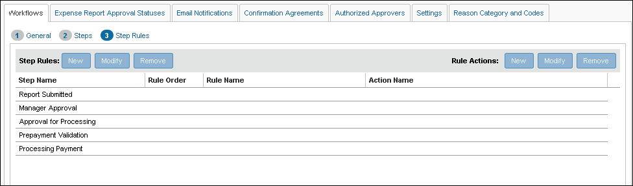

Using the Step Rules Page
Before working with rules, refer to Overview - Understanding Workflow Rules and the Condition Editor in this guide.
This process includes three steps:
- Name the rule.
- Create a condition (the "if" portion - "it this happens").
- Define the action (the "then" portion - "then do this").
To create a workflow rule:
- On the Step Rules page, select a step name.
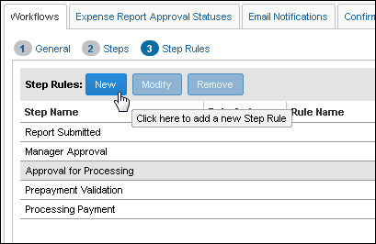
Not all steps can have rules. If the selected step can have a rule, the New button becomes available.
- Click New. The Edit Condition window appears.
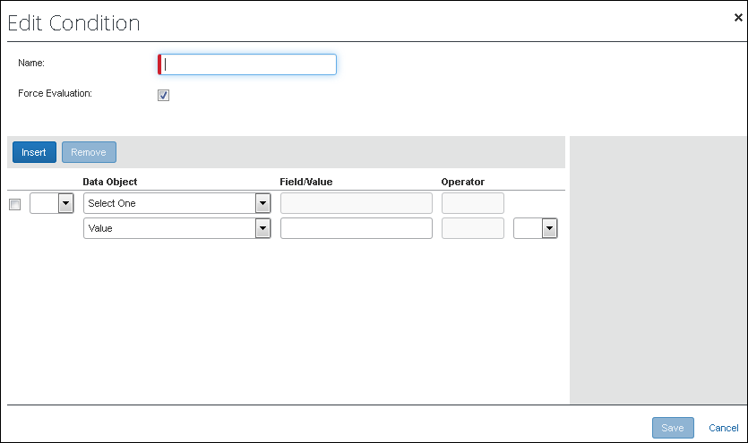
- Complete the fields at the top of the window.
Field | Description
Name | Type any alphanumeric name for the workflow rule. The name does not have to be unique.
Force Evaluation | If the check box is not selected, then the rules are evaluated in order and execution halts after a rule is determined to be true. Rules ordered after this point will not be evaluated.  If the check box is selected and there are multiple workflow rules, then the rule is evaluated regardless of whether the other rules are false or true.  Example:  Assume that you have a workflow step with two rules:  - If an expense report is less than 1000 USD, then skip this step.  - If an entry is Seminar Fees, then generate an exception.  In this case:  - If not selected, if the expense report is less than 1000 USD, then it does not evaluate the next rule to see if it is for Seminar Fees. If the report is more than 1000 USD, then it evaluates the next rule, continuing to do so until it finds a rule that is true, then it stops evaluating.  - If selected, then the product evaluates both rules and executes both actions if both are true.
- Create a condition.
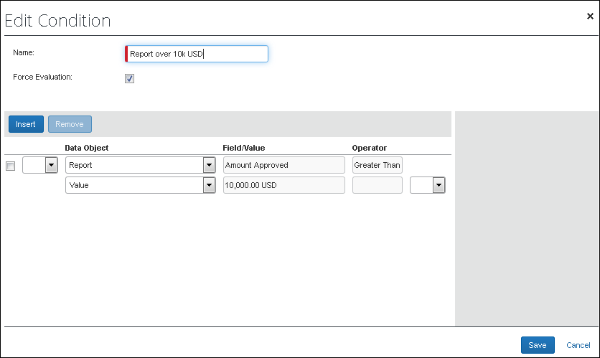
- Refer to Overview - Understanding Workflow Rules and the Condition Editor in this guide.
- In the Edit Condition window, click Save. The new rule appears on the Step Rules page.
- To add the action, click New.
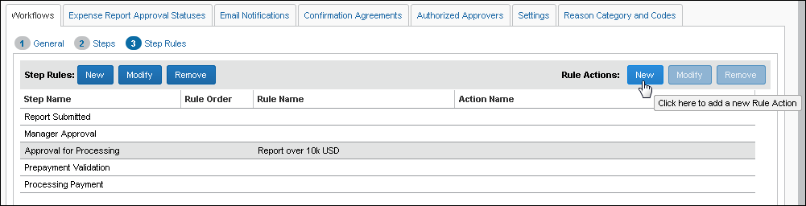
The Edit Action window appears.
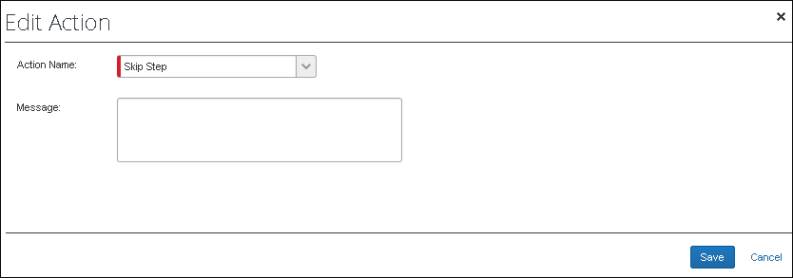
- From the Action Name list, select the desired action.
You may have multiple actions, but they cannot conflict with each other. If the actions conflict, an error message appears.
Once you choose an action from the list, the page refreshes and provides any fields needed for the action you selected.
- Complete the remaining action field(s).
Action | Description
Change Approver | Select an approver.  When the criteria for this condition occur, the system routes the report/advance to the approver designated here.
Generate Exception | Select an exception from the helper pane or create a new one.  A message appears to those you designate in the Exception Visibility field.
Reject  (cash advance workflows only) | Enter a comment that the employee will see, explaining why the cash advance request was rejected, for example, Above the maximum request limit
Send Back to Employee | Enter a comment that the employee will see, explaining why the report/advance was returned.  This comment is visible wherever report comments are available to the employee, approver, and/or processor.  This field does not appear for cash advance workflow rules.
Send Email | You may:  - Select an email recipient _- OR – Select Default Approver to send it to that approver  - Select a standard email template from the Email Notification list – OR – type text directly into the Email Subject and Message text fields  - Refer to Working with Send Email in this document for more information.
Skip Step | Type a message in the Message field.  This message is visible wherever report messages are available to the employee, approver, and/or processor.
- In the Edit Action window, click Save.
- When done with all rules and actions, click Done on the Workflows tab.

Working With Send Email
The administrator has several options they can use when sending an email to an approver for the Send Email workflow step rule action. For example, send a custom message to the approver, or elect to send a template email notification to an employee they select from an email list.
To do this, first select Send Email to re-display the Edit Action dialog box with associated options. Then, use the figure below to choose how the email should appear and to whom it should be sent.
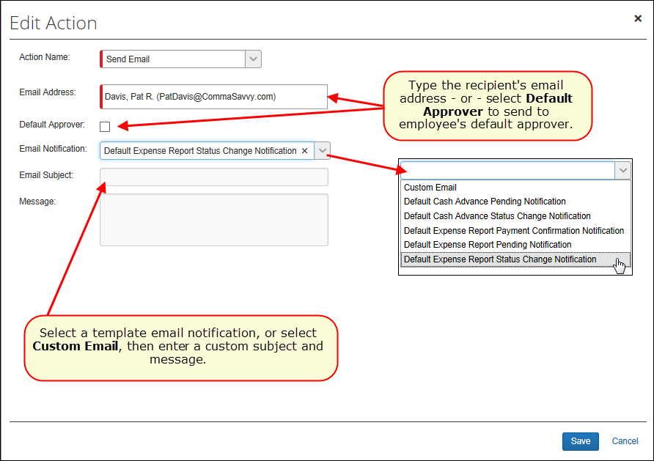

Procedure: Configuring Workflow Event Notifications and External Validation Steps
In order to create event notifications, you must configure them at the workflow step level. Event notifications can be configured for any editable workflow step. When an expense report reaches a specific step in a workflow that is configured for external notifications, a third-party application is notified of the event. Event notifications are always sent for certain events, but additional steps may be configured to be included in the notifications to meet company-specific needs.
- Please refer to the SAP Concur Developer Center for additional information about the event subscription service (ESS).
External validation steps may be created as well, where the role assigned to the step is an external system and that system is prompted to complete the required action on the corresponding report.

Configuring an event notification
To configure an event notification:
- Click Administration > Expense > Expense Admin > Workflows. The Workflows page opens on the Workflows tab.
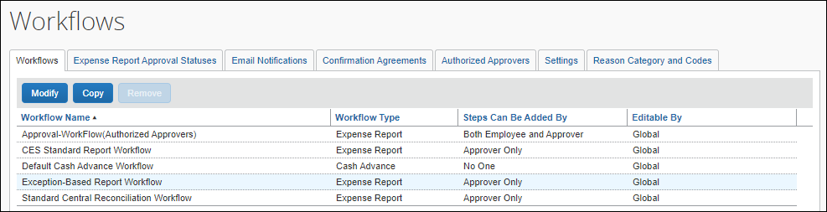
- Select the workflow you want to modify. Once selected, the row turns blue and the Modify button becomes available.
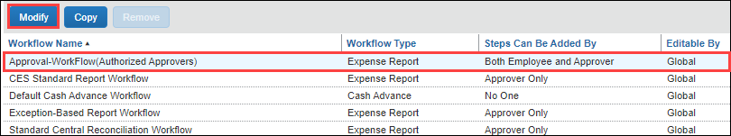
- Click Modify.
- Click Steps to open the Steps section of the Workflows tab.
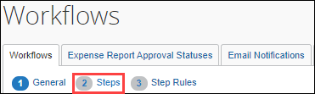
- Select the step where you want to create an external notification. Once selected, the step's row is highlighted.
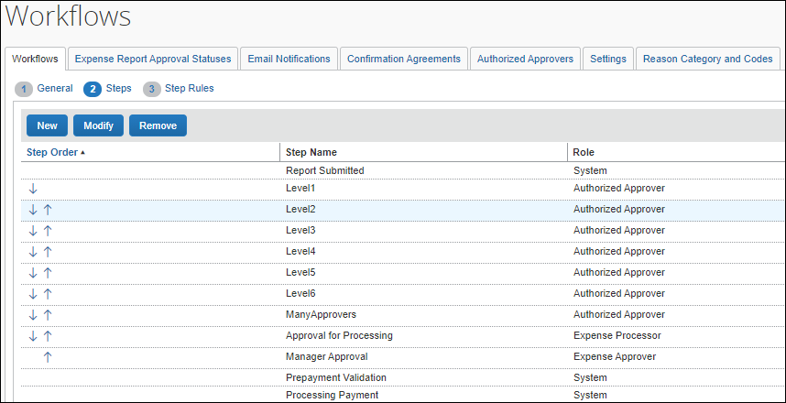
- Click Modify. The Modify Workflow Step page opens.
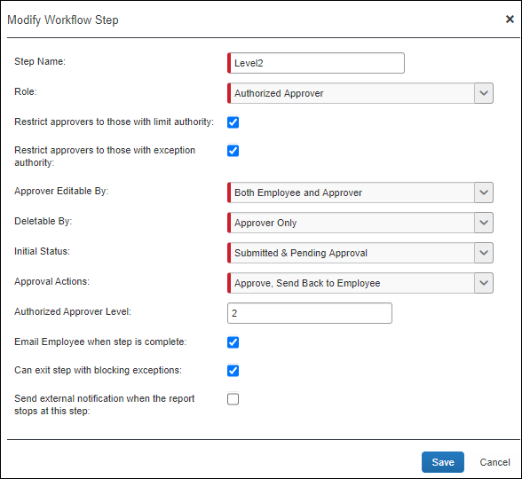
The Send external notification when the report stops at this step option is only available for steps you can modify in the workflow.
- In the Modify Workflow Step dialog, check the box Send external notification when the report stops at this step. Once this box is checked, the Step Code field displays.
- In the Step Code field, enter a business code that is meaningful to the system subscribing to the event notifications.
The Step Code displays as an attribute in the event schema of the notification message that the third-party application receives. It can be used to filter the events for a particular workflow step when multiple workflow steps are configured for notifications with unique step codes. In the following example, FINPOSTING is equal to the event, Financial Posting.
The Step Code field has a 10-character limit.

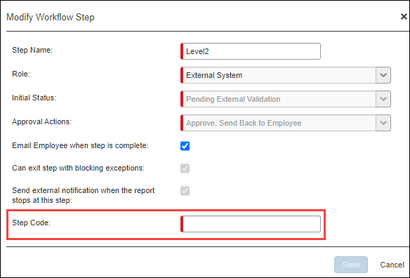
- Click Save. The workflow step is now configured to send an external notification when an expense report reaches the corresponding step in the workflow.

Configuring an external validation step
To configure an external validation step:
- Click Administration > Expense > Expense Admin > Workflows. The Workflows page opens on the Workflows tab.
- Select the workflow you want to modify. Once selected, the row turns blue and the Modify button becomes available.
- Click Modify.
- Click Steps to open the Steps section of the Workflows tab.
- Click New to create a new step. The Add Workflow Step page opens.
- In the Step Name field, enter a name for this step.
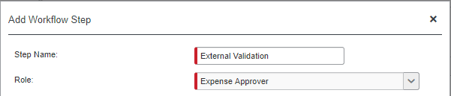
- In the Role list, select External System.
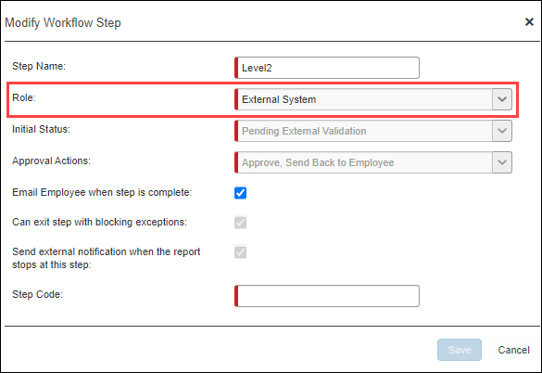
When the External System role is selected, a Concur Admin can configure any workflow step prior to extract as an external validation step. The workflow step the workflow step can be moved up and down in the order, and multiple External System steps may be configured in the same workflow
When External System is selected, the Step Code field displays.
The step code serves as a filter for the third-party system to take action when the notification for this specific step is received. Clients define the Step Code based on their business needs (for example, FINPOSTING for financial posting).
- In the Step Code field, enter a business code that is meaningful to the system subscribing to the event notifications.
The Step Code displays as an attribute in the event schema of the notification message that the third-party application receives. It can be used to filter the events for a particular workflow step when multiple workflow steps are configured for notifications with unique step codes. In the following example, FINPOSTING is equal to the event, Financial Posting.
The Step Code field has a 10-character limit.
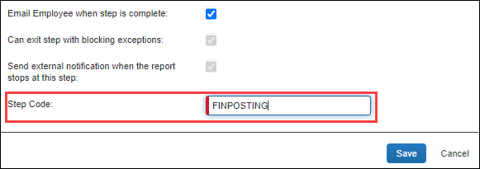
- Click Save. The workflow step is now configured to send an external notification when an expense report reaches the corresponding step in the workflow. The report will remain in this workflow step until the external system approves or returns the report to the employee via API calls.

Editing and Deleting Workflows, Properties, and Steps

Overview
Depending on your permissions, you may be able to view or perhaps edit certain workflows.
You can make edits to a workflow at any time; however, note the following:
- The system does not update the workflow for an expense report that has already been submitted.
- If a report is returned to the user (for example, by the approver) and the user resubmits the report, the new workflow applies.
- If the workflow has been edited to add, delete, or reorder steps between the time the report was created and submitted, the system resets the workflow page to the new configuration (discarding any user changes), and displays a message to the employee advising them of this reset.

Procedures: Editing and Deleting

Editing Workflow Properties
You can change any properties associated with that workflow, such as number of days for an approval timeout to be rerouted or whether a workflow can be employee-edited.
To edit workflow properties:
- Click Administration > Expense > Workflows.
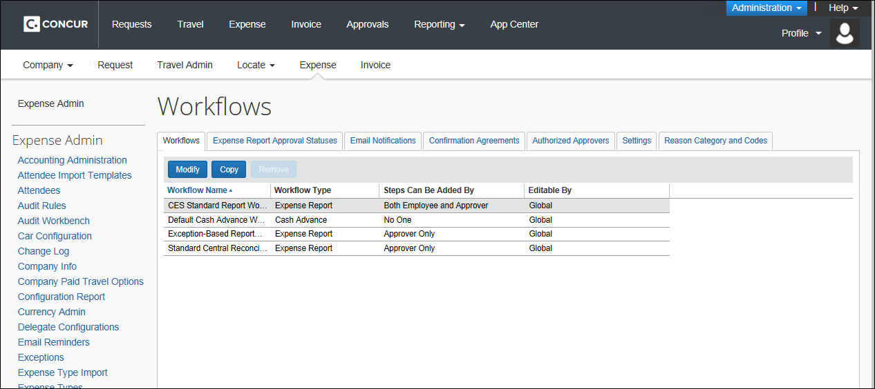
- Either:
- Select the desired workflow and click Modify.
– or –
- Double-click the desired workflow.
The General page appears.
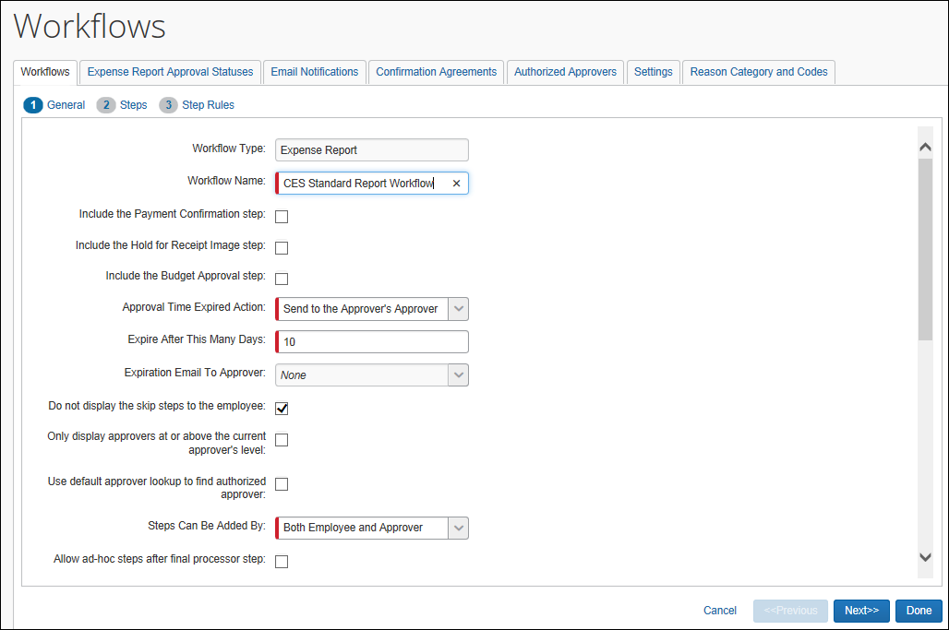
- Make the necessary changes.
- Refer to Creating a New Workflow for a complete description of the fields on this page.
- Click Done.

Editing and Reordering Workflow Steps
To edit workflow steps:
- On the Steps page, either:
- Select the desired step and then click Modify.
– or –
- Double-click the desired step.
The Modify Workflow Step window appears.
- Make the desired changes.
- Refer to Using the Steps Page in this guide for information about these fields.
- Click Save.
To reorder workflow steps:
- On the Steps page, use the Step Order column to reorder the steps.
Not all steps can be reordered.
- Click Done.

Editing Workflow Rules and Actions
To edit a workflow rule:
- On the Step Rules page, either:
- Select the desired rule and then click Modify.
– or –
- Double-click the desired rule.
The Edit Condition window appears.
- Make the desired changes.
- Refer to Using the Step Rules Page in this guide for information about these fields.
- Click OK.
To edit an action:
- On the Step Rules page, either:
- Select the desired action and then click Modify.
– or –
- Double-click the desired action.
The Edit Action window appears.
- Make the desired changes.
- Refer to Using the Step Rules Page in this guide for information about these fields.
- Click Save.
- Click Done.

Deleting a Workflow or Workflow Steps
You can delete a workflow or workflow steps if:
- The workflow was created for use by your group or you are the global administrator.
- The workflow is not currently assigned to a policy. The system does not allow you to delete a workflow that is currently assigned to a policy. To delete a workflow that is currently in use, remove it from that policy.
To delete a workflow:
- On the Workflows tab, select the desired workflow.
If the workflow is available for deletion, the Remove button becomes available.
- Click Remove.
To delete workflow steps:
- On the Steps page, select the desired step.
If the step is available for deletion, the Remove button becomes available.
- Click Remove.
- Click Done.

Approval and Payment Statuses

Overview
There are two types of statuses that are associated with each workflow step: approval and payment
Status | Description
Approval | The approval status defines the step that the expense report or cash advance request is in now, such as Not filed or Pending Approval.  - This status is displayed to the employee and the approver on the list of expense reports in Concur Expense.  - The back-office personnel can also see the status in Expense Processor.  - The administrator can customize approval statuses.  - Approval statuses should be determined before you create custom workflows because they are associated with a workflow step.
Payment | The payment status shows the employee the reimbursement status for their submitted expense report. The payment statuses are all pre-defined and cannot be customized.

Default Approval Statuses
There are several default approval statuses. You can edit the approval name, such as Approved to Approving, edit the action text, or edit the description text.
This is not a comprehensive list. There are several other statuses that may appear, based on features enabled by the client.

Approval Status | Description
Anomaly & Fraud Check | Report submission triggers Anomaly & Fraud Check
Approval Time Expired | The expense report has not been approved within the defined number of allowable days (calendar days - not business days) and has taken an Approval Time Expired action.  This status appears for only a moment before it moves on to the designated action and is typically not seen by the employee.
Approved | The appropriate managers have approved the expense report for payment. The system does not set this status until all workflow steps that require manager approval have been completed.
Approved & In Accounting Review | The expense report is waiting for the accounting department or processor to approve for payment. When the report is in this state, the system may allow partial approval. In addition, the processor may be able to make edits to the expense report while in this state.
Auto Approved | The system has automatically approved the expense report. If there is a condition with a rule for skipped step, then this is the approval action used.
Disputed | The reports are waiting for the CR Processor and Issuer to solve the situation, used with the Central Reconciliation feature.
Hold for Receipt Images | The system is holding the report until the user attaches the required scanned receipts. This step occurs after submit, before being sent to the first approver. Once the receipts are received by Imaging, the report moves to the first approver.  NOTE: Concur Expense considers the receipts to be received when there is at least one line-item or a report-level attachment. Clients can use an audit rule to require attachment for all line items that require a receipt if the client does not want the report to move forward.  - For more information, refer to Hold for Receipt Image (Workflow Step) in this guide.
Holding Payment | The system is not exporting the report for payment until a defined condition is met, such as handing in receipts.
Issued | A cash advance has been issued by the Expense Cash Advance administrator. This status does not appear on the Approval Status page and is not editable.
Not Issued | A cash advance has been canceled by the Expense Cash Advance administrator. This status does not appear on the Approval Status page and is not editable.
Not Paid | The report is not yet paid.
Not Submitted | The expense report has not been submitted and has not entered a workflow process.
Paid | The report is has been paid.
Payment Confirmed | The payment demand created for this expense report has been sent to the banking system for processing by Expense Pay.  - For more information, refer to Payment Confirmation (Workflow Step) in this guide.
Pending Budget Approval | The expense report is in the budget approval step, if using the Budget feature.
Pending Cost Object Approval | The expense report is in a cost object approval step and has not completed the approval process for all cost object approvers.
Pending External Validation | This status is associated with the External Validation feature. For more information about this custom feature, refer to https://developer.concur.com/api-reference/callouts/event-notification.html. Contact SAP Concur support for assistance enabling the feature and configuring the workflow step.  If you see this status and you are using the External Validation feature, refer to https://developer.concur.com/api-reference/callouts/get-notifications-status.html for more information.
Pending Validation | The report is pending prepayment validation. This status is typically not seen by an end user.  The system does this check directly after the processor approves the report and before it is marked as ready for extract. The check simply verifies that all journal entries add up to the total of the expense; the allocations add up to the total of the expense; and so on as a final check that the data is completely correct.  When any error is found, the report goes into the Pending Validation status to prevent the extract of bad financial data. The report then requires manual intervention to determine and correct the problem, and the typical workaround is to send it back to the employee for resubmission.  As part of the submission process, all of the journal entries are recalculated so any error is usually corrected.
Sent Back to Employee | The expense report is sent back to the employee for more information or correction.
Submitted | An employee has submitted the expense report. When in this state, the system may allow partial approval and minor edits.
Submitted | The report has been submitted.
Submitted & Pending Approval | The expense report is somewhere in the approval process, but has not been given final approval.

Procedures: Approval Statuses
The approval statuses are configured within the Workflow tool.

Accessing the Expense Report Approval Status Tab
To access the tab:
- Click Administration > Expense > Workflows.
- Click the Expense Report Approval Statuses tab.
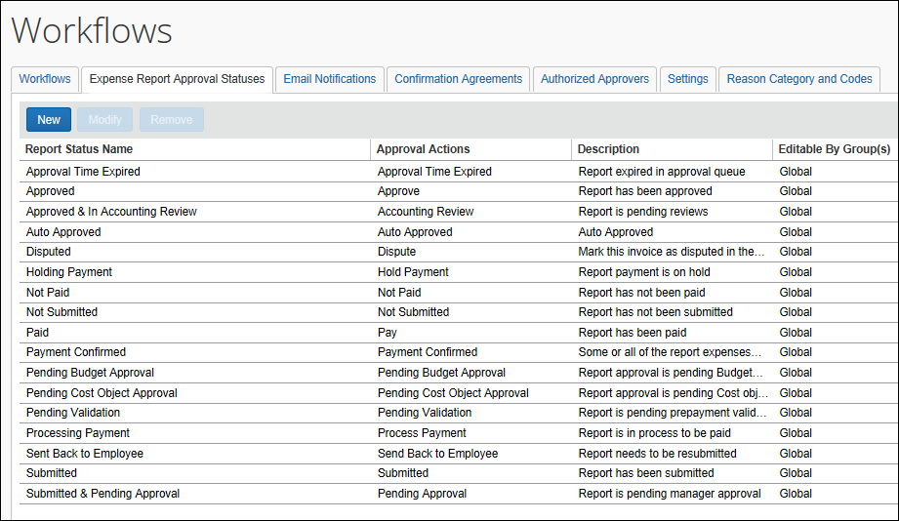

Adding an Approval Status
To add an approval status:
- On the Expense Report Approval Statuses tab, click New. The Report Status window appears.
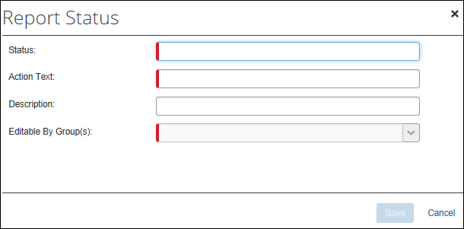
- Complete the appropriate fields:
Field | Description
Status | Type a name for the new status.
Action Text | Type descriptive text to be used as the action text. This text becomes button text for the approver. When the approver clicks the button, the expense report approval status changes to this approval status.
Description | Type the description text.
Editable By Group(s) | Select the group configuration(s) that can edit this workflow.
- Click Save.

Editing an Approval Status
To edit an approval status:
- On the Expense Report Approval Statuses tab, either:
- Select the desired status and then click Modify.
– or –
- Double-click the desired status.
The Edit Action window appears.
- Make any necessary changes.
- Refer to Adding an Expense Report Approval Status for information about these fields.
- Click Save.

Deleting an Approval Status
Some approval statuses cannot be deleted because the system is dependent on them.
To delete an expense report approval status:
- On the Expense Report Approval Statuses tab, select the desired status.
If a status is available for deletion, the Remove button becomes available.
- Click Remove.

Understanding Payment Statuses
The pre-defined payment statuses are listed in the table below. Note the following:
- You cannot edit these payment statuses.
- You cannot add any new statuses.
- There is no tool in Expense Admin that displays these statuses.
All expense reports have the payment status of Not Paid until after the expense report has been approved in Expense Processor. The back-office personnel can view the payment status once the expense report has entered Processor.
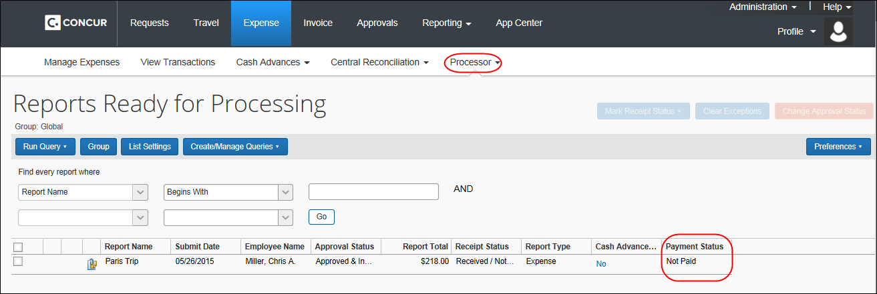

Payment Status | Description
Hold for Payment | Payment is being held based on receipt requirements, as defined by the Payment Hold feature.
In Progress | The system has extracted the report for payment but no payment file has been received yet from the payment system.
Not Paid | The system has not yet extracted the report for payment.
Paid | The payment system has completed processing and has sent a payment file indicating that the report has been paid.
Payment Confirmed | Some or all amounts due to an employee or company card have been actually paid for a report. An import file has been imported into the system to confirm this payment after payment was made to the employee or company card vendor. Additional payments may occur at some future time, but the report payment status will continue to show Payment Confirmed.  This status is shown only if Expense Pay is used and/or the Payment Confirmation Import is used.
Processing Payment | The report has been approved for payment but has not yet been extracted to the financial systems. The report can still be sent back to the previous processor workflow step using recall.
For example, on a standard workflow:
Action | Payment Status
The user has submitted the report. It has been approved. It has moved to the processor. | Not Paid
The approver has approved the report for payment. | Processing Payment
The amount has been extracted for import into the company's financial system. | Paid
If the company uses the payment confirmation feature, this status appears after the payment confirmation import. | Payment Confirmed

Workflow Settings
Workflow settings define the general workflow actions. All workflow settings are global. They apply to all workflows and all employees – regardless of group. There are two separate sets of settings: expense report and cash advance

Accessing the Settings Tab
To access the tab:
- Click Administration > Expense > Workflows.
- Click the Settings tab.
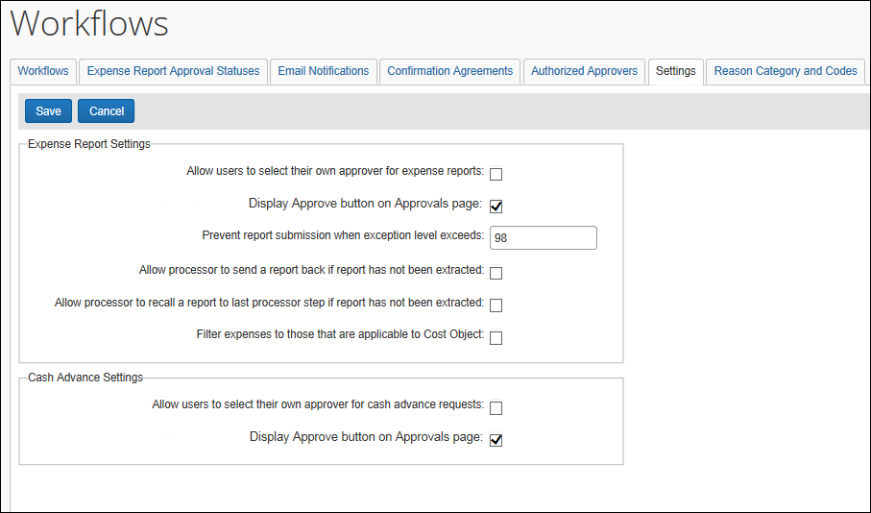

Changing Expense Report Settings
These settings apply to expense reports. Changes are applied immediately.
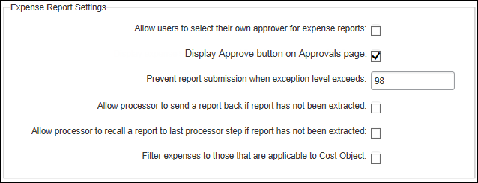
To change options:
- Select an option or complete the field as described in the table below.
Setting | Description
Allow users to select their own approver for expense reports | If this check box is selected and:  If this check box is not selected, then the user cannot select an approver. If the user attempts to submit a report and there is no approver already assigned, the user is presented a message to notify an administrator.
  "Prompt" setting in user profile is: | Default approver is: | Then....
  Selected (On) | Identified | The user is prompted; the default approver names appears but can be changed.
  Selected (On) | Not identified | The user must select an approver.
  Cleared (Off) | Identified | The user is not prompted; the report is submitted.
  Cleared (Off) | Not identified | The user must select an approver.
Display Approve button on Approvals page | If selected, the Approve link appears on the Expense Report tab of the Approvals page. This allows the approver to quickly approve expense reports.  If not selected, then the approver must open the expense report and approve it.
Prevent report submission when exception level exceeds X | Type a number from one to 99.  Any expense report that meets the criteria for an exception with this level or above prevents the employee from submitting the expense report. The employee must then make the necessary changes before being able to submit the expense report.  An exception message is presented to the user.
Allow processor to send a report back if report has not been extracted | Select this option to allow a processor to send a report back to an employee and reset the workflow even if the report has already been authorized. When selected, the system displays the Send Back to Employee link for a report, allowing the processor to act on a report later in the workflow if new information requires the report to be sent back.  NOTE: The report cannot be sent back if either an informational or standard extract has been performed on the report.
Allow processors to recall a report to last processor step if report has not been extracted or paid (in part or full) | Select this option to allow a processor to send a report back to the last processor step in workflow. When selected, the system displays the Recall to Processor link in the detail view of the expense report.  NOTE: This option is unavailable if the current workflow step the admin is working with is either a COA or Budget step.  Once recalled, the workflow is rolled back to the most recent processor workflow step (if multiple processor steps are included), noting that, if a processor step is skipped, it will not be skipped following the recall action. In addition, no notification email is sent to the employee on recall, but the employee will receive notification when the report is approved and continues through workflow.
Filter expenses to those that are applicable to Cost Object | Select this option to filter the view of the user to only those items that they are responsible for in Cost Object Workflow.
- Click Save.

Changing Authorization Request Settings
Selected clients may still have the legacy Concur Expense feature Authorization Request. These users can draw on options in the Authorization Request Settings section.
- Refer to Expense: Authorization Requests Setup Guide for more information about these settings.

Changing Cash Advance Settings
These settings apply to cash advances. Changes are applied immediately.
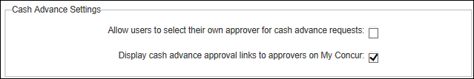
To change options:
- Select an option as described in the table below.
Setting | Description
Allow users to select their own approver for cash advance requests | If this check box is selected and:  If this check box is not selected, then the user cannot select an approver. If the user attempts to submit a cash advance request and there is no approver already assigned, the user is presented a message to notify an administrator.
  "Prompt" setting in user profile is: | Default approver is: | Then....
  Selected (On) | Identified | The user is prompted; the default approver names appears but can be changed.
  Selected (On) | Not identified | The user must select an approver.
  Cleared (Off) | Identified | The user is not prompted; the report is submitted.
  Cleared (Off) | Not identified | The user must select an approver.
Display Approve button on Approvals page | If selected, the Approve link appears on the Cash Advances tab of the Approvals page. This allows the approver to quickly approve cash advances.  If not selected, then the approver must open the cash advance and approve it in Concur Expense.
- Click Save.

Reason Category and Codes

Overview
The Reason Category and Codes tab is used to create reasons why either part or all of a report is returned to an employee. For example, a reason code called “Missing Receipt” can be created that alerts the report creator that they are missing the receipt image required for their report. This reason code is selected whenever the processor returns part of (split, or partial) or all of a report, and is a mandatory step when doing so.
The Expense Configuration administrator (Restricted) accesses Workflows > Reason Category and Codes to create the set of codes that reflects the reason set they will find most useful at their site. Reason codes are categorized, but the descriptive code name can be anything that best describes the reason for the return.
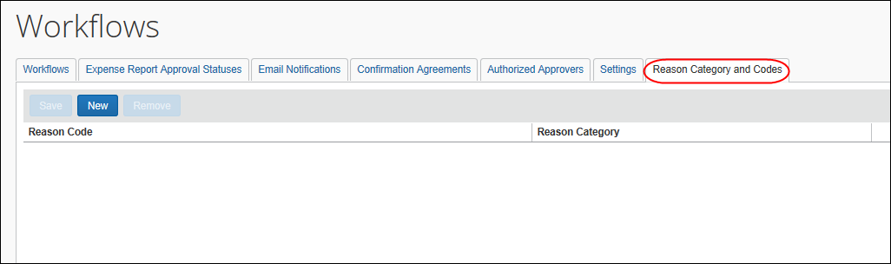
The information made available by selecting codes provides the company with structured tracking of the reasons that reports in part or full are sent back, so that statistical analysis can point out areas for additional employee training or re-examination of the business policy rules.

What the Processor Sees
When the processor clicks Send Back to Employee, the Send Back Report or Send Back to Employee (split, or partial) dialog box appears, with all selections created by the administrator listed for the processor to choose from. The processor selects the correct code or codes, and then clicks OK to return the report to its original owner. When this field is displayed, the processor must make at least one selection from the list of available choices.
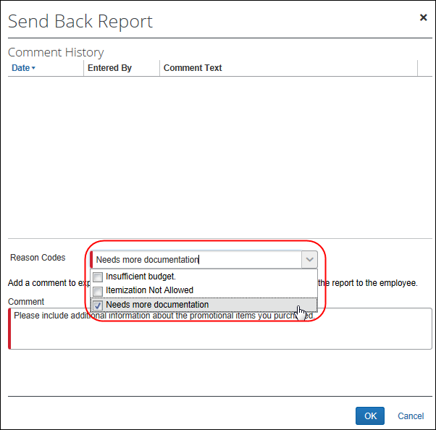
The descriptive code name is used for selection and retained by the system in the audit trail.

Creating the Reason Code
The Expense Configuration administrator (Restricted) role is required to use the options on this tab.
To create reason codes:
- Click the Reason Category and Codes tab.
- Click New. A new line appears in the table.
- Click the Reason Category.
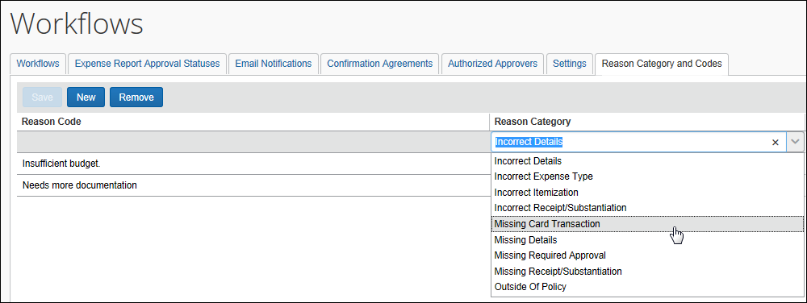
- Under Reason Code, type in a descriptive name that fits within the category and best explains the error – this will be viewed by both the processor and user.
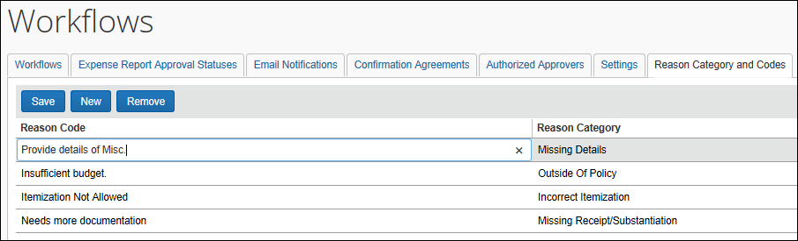
- Click Save.

Modifying a Reason Code
Modification of a reason code is limited to:
- Changing the name of the existing reason code
- Selecting a new reason category for the existing reason code
If the code is now obsolete, it should be removed to prevent confusion. However, if the code simply needs editing refer to Creating a Reason Code, using this procedure to modify the reason code.

Deleting a Reason Code
When a reason code no longer applies the code should be deleted to prevent erroneous use by the processor.
To delete a reason code:
- Select the code to be removed.
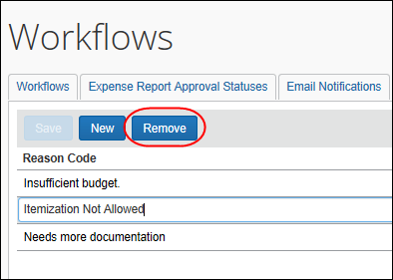
- Click Remove – a confirmation message appears.
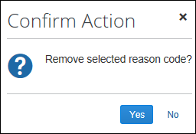
- Click Yes to remove the reason code from the list.

Payment Confirmation (Workflow Step)

Overview
The Payment Confirmation workflow step is optional and is used whenever the administrator wants to use extract and import actions to automatically validate and disburse payment for outstanding employee payment requests. With the system set to extract employee payment requests, the administrator adds the optional Payment Confirmation step to the workflow and initiates a Payment Confirmation import from the financial system. Doing this causes Concur Expense to update all request records with payments made, advance each request to the Payment Confirmed status, and, if configured, send an email notification to the employee.
- Best Practices: SAP strongly recommends that you use the payment confirmation feature if you use Expense Pay.

How It Works
The Payment Confirmation feature uses the Expense Payment Confirmation import to import data directly from the customer's financial system to Concur Expense. By enabling this feature (it is OFF by default) and adding this step to the workflow, the import validates and saves payment records to the database; advances each workflow to the Payment Confirmation step; and optionally emails the employee with this information.
For viewing purposes:
- The employee, approver, and processor can view the statuses in the Payment Status column on the Report Library page.
- Also, on the list of expense reports, the employee can use the Payment Confirmed Reports option on the View menu to locate reports with this specific status.
- The processor can configure a custom query to search for the status.
Note the following about the Payment Confirmation feature:
- This is the final step in the workflow and cannot be edited or deleted by the employee, approver, or processor.
- The step cannot have workflow rules.
- Since it is a system step, it will never appear on the Approval Flow page.

Configuration
The administrator completes the following steps:
Step | Description | Refer to...
1 | Configure the Expense Payment Confirmation import. | Expense: Payment Confirmation Import Specification
2 | Add the Payment Confirmation Step to the workflow. | Workflow Procedures in this guide
3 | Activate email notification. To do so, while configuring the workflow, select the Email Employee when step is complete check box.  NOTE: The Send email when… The status of an expense report changes check box must be selected in the employee's Profile > Expense Preferences in order for that employee to receive this email notice.

Hold for Receipt Image (Workflow Step)

Overview
Hold for Receipt Image is an optional step that the administrator can use to ensure that scanned receipt images are attached to an expense report before the report is sent to the first approver.
Concur Expense considers the receipts to be received when there is at least one line-item or a report-level attachment. Clients can use an audit rule to require attachment for all line items that require a receipt if the client does not want the report to move forward.
This workflow step works only if:
- The company uses Imaging.
– and –
- There is at least one expense on the expense report that requires a receipt image.
- For more information about requiring receipts, refer to the Concur Expense: Receipt Handling – Receipt Limits Setup Guide.
When the user submits the report, the report is held by the system until the required receipts are attached. Once the imaging service receives the receipts, they are attached to the report in PDF format and the report moves to the next step in the workflow.
If the administrator defines a timeout period in the Expire After This Many Days field, then this becomes the number of days (calendar days - not business days) the expense report will be held in this status without receipts. However, once the number of days has been reached – unlike other workflow steps – the report is not rerouted as defined in the Approval Time Expired Action field. Instead, the report is returned to the employee.

Employee Notification
While the report is being held for receipts, the status Hold for Receipt Images appears:
- On the Report Library page
– and –
- In the audit trail
The administrator can also elect to configure an email reminder to remind the employee to provide the receipts.
- For more information about email reminders, refer to the Concur Expense: Email Reminders Setup Guide.
Like other workflow steps, the administrator can elect to have an email sent to the user when the step is complete.
- Refer to Workflow Procedures in this guide.

Expense Processor
Like other approval statuses, the Expense processor can query on the Hold for Receipt Image approval status.

Configuration
The administrator adds the Hold for Receipt Image step to the workflow as described in the Workflow Procedures section of this guide.

Confirmation Agreements

Overview
Many companies require a legally binding acceptance statement from their employees when finances are used to procure a good or service for company use. With this feature, the company can display a customized confirmation agreement when:
- Submit: A user submits an expense report
- Approve: An approver approves an expense report
When the terms of the agreement statement are accepted by a user or approver, an audit trail entry is created to satisfy these legal requirements.

How It Works
When a user or approver is working under a policy where the workflow specifies the use of confirmation agreements, the system displays that agreement in the body of the Final Review/Confirmation message boxes that appear on submit and approval actions. If receipts are required, the system displays the Receipts Required! text under the agreement text.
After the actual agreement is developed, to "activate" the feature:
- For expense reports, associate the confirmation agreement with the workflow, then associate the workflow with the policy.
- For cash advances, associate the confirmation agreement with the workflow, then associate the workflow with the group (the Select Group page in the classic user interface)
Details are provided on the following pages.

User Experience

Expense Report Submit
When the user clicks Submit Report, the Final Review message box appears.
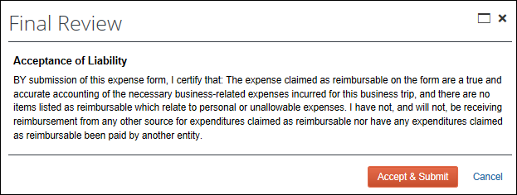
The user clicks Accept & Submit.
Clicking Cancel prevents the report from being submitted and returns the user to the expense report.

Expense Report Approval
The approver sees the Final Confirmation message box when approving an expense report. The approver may or may not see the same agreement seen by the user.
When the approver clicks Approve, the Final Confirmation message box appears. It may look much like the figure shown below.
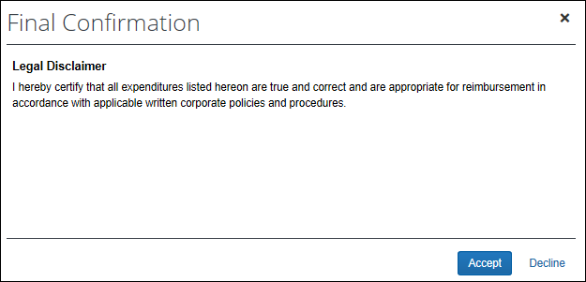
The approver clicks Accept.
Clicking Decline prevents the report from being approved and returns the approver to the Expense Report List page.

Procedures

Accessing the Confirmation Agreement Tab
To access the Confirmation Agreement tab:
- Click Administration > Expense > Workflows.
- Click the Confirmation Agreements tab.
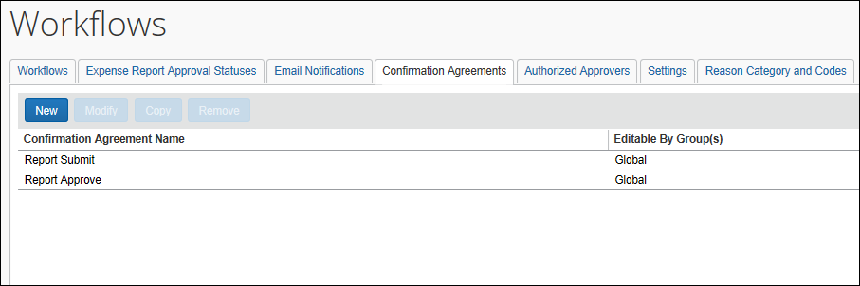

Creating a Confirmation Agreement
To create a Confirmation Agreement:
- On the Confirmation Agreement tab, click New. The Confirmation Agreement window appears.
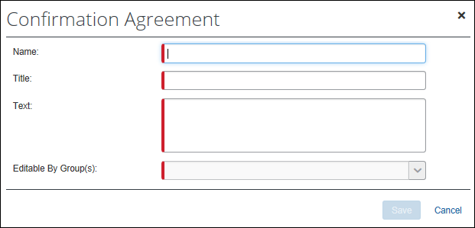
- Complete the appropriate fields.
Field Name | Description
Name | Enter a unique name.  This name is used internally in the workflow; it is not seen by the user or approver.
Title | Enter the title.  The text that is typed here appears in bolded text (no HTML tagging is required), and appears at the top of the message body area, directly below the title bar.
Text | Enter the text of the agreement.  This text is displayed in the body of the message box and constitutes the legal disclaimer or acceptance you want the user or approver to view.  You may type up to 2000 characters. The following HTML tags may be used to enhance the message:  <B> Bold  <BIG> Big Text  <BR> Line Break  <CENTER> Center  <I> Italic  <SMALL> Small Text  <STRIKE> Strikethrough  <u> Underline
Editable by Group(s) | Select the group or groups that can edit the agreement.
- Click Save. The agreement is now available for association with workflow.

Activating the Confirmation Agreement Feature
After creating the agreement:
- For expense reports, associate the confirmation agreement with the workflow, then associate the workflow with the policy.
- For cash advances, associate the confirmation agreement with the workflow, then associate the workflow with the group (the Select Group page in the classic user interface)
To associate a confirmation agreement with the workflow (expense report and cash advance):
- Using Administration > Expense > Workflows – while creating or editing a workflow (expense report or cash advance) – make your selections on the General page of the Workflows page:
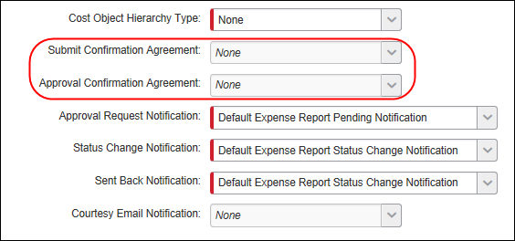
- In the Submit Confirmation Agreement list, choose the agreement to be displayed when submitting an expense report or cash advance.
- In the Approval Confirmation Agreement list, choose the agreement to be displayed when approving an expense report or cash advance.
- Click Done.
To associate the workflow to a policy (expense report):
- Using Expense Admin > Policies – while creating or editing a policy – make your selections on the General page of the New Policies or Modify Policies page.
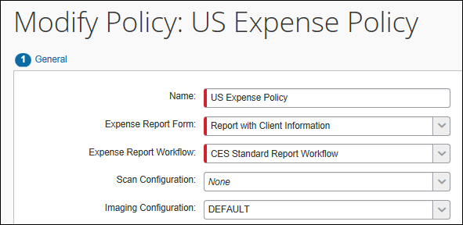
- In the Expense Report Workflow list, choose the appropriate workflow.
- Click Save.
To associate the workflow to a group (cash advance):
- Click Administration > Expense > Group Configurations.
- Either:
- Select the desired group name and click Modify.
– or –
- Double-click the desired group name.
The Configuration for Group window appears.
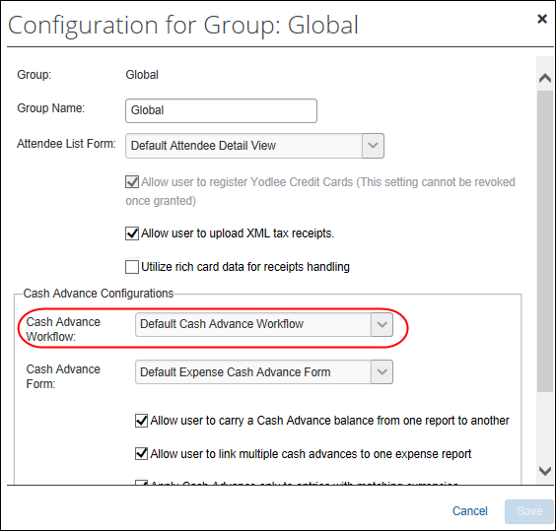
- In the Cash Advance Workflow list, choose the appropriate workflow.
- Click OK.

Editing a Confirmation Agreement
Changes made to a confirmation agreement are immediately visible to the submitting user and the approver on approval action.
To edit a confirmation agreement:
- On the Confirmation Agreement tab of the Workflows page, either:
- Select the desired agreement and then click Modify.
– or –
- Double-click the desired agreement.
The Confirmation Agreement window appears.
- Edit the agreement as required.
- Refer to Creating a Confirmation Agreement for information about the agreement.
- Click Save.
- Click Done.

Deleting a Confirmation Agreement
To delete a confirmation agreement:
- On the Confirmation Agreement tab of the Workflows page, select the desired agreement.
- Click Remove.

Split Expense Report on Approval
An approver and/or processor can send one or more expenses back to the employee – without returning the entire expense report. The remaining expenses on the report are then approved and moved to the next workflow step.
This feature is available to Authorized Approvers and is not available to Cost Object Approvers.

Returning Selected Expenses
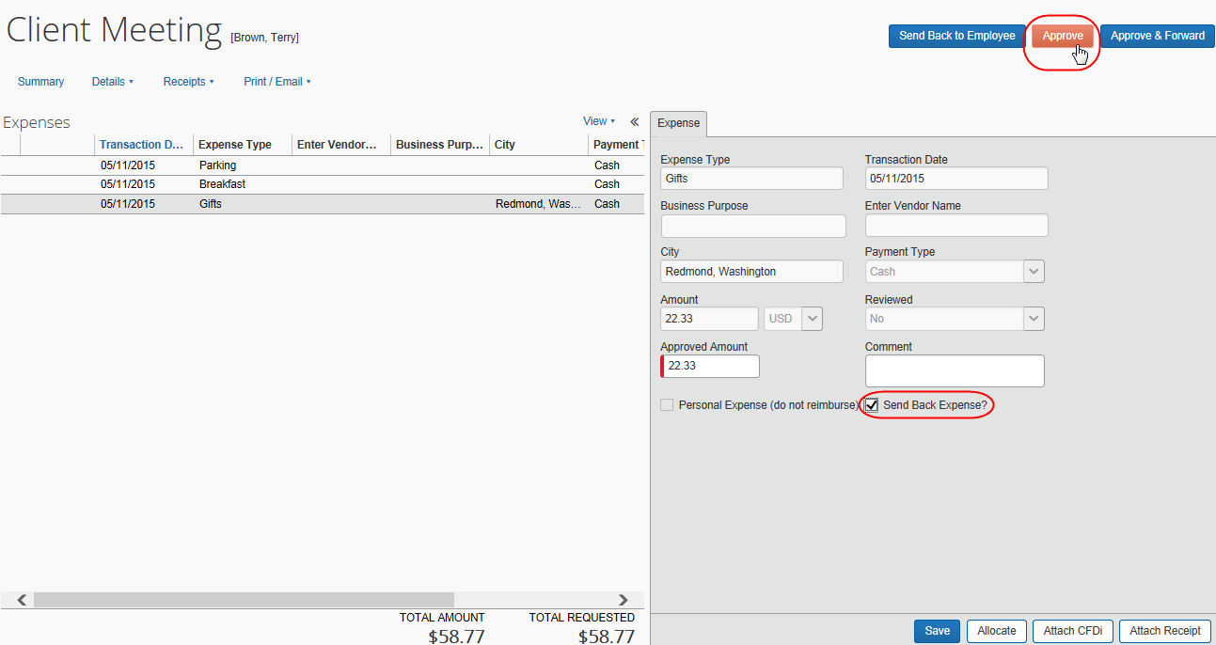
To return an expense, the approver selects the desired expense, selects the Send Back Expense? check box, and clicks Approve.

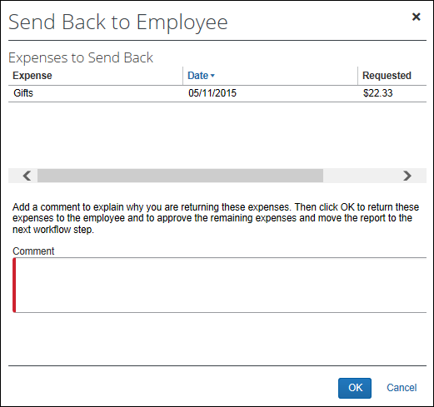
The Send Back to Employee / Expenses to Send Back window appears.
The approver reviews the listed expenses, enters a comment, and clicks OK.

Then, Concur Expense automatically:
- New report:
- Creates a new report named "Addendum to: <report name>" using the report header information from the original report along with any report-level exceptions
This sample shows the existing UI:
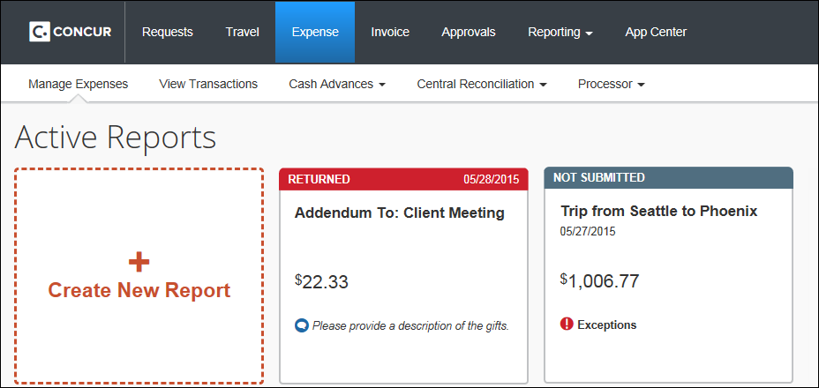
This sample shows NextGen UI:
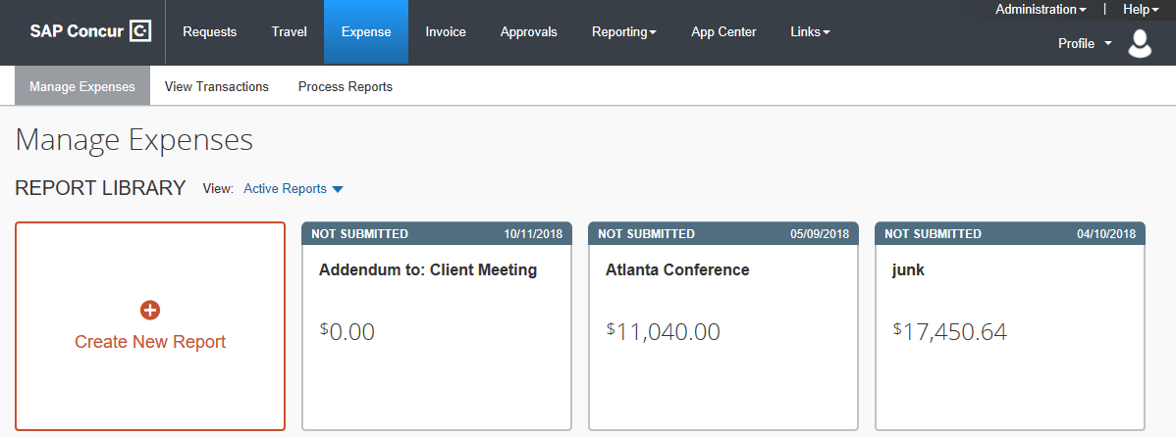
- Attaches the selected expenses along with any entry-level exceptions
- Adds an audit trail item, which includes the original report name and report ID
- Returns the newly generated report to the employee along with the approver-entered comment
The newly created report is treated like a regular new report from that point forward. The user may not elect to submit it and can delete the report entirely. If it is submitted, it is handled like a completely separate report from the original transaction. When submitted, the workflow begins again.
- Original report:
- Approves the remaining expenses on the original report
- Adds an audit trail item, which includes the newly generated report name and report ID
- Moves the original report to the next workflow step
Both reports (with current status and comment) appear on the user's Manage Expenses page. The user can now open the newly generated report, make the requested changes, and submit the report.
This sample shows the existing UI:
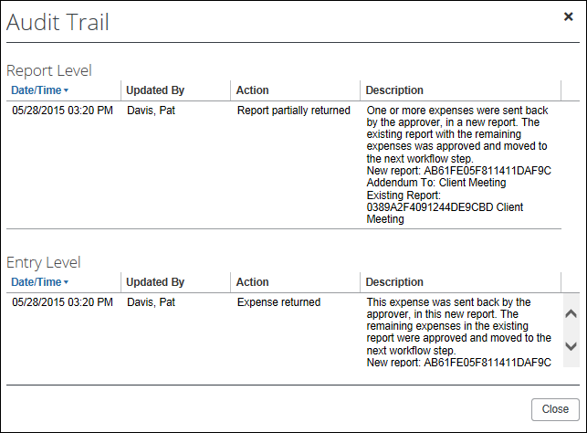
Audit trail entries appear on both the original report and the newly generated report

This sample shows NextGen UI:
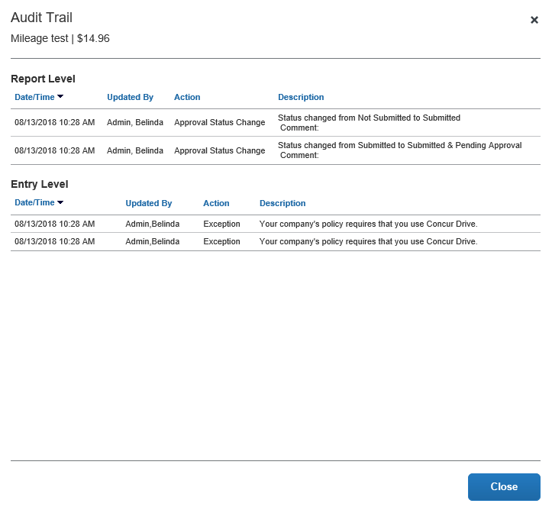
Audit trail entries appear on both the original report and the newly generated report

Processor
This document describes the process for an approver. The process is identical for a processor.

Eligible Expenses
Not all entries can be split from the original expense report and sent back to an employee. Several of the Concur Expense features are incredibly complex and are only effective if all related expenses appear on the same expense report. Certain required calculations and some of the compliance processing require that the entire report remaining in-tact.
For example, the Send Back Expense? check box does not appear for the approver or processor for the following:
- Concur Expense marked as personal
- Travel allowance expenses (either daily allowances or actual expenses with Travel Allowance checked for the entry)
- Expenses that share a receipt image with other expenses on the report
- Itemized expenses (the "child" entries of an itemized expense)
Itemized expenses cannot be sent back individually; the entire itemized expense (the "parent") must be sent back to the employee.
- Expense reports with
- Cash advance attached
- Request or authorization request attached

Returning all Expenses
If an approver or processor returns all expenses on a report using the Send Back Expense? check box, Concur Expense assumes that the entire report should be returned. Concur Expense does not create the "addendum" report; Concur Expense returns the original report as per normal procedure. The processor must at this time select one or more reason codes just as they would if they had used the Return Report functionality.

Configuration
To "activate" this feature, the only requirement is that the entry-level Send Back Expense? check box is added to the appropriate entry form(s).
Clients who are interested in using this feature must contact SAP Concur support and provide the following information:
- The entry-level forms that require the new field
- Whether the field can be modified by approvers and/or processors

Auto-Issuance Step for Cash Advance Request

Overview
The Cash Advance workflow Cash Advance Reviewed step can be configured to automatically perform the issuance of a cash advance to the requestor. Doing this systematically replaces the step of Manual Issuance and instead automatically processes an approved cash advance request for issuance based on configuration of the rule and action underlying the condition for this step.
For example, the associated condition for the step is named and then configured to limit the allowable cash advance issuance to no more than $1,000. Now, when the requestor inputs the cash amount, the amount either below or above this amount drives the logic to issue or reject the cash advance respectively, without need for the admin to review each request for the same purpose.
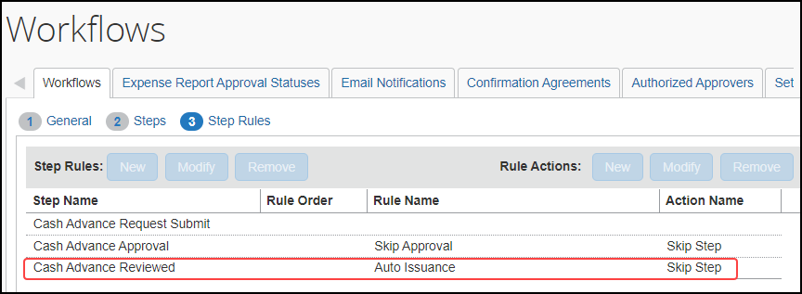
- For more information, refer to the Issuing a Cash Advance Automatically Without Manual Review topic in the Concur Expense: Cash Advance Admin User Guide.

☼

