Concur Expense: Employee Taxability and Corporate Deductibility Service
Setup Guide
Last Revised: September 15, 2023
Applies to these SAP Concur solutions:
Expense
Professional/Premium edition
Standard edition
Travel
Professional/Premium edition
Standard edition
Invoice
Professional/Premium edition
Standard edition
Request
Professional/Premium edition
Standard edition
Table of Contents
Section 1: Permissions 1
Section 2: Overview 1
Employee Taxability 1
Corporate Deductibility 2
Travel Allowance 2
Flat Rate (Germany) 2
Mileage 2
Section 3: General Information 3
Terminology 3
Payroll Integration 4
Section 4: What the User Sees 4
Taxation Summary 4
View a Taxation Summary 5
Section 5: Enable and Access the T&DS 6
Enable the Taxability and Deductibility Configuration Page 6
Access the Taxability and Deductibility Configuration Page 7
Section 6: Client-Specific Configuration 8
View Legacy T&D Configuration 9
Display Field Settings 9
Configure Custom Fields 9
Understand the SAE versus SAP Payroll Integration 11
Understand Hybrids of the T&DS and T&D Solutions 11
Employee Taxability 12
Read-only View 12
View a Taxability Limit 13
Add a Taxability Configuration 14
Edit a Taxability Configuration 16
Delete a Taxability Configuration 17
Corporate Deductibility 18
View a Deductibility Configuration 18
Add a Deductibility Configuration 21
Edit a Deductibility Configuration 24
Delete a Deductibility Configuration 25
Travel Allowance 27
View a Travel Allowance Configuration 27
Add a Travel Allowance Configuration 29
Edit a Travel Allowance Configuration 30
Delete a Travel Allowance Configuration 31
Mileage 32
View a Mileage Configuration 32
Add a Mileage Configuration 33
Edit a Mileage Configuration 36
Delete a Mileage Configuration 37

Revision History
Date | Notes / Comments / Changes
September 15, 2023 | Updated steps and a screenshot to view legacy T&D configuration
April 21, 2023 | Updated screenshots and explanation to reflect a new feature allowing 100% VAT reclamation for Germany
February 15, 2022 | Updated information about Mileage tab and its configuration
April 21, 2023 | Updated screenshots and explanation to reflect a new feature allowing 100% VAT reclamation for Germany
November 13, 2021 | Updated screenshots to reflect cosmetic UI enhancements  Added information about the new read-only view available for Restricted Expense Configuration Admins
October 16, 2021 | Updated Taxation Summary section:  On the Employee Taxability tab of the Taxation Summary page, the user sees reordered columns, new column totals, and only if they are a German user, the Flat Rate Taxation column  On the Corporate Deductibility tab of the Taxation Summary page, the user sees reordered columns, new VAT columns, and new column totals
June 19, 2021 | Created new guide

Taxability and Deductibility
NOTE: Multiple SAP Concur product versions and UI themes are available, so this content might contain images or procedures that do not precisely match your implementation. For example, when SAP Fiori UI themes are implemented, home page navigation is consolidated under the SAP Concur Home menu.

Permissions
A company administrator may or may not have the correct permissions to use this feature. The administrator may have limited permissions, for example, they can affect only certain groups and/or use only certain options (view but not create or edit).
If a company administrator needs to use this feature and does not have the proper permissions, they should contact the company's Concur Expense administrator.
Also, the administrator should be aware that some of the tasks described in this guide can be completed only by SAP Concur. For tasks not completed during implementation, the client must initiate a service request with SAP Concur support.

Overview
As a traveler, in a number of countries, some allowances or expenses are tax free, but only up to a certain amount. A reimbursement above a certain amount might increase what the employee must pay in income tax.
As a company, in a number of countries, some spend is deductible from your corporation taxes as reclaimable Value-Added Tax (VAT).
The Employee Taxability and Corporate Deductibility Service (T&DS) provides the ability to set up taxability and deductibility calculation configurations based on considerations such as country, expense type, and policy.
Final calculations are performed after Processor Approval (pre-payment step) although a preview of the expected calculations is available to the user on the Report Details > Taxation Summary page.
An expense type should not be configured as both taxable and deductible.

Employee Taxability
The configurations for employee taxability allow the system to identify amounts for which an employee may need to pay income tax. An expense can be split into taxable and non-taxable portions in order to account for the portion of an expense that might be taxable to the employee.
For example, in Italy, incidental expenses without receipts can be reimbursed up to a certain amount per day and any amount the company reimburses above that amount is taxable to the user.

Corporate Deductibility
The configurations for corporate deductibility allow the system to identify expenses that may be deductible from corporate taxes. An expense can be split into deductible and non-deductible portions in order to account for the portion of an expense that might be deductible for the company. Once these deductible amounts are identified, the system can correctly calculate the reclaimable VAT.
For example, in some countries, a certain portion of an entertainment expense may be deductible (on the company's tax return), based on the number of attendees and perhaps whether the attendees are employees or non-employees.

Travel Allowance
The configurations for travel allowance allow the system to identify amounts which exceed a statutory tax-free limit and yet will be reimbursed to the user based on company policy.
For example, in some companies, a policy may exist that provides otherwise taxable travel allowance reimbursements to certain users at no cost.

Flat Rate (Germany)
In Germany, the configurations for travel allowance allow the system to identify expenses that are subject to a flat income tax rate in addition to a personal income tax rate.
Fixed meals (or daily allowances) need to be split into portions that are tax-free, subject to a flat income tax rate, and subject to a personal income tax rate. These calculations support the SAP ICS Payroll Integration solution.
- IMPORTANT: If the flat rate taxable calculation is configured for any country other than Germany, the system will not perform the calculations.

Mileage
The configuration for mileage allows the system to identify the amount that exceed a statutory tax-free limit and will be reimbursed to the user based on the company policy.
For example, in some companies, a policy may exist that provides otherwise taxable mileage reimbursements to certain users at no cost.

General Information
This section provides requirements and general information about the taxability and deductibility solution.

Terminology
In this guide and in some of the configuration settings, you may see these T&DS terms.
Term | Definition
Display Field Settings | This link displays the Update Custom Fields page for mapping existing fields with T&DS functionality.
Overwrite | This checkbox only displays when editing an existing configuration and is selected by default. By clearing this check box, a new configuration is created rather than updating the existing configuration.
SAP ICS Payroll Integration | The payroll solution that supports clients who want to integrate Concur Expense Professional Edition with one of the following SAP financial systems:  - SAP ECC 6.0 or higher  - SAP S/4HANA (on-premise)  - SAP S/4HANA Cloud
Taxation Summary | Targeted to the submitter, approve, and processor, the Report Details page that displays the calculated amounts specific to the expense report being viewed.
Limit By | The method used to determine the limits:  - Per Receipt  - Daily  - Per Person/Receipt (deductibility only)
Limit Type | The type of calculation used:  - Threshold  - See also Threshold in this table.  - Percentage  - Fixed Amount (taxability only)  - Full (taxability only)  - See also Fully Taxable Threshold in this table.
Threshold | Of the total amount, only the portion above the Threshold is taxable. Only the difference is taxable, not the whole amount. The amount below the threshold is not taxable.  - See also Limit Type in this table.
Fully Taxable Threshold | When the amount is above the Fully Taxable Threshold, the entire amount becomes taxable  - See also Limit Type in this table.
Taxable Limit | A statutory maximum amount that may be reimbursed to an employee without creating a possible tax liability burden for that employee.
Deductible Limit | A statutory maximum amount for company expenses that a company is allowed deduct from their taxes.

Payroll Integration
The Travel Allowance and Mileage tab of the T&DS UI supports payroll integration with SAP ERPs.
For more information, refer to the Concur Expense: Payroll Integration for SAP ECC, SAP S/4HANA, and SAP S/4HAHA Cloud Setup Guide for SAP Concur Professional Edition.

What the User Sees
This section of this guide describes the various features and options.

Taxation Summary
A Taxation Summary is available to the submitter, approver, and processor from Report Details for employee taxability and corporate deductibility.

View a Taxation Summary
To view a Taxation Summary
- From the Report Details menu, select Taxation Summary.
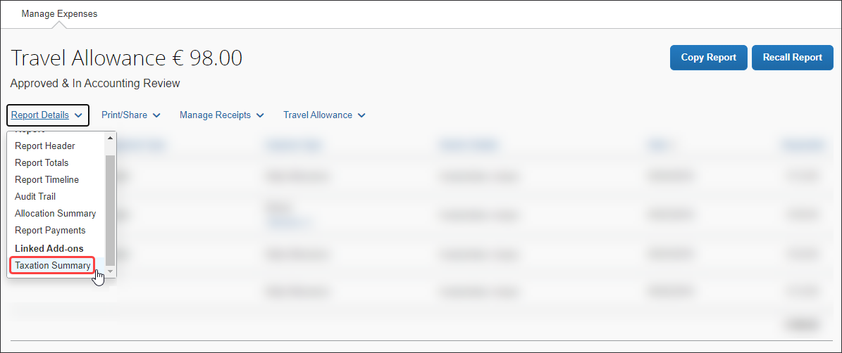
Example (without details)
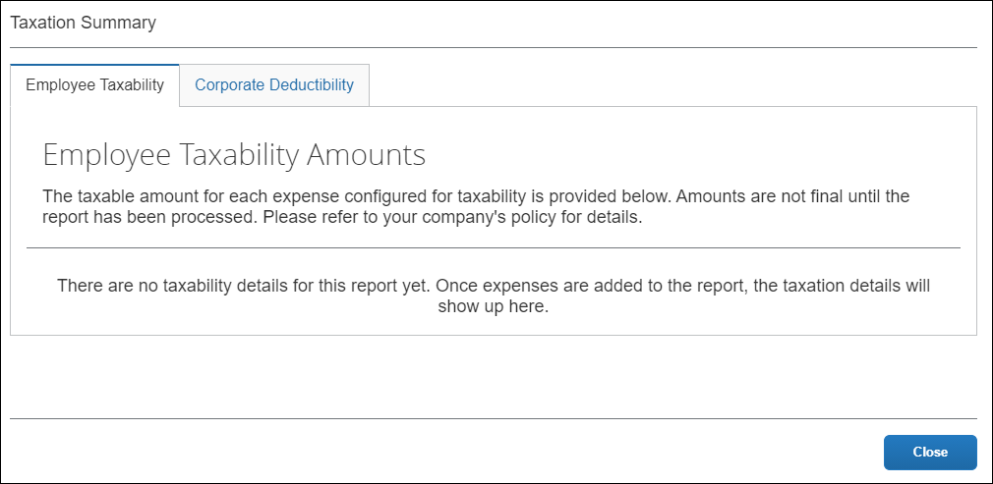
Example (with details)
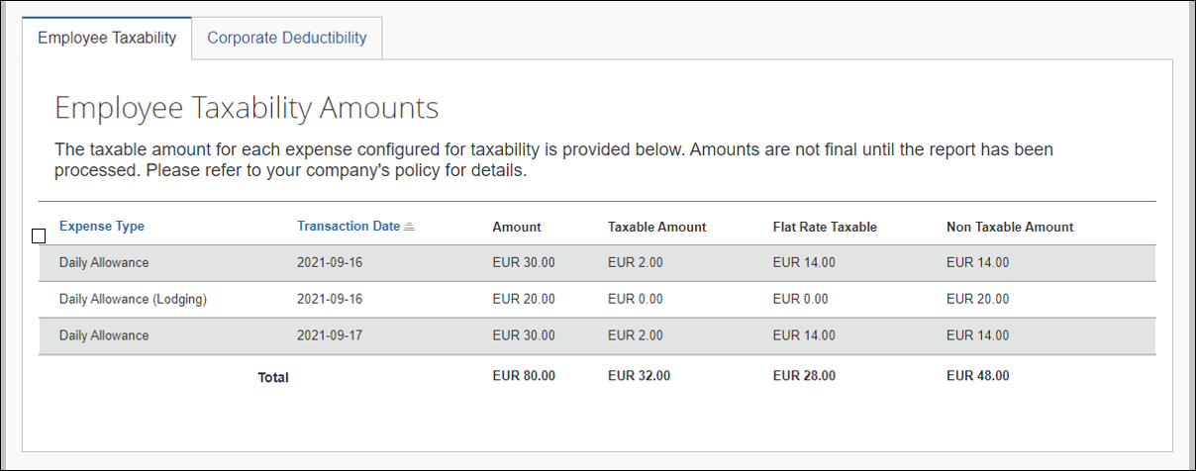
The Flat Rate Taxable column only displays to German users.
and
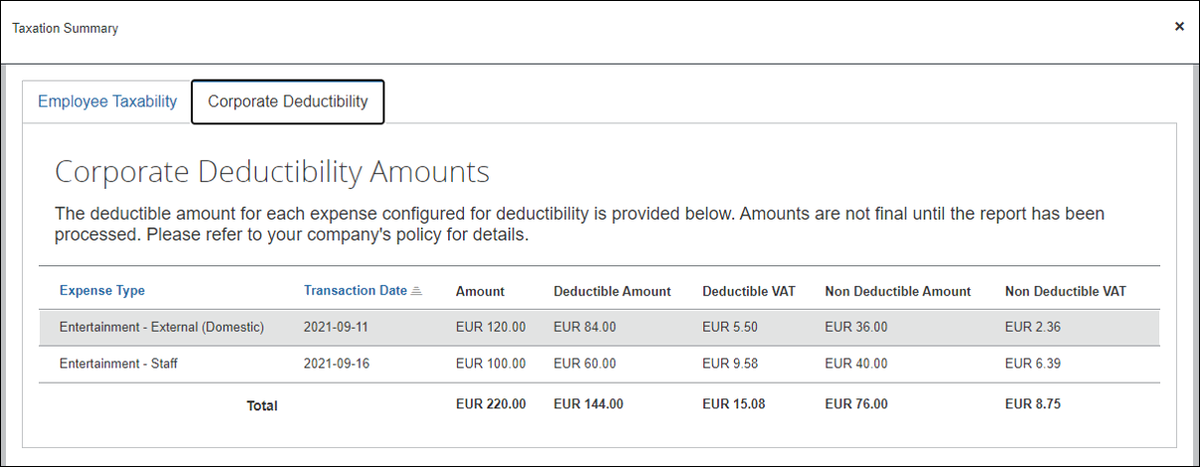
- Click Close.

Enable and Access the T&DS

Enable the Taxability and Deductibility Configuration Page
The T&DS solution is enabled on the Site Settings page by selecting Enable Taxability and Deductibility Calculation Service.
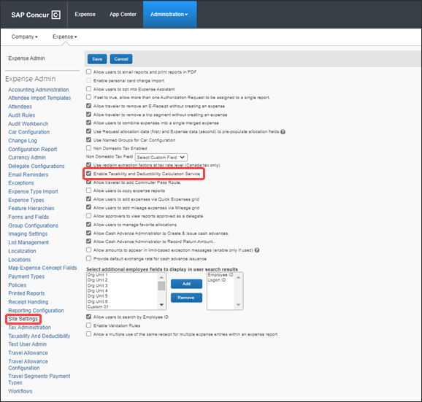

Access the Taxability and Deductibility Configuration Page
To access the Taxability and Deductibility Configuration page:
- Log in as Concur Admin (a user with the unrestricted Expense Configuration Administrator role).
- Click Administration > Expense > Taxability and Deductibility or Employee Taxability And Corporate Deductibility.
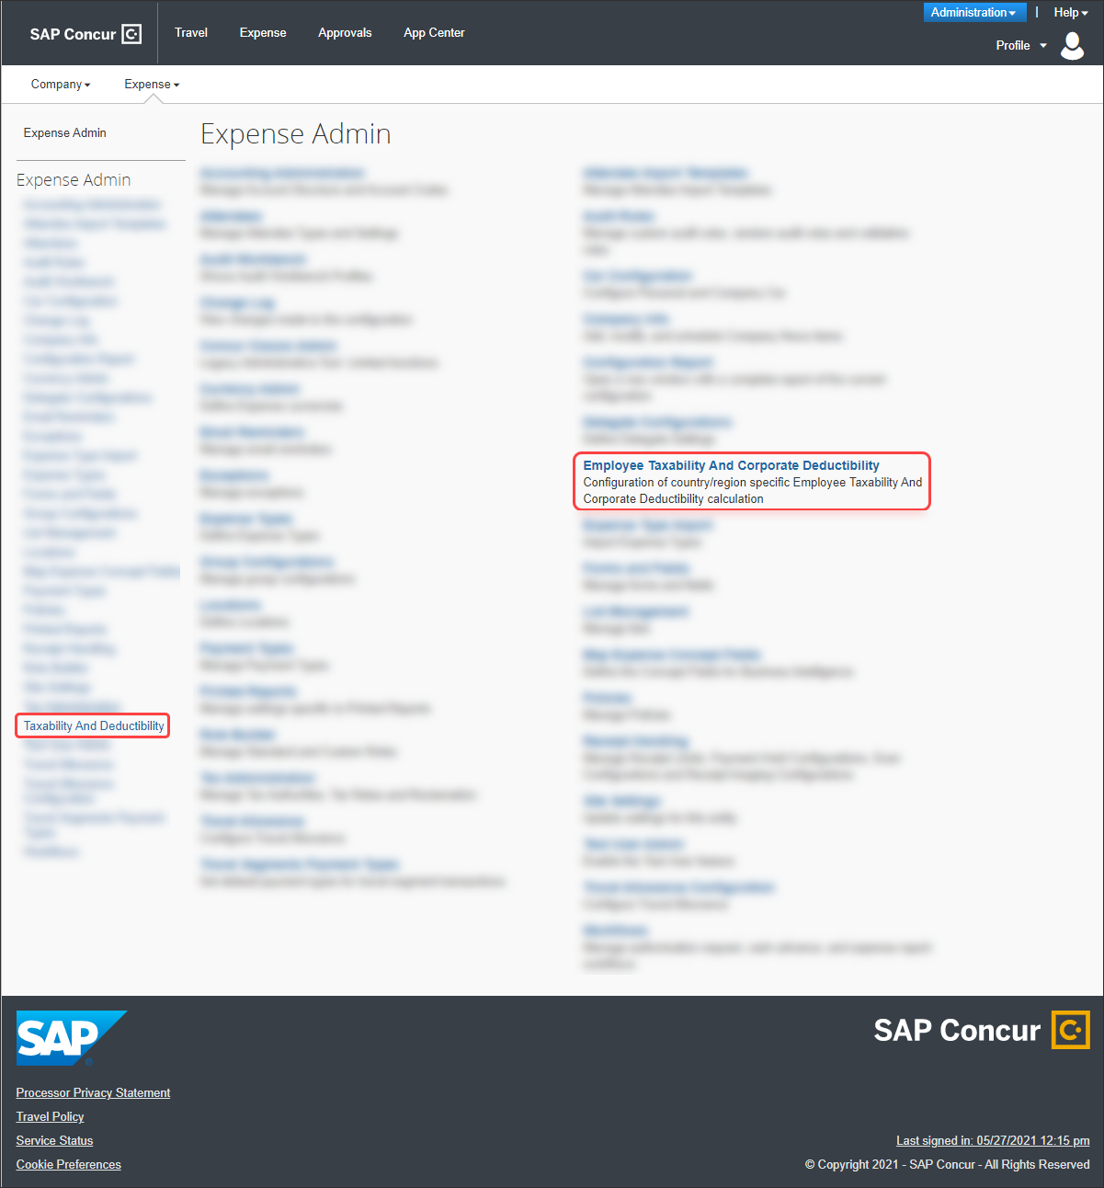

Client-Specific Configuration
This section describes the UI pages and fields that can be configured based on individual client needs.
For typical configurations based on country/region, see the Country/Region-Specific Configurations section of this guide.

View Legacy T&D Configuration
The T&DS allows clients to view the old configuration maintained using the Taxability/Deductibility import if they are still active in the legacy Taxability and Deductibility solution.
To view Legacy T&D Configuration:
- Log in as an Expense Configuration Administrator.
- Click Administration > Expense > Taxability and Deductibility or Employee Taxability And Corporate Deductibility > Taxability and Deductibility Configuration.
- Click View Legacy T&D Configuration toggle.
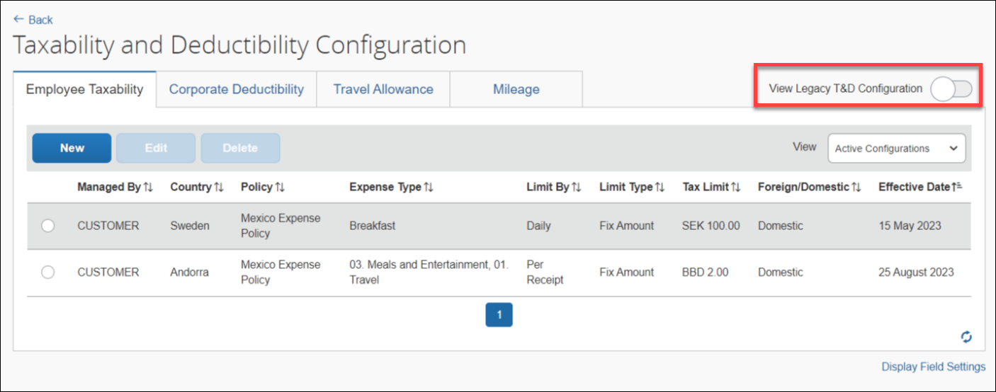

Display Field Settings
Fields for taxable/deductible amount and non-taxable/non-deductible amount must be mapped for T&DS functionality.

Configure Custom Fields
To configure Custom Fields
- Log in as an Expense Configuration Administrator.
- Click Administration > Expense > Taxability and Deductibility or Employee Taxability And Corporate Deductibility.
- Click Display Field Settings.
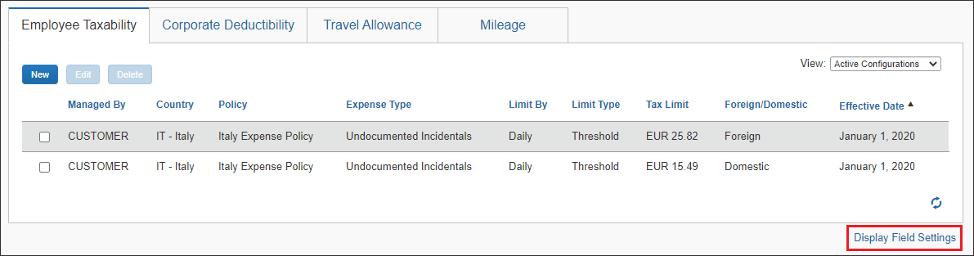
- Fill in the available fields:

Field | Description
Taxable/Deductible Amount * | A custom entry field to contain the amount calculated by the system as taxable or deductible for the expense entry. This amount will be used to generate the taxable or deductible journal split.  Valid values: Custom 1-40  - For more information, refer to the Concur Expense: Forms and Fields Setup Guide.
Non-Taxable/Non-Deductible Amount * | A custom entry field to contain the amount calculated by the system as non-taxable or non-deductible for the expense entry. This amount will be used to generate the non-taxable or non-deductible journal split.  Valid values: Custom 1-40  For more information, refer to the Concur Expense: Forms and Fields Setup Guide.
Flat Rate Taxable Amount | A custom entry field to contain the flat rate taxable amount required when this option is configured for taxability for German travel allowance.  Valid values: Custom 1-40  For more information, refer to the Concur Expense: Forms and Fields Setup Guide.
Tax Deductible VAT Amount | A custom entry field to contain the amount calculated by the system as deductible (reclaimable) VAT. This amount is based on the VAT configuration for the expense type and applied only to the deductible amount.  Valid values: Custom 1-40  For more information, refer to the Concur Expense: Forms and Fields Setup Guide.
Non-Tax Deductible VAT Amount | A custom entry field to contain the amount calculated by the system as non-deductible (non-reclaimable) VAT. This amount is based on the VAT configuration for the expense type and applied only to the non-deductible amount.  Valid values: Custom 1-40  For more information, refer to the Concur Expense: Forms and Fields Setup Guide.
Asterisks indicate required fields.
- Click Update.

Understand the SAE versus SAP Payroll Integration
For clients using SAP ICS Integration, the custom entry display fields are for information purposes only and are not used to define the journal splitting used to determine the amounts which are taxable and non-taxable. This applies to both the T&DS as well as the classic T&D (for example, where used for mileage taxability while awaiting support for this in the T&DS).
For clients using the Standard Accounting Extract (SAE) or any other form of integration outside of SAP Payroll, the custom entry display fields are still required to be configured as these continue to be used to define the journal splitting to determine taxable and non-taxable amounts. Again, this applies to both the T&DS as well as classic T&D.

Understand Hybrids of the T&DS and T&D Solutions
The display field settings in the T&DS are tied to the classic T&D site settings used for defining custom entry fields for storing the taxable and deductible splits. The legacy import file defines these site setting fields in the 200 record, as detailed in the Concur Expense: Taxability / Deductibility Import Specification. An example of how this appears in the import file can be seen below:
200,Custom31,Custom32,Custom33,Custom34,,,,,,,,,,,,,,,
It is therefore important to note that when using a hybrid of the T&DS together with classic T&D that the same entry fields are referenced in both areas.
If the settings in one area of the system are updated or changed (legacy import or T&DS Display Field Settings), the system will automatically update the other settings to match.

Employee Taxability
The Employee Taxability tab displays the taxability configurations.
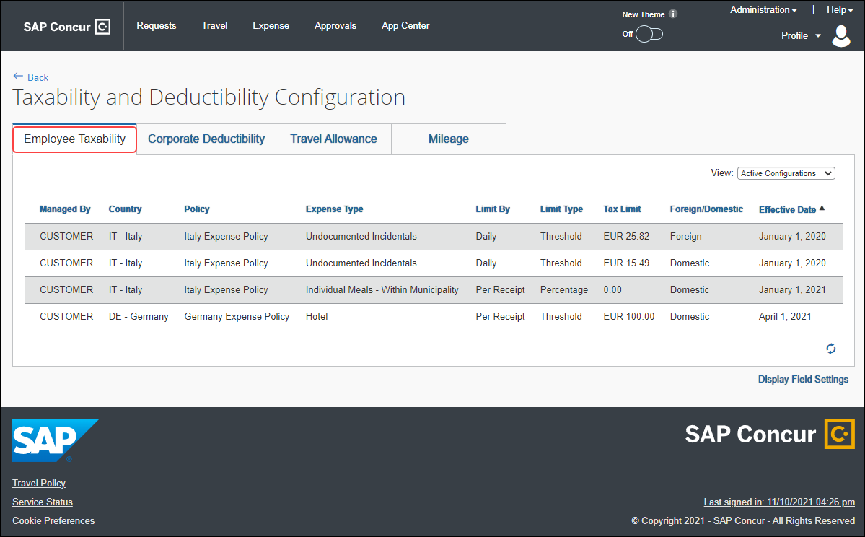

Read-only View
A read-only view for Restricted Expense Configuration Admins displays without options to add, update, or delete configuration. Only Concur Admin can see the New, Edit, and Delete buttons.
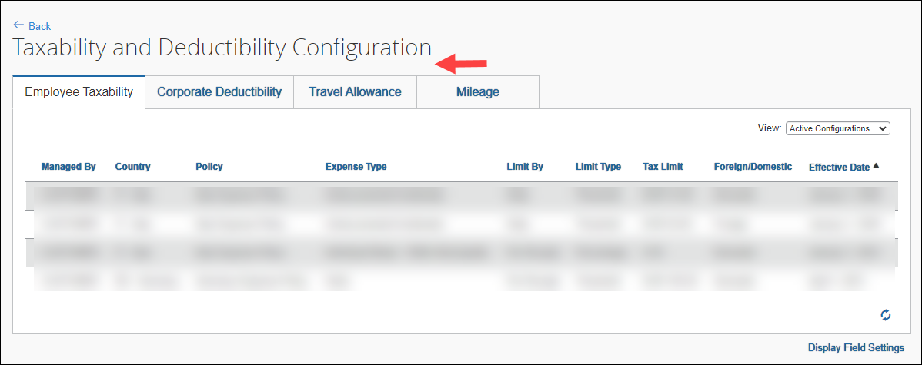

View a Taxability Limit
To view a Taxability Configuration
- Log in as an unrestricted Expense Configuration Administrator.
- Click Administration > Expense > Taxability and Deductibility or Employee Taxability And Corporate Deductibility.
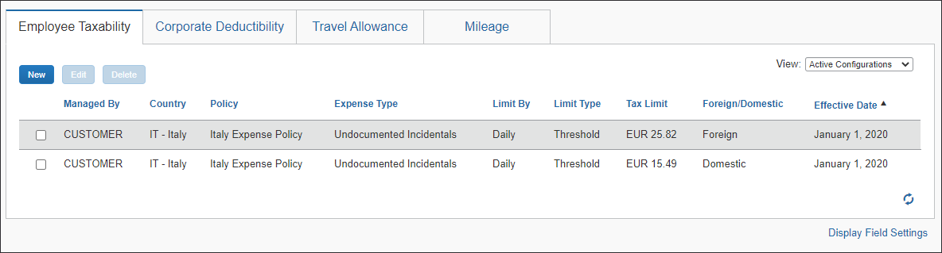
- (Optional) From the View list, select one of the following:
- Active Configurations – (default) Displays configurations for which today's date is between the Effective Date and End Date of the configuration.
- Expired Configurations – Displays the configurations for which today's date is after the End Date of the configuration.
- Future Configurations – Displays the configurations for which today's date is before the Effective Date of the configuration.
- All Configurations – Displays all of this tab's configurations for this client.
- (Optional) Click the Refresh () icon.
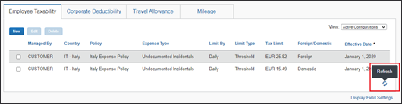

Add a Taxability Configuration
To add a Taxability Configuration
- On the Employee Taxability tab, click New. The Add Taxability Configuration page displays.
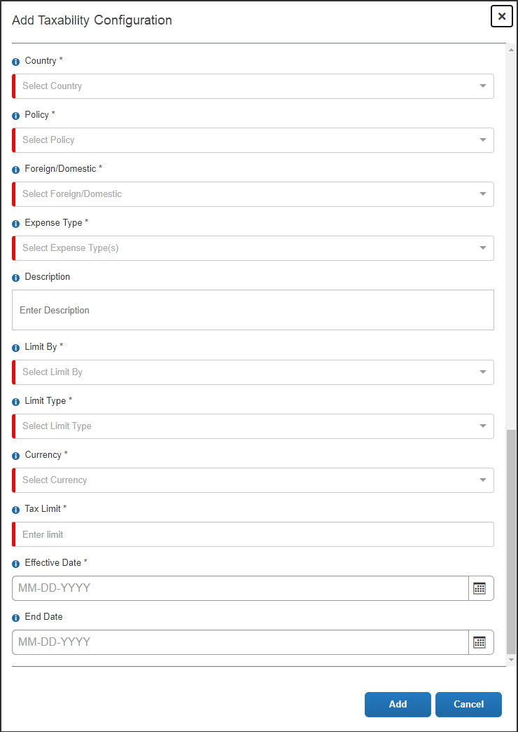
- Fill in the available fields:

Field | Description
Country * | Country for which the configuration is valid.
Policy * | The policy for which the configuration is valid.  For more information, refer to the Concur Expense: Policies Setup Guide.
Foreign/Domestic * | Indicator of whether the configuration is valid for domestic travel, foreign travel, or both.  Valid values: Domestic, Foreign, or Both
Expense Type * | The expense type(s) for which the configuration is valid.  For more information, refer to the Concur Expense: Expense Types Setup Guide.
Description | Description text for the limit.
Limit By * | Calculation for the limit amount.  Valid values: Daily, or Per Receipt.  NOTE: The value of this field can change based on the value selected in the Limit Type field.
Limit Type * | Calculation by type for the limit amount.  Valid values:  - Threshold  - Fix Amount  - Percentage - only available with Limit By Per Receipt  - Fully Taxable Threshold - only available with Limit By Per Receipt
Currency * | The currency to which this limit applies.  NOTE: Not applicable when Percentage is selected.
Tax Limit *  -or-  Tax Limit * (%) | For Threshold, the amount up to which is non-taxable.  For Fixed Amount, any amount over this amount is non-taxable.  For Percentage, the amount up to the percentage is non-taxable and any amount over this amount is taxable.  For Fully Taxable Threshold, the amount up to which is non-taxable and if any portion is over this amount, then the full amount is taxable.  NOTE: Any amount over this amount is taxable.  This field name will change to Tax Limit * (%) if Percentage is selected as the Limit Type.
Effective Date * | The first valid date for this configuration.
End Date | The last valid date for this configuration.  System default value: 12/31/2999
Asterisks indicate required fields.
- Click Add. The Employee Taxability configurations display.
Example
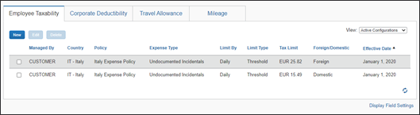

Edit a Taxability Configuration
To edit a Taxability Configuration
- On the Employee Taxability tab, select a row and click Edit.
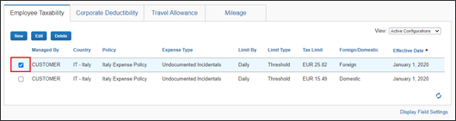
- On the Update Taxability Limit page, edit the desired fields.
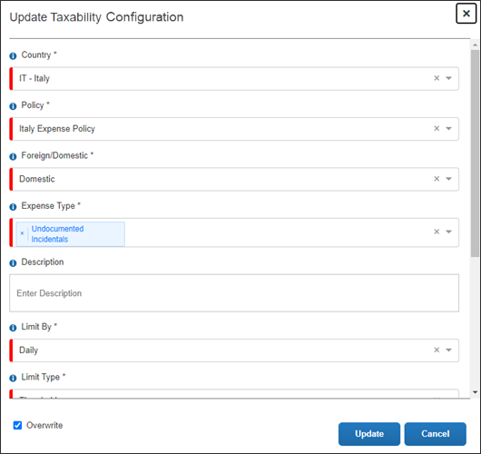
When updating/correcting an existing configuration, leave Overwrite selected. Clearing this check box will create another configuration.
- Click Update.

Delete a Taxability Configuration
To delete a Taxability Configuration
On the Employee Taxability tab, select a row and click Delete.

If the configuration is in use, it cannot be deleted.

Corporate Deductibility
The Corporate Deductibility tab displays the deductibility configurations.
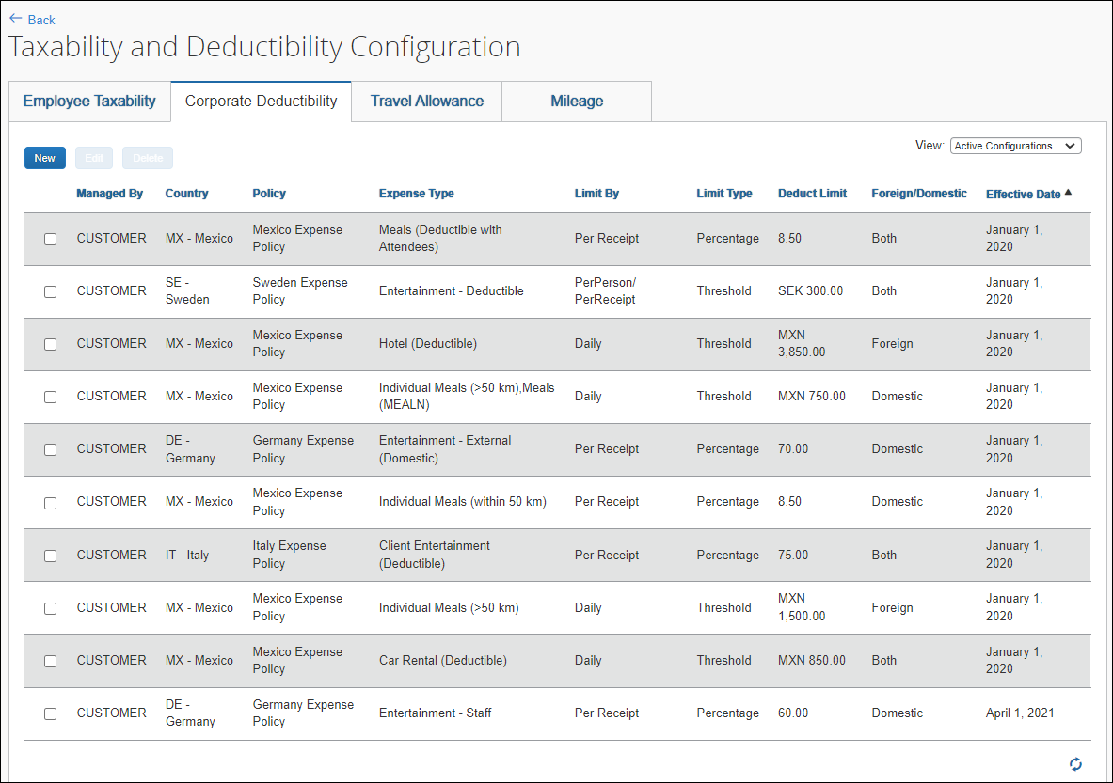

View a Deductibility Configuration
To view a Deductibility Configuration
- Log in as an Expense Configuration Administrator.
- Click Administration > Expense > Taxability and Deductibility or Employee Taxability And Corporate Deductibility.
- Click the Corporate Deductibility tab.
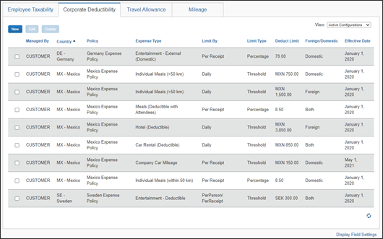
- (Optional) From the View list, select one of the following:
- Active Configurations – (default) Displays configurations for which today's date is between the Effective Date and End Date of the configuration.
- Expired Configurations – Displays the configurations for which today's date is after the End Date of the configuration.
- Future Configurations – Displays the configurations for which today's date is before the Effective Date of the configuration.
- All Configurations – Displays all of this tab's configurations for this client.
- (Optional) Click the Refresh () icon.
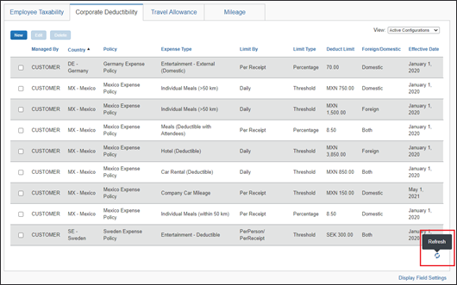

Add a Deductibility Configuration
To add a Deductibility Configuration
- On the Corporate Deductibility tab, click New. The Add Deductibility Configuration page displays.
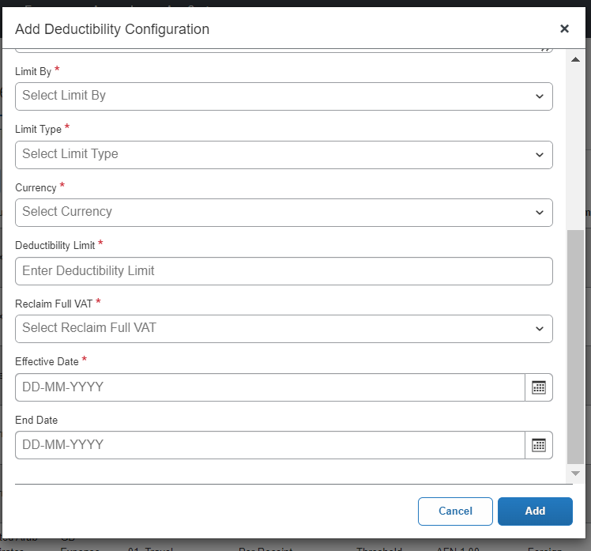
- Fill in the available fields:

Field | Description
Country * | Country for which the configuration is valid.
Policy * | The policy for which the configuration is valid.  - For more information, refer to the Concur Expense: Policies Setup Guide.
Foreign/Domestic * | Indicator of whether the configuration is valid for domestic travel, foreign travel, or both.  Valid values: Domestic, Foreign, or Both
Expense Type * | The expense type(s) for which the configuration is valid.  - For more information, refer to the Concur Expense: Expense Types Setup Guide.
Description | Description text for the limit.
Limit By * | Calculation for the limit amount.  Valid values:  - Per Receipt  - PerPerson/ PerReceipt  - Daily
Limit Type * | Calculation by type for the limit amount.  Valid values:  - Threshold  - Percentage – only available with Limit By Per Receipt
Currency * | The currency to which this limit applies.  NOTE: Not applicable when Percentage is selected.
Deduct Limit *  -or-  Deduct Limit * (%) | The amount up to which is deductible.  NOTE: Any amount over this amount is  non-deductible.  NOTE: This field name will change to Deduct Limit * (%) if Percentage is selected the Limit Type.
Reclaim Full VAT * | Indicates if VAT should be fully or partially reclaimed.  NOTE: Currently, this field is available only for Germany.
Effective Date * | The first valid date for this configuration.
End Date | The last valid date for this configuration.  System default value: 12/31/2999
Asterisks indicate required fields.
Setting the Reclaim Full VAT Option:
Selecting Yes or No in the Reclaim Full VAT option determines whether the VAT deduction is applicable on the full amount or only the deductible amount.
For example, a deductibility configuration for domestic client entertainment expense in Germany is maintained with deductibility limit set to 70%.
If you select Yes in the Reclaim Full VAT option for the expense amount of EUR 119.00, with Expense Type as VAT and a tax rate of 19% maintained in the Tax Administration, the VAT amount comes to EUR 19.00. The Deductible Amount is 70% of 119, which is EUR 83.30. However, in this case, the deductible VAT amount is EUR 19.00 and full EUR 19.00 is reclaimable.
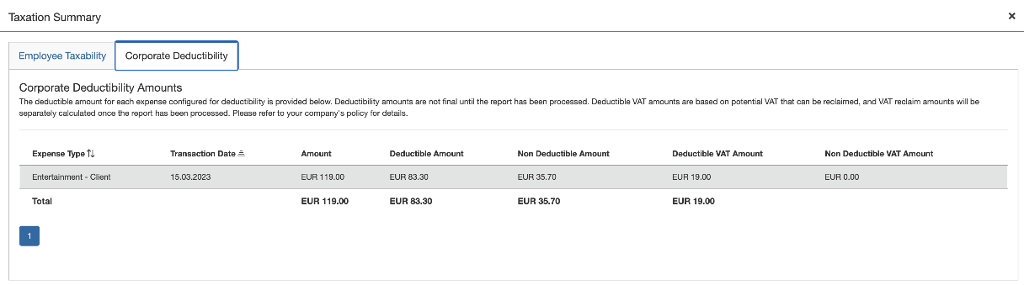
By selecting No in the Reclaim Full VAT option, the company can reclaim VAT calculated only on the deductible amount of 83.30 (70% of 119). At the rate of 19%, it come to EUR 13.30.
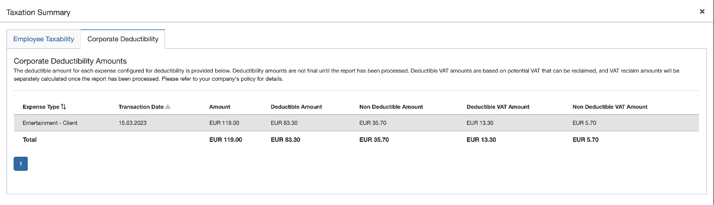
For more information on VAT and reclaim calculation refer to section 11 of Concur Expense: Value Added Tax (VAT) / Tax Administration Setup Guide

- Click Add. The Corporate Deductibility configurations display.
Example
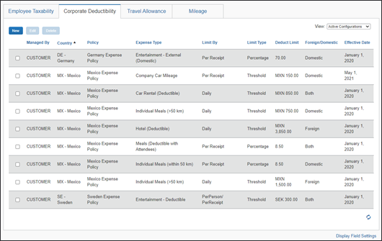

Edit a Deductibility Configuration
To edit a Deductibility Configuration
- On the Corporate Deductibility tab, select a row and click Edit.
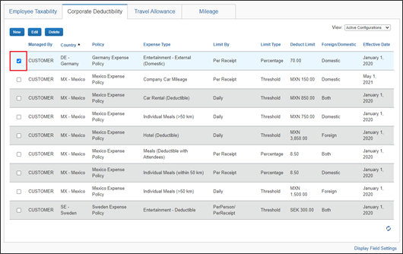
- On the Update Deductibility Limit page, edit the desired fields.
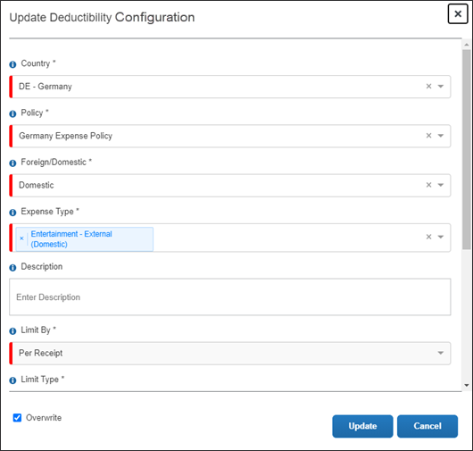
When updating/correcting an existing configuration, leave Overwrite selected. Clearing this check box will create another configuration.
- Click Update.

Delete a Deductibility Configuration
To Delete a Deductibility Configuration
On the Corporate Deductibility tab, select a row and click Delete.
If the configuration is in use, it cannot be deleted.

Travel Allowance
The Travel Allowance tab displays the travel allowance configurations.
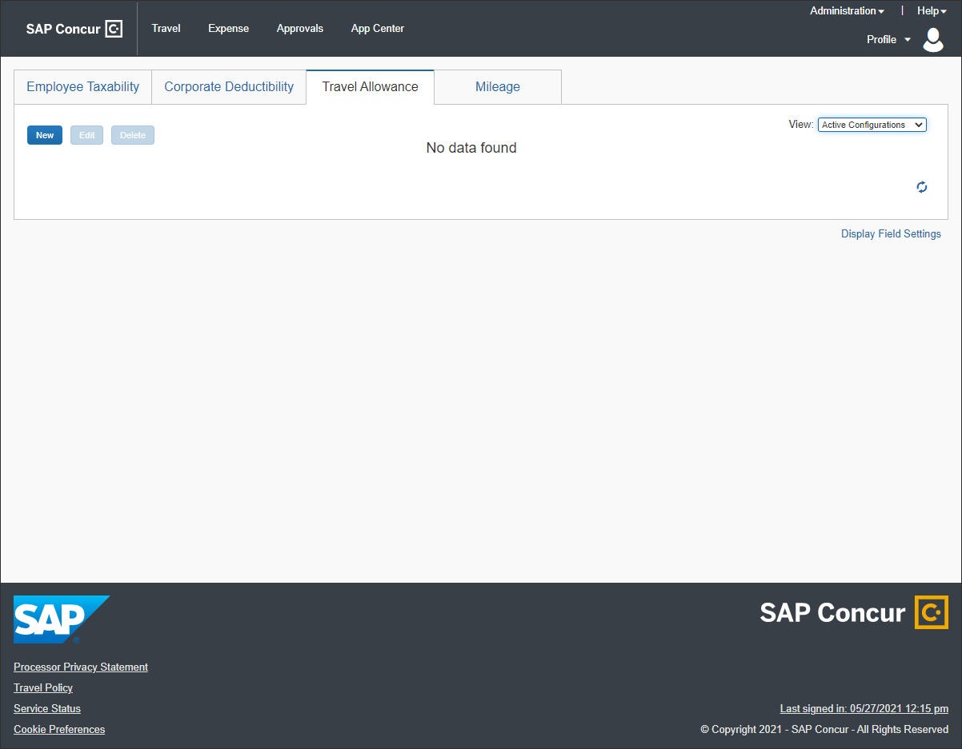

View a Travel Allowance Configuration
To view a Travel Allowance Configuration
- Log in as an unrestricted Expense Configuration Administrator.
- Click Administration > Expense > Taxability and Deductibility or Employee Taxability And Corporate Deductibility.
- Click the Travel Allowance tab.
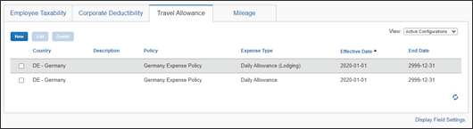
- (Optional) From the View list, select one of the following:
- Active Configurations – (default) Displays configurations for which today's date is between the Effective Date and End Date of the configuration.
- Expired Configurations – Displays the configurations for which today's date is after the End Date of the configuration.
- Future Configurations – Displays the configurations for which today's date is before the Effective Date of the configuration.
- All Configurations – Displays all of this tab's configurations for this client.
- (Optional) Click the Refresh () icon.
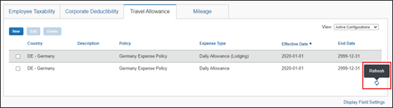

Add a Travel Allowance Configuration
To add a Travel Allowance Configuration
- On the Travel Allowance tab, click New. The Add Travel Allowance Configuration page displays.
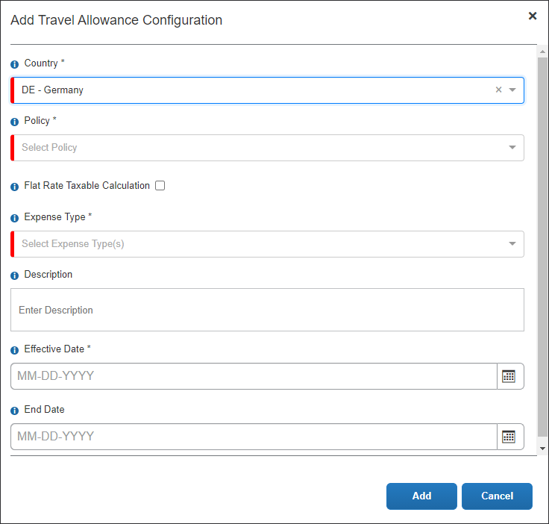
- Fill in the available fields:

Field | Description
Country * | Country for which the configuration is valid.
Policy * | The policy for which the configuration is valid.  For more information, refer to the Concur Expense: Policies Setup Guide.
Flat Rate Taxable Calculation | Check box for enabling flat rate calculations.  NOTE: This field only displays when the Country selected is Germany.
Expense Type * | The expense type(s) for which the configuration is valid.  For more information, refer to the Concur Expense: Expense Types Setup Guide.
Description | Description text for the configuration.
Effective Date * | The first valid date for this configuration.
End Date | The last valid date for this configuration.  System default value: 12/31/2999
Asterisks indicate required fields.
- Click Add. The Travel Allowance configurations display.
Example

Edit a Travel Allowance Configuration
To edit a Travel Allowance Configuration
- On the Travel Allowance tab, select a row and click Edit.
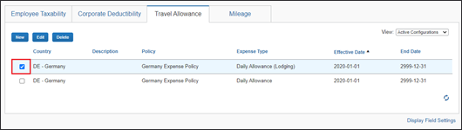
- On the Update Travel Allowance Configuration page, edit the desired fields.
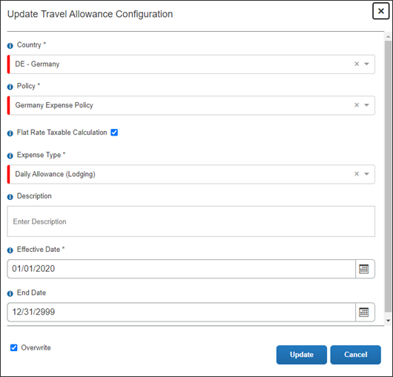
When updating/correcting an existing configuration, leave Overwrite selected. Clearing this check box will create another configuration.
- Click Update.

Delete a Travel Allowance Configuration
To delete a Travel Allowance Configuration
On the Travel Allowance tab, select a row and click Delete.
(If the configuration is in use, it cannot be deleted.

Mileage
The Mileage tab displays the mileage configurations.
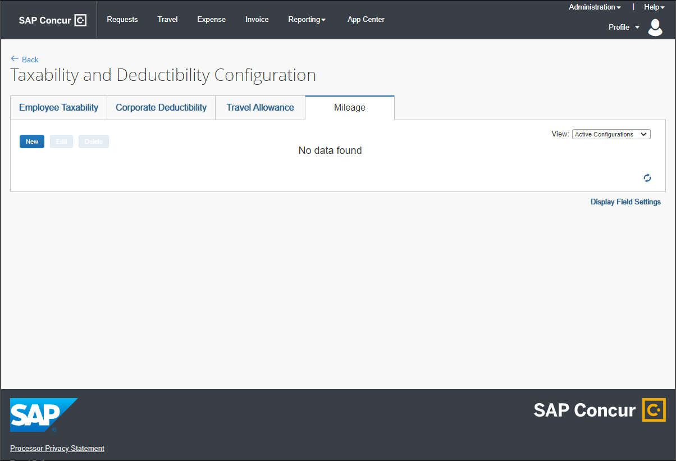

View a Mileage Configuration
To view a Mileage Allowance Configuration
- Log in as an unrestricted Expense Configuration Administrator.
- Click Administration > Expense > Taxability and Deductibility or Employee Taxability And Corporate Deductibility.
- Click the Mileage tab.
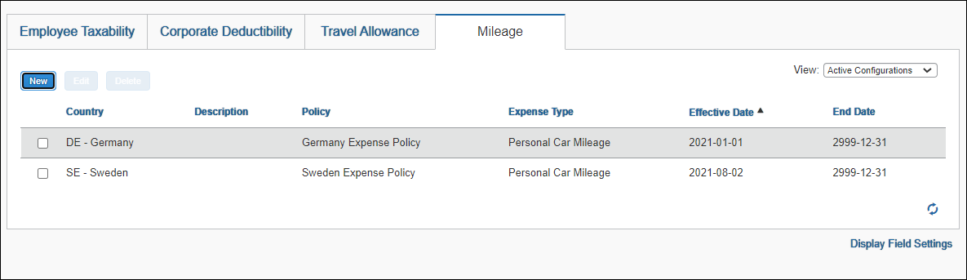
- (Optional) From the View drop-down list, select one of the following:
- Active Configurations – (default) Displays configurations for which today's date is between the Effective Date and End Date of the configuration.
- Expired Configurations – Displays the configurations for which today's date is after the End Date of the configuration.
- Future Configurations – Displays the configurations for which today's date is before the Effective Date of the configuration.
- All Configurations – Displays all of this tab's configurations for this client.
- (Optional) Click the Refresh () icon to view the changes.

Add a Mileage Configuration
To add a Mileage Configuration
- On the Mileage tab, click New. The Add Mileage Configuration page displays.
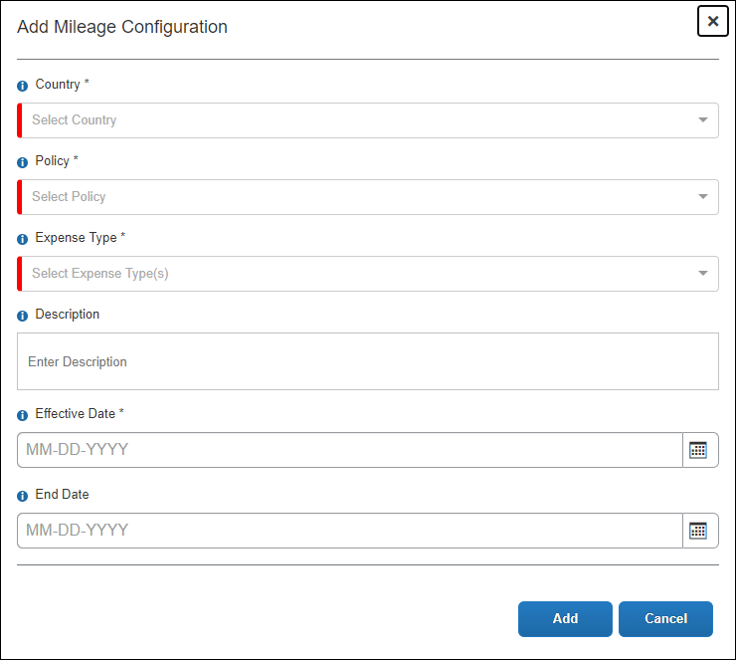
- Fill in the available fields:

Field | Description
Country * | Country for which the configuration is valid. Only countries for which mileage service is active are displayed in the list.
Policy * | The policy for which the configuration is valid.  For more information, refer to the Concur Expense: Policies Setup Guide.
Expense Type * | The expense type(s) for which the configuration is valid. The following expense types of spend categories are available as options:  - Personal Car - Mileage Reimbursement  - Company Car - Mileage Reimbursement  For more information, refer to the Concur Expense: Expense Types Setup Guide.
Description | Description text for the configuration
Effective Date * | First valid date for this configuration
End Date | Last valid date for this configuration  System default value: 12/31/2999
Asterisks indicate required fields.
- Click Add. The Mileage configurations display.
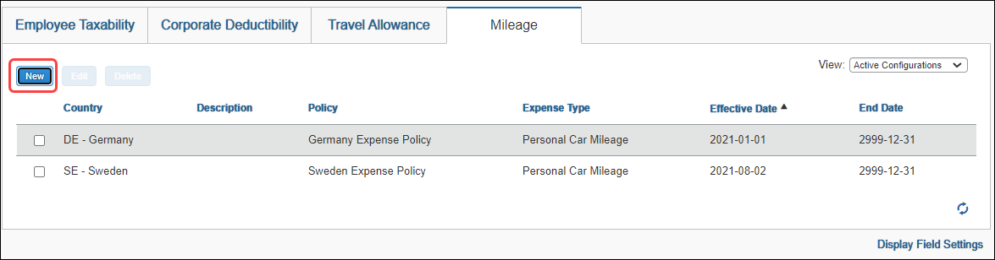

Edit a Mileage Configuration
To edit a Mileage Configuration
- On the Mileage tab, select a row and click Edit.
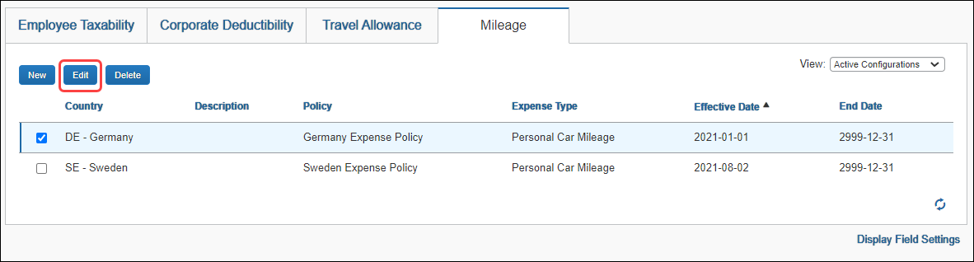
- On the Update Mileage Configuration page, edit the desired fields.
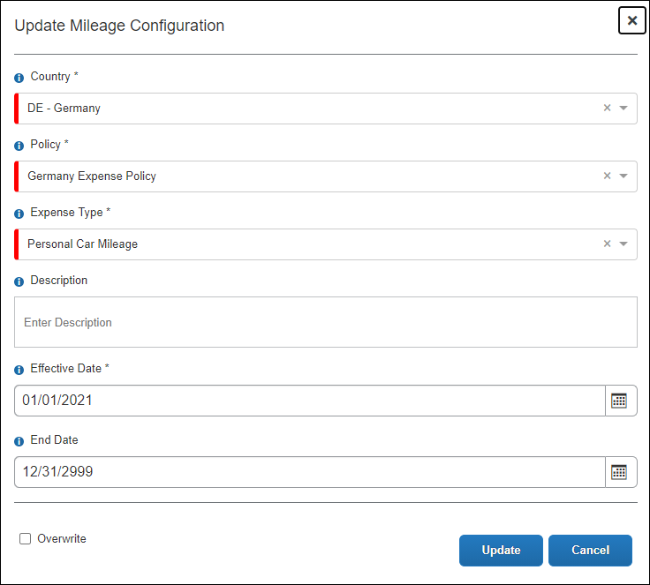
When updating/correcting an existing configuration, unselect the Overwrite checkbox. Clearing this checkbox creates another configuration.
- Click Update.

Delete a Mileage Configuration
To delete a Mileage Configuration
On the Mileage tab, select a row and click Delete.
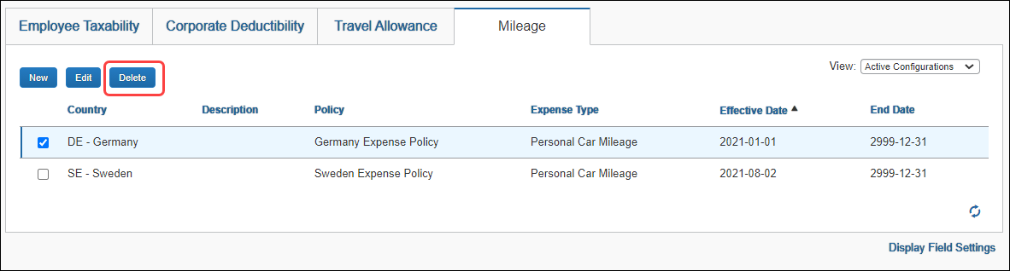
If the configuration is in use, it cannot be deleted.

