
Concur Expense: Travel Allowance
Setup Guide

Last Revised: January 18, 2019
Applies to these SAP Concur solutions:
 Expense
 Professional/Premium edition
 Standard edition
 Travel
 Professional/Premium edition
 Standard edition
 Invoice
 Professional/Premium edition
 Standard edition
 Request
 Professional/Premium edition
 Standard edition
Table of Contents
Section 1: Permissions 1
Section 2: Overview 1
Fixed vs Reimbursable Allowances 1
Additional Definitions/Terminology 2
Travel Allowance Configuration Elements and Documentation 3
Hierarchy 3
Configuration and Rates 3
Optional Configuration Elements 4
Section 3: What the User Sees 4
Delegates, Proxies, and Travel Allowance 4
Travel Allowance Wizard 5
Understanding the Basic Process 5
Matching the User to the Correct Travel Allowance Configuration 6
Step 1: Creating the Expense Report 7
Step 2: Creating the Itinerary 8
Selecting a Different Travel Allowance Configuration 8
Defining the Trip Length 9
Creating a Standard Itinerary 9
Creating Single-Day Itineraries 13
Importing Itinerary Information 16
Step 3: Working with Available Itineraries 18
Step 4: Working with Fixed (Daily) Allowances or Adjustments 20
Making Adjustments 20
Creating the Expenses for Fixed Allowances 21
Editing the Fixed Allowances Expenses 21
Step 5: Working with Reimbursable (Actual Expense) Allowances 22
Editing the Expenses for Reimbursable Allowances 24
Section 4: What the User Sees – Other Expense Reports Pages 25
Itemized Expenses 25
Approvals 25
Section 5: What the User Sees – Wizard and Non-Wizard Pages 26
Wizard vs. Standard (Non-Wizard) Pages 27
Section 6: Configuration Options 29
Configuration Options for the Expenses & Adjustments Page 29
Required Columns 29
Optional Columns 30
Configuration Options for the Reimbursable Allowances Summary Page 37
Required Columns 37
Optional Columns 38
Section 7: Validations, Calculations, and Adjustments 40
Validation and Submit Checks 40
Audit Rules 41
System Calculation of Reimbursable Expenses 41
Pro-Rating Reimbursable Expenses Over the Entire Day 41
Charging the Over-Limit Amount Against Lodging then Meals 42
Reimbursable Allowance Summary Totals Across Multiple Reports 42
Record Adjustments 44
Reporting Requirements 45
Section 8: Travel Allowance Configuration Summary 45
Section 9: Travel Allowance Configuration – Initial Configuration 46
Step 1: Setting up the Hierarchy 46
Step 2: Importing the Initial Configuration and Rates 46
Before You Begin 46
Importing the Initial Configuration and Rates 47
Exporting the Rates for Editing and Re-Import 48
Step 3: Adding the Mapping of the Company's Organization to the Configurations 48
Map Users to a Single Travel Allowance Configuration (Users Cannot Select the Configuration) 49
Map Users to a Set of Travel Allowance Configurations (Users Can Select the Configuration) 51
Step 4: Configuring Optional Features 53
Section 10: Travel Allowance Configuration – Editing and Viewing Configuration Information 53
Editing a Travel Allowance Configuration 53
Viewing and Editing Rate Data 65
Required Roles 65
Viewing Rates 65
Editing Rates 67
Working With Rate Location Mappings 69
Adding Rate Location Mappings 69
Deleting Rate Location Mappings 71
Editing the Mapping of the Company's Organization to the Configurations 72
Editing Configuration Sets 72
Viewing Travel Allowance Data by Travel Date and Employee 72
Using the Itinerary Display Information 73
Working With Calculation Method Properties 74
Section 11: Travel Allowance Configuration – Optional Configuration Elements 75
Configuring Expense Types 75
Expense Types for Fixed Allowances 75
Expense Types for Reimbursable Allowances 76
Editing Transaction Dates for Company Card Transactions 78
Alternative Solution 78
Site Setting Change for Itineraries 78
Travel Allowance and Exchange Rates 78
Configuration of Column Headings on the Expenses & Adjustments Page 79
Audit Rules 81
Events and Data Objects 81
Events and Evaluation by Audit Rules 84
Timing 85
Samples 85

Revision History
Date | Notes / Comments / Changes
January 21, 2022 | Updated the copyright year; no other changes; cover date not updated
January 7, 2021 | Updated the copyright; added Concur to the cover page title; cover date not updated
April 9, 2020 | Renamed the Authorization Request check box to Request on the guide’s title page; cover date not updated
January 2, 2020 | Updated the copyright; no other changes; cover date not updated
January 18, 2019 | Corrected the first table in this section: EXAMPLE - RESULTS OF USING THE CREATE ITINERARY ROWS BASED ON AIR SETTING
January 4, 2019 | Updated the copyright; no other changes; cover date not updated
April 4 2018 | Changed the check boxes on the front cover; no other changes; cover date not updated
February 20 2018 | Updated guide name in references to the Expense: Travel Allowance Import (XML v 3) Specification guide.
January 9 2018 | Updated the copyright; no other changes; cover date not updated
August 4 2017 | Added a note about the wizard prompt text to clarify that this is a text field and does not support HTML formatting.
December 14 2016 | Changed copyright and cover; no other content changes.
December 9 2016 | Updated the guide content to new corporate style; no content changes.
May 13 2016 | Updated instances of he/she to they.
February 19 2016 | Added information about new Use Address List country-specific option
January 24 2016 | Changed references to the import/extract guides; no other changes
August 31 2015 | Added additional definition for lodging, overnight allowance, benefit-in-kind meals, and JTR – Joint Travel Regulations  Updated the screen shots to the enhanced UI; no other content changes
February 6 2015 | Changed occurrence of Use Standard and Allowance Expenses Exception to Use System Exception
September 24 2014 | Added information about two user interfaces; no other content changes.
July 11 2014 | Revised the information about the Display Base Meals Rate In Rate Currency option
June 13 2014 | Added information about the Display Base Meals Rate In Rate Currency option and Trip Length field
April 11 2014 | Added information about custom text to prompt user about the wizard
September 20 2013 | A warning message appears if a user creates an itinerary exceeding 30 days – this can alert a user to an excessive itinerary span and prevent calls to Support to unlock an itinerary
August 23 2013 | Addition of:  - Ability to export existing rate configuration (Configurations tab > Download Rates button) in a re-importable feed file for TA import  - New Has Travel Allowance Credit after Over Limit on Prior Report condition for Report Submit event – allows manual credit handling where credit from second report should be applied (prorated) to first report with overlimit
December 28 2012 | Made rebranding and/or copyright changes; no content changes
December 14 2012 | The Meals expense types Lunch and Dinner can now be set to Provided.
October 19 2012 | Changed and updated the following content:  - New Itinerary Search tab  - New Calculation Properties tab  - Changed tab name Configuration Assignments to Employee-Related Configurations  - Rates tab now allows location mapping  - Explain change to logic of now renamed Skip hotel itinerary rows when air is present in import setting
February 2012 | Changed copyright; no content change
November 23 2011 | Added information to clarify what each Condition means:  - Travel Allowance Itinerary: This data object references the specific itinerary associated with the expense.  - Travel Allowance Itinerary (On Report): This data object references any itinerary attached to the report, and is not specific to what is linked to an expense.
August 12 2011 | Added information about:  - Automatic row creation for Hotel data if included on import
July 22 2011 | Added information about:  - Addition of the External URL and External URL's Text fields to the TA Configuration page  - Expansion of the Itinerary calendar to now show 7 days instead of 5  - Days already used appear in the New Itinerary Stop calendar as greyed out and unavailable  - A prompt now appears when deleting an expense report with linked itineraries that asks if the user wishes to delete the itinerary as well  - The system will now query the user who creates a single leg equal or greater than 4 days to ensure correct entry of the leg
February 25 2011 | Added information about:  - Configuration moved from classic user interface to the current user interface in January and February  - Rates can be edited
December 31 2010 | Updated the copyright and made rebranding changes; no content changes
June 18 2010 | Added information about:  - Itinerary-level objects for audit rules (for both Travel Allowance Itinerary and Travel Allowance Itinerary (on report):  - Number of Days in Trip  - Trip Start Date  - Trip End Date  - Clarification of On Submit Check
April 29 2010 | For the Oanda rate information, changed Oanda interbank median bid rate to Average Ask Rate
March 19 2010 | Added information about configuration sets
February 19 2010 | Added information about accessing the wizard from the Details menu, and assigning spend categories to expense types
January 15 2010 | Added information about "Administrative Region" (county) locations
December 2009 | Changed to stand-alone setup guide; no content change
October 16 2009 | Added information about:  - Single row itinerary check  - Audit rules for travel allowances  - Change the Save & Add Another Stop button (Create New Itinerary page) to Save  - Column changes on the Available Itineraries page; time/date has its own column  - Information about creating or editing an itinerary without the associated report open
September 18 2009 | Added information about the Display Quick Itinerary Wizard configuration setting
January 16 2009 | Added information about using the Single Day Itineraries page
December 12 2008 | Changed the arrangement of the options on the Edit Travel Allowance Configuration page
August 15 2008 | Added information about:  - Configure the column heading labels on the Expenses & Adjustments page  - Oanda rates
July 19 2008 (SU33) | Added information about:  - New fields on the Edit Travel Allowance Configuration page  - Field name change on the Create New Travel Allowance Configuration Assignment page  - Clarified the use of Oanda with exchange rates
May 2008 (SU31) | Added information about:  - User selection of the configuration when creating the itinerary  - Expense creation of an itinerary based on a Travel itinerary or company card (level 3) data  - Label and page name changes  - Travel Allowance Rates Location page  - Edit Travel Allowance Configuration Selections page
Apr. 2008 (SU30) | Added information about the two available user interfaces:  - Classic user interface  - Current user interface  This document applies to the current user interface.

Travel Allowance
NOTE: Multiple SAP Concur product versions and UI themes are available, so this content might contain images or procedures that do not precisely match your implementation. For example, when SAP Fiori UI themes are implemented, home page navigation is consolidated under the SAP Concur Home menu.

Permissions
A company administrator may or may not have the correct permissions to use this feature. The administrator may have limited permissions, for example, they can affect only certain groups and/or use only certain options (view but not create or edit).
If a company administrator needs to use this feature and does not have the proper permissions, they should contact the company's Concur administrator.
Also, the administrator should be aware that some of the tasks described in this guide can be completed only by Concur. In this case, the client must initiate a service request with Concur Client Support.

Overview
A company may reimburse its employees' travel expenses according to a schedule of set reimbursement rates, commonly known as "per diem" or "travel allowance" rates. The rates are determined by government and company policies and may differ depending on location and length of travel as well as partial days of travel, seasonal travel, and so on. Travel allowances apply to meals (which usually includes incidentals) and lodging expenses.
Travel allowances do not apply to expenses such as car rentals, airline tickets, seminars, and so on.

Fixed vs Reimbursable Allowances
There are two types of travel allowances:
- Fixed (also known as Daily Allowance): With a fixed type of travel allowance, the employee is reimbursed the fixed rate regardless of the actual amount of expenses. For example, assume that the fixed rate for meals (including incidentals) is 55.00 EUR per day.
- If the employee spends less than 55.00 EUR per day, the employee keeps the difference.
- If the employee spends more than 55.00 EUR per day, the employee is responsible for paying the difference.
Since the employee is paid the amount regardless of the actual expense, the employee does not enter actual expenses into Expense or collect receipts. The system creates the fixed-amount expenses based on the location and duration information that the employee provides by preparing an itinerary.
In this guide and in some of the configuration settings, you will see the term "fixed" as well as "daily allowance" – they mean the same thing.
- Reimbursable (also known as Actual Expenses): With a reimbursable type of travel allowance, there is a schedule of reimbursement rates but the employee may or may not be paid the reimbursement rate.
The employee enters the actual expense into Expense and the system compares the actual expense amount to the rate (limit). Then:
- If the actual expense is less than or equal to the limit amount, the company reimburses the employee for the actual expense amount.
- If the actual expense is greater than the limit amount, the company may reimburse the employee for the actual expense amount or perhaps only up to the limit amount.
- If policy dictates that the employee is reimbursed the amount of the actual expense, then the company pays the employee the full amount of the expense but also keeps track of the amount that is over the limit. In some cases, such as Germany, the amount paid to the employee that is over the limit becomes taxable to the employee. In other cases, the amount that is over the limit may not be billable to the client and may be charged as company overhead.
- If company policy dictates that the employee is reimbursed only up to the limit, then the employee is responsible for any amount above the limit.
In this guide and in some of the configuration settings, you will see the term "reimbursable" as well as "actual expenses" – they mean the same thing.

Additional Definitions/Terminology
In this guide and in some of the configuration settings, you will see these terms.
Term | Definition
Lodging | The user stays in a hotel, motel, or other traditional (likely commercial) accommodations.
Overnight allowance | The overnight allowance is given to the employee instead of the lodging allowance.  While this may vary by country, this is typically used when the employee stays with friends, in a caravan, or any other lodging arrangement other than traditional hotel accommodations.  The overnight allowance, which is intended to be used by the employee to purchase a gift for the host, is a much lower amount than the lodging allowance.
Benefit-in-kind Meals | Meals, which are supplied by the company to German employees are, in certain circumstances, considered to constitute a benefit-in-kind for tax purposes. For example:  - A meal supplied at a company canteen paid for by in-house currency or voucher  - A meal supplied as part of a training course, seminar, or conference arranged and paid for by the company  – or –  - Any meal arranged in advance
JTR – Joint Travel Regulations | These are applicable to the United States Department of Defense.

Travel Allowance Configuration Elements and Documentation
The main elements of travel allowance configuration are listed here and discussed in detail in the configuration information at the end of this guide – after the discussion of how each option affects the user interface.

Hierarchy
The administrator edits the default travel allowance hierarchy to meet the needs of the company.

Associated Documentation
- Refer to the Shared: Feature Hierarchies Setup Guide.

Configuration and Rates
Configuration and rates differ by country. There is currently no user interface (UI) for initial configuration and rates. Instead, the travel allowance import is used to import:
- Configuration and hierarchical group mapping data
- Rates
- Rate location-to-system location mapping data
Then, once the initial configuration and rate information is imported, the admin can edit using the UI, which is detailed in the configuration section of this guide.
Also, there is a Download Rates option that is used to export existing rates in order to update and re-import. This process, too, is detailed in the configuration section of this guide.

Associated Documentation
To gain a general understanding about travel allowances, read the remainder of this guide. This guide provides descriptions and examples of the various options available to clients, for example, whether to have reimbursable travel allowances or whether to have check boxes instead of drop lists on certain user pages.
For information about the import, refer to the Expense: Travel Allowance Import (XML v 3) Specification.
For country-specific information about configuration and rates, refer to the individual Travel Allowance Configuration Guides.

Optional Configuration Elements
There are additional elements that may or may not be used, depending on the configuration and/or country. They are:
- Expense Types: The administrator may be required to configure some of the expense types.
- Company Card Setting: The administrator can change a setting so users can edit transaction dates on imported company card transactions.
- Site Setting for Itineraries: The administrator can control the date range of the itineraries listed on the Available Itineraries page.
- Exchange Rates: Travel allowances with rates set in currencies other than the employee's reimbursement currency may not be calculated by the system unless exchange rates are configured properly.
- Column Headings: The administrator can configure the labels of the column headings on the Expenses & Adjustments page.
- Audit Rules: The administrator can create audit rules to manage and monitor travel allowances.

Associated Documentation
These options are detailed in the configuration section of the guide.

What the User Sees
This section of this guide describes the various features and options. The configuration section of this guide details the configuration steps.

Delegates, Proxies, and Travel Allowance
Proxies and delegates with Prepare rights have the same access and abilities as the users they represent.

Travel Allowance Wizard
There is a travel allowance wizard available for users. With the wizard, users walk through the travel allowance process step-by-step, minimizing errors.
Users can access the wizard in two ways:
- The company can elect to have Expense launch the wizard immediately after the user saves the report-level information (expense header). (The company can also elect to prompt the user.)
– or –
- The user can access the wizard anytime they want after saving the report-level information (report header).
Concur recommends that the company have Expense launch the travel allowance wizard automatically. It will help ensure that the user completes the proper steps – in the proper order.

Understanding the Basic Process
The basic process is described here briefly and then in detail on the following pages. (All configuration steps are described in the configuration section at the end of this guide.)
- IMPORTANT!! The travel allowance feature is highly configurable.
For the remainder of this guide, assume the following:
1) The travel allowance configuration described here allows for fixed (daily allowance) meals and reimbursable (actual expenses) lodging allowances.
2) The system is configured to launch the travel allowance wizard immediately after the user saves the report header. (Though the client has to option to prompt the user, in this case, there is no prompt; it launches automatically.)
When the user logs on, Expense determines whether the user is eligible to be reimbursed through travel allowance (detailed in the following section). If so, the user follows these steps.
Step 1: Create the expense report
The user starts an expense report. Upon saving the report header, the travel allowance wizard starts.
Step 2: Create the itinerary
On the first page of the wizard, the user creates the itinerary, which provides the trip details (departure and destination information). Expense uses this information (location, amount of time, etc.) to determine the allowance rates.
Step 3: Work with available itineraries
On the second page of the wizard, the user assigns one or more other itineraries to the report, if desired.
Step 4: Work with fixed (daily allowances) allowances or adjustments
If the travel allowance configuration includes fixed allowances or requires user input for items like provided meals, a third page of the wizard appears. The user reviews the allowance information, makes any required adjustments, and saves. Expense creates the actual fixed allowance expenses on the expense report, saves any other provided data, and makes any requested adjustments.
Step 5: Work with reimbursable (actual expenses) allowances
If the travel allowance configuration includes reimbursable expenses, the user creates the associated expenses on the expense report. Expense calculates the reimbursement amounts.
The following pages describe the entire process in detail.

Matching the User to the Correct Travel Allowance Configuration
When a user creates an expense report, the system compares the user's employee profile (header) information to the travel allowance hierarchy information defined in the travel allowance configurations. If they match, then the user is eligible to be reimbursed through travel allowance and the appropriate links and travel allowance pages become available.
When comparing, the system starts with the Country field:
- If there is no match on the Country field, the user cannot use travel allowances.
- If there is a match on the Country field, the system continues to compare the fields that define the hierarchy. The hierarchy fields are used in order, without gaps.
Assume that a company defined its hierarchy using the organizational units 1 through 6. The tables below show how the system compares two users to the company's three travel allowance configurations (TA1, TA2, and TA3).
User | Country | Org  Unit 1 | Org  Unit 2 | Org  Unit 3 | Org  Unit 4 | Org  Unit 5 | Org  Unit 6
Employee 1 | Germany | ABC | 1234 | Sales | 1X123 | B
Employee 2 | Germany | ABC | 1234 | R&D | 20293 | A

Config | Country | Org  Unit 1 | Org  Unit 2 | Org  Unit 3 | Org  Unit 4 | Org  Unit 5 | Org  Unit 6
TA Config 1 | Germany | ABC
TA Config 2 | Germany | ABC | 1234 | Sales
TA Config 3 | Germany | ABC | 1234 | Sales | 1X123
- The most precise match for Employee 1 is TA Config 3, since more fields match to the employee record than for TA Config 1 or 2.
- The most precise match for Employee 2 is TA Config 1, since fields either match or are blank for the employee record.
When the user creates a report, Expense automatically assigns the most appropriate travel allowance configuration – with all of its options and restrictions – to that report.
- If the configuration is later edited, the changes are immediate. If the user opens the itinerary or expense report after the configuration is edited, those edits will apply.
- If the user's data changes so that the user is now using a different travel allowance configuration, the original configuration applies to the itinerary and expense report. Even if the user opens the itinerary or expense report, the original configuration is still used.
Depending on the company's configuration, the user may be able to select a different configuration, as described later.

Step 1: Creating the Expense Report
In this example, the system is configured to automatically launch the wizard.
When the user clicks Next on the Create a New Expense Report page, the wizard starts; the Create New Itinerary page appears.
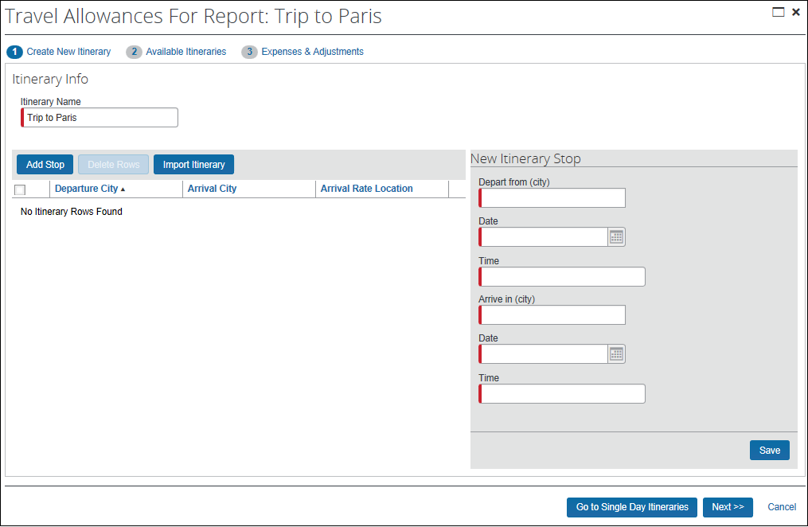
At this point, Expense has assigned the most appropriate travel allowance configuration to the expense report, as described previously.
Depending on the company's configuration, the user may be able to select a different configuration, as described in the next section.

Step 2: Creating the Itinerary
On the Create New Itinerary page, Expense automatically copies the expense report name into the Itinerary Name field. The user can change it if desired.
There are several actions the user can take using this page. As detailed on the following pages, the user can:
- Select a different travel allowance configuration, depending on the company's configuration
- Define the trip length, depending on the company's configuration
- Create the actual itinerary using any of these methods:
- Create a standard itinerary
- Create one or more single-day itineraries using the quick-entry page
- Have Expense create an itinerary based on information imported from Travel or based on certain imported company card data

Selecting a Different Travel Allowance Configuration
The company can allow the user to select a different travel allowance configuration. If the company uses this feature, the most appropriate configuration that Expense assigned (as described previously) becomes the user's default configuration. While creating a new itinerary, the user can use that default configuration or can use the Selection field to select from a list of company-defined travel allowance configurations.
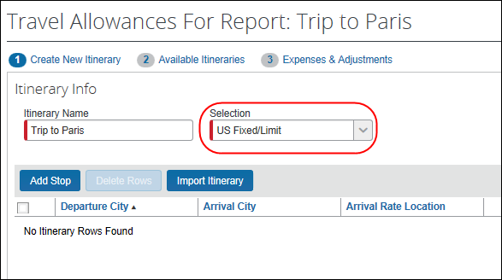
Once the user saves and leaves the Create New Itinerary page, the user cannot change the configuration. The field becomes read-only.

Defining the Trip Length
If the company's configuration includes the display of the Trip Length list, then the user can select one of these:
- 3 months or less
- Over 3 months
- Over 48 months
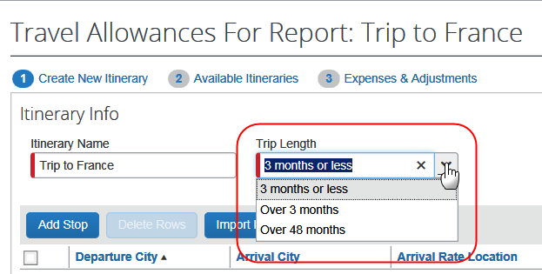
The selection the user makes in this list drives the extended trip treatment for the entire trip, based on the travel allowance country module used. For example, the user selection of Over 3 months or Over 48 months may reduce the meals amount to the extended trip amount.
- IMPORTANT: This option has limited usage. If you turn on this feature for most countries, it is ignored.
 Refer to the individual country-specific Travel Allowance Configuration Guides to see if this option is used.

Creating a Standard Itinerary
First – as described above – depending on the company's configuration:
- The Selection field may appear to the right of the Itinerary Name field. The user can select from the list of available travel allowance configurations.
- The Trip Length list may appear to the right of the Itinerary Name field. The user can select the trip length.
Then, in the New Itinerary Stop section on the right side of the page, the user enters the information for the first stop of the trip.
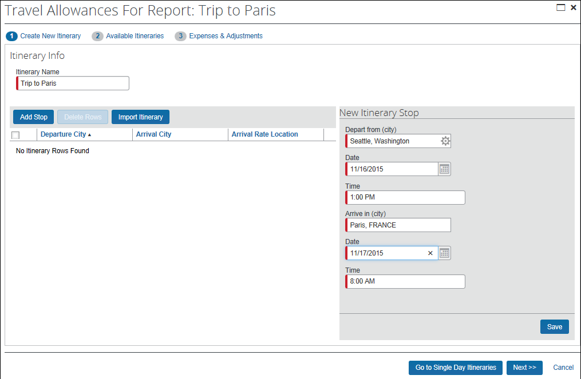
Field | Description
Depart from (city) | The user starts typing (at least three letters) the name of the city. A list appears. The user selects the desired city.
Date | The user types the departure date or selects it from the calendar.
Time | The user types the departure time (local time for the departure location).  Note the following about entering time:  - For standard workday times (between 7:00 AM to 6:00 PM), the user can type whole numbers instead of the hour, minute, and AM or PM. For example, if the user types 7 and then presses TAB or clicks in another field, 7:00 AM appears. If the user types 5 and then presses TAB or clicks in another field, 5:00 PM appears.  - If the company uses a 12-hour clock, the user can type 22 and 10:00 PM appears.  - If the company uses a 24-hour clock, the user can type 22 and 22:00 appears.
Arrive in (city) | The user starts typing (at least three letters) the name of the city. A list appears. The user selects the desired city.
Date | Expense fills the departure date into this field since each stop of the trip usually starts and ends on the same day. The user changes the date if necessary.
Time | The user types the arrival time (local time for the arrival location). (This field works like the Time field described previously.)
When the user clicks Save:
- The saved stop information appears on the left side of the page.
- Expense fills the arrival city from the previous stop to the Depart from (city) field, based on the assumption that the user will likely be leaving from this location. The user changes it if necessary.
- All other fields are cleared.
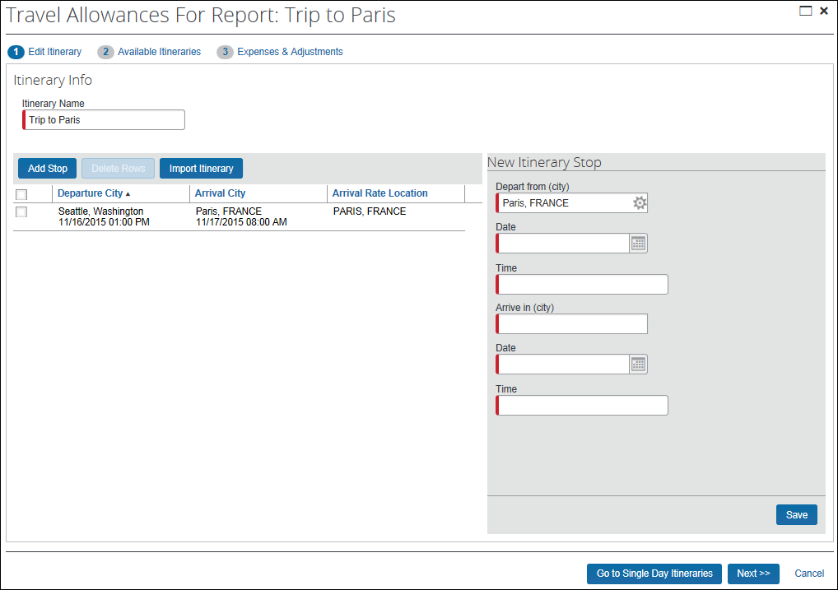
- (Optional) A query appears requesting confirmation if the single leg is equal to or greater than 4 days.
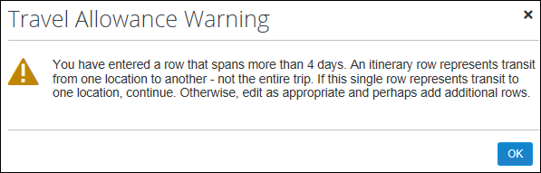
- If the total of all stops exceeds 30 days, a warning message is displayed requesting confirmation for this date span.
The prompt prevents the user from creating an itinerary that the client may need to have unlocked by Support.
The user completes the fields for the next stop of the trip. The user continues, saving each stop using these steps.

Standard Itinerary: Adding and Removing Stops
Before moving on, the user reviews the itinerary for accuracy, changing it if necessary.
- To remove a stop, the user selects the desired check box and clicks Delete Rows.
- To add more stops, the user clicks Add Stop and completes the fields on the right side of the page.

Standard Itinerary: Changing the Arrival Rate Location
Expense automatically provides the information in the Arrival Rate Location column. To determine the Arrival Rate Location, Expense (in this order):
- Checks the rate location mapping table (imported in the travel allowance import)
- Checks for an exact match on Country, State/Province, and City
- Checks for an exact match on Country and City but State/Province is blank
- Checks for an exact match on Country, State/Province and county (also known as "Administrative Region"), but City is blank
- Checks for an exact match on Country and State/Province but City is blank
- Checks for an exact match on Country but both State/Province and City are blank
- Checks for a record with both Country and State/Province are blank but has the company-defined label for "All Other Countries"
As described above, Expense attempts to match the location on the user's itinerary to the approximately 40,000 locations listed in Expense. Sometimes, an exact match cannot be located. Unfortunately, that can affect the amount that the user is reimbursed, since the reimbursement rate is based on location. To ensure the most flexibility in location selection, the client can configure Expense so that its users are allowed to edit the arrival rate location.
If the company allows the user to edit the rate location:
- The user clicks the check box associated with the desired stop. The stop appears in the Edit Itinerary Stop section of the page.
- The user types the new location.
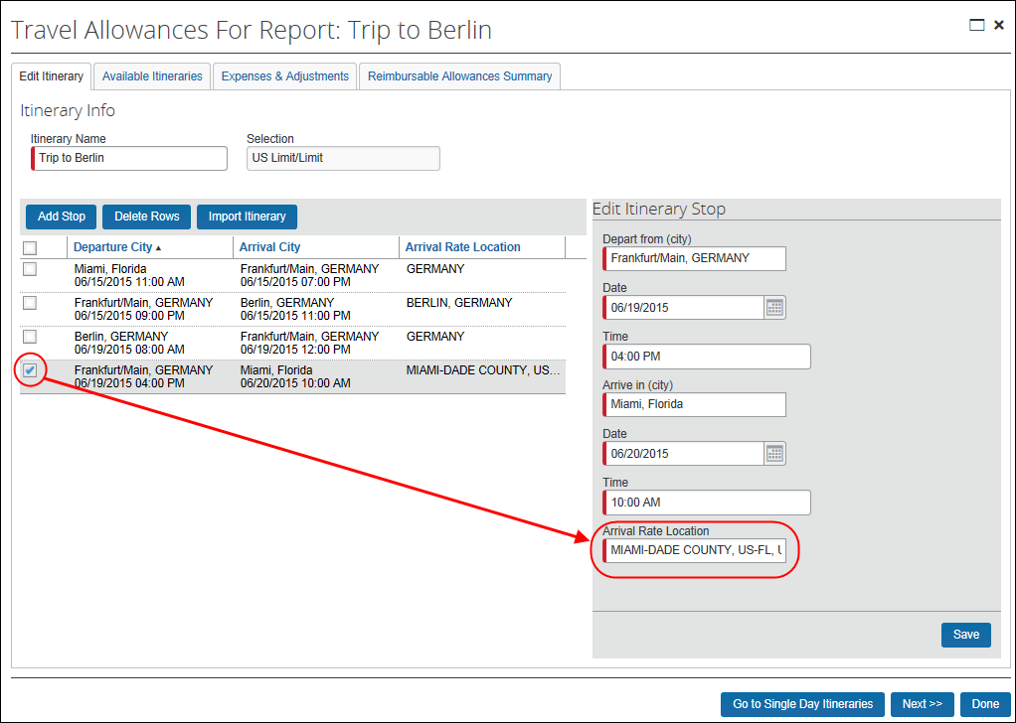

Standard Itineraries: Finishing Up the Itinerary
At this point, the itinerary should be complete and correct. When done, the user clicks Next. The Available Itineraries page appears.

Creating Single-Day Itineraries
The user can use the "standard itinerary" process described above to create single-day itineraries or can use the quick entry page. To access the quick entry page, the user clicks the Go to Single Day Itineraries button on the Create New Itinerary (or Edit Itinerary) page. The Single Day Itineraries page appears.
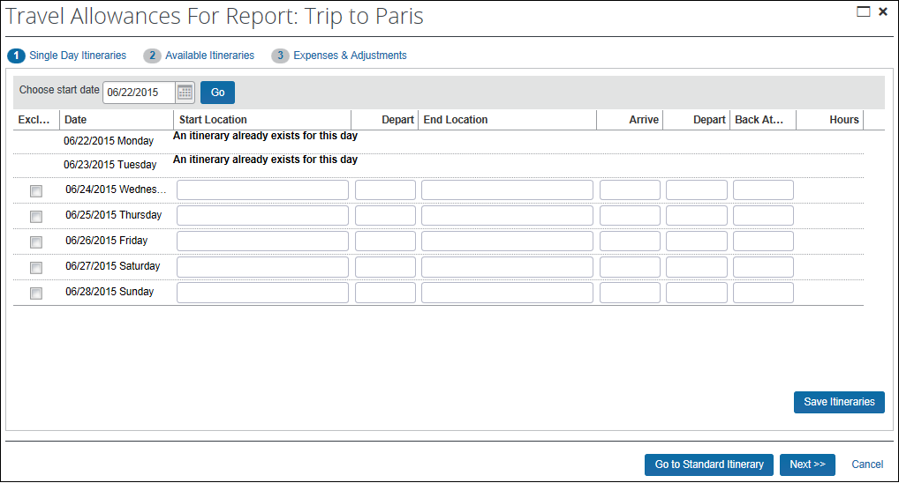
On the Single Day Itineraries page, the user completes these fields.
Field / Column | Description
Choose start date | By default, the system provides a row for each day of the current week. If the user wants a different seven-day period, the user types a date (or uses the calendar) in the Choose start date field and clicks Go. The seven days (starting with that date) appear.
Start Location  End Location | The user starts typing (at least three letters) the name of the city. A list appears. The user selects the desired city.
Depart  Arrive  Depart  Back At Origin | The user enters the time for:  - Depart (from the start location)  - Arrive (at the end location)  - Depart (from the end location)  - Back At Origin (arrive back at the start location)  Note the following about entering time:  - For standard workday times (between 7:00 AM to 6:00 PM), the user can type whole numbers instead of the hour, minute, and AM or PM. For example, if the user types 7 and then presses TAB or clicks in another field, 7:00 AM appears. If the user types 5 and then presses TAB or clicks in another field, 5:00 PM appears.  - If the company uses a 12-hour clock, the user can type 22 and 10:00 PM appears.  - If the company uses a 24-hour clock, the user can type 22 and 22:00 appears.
Hours | Read-only; The system calculates the elapsed time of the trip.
Exclude | The user selects the Exclude check box for those days that do not have trips. (The user can also simply leave all fields in that row blank.)
The user then clicks Save Itineraries and then Next. The Available Itineraries page appears.

Single-Day Itineraries: Configuration Option
The company can elect to not allow its travelers to use the Single Day Itineraries page.

Single-Day Itineraries: User Preferences
The user can elect to have the Single Day Itineraries page appear by default in Profile > Profile Settings > Expense Preferences (left menu). The user selects Make the Single Day Itineraries page my default in the Travel Allowance wizard in the Display section of the page.
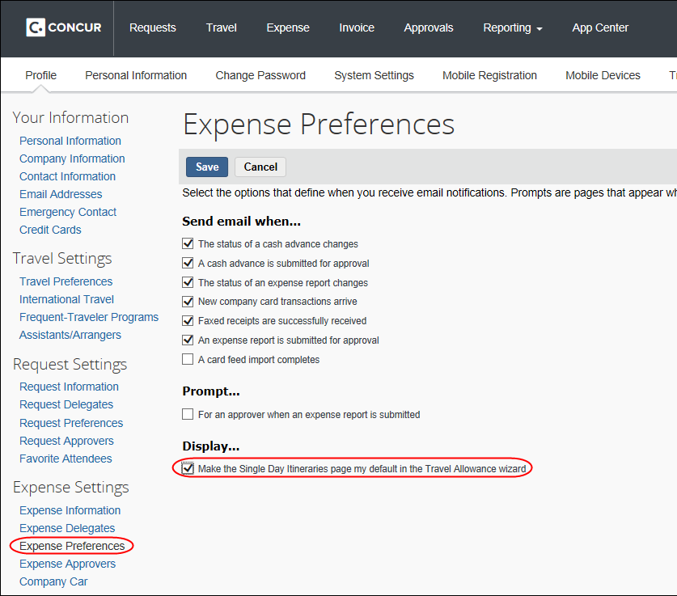
If the company has elected to not allow its travelers to use the Single Day Itineraries page, then this profile option does not appear.

Importing Itinerary Information
If the company uses Travel and/or the company card download feature, instead of creating the itinerary manually, the user can have Expense create an itinerary based on information imported from Travel or based on certain imported company card data. The user clicks Import Itinerary on the Create New Itinerary page. A list of Travel itineraries and company card data appears.
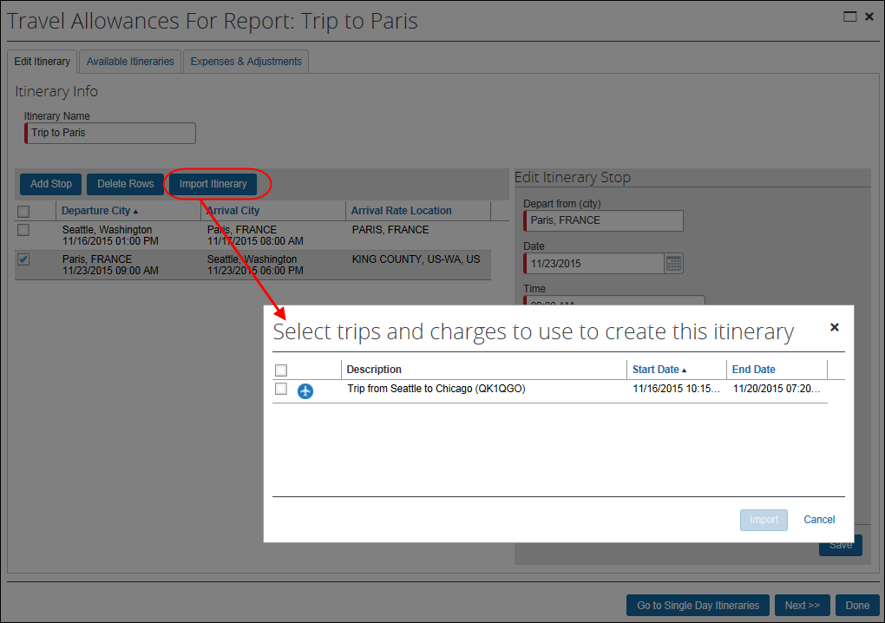
The user imports the desired information and edits the itinerary as needed.
This is a data-entry convenience and often results in incomplete itinerary rows when the needed data is not available from the source travel booking or card transaction. Expense prompts the user for any information that is required but not provided by the imported itinerary.
Note the following:
- Expense collects train information from the Travel itinerary. If the imported itinerary shows train travel, Expense generates the itinerary rows (stops) based on the dates, times, and locations shown in the Travel itinerary.
- Expense collects airfare and hotel information from the imported Travel itinerary and/or imported company card data.
- Expense uses the airfare information first (before the hotel information) to generate the itinerary rows (stops) if the airfare is ticketed.
- Expense uses the hotel information to generate the itinerary rows for hotel.
- If there are additional days identified in the hotel data, then Expense generates additional rows on the itinerary for those days.
- For airfare, Expense uses the dates, times, and locations shown in the Travel itinerary.
- For hotel, Expense uses (in this order) hotel booking information shown on the Travel itinerary, e-receipt information, then company card "level 3" information. Expense collects the location and check-in/check-out dates. The time must be provided by the user.
- Expense will not create another row for the same date if one already exists for that date except in the case of air with connecting flights.
- If Default City is provided on the employee’s profile, then it will provide the departure location for the start of the trip when airfare is not present on the Travel itinerary.
- Optional: Expense uses the hotel information instead of air information whenever the Create itinerary rows based on air setting is disabled (the checkbox is cleared).
- If hotel only or air and hotel information is present, then the air will be used for initial departure and final arrival locations. All other information on the itinerary will be based on hotel locations.
- If only airfare is present, then there will be no change in behavior to the standard description above.
- Refer to Editing a Travel Allowance Configuration in this guide.

EXAMPLE - Results of Using the Create itinerary rows based on air Setting
Examine the following travel reservation information:
 | Departure | Time | Arrive | Time
1 | Seattle SEA | Day 1 23:30 | Chicago ORD | Day 2 05:00
2 | Chicago ORD | Day 2 06:30 | Orlando MCO | Day 2 09:00
5 | Orlando MCO | Day 4 17:15 | Detroit DTW | Day 4 21:00
6 | Detroit DTW | Day 4 21:40 | Seattle SEA | Day 4 23:30
Under the standard configuration, the resulting travel allowance itinerary will have the following rows:
Departure | Time | Arrive | Time
Seattle | Day 1 23:30 | Oak Ridge | Day 2 10:00
Oak Ridge | Day 4 14:00 | Seattle | Day 4 23:30
With the setting Create itinerary rows based on air disabled (the checkbox is cleared), the resulting travel allowance itinerary will be simplified and created based only on hotel stays:
Departure | Time | Arrive | Time
Seattle | Day 1 23:30 | Oak Ridge | Day 2 10:00
Oak Ridge | Day 4 14:00 | Seattle | Day 4 23:30

Step 3: Working with Available Itineraries
An itinerary may be associated with one or more expense reports. For example, the company may require weekly expense reports but the trip (itinerary) may last for a month. In this case, one itinerary will span (probably) four expense reports.
An expense report can be associated with one or more itineraries. For example, the company may not allow users to submit expense reports more than once a week. Yet sometimes a user may have two short trips (itineraries) in the same week. In this case, two itineraries may be associated with one expense report. However, multiple itineraries can be assigned to the same report only if the itineraries are based on the same travel allowance configuration.
On the Available Itineraries page:
- The current itinerary appears in the top section of the page.
If the user created the itineraries using the Single Day Itineraries page, then all newly created single-day itineraries:
- Show a system-generated itinerary name
- Are attached to the current report
The user can unassign any or all single-day itineraries by selecting the desired itineraries and clicking Unassign.
- Other available itineraries appear in the bottom of the page.
The user can search for other itineraries using the drop list at the top of this section. Only itineraries based on the same configuration can be assigned to a report.
To assign one or more additional itineraries to the current report, the user selects the desired itinerary in the bottom section and clicks Assign. The newly assigned itinerary then appears in the top section.
At this point, the desired itineraries have been assigned to the report. Now:
- If the configuration calls for fixed (daily) allowances, the user clicks Next. The Expenses & Adjustments page appears.
- If the configuration does not call for fixed allowances, the user clicks Finish.
In this case, we have assumed that there are fixed allowances so the Expenses & Adjustments page appears.
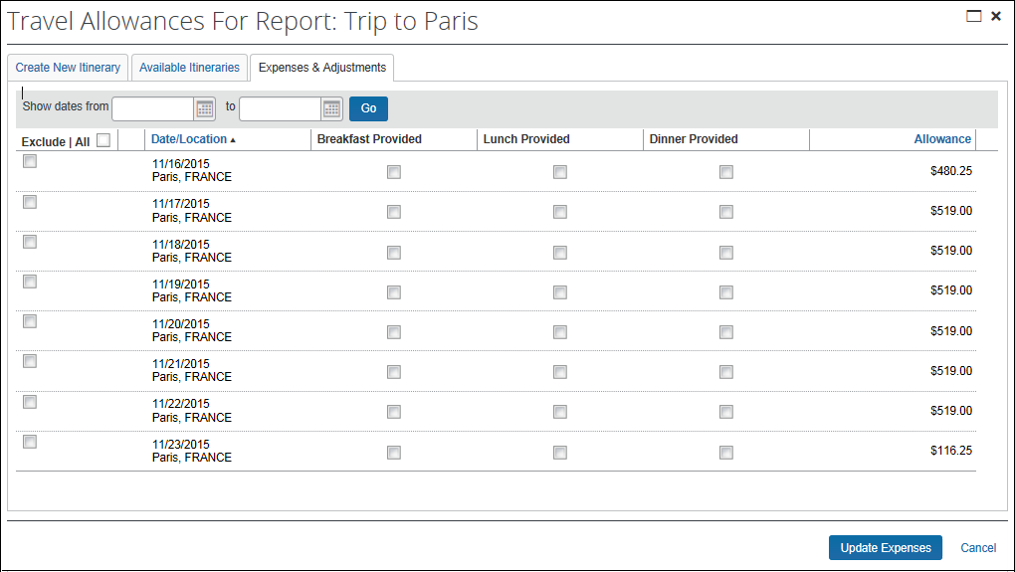

Step 4: Working with Fixed (Daily) Allowances or Adjustments

Making Adjustments
Expense calculates the allowances for the user. The user verifies the amounts and makes any required adjustments for provided meals, personal expenses, and so on.
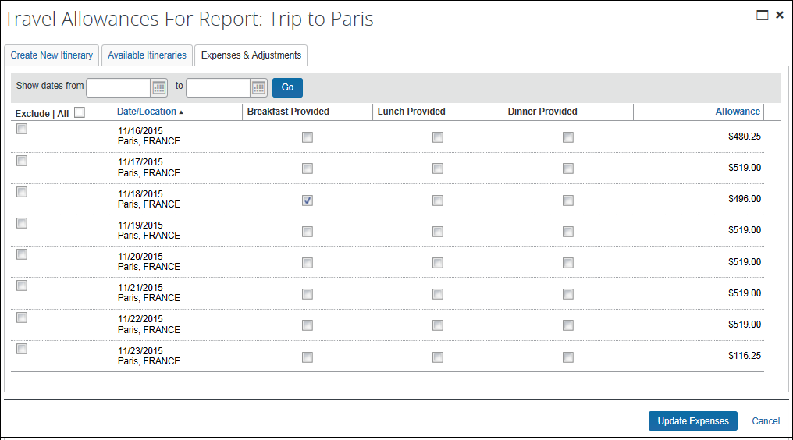
In the sample above:
- The amounts are automatically reduced for the first and last day because the user did not spend full days at that location.
- The amount is reduced for the third day because the user indicated that breakfast was provided (for example, by the hotel or conference center).
Note the following about the Expenses & Adjustments page:
- The user can enter a date range (top of the page) within which to view the fixed allowance information. To do so, the user can enter the start and end date and click Go. If the user filters by specific dates and then clicks Create Expenses/Update Expenses, then the expenses for only those days are created/updated.
- Days that are included on a submitted report are always unavailable for use on another report.
- The sample shows only one of many configuration options. The other options are discussed later in this guide.
Any deduction can reduce the allowance amount to zero but never less than zero; it can never result in a charge to the user.

Creating the Expenses for Fixed Allowances
The user clicks Create Expenses. The system then creates the appropriate expenses for each day, which appear on the user's expense report page.
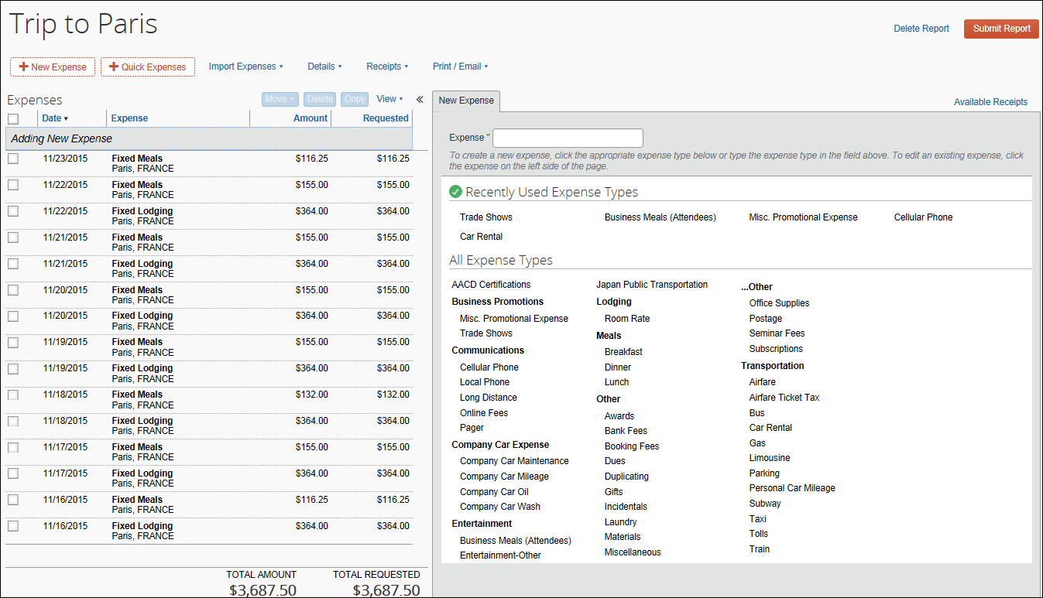
Note the following about the system-created expenses:
- Meals expenses are assigned the expense type of Fixed Meals; lodging expenses are assigned the expense type of Fixed Lodging.
- If there are both meals and lodging allowances on the same day, an expense is created for each expense type for each day.

Editing the Fixed Allowances Expenses
Note the following about fixed allowance expenses:
- The user can edit fixed allowance expenses on the expense report page, for example, to add information for company-specific custom fields. The other fields are read-only and cannot be changed.
- If the user changes any information on the Expenses & Adjustments page after creating expenses, the user clicks Update Expenses to make the adjustments.
- If the user changes any information on the itinerary that affects fixed allowances (like adding or removing stops), the user must return to the Expenses & Adjustments page and click Update Expenses.
- If rate information is changed after the fixed allowance expenses have been created, the amounts are not automatically updated. The amounts will be updated if the user opens the Expenses & Adjustments page and then clicks Update Expenses or when the user submits the report.
- If the actual expenses are imported through the company card import but the user was reimbursed with fixed allowances, then the user should mark the imported expenses as personal.
At this point, the user is ready to work with the reimbursable expenses.

Step 5: Working with Reimbursable (Actual Expense) Allowances
For reimbursable allowances, the user must enter the expenses on the expense report or import them (company card import).
The user enters the expense information as usual (on the Expense or New Expense tab of the expense report page) using the meals or lodging expense type and selects the Travel Allowance check box. For imported company card transactions, the user edits the imported transaction, completes any required fields, and selects the Travel Allowance check box.
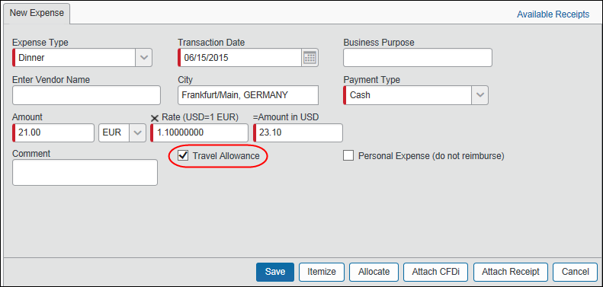
The Travel Allowance check box appears only if the user is eligible to use travel allowances and only for the appropriate expense types. For example, if the user selects the Airfare expense type (not applicable to travel allowance), the Travel Allowance check box does not appear.
When the user saves the expense (and the Travel Allowance check box is selected), the system compares the itinerary information to the expense. If the date on the expense:
- Falls within the date range of the itinerary, the system calculates the reimbursement amount (displayed on the Reimbursable Allowances Summary page).
- Does not fall within the date range of the itinerary, a message appears informing the user that the expense date is outside the date range. The user must change the expense date, change the itinerary date(s), or clear the Travel Allowance check box.
If an itinerary is not already assigned to the report when an expense is saved, the user receives a message indicating that the expense report cannot be submitted until an itinerary is assigned.
After the user enters or imports all expenses, the user selects Details > Reimbursable Allowances Summary.
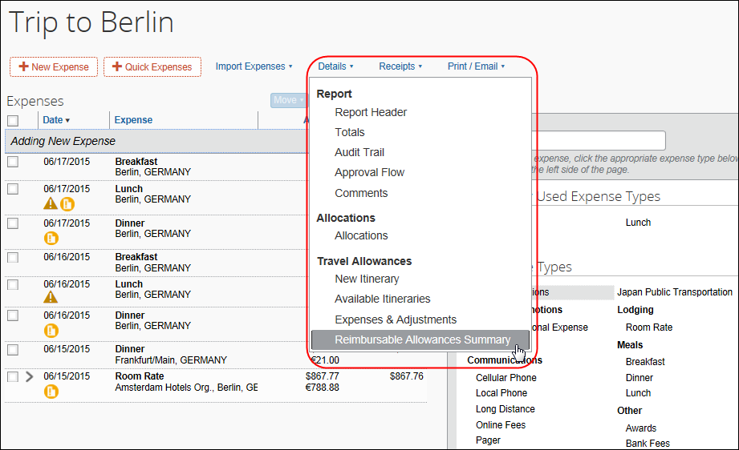
The Reimbursable Allowances Summary page appears.
The user can also use this menu to access the attached itinerary, other available itineraries, and fixed allowances. These pages are similar to the ones seen in the wizard.
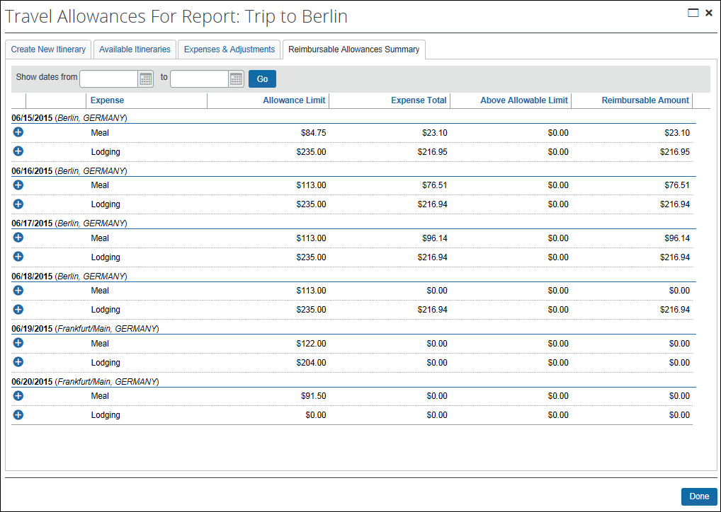
Note the following about the Reimbursable Allowances Summary page:
- The user can enter a date range (top of the page) within which to view the reimbursable allowance amounts. To do so, the user can enter the start and end date and click Go.
- The sample shows only one of many configuration options. The other options are discussed later in this guide.

Editing the Expenses for Reimbursable Allowances
Note the following about reimbursable allowance expenses:
- The user can edit a reimbursable expense using his/her expense report, for example, to add information for company-specific custom fields. Changes in amounts or dates may affect the totals that appear on the Reimbursable Allowances Summary page.
- When the user changes any information on the itinerary that affects reimbursable allowances, the system updates the reimbursable allowance accordingly. If a date is removed from the itinerary, all associated reimbursable allowance expenses will be flagged as exception items (cannot be submitted) since each reimbursable allowance expense must match a date on an itinerary associated with the report.
- When the user changes any information on the Expenses & Adjustments page, the system updates the allowance limits accordingly.
At this point, the user has reviewed all allowances and made any adjustments. The user can now submit the expense report for reimbursement.

What the User Sees – Other Expense Reports Pages

Itemized Expenses
Note the following:
- Reimbursable (actual expenses) allowances: If a user itemizes a reimbursable expense, the Travel Allowance check box is removed from the "parent" expense and is assigned to each of the itemizations.
The date of the itemized entry – not the "parent" entry – is the date used by Expense for calculating the daily totals, validation, and so on.
- Fixed (daily) allowances: A fixed allowance can be itemized by the system if the company has selected this configuration option for fixed allowances. This type of itemization is different from user-entered itemizations; its only purpose is to provide the itemization of the user-entered adjustments in order to provide for proper accounting. The itemizations are not visible on the expense report like other expenses; they are visible only on the Expenses & Adjustments page.

Approvals
Note the following:
- Reimbursable (actual expenses) allowances: The approver can lower the approved amount of the expense to disallow unreasonable amounts. (This is assuming the company allows the approver to adjust amounts.)
The approver adjusts the amount in the Approved Amount field as usual, but the actual pro-rated change is reflected in a read-only field (Reimbursable Amount). (That is, the approver can change the Approved Amount by 10.00 USD but the Reimbursable Amount field may change by 8.50 USD.)
The way the change appears on the approver's screen depends on the limit/no limit setting. For "no limit" reimbursable allowances, there is no change on the approver's screen. However, regardless of the limit/no limit setting, approver changes always affect journal entries.
 Refer to the information about prorating in the System Calculation of Reimbursable Expenses section of the guide.
- Fixed (daily) allowances: The approver cannot adjust the amount of a fixed allowance expense, so the Approved Amount field is read-only.

What the User Sees – Wizard and Non-Wizard Pages
A previous section described the user experience if the system was configured to launch the wizard automatically. The user can also access the wizard manually.
If there is no itinerary already associated with an expense report, the user can access the travel allowance wizard by selecting the Details menu and then any of the options under Travel Allowances.
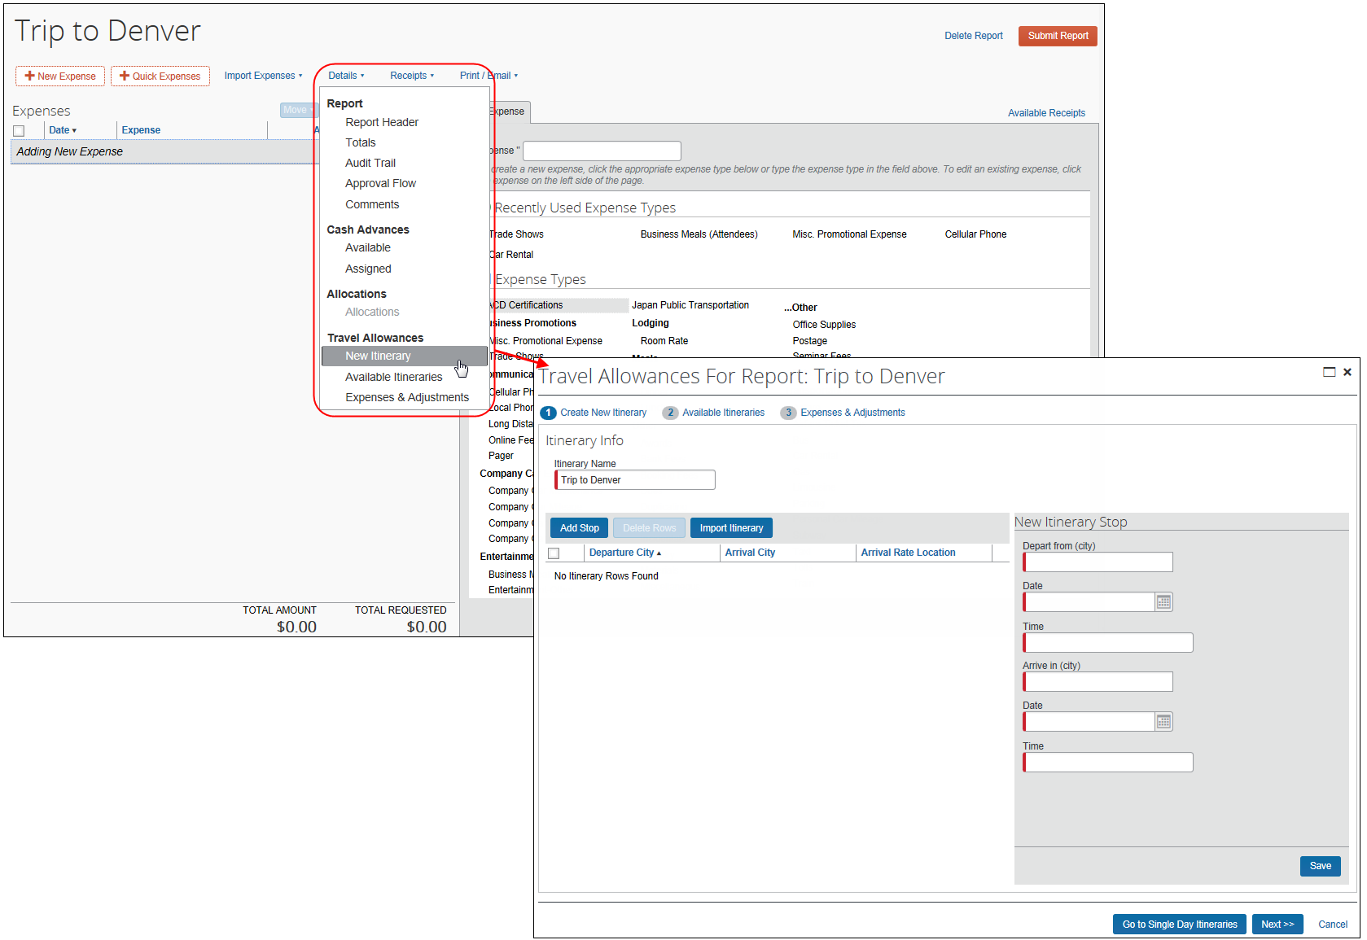
If there is an itinerary already attached to the report, the user will see the standard travel allowance pages (non-wizard) when they select the travel allowance options on the Details menu.

Wizard vs. Standard (Non-Wizard) Pages
The wizard format includes numbered steps instead of tabs, and a Next button that walks the user through the steps in order.
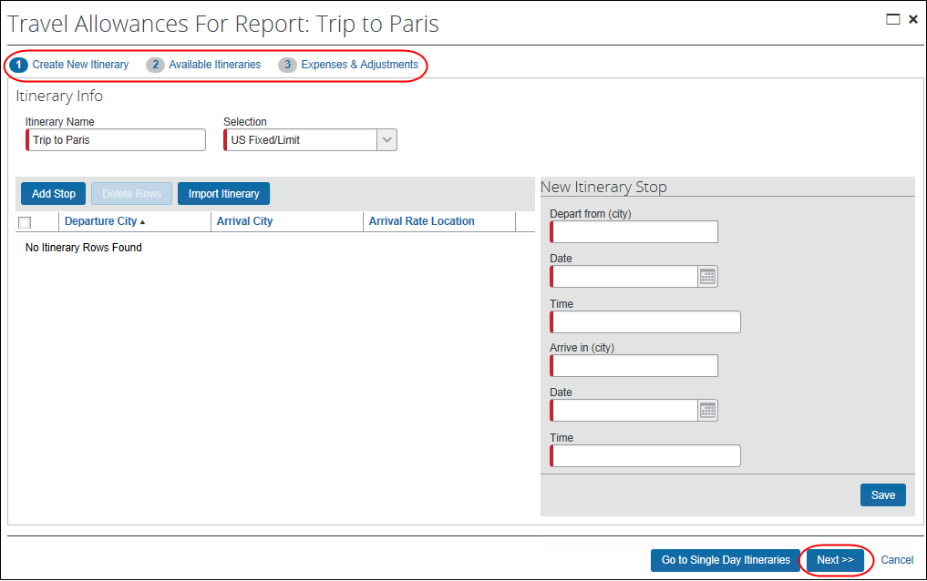
The non-wizard format includes tabs instead of numbered steps, and has both a Next and a Done button, allowing the user to navigate to the tabs in any order.
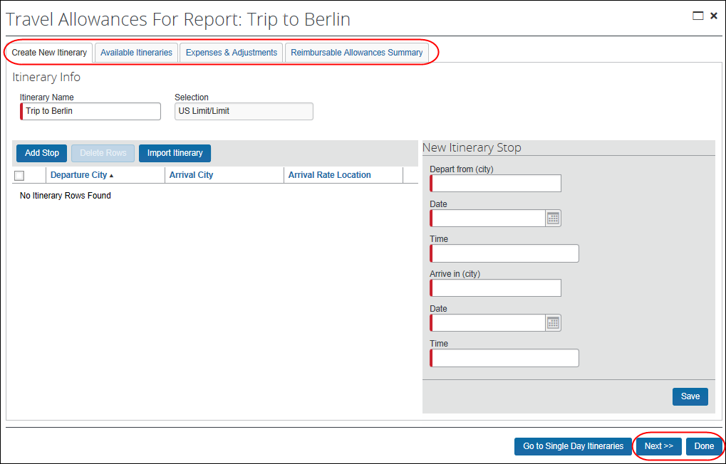

Configuration Options

Configuration Options for the Expenses & Adjustments Page
There are several configuration options that can affect the Expenses & Adjustments page. There are columns that always appear (required columns) and columns that appear only if configured to appear (optional columns).

Required Columns
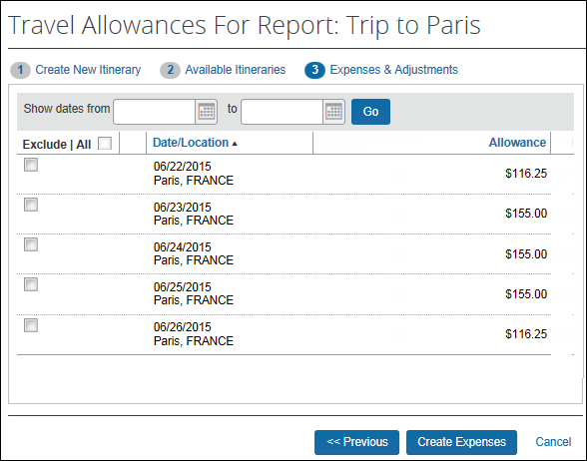
Figure 1: Required columns on the Expenses & Adjustments page
The following columns always appear.
Column | Description
Exclude/All | The user can click All to select all rows, or select (enable) the check box for each row that represents:  - Personal time; for example, if the user adds a few personal vacation days to the end of a trip and will not be reimbursed by the company  - Days that are not to be included on the current expense report; such as when an itinerary spans several expense reports  The Expenses & Adjustments page applies to the entire itinerary for each itinerary assigned to the report. If an itinerary covers a four-week trip but the company requires weekly expense reports, the user will eventually create four expense reports, excluding all rows that do not apply to the current weekly report. For example, if an itinerary spans four weekly reports, on the first week, the user excludes the rows (selects the check boxes) that apply to the second, third, and fourth weeks. When the user prepares the second, third, and fourth reports, the user excludes the upcoming weeks; the system automatically excludes (the check box is selected) the rows that are associated with the previous expense reports.  For each row that the user manually excludes, the amount in the Allowance column is zero and no fixed allowance expense will be created. For each row that is excluded by the system (indicating the days that were included on a previous report), the allowance amounts appear.
Date/Location | Displays the date and location associated with that row, as indicated on the itinerary
Allowance | Displays the total allowance for the day (meals/incidentals and lodging) that the user will be reimbursed  The rate used and displayed is the government rate for Government Only or the company rate for either Company Only or Government and Company rates.

Optional Columns
There are several additional configuration options that can affect the page.
Be aware that not all countries support all of these configuration options. Also, even if an option is supported by a country, it may not be required so a company may not use it.
 Refer to the individual country-specific Travel Allowance Configuration Guides for specific requirements.

Configurable Column Headings
Certain columns headings can be configured and localized by the company. (Configuration is detailed in the configuration section at the end of this guide.)
The first three options are mutually exclusive:
- No provided meals: If the system is configured to not deduct for provided meals, there are no columns shown for meals.
Figure 2: No deduction for provided meals
- Provided meals check boxes: If the system is configured to deduct for provided meals and the provided meals do not include benefit-in-kind meals, the breakfast/lunch/dinner check box columns appear.
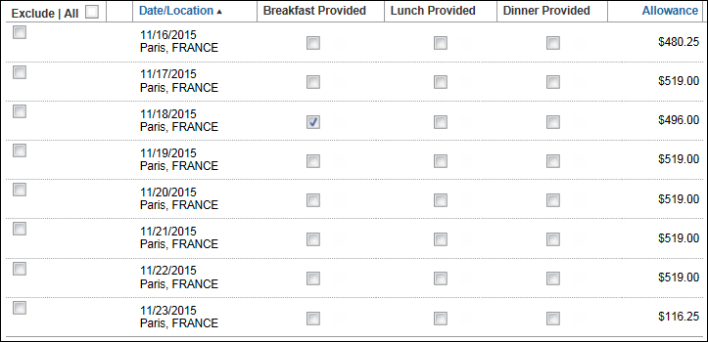
Figure 3: Provided meals check boxes
For each check box selected, the amount in the Allowance column is reduced by the amount defined in the rate tables.
- Provided meals drop lists: This option is required for Germany but can be used by other countries. If the system is configured to deduct for provided meals and the provided meals can include benefit-in-kind meals, the meals check boxes are replaced by drop lists.
When configuring, there are two choices: Germany Deduction List and Benefit In Kind Deduction List.
- Germany Deduction List configurations:
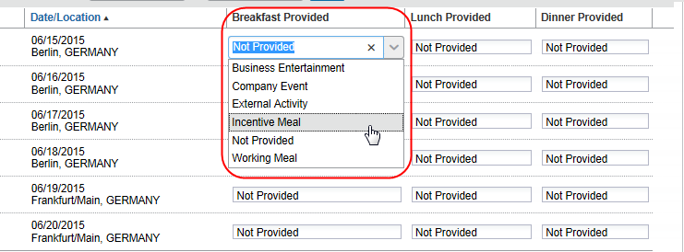
Figure 4a: Provided meals drop lists (Germany Deduction List)
The list for Germany Deduction List configurations contains these choices:
Option | Description
Business Entertainment | The meal was provided and the meal amount is deducted from the allowance.
Company Event | The meal was provided and the meal amount is deducted from the allowance.
External Activity | The meal was provided and the length of the trip determines the action:  - If the total trip duration is over 8 hours, then the provided meal amount is deducted from the allowance.  - If the total trip duration is less than 8 hours (no allowance is earned), the value is recorded for reporting purposes but no adjustment is made to the allowance amount. The information may be used in reporting to determine the benefit in kind amount.
Working Meal | The meal was provided and the meal amount is deducted from the allowance.
Incentive Meal | The meal was provided and the value is recorded for reporting purposes but no adjustment is made to the allowance amount.
Not Provided | The meal was not provided and no deduction from the allowance will be made for the meal.
- Benefit in Kind Deduction List configurations:
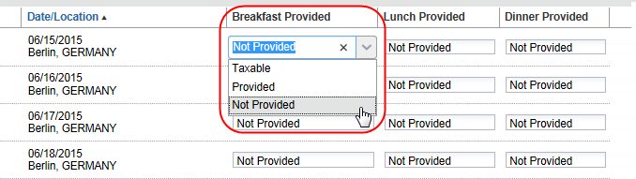
Figure 4b: Provided meals drop lists (Benefit in Kind Deduction List)
The list for Benefit in Kind Deduction List configurations contains these choices:
Option | Description
Provided  (Prorated) | The meal was provided and the configured meal amount will be deducted from the allowance.
Not Provided  (No Prorate) | The meal was not provided and no deduction from the allowance will be made for the meal.
Taxable  (Tax Receipt) | The meal was taxable as a benefit-in-kind and the configured meal tax amount will be deducted from the allowance.
The fourth configuration option is a setting applicable to the provided meals configurations.
- Provided meals with breakfast amount: This option was used in historical regulatory rules by Germany. If the system is configured to deduct for provided meals and the user knows the amount of the provided breakfast, there is an additional column for the user to enter the breakfast amount. (The Meals Rate column shown here is optional.)
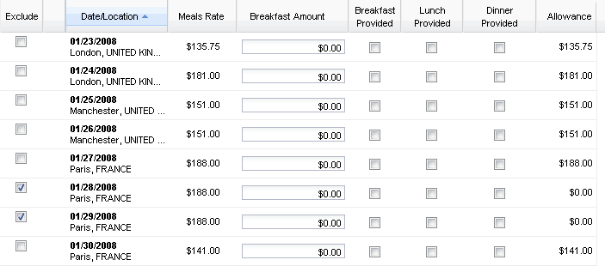
Figure 5: Provided meals with breakfast amount (Germany only)
The remaining configuration options are independent of the other options:
- Meals Rate: The Meals Rate column shows the maximum amount that can be paid for each row, based on rates the company uses; that is, this is the amount before any adjustments
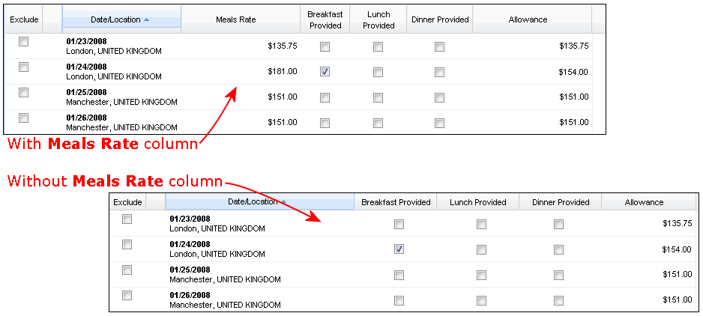
Figure 6: Meals Rate column
- Overnight allowance: If the system is configured to allow for Overnight allowance, the Overnight column appears.
For Finland, the column is named Night Allowance.
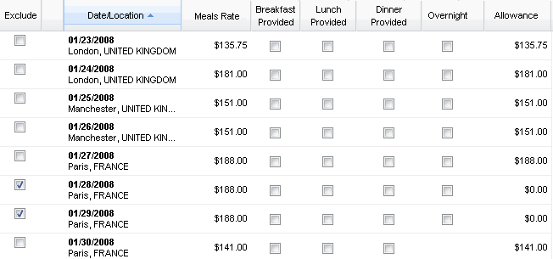
Figure 7: Overnight allowance
If this check box is selected, the user is reimbursed the overnight rate rather than the lodging rate.
- If lodging is set for fixed or reimbursable allowance, the lodging amount uses the overnight amount.
- If lodging is not set to use an allowance, the overnight amount is added to the meals allowance.
The final day of the trip will not show a check box for this column since overnight does not apply to the last day.
- Display Government and Company Limit Comparison: If the system is configured to use both government and company rates and to display the comparison between those rates, the Above Limit column appears. In this configuration, the user is reimbursed based on the company limit. The government limit is used for splitting the expense amounts into the allowable (up to the limit) and unallowable (above the limit) amounts for export to the financial systems.
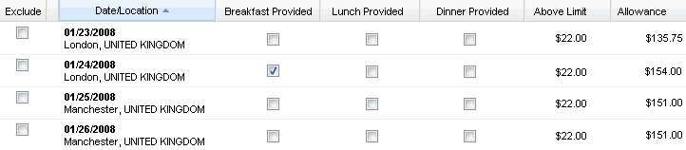
Figure 8: Above Limit
- Use Lodging Type: This option is used only by Norway and Germany. If the system is configured to allow the user to select the lodging type, the Lodging Type list appears in the first column. The option selected by the user determines the amount the user is reimbursed for meals.
- For Norway configurations:
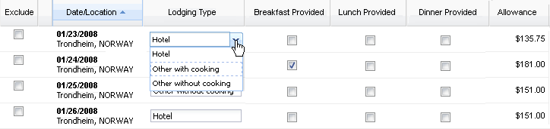
Figure 9a: Use Lodging Type (Norway)
The list for Norway configurations contains these choices:
Option | Description
Hotel / None | The user stayed in a hotel.
Other with cooking | The user stayed in a housing option, other than a hotel, that had cooking facilities.
Other without cooking | The user stayed in a housing option, other than a hotel, that did not have cooking facilities.
- For Germany configurations:
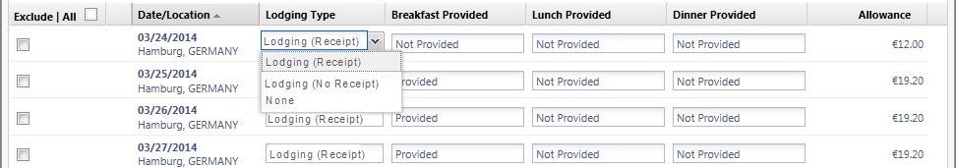
Figure 9b: Use Lodging Type (Germany)
The list for Germany configurations contains these choices:
Option | Description
Lodging (Receipt) | The user stayed in a hotel and has a receipt for the expense.
Lodging (No Receipt) | The user stayed in a hotel or other accommodations but there is no receipt available.
None | The user did not have lodging.
- Use Percent Rule: This option is used only by the United States. If the system is configured to allow the user to select the percent rule, the Use Percent Rule column appears. This allows the system to adjust the meals and/or lodging rates by a GSA-defined percentage. For example, assume that the user had no choice about accommodations for a conference so the accommodations were more expensive than generally allowed. The percent rule would allow perhaps 150% of the standard lodging allowance rate.
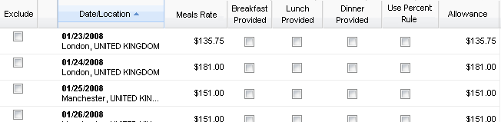
Figure 10: Use Percent Rule
- User Entry of Extended Trip: If the system is configured to allow the user to select the extended trip rule, the Extended Trip column appears. The configuration defines the rates that apply to trips that last longer than a defined number of days, for example 90 days.
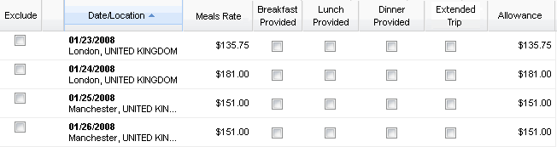
Figure 11: User Entry of Extended Trip
- Display Base Meals Rate In Rate Currency: If this option is used and if the base rate currency is available, the amount displays in the Meals Rate column in the reimbursement currency and the rate currency.
This option is not supported by all configurations; please check the applicable country setup guide to determine if it is supported for that configuration.
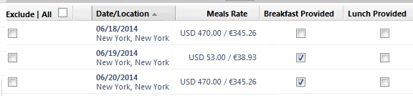
Figure 12: Display Base Meals Rate In Rate Currency

Configuration Options for the Reimbursable Allowances Summary Page
There are several configuration options that affect the Reimbursable Allowances Summary page.

Required Columns
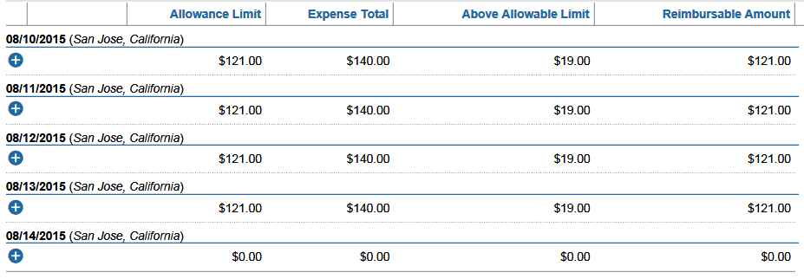
Figure 13: Required fields on the Reimbursable Allowances Summary page
The following columns always appear.
Column | Description
Date and Location (no heading) | Date and location associated with that row, as indicated on the itinerary
Allowance Limit | The limit, defined either by the company or by the government
Expense Total | As entered by the user on the expense report page
Above Allowable Limit | Amount over the limit; column name may change based on the configuration
Reimbursable Amount | Total allowance for the day (meals/incidentals and lodging) that the user will be reimbursed
When a row is expanded, the expense type, vendor, foreign amount, and amount (in the user's reimbursement currency) appear.
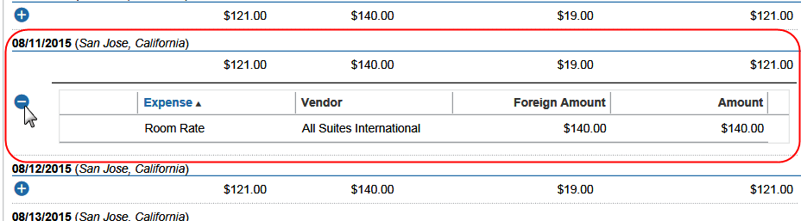
Figure 14: Expanded detail on the Reimbursable Allowances Summary page

Optional Columns
There are several other configuration options that can affect the Reimbursable Allowances Summary page.
Be aware that not all countries support all of these configuration options. Also, even if an option is supported by a country, it may not be required so a company may not use it.
 Refer to the individual country-specific Travel Allowance Configuration Guides for specific requirements.
- Actual expenses (with over-limit tracking) (formerly known as Reimbursable - No Limit): The expense amount is paid, regardless of the limit.
The amount in the Reimbursable Amount column always equals the amount in the Expense Total column.
The comparison to the limits (Above Allowance Limit column) is used for splitting the expense amounts into the allowable (up to the limit) and unallowable (above the limit) amounts for export to the financial systems. The rate used (Allowance Limit column) is the government rate for Government Only configurations or the company rate for Company Only configurations.
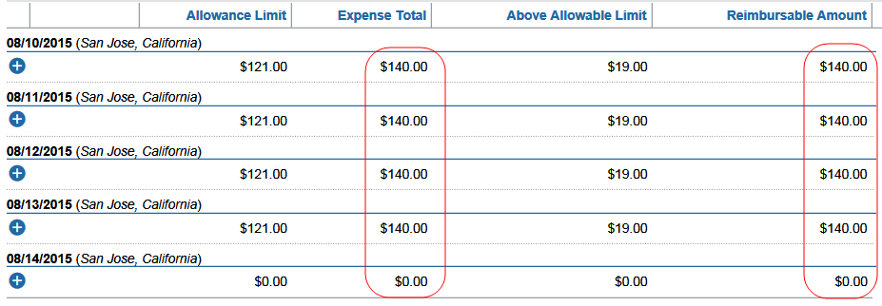
Figure 15: Actual expenses (with over-limit tracking) (formerly known as Reimbursable - No Limit)
- Actual expenses up to allowed limit (formerly known as Reimbursable - Limit): The reimbursable amount is capped by the rate limit.
The amount in the Reimbursable Amount column equals the amount in the Allowance Limit column or the Expense Total column, whichever is smaller.
The comparison to the limits (Above Allowance Limit column) is used to limit the amount reimbursed to the user and automatically sets the authorized amounts for the expenses accordingly. The rate used (Allowance Limit column) is the government rate for Government Only configurations or the company rate for Company Only configurations.
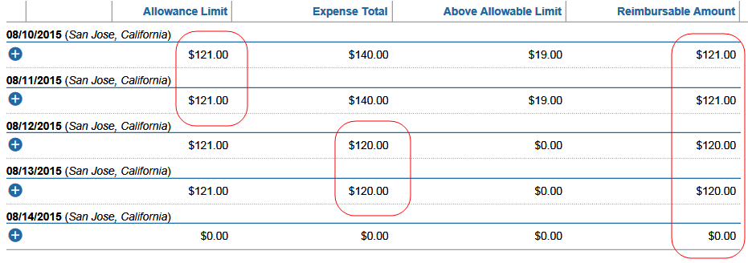Figure 16: Actual expenses up to allowed limit (formerly known as Reimbursable - Limit)
- Actual expenses up to allowed limit (formerly known as Reimbursable - Limit) – Government and Company Rates: The reimbursable amount is capped by the company rate limit.
The amount in the Reimbursable Amount column equals the amount in the Allowance Limit column or the Expense Total column, whichever is smaller.
The comparison to the government rate limits is also displayed. The government limit (Above Gov Limit column) is used for splitting the expense amounts into the allowable (up to the limit) and unallowable (above the limit) amounts for export to the financial systems. The rates used (Allowance Limit column) are both the government rate and the company rate for the Government and Company rates configurations.
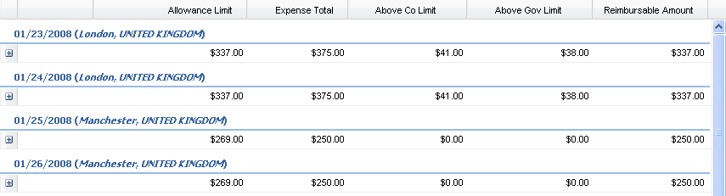Figure 17: Actual expenses up to allowed limit (formerly known as Reimbursable - Limit) – Government and Company Rates
- Actual expenses (with over-limit tracking) (formerly known as Reimbursable - No Limit) – Government and Company Rates: The columns appear as in the sample above, but the amount in the Reimbursable Amount column equals the amount in the Expense Total column.
- Combined meals and lodging: Another option is to combine meals and lodging rates for comparison purposes. If both are configured for reimbursable allowances that are combined together, the meals and lodging allowances and expenses are added together. If they are not combined, two rows may be required for each day: one for lodging and one for meals. (No sample shown.)

Validations, Calculations, and Adjustments

Validation and Submit Checks
Travel allowances require some validation and submit checks. These are primarily to identify and either prevent submission or notify approvers of cases where expenses are being claimed that may not be allowed.
Validation/Check | Description
On Expense Save Validation | For reimbursable allowances, the system validates that the expense date is within the dates of the associated itinerary. If a user creates an expense and selects the Travel Allowance check box but the date of the expense is not within the dates of the associated itinerary, the expense cannot be submitted. The user must clear the Travel Allowance check box or change the date on the expense or the itinerary.  NOTE: For itemized expenses, the date of the itemized entry – not the "parent" entry – is the date used by the system for validation.
On Submit Checks | In most companies, a user is not allowed to claim both a travel allowance expense and a standard expense for meals or lodging on the same day. The user should not have these expenses on the same day:  - Fixed lodging and standard lodging  - Fixed meals and standard meals  - Reimbursable lodging and standard lodging  - Reimbursable meals and standard meals  The exception creates a message that is visible to all participants in the workflow (user, approver, and processor) with a level of zero. This exception does not prevent the user from submitting the report. It is, however, an indication to the approver that the day's expenses should be reviewed closely.  This exception occurs based on the date of the expenses that have been submitted. It does not require that the expenses appear on the same report.  NOTES:  - The setting is Use System Exception on the Modify Travel Allowance Configuration page. Refer to the configuration section of this guide.  - The exception message reads (approximately): "There is a possible Travel Allowance conflict with another entry having the same expense code for this date."

Audit Rules
The administrator can create additional audit rules.
- For additional information, refer to Travel Allowance Configuration – Optional Configuration Elements in this guide.

System Calculation of Reimbursable Expenses

Pro-Rating Reimbursable Expenses Over the Entire Day
If reimbursable allowances are used and the company pays only up to a limit, the total of the expenses can exceed the reimbursement amount. In the sample below, the expenses for lunch (10.60), dinner (30.19) and incidentals (2.30) total 43.09 but the user will be reimbursed only 23.50.
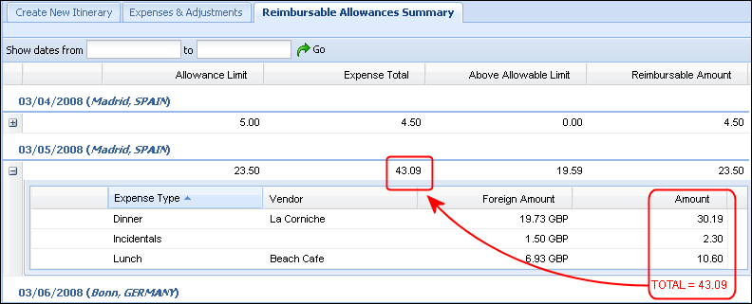
After the user submits the expense report, the system adjusts the approved amount for each expense proportionally. For example, in this case:
Expense | Original Amount | As a % of the total of 43.09 | Same % of the reimbursement amount of 23.50
Dinner | 30.19 | 70% | 16.45
Incidentals | 2.30 | 5% | 1.18
Lunch | 10.60 | 25% | 5.87
Total | 43.09 | 100% | 23.50
The system adjusts the approved amount for lunch to be 5.87, dinner to be 16.45, and incidentals to be 1.18.

Charging the Over-Limit Amount Against Lodging then Meals
The company can opt to offset the over-limit amount against lodging. If so:
- If the lodging amount is less than the over-limit amount, the lodging amount is reduced to zero and the remaining over-limit amount is pro-rated across the other expenses.
- If there is no lodging or if the lodging amount is on another report, the over-limit amount across the other expenses.

Reimbursable Allowance Summary Totals Across Multiple Reports
The system attempts to ensure that the reimbursable allowance is pro-rated over the entire day's expenses, taking into account expenses on a report that has been submitted. For example:
- A user locates a receipt for an expense that should have been included with a previously submitted expense report; or
- Approvers or processors change approved amounts.
In the case of the missing receipt, when the user creates the new expense, the system checks across multiple reports for the same dates as the submitted itinerary/expense report. The system also checks across multiple reports when approvers or processors change approved expense amounts. Previously submitted expense approved amounts are not adjusted, but the new expense can use only the portion of the allowance amount that is still available for reimbursement.
If such expenses/changes are found, the expenses/changes are included in the expense total for the day and the rest of the day's totals are recalculated. Once this recalculation has been made, these expenses from other reports will show in the current report's expense detail for the date. Both the summary row and the expanded row for the date show the icon to indicate to the user and other reviewers that a transaction from another report has been identified, though the transaction may or may not create an adjustment.
No adjustments are made to journal entries for previously submitted expenses; any required changes will be on the current expense report alone. In addition, the amount up to the limit is always "used up" on the current expense report's expenses.
For example, assume the user submitted the report containing the reimbursable travel allowance information shown below.
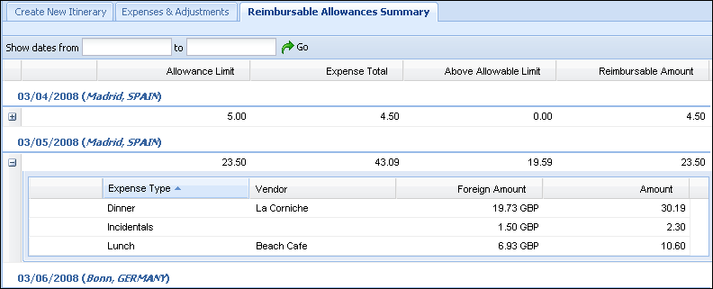
Then, the user locates the breakfast receipt and enters it on a new report.
On the Reimbursable Allowances Summary page, the icon appears on the summary row and the expanded area for the affected expense. Notice the amounts in the Expense Total column and the Above Allowable Limit column are increased by the amount of the breakfast expense (11.05 in the Amount column).
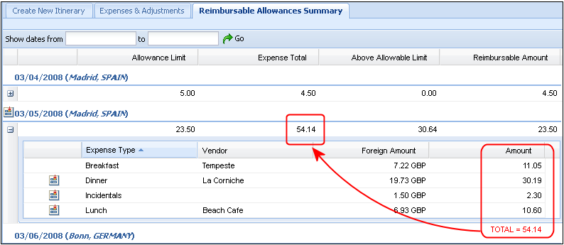
The date of the itemized entry – not the "parent" entry – is the date used for calculating the daily totals.

Record Adjustments
A lock icon may appear on selected itinerary rows and expense dates, along with text explaining the locked condition. For example, if the expense has been submitted, the lock icon appears and when hovering over the icon explanatory text appears as well.
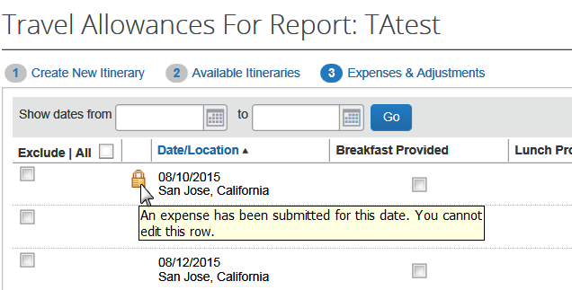
A lock icon on an itinerary row indicates that row may no longer be edited. If the expenses are not for the exact date represented on the row, it is often possible to insert additional rows to the itinerary using different dates, as long as those rows do not impact the rate location assignment or allowance calculation for the submitted expenses.
The system locks and unlocks the travel allowance itinerary row records in the cases shown in the table below.
Action | Description
Report submit | The system locks the associated rows of the travel allowance table so that the system knows when the itinerary rows may be edited.
Report return (Send Back to Employee) | The system unlocks the rows where no other submitted expenses require them to remain locked.
Report delete | The system unlocks the rows where no other submitted expenses require them to remain locked. If the itinerary is not associated with any other report, the system prompts if the entire itinerary should be deleted.  If it is associated with other reports, the system adjusts the appropriate report totals and makes the appropriate journal entries for other unsubmitted reports.  NOTE: Expenses and journal amounts are not adjusted for submitted reports.
Reimbursable allowance expense delete | The system adjusts the associated travel allowance record totals, checks to see if the record should be unlocked, adjusts the appropriate report totals, and makes the appropriate journal entries for the current report and any other unsubmitted reports.

Reporting Requirements
All of the travel allowance data is stored in the data tables in an easily accessible manner in order to meet the reporting requirements for the various countries that mandate the use of travel allowances.
In many countries, the production and submission of these reports to the government on a periodic basis is a legal requirement of the local income tax codes and their production is of critical importance to our customers.

Travel Allowance Configuration Summary
The remainder of this guide describes the configuration steps, which are:
- Steps for initial configuration
- Viewing, editing, or deleting configuration information
- Configuration of optional travel allowance features

Travel Allowance Configuration – Initial Configuration

Step 1: Setting up the Hierarchy
The administrator uses the Feature Hierarchies tool to define the travel allowance hierarchy.
The Country field is not an option when defining the travel allowance hierarchy. When the system matches the user to a configuration, the system looks at the Country field and then the hierarchy. Therefore, the administrator must define the hierarchy knowing that Country is always above the first level of the hierarchy.
- For more information about setting up the hierarchy, refer to the Shared: Feature Hierarchies Setup Guide.

Step 2: Importing the Initial Configuration and Rates

Before You Begin

Calculation Properties
Calculation properties are data that is required for a particular country's implementation of their travel allowance rules. These properties represent data used when calculating or adjusting travel allowance rates. Examples of properties include factors (percentages) applied to meals rates for first/last day calculations, times or durations in hours for partial-day calculations, and trip duration in days for extended-trip calculations. The values for these properties are stored in the database for ease of maintenance when regulations change or individual clients choose to use different values. Not all countries' implementations need these calculation properties.
- For information about the calculation properties required for each country, refer to the country-specific Travel Allowance Configuration Guides.
There is no user interface for entering or modifying these values, and client-specific changes must be made directly in the database through a service request.

Travel Allowance Rates Considerations
When considering the rates to load, the administrator must include the following:
- Country-level rate for a country: Not all cities and/or subdivisions within a country are listed in the rate tables. For those countries where you know that users will travel, it is prudent to enter a "country" rate. Therefore, if the system cannot locate the city or subdivision rate, it will locate the country rate.
The actual structure of the rate location has the country designator and a NULL value loaded for both the subdivision and location name.
- "All other countries" rate: Expense requires an "all other countries" rate that it can use as a "rate of last resort." If the system fails to locate a rate during the normal rate-location process and if there is no "rate of last resort," then the transaction fails and the user cannot submit the travel allowance expenses.
The actual structure of the rate location has the country and subdivision with a NULL value and a text value in the location name.
- Effective dates: When entering rates, ensure that the associated effective dates takes into account past expenses. If you set the effective date to be today (for example), then the rates will not apply to expense with dates prior to today. Always enter rates in effective date order.
If the user's reimbursement currency is different from the travel allowance rate currency, the exchange rates between those two currencies must be loaded into the system.
 Refer to Travel Allowance Configuration – Optional Configuration Elements in this guide.

Importing the Initial Configuration and Rates
The initial load of configuration and rate data for a country is completed through an import. After the basic data has been imported, you can use Expense Admin > Travel Allowance (left menu) to view and edit configuration information as described in Travel Allowance Configuration – Editing and Viewing Configuration Information in this guide.
The travel allowance import includes the following:
- Import Settings
- Time Band Meal Rates
- Rates
- Expired Rates
- Rate Location to City Mapping
- Travel Allowance Configuration
- Travel Allowance Configuration Mapping (Organization Assignment)
- Deduction Percentages (for deriving rate data)
- Deduction Amounts (for deriving rate data)
There are three sources of additional information about the travel allowance import:
- Refer to the next section for general information about configuration options.
- Refer to the Expense: Travel Allowance Import (XML v 3) Specification.
- Refer to the individual Travel Allowance Configuration Guides for the appropriate configuration and import options for each country.

Exporting the Rates for Editing and Re-Import
Existing rate configurations can be selected and the data exported into an editable file. This allows the administrator to capture existing rates, update them, and use the overnight Travel Allowance import to re-import the modified rates. On import of the file, the new rates appear and are in use for the selected TA rate configurations.

How It Works
This feature works by selecting a TA rate configuration in the Configurations tab, which activates the Download Rates button.
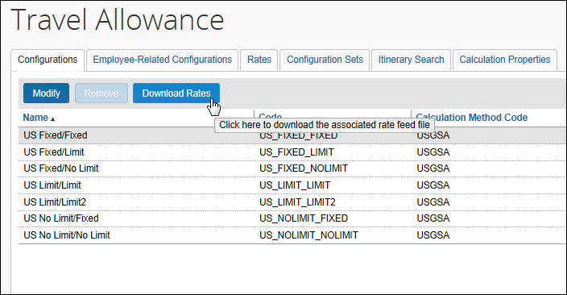
Clicking the button prepares and downloads the export rate feed file for review and editing by the administrator.
- Refer to the Expense: Travel Allowance Import (XML v 3) Specification.

Step 3: Adding the Mapping of the Company's Organization to the Configurations
There are two ways to map users to configurations. You can either:
- Map users to a single configuration (users cannot select a configuration; they use the one that you assign)
- or -
- Map users to a set of configurations (users can select from a set of configurations)
With this option, the Selection list appears on the Create New Itinerary page. Using this list, the user can select any configuration within the defined configuration set.

Map Users to a Single Travel Allowance Configuration (Users Cannot Select the Configuration)
To map the configuration to the organization:
- Click Administration > Expense (on the sub-menu).
Depending on your permissions, the page may appear immediately after you click Administration.
- Click Travel Allowance (left menu). The Configurations tab of the Travel Allowance page appears.
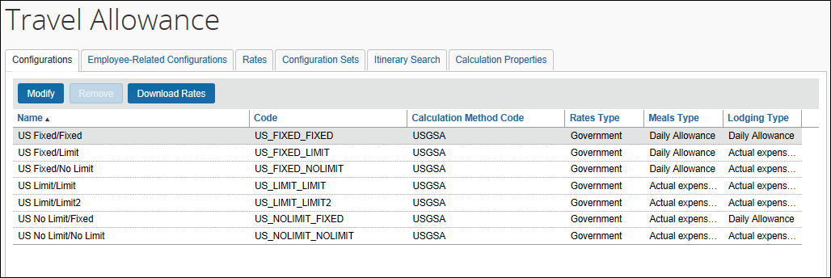
- Click the Employee-Related Configuration tab.
- Click New. The Modify Travel Allowance Configuration Assignment window appears.
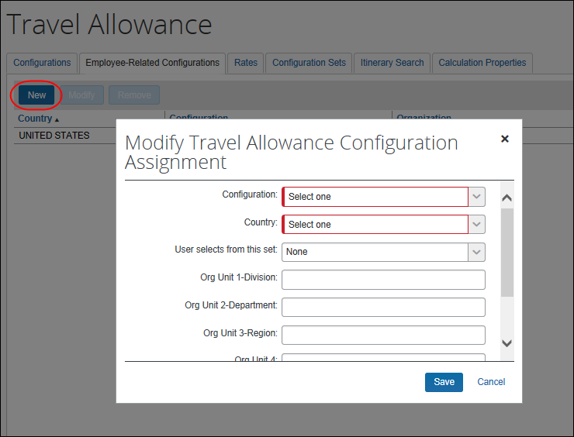
- Complete the appropriate fields.
Field | Description
Configuration | Select the name of the configuration.
Country | Select the associated country.
User selects from this list | Select None.  This field allows for user selection of configurations, as described in the next section.
(hierarchy fields) | These fields are named the same as those listed on your company's travel allowance hierarchy, such as Region, Division, and so on.  Type the desired data, as appropriate.  - The values should be the short codes used for these fields.  - There is no validation for these fields, so if you mistype the value, the hierarchy will not be altered.  - The field is case sensitive.
- Click Save.

Map Users to a Set of Travel Allowance Configurations (Users Can Select the Configuration)
To define the configuration sets:
The first step is to define the configuration sets - a named group of configurations from which a user can choose.
- Click Administration > Expense (on the sub-menu).
Depending on your permissions, the page may appear immediately after you click Administration.
- Click Travel Allowance (left menu).
- Click the Configuration Sets tab.
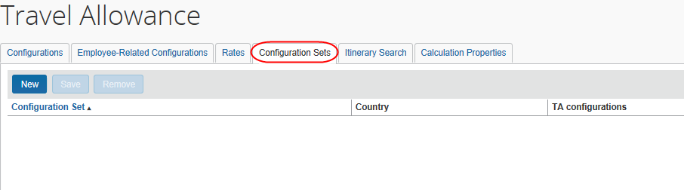
- Click New. A blank line appears.
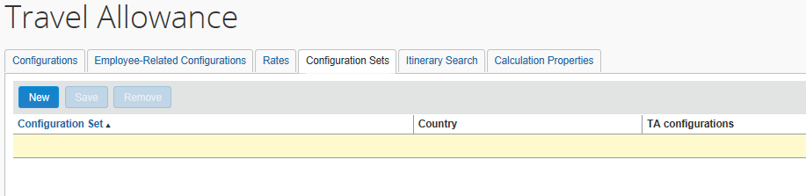
- Complete the appropriate fields.
Field | Description
Configuration Set | Enter the name of this set of configurations.  The name must be unique.
Country | Select the country.
TA Configurations | Select the configurations from the list that appears.
- Click Save.
Add as many sets as desired.
To map a configuration set to users:
- Click the Employee-Related Configurations tab.
- Click New. The Modify Travel Allowance Configuration Assignment page appears.
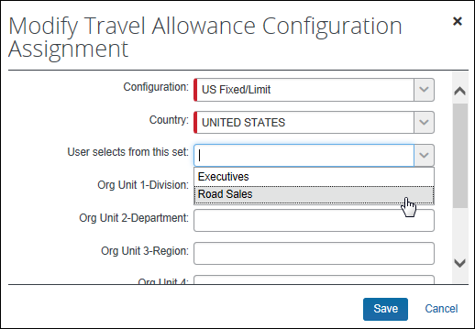
- Complete the appropriate fields.
Field | Description
Configuration | Select the name of the configuration that will be the user's default configuration.  NOTE: This configuration does not have to be one of the configurations in the configuration set, but it likely will be.  While creating an itinerary, a user can elect to use the default configuration or can select a travel allowance configurations in the set.
Country | Select the country.
User selects from this set | Select the name of the configuration set from which the user can select when creating an itinerary.
(hierarchy fields) | These fields are named the same as those listed on your company's travel allowance hierarchy, such as Region, Division, and so on.  Type the desired data, as appropriate.  - The values should be the short codes used for these fields.  - There is no validation for these fields, so if you mistype the value, the hierarchy will not be altered.  - The field is case sensitive.  This information will be used to determine the default travel allowance configuration.
- Click Save.

Step 4: Configuring Optional Features
Review the Travel Allowance Configuration – Optional Configuration Elements section in this guide and determine which (if any) of the options your company wants to use.

Travel Allowance Configuration – Editing and Viewing Configuration Information

Editing a Travel Allowance Configuration
After the initial import, the configuration data can be maintained in Administration > Expense > Travel Allowance (left menu).
To edit general configuration settings:
- Click Administration > Expense (on the sub-menu).
Depending on your permissions, the page may appear immediately after you click Administration.
- Click Travel Allowance (left menu). The Configurations tab of the Travel Allowance page appears.
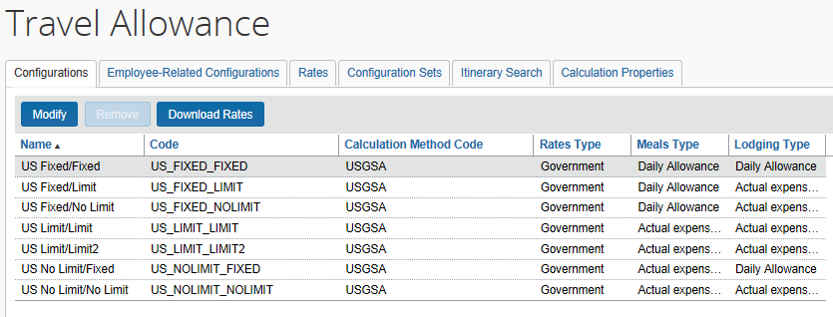
- Either:
- Click the desired configuration and then click Modify.
– or –
- Double-click the desired configuration.
The Modify Travel Allowance Configuration window appears.
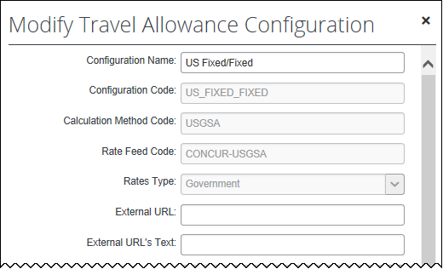
- Make the desired changes.
This page is quite long and is displayed in several parts.
Field | Description | Notes
Configuration Name | Unique name for the configuration
Configuration Code | All travel allowance configuration data that is being imported is associated with this Configuration Code.  This code must be used in subsequent imports in order to replace existing configurations with updated values.  This code must also be used when importing travel allowance configuration map records used to associate users with a particular configuration. | This field cannot be changed – either by import or by using this page.
Calculation Method Code | Identifies the applicable country-specific travel allowance calculation method assigned to the configuration; this code is assigned during the import process | This field cannot be changed – either by import or by using this page.
Rate Feed Code | Identifies the rate feed assigned to the configuration; this code is assigned during the import process | This field cannot be changed – either by import or by using this page.
Rates Types | Type of rates:  - Government: Use only government rates; one set of rates is loaded  - Company: Use only company rates; one set of rates is loaded  - Government and Company: Use both rates; two sets of rates are loaded for all locations | Not editable in the UI
External URL | The client-specified URL that directs the user to a web page with itinerary (or similar) information | In format "http://www.yourdomain.com"
External URL's Text | The tooltip text that is displayed next to the External URL link
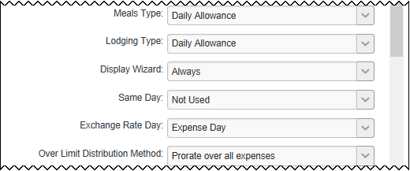
Field | Description | Notes
Meals Type  Lodging Type | Type of travel allowance:  - Not Used: No travel allowance is used.  - Daily Allowance (also known as Fixed): Users are reimbursed for the rate amount with no consideration of actual expenses.  - Actual expenses (with over-limit tracking) (also known as Reimbursable - No Limit): Users are reimbursed for the actual amount of expenses. The rates are loaded for comparison purposes and for creating allowable and unallowable journal entries. **  - Actual expenses up to allowed limit (also known as Reimbursable - Limit): Users are reimbursed for the actual amount of expenses up to the limit. **  **  - If only government or only company rates are used, then all calculations and limits are based on these rates.  - If both government rates and company rates are used, then all calculations and limits are based on company rates. Government rates are used only for calculating the allowable/ unallowable amounts in the journal entries. | Either field can be None; both fields cannot be None.
Display Wizard | Allows the display of the travel allowance wizard immediately after the user saves the report header  Options:  - Always: After the user saves the expense report header, the wizard starts.  NOTE: In those cases where the wizard starts but the user does not want to use it, the user can click Cancel. The wizard closes.  - Never: The wizard does not start automatically nor is the user prompted. The user can access the wizard manually using the Travel Allowance options on the Details menu.  - Prompt: After the user saves the expense report header, the user is asked if any expenses are related to travel allowance. If the user clicks Yes, the wizard starts.  NOTE: See Wizard Prompt Text below. | IMPORTANT: Regardless of the option selected here, if there is no itinerary assigned to an expense report and the user selects Details and then any of the options under Travel Allowances, the wizard starts.  - Refer to What the User Sees – Wizard and Non-Wizard Pages in this guide.
Wizard Prompt Text (optional) | This field appears only if Display Wizard is set to Prompt.  Text displays to the user when they are prompted to use the wizard.  - If the client wants a custom message for the user, the admin can enter a custom message in this field, using letters, numbers, and symbols – with a maximum of 512 characters.  - If the client wants to use the default message, the client leaves this field blank. The default message is: Will this report include travel allowance expenses? | This is a text field and does not support HTML formatting.
Same Day | Defines whether two itineraries can share the same date; for example, if the user ends one trip in the morning and starts another trip later that same day  Options:  - Not Used: Two itineraries cannot have the same date  - Cumulative: Expense adds the hours of each trip together and then calculates the allowance based on that total  For example, if a user had four hours of one trip and six hours of another, the user receives the allowance for ten hours.  - Separate: Expense calculates the amount for each trip separately  For example, if a user had four hours of one trip and six hours of another, the user receives a four-hour allowance and a six-hour allowance.
Exchange Rate Day | Defines the exchange rate to use to convert the allowance to the user's reimbursement currency, if the allowance currency is different from the reimbursement currency  Options:  - Expense Day: Rate in effect on the date of the expense (default)  - First Itinerary Day: Rate in effect on the first day of the trip  - Last Itinerary Day: Rate in effect on the last day of the trip
Over Limit Distribution Method | Defines how to distribute the amount of the allowance that is over the limit  Options:  - Prorate over all expenses: Over-limit amount prorated and distributed over all expenses (default)  - Apply to Lodging first and Meals second: Entire over-limit amount applied to the lodging expense, where possible

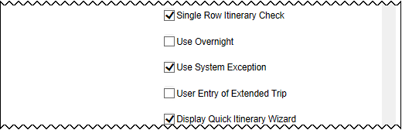
Field | Description | Notes
Single Row Itinerary Check | Activates a system audit rule that prevents the submission of an itinerary with only one row
Use Overnight | Displays an Overnight column on the Expenses & Adjustments page (Figure 7) | Requires an overnight rate to be present in the system
Use System Exception | Use the submit check to identify standard and travel allowance expenses on the same day (as described in Validation and Submit Checks in this guide) | This setting is commonly referred to as On Submit Check.
User Entry of Extended Trip | Displays the Extended Trip column on the Expenses & Adjustments page (Figure 11)
Display Quick Itinerary Wizard | Displays the Single Day Itineraries page as a quick-entry option for users (as described in the Creating Single-Day Itineraries section in this guide) | If you elect to not allow travelers to use the Single Day Itineraries page, then the single day itineraries default option does not appear in the user's Profile > Profile Settings > Expense Preferences (left menu).
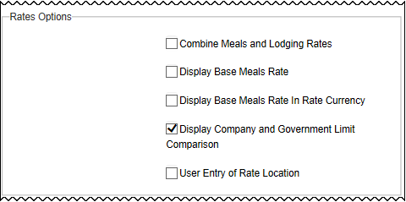
Rate Options
Field | Description | Notes
Combine Meals and Lodging  Rates | Applicable only for Reimbursable Allowances  Combines the amounts for meals and lodging for all allowance, expense, and comparison numbers | If Yes (selected), then the Meals Type and the Lodging Type fields must both be reimbursable and both must be the same reimbursable choice.
Display Base Meals Rate | Displays the Meals Rate column on the Expenses & Adjustments page (Figure 6)
Display Base Meals Rate in Rate Currency | If the base rate currency is available, the amount displays in the Meals Rate column in the reimbursement currency and the rate currency on the Expenses & Adjustments page (Figure 12) | Available only for selected configurations  - Refer to the applicable country setup guide.
Display Company and Government Limit Comparison | Displays the government rate column on the Reimbursable Allowances summary page (Figure 17) or the Expenses & Adjustments page (Figure 8) | The Rates Types field must be set to BOTH.
User Entry of Rate Location | Allows the user to override the system-selected Arrival Rate Location | - Refer to Standard Itinerary: Changing the Arrival Rate Location in this guide.
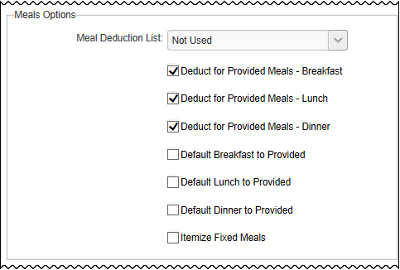
Meals Options
Field | Description | Notes
Meals Deduction List | Shows the meals columns as drop lists instead of check boxes (Figure 4a and 4b):  The options are:  - Germany Deduction List (Figure 4a)  - Benefit in Kind Deduction List (Figure 4b)  - Not used | Requires both provided meals and benefit-in-kind meals deduction amounts to be entered for the rates  At least one of these fields must be set to Yes (selected):  - Deduct for Provided Meals - Breakfast  - Deduct for Provided Meals - Lunch  - Deduct for Provided Meals - Dinner
Deduct for Provided Meals - Breakfast  Deduct for Provided Meals - Lunch  Deduct for Provided Meals - Dinner | Meals check boxes (Figure 3) or drop lists (Figure 4a and 4b) appear on the Expenses & Adjustments page, allowing the user to indicate whether the meal was provided | Requires meals deduction amounts to be entered for the rates  Check boxes become drop lists if the Meals Deduction List field is set to Yes (selected).
Default Breakfast to Provided | Sets the default value for the Breakfast Provided column to "selected" (Yes or Provided) for the second through last day of the trip  NOTES:  If both Lunch Provided and Dinner Provided options (below) are selected, Breakfast Provided is also selected by default.  This accommodates the European practice of including breakfast in the price of lodging. | At least one of these fields must be set to Yes (selected):  - Deduct for Provided Meals - Breakfast  - Deduct for Provided Meals - Lunch  - Deduct for Provided Meals - Dinner
Default Lunch to Provided | Sets the default value for the Lunch Provided column to "selected" (Yes or Provided) | If selected with Dinner Provided forces Breakfast Provided as selected option
Default Dinner to Provided | Sets the default value for the Dinner Provided column to "selected" (Yes or Provided) | If selected with Lunch Provided forces Breakfast Provided as selected option
Itemize Fixed Meals | Creates itemized entries for each fixed meal expense to ensure proper accounting treatment
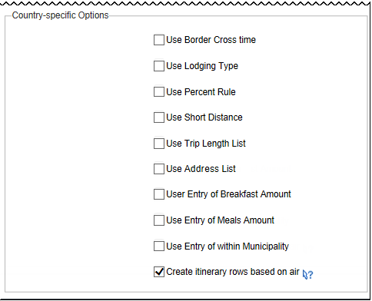

Country-specific Options
Field | Description | Notes
Use Border Cross Time | Displays the Border Crossing Date and the Border Crossing Time fields on the itinerary page | Applies to several countries  - Refer to the country-specific Travel Allowance Configuration Guides.
Use Lodging Type | Displays the Use Lodging Type column on the Expenses & Adjustments page (Figure 9) | Used in configurations for Norway and Germany  - Refer to the Norway Travel Allowance Configuration Guide and the Germany Travel Allowance Configuration Guide.
Use Percent Rule | Displays the Use Percent Rule column on the Expenses & Adjustments page (Figure 10) | Used in configurations for the United States only  - Refer to the US/GSA Travel Allowance Configuration Guide.
Use Short Distance | Displays a check box in the itinerary header, which the user selects to indicate that the trip is less than 50 KM | Used in configurations for Sweden only  - Refer to the Sweden Travel Allowance Configuration Guide.
Use  Address List | Displays Street Address, City, and Postal Code fields on the itinerary page | Used in configurations for Germany only  - Refer to the Germany Travel Allowance Configuration Guide.
Use Trip Length List | Displays the Trip Length list as described in Defining the Trip Length in this guide  Options are:  - 3 months or less  - Over 3 months  - Over 48 months | - Refer to the Germany Travel Allowance Configuration Guide.
User Entry of Breakfast Amount | Displays a field for the user to enter the amount of the breakfast that appears on the hotel receipt (Figure 5) to be deducted from the meals allowance  NOTE: This amount is used as the breakfast provided deduction amount. | Historically used in configurations for Germany only.  The Deduct for Provided Meals - Breakfast field must be set to Yes (selected).
User Entry of Meals Amount | Displays a field for the user to enter the meals amount instead of using the meals amounts loaded in the rates table | Used in configurations for Spain only  - Refer to the Spain Travel Allowance Configuration Guide.
User Entry of Within Municipality | Displays a check box, which the user selects to indicate if the expense was incurred inside or outside of the municipality | Used in configurations for Italy only  - Refer to the Italy Travel Allowance Configuration Guide.
Create itinerary rows based on air | Clear to use the Hotel location instead of Air, factoring hotel arrival and departure times as 1 hour after and 1 hour prior to flight times respectively.  Select to use arrival and departure times from Air booking segments and airport location, including connecting-flight airports. | This option is typically selected (enabled), to use air information when creating itineraries from travel reservations.  Clearing (disabling) this option creates the itinerary by placing preference on hotel reservations for itinerary rows over air reservations.  NOTE: This option to use hotel instead of air is available for use with any travel allowance configuration, even though it is optimized for the US model.
- Click Save.

Viewing and Editing Rate Data
Once the rates are loaded via import, you can view and edit the basic rates online.
Not all rates, such as time band, are displayed.

Required Roles
All expense administrators with access to the travel allowances area can view rates. Those with the unrestricted Expense Configuration Administrator role assigned at the global level will also be able to edit the rate amounts.

Viewing Rates
To access the rates:
- Click Administration > Expense (on the sub-menu).
Depending on your permissions, the page may appear immediately after you click Administration.
- Click Travel Allowance (left menu).
- Click the Rates tab.
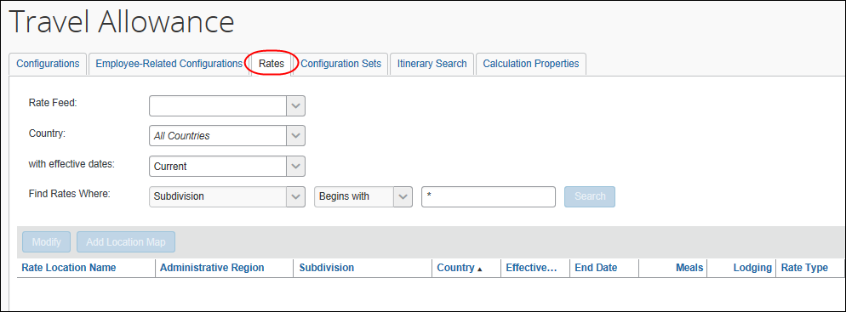
- Select the desired rate feed, country, etc.
- Click Search. The rates appear.
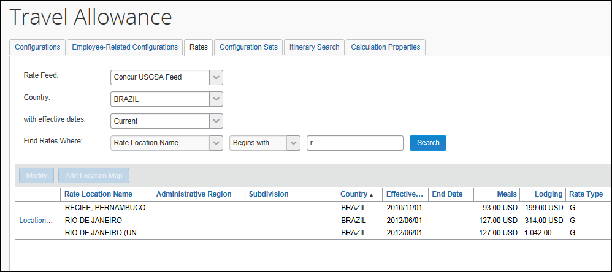
If a location is named in the Rate Location Name column, then a rate has been defined for that location.
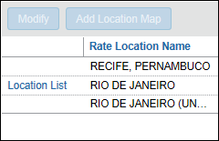
The Location List link indicates that one or more mappings exist.

All Other Locations
The All other locations label is a system-generated label. The rate shown is the rate that applies to the country/subdivision. It is not the "All other countries" rate (also known as the "rate of last resort" described in Travel Allowance Rates Considerations in this guide) that your company may have loaded.

Editing Rates
When you make changes to the rates:
- The new rates go into effect immediately after you click Save.
- The new rates apply to all unsubmitted reports.
- Rates on reports submitted before this update are not changed.
- If a user resubmits a returned report after the update, the new rates are used.
To edit rates:
- Once you have located the desired rate, either:
- Select the desired rate and click Modify.
– or –
- Double-click the desired rate.
The Modify Travel Allowance Rate window appears.
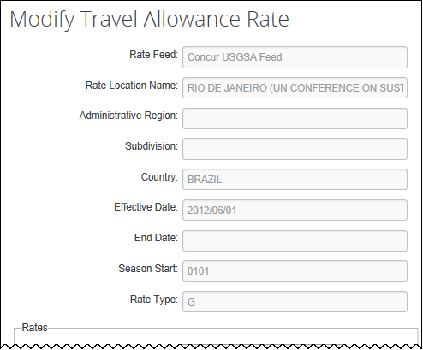
- Enter the appropriate information.
Field | Description
Rate Feed, Rate Location Name, Administrative Region, Subdivision, Country, Effective Date, End Date, Season Start, Rate Type | These fields cannot be edited.
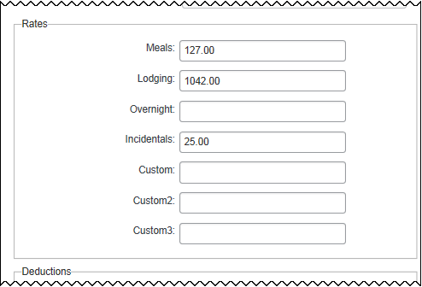
Field |  | Description
Rates: Meals, Lodging, Overnight, Incidentals, custom fields | These are the imported rates from the feed for meals, etc.  Edit these fields as needed.
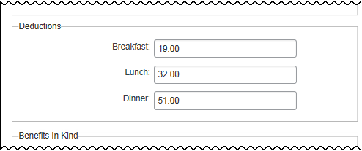
Field |  | Description
Deductions: Breakfast, Lunch, Dinner | These are the amounts that are deducted from the rates (above) if the user indicates that these meals were provided.  Edit these fields are needed.
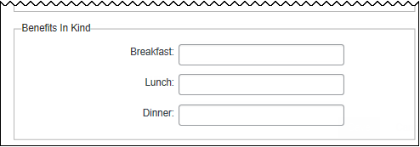
Field |  | Description
Benefits in Kind: Breakfast, Lunch, Dinner | These are the amounts that are deducted from the rates (above) if the user indicates that these meals were provided as taxable meals.  Edit these fields as needed.
- Click Save.

Working With Rate Location Mappings
Rate (by location) mappings are used to associate specific rates to a location (city) by that location's country and then subdivision (if applicable). This mapping directs Expense to apply the correct rates when the system process for matching cities to rates might otherwise make a different choice.
- Refer to Standard Itinerary: Changing The Arrival Rate Location in this guide.

Adding Rate Location Mappings
If you have added one or more rate mappings by import, or by using options in the user interface, the Location List link appears in the left-most column. This link is used to view, add, and delete existing location mappings for the selected location.
If no mapping exists, then no link appears, and you use the Add Location Map button to add one or more rate mappings; doing this causes the Location List link to now appear for that location.
The procedure below describes how to add a rate mapping for rates with and without existing rate mappings.
To add one or more locations to a rate mapping:
- Click Administration > Expense (on the sub-menu).
Depending on your permissions, the page may appear immediately after you click Administration.
- Click Travel Allowance (left menu).
- Click the Rates tab.
- Search for and display the rate location to which you will map locations.
- Either:
- No Rate Mapping: Click Add Location Map.
- Existing Rate Mapping: Click Location List, then click Add Location Map.
- The Add Location Map dialog box displays.
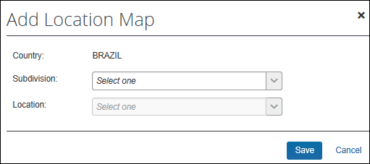
- Map the rate location by first choosing a value for Subdivision, then select a value for Location.
If a subdivision is not applicable, select All Locations under Subdivision to filter only by location name.
- Click Save.

Deleting Rate Location Mappings
A rate mapping is deleted using options in Location List for Rate Location.
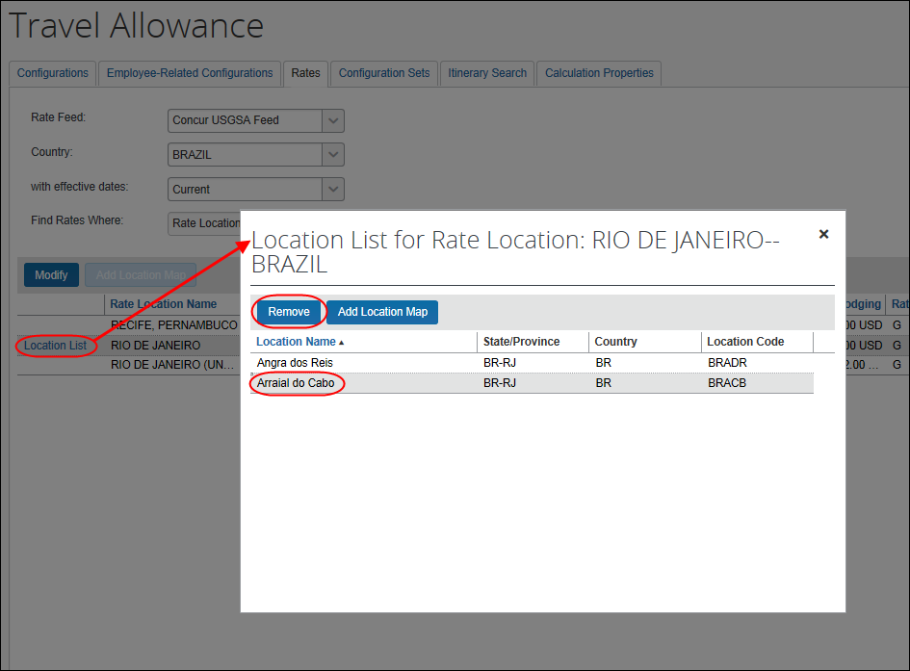
To delete a mapping:
- Click Location List for the desired mapping. The Location List for Rate Location page appears.
- Select the desired location.
- Click Remove.

Editing the Mapping of the Company's Organization to the Configurations
To edit a mapping:
- On the Employee-Related Configurations tab, either:
- Select the desired assignment and click Modify.
– or –
- Double-click the desired assignment.
- Make the desired changes.
- Refer to Adding the Mapping of the Company's Organization to the Configurations in the initial configuration steps for details about the fields.
- Click Save.

Editing Configuration Sets
Be aware that these selections apply at the country level; they cannot be defined to be dependent on any other criteria or fields, such as Org Unit.
To edit configuration sets:
- On the Employee-Related Configurations tab, either:
- Select the desired configuration set and click Modify.
– or –
- Double-click the desired configuration set.
- Make the desired changes.
- Refer to Adding the Mapping of the Company's Organization to the Configurations in the initial configuration steps for details about the fields.
- Click Save.

Viewing Travel Allowance Data by Travel Date and Employee
The Expense Configuration administrator can perform a search for a specific itinerary and associated expenses by providing an employee's name and their travel date as search criteria in the Itinerary Search tab. This opens the itinerary for viewing, and helps the administrator identify an itinerary that, for example, the system has locked due to submitted expenses.
- Refer to Record Adjustments in this guide for more information on system actions that lock and unlock itineraries.
To search for a specific itinerary by user and date:
- Click Administration > Expense (on the sub-menu).
Depending on your permissions, the page may appear immediately after you click Administration.
- Click Travel Allowance (left menu).
- Click the Itinerary Search tab.
- Input the search criteria (both criteria are required to return a search result):
- Travel Date: Any date that falls within the total span of days of travel.
- Employee: The name or user ID of the traveler.
- Click Search to return the results.
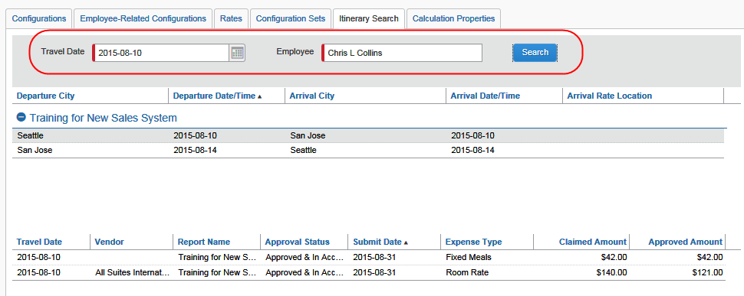
- The search results appear in two separate grids:
- Upper Grid: All itineraries that include the specified date are displayed for viewing in expanded format.
- Lower Grid: The expenses related to the itinerary are displayed.

Using the Itinerary Display Information
The information that is returned is not editable, but is instead used to identify the itineraries or reports where action might be taken. For example, the Report Name provides the unique name (along with the submission date) that contains submitted expenses against the date. With this data the administrator might be able to edit expenses or return an unpaid report for edit.
Approval Status indicates if the report is submitted, pending approval, or otherwise. The itinerary might show that the end date for the trip is incorrect, so the user might then correct that information by editing the itinerary to insert a new row with the correct departure and arrival information for the final date of the trip, then delete the unneeded, incorrect final row.

Working With Calculation Method Properties
The Expense Configuration administrator can open and view country-specific calculation methods; the unrestricted Global administrator may also edit the value for each property.
To view and change the value of a calculation property:
- Click Administration > Expense (on the sub-menu).
Depending on your permissions, the page may appear immediately after you click Administration.
- Click Travel Allowance (left menu).
- Click the Calculation Properties tab.
- Choose the country under Calculation Method.
- From the rows that display, select the property, then click Modify to display the property in the Edit Calculation Property dialog box.
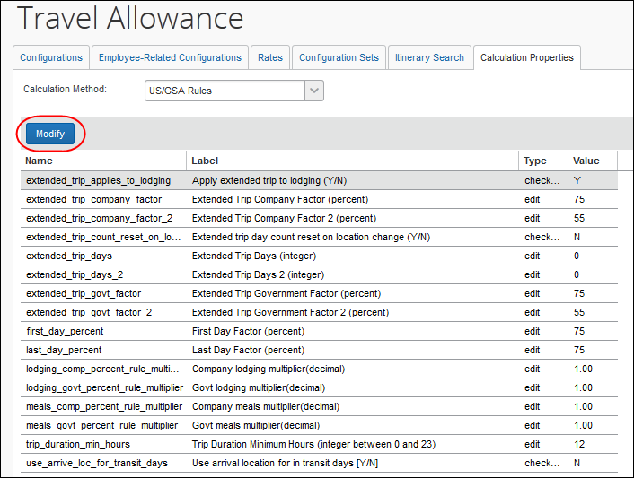
- Under Value, edit the property as required (this is the only editable area of the property).
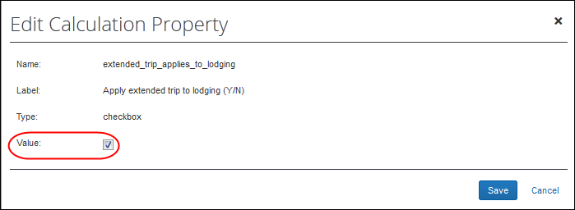
In this example, the Value type of checkbox is either Yes (select the check box), or No (clear the check box); in the figure above, the default is now Yes.
It is important to note that the onus is on the administrator to put the correct value into the field, especially for edit types where the text supplied is not validated.
 Please always refer to the System Calculation Properties section of the applicable country configuration guide for information about appropriate values.
- Click Save.

Travel Allowance Configuration – Optional Configuration Elements
There are several other options to consider when configuring travel allowances.

Configuring Expense Types

Expense Types for Fixed Allowances
For fixed allowances, the system automatically provides the required expense types (Fixed Meals and Fixed Lodging). If desired, these expense type names can be changed using Administration > Expense Admin > Expense Types.
- Refer to the Expense: Expense Types Setup Guide for more information.
- Refer to the Shared: Localization Setup Guide for information about changing the expense type names for other languages.
The administrator must also ensure account codes are set for the fixed allowance expense types.
- Refer to the Expense: Account Codes Setup Guide.

Expense Types for Reimbursable Allowances
As described previously in this guide, the user selects the Travel Allowance check box on the Expense (or New Expense) section of the expense report page when the user creates a reimbursable lodging or meals expense. Then, the system compares the expense to the itinerary and the user is reimbursed according to travel allowance rates.
The Travel Allowance check box appears only if:
- The user's header information matches the hierarchy information of a travel allowance configuration with reimbursable meals or lodging; and
- The user selects either a meals or lodging expense type.
In reality, the system recognizes the meals and lodging spend categories, not the actual expense types. The Lodging – Track Room Rate Spending spend category should be assigned to the Lodging expense type; the Meal – Count in Daily Meal Allowance spend category should be assigned to the Breakfast, Lunch, and Dinner expense types.
The administrator selects the spend category on the Modify Expense Type page of Expense Types.
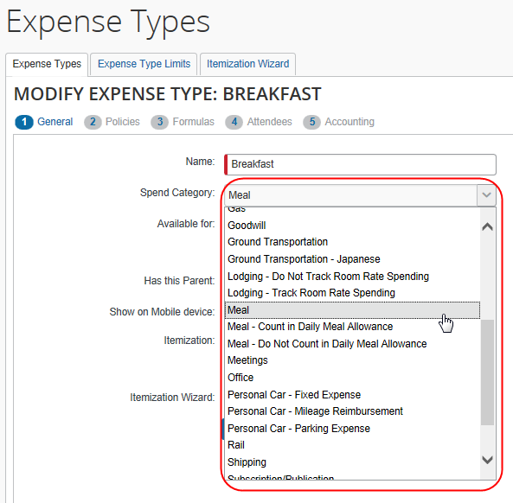
- Refer to the Expense: Expense Types Setup Guide for more information
If the administrator has created new meals-related or lodging-related expense types, then the administrator must ensure that the correct spend category is used.

Incidentals
Companies can also elect to include Incidentals as part of reimbursable travel allowance expenses. If so, the administrator must change the spend category for the Incidentals expense type to Meal – Count in Daily Meal Allowance. This will ensure that the Travel Allowance check box appears on the Expense (or New Expense) tab of the expense report page, when the user selects the Incidentals expense type.
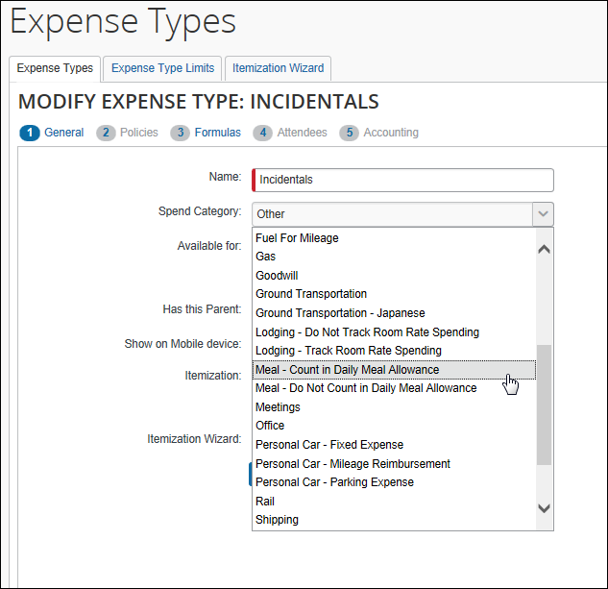

Editing Transaction Dates for Company Card Transactions
By default, the Transaction Date, Vendor, Currency, Exchange Rate, and Amount fields on imported company card transactions are locked (read-only; the user cannot edit them). This may create a problem for companies that use reimbursable travel allowances.
Dates for reimbursable travel allowance expenses must be within the date range of the associated itinerary and must occur on the actual date of the meal to be correctly assessed against that day's allowance limit. However, it is not unusual that the transaction date on a company card restaurant charge appears as the day after the actual transaction. This one-day difference may cause a restaurant charge to fall on the wrong date and, thus, exceed the allowance limit for the day or fall outside the data range of the itinerary.
The remedy is to allow users to edit the transaction date of imported company card transactions. To do so, select the Allow employees to edit the Transaction Date for company card transactions check box on the Settings page in Company Card Administrator. The transaction date will then be user-editable. Other locked fields remain locked.

Alternative Solution
If a company does not want its users to edit the date, an alternative approach is to instruct users to itemize transactions where this occurs. The date used for the travel allowance calculation is the date on the itemized entry – not the date of the main ("parent") expense.

Site Setting Change for Itineraries
The search list on the Available Itineraries page initially appears with the Current Itineraries option selected. By default, Current Itineraries includes the itineraries with the earliest depart date within the past 60 days or in the future. The 60-day limit can be changed by submitting a service request to update the TA_ITINERARY_AGE site setting to a specified number of days.

Travel Allowance and Exchange Rates
If the currency defined in the travel allowance rates is different from the user's reimbursement currency, travel allowances may not be calculated by the system unless:
- The Exchange Rates feature is activated.
- and -
- Either:
- The currency in which the travel allowance is defined is one of the imported rates and it is converted to the user's reimbursement currency.
- or -
- The Oanda rate service is enabled.
The Oanda exchange rate feed is a daily (business/weekdays only) feed that can populate the exchange rate on cash expenses for the end user. The rate loaded is the daily Average Ask Rate.
- For more information about reimbursement currencies and the Exchange Rates feature, refer to the Expense: Currency Admin Setup Guide.

Configuration of Column Headings on the Expenses & Adjustments Page
The labels of the column headings on the Expenses & Adjustments page can be configured. The client can customize the following column headings.
- Overnight
- Breakfast Provided (for checkbox and dropdown)
- Lunch Provided (for checkbox and dropdown)
- Dinner Provided (for checkbox and dropdown)
- Exclude
- Use Extended Trip Rule
- Use Percent Rule
- Lodging Type
The column headings are available in the Column Labels field in Administration > Expense > Localization.
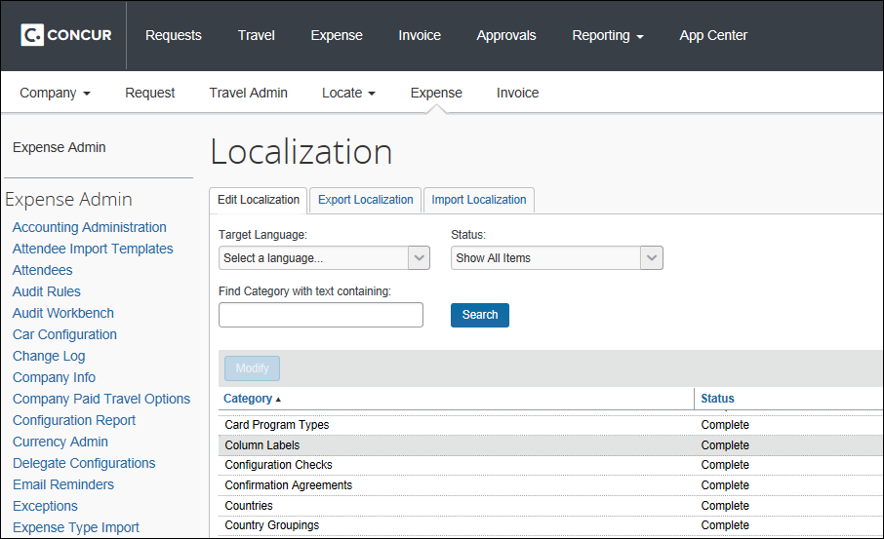
The strings in the file are:
100.CT_COLUMN_METADATA_LANG.LABEL.CT_TA_FIXED.
OVERNIGHT=Overnight
100.CT_COLUMN_METADATA_LANG.LABEL.CT_TA_FIXED.
BREAKFAST_PROVIDED=Breakfast Provided
100.CT_COLUMN_METADATA_LANG.LABEL.CT_TA_FIXED.
LUNCH_PROVIDED=Lunch Provided
100.CT_COLUMN_METADATA_LANG.LABEL.CT_TA_FIXED.
DINNER_PROVIDED=Dinner Provided
100.CT_COLUMN_METADATA_LANG.LABEL.CT_TA_DAY.
EXCLUDE=Exclude
100.CT_COLUMN_METADATA_LANG.LABEL.CT_TA_DAY.
LODGING_TYPE=Lodging Type
100.CT_COLUMN_METADATA_LANG.LABEL.CT_TA_DAY.
APPLY_PERCENT_RULE=Apply Percent Rule
100.CT_COLUMN_METADATA_LANG.LABEL.CT_TA_DAY.
APPLY_EXTENDED_TRIP_RULE=Apply Extended Trip Rule
- For more information about localizations, refer to the Shared: Localization Setup Guide.

Audit Rules
Use the Expense: Audit Rules Setup Guide to become familiar with audit rules, events, data objects, exceptions, the condition editor, and so on. Then, use the information on the following pages to create audit rules specifically for travel allowances.

Events and Data Objects
The table below lists the events (selected on the Audit Rule step) and the data objects (selected on the Conditions step) that pertain to travel allowances.
Audit Rule step - Event field | Conditions step - Data Object field | Options / Description | Possible Values
Entry Submit | Travel Allowance | - Exceeded Company Limit: Indicates if the allowance given to the employee exceeds the company limit  This field is only applicable to reimbursable allowances with no limit using company rates or both company and government rates; all other configurations will not ever exceed this limit.  - Exceeded Government Limit: Indicates if the allowance given to the employee exceeds the government limit  This field is applicable to:  - Fixed allowances when both company and government rates are used  - Reimbursable allowances when:  - No limit is used with government rates or both company and government rates  - Limit is used with both company and government rates | Yes / No
Entry Save  Entry Submit  Post Report Submit  Report Save  Report Submit | Report | Has a Travel Allowance Entry: Indicates if any expense on the report is marked as part of travel allowance | Yes / No
Entry Save  Entry Submit  Post Report Submit  Report Submit | Entry | Travel Allowance: Indicates if the expense is fixed allowance or reimbursable allowance expense | Yes / No
Entry Save  Entry Submit | Travel Allowance Adjustments | Breakfast Provided: Indicates if breakfast has been provided to the user and if it is taxable (if provided)  Lunch Provided: Indicates if lunch has been provided to the user and if it is taxable (if provided)  Dinner Provided: Indicates if dinner has been provided to the user and if it is taxable (if provided) | Benefit in Kind Deductions List:  - Not Provided  - Provided (means provided and not taxable)  - Taxable (means provided and taxable)  Germany Deduction List:  - Business Entertainment  - Company Event  - External Activity  - Working Meal  - Incentive Meal  - Not Provided
Entry Save  Entry Submit | Travel Allowance Adjustments | Overnight: Indicates if there was an overnight stay for the travel allowance day and the allowance was calculated accordingly | Yes / No
Entry Save  Entry Submit | Travel Allowance Itinerary  Travel Allowance Itinerary (on report) | Number of Days in Trip: Indicates the number of days in the trip based on condition:  - Itinerary: references the specific itinerary associated with the expense.  - Itinerary (on report): references any itinerary attached to the report, and is not specific to what is linked to an expense.  NOTES:  - Some configurations do not allow certain expense types, such as Laundry, unless the trip is at least a specified number of days.  - The number of days in the trip is calculated by counting the calendar dates in the itinerary. Be aware that the number of days may not calculate correctly for trips where the travel allowance configuration uses a 24-hour period as the definition of a day. | Number of days
Entry Save  Entry Submit |  | Single Day Trip: Indicates if this itinerary is a single-day trip | Yes / No
Entry Save  Entry Submit |  | Travel Allowance Configuration: Indicates the travel allowance configuration associated with the itinerary | Lists all travel allowance configurations in the system
Entry Save  Entry Submit |  | Trip End Date: End date/last date of the trip in local time  Trip Start Date: Start date/first date of the trip in local time  NOTE: Used in those cases where the hotel transaction posts one day after the traveler actually checked out, so the last day of lodging appears to be on or after the last day of the trip. This may result in the traveler not receiving a lodging expense for when they were actually supposed to. | Date
Entry Save  Entry Submit | Travel Allowance Itinerary Day | Extended Trip: Indicates if the extended trip rule is applied when calculating the allowance for the day  Full Allowance Day: Indicates if the itinerary day is treated as a full allowance day when calculating the allowance  Use Percent Rule: Indicates if the percent rule is applied to this itinerary day | Yes / No
Entry Save  Entry Submit | Travel Allowance Itinerary Day | Lodging Type: Indicates the type of lodging selected for the itinerary day | Norway:  - Hotel/None  - Other without cooking  - Other with cooking  Germany:  - Lodging (receipt)  - Overnight Allowance  - None
Post Report Submit  Report Save  Report Submit | Travel Allowance Itinerary | (Same as described above)

Events and Evaluation by Audit Rules
Note the following:
- Events – Report Save, Report Submit, and Post Report Submit: All itinerary records associated with the report are evaluated for audit rule purposes.
- Events – Entry Save, Entry Submit: Only the itineraries, itinerary days, and travel allowance records associated with the specific itinerary day are evaluated for audit rule purposes. That is, there must be a match between the entry date and the itinerary day; all other records associated with the report not matching the entry date will be ignored.

Timing
The Report Save event is fired normally on header save, etc. In addition, it is fired and any rules configured for that event are executed:
- For an itinerary that is assigned to a single report:
- When the itinerary is assigned to a report
- When the itinerary is edited from within the associated report
- When the itinerary is unassigned from the report (to remove any exceptions that had been generated)
- For an itinerary that is assigned to multiple reports:
- When the itinerary is assigned to an additional report
- When the itinerary is edited from within any of the associated reports
The Report Save event fires only for the currently open report. Other reports associated with that itinerary are not affected.
If the itinerary is edited without having any associated report open, the Report Save event is not fired for any expense reports associated with that itinerary.

Samples
Audit Rules - Samples
Rule to flag a Laundry expense if the trip is less than 4 days
Some configurations do not allow certain expense types, such as Laundry, unless the trip is at least a specified number of days.
Event: either Entry Save or Entry Submit
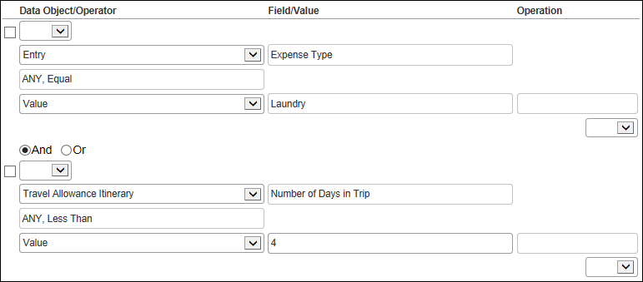
Rule to flag a trip where the trip end date is equal to the transaction date for the room rate
Used in those cases where the hotel transaction posts one day after the traveler actually checked out, so the last day of lodging appears to be on or after the last day of the trip. This may result in the traveler not receiving a lodging expense for when they were actually supposed to.
Event: either Entry Save or Entry Submit
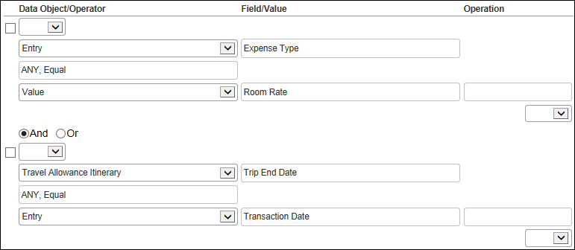
Audit Rules – Special Circumstances
Rule to flag a credit to paid expenses with over limit allowance
When a second expense report with a travel allowance expense that is a credit is submitted, and the first report had expenses over the limit, the credit is only applied to the account code of the expense type of the credit.
Some clients prefer to prorate the credit to all the over-limit account codes from the first report.
Event: Report Submit




