
Concur Expense: Site Settings
Setup Guide

Last Revised: March 31, 2023
Applies to these SAP Concur solutions:
 Expense
 Professional/Premium edition
 Standard edition
 Travel
 Professional/Premium edition
 Standard edition
 Invoice
 Professional/Premium edition
 Standard edition
 Request
 Professional/Premium edition
 Standard edition
Table of Contents
Section 1: Permissions 1
Section 2: Overview 1
Section 3: Access and Use the Site Settings Page 6
Section 4: Additional Information 8
Feature/Setting Information: Copy a Report 8
User Experience 8
Feature/Setting Information: Enhanced Employee Search 9
Feature/Setting Information: Expense Assistant 11
Feature/Setting Information: Combine Expenses 17
User Experience 18
Feature/Setting Information: One Receipt Image for Multiple Expenses 18
User Experience 18
Feature/Setting Information: View Reports Approved as Delegate 20

Revision History
Date | Notes / Comments / Changes
March 31, 2023 | Removed the following sections:  - Feature/Setting Information: Quick Expenses Grid Feature  - Feature/Setting Information: Quick Mileage Expenses Feature
November 9, 2022 | Updated reference to Bambora (now rebranding to Worldline) and Western Union (now rebranding to Convera)
September 20, 2022 | Clarified that the Combine button functions differently under the two different user interfaces – Legacy (current UI) and Next Generation (NextGen).
June 3, 2022 | Updated favorite allocation section to note that read-only and hidden allocation fields will use the configured copy down value and not the values stored in the allocation favorite.
March 22, 2022 | Added the Enable Report Number for Expense Accounting Extracts option and description to the Overview section.
January 21, 2022 | Updated the copyright year; no other changes; cover date not updated
August 27, 2021 | In the Overview section, for the Allow users to combine expenses into a single merged expense option, added a “For more information…” reference (in the Description column) to the user guide for Japan Public Transportation (JPT) on NextGen UI.  Added three (new) settings:  - Enable Expense Pay Global (Bambora)  - Enable Expense Pay Global (Western Union USD)  - Enable Expense Pay Direct File (Western Union)
June 19, 2021 | Added new setting Enable Taxability and Deductibility Calculation Service.
January 7, 2021 | Updated the copyright; no other changes; cover date not updated
July 1, 2020 | Added information about the NextGen UI; made modifications throughout; cover revision date updated
June 8, 2020 | Changed “Authorization Request” to “Concur Request” in Request guide references to align with Concur Request product branding.
April 9, 2020 | Renamed the Authorization Request check box to Request on the guide’s title page; cover date not updated
January 2, 2020 | Updated the copyright; no other changes; cover date not updated
September 20, 2019 | Added the Non Domestic Tax Enabled option and description to the Overview section.
May 11, 2019 | Updated the section on copying a report regarding offsets when a new start date is on the header. One day is no longer the default offset.
January 4, 2019 | Updated the copyright; no other changes; cover date not updated
Older revision history has been removed.

Site Settings
NOTE: Multiple SAP Concur product versions and UI themes are available, so this content might contain images or procedures that do not precisely match your implementation. For example, when SAP Fiori UI themes are implemented, home page navigation is consolidated under the SAP Concur Home menu.

Permissions
A company administrator may or may not have the correct permissions to use this feature. The administrator may have limited permissions, for example, they can affect only certain groups and/or use only certain options (view but not create or edit).
If a company administrator needs to use this feature and does not have the proper permissions, they should contact the company's SAP Concur administrator.
Also, the administrator should be aware that some of the tasks described in this guide can be completed only by SAP. In this case, the client must initiate a service request with support.

Overview
The Site Settings page allows the admin to enable or disable certain Concur Expense features.
This table describes the settings on this page. Some of the settings are further described later in this guide; some are further described on other guides. That information, too, is in the table below.
- IMPORTANT: The This setting affects column lists the associated SAP products. That means:
- If you enable the setting here, you enable it in the products listed.
- If you disable the setting here, you disable it in the products listed.
Option | Description | This setting affects…
Allow users to email reports and print reports in PDF | If enabled, allows a user to generate a PDF copy of their expense report. The user can send the PDF copy to one or more email recipients.  - For more information, refer to the Concur Expense: PDF and Email Reports Setup Guide. | Concur Request and Expense
Enable personal card charge import | The manual personal charge card import feature has been retired and is not included in the NextGen UI for Concur Expense. The personal charge card import feature was used to pre-populate expense data for users who have personal cards with reimbursable expenses.  The user can register a card on the Expense Credit Card page in Profile or use ExpenseIt. Clients can opt to replace this with the automated personal charge card import feature. To activate this alternate feature, clients should open a support ticket with SAP Concur support.
Allow users to opt into Concur Expense Assistant | If disabled, a user will not have the option to turn on Expense Assistant on their Expense Preferences page in Profile. | Concur Expense
If set to true, allow more than one authorization request to be assigned to a single report. | If enabled, allows a user to attach more than one authorization request to an expense report. | Concur Expense
Allow users to remove e-receipts without creating expenses | If enabled, allows a user to delete e-receipts from Concur Expense without creating associated expenses. | Concur Expense
Allow users to remove trip segments without creating expenses | If enabled, allows a user to delete trip segments from Concur Expense without creating associated expenses. | Concur Expense
Use Request allocation data (first) and Concur Expense data (second) to pre-populate allocation fields | If enabled, defines how allocations from Request are copied down into Concur Expense allocations.  - For more information and additional configuration requirements, refer to the Concur Request: Allocations Setup Guide. | Concur Expense
Use Named Groups for Car Configuration | If enabled, allows a user to set up a group record and give it a name. This group record is then applied to the car mileage configuration of a specific group.  - For more information, refer to the Concur Expense: Car Configuration Setup Guide. | Concur Expense
Non Domestic Tax Enabled | If enabled, allows a company to have a single code that is understood by the client's financial system to represent "non-domestic" transactions.  For the Non Domestic Tax Field, the custom field selected will correspond to the Entry Line in the extract. Without this selection, no tax line will appear for these expenses in the extract.  For more information, refer to the Shared: SAP Integration with Concur Solutions for SAP ECC and SAP S/F HANA Setup Guide. | Concur Expense
Enable Report Number for Expense Accounting Extracts | If enabled, the Report Number field is positioned in the same column wherever Report Key is currently configured, replacing it. Now, report number data replaces the report key data by changing the extract output to include one and not the other.  - For more information, refer to the Enable Report Number in Concur Expense Accounting Extracts release note in the March Expense Professional Release notes. | Concur Expense
Use reclaim extraction factors at tax rate level (Canada tax only) | If enabled, allows a user to select Extraction Factor from the Calculation Method menu when adding a new extraction factor tax rate type.  - For more information, refer to the release note Concur Expense: Value Added Tax (VAT) / Tax Administration Setup Guide. | Concur Expense
Enable Taxability and Deductibility Calculation Service | If enabled, displays a link on the Expense Admin page for configuring employee taxability and corporate deductibility calculation configurations based on considerations such as country, expense type, and policy.  - For more information, refer to the Concur Expense: Employee Taxability and Corporate Deductibility Service Setup Guide.  NOTE: This setting is for the new service, not the original solution. The original T&D solution does not have a UI. | Concur Expense and SAP ICS Payroll Integration
Allow traveler to add Commuter Pass Route | If enabled, adds links to the user's Profile page under Expense Settings to allow the user to add commuter pass routes in profile.  See and use this feature with the Japanese Public Transportation (JPT) feature enabled.  - For more information, refer to Concur Expense: Japanese Public Transportation User Guide. | Concur Expense
Allow users to copy expense reports | If enabled, allows a user to select any report and copy it whether the report is unsubmitted, already paid, or any other statuses. The user can edit the copy as desired.  - For information about this feature, refer to Additional Information later in this guide. | Concur Expense
Allow users to add expenses via Quick Expenses grid | The quick expense entry grid is not included in the NextGen UI for Concur Expense.
Allow users to add mileage expenses via Mileage grid | The quick expense entry grid for mileage is not included in the NextGen UI for Concur Expense.
Allow approvers to view reports approved as a delegate | If enabled, the delegate approver can see all reports they approved – all in one place. When the delegate approver views the list of reports they approved – all approved reports appear, including those approved while working as a delegate.  - For information about this feature, refer to Additional Information later in this guide. | Concur Expense
Allow users to manage favorite allocations | If enabled, allows a user to create a list of allocation favorites so they can quickly apply sets of allocations to expenses.  NOTE: Read-only and hidden allocation fields will use the configured copy down value and not the values stored in the allocation favorite. List fields are verified to ensure any project codes or other list fields are still valid and will alert the user if data needs to be corrected. This ensures that the field values used on the resulting allocation are appropriate for the new expense.  - For more information, refer to Concur Expense: Allocations Setup Guide. | Concur Request and Concur Expense
Allow Cash Advance Administrator to Create & Issue Cash Advances | If enabled, allows the Cash Advance admin to create and issue cash advances using the Cash Advance Admin tool.  - For more information, refer to the Concur Expense: Cash Advance Administrator User Guide. | Concur Request and Concur Expense
Allow Cash Advance Administrator to Record Return Amount | If enabled, allows the Cash Advance admin to record the return of all or part of an issued cash advance, which was manually returned by the user.  - For more information, refer to the Concur Expense: Cash Advance Administrator User Guide. | Concur Request and Concur Expense
Allow amounts to appear in limit-based exception messages (enable only if used) | If enabled, the admin can create specific audit rules with specific exception messages that contain variables for amounts.  NOTE: If you do not intend to use variables in exception messages, do not enable this check box. This may cause slowing of your Concur Expense processing.  - For more information, refer to the Concur Expense: Exceptions Setup Guide. | Concur Expense
Provide Default Exchange Rate for Cash Advance Issuance | If enabled, displays the default exchange rate to the Cash Advance administrator when issuing cash advances in a foreign currency.  - For more information, refer to the Concur Expense: Cash Advance Administrator User Guide. | Concur Request and Concur Expense
Select additional employee fields to display in user search results | If enabled, allows the admin to add and/or remove additional employee fields to display in user search results.  - For information about this feature, refer to Additional Information later in this guide. | Concur Request, Concur Expense, and Concur Invoice
Allow users to search by Employee ID | If enabled, allows a user to search for employees by their ID.  - For information about this feature, refer to Additional Information later in this guide. | Concur Request, Concur Expense, and Concur Invoice
Enable Validation Rules | If enabled, allows the admin to use options on the Validation Rules tab of Audit Rules.  NOTE: Be aware that if you clear (disable) this check box:  - The Validations tab is removed from the Audit Rules tool.  - The functionality is no longer available.  - Existing validation rules no longer run.  - For more information about validation rules, refer to the Expense: Concur Audit Rules (Validation Rules) Setup Guide. | Concur Request, Concur Expense, and Concur Invoice
Allow a multiple use of the same receipt for multiple expense entries within an expense report | - For information about this feature, refer to Additional Information later in this guide. | Concur Expense
Enable Expense Pay Global (Worldline) | Use this option for Expense Pay Global clients utilizing Worldline as their payment provider who are implemented after August 2021.  See and use this feature with the Expense Pay feature enabled.  NOTE: This setting populates the Provider list on the Funding Account page. | Concur Expense
Enable Expense Pay Global (Convera USD) | Use this option for transitioning clients from (classic) Expense Pay to Expense Pay Flex with Convera for USD reimbursements.  See and use this feature with the Expense Pay feature enabled.  NOTE: This setting populates the Provider list on the Funding Account page. | Concur Expense
Enable Expense Pay Direct File (Western Union/Convera) | Use this option for transitioning clients from (classic) Expense Pay to Expense Pay Flex with Western Union/Convera for other (non-USD) supported currencies.  See and use this feature with the Expense Pay feature enabled.  NOTE: This setting populates the Provider list on the Funding Account page. | Concur Expense

Access and Use the Site Settings Page
To access the site settings:
- Click Administration > Expense.
Depending on your permissions, the page may appear immediately after you click Administration.
- Click Site Settings (left menu). The Site Settings page appears.
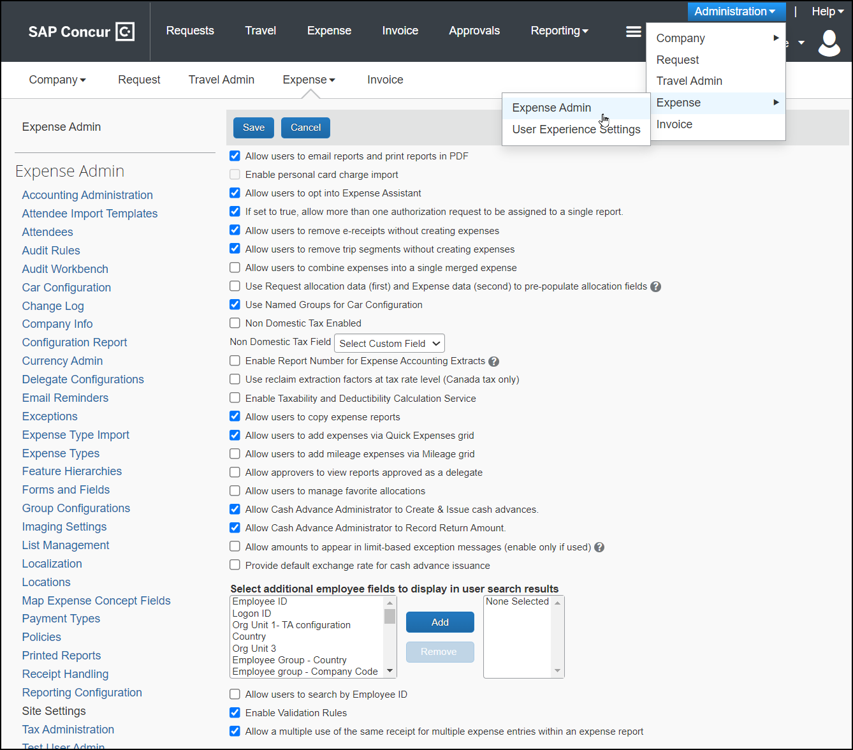
The order that this page displays these settings may vary. For a complete list of settings, refer to the table in the Overview section of this guide.
- Make the desired changes, referring to the table in the Overview section of this guide for details on each option.
- Click Save.

Additional Information

Feature/Setting Information: Copy a Report
Once the Allow users to copy reports setting is enabled, a user can select any expense report and copy it as a template for the new report. This option is available whether the report is unsubmitted, already paid, or any other statuses. The user can then edit the copied report as desired.
Note the following when copying a report:
- The new name of the report is Copy of <report name>.
- Copied expense entries are automatically adjusted to a user-defined interval or adjusted based on the report start date (if configured on the header) provided.
- Attendees and allocations are copied to the new report.
- Information that is unique to each expense is not copied, for example images, audit trails, comments, pay conformation history, etc.
- Travel allowance entries, such as fixed meals and fixed lodging, are not copied to the new report.

User Experience
To copy a report:
- Open the desired report.
- Click More Actions > Copy Report.
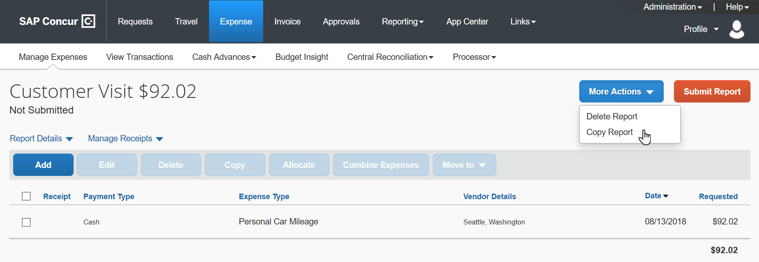
The Copy Report window appears.
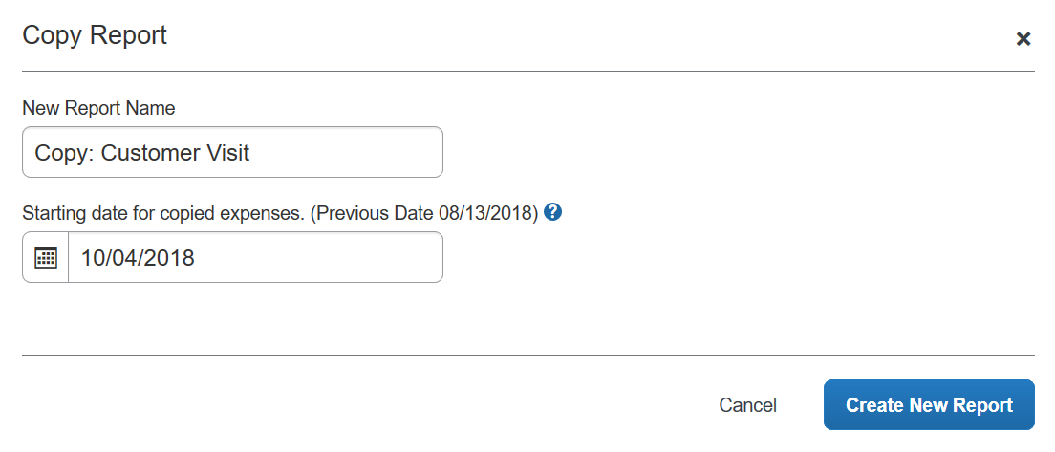
- On the New Report Name field, change the name if desired.
- In the Starting date for copied expenses field, enter the desired starting date of the new report entries. The system calculates the remaining entries on the new report based on the new starting date (that is, number of days difference and then increments the date for each entry on the new report by the same number of days).
The Previous Date field displays the oldest transaction date in the list of entries for the source report.
- Click Create New Report. The report is copied with the new name and information. The report is automatically opened and ready for the user to edit.
Note the following:
- If an entry cannot be copied over, the user receives a message about the issue.
- If none of the entries can be copied over (for example, travel allowance fixed expenses), then the report header is copied but there are no expense entries.

Feature/Setting Information: Enhanced Employee Search
The Enhanced Employee Search settings improve the search capabilities and search results display for:
- Employee Administrators who are searching for delegates and approvers
- Users who are searching for delegates and approvers (in Profile and Approval Flow)
- Expense Proxies who are searching for users
By default, this is the display:
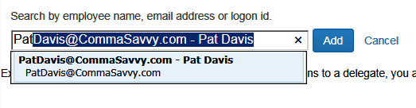
There are two additional options:
- Employee ID as search criteria: By default, these types of searches can be completed using the employee's name, email address. With this setting, the administrator can also allow the employee ID as search criteria by adding Employee ID to the Select additional employee fields to display in user search results field.
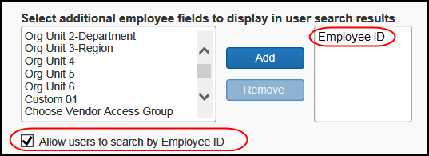
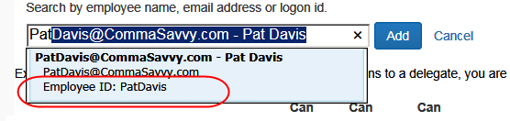
- Additional fields in the search results: The administrator can elect to display more information in the search results, ensuring that the correct user is selected.
- The administrator can include up to three additional fields, including:
- Employee ID
- Logon ID
- Organization unit fields (Org Unit #)
- Custom fields
- Field labels that display are the localized field-level labels.
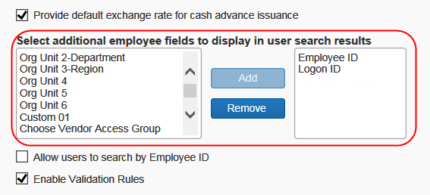
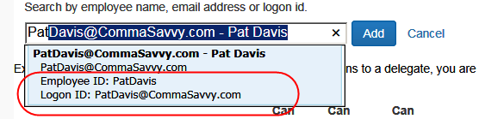
Note the following:
- If the administrator uses either of these two settings, note that it affects Concur Expense, Concur Request, and Concur Invoice.
- Including the Employee ID in a search or search results display is disabled by default; this prevents the display of sensitive information (for example, employee tax ID) that may be used for this value.

Feature/Setting Information: Expense Assistant
Expense Assistant adds all expenses in your Available Expenses list to any open expense report. An open report can be a user-created expense report or an expense report auto-created by Expense Assistant. Expense Assistant continues to add all new incoming expenses that have a date that matches the calendar month of the expense report to that expense report.
If more than one expense report is open, Expense Assistant uses the following logic to determine which report new expenses are added to:
- Expense Assistant will add the expenses to an open expense report auto-created by Expense Assistant if the expense transaction date is in the same month as the expense report month.
- If the expense transaction date does not match the month of the auto-created expense report, Expense Assistant adds the expenses to an open user-created expense report for that month.
- If there are multiple open user-created reports for the same month, Expense Assistant adds the expenses to the user-created expense report with the most recent date for that month.
- If there are no open user-created expense reports, then Expense Assistant will automatically create a new expense report and add the expenses to the new report.
Expense Assistant will auto-create a new expense report for each calendar month, or by trip depending on what is selected on the Configuration for Group page (Administration > Expense > Group Configuration > Expense tab). The choices are:
- Monthly or By Trip – Users in the group can enable Expense Assistant. If a user in the group enables Expense Assistant, the user can choose whether Expense Assistant automatically creates calendar-based or trip-based expense reports for that user. The user can only use one of these options, the user cannot use both.
- Monthly only – Users in the group can enable calendar-based Expense Assistant. If a user in the group enables Expense Assistant, Expense Assistant will automatically create calendar-based expense reports for that user.
- By Trip only – Users in the group can enable trip-based Expense Assistant. If a user in the group enables Expense Assistant, Expense Assistant automatically creates trip-based expense reports for that user.
- None – Expense Assistant will not be available to users in the group.
Expense Assistant will work for delegates. The user whom the delegate is delegating for will need to have enabled Expense Assistant in Concur Expense or their Expense Preferences.
Once Expense Assistant is enabled for your company, users will need to enable Expense Assistant for themselves.
If the user has at least one unexpensed travel segment (itinerary) in Available Expenses, the Expense Assistant page appears.
There are several ways a user can enable Expense Assistant: when they have Available Expenses, whether or not they have any Available Expenses, and from Profile.
- When your users log on to Concur Expense and go to the Concur Expense home page, they will see the following screen. Since Concur Expense needs some available expenses and an unexpensed travel segment (itinerary) present to show how it works, this will show at the first time the user logs in and has available expenses to be used.
- If the admin selected By Trip only in the For Expense Assistant, allow users to opt out or to use list in Group Configuration (described above), then the Expense Assistant page that appears allows the user to select whether or not to use the feature.
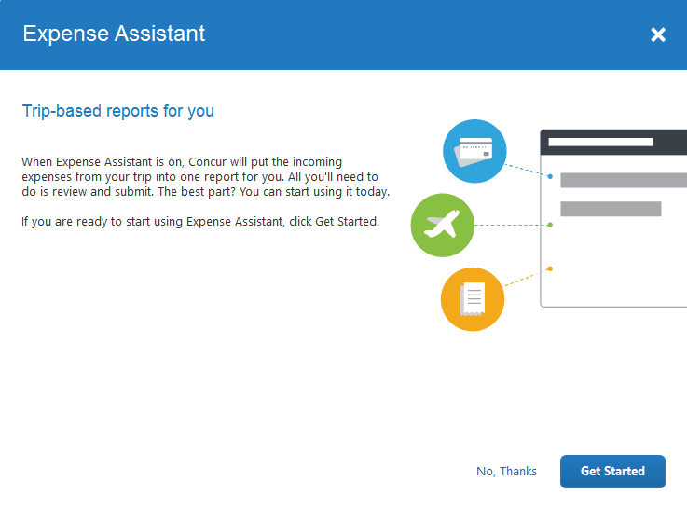
- If the admin selected Monthly or By Trip in the For Expense Assistant, allow users to opt out or to use list in Group Configuration (described above), then the Expense Assistant page that appears allows the user to select trip-based, calendar-based, or neither.
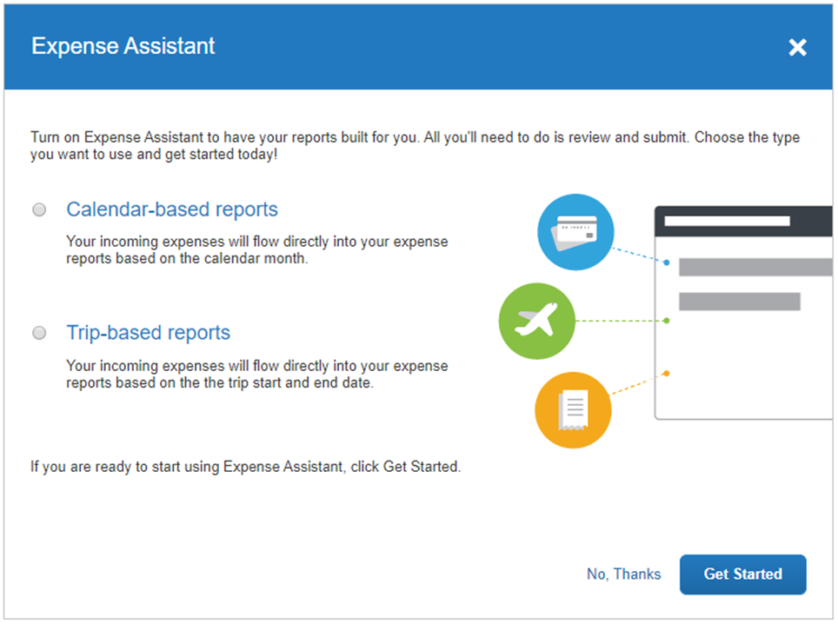
-Or-
- If users do not currently have any available expenses or an unexpensed travel segment (itinerary), they will see the following message in the Available Expenses section:
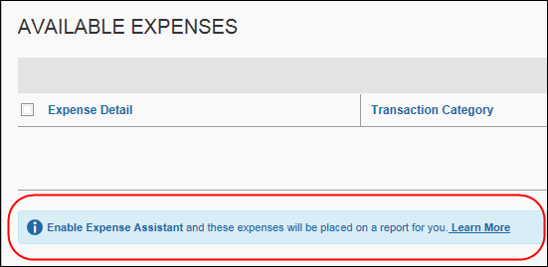
The users need to click Learn More, and then click Try it Now to begin using Expense Assistant.
-Or-
- If the user wants to enable Expense Assistant and the pages shown above do not appear automatically, the user can enable the feature in Profile. On the Expense Preferences page (Profile > Profile Settings), the user selects By Month or By Trip from the Expense Assistant using this method list, and then clicks Save.
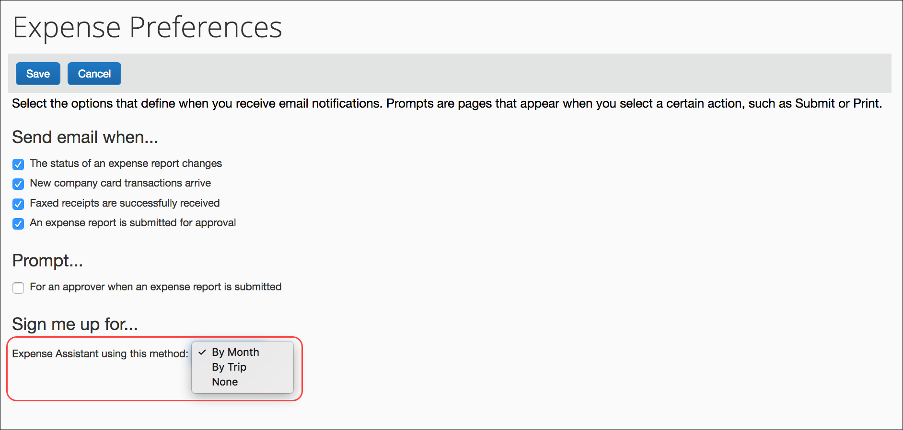
-Or-
- On an iPhone.
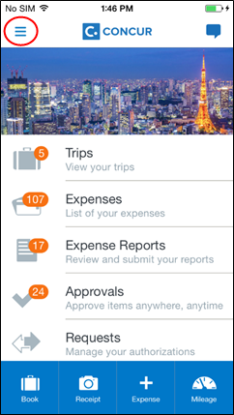 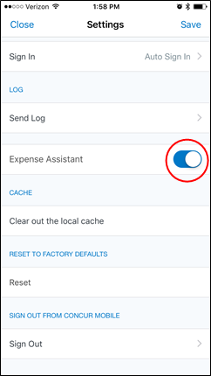
- On an Andriod.
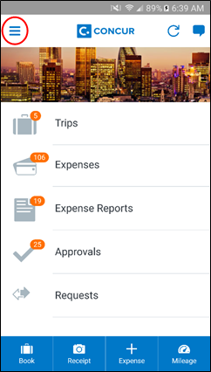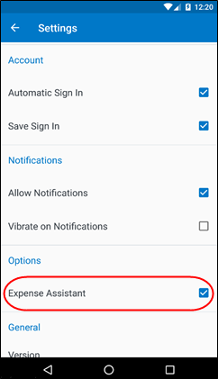

Feature/Setting Information: Combine Expenses
The Combine link appears to the user when they select multiple "like" expense entries on an expense report. When the user clicks Combine, the selected expenses are merged into a single entry. This lets the user easily combine two expenses perhaps if one was created in error. This option is always available to users and cannot be disabled
The user can manually combine the following items:
- Card transaction
- E-receipt
- Expense entry (either entered online or via Mobile)
- ExpenseIt receipt
- Trip segment
Users may not match items of the same type, such as two card transactions.
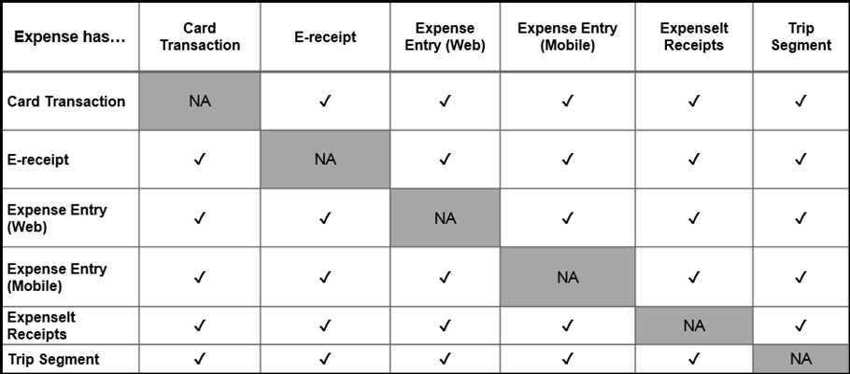

User Experience
In an expense report, with multiple expenses from the same transaction selected simultaneously, the user sees the option to combine items.
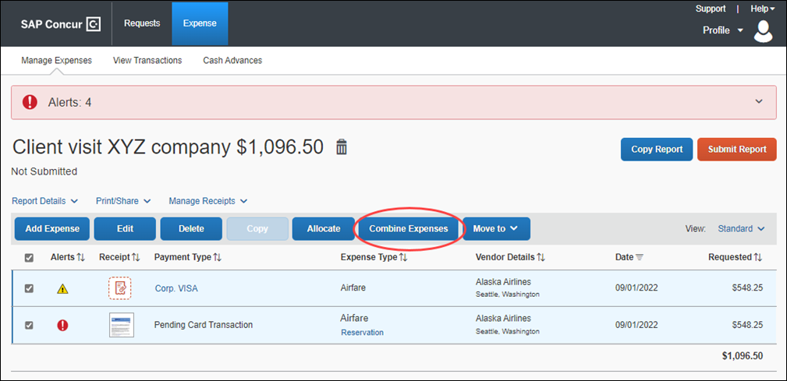
If the user wants to uncombine expenses, they should remove the combined expense from their expense report. This returns the two expenses for selection again in Available Expenses.
- For more information about matching logic, refer to the Concur Smart Expenses Matching Fact Sheet.

Feature/Setting Information: One Receipt Image for Multiple Expenses
Users can attach one receipt image to more than one expense on the same expense report.

User Experience
To use a receipt image more than once, the user completes the first expense as usual and attaches the receipt image. For any other expense that the user wants to associate with the receipt image, while creating the expense entry, the user:
- Completes the expense as usual.
- Clicks Attach Receipt Image as usual. The Attach Receipt window appears.
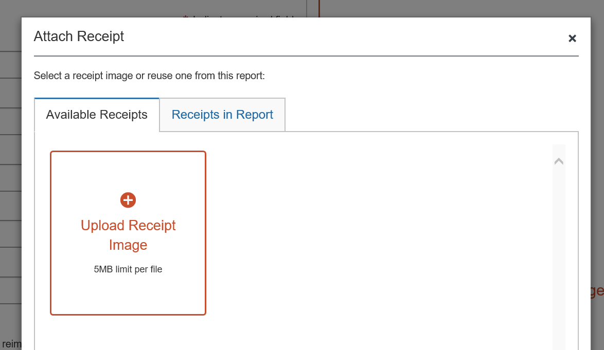
- Clicks the Receipts in Report tab.
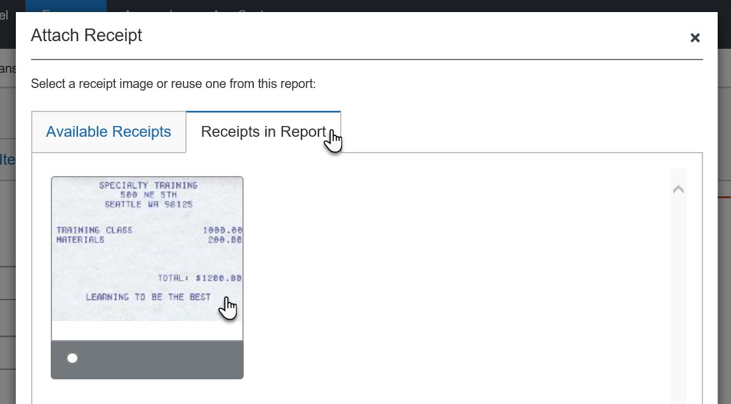
- Clicks the desired image and then clicks Attach.
The process is the same if the user attaches receipt images on the report page. For the second and subsequent expense entries, the user can select the desired image from the Receipts in Report tab.
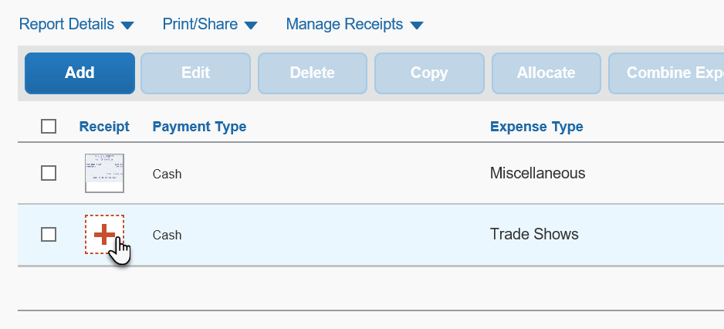

Feature/Setting Information: View Reports Approved as Delegate
By default, when a delegate – working on behalf of an approver – approves a report and then later wants to view that report, the delegate has to again be working on behalf of that same approver. That is, the approved report appears in the approver's list of approved reports, but not in the delegate's list of approved reports.
If the Allow approvers to view reports approved as a delegate setting is enabled, the delegate approver can see all reports they approved – all in one place. When the delegate approver views the list of reports they approved – all approved reports appear, including those approved while working as a delegate.
In this example, Chris Collins is working as a delegate for Pat Davis. Chris approves the report from Terry Brown for a Conference expense.
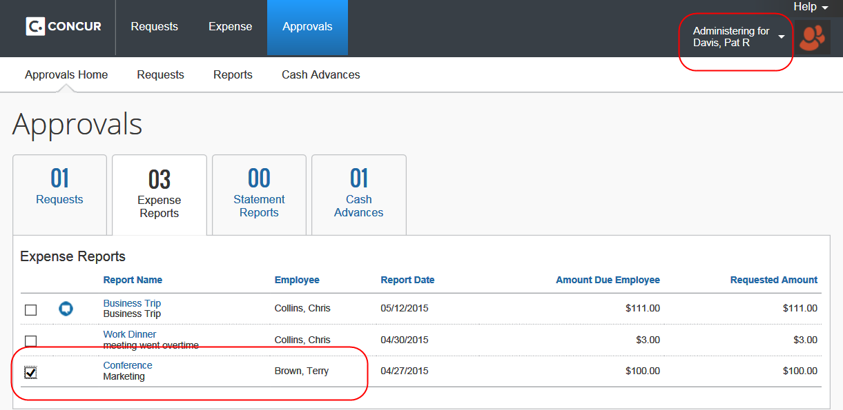
Later, Chris Collins – working as himself; not as a delegate – views the reports he has approved. Terry Brown's report appears in Chris's list of approved reports, even though he approved the report on behalf of Pat Davis.




