
Concur Expense: Receipt
Handling – Digital Receipts
Setup Guide
Last Revised: November 3, 2022
Applies to these SAP Concur solutions:
 Concur Expense
 Professional/Premium edition
 Standard edition
 Concur Travel
 Professional/Premium edition
 Standard edition
 Concur Invoice
 Professional/Premium edition
 Standard edition
 Concur Request
 Professional/Premium edition
 Standard edition
Table of Contents
Section 1: Permissions 1
Section 2: Several Guides about Imaging and Receipts 1
Section 3: Overview 2
This Guide 2
Overview 2
Upload versus Email 3
Report Level versus Expense Entry Level 3
Section 4: Prepare to Use the Available Receipts Library 4
Email Verification 4
Delegates and Registration 6
Section 5: Guidelines for Uploads, Emails, and Digitalized Receipts 6
About Emails and Uploads (General Information) 6
About Uploaded Images 6
About Fapiao Receipts 7
About Digitalized Receipts 7
Glossary of Terms 8
Supported Markets 8
E-Archiving Guidelines (Portugal) 8
About Emailed Images 9
About PDF Files 10
About Timestamped Images 10
Section 6: User Experience 10
Determine if a Receipt is Required 11
Upload/View/Remove a Receipt at the Report Level – Before Report Submission 12
Upload – Report Level 12
View – Report Level 14
Remove – Report Level 15
Upload/View/Remove a Receipt at the Expense Entry Level 16
Upload – Expense Entry Level 16
View – Expense Entry Level 17
Remove – Expense Entry Level 19
Attach/View/Remove a Receipt in the Available Receipts Library 19
Attach – Available Receipts Library 19
View – Available Receipts Library 21
Remove – Available Receipts Library 21
Submit Report 21
Section 7: Delegate Experience 22
Delegate Configuration and User Profile 22
Email Registration for the Available Receipts Library 23
Email Receipts to a User's Available Receipts Library 23
Delegate Permissions When Using the Available Receipts Library 24
Section 8: Approver and Processor Experience 24
Section 9: Manage the Available Receipts Library 24
Email Receipts to the Library 25
Delegates 25
Upload Receipts to the Available Receipts Library 25
From the Expense Home Page 25
From the Expense Entry 26
Delete Receipts from the Library 27
Section 10: Other Considerations 28
Hold for Receipt Image Workflow Step 28
Adobe Reader 29
Compression 29
Troubleshooting Receipt Image Uploads 29
Section 11: Using the Missing Receipt Declaration 30
Overview 30
User, Delegate, and Proxy 30
User Experience 31
Delete the Declaration 32
Configuration 32
Section 12: Japan E-Bunsho Receipt Timestamps 33
User Experience 33
Admin Experience 35
Group Configurations 36
Workflow Rules 37
Audit Rules 37
Receipt Handling 38
Tools 39
Process Reports 42
Configuration/Feature Activation 42
NextGen UI 42
Section 13: Fapiao Receipt Capture 42
Capturing Fapiao 44
User Experience 46
Fapiao Fields 46
Admin Experience 49
Section 14: Receipt Digitalization 50
Overview 50
Digitalizing Paper Receipts 51
Failed Digitalization of Receipts 51
User Experience 52
Digitalized Receipt in Available Expenses 52
Digitalized Receipt in Available Receipts 52
Digitalized Receipt in the Expense List 53
Deleting Digitalized Receipts 53
Downloading Digitalized PDFs 53
Approver and Processor Experience 53
Admin Experience 54
Group Configurations 54
Workflow Rules 55
Audit Rules 55
Receipt Handling 57
Process Reports 57
Configuration/Feature Activation 57
Section 15: Configuration 57
Step 1: Enable the Concur-Internal Setting 58
Step 2: Enable the Imaging Service 58
Step 3: Create or Modify a Receipt Imaging Configuration 58
Step 4: Assign to a Policy 59
Step 5: (Optional) Modify the Receipt Reminder Text 60
Step 6: (Optional) Modify the Delegate Configuration 60
Step 7: (Optional) Hold for Receipt Workflow Step 62
Step 8: (Optional) Enable the Missing Receipt Declaration 62
Enable the Feature 62
Declaration Rule 63
Step 9: (Optional) Japan E-Bunsho Timestamps 63
Enable the Feature 63
Step 10: (Optional) Enable Fapiao Capture 64
Step 11: (Optional) Enable Receipt Digitalization 64

Revision History
Date | Notes / Comments / Changes
November 3, 2022 | Added information about NextGen UI; made modifications throughout; cover revision date updated
October 1, 2022 | Removed references to faxing as part of the fax feature decommissioning on November 1, 2022.
June 20, 2022 | Users may upload an unlimited number of receipts when using the NextGen UI.
June 18, 2022 | Added information about additional support for Portugal for the Receipts Digitalization feature. Content refinements in the Receipts Digitalization sections.
April 1, 2022 | Correct link to government digital receipt site.
January 22, 2022 | Added information about additional supported receipt types such as OFD.  Removed mentions of uploading HTML (formatted) files as this is no longer supported.
October 18, 2021 | Added a NextGen UI section to the Process Reports section that features a table that explains the differences in the Legacy UI versus the NextGen UI for handling expense entries with a timestamp image (specifically, before and after expense report submission).
October 12, 2021 | Added a new Specifically About Timestamped Images section to Section 5:  Guidelines for Uploads, Emails, and Digitalized Receipts.  Updated Section 6: What the User Sees to reflect the changes associated with moving, removing, and detaching receipt images at the report level (both before and after report submission).  Updated Section 12: Japan e-Bunsho Receipt Timestamps to reflect UI changes since the last guide update.
May 14, 2021 | Updated the About Emails and Uploads – General section to include HTML as an acceptable file format.
January 27, 2021 | Added three new sections: Specifically About Fapiao Receipts, Fapiao Receipt Capture, and (Optional) Enable Fapiao Capture.
January 7, 2021 | Updated the copyright; added Concur to the cover page title; cover date not updated.
September 25, 2020 | Updated fax doc title. Added a note regarding fax feature being legacy; cover date not updated.
April 9, 2020 | Renamed the Authorization Request check box to Request on the guide’s title page; cover date not updated.
March 24, 2020 | Fixed broken link.
January 2, 2020 | Updated the copyright; no other changes; cover date not updated
November 15, 2019 | Minor edit.
October 31, 2019 | Updated the Concur Travel & Expense Web Receipts Google Chrome extension images
October 30, 2019 | Updated the SAP Concur Sign In page images
October 2, 2019 | Updated the legislation for France in the Glossary of Terms for the Specifically for Digitalized Receipts section. Other minor edits.
October 1, 2019 | Added content for the Receipt Digitalization feature.
February 13, 2019 | Corrected the image requirement for eligible e-Bunsho receipts from 5M pixels to 3.88M pixels.
January 24, 2019 | Minor edits.
January 12, 2019 | Updated e-Bunsho graphics to show updated timestamp icon ().  Updated e-Bunsho graphics with new timestamp labels.
January 4, 2019 | Updated the copyright; no other changes; cover date not updated.
November 2, 2018 | Removed the not that states that the Missing Receipt Declaration is not available on SAP Concur's mobile app.
September 14, 2018 | The September release has been moved to September 22, 2018.
September 15, 2018 | Updated the E-Bunsho section to include the Digital Compliance Administrator role.  Removed mentions of uploading HTML (formatted) files as this is no longer supported.
June 6, 2018 | Added the following note to the Email Verification section: To verify the email address, the user must have the Expense User role/permission activated, otherwise the verification button will not display.
April 4, 2018 | Changed the check boxes on the front cover; no other changes; cover date not updated.
January 8, 2018 | Updated the copyright; no other changes; cover date not updated.
August 19, 2017 | Updated references (screenshots) to remove “Captured” date and time for  e-Bunsho receipts.
July 8, 2017 | Added e-Bunsho feature.
December 14, 2016 | Changed copyright and cover; no other content changes.
December 9, 2016 | Updated the guide content to new corporate style; no content changes.
November 30, 2016 | Add notes that HTML files cannot be successfully uploaded and processed if they contain double-byte characters.
October 28, 2016 | Added a note that the Missing Receipt Declaration is not available on SAP Concur's mobile app.
May 13, 2016 | Updated instances of he/she to they
September 28, 2015 | The Save button auto-attaches a receipt to the selected line item.
July 6, 2015 | Fixed a typo; no other content changes
June 19, 2015 | Added notes about the email feature being available for a Production entity but not a Test entity.
June 3, 2015 | Added a note about the Available Receipts library/section contains only the images received by Concur in the previous 365 days.
April 20, 2015 | Provided additional detail throughout.
 | Older revision history has been removed. Initial publication of this guide was January 16, 2015.

Uploaded and Emailed Images
NOTE: Multiple SAP Concur product versions and UI themes are available, so this content might contain images or procedures that do not precisely match your implementation. For example, when SAP Fiori UI themes are implemented, home page navigation is consolidated under the SAP Concur Home menu.

Permissions
A company administrator may or may not have the correct permissions to use this feature. The administrator may have limited permissions, for example, they can affect only certain groups and/or use only certain options (view but not create or edit).
If a company administrator needs to use this feature and does not have the proper permissions, they should contact the company's SAP Concur administrator.
Also, the administrator should be aware that some of the tasks described in this guide can be completed only by SAP Concur. In this case, the client must initiate a service request with SAP Concur support.

Several Guides about Imaging and Receipts
There are several ways for the user to manage receipts and receipt images – depending on the needs and configuration of the client. There are several guides about the different processes. Choose the appropriate guide based on your company's configuration.
Method | Description | Guide
Upload | The user can upload an electronic receipt (for example, a scanned image or a picture taken with a mobile device) or a digitalized receipt (a conformed original paper receipt that has successfully been digitalized) into Concur Expense.  Then, the user can:  - Attach it at the report level, if applicable.  - Attach it at the expense entry level, if applicable.  - Save it directly to the Available Receipts library, where later the user can attach it at the expense entry level.  NOTE: Images in the library cannot be attached at the report level.  NOTE: The ability to digitalize a receipt captured at the report level is not yet available. | Expense: Receipt Handing – Digital Receipts Setup Guide
Email | The user can email an electronic image (for example, a scanned image or a picture taken with a mobile device) to Concur Expense.  In Concur Expense, the image is automatically saved to the Available Receipts library, where later the user can attach it at the expense entry level.  NOTES:  - Images in the library cannot be attached at the report level.  - This feature is available only in Production – not Test – sites. | Expense: Receipt Handing – Digital Receipts Setup Guide
CFDi | Digital CFDi files are in XML format to support the digital format requirement for Mexico.  CFDi files:  - Are XML files – not images  - Can be attached only at the expense entry level  - Cannot be saved to the Available Receipts library | Expense: Receipt Handing – Digital Tax Invoice Setup Guide

Overview

This Guide
Imaging is a free service hosted entirely by SAP Concur. It enables users to upload and email images to Concur Expense. Once the images are received by the service, they are displayed in PDF file format (using Adobe Reader) within Concur Expense. This guide describes the upload and email processes – for users, delegates, approvers, and processors.
This guide also describes the Receipt Digitalization feature, which provides the ability to conform a paper receipt into a legal digital copy according to a country's regulatory or government authorities.

Overview
There are several ways to obtain an electronic image of a receipt. For example, the user can:
- Scan a receipt
- Take a picture of a receipt with a mobile device
- Take a picture of a paper receipt and create a legal, digitalized receipt using the latest version of the SAP Concur mobile app or ExpenseIt
- Use an attachment sent via email
- PDF an email or other document
The user can then:
- Upload the receipt into Concur Expense and:
- Attach it at the report level, if applicable
- Attach it at the expense entry level, if applicable
- Save it directly to the Available Receipts library, where later the user can attach it at the expense entry level
- Email an electronic receipt to Concur Expense; it is automatically saved to the Available Receipts library, where later the user can attach it at the expense entry level
The ability to email receipts to the Available Receipts library cannot be used in a Test entity. It is available only for Production entities.

Upload versus Email
If the configuration allows the user to upload and attach images, then they also have access to the Available Receipts library – a repository that stores the user's images or digitalized receipts until the user is ready to use them.
There are several factors that may determine which process the user uses, like:
- If the user is currently creating or modifying an expense or report, the user might upload and immediately attach the image to the report or expense entry. In this case, perhaps there is no reason to have the image in the Available Receipts library.
- If the user is using the Receipt Digitalization feature, once the digitalized receipt is conformed and certified through the digitalization process, the digitalized receipt is automatically uploaded to the Available Receipts library and displays as a "Certified" receipt.
- If the user simply wants to store the receipt until later, then they might upload or email it to the Available Receipts library.
- The first step in the email process involves verification of the incoming email address (described on the following pages). Until that verification is complete, a user cannot email receipts to the Available Receipts library but they can upload to it.

Report Level versus Expense Entry Level
Whether the user attaches a receipt at the report level or expense entry level can depend on:
- Company policy/configuration may dictate where the receipt is attached. For example, the client may not allow its users to attach it at the report level.
- If the receipt is in the Available Receipts library, it cannot be attached at the report level; it must be attached at the expense entry level.

Prepare to Use the Available Receipts Library
Once the Imaging service has been configured (as described in the configuration section of this guide), users can begin uploading receipts and attaching them directly to a report or expense entry (whichever is appropriate) or to the Available Receipts library. However, before the user can email receipts to the Available Receipts library, SAP Concur requires verification of the user's email address.
The user can register more than one email address with SAP Concur, but an email address can be registered only once.
The Available Receipts library contains receipts received by Concur Expense within the previous 365 days. Older receipts will not be available.

Email Verification
To provide an email address for verification, the user clicks Profile > Profile Settings.
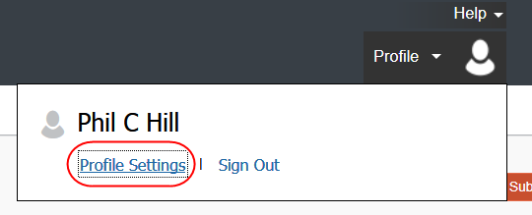
The user clicks Email Addresses in the left menu. The Email Addresses section of Profile appears.

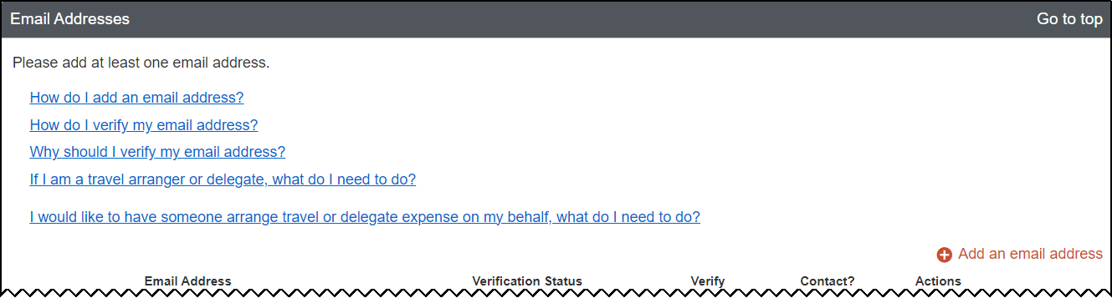
The user adds an email address for verification by clicking Add an email address.
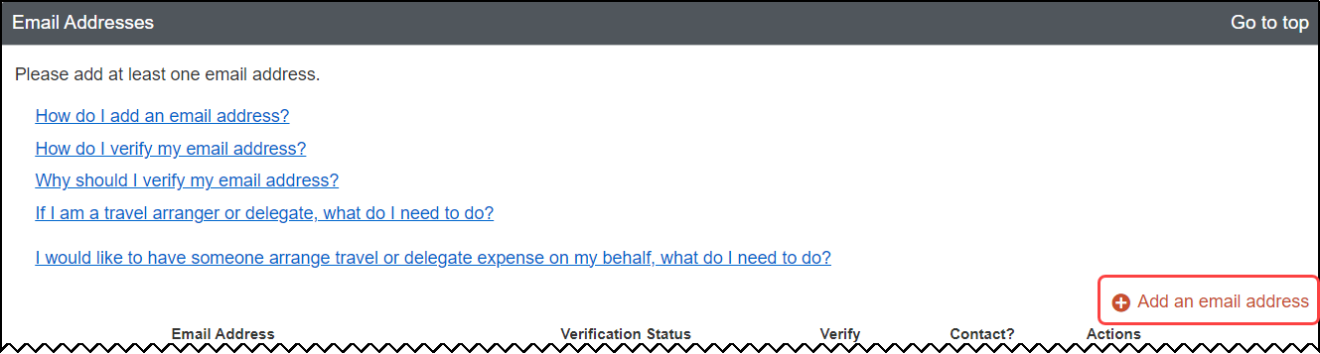
A new row appears, where the user must enter their email address. They can opt to select whether they want to be contacted for travel notifications. The user clicks OK.
The user clicks Verify and this message appears.
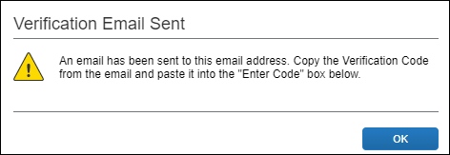
The user accesses their email, finds the email from SAP Concur, copies the verification code, and then types the code in the Enter Code field. The user clicks OK.
- IMPORTANT: The user should allow several minutes for the email to arrive before clicking Resend. Otherwise, there will likely be confusion around multiple emails and multiple verification codes.
To verify the email address, the user must have the Expense User role/permission activated, otherwise the verification button will not display.
When the Verified message appears, the process is complete.
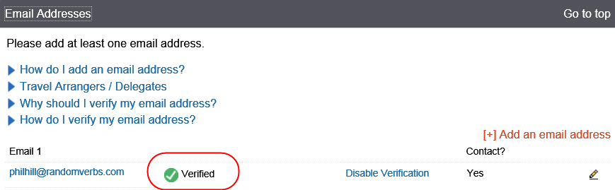
The user can now email receipt images from the verified address to receipts@concur.com, using the information in Guidelines for Uploads and Emails in this guide.

Delegates and Registration
- Refer to Delegate Experience in this guide.

Guidelines for Uploads, Emails, and Digitalized Receipts

About Emails and Uploads (General Information)
Uploaded or emailed, the file format must be PNG, JPG, JPEG, PDF, TIF, or TIFF files.
Some PDFs may fail to process to an image because there are many types of complex PDF file types. If you have multiple examples of a type of PDF that is not processing, please contact SAP Concur support; we may be able to make system adjustments to accept those types of PDFs.
- Refer to Specifically About Digitalized Receipts in this section of this guide for details regarding digitalized receipts.

About Uploaded Images
Note the following:
- When scanning, the images should be scanned at 300 dpi or lower to reduce file size. For best results, scan or take a photo as a black and white picture with no more than 1024 x 768 image resolution.
- There is a size limit for each image file; the Receipt Upload and Attach window displays that limit.
- No more than 10 files may be uploaded in a single session.
- To upload more than 10, simply upload the first 10 and then upload another 10, until done.
- Occasionally, we must recompress an image sent to us. If a non-PDF image is over 1 megabyte or if a single page of a PDF is over 100k, we must move the file to a queue for reprocessing. If we cannot manage the reprocessing task within a reasonable time limit, we send the image "as is" to the user – in an effort to not keep the user waiting. Some of these images may not be as legible if the image background color too closely matches to the font color. In this case, the user should save the original image again as a black and white picture with no more than 1024 x 768 image resolution.

About Fapiao Receipts
A fapiao is a legal tax receipt required for every business transaction in China. A fapiao is issued by the State Taxation Administration of the People's Republic of China but provided by the merchant.
Users must use the SAP Fapiao Capture mini app in the WeChat™ mobile app, specifically built for fapiao capture. This mini app is the only compliant means of fapiao capture and upload to Concur Expense. For VAT fapiao, captured fapiao in the WeChat app satisfies government requirements on fapiao authenticity and uniqueness.
- For more information, refer to the State Taxation Administration of the People's Republic of China
- For more details, refer to Section 13: Fapiao Receipt Capture in this document.

About Digitalized Receipts
When a user takes a picture of an original paper receipt in the SAP Concur mobile app, or using ExpenseIt, the digitalization process occurs, which conforms the paper receipt according to country-specific compliance rules. Once this process occurs, the receipt is considered "certified", meaning that the digitalized copy has the same probatory value as the original paper receipt, thus enabling users to retain the digitalized copy and eliminate the paper. Digitalized receipts can then be used like any other receipt on an expense.
The paper digitalization process applies only to receipts originally issued on paper and that are digitalized. The application that captures the receipt and transforms it must be part of the certified solution to ensure fidelity (i.e., that the original and the digitalized copy are identical). For this reason, pictures of receipts from other phone apps or previously uploaded receipts in the Available Receipt library (not certified) cannot be conformed through the SAP Concur mobile digitalization process.
Electronic receipts are considered original receipts from an electronic source and subject to different regulations around validation of the receipt.

Glossary of Terms
Term | Definition
"Certified" | Label applied to a digitalized receipt as displayed in Concur Expense.
Certification / Homologation | The two words are similar in the context in this document, with homologation being more specific (homologation is the process of certifying or approving a product to indicate that it meets regulatory standards and specifications by an official authority)  - For paper into digital in Spain, to be compliant SAP Concur requires a mandatory homologation granted by the tax authorities. Homologation is granted by the Agencia Estatal de Administración Tributaria (AEAT -Central Spanish tax authority) and the 4 regional tax agencies (Hacienda forales: Araba-Álava, Bizkaia, Guipuzkoa, Navarra)
Compliance | Adherence to the set of rules or regulations published by a governmental body; for example, SAP Concur’s compliance with the rules of how a receipt must be digitalized.
Conform | The process of applying the rules/regulations of a specific country regarding converting a paper receipt into a digital copy with probatory value (the process).
Digitalization | The result of conformation of a paper receipt; a conformed receipt is considered “digitalized.” A digitalized receipt in Concur Expense will have an icon that displays “Certified.”
Rule / Regulation | Applicable legislation relating to the conformation and digitalization of paper invoices/receipts.
Validation | In the context of data validation, any service or person that takes a value and validates it against an internal or third-party source.

Supported Markets
The SAP Concur business solution for capturing, consuming, storing, and retrieving paper receipts and/or legal copies of paper receipts is currently only compliant to the rules published in France, Spain, and Portugal.
In all cases, clients should consult with their own tax and/or legal authorities in their country to determine what is compliant in their country or region. There are many countries that do not have strict rules regarding legal digital copies of receipts, like the United States. In those countries, SAP Concur strongly advises that clients consult with their own authorities to ensure compliance with their laws.

E-Archiving Guidelines (Portugal)
Clients who want to go paperless with digitalized receipts in Portugal must also have an e-archival process in place that complies with the local legislation. Having a defined e-archiving process is a best practice for SAP Integration with Concur Solutions (SAP ICS) for ERP integration and ensures compliance with the e-archiving rules established by Portuguese authorities.
Non-SAP ERP clients can use this best practice process as a guide but will need to adapt it to their specific ERP or e-archiving solutions. Clients that activate the receipt digitalization process and follow the e-archiving best practices will be fully compliant and can go paperless.
E-Archiving Guidelines include the following requirements:
- Document type: Users must be able to easily identify all documents and tracking of document movements within Concur Expense
- General Accounts: A list of general accounts to be used and tracking of accounting movements within Concur Expense
- Images: Required naming of images to be archived in the ERP system
- The images names must contain the expense report number and an additional number that represents the index lines in the report. This information provides a link between the report number and each image.
- For example, if an expense report contains three lines of text, each image will be identified as: 12345689 – 01, 12345689 – 02, 123456789 – 03, according to the line with which it's associated.
- Additional Information: Tracking of additional information.
- For example, the expense report number can be tracked in a specific field, such as the Reference field, so that accounting information can be reviewed. This information can then be searched in both the expense report and the associated archive.
- This example allows information to be tracked in accounting documents associated with the expense report. Additional reports can be generated using Transaction ID field, like the one used in the SAF-T file; the statutory reporting file format in Portugal used for tax reporting purposes.
- For more information regarding the SAF-T file, refer to SAF-T for Portugal User Guide.

About Emailed Images
Note the following:
- Each email attachment is treated as a single image file – a single image file with two receipt images within it is still treated as a single receipt image.
- An image embedded in the body of the email is treated as a single image file.
- The system does not support a combination of attached image files along with an image embedded in the body of the same email. In this scenario, the embedded images are ignored.
The ability to email receipt images to the Available Receipts library cannot be used in a Test entity. It is available only for Production entities.

About PDF Files
There are several types of PDF files. The PDF files listed here cannot be successfully uploaded as images:
- Password protected: These files cannot be decrypted so they cannot be stored by Concur Expense.
- AcroForm PDFs: These PDFs may upload but the text in these Acrobat fill-in-the-blanks forms will likely not be visible. In fact, this issue occurs only if multiple AcroForms are uploaded; single AcroForms likely upload properly. Best practice is to avoid uploading AcroForms since the results are not reliable.
- XFA PDFs: These XML-based PDFs collect information associated with electronic forms. Since they are interactive, they cannot be successfully uploaded.
There is another type of PDF file known as a Portfolio PDF. These "collection" PDFs can contain files with various file types. Concur Imaging keeps any included file with an acceptable imaging file type (PNG, JPG, JPEG, PDF, TIF, OR TIFF) and discards the remaining files.

About Timestamped Images
Note the following:
- Timestamped images can be deleted, detached, and moved from reports.
- Corresponding Concur Expense UI behavior depends on the report status (specifically, before or after report submission) and user action (for example, remove, detach, and move).

User Experience
This section describes a common user process. The user generally:
- Completes the expense report as usual
- Determines if receipts are required
- If required:
- Attaches or uploads one or more receipt attachments
- Checks to ensure the attached receipts are clear and readable
- Submits the report

Determine if a Receipt is Required
The client defines when receipts are required, for example, for dinners over $50, for all airline tickets, etc. If a receipt is required, Expense displays an Alerts column with an alert icon  beside the default Receipt column, where a receipt icon  appears.
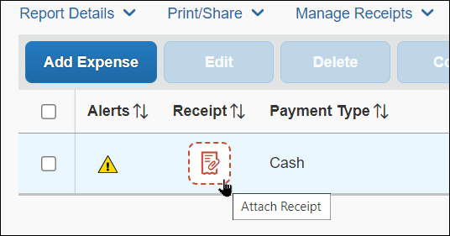
Once the receipt is attached, the Alerts column is no longer displayed (provided all other report errors are cleared), and the Receipt column displays the receipt image.
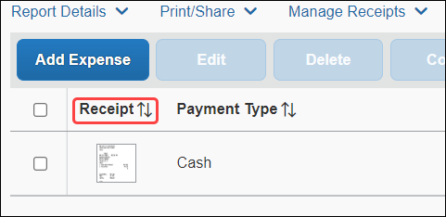

On Submit
The user is also reminded in the Alert window when the user clicks Submit Report.
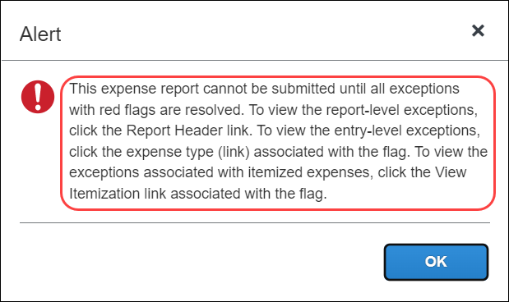
The reminder instructions – shown below Reminder: Receipts Required! – can be customized. Refer to the configuration information in this guide.

Upload/View/Remove a Receipt at the Report Level – Before Report Submission

Upload – Report Level
The client may not allow its users to upload to the report level; the client may prefer that the user upload for each individual expense. However, if the user is allowed to do so, the user may do this at the report level.
The amount of time required to upload the receipt depends both on the size of each file and the overall connection speed.

Upload While Creating/Editing the Report
With the report open, the user clicks the receipt icon .
The Attach Receipt window appears. Use the options on this page to review Available Receipts resident in the Available Receipts library and upload the required receipt using the Upload Receipt Image tile.
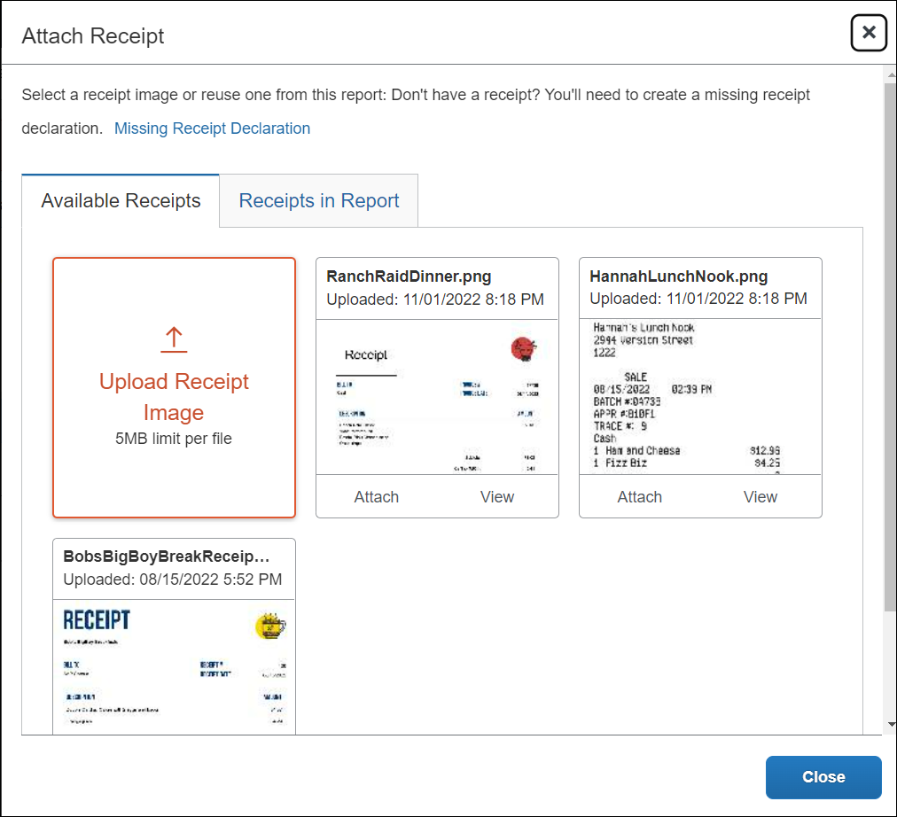

Upload While Submitting the Report
While an alert appears as a reminder, there is no option to add a receipt when submitting the report. Open the report and add the receipt using the instructions above.

View – Report Level
Once the upload is complete, to view the receipts, the user clicks Manage Receipts > Manage Attachments.
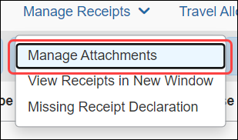
In the window that appears the user may manage the receipt as required, including removing, adding additional receipts, and opening the receipt in a separate window.
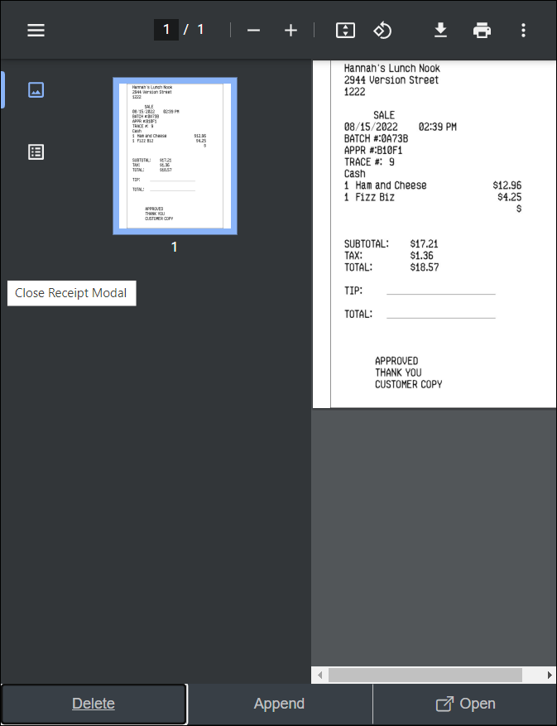

Remove – Report Level
As described above, the user may remove the receipt from the expense using the Delete option.
Note the following:
- The entire set of receipts (PDF) will be removed from the report.
- For reports that have been returned to the user:
- Concur Expense creates an audit trail entry indicating that receipts have been deleted.
- If Concur Expense had marked the receipts as received (in Processor), the delete process will mark the receipts as not received.

Upload/View/Remove a Receipt at the Expense Entry Level

Upload – Expense Entry Level
The amount of time required to upload the receipt depends both on the size of each file and the overall connection speed.
With the expense entry open, the user first notes if receipts are required by referencing the Alerts column. If so, the user clicks the receipt icon in the Receipt column and, in the Details tab of the window that appears, clicks Upload Receipt Image.
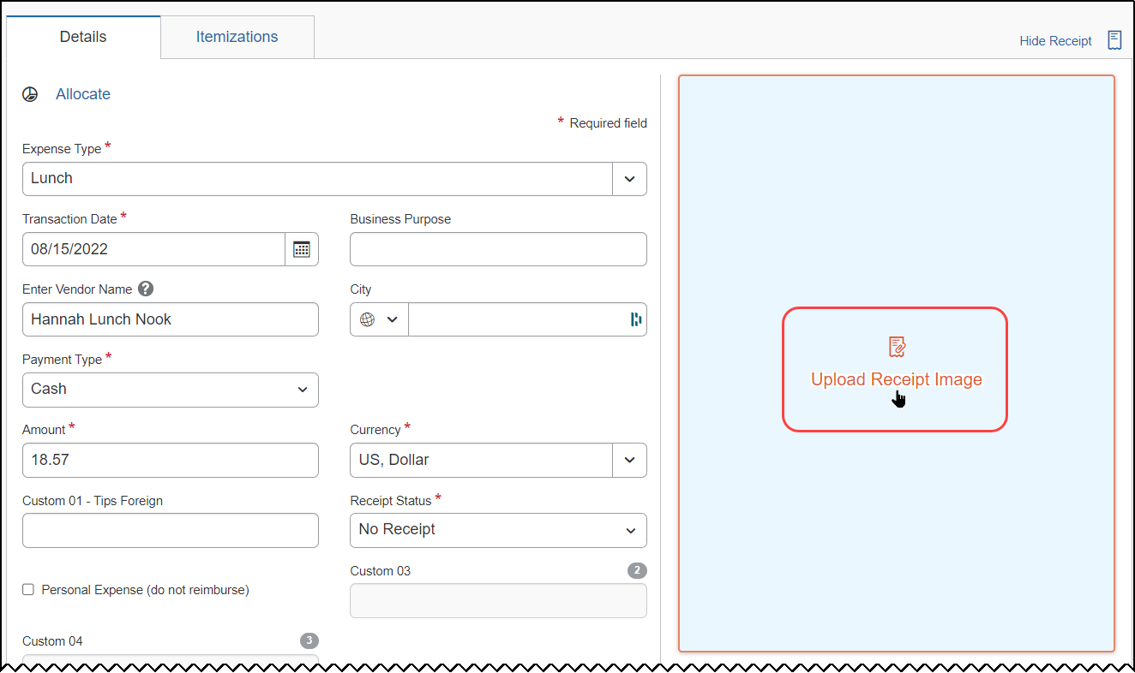
The Attach Receipt window appears. Use the options on this page to review Available Receipts resident in the Available Receipts repository and upload the required receipt.

View – Expense Entry Level
When open, the image, when attached, appears directly to the right of the expense entry.
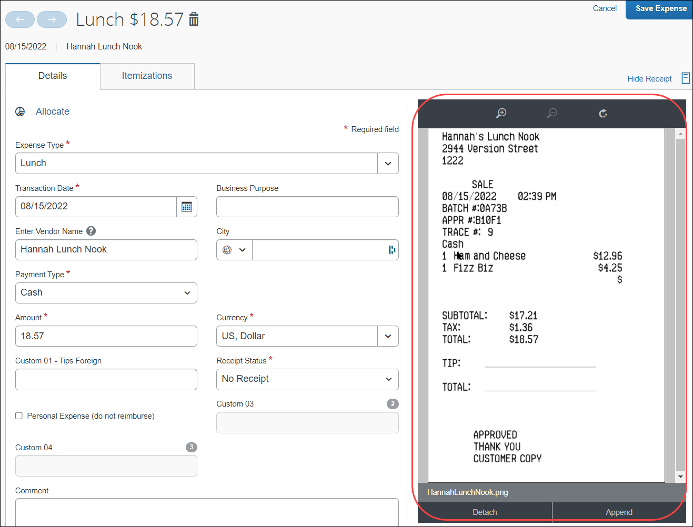
The user can use the toolbar to zoom and rotate the image, if desired.

Rotating is not available for all image formats.
The user may also toggle the receipt view by clicking Hide Receipt and Show Receipt links.
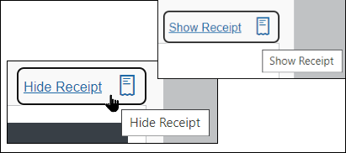

Remove – Expense Entry Level
If the user uploaded the wrong image, they can delete it and try again. The user can delete the receipts only if the report has not yet been submitted or if the report has been submitted then returned to the user.
A recalled report does not allow for removal.

Note the following:
- A removed/detached receipt is not actually deleted. It is moved or added to the Available Receipts library – even if it was not originally housed in the Available Receipts library.
- Once the receipt is removed/detached, the icon associated with the expense entry is changed from the receipt image to the receipt required icon .
- For reports that have been returned to the user:
- Concur Expense creates an audit trail entry indicating that receipts have been deleted.
- If Concur Expense had marked the receipts as received (in Processor), the delete process will mark the receipts as not received.
When you click Detach, a confirmation dialog appears.
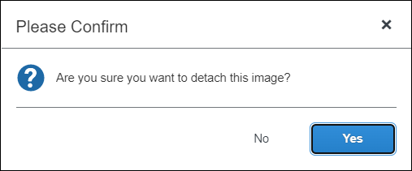
Click Yes to detach the receipt from the expense entry. The receipt image is returned or added to the Available Receipts library and the expense entry no longer has the corresponding receipt attached to it.

Attach/View/Remove a Receipt in the Available Receipts Library

Attach – Available Receipts Library
Receipts in the Available Receipts library may be attached at the expense entry level using the receipt required icon.
Note the following:
- Receipts in the Available Receipts library can be attached to expense entries. They cannot be attached at the report level.
- The Available Receipts library contains receipts received by Concur Expense within the previous 365 days. Older receipts will not be available.
- Once the receipt is attached, the Alerts column is no longer displayed (provided all other report errors are cleared), and the Receipt column displays the receipt image.

Use the Receipt Icon to Open the Available Receipts Library
With the report open, the user clicks the receipt icon .
The Attach Receipt window appears, displaying for view (only) all Available Receipts in the Available Receipt library. Use the options on this page to review Available Receipts and upload the required receipt using the Upload Receipt Image tile.

View – Available Receipts Library
The user can view receipts using the steps in View –Expense Entry Level.

Remove – Available Receipts Library
The user can remove receipts using the steps in Remove –Expense Entry Level.

Submit Report
Once the user ensures that the receipts are attached correctly, they submit the expense report as usual.

Delegate Experience

Delegate Configuration and User Profile
Whether or not a delegate can view, add, or remove receipts (either directly or in the user's Available Receipts library) depends on two factors:
- If the client's delegate configuration allows it.
- Refer to the configuration information in this guide.
– and –
- If the configuration allows it, then whether the user allows it (as shown below).
If the client configuration allows delegates to manage receipts, then the Can View Receipts option is available in Profile for users to define the options available to their delegates.
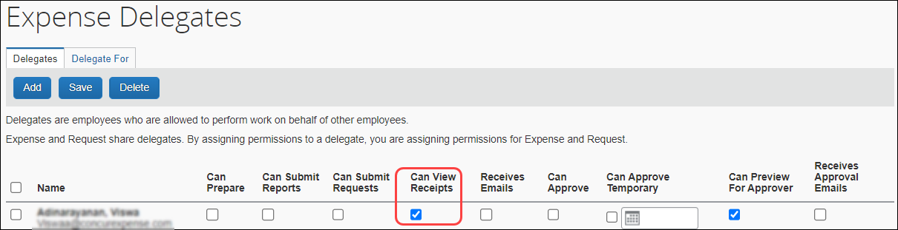
The user clicks Profile > Profile Settings and then Expense Delegates (left menu). For the desired delegate, the user selects (enables) the Can View Receipts check box.
The setting says "view", but it includes view, add, delete, etc.
If the Can View Receipts check box is not checked, these are not visible/available to the delegate:
- Receipts Received icon
- Manage Receipts menu
- The Upload Receipt image tile (at the expense entry level)
- The Available Receipts library
The remaining information in this section assumes that the Can View Receipts is enabled.

Email Registration for the Available Receipts Library
To allow the delegate to email receipts into a user's Available Receipts library, the user's email address and the delegate's email address must be verified in their respective profiles.
First, the delegate verifies their own email address (as described in Prepare to Use the Available Receipts Library in this guide).
Then, the user can verify their own email address or the delegate can initiate the verification process on behalf of a user, but the delegate cannot complete it. To do so, the delegate – while working on behalf of the user – clicks Verify in the user's profile. Concur Expense sends the verification email to the user – not the delegate. The user opens the email and enters the verification code into their own profile.
When the process is complete, the delegate can email receipts on behalf of the user as described below.

Email Receipts to a User's Available Receipts Library
To email receipts for a user, the delegate:
- Prepares an email to receipts@concur.com
- Enters only the user's verified email address in the Subject: line
- Attaches the receipts
- Sends the email
The system:
- Confirms that both the delegate sending the email and the user in the subject line (delegator) have verified email addresses
- Confirms that a delegate-to-delegator relationship exists between the sender (delegate) and the user in the subject line (delegator)
Then:
- If both verification steps are found to be true, the receipt is added to the user's Available Receipts library.
- If the sender is not the delegate of the user in the subject line (delegator), the receipt is added to the delegate's Available Receipts library.
- If the delegate does not have a verified email address, the email is discarded.
- Notice of discarding is not generated – the user and delegate must confirm and correct any issues with unverified email addresses.

Delegate Permissions When Using the Available Receipts Library
A delegate can – while working as a user – perform all actions allowed to the user they are working on behalf of within the user's Available Receipts library. The delegate uses the steps in User Experience section in this guide.

Approver and Processor Experience
The approver and processor:
- Can view receipts
- Can upload receipts at the report level, if the configuration allows report level attachments
- If a receipt already exists at this level, then the approver/processor attachment is appended to the original.
- If there is not already an attachment, then the approver/processor attachment is the only receipt.
- Can upload receipts at the expense level (not from the Available Receipts library)
- If a receipt already exists at this level, then the approver/processor attachment is appended to the original.
- If there is not already an attachment, then the approver/processor attachment is the only receipt.
- Cannot remove a receipt, even if the approver/processor added the receipt
- Cannot access or view the user's Available Receipts library
To upload and view, the approver and processor uses the steps in User Experience in this guide.
If the processor or approver wants a receipt removed, they must return the report the user (or delegate) to complete that task.

Manage the Available Receipts Library
This section provides additional information about the Available Receipts library, including how to:
- Email receipts to the library
- Upload receipts to the library if you are allowed to upload
- Delete receipts from library
- View, zoom, and rotate receipts
- Send receipts to the library

Email Receipts to the Library
The user prepares the attachments using the information in Guidelines for Uploads and Emails in this guide. Then, the user prepares the email to receipts@concur.com, attaches the receipts, and sends the email.

Delegates
- For information about delegates sending receipts to the Available Receipts library, refer to Delegate Experience in this guide.

Upload Receipts to the Available Receipts Library

From the Expense Home Page
The user clicks Expense, then scrolls to the bottom of the screen to display the Available Receipts section.
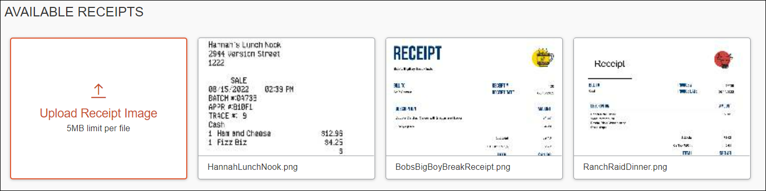
At the bottom of the page, the user clicks the Upload Receipt Image tile. The Open window appears.
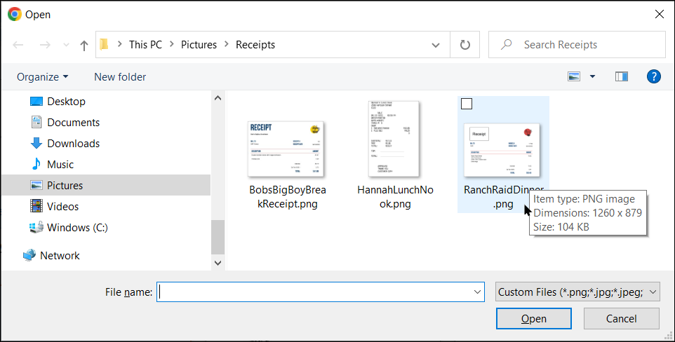
The user clicks Browse and locates the desired receipt, then clicks Open to add the receipt image to the library. The receipt is then available to be attached at any time.

From the Expense Entry
With the expense entry open, the delegate clicks the receipt icon in the Receipt column and, in the Details tab of the window that appears, clicks Upload Receipt Image.
The Attach Receipt window appears. Use the options on this page to review Available Receipts resident in the Available Receipts repository and upload the required receipt.

Delete Receipts from the Library
In the Available Receipts library, click the image to be deleted.
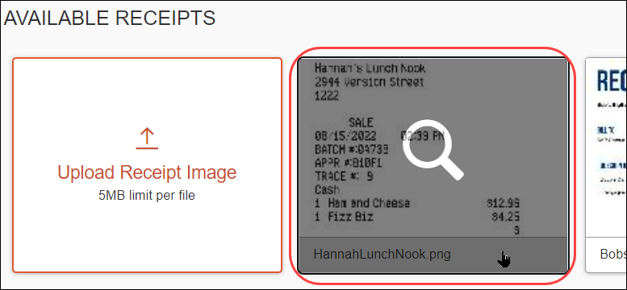
The image opens in a separate window. Click Delete, then Delete in the Confirm Delete window.
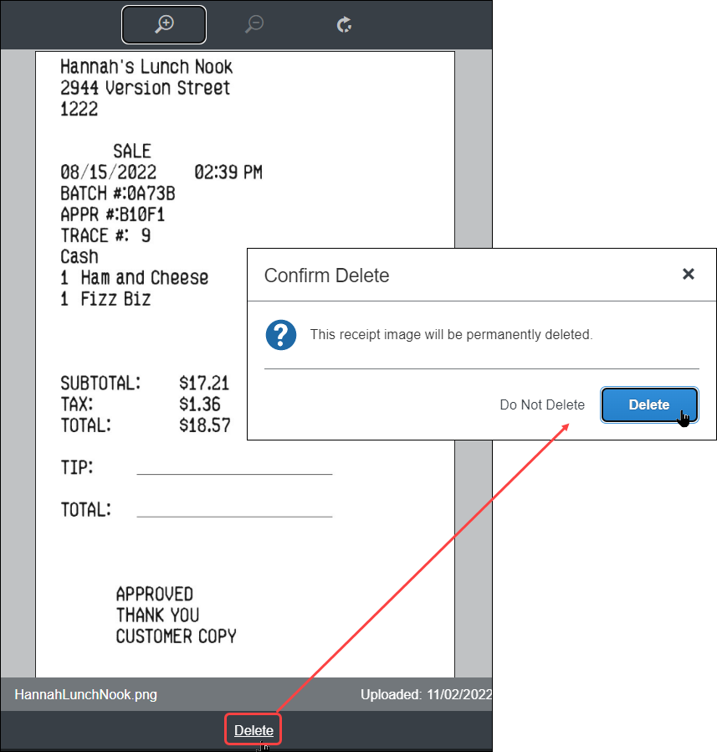
If the receipt is associated with a mobile expense (an expense generated on a mobile device using the SAP Concur mobile app) or is an e-receipt, the user cannot delete the receipt from the library.
- To delete a receipt associated with a mobile expense, the user must delete the mobile expense.
- To delete an e-receipt, the user must delete it from the Available Expenses area, providing the client's configuration allows deletions.

Other Considerations

Hold for Receipt Image Workflow Step
The administrator can add a step to the Concur Expense workflow that requires receipt images to be attached to an expense report before the report can be sent to the first approver. Once the Imaging service receives the receipts, they are attached to the report in PDF format and the report can move to the next step in the workflow.
- For more information, refer to the Concur Expense: Workflow - General Information Setup Guide.

Adobe Reader
Every client computer that utilizes the Imaging service must have the correct version of Adobe Reader installed. SAP Concur recommends version 8.0 or newer. Concur Expense does not provide Adobe Reader as part of Imaging. Adobe Reader is free to install and can be downloaded at http://www.adobe.com.
The first time an employee submits or prints a report from within Concur Expense and Imaging has been activated, the system checks for the availability of Adobe Reader on the employee's computer. To assist the employee with the application installation, a link can be provided during configuration of Imaging that will direct the employee to the Adobe website to install the application, or to any other URL that is designated as the access point for Adobe Reader.
Adobe Reader must be configured to display the PDF in the browser and not in a separate window.

Compression
The Imaging service compresses larger PDFs. Images are not affected immediately; however, if a user views a PDF later, the user may notice that the receipt image is now grayscale and may not be quite as clear.

Troubleshooting Receipt Image Uploads
The following table displays error messages or scenarios that the employee may experience after attempting to upload receipt images to the Image Upload Server.
Error Message | Description | Solution
No files selected. | There are no files to be uploaded in the Files selected for uploading list. | Use the Browse button to select files to upload.
Completed. | The file is successfully uploaded. | N / A.
File Exceeds Size Limit. | The maximum file size is displayed in the Attach Files window. Refer to that information. | Save the file in a different format or rescan the file at 300 dpi or lower to reduce the file size. For best results, scan or take a photo as a black and white picture with no more than 1024 x 768 image resolution.  NOTE: Do NOT attempt to compress the file using file compression software.
File Format not Supported. | The format of the file is not supported by the Receipt Image Upload feature. | Save the file in the PNG, JPG, JPEG, PDF, TIF, OR TIFF formats only.  Also, refer to Specifically About PDF Files in this guide.
Upload Error. | The file was not successfully uploaded for unspecified reasons. | The upload process was not successful. You may attempt to upload the file in a new session. If this error continues, consult your SAP Concur Administrator for further directions.
Session has expired. Please log on to the application again. | The session has timed out due to inactivity over 24 hours. | Close and log in again.
Unable to upload images at this time. There may have been an error in the application, or you may have clicked the Refresh button. Close this browser window and retry the image upload from within the application. | The file was not successfully uploaded for a variety of reasons. | Open a new instance of Expense and try again to upload files.

Using the Missing Receipt Declaration

Overview
When a user is required to provide receipt images but cannot locate them (for example, they are lost or destroyed), the user can digitally sign an affidavit that is submitted instead of the actual imaged receipts. This way, the report can be submitted in a timely manner and, at the same time, comply with company policy on receipt submission.

User, Delegate, and Proxy
The affidavit can be submitted only by the user – not the user's delegate or a proxy.

User Experience
The user requiring an affidavit clicks Manage Receipts > Missing Receipt Declaration.
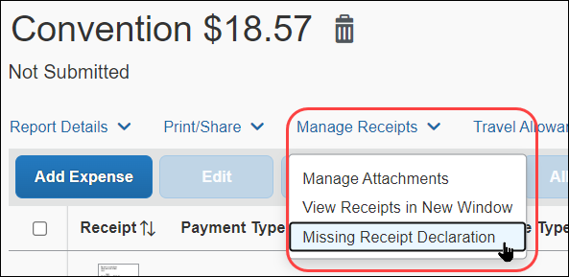
The Create Receipt Declaration window appears. Select the correct expense (there may be several listed) and then click Accept & Create.
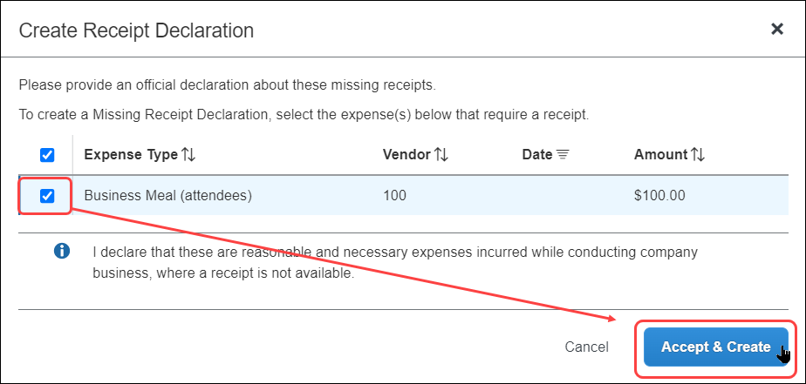
The client can add customized text above and below the listed expenses in the Create Receipt Declaration window. The text can also be localized. Both processes are described in the configuration section in this guide.
The system adds the  icon to each expense entry associated with the affidavit:
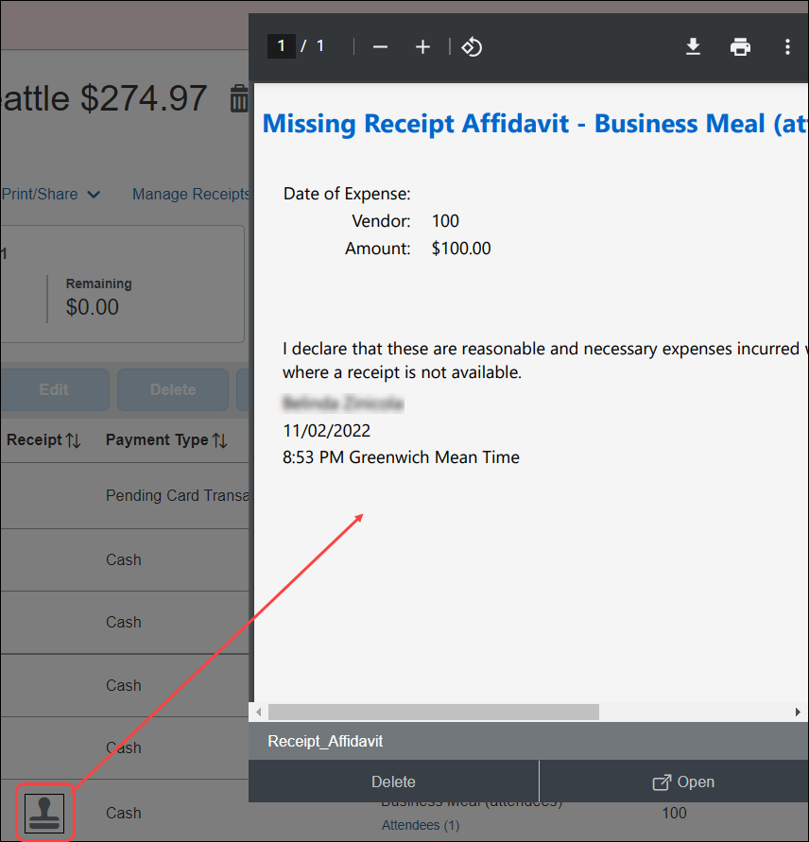
The system also creates an image of the affidavit statement, attaches it to the entry or entries, and creates a record of the date, time, employee name, and other details for review purposes.
In addition, a flag is set that can be used for audit rules to identify reports using the affidavit image type, as described in the configuration section of this guide.

Delete the Declaration
If the user later finds the receipt (before the report is submitted), they can delete the affidavit and attach the receipt image. To do so, the user clicks the icon and then clicks Delete. Then, in the Confirm Delete window, clicks Delete.

Configuration
To configure the affidavit feature, refer to the configuration section below.

Japan E-Bunsho Receipt Timestamps
The e-Bunsho Timestamp feature for Japan allows admins to configure timestamping of receipts for groups of users.
Admins may use these timestamps in workflow rules and audit rules.
There is a validation process for monitoring received, pending, requested, and ineligible timestamps. The validation process revalidates the successfully timestamped images and displays counts and totals by date range for valid and invalid timestamped images.
This feature allows clients in Japan to maintain legal compliance to use images in lieu of paper receipts, per the e-Bunsho regulations.

User Experience
When creating expense reports, users see successfully timestamped receipts display with a new icon (). Available Receipts display a valid timestamp or a status for each receipt image.
Users cannot append another image once an image has been timestamped.

E-Bunsho Icon
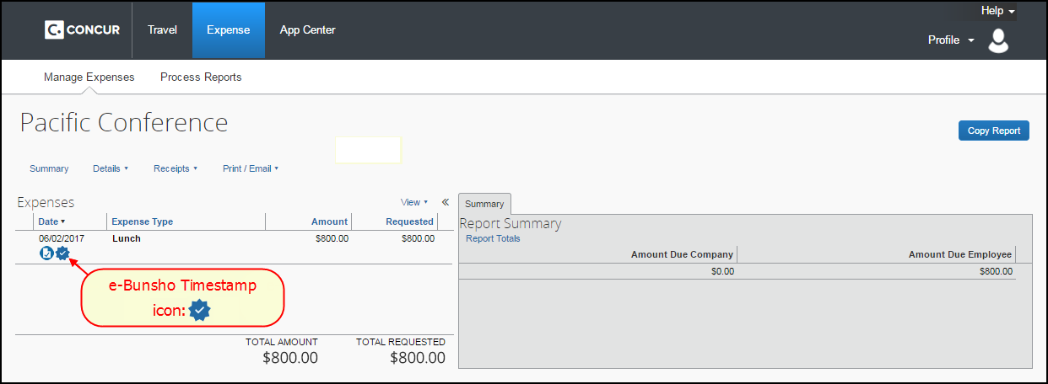

Receipt with e-Bunsho Timestamp
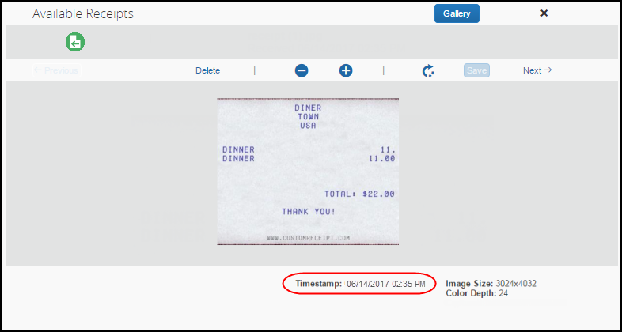

Receipt without e-Bunsho Timestamp
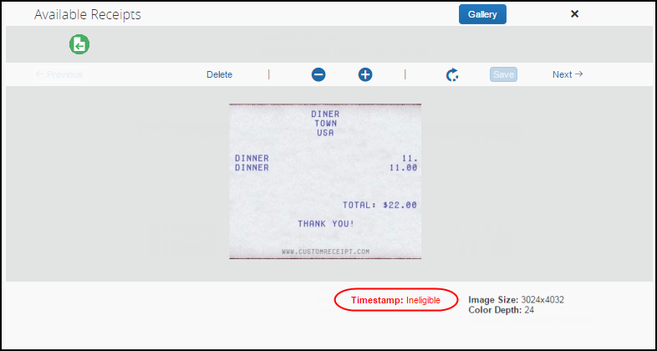

Possible Timestamp Statuses
Status | Description
Received | The receipt has entered the system.
Pending | The image is not yet queued for a timestamp.
Requested | A timestamp has been requested.
Ineligible | The image is not eligible for a timestamp because it is less than 3.88M pixels.  NOTE: To be eligible for an e-Bunsho timestamp, images must be more than 200dpi (scanner) or 3.88M pixels (smartphone/digital camera) and at least 24-bit color for RGB.
Invalid | The image has failed a validation check.
Timestamp statuses display to the user and are described in this guide; however, validation statuses do not display to users and are available to Concur Expense for troubleshooting purposes only. The validation statuses are:
● ENTITY NOT FOUND
● NOT TIMESTAMP IMAGE
● INELIGIBLE IMAGE
● INVALID IMAGE ID
● IMAGE NOT FOUND
● DELETED
● TIMESTAMP NOT YET RECEIVED
● INVALID
● VALID

Deleting Receipt Images
There are instances when the system disables a user’s ability to delete or remove a receipt image:
- In the Receipt Library, when a receipt image is successfully timestamped or if the status is in pending, the user may not delete the receipt image.
- On an expense entry, when a receipt image is successfully timestamped or if the status is in pending, the user may not detach the receipt image from the entry.
Deleting and detaching receipt images is permitted when the timestamp status displays in red text, such as ineligible and invalid statuses, unless the status is in pending.

Admin Experience
Admins see changes in the following places:
- Group Configurations
- Workflow Rules
- Audit Rules
- Receipt Rules
- Tools
- Process Reports

Group Configurations
On the Group Configurations page, from the Digital Compliance Country Rule list, admins can select Japan e-Bunsho for groups of users.
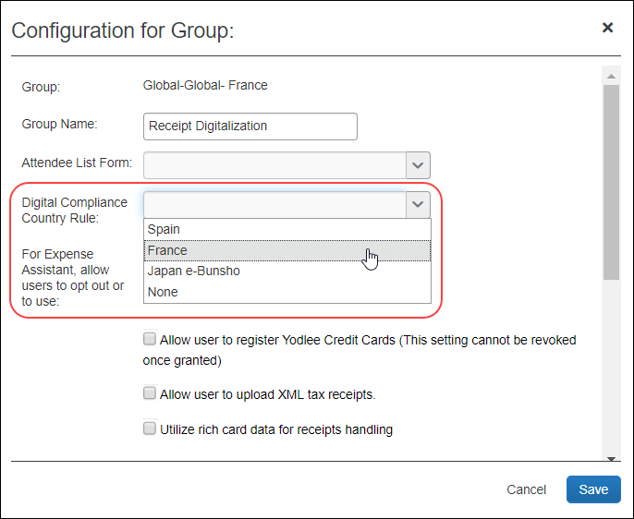
- For more information, refer to the Concur Expense: Group Configurations for Expense Setup Guide.

Workflow Rules
Admins see Is Digitally compliant in Workflow Rules (and Audit Rules and Receipt Handling).
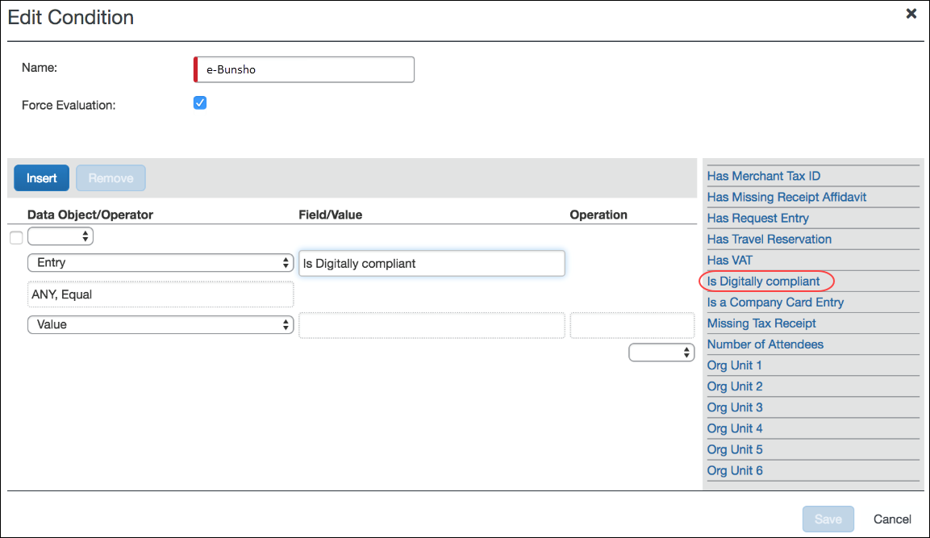
- For more information, refer to the Concur Expense: Workflow – General Information Setup Guide.

Audit Rules
Admins can create restrictions on save of expense entries using Audit Rules.
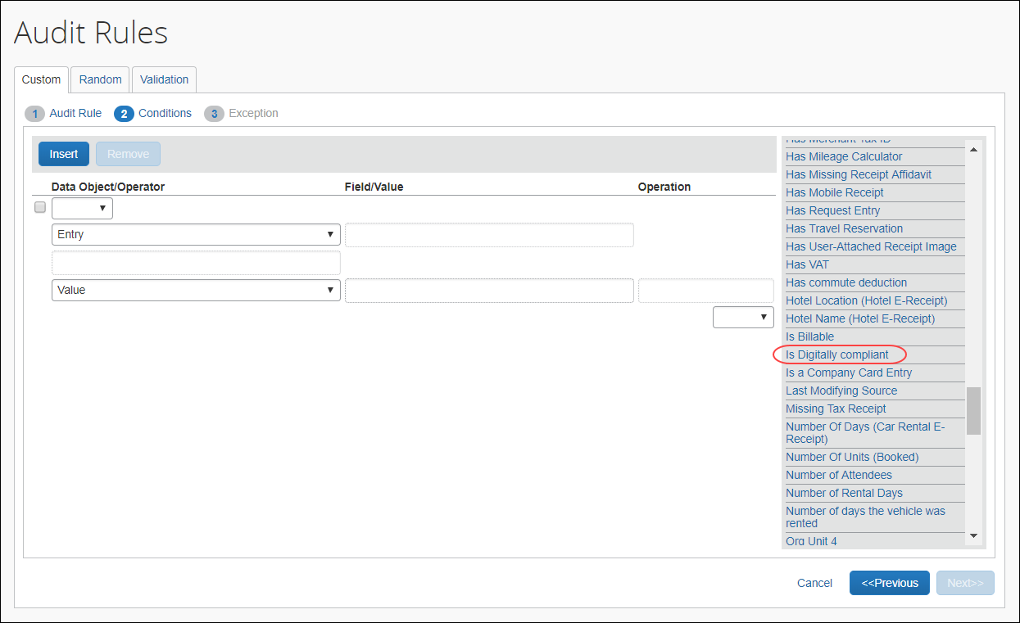
- For more information, refer to the Concur Expense: Audit Rules Setup Guide or the Expense: Workflow Setup Guide.

Receipt Handling
Admins can create limits using Receipt Handling.
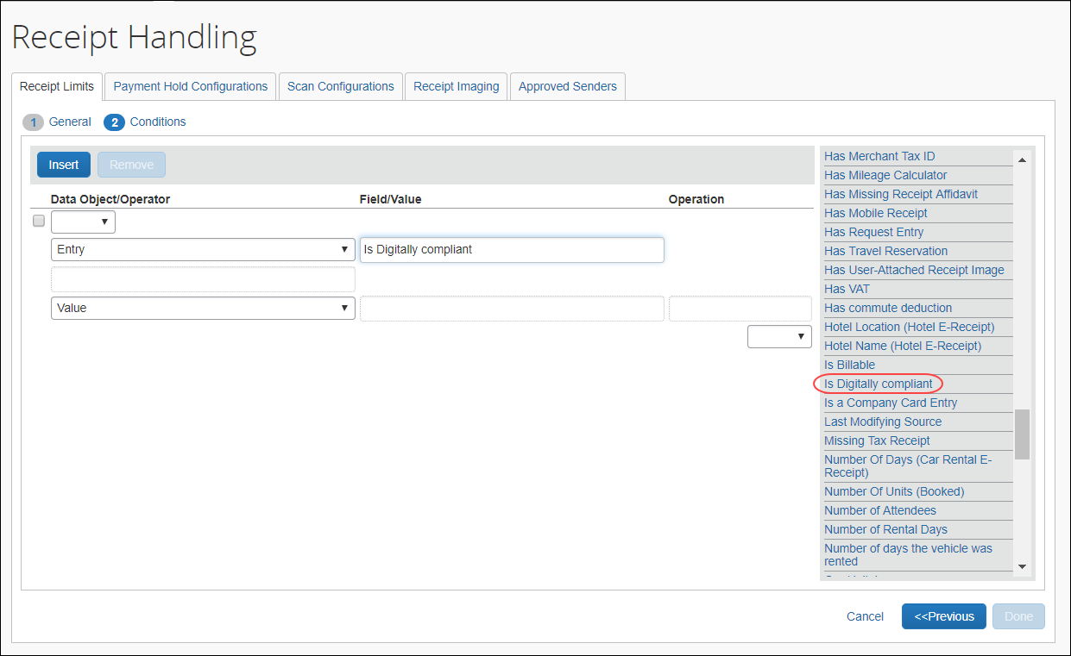

Tools
The E-Bunsho Timestamp validation tool allows the company to validate the timestamps on a selected set of expense reports, usually done during the course of a government audit. The tool displays counts of images submitted for validation during a date range and can be used to view images that failed validation.
This tool is available to admins. The Digital Compliance Administrator role was created to provide access to this tool.
On the Tools page, users can see the E-Bunsho Timestamp validation request tool.
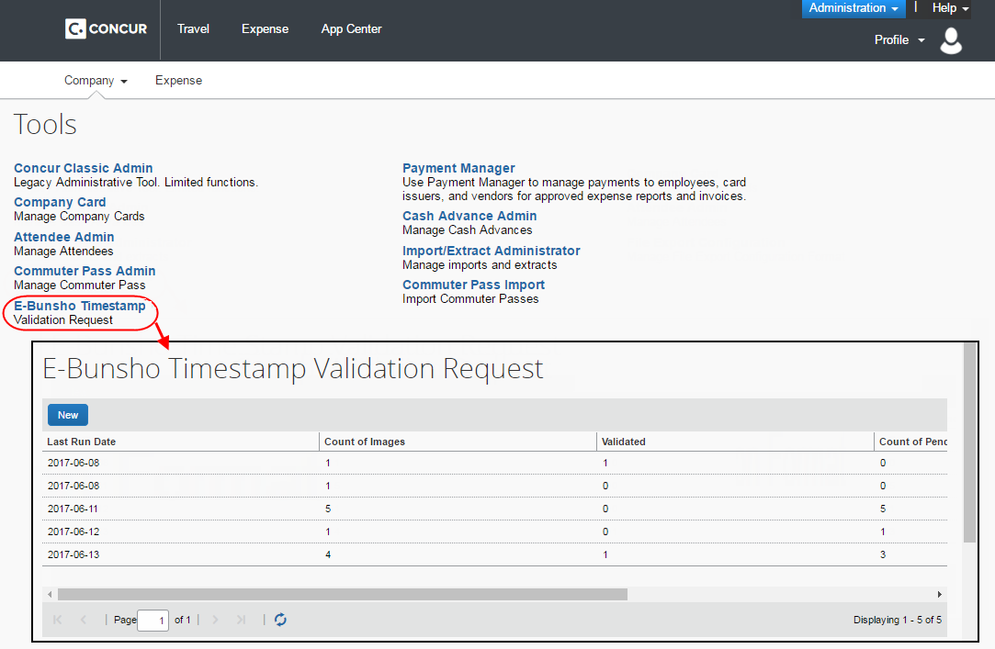
The tool can be used to view the following information by date:
- Total Number / Count of Images
- Total Number / Count of Validated Images
- Total Number / Count of (images) Pending validation
- Total Number / Count of Failed images
- Report Name
- Expense Type
- Vendor
- Submit Date
- Amount
To create a new validation request
- Click Administration > Company > Tools.
- Click E-Bunsho Timestamp.
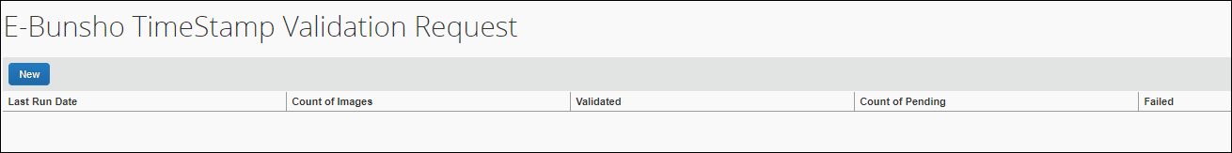
- Click New. The E-Bunsho Timestamp Validation Request page appears.
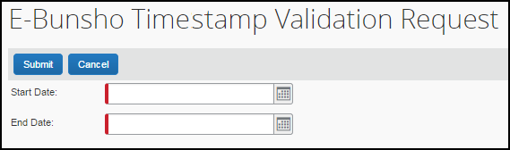
- In the Start Date field, type a date or use the date picker button.
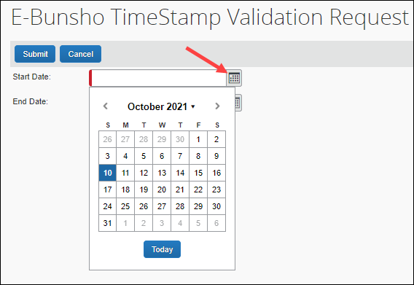
- In the End Date field, type a date or use the date picker button.
- Click Submit. The report shows the total count of images, the number of validated images, the number of pending images, and the number of failed images.

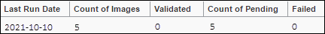
Submitting a date multiple times does not create the appearance of duplicate validations. Each image will display as validated in only one run. The run history displays on the tool’s main window.
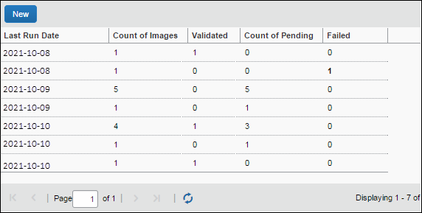
View the details of failed validations
- In the Failed column, click on a number. The details display in a Timestamp Validation Failure window.
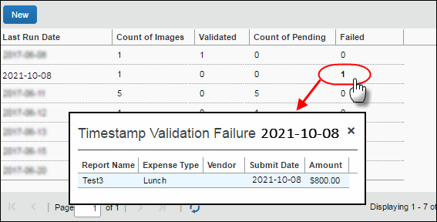
- Click X to close the Timestamp Validation Failure window.

Process Reports
Users with sufficient permissions may create queries from the Process Reports page using the timestamp fields:
- Digital Compliance validation date
- Digital Compliance Status
Sufficient permissions in this instance means having one of the following:
- Expense Processor
- Expense Processor (Audit)
- Expense Processor Manager

Configuration/Feature Activation
To configure the e-Bunsho feature, refer to the configuration section below.

NextGen UI
There are differences in behavior between the Legacy UI and NextGen UI in terms of handling expense entries with a timestamp image. Once the expense report is submitted, users will no longer be able to detach the image, delete or move the expense entry from a report in NextGen UI.
It is recommended all administrators are aware of the differences when migrating to the NextGen UI and consider the appropriate process for e-Bunsho.

 | Legacy UI |  | NextGen UI
 | Before Submit | After Submit | Before Submit | After Submit
Delete entry | X | X | ✔︎ | X
Move entry | ✔︎ | ✔︎ | ✔︎ | X
Detach Image | X | X | ✔︎ | X

Unlimited Receipt Upload Supported
The NextGen UI supports and unlimited number of receipt uploads.

Fapiao Receipt Capture
The Fapiao Receipt Capture integration allows users to capture and upload fapiao into Concur Expense according to Chinese regulatory or government authorities.
A fapiao is a legal receipt required for business transactions, employee reimbursement, and VAT deduction. A fapiao is issued by the State Taxation Administration of the People's Republic of China but provided by the merchant.
The feature is available to new and existing clients based in China and deployed to the China datacenter. Other datacenters are not included at this time.
The Fapiao Receipt Capture for China feature includes:
- Offering a fapiao solution in compliance with State Taxation Administration of the People's Republic of China and as provided by the merchant
- Providing reimbursement and VAT reporting process efficiency, reducing time to perform these tasks
- Capturing of VAT fapiao and non-VAT fapiao documents via the SAP Concur mini app in the WeChat™ app
- Supported fapiao and documents include:
- General VAT fapiao in paper form
- General VAT - Roll fapiao in paper form
- Special VAT fapiao in paper form
- Special VAT fapiao in PDF form
- General VAT fapiao in electronic form as stored in WeChat wallet
- General VAT fapiao in PDF form
- General VAT fapiao in OFD form
- Official China Rail tickets
- Official airline tickets issued by China Aviation
- Official taxi fapiao
- Official fix amount fapiao
- Uploading of fapiao and documents to Concur Expense:
- For VAT fapiao, a validation is performed against State Taxation Administration of the People's Republic of China prior to the fapiao upload
- For VAT fapiao, a duplication check is performed prior to the fapiao upload
- Additional documents, such as itemized receipts, can also be uploaded with each fapiao submission
- Improving efficiency when capturing and merging multiple documents into one e-receipt transaction
- Displaying fapiao information in custom fields in Concur Expense with assistance from an SAP implementation coach
- For more information, refer to the State Taxation Administration of the People's Republic of China.
Unsupported fapiao or documents for the initial feature release include:
- Vehicle sales fapiao
- Freight Special fapiao
- Traffic fee fapiao
- Secondhand vehicle fapiao

Capturing Fapiao
To capture legal copies of original paper receipts, customers must use an SAP Concur mini program embedded in the WeChat™ mobile app. Customers can also upload fapiao information from WeChat wallet. The user takes a picture of the paper receipt within the mobile app. Once the picture is taken, the mobile app uploads the image to an approved third-party vendor for validation. A message is returned to the user in the mobile app indicating success or failure.
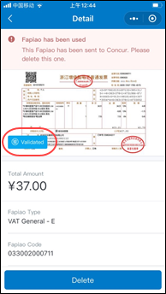
Once the image capture is verified, a Validated stamp  displays on the electronic fapiao in the SAP Concur min app in the WeChat program, indicating the electronic fapiao is validated. The mini program also checks for duplicate entries of VAT fapiao.
Once the fapiao is validated, users can upload the fapiao to Concur Expense by clicking the Send to Concur button. The fapiao also displays in the SAP Concur mini app for the applicable expense.
- IMPORTANT: SAP cannot guarantee compliance of fapiao receipts if users are not using the SAP Concur mini app in the WeChat™ mobile app to capture and upload receipts to Concur Expense.

Fapiao in The SAP Concur Mini App
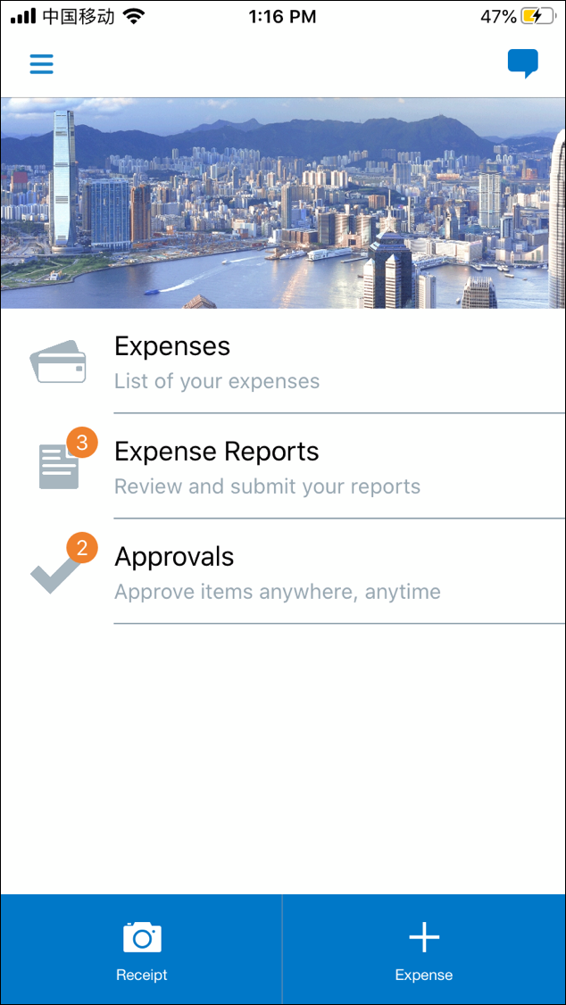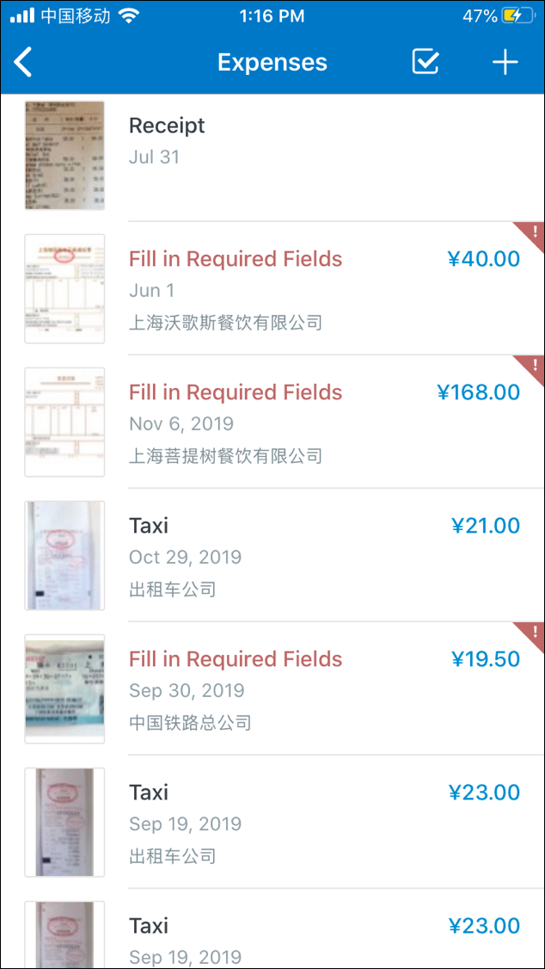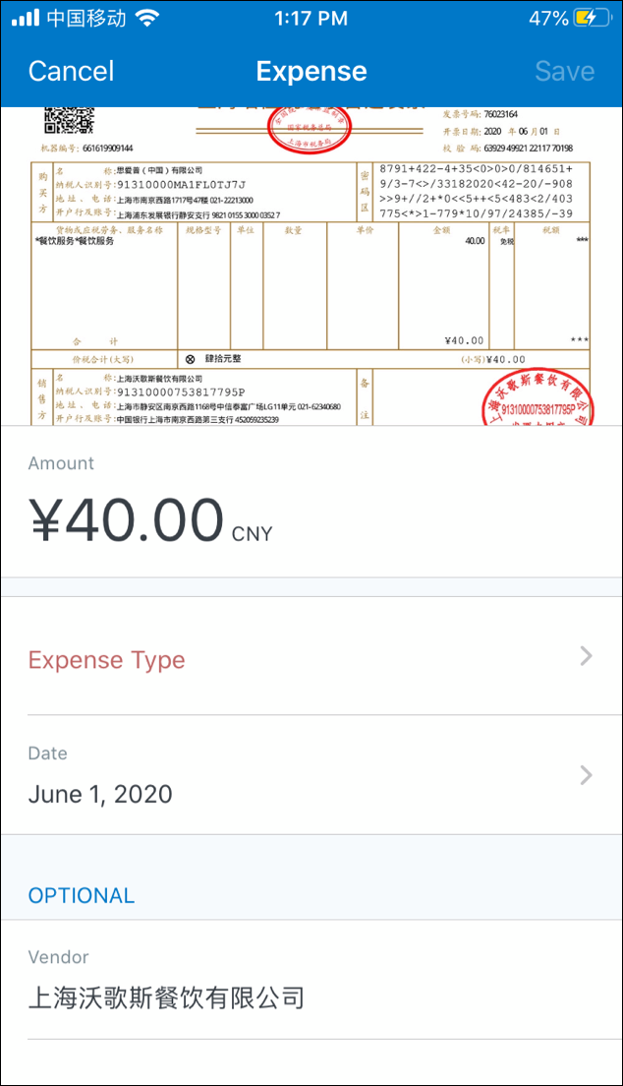
On the SAP Concur mini app, an individual e-receipt expense item within an expense report only shows one attachment at the expense item level. Additional attachment images are located at the report level. This means if an expense item has additional attachment other than the fapiao image (such as an itemized receipt), it is viewable on the Receipt tab of the expense report, as shown in the following image.
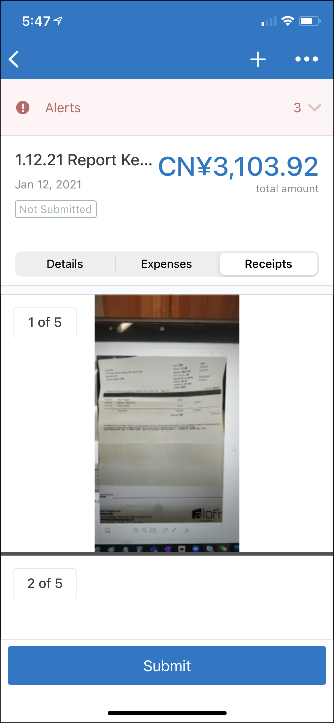

User Experience
The captured fapiao displays for users in Concur Expense like any other receipt.
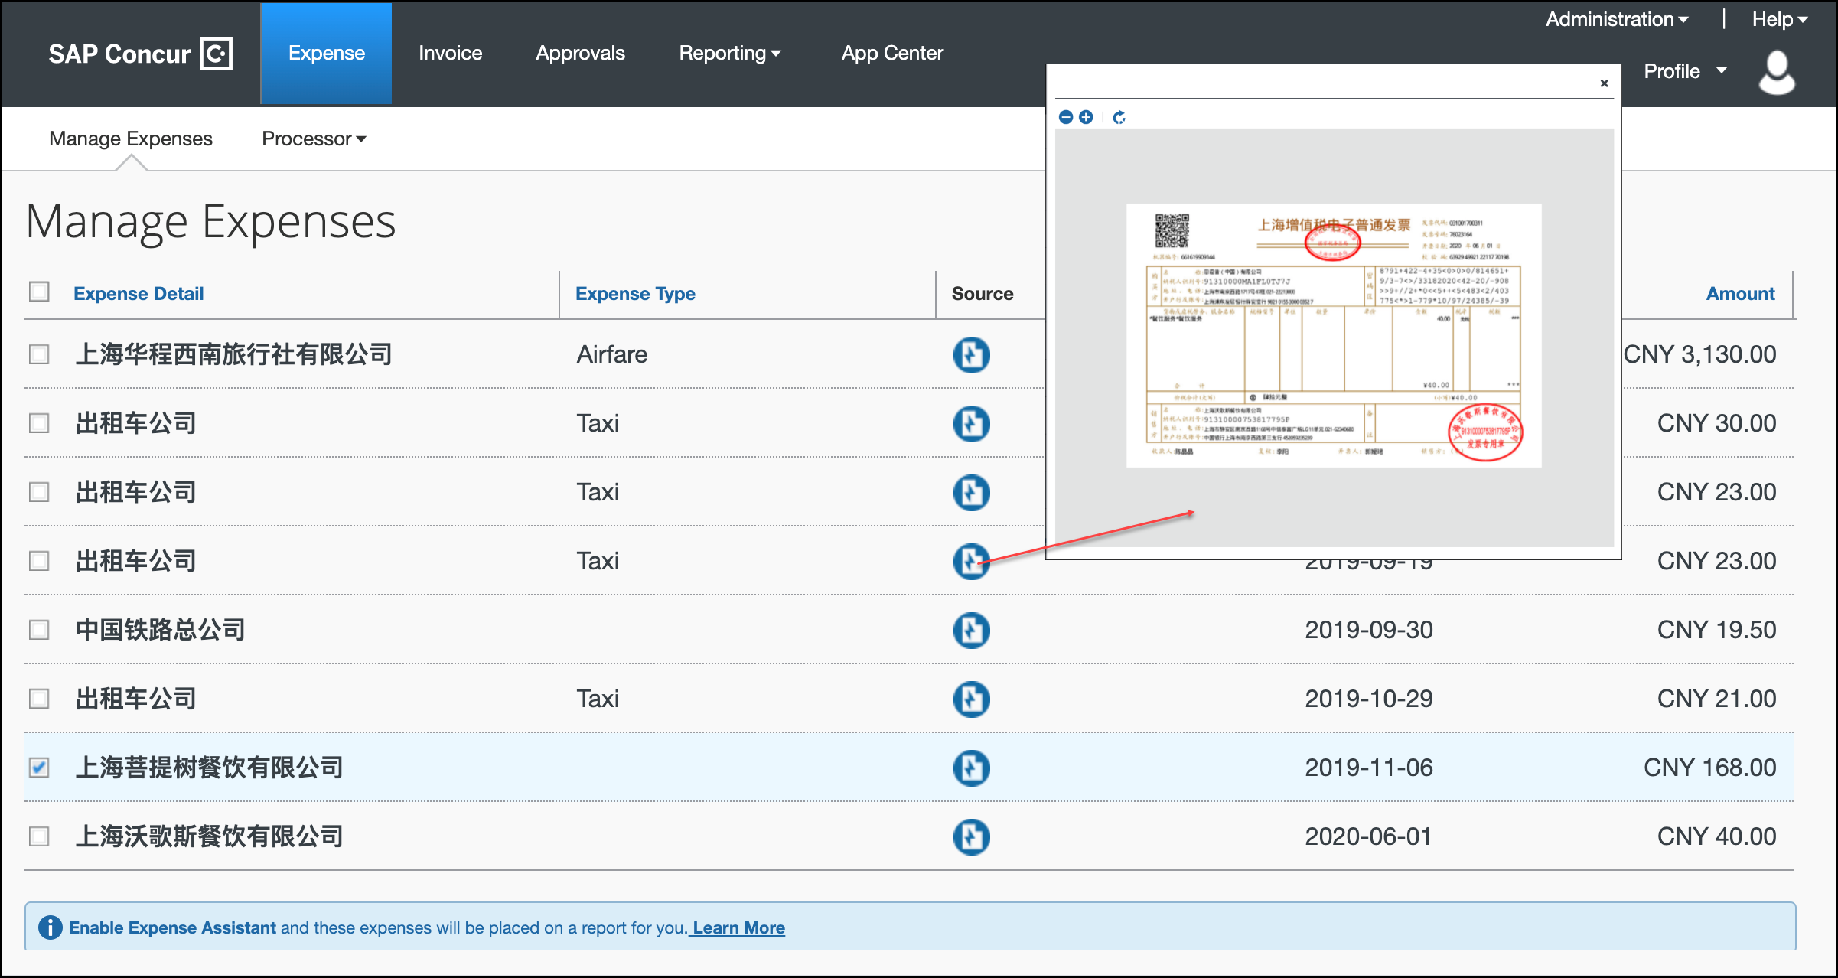

Fapiao Attached to an Expense Report
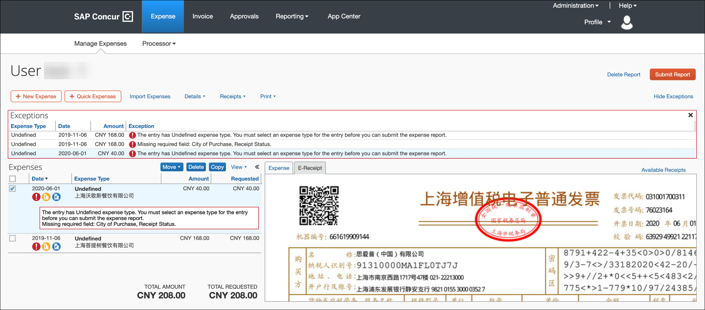

Fapiao Fields

VAT Fapiao Fields
Fapiao Fields (Chinese) | Fapiao Fields | SAP Concur Mini App | Concur Expense
发票代码 | Fapiao Code | ✓ | ✓ custom field
发票号码 | Fapiao Number | ✓ | ✓ custom field
开票日期 | Issue Date | ✓ | ✓ custom field
消费日期 | Transaction Date | ✓ | ✓ standard field:  Transaction Date
校验码 | Verification Code | ✓ | ✓ custom field
合计金额 | Amount Before Tax | ✓ | ✓ custom field
合计税额 | Tax Amount | ✓ | ✓ custom field
发票类型 | Fapiao Type | ✓ | ✓ custom field
价税合计 | Total Amount | ✓ | ✓ standard field:  Amount
购买方-名称 | Buyer Name | ✓ | ✓ custom field
购买方-纳税人识别号 | Buyer Tax Number | ✓ | ✓ custom field
购买方-地址、电话 | Buyer Address  Buyer Phone | N/A  N/A | ✓ custom field  ✓ custom field
销售方-名称 | Seller Name | ✓ | ✓ standard field:  Vendor Name
销售方-纳税人识别号 | Seller Tax Number | ✓ | ✓ custom field
销售方- 地址、电话 | Vendor Address  Vendor Phone | N/A  N/A | ✓ custom field  ✓ custom field
货物或应税劳务、服务名称 | Line Item - Name | N/A | ✓ custom field
规格型号 | Line Item - Specification | N/A | ✓ custom field
单价 | Line Item - Unit Price | N/A | ✓ custom field
数量 | Line Item – Quantity | N/A | ✓ custom field
金额 | Line Item – Amount | N/A | ✓ custom field
税率 | Line Item - Tax Rate | N/A | ✓ custom field
税额 | Line Item - Tax Amount | N/A | ✓ custom field

Taxi Fapiao
Fapiao Fields (Chinese) | Fapiao Fields | SAP Concur Mini App | Concur Expense
发票代码 | Fapiao Code | ✓ | N/A
发票号码 | Fapiao Number | ✓ | N/A
发票类型 | Fapiao Type | ✓ | ✓ custom field
开票日期 | Issue Date | ✓ | ✓ standard field:  Transaction Date
上车时间 | Get On Time | N/A | N/A
下车时间 | Get Off Time | N/A | N/A
距离 | Distance | ✓ | N/A
出租车所在地 | Taxi Location | ✓ | N/A
金额 | Total Amount | ✓ | ✓ standard field:  Amount

Train Ticket
Fapiao Fields (Chinese) | Fapiao Fields | SAP Concur Mini App | Concur Expense
开票日期 | Issue Date | ✓ | ✓ custom field
消费日期 | Transaction Date | ✓ | ✓ standard field:  Transaction Date
发票类型 | Fapiao Type | ✓ | ✓ custom field
出发城市 | Departure City | ✓ | N/A
到达城市 | Arrival City | ✓ | N/A
列车号 | Train No. | ✓ | N/A
旅客姓名 | Passenger | ✓ | N/A
金额 | Total Amount | ✓ | ✓ standard field:  Amount
座位等级 | Seat Classes | ✓ | N/A

Air Ticket
Fapiao Fields (Chinese) | Fapiao Fields | SAP Concur Mini App | Concur Expense
填开日期 | Issue Date | ✓ | ✓ standard field:  Transaction Date
发票类型 | Fapiao Type | ✓ | ✓ custom field
填开单位 | Issued By | ✓ | ✓ standard field:  Vendor
票价 | Ticket Price | ✓ | N/A
起飞日期 | Departure Date | ✓ | N/A
起飞时间 | Departure Time | ✓ | N/A
民航发展基金 | CaaC Development Fund | ✓ | N/A
燃油附加费 | Fuel Surcharge | ✓ | N/A
其他税费 | Other Taxes | ✓ | N/A
保险费 | Insurance | ✓ | N/A
出发城市 | Departure City | ✓ | N/A
到达城市 | Arrival City | ✓ | N/A
航班号 | Flight No. | ✓ | N/A
旅客姓名 | Passenger | ✓ | N/A
座位等级 | Seat Classes | ✓ | N/A
电子客票号码 | Electronic Ticket Number | ✓ | N/A
合计 | Total Amount | ✓ | ✓ standard field:  Amount

Admin Experience
Concur Expense will post a Standard Accounting Extract (SAE) together with fapiao details to various SAP VAT management systems for monthly VAT processing and reporting to the China's e-tax filing system.

Receipt Digitalization

Overview
The Receipt Digitalization feature allows clients in France, Spain and Portugal or clients who have employees or configurations in these countries, to digitalize paper receipts per the country's relevant regulatory requirements, meaning that the document resulting of the digitalization process has the same value than the original paper document, thus enabling for paper to be dematerialized.
This feature requires that users must be using the latest version of SAP Concur mobile and the NextGen UI. The entire company does not need to transition to the NextGen UI. However, any users associated to a group configuration, who want to use the Receipt Digitalization feature, must transition to the NextGen UI.
- For more information, refer to the NextGen UI for Concur Expense guides and resources.
The Receipt Digitalization feature includes:
- Enabling the conversion of paper receipts into digital copies with probatory value
- Configuring audit rules that look for expenses with paper receipts
- Viewing the "Certified" status of the digitalized receipt in the NextGen UI
- (Spain only) A solution audited and homologated by the Spanish tax authority, Agencia Estatal de Administración Tributaria (AEAT), as well as the four regional authorities (Haciendas Forales)
- (Portugal) E-archiving guidelines to ensure compliance with the e-archiving rules established by Portuguese authorities.
- For more information on e-archiving, refer to E-Archiving Guidelines (Portugal) in the Specifically for Digitalized Receipts section of this guide. Non-SAP clients are welcome to reference e-archiving guidelines.
For more information regarding legislation, refer the following:
- Spain: refer to the AEAT website.
- France: refer to the Legifrance website.
- Portugal: refer to the Diario de República Electrónico website.
For information regarding the Quality Management Plan for Receipt Digitalization, contact your SAP Concur account representative.

Digitalizing Paper Receipts
To digitalize original paper receipts, users must use the latest version of the SAP Concur mobile app, and can use Expense It with the mobile app. The user takes a picture of the paper receipt with mobile app. Once the picture is captured, the relevant digitalization process is applied to the image. Once the process is complete, a stamp displays on the digitalized receipt in the mobile app confirming whether the digitalization process has been successful.
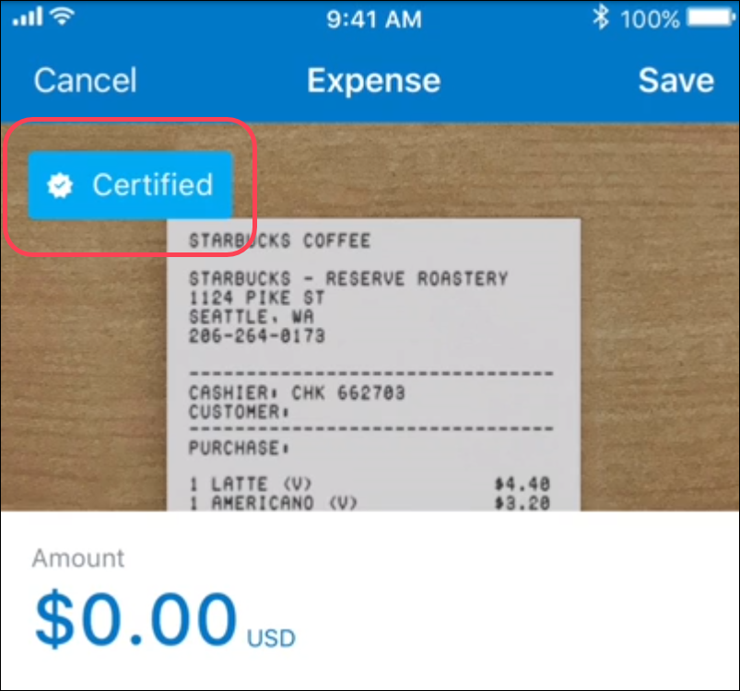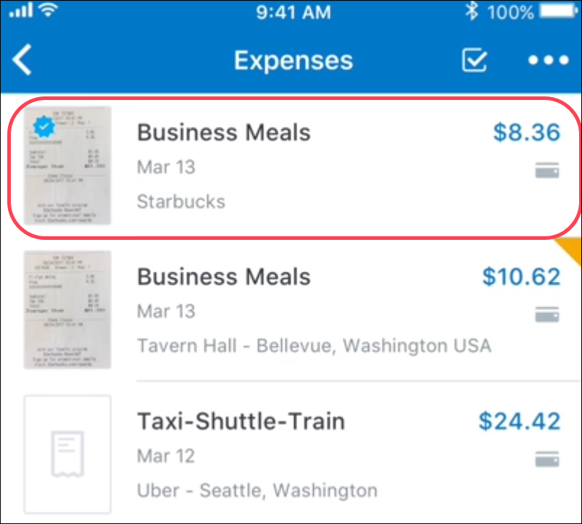
The ability to digitalize a receipt captured at the report header level is not yet available.

Failed Digitalization of Receipts
If the digitalization process is interrupted, a message appears to the user that the image is not certified and asks the user to try again. The SAP Concur mobile app camera appears so the user can capture a picture of the receipt again.
If the picture is taken using ExpenseIt, the types of technical failure include:
- Image capture fail through ExpenseIt due to low lighting or camera being too far away
- Loss of internet connectivity
- Service processing error
In each case, a message appears in the app advising the user to either retake the picture or wait for processing to complete.
- For more information, refer to the SAP Concur Mobile App User Guide for Concur Expense.
- For more information, refer to ExpenseIt training videos on image capture optimization and best practices.

User Experience
When creating expense reports, users see successfully conformed digitalized receipts display with a "Certified" icon (). Digitalized receipts display for users in the NextGen UI in Available Expenses, Available Receipts, and in the expense list.
Delegates can complete an expense report for a user once the user has taken a picture of the digitalized receipt using the SAP Concur mobile app.
Users or admins who have permissions to open an expense report can go to any line item with a digitalized receipt and download the digitalized PDF file. The PDF created through the receipt digitalization process includes all information required for it to have or evidential value.

Digitalized Receipt in Available Expenses
The following example shows receipts that are certified displaying in Available Expenses. A "Certified" icon displays for receipts that are certified.
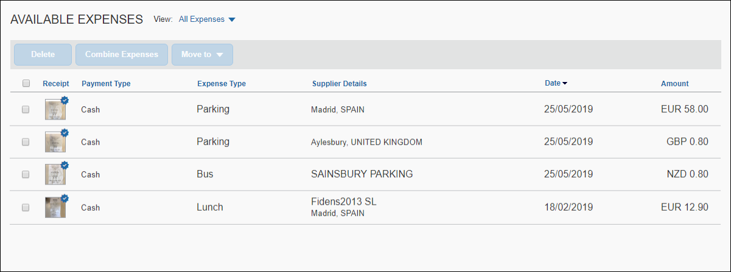

Digitalized Receipt in Available Receipts
The following example shows receipts that are certified displaying in Available Receipts.
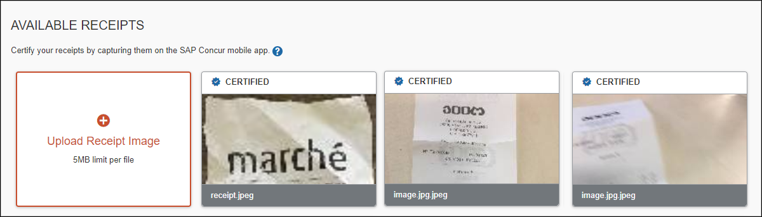

Digitalized Receipt in the Expense List
The following example shows receipts that are certified displaying in the expense list.
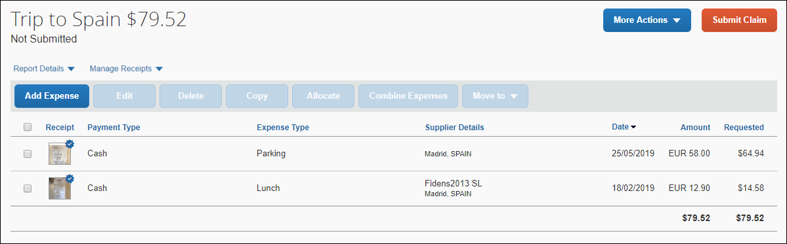

Deleting Digitalized Receipts
Deleting digitalized receipts will completely eliminate the document. Make sure the receipt is not required, or that the original paper receipt is still available, before deleting a digitalized document.
If the user deletes the digitalized receipt from a report entry, and it was captured by the SAP Concur mobile app within the expense entry, deletion of the report entry will delete the digitalized document attached to it.

Downloading Digitalized PDFs
The PDF created through the Receipt Digitalization process includes all information required for it to have probative value. Users and administrators who have permissions to open an expense report can go to any line item with a digitalized receipt and download the digitalized PDF file.
- Refer to Specifically About Digitalized Receipts in this guide for details about the digitalized PDF file for each country.

Approver and Processor Experience
Approvers and processors view the "Certified" receipt status in the expense report and expense list in the existing version of Concur Expense.

Admin Experience
Admins see changes in the following places:
- Group Configurations
- Workflow Rules
- Audit Rules
- Receipt Rules
- Process Reports

Group Configurations
On the Group Configurations page, in the Digital Compliance Country Rule list, admins can select the digitalization process to be followed by the relevant user group.
For users in Spain or Portugal, select Spain. For French users, select France.
- For more information regarding Group Configuration settings, refer to the Concur Expense: Group Configurations for Expense Setup Guide.

Workflow Rules
Admins see Is Digitally compliant in Workflow Rules (and Audit Rules and Receipt Handling).
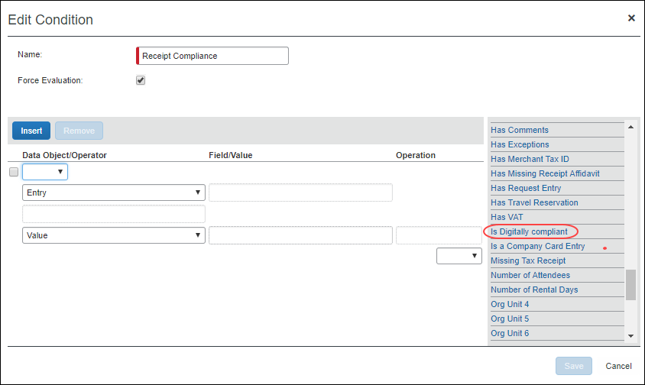
- For more information, refer to the Concur Expense: Workflow General Information Setup Guide.

Audit Rules
Admins can create restrictions on save of expense entries using Audit Rules.

Audit Rules for Receipt Digitalization
The following table provides examples for configuring audit rules for receipt digitalization. These rules may help with establishing correct use from travelers, as well as alert approvers and processors of non-compliance receipts.
Description | Event | Conditions | Exception | Comments
This rule will trigger an expense save if there is a receipt attached (whether the receipt has been added from SAP Concur mobile or the NextGen UI for Concur Expense) to the expense which is not digitally compliant. It will not trigger for Concur Expense e-receipts. | Expense Save | Is digitally compliant = NO AND  Has E-Receipts = no AND  Has User-Attached Receipt Image = Yes | The receipt attached to this entry is flagged as non-digitally compliant.  If this is a copy of an original paper receipt, please, capture the receipt again using the compliant method.  If this is a genuine electronic receipt, ignore this exception | Clients should choose whether to create a Warning or Blocking Exception.
This rule will trigger on expense save if there is a receipt attached (whether the receipt has been added from SAP Concur mobile) to the expense which is not digitally compliant. It will not trigger for Concur Expense e-receipts. |  | Is digitally compliant = NO AND  Has E-Receipts = no AND  Has Mobile Receipt = Yes | The receipt attached to this entry is flagged as non-digitally compliant.  If this is a copy of an original paper receipt, please, capture the receipt again using the compliant method.  If this is a genuine electronic receipt, ignore this exception | Clients should choose whether to create a Warning or Blocking Exception.
- For more information, refer to the Concur Expense: Audit Rules Setup Guide or the Expense: Workflow General Information Setup Guide.

Receipt Handling
Admins can create limits using Receipt Handling.
- For more information, refer to the Concur Expense: Receipt Handling – Receipt Limits Setup Guide.

Process Reports
Users with sufficient permissions may create queries from the Process Reports page using the timestamp fields:
- Digital Compliance validation date
- Digital Compliance Status

Configuration/Feature Activation
To configure the Receipt Digitalization feature, refer to the configuration section in this guide.

Configuration
This process is likely completed during implementation. If not, the client can contact SAP Concur support for assistance.
The basic steps are listed here and described in detail on the following pages.
- Step 1: Enable the Concur-internal setting
- Step 2: Enable the Imaging Service
- Step 3: Create or modify a receipt imaging configuration
- Step 4: Assign the configuration to a policy
- Step 5: (Optional) Modify the receipt reminder text
- Step 6: (Optional) Modify the delegate configuration
- Step 7: (Optional) Hold for Receipt workflow step
- Step 8: (Optional) Enable the Missing Receipt Declaration
- Step 9: (Optional) Enable e-Bunsho timestamps
- Step 10: (Optional) Enable Fapiao Capture
- Step 11: (Optional) Enable Receipt Digitalization
Some of these steps are completed by SAP Concur; some may be completed by the client. The client and SAP Concur should work closely to coordinate efforts.

Step 1: Enable the Concur-Internal Setting
In the Concur-internal management console, the Concur Admin sets the Allow Image Upload option (on the Settings page) to Yes.

Step 2: Enable the Imaging Service
The Concur Admin enters the client's unique company ID and public key in Imaging Settings.
- Refer to the Shared: Imaging Settings Setup Guide.

Step 3: Create or Modify a Receipt Imaging Configuration
To create or modify a receipt imaging configuration:
- Click Administration > Expense (on the sub-menu).
- Click Receipt Handling (left menu). The Receipt Handling window appears.
- Click the Receipt Imaging tab.
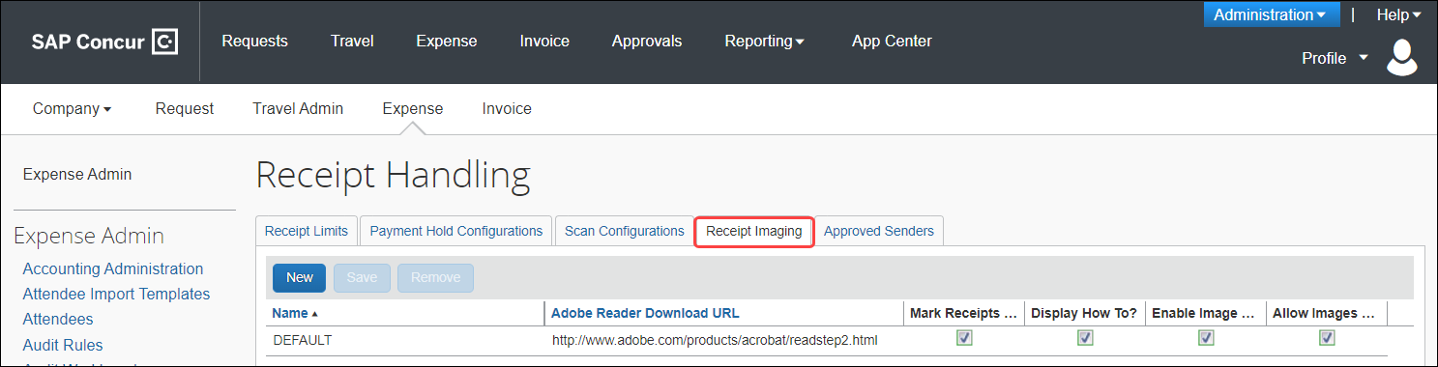
- Either:
- Click the default row to edit the existing default configuration.
– or –
- Click New to create a new configuration. A new row appears.
- Complete the appropriate fields.
Field name | Description/Action
Name | Enter a unique name for the configuration. This name will appear as an option when setting up policies.
Acrobat Reader Download URL | Enter the link to the Adobe website where the employee can download the software.  The link appears in the error message that displays when the system checks to see if Adobe Reader is installed.  NOTE: The system checks to see if Adobe Reader is installed when the employee clicks the Receipts menu.
Mark Receipts Received? | Select (enable) this check box to have the system change the Receipts Received flag in Expense Processor from No to Yes when receipts have been received successfully.
Display How To? | No longer used.
Enable Image Upload? | Select (enable) this check box to allow users to upload images. If enabled:  - The Attach Receipt Images link appears on the Receipts menu.  - With the expense entry open, the Attach Receipt link appears at the bottom of the Expense tab.  - The user can upload to the Available Receipts library.
Allow Images on Report? | Select (enable) this check box to allow users to attach an image at the report level. If enabled, the user can attach at the report level and the expense entry level.  NOTE: If the user is allowed to upload, the user can always attach at the expense entry level, regardless of this setting.
- Click Save.

Step 4: Assign to a Policy
To assign an imaging configuration to a policy:
- Click Administration > Expense (on the sub-menu).
- Click Policies. The Policies page appears.
- Either:
- Click the desired policy and click Modify.
– or –
- Double-click the desired policy.
The Modify Policy page appears.
- From the Imaging Configuration list, select the appropriate imaging configuration.
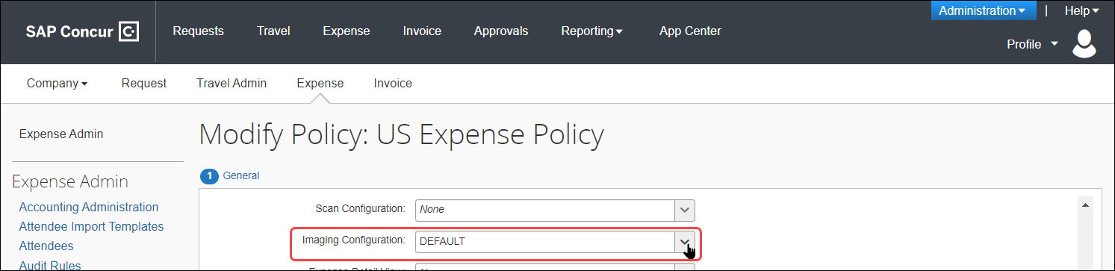
- Click Save.
- For more information about adding or editing a policy, refer to the Concur Expense: Policies Setup Guide.

Step 5: (Optional) Modify the Receipt Reminder Text
If desired, you can edit the reminder text that appears to the user.
To edit the receipt text:
- In Policies (as described in the previous step), enter the desired text in the Receipt Text field.
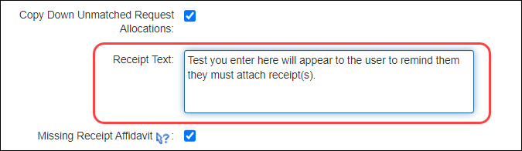
- Click Save.

Step 6: (Optional) Modify the Delegate Configuration
You can grant or deny delegates the ability to manage receipt images for expense reports they are preparing on behalf of another employee. If your company allows delegates to manage receipts, individual users can still deny in Profile.
- Refer to Delegate Experience in this guide.
To modify the delegate configuration:
- Click Administration > Expense (on the sub-menu).
- Click Delegate Configurations (left menu). The Expense Delegate Configurations page appears.
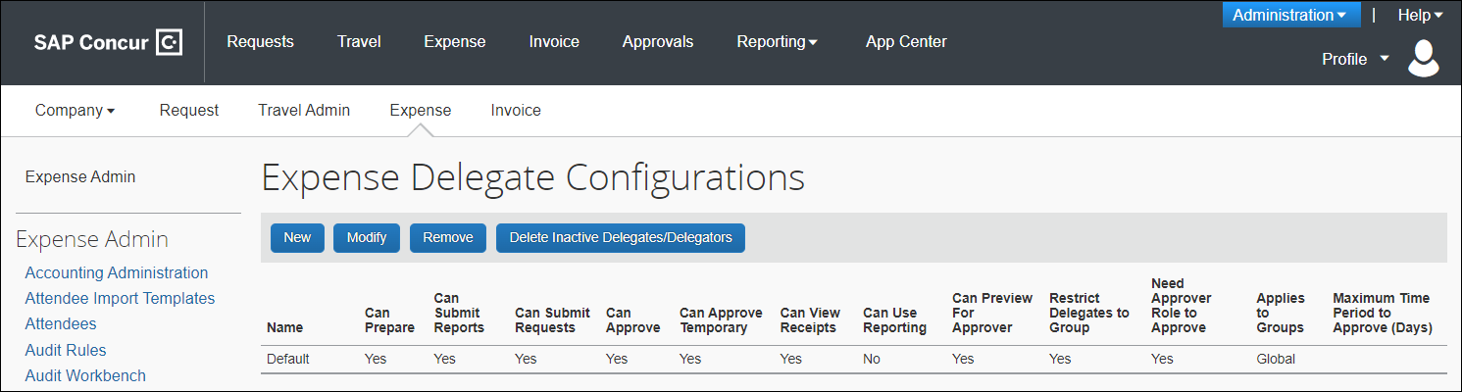
- Either:
- Click the desired configuration and click Modify.
– or –
- Double-click the desired configuration.
The Edit Expense Delegate Configuration page appears.
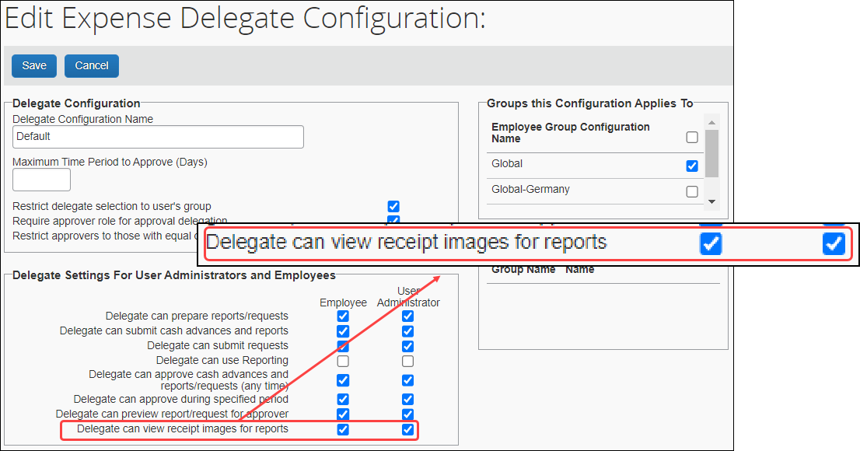
- Select (enable) the Delegate can view receipt images for reports check boxes as required.
The setting says "view" but it includes view, add, delete, etc.
- Click Save.

Step 7: (Optional) Hold for Receipt Workflow Step
- For more information, refer to the Other Considerations section in this document.

Step 8: (Optional) Enable the Missing Receipt Declaration

Enable the Feature
To enable the Declaration feature and customize the text:
- Click Administration > Expense (on the sub-menu).
- Click Policies (left menu). The Policies page appears.
- Either:
- Click the desired policy and click Modify.
– or –
- Double-click the desired policy.
The Modify Policy page appears.
- Select Missing Receipt Declaration. When you do this, two additional text boxes appear as shown in the figure below:
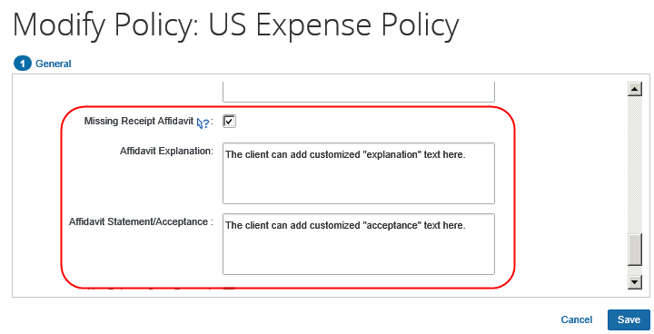
- Enter the explanation and acceptance text as desired.
The affidavit text can be localized via Administration > Expense Admin > Localization. Select the desired language. Select Policy Names in the Category column. Then, modify the text for one or more policies.
- Click Save.
- For more information, refer to the Concur Expense: Policies Setup Guide.

Declaration Rule
The admin can use the entry field Has Missing Receipt Declaration to detect expense entries with affidavits. A sample audit rule is shown below:
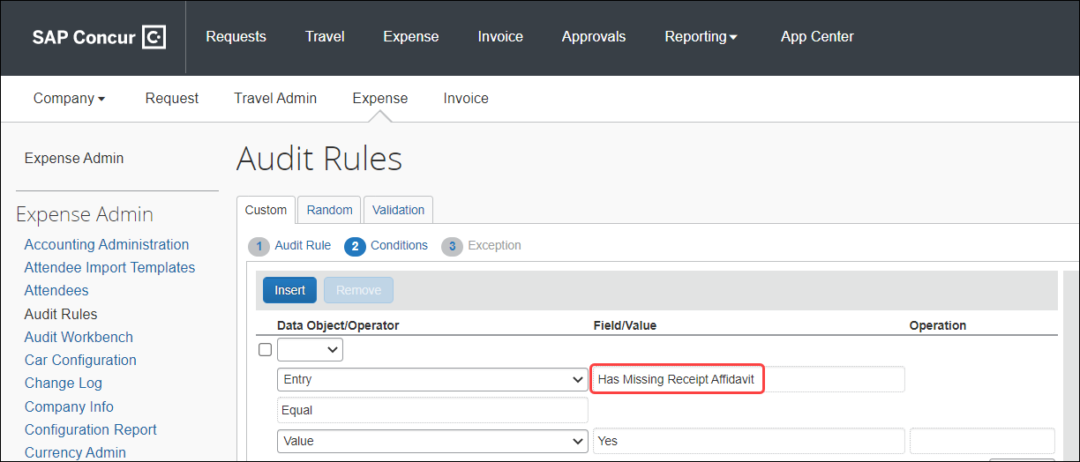

Step 9: (Optional) Japan E-Bunsho Timestamps

Enable the Feature
To enable this feature, contact SAP Concur support.
To configure a group to Use e-Bunsho Timestamps
- On the Group Configurations page, select the group and click Modify.
- On the Configuration for Group page, from the Digital Compliance Country Rule list, select Japan e-Bunsho.
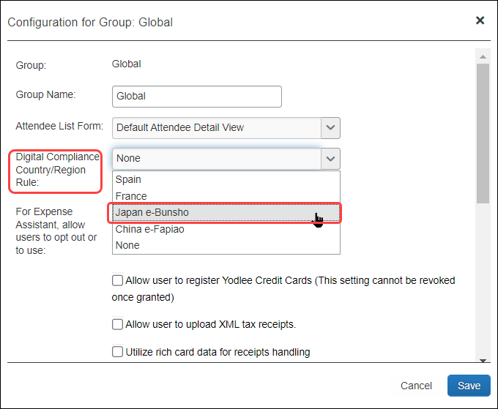
- Click Save.

Step 10: (Optional) Enable Fapiao Capture
To enable this feature, contact support or your implementation coach.
Concur Admins can enable fapiao receipt capture for clients who have purchased it. Once enabled, all Concur users in the company are eligible to use the SAP Concur mini app program embedded in the WeChat™ mobile app, regardless of their nationality.

Step 11: (Optional) Enable Receipt Digitalization
An administrator with the Concur Expense Group Administration role can configure the Receipt Digitalization feature in Group Configuration. Once configured, the feature is available for all users in that group.
To configure a group to use Receipt Digitalization:
- On the Group Configurations page, select New. The Select Group window appears.
If you do not define a group, then it will inherit from the next level that is defined. You always inherit the policy for undefined groups.
- In the Select Group box, select the desired group.
- Click Done. The Configuration for Group window appears.
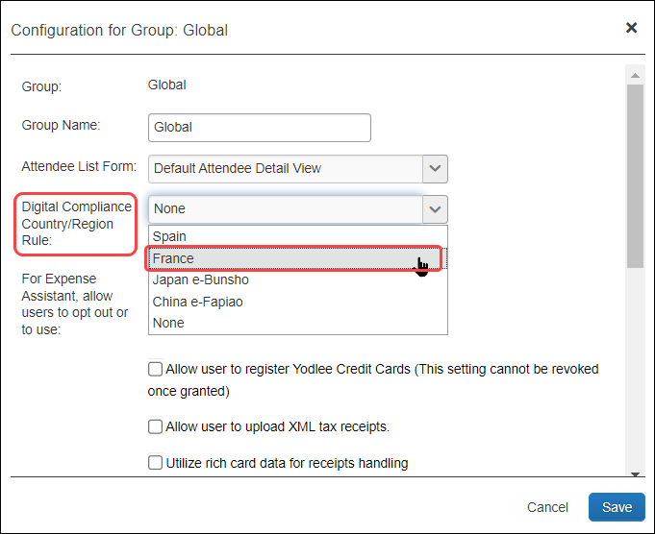
- On the Configuration for Group page, in the Group Name field, type in a name for the group.
- In the Digital Compliance Country Rule list, select the appropriate process to be followed:
- For Spanish or Portuguese users, select Spain
- For French users, select France
- For Japan users, select Japan e-Bunsho
- For China users, select China e-Fapiao
- Click Save.
- For more information regarding Group Configuration settings, refer to the Concur Expense: Group Configurations for Expense Setup Guide.
☼

