
Concur Expense: JPT on NextGen UI
Setup Guide

Last Revised: August 26, 2022
Applies to these SAP Concur solutions:
 Expense
 Professional/Premium edition
 Standard edition
 Travel
 Professional/Premium edition
 Standard edition
 Invoice
 Professional/Premium edition
 Standard edition
 Request
 Professional/Premium edition
 Standard edition
Table of Contents
Section 1: Permissions 1
Section 2: Overview 1
Who Should Use This Feature? 2
Corporate Card Users and the Japan Public Transportation Expense Type 2
IC Card Users 2
Required Roles 2
Section 3: Accessing Japan Public Transport 2
Section 4: What the Approver/Processor Sees 3
Section 5: What the Administrator Sees 4
Section 6: Configuring Japan Public Transport 7
Overview 7
Activate the JPT Expense Type 7
Add the JPT Expense Type to Policy 7
Displaying the Commuter Pass Routes Links in the User's Profile 8
Configuring the Show on Mobile Device Setting 9
Section 7: Audit Rules and Japan Public Transport 12
Section 8: Importing Commuter Pass Routes For the User 14
Using the On-Demand Excel Import to Import Commuter Pass Routes 14
Using the Employee Import Job to Import Commuter Pass Routes 15
Section 9: Managing the User’s Commuter Pass Routes 15
Importing the Commuter Pass Routes 15
Managing the Commuter Pass Routes 15
Searching for Commuter Pass Routes by User 16
Adding a Commuter Pass Route 17
Exporting Commuter Passes 19
Deleting a Commuter Pass Route 20

Revision History
Date | Notes / Comments / Changes
August 26, 2022 | Updated screenshots and path information for commuter pass screens.
April 23, 2022 | Updated the information on newly added via fields for commuter pass  Updated information on audit rules
March 19, 2021 | General guide updates.
December 10, 2021 | Added several new sections to Section 4: What the User Sees that detail the new Favorites feature. New sections address how to add a favorite route, add a JPT expense from a favorite route, saving and adding another JPT expense, deleting a favorite route from both the Route Search and Favorite Routes tabs, adding an expense from a favorite route for the requested trip date and time, and adding a favorite via station.  Added a new Exporting Commuter Passes section to the Managing the Commuter Pass Routes section.
September 23, 2021 | Removed reference to manual option for users typing in an entry in the Creating a JPT on NextGen UI Expense Report Using Route Search section.
September 14, 2021 | Added note regarding the future availability of JPT on NextGen UI in the China data center in the Overview section.
August 27, 2021 | Updated feature name from JPT 2.0 to JPT on NextGen UI.
June 30, 2021 | New guide.

Japan Public Transport on NextGen UI
NOTE: Multiple SAP Concur product versions and UI themes are available, so this content might contain images or procedures that do not precisely match your implementation. For example, when SAP Fiori UI themes are implemented, home page navigation is consolidated under the SAP Concur Home menu.

Permissions
A company administrator may or may not have the correct permissions to use this feature. The administrator may have limited permissions, for example, they can affect only certain groups and/or use only certain options (view but not create or edit).
If a company administrator needs to use this feature and does not have the proper permissions, they should contact the company's Concur administrator.
Also, the administrator should be aware that some of the tasks described in this guide can be completed only by Concur. In this case, the client must initiate a service request with Concur Client Support.

Overview
Rail travel in Japan represents 28% of an estimated JPY 7.1 trillion spent within the Japan travel market. There are 160 rail companies in Japan with well over 9,000 individual rail stations, allowing people in this country many different options to travel by rail. The typical businessperson in Japan can have multiple train rides per day that they will track and process for reimbursement. To answer the need to expense this type of travel, Concur designed and integrated the Japan Public Transport (JPT) on NextGen UI feature into the Expense product.
This feature allows users to quickly expense JPT in several ways:
- IC Card import using a network IC Card reader
- Route search (look up routes bases on a from/to station)
This feature allows admins to quickly manage commuter pass routes:
- Search for routes by employee and pass route status for review
- Grant JPT travelers rights to add IC Cards and commuter pass routes
- Perform an on-demand, Excel-based commuter pass route import
JPT on NextGen UI is not yet supported/available on the China data center. However, deployment to the China data center is planned for a future date.

Who Should Use This Feature?
The JPT on NextGen UI feature is intended for use by both Japanese domiciled companies, and by multinational companies with employees located in Japan. The rail content sourced is specific to the Japan marketplace. The feature cannot be used with any rail content outside of Japan.
Customers who have employees located in Japan can use this feature as Add-On. Please contact to your Account Manager if you want to start using this feature.

Corporate Card Users and the Japan Public Transportation Expense Type
A corporate card cannot be used with the Japan Public Transportation expense type. Only the Cash Out of Pocket payment types are supported.

IC Card Users
To import data from an IC Card into Concur Expense, use one network IC Card reader per office location.
A network IC Card reader enables users to import their IC Card data into Expense via the Internet. The Concur Client Executive should contact an implementation partner directly to purchase a network IC Card reader and run an implementation project.
- For more information about configuring and using IC Cards, refer to the Expense: Japan Public Transport on NextGen UI User Guide.

Required Roles
There are no required roles to use the Japan Public Transport feature; you need only have the Expense User role. However, configuration tasks may require you to submit a Service Request to Support.

Accessing Japan Public Transport
Any Japan-based Expense user can access this feature by selecting the Japan Public Transportation expense type when creating their expense report.
The Japan Public Transportation expense type must first be associated with an active policy to see it in Expense.

What the Approver/Processor Sees

Processing a Japan Public Transportation Route Search Expense
On the home page in the Required Approvals section of My Tasks, approvers can view and select a report which has JPT expense to review and approve. Processors can view and select a report on “Process Reports” screen.
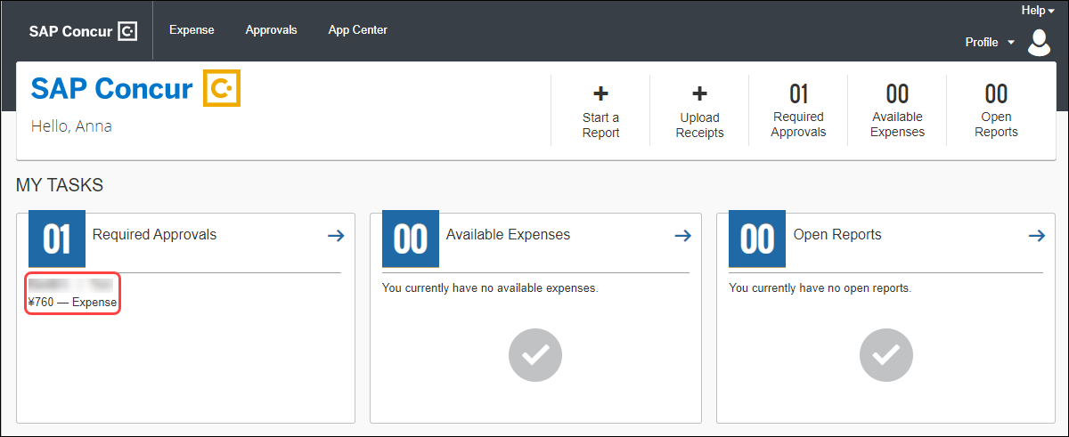
When the expense is selected, approvers and processors can view the journey's route details; this gives them the opportunity to verify if the route complies with the organization's travel policy.
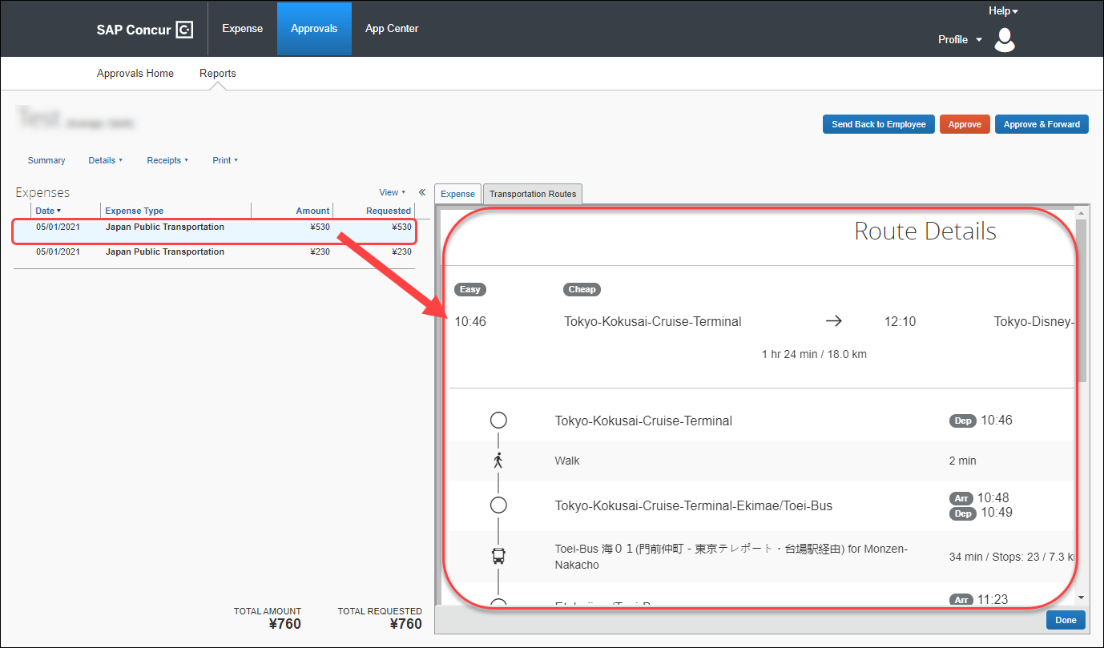

Adding a Commuter Pass
Approvers and processors can also add a commuter pass but are restricted. If an approver or processor needs to change the end date of their own commuter pass, they must contact Concur Admin to configure the end date of the commuter pass.
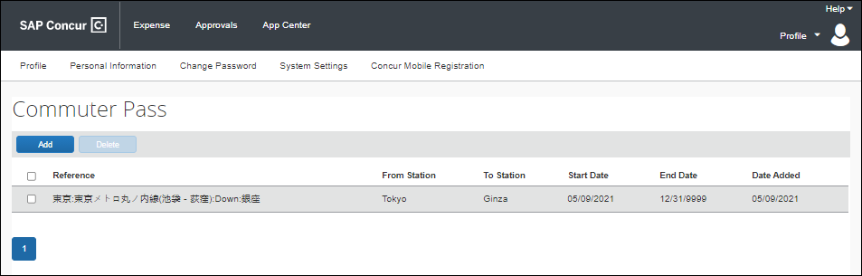

What the Administrator Sees
Admin can process JPT expenses as expected and can configure a commuter pass added by a user and import commuter passes that they can then allocate to users.
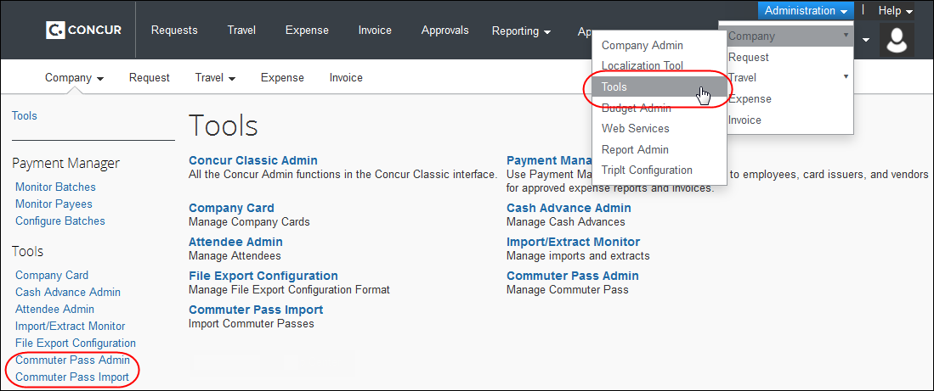

Processing a Japan Public Transportation Route Search Expense
From the Expense > Processor > Process Reports page, the Processor searches for the corresponding expense tied to a JPT expense.
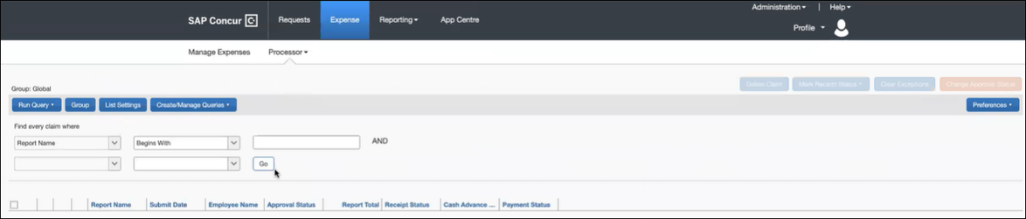

Example of Claims Search Results
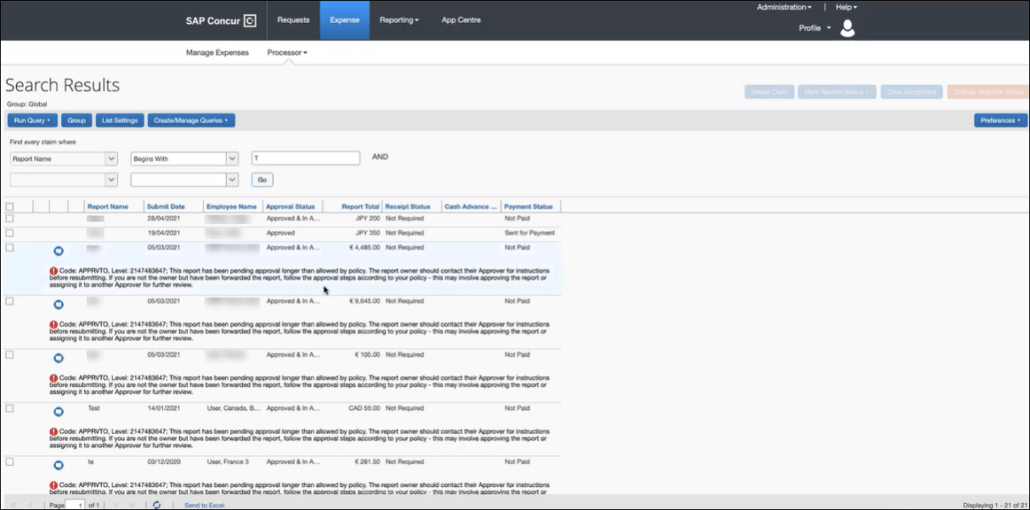
By default, once the expense report is selected, the route details of that JPT expense displays.
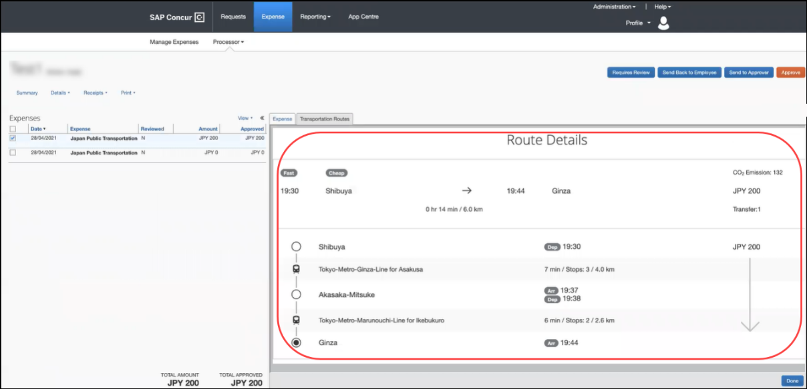
The Processor will then approve the expense report if no further actions are required (for example, Requires Review, Send Back to Employee, or Send to Approver).

Configuring the Commuter Pass
From the Commuter Pass Administrator page (Administration > Tools > Commuter Pass Admin), Concur Admin can configure the settings of a user's commuter pass. For example, a user cannot configure the expiry date of their commuter pass, so they must contact their Concur Admin to change the end date for them. When Concur Admin adds an end date, the user can then add another commuter pass.

Adding a Commuter Pass
On the Commuter Pass Administrator page (Administration > Tools > Commuter Pass Administrator), Concur Admin will be able to add commuter passes and then allocate them to users.
Concur Admin can also configure commuter pass settings that a user cannot configure. Using the Find commuter passes where fields, Concur Admin can search for and select a user whose commuter pass they want to modify.
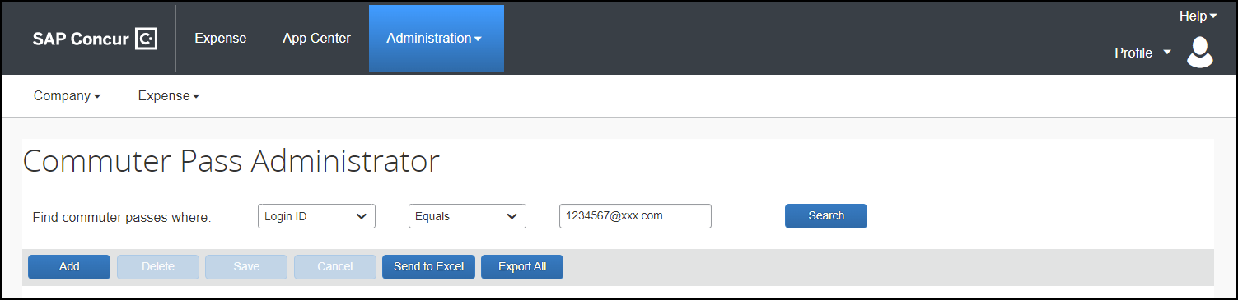
For example, a user cannot change the end date of their commuter pass. When a Concur Admin receives the user's request, Concur Admin can then add an end date, allowing the user to add another commuter pass.
Concur Admin can also delete commuter passes and export commuter pass information to Microsoft Excel.
- For more information on importing commuter pass routes, refer to the Importing Commuter Pass Routes For the User section in this guide.
- For more information on exporting commuter pass information to Microsoft Excel, refer to the Importing Commuter Pass Routes For the User section in this guide.

Configuring Japan Public Transport

Overview
Each of these configuration areas requires that a specific role be assigned. For example, access to the Policies tool to assign the JPT expense type, or to work with forms and fields requires the unrestricted Employee Configuration Administrator role.

Activate the JPT Expense Type
The Japan Public Transportation expense type must be activated. To do this, use the Policies tool (Administration > Expense > Policies > Expense Types) to activate the expense type for the target policy.
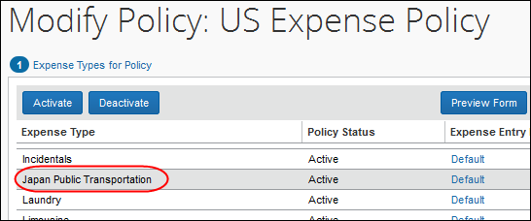

Add the JPT Expense Type to Policy
The Japan Public Transportation expense type must be associated to the Policy for users in Japan (for example, Japan Division Expense Policy).
To add the JPT expense type to the policy:
- Click Administration > Expense.
- Click Expense Types (left menu).
- Search for the Japan Public Transportation expense type.
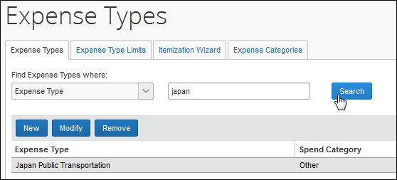
- Click Modify and proceed to Step 2 by clicking Next.
- Select the policy to which the JPT expense type will be associated.
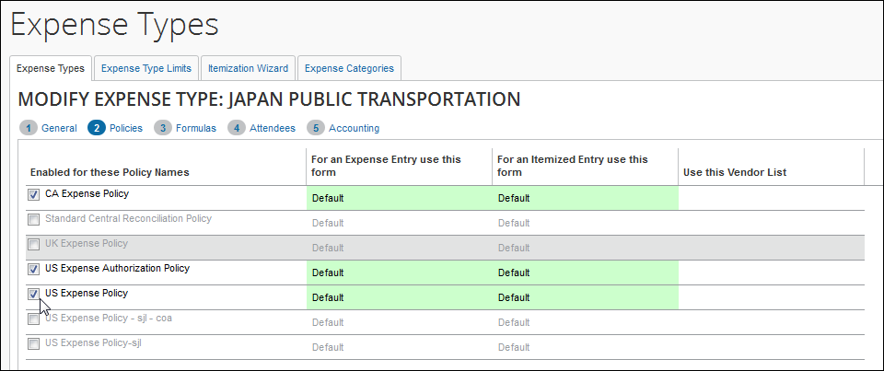
- Click Next as needed, then Done to exit the Expense Types tool.
The expense type is now associated with this policy and can be selected when creating an expense report under this policy.
- Refer to Expense: Expense Types Setup Guide for more information.

Displaying the Commuter Pass Routes Links in the User's Profile
Two links can be made available to the JPT traveler that lets them register their IC Card and create custom commuter routes for their personal use. This is done by using the site settings feature in Expense to enable the links.
To display the commuter pass route links in Profile:
- Click Administration > Expense.
- Click Site Settings (left menu).
- Select (enable) the Allow traveler to add Commuter Pass Route setting.
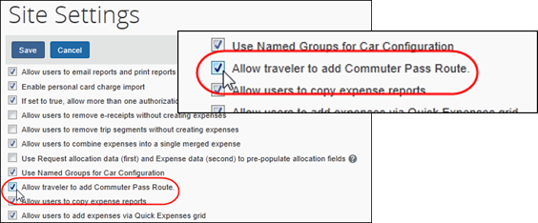
- Click Save.
The links will now appear in the user's Profile, and in User Admin that will allow management of the IC Card and commuter pass routes by the user.
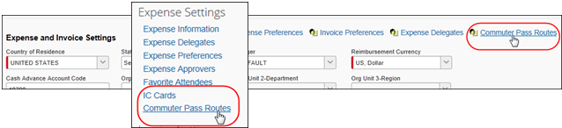

Configuring the Show on Mobile Device Setting
When configured by a Concur consultant or Support, the Show on Mobile device setting allows Concur Mobile users to see an expense display as a selectable expense on the Concur Mobile app. This setting allows client administrators to change the setting for Japan Public Transport (JPT).
What the Admin Sees
A client administrator sees a new field, Show on Mobile device on the Expense Types page.
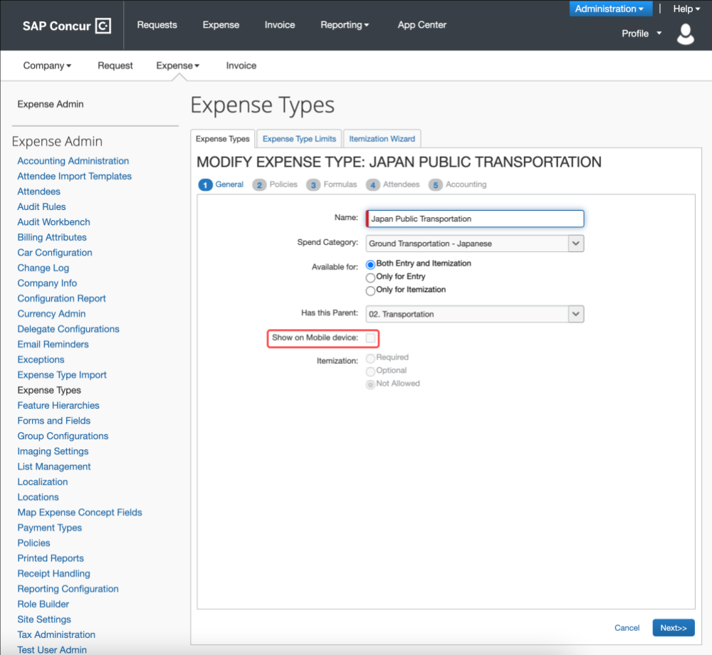
What the User Sees
The SAP Concur mobile app will display an expense as a selectable expense for an expense report.
To configure the Show on Mobile device setting
- On the Expense Types page, select Japan Public Transportation.
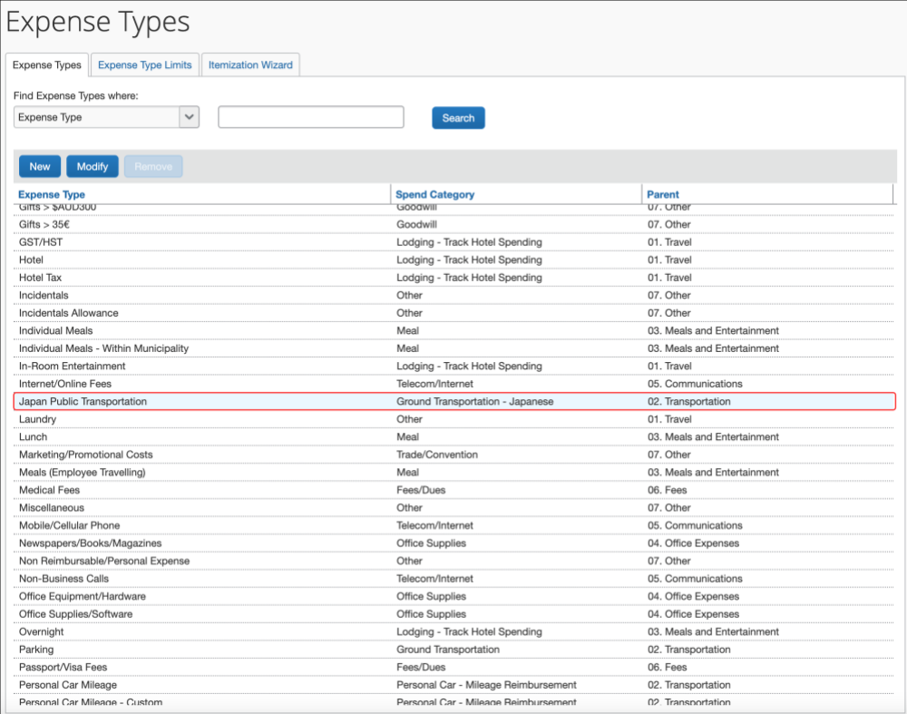
- Click Modify.
- Verify Show on Mobile device is checked. If your organization does not want to show JPT expense type on Mobile, clear (unchecked) the option, as shown.
By default, the Show on Mobile device setting is checked on JPT on NextGen UI enabled Entity.
- Click Save.

Audit Rules and Japan Public Transport
Audit Rules is a parity feature and can be used to flag the use of Japan Public Transport (JPT). For example, the administrator can generate exceptions based on the source used to enter the Transport route by the JPT traveler. This is used by companies whose specific policy rules restrict how an employee expenses a JPT transaction (which may require a receipt). By raising an exception, these criteria may be enforced at the company policy level.
For the itemized JPT expense audit rules to work both on JPT 1.0 and on JPT on NexGen UI, customer admins should modify audit rules before migrating. In the NextGen UI, only the event Entry Save is supported.
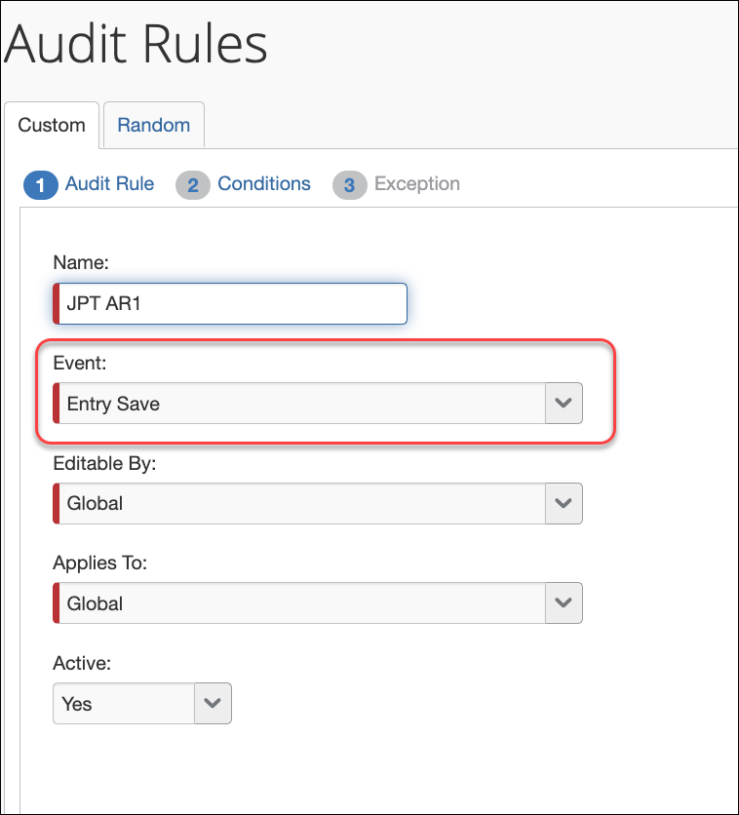
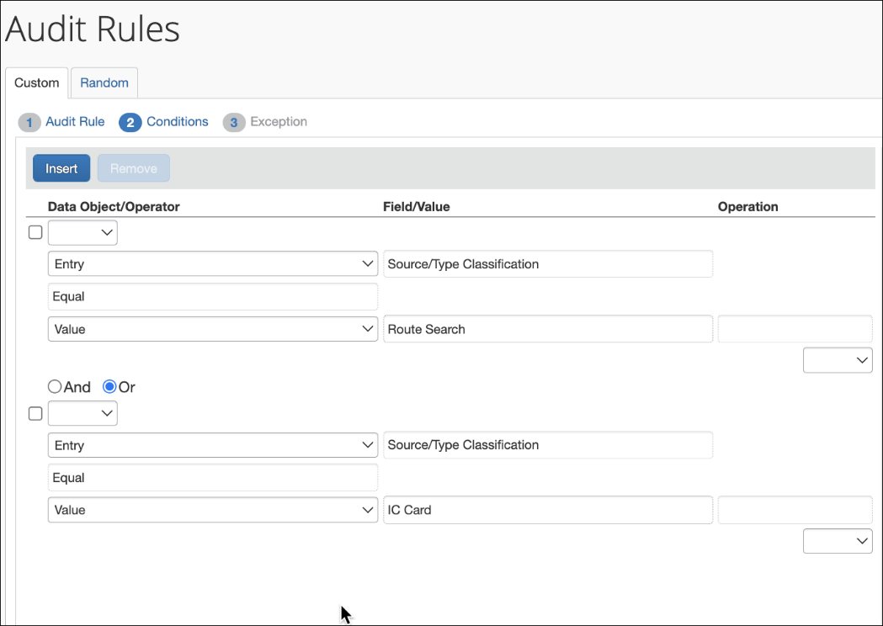
The admin can choose from JPT-specific fields display when the feature is enabled on the entity and the Entry object is selected. The choices are as follows:

Field Name | Available Selections for the Field
Source/Type Classification | Identifies the type of input based on the source of the route data used by the JPT traveler:  - CARD = (IC Card) Route data entered using IC Card  - RSRC = (Route Search) Route data entered by search

Importing Commuter Pass Routes For the User
The administrator can elect to add commuter pass routes by importing them. There are two ways the admin can do this in Expense:
- On-Demand Using Spreadsheet: Using options in the Commuter Pass Import tool available in Expense Tools, the routes are imported immediately.
- Overnight Using Employee Import Job: Scheduling an Employee Import whose 1300-level record set imports the commuter pass route data, adding or removing the routes as specified
In both imports, the records of commuter pass routes are added or deleted from Profile.
Click Profile > Profile Settings > Commuter Pass Routes (under Expense Settings).
The page is shown with imported routes in the figure below:
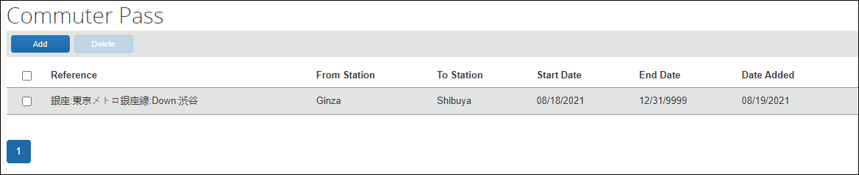

Using the On-Demand Excel Import to Import Commuter Pass Routes
The administrator can import commuter routes for specified employees, adding or deleting the commuter routes and setting both the start and end date as needed. The spreadsheet is shown below:
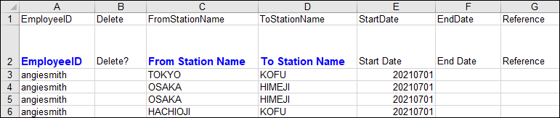
- Refer to Expense: Japan Public Transport – Commuter Pass Import for more information.

Using the Employee Import Job to Import Commuter Pass Routes
The 1300-level record set of the Employee import is used to add or remove commuter pass routes associated with the employee. The client should work with Concur to determine the records needed to import into Expense.
- Refer to Shared: Employee Import Specification guide for more information.

Managing the User’s Commuter Pass Routes
The administrator manages the commuter pass routes to ensure that, when their employees submit their transit information, these routes are not counted towards reimbursement in the report.

Importing the Commuter Pass Routes
An on-demand, Excel-based spreadsheet is used to import the commuter pass route information by employee. The admin specifies the employee, the route via stations, and optionally the start and end date as well. The figure below shows sample data that adds routes and their legs for the user “Erin Fletcher”:

Refer to Using the On-Demand Excel Import to Import Commuter Pass Routes in this document for more information.

Managing the Commuter Pass Routes
The admin uses the Commuter Pass Admin page to:
- Add or remove commuter pass routes for an employee:
By employee, add a route, or select and then delete the route.
- Manage the ending date of the employee’s commuter pass:
The end date can be edited in the grid, and does not appear to the employee
Go to Commuter Pass Administrator page (Administration > Company > Tools > Commuter Pass Administrator). The commuter pass routes are listed in the Commuter Pass Administrator page by the employee’s Login ID value.
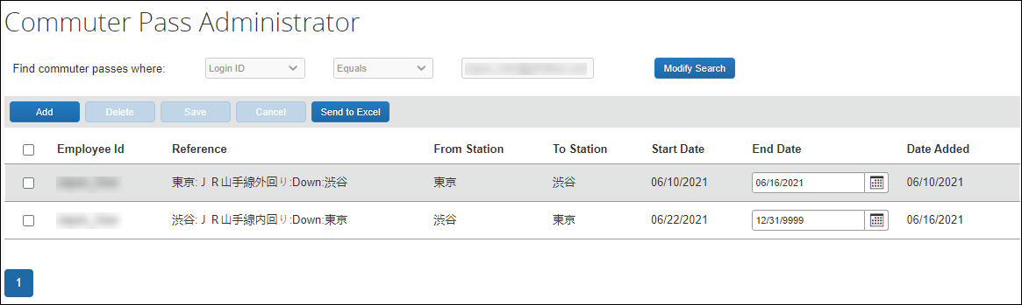

Searching for Commuter Pass Routes by User
All Commuter pass routes in the Expense system can be accessed from the Commuter Pass Admin page. The Search criteria let the administrator search by login ID.
A search is performed by selecting from the available criteria and entering the employee’s identification.
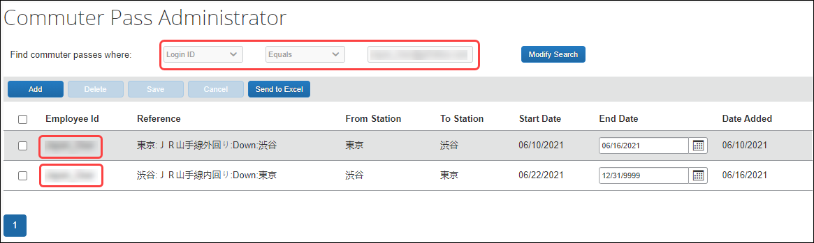

Adding a Commuter Pass Route
Concur Admin will be able to search and add commuter passes on behalf of the user. Push [Add] button on Commuter Pass Administrator page, then enter Login ID of the user, Start Date, Departure & Arrival Station. If necessary, they can also add up to four through stations.
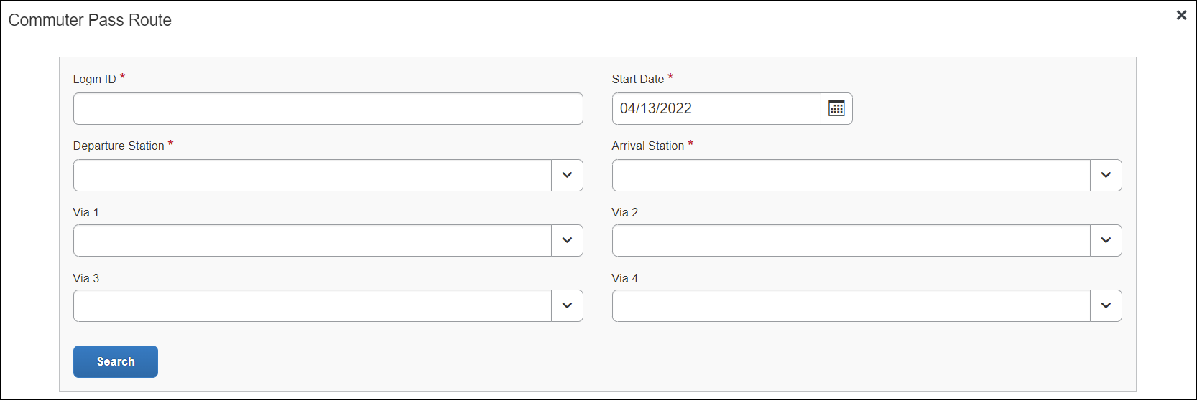
To enter a route for an employee:
- On the Commuter Pass Administrator page, click Add.
- On the Commuter Pass Route page, provide the Login ID for the user you are creating the route for and complete the required fields.
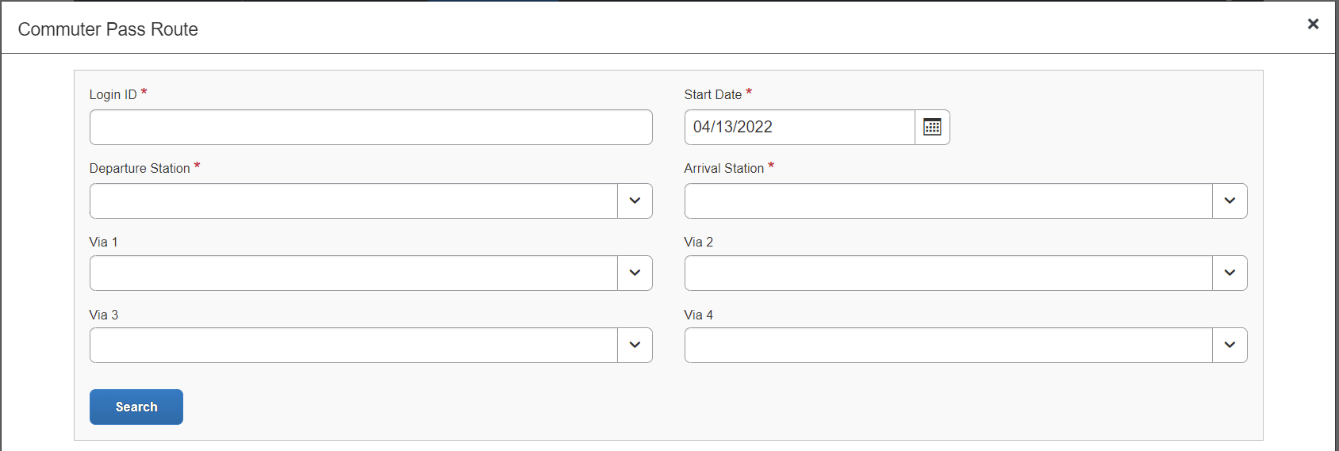
- Login ID: Provide the Login ID of the user.
- Start Date: Select the date that is the starting date of the route the user will travel.
- Departure Station: Enter the route by first specifying the starting station the user will travel.
- Arrival Station: Enter the route by first specifying the ending station the user will travel.
- (Optional) Via 1- Via 4: You may optionally specify the station(s) through which the travel should route. Click Search to return a list of routes validated by the Ekispert service.
If no route is returned, the service cannot find a route that matches the stations – try a different station.
- In the listed routes, click Select Route and then click Add Commuter Pass.
- (Optional): The administrator can now elect to define an end date for the commuter pass routes directly in the grid by clicking in End Date.
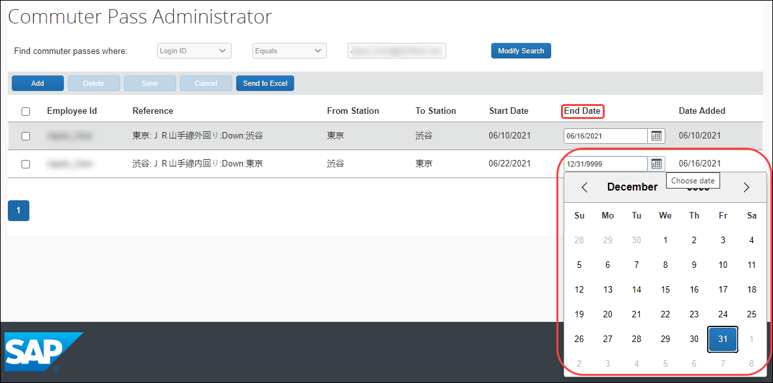
Concur Admin can also configure commuter pass settings that a user cannot configure. Using the Find commuter passes where fields, Concur Admin can search for and select a user whose commuter pass they want to modify.
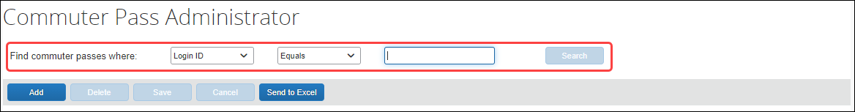
For example, a user cannot change the end date of their commuter pass. When a Concur Admin receives the user's request, Concur Admin can then add an end date, allowing the user to add another commuter pass.
Concur Admin can also export commuter pass information to Microsoft Excel and delete commuter passes.

Exporting Commuter Passes
Concur Admin can export all commuter pass information from Administration > Commuter Pass Admin. This allows the admin to see commuter passes registered in Concur Expense.
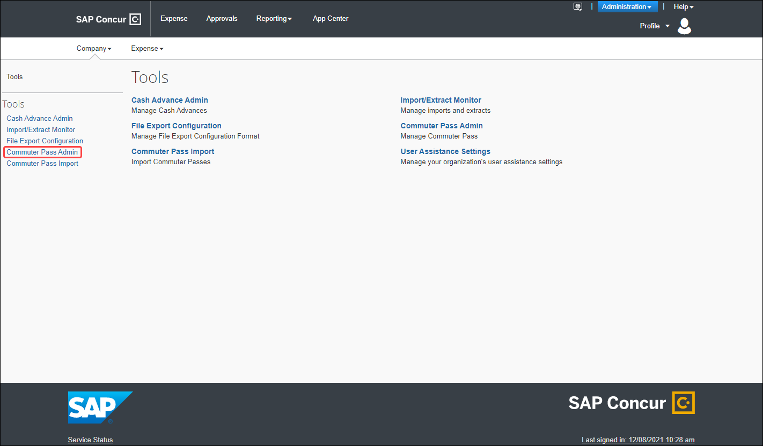
On the Commuter Pass Administrator page, Concur admin clicks the Export All button to export the commuter pass information to an Excel spreadsheet. All existing commuter passes of JPT on NextGen UI will be exported and there will be no value sets on Find commuter passes where field.
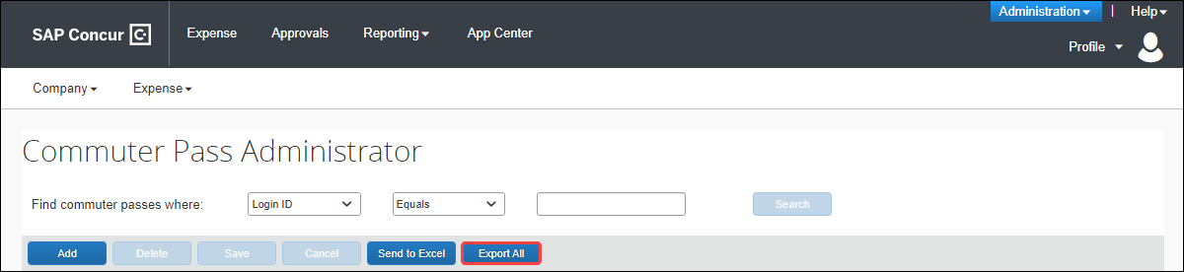
An Excel spreadsheet is downloaded to their default downloads location and then opens to show commuter pass information, such as the Employee ID, from and to station names, and so forth, for all users with a commuter pass.

Example
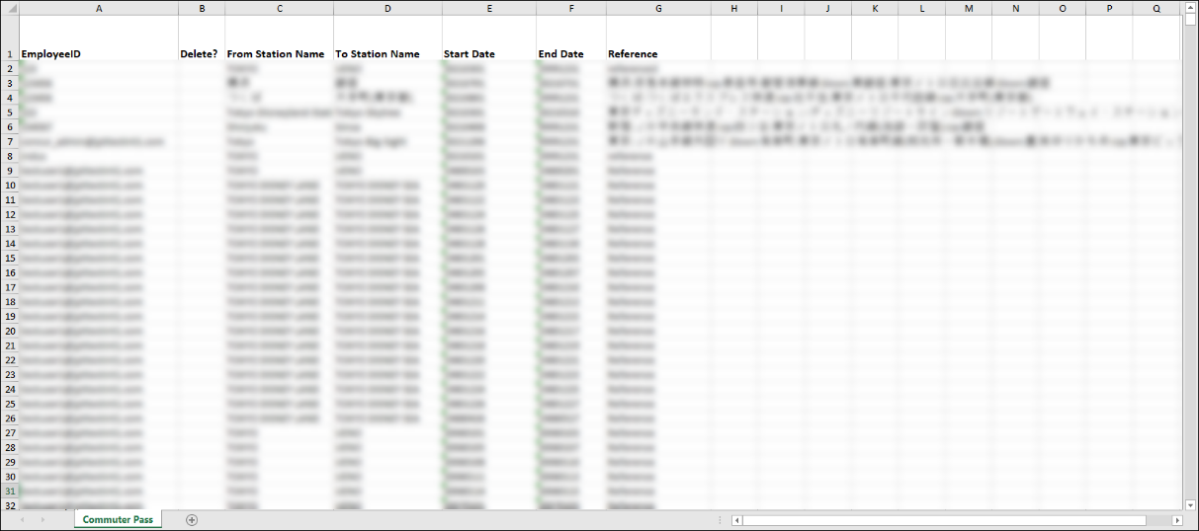

Deleting a Commuter Pass Route
To delete a commuter pass route:
- On the Commuter Pass Admin page, search for the Login ID of the user.
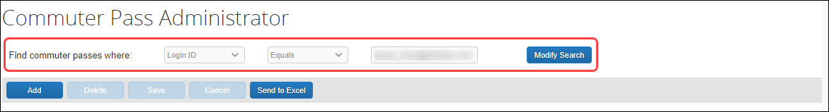
- In the list of returned routes, select the check box for one or more routes to remove.
- Click Delete.
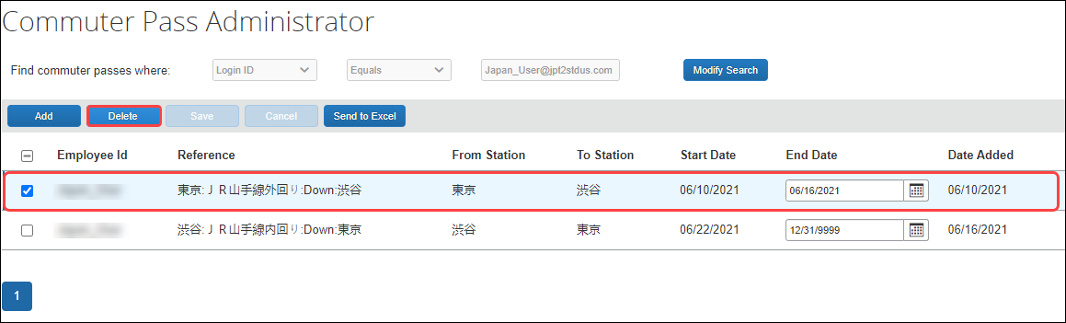
- Click Yes in the Delete message box to complete the deletion of the route.
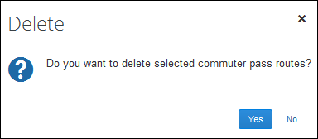
The route is removed from the user’s list of commuter pass routes.
- For more information on importing commuter pass routes, refer to the Importing Commuter Pass Routes For the User section in this guide.

☼

