
Concur Expense: Cash Advance
Setup Guide

Last Revised: September 27, 2022
Applies to these SAP Concur solutions:
 Expense
 Professional/Premium edition
 Standard edition
 Travel
 Professional/Premium edition
 Standard edition
 Invoice
 Professional/Premium edition
 Standard edition
 Request
 Professional/Premium edition
 Standard edition
Table of Contents
Section 1: Permissions 1
Section 2: Overview 1
Cash Advance Admin 1
Typical Cash Advance Process 1
Directly Issued and Auto-Issuance Cash Advances 2
Cash Advances Using a Company Card 2
Imported Transactions with the Cash Advance Transaction Type 3
Section 3: User Experience 3
Requesting Cash Advances 7
Managing Cash Advance Details 8
Attaching Documentation to the Cash Advance 8
Viewing the Approval Flow 11
Returning or Utilizing Cash Advances 12
Two Cash Advance Expense Types 12
Accounting for the Cash Advance 13
Carrying Employee Balance Owed to a New Expense Report 17
Restricting the User to Adding Only a Single Cash Advance to the Report 17
Restricting the User to Matching a Cash Advance to Like Currencies Only 18
Allowing a User to Exclude an Entry from Their Cash Advance 19
Returning Cash Manually Outside of an Expense Report 20
Foreign Currency and Cash Advances 21
Displaying Different Currency Types to the User 21
Currency Gain/Loss Expense Type 23
User Email Notifications 24
Cash Advance Admin Has Pending Cash Advance Issuance 24
Employee Alert of Cash Advance Status Change 26
Automatically Issuing a Cash Advance 26
Overview 26
Cash Advance Approvers 27
Allowing an Approver to Self-Approve a Cash Advance in Their Group 28
Report Totals and Receipt Report 29
Section 4: Approver Experience 31
Viewing the Attached Images 33
Viewing the Approval Flow 34
After Final Approval 35
Approver Email Notifications 36
Section 5: Calculating Cash Advance Utilization 36
Section 6: Configuring the Cash Advance Feature 37
Step 1: Workflow - Configure the Cash Advance Workflow 37
Step 2: Forms and Fields – Configure the Cash Advance Forms 38
Step 3: Group Configurations - Configure the Group 38
Using Imported Local Rates with the Cash Advance Feature 38
Using the Update Cash Advance Exchange Rate On Expense Entries Setting 40
Step 4: (Optional) Expense Types - Hide the Expense Types 40
Step 5: User Administration - Cash Advance Account Code 40
Step 6: Email Reminders – Add Cash Advance Email Reminders 41
Step 7: Site Settings – Select Cash Advance Settings 41
Section 7: Cash Advance Admin Tool 41
Section 8: Cash Advance Issuance and Financial Extracts 42

Revision History
Date |  |  | Notes / Comments / Changes
September 27, 2022 |  | Added information about NextGen UI; made modifications throughout; cover revision date updated
August 27, 2021 | Added information about the Auto-Issuance Step for Cash Advance Request workflow that automates the issuance of a cash advance to the requestor.
January 6, 2021 |  | Updated the copyright; added Concur to the cover page title; cover date not updated
April 9, 2020 |  | Renamed the Authorization Request check box to Request on the guide’s title page; cover date not updated
January 2, 2020 |  | Updated the copyright; no other changes; cover date not updated
January 4, 2019 |  | Updated the copyright; no other changes; cover date not updated
April 4 2018 |  | Changed the check boxes on the front cover; no other changes; cover date not updated
February 20 2018 |  | Updated guide names in references to the Expense: Standard Accounting Extract, Version 2 Specification and Expense: Standard Accounting Extract, Version 3 Specification guides.
January 4 2018 |  | Updated the copyright; no other changes; cover date not updated
July 29 2017 |  | Added a clarification note: Even if the employee returns the entire outstanding balance, the employee will continue to see the cash advance balance, $0.00, in their profile until the extract job runs. The extract job changes this status from Issued to Completed and removes the cash advance from the employee's profile.
July 18 2017 |  | Added a clarification note: The exchange rate cannot be overwritten by the Cash Advance exchange rate for any expense that is partially approved or is a subordinate (child) expense even if Update Cash Advance exchange rate on expense entries is enabled in Group Settings.
December 14 2016 |  | Changed copyright and cover; no other content changes.
May 13 2016 |  | Updated instances of he/she to they.
January 24 2016 |  | Added information that the local imported rate used by a report is matched in an itemized expense entry only if the current date (report) and the transaction date (entry) are the same.  Added information that the system will not apply a local rate to a cash advance unless the specific rate was imported (and applicable to) the same date on which the cash advance was created.  Changed references to the import/extract guides
December 22 2015 |  | Changed a reference to another guide; no other content changes
August 19 2015 |  | Added Cash Advance Issuance and Financial Extracts section.
August 14 2015 |  | Added information that the Approval Flow and Documents tabs will appear on the New Cash Advance page.
April 10 2015 |  | Added information on Approval Flow and Documents tabs, removed references to the current user interface.
March 13 2015 |  | Changes to the system behavior of the partial approval of a cash advance.
September 24 2014 |  | Added information about two user interfaces; no other content changes.
June 20 2014 |  | Clarified returning cash advance amounts, and details of cash advance card transactions.
March 11 2014 |  | Added information about the Cash Admin feature – Send Back to Employee
January 17 2014 |  | Added direct issue Cash Advance information, added Cash Advance form and email reminder configuration steps, updated group configuration step.
December 13 2013 |  | Addition of feature restricting the Cash Advance administrator role from self-approving an advance – the client must restrict the assignment of the role to a single employee to enable self-approval of the advance
October 18 2013 |  | Addition of the Provide Default Exchange Rate for Cash Advance Issuance setting to the Site Settings tool – this displays the default exchange rate to the Cash Advance administrator in the Cash Advance Details dialog box when issuing cash advances in a foreign currency
June 14 2013 |  | Added information that the employee is provided the balance of a cash advance in a table that displays whenever they use the Currency Gain/Loss expense type
May 17 2013 |  | The following features were included in this service release:  - Differing currencies between the advance and reimbursement are both now displayed to make returning a cash advance easier  - A Group setting allowing the cash advance exchange rate to automatically overwrite the existing exchange rate of the expense entry the advance is being associated with  - The Currency admin can now prevent or allow inversion of currency rate pairs using a setting in that tool  - The remaining amount is now displayed whenever the user adds a cash advance to a report intending to return all or part of the advance
April 3 3012 |  | Removed all references to the legacy Authorization Request feature in Concur Expense  Changed any references to Concur's Travel Request service to Request, Concur Request, or Authorization Request, depending on the situation  No other content changes
February 22 2013 |  | Added two new features:  - User may exclude an expense entry from their cash advance  - A cash advance may only be matched to entries using like currencies
December 28 2012 |  | Made rebranding and/or copyright changes; no content changes
November 16 2012 |  | Added information about a setting allowing or restricting the number of cash advances that can be associated with an expense report
October 19 2012 |  | The Balance Carry Forward feature is added - this allows the system to track money owed by the employee and net this against money owed by the employee to the company in a future expense report

Cash Advance
NOTE: Multiple SAP Concur product versions and UI themes are available, so this content might contain images or procedures that do not precisely match your implementation. For example, when SAP Fiori UI themes are implemented, home page navigation is consolidated under the SAP Concur Home menu.

Permissions
A company administrator may or may not have the correct permissions to use this feature. The administrator may have limited permissions, for example, they can affect only certain groups and/or use only certain options (view but not create or edit).
If a company administrator needs to use this feature and does not have the proper permissions, they should contact the company's SAP Concur administrator.
Also, the administrator should be aware that some of the tasks described in this guide can be completed only by SAP Concur. In this case, the client must initiate a service request with SAP Concur Client Support.

Overview
This guide describes the Cash Advance feature and the configuration process. There is no Cash Advance configuration tool; the administrator uses various tools in Expense Admin and User Administration to configure the Cash Advance feature.

Cash Advance Admin
A separate tool - Cash Advance Admin - is used by a client administrator to issue cash advances to employees and record cash returned manually by employees. The Cash Advance Admin tool is explained briefly in this guide and explained in detail in the Expense: Cash Advance Admin User Guide.

Typical Cash Advance Process
Depending on the company's configuration, employees may be able to request a cash advance before going on a trip or incurring an expense. Requesting a cash advance is typically a three-step process:
- The employee creates and submits a cash advance request.
- Concur routes the request to the employee's cash advance approver.
The cash advance approver may or may not be the employee's manager and can be different from the employee's expense report approver.
- Once approved, Concur sends the cash advance request to a Cash Advance admin who reviews it and then either "issues" it or returns the request to the user (perhaps for more information).
In this case, the term "issue" means final approval in Expense.
If the Cash Advance administrator issues the cash advance, the company pays the actual cash to the employee. After the employee takes the trip or makes the purchase, they must create an expense report to account for the cash.
Note the following about the cash advance workflow:
- There can be more than one cash advance approver in the workflow.
TIP: Use multiple cash advance approvers if you would like to restrict approvers from approving an advance within a group they manage; assign the role to a single cash advance administrator to allow this behavior.
- The approval step is not actually required. If so, the request goes directly to the Cash Advance administrator.

Directly Issued and Auto-Issuance Cash Advances
The Cash Advance admin can issue a cash advance directly to a user – without waiting for the user to submit a request – if the user has a cash advance account code assigned. If the Cash Advance feature is not enabled for that user's group, the user can utilize the issued cash advance but cannot request any additional advances.
Additionally, the Cash Advance tool can be configured to automatically perform the issuance of a cash advance to the requestor. Doing this systematically replaces the step of Manual Issuance and instead automatically processes an approved cash advance request for issuance based on configuration of the rule and action underlying the condition for this step.

Cash Advances Using a Company Card
An employee can also obtain a cash advance using his/her company charge card or ATM. The company may choose whether or not these are imported as cash advances into Concur Expense, based on the settings for the card import. When these are imported as cash advances, none the above steps apply. Company card cash advances or those transactions coming from a company card feed:
- Are accessible from the Cash Advance List page in Expense
- Are not displayed with the employee's other company card transactions in the Available Expenses page
If an employee uses a company card to receive an ATM cash advance but the group that the employee belongs to does not support cash advances, a Cash Advance List page appears in Expense for that employee; however, the other cash advance pages and options do not appear. That employee cannot request cash advances as described in the guide.

Imported Transactions with the Cash Advance Transaction Type
The card importer will detect if a transaction with the ATM Withdrawal transaction type is imported as a Cash Advance. However, if no cash advance account code is associated with the owner of the imported cash advance, the system allows the import but automatically hides the transaction. The transaction can be assigned only after the account code is created for the user. At that time, the Company Card administrator can assign the transaction manually.
- For more information about searching for and assigning hidden cash advance transactions to an employee, refer to Expense: Company Card Administrator User Guide.

User Experience
A user who is allowed to use cash advances will see the Cash Advances link under the Expense menu.
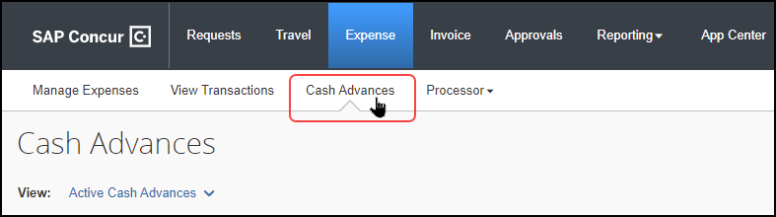
The Cash Advances page displays several options:
- Request Cash Advance tile: Used to create a new cash advance request (based on configuration)
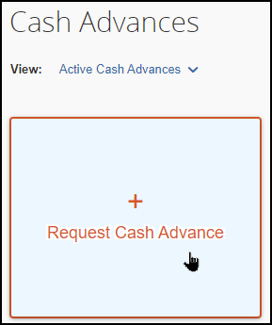
- View menu: On the user's expense report, the View > Cash Advances menu includes multiple viewing options (Active Cash Advances shown) the user can choose to review their cash advance status.
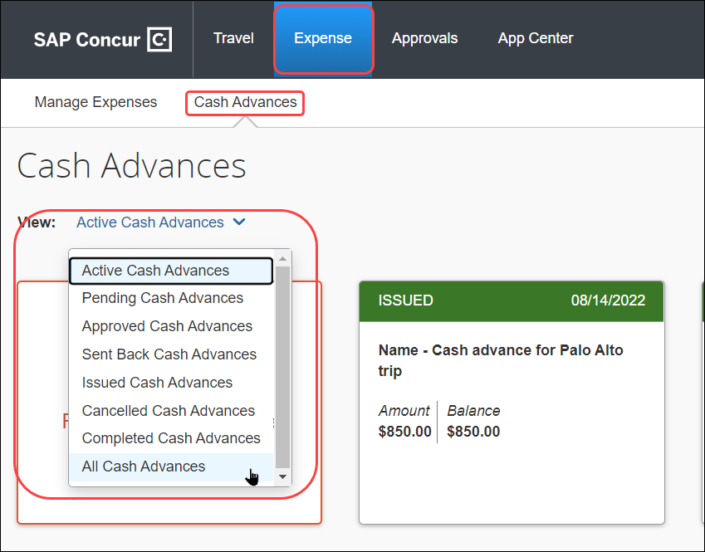
Selecting any option opens that option’s view, and all views include the Create New Cash Advance option as well:
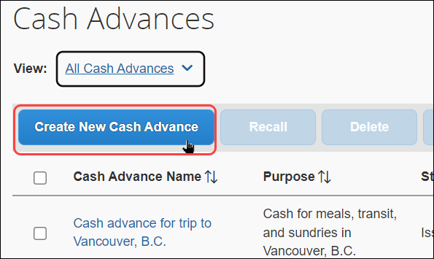
Company card cash advances appear on the Cash Advances page (View > Cash Advances menu option) – not the regular page that lists all the user's company card transactions (Available Expenses section in the expense report).
With the expense report open, the used and remaining amounts of the cash advance linked to the report are shown above the list of expenses (clicking the tile causes the Cash Advances page to open):
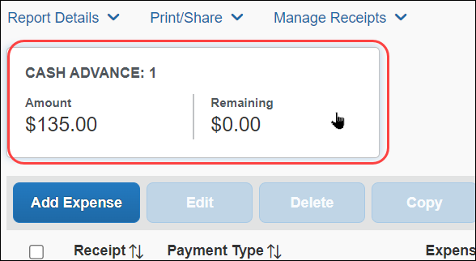
The total decreases as expenses that are non-personal and have an appropriate payment type are added to the report. Applicable payment types are those reimbursed directly to the employee, such as cash or individual credit cards.

The user may also click Report Details > Manage Cash Advances to open the Cash Advances page.
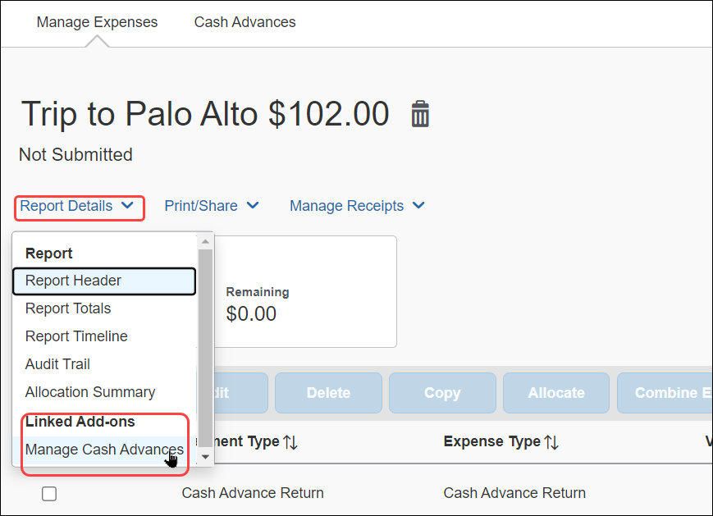
The Report Totals page (Details > Totals (under Report)) also displays the cash advance utilized amount if the report has a cash advance associated with it.
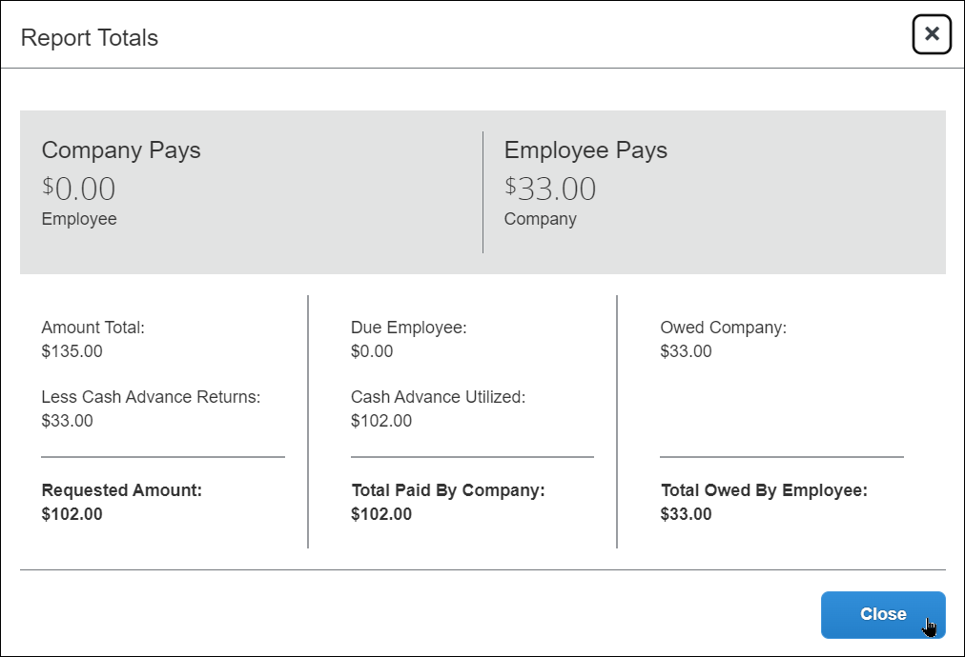

Requesting Cash Advances
The employee completes the New Cash Advance page including the amount requested and the reason for the request. They have the option of submitting the cash advance now or saving the request and submitting it later.
Alternatively, the cash advance may be created on behalf of a user by the Cash Advance administrator who can then issue the amount which will appear for the user.
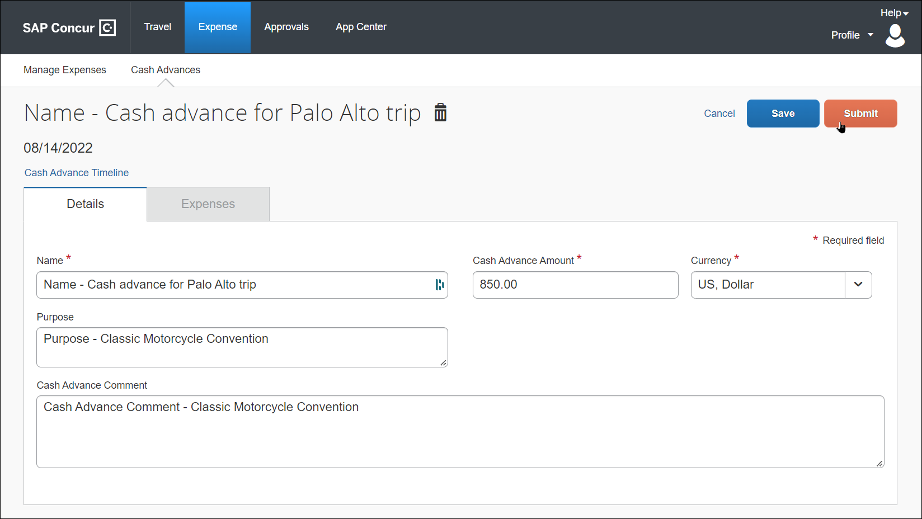
Once submitted, the request goes through an approval process and then on to the Cash Advance administrator for issuing. The company then distributes the cash according to its internal process.

Managing Cash Advance Details

Attaching Documentation to the Cash Advance
Some companies allow the user to attach images to the cash advance. If this feature is enabled, the user will see the Manage Attachments link which becomes active when the cash advance is created and when editing the cash advance.
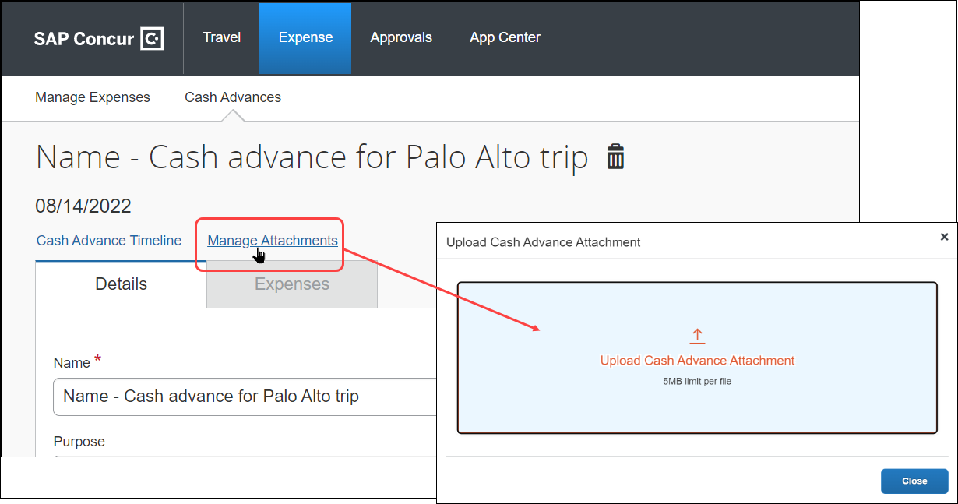
The user clicks Manage Attachments, then navigates to the image to upload and attach it to the cash advance.
Once an image is attached, the user can optionally delete it by clicking Delete prior to submission. Click Append to add additional images to make a multipage document. There is no limit to the number of appended pages.
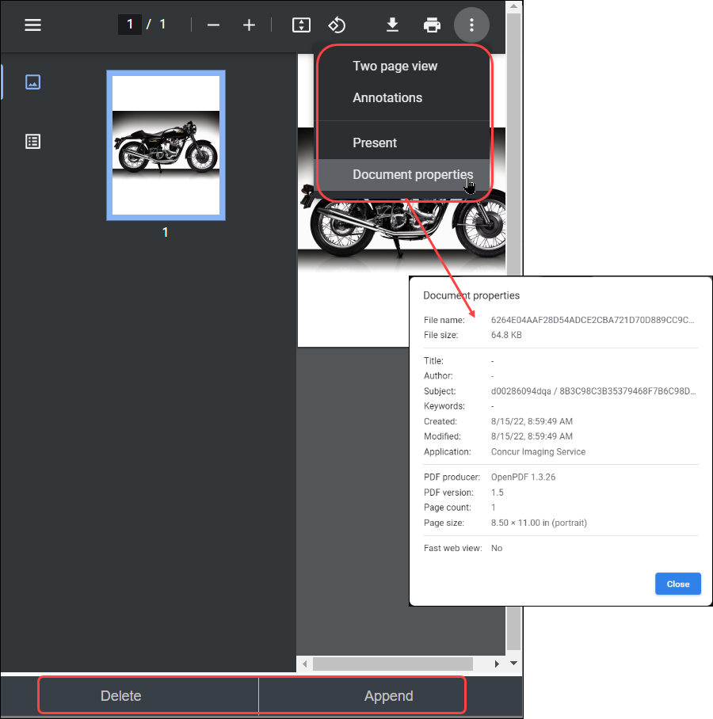

Viewing the Approval Flow
The user can view the approval flow for the cash advance by clicking Cash Advance Timeline.
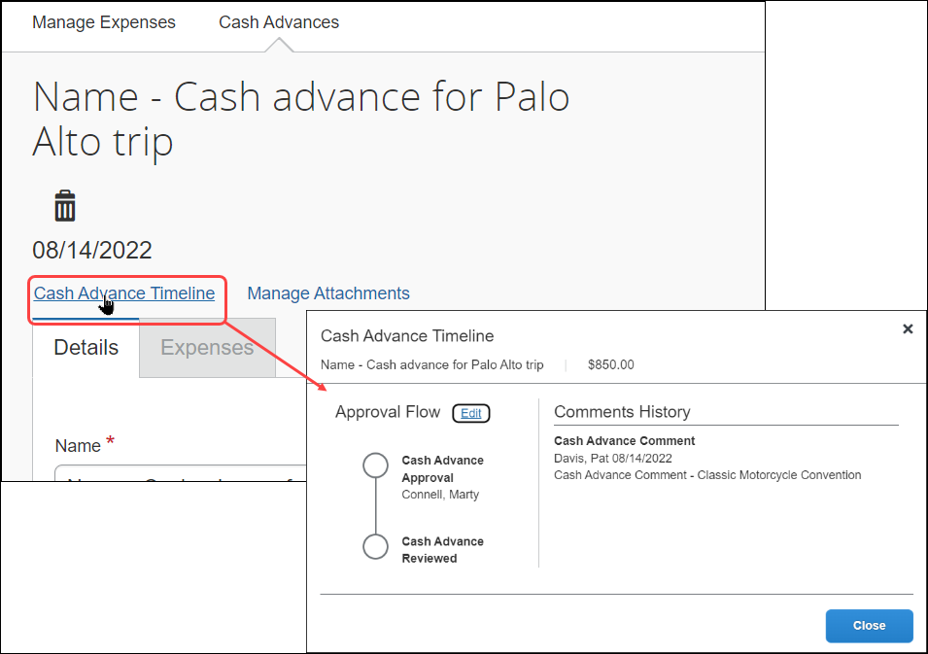
If the user is allowed to select the approver, the user can do so by clicking Edit on the Cash Advance Timeline page and then use options on the page to select and save an approver in the cash advance workflow.
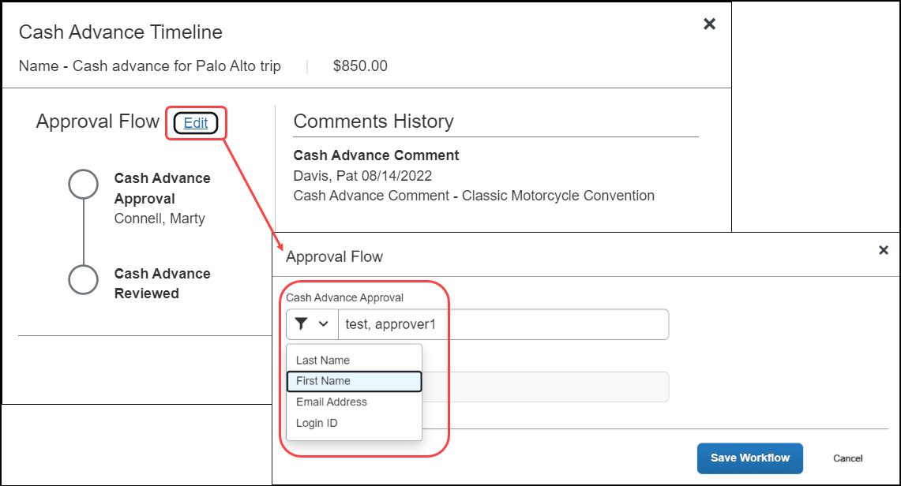

Returning or Utilizing Cash Advances
After the employee uses all or part of the cash (on a trip or for a purchase), the employee must account for any used and unused portion of a cash advance. This may be done in an expense report, or by returning the unused amount to the cash advance administrator who then records the return in the system. The system can display both the issued and base (user’s assigned currency) amounts (if differing currencies) to make this easier for the user. When returning an amount, the system will show the amount due back once the advance is assigned to the report.
Depending on the company's configuration, the employee may be able to use more than one expense report.

Two Cash Advance Expense Types
The employee may use one or both of these expense types to account for the cash advance on an expense report:
- Currency Gain/Loss: Used to account for the differences in foreign exchange rate conversions.
- Cash Advance Return: Used to record that the employee returned the unused portion of the cash advance to the company. The processor can mark the cash advance as returned (similar to marking receipts as received). This is typically done when the check or payment arrives in the accounting offices, with any physical receipts that are required.
Concur recommends that companies enable the Record Return Amount feature for the Cash Advance Admin, to allow them to mark returned amounts in Concur. With that feature, the cash advance amounts are immediately updated, without waiting for a report to finish the approval workflow. For more information, refer to Returning Cash Manually Outside of an Expense Report.
Note the following:
- These expense types do not appear if there is no cash advance associated with the report.
- Approvers cannot reject or partially approve these expense types.

Accounting for the Cash Advance
The user accounts for their cash advance on their expense report. The user can link cash advances to their expense reports two ways:
- During report creation, when the user is automatically alerted to availability
- Within the report, using cash advance options on the Report Details menu
The user is automatically prompted to link any issued and outstanding cash advances when they create a new report. The Cash Advances page appears with the View link for cash advances after the user has saved the report header:
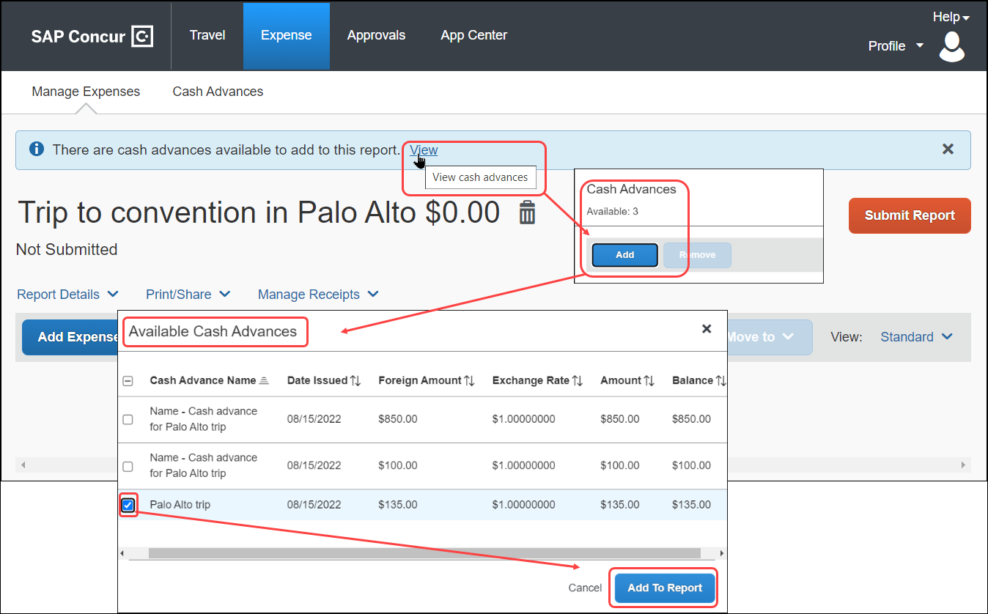
The user clicks View then Add on the Cash Advances page, selecting the cash advance from the Available Cash Advances page and finally clicking Add to Report.
The user can also link a cash advance to the report using the Report Details menu.
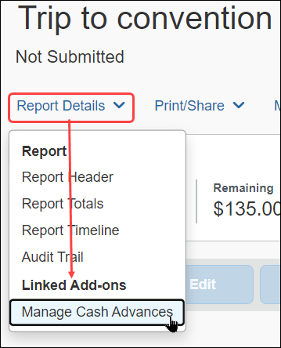
On the menu, select Report Details > Manage Cash Advances (under Linked Add-ons) and choose the outstanding cash advance(s) that should be associated with the current report.
Depending on the company’s configuration, the user may be able to select and then link multiple cash advances to apply to expenses in a single report.

What Payment Type is Applicable to a Cash Advance?
Any expense on the expense report that is non-personal and has a payment type of Cash or IBIP (Individually Billed/Individually Paid) is used to offset the cash advance. Additionally, the Cash Advance Return expense type may be used to return all or part of the balance of the advance to the company via an expense report.

Viewing the Cash Advance Details Within the Expense Report
The running total of the outstanding cash advance appears at the top, above the expense list. This total is listed in the user’s reimbursement currency and is updated as the user adds expenses.
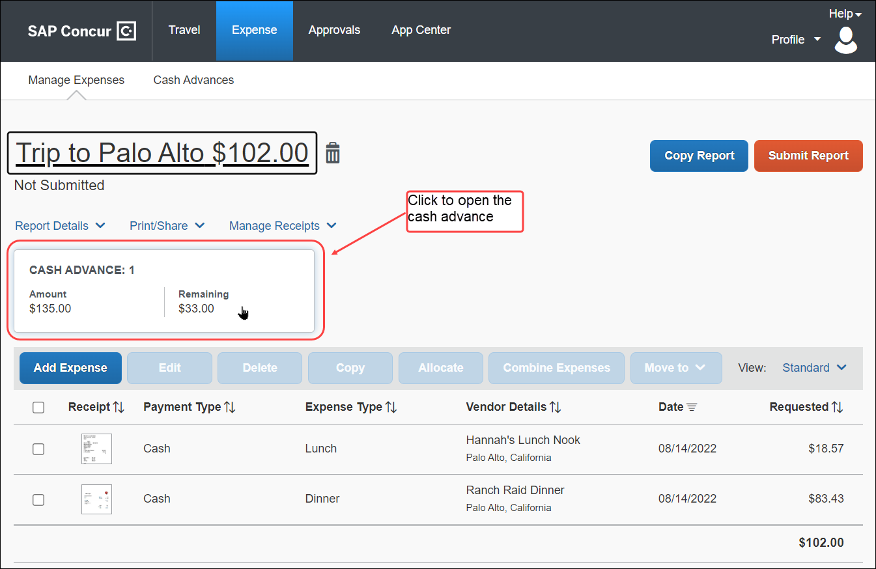
The user can click the cash advance tile directly to view the full details of the associated cash advance(s). Selecting the cash advance lets the user take the step of adding another cash advance or deleting the selected advance from this report (it will return to the available cash advance queue.
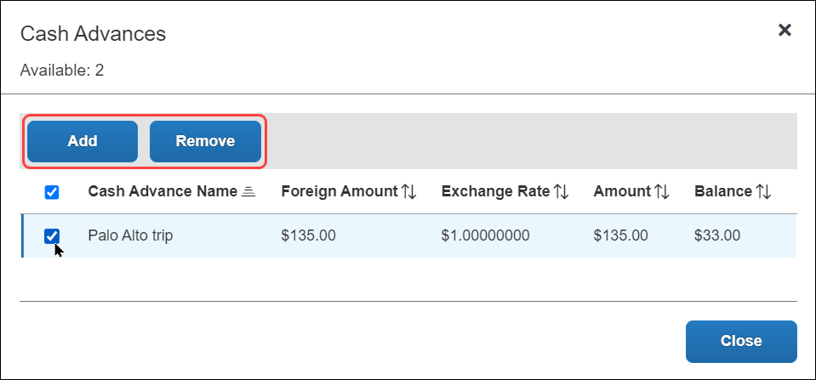

Calculation Logic: Offsets, Less and Greater Than, and Carry Forward
If the cash advance amount is less than the total of the cash/IBIP expenses, then the employee is reimbursed for the difference.
If configured, the amount due the employee may be offset by prior balance due to the company by the employee. For more information about the Balance Due Management feature, refer to the Expense: Standard Accounting Extract, Version 2 Specification and Expense: Standard Accounting Extract, Version 3 Specification guides.
- If the cash advance amount is greater than the total of the cash/IBIP expenses, depending on the company's configuration:
- The employee physically returns the remaining cash to the proper person in the company who then records this information in the cash advance admin area.
- The employee creates an expense using the Cash Advance Return expense type for the difference, and then physically attaches funds (check, voucher, etc.) to the printed expense report and submits it to the accounting department.
- If the employee is allowed to carry balances forward, they can "use up" the remaining cash advance balance on future expense reports.
Example: Chris has an outstanding cash advance of 100 USD and she/he associates this cash advance with a report. Assume her/his expense report has two cash expenses: one for Meals in the amount of 50 USD and one for Taxi in the amount of 20 USD. She/He would have an outstanding cash advance balance of 30 USD.
Depending on her/his company's configuration, Chris will either:
- Return the funds to the Cash Advance administrator, who can manually record the return.
- Add a Cash Advance Return expense to the expense report for 30 USD and then return the 30 USD in cash to the appropriate person in the company.
- Use the remaining 30 USD on a future expense report.

Carrying Employee Balance Owed to a New Expense Report
Whenever the employee is due money from the company, that amount can be compared against any outstanding balance owed by the employee to the company, and that amount reconciled against what the employee requests from the company. This Balance Due Management feature is enabled by the Expense Configuration administrator using the Policies tool.
When activated, an expense report with a balance due to the company from the employee will generate an internal tracking record for that balance due to the company. A subsequent report with an amount due the employee from the company will automatically have this balance applied at the point in time that the processor approves the report for payment, netting out the amount due to the employee against the amount remaining that is due to the company from the prior report.
The balance due is automatically applied to the expense report at the point the processor approves the report for payment, reducing the amount due the employee by the amount of the outstanding balance.
- For more information, refer to the Expense: Standard Accounting Extract, Version 2 Specification and Expense: Standard Accounting Extract, Version 3 Specification guides.

Restricting the User to Adding Only a Single Cash Advance to the Report
A setting is available in Group Configuration that restricts all expense reports to the addition of only a single cash advance. This is typically used when the financial systems used by the company cannot accept information for more than one cash advance per expense report.
This setting is available to the Expense Configuration administrator using the Group Configurations link. By default, the feature is enabled, allowing the user to link multiple cash advances to a single report.
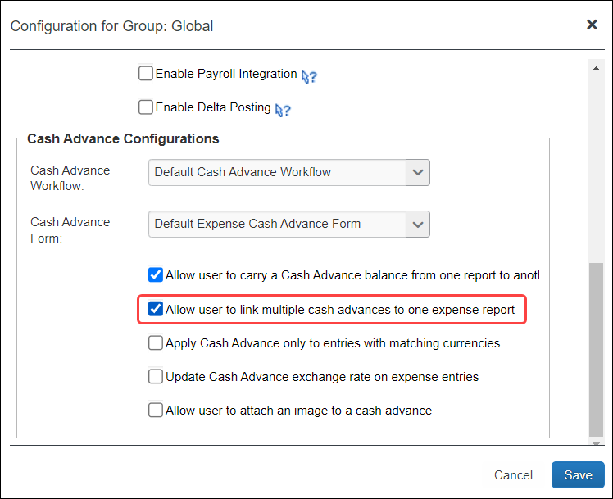
A Service Request may be required to configure this setting for the client - contact Concur for more information.

Restricting the User to Matching a Cash Advance to Like Currencies Only
A setting is available in Group Configuration that restricts the user from matching any of their cash advances to an expense entry that does not match the currency of the cash advance. This forces the system and user to match only expense entries with those cash advances that share a like currency.
This setting is available to the Expense Configuration administrator using the Group Configurations link, and is disabled by default.
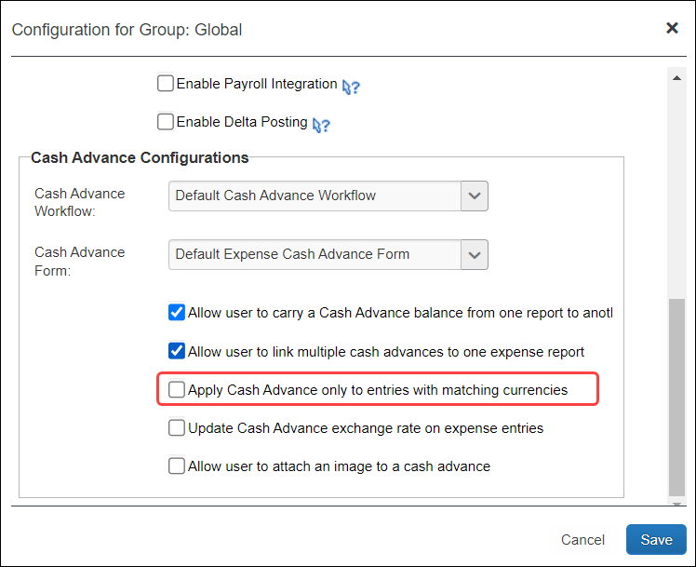

Allowing a User to Exclude an Entry from Their Cash Advance
A field may be added to the Entry form of the Forms and Fields tool that appears only when a cash advance is available to the report. When selected, this option allows the user to prevent association of the cash advance to the selected expense entry. This allows the user to exclude an out-of-pocket expense from a cash advance when creating an expense entry for their expense report, preventing the entry from being allocated against the employee’s cash advance.
The user does this by selecting (enabling) the Exclude From Cash Advance field, on the New Expense entry form when creating their expense if the report has an advance linked to it.
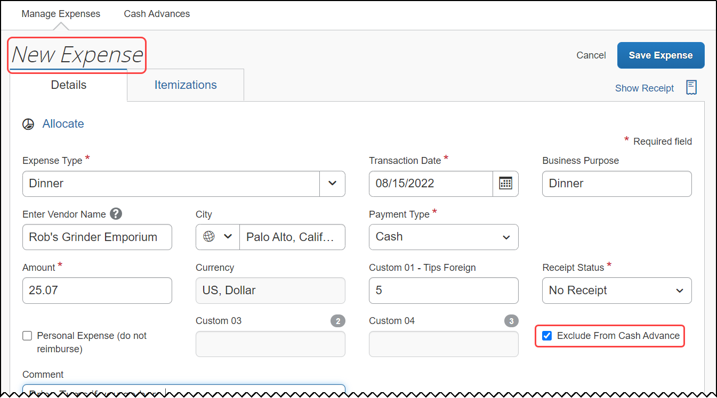
- For more information about how to add this field to the Entry form, refer to Expense: Forms and Fields Setup Guide.

Returning Cash Manually Outside of an Expense Report
Concur provides two methods to track cash advance amounts that have been returned to the company by the employee.
- Recommended: If configured, the Cash Advance Admin can accept manually-returned amounts and record them in Expense. The outstanding balance amount of the advance immediately reflects this adjustment, reducing the amount that must be accounted for by the employee.
Even if the employee returns the entire outstanding balance, the employee will continue to see the cash advance balance, $0.00, in their profile until the extract job runs. The extract job changes this status from Issued to Completed and removes the cash advance from the employee's profile.
- The company may require the user to attach a check to their paper expense report or otherwise mail funds to the accounting team. The user then creates an expense entry using the Cash Advance Return expense type. The expense processor can then select Yes/No in the Cash Advance Return Received column on the Process Reports page to indicate that they actually received the funds, which adds an audit trail record to the report.
Company card advances may not be returned manually outside of an expense report.

Foreign Currency and Cash Advances
Employees can request a cash advance in a foreign currency, but it is stored and tracked in the user's reimbursement currency.
The Cash Advance administrator is responsible for entering an exchange rate for foreign currency cash advances. Concur has a site setting (Provide Default Exchange Rate for Cash Advance Issuance) that displays the default exchange rate to the Cash Advance administrator in the Cash Advance Details dialog box when issuing cash advances in a foreign currency.
- For more information, refer to the Expense: Site Settings Setup Guide.

Displaying Different Currency Types to the User
When working with a cash advance issued in one currency and reimbursed in another, the system will automatically display both currencies when the user selects the cash advance to associate with the report.
Three conditions must be met to see the differing currencies:
- They must be of differing currency types
- The Group setting Apply Cash Advance only to entries with matching currencies must be selected
- The Group setting Update Cash Advance exchange rate on expense entries must be selected
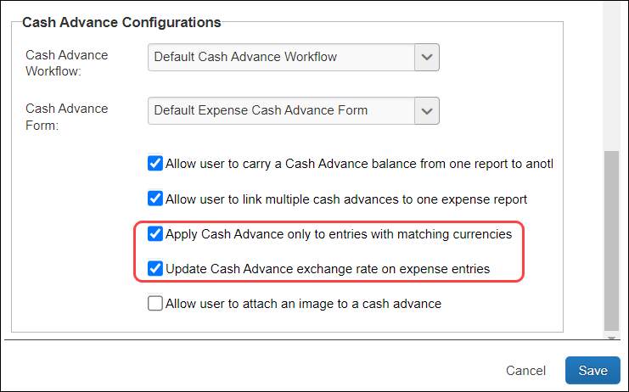
User Experience
The user will see both the issued and the base currencies, with the issued currency below the base currency the user is familiar with.
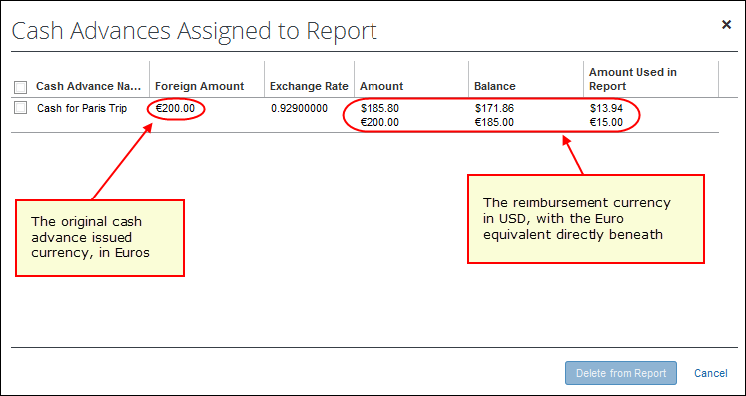

Currency Gain/Loss Expense Type
Employees use the Currency Gain/Loss expense type to account for foreign exchange rate conversion issues in cases where the total of cash used and cash returned does not equal the amount of cash originally issued, such as:
- When an employee uses a cash advance in a foreign currency and tries to return the cash advance later in another currency, the exchange rate at the time of return may be different from the exchange rate at the time the cash advance was issued. This may cause the cash advance amounts to differ.
- When a cash advance is issued in one foreign currency and partially or fully spent in one or more foreign currencies, the various exchange rates and the associated rounding cause a discrepancy in the reimbursement currency amount.
- When the option to overwrite the expense entry exchange rate with that of the original cash advance exchange rate is not used (note this is used only with matching currency types).
Example: An employee travels to Europe and requests a cash advance for 100 USD. Once there, the employee converts the USD to Euro and, just before coming back, converts the remaining Euro back into USD. After calculating the expenses, the employee sees a 2 USD difference because of the difference in exchange rates. The employee would then add an expense to the expense report using the Currency Gain/Loss expense type in the amount of 2 USD.
Currency Gain/Loss expenses can either be entered as positive (loss) or negative (gain) amounts depending on the situation.
- If the employee has spent and/or returned the entire cash advance but the advance still shows a positive balance remaining due to exchange rates, the employee can account for the additional money owed to the company with a currency gain/loss entry for that remaining amount. In this scenario, the entry is a loss and the amount entered by the employee is positive.
- If the employee has spent and/or returned the cash advance and the exchange rate calculations cause the cash advance balance to be negative, the employee can bring the cash advance balance to zero with a currency gain/loss entry. In this scenario, the entry is a gain and the amount entered by the employee is negative. In cases where the cash advance balance is negative, the employee will receive an error message when they try to submit the associated report. The employee cannot submit the report while the cash advance balance is negative.
Currency Gain/Loss cannot be applied to company card cash advances.
If a company does not want to use this expense type (for example, the company wants to absorb the currency gain/loss), then this expense type should be inactivated from the policy using the Expense Type page in Administration > Expense.

Employee Experience – Currency Gain/Loss Expense Type
The employee using the Currency Gain/Loss expense type is provided with the amount balance when they create their report as shown in the figure below:
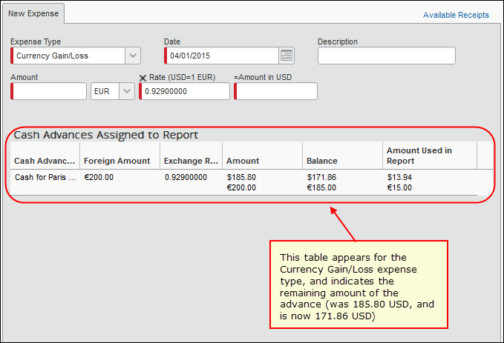

User Email Notifications
Two different email notifications, one for the Cash Advance admin, the other for the user, can be configured as explained below.

Cash Advance Admin Has Pending Cash Advance Issuance
The Cash Advance administrator can receive emails about pending cash advances they need to issue. This is configured in Administration > Company > Company Admin > User Permissions by clicking the Expense tab, searching for the employee, and then selecting the Expense Cash Advance Administrator role. The Send Cash Advance Pending Issuance Emails check box appears, and can be selected at this time.
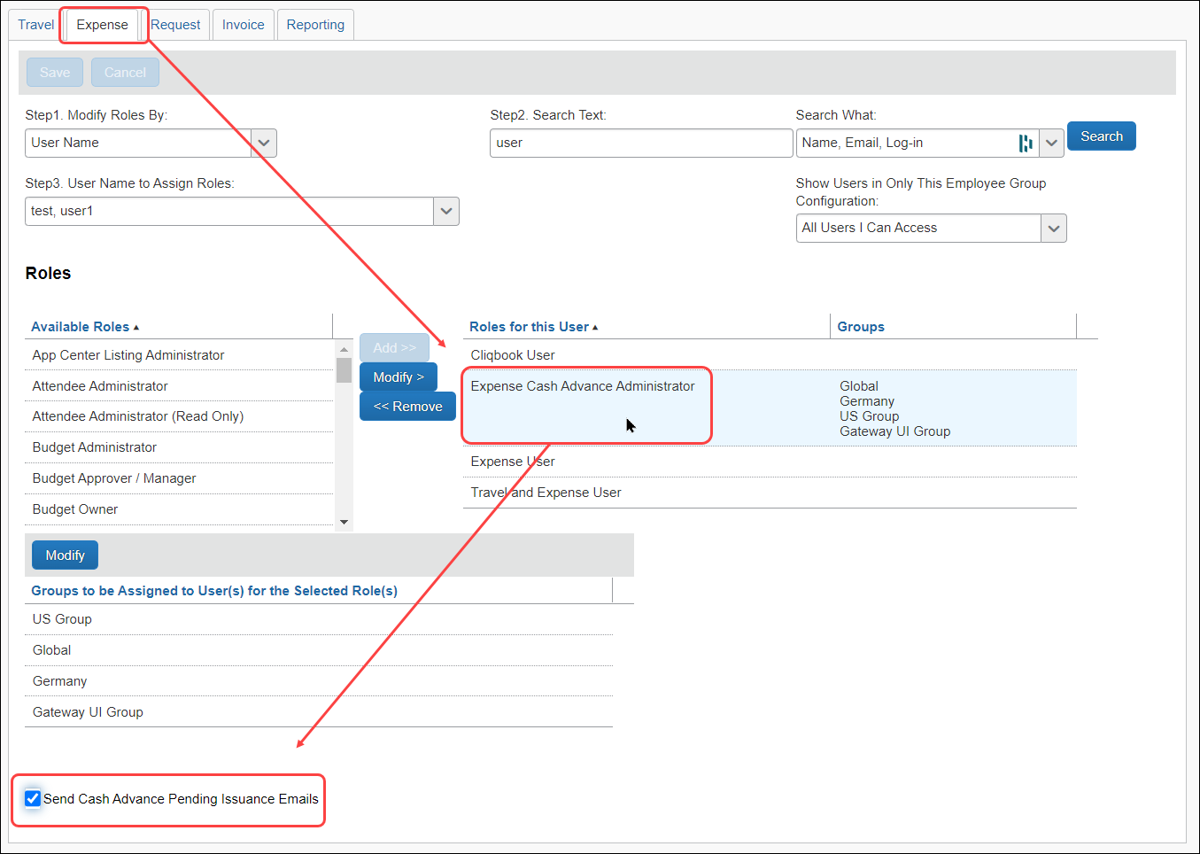
- For more information, refer to the Shared: User Administration User Guide.

Employee Alert of Cash Advance Status Change
Employees can choose to have email sent to alert them when a cash advance request changes status, such as from Pending Approval to Issued. This option appears in Profile > Profile Settings > Expense Preferences (left menu).
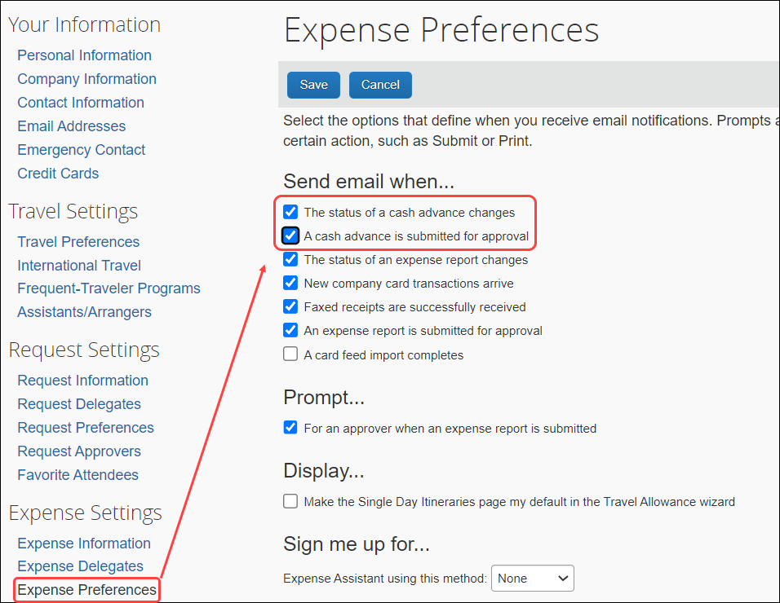

Automatically Issuing a Cash Advance

Overview
The Cash Advance workflow Cash Advance Reviewed step can be configured to automatically perform the issuance of a cash advance to the requestor. Doing this systematically replaces the step of Manual Issuance and instead automatically processes an approved cash advance request for issuance based on configuration of the rule and action underlying the condition for this step.
For example, the associated condition for the step is named and then configured to limit the allowable cash advance issuance to no more than $1,000. Now, when the requestor inputs the cash amount, the amount either below or above this amount drives the logic to issue or reject the cash advance respectively, without need for the admin to review each request for the same purpose.
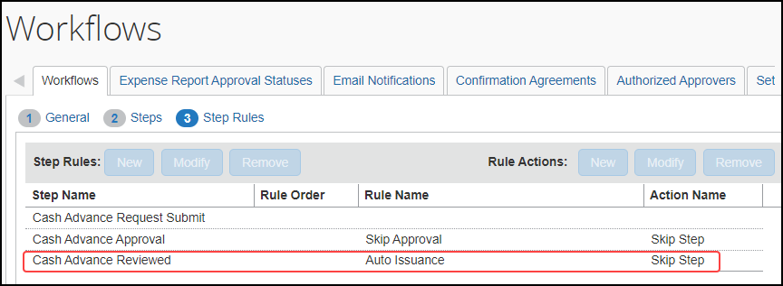
- For more information, refer to the Issuing a Cash Advance Automatically Without Manual Review topic in the Concur Expense: Cash Advance Admin User Guide.

Cash Advance Approvers
The employee's cash advance approver may or may not be the same as the employee's expense report approver. The cash advance approver is displayed in Profile > Profile Settings > Expense Approvers (left menu).
- If the employee is allowed to choose his/her own approver, then an editable Default approver for your cash advance requests field appears on the page.
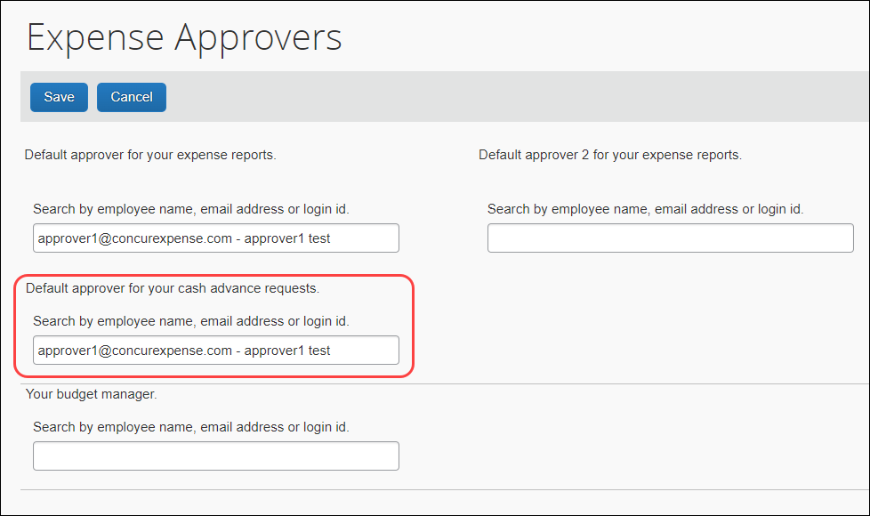
- If the employee is not allowed to choose his/her own cash advance approver, then the Default approver for your cash advance requests field is editable in User Administration; it appears in Profile as a read-only field.
This field appears only if a cash advance workflow is set for the employee's group.
A cash advance approver can also be added during the employee load import.

Allowing an Approver to Self-Approve a Cash Advance in Their Group
By default, the system prevents the Cash Advance administrator role from approving their own advance within their group. This security measure prevents fraud by restricting the administrator from issuing and approving advances on their behalf.
If the client wants this capability, they should assign the role to only a single employee – the system automatically drops the self-approval restriction if only a single user is assigned the role. This configuration lets the client choose to enable or disable the self-approval capability within a group by simple assignment.

Report Totals and Receipt Report
There are two line items used for cash advances on the Report Totals page and the printed Receipt Report in Expense and Expense Processor:
- Less Cash Advance Returns: This item appears only if the employee created a Cash Advance Return expense in the expense report.
- Cash Advance Utilized: This item appears only if a cash advance has been associated with this expense report.
If the cash advance is from the employee's company card (IBCP), then the amount of the cash expenses associated with the report is added to the Amount Due Company Card field.
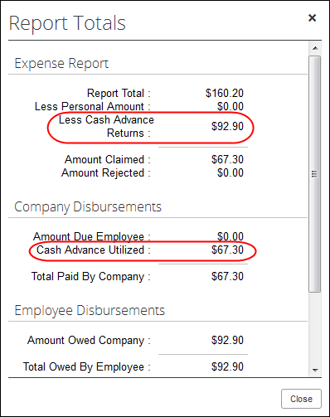
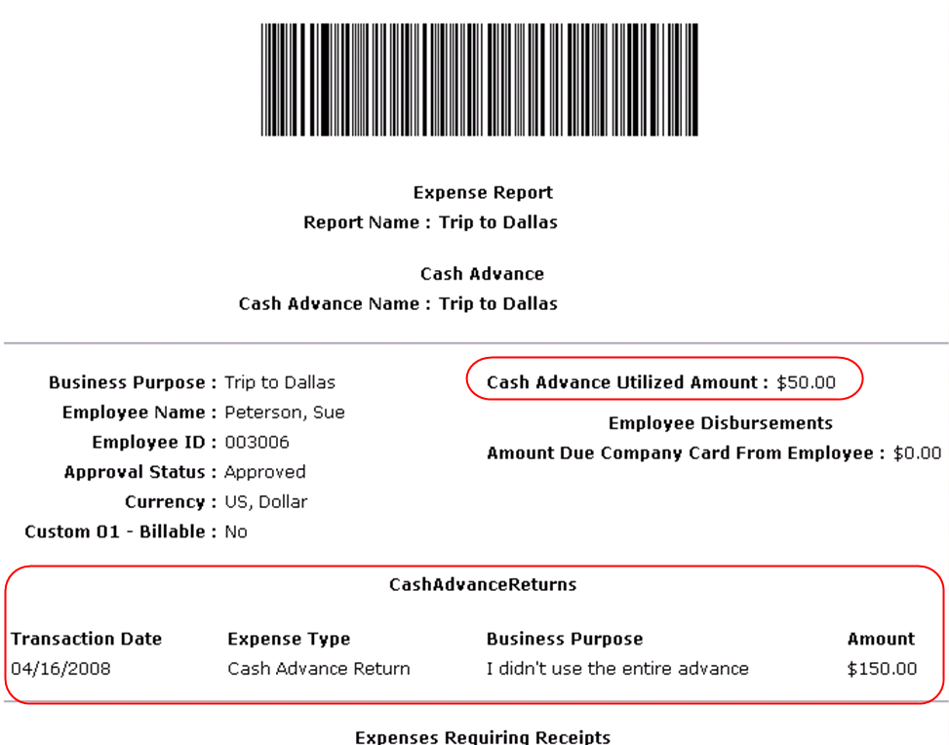

Approver Experience
The Cash Advances item in the Required Approvals section of My Tasks appears on the Home page for cash advance approvers.
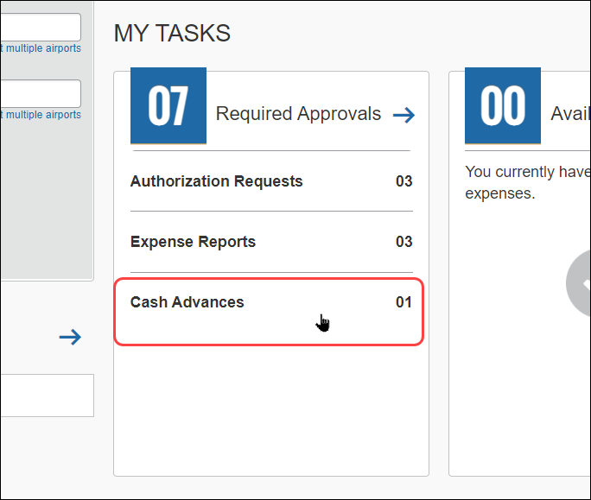
The approver can click the Cash Advances line to go to the Cash Advance Approval List.
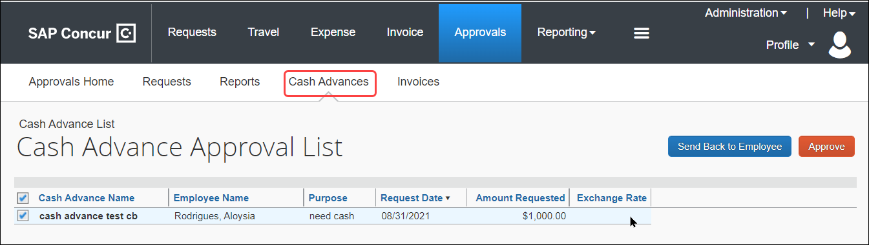
The approver can open the request, review the information, and then approve or reject the request.
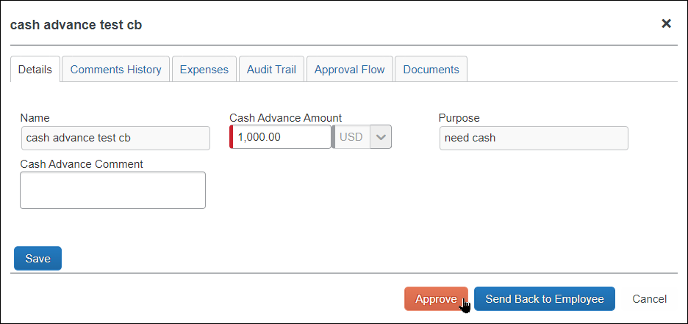
The approver can also click the Approvals menu, then the Cash Advances tab to view the list of cash advances for approval.
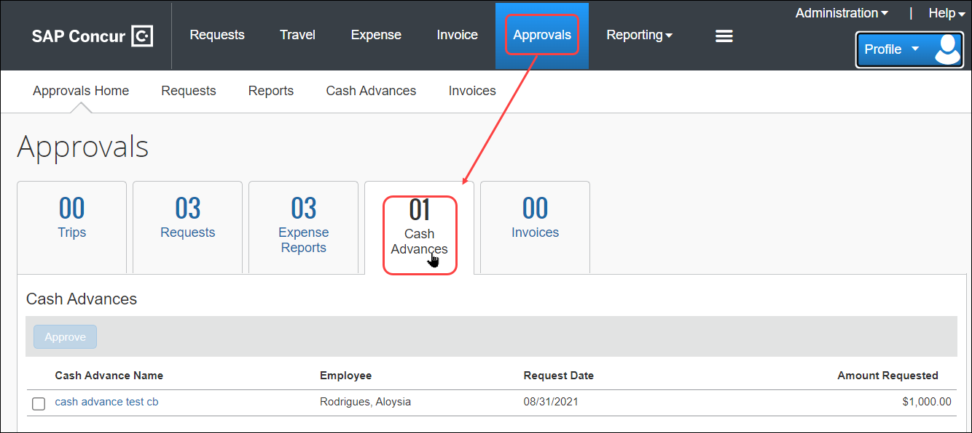
Users with the approval role see the Cash Advance approvals regardless of whether their own group is configured to use the Cash Advance feature. The approver role is not group aware, so an approver may have to approve items for an employee in another group that has cash advance privileges.
This page displays all cash advance requests pending approval. There are two options for the approver:
- To approve the cash advance
– or –
- To send the cash advance back to the user (perhaps for more information)

Viewing the Attached Images
The approver can view the images attached to a cash advance on the Documents tab, if configured.
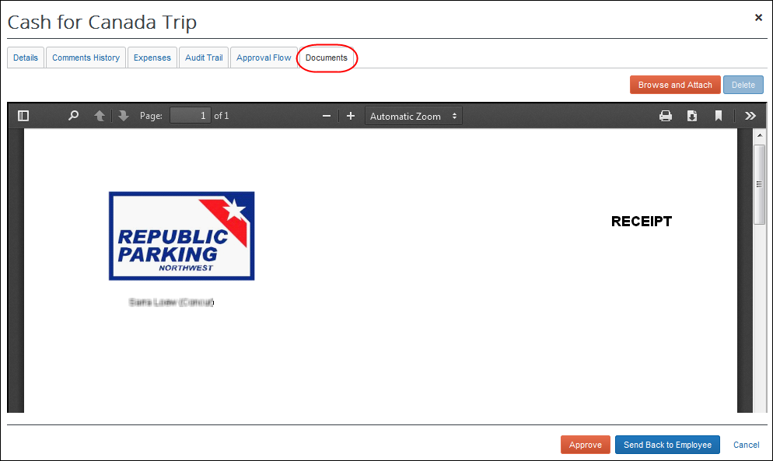
The approver can attach images to a cash advance but cannot delete existing images. If the approver attaches an image to a cash advance that already has an image, the new image will be appended to the existing image.
- For more information on enabling the Documents tab, refer to the Configuration section of this guide.

Viewing the Approval Flow
The approver can view the cash advance workflow on the Approval Flow tab.
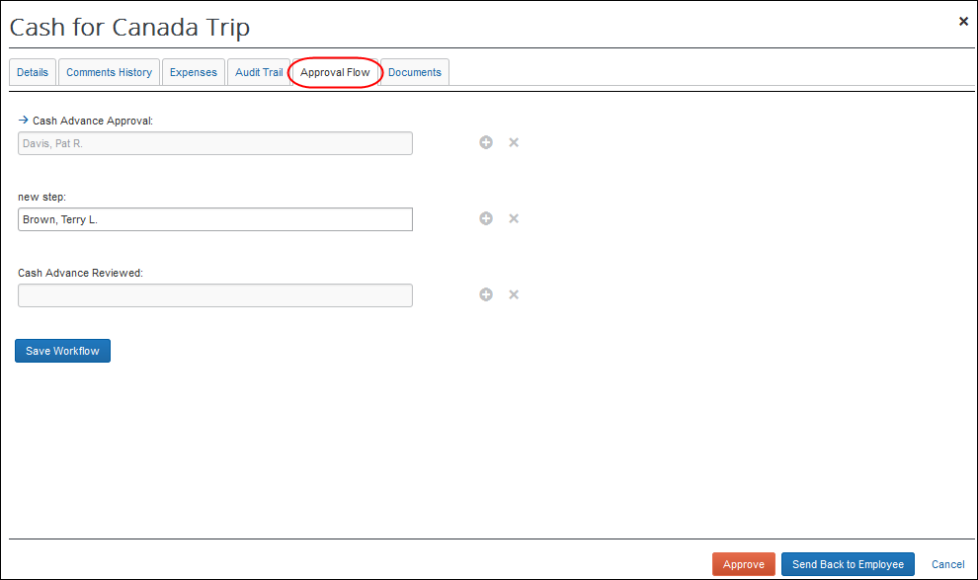

After Final Approval
Once approved by all approvers, the system sends the request to the Cash Advance admin for issuance.
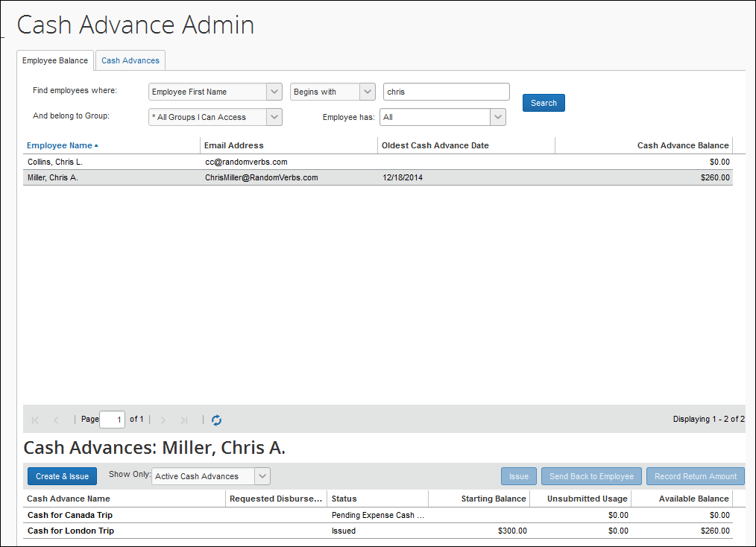

Approver Email Notifications
The approver can choose to have email sent when a cash advance is awaiting approval. This option appears in Profile > Profile Settings > Expense Preferences (left menu).
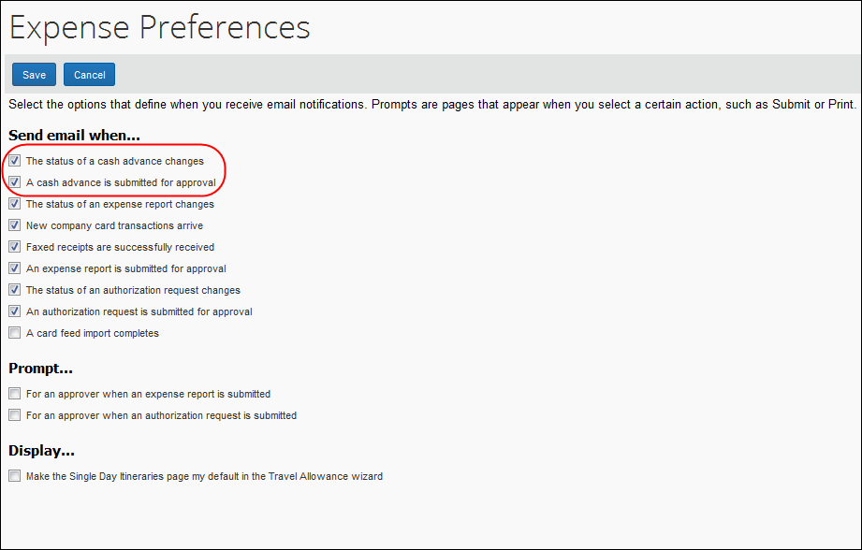

Calculating Cash Advance Utilization
When an employee submits an expense report with an associated cash advance, any expense on that report that is non-personal and has a payment type of Cash or IBIP is used to offset the cash advance. If there are multiple cash advances attached to the report, the expense amount is subtracted from the oldest cash advance first (based on issue date) regardless of currency.
Behavior With Partial Approval
If an expense used to offset a cash advance is partially approved by an approver, the remaining balance is either applied to other eligible expense in the same report or added back into the cash advance balance under the "carry over" employee privilege. However, if the advance cannot be applied to another expense or the carry over is not allowed, the system creates a new Cash Advance Return to document additional funds due from the employee and a system exception is applied to this new advance.
This specifically applies when the amount of the requested expense is reduced during the approval process, thus freeing up part of that advance.
- If the cash advance was completed through a company card (Individually Billed/Company Paid – IBCP), the unused amount is added to the Employee Amount Due Company Card total.
- If the employee is using a CBCP (Company Billed/Company Paid) card, is not permitted to "carry over" balances, and the balance cannot be applied to another eligible expense on the report, Expense will then create a Cash Advance Return to visually indicate to the user, approver, and processor that the report originator owes this balance to the company, and:
- The Cash Advance Return's Amount field is locked to prevent editing
- The advance is flagged and the system exception message "This cash advance return was created as a result of a partial approval" is applied to the advance
- If the employee is allowed to carry a cash advance balance over to another report, the unapproved amount is deducted from cash or CBCP cash advances and added back into the available balance for those cash advances.
All these report amounts appear on the Report Totals page for an expense report.
There is no change to the application of the advance prior to or upon submission of the report. This specifically applies when the amount of the requested expense is reduced during the approval process, thus freeing up part of that advance.

Configuring the Cash Advance Feature
The administrator completes the steps outlined below using Administration > Expense.

Step 1: Workflow - Configure the Cash Advance Workflow
To create or modify the cash advance workflow:
- (Optional) Create new cash advance workflow email notifications using Workflows, on the Email Notifications tab.
- Verify, copy, or edit the cash advance workflow using, on the Workflows tab.
Expense has a default cash advance workflow that consists of three steps. You can add more approval steps and conditions. The fields on the Cash Advance form are available to create workflow step rules.
- Select the appropriate cash advance settings using Workflows, on the Settings tab.
- For more information about the cash advance workflow and settings, refer to the Expense: Workflow - General Information Setup Guide.

Step 2: Forms and Fields – Configure the Cash Advance Forms
The administrator can configure one or more cash advance forms.
To create or modify the cash advance form(s):
- Click Administration > Expense > Forms and Fields.
- Select the Cash Advance form type.
- The system includes a default form for Expense. Either copy it to create a new form or edit the default.
- For more information about forms and fields configuration, refer to the Expense: Forms and Fields Setup Guide.

Step 3: Group Configurations - Configure the Group
Cash advances are group based, not policy based. The Cash Advance feature is activated for a group when a Cash Advance workflow is assigned to the group. The users within that group can request cash advances if they have a cash advance account code configured.
The Cash Advance administrator can also issue cash advances to users whose groups do not have a Cash Advance workflow configured. Those users still need to have a cash advance account code configured. However, they will not be able to request any additional advances as their group does not have the cash advance feature enabled.

Using Imported Local Rates with the Cash Advance Feature
The system will not apply a local rate to a cash advance unless the specific rate was imported (and applicable to) the same date on which the cash advance was created.
To configure the group:
- Select the desired cash advance workflow for the group using Administration > Expense > Group Configurations.
- Select the desired group, then click Modify to access options in Cash Advance Configurations.
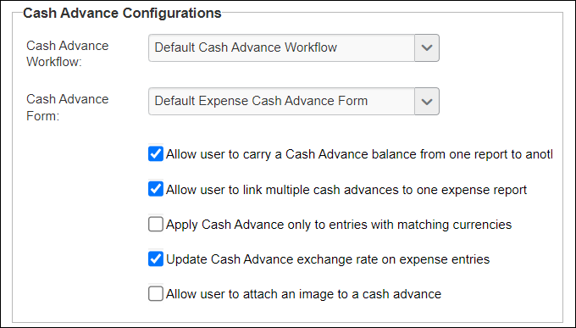
- Select the desired options:
- Cash Advance Carry Forward
Select (enable) the Allow user to carry a Cash Advance balance from one report to another setting to allow users to carry cash advance balances forward to future expense reports.
NOTE: Option is applied to cash advances created after saving this option.
- Multiple Cash Advances per Report
Select (enable) the Allow user to link multiple cash advances to one expense report setting to allow additional cash advances to be linked to reports after one has already been linked.
- Display both issued and base currencies for the user when working with differing currencies
Select (enable) both the Update Cash Advance exchange rate on expense entries and the Apply Cash Advance only to entries with matching currencies settings to have the system display both currencies assigned to a report.
- Match Exchange Rates to Reduce Gain/Loss
Select (enable) the Update Cash Advance exchange rate on expense entries setting to overwrite the entry exchange rate in favor of that of the original issued exchange rate.
NOTE: Option is applied to cash advances created after saving this option.
- Attach images to cash advances
Select (enable) the Allow user to attach an image to a cash advance setting to expose the Documents tab on the cash advance. The user can use the Documents tab to attach and delete images. The approver and Cash Advance administrator can also attach images to the cash advance using the Documents tab.

Using the Update Cash Advance Exchange Rate On Expense Entries Setting
In order for the entry to match the rate used in the report the Transaction Date must match the Current Date. This is because the report uses the cash advance issue date to apply the local imported rate, and the entry will always refer to the transaction date.
The exchange rate cannot be overwritten by the Cash Advance exchange rate for any expense that is partially approved or is a subordinate (child) expense even if Update Cash Advance exchange rate on expense entries is enabled in Group Settings.
- For more information about group configurations, refer to the Expense: Expense Group Configurations Setup Guide.

Step 4: (Optional) Expense Types - Hide the Expense Types
If an administrator does not want one or both of the expense types added for Cash Advance (Cash Advance Return and Currency Gain/Loss), then the administrator must inactivate the expense types from the policy associated with the group that has a Cash Advance Workflow.
- WARNING: Be sure you carefully read the sections in this guide that explain the importance of these expense types before inactivating them.
- For more information on expense types, refer to the Expense: Expense Types Setup Guide.

Step 5: User Administration - Cash Advance Account Code
The cash advance account code is the accounting code (for journal entries) to which the system posts all requested and processed cash advances. You must provide a cash advance account code for an employee before the employee can use the Cash Advance feature.
The Cash Advance Account Code field appears in Administration > Company > Company Admin > User Administration in the Expense and Invoice Settings section of the User Details page.
The field appears in the employee form by default. If the company is not using cash advance, the administrator can remove this field from the employee form using Administration > Expense > Forms and Fields.
- For more information on account codes and employee forms, refer to the Expense: Account Codes Setup Guide and Shared: Forms Setup Guide.

Step 6: Email Reminders – Add Cash Advance Email Reminders
The Email Reminders feature supports all the fields available for the Cash Advance form.
The administrator can go to Administration > Expense > Email Reminders and create rules and reminders based on the cash advance fields.
- For more information, refer to the Expense: Email Reminders Setup Guide and the Expense: Forms and Fields Setup Guide.

Step 7: Site Settings – Select Cash Advance Settings
There are additional settings for Cash Advance on the Site Settings page. The administrator can select:
- Whether the Cash Advance Administrator can create and issue cash advances (on by default)
- Whether the Cash Advance Administrator can record return amounts (on by default)
- Whether Expense should provide a default exchange rate when the Cash Advance Admin creates cash advances in a foreign currency.
- For more information, refer to the Expense: Site Settings Setup Guide.

Cash Advance Admin Tool
The Cash Advance Admin tool is used to issue and monitor cash advances in a company. With the Cash Advance Admin tool, the administrator can:
- Review cash advance history of employees
- Issue cash advances
- Send the request back to the employee
- Record manually-returned cash amounts from an employee (requires Site Setting, but is on by default)
- View employee balances
- For in-depth information on what this tool is and how to use it, refer to the Expense: Cash Advance Admin User Guide.

Cash Advance Issuance and Financial Extracts
The Cash Advance issuance record may be optionally included in the Standard Accounting Extract and any other financial extracts. This allows for company processes where the issuance is executed outside of Concur or via the data coming from Concur to the financial systems.
There are some special circumstances that have unique handling:
- Cash Advance Issuance paid via Expense Pay. If the employee is reimbursed for expense reports via Concur’s payment services such as Expense Pay, then the cash advance issuance may also optionally be paid via the same service.
- Cash Advance Issuance via CBCP ATM Withdrawal. When a cardholder obtains an ATM cash advance via their company card and the payment type of that card is CBCP, the event creates an issuance record for the financial extract. These cash advance issuance records may be included in the financial extracts so that they are tracked within the financial systems.
- Cash Advance Issuance via IBCP ATM Withdrawal. When a cardholder obtains an ATM cash advance via their company card and the payment type of that card is IBCP, the event creates NO liability for the company within Concur as the employee is responsible for repayment of the advance. Because of that, there is no cash advance issuance record included in the financial extracts.
- For more information about the Cash Advance issuance records in the SAE, refer to the Standard Accounting Extract, Version 3 chapter of the Expense: Standard Accounting Extract, Version 3 Specification guide.
☼

