
Concur Expense: Audit Rules
Setup Guide

Last Revised: March 23, 2024
Applies to these SAP Concur solutions:
 Expense
 Professional/Premium edition
 Standard edition
 Travel
 Professional/Premium edition
 Standard edition
 Invoice
 Professional/Premium edition
 Standard edition
 Request
 Professional/Premium edition
 Standard edition
Table of Contents
Section 1: Permissions 1
Section 2: Overview 1
Section 3: Custom Audit Rules 2
Provided Audit Rules 2
General Rules 2
Rules for Value Added Tax (VAT) 3
General Concepts about Audit Rules 3
Conditions ("if" portion of the "if / then" statement) 3
Events (Triggers) 4
Exceptions ("then" portion of the "if / then" statement) 5
Visibility 6
Summary – The Basic Process of Creating Custom Audit Rules 7
Understanding Conditional Expressions 7
Custom Audit Rules and Different Currencies 12
Example 12
The Condition Page 13
Procedures: Custom Audit Rules 27
Accessing Custom Audit 27
Adding a Custom Audit Rule 28
Copying a Custom Audit Rule 33
Editing a Custom Audit Rule 34
Deactivating / Activating a Custom Audit Rule 34
Removing a Custom Audit Rule 35
Viewing a Custom Audit Rule 35
Section 4: Additional Samples of Custom Audit Rules 35
Image Certification Date (e-Bunsho) 35
Multiple Expense Types (In/Not In and Equal/Not Equal) 36
Allocations 37
Transaction Type 38
Connected Lists 39
Invalid List Item 40
Duplicate Transaction Variance 41
Expense Exchange Rate Variance 44
Daily/Weekly/Monthly/Yearly Amount Limit – Single Expense Type 44
Daily/Weekly/Monthly/Yearly Amount Limit – Multiple Expense Types 47
Variables in Exception Messages for Daily/Weekly/Monthly/Yearly Amount Limit – Single or Multiple Expense Types 48
Daily/Weekly/Monthly/Yearly Transaction Frequency Count – Multiple Expense Types 52
Prevent Submission When Company Card Transactions are Older Than # Days 53
Managing Unused or Unsubmitted Company Card Transactions 54
Attendee Totals and Attendee Frequency (using the Entry Attendee Submit Event) 58
Travel Allowance 62
Corporate Card ATM Transactions As a Regular Expense 62
Comparing Expenses to Request Pre-Approval Limits and Entries 63
Date Objects – Adding and Subtracting Days and Months 64
Cash Advance – Exclude Balance Included From Balance Due Management 65
Detect Unassigned Card Transactions of a Given Payment Type 66
Detect and Flag Source of Japan Public Transport Route Data 67
Using Report Start Date and Report End Date Fields 68
Mileage Variance (Google Maps) 70
Drive: Drive Not Used 70
Drive: Drive Policy Reminder 71
Drive: Mileage Route Required 72
Foreign Amount: Posted Amount and Currency Identifier 73
Rule #1: Tip Equals Amount 73
Rule #2: Tip greater Than 18% of Amount 75
Credit Card VAT data 77
Merchant Tax ID 78
Initial Setup of the Expense Entry Form 78
Rule Setup 78
Leave of Absence 79
Section 5: Provided Custom Audit Rules 80
Air Comparison Fare 81
Airfare Limit 84
Airfare Payment Method 86
Airfare Preferred Vendor 87
Amount Due Employee 88
Bank Account Currency Check 88
Breakfast Limit 89
Business Meal Limit 90
Car Rental Limit 91
Car Rental Limit 92
Car Rental Payment Method 93
Car Rental Preferred Vendor 94
Dinner Limit 95
Duplicate Ticket Number 96
Duplicate Transaction Check 97
Electronic Receipt with no corporate card transaction check 98
Entertainment-Other Limit 99
Expense Limit Check 100
Expenses on week end days 101
Hotel Itemization Required 102
Lodging Payment Method 103
Lunch Limit 104
Office Supplies Limit 105
Parking Limit 106
Personal Use of Corp Card 107
Report Total 107
Taxi Limit 108
Ticket Number Mismatch 109
Travel Ticket Number Mismatch 110
Travel Forced Match: E-Receipt, Travel, and Card Data 111
Travel Payment Type 112
Travel No Matching Reservation 113
Travel No Matching Reservation (Approver/Processor Only) 114
Travel Actual vs Booked, Airfare 115
Travel Actual vs Booked, Car Rental 116
Travel Actual vs Booked, Car Rental Per Day 117
Travel Actual vs Booked, Room Rate Per Day 118
Vat Currency Consistency Check 119
Vat Receipt Required Check 120
Section 6: Random Audit Rules 120
General Concepts 121
General Concepts 121
Events (Triggers) 121
Visibility 121
Exceptions 122
Summary – The Basic Process of Creating Random Audit Rules 122
Procedures: Random Audit Rule 123
Accessing Random Audit 123
Adding a Random Audit Rule 123
Editing a Random Audit Rule 125
Deactivating / Activating a Random Audit Rule 126
Removing a Random Audit Rule 126
Section 7: Appendix – Default Exception Codes 127

Revision History
Date |  | Notes / Comments / Changes
March 23, 2024 | Added Leave of Absence example to the Additional Samples of Custom Audit Rules section.
December 9, 2023 | Added IsReopened attribute to the Report data object in The Condition Page section.
September 16, 2023 | Added information about the Merchant Tax ID configuration for Japan Qualified Invoice (JQI).
July 17, 2023 | Updated the Duplicate Transaction Variance example that it should always employ the Less Than or Less Than or Equal operators.
May 16, 2023 | Updated the Condition Page and Section 4: Additional Samples of Custom Audit Rules with a new operator “Is not Active”.
August 4, 2022 | Added information about the NextGen UI; made modifications throughout; cover revision date updated
January 20, 2021 |  | Updated the Description of the Entry Save event.  Updated the copyright.
September 18, 2021 |  | Added a new section, Working with Custom Fields for Credit Card VAT data to Section 4: Additional Samples of Custom Audit Rules.
June 19, 2021 |  | Updated the Digital Compliance Validation Date (e-Bunsho) content in Section 4 to reflect the name change of the Digital Compliance Validation Date field to the Image Certification Date field.
May 14, 2021 |  | Added the Digital Compliance Validation Date (e-Bunsho) content in Section 4. Edited "Concur Drive" to "Drive".
April 28, 2021 |  | Removed a clarification Note from the Random Audit Rules General Concepts section stating that Statement Reports are excluded from Random Audit rules. Replaced note with reference to the Concur Expense: Company Statement Reports Setup Guide.
March 20, 2021 |  | Updated the Data Object List to include Comparison fare for air segment.  Added a new Data Object, Travel Reservation Exception, to the Data Object List. This also includes the new field associated with this Data Object, Reason code associated with trip segment.  Added the Air Comparison Fare section to Section 5: Provided Custom Audit Rules. This new section provides common conditions and examples related to air comparison fare.
January 6, 2021 |  | Updated the copyright; no other changes; cover date not updated
July 14, 2020 |  | Added a note to the All Expenses Must be Within Report Start and End Dates section.
July 8, 2020 |  | Updated the Has Commute Deduction description for the Entry (Expense) selection from the Data Object list.
April 9, 2020 |  | Renamed the Authorization Request check box to Request on the guide’s title page; cover date not updated
January 17, 2020 |  | Update random audit rule trigger to note that the event is triggered after the report enters the first step of workflow, not immediately on submit action.
January 2, 2020 |  | Updated the copyright; no other changes; cover date not updated
December 7, 2019 |  | Removed reference(s) to legacy Budget Insight feature. Clients who want to use budget functionality are recommended to implement the new Budget product that SAP Concur released last year.
May 2, 2019 |  | Updated the Variables in Exception Messages for Daily/Weekly/Monthly/Yearly Amount Limit – Single or Multiple Expense Types section's note about multiple conditions to clarify that if there is more than one amount condition in an audit rule that meets the criteria, it is not possible to predict which condition will define the amounts that are reported.
April 13, 2019 |  | Updated the description of the Entry Submit event in the Event (Triggers) section by appending the following sentence to the Note: "When a processor changes expense types, the entry submit rule will be triggered in order to validate the changes made by the processor."
March 16, 2019 |  | Added information about the Report Budget Submit event.
February 14, 2019 |  | Added a note to the No Reports May Overlap Another Report section, "NOTE: A single shared date is not considered overlapping. For example, the same date may be shared by two reports when the Report End Date of the first report is the same as the Report Start Date of a second report."
February 1, 2019 |  | Updated the Data Object List to include the Is Digitally Compliant timestamp.
January 4, 2019 |  | Updated the copyright; no other changes; cover date not updated
December 20, 2018 |  | Added the appendix for the default exception codes, and associated notes
December 8, 2018 |  | Added Budget audit rules fields.
December 3, 2018 |  | Clarified the Report Submit bullet of Events (Triggers) in the General Concepts section to read that the rule is triggered even if that step is auto-approved.
August 9, 2018 |  | Updated this statement: These variables cannot be used in conjunction with the Duplicate Transaction Variance rule for finding potential duplication of expenses. These variables are not supported for use in validation rules.  Added the following note regarding Entry (Expense) Has Comments: "This field will be Yes if any comment exists from any user in the workflow process. It is not specific to the latest step."
August 2, 2018 |  | Making a Minor Edit to the Audit Rules Setup Guide <eom>
June 13, 2018 |  | Changed copy-down to copydown; no other changes; cover date not updated
June 6, 2018 |  | Added Allow Maps and Route Sources to Data objects and associated choices table.
April 19, 2018 |  | Added a bullet to the Attendee Totals and Attendee Frequency (using the Entry Attendee Submit Event) section that for audit rules that evaluate attendee totals for both amount and frequency, objects should not be used if attendees are in the parent expense entries, and instead, attendees should be in the itemization entries. When using these objects, attendees should not be in the parent entries.  Clarify the Duplicate Transaction Variance section to indicate that it is the reimbursement amount that the system uses to check for duplicates.
April 14, 2018 |  | Added additional examples of custom audit rules for clients who use the Concur Drive (Concur's mobile app > Mileage > Auto Tracking) feature. Two new fields are available: Allow Maps and Route Source.
April 4, 2018 |  | Changed the check boxes on the front cover; no other changes; cover date not updated
January 3, 2018 |  | Updated the copyright; no other changes; cover date not updated
September 16, 2017 |  | Added the condition Dates Overlap another Report to the Using Report Start Date and Report End Date Fields section.

Audit Rules
NOTE: Multiple SAP Concur product versions and UI themes are available, so this content might contain images or procedures that do not precisely match your implementation. For example, when SAP Fiori UI themes are implemented, home page navigation is consolidated under the SAP Concur Home menu.

Permissions
A company administrator may or may not have the correct permissions to use this feature. The administrator may have limited permissions, for example, they can affect only certain groups and/or use only certain options (view but not create or edit).
If a company administrator needs to use this feature and does not have the proper permissions, they should contact the company's SAP Concur administrator.
Also, the administrator should be aware that some of the tasks described in this guide can be completed only by SAP Concur. In this case, the client must initiate a service request with SAP Concur support.

Overview
The Audit Rules tool, which is part of Expense Admin, uses three types of audit rules:
- A custom audit rule is used to monitor information entered by Expense users and is triggered by an event. You can tailor custom audit rules to a specific configuration and Travel and Entertainment (T&E) rules of your company. For example, assume that you create a rule that defines the breakfast limit as less than 20.00 USD and that the rule is triggered when the user saves an expense. Then, when the user saves a breakfast expense for 20.00 USD or more, the system generates an exception.
- A random audit rule allows for the auditing of selected expense reports, either as a percentage of reports submitted (for example, 10% would result in each expense report having a 10% chance of being audited) or as a specific number of reports (for example, every 10th expense report submitted).
- A validation rule is used to compare values in expense report fields to a table of predefined values, imported by your company. The comparison can be configured to take place on entry save and submit, allocation save, and report save, submit, or post submission. If the comparison uncovers a mismatch, the validation rule can generate an exception, update the report field (except on allocation save), or both.
The Validation Rules functionality may not be available depending on your company's configuration. To enable the feature, a Service Request should be submitted to SAP Concur.
- For information about validation rules, refer to the Expense: Audit Rules (Validation Rules) Setup Guide.
The document you use depends on the type of rules you need to manage.
Guide | For information about:
This guide | Custom audit rules and random audit rules
Expense: Audit Rules (Validation Rules) Setup Guide | All Validation rules

Custom Audit Rules
Use custom audit rules to monitor the activity of Expense users, for example:
- To monitor the use of preferred vendors
- To define the maximum amount allowed for certain types of expenses, such as breakfast
- To monitor all expense reports submitted by a particular employee
- To track amounts spent on attendees
Custom audit rules can apply to:
- Expenses, for example, related to vendors, expense amounts, dates, project codes, and so on
- Expense reports, for example, related to report totals, approval status, report date, and so on
- Requests (formerly travel requests), for example, comparing the amount of the request to the amount of the associated expense report
- Employees, for example, related to individual employees, groups, and so on
- Attendees

Provided Audit Rules

General Rules
Your system may have additional provided custom audit rules. Instead of having to create all new rules, you may be able to simply activate (and perhaps edit) these provided rules. This guide provides the information you need to understand the entire custom audit rule process. Use this information to create new rules or to edit and activate the provided rules.
- Refer to Provided Custom Audit Rules in this guide for a brief description of the provided audit rules.

Rules for Value Added Tax (VAT)
There are two custom audit rules – VAT Currency Consistency Check and VAT Receipt Required Check – that are provided by SAP Concur and are used by companies that track value added tax (VAT).
- For more information, refer to the Expense: Value Added Tax (VAT) / Tax Administration Setup Guide.

General Concepts about Audit Rules
Custom audit rules are if / then statements – if the defined conditions are met, then an exception is created.

Conditions ("if" portion of the "if / then" statement)
When creating or editing a custom audit rule, you must define the conditional expression(s) – the if portion of the rule. The expression can contain one or more conditions separated by and or or. For example:
- Assume that you want to monitor all car rentals involving a vendor other than the company's preferred vendor, which is Avis. The condition for the expense-related rule for "car rentals from a vendor other than Avis" is:
(Expense Type equals Car Rental) and (Vendor is not equal to Avis)
In the Audit Rules tool, it appears as:
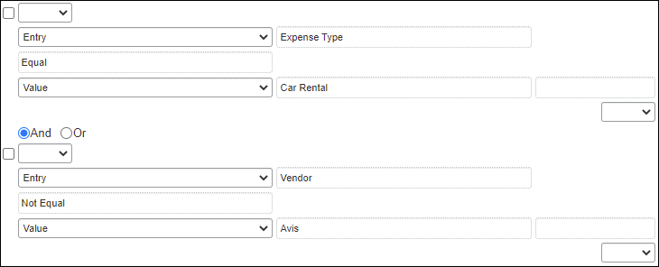
- Assume that you want to limit breakfast expenses to less than 20.00 USD. The condition for the expense-related rule for "breakfast of 20.00 USD or more" is:
(Expense Type equals Breakfast) and (Amount is greater than or equal to 20.00 USD)
In the Audit Rules tool, it appears as:
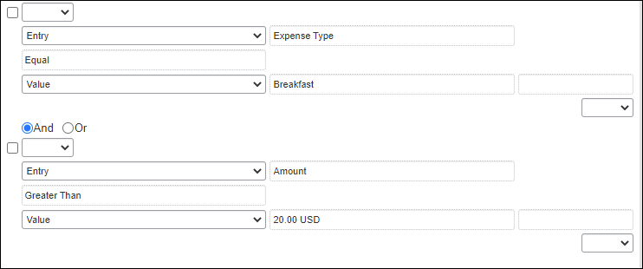
- Assume that you want to monitor all expense reports submitted by one employee. The condition for the employee-related rule for "review all expense reports submitted by Chris Smith" (whose employee ID is 5790556) is:
(Employee ID equals 5790556)
In the Audit Rules tool, it appears as:
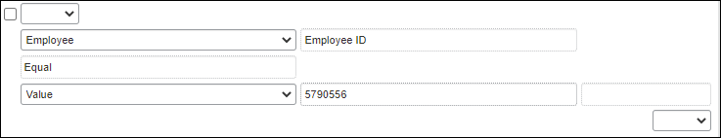
- For more information about the condition editor, refer to the Understanding Conditional Expressions section of this guide.

Events (Triggers)
When creating or editing a custom audit rule, you must specify the event that triggers the rule, for example:
Event | Description
Allocation Save | The rule is triggered as each individual allocation "line item" is saved.
Entry Attendee Submit | The rule is triggered when the expense is submitted.
Report Budget Submit | The rule applies if the Budget service is activated and is triggered when the report is submitted.
Entry Save | The rule is triggered when an expense or report is saved, whether by the user, approver, or processor.
Entry Submit | The rule is triggered when the expense is submitted.  NOTE: Entry Submit rules are processed before Report Submit rules. When a processor changes expense types, the entry submit rule will be triggered in order to validate the changes made by the processor.
Report Budget Submit | The rule is triggered when a report associated with a budget is submitted.
Post Report Submit | The rule is triggered immediately after a report enters the first step of workflow. Any exceptions generated will not prevent the report from being submitted.
Report Save | The rule is triggered immediately after the report header information is saved whether by the user, approver, or processor.
Report Submit | The rule is triggered when the report is submitted.  NOTE: If there are exceptions generated that are above the exception level limit (that is, prevents report submission; described in Exceptions in this guide), then the report will not be submitted and will not enter the first step of a workflow.
The following Event data objects are for Web Services (WS) only:
WS Allocation Exception | The rule is triggered when the Expense Report web service adds an exception at the allocation level.
WS Attendee Exception | The rule is triggered when the Expense Report web service adds an exception at the attendee level.
WS Entry Exception | The rule is triggered when the Expense Report web service adds an exception at the entry level.
WS Report Exception | The rule is triggered when the Expense Report web service adds an exception at the report level.

Exceptions ("then" portion of the "if / then" statement)
When creating or editing a custom audit rule, you must assign an exception – the then portion of the if / then statement. All exceptions contain the following:
- Exception code: This is the company-defined code for the exception, up to eight alphanumeric characters, all uppercase.
- Exception level: The company decides how many exception levels (up to 99) to use. For example, assume that the company decides to have six exception levels, with level 1 being a minor exception and level 6 being a severe exception.
The company also decides the point at which the severity of the exception prevents the user from submitting the expense report. For example, assume that the system does not allow the user to submit an expense report if it contains a level 6 exception.
The limit is set in Expense Admin > Workflows, on the Settings tab.
Exception example:
Assume that you created a rule defining the maximum amount allowed for breakfast to be less than 20.00 USD, with the exception level of 1. Assume that a user submits a report containing a breakfast expense of 22.00 USD. The exception level does not prevent the user from submitting the expense report (only level 6 exceptions prevent submission). So, upon submission, the report is routed to the user's approver. The approver must decide how to handle the issue.
The approver can:
- Pay the expense "as is"
- Send back the entire expense report to the user to correct or, depending on the company's configuration, send back one or more expenses but not the entire report
- Adjust (lower) the amount of the expense to comply with company policy and then pay the lower amount (if the company's configuration allows the approver to adjust amounts)
- Exception message: This is the actual message that appears, such as "The amount of this expense exceeds the company-defined limit of 20.00 USD." or "This is not the preferred vendor for this expense type. Enter a comment before submitting the report."
- Refer to the appendix in this guide for a list of the default exception codes and how they affect reporting by exception code.

Visibility
When creating or editing a rule, you must define who sees the exception message:
- Traveler (user), Approver, and Expense Processor: Assume that you created a rule that is triggered when a user saves an expense and the exception message is visible to the user, approver, and Expense processor. When a user saves an expense that meets the conditions of the rule, the exception text (message) appears to the user, approver, and processor.
- Approver and Expense Processor: The user does not see the exception message and, hence, does not know an exception was generated.
- Expense Processor: The user and approver do not see the exception message and, hence, do not know an exception was generated.
For rules using the Entry Attendee Submit event, the exception message that appears with the attendee name is visible to everyone.
The exception message appears along with:
- A red icon for exceptions that prevent submission of the expense report
- A yellow icon for exceptions that do not prevent submission of the expense report
- A blue icon if the Expense processor has cleared the exception

Summary – The Basic Process of Creating Custom Audit Rules
To summarize, when completing the if portion of the custom audit rule, you will:
- Name the rule
- Identify the event that triggers the rule
- Identify the administrator (of the group configuration) who can edit the rule
- Identify the group configuration to which the rule applies
- Define the conditions using the Audit Rules condition editor
When completing the then portion of the custom audit rule, you will:
- Define who sees the exception text:
- Traveler (user), approver, and Expense processor
- Approver and Expense processor
- Expense processor
- Select (or create) the appropriate exception, which includes:
- Exception code
- Exception level
- Exception message

Understanding Conditional Expressions
- IMPORTANT: Evaluating unnecessarily complex conditions is inefficient for the system and increase the likelihood of unwanted results.
SAP Concur strongly recommends that before you set up your configuration, you write down your logic on paper. This will allow you to group sub-conditions and arrange them in the simplest way, helping to ensure overall correctness before you create rules on the Audit Rules admin page.
Example (Part 1 of 3, initial thoughts on paper)
(
Field contains GROUP1
and (
(Card Program is Individual Card or Department Card)
and
(Business Unit is Sales and Business Type equals R&D)
)
)
or
(
(Card Program is Purchasing Card, and Business Unit is Sales, and Business Type equals R&D)
and
Personal Expense is N
)
Example (Part 2 of 3, simplified re-write on paper)
Field contains "GROUP1"
and Business Unit equals Sales
and Business Type equals R&D
(
Card Program equals Individual Card,
or Department Card
or (Purchasing Card and Personal Expense equals "N")
)

Example (Part 3, in SAP Concur)
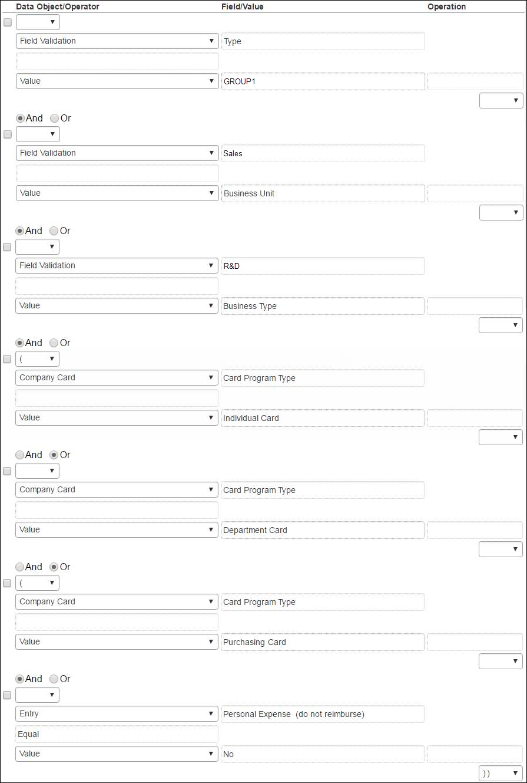

When creating or editing conditional expressions, consider the following.
- There is no limit to the number of conditions that comprise a total expression. The conditional expression for "breakfast of 20.00 USD or more" is:
(Expense Type equals Breakfast) and (Amount is equal to or greater than 20.00 USD)
It is comprised of two conditions, separated by the Boolean separator of and.
- Most conditions are comprised of a field then an operator then a value. For example:
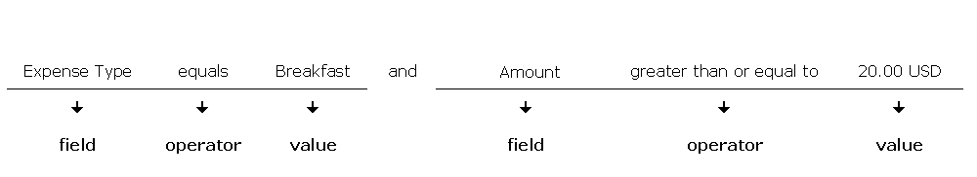
- A field consists of a data object (essentially a database table) and a field in that data object (essentially a database column). The field selected defines the data type of the condition (number, text, date, and so on).
- An operator is one of several pre-defined comparison operators (equals, not equals, is greater than, and so on). The list of operators changes depending on the type of data being compared.
- An operator is further defined by Any, Every, and Within, depending on the type of data being compared. For example, a Report Submit event combined with an Entry data object and Amount field/value results in an Operator value that can have multiple values and thus multiple interpretations. In this circumstance, the report level condition will trigger the rule as follows:
- ANY: Where a single expense of many associated with the report is true for the operator. As "the amount is greater than" for any expense causes the rule to be triggered.
- EVERY: Where all expenses associated with the report are true for the operator. As "the amount is greater than" for every expense causes the rule to be triggered.
- WITHIN: Where a range of dates are evaluated.
Example 1 Within Today +2
Jul 31 | Aug 1 | Aug 2 | Aug 3 | Aug 4 | Aug 5 | Aug 6
-3 | -2 | -1 | 0 | 1 | 2 | 3
- Example 2 Not Within Today +2
Jul 31 | Aug 1 | Aug 2 | Aug 3 | Aug 4 | Aug 5 | Aug 6
-3 | -2 | -1 | 0 | 1 | 2 | 3
- Example 3 Within Today -2
Jul 31 | Aug 1 | Aug 2 | Aug 3 | Aug 4 | Aug 5 | Aug 6
-3 | -2 | -1 | 0 | 1 | 2 | 3
- Example 4 Not Within Today -2
Jul 31 | Aug 1 | Aug 2 | Aug 3 | Aug 4 | Aug 5 | Aug 6
-3 | -2 | -1 | 0 | 1 | 2 | 3

- A value is a constant and – like the field – can be of any data type. The data type of the value must match the data type of the field.
- If a second field is used in the condition, its data type must match that of the first field.
- When a conditional expression is composed of multiple conditions, each condition is separated by either and or or.
- Parentheses are optional and are used to define the order of operation for the and/or operators. If the parentheses are omitted, and/or operations are carried out left to right. There is no precedence of and over or – the evaluation of the expression is simply left to right.
- If a conditional expression contains parentheses, the count of left parentheses must match the count of right parentheses. There can be up to three parentheses for both left and right sides.
Example of correct placement of parentheses and total left/right count:
(Condition 1) and (Condition 2)
Examples of incorrect parentheses even though the total left/right count matches:
Condition1 ) And ( Condition2
Condition1 ) And ( Condition2 ) Or ( Condition3
( Condition1 )) And ( Condition2
- Conditional expressions must be precise to include or exclude all necessary criteria. If a rule does not apply to personal expenses, then the condition must exclude personal expenses.

Custom Audit Rules and Different Currencies
By default, the system uses the Exchange Rate feature to "convert" (for the purpose of evaluation) the amount in other reimbursement currencies to the currency identified in the rule. The Exchange Rates feature is configured by default to use rates provided by SAP Concur.
If the exchange rates feature is turned off, the audit rules will evaluate amounts only in the currency (or currencies) identified in the rule. If your company uses multiple reimbursement currencies, then you must use the Exchange Rates feature in order for the system to evaluate against the additional reimbursement currencies or create separate rules for each currency (see the example below).

Example
Assume that you want to monitor all expense reports that exceed 10,000 USD but your company reimburses its employees in US dollars, Euros, and Canadian dollars. You can either:
- Create three separate rules (one for US dollars, one for Euros, and one for Canadian dollars) or one three-part rule (one part for US dollars, one part for Euros, and one part for Canadian dollars), with the Exchange Rates feature OFF.
– or –
- Use the Exchange Rates feature so the system monitors expense reports that exceed the equivalent of 10,000 USD.
- For more information, refer to the Expense: Currency Admin Setup Guide.
Date Handling
Entry rules will use the transaction date of the expense or, if no transaction date is present, the submit date instead. If the expense is unsubmitted and has no transaction date for a Save rule, then the current date is used (‘today’).
Report and any other rules will use the submit date of the report unless the report is unsubmitted, at which time the current date is used instead.

The Condition Page
The Condition page in Audit Rules is similar to the Condition page used for Workflow and Expense Processor.
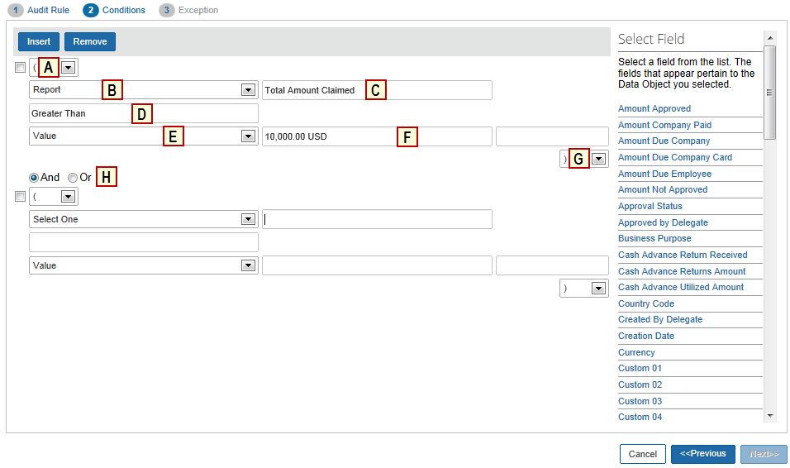
Table 1: Description of the Condition page
Field | Description
A: Left Parenthesis | Up to three parentheses, depending on the complexity
B: Data Object | The choices that appear depend on the event that triggers the rule:  - Allow Maps: To create mileage rules for Drive  - Attendee Entry Amount: Appears only for the Entry Attendee Submit (Authorized) event  - Attendee Total: To create attendee audit rules based on the total amount spent on an attendee (by quarter, by year, for the current employee, or the entire company) or the frequency of attendance (by month, by quarter, by year, for the current employee, or the entire company)  - Budget Amounts: used with the Budget feature; Appears only for the Report Budget Submit (Authorized) event  - Company Card: To create a condition based on company card transaction fields for the company card transaction associated with the entry  - Employee: To create a condition based on employee-level fields  - Entry: To create a condition based on expense-level fields  - Entry Allocation: To create a condition based on an allocation  - Entry Attendee: To create a condition based on attendee information  - Entry Car: To create a condition based on the car information  - Expense Entry Spend Category: Appears for the Entry Save event  - Group of Central Reconciliation Expense Types  Group of Request Segment Types: Appears only for the Centrally Reconciled Invoice – request Assigned event  - Report: To create a condition based on report-level fields  - Report Exception: To create a condition based on report exceptions  - Request related Reports: To create a condition based on requests (like travel requests) associated with the report  - Route Source: To create mileage rules for Drive  - Tax: To create a condition based on value added tax associated with an entry  - Travel Allowance  Travel Allowance Adjustments  Travel Allowance Itinerary: This data object references the specific itinerary associated with the expense.  Travel Allowance Itinerary (on report): This data object references any itinerary attached to the report, and is not specific to what is linked to an expense.  Travel Allowance Itinerary Day  - For complete information about travel allowance audit rules, refer to the Expense: Travel Allowance Setup Guide.  - Travel Reservation: To create a condition based on the travel reservation fields for the travel reservation associated with the entry
C: Field / Value | Select an item from the helper pane that appears. The information that appears in this pane is based upon the selection made in the Data Object list.  See Table 2 below.
D: Operator | Select an item from the helper pane that appears. The information that appears in this pane is based upon your previous choices.  NOTES:  - If you use the In or Not In operators for expense types, you can select multiple check boxes to include as many expense types as are required. Refer to Additional Samples of Custom Audits in this guide.  - The Within operator defines a set of dates for the system to check against when evaluating the rule. For example, if you use Within Today -2 to evaluate the Report Submit Date, the system will look for the submit dates within the two ends of the range: Today, and two days earlier.  - For custom fields that have lists, the Is Not Active operator is available to determine whether the list item in the expense is valid. For example, a user may have created an expense using a particular list item, but the admin may have removed the list item prior to submission.
E: Data Object | The system provides the option that best suits the previous choices. Change it if necessary.
F: Field / Value | Select an item from the helper pane that appears. The information that appears in this pane is based upon the selection made in the Data Object list.  See Table 2 below.
G: Right Parenthesis | Select zero to three parentheses, depending on the complexity of the condition.
H: And / Or | Select either option to join the current condition to the next condition.
Table 2: Data objects and associated choices
Selection from the Data Object list | Choices Displayed for Field / Value
Allow Maps | No  Yes  Required
Attendee | Attendee Approved Amount  Attendee Title  Attendee Type  Company  Custom 1-20: Configurable fields that the customer can set to any data type  External ID  First Name  Last Name
Attendee Total(s) | Cost - Total for Quarter - All  Cost - Total for Quarter - Employee  Cost - Total for Year - All  Cost - Total for Year - Employee  Frequency for Month - All  Frequency for Month - Employee  Frequency for Quarter - All  Frequency for Quarter - Employee  Frequency for Year - All  Frequency for Year - Employee  NOTE: Frequency totals are only available for the Entry Attendee Submit event.
Attendee Entry Amount | Authorized Remaining Amount Per Attendee  Expense Amount Per Attendee
Budget | Actual Pending Consumption Percent  Actual Spent Consumption Percent  Alert Limit  Budget Amount  Budget Name  Budget Remaining Amount  Budget Type  Committed Pending Consumption Percent  Committed Spent Consumption Percent  Control Limit  HasBudget  Pending Consumption Percent  Period Type  Spent Consumption Percent  Total Consumption Percent  - For more information about Budget audit rules, refer to the Shared: Budget Setup Guide.
Budget Amounts | Budget Used Amounts (In Percentage) (Refer to the Shared: Budget Setup Guide.)
Company Card | Adjustment Amount  Arrival Date  Arrival Location  Bar Charge  Base Fare  Billing Date  Card Program Type: Normal (blank) or Purchase Card  Card Provider Market Identifier  Class Code  Commodity Code  Credit Card Transaction Type: Such as transaction, fee, finance charge, etc.  Daily Rental Rate  Daily Room Rate  Departure Location  Description  Discount Amount  Folio Number  Food Charge  Fuel Charge  GST or VAT Amount  Gift Charge  Guest Name  Has Future Billing Date: Yes = Card billing date in the future  Has Rich Data  Insurance Charge  Invoice Number  Issue Date  Item Quantity  Late Charge  Laundry Charge  Lodging – Departure Date  Merchant City  Merchant Code  Merchant Country  Merchant Name  Merchant State  Merchant Tax Class  Merchant VAT Number  Merchant Zip  Movie Charge  Number in Party  Number of Room Nights  Order Date  Other Charge  Parking Charge  Passenger Name  Phone Charge  Pickup Date  Pickup Property ID  Prepaid Amount  Rental Agreement Number  Rental Days  Renter Name  Return Date  Service Class  Statement Period - Start Date: Applicable only to Company Bill Statement Reports feature  Statement Period - End Date: Applicable only to Company Bill Statement Reports feature  Tax Amount  Ticket Number  Tip Charge  Total Fee  Total Line Amount  Total Lodging Amount  Total Non Room Charge  Total Room Tax  Transaction Amount: Amount of transaction in spend currency  Transaction Date  Travel – Departure Date  Travel Agency Name  Travel Detail – Departure Date  Unit Amount  Unit of Measure  VAT Data Indicator  Weekly Rate
Employee | Active: Yes = User is an active SAP Concur user  Bank Account Currency: Currency of user's bank account  Bank Account Status: Status code of the bank account – confirmed, unconfirmed, failed  Bank Account is Active: Yes = User's bank account is an active account  Cash Advance Balance: Sum of the unused cash advances (balance not associated with a submitted report, including remaining amounts from partially used cash advances)  Cash Advance Balance (excluding system): Same as above excluding system-generated cash advances  City: User's home city  Country of Residence: User's country of residence  Custom 1-22: Configurable fields that the customer can set to any data type  Email Address: User's email address  Employee First Name: User's first name  Employee ID: User's employee ID  Employee Last Name: User's last name  Has Company Card: Yes = User has an assigned company card  Has Unused Card Transactions: Yes = There is at least one credit card transactions assigned to the user that have not been assigned to an expense report  Is Non Employee: Related to the Sponsored Guest feature  Is a Test User?: Yes = User is a designated test user  Ledger: Ledger currently assigned to user  Locale: Locale of the user to display in SAP Concur  Logon ID: User's logon ID  Oldest Cash Advance Date: Request date of the oldest cash advance with an outstanding balance  Org Units 1-6: Configurable fields that the customer can set to any data type  Payment Types of Unused Card Transactions: Payment type of company cards assigned to this user  Reimbursement Currency: Currency in which the user is to be reimbursed  Reimbursement Method: Concur Pay - method used to pay the user  State/Province: State/province of the user at the time the report was created  NOTE: Employee data changes over time and may change between the time an entry is created and when an entry is edited. Given that, consider not creating conditions against employee fields. Instead, it is strongly recommended that you use the copydown functionality to copy the employee data to the report or entry level and then write the condition against the copieddown field to ensure consistent data.
Entry (Expense) | Airline Fee Type Code: Type of additional fee from airline  Amount: Transaction amount in the report currency  Amount-Daily Total: Sum of approved amounts (in report currency) for this user's transactions that have same individual expense type (defined in rule) on the same calendar day  Refer to Additional Samples of Custom Audits in this guide.  Amount-Daily Total (multiple expense types): Sum of approved amounts (in report currency) for this user's transactions that have same expense types (defined in rule/combined) on the same calendar day  Refer to Additional Samples of Custom Audits in this guide.  Amount-Monthly Total: Sum of approved amounts (in report currency) for this user's transactions that have the same individual expense type (defined in rule) in the same calendar month  Refer to Additional Samples of Custom Audits in this guide.  Amount-Monthly Total (multiple expense types): Sum of approved amounts (in report currency) for this user's transactions that have the same expense types (defined in rule/combined) in the same calendar month  Refer to Additional Samples of Custom Audits in this guide.  Amount-Weekly Total: Sum of approved amounts (in report currency) for this user's transactions that have the same individual expense type (defined in rule) in the same calendar week (Sun-Sat)  Refer to Additional Samples of Custom Audits in this guide.  Amount-Weekly Total (multiple expense types): Sum of approved amounts (in report currency) for this user's transactions that have the same expense types (defined in rule/combined) in the same calendar week (Sun-Sat)  Refer to Additional Samples of Custom Audits in this guide.  Amount-Yearly Total: Sum of approved amounts (in report currency) for this user's transactions that have the same individual expense type (defined in rule) in the same calendar year (Jan 1 – Dec 31)  Refer to Additional Samples of Custom Audits in this guide.  Amount-Yearly Total (multiple expense types): Sum of Approved Amounts (in report currency) for this user's transactions that have the same expense types (defined in rule/combined) in the same calendar year (Jan 1 – Dec 31)  Refer to Additional Samples of Custom Audits in this guide.  Approved Amount: Approved amount of the entry  Arrival Date (Hotel E-Receipt): As per the e-receipt, if any  Average Cost Per Attendee  Average Cost Per Attendee (Attendee count plus 1)  Average Daily Rate (Car Rental E-Receipt): As per the e-receipt, if any  Average Daily Rate (Hotel Rental E-Receipt): As per the e-receipt, if any  Booking Origin: How the booking arrived in Concur- from Amadeus E-Travel, Concur Travel, TripLink, Travel Supplier, or TripIt  Booking Source: Where the booking was created, usually a GDS or travel supplier name  Business Distance (car distance expenses)  Business Mileage Overage  Business Purpose: As entered for the entry by the preparer (user or delegate)  CCT Key: Link to the associated company card transaction  Car Class (Car Rental E-Receipt): As per the e-receipt, if any  City  Claimed Amount  Class of Service (Booked)  Comparison fare or air segment: Air Comparison Fare amount associated to the trip segment for an expense.  NOTE: This value will be considered zero if no Air Comparison Fare information was received from Concur Travel.  Country  Country Default Currency  Currency: Currency in which the expense is posted  Custom 1-40: Configurable fields that the customer can set to any data type  Departure Date (Hotel E-Receipt): As per the e-receipt  Duplicate Ticket Number: Yes = Ticket number exists for more than 1 entry  Duplicate Transaction Variance: Refer to Additional Samples of Custom Audits in this guide.  EReceipt Type  End Date (Booked)  Enter Vendor Name  Exceeds Category Authorization Request Amount  Exceeds Entry Request Amount: Determine if the amount of this expense (plus any other submitted expenses or expenses on this report) exceed the amount pre-approved for the related request expense type (Concur Request)  Exchange Rate  Exchange Rate Variance: The system evaluates the exchange rate of the expense as a "multiply by" rate against the rate in the corporate rate table. When the expense rate is entered as a "divide by" rate, the rule first takes the inverse of the rate and then evaluates the variance.  Expense Type  Foreign Amount: Currency of the transaction if foreign  Foreign or Domestic: Domestic = country of employee equals country of transaction  Fuel Service Charge  Fully Allocated: Yes = Entry is fully allocated  Refer to Additional Samples of Custom Audits in this guide.  Has Allocation: Yes = Entry allocated by the user  Has Attendees: Yes = Entry has attendees  Has CFDi XML File: Yes = Entry has an attached CFDi XML file (Mexico)  Has Comments: Yes = Entry has comments  NOTE: This field will be Yes if any comment exists from any user in the workflow process. It is not specific to the latest step.  Has Commute Deduction: Yes = User has deducted a commute through the mileage calculator.  Has Duplicate CFD  Has E-Receipts: Yes = Entry has at least one associated e-receipt  Has Mileage Calculator (car distance expenses): Yes = Uses Google maps to calculate mileage.  Has Missing Receipt Affidavit: Yes = User has attached an affidavit declaring that the required receipt is missing  Has Mobile Receipt: Yes = Entry has receipt image attached via SAP Concur’s Mobile app  Has Request Entry: Yes = Entry has an associated request (Concur Request)  Has Travel Reservation: Yes = Entry has a linked travel reservation transaction  Has User-Attached Receipt Image: Yes = Entry includes an attached receipt image  Has VAT: Yes = Entry has value added tax  Hotel Location (Hotel E-Receipt): As per the e-receipt, if any  Hotel Name (Hotel E-Receipt): As per the e-receipt, if any  Is Billable: Yes = Entry is billable  Is Digitally compliant  Is a Company Card Entry: Yes = Entry was initiated by a company card transaction  Last Modified Source: How the entry was last modified: Web, Mobile, or Other  Merchant Tax ID  Missing Tax Receipt  Number of Attendees  Number of Days (Car Rental E-Receipt): As per the e-receipt, if any  Number of Units (Booked)  Org Units 1-6: Configurable fields that the customer can set to any data type  Passenger Count (car distance expenses)  Payment Type: Payment type used on entry  Personal Distance (car distance expenses)  Personal Expense (do not reimburse): Yes = Entry is declared as a personal expense and is not reimbursable to the user  Pickup Date (Car Rental E-Receipt): As per the e-receipt, if any  Receipt Image Required: Yes = Electronic receipt image required for this entry  Receipt Required: Yes = Paper receipt image required for this entry  Receipt Status: Tax receipt status: no receipt, receipt, or tax receipt  Return Date (Car Rental E-Receipt): As per the e-receipt, if any  Round Trip Deduction (car distance expenses)  Segment Type Key  Source: How the entry was created: Web, Mobile, or Other  Source/Type Classification: Refer to Additional Samples of Custom Audits in this guide.  Start Date (Booked)  State/Province: Associated with the entry  Tax Source  Ticket Number  Ticker Number Mismatch  Total Days (Booked)  Total Invoice Amount (Hotel E-Receipt): As per the e-receipt, if any  Total Reclaim Adjusted Amount  Total Reclaim Posted Amount  Total Tax Adjusted Amount  Total Tax Posted Amount  Transaction Date: As entered by the user or from the company card import  Transaction Type: Normal entry (expense without an itemization/ REG/regular), Entry with itemization (PAR/parent), or Itemized entry on an expense (CHD/child)  Refer to Additional Samples of Custom Audits in this guide.  Transaction-Daily Total (multiple expense types): Count of number of times expense types (defined in rule) used on a single day  Transaction-Monthly Total (multiple expense types): Count of number of times expense types (defined in rule) in a calendar month  Transaction-Weekly Total (multiple expense types): Count of number of times expense types (defined in rule) used in a calendar week (Sun - Sat)  Transaction-Yearly Total (multiple expense types): Count of number of times expense types (defined in rule) used in a calendar year (Jan 1 – Dec 31)  Travel Allowance: Yes = Entry is a travel allowance entry  For information about travel allowance audit rules, refer to the Expense: Travel Allowance Setup Guide.  Units Driven (Car Rental E-Receipt): As per the e-receipt, if any  Vendor: As selected from the list of vendors  Vendor Name (Booked)  Vendor Name (Car E-Receipt): As per the e-receipt, if any
Entry Allocation | Account Code 1-2  Custom 1-20: Configurable fields that the customer can set to any data type
Entry (Expense) Attendee | Attendee Title  Attendee Type  Company  Custom 01 – 20: Configurable fields that the customer can set to any data type  External ID  First Name  Instance Count  Last Name  Transaction Amount
Entry Car | CO2 Emission Rate  Car Criteria Category: Engine type/size  Criteria Key: Vehicle type  Custom 01 – 05: Configurable fields that the customer can set to any data type  End Date of Circulation: Last day of car usage  Energy  Engine Size  First Date of Circulation For Company: First day of car usage; company car  First Date of Circulation: First day of car usage; personal car  Registration Date: Date the car was created in the system  Vehicle ID: As entered by the user
Report | Amount Approved  Amount Company Paid  Amount Due Company  Amount Due Company Card  Amount Due Employee  Amount Not Approved  Approval Status: Approval status of the report  Approved by Delegate: Yes = Approved by an approver's delegate  Business Purpose: As entered by the report preparer (user or delegate)  Cash Advance Return Received: Yes = Cash advance returns have been received for this report  Cash Advance Returns Amount: Total of the cash advance returns on the report  Cash Advance Utilized Amount: Total of cash advances used on the report  Country Code: User country at the time the report was created  Created By Delegate: Yes = Report was created by a delegate; not the user  Creation Date: Date the report was created; system date – not date entered by user  Currency: User's reimbursement currency at the time the report was created  Custom 1-20: Configurable fields that the customer can set to any data type  Employee has Unused Card Transactions with (Current date - Posted date): Checks to see if the employee has unattached/ unsubmitted card transactions – excluding any transactions attached to the current report – where the posted date is at least x days older than the current date  Refer to Additional Samples of Custom Audits in this guide.  Employee has Unused Card Transactions with (Current date - Transaction date): Checks to see if the employee has unattached/unsubmitted card transactions – excluding any transactions attached to the current report – where the transaction date is at least x days older than the current date  Refer to Additional Samples of Custom Audits in this guide.  Ever Sent Back: Yes = Report was sent back to the user  Exceeds Request Amount: On Reports Submit event, determine if the total of all expenses exceeds the total amount authorized for the request; typically used with the Has Request condition.  NOTE: Expenses are those mapped to a request expense type.  Exception Approved: Either there are no exceptions within range defined in workflow Authorized Approver settings OR the report was approved by an Authorized Approver with exception authority  Exception Level Total: Sum of the exception levels of exceptions associated with the report  Group: User's group at the time the report was created  Has Cleared Exceptions: Yes = Report had exceptions that have been cleared  Has Comments: Yes = Report header or any of the expenses on the report have a comment  Has Company Card Entry: Yes = Report has at least one associated company card entry  Has Request: Yes = Report has an associated request  Has Sponsorship: Yes = Report has an associated sponsored guest  Has Travel Allowance Credit after Over Limit on Prior Report  Has Travel Diary: Yes = Report has an associated travel diary; related to the fringe benefits tax (FBT) in Australia and New Zealand  Has Unsubmitted Card Transactions with (Current date - Posted date): Checks to see if the current report has unsubmitted card transactions where the posted date is at least x days older than the current date  Refer to Additional Samples of Custom Audits in this guide.  Has Unsubmitted Card Transactions with (Current date - Transaction date): Checks to see if the current report has unsubmitted card transactions where the transaction date is at least x days older than the current date  Refer to Additional Samples of Custom Audits in this guide.  Has a Travel Allowance Entry: For information about travel allowance audit rules, refer to the Expense: Travel Allowance Setup Guide.  Has a VAT Entry: Yes = Report has at least one entry with value added tax  Invoice Date (Central Reconciliation)  IsReopened: Yes = Report has been reopened by the delta posting functionality of the SAP Integration with Concur Solutions (ICS). For information about the ICS, refer to the Shared: SAP Integration with Concur Solutions for SAP ECC and SAP S/4HANA and Shared: SAP Integration with Concur Solutions for SAP S/4HANA Cloud setup guides.  Last Segment (Central Reconciliation)  Ledger: User's ledger at the time the report was created  Limit Approved: Yes = Report was approved by an Authorized Approver whose approval limit exceeds the value of the report  Maximum Exception Level: Highest exception level of the exceptions associated with the report  Offline Edited: Yes = Report edited using SAP Concur’s Mobile app  Org Units 1-6: Configurable fields that the customer can set to any data type  Payment Status: Payment status of the report  Personal Expenses: Amount of personal expense on this report  Policy: Policy assigned to the report  Receipt Image Available: Yes = Image attached to the report or at least one entry  Receipt Image Required: Yes = Electronic receipt image required for at least one entry  Receipts Received: Yes = Paper receipts scanned or an image was received and the Imaging configuration turned this flag to Yes  Receipts Required: Yes = Paper receipts are required  Report Date: As entered by the report preparer (user or delegate)  Report End Date: Refer to Additional Samples of Custom Audits in this guide.  Report ID: As generated by the system  Report Name: As entered by the report preparer (user or delegate)  Report Start Date: Refer to Additional Samples of Custom Audits in this guide.  Report Total  Report Type: Normal (blank), Central Reconciliation, or Statement report  State/Province: State/province of the user at the time the report was created  Submit Date: Date of the last time the report was submitted  Submitted by Delegate: Yes = Report submitted by a delegate  Total Amount Claimed
Report Exception | Exception Code  Exception Level
Route Source | None  Manual  GPS
Travel Allowance  Travel Allowance Adjustments  Travel Allowance Itinerary  Travel Allowance Itinerary (on report)  Travel Allowance Itinerary Day | - For more information about travel allowance audit rules, refer to the Expense: Travel Allowance Setup Guide.
Travel Reservation  (only available for Entry Submit) | Amount Per Day:  - Airfare: Total amount of reservation, since per day is not relevant for airfare  - Car rental: Based on daily rate  - Hotel: Based on estimated rate per night  Total Amount:  - Airfare: Based on total amount of air reservation  - Car rental: Based on estimated total amount for the car rental reservation  - Hotel: Based on estimated total amount for the hotel reservation
Travel Reservation Exception | Reason code associated with trip segment

Procedures: Custom Audit Rules

Accessing Custom Audit
To access Custom Audit:
- Click Administration > Expense.
- Click Audit Rules. The Custom tab of the Audit Rules page appears.
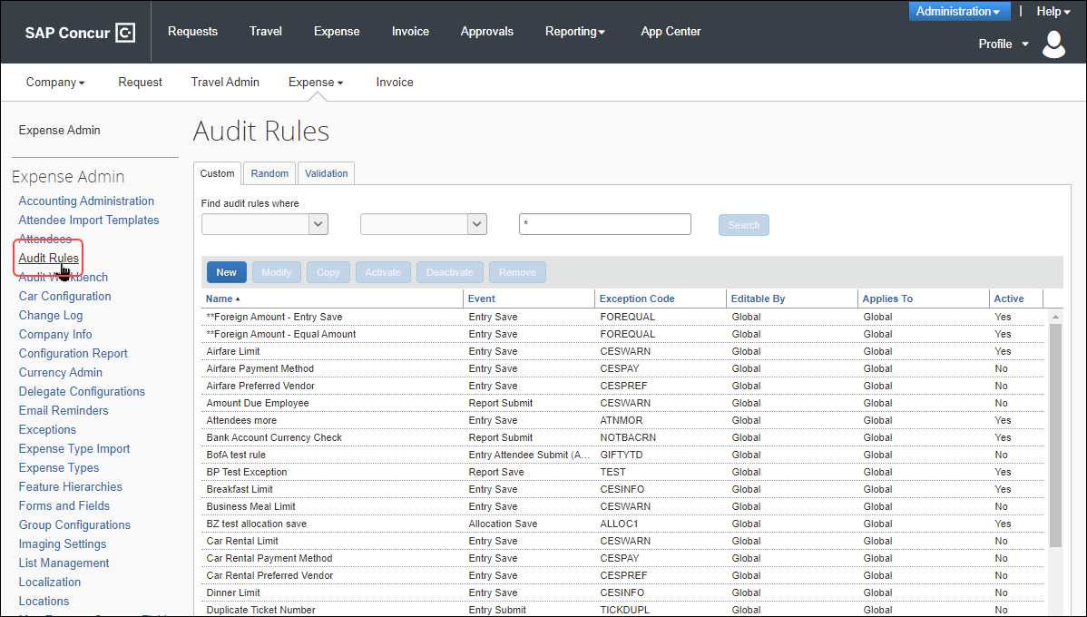
- Your system may contain additional provided custom audit rules. Refer to Provided Custom Audit Rules in this guide for a brief description of the provided audit rules.

Adding a Custom Audit Rule
To add a custom audit rule:
- On the Custom tab, click New. The Audit Rule step appears.
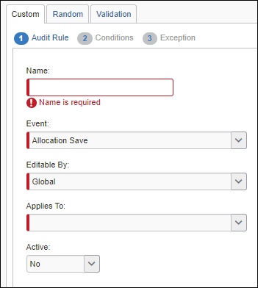
- Complete the appropriate fields.
Field | Description
Name | Type a meaningful rule name.
Event | Select the event that triggers the rule.  - For more information, refer to Events (Triggers) in this guide.
Editable By | Select the Expense group configuration(s) that can edit this audit rule.
Applies To | Select the Expense group configuration(s) to which this rule applies. (This is based on the Expense group assigned to the employee.)
Expense Types for Attendee Totals | This field appears only if Entry Attendee Submit or Entry Attendee Submit (Authorized) is selected from the Event list.  Select the expense type(s) that will be used to calculate the totals.  - Refer to Additional Samples of Custom Audits in this chapter.
Expense Report Group By Field Value | This field appears only if:  - Entry Attendee Submit (Authorized) is selected from the Event list  – and –  - The appropriate Audit Rule Group By Field option is defined in Administration > Expense > Attendee > Settings  Define the value for a report-level field used in selecting the expenses to be included in the attendee totaling for the audit rule.  NOTE: If the field is defined as a List or Connected list, the value entered is the short code, and the operator applied is "begins with." That is, if the Attendee Settings page specifies the Custom 1 field and the Custom 1 field is defined as a list, then – in this field – enter the first few characters of the short code associated with the desired list item. Text fields always use the "begins with" operator.  Leave blank to include all expense reports.
Active | Select Yes to activate the rule upon completion.
- Click Next. The Conditions step appears.
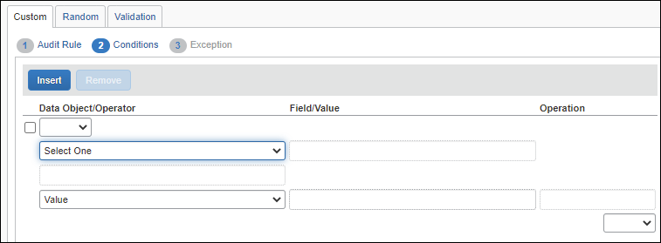
- Complete the appropriate fields, making selections from the helper pane.
- Refer to Understanding Conditional Expressions in this guide for a description of this page.
- Complete all conditions using these same steps, using Insert to add conditions and Remove to delete conditions.
- If you simply click Insert, the new condition is added at the bottom.
- To insert the new condition between existing conditions, select the condition that will be below the new condition.
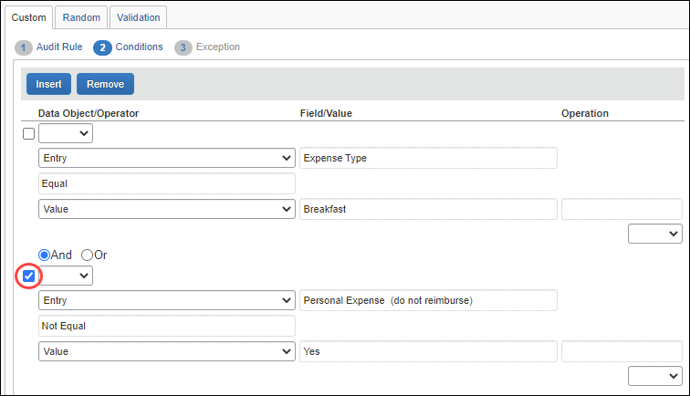
Click Insert. The new blank row appears.
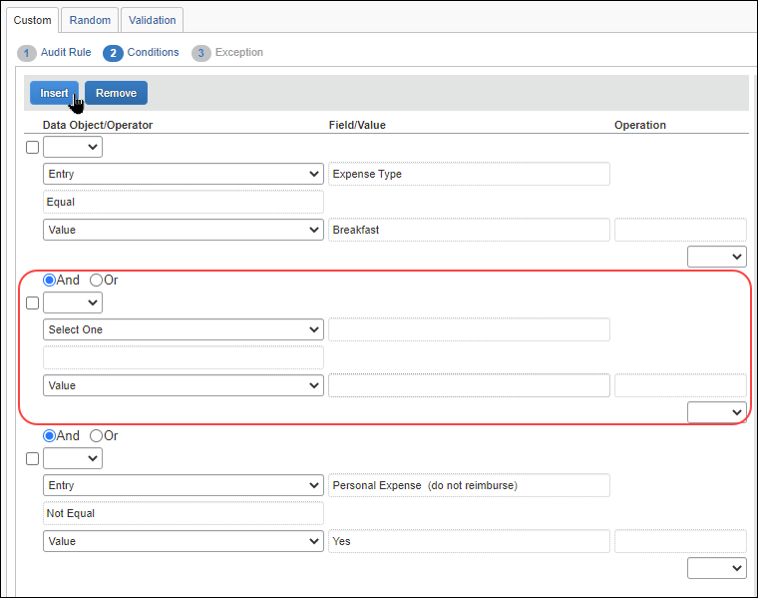
- When all conditions have been added, click Next. The Exception step appears.
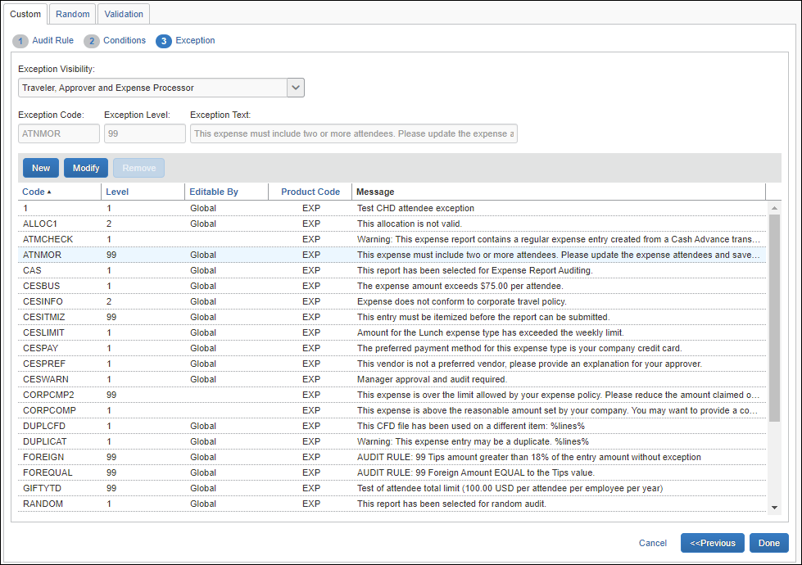
- From the Exception Visibility list, select the users who are able to see the exception message by selecting:
- Traveler, Approver, and Expense Processor
- Approver and Expense Processor
- Expense Processor
- For the exception, you can:
- Use an existing exception. To use an existing exception, click the desired exception. It appears in the Exception Code, Exception Level, and Exception Text fields at the top of the page.
- Create a new exception.
- Click New. The New Exception window appears.
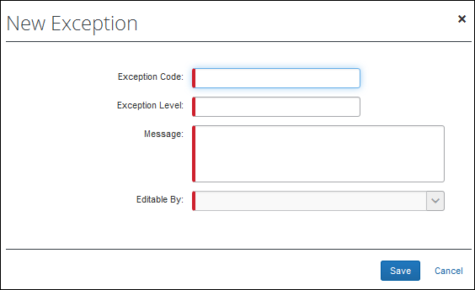
- Complete the fields.
Field | Description/Action
Exception Code | The company-defined code for the exception, up to eight alphanumeric characters, all uppercase.
Exception Level | The numeric exception level of the audit rule.  The company decides how many exception levels (up to 99) to use. For example, the company can decide to have six exception levels, with level 1 being a minor exception and level 6 being a severe exception.
Message | The exception message that appears to the user, approver and/or processor.
Editable By | Select the group(s) that can edit the audit rule.
- Click Save.
- Click Done.

Copying a Custom Audit Rule
Instead of creating all rules, you can save time by copying a similar custom audit rule and then edit the copy. For example, assume you want three rules to specify the maximum amount allowed for breakfast (20.00 USD), lunch (25.00 USD), and dinner (40.00 USD). You can create the first one (for example, using the Expense Type of Breakfast and the Claimed Amount of 20.00 USD) and then copy it. Edit the copy by changing the Expense Type to Lunch and the Claimed Amount to 25.00 USD. Repeat the same process for the dinner rule.
- For detailed information about all of the fields on this page, refer to Adding a Custom Audit Rule in this guide.
To copy a custom audit rule:
- On the Custom tab, select the rule you want to copy.
- Click Copy. The Audit Rule step appears.
- Make any desired changes.
- Click Next. The Conditions step appears.
- Edit the condition(s) as required.
- Click Next. The Exception step appears.
- Make the desired changes.
- Click Done.

Editing a Custom Audit Rule
- For detailed information about all of the fields, refer to Adding a Custom Audit Rule in this guide.
To edit a custom audit rule:
- On the Custom tab, select the rule you want to edit.
- Click Modify. The Audit Rule step appears.
- Make any desired changes.
- Click Next. The Conditions step appears.
- Edit the condition(s) as required.
- Click Next. The Exception step appears.
- Make the desired changes.
- Click Done.

Deactivating / Activating a Custom Audit Rule
Activate a rule when you are ready to use it.
Instead of removing a rule, you can deactivate it. This way, the rule is still available if you want to use it in the future.
To deactivate / activate a custom audit rule:
- On the Custom tab, select the rule you want to affect.
- Click Deactivate or Activate, whichever applies.

Removing a Custom Audit Rule
Once you have removed a rule, it will be permanently deleted from the system. If you think you might want to use it again, deactivate it instead of removing it.
To remove a custom audit rule:
- On the Custom tab, select the rule you want to remove.
- Click Remove.

Viewing a Custom Audit Rule
To view a custom audit rule:
- On the Custom tab, select the rule you want to view.
- Click Modify. The Audit Rule step appears.
- Click Next to move through the pages.
- Click Finish when done.

Additional Samples of Custom Audit Rules
Here are some other examples of custom audit rules.

Image Certification Date (e-Bunsho)
Administrators can configure audit rules based on the date value in the Image Certification Date field. Once the audit rule is configured, administrators can compare the receipt timestamp date to the expense entry transaction date and can send alerts to users/groups and stop the flow of expenses reports when regulations are not met.
Currently, the Image Certification Date field is the e-Bunsho timestamp date used in Japan.
Image Certification Date field considerations:
- Field calculation is based on the calendar day (business day logic is not included).
- Dates used in the number of day calculation are based on the GMT time zone. We recommend making audit rules for one day less than desired to account for the time difference between the GMT and JST time zones.
- Audit rules and compliance validations will be based on information provided by the user for the transaction date. Because users can edit transaction dates, responsibility is with the user to ensure the transaction date is accurate based on receipt information.
- Admins will have the ability to create multiple audit rules for comparing the transaction date to the receipt timestamp date.
The e-Bunsho image certification date is based in Greenwich Mean Time (GMT). User transaction dates are likely based in Japanese Standard Time (JST). Configuration of the audit rule should account for the time difference. We recommend making audit rules for one day less than desired to account for the time difference between the GMT and JST time zones.
For example, if you are trying to flag instances where the image certification date is more than 3 days after the transaction date, we suggest setting the value to 2 to account for the time difference.
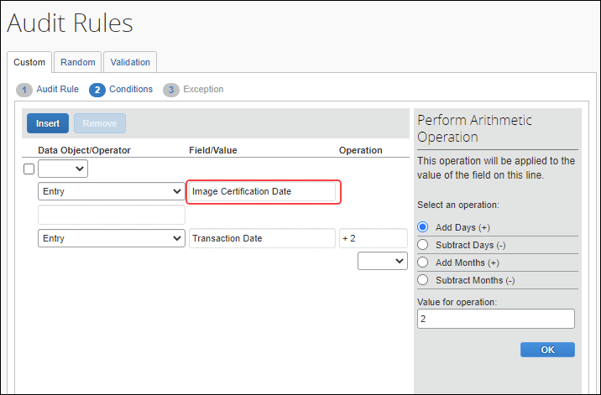

Multiple Expense Types (In/Not In and Equal/Not Equal)
Assume that you want to create a custom audit rule that includes several expense types. When you select Entry from the Data Object list on the Conditions page, the choices of In, Not In, Equal, and Not Equal appear in the Select Operator helper pane.
If you select In or Not In, then you can select more than one expense type to include in or exclude from the audit rule.
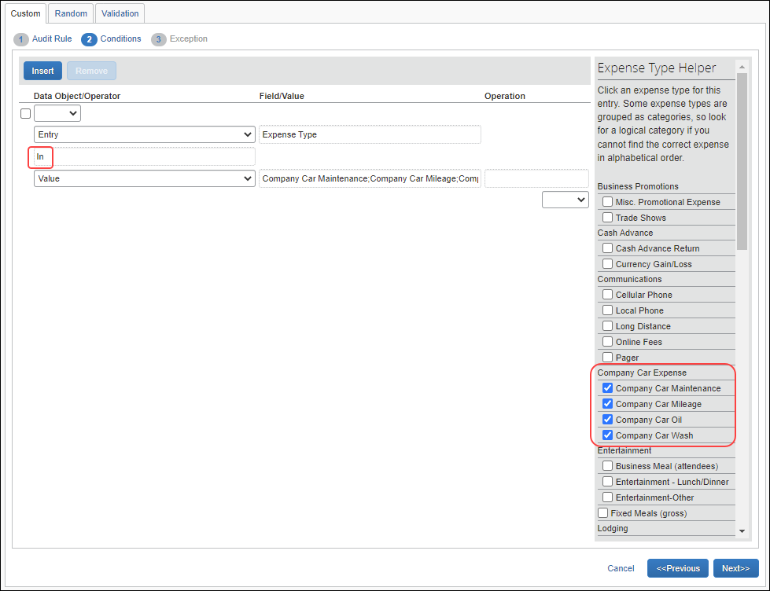
If you select Equal or Not Equal, then only one expense type can be selected.
This option of selecting multiple objects applies only to expense types.

Allocations
You can use audit rules to ensure that certain expenses (perhaps by expense type) are allocated (that is, they have user-entered allocation information, though not necessarily 100% of the expense). In addition, you can use audit rules to ensure that allocated expenses are fully (100%) allocated.
When creating the condition for the audit rule that permits allocation, the following should be excluded as part of the condition:
- Personal expense types
- Other expense types that cannot be allocated (such as Cash Advance, Cash Advance Return, Currency Gain/Loss)
In the example below, assume that you want airfare expenses to be fully (100%) allocated.
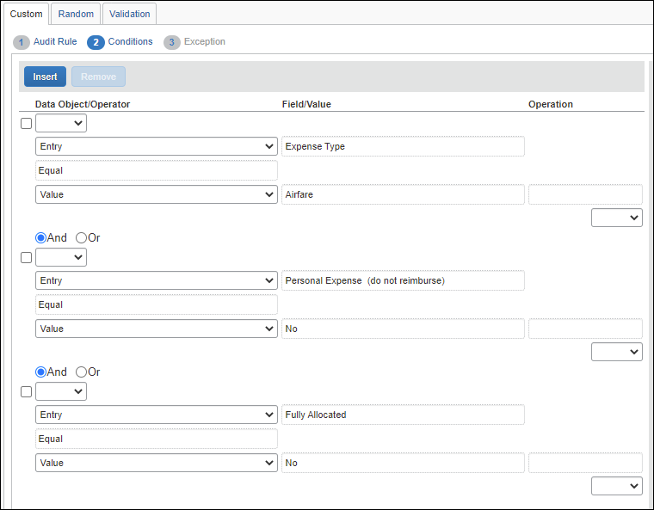

Transaction Type
You can differentiate between transaction types when creating an audit rule. Assume in this case, you can select:
- Expense without itemization
- Expense with itemization (total) (the "parent" portion of an itemized expense)
- Itemized entry on an expense (the "child" portion of an itemized expense)
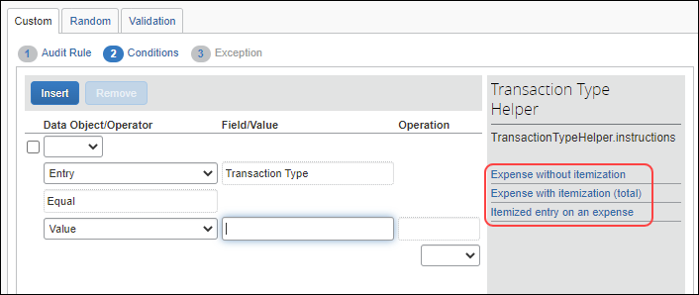

Connected Lists
You can create rules based on data in connected lists. To do this, select the appropriate level in the list. In this sample, the rule is based on the first level of a connected list, which is Department.
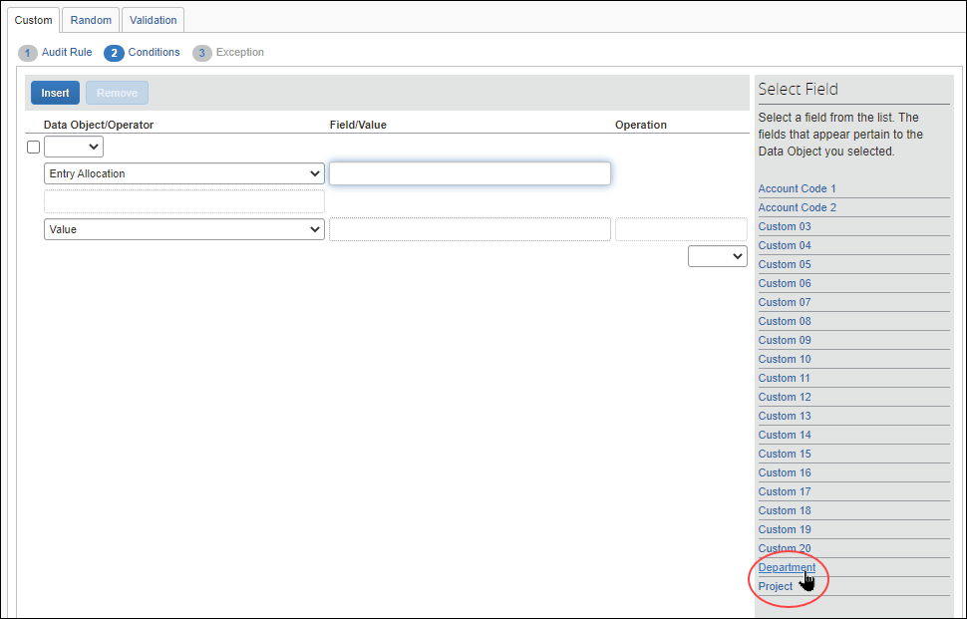
When the administrator selects Department, then the name of the connected list appears, which in this case, is Department-Project. The administrator selects the connected list.
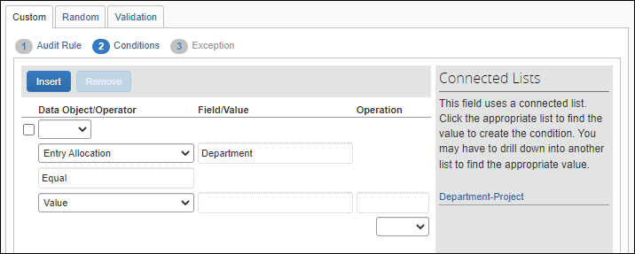
Then, the administrator selects the appropriate Project from the choices, which in this case, is Sales.
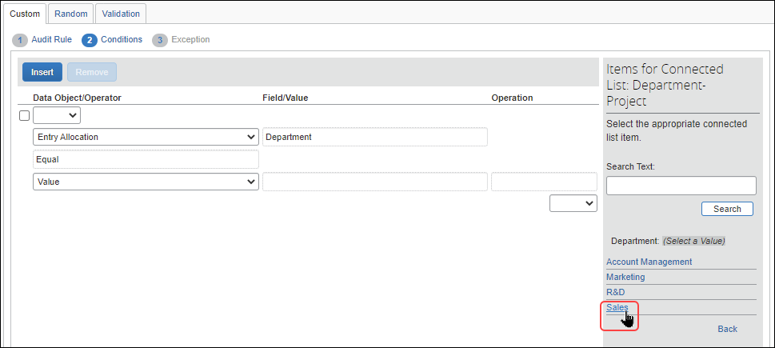

Invalid List Item
You can configure an audit rule that ensures that a custom list item is valid at report submission.
For example, a custom list has been created, and an employee has used an item from the custom list in their expense entry. Between when the user saves the entry, and when the report is submitted, the item may have been removed from the custom list.
A company may want to create an audit rule to ensure that an item in a custom list is valid at report submission time.

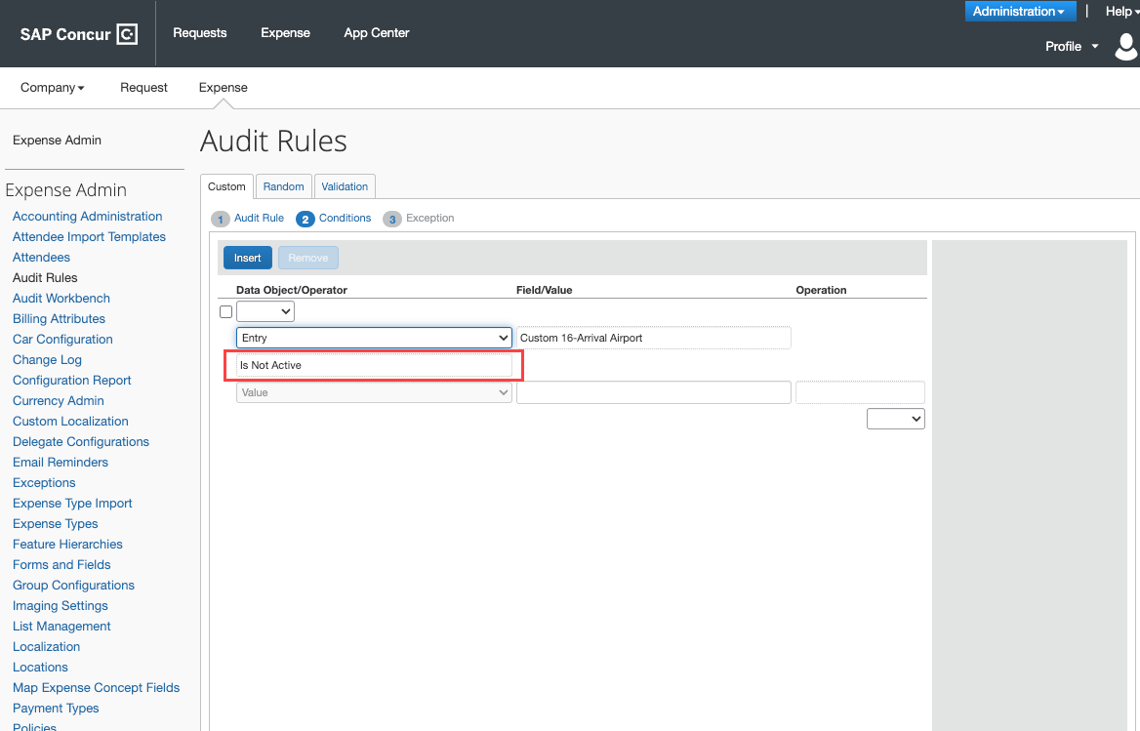

Duplicate Transaction Variance
Use the Duplicate Transaction Variance option to create audit rules that allow you to monitor for (or prevent) the submission of duplicate expenses, even across multiple expense reports.
TIP: Include the %lines% variable in the exception code output to include a list of possible duplicate expense report and expense report entry details, for example Warning: This expense entry may be a duplicate. %lines%.
When you create an audit rule using the Duplicate Transaction Variance, you specify:
- Which expense types you want it to include (dinner, hotel) or exclude (taxi, bus, cash advance; since it is common to have more than one of these types of expenses in the same day)
– and –
- The amount of the variance
All variances are by percent.
Then, Concur Expense checks a user's expenses and creates an audit rule exception if:
- Two or more expenses have the same expense type
– and –
- The expenses are on the same report or separate reports that have been submitted and not returned to the user
– and –
- The dates of the transactions are the same
– and –
- The reimbursement amounts of the transactions match the variance condition defined in the audit rule
To create the audit rule:
- On the Audit Rule step, complete the Name, Editable By, Applies To, and Active fields as usual.
- For the Event, select either Entry Submit or Report Submit.
Though you can select the event of Entry Save, it is strongly recommended that you do not. Each time an expense is saved, Expense will run the audit rule and check all submitted reports, which can negatively affect performance.
- On the Conditions step:
- Exclude expenses marked as personal
- Specify which expense types to include, such as lodging, car rental, or dinner
– or –
Specify which expense types to exclude, such as taxi, cash advance, or currency gain/loss
- Specify the amount of the variance, such as 3%
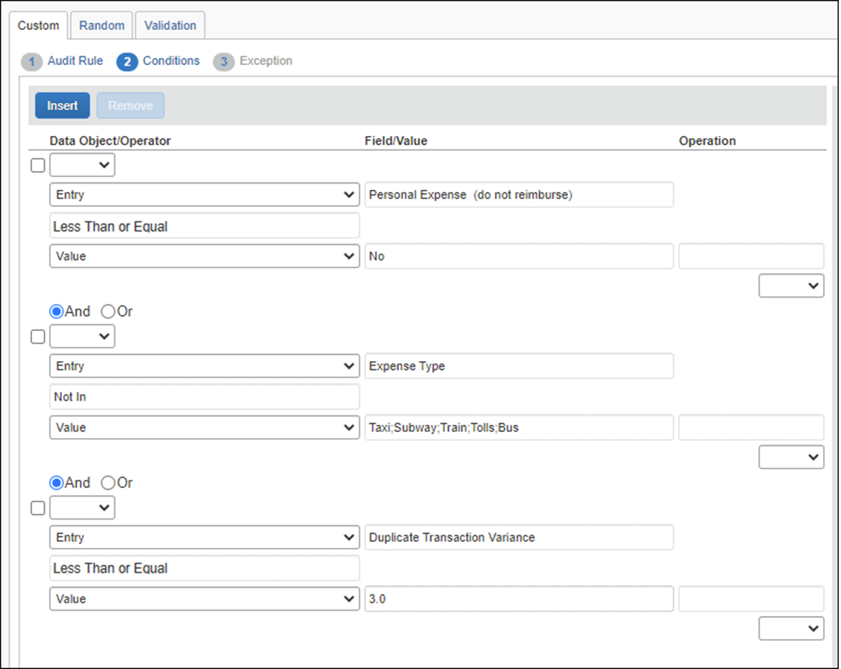
In this rule, personal expenses are excluded; taxi, subway, tolls, and so on are excluded; and the amount of the expense in question is within 3% of another expense.

Variance Operator
The Duplicate Transaction Variance should always employ the Less Than or Less Than or Equal operator. It is intended to find expenses within the defined variance for the amount, including the application of exchange rates for comparisons of amounts in differing currencies.
The Equal operator should never be used with this condition.
- On the Exception step, consider making the exception visible to the user, approver, and processor. Then, either:
- Set the exception level low enough so it does not prevent report submission. The exception text will serve as a warning for the user and allow the approver to make the decision about paying the expense.
- Set the exception level high enough to prevent report submission so the user cannot submit the expense. If it truly is a duplicate, the user must delete it. If the user simply made an error, for example, the date is incorrect, then the user can correct and then submit the expense.
This choice should be used with caution, as there are often valid business reasons for an exception to the rule.

Expense Exchange Rate Variance
Use the Exchange Rate Variance option to create audit rules that allow you to monitor the exchange rate used by employees on an expense against the default exchange rate provided by either your company's exchange rate import or the rates provided by SAP Concur.
A typical rule would allow a variance from the default rates to provide for exchange rate fluctuations from different currency providers, usually somewhere between 2-10%. The value entered for this field is the percentage of variance from the default exchange rate, as shown in the figure below.
The variance used for this rule must be greater than zero. The minimum supported variance is 0.1%.
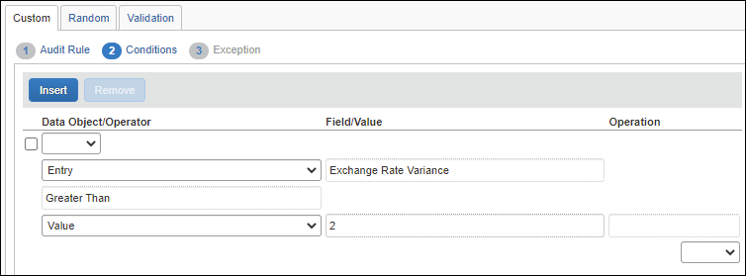

Daily/Weekly/Monthly/Yearly Amount Limit – Single Expense Type
Use the Amount Limit options to create audit rules that allow you to monitor for (or prevent) the submission of expenses that exceed daily, weekly, monthly, or yearly limits. For example, you may currently have a $25 limit for dinner. Using the Amount Limit - Weekly option, you can set a $100 weekly limit as well (or instead).
When you create an audit rule using one of the Amount Limit options (Amount- Daily Total; Amount- Weekly Total; Amount- Monthly Total; Amount- Yearly Total), you specify the expense type and the limit.
Then, Concur Expense checks a user's expenses and creates an exception if:
- One or more expenses exceed the daily, weekly, monthly, or yearly limit defined in the audit rule
– and –
- The expenses are on the same report or separate reports that have been submitted and not returned to the user
– and –
- The expenses match the expense type specified in the audit rule
– and –
- The transaction dates fall within the defined frequency
- "Monthly" is defined as within the same calendar month
- "Weekly" is defined as from Sunday through Saturday of the same calendar week
- "Yearly" is a calendar year, from January 1st to December 31st
If you select multiple expense types in the condition editor, the total is applied individually to each expense type.
To create the audit rule:
- On the Audit Rule step, complete the Name, Editable By, Applies To, and Active fields as usual.
- For the Event, select either Entry Submit or Report Submit.
Though you can select the event of Entry Save, it is strongly recommended that you do not. Each time an expense is saved, Concur Expense will run the audit rule and check all submitted reports, which can negatively affect performance.
- On the Conditions step:
- Exclude expenses marked as personal.
- Specify the expense type.
- Specify the limit.
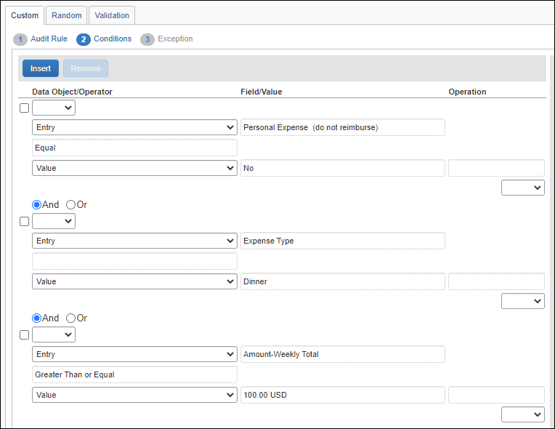
In this rule, personal expenses are excluded, dinner is specified, and the weekly limit is 100 USD.
If you select multiple expense types, the total is applied to each expense type; you cannot have it sum multiple expense types. For example, this option will not total breakfast, lunch, and dinner amounts to create a daily "meals" limit.
- On the Exception step, consider making the exception visible to the user, approver, and processor. Then, either:
- Set the exception level low enough so it does not prevent report submission. The exception text will serve as a warning for the user and allow the approver to make the decision about paying the over-limit expense.
- Set the exception level high enough to prevent report submission so the user cannot submit the expense(s). If the user has exceeded the limit, the user must edit the expenses to make the excess amount personal in order to submit. If the user simply made an error, then the user can correct and then submit the expense(s).
This choice should be used with caution, as there are often valid business reasons for an exception to the rule.
You can include variables in the exception message, for example, to show the user the limit amount, the amount over limit, etc. For more information, refer to the Concur Expense: Exceptions Setup Guide.

Daily/Weekly/Monthly/Yearly Amount Limit – Multiple Expense Types
Use the Amount Limit (multiple expense types) options to create audit rules that allow you to monitor for (or prevent) the submission of expenses that exceed daily, weekly, monthly, or yearly limits totaling across a specific set of expense types. For example, you may currently have a $50 limit for meals per day. Using the Amount Limit – Daily (multiple expense types) option, you can check the sum of expense types for Breakfast, Lunch and Dinner for this limit.
These rules are very similar in operation to the single expense type version described above; the primary difference is that they will total multiple expense types versus a single expense type.
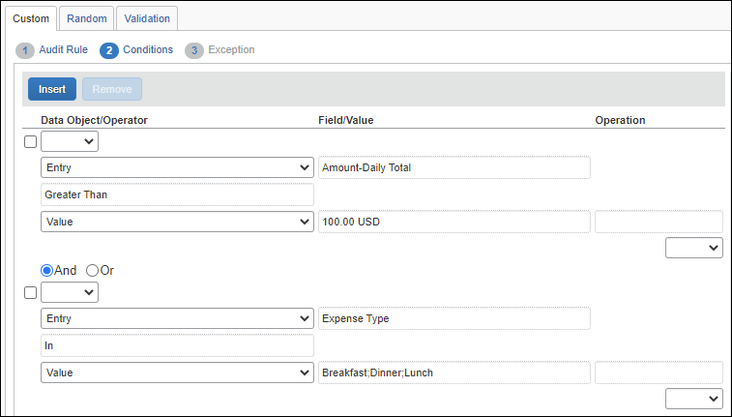
The following are the Entry Data Object options for multiple expense types:
- Amount – Daily Total (multiple expense types)
- Amount – Monthly Total (multiple expense types)
- Amount – Weekly Total (multiple expense types)
- Amount – Yearly Total (multiple expense types)

Variables in Exception Messages for Daily/Weekly/Monthly/Yearly Amount Limit – Single or Multiple Expense Types
These variables cannot be used in conjunction with the Duplicate Transaction Variance rule for finding potential duplication of expenses. These variables are not supported for use in validation rules.

Overview
If the client uses amount-based audit rules (such as those that track daily, weekly, or monthly totals), the client can also include variables in the exception message that appears to the user, approver, and/or processor. For example, assume that an audit rule is triggered if a user spends more than $50 a month for office supplies. Further assume that the admin created an exception message that includes the amount variables.
So, when the user saves an office supply expense for $15, which brings the monthly total to $60, the exception message might be: "The monthly limit for this type of expense is $50. Your expense exceeds the limit by $10, bringing the monthly total to $60. Be sure to include a comment for your approver."

Configuration
The basic steps are:
- Step 1: Set the site setting
- Step 2: Create the audit rule
- Step 3: Create the exception

Step 1: Set the Site Setting
This feature is activated in Site Settings.
- Click Administration > Expense.
- Click Site Settings (left menu).
- Select (enable) the Allow amounts to appear in limit-based exception messages (enable only if used) check box.
If you have created exception messages with variables and then you later clear (disable) this check box, the variable syntax, in plain text, is displayed instead of the amount as shown in this example:
- Enabled:
"Company policy limits expenses in this area to €50.00 per month. You have spent €80.48 this month, over the limit by €30.48."
- Disabled:
"Company policy limits expenses in this area to %AmountLimit% per month. You have spent %TotalAmount% this month, over the limit by %AmountOverLimit%."
- For more information about site settings, refer to the Concur Expense: Site Settings Setup Guide.

Step 2: Create the Audit Rule
Once the feature is activated, the admin can create the audit rule exception messages. The new exception message variables can be used with audit rules that meet the following criteria:
- The event must be one of these:
- Entry Save
- Entry Submit
- The data object must be Entry.
- The field/values must be one of these:
- Amount
- Amount-Daily Total
- Amount-Daily Total (multiple expenses)
- Amount-Monthly Total
- Amount-Monthly Total (multiple expenses)
- Amount-Weekly Total
- Amount-Weekly Total (multiple expenses)
- Amount-Yearly Total
- Amount-Yearly Total (multiple expenses)
- Foreign Amount
- The operator must be one of these:
- Greater Than
- Greater Than or Equal
For example, this audit rule would track office supply expenses that total $50 or more in a month:
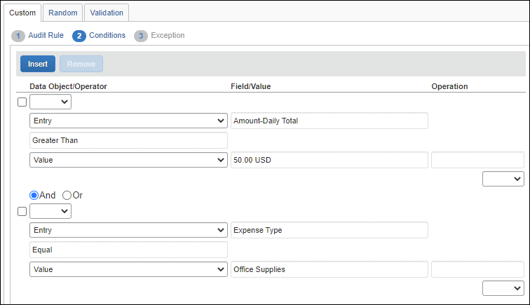
Note the following:
- Multiple conditions: If there is more than one amount condition in an audit rule that meets the criteria, it is not possible to predict which condition will define the amounts that are reported. Best Practice: Use only one condition that meets the criteria.
- With variance: This type of rule and message also work if the audit rule includes a variance. Assume that the client has a rule for a maximum monthly spend of $100 (with a variance of 2%) for office supplies, so the user is permitted to spend up to $102 without exception.
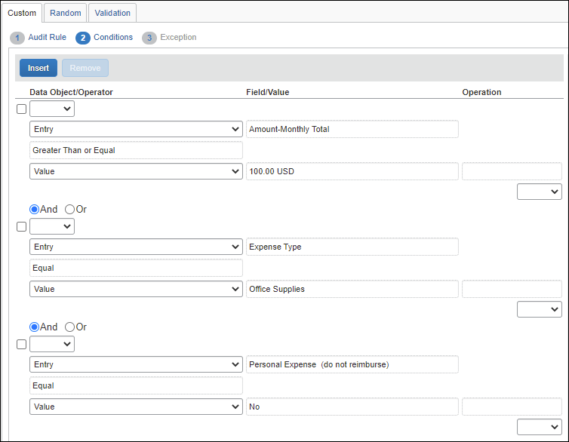
For this type of rule:
- The rule is triggered based on the variance, so the exception message will not appear until the user exceeds $102.
- The exception message is based on the base amount of $100 with no mention of the variance.
So:
- If the user's total for the month equals $101, the rule is not triggered so there is no exception.
- If the user's total for the month equals $103, the rule is triggered and this type of client-configured exception message could appear: "Company policy limits expenses in this area to $100 per month. You have spent $103 this month, over the limit by $3."

Step 3: Create the Exception
Then, when creating the exception for the audit rule, the admin can use any or all of these variables. (These variables are not case-sensitive.)
Variable | Description | Currency
%AmountLimit% | Amount of the limit as defined in the rule | Appears in the exception in the currency defined in the audit rule – with the appropriate symbol (such as the dollar sign) or three-character currency code (such as CAD)
%AmountOverLimit% | Amount that exceeds the limit (TotalAmount minus AmountLimit)
%TotalAmount% | Total amount of the expense(s) selected by the rule
%AmountLimitRemaining% | Amount remaining between the limit and the total amount expensed (AmountLimit – TotalAmount)
%UserTotalAmount% | Total amount of the expense(s) selected by the rule – in the applicable currency | If the audit rule amount condition uses the Foreign Amount field, then this amount appears in the exception in the transaction currency of that expense.  If the audit rule uses any of the other amount fields listed above, this amount appears in the exception in the currency of the expense report.
- For more information about creating exceptions, refer to the Concur Expense: Exceptions Setup Guide.

Daily/Weekly/Monthly/Yearly Transaction Frequency Count – Multiple Expense Types
Use the Transaction Frequency (multiple expense types) options to create audit rules that allow you to monitor for (or prevent) the submission of expenses that exceed daily, weekly, monthly, or yearly frequency limits across a specific set of expense types. For example, you may currently have a limit of number of occurrences for specific expense types like seminars during the year. Using the Transaction–Yearly Total (multiple expense types) option, you can check the count of expense types for Seminar Fees against this annual limit.
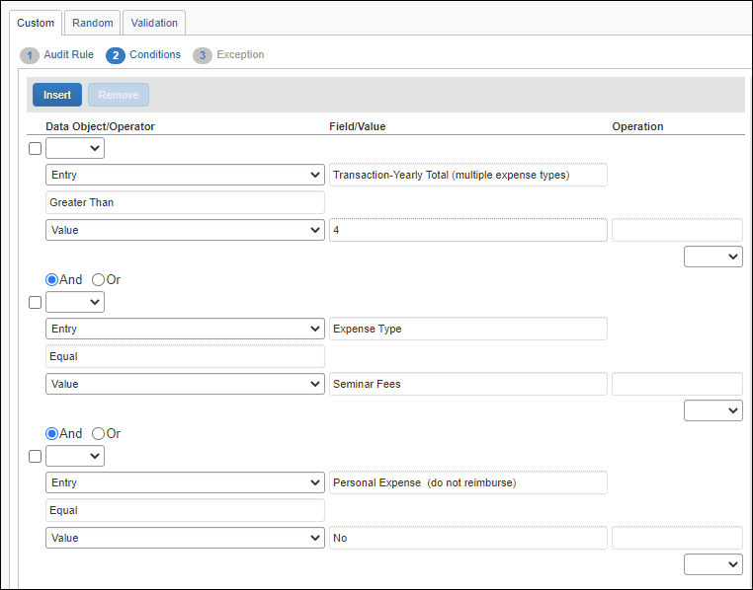
The following are the Entry Data Object options for multiple expense types:
- Transaction – Daily Total (multiple expense types)
- Transaction – Monthly Total (multiple expense types)
- Transaction – Weekly Total (multiple expense types)
- Transaction – Yearly Total (multiple expense types)

Prevent Submission When Company Card Transactions are Older Than # Days
This rule blocks a user from submitting any additional reports when the system detects that their queue of unattached card transactions includes one or more transactions older than X number of days.

Sample
In this sample, the system will block submission of expense reports where the any unused card transaction date exceeds the report's posted date plus the specified number of days.
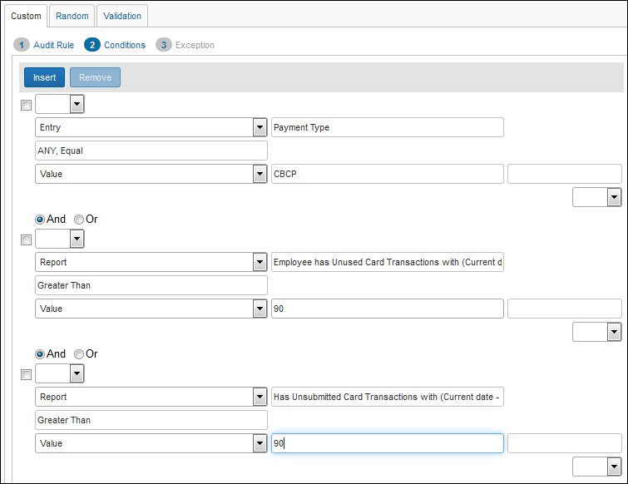
The lack of submission privileges prompts the user to resolve the issue.

Managing Unused or Unsubmitted Company Card Transactions
These rule options allow you to monitor company card transactions that are unused (either not yet attached to an expense report or attached to an unsubmitted expense report). Using these options, you can design audit rules that prevent submission of other expense reports until the user has submitted all card transactions older than a client-defined number of days.
The options are associated with the Report Submit event and the Report data object. They are:
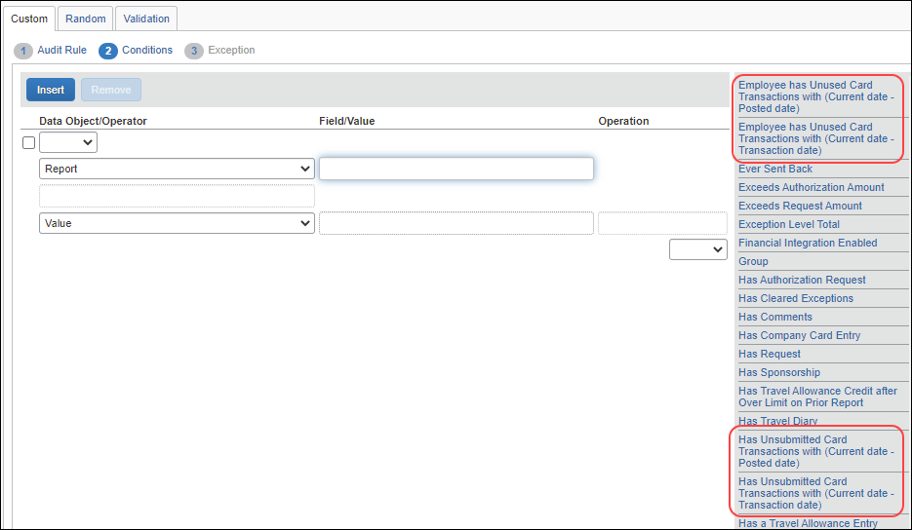

Option | Description
Employee has Unused Card Transactions with (Current date - Posted date) | Checks to see if the employee has unattached/ unsubmitted card transactions – excluding any transactions attached to the current report – where the posted date is at least x days older than the current date
Has Unsubmitted Card Transactions with (Current date - Posted date) | Checks to see if the current report has unsubmitted card transactions where the posted date is at least x days older than the current date
Employee has Unused Card Transactions with (Current date - Transaction date) | Checks to see if the employee has unattached/ unsubmitted card transactions – excluding any transactions attached to the current report – where the transaction date is at least x days older than the current date
Has Unsubmitted Card Transactions with (Current date - Transaction date) | Checks to see if the current report has unsubmitted card transactions where the transaction date is at least x days older than the current date
Consider when using the options:
- First, determine how you want to define "aged" (such as 30 days).
- Then, whether to compare the current date to the posted date or to the transaction date (such as 30 days past the transaction date).
- Then, whether to use the new exception named UNUSEDCC. If you do, then if the user has aged card transactions already attached to one or more reports, the report names appear in the exception message.

Sample
In this sample, the system will block submission of expense reports until all aged card transactions are submitted. Every report that contains Cash transactions will be blocked until the aged transactions are submitted.
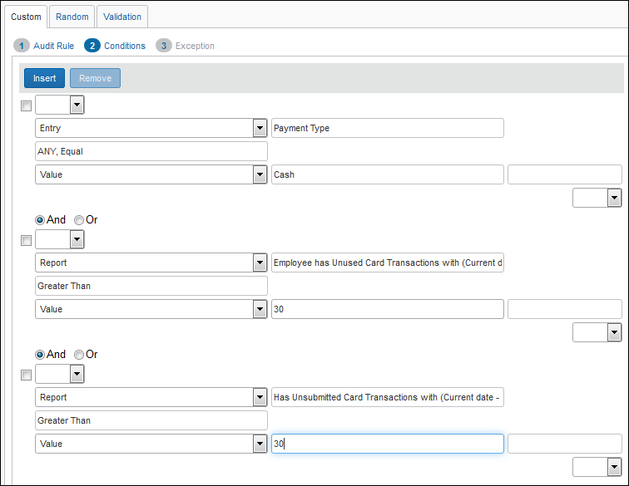
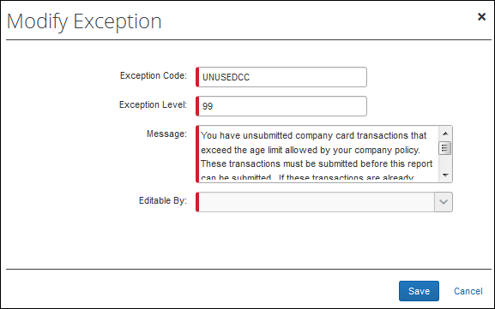

How It Works
Assume that the user has unused aged card transactions.
The user tries to submit.... | Result
Expense report #1 - contains only cash transactions | Report #1 is blocked until all aged card transactions are submitted
Expense report #1 - contains only cash transactions  Expense report #2 - contains aged card transactions | Report #1 is blocked  Report #2 is processed  When all aged card transactions are submitted, then the user can submit report #1
Expense report #1 - contains cash and aged card transactions  Expense report #2 - contains aged card transactions | Report #1 is blocked  Report #2 is processed  Report #1 will remain blocked until the cash transactions are removed. Once that happens, the user can submit Report #1
Expense report #1 - contains only cash transactions  Expense report #2 - contains card transactions under the age limit  Expense report #3 - contains aged card transactions | Report #1 and #2 are blocked  Report #3 is processed  When all aged card transactions are submitted, then the user can submit report #1 and #2

Attendee Totals and Attendee Frequency (using the Entry Attendee Submit Event)
You can create attendee audit rules, for example:
- To track the amount spent on an attendee, based on an audit limit, either company-wide or by the current employee (owner of the current report)
- To track the number of times an individual has been named as an attendee, either company-wide or by the current employee (owner of the current report)
Note the following about attendee audit rules (Entry Attendee Submit event):
- For a single-condition rule, that condition must contain the Attendee Totals data object.
- For a multiple-condition rule, the rule must contain only one condition with the Attendee Totals data object.
- Like other audit rules, you can make the exception visible to users; users and approvers; or users, approvers, and processors. The exception text associated with the entry follows the same visibility guidelines as other custom rules; however, the exception text that appears with the attendee name is visible to everyone.
- Like other audit rules, you can also set the exception level high enough to prevent report submission. The icon associated with the entry follows the standard color guidelines (red/yellow/blue), however, the flag that appears with the attendee name is always red.
- Amount and frequency totals that apply to the current employee are stored with the expense entry. Amount and frequency totals that apply to the entire company are stored with the expense entry and the attendee record.
- For audit rules that evaluate attendee totals for both amount and frequency, objects should not be used if attendees are in the parent expense entries, and instead, attendees should be in the itemization entries. When using these objects, attendees should not be in the parent entries.
To create an Attendee Totals rule:
- On the Audit Rule step, complete the Name, Editable By, Applies To, and Active fields as usual.
- Then:
- For the Event, select Entry Attendee Submit.
- For Expense Types for Attendee Totals, select the expense type(s) that you want included in the total.
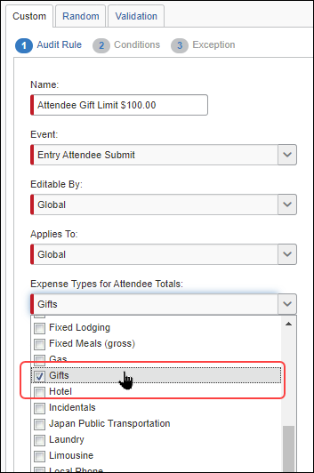
- On the Conditions step:
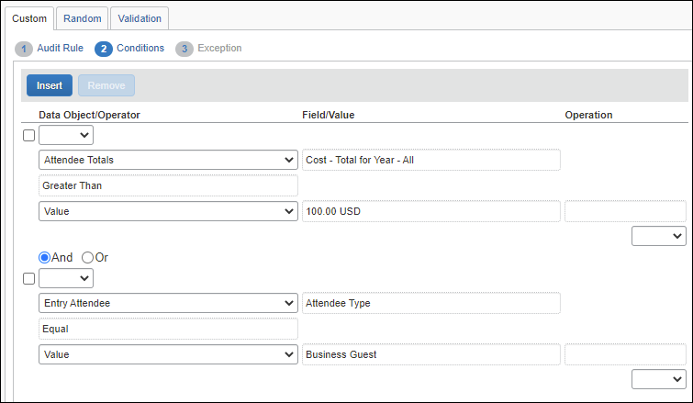
- For the first condition, select one of the "cost" options (by quarter or year; All for company-wide or Employee for current employee), the operator, and the amount.
- For the second condition, select the attendee types to include or exclude.
- Consider excluding the "No Show" attendee type since that attendee type reflects a company-wide cumulative total and would likely always be flagged.
- Consider excluding the "This Employee" attendee type since it is the current employee.
- On the Exception step:
- Consider making the exception visible to the user, approver, and processor so the user can see the flags and exception messages.
- Consider setting the exception level low enough so it does not prevent report submission. The exception text will serve as a warning for the user and allow the approver to make the decision about paying the expense.
To create an Attendee Frequency rule:
- On the Audit Rule step, complete the Name, Editable By, Applies To, and Active fields as usual.
- Then:
- For the Event, select Entry Attendee Submit.
- For Expense Types for Attendee Totals, select the expense type(s) that you want included in the total.
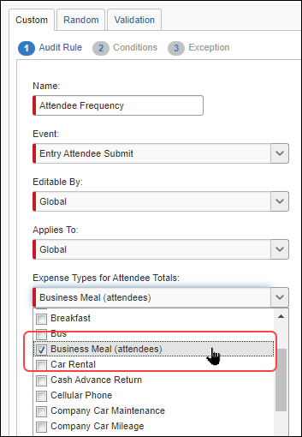
- On the Conditions step:
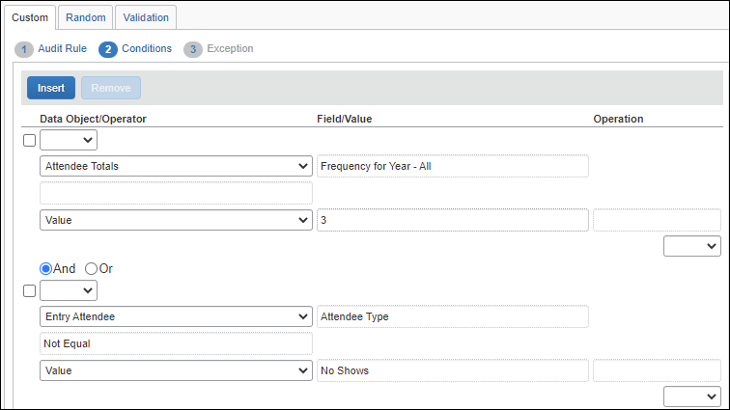
- For the first condition, select one of the "frequency" options (by month, quarter, or year; All for company-wide or Employee for current employee), the operator, and the amount.
- For the second condition, select the attendee types to include or exclude.
- Consider excluding the "No Show" attendee type since that attendee type reflects a company-wide cumulative total and would likely always be flagged.
- Consider excluding the "This Employee" attendee type since it is the current employee.
- On the Exception step:
- Consider making the exception visible to the user, approver, and processor so the user can see the flags and exception messages.
- Consider setting the exception level low enough so it does not prevent report submission. The exception text will serve as a warning for the user and allow the approver to make the decision about paying the expense.

Travel Allowance
- For more information about travel allowance audit rules, refer to the Concur Expense: Travel Allowance Setup Guide.

Corporate Card ATM Transactions As a Regular Expense
A client can elect to treat a corporate card cash withdrawal from an ATM as an expense type instead of a cash advance in order to import and itemize the withdrawal. In this scenario, the ATM Check audit rule is used as a check for potential fraud, as in the following:
ATM Check (System Audit Rule Activate if CA ATM = Reg)
The ATM Check audit rule should be modified to meet the client's needs for ensuring that fraud has not been committed. Specific audit rule conditions that identify a possible ATM charge (for example, by bank) are not possible or advised due to the changing nature of the import file data.
Best practice is to treat cash withdrawals on a corporate card as a Cash Advance.

Comparing Expenses to Request Pre-Approval Limits and Entries
Several Audit Rules conditions allow comparison of expenses against pre-approved limits from the request and its request entries.
Sample, Based on Report:
- Validate that the expense report has a linked request:
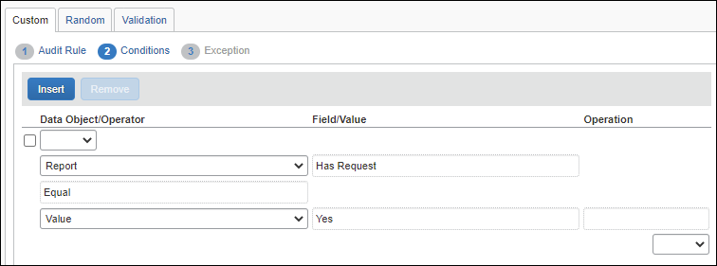
- Check to see if the total expenses against a request exceed the total amount pre-approved for that request:
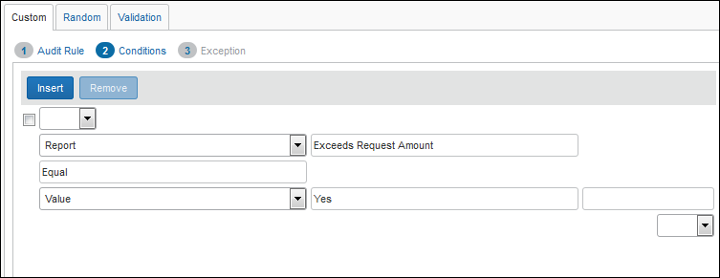
Sample, Based on Entry:
- Check to see if the total expenses against the hotel segment entry of a travel request exceed the pre-approved amount of that segment:
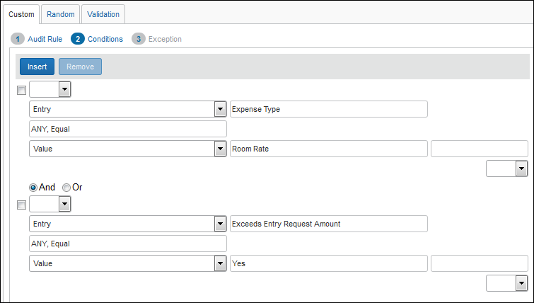

Date Objects – Adding and Subtracting Days and Months
When working with a Date object (Transaction Date, etc.) it is possible to specify a date object comparison whose outcome can be analyzed for a desired number of days or months that should separate the two dates. For example, if a company has a policy to purchase airline tickets 30 days prior to travel, they can create a rule that notes the purchase and travel dates, flagging those whose date span falls under the required 30 day policy.
In the example below for a client with Concur Expense and Concur Travel, Start Date (Booked) is compared against the Transaction Date – 1 month. If the Transaction Date is within 30 days of the Start Date, the rule is fired.
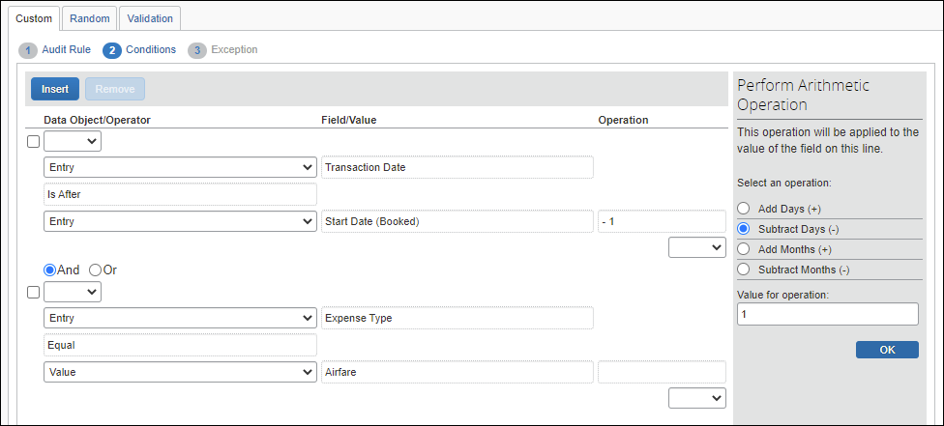
In practice, the system will subtract 30 days from the Start Date (Booked) value, then determine if the output date falls before or after the Transaction Date. If the Transaction Date is before the output date, the report is not flagged. If the Transaction Date is after the output date, the report is flagged, as the user has not purchased the tickets 30 days prior to the Start Date (Booked).

Cash Advance – Exclude Balance Included From Balance Due Management
This condition works with the Employee object, and is used to build a rule that excludes any balance included by the Balance Due Management feature when analyzing the rule. This is useful whenever a client wants to use both the Balance Carry Forward feature and regular cash advances at their site. The new field allows for accurate audit rules based on the intent of the business need.
- Cash Advance Balance (Excluding System) represents the outstanding balance of cash advances that the user may assign to a report. This field is recommended for use in writing rules aimed at guiding or controlling user behavior to appropriately attach cash advances to reports.
- Cash Advance Balance represents the entire balance of cash advances outstanding for the user, including amounts managed by the Balance Due Management tracking feature. For clients not using the balance due tracking, this can be used generally for referring to the balance of outstanding cash advances. For a client that does use balance due tracking, this may cause audit rules to fire erroneously for outstanding system-managed cash advance amounts that the user cannot control

Detect Unassigned Card Transactions of a Given Payment Type
Companies that issue different card types (IBCP; CBCP; etc.) to a user can use the Payment Types of Unused Card Transactions audit rule field to identify the card program type in order to control when the user pays the balance on either card type. The new rule is available to the Employee object-based rule.
The intent of this field is to allow a client to enforce the desired behavior of submission of card charges based on their payment type.

Example
Assume a company has issued the following cards and payment parameters to a single user:
Card Program Type | Submit Policy | Description
IBCP Corporate Card | Once per month | Policy enforces a monthly payment on this card type.
CBCP Purchasing Card | As soon as possible | Company wants benefit of quick payment rebates from issuer.
The administrator then creates the audit rule:
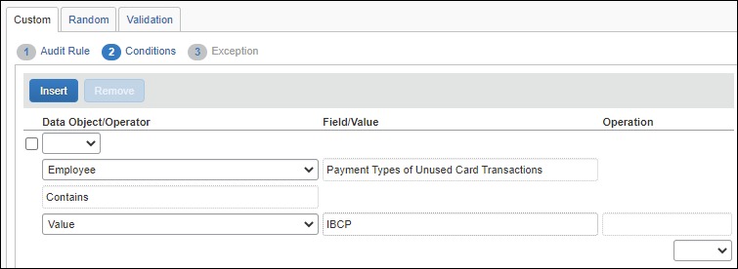
By allowing an audit rule-based distinction between the card payment types, the administrator can flag unassigned transactions of one payment type in order to free the user to submit reports with charges of another payment type.

Detect and Flag Source of Japan Public Transport Route Data
Administrators of the Japan Public Transport (JPT) feature can create audit rules that generate exceptions based on the source used to enter the transportation route by the JPT traveler. This feature supports clients whose specific policy rules restrict how an employee expenses a JPT transaction (which may require a receipt). By raising an exception, these criteria may be enforced at the company policy level.
Field Name | Available Selections for the Field
Source/Type Classification | Identifies the class of travel based on the source of the route data used by the JPT traveler:  - MANL = (Manual) Route data entered manually  - CARD = (IC Card) Route data entered using IC card  - RSRC = (Route Search) Route data entered by search (i.e. Jorudan)
These new fields display when JPT is enabled on the entity and the Entry object is selected.
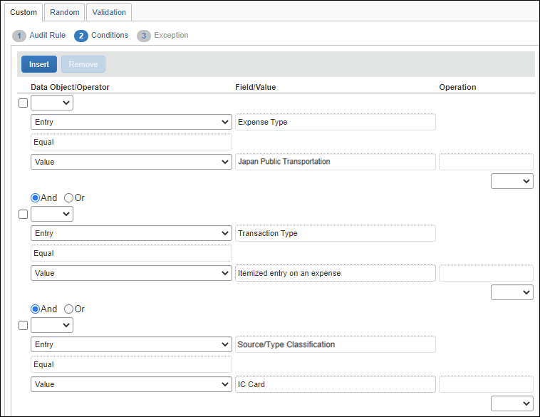

Using Report Start Date and Report End Date Fields
The Report Start Date and Report End Date fields may be added to a report header form to capture a date range for the expense report. If these fields are used, the administrator can create additional rules to ensure only one report covers a specific period of time.

All Expenses Must be Within Report Start and End Dates
The example below uses the Report Submit event. If the user has provided both the Report Start Date and the Report End Date values, the rule checks the expense entries to verify that the transaction date is within the specified date range. The audit rule will flag expenses that are outside the date range of the report.
If your organization uses the Company Billed Statements (CBS) feature, please include a condition to exclude statement reports from this rule. For example, a final condition of the Report – Report Type – Not Equal – Statement Report would exclude statement reports from the rule.
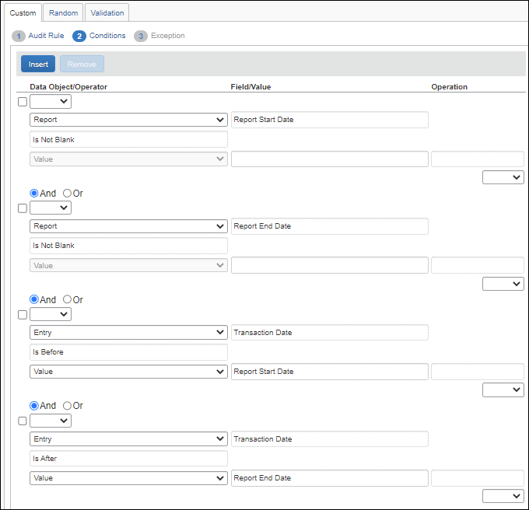

No Reports May Overlap Another Report
The example below uses the Report Submit event. The rule uses the Dates Overlap Another Report condition to check that an employee is not submitting a second expense report that overlaps the start and end date of the prior (the "first") report. This is done by comparing the first report's Report Start Date and Report End Date header values with subsequent reports. If any submitted report falls within that date range, the audit rule triggers and an exception displays.
A single shared date is not considered overlapping. For example, the same date may be shared by two reports when the Report End Date of the first report is the same as the Report Start Date of a second report.
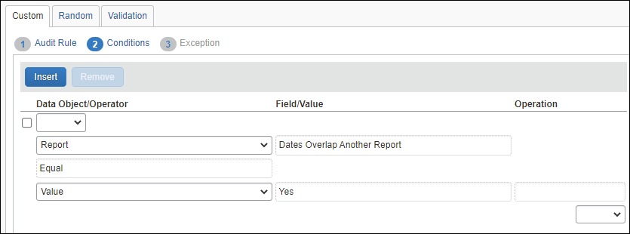

Mileage Variance (Google Maps)
Use the Business Distance option to create audit rules that allow you to monitor the variance between the business distances entered by employees on an expense against the distance calculated by Google Maps. This example rule would not create an exception if the Google Maps mileage calculator were not used for the entry.
A typical rule would allow a variance from the default distance to provide for current road conditions such as construction, accidents, etc., usually somewhere between
2-10%. The value entered for this field is a decimal value representing percentage of variance from the Google Maps distance, as shown in the figure below.
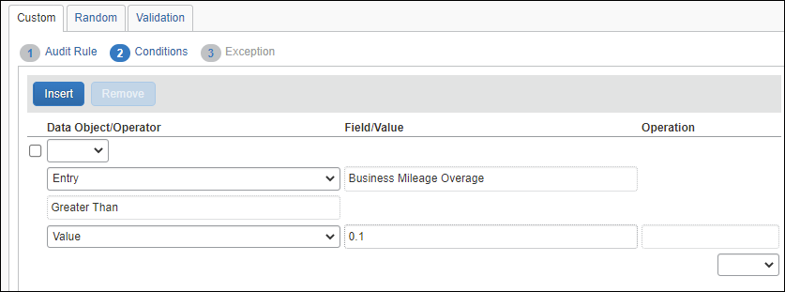

Drive: Drive Not Used
Use this rule so that when a user claims a Personal Car Mileage expense and they have not used Drive, they are forced to enter a comment.
Drive refers to the feature that is enabled from Concur's mobile app > Mileage > Auto Tracking. To enable Drive, contact SAP Concur support.
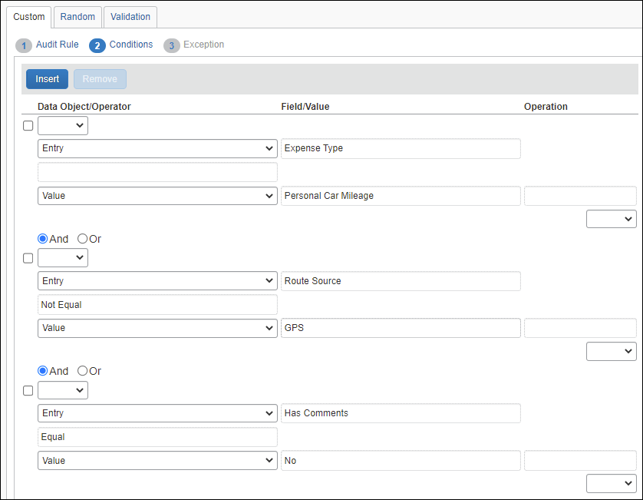

Drive: Drive Policy Reminder
Use this rule so that when a user has not used Drive, they are reminded by a warning exception message.
Drive refers to the feature that is enabled from Concur's mobile app > Mileage > Auto Tracking. To enable Drive, contact SAP Concur support.
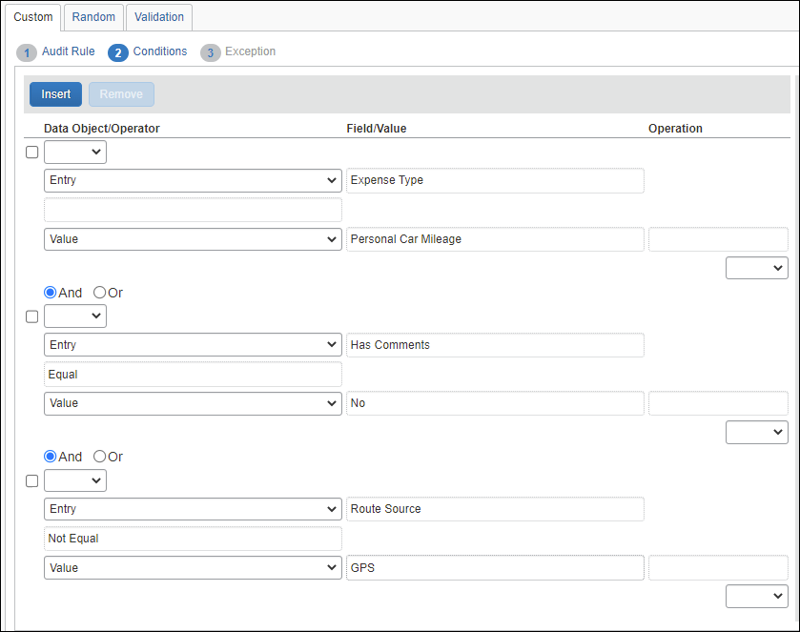

Drive: Mileage Route Required
Use this rule so that when a user does not have a mapped route, they are presented with an exception instructing them to add a route.
Drive refers to the feature that is enabled from Concur's mobile app > Mileage > Auto Tracking. To enable Drive, contact SAP Concur support.
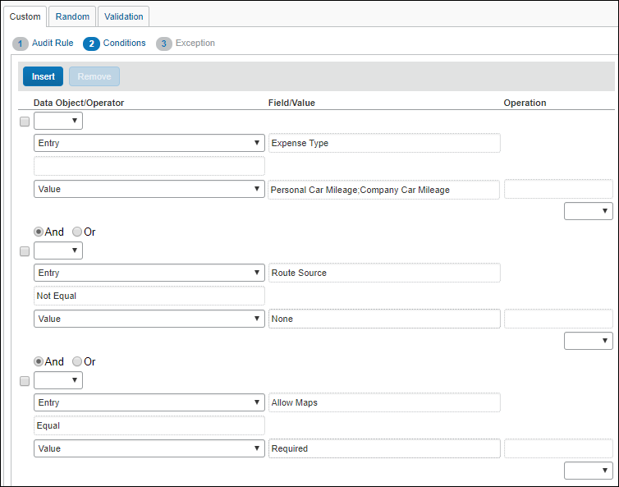

Foreign Amount: Posted Amount and Currency Identifier
Note the following:
- When using the Foreign Amount object in the condition editor, Concur Expense compares the posted amount – not the transaction amount.
- Custom fields that are defined as Amount fields are presumed to be in reimbursement currency for the purposes of audit rule execution, since they do not have their own currency identifier.
Here are two examples to demonstrate.

Rule #1: Tip Equals Amount
Assume you want a rule that checks to see if the tip equals the amount of the purchase. This rule is not particularly useful; it simply demonstrates the two points noted above.

The Rule
In this case, the rule is triggered on Entry Save.
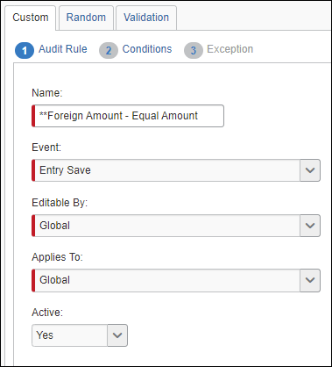
The rule shown below will trigger when the custom field for the tip amount (Custom 01 - Tips Foreign field) equals the posted amount for breakfast expenses.
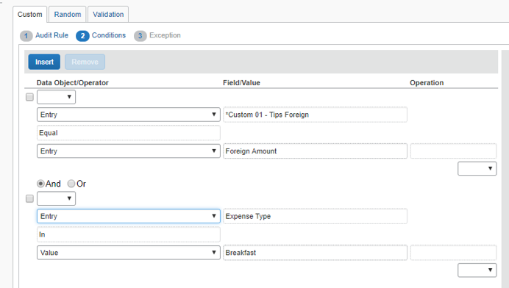
As usual, the audit rule is assigned an exception and exception code.
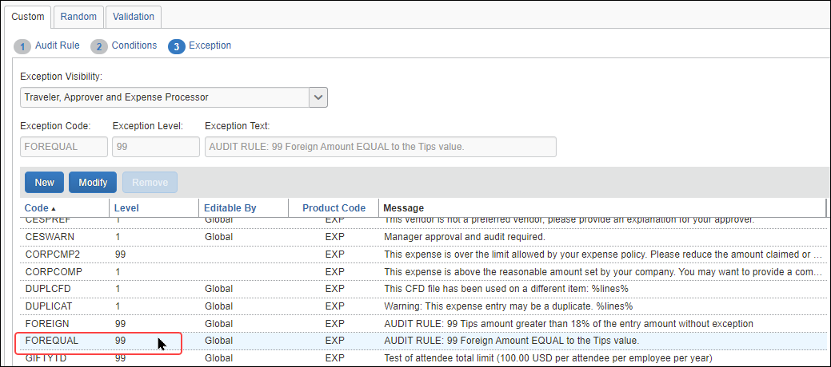

Trigger the Rule
As expected:
- The foreign amount of 10.00 EUR is converted to the posted amount of 11.64 USD.
- The audit rule is triggered only when the custom Tips Foreign field is equal to the posted amount (Amount in USD field).
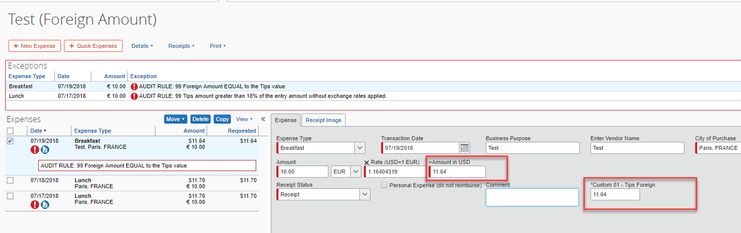

Rule #2: Tip greater Than 18% of Amount
In this case, the rule is triggered on Entry Save.
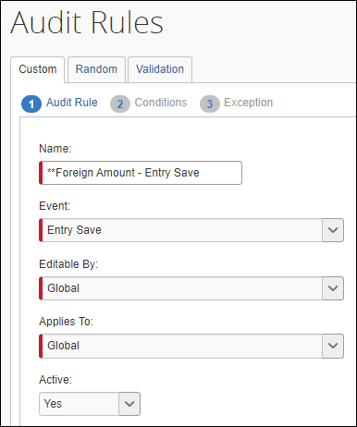
The rule shown below will trigger when the custom field for the tip amount (Custom 01 - Tips Foreign field) is greater than 18% of the posted amount for lunch expenses.
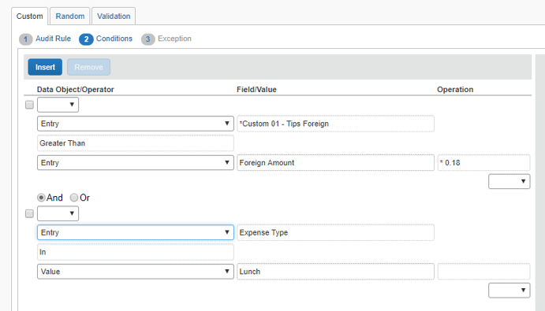
As usual, the audit rule is assigned an exception and exception code.
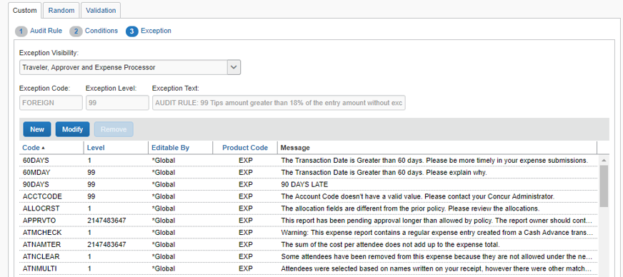
As expected:
- The foreign amount of 10.00 EUR is converted to the posted amount of 11.70 USD.
- 18% of 11.70 is 2.106.
- The audit rule is triggered when the amount in the Tips Foreign field is greater than 2.106, in this case 2.11.
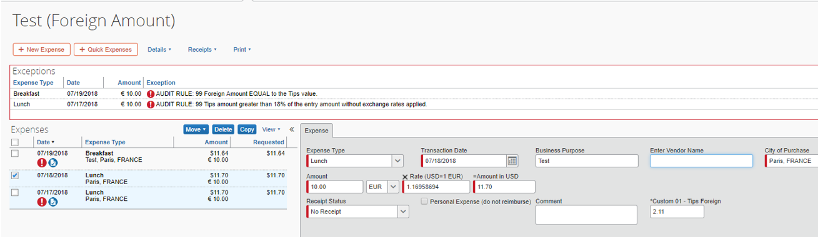

Credit Card VAT data
For clients who use AirPlus, SAP Concur has the ability to import tax rate data using the TaxRate field. If AirPlus data is provided, SAP Concur imports it into the TaxRate field.
This field also supports the importation of tax rate data from any source, as long as the data is provided.
This custom field is automatically available, so there are no additional configuration or activation steps to use it.

Merchant Tax ID
For expense entries where the country is specified as Japan or a city within Japan, an audit rule can be created to validate the value of the Merchant Tax ID with the Japan National Tax Agency (NTA). You can create a rule to determine whether the Merchant Tax ID is valid, invalid, or whether the Merchant Tax ID could not be verified with the Japan NTA (unverified). The system will then allow the expense to be saved, will show an exception as invalid and prevent saving the expense, or generate a system exception requiring a resave of the entry respectively.

Initial Setup of the Expense Entry Form
To use the Merchant Tax ID audit rule feature, the expense entry form must include the following:
- The Merchant Tax ID form field
- AND-
- The country for the expense (that is, Japan)
The Expense entry form must have the Country/Region field so that the user can enter the country value, required for validation.
At this time, the validation of the Merchant Tax ID will only be performed for expense entries where the country is set to Japan or a city within Japan – a future release will create support for other countries.

Rule Setup
An audit rule is configured to test the Merchant Tax ID value in the entry in 3 ways:
- Valid: The Merchant Tax ID is valid, according to the Japan NTA
- Not Valid: The Merchant Tax ID is invalid, according to the Japan NTA
- Unverified: The validity of the Merchant Tax ID could not be validated – this is due to the Japan NTA API being unavailable
The following image shows the configuration of the conditions for an audit rule to determine if the Merchant Tax ID is not valid.
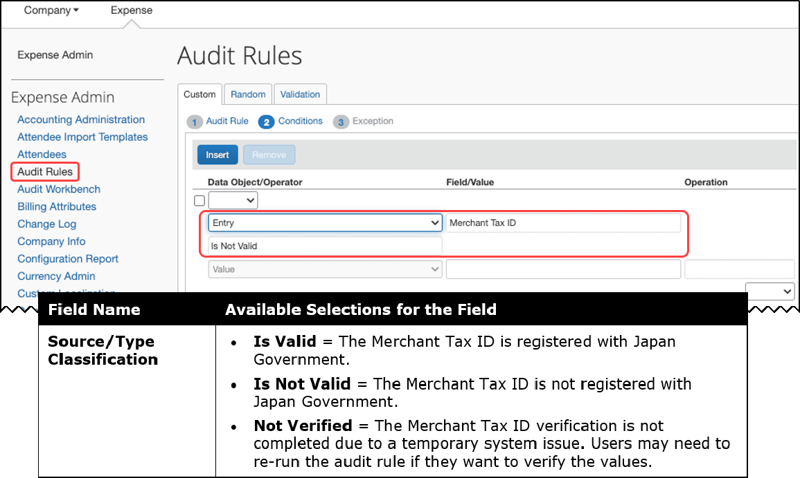
Per this rule, if the Merchant Tax ID is not valid, then an exception will be raised. The exception can be specified on the Exceptions pane. Depending on the level of the exception specified, the user may be blocked from submitting the expense report. The user can change the Merchant Tax ID and save the expense again – this will execute the audit rule again, and validation of the revised Merchant Tax ID will again be performed with the Japan NTA.
If the Japan NTA API is unavailable, then a system exception (MTXUNAV) will be attached to the expense entry. In this case, the user will be directed to open and save the expense to retry the validation.

Disclaimer
This function is based on information fetched from Invoice-kohyo system Web API by Japan National Tax Agency (NTA-API). Japan NTA does not give any guarantee to the results of this function. Since NTA-API is provided by Japan NTA, SAP Concur cannot assure its service time. Users must know that system errors of NTA-API affect the function results.

Leave of Absence
Identify when a user may submit an expense report whose dates coincide with time out of the office which may be approved or not for expense report submission.
Name/Event/Code/Text
Name: Leave of Absence
Event: Report Save / Submit
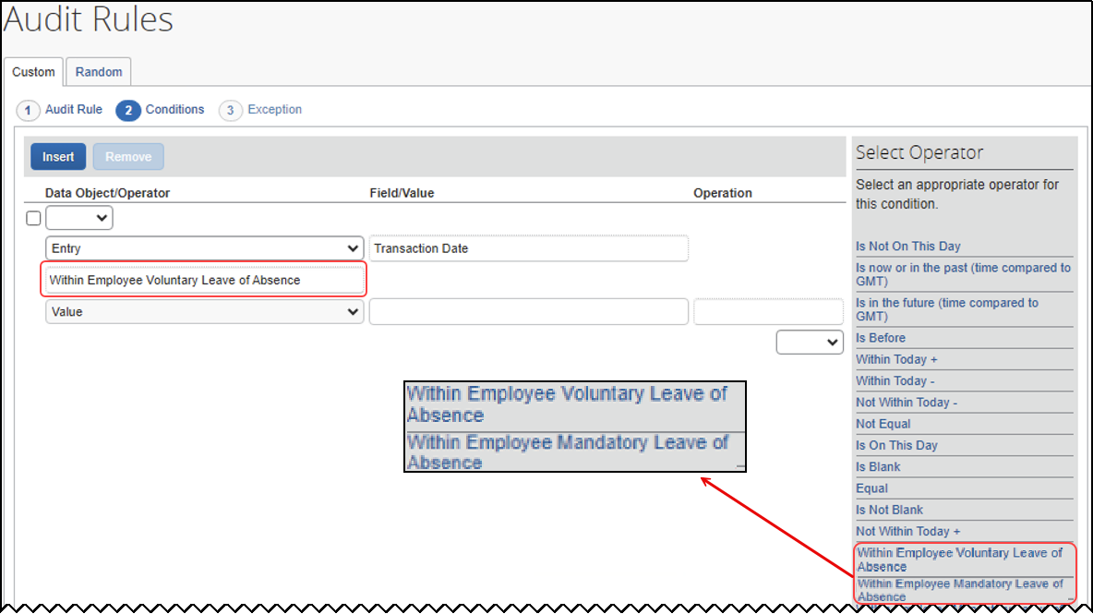

Provided Custom Audit Rules
Several custom audit rules may be provided and may appear as default rules.
Note the following:
- If your system does not include these provided rules, consider evaluating the samples and creating similar rules for your system.
- Use this information as a guideline. The following table describes the provided custom rules as they initially appeared; they may have been edited.
- Before activating any of these rules, view all pages of the rule to ensure that the information is as expected. Make changes as necessary.
For each of the provided audits listed below:
- Editable By is Global
- Applies To is Global
- Active is No

Air Comparison Fare
- Expense Type: Specify Airfare Overlimit; this will ensure an audit rule only applies to an airfare expense type that identifies the over limit itemization.
INCLUDEPICTURE "C:\\Users\\I535968\\AppData\\Local\\Temp\\SNAGHTML1b0e12b5.PNG" \* MERGEFORMATINET INCLUDEPICTURE "C:\\Users\\I535968\\AppData\\Local\\Temp\\SNAGHTML1b0e12b5.PNG" \* MERGEFORMATINET 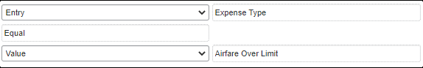
- Personal Expense (do not reimburse): Select No to ensure the rule only regards expenses that are not already marked as personal.
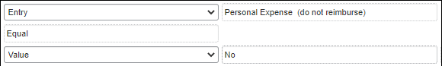
- Parent expenses: Select Transaction Type not equal to Expense with itemization (total) to ensure regular and itemizations are the ones reviewed by the rule.
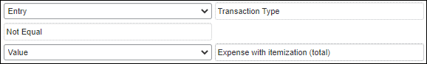
- Expenses with no associated travel reservation
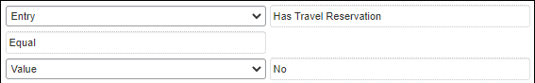
- Example 1: Expenses where Airfare Over limit exceeds a predefined policy amount.
For example, your organization may have a $100 threshold for overlimit airfare expenses. In addition, your organization may build additional conditions for this audit rule based on your policy requirements.
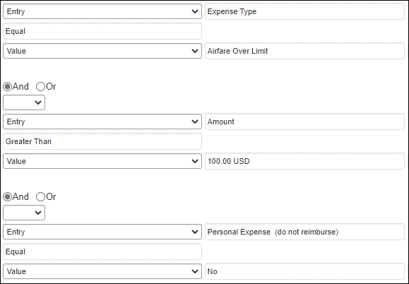

- Example 2: Any airfare expenses with specific reason code
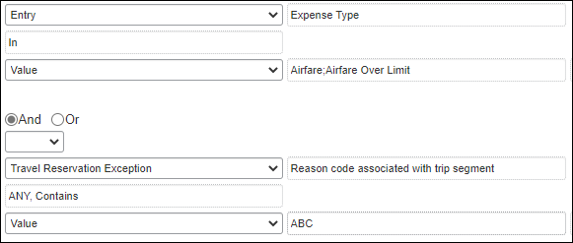
- Example 3: Overlimit amount exceeds 10% tolerance
This type of rule could identify expenses that exceed a certain tolerance to be flagged for audit.
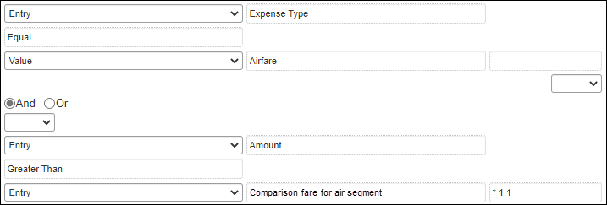
- Example 4: Incorrect expense type or itemization required
This type of Entry Save audit rule could identify airfare expenses that should be itemized by the employee into Airfare and Airfare Overlimit itemizations.
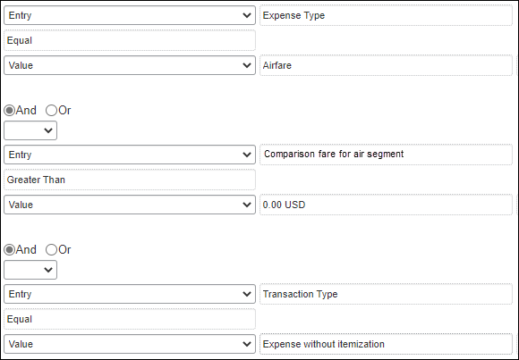

Airfare Limit
Name/Event/Code/Text
Name: Airfare Limit
Event: Entry Save
Exception Code: CESWARN
Exception Text: Manager approval and audit required.
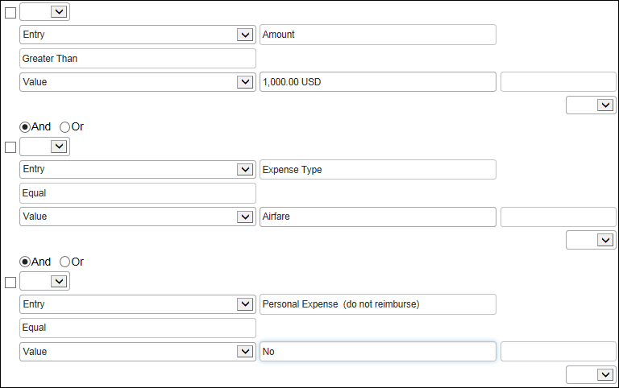

Airfare Payment Method
Name/Event/Code/Text
Name: Airfare Payment Method
Event: Entry Save
Exception Code: CESPAY
Exception Text: The preferred payment method for this expense type is your company credit card.)
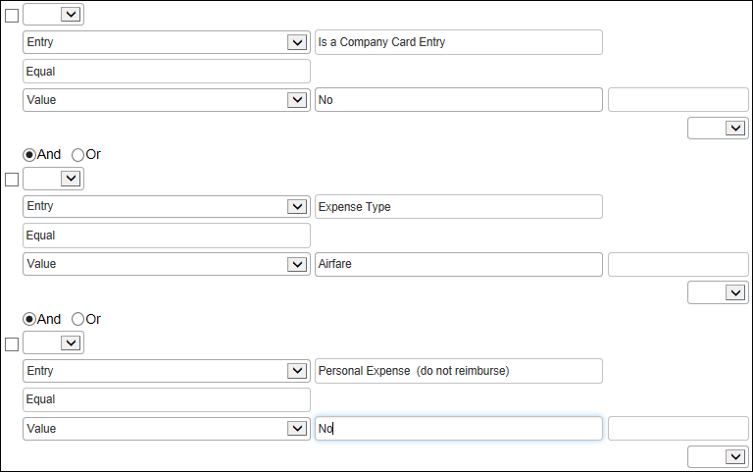

Airfare Preferred Vendor
Name/Event/Code/Text
Name: Airfare Preferred Vendor
Event: Entry Save
Exception Code: CESPREF
Exception Text: This vendor is not a preferred vendor; please provide an explanation for your approver.)
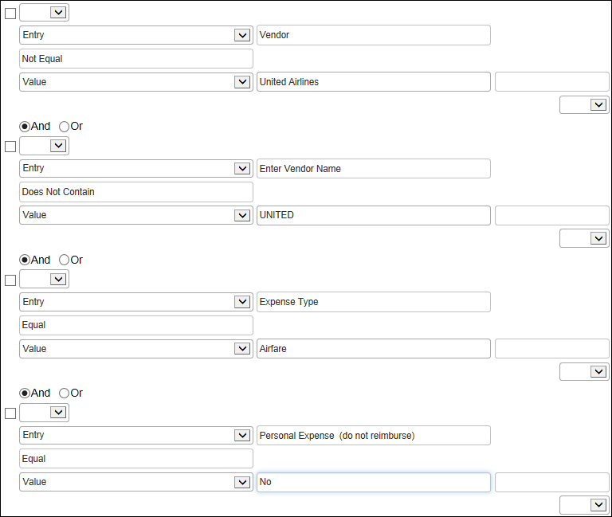

Amount Due Employee
Name/Event/Code/Text
Name: Amount Due Employee
Event: Report Submit
Exception Code: CESWARN
Exception Text: Manager approval and audit required.
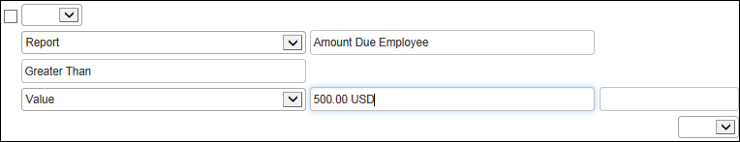

Bank Account Currency Check
Name/Event/Code/Text
Name: Bank Account Currency Check
Event: Report Submit
Exception Code: NOTBACRN
Exception Code: User cannot submit report.
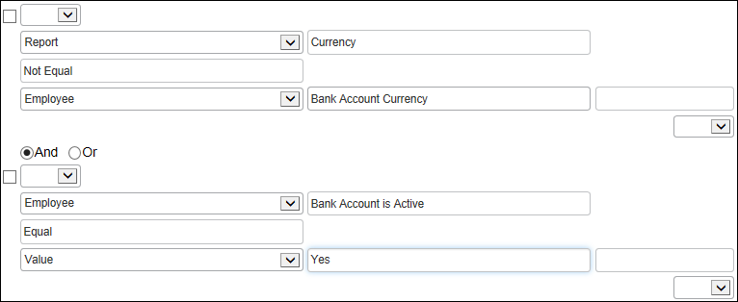

Breakfast Limit
Name/Event/Code/Text
Name: Breakfast Limit
Event: Entry Save
Exception Code: CESINFO
Exception Text: Expense does not conform to corporate travel policy.
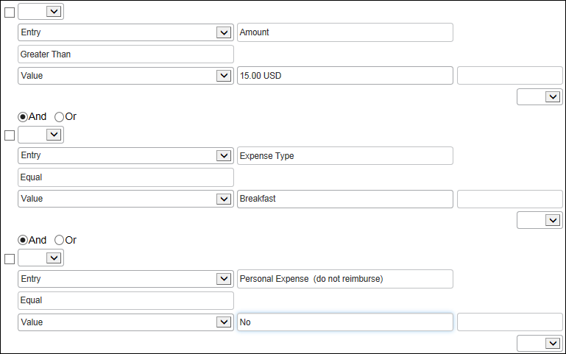

Business Meal Limit
Name/Event/Code/Text
Name: Business Meal Limit
Event: Entry Save
Exception Code: CESWARN
Exception Text: Manager approval and audit required.
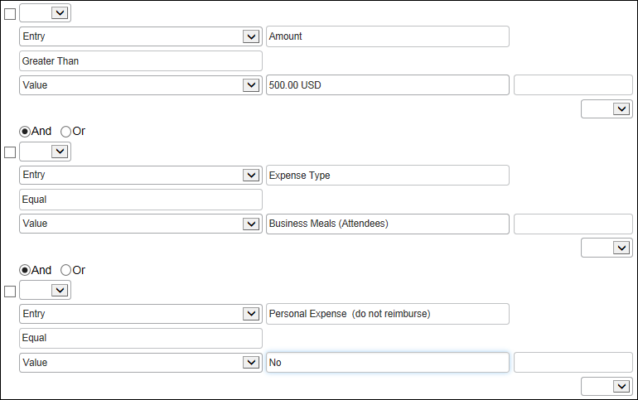

Car Rental Limit
Name/Event/Code/Text
Name: Car Rental Limit
Event: Entry Save
Exception Code: CESWARN
Exception Text: Manager approval and audit required.
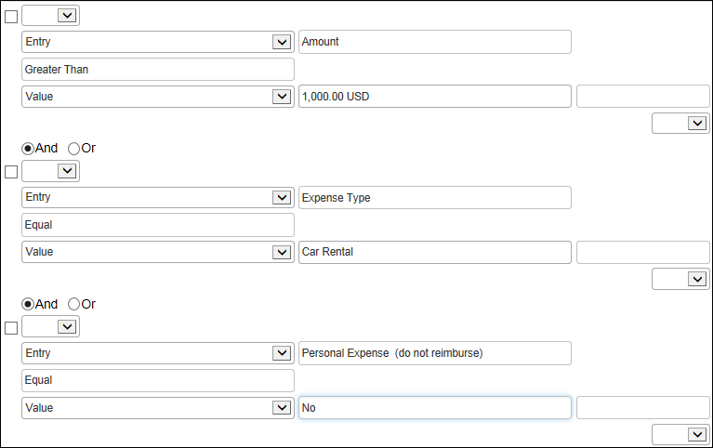

Car Rental Limit
Name/Event/Code/Text
Name: Car Rental Limit
Event: Entry Save
Exception Code: CESWARN
Exception Text: Manager approval and audit required.

Car Rental Payment Method
Name/Event/Code/Text
Name: Car Rental Payment Method
Event: Entry Save
Exception Code: CESPAY
Exception Text: The preferred payment method for this expense type is your company credit card.)
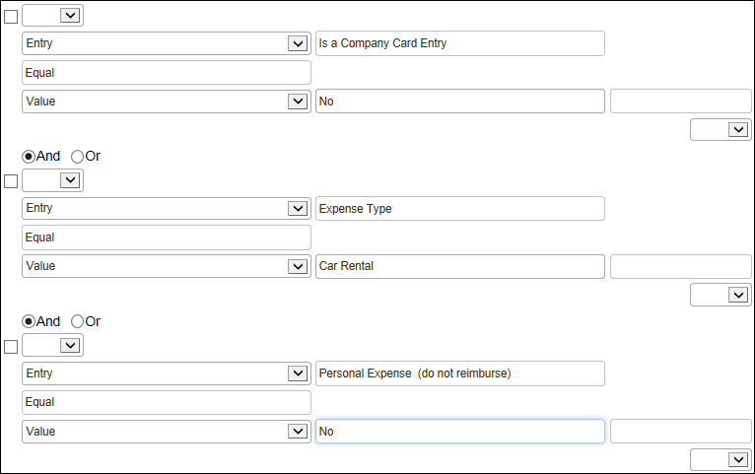

Car Rental Preferred Vendor
Name/Event/Code/Text
Name: Car Rental Preferred Vendor
Event: Entry Save
Exception Code: CESPREF
Exception Text: This vendor is not a preferred vendor; please provide an explanation for your approver.
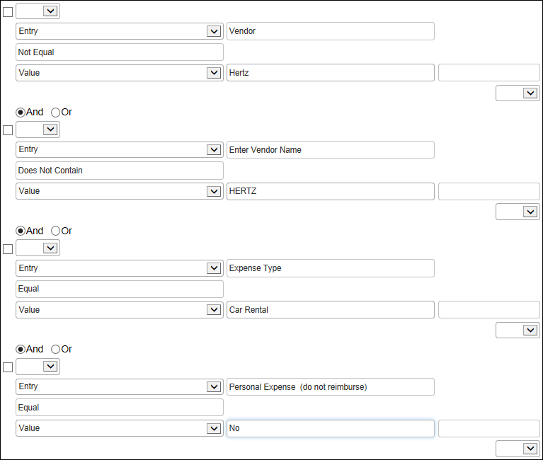

Dinner Limit
Name/Event/Code/Text
Name: Dinner Limit
Event: Entry Save
Exception Code: CESINFO
Exception Text: Expense does not conform to corporate travel policy.
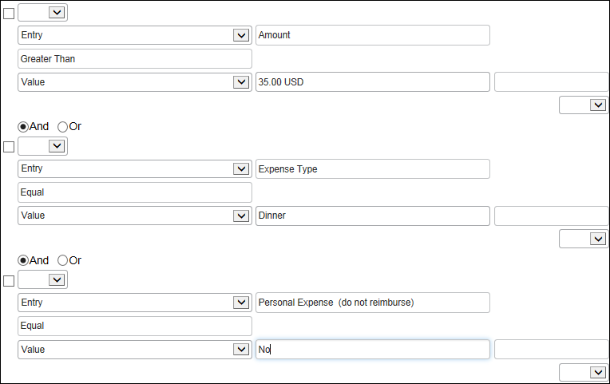

Duplicate Ticket Number
Name/Event/Code/Text
Name: Duplicate Ticket Number
Event: Entry Submit
Exception Code: TICKDUPL (
Exception Text: Another expense has been submitted with the identical air ticket number.
Report: <reportID> <report name> Expense: <transaction date>, <expense type>, <expense amount + ISO currency>.
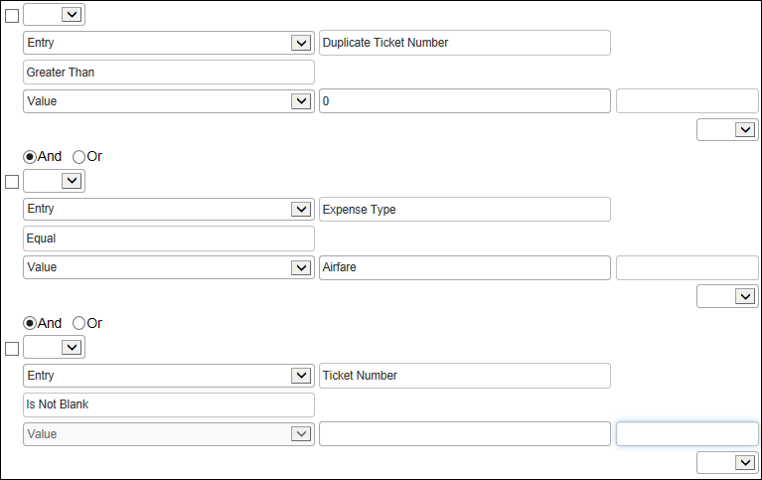

Duplicate Transaction Check
Name/Event/Code/Text
Name: Duplicate Transaction Check
Event: Entry Submit
Exception Code: DUPLICAT
Exception Text: Warning: This expense entry may be a duplicate. %lines%)
Where %lines% is a list of possible duplicate report/report entry details
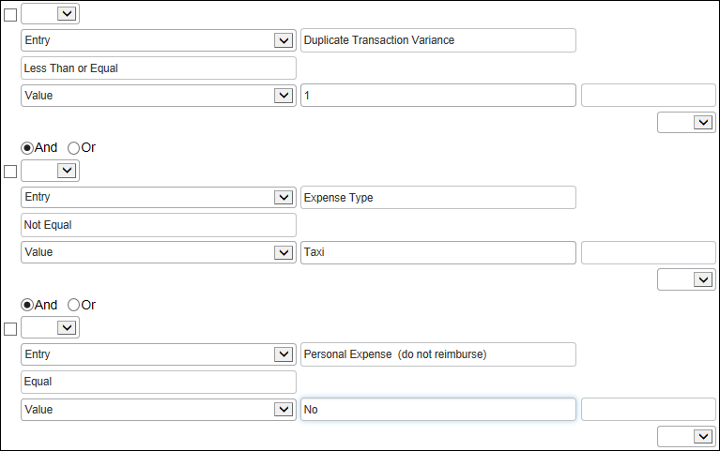
The Duplicate Transaction Variance should always employ the Less Than or Less Than or Equal operator. It is intended to find expenses within the defined variance for the amount, including the application of exchange rates for comparisons of amounts in differing currencies.
The Equal operator should never be used with this condition.

Electronic Receipt with no corporate card transaction check
Name/Event/Code/Text
Name: Electronic Receipt with no corporate card transaction check
Event: Entry Save
Exception Code: RCTNOCRD
Exception Text: Warning: You have an expense that has an e-receipt but does not have corresponding corporate card transaction. Please wait for card transaction to be available before you submit this report)
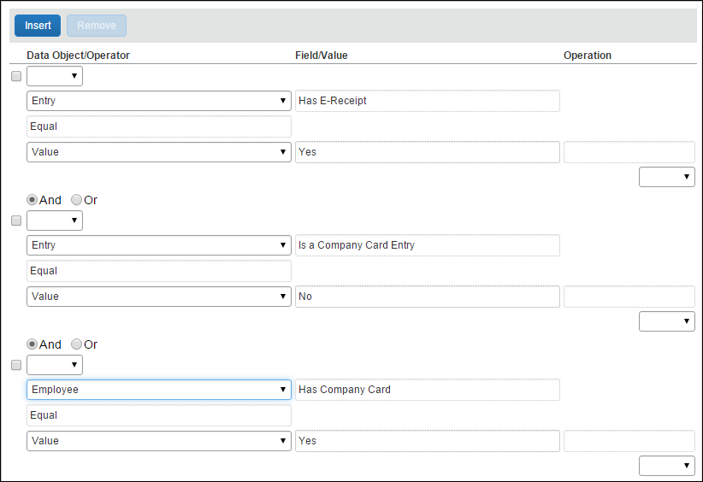

Entertainment-Other Limit
Name/Event/Code/Text
Name: Entertainment-Other Limit
Event: Entry Save
Exception Code: CESBUS
Exception Text: The expense amount exceeds $75.00 per attendee.
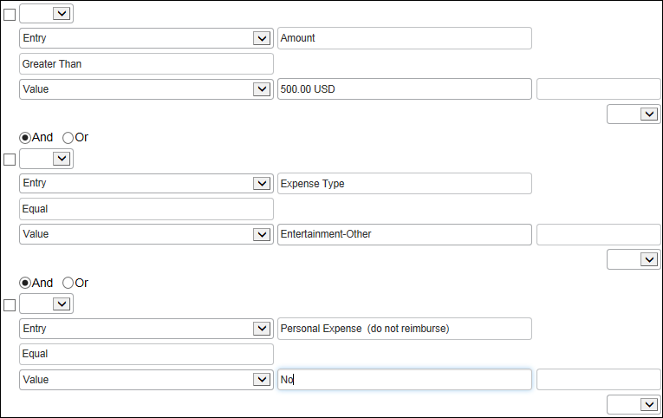

Expense Limit Check
Name/Event/Code/Text
Name: Expense Limit Check
Event: Entry Submit
Exception Code: CESLIMIT
Exception Text: Amount for the Lunch expense type has exceeded the weekly limit.
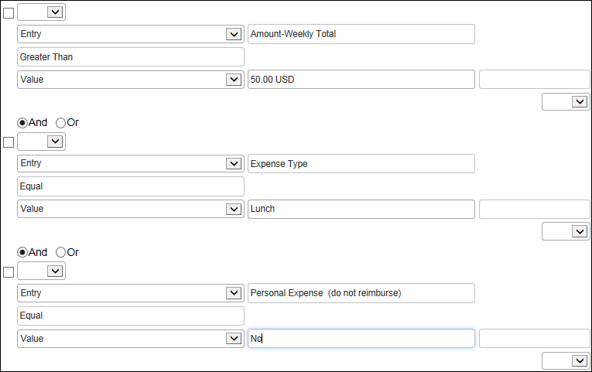

Expenses on week end days
Name/Event/Code/Text
Name: Expenses on week end days
Event: Entry Save
Exception Code: EXPWE
Exception Text: The expense occurs during a week-end.
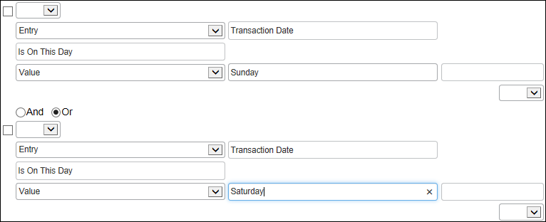

Hotel Itemization Required
Name/Event/Code/Text
Name: Hotel Itemization Required
Event: Entry Save
Exception Code: CESITMIZ (This entry must be itemized before the report can be submitted.)
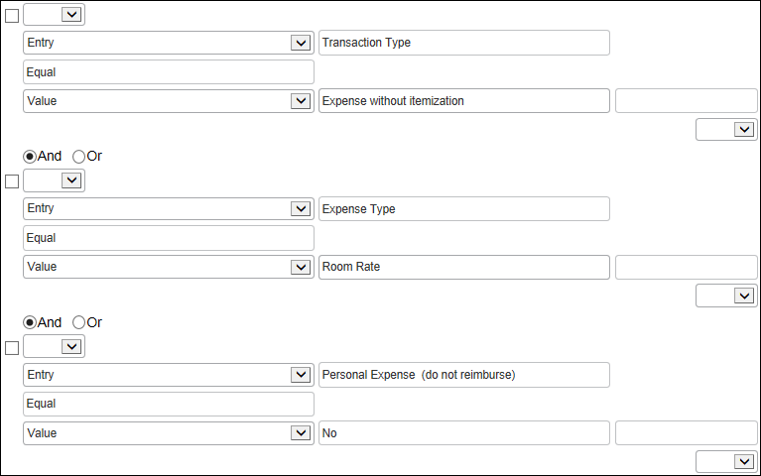

Lodging Payment Method
Name/Event/Code/Text
Name: Lodging Payment Method
Event: Entry Submit
Exception Code: CESPAY
Exception Text: The preferred payment method for this expense type is your company credit card.
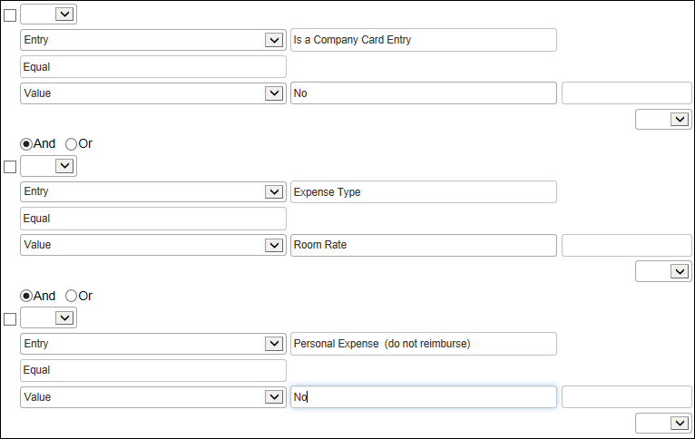

Lunch Limit
Name/Event/Code/Text
Name: Lunch Limit
Event: Entry Save
Exception Code: CESINFO
Exception Text: Expense does not conform to corporate travel policy.
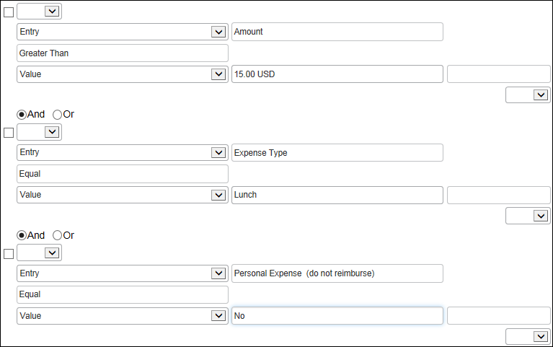

Office Supplies Limit
Name/Event/Code/Text
Name: Office Supplies Limit
Event: Entry Save
Exception Code: CESINFO
Exception Text: Expense does not conform to corporate travel policy.
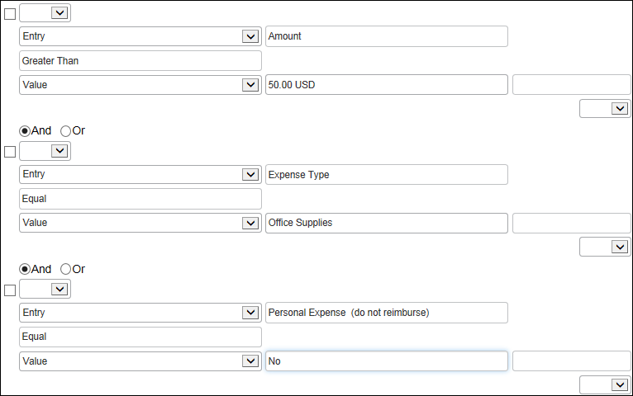

Parking Limit
Name/Event/Code/Text
Name: Parking Limit
Event: Entry Save
Exception Code: CESINFO
Exception Text: Expense does not conform to corporate travel policy.
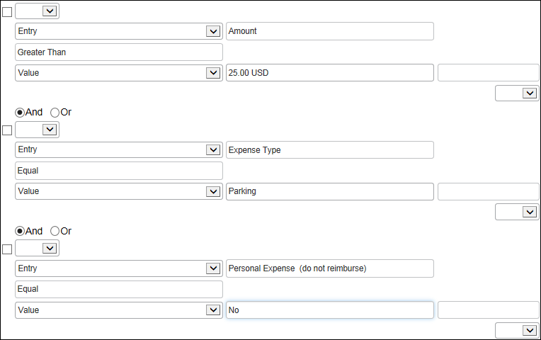

Personal Use of Corp Card
Name/Event/Code/Text
Name: Personal Use of Corp Card
Event: Entry Submit
Exception Code: CESINFO
Exception Text: Expense does not conform to corporate travel policy.)
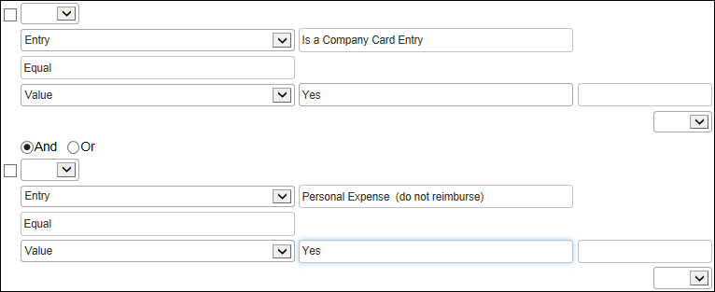

Report Total
Name/Event/Code/Text
Name: Report Total
Event: Report Submit
Exception Code: CESWARN
Exception Code: Manager approval and audit required.
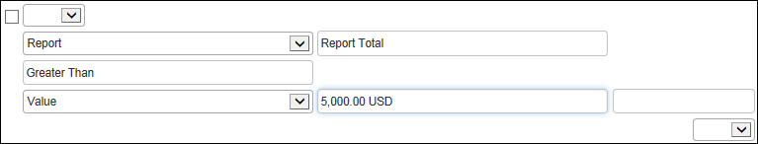

Taxi Limit
Name/Event/Code/Text
Name: Taxi Limit
Event: Entry Save
Exception Code: CESINFO
Exception Code: Expense does not conform to corporate travel policy.
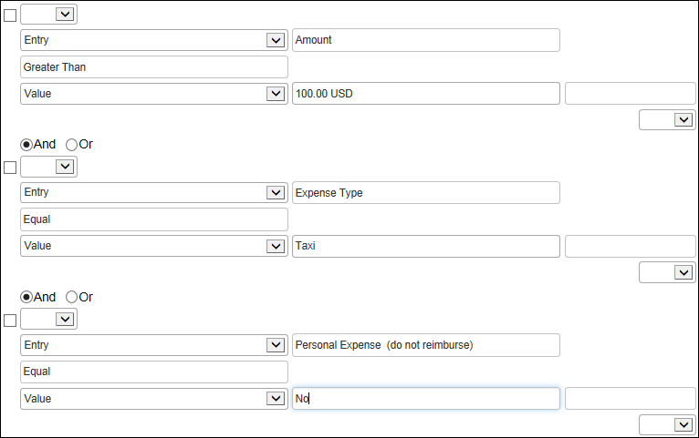

Ticket Number Mismatch
Name/Event/Code/Text
Name: Ticket Number Mismatch
Event: Entry Save
Exception Code: TICKMISM (The ticket number for this expense is different than the ticket number on the associated record: %tickets%)
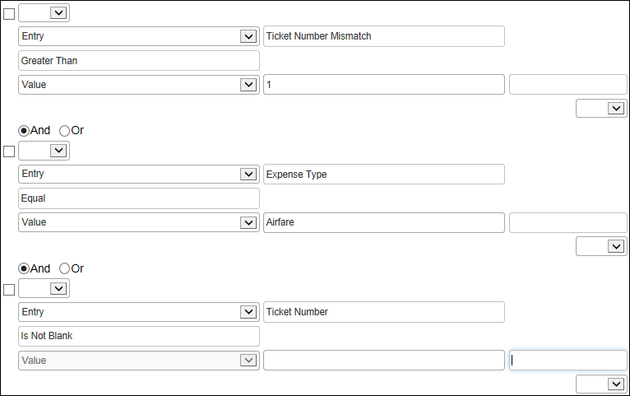

Travel Ticket Number Mismatch
Name/Event/Code/Text
Name: Travel Ticket Number Mismatch
Event: Entry Save
Exception Code: TICKMISM
Exception Text: The ticket number for this expense is different than the ticket number on the associated record: %tickets%.

The Ticket Number field data is truncated from 14 to 13 characters to conform to the default number total and ensure the audit rule triggers based on the data and not on a mismatch of total number of characters.

Travel Forced Match: E-Receipt, Travel, and Card Data
Name/Event/Code/Text
Name: Travel Forced Match: E-Receipt, Travel, and Card Data
Event: Entry Save
Exception Code: FORMATCH
Exception Text: You have an e-receipt or travel data, but no matching credit card transaction. Please wait until your credit card transaction imports into Concur Expense to add this e-receipt.
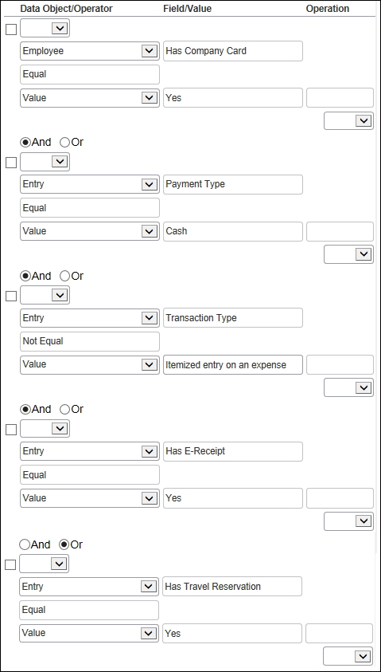

Travel Payment Type
Name/Event/Code/Text
Name: Travel Payment Type
Event: Entry Save
Exception Code: TRVPYMT
Exception Text: Air, rental car, and hotel reservations made through Travel should be charged to a company card.
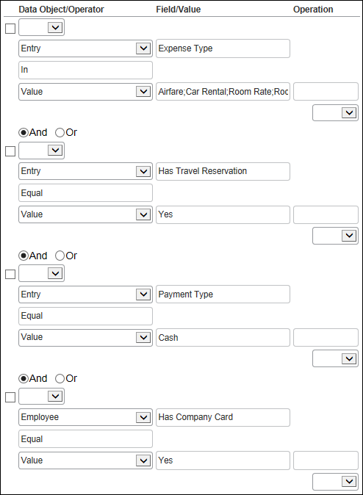

Travel No Matching Reservation
Name/Event/Code/Text
Name: Travel No Matching Reservation
Event: Entry Save
Exception Code: NOMATCH
Exception Text: This expense has no matching travel reservation. Please import trips and apply the booking or use the expense report comments to explain why there was no reservation made for this expense.
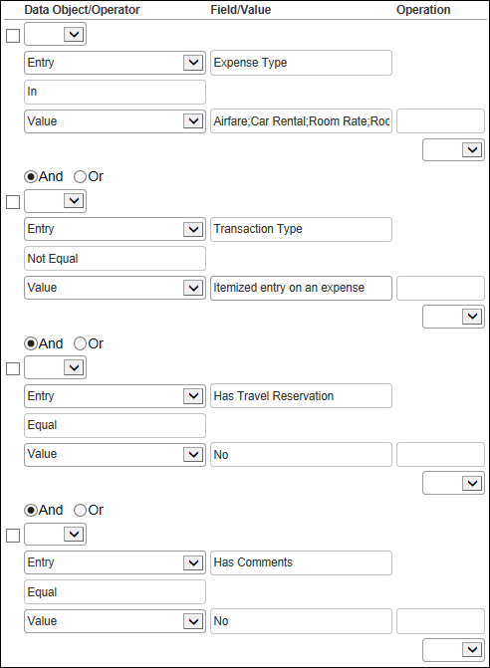

Travel No Matching Reservation (Approver/Processor Only)
Name/Event/Code/Text
Name: Travel No Matching Reservation (Approver/Processor Only)
Event: Entry Save
Visibility: Approver and Processor Only
Exception Code: CMNTTRVL
Exception Text: This expense has no matching travel reservation. Please ensure that the comment adequately explains why the expense was not booked using Concur Travel.
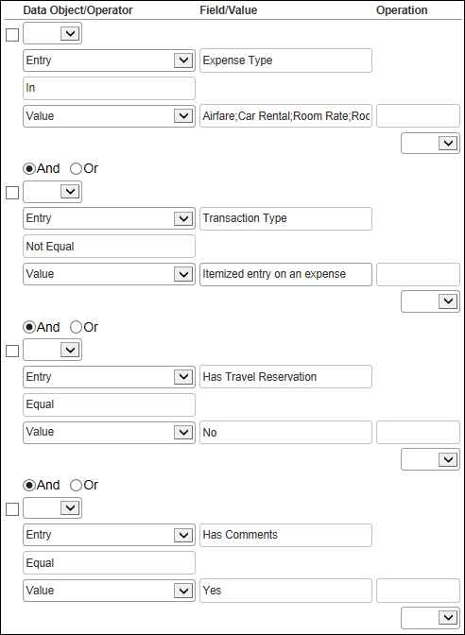

Travel Actual vs Booked, Airfare
Name/Event/Code/Text
Name: Travel Actual vs Booked, Airfare
Event: Entry Submit
Exception Code: AVSBCOST
Exception Text: The expense is greater than the estimated expense in the travel reservation.
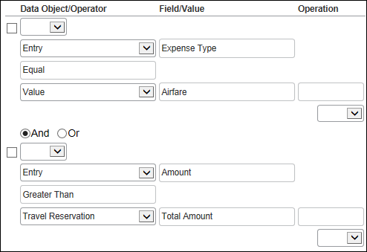

Travel Actual vs Booked, Car Rental
Name/Event/Code/Text
Name: Travel Actual vs Booked, Car Rental
Event: Entry Submit
Exception Code: AVSBCOST
Exception Text: The expense is greater than the estimated expense in the travel reservation.
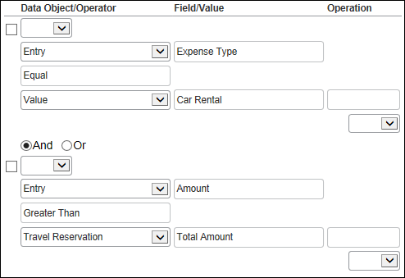

Travel Actual vs Booked, Car Rental Per Day
Name/Event/Code/Text
Name: Travel Actual vs Booked, Car Rental Per Day
Event: Entry Submit
Exception Code: AVSBPERD
Exception Text: The per-day expense is greater than the estimated per-day expense in the travel reservation.
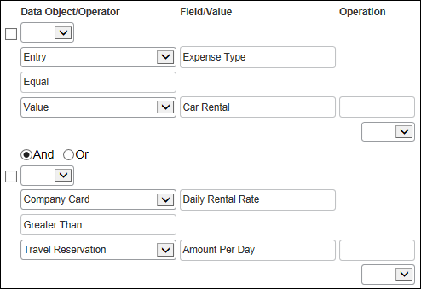

Travel Actual vs Booked, Room Rate Per Day
Name/Event/Code/Text
Name: Travel Actual vs Booked, Room Rate Per Day
Event: Entry Submit
Exception Code: AVSBPERD
Exception Text: The per-day expense is greater than the estimated per-day expense in the travel reservation.
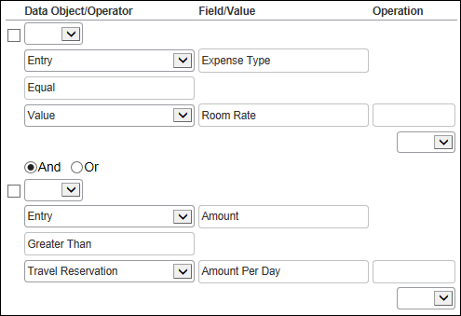

The following table describes the two rules used by companies that track value added tax.
For each of the provided audits listed below:
- Editable By is Global
- Applies To is Global
- Active is Yes

Vat Currency Consistency Check
Name/Event/Code/Text
Name: Vat Currency Consistency Check
Event: Entry Save
Exception Code: VATCRN
Exception Text: The currency used is not the expected currency for this location.
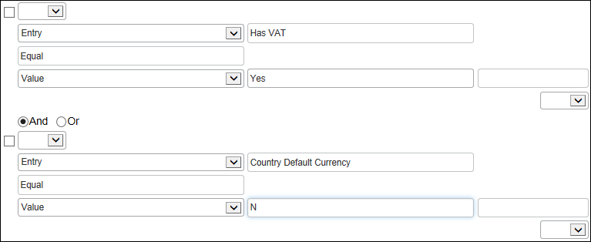

Vat Receipt Required Check
Name/Event/Code/Text
Name: Vat Receipt Required Check
Event: Entry Save
Exception Code: VATRCPT
Exception Text: A receipt is required for this expense and the receipt status is 'No Receipt Available.'
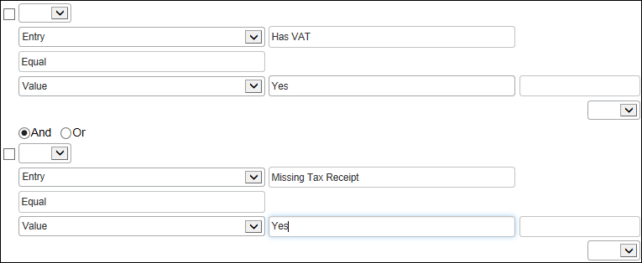

Random Audit Rules
Random audit rules allow for the auditing of selected submitted expense reports either by:
- Sequential: The sequential audit is based on some number of reports that users submit (for example, 10 reports). Then, every 10th expense report submitted by the selected group or groups is audited. (The maximum is 999,999.)
- Percentage: The percentage audit is based on the chance of a report being audited (for example 10%). That is, each report submitted by the selected group or groups has a 10% chance of being audited. (The maximum is 100%.)
The percentage-based random audit rule is based on averages. In the long term, the desired percent of the reports will be audited. In the short term, the exact percentage of reports audited may be slightly more or less.
- IMPORTANT: Your company should have only one active random audit rule for each group configuration. SAP Concur may let you activate more than one random rule but the results will be unreliable. Best practice is to have only one active random audit rule for each group configuration.

General Concepts

General Concepts

Groups and the Random Audit Rule
Assume a sequential random audit rule applies only to Group 1, then every 10th report submitted from members of Group 1 will be audited. Assume the rule applies to Group 1, 2, and 3, then for auditing purposes the groups are combined so every 10th report submitted from members of Group 1, 2, or 3 will be audited. That is, it is not the 10th report from Group 1, the 10th report from Group 2, and the 10th report from Group 3; it is the 10th report from the collective group.
A percentage-based random audit rule works essentially the same way.
- For information about statement reports and random audit rules, refer to the Concur Expense: Company Bill Statement Reports Setup Guide.

Events (Triggers)
When creating or editing a random audit rule, you must specify the event that triggers the rule, for example:
- Report Submit: The rule is triggered immediately when the report is submitted, prior to entrance to the workflow. As the report may be blocked from submission by various rules, the information is re-evaluated upon entrance to the workflow to ensure that the report is regarded with respect to the random audit rule frequency configuration.
- Post Report Submit: The rule is triggered when the report enters the workflow.

Visibility
When creating or editing a random audit rule, you must define who sees the exception text:
- Traveler (user), Approver, and Expense Processor: The user, approver, and Expense processor see the exception text.
- Approver and Expense Processor: The user does not see the exception text and, hence, does not know the report will be audited.
- Expense Processor: The user and approver do not see the exception text and, hence, do not know the report will be audited.
The exception text appears along with:
- A yellow icon since the exception does not prevent submission of the expense report
- A blue icon if the Concur Expense processor has cleared the exception

Exceptions
When creating or editing the random audit rule, you must assign an exception. All exceptions contain the following:
- Exception code: This is the company-defined code for the exception, up to eight alphanumeric characters, all uppercase.
- Exception level: The company decides how many exception levels (up to 99) to use. For example, assume the company decides to have six exception levels, with level 1 being a minor exception and level 6 being a severe exception.
The company also decides the point at which the severity of the exception prevents the user from submitting the expense report. For example, assume the system does not allow the user to submit an expense report if it contains a level 6 exception.
Though the administrator can define custom audit rules to prevent submission, the administrator cannot define random audit rules for this effect. The administrator selects an exception with an exception level that does not prevent submission.
- Exception message: This is the actual message that appears, such as "This report has been selected for Random Audit."
- Refer to the appendix in this guide for a list of the default exception codes and how they affect reporting by exception code.

Summary – The Basic Process of Creating Random Audit Rules
To summarize, when creating the random audit rule, you will:
- Name the rule
- Define the type of audit:
- Percentage
- Sequential
- Identify the event that triggers the rule:
- Report Submit
- Post Report Submit
- Define who sees the exception text:
- Traveler (user), Approver, and Concur Expense Processor
- Approver and Concur Expense Processor
- Concur Expense Processor
- Select (or create) the appropriate exception, which includes:
- Exception code
- Exception level
- Exception text
- Identify the administrator (of the group configuration) who can edit the rule
- Identify the group configuration to which the rule applies
- Activate the rule

Procedures: Random Audit Rule

Accessing Random Audit
To access Random Audit:
- Click Administration > Expense.
- Click Audit Rules (left menu). The Custom tab appears.
- Click the Random tab.
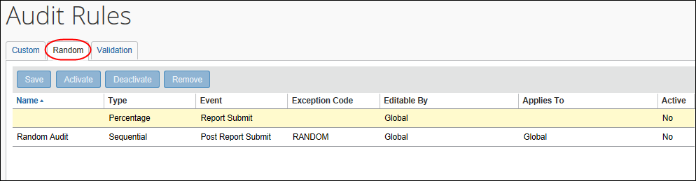

Adding a Random Audit Rule
To add a random audit rule:
- Use the first line (yellow background) in the grid to add a new rule. Click in the Name field, then enter the rule name.
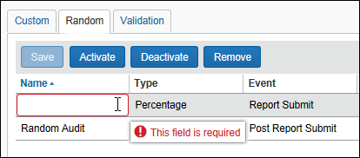
- Click the Type field. The Rule Type window appears.
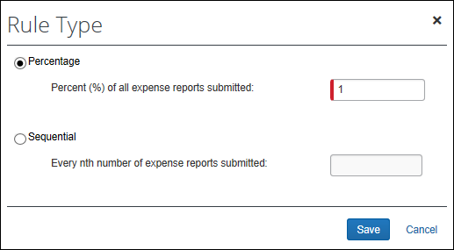
- Select either:
- Percentage and then enter the appropriate percentage
- Sequential and then enter the appropriate number
- Click Save.
- In the Event field, select either:
- Report Submit
- Post Report Submit
- Click the Exception Code field. The Exceptions window appears.
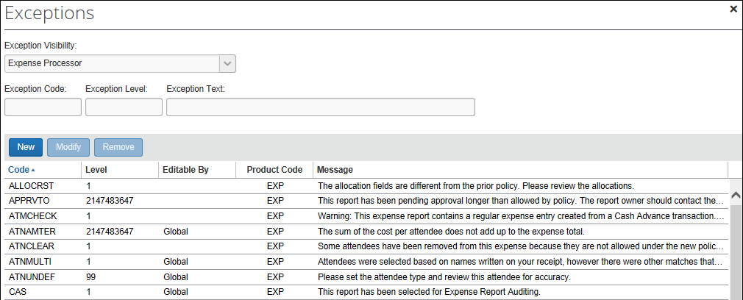
- From the Exception Visibility list, select the users who are able to see the exception message by selecting:
- Traveler (user), Approver, and Concur Expense Processor
- Approver and Concur Expense Processor
- Concur Expense Processor
- Using the exceptions list, you can:
- Use an existing exception.
- Create a new exception.
- Refer to the exception information in Adding a Custom Audit Rule in this guide.
- In the Editable By field, select the group configuration(s) that can edit this rule.
- In the Applies To field, select the appropriate group configuration(s) to which this rule applies.
- Click Save.
- With the rule selected, click Activate.
- IMPORTANT: Your company should have only one active random audit rule for each group configuration. SAP Concur may let you activate more than one random rule but the results will be unreliable. Best practice is to have only one active random audit rule for each group configuration.

Editing a Random Audit Rule
- For detailed information about all of the fields, refer to Adding a Random Audit Rule in this guide.
To edit a random audit rule:
- In the Name field, change the name as desired.
- Click the Type field. The Rule Type window appears.
- Make the desired changes.
- Click Save.
- For the remaining fields, make the desired changes.
- Click Save.

Deactivating / Activating a Random Audit Rule
Activate a rule when you are ready to use it.
Instead of removing a rule, you can deactivate it. This way, the rule is still available if you want to use it in the future.
To deactivate / activate a random audit rule:
- On the Random tab, select the desired rule.
- Click Deactivate or Activate, whichever applies.

Removing a Random Audit Rule
Once you have removed a rule, it will be permanently deleted from the system. If you think you might want to use it again, deactivate it instead of removing it.
To remove a random audit rule:
- On the Random tab, select the rule you want to remove.
- Click Remove.

Appendix – Default Exception Codes
The exception codes that are provided by Concur Expense do not increase a user's exception level totals. That is, any audit rules – custom or random – are ignored in the exception level count if they use the following exception codes:
ALCCPYDN  ALLOCRST  APPRVTO  ATMCHECK  ATNAMTER  ATNCLEAR  ATNMDUP  ATNMULTI  ATNUNDEF  AUDTFAIL  AUDTPWX  AUDTPXR  BADARHDR  BADHEADR  BOW | CAS  CASAAF  CASAFB  CONOAPPR  COW  DUPCHECK  EXPTYER1  EXPTYER2  EXPWE  EXRATEOV  INVEXPTY  INVXMLST  NOACCODE  NOACODNB  NOAPPR | NODATE  NOEXRATE  NOITIN  NORLEXRT  NOTBACRN  NOTRAPPR  NOTREXRT  PENDCARD  POSTFAIL  PREPAY01  PREPAY02  PREPAY03  PREPAY04  PREPOP  PYRLFAIL | REDRFUND  RULEFAIL  SELFAPPR  SYSCRTOF  TADATE  TADBLDIP  TICKDUPL  UNDEFEXP  UNMCCACT  UNMEXPER  UNMEXPES  UNMSTMTP  UNMSTMTR

☼

