

Concur Expense: Verify

User Guide

4

Applies to these SAP Concur solutions:

⮽ Expense  
⮽ Professional/Premium edition  
⮽ Standard edition

□ Travel   
□ Professional/Premium edition   
□ Standard edition

□ Invoice  
□ Professional/Premium edition   
□ Standard edition

□ Request  
□ Professional/Premium edition  
□ Standard edition

Contents

Verify User Guide 1

Section 1: Permissions 1

Section 2: Overview 1

Feature Benefits 2

Section 3: Library of Audit Checks 2

Examples of Receipt-Related Checks 9

Incorrect Amount 9

Incorrect Date 10

No Itemized Receipt 10

Incorrect Expense Type 12

Traveler Name 12

Examples of Policy-Related Checks 12

Air Class 12

Additional Air Charges 13

Alcohol 14

Rental Car Class 14

Additional Car Charges 15

Car Wash 16

Excessive Tip 17

Gift Cards 17

Additional Hotel Charges 17

Late Charges 19

Family and Home Care 19

Traffic or Parking Violations 19

Travel Insurance 20

Evaluation of an Expense Report 20

Section 4: Auditor Experience 20

Reports Pending Audit Review 20

Section 5: Configuration 28

Verify Roles 29

Audit Profile 30

Access 30

Groups 30

Assigned Auditors 32

Add New Profile 33

Edit Profile 37

Copy Profile 38

Manage Merchant Categories 38

Language Support 39

Section 6: Known Issues / Limitations 40

Revision History

| Date | | Revision Notes/Comments |
| --- | --- | --- |
| January 17, 2024 | Added information about Bulk Approve in *Section 4: Auditor Experience.* | |
| December 8, 2023 | Made multiple updates in the guide:   * Updated image in *Audit Profile* under *Section 5: Configuration* * Updated *Section 4: Auditor Experience* for auto-assign, last modified, and auditor note features. | |
| October 6, 2023 | Removed *Anomaly and Fraud Events* topic from *Section 4: Auditor Experience*. Made changes throughout the guide to remove all instances of **Anomaly and Fraud** events. Updated description for *Duplicate Receipt* check. Updated *Section 4: Auditor Experience* information about sorting expenses and updated steps under *Add New Profile*, under *Audit Profile* section. | |
| September 14, 2023 | Updated information about Auditor Responses such as Pass – Approve with Exception option in *Section 4: Auditor Experience > Reporting Pending Audit Review.* Also updated steps under *Add New Profile*, under *Audit Profile* section. | |
| August 3, 2023 | Date for deprecation of Out of workflow checks moved from July 31st, 2023, to August 3rd, 2023. | |
| June 22, 2023 | Updated four new Policy related checks and renamed two checks in *Section 3: Library of Audit Checks* | |
| March 15, 2023 | Updated notes in several places for *Anomaly and Fraud Events* page and *Out of workflow checks* removal. Updated *Library of Audit Checks* section with six checks that were previously part of *Anomaly and Fraud Events* section. Updated *Reports Pending Audit Review* in *Auditor Experience* section with auditor response details. | |
| December 14, 2022 | Updated instructions for reverting to default expense type selections in *Add New Profile* in the *Configuration* section. | |
| November 28, 2022 | Updated *Reports Pending Audit Review* in *Auditor Experience* section with viewing receipts. | |
| November 14, 2022 | Updated *Reports Pending Audit Review* in *Auditor Experience* section with travel itinerary details. | |
| October 18, 2022 | Updated descriptions under *Library of Audit Checks* and added new screenshots under *Reports Pending Audit Review* topic | |
| September 6, 2022 | Updated definition for Assignee under *Auditor Experience* section | |
| August 18, 2022 | Updated *Reports Pending Audit Review* in *Auditor Experience* section | |
| July 11, 2022 | Updated labels for these anomaly and fraud checks:   * Fake Receipt: now called Online Generated Receipt * Suspicious Meal: now called Duplicate Meal Claim   Added Rail Check to *Library of Audit Checks* section | |
| July 4, 2022 | Updated instructions for selecting a single expense report in the *What the Auditor Sees* section | |
| June 7, 2022 | Updated *Library of Audit Checks* section with three non-compliant checks | |
| April 11, 2022 | Updated *Configuration* section note on threshold condition | |
| February 7, 2022 | Updated *Resubmit* label to *Resubmitted* throughout | |
| January 24, 2022 | Updated instructions in *Reports Pending Audit Review* topic of the *What the User Sees* section | |
| December 10, 2021 | Replaced Audit Reports, Reports to Audit, Audit Events, and Events to Audit labels | |
| November 29, 2021 | Updated *Assigned Auditors* topic in the *Audit Profile* area of the *Configuration* section | |
| October 21, 2021 | Updated *Permissions* section with hyperlink to Reports document | |
| October 4, 2021 | Updated *Library of Audit Checks* and *Configuration* sections | |
| September 2, 2021 | Updated *Edit Profile* topic in the *Configuration* section | |
| August 23, 2021 | Updated user interface labels throughout | |
| August 9, 2021 | Updated Suspicious Meal check description | |
| July 26, 2021 | Updated information on Unreasonable Amount event page | |
| July 22, 2021 | Initial GA publication | |

## 

# Verify User Guide

## Permissions

A company administrator may or may not have the correct permissions to use this feature. The administrator may have limited permissions, for example, they can affect only certain groups and/or use only certain options (*view* but not *create* or *edit*).

If a company administrator needs to use this feature and does not have the proper permissions, they should contact the company's SAP Concur administrator.

The administrator should be aware that some of the tasks described in this guide can be completed only by SAP Concur. In this case, the client must initiate a service request with SAP Concur support.

1. Verify is an extension to Concur Expense. It does not include Concur Invoice or Company Bill Statements.

For information on the roles required to work with Verify as an administrator or auditor, please refer to the *Shared: User Administration User Guide*.

For information about Audit Service Reports, refer to the [*Standard Reports by Folder for Analysis / Intelligence*](http://www.concurtraining.com/customers/tech_pubs/Docs/Cognos/DefaultRpts/Catalog.pdf) document.

For more visibility and insights, use the pre-built reports available for Audit.

If your company has Analysis, use the **Analysis - Standard Reports** link to access your standard reports.

If your company uses Intelligence, use the **Intelligence - Standard Reports** link to access your standard reports.

When you select the appropriate link, the list of folders appears, including Audit. Actual audit reports are listed under the **Audit** folder. For the report views of these reports, use the **Verify** subfolder.

## Overview

The Verify extended audit service allows a company to obtain a much more thorough, accurate view into its spending, risk, and compliance. This provides the opportunity for better oversight and management of a company’s entire travel and expense policy.

A major component of Verify is Artificial Intelligence, specifically Machine Learning. In the machine learning process, computers are presented with large amounts of related data. As the machine "learns" to recognize data and patterns, it also learns to make data-driven decisions and predictions. In this case, Verify has reviewed and evaluated millions of receipts, and has developed the ability to recognize – on the receipt – the amount, date, type of expense, etc. As with all machine learning tools, the machines continue to learn over time, which increases accuracy.

In addition, the processing speed of machines makes Verify capable of reviewing and analyzing 100% of a company's expense reports. In "human" auditing processes, in most cases, only a percentage of expense reports are reviewed and evaluated. This volume of reviewed expenses provides the most precise view of spend, violations, gaps, and areas of improvement. Verify can also perform tasks that are not feasible in manual audits, such as looking for duplicates across different reports.

Using the data provided by Verify, companies can see common travel and expense policy gaps and trends and then strengthen its policies to reduce risk and overall cost.

### Feature Benefits

Key features for Verify include the self-service audit user interface, client-specific configuration, and an extensive library of detection scenarios.

The Verify screen is designed to help the auditor focus on exceptions found by the backend intelligence. Receipt and Policy exceptions are handled as part of the expense workflow process allowing auditors to catch issues prior to employee reimbursement.

Verify audit checks can be configured for expansive or granular levels, using multiple conditions such as amount, expense type, and more. Checks include receipt validation and policy scenarios, all of which are pre-built, utilizing machine learning.

## Library of Audit Checks

This list is subject to change based on testing and performance. Other constraints such as line level expenses, region, and language (for example, US-English), or other country limitations may apply. It is important when activating these checks to only assign expense types relevant to the check (for example: Air Class check – Airfare expense types). Non-relevant expense types will cause an increase in false positives.

1. In edge cases, minor differences in exchange rates may affect the exceptions raised.

The following table includes the currently available checks and a description of when they will raise exceptions:

| Category | Checks | Raises Exception or |
| --- | --- | --- |
| Receipt (exceptions are shown on the **Reports Pending Audit Review** screen) | Duplicate Receipt | Verify reviews the receipt and compares it to other submitted receipts. If a receipt appears to have been used before by the same or different employee, Verify raises an exception. Receipts used more than once on the same expense report will not cause an exception. |
| Illegible Receipt | If Verify is unable to clearly analyze the receipt, it raises an exception. Verify primarily looks for the date and amount to determine if the receipt is legible. Some images may be readable by a person but largely unreadable by the system.  Examples include low contrast and images with overlapping text such as watermarks. |
| Incorrect Amount | Verify reviews the receipt and attempts to determine the amount and currency. If there is discrepancy between the receipt amount and the expense report amount, Verify raises an exception. The allowable discrepancy between the receipt and the expense report is configurable. |
| Incorrect Date | Verify reviews the receipt and attempts to determine the receipt date. If discrepancies are found between the receipt date and the line-item date, Verify raises an exception. The allowable difference between these two dates is configurable. |
| Incorrect Expense Type | Verify reviews the receipt and the expense type from the expense report and attempts to determine what type of spend they are. Examples include meal, lodging or airfare. If there is a suspicion that the types of spend for the receipt and the expense type do not match, Verify raises an exception. |
| No Itemized Receipt | Verify reviews the receipt and will raise an exception if the receipt does not contain an itemized list of the goods or services purchased. For example, if it is a credit card receipt only. |
| Policy (exceptions are shown on the **Reports Pending Audit Review** screen) | Additional Air Charges   * Baggage charges * Seat selection charges * Early boarding charges * In-flight Wi-Fi * Frequent Flyer Program Charges * In-flight food/beverage charges * In-flight headset charges * TSA/security charges | Verify reviews the receipt and attempts to confirm that the employee has not added additional charges to their air travel. Examples include baggage fees, priority boarding, lounge access, Wi-Fi, or seat selection. Up on suspicion, Verify raises an exception.  **NOTE**: Configure this check only for air related expense types. |
| Additional Car Charges   * Fuel charges * Insurance charges * GPS charges * Satellite radio charges * Frequent traveler program | Verify reviews the receipt and attempts to confirm that the employee has not added additional charges to their rental car. Examples include GPS, baby seat, ski rack, or fuel charges. Verify raises an exception if it detects suspicious activity.  **NOTE**: Configure this check only for car rental related expense types. |
| Additional Hotel Charges   * Phone charges * Internet charges * Meal charges * Mini-bar charges * In-room movie charges * Parking or valet charges * Health-club charges * Laundry charges (Short stay) * Frequent guest program * No-show charges | Verify reviews the receipt and attempts to confirm that the employee has not added additional charges to their hotel expense. Examples include phone charges, Internet charges, mini-bar, in-room/on-demand movies, parking/valet charges, laundry charges, or gym/health club. Verify raises an exception if it detects suspicious activity.  **NOTE**: Configure this check only for hotel related expense types. |
| Air Class | Verify reviews the receipt and attempts to confirm that the employee has booked airfare in economy or coach class. If Verify cannot confirm the class, it raises an exception. Examples include Economy Plus, Business, Premium Economy, or First class.  **NOTE**: Configure this check only for air related expense types. |
| Alcohol | Verify reviews the receipt and attempts to identify the purchase of cocktails or full bottles of alcohol. |
| Car Wash | Verify reviews the receipt and attempts to detect a car wash or detailing service. |
| Companion Travel | Verify reviews the receipt and attempts to detect companion travel charges. For example, a name other than the traveler’s name is also present on an itinerary.  **NOTE**: Configure this check only for travel related expense types such as air and hotel. |
| Company Card Not Used | Verify reviews the payment method from the expense report and, if an expense is paid for using any other method other than a company card, an exception is raised. |
| Configured Expense Type | Verify reviews all the expense types from an expense report. If the expense type on the report is on the configured list of expense types, an exception is raised. Some examples are expenses that require comments, forms, or pre-authorization. |
| Duplicate Meal Claim | Verify looks for scenarios where two attendees may have claimed the same meal, or a meal was claimed for an attendee that wasn’t present. We classify the meal type as breakfast, lunch or dinner using the expense type from the expense report and the time from the receipt. If there are two claims from different employees for the same meal type, Verify raises an event.  **NOTE**: Attendees must be configured by the expense administrator with the SYSEMP Attendee Type Code. Expense admins can refer to the [Concur Expense Attendees Setup Guide](http://www.concurtraining.com/customers/tech_pubs/Docs/_Current/SG_Exp/Exp_SG_Attendees.pdf) and the [Attendee Administrator Guide](http://www.concurtraining.com/customers/tech_pubs/Docs/_Current/UG_Shr/Shr_UG_Attendee%20Admin.pdf) for more details.  **NOTE**: Configure this check only for meal related expense types. |
| Duplicate Transaction | Verify reviews the expense report details and compares them to other expense reports from across the company. If it finds what appears to be the same claim for the same or different employee, Verify raises an exception. |
| Excessive Tip | Verify reviews the receipt and attempts to determine the tip by looking at the pre-authorization amount and the final amount. If the tip percentage is excessive, Verify raises an exception. The excessive tip percentage is configurable.  **NOTE**: Configure this check only for meal related expense types. |
| Family and Home Care | Verify reviews the receipt and attempt to detect pet care, childcare, elder care, or house-sitting charges. |
| Gift Cards | Verify reviews the receipt and attempts to identify the purchase of gift cards. |
| Improper Merchant Category | Major payment card organizations such as MasterCard, Visa, and Amex categorize merchants by the types of goods or services they provide. If an expense is from a merchant whose category may be inappropriate for a business expense, Verify raises an exception. Examples include antique shops, clothing stores, or cosmetics.  Verify takes the merchant category directly from the credit card transaction feed and can only raise exceptions for expenses containing this information.  Verify has a pre-configured list of improper merchant categories. |
| Late Charges | Verify reviews the receipt and attempts to identify charges due to partial or late credit card payments. |
| Non-Compliant GST Receipt/Invoice – Australia | Verify attempts to identify common causes of non-GST compliant receipts/invoices being claimed as tax receipts/invoices. Examples include a missing supplier ABN or a date without the year.  **NOTE**: This check will only run for expenses in Australia where the Receipt Status is **Tax Receipt**. |
| Non-Compliant GST Receipt/Invoice – New Zealand | Verify attempts to identify common causes of non-GST compliant receipts/invoices being claimed as tax receipts/invoices. Examples include a missing supplier GST number or a date without the year.  **NOTE**: This check will only run for expenses in New Zealand where the Receipt Status is **Tax Receipt**. |
| Non-Compliant VAT Receipt/Invoice – UK | Verify attempts to identify common causes of non-VAT compliant receipts/invoices being claimed as tax receipts/invoices. Examples include a missing supplier VAT registration number or a date without the year.  **NOTE**: This check will only run for expenses in the United Kingdom where the Receipt Status is **Tax Receipt**. |
| Old Date | Verify reviews the transaction date from the expense report to see if they fall within the acceptable time frame. If Verify cannot confirm these transactions as acceptable, an exception is raised. The acceptable time frame is configurable in days. |
| Online Generated Receipt | Verify reviews the receipt and will raise an event if it suspects the receipt may have been generated using an online receipt generator. |
| Personal Entertainment | Verify reviews the receipt and attempts to identify personal entertainment charges. Examples include sporting events, theater tickets, amusement parks, or concerts. |
| Personal Items | Verify reviews the receipt and attempts to identify personal items. Examples include toiletries, tobacco, medicine, or newspapers. |
| Personal Services | Verify reviews the receipt and attempts to identify charges for personal services. Examples include spa, gym, massage, salon, or doctor visits. |
| Personal Use of Company Card | Verify reviews the payment method and the personal expense flag from the expense report. If a company card was used for a personal expense, an exception is raised. |
| Premium Ride | Verify reviews the receipt and attempts to identify limousines or premium car ride charges for taxi and ride share companies such as Uber, Limos, or Lyft.  **NOTE**: Configure this check only for taxi related expense types. |
| Rail Class | Verify reviews the receipt and attempts to confirm that the employee has booked a rail ticket in the Standard, STD, or Economy class. If Verify cannot confirm these classes, it raises an exception. Examples include Standard Premier, Business Class, First Class, Second Class, and no Class.  **NOTE**: This check will only run for expenses in the United Kingdom. |
| Rental Car Class | Verify reviews the receipt and attempts to confirm that an employee has booked a compact, intermediate, or midsize class rental car. If Verify cannot confirm the class of rental car, it raises an exception.  **NOTE**: Configure this check only for car rental related expense types. |
| Traffic or Parking Violations | Verify reviews the receipt and attempts to identify traffic or parking violations. Examples include parking tickets, moving, or speeding tickets, or toll violations. |
| Travel Insurance | Verify reviews the receipt and attempts to identify the purchase of travel insurance. |
| Traveler Name | Verify reviews the receipt and attempt to determine the traveler’s name. If there is a mismatch between the name on the receipt and the name from the expense report, Verify raises an exception.  **NOTE**: Configure this check only with travel related expense types such as air/flight, car, rental, and hotel. |
|  | Unreasonable Amount | Verify compares the claimed amount for a meal to a cross-Concur average. It determines the average based on the predicted meal type (breakfast, lunch, dinner), the location, and the number of attendees. Verify raises an exception if the cost is an unreasonably high percentage above the average.  The exception volume percentage is configurable and controls how many exceptions will be raised. As an example, with a value of 5%, an exception would be raised if a meal claim amount is in the top 5% of expensive meals for that location and meal type. You may like to configure this up or down depending on your specific company.  Verify reviews the expense type from the expense report and attempts to determine the time from the receipt to classify the expense as either breakfast, lunch, or dinner. If unsure, it will classify the expense as dinner. |

### Examples of Receipt-Related Checks

#### Incorrect Amount

The system attempts to determine the total amount and currency in real time from the receipt.

##### Amount

The system compares the amount found on the receipt to the claimed amount on the expense report. It can read handwritten amounts. It does not validate other major numbers such as tip amount, sub-totals, or tax amounts.

1. Any discrepancies found between the receipt and the expense report raises an exception for the auditor to review.

##### Currency

The system attempts to determine the currency using words, symbols, and other key identifiers extracted from the receipt. The system has captured and evaluated millions of receipts from different countries, and it has learned to recognize certain patterns that identify a currency. This can be as simple as identifying symbols like $ or €, or more complex identifiers, such as phrasing found on the receipt.

1. In some cases, currency patterns are very similar (for example, US dollar and Canadian dollar receipts), so the currency is more difficult to establish.

#### Incorrect Date

To identify the receipt dates, the system reviews the entire receipt text and attempts to determine the sequence of characters that most likely represents the expense date in that receipt.

It can recognize common date formats, such as in the US where it is typically formatted as MM/DD/YY, while in Europe it is more common to see DD/MM/YY.

The system prioritizes the date most frequently used on receipts when it finds multiple candidates. For hotel folios, this is typically the check-out date. For car rentals, it is typically the return date. In more general cases, this is the date on which the bill is usually paid.

The system then compares this date with the date on the expense report.

1. This check allows for a configurable variance of several days (for example, within 1 or 2 days). Setting a variance of 0 days means that the date must match exactly to not raise an exception.

#### No Itemized Receipt

This check attempts to detect non-itemized receipts. For example, with a restaurant receipt, it checks whether the meals and drinks are listed individually. Often employees only submit a credit card receipt, instead of the itemized meal receipt. The credit card receipt from a meal typically contains only summary information, such as the final total amount.

It does not verify if the amounts add up to the correct amount or if any other aspect, such as attendee information, is transferred correctly to the expense report.

**Example of Itemized Receipt**

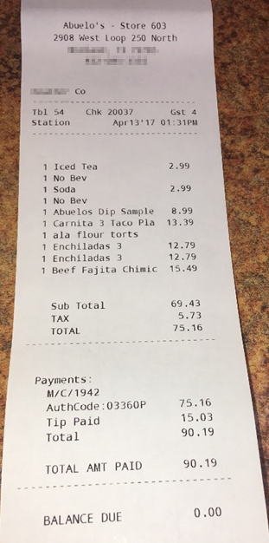

**Example of Credit Card Receipt**

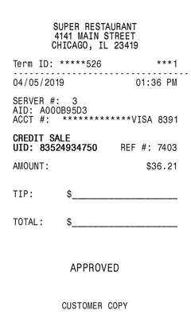

#### Incorrect Expense Type

Each customer expense type is mapped to an expense type. The system attempts to determine the expense type of the receipt (for example, Meal, Gifts, Train etc.). An exception is raised if the expense type appears to be different from the type that’s mapped to the expense type the user selected. For example, this appears to be a meal but has been submitted under an expense type in the Gifts expense type.

For Professional Edition, refer to [Concur Expense: Expense Types Setup Guide (concurtraining.com)](http://www.concurtraining.com/customers/tech_pubs/Docs/_Current/SG_Exp/Exp_SG_Expense_Types.pdf).  
  
For Standard Edition, refer to [Concur Expense: Expense Types Setup Guide for Standard Edition (concurtraining.com)](http://www.concurtraining.com/customers/tech_pubs/Docs/ConcurPremier/SG_Exp/SG_Exp_Expense_Types.pdf).

1. This check does not verify that the user is using the correct or specific Expense Type the company may have customized and want their employees to use for accounting purposes. It is meant to validate if the correct general classification has been used. For example, it will not evaluate the accuracy of Dinner with External Vendors.   
     
   To increase the accuracy of this check, ensure that custom expense types are correctly mapped to their spend categories (refer to the guides above).

#### Traveler Name

This check attempts to determine if the name on the receipt matches the name on the expense report. The system extracts traveler names from a wide variety of receipts and similar types of spend evidence, especially those related to travel and credit cards. It is compared with the known traveler’s name, allowing for some difference.

1. The system may be unable to provide a matching name due to poor image resolution, system abbreviations, and other similar occurrences.

### Examples of Policy-Related Checks

#### Air Class

This check attempts to confirm that a user has booked airfare in the economy or coach class, otherwise an exception is raised (for example, for economy plus, business, or first class).

Standalone receipts are evaluated and do not include structured data from Concur Travel, TripIt, or one letter code classes.

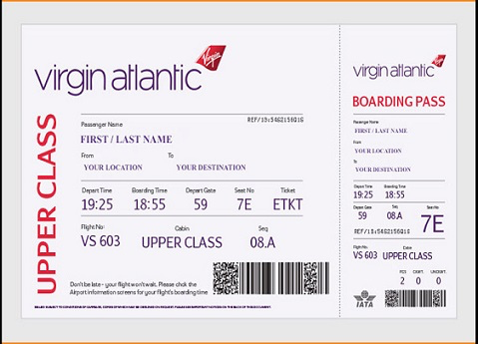

1. This check is not configurable. It cannot be changed to allow for other classes of services or evaluation of duration in conjunction with class.

#### Additional Air Charges

This check attempts to confirm that the user has not added additional fee items to their air travel. These often include the additional services and fees that had, in the past, been part of bundled travel fares. This check relies only on the attached receipt. If the system was unable to confirm this, then an exception is raised.

This check looks for:

* Baggage fees
* Seat assignment/selection/upgrade
* Early boarding
* Food/Drinks
* Wi-Fi
* Headset
* TSA/Clear/Global entry
* Airline lounge

1. You can configure approval reasons for report checks which will then be considered by the auditor when passing or failing the line item. For example, your company may allow for inflight wi-fi charges. Although an exception was raised by the system, the wi-fi charge could be then allowed by the auditor.

#### Alcohol

This check attempts to identify obvious scenarios such as the purchase of cocktails or full bottles of alcohol.

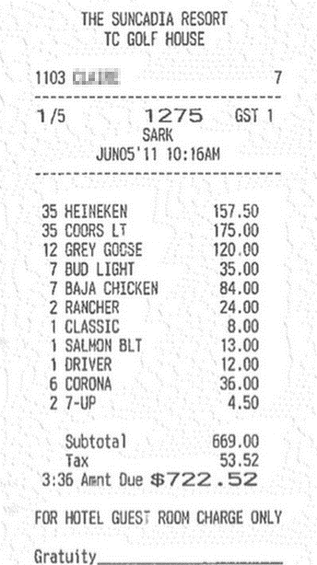



1. You can configure approval reasons for report checks which will then be considered by the auditor when passing or failing the line item. For example, your company may allow for alcohol if a client is present. Although an exception was raised by the system, this could then be allowed by the auditor.

#### Rental Car Class

This check attempts to confirm that a user has booked a rental car that was intermediate, compact, or midsize class. If it was unable to confirm this, then an exception is raised.

Standalone receipts are evaluated. It does not include structured data from SAP Concur Travel or TripIt.

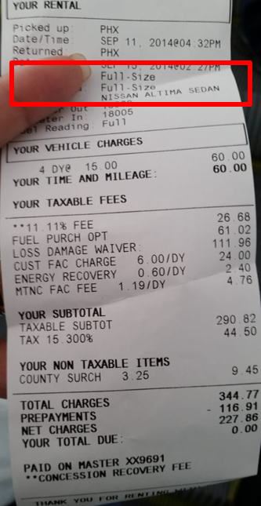

1. This check is not configurable. It cannot be changed at this time to allow for other classes of services nor evaluation of other variables (such as number of passengers sharing the vehicle).   
     
   You can configure approval reasons for report checks which will then be considered by the auditors when passing or failing the line item.

#### Additional Car Charges

This check identifies transactions where a user has added additional fee items to the car rental. This check evaluates a standalone receipt.

This check looks for:

* Fuel charges
* Insurance charges
* GPS charges
* Satellite radio
* Special equipment



* Upgrades
* Late return/no show charges



1. You can configure approval reasons for report checks which will then be considered by the auditors when passing or failing the line item. For example, your company may allow fuel charges. Although an exception was raised by the system, the fuel charge could then be allowed by the auditor.

#### Car Wash

Many employees use their car for transporting customers, other employees, or running company errands. While it is nice to have a clean car for those tasks, car washes and detailing may not be reimbursable by company policy.

This check evaluates a standalone receipt aiming to detect a car wash or detailing service.

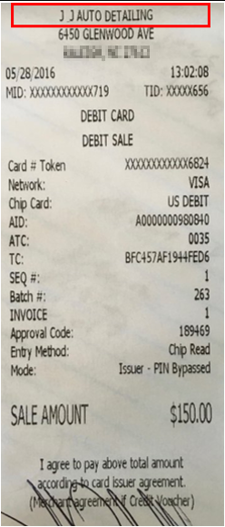

#### Excessive Tip

Excessive tips can indicate not only overpayment but a quid pro quo situation between the vendor and the employee.

This check attempts to determine the tip amount from the receipt. It evaluates the tip amount violation against the total and does not account for pre-tax sub-totals or gratuity included receipts. If the tip percentage is excessive, then an exception is raised.

1. This check can be configured according to your company definition of “excessive”, for example 20% or 25%.

#### Gift Cards

This check attempts to identify situations where a gift card has been purchased by the employee and is visible on the receipt. The system can prevent false positives, such as when an employee is using a gift card or pre-paid debit card to pay for the purchase.

1. This check is currently not configurable to allow or disallow only specific vendor’s gift cards.

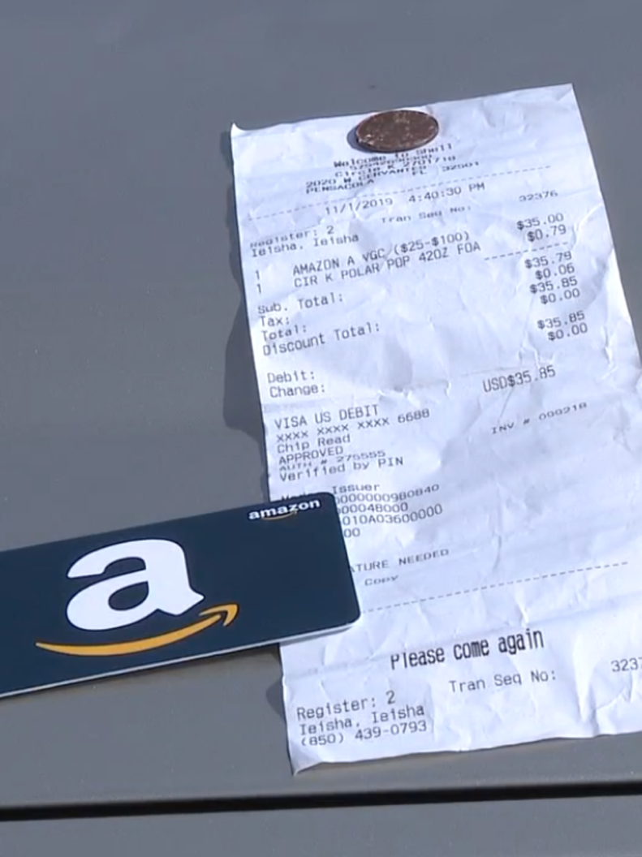

#### Additional Hotel Charges

Hotel charges can be difficult for both travelers as well as approvers to identify on long, multi-page folios. They often use confusing non-standard or industry terminology.

This check attempts to identify any of the following on a standalone receipt:

* Phone charges
* Internet charges
* Mini-bar charges
* In-room/On-Demand movie charges
* Parking/valet charges
* Laundry charges
* Gym/Health club

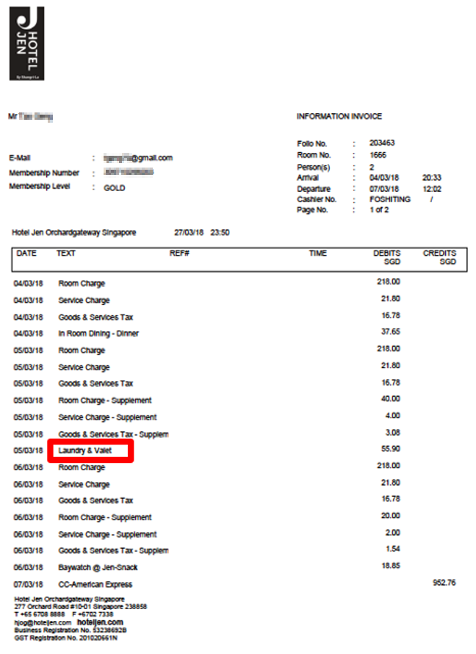



1. You can configure approval reasons for report checks which will then be considered by the auditors when passing or failing the line item. For example, your company may allow hotel gym fees. Although an exception was raised by the system, the gym fee could be then allowed by the auditor.

#### Late Charges

This check attempts to identify transactions where a user has incurred fees and charges due to partial or late payments for their credit cards (for example, personal, Individual Billed Individual Paid (IBIP), or Individual Billed Company Paid (IBCP)). Though the reason for the fee or charge may be business related, reimbursement may not be allowed by company policy.

This check does not rely on a credit card data feed. It evaluates attached receipts for the following:

* Late fees
* Interest charges
* Penalty payments

#### Family and Home Care

This check attempts to identify scenarios where the employee is attempting to charge the company for assistance with their personal arrangements. Though they are related to the business, reimbursement is seldom allowed by company policy. This check evaluates a standalone receipt.

This check attempts to identify the following on a standalone receipt:

* Pet care
* Childcare
* Elder care fees
* House sitting fees



#### Traffic or Parking Violations

Parking and traffic violations can happen during an employee’s trip; however, most companies do not allow for these types of expenses, at least without justification and specific approvals.

This check attempts to identify the following on a standalone receipt:

* Parking tickets
* Moving or speeding tickets
* Toll violations

#### Travel Insurance

This check attempts to identify travel insurance on a standalone receipt.

In certain situations, travel insurance may be warranted and financially advantageous. However, reimbursement may not be allowed by company policy.

### Evaluation of an Expense Report

Expense reports are evaluated using Concur Verify’ s checks per the relevant audit profile settings. Receipt and Policy detections are referred to as **Exceptions** and are routed to the **Reports Pending Audit Review** screen.

1. If the report has at least one exception it will be routed to the **Reports Pending Audit Review** screen. High confidence and negative results (where no exceptions are identified) result in the report automatically moving to the next step in the expense workflow (for example, to manager approval).
2. Report that raised exceptions will require the auditor’s evaluation. An auditor can decide to approve the report by approving all exceptions or send it back to the employee by failing at least one of the exceptions and asking for a resubmit. Once a report has passed the audit step (either due to no exceptions being raised after a resubmit, or the auditor passing the report), it will continue to the next step in the expense workflow.
3. Customers can ask for **Split Report for Audit** to be configured by SAP Concur on an entity basis and will apply only if this functionality is also enabled in Concur Expense for this entity. Once enabled, for all reports that are sent back in Verify (at least one exception fails), the failed expenses will automatically return to the submitter as a new report (‘Addendum’) and the rest will remain in the original report and continue to the next workflow step. Verify does recognize the new Addendum report as a ‘resubmit’, and if it fails again, all the history for those expenses will remain.

## Auditor Experience

### Reports Pending Audit Review

From the **Reports Pending Audit Review** screen, auditors will be able to:

* View, filter, and search a list of submitted expense reports.
* Select a single report to view details.
* Self-assign or unassign an expense report
* Assign to other auditors.
* Pass or fail an exception in an expense report with comments.
* Add comments to a failed exception or when approved with exception.
* Complete an audit on a report.
* Add an Auditor Exception to fail or approve with exception for another reason.

1. To view a list of submitted expense reports:
2. From the **Expense** tab, click **Verify**.The **Reports Pending Audit Review** page displays.

As an Auditor, on the **Reports Pending Audit Review** page you can view a list of expense reports, and then take further action as needed by clicking on an individual report. You can use the dropdown filters above the reports list to filter them by **Submission Date Range**, **Audit Profile**, and **Assigned To** fields.

1. Auditors will only see reports for audit profiles to which they have been assigned. Please refer to the Configuration section for more details.
2. To search for a specific report, use the search field to search by **Report Name, Report ID**, **Employee Name**, and **Employee ID**.

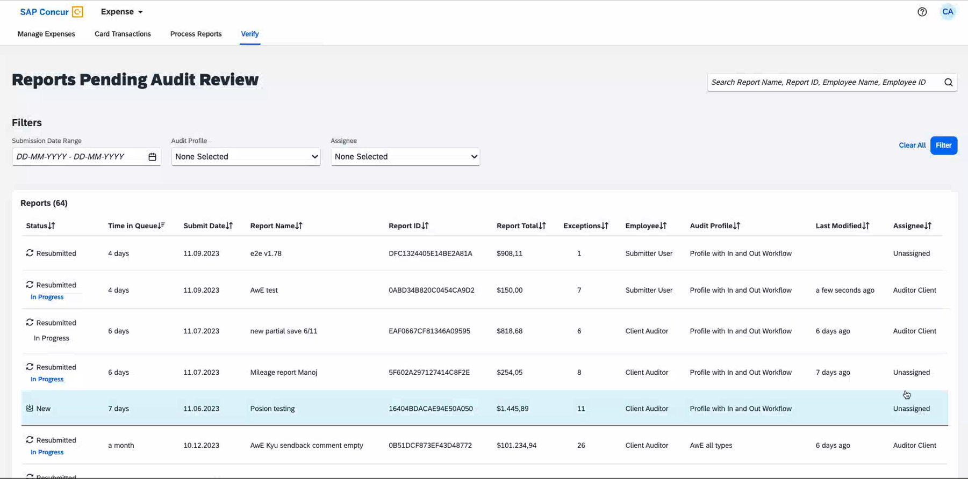

1. In this view, users may sort the list of results by any column. To sort, click the column header.

| Column Name | Description |
| --- | --- |
| Status | Report statuses include New, Resubmitted, and Processing Error. Reports currently being edited displays the **In Progress** status in this column. The reports in progress may contain an auditor’s note. |
| Time in Queue | Duration between date the report was submitted for audit and the current date |
| Submit Date | Date of submission by employee |
| Report Name | The expense report name |
| Report ID | An auto-generated unique ID for the report |
| Report Total | The total amount of expenses in the report |
| Exceptions | The total number of exceptions within the report |
| Employee | The name of the employee who submitted the expense report |
| Audit Profile | The name of the Audit Profile used to evaluate this expense report |
| Last Modified | The date and time when the report was last modified |
| Assignee | The name of the auditor assigned to the report; if no one is assigned, it displays as “Unassigned”. The list of assignees is populated based on the report’s audit profile. As an auditor, you will not be notified when reports are assigned to you or unassigned and then reassigned to another auditor. |

1. To select a single expense report:
2. Click the row of the report you want to view. The page will refresh with the selected report displaying expense details and any attached expense receipts on the **Expenses** tab. All the three columns in this tab are scrollable and resizable. Collapse the column on the far left to enlarge and focus on one expense. You can also sort the **Expenses** column to view similar expense types together. The expenses are sorted by default based on their transaction dates.

When applicable, Verify displays receipts of all types linked to an expense. If both types of receipts are linked to an expense, a toggle displays above the receipt such as **E-Receipt** and **Receipt**. This toggle helps switch between the receipt views.

1. The default view displays only expenses containing exceptions. To view all expenses, select the **Show expenses without exceptions** checkbox.

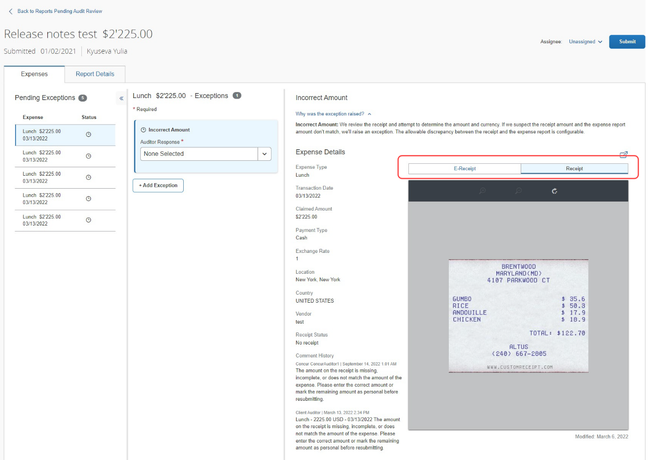

If an itinerary is linked to an expense in Verify, it displays as part of the **Expense Details**. Under **Itinerary**, the auditor sees an active **Reservation** hyperlink. This link displays Trip Overview and Reservation details in the **Itinerary Details** popup.

If credit card details are available, the auditor can click the **Payment Type** name to view all available transaction details.

The total count of **Attendees** as well as the count for each type of attendee listed now displays when available. The average amount per person is calculated accordingly.

Use the **Auditor Note** field inside the report to leave a small note to yourself or the next auditor in case of any interruptions during audit.

1. You can browse the **Report Details** tab to review a summary of report, employee, and audit status details. Click **View Audit Trail** to see a timeline of employee expense report activities and audit level activities.

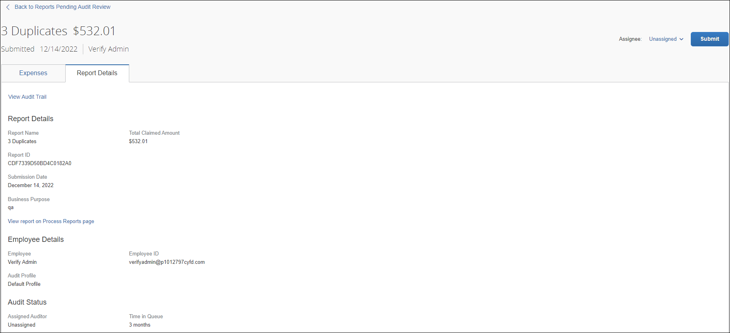

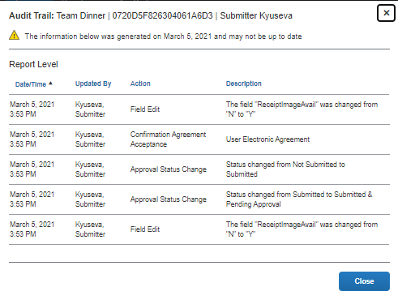

Users with the **Processor** role assigned to them can click **View report on Process Reports page** to directly access the report on the processor view according to their role permission.

The **Audit History** tab displays for a resubmitted report and shows a list of audit responses that were previously audited in Verify.

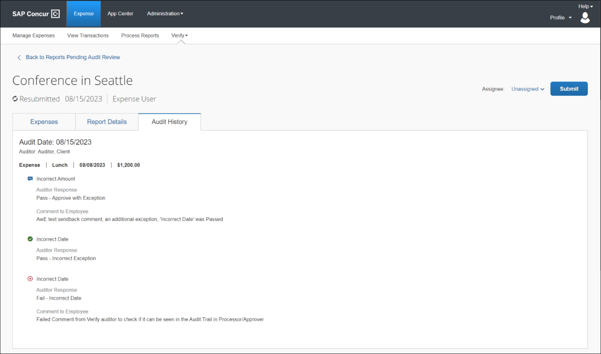

1. To assign the expense report to yourself or another auditor for auditing:
2. Select the auditor name from the **Assignee** dropdown. By default, new reports are set to “Unassigned”. Additionally, the report is automatically assigned to the auditor currently editing the report.
3. Verify auditors can assign reports to any auditor who is assigned to the report’s audit profile.
4. You can view or close a report (not complete) without being assigned to a user. Users may assign any report to themselves, whether unassigned or assigned to a different user. No notifications are sent when the report assignment is modified.
5. To pass or fail an exception in an expense report:
6. For each item exception, in the **Auditor Response** field, the default selection is **None Selected,** because no response has been chosen. To respond, choose one of the following:

* **Pass - Incorrect Exception** – This is a default pass response. The expense item was incorrectly flagged as an exception and does not violate company policy. No further action is required from the employee.
* **Fail - Out of policy** – This is a default response. The expense item violates company policy. The employee will receive an email notifying them that their expense report has been rejected. Their next steps are to edit and resubmit their expense report.

1. **Out of policy** is a common, pre-defined fail option. Receipt checks can have other options for each exception.

* **Pass - Approve with Exception** – This is a default pass response. The expense item violates company policy; however, the auditor decides to allow it for this exception. No further action is required from the employee.
* **Pass - [Customized Pass Label]** – The expense item does not violate company policy, based on the company-configured pass options. No further action is required from the employee.
* **Pass (with comment) - [Customized Pass Label]** – The expense item violates company policy, based on the company-configured pass with comment options, however the auditor decides to allow it for this exception. No further action is required from the employee.

1. If you choose **Fail - Out of policy** or **Pass - Approve with Exception**, you can modify the predefined comment to provide additional information or corrective instruction to the employee.
2. For each exception, you can add comments to the employee and these comments are predefined and localized (unless customized by the admin). However, if you amend or add more comments, be aware that localization of the edited text will be unavailable.

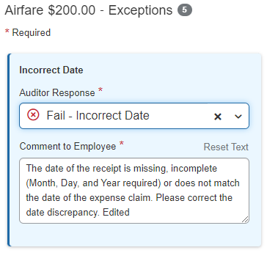

1. As you select a response, the exception item will update with an exception status of “Fail” or “Pass”. If no response is selected, the exception will remain in “Pending” status.

You can also pass all pending exceptions using the **Pass Pending Exceptions** icon in the **Expenses** tab. Click **Update** after selecting the response.

1. To complete an audit:
2. Click **Submit** once you have applied your response to the expense report exception. The report will be sent back to the employee even if there is one exception set to “Fail”. If all exceptions are “Pass”, then the report will continue in the workflow.

If you have the **Split report for Audit** feature configured, all the exceptions that have been failed are sent back as a new report and all the passed expenses continue in the workflow as a part of the original report.

1. Reports with pending exceptions or empty “Fail” **Comments to Employee** field cannot be submitted.
2. Contact SAP Concur support to set up **Split Report for Audit** feature.

You can also approve multiple pending exceptions for a report pending audit review. Click the **Pass Pending Exceptions** () icon in the **Expenses** tab. The **Pass Pending Exceptions** dialog displays.

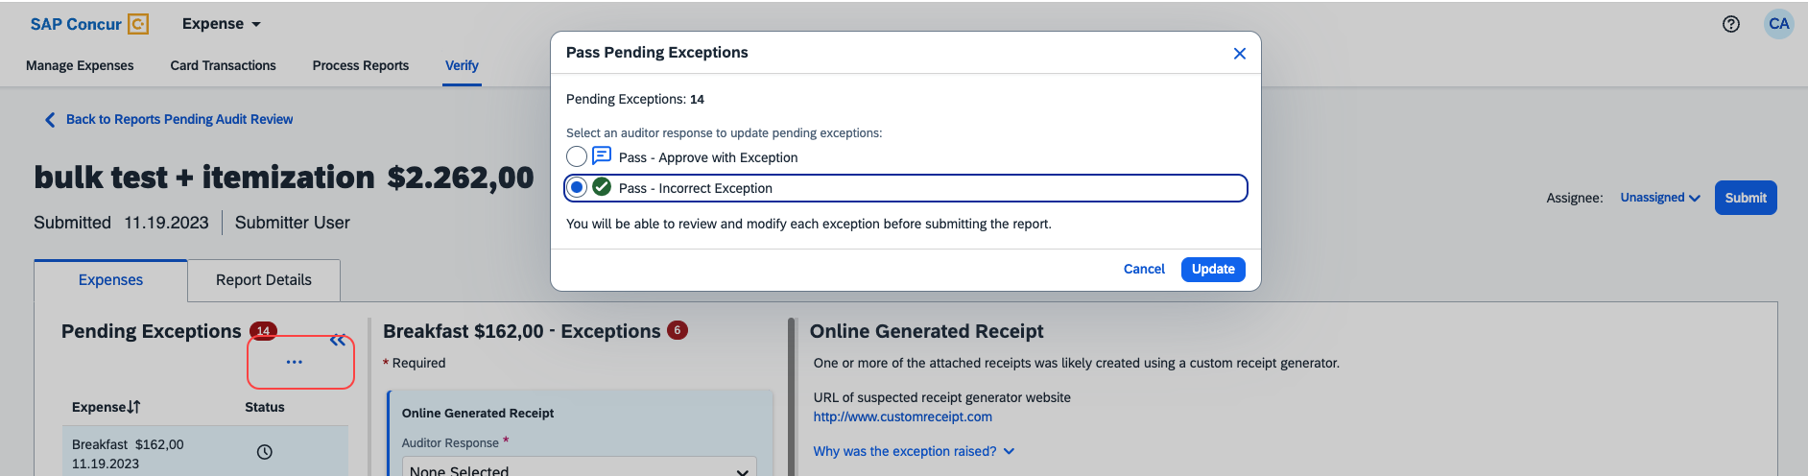

Select a response in the dialog box and click **Update**. The auditor response is populated in all the pending exceptions inside the report.

1. When the employee resubmits the report, Verify will audit it again. If no exceptions are detected, the report will move to the next step in the expense report workflow and will not be displayed on the **Reports Pending Audit Review** list. If one or more exceptions are detected, the report appears in the **Reports Pending Audit Review** list again.
2. A **Resubmitted** label appears for any report that contains at least one expense/line item that was previously audited, sent back to the employee, and resubmitted by the employee.
3. To add an Auditor Exception:
4. Click **Add Exception**. The Auditor Exception allows you to include an additional exception for each entry for reasons that are not necessarily related to the exceptions found by Verify. Exceptions can be added for each type of expense entry, including itemizations, personal expense, and so on.

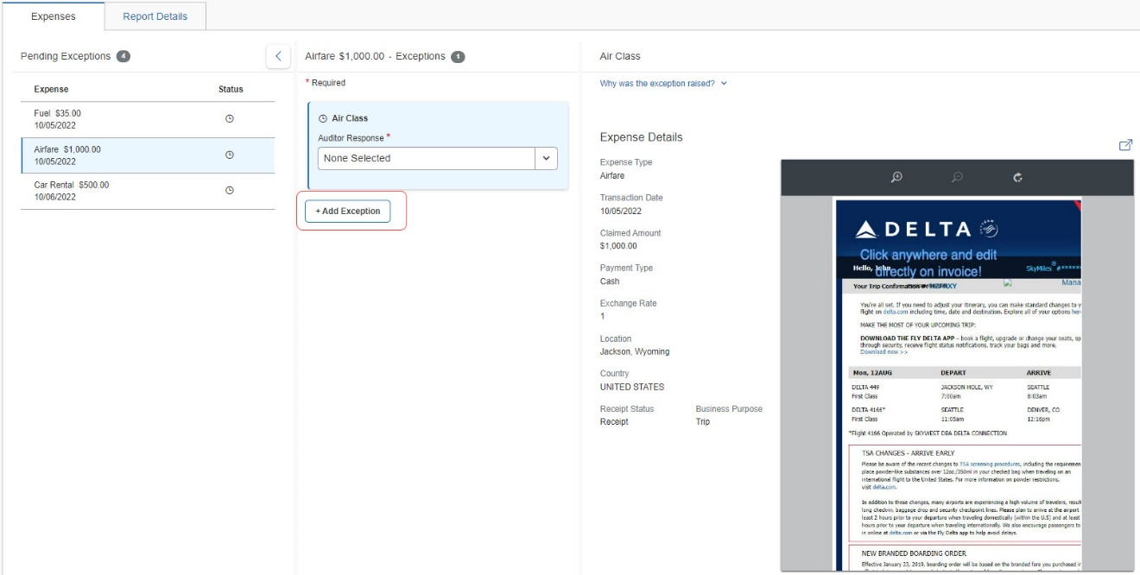

1. Enter a comment for the employee in the **Comment to Employee** field. A comment is mandatory for an auditor exception.
2. For resubmitted reports where there was a previous auditor exception, choose **Fail** and add a new comment or choose **Pass – Approve with Exception** and add a new comment. You can also choose **Pass** without a comment added to it.
3. Expenses that contain “Fail” auditor exceptions will always return to the auditor to re-audit after the employee resubmits a report containing such exceptions.

## Configuration

The following lists configuration items to note:

* Multiple Audit Profiles can be configured.
* An Audit Profile can be configured to contain checks.
* Checks can be configured with conditions.
* The Audit Profile that is used to evaluate an expense report is controlled by assigning Audit Profiles to expense policy groups.
* Auditors can be assigned to Audit Profiles. On the **Reports Pending Audit Review** screen, auditors will only see expense reports that were evaluated using the Audit Profiles to which they are assigned.
* All checks can be configured with a minimum amount threshold condition. The minimum amount threshold means no exceptions will be raised for any line items below this amount. This threshold can be set from a list of available currencies.
* All checks can be configured with an expense type condition. No exceptions will be raised for line items with an expense type not in this list. Most checks can also be configured to run for all expense types.
* Certain checks can also be configured with additional conditions such as an allowable date variance or an allowable tip percentage.
* All checks that display exceptions on the **Reports Pending Audit Review** screen can also have up to nine approval reasons configured. Approval reasons display on the **Reports Pending Audit Review** screen and can be selected by the auditor as a reason to pass this exception and allow for communicating policy to the auditors. A default approval reason of **Incorrect Exception** is always included and cannot be modified.

### Verify Roles

Verify is supported by two user roles:

* **Verify Administrator**: Allows user to do as follows:
* Access the Verify configuration page.
* Manage which profiles are assigned to which groups.
* Manage which auditors are assigned to which profile for the Reports Pending Audit Review.

1. All Concur Expense standard entity users with the **Can Administer** permission enabled will be assigned the **Verify Administrator** role.

* **Verify Reports Auditor**: Allows user to see and access **Reports Pending Audit Review** page and audit Verify policy and receipt exceptions as part of the audit process.

1. All Concur Expense standard entity users with the **Can Process Expense Reports** permission enabled will be assigned the **Verify Reports Auditor** role.

For information on the roles required to work with Verify as an administrator or auditor, please refer to the [*Shared: User Administration User Guide*](http://www.concurtraining.com/customers/tech_pubs/Docs/_Current/UG_Shr/Shr_UG_User_Admin.pdf) for Professional edition. Also refer to the [*Shared: Users Setup Guide for Concur Standard Edition*](https://www.concurtraining.com/customers/tech_pubs/Docs/ConcurPremier/SG_Shr/SG_Shr_Users.pdf), the [*Expense Processor Online Help*](https://help.sap.com/docs/CONCUR_EXPENSE/93ceb32335c6486d902426c6727b80f2/c405cea951c31015a250d2023263fab5.html?q=expense%20processor), and the [*Concur Expense Standard Edition Administration Help*](https://help.sap.com/docs/CONCUR_EXPENSE?version=2023_01) for information on the Can Administer and Can Process Expense Reports permissions.

The **Verify Administrator** and **Concur Expense Administrator** roles are required to configure your company’s Verify settings.

Users assigned the **Concur** **Expense Administrator** role can access the Expense Administration configuration.

### Audit Profile

#### Access

1. To access the Verify Audit Profile page:
2. For **Professional** users, to access Verify settings, go to **Administration > Expense Admin > Verify**.   
     
   For **Standard** users, go to **Administration > Expense Admin > Policy > Advanced Settings > Verify**.
3. The **Verify Audit Profile** page displays.

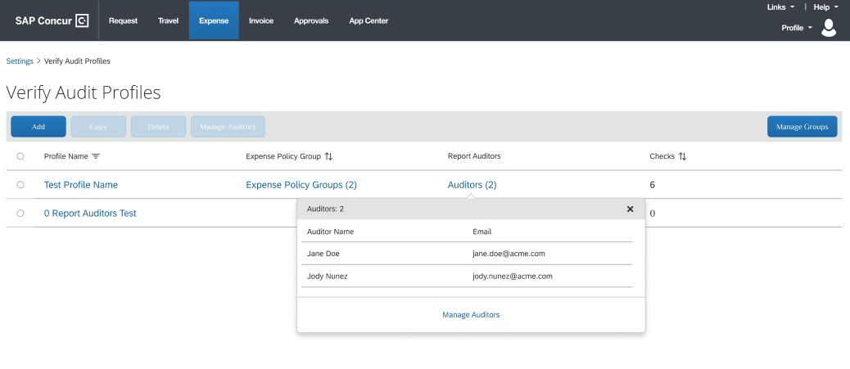

1. By default, a profile called “Default Profile” has been created. This profile name cannot be modified.

#### Groups

For the standard edition, expense policy groups are optional and can be added as a hierarchy to the default country packs (e.g., UK, US). For example, a company can add up to five policy groups to a country pack. The user is then assigned to one of the policy groups. If the country pack does not have policy groups, then the user is assigned to a default group belonging to the country pack.

For the professional edition, expense groups are configurable and can have multiple hierarchies.

1. To manage which profiles are assigned to which groups:
2. Open the **Verify Audit Profiles** page.
3. This page lists the configured profiles for the company, by Profile Name.

* **Profile Name** – displays the profile name; click this label to display profiles in ascending or descending alphabetical order.
* **Expense Policy Groups** – displays the expense policy groups to which the profile has been assigned.
* **Report Auditors** – displays the name(s) of the auditor(s) assigned to the profile for the Report Audit UI. This controls which reports auditors will have access to see on the Report Audit user screens.
* **Checks** – displays the number of checks enabled for the profile.

1. To edit the groups assigned to a profile, click **Manage Groups**. The **Manage Expense Policy Group and Audit Profile Assignment** page displays.

The page displays all groups for all profiles, in a hierarchical order; there is no display available for a single group, or single profile.

If a group is not assigned to a profile, it will automatically assign to the group above it. The top group of the hierarchical order is Global.

1. Using the **Profile** dropdown field opposite each group, select a profile for each group listed.
2. Once each group has been configured to a profile, click **Save**. To return to the **Verify Audit Profiles** page without saving the changes, click **Cancel**.

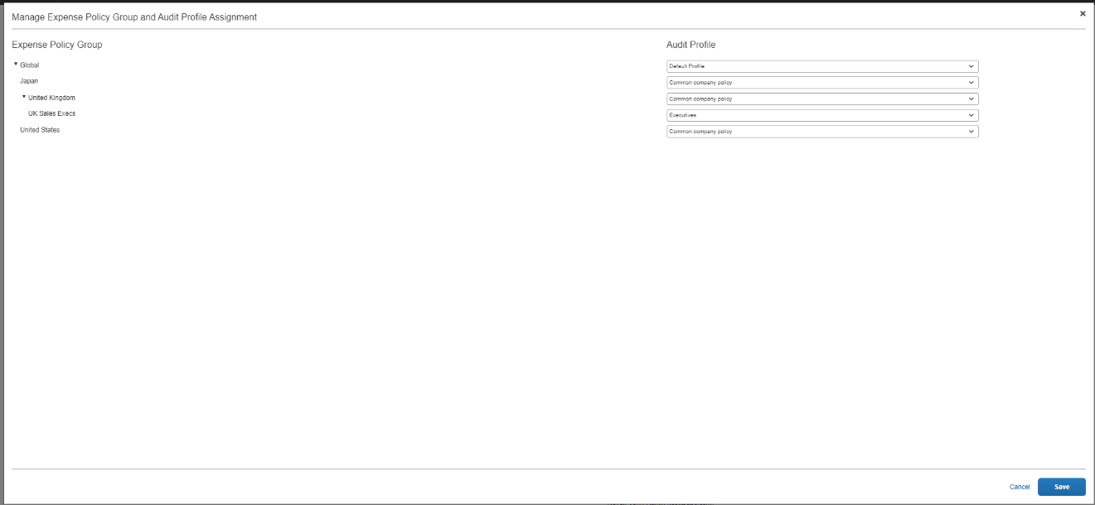

1. Changes are visible in the **Expense Policy Groups** column for the edited profile(s).

#### Assigned Auditors

1. To manage the auditors assigned to a profile:
2. Open the **Verify Audit Profiles** page.
3. Select a profile; this will enable the **Manage Auditors** button.
4. Click **Manage Auditors**. The **Manage Auditors** page displays.
5. Click **Add Auditor.** A list of all users with the required permissions displays.
6. If the required auditor is not visible, ensure that the auditor has the **Verify Reports Auditor** role. All Concur Expense standard entity users with the **Can Process Expense Reports** permission enabled will be assigned the **Verify Reports Auditor** role.

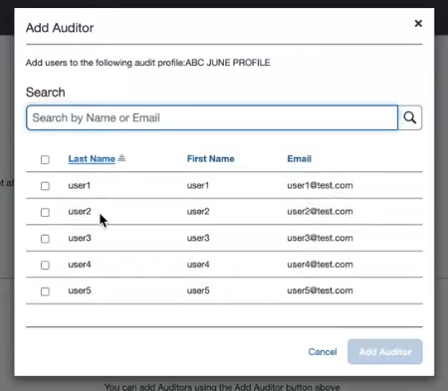

1. Optionally, filter by **Name** or **Email**.
2. Select the required auditor(s).
3. Click **Add Auditor**.
4. Click **Save** on the Manage Auditors page. The changes are saved.
5. To remove an auditor from a profile
6. Go to the **Verify Audit Profiles** page and select the required Audit Profile.
7. Click **Manage Auditors.** The Manage Auditors page displays.
8. Click **Remove** next to the appropriate auditor.
9. Click **Save**. The changes are saved.

#### Add New Profile

1. To add a new audit profile:
2. On the **Verify Audit Profiles** page, click **Add**.
3. In the **Profile** **Name** field, enter the name of audit profile and then click **Save**.

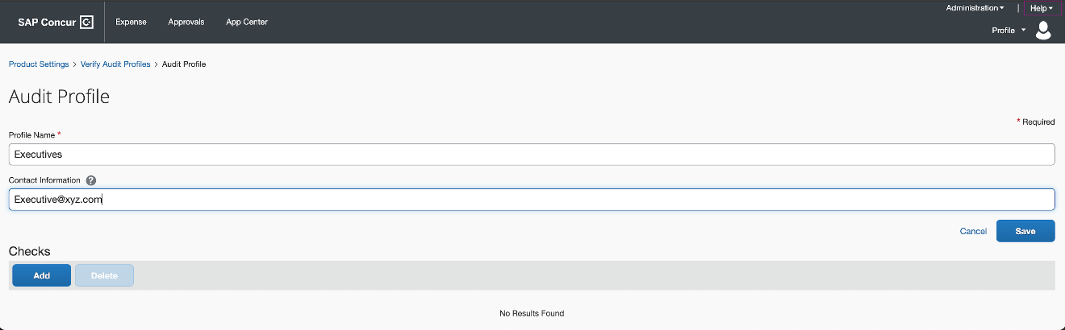

1. In the **Contact Information** field, enter the email address, phone number, or URL you'd like to direct your users to if they require support. This information will be included in localized emails sent to update users on the status of their expense report. You can preview the text that will appear below. If you need additional assistance, please contact SAP Concur support.
2. In the **Check** section, click **Add**.

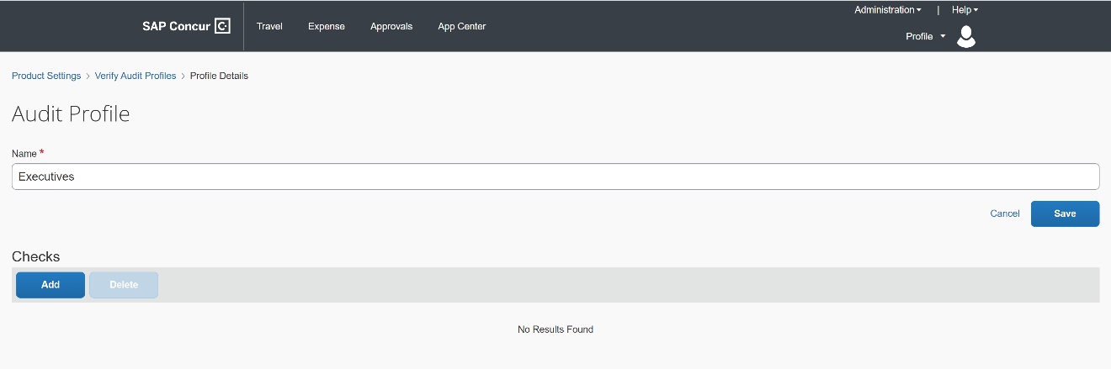

1. On the **New Check** page, select one from the list of checks in the **Check Name** dropdown. You can only add each check once per audit profile.

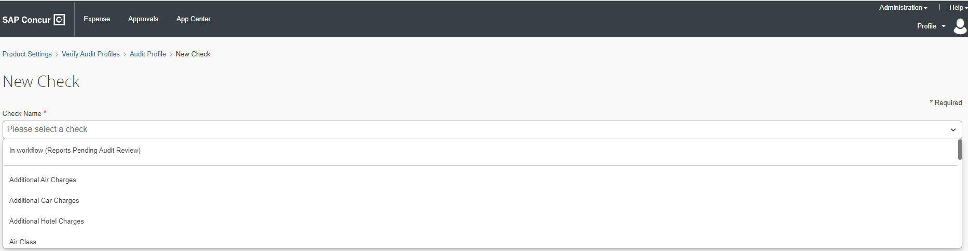

1. Once you select a check, the **Check Details** page displays for you to setup.

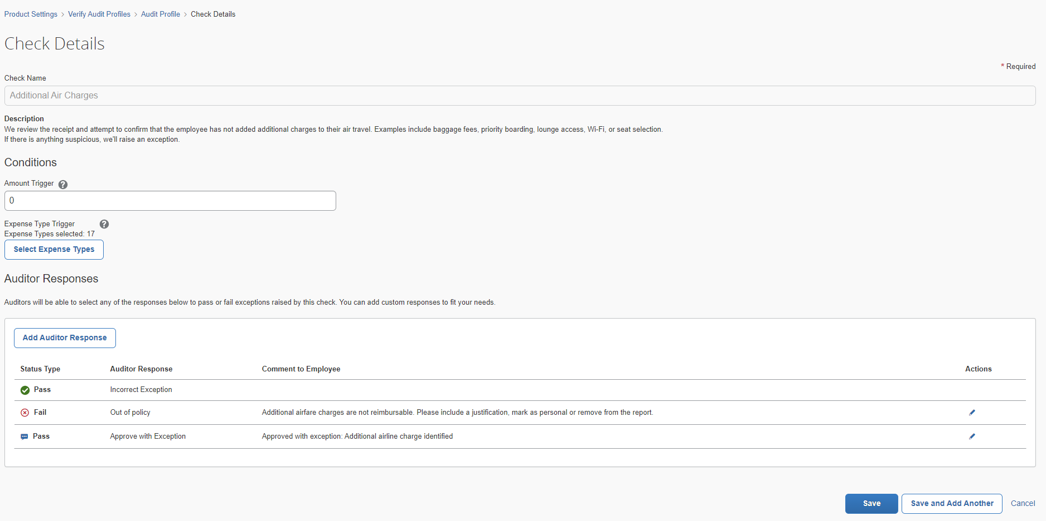

1. Under the **Conditions** section, in the **Amount Trigger** field, enter the maximum amount for line items that can be ignored by this check.
2. Line items in different currencies will be converted before evaluating this condition.
3. When new checks are added to existing profiles, the currency field **Amount Trigger** is automatically pre-populated with the most frequently used currency.

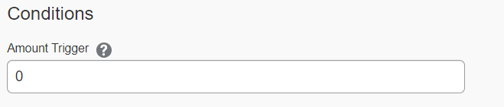

1. For the **Expense Types Trigger**, each check comes with a pre-configured default set of enabled expense types covering any standard Concur Expense Types. Any custom expense types must be configured manually. Click **Select Expense Types** to configure this list. An **Expense Types** page displays where you can choose:
2. You can reset any changes made to the expense type selections back to the default selections using the **Reset Expense Types selections back to default recommendation** option available on the page.
3. The **Duplicate Meal Claim** check also displays a filtered view for Meals related categories when you click **Select Expense Types**. At least one expense type must be selected.
   1. **Restrict by Expense Type**: Displays all categories of expenses and their related items where you can make individual expense type selections or select all types within a category. When not selected, the check runs for all expense types.

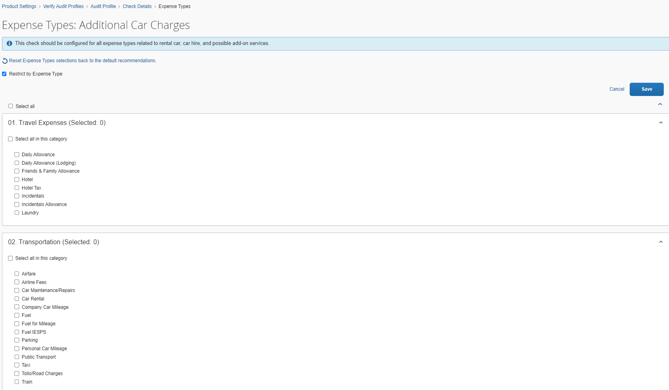

* 1. **Select all**: You can select all expense types but then deselect the few that are not applicable for checks.

1. For the **Excessive tip** check, also enter a value in the **Maximum percentage allowed for tipping** field.
2. For the **Incorrect** **Date** check, also enter the allowed number variation in days reported on the receipt itself compared to the date recorded for the expense line item in the **Allowable difference in days** field.
3. For the **Old Date** check, enter the desired value in the **Acceptable number of days** field.
4. For the **Unreasonable amount** check for meal and/or entertainment type expenses, also enter the **Exception Volume** using the slider bar to set the threshold percentage for a meal expense. You can choose the volume based on if you want exceptions to be raised anywhere between 1% to 20% top spend amounts.
5. For the **Improper Merchant Category** check, optionally configure the default list by clicking the **Select Merchant Categories** button.
6. Click **Save**. If you chose the option to select specific expense types, the number of expense types selected will display.
7. An **Auditor Response** area displays on the **Check Details** page. There are three default options to choose from:

* **Pass – Incorrect Exception**: This is a default pass response. This option can neither be edited nor deleted.
* **Fail – Out of policy**: This is a default fail response. **Auditor Response** field is not editable but the **Comment to Employee** field is editable.
* **Pass – Approve with Exception**: This is a default pass response. **Auditor Response** field is not editable but the **Comment to Employee** field is editable.

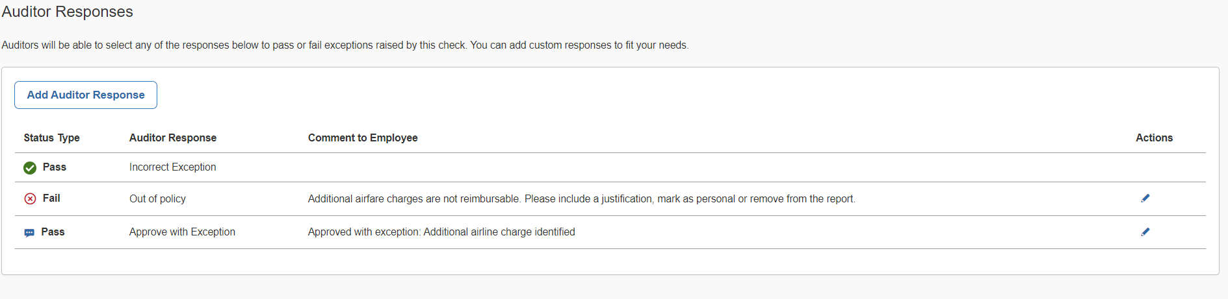

You can also click the **Add Auditor Response** button and create a custom auditor response using the options as follows:

* **Pass audit**: Enter a label in the **Auditor Response** field. The **Comment to Employee** field is disabled for this option.
* **Pass audit with comment**: Enter a label in the **Auditor Response** field. The Comment to Employee field can be edited in this option.

Auditors can view the reason on the **Reports Pending Audit Review** page when the exception is raised and allow the exception to pass. Click **Add** to save the reason. If you need to edit it, click on the reason. You can also click the **Trash** icon to remove the reason.

If you choose to edit the **Comment to Employee** field for any of the **Auditor Responses**, a warning pops up to display that modifying comments will remove translations for that text. Select **Confirm** to change the comment. Auditors can view this comment when they select **Failed - Out of Policy** option from **Auditor Response**. You can also select **Reset** to change the comment back to its original content.

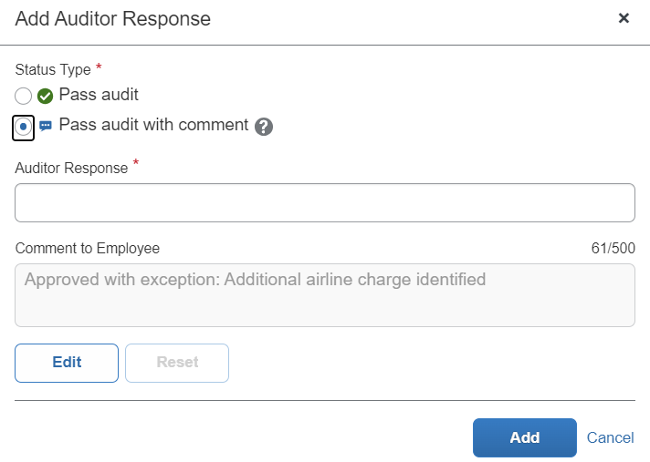

1. For each exception, comments to the employee are predefined and localized. Be aware that localization of the edited text will be unavailable.
2. Select **Save** to finish setting up the check details or select **Save and Add Another** to add another check.

#### Edit Profile

1. To edit an audit profile
2. Go to the **Verify Audit Profiles** page and then click a profile name to view it and edit.

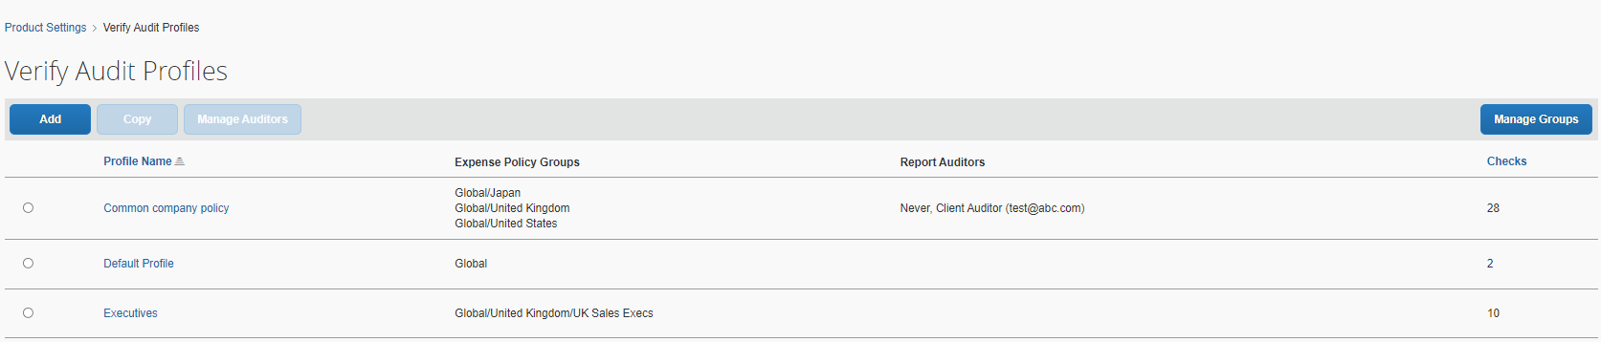

1. To configure expense types for an existing check
2. After adding a check to a profile, click **Select Expense Types** below **Expense Type Trigger**.
3. Select or deselect any additional expense types to run for this check.
4. Click **Save** to save the expense type selection.
5. Click **Save** to save the check.

#### Copy Profile

1. To copy an audit profile
2. Go to the **Verify Audit Profiles** page, select a profile, and then click **Copy**.
3. Rename the profile and click **Save**. It will copy over all the check configurations from the profile you copied. It does not copy over the group assignment or assigned report auditor information.
4. Follow the steps listed earlier in this Configuration section on how to manage which profiles are assigned to which groups.
5. Follow the steps listed earlier in this Configuration section on how to manage the auditors assigned to a profile.

#### Manage Merchant Categories

The list of allowed/not allowed merchant categories for **the Improper Merchant Category** check can be modified. Merchant categories that are moved to the **Allowed Categories** list will not raise exceptions.

1. To configure
2. Go to the **Verify Audit Profiles** page and then click a profile name to view it on a new page and edit.
3. Click **Improper Merchant Category** to view the check.
4. Click **Manage Merchant Categories.**
5. Search for a particular merchant category using the code or description.

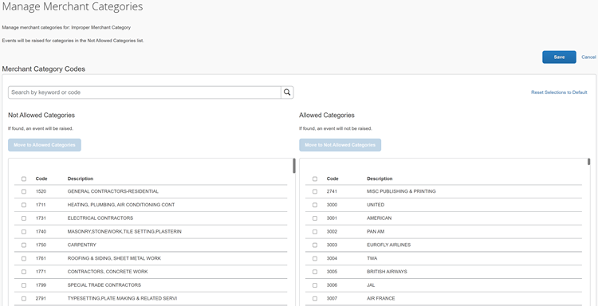

1. Click the merchant category to select it.
2. Click **Move to Allowed Categories.**
3. Click **Save.**

Any expenses submitted after this point will no longer raise exceptions for this merchant category.

### Language Support

All languages supported by SAP Concur are applicable to the Verify admin configuration pages and **Reports Pending Audit Review** page.

Admins and auditors can set up their preferred language via the SAP Concur login and then view the Verify user interface in that language.

1. For each exception, you can add comments to the employee and these comments are predefined and localized. However, if you amend or add more comments, be aware that localization of the edited text will be unavailable.

The labels will display the preferred language according to user settings.

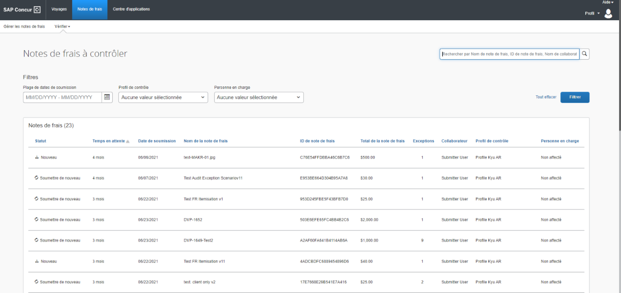

## Known Issues / Limitations

When modifying comments for failing receipt and policy exceptions on an expense report, be aware that the edited text will not be localized.