SAP Concur Release Notes
Concur TripLink and TripIt
Month | Audience
Release Date: April 20, 2024  Initial Post: Friday, April 19 | SAP Concur Client – FINAL
Contents
Release Notes 1
Concur TripLink 1
Concur TripLink Hub Connection Status Update 1
TripIt 2
TripIt Risk Alerts 2
Planned Changes 3
Concur TripLink 3
**Planned Changes** Travel Partner Integrations Removed from App Center 3
**Planned Changes** Amtrak Integration with TripLink (April 24) 4
TripIt 5
No Planned Changes This Month 5
Client Notifications 6
Accessibility 6
Accessibility Updates 6
In-Product User Assistance 6
Client Customized Content 6
Gender Diversity 6
Subprocessors 7
SAP Concur Non-Affiliated Subprocessors 7
Supported Browsers 7
Supported Browsers and Changes to Support 7
Additional Release Notes and Technical Documentation 8
Online Help 8
SAP Concur Support Portal – Selected Users 8
Cases 9
Steps for Getting a Status 9
Legal Disclaimer
The information in this presentation is confidential and proprietary to SAP SE or an SAP affiliate company and may not be disclosed without the permission of SAP SE or the respective SAP affiliate company. This presentation is not subject to your license agreement or any other service or subscription agreement with SAP SE or its affiliated companies. SAP SE and its affiliated companies have no obligation to pursue any course of business outlined in this document or any related presentation, or to develop or release any functionality mentioned therein. This document, or any related presentation and SAP SE or an SAP affiliate company’s strategy and possible future developments, products and or platforms directions and functionality are all subject to change and may be changed by SAP SE and its affiliated companies at any time for any reason without notice. The information in this document is not a commitment, promise or legal obligation to deliver any material, code or functionality. This document is provided without a warranty of any kind, either express or implied, including but not limited to, the implied warranties of merchantability, fitness for a particular purpose, or non-infringement. This document is for informational purposes and may not be incorporated into a contract. SAP SE and its affiliated companies assume no responsibility for errors or omissions in this document, except if such damages were caused by SAP SE or an SAP affiliate company’s willful misconduct or gross negligence.
All forward-looking statements are subject to various risks and uncertainties that could cause actual results to differ materially from expectations. Readers are cautioned not to place undue reliance on these forward-looking statements, which speak only as of their dates, and they should not be relied upon in making purchasing decisions.

Release Notes
Concur TripLink provides solutions to bring travel bookings from outside Concur Travel into SAP Concur solutions, and can be paired with Concur Expense, Concur Travel, or both products. Its main features include the ability to capture itineraries through direct booking partners, capture of data from business reservations sent to TripIt, and the TripIt Pro features that are available to all travelers.

Concur TripLink

Concur TripLink Hub Connection Status Update

Overview
With the April release, Concur TripLink is introducing more detailed connection status messages. This improvement provides users with a deeper understanding of their connection status and assists them in identifying actionable steps for quick issue resolution, promoting a smoother user engagement on TripLink Hub.

End User Experience
This feature enhances user understanding of their connection status. When a user attempts to set up a connection on the TripLink Hub and there is an error, user will see the connection status error with actionable steps to resolve the issue.
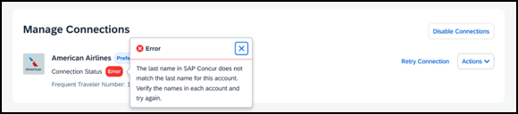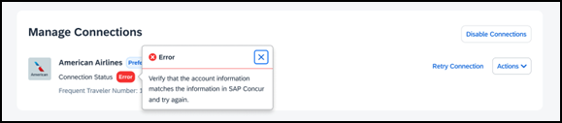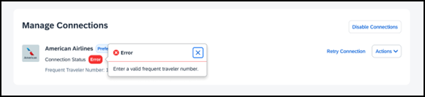

Configuration / Feature Activation
There are no configuration steps. The migration will occur automatically.

TripIt

TripIt Risk Alerts

Overview
With this release, Concur TripIt is introducing a new feature. Risk Alerts will provide proactive notifications about events that have the potential to disrupt the trip.

Business Purpose/ Client Benefit
Risk Alerts will deliver relevant and timely information about potentially disruptive events so the traveler can determine next steps, reach out to appropriate contacts, or make alternate plans as necessary. This is part of TripIt’s Health and Safety initiative and adds value to TripIt Pro.

End User Experience
With this change, users will be informed if there are some events or circumstances that would upset their journey or travel plans.
The risk alerts reach the user as push notifications on their mobile device. Within the app, travelers will see indicators on the trip timeline and on the flight details screens. They can also see details of the risk alert in the app: summary/title, date(s), more information, action/advice as appropriate, and impacted carriers when applicable.
The type of situations that risk alerts will notify the traveler of are:
- Weather (for example, thunderstorms, snowstorms, tornados, etc.)
- Political unrest (for example, protests)
- Labor action (for example, strikes)
- Communication and technology outages
- Airport incidents (for example, runway closures, walkouts by airport staff)

Configuration / Feature Activation
There are no configuration steps. The migration will occur automatically.

Planned Changes
The items in this section are targeted for future releases. SAP Concur reserves the right to postpone implementation of – or completely remove – any enhancement/change mentioned here.
IMPORTANT: These Planned Changes may not be all of the upcoming enhancements and modifications that affect this SAP Concur product or service. The Planned Changes that apply to multiple SAP Concur products and/or services are in a consolidated document. Please review the additional Planned Changes available in the Shared Planned Changes Release Notes.

Concur TripLink

**Planned Changes** Travel Partner Integrations Removed from App Center
Information First Published | Information Last Modified | Feature Target Release Date
April 12, 2024 | -- | Q2,2024
Any changes since the previous monthly release are highlighted in yellow in this release note.

Overview
Currently, users are able to enroll in Travel Partner Integrations through the TripLink Hub, the Travel Profile or the App Center app listing. To streamline and centralize the enrollment process for Travel Partner Integrations within Concur, Travel Partner Integrations app listing will be removed from the App Center, hence reducing one point of access.

End User Experience
Users won't see Travel Partner Integrations app in App Center anymore. To enroll in Travel Partner Integrations, users need to enable their connections on the TripLink Hub or Travel Profile.

Configuration / Feature Activation
There are no configuration steps. The change will occur automatically.

**Planned Changes** Amtrak Integration with TripLink (April 24)

Information First Published | Information Last Modified | Feature Target Release Date
April 12, 2024 | April 19, 2024 | April 24, 2024
Any changes since the previous monthly release are highlighted in yellow in this release note.

Overview
From April 24, Concur TripLink will activate another partner, Amtrak, in our ecosystem. Users will be able to connect their Amtrak loyalty account with their SAP Concur account, to have their business reservations booked directly with Amtrak with their receipts, being available in SAP Concur accounts automatically.

End User Experience
This integration will enable users to book directly with Amtrak, while receiving their company's corporate rate and having itineraries and receipts posted to their account in SAP Concur solutions. This enables companies to fulfill their duty of care needs by knowing where their employees are traveling, being aware of upcoming spend to manage budget and knowing that travelers are getting the best rate by having their corporate discounted rate applied.

Configuration / Feature Activation
There are no configuration steps. However, the end users will have to connect their Amtrak loyalty account with their SAP Concur account, which can be easily done through the TripLink Hub.
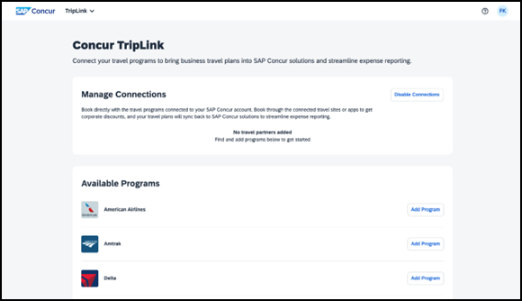
It can also be done through the App Center, by searching for Amtrak and entering their loyalty number.
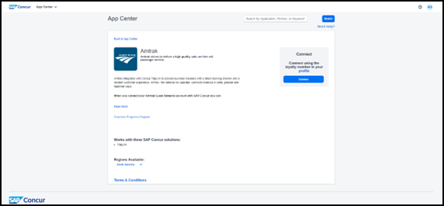

TripIt

No Planned Changes This Month

Client Notifications

Accessibility

Accessibility Updates
SAP implements changes to better meet current Web Content Accessibility Guidelines (WCAG). Information about accessibility-related changes made to SAP Concur solutions is published on a quarterly basis. You can review the quarterly updates on the Accessibility Updates page.

In-Product User Assistance

Client Customized Content
If your company creates customized content for SAP Concur solutions through a user assistance tool such as SAP Enable Now or Concur User Assistant by WalkMe, the changes described in these release notes might affect your customized content. SAP Concur recommends reviewing the monthly release notes for all of your SAP Concur solutions as well as the Shared Changes Release Notes to confirm whether any of the planned or released changes might impact your internal, customized content.
If any changes in a release impact your content, work with your internal teams to update your content accordingly.

Gender Diversity
SAP Concur is committed to supporting gender diversity. Over time we plan to implement product changes to help ensure that SAP Concur solutions support gender non-binary users. These changes will include but are not limited to support for preferred names, non-binary gender options in travel preferences, and non-binary titles.
These planned changes reflect SAP's commitment to supporting gender diversity and enable gender non-binary users to enter consistent information when making travel arrangements and entering personal information into SAP Concur solutions.
Timelines and details about these ongoing changes will be provided in the SAP Concur release notes.

Subprocessors

SAP Concur Non-Affiliated Subprocessors
The list of non-affiliated subprocessors is available from the SAP Sub-processors / Data Transfer Factsheets page.
To access the SAP Concur Sub-processors List:
- Click the following link to navigate to the SAP Sub-processors / Data Transfer Factsheets page:
SAP Sub-processors / Data Transfer Factsheets
- Sign in to the SAP Support Portal using your Support User ID (S-user) and password.
SAP customers must sign in to the SAP Support Portal using their Support User ID (S-user) and password. For information about S-User IDs, refer to Your New Support User ID (S-user) and to the Learn All About S-User IDs blog post.
- On the SAP Sub-processors / Data Transfer Factsheets page, type "Concur" in the Search field.
- In the Title column, click SAP Concur Sub-processors List.
If you have questions or comments, please reach out to: Privacy-Request@Concur.com

Supported Browsers

Supported Browsers and Changes to Support
For information about supported browsers and planned changes to supported browsers, refer to the Concur Travel & Expense Supported Configurations guide.
When changes to browser support are planned, information about those changes will also appear in the Shared Changes Release Notes.

Additional Release Notes and Technical Documentation

Online Help
You can access release notes, setup guides, user guides, admin summaries, supported configurations, and other resources via the in-product Help menu or directly on the SAP Help Portal.
To access the full set of documentation for your product, use the links in the SAP Concur Help menu, or visit the SAP Concur solutions page.
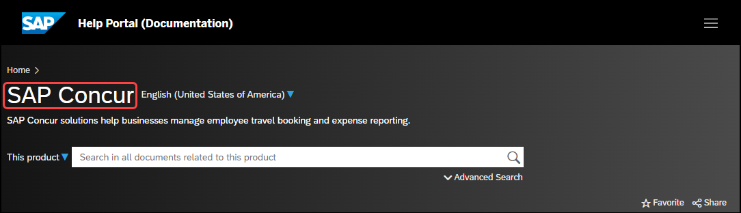

SAP Concur Support Portal – Selected Users
Access release notes, webinars, and other technical documentation on the SAP Concur support portal.
If you have the required permissions, Contact Support is available on the SAP Concur Help menu and in the SAP Concur page footer.
Click Contact Support to access the SAP Concur support portal, then click Resources.
- Click Release/Tech Info for release notes, technical documents, etc.
- Click Webinars for recorded and live webinars.

Cases

Steps for Getting a Status
Each service release contains case resolutions.
How to check the status of a submitted case
- Log on to https://concursolutions.com/portal.asp.
- Click Help > Contact Support.
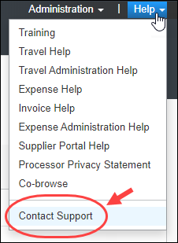
If you do not have the option to contact SAP Concur support under the Help menu, then your company has chosen to support the SAP Concur service internally. Please contact your internal support desk for assistance.
- Click Support > View Cases.
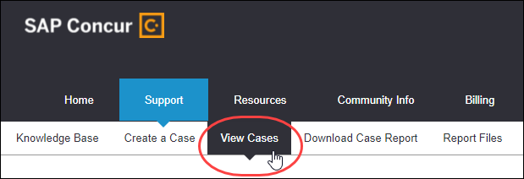
- In the table, view the desired type of cases based on the View list selection. Search results are limited to each company's own cases.
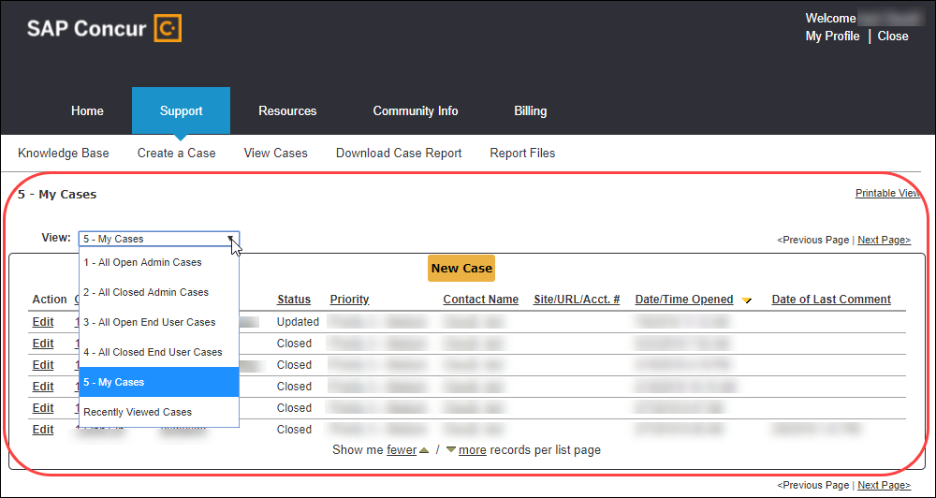

© 2023 SAP SE or an SAP affiliate company. All rights reserved.
No part of this publication may be reproduced or transmitted in any form or for any purpose without the express permission of SAP SE or an SAP affiliate company.
SAP and other SAP products and services mentioned herein as well as their respective logos are trademarks or registered trademarks of SAP SE (or an SAP affiliate company) in Germany and other countries. Please see http://global12.sap.com/corporate-en/legal/copyright/index.epx for additional trademark information and notices.
Some software products marketed by SAP SE and its distributors contain proprietary software components of other software vendors.
National product specifications may vary.
These materials are provided by SAP SE or an SAP affiliate company for informational purposes only, without representation or warranty of any kind, and SAP SE or its affiliated companies shall not be liable for errors or omissions with respect to the materials. The only warranties for SAP SE or SAP affiliate company products and services are those that are set forth in the express warranty statements accompanying such products and services, if any. Nothing herein should be construed as constituting an additional warranty.
In particular, SAP SE or its affiliated companies have no obligation to pursue any course of business outlined in this document or any related presentation, or to develop or release any functionality mentioned therein. This document, or any related presentation, and SAP SE’s or its affiliated companies’ strategy and possible future developments, products, and/or platform directions and functionality are all subject to change and may be changed by SAP SE or its affiliated companies at any time for any reason without notice. The information in this document is not a commitment, promise, or legal obligation to deliver any material, code, or functionality. All forward-looking statements are subject to various risks and uncertainties that could cause actual results to differ materially from expectations. Readers are cautioned not to place undue reliance on these forward-looking statements, which speak only as of their dates, and they should not be relied upon in making purchasing decisions.

