
Concur Expense: Travel Allowance Poland Statutory Bundle
Setup Guide
Last Revised: May 20, 2022
Applies to these SAP Concur solutions:
S Expense
S Professional/Premium edition
 Standard edition
 Travel
 Professional/Premium edition
 Standard edition
 Invoice
 Professional/Premium edition
 Standard edition
 Request
 Professional/Premium edition
 Standard edition
Table of Contents
Section 1: Permissions 1
Section 2: Overview 1
Section 3: What the User Sees 1
Creating an Expense Report 1
Adding Additional Itineraries to an Expense Report 10
Deleting an Itinerary from an Expense Report 11
Section 4: View the Poland Statutory Bundle 11
Accessing the Travel Allowance Configuration Page 12
Viewing a Statutory Rate Bundle 12
Viewing the Contents of the Statutory Rate Bundle 15
Viewing Rate Types and Calculation Rules (Lodging and Meals) 15
Viewing Trip Types (None) 21
Viewing Meal Types (None) 22
Viewing Lodging Types (Overnight) 23
Viewing Rates 24
Viewing Deductions 29
Viewing Adjustments 33
Section 5: Poland-Specific Statutory Validations, Calculations Logic, and Adjustments 38
Rates 38
Calculations for Multiple Trips in a Day 39
Lodging Allowance 39
Domestic Overnight 39
Foreign Overnight 40
Meals Allowance 43
Single-Day Trips (Domestic) 43
Multiple-Day Trips (Domestic) 45
Foreign Trips 47
Provided Meals 49
Pro-Rated Incidentals (Foreign) 52
Section 6: Considerations for Creating Configurable Bundles 52
Paying Higher or Lower Than Statutory Meals Allowances 52
Using a Calendar Date vs 24-Hour "Day" 53
Supporting Extended Trips 53
Paying Pro-Rated Provided Meals Deductions for Partial Days 54

Revision History
Date | Notes / Comments / Changes
May 20, 2022 | Addition of the Show Filters feature on the Adjustments page that supports setting recurring dates for repeated travel.
February 16, 2022 | Updated the new rule option for Location for rate determination, foreign and removed the unused rule options from the Viewing the statutory rate bundle section
July 19, 2021 | Created new guide for the travel allowance solution available with the NextGen UI for Concur Expense

Travel Allowance
NOTE: Multiple SAP Concur product versions and UI themes are available, so this content might contain images or procedures that do not precisely match your implementation. For example, when SAP Fiori UI themes are implemented, home page navigation is consolidated under the SAP Concur Home menu.

Permissions
A company administrator may or may not have the correct permissions to use this feature. The administrator may have limited permissions, for example, they can affect only certain groups and/or use only certain options (view but not create or edit).
If a company administrator needs to use this feature and does not have the proper permissions, they should contact the company's Concur Expense administrator.
Also, the administrator should be aware that some of the tasks described in this guide can be completed only by SAP Concur. For tasks not completed during implementation, the client must initiate a service request with SAP Concur support.

Overview
This document provides country-specific template information about the SAP Concur-managed, statutory bundle for Poland.
- IMPORTANT: This guide is a supplement to the Expense: Travel Allowance Setup Guide which contains essential information about the travel allowance feature.
Clients who use the statutory bundle for Poland, but also want to supersede some of the statutory rates, may also create configurable bundles.
- For more information about client-managed bundles, refer to the Expense: Travel Allowance Generic Configurable Bundle Setup Guide.

What the User Sees
This section uses the most common method of reimbursement in Poland – daily allowances for incidentals and meals and actual expenses for lodging.

Creating an Expense Report
When the travel allowance feature is available to a user, after the user completes the header on a new expense report, they are prompted for itinerary and adjustment information.
To create an expense report:
- From Concur Expense, click Create New Report.
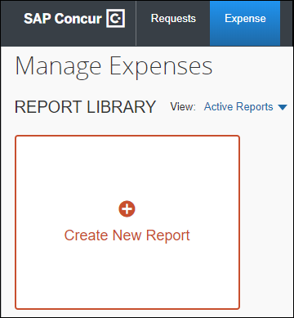
There are other valid paths to start a new expense report.
- On the Create New Report page, commonly referred to as the report header, complete all required fields. An asterisk indicates a required field.
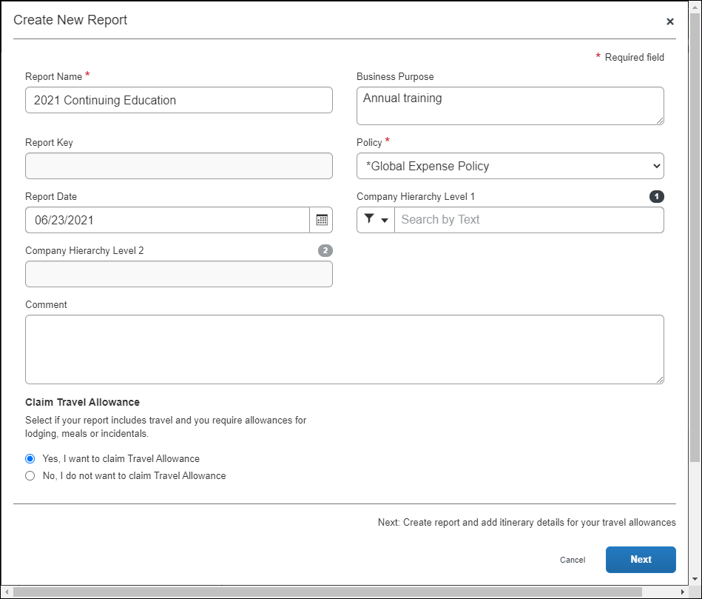
The policy selected may impact which fields display.
When claiming travel allowance is available to the user, Yes, I want to claim Travel Allowance is selected by default.
- Click Next to create the expense report and display the Itinerary page.
- On the Itinerary page, complete all required fields. An asterisk indicates a required field.
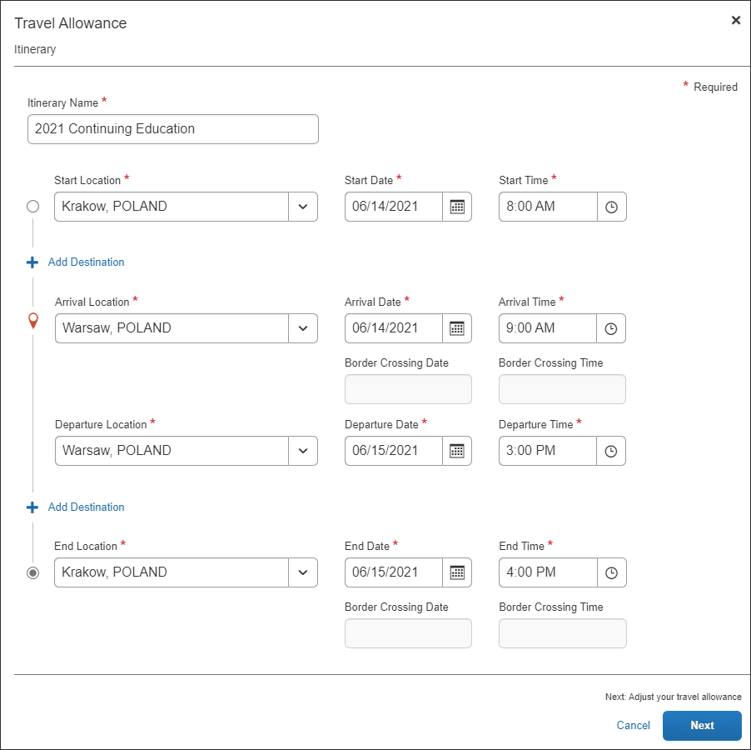
The following table shows the fields and their descriptions. An asterisk indicates a required field.
Field/Option | Description
Itinerary Name * | Enter an itinerary name or use the default name provided that matches the Report Name.
Start Location * | Enter the first few letters of the origination city for this itinerary and select it from the list of cities.
Start Date * | Enter a beginning month, day, and year for the time period covered by this itinerary.
Start Time * | Enter a beginning hour and minutes for the time period covered by this itinerary.
Add Destination | Click Add Destination to display another set of location fields to this itinerary. This option displays twice for convenience.
Arrival Location * | Enter the first few letters of the destination city and select it from the list of cities.
Arrival Date * | Enter the beginning month, day, and year of your time at this Arrival Location.
Arrival Time * | Enter the beginning hour and minutes of your time at this Arrival Location.
Border Crossing Date* | Enter the beginning month, day, and year on the date when you crossed the Polish border on your way to this Arrival Location.  NOTE: This field is only enabled for foreign trips and defaults to match the Arrival Date.  IMPORTANT: Users must edit the default contents of this field as needed to accurately reflect the date that the border crossing occurred.
Border Crossing Time* | Enter the beginning hour and minutes on the date when you crossed the Polish border on your way to this Arrival Location.  NOTE: This field is only enabled for foreign trips and defaults to match the Arrival Time.  IMPORTANT: Users must edit the default contents of this field as needed to accurately reflect the local Polish time that the border crossing occurred, such as the time when the flight departed from Poland.
Departure Location * | Enter the first few letters of the last location at this Arrival Location and select it from the list of cities.
Departure Date * | Enter the month, day, and year that you left the Departure Location.
Departure Time * | Enter the hour and minutes that you left the Departure Location.
End Location * | Enter the first few letters of the final city for this trip and select it from the list of cities.
End Date * | Enter a ending month, day, and year for the time period covered by this itinerary.
End Time * | Enter an ending hour and minutes for the time period covered by this itinerary.
- Click Next to save the itinerary and display the Adjustments page.
Adjustments (view)
This is the default view where a user can see a row for each calculated daily allowance and select provided meals and claim overnight stays that do not have a receipt, such as when staying with a friend.
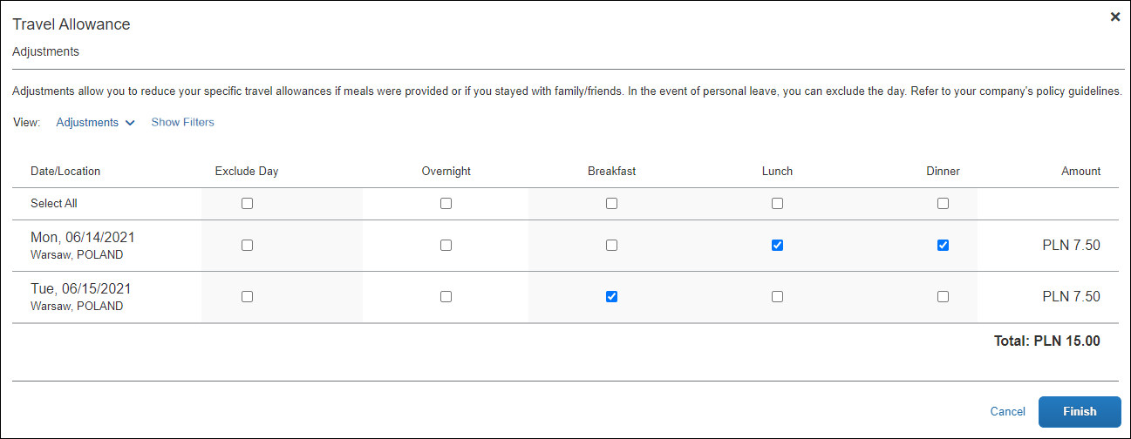
In this sample instance:
- If you select Show Filters the following options become available.
Field/Option | Description
Date Range | Enter the beginning and ending of the travel either in MM/DD/YYYY format, or by selecting the calendar icon to input these values by selecting the month(s) and days.
Recurrence | Set how often this same travel occurs by the number of weeks and the days for each week that you travel, for example every 3 weeks from Monday through Friday.  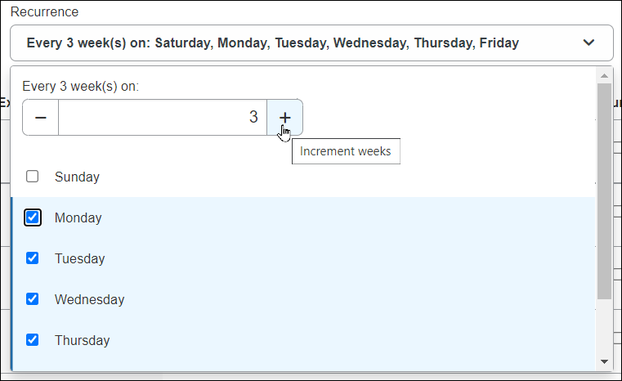
Location | The travel destination where you will spend your trip.
Apply / Clear Filters buttons | Click Apply to set the configured trip, or reset the filter entirely by clicking Clear Filters.
Hide Filters button | Click Hide Filters to dismiss the filter options and return to the non-filter view of this page.
Reimbursement Details (view)
This view shows details for the adjustments based on what the user selected for provided meals and Overnight together with original rate amounts, any deductions for the day, and total reimbursable amounts.
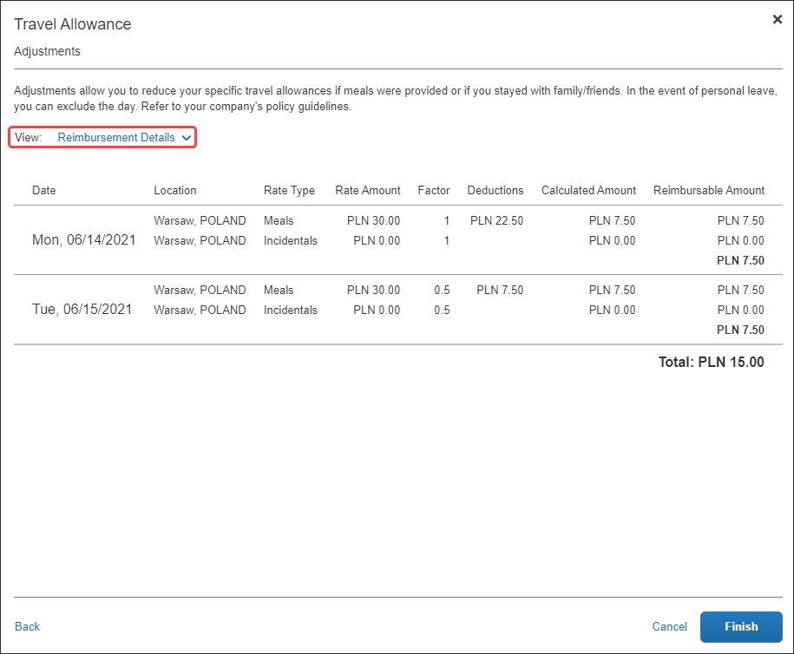
For foreign trips, the Reimbursable Amount displays in the reimbursement currency, while the Rate Amount displays in the currency against which the rate is defined.
The following table shows the fields and their descriptions. An asterisk indicates a required field.
Column | Description
Exclude Day | Select this check box to mark a date as personal time and therefore not elibigle for travel allowance benefits.  NOTE: There is a Select All check box available for this column.
Overnight | If configured for your company, and selected, the system will add an amount to the calculated meals rate if you stayed overnight, but do not have a (hotel or similar) receipt for the purpose of purchasing a gift for the host.
Breakfast | Select this check box to mark the meal as provided and therefore not eligible for travel allowance benefits.  NOTE: Provided meals reduce the daily allowance total shown in the Amount column.  NOTE: There is a Select All check box available for this column.
Lunch | Select this check box to mark the meal as provided and therefore not eligible for travel allowance benefits.  NOTE: Provided meals reduce the daily allowance total shown in the Amount column.  NOTE: There is a Select All check box available for this column.
Dinner | Select this check box to mark the meal as provided and therefore not eligible for travel allowance benefits.  NOTE: Provided meals reduce the daily allowance total shown in the Amount column.  NOTE: There is a Select All check box available for this column.
- (Optional) Click Back to edit the itinerary page.
- (Optional) Click Cancel to close the adjustments page without saving your selections.
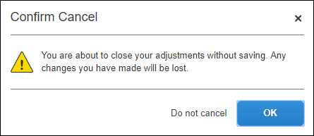
The expense report is not deleted and the itinerary and allowances can be edited later by selecting Travel Allowance > Edit Travel Allowance.
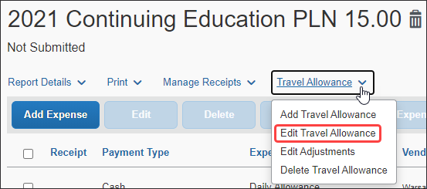
- Click Finish to create the daily allowances and display the expense report.
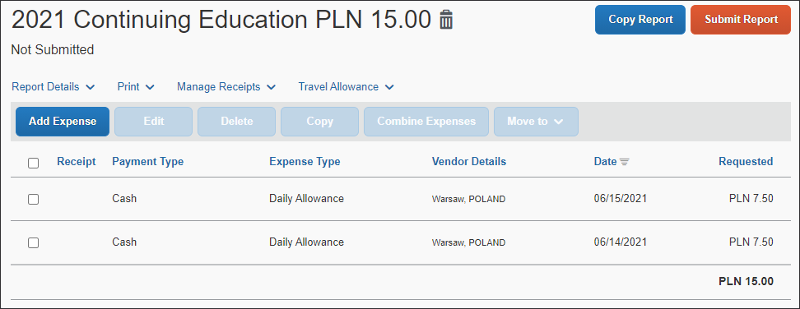
It is important to understand the following about system-created expenses:
- As applicable, daily allowance expenses are assigned the default expense type of Daily Allowance or Daily Allowance (Lodging).
- If there are both meals and lodging allowances on the same day, an expense is created for each expense type for each day.
- If rate information is changed after the daily allowance expenses have been created, the amounts are not updated unless the user returns to the adjustments page and clicks Finish again.
- If the actual meals expenses are imported through the company card import but the user was reimbursed with daily allowances, then the user should mark the imported meals expenses as provided.
- Click Add Expense to add actual expenses. This step is not specific to the travel allowance feature and is accomplished in the same manner that is used to add non-travel allowance expenses to an expense report.
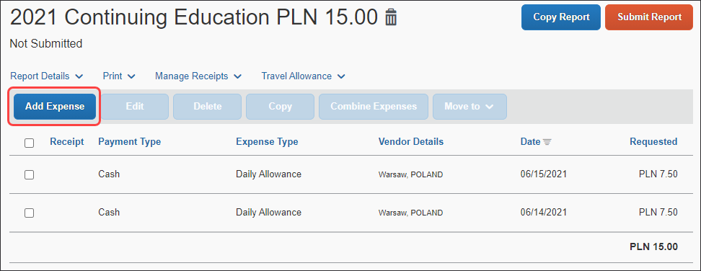

Adding Additional Itineraries to an Expense Report
To add additional itineraries to an expense report
- Open the expense report and click Travel Allowance > Add Travel Allowance. The Travel Allowance wizard begins again from the Itinerary page.
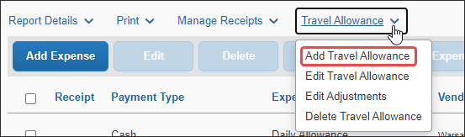
There is no restriction on the number of itineraries that may be associated with an expense report.
- Complete the wizard and click Finish.

Deleting an Itinerary from an Expense Report
To delete an itinerary from an expense report
- Open the expense report and click Travel Allowance > Delete Travel Allowance.
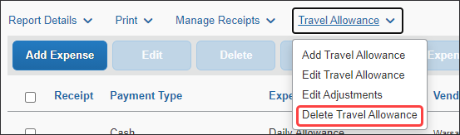
- On the Itinerary Management page of the Travel Allowance wizard, in the desired row, click Delete.
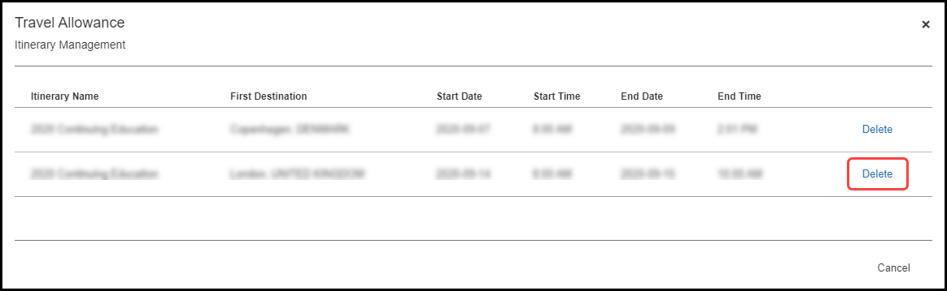
- Click Delete.
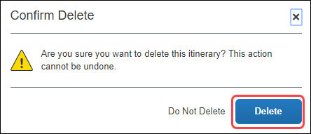

View the Poland Statutory Bundle
A bundle is a set of rates. The simplest initial configuration of the travel allowance feature uses the statutory rate bundle provided by SAP Concur to create a configuration code.
- A Rate Bundle consists of rate types, calculation rules, trip types, meal types, lodging types, rates, deductions, and adjustments. SAP Concur provides statutory bundles based on current data available from each country's government.
Administrators may create their own configurable bundles to supersede the provided statutory bundles.
- For more information about creating a (configurable) copy of an SAP-provided (read-only) statutory bundle, refer to the Expense: Travel Allowance Generic Configurable Bundle Setup Guide.
- A Configuration Code consists of a statutory and/or a configurable Rate Bundle.
- For more information about enablement, hierarchy, mappings, configuration codes, and optional configuration, refer to the Expense: Travel Allowance Setup Guide.

Accessing the Travel Allowance Configuration Page
To access the Travel Allowance Configuration page:
- Click Administration > Expense > Expense Admin > Travel Allowance Configuration.

Viewing a Statutory Rate Bundle
To view a statutory rate bundle:
- On the Travel Allowance Configuration page, click Rate Bundles. The Rate Bundles page displays.
- On the Rate Bundles page, in the row for the statutory bundle, click View ().
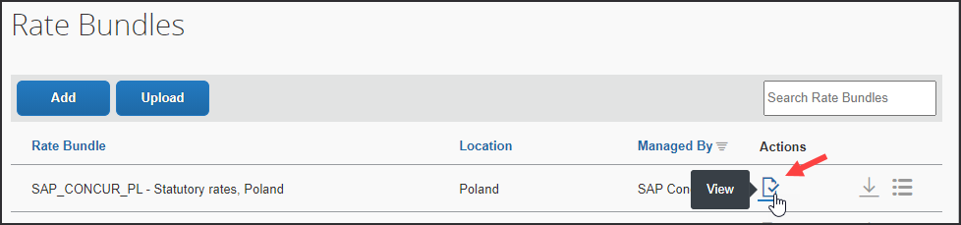
The View Rate Bundle page displays.
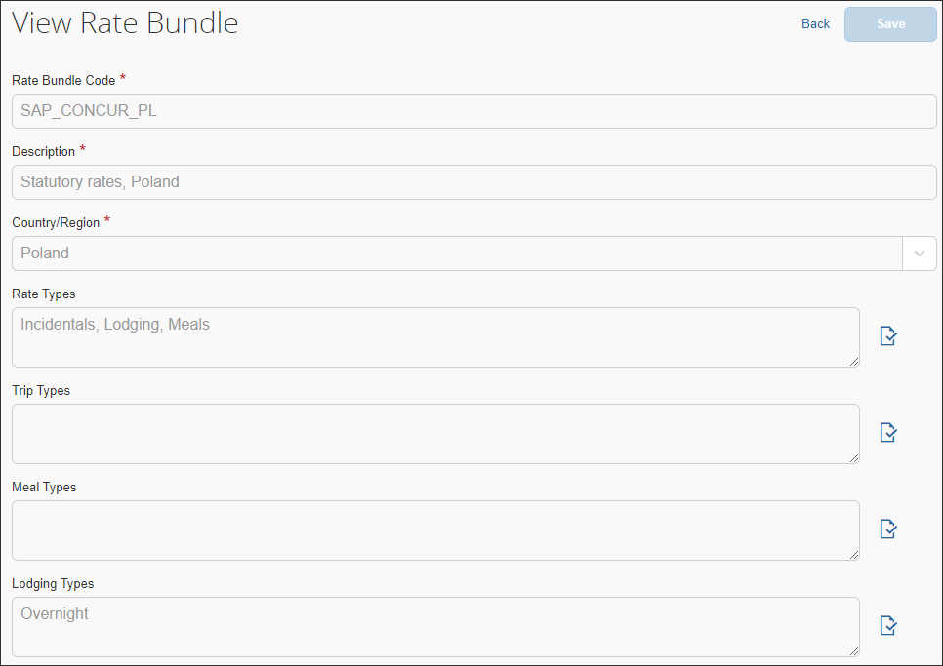
All statutory bundles are read-only.
- Click View () on the Rate Types, Trip Types, Meal Types, or Lodging Types to display the desired details such as codes, descriptions, rate categories, and calculation rules.
- For more information about optional configuration for expense types, refer to the Expense: Travel Allowance Setup Guide.
- Click Back.
- Click View contents ().
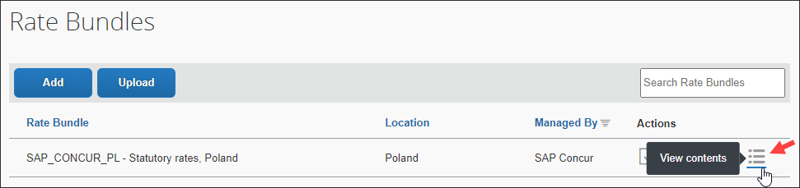
The Statutory rates, Poland page displays.
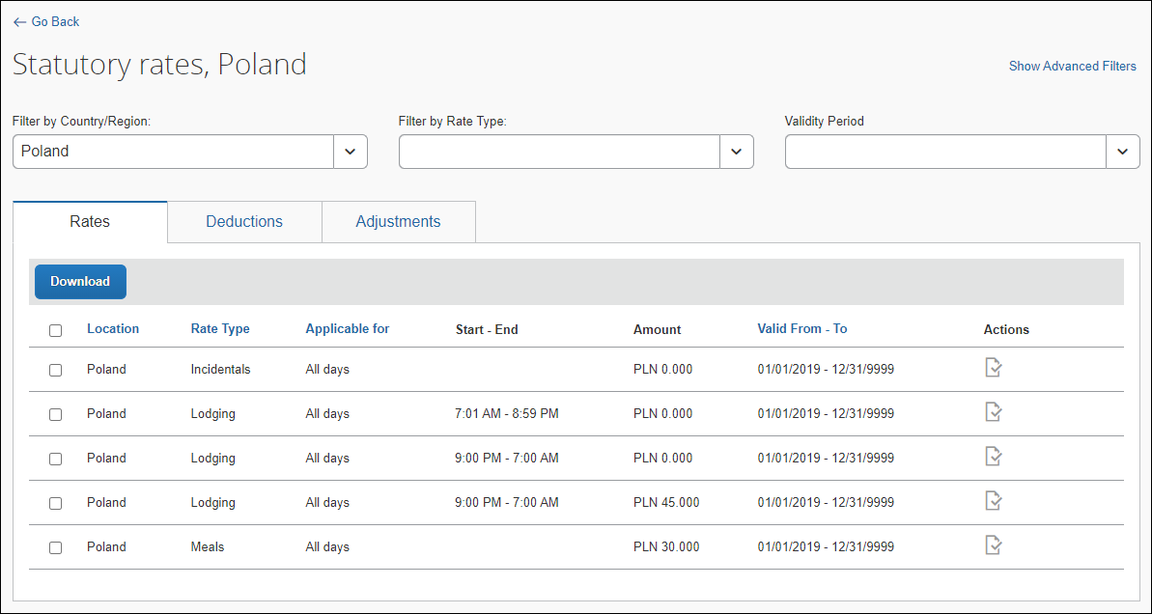
The view shown has been filtered by "Poland".
- Click View () on the Rates, Deductions, and Adjustments tab along with the filters to display the desired details.
Click Show Advanced Filters to display more filters.
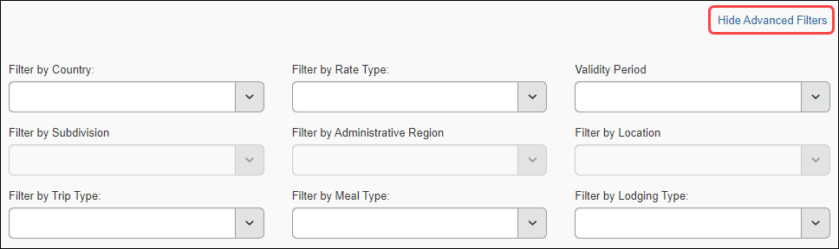
Show Advanced Filters toggles to and from Hide Advanced Filters.

Viewing the Contents of the Statutory Rate Bundle

Viewing Rate Types and Calculation Rules (Lodging and Meals)
Rate Bundles contain Rate Types and Rate Types contain calculation rules.
To view the rate types:
- On the Rate Bundles page, in the row for the statutory bundle, click View ().
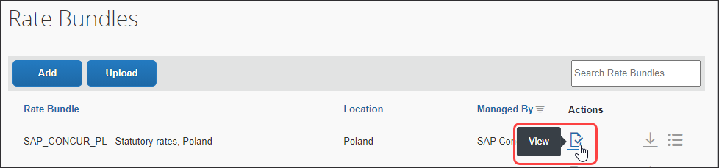
- On the View Rate Bundle page, click View () on the Rate Types.
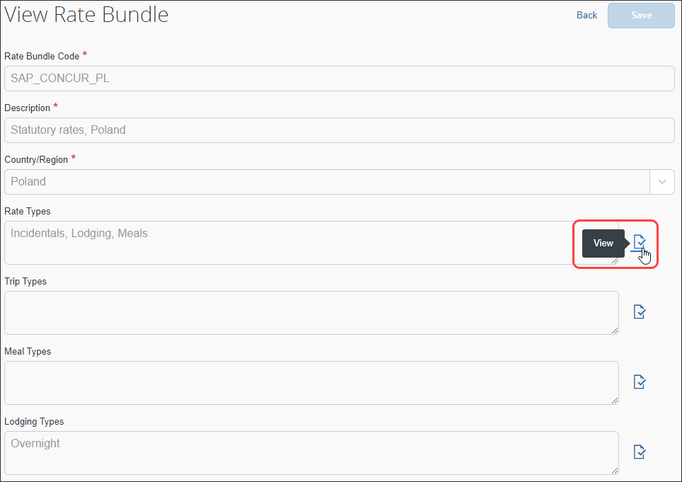
The View Rate Types page displays.
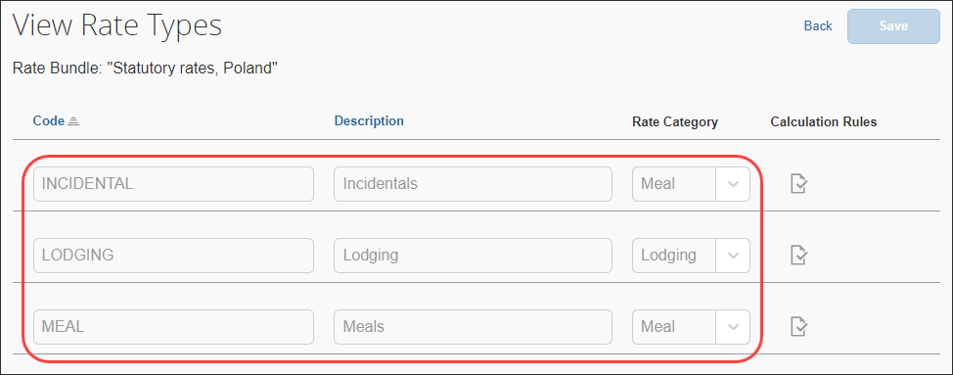
- Click View () on the desired row. The calculation rules display.
The following example graphics show the rules for the Incidentals, Lodging, and Meals rate types. The default Rule selected depends on the Rate Category being viewed.
Incidentals
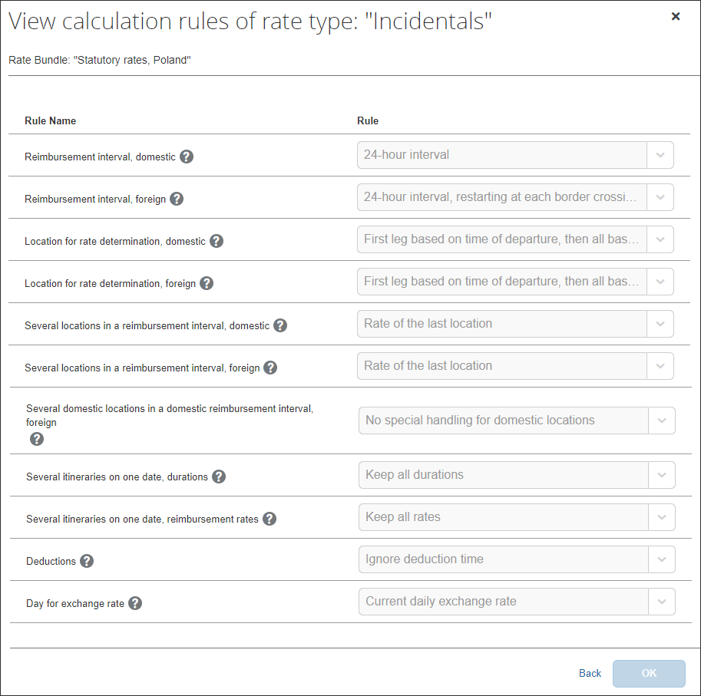
Lodging
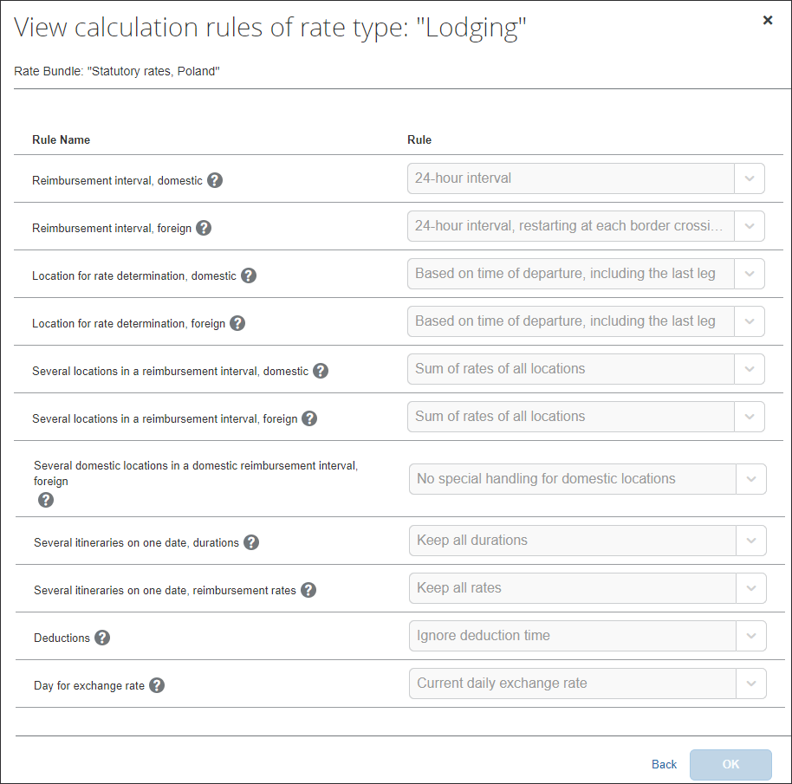
Meals
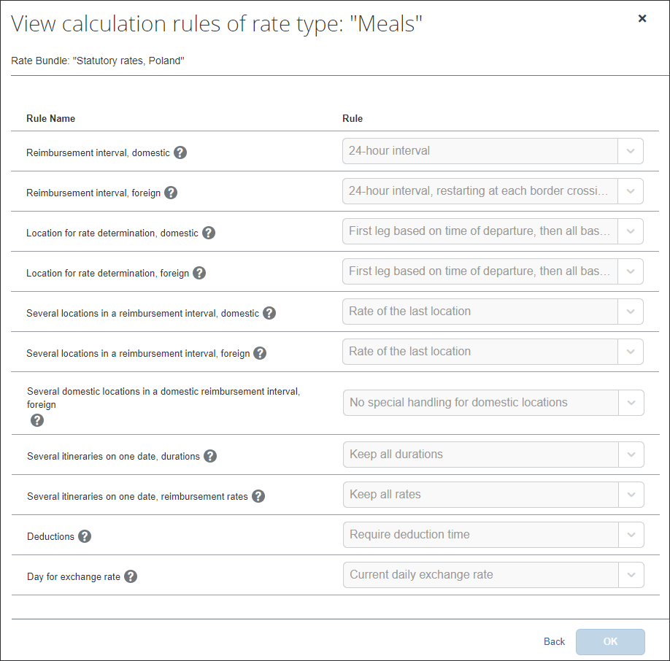
The following table shows the read-only values that exist in the statutory bundle for rate types and calculation rules, and also the possible options in the event that a configurable bundle is needed to supersede portions of the statutory bundle.
- For more information about custom bundles, refer to the Expense: Travel Allowance Generic Configurable Bundle Setup Guide.
Rule Name | Rule Options
Reimbursement interval, domestic | - 24-hour interval (default for Incidentals, Lodging, and Meals)
Reimbursement interval, foreign | - 24-hour interval, restarting at each border crossing and restarting the day count (default for Incidentals, Lodging, and Meals)
Location for rate determination, domestic | - Based on time of departure, including the last leg (default for Lodging)  - First leg based on time of departure, then all based on time of arrival (default for Incidentals and Meals)
Location for rate determination, foreign | - Based on time of departure, including the last leg (default for Lodging)  - Based on border crossing or arrival time modifying time zones first stop at departure location last stop at arrival location (default for Incidentals and Meals)
Several locations in a reimbursement interval, domestic | - Rate of the last location (default for Incidentals and Meals)  - Sum of rates of all locations (default for Lodging)
Several locations in a reimbursement interval, foreign | - Rate of the last location (default for Incidentals and Meals)  - Sum of rates of all locations (default for Lodging)
Several domestic locations in a domestic reimbursement interval, foreign | - No special handling for domestic locations (default for Incidentals, Lodging, and Meals)
Several itineraries on one date, durations | - Keep all durations (default for Incidentals, Lodging, and Meals)
Several itineraries on one date, reimbursement rates | - Keep all rates (default for Incidentals, Lodging, and Meals)
Deductions | - Ignore deduction time (default for Incidentals and Lodging)
Day for exchange rate | - Current daily exchange rate (default for Incidentals, Lodging, and Meals)
- For more information about rule options, refer to the Expense: Travel Allowance Service Setup Guide.
- Click Back.

Viewing Trip Types (None)
The statutory Poland bundle does not contain any Trip Types.
To view the trip types:
- On the Rate Bundles page, in the row for the statutory bundle, click View ().
The Trip Types field does not contain any trip types.
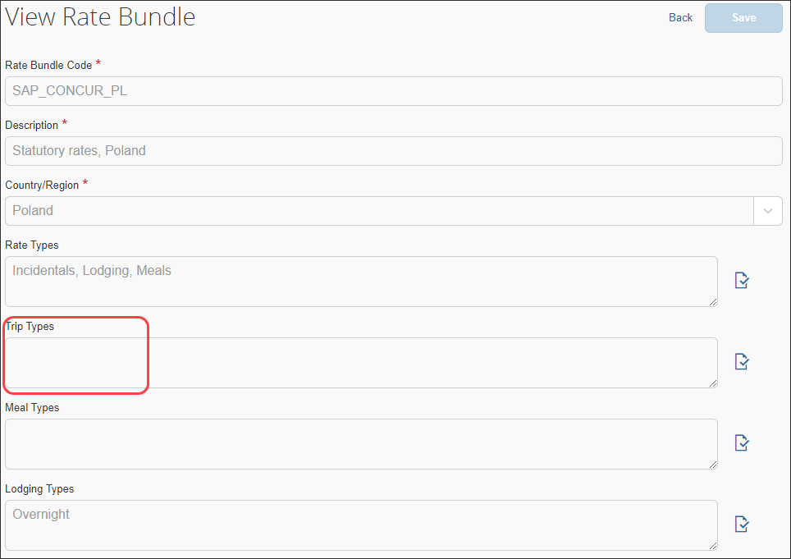
- Click Back.

Viewing Meal Types (None)
The statutory Poland bundle does not contain any Meal Types.
To view meal types:
- On the Rate Bundles page, in the row for the statutory bundle, click View ().
The Meal Types field does not contain any meal types.
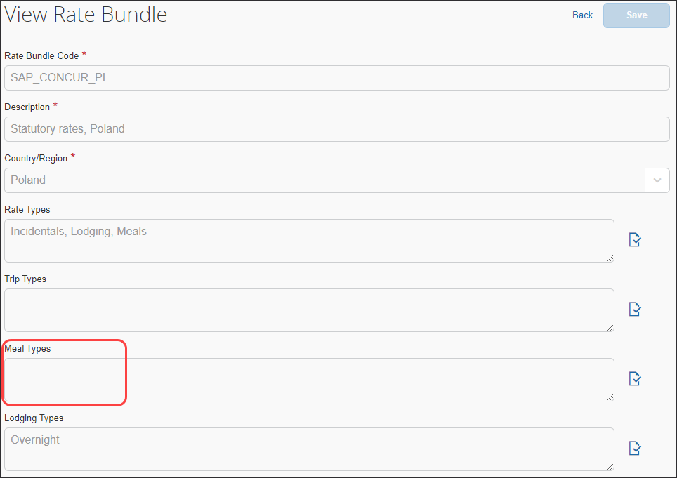
- Click Back.

Viewing Lodging Types (Overnight)
Rate Bundles contain Lodging Types.
To view lodging types:
- On the Rate Bundles page, in the row for the statutory bundle, click View ().
- On the View Rate Bundle page, click View () on the Lodging Types.
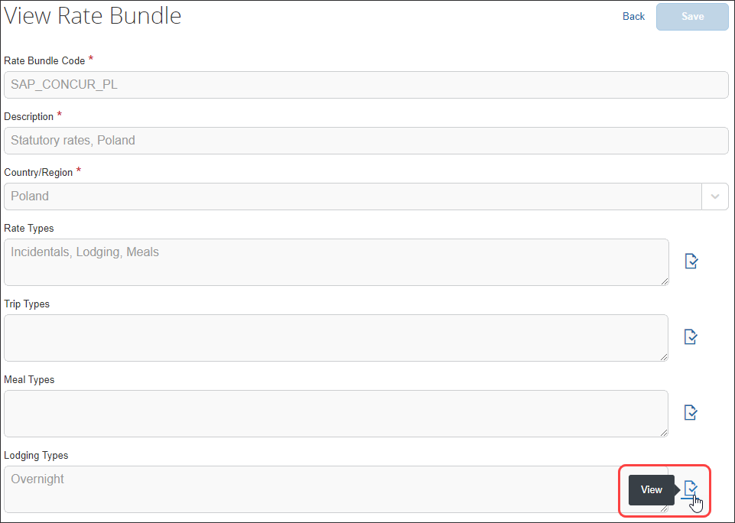
The View Lodging Types page displays.
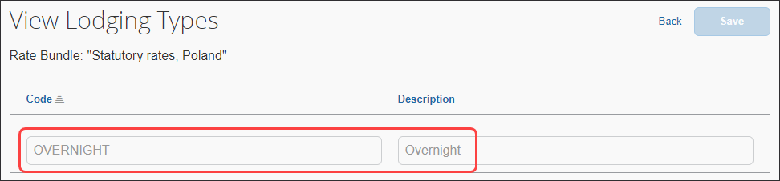
- Click Back.

Viewing Rates
To view rates:
- On the Rate Bundles page, in the bundle’s row, click View contents ().
The bundle’s contents page displays the Rates tab and rates.
The view shown has been filtered by "Poland".
- (Optional) Use filters to locate the desired rate.
- (Optional) Use advanced filters to locate the desired rate.
- Click View () on the desired row.
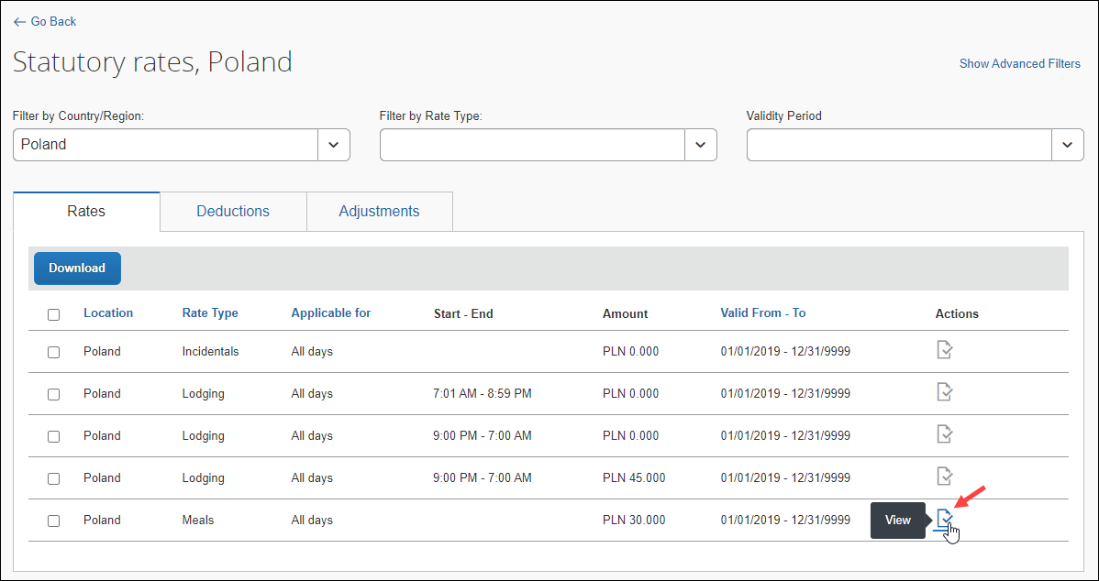
The details of the rate display.
Example
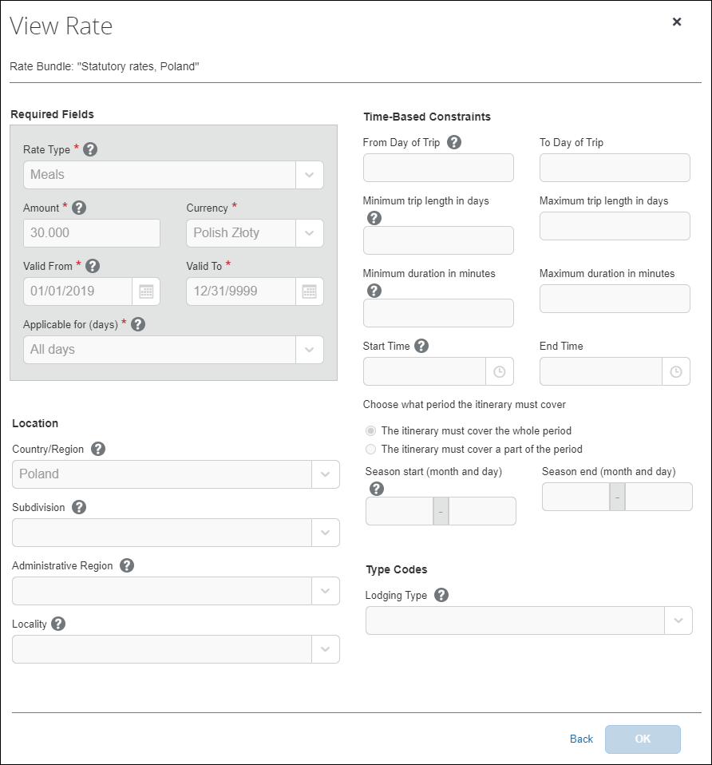
The following table shows the read-only values that exist in the statutory Poland rates, and also the possible options in the event that a configurable bundle is needed to supersede portions of the statutory bundle. An asterisk indicates a required field.
- For more information about configurable bundles, refer to the Expense: Travel Allowance Generic Configurable Bundle Setup Guide.
Field | Description
Required Fields  Rate Type * | The value is Incidentals, Lodging, or Meals.
Required Fields  Amount *  Currency * | The value is an amount and a currency to which the rate applies.  When creating an expense report, the currency displayed here will be converted into the user’s reimbursement currency as determined by the user's User Administration settings.
Required Fields  Valid From *  Valid To * | This value is a date range.  A date range allows previous rates to remain applicable when processing trips in the past.  NOTE: Regulatory rates are typically updated annually by calendar or financial year and so are valid only for limited date ranges.
Required Fields  Applicable for (days) * | This value is First day, Last day, All days, or Intervening days.  Intervening days are the days between the first and last day of a trip. The All days value includes the first day, intervening days, and the last day, and applies to one-day trips.
Location  Country/Region | If this field is used for this rate, the value is the country where these rates apply.
Location  Subdivision | If this field is used for this rate, the value is the state or province where these rates apply.
Location  Administrative Region | If this field is used for this rate, the value is the county where these rates apply.
Location  Locality | If this field is used for this rate, the value is the city where these rates apply.
Time-Based Constraints  From Day of Trip  To Day of Trip | If these fields are used for this rate, they display a number range of days during which the rate applies.  This setting may be used when meal rates decrease after a certain number of days, since it is assumed that users become familiar with the place and find ways to spend less on meals.  For example, meal per diems may be reduced to 80% as of day 15 of travel, and further reduced to 60% as of day 30 of travel.  NOTE: This setting creates a per trip rate constraint and does not apply across multiple itineraries or trips.
Time-Based Contraints  Minimum trip length in days  Maximum trip length in days | If these fields are used for this rate, they display a number range of days from 1 to 999 to which this rate applies.  This setting may be used when single-day trips have different rates than multi-day trips.  For example, when both the minimum and maximum days display 1, then this rate applies only to a single-day trip.
Time-Based Contraints  Minimum duration in minutes  Maximum duration in minutes | If these fields are used for this rate, they display a number range of minutes to which this rate applies.  For example, users may receive a meal per diem, such as 12 EUR when their trip is more than 8 hours (481 minutes) and less than 24 hours (1439 mintues) on a given day.
Time-Based Contraints  Start Time  End Time | If these fields are used for this rate, they display a clock time range during which the travel allowance is valid.  For example, if a meal allowance is defined for travel between 13:00 and 14:00 and the trip ends at 12:30, then no meal allowance allowance is provided.
Time-Based Contraints  The itinerary must cover the whole period  -or-  The itinerary must cover a part of the period | If one of these contraints is used for this rate, the other cannot be used because these choices are mutually exclusive.  For example, if a meal allowance is defined for travel between 13:00 and 14:00 and the trip ends at 13:30, then The itinerary must cover the whole period means no allowance is provided; however The itinerary must cover a part of the period means the allowance is provided as long as the Minutes to be covered at least is met.
Time-Based Constraints  Minutes to be covered at least  Minutes to be covered at most | If the The itinerary must cover a part of the period constraint displays, then these fields display a number range of minutes to which that constraint applies.
Time-Based Contraints  Season start (month and day)  Season end (month and day) | If these fields are used for this rate, they display months and days to which this rate applies.  This setting is used when rates are different depending on the season.  For example, rates in Darwin, Australia are lower during the rainy season (December – March) than during the rest of the year.
Type Codes  Lodging Type  Note: Type Codes (trip, meal, and lodging) are highly configurable and will impact this section of the page.  - For more information, refer to the Editing a Configurable Bundle procedure of this guide. | If this field is used for this rate, the value is Overnight.
- Click Back.

Viewing Deductions
To view deductions in a rate bundle:
- On the Rate Bundles page, in the bundle’s row, click View contents ().
The bundle’s contents page displays with tabs for rates, deductions, and adjustments.
- Click the Deductions tab.
- In the desired row, click View ().
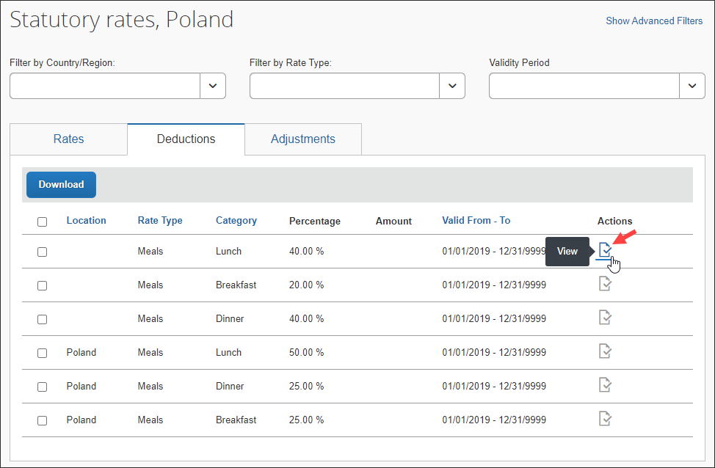
- The View Deduction page displays.
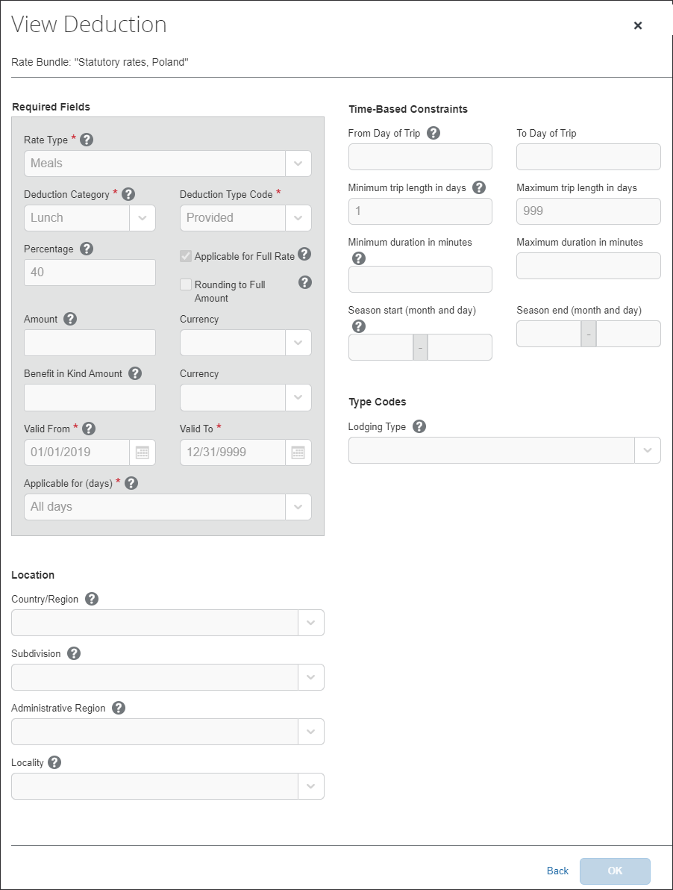
The following table shows the read-only values that exist in the statutory Poland deductions, and also the possible options in the event that a configurable bundle is needed to supersede portions of the statutory bundle. An asterisk indicates a required field.
- For more information about custom bundles, refer to the Expense: Travel Allowance Generic Configurable Bundle Setup Guide.
Field | Description
Required Fields  Rate Type * | The value is Incidentals, Lodging, or Meals.
Required Fields  Deduction Category * | This value is a further break-down of the Rate Type.
Required Fields  Deduction Type Code * | This value is a further breakdown of the Deduction Category.
Required Fields  Percentage * | This value is a percentage amount.  This is the amount by which the daily rate is reduced calculated as a percentage of the associated rate.  For example, a breakfast deduction may be configured as 20% of the meal rate.  NOTE: The Percentage field and Amount field are mutually exclusive.
Required Fields  Applicable for Full Rate | This value is selected or cleared.  This setting is used for a deduction percentage.  Typically, the percentage deduction is calculated on the rate for a full day in which case this option is selected. In some instances, the percentage deduction is calculated for the actual rate of that day. This may be a reduced rate for the first or last day of a trip.  For example, when Applicable for Full Rate is selected, a breakfast deduction is defined as 20% of the meal rate. If the meal rate for full days is 28 EUR and the meal rate for the first and last day is 14 EUR, and the user receives a free breakfast on the last day of travel, then the breakfast deduction is 20% of 28 EUR, which is 5.60 EUR.  NOTE: A rate for a full day is an All_days rate defined for a duration of 1440 minutes, the equivalent of 24 hours.
Rounding to Full Amount | This value is selected or cleared.  This setting is used for a deduction percentage.  Selecting the check box means deduction amounts which are calculated from deduction percentages are rounded to the next full number.  If the setting is cleared, deduction amounts which are calculated from deduction percentages retain the number of decimal places used for the currency.
Required Fields  Amount / Currency * | This value is a fixed amount and a currency to which the deduction amount will apply.  When creating an expense report, the currency displayed here will be converted into the user’s reimbursement currency as determined by the user's User Administration settings.  NOTE: The Percentage field and Amount field are mutually exclusive.
Required Fields  Benefit in Kind Amount / Currency | This value is an amount and a currency to which the deduction amount applies. This is a taxable benefit amount, which is created for a free meal when there is no meal allowance from which to deduct it.  For example, if the user travels less than 8 hours and does not get a meal allowance, but gets a free meal, the system will then treat this amount as a taxable benefit.  NOTE: This amount is not visible to the user and does not affect their reimbursement. It is displayed here in anticipation of further processing by a payroll system.
Required Fields  Valid From *  Valid To * | This value is a date range.  The date range allows previous rates to remain applicable when processing trips in the past.  NOTE: Regulatory rates are typically updated annually by calendar or financial year and so are valid only for limited date ranges.
Required Fields  Applicable for (days) * | This value will be First day, Last day, All days, or Intervening days.  Intervening days are the days between the first and last day of a trip. The All days value includes the first day, intervening days, and the last day, and applies to one-day trips.
Location  Country/Region | If this field is used for this rate, the value is the country where these rates apply.
Location  Subdivision | If this field is used for this rate, the value is the state or province where these rates apply.
Location  Administrative Region | If this field is used for this rate, the value is the county where these rates apply.
Location  Locality | If this field is used for this rate, the value is the city where these rates apply.
Time-Based Contraints  From Day of Trip  To Day of Trip | If these fields are used for this deduction, they display a number range of days during which the deduction applies.  NOTE: This setting creates a per trip deduction constraint and does not apply across multiple itineraries or trips.
Time-Based Contraints  Minimum trip length in days  Maximum trip length in days | If these fields are used for this deduction, they will display a number range of days from 1 to 999 to which this deduction applies.  This setting may be used when single-day trips have different deductions than multi-day trips.  For example, when both the minimum and maximum days display 1, then this deduction applies only to a single-day trip.
Time-Based Contraints  Minimum duration in minutes  Maximum duration in minutes | If these fields are used for this deduction, they will display a number range of minutes to which this deduction applies.
Time-Based Contraints  Season start (month and day)  Season end (month and day) | If these fields are used for this deduction, they display months and days to which this deduction applies.  This setting is used when deduction are different depending on the season.
Type Codes  Lodging Type  Note: Type Codes (trip, meal, and lodging) are highly configurable and will impact this section of the page. | If this field is used for this deduction, the value is Overnight.
- Click Back.

Viewing Adjustments
To view adjustments in a rate bundle:
- On the Rate Bundles page, in the bundle’s row, click View contents ().
The bundle’s contents page displays with tabs for rates, deductions, and adjustments.
- Click the Adjustments (tab).
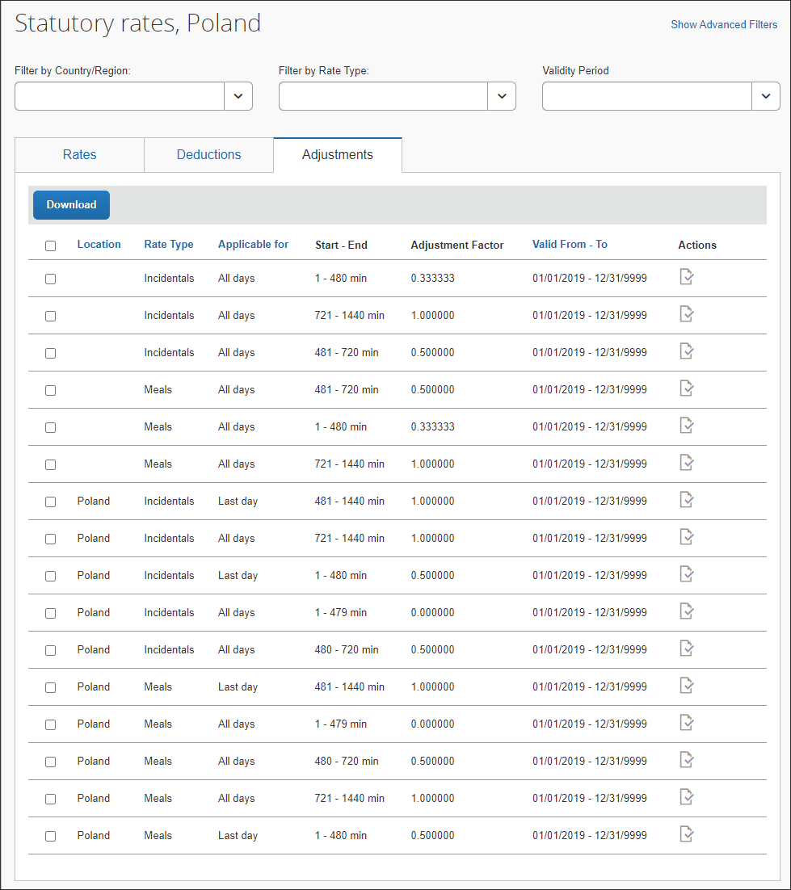
- In the desired row, click View ().
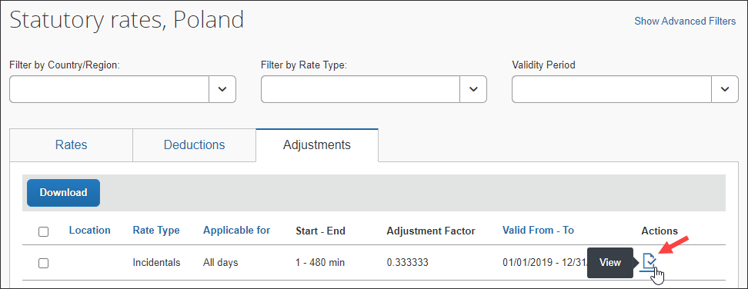
- The View Adjustment page displays.
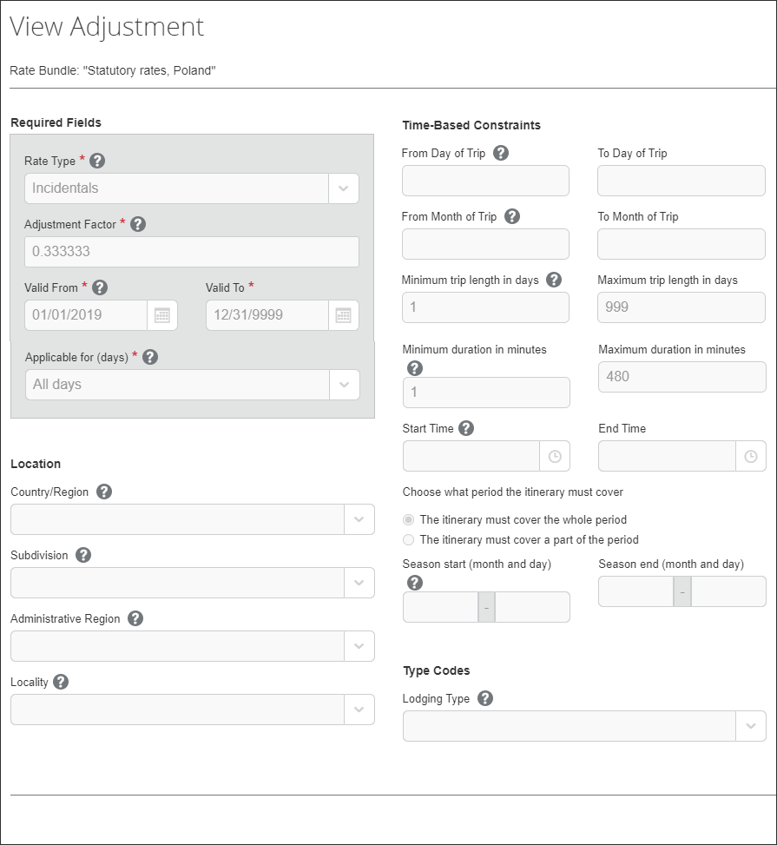
The following table shows the read-only values that exist in the statutory Poland adjustments, and also the possible options in the event that a configurable bundle is needed to supersede portions of the statutory bundle. An asterisk indicates a required field.
- For more information about custom bundles, refer to the Expense: Travel Allowance Generic Configurable Bundle Setup Guide.
Field | Description
Required Fields  Rate Type * | The value is Incidentals, Lodging, or Meals.
Required Fields  Adjustment Factor * | This number either increases or reduces the rate.  A number greater than 1 will increase the rate while a decimal number less than 1 will reduce the rate.
Required Fields  Valid From *  Valid To * | This value is a date range.  The date range allows previous rates to remain applicable when processing trips in the past.  NOTE: Regulatory rates are typically updated annually by calendar or financial year and so are valid only for limited date ranges.
Required Fields  Applicable for (days) * | This value will be First day, Last day, All days, or Intervening days.  Intervening days are the days between the first and last day of a trip. The All days value includes the first day, intervening days, and the last day, and applies to one-day trips.
Location  Country/Region | If this field is used for this rate, the value is the country where these rates apply.
Location  Subdivision | If this field is used for this rate, the value is the state or province where these rates apply.
Location  Administrative Region | If this field is used for this rate, the value is the county where these rates apply.
Location  Locality | If this field is used for this rate, the value is the city where these rates apply.
Time-Based Contraints  From Day of Trip  To Day of Trip | If these fields are used for this adjustment, they display a number range of days during which the adjustment applies.  NOTE: This setting creates a per trip deduction constraint and does not apply across multiple itineraries or trips.
Time-Based Contraints  From Month of Trip  To Month of Trip | If these fields are used for this adjustment, they display a number range of days during which the adjustment applies.  NOTE: This setting creates a per trip adjustment constraint and does not apply across multiple itineraries or trips.
Time-Based Contraints  Minimum trip length in days  Maximum trip length in days | If these fields are used for this adjustment, they display a number range of days from 1 to 999 to which this adjustment applies.  This setting may be used when single-day trips have different adjustment than multi-day trips.  For example, when both the minimum and maximum days display 1, then this adjustment applies only to a single-day trip.
Time-Based Contraints  Minimum duration in minutes  Maximum duration in minutes | If these fields are used for this adjustment, they display a number range of minutes to which this adjustment applies.
Time-Based Contraints  Start Time  End Time | If these fields are used for this adjustment, they display a time range to which this adjustment applies.
Time-Based Contraints  The itinerary must cover the whole period  -or-  The itinerary must cover a part of the period | If one of these contraints is used for this adjustment, the other cannot be used because these choices are mutually exclusive.
Time-Based Constraints  Minutes to be covered at least  Minutes to be covered at most | If the The itinerary must cover a part of the period constraint displays, then these fields display a number range of minutes to which that constraint applies.
Time-Based Contraints  Season start (month and day)  Season end (month and day) | If these fields are used for this adjustment, they display months and days to which this adjustment applies.  This setting is used when adjustments are different depending on the season.
Type Codes  Lodging Type  Note: Type Codes (trip, meal, and lodging) are highly configurable and will impact this section of the page.  For more information, refer to the Editing a Configurable Bundle procedure of this guide. | If this field is used for this adjustment, the value is Overnight.
- Click Back.

Poland-Specific Statutory Validations, Calculations Logic, and Adjustments
Using the Poland travel allowance bundle, the system calculates reimbursements based on the duration the user is away from the user's home location. Each 24-hour interval of time from the time of departure is considered a day. In the event of a border crossing, a new 24-hour interval begins.
Foreign and domestic trip segments are calculated separately. Further, the domestic segments at the beginning and ending of a trip are calculated separately. Typically the domestic parts of a foreign trip are usually less than 24 hours and so are calculated as if they were single day trips even though the total trip duration including foreign segments may be longer than 24 hours. Only when the domestic segment of the trip is longer than 24 hours do first day or last day rules apply. The system differentiates between segments using the border crossing times provided by the user in their itinerary. For example, a mixed trip from Warsaw (home) to Berlin to Barcelona and back to Warsaw would be considered four segments, each calculated separately.
The most common method of reimbursement in Poland uses daily allowances for meals and actual expenses for lodging.

Rates
The statutory rates for domestic Poland travel are the same throughout Poland, but vary for international travel depending on the country visited.
Currently, for foreign locations, the Polish rates are split into 75% for Meals and 25% for Incidentals.
The currency of the rate for the location may or may not match the expected currency for that country because domestic rates are published in Polish Zloty (PLN) and foreign rates are published in various currencies. The system will convert these allowances to the user's reimbursement currency using either the OANDA rates or imported corporate conversion rates.

Calculations for Multiple Trips in a Day
While end users have the ability to expense multiple trips in a day, the system treats each trip independently and calculates allowances separately.
- IMPORTANT: It is recommended that clients who have end users with travel patterns that may lead to unexpected reimbursement amounts, address this possible scenario through training, monitoring, or other means to ensure that government requirements for calculations are met.

Lodging Allowance
Lodging allowances are based on whether or not the user spent the night at accommodations other than the user's home. The lodging allowance is defined for each location and the user is either eligible for the whole allowance or no allowance for lodging – there are no partial lodging allowances.
The user may be reimbursed the actual amount of the lodging cost without tax implications, as long as a receipt is provided for the expense.

Domestic Overnight
For domestic travel, the statutory bundle provides Overnight supplements of 150% of the daily meal allowance to users who travel at least six hours between 9 PM and 7 AM and select the Overnight check box when creating their expense report.
This rate is available on the Rates tab.
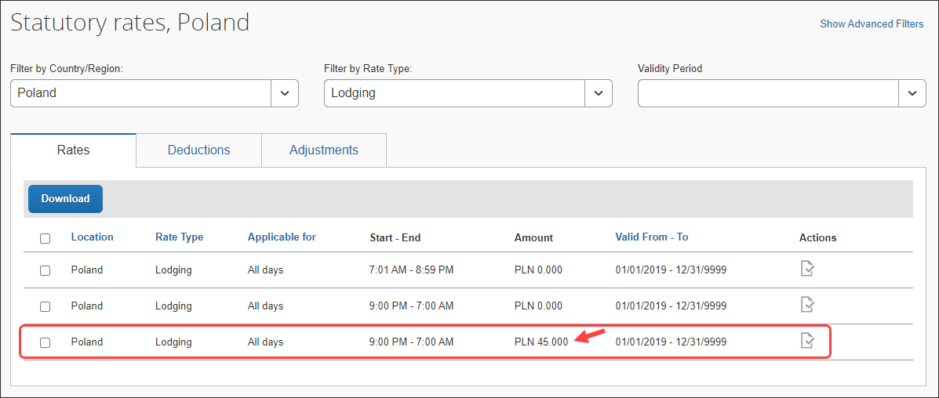
The details of this rate can be viewed on the View Rate page.
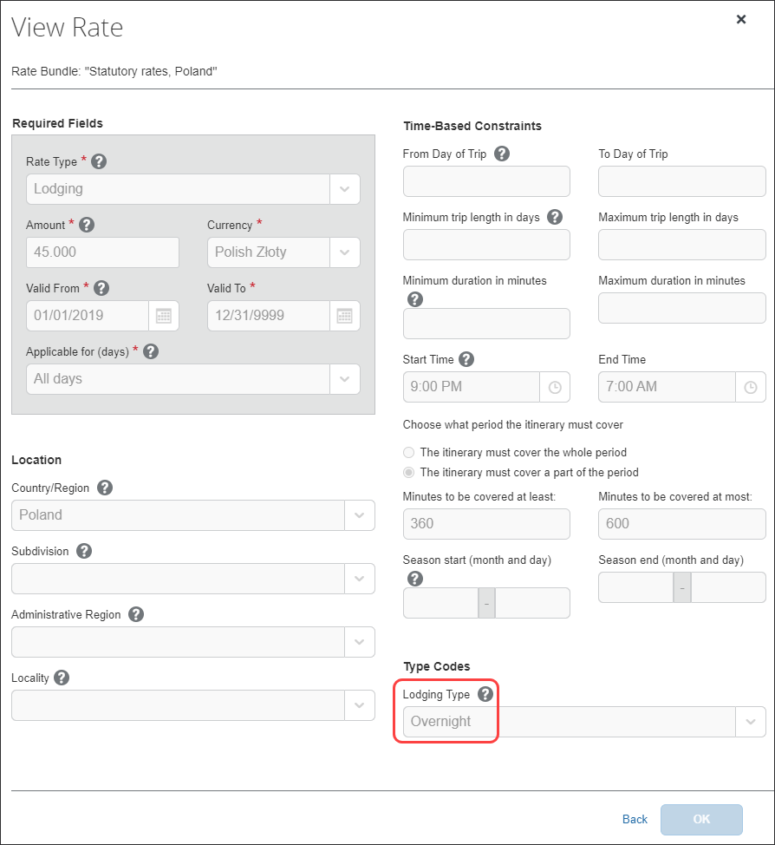

Foreign Overnight
For foreign travel, the statutory bundle provides Overnight supplements of 25% of the statutory accommodation rate to users when the trip covers midnight (23:59) and the user selects the Overnight check box when creating their expense report.
An example, for France, of this rate is available on the Rates tab.
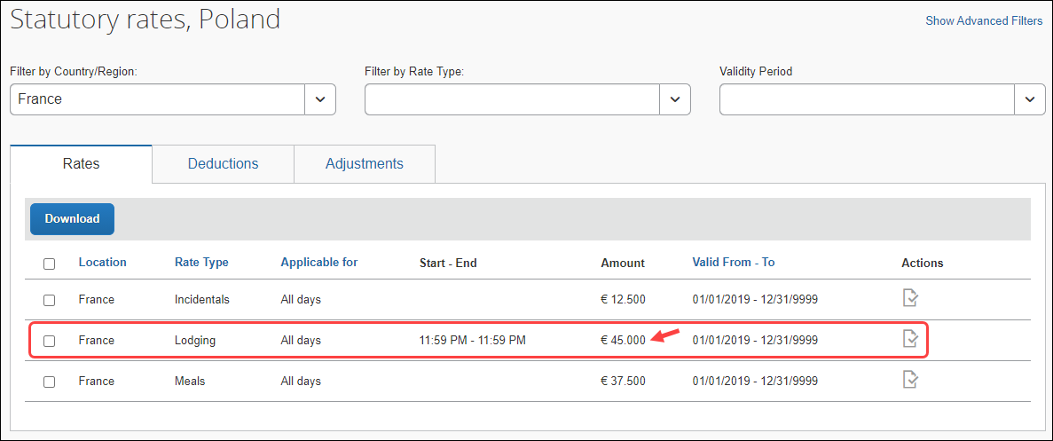
The details of this rate can be viewed on the View Rate page.
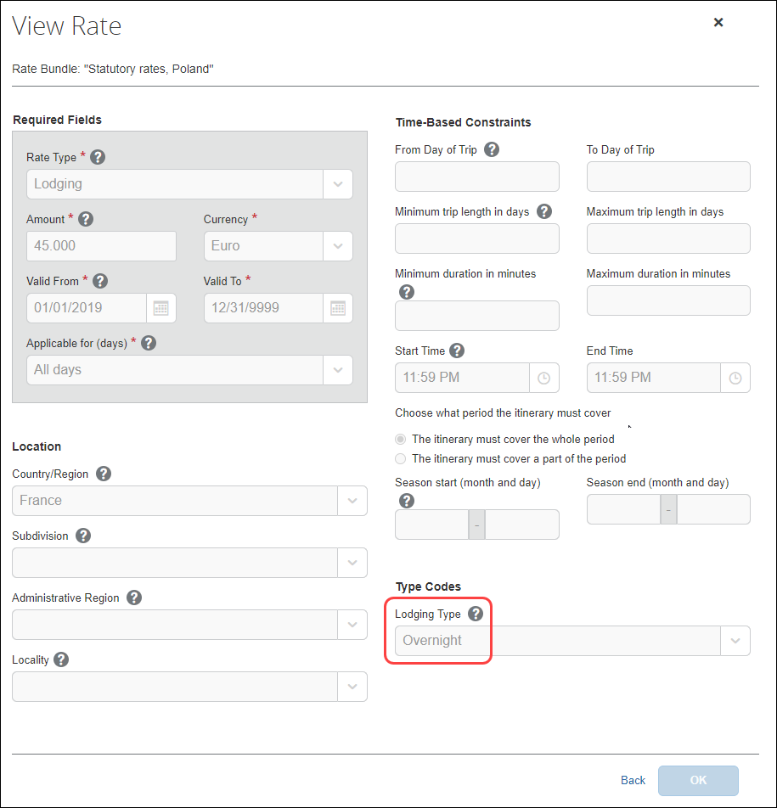

Meals Allowance
All Poland travel allowance meals calculations are based on location. All rates for meals within a country are the same for all locations but vary depending on the length of the trip.
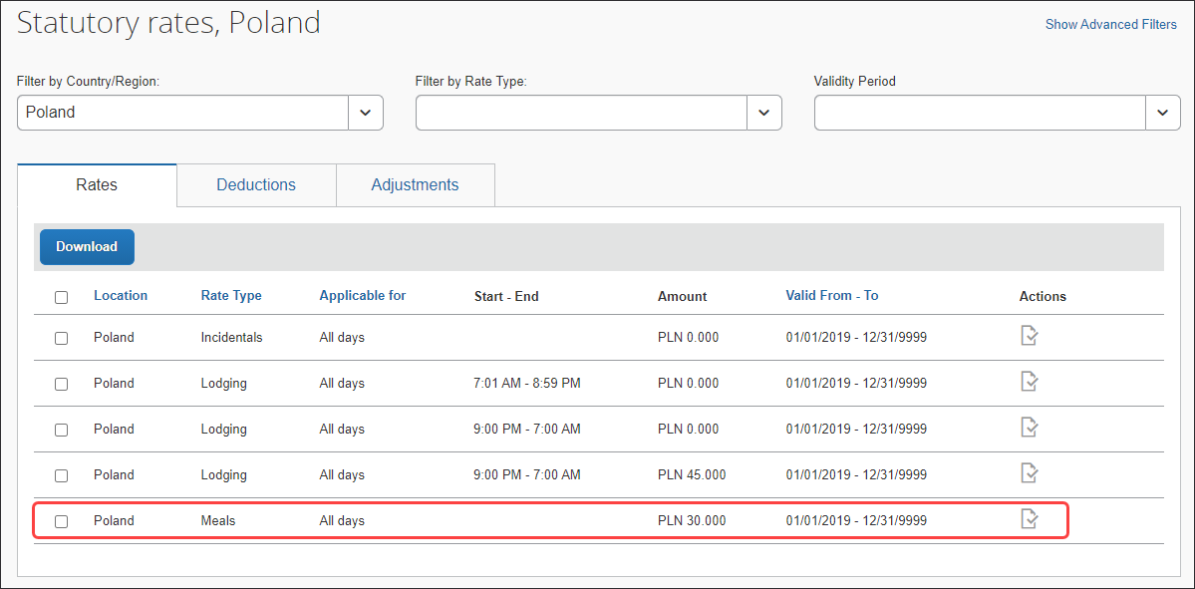

Single-Day Trips (Domestic)
Single-day trips use trip length logic to calculate partial day allowances.
The trip length logic is based on the configuration of a 480-minute (at least 8-hour) threshold or a 721-minute (at least 12-hour) threshold.

Duration | Expression | Percentage of Full Daily Allowance
Less than 8 hours | <8 hours | 0%
At least 8 hours and up to and including 12 hours | 8 – 12 hours | 50%
More than 12 hours | >12 hours | 100%

In the statutory bundle, the value of the setting, Minimum duration in minutes, displays on the Adjustments tab.
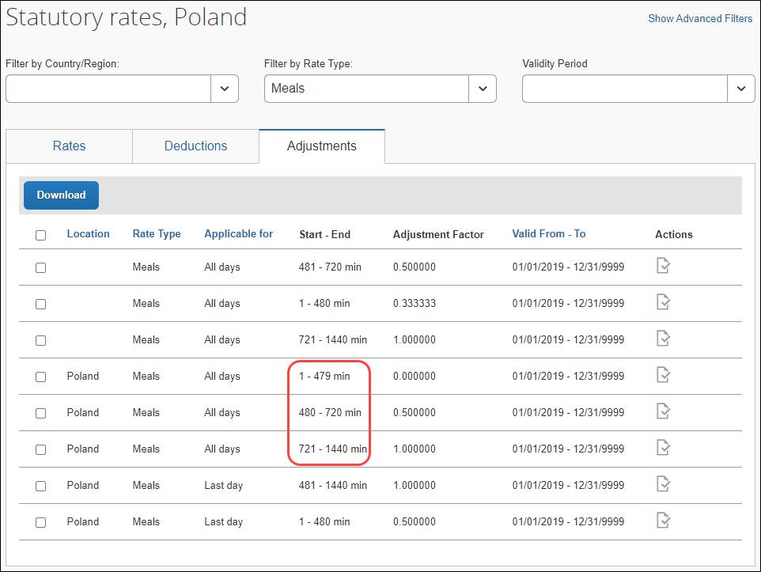
The details of this setting can be viewed on the View Adjustment page.

Example
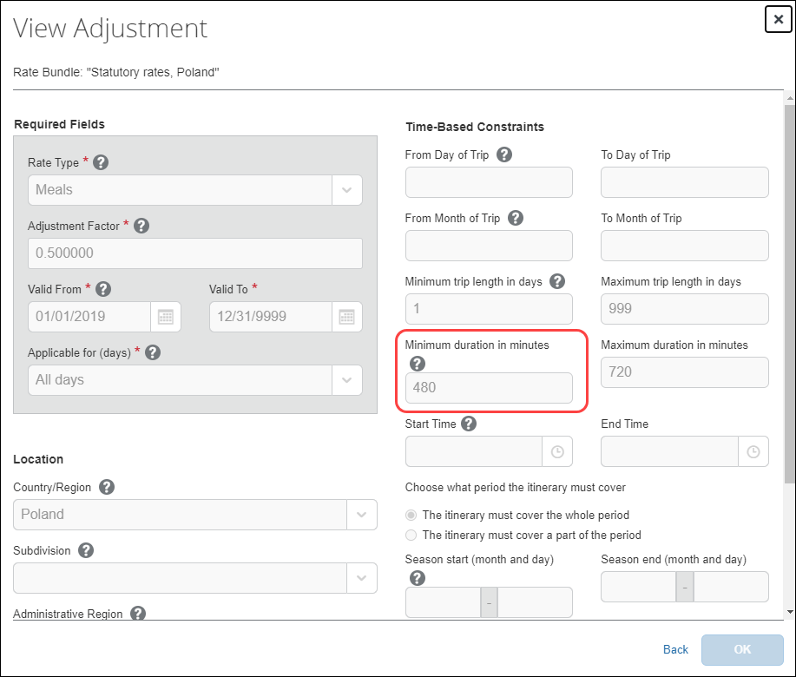

Multiple-Day Trips (Domestic)
Multiple-day trips also use trip length logic to calculate partial day allowances.
The trip length logic is based on the configuration of a 480-minute (at least 8-hour) threshold.

Duration | Expression | Percentage of Full Daily Allowance
Up to and including 8 hours | < or = 8 hours | 50%
More than 8 hours | >8 hours | 100%
In the statutory bundle, the value of the setting, Minimum duration in minutes, displays on the Adjustments tab.
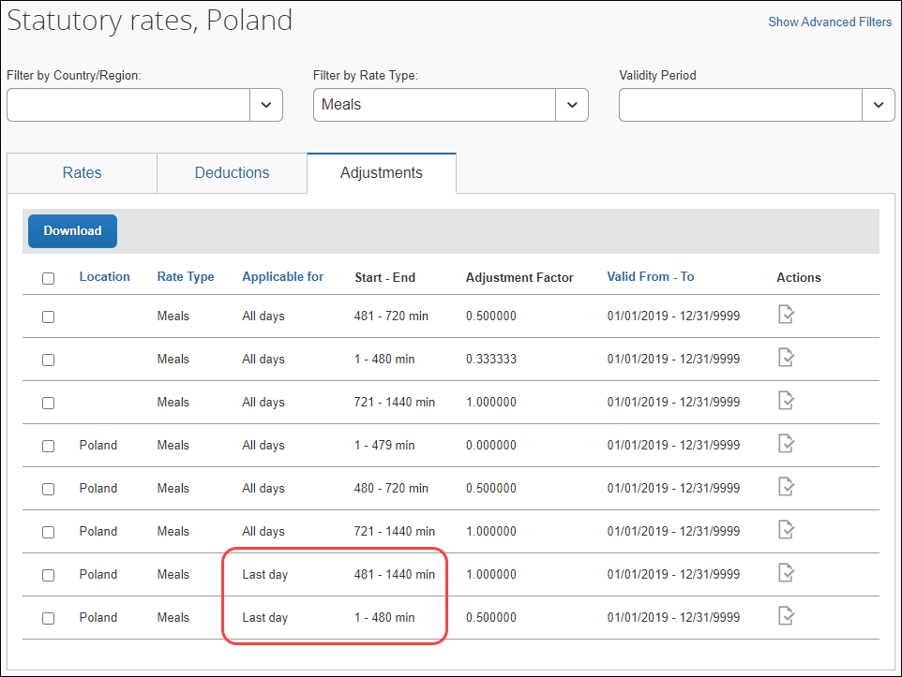
The details of this setting can be viewed on the View Adjustment page.

Example
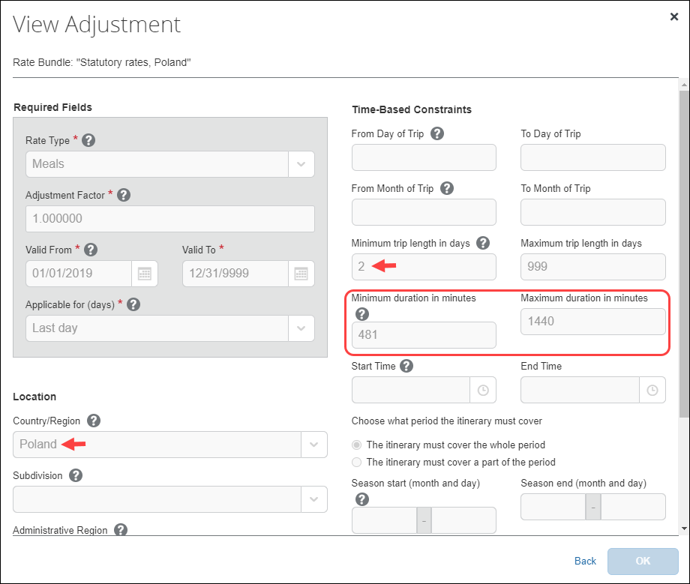

Foreign Trips
Foreign single-day and multiple-day trips also use trip length logic to calculate partial day allowances.
The trip length logic is based on the configuration of an adjustment factor (percentage of the full daily allowance).

Duration | Expression | Percentage of Full Daily Allowance
Up to and including 8 hours | < or = 8 hours | 33%
More than 8 hours and up to and including 12 hours | >8 – 12 hours | 50%
More than 12 hours | >12 hours | 100%
In the statutory bundle, the value of the setting, Minimum duration in minutes, displays on the Adjustments tab.
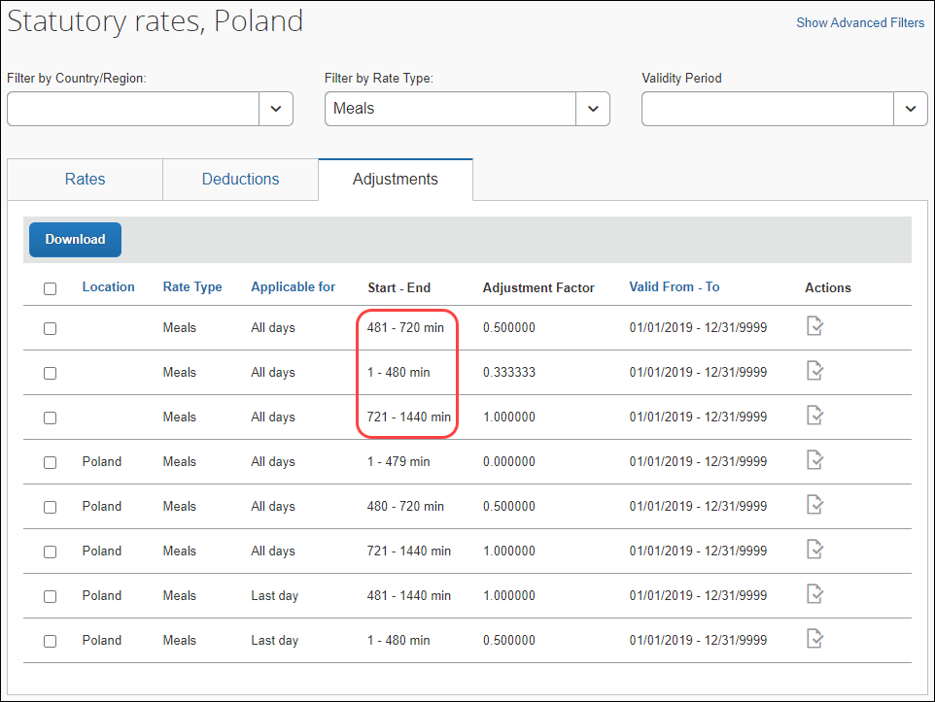
The details of this setting can be viewed on the View Adjustment page.

Example
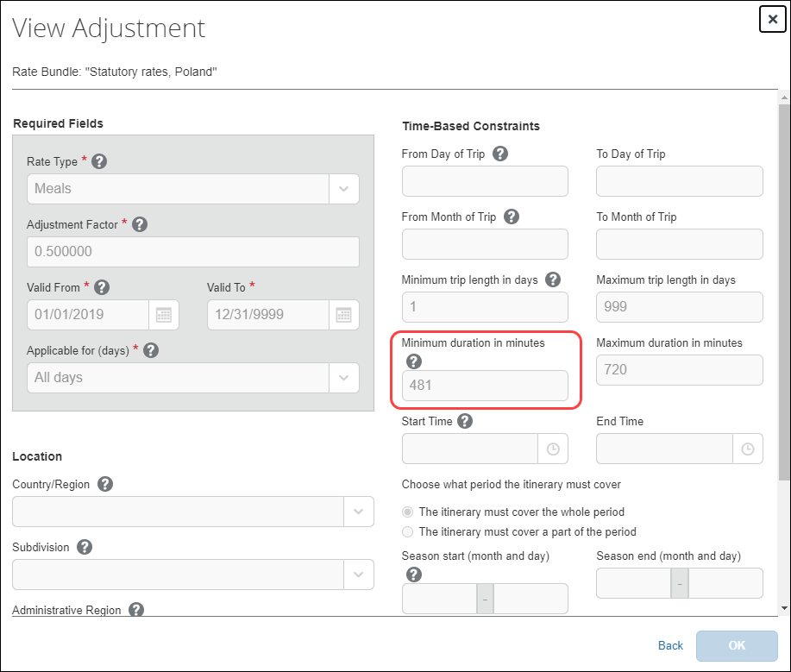

Provided Meals
Provided meals must be indicated by the user and are deducted from the allowed allowance. The amount of the allowance attributed to a specific meal is shown on the Reimbursement Details view of the Adjustments page.

Domestic Deductions
Breakfast | Lunch | Dinner
25% reduction | 50% reduction | 25% reduction

Foreign Deductions
NOTE: Deductions do not apply to the 25% reserved for Incidentals.
Breakfast | Lunch | Dinner
15% reduction | 30% reduction | 30% reduction

Deducting From the Appropriate 24-hr Reimbursement Interval
When the user deducts a meal, sometimes the amount is deducted from the reimbursement from the previous day. This is because a calendar date view is used on the Adjustments page, however 24-hour intervals are used to calculate the different segments of a trip - together with deduction times (times of day that are assigned to Breakfast, Lunch and Dinner):

Deduction Times
Breakfast | Lunch | Dinner
08:00 | 13:00 (1:00 o'clock PM) | 19:00 (7:00 o'clock PM)
Example
A Trip from Poland to Germany, starting on Monday at 1900 and returning at 2200 on Wednesday:
- First trip segment: Poland – 0.00 PLN (1 hour)
- Day 1 – Mon 1900 – Domestic Trip Starts
- Day 1 – Mon 2000 – Domestic Trip Ends (1 hour in Poland - user crosses border at 2000 from Poland to Germany)
- Second trip segment – Germany – 49.00 EUR (24 hours)
- Day 1 – Mon 2000 – Foreign Day 1 Starts
- Day 2 – Tue 1959 – Foreign Day 1 Ends
- Third trip segment – Germany – 49.00 EUR (18 hours)
- Day 2 – Tue 2000 – Foreign Day 2 Starts
- Day 3 – Wed 1400 – Foreign Day 2 Ends (18 hours in Germany – user crosses border at 1400 from Germany to Poland)
- Fourth trip segment – Poland – 15.00 PLN (8 hours)
- Day 3 – Wed 1400 – Domestic Trip Starts
- Day 3 – Wed 2200 – Domestic Trip Ends (8 hours in Poland)
The second trip segment is showing as the first line on the Adjustments page because the 24-hour period started on Monday at 8 PM and carried over into Tuesday. The Breakfast on Tuesday happened in Germany at 08:00, which belongs to the first 24-hour segment rate – which belongs to the 49.00 EUR rate showing on Monday:
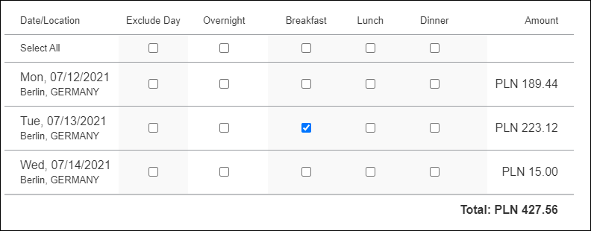
Reimbursement Details
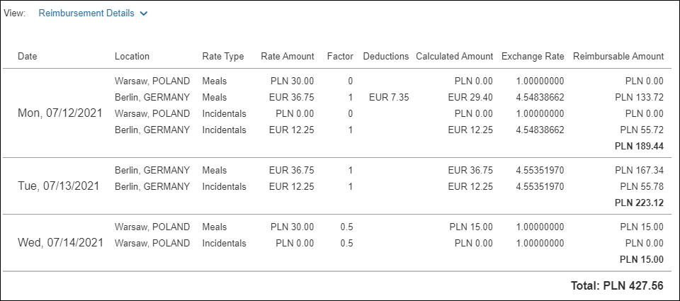

Pro-Rated Incidentals (Foreign)
For foreign travel, a user is entitled to a 25% incidentals amount even if all meals are provided, though this may be further adjusted for partial days.
Meal deductions are based on the full daily allowance, while the system will always provide 25% pro-rated Incidentals for foreign trips. This is supported by using a dedicated Incidentals rate which is only applicable to foreign locations. Meals are configured as 75% of the foreign rate, while Incidentals are configured as 25% of the calculated rate (pro-rated). By configuring the Incidentals as its own dedicated rate type, this amount will not be affected by any meal deductions thus ensuring the user always receives a minimum 25% pro-rated allowance for all foreign days of travel.
To ensure the correct deductions - applicable for full rate, but only applied to 75% of the Meals rate - foreign deduction percentages (15%, 30%, 30%) are multiplied by 1.3333 (100/75):

Meals Deductions
Breakfast | Lunch | Dinner
20% reduction | 40% reduction | 40% reduction
Because incidentals are required configuration (for foreign trips) but not used for domestic trips, the Adjustments page will display the Incidentals rate type – and in the case of domestic trips, the rate amount will be zero.

Considerations for Creating Configurable Bundles
This section lists important considerations and options available to clients who choose to create custom configurable bundles to supersede portions of the Poland statutory bundle.
When using a configurable bundle along with a statutory bundle, the configurable bundle only needs to contains the settings that will supersede the statutory bundle, not all settings.

Paying Higher or Lower Than Statutory Meals Allowances
It is common for larger customers to require supported rate deviations due to company policy or agreements with the state, such as:
- Reduced domestic rates for travel to company locations
If desired, the system can be configured to pay higher or lower than the statutory amounts for meals allowances based on time:
- Partial Day
- Full Day
- Both Partial and Full Days
Paying higher rates would mean that the difference (compared to the tax-free rate) is subject to income tax.

Using a Calendar Date vs 24-Hour "Day"
Some clients may want to define a "day" as a calendar date rather than a period of 24 hours.

Supporting Extended Trips
Some clients may want to add support for extended trip calculations.
Extended stay rules differ greatly based on labor agreements with the various unions.
As the statutory bundle for Poland will not be delivered with extended trips, any client who requires this functionality would need an additional client bundle.
This can be configured using an Adjustment.
Example
- With Meals allowance adjusted to 90% (0.900000) for trips over 30 days (from Day 31 onwards)
- With all locations (domestic and foreign - Country/Region is left blank).
If the client requires different extended trip logic for domestic, select Poland as the Country/Region.
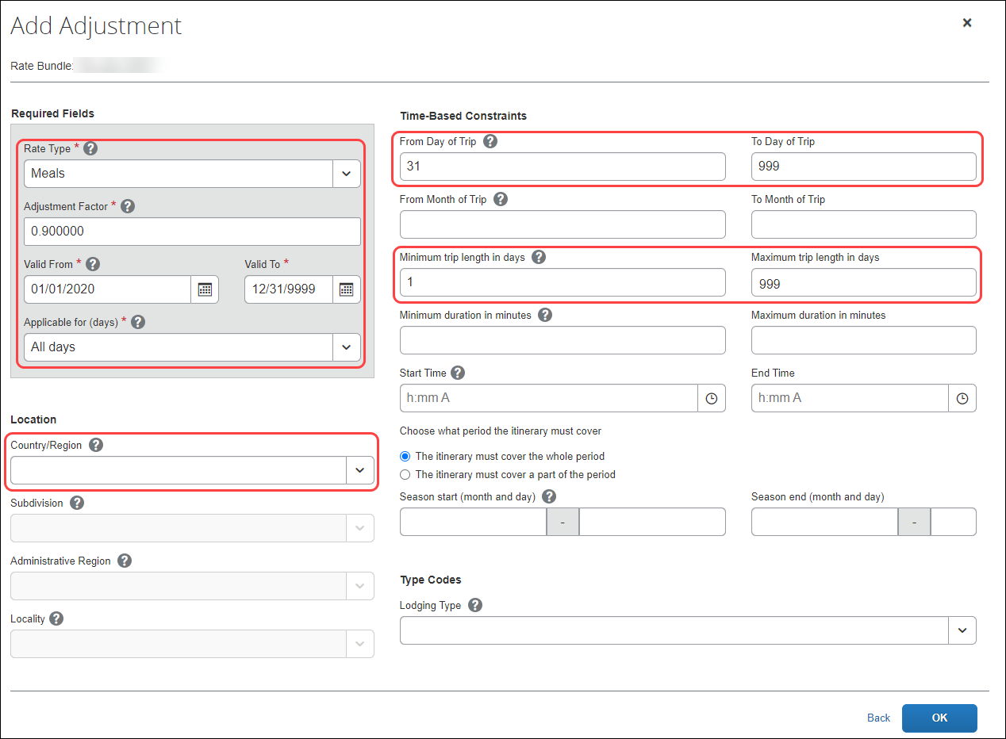

Paying Pro-Rated Provided Meals Deductions for Partial Days
Some clients may want to pro-rate the domestic and/or international meals deductions for a partial day of travel.
By default, Meal deductions in the statutory bundle are based on full daily allowances.
Pro-rated provided meals allows the deduction to be pro-rated based on the same percentage used for the partial-day allowance. If the partial-day allowance is 50% of the full-day allowance, then the provided meal deduction would also be reduced by 50%.
To pro-rate the domestic and/or international meals deduction for a partial day of travel, a generic configurable bundle is needed. The configuration would contain only Meal Deductions configured to exactly match the setup in the statutory bundle, with the exception that the Applicable for Full Rate setting is cleared.



