
Concur Expense: Travel Allowance Generic Configurable Bundle
Setup Guide
Last Revised: September 15, 2023
Applies to these SAP Concur solutions:
S Expense
S Professional/Premium edition
 Standard edition
 Travel
 Professional/Premium edition
 Standard edition
 Invoice
 Professional/Premium edition
 Standard edition
 Request
 Professional/Premium edition
 Standard edition
Table of Contents
Section 1: Permissions 1
Section 2: Overview 1
Section 3: What the User Sees 1
Creating an Expense Report 2
Adding Additional Itineraries to an Expense Report 11
Deleting an Itinerary from an Expense Report 12
Section 4: Create a Configurable Bundle 12
Accessing the Travel Allowance Configuration Page 13
Adding a Configurable Bundle from Scratch 13
Adding a Rate Type and Calculation Rules 15
Adding a Trip Type 21
Adding a Meal Type 22
Adding a Lodging Type 23
Adding a Deduction Category Type 24
Adjusting the Default Time for a Deduction 24
Adding Rates 25
Copying Rates 31
Adding Deductions 32
Copying Deductions 39
Adding Adjustments 40
Copying Adjustments 45
Copying an Existing Configurable Bundle 46
Uploading an Existing Configurable Bundle 48
Section 5: Maintain a Configurable Bundle 49
Viewing a Configurable Bundle 50
Editing a Configurable Bundle 52
Deleting a Configurable Bundle 54
Maintaining the Contents of a Configurable Bundle 54
Maintaining Rate Types and Calculation Rules 54
Maintaining Trip Types 56
Maintaining Meal Types 57
Maintaining Lodging Types 58
Maintaining Deduction Category Types 59
Maintaining Rates 60
Maintaining Deductions 72
Maintaining Adjustments 82

Revision History
Date | Notes / Comments / Changes
September 15, 2023 | Added five new calculation rules available in Austria:  - Used by Austria only – Based on border crossing time considering foreign parts less equal 3 hours as domestic  - Used by Austria only – Duration of all legs rounded to 12 hours preferring foreign time, with domestic difference only being calculated where foreign allowance does not consume all 12th of the total trip time  - Used by Austria only – Duration of all legs rounded to 12 hours preferring foreign time, with domestic difference only being calculated where foreign allowance does not consume all 12th of the reimbursement interval  - Used by Austria only – Require deduction time, taking domestic deductions from domestic leftover  - Used by Austria only – Ignore deduction time, preferring foreign location for all deductions
July 16, 2022 | Addition of the Deduction Categories and the Default Time for Deduction feature on the Add or Edit Rate Bundle page where you can add additional deduction categories and, optionally, values for these categories, and finally adjust the default time for the deduction as well.
June 18, 2022 | Addition of new rule option Use rate of itinerary with longest duration for the rule Several itineraries on one date, reimbursement rates.
May 20, 2022 | Addition of the Show Filters feature on the Adjustments page that supports setting recurring dates for repeated travel.
February 16, 2022 | Updated the Adding a Configurable Bundle from Scratch section to reference the main guide (Concur Expense: Travel Allowance Service Setup Guide) for a complete list of calculation rules and options with descriptions.
July 19, 2021 | Added new rule option:  - 24-hour interval, restarting at each border crossing and restarting the day count  Added new rule and its options:  - (rule) Day for exchange rate  - (option) Current daily exchange rate  - (option) Exchange rate on the first day of the itinerary  Minor style edits.
January 22, 2021 | Added new setting: Rounding to Full Amount
December 5, 2020 | Added new rule options:  - Rate of the first foreign location, including all time spent in foreign locations  - Calendar day, two days will be handled as one day when returning on second day before 6am  - First leg based on time of departure, then all based on time of border crossing or time of arrival, but last leg based on time of arrival
October 17, 2020 | Added new rule options:  - Several itineraries on one date, durations  - Several itineraries on one date, reimbursement rates
July 1, 2020 | Created new guide for the travel allowance solution available with the NextGen UI for Concur Expense

Travel Allowance
NOTE: Multiple SAP Concur product versions and UI themes are available, so this content might contain images or procedures that do not precisely match your implementation. For example, when SAP Fiori UI themes are implemented, home page navigation is consolidated under the SAP Concur Home menu.

Permissions
A company administrator may or may not have the correct permissions to use this feature. The administrator may have limited permissions, for example, they can affect only certain groups and/or use only certain options (view but not create or edit).
If a company administrator needs to use this feature and does not have the proper permissions, they should contact the company's Concur Expense administrator.
Also, the administrator should be aware that some of the tasks described in this guide can be completed only by SAP Concur. For tasks not completed during implementation, the client must initiate a service request with SAP Concur support.

Overview
Where a country-specific guide is not available, this document provides information about configuring custom bundles and is a supplement to the Expense: Travel Allowance Setup Guide which contains essential information about the travel allowance feature.
- IMPORTANT: Where possible, SAP Concur recommends clients use a country-specific statutory bundle. Generic, configurable bundles are not eligible for the SAP Concur managed rate service and so keeping rates current is a manual process for clients or their representatives.
This guide is also applicable to clients who use a country-specific statutory bundle, but want to supersede some of the statutory rates by creating custom, client-managed bundle.

What the User Sees
This section uses a common method of reimbursement – daily allowances for meals and actual expenses for lodging.

Creating an Expense Report
When the travel allowance feature is available to a user, after the user completes the header on a new expense report, they are prompted for itinerary and adjustment information.
To create an expense report:
- From Concur Expense, click Create New Report.
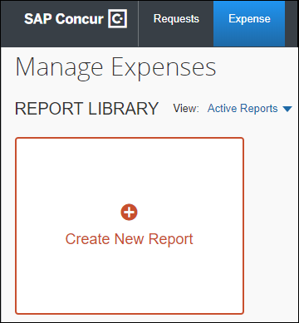
There are other valid paths to start a new expense report.
- On the Create New Report page, commonly referred to as the report header, complete all required fields. An asterisk indicates a required field.
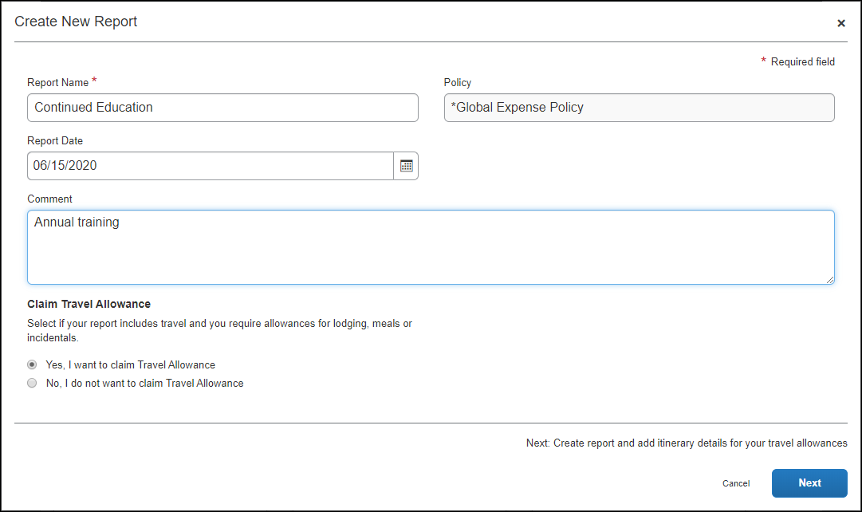
The policy selected may impact which fields display.
When claiming travel allowance is available to the user, Yes, I want to claim Travel Allowance is selected by default.
- Click Next to create the expense report and display the Itinerary page.
- On the Itinerary page, complete all required fields. An asterisk indicates a required field. Fields vary by country.
Without Detailed Itinerary selected:
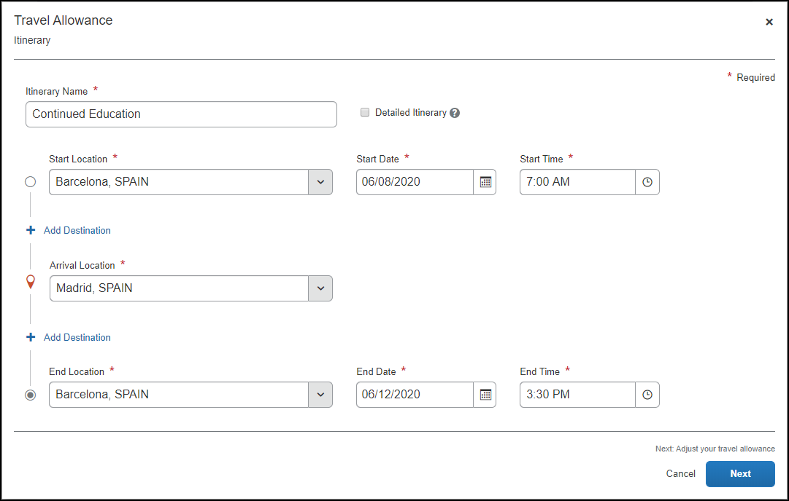
Additional required fields display when Detailed Itinerary is selected:
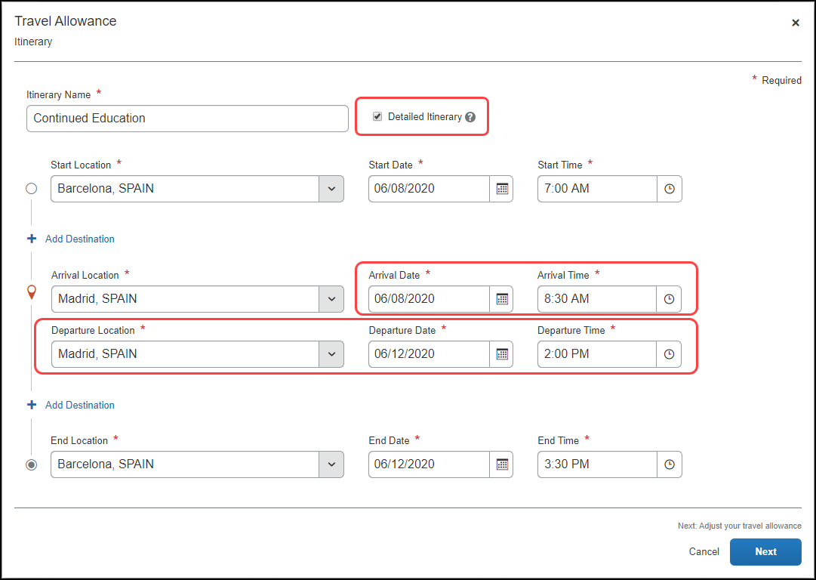
The following table shows the fields and their descriptions. An asterisk indicates a required field.
Field/Option | Description
Itinerary Name * | Enter an itinerary name or use the default name provided that matches the Report Name.
Detailed Itinerary | Select this option to display five additional fields:  - Arrival Date *  - Arrival Time *  - Departure Location *  - Departure Date *  - Departure Time *  NOTE: These fields are required when Detailed Itinerary is selected.
Start Location * | Enter the first few letters of the origination city for this itinerary and select it from the list of cities.
Start Date * | Enter a beginning month, day, and year for the time period covered by this itinerary.
Start Time * | Enter a beginning hour and minutes for the time period covered by this itinerary.
Add Destination | Click Add Destination to display another set of location fields to this itinerary. This option displays twice for convenience.
Arrival Location * | Enter the first few letters of the destination city and select it from the list of cities.
Arrival Date * | Enter the beginning month, day, and year of your time at this Arrival Location.
Arrival Time * | Enter the beginning hour and minutes of your time at this Arrival Location.
Departure Location * | Enter the first few letters of the last location at this Arrival Location and select it from the list of cities.
Departure Date * | Enter the month, day, and year that you left the Departure Location.
Departure Time * | Enter the hour and minutes that you left the Departure Location.
End Location * | Enter the first few letters of the final city for this trip and select it from the list of cities.
End Date * | Enter an ending month, day, and year for the time period covered by this itinerary.
End Time * | Enter an ending hour and minutes for the time period covered by this itinerary.
- Click Next to save the itinerary and display the Adjustments page.
Adjustments (view)
In this example, having Within Municipality, this is the default view where a user can see a row for each calculated daily allowance and select adjustments such as excluded days, provided meals, and others based on the configuration of the generic bundle.
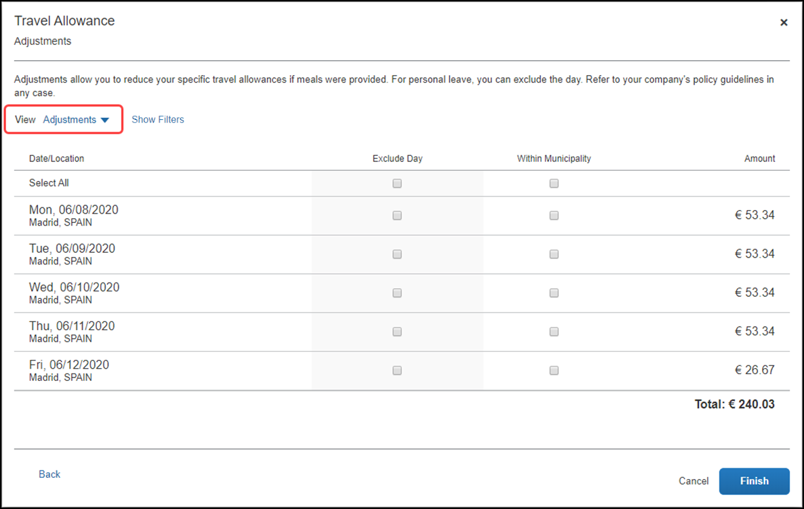
In this sample instance:
- If you select Show Filters the following options become available.
Field/Option | Description
Date Range | Enter the beginning and ending of the travel either in MM/DD/YYYY format, or by selecting the calendar icon to input these values by selecting the month(s) and days.
Recurrence | Set how often this same travel occurs by the number of weeks and the days for each week that you travel, for example every 3 weeks from Monday through Friday.  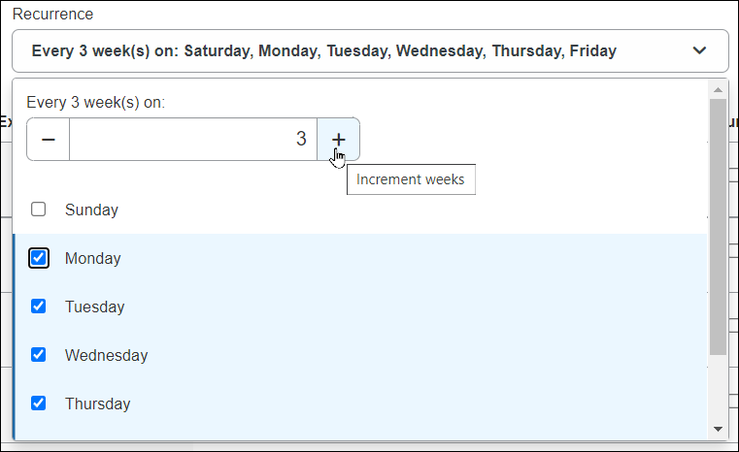
Location | The travel destination where you will spend your trip.
Apply / Clear Filters buttons | Click Apply to set the configured trip, or reset the filter entirely by clicking Clear Filters.
Hide Filters button | Click Hide Filters to dismiss the filter options and return to the non-filter view of this page.
- For the first and last days, the amounts are automatically reduced because the user did not spend full days at the location.
Any deduction can reduce the allowance amount to zero but never less than zero; it can never result in a charge to the user.
Reimbursement Details (view)
This view shows details for the adjustments based on what the user selected on the Adjustments page together with original rate amounts, any deductions for the day, and total reimbursable amounts.
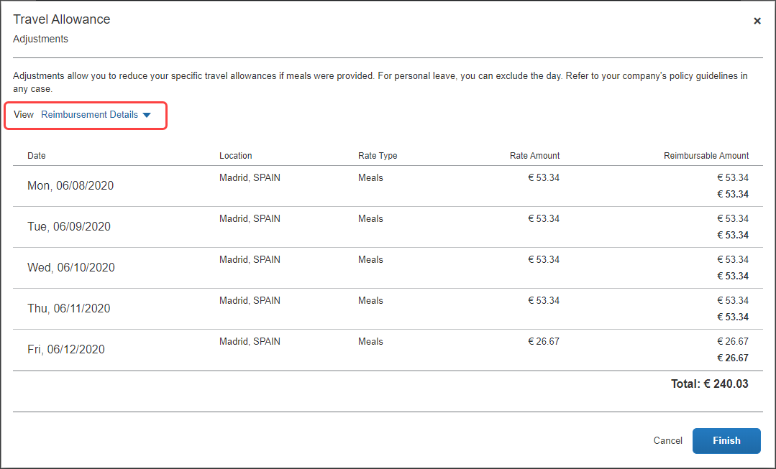
Example Tax-Exempt Amounts (view)
This view only displays for configurations that include both the statutory rate bundle and a configurable rate bundle where the amounts differ. The difference is tracked as taxable to the user. Users can compare the amount on the Adjustments page with the tax-exempt amount on this page to know how much of their daily allowance is taxable.
Example
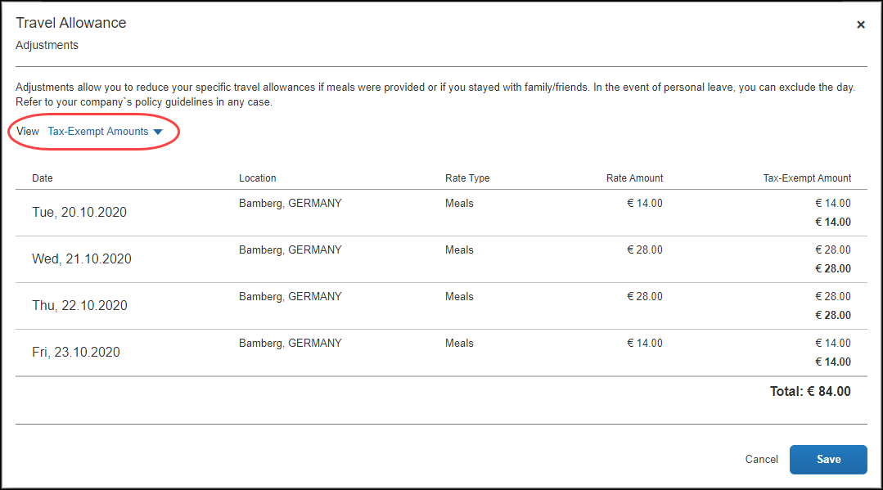
The following table shows the fields and their descriptions.
Column | Description
Exclude Day | Select this check box to mark a date as personal time and therefore not eligible for travel allowance benefits.  NOTE: There is a Select All check box available for this column.
Within Municipality | Select this check box to indicate that the municipality where the day's work was performed is the same municipality where you live and usually work.
- (Optional) Click Back to edit the itinerary page.
- (Optional) Click Cancel to close the adjustments page without saving your selections.
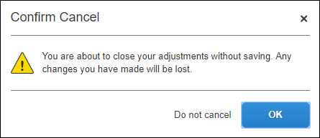
The expense report is not deleted, and the itinerary and allowances can be edited later by selecting Travel Allowances > Edit Travel Allowance.
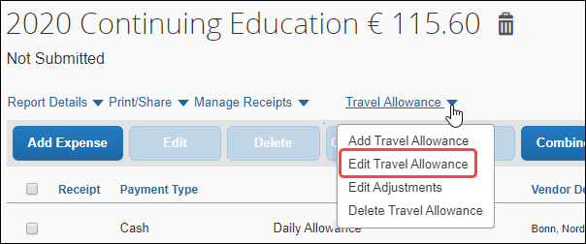
- Click Finish to create the daily allowances and display the expense report.
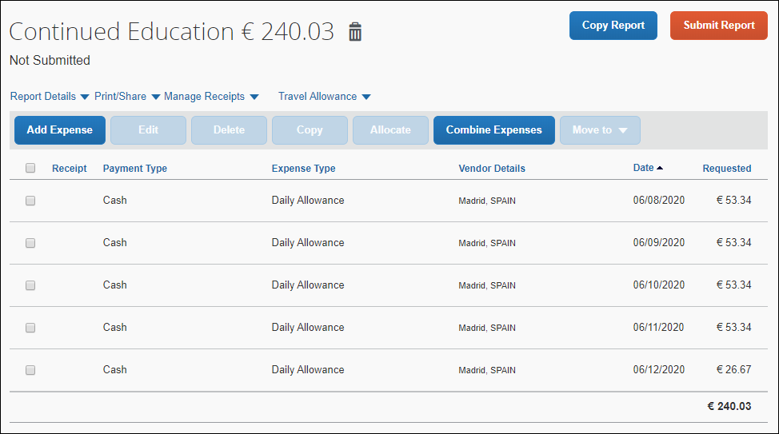
It is important to understand the following about system-created expenses:
- As applicable, daily allowance expenses are assigned the default expense type of Daily Allowance or Daily Allowance (Lodging).
- If there are both meals and lodging allowances on the same day, an expense is created for each expense type for each day.
- If rate information is changed after the daily allowance expenses have been created, the amounts are not updated unless the user returns to the adjustments page and clicks Finish again.
- If the actual meal expenses are imported through the company card import but the user was reimbursed with daily allowances, then the user should mark the imported meal expenses as personal.
- Click Add Expense to add actual expenses. This step is not specific to the travel allowance feature and is accomplished in the same manner that is used to add non-travel allowance expenses to an expense report.
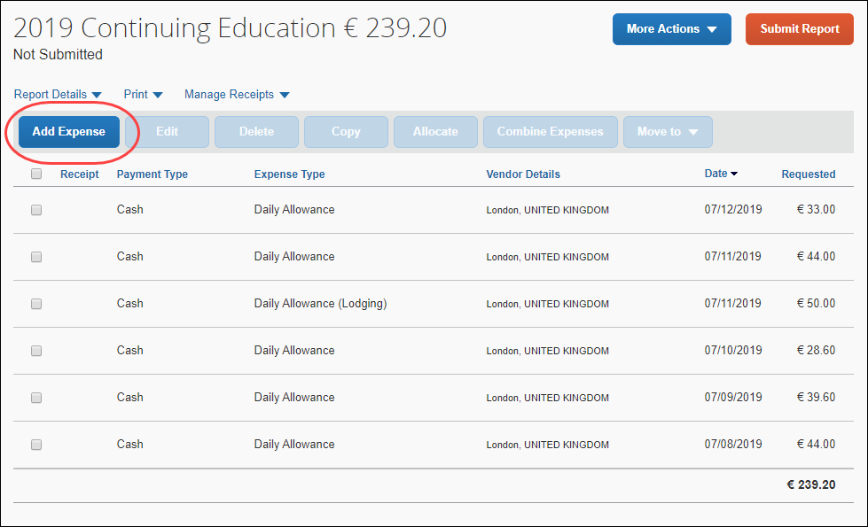

Adding Additional Itineraries to an Expense Report
To add additional itineraries to an expense report
- Open the expense report and click Travel Allowance > Add Travel Allowance. The Travel Allowance wizard begins again from the Itinerary page.
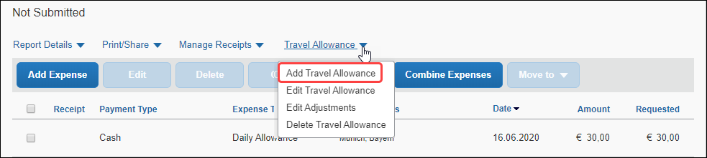
There is no restriction on the number of itineraries that may be associated with an expense report.
- Complete the wizard and click Finish.

Deleting an Itinerary from an Expense Report
To delete an itinerary from an expense report
- Open the expense report and click Travel Allowance > Delete Travel Allowance.
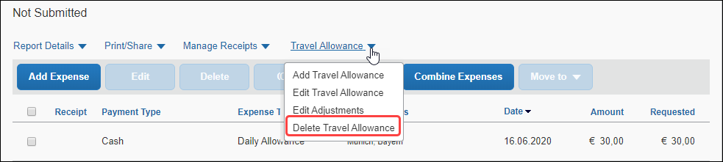
- On the Itinerary Management page of the Travel Allowance wizard, in the desired row, click Delete.
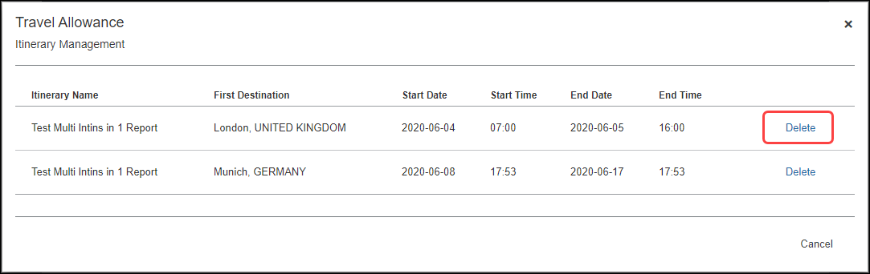
- Click Delete.
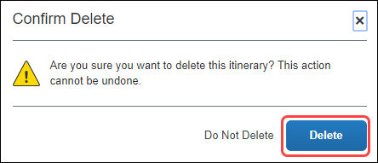

Create a Configurable Bundle
A bundle is a set of rates. The simplest initial configuration of the travel allowance feature uses a bundle to create a configuration code.
- A Rate Bundle consists of rate types, calculation rules, trip types, meal types, lodging types, rates, deductions, and adjustments.
There are no default bundles provided by SAP Concur. This generic guide explains how clients may add custom/configurable bundles.
- A Configuration Code consists of a at least one Rate Bundle.
Bundles may be created in three (3) ways:
- Added – Created entirely from scratch.
Clicking Add means the new bundle will not have calculation rules, trip types, meal types, lodging types, rates, deductions, or adjustments.
- Copied – Created by starting with a copy of an existing configurable bundle.
Clicking Copy () means the new bundle will have rate types, calculation rules, trip types, meal types, and lodging types if they existed in the source bundle, but will not have rates, deductions, or adjustments.
- Uploaded – Created by starting with a bundle that has been downloaded from another instance (such as a test instance) of Concur Expense.
Clicking Upload mean the new bundle will have rate types, calculation rules, trip types, meal types, and lodging types if they existed in the source bundle, but will not have rates, deductions, or adjustments. Rates, deductions, and adjustments would each need to be separately downloaded and uploaded from the other instance or added manually.
- For more information about enablement, hierarchy, mappings, configuration codes, and optional configuration, refer to the Expense: Travel Allowance Setup Guide.

Accessing the Travel Allowance Configuration Page
To access the Travel Allowance Configuration page:
- Click Administration > Expense > Travel Allowance Configuration.

Adding a Configurable Bundle from Scratch
A bundle includes rate types, calculation rules, trip types, meal types, lodging types, rates, deductions, and adjustments.
This section contains information about how to create a configurable bundle and then create rate types, calculation rules, trip types, meal types, lodging types, rates, deductions, and adjustments inside that bundle.
To add a configurable rate bundle:
- Click Administration > Expense > Travel Allowance Configuration.
- On the Rate Bundles page, click Add.
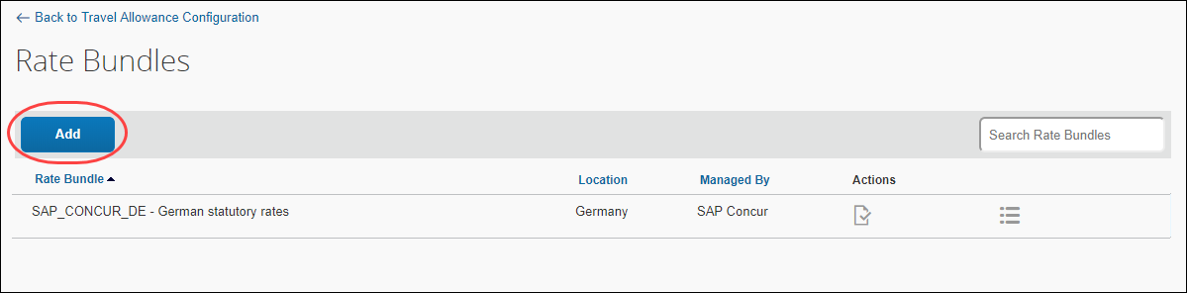
The Add Rate Bundle page displays.
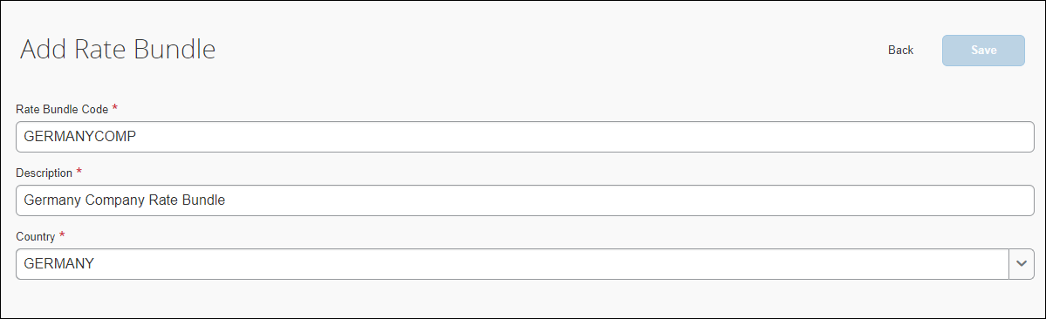
The Edit Rate Bundle page displays additional settings such as the fields for configuring Rate Types, Trip Types, Meal Types, and Lodging Types. For more information, refer to the Editing Rate Bundles section in this guide.
- Fill in the fields. An asterisk indicates a required field.
Field | Description
Rate Bundle Code * | Enter a code for this rate bundle.  NOTE: Valid characters, up to a maximum of 30, include upper case letters, numbers, and the underscore character. Spaces are not permitted.
Description * | Enter a description for this rate bundle.
Country/Region * | Select from the list to indicate the location where these rates apply.
- Click Save.
The new bundle displays on the list.
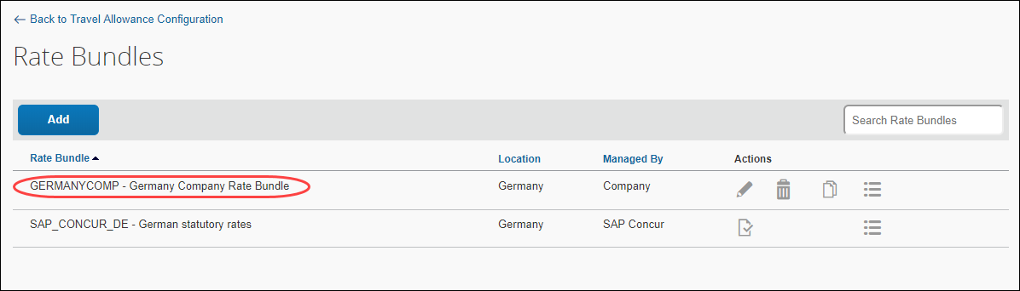

Adding a Rate Type and Calculation Rules
To add a rate type
- On the Edit Rate Types page, click Add.
- In the Code field, enter a code for the rate type. Valid characters are A-Z, 0-9, and underscore _.
- In the Description field, enter a description for the rate type.
- From the Rate Category list, select Incidental, Meal, or Lodging.
- Click Save.
- In the new row, click Edit ().
- Select a Rule for each Rule Name.
The default Rule shown depends on the Rate Category (Incidental, Meal, or Lodging) being edited.
- IMPORTANT: If you have a statutory bundle, ensure that the rate type's calculation rules in your configurable bundle match the rate type calculations in your statutory bundle.
Incidental
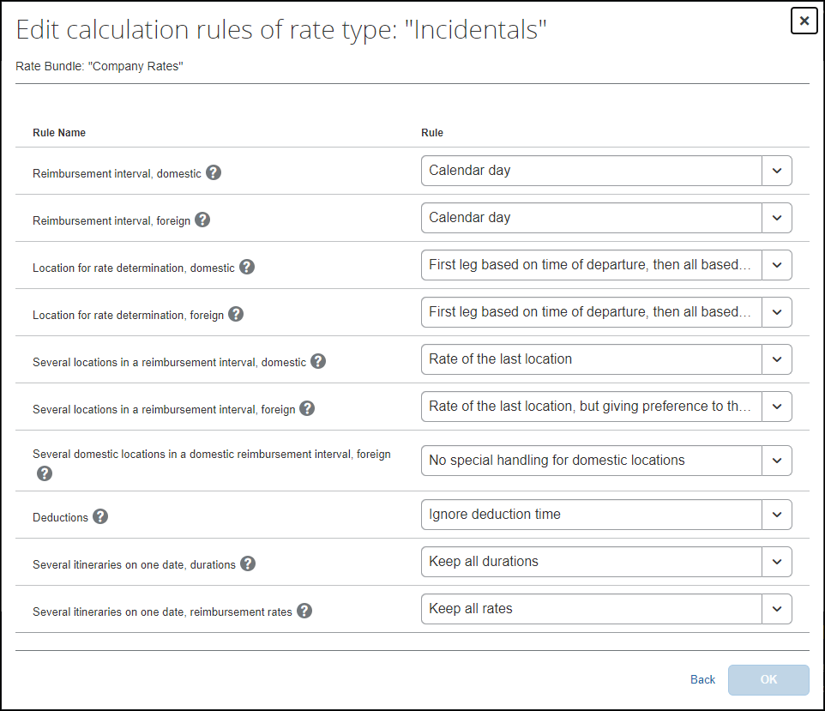
Lodging
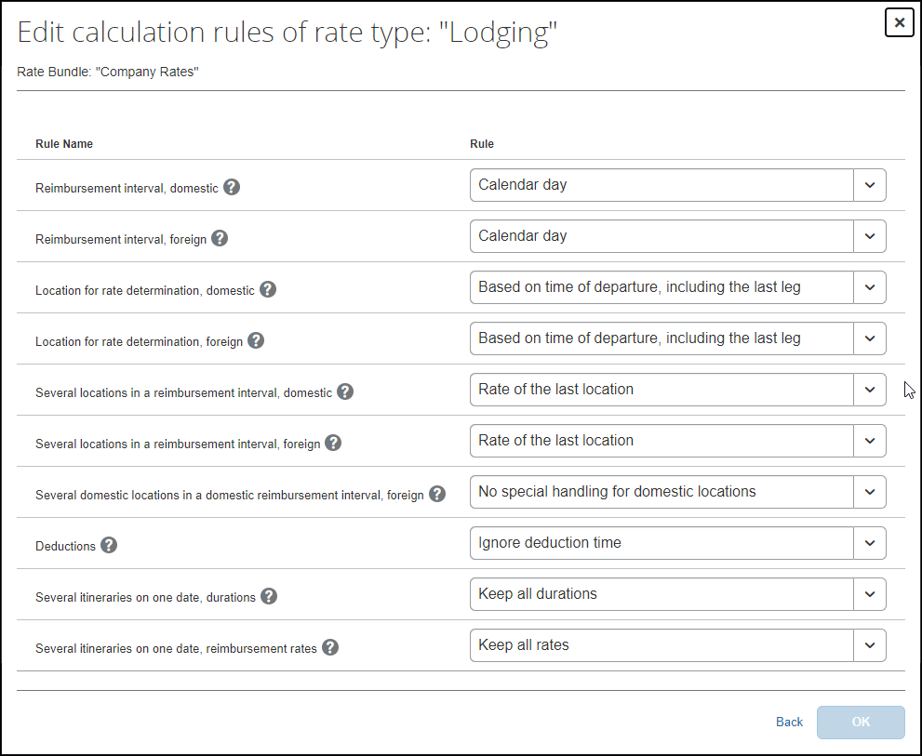
Meal
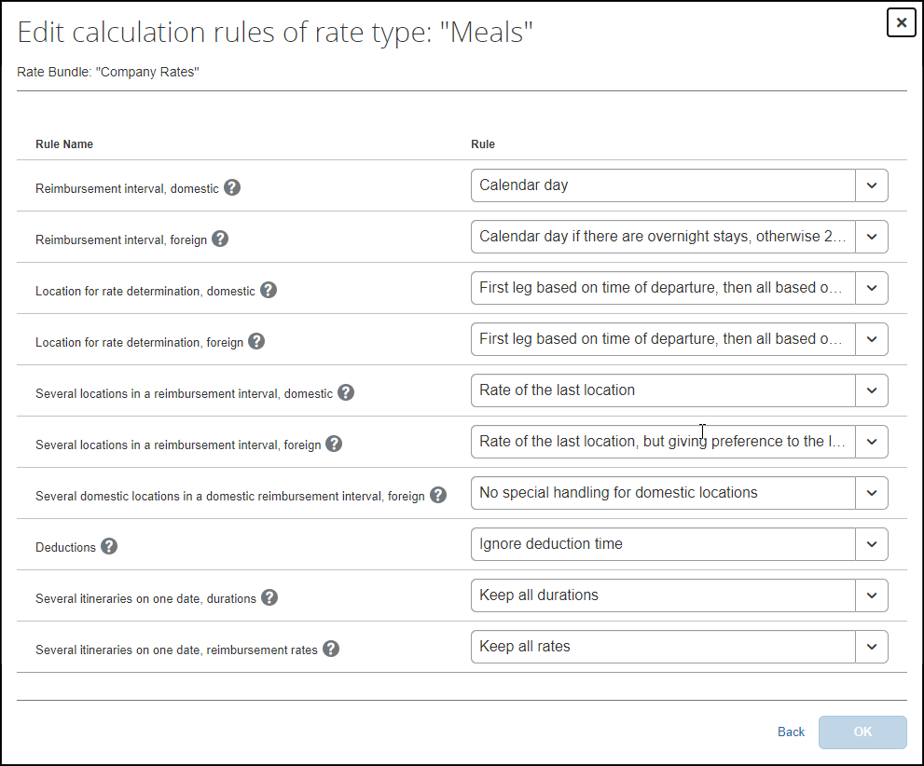
The following table shows the possible rule options for a configurable bundle.
Rule Names and Rule Options
Rule Name | Rule Options
Reimbursement interval, domestic | - 24-hour interval  - Calendar day (default for Incidentals, Lodging, and Meals)  - Calendar day if there are overnight stays, otherwise 24-hour interval  - Calendar day, but up to 24 hours as a 24-hour interval  - Calendar day, two days will be handled as one day when returning on second day before 6am
Reimbursement interval, foreign | - 24-hour interval  - 24-hour interval for domestic locations, but calendar day for foreign locations  - 24-hour interval, restarting at each border crossing and restarting the day count  - Calendar day (default for Incidentals, Lodging, and Meals)  - Calendar day if there are overnight stays, otherwise 24-hour interval  - Calendar day, but up to 24 hours as a 24-hour interval  - Calendar day, restarting at each change from domestic to foreign location and vice versa  - Calendar day, two days will be handled as one day when returning on second day before 6am
Location for rate determination, domestic | - Based on time of arrival, including the first leg (default for Incidentals and Meals)  - Based on time of departure, including the last leg (default for Lodging)  - First leg based on time of departure, then all based on time of arrival
Location for rate determination, foreign | - Based on time of arrival, including the first leg (default for Incidentals and Meals)  - Based on time of departure, including the last leg (default for Lodging)  - First leg based on time of departure, then all based on time of arrival  - First leg based on time of departure, then all based on time of border crossing or time of arrival, but last leg based on time of arrival  - Based on border crossing or arrival time modifying time zones first stop at departure location last stop at arrival location  - Used by Austria only – Based on border crossing time considering foreign parts less equal 3 hours as domestic
Several locations in a reimbursement interval, domestic | - Highest rate of all locations  - Rate of the first location (default for Lodging)  - Rate of the last location (default for Incidentals and Meals)  - Rate of the last location, but rate of the first location on the last day  - Rate of the location with the longest duration  - Rate of the location with the longest duration excluding travel time  - Sum of rates of all locations
Several locations in a reimbursement interval, foreign | - Highest rate of all locations  - Rate of the first location (default for Lodging)  - Rate of the first foreign location, including all time spent in foreign locations  - Rate of the last location  - Rate of the last location, but foreign location when more than ten hours aboard  - Rate of the last location, but giving preference to the last foreign location (default for Incidentals and Meals)  - Rate of the last location, but giving preference to the last foreign location on the last day or single day  - Rate of the last location, but rate of the first location on the last day  - Rate of the location with the longest duration  - Rate of the location with the longest duration excluding travel time  - Rate of the location with the longest duration, but giving preference to the last foreign location  - Sum of rates of all locations  - Used by Austria only – Duration of all legs rounded to 12 hours preferring foreign time, with domestic difference only being calculated where foreign allowance does not consume all 12th of the total trip time  - Used by Austria only – Duration of all legs rounded to 12 hours preferring foreign time, with domestic difference only being calculated where foreign allowance does not consume all 12th of the reimbursement interval
Several domestic locations in a domestic reimbursement interval, foreign | - Highest rate of all locations  - No special handling for domestic locations (default for Incidentals, Lodging, and Meals)  - Rate of the first location  - Rate of the last location  - Rate of the last location, but rate of the first location on the last day  - Rate of the location with the longest duration  - Rate of the location with the longest duration excluding travel time  - Sum of rates of all locations
Deductions | - Used by Austria only – Require deduction time, taking domestic deductions from domestic leftover  - Used by Austria only – Ignore deduction time, preferring foreign location for all deductions
Several itineraries on one date, durations | - Keep all durations (default for Lodging and Meals)  NOTE: Using this rule option, when multiple trips occur on the same day, each trip is calculated independently.  - Use total duration of all domestic itineraries, keep all individual durations of foreign itineraries
Several itineraries on one date, reimbursement rates | - Keep all rates (default for Lodging and Meals)  - Use highest rate of all itineraries  - Use rate of itinerary with longest duration
Day for exchange rate | - Current daily exchange rate (default for Incidentals, Lodging, and Meals)  - Exchange rate on the first day of the itinerary
- For a complete list of calculation rules and options with descriptions, refer to the Concur Expense: Travel Allowance Service Setup Guide.
- Click OK.
- Click Save.

Adding a Trip Type
To add a trip type
- On the Edit Trip Types page, click Add.
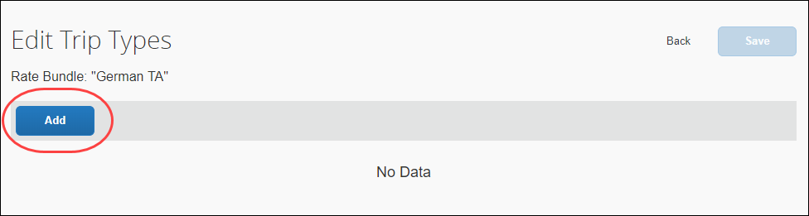
- In the Code field, enter a code for the trip type. Valid characters are A-Z, 0-9, and underscore _.
- In the Description field, enter a description for the trip type.
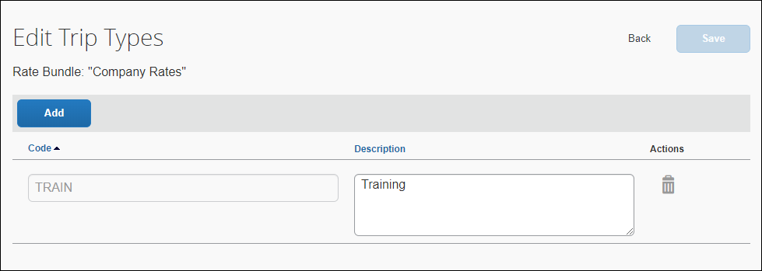
The Description field values should accommodate all language requirements. These values are your company's custom (non-translatable) labels that will be displayed to your users.
- Click Save.

Adding a Meal Type
To add a trip type
- On the Edit Meal Types page, click Add.
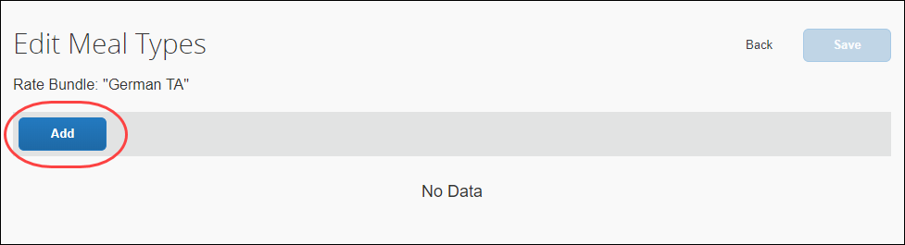
- In the Code field, enter a code for the meal type. Valid characters are A-Z, 0-9, and underscore _.
- In the Description field, enter a description for the meal type.
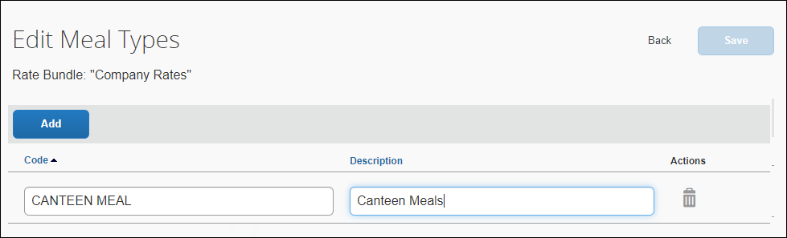
The Description field values should accommodate all language requirements. These values are your company's custom (non-translatable) labels that will be displayed to your users.
- Click Save.

Adding a Lodging Type
To add a lodging type
- On the Edit Lodging Types page, click Add.
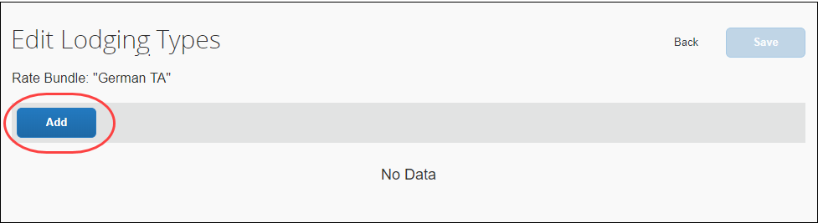
- In the Code field, enter a code for the lodging type. Valid characters are A-Z, 0-9, and underscore _.
- In the Description field, enter a description for the lodging type.
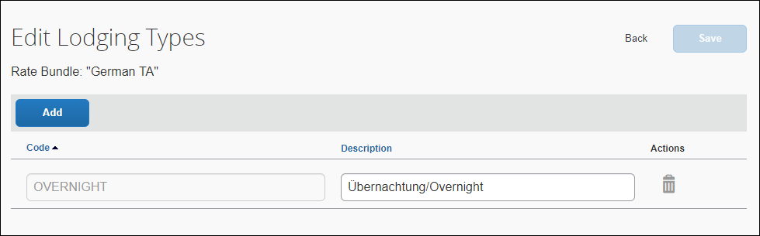
The Description field texts should accommodate all language requirements. These values are your company's custom (non-translatable) labels that will be displayed to your users.
- Click Save.

Adding a Deduction Category Type
To add a deduction category type
- On the Edit Deduction Category Types page, click Add.
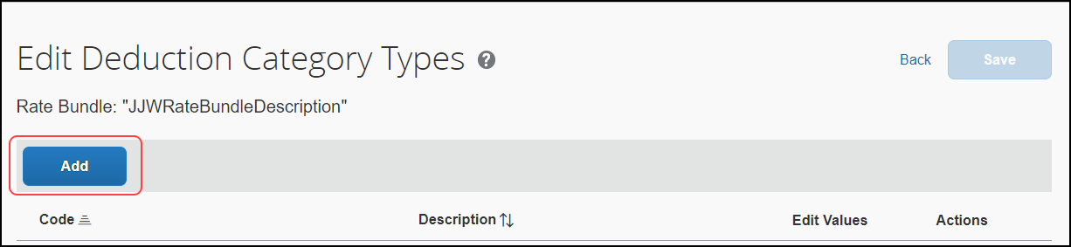
- In the Code field, enter a code for the deduction type. Valid characters are A-Z, 0-9, and underscore _.
- In the Description field, enter a description for the deduction type.
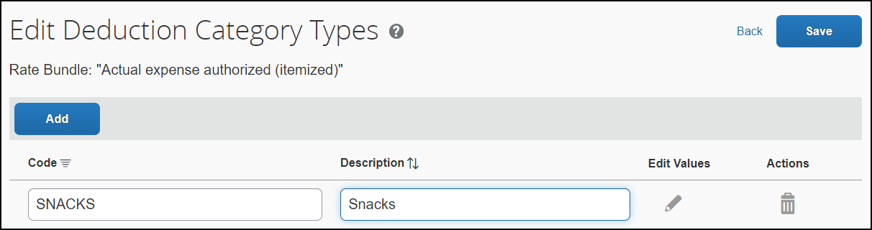
The Description field values should accommodate all language requirements. These values are your company's custom (non-translatable) labels that will be displayed to your users.
- OPTIONAL: Add one or more values for the deduction type by clicking Edit () beside the deduction category type and providing values for the Deduction Type Code and Deduction Type Description fields. For example, if you added the deduction type “Snacks” you might add two values labeled “Hot Snacks” and “Cold Snacks.”
- Click Save.

Adjusting the Default Time for a Deduction
Any deduction category type can have the default time adjusted from its default. Two examples explain the adjustment of time based on a country’s requirements:
- Calculation by 24-hour Interval: Any given 24-hour period of a trip represents a travel day whose initial hour (11 a.m.) ends at the same hour on the next day – if an 8 a.m. Breakfast and 1 p.m. Lunch is included these will both fall within the “first” travel day.
- Calculation by Foreign or Domestic: Separate calculations for travel either foreign and domestic means the same 8 a.m. Breakfast and 1 p.m. Lunch will be calculated based on where the event occurs during travel – Breakfast during the Domestic leg, and Lunch during the Foreign leg of the travel day.
To adjust the time for a deduction category type
- On the Edit Deduction Category Types page, click Edit () beside the deduction whose default time you will change.
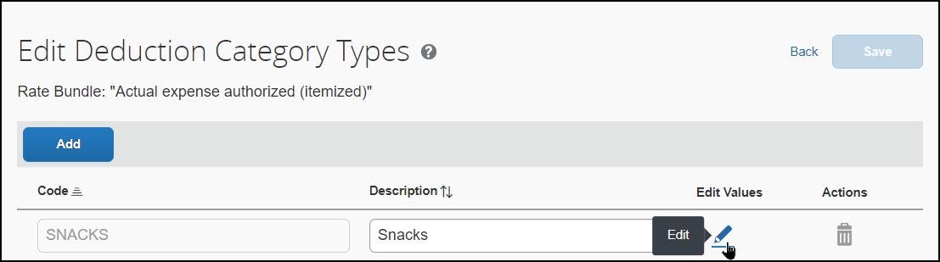
- Change the time as shown below.
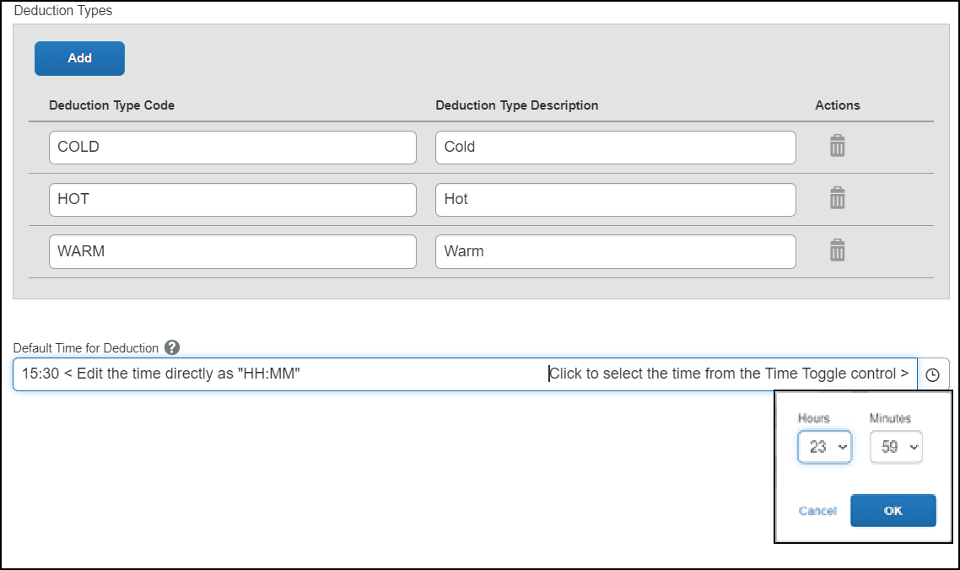
- Click Back, then Back again to return to the Edit Rate Bundle page.

Adding Rates
Rates can be added in two ways: directly by clicking Add as described below, or downloaded, edited, and uploaded using the Download and Upload buttons shown below.
- To view the numbered steps for using the Download and Upload buttons, refer to the Editing Rates section in this guide.
To add rates to a rate bundle:
- On the Rate Bundles page, in the bundle’s row, click View contents ().
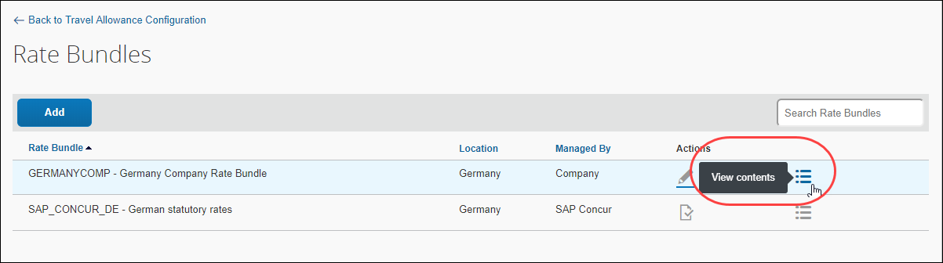
The contents page displays with tabs for rates, deductions, and adjustments.
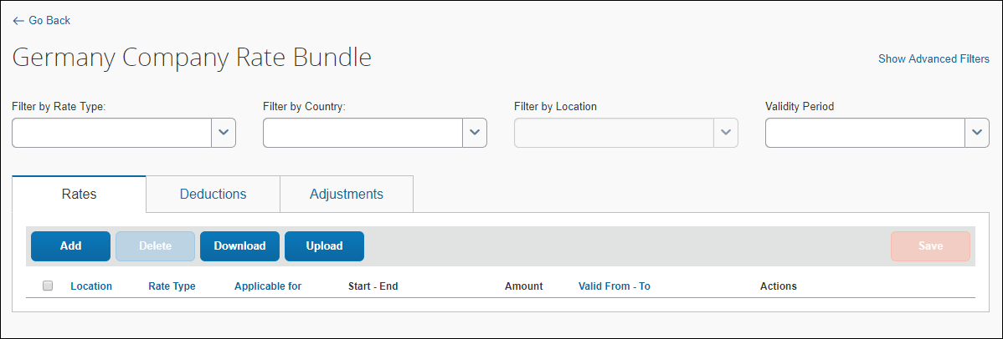
On the Rates tab, click Add. The Add Rate page displays.
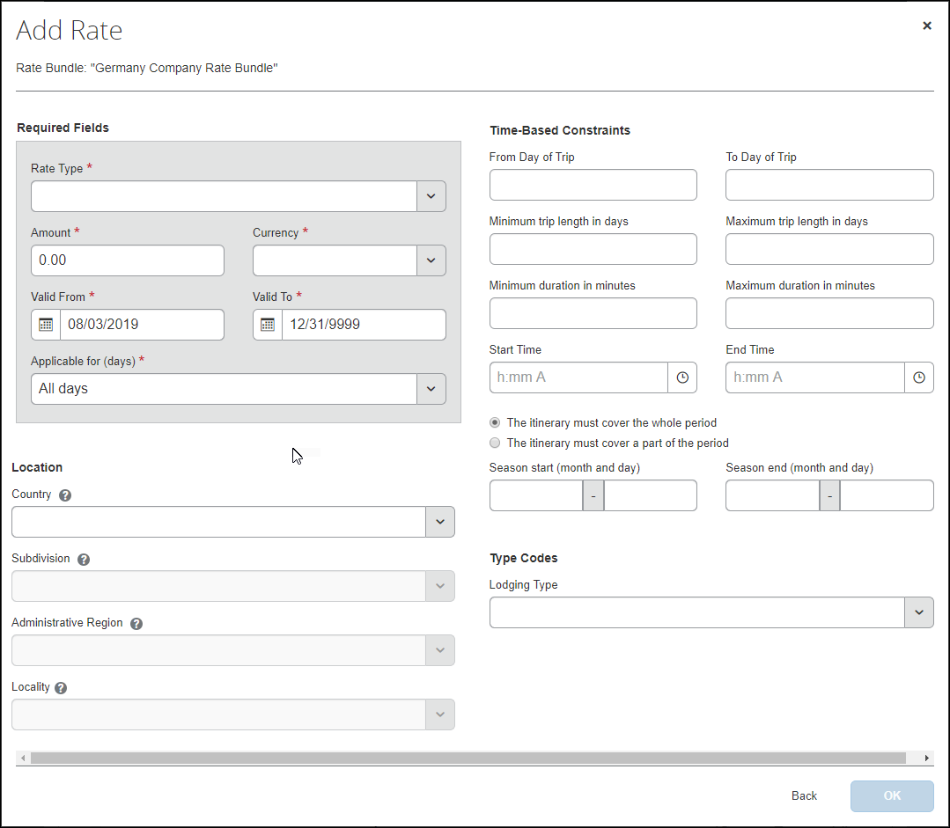
- Fill in the fields. An asterisk indicates a required field.
Field | Description
Required Fields  Rate Type * | Make a selection from the rate type list.  You may select Incidentals, Lodging or Meals.
Required Fields  Amount *  Currency * | Enter an amount and a currency (from the list) to which the rate will apply.  The rate amount can be set in any currency, for example in the currency of the destination country of the trip. When creating an expense report, it will be converted into the user’s reimbursement currency as determined by the user's User Administration settings.
Required Fields  Valid From *  Valid To * | Enter a date.  The date range allow previous rates to remain applicable when processing trips in the past.  NOTE: Regulatory rates are typically updated annually by calendar or financial year and so are valid only for limited date ranges.
Required Fields  Applicable for (days) * | Make a selection from the list.  Intervening days are the days between the first and last day of a trip. The All days choice includes the first day, intervening days, and the last day, and applies to one-day trips.  You may select First day, Last day, All days, or Intervening days.  NOTE: This is a high-level setting.  The concept of a "full day" can be accomplished by selecting All days for this setting and then using the time-based constraint setting, Minimum duration in minutes, configured as 1440 minutes, the equivalent of 24 hours.
Location  Country/Region | Select from the list to indicate the country where these rates apply or leave this setting blank.  Leaving this setting blank means the location is universal and the rate will apply to all destinations regardless of country, locality, subdivision, or location code.
Location  Subdivision | This is a read-only field. A state or province is derived based on the search locality selected.  NOTE: Rates are either universal (no location specified) or valid for a country, city, state/region (subdivision), or location code.
Location  Administrative Region | Make a selection from the list to indicate the county where these rates apply or leave this setting blank.  NOTE: Rates are either universal (no location specified) or valid for a country, city, state/region (subdivision), or location code.
Location  Locality | This is a read-only field. The UN location code is derived based on the search locality selected.  NOTE: Rates are either universal (no location specified) or valid for a country, city, state/region (subdivision), or location code.
Time-Based Constraints  From Day of Trip  To Day of Trip | Enter a number range.  Use this setting if you desire meal rates decrease after a certain number of days, since it is assumed that users become familiar with the place and find ways to spend less on meals.  For example, meal per diems may be reduced to 80% as of day 15 of travel, and further reduced to 60% as of day 30 of travel.  NOTE: This setting creates a per trip rate constraint and does not apply across multiple itineraries or trips.
Time-Based Constraints  Minimum trip length in days  Maximum trip length in days | In these fields, enter a number range of days from 1 to 999 to which this rate will apply.  Use this setting if you desire single-day trips to have different rates than multi-day trips.  For example, setting both the minimum and maximum days to a value of 1 means this rate will apply only to a single-day trip.
Time-Based Constraints  Minimum duration in minutes  Maximum duration in minutes | In these fields, enter a number range of minutes to which this rate will apply.  .  For example, users may receive a meal per diem, such as 12 EUR when their trip is more than 8 hours (481 minutes) and less than 24 hours (1439 minutes) on a given day.
Time-Based Constraints  Start Time  End Time | In these fields, enter a clock time range during which the travel allowance is valid.  For example, if a meal allowance is defined for travel between 13:00 and 14:00 and the trip ends at 12:30, then no meal allowance will be provided.
Time-Based Constraints  The itinerary must cover the whole period  -or-  The itinerary must cover a part of the period | Choose one of these periods. These choices are mutually exclusive.  For example, if a meal allowance is defined for travel between 13:00 and 14:00 and the trip ends at 13:30, then selecting The itinerary must cover the whole period means no allowance will be provided; however, selecting The itinerary must cover a part of the period means the allowance will be provided.
Time-Based Constraints  Minutes to be covered at least  Minutes to be covered at most | If you selected The itinerary must cover a part of the period, then in these fields, enter a number range of minutes to which this constraint will apply.
Time-Based Constraints  Season start (month and day)  Season end (month and day) | Enter a season.  NOTE: In some cases, rates are different depending on the season.  For example, rates in Darwin, Australia are lower during the rainy season (December – March) than during the rest of the year.
Type Codes  Lodging Type  Note: Type Codes (trip, meal, and lodging) are highly configurable and will impact this section of the Add Rate page.  - For more information, refer to the Editing a Configurable Bundle procedure of this guide. | You may select from the rate type list.
- Click OK. This rate is added as a new row on the list of rates on the Rate tab.
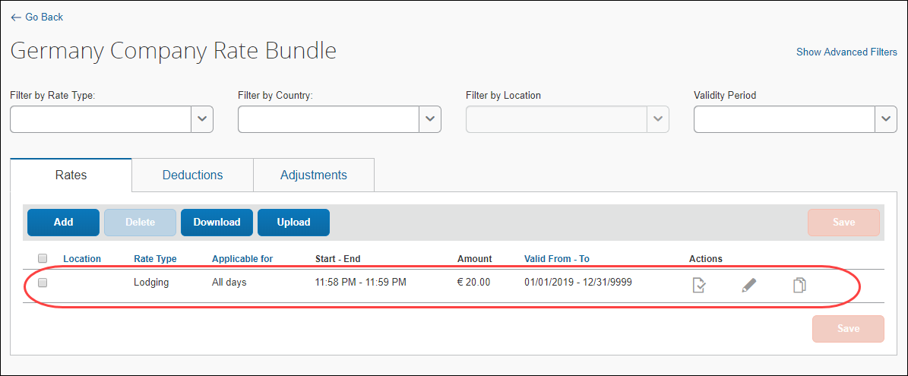
- (Optional) Repeat this procedure to add rates with different field values.
- Click Save.

Copying Rates
To copy a rate:
- On the Rates tab of the {bundle name} page, in the desired row, click Copy ().
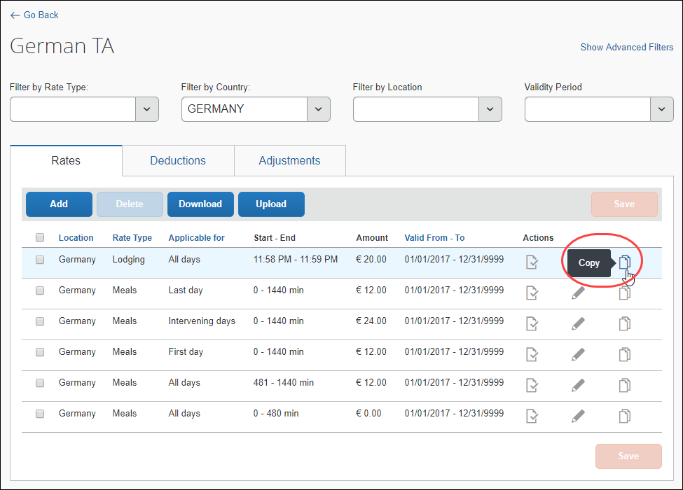
- On the Copy Rate page, edit the fields as desired.
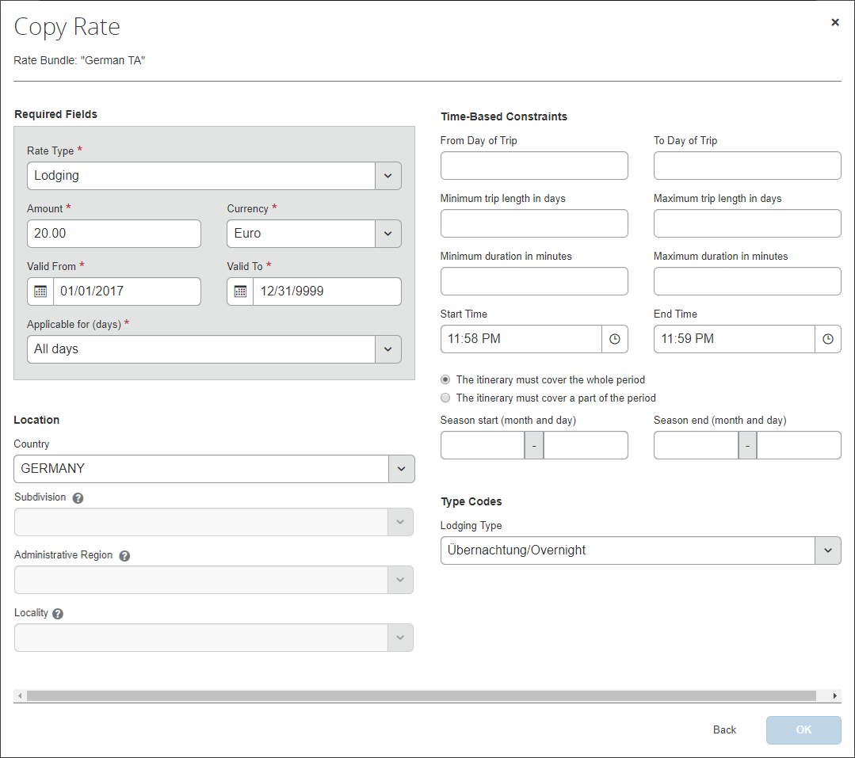
- Click OK.

Adding Deductions
Deductions can be added in two ways: directly by clicking Add, or downloaded, edited, and uploaded using the Download and Upload buttons. Both ways are described in this section.
- To view the numbered steps for using the Download and Upload buttons, refer to the Editing Deductions section in this guide.
To add deductions to a rate bundle:
- On the Rate Bundles page, in the bundle’s row, click View contents ().
The contents page displays with tabs for rates, deductions, and adjustments.
- Click the Deductions tab.
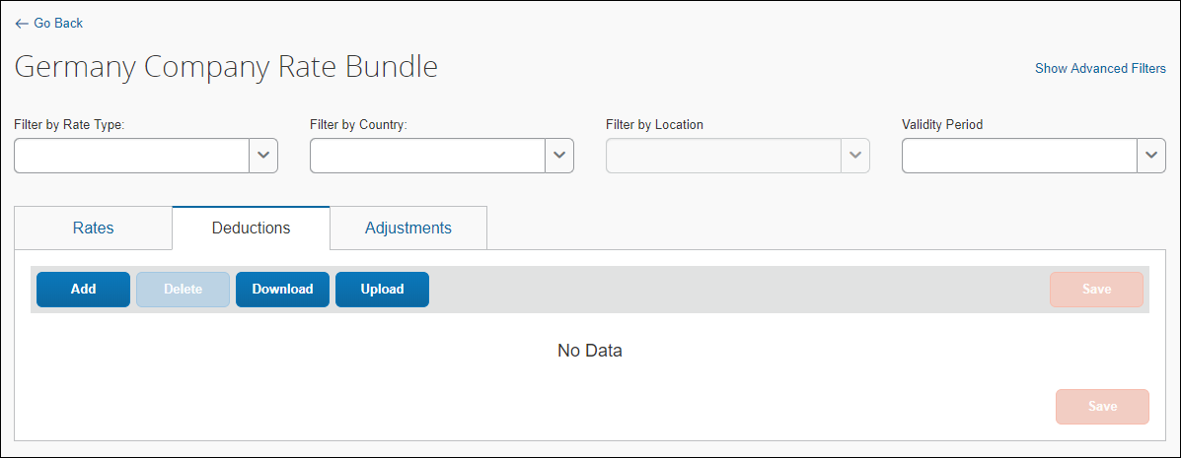
- Click Add. The Add Deductions page displays.
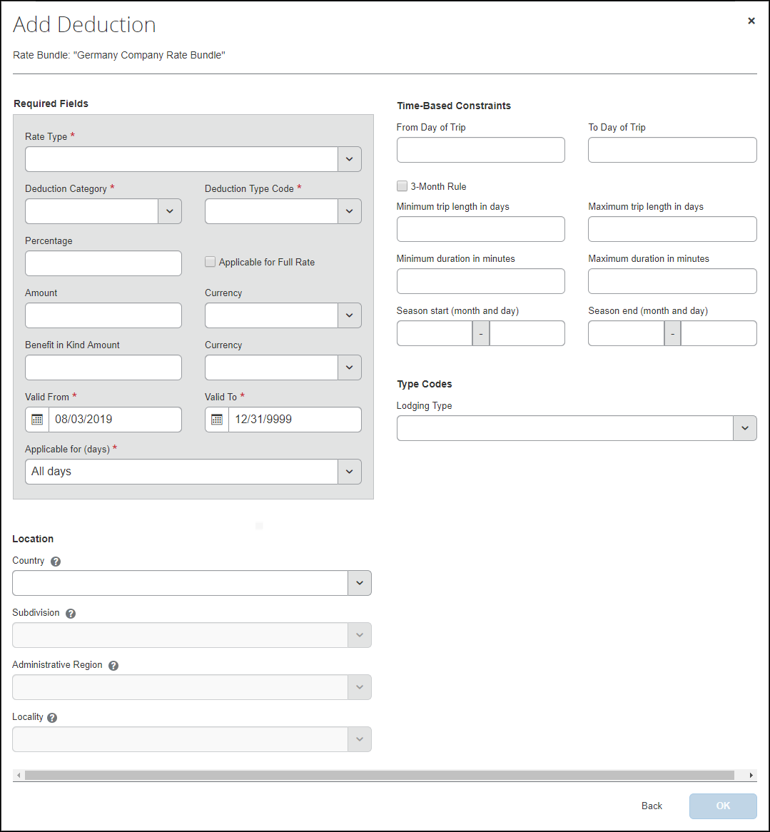
- Fill in the fields. An asterisk indicates a required field.
Field | Description
Required Fields  Rate Type * | Make a selection from the rate type list.  You may select Incidentals, Lodging or Meals.
Required Fields  Deduction Category * | Select from the list.  This is a further break-down of the rate.  For example, for meal allowance rates, you can define breakfast, lunch, and dinner deductions. The deduction category displays to the user as a column on the Adjustments page with checkboxes or lists for each day of travel. When the user selects a value, the deduction is applied for that day.  NOTE: This list contains the deduction categories that are generated when the bundle is created. It is not the list of rate types.  - See the section Adding a Deduction Category Type to add types to your deduction category.
Required Fields  Deduction Type Code * | Select from the list.  NOTE: This list varies depending on the selected Deduction Category.
Required Fields  Percentage | Enter a percentage amount.  This is the amount by which the daily rate is reduced calculated as a percentage of the associated rate.  For example, a breakfast deduction can be configured as 20% of the meal rate.  NOTE: The Percentage field and Amount field are mutually exclusive.
Required Fields  Applicable for Full Rate | Make a selection from the list.  You may select First day, Last day, All days, or Intervening days.  For the first and last days, rates are commonly lower since travel days are not full days.  Typically, the percentage deduction is calculated on the rate for a full day. In this case, this option must be selected. In some instances, the percentage deduction is to be calculated for the actual rate of that day. This can be a reduced rate for the first or last day of a trip.  For example, when Applicable for Full Rate is selected, a breakfast deduction is defined as 20% of the meal rate. The meal rate for full days is 24 EUR and the meal rate for the first and last day is 12 EUR. The user receives a free breakfast on the last day of travel. The breakfast deduction is 20% of 24 EUR, which is 4.80 EUR.
Rounding to Full Amount | This value is selected or cleared.  This setting is used for a deduction percentage.  Selecting the check box means deduction amounts which are calculated from deduction percentages are rounded to the next full number.  If the setting is cleared, deduction amounts which are calculated from deduction percentages retain the number of decimal places used for the currency.
Required Fields  Amount / Currency | Enter a fixed amount and select a currency (from the list) to which the deduction amount will apply.  NOTE: Rates can be defined in the currency of the respective country. On the expense report, travel allowance rates in foreign currencies will be converted to the user’s reimbursement currency.  NOTE: The Percentage field and Amount field are mutually exclusive.  IMPORTANT: Never set up a meal deduction to deduct from the full rate where there is no full rate configured. If a meal deduction is configured and Applicable for Full Rate is selected, but there is no valid full day rate set up in the system, then the user will receive an error.
Required Fields  Benefit in Kind Amount /  Currency | Enter an amount and select a currency (from the list) to which the deduction amount will apply. This is a taxable benefit amount, which is created for a free meal when there is no meal allowance from which to deduct it.  For example, if the user travels less than 8 hours and does not get a meal allowance, but gets a free meal, the company might then treat this amount as a taxable benefit (benefit in kind) after consulting with a taxation expert.  NOTE: This amount is not visible to the user and does not affect their reimbursement. It is configured here in anticipation of further processing by a payroll system.
Required Fields  Valid From *  Valid To * | Enter a date range.  The date range allow previous rates to remain applicable when processing trips in the past.  NOTE: Regulatory rates are typically updated annually by calendar or financial year and so are valid only for limited date ranges.
Required Fields  Applicable for (days) * | Select from the list.  A deduction is valid for either all days of a trip, the first or last day, or the days in between.  For example, for the first and last days, rates are typically lower, since travel days are not full days.  NOTE: This is a high-level setting.  The concept of a "full day" can be accomplished by selecting All days for this setting and then using the time-based constraint setting, Minimum duration in minutes, configured as 1440 minutes, the equivalent of 24 hours.
Location  Country/Region | Select from the list to indicate the country where these rates apply or leave this setting blank.  Leaving this setting blank means the location is universal and the rate will apply to all destinations regardless of country, locality, subdivision, or location code.
Location  Subdivision | This is a read-only field. A state or province is derived based on the search locality selected.  NOTE: Rates are either universal (no location specified) or valid for a country, city, state/region (subdivision), or location code.
Location  Administrative Region | Make a selection from the list to indicate the county where these rates apply or leave this setting blank.  NOTE: Rates are either universal (no location specified) or valid for a country, city, state/region (subdivision), or location code.
Location  Locality | This is a read-only field. The UN location code is derived based on the search locality selected.  NOTE: Rates are either universal (no location specified) or valid for a country, city, state/region (subdivision), or location code.
Time-Based Constraints
From Day of Trip
To Day of Trip
Time-Based Constraints  3-Month Rule | Select this box to enable the 3-month rule.
Time-Based Constraints  Minimum trip length in days  Maximum trip length in days | In these fields, enter a number range from 1 to 999.  NOTE: Rates can depend on the length of a trip.
Time-Based Constraints  Minimum duration in minutes  Maximum duration in minutes | Enter a number.  NOTE: Rates can depend on the number of minutes travelled on a given day.  For example, users may receive a meal per diem, when their travel time is more than 8 hours on a given day.
Time-Based Constraints  Season start (month and day)  Season end (month and day) | Enter a season.  NOTE: In some cases, rates are different depending on the season.  For example, rates in Darwin, Australia are lower during the rainy season (December – March) than during the rest of the year.
Type Codes  Lodging Type  Note: Type Codes (trip, meal, and lodging) are highly configurable and will impact this section of the Add Rate page.  - For more information, refer to the Editing a Configurable Bundle procedure of this guide. | You may select from the list.
- Click OK. This deduction is added as a new row on the list of deductions on the Deductions tab.
- (Optional) Repeat this procedure to add other deductions.
- Click Save.

Copying Deductions
To copy a deduction:
- On the Deductions tab of the {bundle name} page, in the desired row, click Copy ().
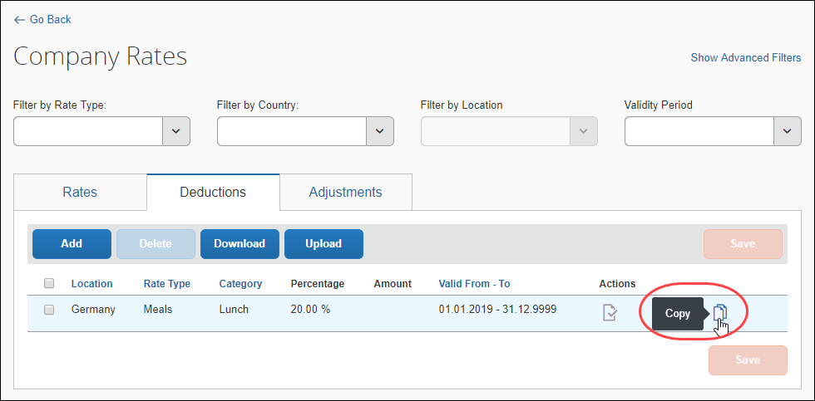

- On the Copy Deduction page, edit the fields as desired.
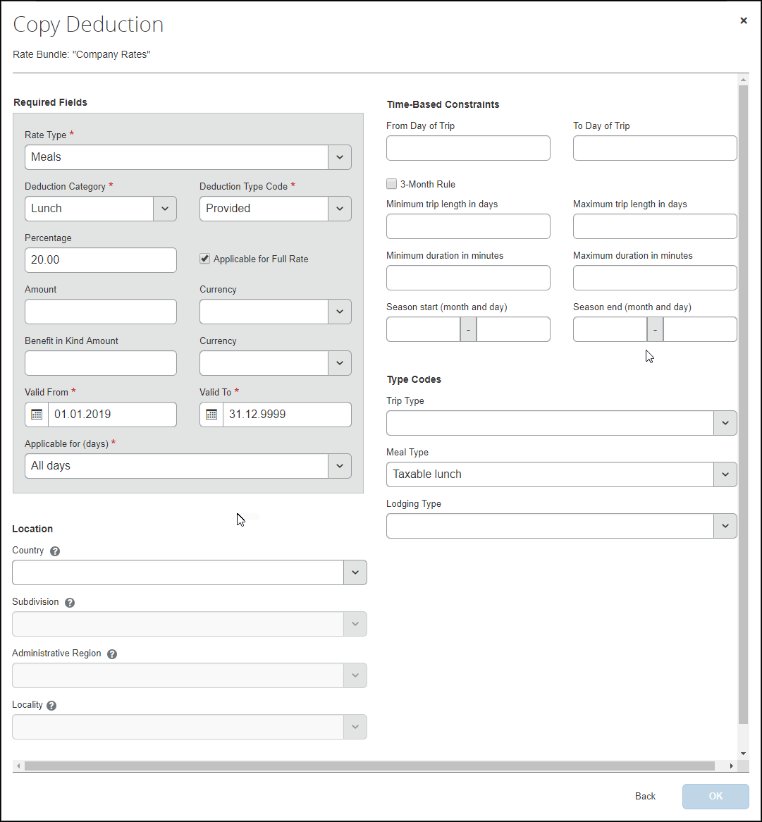
- Click OK.

Adding Adjustments
Adjustments can be added in two ways: directly by clicking Add as described below, or downloaded, edited, and uploaded using the Download and Upload buttons shown below.
- To view the numbered steps for using the Download and Upload buttons, refer to the Editing Adjustments section in this guide.
During a calculation of a daily allowance, the selected rate may be adjusted, by a specific factor.
For example, after a month-long business trip, the rate may be reduced to 50%. To configure this adjustment, enter 0.5 as the Adjustment Factor.
To add adjustments to a rate bundle:
- On the Rate Bundles page, in the bundle’s row, click View contents ().
The contents page displays with tabs for rates, deductions, and adjustments.
- Click the Adjustments tab.
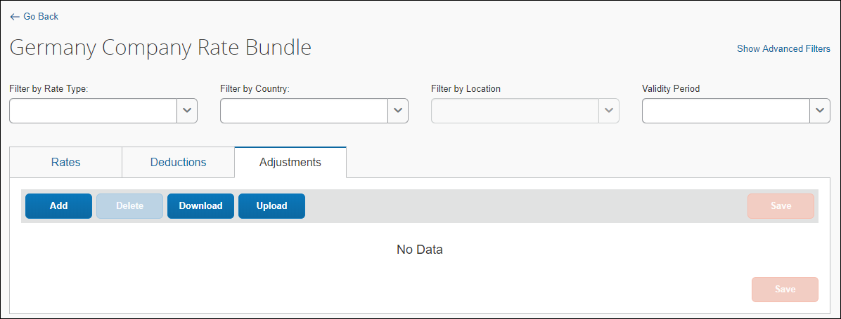
- Click Add. The Add Adjustment page displays.
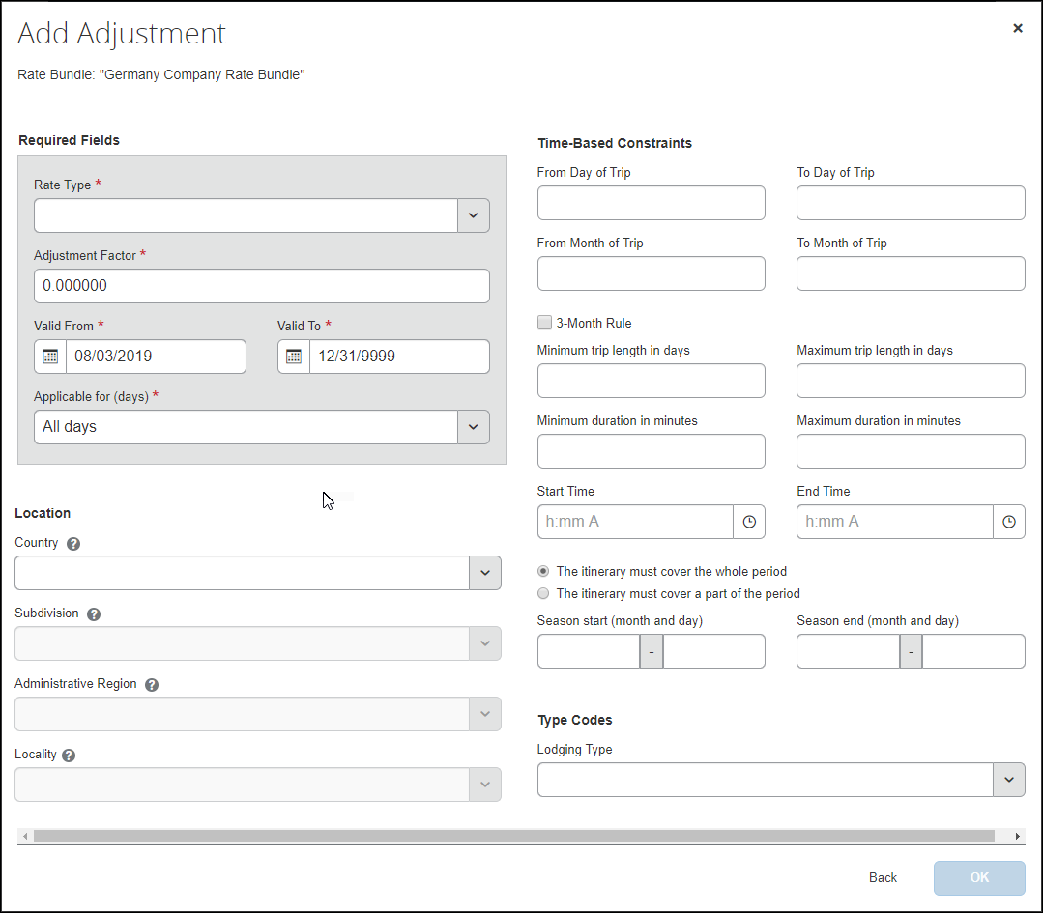
- Fill in the fields. An asterisk indicates a required field.
Field | Description
Required Fields  Rate Type * | Make a selection from the rate type list.  You may select Incidentals, Lodging, or Meals.
Required Fields  Adjustment Factor * | This number either increases or reduces the rate.  A number greater than 1 will increase the rate while a decimal number less than 1 will reduce the rate.
Required Fields  Valid From *  Valid To * | Enter a date range.  The date range allow previous rates to remain applicable when processing trips in the past.  NOTE: Regulatory rates are typically updated annually by calendar or financial year and so are valid only for limited date ranges.
Required Fields  Applicable for (days) * | Enter a number. An adjustment is valid for either all days of a trip, the first or last day, or the days in between.  For example, for the first and last days, rates are typically lower, since travel days are not full days.  NOTE: This is a high-level setting.  The concept of a "full day" can be accomplished by selecting All days for this setting and then using the time-based constraint setting, Minimum duration in minutes, configured as 1440 minutes, the equivalent of 24 hours.
Location  Country/Region | Select from the list to indicate the country where these rates apply or leave this setting blank.  Leaving this setting blank means the location is universal and the rate will apply to all destinations regardless of country, locality, subdivision, or location code.
Location  Subdivision | This is a read-only field. A state or province is derived based on the search locality selected.  NOTE: Rates are either universal (no location specified) or valid for a country, city, state/region (subdivision), or location code.
Location  Administrative Region | Make a selection from the list to indicate the county where these rates apply or leave this setting blank.  NOTE: Rates are either universal (no location specified) or valid for a country, city, state/region (subdivision), or location code.
Location  Locality | This is a read-only field. The UN location code is derived based on the search locality selected.  NOTE: Rates are either universal (no location specified) or valid for a country, city, state/region (subdivision), or location code.
Time-Based Constraints  From Day of Trip  To Day of Trip | In these fields, enter a number range.  For example, meal per diems may be reduced to 80% as of day 15 of travel, and further reduced to 60% as of day 30 of travel.
Time-Based Constraints  From Month of Trip  To Month of Trip | In these fields, enter a number range.  For example, meal per diems may be reduced for trips longer than one month.
Time-Based Constraints  3-Month Rule | Select this box to enable the 3-month rule.
Time-Based Constraints  Minimum trip length in days  Maximum trip length in days | In these fields, enter a number range from 1 to 999.  NOTE: Rates can depend on the length of a trip.
Time-Based Constraints  Minimum duration in minutes  Maximum duration in minutes | Enter a number.  NOTE: Rates can depend on the number of minutes travelled on a given day.  For example, users may receive a meal per diem, when their travel time is more than 8 hours on a given day.
Time-Based Constraints  Start Time  End Time | In these fields, enter a time range.
Time-Based Constraints  The itinerary must cover the whole period  -or-  The itinerary must cover a part of the period | Choose one of these periods. These choices are mutually exclusive.
Time-Based Constraints  Minutes to be covered at least  Minutes to be covered at most | If you selected The itinerary must cover a part of the period, then in these fields, enter a number range of minutes to which this constraint will apply.
Time-Based Constraints  Season start (month and day)  Season end (month and day) | Enter a season.  NOTE: In some cases, rates are different depending on the season.  For example, rates in Darwin, Australia are lower during the rainy season (December – March) than during the rest of the year.
Type Codes  Lodging Type  Note: Type Codes (trip, meal, and lodging) are highly configurable and will impact this section of the Add Rate page.  - For more information, refer to the Editing a Configurable Bundle procedure of this guide. | You may select from the rate type list.
- Click OK. This deduction is added as a new row on the list of adjustments on the Adjustments tab.
- (Optional) Repeat this procedure to add other adjustments.
- Click Save.

Copying Adjustments
To copy an adjustment:
- On the Adjustments tab of the {bundle name} page, in the desired row, click Copy ().
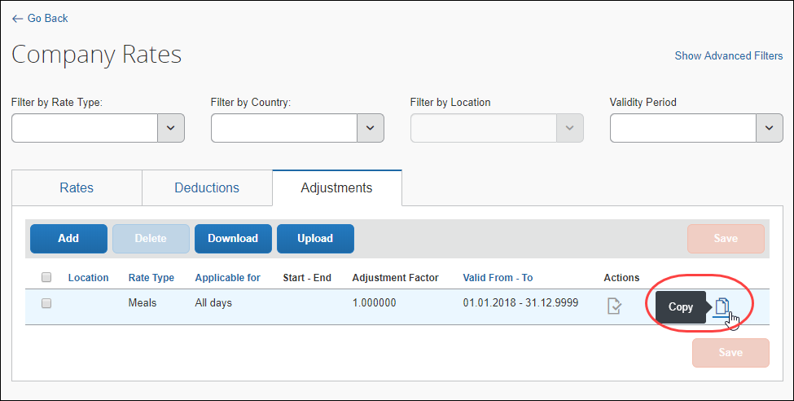
- On the Copy Adjustment page, edit the fields as desired.
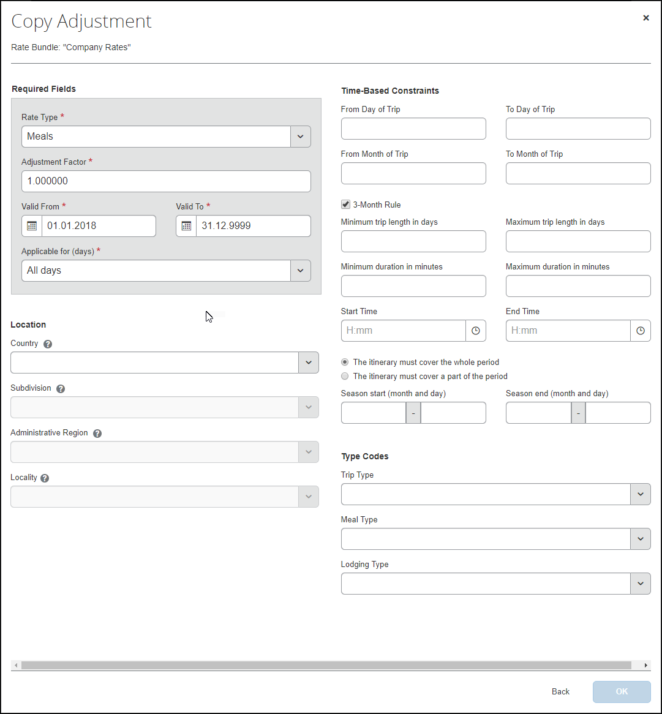
- Click OK.

Copying an Existing Configurable Bundle
A copied bundle includes rate types, calculation rules, trip types, meal types, lodging types, if they existed in the source bundle, but does not include rates, deductions, or adjustments.
- To obtain a duplicate bundle that includes rate types, calculation rules, trip types, meal types, lodging types, and rates, deductions, or adjustments, refer to the Uploading an Existing Configurable Bundle section of this guide.
- After completing the procedure in this section, to add rates, deductions, and adjustments, from scratch or by make copies of existing ones, refer to the Adding a Configurable Bundle from Scratch section of this guide.
Only existing company-managed bundles may be copied.
To copy a configurable bundle:
- On the Rate Bundles page, in the bundle's row, click the Copy () icon.
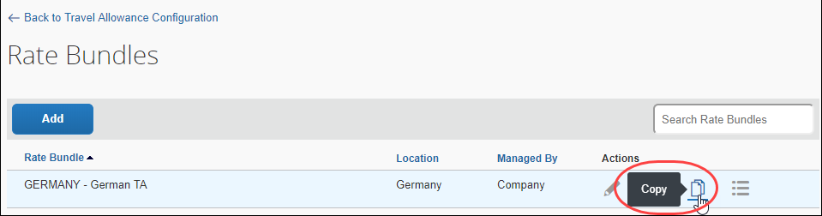
- (Optional) On the Copy Rate Bundle page, edit the Rate Bundle Code and or the Description.
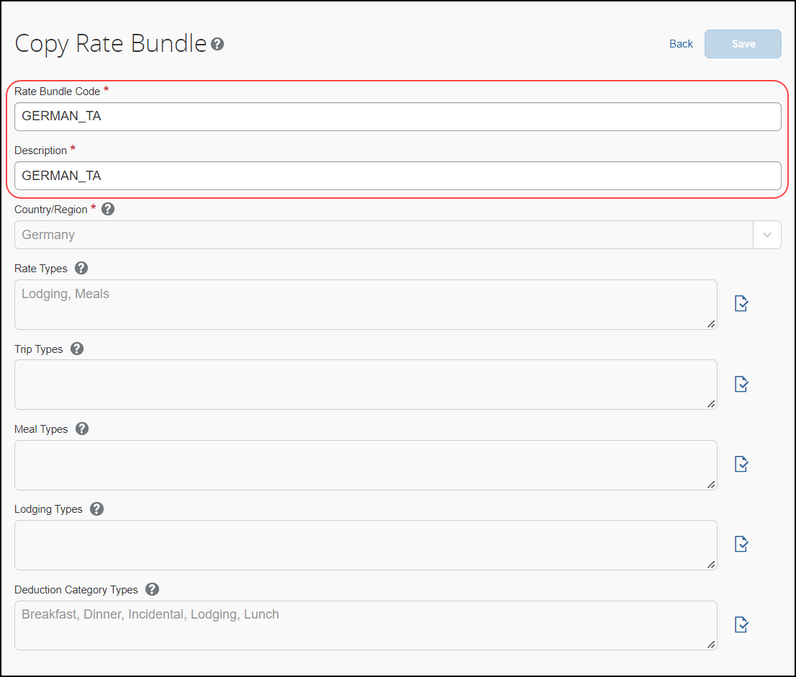
- Click Save.

Uploading an Existing Configurable Bundle
The download and upload functionality for rate bundles allows a bundle to be added to an instance of Concur Expense from another instance of Concur Expense. For example, you may download a bundle from a test site and then upload it to a production site.
A downloaded bundle includes rate types, calculation rules, trip types, meal types, lodging types, rates, deductions, and adjustments, if they existed in the source bundle.
There are four unique download / upload procedures, one for each of the following configuration elements: bundles, rates, deductions, and adjustments.
To upload a configurable bundle from a test site:
- Using the test site, on the Rate Bundles page, click Download () on the desired row.
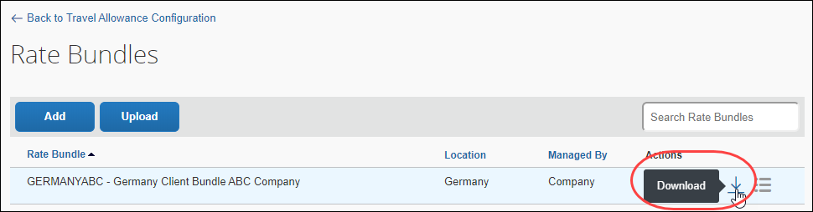
A confirmation message displays and a .zip file is downloaded locally.
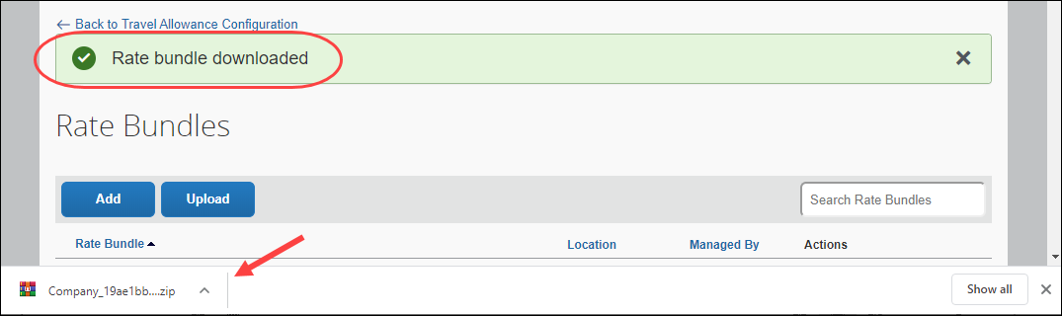
- Using the production site, on the Rate Bundles page, click Upload.
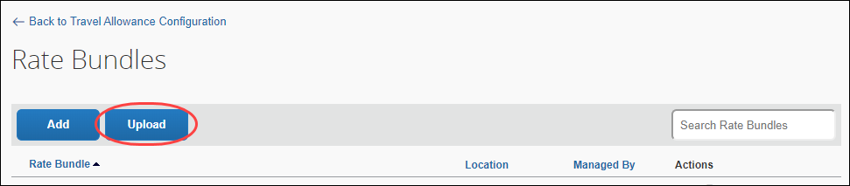
- On the Upload Settings page, fill in the fields. An asterisk indicates a required field.
Field | Description
Rate Bundle Code * | Enter a name for this bundle.  NOTE: The valid characters are A-Z, 0-9, and underscore (_).
File name * | Enter a file name by clicking Pick a file and navigating to the .zip file that you downloaded from the test site.
- Click Upload.
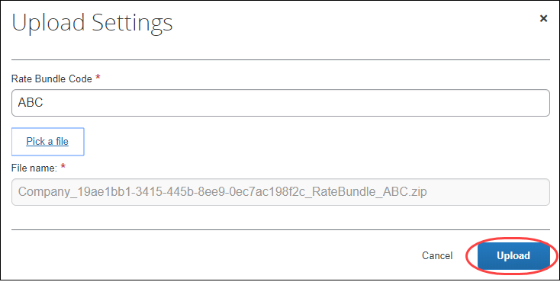
A confirmation message displays, and the new bundle is available.
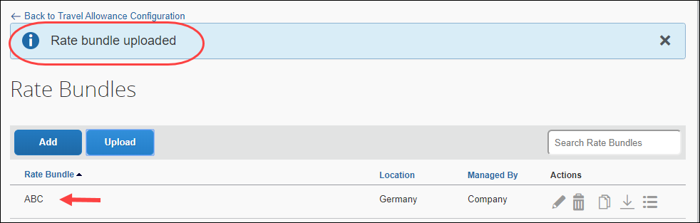

Maintain a Configurable Bundle
After the initial creation of a bundle, it may be viewed, edited, and deleted.
- To maintain rates, and other details, refer to the Maintain the Contents of a Bundle section of this guide.

Viewing a Configurable Bundle
All bundles may be viewed, both company-managed, configurable bundles and SAP Concur-managed, statutory bundles.
To view a configurable rate bundle:
- Click Administration > Expense > Travel Allowance Configuration.
- On the Travel Allowance Configuration page, click Bundles. The Rate Bundles page displays.
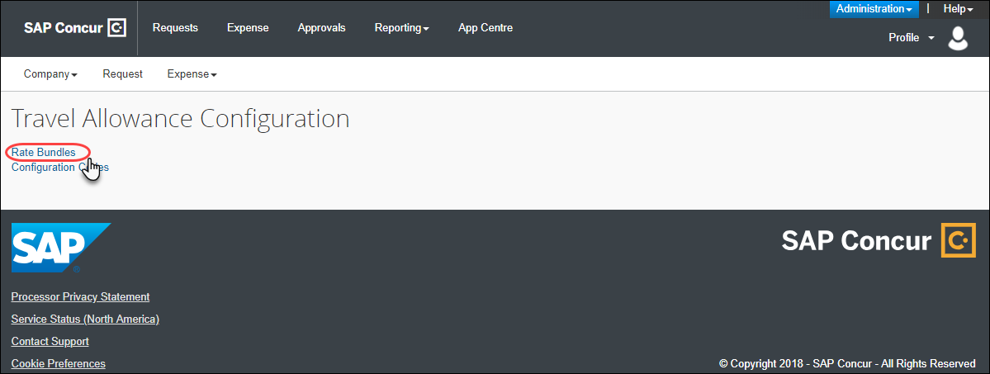
Company bundles are managed by the client or a representative of the client and not by SAP Concur.
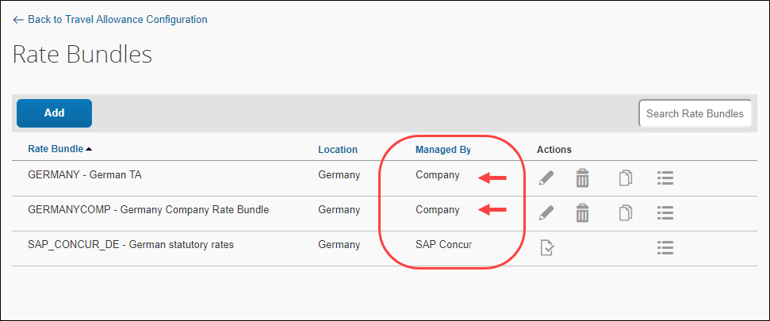
- In the row of the bundle you want to view, click Edit ().
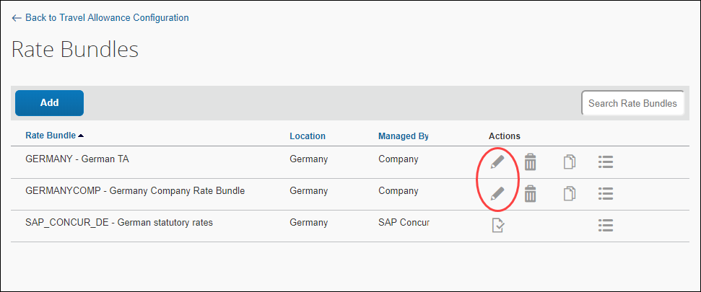
The Edit Rate Bundle page displays.
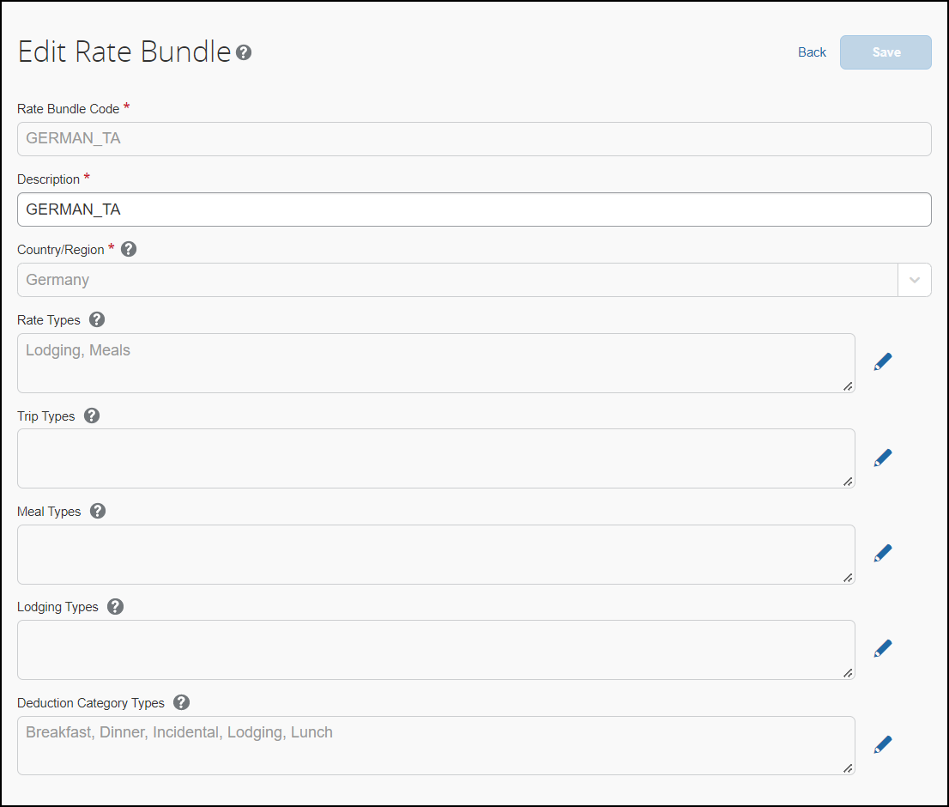
- Click Back.

Editing a Configurable Bundle
Only company-managed bundles may be edited.
To edit a configurable rate bundle:
- On the Rate Bundles page, in the bundle’s row, click Edit ().
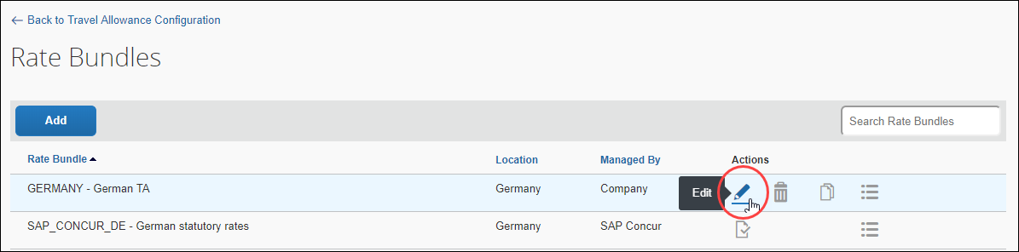
The Edit Rate Bundle page displays.
- Edit the fields as desired either by typing in the field or clicking Edit (). An asterisk indicates a required field.
Field | Description
Description * | Enter a description for this configuration.
Trip Types | Enter a code and description for company trip types, such as "Customer Meeting" or "Training".  NOTE: Valid characters, up to a maximum of 30, include upper case letters, numbers, and the underscore character. Spaces are not permitted.  If one trip type is configured, it will appear to the user as a checkbox on the Create New Report header page. If more than one is configured, a Trip Types column will display a list of choices for the user.
Meal Types | Enter a code and description for company meal types, such as " Canteen meal".  NOTE: Valid characters, up to a maximum of 30, include upper case letters, numbers, and the underscore character. Spaces are not permitted.  If one meal type is configured, it will appear to the user as a checkbox on the Adjustments page. If more than one is configured, a Meal Types column will display a list of choices for the user.
Lodging Types | Enter a code and description for company lodging types, such as "Overnight".  If one lodging type is configured, it will appear to the user as a checkbox on the Adjustments page. If more than one is configured, a Lodging Types column will display a list of choices for the user.  NOTE: Valid characters, up to a maximum of 30, include upper case letters, numbers, and the underscore character. Spaces are not permitted.
Deduction Category Types | Enter a code and description for deduction types, such as “Snacks” or “Incidentals.”  Optional: Click Edit Values to further classify the deduction type for one or more values which can appear as a checkbox or a multiple-choice list, for example “Hot Snacks” and “Cold Snacks.”  - See the section Adjusting the Default Time for a Deduction in this document to change the default time (Breakfast = 7 a.m.) for a deduction to accommodate a 24-hour or regional requirement specific to the bundle.
- (Optional) On the Edit Rate Types page, click Add.
- Click OK.

Deleting a Configurable Bundle
Only company-managed bundles may be deleted.
- IMPORTANT: There is no confirmation message and no undo.
To delete a configurable rate bundle:
- On the Rate Bundles page, in the bundle’s row, click Delete ().
If the bundle is in use, it will not be deleted, and a message will display.
For example:

Maintaining the Contents of a Configurable Bundle
Maintenance of a bundle's contents includes viewing, editing, and deleting rate types, calculation rules, trip types, meal types, lodging types, rates, deductions, and adjustments.

Maintaining Rate Types and Calculation Rules
Rate Bundles contain Rate Types and Rate Types contain calculation rules.

Viewing and Editing a Rate Type's Description
To view and edit the description of a rate type
- On the Edit Rate Types page, in the desired row, in the Description field, view the existing and/or enter a new value.
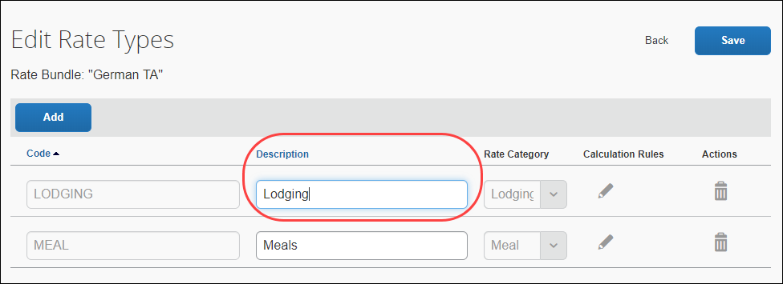
- Click Save.

Editing a Rate Type's Calculation Rules
To edit calculation rules
- On the Edit Rate Types page, in the desired row, click Edit ().
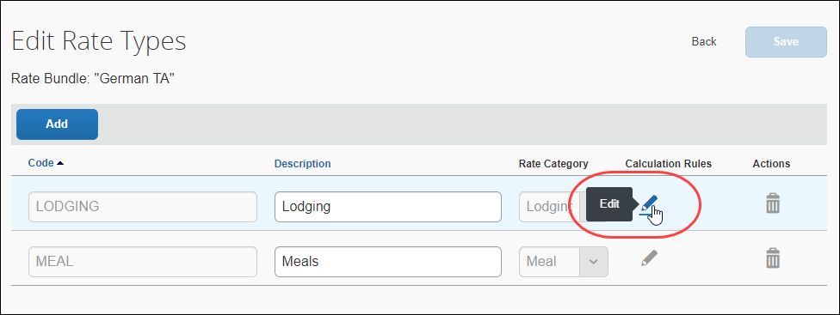
- On the Edit calculations rules of rate type: "..." page, select a Rule for each Rule Name.
For field descriptions, refer to the procedure in this guide for adding rate types and calculation rules.
- Click OK.

Deleting a Rate Type
- IMPORTANT: There is no confirmation message and no undo.
To delete a rate type
- On the Edit Rate Types page, in the rate type's row, click Delete ().
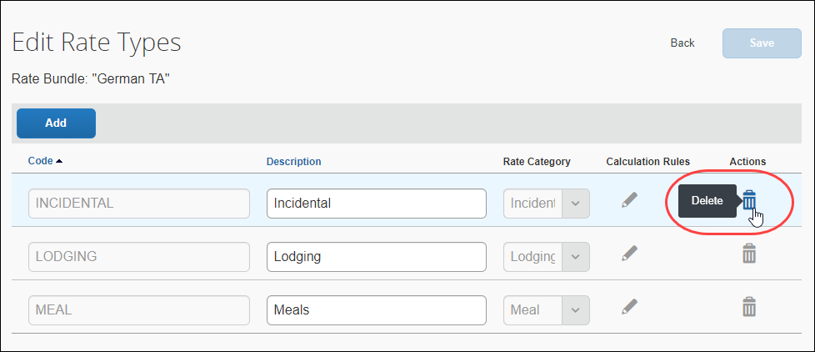
If the rate type is in use, it will not be deleted, and a message will display.

Maintaining Trip Types
Rate Bundles contain Trip Types.

Viewing and Editing a Trip Type
To view and edit the description of a trip type
- On the Edit Trip Types page, in the desired row, in the Description field, view the existing and/or enter a new value.
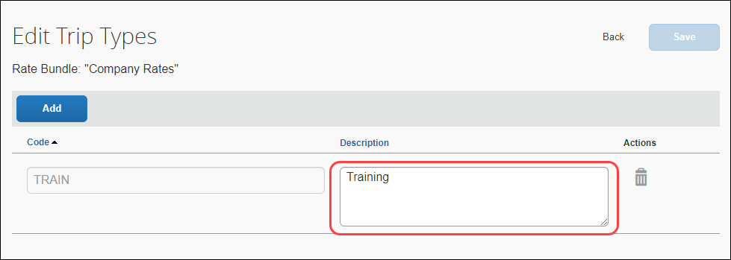
The Description field texts should accommodate all language requirements. These values are your company's custom (non-translatable) labels that will be displayed to your users.
- Click Save.

Deleting a Trip Type
- IMPORTANT: There is no confirmation message and no undo.
To delete a trip type
- On the Edit Trip Types page, in the rate type's row, click Delete ().
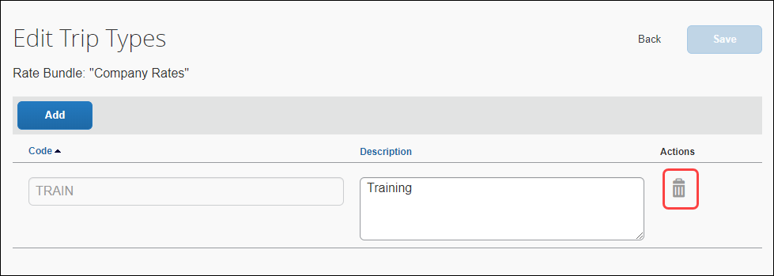
If the trip type is in use, it will not be deleted, and a message will display.

Maintaining Meal Types
Rate Bundles contain Meal Types.

Viewing and Editing a Meal Type
To view and edit the description of a meal type
- On the Edit Meal Types page, in the desired row, in the Description field, view the existing and/or enter a new value.
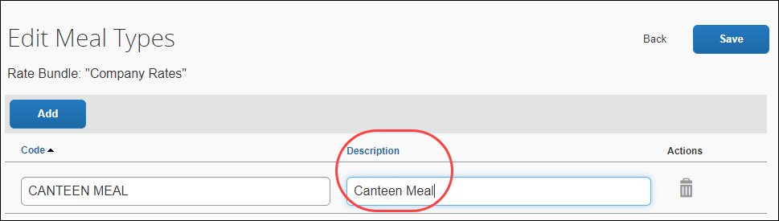
The Description field texts should accommodate all language requirements. These values are your company's custom (non-translatable) labels that will be displayed to your users.
- Click Save.

Deleting a Meal Type
- IMPORTANT: There is no confirmation message and no undo.
To delete a meal type
- On the Edit Meal Types page, in the rate type's row, click Delete ().
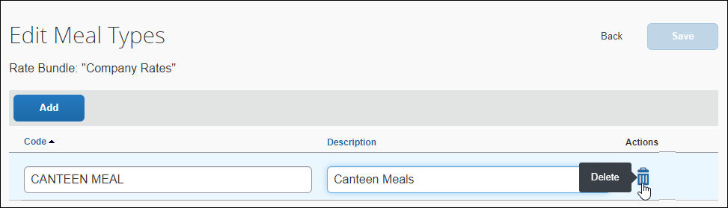
If the meal type is in use, it will not be deleted, and a message will display.

Maintaining Lodging Types
Rate Bundles contain Lodging Types.

Viewing and Editing a Lodging Type
To view and edit the description of a lodging type
- On the Edit Lodging Types page, in the desired row, in the Description field, view the existing and/or enter a new value.
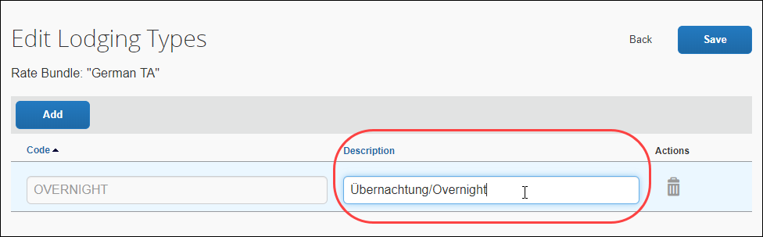
The Description field texts should accommodate all language requirements. These values are your company's custom (non-translatable) labels that will be displayed to your users.
- Click Save.

Deleting a Lodging Type
To delete a lodging type
- IMPORTANT: There is no confirmation message and no undo.
- On the Edit Lodging Types page, in the rate type's row, click Delete ().
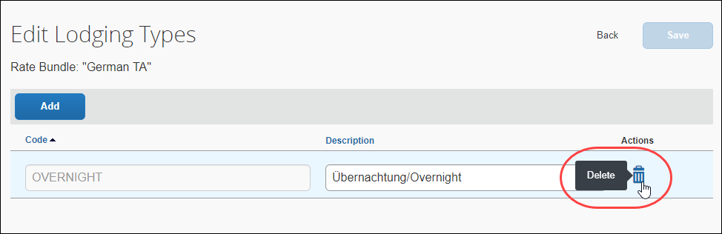
If the lodging type is in use, it will not be deleted, and a message will display.

Maintaining Deduction Category Types
Rate Bundles contain Deduction Category Types.

Viewing and Editing a Deduction Category Type
To view and edit the description of a deduction category type
- On the Edit Deduction Category Types page, in the desired row, in the Description field, view the existing and/or enter a new value.
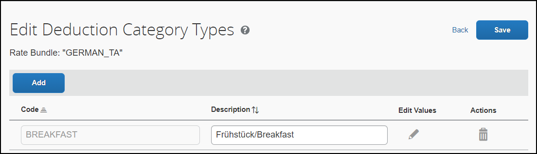
The Description field texts should accommodate all language requirements. These values are your company's custom (non-translatable) labels that will be displayed to your users.
- Click Save.
- See the section Adjusting the Default Time for a Deduction in this document to optionally adjust the default time for the deduction.

Deleting a Deduction Category Type
To delete a deduction category type
- IMPORTANT: There is no confirmation message and no undo.
- On the Edit Deduction Category Types page, in the rate type's row, click Delete ().
If the deduction category type is in use, it will not be deleted, and a message will display.

Maintaining Rates
When you make changes to the rates:
- The new rates go into effect immediately after you click Save based on the Effective Date of the rate.
- The new rates apply to unsubmitted reports only if:
  - the itinerary is changed manually
  - adjustments are made
  - the report is resubmitted after the update
  - the dates in the itinerary are on or after the Effective Date of the rate
- Rates on reports submitted before this update are not changed.

Viewing Rates
To view rates in a rate bundle:
- On the Rate Bundles page, in the bundle’s row, click View contents ().
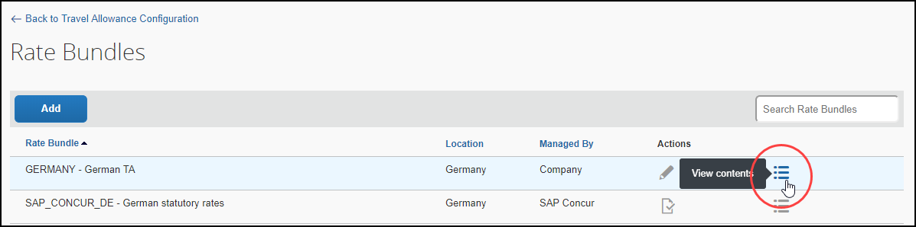
The bundle’s contents page displays with tabs for rates, deductions, and adjustments.
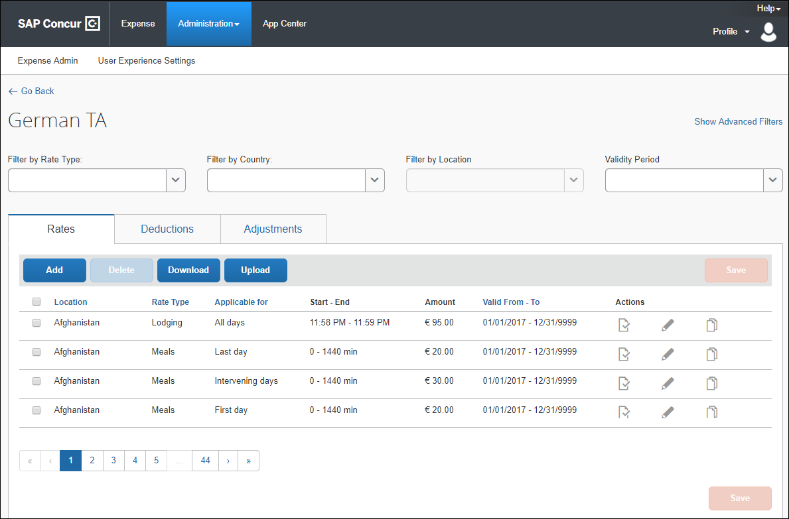
If "No Data" displays, the system may need a few more seconds to retrieve data.
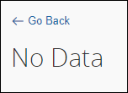
- In the desired row, click the View ().
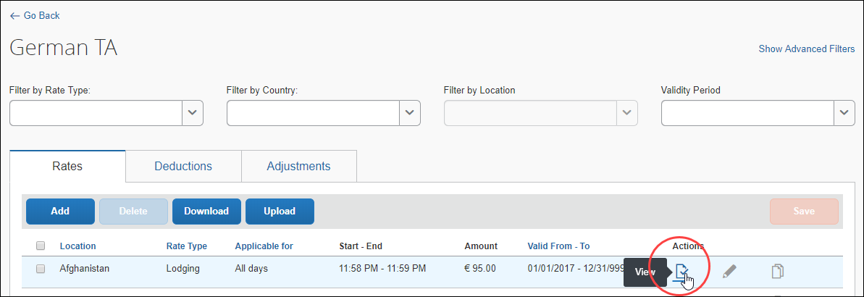
- The View Rate page displays.
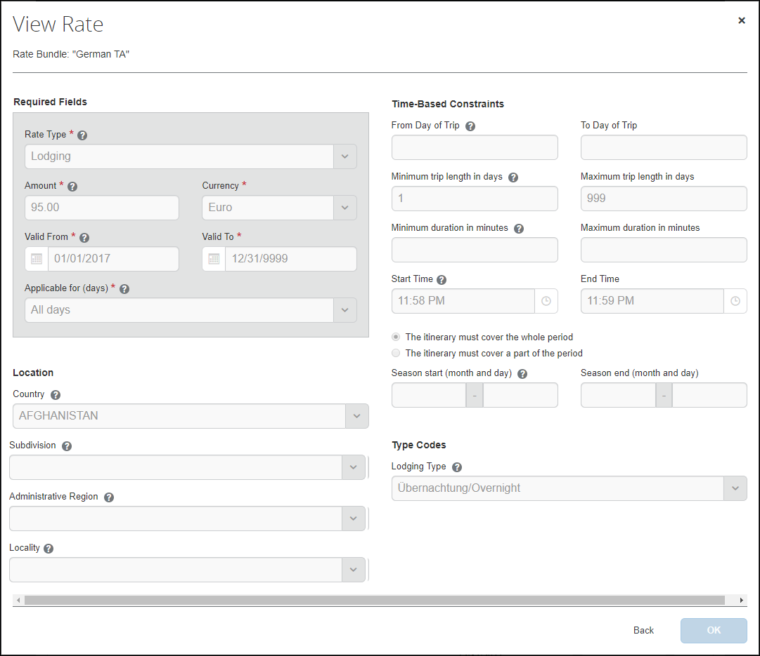

Editing Rates
Rates can be edited in two ways: directly, or downloaded, edited, and uploaded. Both ways are described in this section.
To edit rates in a rate bundle directly:
- On the Rate Bundles page, in the bundle’s row, click View contents ().
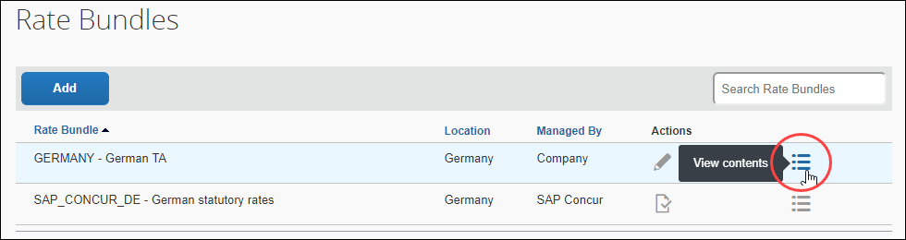
The bundle’s contents page displays with tabs for rates, deductions, and adjustments.
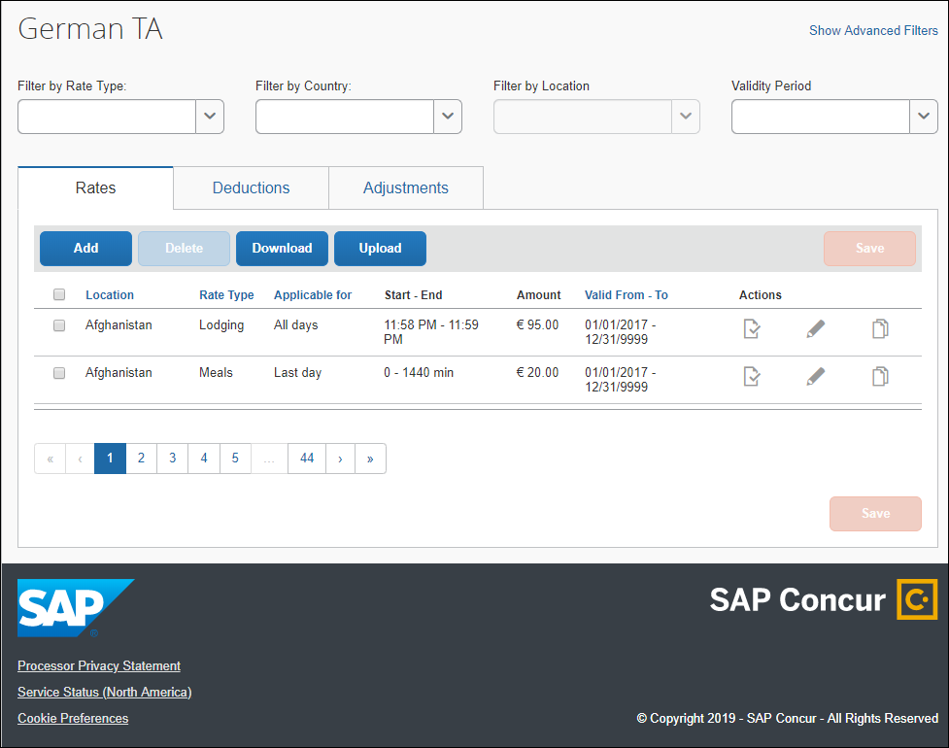
- In the desired row, click Edit ().
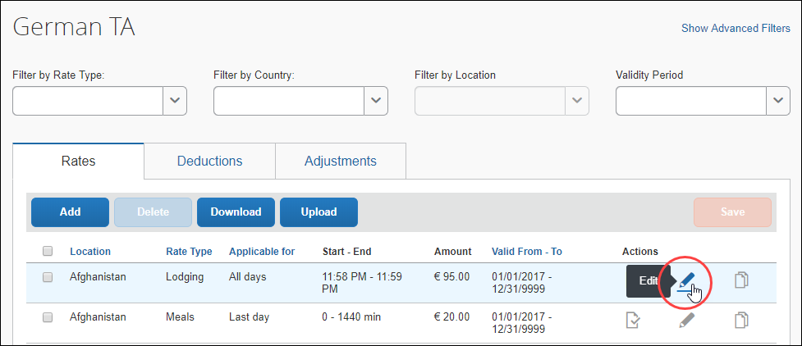
The Edit Rate page displays.
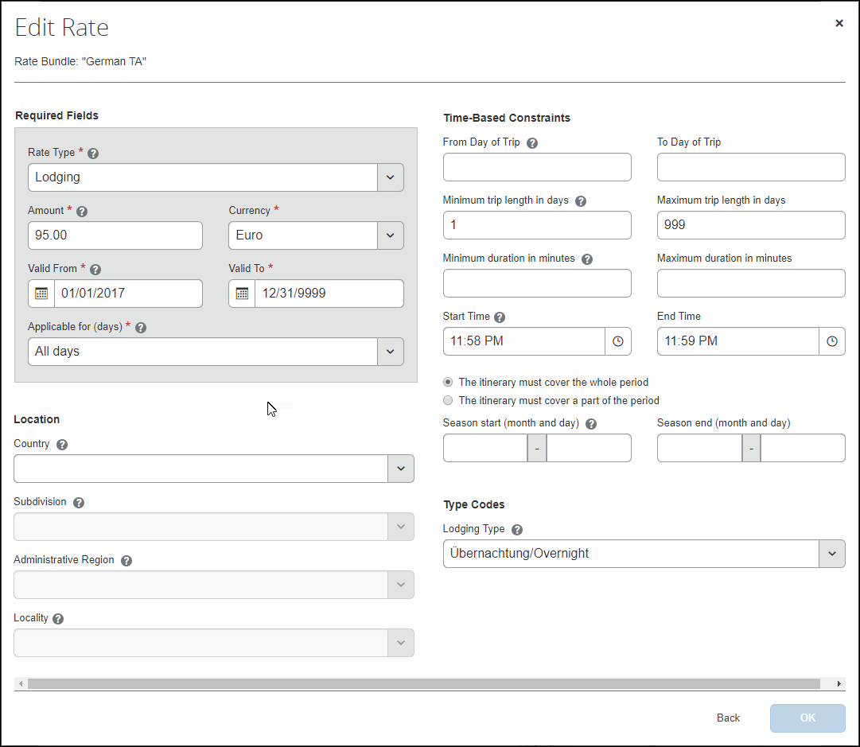
- Edit the fields as desired. An asterisk indicates a required field. For field descriptions, refer to the procedure in this guide for adding rates.
- Click OK.
- Click Save.
To edit, add, or delete rates in a rate bundle using the download and upload functionality:
Rates can be downloaded from one bundle and uploaded to another.
- On the Rate Bundles page, in the bundle’s row, click View contents ().
The bundle’s contents page displays with tabs for rates, deductions, and adjustments.
The name of the page reflects the bundle name, German TA, in the example below.
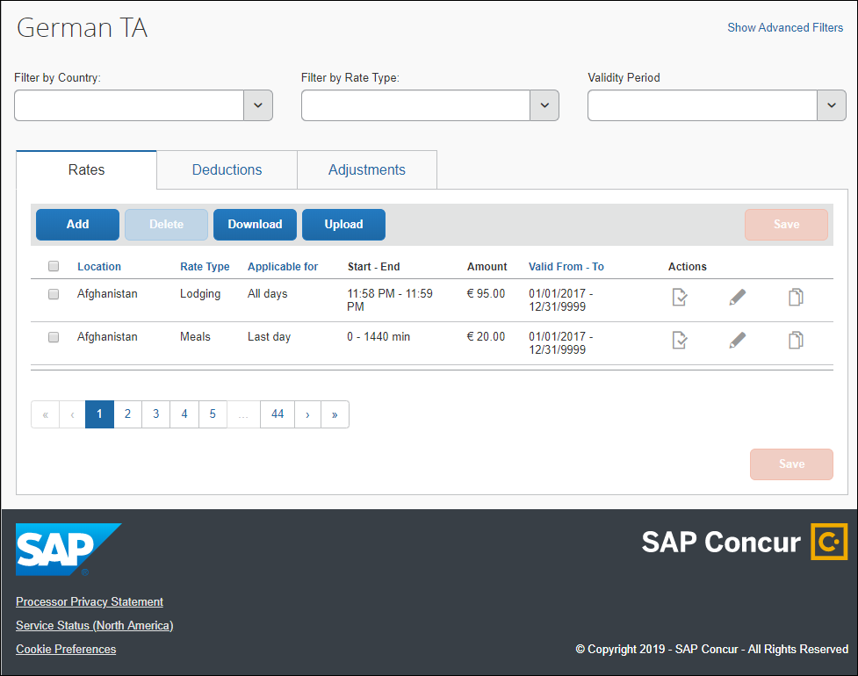
- To download all rate data you see, filters may be applied, and click Download.
Example with Germany selected as a filter
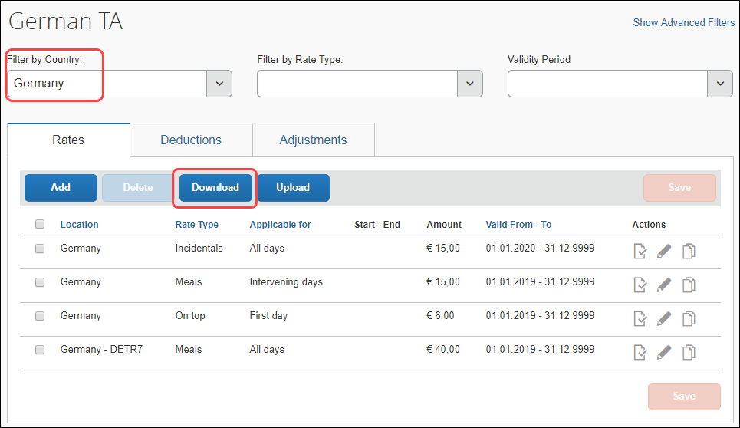
Selecting rows does not limit the rate data that will be downloaded. All rows displayed will be downloaded.
When the download succeeds, open the local Excel file to see the downloaded data.
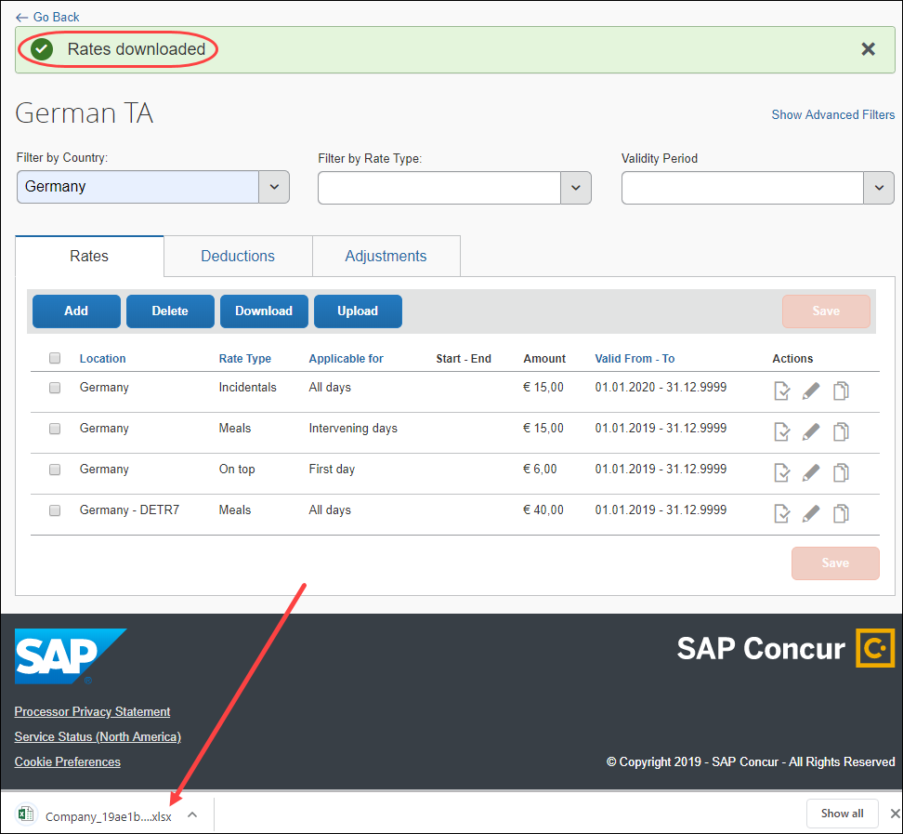
- (Optional) If the Excel file opens in protected view, click Enable Editing.
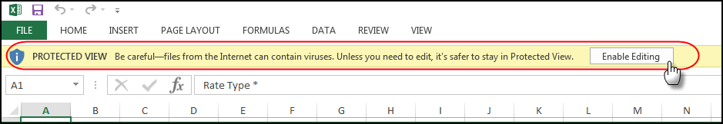
To comply with restrictions for date and time format, switch your system preferences to dd/mm/yyyy or dd-mm-yyyy for date format and to 24h format: hh:mm for time format.
- Edit the rows, or add new rows, as desired. To delete a row of data from the database, in the Remove data from system column, select Remove.
- IMPORTANT: Deleting a row from the worksheet in Excel does not delete the row's data from your Concur Expense database. To remove data from the database, you must select Remove within that row and then re-import the Excel worksheet.
If you click in a cell and see a list button, you must make a selection from the list of acceptable values. For example:
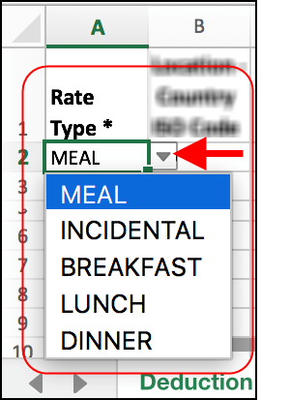
- IMPORTANT: For date and time data, you must use the following formats: dd/mm/yyyy or dd-mm-yyyy and (24-hour) hh:mm.
- For field descriptions, refer to the procedure in this guide for adding rates. An asterisk indicates a required field.
- Click File > Save As and save the file as type CSV Comma delimited (*.csv). Only this file format is supported for this feature.
If prompted to do so, click Save Active Sheet.
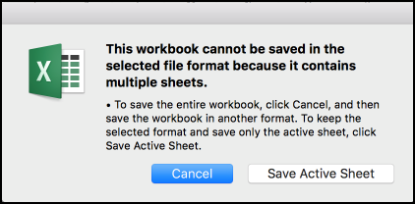
- On the Rates tab in Concur, click Upload.
The system has a 1 MB (about 10,000 records) file limitation.
- Browse to the .csv file you created and click Open.
- (Optional) On the Confirm Upload page, select Allow overwriting or deleting existing records. To avoid unintended data loss, this setting is defaulted to cleared (not selected).
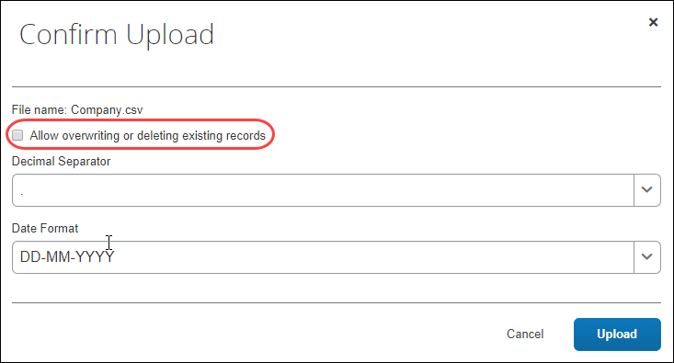
- On the Confirm Upload page, select a decimal separator and the date format which you are using in the csv file that you want to upload, and click Upload.
The system has a 1 MB (about 10,000 records) file limitation.
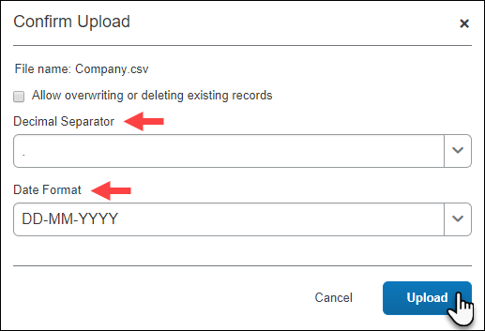
Rates uploaded message displays.
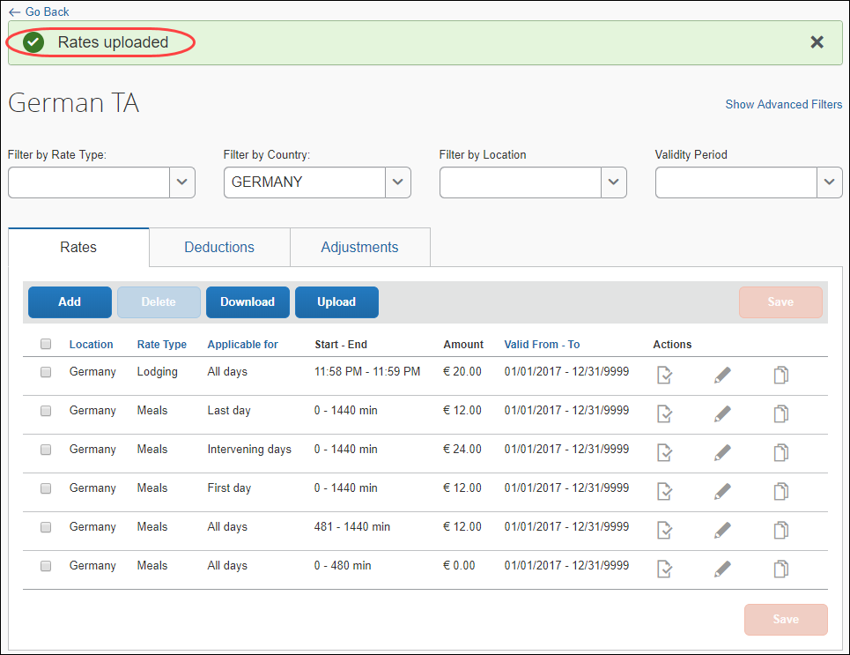
If the upload fails, helpful information is displayed. For example, that the file header has the wrong structure indicating the file might be for rates rather than for deductions, or for deductions rather than for adjustments, and so on.
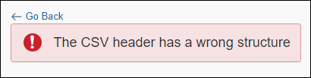
If the upload fails, no portion of the data in the file is uploaded/saved.
- IMPORTANT: Having the current version of the template is essential to a successful upload. Always download the current version of the template before editing and uploading.

Deleting Rates
- IMPORTANT: There is no confirmation message and no undo.
To delete a rate:
- On the Rates tab of the {bundle name} page, in the desired row, click Delete ().
If the rate is in use, it will not be deleted, and a message will display.

Maintaining Deductions

Viewing Deductions
To view deductions in a rate bundle:
- On the Rate Bundles page, in the bundle’s row, click View contents ().
The bundle’s contents page displays with tabs for rates, deductions, and adjustments.
- Click the Deductions tab.
- In the desired row, click View ().
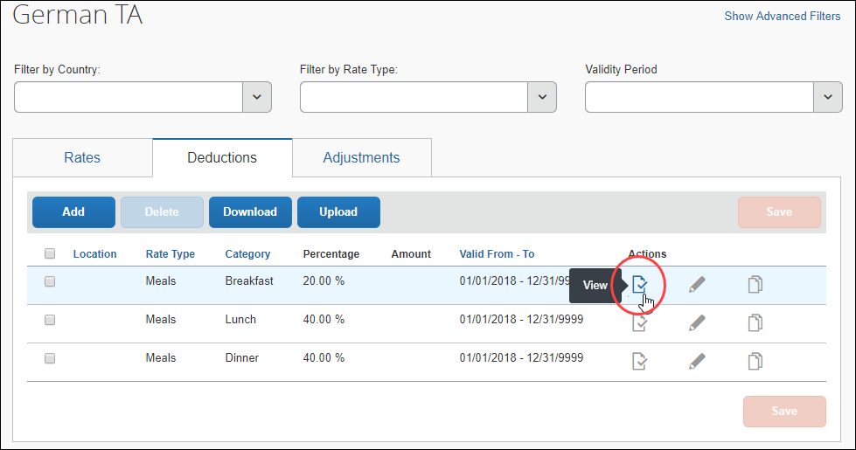
- The View Deduction page displays.
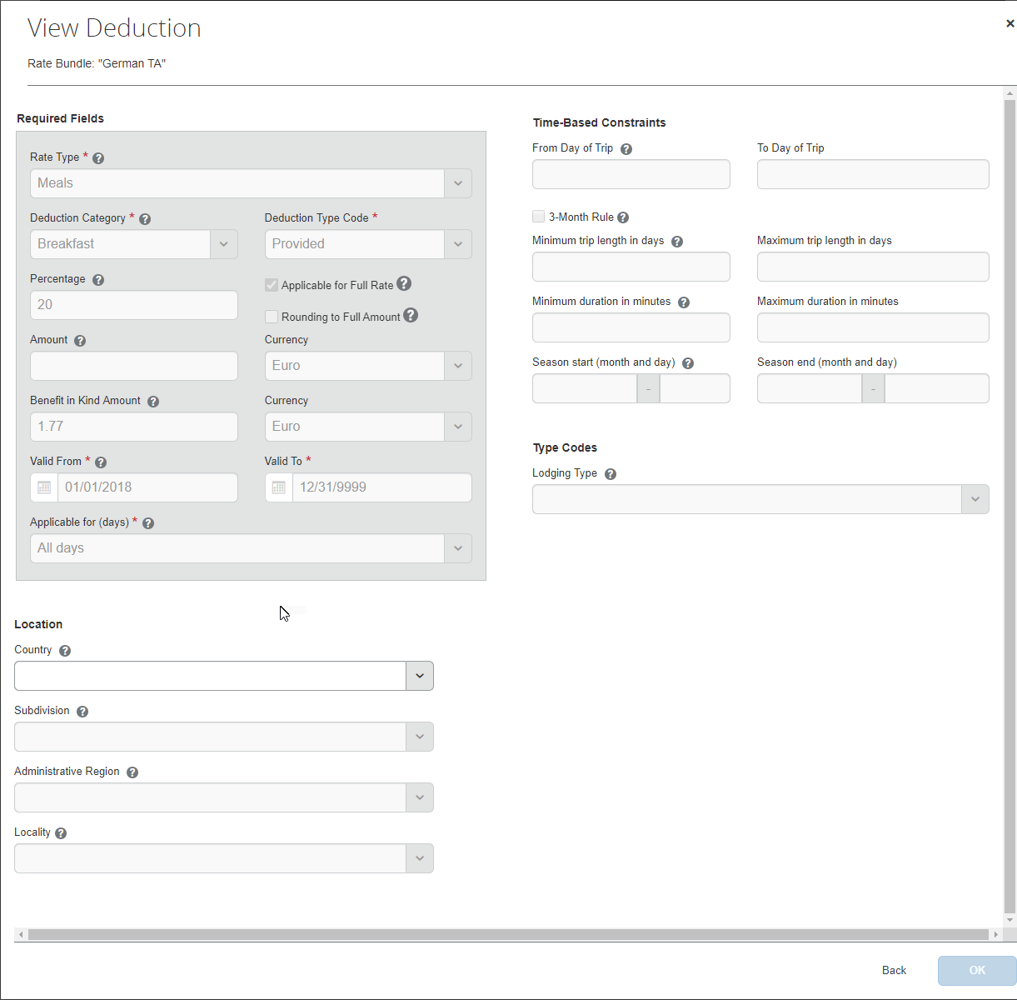

Editing Deductions
Deductions can be edited in two ways: directly, or downloaded, edited, and uploaded. Both ways are described in this section.
To edit deductions in a rate bundle directly:
- On the Rate Bundles page, in the bundle’s row, click View contents ().
The bundle’s contents page displays with tabs for rates, deductions, and adjustments.
- Click the Deductions tab.
- In the desired row, click Edit ().
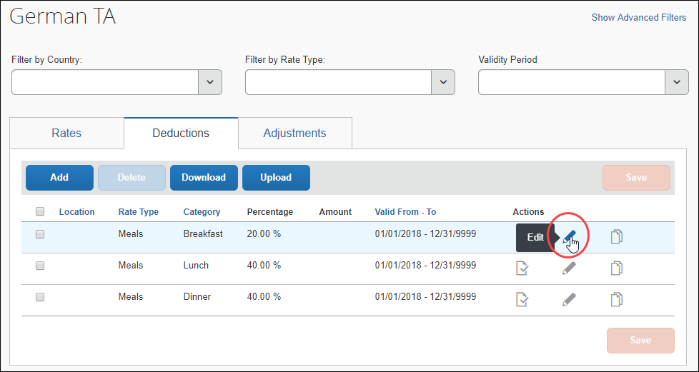
The Edit Deduction page appears.
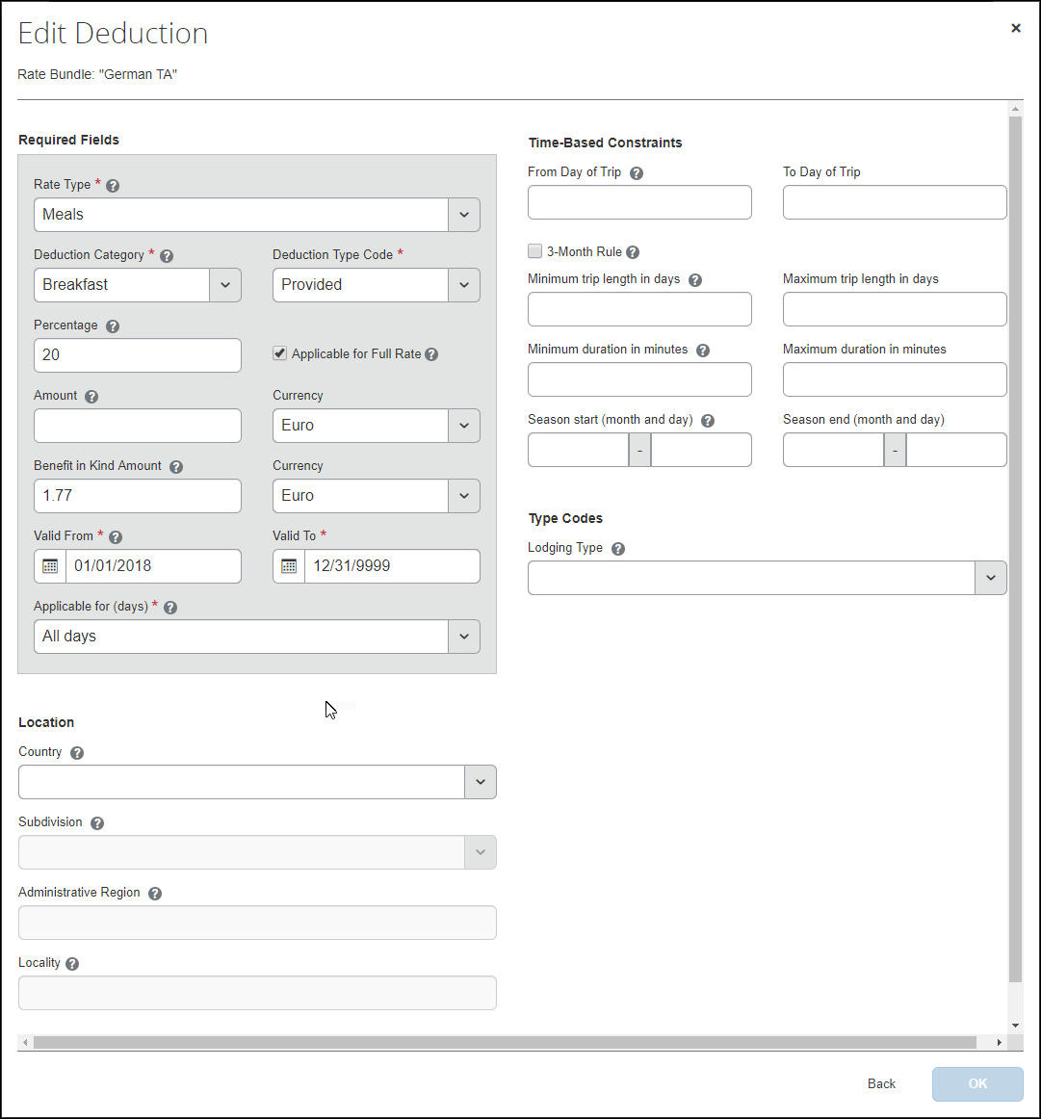
- Edit the fields as desired. An asterisk indicates a required field. For field descriptions, refer to the procedure in this guide for adding deductions.
- Click OK.
- Click Save.
To edit, add, or delete deductions in a rate bundle using the download and upload functionality:
Deductions can be downloaded from one bundle and uploaded to another.

- On the Rate Bundles page, in the bundle’s row, click View contents ().
The bundle’s contents page displays with tabs for rates, deductions, and adjustments.
- Click the Deductions tab.
- To download all deduction data you see, filters may be applied, click Download.
Example with Meals selected as a filter
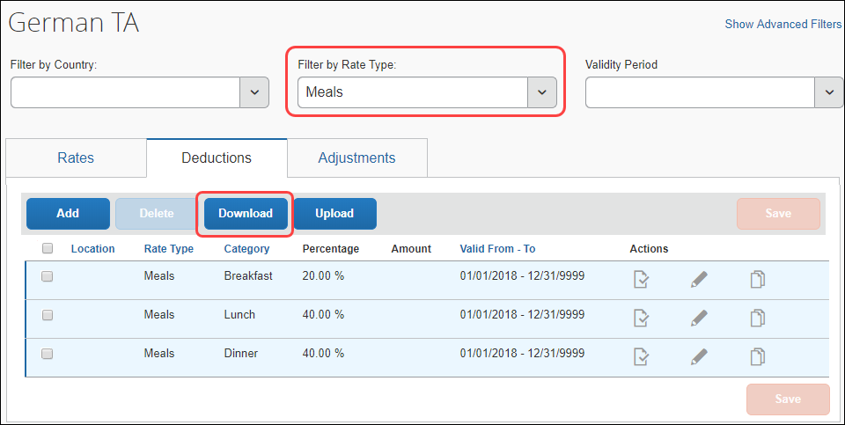
Selecting rows does not limit the deduction data that will be downloaded. All rows displayed will be downloaded.
- When the download succeeds, open the local Excel file to see the downloaded data.
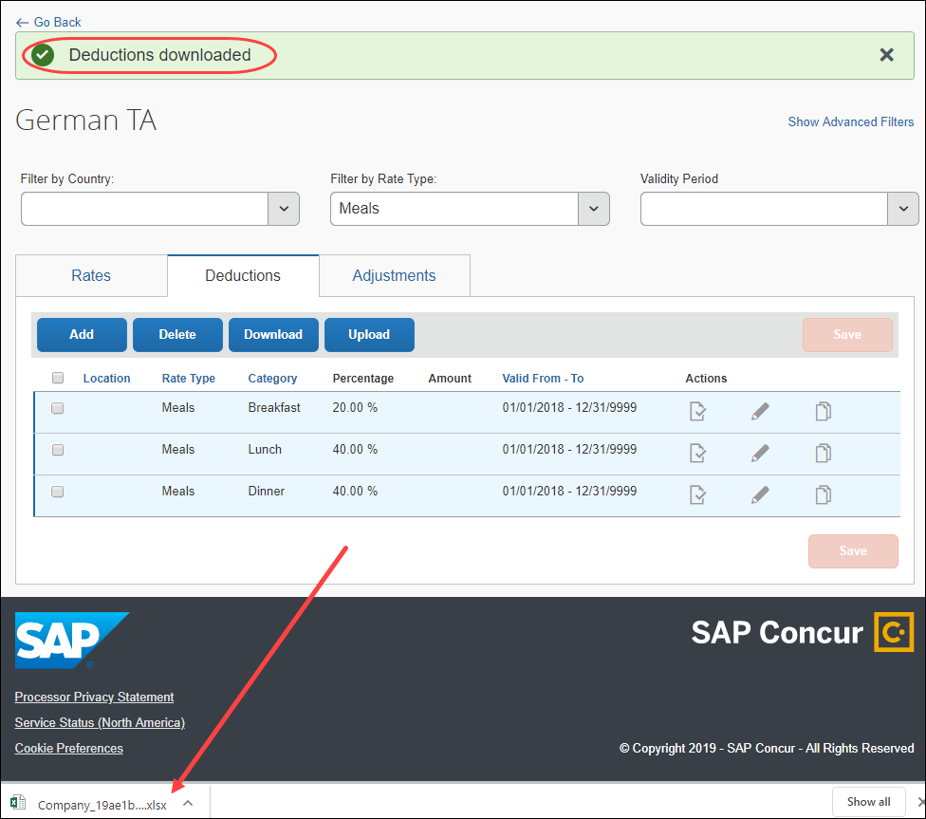
- (Optional) If the Excel file opens in protected view, click Enable Editing.
- Edit the rows, or add new rows, as desired. To delete a row of data from the database, in the Remove data from system column, select Remove.
- IMPORTANT: Deleting a row from the worksheet in Excel does not delete the row's data from your Concur database. To remove data from the database, you must select Remove within that row and then
re-import the Excel worksheet.
If you click in a cell and see a list button, you must make a selection from the list of acceptable values. For example:
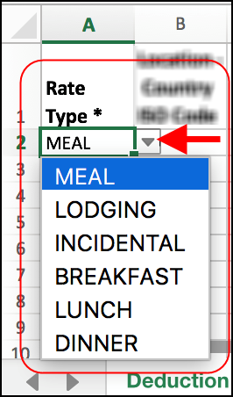
- IMPORTANT: For date and time data, you must use the following formats: dd/mm/yyyy or dd-mm-yyyy and (24-hour) hh:mm.
- For field descriptions, refer to the procedure in this guide for adding deductions. An asterisk indicates a required field.
- Click File > Save As and save the file as type CSV Comma delimited (*.csv). Only this file format is supported for this feature.
If prompted to do so, click Save Active Sheet.
- On the Deductions tab in Concur, click Upload.
The system has a 1 MB (about 10,000 records) file limitation.
- Browse to the .csv file you create and click Open.
- (Optional) On the Confirm Upload page, select Allow overwriting existing records. To avoid unintended data loss, this setting is defaulted to cleared (not selected))
- On the Confirm Upload page, select a decimal separator and the date format which you are using in the csv file that you want to upload, and click Upload.
The system has a 1 MB (about 10,000 records) file limitation.
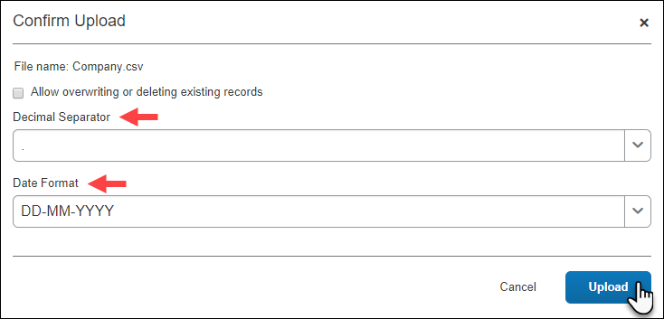
- The Deductions uploaded message displays.
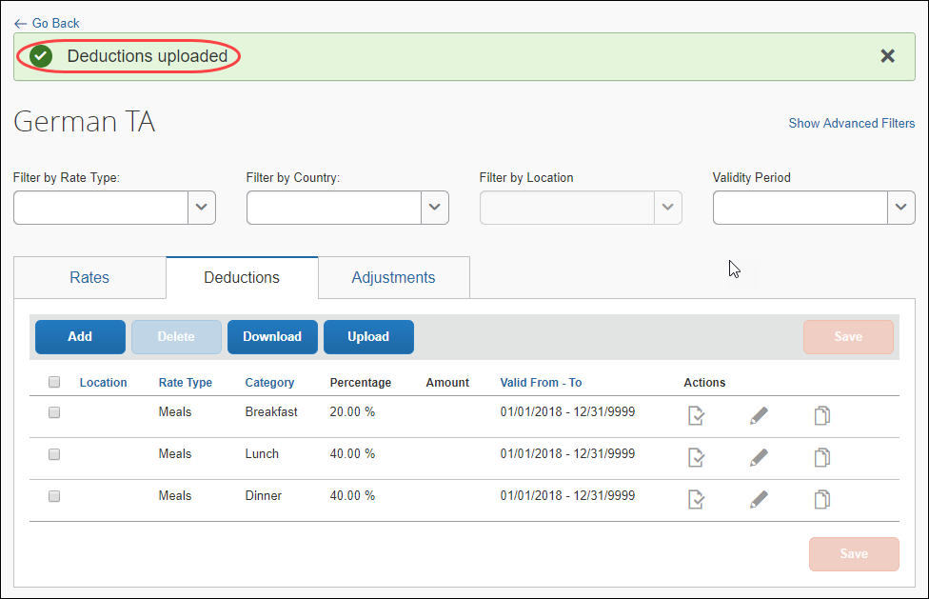
If the upload fails, helpful information is displayed. For example, that the file header has the wrong structure indicating the file might be for rates rather than for deductions, or for deductions rather than for adjustments and so on.
If the upload fails, no portion of the data in the file is uploaded/saved.
- IMPORTANT: Having the current version of the template is essential to a successful upload. Always download the current version of the template before editing and uploading.

Deleting Deductions
- IMPORTANT: There is no confirmation message and no undo.
To delete a deduction:
- On the Deductions tab of the {bundle name} page, in the desired row, click Delete ().
If the deduction is in use, it will not be deleted, and a message will display.

Maintaining Adjustments

Viewing Adjustments
To view adjustments in a rate bundle:
- On the Rate Bundles page, in the bundle’s row, click View contents ().
The bundle’s contents page displays with tabs for rates, deductions, and adjustments.
- Click the Adjustments (tab).
- In the desired row, click View ().
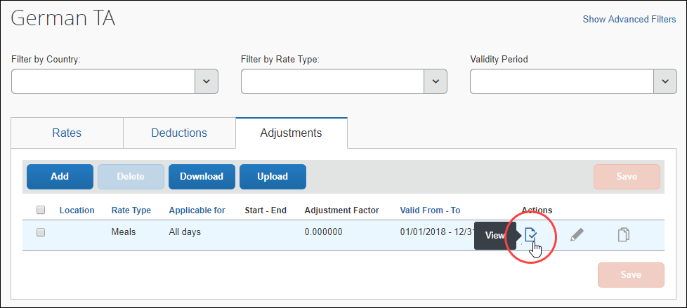
- The View Adjustment page displays.
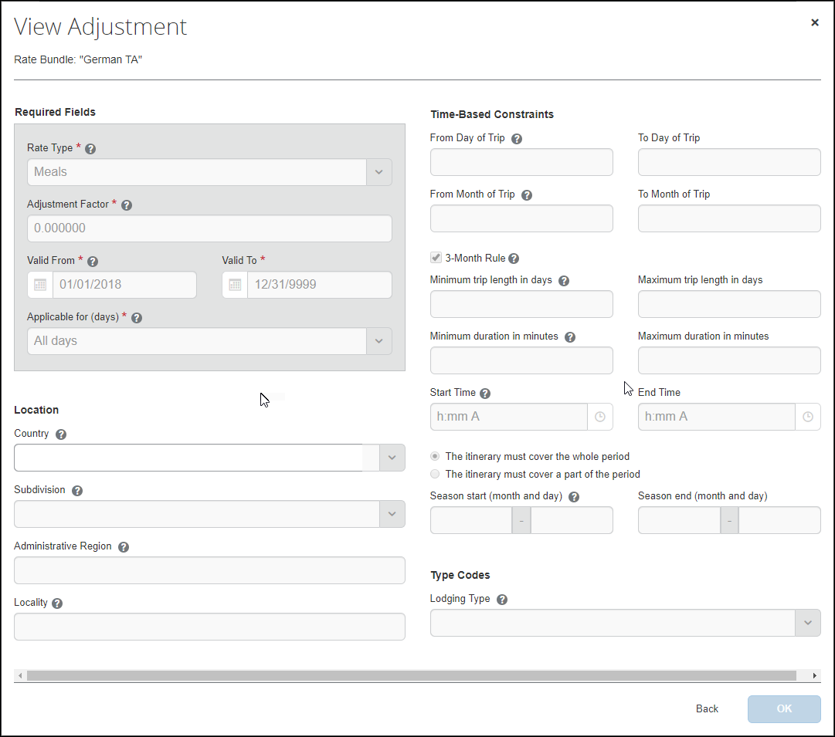

Editing Adjustments
Adjustments can be edited in two ways: directly, or downloaded, edited, and uploaded. Both ways are described in this section.
To edit adjustments in a rate bundle directly:
- On the Rate Bundles page, in the bundle’s row, click View contents ().
The bundle’s contents page displays with tabs for rates, deductions, and adjustments.
- Click the Adjustments tab.
- In the desired row, click the edit () icon.
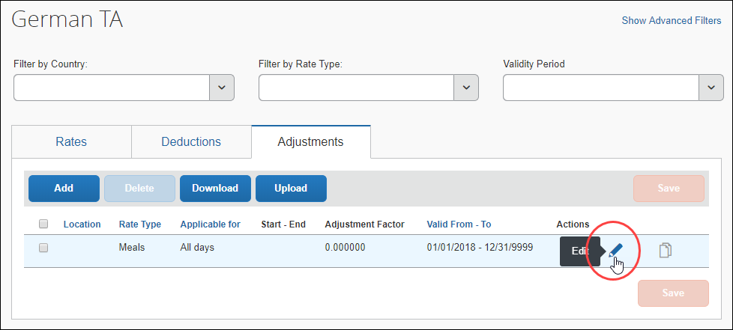
- Edit the fields as desired. An asterisk indicates a required field. For field descriptions, refer to the procedure in this guide for adding adjustments.
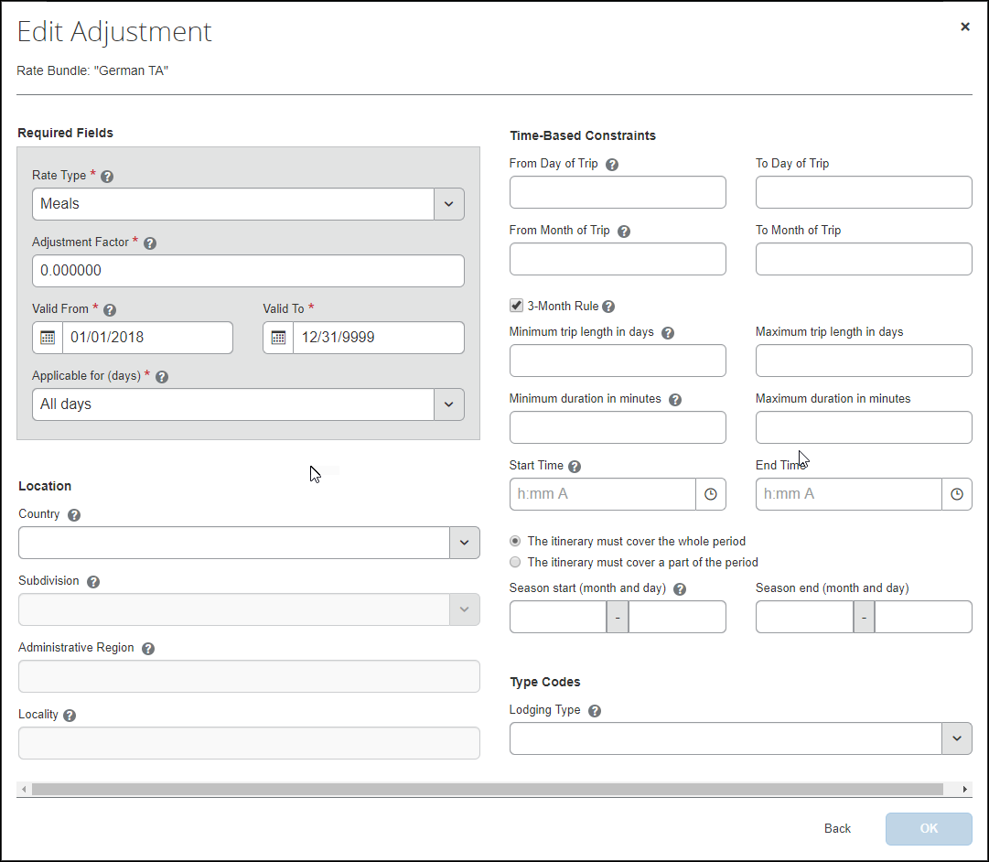
- Click OK.
- Click Save.
To edit, add, or delete adjustments in a rate bundle using the download and upload functionality:
Adjustments can be downloaded from one bundle and uploaded to another.
- On the Rate Bundles page, in the bundle’s row, click View contents ().
The bundle’s contents page displays with tabs for rates, deductions, and adjustments.
- Click the Adjustments tab.
- To download all adjustment data you see, filters may be applied, click Download.
Example with Meals selected as a rate type filter
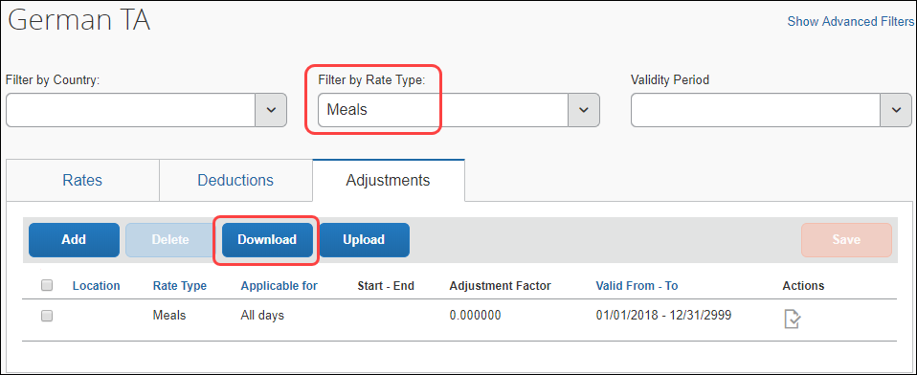
Selecting rows does not limit the adjustments data that will be downloaded. All rows displayed will be downloaded.
- When the download succeeds, open the local Excel file to see the downloaded data.
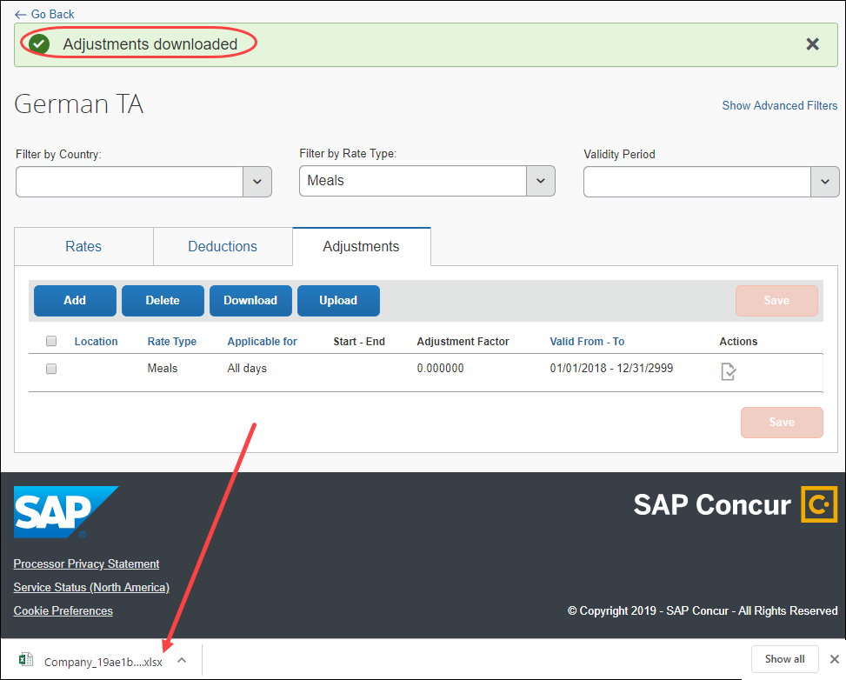
- (Optional) If the Excel file opens in protected view, click Enable Editing.
- Edit the rows, or add new rows, as desired. To delete a row of data from the database, in the Remove data from system column, select Remove.
- IMPORTANT: Deleting a row from the worksheet in Excel does not delete the row's data from your Concur database. To remove data from the database, you must select Remove within that row and then
re-import the Excel worksheet.
If you click in a cell and see a list button, you must make a selection from the list of acceptable values. For example:
- IMPORTANT: For date and time data, you must use the following formats: dd/mm/yyyy or dd-mm-yyyy and (24-hour) hh:mm.
- For field descriptions, refer to the procedure in this guide for adding adjustments. An asterisk indicates a required field.
- Click File > Save As and save the file as type CSV Comma delimited (*.csv). Only this file format is supported for this feature.
If prompted to do so, click Save Active Sheet.
- On the Adjustments tab in Concur, click Upload.
The system has a 1 MB (about 10,000 records) file limitation.
- Browse to the .csv file you create and click Open.
- (Optional) On the Confirm Upload page, select Allow overwriting existing records. To avoid unintended data loss, this setting is defaulted to cleared (not selected).
- On the Confirm Upload page, select a decimal separator and the date format which you are using in the csv file that you want to upload, and click Upload.
The system has a 1 MB (about 10,000 records) file limitation.
- The Upload succeeded message displays.
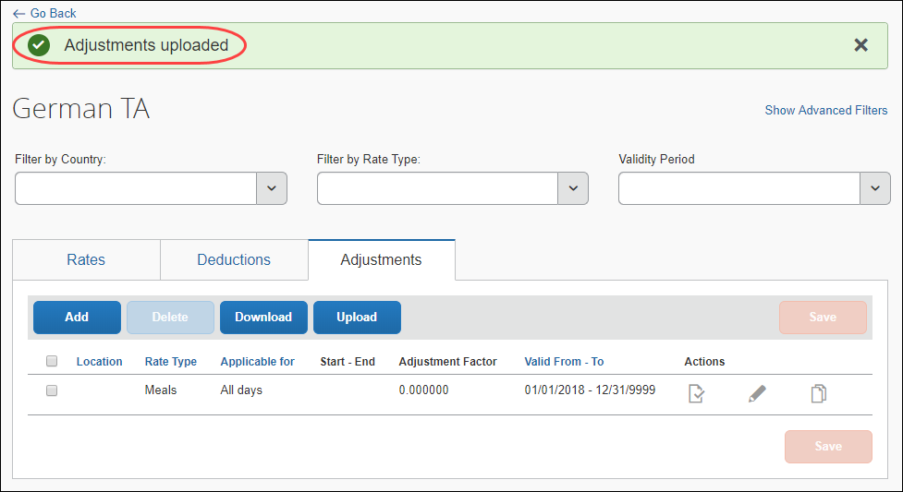
If the upload fails, helpful information is displayed. For example, that the file header has the wrong structure indicating the file might be for rates rather than for deductions, or for deductions rather than for adjustments and so on.
If the upload fails, no portion of the data in the file is uploaded/saved.
- IMPORTANT: Having the current version of the template is essential to a successful upload. Always download the current version of the template before editing and uploading.

Deleting Adjustments
- IMPORTANT: There is no confirmation message and no undo.
To delete an adjustment:
- On the Adjustments tab of the {bundle name} page, in the desired row, click Delete ().
If the adjustment is in use, it will not be deleted, and a message will display.
☼

