
Concur Expense: Travel Allowance Spain Statutory Bundle
Setup Guide
Last Revised: May 20, 2022
Applies to these SAP Concur solutions:
S Expense
S Professional/Premium edition
 Standard edition
 Travel
 Professional/Premium edition
 Standard edition
 Invoice
 Professional/Premium edition
 Standard edition
 Request
 Professional/Premium edition
 Standard edition
Table of Contents
Section 1: Permissions 1
Section 2: Overview 1
Section 3: What the User Sees 1
Creating an Expense Report 1
Adding Additional Itineraries to an Expense Report 11
Deleting an Itinerary from an Expense Report 12
Section 4: View the Spain Statutory Bundle 12
Accessing the Travel Allowance Configuration Page 13
Viewing a Statutory Rate Bundle 13
Viewing the Contents of the Statutory Rate Bundle 17
Viewing Rate Types and Calculation Rules (Lodging and Meals) 17
Viewing Trip Types (None) 21
Viewing Meal Types (Within Municipality) 22
Viewing Lodging Types (None) 24
Viewing Rates 25
Viewing Deductions 30
Viewing Adjustments 31
Section 5: Spain-Specific Statutory Validations, Calculations Logic, and Adjustments 31
Rates 32
Cumulative Calculations for Multiple Trips in a Day 32
Lodging Allowance 32
Meals Allowance 33
Within Municipality 33
Single-Day Trips Not in Municipality 36
Multiple-Day Trips Not in Municipality 38
Last Day of Multiple-Day Trips Within Municipality 40
Last Day of Multiple-Day Trips Not Within Municipality 42
Section 6: Considerations for Creating Configurable Bundles 43
Marking a Meal as Provided 44
What the User Sees 44
What the Admin Sees 45
Marking a Provided Meal as Taxable 45
What the User Sees 46
What the Admin Sees 46
Paying Higher or Lower Than Statutory Meals Allowances 46
Paying Allowances for Days Where No Tax-Free Allowance Applies 46
Paying for In-Municipality Meals and Tracking Them as Taxable 47

Revision History
Date | Notes / Comments / Changes
May 20, 2022 | Addition of the Show Filters feature on the Adjustments page that supports setting recurring dates for repeated travel.
February 16, 2022 | Removed unused rule options from the Viewing the statutory rate bundle section
July 19, 2021 | Added new rule option:  - 24-hour interval, restarting at each border crossing and restarting the day count  Added new rule and its options:  - (rule) Day for exchange rate  - (option) Current daily exchange rate  (option) Exchange rate on the first day of the itinerary  Minor style edits.
January 22, 2021 | Minor style edits.
December 5, 2020 | Added new rule options:  - Rate of the first foreign location, including all time spent in foreign locations  - Calendar day, two days will be handled as one day when returning on second day before 6am  - First leg based on time of departure, then all based on time of border crossing or time of arrival, but last leg based on time of arrival
October 17, 2020 | Added new rule options:  - Several itineraries on one date, durations  - Several itineraries on one date, reimbursement rates
July 1, 2020 | Created new guide for the travel allowance solution available with the NextGen UI for Concur Expense

Travel Allowance
NOTE: Multiple SAP Concur product versions and UI themes are available, so this content might contain images or procedures that do not precisely match your implementation. For example, when SAP Fiori UI themes are implemented, home page navigation is consolidated under the SAP Concur Home menu.

Permissions
A company administrator may or may not have the correct permissions to use this feature. The administrator may have limited permissions, for example, they can affect only certain groups and/or use only certain options (view but not create or edit).
If a company administrator needs to use this feature and does not have the proper permissions, they should contact the company's Concur Expense administrator.
Also, the administrator should be aware that some of the tasks described in this guide can be completed only by SAP Concur. For tasks not completed during implementation, the client must initiate a service request with SAP Concur support.

Overview
This document provides country-specific template information about the SAP Concur-managed, statutory bundle for Spain.
- IMPORTANT: This guide is a supplement to the Expense: Travel Allowance Setup Guide which contains essential information about the travel allowance feature.
Clients who use the statutory bundle for Spain, but also want to supersede some of the statutory rates, may also create configurable bundles.
- For more information about client-managed bundles, refer to the Expense: Travel Allowance Generic Configurable Bundle Setup Guide.

What the User Sees
This section uses the most common method of reimbursement in Spain – daily allowances for meals and actual expenses for lodging.

Creating an Expense Report
When the travel allowance feature is available to a user, after the user completes the header on a new expense report, they are prompted for itinerary and adjustment information.
To create an expense report:
- From Concur Expense, click Create New Report.
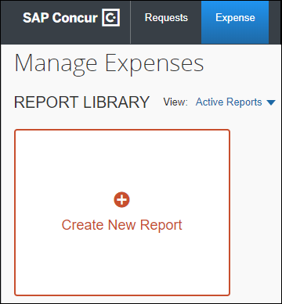
There are other valid paths to start a new expense report.
- On the Create New Report page, commonly referred to as the report header, complete all required fields. An asterisk indicates a required field.
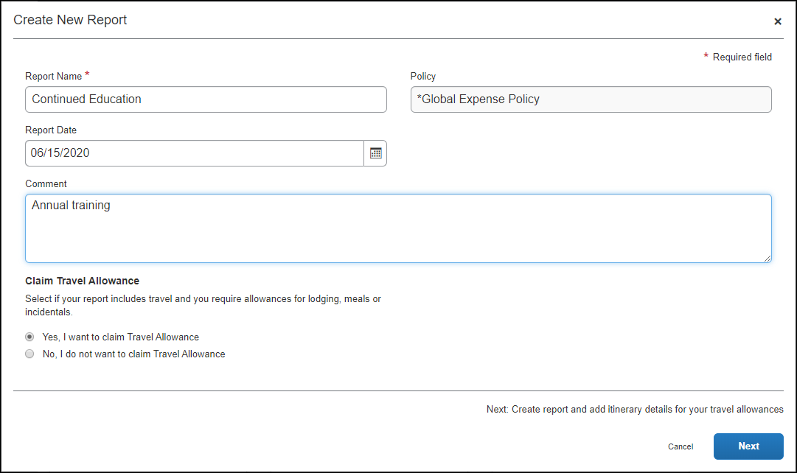
The policy selected may impact which fields display.
When claiming travel allowance is available to the user, Yes, I want to claim Travel Allowance is selected by default.
- Click Next to create the expense report and display the Itinerary page.
- On the Itinerary page, complete all required fields. An asterisk indicates a required field.
Without Detailed Itinerary selected:
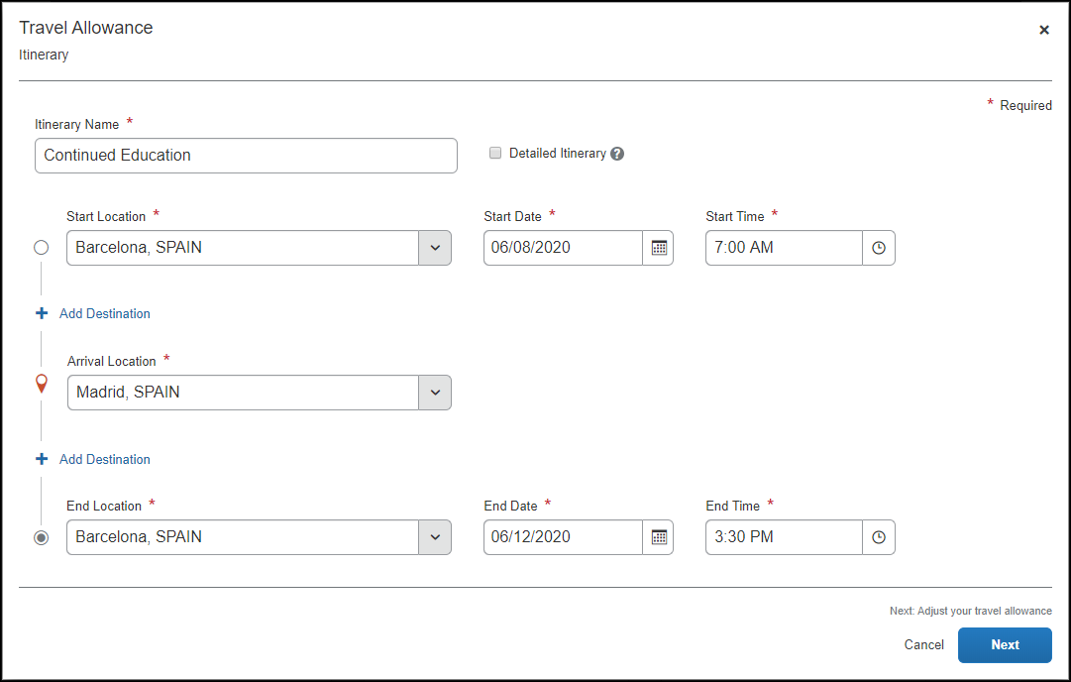
Additional required fields display when Detailed Itinerary is selected:
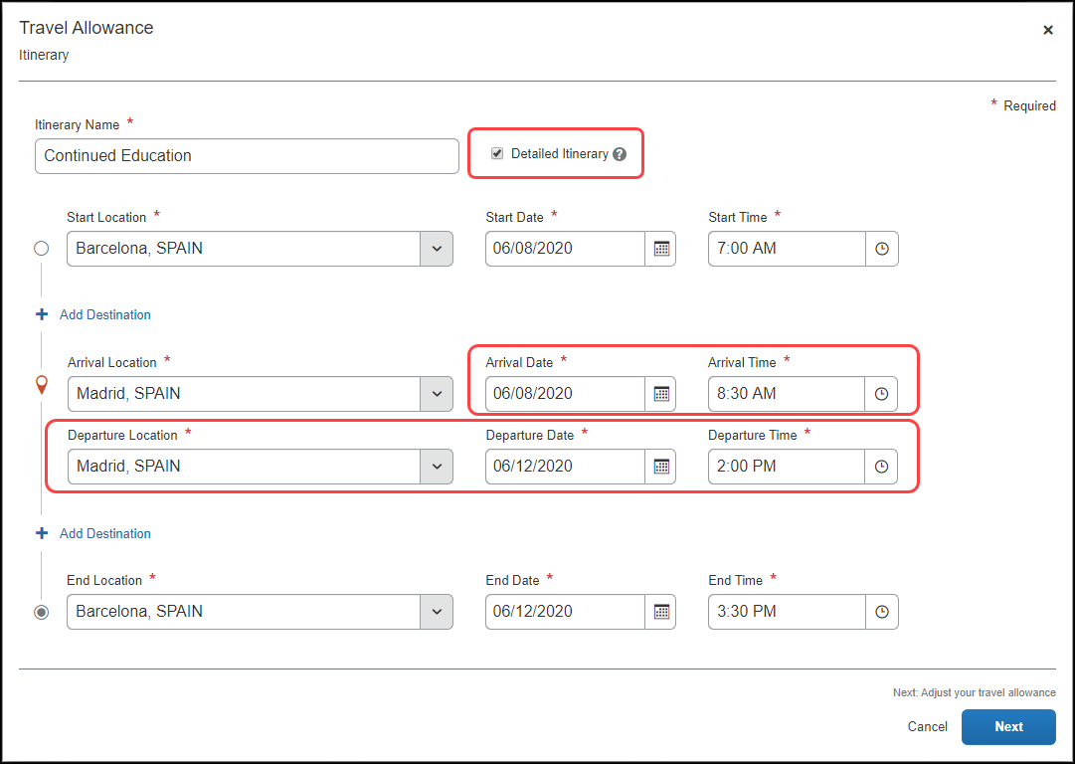
The following table shows the fields and their descriptions. An asterisk indicates a required field.
Field/Option | Description
Itinerary Name * | Enter an itinerary name or use the default name provided that matches the Report Name.
Detailed Itinerary | Select this option to display five additional fields:  - Arrival Date *  - Arrival Time *  - Departure Location *  - Departure Date *  - Departure Time *  NOTE: These fields are required when Detailed Itinerary is selcted.
Start Location * | Enter the first few letters of the origination city for this itinerary and select it from the list of cities.
Start Date * | Enter a beginning month, day, and year for the time period covered by this itinerary.
Start Time * | Enter a beginning hour and minutes for the time period covered by this itinerary.
Add Destination | Click Add Destination to display another set of location fields to this itinerary. This option displays twice for convenience.
Arrival Location * | Enter the first few letters of the destination city and select it from the list of cities.
Arrival Date * | Enter the beginning month, day, and year of your time at this Arrival Location.
Arrival Time * | Enter the beginning hour and minutes of your time at this Arrival Location.
Departure Location * | Enter the first few letters of the last location at this Arrival Location and select it from the list of cities.
Departure Date * | Enter the month, day, and year that you left the Departure Location.
Departure Time * | Enter the hour and minutes that you left the Departure Location.
End Location * | Enter the first few letters of the final city for this trip and select it from the list of cities.
End Date * | Enter a ending month, day, and year for the time period covered by this itinerary.
End Time * | Enter an ending hour and minutes for the time period covered by this itinerary.
- Click Next to save the itinerary and display the Adjustments page.
Adjustments (view)
In this example, having Within Municipality, is the default view where a user can see a row for each calculated daily allowance and select adjustments such as excluded days, provided meals, and others based on the configuration of the generic bundle.
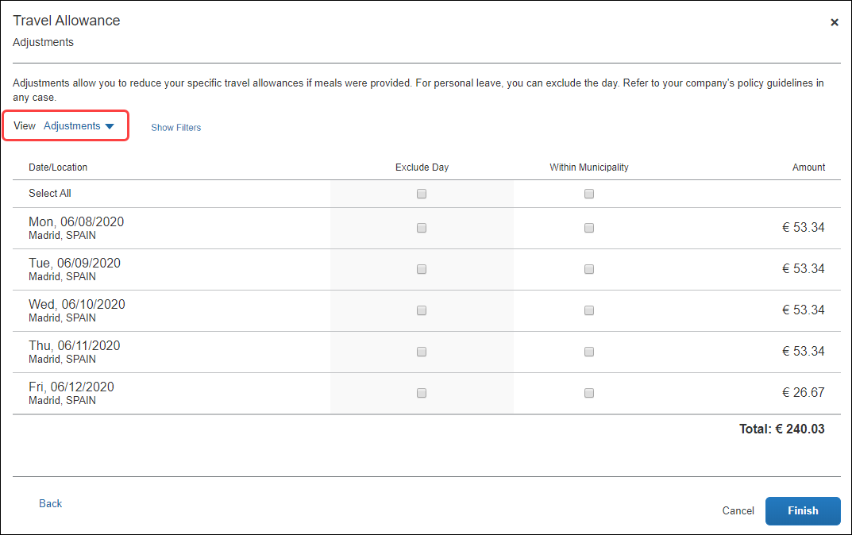
In this sample instance:
- If you select Show Filters the following options become available.
Field/Option | Description
Date Range | Enter the beginning and ending of the travel either in MM/DD/YYYY format, or by selecting the calendar icon to input these values by selecting the month(s) and days.
Recurrence | Set how often this same travel occurs by the number of weeks and the days for each week that you travel, for example every 3 weeks from Monday through Friday.  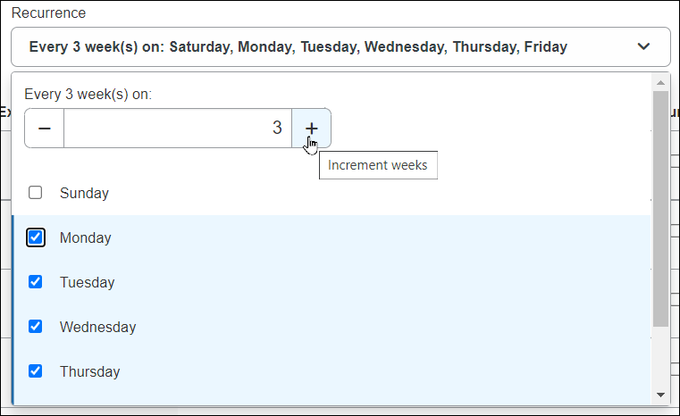
Location | The travel destination where you will spend your trip.
Apply / Clear Filters buttons | Click Apply to set the configured trip, or reset the filter entirely by clicking Clear Filters.
Hide Filters button | Click Hide Filters to dismiss the filter options and return to the non-filter view of this page.
- For the first and last days, the amounts are automatically reduced because the user did not spend full days at the location.
Any deduction can reduce the allowance amount to zero but never less than zero; it can never result in a charge to the user.
Reimbursement Details (view)
This view shows details for the adjustments based on what the user selected on the Adjustments page together with original rate amounts, any deductions for the day, and total reimbursable amounts.
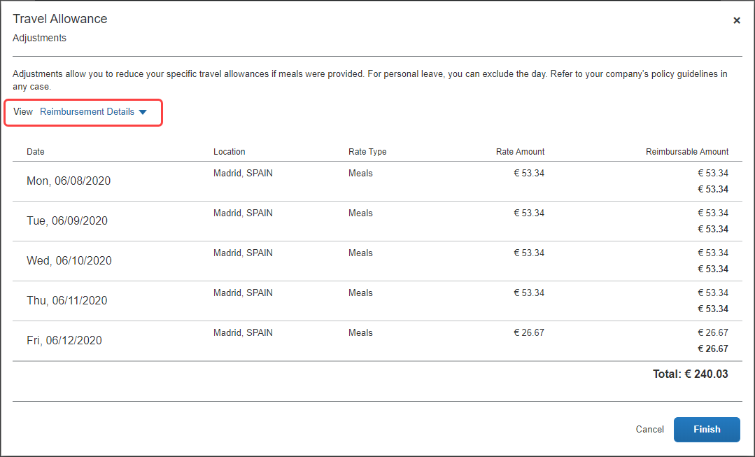
Example Tax-Exempt Amounts (view)
This view only displays for configurations that include both the statutory rate bundle and a configurable rate bundle where the amounts differ. The difference is tracked as taxable to the user. Users can compare the amount on the Adjustments page with the tax-exempt amount on this page to know how much of their daily allowance is taxable.
Example
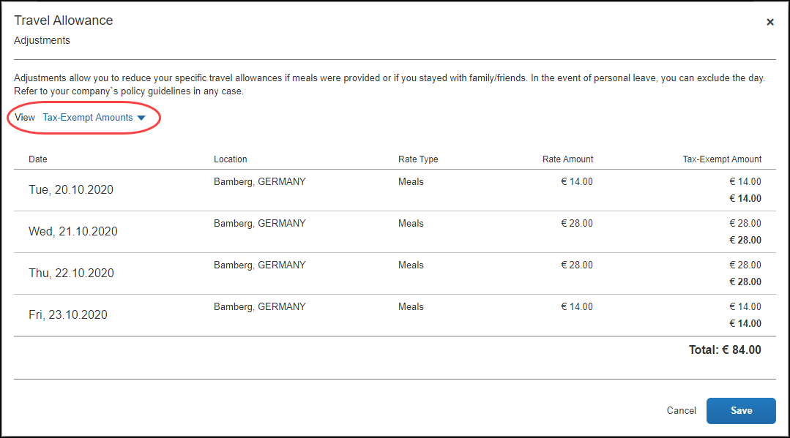
The following table shows the fields and their descriptions.
Column | Description
Exclude Day | Select this check box to mark a date as personal time and therefore not elibigle for travel allowance benefits.  NOTE: There is a Select All check box available for this column.
Within Municipality | Select this check box to indicate that the municipality where the day's work was performed is the same municipality where you live and usually work.
- (Optional) Click Back to edit the itinerary page.
- (Optional) Click Cancel to close the adjustments page without saving your selections.
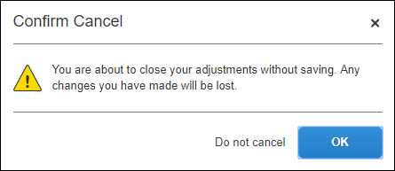
The expense report is not deleted and the itinerary and allowances can be edited later by selecting Travel Allowance > Edit Travel Allowance.
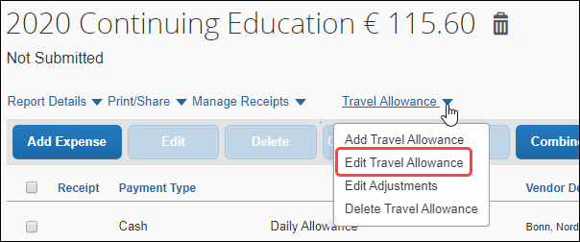
- Click Finish to create the daily allowances and display the expense report.
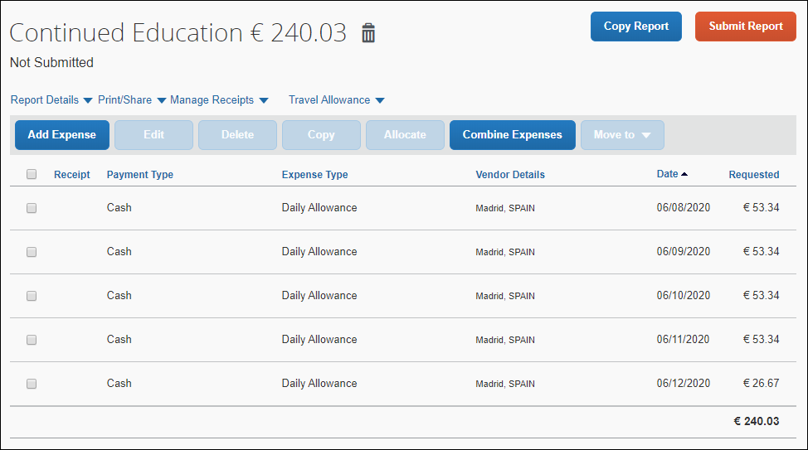
It is important to understand the following about system-created expenses:
- As applicable, daily allowance expenses are assigned the default expense type of Daily Allowance.
- If rate information is changed after the daily allowance expenses have been created, the amounts are not updated unless the user returns to the adjustments page and clicks Finish again.
- Click Add Expense to add actual expenses. This step is not specific to the travel allowance feature and is accomplished in the same manner that is used to add non-travel allowance expenses to an expense report.
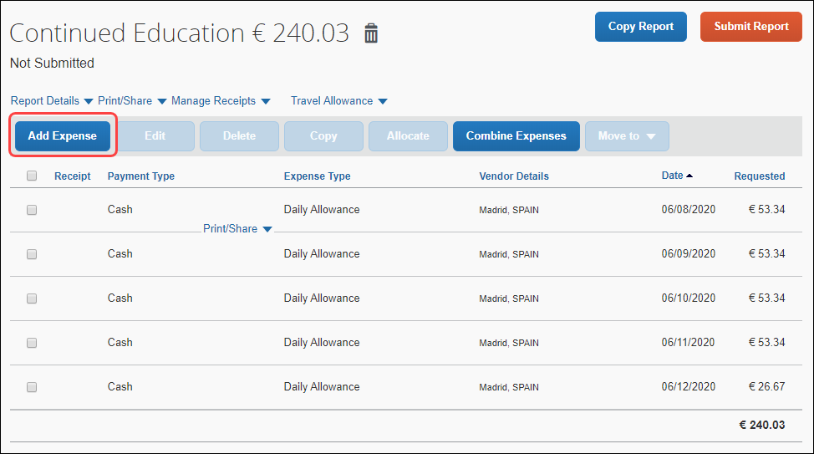

Adding Additional Itineraries to an Expense Report
To add additional itineraries to an expense report
- Open the expense report and click Travel Allowance > Add Travel Allowance. The Travel Allowance wizard begins again from the Itinerary page.
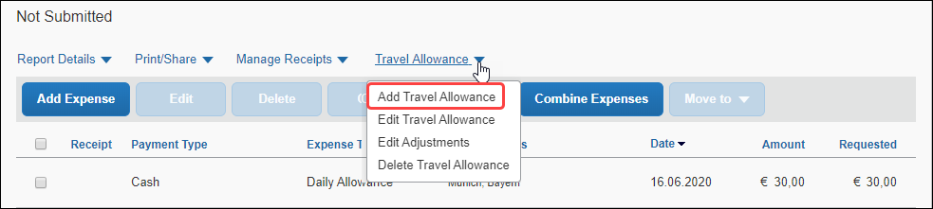
There is no restriction on the number of itineraries that may be associated with an expense report.
- Complete the wizard and click Finish.

Deleting an Itinerary from an Expense Report
To delete an itinerary from an expense report
- Open the expense report and click Travel Allowance > Delete Travel Allowance.
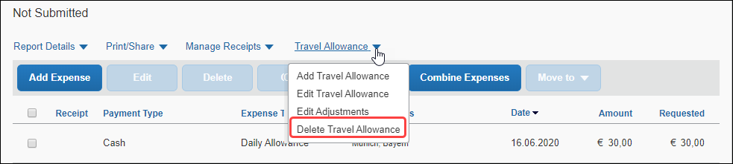
- On the Itinerary Management page of the Travel Allowance wizard, in the desired row, click Delete.
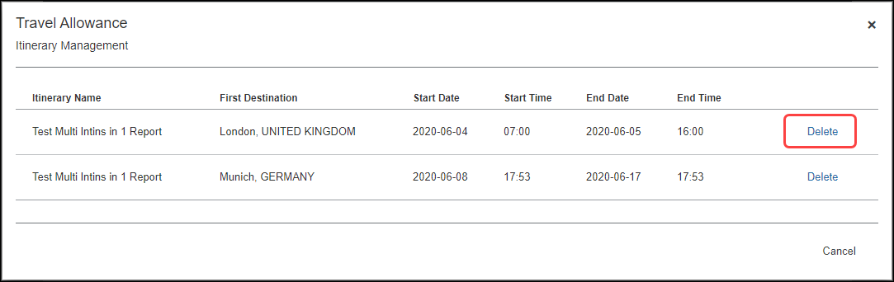
- Click Delete.
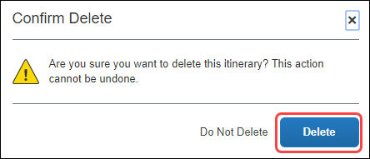

View the Spain Statutory Bundle
A bundle is a set of rates. The simplest initial configuration of the travel allowance feature uses the statutory rate bundle provided by SAP Concur to create a configuration code.
- A Rate Bundle consists of rate types, calculation rules, trip types, meal types, lodging types, rates, deductions, and adjustments. SAP Concur provides statutory bundles based on current data available from each country's government.
Administrators may create their own configurable bundles to supersede the provided statutory bundles.
- For more information about creating a (configurable) copy of an SAP-provided (read-only) statutory bundle, refer to the Expense: Travel Allowance Generic Configurable Bundle Setup Guide.
- A Configuration Code consists of a statutory and/or a configurable Rate Bundle.
- For more information about enablement, hierarchy, mappings, configuration codes, and optional configuration, refer to the Expense: Travel Allowance Setup Guide.

Accessing the Travel Allowance Configuration Page
To access the Travel Allowance Configuration page:
- Click Administration > Expense > Travel Allowance Configuration.

Viewing a Statutory Rate Bundle
To view a statutory rate bundle:
- On the Travel Allowance Configuration page, click Rate Bundles. The Rate Bundles page displays.
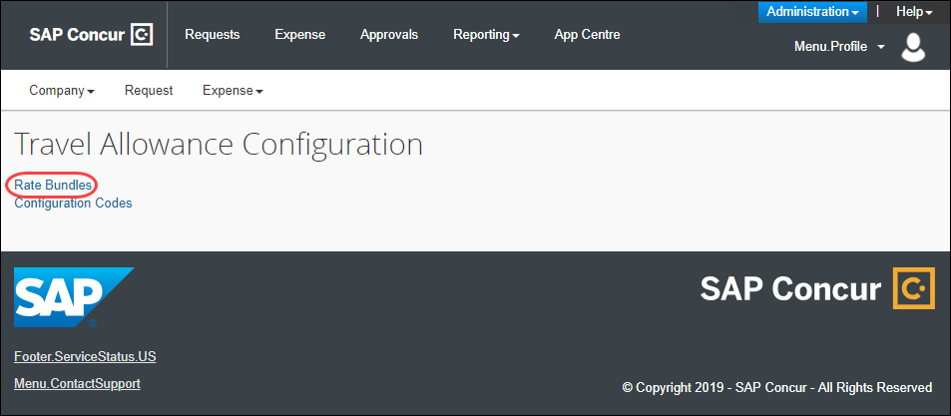
- On the Rate Bundles page, in the row for the statutory bundle, click View ().
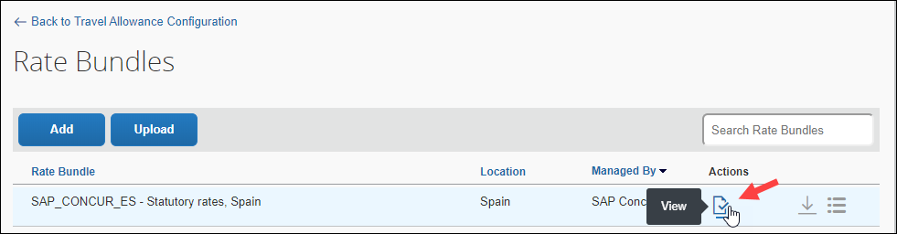
The View Rate Bundle page displays.
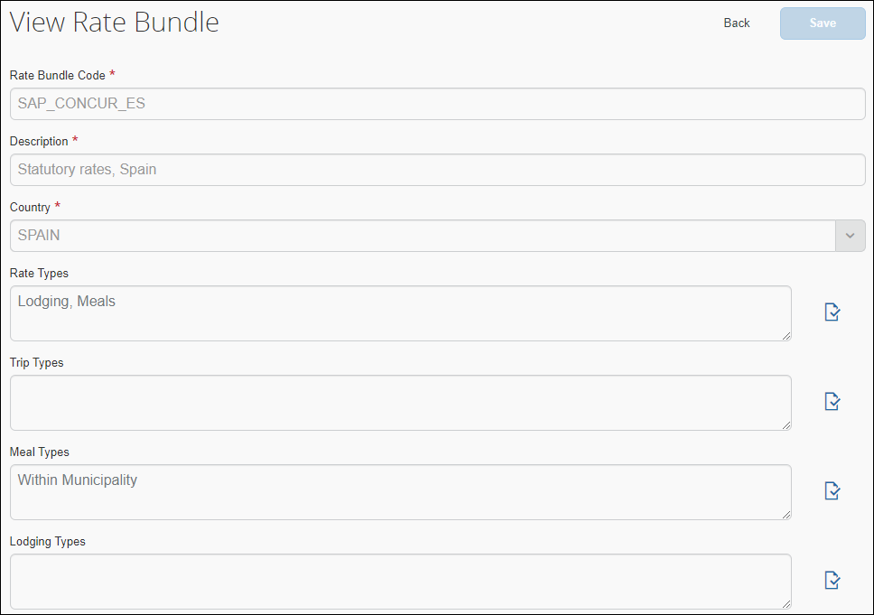
All statutory bundles are read-only.
- Click View () on the Rate Types, Trip Types, Meal Types, or Lodging Types to display the desired details such as codes, descriptions, rate categories, and calculation rules.
- For more information about optional configuration for expense types, refer to the Expense: Travel Allowance Setup Guide.
- Click Back.
- Click View contents ().
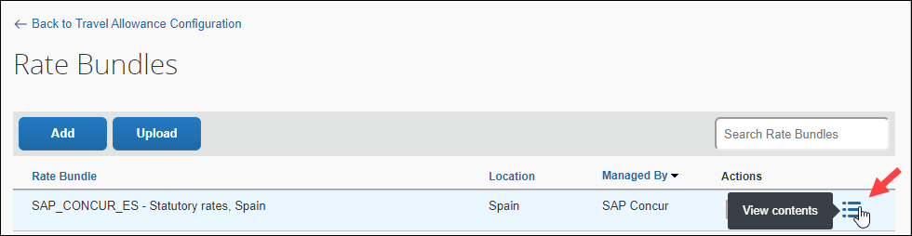
The Statutory rates, Spain page displays.
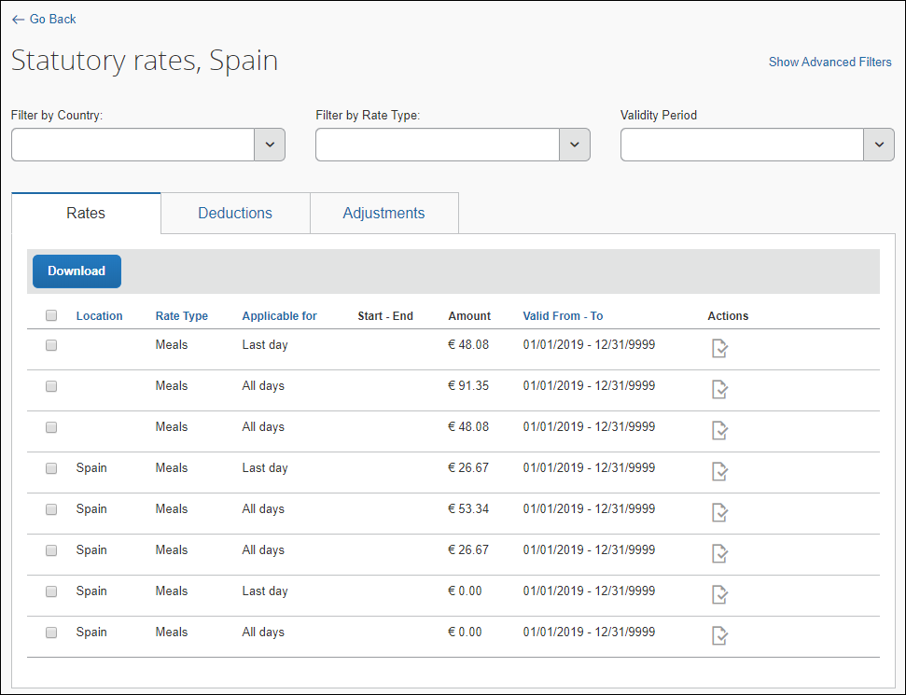
- Click View () on the Rates, Deductions, and Adjustments tab along with the filters to display the desired details.
Click Show Advanced Filters to display more filters.
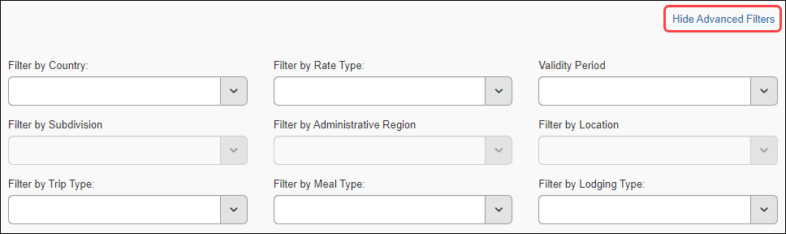
Show Advanced Filters toggles to and from Hide Advanced Filters.

Viewing the Contents of the Statutory Rate Bundle

Viewing Rate Types and Calculation Rules (Lodging and Meals)
Rate Bundles contain Rate Types and Rate Types contain calculation rules.
To view the rate types:
- On the Rate Bundles page, in the row for the statutory bundle, click View ().
- On the View Rate Bundle page, click View () on the Rate Types.
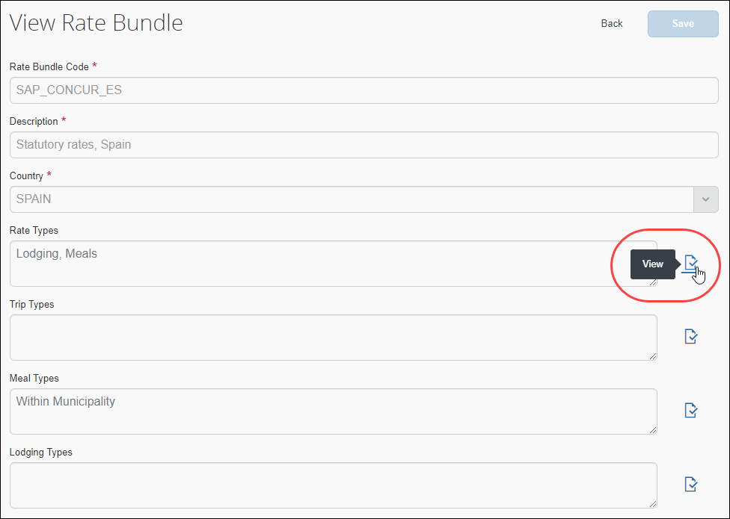
The View Rate Types page displays.
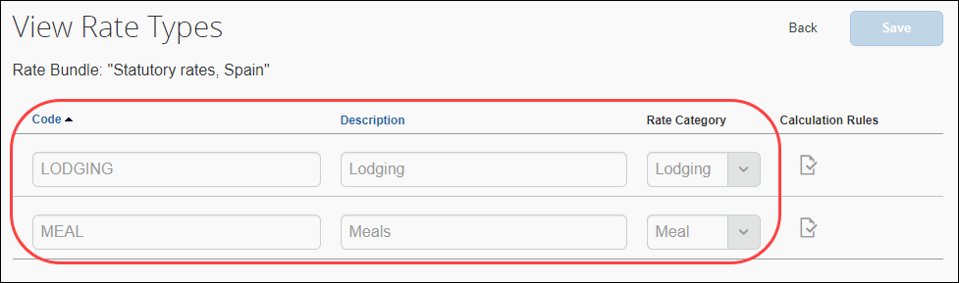
- Click View () on the desired row. The calculation rules display.
The following example graphic shows the rules for the Meals rate category. The default Rule selected depends on the Rate Category being viewed.
Meals
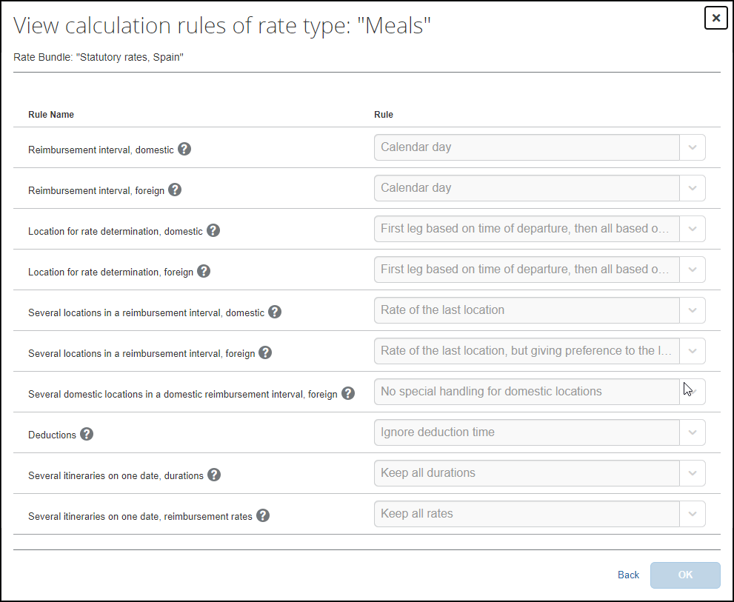
Lodging
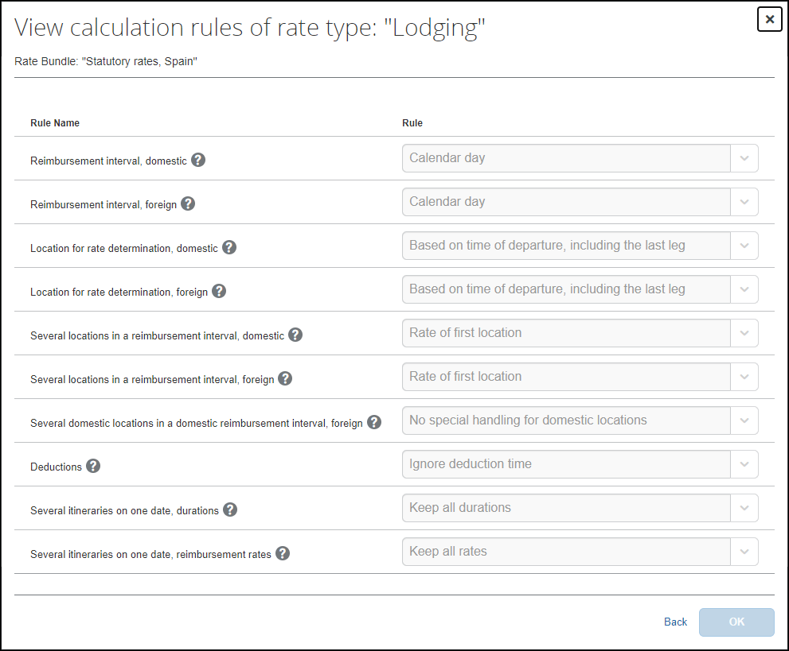
The following table shows the read-only values that exists in the statutory bundle for rate types and calculation rules and also the possible options in the event that a configurable bundle is needed to supersede portions of the statutory bundle. An asterisk indicates a required field.
- For more information about custom bundles, refer to the Expense: Travel Allowance Generic Configurable Bundle Setup Guide.
Rule Name | Rule Options
Reimbursement interval, domestic | - Calendar day (default for Lodging and Meals)
Reimbursement interval, foreign | - Calendar day (default for Lodging and Meals)
Location for rate determination, domestic | - Based on time of departure, including the last leg (default for Lodging)  - First leg based on time of departure, then all based on time of arrival (default for Meals)
Location for rate determination, foreign | - Based on time of departure, including the last leg (default for Lodging)  - First leg based on time of departure, then all based on time of arrival (default for Meals)
Several locations in a reimbursement interval, domestic | - Rate of the first location (default for Lodging)  - Rate of the last location (default for Meals)
Several locations in a reimbursement interval, foreign | - Rate of the first location (default for Lodging)  - Rate of the last location, but giving preference to the last foreign location on the last day or single day (default for Meals)
Several domestic locations in a domestic reimbursement interval, foreign | - No special handling for domestic locations (default for Lodging and Meals)
Several itineraries on one date, durations | - Keep all durations (default for Lodging and Meals)  NOTE: Using this rule option, when multiple trips occur on the same day, each trip is calculated independently.
Several itineraries on one date, reimbursement rates | - Keep all rates (default for Lodging and Meals)
Deductions | - Ignore deduction time (default for Lodging and Meals)
Day for exchange rate | - Current daily exchange rate (default for Lodging and Meals)
- For more information about rule options, refer to the Expense: Travel Allowance Service Setup Guide.
- Click Back.

Viewing Trip Types (None)
The statutory Spain bundle does not contain any Trip Types.
To view the trip types:
- On the Rate Bundles page, in the row for the statutory bundle, click View ().
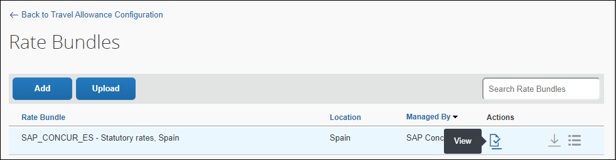
The Trip Types field does not contain any trip types.
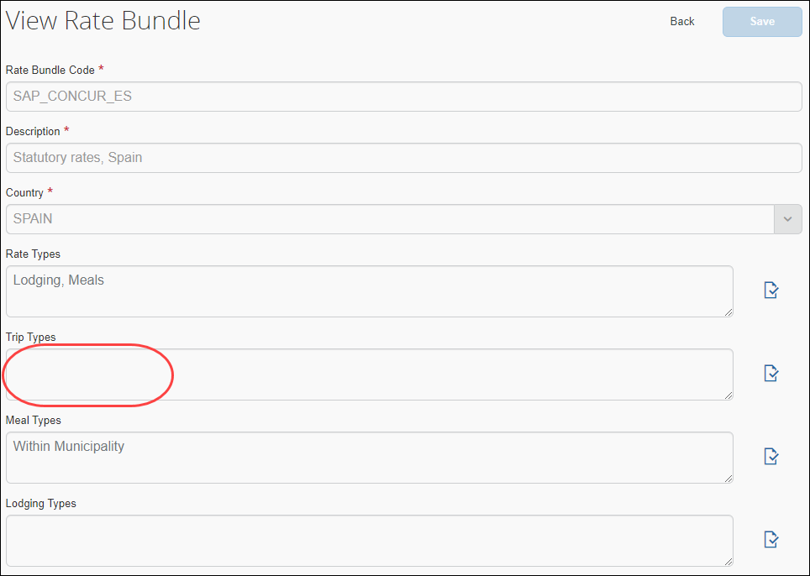
- Click Back.

Viewing Meal Types (Within Municipality)
Rate Bundles contain Meal Types and Meal Types contain codes and descriptions.
To view meal types:
- On the Rate Bundles page, in the row for the statutory bundle, click View ().
- On the View Rate Bundle page, click View () on the Meal Types.
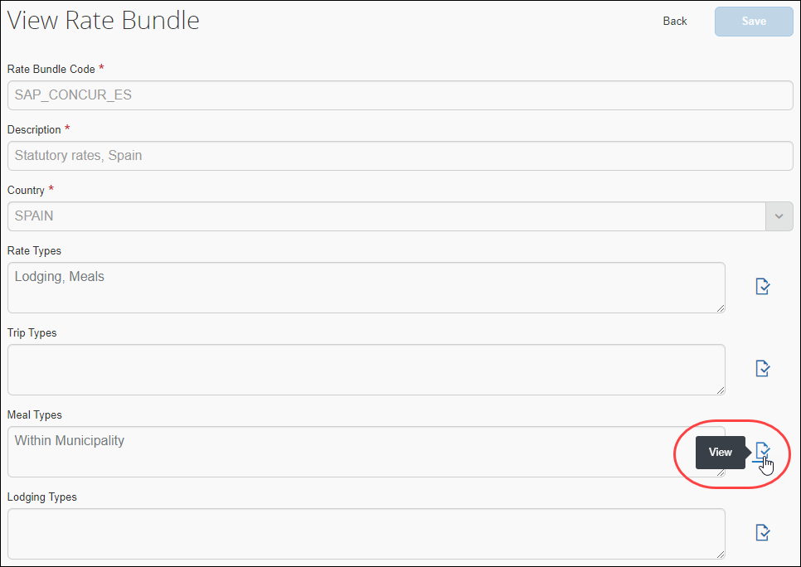
The View Meal Types page displays.
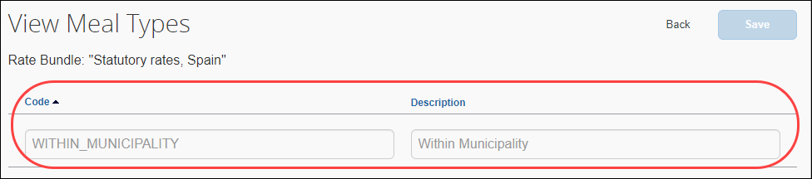
The following table shows the read-only value that exists in the statutory bundle for meal types.
- For more information about custom bundles, refer to the Expense: Travel Allowance Generic Configurable Bundle Setup Guide.
Code | Description
WITHIN_MUNICIPALITY | This code reduces rates for travel allowances that occur within the municipality where the user lives and usually works.
- Click Back.

Viewing Lodging Types (None)
The statutory Spain bundle does not contain any Lodging Types.
To view lodging types:
- On the Rate Bundles page, in the row for the statutory bundle, click View ().
The Lodging Types field does not contain any lodging types.
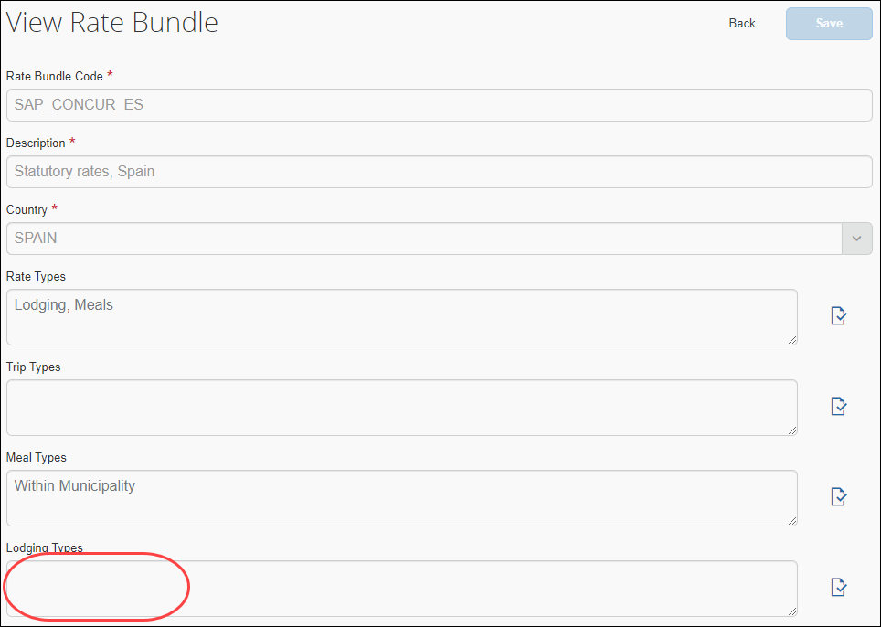
- Click Back.

Viewing Rates
To view rates:
- On the Rate Bundles page, in the bundle’s row, click View contents ().
The bundle’s contents page displays the Rates tab and rates.
- (Optional) Use filters to locate the desired rate.
- (Optional) Use advanced filters to locate the desired rate.
- Click View () on the desired row.
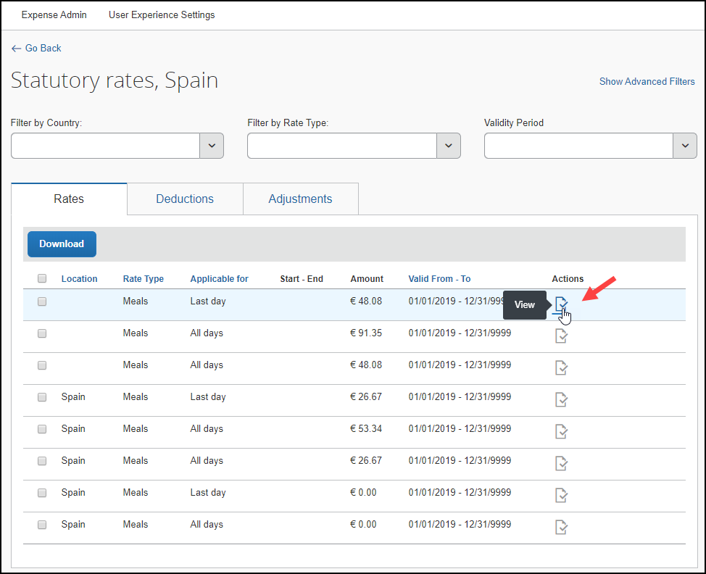
The details of the rate display.
Example
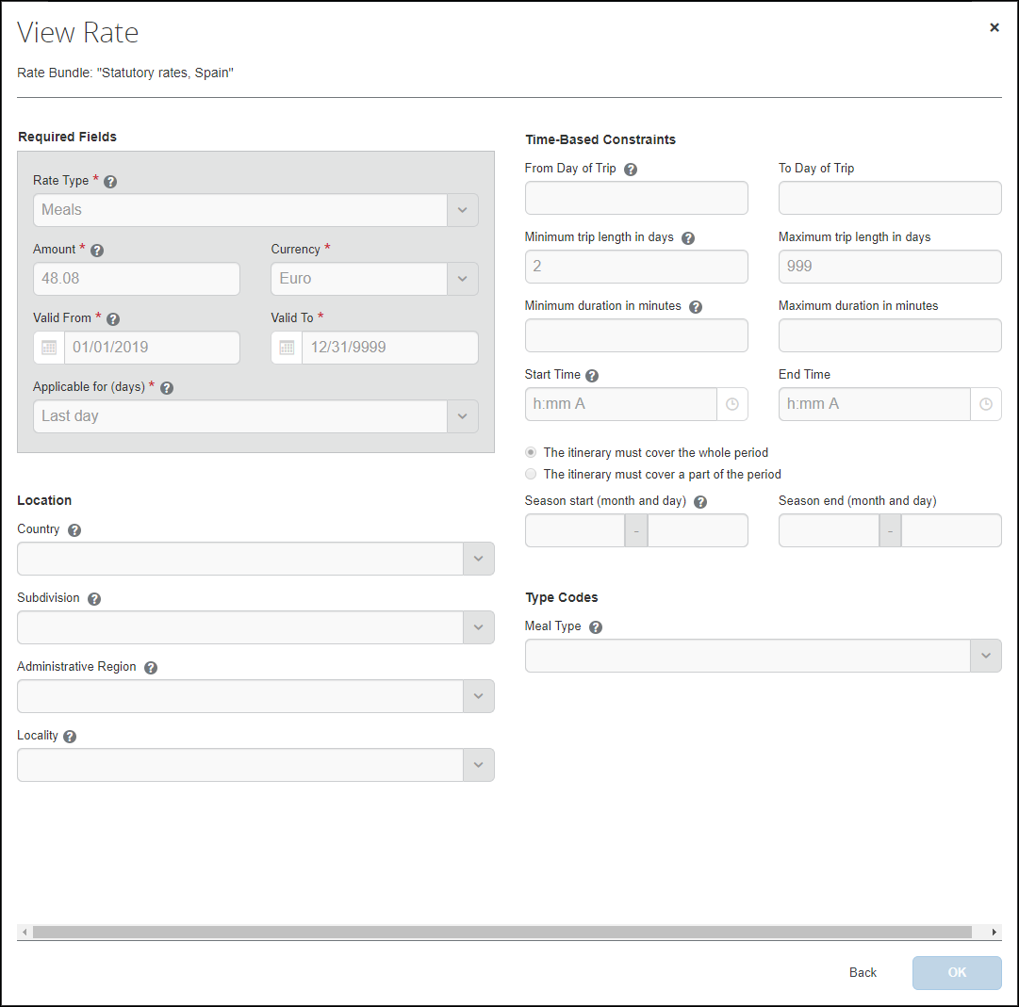
The following table shows the read-only values that exists in the statutory Spain rates and also the possible options in the event that a configurable bundle is needed to supersede portions of the statutory bundle. An asterisk indicates a required field.
- For more information about configurable bundles, refer to the Expense: Travel Allowance Generic Configurable Bundle Setup Guide.
Field | Description
Required Fields  Rate Type * | The value is Incidentals, Lodging, or Meals.
Required Fields  Amount *  Currency * | The value is an amount and a currency to which the rate applies.  When creating an expense report, the currency displayed here will be converted into the user’s reimbursement currency as determined by the user's User Administration settings.
Required Fields  Valid From *  Valid To * | This value is a date range.  A date range allows previous rates to remain applicable when processing trips in the past.  NOTE: Regulatory rates are typically updated annually by calendar or financial year and so are valid only for limited date ranges.
Required Fields  Applicable for (days) * | This value is First day, Last day, All days, or Intervening days.  Intervening days are the days between the first and last day of a trip. The All days value includes the first day, intervening days, and the last day, and applies to one-day trips.
Location  Country/Region | If this field is used for this rate, the value is the country where these rates apply.
Location  Subdivision | If this field is used for this rate, the value is the state or province where these rates apply.
Location  Administrative Region | If this field is used for this rate, the value is the county where these rates apply.
Location  Locality | If this field is used for this rate, the value is the city where these rates apply.
Time-Based Constraints  From Day of Trip  To Day of Trip | If these fields are used for this rate, they display a number range of days during which the rate applies.  This setting may be used when meal rates decrease after a certain number of days, since it is assumed that users become familiar with the place and find ways to spend less on meals.  For example, meal per diems may be reduced to 80% as of day 15 of travel, and further reduced to 60% as of day 30 of travel.  NOTE: This setting creates a per trip rate constraint and does not apply across multiple itinerariesor trips.
Time-Based Contraints  Minimum trip length in days  Maximum trip length in days | If these fields are used for this rate, they display a number range of days from 1 to 999 to which this rate applies.  This setting may be used when single-day trips have different rates than multi-day trips.  For example, when both the minimum and maximum days display 1, then this rate applies only to a single-day trip.
Time-Based Contraints  Minimum duration in minutes  Maximum duration in minutes | If these fields are used for this rate, they display a number range of minutes to which this rate applies.  For example, users may receive a meal per diem, such as 12 EUR when their trip is more than 8 hours (481 minutes) and less than 24 hours (1439 mintues) on a given day.
Time-Based Contraints  Start Time  End Time | If these fields are used for this rate, they display a clock time range during which the travel allowance is valid.  For example, if a meal allowance is defined for travel between 13:00 and 14:00 and the trip ends at 12:30, then no meal allowance allowance is provided.
Time-Based Contraints  The itinerary must cover the whole period  -or-  The itinerary must cover a part of the period | If one of these contraints is used for this rate, the other cannot be used because these choices are mutually exclusive.  For example, if a meal deduction is defined for travel between 13:00 and 14:00 and the trip ends at 13:30, then The itinerary must cover the whole period means no allowance is provided; however The itinerary must cover a part of the period means the allowance is provided.
Time-Based Constraints  Minutes to be covered at least  Minutes to be covered at most | If the The itinerary must cover a part of the period constraint displays, then these fields display a number range of minutes to which that constraint applies.
Time-Based Contraints  Season start (month and day)  Season end (month and day) | If these fields are used for this rate, they display months and days to which this rate applies.  This setting is used when rates are different depending on the season.  For example, rates in Darwin, Australia are lower during the rainy season (December – March) than during the rest of the year.
Type Codes  Meal Type  Note: Type Codes (trip, meal, and lodging) are highly configurable and will impact this section of the page.  - For more information, refer to the Editing a Configurable Bundle procedure of this guide. | If this field is used for this rate, the value is Within Municipality.

Viewing Deductions
The statutory Spain bundle does not contain any Deductions.
To view deductions in a rate bundle:
- On the Rate Bundles page, in the bundle’s row, click View contents ().
The bundle’s contents page displays with tabs for rates, deductions, and adjustments.
- Click the Deductions tab.
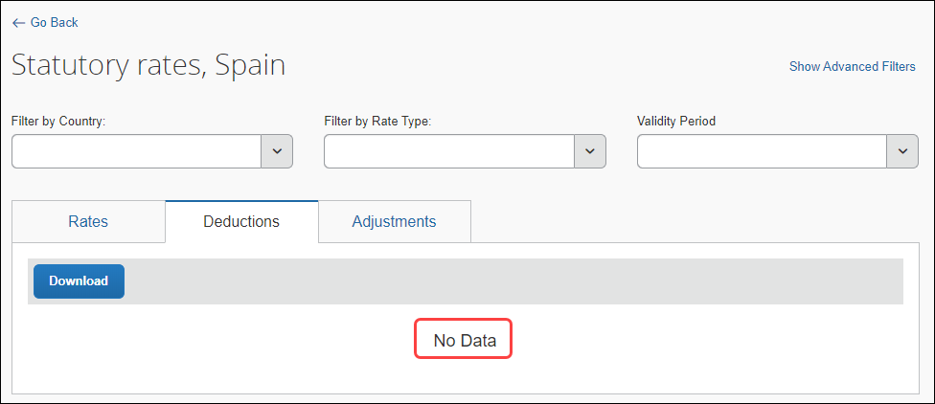
- Click Go Back.

Viewing Adjustments
The statutory Spain bundle does not contain any Adjustments.
To view adjustments in a rate bundle:
- On the Rate Bundles page, in the bundle’s row, click View contents ().
The bundle’s contents page displays with tabs for rates, deductions, and adjustments.
- Click the Adjustments tab.
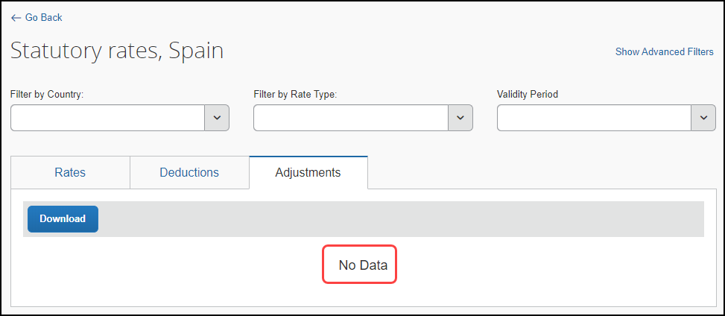
- Click Go Back.

Spain-Specific Statutory Validations, Calculations Logic, and Adjustments
In the Spain travel allowance bundle, the definition of a business trip is when the user travels to a location that is not the regular workplace regardless of whether the trip is started from home or from the office. The system calculates reimbursements based on the duration the user is away from the user's home location during each day of the trip.
The most common method of reimbursement in Spain uses daily allowances for meals and actual expenses for lodging. If rates higher than the regulatory rates are used, the company should track the amount paid which is over the regulatory limit because that amount is viewed as income by the taxation authorities and thus taxable to the user. It is common for collective agreements to set reimbursement amounts higher than those of the government.

Rates
The statutory rates for domestic Spain travel are the same throughout Spain, unless the travel is within the municipality where the user lives and usually works.

Cumulative Calculations for Multiple Trips in a Day
While end users have the abilty to expense multiple trips in a day, the system treats each trip independently and calculates allowances separately.
- IMPORTANT: It is recommended that customers who have end users with travel patterns that may lead to unexpected reimbursement amounts, address this possible scenario through training, monitoring, or other means to ensure that government requirements for cumulative calculations are met.

Lodging Allowance
Lodging allowances are based on whether or not the user spent the night at accommodations other than the user's home. The lodging allowance is defined for each location and the user is either eligible for the whole allowance or no allowance for lodging – there are no partial lodging allowances.
The user may be reimbursed the actual amount of the lodging cost without tax implications, as long as a receipt is provided for the expense.
The statutory bundle for Spain does not contain rates for lodging.
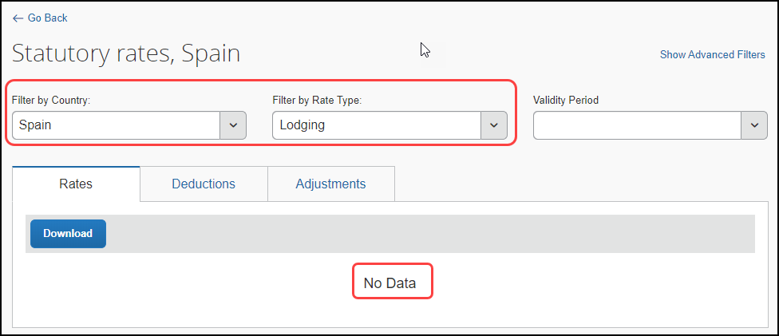

Meals Allowance
All Spanish travel allowance calculations are based on destination (domestic or international) and time (with or without overnight). All rates for meals within Spain are the same for all locations, unless the travel is within the home municipality, but vary depending on the length of the trip, that is with or without an overnight stay.

About Partial Days
The Spanish government does not define rules for reducing the allowance amount for a partial day other than as already described for the last day of a trip, or a single-day trip. Therefore, partial days will have no reduction and the user will be entitled to the full allowance as determined by other rules such as provided meals.
The rates for Spain can be viewed on the Statutory rates, Spain page.
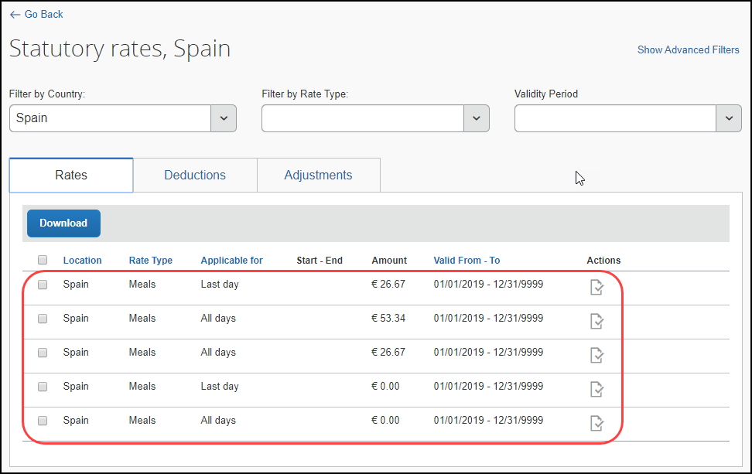

Within Municipality
Domestic trips within the user's home and usual work municipality use a type code calculation.
When creating an expense report, if an user marks an allowance as Within Municipality, no allowance is paid for domestic trips.
The Within Municipality setting only applies to domestic trips and affects no change if selected for a foreign trip.
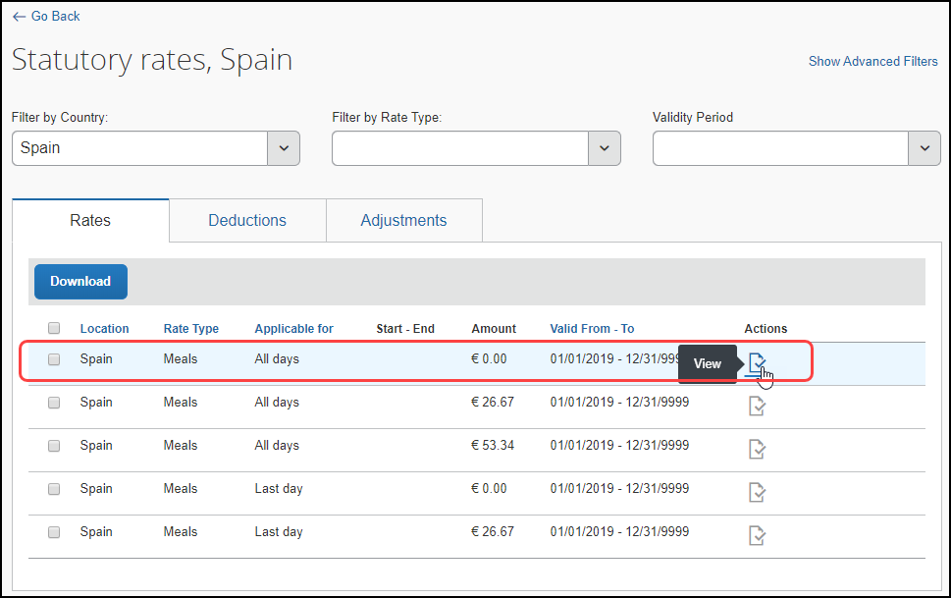
The details of this rate can be viewed on the View Rate page.
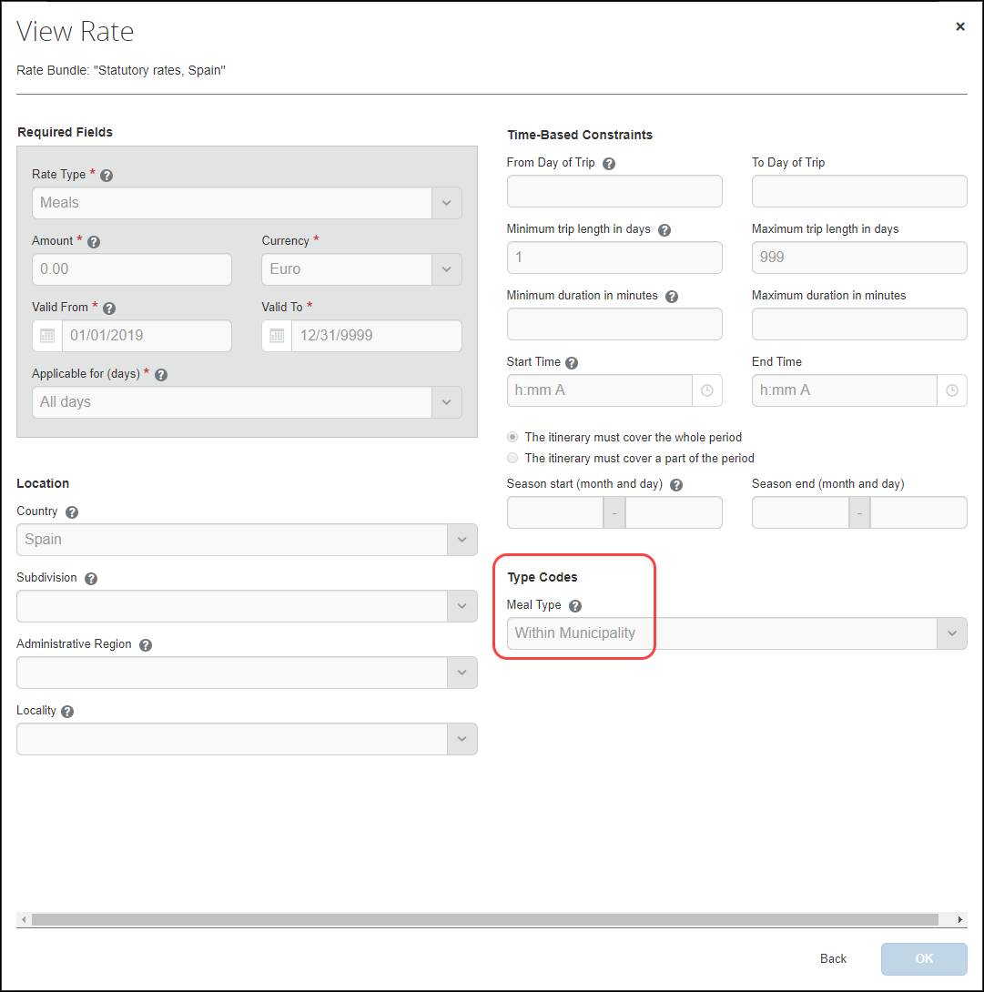

Single-Day Trips Not in Municipality
Single-day trips use trip length logic based on the configuration of a maximum one day threshold. The statutory bundle provides a rate for domestic and overseas single-day trips not in the user's municipality.
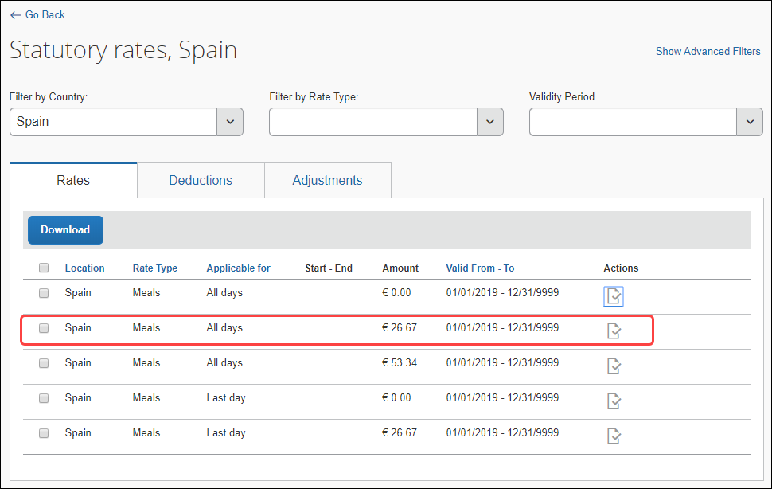
The details of this rate can be viewed on the View Rate page.
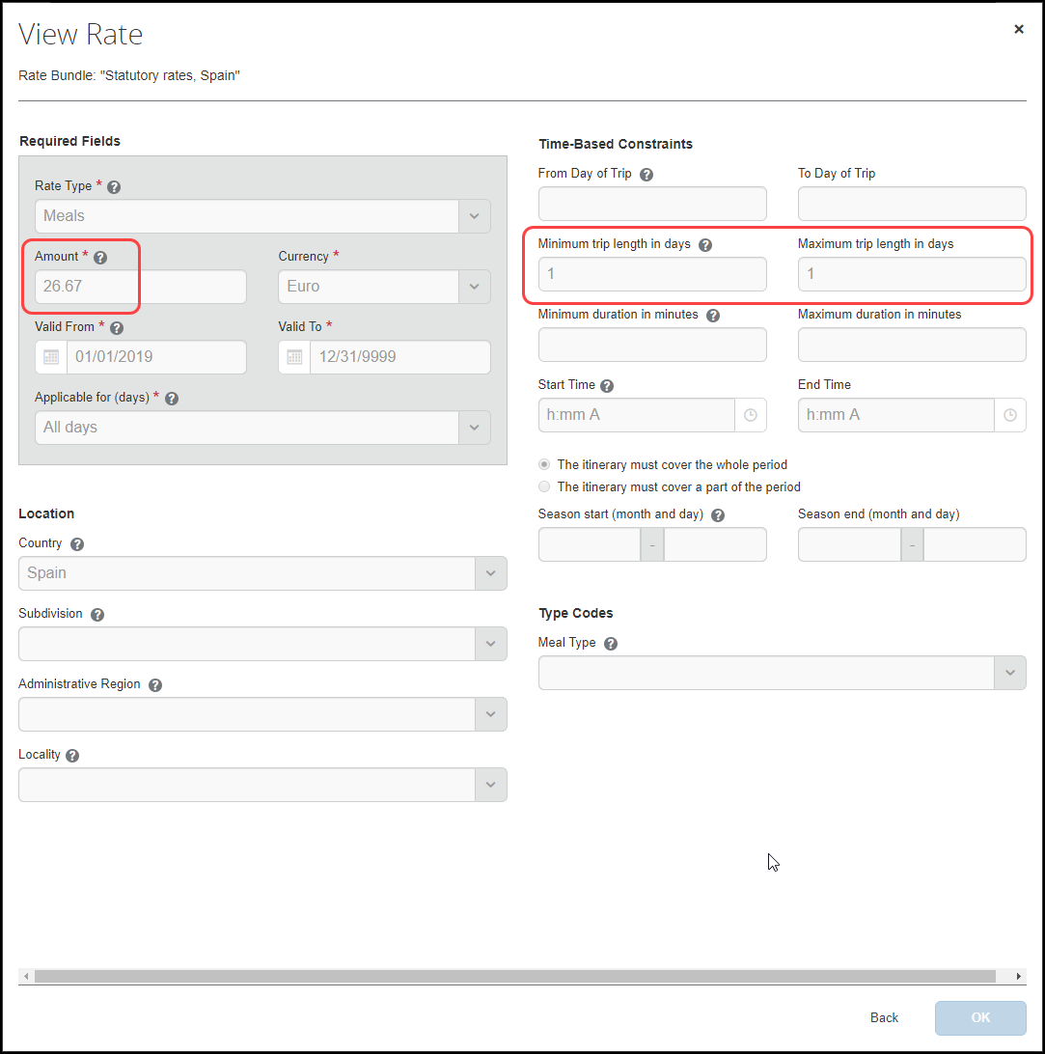

Multiple-Day Trips Not in Municipality
Multiple-day trips use trip length logic based on the configuration of a minimum two day threshold. The statutory bundle provides a rate for multiple-day trips not in the user's municipality.
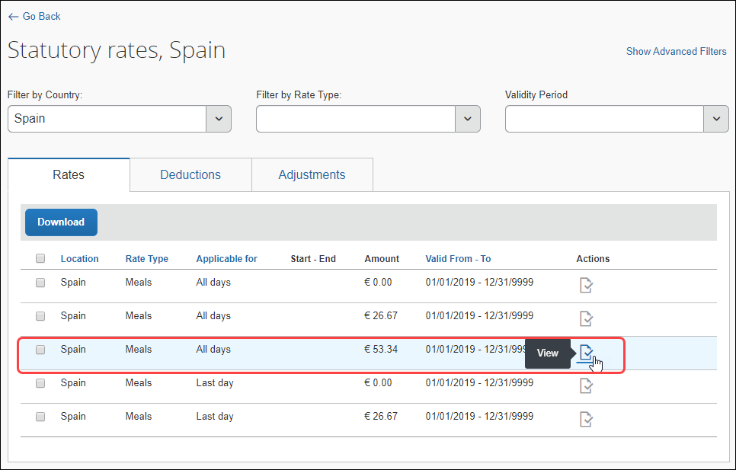
The details of this rate can be viewed on the View Rate page.
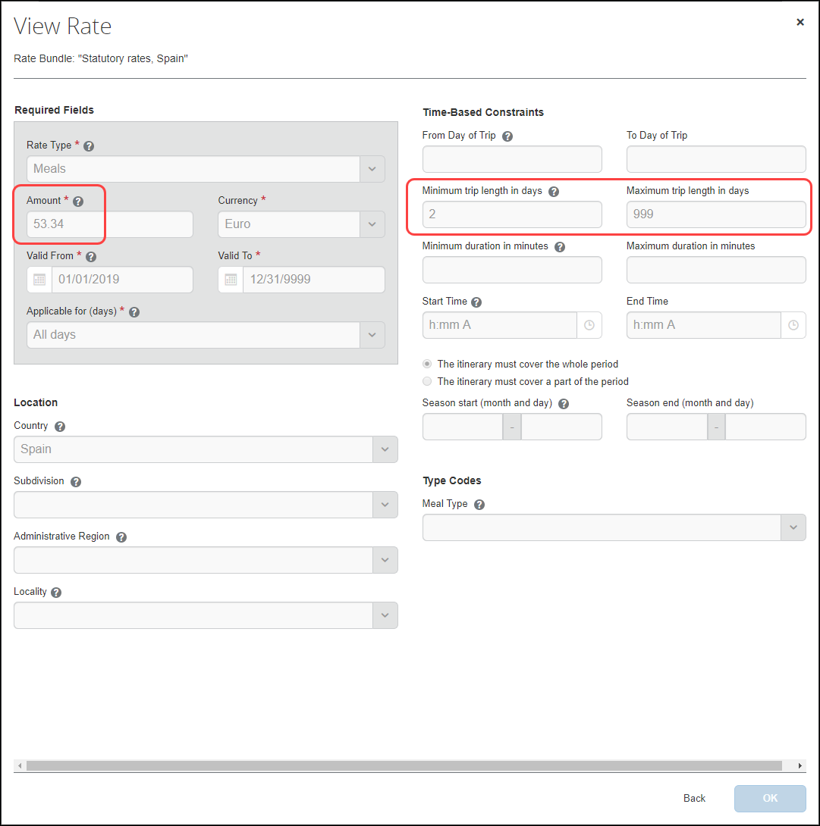

Last Day of Multiple-Day Trips Within Municipality
The last day of a multiple-day trip within the user's home and usual work municipality use an Applicable for (days) field along with the type code calculation.
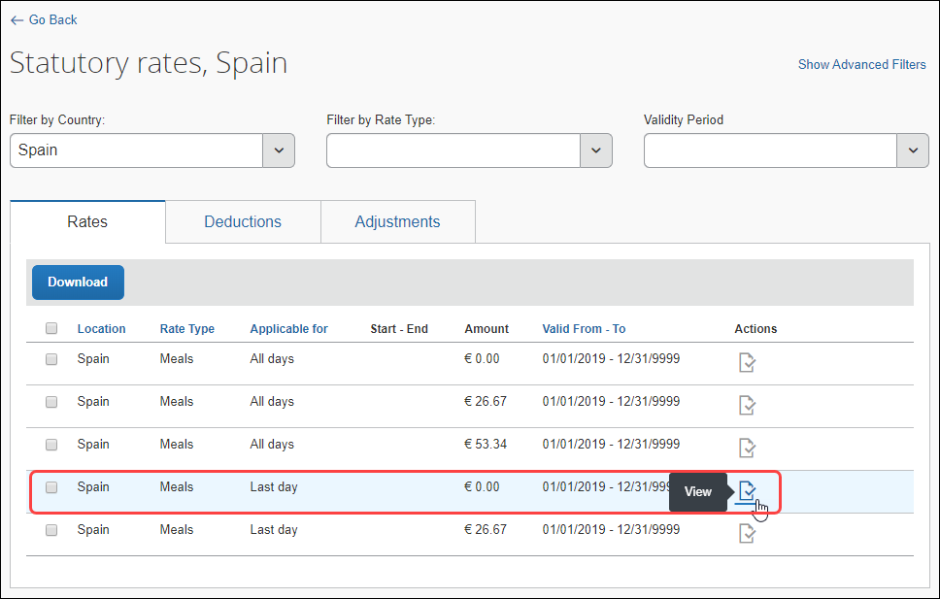
The details of this rate can be viewed on the View Rate page.
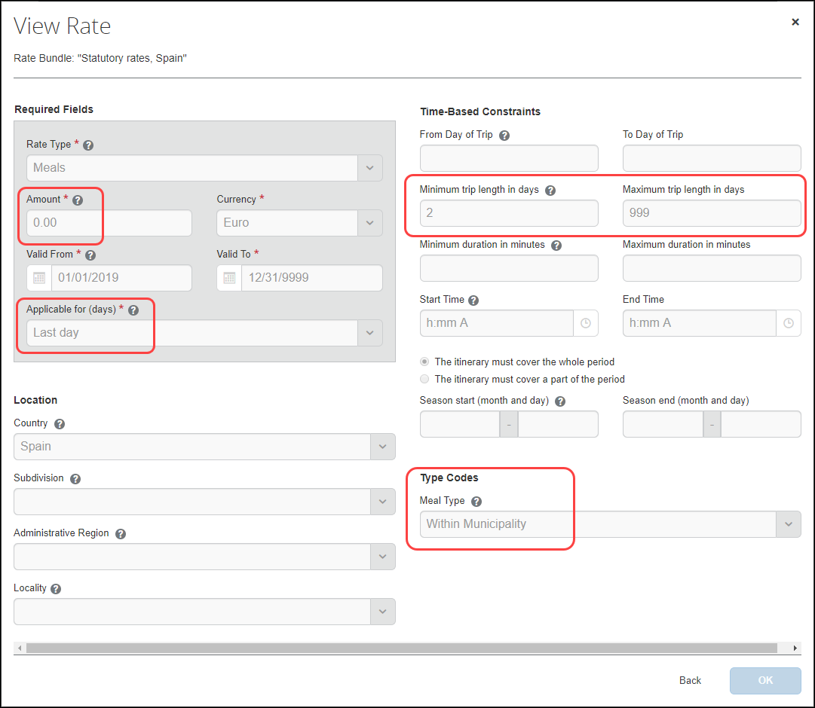

Last Day of Multiple-Day Trips Not Within Municipality
The last day of a multiple-day trip not within the user's home and usual work municipality uses an Applicable for (days) field without a type code calculation.
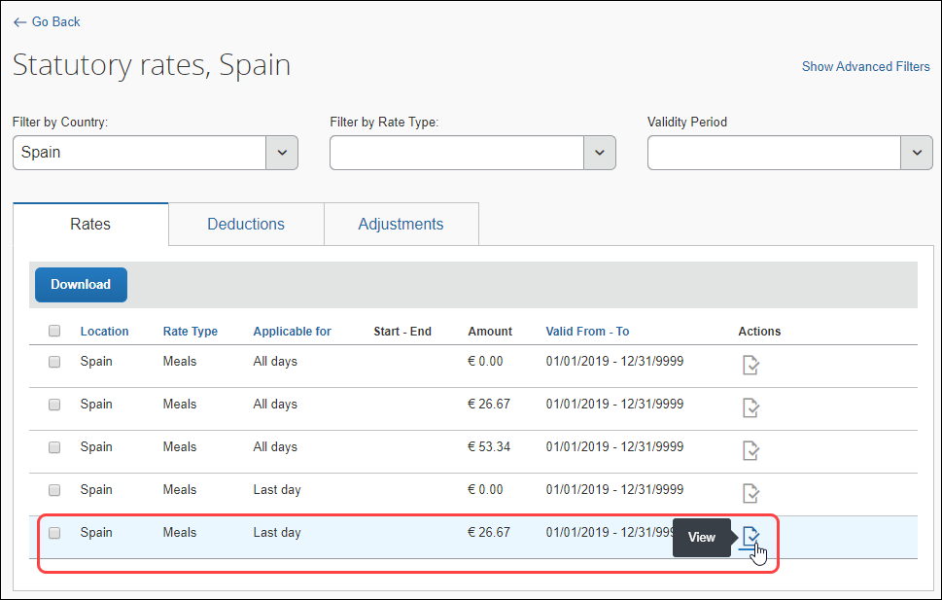
The details of this rate can be viewed on the View Rate page.
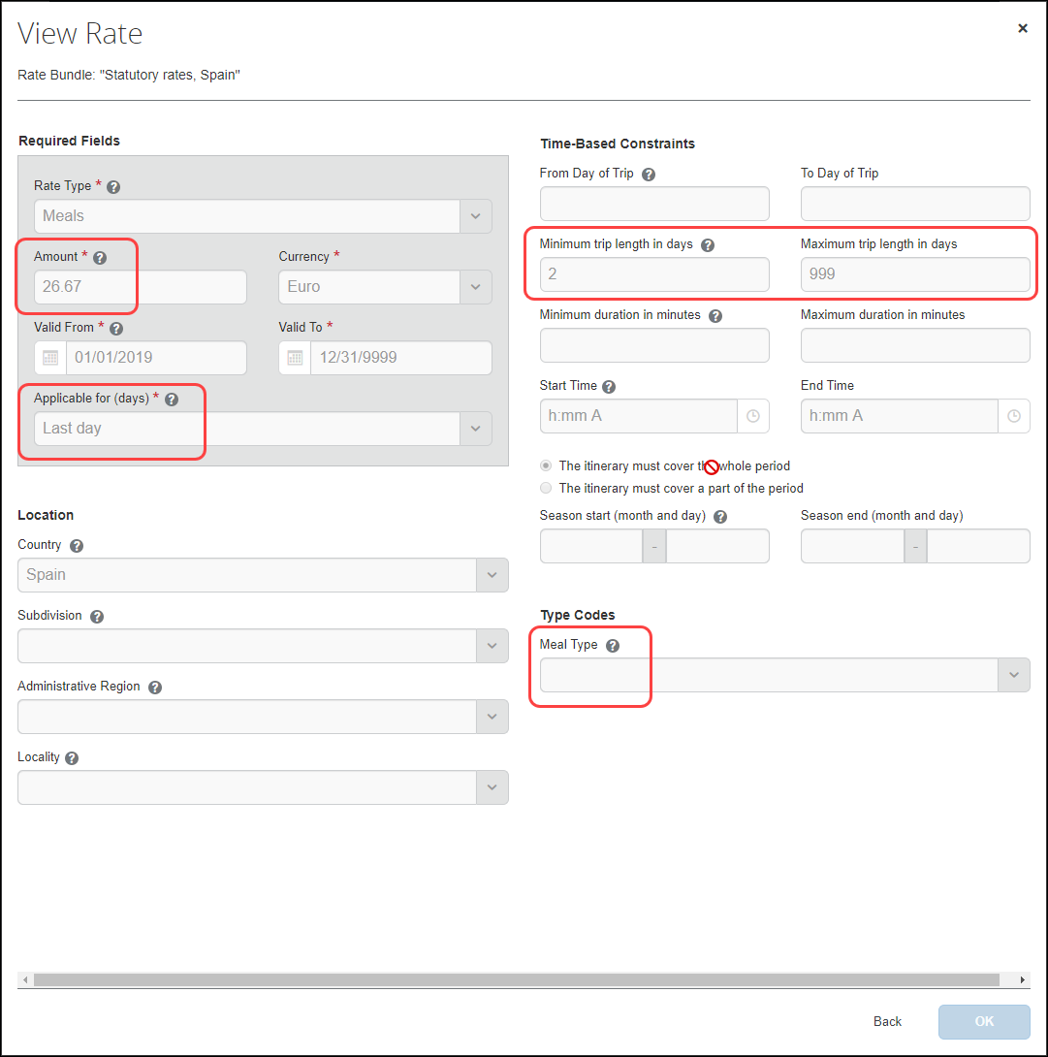

Considerations for Creating Configurable Bundles
This section lists important considerations and options available to clients who choose to create custom configurable bundles to supersede portions of the Spain statutory bundle.
When using a configurable bundle along with a statutory bundle, the configurable bundle only needs to contains the settings that will supersede the statutory bundle, not all settings.

Marking a Meal as Provided
The Spanish government does not provide clearly defined guidelines for the handling of provided meals (i.e. as fixed amounts per meal type or as a % of the full allowance). For this reason, the statutory bundle does not include deductions for provided meals. Companies may manage their desired deductions for provided meals using a configurable bundle.

What the User Sees
Additionally configured meal types choices display to the user on the Adjustments page.
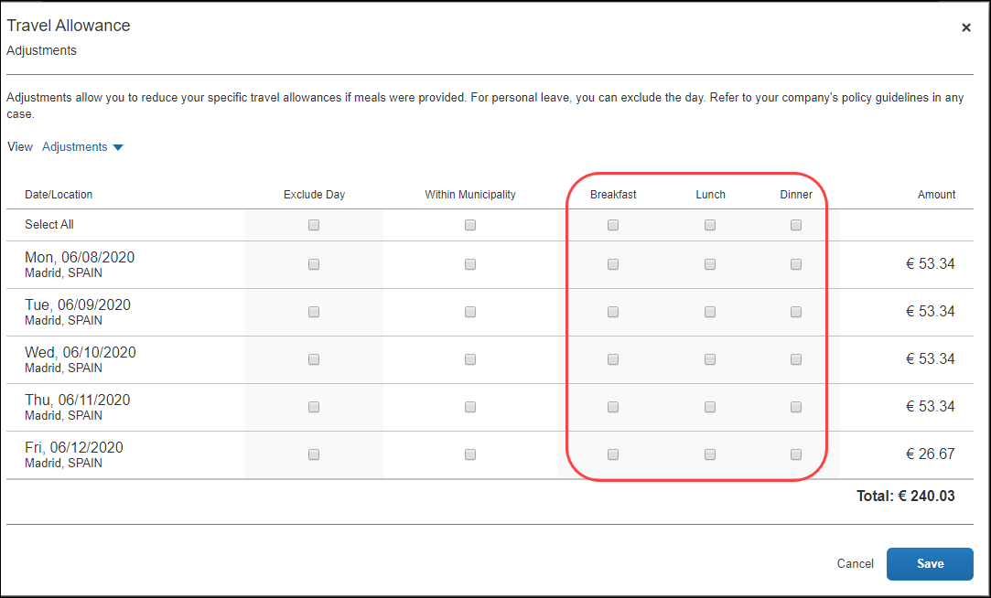

What the Admin Sees
Meal types choices can be configured from the Deductions tab of the bundle.
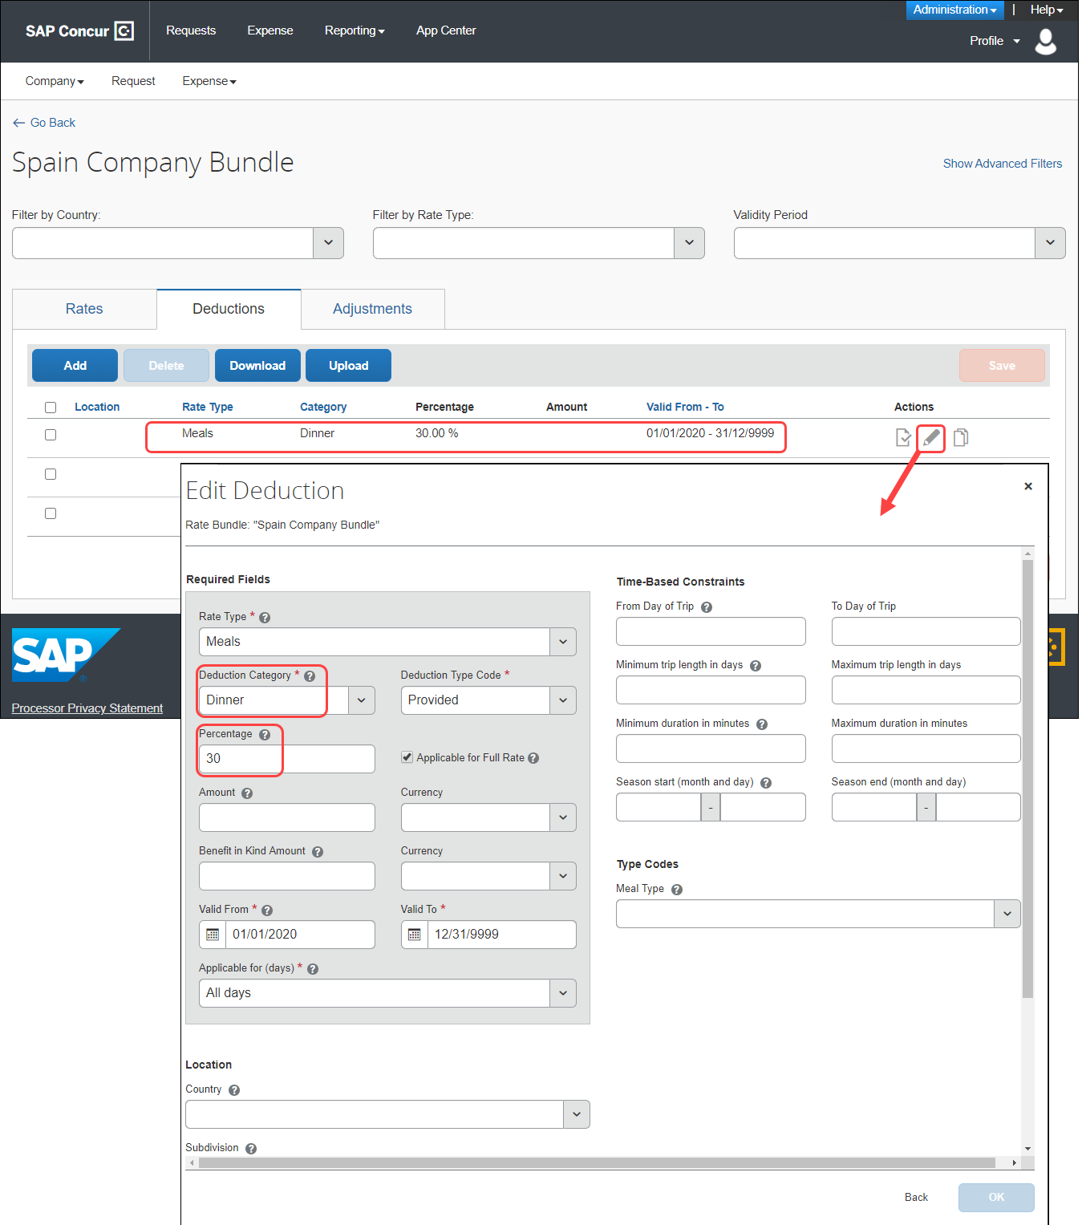

Marking a Provided Meal as Taxable
To support marking a provided meal as a taxable benefit, a custom meal type value must be configured in the configurable bundle. This allows required tracking for reporting purposes.
Meals which are supplied by the company to Spanish users, in certain circumstances, are considered to constitute a benefit-in-kind for tax purposes. For example:
- A meal supplied at a company canteen paid for by in-house currency or voucher;
- A meal supplied as part of a training course, seminar, or conference arranged and paid for by the company; or
- Any meal arranged in advance by the company and paid for by the company or a third party on behalf of the company.
If the value of the meal is over the statutory rate, then the full value of the meal is considered taxable.
A company can choose to handle benefit-in-kind meals in different ways, but the amount must be accounted for in some way.
The configuration for marking provided meals as taxable is flexible. For example, rather than adding a single meal type choice of "Taxable", multiple choices in the list may be configured to represent different meal combinations – this accommodates indicating which of the meals is taxable where more than one meal is marked as provided and not all of the meals are taxable.

What the User Sees
Additionally configured meal types choices display to the user on the Adjustments page.

What the Admin Sees
Meal types choices can be configured by the admin on the Edit Meal Types page of the bundle.

Paying Higher or Lower Than Statutory Meals Allowances
Client may desire supported rate deviations due to company policy or agreements with the state, such as:
- Reduced domestic rates for travel to company locations
- Paying allowances where legally no allowance would be paid
If desired, the system can be configured to pay higher or lower than the statutory amounts for meals allowances.
Paying higher rates would mean that the difference (compared to the tax-free rate) may be subject to income tax.

Paying Allowances for Days Where No Tax-Free Allowance Applies
If desired, the system can be configured to pay an allowance where the statutory rates would not provide one.
This total allowance would then be subject to income tax.

Paying for In-Municipality Meals and Tracking Them as Taxable
While there is no statutory meals allowance for trips within the user's home municipality, clients may choose to pay an allowance for these trips. Clients may define their own meals allowance and track that full amount as taxable.
☼

