SAP Concur Release Notes
Concur Invoice Professional/Premium
Includes: Concur Invoice, Capture Processing, Invoice Pay, Purchase Requests and Purchase Orders
Month | Audience
Release Date: June 18, 2022  Initial Post: June 17, 2022 | Client FINAL
Contents
Release Notes 1
Invoice Pay 1
New Fields Added to Invoice Payment Confirmation Extract for Payment Provider Payments 1
Test Entities | Production Sandbox Environment 2
**Ongoing** Audit Trail for Vendor Manager Not Migrated 2
Planned Changes 4
Invoice Pay 4
**Planned Changes** New Date Fields on Provider Payment Manager Payment Details Page 4
Vendor Management 5
**Planned Changes** New Vendors from Embargoed Countries Now Blocked 5
Client Notifications 6
Accessibility 6
Accessibility Updates 6
Subprocessors 6
SAP Concur Non-Affiliated Subprocessors 6
Supported Configurations 7
Supported Browsers and Changes to Support 7
SAP Concur Support Case Status 8
Check Support Case Status 8
Additional Release Notes and Other Technical Documentation 10
Online Help 10
SAP Concur Support Portal – Selected Users 10

Legal Disclaimer
The information in this presentation is confidential and proprietary to SAP SE or an SAP affiliate company and may not be disclosed without the permission of SAP SE or the respective SAP affiliate company. This presentation is not subject to your license agreement or any other service or subscription agreement with SAP SE or its affiliated companies. SAP SE and its affiliated companies have no obligation to pursue any course of business outlined in this document or any related presentation, or to develop or release any functionality mentioned therein. This document, or any related presentation and SAP SE or an SAP affiliate company’s strategy and possible future developments, products and or platforms directions and functionality are all subject to change and may be changed by SAP SE and its affiliated companies at any time for any reason without notice. The information in this document is not a commitment, promise or legal obligation to deliver any material, code or functionality. This document is provided without a warranty of any kind, either express or implied, including but not limited to, the implied warranties of merchantability, fitness for a particular purpose, or non-infringement. This document is for informational purposes and may not be incorporated into a contract. SAP SE and its affiliated companies assume no responsibility for errors or omissions in this document, except if such damages were caused by SAP SE or an SAP affiliate company’s willful misconduct or gross negligence.
All forward-looking statements are subject to various risks and uncertainties that could cause actual results to differ materially from expectations. Readers are cautioned not to place undue reliance on these forward-looking statements, which speak only as of their dates, and they should not be relied upon in making purchasing decisions.

Release Notes
This document contains the release notes for Concur Invoice for professional edition.
Features and changes that apply to SAP Concur site-wide or to multiple products/services are documented in the Shared Changes Release Notes. For information about site-wide or shared changes in this release that might impact your SAP Concur solutions, refer to the Shared Changes Release Notes.

Invoice Pay

New Fields Added to Invoice Payment Confirmation Extract for Payment Provider Payments

Overview
New fields are now added to the Invoice Payment Confirmation Extract to provide clients additional information for payments processed by Payment Providers.
Field Name | Description
Funding Source Reference | This identifies the client’s funding source /account used to pay the invoice.
Provider Payment Method | The method the payment was issued by the Payment Provider.
Funding Request Reference | This is the identifier for the debit transaction from the client's account to fund a payment.
Third Party Reference | Unique identifier of a payment issued by the Payment Provider (ex. check number or ACH trace number).
Invoice Currency | The currency of the invoice being paid.
Funding Currency | Currency in which the payment was funded in by the client to the Payment Provider.
Payment Currency | The currency in which the payment to the vendor was made.
Foreign Exchange Rate | The foreign exchange rate used to calculate the payment in the payment currency based on the funding currency.
These field additions are aligned with upcoming Invoice Pay v4.0 API enhancements.
For more information regarding Invoice Pay v4.0 APIs, refer to the Developer Center release notes.

Business Purpose / Client Benefit
This update allows clients to extract additional payment information updated in Concur Invoice by Payment Providers.

Configuration / Feature Activation
These updates occur automatically; there are no additional configuration or activation steps.
For more information, refer to the Concur Invoice: Payment Confirmation Extract Specification Guide.

Test Entities | Production Sandbox Environment

**Ongoing** Audit Trail for Vendor Manager Not Migrated

Information First Published | Information Last Modified | Feature Target Release Date
October 2021 | January 21, 2022 | October 1, 2021 through mid-2022
Any changes since the previous monthly release are highlighted in yellow in this release note.

Overview
Some SAP Concur users use Production Sandbox Environment (PSE) entities to set up, test, and train on new configurations prior to deploying them to their live production entity. SAP Concur plans to migrate PSEs as part of our move to Amazon Web Services (AWS).
For more information, refer to the Sap Concur Cloud Platform Strategy FAQ.
When PSEs are migrated, the vendor audit trail associated with vendors in Vendor Manager, will not be migrated. The audit trail will be rebuilt as changes are made to vendor information after migration.
These changes apply to PSEs once they are moved or created in the AWS environment, which will occur at a future date.

Business Purpose / Client Benefit
Once in AWS, PSEs will benefit from the same stability, monitoring capabilities, and level of performance as production entities.

Admin Experience
When an admin with the required permissions navigates to the Audit Trail page for a vendor, they will not see any entries on the Audit Trail page.

Configuration / Feature Activation
This change occurs when a PSE is migrated to the new AWS environment; there are no configuration or activation steps.
For more information about the vendor audit trail, refer to the Invoice: Vendor Manager User Guide.

Planned Changes
The items in this section are targeted for future releases. SAP Concur reserves the right to postpone implementation of – or completely remove – any enhancement/change mentioned here.
The planned changes listed in this document are specific to this product. For information about planned site-wide or shared changes that might impact your SAP Concur solutions, refer to the Shared Changes Release Notes.

Invoice Pay

**Planned Changes** New Date Fields on Provider Payment Manager Payment Details Page

Information First Published | Information Last Modified | Feature Target Release Date
May 2022 | -- | July 2022
Any changes since the previous monthly release are highlighted in yellow in this release note.

Overview
SAP Concur Payment Providers can soon update invoice payments that they process with new Payment Initiation Date and Funding Settlement Date fields.
Invoice Payment Manager users can access the Provider Payment Manager page to search for payments processed by Payment Providers and view payment information. Fields for the Payment Initiation Date and Funding Settlement Date will be added to the Payment Details section in Provider Payment Manager for Invoice Payment Managers to view this information.

Business Purpose / Client Benefit
This update allows Invoice Payment Manager users to view Payment Initiation Date and Funding Settlement Date fields in the Payment Provider Manager page.

Configuration / Feature Activation
This update will occur automatically.
For more information, refer to Concur Expense: Invoice Pay Setup Guide and Concur Invoice: Invoice Pay User Guide.

Vendor Management

**Planned Changes** New Vendors from Embargoed Countries Now Blocked

Information First Published | Information Last Modified | Feature Target Release Date
May 2022 | June 9, 2022 | July 2022
Any changes since the previous monthly release are highlighted in yellow in this release note.

Overview
Concur Invoice will soon require all vendors to have the Country Code field populated in the system. The Country Code field will now be a required field regardless of how a vendor record is input (through the API, imported, or manually input).
Additionally, embargoed countries will no longer display in the Country Code list, preventing the creation of any new vendors who reside in embargoed countries from being added within Concur Invoice.
This change helps ensure that vendors whose address is originating from countries that fail to adhere to SAP's policy for conducting business with embargoed countries are no longer added in Concur Invoice. SAP policy prohibits the use of all SAP products and services in, from, or in support of, any business activities in locations where SAP products and services are not available. This list includes Cuba (CU), Iran (IR), North Korea (KP), Syria (SY), and Crimea Region / Sevastopol.
Vendors who are already in Concur Invoice will not be impacted.

Business Purpose / Client Benefit
This change ensures clients follow local, national, and international laws governing embargoed countries, and are systematically protected to the best ability from malicious actors and actions when working with SAP Concur products.

Configuration / Feature Activation
This change will occur automatically.

Client Notifications

Accessibility

Accessibility Updates
SAP implements changes to better meet current Web Content Accessibility Guidelines (WCAG). Information about accessibility-related changes made to SAP Concur solutions is published on a quarterly basis. You can review the quarterly updates on the Accessibility Updates page.

Subprocessors

SAP Concur Non-Affiliated Subprocessors
The list of non-affiliated subprocessors is available from the SAP Sub-processors / Data Transfer Factsheets page.
To access the SAP Concur Sub-processors List:
- Click the following link to navigate to the SAP Sub-processors / Data Transfer Factsheets page:
SAP Sub-processors / Data Transfer Factsheets
- Sign in to the SAP Support Portal using your Support User ID (S-user) and password.
SAP customers must sign in to the SAP Support Portal using their Support User ID (S-user) and password. For information about S-User IDs, refer to Your New Support User ID (S-user).
- On the SAP Sub-processors / Data Transfer Factsheets page, type Concur in the Search field.
- In the Title column, click SAP Concur Sub-processors List.
If you have questions or comments, please reach out to: Privacy-Request@Concur.com

Supported Configurations

Supported Browsers and Changes to Support
For information about supported browsers and planned changes to supported browsers, refer to the Concur Travel & Expense Supported Configurations guide.
When changes to browser support are planned, information about those changes will also appear in the Shared Changes Release Notes..

SAP Concur Support Case Status
This release might resolve previously submitted support cases. You can check the status of a support case to confirm whether the case issue has been resolved.

Check Support Case Status
The steps in this procedure provide instructions for checking whether a case is resolved.
To check the status of a submitted case:
- Log on to https://concursolutions.com/portal.asp.
- Click Help > Contact Support.
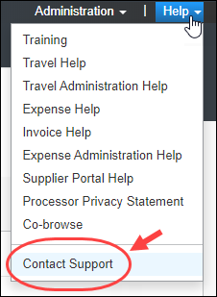
If you do not have the option to contact SAP Concur support in the Help menu, then your company has chosen to support the SAP Concur service internally. Please contact your internal support desk for assistance.
- Click Support > View Cases.
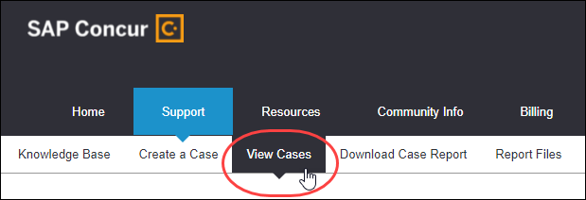
In the table, view the desired type of cases based on the View list selection. Search results are limited to each company's own cases.
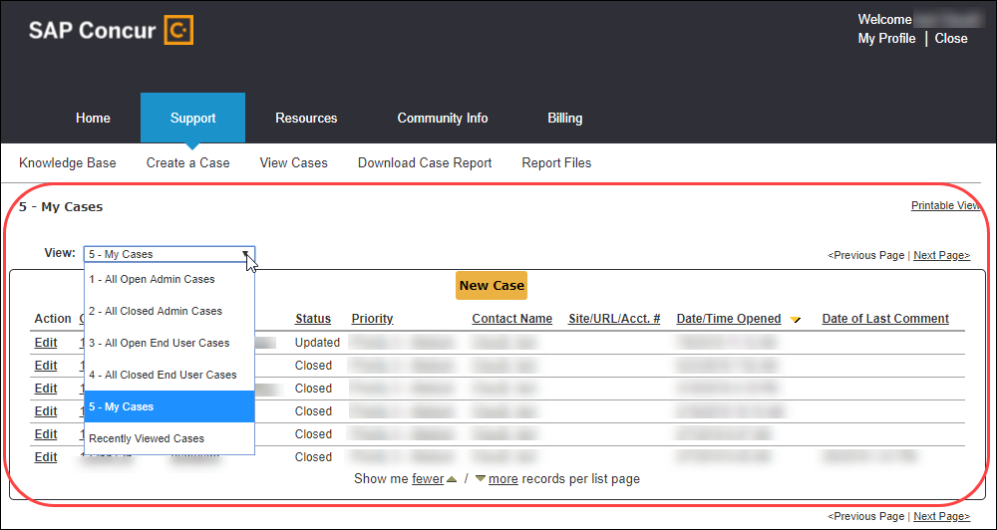

Additional Release Notes and Other Technical Documentation

Online Help
Any user can access release notes, setup guides, user guides, admin summaries, monthly browser certifications, supported configurations, and other resources via online Help or directly on the SAP Help Portal.
Use the links in the Help menu in the app, or search for your SAP Concur product (Concur Expense, Concur Invoice, Concur Request, or Concur Travel) on the SAP Help Portal (https://help.sap.com) to view the full set of documentation for your product.

SAP Concur Support Portal – Selected Users
Access release notes, webinars, and other technical documentation on the SAP Concur support portal.
If you have the proper permissions, Contact Support appears on the Help menu. Click to access the SAP Concur support portal, then click Resources.
- Click Release/Tech Info for release notes, technical documents, etc.
- Click Webinars for recorded and live webinars.
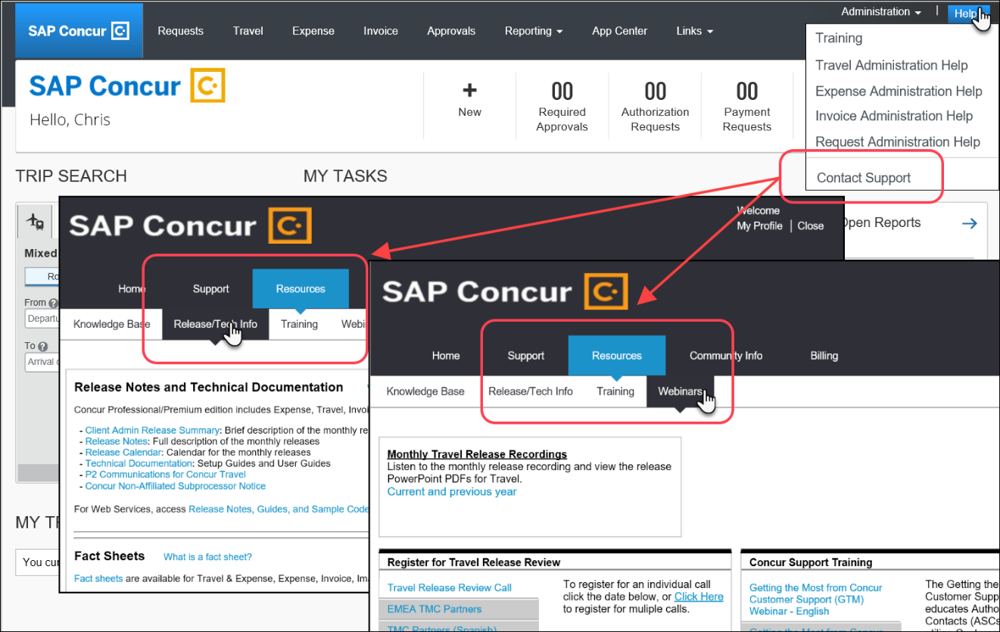

© 2022 SAP SE or an SAP affiliate company. All rights reserved.
No part of this publication may be reproduced or transmitted in any form or for any purpose without the express permission of SAP SE or an SAP affiliate company.
SAP and other SAP products and services mentioned herein as well as their respective logos are trademarks or registered trademarks of SAP SE (or an SAP affiliate company) in Germany and other countries. Please see http://global12.sap.com/corporate-en/legal/copyright/index.epx for additional trademark information and notices.
Some software products marketed by SAP SE and its distributors contain proprietary software components of other software vendors.
National product specifications may vary.
These materials are provided by SAP SE or an SAP affiliate company for informational purposes only, without representation or warranty of any kind, and SAP SE or its affiliated companies shall not be liable for errors or omissions with respect to the materials. The only warranties for SAP SE or SAP affiliate company products and services are those that are set forth in the express warranty statements accompanying such products and services, if any. Nothing herein should be construed as constituting an additional warranty.
In particular, SAP SE or its affiliated companies have no obligation to pursue any course of business outlined in this document or any related presentation, or to develop or release any functionality mentioned therein. This document, or any related presentation, and SAP SE’s or its affiliated companies’ strategy and possible future developments, products, and/or platform directions and functionality are all subject to change and may be changed by SAP SE or its affiliated companies at any time for any reason without notice. The information in this document is not a commitment, promise, or legal obligation to deliver any material, code, or functionality. All forward-looking statements are subject to various risks and uncertainties that could cause actual results to differ materially from expectations. Readers are cautioned not to place undue reliance on these forward-looking statements, which speak only as of their dates, and they should not be relied upon in making purchasing decisions.

