SAP Concur Release Notes
Concur Invoice Professional/Premium
Includes: Concur Invoice, Capture Processing, Invoice Pay, Purchase Requests and Purchase Orders
Month | Audience
Release Date: January 22, 2022  Initial Post: Friday, January 21, 2022 | Client FINAL
Contents
Release Notes 4
Concur Invoice 4
Invoices from Embargoed Countries Now Blocked (Jan 20) 4
Invoice Capture 6
CFDi Version 4.0 Now Supported (Mexico) 6
Invoice Pay 6
General Availability of the Invoice Provider ACH Feature 6
Add Funding Account button for Invoice Pay ACH Removed 7
File Transfer Updates 8
Rotating PGP Key Available for File Transfers 8
**Ongoing** SAP Concur Legacy File Move Migration 8
Miscellaneous 8
**Ongoing ** SAP Concur Homepage Changes 8
SAP Fiori Themes 9
Profile Menu Functional Changes Under Fiori Light Theme 9
SAP Concur User Assistance 9
Shared Planned Changes Moving to New Shared Changes Release Notes 9
Test Entities | Production Sandbox Environment 10
**Ongoing** Audit Trail for Vendor Manager Not Migrated 10
Test Entity Data Maintenance and Entity Deletion (Dec 6) 11
Planned Changes 12
There are currently no planned changes. 12
Client Notifications 13
Accessibility 13
Accessibility Updates 13
Subprocessors 13
SAP Concur Non-Affiliated Subprocessors 13
Supported Configurations 13
Supported Browsers and Changes to Support 13
SAP Concur Support Case Status 14
Check Support Case Status 14
Additional Release Notes and Other Technical Documentation 16
Online Help 16
SAP Concur Support Portal – Selected Users 16

Legal Disclaimer
The information in this presentation is confidential and proprietary to SAP SE or an SAP affiliate company and may not be disclosed without the permission of SAP SE or the respective SAP affiliate company. This presentation is not subject to your license agreement or any other service or subscription agreement with SAP SE or its affiliated companies. SAP SE and its affiliated companies have no obligation to pursue any course of business outlined in this document or any related presentation, or to develop or release any functionality mentioned therein. This document, or any related presentation and SAP SE or an SAP affiliate company’s strategy and possible future developments, products and or platforms directions and functionality are all subject to change and may be changed by SAP SE and its affiliated companies at any time for any reason without notice. The information in this document is not a commitment, promise or legal obligation to deliver any material, code or functionality. This document is provided without a warranty of any kind, either express or implied, including but not limited to, the implied warranties of merchantability, fitness for a particular purpose, or non-infringement. This document is for informational purposes and may not be incorporated into a contract. SAP SE and its affiliated companies assume no responsibility for errors or omissions in this document, except if such damages were caused by SAP SE or an SAP affiliate company’s willful misconduct or gross negligence.
All forward-looking statements are subject to various risks and uncertainties that could cause actual results to differ materially from expectations. Readers are cautioned not to place undue reliance on these forward-looking statements, which speak only as of their dates, and they should not be relied upon in making purchasing decisions.

Release Notes
This document contains the release notes for Concur Invoice for professional edition.
Features and changes that apply to SAP Concur site-wide or to multiple products/services are documented in the Shared Changes Release Notes. For information about site-wide or shared changes in this release that might impact your SAP Concur solutions, refer to the Shared Changes Release Notes.

Concur Invoice

Invoices from Embargoed Countries Now Blocked (Jan 20)

Overview
Beginning January 20, 2022, the Concur Invoice system began blocking the payment facilitation of submitted invoices originating from countries that fail to adhere to SAP's policy for conducting business with embargoed countries. SAP policy prohibits the use of all SAP products and services in, from, or in support of, any business activities in locations where SAP products and services are not available.
This list includes Cuba (CU), Iran (IR), North Korea (KP), Syria (SY), and Crimea Region / Sevastopol. In practice, each invoice on submission is analyzed for country code and rejected, with an error message stating why, where an embargoed country is identified.
Blocking does not apply to historical (prior to January 20, 2022) submitted and/or approved invoices, nor the Purchase Request / Purchase Order modules within the SAP Concur Invoice product.

Business Purpose / Client Benefit
This feature ensures clients follow local, national, and international laws governing embargoed countries, and are systematically protected to the best ability from malicious actors and actions when working with SAP Concur products.

What the User Sees
The user submitting the invoice where the country code is associated with an embargoed country will see the exception message "The selected Country of Origin contains a country or region in which Invoice is not supported."
From within Invoice:
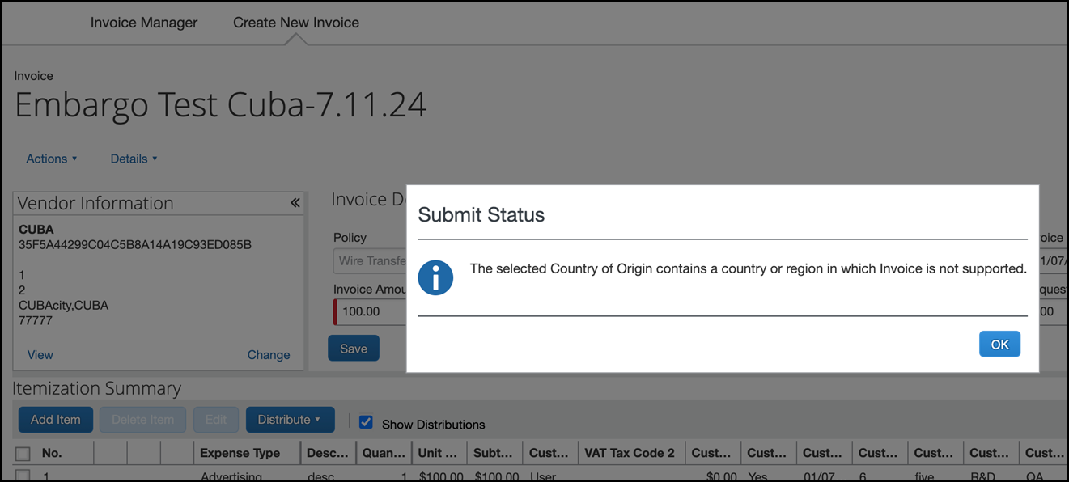
From listed invoice:
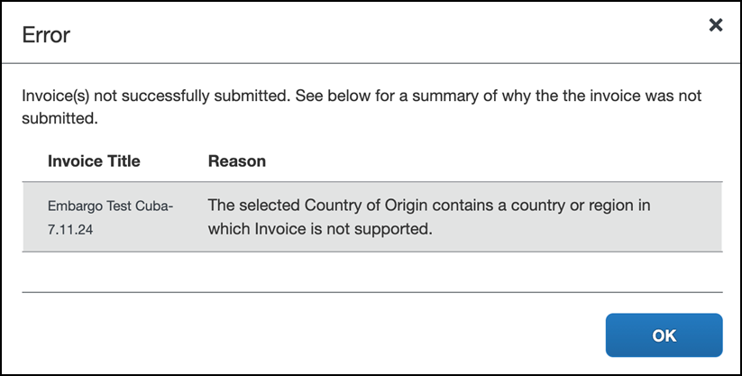
From the Mobile app:
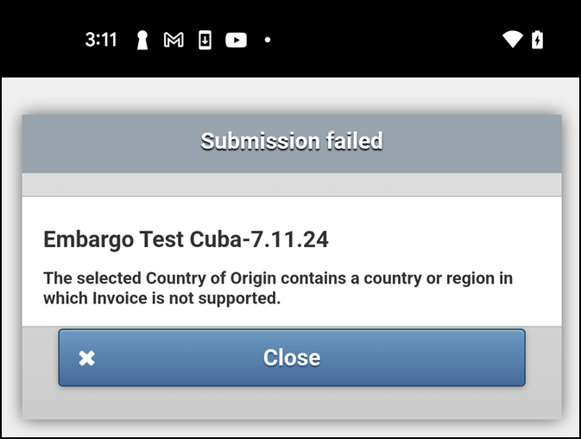

Configuration / Feature Activation
This change occurred automatically.

Invoice Capture

CFDi Version 4.0 Now Supported (Mexico)

Overview
With this release, Concur Invoice supports the new Comprobante Fiscal Digital por Internet (CFDi) version 4.0 format provided by Mexican tax authorities. Regulations in Mexico require that a CFDi document in XML format be attached to every submitted invoice.
With the availability of the new CFDi format, Capture Processing users reporting to Mexican tax authorities and submitting invoices with CFDi attachments will be in compliance with current Mexican tax regulations.

Business Purpose / Client Benefit
This update supports Capture Processing users reporting to Mexican tax authorities who need their invoice and attached CFDi tax document submitted as a single payment request in Concur Invoice.

Configuration / Feature Activation
Invoice Configuration administrators can enable users to upload CFDi attachments in Group Configurations.
This update is automatically available; there are no additional configuration or activation steps.
For general information about this functionality, refer to the Concur Invoice: Capture Processing (Client-Managed) Setup Guide and the Concur Invoice: Capture Processing (Client-Managed) User Guide.

Invoice Pay

General Availability of the Invoice Provider ACH Feature

Overview
With this release, Invoice Provider ACH is now available to all direct clients. Currently, USD ACH payments by Bambora/Worldwide as the payment provider are supported for this feature.

Background
To better serve clients, Invoice Provider ACH is replacing the Classic Invoice Pay ACH feature as part of a transition of Invoice Pay to a payment provider solution for invoice payments. With the Invoice Provider ACH feature, fund transfers for ACH payments are handled by a third-party company (payment provider) instead of SAP Concur.
As of end of year 2021, only direct clients who purchased Invoice before June 21, 2021 were eligible to gain an Accepted status and use the Invoice Provider ACH feature to process ACH payments. Classic Invoice Pay ACH users were able to process batch payments up to November 15, 2021 after which new invoice payment processing was discontinued.
For more information on the retirement of the Invoice Pay ACH feature, refer to the Invoice Pay Solutions FAQ.

Business Purpose / Client Benefit
To better serve clients, Invoice Provider ACH is now available to all direct Invoice clients.

More Information
Please reference the guides and release note listed below for more information.
For general information about Invoice Provider ACH, refer to the Concur Invoice Pay User Guide for Professional Edition or the Invoice Pay User Guide for Standard Edition.
- For more information about creating and activating Invoice Provider ACH funding accounts, refer to the Concur Invoice: Invoice Provider ACH Setup Guide.

Add Funding Account button for Invoice Pay ACH Removed

Overview
Classic Pay services for the Invoice Pay ACH feature were shut down on December 1st, 2021. The Add Funding Account button on the Funding Accounts page used to create a new Classic Invoice Pay ACH funding account is being removed.
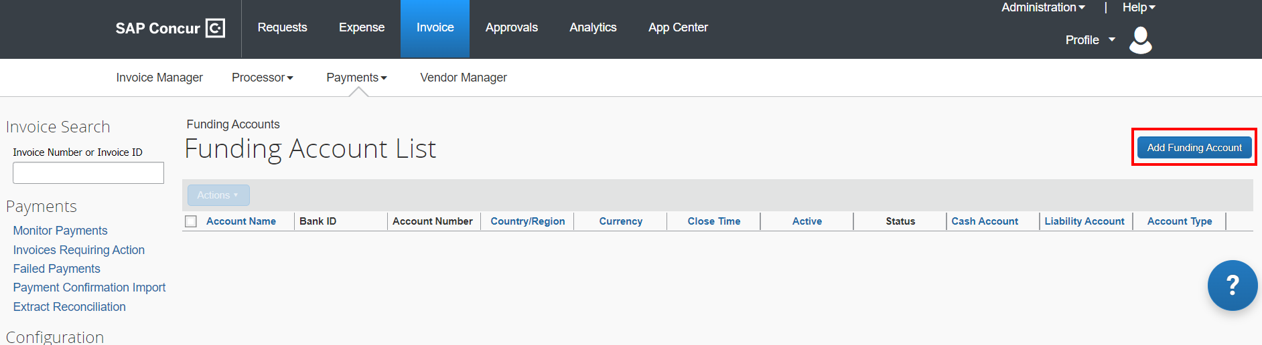

Business Purpose / Client Benefit
This change is part of the decommissioning of the Classic Invoice Pay ACH feature.

Configuration / Feature Activation
There are no configuration or activation steps; this change occurs automatically.

File Transfer Updates

Rotating PGP Key Available for File Transfers
This feature is now documented in the Shared Changes Release Notes.
For more information, refer to Shared Planned Changes Moving to New Shared Changes Release Notes in this document.

**Ongoing** SAP Concur Legacy File Move Migration

Information First Published | Information Last Modified | Feature Target Release Date
March 6, 2020 | January 14, 2022 | Ongoing until January 24, 2022

This feature is now documented in the Shared Changes Release Notes.
- For more information, refer to Shared Planned Changes Moving to New Shared Changes Release Notes in this document.

Miscellaneous

**Ongoing ** SAP Concur Homepage Changes

Information First Published | Information Last Modified | Feature Target Release Date
October 8, 2020 | January 14, 2022 | Q4 2021 – Q2 2022
This feature is now documented in the Shared Changes Release Notes.
For more information, refer to Shared Planned Changes Moving to New Shared Changes Release Notes in this document.

SAP Fiori Themes

Profile Menu Functional Changes Under Fiori Light Theme
This feature is now documented in the Shared Changes Release Notes.
For more information, refer to Shared Planned Changes Moving to New Shared Changes Release Notes in this document.

SAP Concur User Assistance

Shared Planned Changes Moving to New Shared Changes Release Notes

Overview
Beginning with the January 2022 draft release notes, shared (SAP Concur cross-product) changes, shared planned changes, and changes to SAP Concur core technologies are published in a new document, Shared Changes Release Notes. This document replaces the current Shared Planned Changes Release Notes.
Shared and core technology features and changes include, but are not limited to:
- Security-related changes—for example, annual security certificate renewals, changes to support for security ciphers, changes in support for security protocols, and changes to username and password requirements.
- UI design changes that impact all products—for example, changes to the functionality or appearance of the SAP Concur home page, the addition or removal of links from the site header or footer, changes to the user profile. page, and theme changes that impact the overall look and feel of the SAP Concur site.
- Sign-in process changes—for example, the addition or removal of sign-in features, URL changes, domain-name changes, and changes to verified email.
- Changes to production or test environments.
- Changes that impact site-wide settings, changes to global settings, and changes to pages for configuring site-wide or global settings—for example, changes to the User Administration page, changes to Product Settings for Standard Edition, and the introduction of new administration tools.
Previous Process
SAP Concur User Assistance published the Shared Planned Changes Release Notes in coordination with each monthly release. This document included shared and core features and changes that SAP Concur plans to implement in the future. When those changes were officially released, the release or implementation of the change was distributed and documented in the product-specific release notes—for example, the Concur Expense, Concur Invoice, Concur Request, or Concur Travel release notes.
New Process
Beginning in January 2022, the implementation of shared and core features, and changes to existing shared and core features are now documented in the new Shared Changes Release Notes. This applies both when the features and changes are planned changes and when they are officially released. The shared/core release notes will no longer be distributed to product-specific release notes.
Changes that are specific to one product and that impact that product's functionality or UI for admins or for end users will continue to be documented in that product's release notes.

Business Purpose / Client Benefit
This change reduces duplication of information, ensures that the product-specific release notes contain product-specific information, and provides a single source for SAP Concur shared changes and changes to core technologies.

Configuration / Feature Activation
This process change occurred automatically.
For more information and for information about the implementation of shared and core features, changes to existing shared and core features, and planned changes to shared and core features, refer to the SAP Concur Shared Changes Release Notes.

Test Entities | Production Sandbox Environment

**Ongoing** Audit Trail for Vendor Manager Not Migrated

Information First Published | Information Last Modified | Feature Target Release Date
October 2021 | January 21, 2022 | October 1, 2021 through mid-2022
Any changes since the previous monthly release are highlighted in yellow in this release note.

Overview
Some SAP Concur users use Production Sandbox Environment (PSE) entities to set up, test, and train on new configurations prior to deploying them to their live production entity. SAP Concur plans to migrate PSEs as part of our move to Amazon Web Services (AWS).
For more information, refer to the Sap Concur Cloud Platform Strategy FAQ.
When PSEs are migrated, the vendor audit trail associated with vendors in Vendor Manager, will not be migrated. The audit trail will be rebuilt as changes are made to vendor information after migration.
These changes apply to PSEs once they are moved or created in the AWS environment, which will occur at a future date.

Business Purpose / Client Benefit
Once in AWS, PSEs will benefit from the same stability, monitoring capabilities, and level of performance as production entities.

What the Admin Sees
When an admin with the required permissions navigates to the Audit Trail page for a vendor, they will not see any entries on the Audit Trail page.

Configuration / Feature Activation
This change occurs when a PSE is migrated to the new AWS environment; there are no configuration or activation steps.
For more information about the vendor audit trail, refer to the Invoice: Vendor Manager User Guide.

Test Entity Data Maintenance and Entity Deletion (Dec 6)
This feature is now documented in the Shared Changes Release Notes.
For more information, refer to Shared Planned Changes Moving to New Shared Changes Release Notes in this document.

Planned Changes
The items in this section are targeted for future releases. SAP Concur reserves the right to postpone implementation of – or completely remove – any enhancement/change mentioned here.
The planned changes listed in this document are specific to this product. For information about planned site-wide or shared changes that might impact your SAP Concur solutions, refer to the Shared Changes Release Notes.

There are currently no planned changes.

Client Notifications

Accessibility

Accessibility Updates
SAP implements changes to better meet current Web Content Accessibility Guidelines (WCAG). Information about accessibility-related changes made to SAP Concur solutions is published on a quarterly basis. You can review the quarterly updates on the Accessibility Updates page.

Subprocessors

SAP Concur Non-Affiliated Subprocessors
The list of non-affiliated subprocessors is available here: SAP Concur list of Subprocessors
If you have questions or comments, please reach out to: Privacy-Request@Concur.com

Supported Configurations

Supported Browsers and Changes to Support
For information about supported browsers and planned changes to supported browsers, refer to the Concur Travel & Expense Supported Configurations guide.
When changes to browser support are planned, information about those changes will also appear in the Shared Changes Release Notes..

SAP Concur Support Case Status
This release might resolve previously submitted support cases. You can check the status of a support case to confirm whether the case issue has been resolved.

Check Support Case Status
The steps in this procedure provide instructions for checking whether a case is resolved.
To check the status of a submitted case:
- Log on to https://concursolutions.com/portal.asp.
- Click Help > Contact Support.
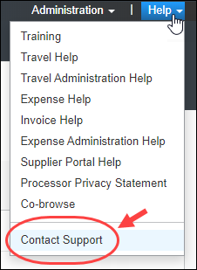
If you do not have the option to contact SAP Concur support in the Help menu, then your company has chosen to support the SAP Concur service internally. Please contact your internal support desk for assistance.
- Click Support > View Cases.
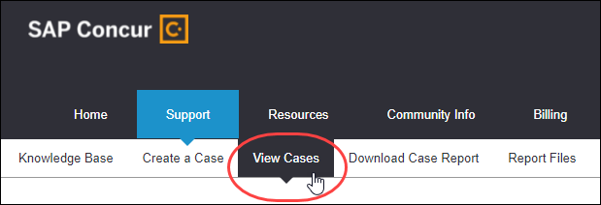
In the table, view the desired type of cases based on the View list selection. Search results are limited to each company's own cases.
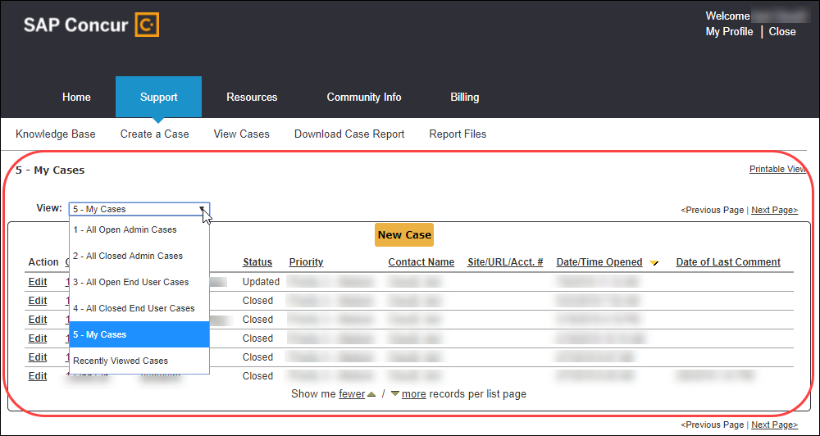

Additional Release Notes and Other Technical Documentation

Online Help
Any user can access release notes, setup guides, user guides, admin summaries, monthly browser certifications, supported configurations, and other resources via online Help or directly on the SAP Help Portal.
Use the links in the Help menu in the app, or search for your SAP Concur product (Concur Expense, Concur Invoice, Concur Request, or Concur Travel) on the SAP Help Portal (https://help.sap.com) to view the full set of documentation for your product.

SAP Concur Support Portal – Selected Users
Access release notes, webinars, and other technical documentation on the SAP Concur support portal.
If you have the proper permissions, Contact Support appears on the Help menu. Click to access the SAP Concur support portal, then click Resources.
- Click Release/Tech Info for release notes, technical documents, etc.
- Click Webinars for recorded and live webinars.
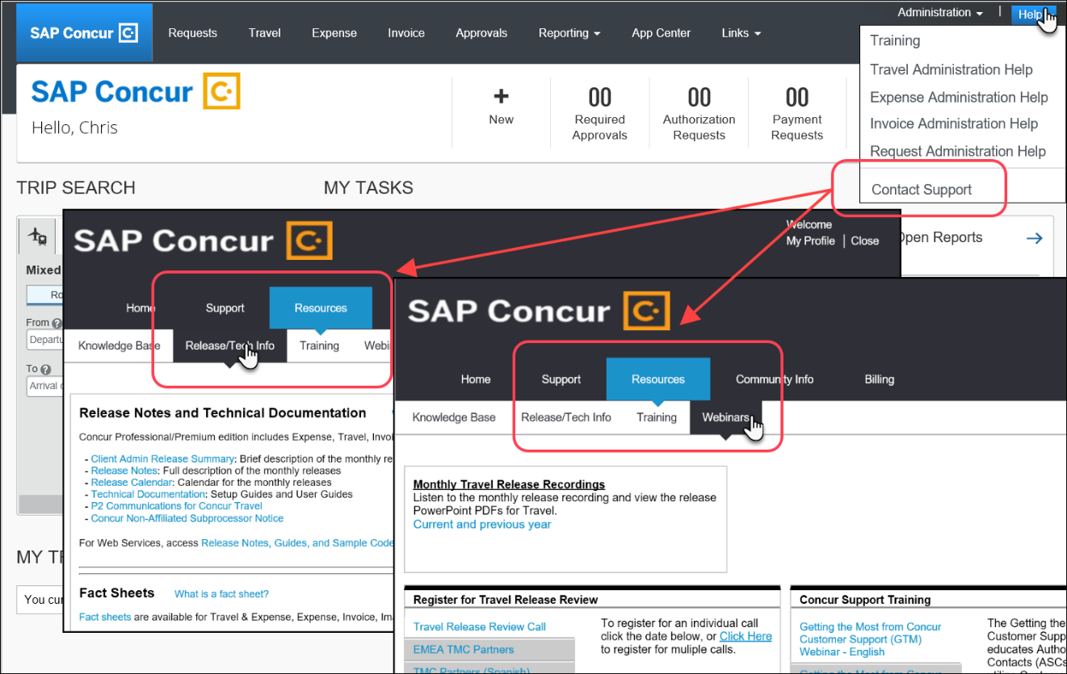
© 2022 SAP SE or an SAP affiliate company. All rights reserved.
No part of this publication may be reproduced or transmitted in any form or for any purpose without the express permission of SAP SE or an SAP affiliate company.
SAP and other SAP products and services mentioned herein as well as their respective logos are trademarks or registered trademarks of SAP SE (or an SAP affiliate company) in Germany and other countries. Please see http://global12.sap.com/corporate-en/legal/copyright/index.epx for additional trademark information and notices.
Some software products marketed by SAP SE and its distributors contain proprietary software components of other software vendors.
National product specifications may vary.
These materials are provided by SAP SE or an SAP affiliate company for informational purposes only, without representation or warranty of any kind, and SAP SE or its affiliated companies shall not be liable for errors or omissions with respect to the materials. The only warranties for SAP SE or SAP affiliate company products and services are those that are set forth in the express warranty statements accompanying such products and services, if any. Nothing herein should be construed as constituting an additional warranty.
In particular, SAP SE or its affiliated companies have no obligation to pursue any course of business outlined in this document or any related presentation, or to develop or release any functionality mentioned therein. This document, or any related presentation, and SAP SE’s or its affiliated companies’ strategy and possible future developments, products, and/or platform directions and functionality are all subject to change and may be changed by SAP SE or its affiliated companies at any time for any reason without notice. The information in this document is not a commitment, promise, or legal obligation to deliver any material, code, or functionality. All forward-looking statements are subject to various risks and uncertainties that could cause actual results to differ materially from expectations. Readers are cautioned not to place undue reliance on these forward-looking statements, which speak only as of their dates, and they should not be relied upon in making purchasing decisions.

