
Shared: App Center Administrator
User Guide

Last Revised: December 5, 2023

Applies to these SAP Concur solutions:
 Expense
 Professional/Premium edition
 Standard edition
 Travel
 Professional/Premium edition
 Standard edition
 Invoice
 Professional/Premium edition
 Standard edition
 Request
 Professional/Premium edition
 Standard edition

Table of Contents
Section 1: Permissions 1
Section 2: Overview 1
Section 3: What the User Sees 2
What the User Sees 3
Disabled App 3
Unsupported Product 3
Accessing the App Center Page 4
Searching for Apps 5
Section 4: Configuration 6
Connecting an App 6
Connecting an App – From the Enable Partner Applications Page 6
Connecting an Enterprise App – From the App Center 8
Disconnecting an App 11
Disconnecting an App – From the Enable Partner Application Page 11
Disconnecting an App – From the App Center 12
Disabling an App 13
Disabling an App – From the Manage Partner Applications Page 13

Revision History
Date |  | Notes/Comments/Changes
December 5, 2023 | Updated the App Center Release Notes link in Section 2: Overview
September 13, 2023 | Updated content and image to reflect searching for newly released apps under Searching for Apps section.
July 15, 2022 | Updated some images to reflect new filter feature
April 12, 2022 | Updated images throughout. Combined Disabling an App sections. Updated text in Connecting an app section for clarity. Changed the name of Consumer apps to User Connections. Added link to TripLink admin controls.
January 21, 2022 | Updated the copyright year; no other changes; cover date not updated
October 15, 2021 | Added the Section 5: Configuration section with information about the ability to disable enterprise applications
January 25, 2021 | Updated images and details regarding app disablement to Managing Consumer Apps section.
April 27, 2020 | Renamed the Authorization Request check box to Request on the guide’s title page; cover date not updated
January 15, 2020 | Updated the copyright; no other changes; cover date not updated
March 21, 2019 | Updated some images. No term change required for invoice change from "payment request" to "invoice".
February 1, 2019 | Updated the copyright; no other changes; cover date not updated
December 21, 2018 | Updated guide to add information managing applications using the Manage Partner Applications page. Updated the Connecting an Enterprise App and Disconnecting an Enterprise App sections.
September 12, 2018 | Updated the What the User Sees section.
April 17, 2018 | Changed the check boxes on the front cover; no other changes; cover date not updated
January 26, 2018 | Updated the copyright; no other changes; cover date not updated
August 19, 2017 | Guide now generally available.
August 2, 2017 | Minor edit; no change to Last Revised date on cover or footers
July 29, 2017 | Added the Managing Consumer Apps section.
July 19, 2017 | Minor edit; no change to Last Revised date on cover or footers
March 18, 2017 | New guide.

App Center Administrator

Permissions
The SAP Concur App Center allows administrators to activate enterprise apps for their company. To activate an app, the administrator must have one of the following user roles:
Professional Edition:
- Company Administrator
- Web Services Administrator
Standard Edition:
- Can Administer

Overview
This guide provides information about the SAP Concur App Center, managing User Connection Applications, and connecting to Enterprise Applications.
User Connection and Enterprise Applications are pre-built integrations with SAP Concur solutions. Applications are available to support a wide variety of functions including IT, Finance, Compliance, Sales, and more. These applications improve spend management and compliance while making travel and expensing easier for users.
User Connections are available for end users to directly connect to. Enterprise Applications must be enabled by a company administrator before the end user can connect with them.
Most of the setup steps are the same for all providers. For information on specific providers and new User Connection apps, please refer to the App Center Release Notes.

What the User Sees
User Connection apps allow the user to connect their SAP Concur account to the app supplier without involving the SAP Concur administrator. A User Connection app appears in the User Connections sections in the App Center.
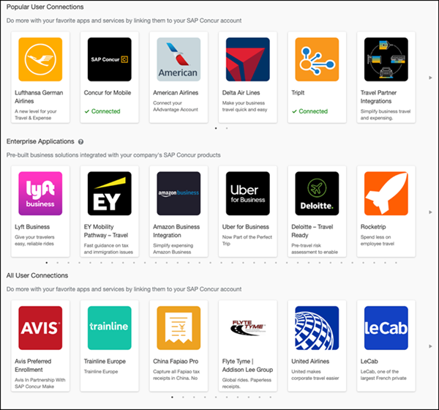

What the User Sees
User Connection apps allow the end user to connect directly with the app supplier, using the Connect button, in the App Center:
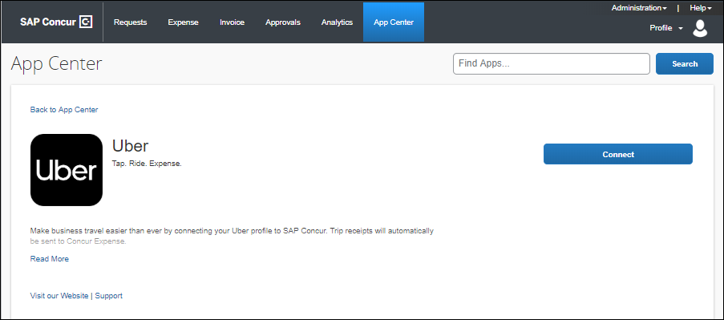

Disabled App
Disabled apps will not appear in the user’s App Center link within your SAP Concur solution. If a user accesses a disabled app via a direct link or login link from the public App Center, they will not see a Connect button and will see a message that the app is unavailable:
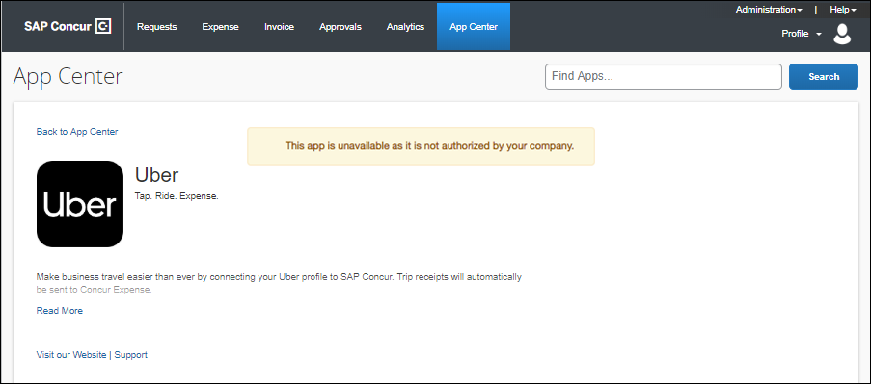

Unsupported Product
If the user accesses the listing for an app that is not supported by their SAP Concur products, the user will see an error directing them to the list of compatible products.
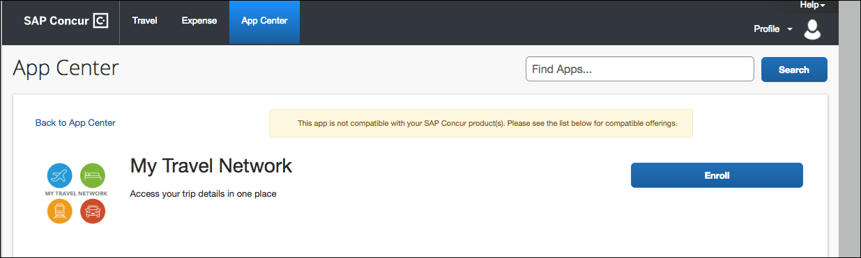
The SAP Concur products supported by the app are listed in the Works with these Concur Offerings section of the App Center listing.
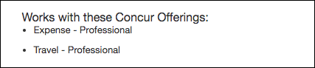

Accessing the App Center Page
The App Center page is available on the top menu of the SAP Concur home page.
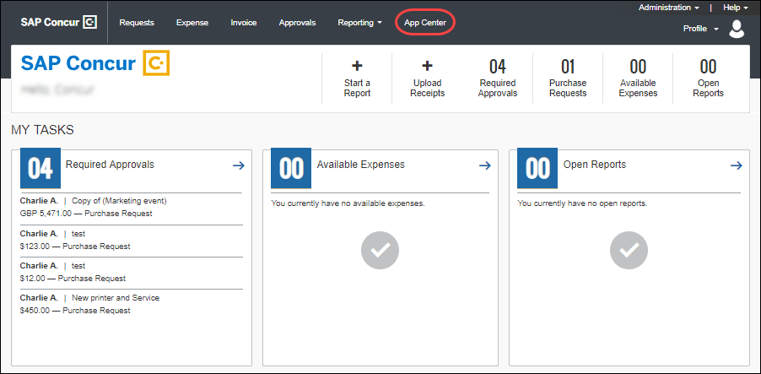

Searching for Apps
To search for apps, the administrator may:
Enter the desired app name in the search field and click Search or filter apps by Category, Product, Country, or Region. You can also view the newly released apps by clicking the Show newly release apps checkbox.
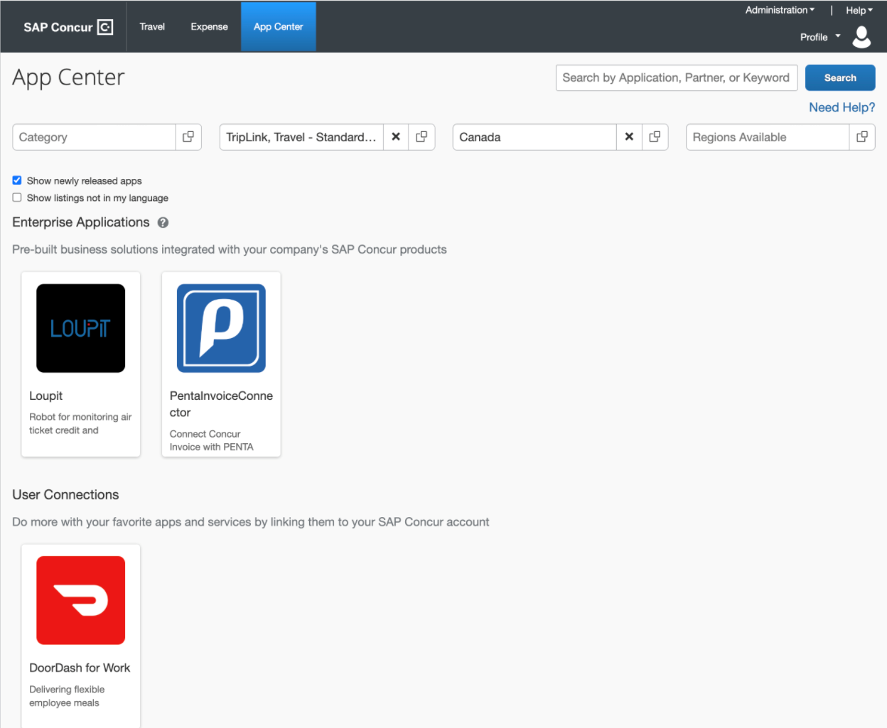
Use the arrow buttons to scroll through the Enterprise Applications apps:
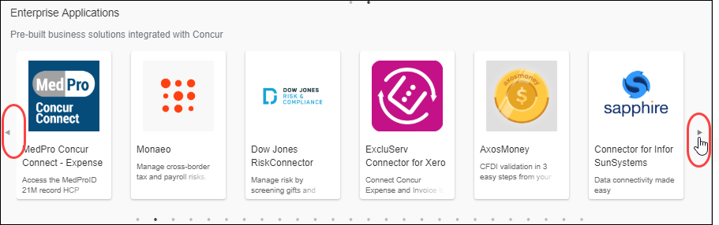

Configuration

Connecting an App
There are several ways to connect an app. These processes are described below.

Connecting an App – From the Enable Partner Applications Page
Some apps must be enabled using the Enable Partner Applications page in SAP Concur. To complete this process, the user must have the correct permission:
- Professional Edition: Web Services Admin
- Standard Edition: Can Administer
- For more information on how to assign user roles in Professional Edition, refer to the Shared: User Administration User Guide.
- For more information on how to assign user roles in Standard Edition, refer to the Shared: Users Setup Guide.
To access the Enable Partner Applications page:
The Manage User Applications page is available at Administration > Company > Web Services > Enable Partner Applications.
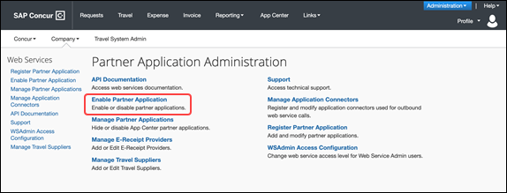
The Enable Partner Applications page appears.
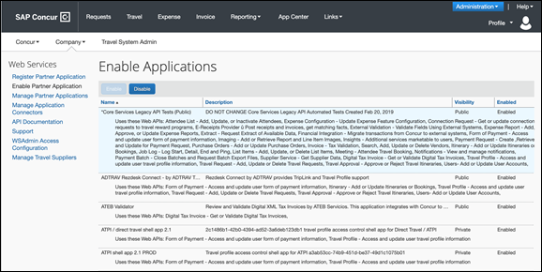
To connect an app:
- Sign into your SAP Concur solution as a user with the required permission.
- Click Administration > Company > Web Services > Enable Partner Application.
- Select the desired application.
- Click Enable. You will be prompted to agree to the data sharing terms and conditions.

Connecting an Enterprise App – From the App Center
The App Center Enterprise Applications will require one of the two supported authorization flows.
To connect an enterprise app:
- Click the App Center listing for the desired app. The listing displays. Depending on the application, you will see one of two options:
- The Activate (Connect) option. These applications can be activated directly from the App Center.
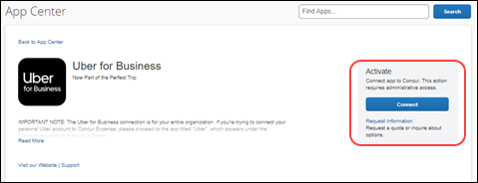
- The Request Information option. These apps are customizable for your company or are serviced by the partner directly. For these apps, the partner will contact you to connect.
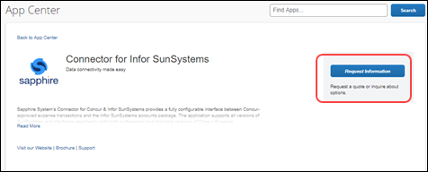
The remainder of this procedure covers the Activate process.
The Request Information option can be used for answers to any questions regarding the integration and customization, or for support in the connection process.
- Click Connect to begin the connection process.
- Use the arrow to expand the sections on the Terms & Conditions window.
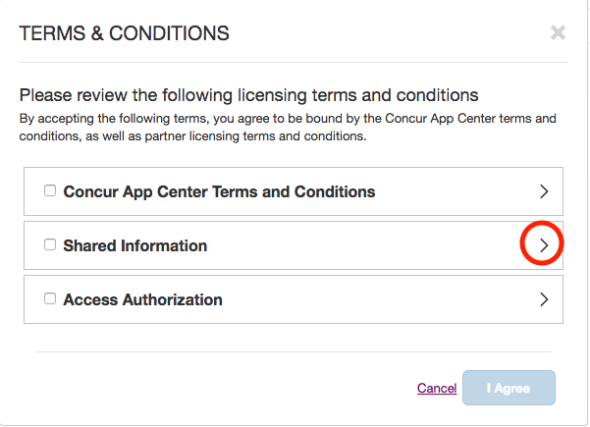
You will see up to three Terms and Conditions for review:
- Concur App Center End-User Terms & Conditions. These are the basic terms of use for individual users in the App Center. You will be asked to accept these terms only once.
- Shared Information. This states the specific information that will be shared with the partner. This is specific to the partner integration you are connecting to. You will be asked to accept these terms for each application.
- For more information on the exact information shared with partners, please visit https://developer.concur.com/api-reference/.
- Customer Authorization to Link Accounts. These are the basic terms of use for company-wide integrations. Your company will be asked to accept these terms only once.
- For answers to frequently asked questions regarding the Customer Authorization to Link Accounts, please see our FAQ.
- Select the check boxes for each of the applicable Terms and Conditions for the app.
- Click I Agree.
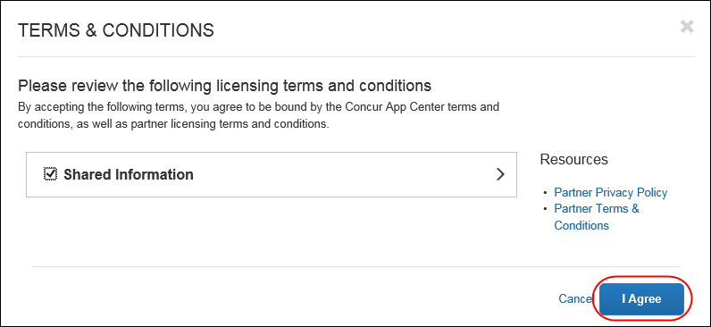
- You will then be redirected to the partner site in a new window. Here, you will sign in using your existing account or create a new administration account with the partner.
- Once signed in, your administration account can be used going forward to manage the application and integration with SAP Concur. Follow the steps on the partner’s site to complete the integration.
- When the partner application integration is complete, the app will show as Connected in the App Center:
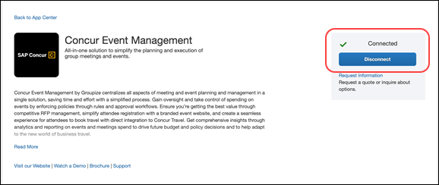
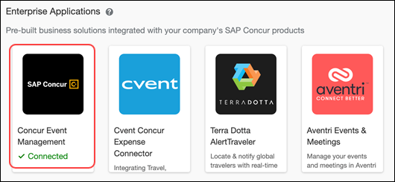
To verify whether your organization is connected to an application:
- Log in to your SAP Concur solution.
- Click App Center.
- In the Enterprise Applications area, check the desired app for the Connected status.

Disconnecting an App
The administrator can disconnect from an app at any time. As soon as the app is disconnected, the integration will be stopped.

Disconnecting an App – From the Enable Partner Application Page
Apps that are enabled via the Enable Partner Applications page can be disabled from the same page.
To disconnect an Enterprise Application via the Enable Partner Application:
- Click Administration > Company > Web Services > Enable Partner Application.
- Click the app you would like to disconnect.
- Click Disable.
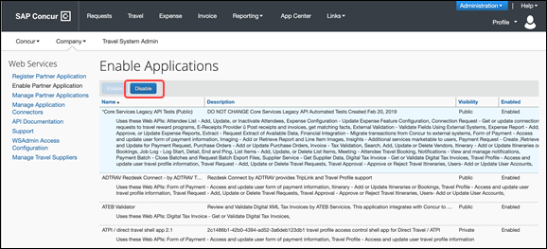
- Follow any additional disconnect processes with the partner.

Disconnecting an App – From the App Center
Apps that were connected using the App Center can also be disabled in the App Center.
To disconnect an app via the App Center:
- Select the app listing in the App Center.
- Click Disconnect. Only Administrators with the Web Services admin role can disable Enterprise Applications.
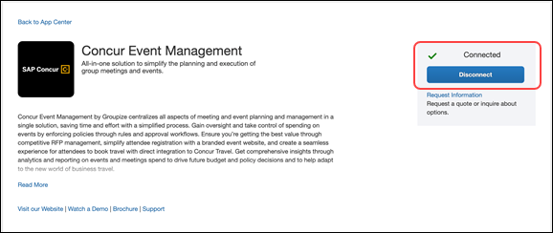
- For Enterprise Applications, follow any additional disconnect steps provided by the partner.

Disabling an App

Disabling an App – From the Manage Partner Applications Page
Some SAP Concur clients need to restrict which apps the end users can connect and
view on the App Center. You can use the Manage Partner Applications page to disable the applications in your App Center.
The app settings:
- Remove the app from the App Center tab within your SAP Concur instance.
- For User Connections: Prevent users from connecting to the integration from outside the App Center.
- For both User Connections and Enterprise Applications: Break any connections that the users or your company has already made to the app through the App Center.

- IMPORTANT: If any employees or your business are connected to an application via the SAP Concur App Center, disabling the application will break those connections and block future connections.
To disable an app:
- Log in to your SAP Concur solution as a user with the correct permission:
- Professional Edition: Web Services Admin
- Standard Edition: Can Administer
- Click Administration > Company > Web Services > Manage Partner Applications.
- Depending upon which type of application you would like to disable, select User Connections or Enterprise Applications in the App Type filter.
- Click Search.
- For the desired application, select the Disable Application check box.
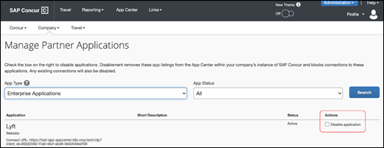
- IMPORTANT: To avoid service disruptions, it is highly recommended to confirm that your organization is not connected to an Enterprise Application before disabling it.
- Click Confirm on the dialog. The listing for that application will be removed from your company’s SAP Concur App Center and connections will be disabled.
Users who access the listing page using a direct link or from the public App Center will see a message that the app is unavailable and the connect button will be removed.
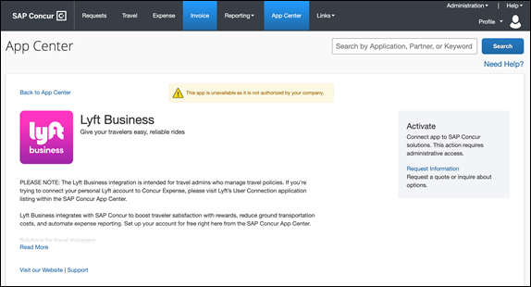

Some User Connection applications cannot be disabled via this tool, including:
SAP Concur Applications (such as Concur Mobile). These applications are components of the SAP Concur offerings and cannot be removed.
To manage Concur TripLink applications, you will need to use the TripLink Admin Controls. View the User Guide for TripLink for more details.
☼

