
Concur Invoice: Purchase Request and Purchase Order
User Guide for Standard Edition
Last Revised: September 16, 2023
Applies to these SAP Concur solutions:
 Concur Expense
 Professional/Premium edition
 Standard edition
 Concur Travel
 Professional/Premium edition
 Standard edition
 Concur Invoice
 Professional/Premium edition
 Standard edition
 Concur Request
 Professional/Premium edition
 Standard edition

Table of Contents
Section 1: Overview 1
Section 2: Access the Feature 2
Section 3: What the Purchase Request User Can Do 3
Create a Purchase Request 4
Add New Item 4
Review Vendor Information 5
Request New Vendor 6
Enter Purchase Request Details 8
Manage a Pending Request 11
Manage Images 11
Search for a Ship-to Address 15
Change Ship-To or Bill-To Address 15
Create and Submit a PO Change Order 17
Edit an Existing Purchase Request 20
Delete an Existing Purchase Request 20
Cancel a Change Request 20
Copy an Existing Purchase Request 21
Change Purchase Request Policy 22
Submit a Purchase Request 23
View Purchase Orders 23
Create Invoices From Purchase Orders 23
Recall a Purchase Request 24
Auto-Assign PO-Based Invoices to Original Purchase Request Owner 25
Reassign PO-Based Invoices Created Within Concur Invoice 26
Reassign PO-Based Invoice Created Outside of Concur Invoice 27
Manage Receipts and Receipt Images 27
Search for a Purchase Request 28
Change View Search Option 28
Add a Comment to an Item 29
View Comments 30
View the Audit Trail 32
Select Different Vendors for Project- and Event-Based Requests 33
Distribute (Allocate) a Purchase Request 33
Import Distributions 36
Create and Manage Allocation Favorites 38
Act As a Proxy for a Purchase Request User 41
How It Works 41
Stop Acting as a Proxy 43
View the Approval Flow 43
View Default Purchase Request Approver 44
Email Notifications of Status Change and Required Approvals 45
Section 4: What the Purchase Request Approver Can Do 45
Search for a Purchase Request 46
Change View Search Option 46
Send Back a Purchase Request 46
Approve and Forward a Purchase Request 48
Approve a Change Request 48
Upload and View Images 49
View Comments 52
View the Audit Trail 53
View the Approval Flow 54
Add a Comment to an Item 55
View Purchase Order Contact and Email Address 57
Section 5: What the Purchasing Admin Can Do 57
Process Purchase Requests 57
Send Back a Purchase Request 58
Search for a Purchase Request 59
Change View Search Option 60
Use a Query to Search for a Purchase Request 60
View Associated Images to a Purchase Request 63
Purchase Order Contact and Email Address 64
Clear Exceptions for a Purchase Request 64
Approve a Purchase Request 65
Approve and Forward a Purchase Request 66
Approve a Change Request 67
Upload, View, and Delete Images 67
View Comments 70
Review Audit Trail 71
View Approval Flow 72
Change Ship-To Address 74
Add a Comment to an Item 75
Delete an Item from a Purchase Request 77
Distribute (Allocate) a Purchase Request 77
Process Purchase Orders 84
Review or Change a Vendor 85
Change Ship-To or Bill-To Address 86
Edit Purchase Order Details 87
Send Back a Purchase Order 88
Create Invoices From Transmitted Purchase Orders 90
Void a Purchase Order 90
Upload, View, and Delete Images 92
Close a Purchase Order 95
Reopen a Closed Purchase Order 97
View Associated Images to the Purchase Order 98
Search for a Purchase Order 98
Use a Query to Search for a Purchase Order 99
View PO Amount That Has Been Invoiced 101
View Original Invoice or Purchase Request Associated with a PO 102
Review the Audit Trail 104
Preview a Purchase Order 105
Preview a PO Change Order 107
Transmit Purchase Order to the Vendor 108
Automatically Transmit Purchase Orders 109
Transmit a Change Order 109
Manage Receipts and Receipt Images 110
Extract Purchase Orders 111
Download and Search for Purchase Order Extracts 112
Section 6: Configure Column and Fields Set View 113
Add, Delete, and Move Columns 113
Rearrange Columns 114

Revision History
Date | Notes/Comments/Changes
September 16, 2023 | Updated the Create a Purchase Request section to include the new Policy field.
August 31, 2022 | Minor edits; cover date not updated
January 21, 2022 | Updated the copyright year; no other changes; cover date not updated
December 2, 2021 | Updated the screenshots and text on pages 105 and 106 to reflect new static suffix for the From line in PO preview.
March 4, 2021 | Updated the copyright year; no other changes; cover date not updated
October 21, 2020 | Added information about users with the Purchase Request User and Purchase Request Processors roles being able to delete images.
June 12, 2020 | Minor edit; no content change.
June 11, 2020 | Added information about reopening closed purchase orders.
May 21, 2020 | Added note that states that users who do not have access to the Distribution functionality will not see it.
January 8, 2020 | Updated the copyright; no other changes; cover date not updated
December 17, 2019 | Removed references to the deprecated ‘pause while “Acting as” another user’ feature.
October 8, 2019 | Minor edit; no content changes.
September 25, 2019 | Minor spelling correction; no content changes.
September 24, 2019 | Updated the Reassign PO-Based Invoice Created Outside of SAP Concur section.
September 23, 2019 | Updated the “Auto-Assign PO-Based Invoices to Original Purchase Request Owner” procedure.
May 11, 2019 | Added information about the new View Details link and new comments icon.
February 28, 2019 | Fixed a couple more instances of 'payment request'. Updated 'Concur' to SAP Concur'. Updated images and added some details in the 'act as a proxy user' section.
January 30, 2019 | Updated the copyright; no other changes; cover date not updated
November 17, 2018 | Added Purchase Order Extracts. Updated screenshots with outdated logos (with exceptions). Replaced instances of ‘payment request’ with ‘invoice’.
April 11, 2018 | Changed the check boxes on the front cover; no other changes; cover date not updated
March 19, 2018 | Added information about bill-to address on PO Change Order editable when deleted on original purchase order.
March 17, 2018 | Added information about ship-to address on PO Change Order editable when deleted on original purchase order.
October 14, 2017 | Added information about hyperlinked invoice and purchase request numbers.
September 16, 2017 | Updated some images to show the now available hyperlinked purchase requests and purchase orders in some windows for purchase request users, purchase request processors, and purchase order processors.
July 29, 2017 | Added information about transmitted PO PDF emails to vendors displaying all recipients.
June 24, 2017 | Added the following information:  - Purchase Request Creators can create invoices from their purchase orders  - Purchase request users can add notes to vendors for specific purchase request
June 3, 2017 | Added the following information:  - Search options for purchase request processors  - PO contact name and email address available in Vendor list and field for purchase request creators, purchase request approvers, and purchase request processors
April 22, 2017 | Added the following information:  - PO Change Order feature  - Users can change bill-to address on purchase requests  - Users cannot edit or delete a receipt that is associated with an invoice
March 18, 2017 | Added information about purchase request users being able to see the purchase orders resulting from their purchase requests.
January 20, 2017 | Added information about Invoice Users being able to reassign invoices to another user.
December 13, 2016 | Changed copyright and cover; no other content changes.
December 5, 2016 | Updated the guide content to new corporate style; no content changes.
November 4, 2016 | Added information about the following:  - The Concur Receiving feature  - Processor page now displaying all invoices that need to be processed for new clients
October 14, 2016 | Added information about the Need By Date field.
September 9, 2016 | Added information about the following:  - Purchase request vendor search enhancements  - Ability to change purchase request policy
August 12, 2016 | Added information about warning message appearing for processor in Preview Purchase Order window and updated purchase order images.
July 8, 2016 | Added information about searching for a ship-to address.
February 19, 2016 | Added information about the following:  - Exporting query results  - Ability to view account code
 | Older revision history has been removed.

NOTE: Multiple SAP Concur product versions and UI themes are available, so this content might contain images or procedures that do not precisely match your implementation. For example, when SAP Fiori UI themes are implemented, home page navigation is consolidated under the SAP Concur Home menu.

Purchase Request and Purchase Order

Overview
The Purchase Requests and Purchase Orders (PR and PO) feature allows clients to achieve internal spend authorization by using purchase requests. These requests are become purchase orders (documents that authorize a supplier to provide goods or services at specified prices and quantities) in return for payment. When coupled with existing Concur Invoice, PO Matching and Pay functionality, these features provide an end-to-end spend authorization to pay lifecycle.
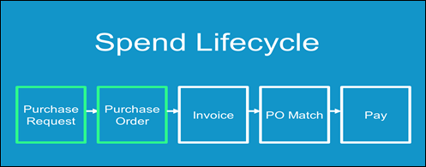

Access the Feature
To access the Purchase Request (PR) feature, first ensure that SAP Concur has enabled the feature.
- For more information, refer to the Concur Invoice: Purchase Request and Purchase Order Setup Guide.
To access the feature, click Requests, and then select an option in the Purchase Request menu depending on your user role.
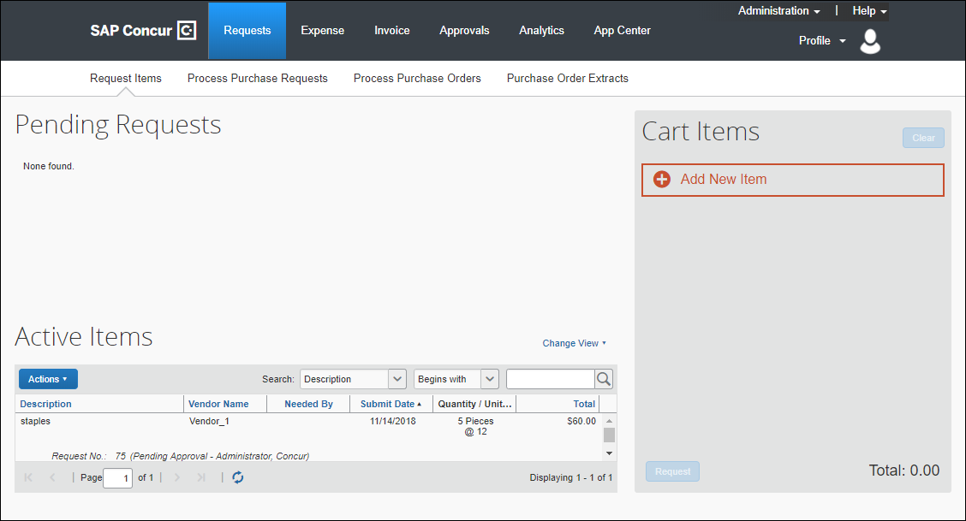
Users who work with purchase requests and purchase orders have a unique view designed to allow rapid entry and review. Additional options allow each user, depending on their role, to submit, approve, and transmit, or as required, return a request to the requestor, or even to terminate the PO past its transmittal phase, after it is in the hands of the vendor.

What the Purchase Request User Can Do
The user with the Purchase Request User role is limited to opening only the Pending Requests page via the Request > Request Items menu. When creating the purchase request, the user is assembling goods and/or services request items, then assembling these items under a single PR, using a descriptive name, such as Flood Damage Repair or Christmas Gala 2022. This is essentially the reverse of tasks presented when creating an invoice in Concur Invoice, where the line items follow the header items. If the user clicks in the Vendor field, the five most recently used vendors appear in a list. Users may also click the More Search Options link that appears in the vendor list to be able to perform more advanced search options. These search options are also available on the purchase request details page.
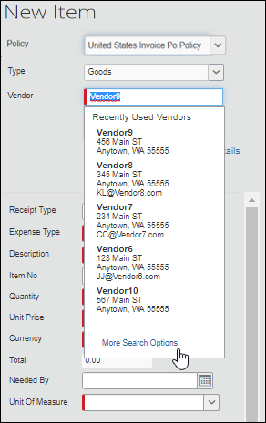

Create a Purchase Request

Add New Item
The user may create one or more items by first clicking Add New Item, selecting the PO policy based on activated country packs, specifying the type of item (Goods or Services), and then selecting a vendor. When selecting a vendor, type the name in the Vendor field to view a list of vendors from which to choose.
The Policy list’s field values are determined from the user’s Profile configuration on the Invoice Information page in Invoice Settings.
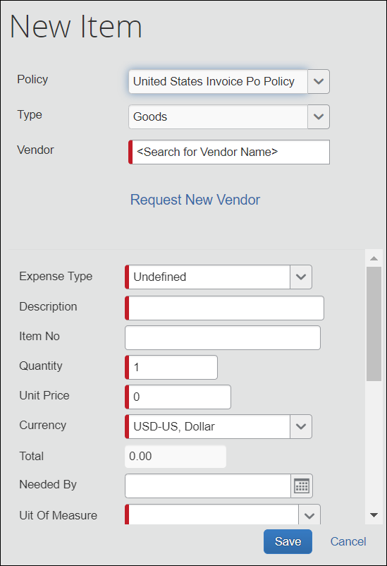

Review Vendor Information
After selecting a vendor, the user can see the vendor address below the Vendor field. If the vendor information includes the PO contact name and/or the PO contact email address, this information will also be displayed below the Vendor field.
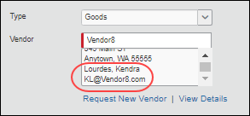
After selecting a vendor in the Vendor field, the user can review all available vendor information by clicking View Details to open the Vendor Information page.
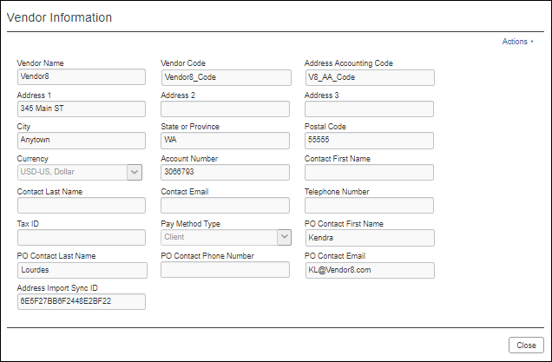
The View Details link is also available for each line item in the Request Items section when the user views an opened purchase request.
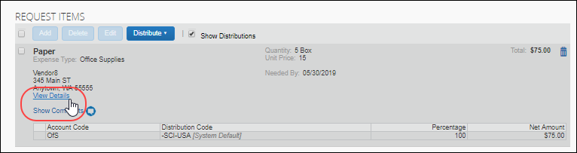
The PO contact name, email address, and View Details link are also visible in the Request Items section of a purchase request line item that is opened for editing.
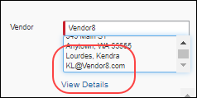

Request New Vendor
When adding new items to a purchase request, the user can also request a new vendor by clicking Request New Vendor.
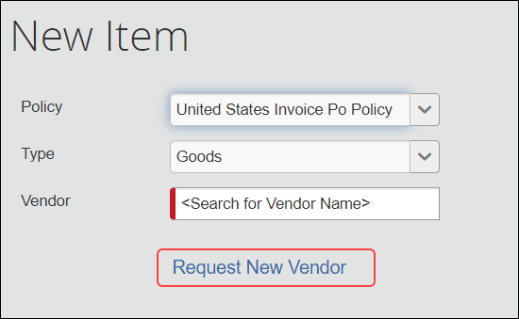
The Request New Vendor page appears.
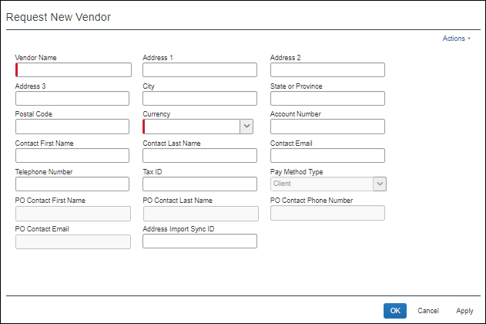
After entering the required information and clicking OK, the new vendor is added to the system with a status of Unapproved.
The Vendor Manager reviews and approves the vendor as appropriate. For more information, refer to the Concur Invoice: Administration User Guide for Standard Edition.
The user can now fill out the remaining fields for the purchase request type. Required fields are marked with a red bar.
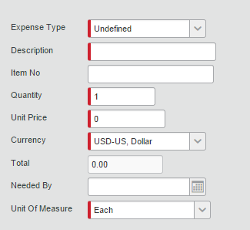
If the user selects a needed-by date, this date appears on the Purchase Order page and in the Preview Purchase Order window. If the field is left blank, the purchasing admin will not see this field in the Preview Purchase Order window.

Enter Purchase Request Details
After entering the required information, the user clicks Request and the Purchase Details page opens.
To save the request, the user must fill in the required purchase request header information. The required fields are marked with a red bar.
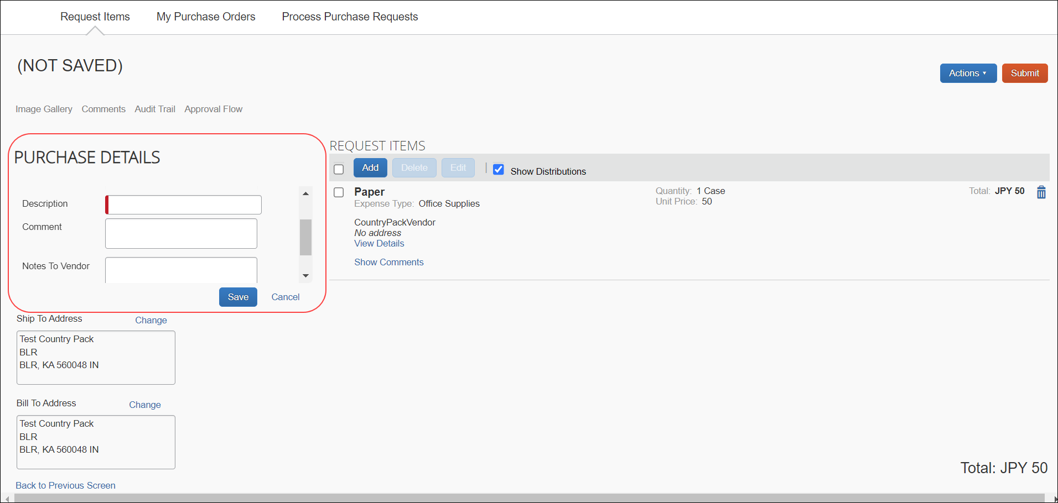

Set Ship To and Bill To Addresses
When the user clicks in the Ship To Address or Bill To Address field, a list of the addresses that the Invoice Admin configured in Product Settings > Company Locations displays.
- For more information about company locations, refer to the Concur Invoice: Company Locations User Guide.
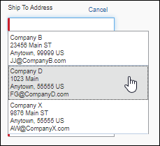
After selecting an address, the user can change the address by clicking Change or make the address their default shipping address by selecting (enabling) Make this location my default.
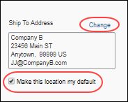
The default address will be selected in the Ship To Address field automatically when new purchase requests are created.
The default shipping address can be changed by clicking Change on the Purchase Details page, changing the address, and then re-selected (enabling) Make this location my default.
The user can also change the default shipping address by going to Profile > Profile Settings > Invoice Preferences.
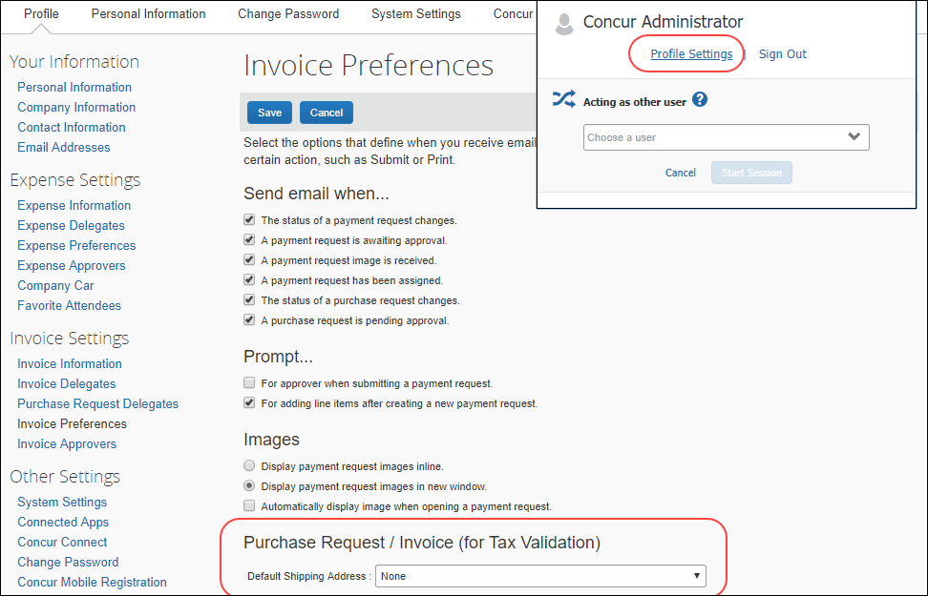

Additional Fields
You can add comments for purchase request users, approvers and processors and add notes to the vendor about a purchase request.
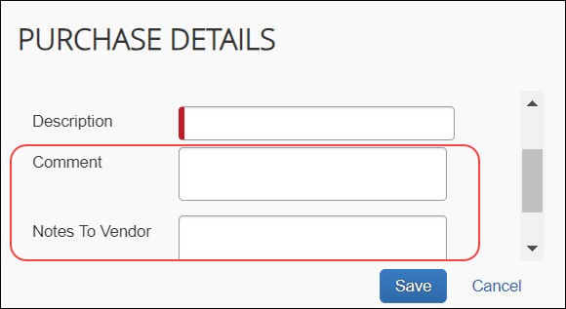

Manage a Pending Request
Clicking Save adds the request to the Pending Requests section on the Request Items page.
Prior to submitting the request, you can add line items, edit existing line items, submit, edit, or delete the request. In addition, you can use the Actions menu to add an image and you can review comments and the audit trail.
If comments have been added to a purchase request line item or purchase request header, an icon displays next to the Show Comments link.
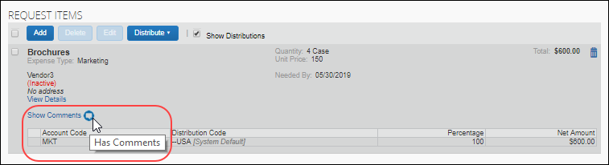
After you submit the purchase request, you can no longer make changes to the request.

Manage Images
The user can upload, view, and delete images. In addition, the user can attach supporting documents to a purchase order that transmits to a vendor by selecting (enabling) the Include in PO Transmission check box in the Upload Image window. Further, the user can choose documents that are already available for a purchase request and attach these documents for the vendor.
To upload an image
- Click Actions > Upload Image.
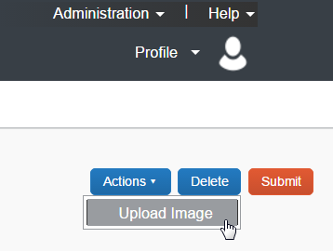
The Upload Image window appears.
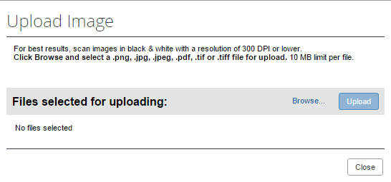
- Click Browse and select the desired image by double-clicking it, or by selecting it and clicking Open.
- (Optional) Select (enable) the Include in PO Transmission check box.
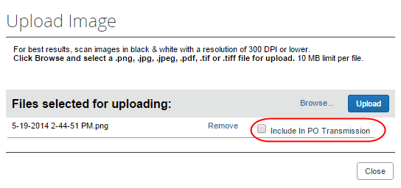
- Click Upload.
- Click Close.
To view an image:
- On the Request page, click Image Gallery.
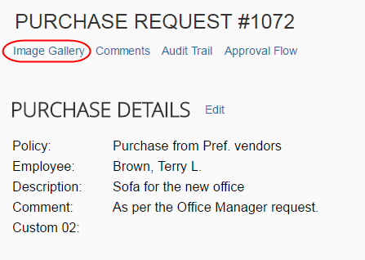
The Purchase Request Images window appears. If there are more than one image or supporting document, you can toggle between them by using the Next and Previous buttons.
You can also include supporting documents in the PO transmission from the Purchase Request Images window by selecting (enabling) the Include in PO Transmission check box.
The approver and purchasing admin, who processes purchase requests, can view images and include supporting documents in the PO transmission. The processor can also delete images, whereas approver cannot.
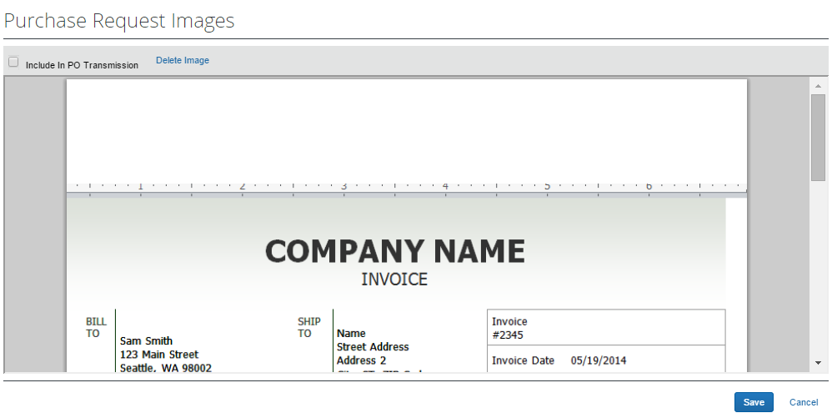
- Click Save or Cancel when you are done.
To delete an image:
- On the Request page, click Image Gallery.
- In the Purchase Request Images window, click Delete Image.
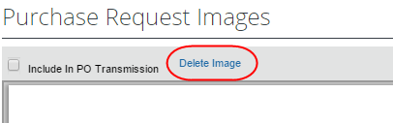
The Please Confirm window appears.
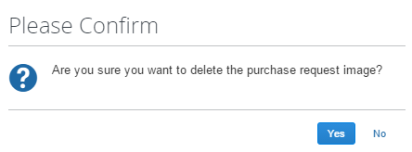
- Click Yes. Once you have deleted an image, the next image, if there is one, appears.

Search for a Ship-to Address
To search for a ship-to address, start entering the company name in the Ship To Address field. The list that appears shows the company name and the full address details. In addition, the list shows the default address.
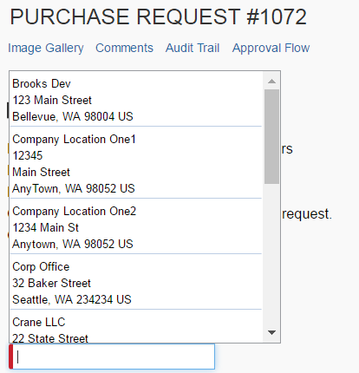

Change Ship-To or Bill-To Address
The purchase request user can change the ship-to or bill-to address on purchase requests, so that they can send the vendor the correct address to which to ship or bill the request. Users can switch to any ship-to or bill-to address available for their company.
The default ship-to or bill-to address that is used on policy level should be used for the purchase request. If the user changes the policy on the purchase request, the system does not change the ship-to or bill-to address on the purchase request since the user might have changed this previously from the former policy default.
To change the ship-to or bill-to address:
- Double-click the desired purchase request. The Purchase Request window appears.
- In the Ship To or Bill To section, click Change.
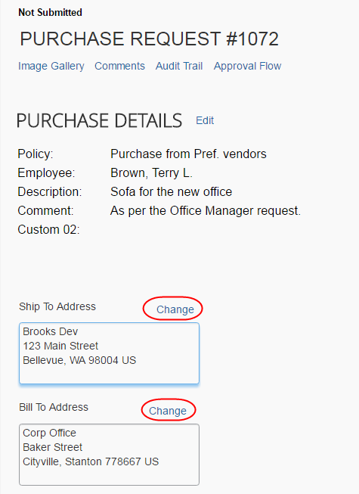
- In the Ship To or Bill To field, click the field to select a different ship-to or bill-to address. (Example of Bill To field below.)
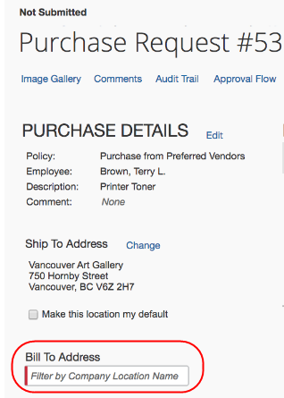
- Click Save.

Create and Submit a PO Change Order
Provided SAP Concur or the client admin has activated the PO Change Order feature, the purchase request user will be able to start creating PO change orders from their transmitted purchase orders. The purchase request user first locates the purchase order from which they would like to create a change order by clicking Requests > Purchase Requests > My Purchase Orders.
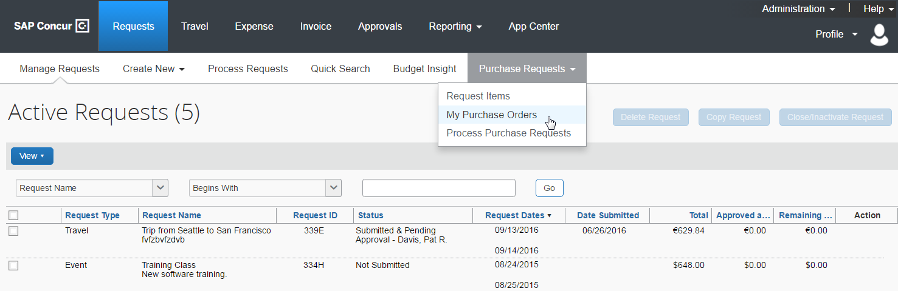
From the All Orders page, the purchase request user can view their purchase orders in read-only mode, but will be able to select a transmitted purchase order, and then clicks Actions > Create Change Order.
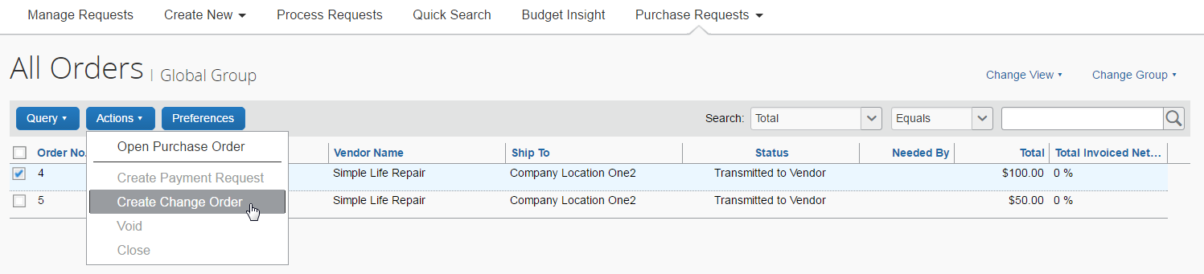
The purchase order will now return to the original purchase request, and an icon appears on the now unsubmitted purchase request. As a matter of fact, most users who work with a specific purchase request or purchase order that is in a PO Change Order mode will see this icon next to the purchase request/purchase order.
Once the purchase order is in a PO Change Order mode, additional changes cannot be requested for that purchase order until it has been approved.
The purchase request user can now add new line items to the purchase request by opening the purchase request and clicking Add.
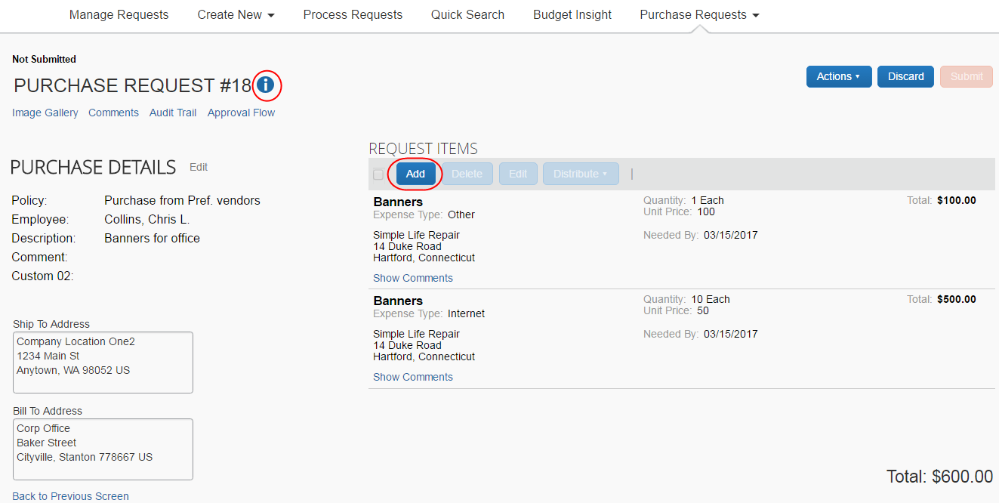
Apart from adding line items, the purchase request user can edit, delete, or distribute line(s) they they have just added. All other fields will be read-only, such as vendor details. In addition, they can add or update the ship-to and bill-to addresses on the PO Change Order if the addresses were deleted on the original purchase order. When the purchase request user has added the desired line items, they need to click Save.
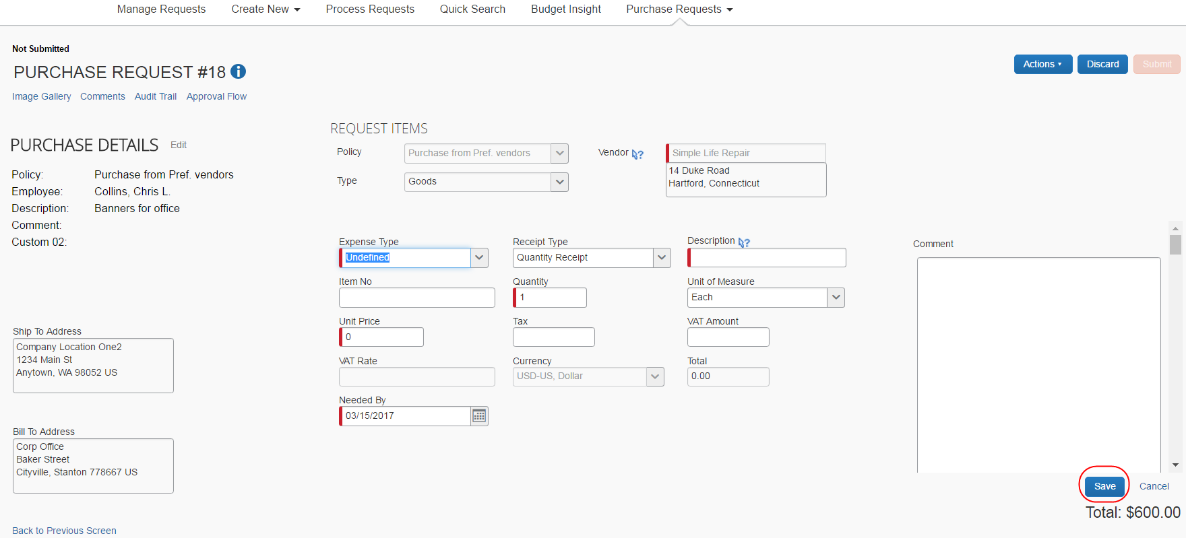
After saving the purchase request, the purchase request user is taken back to the purchase request details page from which they can click Submit to send the purchase request for approval. The purchase request will go through the same approval workflow as previously.
If the purchase request is part of a limit approval workflow, the approval workflow will be based on the new total purchase order amount.
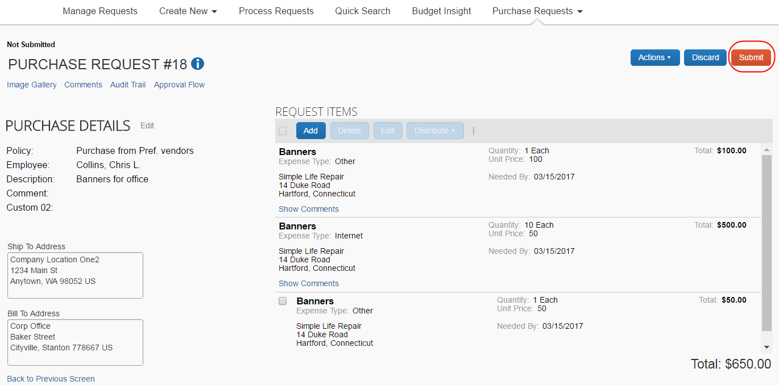

Edit an Existing Purchase Request
To edit a purchase request, for example adding items, double-click it directly and use the instructions in the Create a Purchase Request section as a guide.
Once the purchase request has been submitted, the purchase request user cannot edit the request.

Delete an Existing Purchase Request
The user can delete a purchase request by clicking the Trash icon for the unsubmitted request on the Pending Requests page, or, by clicking Delete if the user has opened the request.
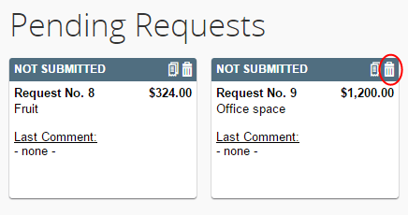

Cancel a Change Request
If the purchase request user wants to cancel any current unsubmitted change requests they are working on, for example, if a manager does not approve a change and sends the request back to the purchase request user, they can do so by clicking Discard.
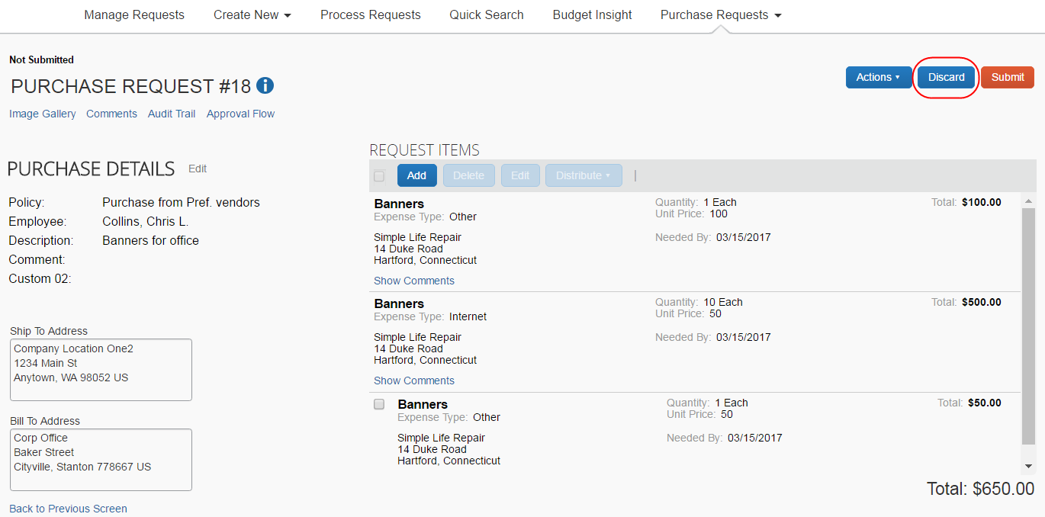

Copy an Existing Purchase Request
The user can copy a purchase request to create a new request. Do this by either:
- Unsubmitted Request: Clicking the Copy icon for the unsubmitted request
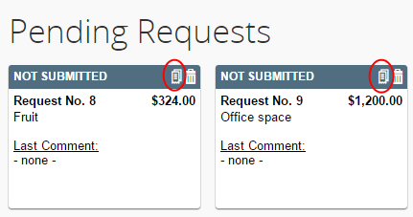
- Submitted Request: Selecting the request and then clicking Copy Request from the Actions menu of the submitted request
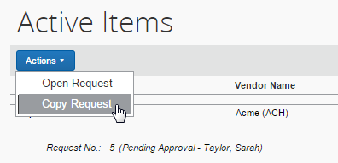
A user cannot copy a request that is associated with a closed purchase order.

Change Purchase Request Policy
Purchase request users can change policies of unsubmitted purchase requests, for example, if they have selected incorrect ones.
Concur Invoice will track the change of policy in the audit trail.
To change the policy, the user needs to open the purchase request and click the Edit link.
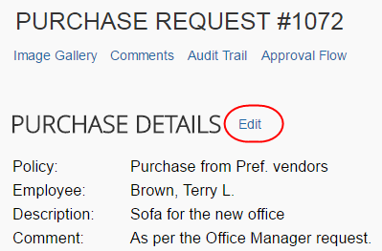
Then, in the Policy list, the user can change the policy and click Save.
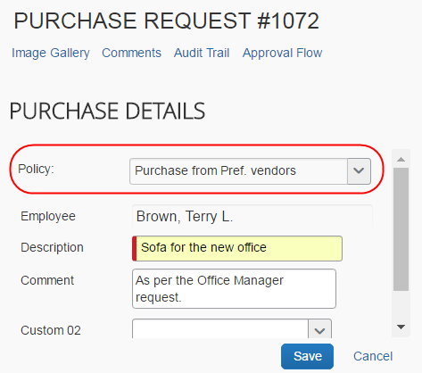

Submit a Purchase Request
Once submitted, the purchase request is first moved to the Active Items section pending final approval and processing, and then order generation and transmittal to the supplier.

View Purchase Orders
Purchase request users can view the purchase orders resulting from their created purchase requests. To do so, in the Purchase Request menu, click My Purchase Orders.
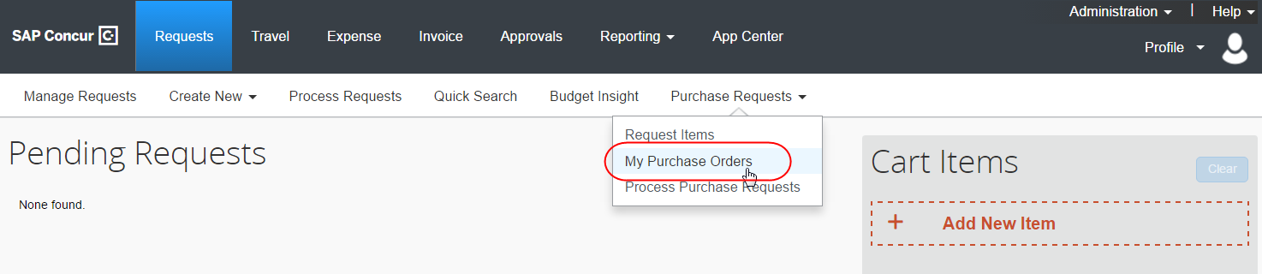
If you are both a purchase request user and a purchase request processor, you will not see the My Purchase Orders menu option.

Create Invoices From Purchase Orders
Purchase request creators can create invoices from their own transmitted purchase orders by selecting the Create Payment Request option in the Actions menu, either from the All Orders page or from an opened purchase order.
All Orders page:
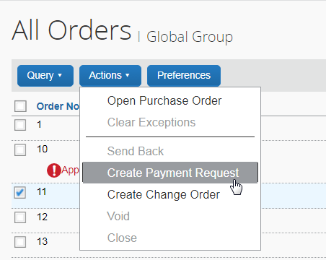
Purchase Order page:
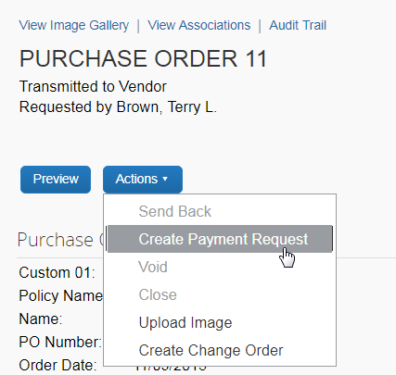

Recall a Purchase Request
The purchase request user can recall a purchase request that they have submitted but that the approver has not yet approved.
To recall a purchase request:
- On the Pending Requests page, double-click the submitted, but the not yet approved purchase request.
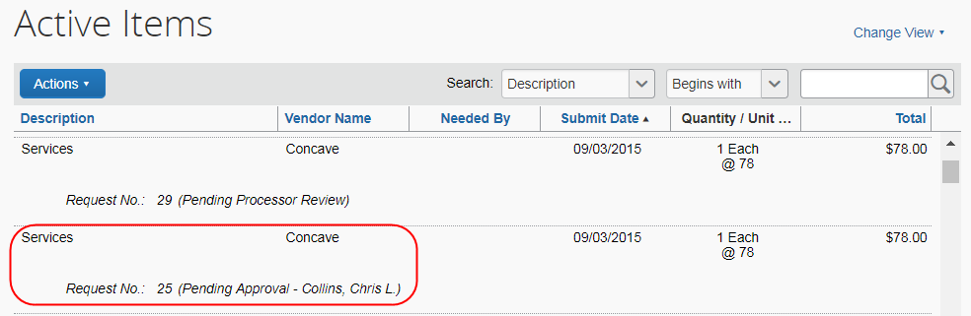
- On the Request page, in the Actions menu, click Recall Request.
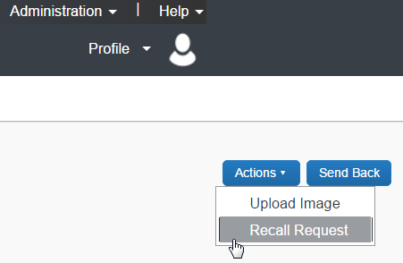
- In the Recall Request window that appears, click Yes.
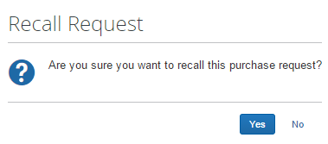

Auto-Assign PO-Based Invoices to Original Purchase Request Owner
SAP Concur created or externally created PO-based invoices that can be automatically assigned to the purchase request owner provided the Assign invoice to Purchase Request Owner option is selected (enabled) in the Approval Routing step of Product Settings.
This means that Concur Invoice will try to find the purchase request owner of the PO-based invoices. When the PR owner is found, Concur Invoice will automatically assign the purchase request owner as the invoice owner of the PO-based invoices.
- For more information, refer to the Concur Invoice: Approval Routing Setup Guide for Standard Edition.

Reassign PO-Based Invoices Created Within Concur Invoice
If the user wants to assign the unsubmitted PO-based invoice, where the PO is generated within Concur Invoice, they can do so from the My Invoices page.
To reassign a PO-based invoice:
- Open the invoice and then click the Assign button.
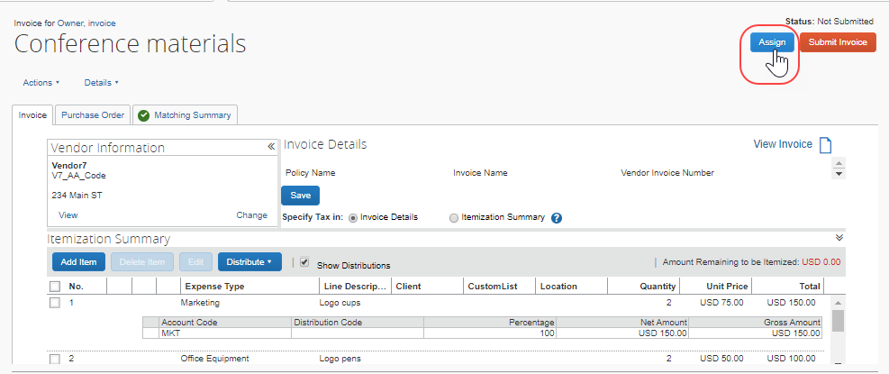
The Assign Invoices window appears..
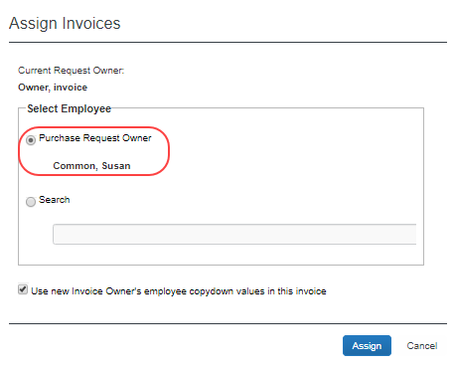
- Select the purchase request owner (the default selection) or search for the desired owner.
- Click Assign.

Reassign PO-Based Invoice Created Outside of Concur Invoice
In cases where the AP user needs to assign the externally created PO-based invoice, they can do so by clicking the Assign button or the Select Invoice Owner link.
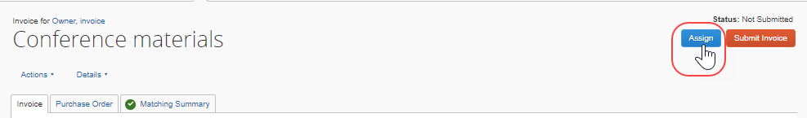
If they click the Assign button, the Assign Invoices window appears where the AP user can see who requested the purchase order or search for the desired owner and assign the PO-based invoice to that user.
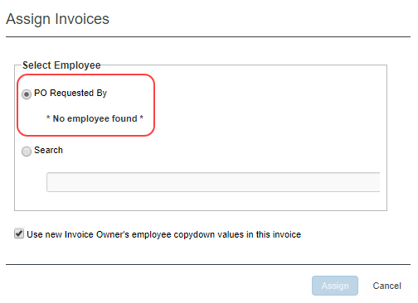

Manage Receipts and Receipt Images
Purchase Request Owners, who work with the Receiving feature, can add, edit, delete receipts and receipt images of the transmitted purchase order provided the Allow Purchase Request Owners to Edit their own Purchase Orders option is selected (enabled) in Invoice Settings.
If a receipt is associated with an invoice, a user will not be able to edit or delete the receipt and the Edit and Delete buttons will be disabled. If a user needs to make changes to an invoice, they need to first unassociated the receipt to the invoice.
- For more information, refer to the Concur Receiving section of the Concur Invoice: Purchase Order Matching User Guide.

Search for a Purchase Request
Purchase request users can search for their submitted purchase requests in the search area by selecting different search criteria, such as Vendor Name, Item Total, or Order No.
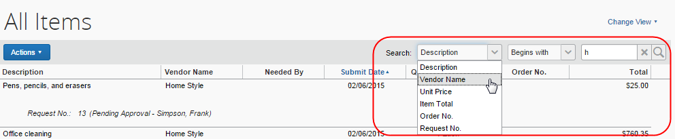

Change View Search Option
Purchase request users can also use the Change View menu to display active items or items submitted by date range. By changing the view, the result appears on the page.
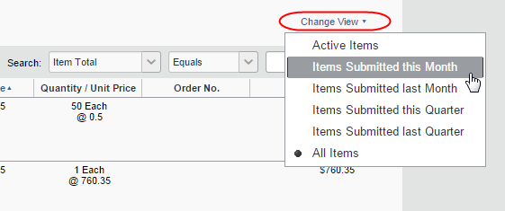

Add a Comment to an Item
Purchase request users can add comments to an item to clarify an item or to provide more information about an item.
To add a comment to an item:
- Open the desired purchase request.
- In the Items section, click Show Comments.
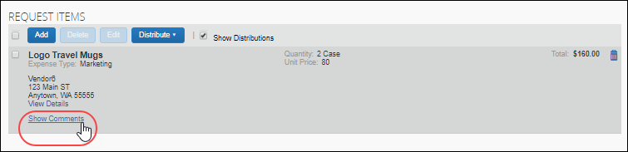
- Click the Add Comment link that appears.
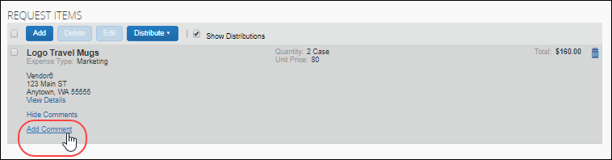
- In the comments field, type the comment, and then click Save.
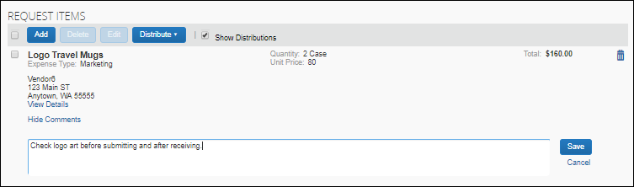
The comment appears in the Request Items section.
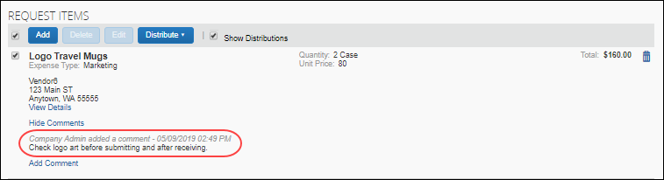
If comments have been added but are hidden, an icon is displayed next to the Show Comments link.
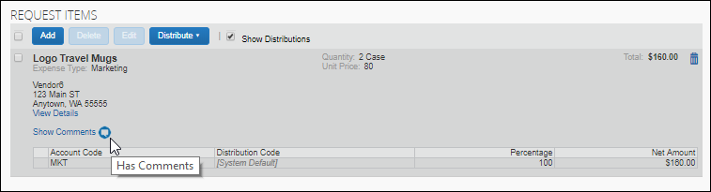

View Comments
The purchase request user can view comments about the purchase request that they have entered in the Details section of the purchase request or that the approver has entered when they have sent back a purchase request to the user.
To view comments:
- Open the desired purchase request.
- If comments have been added at the header level of the purchase request, an icon displays next to the Comments link. Click Comments to review the comments.
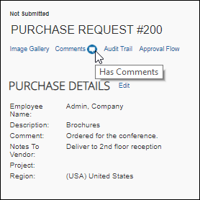
- In the Comment History window that appears, view the comments about the purchase request.
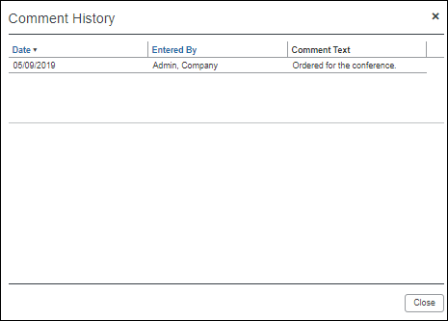
- Click Close.

View the Audit Trail
To review the audit trail, open the purchase request, and then click Audit Trail.
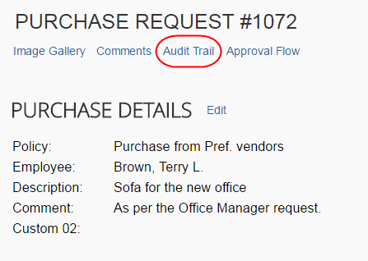
The Audit Trail window appears with information about actions that the purchase request user and the system have taken on the specific purchase request.
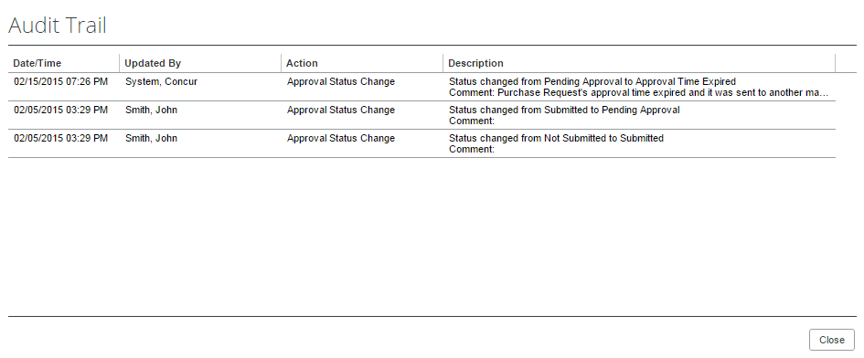
All users who have access to a PO change order transaction will be able to view the audit trail history of the PO Change Order.

Select Different Vendors for Project- and Event-Based Requests
When creating their purchase request, users may select a different vendor for each item within the overall purchase request. Associating a vendor at the item level adds more detail to the request and, combined with the ability to create project- or event-based requests, makes the process more efficient and budget appropriate.
For example, an office update project may combine goods (pens and pencils) alongside services (cleaning), with different vendors as required.
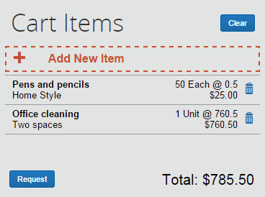
From this single request, multiple purchase orders are generated, each associated with the items contained in the original request. The unique PO number guides the system when an action, such as Send Back, requires that all POs be identified with the parent PR being returned to the requestor.

Distribute (Allocate) a Purchase Request
The purchase request user or purchasing admin, who processes purchase requests, can specify distributions at the line item level, so that they can allocate the cost of the purchase accurately. In addition, if they want to apply the same distributions to all line items, they can specify the distributions once and apply it to all line items.
The purchase request user, the approver, and the purchasing admin, who processes purchase requests, can create and manage distributions (allocations).
Only users with access to the Distribution functionality will see it. Users who need to access the Distribution functionality should contact their client administrator.
Distribute a purchase request:
- Open the desired purchase request.
- On the Request page, select one or more itemizations to that you want to distribute between departments.
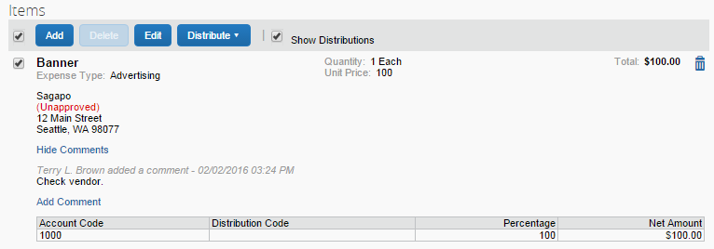
- Click Distribute > Distribute Selected Items.
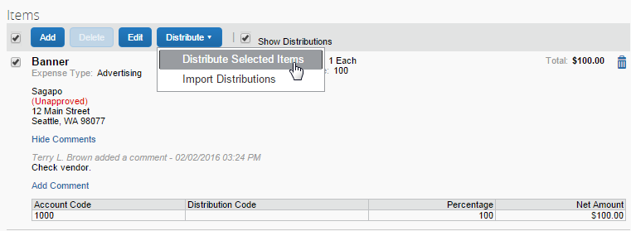
The Distribute Selected Items page appears.
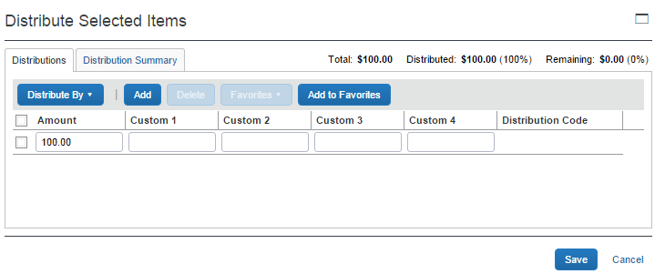
- Click Distribute By and select to distribute the allocation by amount or by percentage.
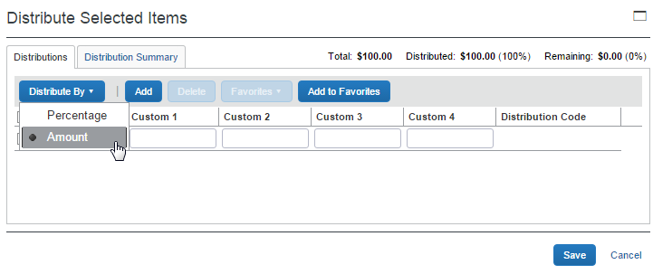
- Click Add. The total is now evenly spread between the number of allocations (you may adjust these manually, but the percent must equal 100 or the amount the overall total, excepting tax and shipping before you can proceed).
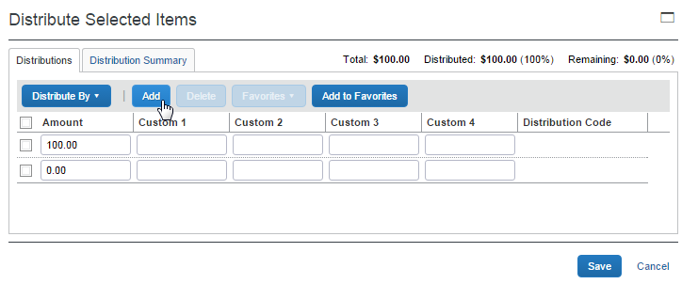
- Complete all required fields and the optional fields as directed by your company. (Your company defines the fields that appear on this page.)
- Click Save.
You can add or delete an item by clicking the Add or Delete button respectively.

Import Distributions
The purchase request user can import their distributions (allocations) by using the Import feature. This feature supports clients who need to distribute a single purchase request across a large number of cost objects. For example, the corporate office may decide one purchase request should be shared by all the 400 company retail locations. Imported distributions can be:
- Specified to import as either percentage or amount, with restrictions based on the sign (negative or positive)
- Applied across multiple line items at once
To import distributions:
- Double-click the purchase request that you would like to open.
- On the Request page, in the Items section, select the item for which you want to import distributions.
- Click Distribute, and then Import Distributions.
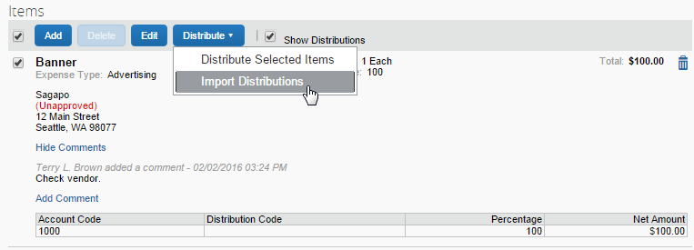
- In the Import Distributions window that appears, click Browse to select the file that you want to import. You may download a sample Excel file (.xls) template based off distribution (allocation) configuration fields by clicking Download Template.
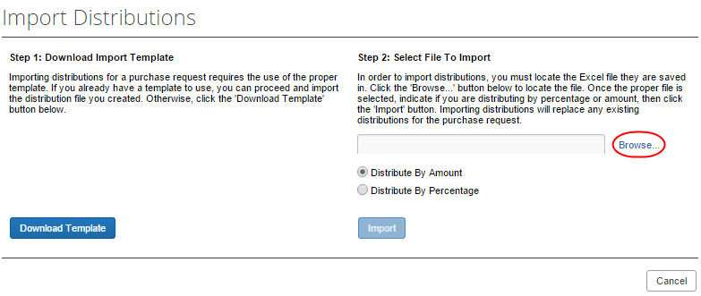
- Select the file to import, and then click Open.
- Click Import.
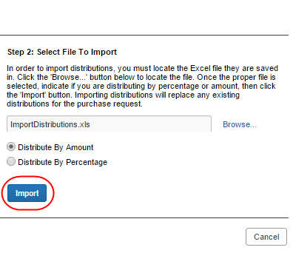
Concur Invoice imports the distributions and displays them in Concur Invoice.
- Click Save.
While Concur Invoice imports the distributions, error checking and validations are processed, and the results appear in the Import Errors window.

Create and Manage Allocation Favorites
Users often allocate many expenses in an identical manner. For example, they will allocate 20% of an expense to Cost Center A, and 80% to Cost Center B. The Allocation Favorites feature allows the user to save a group of allocations, to use on other expenses.
When the user applies these allocation favorite "sets" to another expense, the system validates the data in those stored allocation records to ensure any project codes or other list fields are still valid, and alerts the user if the user needs to correct data. The user adds the allocation to the expense, and then the user can edit the allocation just like a manually entered allocation row.
To create an allocation favorite:
- Open the desired purchase request.
- On the Request page, in the Items section, select the item for which you want to create a favorite allocation.
- Click Distribute > Distribute Selected Items.
- In the Distribute By menu, select if you would like to distribute the allocation by amount or percentage.
You can use the Add button to correctly identify and budget the expense to the accounting system. For example, use this if your need to spread your expenses across several projects or departments.
- Click Add to Favorites.
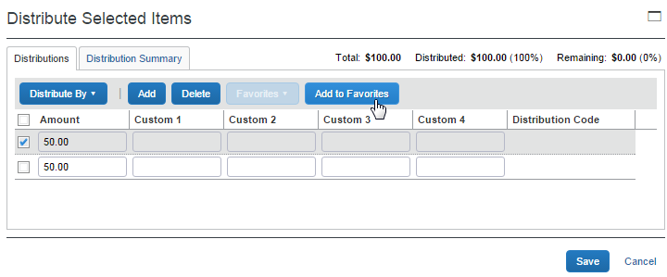
The Add to Favorites window opens.
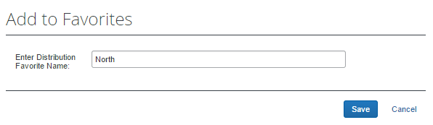
- Enter a name for the allocation favorite and then click Save. The system adds the allocation to your favorites, which you can see if you click Favorites.
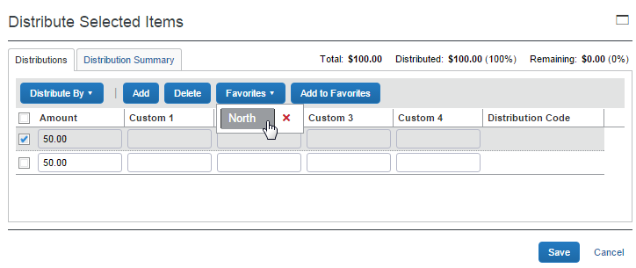
To assign your allocation favorite:
To assign your allocation favorites, follow the To create allocation favorite procedure that is described above. However, instead of clicking Add to Favorites, in the Favorites menu, select the favorite allocation that you would like to use.
To remove an allocation favorite:
Over time, allocation favorites will become incorrect or obsolete. The user can remove out-of-date allocation favorites by clicking on the red X icon next to the name as shown in the figure below.
To edit an allocation favorite:
The user can update the set by using it on an expense, making needed corrections, and then saving the resulting allocations to the same allocation favorite name. The system will confirm that the user wants to overwrite the existing set.
On the Distribution Summary page of the Distribute Selected Items window, the user may view a summary of a distribution they made of a particular line item.

Mapping Account Codes to Purchase Requests
Users may view the account code for the expense type that they selected when they created an item, so that they know which account code is going to apply to a specific purchase request. The account code for a purchase request is applicable for the item, but displayed and available at the distribution level. As the account code is derived from the expense type selected for an item, the same account code will be applied across all distributions for that item.
The user will be able to see the Account Code column in the following two places:
- In the Distribution Summary tab on the Request Number page
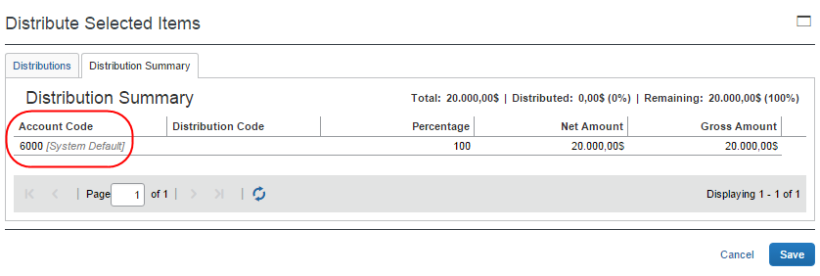
- In the Items section on the Request Number page
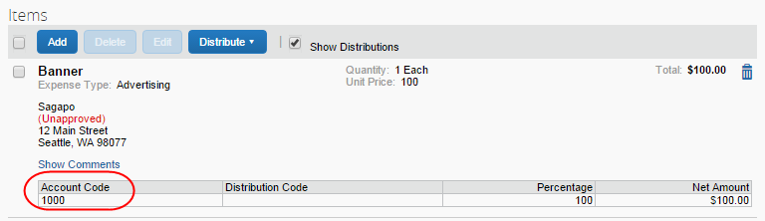

Act As a Proxy for a Purchase Request User
A user can be assigned a role that allows them to act on behalf of users assigned the Purchase Request User role. This feature is identical to its implementation in Concur Invoice, and is designed specifically to work within Purchase Request, without changing the Purchase Request User role and access right when they exit Purchase Request and begin working within Concur Invoice.

How It Works
The proxy feature works when the following role relationship is in effect:
- The Invoice Admin role is assigned to the user who will act as a proxy for users with the Purchase Request User role.
- The Purchase Request User role is assigned to the users that the Invoice Admin will act as a proxy for.
With this relationship in place, the Invoice Admin sees a list of users in the Acting as other user list in the Profile menu and will have the ability to select and act as a proxy for any user with the Purchase Request User role.
To act as a user with the Purchase Request User role:
- (Invoice Admin) Click Profile and then select the name of the user with the Purchase Request User role from the menu in the Acting as other user field.
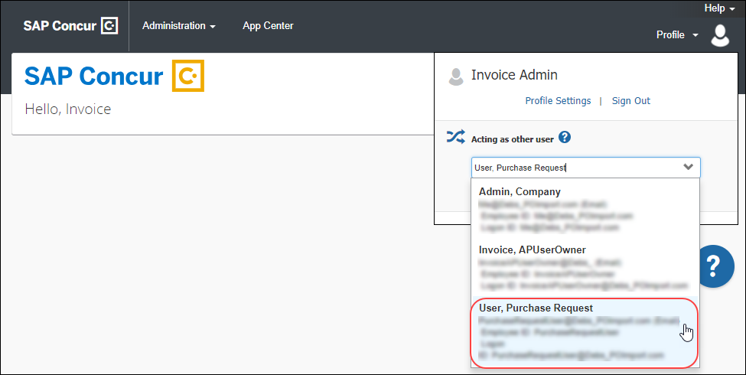
If the Invoice Admin has permission to act as users with other roles, those other users will also appear in the menu.
- Click Start Session.
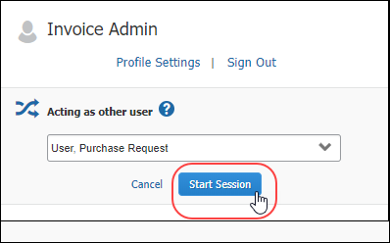
While the Invoice Admin is acting as a proxy for the Purchasing Request User, they will see the Purchase Request User's name below the SAP Concur logo on the left side of the page. In addition, a message that indicates they are acting as the selected user replaces the Profile menu heading.
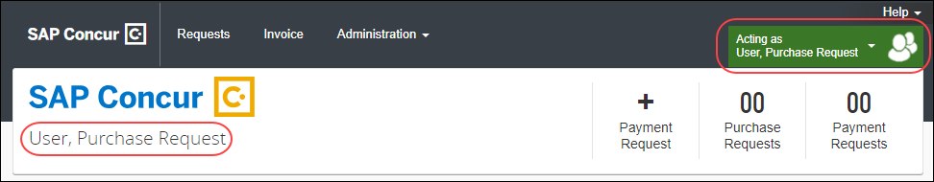

Stop Acting as a Proxy
To stop acting as a proxy for the Purchase Request User:
- Click on the message that indicates you are acting as the Purchase Request User.
- Click Done acting for others.
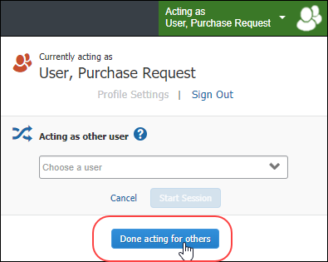

View the Approval Flow
The purchase request user can view the workflow to see all the approval steps that are part of the purchase request process. In addition, it is possible to submit the purchase request from the Approval Flow for Purchase Request window.
To view the approval flow:
- Open the desired purchase request.
- On the Request page, click Approval Flow.
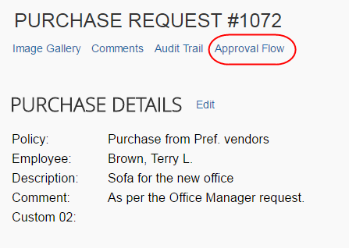
- In the Approval Flow for Purchase Request window, review the workflow, and then click Cancel, or click Submit to submit the request.
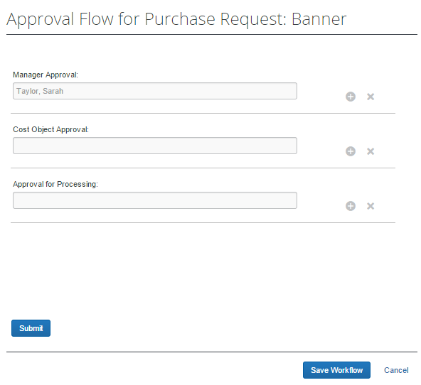

View Default Purchase Request Approver
The purchase request user can view the default purchase request approver by going to Profile > Profile Settings > Invoice Approvers. For users, the Invoice Approver page is a read-only page.
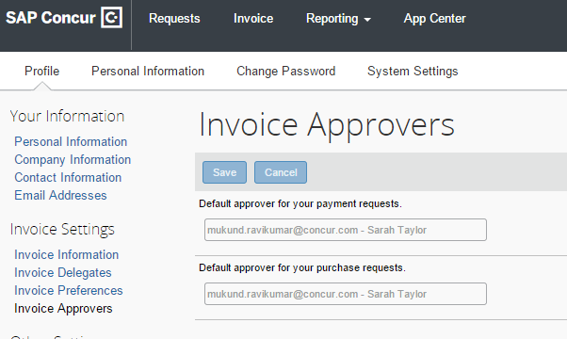

Email Notifications of Status Change and Required Approvals
Clients receive email notifications about status changes or approvals to be done of purchase requests. These notification emails contain a link that will take the client directly to the specific purchase request that has changed or that needs to be approved.
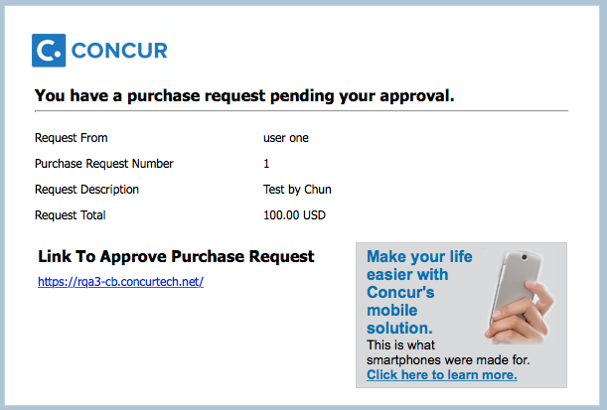

What the Purchase Request Approver Can Do
The user who has the Purchase Request Approver role clicks Approvals > Purchase Requests to access the request with which they need to work. The Request Pending your Approval page and its actions are virtually identical to those in Invoice, including search functionality and a Change View option to view by action or approval date range.
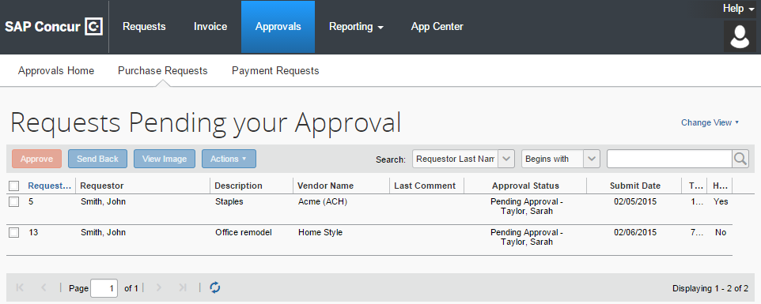
Additional options let the approver review the image and either approve, or send the purchase request back to the requestor. The approver is limited in what they can change in the request, and so may elect to send back, or have the purchasing admin adjust as needed.

Search for a Purchase Request
Approvers can search for approved purchase requests or requests that are pending approval in the search area by selecting different search criteria, such as Requestor Last Name, Total, or Request No.
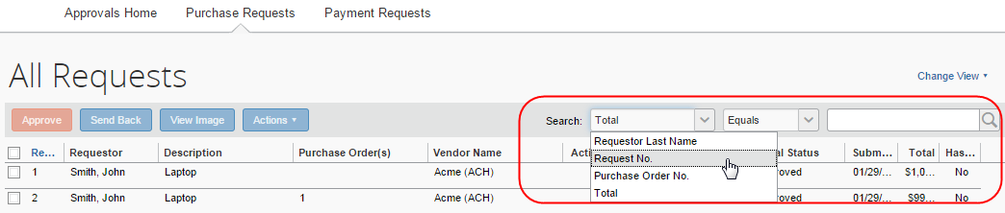

Change View Search Option
Approvers can also use the Change View menu to display requests pending their approval or requests approved by date range. By changing the view, the result appears in the page.
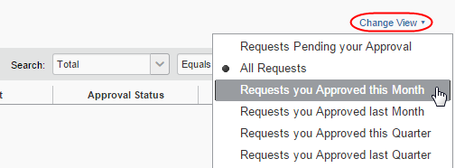

Send Back a Purchase Request
Approvers can send back a purchase request prior to transmittal to vendor to remove a purchase request from its workflow for the purpose of additional review, correction of the associated purchase request amount or cost object, or amend some additional items to the PR.
When a Send Back action is taken on the PR, the assigned purchase request number is voided, the original associated request item(s) are made read-only, and a new, duplicate PR is created with a status of Sent Back to Employee that includes the original items and allocations that were part of the now-retired PR. An indicator is also added to the new PR to show it was generated based on a now-invalid PR.
Finally, an email notification is generated and sent based on the purchase request email notification settings for the requestor.
To send back a purchase request:
- On the Requests Pending your Approval page, select the purchase request you want to send back by clicking its check box.
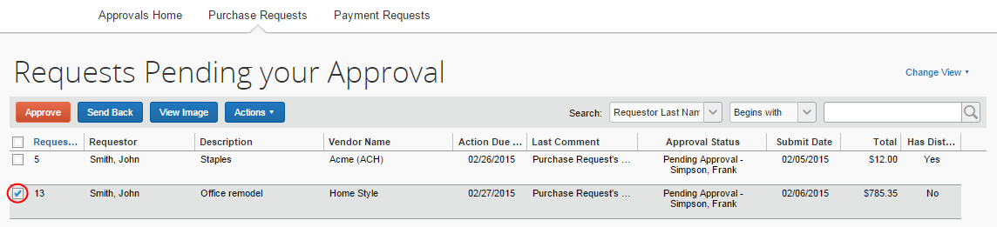
- Click Send Back.
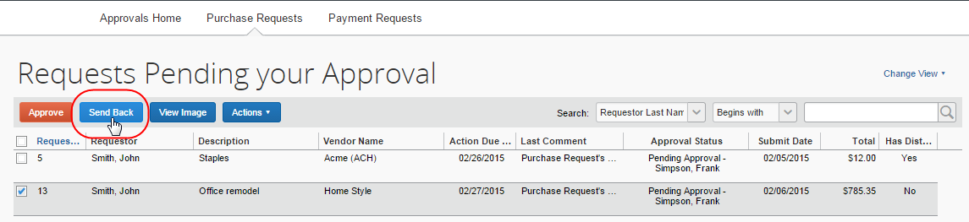
- In the Send Back Purchase Request window that appears, enter a comment about why you want to send back the purchase request, and then click OK.
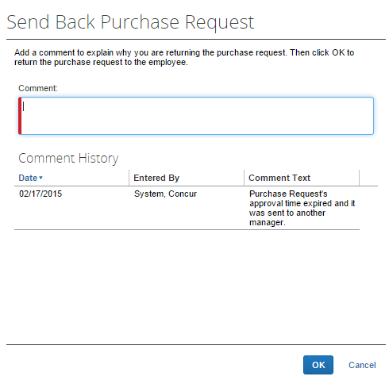

Approve and Forward a Purchase Request
If the approver wants to approve a purchase request but also add another approver, they can do this by opening the desired PR and clicking Approve & Forward.
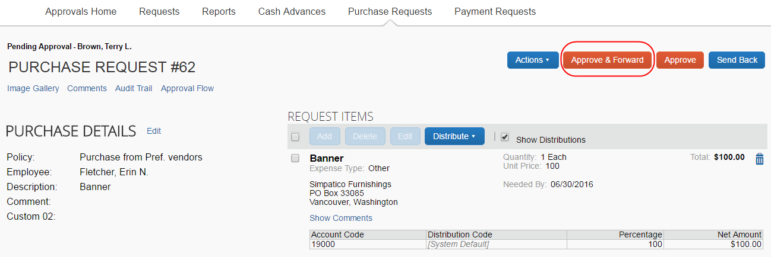
In the Approve & Forward Purchase Request window that appears, the approver can add another approver and a comment about why they would like to do this. Complete this step by clicking Approve & Forward.
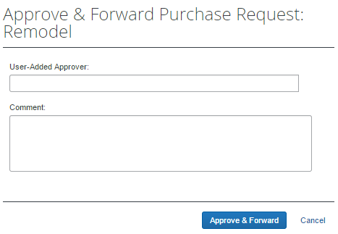

Approve a Change Request
When the approver logs in to approve the purchase request, they will see the icon, which indicates that this is a change request.
Apart from approving the purchase request, the approver will be able to edit the quantity of the purchase request. In addition, the approver can send the purchase request back to the purchase request user by clicking Send Back. The approver should include a send-back reason and the purchase request user is then notified by email that the purchase request is being sent back. Reminders, notifications, and escalations work the same way for change requests as they do for purchase requests.
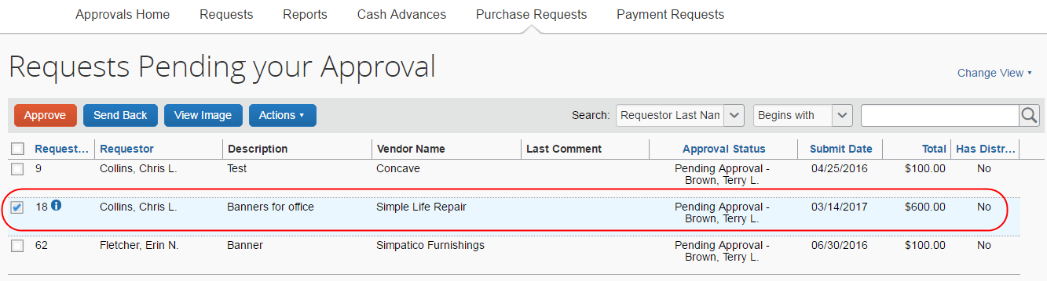
Once the approver clicks Approve, the purchase request will proceed to the purchase request processor for approval.
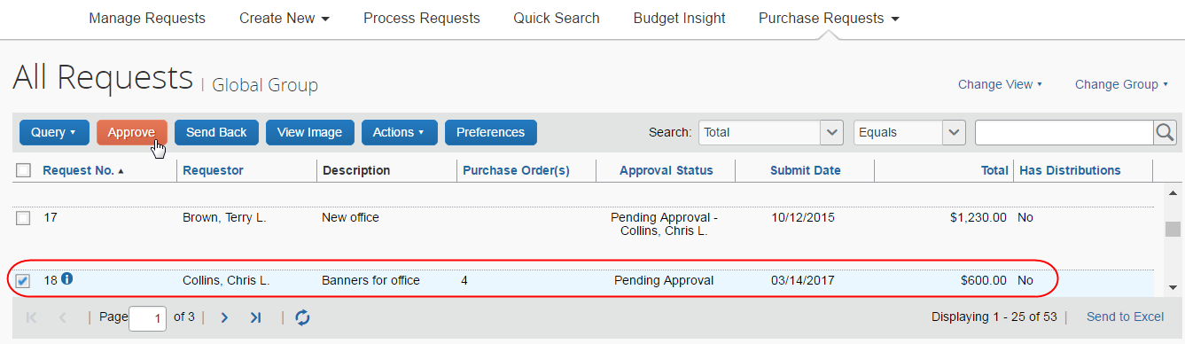

Upload and View Images
The approver can upload and view images to the purchase requests. However, approvers cannot delete images.
To upload an image:
- Open the desired purchase request.
- On the Request page, click Actions > Upload Image.
The Upload Image window appears.
- Click Browse and select the desired image by double-clicking it, or by selecting it and clicking Open.
- (Optional) Select (enable) the Include in PO Transmission check box.
- Click Upload.
- Select the file that you want to upload by double-clicking it or selecting it and clicking Open.
- Click Close.
To view an image:
- Open the desired request.
- On the Request page, click View Image Gallery.
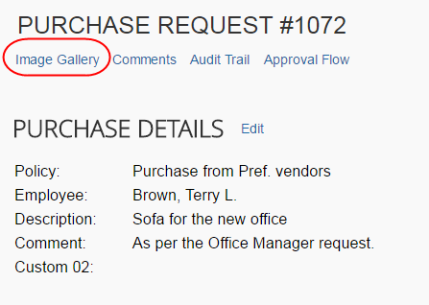
The Purchase Request Images window appears. If there are more than one image or supporting document, you can toggle between them by using the Next and Previous buttons.
You can also include supporting documents in the PO transmission from the Purchase Request Images window by selecting (enabling) the Include in PO Transmission check box.
- Click Save or Cancel when you are done.

View Comments
The approver can view comments about the purchase request that the purchase request user has entered in the Details section of the purchase request or that the approver has entered when they have sent back a purchase request to the user.
To view comments:
- Open the desired purchase request.
- If comments have been added at the header level of the purchase request, an icon displays next to the Comments link. Click Comments to review the comments.
- In the Comment History window that appears, view the comments about the purchase request.
- Click Close.

View the Audit Trail
To review the audit trail, open the purchase request, and then click Audit Trail.
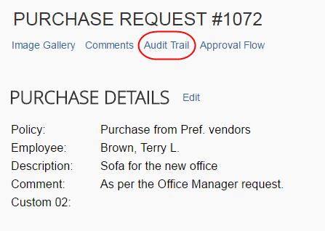
The Audit Trail window appears with information about actions that the approver and the system have taken on the specific purchase request.
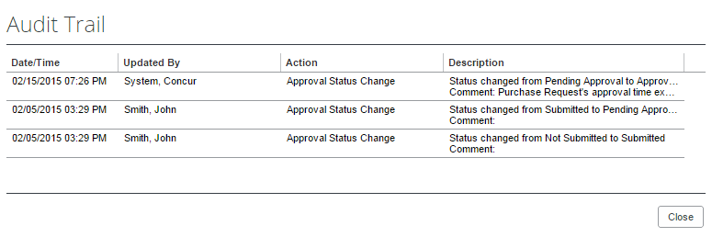
All users who have access to a PO change order transaction will be able to view the audit trail history of the PO Change Order.

View the Approval Flow
The approver can view the workflow to see all the approval steps that are part of the purchase request process. In addition, they can approve or send back the purchase request in the Approval Flow for Purchase Request window.
To view the approval flow:
- Open the desired purchase request.
- On the Request page, click Approval Flow.
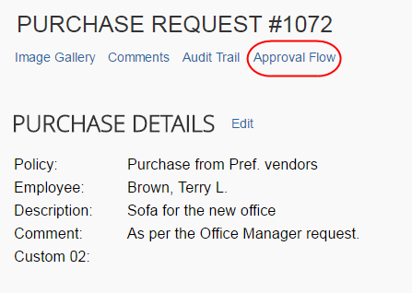
- In the Approval Flow for Purchase Request window, review the workflow, and click Cancel, or click Approve or Send Back to approve or send back the purchase request.
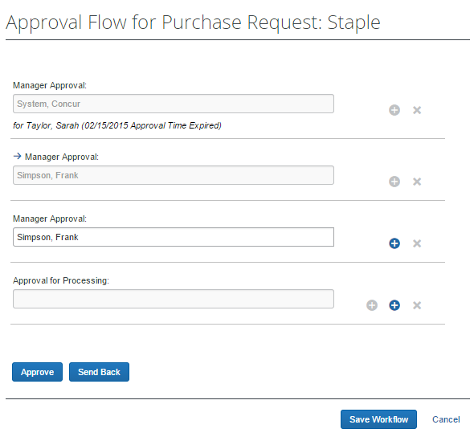

Add a Comment to an Item
Approvers can add comments to an item to make a clarification about an item, or to provide more information.
To add a comment to an item:
- Open the desired purchase request.
- In the Items section, click Show Comments.
- Click the Add Comment link that appears.
- In the comments field, type the comment, and then click Save.
The comment appears in the Request Items section.
If comments have been added but are hidden, an icon is displayed next to the Show Comments link.

View Purchase Order Contact and Email Address
The purchase request approver will see the contact name and email address of the purchase order contact in the Vendor field of the Request Items section of the opened purchase request in edit mode, provided this information has been imported into Invoice. This makes it easy to quickly find the relevant contact person of the purchase order.
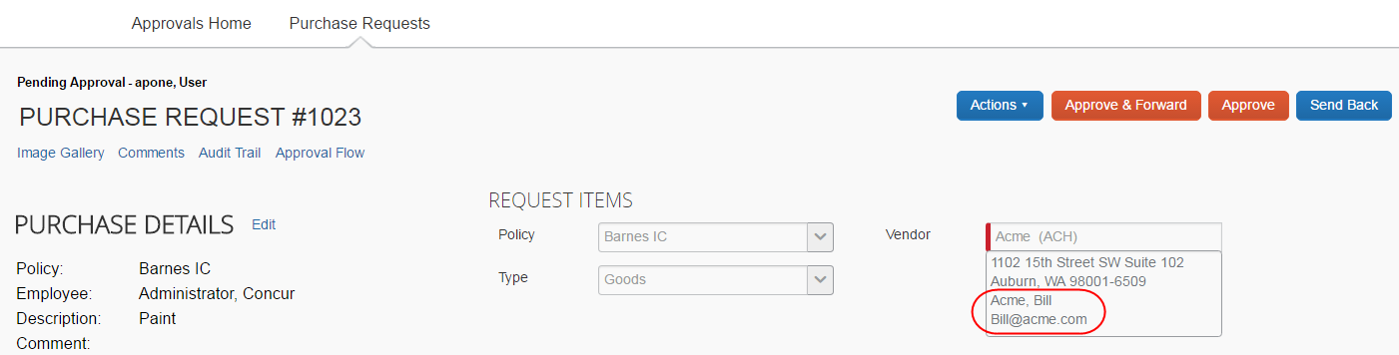

What the Purchasing Admin Can Do
The user who has the purchasing admin role can process both purchase requests and purchase orders. This section talks about how to process purchase requests and purchase orders.

Process Purchase Requests
The purchasing admin typically reviews a PR for completeness. This means reviewing that required field types are completed, exceptions are cleared, and other details to ensure the requestor has properly filled out the request.
The purchasing admin clicks Requests > Process Purchase Requests. Here, the purchasing admin can review purchase requests pending all approvers and perform processing tasks on the purchase request.
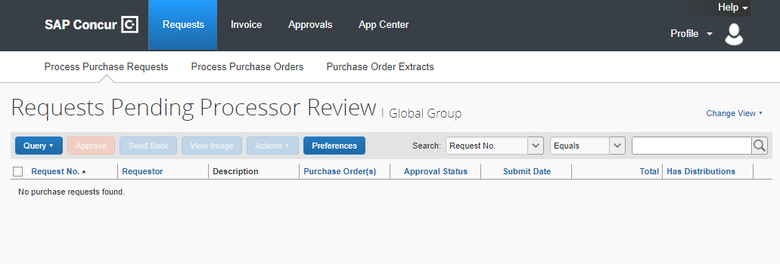
The default view showing all requests pending processing appears for new clients only.
When opened, all functionality available to the original purchase requestor is available to the purchasing admin, plus additional actions such as the following:
- Approve the PR
- Send the request back to the requestor for corrections
- View the associated image(s) for the PR
- Clear exceptions on the selected PR
- Create queries to search for requests

Send Back a Purchase Request
Purchasing admins can send back a purchase request prior to transmittal to vendor to remove a purchase request from its workflow for the purpose of additional review, correction of the associated purchase request amount or cost object, or amend some additional items to the PR.
When a Send Back action is taken on the PR, the assigned purchase request number is voided, the original associated request item(s) are made read-only, and a new, duplicate PR is created with a status of Sent Back to Employee that includes the original items and allocations that were part of the now-retired PR. An indicator is also added to the new PR to show it was generated based on a now-invalid PR.
Finally, an email notification is generated and sent based on the purchase request email notification settings for the requestor. The image below shows a sample email body text:
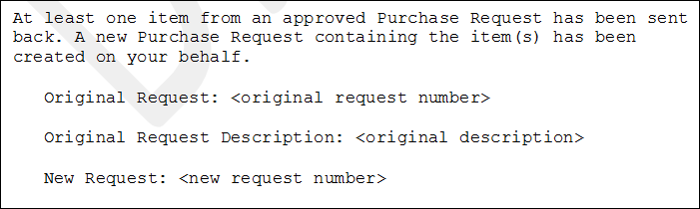
To send back a purchase request:
- On the Requests Pending Processor Review page, select the purchase request you want to send back by clicking its check box.
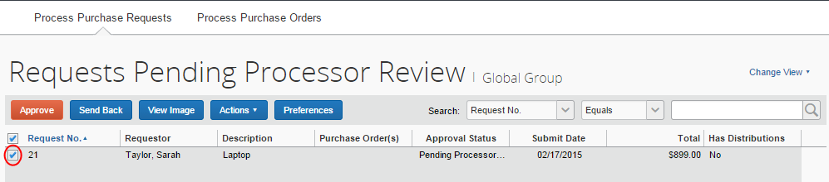
- Click Send Back.
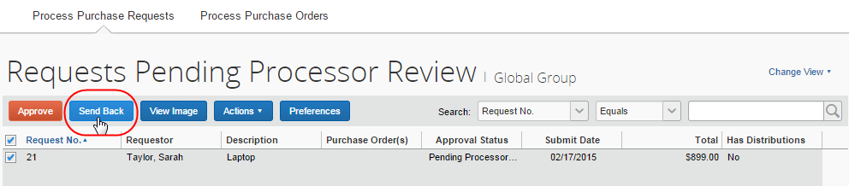
- In the Send Back Purchase Request window that appears, enter a comment about why you want to send back the purchase request, and then click OK.
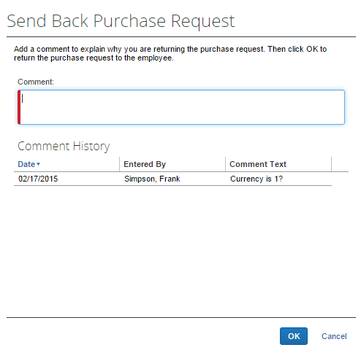

Search for a Purchase Request
Purchasing admins can search for purchase requests pending processor review in the search area by selecting different search criteria, such as Requestor Last Name, Total, or Vendor Name.
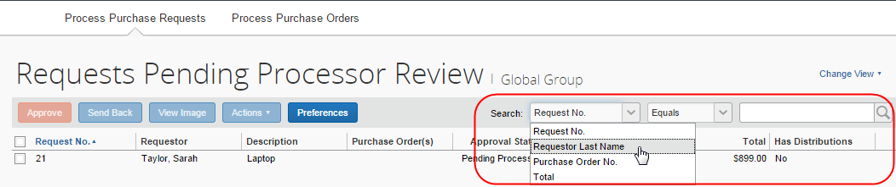

Change View Search Option
Purchasing admins can also use the Change View menu to display requests pending processor review, all requests, or change order requests pending processor review. By changing the view, the result appears on the Requests Pending Processor Review page, the All Requests page, or the Change Orders Requests Pending Processor Review.
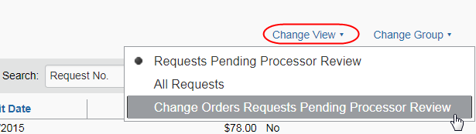

Use a Query to Search for a Purchase Request
You can also search for a request by using standard queries or those you create yourself using options within the Query section of PR Processor. The query can be created by clicking New Query where you can build a customized, condition-based query to return your requests, or you can select an existing query that you have created.

Create a Custom Query
You can create a new query for your personal use on the Processor Query page. Queries you create are your own and cannot be viewed, edited, deleted, or used by anyone else. This means that all newly created queries cannot be shared across processors.
To create a new query:
- Click Query > New Query.
- In the Query Builder window, build the conditions for the query.
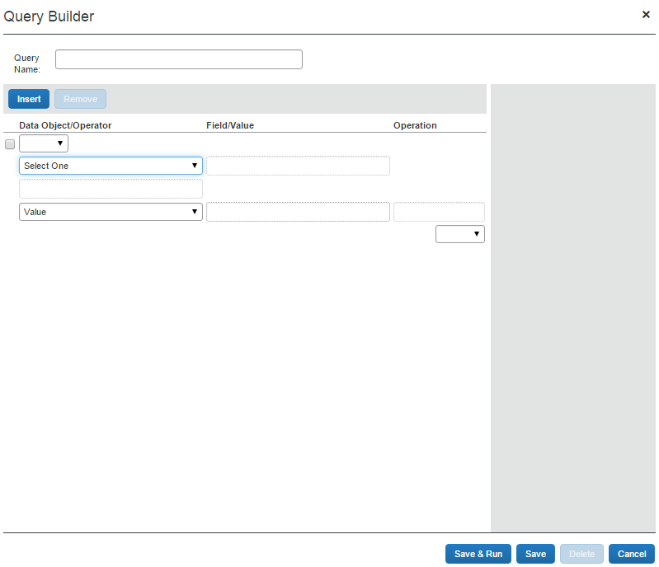
- Click:
- Save & Run: Saves the query in the Query menu, and runs it immediately, returning the results.
- Save: Saves the query for use in the Query menu.
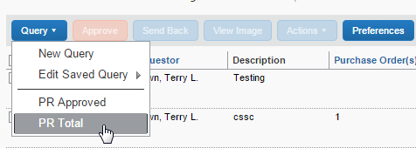

Edit a Saved Query
You are allowed to edit only those custom queries you have created, and no other user-created custom queries are available for edit, only your own.
To edit your custom queries:
- Click Queries > Edit Saved Query and point to the query you wish to edit.
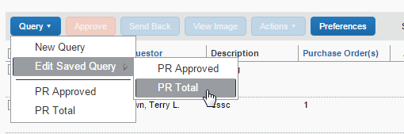
- Click the query in the list to open it in the Query Builder window. Refer to Create a Custom Query in this document to edit your query.
- When done click:
- Save & Run: Saves the query in the Query menu, and runs it immediately, returning the results.
- Save: Saves the query for use in the Query menu.

Delete a Query
You are allowed to delete only those custom queries that you have created. You cannot delete others user-created custom queries.
To delete your custom query:
- Click Queries > Edit Saved Query and point to the query you wish to delete.
- Click the query in the list to open it in the Query Builder window.
- Click Delete.
- In the Please Confirm window that appears prompting you to confirm your action of deleting the query, click Yes.
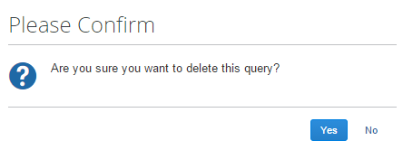

Export Query Results
You can export your query results into an Excel-based data template. This allows you to open Excel and load the results of your query for use in application.
To export the results of your query:
- Run the query for the results you are seeking.
- Click Send to Excel in the lower-right corner of the page.
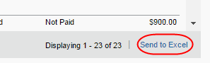
The data is loaded and automatically appears in Excel with each column representing a field within the purchase request.

View Associated Images to a Purchase Request
To view associated images to the purchase request, click Image Gallery.
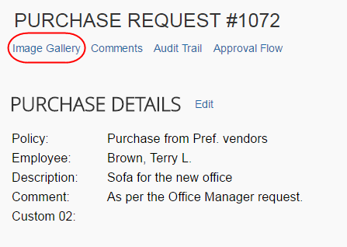

Purchase Order Contact and Email Address
The purchase request processor can see the contact name and email address of the purchase order contact in the Vendor field of the Request Items section of the opened purchase request in edit mode, provided this information has been imported into Concur Invoice. This makes it easy to quickly find the relevant contact person of the purchase order.
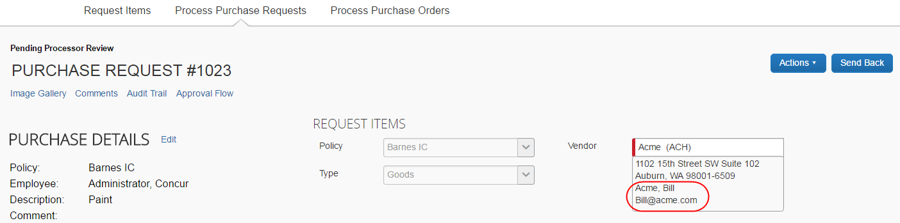

Clear Exceptions for a Purchase Request
To clear exceptions for a purchase request, read the exception message in the Exceptions section of the purchase request that you have opened and take the actions necessary to resolve the exception(s).
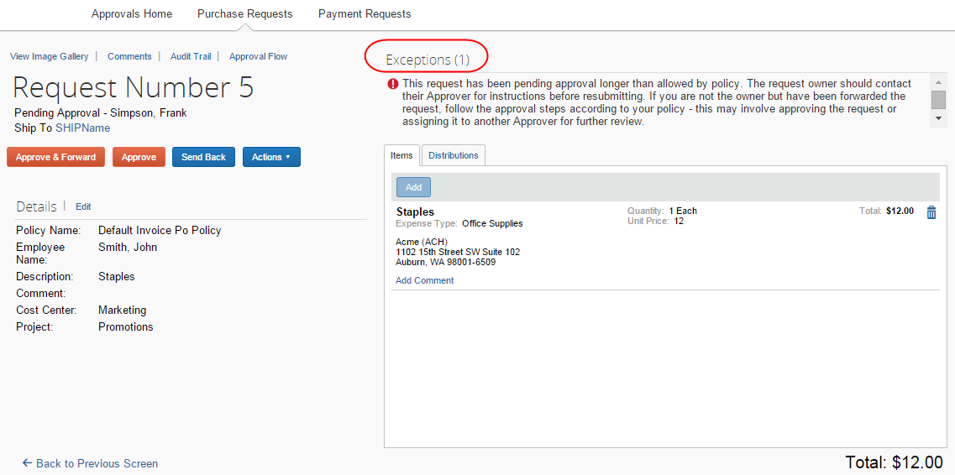

Approve a Purchase Request
To approve a purchase request, simply select the request and then click Approve.
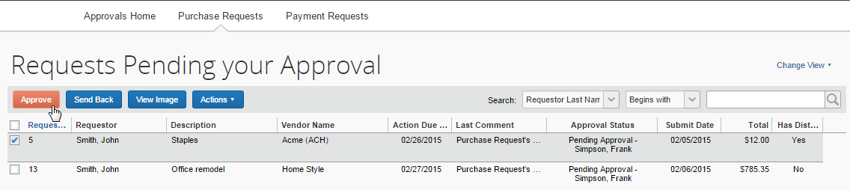
If you need to review the details of the purchase request, you may first open the request by double-clicking it.
Ensure that you clear any exceptions before you approve the purchase request.
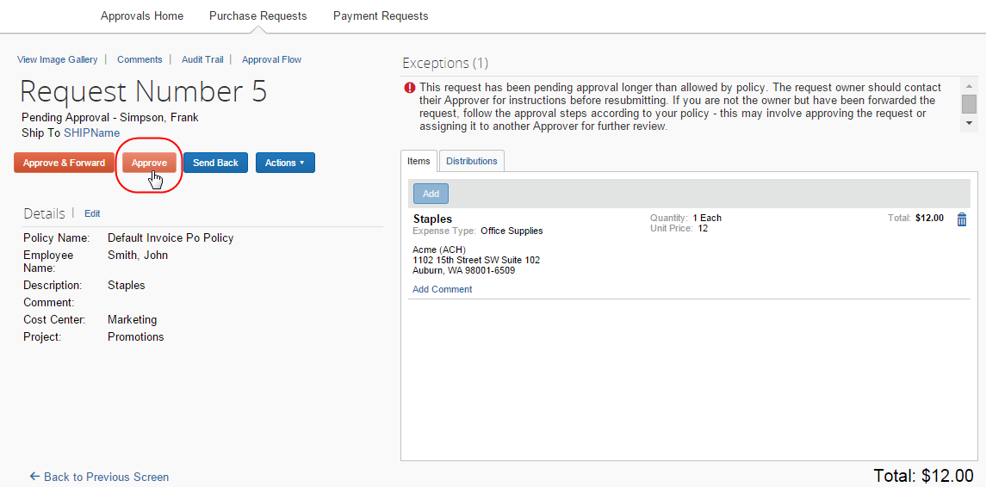
Following approval, the system turns the purchase request into one or more purchase orders, each PO generated from an item that makes up the parent request. For the PR shown in the figure below, the system creates two POs, which will go to two different vendors:

Approve and Forward a Purchase Request
If the purchasing admin wants to approve the purchase request but also add another approver, they can do this by opening the desired PR and clicking Approve & Forward.
In the Approve & Forward Purchase Request window that appears, the purchasing admin can add another approver and a comment about why they would like to do this. Complete this step by clicking Approve & Forward.

Approve a Change Request
Once the approver has approved the change request, the request will proceed to the purchase request processor for approval. The approver will see a icon, which indicates that this is a change request.
To approve a change request:
- Open the desired purchase request.
- On the Request page, select the change request to approve and then click Approve.

Upload, View, and Delete Images
The purchasing admin, who processes purchase requests, can upload, view, and delete images to the purchase requests.
To upload an image:
- Open the desired purchase request.
- On the Request page, click Actions > Upload Image.
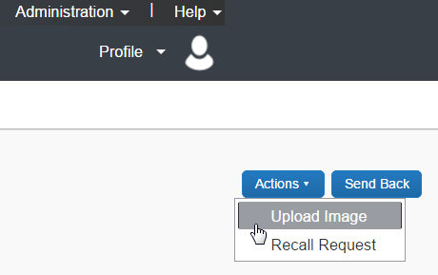
The Upload Image window appears.
- Click Browse and select the desired image by double-clicking it, or by selecting it and clicking Open.
- (Optional) Select (enable) the Include in PO Transmission check box.
- Click Upload.
- Click Close.
To view an image:
- On the Request page, click Image Gallery.
The Purchase Request Images window appears. If there are more than one image or supporting document, you can toggle between them by using the Next and Previous buttons.
You can also include supporting documents in the PO transmission from the Purchase Request Images window by selecting (enabling) the Include in PO Transmission check box.
- Click Save or Cancel when you are done.
To delete an image:
- On the Request page, click Image Gallery.
The Purchase Request Images window appears.
- Select the image you want to delete and click Delete Image.

View Comments
The purchasing admin can view comments about the purchase request that the purchase request user has entered in the Details section of the purchase request or that the approver has entered when they have sent back a purchase request to the user.
To view comments:
- Open the desired purchase request.
- On the Request page, click Comments.
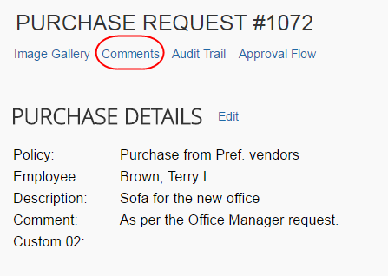
- In the Comment History window that appears, view the comments about the purchase request.
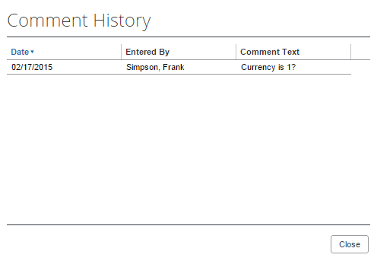
- Click Close.

Review Audit Trail
To review the audit trail, open the purchase request, and then click Audit Trail.
The Audit Trail window appears with information about actions that the purchasing admin and the system have taken on the specific purchase request.
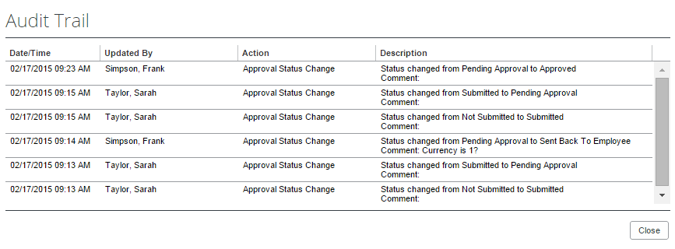
All users who have access to a PO change order transaction will be able to view the audit trail history of the PO Change Order.

View Approval Flow
The purchasing admin can view the workflow to see all the approval steps that are part of the purchase request process. In addition, it is possible to approve or send back the purchase request from the Approval Flow for Purchase Request window.
To view approval flow:
- Open the desired purchase request.
- On the Request page, click Approval Flow.
- In the Approval Flow for Purchase Request window, review the workflow, and click Cancel, or click Approve or Send Back to approve or send back the purchase request.
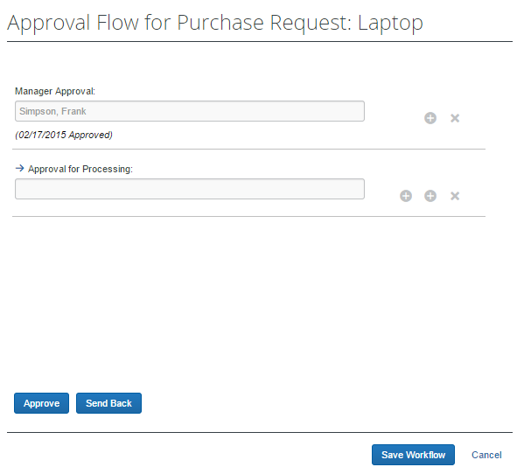

Change Ship-To Address
The purchasing admin can change the ship-to address.
To change the ship-to address:
- Open the desired purchase request.
- In the Ship To Address section, click the Change link.
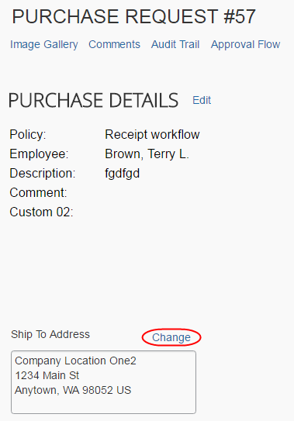
- Click in the field that appears and select the ship-to name.
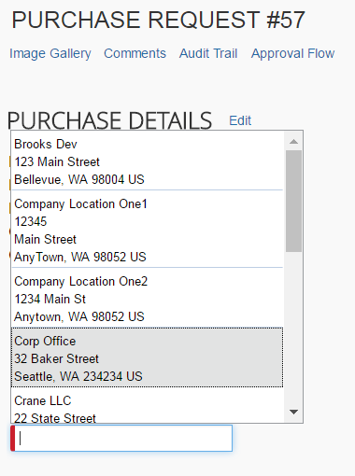
- Click Save.

Add a Comment to an Item
Purchasing admins can add comments to an item to clarify an item or to provide more information about the item.
To add a comment to an item:
- Open the desired purchase request.
- In the Items section, click Show Comments.
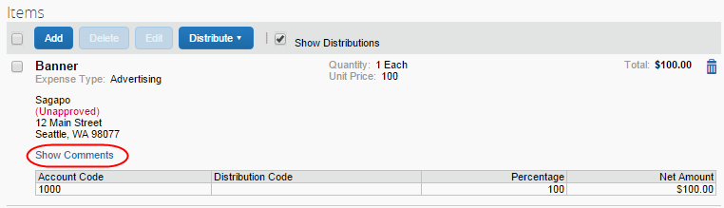
- Click the Add Comments link that appears.
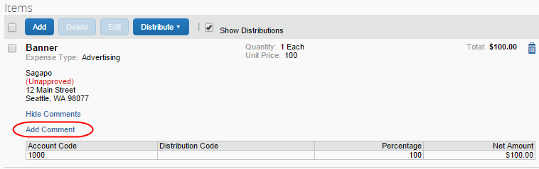
- In the comments field, type the comment, and then click Save.
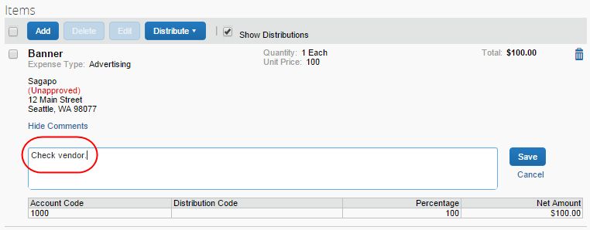
The comment appears in the Items section.
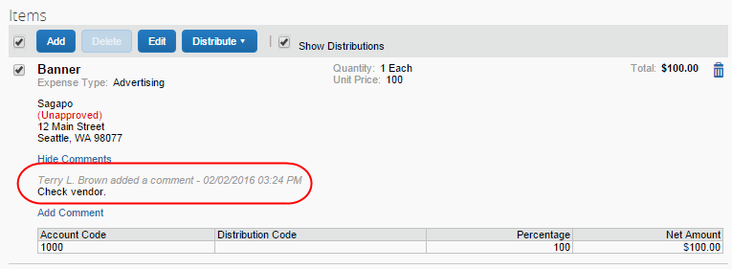

Delete an Item from a Purchase Request
The purchasing admin can delete an item from the purchase request.
To delete an item from a purchase request:
- Open the desired purchase request.
- In the Items section, select the item that you want to remove.
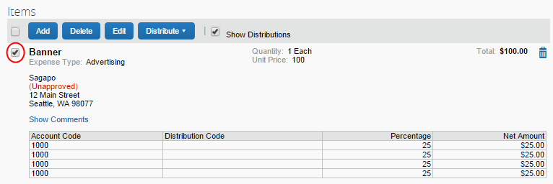
- Click the Trash icon.
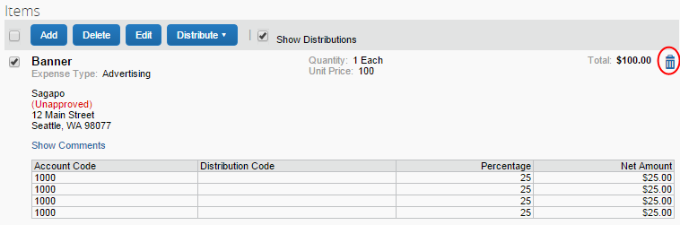
The system will remove the item from the purchase request.

Distribute (Allocate) a Purchase Request
The purchasing admin, who processes purchase requests, can specify distributions at the line item level, so that they can allocated the cost of the purchase accurately. In addition, if they want to apply the same distributions to all line items, they can specify the distributions once and apply it to all line items.
Both the purchase request user and the approver can also create and manage distributions (allocations).
Distribute a purchase request:
- Open the desired purchase request.
- On the Request page, select one or more itemizations to that you want to distribute between departments.
- Click Distribute > Distribute Selected Items.
The Distribute Selected Items page appears.
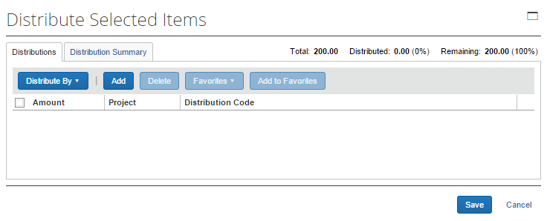
- Click Distribute By and select to distribute the allocation by amount or by percentage.
- Click Add. The total is now evenly spread between the number of allocations (you may adjust these manually, but the percent must equal 100 or the amount the overall total, excepting tax and shipping before you can proceed).
- Complete all required fields and the optional fields as directed by your company. (Your company defines the fields that appear on this page.)
- Click Save.
You can add or delete an item by clicking the Add or Delete button respectively.

Import Distributions
The purchasing admin can import their distributions (allocations) by using the Import feature. This feature supports clients who need to distribute a single purchase request across a large number of cost objects. For example, the corporate office may decide one purchase request should be shared by all 400 company retail locations. Imported distributions can be:
- Specified to import as either percentage or amount, with restrictions based on the sign (negative or positive)
- Applied across multiple line items at once
To import distributions:
- Double-click the purchase request that you would like to open.
- On the Request page, in the Items section, select the item for which you want to import distributions.
- Click Distribute, and then Import Distributions.
- In the Import Distributions window that appears, click Browse to select the file that you want to import. You may download a sample Excel file (.xls) template based off distribution (allocation) configuration fields by clicking Download Template.
- Select the file to import, and then click Open.
- Click Import.
Concur Invoice imports the distributions and displays them in the invoice.
- Click Save.
While Concur Invoice imports the distributions, error checking and validations are processed, and the results appear in the Import Errors window.

Create and Manage Allocation Favorites
The purchasing admin has the same ability as the purchase request user and approver to create and manage allocations.
To create an allocation favorite:
- Open the desired purchase request.
- On the Request page, in the Items section, select the item for which you want to create a favorite allocation.
- Click Distribute > Distribute Selected Items.
- In the Distribute By menu, select if you would like to distribute the allocation by amount or percentage.
You can use the Add button to correctly identify and budget the expense to the accounting system. For example, use this if your need to spread your expenses across several projects or departments.
- Click Add to Favorites.
The Add to Favorites window opens.
- Enter a name for the allocation favorite and then click Save. The system adds the allocation to your favorites, which you can see if you click Favorites.
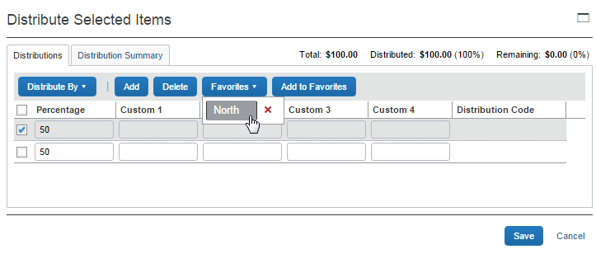

Process Purchase Orders
The purchasing admin typically reviews a purchase order for buying details. This means, for example, reviewing the PO for correct shipping method and terms, and reviewing the selected vendor to ensure it is a preferred supplier.
To process purchase orders, the purchasing admin clicks Requests > Process Purchase Orders. Here, the purchasing admin can review PO requests pending all approvers and perform processing tasks on the PO request.
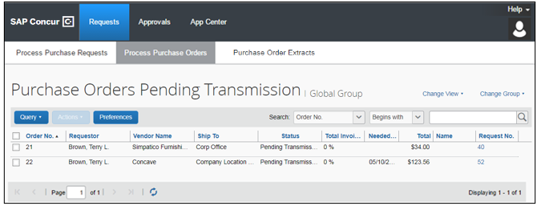
The default view showing all requests pending processing appears for new clients only.
With the purchase order open in detail view, the purchasing admin can perform the following actions:
- Review and change the selected vendor
- Change the Ship To and Bill To values
- Create queries to search for requests
- Send the request associated with an untransmitted PO back to the requestor (the PO number is voided, and a new PR is created in this scenario)
- Void transmitted POs
- Close transmitted POs
- View associated image(s) for the POs
- Review the original payment or purchase requests associated with this purchase order
- Edit certain purchase order details such as description and need-by date
- Review the audit trail
- Preview purchase orders, in PDF format
- Transmit POs to vendors

Review or Change a Vendor
To view or change a vendor:
- Double-click the desired purchase order. The Purchase Order window appears.
- In the Vendor section, click View Details or Edit depending on what you want to do.
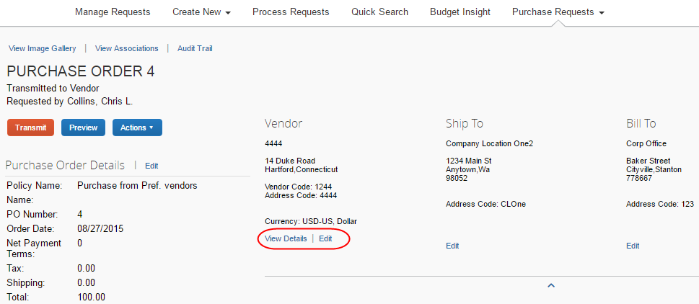

Change Ship-To or Bill-To Address
To change the ship-to or bill-to address:
- Double-click the desired purchase order. The Purchase Order window appears.
- In the Ship To or Bill To section, click Edit.
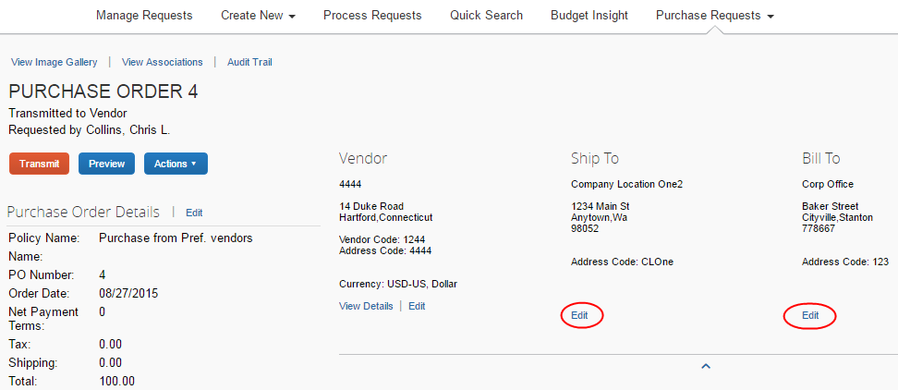
- In the Change Address window, select a different ship-to or bill-to address.
Change Address window (ship-to address):
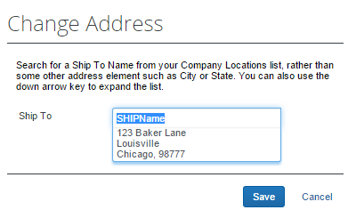
Change Address window (bill-to address):
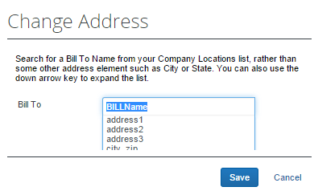
- Click Save.

Edit Purchase Order Details
Purchasing admins can edit some of the details, for example, the description, need-by date, or shipping cost of the purchase order.
To edit purchase order details:
- Open the desired purchase order.
- Click Edit.
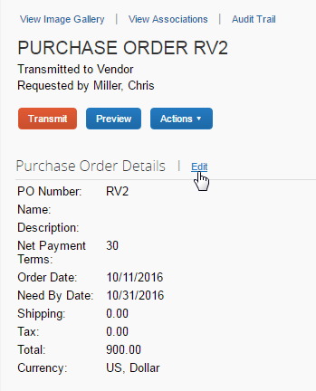
- In the Purchase Order Details window that appears, edit the fields and then click Save.
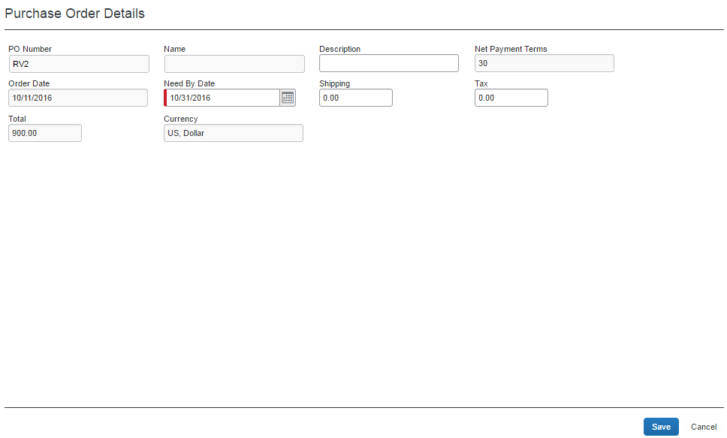

Send Back a Purchase Order
Purchasing admins can send back a purchase order prior to transmittal to vendor to remove a purchase order from its workflow for the purpose of additional review, correction of the associated purchase request amount or cost object, or amend some additional items to the PR.
When a Send Back action is taken on the PO, the assigned PO number is voided, the original associated request item(s) are made read-only, and a new, duplicate PR is created with a status of Sent Back to Employee that includes the original items and allocations that were part of the now-retired PO. An indicator is also added to the new PR to show it was generated based on a now-invalid PR.
Finally, an email notification is generated and sent based on the purchase request email notification settings for the requestor. The image below shows a sample email body text:
To send back a purchase order:
- On the Purchase Orders Pending Transmission page, select the purchase order you want to send back by clicking its check box.
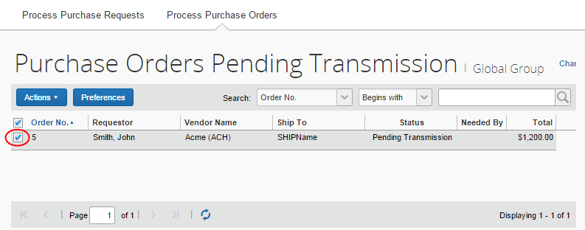
- On the Actions menu, click Send Back.
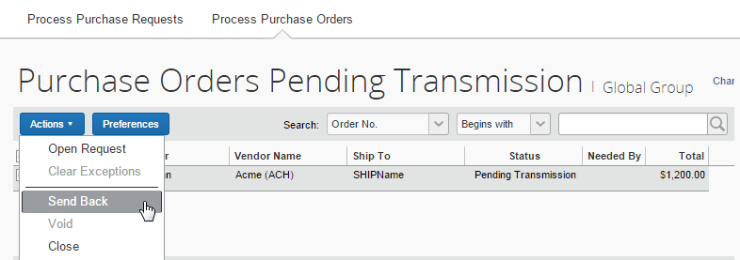
- In the Send Back Purchase Order window that appears, enter a comment about why you want to send back the purchase order, and then click OK.
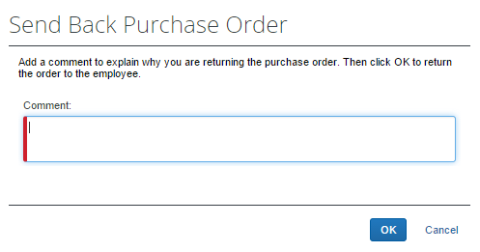

Create Invoices From Transmitted Purchase Orders
When purchasing admins view their list of purchase orders, they can create an invoice from a purchase order on this list. The option to create an invoice from the PO list is available only when the purchasing admin selects a single, transmitted PO that has not yet been closed.
This feature is useful when, for example, the supplier has sent a PO-based invoice, but not provided the purchase order number of that invoice.
The purchasing admin can create the invoice in the Actions menu on the All Orders page.
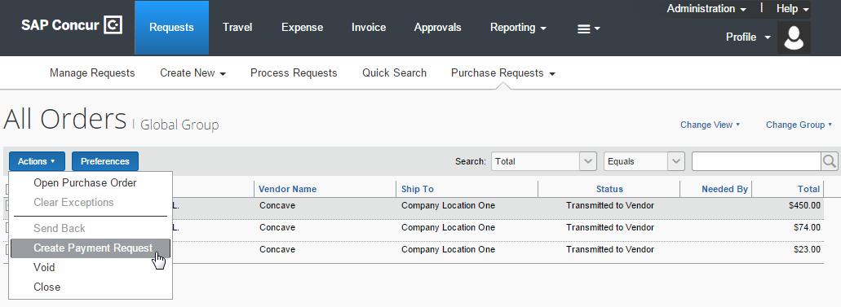

Void a Purchase Order
A purchasing admin may want to void a purchase order after transmittal to vendor if, for example, the order cannot be fulfilled due to a discontinued item, or if there are vendor issues or changes in the business environment that deems the PO invalid.
When a purchasing admin voids a purchase order, the system sets the PO to Voided. A record of the PO remains in the system, but the PO is not included in any listing or extract of general purchase orders. However, voided purchase orders can be included in search result lists by filtering the search where the status is equal to Voided.
Voiding the PO is a "housecleaning" measure used to ensure any associated invoices referencing this PO Number will be identified and handled appropriately.
Before the purchasing admin voids a purchase order, the system must first extract the PO.
To void a purchase order:
- On the All Orders page, select the purchase order you want to void by clicking its check box.
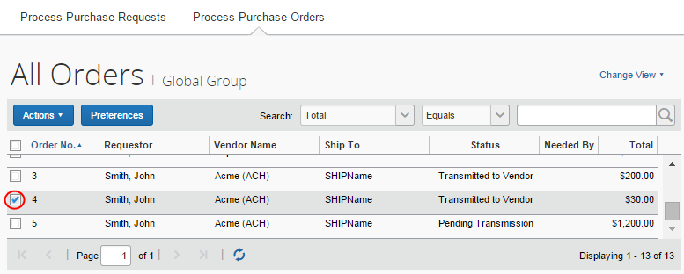
- On the Actions menu, click Void.
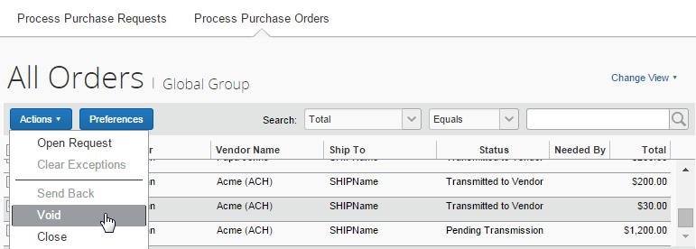
- In the Void Purchase Order window that appears, enter a comment about why you want to void the purchase order, and then click OK. The system updates the audit log and changes the status of the purchase order to Voided.
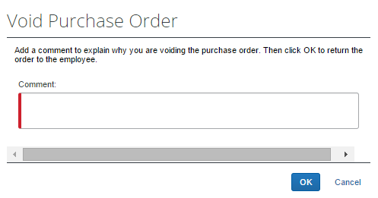

Upload, View, and Delete Images
The purchasing admin, who processes purchase orders, can upload, view, and delete images of purchase orders.
To upload an image:
- Open the desired purchase order.
- On the Request page, click Actions > Upload Image.
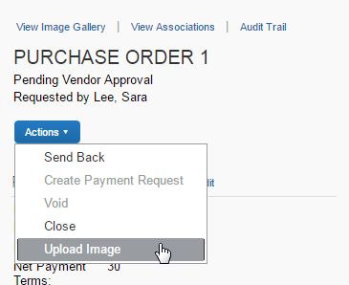
The Upload Image window appears.
- Click Browse and select the desired image by double-clicking it, or by selecting it and clicking Open.
- (Optional) Select (enable) the Include in PO Transmission check box.
- Click Upload.
- Click Close.
To view an image:
- On the Purchase Order page, click View Image Gallery.
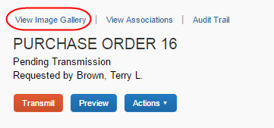
The Purchase Order Images window appears. If there are more than one image or supporting document, you can toggle between them by using the Next and Previous buttons.
You can also include supporting documents in the PO transmission from the Purchase Order Images window by selecting (enabling) the Include in PO Transmission check box.
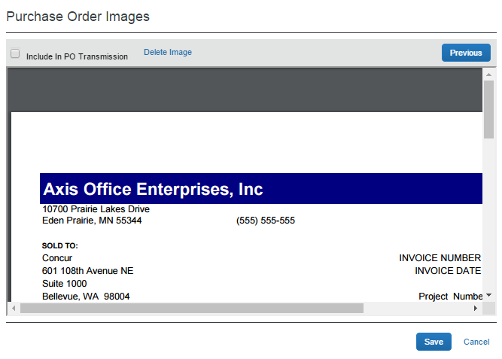
- Click Save or Cancel when you are done.
To delete an image:
- On the Purchase Order page, click View Image Gallery.
- In the Purchase Order Images window, click Delete Image.
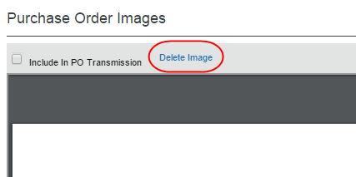
The Please Confirm window appears.
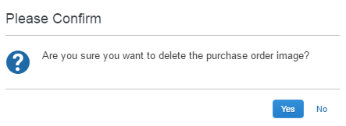
- Click Yes. Once you have deleted an image, the next image, if there is one, appears.

Close a Purchase Order
When a purchasing admin closes a purchase order after transmittal to vendor, the system removes the closed PO from the list of purchase orders pending actions. This helps the processor to manage their POs and their statuses more efficiently.
If the purchasing admin wants to search on closed POs, they can do so by selecting Status Equals Closed in the search area. The page will list all the closed POs.
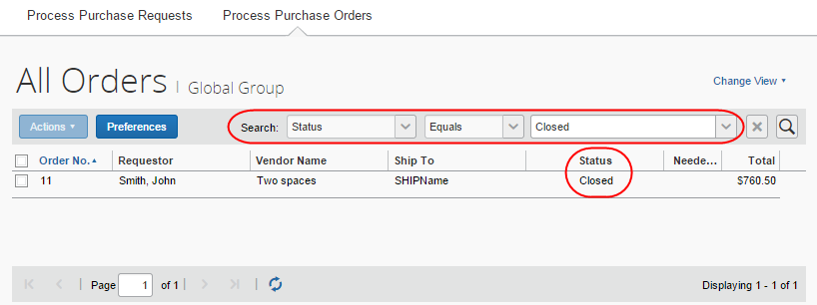

Please note that the purchasing admin cannot copy a request if it is associated with a closed PO.
If the client uses an external purchasing system, a standard PO import into Concur Invoice can update any PO with a Closed status.
To close a purchase order:
- On the All Orders page, select the purchase order you want to close by clicking its check box.
- On the Actions menu, click Close.
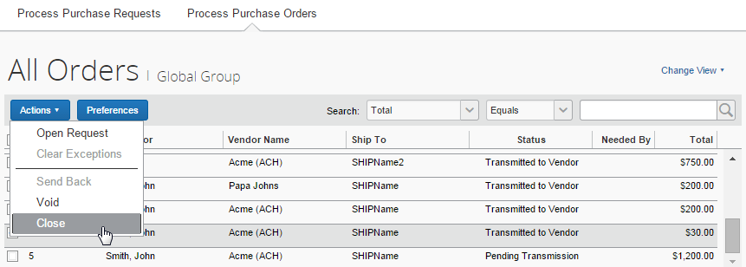
3. In the Close Purchase Order window that appears, enter a comment about why you want to close the purchase order, and then click OK. When the purchasing admin has closed the PO, it will no longer appear in the list of that page.
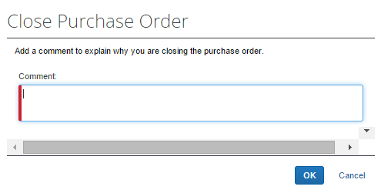
In addition, a closed PO will not be available in the list of active POs for matching invoices.

Reopen a Closed Purchase Order
Users with the Purchasing Admin role can reopen closed purchase orders. This is useful when a PO has been incorrectly closed and needs to be reopened and processed correctly.
To reopen a closed purchase order:
- On the Closed purchase orders page or in an opened purchase order, in the Actions menu, select Reopen.
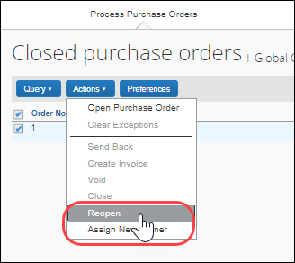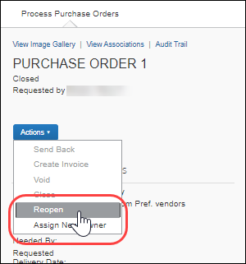
The Reopen Purchase Order window appears.
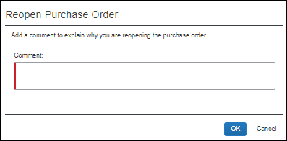
- In the Comments field, enter a comment and then click OK. The PO is reopened with the status it was in when it was closed. For example, if the status of the PO was Transmitted to Vendor when the PO was closed, the PO will be reopened with a status of Transmitted to Vendor.

View Associated Images to the Purchase Order
To view associated images to the purchase order, click View Image.
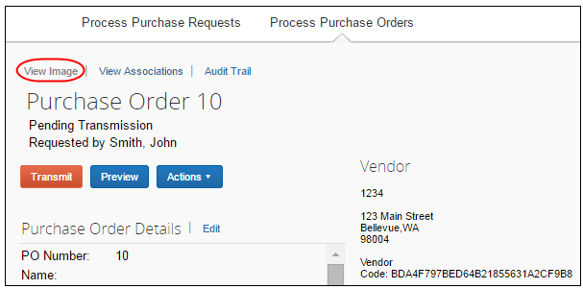

Search for a Purchase Order
Purchasing admins can search for purchase orders that are pending transmission or all purchase orders in the search area by selecting different search criteria, such as Requestor Last Name, Total, or Vendor Name.
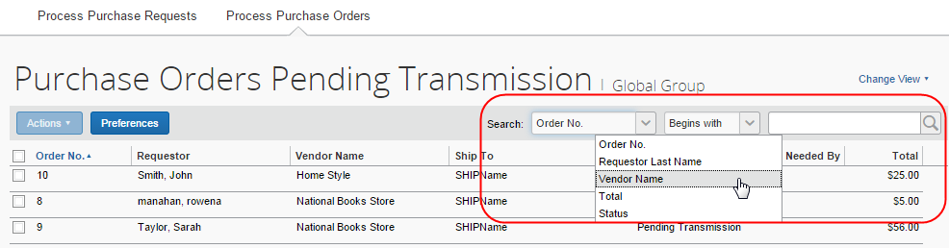

Change View Search Option
Purchasing admins can also use the Change View menu to display purchase orders or change orders pending transmission or purchase orders pending vendor approval. By changing the view, the result appears on the page.
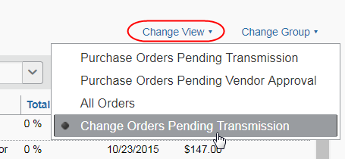

Use a Query to Search for a Purchase Order
You can also search for a purchase order by using standard queries or those you create yourself using options within the Query section of PO Processor. The query can be created by clicking New Query where you can build a customized, condition-based query to return your purchase orders, or you can select an existing query that you have created.

Create a Custom Query
You can create a new query for your personal use on the Purchase Orders Pending Transmission page. Queries you create are your own and cannot be viewed, edited, deleted, or used by anyone else. This means that all newly created queries cannot be shared across processors.
To create a new query:
- Click Query > New Query.
- In the Query Builder window, build the conditions for the query.
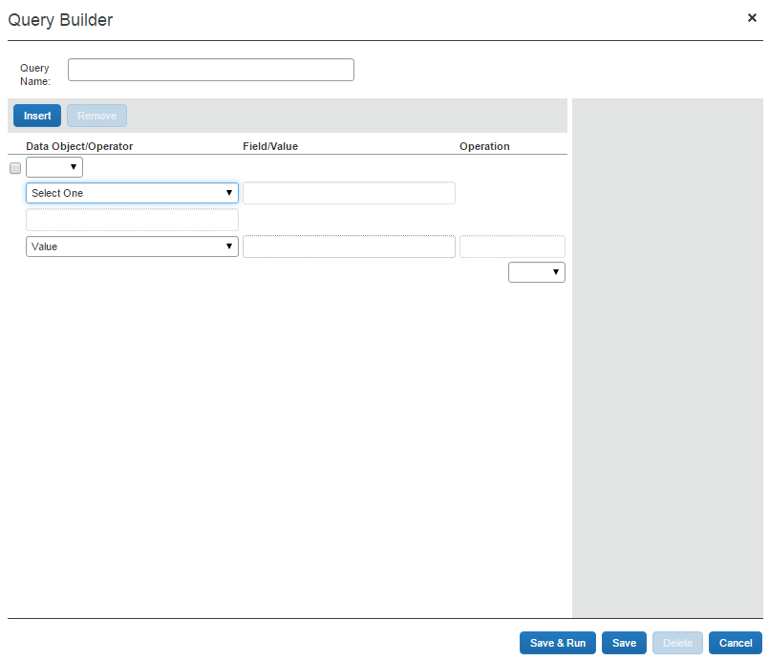
- Click:
- Save & Run: Saves the query in the Query menu, and runs it immediately, returning the results.
- Save: Saves the query for use in the Query menu.
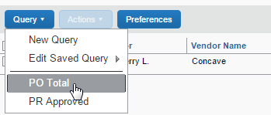

Edit a Saved Query
You are allowed to edit only those custom queries you have created, and no other user-created custom queries are available for edit, only your own.
To edit your custom queries:
- Click Queries > Edit Saved Query and point to the query you wish to edit.
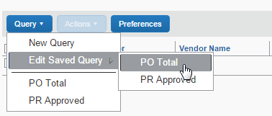
- Click the query in the list to open it in the Condition Builder window. Refer to Create a Custom Query in this document to edit your query.
- When done click:
- Save & Run: Saves the query in the Query menu, and runs it immediately, returning the results.
- Save: Saves the query for use in the Query menu.

Delete a Query
You may delete only those custom queries that you have created. You cannot delete others user-created custom queries.
To delete your custom query:
- Click Queries > Edit Saved Query and point to the query you wish to delete.
- Click the query in the list to open it in the Condition Builder window.
- Click Delete.
- In the Please Confirm window that appears prompting you to confirm your action of deleting the query, click Yes.

Export Query Results
You can export your query results into an Excel-based data template. This allows you to open Excel and load the results of your query for use in application.
To export the results of your query:
- Run the query for the results you are seeking.
- Click Send to Excel in the lower-right corner of the page.
The data is loaded and automatically appears in Excel with each column representing a field within the purchase order.

View PO Amount That Has Been Invoiced
PO Processor can see how much of the purchase order amount that has been invoiced. To do so, the PO Processor may create a query that defines if a purchase order has been fully or partially invoiced, or not invoiced at all. This information is important and lets the PO Processor take necessary actions, such as closing the purchase order, or contact the vendor regarding the outstanding invoices.
The query will be based on approved invoices.
In the following example, the system will query for purchase orders where 90 percent or more of the PO amount have been invoiced.
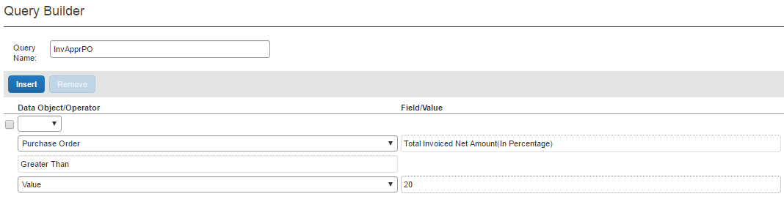
By clicking the Preferences button, the PO Processor can add the new column, Total Invoiced Net Amount (in Percentage) to the Purchase Orders page.
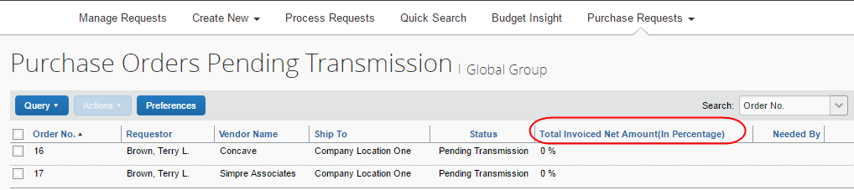

View Original Invoice or Purchase Request Associated with a PO
To view the original payment or purchase request associated with a specific purchase order, click View Associations.
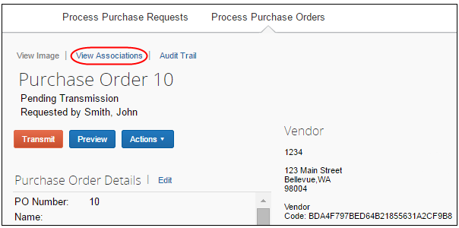
The Purchase Order Associations window appears with information about the associated payment and purchase order requests of the purchase order.
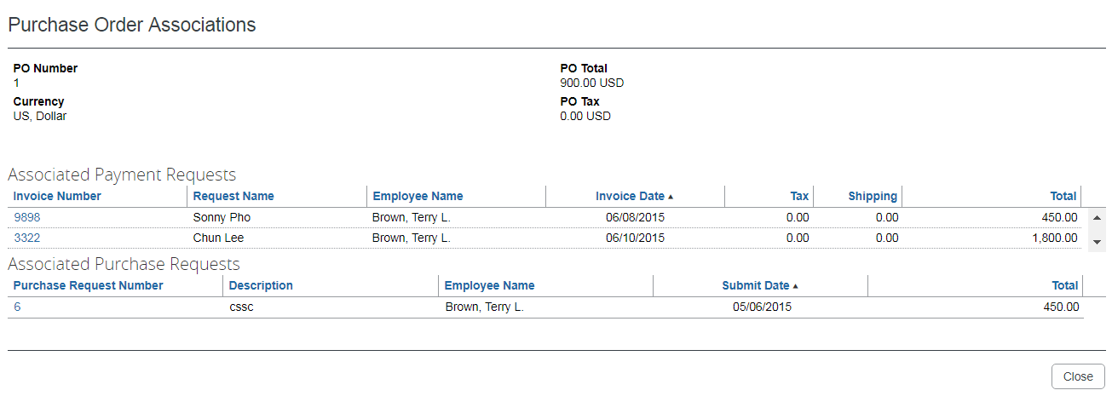
Depending on your user permission role, you might be able to click on the associated invoice and/or purchase request number to see the related record.

Approval Flow Available to View Within Purchase Order
The purchasing admin can double-click the purchase request in the Purchase Order Association window to view the approval flow of a purchase request within a purchase order.
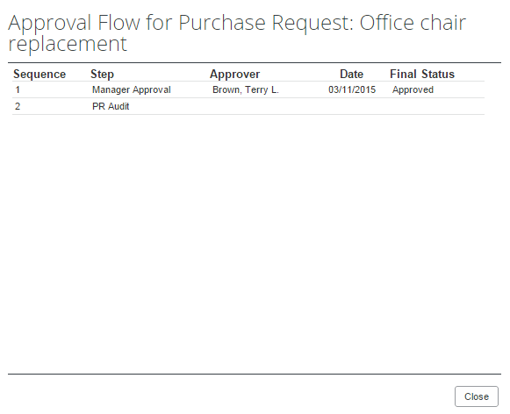

Review the Audit Trail
To review the audit trail, click Audit Trail.
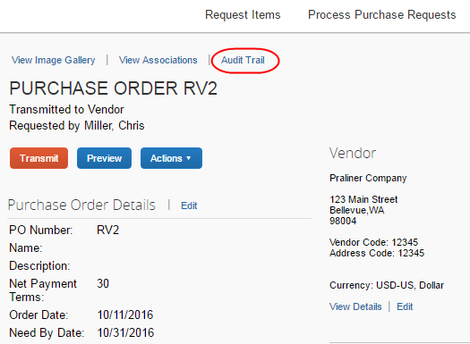
The Audit Trail window appears with information about actions that the purchasing admin has taken on the specific purchase order.
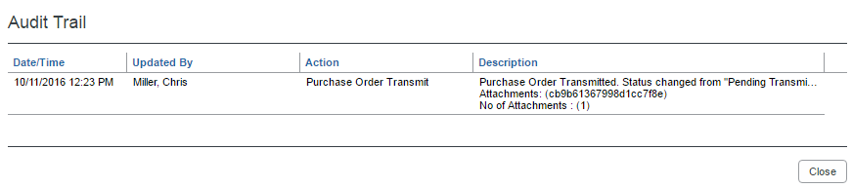
All users who have access to a PO change order transaction will be able to view the audit trail history of the PO Change Order.
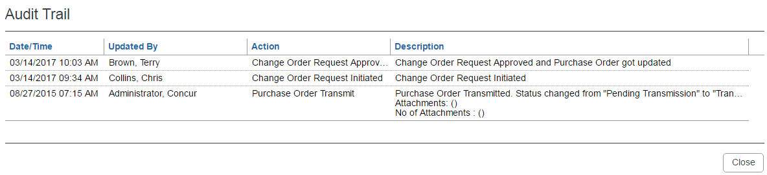

Preview a Purchase Order
The purchasing admin has a unique view of the overall PR to PO creation by being able to view a PDF of the final purchase order, as it will appear to the vendor on receipt via email. This view allows the purchasing admin to verify information in a single view, including address, email, and comments to the vendor.
In addition, purchasing admins can view all documents that are associated with a specific purchase order, which gives them an overview of all documents that they transmit to a vendor.
This includes documents uploaded by:
- Administrators who configure purchase orders in PO Configuration
- Users who create purchase requests and select the Include in PO Transmission option
- Approvers who approve purchase requests and select the Include in PO Transmission option
- Purchasing admins who process purchase requests and select the Include in PO Transmission option
To preview a purchase order in PDF format:
- On the All Orders page, double-click the purchase order that you want to view.
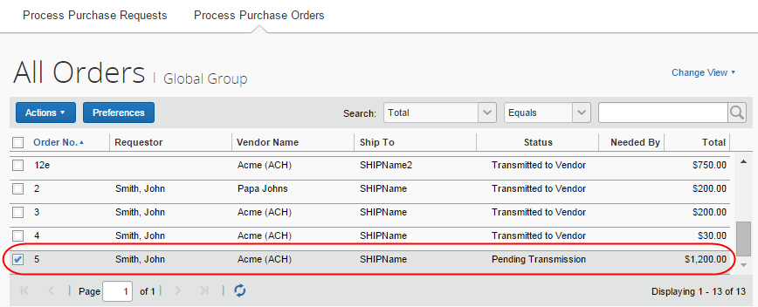
- Click Preview.
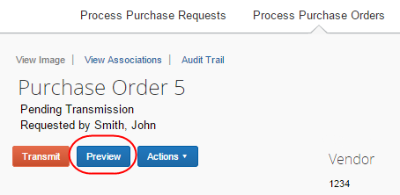
The Preview Purchase Order window appears.
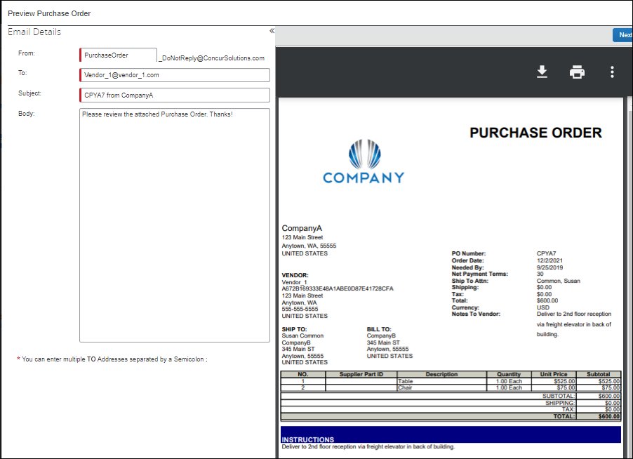
The purchasing admin can correct selected items in the Preview Purchase Order window, and add one or more additional email addresses as needed. If multiple email addresses exist, vendors will see all other contacts who received the email by looking at the To line of their email. This helps prevent multiple vendor contacts from fulfilling the same purchase order.
To change any PO data presented in the PDF, the purchasing admin opens the actual PO and edits the fields.The purchasing admin can also email the PO from this window by clicking Transmit.
The client administrator can change the default text (Body text, address, instructions, etc.) in the PO Configuration step of Setup.
The processor can change the prefix for the From address but cannot change the suffix of the address from "_DoNotReply@ConcurSolutions.com".

Preview a PO Change Order
Once a PO change order has gone through the workflow and has been fully approved, the PO processor will be able to open the Preview Purchase Order window view information about the revision number and revision date of the last revision, new line items, and updated amount of the PO change order.
The PO processor can also view a Change Order Revision section of the purchase order PDF with revision information.
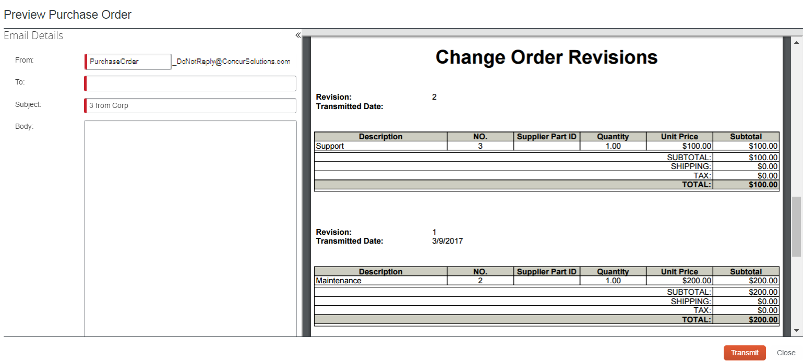

Transmit Purchase Order to the Vendor
To transmit a purchase order to the vendor, click Transmit.
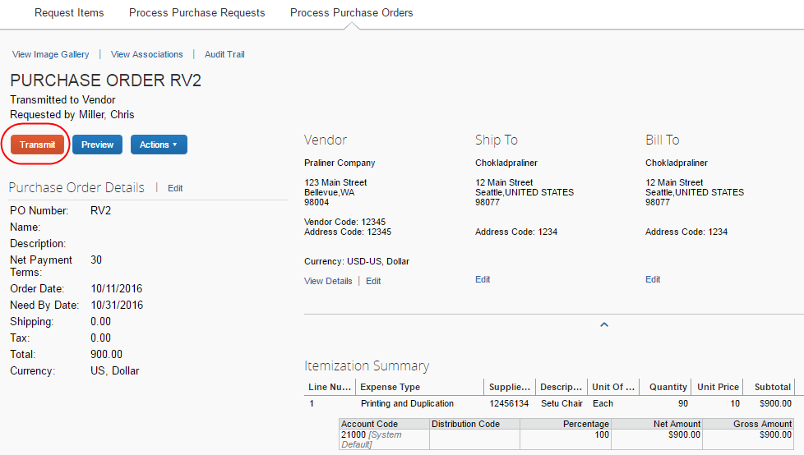

Automatically Transmit Purchase Orders
The client administrator may enable (select) an option in the Setup Wizard, which removes a workflow step in the purchase order process. In this case, Concur Invoice will transmit purchase orders from the processed purchase request directly to the supplier.
If the purchase order contains incorrect data, such as an incorrect vendor email address, Concur Invoice will not transmit the purchase order automatically, but instead it will require manual PO processing.

Transmit a Change Order
When the purchase request processor has approved the purchase request, the PO processor will be able to see an updated purchase order with a Pending Transmission status in the processor view. They will also be able to tell that the purchase order is a change order by the icon that is visible by the order number.
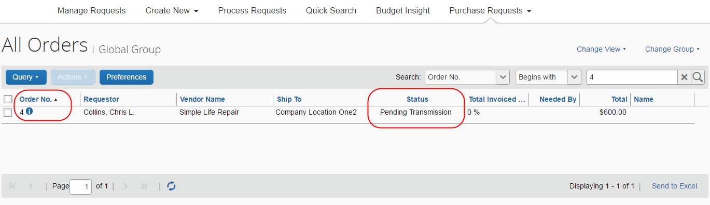
The PO processor can open the purchase order to see the newly added line item(s) and a notification that the purchase order has changed.
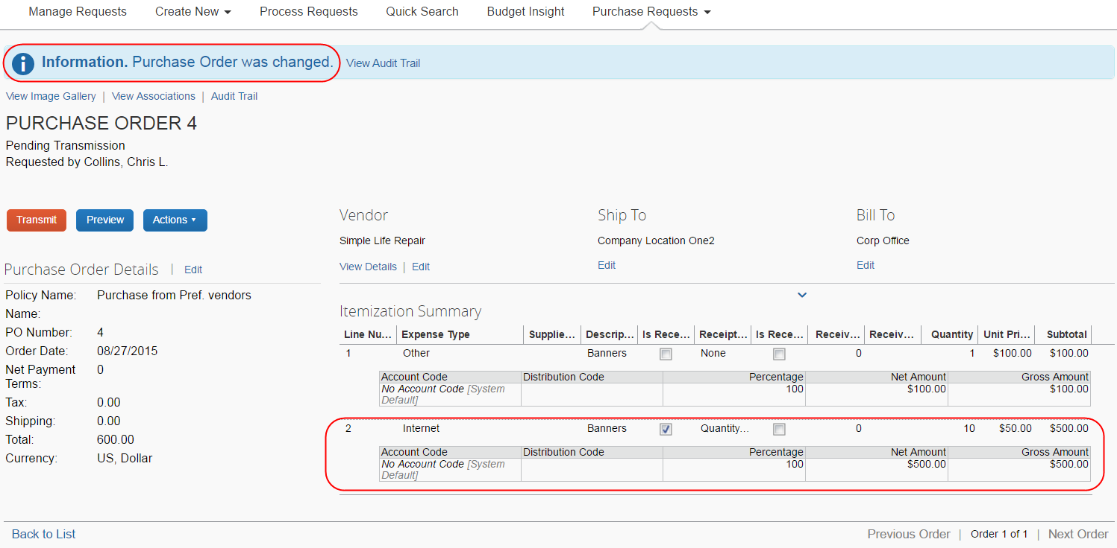
When the PO processor has reviewed the updates of the purchase order, they click Transmit. Once the purchase order has been transmitted, all the icons disappear that are associated with that specific purchase order.
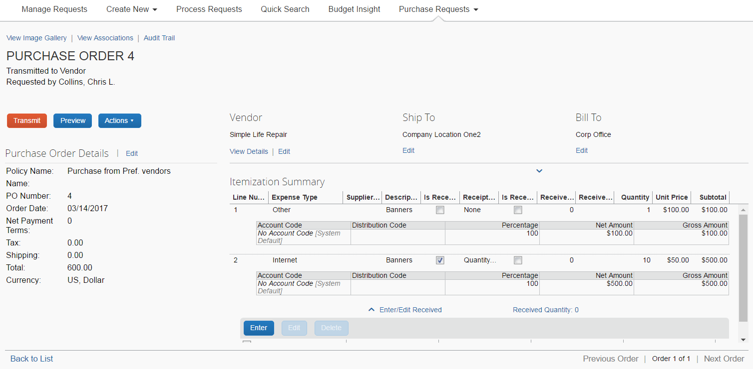

Manage Receipts and Receipt Images
Purchasing Administrators, who work with the Receiving feature, can add, edit, delete receipts and receipt images of the transmitted purchase order.
If a receipt is associated with an invoice, a user will not be able to edit or delete the receipt and the Edit and Delete buttons will be disabled. If a user needs to make changes to an invoice, they need to first unassociated the receipt to the invoice.
- For more information, refer to the Concur Receiving section of the Concur Invoice: Purchase Order Matching User Guide.

Extract Purchase Orders
The Purchase Order Extracts page enables the Purchasing Admin to run an on-demand job to extract purchase order or purchase order receipt data from the Concur Invoice system. After the data is extracted, clients can download the data and then import it into their system of record so that the inventory values reflect the quantities received.
To extract purchase orders:
- Click Requests > Purchase Order Extracts.
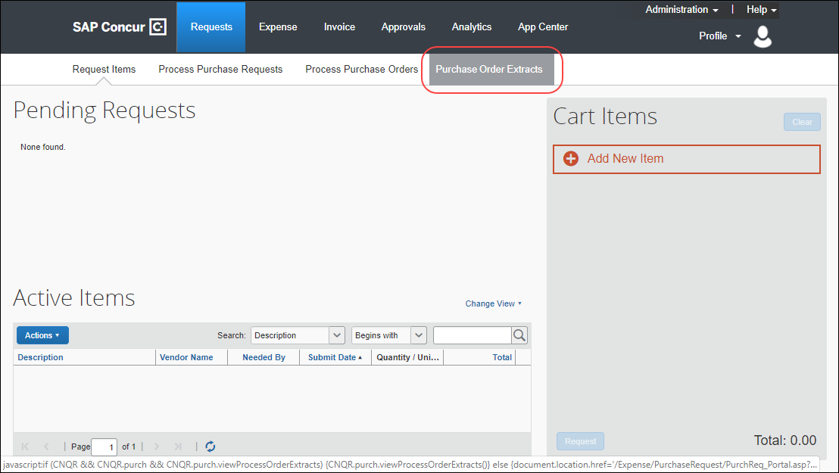
- On the Extract menu, click Purchase Order Extract.
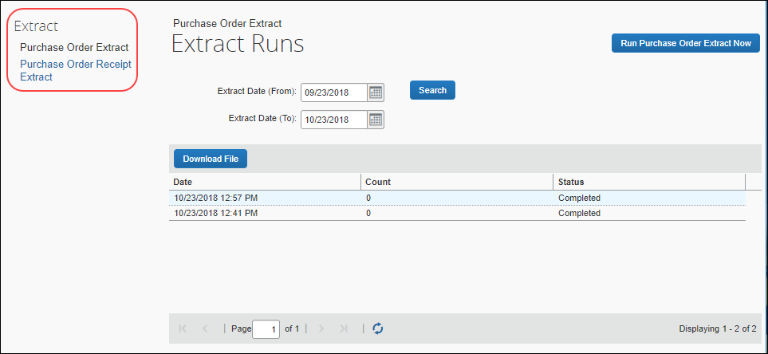
- Click the Run Purchase Order Extract Now button to start the extract.

Download and Search for Purchase Order Extracts
Once the data has been extracted, the extract can be downloaded as a pipe-delimited text file.
To download the extracted data, select the row for the extract you want to download, and then click Download File. The file is downloaded to the default download location for the local machine.
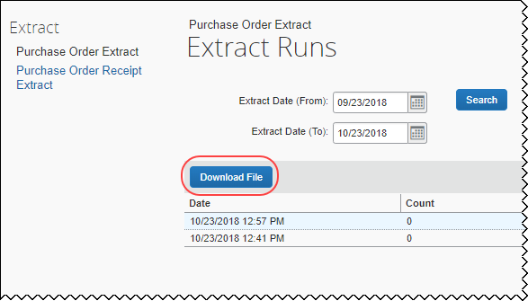
You can also search for previously generated extracts by setting a range of dates in the Extract Date (From) and Extract Date (To) fields, and then clicking Search.
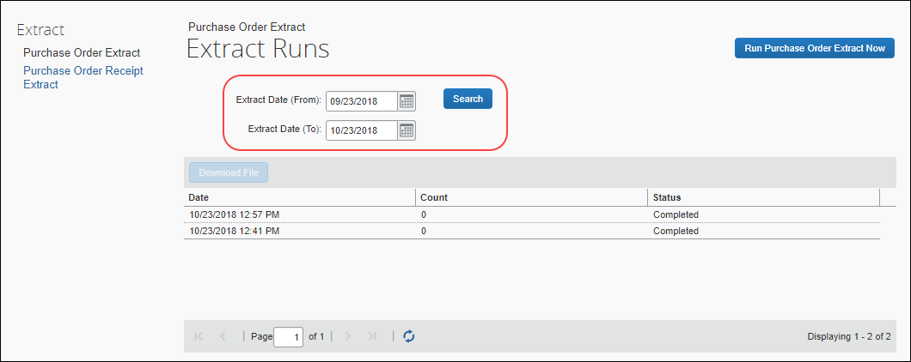

Configure Column and Fields Set View
The approver and purchasing admin working with either purchase orders or purchase requests can arrange the column view to include and exclude fields, and arrange the sequence in the order they want.

Add, Delete, and Move Columns
First, click Preferences to open the Preferences window, and then select or clear the check boxes next to those fields you want to add or remove.
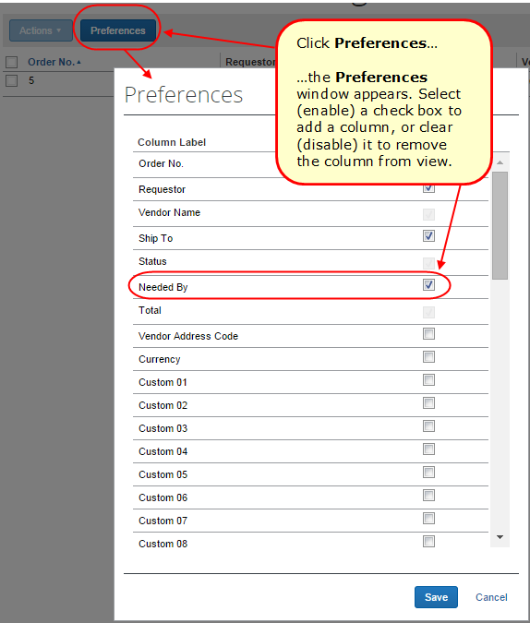

Rearrange Columns
A simple drag-and-drop action lets you grab the column heading, and then move it to a new location in the list view.



