
Concur Invoice: Purchase Order Matching
User Guide for Standard Edition
Last Revised: December 9, 2020
Applies to these SAP Concur solutions:
 Concur Expense
 Professional/Premium edition
 Standard edition
 Concur Travel
 Professional/Premium edition
 Standard edition
 Concur Invoice
 Professional/Premium edition
 Standard edition
 Concur Request
 Professional/Premium edition
 Standard edition

Table of Contents
Section 1: Overview 1
Required Roles 1
Concur Invoice Receiving Roles 1
Additional Roles 2
PO Invoice Lifecycle 3
How a PO invoice Is Processed 3
Establish PO Match "To Be" Model 4
PO Invoice Quick Tour 5
Matching Summary Tab 6
Purchase Order Tab 9
Invoice Tab 10
Section 2: PO Association 11
Associate PO During Manual Invoice Creation 11
Associate PO by Using Capture Processing 11
Associate Invoice With Multiple Purchase Orders 12
Enable and Disable Line Item Level PO 13
PO Line Item Association 15
View and Manage Multiple POs 16
Associate the Invoice to a Different PO 20
Automatically Associate Invoices With Purchase Orders 21
PO Association and Expense Types 21
Change a PO-Based Invoice to a Non-PO Based Invoice 21
Quantities and Amounts Freed up on Voided PO-Based Invoices 22
Match Rules and Match Status 22
Understand the Match Status Assigned to an Invoice 22
When Does Concur Invoice Run Match Rules? 23
Section 3: Workflow and Approval Routing 23
Capture With Exceptions 24
Capture Without Exceptions 24
Manual Entry of Invoice 24
Section 4: Concur Invoice Receiving 24
Add a Receipt 25
Edit a Receipt 26
Delete a Receipt 27
Add a Receipt Image 28
View a Receipt Image 29
Delete a Receipt Image 31
Purchase Order Import for Receiving 32
Section 5: Invoice Processor Role 33
Search for and View Invoices by PO Number 33
Search for an Invoice by Using the Go To Feature 33
Add a PO Number Column to the Processor View 34
Search for a PO-Based Invoice by Creating a Custom Query 35
Edit the Invoice 36
Resolve Exceptions 36
Compare Invoiced Quantities and Received Quantities Rule 37
Receipt Association 39
Section 6: Purchasing Admin 39
Process Purchase Orders 39
Void a Purchase Order 40
Close a Purchase Order 41
View Associated Images to the Purchase Order 42
Search for a Purchase Order 43
View Original Invoice or Purchase Request Associated with a PO 43
Section 7: Quantity Receipt Import for Three-Way Matching 44
Section 8: PO-Based Invoices That Should Not Be Matched 44

Revision History
Date | Notes/Comments/Changes
August 30, 2022 | Minor edits; cover date not updated
January 21, 2022 | Updated the copyright year; no other changes; cover date not updated
March 4, 2021 | Updated the copyright year; no other changes; cover date not updated
December 9, 2020 | Added the Receipt User role to the SAP Concur Receiving Roles' table.
January 8, 2020 | Updated the copyright; no other changes; cover date not updated
October 4, 2019 | Added several procedures.
September 21, 2019 | Added procedures for view invoices and POs.
August 17, 2019 | Added information about quantities and amounts freed up on voided PO-based invoices.
July 9, 2019 | Removed "Concur" from the title and footer. No revision date change.
June 11, 2019 | Updated images throughout.
March 16, 2019 | Added a note regarding the new All Purchase Orders list page for Purchasing Admins in the March release.
March 8, 2019 | Replaced "payment request" with "invoice". Updated "Concur" with "SAP Concur". Updated one image. Replaced "Concur's".
January 30, 2019 | Updated the copyright; no other changes; cover date not updated
June 14, 2018 | Changed copy-down to copydown; no other changes; cover date not updated
April 11, 2018 | Changed the check boxes on the front cover; no other changes; cover date not updated
November 4, 2017 | Updated guide to include new Product Settings page, which replaces the Setup Wizard.
July 8, 2017 | Added information about the Central Receiver role.
April 22, 2017 | Added information about users not being able to edit or delete receipts associated to an invoice.
December 13, 2016 | Changed copyright and cover; no other content changes.
December 5, 2016 | Updated the guide content to new corporate style; no content changes.
November 4, 2016 | Added information about the Concur Receiving feature.
August 12, 2016 | Updated Purchase Order tab images and added information about warning when non-blocking purchase order matching errors occur.
April 15, 2016 | Added information about the following:  - Three-Way Matching  - Multiple Purchase Orders  - Automatic copy-down of expense types from PO line to invoice line  - Automatic association of invoices and purchase orders
June 12, 2015 | Updated with information about the redesign of the PO Matching Summary, Payment Request, and Purchase Order tabs.
March 13, 2015 | New document.

NOTE: Multiple SAP Concur product versions and UI themes are available, so this content might contain images or procedures that do not precisely match your implementation. For example, when SAP Fiori UI themes are implemented, home page navigation is consolidated under the SAP Concur Home menu.

Purchase Order Matching

Overview
Purchase Order (PO) Matching helps companies maintain control by identifying and resolving any matching exceptions before paying suppliers, such as limiting payment to the quoted price, terms, and quantity ordered. Clients who create purchase orders in their financial system can import PO data to Concur Invoice by using the PO Import. From there, clients can configure rules that help identify match exceptions, or enable straight-through processing in cases where invoices match.
Concur Invoice offers two types of matching methods:
- Two-Way Matching: Matching between invoices and purchase orders (no receipt)
- Three-Way Matching: Matching between invoices and purchase orders and received quantities
The two-way matching verifies that purchase order and invoice information match whereas the three-way matching allows clients to match invoices with purchase orders and received quantities (of goods) before the invoices are processed and paid.

Required Roles
Once the Concur Admin has enabled the PO Matching feature, the client administrator can access and configure the PO Matching feature in Concur Invoice.

Concur Invoice Receiving Roles
This table shows different roles and what users with these roles can and cannot do when working with the Concur Invoice Receiving feature.

Role | What the User Can Do | Where? | Conditions
Purchasing Admin (who processes purchase orders) | Can add, edit, and delete receipts and receipt images. | In the transmitted purchase order. | None.
Invoice Processor | Can add, edit, and delete receipts and receipt images. | In Purchase Order tab of Concur Invoice. | None.
Purchase Request User | Can add, edit, and delete receipts and receipt images. | In the transmitted purchase order. | None.
Invoice Owner | Can add, edit, and delete receipts and receipt images. | In Purchase Order tab of Concur Invoice. | None.
Central Receiver | Can add, edit, and delete receipts and receipt images. | In the transmitted purchase order. | Cannot transmit or process purchase orders or invoices.
Receipt User | Can add, edit, and delete receipts and receipt images.  Can only add, edit, and delete receipt data for their own purchase orders. | In the transmitted purchase order. | The Concur Receiving feature must be activated.
For clients who import purchase orders on entities that do not have the Purchase Request feature enabled, a user who is assigned the Purchasing Admin role can see a list of imported purchase orders by navigating to the Requests > All Purchase Orders page.

Additional Roles
AP User: Used for sites which rely on back-office personnel to code their invoices and handle assignment and reassignment of invoices.
Invoice Owner: Can create and submit invoices.
Purchasing Admin: Typically, a purchasing specialist who updates the Purchase Order in the client’s Purchasing system. The Purchasing Admin can view all the POs within Concur Invoice. In addition, the Purchasing Admin can process purchase requests and purchase orders.

PO Invoice Lifecycle
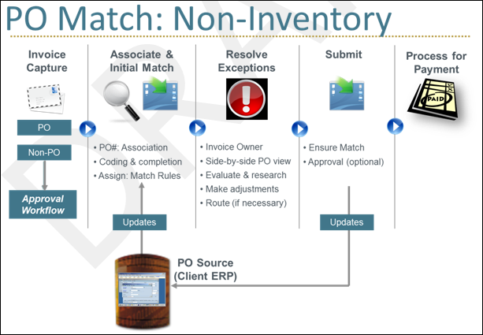
If there are no exceptions, the invoice will proceed to the purchasing admin for payment processing.

How a PO invoice Is Processed
- Invoice Capture
- PO and non-PO invoices can be captured centrally
- Association and Initial Match
- PO-based invoices are associated to the PO, based on the entered PO number
- For centralized organizations, AP Users typically complete invoice coding first
- SAP Concur has a copy of PO data from client ERP (via web service or FTP)
- Match Rules are run for the first time when the Invoice Owner is established (Assign), and exceptions are flagged
- Resolve Exceptions
- Invoice Owner (or AP in a centralized organization) reviews and resolves exceptions
- The system expedites resolution with complete visibility into the associated PO, and a side-by-side view of the PO line and Invoice line for easy comparison
- Invoice Owner/AP makes adjustments if policy allows, and if necessary, engages Purchasing or the vendor for questions or corrections
- Back office has visibility and traceability for all invoices in the system
- Submit
- Exceptions can be configured to either create a warning, or to require full resolution prior to invoice submission (hard stop)
- If there are no hard-stop exceptions, the system routes matched invoices to final processing by default; no further manager approval is required
- Process for Payment
- The invoice is moved to final processing and payment

Establish PO Match "To Be" Model
Handling Purchase Orders can involve several roles and departments, and the change to matching within Concur Invoice might involve some business process reengineering. Therefore, it is important to work with your SAP Concur representative to map your current process to a "To Be" model within Concur Invoice. The flow below shows a high-level Best Practices model and outlines key considerations.
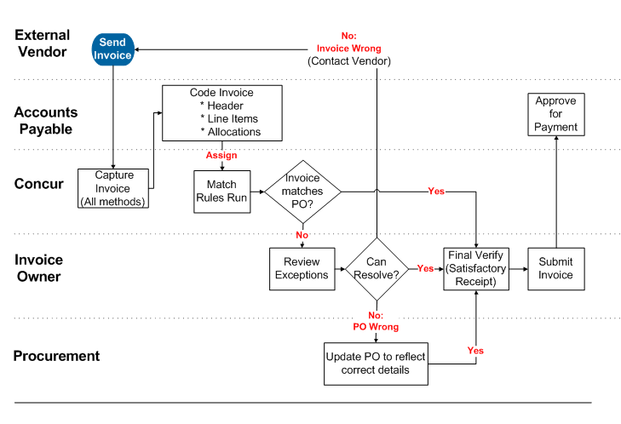
NOTES:
- Code Invoices: ALTERNATIVE - The Invoice Owner can create and/or code the invoice.
- Can Resolve?: ALTERNATIVE – The Invoice Owner can edit the current invoice to resolve the exceptions (aka "short-pay"), or contact vendor to issue corrected invoice or credit memo.
- No PO Wrong: ALTERNATIVE – Purchasing Admin can make edits within the client system which are updated to Concur Invoice via a PO Import.
- Final Verify: Regardless of match status, all invoices are routed to the Invoice Owner. The user has an opportunity to verify satisfactory receipt at an overall invoice level and can quickly dispatch perfect matches from the list view. If line level receiving is required, this must be done in another system (client ERP).
PO invoices go directly to Accounting Review (no additional manager approval can be added).

PO Invoice Quick Tour
The Matching Summary view brings together all aspects of the invoice in a single view with options to drill into the invoice, the PO, or take actions.
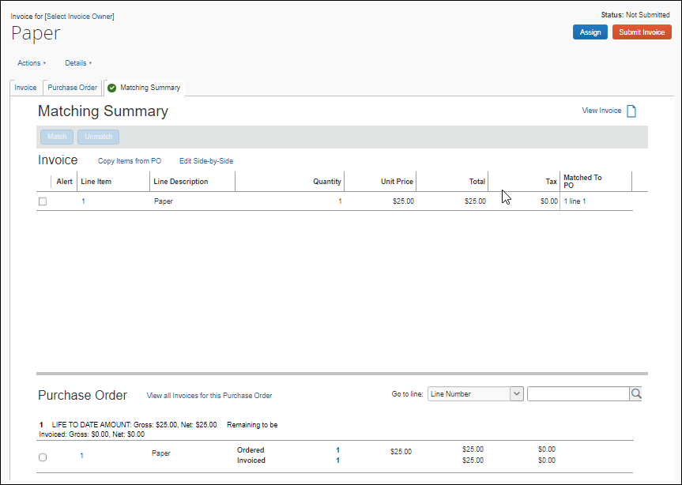

Matching Summary Tab
This comprehensive view includes:
- Matching Exceptions section listing all current exceptions
- Line Item Summary section with key fields for both invoice and PO (and receipts if the PO is part of three-way matching), including the ability to match and unmatch line items
- Side-by-Side view of invoice, PO, and associated invoice image, including Previous and Next buttons allowing for easy navigation between vendor, header, and each line item.
- View invoices and requests that share the same PO Number

Matching Line Items
The user matches one set of line items at a time by selecting one or more invoice line items and one matching PO line item, and then clicking the Match button. Alternatively, the user can right-click to perform the matching.
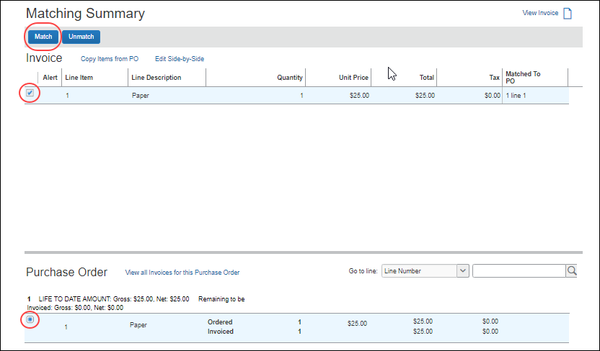
When a user clicks a line item of a purchase request or purchase order, which has not been matched, the selected line item will be highlighted, and the corresponding check box will be selected automatically. The system will then enable the Match button.
When a user clicks a line item of a purchase request or PO, which has already been matched, the Unmatch button will be enabled for the matched purchase request line item.
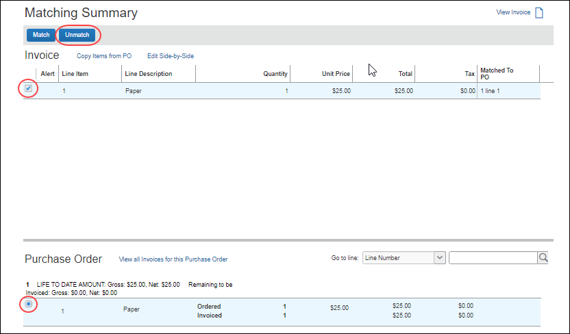
In addition, the Invoice and Purchase Order tabs display the invoice and PO details. The user can make edits based on field access configuration.
For three-way matching, the user can see the receipt information in the Matching Summary tab and in the Purchase Order tab of the invoice detail view.
The receipt information for each PO line is nested within the corresponding PO line, and consists of Receipt#, Delivery Slip #, Date, and Quantity.
Concur Invoice will highlight matched PO line items and receipts when a user selects an invoice line item.
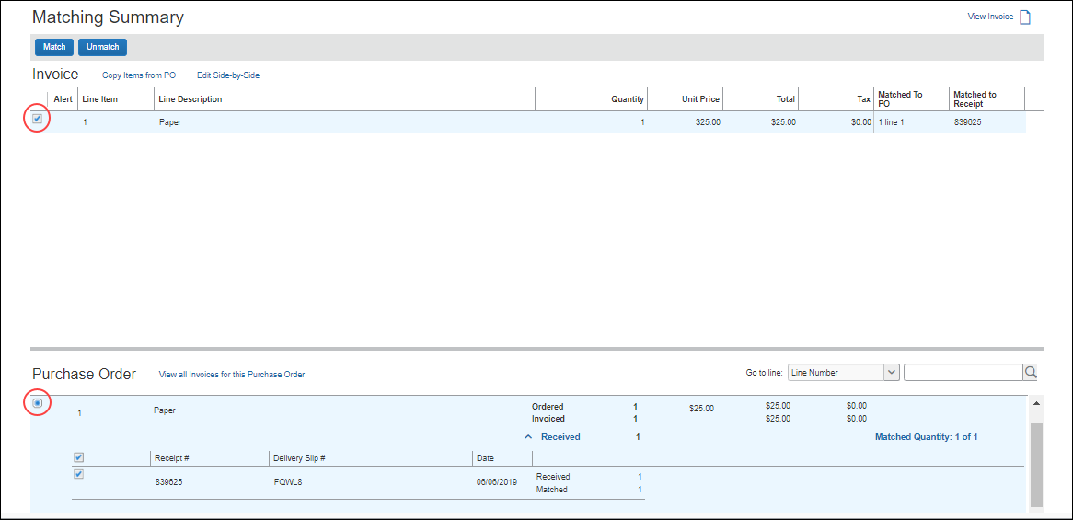

View an Invoice
To view an invoice:
- Click Invoice and select the relevant view.
- Open the invoice by clicking it.
- On the Matching Summary tab, click the View Invoice icon. The invoice images appear.

View All Invoices for This Purchase Order
To view an invoice:
- On the My Invoices page, open the invoice in detailed view.
- On the Matching Summary tab, click the View all Invoices for this Purchase Order link.
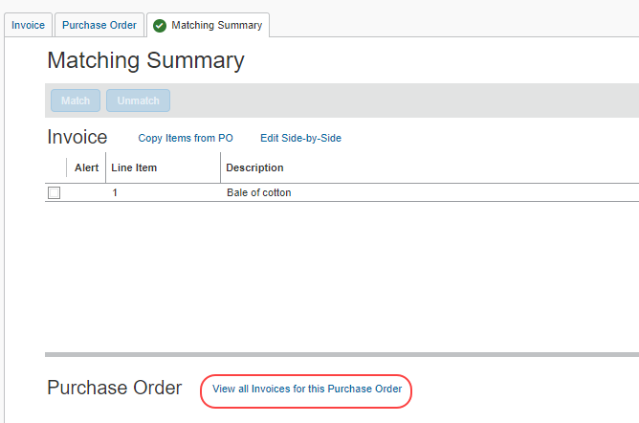
The Invoices matched to this Purchase Order page appears.
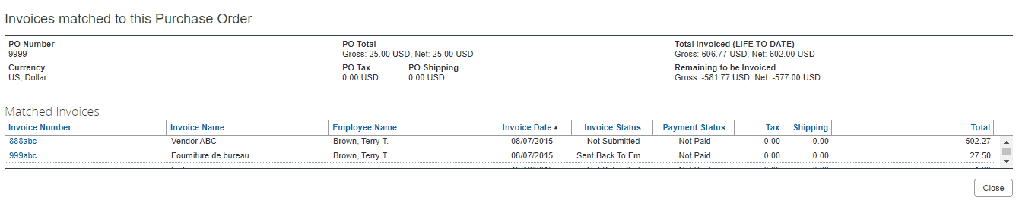

Purchase Order Tab
The Purchase Order tab provides comparison information necessary to resolve exceptions. PO data is read-only within Concur Invoice, so any changes need to be made in the PO system of record.
Purchase Order data is made available through an import from the client system of record.
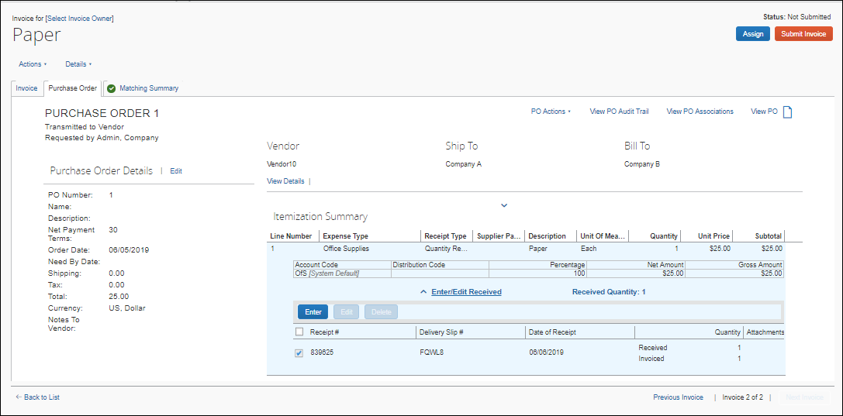

Edit a PO
To edit a PO:
- Click Invoice and then select the relevant view.
- On the Purchase Order tab, click the desired Edit link to edit the PO.
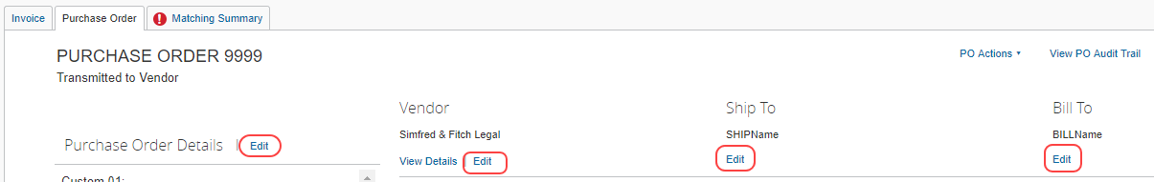
- Click Save where applicable.

View a PO
To view a PO:
- Click Invoice and then select the relevant view.
- On the Purchase Order tab, click the View PO icon.
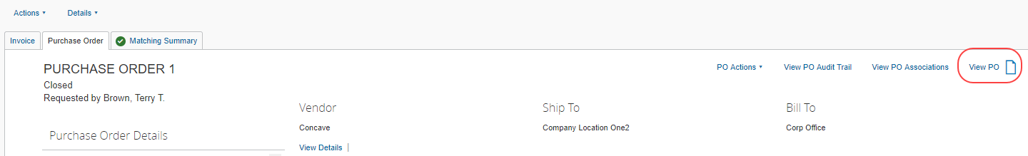
The PO images appear.

View PO Associations
To view PO associations:
- Open the desired PO-based invoice by clicking Invoice and selecting the relevant view.
- On the Purchase Order tab, click the View PO Associations.
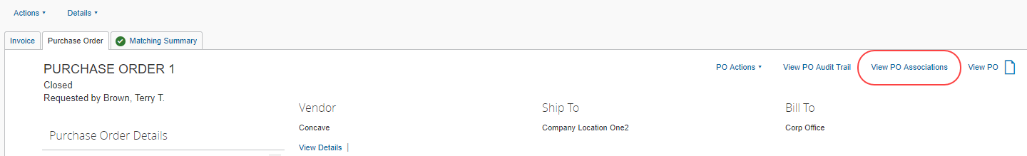
The Purchase Order Associations page appears showing information about purchase order associations to purchase requests and invoices.
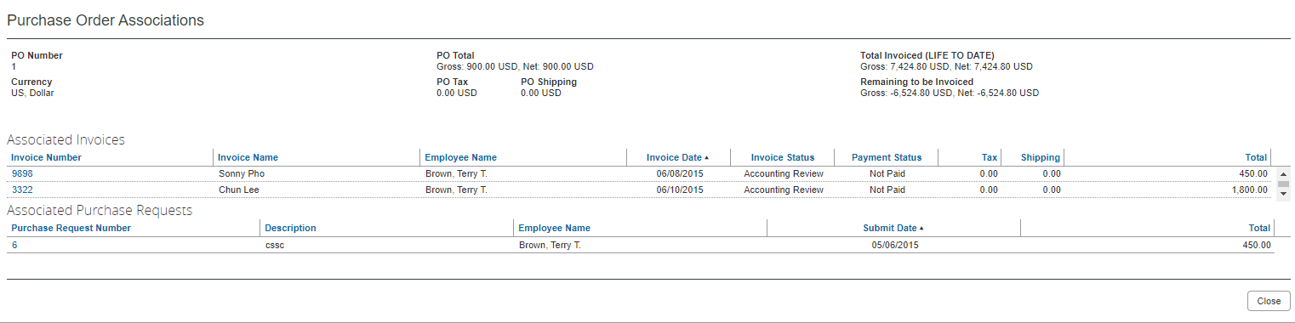

Invoice Tab
The Invoice tab contains all the information about the invoice(s) associated to the purchase order.

PO Association
When an invoice has a value entered for PO Number and the PO number matches that of a PO in Concur Invoice, the invoice is associated to the PO. This can happen during invoice creation, or it can be changed to this state for an existing invoice.

Associate PO During Manual Invoice Creation
When a user creates an invoice, if they enter a PO number into the PO Number field that matches the PO number of a PO that is already in Concur Invoice, the user can automatically associate the PO with the invoice.
After entering the required information on the Invoice Details page, when the user clicks Save, the following message appears.
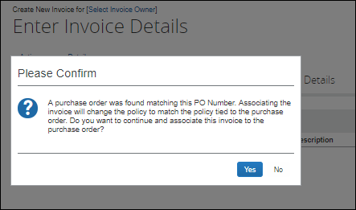
If the user clicks Yes, the invoice is automatically associated with the PO with the matching number.

Associate PO by Using Capture Processing
When the system processes an invoice through Capture Processing, the PO number appears in the PO Number field on the Verification page of Invoice Capture. The PO number captured will carry over to Invoice regardless. However, the key is that any PO-related validation will not occur, unless the captured PO number can be associated to a PO in Concur Invoice. If there is a valid association, then copy down and match rule validation will occur; if not, the system will still carry the PO number to the invoice, without any additional copy downs or ability to match.
To access the Verification page, click Invoice > Invoice Capture, and then click Verification.
Verification page:
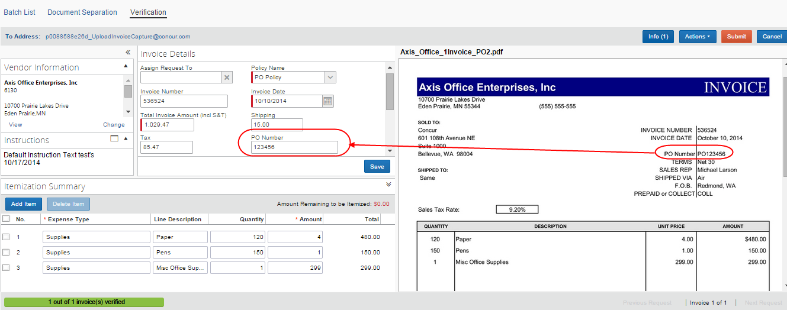
Detailed view of the Verification page showing the PO Number field:
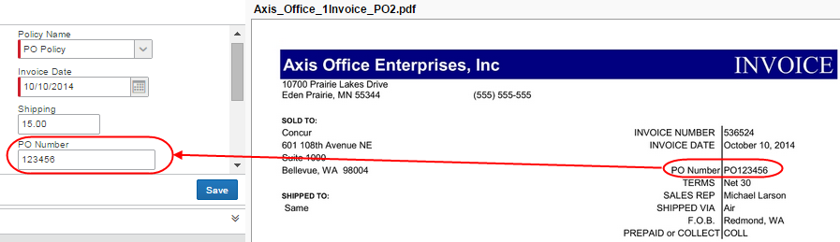

Associate Invoice With Multiple Purchase Orders
Concur Invoice can process invoices that are associated with multiple purchase orders, which might be useful for clients who only want to receive one invoice for a number of purchase orders that are tied to that particular invoice.
Some clients will get a mix of invoices with some invoices referencing a purchase order number at the header level and with some invoices referencing purchase order numbers at the line item level where each line item’s PO number could be different.
With the Multiple Purchase Orders feature, Invoice supports the ability to associate a purchase order number at the invoice line item level.
Companies with this feature can:
- Enable PO numbers at the line item level
- Disable PO numbers at the line item level
- Change the associated PO number for an invoice line item on the Invoice tab
- View each PO associated to a specific invoice on the Purchase Order tab

Enable and Disable Line Item Level PO
The Multiple Purchase Orders feature provides employees with the Enable Line Level PO command in the Actions menu for an invoice (provided the Multiple Purchase Orders feature has been activated by SAP Concur). The user selects one purchase order number from which to create an invoice from the Purchase Order Number list on the Create New Invoice page. This PO number will serve as the primary PO number for all header PO-based copydowns. Then the user selects the Enable Line Level PO option, and can manually add PO numbers at the line level in the Invoice tab. With this option selected (enabled), the user has indicated that it is a multiple PO invoice, and the PO number field at the line level becomes visible and editable. When the user adds a line item, the primary PO is defaulted as the first line’s PO. Users can change this line level PO number, and when the user creates additional line items, the previous line’s PO number is defaulted to the new line.
If the user changes the PO number:
- At the header level: The user is notified that any header copydowns will also be changed if they proceed to make the change. Line item level PO numbers will be unchanged
- At the line item level: That line item’s PO number will be changed, and the default for the next line will be the new PO number if the next line does not already have a PO number
Users can view all the POs belonging to a specific invoice in the Purchase Order tab, and to match invoice lines to PO lines belonging to different POs, a user needs to go into the Matching Summary tab.
If a purchase order is changed or updated, Concur Invoice will check if this PO is associated to any invoice line items. When the PO is saved, Invoice will run configured matching rules against existing associated invoices.
Should the user wish to disable the Multiple Purchase Order functionality, they can do so by selecting the Disable Line Level PO command in the Actions menu.
To enable line item level PO:
- Click Invoice > Create New Invoice.
- On the Create New Invoice page, in the Purchase Order Search field, start typing in a PO number, and then select the PO number that you want to use.
- On the Enter Invoice Details page, in the Actions menu, click Enable Line Level PO.
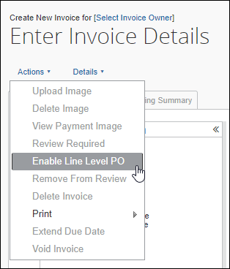
The Purchase Order Number column is added to the line item level.
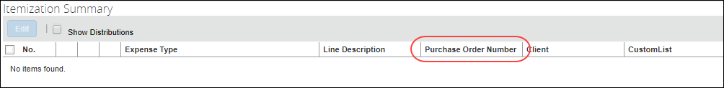
To disable line item level PO:
- Open the desired invoice.
- In the Actions menu, click Disable Line Level PO.
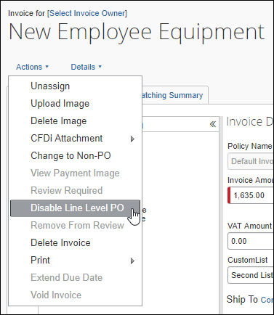
- In the Please Confirm window that appears, click Yes.
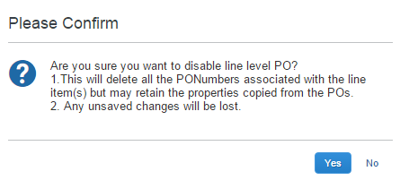
Please ensure that you really want to delete all purchase order numbers associated with the line item in question.

PO Line Item Association
If an invoice is associated to multiple purchase orders, the system creates a link between each invoice line and its corresponding PO. The PO number is then used for line association between the invoice line and the appropriate line of the PO. If the client has selected to use auto line association, this logic will be used for multiple POs as well.
Line item level PO-based copydowns will occur from the associated PO line items.
Invoice line items that do not have a PO number will not be associated to a PO line item by the system.
If the user needs to change the associated PO number for an invoice line item, they will be able to do so in the Invoice tab.

View and Manage Multiple POs
Users can view and manage multiple POs in the Purchase Order tab and Matching Summary tab.

Purchase Order Tab
On the Purchase Order tab, the user will be able to select each purchase order tied to a specific invoice in a list.
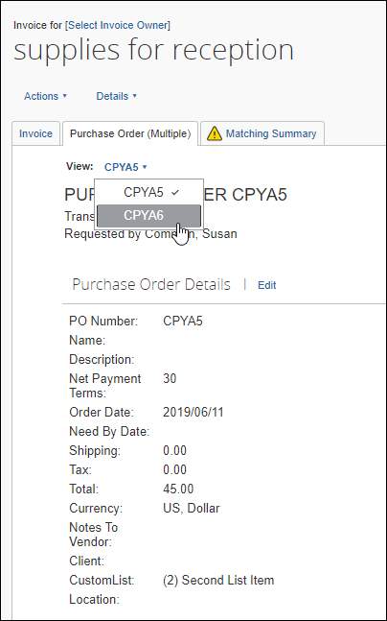
Once the user has selected a purchase order, they can view the details of the purchase order and work with it as usual.
To view and manage multiple purchase orders:
- Open the desired invoice.
- Click on the Purchase Order tab.
- In the list, select the purchase order you want to view or work with.

Matching Summary Tab
On the Matching Summary tab, in the Purchase Order list, users will see the header level purchase order as default.
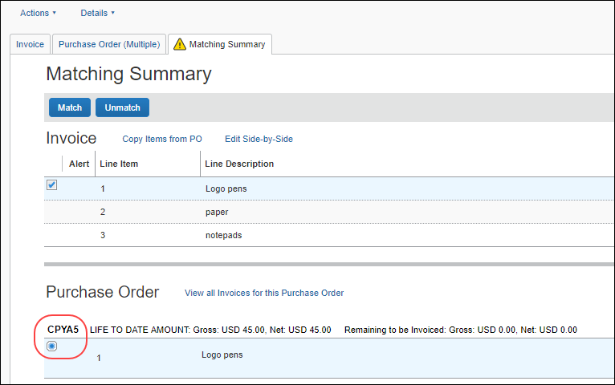
Once the user clicks on a line item purchase order in the Invoice list, the purchase order matched to that invoice shows in the Purchase Order list.
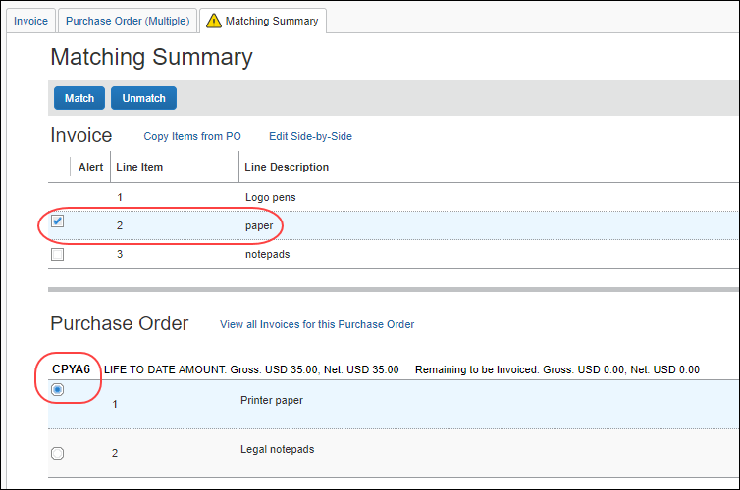

Copy Items from PO
In the Copy Items from PO window, the user will be able to see all lines of the purchase order tied to the specific invoice with which they are working.
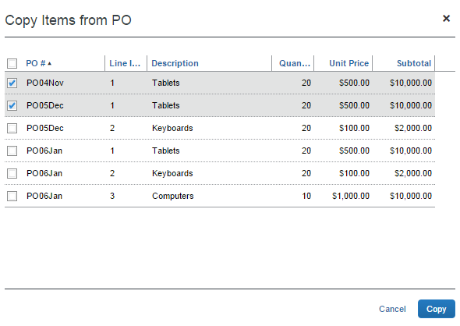
To copy items from a PO:
- Click Invoice and then select the relevant view.
- Open the invoice by clicking it.
- On the Matching Summary page, click the Copy Items from PO link.
- Select the items you would like to copy and then click Copy.

Edit Side by Side
In the Side-by-Side Editor window, the user or processor will see a list with all purchase orders tied to the invoice in question. By selecting one of the purchase orders from the list, the user or processor will see the purchase order header data in the Purchase Order section. This means that the purchase order header data will change depending on purchase order selected in the list. The invoice details stay the same.
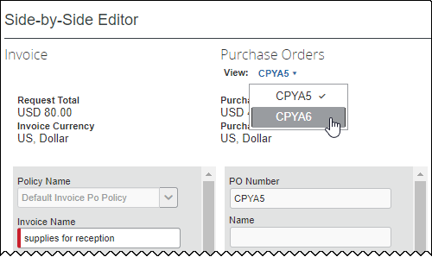
To edit in side-by-side view:
- Open the desired purchase order and click the Matching Summary tab.
- Click Edit Side-by-Side. The Side-by-Side Editor window appears.
- Edit the fields you would like to update.
- Click Save.

Associate the Invoice to a Different PO
You can associate an invoice to a different PO if it is, for example, incorrectly associated.
To associate an invoice to a different PO:
- Click Invoice and then open the desired invoice.
- Click the Invoice tab.
- In the PO number field, type the new PO number.
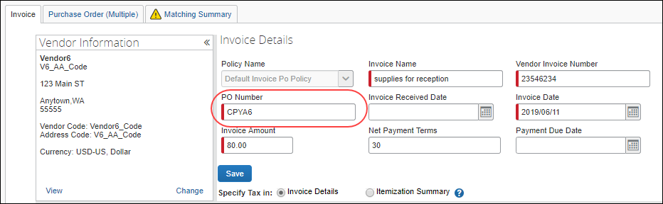
- Click Save.

Automatically Associate Invoices With Purchase Orders
If an invoice has one line item and a purchase order has one line item, Invoice will automatically associate the invoice line with the PO line.

PO Association and Expense Types
When a user manually associates an invoice line item to a purchase order line item, or when the system associates an invoice line item to a purchase order line item, the expense type of the PO line item will automatically copy down to the invoice line item to ensure that the correct expense type is processed with the invoice.

Change a PO-Based Invoice to a Non-PO Based Invoice
If an invoice is incorrectly associated to a PO, but is actually a non-PO based invoice, the user can reclassify the invoice.
To change a PO-based invoice to a Non-PO based invoice:
- On the Invoice Manager page, in the My Tasks section, click Unsubmitted Invoices.
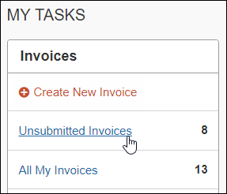
- In the More Actions menu, click the Change PO to Non-PO command.
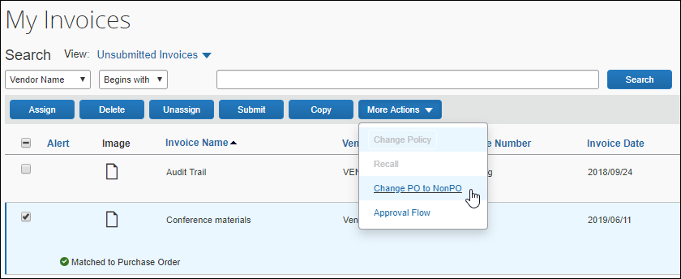
- In the Please Confirm window that appears, click Yes.
Depending on the configuration of the entity, a prompt to change the policy assigned to the invoice might appear.
When the invoice is changed to a Non-PO invoice, it might need to be assigned to a different owner. If so, the invoice must be in an unsubmitted state and the new owner must have access to the policy associated with the invoice.
If the new owner does not have access to the new policy, unassigning the invoice allows the AP User or other back-office personnel to perform the reassignment.

Quantities and Amounts Freed up on Voided PO-Based Invoices
Voided invoices remain associated with the PO, but the goods receipt quantities and amounts are freed up to be invoiced on a replacement invoice. While Concur Invoice shows those voided invoices, they fully umatch the lines for re-invoicing. When a new invoice is created, it will have the same purchase order referenced on it.

Match Rules and Match Status
Match Rules are configurable, similar to Audit and Workflow rules. They can be specified at the Header, Vendor, or Line Item level, and can be applied on a one-to-one basis between the current invoice and the PO, as well as a "Life-to-Date" basis that looks at all invoices in the system sharing the same PO Number. Concur Invoice applies exceptions to a PO invoice when Match Rules run and fail.

Understand the Match Status Assigned to an Invoice
Match Status is an attribute of an invoice, and is determined by:
- Successful association to a PO
- AND -
- Presence of any match exceptions
Match Status displays on the My Invoices, Unsubmitted Invoices, Unapproved Invoices, and Process Invoices pages. The table below shows all possible Match Status types.
Status Name | Description
Matched | The invoice is associated to a PO and has no exceptions (note that several invoices can match a single PO).
Does Not Match | The invoice is associated to a PO and has one or more exceptions (note that several invoices can match a single PO).

When Does Concur Invoice Run Match Rules?
Concur Invoice first runs matching rules when:
- An invoice is both successfully associated to a PO
- AND -
- The invoice is in an assigned state (by any method, such as the Payment Request Import, Vendor to Employee rules assignment, AP User assigning to Invoice Owner, one Invoice Owner to another).
For three-way matching, invoices must, in addition to be associated with purchase orders, also be associated to received quantities (of goods).
When these two things are true, Invoice reruns rules whenever the client makes relevant changes to the invoice or the PO. These include:
- On Header save and Line Item delete/save, and on line sequence change
- Changing Invoice Owner, Vendor, or re-assigning an invoice
- Upon PO import, if 1) the import identifies a matching invoice in Concur Invoice that had not been previously associated to a PO, or 2) the import identifies that a relevant value like unit price or quantity has been updated on the PO for a previously associated invoice
Rules are rerun for the changes listed above regardless of workflow status. This applies if the invoice is pending an Invoice Owner, Approver, or Processor.
The PO matching status of the invoice will be written to the Audit Trail whenever it changes.
Invoice cannot run rules if an invoice:
- Has been extracted
- Is part of a payment demand
- Has a status of Unassigned
- For more information about payment demands and their effect on running rules, refer to the Concur Invoice: Invoice Pay User Guide.

Workflow and Approval Routing
There are three general processes for purchase request workflows.
- Capture with exceptions
- Capture without exceptions
- Manual entry of invoice

Capture With Exceptions
If the invoice is processed through capture processing, the invoice and any relevant purchase order will be associated, and match rules run. If there are exceptions, the user resolves these and then submits the invoice. Then the system will route the invoice to the Invoice Processor who will approve the invoice. After this step, the invoice continues to invoice extraction.
Workflow
Capture → Invoice Owner (reviews for accuracy and solves exceptions) → Invoice Processor → Invoice Extraction

Capture Without Exceptions
If the invoice is processed through capture processing, the invoice and any relevant purchase order will be associated, and match rules run. The user reviews the invoice and submits. The system will then route the invoice to the Invoice Processor who will approve the invoice. After this step, the invoice continues to invoice extraction.
Workflow
Capture → Invoice Owner (reviews for accuracy) → Invoice Processor → Invoice Extraction

Manual Entry of Invoice
The invoice owner enters the invoice manually into the system, and then submits the invoice. Then the system will route the invoice to the Invoice Processor who will approve the invoice. After this step, the invoice continues to invoice extraction.
Workflow
Invoice Owner → Invoice Processor → Invoice Extraction

Concur Invoice Receiving
In a typical purchasing process, the buyer orders goods from the supplier by issuing a purchase order. The supplier delivers the goods with a document detailing the goods that are shipped (Delivery Slip Note/Bill of Lading). The buyer receives the goods and records the receipt by creating a Goods Receipt Note. The supplier then invoices the buyer for the items they have shipped. The buyer reconciles the invoice against the ordered and received items and then processes the invoice for payment.
This section describes how to enter quantity receipt data manually into the Concur Invoice product. This is beneficial for clients who can receive receipts in Concur Invoice and use three-way matching to give them more control over their invoice process.
Invoice Owners, Invoice Processors, and Purchasing Administrators, who processes purchase orders, can enter, edit, and delete receipts, and add, view, and delete receipt images. In addition, Invoice Owners and Invoice Processors can manage receipts at any time in the workflow process within Concur Invoice.
Purchase Request Owners will also be able to manage receipts and receipt images provided the Allow Purchase Request Owners to Edit their own Purchase Orders option is selected (enabled) in Invoice Settings.
If the Purchase Request Owner becomes the owner of the invoice as well, then they can add/change/delete receipts on the invoice (through the Purchase Order tab) when they submit the invoice. For this to work, the Assign invoice to Purchase Request Owner option must be selected (enabled) in Invoice Settings, or the invoice must be manually assigned to the user.
When Purchase Request Owners create a new item, they will be able to specify if the item requires quantity receipts or not in the Receipt Type list. The default will be None for services and Quantity Receipt for goods.
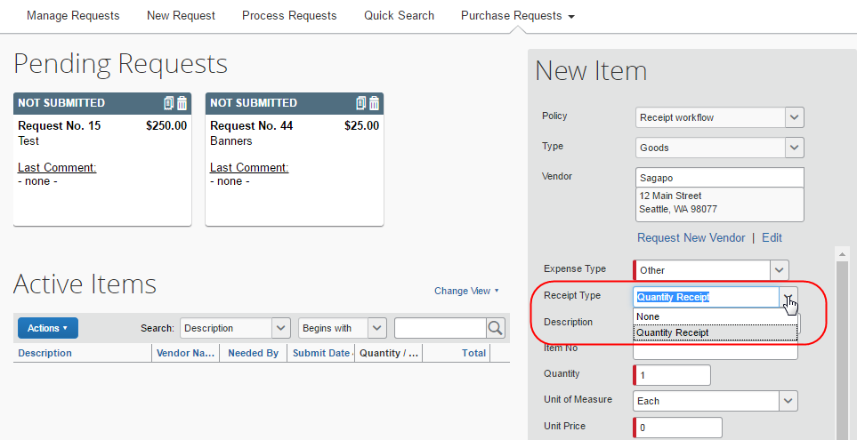

Add a Receipt
Invoice Owners, Invoice Processors, Purchasing Administrators (who processes purchase orders), and Purchase Request Owners (who can edit their own purchase orders) can open transmitted purchase orders and add receipts at the line item level of the purchase orders.
To add a receipt:
- Open the desired purchase order and then click the Purchase Order tab.
- In the Itemization Summary section, click the Enter button. The Enter Received Goods window appears.
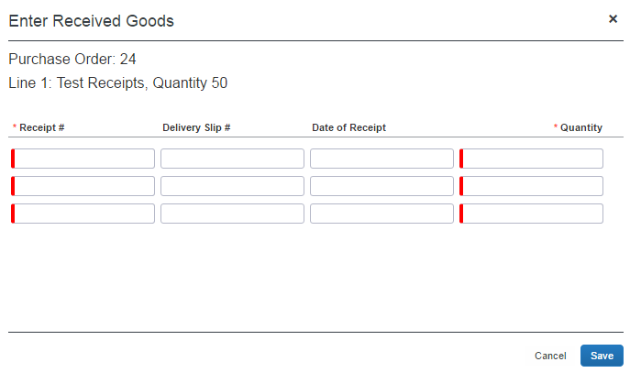
- In the Enter Received Goods window, complete the required fields and any other field that you would like to fill in.
Field | Description/Action
Receipt # | (Required) Enter the receipt number of the goods that you received.
Delivery Slip # | (Optional) Enter the Delivery Slip Number of the goods that you received.
Date of Receipt | (Optional) Enter the date when you received the goods. If left blank, today’s date is used.
Quantity | (Required) Enter the quantity of goods that you have received. The quantities are incremental.
- Click Save.

Edit a Receipt
Invoice Owners, Invoice Processors, Purchasing Administrators, who processes purchase orders, and Purchase Request Owners (who are allowed to edit their own purchase orders) can open transmitted purchase orders and edit receipts at the line item of the purchase orders.
If a receipt is associated with an invoice, a user will not be able to edit the receipt and the Edit button will be disabled. If a user needs to make changes to an invoice, they need to first unassociated the receipt to the invoice.
To edit a receipt:
- Open the desired purchase order and then click the Purchase Order tab.
- In the Itemization Summary section, select the receipt that you would like to edit, and then click the Edit button. The Edit Received Goods window appears.
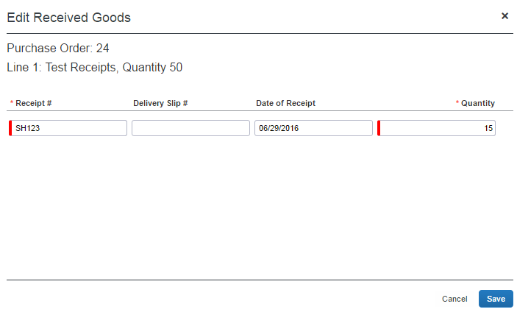
- Edit desired fields, and then click Save.

Delete a Receipt
Invoice Owners, Invoice Processors, Purchasing Administrators, who processes purchase orders, and Purchase Request Owners (who are allowed to edit their own purchase orders) can open transmitted purchase orders and delete receipts at the line item of the purchase orders.
If a receipt is associated with an invoice, a user will not be able to delete the receipt and the Delete button will be disabled. If a user needs to make changes to an invoice, they need to first unassociated the receipt to the invoice.
To delete a receipt:
- Open the desired purchase order and then click the Purchase Order tab.
- In the Itemization Summary section, select the receipt that you would like to delete, and then click the Delete button. The Do you want to delete the following Received entries? window appears.
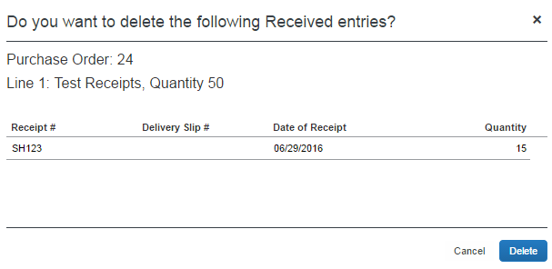
- Click Delete.

Add a Receipt Image
Invoice Owners, Invoice Processors, Purchasing Administrators, who processes purchase orders, and Purchase Request Owners (who are allowed to edit their own purchase orders) can open transmitted purchase orders and add receipt images at the line item of the purchase orders. Only one image ID can be associated with a receipt. Additional uploaded receipts are appended to the same image.
To add a receipt image:
- Open the desired purchase order and then click the Purchase Order tab.
- In the Itemization Summary section, click the  icon of the receipt to which you would like to add a receipt image. The Upload Image window appears.
- Click Browse to locate the receipt you want to attach.
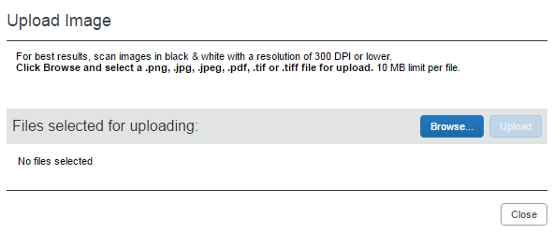
- Click Open or double-click the receipt image.
- Click Upload and then Close.
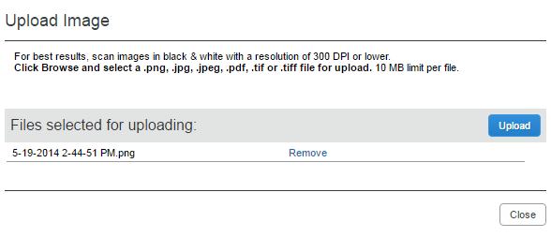

View a Receipt Image
Invoice Owners, Invoice Processors, Purchasing Administrators, who processes purchase orders, and Purchase Request Owners (who are allowed to edit their own purchase orders) can open transmitted purchase orders and view receipt images of the purchase order.
To view a receipt image:
- Open the desired purchase order and then click the Purchase Order tab.
- In the Itemization Summary section, click the  icon of the receipt you would like to view. The Purchase Order Receipt Image window appears.
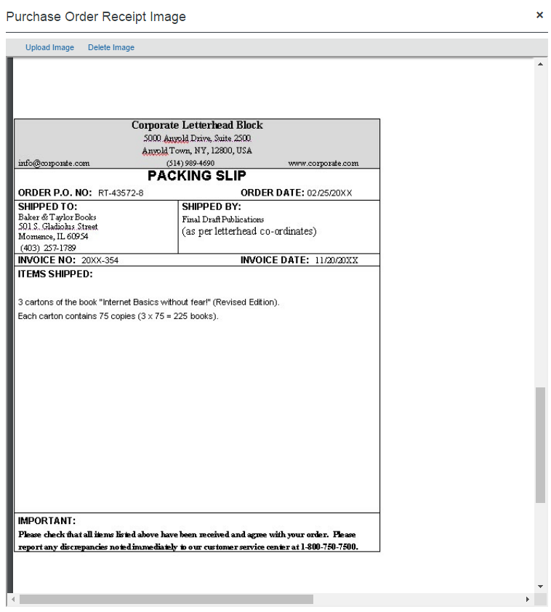
Review the receipt image and then close the window by clicking the x in the top-right corner.
You can also upload receipt images from this window by clicking the Upload Images link.
In the Purchase Order Receipt Image window receipt images can be rotated, downloaded, printed, zoomed in and out, and fitted to page.
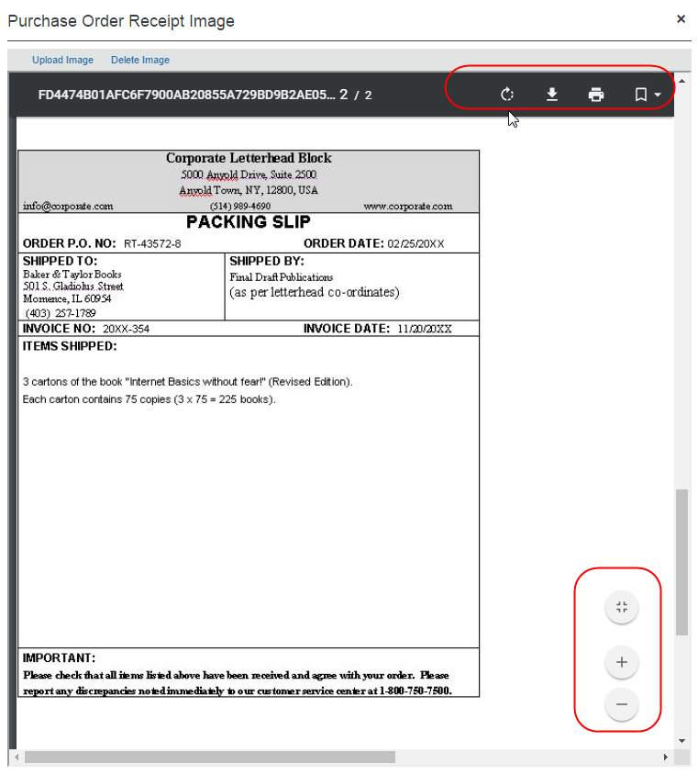

Delete a Receipt Image
Invoice Owners, Invoice Processors, Purchasing Administrators, who processes purchase orders, and Purchase Request Owners (who are allowed to edit their own purchase orders) can open transmitted purchase orders and delete receipt images of the purchase orders.
To delete a receipt image:
- Open the desired purchase order and then click the Purchase Order tab.
- In the Itemization Summary section, click the icon of the receipt you would like to delete. The Purchase Order Receipt Image window appears.
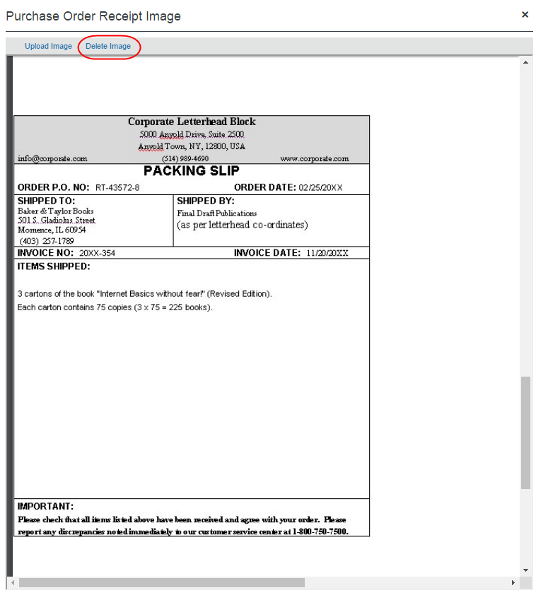
- Click Delete Image.

Purchase Order Import for Receiving
The Receipt Type is supported at the header and line item level of the Purchase Order Import.
- For more information, refer to the Concur Invoice: Import and Extract File Specifications - Purchase Order Import document.

Invoice Processor Role
When approving, the processor can draw on features specific to this type of invoice, including:
- Search for PO invoices by querying for their associated Purchase Order Number, Invoice Number, or Request Number value
- Side-by-side edit view of PO and invoice for vendor, header, and line item editing
- Ability to change the sequence and number of line items in the invoice to match those of the PO
- Ability to clear exceptions that prevent matching

Search for and View Invoices by PO Number
You can search for a purchase order by either using the Go To feature, or by creating a query, and you can view purchase orders by adding the PO number to the Invoices Ready for Processing page. To do so, use the following procedures.

Search for an Invoice by Using the Go To Feature
The Purchase Order Number attribute is unique and can return one or more invoices associated with their PO. To view these in the Processor view, a search function using the Go To button is available.
To search for an invoice by using the Go To feature:
- Click Invoice > Process Invoices.
- On the Invoices Ready for Processing page, click Go To.
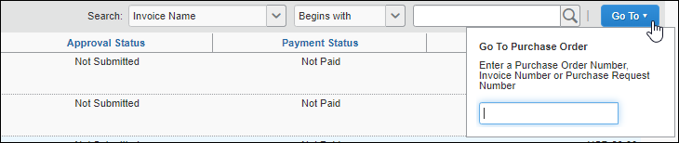
- Type in the Purchase Order Number, Invoice Number, or Purchase Request Number associated with the PO for which you are searching. When a match is found, the system returns one (or more) purchase orders.
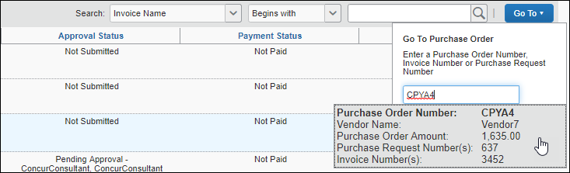
- Click the result to view the purchase order (you can only open one at a time.)

Add a PO Number Column to the Processor View
You can add the PO Number column to the grid view which allows a sort-by-number view to quickly sort and identify purchase requests.
To add the PO Number column to the processor view:
- Click Invoice > Process Invoices.
- On the Invoices Ready for Processing page, click Preferences.
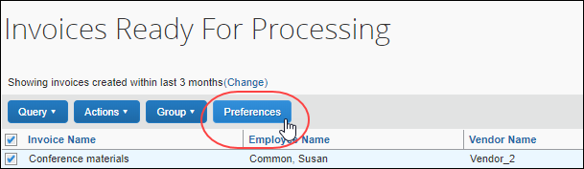
- Locate the PO Number option in the list and select (enable) it.
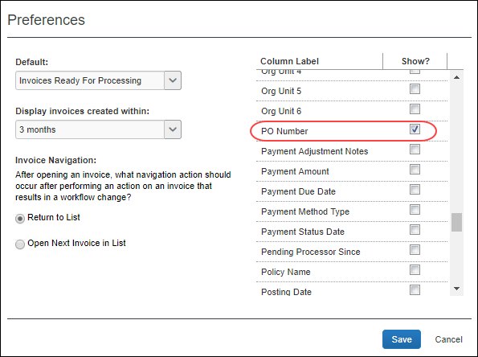
- Click Save. The PO Number column appears on the Invoices Ready for Processing page.
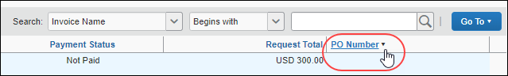

Search for a PO-Based Invoice by Creating a Custom Query
Creating a query can eliminate tiresome repetition whenever the same search criterion is used repeatedly to return purchase order invoices.
To search for a PO-based invoice by creating a custom query:
- Click Invoice > Process Invoices.
- On the Invoices Ready for Processing page, click Query > New Query.
- Create the query as shown in the following figure.
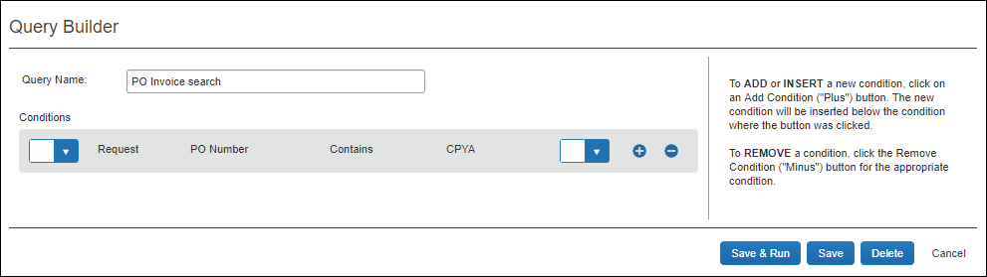
- Click Save (or Save & Run to return all invoices using that number). The system saves the query and you can now run the query by clicking it directly.
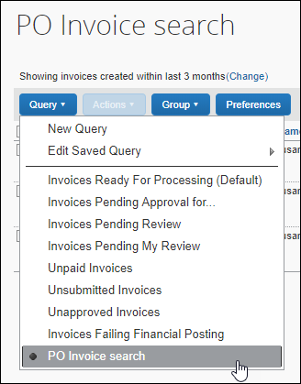

Edit the Invoice
A PO invoice might need adjusting prior to approval. The processor has the option of sending the invoice back to the invoice owner with directions in the Comment field explaining the required changes. Otherwise, the processor can adjust the invoice as needed.
- For more information, refer to the Edit the PO Invoice section in this guide.

Resolve Exceptions
Because a purchase request typically cannot be submitted or approved while it has exceptions (unless configured so in matching rules), it is rare that a non-Invoice Owner role (such as Processor or Approver) will see an invoice with match exceptions. However, this can occur in the following cases:
- Processor or approver makes an edit that causes the previously matched invoice to have exceptions.
- The PO import applies new updates to a PO. For example, suppose PO#123 had a total of $1,000. Its associated invoice had a status of Matched and was submitted. While pending an approver, the import updated PO#123 to a total of $800. An amount-based exception would occur.
In either case, the user would need to correct the exceptions (by making edits if their role allowed, or by sending back to the Invoice Owner for corrections) before the invoice could be approved.
If company policy allows, the processor typically resolves exceptions just as the Invoice Owner would, except this is done from the Invoices Ready for Processing page.
When an invoice has only non-blocking purchase order matching errors, the icon on the Matching Summary tab and the icon on the Invoice list will show a warning (a yellow triangle) indicating that there is an error. However, the invoice can still be matched.
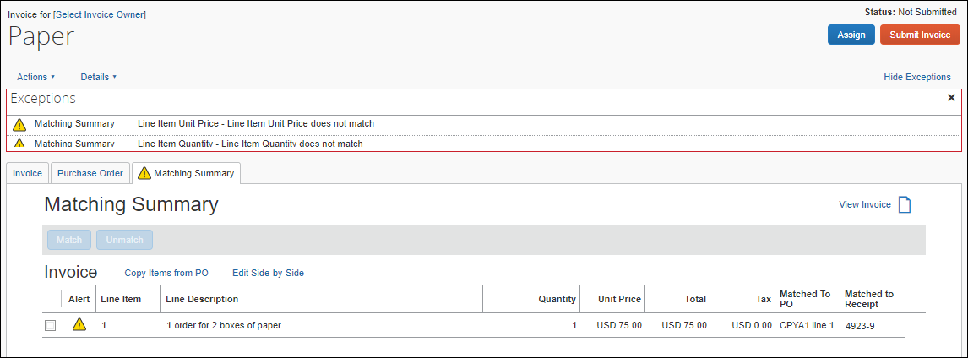

Compare Invoiced Quantities and Received Quantities Rule
The Invoice Quantities rule is a Life-To-Date rule that compares the total quantities invoiced (based on quantities matched) against the total quantities on the associated receipts.
The rule can be set up as a warning or prevent submission if invoiced quantities for all invoice line items associated with that receipt is more than the configured number or percentage over the received quantity of associated receipts. This rule is unchecked (disabled) by default.
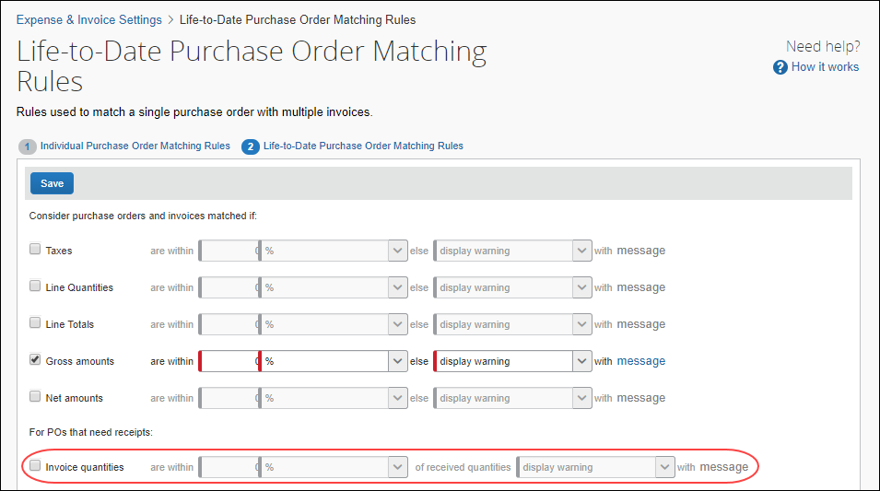
Example 1
Let us assume that we have the following:
PO
Line 1: Ordered Quantity is 30
Receipts
GRN#1: Received Quantity is 20
Invoices
Invoice 1: Line 1 quantity is 10
Invoice 2: Line 1 quantity is 10
Invoice 3: Line 1 quantity is 10
The system will associate Invoice 1: Line 1 and Invoice 2: Line 1 to GRN #1. The system will not associate Invoice 3: Line 1 to a receipt, as there are no available receipts to associate for this invoice. However, if a user associates Invoice 3: Line 1 to GRN#1, the Life-to-Date rule will fire and throw an exception on all three invoices.
Example 2
Let us assume that we have the following:
PO
Line 1: Ordered Quantity is 30
Receipts
GRN#1: Received Quantity is 20
Invoices
Invoice 1: Line 1 quantity is 30
The system will associate Invoice 1: Line 1 to GRN #1. The Life-to-Date rule will fire and throw an exception on Invoice 1: Line 1, because the receipt quantity is less than the Invoice quantity.

Receipt Association
Concur Invoice will automatically try to associate incoming invoice line to available receipts on the associated PO lines by using the following logic:
- For invoices where there is not a specified Delivery Slip Number, Concur Invoice will associate invoice lines to available receipts in a sequential order, filling each invoice line with available quantities from GRN #1, GRN #2, and so on.
- For invoices where the client has specified the Delivery Slip Number, Concur Invoice will associate it to the GRN that has the same DSN. If Concur Invoice does not find a GRN with the same DSN, it will revert to the sequential association logic.

Purchasing Admin
Within the PO Matching process for external POs, there might be a need to view and process the external POs that have been imported into the Concur Invoice product. A user with the Purchasing Admin role can review and perform certain actions on these external purchase orders.

Process Purchase Orders
The purchasing admin typically reviews purchase orders and performs PO-related tasks.
To process purchase orders, the purchasing admin clicks Requests > Process Purchase Orders. Here, the purchasing admin can perform processing task on the purchase order.
With the purchase order open in detail view, the purchasing admin can perform the following actions:
- Void the transmitted PO
- Close the transmitted PO
- View the associated image(s) for the PO
- Review the original payment or purchase requests associated with this purchase order
Purchasing admins who work with multiple purchase orders will be able to perform the same task as the user, when working in the Purchase Order tab and Matching Summary tab. For more information, refer to the View and Manage Multiple Purchase Orders section in this document.

Void a Purchase Order
A purchasing admin might want to void a purchase order after transmittal to vendor if, for example, the order cannot be fulfilled due to a discontinued item, or if there are vendor issues or changes in the business environment that deems the PO invalid.
When a purchasing admin voids a purchase order, the system sets the PO to Voided. A record of the PO remains in the system, but the PO is not included in any listing or extract of general purchase orders. However, voided purchase orders can be included in search result lists by filtering the search where the status is equal to Voided.
Voiding the PO is a "housecleaning" measure used to ensure any associated invoices referencing this PO Number will be identified and handled appropriately.
To void a purchase order:
- On the All Orders page, select the purchase order you want to void by clicking its check box.
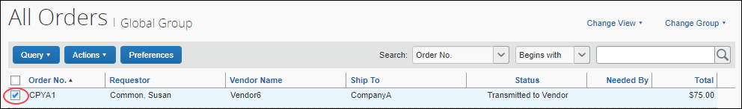
- On the Actions menu, click Void.
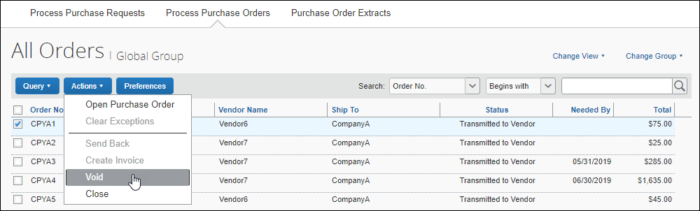
- In the Void Purchase Order window that appears, enter a comment about why you want to void the purchase order, and then click OK. The system updates the audit log and changes the status of the purchase order to Voided.
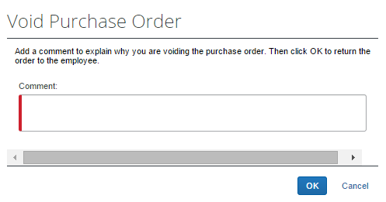

Close a Purchase Order
When a purchasing admin closes a purchase order after transmittal to vendor, the system removes the closed PO from the list of purchase orders pending actions. This helps the processor to manage their POs and their statuses more efficiently.
If the purchasing admin wants to search on closed POs, they can do so by selecting Status Equals Closed in the search area. The page will list all the closed POs.
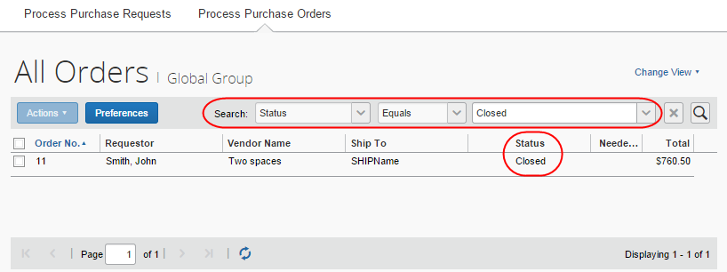
Please note that the purchasing admin cannot copy an invoice if it is associated with a closed PO.
If the client uses an external purchasing system, a standard PO import into Concur Invoice can update any PO with a Closed status.
To close a purchase order:
- On the All Orders page, select the purchase order you want to close by clicking its check box.
- On the Actions menu, click Close.
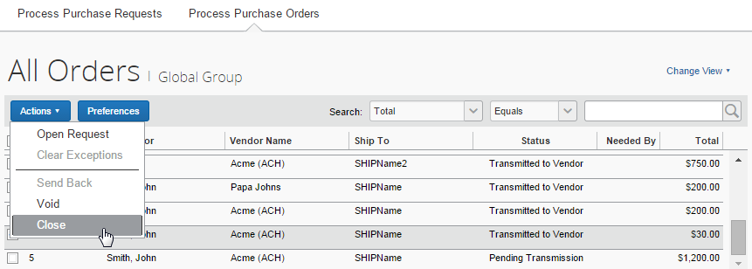
- In the Close Purchase Order window that appears, enter a comment about why you want to close the purchase order, and then click OK. When the purchasing admin has closed the PO, it will no longer appear in the list of that page.
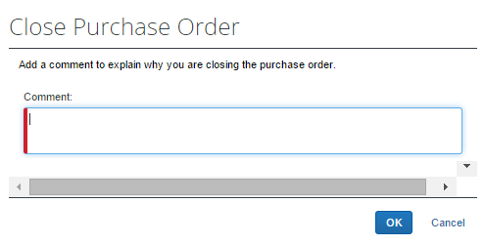
In addition, a closed PO will not be available in the list of active POs for matching invoices.

View Associated Images to the Purchase Order
To view associated images to the purchase order, click View Image Gallery.
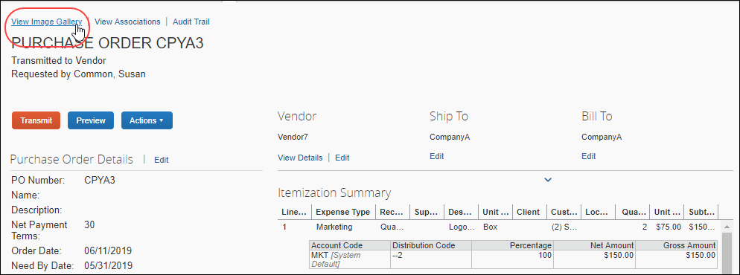

Search for a Purchase Order
Purchasing admins can search for purchase orders that are pending transmission or all purchase orders in the search area by selecting different search criteria, such as Requestor Last Name, Total, or Vendor Name.
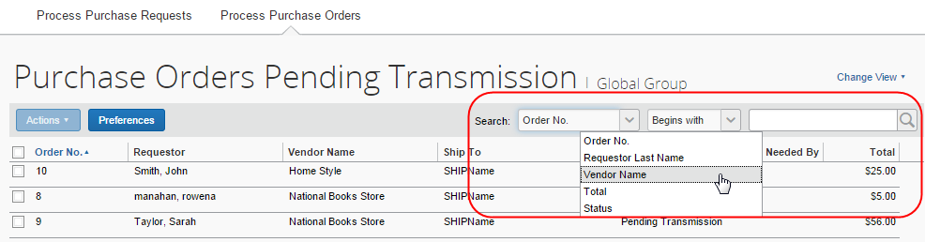

Change View Search Option
Purchasing admins can also use the Change View menu to display purchase orders pending transmission or pending vendor approval. By changing the view, the result appears on the page.
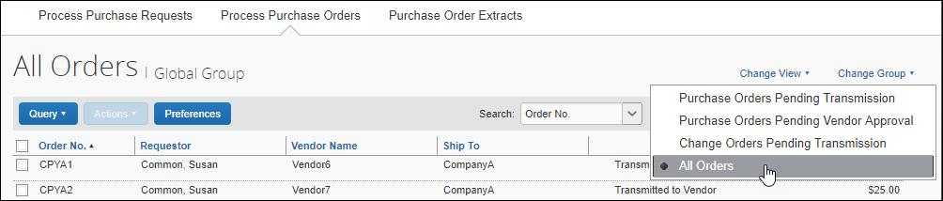

View Original Invoice or Purchase Request Associated with a PO
To view details about the original invoice or purchase request associated with a specific purchase order, click View Association.
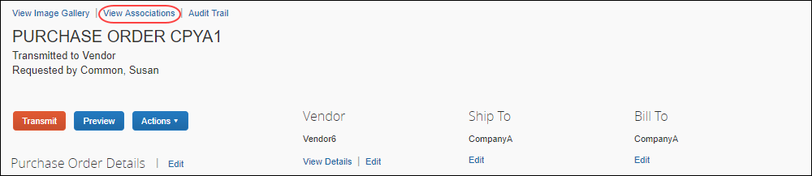
The Purchase Order Associations window appears.
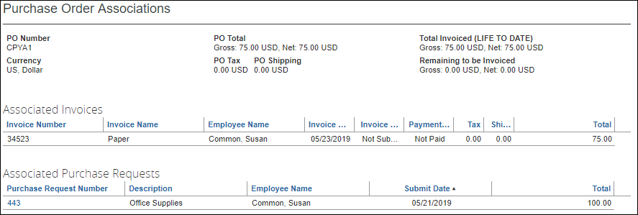

Quantity Receipt Import for Three-Way Matching
Before clients can start to use the Three-Way Matching feature, they need to import the Quantity Receipt file, which they can do through an FTP import or through the API. The receipt information that clients import into Concur Invoice enables the system to associate and validate incoming invoice lines. The associated receipt information is then available for extract through the Standard Accounting Extract.
If clients need to use three-way matching, they should use the Quantity Receipt Import.
- For more information, refer to the Concur Invoice: Import and Extract File Specifications - Purchase Order Receipt Import Version 2 (Quantity Receipt for Three-Way Match) document.

PO-Based Invoices That Should Not Be Matched
In some cases, a client will use Concur Invoice to capture and route PO invoices but will not want matching to be performed on them. For example, the client might have a set of inventory-related POs which require receiving and matching to be performed within the ERP PO module (not Concur Invoice).
The most common benefits of using Concur Invoice in this way are standardizing capture methods, as well as consolidating images and reporting data in one system. Clients commonly choose a workflow for these PO invoices that routes straight to Processor, extracts the invoices, and then performs the match in their ERP.
In cases like these, ensure that you do not enter any value in the Concur Invoice Purchase Order Number field so that the system will not perform any matching in Concur Invoice.
When creating an invoice, enter the PO Number on the Invoice Header Form. Do not enter it in the Purchase Order Number field on the Create New Invoice page. The latter approach will look for a matching PO number in Concur Invoice, which will not exist.

☼

