
Concur Expense: Japan IC Card Integration
User Guide
Last Revised: December 8, 2023
Applies to these SAP Concur solutions:
 Expense
 Professional/Premium edition
 Standard edition
 Travel
 Professional/Premium edition
 Standard edition
 Invoice
 Professional/Premium edition
 Standard edition
 Request
 Professional/Premium edition
 Standard edition
Table of Contents
IC Card Integration 1
Section 1: Overview 1
Who Should Use This Feature 1
Required Roles 1
Section 2: Managing Suica and PASMO IC Cards 2
Registering a Suica/PASMO IC card for a user 3
Deleting a Suica/PASMO IC card 11

Revision History
Date | Notes / Comments / Changes
Dec 8, 2023 | Updated the content with information related to PASMO IC card integration.
Sep 15, 2023 | Added note on addition of “Suica-” prefix under vendor details in the receipt.
Dec 16, 2022 | Added notes on JR East website and the availability of the service only in Japan.
March 21, 2022 | Updated screenshot and updated the content as per change in railway company’s specifications.
November 19, 2021 | New guide.

IC Card Integration
NOTE: Multiple SAP Concur product versions and UI themes are available, so this content might contain images or procedures that do not precisely match your implementation. For example, when SAP Fiori UI themes are implemented, home page navigation is consolidated under the SAP Concur Home menu.

Overview
IC (Integrated Circuit) cards are rechargeable plastic prepaid cards issued by railway companies in Japan. These cards are available at ticket vending machines at train stations or major airports.
Different IC card companies issue more than ten different cards and some of them are Suica card, PASMO card, ICOCA card, and nimoca card.
The IC Card Integration (ICCI) is a Japan Public Transport (JPT) option that draws all the transactions from the railway company’s server to Concur Expense. This solution was proposed because of three reasons:
- High equipment maintenance (Reader)
- Availability of Readers only on office premises
- Transaction limit up to 20 transactions per card (Users would need to travel to their office after the limit is reached.)
In this guide, you will learn how to integrate Suica and PASMO cards by JR East and Pasmo respectively, with SAP Concur. This integration will allow Concur Expense to retrieve travel transactions, such as train, bus, taxi, and parking expenses, from the JR East server for expense reporting.
This service is only available for employees of companies that are based in Japan.

Who Should Use This Feature
The ICCI is intended for use by all users who have registered their Suica/PASMO IC card through Concur Expense. Concur Admins can activate this service from JPT.
The user must also have JPT 2.0 on NextGen UI.
This option is not available with any rail, bus, taxi, and parking expenses outside of Japan.

Required Roles
There are no required roles to use this feature; you need only have the Expense User role.
Companies can also assign certain validation rights to a few of their associates who will register themselves in Concur Expense as Checkers. They validate the authenticity of the users registered for the Suica/PASMO cards. These Checkers also need to be registered with JR East. You can follow the instruction on JR East on how to assign Checker roles.
If you need additional support, contact your Concur Admin.

Managing Suica and PASMO IC Cards
IC card registration gives the necessary rights for Concur Expense to receive the trip transaction details from the railway company.
The registration steps depend on the type of card the user has.
The Suica IC cards are issued by Japan Railway (JR) East and the PASMO IC cards are issued by Pasmo. Both IC cards can be used for rail and road transportation. They can also be used for subway, bus, and parking expenses.
For Suica and PASMO cards, users need to register on Concur Expense which is integrated with JR East. Once the process of registration is initiated in Concur Expense, the user will receive an email with a registration link that directs them to the JR East website. The user needs to first verify their email and then fill in all the necessary details. JR East will first validate the details and then send an approval notification to Concur Expense. Once the status of the card is changed to Registered, Concur Expense will start tracking all the transactions from the registered date.
The process of validation involves authorized Checkers who check the legitimacy of the user information, and these Checkers are specified in different steps of the validation process in advance.

Registering a Suica/PASMO IC card for a user
To register a Suica/PASMO IC card:
- Click Profile > IC cards.
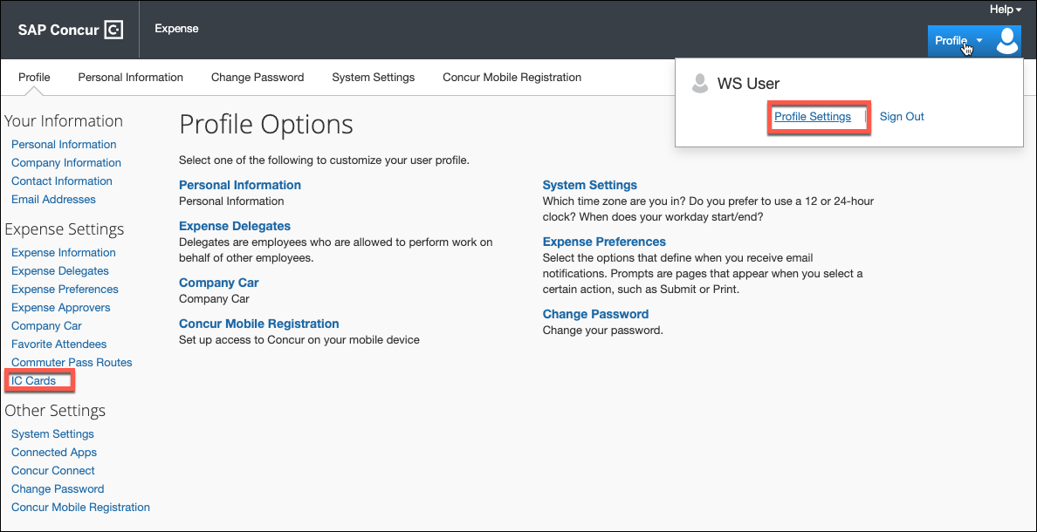
- Click Add.
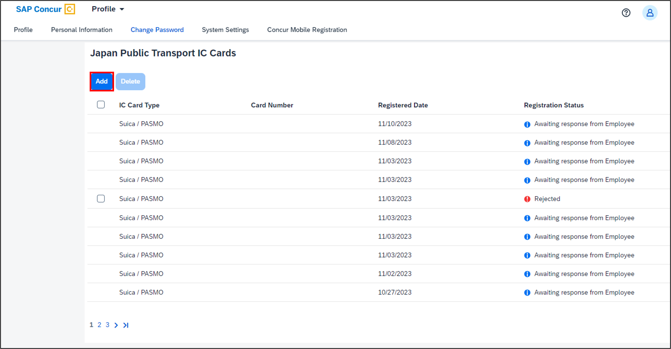
The New IC Card page opens. By default, in the IC Card Type list, Suica / PASMO is selected.
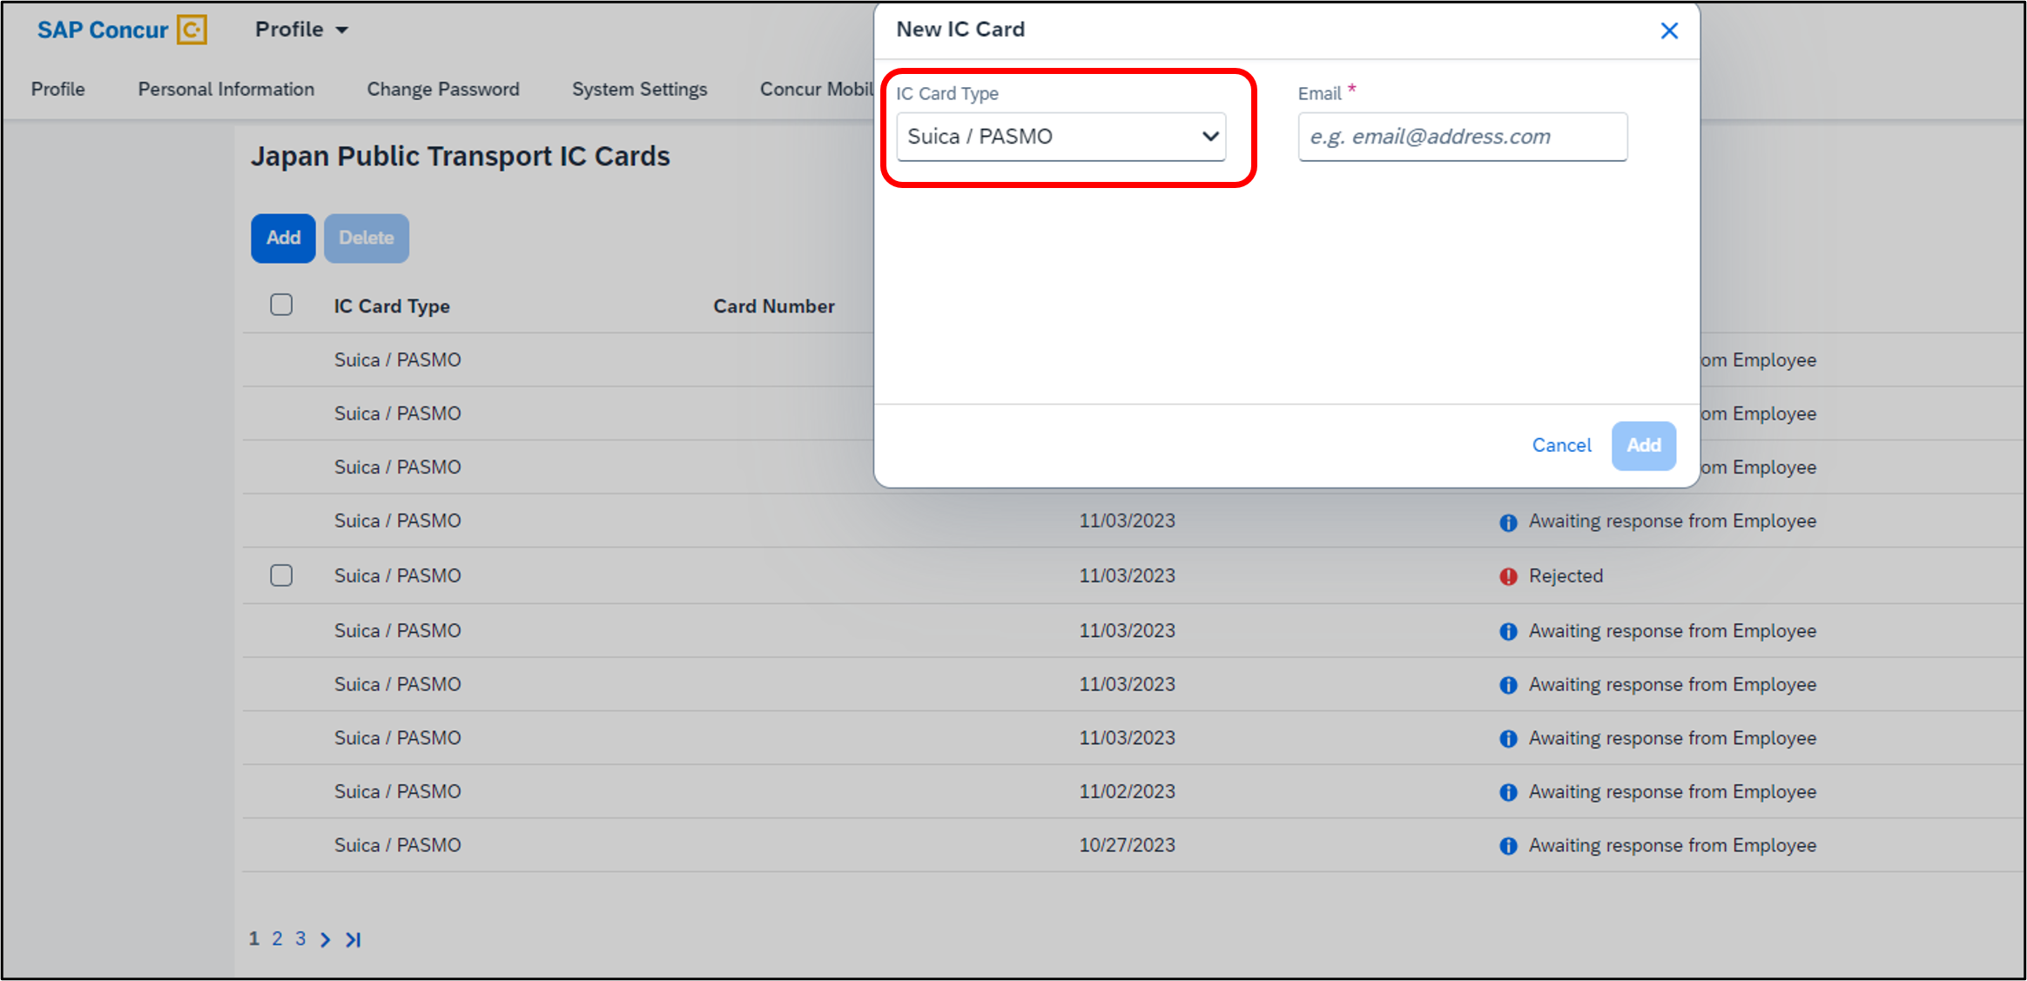
- In the Email field, enter the user’s corporate email address and click Add to process the request to add and associate their email address to the Suica/PASMO IC cards.
In the Email field, a warning message appears when you start entering your mail ID. This is to let you know that a valid email ID is required to add the card.
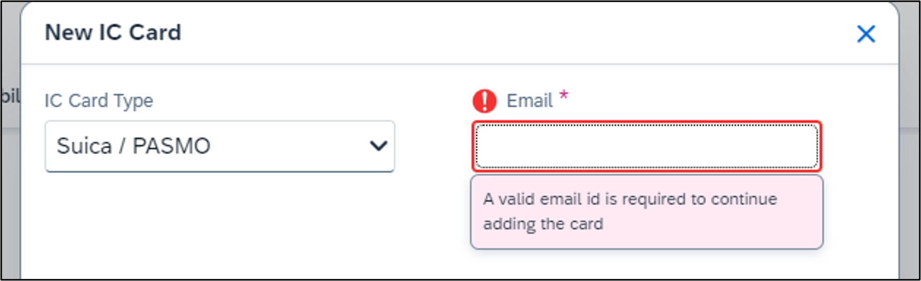
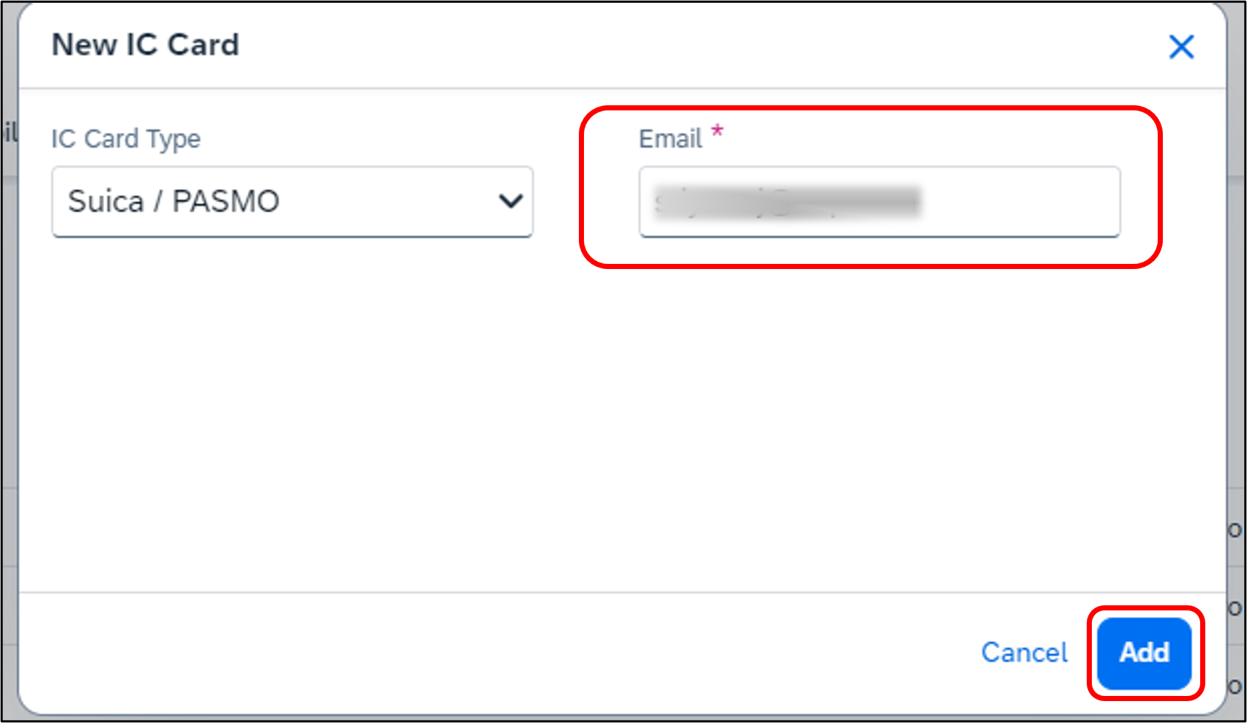
- When the Terms and Conditions page displays, select Concur End-User Terms and Conditions and click I Agree.
Before agreeing, read the licensing terms and conditions carefully. The I Agree button is disabled until the two checkboxes are selected.
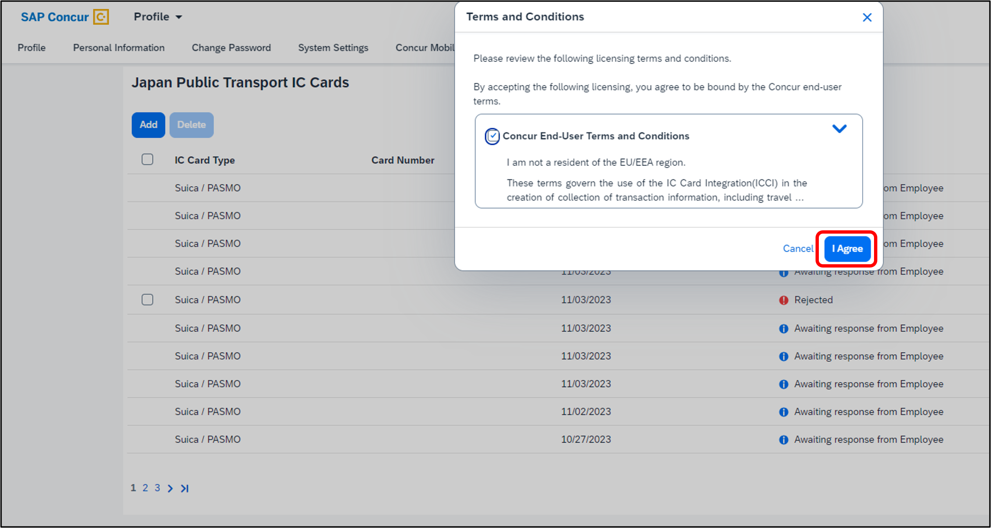
The card is added to the Japan Public Transport IC Cards list with the status listed as Awaiting response from Employee.
JR East emails the user with the card registration status. Additional details also display in Concur Expense on the Japan Public Transport IC Cards page. These details include a timestamp of the date of the registration request as well as the Registration Status column lists the status as Awaiting Response from Employee.
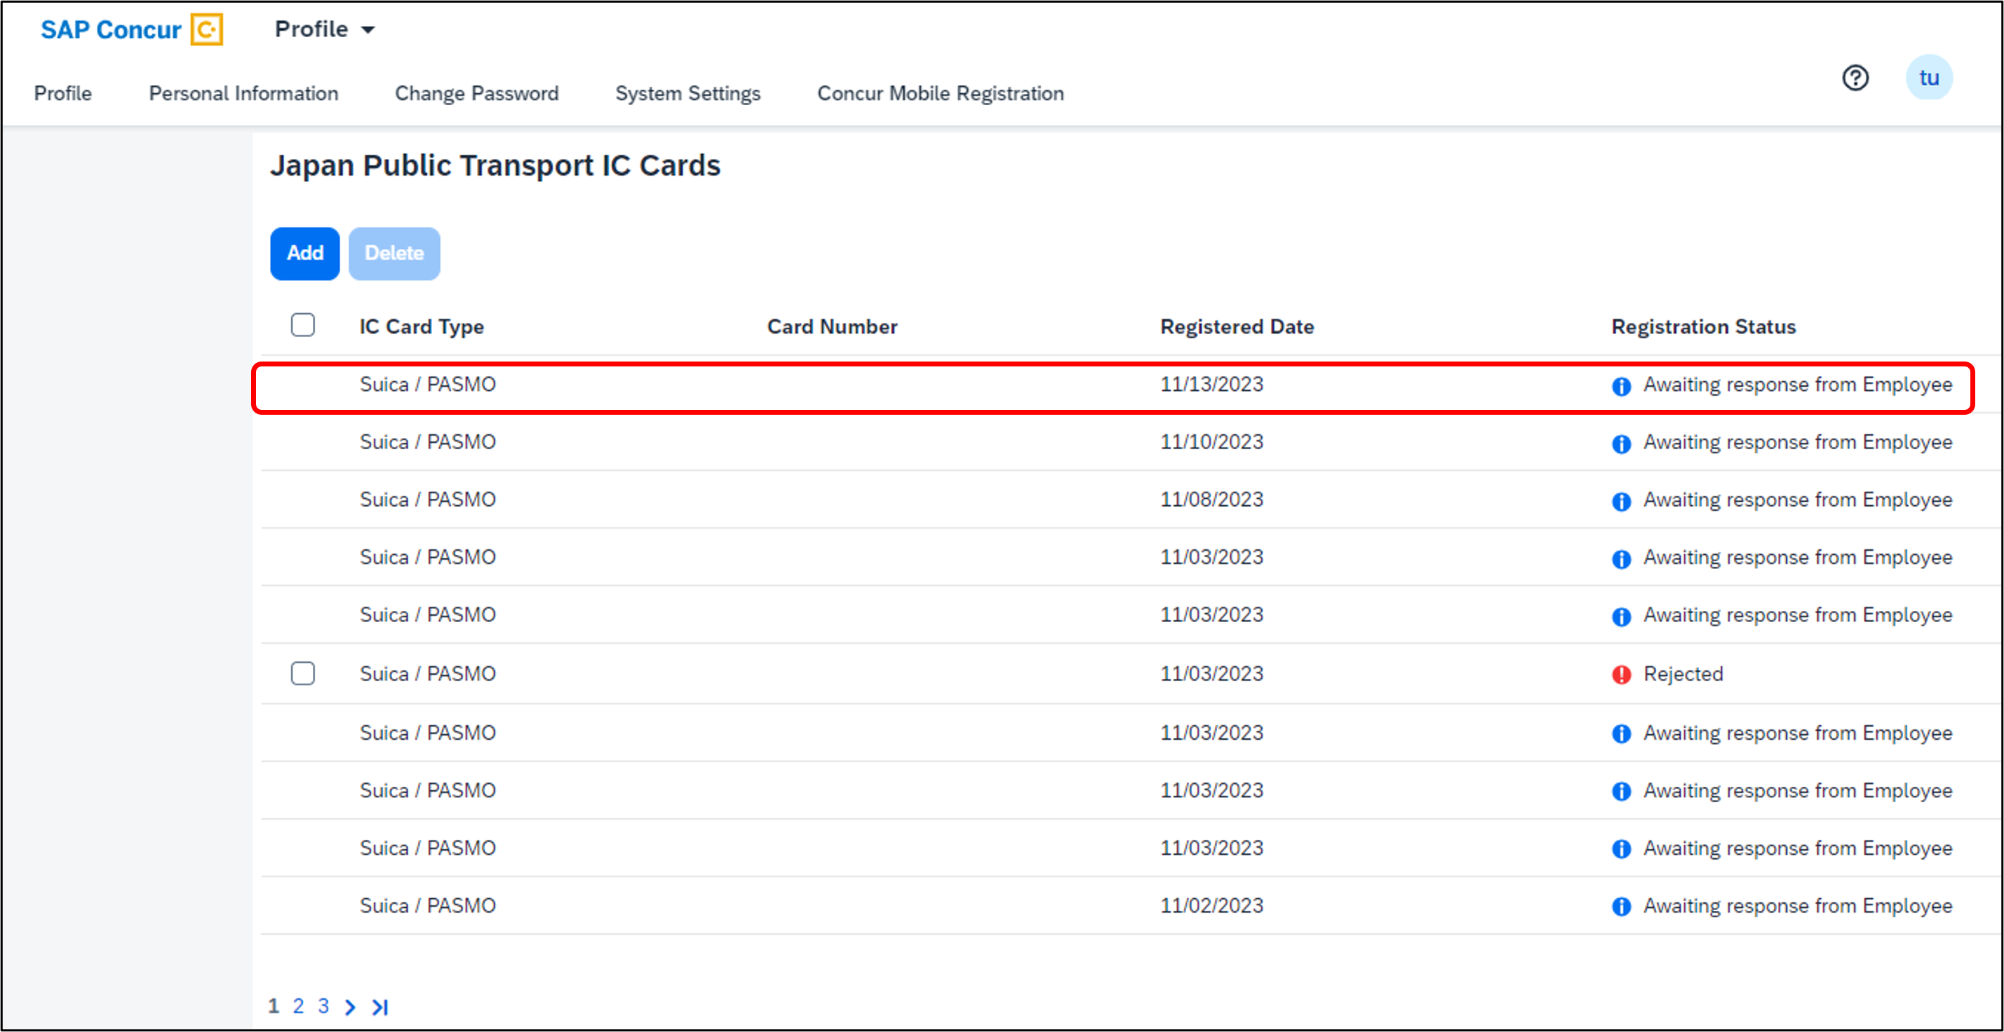
The confirmation also initiates the following user validation process:
- Concur Expense provides the email ID to Japan Railway (JR) East.
- JR East emails the registration link to the Concur Expense user.
- The user receives the email (similar to the one shown below) and clicks the registration link, which sends them to the JR East portal.
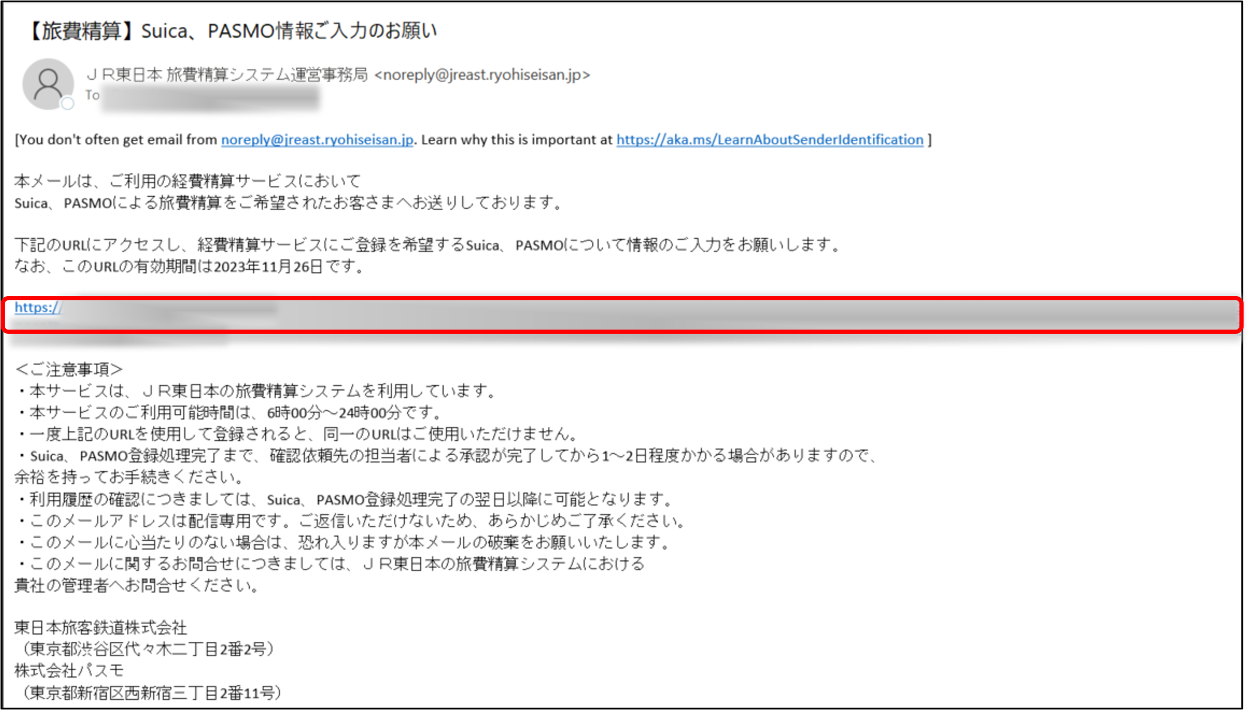
JR East portal:
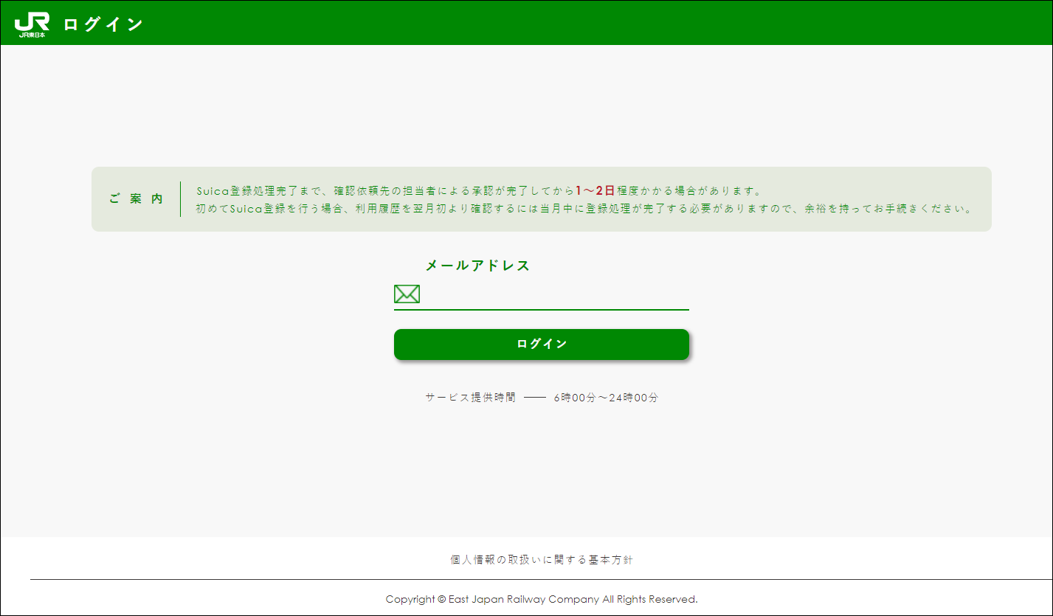
- The user completes the process by first verifying their email address.
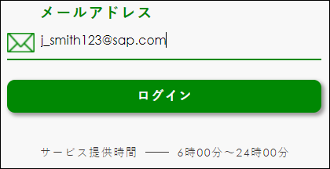
- The user can choose either Suica or PASMO card to register by selecting the option available in the JR East website.
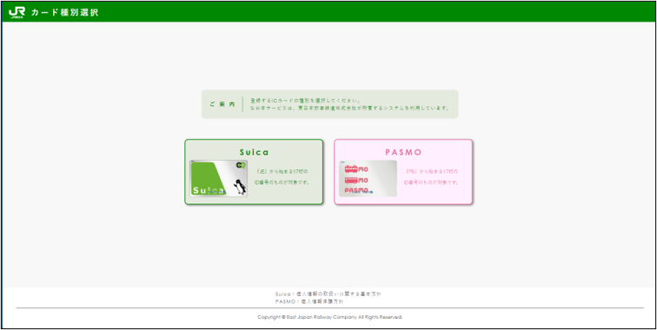
- The user then completes a registration form and clicks Verification to submit the registration form for the Suica/PASMO IC Cards.
Registration form for Suica:
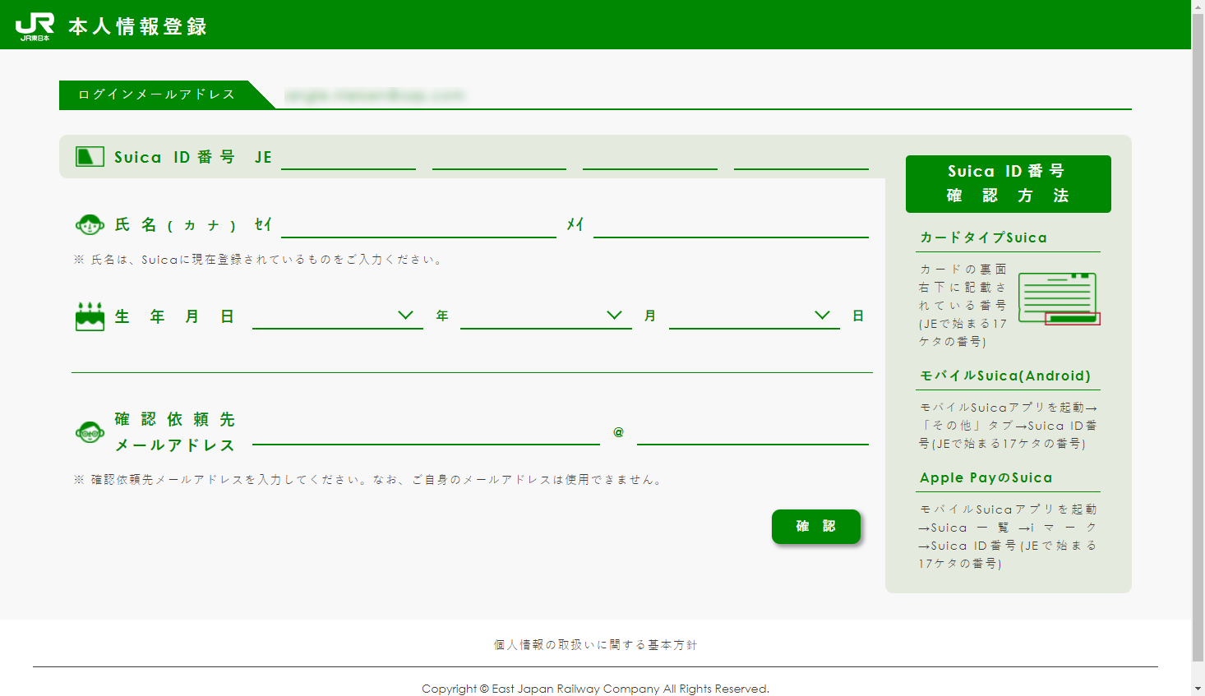
Registration form for PASMO:
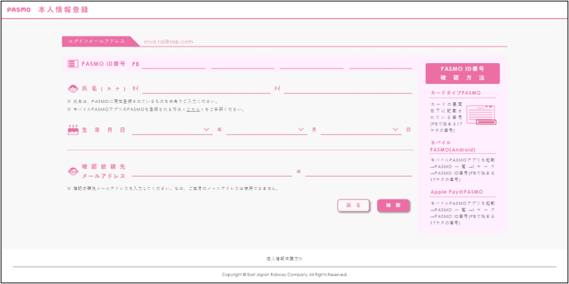
Once the card is approved from JR East/Pasmo and the validation from Checker is completed, the status in Concur Expense changes to Registered and masks the newly generated IC Card number provided by JR East/Pasmo. It also displays the exact card name (Suica or PASMO) after registration.
If the user rejects the request, the status changes to Rejected and Suica/PASMO IC cards will not be issued, nor will one be associated with the user’s profile. To understand the reason for rejection, hover over the Rejected status.
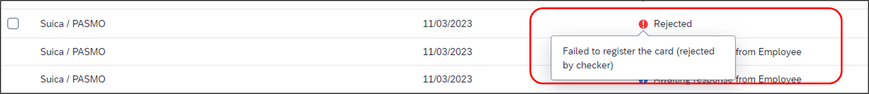
JR East website is offered and managed by JR East. The captures and instructions above may differ from the actual site.
Once the card is approved, and the status is changed to Registered, the system will display the trip transaction details from the day the card was registered. For example, if a user registers a card on the 12th day of a month and the card is set to the Registered state in Concur Expense, the user will start receiving the IC card data from the 12th itself.​
The user cannot delete or unregister a card if the status is in Pending Validation. The Pending Validation status indicates that JR East is still processing your application.
All the cards are deregistered if the Company admin deselects the Enable Suica/PASMO IC Card option from the Hidden Site Settings link. The system waits for 30 days, after which the card details are permanently deleted.
If a user loses their Suica/PASMO IC Card, they can de-register the card from Concur Expense and then re-apply for a new card.
Once the card is activated, Concur Expense will post any journey transactions (rail, bus, parking, and taxi fees) incurred and, therefore, available to view under AVAILABLE EXPENSES section.

Example Japan Rail Expense
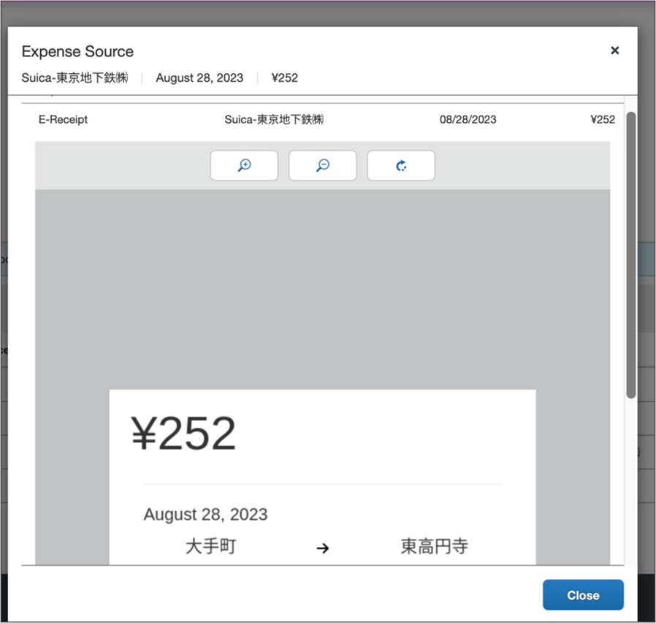
Prefixes “Suica-” and “PASMO-” are added in the vendor details for easy identification of the respective cards associated with the transactions.
Once Concur Expense posts the train journey incurred using the registered card, it takes 24-48 hours for the transaction to be visible in Available Expenses. In the case of other transactions, such as bus, taxi, and parking fees, the posting and viewing of the transactions may be delayed by 4-5 days. There might be instances when the train transaction detail gets delayed if the precedence bus data is delayed. Up to 4 days delay is in-design by the railway companies.
Once you have moved the expenses to the expense report from the Available Expenses page, you can submit your expense report.
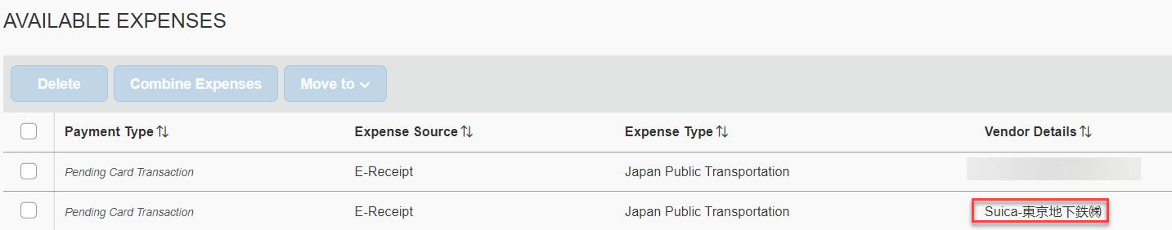

Deleting a Suica/PASMO IC card
You can only remove Suica/PASMO IC card if the registration status is Rejected or Registered. If the IC Cards has either status, a check box is displayed, allowing you to select the corresponding Suica/PASMO IC cards on the date it was requested or registered.
If the request is rejected, the IC Card numbers will not display and the field will be blank, as the user has rejected the approval of the card.
To remove a Suica/PASMO IC card:
- Click Profile > Profile Settings > Japan Public Transport IC cards.
- On the Japan Public Transport IC Cards page, select the Rejected or Registered Suica/PASMO IC Cards you want to delete.
You can identify which card to delete by the last four digits of the card number. Concur only displays the last four digits of the card number.
Once a Registered card is deleted, the de-register process is initiated. Once the card is de-registered, the card is automatically cleared from the Japan Public Transport IC Cards page’s user list. However, in Available Expenses, the de-registered card will not be deleted.
For rejected cards, the de-register process does not take effect; only the Rejected card is deleted from the user list.
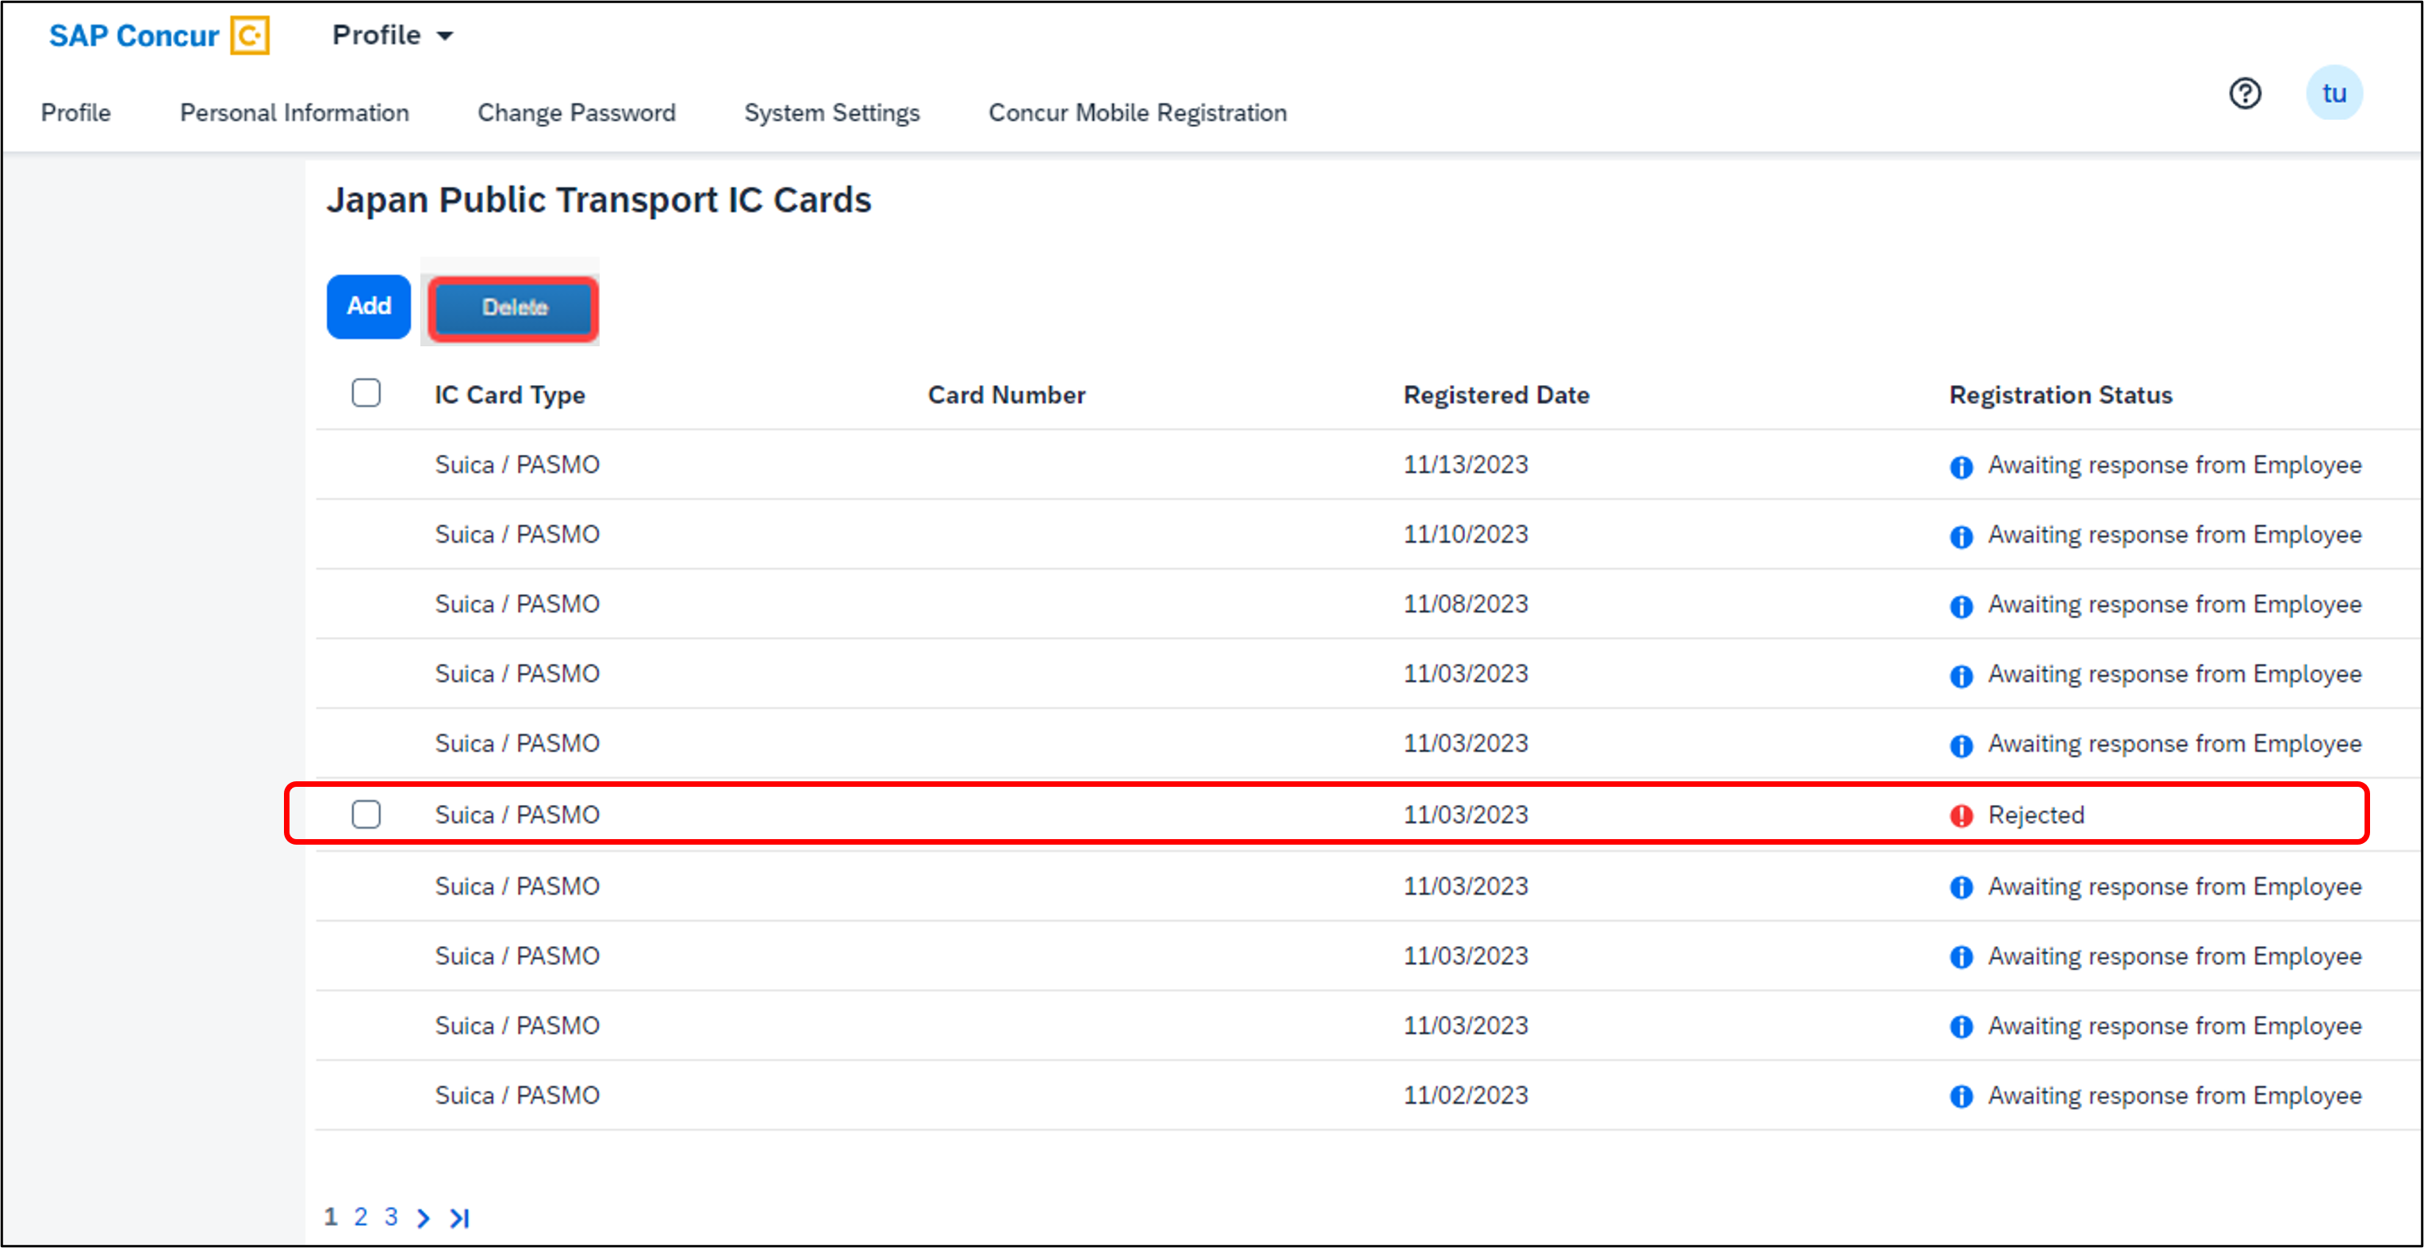
- When the Delete confirmation window displays, click Delete.
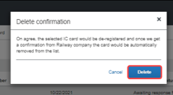
When you delete Suica/PASMO IC cards, the card is de-registered. Once Concur Expense receives confirmation from the railway company, the card is also automatically removed from the list – and, therefore, removed from the corresponding user’s user profile.

☼

