
Travel Setup Guide
for Concur Standard

Last Updated: December 10, 2021
Applies to these SAP Concur solutions:
 Expense
 Professional/Premium edition
 Integrated with Professional/Premium Travel
 Stand-alone
 Standard edition
 Integrated with Standard Travel
 Stand-alone
 Concurforce
S Travel
 Professional/Premium edition
 Integrated with Professional/Premium Expense
 Integrated with Professional/Premium Request
 Stand-alone
S Standard edition
S Integrated with Standard Expense
S Stand-alone
 Invoice Management
 Professional/Premium edition
 Integrated with Professional/Premium Expense
 Stand-alone
 Standard edition
 Integrated with Standard Expense
 Stand-alone
 Request (formerly Travel Request)
 Professional/Premium edition
 Integrated with Professional/Premium Expense
 Integrated with Professional/Premium Travel
 Stand-alone
Table of Contents
Travel Setup 1
Section 1: About this Guide 1
Travel Service Guides 1
Service Description Guide 1
Section 2: Introduction 2
Section 3: Log in to Travel - Access the Setup Wizard 2
Section 4: Setup Wizard 3
Implement Travel by Itself (Without Expense) 3
Implement Travel with Expense 5
Step 1 – Travel Policy 5
Overview 5
Step 2 – Travel Rules 6
Define Search Options 6
Step 3 – Configurable Messaging 9
Step 4 – Custom Text 9
Step 5 – Organization Units 9
Overview 9
What the Admin Sees 9
What the User Sees 10
Add a New Organization Unit 11
Work with Properties 12
Modify an Organization Unit 13
Delete an Organization Unit 14
Step 6 – Policy Violation Codes 15
Step 7 – Company Locations 15
Overview 15
Map Coordinates 15
Create a New Company Location Manually 16
Edit a Company Location Manually 18
Delete a Company Location Manually 19
Import Company Locations 20
Step 8 – Form of Payment 22
Overview 22
Add a New Corporate Ghost Card 23
Define Payment Options 26
Edit a Corporate Ghost Card 27
Delete a Corporate Ghost Card 28
Enable AirPlus A.I.D.A. 28
Step 9 – Discounts and Travel Content 28
Overview 28
Add Corporate Discounts for Air, Car, Hotel, and Rail; Set the Preference Level for Non-GDS Airline and Hotel Vendors; Upload Hotel Property Discounts 29
Enable a Direct Connect Provider 29
Requirements for Each Air Connector 30
Requirements for Each Rail Connector 30
Requirements for Each Car Connector 32
Requirements for Each Hotel Connector 32
Requirements for Each Ground Connector 34
Enable Travelfusion Suppliers 34
Enable Government Rates 35
Step 10 – Custom Trip Fields 35
Overview 35
Considerations for Creating Custom Fields 35
Treatment of Existing Data 36
Determine the Types of Fields 36
Order of Display 36
Guest Travel Bookings 36
Configure and Enable a Custom Trip Field 37
Add More Custom Trip Fields 40
Step 11 – Custom Profile Fields 41
Overview 41
Important 41
Considerations for Creating Custom Fields 41
Treatment of Existing Data 41
Determine the Types of Fields 42
Order of Display 42
Configure and Enable a Custom Profile Field 43
Add More Custom Profile Fields 46
Step 12 – Unused Tickets 47
Overview 47
Step 13 – Site Customization 47
Overview 47
Upload a Company Logo 48
Set Up Self-Registration 49
Allow/Disallow Refundable Fares; Allow/Disallow Booking Hotels with Deposit; Allow/Disallow Policy by Leg (Flex Faring); Default to Mixed Classes (Flex Faring) 49
Step 14 – Manage Users 51
Overview 51
Menus 52
Add and Modify User Information Manually 52
Add and Modify User Information via Import 52
Manually Add a New User – Travel WITHOUT Expense 53
Manually Add a New User – Travel WITH Expense 55
Locate an Existing User – Travel WITH or WITHOUT Expense 59
Edit User Information – Travel WITH or WITHOUT Expense 60
Delete Users – Travel WITH or WITHOUT Expense 61
Import Users – Travel WITH Expense 61
Import Users – Travel WITHOUT Expense 62
View Import Status – Travel WITH or WITHOUT Expense 63
Access User Profiles – Travel WITH or WITHOUT Expense 64
Step 15 – Invite Users 65
Overview 65
Invite Users 65
Step 15/16 – Agency Settings 66
Overview 66
Work with General Settings 67
Work with TSA Settings 68
Work with Agency Invoice Settings 69
Section 5: Travel Reporting 69
Overview 69
Run a Travel Report 69
Section 6: Travel System Admin 70
Overview 70
Travel System Admin 72
Default Travel System Admin Settings 72
Section 7: Additional Configuration Information 80
Gogo Inflight Wi-Fi 80
Sabre Profiles 80
Dual Fare Display (Sabre Only) 81
Concur Meeting/Third-Party Meeting 81
Hotel Previous Stay History 81
Offline Approval Error Queue 81
Section 8: Appendix A – Find the Travel Service Guides & Fact Sheets 83
Section 9: Appendix B – Password Defaults 83

Revision History
Date | Notes / Comments / Changes
January 21, 2022 | Updated the copyright year; no other changes; cover date not updated
December 10, 2021 | Updated instructions for Product Settings page
August 30, 2021 | Removed references to CIBT (retired this date).
March 19, 2021 | Updated About this Guide and Setup Wizard sections
July 24, 2020 | Updated the procedure on pages 55-56 to reflect updates to the Users page UI.
April 27, 2020 | Renamed the Authorization Request check box to Request on the guide’s title page; cover date not updated
February 17, 2020 | Updated China terminology to Hong Kong, China
January 15, 2020 | Updated the copyright; no other changes; cover date not updated
May 23, 2019 | Added information about Dual Fare Display (Sabre Only)
May 13, 2019 | Minor edits; removed information on password hints
February 12, 2019 | Updated the copyright; no other changes; cover date not updated
May 29, 2018 | Updated to include the changes for May 2018 including:
May 29, 2018 | Section | Description/Action
May 29, 2018 | Site Customization | Removed setting for the privacy agreement
March 30, 2018 | Added notes about best practice of not allowing personal or sensitive data in custom fields
January 23, 2018 | Added: NOTE: The LoginID must be unique across all Concur products. If a LoginID is currently in use in any Concur product, it cannot be assigned again unless the original occurrence is changed. For example, assume that a LoginID was assigned in error. That LoginID can only be used again if an admin (either manually or via import) renames the original occurrence, allowing the LoginID to be used again.
January 28, 2018 | Updated to include the changes for January 2018 including:
January 28, 2018 | Section | Description/Action
January 28, 2018 | Default Travel System Admin Settings | In the TSA Settings section, the Date of Birth Unknown check box automatically appears
January 28, 2018 | Changes not related to the release  Removed these sections; created new Travel Service Guides:  - Travel Admin – Travel Policy tab  - Travel Admin – Policy Violation Codes tab  Refer to the Approvals, Rules, and Classes/Policies Travel Service Guide.
Older revision history has been removed.

Travel Setup
NOTE: Multiple SAP Concur product versions and UI themes are available, so this content might contain images or procedures that do not precisely match your implementation. For example, when SAP Fiori UI themes are implemented, home page navigation is consolidated under the SAP Concur Home menu.

About this Guide
The information in this guide applies to Travel in Concur Standard. There is a separate guide for Expense in Concur Standard.

Travel Service Guides
There are travel service guides available for many of the features described in this setup guide. Where this setup guide describes how to configure each option in the Travel Setup Wizard – for example, how to enable a direct connect – the travel service guides are more comprehensive and provide important information like:
- Steps required before using the Travel Setup Wizard, like obtaining the required agreement with a vendor
- Additional implementation steps, for example, in Travel System Admin
- What the user sees; the user experience
- How the feature works
- The benefits of using the feature
- FAQs
Some of the features in this guide require that you review the travel service guide before implementing the feature in Travel (direct connects); most do not (travel rules, organization units, custom text, etc.).
In those cases where it is important to review the information in the travel service guide for successful implementation, this type of message appears.

For this feature/option, additional steps are required. In some cases, the required steps must be completed before using the Travel setup wizard (like obtaining a vendor agreement).
- Refer to the <name> Travel Service Guide.
To locate for guide, see Find the Travel Service Guides & Fact Sheets in the appendix of this guide.

Service Description Guide
SAP Concur has added the Service Description Guide link to the Help menu on the SAP Concur home page. This change is provided in accordance with SAP Concur Legal requirements.
To access the Service Description Guide link, click Help (upper-right corner) on the SAP Concur home page and then click the Service Description Guide link.
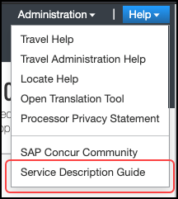
The Service Description Guide – SAP Concur page appears.
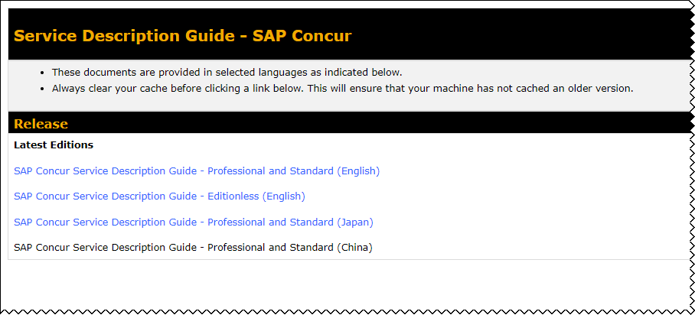

Introduction
Use the Travel Setup Wizard to manage company options, user data, and travel booking settings. You can access the setup wizard by clicking Administration > Setup > Travel at the top of any page. Once in the setup wizard, you can access different pages by using the left-side menu. None of these steps/pages are dependent on the other.

Log in to Travel - Access the Setup Wizard
To log in to Travel and access the Setup Wizard:
- Go to www.concursolutions.com.
- Type your Login ID in the User Name field.
- Type your password in the Password field.
Remember the password is case sensitive.
- Click Login.
- Click Administration > Setup at the top of any Travel page.

Setup Wizard
The setup wizard allows you to manage all administrative settings and preferences. The Setup Wizard page and the setup process differ slightly if you are implementing Travel by itself versus implementing Travel with Expense.

Implement Travel by Itself (Without Expense)
The Setup Wizard page has 16 steps (detailed in the table below).
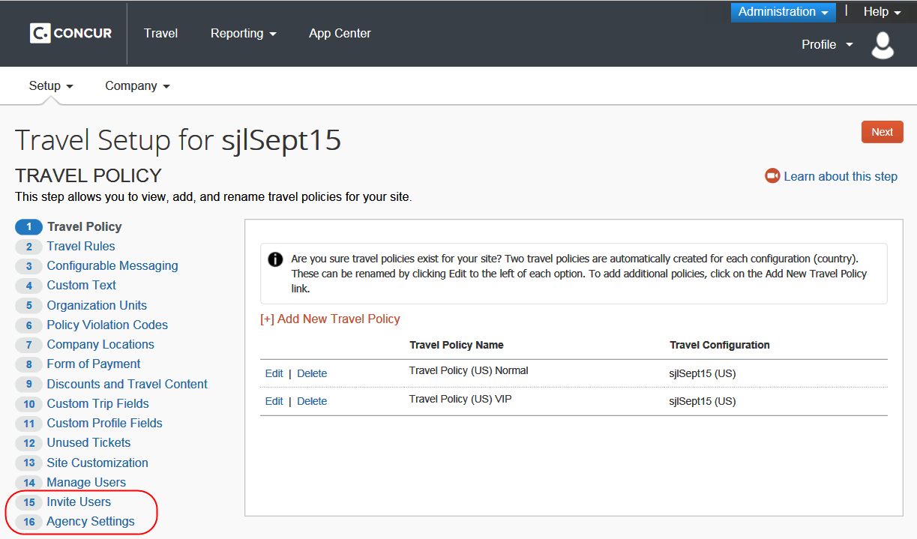
The first 14 steps match exactly the steps available when implementing Travel with Expense; the last 2 steps differ. Each is described on the remaining pages of this guide.
Step | Option | Description/Action
1 | Travel Policy | Edit travel policy names
2 | Travel Rules | Manage travel rules (pre-defined and custom), benchmark lowest fares, manager notifications, search options, and other travel features
3 | Configurable Messaging | Manage trip-specific custom messaging
4 | Custom Text | Manage custom text (labels)
5 | Organization Units | Manage organization units (groups)
6 | Policy Violation Codes | Manage messaging and codes for users when booking out-of-policy trips
7 | Company Locations | Define company locations
8 | Form of Payment | Manage ghost cards
9 | Discounts and Travel Content | Manage vendor discounts, preference levels, hotel imports, direct connect providers, visa/passport services, Travelfusion suppliers, and government rates
10 | Custom Trip Fields | Manage questions asked of the user during the booking process
11 | Custom Profile Fields | Manage profile fields
12 | Unused Tickets | Manage unused tickets for all users
13 | Site Customization | Upload the customer's logo, and manage other configuration settings
14 | Manage Users | Create, modify, and delete users  NOTE: This option appears only if the implementation does not include Expense Standard.
15 | Invite Users | Email notification sent out to users at launch  NOTE: This option appears only if the implementation does not include Expense Standard.
15 / 16 | Agency Settings | Manage trips-on-hold, companions, etc., Transportation Security Administration (TSA) settings, and agency invoice  NOTE: If the implementation includes Expense Standard, then this step becomes step 15.

Implement Travel with Expense
The Setup Wizard page has 15 steps (detailed in the table above).
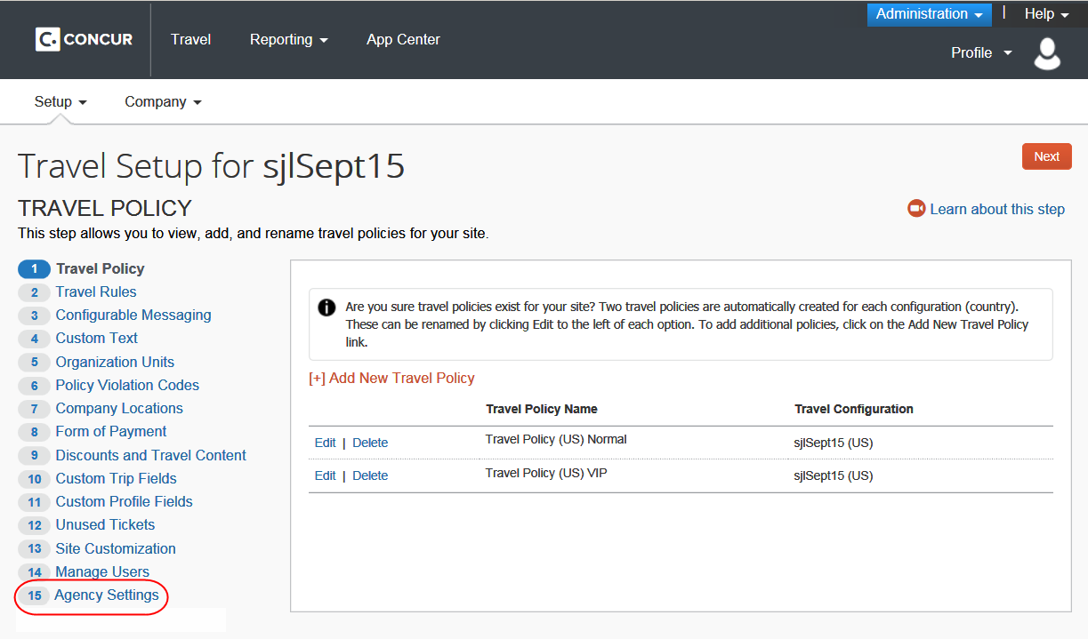

Step 1 – Travel Policy

Overview
A policy is a collection of travel settings and preferences. Concur provides two travel policies per configuration. You can create an unlimited number of additional policies.
Use the Travel Policy step to:
- Edit the names of the provided (default) policies
- Create new policies
- Delete policies

- For complete details, screen captures, and setup steps, refer to the Approvals, Rules, and Classes/Policies Travel Service Guide.

Step 2 – Travel Rules
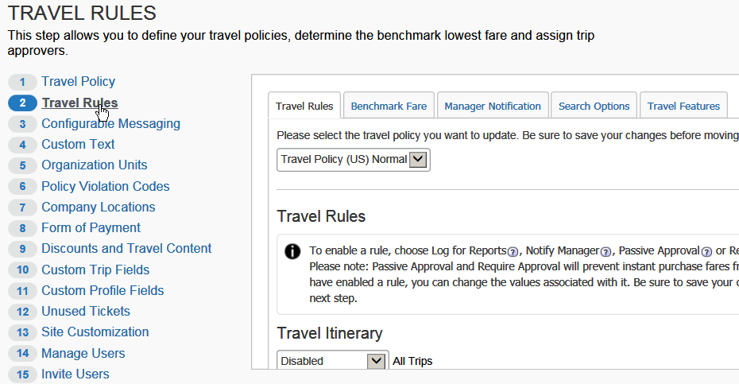
Tab | Description/Action
Travel Rules | - Refer to the Approvals, Rules, and Classes/Policies Travel Service Guide.
Benchmark Fare | - Refer to the Lowest Logical Fare (LLF) / Benchmark Lowest Airfare Travel Service Guide.
Manager Notification | - Refer to the Approvals, Rules, and Classes/Policies Travel Service Guide.
Search Options | See below.
Travel Features | - Refer to the Approvals, Rules, and Classes/Policies Travel Service Guide.

Define Search Options
To define search options:
- In the left-side menu, click Travel Rules.
- Click the Search Options tab.
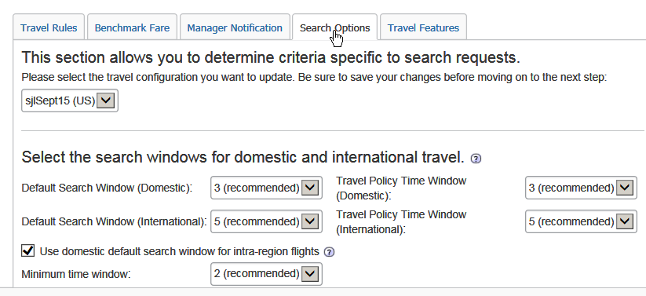
- Select the desired policy.
- Modify the settings as needed. Help text is available to explain nuances.
Setting | Default | Description/Action
Default Search Window (Domestic) | 3 Hours | Select the number of hours for the default search window, for both domestic and international travel.  The default window will pre-populate when the traveler selects dates and times on the Flight tab. The traveler can change the default window when searching but cannot search a smaller time window than is defined in the Minimum time window field or a longer time than is defined in the Maximum time window field below.
Default Search Window (International) | 5 Hours
Travel Policy Time Window (Domestic) | 3 Hours | Select the number of hours for the default window for benchmark lowest fares, for both domestic and international travel.  The default window will pre-populate when the traveler selects dates and times on the Flight tab. The traveler can change the default window when searching but cannot search a smaller time window than is defined in the Minimum time window field or a longer time than is defined in the Maximum time window field below.  NOTE: For Worldspan only, the Anytime option will appear only for users if the Maximum Window field is set to 12 hours.
Travel Policy Time Window (International) | 5 Hours
Use domestic search window for intra-region flights | On | Select to enable.  NOTES:  - Domestic is defined as within a country, for example, Chicago to New York.  - International is defined as crossing a country border, for example, Paris to Hong Kong, China.  Enabling this feature will cause intra-region itineraries to default to the domestic time window, for example, London to Frankfurt will become domestic rather than international.
Minimum time window | 2 Hours | Select the minimum time window (in hours) that a user can define for searches.
Maximum time window | 9 Hours | Select the maximum time window (in hours) that a user can define for searches.  NOTES:  - For Worldspan only, the Anytime option will appear only for users if the Maximum Window field is set to 12 hours.  - For Sabre only, the admin can select an option greater than 9 from the Maximum Window list only if Bargain Finder Max is enabled and if the Max Search Results field is set to 200. (Bargain Finder Max is set in Travel System Admin.)
Default Search Type | Initially default to Search by Price | Click one of these:  - Initially default to Search by Price  - Initially default to Search by Schedule  - Always default to Search by Schedule  - Only Search by Schedule: When using the Travel Wizard, users will not have a choice to search by price or schedule. Travelers are automatically directed to the Shop by Schedule tab but the Shop by Fares tab is available for use.
Don't show prices on Schedule | Off | Select (enable) this check box if you do not want prices to appear.  NOTE: Choosing Only Search By Schedule as the default search type and enabling Don't show prices on Schedule will force travelers to always go to the Shop by Schedule tab where they see a schedule with no prices. The traveler will be able to select individual combinations of flights and the low-fare search would begin when travelers quote their options.
- Click Save.

Step 3 – Configurable Messaging

- For complete details, screen captures, and setup steps, refer to the Configurable Message Boards Travel Service Guide.

Step 4 – Custom Text

- For complete details, screen captures, and setup steps, refer to the Custom Text Travel Service Guide.

Step 5 – Organization Units

Overview
Use the Organization Units step to create groups. Then, you can apply certain settings and features by organization unit.
Please be sure to consult your fulfillment TMC on all additions, changes, and deletions if your company is using organization units to manage company-level profiles. Changes will have a signification impact to their operational process.

What the Admin Sees
If enabled, the admin sees the Organization Unit dropdown in the profile in the Manage User step. This will be editable for any user with access to the setup wizard.
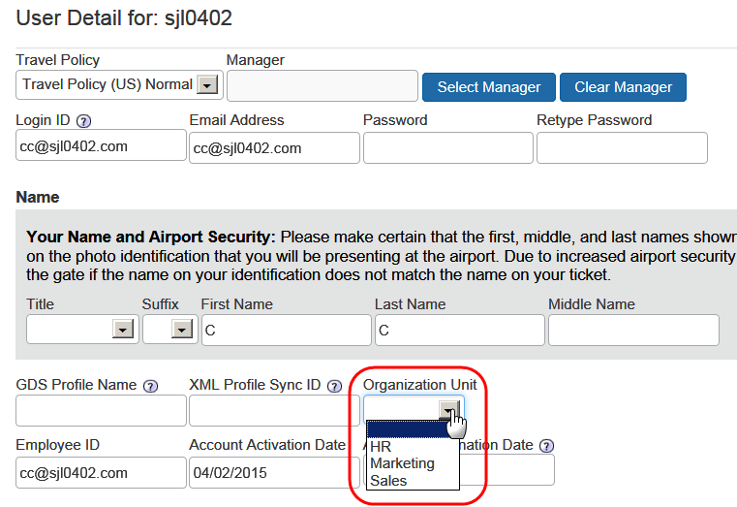

What the User Sees
If enabled and made visible to users, the user sees the Org Unit/Division dropdown in his/her profile in the Company Information section. This will be set to either view-only or editable, depending on the configuration setup.
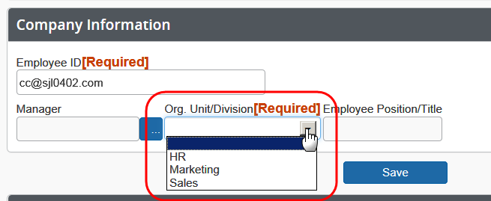

Add a New Organization Unit
To add a new Organization Unit:
- In the left-side menu, click Organization Units.
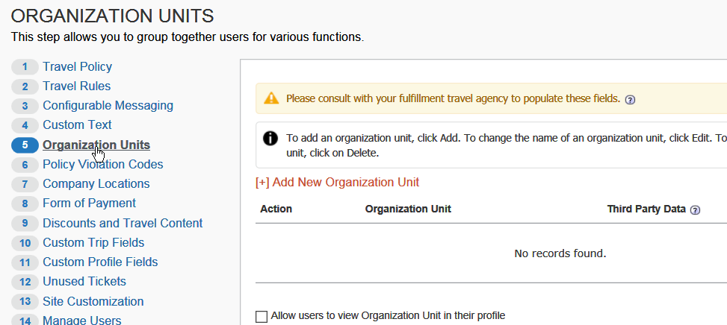
- Click Add New Organization Unit.
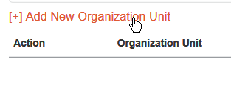
The Add New Organization Unit window appears.
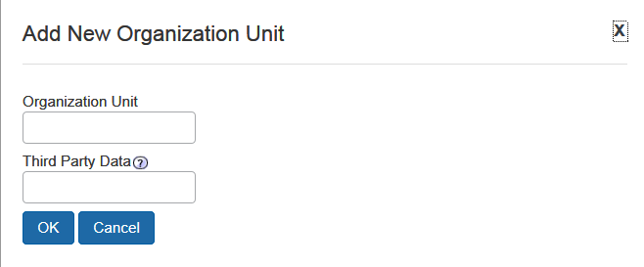
- Make the appropriate choices as described in the following table.
Field | Description/Action
Organization Unit | Enter a name for the organization unit.
Sabre Profiles Template ID | This field appears only if using Sabre Profiles.  Work with your fulfillment TMC to determine the Sabre Profiles Template ID.
Third Party Data | If passing to a third party, determine the value to be passed.
- Click OK.
Admins may also assign organization units via the User Upload feature.

Work with Properties
There are three options available via check boxes:
- Allow users to view Organization Unit in their profile
- Allow users to edit Organization Unit in their profile – If selected (enabled), the check box above will automatically be selected, allowing users to view as well as edit in their profile
- Require Organization Unit – If selected (enabled), the two check boxes above will automatically be enabled, allowing users to view and edit in their profile
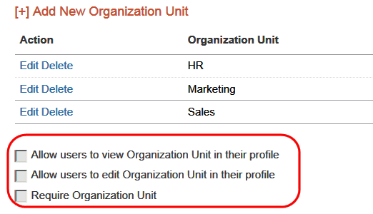
To use the properties:
- In the left-side menu, click Organization Units.
- Select (enable) the desired properties.

Modify an Organization Unit
To modify an organization unit:
- In the left-side menu, click Organization Units.
- Click Edit to the left of the desired organization unit.
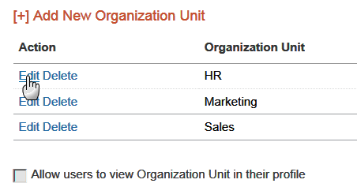
The Edit Organization Unit window appears.
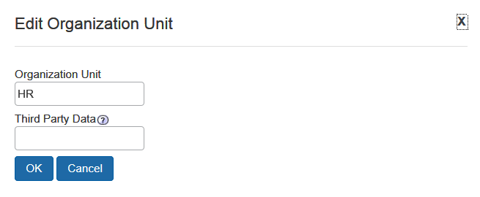
- Make the appropriate changes.
- Click OK.

Delete an Organization Unit
To delete an organization unit:
- In the left-side menu, click Organization Units.
- Click Delete to the left of the unit.
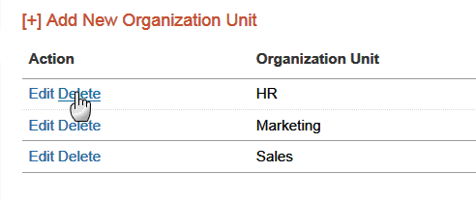
- Then:
- If no users are assigned to that unit, click OK to delete.
- If users are assigned to the unit, you will be asked to choose a replacement unit.

Step 6 – Policy Violation Codes

- For complete details, screen captures, and setup steps, refer to the Approvals, Rules, and Classes/Policies Travel Service Guide.

Step 7 – Company Locations

Overview
Use the Company Locations step to set up company locations for your organization. There are several uses for company locations:
- You can assign users to company locations in order to automatically add a work address to their user records. Users have the ability to update their own home or work addresses in their profile.
- Users can use company locations to search for hotels in Concur Travel. When users search for a hotel using a company location, users can choose from this list of locations.
Use the:
- Company Locations tab to manage them manually
- Import tab to manage them via import

Map Coordinates
Map Coordinates – also known as geocoding – is the process of assigning latitude and longitude to a point, based on street addresses, city, state, and zip code. In Concur Travel, the Map Coordinates option adds the latitude and longitude to a company location. This allows users to search for hotels by company location.
- Best Practice tips:
- It is not required to add the zip code when adding company locations, however results will be more accurate if the zip code is included.
- For best results, do not include suite or floor numbers with the street address. You can enter this information after you geocode but before you save to include it as part of the address.
- When entering company locations, enter the addresses consistently. The company location list is in alpha order by country code. Then, they are listed by city, state, and location name. If you enter the state for one location but not for another, they will appear under separate headings in the locations list.
- For addresses containing the number (#) sign, change this to the word Number or abbreviation No. Bing Maps does not recognize the # sign.

Create a New Company Location Manually
To create a new company location:
- In the left-side menu, click Company Locations.
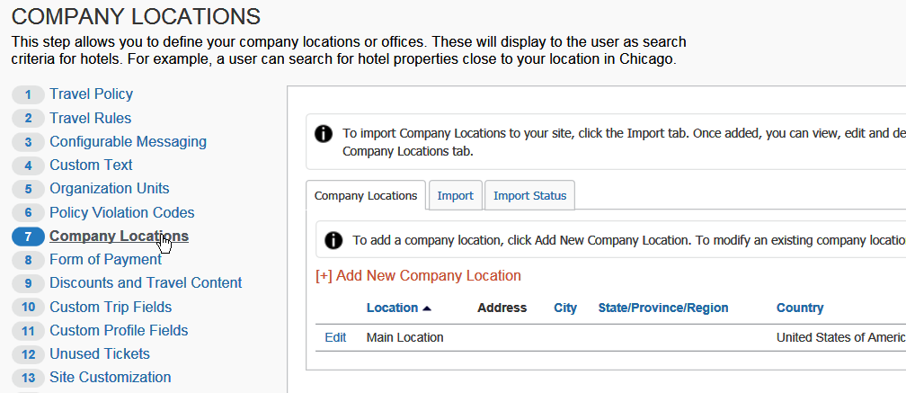
- Click the Company Locations tab, if it is not already selected.
- Click Add New Company Location.
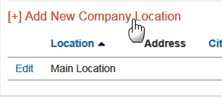
The Location Detail window appears.
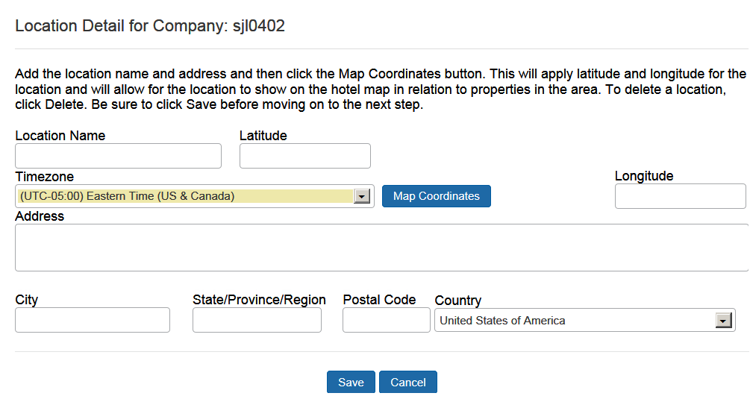
- Make the appropriate choices as described in the following table.
Field | Description/Action
Location Name | Enter a name for the location that will be relevant to the user. This name will appear when selecting locations to find a hotel.
Map Coordinates | Click this button to add the latitude and longitude for the location. If there is more than one possible result, Concur Travel might show choices in a popup box. Click the choice that most closely matches the location you are trying to enter.
Phone, Fax Number, Timezone, Address, City,  State, Province, Region | Enter this information for the location.
Zip/Postal Code | Enter the zip or postal code for more accurate geocoding.
Country | Select the appropriate country for the location.
- Click Save.

Edit a Company Location Manually
To edit a location:
- In the left-side menu, click Company Locations.
- Click the Company Locations tab, if it is not already selected.
- Click Edit for the desired location.
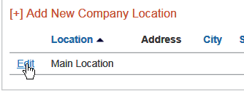
The Location Detail window appears.
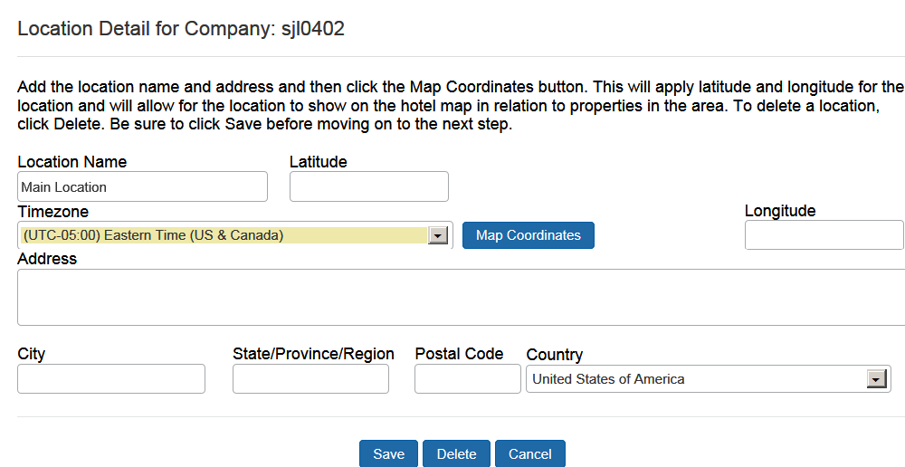
- Edit the address for the location. (All fields are described above in the Creating a New Company Location section.)
- Click Save.

Delete a Company Location Manually
To delete a location:
- In the left-side menu, click Company Locations.
- Click the Company Locations tab, if it is not already selected.
- Click Edit for the desired location.
The Location Detail window appears.
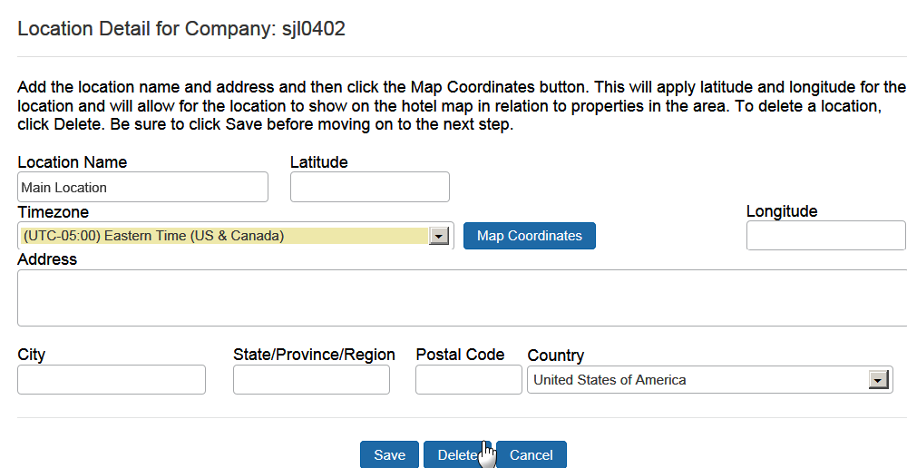
- Click Delete.

Import Company Locations
Between 9 AM – 5 PM (your local time), uploads are limited to 5MB or smaller. If you attempt to upload a file that is larger than that, a message appears. You can often reduce file sizes by changing file formats from .csv to Excel. If changing the format is not an option, you can upload larger files after business hours (9 AM – 5 PM your local time).
To import company locations:
- In the left-side menu, click Company Locations.
- Click the Import tab.
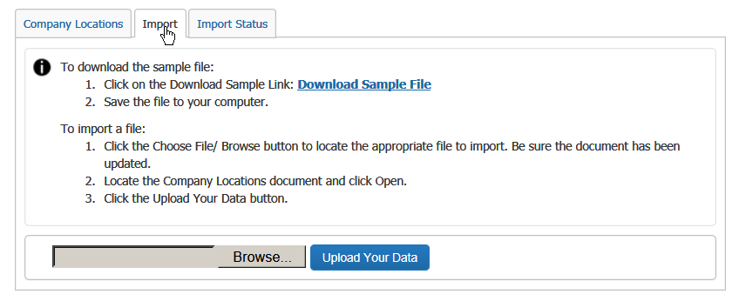
- To complete the import file:
- Click Download Sample File. A spreadsheet is downloaded; instructions are included.
- On the spreadsheet, add the company locations you want to import.
- Save the spreadsheet as .xml to your computer.
- To upload:
- Click the Browse/Choose File (depending on the browser) button.
- Locate your saved file.
- Click Upload Your Data.
To view the import details:
- Click the Import Status tab to see a list of the last 10 imports performed.
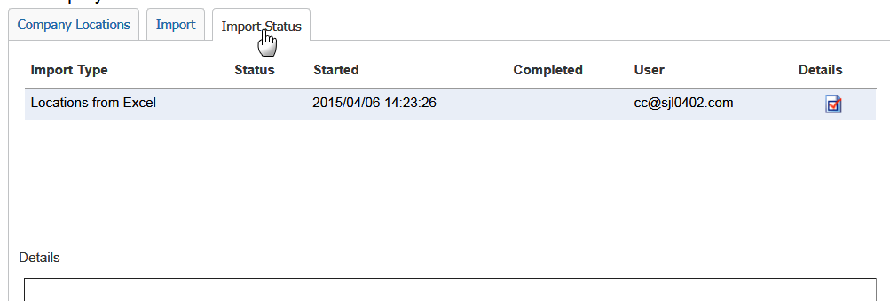
- To see the details on an import, click the icon in the Details column.
- Details appear toward the bottom, in the Details section.
- A link will also be provided to download the original import file, with a new column at the end labeled Errors.
- The administrator will be able to identify the issue and make corrections. The admin can then perform an additional import to apply the changes.
To validate the import:
Administrators can also validate that the import is complete by clicking on the Company Locations tab. The new locations appear once the import has run.
Administrators most go to another setup step and then return to the Company Locations step to see this updated.
There is a separate batch job that runs nightly that adds the geo-coding for company locations. Admins must wait for that to complete before users/arrangers will see their locations or they can go in and geo-code manually by clicking Edit to the left of the location, clicking Map Coordinates in the popup, and then Save.
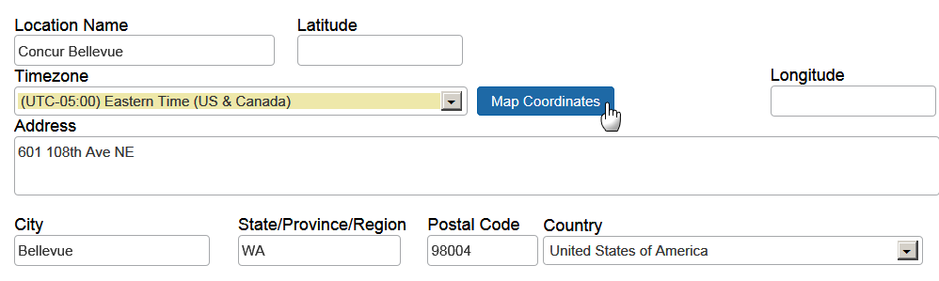

Step 8 – Form of Payment

Overview
Use the Form of Payment step to add and assign corporate ghost credit cards:
- There is no limit on the number of corporate ghost cards supported.
- The admin can define:
- Which segment types should be charged to the card
- Whether personal cards are allowed
The AirPlus feature on this page is not available at this time.

- For information about different forms of payment, how they may affect each other, and configuration points to watch, refer to the Form of Payment Travel Service Guide.

Add a New Corporate Ghost Card
To add a new corporate ghost card:
- In the left-side menu, click Form of Payment.
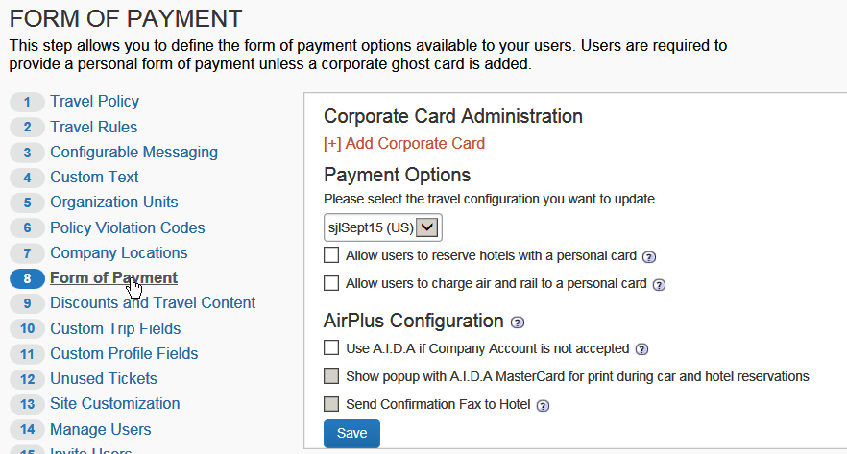
- Click Add Corporate Card.
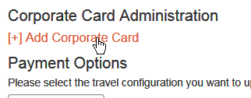
The Credit Card Detail window appears.
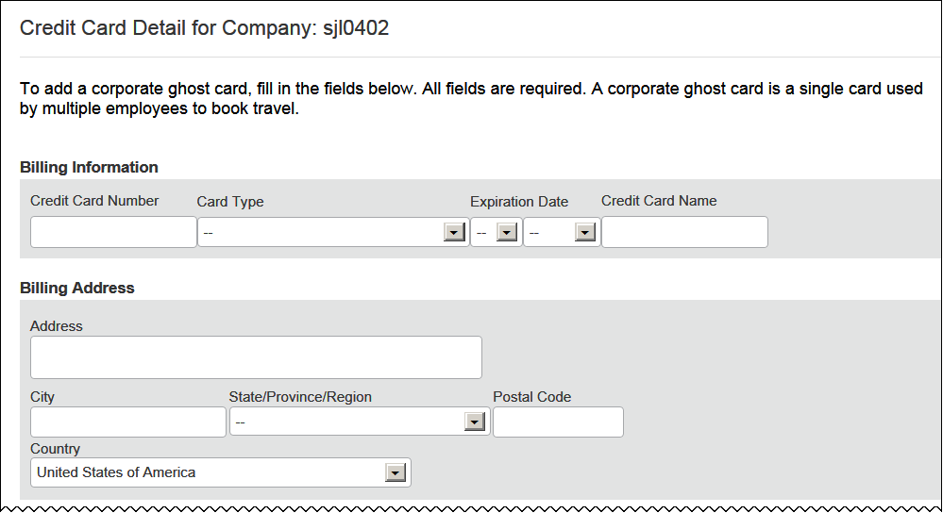
- Make the appropriate choices as described in the following table.
Field | Description/Action
Billing Information – all fields are required
Credit Card Number | Enter the card number.  Do not enter dashes, spaces or periods – only the number.
Card Type | Select the appropriate card type.
Expiration Date | Select the expiration date.  NOTE: Travel assumes that the expiration date is the last day of the selected month. For example, if you select February 2016, then the expiration date is February 28 2016.
Credit Card Name | Enter the name for the card.
Billing Address – all fields are required
<all fields> | Enter as appropriate.
Scroll down to the next section.
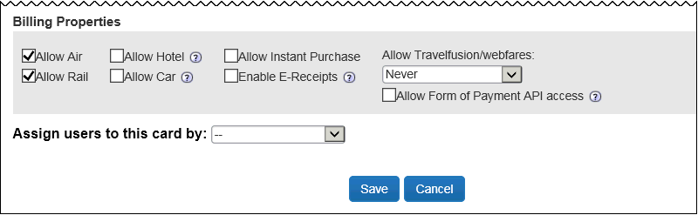
Field | Description/Action
Billing Properties
Allow Air  Allow Rail  Allow Hotel  Allow Car  Allow Instant Purchase  Enable E-Receipts  Allow Travelfusion/ webfares | Select (enable) the check boxes for the segment types that can be charged/guaranteed to the card.  Air and Rail will be defaulted to ON.
Allow Form of Payment API Access | Select (enable) to pass profile data from Concur to third parties, such as TripLink vendors and fulfillment TMCs.
<users>
Assign users to this card by | Click one of these:  - Travel Configuration  - Organization Unit  - Individual User  Travel Configuration:  If you select Travel Configuration, the available travel configurations appear.  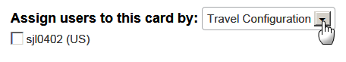  Select (enable) the desired configuration(s).  Organization Unit:  If you select Organization Unit, the available organization units appear.  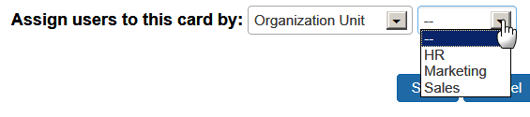  Select the desired unit.  Individual User:  If you select Individual User, the available users appear.  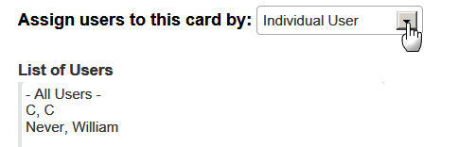  Select the desired user(s) and click Add.
- Click Save. Once a card has been added, the screen refreshes and the grid updates.
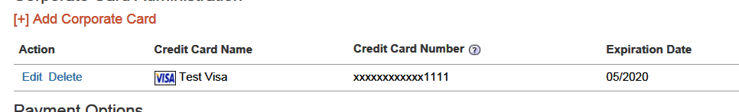

Define Payment Options
Admins also have the ability to define the payment options. These are set at a configuration level and provide users the ability to override the corporate ghost card with a personal card.
The admin can define:
- Whether to allow users to reserve hotel with a personal card
- Whether to allow users to charge air/rail to a personal card
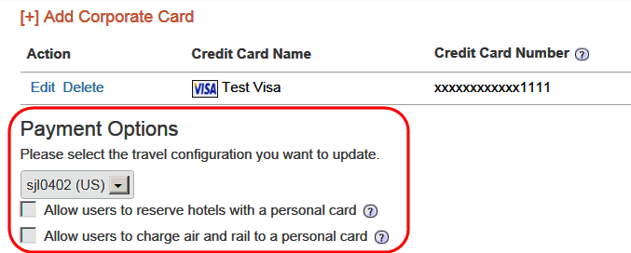
To define payment options:
- In the left-side menu, click Form of Payment.
- In the Payment Options section, select the desired travel configuration.
- Select (enable) one or more of these settings:
- Allow users to reserve hotels with a personal card
- Allow users to charge air and rail to a personal card
- Click Save.

Edit a Corporate Ghost Card
To edit a corporate ghost card:
- In the left-side menu, click Form of Payment.
- Click Edit to the left of the desired card.
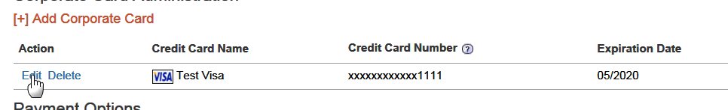
The Credit Card Detail window appears.
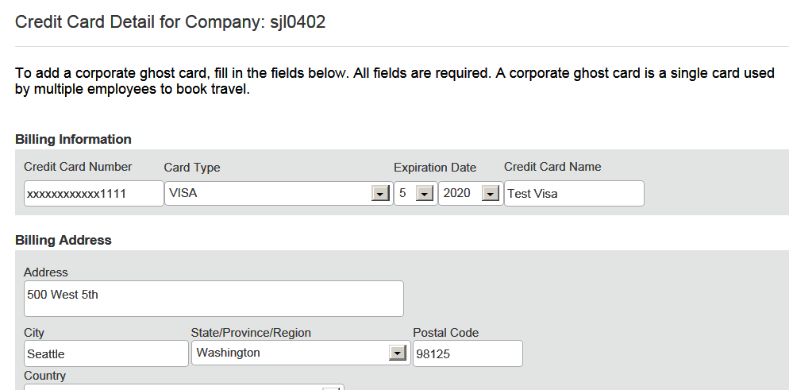
- Make the desired changes.
- Click Save.

Delete a Corporate Ghost Card
To delete a corporate ghost card:
- In the left-side menu, click Form of Payment.
- Click Delete to the left of the desired card.
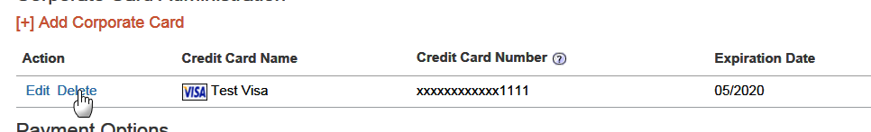
- Click Yes for the confirmation message.

Enable AirPlus A.I.D.A.
This feature is currently not available.

Step 9 – Discounts and Travel Content

Overview
Use the Discounts and Travel Content step to:
- Add corporate discounts for air, car, hotel, and rail
- Set the preference level for airline and hotel vendors that are not available in the company's reservation system (GDS)
You can set preference levels; you cannot use any other features (like discounts) on this page for these vendors.
- Upload hotel property discounts
- Enable all pertinent direct connect provider content (these are typically vendors who provide access to content not available via the GDS)
- Enable Travelfusion providers
- Enable government rates
- IMPORTANT: Consult with your travel agency before adding/modifying/deleting anything in this step as it often requires TMC intervention for accurate pricing. Your agency will provide the codes needed to access your discounts.

Add Corporate Discounts for Air, Car, Hotel, and Rail;
Set the Preference Level for Non-GDS Airline and Hotel Vendors;
Upload Hotel Property Discounts

- For complete details, screen captures, and setup steps, refer to the Discounts Travel Service Guide.

Enable a Direct Connect Provider
To enable a direct connect provider:
- In the left-side menu, click Discounts and Travel Content.
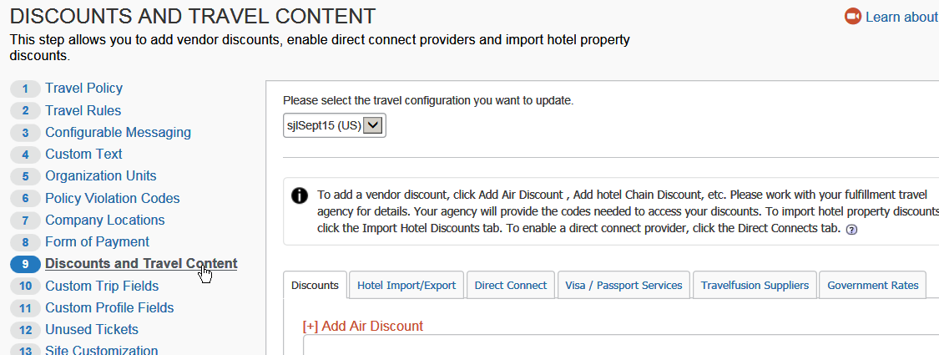
- Select the desired configuration.
- Click the Direct Connect tab.
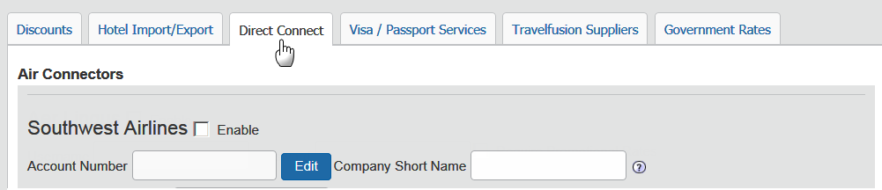
This section contains all the direct connect providers available based on the regions you have enabled for your site. The most common ones are listed below.

Requirements for Each Air Connector

For this feature/option, additional steps are required. In some cases, the required steps must be completed before using the Travel setup wizard (like obtaining a vendor agreement).
- Refer to the Travel Service Guide for each vendor.

Southwest Airlines

- For complete details, screen captures, and setup steps, refer to the Southwest Direct Connect Travel Service Guide.

Air Canada

- For complete details, screen captures, and setup steps, refer to the Air Canada Direct Connect Travel Service Guide.

Cleartrip

- For complete details, screen captures, and setup steps, refer to the Cleartrip (Air) Travel Service Guide.

Travelfusion

- For complete details, screen captures, and setup steps, refer to the Travelfusion Direct Connect Travel Service Guide.

Requirements for Each Rail Connector

For this feature/option, additional steps are required. In some cases, the required steps must be completed before using the Travel setup wizard (like obtaining a vendor agreement).
- Refer to the Travel Service Guide for each vendor.

General
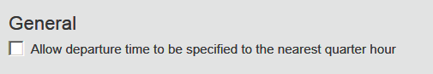
Select the check box to allow departure time to the nearest quarter hour.

Amtrak

- For complete details, screen captures, and setup steps, refer to the Amtrak Direct Connect Travel Service Guide.

BIBE (Bahn Internet Booking Engine)

- For complete details, screen captures, and setup steps, refer to the Deutsche Bahn (BIBE) Direct Connect Travel Service Guide.

SNCF

- For complete details, screen captures, and setup steps, refer to the SNCF Direct Connect Travel Service Guide.

Trainline

- For complete details, screen captures, and setup steps, refer to the Trainline Direct Connect Travel Service Guide.

Evolvi

- For complete details, screen captures, and setup steps, refer to the Evolvi Direct Connect Travel Service Guide.

VIA Rail
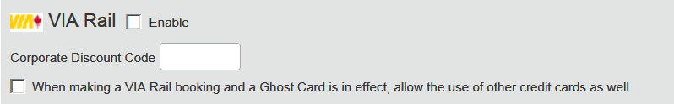
To enable:
Field | Description/Action
Enable | Select to enable.
Corporate Discount Code | Enter the code.
When making a VIA Rail booking and a Ghost Card is in effect, allow the use of other credit cards as well | Select, if desired.

Requirements for Each Car Connector

For this feature/option, additional steps are required. In some cases, the required steps must be completed before using the Travel setup wizard (like obtaining a vendor agreement).
- Refer to the Travel Service Guide for each vendor.

Sixt

- For complete details, screen captures, and setup steps, refer to the Sixt Direct Connect Travel Service Guide.
The discount code for Sixt is entered on the Discounts tab.
- For complete details, screen captures, and setup steps, refer to the Discounts Travel Service Guide.

Hertz

- For complete details, screen captures, and setup steps, refer to the Hertz Direct Connect Travel Service Guide.
The discount code for Hertz is entered on the Discounts tab.
- For complete details, screen captures, and setup steps, refer to the Discounts Travel Service Guide – to locate, see Find the Travel Service Guides & Fact Sheets in the appendix of this guide.

Requirements for Each Hotel Connector

For this feature/option, additional steps are required. In some cases, the required steps must be completed before using the Travel setup wizard (like obtaining a vendor agreement).
- Refer to the Travel Service Guide for each vendor.

hotel.de

- For complete details, screen captures, and setup steps, refer to the HOTEL DE Direct Connect Travel Service Guide.

HRS
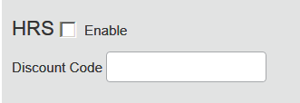
HRS and hotel.de cannot both be activated.
To enable:
Field | Description/Action
Enable | Select to enable.
Corporate Discount Code | Enter the code.
Related option(s) are hidden, set by default, and cannot be changed:
Field | Description/Action
Availability timeout | Unavailable
Main customer key | Unavailable
Frequent guest card key | Unavailable
Notify customer | Unavailable
Send notification to additional e-mail addresses  Additional e-mail addresses | Unavailable
When you select Enable, the country section appears at the bottom of the Hotel Connectors section. Select the desired country.

Hilton
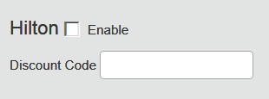
To enable:
Option | Description/Action
Enable | Select to enable direct connect.
Discount Code | Enter the discount code.
When you select Enable, the country section appears at the bottom of the Hotel Connectors section. Select the desired country.

AOT
- IMPORTANT: AOT is currently available only for AMEX in Australia.
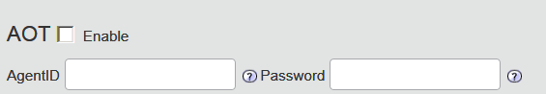
To enable:
Option | Description/Action
Enable | Select to enable.
Agent ID | Enter the agent ID.
Password | Enter the password.
When you select Enable, the country section appears at the bottom of the Hotel Connectors section. For AOT, select Australia.
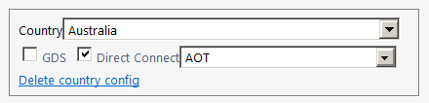

Booking.com, CDS, Direct Connect Hotels (Cleartrip Hotels), HCorpo, iAlbatros, Premier Inn, Rakuten Travel, The Hotel Network (THN), The Lido Group

- For complete details, screen captures, and setup steps, refer to the Hotel Service Content Suppliers Travel Service Guide.

Requirements for Each Ground Connector

GroundSpan, SummitQwest, Talixo

- For complete details, screen captures, and setup steps, refer to the Ground Content Suppliers Travel Service Guide.

Enable Travelfusion Suppliers

- For complete details, screen captures, and setup steps, refer to the Travelfusion Travel Service Guide.

Enable Government Rates
This tab appears only if you have a United States configuration.
Customers who conduct business with the US Government often are granted access to special, discounted government rates.
Please work with your fulfillment TMC to ensure access to these rates has been granted in the GDS prior to enabling in Concur.

- For complete details, screen captures, and setup steps, refer to the Government Features Travel Service Guide.

Step 10 – Custom Trip Fields
Best practice is to not allow personal, sensitive, or uniquely identifying information in custom fields.

Overview
You can use custom trip fields to create questions for the user to answer during the booking process. Concur automatically provides two custom trip fields but you can create an unlimited number of additional custom profile fields.
Use the Custom Trip Fields step to:
- Configure and enable custom trip fields
- Add more custom trip fields
- IMPORTANT: Because travel agencies use custom fields to pass information into the booking system, you should not add/modify/delete these fields unless you first verify with your travel agency or Concur Client Support. If you do not verify first, you risk causing serious issues with profiles and itineraries in the agency booking system.

Considerations for Creating Custom Fields
Best practice is to not allow personal, sensitive, or uniquely identifying information in custom fields.

Treatment of Existing Data
When you create new custom fields, you must consider how existing data might be affected. Travel will treat existing data as follows:
- If you assign valid values where there were none before, existing data will not be affected but may not display correctly.
- If you change values in a list that are in use, existing data will be updated.
- If you delete a value from a list, existing data with that value will be cleared.
- If you change the data type to numeric, any non-numeric data will be left unaffected until the next time you edit that employee, at which time a valid value must be entered.

Determine the Types of Fields
For each new custom field, determine the field type. The following types of fields are available.
Field type | Description/Action
Text/Drop-Down | Creates a text or dropdown menu  For this field type:  - Set the number of characters available in the Max Length field.  - Choose whether to enter optional values.  - If you enter optional values, those values will appear in a dropdown menu.  - If you leave this blank, the user will be able to type information into the field.  - To enter optional values, enter the option name and stored value and then click Add.  - Use the Up, Down, Change, and Delete buttons to modify the values.
Long Text | Creates a text field  For this field type, set the number of characters available in the Maximum Length field. Users will be able to type in the field up to the maximum length and will not be presented with a dropdown menu.
Number | Creates a list of numbers
Yes/No | Create a Yes/No list

Order of Display
By default, fields display to the user in alphabetical order. If you place a number in front of the text, then the field will appear first.

Guest Travel Bookings
Be aware that all custom trip fields apply automatically to Guest Travel bookings.

Configure and Enable a Custom Trip Field
To configure a new custom trip field:
- In the left-side menu, click Custom Trip Fields.
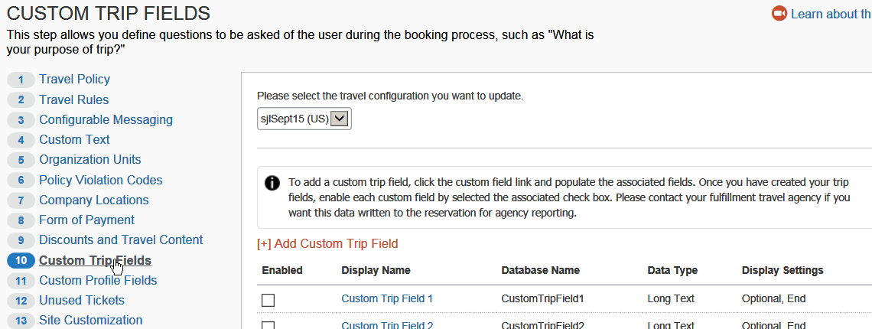
- Select the desired configuration.
- Click the custom trip field name (ex: Custom Trip Field 1).
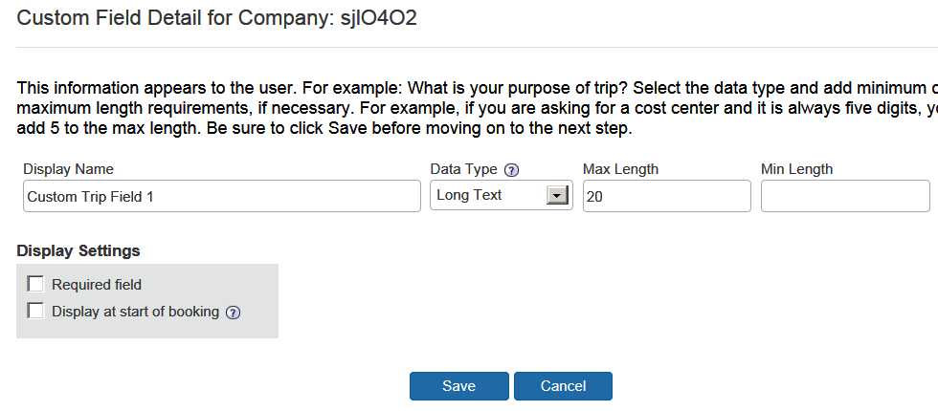
- Make the appropriate choices as described in the following table.
Field | Description/Action
Display Name | Text that should appear to the user. Example: What is your purpose of trip?  NOTE: Best practice is to not allow personal, sensitive, or uniquely identifying information in custom fields.
Data Type | Select one of these:  - Text /Drop-Down  - Long Text  - Number  - Yes/No
For Text/Drop-Down
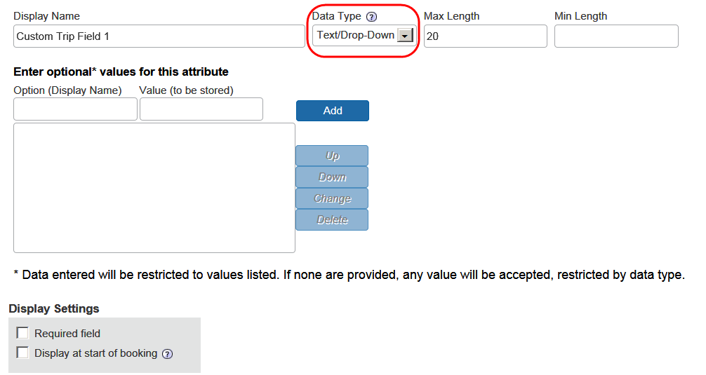
Max Length / Min Length | Minimum and maximum character length
Enter optional values for this attribute | To create the dropdown menu, add each option to the Option field and click Add.  If you want a different value than the display name, then also add the Value.  Example: Purpose of trip display options are business, leisure and meetings but the value added to the PNR for the TMC is a two letter code.
For Long Text
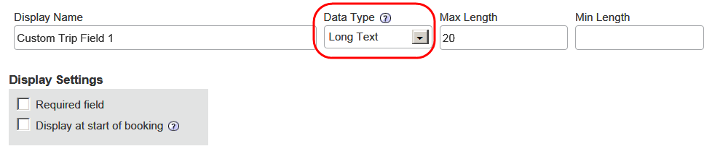
Max Length / Min Length | Minimum and maximum character length
For Number
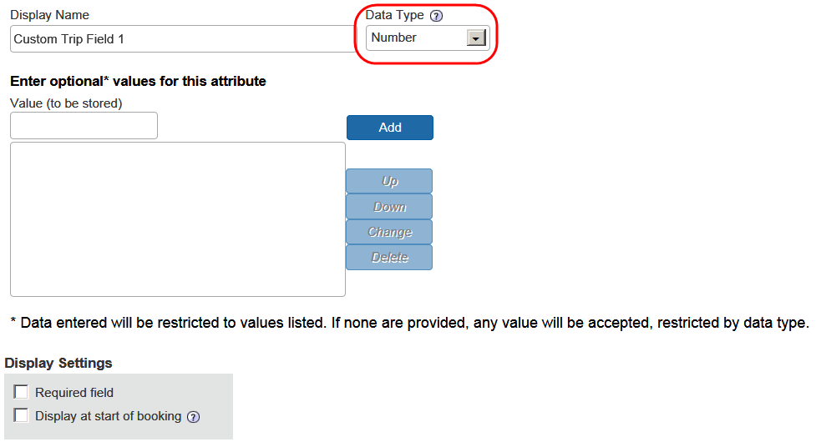
Enter optional values for this attribute | To create the dropdown menu, add each option to the Value field and click Add.
For Yes/No
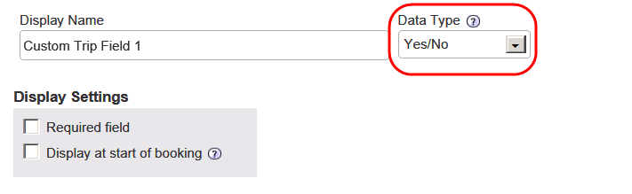
For all types
Required Field | Select this check box if this question must be answered by the user to complete the booking.
Display at Start of Booking | Select this check box if you want the question asked at the beginning of the booking instead of at the end.
- Click Save.
- Once configured, click the check box in the Enable column.

Add More Custom Trip Fields
To add more custom fields:
- In the left-side menu, click Custom Trip Fields.
- Select the desired configuration.
- Click the Add Custom Trip Field link.
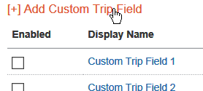
The Add Custom Trip Field popup appears.
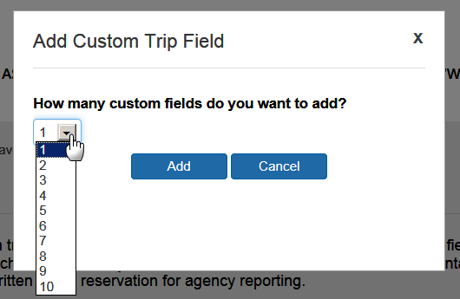
- Select the desired number, between 1 and 10.
- Click Add. The new fields appear at the bottom of the grid.
- Configure and enable the fields as described in Configure and Enable a Custom Trip Field in this guide.

Step 11 – Custom Profile Fields
Best practice is to not allow personal, sensitive, or uniquely identifying information in custom fields.

Overview
You can use custom profile fields to collect additional information in the user's profile. Concur automatically provides nine custom profile fields but you can create an unlimited number of additional custom profile fields.
Use the Custom Profile Fields step to:
- Configure and enable custom profile fields
- Add more custom profile fields

Important
- Because travel agencies use custom fields to pass information into the booking system, you should not add/modify/delete these fields unless you first verify with your travel agency or Concur Client Support. If you do not verify first, you risk causing serious issues with profiles and itineraries in the agency booking system.
- For Concur Standard Travel and Expense customers, custom profile fields are not synchronized between the two systems. If both systems need to track the same item, such as a cost center, then a custom field will need to be created and maintained separately within both systems.

Considerations for Creating Custom Fields
Best practice is to not allow personal, sensitive, or uniquely identifying information in custom fields.

Treatment of Existing Data
When you create new custom fields, you must consider how existing data might be affected. Travel will treat existing data as follows:
- If you assign valid values where there were none before, existing data will not be affected but may not display correctly.
- If you change values in a list that are in use, existing data will be updated.
- If you delete a value from a list, existing data with that value will be cleared.
- If you change the data type to numeric, any non-numeric data will be left unaffected until the next time you edit that employee, at which time a valid value must be entered.

Determine the Types of Fields
For each new custom field, determine the field type. The following types of fields are available.
Field type | Description/Action
Text/Drop-Down | Creates a text or dropdown menu  For this field type:  - Set the number of characters available in the Max Length field.  - Choose whether to enter optional values.  - If you enter optional values, those values will appear in a dropdown menu.  - If you leave this blank, the user will be able to type information into the field.  - To enter optional values, enter the option name and stored value and then click Add.  - Use the Up, Down, Change, and Delete buttons to modify the values.
Long Text | Creates a text field  For this field type, set the number of characters available in the Maximum Length field. Users will be able to type in the field up to the maximum length and will not be presented with a dropdown menu.
Number | Creates a list of numbers
Yes/No | Create a Yes/No list

Order of Display
By default, fields display to the user in alphabetical order. If you place a number in front of the text, then the field will appear first.

Configure and Enable a Custom Profile Field
To configure a custom profile field:
- In the left-side menu, click Custom Profile Fields.
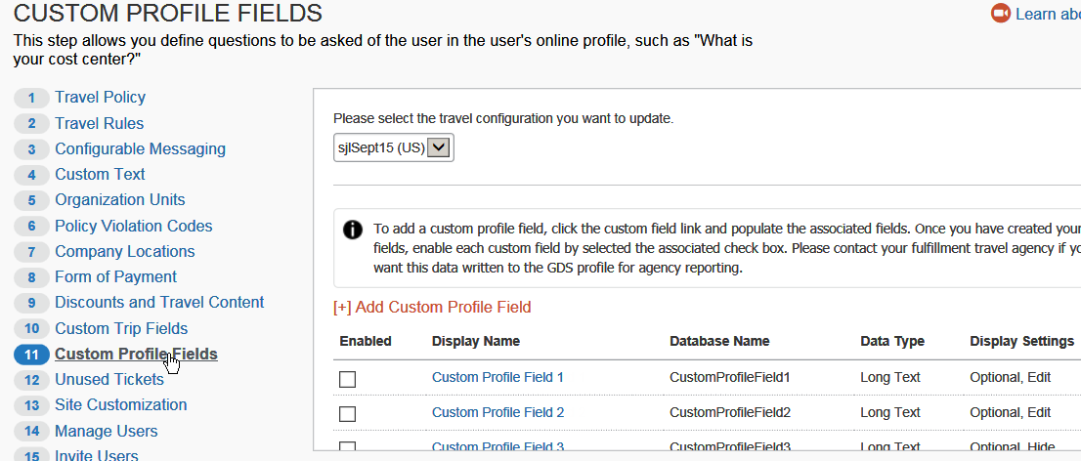
- Select the desired configuration.
- Click the name of the custom field (ex: Custom Profile Field 1).
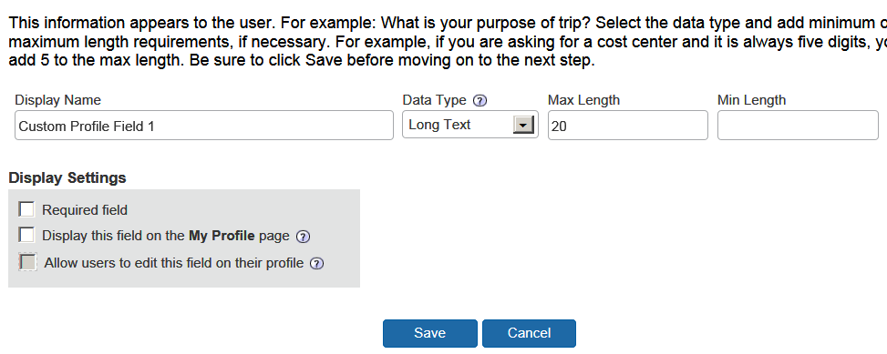
- Make the appropriate choices as described in the following table.
Field | Description/Action
Display Name | Text that should appear to the user. Example: What is your purpose of trip?  NOTE: Best practice is to not allow personal, sensitive, or uniquely identifying information in custom fields.
Data Type | Select one of these:  - Text /Drop-Down  - Long Text  - Number  - Yes/No
Send to Sabre Profiles | This check box may appear if Sabre Profiles is enabled. If so, it is selected (enabled) by default and cannot be changed.
For Text/Drop-Down
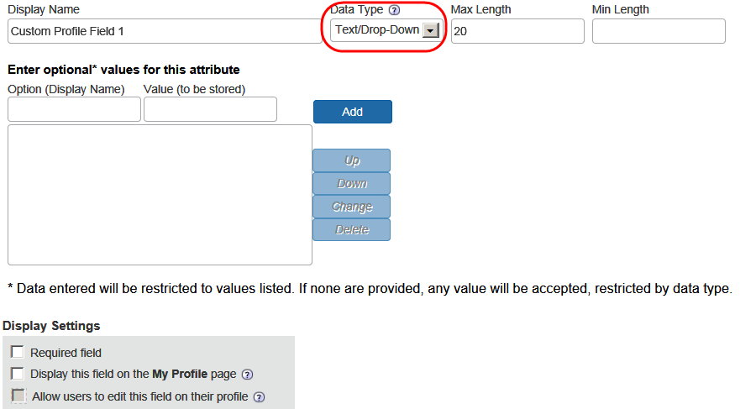
Max Length / Min Length | Minimum and maximum character length
Enter optional values for this attribute | To create the dropdown menu, add each option to the Option field and click Add.  If you want a different value than the display name, then also add the Value.  Example: Purpose of trip display options are business, leisure and meetings but the value added to the PNR for the TMC is a two-letter code.
For Long Text
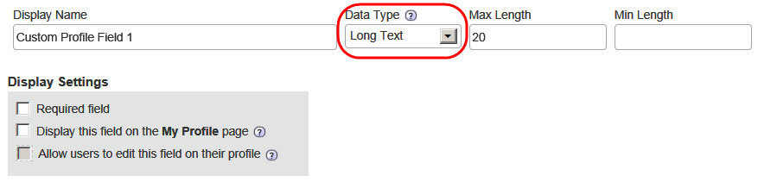
Max Length / Min Length | Minimum and maximum character length
For Number
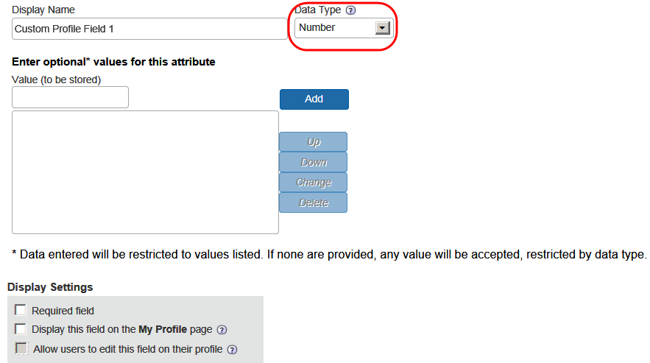
Enter optional values for this attribute | To create the dropdown menu, add each option to the Value field and click Add.
For Yes/No
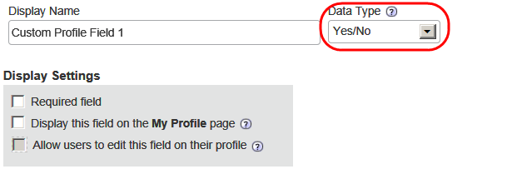
For all types
Required Field | Select this check box if this question must be answered by the user to complete the booking.
Display this field on the My Profile page | Select this check box to make this field appear on users' profile pages.  If you clear this check box, the custom field will appear only to administrators via the User step; the user will not be able to view or edit this field in the profile.
Allow users to edit this field on their profile | Select this check box to allow users to edit the contents of this field on their profile pages.  If you clear this check box, the field will appear to users but will be grey and not available for editing. Administrators will be able to edit the field via the User step.
- Click Save.
- Once configured, click the check box in the Enable column.

Add More Custom Profile Fields
To add more custom fields:
- In the left-side menu, click Custom Profile Fields.
- Select the desired configuration.
- Click the Add Custom Profile Field link.
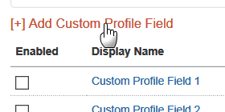
The Add Custom Profile Field popup appears.
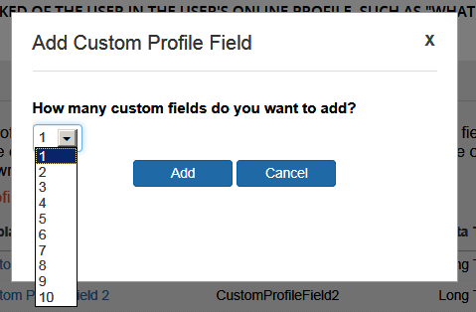
- Select the desired number, between 1 and 10.
- Click Add. The new fields appear at the bottom of the grid.
- Configure and enable the fields as described in Configure and Enable a Custom Profile Field in this guide.

Step 12 – Unused Tickets

Overview
Use the Unused Tickets section to view unused tickets for your organization. This allows you to take appropriate action to use, refund, or delete unused tickets. Users are shown their unused tickets during the booking process.
- IMPORTANT: Customers will want to work with their TMC to determine how unused tickets will be used. Concur Travel only alerts the user that an unused ticket is on file. The TMC actually processes the exchange.

- For complete details, screen captures, and setup steps, refer to the Unused Tickets Travel Service Guide.

Step 13 – Site Customization

Overview
On the Site Customization setup step, use the Site Wide Settings tab to:
- Add your company logo
- Define your self-registration code and email
If a site has Expense enabled, the Self-Registration section will be hidden. If a site was Travel-only with Self-Registration enabled and then Expense is added, the Self-Registration feature will be disabled and hidden.
On the Site Customization setup step, use the Configuration Settings tab allow/disallow:
- Refundable fares
- Policy by leg (Flex faring)
- Default to Mixed Classes for Class of Service (Flex faring)
- Booking hotels that require a deposit

Upload a Company Logo
Your logo will appear in the upper right corner of the page.
Note the following:
- Company logos can be either .jpg or .gif files.
- They must be under 100kb in size.
- The image should be no more than 55 pixels in height and 200 pixels in length.
- IMPORTANT: Anything outside of these parameters will be rejected.
To upload a company logo:
- In the left-side menu, click Site Customization.
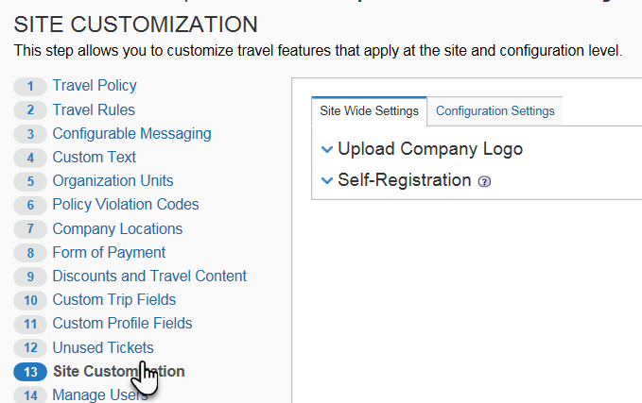
- Click the Site Wide Settings tab, if it is not already selected.
- Expand the Upload Company Logo section.
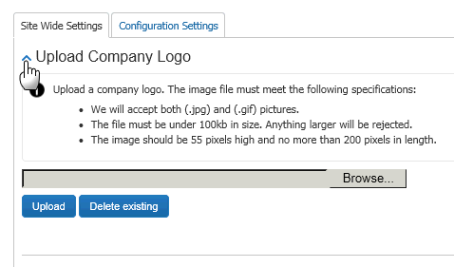
- Click Browse/Choose File (depending on the browser) to locate your company logo.
- Click Upload once you locate the logo file.

Set Up Self-Registration

- For complete details, screen captures, and setup steps, refer to the Self-Registration Travel Service Guide.

Allow/Disallow Refundable Fares;
Allow/Disallow Booking Hotels with Deposit;
Allow/Disallow Policy by Leg (Flex Faring);
Default to Mixed Classes (Flex Faring)
To change these settings:
- In the left-side menu, click Site Customization.
- Click the Configuration Settings tab.
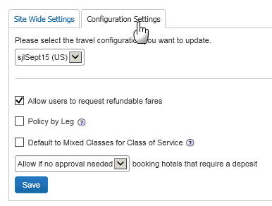
- Select the desired configuration.
- Make the appropriate choices as described in the following table.
Field | Description/Action
Allow users to request refundable fares | Select (enable) this check box as appropriate.
Policy by Leg | For flex faring, select (enable) this check box to allow policy and LLF evaluation per leg, which may result in multiple violations per trip.  - Refer to the Flex-Faring Travel Service Guide – to locate, see Find the Travel Service Guides & Fact Sheets in the appendix of this guide.
Default to Mixed Class for Class of Service | For flex faring, select (enable) this check box to default the Class of Service dropdown in the Travel Wizard to Mixed Classes and ensure the search results for all cabins allowed for the user will be returned.  - Refer to the Flex-Faring Travel Service Guide – to locate, see Find the Travel Service Guides & Fact Sheets in the appendix of this guide.
…booking hotels that require a deposit | Select one of these:  - Allow if no approver needed  - Do not allow
- Click Save.

Step 14 – Manage Users

Overview
The menu and process differ depending on:
- Whether you implement Travel with Expense or without Expense
– and –
- Whether you are adding users or updating existing user information
– and –
- Whether you are completing the task manually (using the user interface) or via import
All situations are described on the following pages.

Menus
Menu options differ if you are implementing Travel with Expense or without Expense.
Travel with Expense:  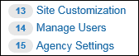 |  | Travel without Expense:  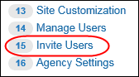
If implementing Travel with Expense, the Invite Users option does not appear. That task is completed on the Users page in Product Settings for Concur Expense.

Add and Modify User Information Manually
If you are implementing Travel without Expense, you can use the Manage Users step in Travel setup to manually add/modify/delete users, change passwords, and manage other information for Travel users.
If you are implementing Travel with Expense:
- Add users on the Users page in Product Settings for Concur Expense.
- Modify user information using the Manage Users step in the Travel Setup Wizard.

Add and Modify User Information via Import
If you are implementing Travel without Expense, you can use the import in the Manage Users step in Travel setup to import new users as well as modify existing user information.
If you are implementing Travel with Expense:
- Add users via import on the Users page in Product Settings. On the Users page, click Import Users to download a spreadsheet.
- Modify user information via import using the Manage Users step in the Travel Setup Wizard.
Between 9 AM – 5 PM (your local time), uploads are limited to 5MB or smaller. If you attempt to upload a file that is larger than that, a message appears. You can often reduce file sizes by changing file formats from .csv to Excel. If changing the format is not an option, you can upload larger files after business hours (9 AM – 5 PM your local time).

Manually Add a New User – Travel WITHOUT Expense
To add a new user:
- In the left-side menu, click Manage Users.
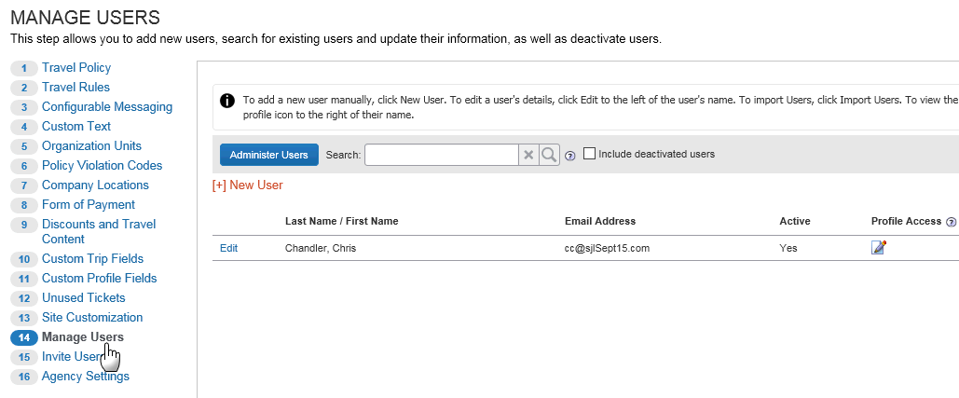
- Click New User. The User Detail window appears.
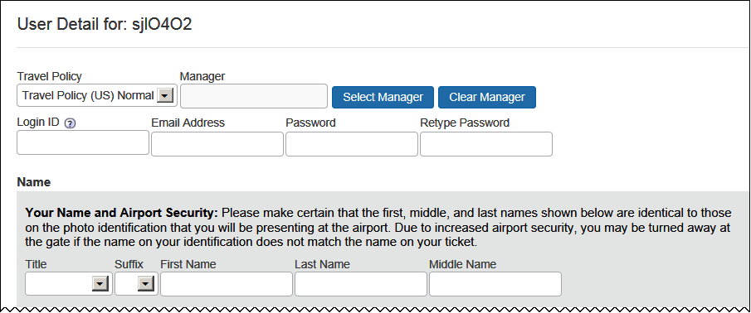
- Make the appropriate choices as described in the following table.
Field | Description/Action
Travel Policy | Select the travel policy that will apply to the user.
Manager | Select the user's manager's name.  - If you are planning to use approvals or notifications, every user should have a manager displayed in this field. Click Edit to search for and select a manager.  - If approvals or notifications are not used or will be handled by a designated travel approver, it is not necessary to select a manager in this field.  You can also define at the travel-class level via the Travel Policy step.
Login ID | Enter the user's ID for logging in to Travel.  - ONLY the following special characters are allowed: hyphen, at symbol, period, and underscore. ( - @ . _)  - Leading and trailing spaces are permitted. Verify that you have not entered one in error.  - The LoginID must be unique across all Concur products. If a LoginID is currently in use in any Concur product, it cannot be assigned again unless the original occurrence is changed. For example, assume that a LoginID was assigned in error. That LoginID can only be used again if an admin (either manually or via import) renames the original occurrence, allowing the LoginID to be used again.
Email Address | Enter the user's email address  - ONLY the following special characters are allowed: hyphen, at symbol, period, and underscore. ( - @ . _)  - Leading and trailing spaces are permitted. Verify that you have not entered one in error.
Password / Retype Password | Enter the password for logging in to Travel.  This is the field to use if you want to reset a password as well.  If you reset a password to the user's Login name, the system will automatically prompt the user to change it the next time he/she logs in to Travel.
Title, First Name, Middle Name, Last Name, Suffix | Enter or select as appropriate.  IMPORTANT! The user's name should always be the name that appears on his/her identification for travel purposes.
Scroll down to the next section.
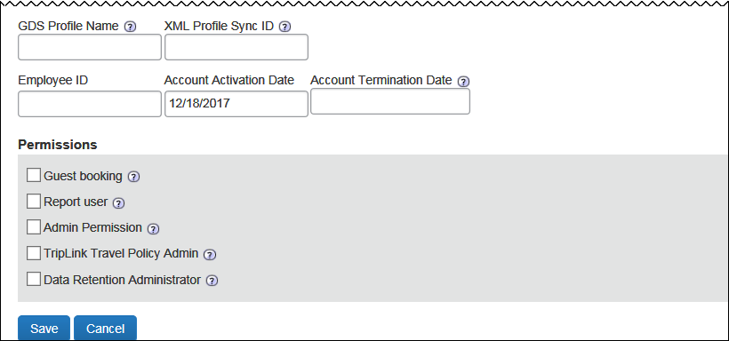
Field | Description/Action
GDS Profile Name | Provided by the TMC
XML Profile Sync ID | Either:  - If the field is already populated, make no changes; the field has been configured to provide either the Login ID or the Employee ID.  - If the field is blank, enter the identifier as defined by your company or TMC.
Organization Unit | Select the desired organization unit.
Employee ID | Enter the employee ID
Account Activation Date | Concur automatically assigns the date the user record was created.
Account Termination Date | Enter (or select using the calendar) the date the user will stop using Travel. Once a user is de-activated, they no longer can access Concur Travel.  If someone is leaving the company or will no longer be traveling, set this date to the last date the person will use Travel. You can set this to a date in the past to deactivate someone immediately.
<custom profile fields> | Add values here if applicable as directed by your company.
Permissions | Select the check boxes that apply:  - Guest booking: Allows user to make bookings for non-profiled travelers, such as recruits  - Report user: Grants access to reports  - Admin Permission: Grants access to the setup wizard  - TripLink Travel Policy Admin: Grants access to TripLink (This check box appears only if this feature is enabled for this company.)  - For more information, refer to the TripLink User Guide.  - Data Retention Administrator: Not yet available; do not use
- Click Save.

Manually Add a New User – Travel WITH Expense
To add a new user:
- Click Administration > Expense Settings or Expense & Invoice Settings.
- In the Product list click Expense.
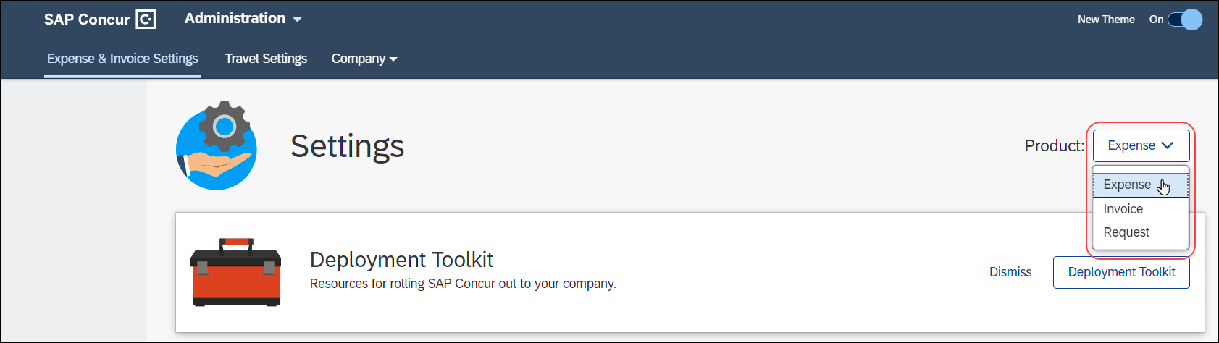
- In the Access To Concur section, on the User Accounts tab, click Edit.
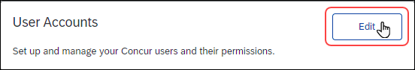
The Users page appears.
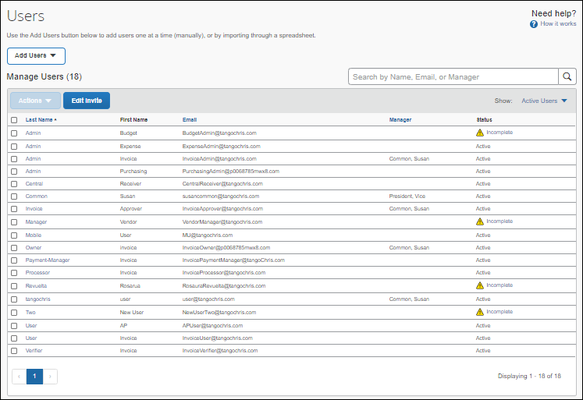
On the Users page, click Create New User to add a new user.
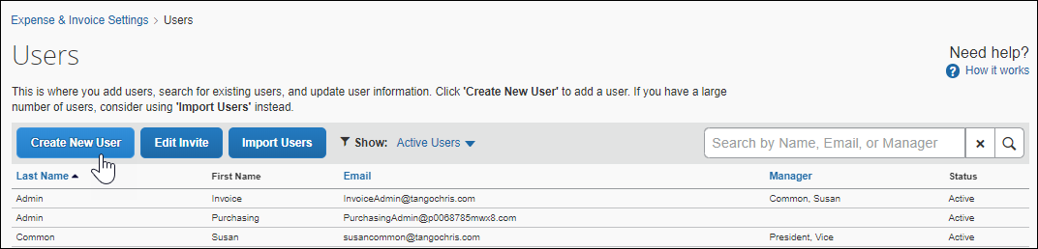
The Create User page appears.
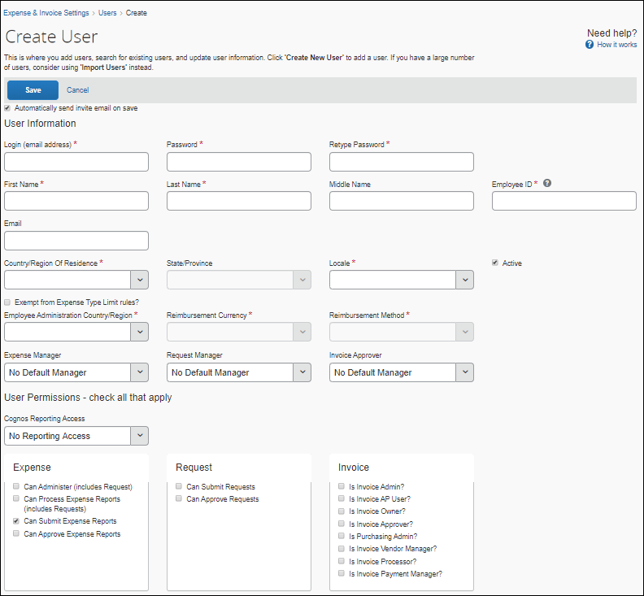
- For the Expense-related fields, refer to the Shared: Users Setup Guide for Concur Standard Edition.
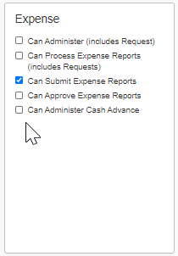
- For the Travel-related fields, make the appropriate choices as described in the following table.
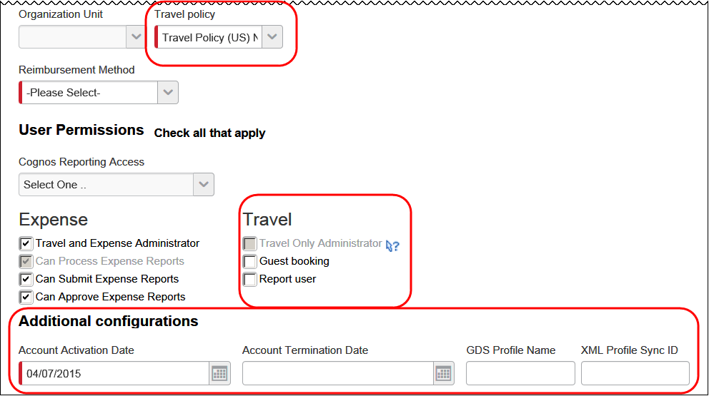
Field | Description/Action
Travel Policy | Select the travel policy that will apply to the user.
Travel (permissions) section
Travel Only Administrator | Select to allow access to the setup wizard where the user can modify user information but cannot add a new user.
Guest booking | Select to allow the user to make bookings for non-profiled travelers, such as recruits.
Report user | Select to allow access to reports.
Additional configurations
Account Activation Date | Concur automatically assigns the date the user record was created.
Account Termination Date | Enter (or select using the calendar) the date the user will stop using Travel. Once a user is de-activated, they no longer can access Concur Travel.  If someone is leaving the company or will no longer be traveling, set this date to the last date the person will use Travel. You can set this to a date in the past to deactivate someone immediately.
GDS Profile Name | Provided by the TMC
XML Profile Sync ID | Either:  - If the field is already populated, make no changes; the field has been configured to provide either the Login ID or the Employee ID.  - If the field is blank, enter the identifier as defined by your company or TMC.
- Click Save.

Locate an Existing User – Travel WITH or WITHOUT Expense
To locate an existing user:
- In the left-side menu, click Manage Users.
The sample shows Travel without Expense. If implemented with Expense, the New User button is not available.
- Use the Search field to type in a name or any part of a name. Entries in this field are not case-sensitive. Check the box to include inactive users if you want to search all profiles. Leaving this unchecked will limit the search to active profiles.
- In the results list, click the name of the user (link) that you want to review.

Edit User Information – Travel WITH or WITHOUT Expense
To edit an existing user's information:
- In the left-side menu, click Manage Users.
The sample shows Travel without Expense. If implemented with Expense, the New User button is not available.
- Click Edit for the desired user. The User Detail window appears.
- Make the desired changes as defined in Adding a New User in this guide.
Depending on your permissions, you may not be able to edit all fields. Go to the Users page in Product Settings to see if you can edit those fields.

Delete Users – Travel WITH or WITHOUT Expense
To delete an existing user:
- In the left-side menu, click Manage Users.
The sample shows Travel without Expense. If implemented with Expense, the New User button is not available.
- Locate the desired user, using the Search field (as described above), if necessary.
- Click Edit for the desired user. The User Detail window appears.
- Enter a date in the Account Termination Date field. Enter the date the user will stop using Travel. Once a user is de-activated, the user will no longer have access to Concur Travel. You can set this to a date in the past to deactivate a user immediately.
- Click Save. Concur Travel will also delete the GDS profile 24 hours later so the TMC knows that user has been de-activated. De-activated profiles remain in the Concur Travel database until the site is deleted.

Import Users – Travel WITH Expense
If you are implementing Travel with Expense:
- Add users via import using the Users step in Expense setup.
- Refer to the Shared: Users Setup Guide for Concur Standard Edition.
- Modify user information via import using the Manage Users step in the Travel Setup Wizard.

Import Users – Travel WITHOUT Expense
If you are implementing Travel without Expense, you can import new users and modify existing user information via import in the Travel Setup Wizard.
To import users:
- In the left-side menu, click Manage Users.
- Click Administer Users. The Administer Users window appears.
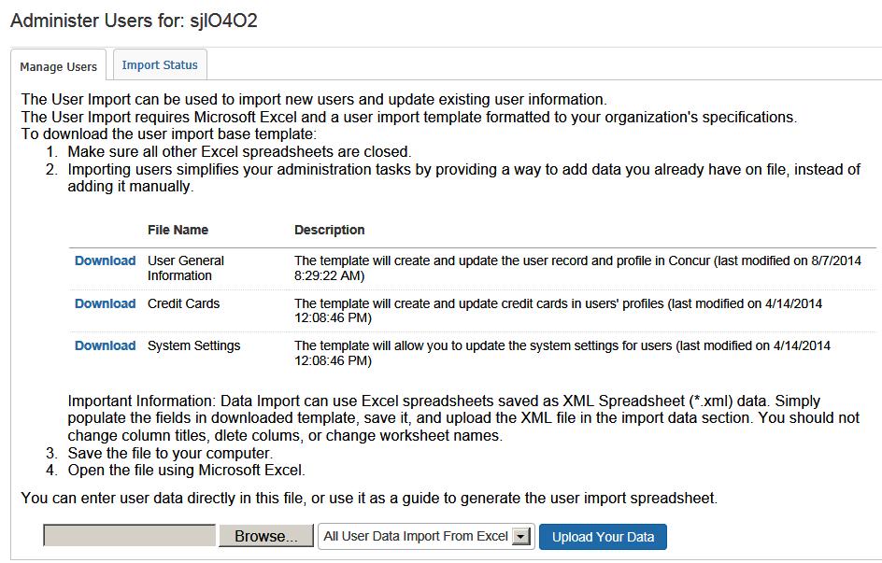
- Click the Manage Users tab, if not already selected.
- Click the Download link to the left of the desired file.
- Update the file and save to your computer.
- Click Browse/Choose File (depending on the browser) to locate the updated file on your computer.
- Once added, click the Upload Your Data button.

View Import Status – Travel WITH or WITHOUT Expense
To view the import status:
- In the left-side menu, click Manage Users.
The sample shows Travel without Expense. If implemented with Expense, the New User button is not available.
- Click Administer Users. The Administer Users window appears.
- Click the Import Status tab to view the status of the last 10 imports.
- To see the details on the particular import, click the icon in the Details column.
- Details will show below with time/date stamps.
- A link will also be provided to download the original import file, with a new column at the end labeled Errors.
- The administrator will be able to see what the issue was and make corrections. They can then perform an additional import to apply the changes.

Access User Profiles – Travel WITH or WITHOUT Expense
To access user profiles:
- In the left-side menu, click Manage Users.
The sample shows Travel without Expense. If implemented with Expense, the New User button is not available.
- Click the icon in the Profile Access column. The profile page appears.
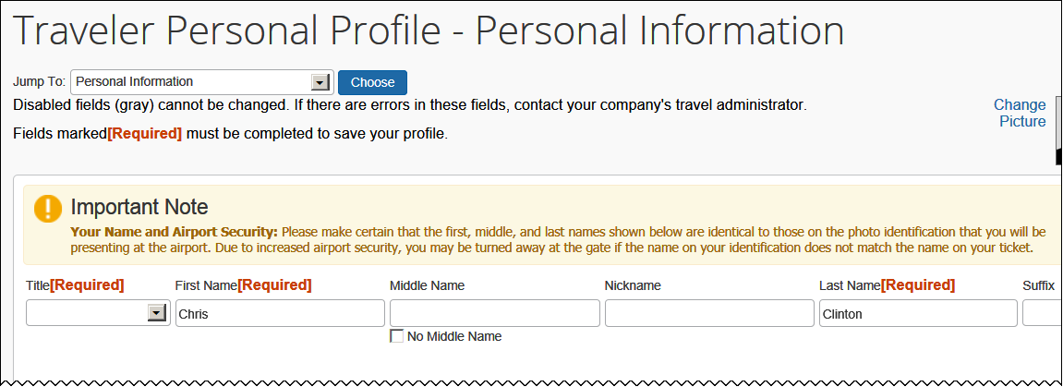
- Make the desired changes.
- When you click Save in Profile, this will push all changes to the GDS or the third-party profile sync tool (if applicable).
When you view the profile, this will pull data from the GDS or the third-party profile sync tool (if applicable). This portion will occur only if bi-directional sync has been enabled in the travel configuration.

Step 15 – Invite Users

Overview
The Invite Users step appears only if Travel is implemented without Expense.
Use the Invite Users step to perform the final actions to launch your new travel site. You can add a custom message to the email that all your users will receive when you launch the site. This email contains a link that allows users to log in and set up a secure password.
Invite Users does the following:
- Allows you to add a personal message to the welcome email
- Alerts your entire organization that Concur is now ready to accept travel bookings and sends a welcome email to all users
- Provides employees with a link to access the site and begin booking travel

Invite Users
To invite users:
- In the left-side menu, click Invite Users.
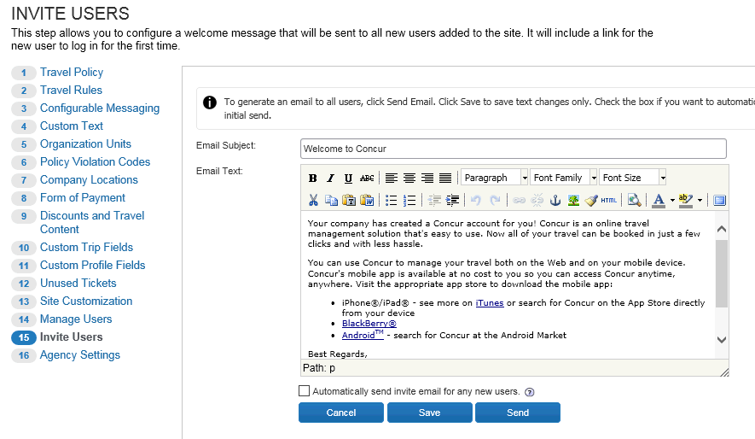
- Enter your custom text in the Email Text field. This text will be displayed at the beginning of the welcome email, followed by the standard text.
- Select Automatically send invite email for any new users if you want any newly added users (added either manually or via upload) to automatically receive this email.
- Then, click:
- Cancel: All changes in the HTML editor are ignored.
- Save: Changes will be saved but no email is sent, unless the check box to automatically send for new users is checked. If that is the case, then the new version will be used in those scenarios.
- Send: Email will be sent to all existing users.

Step 15/16 – Agency Settings

Overview
Use the Agency Settings step to manage:
- General agency settings, such as trip-on-hold, multiple booking sources, companions, etc.
- Transportation Security Administration (TSA) settings
- Agency invoice options
The step number will differ depending on whether you are configuring Travel-only or Travel with Expense.

Work with General Settings
To change settings:
- In the left-side menu, click Agency Settings.
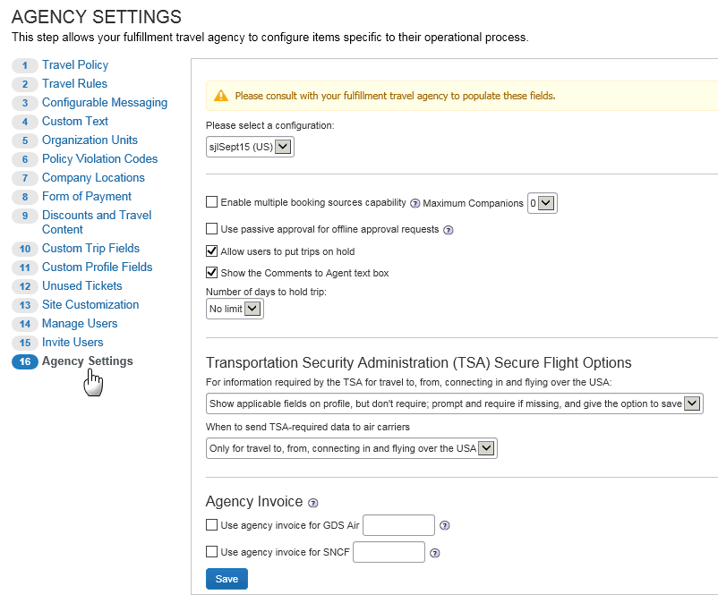
- Select the desired configuration.
- Make the desired selections:
Option | Description/Action
Enable multiple booking sources capability | Select this check box to allow users to combine GDS in the same PNR with: Air Canada, Southwest, Travelfusion (web fares), Cleartrip, and Amtrak.  NOTE: You cannot enable Agency Invoice and Enable multiple booking sources capability. If you attempt to save with both, multiple booking sources will be disabled.
Maximum Companions | Select the number of companions that will be allowed in the same trip, treated as a group, in one reservation (PNR).  If you select a number greater than zero, the Number of adults list appears in the Travel Wizard so the user can select the number of traveling companions.  IMPORTANT: This feature should be enabled only by the fulfillment travel agency or with their permission. There may be challenges with supporting this feature from a TMC perspective.  NOTES:  - If there are schedule changes, then the airline will do its best to keep the travelers together.  - The airline will do its best when one person uses his/her status to upgrade another, for some airlines.  - If one of the users has to change his/her trip, the reservation must be "split" before the change can be made.  - Some fulfillment travel agencies do not support companion travel due to the operational challenges with changes.  - This setting will not appear if the travel configuration is associated with Amadeus.
Use passive approval for offline approval requests | This feature should only be enabled by the fulfillment TMC.  The agency must populate the offline approval queue for this to work via the Agency configuration.
Allow users to put trips on hold | Select this check box to allow travelers to hold a trip on the Trip Booking Information page, which is the point where they would normally purchase the trip.  This option reserves the fare and any other options; however, it does not send the flight for ticketing until the traveler chooses to purchase the fare in Travel. It is important to make sure that travelers are aware of rules and limitations for holding fares.
Show the Comment to Agent text box | Select to allow the Comments to Agent field that appears on the Trip Details page.  NOTE: This causes a reservation to fall out of automation and be looked at by an agent. This typically incurs a "touch fee" and becomes a more costly PNR for fulfillment.
Number of days to hold trip | Select the number of days a user can place a trip on hold.
- Click Save.

Work with TSA Settings
- For complete details, screen captures, and setup steps, refer to the Transportation Security Administration (TSA) Requirements Travel Service Guide.

Work with Agency Invoice Settings
Some customers and TMCs have an agreement that monthly billing will be used for air tickets via the GDS. In this case, Concur does not ask the user for a credit card and writes the form of payment to the PNR as invoice. The agency issues the ticket and then provides a bill to the customer.
You cannot enable Agency Invoice and Enable multiple booking sources capability. If you attempt to save with both, multiple booking sources will be disabled.

- For information about different forms of payment, how they may affect each other, and configuration points to watch, refer to the Form of Payment Travel Service Guide.

Travel Reporting

Overview
Use the Reporting tab (main menu) to run travel reports.

- For a complete list (and description) of the reports, refer to the Travel Reporting User Guide.

Run a Travel Report
To run a report:
- In the main menu, click Reporting > Travel Reports. This page appears.
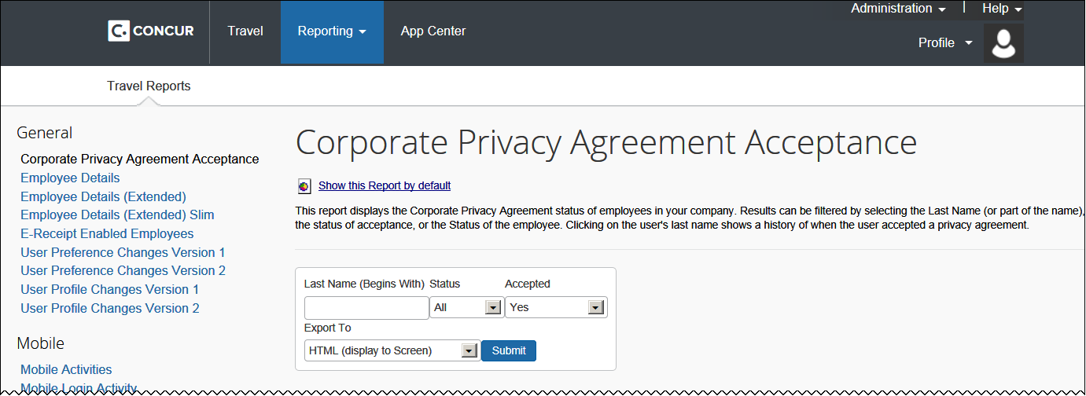
- Click any report listed on the left side.
- Each report will have different options such as whether to display on screen or export to Excel.

Travel System Admin

Overview
The concept of administration changes with Concur Standard. Many options are now part of the setup wizard. Travel configurations will remain but will have limited options. These options are now limited to travel-agency-specific features.
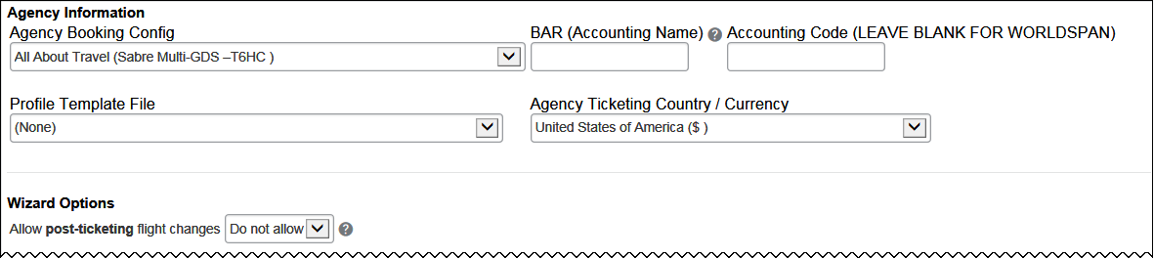
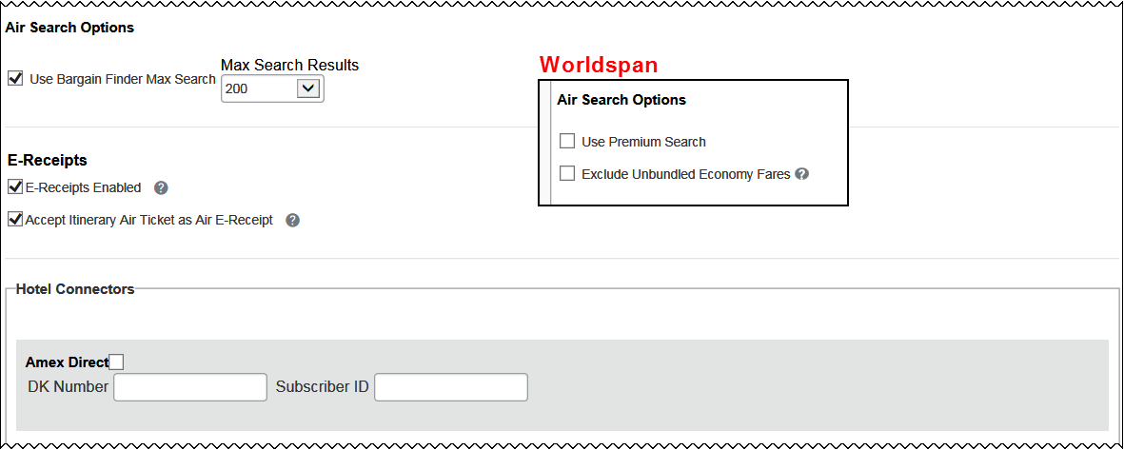
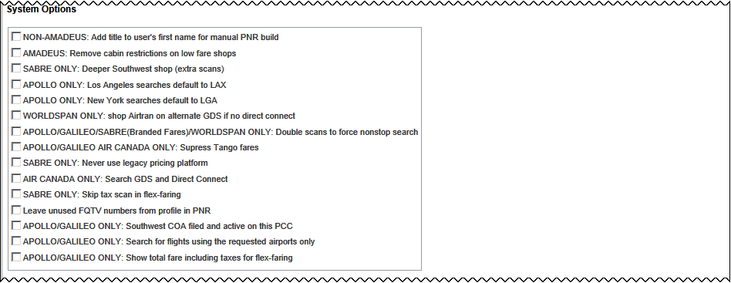
Amadeus only:
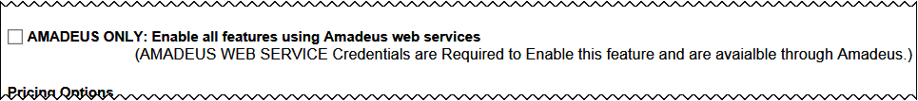
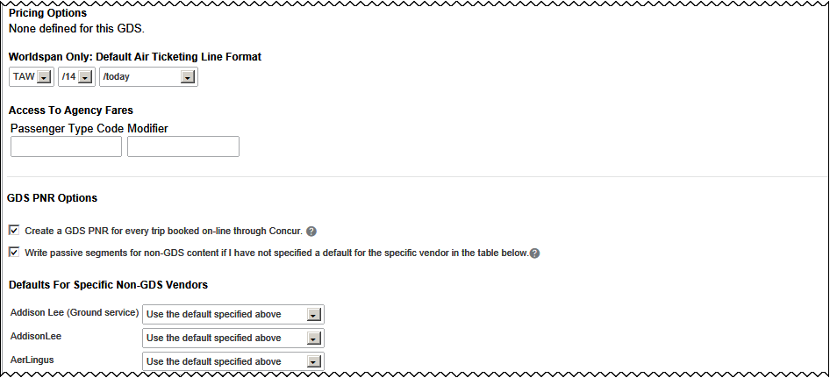
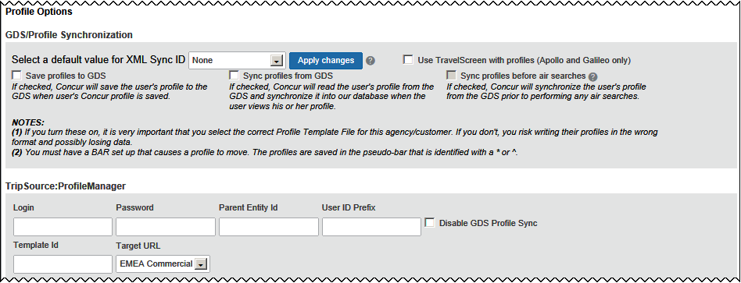
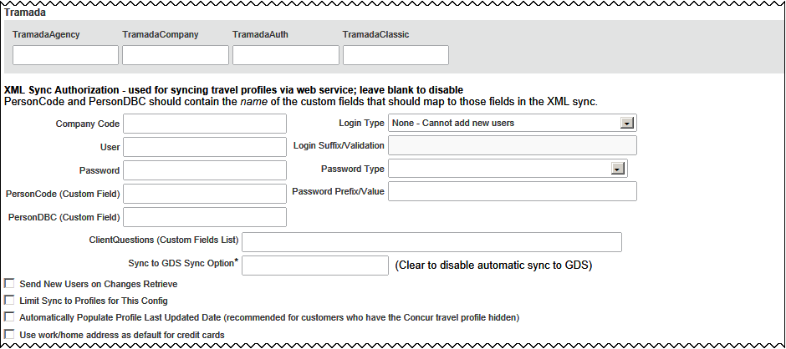
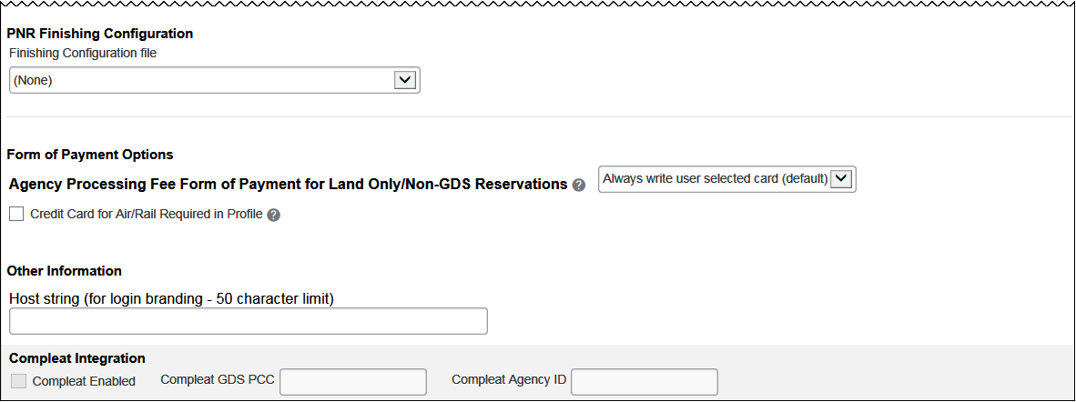

Travel System Admin
To access/update travel system admin:
- In the Professional edition of Concur Travel, click Administration > Travel > Travel System Admin. Locate the Concur Standard Travel configuration.
- Click the site or configuration link you wish to update.
- You will now see TMC-specific items that should be updated for any Standard implementation. Only TMCs will have access to this page.

- Refer to the Concur Travel: Travel System Admin User Guide (for Professional/ Premium Travel) for information about the fields on this page. Not all fields that are available in Professional/Premium are available in Standard. However, if the field is available in Standard, the definition provided in the Professional/Premium documentation applies.
- Click Save.

Default Travel System Admin Settings
The options in this table have been hidden, set to the default shown below, and cannot be changed.
Travel Configuration Setting | Default Value
Billing Tier | No longer needed
Sabre Profiles Template ID  Sabre Profiles Name Field Remark  Sabre Profiles Name Format | These fields appear only if Sabre Profiles has been activated. If they appear, they are blank by default.  - For complete details, refer to the Sabre Profiles Travel Service Guide – to locate, see Find the Travel Service Guides & Fact Sheets in the appendix of this guide.
Hotel Override IATA | Blank
Car Override IATA | Blank
Air Connectors
Air Connectors | - Refer to Discounts and Travel Content in this guide for configuration information. If there are default settings, they are listed there.
Wizard Options
Augment price results… | Automatically
Notify Traveler if non-stop flights are outside the time window | Auto-on
Enforce LLF based on | Search window
Number of LLF definitions per rule class | 1
Constrain rule violation fare list to LLF window | Off
Mark LLF Fare/s with icon | On
Find closest LLF flight and capture details | Off
No Personal Trips | On
Allow Auto Cancel of air/rail trips that are rejected | On
Allow Immediate Cancel of non-air/rail trips that are rejected | On
Allow Multiple Violation Reason Codes | Off
Allow Auto Cancel of Trips on Hold | On
Allow Auto Cancel of trips that require approval | On
Auto-approve trips on passive hold… | On with a maximum of 1 day
Allow pre-ticketing flight changes | On when trip is on hold
Allow ticket voids | On  - For complete details, refer to the Trip Cancel and Voids Travel Service Guide – to locate, see Find the Travel Service Guides & Fact Sheets in the appendix of this guide.
Enable Churn Detection | On for all vendors
Enable Duplicate Detection | Auto-on for Delta only
Visa Requirements Reminder | Off
Show Flight Finder | On
Automatically assign seats on airlines that charge for it | Off
Show IATA Travel Centre Links | On
Show "Add Air" on Existing Itineraries | On
Hide Fee Display on Itineraries and Email | On
Hotel check-in date prompt… | 6:00 AM
Show Morning, Afternoon, Evening, and Anytime as flight time options | On  NOTE: The Anytime option appears to users only if Bargain Finder Max is enabled and if the Max Search Results field is set to 200. (Bargain Finder Max is set in Travel System Admin.)
Default Departure Hour | 9:00 AM
Default Return Time Hour | 3:00 PM
Allow travelers to edit Frequent Flier programs | On
Allow Upgrade Requests for Non-Ticketed Itineraries | Off
Mixed carriers split ticketing | From Schedule and Price Search
Enable Request Integration | Off
Enable Request Booking Switch | Off
… user confirmation of hotel rate policy | Required
Allow Airline FF number association for Car/Hotel | On
Disable auto-lookup for Company Location selection | Off
Enable vendor segment fees | Off
TSA Settings
Allow guest bookings when the Date of Birth is unknown | On (Date of Birth Unknown check box appears)
Write middle name to Itinerary | On
Carbon Models Options for AIR
Carbon Models | On - set to DEFRA  - For complete details, screen captures, and setup steps, refer to the Green Support Travel Service Guide – to locate, see Find the Travel Service Guides & Fact Sheets in the appendix of this guide.
Class of Service Options
When the traveler is authorized… | Default to lowest class of service
Rule Class Options
Rule Class Selection | User cannot select rule class
Air rules use base fare instead of total fare
Air Search Options
Access to Guaranteed Ticketing Carriers | Allow Unless Manager Approval is Required
AF Abonnement | Auto-on for French Configurations
Air Bookings via Concur Mobile Enabled | On
Hide Multiseg Air/Rail Search Option | Off
Hide Propeller Planes Filter | Off
Run extra search on hub when an associated airport is selected | Off
Enable "View More Air Fares" Option | On  - For complete details, screen captures, and setup steps, refer to the View More Air Fares Travel Service Guide – to locate, see Find the Travel Service Guides & Fact Sheets in the appendix of this guide.
Allow user to specify airline for deeper search | On
Auto-check all Airport Filters in Flight Search | Off
Highlight Fly America Act Compliant Options | Off  - For complete details, screen captures, and setup steps, refer to the Government Features Travel Service Guide – to locate, see Find the Travel Service Guides & Fact Sheets in the appendix of this guide.
Show no car/hotel alert | On
Flex Faring
Flex Faring | Auto-on  - For complete details, screen captures, and setup steps, refer to the Flex-Faring Travel Service Guide – to locate, see Find the Travel Service Guides & Fact Sheets in the appendix of this guide.
Hotel Search Options
Default search radius | 5
Search radius for corporate hotels | 30
Number of hotel results to shop | 10  NOTE: Concur displays a default of 25 hotel search results on the hotel search results page. Note that there is a difference between hotel search results and priced hotel search results. The number of priced hotel search results that return are reflected in this field. For example, if a customer has the value 10 set to hotel shops (in this field), then the hotel search results will show 25 total, 10 of which will have prices fetched for them.
Company Location Search Radius | 70
Display per diem rates with individual hotel selections | Off
Hide these profile preferences and search options | Off
Hilton DC | Off
Hotel Connectors
Hotel Connectors | - Refer to Discounts and Travel Content in this guide for configuration information. If there are default settings, they are listed there.
Availability Results Sorting
Shop by Fares Default | Company Policy
Shop by Schedule and Flex Faring Default | For Australia configurations: Fewest Stops  For Canada configurations: Earliest Departure  - Refer to the Flex-Faring Travel Service Guide – to locate, see Find the Travel Service Guides & Fact Sheets in the appendix of this guide.
Hotel Sort Default | Company Policy
Rail Connectors
Rail Connectors | - Refer to Discounts and Travel Content in this guide for configuration information. If there are default settings, they are listed there.
Ground Reservation Options
GGA Limos/Ground Connectors | - Refer to Discounts and Travel Content in this guide for configuration information. If there are default settings, they are listed there.
Parking
Park 'N Fly | On  - For complete details, screen captures, and setup steps, refer to the Park 'N Fly Travel Service Guide – to locate, see Find the Travel Service Guides & Fact Sheets in the appendix of this guide.
American Airlines AirPass Options (formerly AAirpass)
AirPass | Off  - For complete details, screen captures, and setup steps, refer to the American Airlines AAirpass Travel Service Guide – to locate, see Find the Travel Service Guides & Fact Sheets in the appendix of this guide.
Car Search Options
Allow Automatic Reservations of… | Cars that are in policy
Allowable Car Types | All
Default Car Type | Intermediate
Default Car Transmission | Automatic for US, Canada and Australia. Manual for UK, France and Germany
Hide Ski Rack option on Profile and in searches | Off
Always run a general shop request for car searched | Off
Require credit card for car reservation | Off
Don't send card information to Hertz | Off
Allow Car Promos | Applies to Sabre only: On
Allow delivery and collection… | Off
Car Connectors
Car Connectors | - Refer to Discounts and Travel Content in this guide for configuration information. If there are default settings, they are listed there.
AirPlus DBI
AirPlus | Off - AirPlus is not available at this time
Trip Sharing and Cloning
Trip Sharing and Cloning | On  - For complete details, screen captures, and setup steps, refer to the Clone/ Share Trip Travel Service Guide – to locate, see Find the Travel Service Guides & Fact Sheets in the appendix of this guide.
Manifest Clone Options
<All options> | Off
DC Configuration
Finishing | Notify Customer with default text for Amtrak and Southwest
System Options
Maximum air contracts/prefs to combine in a search | 2
GDS PNR Options
Write passive segments for user supplied hotel | Off
Email Options
Confirmation Emails | Send
Ticketing Emails | Off
Travel Reservation Email Subject | Concur Itinerary: {DEPDAY}: {RECORDLOCATOR}
Reminder Emails | Off
Email Hotel/Map Directions | Off
Cancellation Email | On
Cancellation Email Subject | Trip Cancelled: {RECLOC}
Fares Revalidation
<All options> | Off
Approval Email Options
<All options> | On
Orphan Trip Email
<All options> | On with default message and subject line
Profile Options
Send users an email whenever their profile is updated | Off
Suppress emails sent when travel assistant changes are made | Off
Profile Shows Company Locations | Off
Profile Passport Information | Warn if Incomplete
When a user's GDS profile is changed by Concur, email change list to: | Off
When a user's GDS profile is changed by Concur, email change list to: | Off
Refuse Self Assigning assistants… | Off
Custom Attributes
<All options> | - Refer to Custom Trip Fields and Custom Profile Fields in this guide for configuration information. If there are default settings, they are listed there.
Invoicing
Invoicing | Send invoice directly to company for Concur Fee
Form of Payment Options
Use agency invoice for government-only airfare | Off
Government Only Airfare Ghost Card… | Off
User Custom Property for Default Credit Card | Off
Allow temporary credit cards for guest bookings | On
Enforce BIN Restrictions on temporary Card | Off – we don't support BIN restrictions
Temporary Cards for hotel only | Off
Force users to Choose a credit card | Off
Project Billing
<All options> | Off
PNR Finishing Configuration
E-tickets | Auto-on
Enable Sabre Web Services… | Auto-on
Force Finishing Before Approval | Off
Preauthorization | Off
Other Information
Name Remark | Blank
Wizard Mode | Defaults to Galileo Prod for any configurations that use the Galileo GDS
Travel Help URL | Default
Travel Tools URL | Default
Manager Approver Label | Default of "manager"
Alternate Login Text | Off
Refundable Check Box | Show
Non-Refundable Ticket Alert | Default Text
Implementation Notes | Hidden

Additional Configuration Information

Gogo Inflight Wi-Fi
Gogo Inflight Wi-Fi is automatically ON for Standard Travel.
- Refer to the Gogo Inflight Wi-Fi Travel Service Guide.

Sabre Profiles
If a Standard travel configuration is associated to an Agency Configuration that has Sabre Profiles enabled, then the configuration steps are the same as for Professional Travel.
- Refer to the Sabre Profiles Travel Service Guide.
The custom profile fields configured under Standard Travel setup step 10 (Custom Profile Fields step) display the Send to Sabre Profiles check box. The check box is selected (enabled) by default and it is not editable.

Dual Fare Display (Sabre Only)
This feature is ON by default. It can be disabled by contacting SAP Concur support for assistance with the associated module property.
- Refer to the Dual Fare Display (Sabre Only) Travel Service Guide.

Concur Meeting/Third-Party Meeting
Neither Concur Meeting nor Third-Party Meeting are currently available in Standard.

Hotel Previous Stay History
The hotel search results show a "stay history" message for each hotel the traveler has previously booked. This feature is automatically ON for Standard Travel and is not available for change.
- Refer to the Hotel Previous Stay History Fact Sheet.

Offline Approval Error Queue
This queue is available specifically for managing offline approval PNRs that Concur is unable to process. This allows TMCs to monitor a specific queue for these reservations to ensure they can be approved before the traveler's departure.
To set up the queue:
- Click Administration > Travel > Travel System Admin.
- In the Agency Setup section of the left menu, click View Travel Agencies.
- Locate the agency configuration for the site.
- In the Queue Sets section, provide the Pseudo City/Office ID/Subscriber ID, Queue, and Category information under the new Offline approval error queue queue type and click Submit.
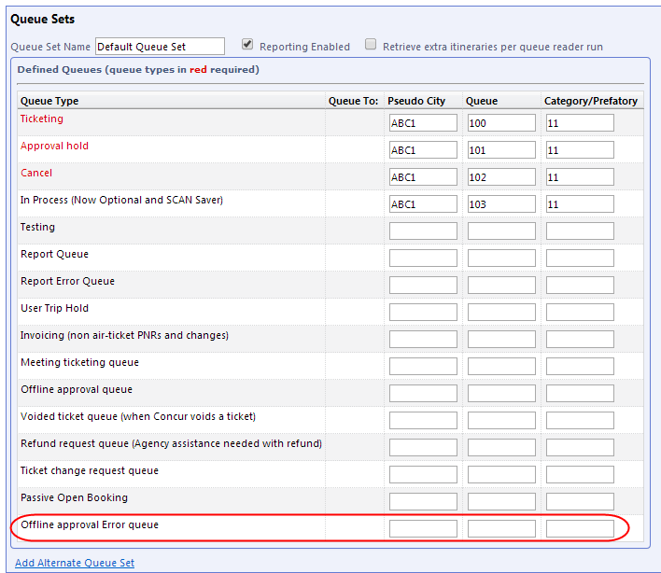
NOTES:
- The Offline approval error queue cannot be located in the Queue Sets table immediately after the existing Offline approval queue due to the order in which support for the various queues was implemented. Implementers should take care to note the location of this new queue to ensure it is not missed when setting up new customers.
- Standard Travel administrators may not have access to the Agency Configuration page. This will likely need to be discussed with and managed by the travel agency.

Appendix A – Find the Travel Service Guides & Fact Sheets
Travel Service Guides are mentioned throughout this guide.
- If you have the proper permissions, you can access them using the Concur Support Portal.
- If you have any type of Travel "admin" permission, you can access them through online Help in Travel.
Click Help > Travel Administration Help. Then, click the Travel Service Guides & Fact Sheets link.
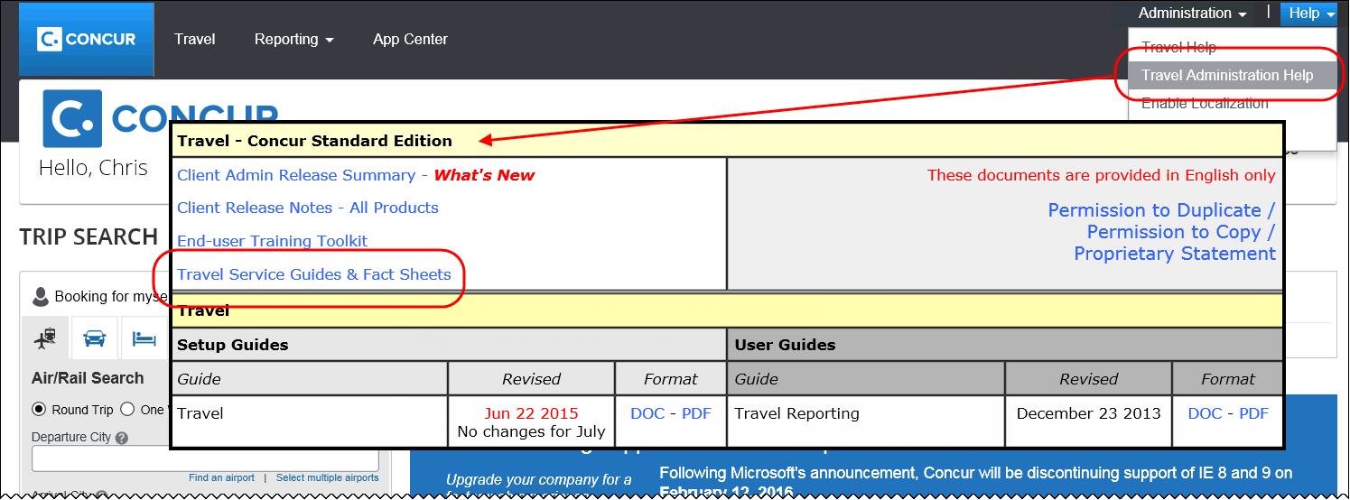
The Travel Administration Help menu option appears every time an admin accesses Help, including before and during setup.

Appendix B – Password Defaults

- For complete information about this topic, refer to the Password Management and Defaults Fact Sheet.

☼

