
Applies to these SAP Concur solutions:
 Expense
 Professional/Premium edition
 Standard edition
 Travel
 Professional/Premium edition
 Standard edition
 Invoice
 Professional/Premium edition
 Standard edition
 Request
 Professional/Premium edition
 Standard edition

Shared:
Concur Salesforce Connector
Setup Guide for Concur Standard Edition
Last Revised: June 8, 2019
Table of Contents
Section 1: Permissions 1
Section 2: Overview 1
Multiple Salesforce Organization Functionality 1
Features 2
Search for Attendees in Salesforce 2
Track Expense Cost Object by any Salesforce Object 3
Section 3: User Experience 6
Cost Object Tracking 6
Salesforce Attendees 7
Trips 8
Expense Reports 8
Card Charges 8
Expense Report Approvals 9
Section 4: Before You Begin 9
Prerequisites 9
Section 5: Configuration 10
Overview 10
Connector Installation/Setup Process 10
Manage User Access to the Connector 10
User Profiles 11
Connector Package Installation 13
Connector Configuration Process 16
Configure Custom Fields 18
Add the Connector Fields to the Page Layouts 24
(Optional) Scheduling Additional Synchronization Jobs 25
(Optional) Disabling Chatter 27
Concur and Salesforce Configuration 27
Filtering Cost Object Lists That Displayed in Concur 27
Configure the Salesforce Attendee Search 28
Concur Expense Configuration 31
(Optional) Application Connector Update 31
Salesforce Cost Objects Configuration 32
Salesforce Reporting 32
Section 6: Troubleshooting 33
Uninstall the Connector 33
Salesforce Uninstall 34
Custom Fields Configuration in Salesforce Must be Updated 34
Concur User Credential Must be Updated 35
SSO Key Must be Updated 36
Opportunity Spend Totals Are Not Updating 37
Error in Cost Object Tracking – Query Cannot be Dynamically Created 38
Known Issue: Opportunity List Only Shows One Opportunity 39

Revision History
Date | Notes / Comments / Changes
September 17, 2022 | Minor edits.
January 21, 2022 | Updated the copyright year; no other changes; cover date not updated
April 15, 2021 | Updated the copyright year; no other changes; cover date not updated
May 27, 2020 | Updated text throughout to reflect UI name change from "Manage Custom Fields" to "Custom Fields"
April 27, 2020 | Renamed the Authorization Request check box to Request on the guide’s title page; cover date not updated
January 15, 2020 | Updated the copyright; no other changes; cover date not updated
June 8, 2019 | Updated text and images throughout to reflect UI name change from "Cost Tracking" to "Custom Fields".
February 12, 2019 | Updated the copyright; no other changes; cover date not updated
August 2, 2018 | Updated the following information: The Concur Salesforce Connector does not have the concept of delegates, so it is not possible to access Concur data as a delegate from within Salesforce. However, a Concur Expense user can act as a delegate and access the Salesforce data elements (such as account, opportunity, attendees, and so on) associated with the user they are delegating for, when logged into Concur Expense directly.
April 16, 2018 | Changed the check boxes on the front cover; no other changes; cover date not updated
February 10 2018 | Added updated screenshots for the support of Salesforce Lightning.  NOTE: This setup guide is targeted to new clients and aims to reflect the newest version of Salesforce, Lightning, that is currently supported by the Concur Salesforce Connector.
June 3 2017 | Professional and Group have been removed from the list of Salesforce editions that support the Concur Salesforce Connector.
March 18 2017 | Updated with menu option name change to access Setup Wizard.
February 17 2017 | Added new Troubleshooting section, Error in Cost Object Tracking – Query Cannot be Dynamically Created.
December 15 2016 | Changed copyright and cover; no other content changes.
December 8 2016 | Updated the Permissions section and guide content to new corporate style; no content changes.
September 9 2016 | Added new section, Filtering Cost Object Lists That Displayed in Concur.
July 21 2016 | Updated the procedure, To add objects to cost tracking, to include new search fields.
November 20 2015 | Updated reference to the renamed Accounting page, formerly known as the Introduction page.
June 25 2015 | Updated the Connector Package Installation procedure.
June 4 2015 | Removed the Salesforce User Account Information procedure.  Updated the Application Connector Update procedure.
May 15 2015 | Updated the screen shots to the enhanced UI  Added Cost Tracking Configuration in Salesforce Must be Updated section
December 3 2014 | Added information about new object search filter on the Concur Connector Admin Tools and Cost Object Tracking pages, and added search information in the Salesforce Attendees section.
November 14 2014 | Added a note stating that Concur does not save Attendee expense details in Salesforce and that Concur saves only the expense data for those objects configured when setting up Cost Tracking.
October 17 2014 | Added information about new Track Expense Cost Object by any Salesforce Object feature.
September 17 2014 | Added information about two user interfaces; no other content changes.
March 31 2014 | Added new information about the Search for Attendees in Salesforce feature.
October 18 2013 | Clarified feature set.
July 11 2013 | Returned application connector update to the Setup process.
July 10 2013 | Updated Connector Configuration Process and Concur Synchronization Job in Apex Classes sections.
June 28 2013 | Added information about using the connector with multiple Salesforce organizations.
January 18 2012 | Added information about disabling Opportunity or Account fields, known Opportunity issue, and uninstall information.
December 28 2012 | Made rebranding and/or copyright changes; no content changes
December 14 2012 | Added information on restricting user access to the connector
November 16 2012 | Updated What the User Sees section.
November 1 2012 | Updated Prerequisites.
October 26 2012 | Updated Connector update information.
October 23 2012 | Updated SSO information.
October 19 2012 | Added more information about the reporting objects.
September 11 2012 | Added information about the Concur Connector Admin Tools page and clarified User Profile information.
September 6 2012 | Added steps to update SSO key.
July 23 2012 | Updated profile and SSO information.
July 13 2012 | Added new Expense sections for My Concur page.
June 22 2012 | Clarified Custom User Profile requirements, updated Concur Expense Configuration, and updated prerequisites.
June 12 2012 | Updated Concur Expense Configuration instructions.
June 7 2012 | Added information about updating the Opportunity page layouts.
May 18 2012 | Added information on Salesforce reporting and troubleshooting.
December 16 2011 | New document.

Concur Salesforce Connector
NOTE: Multiple SAP Concur product versions and UI themes are available, so this content might contain images or procedures that do not precisely match your implementation. For example, when SAP Fiori UI themes are implemented, home page navigation is consolidated under the SAP Concur Home menu.

Permissions
A company administrator may or may not have the correct permissions to use this feature. The administrator may have limited permissions, for example, they can affect only certain groups and/or use only certain options (view but not create or edit).
If a company administrator needs to use this feature and does not have the proper permissions, they should contact the company's Concur administrator.
Also, the administrator should be aware that some of the tasks described in this guide can be completed only by Concur. In this case, the client must initiate a service request with Concur Client Support.

Overview
The Concur Salesforce Connector provides a method of integrating Salesforce data with Concur. The Concur Salesforce Connector is a managed package built on the Force.com platform that can be installed into an existing Concur client’s Salesforce organization. After a quick setup process, the connector allows the client’s users to share data and functionality between Salesforce and Concur.

Multiple Salesforce Organization Functionality
If a client has more than one Salesforce organization, they can use the Concur Salesforce Connector in each organization and connect them all to a single Concur company. The administrator for each organization must install the connector in their organization in order for their users to have access to it. The administrator for the first organization completes the Concur configuration steps, which enables the Concur company to work with the connector. Each subsequent organization administrator installs the connector package in their organization but does not need to complete the Concur configuration process.
The end users are prompted to connect their Concur account to their Salesforce account the first time they try to use the connector features. The Salesforce account that they use during this process determines which organization’s contacts and opportunities they have access to. After the user connects their Concur account to their Salesforce account, Concur saves this information and does not ask the user again.
Clients who are upgrading from a previous version of the connector and would like to start using the connector with multiple organizations must upgrade their existing organization first. Once they have installed the new connector package in their original organization, they can install the package in additional organizations.

Features
The connector presently works with Concur (Standard/Professional/Premium). The connector allows Concur users to:
- Bring attendee information into Concur from Salesforce, and associate it to their expenses, using the Search for Attendees in Salesforce feature.
- Associate their expenses with any Salesforce object, using the Track Expense Cost Object by any Salesforce Object feature.
- Access their current trips from within Salesforce.
- View their current expense reports, card charges and expense report approvals.
- SSO to Concur to manage expense reports, card charges and expense report approvals.
- Share their Travel itineraries with coworkers using Chatter.
- Follow other user’s Travel updates using Chatter.

Search for Attendees in Salesforce
Expense users can search in Salesforce for attendees to associate with their expenses in Concur. The Concur and Salesforce administrators configure the attendee search page to work with any Salesforce object, and map the Expense attendee fields to the Salesforce object fields. The most commonly used Salesforce object is Contact, however any Salesforce object can be used as the basis for attendees.
Some clients may choose to map the Expense attendee fields to an HCP object in Salesforce, or another specialized record.
When the user selects an attendee to add to the expense, the mapped object field information in Salesforce is saved in Concur.
The user’s access to the Salesforce objects is controlled in Salesforce. They must have read access to the object in Salesforce to search using the object’s fields.
The configuration process is completed by the Concur and Salesforce administrators, and has the following steps:
- The Concur and Salesforce administrators determine which Expense attendee fields map to Salesforce object fields. The users search for attendees using these fields, and bring the Salesforce information into Expense when assigning attendees to their expenses.
- The Salesforce administrator maps the Expense fields on the attendee search page with the Salesforce object fields.
- For more information, refer to the Configuring the Salesforce Attendee Search section of this guide.
Some clients may wish to associate the HCP Attendee type with the Salesforce connector, in addition to the Salesforce Contact attendee type. This allows clients to map the HCP attendee type to the HCP object in Salesforce, or complete other specialized mapping. These clients must complete the following configuration before mapping the fields in Salesforce:
- The Concur Admin must update the Fetch Attendee Application Connector on the Web Services Admin page to use the HCP attendee type.
- For more information, refer to the Concur Expense Configuration section of this guide.

Notes for Upgrading Clients
Clients who were using the previous Salesforce Contacts functionality can continue to use it without taking the steps included in this section. If they want to use the new functionality, they can modify their attendee field mapping using the steps above.

Track Expense Cost Object by any Salesforce Object
In Concur Expense a cost object is a business object that a company wants to use to track expenses. It can be anything a company finds important to their business, for cost tracking.
Cost objects can be simple, such as a single business object like Department, or linked, meaning there are two or more objects connected in a hierarchy such as Event-Product-Cost Center.
Concur Expense users can associate their expenses to one or more cost objects. Concur Expense keeps track of all expenses for all users for each cost object. These are aggregated into total cost for paid and unpaid expenses.
The Track Expense Cost Object by any Salesforce Object feature allows Salesforce administrators to select one or more Salesforce objects to be Concur Expense cost objects. The administrator can configure multiple Expense cost object/Salesforce object mappings.

One to Three Levels
On the Custom Fields Configuration tab, Salesforce administrators can configure their cost objects. For each cost object, they select the Salesforce objects that they would like Concur Expense users to track expenses against. The administrator can select:
- A single Salesforce object for a simple Expense cost object
-and/or-
- Multiple Salesforce objects (up to three) for Expense connected list cost objects
The administrator can configure as many cost objects as necessary, and can utilize both cost objects connected to a single Salesforce object and cost objects connected to multiple Salesforce objects at the same time.

One Salesforce Object
If the administrator selects a single Salesforce object to track, the connector will create a single-level list in Expense, which is associated to a simple list field:
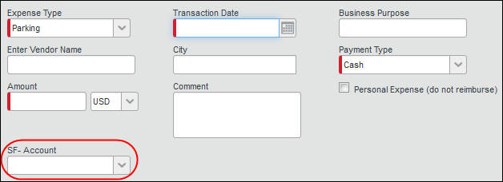

Two Objects
If the administrator selects two Salesforce objects to track, the connector will create a two-level linked list in Expense, which is associated to two-level linked list fields:
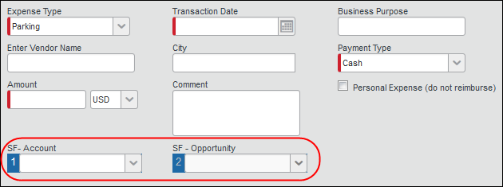

Three Objects
If the administrator selects three Salesforce objects to track, the connector will create a three-level linked list in Expense, which is associated to three-level linked list fields:
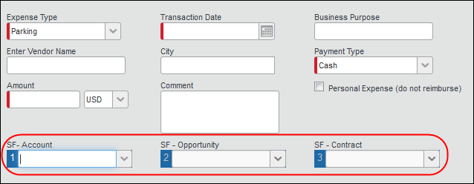
The fields are added to the Custom Fields > Data to Track page of Setup. The connector also creates linked lists on the Custom Fields > Linked Lists page for any two or three level objects.
These lists use Salesforce as their data source instead of Concur Expense. When Expense users access these list fields, Concur Expense will call out to Salesforce and fetch relevant list items for these users.
Salesforce controls what objects users can access, so the users must have access to the objects in Salesforce to see the list items in Concur.

How does the cost data get into Salesforce?
When the user selects a list value in the field in an expense report entry, Concur saves the list item value with the expense amount. When the report is submitted, the amount is added to the total for Unpaid Expenses. When the report is approved for payment, the amount is moved to the Paid Expenses total for the associated Salesforce object.
The Connector gets the aggregate spend for cost objects by running a job in Salesforce. The connector sets a daily job to run 2:00 AM, and the administrator can choose to add hourly jobs, running at different minutes of each hour. This job gets the total unpaid and paid expenses for each cost object from Concur Expense and stores these values into these two custom fields for each Salesforce object:
- Accruing/Unpaid Expense Total
- Final/Paid Expense Total

User Experience
The user can activate the Concur Salesforce Connector from within Salesforce.
The screenshots in the guide reflect the latest version of Salesforce that is supported by the Concur Salesforce Connector.
The user can activate the connector from within Salesforce. They select the My Concur tab and see the Setup page for the Connector.
The user clicks Get Started, and is prompted to log in to Concur in order to grant the connector access to their Concur account.
After the user logs in, they are informed of the changes the connector would like to make.
After the user clicks Approve Access, the My Concur page loads, showing the list of their recent trips from Travel and/or TripIt Pro.
The user can also grant the connector access to their Salesforce data from within Concur, when they use any connected cost object fields or search for attendees.
The Concur Salesforce Connector does not have the concept of delegates, so it is not possible to access Concur data as a delegate from within Salesforce. However, a Concur Expense user can act as a delegate and access the Salesforce data elements (such as account, opportunity, attendees, and so on) associated with the user they are delegating for, when logged into Concur Expense directly.

Cost Object Tracking
The administrator can configure Concur to display cost objects in the expense entry, allocation, and other pages, that use Salesforce as a data source. These fields allow the user to select values for the Salesforce objects while filling out their expense reports, associating the costs with the Salesforce objects. The user sees the configured fields on the expense entry and allocation pages, and possibly on other pages, depending on configuration.
This single object example shows the SF - Account field, which the connector created. This field uses the Salesforce Account object as a source.
When the user selects the down arrow on the Account field, the connector pulls all Accounts that the user has access to from Salesforce. Then the user saves the expense entry, and the expense amount information is saved with the Salesforce object information. The connector pulls the expense information from Concur to Salesforce regularly.
This connected object example shows the SF - Account field and the SF – Opportunity field, which the connector has configured to use the Salesforce Account object and the Salesforce Opportunity object as data sources. The two fields form a linked list.
When the user selects the down arrow on the first field, the connector pulls all Accounts that the user has access to from Salesforce. Once the user selects the desired account, they click the down arrow on the second field. The connector will then pull all Opportunities associated with the selected Account that the user has access to in Salesforce. Then the user saves the expense entry, and the expense amount information is saved with the Salesforce object information. The connector pulls the expense information from Concur to Salesforce regularly.
This connected object example shows the SF - Account field, the SF – Opportunity field, and the SF – Contract field, which the connector has configured to use the Salesforce Account object, the Salesforce Opportunity object, and the Salesforce Contract object as data sources. The three fields form a linked list.
When the user selects the down arrow on the first field, the connector pulls all Accounts that the user has access to from Salesforce. Once the user selects the desired account, they click the down arrow on the second field. The connector will then pull all Opportunities associated with the selected Account that the user has access to in Salesforce. Once the user selects the desired Opportunity, they click the down arrow on the third field. The connector will then pull all Contracts associated with the selected Account and Opportunity that the user has access to in Salesforce. Then the user saves the expense entry, and the expense amount information is saved with the Salesforce object information. The connector pulls the expense information from Concur to Salesforce regularly.
The first time the user uses a cost object connected to Salesforce, they will be prompted to confirm that they want Concur to access their Salesforce information. If they have not activated the connector in Salesforce, they will be asked to log in to their Salesforce account. The confirmation is stored, and the user will not have to confirm again the next time they use either feature. The Salesforce user account determines which organization’s objects the user sees in Concur.
The custom fields are configured as simple lists with dropdown, which display a maximum of 500 items.
All list fields support wildcard (*) searches. To search for all list items starting with T, enter T* in the field.

Salesforce Attendees
The user can search for attendees in Salesforce when adding attendees to an expense. This feature is most often used to search Contacts, however any Salesforce object may be used for this search.
The user clicks the Advanced Search button in the Attendees section.
The user selects the Salesforce Contact Attendee Type, enters the search text and clicks Search.
The search logic is as follows:
- Searching with no wildcards results in a "starts with" search.
- Searching with a wildcard at the end of the string results in a "starts with" search (same as the previous result).
- Searching with a wildcard at the beginning of the string results in a "contains" search.
Concur connects to Salesforce to pull the list of matching attendees in Salesforce for the user.
When the user saves the expense, the attendee information is saved in Expense.

Trips
The user’s trips, from Travel or TripIt Pro, will appear in Salesforce in the My Trips section of the My Concur tab.
The Edit button will appear, however any changes to the trip details will not be sent back to Travel.
The user can click Share to share their trip details with other users via Chatter. When the trip has been shared, it appears in the Chatter stream of any users following the traveler.
The user or follower can click on the trip name to view the trip details.
Trips must be created in Travel, or in a TripIt Pro account that is connected to Travel, in order to appear in the My Trips section.

Expense Reports
The user’s active expense reports will appear in Salesforce in the My Active Reports section of the My Concur tab.
The user can:
- Click New to launch a new window into the New Report page in Concur.
- Click View to launch a new window into the Active Reports list in Concur.
- Click Concur to launch a new window into the Expense Report page for the indicated report in Concur.

Card Charges
The user’s unused card transactions will appear in Salesforce in the My Card Charges section of the My Concur tab.
The user can click View to open a new window to the Unassigned Card Transactions page in Concur.

Expense Report Approvals
The user’s pending expense report approvals will appear in Salesforce in the My Report Approvals section of the My Concur tab.
The user can:
- Click View to open a new window to the Reports to Approve page in Concur.
- Click Concur to launch a new window into the Expense Report page for the indicated report in Concur.

Before You Begin
- IMPORTANT: The Salesforce Connector cannot be installed in an Implementation environment.

Prerequisites
The client must:
- Be an existing Concur client, with Expense, and optionally Travel.
- Have an existing Salesforce Organization, with one of the following Salesforce products:
- Enterprise
- Unlimited
- Have Chatter enabled in their Salesforce Organization. The administrator can choose to disable Chatter once the connector is installed, but it must be active during the installation process.
- The Salesforce Administrator who will be setting up the package must also have the Can Administer user role in Expense or Travel. If the client has multiple Salesforce organizations, the administrator for each organization must have this role, as they each install the connector individually in their organizations.
- Clients must not connect a sandbox Salesforce organization to their Concur company. Verify that the Salesforce credentials are for a production environment before proceeding.
The end user must:
- Have an active SAP Concur account with access to Expense and optionally Travel.
- Have a Salesforce account. Users with the Platform User license will only be able to use the Trips functionality.
- Have a user license with access to the Opportunity object and any other Salesforce objects used in the Custom Fields feature. Without this access, the user will not be able to use the configured custom fields in SAP Concur.
- For more information, refer to the Features > Track Expense Cost Object by any Salesforce Object section of this guide.

Configuration

Overview
The Concur Salesforce Connector must be purchased from Concur. Once it is purchased, the Salesforce administrator completes the following actions. If the client has multiple Salesforce organizations, these actions must be completed in each organization by that organization’s administrator.
- Install the package in their Salesforce Organization
- Receive the required SSO key from Concur
- Connect their Salesforce organization to Concur using both the Concur Connector Setup page and the SSO key
Once the Setup is complete, each user that needs to use the connector must log in to Salesforce, and activate the connector by confirming that the connector can access their Concur data.
For new installations, the Configuration process includes a Concur configuration step. This step should be completed when the connector is installed in the first Salesforce organization. Each additional organization install can skip this step.
Clients upgrading from a previous version do not need to repeat the Concur configuration as these steps have not changed.

Connector Installation/Setup Process

Manage User Access to the Connector
There are two different access points for the Concur Salesforce Connector:
- The My Concur tab within Salesforce
- The configured custom fields within the expense entry page in SAP Concur
The administrator may be able to control which users can access the connector through Salesforce and Concur configuration.

My Concur Tab Access Control
The ability to control access to the My Concur tab in Salesforce varies depending on the version of Salesforce. The Enterprise and Unlimited versions of Salesforce allow control of the My Concur tab based on user profiles. The administrator can update or create a custom user profile that allows access to the My Concur tab, and only set certain users to use that profile. All users with a different user profile will not see the My Concur tab.
- Refer to the User Profiles section of this guide for more information.

Expense Entry Fields Access Control
The ability to control access to the Salesforce expense entry fields varies depending on the Concur product. The Concur Standard product includes the Salesforce fields on the expense entry page for all users.

User Profiles
To use the Concur Salesforce Connector in the Enterprise or Unlimited versions of Salesforce, users must have the Concur User access level applied their profile.
In the Enterprise or Unlimited versions of Salesforce, the Concur User access level may be applied only to custom profiles. It can’t be added to standard profiles. This means that all users who will use the Concur Salesforce Connector must have a custom profile. These users cannot use a standard profile.
This section applies only to organizations using Enterprise or Unlimited versions of Salesforce that have Concur Salesforce Connector users that are presently using a standard profile.
You can skip this section if:
- You use the Enterprise or Unlimited versions, but do not have any users using a standard profile.
If your Salesforce organization uses the standard user profiles, the Salesforce administrator will need to create custom user profiles for the users that need to access the connector.
To create a custom user profile:
- Log in to Salesforce as an administrative user.
- Click the gears () > Setup. The Salesforce Home tab appears.

- Under ADMINISTRATION in right panel, click Profiles.
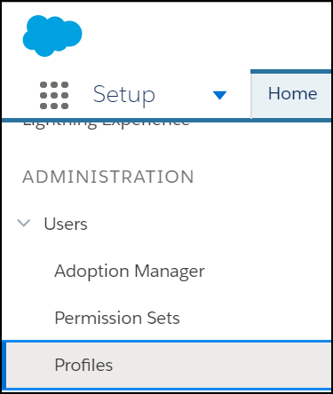
- In the center column, click New Profile (button). The Clone Profile page appears.
- Fill in the fields:
Field | Value
Existing Profile | Standard User
Profile Name | Concur Connector Standard User
- Click Save.
- Click Profiles (left menu).
- Click New Profile.
- Fill in the fields:
Field | Value
Existing Profile | Standard Platform User
Profile Name | Concur Connector Standard Platform User
Cloning the Standard Platform User profile into the custom Concur Connector Standard Platform User profile is necessary only if the organization uses the Standard Platform User profile for any user that you would like to use the Concur Salesforce Connector.

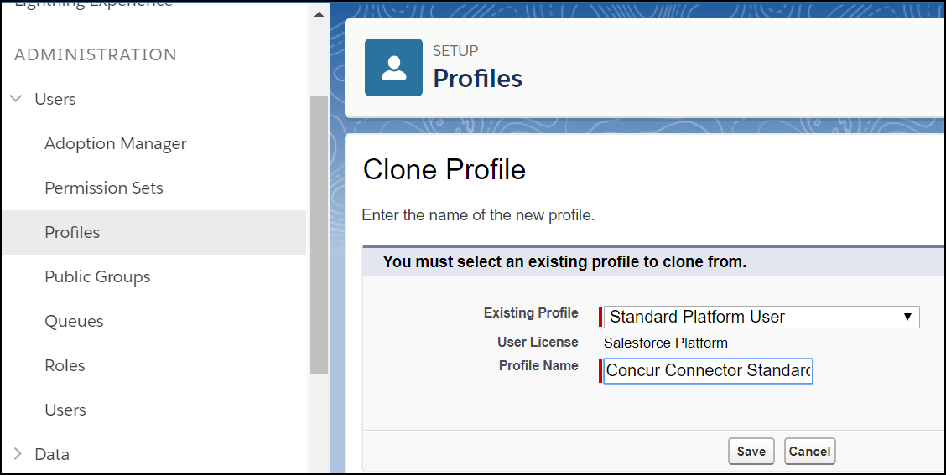
- Click Save.

Connector Package Installation
To upgrade the Salesforce Connector to the latest version, you must log a case in the Concur Support Portal.
If an error occurs during the package installation, Salesforce will send an email to the currently logged in admin account with error information.
To install the Concur Salesforce Connector package:
- Log in to Salesforce as an administrative user.
- Enter the installation package URL into your browser's Address bar. This URL is provided by Concur.
- Click Install for Specific Profiles. The list of configured profiles appears.
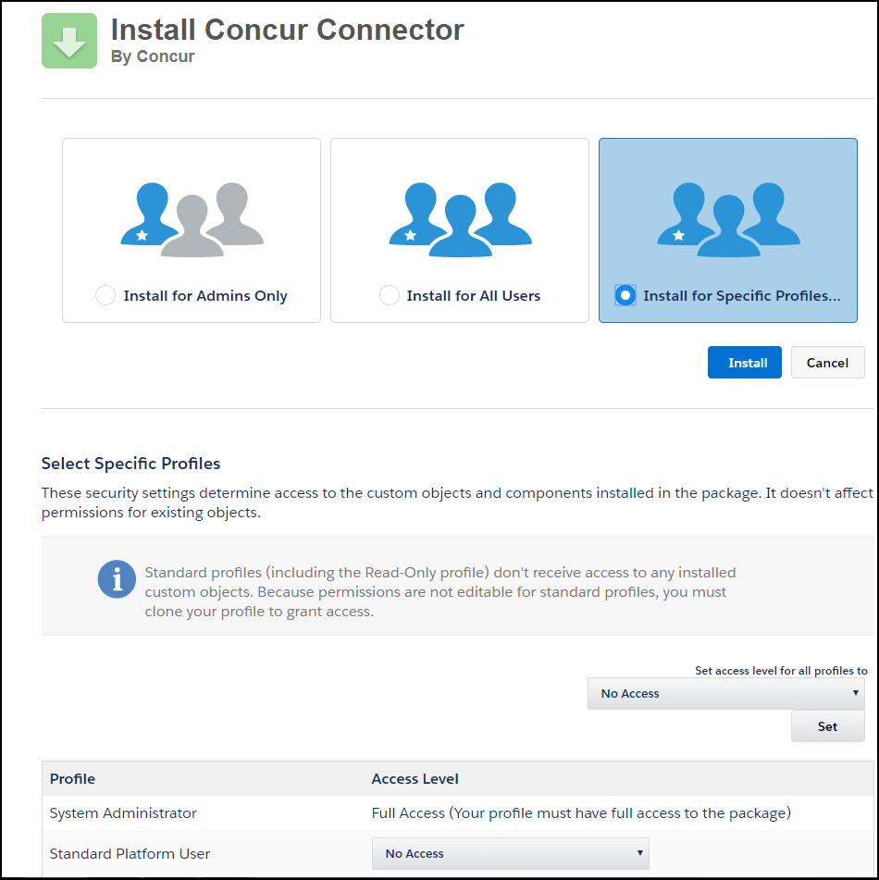
- For all profiles that need to access the connector, select Concur User.
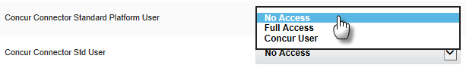
- Click Install (top). The Approve Third-Party Access window appears.
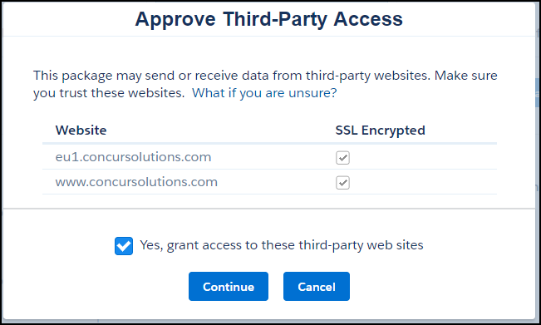
- Click Continue. The installation begins.
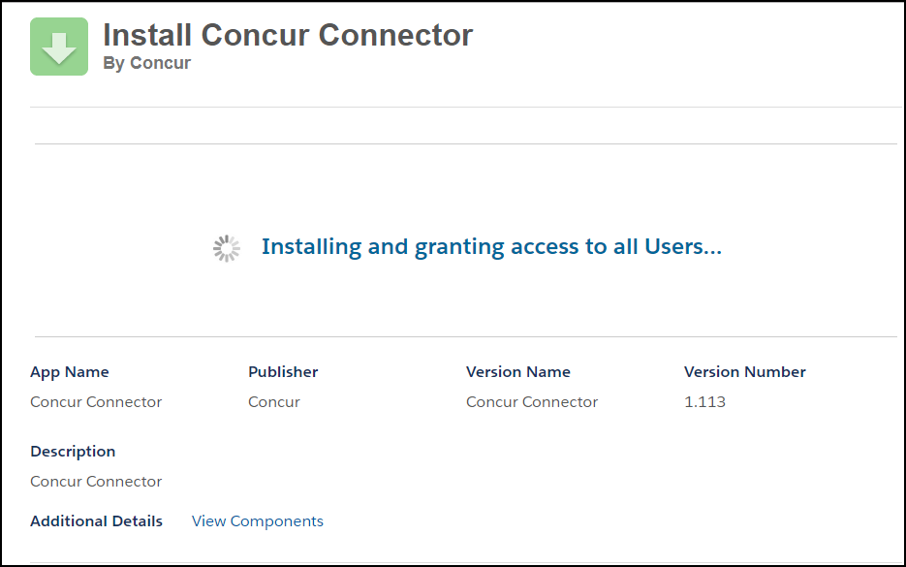
- Click Done.
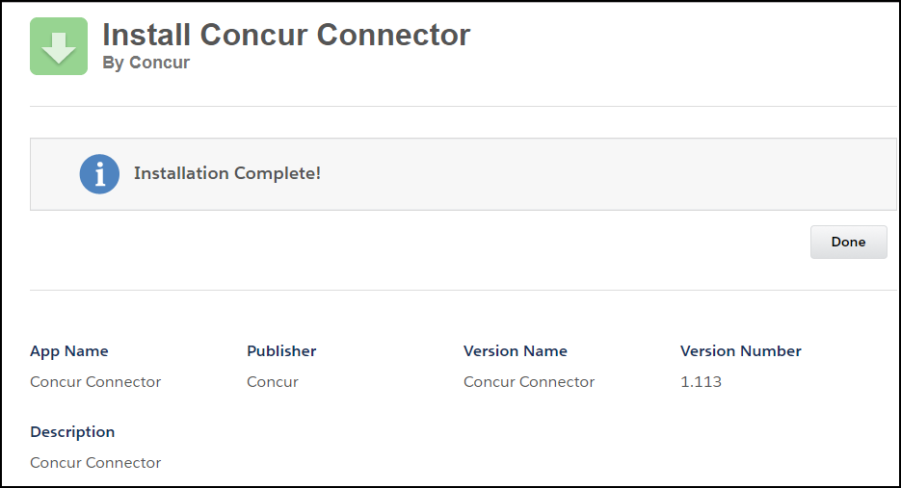
After the installation completes, the Installed Packages page displays.
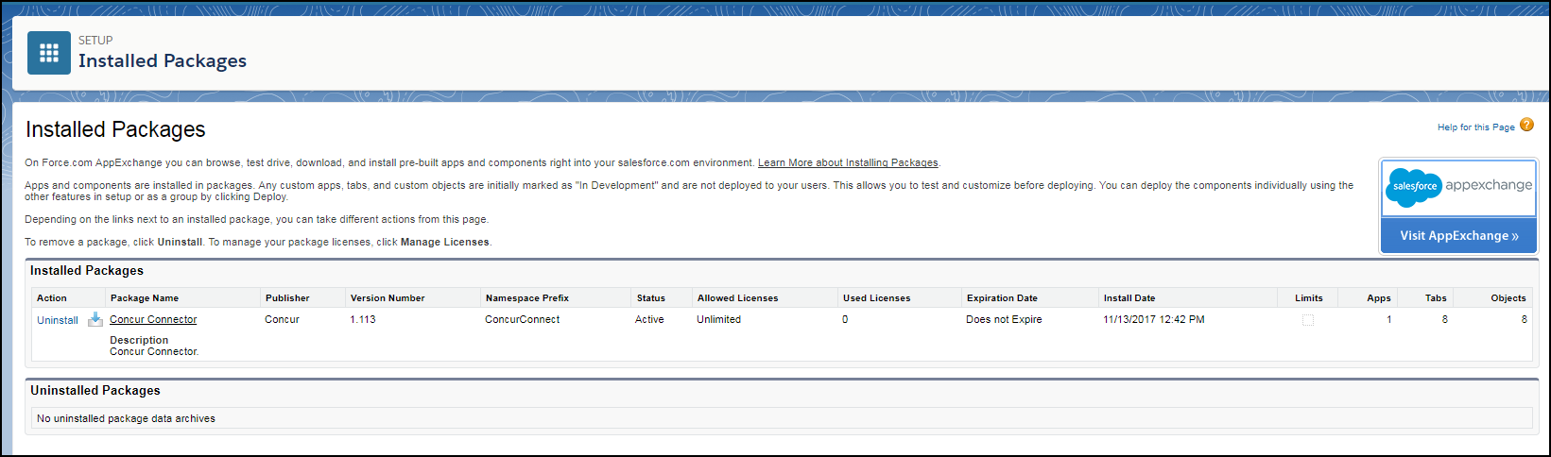

Connector Configuration Process
After installing and deploying the Concur Connector, the Salesforce administrator performs the Connector Setup process. This process is completed in each Salesforce organization that the connector is installed into.
The Connector Setup process prepares the client’s Concur company and Salesforce organization to use the connector features. It performs the following configuration:
- Establishes the SSO connection between the Concur Salesforce Application and Concur.
The first time it is run, it also does the following configuration:
- Creates the Concur Salesforce Connector data source to use with the Salesforce Contacts attendee type.
- Creates the Salesforce Opportunities connected list to use with the Salesforce Opportunity field.

First Install
For the first organization of a multi-organization company, or for single organization companies, the administrator must also complete the Concur Expense Configuration step, detailed later in this guide. Each subsequent organization of a multi-organization company does not need to complete the Concur Expense Configuration step again.

Upgrade
Each organization that installs the connector must complete the Connector Configuration Process. Upgrading clients do not need to complete the Concur Expense Configuration step again.

User Requirement
Before running the Setup, make sure that the Salesforce Administrator user has a corresponding Admin user account in Expense. Once the user authenticates to Concur, the Salesforce user and Expense user will be linked together.
- Before running Setup, Concur Implementation must configure the site to use SSO from Salesforce to Concur. Multi-organization companies use the same SSO key for each organization. Concur Implementation should refer to the Configuring SSO for the Concur Salesforce Connector internal fact sheet for more information.
To run the Setup process:
- Select Concur Connector from the application menu. The My Concur tab appears.
- Click Setup (tab). The Setup tab appears.
- Click Get Started. The Concur login page appears.
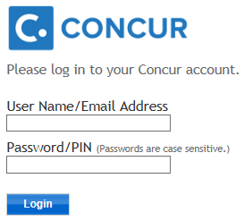
- Log in to Concur.
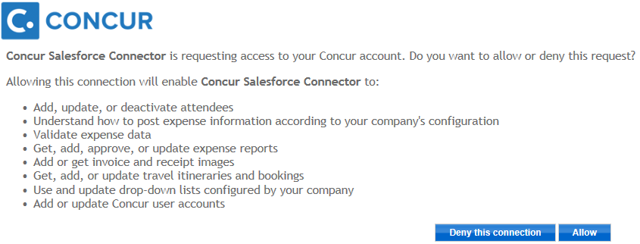
- Click Allow. The Setup page appears, detailing the connector features.
- Enter the SSO Key for the site into the SSO Key field.
- Click Finish Setup. The connector completes the configuration of the client’s Concur company.
To reset the authentication to Concur:
The authentication to Concur for the administrator is managed in the Concur Connector Admin Tools tab. The following steps allow you to remove the existing authentication (in case of a mistaken login).
- Select Concur Connector from the application menu.
- Click the Concur Connector Admin Tools tab.
- Click Remove Administrator’s Access Token.
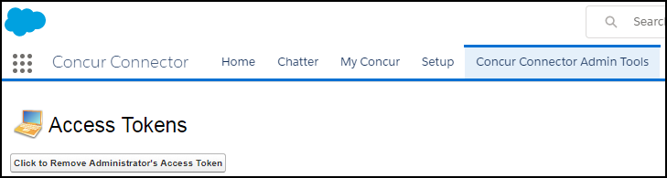
The administrator’s Concur login information is removed. The next time you access the My Concur tab, you will be taken through the setup process again.

Configure Custom Fields
The Cost Tracking Configuration tab allows the administrator to configure Salesforce objects so they can be associated with Concur Expense cost objects. The administrator can select one or more list object(s) in Salesforce (single or linked), and the connector will update Concur with the object list information. The Concur administrator can then associate an Expense field with the Salesforce object. Once this association is complete, the Expense field will display the list values from the Salesforce object list. The end user can select the correct value in the list to associate the expense with a Salesforce object list item. During the configuration process, the Salesforce object gains additional fields in Salesforce that track the expenses.
Salesforce controls which objects a user can access. If the user is able to access the object in Salesforce, they will be able to access the mapped cost object in Concur.
When you select multiple (linked) objects, the expense amounts will be calculated and stored for the lowest-level object in the chain. Because of this, each object can only be the lowest-level object in one chain. However, the object can be used higher up in multiple chains.
- Refer to the Features > Track Expense Cost Object by Any Salesforce Object section of this guide for more information.

Adding objects to custom Fields
The Salesforce administrator and Concur administrator must work together to configure the Salesforce objects and the Expense cost objects for this feature. The general steps are listed here. The detailed steps are laid out next in this guide.
In Salesforce
- Select the Salesforce objects to track costs against. These can be standard or custom objects.
- Some Salesforce objects are not available to use in the Custom Fields feature. Refer to the Salesforce Objects Not Available for Custom Fields section in this guide for the full list.
- (Important) Add two custom cost fields to the selected object(s).
- If this step is not completed, the admin will receive an error when trying to select the object(s) in step 3.
- Refer to the To add the custom cost fields to the object procedure in this section for details.
- Select the Salesforce objects in the Cost Tracking Configuration tab.
- Refer to the To add objects to custom fields procedure in this section for details.
- Add the custom cost fields to the desired page layouts.
- Refer to the Adding the Connector Fields to the Page Layouts section of the guide for details.
In Concur
- Modify the custom cost object field(s) behavior.
- Refer to the Concur Expense Configuration > Salesforce Cost Objects Configuration section of this document for details.
(Important) To add the custom cost fields (example: Currency) to the object in Salesforce:
- Navigate to Fields and Relationships in Object Management to add the two currency fields.
- Click the gears () > Setup. The Salesforce Home tab appears.
- Under Platform Tools, click Objects and Fields > Object Manager. The Setup Object Manager appears.
- Click Object (standard or custom).
- Click on Fields and Relationships.
- Click New (button). The New Custom Field page appears.
- Under the Choose the field type, click Currency (radio button).
- Click Next. The Enter the details page appears.
- In the Field Label, enter a currency label.
Currency Label 1: Accruing / Unpaid Expense Total
Currency Label 2: Final/Paid Expense Total
- In the Length field, enter 16.
- In the Decimal field, enter 2.
- In the Field Name field, enter a currency label.
Currency Label 1: AccruedUnApprovedExpenseTotal
Currency Label 2: FinalExpenseTotal
- Click Next. The Establish Field Level page appears.
- Select all Visible check boxes. At a minimum, the Salesforce System administrator’s profile must have the Visible check box selected.
- Click Next. The Add to page layout appears.
- Select the check boxes for the desired page layouts.
- Click Save & New.
- Repeat these steps for Currency Label 2.
To add objects to custom fields:
Concur pre-configures the Opportunity object on the Cost Tracking Configuration page. If desired, you may modify its configuration.
- Select the Cost Tracking Configuration tab.
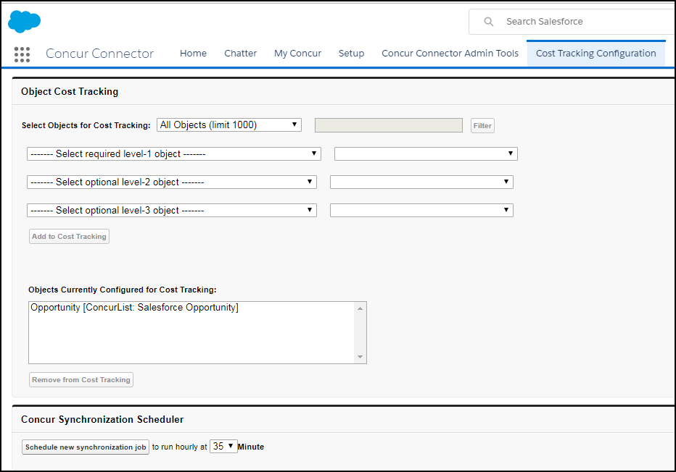
- (Optional) In the Select Objects for Cost Tracking section, select the desired filtering options.
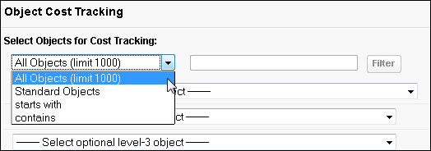
If you select starts with or contains, you can enter text in the text box, and click Filter to limit the list of objects. The text filter is based on the object name, not the object label.
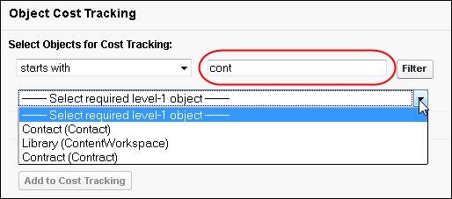
- Select the first level object to track.
- (Optional) Select an optional search field based on the object.
EXAMPLE
Selecting the Asset object allows three search fields to become available for selection: Asset Number, Serial Number, and Status.
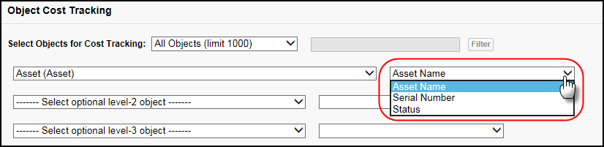
- (Optional) Select the second and third level objects and search fields, to track linked objects.
- Click Add to Cost Tracking. The new object chain will appear in the Objects Currently Configured for Cost Tracking window.
Single-level:
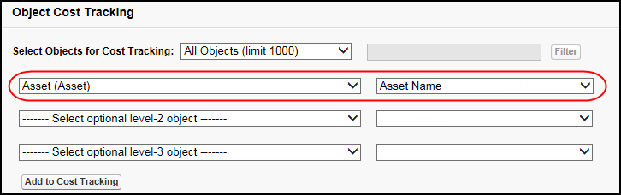
Multi-level:
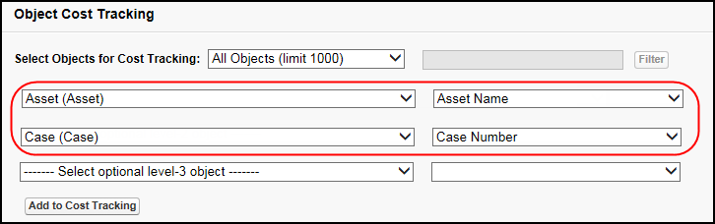
- The Objects Currently Configured in Concur and the Synchronize button only display when they are needed. For more information, refer to the Troubleshooting section of this guide.
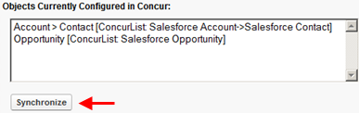
To remove objects from custom fields:
- Select the object chain in the Objects Currently Configured for Cost Tracking window.
- Click Remove from Cost Tracking.
To modify the synchronization schedule:
- In the Concur Synchronization Scheduler section, select the minute within each hour that you would like to schedule a new synchronization job.
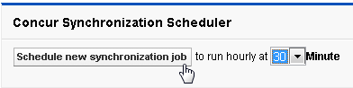
- Click Schedule new synchronization job.

Add the Connector Fields to the Page Layouts
The page layout(s) must be updated with the Connector fields used in the Custom Fields feature. SAP Concur provides an Opportunity layout with this configuration that the Salesforce administrator can use as an example. The administrator should complete the following process with every page layout for every custom fields object.
To add the connector fields to the page layout:
- In Object Management, navigate to Fields and Relationships.
- Click on object (standard and custom) to create / update page layout.
- Click Page Layout.
- Click New to create a new layout. Otherwise, click on an existing layout to modify.
- Select an existing page layout to clone or select None.
- Enter the text for a new page layout.
- Click Save.
- Click fields (right pane).
- Drag and drop the desired fields into the page layout.
- Name this new section Concur Expense and accept the default settings.
- Click OK.
- Drag and drop the two new fields into the section.
Field | Description
Accruing/Unpaid Expense Total | The total amount of unpaid expenses accrued against the opportunity. These expenses have been entered into expense reports, but the reports have not been paid yet.
Final/Paid Expense Total | The total amount of paid expenses accrued against the opportunity. These expenses have been entered into expense reports, which have been paid.
For the Opportunity object, add these additional fields:
Field | Description
Accruing/Unpaid Expense | The unpaid expense amount, as a percentage of the total Expected Revenue.
Final/Paid Expenses | The paid expense amount, as a percentage of the total Expected Revenue.
- Click Save.

(Optional) Scheduling Additional Synchronization Jobs
The Connector installation process automatically creates a job to synchronize data between Concur and Salesforce. This job runs hourly at the 00 minute. If you would like to have the job run more often, you can schedule additional jobs on the Cost Tracking Configuration tab. The new jobs will run once an hour, on the selected minute.
To schedule additional synchronization jobs:
- Log in to Salesforce with an administrator account.
- Select Cost Tracking Configuration (tab).
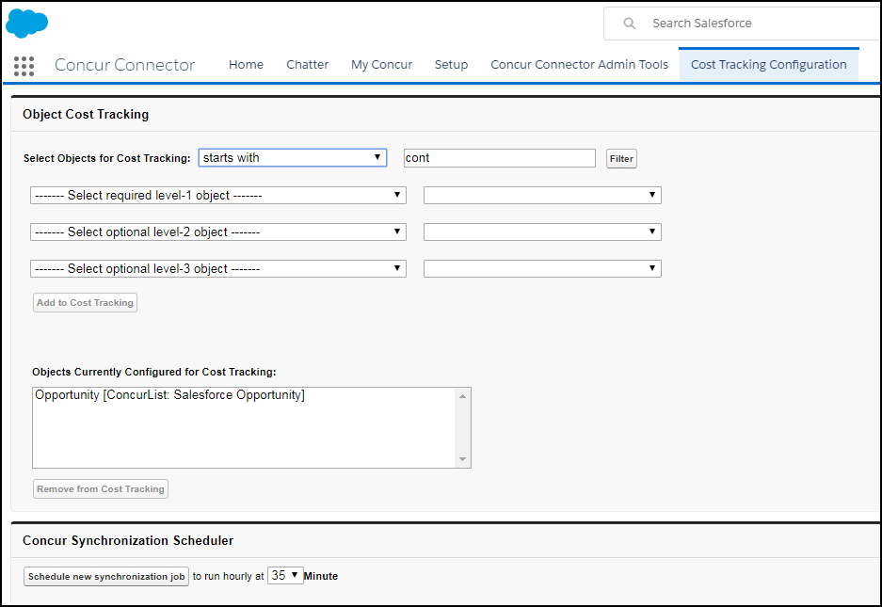
- In the Concur Synchronization Scheduler section, select the minute that you would like the job to run.
The 00 minute is reserved for use by the automatically created job and is not available in the list.
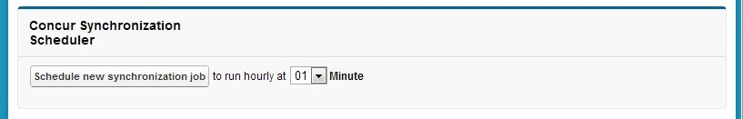
- Click Schedule new synchronization job.

Additional Job View
Clients can view their scheduled jobs using the App Setup area. The Salesforce Organization Administrator follows these steps to view the scheduled Concur Synchronization job(s).
If the administrator views the details of the automatically created job by clicking Manage, it will appear that the job is set to run once a month. This is a known display issue. The job is actually scheduled to run hourly on the 00 minute.
To view the scheduled synchronization job(s):
- Click the gears () > Setup. The Salesforce Home tab appears.
- Under Platform Tools, click Environments.
- Click Jobs.
- Click Scheduled Jobs. The Connector jobs will now appear on your All Scheduled Jobs page.
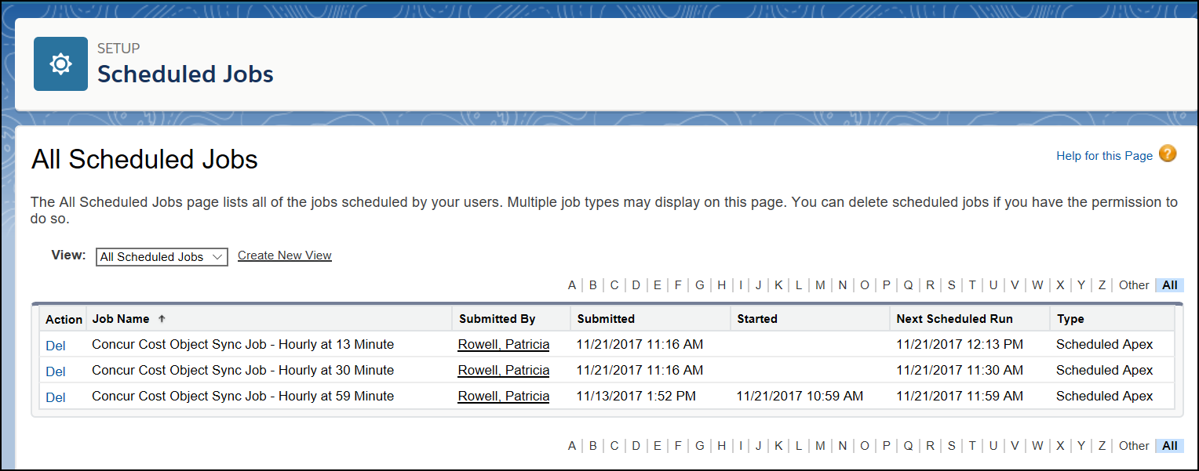

(Optional) Disabling Chatter
The administrator may wish to disable Chatter after the package installation.
To disable Chatter:
- Click the gears () > Setup. The Salesforce Home tab appears.
- Under Platform Tools, click Feature Settings.
- Click Chatter.
- Click Chatter > Settings.
- In the Chatter Settings section, click Edit.
- Clear the Enable check box.
- Click Save.

Concur and Salesforce Configuration

Filtering Cost Object Lists That Displayed in Concur
If the field, Filter Field, is used, the lists displayed to users, such as the Salesforce Opportunity, can be much shorter and easier to navigate.
To use this feature, configure the Filter Field for the Cost Object Config object of your choice.
To populate the value of the Filter Field, use the API Name from one of your custom fields.
The Filter Field formula must resolve to true or false.

Example
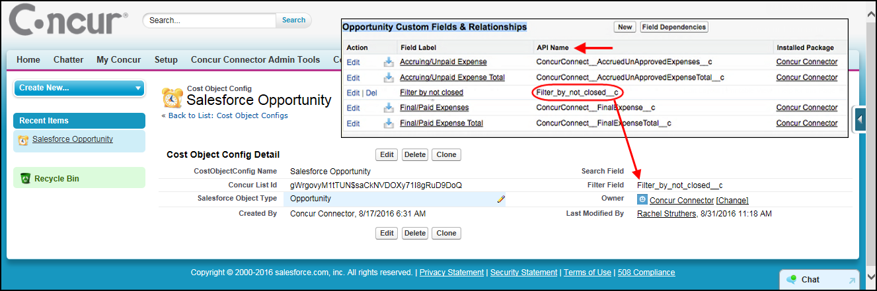

Configure the Salesforce Attendee Search
The Connector allows Expense users to search for attendees in Salesforce while creating their expenses. The attendee fields that they can search on, and bring into Expense, are configured by both the Concur admin and the Salesforce admin.
The Concur and Salesforce administrator determine which Expense fields to associate with Salesforce object fields. In Salesforce, the Contact object is the most frequently used object, however any Salesforce object can be used as the basis for the attendee information. Any data in the Salesforce fields is brought into the mapped Expense fields when the user adds the attendee to the expense entry.
The Concur administrator and the Salesforce administrator must collaborate to choose which Expense and Salesforce object fields will be mapped. The Salesforce administrator then determines which Salesforce object fields align with the Expense fields. Salesforce object fields with the following types can be used: String, Email, Picklist.
The required field is:
- Last Name
The Concur administrator can view and configure the available attendee fields in Setup by selecting Administration > Expense Settings > Expense Types > Attendee Forms. The Salesforce Contact uses the Default Attendee Form. If the client wants to use the HCP Attendee with the connector, they will also review/configure the HCP Attendee form.
Once the Concur and Salesforce administrators have chosen the Expense fields to map to Salesforce object fields, the admin will map the fields on the Concur Connector Admin Tools page in Salesforce.
If the company is using the HCP attendee type instead of or in addition to the default Salesforce Contact attendee type, the Concur administrator must complete the Concur Expense Configuration steps before the Salesforce administrator can configure the attendee search.
To map the Salesforce Objects to the Expense Fields:
- Log in to Salesforce as an administrator.
- Click the App Launcher () and select Concur Connector.
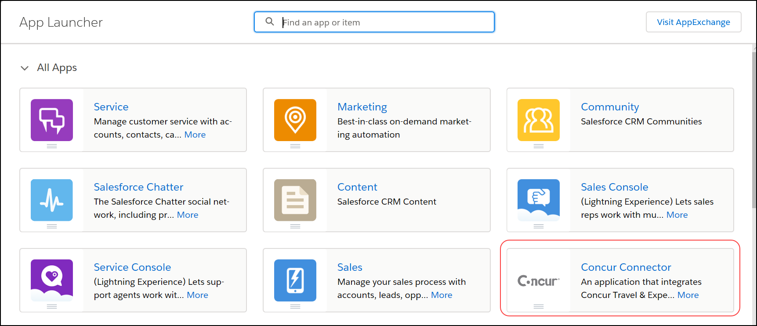
- Click Concur Connector Admin Tools.
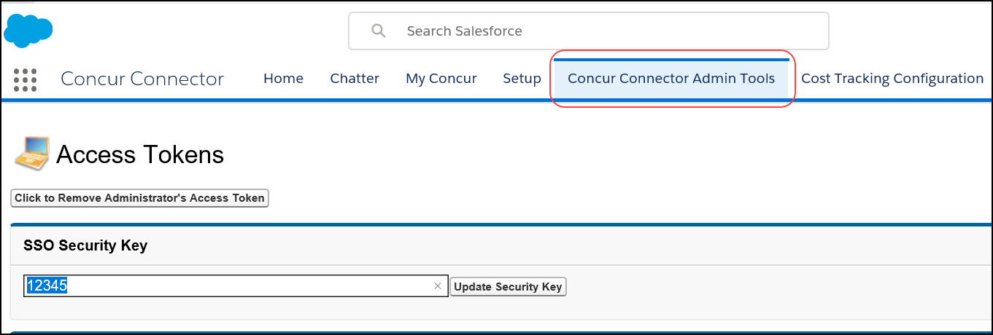
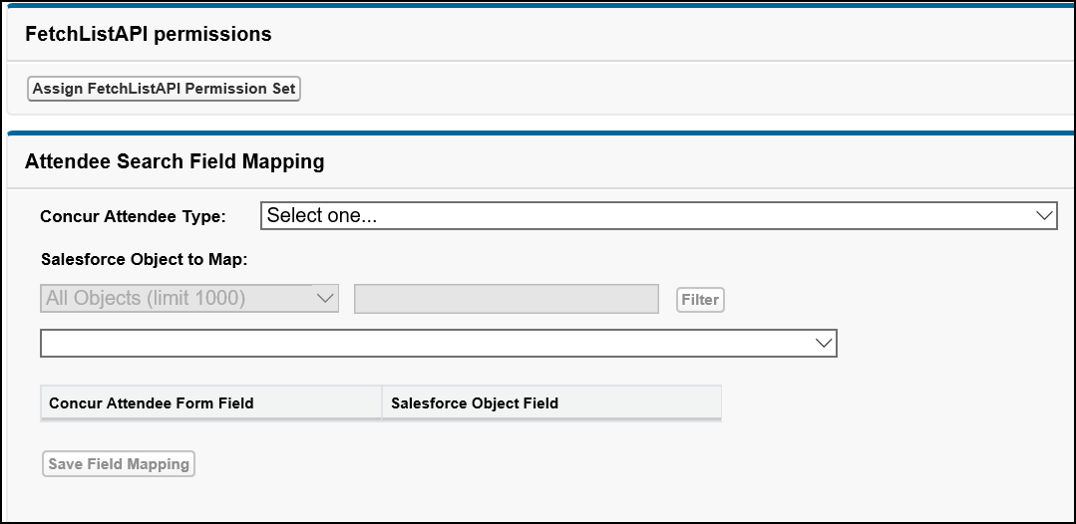
- In the Attendee Search Field Mapping section, fill in the fields:
Field | Description
Concur Attendee Type | Select the attendee type to configure. Only attendee types with the Concur Salesforce Connector Data Source will appear in the list.
Salesforce Object to Map | Select the type of Salesforce object to map. This will control which object fields are available for mapping.
Concur Attendee Form Field | This column contains all the fields on the attendee form for the selected attendee type. Fields that are required on the form are in red font.
Salesforce Object Field | Select the salesforce object field to map to the Expense field.
- Click Save Field Mapping.
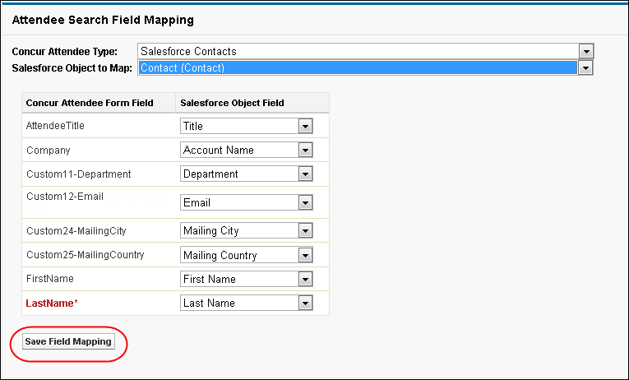
- Repeat for each desired attendee type.
SAP Concur does not save Attendee expense details in Salesforce. SAP Concur saves only the expense data for those objects configured on the Custom Fields step of Setup.

Concur Expense Configuration
Once the connector Setup process has been completed, the Concur administrator must modify the company configuration to enable the Opportunity data transfer.
If the client does not want to use the Salesforce Opportunity or Salesforce Contacts fields, the Concur administrator can clear the check boxes for those fields on the Cost Tracking: Data to Track page of Setup.

(Optional) Application Connector Update
If you would like to use additional Attendee Types with the connector, you must update the application connector. A Concur user must have the Can Administer role to perform these configurations.
To update the application connector:
- Click Administration > Company > Web Services > Manage Application Connectors.
- Select the Concur Connect Salesforce Application.
- Click Modify.
- In the Services area, select Fetch Attendee.
- Click Configure.
- Select the attendee types to use with the connector. The default attendee type is already selected. The administrator can choose to also use the Health Care Professionals attendee type with the connector, if desired.
- Click OK.
- Click Save.

Salesforce Cost Objects Configuration
If the company is using the Track Expense Cost Object by any Salesforce Object feature, the Concur administrator may modify the behavior of the expense cost object fields in Setup. The cost object fields are automatically created by the connector, and any necessary linked lists are created as well.
To modify the cost object field behavior:
- Click Administration > Expense Settings > Custom Fields >
- Custom Fields.
The Salesforce object field labels will be SF – <objectname>.
- For each cost object field, select the desired behavior at the different levels:
Level | Required Setting
Employee | Optional, Read-Only, or Hidden
Report | Optional, Read-Only, or Hidden
Entry | Optional
Allocation | This will depend on whether the client wants the Employee to make allocations by Salesforce Opportunity. If they do, set this to Optional. If not, select Hidden.
- Click Save.

Salesforce Reporting
Concur saves certain expense information in Salesforce as reporting objects for the Opportunity object. The Concur Salesforce Connector creates a report folder in Salesforce. The reports are then configured by the client or implementation to meet the particular needs of the client. The following report objects are available in Salesforce for Opportunities:

Object | Description
Accruing/Unpaid Expenses (amount) | The total expense amount in the organization’s Corporate Currency for expenses charged to the Opportunity on expense reports that have not yet been extracted. This data is populated from Concur Expense when a user submits a report that includes a Salesforce opportunity.
Final/Paid Expenses (amount) | The total expense amount in the organization’s Corporate Currency for expenses charged to the Opportunity on expense reports that have been extracted. This data is populated from Concur Expense when the system extracts a report that includes a Salesforce opportunity.
Accruing/Unpaid Expenses (percent) | The percentage the aggregate spend amount is of the Opportunity Amount (expected revenue in Corporate Currency). This data is calculated by dividing the Accruing/Unpaid Expenses (amount) by Opportunity Expected Revenue in the organization’s Corporate Currency, times 100.
Final/Paid Expenses (percent) | The percentage the aggregate spend amount is of the Opportunity Amount (expected revenue). This data is calculated by dividing the Final/Paid Expenses (amount) by Opportunity Expected Revenue in the organization’s Corporate Currency, times 100.
This information is updated whenever the job configured during the Scheduling the Synchronization Job in Apex Classes step of Configuration runs.
Concur also saves the amounts in the Expense database, so you can use the Concur reporting tools to view them.
Concur does not save Attendee expense details in Salesforce. Concur saves only the expense data for those objects configured when setting up the Custom Fields feature.

Troubleshooting

Uninstall the Connector
- When you uninstall the connector, it deletes all Concur data from the Salesforce organization. To upgrade to a new version, simply install the newest package and your connector will be updated to the latest version.
The connector functionality is disabled in two places:
- The Salesforce administrator uninstalls the managed package.
- The Expense Admin clears the check box for the Salesforce Opportunity field on the Custom Fields – Data to Track page of Setup.

Salesforce Uninstall
If you need to uninstall the connector, you will have to remove the Connector custom fields from the Opportunity Layouts.
Refer to the Adding the Connector Fields to the Opportunity Page Layout section of this guide for steps to modify the Opportunity page.
If you do not remove the custom fields from the Opportunities, you will receive an error during the uninstall process and will not be able to complete it.

Custom Fields Configuration in Salesforce Must be Updated
When your Salesforce Custom Fields configuration is out of sync with your Concur Custom Fields configuration, the Objects Currently Configured in Concur area displays, along with a Synchronize button, on the Cost Tracking Configuration tab in Salesforce. You can use the Synchronize button to update your Salesforce organization configuration to match your SAP Concur configuration.
To sync Salesforce and Concur Custom Fields configuration:
- Log in to Salesforce as an admin.
- From the application menu, select Concur Connector.
- Click Cost Tracking Configuration (tab).
- Click Synchronize.
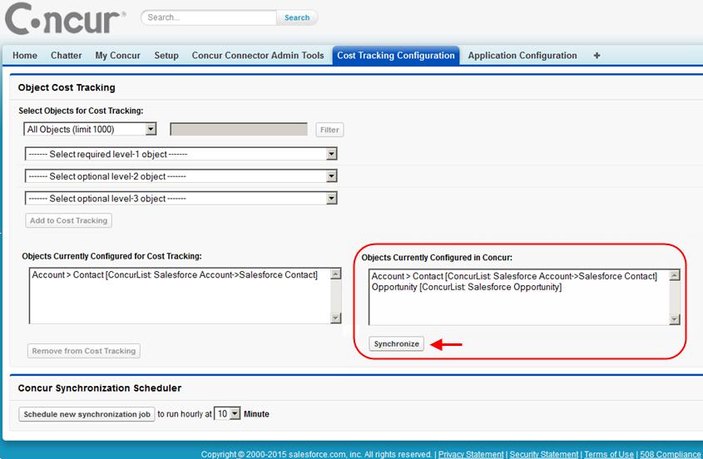

Concur User Credential Must be Updated
Sometimes users choose the wrong SAP Concur user account when authenticating to Concur. Follow these steps to clear the existing user account, so the user can begin the authentication process again.
To reset the authentication to Concur:
- Log into Salesforce as an admin.
- Click the App Launcher () and select OAuth Tokens.
To minimize the All Apps view, click collapse ().
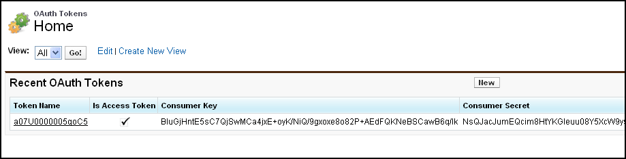
The OAuth Tokens page appears.
- If the user authenticated to Concur, a token will be listed on the page.
- To remove the token, click the token name.
- Click Delete. The next time the user accesses the My Concur tab, they will be prompted to log in to Concur again.

SSO Key Must be Updated
Some clients might need to update the SSO key that the connector uses, or add an SSO key to an existing Connector install. Once the SSO key has been obtained, follow the steps below to update it in the Salesforce Connector
- Log in as a Salesforce administrator.
- Click the App Launcher () and select Application Configuration.
To minimize the All Apps view, click collapse ().
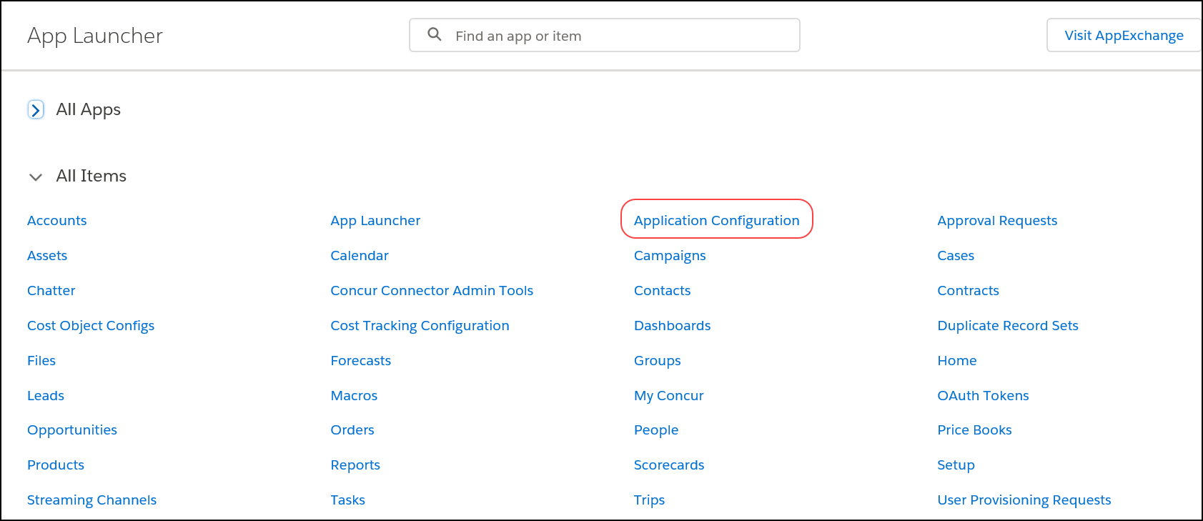
- Click seckey.
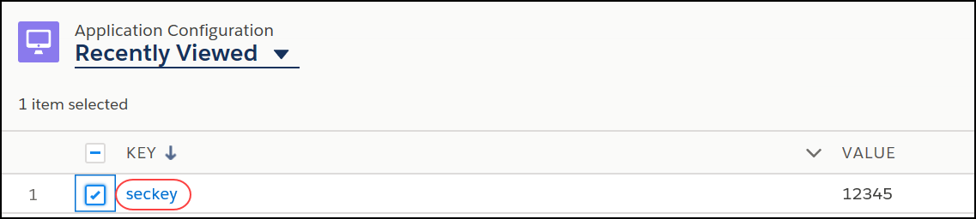
- Click Edit.
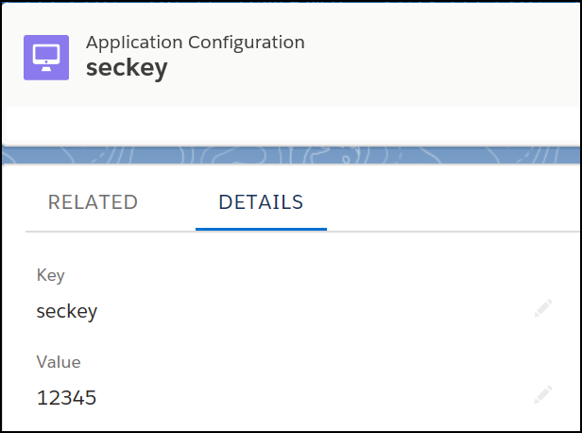
- In the Value field, paste the SSO Key provided to you by Concur.
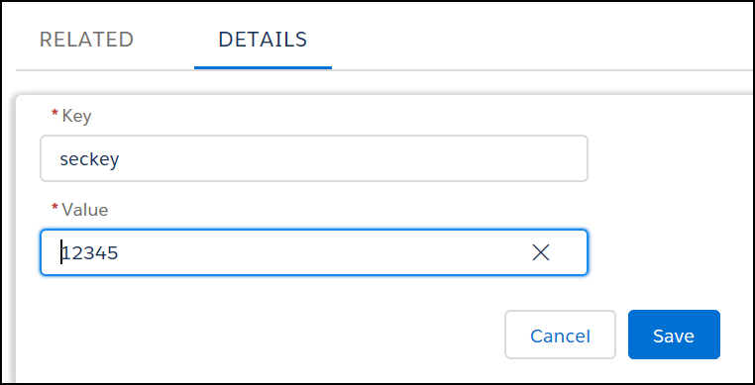
- Click Save.

Opportunity Spend Totals Are Not Updating
If the batch job has been created (refer to the Scheduling the Batch Job in Apex Classes section of Configuration in this guide) but the Opportunity amounts are not updating with the current spend totals, the following steps will provide you with troubleshooting information.
To view job errors:
- Click Setup > Monitoring > Apex Jobs.
- Select the number in the Failures column for the job.
- Use this information to determine the error. Concur Internal staff can look up the error information by number on the Concur Connect Dashboard.
- Internal Only: Refer to the Concur Connect Dashboard Fact Sheet for more information.

Error in Cost Object Tracking – Query Cannot be Dynamically Created
If you receive the following error on the Cost Tracking Configuration page, Object Cost Tracking section after clicking Add to Cost Tracking:
ERROR: After double-checking a relationship you selected (Object1-Object2) it appears a query cannot be dynamically created. Please verify the relationship and access in Salesforce and try again.
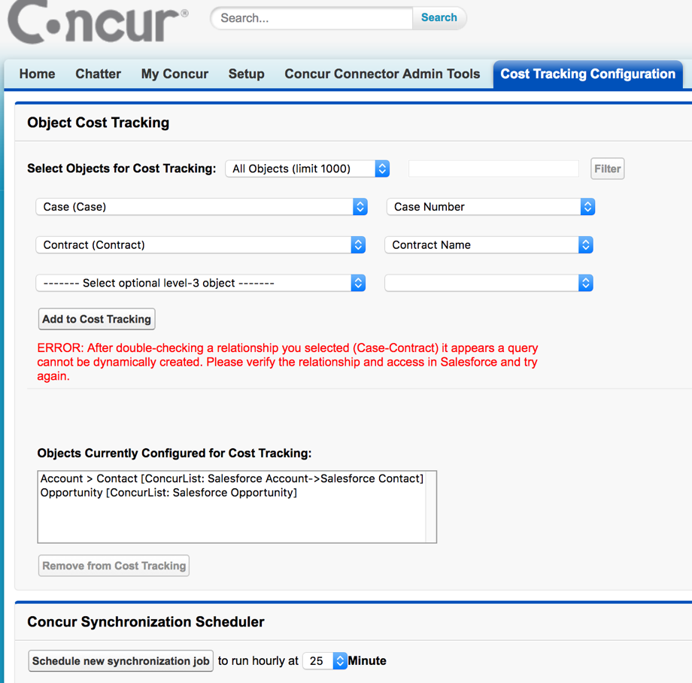
Then you might have one of the following issues:
- You have selected an object that you do not have access rights for.
- The lookup relationship between the parent and child object is not correctly established.
If either of these issues is occurring, contact Concur Client Support.
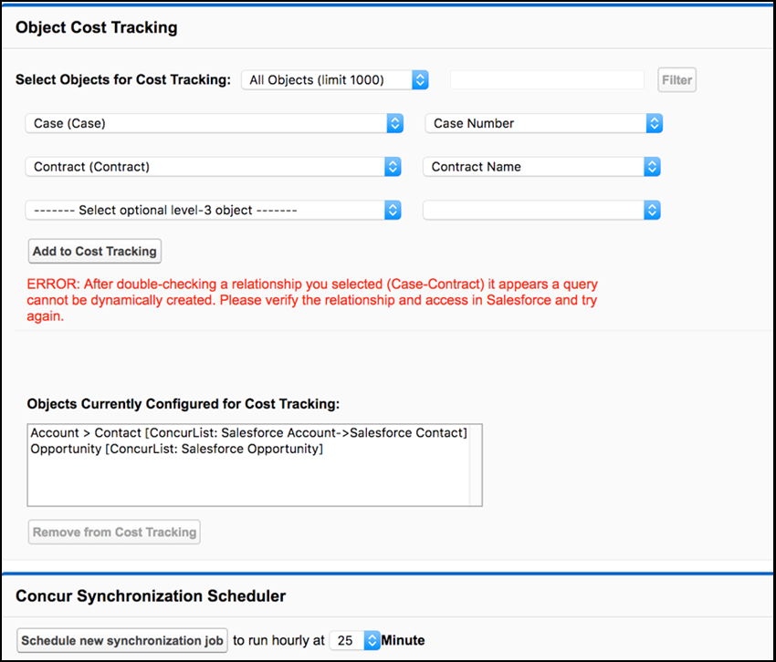

Known Issue: Opportunity List Only Shows One Opportunity
If a user selects a value in the Salesforce Opportunity field, then saves their expense entry, their Salesforce Opportunity list may begin to show only the selected Opportunity.
This known issue can be worked around by clearing the Salesforce Opportunity field and saving the expense entry. If the entry has been deleted, the user can create a new entry, select the one Opportunity, save the entry, then clear the Salesforce Opportunity and save the entry again.
Once the user has saved the entry with the Salesforce Opportunity field empty, the Salesforce Opportunity list should begin showing the full list of available Opportunities again.
☼

