
Shared:
Reporting Configuration
for Analysis / Intelligence
Setup Guide for Concur Standard Edition
Last Revised: December 16, 2021
Applies to these SAP Concur solutions:
 Expense
 Professional/Premium edition
 Standard edition
 Travel
 Professional/Premium edition
 Standard edition
 Invoice
 Professional/Premium edition
 Standard edition
 Request
 Professional/Premium edition
 Standard edition
Table of Contents
Section 1: About this Guide 1
Section 2: Overview 1
Access the Reporting Configuration Page 2
Section 3: Configure Fiscal Calendar 3
Add a Fiscal Calendar 3
Modify a Fiscal Calendar 9
Activate a Fiscal Calendar 12
Deactivate a Fiscal Calendar 13
Remove a Fiscal Calendar 13
Activate a Fiscal Period 14
Deactivate a Fiscal Period 15
Remove a Fiscal Period 17
Section 4: Configure Bursting 18
Burst Import Process 18
Access the Bursting Page 18
Download the Bursting Template 20
Populate the Spreadsheet 20
Bursting Fields 20
Final File Review 21
Upload the Bursting Spreadsheet 21
View the Import Results 21
Section 5: Configure Match Category 22
Definitions of Different Expense Types 22
Access the Match Category Page 23
Associate Expense Types to Match Categories 25
Section 6: Configure Actionable Analytics 26

Revision History
Date | Notes/Comments/Changes
January 21, 2022 | Updated the copyright year; no other changes; cover date not updated
December 16, 2021 | Updated Product Settings page instructions
April 15, 2021 | Updated the copyright year; no other changes; cover date not updated
April 27, 2020 | Renamed the Authorization Request check box to Request on the guide’s title page; cover date not updated
January 15, 2020 | Updated the copyright; no other changes; cover date not updated
June 8, 2019 | Updated text and images throughout to reflect UI name change from "Cost Tracking" to "Custom Fields".
April 29, 2019 | Indicated this Reporting Configuration Setup Guide is for Analysis / Intelligence on the cover.  Added the About this Guide section, which includes a reference to the Standard Edition: Analytics Essentials and Analytics User Guide for more information about the Reporting Configuration page for Analytics.
April 13, 2019 | Updated image of the Actionable Analytics Set Up tab on the Reporting Configuration page
February 12, 2019 | Updated the copyright; no other changes; cover date not updated
June 16, 2018 | June 2018 release moved from June 9, 2018 to June 16, 2018
June 9, 2018 | Updated image of the Actionable Analytics Set Up tab on the Reporting Configuration page
May 21, 2018 | Updated image of the Actionable Analytics Set Up tab on the Reporting Configuration page
April 16, 2018 | Changed the check boxes on the front cover; no other changes; cover date not updated
March 26, 2018 | Made the following updates:  - Added note about the fiscal calendar being shared between Analysis / Intelligence and the new Budget feature  - Added reference to the new Budget feature in the notes regarding activating and deactivating fiscal calendars and fiscal periods
February 10, 2018 | Updated image of the Actionable Analytics Set Up tab on the Reporting Configuration page
January 13, 2018 | Changed copyright; no other content changes
November 4 2017 | Updated guide to include new Product Settings page, which replaces the Setup Wizard
September 18 2017 | Updated image of the Actionable Analytics Set Up step
August 19 2017 | Updated for new enhanced fiscal calendar functionalit.
March 18 2017 | Updated with menu option name change to access Setup Wizard
December 15 2016 | Changed copyright and cover; no other content changes
November 20 2015 | Updated graphics to reflect updated step names and instructional text where applicable
October 16 2015 | Updated graphics to reflect newly styled step numbers
April 17 2015 | Changed the name of Concur Insight to Analysis/Intelligence; no other content changes
January 22 2015 | Updated the screen shots to the enhanced UI; removed information about two user interfaces; no other content changes
September 16 2014 | Added information about two user interfaces; no other content changes
May 16 2014 | New document. (This content originated from the Expense Setup Guide for Concur Standard.)

NOTE: Multiple SAP Concur product versions and UI themes are available, so this content might contain images or procedures that do not precisely match your implementation. For example, when SAP Fiori UI themes are implemented, home page navigation is consolidated under the SAP Concur Home menu.

Reporting Configuration
This page of Product Settings is visible only when enabled by Concur.

About this Guide
In SAP Concur Standard Edition, there are two versions of the Reporting Configuration page. There is one version for Analysis/Intelligence, and one version for Analytics. This guide is for the Analysis/Intelligence version of the Reporting Configuration page.
- For more information about the Reporting Configuration page for Analytics, refer to the Standard Edition: Analytics Essentials and Analytics User Guide.

Overview
The Reporting Configuration page of Product Settings allows you to define the fiscal calendar settings that are used by the reporting tools. If your company uses Analysis/Intelligence (formerly Concur Insight), you can configure the bursting and Actionable Analytics settings on this page. You can also associate your expense types with match categories to properly group your expenses in reports by fiscal calendar.
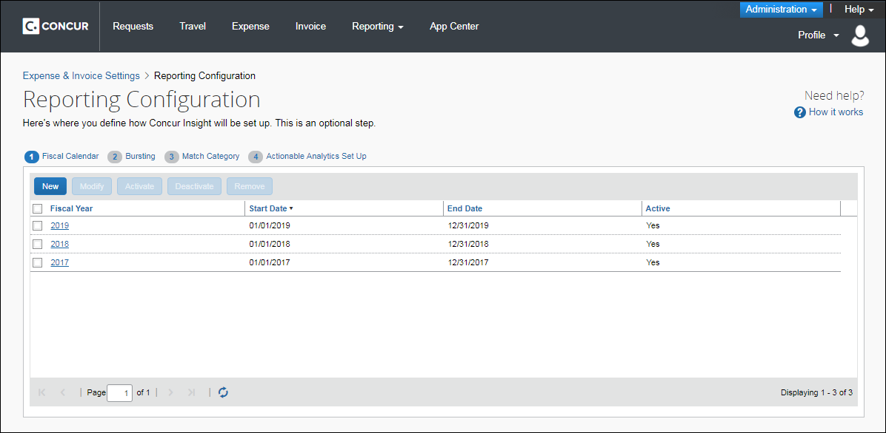

Access the Reporting Configuration Page
To access the Reporting Configuration page:
- Click Administration > Expense Settings or Expense & Invoice Settings or Invoice Settings.
- In the Product list, click Expense or Invoice or Request.
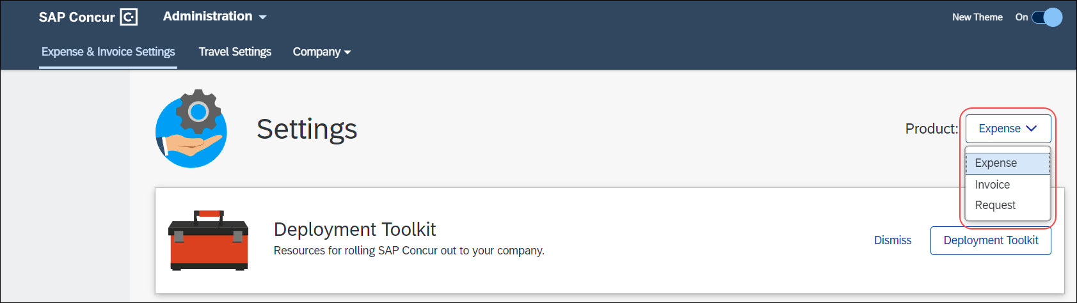
- In the Monitoring Spend section, on the Reporting tab, click Edit.
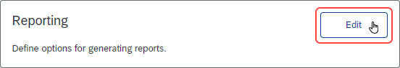
The Fiscal Calendar Set Up tab of the Report Configuration page appears.
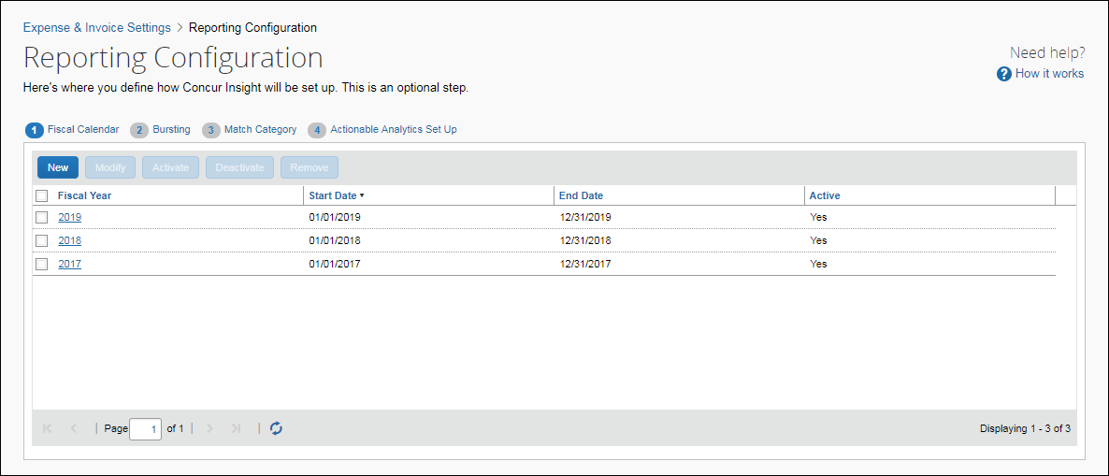

Configure Fiscal Calendar
- IMPORTANT: Fiscal calendar additions and updates will not be immediately available in the Reporting database. An archive must be successfully completed before this information can be utilized. Reporting archives run every night.
Fiscal calendars defined on the Fiscal Calendar tab are used by Analysis / Intelligence for its reports and dashboards. The fiscal calendars are also used by BI Managers to define their budgets on the Reporting Budget page (Profile > Profile Settings > Reporting Settings > Reporting Budget).
A fiscal calendar allows organizations to define their accounting periods independent of the standard calendar year. Many organizations define their own calendars to model their financial reporting to reflect seasons in their business, to compare results with direct competitors, and to avoid the busy year-end season in January.
A fiscal calendar has one or more fiscal years, and fiscal years have one or more fiscal periods.
Fiscal years have a start date and an end date. Each year may have a different length to accommodate leap years and short years or long years. (Organizations use short years and long years when they change the start date of their fiscal year.) Fiscal years cannot overlap with prior fiscal years and no gaps can exist between fiscal years.
Fiscal periods can vary in length within a fiscal year; however, they typically represent months. In the background, for every three fiscal periods a fiscal quarter is generated and for the year, a fiscal year period is generated.
An Expense Administrator must define a fiscal calendar before BI Managers can add and maintain their budgets on the Reporting Budget page.
The fiscal calendar used for reporting is shared with the fiscal calendar used for the new Budget feature. Fiscal calendars are created and maintained on the Fiscal Calendar tab on the Reporting Configuration page and on the Fiscal Calendar tab on the Budget Configuration page.
If your organization is using Analysis / Intelligence and the new Budget feature, any fiscal calendar changes made on one Fiscal Calendar tab are automatically updated on the other Fiscal Calendar tab.

Add a Fiscal Calendar
You can add a fiscal calendar to define your company’s accounting periods. A fiscal year can have one or more periods.
Fiscal years cannot overlap with prior fiscal years and there cannot be any gaps between fiscal years.
To add a fiscal calendar:
- On the Reporting Configuration page, click the Fiscal Calendar tab.
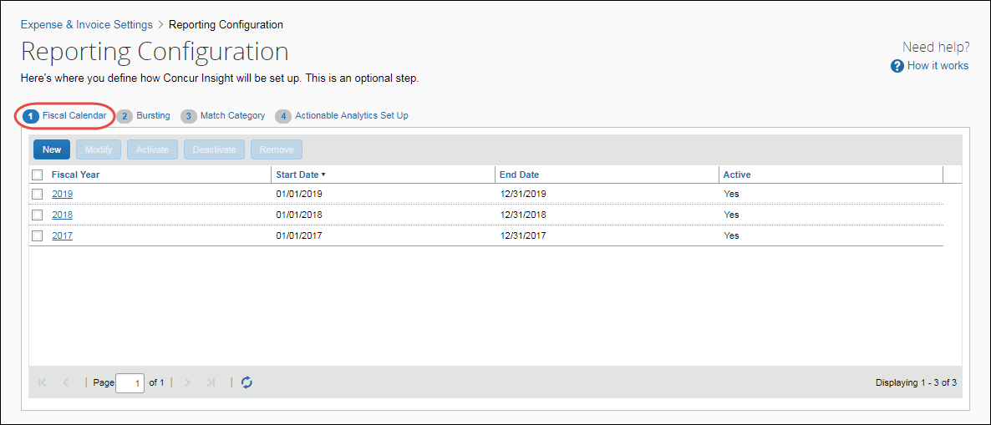
- Click New.
The Add Fiscal Year window appears.
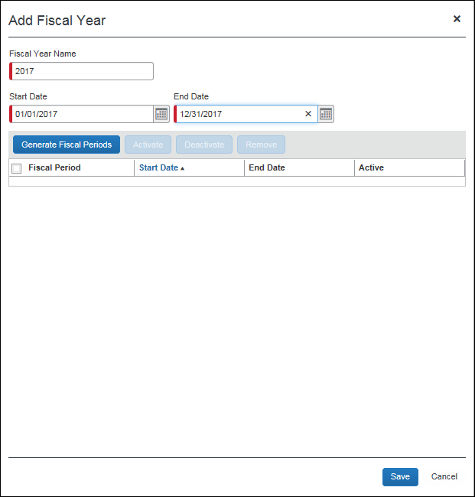
- Complete all required fields.
Field | Description/Action
Fiscal Year Name  (Required) | Enter the name of the fiscal year. This can be any combination of characters, but it must be unique. It is recommended to use the actual calendar year name. If two fiscal years comply within this rule (short year), then use a post fix for the second year.  The Fiscal Year Name field will default to a fiscal year name based on the start date of the fiscal year. If the start date is before July 1, the year of the start date is defaulted as the fiscal year name. If the start date is July 1 or later, the year of the end date is defaulted as the fiscal year name.
Start Date  (Required) | Enter the start date of the fiscal year, which must be the day after the end date of the previous fiscal year. The first fiscal year you create for your company can have any start date.  NOTE: The start date is based on the time zone of the entity, which is managed by Concur.
End Date  (Required) | Enter the end date of the fiscal year, which can be any date after the start date. By default it will be one year minus one day from the start date.  NOTE: The start date is based on the time zone of the entity, which is managed by Concur.
- Click Generate Fiscal Periods to create all fiscal periods for the fiscal year.
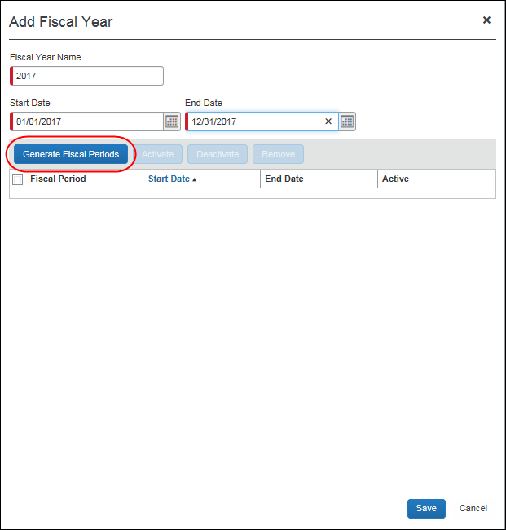
The generated fiscal periods appear on the page.
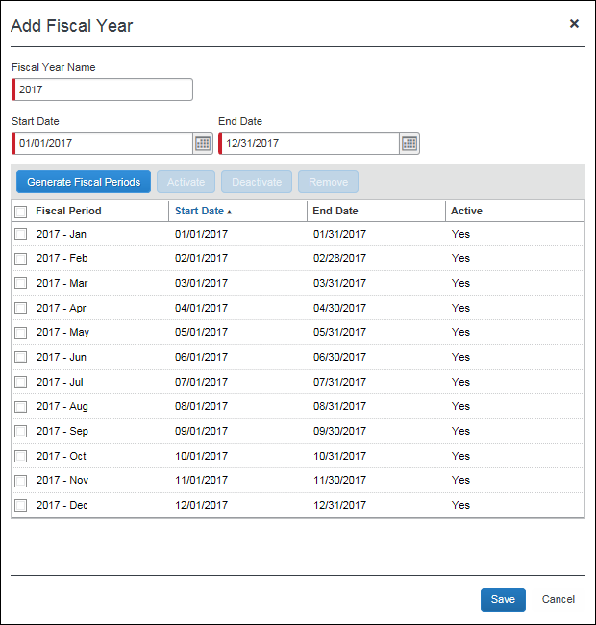
- Click Save. The fiscal year appears on the Fiscal Calendar tab.
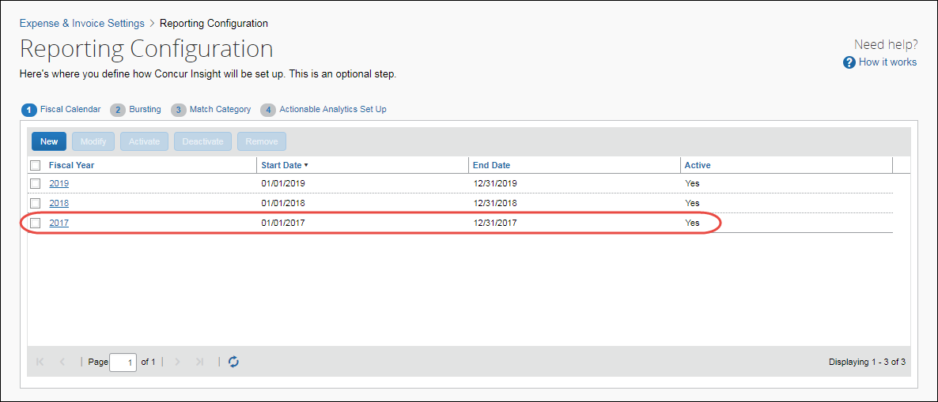
- IMPORTANT: Fiscal calendar additions and updates will not be immediately available in the Reporting database. An archive must be successfully completed before this information can be utilized.

Modify a Fiscal Calendar
You can modify an existing fiscal year, for example, to correct mistakes or to reflect organizational changes, such as a merger or need to follow industry standards.
You cannot change the end date of the current month to today or any date before today, and you cannot change the start date of the current month. In addition, you cannot change any start or end date of past months this year or years prior to this year.
- IMPORTANT: Modifying fiscal years could result in loss of BI Manager budgets.
To modify a fiscal calendar year:
- On the Fiscal Calendar tab, select a fiscal year and then click Modify, or just double-click the fiscal year you want to modify.
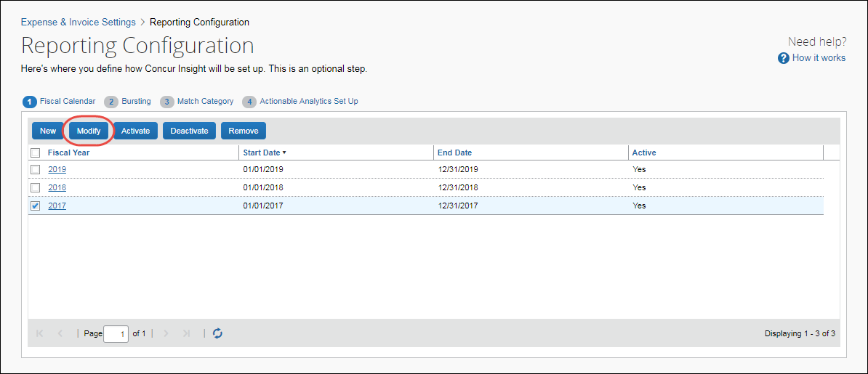
The Modify Fiscal Year window appears.
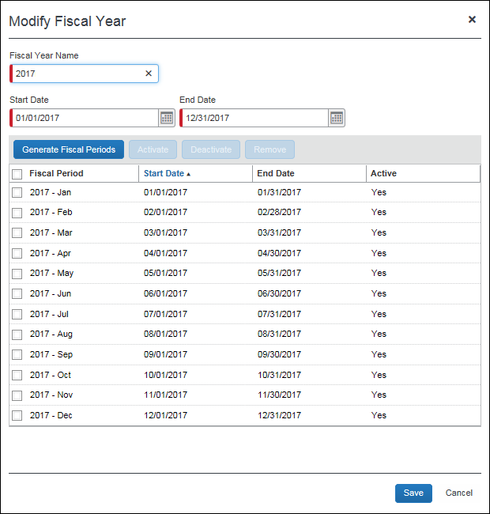
- Make the desired changes.
For field information, refer to the To add a fiscal calendar procedure in this document. If you need a fiscal year to be shorter than 12 months or longer than 12 months, change the end date, but ensure fiscal years are not overlapping and do not have gaps.
- Click Generate Fiscal Periods.
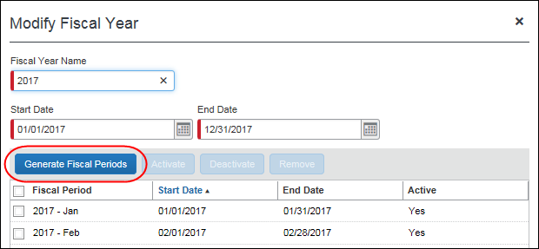
- Click Save.

Activate a Fiscal Calendar
The Activate function on the Fiscal Calendar tab is not recognized by Analysis / Intelligence reporting. This function is only used by the new Budget feature. It is not used by Analysis / Intelligence reporting.
To activate a fiscal calendar year, on the Fiscal Calendar tab, select a fiscal year and then click Activate.
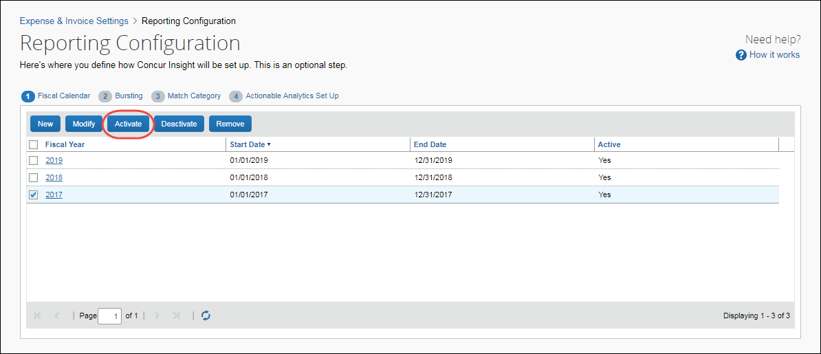

Deactivate a Fiscal Calendar
The Deactivate function on the Fiscal Calendar tab is not recognized by Analysis / Intelligence reporting. This function is only used by the new Budget feature. It is not used by Analysis / Intelligence reporting.
To deactivate a fiscal calendar year, on the Fiscal Calendar tab, select a fiscal year and then click Deactivate.
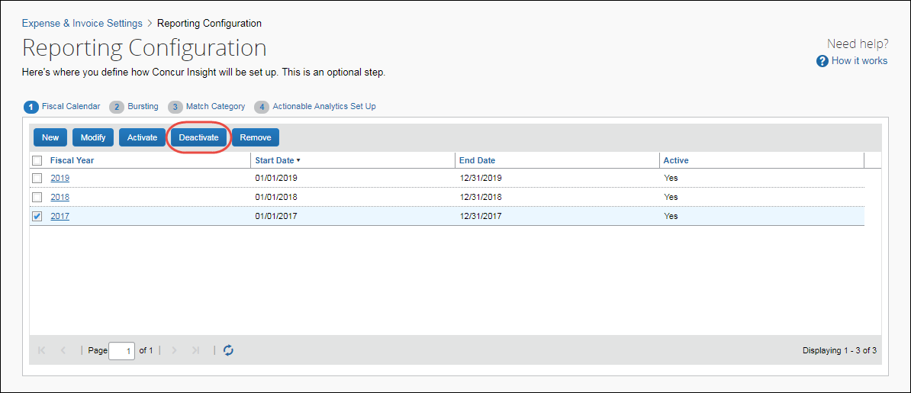

Remove a Fiscal Calendar
You can remove a fiscal year to clean up the list of available fiscal calendars to ensure old fiscal years cannot be re-activated.
- IMPORTANT: Removing a fiscal year will also remove any BI Manager budgets defined for the fiscal year on the Reporting Budget page (Profile > Profile Settings > Reporting Settings > Reporting Budget).
To remove a fiscal calendar year:
- On the Fiscal Calendar tab, select a fiscal year and then click Remove.
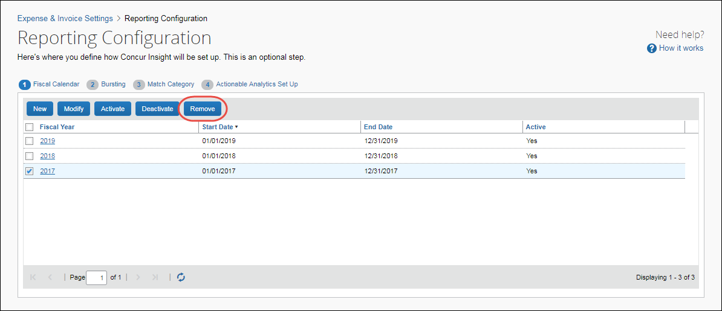
- In the Remove Fiscal Year window that appears, click Yes.
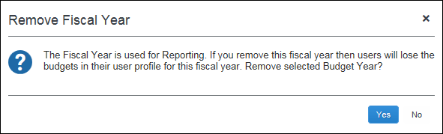
The fiscal year and any BI Manager budgets defined for the fiscal year on the Reporting Budget page will be marked as deleted and cannot be retrieved by any user.

Activate a Fiscal Period
The Activate function on the Modify Fiscal Calendar window is not recognized by Analysis / Intelligence reporting. This function is only used by the new Budget feature. It is not used by Analysis / Intelligence reporting.
To activate a fiscal period:
- On the Fiscal Calendar tab, select a fiscal year and then click Modify.
The Modify Fiscal Year window appears.
- Select a fiscal period and then click Activate.
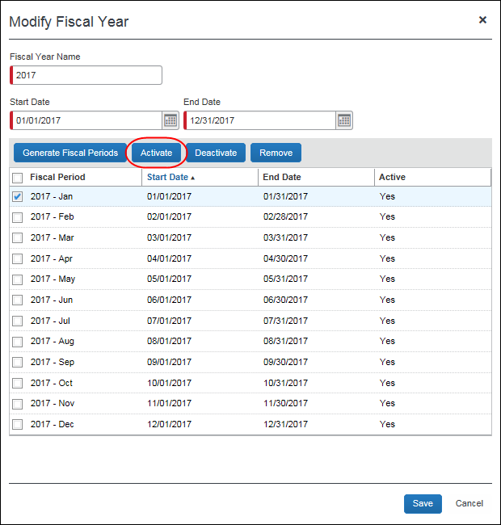
- Click Save.
You can activate a fiscal period of an inactive fiscal year. When you save the change, the fiscal year becomes active.

Deactivate a Fiscal Period
The Deactivate function on the Modify Fiscal Calendar window is not recognized by Analysis / Intelligence reporting. This function is only used by the new Budget feature. It is not used by Analysis / Intelligence reporting.
You can deactivate a fiscal period anytime. All fiscal periods that belong to the fiscal year become inactive when the year is deactivated. If all fiscal periods that belong to the fiscal year are inactive then the year is deactivated.
To deactivate a fiscal period:
- In the Fiscal Calendar tab, select a fiscal year and the click Modify.
The Modify Fiscal Year window appears.
- Select a fiscal period and then click Deactivate.
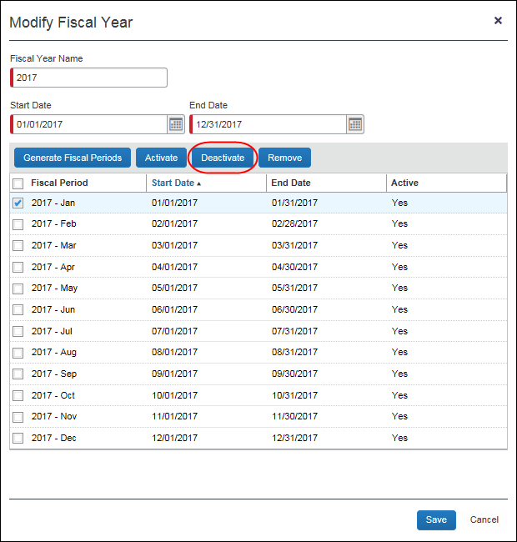
- Click Save.

Remove a Fiscal Period
You can remove a fiscal period to change the fiscal periods of a fiscal year. A fiscal period can be removed anytime.
The fiscal calendar will not show any fiscal periods that are marked as deleted.
- IMPORTANT: Removing fiscal periods could result in loss of BI Manager budgets.
To remove a fiscal period:
- On the Fiscal Calendar tab, select a fiscal year and then click Modify.
The Modify Fiscal Year window appears.
- Select a fiscal period and then click Remove.
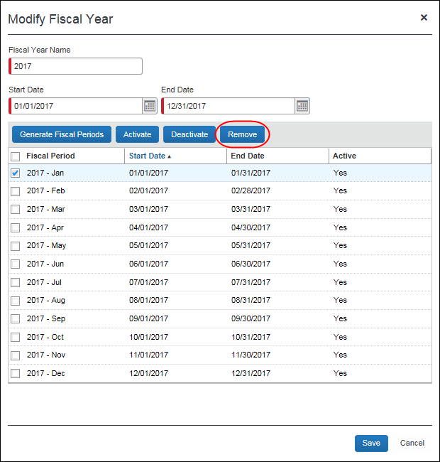
The fiscal period is removed from the fiscal year.
The fiscal periods will be marked as deleted and cannot be retrieved by any user. Concur can decide to permanently remove any records marked as deleted.

Configure Bursting
The Bursting tab allows the administrator to import bursting settings for reports that you burst.
This tab only appears if you have purchased Concur Intelligence.
Example
You'd like to burst a report based on Cost Center values. You can create an import file that creates the bursting configuration. Download the template and enter the Employee IDs for the report recipients. Then enter a value to group the employees together, such as COSTCENTER, in the Bursting ID column. Enter the cost center values in the Bursting Value column. Save the template, and then import it to apply these settings to your reporting configuration. You can create any number of Bursting ID groups, and employees can be in more than one group.

Burst Import Process
The Burst Import process has four steps:
- Downloading the Bursting template
- Populating the Bursting template
- Uploading the Bursting template
- Viewing the import results

Access the Bursting Page
To access the Bursting page:
- Click Administration > Expense Settings or Expense & Invoice Settings.
- In the Product list, click Expense or Invoice or Request.
- In the Monitoring Spend section, on the Reporting tab, click Edit.
The Fiscal Calendar Set Up tab of the Report Configuration page appears.
- Click Bursting (tab).
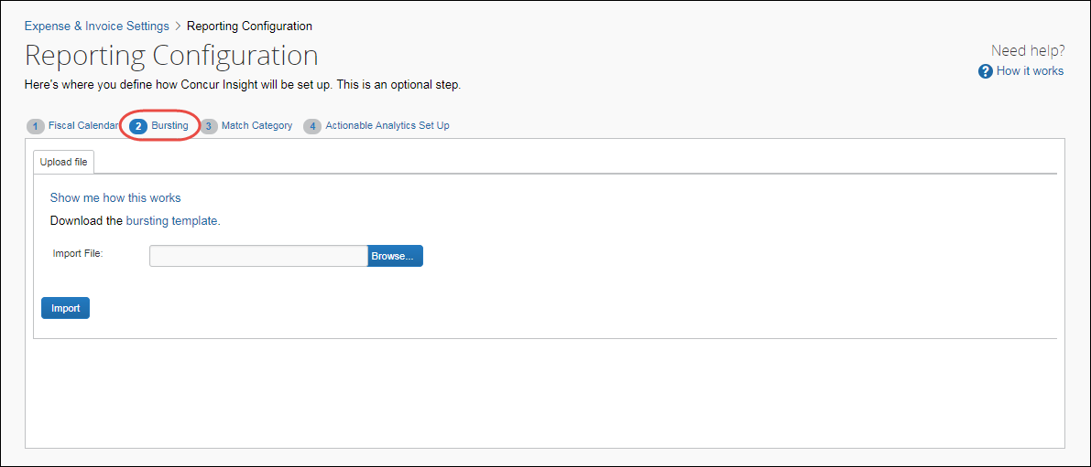

Download the Bursting Template
The administrator can download and use the template spreadsheet to enter bursting data in the correct format.
To download the spreadsheet:
- On the Reporting Configuration page, click the Bursting tab.
- On the Bursting tab, click the Bursting Template link.
- In the File Download dialog box, click Save.
- Select a location on your computer to save the spreadsheet.
The administrator can download a sample spreadsheet with user data from the online help.

Populate the Spreadsheet
The Bursting spreadsheet contains columns for the data fields to import. All fields are required. The values in the spreadsheet header rows (rows 1 and 2) must not be deleted.

Bursting Fields
Field | Description
Employee ID | The Employee ID of the user that receives the bursted report (for example, JSMITH). This value is stored in the Employee ID field on the Users page. If you use QuickBooks, this is the value stored in the QuickBooks Vendor Name field on the Users page.
Bursting ID | A user defined value that groups users who receive bursted reports (for example, Cost Center owners).
Bursting Value | The actual value that the report is bursted off of (for example, if a user wanted to receive all data on Cost Center 1234).

Final File Review
Before you import the user spreadsheet, verify that the spreadsheet is formatted correctly.
All cells in the Excel spreadsheet must have a designation of Text or Number before being uploaded. Always verify the cell formatting when done. If you use the Replace feature in Excel, be aware that it may not maintain the required cell formatting. Testing has shown that cells formatted as text become general format after using Replace. If the cells are not formatted as text, the import fails. If necessary, select the appropriate cells and change the formatting.

Upload the Bursting Spreadsheet
The spreadsheet is uploaded on the Bursting tab.
To upload the spreadsheet:
- On the Bursting tab, click Browse.
- Navigate to the correct location and select the bursting spreadsheet to upload.
- Click Open.
- On the Bursting tab, click Import.

View the Import Results
The results of the Bursting Import are displayed once the Bursting Import is complete. The Bursting tab allows administrators to view the Bursting Import process results. The process results show the total number of records processed, how many records were successfully processed, any errors associated with the import, and the records that failed to be imported successfully.
There are three reasons why a record is not successfully imported:
- The record does not have all fields of the import file populated. All fields are required, so any empty fields can cause a failure.
- An invalid Employee ID is provided. The Employee IDs entered in the Bursting Template must match a valid user. Refer to the Employee ID or QuickBooks Vendor Name field on the Users page for the Employee ID values.
- There are duplicate records in the import file. In this case, the first record is imported, and any subsequent duplicate records are not imported.

Configure Match Category
On the Match Category tab, the administrator can associate custom and standard expense types to a Match Category. The Match Categories are configured by Concur, and include typical travel expenses. Once the expense types are associated, the reporting archives will attempt to match all expenses of those types to the corresponding category.
This tab only appears if you have purchased both Concur Travel and Concur Intelligence.
Example
Your company has two air specific expense types: The standard expense type Airfare and a custom expense type Executive Air Travel. By default, only Airfare expenses will be considered to match to booked trips when loaded into the Reporting database. However, if the client maps the custom expense type Executive Air Travel to the Air Ticket Match Category, both expense types are evaluated when trying to identify a match.
Assigning a custom expense type to a match category is not required, but it is highly recommended for clients who have many custom expense types and wish to have accurate booking leakage reporting.

Definitions of Different Expense Types
- Standard Expense Types: Standard Expense Types are expense types that were created by Concur and are available to all clients. All standard expense types will be included in the Expense Type column of the Match Category page.
- Custom Expense Type: Custom Expense Types are created by a client and are unique to the client who created it. There are no consistent, unique values available. For this reason, custom expense types are never used in Analysis or Intelligence Standard Reports. All custom expense types will be included in the Expense Type column of the Match Category page.
- Match Category: A collection of expense types (both standard expense types and custom expense types) that are matched to travel bookings to identify booking leakage for a client. Expense types can be assigned to a match category on the Match Category page. There are eight Match Categories:

Match Category | Description
Air Ticket | This match category should contain all expense types related to the purchase of an airline ticket. It should be limited to the actual ticket purchase and should not include expense types related to airline fees or ancillary charges.
Breakfast | This match category should contain all expense types related to breakfast. Many clients have negotiated free breakfast as part of the room cost.
Car Amount | This match category should contain all expense types related to car rental. It should be limited to the actual car rental purchase and should not include expense types related to mileage or add-ons like GPS and fuels.
Hotel Room Amount | This match category should contain all expense types related to a hotel room purchase. It should be limited to the actual hotel room purchase and should not include expense types related to hotel taxes or in-room charges.
Hotel Tax Amount | This match category should contain all expense types related to hotel room taxes.
Internet | This match category should contain all expense types related to internet charges. Many clients have negotiated free internet access as part of the room cost.
Parking | This match category should contain all expense types related to parking charges. Many clients have negotiated free parking as part of the room cost.
None | This is the default match code for all custom expense types. If a custom expense type does not fit into one of the above categories, select None.

Access the Match Category Page
To access the Match Category page:
- Click Administration > Expense Settings or Expense & Invoice Settings.
- In the Product list, click Expense or Invoice or Request.
- In the Monitoring Spend section, on the Reporting tab, click Edit.
The Fiscal Calendar Set Up tab of the Report Configuration page appears.
- Click Match Category (tab).
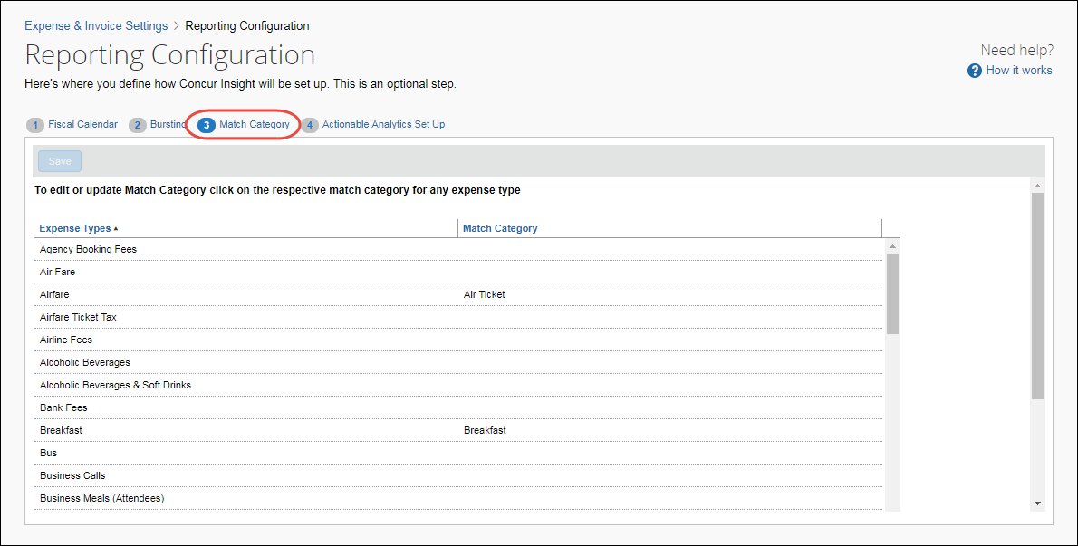

Associate Expense Types to Match Categories
To associate the expense types to categories:
- On the Match Category tab, click in the Match Category column of the desired expense type. A list of the available Match Categories displays.
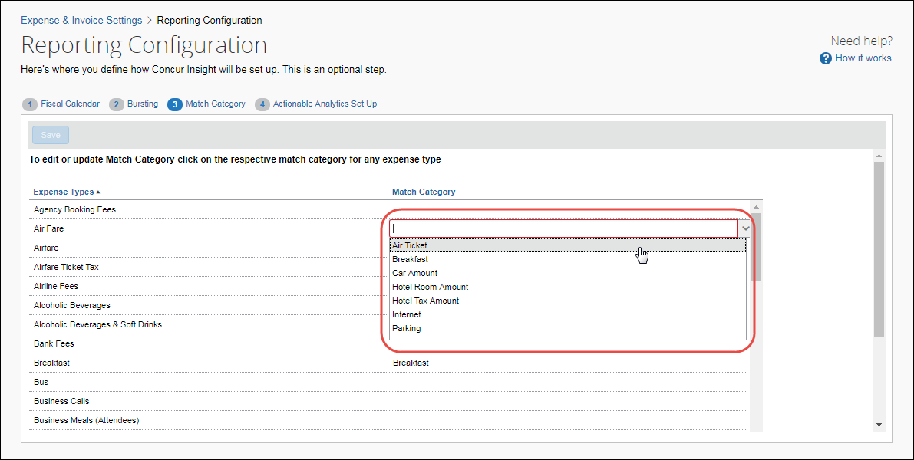
- Select the desired match category.
- Once all desired Expense Types have been mapped to the Match Category, click Save.

Configure Actionable Analytics
The Actionable Analytics Set Up tab only appears if you have purchased Concur Intelligence.
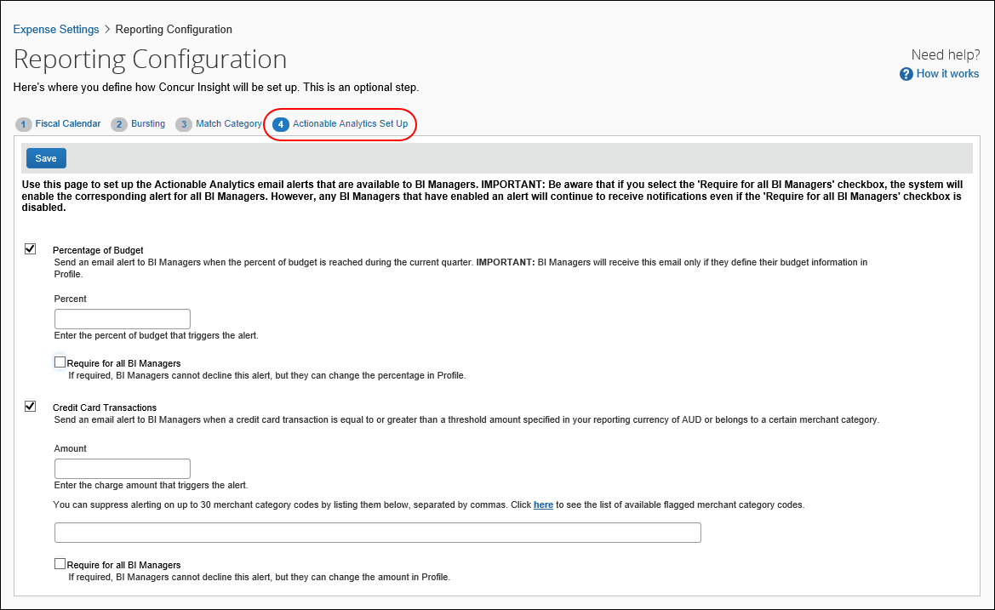
All of the setup steps – for the admin and the BI Manager – are discussed in the Analysis/Intelligence: Actionable Analytics User Guide.
- Refer to the Analysis / Intelligence guides that are available on Client Support Portal or via the Launch link in Cognos.
☼

