
Concur Expense: Expense Assistant
Setup Guide for Standard Edition

Last Revised: November 15, 2021
Applies to these SAP Concur solutions:
 Expense
 Professional/Premium edition
 Standard edition
 Travel
 Professional/Premium edition
 Standard edition
 Invoice
 Professional/Premium edition
 Standard edition
 Request
 Professional/Premium edition
 Standard edition

Table of Contents
Section 1: Overview 1
Section 2: Two User Interfaces for Concur Expense End Users 1
This Guide – What the User Sees 2
Transition Guide for End Users 2
Section 3: How It Works 2
Calendar-based Expense Assistant 2
Trip-based Expense Assistant 3
Section 4: What the Admin Sees 4
Section 5: Configuration 5
Section 6: What the User Sees – Existing UI 6
Choosing to use Expense Assistant 6
Calendar-based Expense Assistant This requires user action. 6
Trip-based Expense Assistant 8
Movement of expenses 10
Calendar-based option 10
Trip-based option 12
Removed expenses 13
Deleted expense reports 13
Returned expense reports 14
Summary emails 14
How Expense Assistant Names Expense Reports 16
Turning off Expense Assistant 16
Re-enabling Expense Assistant 17
Section 7: What the User Sees – NextGen UI 18
Choosing to use Expense Assistant 18
Calendar-based Expense Assistant This requires user action. 18
Trip-based Expense Assistant 20
Movement of expenses 22
Calendar-based option 22
Trip-based option 24
Removed expenses 25
Deleted expense reports 25
Returned expense reports 26
Summary emails 26
How Expense Assistant Names Expense Reports 28
Turning off Expense Assistant 28
Re-enabling Expense Assistant 29

Revision History
Date | Notes/Comments/Changes
January 7, 2022 | Updated the copyright year; no other changes; cover date not updated
November 15, 2021 | Added information about the existing UI and NextGen UI; made modifications throughout; cover revision date updated.  Clarified that expenses older than 30 days will not be automatically moved. Other minor edits.
January 21, 2021 | Updated the copyright; added Concur to the cover page title; cover date not updated
December 3, 2020 | Added note that if reports are auto created using Expense Assistant, delegates who have the appropriate permissions are copied on the weekly Report Summary emails.
April 16, 2020 | Renamed the Authorization Request check box to Request on the guide’s title page; cover date not updated
January 3, 2020 | Updated the copyright; no other changes; cover date not updated
August 10, 2019 | Minor edits.
January 10, 2019 | Updated the copyright; no other changes; cover date not updated
November 17, 2018 | Initial publication.

Expense Assistant
NOTE: Multiple SAP Concur product versions and UI themes are available, so this content might contain images or procedures that do not precisely match your implementation. For example, when SAP Fiori UI themes are implemented, home page navigation is consolidated under the SAP Concur Home menu.

Overview
Expense Assistant can automatically create expense reports and add trip-based expenses to these expense reports. This feature automates more of the expense reporting process, to provide an easier end user experience.
Users using Expense Assistant will be able to have Expense Assistant automatically create calendar-based or trip-based expense reports, but not both types of expense reports.
- For information about using Expense Assistant with the SAP Concur mobile app, continue to refer to the Expense Assistant FAQ.

Two User Interfaces for Concur Expense End Users
SAP is in the process of transitioning from the existing user interface (existing UI) to the NextGen UI user interface.
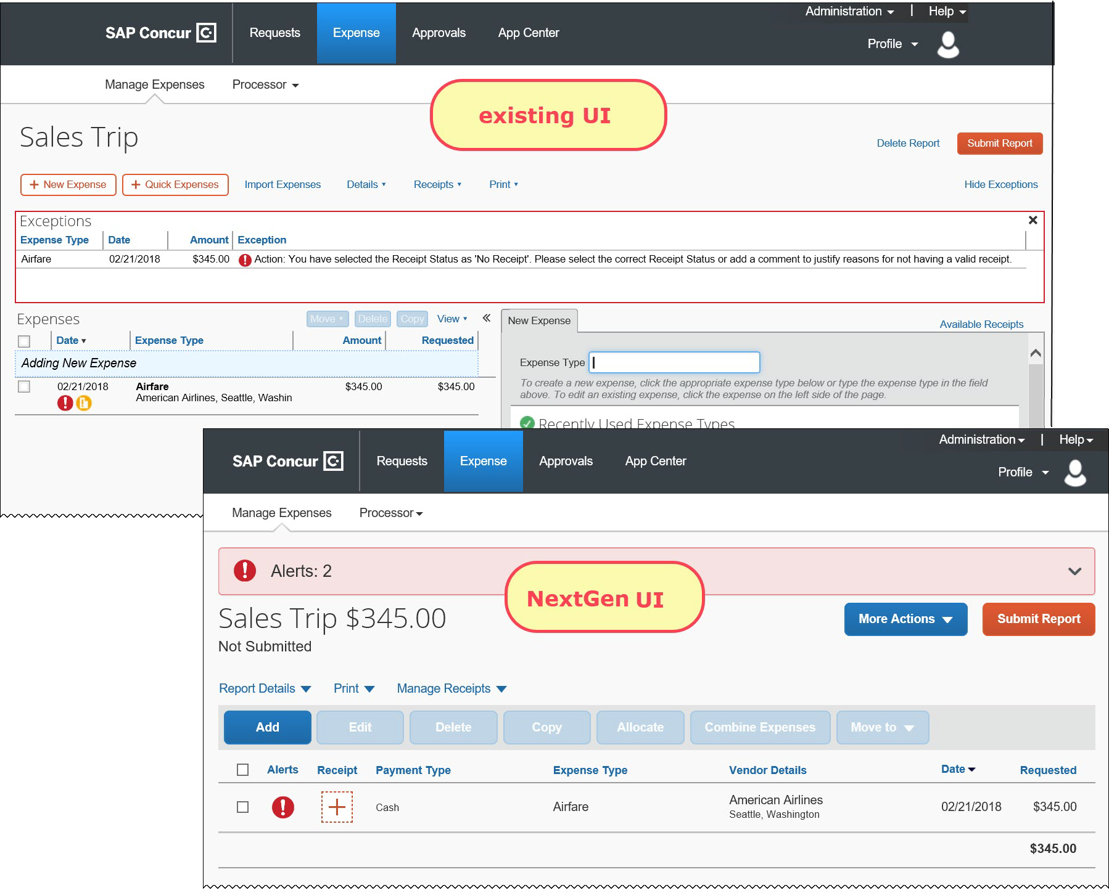
NextGen UI brings some long-awaited usability enhancements – some are significant (involving new pages and processes) while others are minor (involving only look-and-feel).
- IMPORTANT: Be aware that the NextGen UI enhancements affect only Concur Expense and only the end-user experience. Approvers and processors will still use the existing UI.

This Guide – What the User Sees
During this transition period – as clients are moving from the existing UI to NextGen UI – this guide will show both UIs. If there is an end-user screen sample that shows the existing UI, then there will be a NextGen UI sample as well.

Transition Guide for End Users
A detailed end-user guide is available. It describes all changes in NextGen UI.

How It Works
Expense Assistant automatically creates expense reports as a client's expenses flow into Concur. If you do not disable Expense Assistant for your company, then your users who opt-in to using Expense Assistant can choose to have Expense Assistant automatically create either calendar-based or trip-based expense reports.
This feature does not interfere with your normal routing of expense reports. Submitted expense reports will go to the expected managers as they do now.

Calendar-based Expense Assistant
Calendar-based Expense Assistant adds all expenses in your Available Expenses list to any open expense report. An open report can be a user-created expense report or an expense report auto-created by Expense Assistant. Expense Assistant continues to add all new incoming expenses that have a date that matches the calendar month of the expense report to that expense report.
If more than one expense report is open, Expense Assistant uses the following logic to determine which report new expenses are added to:
- Expense Assistant will add the expenses to an open expense report auto created by Expense Assistant if the expense transaction date is in the same month as the expense report month.
- If the expense transaction date does not match the month of the auto-created expense report, Expense Assistant adds the expenses to an open user-created expense report for that month.
- If there are multiple open user-created reports for the same month, Expense Assistant adds the expenses to the user-created expense report with the most recent date for that month.
- If there are no open user-created expense reports, then Expense Assistant will automatically create a new expense report and add the expenses to the new report.
Expense Assistant will auto-create a new expense report for each calendar month and all expenses with transaction dates within 30 days are moved into the expense report automatically. Expenses older than 30 days will not be automatically moved.

Trip-based Expense Assistant
Trip-based Expense Assistant creates an expense report when you create an itinerary in Concur Travel. It will add the airfare itinerary into that report once the airfare is ticketed. If you close that expense report before you leave on this trip, perhaps to be reimbursed for pre-travel expenses, then Expense Assistant will create a new, second expense report for this trip on the day that your itinerary indicates is the first day of your trip. Expense Assistant continues to add all new incoming expenses which have dates that matches the trip itinerary to that expense report.
There will be only one open/unsubmitted report per trip at any given time.
Expense Assistant will auto-create a new expense report for each trip itinerary and all expenses with dates that are covered by a trip itinerary are moved into the expense report automatically. There is a buffer of one day at the trip start and end dates to ensure that all the expenses associated with the trip are captured in the report.
- If the Start Date and End Date fields are on the report header form, the system will automatically populate these fields with the trip start and end dates.
- The system will always honor the start and end date if the user enters a value. If the user does not enter any value, the dates will be the trip start and end dates that the user entered in Concur Travel when booking the trip.
Any expenses that occur between the date that the airfare was ticketed and the trip start date will not be added to the expense report.

What the Admin Sees
Expense Assistant is automatically turned on for your company. There is a company-level setting that allows you to determine whether users will be able to enable Expense Assistant for themselves, and if so, whether the expense reports automatically created by Expense Assistant will be calendar-based or trip-based. The For Expense Assistant, allow users to opt out of to use: [List of options] setting is located on the Compliance Controls – Compliance Rules page in Product Settings.
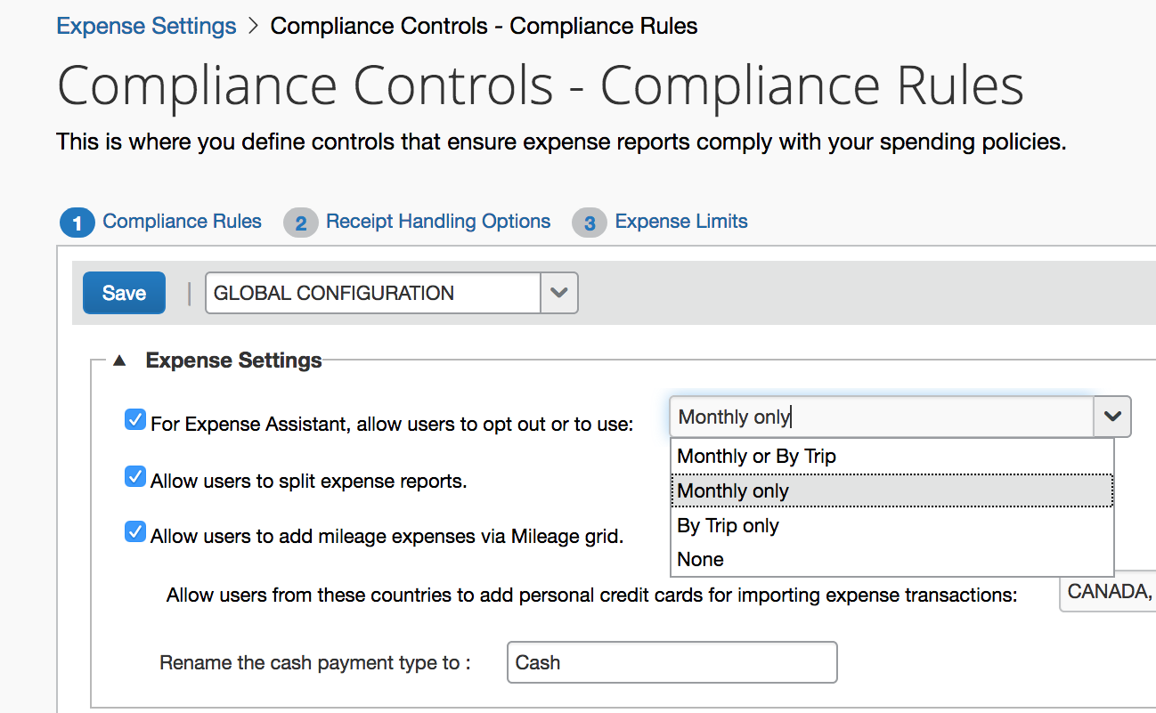
As an Expense admin, you can allow your users to choose whether they want to use calendar-based Expense Assistant or trip-based Expense Assistant, but the user can only select one of these options.
Alternatively, you can make the choice for your users, and designate the calendar-based or trip-based option to meet your company’s policy.
The following selections are available in the For Expense Assistant, allow users to opt out or to use list:
- Monthly or By Trip – Users can enable Expense Assistant. If a user enables Expense Assistant, the user can choose whether Expense Assistant automatically creates calendar-based or trip-based expense reports for that user. The user can only use one of these options, the user cannot use both.
- Monthly only – Users can enable calendar-based Expense Assistant. If a user enables Expense Assistant, Expense Assistant will automatically create calendar-based expense reports for that user.
- By Trip only – Users can enable trip-based Expense Assistant. If a user enables Expense Assistant, Expense Assistant automatically creates trip-based expense reports for that user.
- None – Expense Assistant will not be available to users.
The Allow users to opt into Expense Assistant setting only enables Expense Assistant for your company. It does not enable Expense Assistant for your individual users. For more information, refer to question 2. How do I enable Expense Assistant for my users?
For existing clients, your current Expense Assistant configuration remains unchanged.
For new clients, by default, For Expense Assistant, allow users to opt out or to use is enabled and Monthly or By Trip is selected from the list.

Configuration
You can configure the Expense Assistant feature on the Compliance Controls – Compliance Rules page in Product Settings.
To configure Expense Assistant
- On the Compliance Controls – Compliance Rules page, select from the For Expense Assistant, allow users to opt out or to use list.
- Click Save.

What the User Sees – Existing UI
When this feature is configured to provide a choice to users, switching back and form between calendar-based and trip-based choices, while possible, is not the intended use of the feature and can have unintended consequences such as expenses not auto-populating the desired report.
If a user decides to use Expense Assistant, that user’s delegates and travel arrangers (if they have any) will also see Expense Assistant. Delegates can also turn off Expense Assistant on behalf of a user.

Choosing to use Expense Assistant
Each user must choose to use Expense Assistant.

Calendar-based Expense Assistant This requires user action.
Once Expense Assistant is enabled for your company, as Monthly or By Trip or Monthly Only, users will need to enable Expense Assistant for themselves.
There are three ways a user can enable Expense Assistant:
- When your users log on to Concur and go to the Expense page, they will see the following screen on the Expense home page. Since Concur needs some available expenses present to show how it works, this will show at the first time the user logs in and has available expenses to be used.
The users can click Get Started to begin using Expense Assistant.
It is required that users receive Available Expenses into Concur Expense from sources other than Travel bookings or personal card charges in order to use Expense Assistant. Some examples would be company card transactions, e-receipts from suppliers, ExpenseIt entries, and SAP Concur mobile entries.
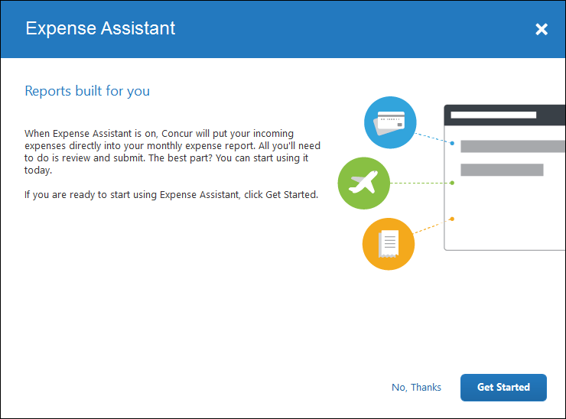
If users do not currently have any available expenses, they will see the following message in the Available Expenses section:
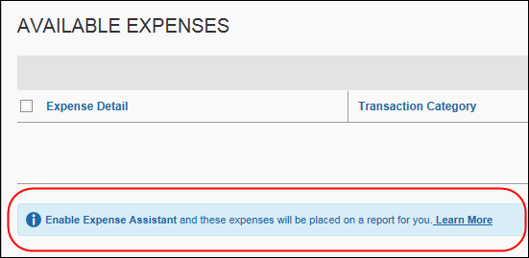
The users need to click Learn More, and then click Try it Now to begin using Expense Assistant.
-Or-
If the user wants to enable Expense Assistant and the pages shown above do not appear automatically, the user can enable the feature in Profile. On the Expense Preferences page (Profile > Profile Settings), the user selects By Month from the Expense Assistant using this method list, and the clicks Save.
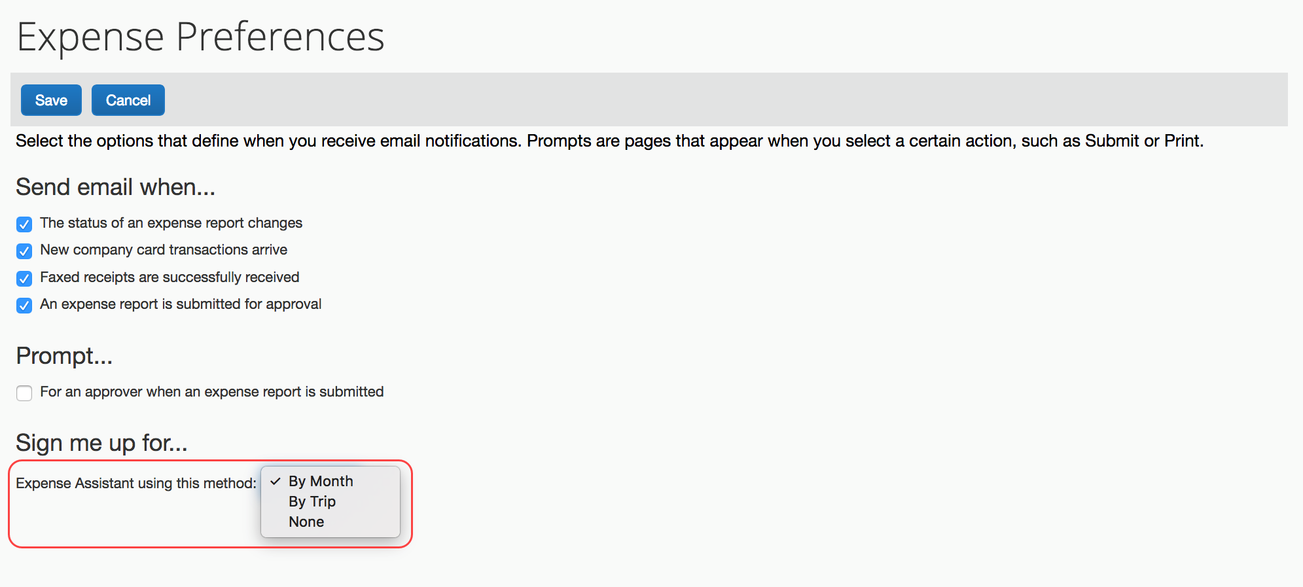

Trip-based Expense Assistant
This requires user action.
Once Expense Assistant is enabled for your company, as Monthly or By Trip or By Trip Only, users will need to enable Expense Assistant for themselves.
It is required that users book trips via Concur Travel.
If the user is using the NextGen UI and if the user has at least one unexpensed travel segment (itinerary) in Available Expenses, the Expense Assistant page appears.
There are three ways a user can enable Expense Assistant: when they have Available Expenses, whether or not they have any Available Expenses, and from Profile.
- When your users log on to Concur Expense and go to the Expense home page, they will see the following screen. Since Concur Expense needs some available expenses and an unexpensed travel segment (itinerary) present to show how it works, this will show at the first time the user logs in and has available expenses to be used.
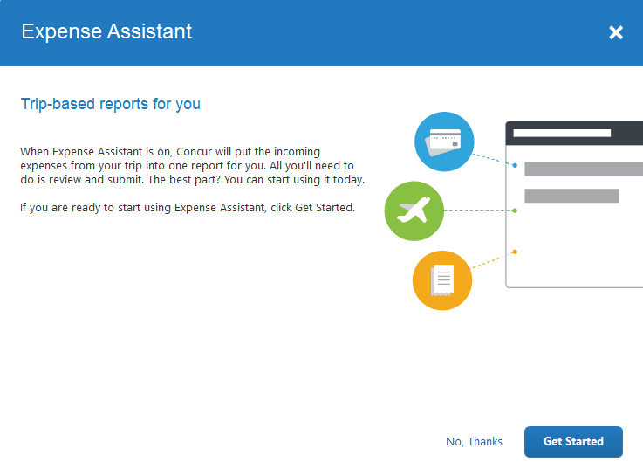
-Or-
- If users do not currently have any available expenses or an unexpensed travel segment (itinerary), they will see the following message in the Available Expenses section:
The users need to click Learn More, and then click Get Started to begin using Expense Assistant.
-Or-
- If the user wants to enable Expense Assistant and the pages shown above do not appear automatically, the user can enable the feature in Profile. On the Expense Preferences page (Profile > Profile Settings), the user selects By Trip from the Expense Assistant using this method list, and then clicks Save.
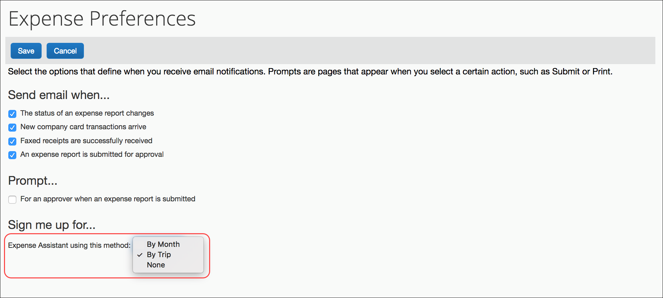

Movement of expenses

Calendar-based option
When you have an open expense report (user created or created by calendar-based Expense Assistant) that is accepting incoming expenses, the following message appears in the Active Reports section:
All incoming expenses will be placed on an unsubmitted report. Stop this process.
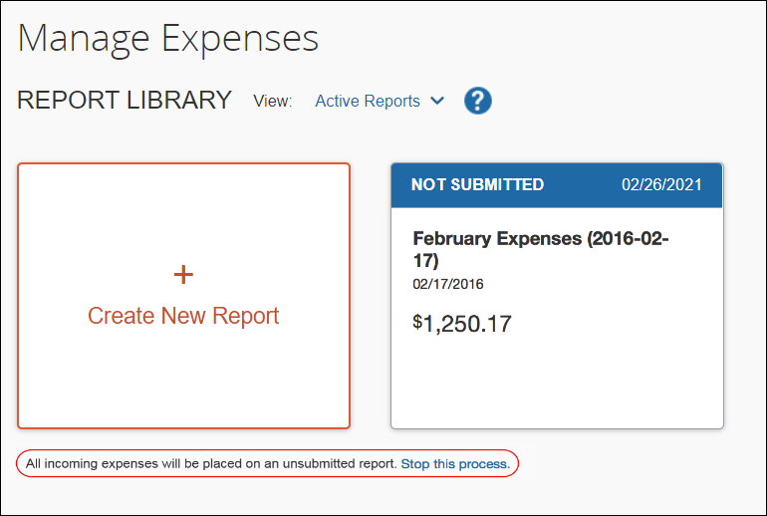
When you do not have any open reports that are accepting incoming expenses, the following message appears:
When expense items come in, they will be placed on a new report. Stop this process.
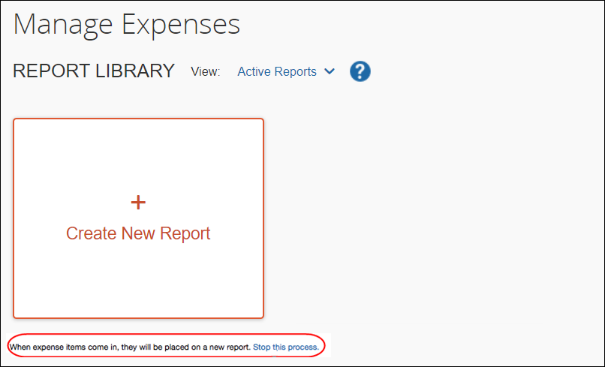

Trip-based option
When you have an open expense report (user created or created by trip-based Expense Assistant) that is accepting incoming expenses, the following message appears in the Active Reports section:
All incoming expenses that occur between your trip start and end date will be placed on a trip-related report. Turn off Expense Assistant.
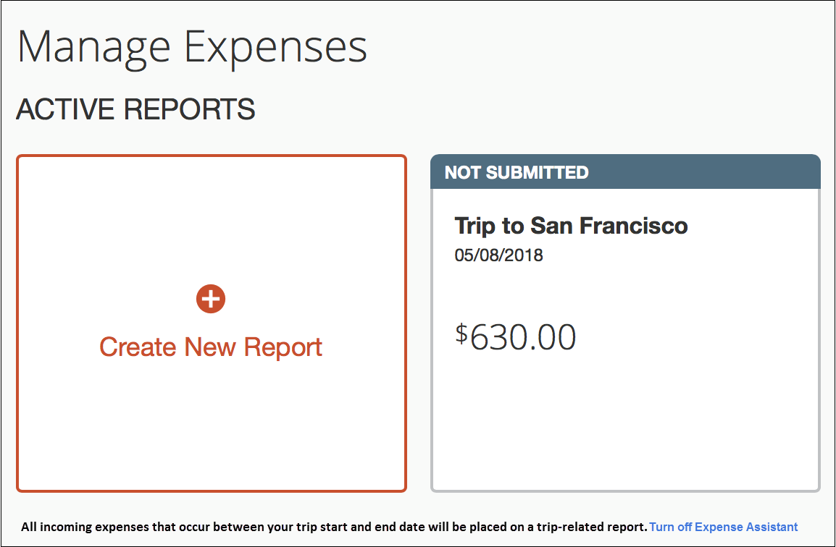
If you booked travel segments on two different itineraries for the same trip (e.g., airfare on one itinerary and hotel on a separate itinerary), Expense Assistant will not move these to one expense report. Expense Assistant will create one expense report per trip itinerary that exists in Concur Travel. You will need to manually move expenses from one trip-based report to another report and delete the empty report.

Removed expenses
If you remove an expense from a report that was created by Expense Assistant, Expense Assistant will not automatically move it back to that – or to any other – expense report.

Deleted expense reports
If you delete an expense reports, any expenses that Expense Assistant moved to that report will automatically be moved back to your Available Expenses list. You can then manually create a new report, move your expenses to that report, and edit as needed.
You must move any expenses that you manually created to another report before deleting the report, as any manually created expenses will truly be deleted when you delete the report.

Returned expense reports
Expense Assistant will not move expenses to a report that has a Returned status.
Be aware that it will match existing entries. If Concur Expense finds a matching expense entry (like an ExpenseIt entry) on a returned report, it will move the new expense (like a credit card entry) to the returned report and then automatically match the two items for you.

Summary emails
There are two ways to identify expenses that were moved into an expense report for you:
- Concur Expense sends you a weekly email that summarizes the activity that occurred in your auto-created expense report over the past week. In addition, Concur Expense notifies you of exceptions, such as missing receipts, before you can submit your report.
The weekly email summary is sent on Thursdays at 2 AM GMT and cannot be turned off. For example, a user in the PST time zone will receive the email Wednesday evening.
- For trip-based expense assistant, Concur Expense sends you a summary email when the trip-based expense report is created (if prior to trip start date). After that, Concur Expense sends a weekly email that summarizes the activity that occurred in your auto-created expense report after the trip begins.
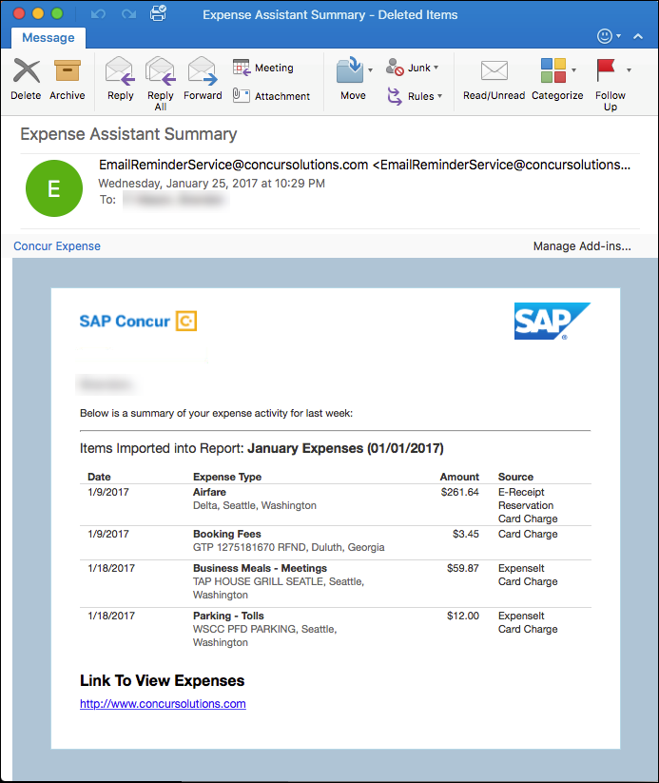
You can specify delegates are copied on the weekly Report Summary emails and allow users to see those assigned delegates on the CC line of a Report Summary email. For more information on how to allow delegates to receive the Report Summary email, refer to the Shared: Delegate Configuration Setup Guide.

How Expense Assistant Names Expense Reports
Expense Assistant names an automatically created expense report so that you can easily see it in your expense report list. As usual, you can rename the report if desired.
Calendar-based expense report names are formatted like this: May Expenses (2018-05-18).
Trip-based expense report names match the trip name (entered by the user when booking the trip in Concur Travel).

Turning off Expense Assistant
If you are using Expense Assistant, one of these two messages appear under the Create New Report tile in the Active Reports section on the Expense home page:
You can click Stop this process to disable Expense Assistant. You will see a confirmation message to confirm your action.
If you are using trip-based Expense Assistant, the following message will appear will under the Create New Report tile in the Active Reports section on the Expense home page:
You can click Turn off Expense Assistant to disable Expense Assistant. You will see a confirmation message to confirm your action.
On the Expense Preferences page (Profile > Profile Settings), the user selects None from the Expense Assistant using this method list, and then clicks Save.
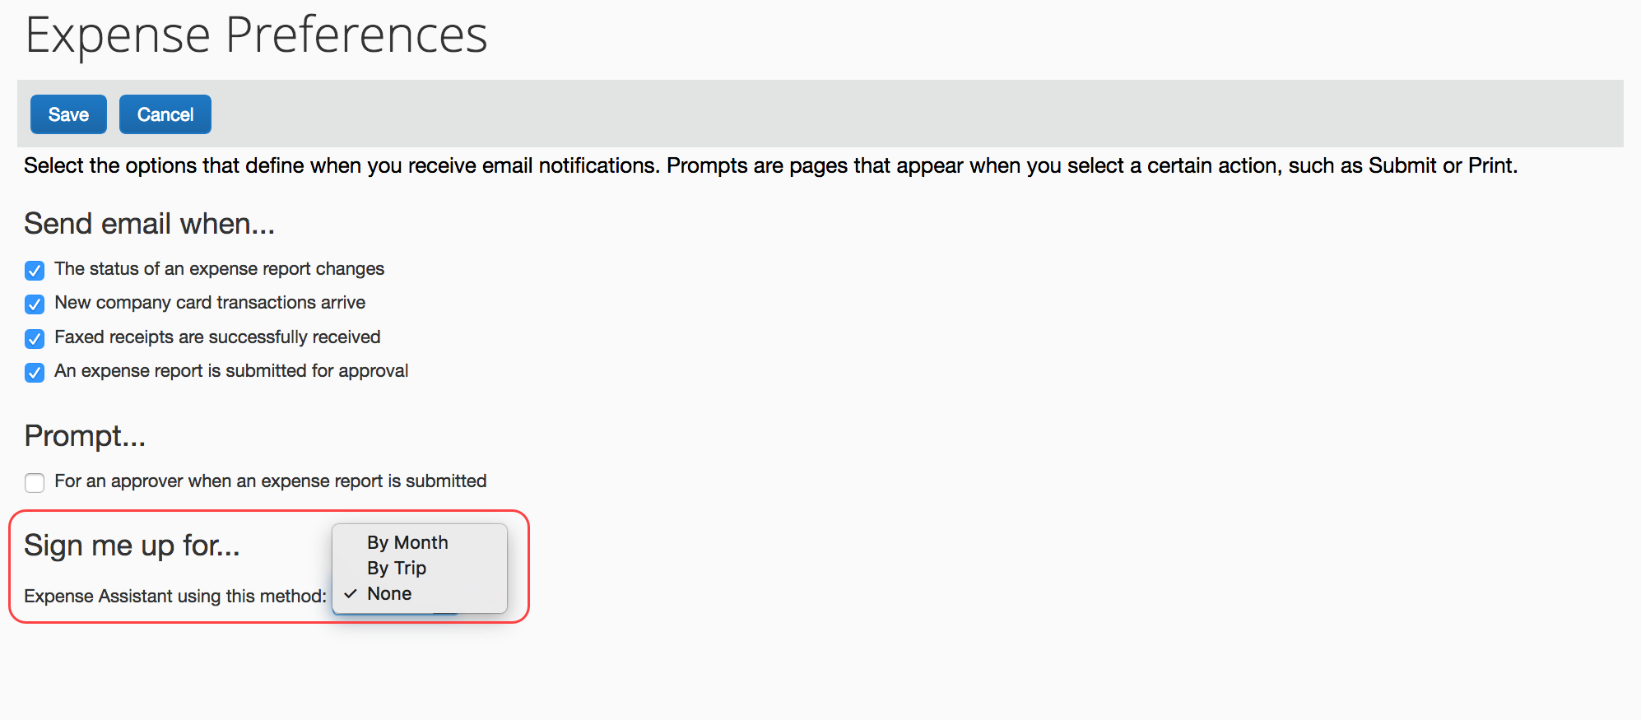

Re-enabling Expense Assistant
If you do not enable calendar-based Expense Assistant on initial login (as described previously) or if you disable Expense Assistant, you will see the following message below your Available Expenses list:
Enable Expense Assistant and these expenses will be placed on a report for you. Learn More.
Click Learn More, and then click the Get Started button.
When Expense Assistant is enabled at the company level, you can also re-enable Expense Assistant from the Expense Preferences page (Profile > Profile Settings) by selecting (enabling) the Expense Assistant using this method: [list of available options] check box, and then clicking Save.

What the User Sees – NextGen UI
When this feature is configured to provide a choice to users, switching back and form between calendar-based and trip-based choices, while possible, is not the intended use of the feature and can have unintended consequences such as expenses not auto-populating the desired report.
If a user decides to use Expense Assistant, that user’s delegates (if they have any) will also see Expense Assistant. Delegates can also turn off Expense Assistant on behalf of a user.

Choosing to use Expense Assistant
Each user must choose to use Expense Assistant.

Calendar-based Expense Assistant This requires user action.
Once Expense Assistant is enabled for your company, as Monthly or By Trip or Monthly Only, users will need to enable Expense Assistant for themselves.
There are three ways a user can enable Expense Assistant:
- When your users log on to Concur and go to the Expense page, they will see the following screen on the Expense home page. Since Concur needs some available expenses present to show how it works, this will show at the first time the user logs in and has available expenses to be used.
The user selects Calendar-based reports and clicks Get Started to begin using Expense Assistant.
It is required that users receive Available Expenses into Concur Expense from sources other than Travel bookings or personal card charges in order to use Expense Assistant. Some examples would be company card transactions, e-receipts from suppliers, ExpenseIt entries, and SAP Concur mobile entries.
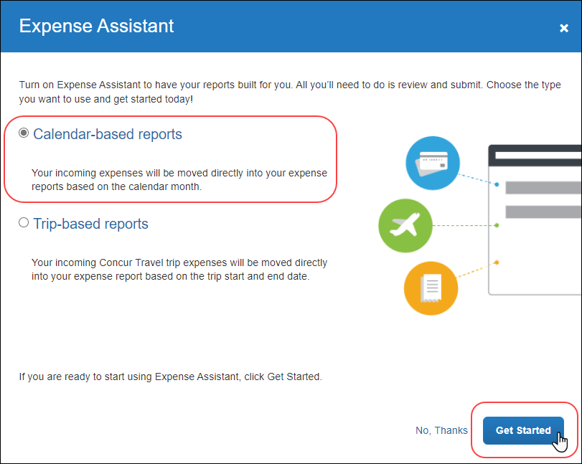
If users do not currently have any available expenses, they will see the following message in the Available Expenses section:
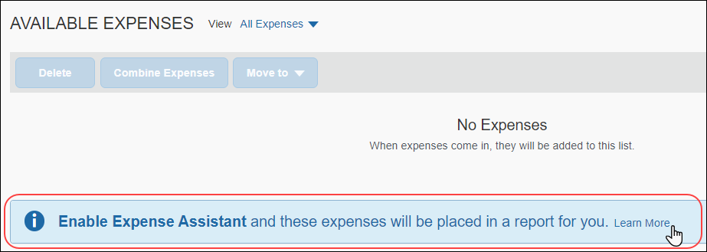
The users need to click Learn More, select Calendar-based reports, and then click Get Started to begin using Expense Assistant.
-Or-
If the user wants to enable Expense Assistant and the pages shown above do not appear automatically, the user can enable the feature in Profile. On the Expense Preferences page (Profile > Profile Settings), the user selects By Month from the Expense Assistant using this method list, and the clicks Save.

Trip-based Expense Assistant
This requires user action.
Once Expense Assistant is enabled for your company, as Monthly or By Trip or By Trip Only, users will need to enable Expense Assistant for themselves.
It is required that users book trips via Concur Travel.
If the user is using NextGen UI and if the user has at least one unexpensed travel segment (itinerary) in Available Expenses, the Expense Assistant page appears.
There are three ways a user can enable Expense Assistant: when they have Available Expenses, whether or not they have any Available Expenses, and from Profile.
- When your users log on to Concur Expense and go to the Expense home page, they will see the following screen. Since Concur Expense needs some available expenses and an unexpensed travel segment (itinerary) present to show how it works, this will show at the first time the user logs in and has available expenses to be used.
The users need to select Trip-based reports and then click Get Started to begin using Expense Assistant.
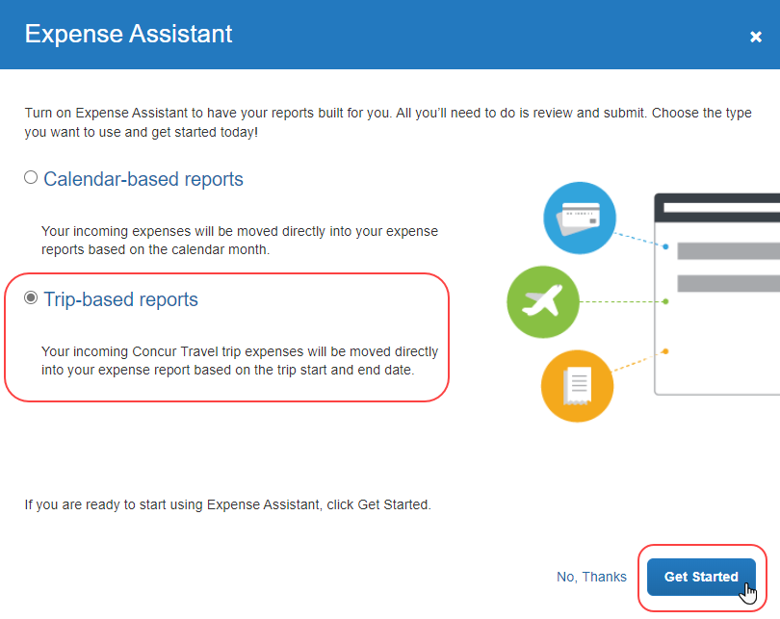
-Or-
- If users do not currently have any available expenses or an unexpensed travel segment (itinerary), they will see the following message in the Available Expenses section:
The users need to click Learn More, select Trip-based reports, and then click Get Started to begin using Expense Assistant.
-Or-
- If the user wants to enable Expense Assistant and the pages shown above do not appear automatically, the user can enable the feature in Profile. On the Expense Preferences page (Profile > Profile Settings), the user selects By Trip from the Expense Assistant using this method list, and then clicks Save.

Movement of expenses

Calendar-based option
When you have an open expense report (user created or created by calendar-based Expense Assistant) that is accepting incoming expenses, the following message appears in the Active Reports section:
All incoming expenses will be placed in an unsubmitted report. Turn off Expense Assistant.
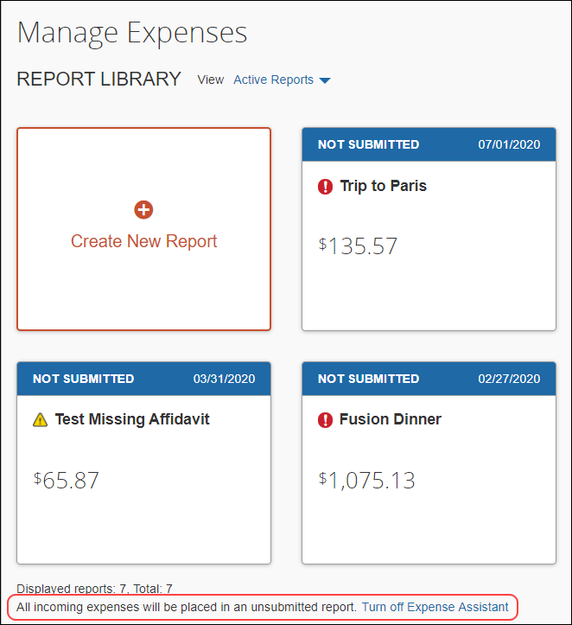
When you do not have any open reports that are accepting incoming expenses, the following message appears:
When expense items come in, they will be placed in a new report. Turn off Expense Assistant.
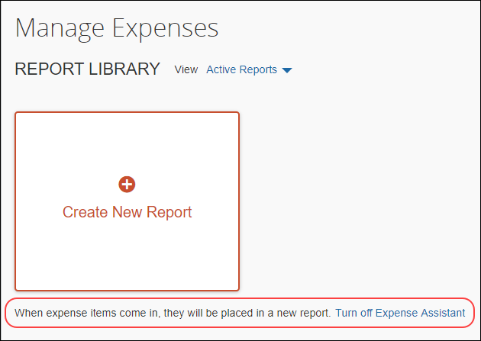

Trip-based option
When you have an open expense report (user created or created by trip-based Expense Assistant) that is accepting incoming expenses, the following message appears in the Active Reports section:
All incoming expenses that occur between the start and end date of a trip will automatically be placed in a trip report. Turn off Expense Assistant.
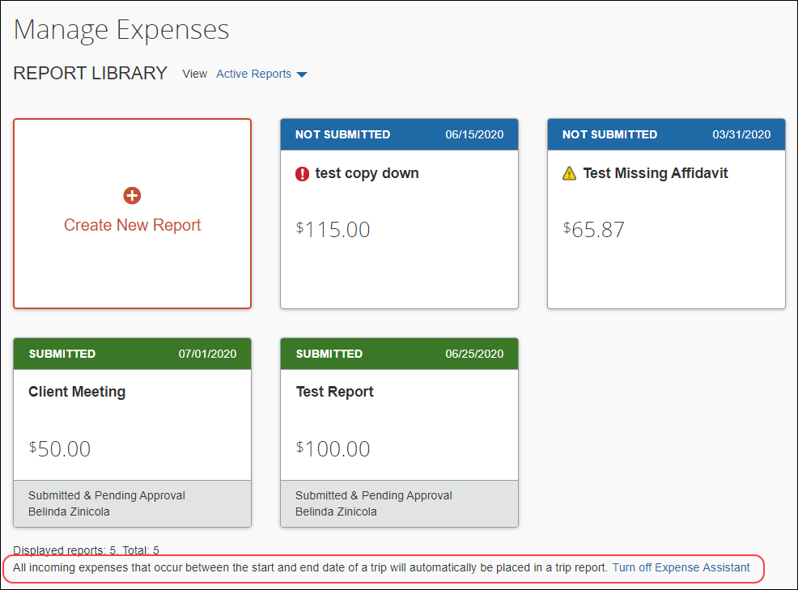
If you booked travel segments on two different itineraries for the same trip (e.g., airfare on one itinerary and hotel on a separate itinerary), Expense Assistant will not move these to one expense report. Expense Assistant will create one expense report per trip itinerary that exists in Concur Travel. You will need to manually move expenses from one trip-based report to another report and delete the empty report.

Removed expenses
If you remove an expense from a report that was created by Expense Assistant, Expense Assistant will not automatically move it back to that – or to any other – expense report.

Deleted expense reports
If you delete an expense reports, any expenses that Expense Assistant moved to that report will automatically be moved back to your Available Expenses list. You can then manually create a new report, move your expenses to that report, and edit as needed.
You must move any expenses that you manually created to another report before deleting the report, as any manually created expenses will truly be deleted when you delete the report.

Returned expense reports
Expense Assistant will not move expenses to a report that has a Returned status.
Be aware that it will match existing entries. If Concur Expense finds a matching expense entry (like an ExpenseIt entry) on a returned report, it will move the new expense (like a credit card entry) to the returned report and then automatically match the two items for you.

Summary emails
There are two ways to identify expenses that were moved into an expense report for you:
- Concur Expense sends you a weekly email that summarizes the activity that occurred in your auto-created expense report over the past week. In addition, Concur Expense notifies you of exceptions, such as missing receipts, before you can submit your report.
The weekly email summary is sent on Thursdays at 2 AM GMT and cannot be turned off. For example, a user in the PST time zone will receive the email Wednesday evening.
- For trip-based expense assistant, Concur Expense sends you a summary email when the trip-based expense report is created (if prior to trip start date). After that, Concur Expense sends a weekly email that summarizes the activity that occurred in your auto-created expense report after the trip begins.
You can specify delegates are copied on the weekly Report Summary emails and allow users to see those assigned delegates on the CC line of a Report Summary email. For more information on how to allow delegates to receive the Report Summary email, refer to the Shared: Delegate Configuration Setup Guide.

How Expense Assistant Names Expense Reports
Expense Assistant names an automatically created expense report so that you can easily see it in your expense report list. As usual, you can rename the report if desired.
Calendar-based expense report names are formatted like this: May Expenses (2018-05-18).
Trip-based expense report names match the trip name (entered by the user when booking the trip in Concur Travel).

Turning off Expense Assistant
If you are using Expense Assistant, one of these two messages appear under the Create New Report tile in the Active Reports section on the Expense home page:
You can click Turn off Expense Assistant to disable Expense Assistant. You will see a confirmation message to confirm your action.
If you are using trip-based Expense Assistant, the following message will appear under the Create New Report tile in the Active Reports section on the Expense home page:
You can click Turn off Expense Assistant to disable Expense Assistant. You will see a confirmation message to confirm your action.
On the Expense Preferences page (Profile > Profile Settings), the user selects None from the Expense Assistant using this method list, and then clicks Save.

Re-enabling Expense Assistant
If you do not enable calendar-based Expense Assistant on initial login (as described previously) or if you disable Expense Assistant, you will see the following message below your Available Expenses list:
Enable Expense Assistant and these expenses will be placed in a report for you. Learn More.
Click Learn More, and then click the Get Started button.
When Expense Assistant is enabled at the company level, you can also re-enable Expense Assistant from the Expense Preferences page (Profile > Profile Settings) by selecting (enabling) the Expense Assistant using this method: [list of available options] check box, and then clicking Save.
☼

