SAP Concur Release Notes
Concur Invoice Standard
Includes: Concur Invoice, Capture Processing, Invoice Pay, Purchase Requests, and Purchase Orders
Month | Audience
Release Date: October 15, 2022  Update #1: October 24, 2022 | Client FINAL

Contents
Release Notes 1
Capture Processing 1
New Self-Service Invoice Capture Setup 1
Invoice Approvals 10
New Status Message for Approval Processing 10
Vendor Management 11
New Vendors from Embargoed Countries Now Blocked 11
Planned Changes 12
Invoice Processing 12
**Planned Changes** Paper Invoice Processing to be Retired 12
Client Notifications 14
Accessibility 14
Accessibility Updates 14
Subprocessors 14
SAP Concur Non-Affiliated Subprocessors 14
Supported Browsers 15
Supported Browsers and Changes to Support 15
Additional Release Notes and Other Technical Documentation 16
Online Help 16
SAP Concur Support Portal – Selected Users 16

Legal Disclaimer
The information in this presentation is confidential and proprietary to SAP SE or an SAP affiliate company and may not be disclosed without the permission of SAP SE or the respective SAP affiliate company. This presentation is not subject to your license agreement or any other service or subscription agreement with SAP SE or its affiliated companies. SAP SE and its affiliated companies have no obligation to pursue any course of business outlined in this document or any related presentation, or to develop or release any functionality mentioned therein. This document, or any related presentation and SAP SE or an SAP affiliate company’s strategy and possible future developments, products and or platforms directions and functionality are all subject to change and may be changed by SAP SE and its affiliated companies at any time for any reason without notice. The information in this document is not a commitment, promise or legal obligation to deliver any material, code or functionality. This document is provided without a warranty of any kind, either express or implied, including but not limited to, the implied warranties of merchantability, fitness for a particular purpose, or non-infringement. This document is for informational purposes and may not be incorporated into a contract. SAP SE and its affiliated companies assume no responsibility for errors or omissions in this document, except if such damages were caused by SAP SE or an SAP affiliate company’s willful misconduct or gross negligence.
All forward-looking statements are subject to various risks and uncertainties that could cause actual results to differ materially from expectations. Readers are cautioned not to place undue reliance on these forward-looking statements, which speak only as of their dates, and they should not be relied upon in making purchasing decisions.

Release Notes
This document contains the release notes for Concur Invoice for standard edition.
Features and changes that apply to SAP Concur site-wide or to multiple products/services are documented in the Shared Changes Release Notes. For information about site-wide or shared changes in this release that might impact your SAP Concur solutions, refer to the Shared Changes Release Notes.

Capture Processing

New Self-Service Invoice Capture Setup

Overview
Concur Invoice clients who want to implement Invoice Capture now have self-service setup available on the Invoice Capture Processing page in Product Settings. The Invoice Capture Processing page is redesigned to include configuration consolidated on one page for simplified initial set up of the feature.
Previously, clients worked with SAP Concur implementation staff to determine setting preferences that were configured for them. Additionally, client set up was completed in two locations: on the Capture Processing page in Product Settings and on the Capture Admin settings tab accessible from Administration > Company > Capture Admin Settings.
With the new user interface design, self-service client configuration of the Invoice Capture feature is consolidated on the Invoice Capture Processing page for administration ease and efficiency.
Existing clients who already have Invoice Capture activated can now manage their email addresses, alias names, and Invoice Capture settings from the new Invoice Capture Processing page in Product Settings. Refer to the Clients Already Using Invoice Capture section of this release note.

Business Purpose / Client Benefit
The new Invoice Capture Processing page offers new and existing clients, who want to implement Invoice Capture, a consolidated self-service option for initial setup of this feature and for any subsequent edits to Invoice Capture preferences.

Choosing an Invoice Capture Processing Method
The Capture Processing features of Invoice Management support capture and validation of invoice data using Optical Character Recognition (OCR).
Invoice Capture offers three options for managing capture processing:
- Concur Managed – Managed, fee-based where SAP Concur staff performs the verification of OCR results on behalf of the client
- Client Managed – Free, client-managed feature of Invoice Management that lets the client self-manage the verification of OCR results
- Dual Support – When a client opts to use both management types simultaneously
Once OCR is performed by the system, the client or SAP Concur staff performs verification of OCR results, after which each invoice is saved and advanced to the beginning of the workflow process.
Clients who use Concur-Managed Invoice Capture or Dual Support (Concur-Managed and Client-Managed Invoice Capture) can process their own invoice batches.
More detailed information is included in the following guides:
- Concur Invoice: Capture Processing (Client-Managed) Setup Guide for Standard Edition
- Concur Invoice: Capture Processing (Client-Managed) User Guide for Standard Edition
- Concur Invoice: Capture Processing (Dual-Support) User Guide for Standard Edition

Access the Invoice Capture Processing Page
In Product Settings, when an administrator clicks the Capture Processing tile the Invoice Capture Processing page appears.
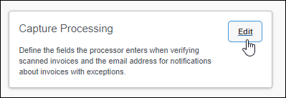
The Set Up Invoice Capture page displays for initial configuration of Invoice Capture.
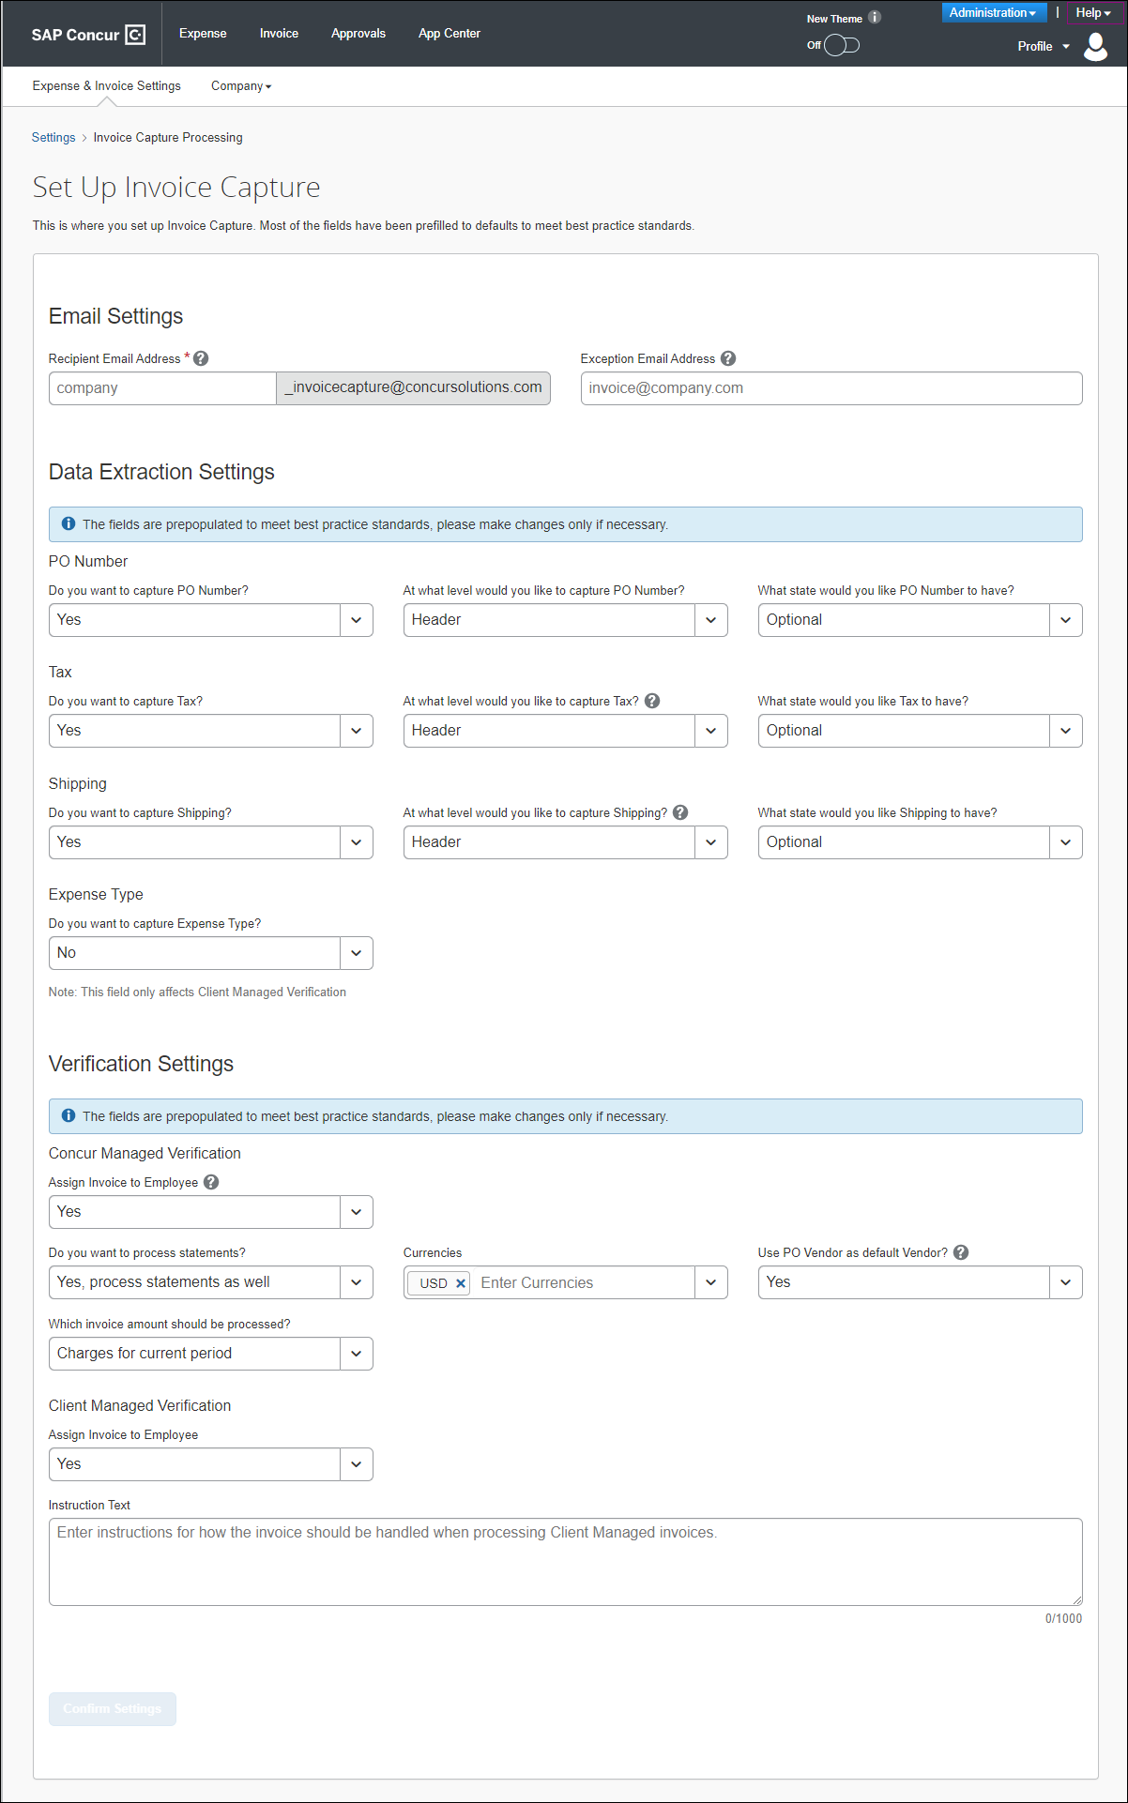
Client administrators will see the Set Up Invoice Capture page display with many fields pre-populated with default entries to meet best practice standards. Administrators are advised not to change the default entries unless necessary. Administrators are required to review and complete the fields in each section, then save the information.

Email Settings
In the Email Settings section of the page, admins enter recipient and exception email addresses:
- Recipient Email Address – The email address to which senders (vendors) will send invoices. Please consider using your company name as the email address.
- Exception Email Address – The system uses this email address to alert administrators that an exception is detected or that non-invoice documents have been received. If there are multiple recipients, please separate each email address with a comma (,) or semicolon (;).

Data Extraction Settings
The Data Extraction Settings section is used to define what data Invoice Capture will capture from incoming invoices from suppliers and how it will display in Concur Invoice.

Verification Settings
The Verifications Settings section is used to define how Invoice Capture processes incoming invoices from suppliers.
The Invoice Capture methods clients opt to use and have activated by SAP Concur support display in this section to allow easy identification of capture processing capture types:
- Concur Managed Settings
- Client Managed Settings
For example, if a client chooses to only use the Concur-Managed option, then they will not see Client Managed Settings section display. If a client opts to use both methods, then both Concur Managed Settings and Client Managed Settings display in this section.

Saving Setting Preferences
When all fields are reviewed and completed, the administrator clicks Confirm Settings to save Invoice Capture preferences. A Confirm Settings dialog displays asking the administrator to verify that all settings are correct.
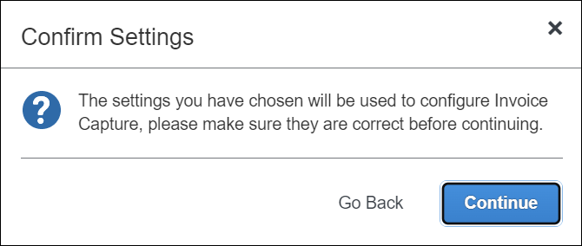
A Congratulations message displays to inform administrators that an SAP Concur representative will review and confirm Invoice Capture set up. To avoid delays, it’s recommended that invoices are not submitted before receiving a confirmation email from an SAP Concur representative.
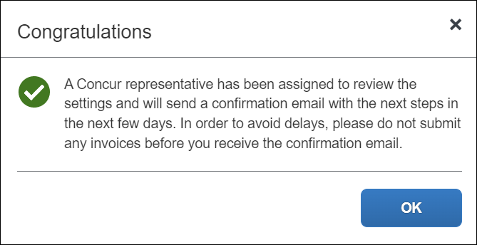
Click Continue to to access the Invoice Capture Processing page.
On the Invoice Capture Processing page administrators now see three tabs used to complete feature configuration:
- General
- Recipient Email Administration
- Sender Email Administration
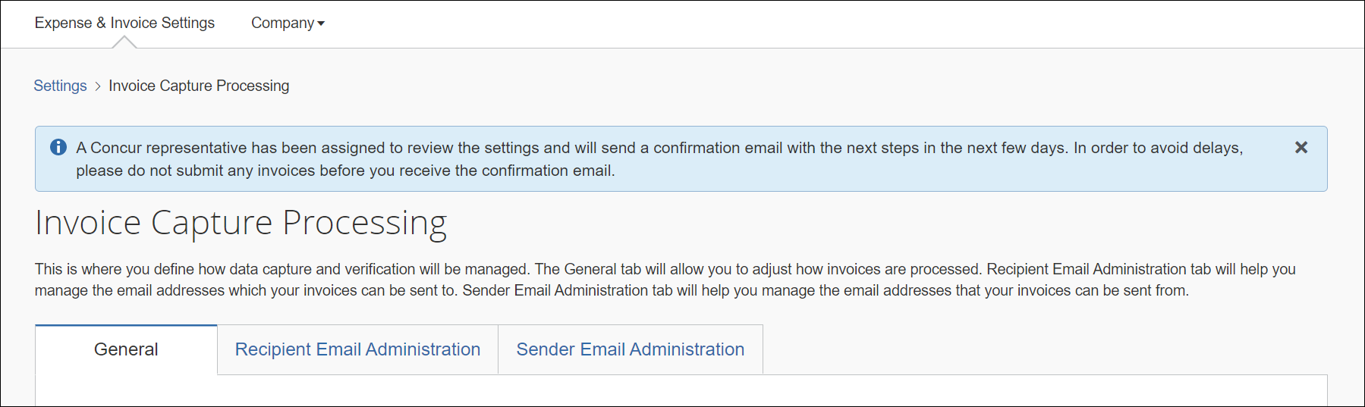
The General tab displays the Invoice Capture settings the administrator just saved, which can be modified as needed. The Recipient Email Administration and Sender Email Administration tabs allow administrators to set up and manage recipient and sender emails.
An onscreen message displays as a reminder that an SAP Concur representative will review the settings and send a confirmation email with next steps. Click X to close the message.

Recipient Email Administration Tab
Administrators click the Recipient Email Administration tab to set up email addresses and associate these email addresses and their attributes to suppliers. They can also edit and deactivate email addresses, and manage aliases on the Recipient Email Administration tab.
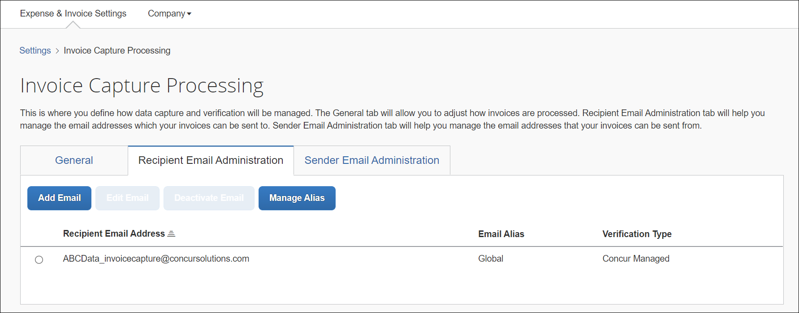
To manage alias names, administrators click the Manage Alias button to access the Manage Alias page.
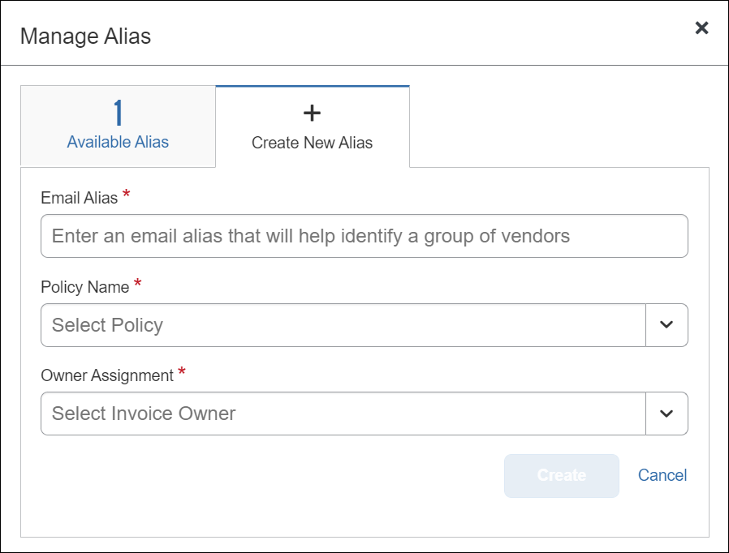
On the Create New Alias tab, administrators enter the alias name, select a policy type, and assign the invoice to an owner.
To view and manage aliases, admins click the Available Alias tab where they can edit or deactivate an alias.
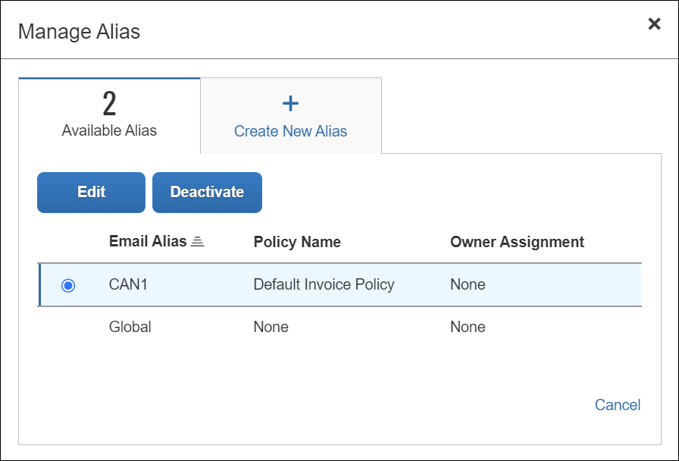

Sender Email Administration Tab
The Sender Email Administration tab includes options that allow administrators to manage email addresses provided by vendors (suppliers) and gathered by Invoice Capture Processing into a list provided on this page.
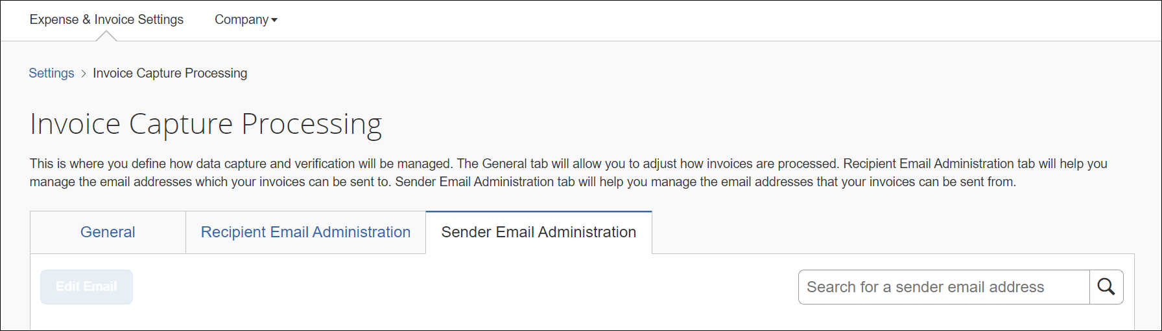

Clients Already Using Invoice Capture
Clients who are already actively using Invoice Capture will now manage their email addresses, alias names, and Invoice Capture settings from the new Invoice Capture Processing page in Product Settings.
Administrators will see three tabs on the Invoice Capture Processing page: General, Recipient Email Administration, and Supplier Email Administration. Each tab will display settings that have already been configured for the client.

Temporary Banner for Existing Clients
A banner appears at the top of the Invoice Capture Processing page alerting client administrators, who already have Invoice Capture configured, that a new administration experience is available. Click X to close the message.
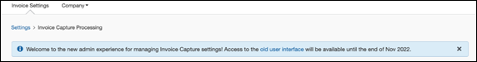
If necessary, administrators can revert to the previous UI experience by clicking the old user interface link in the banner. The option for existing administrators to switch between UIs is temporary and will be removed end of month November 2022.
In December 2022, the Capture Admin page will no longer be available from the Administration > Company menu and all Invoice Capture settings will be managed from the Invoice Capture Processing page.

Configuration / Feature Activation
This change occurs automatically.
Clients interested in using Invoice Capture can contact SAP Concur support for feature activation.
For more information, refer to the Concur Invoice: Capture Processing (Client-Managed) Setup Guide.
For general information, refer to the Concur Invoice: Capture Processing (Client-Managed) User Guide and the Concur Invoice: Capture Processing (Dual-Managed) User Guide.

Invoice Approvals

New Status Message for Approval Processing

Overview
Concur Invoice Approvers may see a new Approve Request Status message display. The most common case for this to occur is for Cost Object approval workflows, as typically multiple approvers will be approving at the same time.

Business Purpose / Client Benefit
This update helps streamline approval processing by alerting Approvers when the system is currently processing an approval for an invoice.

Approver Experience
Approvers may see the Approve Request Status message when the system is currently processing approvals on an invoice and when:
- An Approver has already approved the invoice and then clicks or double-clicks the Approve button again.
- A different Approver approves the same invoice while it’s currently being processed by the system.
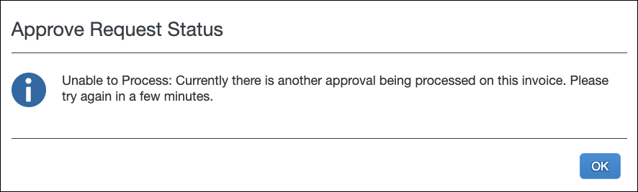
Approvers are advised to wait until the system has completed its current processing before proceeding.

Configuration / Feature Activation
This change occurs automatically.

Vendor Management

New Vendors from Embargoed Countries Now Blocked

Overview
In October 2022, Concur Invoice now requires all vendors to have the Country Code and Currency fields populated in the system. The Country Code and Currency field is a required field regardless of how a vendor record is input (through the API, imported, or manually input).
Additionally, embargoed countries no longer display in the Country Code list, preventing the creation of any new vendors who reside in embargoed countries from being added within Concur Invoice.
This change helps ensure that vendors whose address is originating from countries that fail to adhere to SAP's policy for conducting business with embargoed countries are no longer added in Concur Invoice. SAP policy prohibits the use of all SAP products and services in, from, or in support of, any business activities in locations where SAP products and services are not available. This list includes Cuba (CU), Iran (IR), North Korea (KP), Syria (SY), and regions of the Ukraine (Donestsk, Luhansk, and Crimea). This change also impacts the following currencies Cuba, Peso (CUP); Korea (Democratic); North Korean Won (KPW); Syria, Pound (SYP); Iran, Rial (IRR) from displaying in the Currency field.
Inactive vendors already in Concur Invoice that had embargoed countries/regions/currencies defined on the vendor record should no longer be used.

Business Purpose / Client Benefit
This change ensures clients follow local, national, and international laws governing embargoed countries, and are systematically protected to the best ability from malicious actors and actions when working with SAP Concur products.

Configuration / Feature Activation
This change occurs automatically.
For more information, refer to Concur Invoice: Vendor Import (On-Demand) User Guide for Standard Edition and Concur Invoice: Vendor Import (Scheduled) User Guide for Standard Edition.

Planned Changes
The items in this section are targeted for future releases. SAP Concur reserves the right to postpone implementation of – or completely remove – any enhancement/change mentioned here.
The planned changes listed in this document are specific to this product. For information about planned site-wide or shared changes that might impact your SAP Concur solutions, refer to the Shared Changes Release Notes.

Invoice Processing

**Planned Changes** Paper Invoice Processing to be Retired

Information First Published | Information Last Modified | Feature Target Release Date
July 2022 | — | December 31, 2022
Any changes since the previous monthly release are highlighted in yellow in this release note.

Overview
On December 31, 2022, the Concur Invoice paper invoice processing service of Invoice Capture will be retired. Clients that are still submitting paper invoices to SAP Concur for paper processing, or who have vendors still submitting paper invoices to SAP Concur for paper processing, are impacted by the pending retirement of this service.
Clients onboarded after July 1, 2022, are strongly discouraged from using this service as it will only be available through December 31, 2022.
Prior to December 2022, affected clients are encouraged to set up digital image capture processing in advance of the retirement date and develop a process to inform new or existing vendors to stop mailing paper invoices to SAP Concur for paper capture processing. All Invoice Capture clients have been provided with a unique, designated email address to which they or their vendors can submit electronic invoices to Concur Invoice.
To ensure digital images are sent to the Concur Invoice processing email address, clients can perform the following:
- Hire a third-party service to scan paper invoices and have someone at your organization email the digital invoices
- Use your own scanning equipment to scan paper invoices and email the digital invoices
- Take mobile phone pictures of the paper invoice and email the digital invoices
Please also refer to the client communication email distributed to all affected clients on July 5, 2022.

Business Purpose / Client Benefit
Retirement of the paper invoice processing helps clients streamline their invoice management by using digital image capture processing for invoices, reducing overall technology and operational costs.

Configuration / Feature Activation
This change will occur automatically.
Clients who want to set up digital image capture processing can call SAP Concur support to enable this feature.

Client Notifications

Accessibility

Accessibility Updates
SAP implements changes to better meet current Web Content Accessibility Guidelines (WCAG). Information about accessibility-related changes made to SAP Concur solutions is published on a quarterly basis. You can review the quarterly updates on the Accessibility Updates page.

Subprocessors

SAP Concur Non-Affiliated Subprocessors
The list of non-affiliated subprocessors is available from the SAP Sub-processors / Data Transfer Factsheets page.
To access the SAP Concur Sub-processors List:
- Click the following link to navigate to the SAP Sub-processors / Data Transfer Factsheets page:
SAP Sub-processors / Data Transfer Factsheets
- Sign in to the SAP Support Portal using your Support User ID (S-user) and password.
SAP customers must sign in to the SAP Support Portal using their Support User ID (S-user) and password. For information about S-User IDs, refer to Your New Support User ID (S-user).
- On the SAP Sub-processors / Data Transfer Factsheets page, type "Concur" in the Search field.
- In the Title column, click SAP Concur Sub-processors List.
If you have questions or comments, please reach out to: Privacy-Request@Concur.com

Supported Browsers

Supported Browsers and Changes to Support
For information about supported browsers and planned changes to supported browsers, refer to the Concur Travel & Expense Supported Configurations guide.
When changes to browser support are planned, information about those changes will also appear in the Shared Changes Release Notes.

Additional Release Notes and Other Technical Documentation

Online Help
You can access release notes, setup guides, user guides, admin summaries, supported configurations, and other resources via the in-product Help menu or on the SAP Help Portal.
To access the full set of documentation for your product, use the links in the SAP Concur Help menu, or search for your SAP Concur product (Concur Expense, Concur Invoice, Concur Request, or Concur Travel) on the SAP Help Portal (https://help.sap.com).

SAP Concur Support Portal – Selected Users
Access release notes, webinars, and other technical documentation on the SAP Concur support portal.
If you have the required permissions, Contact Support is available on the SAP Concur Help menu and in the SAP Concur page footer.
Click Contact Support to access the SAP Concur support portal, then click Resources.
- Click Release/Tech Info for release notes, technical documents, etc.
- Click Webinars for recorded and live webinars.

© 2022 SAP SE or an SAP affiliate company. All rights reserved.
No part of this publication may be reproduced or transmitted in any form or for any purpose without the express permission of SAP SE or an SAP affiliate company.
SAP and other SAP products and services mentioned herein as well as their respective logos are trademarks or registered trademarks of SAP SE (or an SAP affiliate company) in Germany and other countries. Please see http://global12.sap.com/corporate-en/legal/copyright/index.epx for additional trademark information and notices.
Some software products marketed by SAP SE and its distributors contain proprietary software components of other software vendors.
National product specifications may vary.
These materials are provided by SAP SE or an SAP affiliate company for informational purposes only, without representation or warranty of any kind, and SAP SE or its affiliated companies shall not be liable for errors or omissions with respect to the materials. The only warranties for SAP SE or SAP affiliate company products and services are those that are set forth in the express warranty statements accompanying such products and services, if any. Nothing herein should be construed as constituting an additional warranty.
In particular, SAP SE or its affiliated companies have no obligation to pursue any course of business outlined in this document or any related presentation, or to develop or release any functionality mentioned therein. This document, or any related presentation, and SAP SE’s or its affiliated companies’ strategy and possible future developments, products, and/or platform directions and functionality are all subject to change and may be changed by SAP SE or its affiliated companies at any time for any reason without notice. The information in this document is not a commitment, promise, or legal obligation to deliver any material, code, or functionality. All forward-looking statements are subject to various risks and uncertainties that could cause actual results to differ materially from expectations. Readers are cautioned not to place undue reliance on these forward-looking statements, which speak only as of their dates, and they should not be relied upon in making purchasing decisions.

