SAP Concur Release Notes
Concur Invoice Standard
Includes: Concur Invoice, Capture Processing, Invoice Pay, Purchase Requests, and Purchase Orders
Month | Audience
Release Date: February 19, 2022  Initial Post: Friday, February 18, 2022 | Client FINAL

Contents
Release Notes 3
Invoice Pay 3
General Availability of the Invoice Provider ACH Feature 3
Planned Changes 5
There are currently no planned changes. 5
Client Notifications 6
Accessibility 6
Accessibility Updates 6
Subprocessors 6
SAP Concur Non-Affiliated Subprocessors 6
Supported Browsers 6
Supported Browsers and Changes to Support 6
Additional Release Notes and Other Technical Documentation 7
Online Help 7
SAP Concur Support Portal – Selected Users 7

Legal Disclaimer
The information in this presentation is confidential and proprietary to SAP SE or an SAP affiliate company and may not be disclosed without the permission of SAP SE or the respective SAP affiliate company. This presentation is not subject to your license agreement or any other service or subscription agreement with SAP SE or its affiliated companies. SAP SE and its affiliated companies have no obligation to pursue any course of business outlined in this document or any related presentation, or to develop or release any functionality mentioned therein. This document, or any related presentation and SAP SE or an SAP affiliate company’s strategy and possible future developments, products and or platforms directions and functionality are all subject to change and may be changed by SAP SE and its affiliated companies at any time for any reason without notice. The information in this document is not a commitment, promise or legal obligation to deliver any material, code or functionality. This document is provided without a warranty of any kind, either express or implied, including but not limited to, the implied warranties of merchantability, fitness for a particular purpose, or non-infringement. This document is for informational purposes and may not be incorporated into a contract. SAP SE and its affiliated companies assume no responsibility for errors or omissions in this document, except if such damages were caused by SAP SE or an SAP affiliate company’s willful misconduct or gross negligence.
All forward-looking statements are subject to various risks and uncertainties that could cause actual results to differ materially from expectations. Readers are cautioned not to place undue reliance on these forward-looking statements, which speak only as of their dates, and they should not be relied upon in making purchasing decisions.

Release Notes
This document contains the release notes for Concur Invoice for standard edition.
Features and changes that apply to SAP Concur site-wide or to multiple products/services are documented in the Shared Changes Release Notes. For information about site-wide or shared changes in this release that might impact your SAP Concur solutions, refer to the Shared Changes Release Notes.

Invoice Pay

General Availability of the Invoice Provider ACH Feature

Overview
With the January 22, 2022 release, Invoice Provider ACH is now available to all direct clients. Currently, USD ACH payments by Bambora/Worldwide as the payment provider are supported for this feature.

Background
To better serve clients, Invoice Provider ACH is replacing the Classic Invoice Pay ACH feature as part of a transition of Invoice Pay to a payment provider solution for invoice payments. With the Invoice Provider ACH feature, fund transfers for ACH payments are handled by a third-party company (payment provider) instead of SAP Concur.
As of end of year 2021, only direct clients who purchased Invoice before June 21, 2021 were eligible to gain an Accepted status and use the Invoice Provider ACH feature to process funding accounts. Classic Invoice Pay ACH users were able to process batch payments up to November 15, 2021 after which new invoice payment processing was discontinued.
For more information on the retirement of the Invoice Pay ACH feature, refer to the Invoice Pay Solutions FAQ.

Business Purpose / Client Benefit
To better serve clients, Invoice Provider ACH is now available to all direct Invoice clients.

More Information
Please reference the guides listed below for more information.
For general information about Invoice Provider ACH, refer to the Concur Invoice Pay User Guide for Professional Edition or the Invoice Pay User Guide for Standard Edition.
For more information about creating and activating Invoice Provider ACH funding accounts, refer to the Concur Invoice: Invoice Provider ACH Setup Guide.

Planned Changes
The items in this section are targeted for future releases. SAP Concur reserves the right to postpone implementation of – or completely remove – any enhancement/change mentioned here.
The planned changes listed in this document are specific to this product. For information about planned site-wide or shared changes that might impact your SAP Concur solutions, refer to the Shared Changes Release Notes.

There are currently no planned changes.

Client Notifications

Accessibility

Accessibility Updates
SAP implements changes to better meet current Web Content Accessibility Guidelines (WCAG). Information about accessibility-related changes made to SAP Concur solutions is published on a quarterly basis. You can review the quarterly updates on the Accessibility Updates page.

Subprocessors

SAP Concur Non-Affiliated Subprocessors
The list of non-affiliated subprocessors is available here: SAP Concur list of Subprocessors
If you have questions or comments, please reach out to: Privacy-Request@Concur.com

Supported Browsers

Supported Browsers and Changes to Support
For information about supported browsers and planned changes to supported browsers, refer to the Concur Travel & Expense Supported Configurations guide.
When changes to browser support are planned, information about those changes will also appear in the Shared Changes Release Notes.

Additional Release Notes and Other Technical Documentation

Online Help
Any user can access release notes, setup guides, user guides, admin summaries, monthly browser certifications, supported configurations, and other resources via online Help or directly on the SAP Help Portal.
Use the links in the Help menu in the app, or search for your SAP Concur product (Concur Expense, Concur Invoice, Concur Request, or Concur Travel) on the SAP Help Portal (https://help.sap.com) to view the full set of documentation for your product.

SAP Concur Support Portal – Selected Users
Access release notes, webinars, and other technical documentation on the SAP Concur support portal.
If you have the proper permissions, Contact Support appears on the Help menu. Click to access the SAP Concur support portal, then click Resources.
- Click Release/Tech Info for release notes, technical documents, etc.
- Click Webinars for recorded and live webinars.
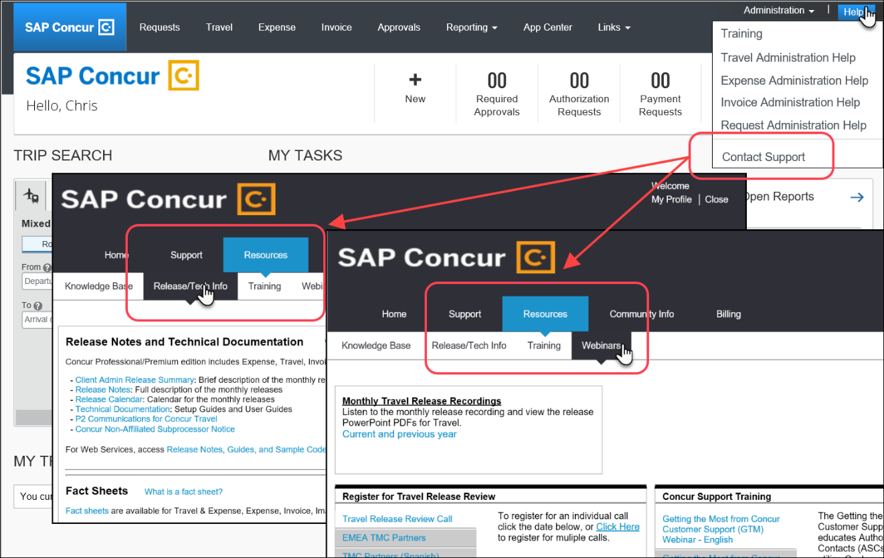
© 2022 SAP SE or an SAP affiliate company. All rights reserved.
No part of this publication may be reproduced or transmitted in any form or for any purpose without the express permission of SAP SE or an SAP affiliate company.
SAP and other SAP products and services mentioned herein as well as their respective logos are trademarks or registered trademarks of SAP SE (or an SAP affiliate company) in Germany and other countries. Please see http://global12.sap.com/corporate-en/legal/copyright/index.epx for additional trademark information and notices.
Some software products marketed by SAP SE and its distributors contain proprietary software components of other software vendors.
National product specifications may vary.
These materials are provided by SAP SE or an SAP affiliate company for informational purposes only, without representation or warranty of any kind, and SAP SE or its affiliated companies shall not be liable for errors or omissions with respect to the materials. The only warranties for SAP SE or SAP affiliate company products and services are those that are set forth in the express warranty statements accompanying such products and services, if any. Nothing herein should be construed as constituting an additional warranty.
In particular, SAP SE or its affiliated companies have no obligation to pursue any course of business outlined in this document or any related presentation, or to develop or release any functionality mentioned therein. This document, or any related presentation, and SAP SE’s or its affiliated companies’ strategy and possible future developments, products, and/or platform directions and functionality are all subject to change and may be changed by SAP SE or its affiliated companies at any time for any reason without notice. The information in this document is not a commitment, promise, or legal obligation to deliver any material, code, or functionality. All forward-looking statements are subject to various risks and uncertainties that could cause actual results to differ materially from expectations. Readers are cautioned not to place undue reliance on these forward-looking statements, which speak only as of their dates, and they should not be relied upon in making purchasing decisions.

