SAP Concur Release Notes
Concur Expense Standard Edition
Month | Audience
Release Date: April 2024  Initial Post: April 19, 2024 | Client FINAL

Contents
Release Notes 1
Custom Fields 1
Next Generation: Check Box Data Value is Now False and not Null 1
Expense Types Redesign 2
**Ongoing** Updated User Interface (UI) for Expense Types 2
Expense Types 4
Enhanced Expense Types Administration 4
Mileage Service 14
Update - Administrator Delegating for a User May Reset Initial Distance Mileage for Personal Car 14
Miscellaneous 15
Keyboard Shortcuts for Expense Screens 15
Value Added Tax (VAT) / Tax Administration 16
New Country Pack with Tax Support for Malaysia 16
Planned Changes 18
Company Card 18
**Planned Changes** Enhancements to the Manage Transactions Screen 18
Receipts – ExpenseIt for Web 21
**Planned Changes** Single Combined Option to Select ExpenseIt for Email and Web Now Two Separate Options 21
Reports 21
**Planned Changes** Enhancements to the Report Timeline 21
**Planned Changes** Preferred Name for Expense Submitter 23
User Interface Changes 24
**Planned Changes** Update to the Report Status Indicator 24
Client Notifications 25
Accessibility 25
Accessibility Updates 25
Gender Diversity 25
Gender Diversity Planned Features and Changes 25
In-Product User Assistance 25
Client Customized Content 25
Subprocessors 26
SAP Concur Non-Affiliated Subprocessors 26
Supported Browsers 26
Supported Browsers and Changes to Support 26
Additional Release Notes and Other Technical Documentation 27
Online Help 27
SAP Concur Support Portal – Selected Users 27
Cases 28
Check Support Case Status 28

Legal Disclaimer
The information in this presentation is confidential and proprietary to SAP SE or an SAP affiliate company and may not be disclosed without the permission of SAP SE or the respective SAP affiliate company. This presentation is not subject to your license agreement or any other service or subscription agreement with SAP SE or its affiliated companies. SAP SE and its affiliated companies have no obligation to pursue any course of business outlined in this document or any related presentation, or to develop or release any functionality mentioned therein. This document, or any related presentation and SAP SE or an SAP affiliate company’s strategy and possible future developments, products and or platforms directions and functionality are all subject to change and may be changed by SAP SE and its affiliated companies at any time for any reason without notice. The information in this document is not a commitment, promise or legal obligation to deliver any material, code or functionality. This document is provided without a warranty of any kind, either express or implied, including but not limited to, the implied warranties of merchantability, fitness for a particular purpose, or non-infringement. This document is for informational purposes and may not be incorporated into a contract. SAP SE and its affiliated companies assume no responsibility for errors or omissions in this document, except if such damages were caused by SAP SE or an SAP affiliate company’s willful misconduct or gross negligence.
All forward-looking statements are subject to various risks and uncertainties that could cause actual results to differ materially from expectations. Readers are cautioned not to place undue reliance on these forward-looking statements, which speak only as of their dates, and they should not be relied upon in making purchasing decisions.

Release Notes
This document contains the release notes for Concur Expense Standard edition.
Features and changes that apply to SAP Concur site-wide or to multiple products/services are documented in the Shared Changes Release Notes. For information about site-wide or shared changes in this release that might impact your SAP Concur solutions, refer to the Shared Changes Release Notes.

Custom Fields

Next Generation: Check Box Data Value is Now False and not Null

Overview
On April 9th, a change to the behavior under the Next Generation (NextGen) user interface is applied to check boxes created using the custom fields feature. Now, for an unselected check box, the system will always send a value of False instead of a value of Null to match the behavior of the previous user interface.
This feature standardizes the behavior of the NextGen and prior user interfaces so that a value of False is the default value sent by NextGen to Expense and this same value will appear on data extraction.

Administrator Experience
The administrator tasked with data extraction will no longer see a value of Null when working with an unselected check box under the NextGen user interface but will instead see a value of False just as they did under the earlier user interface.

Configuration / Feature Activation
The change will occur automatically; there are no additional configuration steps.

Expense Types Redesign

**Ongoing** Updated User Interface (UI) for Expense Types

Information First Published | Information Last Modified | Feature Target Release Date
August 2023 | April 12, 2024 | Q3 2023 – Q4 2024
Any changes since the previous monthly release are highlighted in yellow in this release note.

Overview
SAP Concur is redesigning the Concur Expense UI experience for expense types screens to give product admins a new user experience while creating and managing expense types. These changes will take place between Q3 2023 and throughout 2024.
The new design provides a modern, consistent, and streamlined user experience for Concur Expense admins.
As of April 16-17th, 2024, the redesigned version of expense types now becomes the default version for Concur Expense customers. Customers can continue to use the legacy version if they wish to do so until it is no longer available.

Products and Users Affected
To take advantage of these improvements, Concur Expense customers will be encouraged to transition to the redesigned version of expense types in Concur Expense. The following provides information about the timeline and resources available to ensure this process is smooth and efficient for all users.
These UI changes apply to:
- Standard version of Concur Expense
- Admins; there are no changes for end users, approvers, or processors.

IMPORTANT: Timeline and Milestones
There are three important milestones for Concur Expense customers as they transition from the existing legacy UI for Expense Types to the redesigned version.
- Phase 1: October 2023
In October 2023, customers who had the basic configuration of Concur Expense were offered an Opt-In Period, to try out the redesigned Expense Types.
The redesigned version of expense types was not available for customers who had advanced features such as Policy Groups, Multiple Country Packs, and so on, enabled for their organization. If the customers with the basic configuration chose to enable advanced settings, then they automatically reverted to the legacy version.
Customers used this period to plan their transition and moved to the redesigned expense types when it was right for their business priorities.
During the Opt-In Period, not all Concur Expense features from the existing UI were available in the redesigned user interface.
During the first phase, only the Manage Expense Types screens was covered under the redesigned version.
Any decision to opt-in or opt-out was a company-wide decision and was applicable to all the admins in the company.
- Phase 2: April 2024
On April 16th, 2024, all customers are automatically made to default to the redesigned version of expense types, regardless of the configuration. They still have the chance to access the legacy screens. These changes are available from April 2024.
The features planned for this phase includes a First Run Experience for new customers, Policy Groups, Alternate Account Codes, Multiple Country Packs, and Item Code Mapping for financial integrations.
- Phase 3: TBD
During this period, all customers will be automatically transitioned to the redesigned UI and will not be able to access the legacy screens of expense types any longer.
This ensures that we continue to offer a consistent user experience for all customers and allows for superior product innovation and support. We have not yet set a date for these changes.

Transition Materials – Guides and Other Resources
Customers can use the Concur Expense: Expense Types Setup Guide to learn more about the changes happening in expense types. Along with the setup guide, we also offer release notes, and other resources to aid in the transition.
To help with training needs, customers can create custom training materials by using the setup guide "as is". They can cut, copy, paste, delete, or otherwise edit either guide at will.
- Setup guide: This guide compares the legacy user interface to the redesigned version for Concur Expense to help users become comfortable with the new experience. This guide will be updated as needed during the Opt-In Period as the redesigned UI is being enhanced. Admins should review the guide often.
The customer can cut, copy, paste, delete, or otherwise edit this guide at will.
- Release information: During the Opt-In Period, the release of enhancements will not be on the regular release schedule. Instead, SAP Concur will provide special release notes and information about features and enhancements that are nearing release.

Getting Started
Customers are encouraged to use the transition materials described above and develop a plan for the transition.
For more information on the exact changes, please refer to the Expense Types | Enhanced Expense Types Administration release note in this document.

Expense Types

Enhanced Expense Types Administration

Overview
Over the next few months, SAP Concur will redesign the Concur Expense UI experience of the Manage Expense Types screens to give the product admins a modern, intuitive, and streamlined experience for creating and managing expense types.
This update facilitates better configuration and reduces complexity, time, and effort involved for administrators when setting up expense types.
As of April 16-17th, 2024, the redesigned version of expense types is the default version for Concur Expense customers. They will still have the ability the use the legacy version if they wish to do so until it is no longer available.
Refer to the Expense Types Redesign | **Ongoing** Updated User Interface (UI) for Expense Types release note in this document.
SAP Concur offers a First Run Experience to new customers setting up Concur Expense for the first time using the Activation Wizard. The First Run Experience is an intuitive, two-step process that will guide new customers in setting up their expense types. This experience is not available to existing customers.
The enhanced features such as Alternate Account Codes, Policy Groups, Multiple Country Packs, and Item Code Mapping for Financial Integration are offered in the redesigned user interface for all customers.

Administrator Experience

First Run Experience for New Customers
For the first time set up process, navigate to expense types for Expense through the Configuration Wizard to view the Your Expense Types Setup welcome screen. Click Set Up Now to configure your expense types.
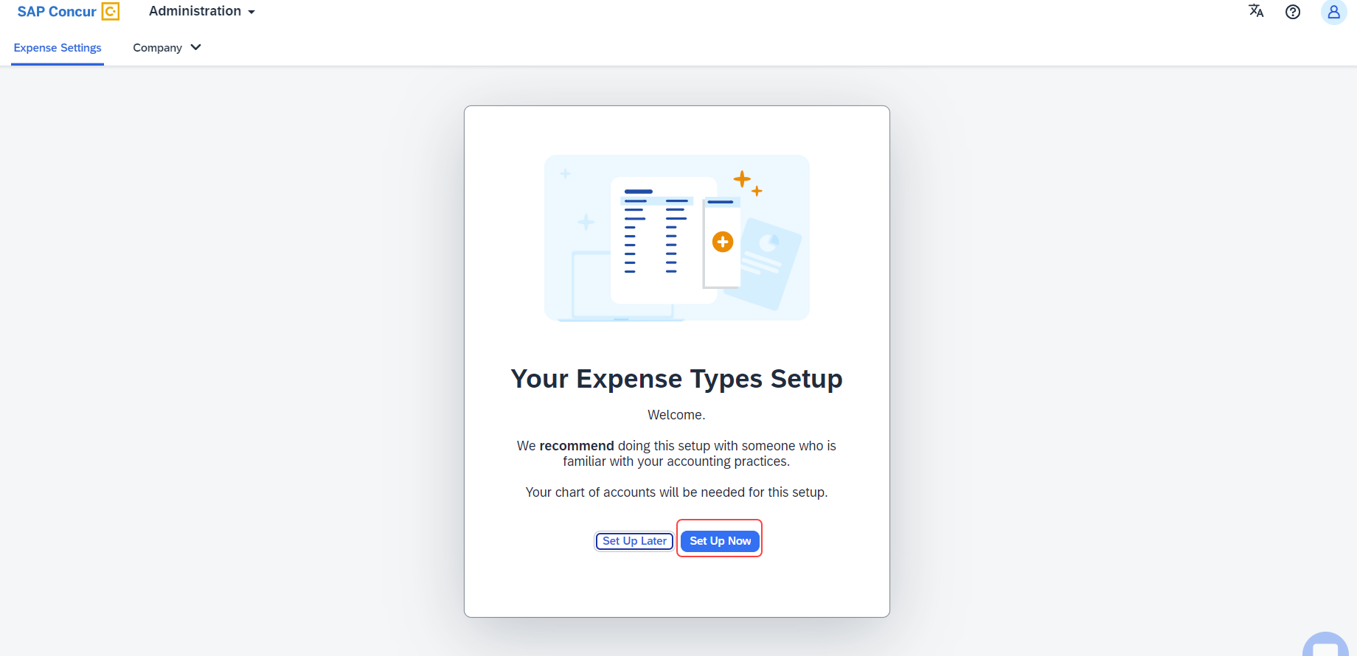
An introductory screen displays in the next screen. Proceed to click Select Expense Types to continue setting up the expense types.
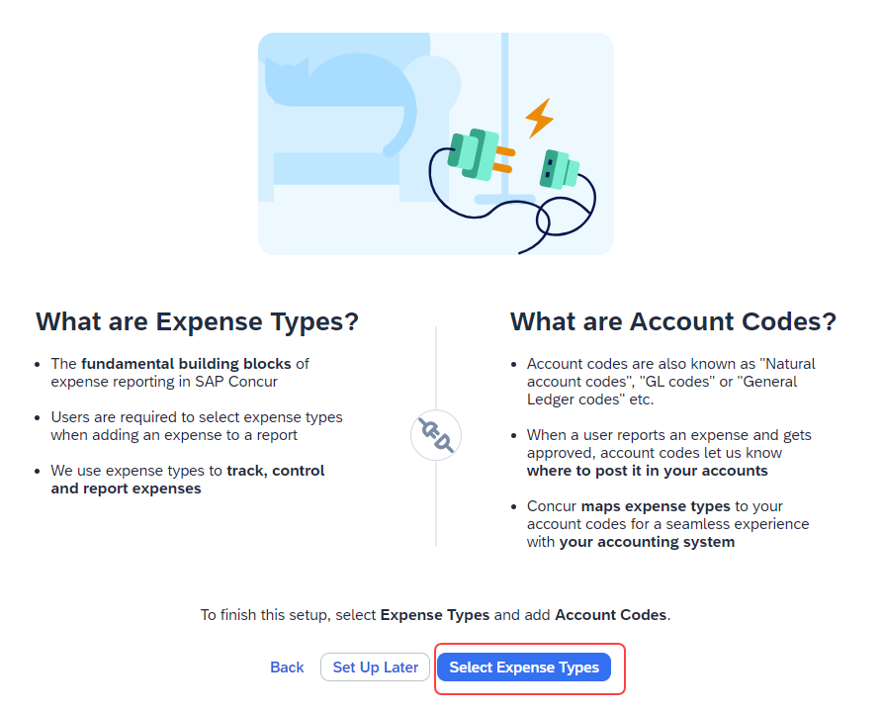
The Your Expense Types Setup screen displays. There are two steps in setting up your expense types. The step progress bar at the top of the screen indicates the progress in the setup process.
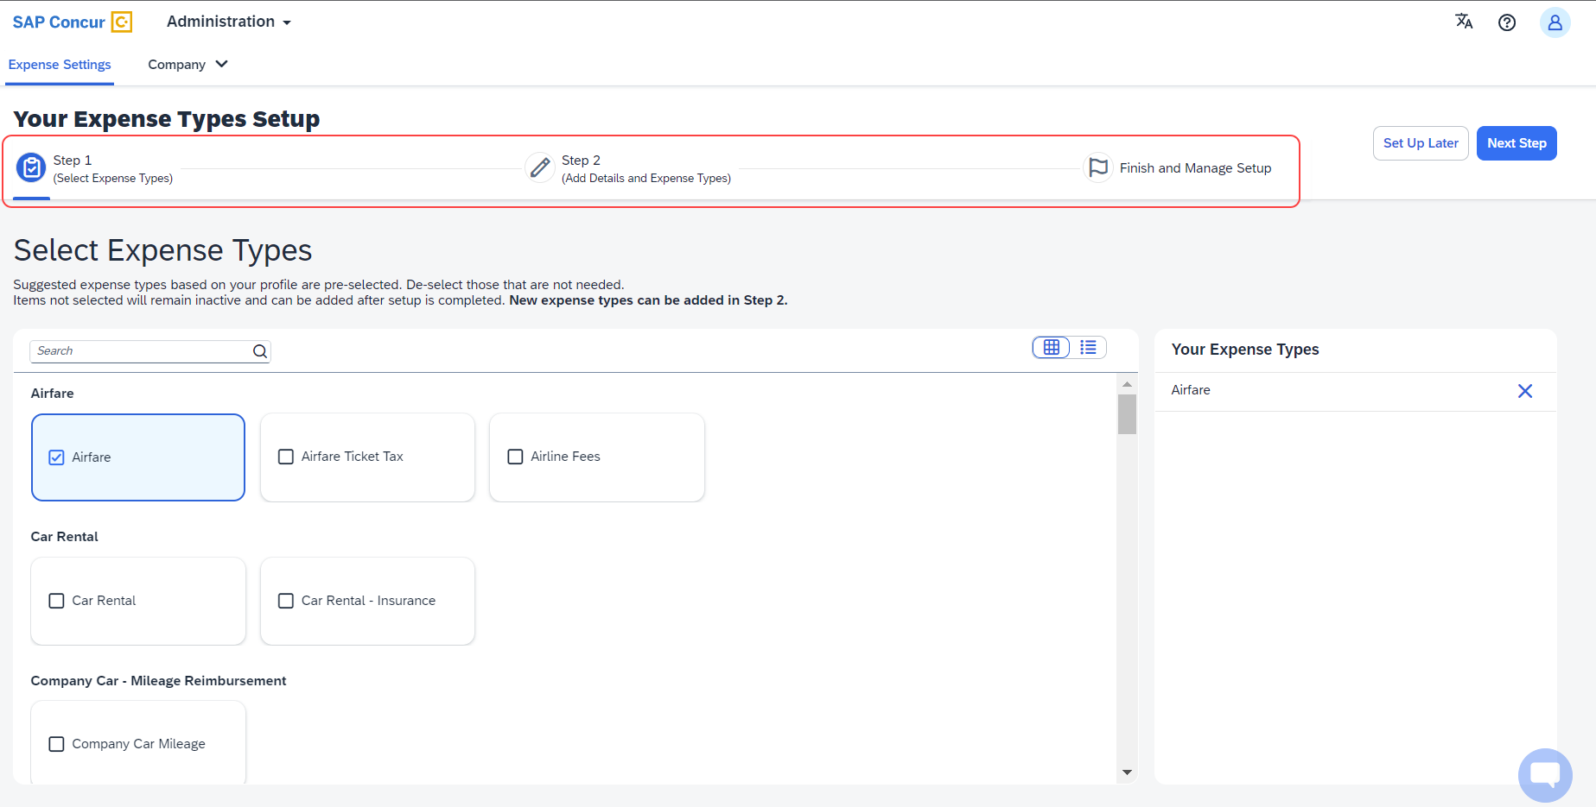
The first step of the First Run Experience now displays. In the Select Expense Types screen, you must check or uncheck the tiles to select your desired expense types.
Concur Expense displays the most used expense types as suggestions. Based on your selections, the Your Expense Types list on the right pane shows the selected expense types.
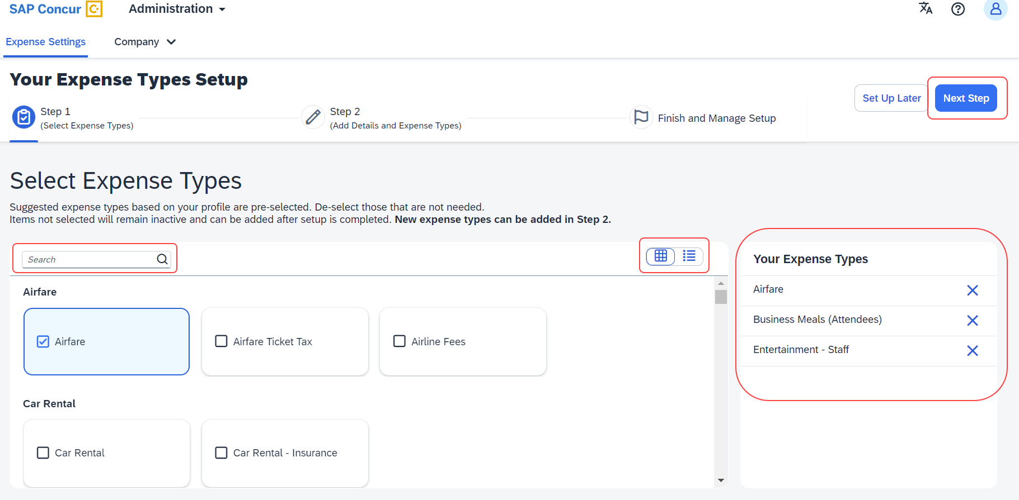
Toggle between card view and list view using the button. Use the search box to search for a specific expense type. When you have made your selections, click Next Step. Click Next to add details to your expense types.
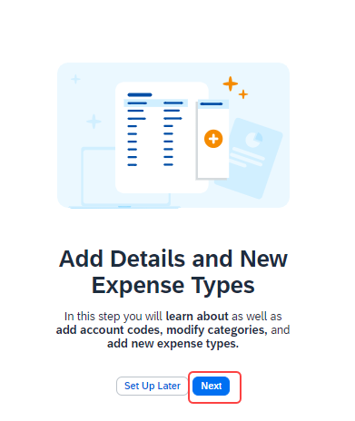
The second step of the First Run Experience displays next.
In the Add Details and Expense Types screen, you can add details to your expense types such as Account Codes, Category, Activation & Limits, and so on, or even create custom expense types.
The progress bar in the top right displays the number of expense types with complete details. The fully configured expense types are indicated using a green check mark listed in the Your Expense Types section. The red X mark indicates that the account codes are missing. Click Save and Next to save the changes.
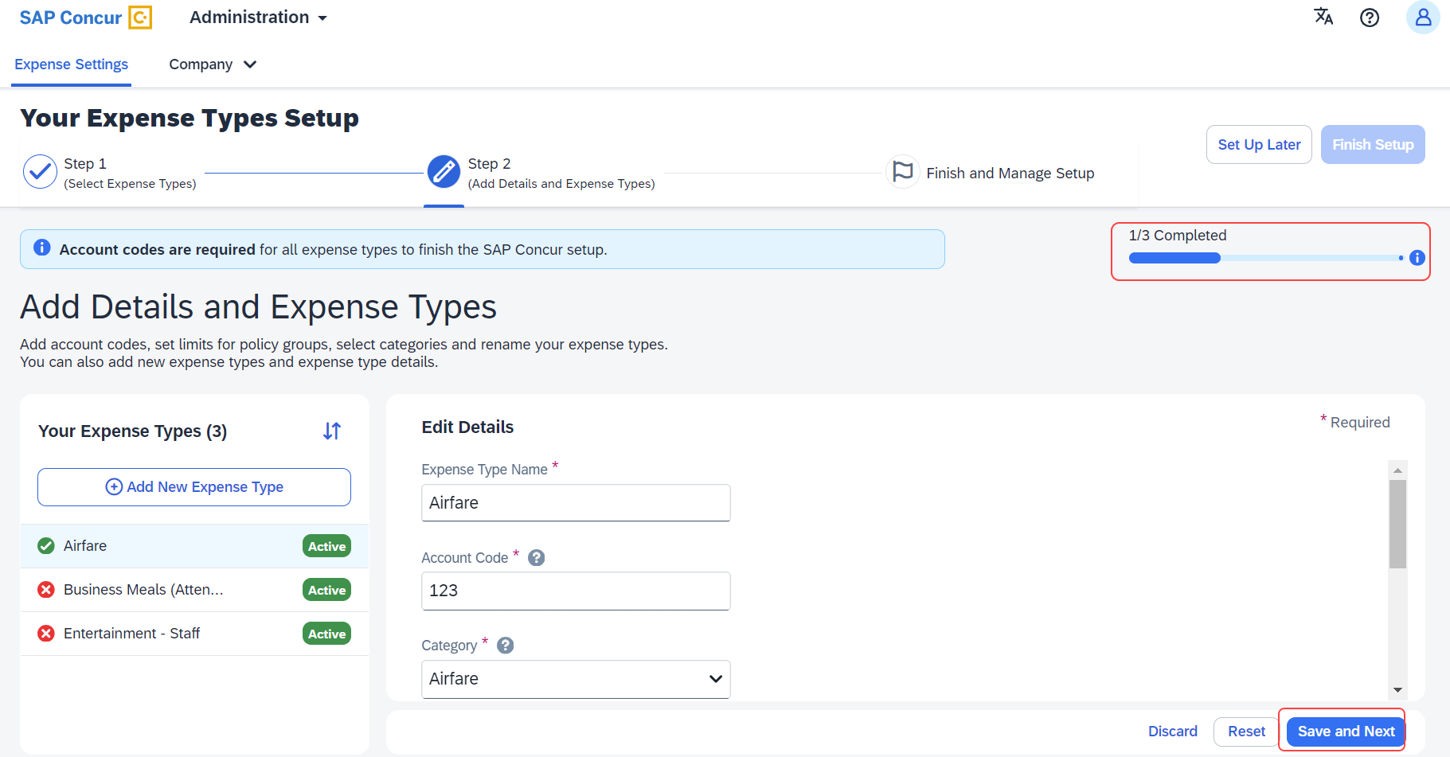
A success message displays when you complete setting up the expense types. The progress bar reflects the completion status as well. Click Finish Setup to exit the screen.
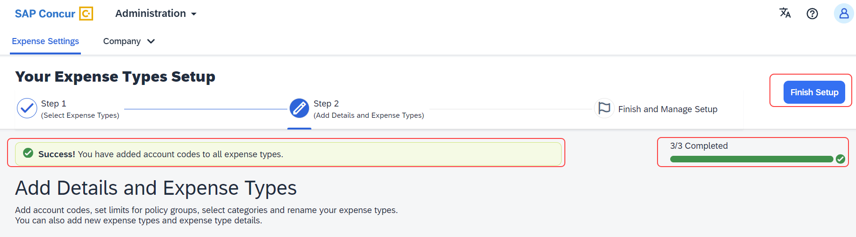
Next, click Take me to my Expense Types to be directed to the Manage Expense Types screen. The congratulatory banner displays indicating that the expense types are set up successfully. This indicates the end of the First Run Experience.
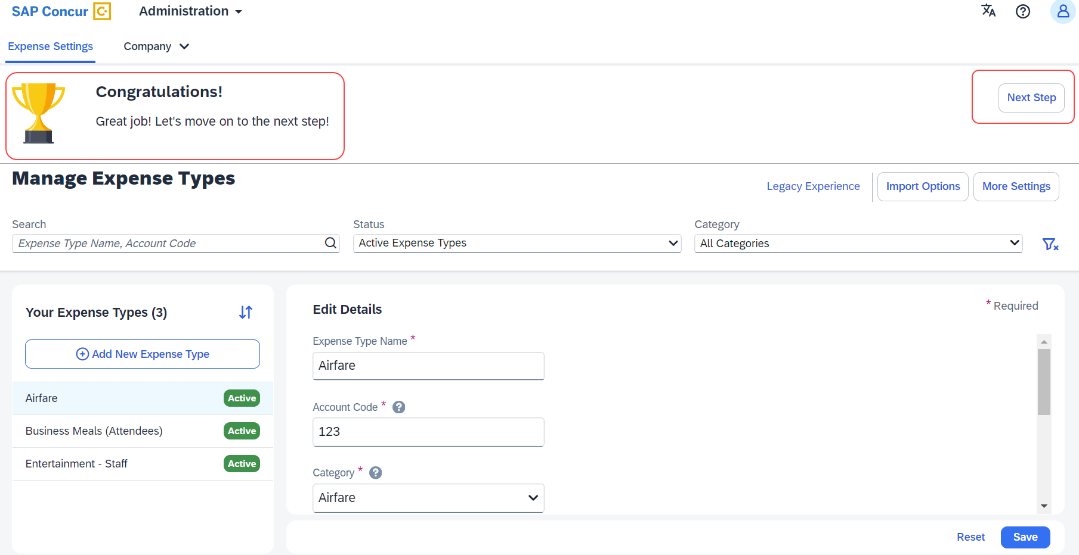
Click Next Step to navigate back to the Activation Wizard to complete setting up Concur Expense. You can postpone setting up your expense types if you select Set Up Later.

Legacy UI: Policy Groups: Activation & limits
In the existing UI, you could select the preconfigured policy groups in the Expense Types screen from the dropdown menu where all the available policy groups for your entity were listed.
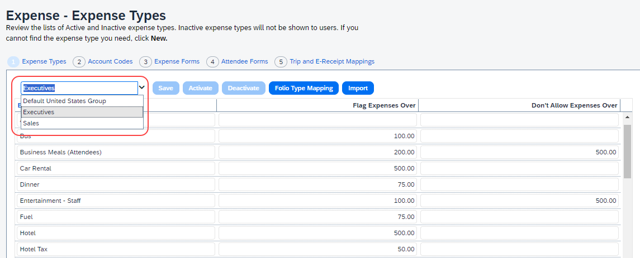

Redesigned UI: Policy Groups: Activation & limits
In the new experience, when there are multiple country packs, they display on the Manage Expense Types screen, in the Edit Details > Policy Groups: Activation & Limits section.
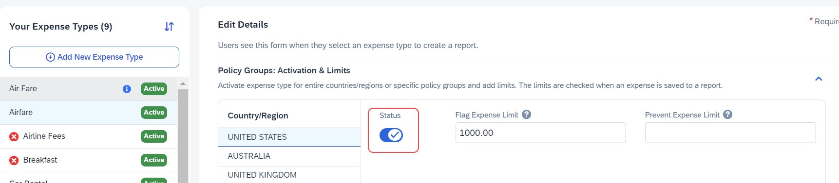
Use the Status toggle button to switch on or off the country pack for an entity. When there are Policy Groups configured for these countries, you can make granular changes to these policy groups as show in the following image. You can set limits, activate, or deactivate expense types, and so on.
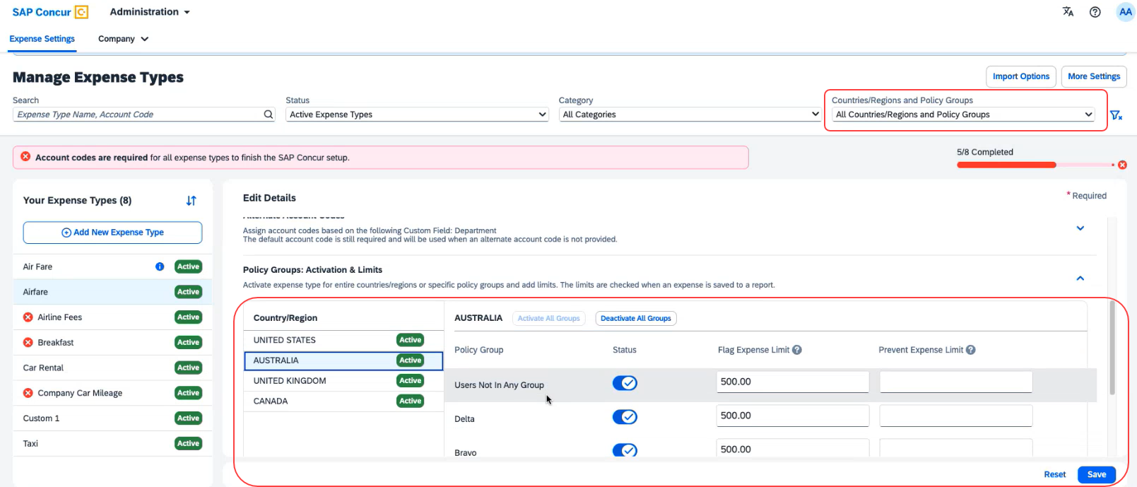
You can search using Countries/Regions and Policy Groups as a filter in the Manage Expense Types screen.

Legacy UI: Alternate Account codes
If there are alternate account codes to be set up, you could set up the same in the Expenses – Expense Types > Account Codes tab. You were able to select the list item from the account code driver list and configure them.
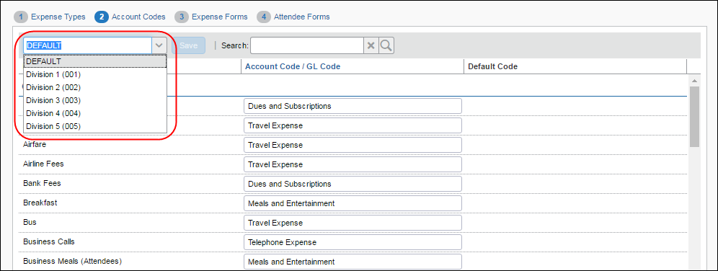

Redesigned UI: Alternate Account codes
In the redesigned UI, you can set up alternate account codes in the Edit Details > Alternate Account Codes section.
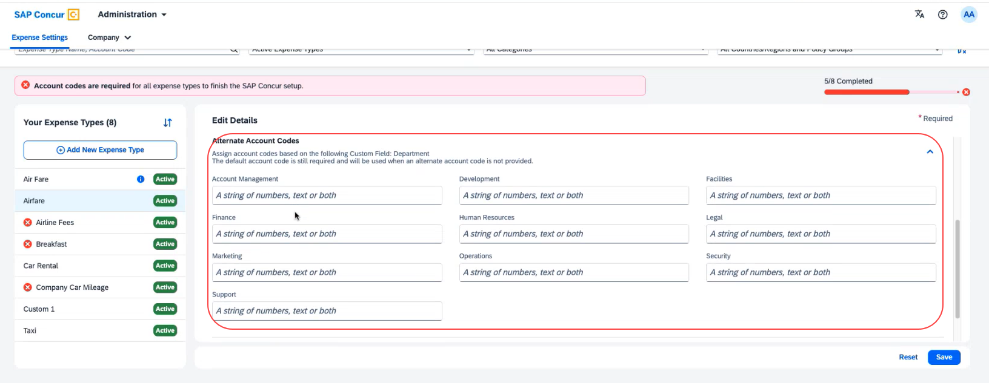

Legacy UI: Item code mapping for financial integrations
If you connected Concur Expense to your financial system using one of SAP Concur's financial integrations, you were able to see options on the Expense – Account Codes page specific to your financial system in the legacy UI.
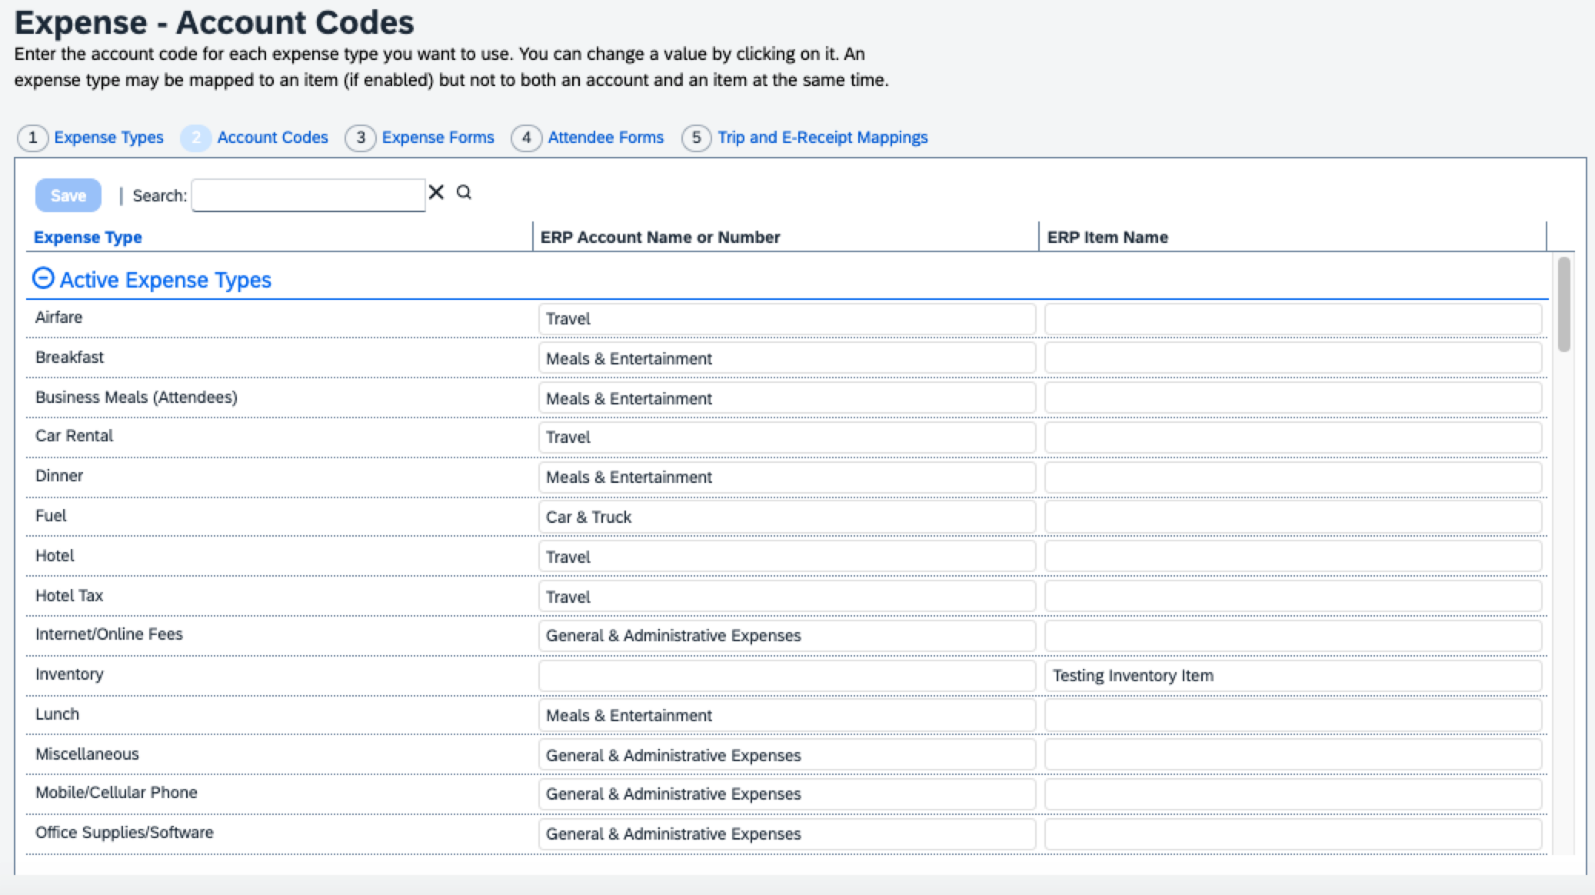

Redesigned UI: Item code mapping for financial integrations
In the redesigned UI, the Account Code field becomes Default Account Code with a dropdown menu for each Expense Type.
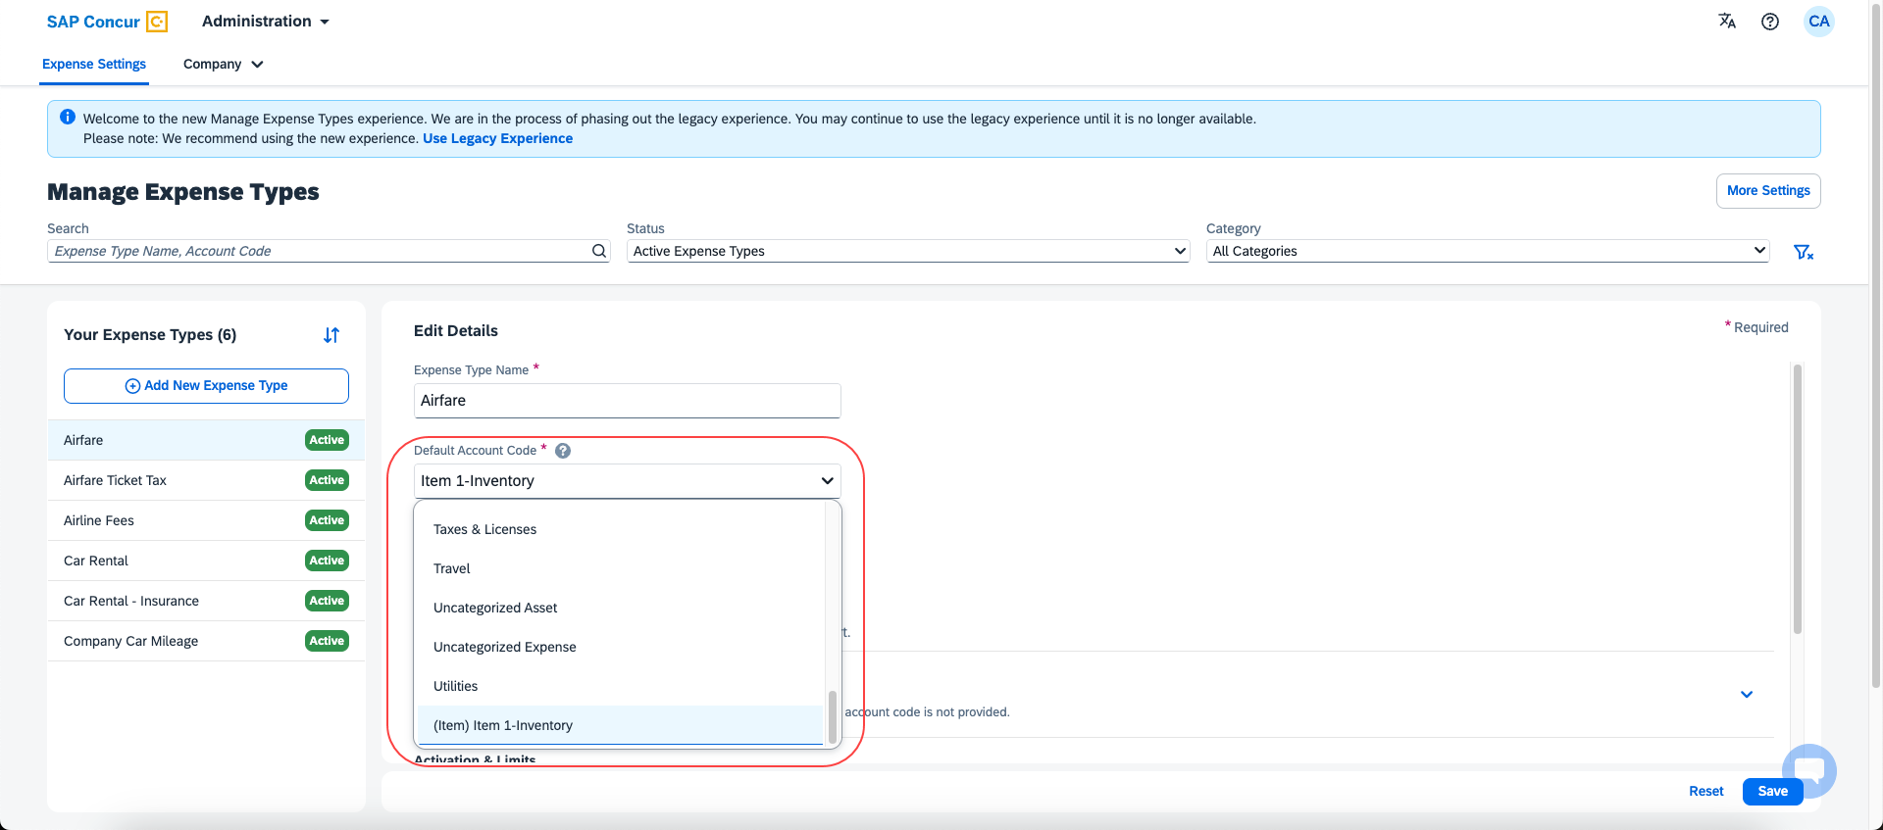

Configuration/Feature Activation
The new redesigned version is automatically made the default version as of April 2024; there are no additional configuration steps.
If you wish to opt out of this experience, click Use Legacy Experience. Your view will return to the legacy screens.
For more information on the exact changes, refer to the Expense Types Redesign| **Ongoing Changes** Updated User Interface (UI) for Expense Types release note in this document. For general information, refer to the Concur Expense: Expense Types Setup Guide.

Mileage Service

Update - Administrator Delegating for a User May Reset Initial Distance Mileage for Personal Car

Overview
In the February release notes it was stated that the administrator for Expense Professional or Standard edition, while delegating for a user, could now reset the initial distance of the user’s personal car. With this release, the Can Administer role in Standard and the Expense Configuration administrator (Restricted) role in Professional may now perform this task for their users.
This feature change lets the client assign the role and complete this task at their site, providing flexibility and is a result of feedback from our client base.

Configuration / Feature Activation
The change will occur automatically; there are no additional configuration steps.
For more information refer to the Concur Expense: Car Configuration Setup
Guide, the Concur Expense: Mileage Service Setup Guide, and the Concur Expense: Mileage Service Setup Guide for Concur Standard Edition.

Miscellaneous

Keyboard Shortcuts for Expense Screens

Overview
SAP Concur has enabled convenient keyboard shortcuts in selective Concur Expense screens such as Expense Home, Report Page, and Expense Entry Page. This update offers users a more convenient way to navigate the expense application faster, ultimately improving productivity, efficiency, and user satisfaction.
This feature will currently be available in English only.

End-User Experience
On selective Expense screens such as Expense Home, Report Page, and Expense Entry Page, press SHIFT + / to view the available shortcuts and to toggle the keyboard shortcuts ON or OFF.
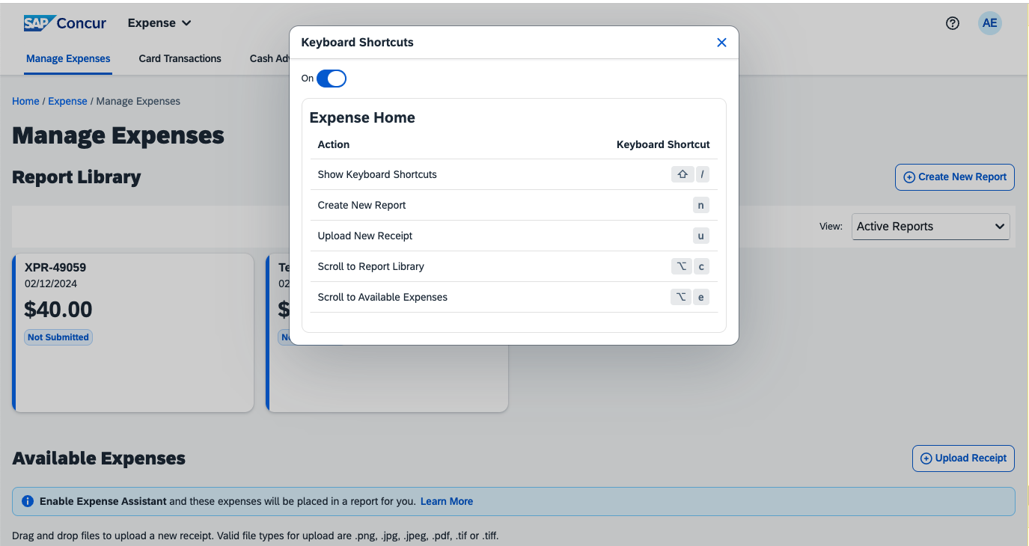
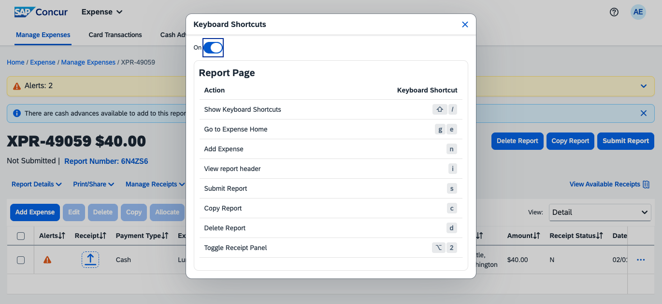
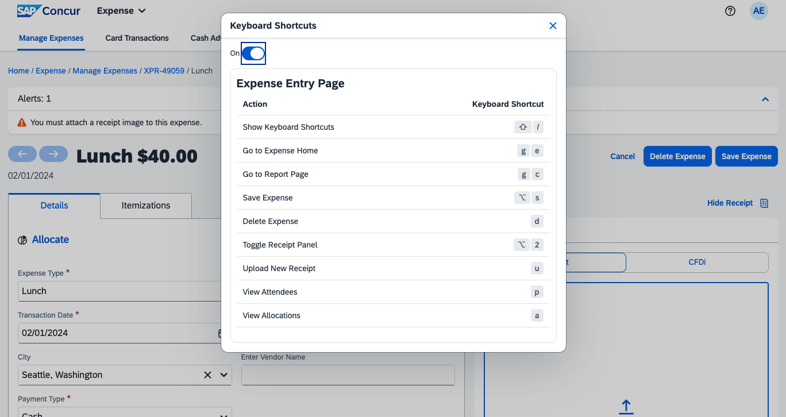

Configuration / Feature Activation
The change occurs automatically; there are no additional configuration steps.

Value Added Tax (VAT) / Tax Administration

New Country Pack with Tax Support for Malaysia

Overview
A new country pack with tax support is now available for Malaysia as a part of Concur Expense Standard Edition.
This release contains a new statutory rate bundle with pre-configured tax rates and calculations for reclaiming VAT (or Sales and Services Tax (SST), as it is known in Malaysia) paid on various employee reimbursements.
IMPORTANT: This solution is available for existing as well as new clients.
The pack only considers VAT on Standard Services as it is applicable to consumers and hence eligible for reimbursement and reclaim. The pack automates the creation of Tax Authority, Tax Group, Tax Conditions, Tax Rate, Reclaim Conditions, Reclaim Rate, etc. and it is non-configurable at the client’s end.
The clients get pre-configured tax rates and calculations for reclaiming Sales and Services Tax (SST) paid on various employee reimbursements in compliance with the government regulations in Malaysia.

Configuration / Feature Activation
Contact your Regional Sales Executive at SAP Concur to get this country pack.
For general information about this functionality, refer to the Concur Expense: Taxation Setup Guide.

Planned Changes
The items in this section are targeted for future releases. SAP Concur reserves the right to postpone implementation of – or completely remove – any enhancement/change mentioned here.
The planned changes listed in this document are specific to this product. For information about planned site-wide or shared changes that might impact your SAP Concur solutions, refer to the Shared Changes Release Notes.

Company Card

**Planned Changes** Enhancements to the Manage Transactions Screen

Information First Published | Information Last Modified | Feature Target Release Date
March 2024 | -- | Late May, 2024
Any changes since the previous monthly release are highlighted in yellow in this release note.

Overview
In late May, enhancements to the Manage Transactions screen will be available to the Company Card administrator for evaluation. These changes will be visible by default and the administrator may work with the new user interface and then decide to revert to the earlier version or continue with the newer version which will become the default user interface in an upcoming release.
More feature information will be available in an upcoming release note.
This feature improves the company card experience by automatically displaying search results from the previous 30 days with the ability to perform a more complex search that displays hidden, visible, duplicate, and expensed transactions in a column order view familiar to administrators working in a financial statement format.

Administrator Experience
The Company Card administrator will see the simple search format of employee transactions of the previous 30 days. Transactions that are both hidden and visible to employees (including transactions that are already on an expense report) will be returned.
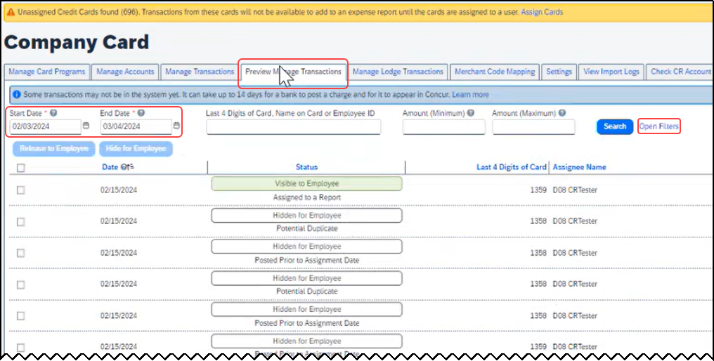
From this simple format, the administrator clicks Open Filters to refine the search:
The Last 4 Digits… search now combines the logic for all the potential typed values:
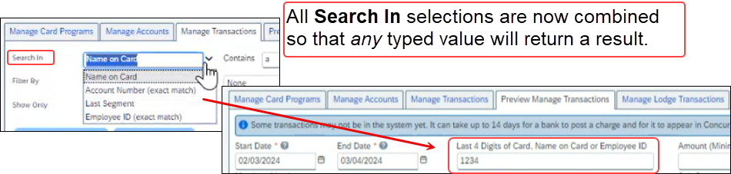
Duplicate transactions are displayed using the Potential Duplicate attribute, and the informational window includes a link to release the transaction to the employee:
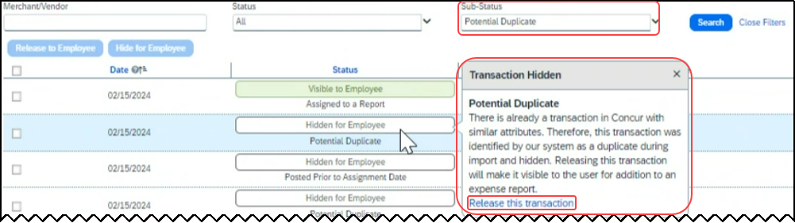
Transactions both already assigned to a report or posted prior to assignment date are clearly marked. For some status types, hovering a cursor opens an informational window describing the condition, action, and links to take action as needed:
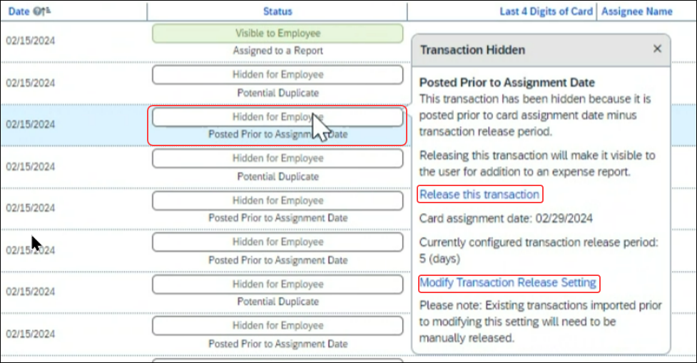

Moving Between the Two Manage Transactions Windows
In the figures above both the Manage Transactions and Preview Manage Transactions tabs are shown for clarity. Only a single tab will be displayed for the benefit of the administrator, who may move from the new user interface to the original interface using the Revert to prior experience link.

Configuration / Feature Activation
The change to the new user interface is visible by default and the administrator may revert to the original interface as needed. Note the new interface will display at any time the administrator moves from the screen and back again in a single session.

Receipts – ExpenseIt for Web

**Planned Changes** Single Combined Option to Select ExpenseIt for Email and Web Now Two Separate Options

Information First Published | Information Last Modified | Feature Target Release Date
April, 2024 | -- | May, 2024
Any changes since the previous monthly release are highlighted in yellow in this release note.

Overview
In May, users of ExpenseIt will have two separate options that let them control how ExpenseIt works for email and on the internet. With this change, an ExpenseIt user may open their expense preferences through their Profile Settings and work with the following options:
- Use ExpenseIt to create expenses from uploaded receipts on the web
- User ExpenseIt to create expenses from receipts mailed to receipts@concur.com

Default Behavior for New and Existing Users
Existing users who disabled the single, combined control will see both new, separate options disabled. New users will always see both options enabled by default.

Configuration / Feature Activation
No end-user action is required: ExpenseIt is automatically enabled the week of January 15, 2024, for all end-users on entities that have purchased ExpenseIt.

Reports

**Planned Changes** Enhancements to the Report Timeline

Information First Published | Information Last Modified | Feature Target Release Date
April 12, 2024 | -- | April 23, 2024
Any changes since the previous monthly release are highlighted in yellow in this release note.

Overview
The user interface for the Report Timeline feature in an expense report will be enhanced and will display updated icons and layout. Some additional details will also display when compared to what is currently displayed.
This feature will provide users with improved usability and will ensure report timeline user interface is easily accessible.

Phases
This feature will be released to specific verticals, vendors, and data centers in April 2024:

Phase | Date of Release
Phase 1: All customer test entities | April 16, 2024
Phase 2: All production entities | April 23, 2024

End-User Experience
Open an expense report and click Report Details > Report Timeline to see the new enhancements in the Report Timeline screen. You will see more information than was previously available, along with the status of the report and names of the approvers.
In the Approval Workflow section, the UI will be improved to display updated icons, approver names along with time and date of approval.
Example:
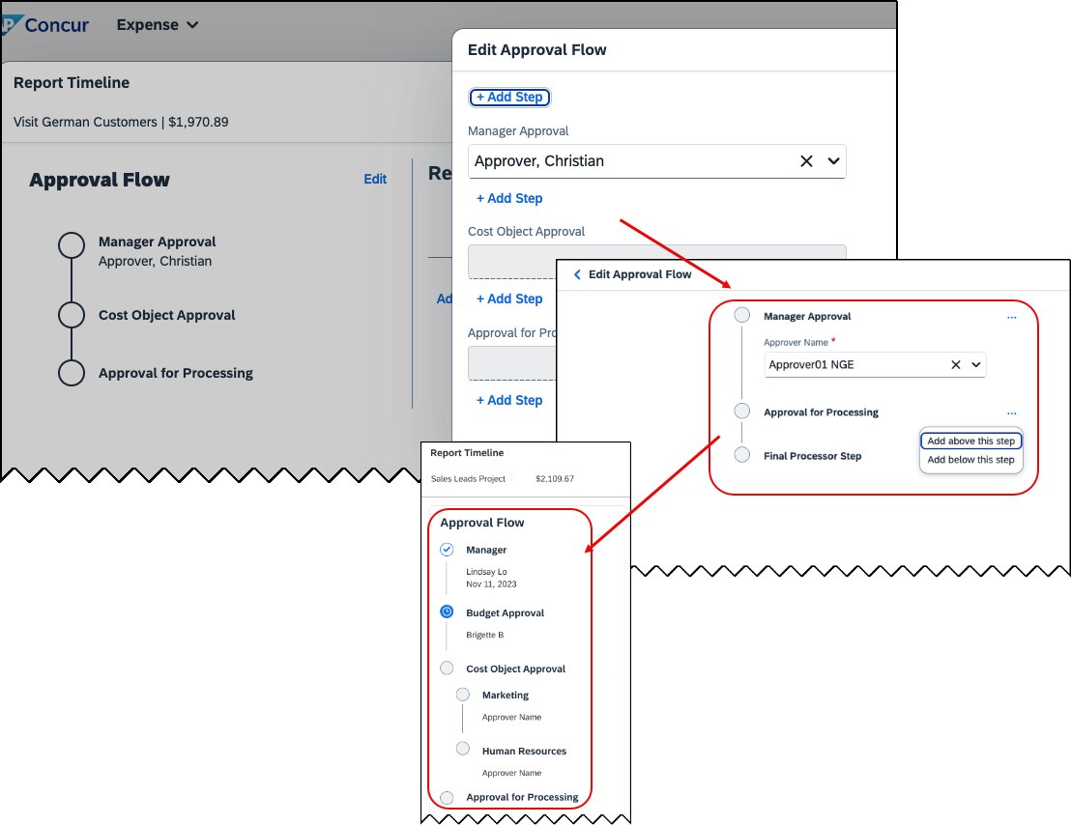

The view in the Report Summary section will also be enhanced to show updated icons and layout. New buttons Sort and Filter will be included in the UI. The comment section will no longer be hidden and will now display to all.
Example: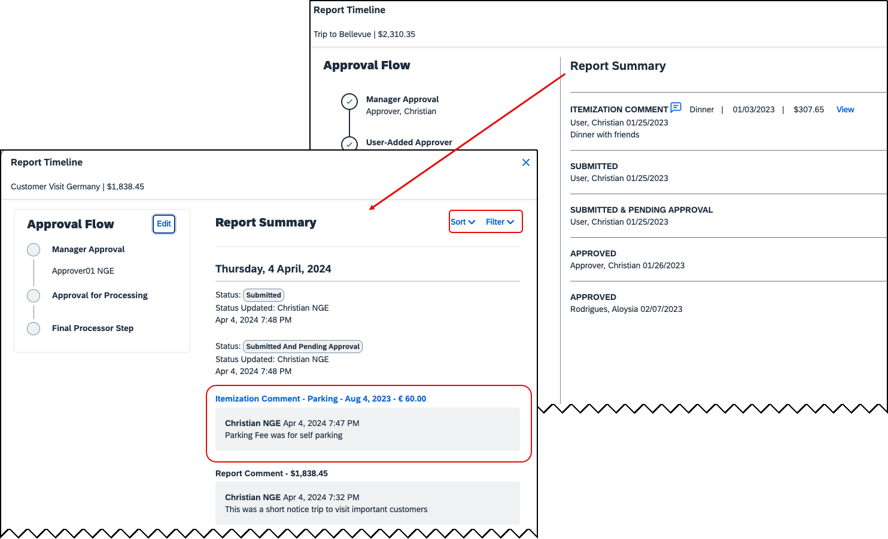

Configuration / Feature Activation
These changes will be automatically available; there are no configuration or activation steps.

**Planned Changes** Preferred Name for Expense Submitter
Information First Published | Information Last Modified | Feature Target Release Date
March 15, 2024 | April 12, 2024 | Q2, 2024
Any changes since the previous monthly release are highlighted in yellow in this release note.

Overview
Targeted for the second quarter of 2024, Concur Expense will support preferred names for users submitting expenses. The users will be able to view the preferred name that has been setup for approvers, company attendees, and other elements that display a name field, if the preferred name has been configured for the user.
Today, in Concur Expense, users can set a preferred name for themselves. In the second quarter of 2024, Concur will display the preferred name for approvers, company attendees, and other names that an expense submitter will see in the system.
For example, if a user with expense approver permissions has specified a preferred name, this preferred name will display to users submitting expenses, when selecting an approver, or when viewing the timeline for an expense report.
Similarly, if another user in the same company has specified a preferred name in Concur Expense, an expense submitter will see the preferred name when searching for an attendee, and when the user has been added as an attendee to an expense.
This update will offer users the flexibility to set up their own preferred names at work, compared to using their given first names and improves user satisfaction.

End-User Experience
The user who is an expense submitter will see the preferred names that is configured for other employees that they interact with in the system, if their locale supports preferred name. This preferred name will appear in places where the users may have seen the given name of the employee previously.

Configuration / Feature Activation
The change occurs automatically; there are no additional configuration steps.

User Interface Changes

**Planned Changes** Update to the Report Status Indicator

Information First Published | Information Last Modified | Feature Target Release Date
April 12, 2024 | -- | April 23, 2024
Any changes since the previous monthly release are highlighted in yellow in this release note.

Overview
Currently, end users can view the updated rectangular indicator that shows the status of an expense report. This indicator, at present, displays in bold colors. Targeted for April 23rd, 2024, this rectangular indicator will be further enhanced to display in more pleasing, mild colors.
With this change, this indicator will be easier on the eyes than the prior version.

End-User Experience
The end-user can now see, in selected screens, a solid color background and white text in the tiles that display the status of the expense report.

Configuration / Feature Activation
These changes are automatically available; there are no configuration or activation steps.

Client Notifications

Accessibility

Accessibility Updates
SAP implements changes to better meet current Web Content Accessibility Guidelines (WCAG). Information about accessibility-related changes made to SAP Concur solutions is published on a quarterly basis. You can review the quarterly updates on the Accessibility Updates page.

Gender Diversity

Gender Diversity Planned Features and Changes
SAP Concur is committed to supporting gender diversity. Over time we plan to implement product changes to help ensure that SAP Concur solutions support gender non-binary users. These changes will include but are not limited to support for preferred names, non-binary gender options in travel preferences, and non-binary titles.
These planned changes reflect SAP's commitment to supporting gender diversity and enable gender non-binary users to enter consistent information when making travel arrangements and entering personal information into SAP Concur solutions.
Timelines and details about these ongoing changes will be provided in the SAP Concur release notes.

In-Product User Assistance

Client Customized Content
If your company creates customized content for SAP Concur solutions through a user assistance tool such as SAP Enable Now or Concur User Assistant by WalkMe, the changes described in these release notes might affect your customized content. SAP Concur recommends reviewing the monthly release notes for all of your SAP Concur solutions as well as the Shared Changes Release Notes to confirm whether any of the planned or released changes might impact your internal, customized content.
If any changes in a release impact your content, work with your internal teams to update your content accordingly.

Subprocessors

SAP Concur Non-Affiliated Subprocessors
The list of non-affiliated subprocessors is available from the SAP Sub-processors / Data Transfer Factsheets page.
To access the SAP Concur Sub-processors List:
- Click the following link to navigate to the SAP Sub-processors / Data Transfer Factsheets page:
SAP Sub-processors / Data Transfer Factsheets
- Sign in to the SAP Support Portal using your Support User ID (S-user) and password.
SAP customers must sign in to the SAP Support Portal using their Support User ID (S-user) and password. For information about S-User IDs, refer to Your New Support User ID (S-user) and to the Learn All About S-User IDs blog post.
- On the SAP Sub-processors / Data Transfer Factsheets page, type "Concur" in the Search field.
- In the Title column, click SAP Concur Sub-processors List.
If you have questions or comments, please reach out to: Privacy-Request@Concur.com

Supported Browsers

Supported Browsers and Changes to Support
For information about supported browsers and planned changes to supported browsers, refer to the Concur Travel & Expense Supported Configurations guide.
When changes to browser support are planned, information about those changes will also appear in the Shared Changes Release Notes.

Additional Release Notes and Other Technical Documentation

Online Help
You can access release notes, setup guides, user guides, administrator summaries, supported configurations, and other resources via the in-product Help menu or directly on the SAP Help Portal.
To access the full set of documentation for your product, use the links in the SAP Concur Help menu, or visit the SAP Concur solutions page.
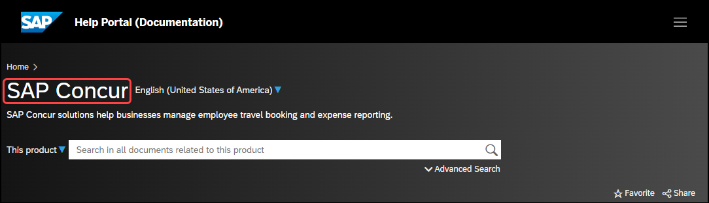

SAP Concur Support Portal – Selected Users
Access release notes, webinars, and other technical documentation on the SAP Concur support portal.
If you have the required permissions, Contact Support is available on the SAP Concur Help menu, and in the SAP Concur page footer.
Click Contact Support to access the SAP Concur support portal, then click Resources.
- Click Release/Tech Info for release notes, technical documents, etc.
- Click Webinars for recorded and live webinars.

Cases

Check Support Case Status
The steps in this procedure provide instructions for checking whether a case is resolved.
To check the status of a submitted case:
- Log on to https://concursolutions.com/portal.asp.
- Click Help > Contact Support.
If you do not have the option to contact SAP Concur support under the Help menu, then your company has chosen to support the SAP Concur service internally. Please contact your internal support desk for assistance.
- Click Support > View Cases.
- In the table, view the desired type of cases based on the View list selection. Search results are limited to each company's own cases.

© 2024 SAP SE or an SAP affiliate company. All rights reserved.
No part of this publication may be reproduced or transmitted in any form or for any purpose without the express permission of SAP SE or an SAP affiliate company.
SAP and other SAP products and services mentioned herein as well as their respective logos are trademarks or registered trademarks of SAP SE (or an SAP affiliate company) in Germany and other countries. Please see http://global12.sap.com/corporate-en/legal/copyright/index.epx for additional trademark information and notices.
Some software products marketed by SAP SE and its distributors contain proprietary software components of other software vendors.
National product specifications may vary.
These materials are provided by SAP SE or an SAP affiliate company for informational purposes only, without representation or warranty of any kind, and SAP SE or its affiliated companies shall not be liable for errors or omissions with respect to the materials. The only warranties for SAP SE or SAP affiliate company products and services are those that are set forth in the express warranty statements accompanying such products and services, if any. Nothing herein should be construed as constituting an additional warranty.
In particular, SAP SE or its affiliated companies have no obligation to pursue any course of business outlined in this document or any related presentation, or to develop or release any functionality mentioned therein. This document, or any related presentation, and SAP SE’s or its affiliated companies’ strategy and possible future developments, products, and/or platform directions and functionality are all subject to change and may be changed by SAP SE or its affiliated companies at any time for any reason without notice. The information in this document is not a commitment, promise, or legal obligation to deliver any material, code, or functionality. All forward-looking statements are subject to various risks and uncertainties that could cause actual results to differ materially from expectations. Readers are cautioned not to place undue reliance on these forward-looking statements, which speak only as of their dates, and they should not be relied upon in making purchasing decisions.

