SAP Concur Release Notes
Concur Expense Standard Edition
Month | Audience
Release Date: February 24, 2024  Initial Post: February 23, 2024 | Client FINAL

Contents
Release Notes 1
Cards 1
Retirement of Batch File Option for Unsupported Card Programs 1
Yodlee Reauthentication Refresh Frequency 2
Expense Types Redesign 3
**Ongoing** Updated User Interface (UI) for Expense Types 3
Mileage Service 5
Delegate Administrator May Reset Initial Distance Mileage for Personal Car 5
Miscellaneous 6
Enhancing Additional Fields with Most Recently Used (MRU) Feature 6
New Action Column Available in Expense Screens 7
Update to the Report Status Indicator 10
Planned Changes 11
Expense Types 11
**Planned Changes** Enhanced Expense Types Administration 11
Client Notifications 21
Accessibility 21
Accessibility Updates 21
Gender Diversity 21
Gender Diversity Planned Features and Changes 21
In-Product User Assistance 21
Client Customized Content 21
Subprocessors 22
SAP Concur Non-Affiliated Subprocessors 22
Supported Browsers 22
Supported Browsers and Changes to Support 22
Additional Release Notes and Other Technical Documentation 23
Online Help 23
SAP Concur Support Portal – Selected Users 23
Cases 24
Check Support Case Status 24

Legal Disclaimer
The information in this presentation is confidential and proprietary to SAP SE or an SAP affiliate company and may not be disclosed without the permission of SAP SE or the respective SAP affiliate company. This presentation is not subject to your license agreement or any other service or subscription agreement with SAP SE or its affiliated companies. SAP SE and its affiliated companies have no obligation to pursue any course of business outlined in this document or any related presentation, or to develop or release any functionality mentioned therein. This document, or any related presentation and SAP SE or an SAP affiliate company’s strategy and possible future developments, products and or platforms directions and functionality are all subject to change and may be changed by SAP SE and its affiliated companies at any time for any reason without notice. The information in this document is not a commitment, promise or legal obligation to deliver any material, code or functionality. This document is provided without a warranty of any kind, either express or implied, including but not limited to, the implied warranties of merchantability, fitness for a particular purpose, or non-infringement. This document is for informational purposes and may not be incorporated into a contract. SAP SE and its affiliated companies assume no responsibility for errors or omissions in this document, except if such damages were caused by SAP SE or an SAP affiliate company’s willful misconduct or gross negligence.
All forward-looking statements are subject to various risks and uncertainties that could cause actual results to differ materially from expectations. Readers are cautioned not to place undue reliance on these forward-looking statements, which speak only as of their dates, and they should not be relied upon in making purchasing decisions.

Release Notes
This document contains the release notes for Concur Expense Standard edition.
Features and changes that apply to SAP Concur site-wide or to multiple products/services are documented in the Shared Changes Release Notes. For information about site-wide or shared changes in this release that might impact your SAP Concur solutions, refer to the Shared Changes Release Notes.

Cards

Retirement of Batch File Option for Unsupported Card Programs

Overview
With this release, any bank card issuers not currently supported by SAP Concur will no longer have the option of using the Batch File option. Instead, these issuers will be asked to use the new Payment Card Integration service-based option instead.
This action does not mean a retirement of the Batch File method for card issuers already integrated using the batch file option.

Business Purpose / Client Benefit
This feature change directs clients to a superior solution for their upcoming card program integrations by retiring the older method of batch file jobs.

The Payment Card Integration Service
The Payment Card Integration service was released in September of 2023. This API-based service lets clients working with participating financial institutions use the SAP Concur App Center to link their corporate and business card types directly to the Concur Expense product’s Card functionality.
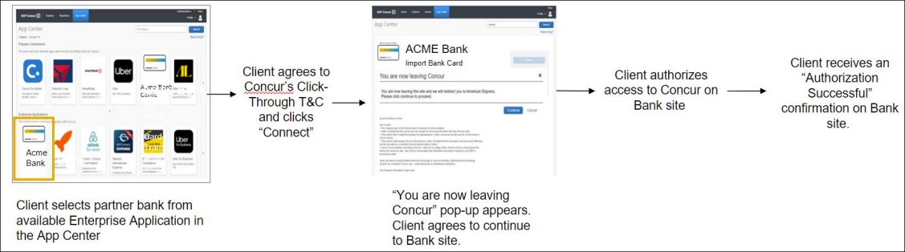
This means any card issuer a client would like to use that is not currently integrated with SAP Concur (or does not provide data via the major card associations) will need to use the service-based method instead.

Administrator Experience
Clients working with a bank not yet integrated with the Payment Card Integration service will need to work together with their bank and account manager to determine if integration via Payment Card Integration service is possible.

Configuration / Feature Activation
These changes are automatically available; there are no configuration or activation steps.
For more information, refer to the section Cards – Announcing the Payment Card Integration Service in the September 2023 SAP Concur Release Notes.

Yodlee Reauthentication Refresh Frequency

Overview
This release note provides information to users of Yodlee on the need to periodically reauthorize the cards that are connected to SAP Concur via Yodlee to avoid interruptions to their personal card transactions flow.

Business Purpose
By sharing this information, customers can better anticipate when they will need to reauthorize their cards, improving overall experience and reducing potential disruptions.

End-User Experience
There are no changes to the user interface, but you may experience an interruption in the personal card transactions flow if you fail to reauthorize the cards within the required period. Contact your administrator for information on the banks and their respective reauthorization timelines.

Administrator Experience
For more information on banks and their reauthorization timelines, see Open Banking Token Expiry Dates.

Configuration / Feature Activation
The change occurs automatically; there are no additional configuration steps.

Expense Types Redesign

**Ongoing** Updated User Interface (UI) for Expense Types

Information First Published | Information Last Modified | Feature Target Release Date
August 2023 | February 2024 | Q3 2023 – Q4 2024
Any changes since the previous monthly release are highlighted in yellow in this release note.

Overview
SAP Concur is redesigning the Concur Expense UI experience for Expense Types screens to give product admins a new user experience while creating and managing expense types. These changes will take place between Q3 2023 and throughout 2024.
The redesigned version of Expense Types will become the default version for Concur Expense customers from April 2024. Customers will still have the ability the use the legacy version if they wish to do so until it is no longer available.

Business Purpose / Client Benefit
The new design provides a modern, consistent, and streamlined user experience for Concur Expense admins.

Products and Users Affected
To take advantage of these improvements, Concur Expense customers will be encouraged to transition to the redesigned version of Expense Types in Concur Expense. The following provides information about the timeline and resources available to ensure this process is smooth and efficient for all users.
These UI changes apply to:
- Standard version of Concur Expense
- Admins; there are no changes for end users, approvers, or processors.

IMPORTANT: Timeline and Milestones
There are three important milestones for Concur Expense customers as they transition from the existing legacy UI for Expense Types to the redesigned version.
- Phase 1: October 2023
In October 2023, customers who had the basic configuration of Concur Expense were offered an Opt-In Period, to try out the redesigned Expense Types.
The redesigned version of Expense Types was not available for customers who had advanced features such as Policy Groups, Multiple Country Packs, and so on, enabled for their organization. If the customers with the basic configuration chose to enable advanced settings, then they automatically reverted to the legacy version.
Customers used this period to plan their transition and moved to the redesigned Expense Types when it was right for their business priorities.
During the Opt-In Period, not all Concur Expense features from the existing UI were available in the redesigned user interface.
During the first phase, only the Manage Expense Types screens was covered under the redesigned version.
Any decision to opt-in or opt-out was a company-wide decision and was applicable to all the admins in the company.
- Phase 2: April 2024
During this period, all customers will automatically default to the redesigned version of Expense Types, regardless of the configuration. They will still have the chance to access the legacy screens. These changes will be available from April 2024.
The features planned for this phase will include a First Run Experience for new customers, Policy Groups, Alternate Account Codes, Multiple Country Packs, and Item Code Mapping for financial integrations.
- Phase 3: TBD
During this period, all customers will be automatically transitioned to the redesigned UI and will not be able to access the legacy screens of Expense Types any longer.
This ensures that we continue to offer a consistent user experience for all customers and allows for superior product innovation and support. We have not yet set a date for these changes.

Transition Materials – Guides and Other Resources
Customers can use the Concur Expense: Expense Types Setup Guide to learn more about the changes happening in Expense Types. Along with the setup guide, we also offer release notes, and other resources to aid in the transition.
To help with training needs, customers can create custom training materials by using the setup guide "as is". They can cut, copy, paste, delete, or otherwise edit either guide at will.
- Setup guide: This guide compares the legacy user interface to the redesigned version for Concur Expense to help users become comfortable with the new experience. This guide will be updated as needed during the Opt-In Period as the redesigned UI is being enhanced. Admins should review the guide often.
The customer can cut, copy, paste, delete, or otherwise edit this guide at will.
- Release information: During the Opt-In Period, the release of enhancements will not be on the regular release schedule. Instead, SAP Concur will provide special release notes and information about features and enhancements that are nearing release.

Getting Started
Customers are encouraged to use the transition materials described above and develop a plan for the transition.
For more information on the exact changes, please refer to the Expense Types | **Planned Changes** Enhanced Expense Types Administration planned change in this document.

Mileage Service

Delegate Administrator May Reset Initial Distance Mileage for Personal Car

Overview
With this release, the Expense Configuration administrator (Unrestricted) delegating for a user will now be able to adjust the existing mileage on the user’s personal car directly using the Distance to date field in the Vehicle Configuration page.
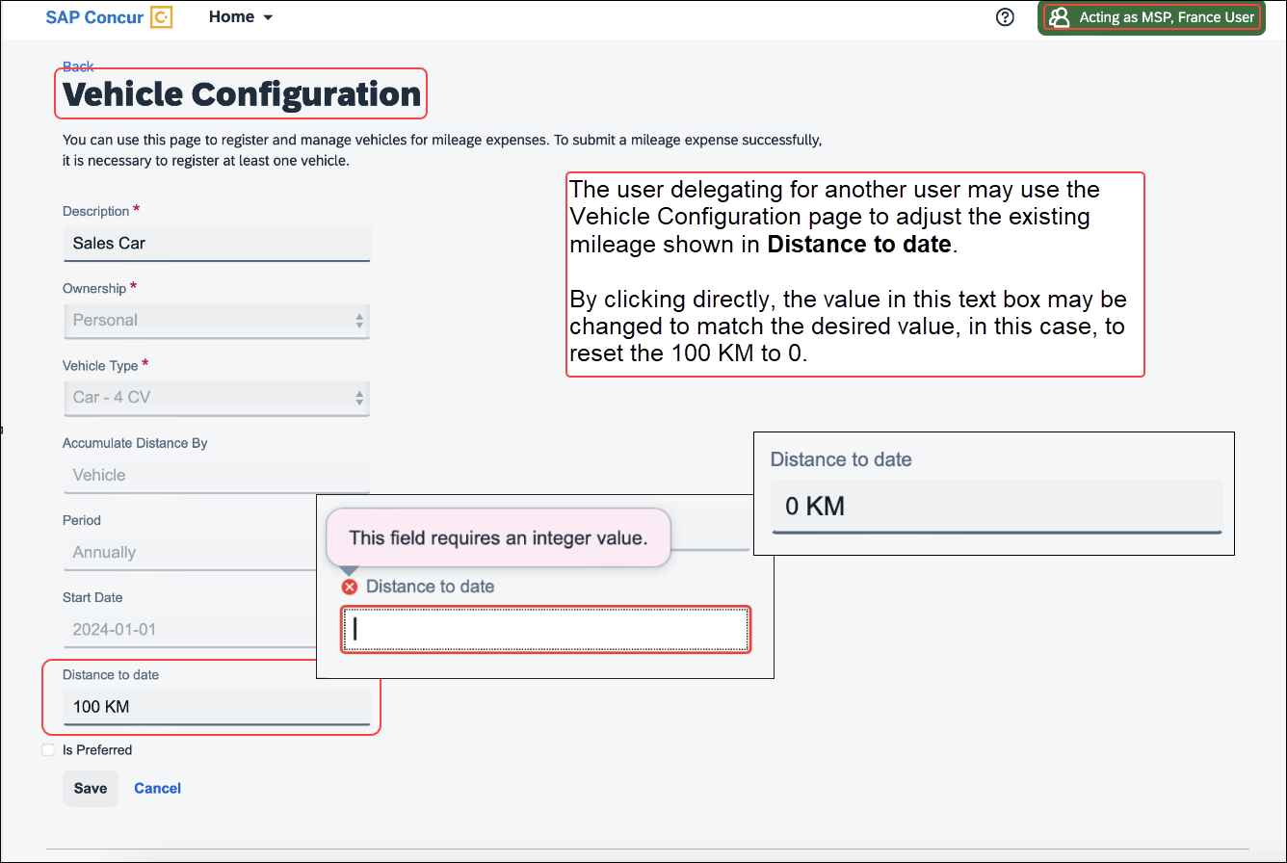
By clicking the value directly, the current mileage attributed to the user’s car may be adjusted as needed.

Business Purpose / Client Benefit
This feature change closes a functionality gap between the legacy and service versions of the Mileage feature.

Administrator Experience
The administrator delegating for a user clicks Profile Settings and navigates to the Vehicle Configuration page to access the selected car. Next, they click the Distance to date field to enter a new mileage amount for that user.

Configuration / Feature Activation
These changes are automatically available after January 24, 2024; there are no configuration or activation steps.

Miscellaneous

Enhancing Additional Fields with Most Recently Used (MRU) Feature

Overview
With this release, we are excited to announce the enablement of Most Recently Used (MRU) feature for location fields, lists, and connected lists in the multi-edit dialog for expense entries in an expense report.
This feature has been implemented based on customer feedback to simplify the selection process for frequently used values in the multi-edit dialog.

Business Purpose
The enablement of MRU for location and list fields in the multi-edit dialog enhances the user experience by making it easier to access frequently used values, improving efficiency when creating or editing expense reports.

Administrator Experience
Users will now see most recently used values for location and any list/connected list fields in the multi-edit dialog, simplifying the selection process and reducing manual effort when entering data in the multi-edit dialog.
This feature is automatically available; there are no additional configuration or activation steps required for administrators.

Configuration / Feature Activation
The change occurs automatically; there are no additional configuration steps.

New Action Column Available in Expense Screens

Overview
As of February 20th, 2024, users can use two new action columns, indicated by and , to perform single click actions or multiple actions such as edit, copy, or delete on the Expense screens, such as editing expense, itemizations, allocations, or travel diaries.
None of the existing functionalities are removed with this release:
- The user can click the row to open the expense details.
- The user can select multiple rows to edit common fields for all the selected expenses.

Business Purpose / Client Benefit
This update allows users to execute actions easily and improves user experience for keyboard and screen reader users.

End-User Experience
All the existing Expense screens where you can perform actions have a new action column. This column will always be visible. A dropdown list displays all the actions that you can perform by selecting a single row of data.
A button link displays for single actions. For multiple actions, a See more () button displays with a dropdown list embedded in it.
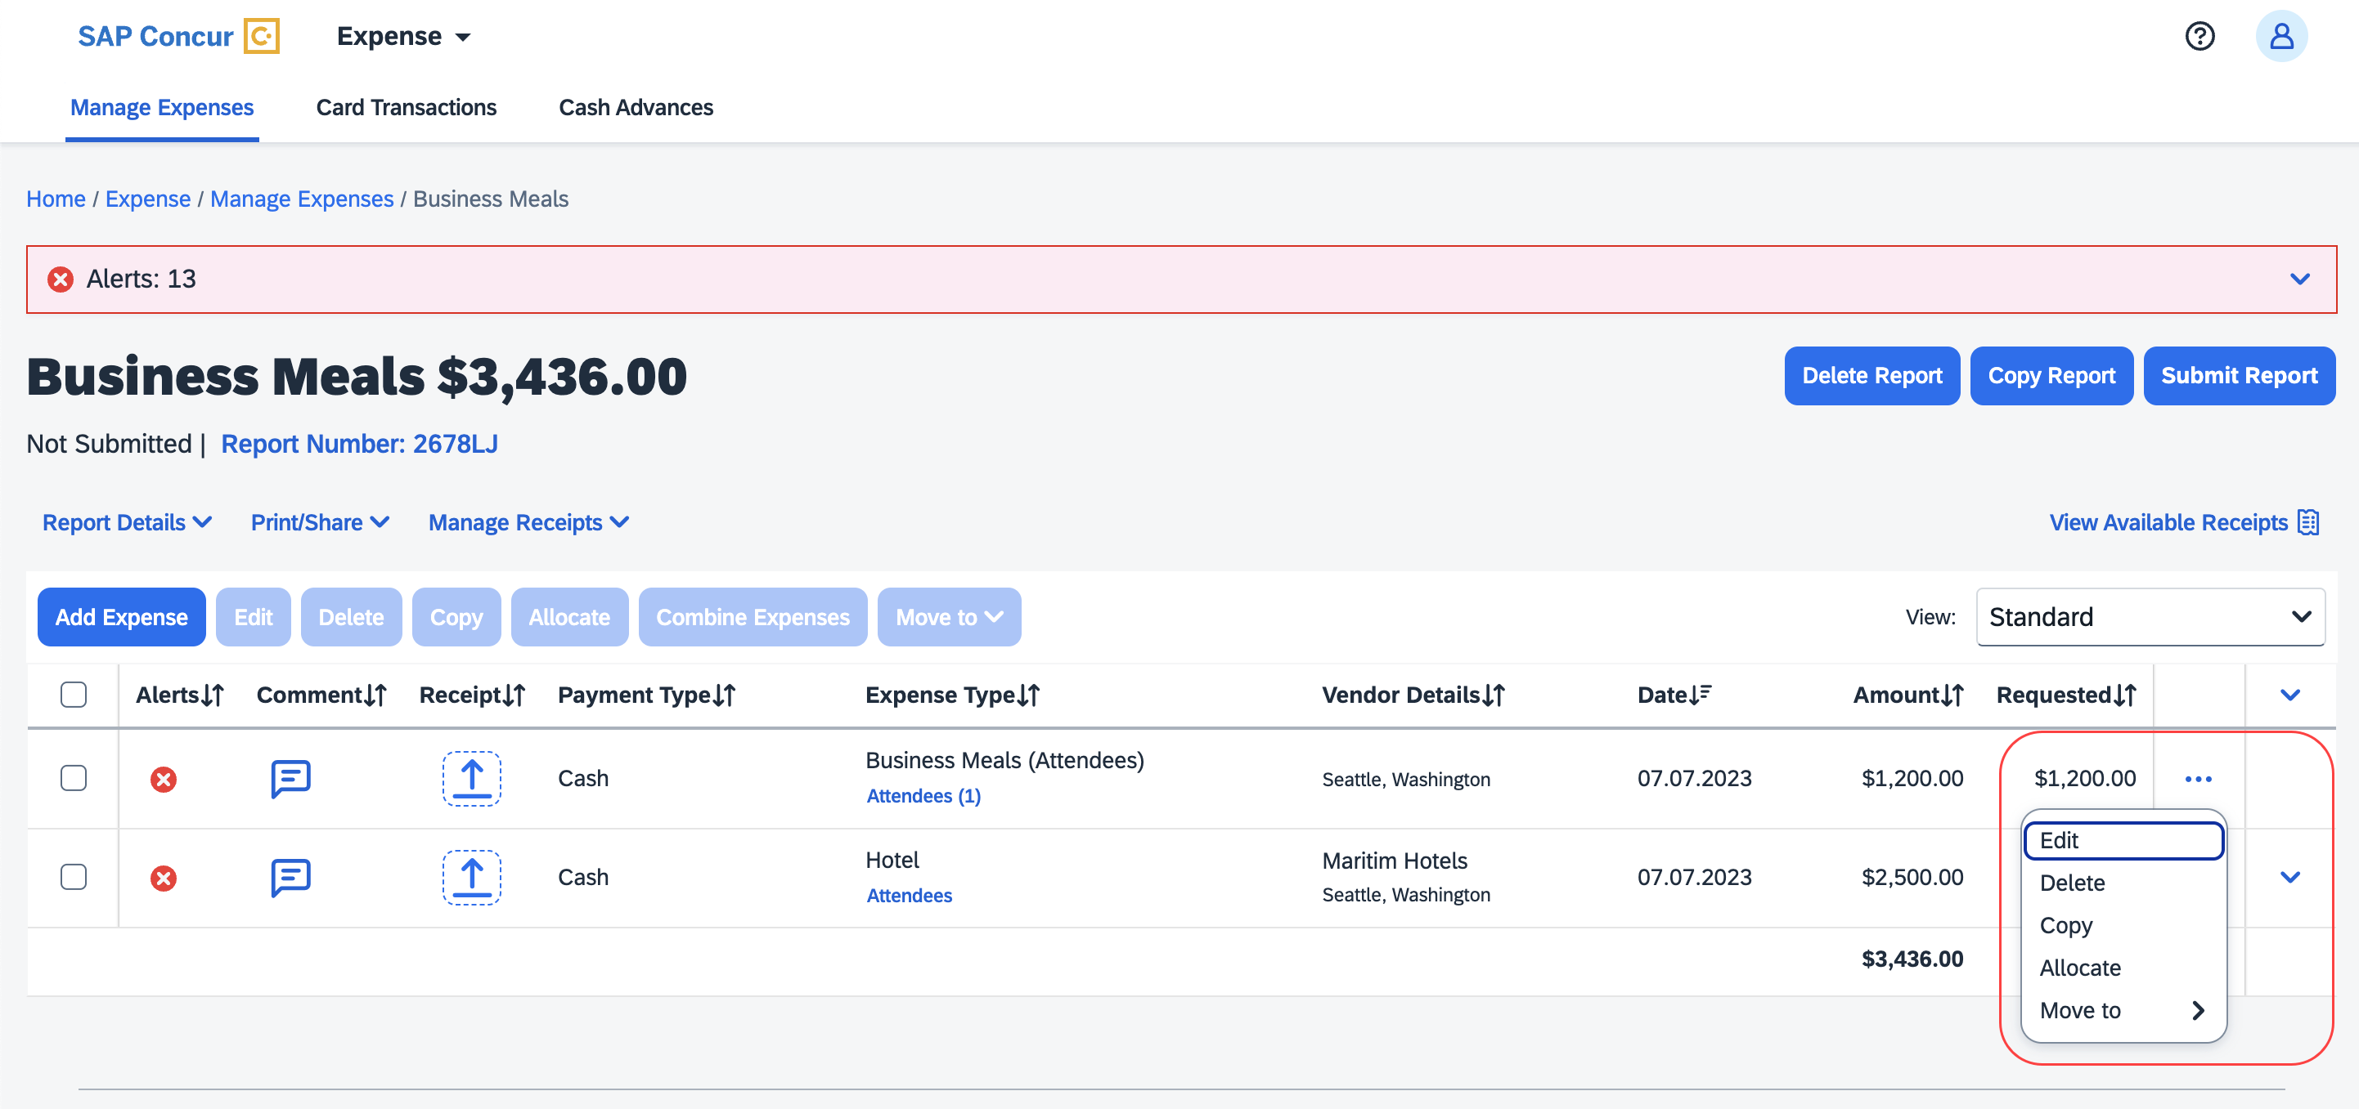
The updated Expense screens and their actions are:
- Reports list
- View
- Available Expenses
- View
- Delete
- Move To
- Available Expenses > Add Expense
- View
- Add to Report
- Cash Advance
- Remove
- Request
- Remove
- Attendees
- Remove
- Create Group
- Attendees Favorite Group
- Add
- Remove
- Recent Attendees
- Add
- Attendees Group
- Add
- Allocations
- Edit
- Remove
- Report Entries
- Edit
- Delete
- Copy
- Allocate
- Move to
- Report Entries (once the report is submitted)
- View
- Itemizations List
- Edit
- Delete
- Allocate
- Copy
- Itemizations List (once the report is submitted)
- View
- Travel Diary
- Edit
- Delete

For Example
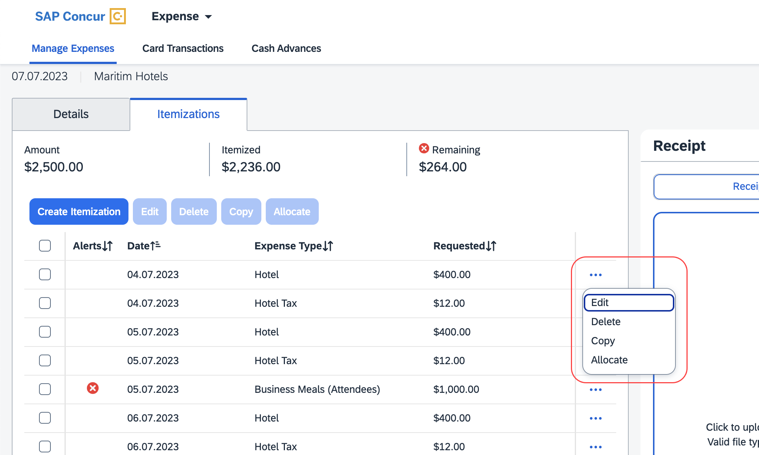
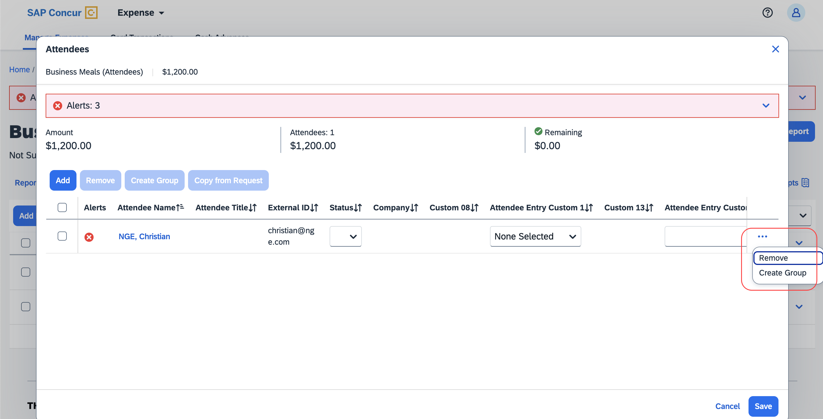

Configuration / Feature Activation
The change occurs automatically; there are no additional configuration steps.

Update to the Report Status Indicator

Overview
The rectangular indicator that shows the status of an expense report is now updated. With the change, this indicator is more prominent and easier to read than the prior version.

Business Purpose / Client Benefit
This feature improves the user’s accessibility to the status information of the expense report by providing greater visibility.

End-User Experience
The end-user will now see, in selected screens, a solid color background and white text in the tiles that display the status of the expense report.
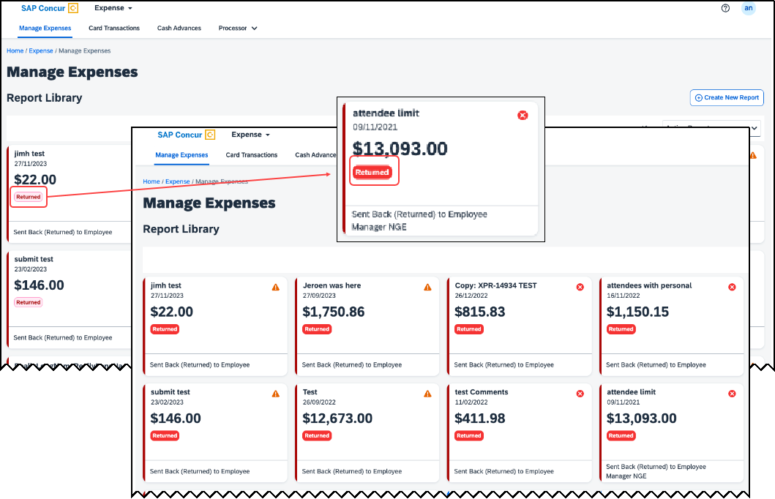

Configuration / Feature Activation
These changes are automatically available after January 30, 2024; there are no configuration or activation steps.

Planned Changes
The items in this section are targeted for future releases. SAP Concur reserves the right to postpone implementation of – or completely remove – any enhancement/change mentioned here.
The planned changes listed in this document are specific to this product. For information about planned site-wide or shared changes that might impact your SAP Concur solutions, refer to the Shared Changes Release Notes.

Expense Types

**Planned Changes** Enhanced Expense Types Administration

Information First Published | Information Last Modified | Feature Target Release Date
February 9, 2024 | February 23, 2024 | April 2024
Any changes since the previous monthly release are highlighted in yellow in this release note.

Overview
Over the next few months, SAP Concur will redesign the Concur Expense UI experience of the Manage Expense Types screens to give the product admins a modern, intuitive, and streamlined experience for creating and managing Expense Types.
The redesigned version of Expense Types will become the default version for Concur Expense customers from April 2024. Customers will still have the ability the use the legacy version if they wish to do so until it is no longer available.
Refer to the Expense Types Redesign | **Ongoing** Updated User Interface (UI) for Expense Types release note in this document.
Targeted for April 2024, SAP Concur will offer a First Run Experience to new customers setting up Concur Expense for the first time using the Activation Wizard. The First Run Experience is an intuitive, two-step process that will guide new customers in setting up their Expense Types. This experience will not be available to existing customers.
The enhanced features such as Alternate Account Codes, Policy Groups, Multiple Country Packs, and Item Code Mapping for Financial Integration will be offered in the redesigned user interface for all customers.

Business Purpose / Client Benefit
This update will facilitate better Expense Types configuration and will reduce complexity, time, and effort involved for administrators when setting up Expense Types.

Administrator Experience

First Run Experience for New Customers
For the first time set up process, navigate to Expense Types for Expense through the Configuration Wizard to view the Your Expense Types Setup welcome screen. Click Set Up Now to configure your Expense Types.
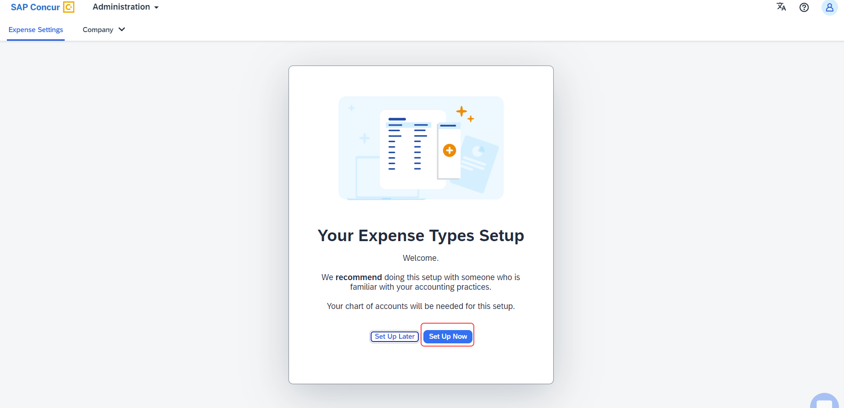
An introductory screen will display in the next screen. Proceed to click Select Expense Types to continue setting up the Expense Types.
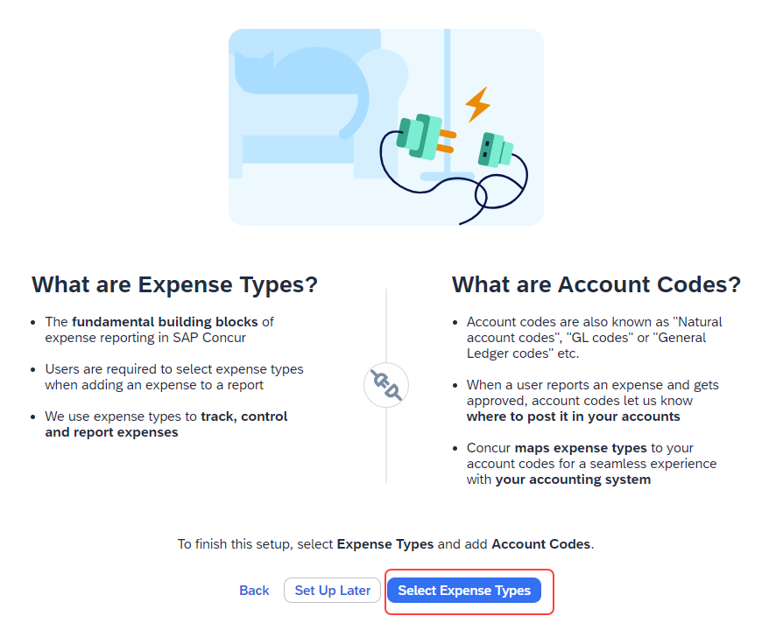
The Your Expense Types Setup screen will display. There are two steps in setting up your Expense Types. The step progress bar at the top of the screen will indicate the progress in the setup process.
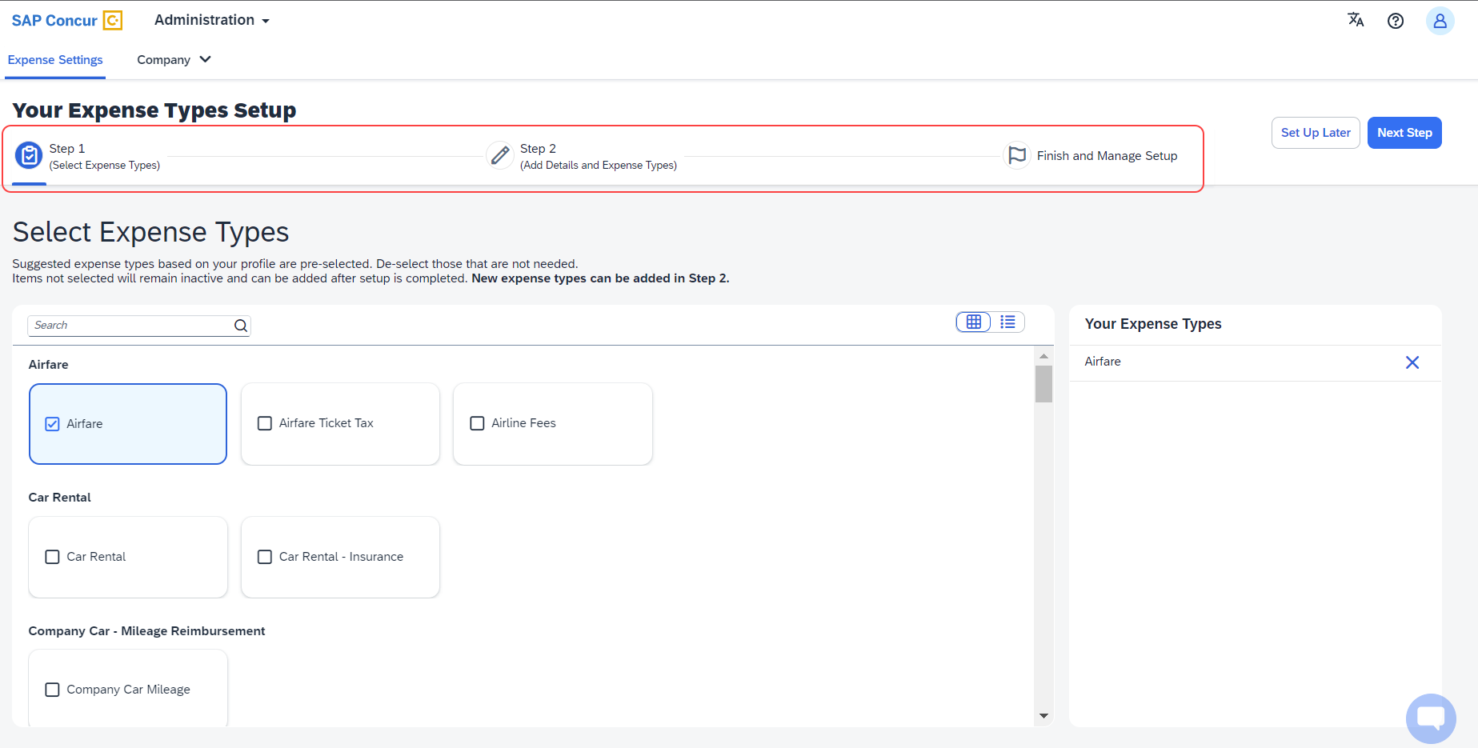
The first step of the First Run Experience will now display. In the Select Expense Types screen, you will check or uncheck the tiles to select your desired expense types.
Concur Expense will display the most used expense types as suggestions. Based on your selections, the Your Expense Types list on the right pane shows the selected expense types.
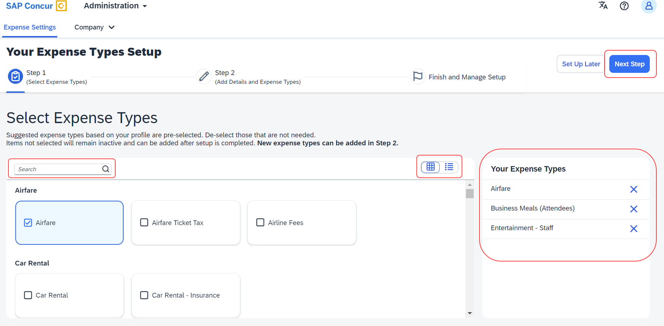
Toggle between tile view and list view using the button. Use the search box to search for a specific expense type. When you have made your selections, click Next Step.
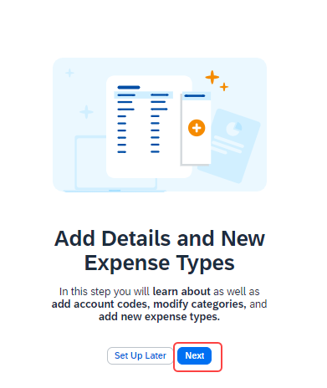
Click Next to add details to your expense types. The second step of the First Run Experience will display next.
In the Add Details and Expense Types screen, you will add details to your expense types such as Account Codes, Category, Activation & Limits, and so on, or even create custom expense types.
The progress bar in the top right will display the number of expense types with complete details.
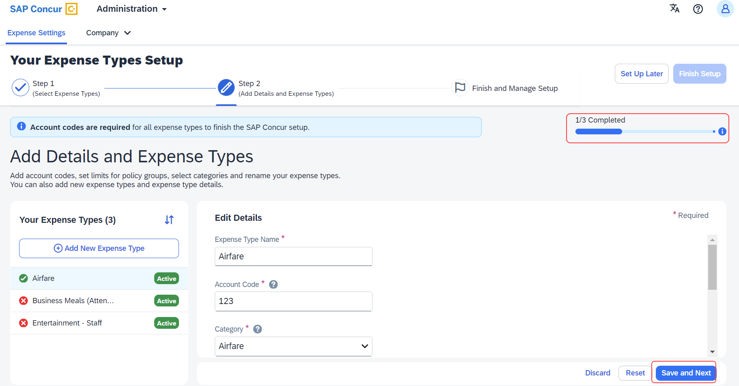
The fully configured expense types will be indicated using a green check mark where it will be listed under Your Expense Types section. The red X mark indicates that the account codes are missing. Click Save and Next to save the changes.
A success message will display when you complete setting up the Expense Types. The progress bar will reflect the completion status as well.
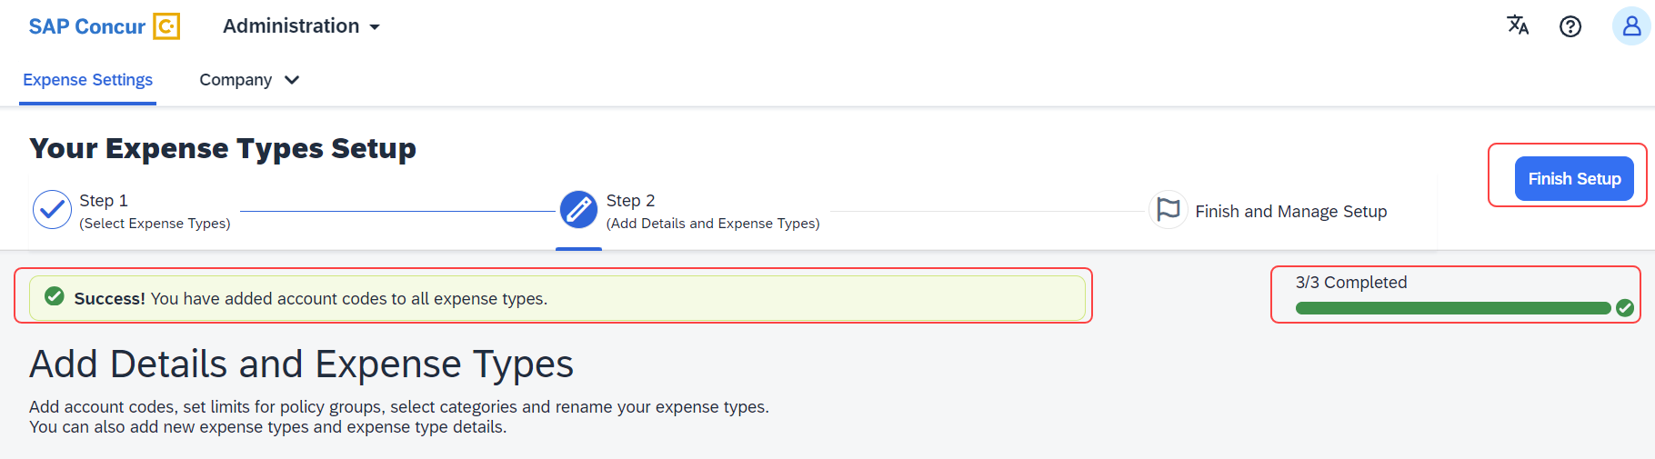
Click Finish Setup to exit the screen. Click Take me to my Expense Types to be directed to the Manage Expense Types screen. The congratulatory banner will display indicating that the Expense Types are set up successfully. This will indicate the end of the First Run Experience.
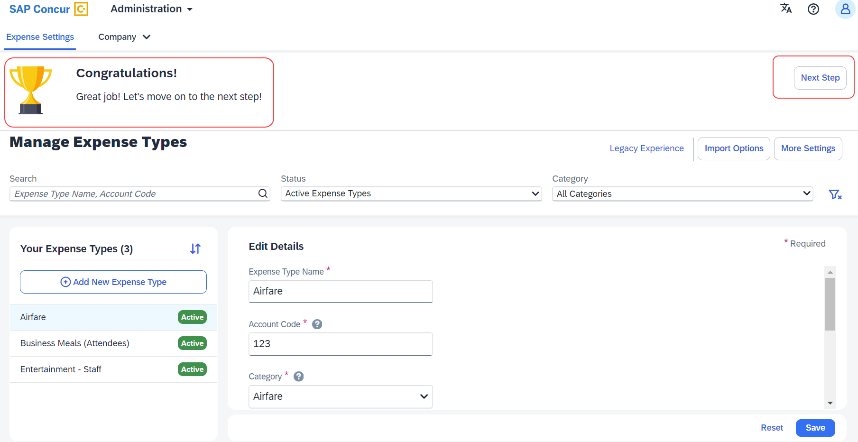
Click Next Step to navigate back to the Activation Wizard to complete setting up Concur Expense. You will also be able to postpone setting up your Expense Types if you select Set Up Later.

Existing UI: Policy Groups: Activation & limits
In the existing UI, you can select the preconfigured policy groups in the Expense Types screen from the dropdown menu where all the available policy groups for your entity are listed.
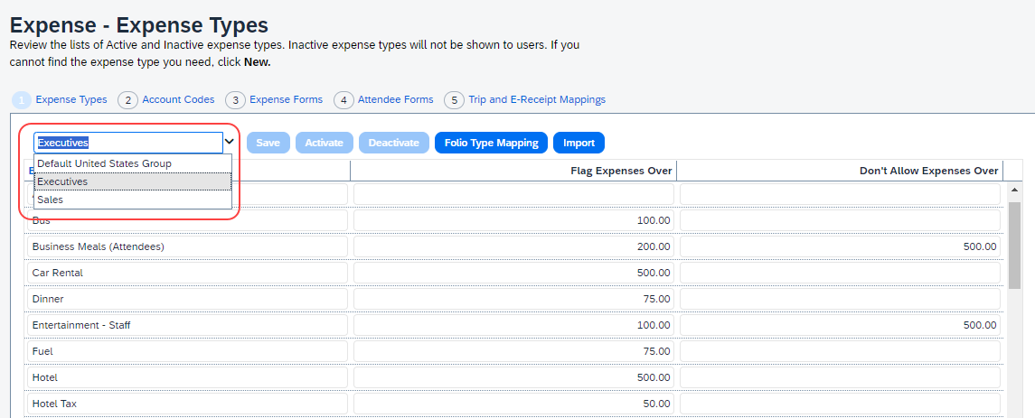

Redesigned UI: Policy Groups: Activation & limits
In the new experience, when there are multiple country packs, they will display on the Manage Expense Types screen, in the Edit Details > Policy Groups: Activation & Limits section.
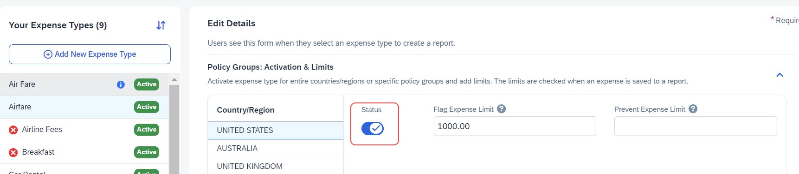
Use the Status toggle button to switch on or off the country pack for an entity. When there are policy groups configured for these countries, you will be able to make granular changes to these policy groups as show in the following image. You will be able to set limits, activate or deactivate expense types, and so on.
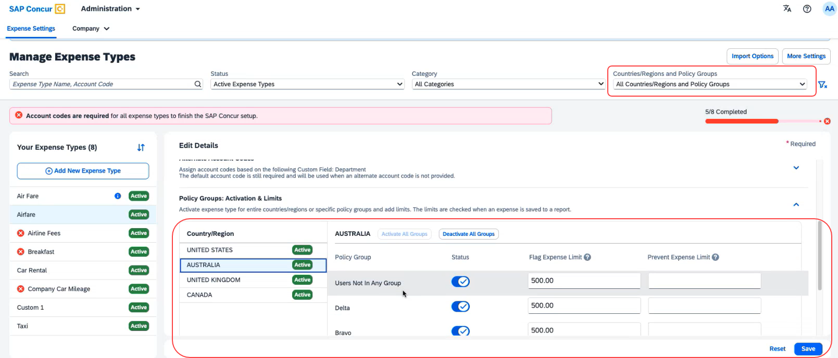
You will also be able to search using Countries/Regions and Policy Groups as a filter in the Manage Expense Types screen.

Existing UI: Alternate Account codes
If there are alternate account codes to be set up, you can set up the same in the Expenses – Expense Types > Account Codes tab. Select the list item from the account code driver list and configure them.
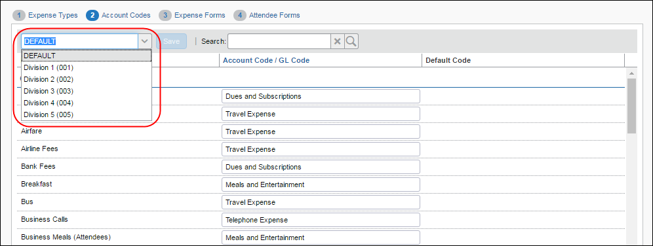

Redesigned UI: Alternate Account codes
In the redesigned UI, you will be able to set up alternate account codes in the Edit Details > Alternate Account Codes section.
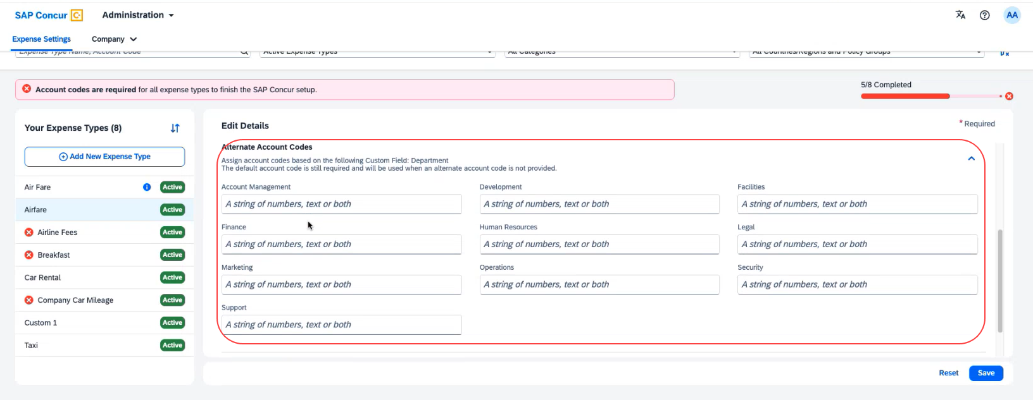

Existing UI: Item code mapping for financial integrations
If you connect Concur Expense to your financial system using one of SAP Concur's financial integrations, you may see options on the Expense – Account Codes page specific to your financial system in the legacy UI.
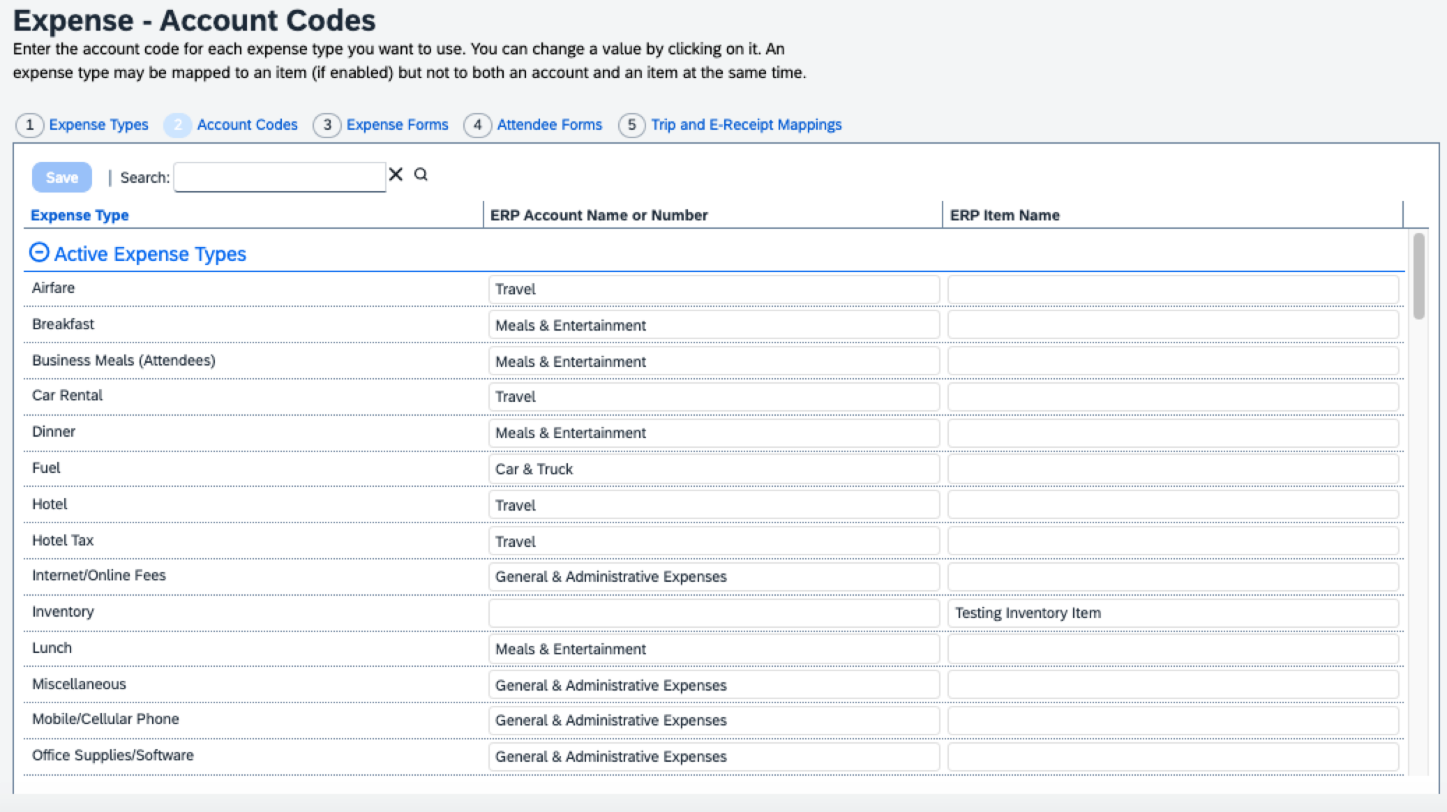

Redesigned UI: Item code mapping for financial integrations
In the redesigned UI, the Account Code field becomes Default Account Code with a dropdown menu for each expense type.
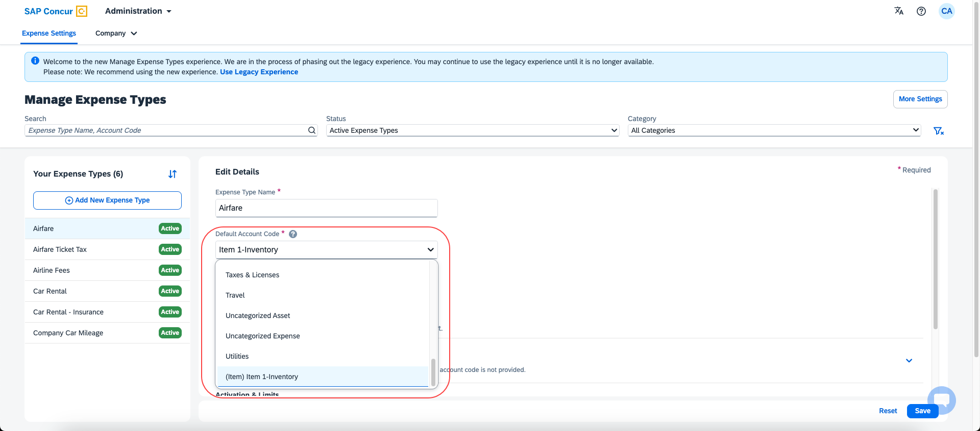

Configuration/Feature Activation
The new redesigned version will be automatically made the default version as of April 2024; there are no additional configuration steps.
If you wish to opt out of this experience, click Use Legacy Experience. Your view will return to the legacy screens.
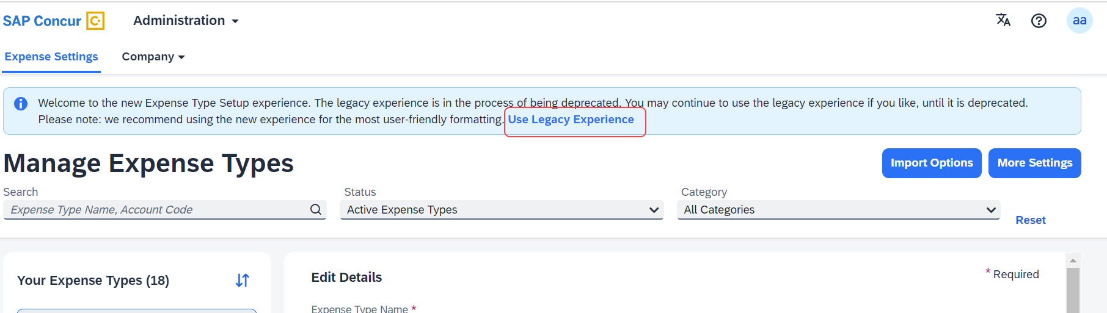
For more information on the exact changes, refer to the Expense Types Redesign| **Ongoing Changes** Updated User Interface (UI) for Expense Types release note in this document. For general information, refer to the Concur Expense: Expense Types Setup Guide.

Client Notifications

Accessibility

Accessibility Updates
SAP implements changes to better meet current Web Content Accessibility Guidelines (WCAG). Information about accessibility-related changes made to SAP Concur solutions is published on a quarterly basis. You can review the quarterly updates on the Accessibility Updates page.

Gender Diversity

Gender Diversity Planned Features and Changes
SAP Concur is committed to supporting gender diversity. Over time we plan to implement product changes to help ensure that SAP Concur solutions support gender non-binary users. These changes will include but are not limited to support for preferred names, non-binary gender options in travel preferences, and non-binary titles.
These planned changes reflect SAP's commitment to supporting gender diversity and enable gender non-binary users to enter consistent information when making travel arrangements and entering personal information into SAP Concur solutions.
Timelines and details about these ongoing changes will be provided in the SAP Concur release notes.

In-Product User Assistance

Client Customized Content
If your company creates customized content for SAP Concur solutions through a user assistance tool such as SAP Enable Now or Concur User Assistant by WalkMe, the changes described in these release notes might affect your customized content. SAP Concur recommends reviewing the monthly release notes for all of your SAP Concur solutions as well as the Shared Changes Release Notes to confirm whether any of the planned or released changes might impact your internal, customized content.
If any changes in a release impact your content, work with your internal teams to update your content accordingly.

Subprocessors

SAP Concur Non-Affiliated Subprocessors
The list of non-affiliated subprocessors is available from the SAP Sub-processors / Data Transfer Factsheets page.
To access the SAP Concur Sub-processors List:
- Click the following link to navigate to the SAP Sub-processors / Data Transfer Factsheets page:
SAP Sub-processors / Data Transfer Factsheets
- Sign in to the SAP Support Portal using your Support User ID (S-user) and password.
SAP customers must sign in to the SAP Support Portal using their Support User ID (S-user) and password. For information about S-User IDs, refer to Your New Support User ID (S-user) and to the Learn All About S-User IDs blog post.
- On the SAP Sub-processors / Data Transfer Factsheets page, type "Concur" in the Search field.
- In the Title column, click SAP Concur Sub-processors List.
If you have questions or comments, please reach out to: Privacy-Request@Concur.com

Supported Browsers

Supported Browsers and Changes to Support
For information about supported browsers and planned changes to supported browsers, refer to the Concur Travel & Expense Supported Configurations guide.
When changes to browser support are planned, information about those changes will also appear in the Shared Changes Release Notes.

Additional Release Notes and Other Technical Documentation

Online Help
You can access release notes, setup guides, user guides, administrator summaries, supported configurations, and other resources via the in-product Help menu or directly on the SAP Help Portal.
To access the full set of documentation for your product, use the links in the SAP Concur Help menu, or visit the SAP Concur solutions page.
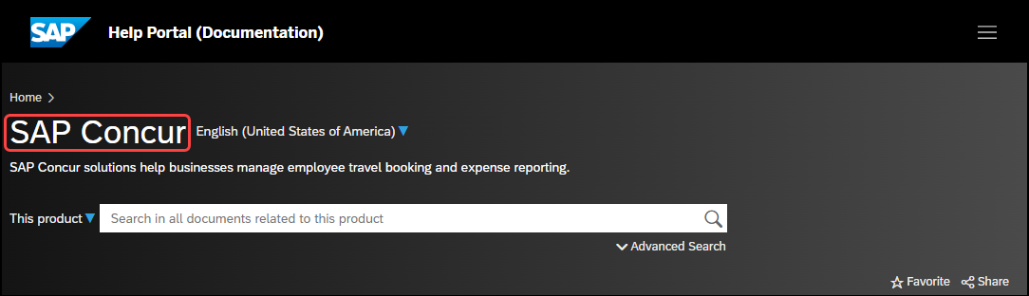

SAP Concur Support Portal – Selected Users
Access release notes, webinars, and other technical documentation on the SAP Concur support portal.
If you have the required permissions, Contact Support is available on the SAP Concur Help menu, and in the SAP Concur page footer.
Click Contact Support to access the SAP Concur support portal, then click Resources.
- Click Release/Tech Info for release notes, technical documents, etc.
- Click Webinars for recorded and live webinars.

Cases

Check Support Case Status
The steps in this procedure provide instructions for checking whether a case is resolved.
To check the status of a submitted case:
- Log on to https://concursolutions.com/portal.asp.
- Click Help > Contact Support.
If you do not have the option to contact SAP Concur support under the Help menu, then your company has chosen to support the SAP Concur service internally. Please contact your internal support desk for assistance.
- Click Support > View Cases.
- In the table, view the desired type of cases based on the View list selection. Search results are limited to each company's own cases.

© 2024 SAP SE or an SAP affiliate company. All rights reserved.
No part of this publication may be reproduced or transmitted in any form or for any purpose without the express permission of SAP SE or an SAP affiliate company.
SAP and other SAP products and services mentioned herein as well as their respective logos are trademarks or registered trademarks of SAP SE (or an SAP affiliate company) in Germany and other countries. Please see http://global12.sap.com/corporate-en/legal/copyright/index.epx for additional trademark information and notices.
Some software products marketed by SAP SE and its distributors contain proprietary software components of other software vendors.
National product specifications may vary.
These materials are provided by SAP SE or an SAP affiliate company for informational purposes only, without representation or warranty of any kind, and SAP SE or its affiliated companies shall not be liable for errors or omissions with respect to the materials. The only warranties for SAP SE or SAP affiliate company products and services are those that are set forth in the express warranty statements accompanying such products and services, if any. Nothing herein should be construed as constituting an additional warranty.
In particular, SAP SE or its affiliated companies have no obligation to pursue any course of business outlined in this document or any related presentation, or to develop or release any functionality mentioned therein. This document, or any related presentation, and SAP SE’s or its affiliated companies’ strategy and possible future developments, products, and/or platform directions and functionality are all subject to change and may be changed by SAP SE or its affiliated companies at any time for any reason without notice. The information in this document is not a commitment, promise, or legal obligation to deliver any material, code, or functionality. All forward-looking statements are subject to various risks and uncertainties that could cause actual results to differ materially from expectations. Readers are cautioned not to place undue reliance on these forward-looking statements, which speak only as of their dates, and they should not be relied upon in making purchasing decisions.

