SAP Concur Release Notes
Concur Expense Standard Edition
Month | Audience
Release Date: January 20, 2024  Initial Post: January 19, 2024 | Client FINAL

Contents
Release Notes 1
Expense Pay 1
Additional Card Program Now Supported for Europe 1
Receipts – ExpenseIt for Web 2
ExpenseIt for Concursolutions.com 2
Verify 7
Audit Profile: Enhanced Display for Multiple Auditors and Groups in Configuration 7
Planned Changes 8
Miscellaneous 8
**Planned Changes** New Action Column Available in Expense Screens 8
User Interface Changes 12
**Planned Changes** Update to the Report Status Indicator 12
Client Notifications 14
Accessibility 14
Accessibility Updates 14
Gender Diversity 14
In-Product User Assistance 14
Client Customized Content 14
Subprocessors 15
SAP Concur Non-Affiliated Subprocessors 15
Supported Browsers 15
Supported Browsers and Changes to Support 15
Additional Release Notes and Other Technical Documentation 16
Online Help 16
SAP Concur Support Portal – Selected Users 16
Cases 17
Check Support Case Status 17

Legal Disclaimer
The information in this presentation is confidential and proprietary to SAP SE or an SAP affiliate company and may not be disclosed without the permission of SAP SE or the respective SAP affiliate company. This presentation is not subject to your license agreement or any other service or subscription agreement with SAP SE or its affiliated companies. SAP SE and its affiliated companies have no obligation to pursue any course of business outlined in this document or any related presentation, or to develop or release any functionality mentioned therein. This document, or any related presentation and SAP SE or an SAP affiliate company’s strategy and possible future developments, products and or platforms directions and functionality are all subject to change and may be changed by SAP SE and its affiliated companies at any time for any reason without notice. The information in this document is not a commitment, promise or legal obligation to deliver any material, code, or functionality. This document is provided without a warranty of any kind, either express or implied, including but not limited to, the implied warranties of merchantability, fitness for a particular purpose, or non-infringement. This document is for informational purposes and may not be incorporated into a contract. SAP SE and its affiliated companies assume no responsibility for errors or omissions in this document, except if such damages were caused by SAP SE or an SAP affiliate company’s willful misconduct or gross negligence.
All forward-looking statements are subject to various risks and uncertainties that could cause actual results to differ materially from expectations. Readers are cautioned not to place undue reliance on these forward-looking statements, which speak only as of their dates, and they should not be relied upon in making purchasing decisions.

Release Notes
This document contains the release notes for Concur Expense Standard edition.
Features and changes that apply to SAP Concur site-wide or to multiple products/services are documented in the Shared Changes Release Notes. For information about site-wide or shared changes in this release that might impact your SAP Concur solutions, refer to the Shared Changes Release Notes.

Expense Pay

Additional Card Program Now Supported for Europe

Overview
Expense Payment Manager now supports the following HSBC credit card programs issued out of Europe:
- HSBC – VISA – GBP – HBEU
- HSBC – MasterCard – EURO – HBEU
- HSBC – MasterCard – GBP – HBCE
- HSBC – MasterCard – EURO – HBCE

Business Purpose / Client Benefit
These additional options can expedite the processing of credit card expenses.

Administrator Experience
These additional credit card programs are available to reimbursement admins on the Manager > Configure Batches > Card Programs (tab) > Add New Card Program page.
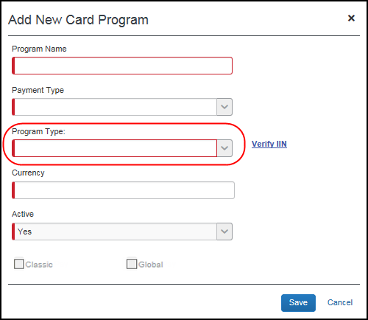
The HBEU cards are issued out of the United Kingdom, while the HBCE cards added are issued out of Continental Europe. Check your issued HSBC card numbers with the Bin ranges allowed for it using the Verify IIN link. This ensures you are selecting the correct HSBC card program type.

Configuration / Feature Activation
The change occurs automatically; there are no additional configuration steps.

Receipts – ExpenseIt for Web

ExpenseIt for Concursolutions.com

Overview
Concur brings the power of ExpenseIt to concursolutions.com. Using ExpenseIt to automatically scan and create an expense from an uploaded receipt can save users time and significantly reduce the risk of report rejections or send backs.
Previously, only available on Concur Mobile, users for companies who have purchased ExpenseIt can now upload receipts through familiar steps in Expense to automatically create expense entries for a report. To do this, ExpenseIt extracts key data from the receipt to automatically fill in expense details, while still giving users the flexibility to edit any values that require changes.

Business Purpose / Client Benefit
This reduces data entry effort for the end-user and provides the company with expanded awareness and benefit from ExpenseIt.

Release Schedule
ExpenseIt for Web was released to all customers the week of December 4, 2023. Individual customers were activated over the course of that week.

End-User Experience
This feature alerts the ExpenseIt end-user that new functionality is available by displaying the ExpenseIt Product Enhancements informational window when the end-user first logs in.
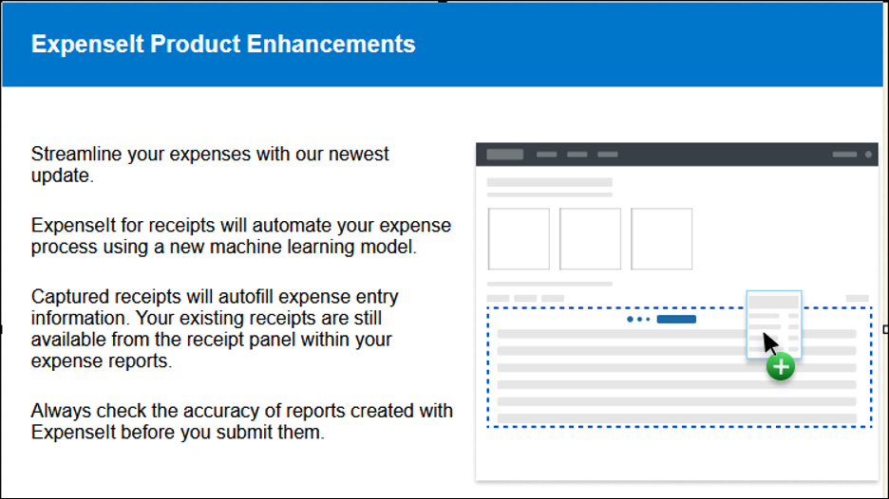
For end-users with ExpenseIt, all receipts uploaded from the Manage Expenses page on Concursolutions.com or emailed to receipts@concur.com automatically appear for viewing on the Available Expenses section of the page.
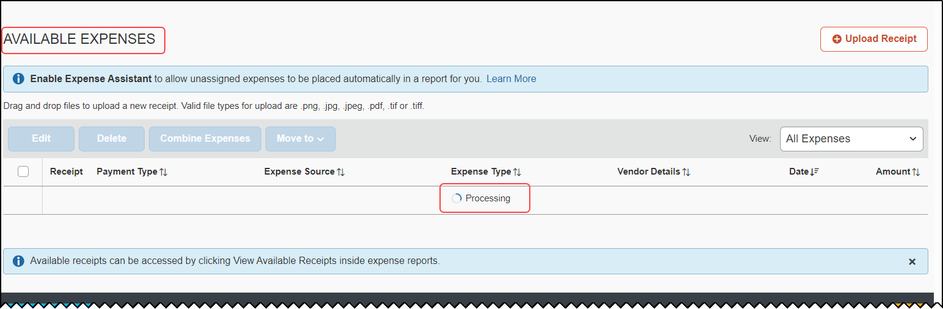
End-users can drag-n-drop receipts or use the Upload Receipt button to add one or more receipts at the same time, all processed by ExpenseIt. A blue bar appears under the expense table with information explaining the user interface – after review, dismiss by clicking the X to the right.
Receipts uploaded via the web UI or emailed may not be eligible for digital certification per the country-specific regulatory requirements that apply for that user. These users should continue to use the same processes they employed prior to this feature to achieve a certified receipt image.
Once processed, a new expense is created for the end-user with the following fields pre-populated from data extracted or predicted from the receipt image:
Fields Pre-Populated by ExpenseIt’s Data Extraction Functionality
Amount | Currency | Date | Expense Type
Location | Payment Type | Vendor
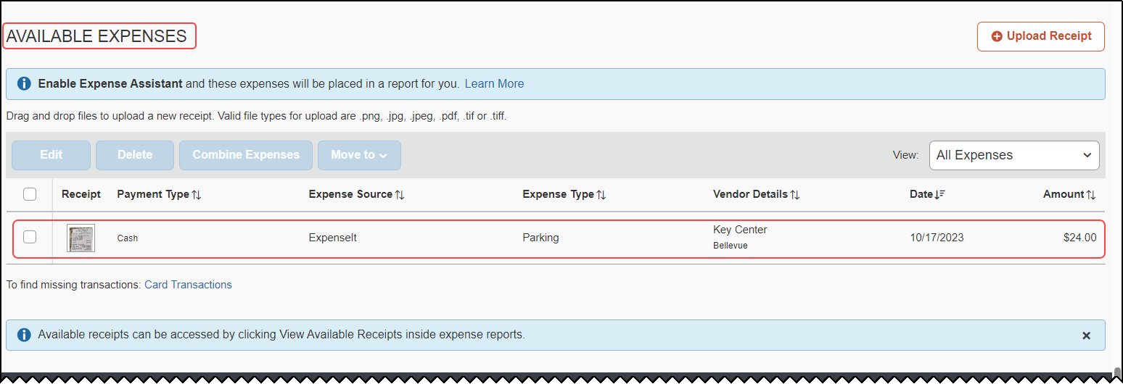
If required, the end-user can edit the ExpenseIt results by selecting the ExpenseIt item from the Available Expenses list. Once selected, choose Edit to open the expense, make any necessary changes, and then save them.
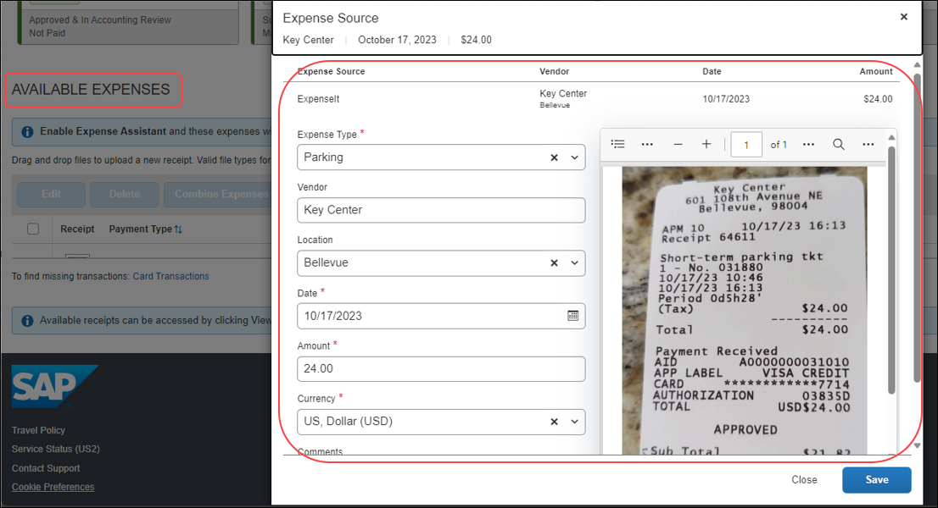

Additional Changes to the User Interface
ExpenseIt end-users should note that the Available Receipts section is no longer available in the Manage Expenses page. Now, all receipt images (including receipts created prior to this feature) are available and may be attached to expenses from within the expense report. To do this, open the report, select the target expense, click Add Receipt, and add a receipt from the new location for Available Receipts. Users can also use this method to add new images to an expense without processing by ExpenseIt.

Handling of Non-Receipt Documents for the Expense Report
Documents to support the expense, such as approval emails, travel itineraries, registration confirmations, or other supporting documents are not emailed or uploaded through the Manage Expense page. Instead, end-users will manually attach those supporting documents to an expense or the expense report.

Important: The Verification Step
ExpenseIt saves time and reduces manual entry errors by extracting information from a receipt image to create and display an expense; however, the technology is not always 100% accurate. Users should always scan and verify ExpenseIt results using the edit function for needed corrections.
Deleting the item and re-uploading the same image will not produce different results. Users should instead edit the available expense to correct the information.

Document Certification/Tax Compliance
Options for providing tax compliant receipt documents are dictated by the country-specific regulatory rules, and users must continue to follow the same processes used prior to this change.
- Receipt Digitalization: Images uploaded on Concursolutions.com or emailed, whether processed by ExpenseIt or as an image only, are not eligible for image certification. Users must continue to utilize Concur Mobile to create compliant images.
- eBunsho Timestamp: For eligible users, images uploaded on Concursolutions.com and processed through ExpenseIt will be sent through the eBunsho timestamping process. The functionality will continue to support emailed receipts and image capture via Concur Mobile.

Disabling ExpenseIt
The end-user may disable the use of ExpenseIt for the Web and remove the end-user interface and functionality described in this release note by clearing the Use ExpenseIt to create expenses from uploaded receipts and receipts emailed to receipts@concur.com on Profile Settings > Expense Preferences.
This Expense Preference only affects ExpenseIt for the Web and receipts that are emailed to SAP Concur. Disabling this user preference will NOT disable ExpenseIt within the Concur Mobile app.
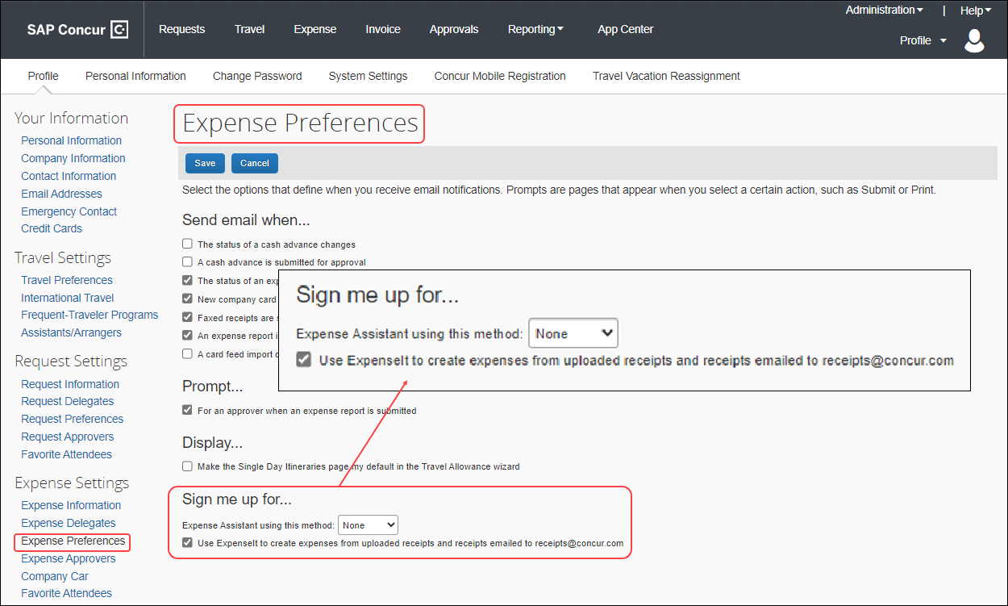

Configuration / Feature Activation
No end-user action is required: ExpenseIt for the Web was enabled during the week of December 4, 2023, for all end-users on entities that have purchased ExpenseIt.

Verify

Audit Profile: Enhanced Display for Multiple Auditors and Groups in Configuration

Overview
Since December 6, 2023, the Verify Audit Profile screen has been enhanced with some user interface modifications to display the details of multiple auditors and policy groups in a structured and organized manner.

Business Purpose / Client Benefit
This feature helps to streamline and improve user experience by presenting diverse auditor and group information in a structured, organized way. This update mitigates information overload, allows easy retrieval of details, and ensures a clutter-free interface. This is beneficial when dealing with multiple auditors and groups.

Administrator Experience
The Verify Audit Profile screen is updated to display details of policy groups and auditors in a more structured format.
Example
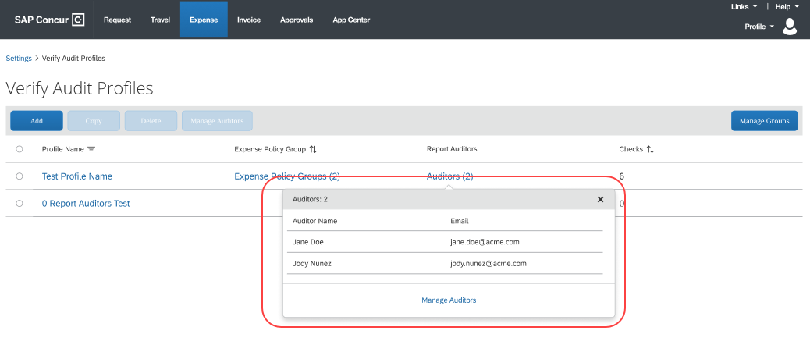

Configuration / Feature Activation
The change occurs automatically; there are no additional configuration steps.

Planned Changes
The items in this section are targeted for future releases. SAP Concur reserves the right to postpone implementation of – or completely remove – any enhancement/change mentioned here.
The planned changes listed in this document are specific to this product. For information about planned site-wide or shared changes that might impact your SAP Concur solutions, refer to the Shared Changes Release Notes.

Miscellaneous

**Planned Changes** New Action Column Available in Expense Screens
Information First Published | Information Last Modified | Feature Target Release Date
January 19, 2024 | -- | February 20, 2024
Any changes since the previous monthly release are highlighted in yellow in this release note.

Overview
Targeted for late February 2024, users will use two new action columns indicated by and , to perform single click actions or multiple actions such as edit, copy, or delete on the Expense screens, such as editing expense, itemizations, allocations, or travel diaries.
The current behavior where the user clicks the Expense rows to trigger an action will no longer be available after late February 2024.

Business Purpose / Client Benefit
This update will allow users to execute actions easily and will improve user experience for keyboard and screen reader users.

End-User Experience
All the existing Expense screens where you can perform actions will have new actions columns. This column will always be visible. A dropdown list will display all the actions that you can perform by selecting a single row of data.
A button link will display for single actions. For multiple actions, a See more () button will display with a dropdown list embedded in it.
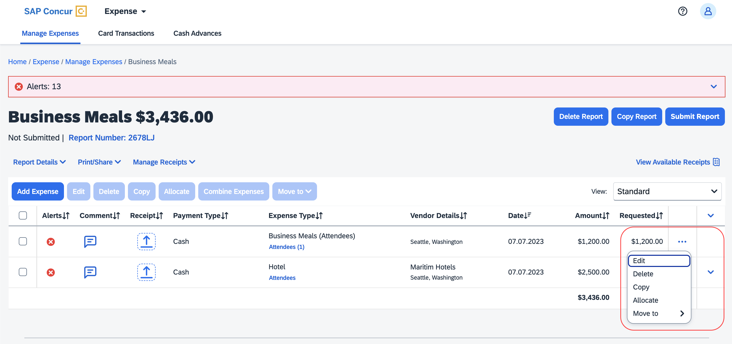
The updated Expense screens and their actions are:
- Reports list
- View
- Available Expenses
- View
- Delete
- Move To
- Available Expenses > Add Expense
- View
- Add to Report
- Cash Advance
- Remove
- Request
- Remove
- Attendees
- Remove
- Create Group
- Attendees Favorite Group
- Add
- Remove
- Recent Attendees
- Add
- Attendees Group
- Add
- Allocations
- Edit
- Remove
- Report Entries
- Edit
- Delete
- Copy
- Allocate
- Move to
- Report Entries (once the report is submitted)
- View
- Itemizations List
- Edit
- Delete
- Allocate
- Copy
- Itemizations List (once the report is submitted)
- View
- Travel Diary
- Edit
- Delete

For Example
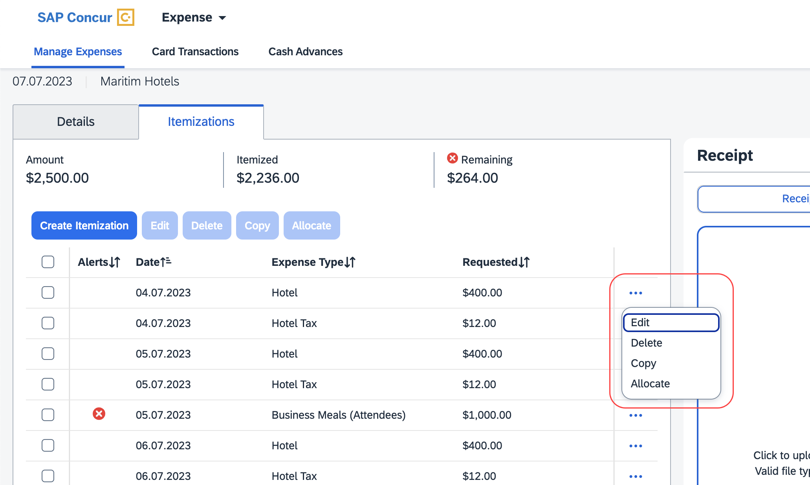
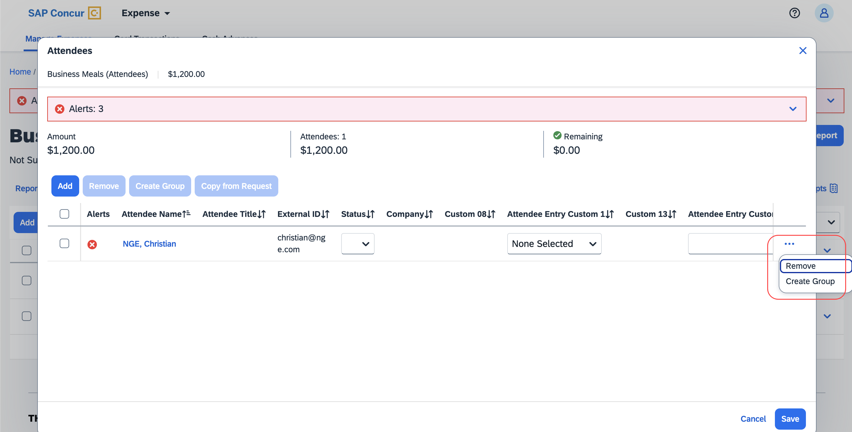

Configuration / Feature Activation
The change occurs automatically; there are no additional configuration steps.

User Interface Changes

**Planned Changes** Update to the Report Status Indicator

Information First Published | Information Last Modified | Feature Target Release Date
January, 2024 | -- | January 30, 2024
Any changes since the previous monthly release are highlighted in yellow in this release note.

Overview
In an upcoming release, the rectangular indicator that shows the status of an expense report will be changed. With the change, this indicator will be more prominent and easier to read than the prior version.

Business Purpose / Client Benefit
This feature improves the user’s accessibility to the status information of the expense report by providing greater visibility.

End-User Experience
The end-user will see, in selected screens, a solid color background and white text in the tiles that display the status of the expense report.
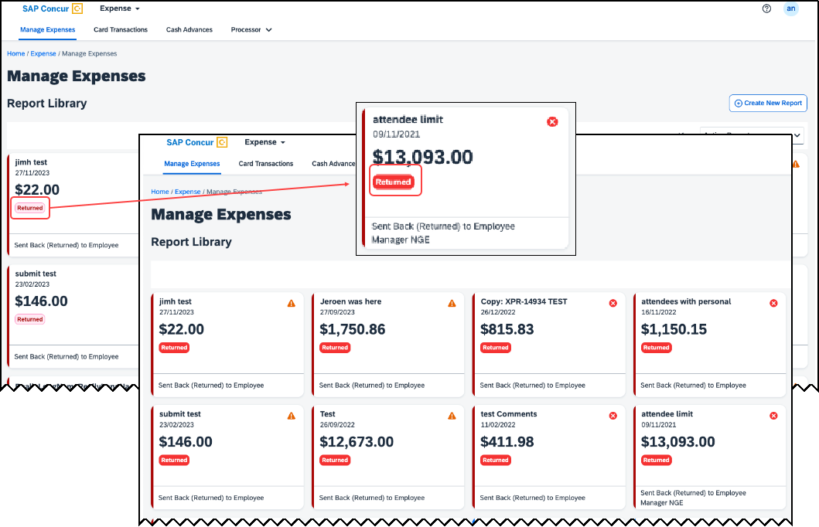

Configuration / Feature Activation
These changes will be automatically available after January 30, 2024; there are no configuration or activation steps.

Client Notifications

Accessibility

Accessibility Updates
SAP implements changes to better meet current Web Content Accessibility Guidelines (WCAG). Information about accessibility-related changes made to SAP Concur solutions is published on a quarterly basis. You can review the quarterly updates on the Accessibility Updates page.

Gender Diversity
SAP Concur is committed to supporting gender diversity. Over time we plan to implement product changes to help ensure that SAP Concur solutions support gender non-binary users. These changes will include but are not limited to support for preferred names, non-binary gender options in travel preferences, and non-binary titles.
These planned changes reflect SAP's commitment to supporting gender diversity and enable gender non-binary users to enter consistent information when making travel arrangements and entering personal information into SAP Concur solutions.
Timelines and details about these ongoing changes will be provided in the SAP Concur release notes.

In-Product User Assistance

Client Customized Content
If your company creates customized content for SAP Concur solutions through a user assistance tool such as SAP Enable Now or Concur User Assistant by WalkMe, the changes described in these release notes might affect your customized content. SAP Concur recommends reviewing the monthly release notes for all of your SAP Concur solutions as well as the Shared Changes Release Notes to confirm whether any of the planned or released changes might impact your internal, customized content.
If any changes in a release impact your content, work with your internal teams to update your content accordingly.

Subprocessors

SAP Concur Non-Affiliated Subprocessors
The list of non-affiliated subprocessors is available from the SAP Sub-processors / Data Transfer Factsheets page.
To access the SAP Concur Sub-processors List:
- Click the following link to navigate to the SAP Sub-processors / Data Transfer Factsheets page:
SAP Sub-processors / Data Transfer Factsheets
- Sign into the SAP Support Portal using your Support User ID (S-user) and password.
SAP customers must sign into the SAP Support Portal using their Support User ID (S-user) and password. For information about S-User IDs, refer to Your New Support User ID (S-user) and to the Learn All About S-User IDs blog post.
- On the SAP Sub-processors / Data Transfer Factsheets page, type "Concur" in the Search field.
- In the Title column, click SAP Concur Sub-processors List.
If you have questions or comments, please reach out to: Privacy-Request@Concur.com

Supported Browsers

Supported Browsers and Changes to Support
For information about supported browsers and planned changes to supported browsers, refer to the Concur Travel & Expense Supported Configurations guide.
When changes to browser support are planned, information about those changes will also appear in the Shared Changes Release Notes.

Additional Release Notes and Other Technical Documentation

Online Help
You can access release notes, setup guides, user guides, administrator summaries, supported configurations, and other resources via the in-product Help menu or directly on the SAP Help Portal.
To access the full set of documentation for your product, use the links in the SAP Concur Help menu, or visit the SAP Concur solutions page.
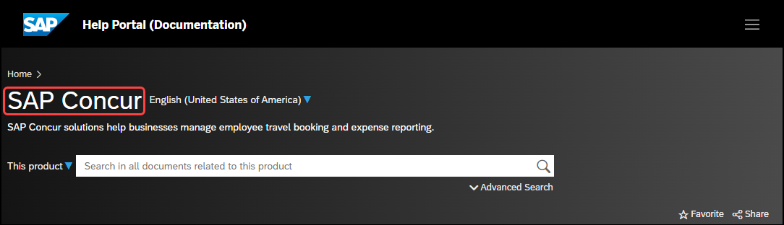

SAP Concur Support Portal – Selected Users
Access release notes, webinars, and other technical documentation on the SAP Concur support portal.
If you have the required permissions, Contact Support is available on the SAP Concur Help menu and, in the SAP Concur page footer.
Click Contact Support to access the SAP Concur support portal, then click Resources.
- Click Release/Tech Info for release notes, technical documents, etc.
- Click Webinars for recorded and live webinars.

Cases

Check Support Case Status
The steps in this procedure provide instructions for checking whether a case is resolved.
To check the status of a submitted case:
- Log on to https://concursolutions.com/portal.asp.
- Click Help > Contact Support.
If you do not have the option to contact SAP Concur support under the Help menu, then your company has chosen to support the SAP Concur service internally. Please contact your internal support desk for assistance.
- Click Support > View Cases.
- In the table, view the desired type of cases based on the View list selection. Search results are limited to each company's own cases.

© 2023 SAP SE or an SAP affiliate company. All rights reserved.
No part of this publication may be reproduced or transmitted in any form or for any purpose without the express permission of SAP SE or an SAP affiliate company.
SAP and other SAP products and services mentioned herein as well as their respective logos are trademarks or registered trademarks of SAP SE (or an SAP affiliate company) in Germany and other countries. Please see http://global12.sap.com/corporate-en/legal/copyright/index.epx for additional trademark information and notices.
Some software products marketed by SAP SE and its distributors contain proprietary software components of other software vendors.
National product specifications may vary.
These materials are provided by SAP SE or an SAP affiliate company for informational purposes only, without representation or warranty of any kind, and SAP SE or its affiliated companies shall not be liable for errors or omissions with respect to the materials. The only warranties for SAP SE or SAP affiliate company products and services are those that are set forth in the express warranty statements accompanying such products and services, if any. Nothing herein should be construed as constituting an additional warranty.
In particular, SAP SE or its affiliated companies have no obligation to pursue any course of business outlined in this document or any related presentation, or to develop or release any functionality mentioned therein. This document, or any related presentation, and SAP SE’s or its affiliated companies’ strategy and possible future developments, products, and/or platform directions and functionality are all subject to change and may be changed by SAP SE or its affiliated companies at any time for any reason without notice. The information in this document is not a commitment, promise, or legal obligation to deliver any material, code, or functionality. All forward-looking statements are subject to various risks and uncertainties that could cause actual results to differ materially from expectations. Readers are cautioned not to place undue reliance on these forward-looking statements, which speak only as of their dates, and they should not be relied upon in making purchasing decisions.

