SAP Concur Release Notes
Analysis / Intelligence
Month | Audience
Release Date: February 24, 2024  Initial Post: February 23, 2024 | Client – FINAL

Contents
Release Notes 1
Model Changes 1
New Folder and Fields: Adjustments Folder and Deduction Category Code and Deduction Type Code Fields 1
New Fields: Custom Name and Code Fields for Invoice 3
Report Changes 4
There are no report changes this month. 4
Other Changes 4
There are no other changes this month. 4
Planned Changes 5
Other Changes 5
**Planned Changes** Report Catalog and Data Model Documentation Links to be Removed from Analysis and Intelligence 5
Client Notifications 8
Accessibility 8
Accessibility Updates 8
Gender Diversity 8
Gender Diversity Planned Features and Changes 8
In-Product User Assistance 8
Client Customized Content 8
Subprocessors 9
SAP Concur Non-Affiliated Subprocessors 9
Supported Browsers 9
Supported Browsers and Changes to Support 9
Additional Release Notes and Other Technical Documentation 10
Online Help 10
Analysis / Intelligence Documentation – concurtraining.com 12
SAP Concur Support Portal – Selected Users 13

Legal Disclaimer
The information in this presentation is confidential and proprietary to SAP SE or an SAP affiliate company and may not be disclosed without the permission of SAP SE or the respective SAP affiliate company. This presentation is not subject to your license agreement or any other service or subscription agreement with SAP SE or its affiliated companies. SAP SE and its affiliated companies have no obligation to pursue any course of business outlined in this document or any related presentation, or to develop or release any functionality mentioned therein. This document, or any related presentation and SAP SE or an SAP affiliate company’s strategy and possible future developments, products and or platforms directions and functionality are all subject to change and may be changed by SAP SE and its affiliated companies at any time for any reason without notice. The information in this document is not a commitment, promise or legal obligation to deliver any material, code or functionality. This document is provided without a warranty of any kind, either express or implied, including but not limited to, the implied warranties of merchantability, fitness for a particular purpose, or non-infringement. This document is for informational purposes and may not be incorporated into a contract. SAP SE and its affiliated companies assume no responsibility for errors or omissions in this document, except if such damages were caused by SAP SE or an SAP affiliate company’s willful misconduct or gross negligence.
All forward-looking statements are subject to various risks and uncertainties that could cause actual results to differ materially from expectations. Readers are cautioned not to place undue reliance on these forward-looking statements, which speak only as of their dates, and they should not be relied upon in making purchasing decisions.

Release Notes
This document contains the release notes for Analysis and Intelligence.
Features and changes that apply to SAP Concur site-wide or to multiple products/services are documented in the Shared Changes Release Notes. For information about site-wide or shared changes in this release that might impact your SAP Concur solutions, refer to the Shared Changes Release Notes.

Model Changes

New Folder and Fields: Adjustments Folder and Deduction Category Code and Deduction Type Code Fields
With this release, there is a new travel allowance-related folder and fields for Expense.
Description: The new Adjustments folder contains the new Deduction Category Code and Deduction Type Code fields. These new fields will allow users to report on meal deduction information from the Adjustments page. These fields were added to the model for use with the Travel Allowance Service.
- For more information about the Travel Allowance Service, refer to the Travel Allowance Service (Current) guides.

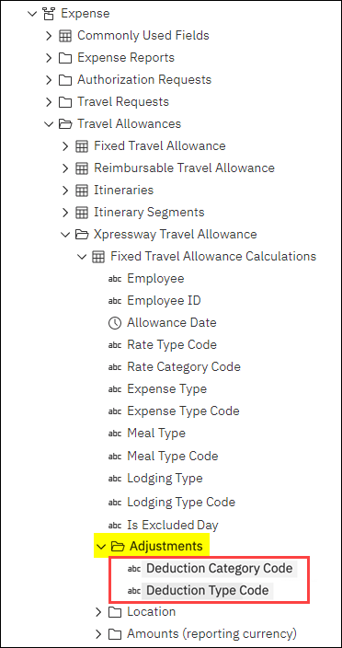
Expense > Travel Allowances
The new travel allowance-related folder and fields for Expense are:
- Folder: Expense > Travel Allowances > Xpressway Travel Allowance > Fixed Travel Allowance Calculations > Adjustments
Field:
- Deduction Category Code
- Deduction Type Code

New Fields: Custom Name and Code Fields for Invoice
With this release, there are new custom report-related fields for Invoice.
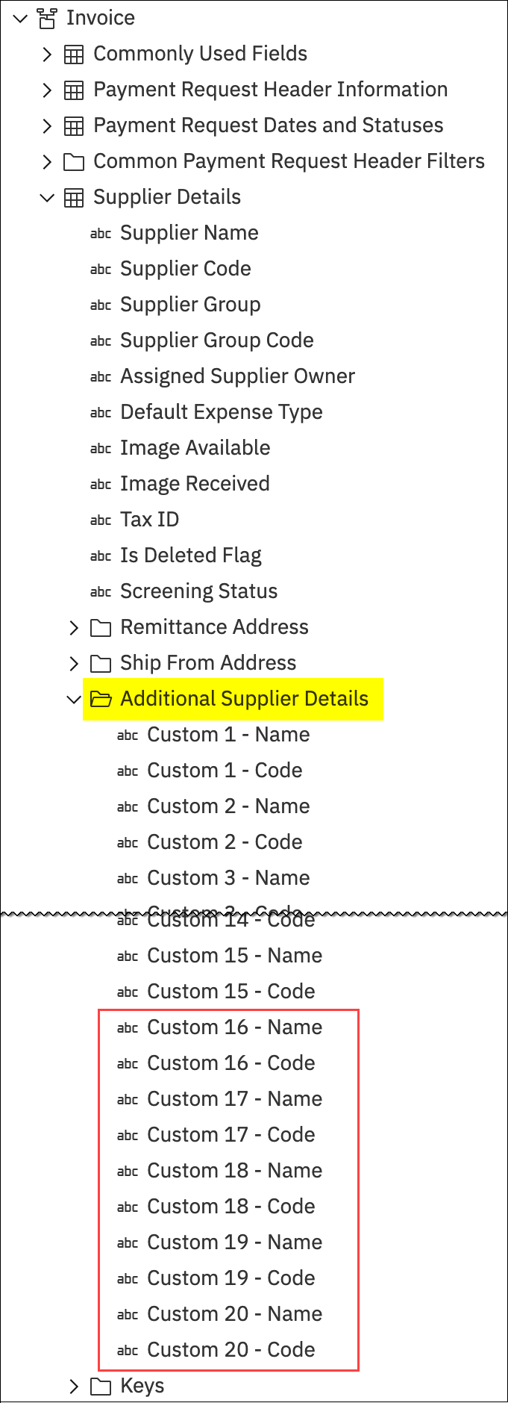
Description: Five additional custom fields are added to the Invoice data model. The five new Custom [#] - Name and five new Custom [#] - Code fields provide users with additional custom fields for custom reports.
The custom fields are populated based on your organization's configuration in Concur Invoice.

Invoice > Supplier Details
The new custom report-related fields for Invoice are:
- Folder: Invoice > Supplier Details > Additional Supplier Details
Field:
- Custom 16 - Name through Custom 20 - Name
- Custom 16 - Code through
Custom 20 - Code

Report Changes

There are no report changes this month.

Other Changes

There are no other changes this month.

Planned Changes
The items in this section are targeted for future releases. SAP Concur reserves the right to postpone implementation of – or completely remove – any enhancement/change mentioned here.
The planned changes listed in this document are specific to this product. For information about planned site-wide or shared changes that might impact your SAP Concur solutions, refer to the Shared Changes Release Notes.

Other Changes

**Planned Changes** Report Catalog and Data Model Documentation Links to be Removed from Analysis and Intelligence

Information First Published | Information Last Modified | Feature Target Release Date
September 8, 2023 | February 23, 2024 | Q1 2024
Any changes since the previous monthly release are highlighted in yellow in this release note.

Overview
As mentioned in the SAP Concur User Assistance | **Ongoing** Links from the SAP Concur Solutions UI to Product Documentation Being Removed release note currently running in the Shared Changes release notes:
Some pages in the SAP Concur solutions UI include links to product documentation or other content. In Q3 2023, SAP Concur plans to begin removing these links. The SAP Help Portal is the central source for all product documentation, release notes, and other content. SAP Concur clients can use the SAP Concur page on the SAP Help Portal to find the complete library of SAP Concur solutions documentation.
As part of this initiative, the two product documentation links to the report catalog and data model documentation that are located within the Analysis and Intelligence UI will be removed.
We are currently targeting to remove the two documentation links from the Analysis and Intelligence UI in Q1 2024.

Business Purpose / Client Benefit
Because the links to product documentation from the SAP Concur solutions UI point to English-only content, the experience is not optimal for users that view the UI in languages other than English. In addition, direct links to a single document prevent the user from viewing and navigating the entire content library. This update is being made to align with SAP best practices.

End-User Experience
In Cognos 11, the Standard Report Catalog and SAP Concur Model links located on the Resources menu will be removed.
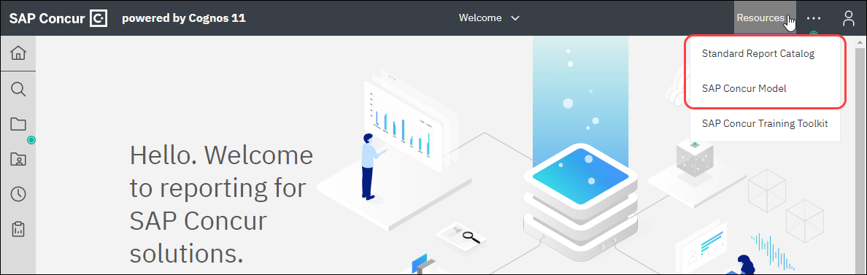
When the links are removed, a new link, SAP Help Portal, will be added to the Resources menu. Clicking the SAP Help Portal link will open the SAP Concur page on the SAP Help Portal.
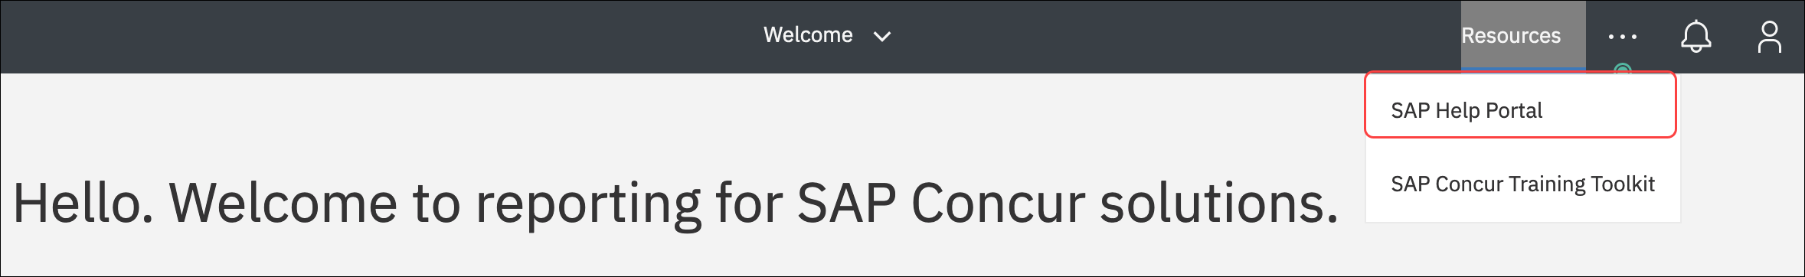
In Cognos 10, the Help - Concur Model and Help - Report Catalog links on the Launch menu will be removed.
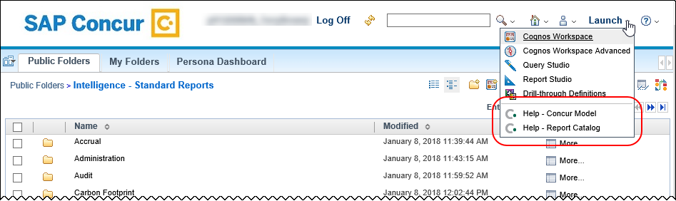
The report catalog and data model documentation, in addition to the other Analysis and Intelligence documentation, can now be accessed directly from the SAP Help Portal by clicking the Analysis/Intelligence User Guides (English Only) link in the Product Assistance section on the SAP Concur page.
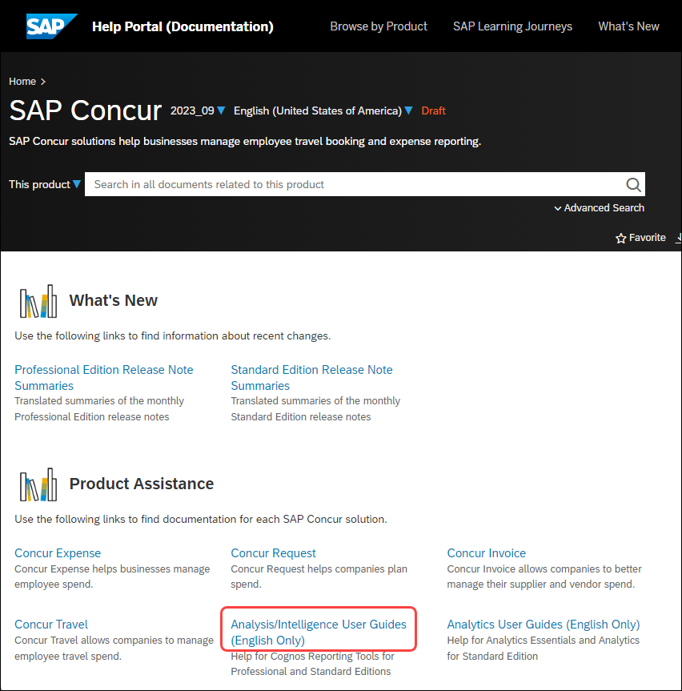

Configuration / Feature Activation
These changes will occur automatically.
- For more information about the removal of the product documentation links from the SAP Concur solutions UI, refer to the SAP Concur User Assistance | **Ongoing** Links from the SAP Concur Solutions UI to Product Documentation Being Removed release note in the Shared Changes release notes.

Client Notifications

Accessibility

Accessibility Updates
SAP implements changes to better meet current Web Content Accessibility Guidelines (WCAG). Information about accessibility-related changes made to SAP Concur solutions is published on a quarterly basis. You can review the quarterly updates on the Accessibility Updates page.

Gender Diversity

Gender Diversity Planned Features and Changes
SAP Concur is committed to supporting gender diversity. Over time we plan to implement product changes to help ensure that SAP Concur solutions support gender non-binary users. These changes will include but are not limited to support for preferred names, non-binary gender options in travel preferences, and non-binary titles.
These planned changes reflect SAP's commitment to supporting gender diversity and enable gender non-binary users to enter consistent information when making travel arrangements and entering personal information into SAP Concur solutions.
Timelines and details about these ongoing changes will be provided in the SAP Concur release notes:
- Standard Edition
- Professional Edition

In-Product User Assistance

Client Customized Content
If your company creates customized content for SAP Concur solutions through a user assistance tool such as SAP Enable Now or Concur User Assistant by WalkMe, the changes described in these release notes might affect your customized content. SAP Concur recommends reviewing the monthly release notes for all of your SAP Concur solutions as well as the Shared Changes Release Notes to confirm whether any of the planned or released changes might impact your internal, customized content.
If any changes in a release impact your content, work with your internal teams to update your content accordingly.

Subprocessors

SAP Concur Non-Affiliated Subprocessors
The list of non-affiliated subprocessors is available from the SAP Sub-processors / Data Transfer Factsheets page.
To access the SAP Concur Sub-processors List:
- Click the following link to navigate to the SAP Sub-processors / Data Transfer Factsheets page:
SAP Sub-processors / Data Transfer Factsheets
- Sign in to the SAP Support Portal using your Support User ID (S-user) and password.
SAP customers must sign in to the SAP Support Portal using their Support User ID (S-user) and password. For information about S-User IDs, refer to Your New Support User ID (S-user) and to the Learn All About S-User IDs blog post.
- On the SAP Sub-processors / Data Transfer Factsheets page, type "Concur" in the Search field.
- In the Title column, click SAP Concur Sub-processors List.
If you have questions or comments, please reach out to: Privacy-Request@Concur.com

Supported Browsers

Supported Browsers and Changes to Support
For information about supported browsers and planned changes to supported browsers, refer to the Concur Travel & Expense Supported Configurations guide.
When changes to browser support are planned, information about those changes will also appear in the Shared Changes Release Notes.

Additional Release Notes and Other Technical Documentation

Online Help
You can access release notes, setup guides, user guides, admin summaries, supported configurations, and other resources via the in-product Help menu or directly on the SAP Help Portal.
To access the full set of documentation for your product, use the links in the SAP Concur Help menu, or visit the SAP Concur solutions page.
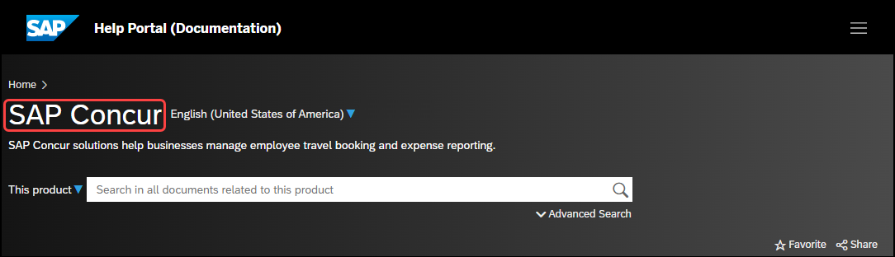
To access the product documentation for Analysis and Intelligence from the SAP Help Portal, on the SAP Concur page, click the Analysis/Intelligence User Guides (English Only) link in the Product Assistance section.

Analysis / Intelligence Documentation – concurtraining.com
The Analysis / Intelligence documentation is available on the Help for Cognos Reporting Tools page:
http://www.concurtraining.com/customers/tech_pubs/Docs/Cognos/_CTE_chp.htm
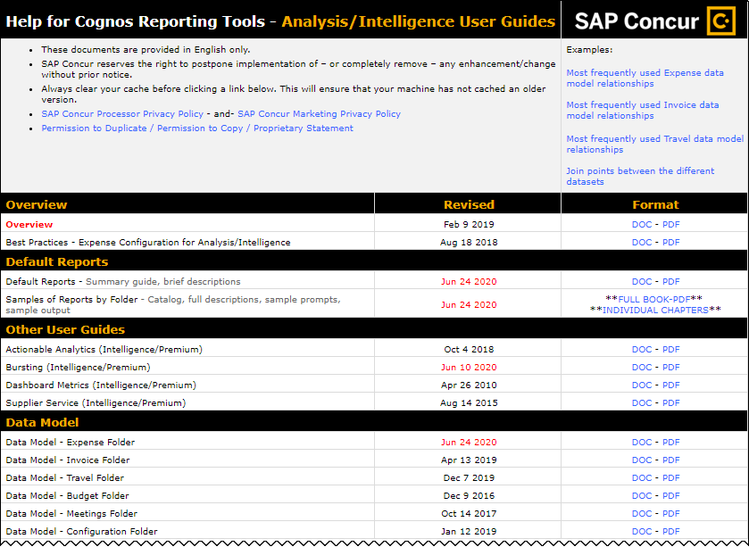

SAP Concur Support Portal – Selected Users
Access release notes, webinars, and other technical documentation on the SAP Concur support portal.
If you have the required permissions, Contact Support is available on the SAP Concur Help menu and in the SAP Concur page footer.
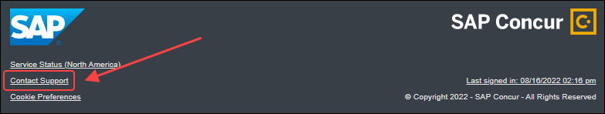
Click Contact Support to access the SAP Concur support portal, then click Resources.
- Click Release/Tech Info for release notes, technical documents, etc.
- Click Webinars for recorded and live webinars.
© 2024 SAP SE or an SAP affiliate company. All rights reserved.
No part of this publication may be reproduced or transmitted in any form or for any purpose without the express permission of SAP SE or an SAP affiliate company.
SAP and other SAP products and services mentioned herein as well as their respective logos are trademarks or registered trademarks of SAP SE (or an SAP affiliate company) in Germany and other countries. Please see http://global12.sap.com/corporate-en/legal/copyright/index.epx for additional trademark information and notices.
Some software products marketed by SAP SE and its distributors contain proprietary software components of other software vendors.
National product specifications may vary.
These materials are provided by SAP SE or an SAP affiliate company for informational purposes only, without representation or warranty of any kind, and SAP SE or its affiliated companies shall not be liable for errors or omissions with respect to the materials. The only warranties for SAP SE or SAP affiliate company products and services are those that are set forth in the express warranty statements accompanying such products and services, if any. Nothing herein should be construed as constituting an additional warranty.
In particular, SAP SE or its affiliated companies have no obligation to pursue any course of business outlined in this document or any related presentation, or to develop or release any functionality mentioned therein. This document, or any related presentation, and SAP SE’s or its affiliated companies’ strategy and possible future developments, products, and/or platform directions and functionality are all subject to change and may be changed by SAP SE or its affiliated companies at any time for any reason without notice. The information in this document is not a commitment, promise, or legal obligation to deliver any material, code, or functionality. All forward-looking statements are subject to various risks and uncertainties that could cause actual results to differ materially from expectations. Readers are cautioned not to place undue reliance on these forward-looking statements, which speak only as of their dates, and they should not be relied upon in making purchasing decisions.

