SAP Concur Release Notes
Analysis / Intelligence
Month | Audience
Release Date: June 18, 2022  Update #2: Tuesday, June 21, 2022 | Client – FINAL

Contents
Release Notes 1
Model Changes 1
There are no model changes this month. 1
Report Changes 1
New Report: Transportation Details Report (JPT 2.0) (Japan) 1
Other Changes 8
**Ongoing** Update to IBM Cognos Version 11 8
Planned Changes 10
**Planned Changes** New Report: IC Card Utilization Rate (JPT 2.0) (Japan) 10
Client Notifications 14
Accessibility 14
Accessibility Updates 14
Subprocessors 14
SAP Concur Non-Affiliated Subprocessors 14
Supported Browsers 15
Supported Browsers and Changes to Support 15
Additional Release Notes and Other Technical Documentation 16
Online Help 16
Analysis / Intelligence Documentation – concurtraining.com 16
Analysis / Intelligence Documentation – Cognos 17
SAP Concur Support Portal – Selected Users 17

Legal Disclaimer
The information in this presentation is confidential and proprietary to SAP SE or an SAP affiliate company and may not be disclosed without the permission of SAP SE or the respective SAP affiliate company. This presentation is not subject to your license agreement or any other service or subscription agreement with SAP SE or its affiliated companies. SAP SE and its affiliated companies have no obligation to pursue any course of business outlined in this document or any related presentation, or to develop or release any functionality mentioned therein. This document, or any related presentation and SAP SE or an SAP affiliate company’s strategy and possible future developments, products and or platforms directions and functionality are all subject to change and may be changed by SAP SE and its affiliated companies at any time for any reason without notice. The information in this document is not a commitment, promise or legal obligation to deliver any material, code or functionality. This document is provided without a warranty of any kind, either express or implied, including but not limited to, the implied warranties of merchantability, fitness for a particular purpose, or non-infringement. This document is for informational purposes and may not be incorporated into a contract. SAP SE and its affiliated companies assume no responsibility for errors or omissions in this document, except if such damages were caused by SAP SE or an SAP affiliate company’s willful misconduct or gross negligence.
All forward-looking statements are subject to various risks and uncertainties that could cause actual results to differ materially from expectations. Readers are cautioned not to place undue reliance on these forward-looking statements, which speak only as of their dates, and they should not be relied upon in making purchasing decisions.

Release Notes
This document contains the release notes for Analysis and Intelligence.
Features and changes that apply to SAP Concur site-wide or to multiple products/services are documented in the Shared Changes Release Notes. For information about site-wide or shared changes in this release that might impact your SAP Concur solutions, refer to the Shared Changes Release Notes.

Model Changes

There are no model changes this month.

Report Changes

New Report: Transportation Details Report (JPT 2.0) (Japan)

Overview
The Transportation Details Report (JPT 2.0) provides information about employee transportation expenses. The report can help Intelligence clients in the Japanese market evaluate the reasonableness of commuter spend, identify suspicious activity associated with route information, and ensure employee compliance with transportation spend.
The Transportation Details Report (JPT 2.0) is only available to Intelligence clients using the JPT (Japan Public Transport) 2.0 feature in the NextGen UI for Concur Expense.
With the June 2022 release, "(JPT 2.0)" may not appear in the report title. We are planning to update report title to "Transportation Details Report (JPT 2.0)" in a future release to clearly indicate that the report is for JPT 2.0.

Report Prompts
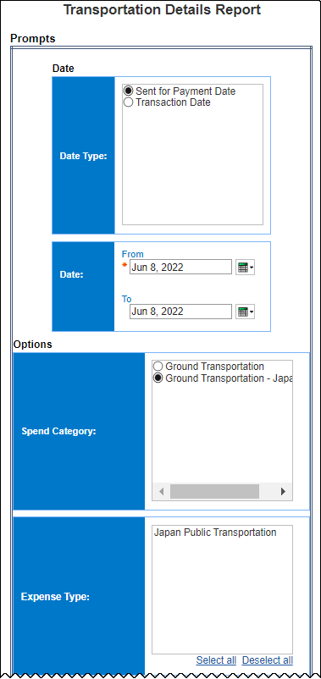
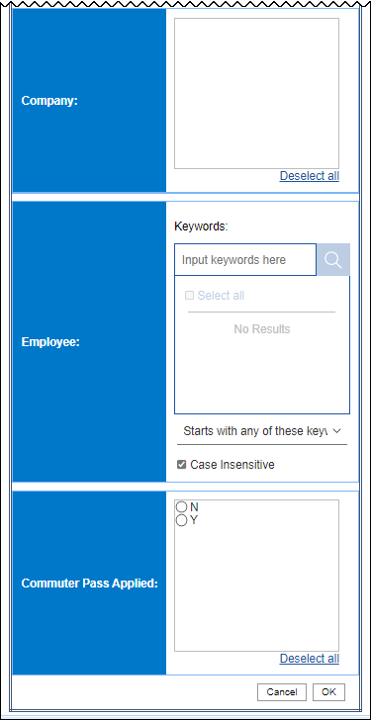

Report Output
This report includes these columns:
- Company
- Employee
- Employee ID
- Report ID
- Report Name
- Report Number
- Spend Category
- Expense Type
- Transaction Date
- Sent for Payment Date
- Transaction Currency
- Transaction Amount
- Reimbursement Currency
- Transaction Amount (reimbursement currency)
- Approved Amount (reimbursement currency)
- Vendor
- City/Location
- From Location
- To Location
- Departure Station
- Arrival Station
- Seat Type
- Additional Charge
- Origin Type
- Is Round Trip
- Is Fast
- Is Easy
- Is Cheap
- Is Commuter Pass Applied
- Purpose
- Comment
- Personal

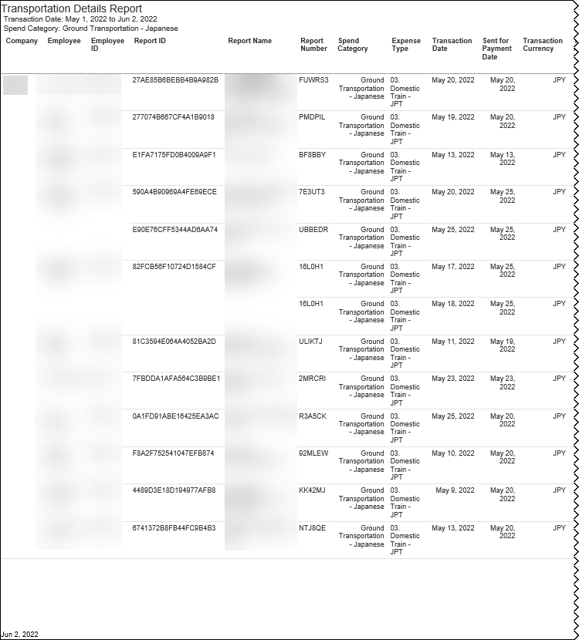
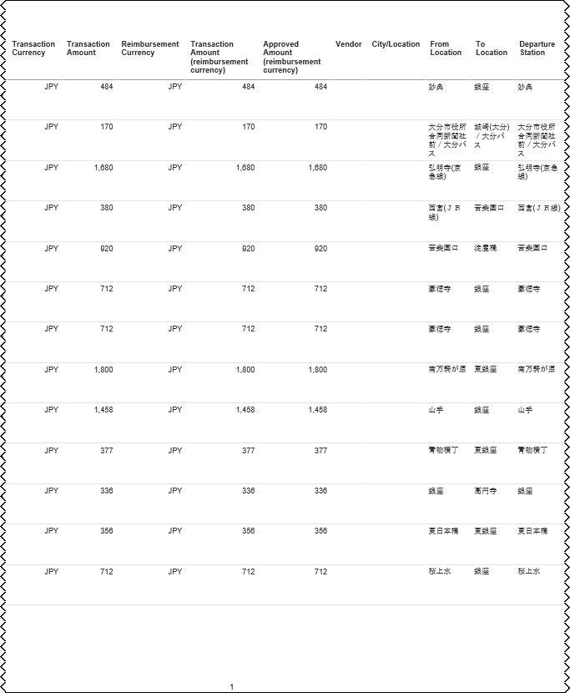
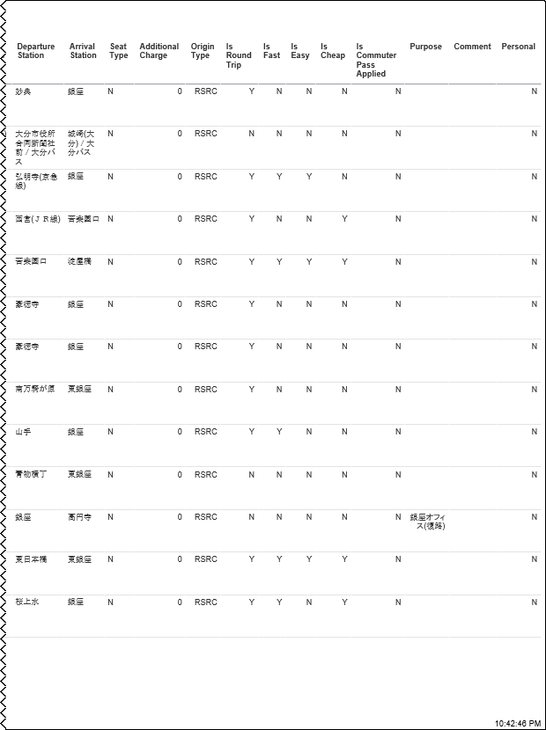

Location of the Report
The report is located here:
- Intelligence - Standard Reports ‎> Market Specific Reports > Japan
- For more information about the Transportation Details Report (JPT 2.0), refer to Chapter 13: Folder – Market Specific Reports in the Standard Reports by Folder guide.

Other Changes

**Ongoing** Update to IBM Cognos Version 11

Information First Published | Information Last Modified | Feature Target Release Date
July 2020 | April 15, 2022 | Ongoing in 2022
Any changes since the previous monthly release are highlighted in yellow in this release note.

Overview
Analysis and Intelligence are powered by IBM® Cognos®. Cognos will be updated to v11 for Analysis and Intelligence.
This update will bring some enhancements to Analysis and Intelligence, such as the following:
- Enhancements to the user interface (UI):
- More modern looking interface
- Instead of hovering over actions such as 'run a report', 'schedule a report', and more menu items, they can be found with just a right click.
- Existing Report Studio will be renamed to Report in Cognos v11
- Includes data element searching within the Concur Data Warehouse Model
Standard Reports and existing data elements offered within the Concur Data Warehouse Model will remain unchanged.

Update Schedule
The Cognos v11 update is underway. This update to the Analysis/Intelligence UI happens automatically for customers over a weekend, so be sure on the Friday prior to the Cognos v11 update to save any reports in-progress, just as you would during a typical release.
The update occurs to an entire server simultaneously and each server can contain hundreds or thousands of entities. Customers with multiple entities or test sites may have different update dates for their entities and sites. We are trying to give customers as much advance notice of the update as possible.
When your entity is scheduled for an update, you will see a notification within the Analysis/Intelligence application. Unfortunately, for technical reasons, we are not able to individualize the schedule for each customer, such as updating specific entities earlier or later.

Update Preparation
In anticipation of the update, please visit the Cognos 11 User Interface Update website where you will find information on the new features and enhancements this update brings.
Also, following the update, you may need to renew your credentials in order to restart any scheduled reports. It only takes a few mouse clicks, and the steps are described on page 5 of the FAQ.

Planned Changes
The items in this section are targeted for future releases. SAP Concur reserves the right to postpone implementation of – or completely remove – any enhancement/change mentioned here.
The planned changes listed in this document are specific to this product. For information about planned site-wide or shared changes that might impact your SAP Concur solutions, refer to the Shared Changes Release Notes.

**Planned Changes** New Report: IC Card Utilization Rate (JPT 2.0) (Japan)

Overview
The IC Card Utilization Rate (JPT 2.0) report will be a new version of the existing IC Card Utilization Rate report that is specifically designed to only provide data from the JPT (Japan Public Transport) 2.0 feature in the NextGen UI for Concur Expense. The IC Card Utilization Rate report will provide utilization rates for IC Cards. The IC Card Utilization Rate report can help Intelligence clients determine the degree of governance and business efficiency for IC card usage using the IC Card data. The report will provide IC Card utilization rates by company, division, and users.
The IC Card Utilization Rate (JPT 2.0) report will only be available to Intelligence clients using the JPT (Japan Public Transport) 2.0 feature in the NextGen UI for Concur Expense.

Report Prompts
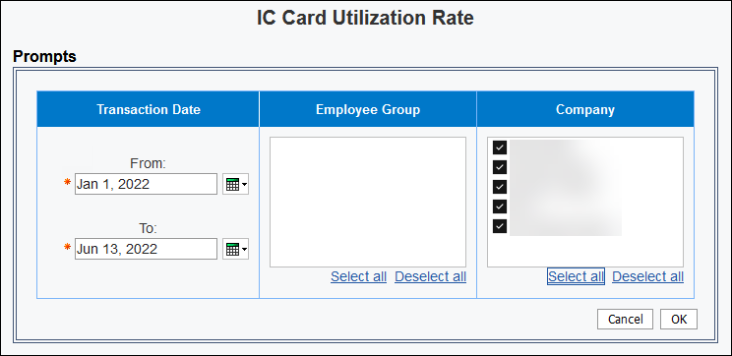

Report Output
This report includes these columns:
- Employee Group
- Employee Group Code
- Number of Employees
- Number of Users
- Usage Rate
- Division
- Division – Code
- Employee Key
- Average
- Company
- Company – Code
- Route Total
- Origin Type
- Route Total by Type
- Utilization Rate
- Number of Route
- %
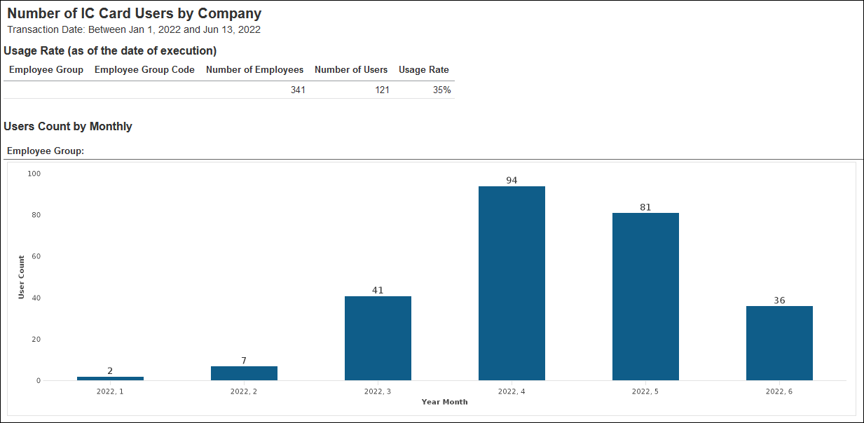
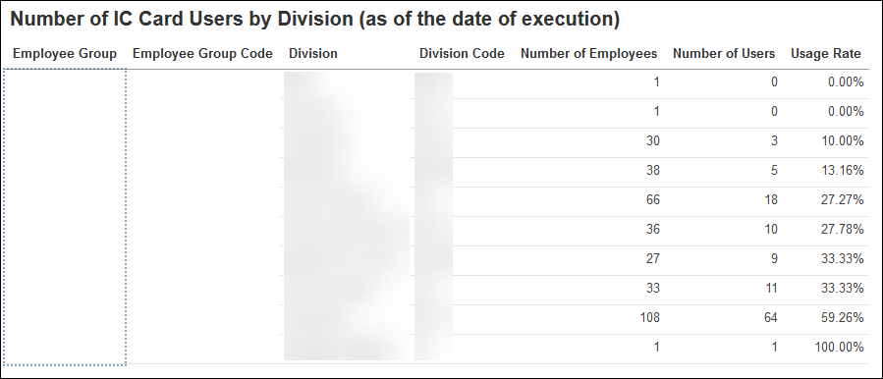
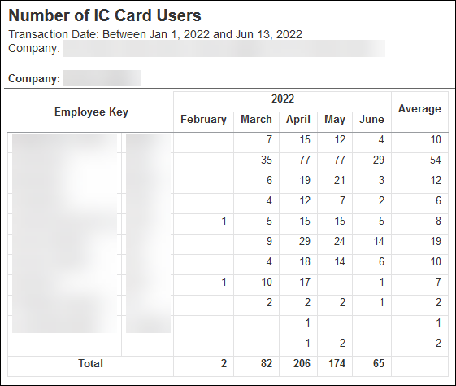
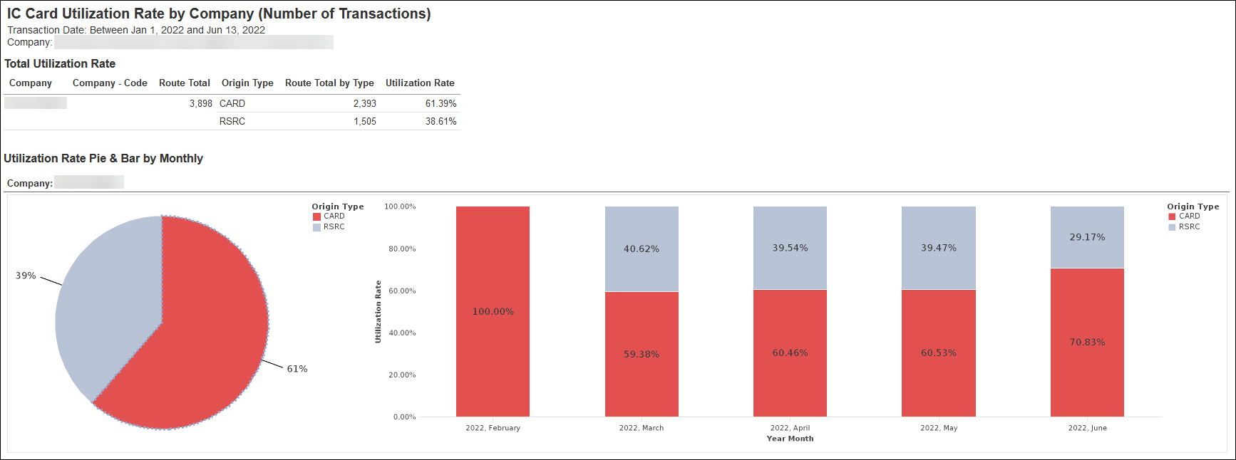
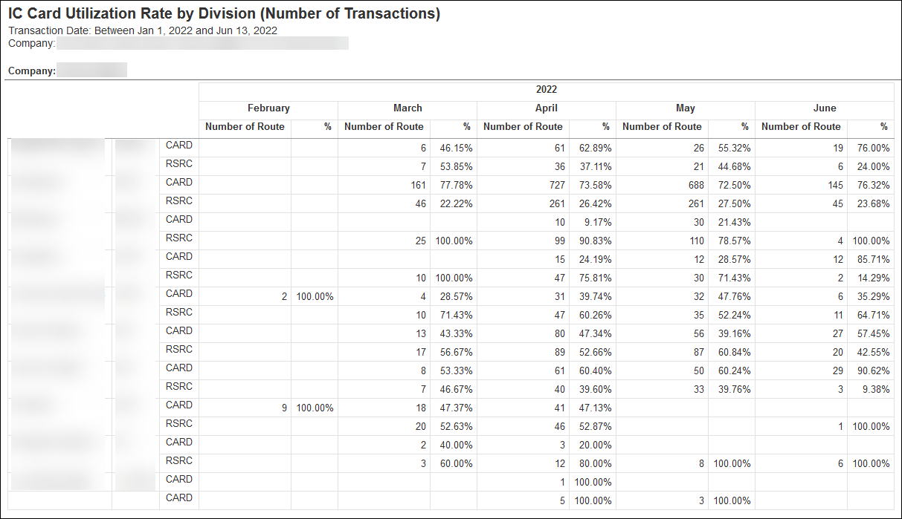

Location of the Report
The report will be located here:
- Intelligence - Standard Reports ‎> Market Specific Reports > Japan
- More information about the IC Card Utilization Rate (JPT 2.0) report will be available in Chapter 13: Folder – Market Specific Reports in the Standard Reports by Folder guide.

Client Notifications

Accessibility

Accessibility Updates
SAP implements changes to better meet current Web Content Accessibility Guidelines (WCAG). Information about accessibility-related changes made to SAP Concur solutions is published on a quarterly basis. You can review the quarterly updates on the Accessibility Updates page.

Subprocessors

SAP Concur Non-Affiliated Subprocessors
The list of non-affiliated subprocessors is available here: SAP Concur list of Subprocessors
To access the SAP Concur Sub-processors List:
- Click the following link to navigate to the SAP Sub-processors / Data Transfer Factsheets page:
SAP Sub-processors / Data Transfer Factsheets
- Sign in to the SAP Support Portal using your Support User ID (S-user) and password.
SAP customers must sign in to the SAP Support Portal using their Support User ID (S-user) and password. For information about S-User IDs, refer to Your New Support User ID (S-user).
- On the SAP Sub-processors / Data Transfer Factsheets page, type "Concur" in the Search field.
- In the Title column, click SAP Concur Sub-processors List.
If you have questions or comments, please reach out to: Privacy-Request@Concur.com

Supported Browsers

Supported Browsers and Changes to Support
For information about supported browsers and planned changes to supported browsers, refer to the Concur Travel & Expense Supported Configurations guide.
When changes to browser support are planned, information about those changes will also appear in the Shared Changes Release Notes.

Additional Release Notes and Other Technical Documentation

Online Help
Any user can access release notes, setup guides, user guides, admin summaries, monthly browser certifications, supported configurations, and other resources via online Help or directly on the SAP Help Portal.
Use the links in the Help menu in the app, or search for your SAP Concur product (Concur Expense, Concur Invoice, Concur Request, or Concur Travel) on the SAP Help Portal (https://help.sap.com) to view the full set of documentation for your product.

Analysis / Intelligence Documentation – concurtraining.com
The Analysis / Intelligence documentation is available on the Help for Cognos Reporting Tools page:
http://www.concurtraining.com/customers/tech_pubs/Docs/Cognos/_CTE_chp.htm
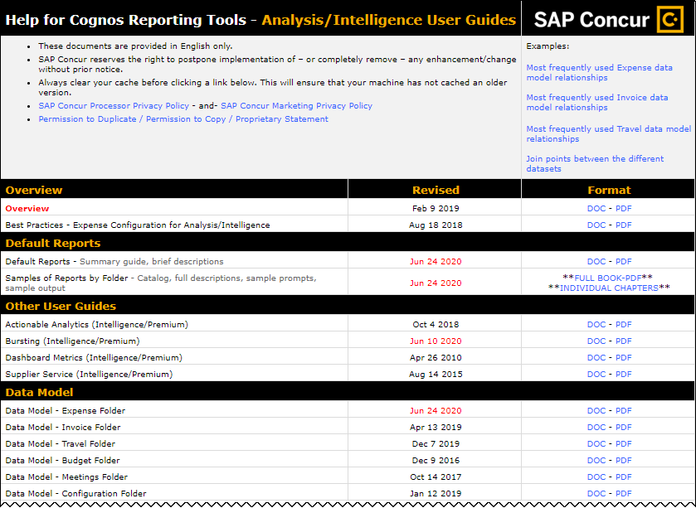

Analysis / Intelligence Documentation – Cognos
You can also access the Concur Analysis / Intelligence documentation from Cognos. In Cognos, click Launch > Help – Concur Model or Help – Report Catalog.
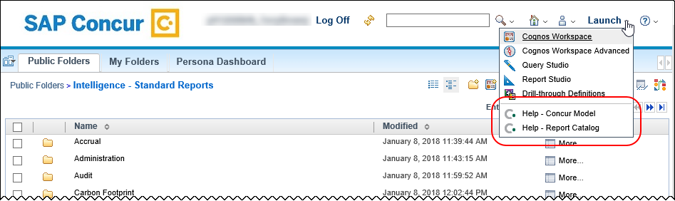

SAP Concur Support Portal – Selected Users
Access release notes, webinars, and other technical documentation on the SAP Concur support portal.
If you have the proper permissions, Contact Support appears on the Help menu. Click to access the SAP Concur support portal, then click Resources.
- Click Release/Tech Info for release notes, technical documents, etc.
- Click Webinars for recorded and live webinars.
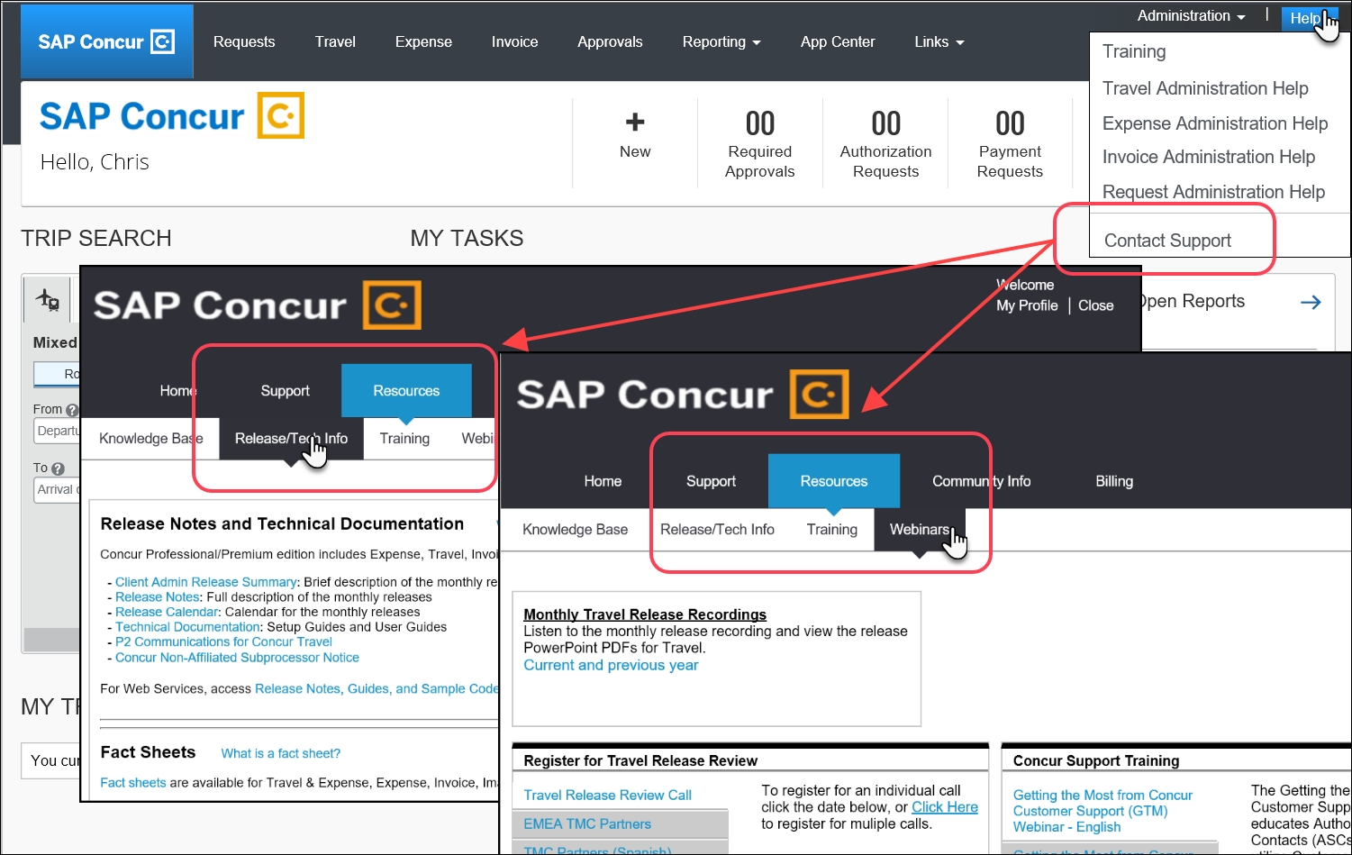
© 2022 SAP SE or an SAP affiliate company. All rights reserved.
No part of this publication may be reproduced or transmitted in any form or for any purpose without the express permission of SAP SE or an SAP affiliate company.
SAP and other SAP products and services mentioned herein as well as their respective logos are trademarks or registered trademarks of SAP SE (or an SAP affiliate company) in Germany and other countries. Please see http://global12.sap.com/corporate-en/legal/copyright/index.epx for additional trademark information and notices.
Some software products marketed by SAP SE and its distributors contain proprietary software components of other software vendors.
National product specifications may vary.
These materials are provided by SAP SE or an SAP affiliate company for informational purposes only, without representation or warranty of any kind, and SAP SE or its affiliated companies shall not be liable for errors or omissions with respect to the materials. The only warranties for SAP SE or SAP affiliate company products and services are those that are set forth in the express warranty statements accompanying such products and services, if any. Nothing herein should be construed as constituting an additional warranty.
In particular, SAP SE or its affiliated companies have no obligation to pursue any course of business outlined in this document or any related presentation, or to develop or release any functionality mentioned therein. This document, or any related presentation, and SAP SE’s or its affiliated companies’ strategy and possible future developments, products, and/or platform directions and functionality are all subject to change and may be changed by SAP SE or its affiliated companies at any time for any reason without notice. The information in this document is not a commitment, promise, or legal obligation to deliver any material, code, or functionality. All forward-looking statements are subject to various risks and uncertainties that could cause actual results to differ materially from expectations. Readers are cautioned not to place undue reliance on these forward-looking statements, which speak only as of their dates, and they should not be relied upon in making purchasing decisions.

