Table of Contents
Chapter 19: Folder – Spending 19-1
Report: Airline Ancillary Fees Summary 19-1
Available to:  Analysis  Intelligence 19-1
Uses: R Expense Data  Travel / TripLink Data 19-1
Report: Ancillary Airline Fees Per Ticket 19-4
Available to:  Analysis  Intelligence 19-4
Uses: R Expense Data  Travel / TripLink Data 19-4
Report: Drive Adoption 19-7
Available to:  Analysis  Intelligence 19-7
Uses: R Expense Data  Travel / TripLink Data 19-7
Report: Excessive Personal Car Mileage 19-10
Available to:  Analysis  Intelligence 19-10
Uses: R Expense Data  Travel / TripLink Data 19-10
Report: Executive Briefing Summary 19-14
Available to:  Analysis  Intelligence 19-14
Uses: R Expense Data  Travel / TripLink Data 19-14
Report: Expense Airline Ancillary Fees - Details 19-23
Available to:  Analysis  Intelligence 19-23
Uses: R Expense Data  Travel / TripLink Data 19-23
Report: Fare Analysis 19-27
Available to:  Analysis  Intelligence 19-27
Uses:  Expense Data R Travel / TripLink Data 19-27
Report: Internet Usage 19-31
Available to:  Analysis  Intelligence 19-31
Uses: R Expense Data  Travel / TripLink Data 19-31
Report: Top Spend by Vendor 19-34
Available to:  Analysis  Intelligence 19-34
Uses: R Expense Data  Travel / TripLink Data 19-34
Report: Top Spenders by Employee 19-37
Available to:  Analysis  Intelligence 19-37
Uses: R Expense Data  Travel / TripLink Data 19-37
Report: Top Spenders by Expense Type 19-40
Available to:  Analysis  Intelligence 19-40
Uses: R Expense Data  Travel / TripLink Data 19-40
Report: Travel Summary 19-43
Available to:  Analysis  Intelligence 19-43
Uses:  Expense Data R Travel / TripLink Data 19-43

Revision History
Date | Notes / Comments / Changes
January 21, 2022 | Updated the copyright year; no other changes; cover date not updated
March 22, 2021 | Replaced references to "Concur Drive" with "Drive" in the Drive Adoption report description for accurate product branding.
February 20, 2021 | Updated the copyright year; no other changes
January 8, 2020 | Changed copyright and updated the calculations for the Total Hotel Spend and Total Car Spend columns on the Travel Summary report.
February 28, 2019 | Added additional information about the Drive Adoption report filter and calculations
February 9, 2019 | Removed references to Insight Premium from the guide and updated copyright
August 22, 2018 | Updated image of the Drive Adoption report
July 12, 2018 | Added the Drive Adoption report
June 12, 2018 | Added additional information about report prompts and reports to the reports in the Spending folder
January 13 2018 | Changed copyright; no other content changes
September 18 2017 | Updated one of the Executive Briefing Summary report images to show the new bar graph that replaced the former pie chart
December 15 2016 | Changed copyright; no other content changes
November 16 2016 | Updated report images to match the current application
October 10 2016 | Updated Prompts images for copied reports
March 23 2016 | Changed the text under the heading from Travel Data to Travel / TripLink Data; no other content changes
September 18 2015 | Changed the chapter number; no other content changes
August 14 2015 | Moved from single book to individual "chapters" – no content changes

Folder – Spending

Report: Airline Ancillary Fees Summary
Available to:  Analysis  Intelligence
Uses: R Expense Data  Travel / TripLink Data
This report will identify all spend on airline ancillary fees. There have been six expense types that make up the ancillary fees. This report will display each of those expense types, and the percentage of all airline spend that they make up.

Report Prompts
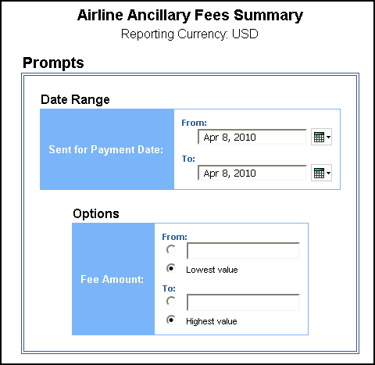

Date Range Prompt
- Sent for Payment Date: Used to filter the report by the date range the payment was sent for reimbursement to the employee(s)

Options Prompts
- Fee Amount:
- From: Used to filter the report using a defined minimum amount of the ancillary fees
- To: Used to filter the report using a defined maximum amount of the ancillary fees
- Lowest value: Used to filter the report using the lowest amount available of the ancillary fees
- Highest value: Used to filter the report using the highest amount available of the ancillary fees

Report Output
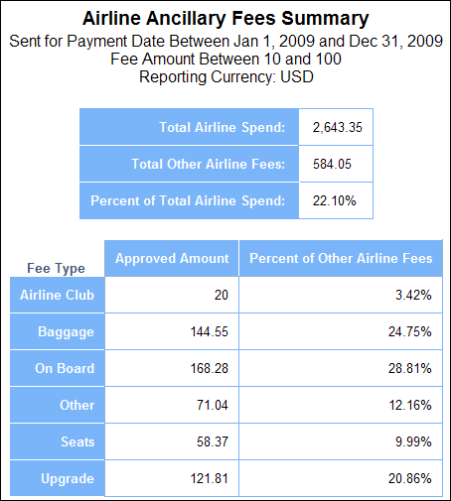

Report Header and Footer
Data Item Label/Name | Data Item Expression | Data Item Description
Sent for Payment Date | ParamDisplayValue('sentForPaymentDateParam') | Displays the date range entered from the Sent for Payment Date prompt on the Prompts page
Fee Amount | ParamDisplayValue('approvedAmountParam') | Displays the fee amount entered from the Fee Amount prompt on the Prompts page
Reporting Currency | [[Expense].[Entry Information].[Reporting Currency] | Displays the currency code in which the reporting currency is shown (for example, USD, CAD, GBP)

Report Data Items
Data Item Label | Data Item Name | Data Item Expression | Data Item Description
Total Airline Spend | <Total Airline Spend> | [Ancillary Fees].[Total Airline Spend] | Amount of the total airline spend approved for reimbursement, converted as needed to the reporting currency
Total Other Airline Fees | <Total Other Airline Fees> | total([Approved Amount] for report) | Amount of the total ancillary fees approved for reimbursement, converted as needed to the reporting currency
Percent of Total Airline Spend | <Percent of Total Airline Spend> | [Total Other Airline Fees]/[Total Airline Spend] | Percentage of the total airline spend, not including ancillary fees
Fee Type | <#Airline Ancillary Fee Type#> | [Ancillary Fees].[Airline Ancillary Fee Type] | Category type of the airline ancillary fee
Approved Amount | <Approved Amount> | [Ancillary Fees].[Approved Amount] | Amount of the ancillary fees approved for reimbursement by ancillary fee type
Percent of Other Airline Fees | <Percent of Other Airline Fees> | total([Approved Amount] for [Airline Ancillary Fee Type])/[Total Other Airline Fees] | Percentage of the ancillary fees by ancillary fee type

Report: Ancillary Airline Fees Per Ticket
Available to:  Analysis  Intelligence
Uses: R Expense Data  Travel / TripLink Data
This report will allow Travel Managers to view how much each employee is spending on ancillary fees on a per ticket basis.

Report Prompts
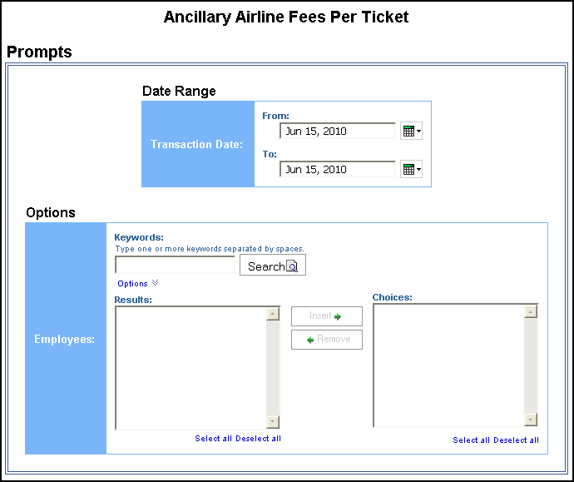

Date Range Prompt
- Transaction Date: Used to filter the report by the date range that transaction(s) were made

Options Prompts
- Employees: Used to filter the report by the name of employee(s) who booked trips

Report Output
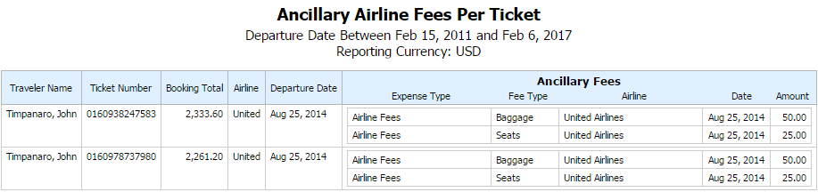

Report Header and Footer
Data Item Label/Name | Data Item Expression | Data Item Description
Departure Date | ParamDisplayValue('transactionDateParam') | Displays the date range from the Transaction Date prompt on the Prompts page
Reporting Currency | [Travel].[Reservations and Tickets].[Reporting Currency] | Displays the currency code in which the reporting currency is shown (for example, USD, CAD, GBP)

Report Data Items
Data Item Label | Data Item Name | Data Item Expression | Data Item Description
Traveler Name | <Primary Traveler> | [Segments].[Primary Traveler] | Name of the traveler taking the trip
Ticket Number | <Ticket ID> | [Segments].[Ticket ID] | Ticket number for the reserved air booking
Booking Total | <Booking Total (reporting currency)> | [Segments].[Booking Total (reporting currency | Sum of the booking amount and the booking tax in the reporting currency
Airline | <Transportation Vendor/Hotel Property> | [Segments].[Transportation Vendor / Hotel Property] | Name of the hotel property/car rental/airline company
Departure Date | <Departure Date> | [Segments].[Departure Date] | Departure date (month day, year format) of the associated ticket segment
Expense Type | <Expense Type> | [Expense].[Entry Information].[Expense Type] | Expense type assigned to the expense
Fee Type | <Airline Ancillary Fee Type> | [Expense].[Entry Information].[Airline Ancillary Fee Type] | Category type of the airline ancillary fee
Airline | <Vendor> | [Expense].[Entry Information].[Vendor] | Airline vendor associated with the expense
Date | <Transaction Date> | [Expense].[Entry Information].[Transaction Date] | Date the transaction was incurred
Amount | <Approved Amount (rpt)> | [Expense].[Entry Information].[Approved Amount (rpt)] | Amount of the expense approved for reimbursement, converted as needed to the reporting currency

Report: Drive Adoption
Available to:  Analysis  Intelligence
Uses: R Expense Data  Travel / TripLink Data
This report provides details about the usage and adoption of Drive for mileage expense entries. The report includes the number of mileage entries, percentage of Drive adoption, number of mileage entries associated with Drive routes, and the percentage of Drive routes that were modified. The report also displays the top 10 employees with the highest number of modifications to their mileage amounts provided by Drive.
The Drive Adoption report is filtered to only show personal car mileage. This filter is based on the Spend Category Code field value PRCRM. PRCRM is the spend category code for the Personal Car – Mileage Reimbursement spend category.
The Drive Adoption report displays the data for the current calendar quarter based on the Sent for Payment Date.

Report Prompts
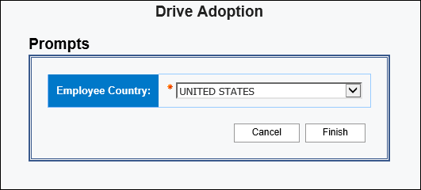

Report Output
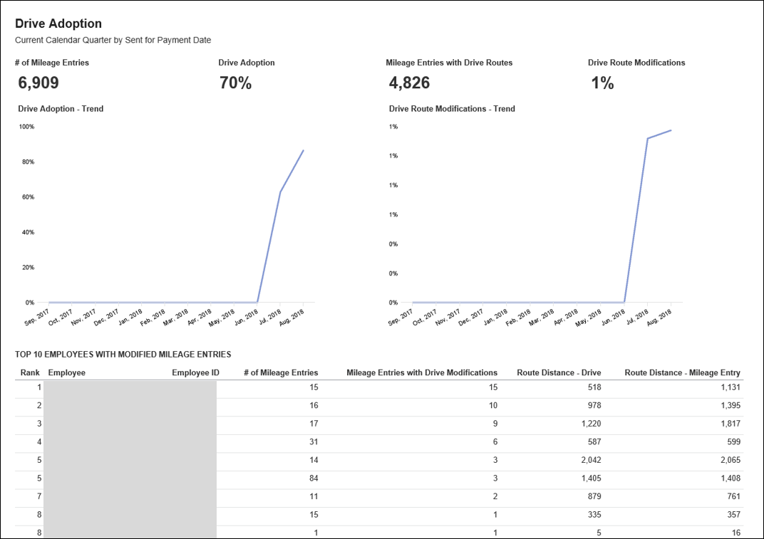

Calculation Information
- # of Mileage Entries
The number of personal car mileage entries.
- Drive Adoption
The number of personal car mileage entries with a Drive/GPS Route attached divided by the total number of personal car mileage entries.
- Mileage Entries with Drive Routes
The number of personal car mileage entries with a Drive/GPS route attached. This is the same number used in the numerator of the Drive Adoption calculation.
- Drive Route Modifications
The number of personal car mileage entries from Drive (GPS) where the Business Distance is different than the distance from Drive/GPS divided by the total number of personal car mileage entries from Drive/GPS.
Because the Business Distance on the personal car mileage expense entry rounds to the nearest whole number and the distance from the Drive/GPS rounds to the nearest tenth of a percent, there is a 0.5 standard deviation used in the calculation.
For example, if the distance from Drive/GPS was 10.6 and the Business Distance on the expense entry was 11, then this would not be considered a modification because 10.6 is less than the 0.5 standard deviation.
However, if the distance from Drive/GPS was 10.3 and the Business Distance on the expense entry was 11, then this would be considered a modification because 10.3 is greater than the 0.5 standard deviation.

Report: Excessive Personal Car Mileage
Available to:  Analysis  Intelligence
Uses: R Expense Data  Travel / TripLink Data
Travelers will use a personal car to travel for business. In many cases, it may be more cost effective for the company to instead rent a car on a trip. This report helps companies to identify how much is being spent on car mileage, and to create and enforce a sensible policy.

Report Prompts
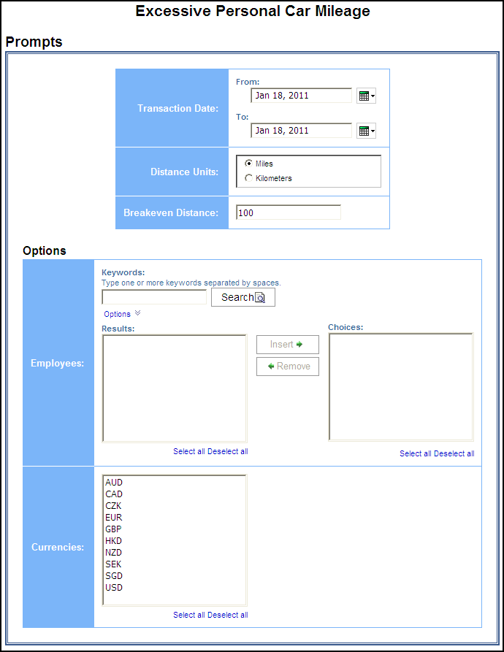
- Transaction Date: Used to filter the report by the date range that transaction(s) were made
- Distance Units: Used to select if the distance should be shown in “Miles” or “Kilometers”
- Break Even Distance: Used to define the distance in which the cost of renting a car was equal to the cost of using a personal car to travel for business

Options Prompts
- Employees: Used to filter the report by the name of employee(s) who booked trips
- Currencies: Used to filter the report by the currency in which the employee(s) is reimbursed

Report Output
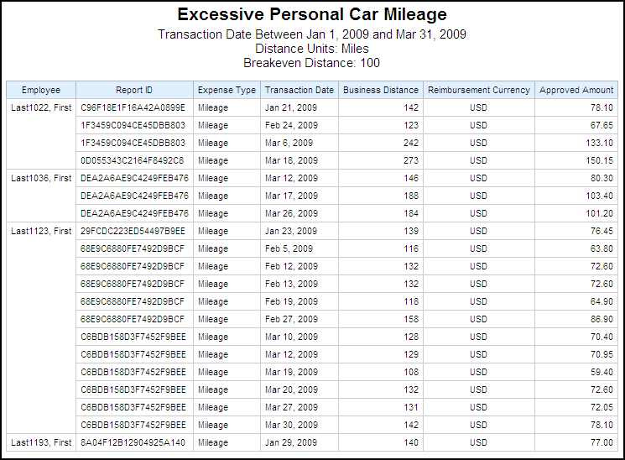

Report Header and Footer
Data Item Label/Name | Data Item Expression | Data Item Description
Transaction Date | ParamDisplayValue('dateRangeParam') | Displays the date range from the Transaction Date prompt on the Prompts page
Distance Units | ParamDisplayValue('distanceUnitParam') | Displays the selected Miles or Kilometers option from the Distance Unit prompt on the Prompts page
Break Even Distance | ParamDisplayValue('breakevenDistanceParam') | Displays the breakeven distance entered from the Break Even Distance prompt on the Prompts page
N/A | AsOfDate() | Displays the date the report was run
N/A | PageNumber() | Displays the page number of the corresponding page
N/A | AsOfTime() | Displays the time the report was run

Report Data Items
Data Item Label | Data Item Name | Data Item Expression | Data Item Description
Employee | <Employee> | [Expense].[Report Header Information].[Employee] | Employee last name, first name, and middle initial
Report ID | <Report ID> | [Expense].[Report Header Information].[Report ID] | Unique system-assigned code that identifies the expense report
Expense Type | <Expense Type> | [Expense].[Entry Information].[Expense Type] | Expense type assigned to the expense
Transaction Date | <Transaction Date> | [Expense].[Entry Information].[Transaction Date] | Date that the expense was incurred
Business Distance | <Business Distance> | round( CASE WHEN ?distanceUnitParam? = 'Miles' AND [Expense].[Car Expenses].[Distance Unit Code] = 'KM' THEN [Expense].[Car Expenses].[Business Distance] * .621371 WHEN ?distanceUnitParam? = 'Kilometers' AND [Expense].[Car Expenses].[Distance Unit Code] = 'MILE' THEN [Expense].[Car Expenses].[Business Distance] * 1.60934 ELSE [Expense].[Car Expenses].[Business Distance] END ,0) | Number of miles driven for business in miles or kilometers
Reimbursement Currency | <Reimbursement Currency> | [Expense].[Entry Information].[Reimbursement Currency] | Currency in which the employee is reimbursed
Approved Amount | <Approved Amount> | [Expense].[Entry Information].[Approved Amount] | Amount of the expense approved for reimbursement, converted as needed to the employee's reimbursement currency

Report: Executive Briefing Summary
Available to:  Analysis  Intelligence
Uses: R Expense Data  Travel / TripLink Data
This report allows users to evaluate several key metrics in a single report. Users can track the following data point with this report:
- T&E Summary
- Total T&E Spend (by Month)
- Total T&E Spend (Top Five by Category)
- Top Five Spend Trend by Category
- Vendor Analysis
- Top Five Vendor Spend by Airline
- Top Ten Vendor Spend by Hotel
- Top Five Vendor Spend by Car Rental
- Top Five Vendor Spend by Cell Provider
- Year over Year
- Total Approved Spend
- Total Number of Reports Processed
- Category Spend Trend

Report Prompts
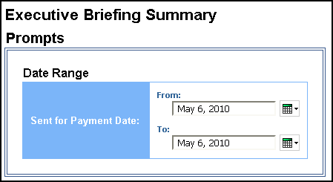

Date Range Prompt
- Sent for Payment Date: Used to filter the report by the date range the payment was sent for reimbursement to the employee(s)

Report Output
T&E Summary report page:
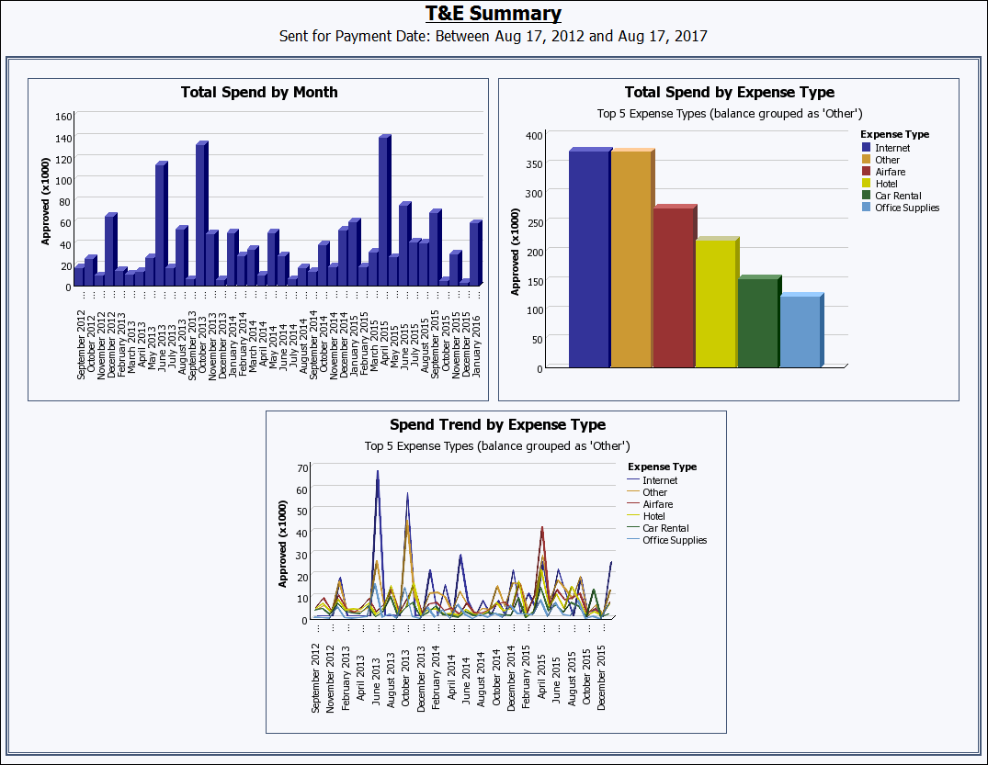
Vendor Analysis report page:
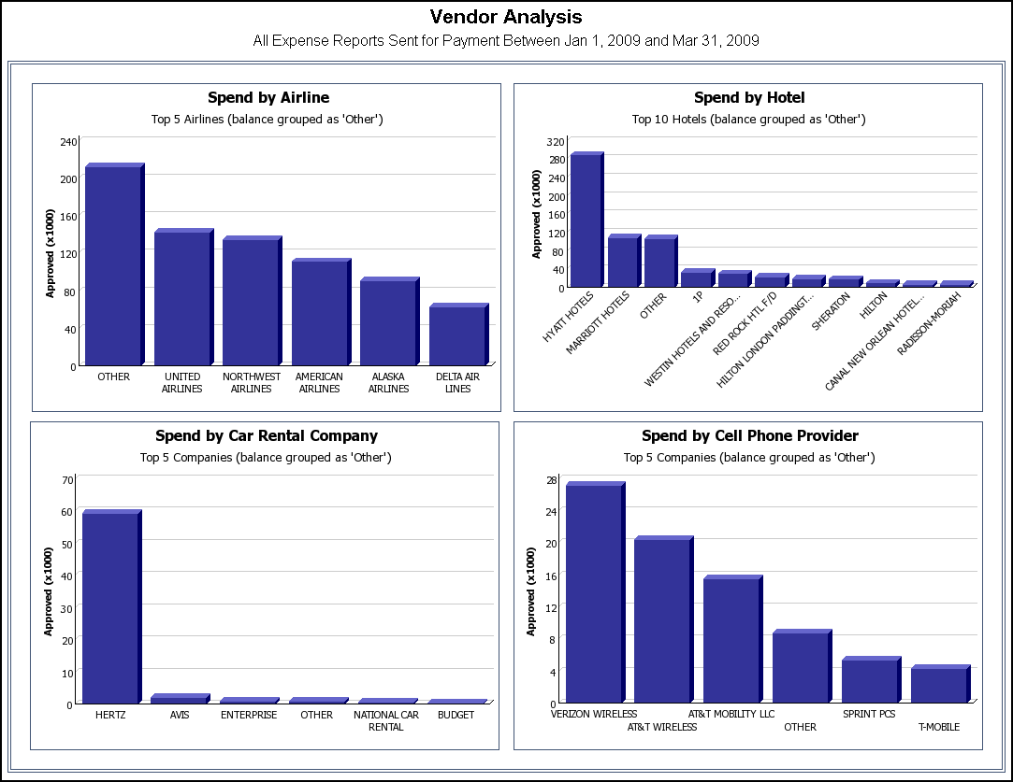
Year Over Year report page:
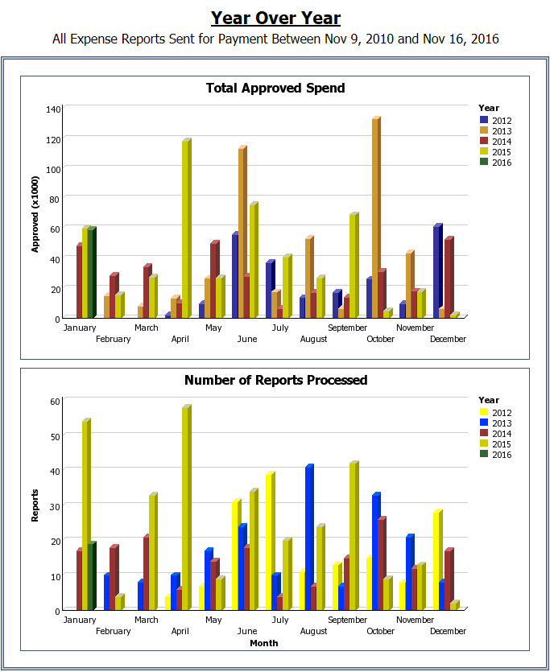
Expense Type Spend Trend report page:
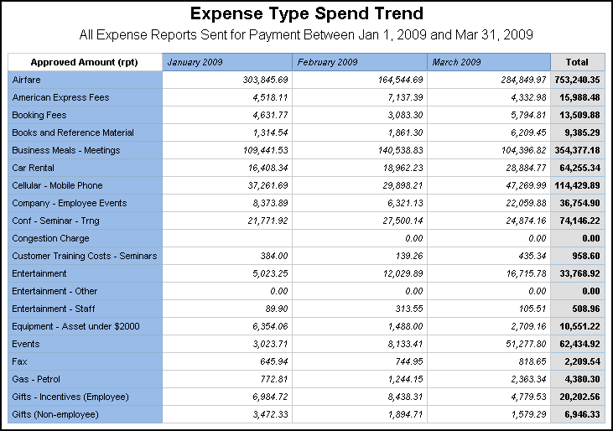

Report Header and Footer
Data Item Label/Name | Data Item Expression | Data Item Description
Sent for Payment Date | ' ' + ParamDisplayValue('Date Sent for Payment') | Displays the date range from the Sent for Payment Date prompt on the Prompts page
All Expense Reports Sent for Payment | ' '+ParamDisplayValue('Date Sent for Payment') | Displays the date range from the Sent for Payment Date prompt on the Prompts page
N/A | AsOfDate() | Displays the date the report was run
N/A | PageNumber() | Displays the page number of the corresponding page
N/A | AsOfTime() | Displays the time the report was run

Report Data Items

T&E Summary
Data Item Label | Data Item Name | Data Item Expression | Data Item Description
Approved (x1000) | <Total Approved Amount (rpt)> | [Expense].[Report Header Information].[Total Approved Amount (rpt)] | Total amount approved to be reimbursed
N/A | <#Month#> | [Expense].[Report Dates and Statuses].[Month] + ' ' + cast_char([Expense].[Report Dates and Statuses].[Year]) | Month and year that the report was sent for reimbursement to the employee(s)
Approved (x1000) | <Approved Amount (rpt)> | [Total Spend by Expense Type - Ranking].[Approved Amount (rpt)] | Amount of the expenses approved for reimbursement, converted as needed to the reporting currency
Expense Type | <#Expense Type#> | if([Total Spend by Expense Type - Ranking].[Rank]<6) then ([Total Spend by Expense Type - Ranking].[Expense Type]) else (case  when # sq($runLocale )# = 'en' THEN 'Other'  when # sq($runLocale )# = 'zh-cn' THEN '其他'  when # sq($runLocale )# = 'en-gb' THEN 'Other'  when # sq($runLocale )# = 'fr-fr' THEN 'Autre'  when # sq($runLocale )# = 'de' THEN 'Sonstiges'  when # sq($runLocale )# = 'ja' THEN 'その他'  when # sq($runLocale )# = 'zh-tw' THEN '其他'  else 'Other'  end) | Expense Type
Approved (x1000) | <Approved Amount (rpt)> | [Expense].[Entry Information].[Approved Amount (rpt)] | Amount of the expense approved for reimbursement, converted as needed to the reporting currency
Expense Type | <#Expense Type#> | if([Expense].[Entry Information].[Expense Type] in ([Total Spend by Expense Type].[Expense Type]))then ([Expense].[Entry Information].[Expense Type]) else (case  when # sq($runLocale )# = 'en' THEN 'Other'  when # sq($runLocale )# = 'zh-cn' THEN '其他'  when # sq($runLocale )# = 'en-gb' THEN 'Other'  when # sq($runLocale )# = 'fr-fr' THEN 'Autre'  when # sq($runLocale )# = 'de' THEN 'Sonstiges'  when # sq($runLocale )# = 'ja' THEN 'その他'  when # sq($runLocale )# = 'zh-tw' THEN '其他'  else 'Other'  end) | Expense Type
N/A | <#Month#> | [Expense].[Report Dates and Statuses].[Month] + ' ' + cast_char([Expense].[Report Dates and Statuses].[Year]) | Month and year that the report was sent for reimbursement to the employee(s)

Vendor Analysis
Data Item Label | Data Item Name | Data Item Expression | Data Item Description
Approved (x1000) | <Approved Amount (rpt)> | [Spend by Airline - Ranking].[Approved Amount (rpt)] | Amount of the expenses for the top 5 air vendors, approved for reimbursement, converted as needed to the reporting currency
N/A | <#Vendor#> | if([Spend by Airline - Ranking].[Rank]<6) then ([Spend by Airline - Ranking].[Vendor]) else ('OTHER') | Top 5 airline vendors associated with the expenses, balance grouped as “Other”
Approved (x1000) | <Approved Amount (rpt)> | [Spend by Hotel - Ranking].[Approved Amount (rpt)] | Amount of the expenses for the top 10 hotel vendors, approved for reimbursement, converted as needed to the reporting currency
N/A | <#Vendor#> | if([Spend by Hotel - Ranking].[Rank]<11) then ([Spend by Hotel - Ranking].[Vendor]) else ('OTHER') | Top 10 hotel vendors associated with the expenses, balance grouped as “Other”
Approved (x1000) | <Approved Amount (rpt)> | [Spend by Car Rental Company - Ranking].[Approved Amount (rpt)] | Amount of the expenses for the top 5 car rental vendors, approved for reimbursement, converted as needed to the reporting currency
N/A | <#Vendor#> | if([Spend by Car Rental Company - Ranking].[Rank]<6) then ([Spend by Car Rental Company - Ranking].[Vendor]) else ('OTHER') | Top 5 car rental vendors associated with the expenses, balance grouped as “Other”
Approved (x1000) | <Approved Amount (rpt)> | [Spend by Cell Phone Provider - Ranking].[Approved Amount (rpt)] | Amount of the expenses for the top 5 cell phone vendors, approved for reimbursement, converted as needed to the reporting currency
N/A | <#Vendor#> | if([Spend by Cell Phone Provider - Ranking].[Rank]<6) then ([Spend by Cell Phone Provider - Ranking].[Vendor]) else ('OTHER') | Top 5 cell phone vendors associated with the expenses, balance grouped as “Other”

Year Over Year
Data Item Label | Data Item Name | Data Item Expression | Data Item Description
Approved (x1000) | <Total Approved Amount (rpt)> | [Expense].[Report Header Information].[Total Approved Amount (rpt)] | Total amount approved to be reimbursed
Year | <#Year#> | [Expense].[Report Dates and Statuses].[Year] | Year that the payment was sent for reimbursement to the employee(s)
N/A | <#Month#> | [Expense].[Report Dates and Statuses].[Month] | Month that the payment was sent for reimbursement to the employee(s)
Reports | <# Reports> | [Expense].[Report Header Information].[Report Key] | Total number of expense reports processed
Year | <#Year#> | [Expense].[Report Dates and Statuses].[Year] | Year that the expense reports were processed
Month | <#Month#> | [Expense].[Report Dates and Statuses].[Month] | Month that the expense reports were processed

Expense Type Spend Trend
Data Item Label | Data Item Name | Data Item Expression | Data Item Description
N/A | <#Expense Type#> | [Expense].[Entry Information].[Expense Type] | Expense type assigned to the expense
N/A | <#Month#> | [Expense].[Report Dates and Statuses].[Month] + ' ' + cast_char([Expense].[Report Dates and Statuses].[Year]) | Month and year that the payment was sent for reimbursement to the employee(s)
Approved Amount (rpt) | <#1234#> | [Expense].[Entry Information].[Approved Amount (rpt)] | Amount of the expense approved for reimbursement, converted as needed to the reporting currency

Report: Expense Airline Ancillary Fees - Details
Available to:  Analysis  Intelligence
Uses: R Expense Data  Travel / TripLink Data
This report provides a detailed breakdown of spend on airline ancillary fees. In conjunction with the Airline Ancillary Fees Summary report, a travel manager can have a complete breakdown of the amount employees are spending on Ancillary Airline fees.

Report Prompts
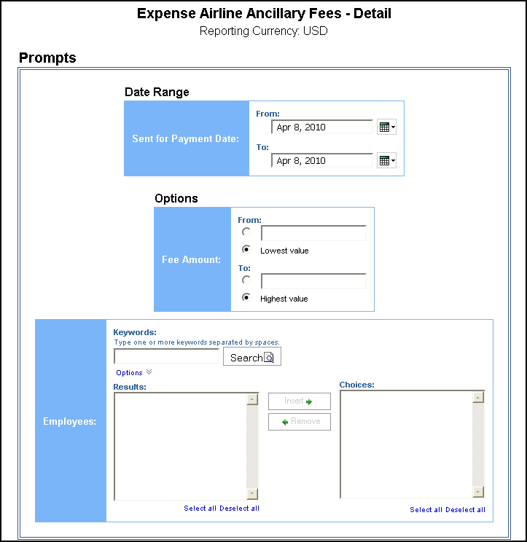

Date Range Prompt
- Sent for Payment Date: Used to filter the report by the date range the payment was sent for reimbursement to the employee(s)

Options Prompt
- Fee Amount:
- From: Used to filter the report using a defined minimum amount of the ancillary fees
- To: Used to filter the report using a defined maximum amount of the ancillary fees
- Lowest value: Used to filter the report using the lowest amount available of the ancillary fees
- Highest value: Used to filter the report using the highest amount available of the ancillary fees
Employees: Used to filter the report by the name of employee(s) who booked trips

Report Output
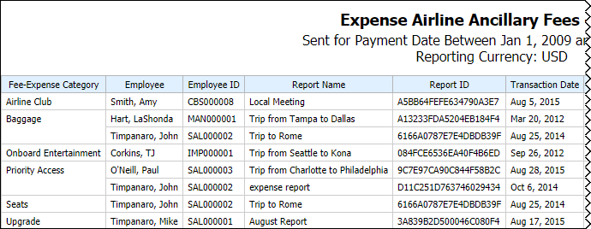
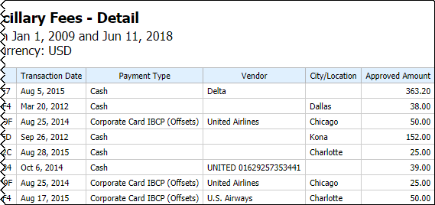

Report Header and Footer
Data Item Label/Name | Data Item Expression | Data Item Description
Sent for Payment Date | ParamDisplayValue('sentForPaymentDateParam') | Displays the date range from the Sent for Payment Date prompt on the Prompts page
Fee Amount | ParamValue('approvedAmountParam') | Displays the fee amount entered from the Fee Amount prompt on the Prompts page
Reporting Currency | [Expense].[Entry Information].[Reporting Currency] | Displays the currency code in which the reporting currency is shown (for example, USD, CAD, GBP)

Report Data Items
Data Item Label | Data Item Name | Data Item Expression | Data Item Description
Fee-Expense Category | <Airline Ancillary Fee Type> | [Expense].[Entry Information].[Airline Ancillary Fee Type] | Category type of the airline ancillary fee
Employee | <Employee> | [Expense].[Report Header Information].[Employee Last Name] + ', ' + [Expense].[Report Header Information].[Employee First Name] | Employee last name, first name, and middle initial
Employee ID | <Employee ID> | [Expense].[Report Header Information].[Employee ID] | Unique number or code that identifies the employee
Report Name | <Report Name> | [Expense].[Report Header Information].[Report Name] | Employee-entered name of the expense report
Report ID | <Report ID> | [Expense].[Report Header Information].[Report ID] | Unique system-assigned code that identifies the expense report
Transaction Date | <Transaction Date> | [Expense].[Entry Information].[Transaction Date] | Date that the expense was incurred
Payment Type | <Payment Type> | [Expense].[Entry Information].[Payment Type] | Method by which the employee paid for the expense, such as cash or a credit card
Vendor | <Vendor> | CASE WHEN [Expense].[Entry Information].[Vendor (from list)] is not missing and [Expense].[Entry Information].[Vendor (from list)] <> ''  THEN [Expense].[Entry Information].[Vendor (from list)] ELSE [Expense].[Entry Information].[Vendor (free-form entry)] END | Vendor associated with the expense
City/Location | <City/Location> | [Expense].[Entry Information].[City/Location] | City/Location where the expense was incurred
Approved Amount | <Approved Amount (rpt)> | [Expense].[Entry Information].[Approved Amount (rpt)] | Amount of the expense approved for reimbursement, converted as needed to the reporting currency

Report: Fare Analysis
Available to:  Analysis  Intelligence
Uses:  Expense Data R Travel / TripLink Data
This report will enabled Travel Managers to evaluate the flights selected by travelers and quickly compare the Quoted Price to the best available GDS and Internet prices.

Report Prompts
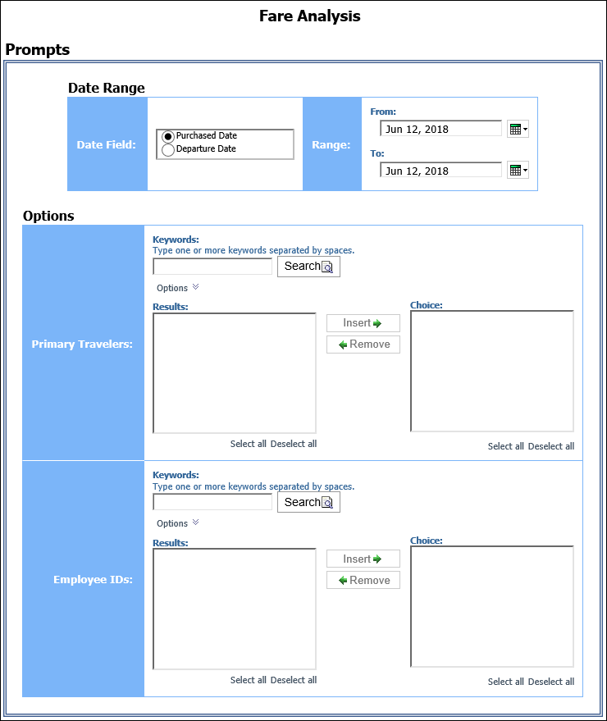

Date Range Prompt
- Date Field: Used to select if the report should be run using the purchased date or departure date
- Range: Used to filter the report by the date range of the purchased date or departure date

Options Prompts
- Primary Travelers: Used to filter the report by the name of the traveler(s) taking the trip(s)
- Employee IDs: Used to filter the report by the Employee ID of the employee(s) who booked the trip(s)

Report Output
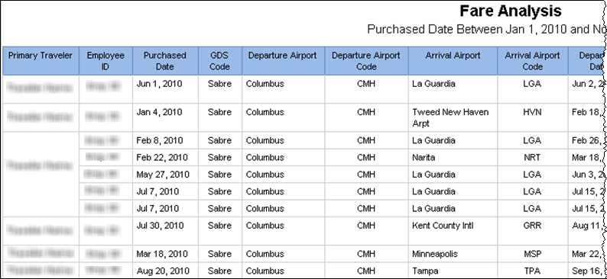

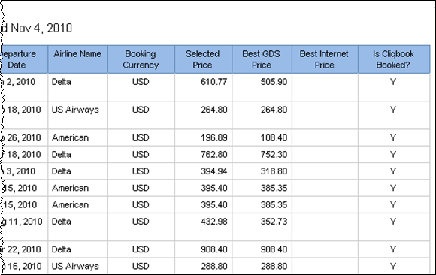

Report Header and Footer
Data Item Label/Name | Data Item Expression | Data Item Description
N/A | ParamDisplayValue('dateFieldParam') + ' ' + ParamDisplayValue('dateRangeParam') | Displays the option selected in the Date Field prompt and the date range entered in the Range prompt on the Prompts page

Report Data Items
Data Item Label | Data Item Name | Data Item Expression | Data Item Description
Primary Traveler | Primary Traveler | [Travel].[Trips].[Primary Traveler] | Name of the traveler(s) taking the trip
Employee ID | Employee ID | [Travel].[Trips].[Employee ID] | Employee ID of the employee who booked the trip
Purchased Date | Entered Date | [Travel].[Booking Decisions].[Entered Date] | Date the trip was purchased (Month Day, Year format)
GDS Code | GDS Code | [Travel].[Booking Decisions].[GDS Code] | Identifies the GDS system used during the booking
Departure Airport | Station One Name | [Travel].[Booking Decisions].[Station One Name] | Full Name of the origin station of the city pair (for example, Seattle-Tacoma)
Departure Airport Code | Station One Code | CASE [Travel].[Booking Decisions].[Station One Code]  WHEN '-1' THEN ''  ELSE [Travel].[Booking Decisions].[Station One Code]  END | Departure airport code
Arrival Airport | Station Two Name | [Travel].[Booking Decisions].[Station Two Name] | Full name of the destination station of the city pair (for example, Atlanta)
Arrival Airport Code | Station Two Code | CASE [Travel].[Booking Decisions].[Station Two Code]  WHEN '-1' THEN ''  ELSE [Travel].[Booking Decisions].[Station Two Code]  END | Three-digit alphabetical identifier for the destination station of the city pair (for example, ATL)
Departure Date | Start Date | [Travel].[Booking Decisions].[Start Date] | Start date of the trip
Airline Name | Transportation Vendor / Hotel Property | [Travel].[Booking Decisions].[Transportation Vendor / Hotel Property] | Name of the hotel property/car rental/airline company
Booking Currency | Booking Currency | [Travel].[Booking Decisions].[Booking Currency] | Currency the trip was booked in (for example, CAD)
Selected Price | Selected Price | [Travel].[Booking Decisions].[Selected Price] | Price selected by the employee booking the trip
Best GDS Price | Best GDS Price | [Travel].[Booking Decisions].[Best GDS Price] | Best price available from the GDS to the employee at the time of booking
Best Internet Price | Best Internet Price | [Travel].[Booking Decisions].[Best Internet Price] | Best price available from the internet to the employee at the time of booking
Is Cliqbook Booked? | Is Cliqbook Booked Trip | [Travel].[Trips].[Is Cliqbook Booked Trip] | Indicates if a trip was booked using Concur Travel

Report: Internet Usage
Available to:  Analysis  Intelligence
Uses: R Expense Data  Travel / TripLink Data
Travelers will frequently charge a company for internet usage at several locations (hotel, airport, etc). These fees can add up quickly and other cheaper options are available. For example, a company may choose to issue an Air Card to frequent travelers. This report will enable companies to identify how much is being spent on internet usage, and create and enforce a sensible policy.

Report Prompts
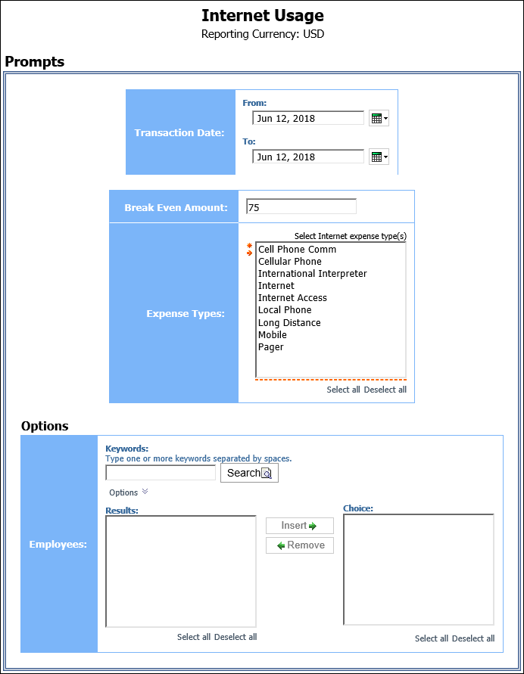
- Transaction Date: Used to filter the report by the date range that the transactions were incurred
- Breakeven Amount: Used to define the amount in which the cost of using an alternative option for internet usage was equal to the cost of using the internet at several locations (hotel, airport, etc.)
- Expense Types: Used to filter the report by the expense type assigned to the expense

Options Prompts
- Employees: Used to filter the report by the name of employee(s) who booked trips

Report Output
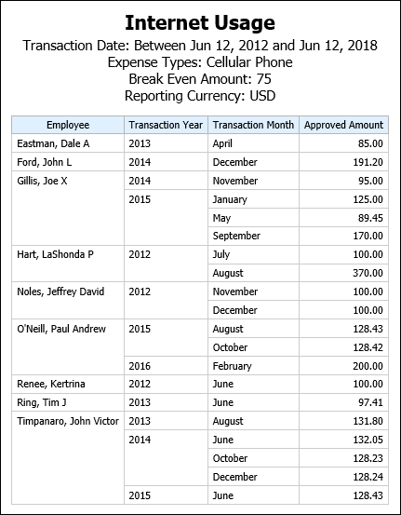

Report Header and Footer
Data Item Label/Name | Data Item Expression | Data Item Description
Transaction Date | ParamDisplayValue('pTransactionDate') | Displays the date range from the Transaction Date prompt on the Prompts page
Expense Types | ParamDisplayValue('expenseTypeParam') | Displays the expense types selected from the Expense Types prompt on the Prompts page
Break Even Amount | ParamDisplayValue('breakevenAmountParam') | Displays the breakeven amount entered in the Break Even Amount prompt on the Prompts page
Reporting Currency | [Expense].[Report Header Information].[Reporting Currency] | Displays the currency code in which the reporting currency is shown (for example, USD, CAD, GBP)
N/A | AsOfDate() | Displays the date the report was run
N/A | PageNumber() | Displays the page number of the corresponding page
N/A | AsOfTime() | Displays the time the report was run

Report Data Items
Data Item Label | Data Item Name | Data Item Expression | Data Item Description
Employee | <Employee> | [Expense].[Report Header Information].[Employee] | Employee last name, first name, and middle initial
Transaction Year | <Transaction Year> | [Expense].[Entry Information].[Transaction Year] | Year that the transactions were incurred
Transaction Month | <Transaction Month> | [Expense].[Entry Information].[Transaction Month] | Month that the transactions were incurred
Approved Amount | <Approved Amount (rpt)> | [Expense].[Entry Information].[Approved Amount (rpt)] | Amount of the expense approved for reimbursement, converted as needed to the reporting currency

Report: Top Spend by Vendor
Available to:  Analysis  Intelligence
Uses: R Expense Data  Travel / TripLink Data
This report ranks vendors with the highest amount of submitted expenses during a specified timeframe.

Report Prompts
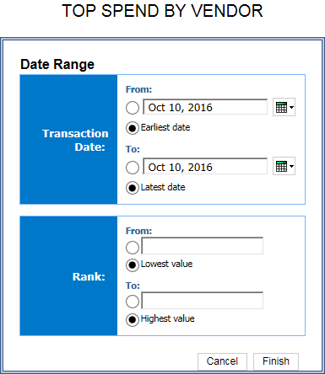

Date Range Prompt
- Transaction Date:
- From: Used to filter the report using a defined start date that transactions were incurred
- To: Used to filter the report using a defined end date that transactions were incurred
- Earliest Date: Used to filter the report using the earliest date that transactions were incurred
- Latest Date: Used to filter the report using the latest date that transactions were incurred
- Rank:
- From: Used to filter the report using a defined minimum number of top vendors to rank in the report (for example, to show the top 10 vendors, enter 10)
- To: Used to filter the report using a defined maximum number of top vendors to rank in the report
- Lowest Value: Used to filter the report using the lowest number of top vendors to rank in the report
- Highest Value: Used to filter the report using the highest number of top vendors to rank in the report

Report Output
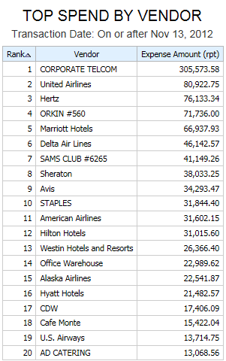

Report Header and Footer
Data Item Label/Name | Data Item Expression | Data Item Description
Transaction Date | ' '+ParamDisplayValue('Transaction_Date') | Displays the date range from the Transaction Date prompt on the Prompts page
Rank | ' '+ParamDisplayValue('Rank') | Displays the rank value from the Rank prompt on the Prompts page
N/A | AsOfDate() | Displays the date the report was run
N/A | PageNumber() | Displays the page number of the corresponding page
N/A | AsOfTime() | Displays the time the report was run

Report Data Items
Data Item Label | Data Item Name | Data Item Expression | Data Item Description
Rank | <Rank> | rank(total([Expense].[Entry Information].[Expense Amount (rpt)]) for report prefilter) | Rank value of top vendor
Vendor | <Vendor> | [Expense].[Entry Information].[Vendor] | Vendor associated with the expense
Expense Amount (rpt) | <Expense Amount (rpt)> | [Expense].[Entry Information].[Expense Amount (rpt)] | Amount of the expense, converted as needed to the reporting currency

Report: Top Spenders by Employee
Available to:  Analysis  Intelligence
Uses: R Expense Data  Travel / TripLink Data
This report lists employees with the highest amount of posted entries.

Report Prompts
The administrator can select the ranking of the top spending employees to be displayed – 1 being the employee with the highest amount of submitted expenses. For example, entering lowest to 10 will return the top 10 spenders. The user can also select one or more values for the transaction year. Both of these prompts are optional.
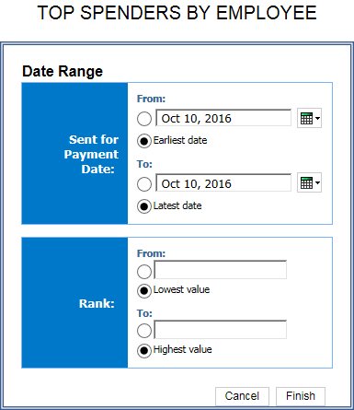

Date Range Prompt
- Transaction Date:
- From: Used to filter the report using a defined start date that the payments were sent for reimbursement to the employee(s)
- To: Used to filter the report using a defined end date that the payments were sent for reimbursement to the employee(s)
- Earliest Date: Used to filter the report using the earliest date that the payments were sent for reimbursement to the employee(s)
- Latest Date: Used to filter the report using the latest date that the payments were sent for reimbursement to the employee(s)
- Rank:
- From: Used to filter the report using a defined minimum number of top spenders to rank in the report (for example, to show the top 10 spenders, enter 10)
- To: Used to filter the report using a defined maximum number of top spenders to rank in the report
- Lowest Value: Used to filter the report using the lowest number of top spenders to rank in the report
- Highest Value: Used to filter the report using the highest number of top spenders to rank in the report

Report Output
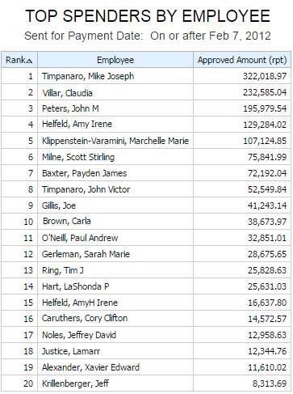

Report Header and Footer
Data Item Label/Name | Data Item Expression | Data Item Description
Sent for Payment Date | ' '+ParamDisplayValue('Sent_for_Payment_Date') | Displays the date range from the Sent for Payment Date prompt on the Prompts page
Rank | ' '+ParamDisplayValue('Rank1') | Displays the rank value from the Rank prompt on the Prompts page
N/A | AsOfDate() | Displays the date the report was run
N/A | PageNumber() | Displays the page number of the corresponding page
N/A | AsOfTime() | Displays the time the report was run

Report Data Items
Data Item Label | Data Item Name | Data Item Expression | Data Item Description
Rank | <Rank> | rank(total([Expense].[Entry Information].[Approved Amount (rpt)]) for report prefilter) | Rank value of top spender
Employee | <Employee> | [Expense].[Report Header Information].[Employee] | Employee last name, first name, and middle initial
Approved Amount (rpt) | <Approved Amount (rpt)> | [Expense].[Entry Information].[Approved Amount (rpt)] | Amount of the expense approved for reimbursement, converted as needed to the reporting currency

Report: Top Spenders by Expense Type
Available to:  Analysis  Intelligence
Uses: R Expense Data  Travel / TripLink Data
This report lists employees with the highest amount of submitted expenses within expense types during a specified timeframe.

Report Prompts
The administrator can select the rank of the top spending employees to be displayed – 1 being the employee with the highest amount of posted entries. For example, entering lowest to 5 will return the top 5 spenders for each expense type. The user can also select a date range. Both of these prompts are optional.
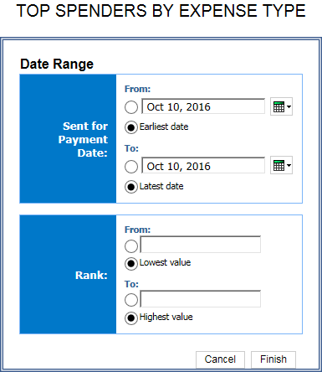

Date Range Prompt
- Transaction Date:
- From: Used to filter the report using a defined start date that the payments were sent for reimbursement to the employee(s)
- To: Used to filter the report using a defined end date that the payments were sent for reimbursement to the employee(s)
- Earliest Date: Used to filter the report using the earliest date that the payments were sent for reimbursement to the employee(s)
- Latest Date: Used to filter the report using the latest date that the payments were sent for reimbursement to the employee(s)
- Rank:
- From: Used to filter the report using a defined minimum number of top expense types to rank in the report (for example, to show the top 10 expense types, enter 10)
- To: Used to filter the report using a defined maximum number of top expense types to rank in the report
- Lowest Value: Used to filter the report using the lowest number of top expense types to rank in the report
- Highest Value: Used to filter the report using the highest number of top expense types to rank in the report

Report Output
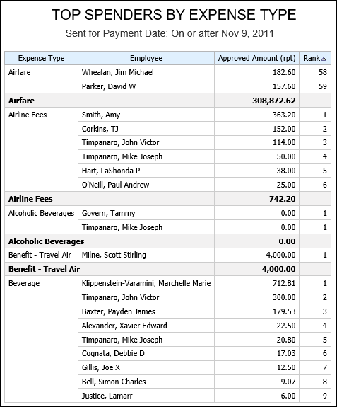

Report Header and Footer
Data Item Label/Name | Data Item Expression | Data Item Description
Sent for Payment Date | ' '+ParamDisplayValue('Sent_for_Payment_Date') | Displays the date range from the Sent for Payment Date prompt on the Prompts page
Rank | ' '+ParamDisplayValue('Rank1') | Displays the rank value from the Rank prompt on the Prompts page
N/A | AsOfDate() | Displays the date the report was run
N/A | PageNumber() | Displays the page number of the corresponding page
N/A | AsOfTime() | Displays the time the report was run

Report Data Items
Data Item Label | Data Item Name | Data Item Expression | Data Item Description
Expense Type | <Expense Type> | [Expense].[Entry Information].[Expense Type] | Expense type assigned to the expense
Employee | <Employee> | [Expense].[Report Header Information].[Employee] | Employee last name, first name, and middle initial
Approved Amount (rpt) | <Approved Amount (rpt)> | [Expense].[Entry Information].[Approved Amount (rpt)] | Amount of the expense approved for reimbursement, converted as needed to the reporting currency
Rank | <Rank> | rank(total([Expense].[Entry Information].[Approved Amount (rpt)]) for ([Expense].[Entry Information].[Expense Type]) prefilter) | Rank value of the top expense type

Report: Travel Summary
Available to:  Analysis  Intelligence
Uses:  Expense Data R Travel / TripLink Data
This report provides some key summary statistics for flights, hotels, and car rentals during a specified timeframe. It provides counts and cost figures and distinguishes between the number of trip components made using the online booking tool compared to booking with the help of a travel agent. It provides some important performance indicators for managing the travel program.

Report Prompts
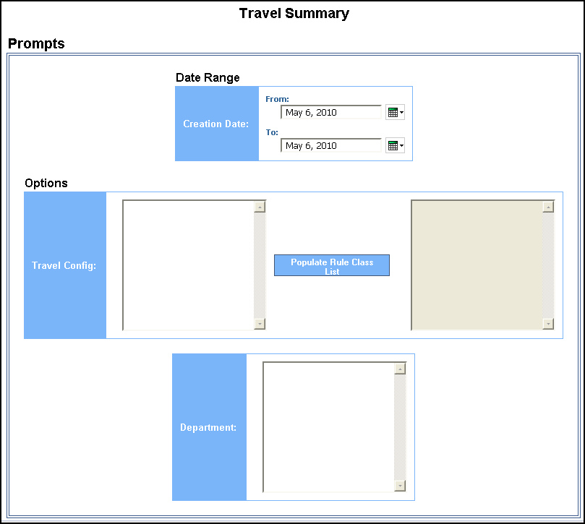

Date Range Prompt
- Creation Date: Used to filter the report by the date range that the expense reports were created

Options Prompts
- Travel Config: Used to filter the report by the travel configuration(s) used by the employee(s) booking the trip
- Populate Rule Class List: Used to populate and select from a list of rule classes used by the employee(s) booking the trip
- Department: Used to filter the report by specific department(s) within the organization

Report Output
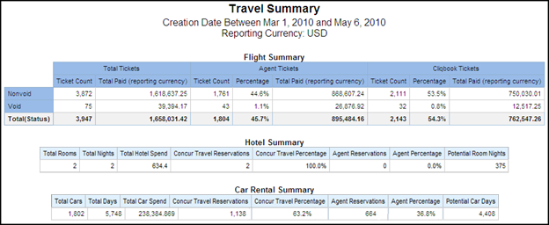

Report Header and Footer
Data Item Label/Name | Data Item Expression | Data Item Description
Creation Date | ' ' + ParamDisplayValue('creationDateParam') | Displays the date range from the Creation Date prompt on the Prompts page
Reporting Currency | [Travel].[Reservations and Tickets].[Reporting Currency] | Displays the currency code in which the reporting currency is shown (for example, USD, CAD, GBP)
N/A | AsOfDate() | Displays the date the report was run
N/A | PageNumber() | Displays the page number of the corresponding page
N/A | AsOfTime() | Displays the time the report was run

Report Data Items

Flight Summary
Data Item Label | Data Item Name | Data Item Expression | Data Item Description
N/A | <#Status#> | CASE WHEN [Travel].[Reservations and Tickets].[Ticket Status] = 'Void' THEN 'Void' ELSE 'Nonvoid' END | Indicates if the rows are “Void” or “Nonvoid” tickets
N/A | <#Total#> | case  when # sq($runLocale )# = 'en' THEN 'Total Tickets'  when # sq($runLocale )# = 'zh-cn' THEN '总票数'  when # sq($runLocale )# = 'en-gb' THEN 'Total Tickets'  when # sq($runLocale )# = 'fr-fr' THEN 'Total des billets'  when # sq($runLocale )# = 'de' THEN 'Tickets gesamt'  when # sq($runLocale )# = 'ja' THEN '合計チケット数'  when # sq($runLocale )# = 'zh-tw' THEN '總計機票'  WHEN # sq($runLocale )# ='cs' then 'Celkem jízdenek/letenek'  WHEN # sq($runLocale )# ='pt-BR' then 'Total de bilhetes'  WHEN # sq($runLocale )# ='es' then 'Total de billetes'  else 'Total Tickets'  end | Displays the header “Total Tickets” in the report user's language (for example, for Spanish users, the header will read “Total de billetes”)
N/A | <#Source#> | CASE WHEN [Travel].[Trips].[Is Cliqbook Booked Trip] = 'Y' THEN 'Cliqbook Tickets' ELSE 'Agent Tickets' END | Indicates in the column header if the trips were booked using Concur Travel or a travel agent (Agent Tickets or Concur Tickets)
N/A | <#Total Paid (reporting currency)#> | [Travel].[Reservations and Tickets].[Total Paid (reporting currency)] | Amount being paid, in the reporting currency

Hotel Summary
Data Item Label | Data Item Name | Data Item Expression | Data Item Description
Total Rooms | <Number of Units> | [Hotel Details].[Number of Units] | Total number of rooms reserved
Total Nights | <Number of Days/Nights> | [Hotel Details].[Number of Days/Nights] | Total number of nights stayed at hotels
Total Hotel Spend | <Total Hotel Spend> | [Travel].[Reservations and Tickets].[Booking Total (reporting currency)] | Total sum of the booking amount and the booking tax for all hotel stays
Concur Travel Reservations | <Concur Travel Reservations> | [Hotel Details].[Concur Travel Reservations] | Indicates the number of rooms booked using Concur Travel
Concur Travel Percentage | <Concur Travel Percentage> | [Hotel Details].[Concur Travel Percentage] | Indicates the percentage of rooms booked using Concur Travel
Agent Reservations | <Agent Reservations> | [Hotel Details].[Agent Reservations] | Indicates the number of rooms booked using a travel agent
Agent Percentage | <Agent Percentage> | [Hotel Details].[Agent Percentage] | Indicates the percentage of rooms booked using a travel agent
Potential Room Nights | <Potential Room Nights> | [Potential Nights] - [Hotel Nights] | Estimated number of nights in a hotel based on the difference between the arrival and departure dates of a trip.

Car Rental Summary
Data Item Label | Data Item Name | Data Item Expression | Data Item Description
Total Cars | <Number of Units> | [Car Details].[Number of Units] | Total number of cars rented
Total Days | <Number of Days/Nights> | [Car Details].[Number of Days/Nights] | Total number of days cars were rented
Total Car Spend | <Total Car Spend> | [Travel].[Reservations and Tickets].[Booking Total (reporting currency)] | Total sum of the booking amount and the booking tax for all cars rented
Concur Travel Reservations | <Concur Travel Reservations> | [Car Details].[Concur Travel Reservations] | Indicates the number of cars booked using Concur Travel
Concur Travel Percentage | <Concur Travel Percentage> | [Car Details].[Concur Travel Percentage] | Indicates the percentage of cars booked using Concur Travel
Agent Reservations | <Agent Reservations> | [Car Details].[Agent Reservations] | Indicates the number of cars booked using a travel agent
Agent Percentage | <Agent Percentage> | [Car Details].[Agent Percentage] | Indicates the percentage of cars booked using a travel agent
Potential Car Days | <Potentials Car Days> | [Potential Nights] - [Car Days] | Estimated number of rental days based on difference between the arrival and departure dates of a trip.

☼

