Table of Contents
Chapter 12: Folder – Invoice 12-1
Report: Attendee Details 12-1
Available to:  Analysis  Intelligence 12-1
Report: Attendee Summary 12-4
Available to:  Analysis  Intelligence 12-4
Report: Capture Service Details 12-7
Available to:  Analysis  Intelligence 12-7
Report: Capture Service Summary 12-11
Available to:  Analysis  Intelligence 12-11
Report: Employee Exceptions – Details 12-14
Available to:  Analysis  Intelligence 12-14
Report: Invoice Briefing Summary 12-18
Available to:  Analysis  Intelligence 12-18
Report: Invoice Expense Type Spend Trend 12-41
Available to:  Analysis  Intelligence 12-41
Report: Invoice Tax Adjustment Report 12-45
Available to:  Analysis  Intelligence 12-45
Report: Invoice Virtual Card Payment Reconciliation 12-48
Available to:  Analysis  Intelligence 12-48
Report: Payment Practices and Performance 12-50
Available to:  Analysis  Intelligence 12-50
Report: Purchase Order to Invoice Matching Exceptions 12-53
Available to:  Analysis  Intelligence 12-53
Report: Purchase Order List 12-56
Available to:  Analysis  Intelligence 12-56
Report: Purchase Orders and Associated Payment Requests 12-58
Available to:  Analysis  Intelligence 12-58
Report: Received Accrual by Line Item 12-61
Available to:  Analysis  Intelligence 12-61
Report: Request Accrual 12-64
Available to:  Analysis  Intelligence 12-64
Report: Request Aging 12-66
Available to:  Analysis  Intelligence 12-66
Report: Request Exception Analysis 12-69
Available to:  Analysis  Intelligence 12-69
Report: Request Exception Analysis (with comments) 12-72
Available to:  Analysis  Intelligence 12-72
Report: Request Header Exceptions 12-75
Available to:  Analysis  Intelligence 12-75
Report: Request Line Item Exceptions 12-77
Available to:  Analysis  Intelligence 12-77
Report: Request Line Item Exceptions Detail Report 12-79
Available to:  Analysis  Intelligence 12-79
Report: Top 10 Longest to Approve 12-82
Available to:  Analysis  Intelligence 12-82
Report: Top Exception Violators 12-84
Available to:  Analysis  Intelligence 12-84
Report: Top Invoice Spenders by Employee - Details 12-86
Available to:  Analysis  Intelligence 12-86
Report: Top Invoice Spenders by Employee - Summary 12-89
Available to:  Analysis  Intelligence 12-89
Report: Top Invoice Vendor Spend - Details 12-92
Available to:  Analysis  Intelligence 12-92
Report: Top Invoice Vendor Spend - Summary 12-97
Available to:  Analysis  Intelligence 12-97
Report: Unsubmitted Requests by Approver – Detail 12-102
Available to:  Analysis  Intelligence 12-102
Report: Unsubmitted Requests by Approver – Summary 12-105
Available to:  Analysis  Intelligence 12-105
Available to:  Analysis  Intelligence 12-108
Report: Workflow Aging – Details 12-111
Available to:  Analysis  Intelligence 12-111
Report: Workflow Cycle Times – Details 12-116
Available to:  Analysis  Intelligence 12-116
Report: Workflow Cycle Times – Summary by Manager 12-121
Available to:  Analysis  Intelligence 12-121
Report: Workflow Cycle Times – Summary by Processor 12-123
Available to:  Analysis  Intelligence 12-123

Revision History
Date | Notes / Comments / Changes
October 14, 2023 | Made the following updates to the Report: Invoice Virtual Card Payment Reconciliation section:  - Updated the image of the Prompts page. Date is no longer displayed above the Payment Settlement Date prompt.  - Updated the image of the report. The Payment Settlement Date column now only displays a date instead of a date and time.
August 19, 2023 | Added the Invoice Virtual Card Payment Reconciliation report
January 21, 2022 | Updated the copyright year; no other changes; cover date not updated
February 20, 2021 | Updated the copyright year; no other changes
September 24, 2020 | Updated the report image for the Invoice Tax Adjustment Report. The Ship to Country label was renamed to Ship to Country/Region.
September 19, 2020 | Updated the images of the Purchase Orders and Associated Payment Request report. The following updates were made to the report:  - Invoice Amount column was removed  - Total Invoice Amount Applied to PO column was added  - Total Approved Amount column renamed to Total Invoice Approved Amount
January 8, 2020 | Changed copyright; no other content changes
August 19, 2019 | Updated the description of the Purchase Order List report
August 17, 2019 | Added additional information about the reports in the Invoice folder
April 13, 2019 | Updated image of the Unsubmitted Requests By Approver – Summary report to show the renamed Request Key column, which is now named to Request Count
March 15, 2019 | Updated images of the Top Invoice Vendor Spend – Details and Top Invoice Vendor Spend – Summary reports and report prompts.
February 9, 2019 | Updated images of the Purchase Order to Invoice Matching Exceptions report. Also removed references to Insight Premium from the guide and updated copyright.
November 17, 2018 | Updated the report prompts images and report images for the following reports to show the new PO Attached prompt, the addition of the Invoice PO Matching Exceptions column, and the renaming of the Exceptions column to Invoice Header Exceptions:  - Workflow Aging – Details  - Workflow Cycle Times – Details  - Workflow Cycle Times – Summary by Manager  - Workflow Cycle Times – Summary by Processor
August 18, 2018 | Added the Purchase Order to Invoice Matching Exceptions report
July 21, 2018 | Updated the image of the Invoice Tax Adjustment Report to include five new columns:  - Ship to Address  - Ship to City  - Ship to State  - Ship to Zip  - Ship to Country
March 20, 2018 | Updated the Capture Service Summary and Capture Service Details reports to indicate that these two reports are only available in Intelligence / Premium.
March 17, 2018 | Added the Received Accrual by Line Item report
January 13 2018 | Changed copyright and added the Capture Service Summary and Capture Service Details reports
September 18 2017 | Updated one of the Invoice Briefing Summary report images to show the new bar graph that replaced the former pie chart
August 4 2017 | Added the Payment Practices and Performance report
July 8 2017 | Added the Invoice Tax Adjustment Report
June 3 2017 | Added the Attendee Details report, updated the image of the Invoice Expense Type Spend Trend report to include the new totals and subtotals by quarter, and updated the report prompts images for the Top Invoice Vendor Spend – Details and Top Invoice Vendor Spend – Details reports.
April 22 2017 | Added the Attendee Summary report
December 15 2016 | Changed copyright; no other content changes
October 14 2016 | Updated Prompts images for copied reports, and updated Workflow Cycle Times – Details report
August 15 2016 | Added the Workflow Aging – Details report
August 14 2015 | Moved from single book to individual "chapters" – no content changes

Folder – Invoice

Report: Attendee Details
Available to:  Analysis  Intelligence
This report provides a detailed view of the spending by employees and the attendee information for expenses that have associated attendees.
The report can be run to provide the total picture or run for a selected set of payment requests that represent money being spent by an employee to cover expenses for fellow employees or non-employee clients or prospective clients.

Report Prompts
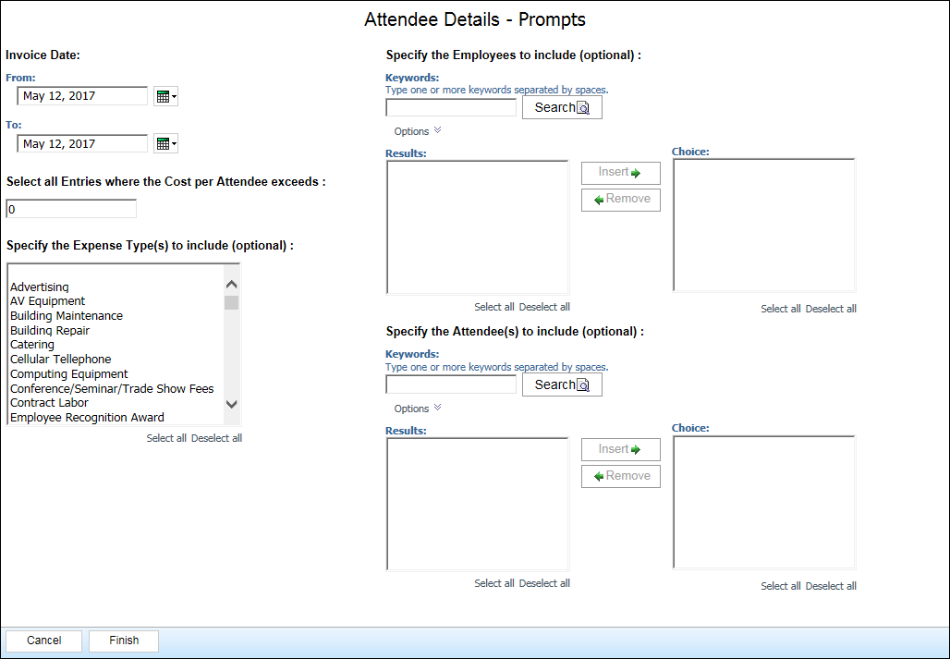

Report Output
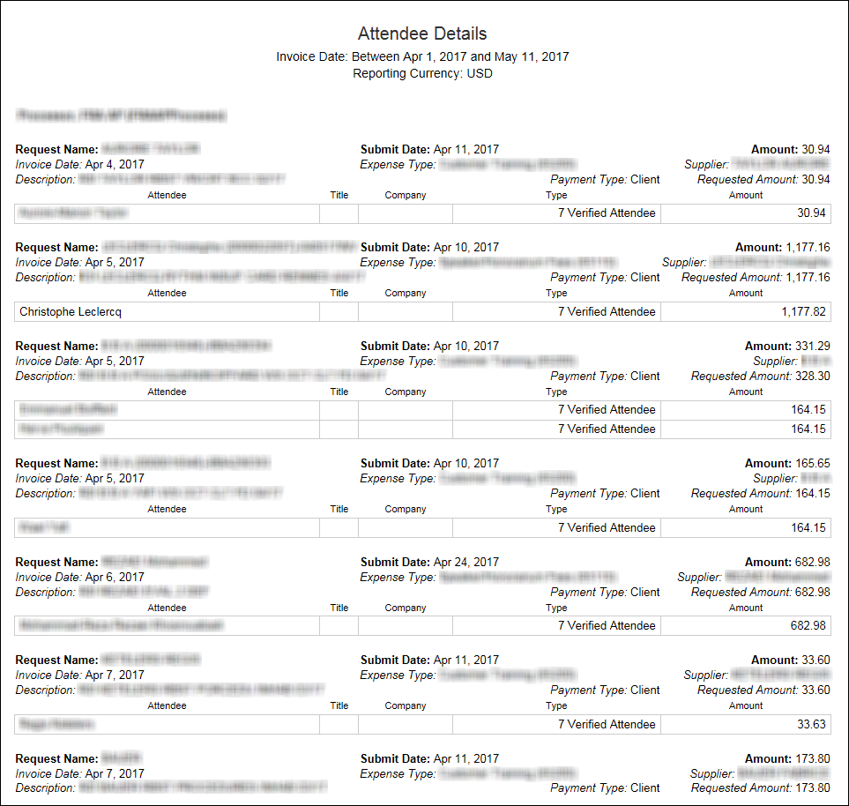

Report Header and Footer
Data Item Label/Name | Data Item Expression | Data Item Description
Invoice Date | '+ParamDisplayValue('Invoice Date') | Displays the date range from the Invoice Date prompt on the Prompts page
Reporting Currency | '+[qAttendeeDetails].[Reporting Currency] | Displays the currency code in which the reporting currency is shown (for example, USD, CAD, GBP)

Report Data Items
Data Item Label | Data Item Name | Data Item Expression | Data Item Description
Employee | <Employee + ID> | [Employee]+' ('+[Employee ID]+')' | Displays the employee name and ID
Request Name | <Request Name> | [Invoice].[Payment Request Header Information].[Request Name] | Displays the request name
Submit Date | <First Submitted Date> | [Invoice].[Payment Request Dates and Statuses].[First Submit Date] | Displays the first submitted date
Amount | <Total Approved Amount (rpt)> | [Invoice].[Payment Request Header Information].[Total Approved Amount (rpt)] | Displays the total approved amount from the expense
Invoice Date | <Invoice Date> | [Invoice].[Payment Request Dates and Statuses].[Invoice Date] | Displays the invoice date
Expense Type | <Expense Type> | [Invoice].[Payment Request Line Items].[Expense Type Name] | Displays the expense type name
Supplier | <Vendor> | [Invoice].[Payment Request Header Information].[Supplier Name] | Displays the supplier's name
Description | <Purpose> | [Invoice].[Payment Request Line Items].[Description] | Displays the purpose of the invoice (description)
Payment Type | <Payment Type> | [Invoice].[Payment Request Header Information].[Payment Method Type] | Displays the payment method type
Requested Amount | <Approved Amount (rpt)> | [Invoice].[Payment Request Line Items].[Total Approved (rpt)] | Displays the total amount approved from the invoice
Attendee | <Attendee Name> | [Invoice].[Payment Request Attendees].[Attendee Name] | Displasy the attendee's name
Title | <Title> | [Invoice].[Payment Request Attendees].[Attendee Title] | Displays the attendee's title
Company | <Company> | [Invoice].[Payment Request Attendees].[Company] | Displays the company
Type | <Attendee Type> | [Invoice].[Payment Request Attendees].[Attendee Type] | Displays the attendee type
Amount | <Approved Amount (Reporting Currency)> | [Invoice].[Payment Request Attendees].[Approved Amount (Reporting Currency)] | Displays the approved amount in the reporting currency

Report: Attendee Summary
Available to:  Analysis  Intelligence
This report provides a summary of the spending on attendees by expense type, instance, and reporting group and currency.
The report provides one or more years of statistics, enabling long-term trend analysis about expenses involving money spent by an employee to cover expenses for fellow employees or non-employee clients or prospective clients.

Report Prompts
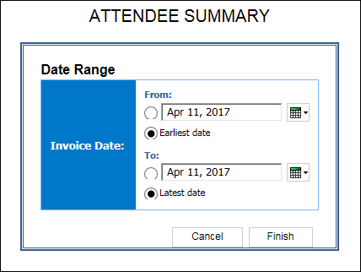

Report Output
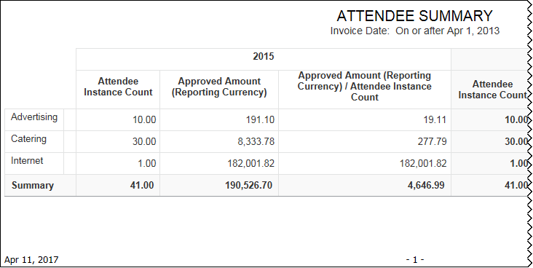
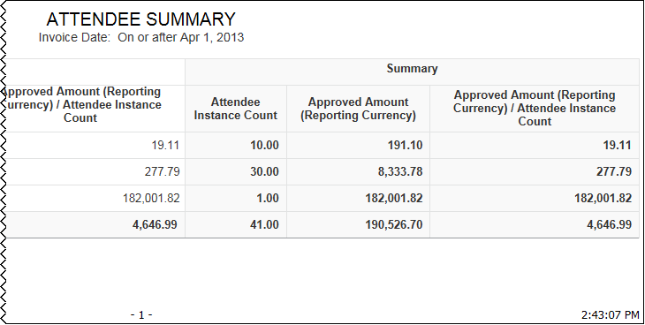

Report Data Items
Data Item Label | Data Item Name | Data Item Expression | Data Item Description
Year/Summary | <Expense Type> | [Invoice].[Payment Request Line Items].[Expense Type Name] | Displays the expense type name
Year/Summary | <Report Grouping> | [Invoice].[Payment Request Header Information].[Reporting Group] | Displays the reporting group
Year/Summary | <Attendee Instance Count> | [Invoice].[Payment Request Attendees].[Attendee Instance Count] | Displays the attendee instance count
Year/Summary | <Approved Amount Reporting Currency)> | [Invoice].[Payment Request Attendees].[Approved Amount (Reporting Currency)] | Displays the approved amount in the reporting currency
Year/Summary | <Approved Amount (Reporting Currency) / Attendee Instance Count> | (total([Invoice].[Payment Request Attendees].[Approved Amount (Reporting Currency)])) / (total([Invoice].[Payment Request Attendees].[Attendee Instance Count])) | Displays the total

Report: Capture Service Details
Available to:  Analysis  Intelligence
This report is a drill-through from the Capture Service Summary report. This report provides the details of the Capture Service fields on the Capture Service Summary report (Invoice Number, Invoice Date, Vendor, Shipping, Tax, Currency, Invoice Amount, and PO).
As with all of our drill-throughs, this report can also be run as a standalone report.

Report Prompts
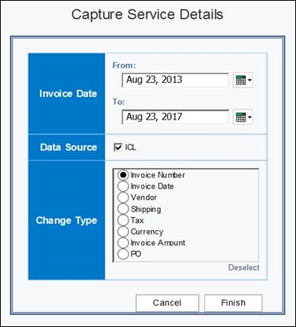

Report Output
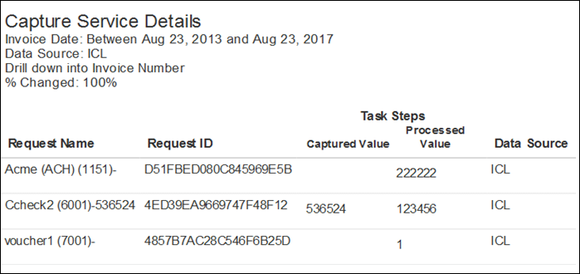

Report Header and Footer
Data Item Label/Name | Data Item Expression | Data Item Description
Invoice Date | ParamDisplayValue('pInvoice_Processed_Date') | Displays the date range from the Invoice Date prompt on the Prompts page
Data Source | ParamDisplayValue('pDataSource_Type') | Displays the data source type(s) selected from the Data Source prompt on the Prompts page
Drill Down Into | ParamDisplayValue('pChangetypeparam') | Displays the selection(s) from the Change Type prompt on the Prompts page
% Changed |  | Displays the percentage changed
% Change by Invoice Number | (Total([Supplier Invoice Number Flag] for report))/[Count of Request ID] | Displays the percentage changed by invoice number
% Change by Invoice Date | (Total([Invoice Date Flag] for report))/[Count of Request ID] | Displays the percentage changed by invoice date
% Change by Vendor Code | (Total([Vendor Code Flag] for report))/[Count of Request ID] | Displays the percentage changed by vendor code
% Change by Shipping Amount | (Total([Shipping Amount Flag] for report))/[Count of Request ID] | Displays the percentage changed by shipping amount
% Change by Tax Amount | (Total([Tax Amount Flag] for report))/[Count of Request ID] | Displays the percentage changed by tax amount
% Change by Currency Code | (Total([Currency Code Flag] for report))/[Count of Request ID] | Displays the percentage changed by currency code
% Change by Invoice Amount | (Total([Invoice Amount Flag] for report))/[Count of Request ID] | Displays the percentage changed by invoice amount
% Change by PO Number | (Total([PO Number Flag] for report))/[Count of Request ID] | Displays the percentage changed by PO number

Report Data Items
Data Item Label | Data Item Name | Data Item Expression | Data Item Description
Request Name | <Request Name> | [Invoice].[Capture Service Request Header].[Request Name] | Displays the request name
Request ID | <Request ID> | [Invoice].[Capture Service Request Header].[Request ID] | Displays the request ID
Vendor Name | <Vendor Name> | [Invoice].[Capture Service Request Header].[Vendor Name] | Displays the vendor's name
Captured Value | <Invoice Number Capture Value> | [Invoice].[Capture Service Request Header].[Invoice Number Captured Value] | Displays the invoice's number captured value
Captured Value | <Invoice Date Capture Value> | [Invoice].[Capture Service Request Header].[Invoice Date Captured Value] | Displays the invoice date's captured value
Captured Value | <Vendor Code Capture Value> | [Invoice].[Capture Service Request Header].[Vendor Code Captured Value] | Displays the vendor code's captured value
Captured Value | <Shipping Amount Captured Value> | [Invoice].[Capture Service Request Header].[Shipping Amount Captured Value] | Displays the shipping amount's captured value
Captured Value | <Tax Amount Captured Value> | [Invoice].[Capture Service Request Header].[Tax Amount Captured Value] | Displays the tax amount's captured value
Captured Value | <Currency Code Captured Value> | [Invoice].[Capture Service Request Header].[Currency Code Captured Value] | Displays the currency code's captured value
Captured Value | <Invoice Amount Captured Value> | [Invoice].[Capture Service Request Header].[Invoice Amount Captured Value] | Display the invoice amount's captured value
Captured Value | <PO Number Captured Value> | [Invoice].[Capture Service Request Header].[PO Number Captured Value] | Displays the PO number's captured value
Processed Value | <Invoice Number Processed Value> | [Invoice].[Capture Service Request Header].[Invoice Number Processed Value] | Displays the invoice number's processed value
Processed Value | <Invoice Date Processed Value> | [Invoice].[Capture Service Request Header].[Invoice Date Processed Value] | Displays the invoice date's processed value
Processed Value | <Vendor Code Processed Value> | [Invoice].[Capture Service Request Header].[Vendor Code Processed Value] | Displays the vendor code's processed value
Processed Value | <Shipping Amount Processed Value> | [Invoice].[Capture Service Request Header].[Shipping Amount Processed Value] | Displays the shipping amount's processed value
Processed Value | <Tax Amount Processed Value> | [Invoice].[Capture Service Request Header].[Tax Amount Processed Value] | Displays the invoice number's processed value
Processed Value | <Currency Code Processed Value> | [Invoice].[Capture Service Request Header].[Currency Code Processed Value] | Displays the tax amount's processed value
Processed Value | <Invoice Amount Processed Value> | [Invoice].[Capture Service Request Header].[Invoice Amount Processed Value] | Displays the invoice amount's processed value
Processed Value | <PO Number Processed Value> | [Invoice].[Capture Service Request Header].[PO Number Processed Value] | Displays the PO number's processed value
Data Source | <Data Source> | [Invoice].[Capture Service Request Header].[Data Source] | Displays the data source

Report: Capture Service Summary
Available to:  Analysis  Intelligence
This report provides a summary of the number and types of changes that occurred after an invoice is created and before the final approval of the invoice.
Clicking a field in the Change Type column on the report opens the Capture Service Details report for the selected field. The Capture Service Summary report can help provide insight into your organization's current invoice processes.

Report Prompts
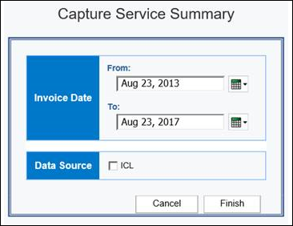

Report Output
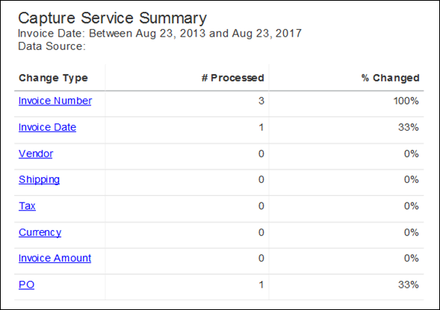

Report Header and Footer
Data Item Label/Name | Data Item Expression | Data Item Description
Invoice Date | ParamDisplayValue('pInvoice_Processed_Date') | Displays the date range from the Invoice Date prompt on the Prompts page
Data Source | ParamDisplayValue('pDataSource_Type') | Displays the data source type(s) selected from the Data Source prompt on the Prompts page
Total # Of Invoices | count (distinct [Request ID] for report) | Displays a distinct count of request ID

Report Data Items
Data Item Label | Data Item Name | Data Item Expression | Data Item Description
Invoice Number(Processed) | <Supplier Invoice Number Flag> | [qCaptureService_NonAggregate_Data].[Supplier Invoice Number Flag] | Displays the invoice flag number
Invoice Number(%Changed) | <% Change by Invoice Number> | (Total([Supplier Invoice Number Flag] for report))/[Count of Request ID] | Displays the percentage of change by invoice number
Invoice Date(Processed) | <Invoice Date Flag> | [qCaptureService_NonAggregate_Data].[Invoice Date Flag] | Displays the invoice flag Date
Invoice Date(%Changed) | <% Change by Invoice Date> | (Total([Invoice Date Flag] for report))/[Count of Request ID] | Displays the percentage of change by invoice date
Vendor (Processed) | <Vendor Code Flag> | [qCaptureService_NonAggregate_Data].[Vendor Code Flag] | Displays the vendor code flag
Vendor (%Changed) | <% Change by Vendor Code> | (Total([Vendor Code Flag] for report))/[Count of Request ID] | Displays the percentage of change by vendor code
Shipping (Processed) | <Shipping Amount Flag> | [qCaptureService_NonAggregate_Data].[Shipping Amount Flag] | Displays the shipping amount flag
Shipping (%Changed) | <% Change by Shipping Amount> | (Total([Shipping Amount Flag] for report))/[Count of Request ID] | Displays the percentage of change by shipping amount flag
Tax (Processed) | <Tax Amount Flag> | [qCaptureService_NonAggregate_Data].[Tax Amount Flag] | Displays the tax amount flag
Tax (%Changed) | <% Change by Tax Amount> | (Total([Tax Amount Flag] for report))/[Count of Request ID] | Displays the percentage of change by tax amount flag
Currency (Processed) | <Currency Code Flag> | [qCaptureService_NonAggregate_Data].[Currency Code Flag] | Display the currency flag code
Currency (%Changed) | <% Change by Currency Code> | (Total([Currency Code Flag] for report))/[Count of Request ID] | Displays the percentage of change in the currency code
Invoice Amount(Processed) | <Invoice Amount Flag> | [qCaptureService_NonAggregate_Data].[Invoice Amount Flag] | Displays the invoice amount flag
Invoice Amount (%Changed) | <% Change by Invoice Amount> | (Total([Invoice Amount Flag] for report))/[Count of Request ID] | Displays the percentage of change by invoice flag
PO (Processed) | <PO Number Flag> | [qCaptureService_NonAggregate_Data].[PO Number Flag] | Displays the PO number flag
PO (%Changed) | <% Change by PO Number> | (Total([PO Number Flag] for report))/[Count of Request ID] | Displays the percentage of change by PO number

Report: Employee Exceptions – Details
Available to:  Analysis  Intelligence
This report will identify all request-level exceptions for a given employee.
A drill-through will be enabled from the Number of Exceptions and Employee columns that open this report.
As with all of our drill-throughs, this report can also be run as a standalone report.

Report Prompts
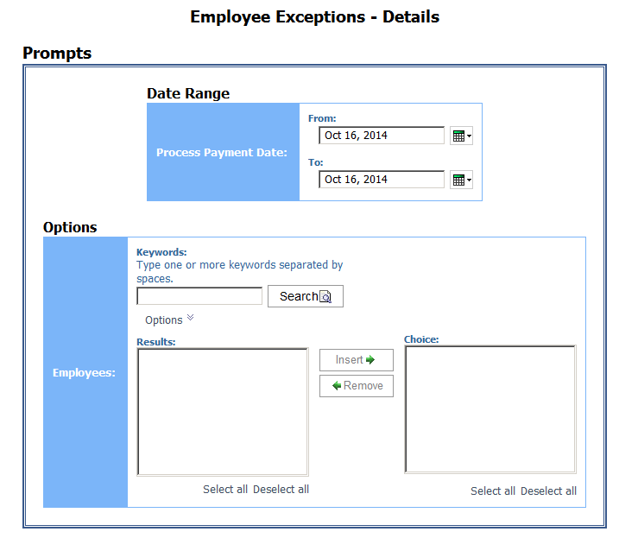

Report Output
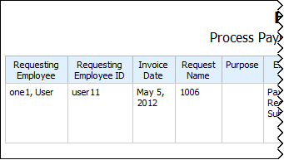
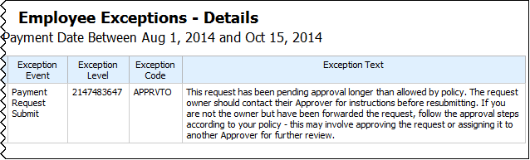

Report Header and Footer
Data Item Label/Name | Data Item Expression | Data Item Description
Process Payment Date | ParamDisplayValue('ProcessPaymentDateParam') | Displays the date range from the Process Payment Date prompt on the Prompts page

Report Data Items
Data Item Label | Data Item Name | Data Item Expression | Data Item Description
Requesting Employee | <Requesting Employee> | [Union1].[Requesting Employee] | Displays the requesting employee resulting from the UNION of ([Invoice].[Payment Request Header Information].[Requesting Employee] AND [Invoice].[Payment Request Header Information].[Requesting Employee])
Requesting Employee ID | <Requesting Employee ID> | [Union1].[Requesting Employee ID] | Displays the requesting employee ID resulting from the UNION of ([Invoice].[Payment Request Header Information].[Employee ID] AND [Invoice].[Payment Request Header Information].[Employee ID])
Invoice Date | <Invoice Date> | [Union1].[Invoice Date] | Displays the invoice date resulting from the UNION of ([Invoice].[Payment Request Dates and Statuses].[Invoice Date] AND [Invoice].[Payment Request Dates and Statuses].[Invoice Date])
Request Name | <Request Name> | [Union1].[Request Name] | Displays the request name resulting from the UNION of ([Invoice].[Payment Request Header Information].[Request Name] AND [Invoice].[Payment Request Header Information].[Request Name])
Purpose | <Purpose> | [Union1].[Purpose] | Displays the purpose resulting from the UNION of ([Invoice].[Payment Request Header Information].[Description] AND [Invoice].[Payment Request Header Information].[Description])
Exception Event | <Exception Event> | [Union1].[Exception Event] | Displays the exception event resulting from the UNION of ([Invoice].[Payment Request Header Exceptions].[Exception Event] AND [Invoice].[Payment Request Line Item Exceptions].[Exception Event])
Exception Level | <ExceptionLevel> | [Union1].[Exception Level] | Displays the exception level resulting from the UNION of ([Invoice].[Payment Request Header Exceptions].[Exception Level] AND [Invoice].[Payment Request Line Item Exceptions].[Exception Level])
Exception Code | <Exception Code> | [Union1].[Exception Code] | Displays the exception code resulting from the UNION of ([Invoice].[Payment Request Header Exceptions].[Exception Code] AND [Invoice].[Payment Request Line Item Exceptions].[Exception Code])
Exception Text | <Exception Text> | [Union1].[Exception Text] | Displays the exception text resulting from the UNION of ([Invoice].[Payment Request Header Exceptions].[Exception Text] AND [Invoice].[Payment Request Line Item Exceptions].[Exception Text])

Report: Invoice Briefing Summary
Available to:  Analysis  Intelligence
This report graphically displays several key metrics in a dashboard-type display. This allows a user to quickly execute a single report but return multiple key values.

Report Prompts
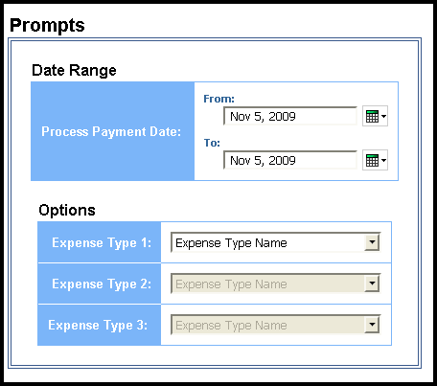

Report Output
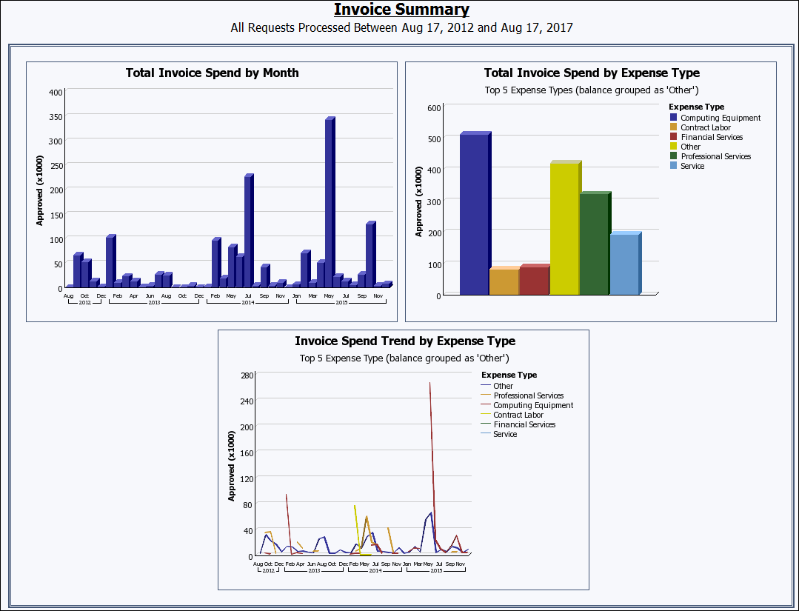
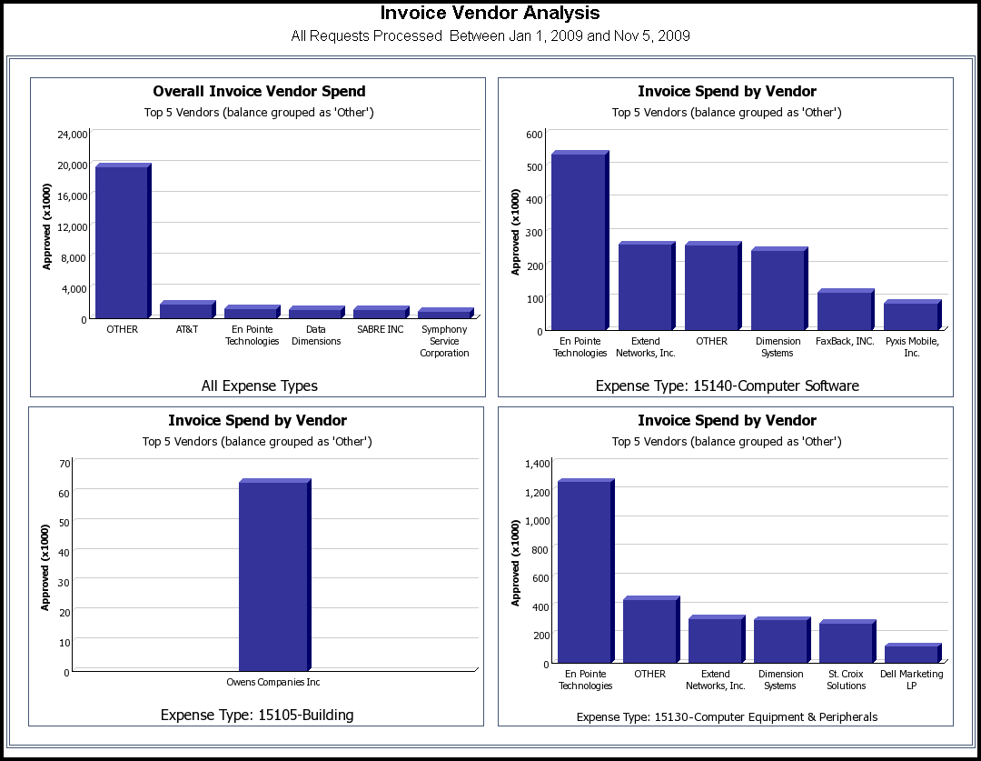
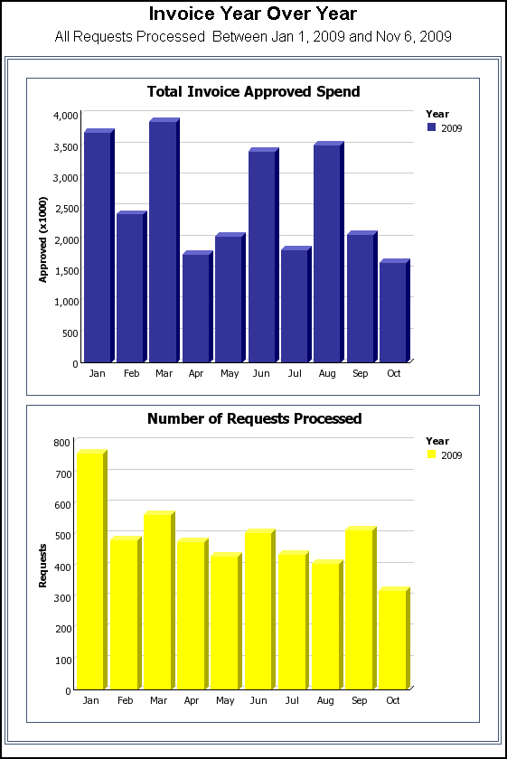

Report Header and Footer
Data Item Label/Name | Data Item Expression | Data Item Description
All Requests Processed | ' '+ParamDisplayValue('processPaymentDateParam') | Displays the date range from the Process Payment Date prompt on the Prompts page

Report Data Items
Data Item Label | Data Item Name | Data Item Expression | Data Item Description
N/A | <Total Approved Amount (rpt)> | [Invoice].[Payment Request Header Information].[Total Approved Amount (rpt)] | Displays the total amount approved
N/A | <Process Payment Year> | extract(year,[Invoice].[Payment Request Dates and Statuses].[Process Payment Date]) | Displays the payment processed year
N/A | <Process Payment Month Name> | case  WHEN [Invoice].[Payment Request Dates and Statuses].[Process Payment Month Number]= 1 and # sq($runLocale )# = 'en' THEN 'Jan'  WHEN [Invoice].[Payment Request Dates and Statuses].[Process Payment Month Number]= 1 and # sq($runLocale )# = 'zh-cn' THEN '一月'  WHEN [Invoice].[Payment Request Dates and Statuses].[Process Payment Month Number]= 1 and # sq($runLocale )# = 'zh-tw' THEN '一月'  WHEN [Invoice].[Payment Request Dates and Statuses].[Process Payment Month Number]= 1 and # sq($runLocale )# = 'en-gb' THEN 'Jan'  WHEN [Invoice].[Payment Request Dates and Statuses].[Process Payment Month Number]= 1 and # sq($runLocale )# = 'fr' THEN 'Jan'  WHEN [Invoice].[Payment Request Dates and Statuses].[Process Payment Month Number]= 1 and # sq($runLocale )# = 'de' THEN 'Jan'  WHEN [Invoice].[Payment Request Dates and Statuses].[Process Payment Month Number]= 1 and # sq($runLocale )# = 'ja' THEN '1 月'  WHEN [Invoice].[Payment Request Dates and Statuses].[Process Payment Month Number]= 1 and # sq($runLocale )# = 'it' THEN 'Gen'  WHEN [Invoice].[Payment Request Dates and Statuses].[Process Payment Month Number]= 1 and # sq($runLocale )# = 'ko' THEN '1월'  WHEN [Invoice].[Payment Request Dates and Statuses].[Process Payment Month Number]= 1 and # sq($runLocale )# = 'sv' THEN 'Jan'  WHEN [Invoice].[Payment Request Dates and Statuses].[Process Payment Month Number]= 1 and # sq($runLocale )# = 'nl' THEN 'Jan'  WHEN [Invoice].[Payment Request Dates and Statuses].[Process Payment Month Number]= 2 and # sq($runLocale )# = 'en' THEN 'Feb'  WHEN [Invoice].[Payment Request Dates and Statuses].[Process Payment Month Number]= 2 and # sq($runLocale )# = 'zh-cn' THEN '二月'  WHEN [Invoice].[Payment Request Dates and Statuses].[Process Payment Month Number]= 2 and # sq($runLocale )# = 'zh-tw' THEN '二月'  WHEN [Invoice].[Payment Request Dates and Statuses].[Process Payment Month Number]= 2 and # sq($runLocale )# = 'en-gb' THEN 'Feb'  WHEN [Invoice].[Payment Request Dates and Statuses].[Process Payment Month Number]= 2 and # sq($runLocale )# = 'fr' THEN 'Fév'  WHEN [Invoice].[Payment Request Dates and Statuses].[Process Payment Month Number]= 2 and # sq($runLocale )# = 'de' THEN 'Feb'  WHEN [Invoice].[Payment Request Dates and Statuses].[Process Payment Month Number]= 2 and # sq($runLocale )# = 'ja' THEN '2 月'  WHEN [Invoice].[Payment Request Dates and Statuses].[Process Payment Month Number]= 2 and # sq($runLocale )# = 'it' THEN 'Feb'  WHEN [Invoice].[Payment Request Dates and Statuses].[Process Payment Month Number]= 2 and # sq($runLocale )# = 'ko' THEN '2월'  WHEN [Invoice].[Payment Request Dates and Statuses].[Process Payment Month Number]= 2 and # sq($runLocale )# = 'sv' THEN 'Feb'  WHEN [Invoice].[Payment Request Dates and Statuses].[Process Payment Month Number]= 2 and # sq($runLocale )# = 'nl' THEN 'Feb'  WHEN [Invoice].[Payment Request Dates and Statuses].[Process Payment Month Number]= 3 and # sq($runLocale )# = 'en' THEN 'Mar'  WHEN [Invoice].[Payment Request Dates and Statuses].[Process Payment Month Number]= 3 and # sq($runLocale )# = 'zh-cn' THEN '三月'  WHEN [Invoice].[Payment Request Dates and Statuses].[Process Payment Month Number]= 3 and # sq($runLocale )# = 'zh-tw' THEN '三月'  WHEN [Invoice].[Payment Request Dates and Statuses].[Process Payment Month Number]= 3 and # sq($runLocale )# = 'en-gb' THEN 'Mar'  WHEN [Invoice].[Payment Request Dates and Statuses].[Process Payment Month Number]= 3 and # sq($runLocale )# = 'fr' THEN 'Mar'  WHEN [Invoice].[Payment Request Dates and Statuses].[Process Payment Month Number]= 3 and # sq($runLocale )# = 'de' THEN 'Mär'  WHEN [Invoice].[Payment Request Dates and Statuses].[Process Payment Month Number]= 3 and # sq($runLocale )# = 'ja' THEN '3 月'  WHEN [Invoice].[Payment Request Dates and Statuses].[Process Payment Month Number]= 3 and # sq($runLocale )# = 'it' THEN 'Mar'  WHEN [Invoice].[Payment Request Dates and Statuses].[Process Payment Month Number]= 3 and # sq($runLocale )# = 'ko' THEN '3월'  WHEN [Invoice].[Payment Request Dates and Statuses].[Process Payment Month Number]= 3 and # sq($runLocale )# = 'sv' THEN 'Mar'  WHEN [Invoice].[Payment Request Dates and Statuses].[Process Payment Month Number]= 3 and # sq($runLocale )# = 'nl' THEN 'Maa'  WHEN [Invoice].[Payment Request Dates and Statuses].[Process Payment Month Number]= 4 and # sq($runLocale )# = 'en' THEN 'Apr'  WHEN [Invoice].[Payment Request Dates and Statuses].[Process Payment Month Number]= 4 and # sq($runLocale )# = 'zh-cn' THEN '四月'  WHEN [Invoice].[Payment Request Dates and Statuses].[Process Payment Month Number]= 4 and # sq($runLocale )# = 'zh-tw' THEN '四月'  WHEN [Invoice].[Payment Request Dates and Statuses].[Process Payment Month Number]= 4 and # sq($runLocale )# = 'en-gb' THEN 'Apr'  WHEN [Invoice].[Payment Request Dates and Statuses].[Process Payment Month Number]= 4 and # sq($runLocale )# = 'fr' THEN 'Avr'  WHEN [Invoice].[Payment Request Dates and Statuses].[Process Payment Month Number]= 4 and # sq($runLocale )# = 'de' THEN 'Apr'  WHEN [Invoice].[Payment Request Dates and Statuses].[Process Payment Month Number]= 4 and # sq($runLocale )# = 'ja' THEN '4 月'  WHEN [Invoice].[Payment Request Dates and Statuses].[Process Payment Month Number]= 4 and # sq($runLocale )# = 'it' THEN 'Apr'  WHEN [Invoice].[Payment Request Dates and Statuses].[Process Payment Month Number]= 4 and # sq($runLocale )# = 'ko' THEN '4월'  WHEN [Invoice].[Payment Request Dates and Statuses].[Process Payment Month Number]= 4 and # sq($runLocale )# = 'sv' THEN 'Apr'  WHEN [Invoice].[Payment Request Dates and Statuses].[Process Payment Month Number]= 4 and # sq($runLocale )# = 'nl' THEN 'Apr'  WHEN [Invoice].[Payment Request Dates and Statuses].[Process Payment Month Number]= 5 and # sq($runLocale )# = 'en' THEN 'May'  WHEN [Invoice].[Payment Request Dates and Statuses].[Process Payment Month Number]= 5 and # sq($runLocale )# = 'zh-cn' THEN '五月'  WHEN [Invoice].[Payment Request Dates and Statuses].[Process Payment Month Number]= 5 and # sq($runLocale )# = 'zh-tw' THEN '五月'  WHEN [Invoice].[Payment Request Dates and Statuses].[Process Payment Month Number]= 5 and # sq($runLocale )# = 'en-gb' THEN 'May'  WHEN [Invoice].[Payment Request Dates and Statuses].[Process Payment Month Number]= 5 and # sq($runLocale )# = 'fr' THEN 'Mai'  WHEN [Invoice].[Payment Request Dates and Statuses].[Process Payment Month Number]= 5 and # sq($runLocale )# = 'de' THEN 'Mai'  WHEN [Invoice].[Payment Request Dates and Statuses].[Process Payment Month Number]= 5 and # sq($runLocale )# = 'ja' THEN '5 月'  WHEN [Invoice].[Payment Request Dates and Statuses].[Process Payment Month Number]= 5 and # sq($runLocale )# = 'it' THEN 'Maggio'  WHEN [Invoice].[Payment Request Dates and Statuses].[Process Payment Month Number]= 5 and # sq($runLocale )# = 'ko' THEN '5월'  WHEN [Invoice].[Payment Request Dates and Statuses].[Process Payment Month Number]= 5 and # sq($runLocale )# = 'sv' THEN 'Maj'  WHEN [Invoice].[Payment Request Dates and Statuses].[Process Payment Month Number]= 5 and # sq($runLocale )# = 'nl' THEN 'Mei'  WHEN [Invoice].[Payment Request Dates and Statuses].[Process Payment Month Number]= 6 and # sq($runLocale )# = 'en' THEN 'Jun'  WHEN [Invoice].[Payment Request Dates and Statuses].[Process Payment Month Number]= 6 and # sq($runLocale )# = 'zh-cn' THEN '六月'  WHEN [Invoice].[Payment Request Dates and Statuses].[Process Payment Month Number]= 6 and # sq($runLocale )# = 'zh-tw' THEN '六月'  WHEN [Invoice].[Payment Request Dates and Statuses].[Process Payment Month Number]= 6 and # sq($runLocale )# = 'en-gb' THEN 'Jun'  WHEN [Invoice].[Payment Request Dates and Statuses].[Process Payment Month Number]= 6 and # sq($runLocale )# = 'fr' THEN 'Jn'  WHEN [Invoice].[Payment Request Dates and Statuses].[Process Payment Month Number]= 6 and # sq($runLocale )# = 'de' THEN 'Jun'  WHEN [Invoice].[Payment Request Dates and Statuses].[Process Payment Month Number]= 6 and # sq($runLocale )# = 'ja' THEN '6 月'  WHEN [Invoice].[Payment Request Dates and Statuses].[Process Payment Month Number]= 6 and # sq($runLocale )# = 'it' THEN 'Giu'  WHEN [Invoice].[Payment Request Dates and Statuses].[Process Payment Month Number]= 6 and # sq($runLocale )# = 'ko' THEN '6월'  WHEN [Invoice].[Payment Request Dates and Statuses].[Process Payment Month Number]= 6 and # sq($runLocale )# = 'sv' THEN 'Jun'  WHEN [Invoice].[Payment Request Dates and Statuses].[Process Payment Month Number]= 6 and # sq($runLocale )# = 'nl' THEN 'Jun'  WHEN [Invoice].[Payment Request Dates and Statuses].[Process Payment Month Number]= 7 and # sq($runLocale )# = 'en' THEN 'Jul'  WHEN [Invoice].[Payment Request Dates and Statuses].[Process Payment Month Number]= 7 and # sq($runLocale )# = 'zh-cn' THEN '七月'  WHEN [Invoice].[Payment Request Dates and Statuses].[Process Payment Month Number]= 7 and # sq($runLocale )# = 'zh-tw' THEN '七月'  WHEN [Invoice].[Payment Request Dates and Statuses].[Process Payment Month Number]= 7 and # sq($runLocale )# = 'en-gb' THEN 'Jul'  WHEN [Invoice].[Payment Request Dates and Statuses].[Process Payment Month Number]= 7 and # sq($runLocale )# = 'fr' THEN 'Jui'  WHEN [Invoice].[Payment Request Dates and Statuses].[Process Payment Month Number]= 7 and # sq($runLocale )# = 'de' THEN 'Jul'  WHEN [Invoice].[Payment Request Dates and Statuses].[Process Payment Month Number]= 7 and # sq($runLocale )# = 'ja' THEN '7 月'  WHEN [Invoice].[Payment Request Dates and Statuses].[Process Payment Month Number]= 7 and # sq($runLocale )# = 'it' THEN 'Lug'  WHEN [Invoice].[Payment Request Dates and Statuses].[Process Payment Month Number]= 7 and # sq($runLocale )# = 'ko' THEN '7월'  WHEN [Invoice].[Payment Request Dates and Statuses].[Process Payment Month Number]= 7 and # sq($runLocale )# = 'sv' THEN 'Jul'  WHEN [Invoice].[Payment Request Dates and Statuses].[Process Payment Month Number]= 7 and # sq($runLocale )# = 'nl' THEN 'Jul'  WHEN [Invoice].[Payment Request Dates and Statuses].[Process Payment Month Number]= 8 and # sq($runLocale )# = 'en' THEN 'Aug'  WHEN [Invoice].[Payment Request Dates and Statuses].[Process Payment Month Number]= 8 and # sq($runLocale )# = 'zh-cn' THEN '八月'  WHEN [Invoice].[Payment Request Dates and Statuses].[Process Payment Month Number]= 8 and # sq($runLocale )# = 'zh-tw' THEN '八月'  WHEN [Invoice].[Payment Request Dates and Statuses].[Process Payment Month Number]= 8 and # sq($runLocale )# = 'en-gb' THEN 'Aug'  WHEN [Invoice].[Payment Request Dates and Statuses].[Process Payment Month Number]= 8 and # sq($runLocale )# = 'fr' THEN 'Aoû'  WHEN [Invoice].[Payment Request Dates and Statuses].[Process Payment Month Number]= 8 and # sq($runLocale )# = 'de' THEN 'Aug'  WHEN [Invoice].[Payment Request Dates and Statuses].[Process Payment Month Number]= 8 and # sq($runLocale )# = 'ja' THEN '8 月'  WHEN [Invoice].[Payment Request Dates and Statuses].[Process Payment Month Number]= 8 and # sq($runLocale )# = 'it' THEN 'Ago'  WHEN [Invoice].[Payment Request Dates and Statuses].[Process Payment Month Number]= 8 and # sq($runLocale )# = 'ko' THEN '8월'  WHEN [Invoice].[Payment Request Dates and Statuses].[Process Payment Month Number]= 8 and # sq($runLocale )# = 'sv' THEN 'Aug'  WHEN [Invoice].[Payment Request Dates and Statuses].[Process Payment Month Number]= 8 and # sq($runLocale )# = 'nl' THEN 'Aug'  WHEN [Invoice].[Payment Request Dates and Statuses].[Process Payment Month Number]= 9 and # sq($runLocale )# = 'en' THEN 'Sep'  WHEN [Invoice].[Payment Request Dates and Statuses].[Process Payment Month Number]= 9 and # sq($runLocale )# = 'zh-cn' THEN '九月'  WHEN [Invoice].[Payment Request Dates and Statuses].[Process Payment Month Number]= 9 and # sq($runLocale )# = 'zh-tw' THEN '九月'  WHEN [Invoice].[Payment Request Dates and Statuses].[Process Payment Month Number]= 9 and # sq($runLocale )# = 'en-gb' THEN 'Sep'  WHEN [Invoice].[Payment Request Dates and Statuses].[Process Payment Month Number]= 9 and # sq($runLocale )# = 'fr' THEN 'Sep'  WHEN [Invoice].[Payment Request Dates and Statuses].[Process Payment Month Number]= 9 and # sq($runLocale )# = 'de' THEN 'Sep'  WHEN [Invoice].[Payment Request Dates and Statuses].[Process Payment Month Number]= 9 and # sq($runLocale )# = 'ja' THEN '9 月'  WHEN [Invoice].[Payment Request Dates and Statuses].[Process Payment Month Number]= 9 and # sq($runLocale )# = 'it' THEN 'Set'  WHEN [Invoice].[Payment Request Dates and Statuses].[Process Payment Month Number]= 9 and # sq($runLocale )# = 'ko' THEN '9월'  WHEN [Invoice].[Payment Request Dates and Statuses].[Process Payment Month Number]= 9 and # sq($runLocale )# = 'sv' THEN 'Sep'  WHEN [Invoice].[Payment Request Dates and Statuses].[Process Payment Month Number]= 9 and # sq($runLocale )# = 'nl' THEN 'Sep'  WHEN [Invoice].[Payment Request Dates and Statuses].[Process Payment Month Number]= 10 and # sq($runLocale )# = 'en' THEN 'Oct'  WHEN [Invoice].[Payment Request Dates and Statuses].[Process Payment Month Number]= 10 and # sq($runLocale )# = 'zh-cn' THEN '十月'  WHEN [Invoice].[Payment Request Dates and Statuses].[Process Payment Month Number]= 10 and # sq($runLocale )# = 'zh-tw' THEN '十月'  WHEN [Invoice].[Payment Request Dates and Statuses].[Process Payment Month Number]= 10 and # sq($runLocale )# = 'en-gb' THEN 'Oct'  WHEN [Invoice].[Payment Request Dates and Statuses].[Process Payment Month Number]= 10 and # sq($runLocale )# = 'fr' THEN 'Oct'  WHEN [Invoice].[Payment Request Dates and Statuses].[Process Payment Month Number]= 10 and # sq($runLocale )# = 'de' THEN 'Okt'  WHEN [Invoice].[Payment Request Dates and Statuses].[Process Payment Month Number]= 10 and # sq($runLocale )# = 'ja' THEN '10 月'  WHEN [Invoice].[Payment Request Dates and Statuses].[Process Payment Month Number]= 10 and # sq($runLocale )# = 'it' THEN 'Ott'  WHEN [Invoice].[Payment Request Dates and Statuses].[Process Payment Month Number]= 10 and # sq($runLocale )# = 'ko' THEN '10월'  WHEN [Invoice].[Payment Request Dates and Statuses].[Process Payment Month Number]= 10 and # sq($runLocale )# = 'sv' THEN 'Okt'  WHEN [Invoice].[Payment Request Dates and Statuses].[Process Payment Month Number]= 10 and # sq($runLocale )# = 'nl' THEN 'Okt'  WHEN [Invoice].[Payment Request Dates and Statuses].[Process Payment Month Number]= 11 and # sq($runLocale )# = 'en' THEN 'Nov'  WHEN [Invoice].[Payment Request Dates and Statuses].[Process Payment Month Number]= 11 and # sq($runLocale )# = 'zh-cn' THEN '十一月'  WHEN [Invoice].[Payment Request Dates and Statuses].[Process Payment Month Number]= 11 and # sq($runLocale )# = 'zh-tw' THEN '十一月'  WHEN [Invoice].[Payment Request Dates and Statuses].[Process Payment Month Number]= 11 and # sq($runLocale )# = 'en-gb' THEN 'Nov'  WHEN [Invoice].[Payment Request Dates and Statuses].[Process Payment Month Number]= 11 and # sq($runLocale )# = 'fr' THEN 'Nov'  WHEN [Invoice].[Payment Request Dates and Statuses].[Process Payment Month Number]= 11 and # sq($runLocale )# = 'de' THEN 'Nov'  WHEN [Invoice].[Payment Request Dates and Statuses].[Process Payment Month Number]= 11 and # sq($runLocale )# = 'ja' THEN '11 月'  WHEN [Invoice].[Payment Request Dates and Statuses].[Process Payment Month Number]= 11 and # sq($runLocale )# = 'it' THEN 'Nov'  WHEN [Invoice].[Payment Request Dates and Statuses].[Process Payment Month Number]= 11 and # sq($runLocale )# = 'ko' THEN '11월'  WHEN [Invoice].[Payment Request Dates and Statuses].[Process Payment Month Number]= 11 and # sq($runLocale )# = 'sv' THEN 'Nov'  WHEN [Invoice].[Payment Request Dates and Statuses].[Process Payment Month Number]= 11 and # sq($runLocale )# = 'nl' THEN 'Nov'  WHEN [Invoice].[Payment Request Dates and Statuses].[Process Payment Month Number]= 12 and # sq($runLocale )# = 'en' THEN 'Dec'  WHEN [Invoice].[Payment Request Dates and Statuses].[Process Payment Month Number]= 12 and # sq($runLocale )# = 'zh-cn' THEN '十二月'  WHEN [Invoice].[Payment Request Dates and Statuses].[Process Payment Month Number]= 12 and # sq($runLocale )# = 'zh-tw' THEN '十二月'  WHEN [Invoice].[Payment Request Dates and Statuses].[Process Payment Month Number]= 12 and # sq($runLocale )# = 'en-gb' THEN 'Dec'  WHEN [Invoice].[Payment Request Dates and Statuses].[Process Payment Month Number]= 12 and # sq($runLocale )# = 'fr' THEN 'Déc'  WHEN [Invoice].[Payment Request Dates and Statuses].[Process Payment Month Number]= 12 and # sq($runLocale )# = 'de' THEN 'Dez'  WHEN [Invoice].[Payment Request Dates and Statuses].[Process Payment Month Number]= 12 and # sq($runLocale )# = 'ja' THEN '12 月'  WHEN [Invoice].[Payment Request Dates and Statuses].[Process Payment Month Number]= 12 and # sq($runLocale )# = 'it' THEN 'Dic'  WHEN [Invoice].[Payment Request Dates and Statuses].[Process Payment Month Number]= 12 and # sq($runLocale )# = 'ko' THEN '12월'  WHEN [Invoice].[Payment Request Dates and Statuses].[Process Payment Month Number]= 12 and # sq($runLocale )# = 'sv' THEN 'Dec'  WHEN [Invoice].[Payment Request Dates and Statuses].[Process Payment Month Number]= 12 and # sq($runLocale )# = 'nl' THEN 'Dec'  WHEN [Invoice].[Payment Request Dates and Statuses].[Process Payment Month Number]= 1 and # sq($runLocale )# ='cs' then 'Led'  WHEN [Invoice].[Payment Request Dates and Statuses].[Process Payment Month Number]= 1 and # sq($runLocale )# ='pt-BR' then 'Jan'  WHEN [Invoice].[Payment Request Dates and Statuses].[Process Payment Month Number]= 1 and # sq($runLocale )# ='es' then 'Ene'  WHEN [Invoice].[Payment Request Dates and Statuses].[Process Payment Month Number]= 2 and # sq($runLocale )# ='cs' then 'Úno'  WHEN [Invoice].[Payment Request Dates and Statuses].[Process Payment Month Number]= 2 and # sq($runLocale )# ='pt-BR' then 'Fev'  WHEN [Invoice].[Payment Request Dates and Statuses].[Process Payment Month Number]= 2 and # sq($runLocale )# ='es' then 'Feb'  WHEN [Invoice].[Payment Request Dates and Statuses].[Process Payment Month Number]= 3 and # sq($runLocale )# ='cs' then 'Bře'  WHEN [Invoice].[Payment Request Dates and Statuses].[Process Payment Month Number]= 3 and # sq($runLocale )# ='pt-BR' then 'Mar'  WHEN [Invoice].[Payment Request Dates and Statuses].[Process Payment Month Number]= 3 and # sq($runLocale )# ='es' then 'Mar'  WHEN [Invoice].[Payment Request Dates and Statuses].[Process Payment Month Number]= 4 and # sq($runLocale )# ='cs' then 'Dub'  WHEN [Invoice].[Payment Request Dates and Statuses].[Process Payment Month Number]= 4 and # sq($runLocale )# ='pt-BR' then 'Abr'  WHEN [Invoice].[Payment Request Dates and Statuses].[Process Payment Month Number]= 4 and # sq($runLocale )# ='es' then 'Abr'  WHEN [Invoice].[Payment Request Dates and Statuses].[Process Payment Month Number]= 5 and # sq($runLocale )# ='cs' then 'Květen'  WHEN [Invoice].[Payment Request Dates and Statuses].[Process Payment Month Number]= 5 and # sq($runLocale )# ='pt-BR' then 'Maio'  WHEN [Invoice].[Payment Request Dates and Statuses].[Process Payment Month Number]= 5 and # sq($runLocale )# ='es' then 'May'  WHEN [Invoice].[Payment Request Dates and Statuses].[Process Payment Month Number]= 6 and # sq($runLocale )# ='cs' then 'Čer'  WHEN [Invoice].[Payment Request Dates and Statuses].[Process Payment Month Number]= 6 and # sq($runLocale )# ='pt-BR' then 'Jun'  WHEN [Invoice].[Payment Request Dates and Statuses].[Process Payment Month Number]= 6 and # sq($runLocale )# ='es' then 'Jun'  WHEN [Invoice].[Payment Request Dates and Statuses].[Process Payment Month Number]= 7 and # sq($runLocale )# ='cs' then 'Čvnc'  WHEN [Invoice].[Payment Request Dates and Statuses].[Process Payment Month Number]= 7 and # sq($runLocale )# ='pt-BR' then 'Jul'  WHEN [Invoice].[Payment Request Dates and Statuses].[Process Payment Month Number]= 7 and # sq($runLocale )# ='es' then 'Jul'  WHEN [Invoice].[Payment Request Dates and Statuses].[Process Payment Month Number]= 8 and # sq($runLocale )# ='cs' then 'Srp'  WHEN [Invoice].[Payment Request Dates and Statuses].[Process Payment Month Number]= 8 and # sq($runLocale )# ='pt-BR' then 'Ago'  WHEN [Invoice].[Payment Request Dates and Statuses].[Process Payment Month Number]= 8 and # sq($runLocale )# ='es' then 'Ago'  WHEN [Invoice].[Payment Request Dates and Statuses].[Process Payment Month Number]= 9 and # sq($runLocale )# ='cs' then 'Zář'  WHEN [Invoice].[Payment Request Dates and Statuses].[Process Payment Month Number]= 9 and # sq($runLocale )# ='pt-BR' then 'Set'  WHEN [Invoice].[Payment Request Dates and Statuses].[Process Payment Month Number]= 9 and # sq($runLocale )# ='es' then 'Sep'  WHEN [Invoice].[Payment Request Dates and Statuses].[Process Payment Month Number]= 10 and # sq($runLocale )# ='cs' then 'Lis'  WHEN [Invoice].[Payment Request Dates and Statuses].[Process Payment Month Number]= 10 and # sq($runLocale )# ='pt-BR' then 'Nov'  WHEN [Invoice].[Payment Request Dates and Statuses].[Process Payment Month Number]= 10 and # sq($runLocale )# ='es' then 'Nov'  WHEN [Invoice].[Payment Request Dates and Statuses].[Process Payment Month Number]= 11 and # sq($runLocale )# ='cs' then 'Pro'  WHEN [Invoice].[Payment Request Dates and Statuses].[Process Payment Month Number]= 11 and # sq($runLocale )# ='pt-BR' then 'Dez'  WHEN [Invoice].[Payment Request Dates and Statuses].[Process Payment Month Number]= 11 and # sq($runLocale )# ='es' then 'Dic'  WHEN [Invoice].[Payment Request Dates and Statuses].[Process Payment Month Number]= 12 and # sq($runLocale )# ='cs' then 'Lis'  WHEN [Invoice].[Payment Request Dates and Statuses].[Process Payment Month Number]= 12 and # sq($runLocale )# ='pt-BR' then 'Nov'  WHEN [Invoice].[Payment Request Dates and Statuses].[Process Payment Month Number]= 12 and # sq($runLocale )# ='es' then 'Nov'  end | Displays the payment processed month
N/A | <Total Approved (rpt)> | [Total Invoice Spend by Expense Type - Ranking].[Total Approved (rpt)] | Displays the total approved
N/A | <Expense Type Name> | if([Total Invoice Spend by Expense Type - Ranking].[Rank]<6) then ([Total Invoice Spend by Expense Type - Ranking].[Expense Type Name]) else ('Other') | Displays the total invoice spent or 'other'
N/A | <Total Approved (rpt)> | [Invoice].[Payment Request Line Items].[Total Approved (rpt)] | Displays the total line item approved
N/A | <Expense Type Name> | if([Invoice].[Payment Request Line Items].[Expense Type Name] in ([Total Invoice Spend by Expense Type].[Expense Type Name])) then ([Invoice].[Payment Request Line Items].[Expense Type Name]) else ('Other') | Displays the payment request line item or 'other'

Report: Invoice Expense Type Spend Trend
Available to:  Analysis  Intelligence
This report is a drill-through from the Briefing Summary.

Report Prompts
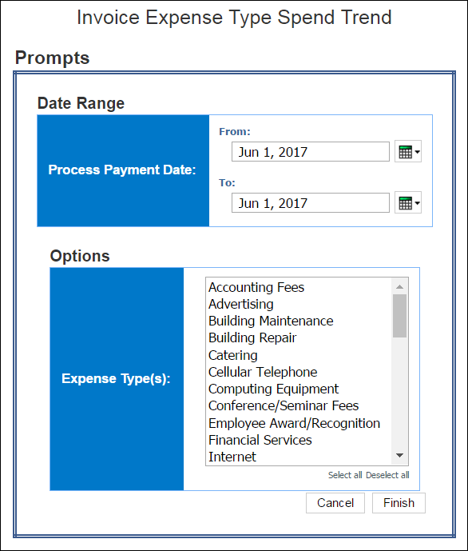

Report Output
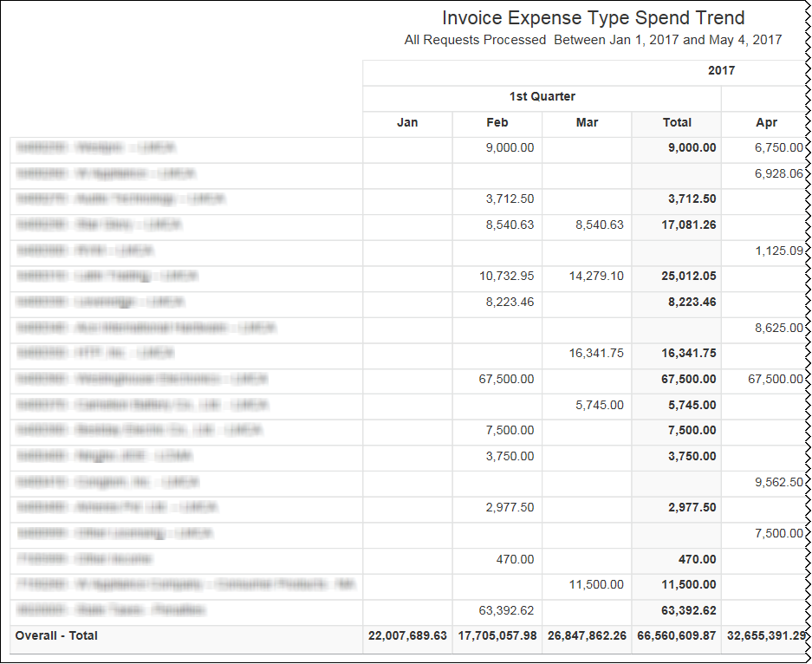
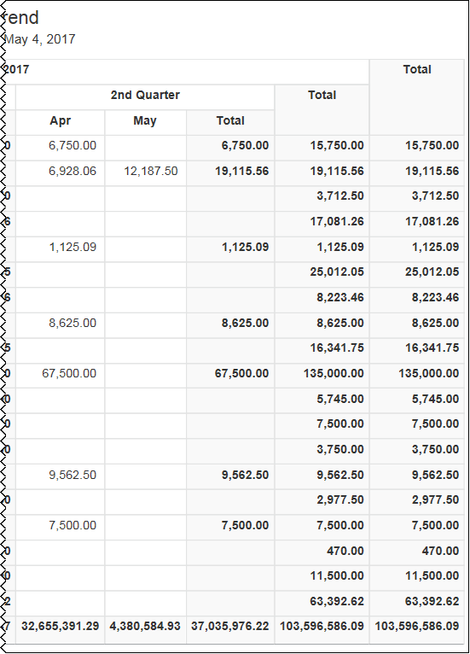

Report Header and Footer
Data Item Label/Name | Data Item Expression | Data Item Description
All Request Processed | ' ' + ParamDisplayValue('processPaymentDateParam') | Displays the date range from the Process Payment Date prompt on the Prompts page
Expense Type(s) | ' ' + ParamDisplayValue('expenseTypeNameParam') | Displays the expense type(s) selected from the Expense Type(s) prompt on the Prompts page

Report Data Items
Data Item Label | Data Item Name | Data Item Expression | Data Item Description
N/A | <Process Payment Year> | extract(year,[Invoice].[Payment Request Dates and Statuses].[Process Payment Date]) | Displays the process payment year
N/A | <Process Payment Quarter> | [Invoice].[Payment Request Dates and Statuses].[Process Payment Quarter] | Displays the process payment quarter
N/A | <Process Payment Month Name> | [Invoice].[Payment Request Dates and Statuses].[Process Payment Month] | Displays the process payment month
N/A | <Expense Type Name> | [Invoice].[Payment Request Line Items].[Expense Type Name] | Displays the expense Expense type
N/A | <Total Approved (rpt)> | [Invoice].[Payment Request Line Items].[Total Approved (rpt)] | Displays the total approved

Report: Invoice Tax Adjustment Report
Available to:  Analysis  Intelligence
This report identifies the differences between the tax amount on invoices and the calculated tax amount provided by a third-party tax validation company.
The report can help clients determine if tax adjustments need to be made in their accounting system to ensure tax-reporting accuracy.

Report Prompts
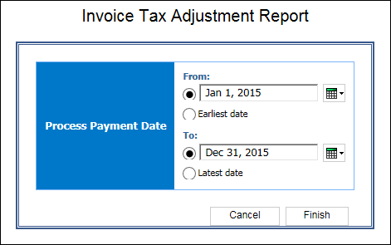

Report Output
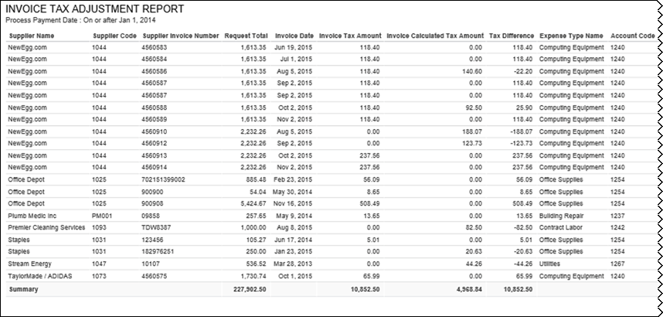
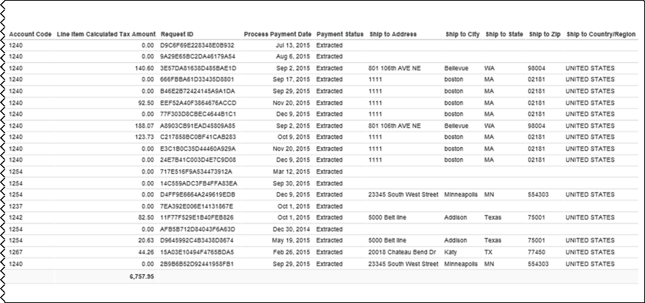

Report Header and Footer
Data Item Label/Name | Data Item Expression | Data Item Description
Process Payment Date | ParamDisplayValue('pProcess_Payment_Date') | Displays the date range from the Process Payment Date prompt on the Prompts page

Report Data Items
Data Item Label | Data Item Name | Data Item Expression | Data Item Description
Supplier Name | <Supplier Name> | [qTax_Adjustment].[Supplier Name] | Displays the supplier name
SupplierCode | <Supplier Code> | [qTax_Adjustment].[Supplier Code] | Displays the supplier code
Supplier Invoice Number | <Supplier Invoice Number> | [qTax_Adjustment].[Supplier Invoice Number] | Displays the supplier invoice number
Request Total | <Request Total> | [qTax_Adjustment].[Request Total] | Displays the request total
Invoice Date | <Invoice Date> | [qTax_Adjustment].[Invoice Date] | Displays the invoice date
Invoice Tax Amount | <Tax Amount> | [qTax_Adjustment].[Tax Amount] | Displays the tax amount
Invoice calculated Tax Amount | <Calculated Tax Amount> | [qTax_Adjustment].[Calculated Tax Amount] | Displays the calculated tax amount
Tax Difference | <Tax Difference> | [qTax_Adjustment].[Tax Difference] | Displays the tax difference
Expense Type Name | <Expense Type Name> | [qTax_Adjustment].[Expense Type Name] | Displays the expense type name
Account Code | <Account Code> | [qTax_Adjustment].[Account Code] | Displays the account code
Line Item Calculated Tax Amount | <Calculated Tax Amount2> | [qTax_Adjustment].[Calculated Tax Amount2] | Displays the tax amount
Request ID | <Request ID> | [qTax_Adjustment].[Request ID] | Displays the request ID
Process Payment Date | <Process Payment Date> | [qTax_Adjustment].[Process Payment Date] | Displays the process payment date
Payment Status | <Payment status> | [qTax_Adjustment].[Payment Status] | Displays the payment status
Ship To Address | <Ship to Address 1> | [qTax_Adjustment].[Ship to Address 1] | Displays the ship to address
Ship To City | <Ship to City/Location> | [qTax_Adjustment].[Ship to City/Location] | Displays the ship to city
Ship To State | <Ship to State/Province/Region> | [qTax_Adjustment].[Ship to State/Province/Region] | Displays the ship to state/province/region
Ship To Zip | <Ship to Postal Code> | [qTax_Adjustment].[Ship to Postal Code] | Displays the ship to postal code
Ship To Country/Region | <Ship to Country> | [qTax_Adjustment].[Ship to Country] | Displays the ship to country/region
Request Total | N/A | [qTax_Adjustment].[Request Total] | Displays the summary of the request total
Tax Amount | N/A | [qTax_Adjustment].[Tax Amount] | Displays the summary of the tax amount
Calculated Tax Amount | N/A | [qTax_Adjustment].[Calculated Tax Amount] | Displays the summary of the calculated tax amount
Tax Difference | N/A | [qTax_Adjustment].[Tax Difference] | Displays the summary of the tax difference
Calculated Tax Amount2 | N/A | [qTax_Adjustment].[Calculated Tax Amount2] | Displays the summary of the tax amount

Report: Invoice Virtual Card Payment Reconciliation
Available to:  Analysis  Intelligence
This report provides virtual card payment information for invoices in Concur Invoice, including batch ID, supplier name and invoice number, and payment information.

Report Prompts
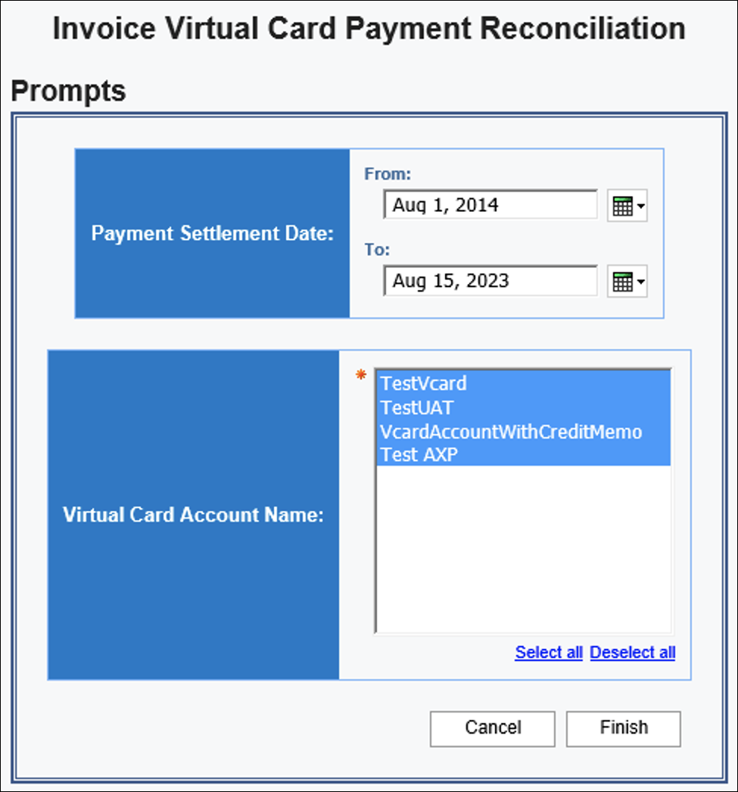

Report Output
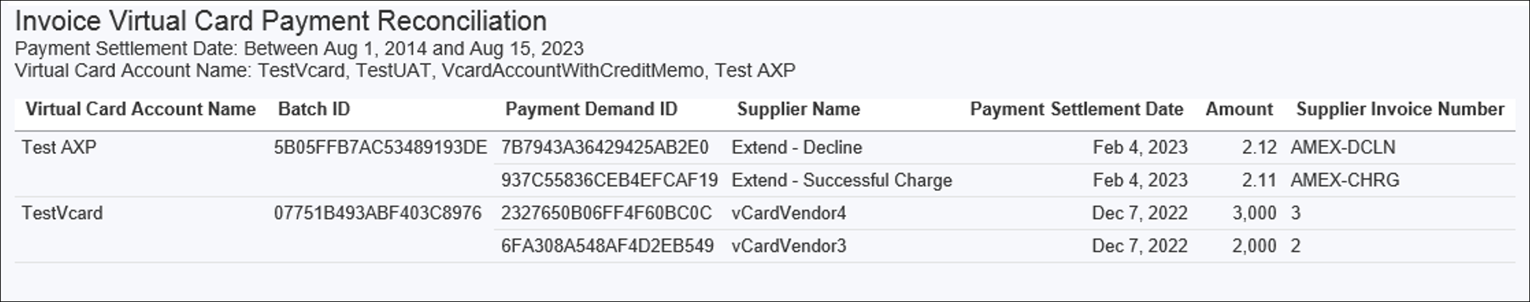

Report: Payment Practices and Performance
Available to:  Analysis  Intelligence
This report was designed to help businesses provide the information required by the Duty to Report on Payment Practices and Performance regulation in the United Kingdom. Companies can use this report to report on their company's ability to pay invoices on time. The report includes the proportion of invoices paid beyond agreed terms (by percentage), the average time taken to pay invoices, and the proportion of invoices paid within various time periods.

Report Prompts
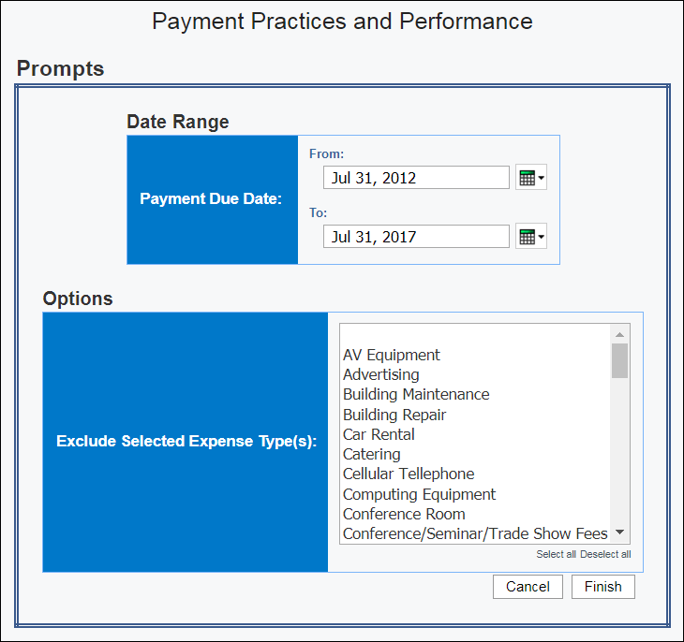

Report Output
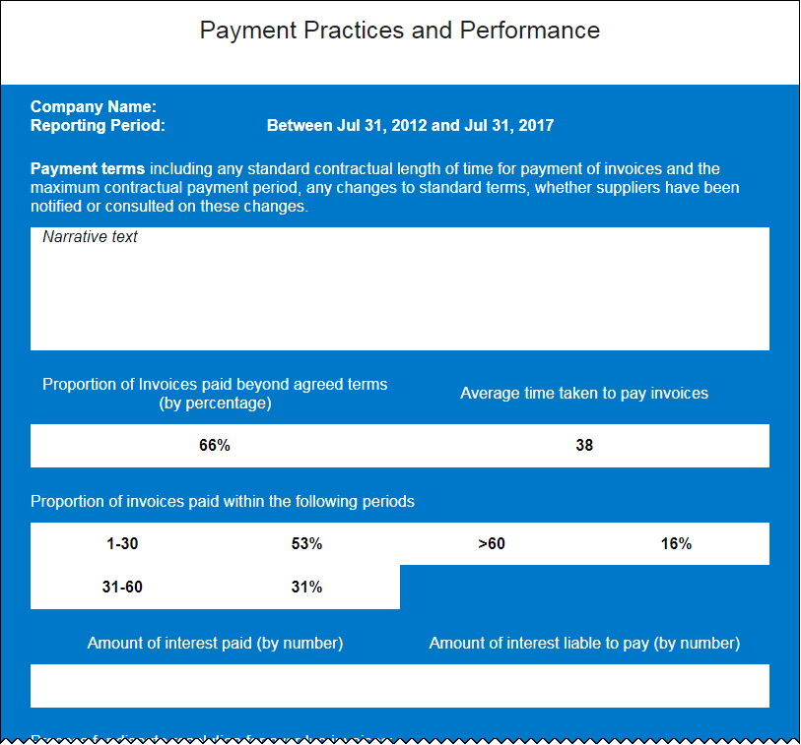
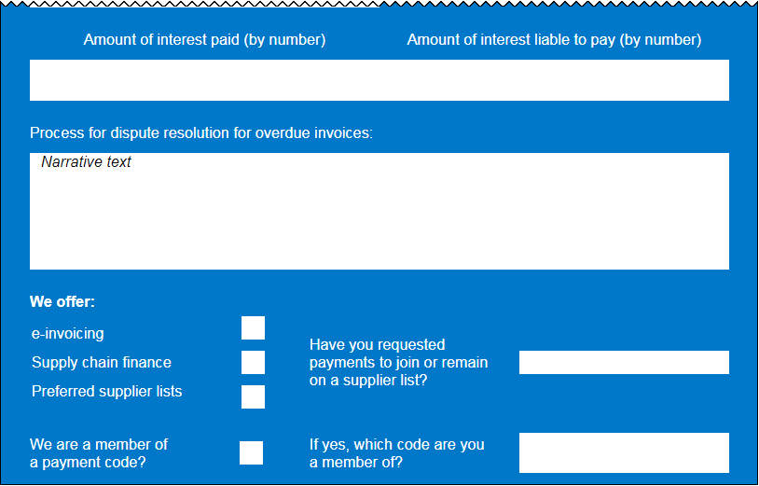

Report: Purchase Order to Invoice Matching Exceptions
Available to:  Analysis  Intelligence
This report identifies the matching exceptions for purchase orders and the invoices associated with the purchase orders. This report can help accounts payable employees determine which invoices require investigation. The report can also help accounts payable managers identify potential issues in the accounts payable workflow, such as seeing exceptions for the same supplier — possibly indicating an issue with the supplier, or seeing the same exception appearing numerous times, regardless of supplier, which may indicate an issue with the purchase orders being created by their organization.

Report Prompts
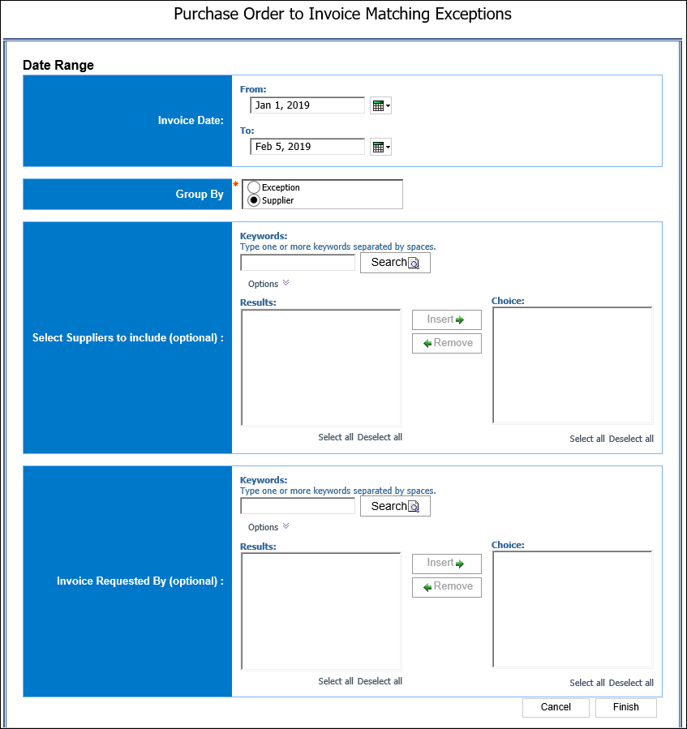

Report Output
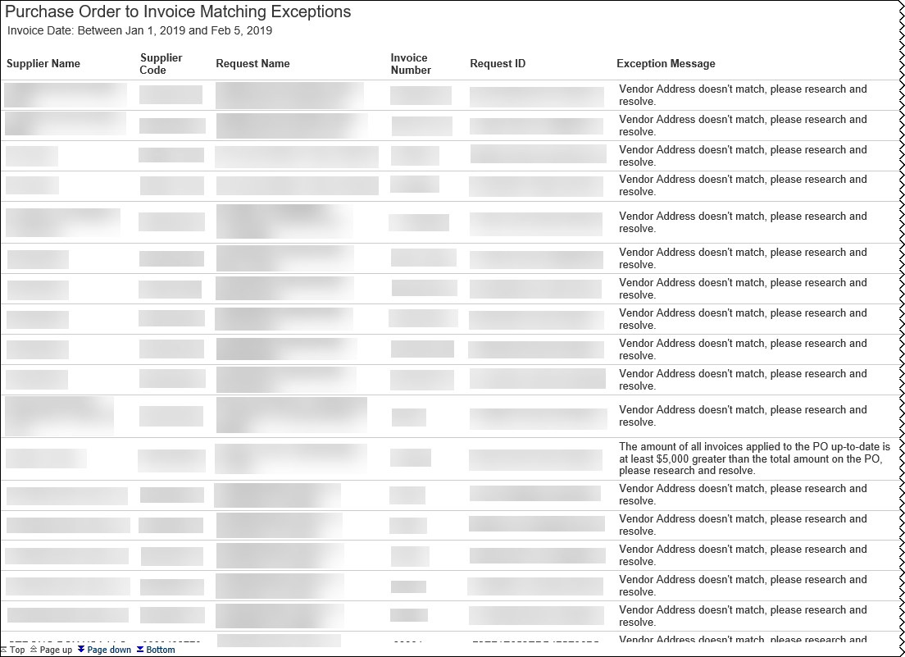
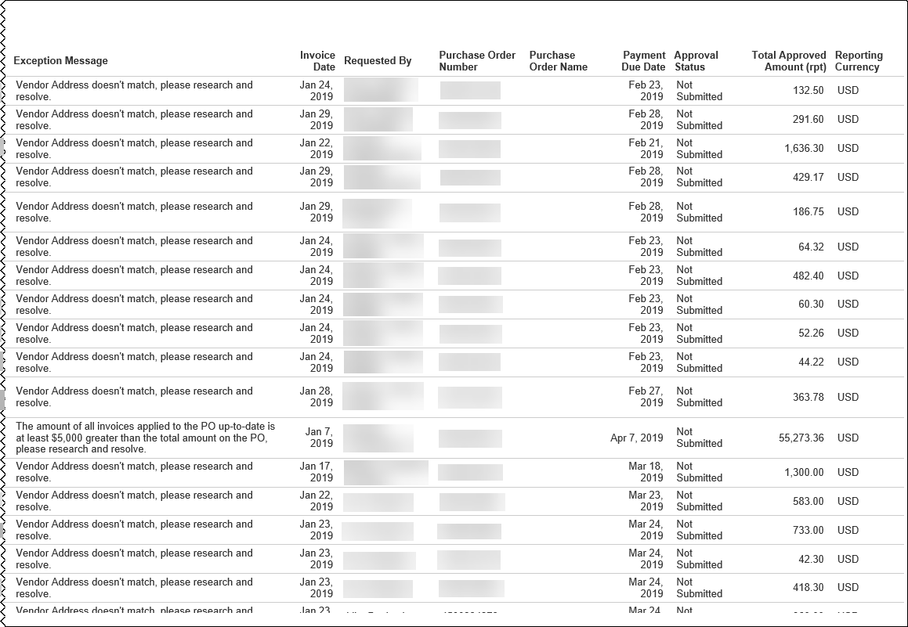

Report: Purchase Order List
Available to:  Analysis  Intelligence
This report provides a detailed view of all purchase orders. AP departments can use this information to forecast amounts of future invoices and allocate funds appropriately.

Report Prompts
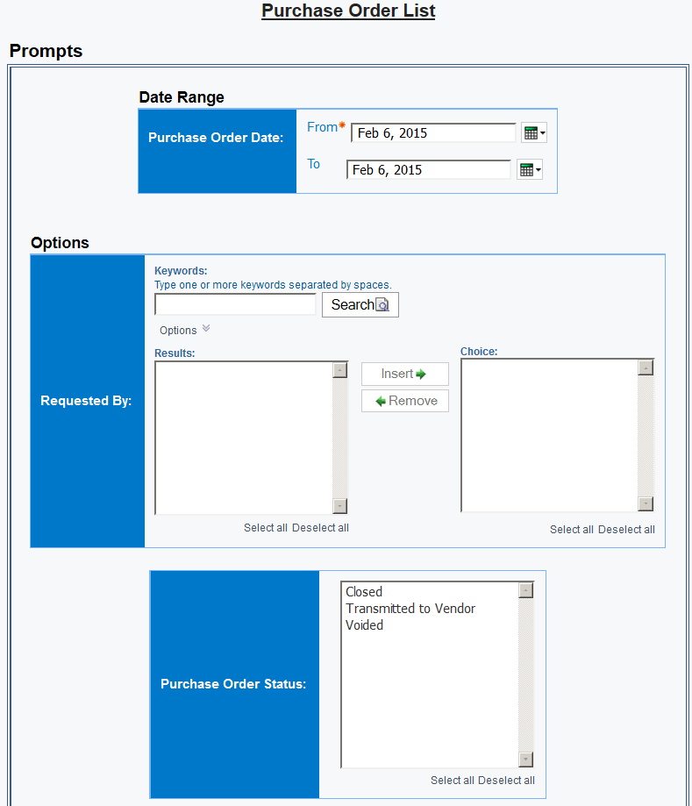
The prompts are:
- Purchase Order Date: The report user enters the range.
- Requested By: Optional – The user searches by keyword if desired.
- Purchase Order Status: Optional – The user selects the desired status.

Report Output
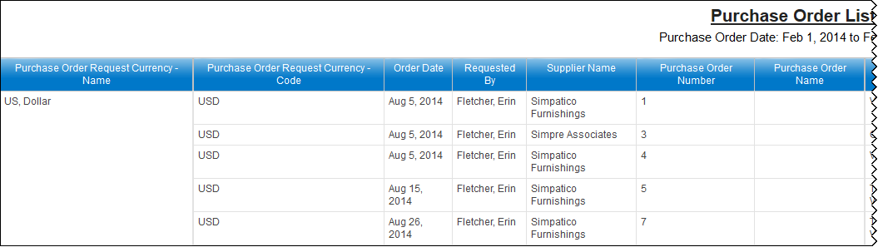
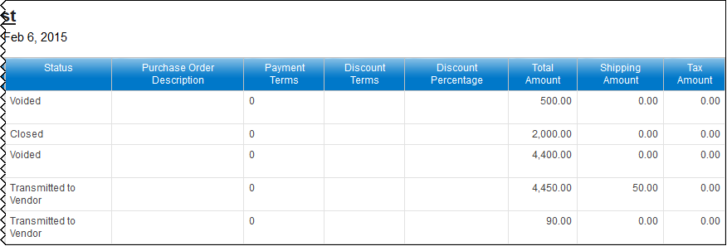

Report: Purchase Orders and Associated Payment Requests
Available to:  Analysis  Intelligence
This report provides a detailed view of all purchase orders and the associated payments requests. Where the existing Request Accrual Report provides visibility into all payment requests, this report displays only payment requests that have an associated PO. This request can be handled differently and having a way to quickly identify them will be beneficial to AP departments.

Report Prompts
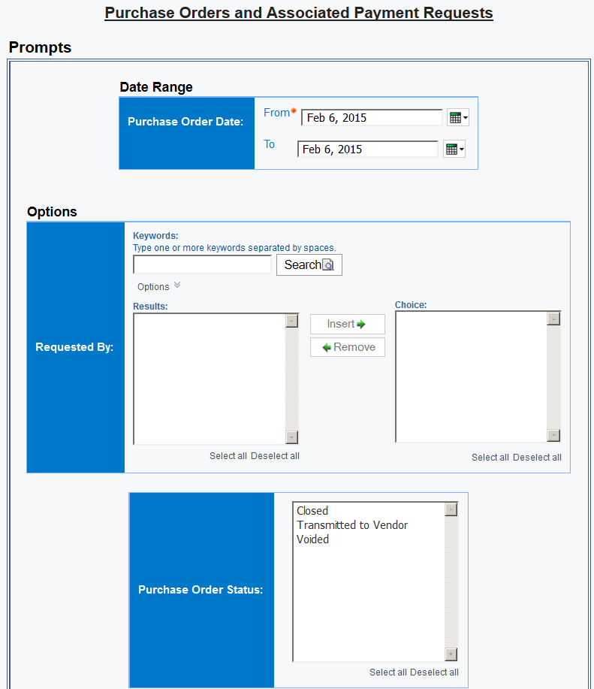
The prompts are:
- Purchase Order Date: The report user enters the range.
- Requested By: Optional – The user searches by keyword if desired.
- Purchase Order Status: Optional – The user selects the desired status.

Report Output
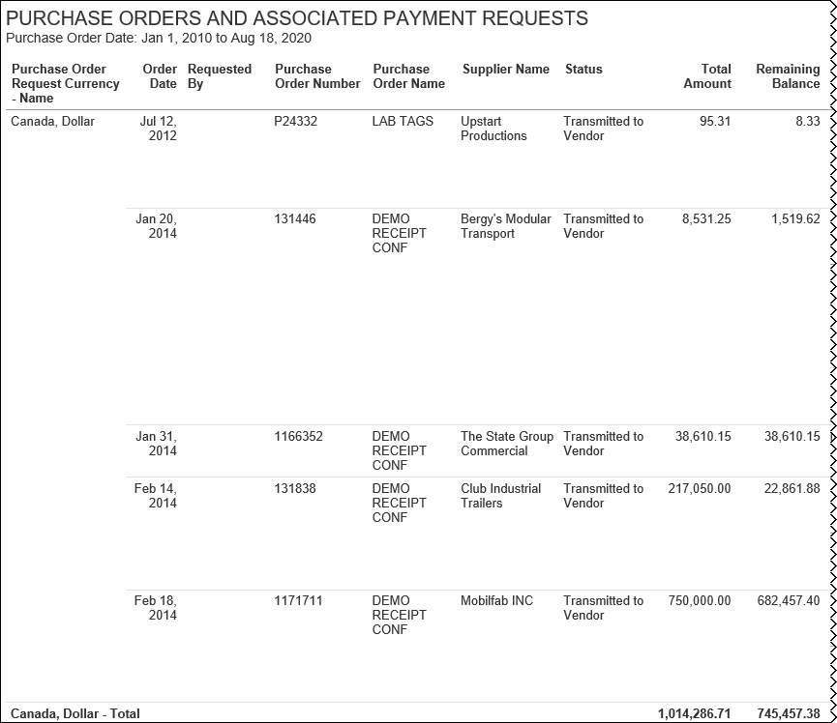
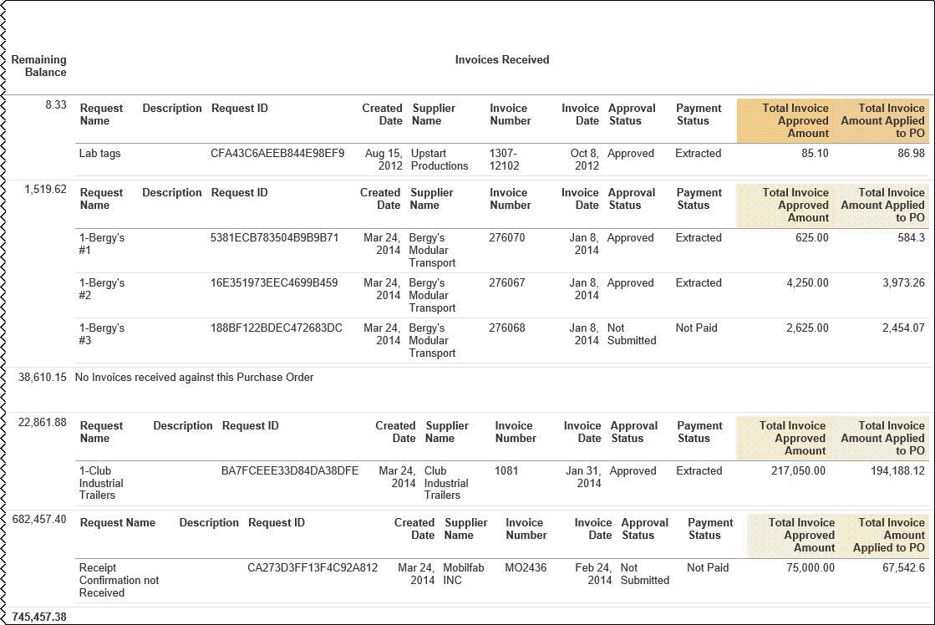

Report: Received Accrual by Line Item
Available to:  Analysis  Intelligence
This report provides a detailed view of all goods received and the invoice line items that have not been assigned to a payment request or have been assigned to a payment request that has not yet been paid. The report provides financial professionals within the organization visibility into outstanding liabilities and potential future cash requirements.

Report Prompts
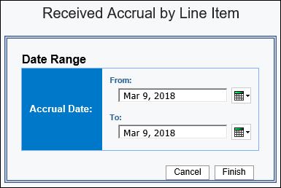

Report Output
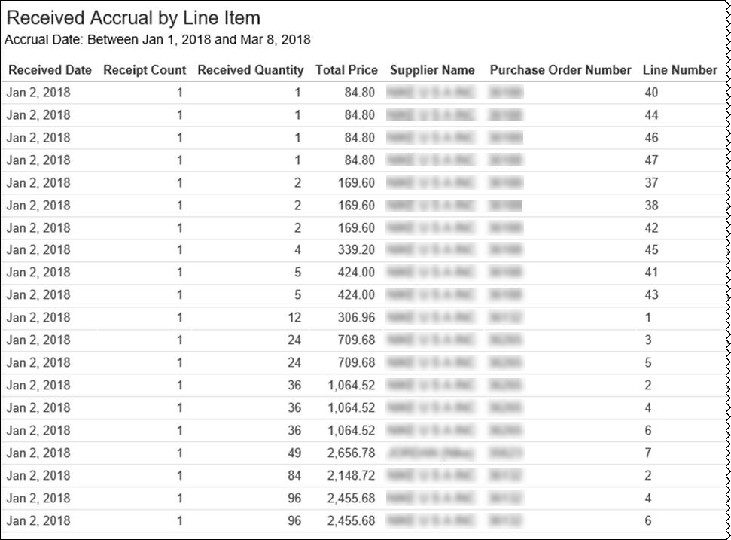
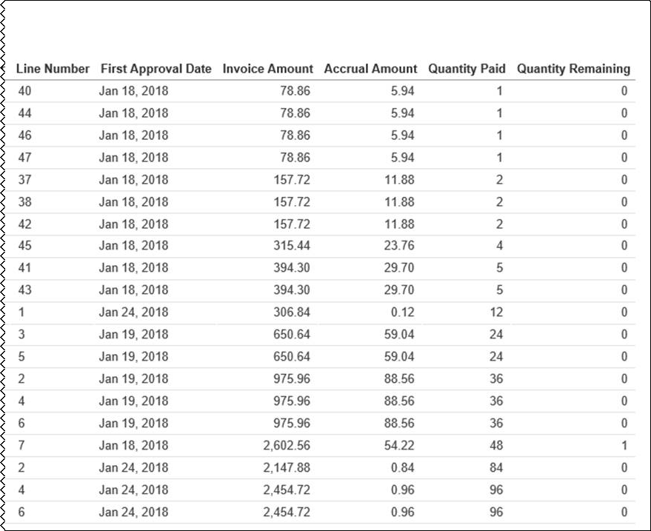

Report: Request Accrual
Available to:  Analysis  Intelligence
This report shows all invoice transactions that have not been assigned to a payment request or have been assigned to a payment request that has not yet been paid. It provides visibility to financial professionals within the organization regarding outstanding liabilities and potential future cash requirements.

Report Prompts
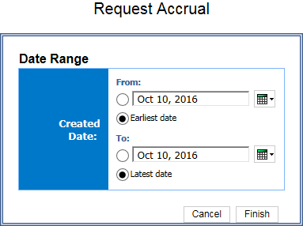

Report Output
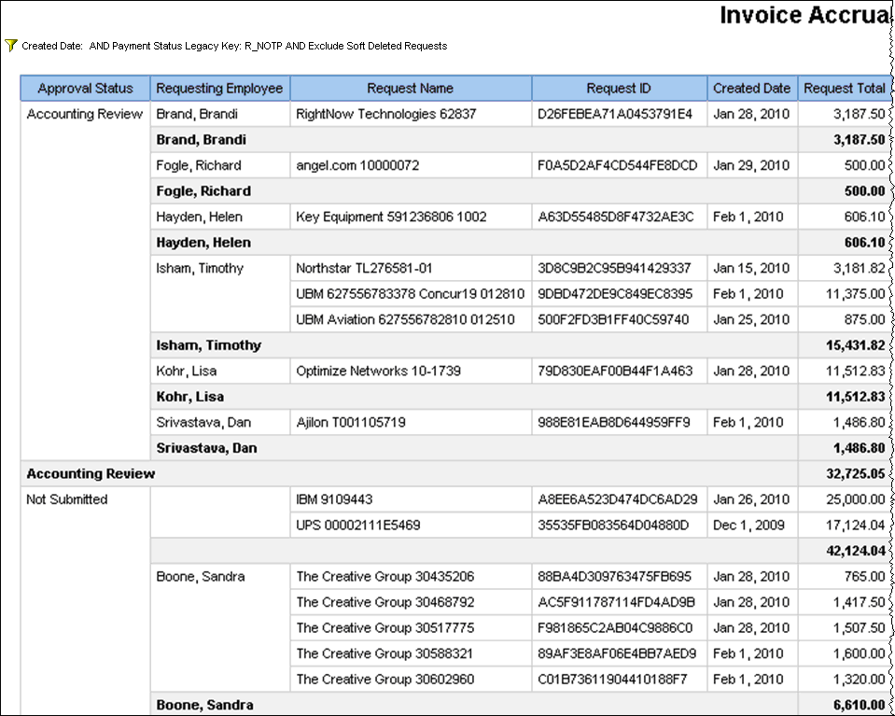
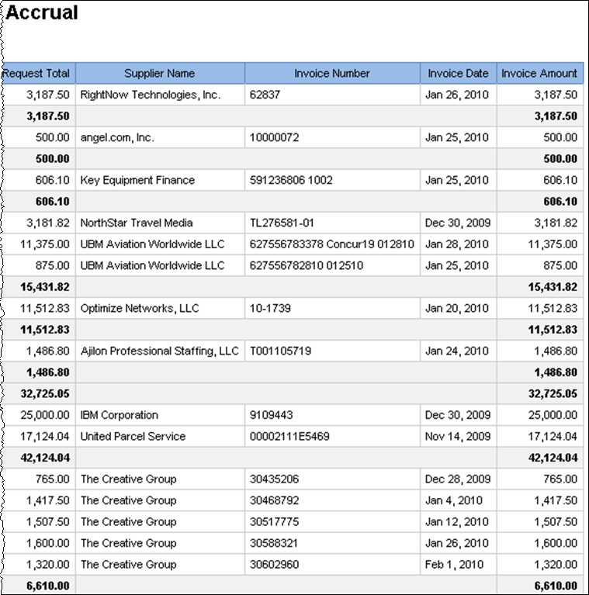

Report: Request Aging
Available to:  Analysis  Intelligence
This report shows aging invoice payment requests.

Report Prompts
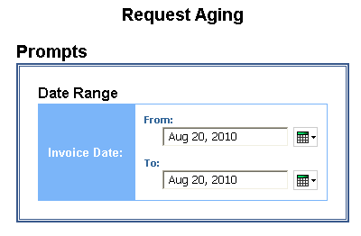

Report Output
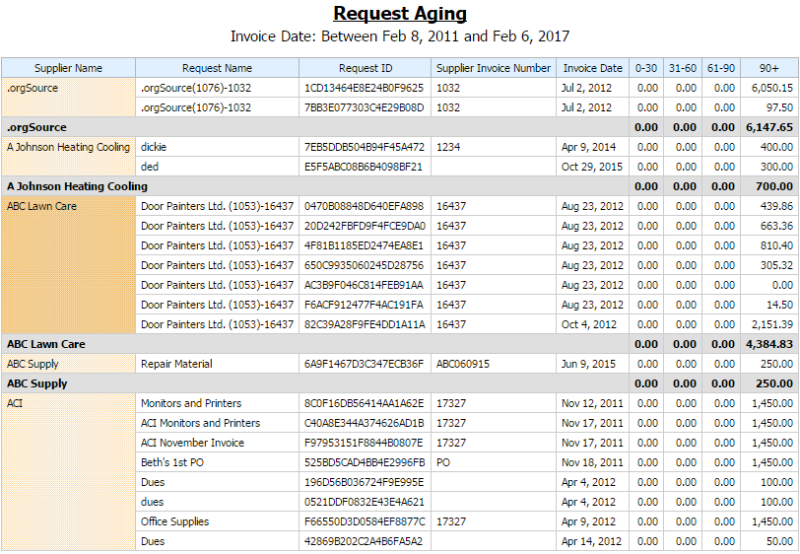

Report Header and Footer
Data Item Label/Name | Data Item Expression | Data Item Description
Invoice Date | ParamDisplayValue('dates') | Displays the date range from the Invoice Date prompt on the Prompts page
Report Data Items
Data Item Label | Data Item Name | Data Item Expression | Data Item Description
Supplier Name | <Supplier Name> | [Invoice].[Payment Request Header Information].[Supplier Name] | Displays the supplier name
Request Name | <Request Name> | [Invoice].[Payment Request Header Information].[Request Name] | Displays the request name
Request ID | <Request ID> | [Invoice].[Payment Request Header Information].[Request ID] | Displays request ID
Supplier Invoice Number | <Supplier Invoice Number> | [Invoice].[Commonly Used Fields].[Supplier Invoice Number] | Displays the supplier invoice number
Invoice Date | <Invoice Date> | [Invoice].[Commonly Used Fields].[Invoice Date] | Displays the invoice date
0 - 30 | <0 – 30> | case  when _days_between(current_date,[Invoice Date]) < 31 then [Invoice].[Payment Request Header Information].[Request Total]  else 0.00  end | Displays the request total
31 - 60 | <31 -60> | case  when _days_between(current_date,[Invoice Date]) >= 31 AND _days_between(current_date,[Invoice Date]) <= 60 then [Invoice].[Payment Request Header Information].[Request Total]  else 0.00  end | Displays the request total
61 - 90 | <61 – 90> | case  when _days_between(current_date,[Invoice Date]) >= 61 AND _days_between(current_date,[Invoice Date]) <= 90 then [Invoice].[Payment Request Header Information].[Request Total]  else 0.00  end | Displays the request total
90+ | <90+> | case  when _days_between(current_date,[Invoice Date]) >= 91 then [Invoice].[Payment Request Header Information].[Request Total]  else 0.00  end | Displays the request total

Report: Request Exception Analysis
Available to:  Analysis  Intelligence
This report provides a list of exceptions for requests based on a date range.

Report Prompts
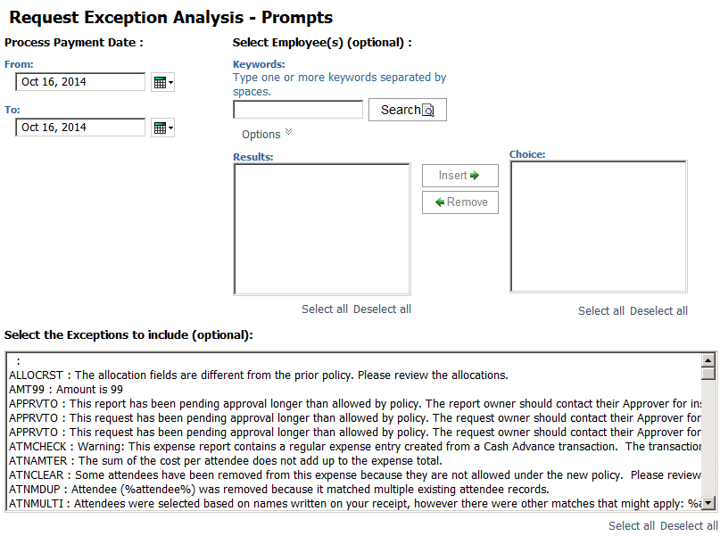

Report Output
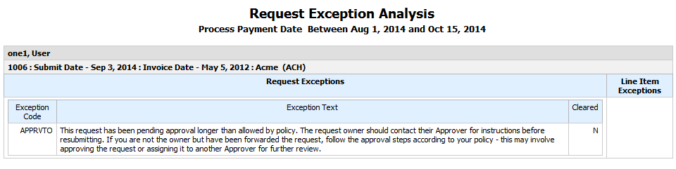

Report Header and Footer
Data Item Label/Name | Data Item Expression | Data Item Description
Process Payment Date | ' ' + ParamDisplayValue('Date') | Displays the date range from the Process Payment Date prompt on the Prompts page
Requesting Employee | if([Request Exceptions and Comments].[Request Key] is null) then([Line Item Exceptions and Comments].[Requesting Employee]) else ([Request Exceptions and Comments].[Requesting Employee]) | Displays the requesting employee selected from the Select Employee(s) prompt on the Prompts page

Report Data Items
Data Item Label | Data Item Name | Data Item Expression | Data Item Description
Exception Code | <Report Exception Code> | [Request Exceptions and Comments].[Exception Code] | Displays the request and comment exception code
Exception Text | <Report Exception Text> | [Request Exceptions and Comments].[Exception Text] | Displays the request and comment exception text
Cleared | <Report Exception Cleared?> | [Request Exceptions and Comments].[Cleared] | Displays whether the request and comment is cleared
Comment | <Report Comment> | [Request Exceptions and Comments].[Comment] | Displays the request and comment comment
Commenter | <Report Commenter's Name> | [Request Exceptions and Comments].[Commenter's Name] | Displays the request and comment commenter's name
Expense Type Name | <Expense Type> | [Line Item Exceptions and Comments].[Expense Type] | Displays the request and comment expense type
Amount | <Approved Amount> | ([Line Item Exceptions and Comments].[Approved Amount] ) | Displays the request and comment approved amount
Exception Code | <Line Item Exception Code> | [Line Item Exceptions and Comments].[Exception Code] | Displays the line item exceptions and comments exception code
Exception Text | <Line Item Exception Text> | [Line Item Exceptions and Comments].[Exception Text] | Displays the line item exceptions and comments text
Cleared | <Line Item Exception Cleared?> | [Line Item Exceptions and Comments].[Cleared] | Displays the line item exceptions and comments cleared
Comment | <Entry Comment> | [Line Item Exceptions and Comments].[Comment] | Displays the line item exceptions and comments comments
Commenter | <Entry Commenter's Name> | [Line Item Exceptions and Comments].[Commenter's Name] | Displays the line item exceptions and comments commenter's name

Report: Request Exception Analysis (with comments)
Available to:  Analysis  Intelligence
This report lists the exceptions for requests based on a date range with detailed comments.

Report Prompts

Report Output
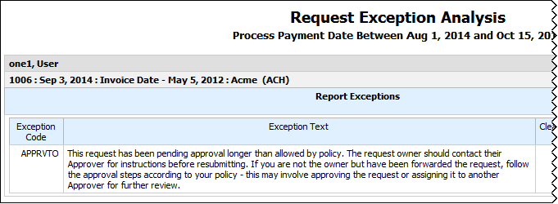
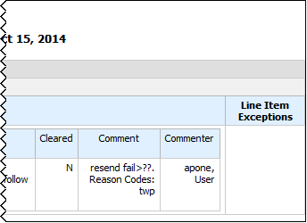

Report Header and Footer
Data Item Label/Name | Data Item Expression | Data Item Description
Process Payment Date | ' ' + ParamDisplayValue('Date') | Displays the date range from the Process Payment Date prompt on the Prompts page
Requesting Employee | if([Request Exceptions and Comments].[Request Key] is null) then([Line Item Exceptions and Comments].[Requesting Employee]) else ([Request Exceptions and Comments].[Requesting Employee]) | Displays the requesting employee selected from the Select Employee(s) prompt on the Prompts page

Report Data Items
Data Item Label | Data Item Name | Data Item Expression | Data Item Description
Exception Code | <Report Exception Code> | [Request Exceptions and Comments].[Exception Code] | Displays the request and comment exception code
Exception Text | <Report Exception Text> | [Request Exceptions and Comments].[Exception Text] | Displays the request and comment exception text
Cleared | <Report Exception Cleared?> | [Request Exceptions and Comments].[Cleared] | Displays whether the request and comment is cleared
Comment | <Report Comment> | [Request Exceptions and Comments].[Comment] | Displays the request and comment comment
Commenter | <Report Commenter's Name> | [Request Exceptions and Comments].[Commenter's Name] | Displays the request and comment commenter's name
Expense Type Name | <Expense Type> | [Line Item Exceptions and Comments].[Expense Type] | Displays the request and comment expense type
Amount | <Approved Amount> | ([Line Item Exceptions and Comments].[Approved Amount] ) | Displays the request and comment approved amount
Exception Code | <Line Item Exception Code> | [Line Item Exceptions and Comments].[Exception Code] | Displays the line item exceptions and comments exception code
Exception Text | <Line Item Exception Text> | [Line Item Exceptions and Comments].[Exception Text] | Displays the line item exceptions and comments text
Cleared | <Line Item Exception Cleared?> | [Line Item Exceptions and Comments].[Cleared] | Displays the line item exceptions and comments cleared
Comment | <Entry Comment> | [Line Item Exceptions and Comments].[Comment] | Displays the line item exceptions and comments comments
Commenter | <Entry Commenter's Name> | [Line Item Exceptions and Comments].[Commenter's Name] | Displays the line item exceptions and comments commenter's name

Report: Request Header Exceptions
Available to:  Analysis  Intelligence
This report shows the year-by-year exceptions that are created most frequently and the number of associated payment requests at the payment requests header level.

Report Prompts
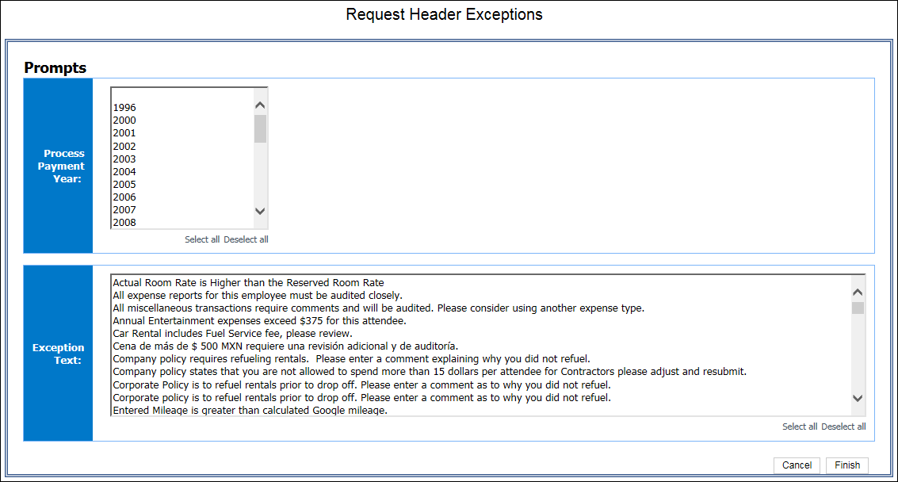

Report Output
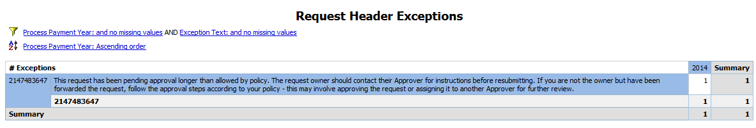

Report Header and Footer
Data Item Label/Name | Data Item Expression | Data Item Description
Process Payment Year | ' '+ParamDisplayValue('Process_Payment_Year') | Displays the date range from the Process Payment Year prompt on the Prompts page
Exception Text | ' '+ParamDisplayValue('Exception_Text') | Displays the exceptions selected from the Exception Text prompt on the Prompts page

Report Data Items
Data Item Label | Data Item Name | Data Item Expression | Data Item Description
N/A | <Exception Level> | [Invoice].[Payment Request Header Exceptions].[Exception Level] | Displays the exception level
N/A | <Exception Text> | [Invoice].[Payment Request Header Exceptions].[Exception Text] | Displays exception text
N/A | <Process Payment Year> | [Invoice].[Payment Request Dates and Statuses].[Process Payment Year] | Displays the payment year
N/A | <Exception Key> | [Invoice].[Payment Request Header Exceptions].[Exception Key] | Displays the exception key

Report: Request Line Item Exceptions
Available to:  Analysis  Intelligence
This report provides statistics about the exceptions that are captured at the line-item level for specified years and exception types, allowing long-term trend analysis of the types of exceptions that are being detected in payment requests.

Report Prompts
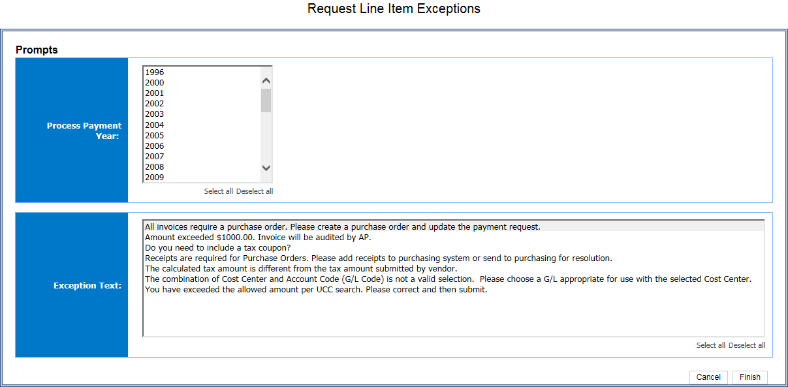

Report Output
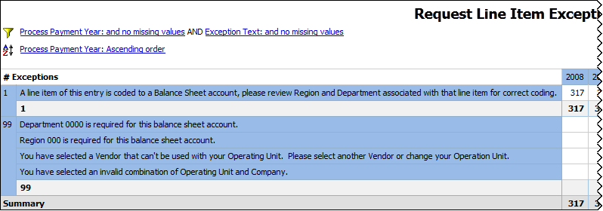
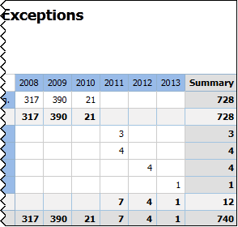

Report Header and Footer
Data Item Label/Name | Data Item Expression | Data Item Description
Process Payment Year | ' '+ParamDisplayValue('Process_Payment_Year') | Displays the date range from the Process Payment Year prompt on the Prompts page
Exception Text | ' '+ParamDisplayValue('Exception_Text') | Displays the exceptions selected from the Exception Text prompt on the Prompts page

Report Data Items
Data Item Label | Data Item Name | Data Item Expression | Data Item Description
N/A | <Exception Level> | [Invoice].[Payment Request Line Item Exceptions].[Exception Level] | Displays the exception level
N/A | <Exception Text> | [Invoice].[Payment Request Line Item Exceptions].[Exception Text] | Displays exception text
N/A | <Process Payment Year> | [Invoice].[Payment Request Dates and Statuses].[Process Payment Year] | Displays the payment year
N/A | <Exception Key> | [Invoice].[Payment Request Line Item Exceptions].[Exception Key] | Displays the exception key

Report: Request Line Item Exceptions Detail Report
Available to:  Analysis  Intelligence
This report provides a detailed list of all line-item exceptions for employees over a user-defined timeframe. Users also have the option of selecting a single employee when running this report.

Report Prompts
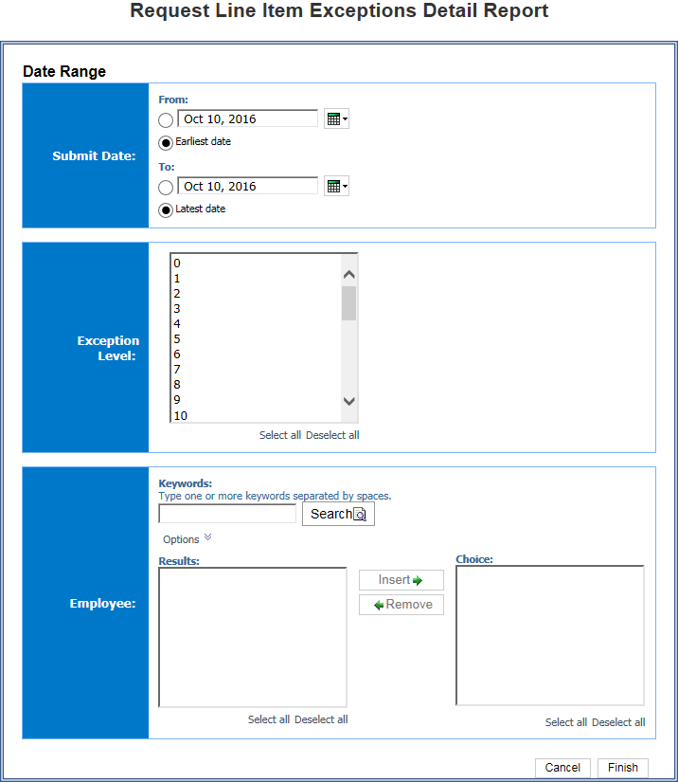

Report Output
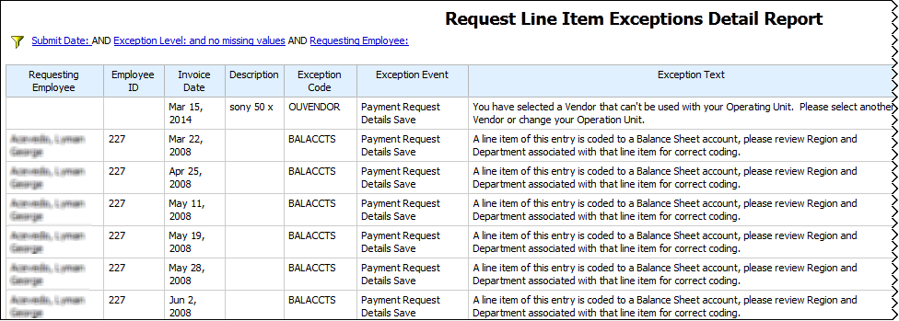
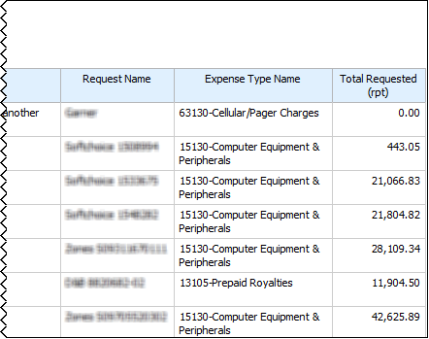

Report Header and Footer
Data Item Label/Name | Data Item Expression | Data Item Description
Submit Date | ' '+ParamDisplayValue('Submit_Date') | Displays the date range from the Submit Date prompt on the Prompts page
Exception Level | ' '+ParamDisplayValue('Exception_Level') | Displays the exception level(s) selected from the Exception Level prompt on the Prompts page
Requesting Employee | : '+ParamDisplayValue('Requesting_Employee') | Displays the employee(s) selected from the Employee prompt on the Prompts page

Report Data Items
Data Item Label | Data Item Name | Data Item Expression | Data Item Description
Requesting Employee | <Requesting Employee> | [Invoice].[Payment Request Header Information].[Requesting Employee] | Displays the requesting employee
Employee ID | <Employee ID> | [Invoice].[Payment Request Header Information].[Employee ID] | Displays the employee ID
Invoice Date | <Invoice Date> | [Invoice].[Payment Request Dates and Statuses].[Invoice Date] | Displays the invoice date
Description | <Description> | [Invoice].[Payment Request Header Information].[Description] | Displays the description
Exception Code | <Exception Code> | [Invoice].[Payment Request Line Item Exceptions].[Exception Code] | Displays the exception code
Exception Event | <Exception Event> | [Invoice].[Payment Request Line Item Exceptions].[Exception Event] | Displays the exception event
Exception Text | <Exception Text> | [Invoice].[Payment Request Line Item Exceptions].[Exception Text] | Displays the exception text
Request Name | <Request Name> | [Invoice].[Payment Request Header Information].[Request Name] | Displays the request name
Expense Type Name | <Expense Type Name> | [Invoice].[Payment Request Line Items].[Expense Type Name] | Displays the expense type name
Total Requested (rpt) | <Total Requested (rpt)> | [Invoice].[Payment Request Line Items].[Total Requested (rpt)] | Displays the total requested

Report: Top 10 Longest to Approve
Available to:  Analysis  Intelligence
This report provides a rank of the longest time to approve payment requests.

Report Prompts
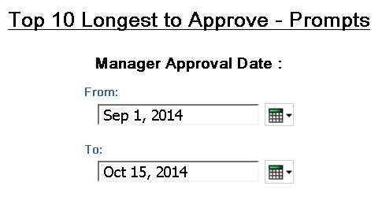

Report Output
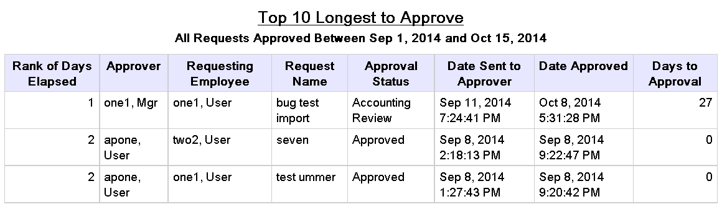

Report Header and Footer
Data Item Label/Name | Data Item Expression | Data Item Description
All Requests Approved | ParamDisplayValue('Step Action Date/Time') | Displays the date range from the Manager Approval Date prompt on the Prompts page
N/A | AsOfDate() | Displays the date the report was run
N/A | PageNumber() | Displays the page number of the corresponding page
N/A | AsOfTime() | Displays the time the report was run

Report Data Items
Data Item Label | Data Item Name | Data Item Expression | Data Item Description
Rank of Days Elapsed | <Rank of Days Elapsed> | rank([Days to Approval]) | Displays the rank number (e.g 1-10) for the top (ranked) approvers
Approver | <Employee Assigned to Step> | [Invoice].[Payment Request Workflow Trail].[Employee Assigned to Step] | Displays the approver's name
Requesting Employee | <Requesting Employee> | [Invoice].[Payment Request Header Information].[Requesting Employee] | Displays the requesting employee's name
Request Name | <Request Name> | [Invoice].[Payment Request Header Information].[Request Name] | Displays the request name
Approval Status | <Approval Status> | [Invoice].[Payment Request Dates and Statuses].[Approval Status] | Displays the approval status
Date Sent to Approver | <Step Entry Date/Time> | [Invoice].[Payment Request Workflow Trail].[Step Entry Date/Time] | Displays the date and time sent to approver
Date Approved | <Step Action Date/Time> | [Invoice].[Payment Request Workflow Trail].[Step Action Date/Time] | Displays the date and time approved
Days to Approval | <Days to Approval> | _days_between([Step Action Date/Time],[Step Entry Date/Time]) | Displays the number of days it took for approval

Report: Top Exception Violators
Available to:  Analysis  Intelligence
This report shows the 10 employees with the highest number exceptions identified by the system on payment requests submitted during a specified timeframe.

Report Prompts
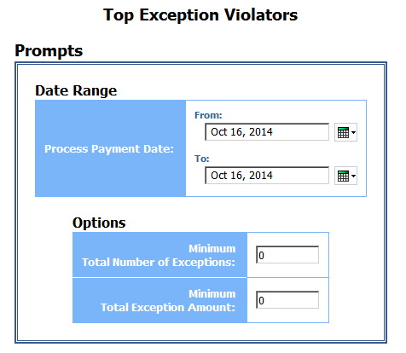

Report Output
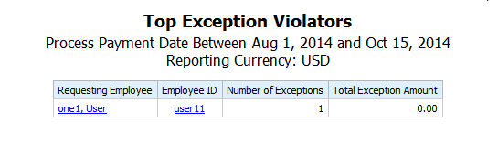

Report Header and Footer
Data Item Label/Name | Data Item Expression | Data Item Description
Process Payment Date | ParamDisplayValue('ProcessPaymentDateParam') | Displays the date range from the Process Payment Date prompt on the Prompts page
Reporting Currency | [Main].[Reporting Currency] | Displays the currency code in which the reporting currency is shown (for example, USD, CAD, GBP)
N/A | AsOfDate() | Displays the date the report was run
N/A | PageNumber() | Displays the page number of the corresponding page
N/A | AsOfTime() | Displays the time the report was run

Report Data Items
Data Item Label | Data Item Name | Data Item Expression | Data Item Description
Requesting Employee | <Requesting Employee> | [Header].[Requesting Employee] | Displays the requesting employee's name
Requesting Employee ID | <Requesting Employee ID> | [Header].[Requesting Employee ID] | Displays the requesting employee's ID
Number of Exceptions | <Number of Exceptions> | [Exception Count].[Exceptions] | Displays a count of the exceptions
Total Exception Amount | <Total Request Amount (rpt)> | [Header].[Total Request Amount (rpt)] | Displays the total request amount

Report: Top Invoice Spenders by Employee - Details
Available to:  Analysis  Intelligence
This report shows a detailed view of the top invoice spenders, sorted by employee.

Report Prompts
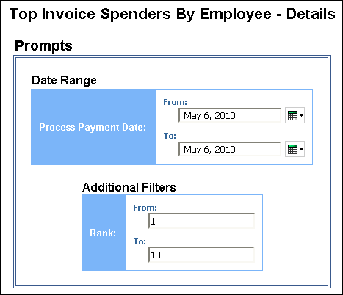

Report Output
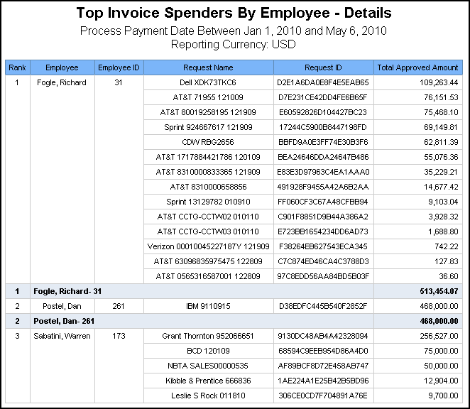

Report Header and Footer
Data Item Label/Name | Data Item Expression | Data Item Description
Process Payment Date | ParamDisplayValue('ProcessPaymentDateParam') | Displays the date range from the Process Payment Date prompt on the Prompts page
Reporting Currency | [Main].[Reporting Currency] | Displays the currency code in which the reporting currency is shown (for example, USD, CAD, GBP)
N/A | AsOfDate() | Displays the date the report was run
N/A | PageNumber() | Displays the page number of the corresponding page
N/A | AsOfTime() | Displays the time the report was run

Report Data Items
Data Item Label | Data Item Name | Data Item Expression | Data Item Description
Rank | <Rank> | rank(total([Total Approved Amount (rpt)] for [Requesting Employee]) for report) | Displays the rank number (e.g 1-10) for the top (ranked) employees
Employee | <Requesting Employee> | [Invoice].[Payment Request Header Information].[Requesting Employee] | Displays the requesting employee's name
Employee ID | <Employee ID> | [Invoice].[Payment Request Header Information].[Employee ID] | Displays the employee's ID
Request Name | <Request Name> | [Invoice].[Payment Request Header Information].[Request Name] | Displays the requester's name
Request ID | <Request ID> | [Invoice].[Payment Request Header Information].[Request ID] | Displays the requester's ID
Total Approved Amount | <Total Approved Amount> | [Invoice].[Payment Request Header Information].[Total Approved Amount (rpt)] | Displays the sum of the total approved amount

Report: Top Invoice Spenders by Employee - Summary
Available to:  Analysis  Intelligence
This report shows the employees that have the most total invoice spend, ranked by a user-defined rank range (e.g. 1 to 10) sorted by rank ascending.

Report Prompts
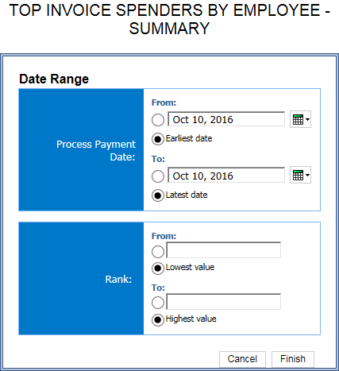

Report Output
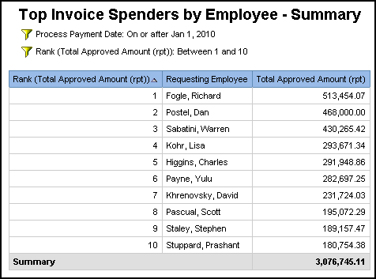

Report Header and Footer
Data Item Label/Name | Data Item Expression | Data Item Description
Process Payment Date | ParamDisplayValue('Process_Payment_Date') | Displays the date range from the Process Payment Date prompt on the Prompts page
Rank | ParamDisplayValue('Rank_(Total_Approved_Amount_(rpt))1') | Displays the rank range from the Rank prompt on the Prompts page.
N/A | AsOfDate() | Displays the date the report was run
N/A | PageNumber() | Displays the page number of the corresponding page
N/A | AsOfTime() | Displays the time the report was run

Report Data Items
Data Item Label | Data Item Name | Data Item Expression | Data Item Description
Rank (total Approved Amount (rpt)) | <Rank (Total Approved Amount (rpt))> | rank(total([Invoice].[Payment Request Header Information].[Total Approved Amount (rpt)]) for report prefilter) | Displays the rank number (e.g 1-10) for the top (ranked) employees
Requesting Employee | <Requesting Employee> | [Invoice].[Payment Request Header Information].[Requesting Employee] | Displays the name of the top (ranked) requesting employee
Total Approved Amount (rpt) | <Total Approved Amount (rpt)> | [Invoice].[Payment Request Header Information].[Total Approved Amount (rpt)] | Displays the total approved amount for the top (ranked) employees

Report: Top Invoice Vendor Spend - Details
Available to:  Analysis  Intelligence
This report shows the vendors that have the highest total invoice spend.

Report Prompts
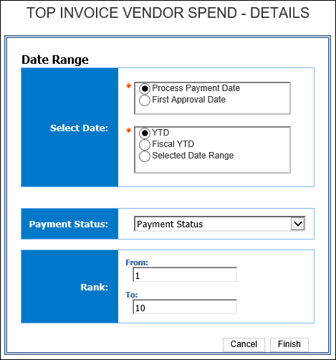

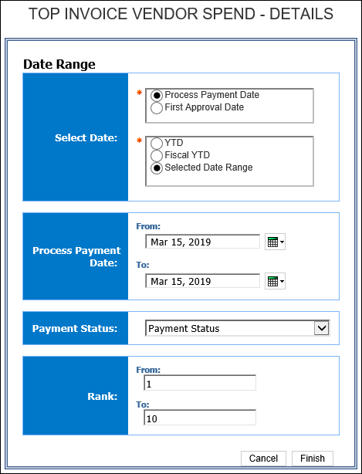
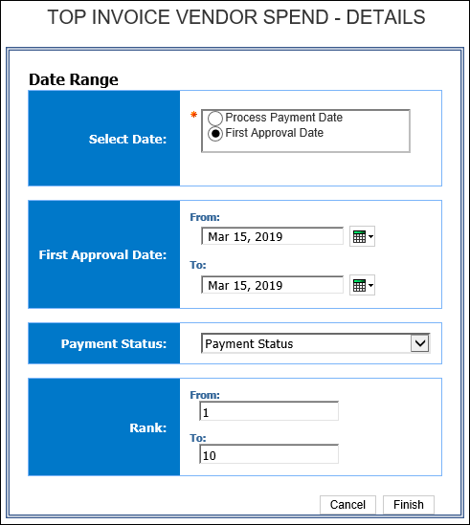

Report Output
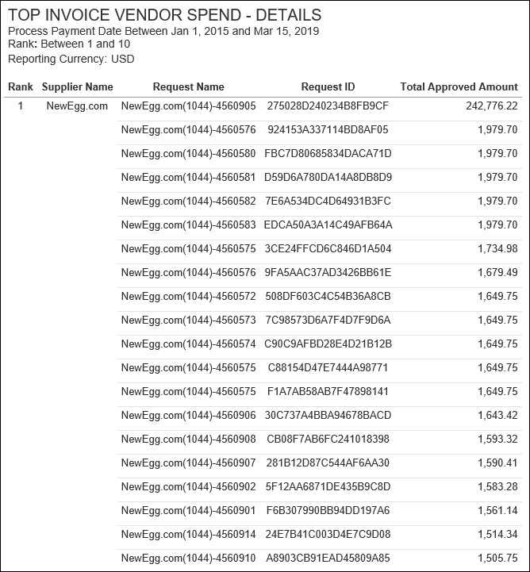

Report Header and Footer
Data Item Label/Name | Data Item Expression | Data Item Description
First Approval Date | ParamDisplayValue('p_FirstApprovalDate') | Displays the date range from the First Approval Date prompt on the Prompts page
Process Payment Date | ParamDisplayValue('P_PaymentProcessDate') | Displays the date range from the Process Payment Date prompt on the Prompts page
Payment Status: | ParamDisplayValue('p_PaymentStatus') | Displays the payment status
Rank | ParamDisplayValue('p_Rank') | Displays the rank range (1…10)
Reporting Currency: | [Main].[Reporting Currency] | Displays the currency code in which the reporting currency is shown (for example, USD, CAD, GBP)

Report Data Items
Data Item Label | Data Item Name | Data Item Expression | Data Item Description
Rank | <Rank> | rank(total([Total Approved Amount (rpt)] for [Supplier Name])) | Displays the total approved amount for the supplier
Supplier Name | <Supplier Name> | [Invoice].[Payment Request Header Information].[Supplier Name] | Displays the supplier name
Request Name | <Request Name> | [Invoice].[Payment Request Header Information].[Request Name] | Displays the request name

Report: Top Invoice Vendor Spend - Summary
Available to:  Analysis  Intelligence
This report shows the vendors that have the highest total invoice spend, ranked by a user-defined rank range (e.g. 1 to 10), and sorted by rank ascending.

Report Prompts
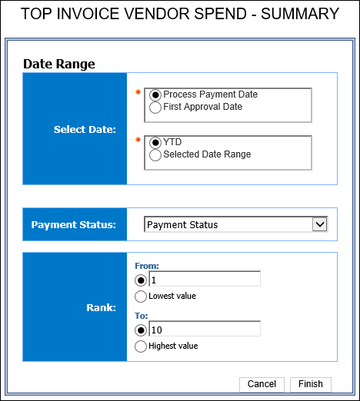
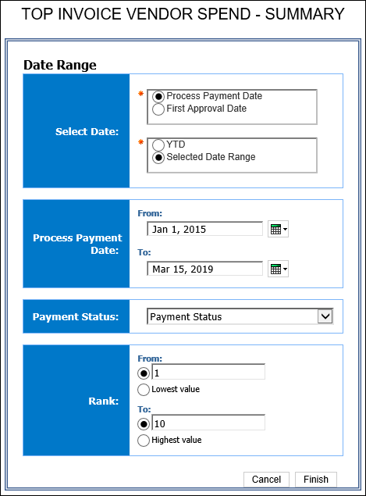
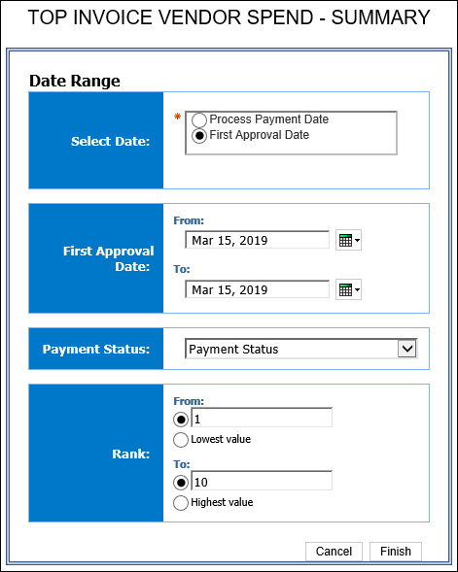

Report Output
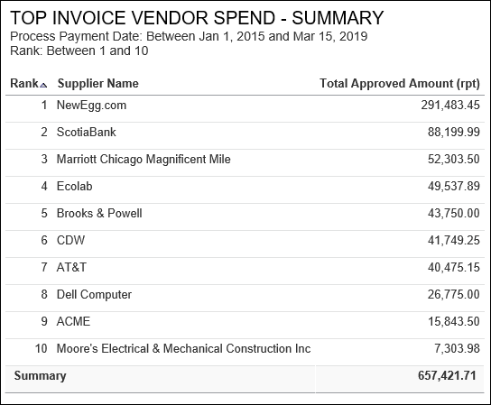

Report Header and Footer
Data Item Label/Name | Data Item Expression | Data Item Description
First Approval Date | ParamDisplayValue('p_FirstApprovalDate') | Displays the date range from the First Approval Date prompt on the Prompts page
Process Payment Date | ParamDisplayValue('P_PaymentProcessDate') | Displays the date range from the Process Payment Date prompt on the Prompts page
Payment Status: | ParamDisplayValue('p_PaymentStatus') | Displays the payment status
Rank | ParamDisplayValue('p_Rank') | Displays the rank range (1…10)
N/A | AsOfDate() | Displays the date the report was run
N/A | PageNumber() | Displays the page number of the corresponding page
N/A | AsOfTime() | Displays the time the report was run

Report Data Items
Data Item Label | Data Item Name | Data Item Expression | Data Item Description
Rank | <Rank> | rank(total([Total Approved Amount (rpt)] for [Supplier Name])) | Displays the total approved amount for the supplier
Supplier Name | <Supplier Name> | [Invoice].[Supplier Details].[Supplier Name] | Displays the supplier name
Total Approved Amount (rpt) | <Total Approved Amount (rpt)> | [Invoice].[Payment Request Header Information].[Total Approved Amount (rpt)] | Displays the summary of the total approved amount

Report: Unsubmitted Requests by Approver – Detail
Available to:  Analysis  Intelligence
This report shows a detailed listing of unsubmitted payment requests, sorted by approver.

Report Prompts
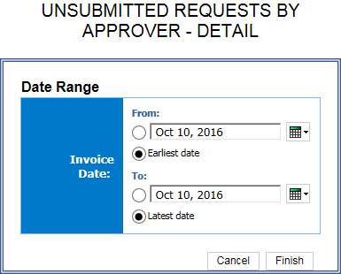

Report Output
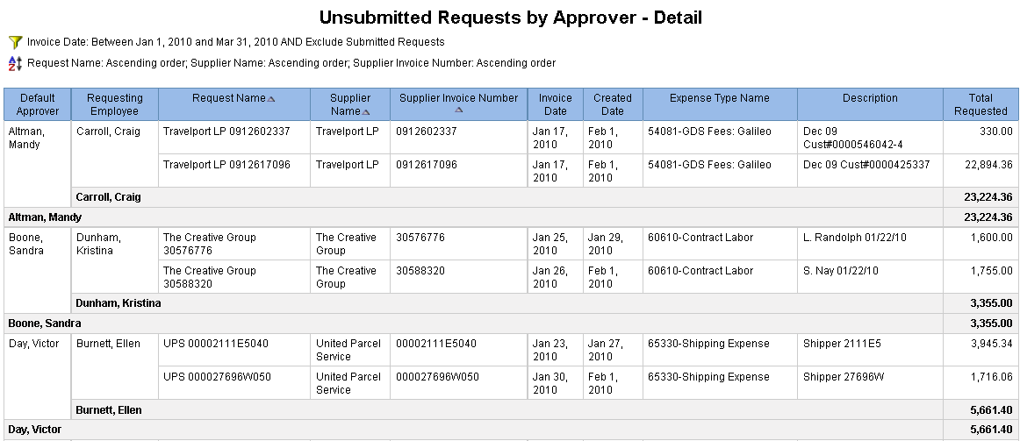

Report Header and Footer
Data Item Label/Name | Data Item Expression | Data Item Description
Invoice Date | : '+ParamDisplayValue('Invoice_Date') | Displays the date range from the Invoice Date prompt on the Prompts page
N/A | AsOfDate() | Displays the date the report was run
N/A | PageNumber() | Displays the page number of the corresponding page
N/A | AsOfTime() | Displays the time the report was run

Report Data Items
Data Item Label | Data Item Name | Data Item Expression | Data Item Description
Default Approver | <Default Approver> | [Invoice].[Payment Request Header Information].[Default Approver] | Displays the default approver
Requesting Employee | <Requesting Employee> | [Invoice].[Payment Request Header Information].[Requesting Employee] | Displays the requesting employee name
Request Name | <Request Name> | [Invoice].[Payment Request Header Information].[Request Name] | Displays the request name
Supplier Name | <Supplier Name> | [Invoice].[Payment Request Header Information].[Supplier Name] | Displays the supplier name
Supplier Invoice Number | <Supplier Invoice Number> | [Invoice].[Payment Request Header Information].[Supplier Invoice Number] | Displays the supplier invoice number
Invoice Date | <Invoice Date> | [Invoice].[Payment Request Dates and Statuses].[Invoice Date] | Displays the invoice date
Created Date | <Created Date> | [Invoice].[Payment Request Dates and Statuses].[Created Date] | Displays the created date
Expense Type Name | <Expense Type Name> | [Invoice].[Payment Request Line Items].[Expense Type Name] | Displays the line item expense type name
Description | <Description> | [Invoice].[Payment Request Line Items].[Description] | Displays the line item description
Total Requested | <Total Requested> | [Invoice].[Payment Request Line Items].[Total Requested] | Displays the total requested
Requesting Employee | N/A | [Invoice].[Payment Request Line Items].[Total Requested] | Displays the summary of the total requesting employee
Default Approver | N/A | [Invoice].[Payment Request Line Items].[Total Requested] | Displays the summary of the total of the default approver
Summary | N/A | [Invoice].[Payment Request Line Items].[Total Requested] | Displays the summary of the total of the request line items total requested

Report: Unsubmitted Requests by Approver – Summary
Available to:  Analysis  Intelligence
This report shows a summarized listing of unsubmitted payment requests, sorted by approver.

Report Prompts
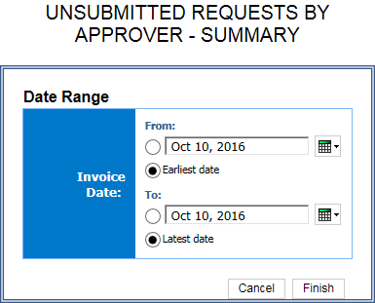

Report Output
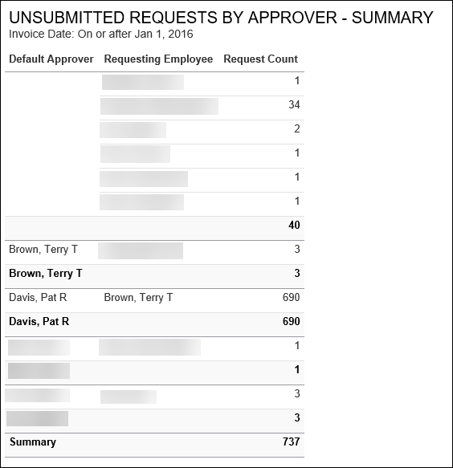

Report Header and Footer
Data Item Label/Name | Data Item Expression | Data Item Description
Invoice Date | : '+ParamDisplayValue('Invoice_Date') | Displays the date range from the Invoice Date prompt on the Prompts page
N/A | AsOfDate() | Displays the date the report was run
N/A | PageNumber() | Displays the page number of the corresponding page
N/A | AsOfTime() | Displays the time the report was run

Report Data Items
Data Item Label | Data Item Name | Data Item Expression | Data Item Description
Default Approver | <Default Approver> | [Invoice].[Payment Request Header Information].[Default Approver] | Displays the default approver
Requesting Employee | <Requesting Employee> | [Invoice].[Payment Request Header Information].[Requesting Employee] | Displays the requesting employee name
Request Key | <Request Key> | [Invoice].[Payment Request Header Information].[Request Key] | Displays the request key

Report: Unsubmitted Requests Rank
Available to:  Analysis  Intelligence
This report shows a ranked listing, by employee, of the most unsubmitted payment requests.

Report Prompts
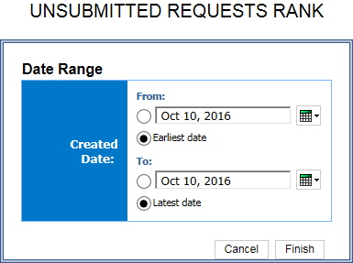

Report Output
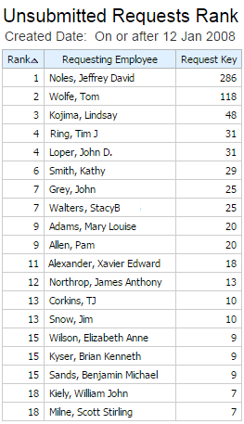

Report Header and Footer
Data Item Label/Name | Data Item Expression | Data Item Description
Created Date | ParamDisplayValue('Created_Date') | Displays the date range from the Created Date prompt on the Prompts page
N/A | AsOfDate() | Displays the date the report was run
N/A | PageNumber() | Displays the page number of the corresponding page
N/A | AsOfTime() | Displays the time the report was run

Report Data Items
Data Item Label | Data Item Name | Data Item Expression | Data Item Description
Rank | <Rank> | [Invoice].[Payment Request Header Information].[Default Approver] | Displays the rank
Requesting Employee | <Requesting Employee> | [Invoice].[Payment Request Header Information].[Requesting Employee] | Displays the requesting employee name
Request Key | <Request Key> | [Invoice].[Payment Request Header Information].[Request Name] | Displays the request key

Report: Workflow Aging – Details
Available to:  Analysis  Intelligence
This report identifies the payment requests that are pending approval, including the approvers associated with the requests, to help ensure approval of payment requests in a timely manner.

Report Prompts
When a company has Cost Object Approvals (COA) enabled, the Prompts page displays the Show Only Cost Object Steps prompt. When Yes is selected, the report displays COA fields.
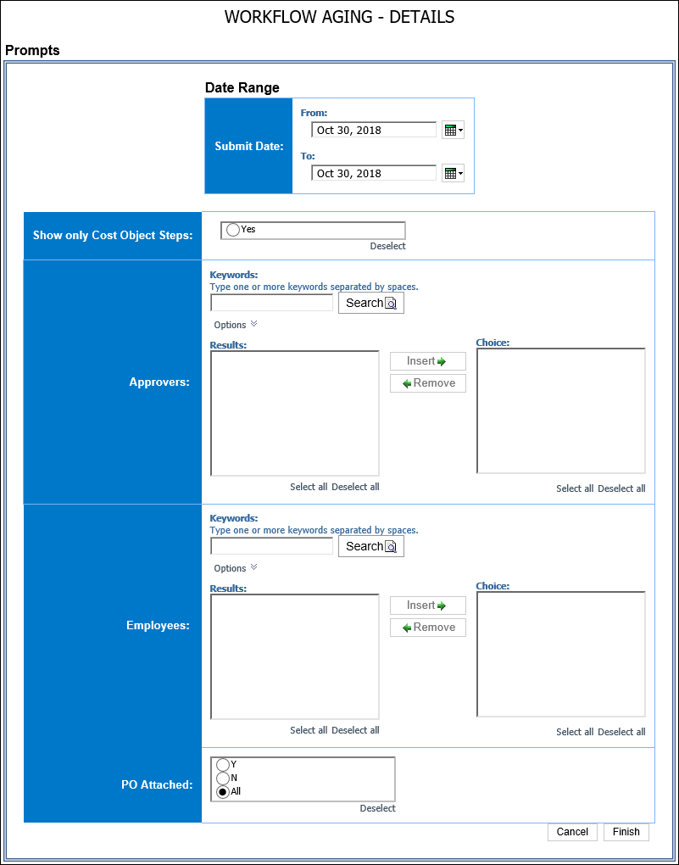

Report Output
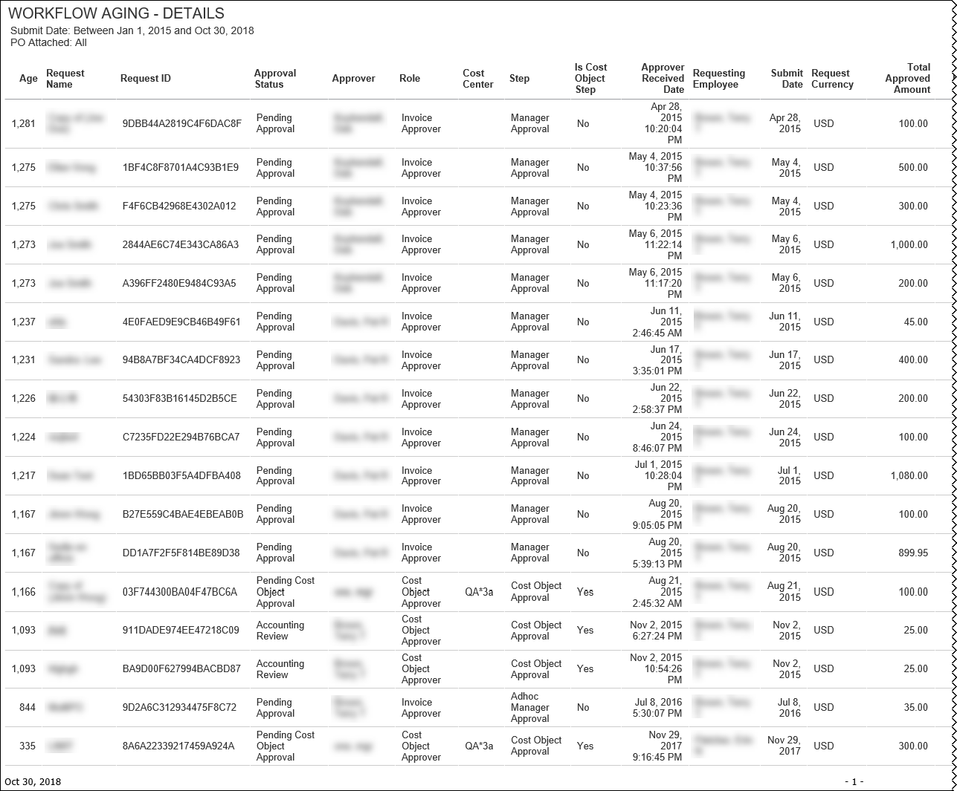
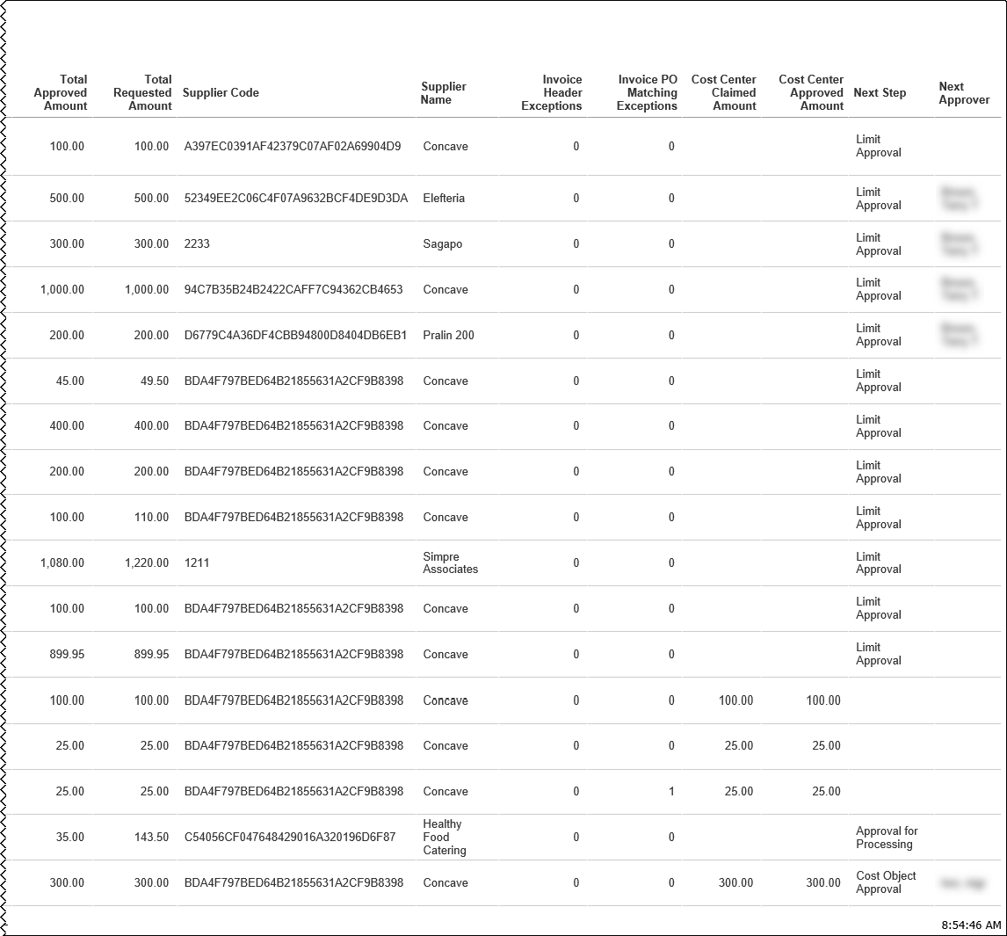

Report Header and Footer
Data Item Label/Name | Data Item Expression | Data Item Description
Submit Date | ' ' + ParamDisplayValue('pSubmitDate') | Displays the date range from the Submit Date prompt on the Prompts page
Show only Cost Object Steps | ' +ParamDisplayValue('pCostObject') | Displays the show only cost object steps
Approvers | ' +ParamDisplayValue('pApprovers') | Displays the approvers
Employees | ' +ParamDisplayValue('pEmployee') | Displays the employees
PO Attached | ' +ParamDisplayValue('pPOAttached') | Displays PO Attached
N/A | AsOfDate() | Displays the date the report was run
N/A | PageNumber() | Displays the page number of the corresponding page
N/A | AsOfTime() | Displays the time the report was run

Report Data Items
Data Item Label | Data Item Name | Data Item Expression | Data Item Description
Age | <Age> | _days_between (current_date,[qWorkflowDetails].[Step Entry Date/Time]) | Displays the age
Request Name | <Request Name> | [qRequestDetails].[Request Name] | Displays the request name
Request ID | <Request ID> | [qRequestDetails].[Request ID] | Displays the request ID
Approval Status | <Approval Status> | [qRequestDetails].[Approval Status] | Displays the approval status
Approver | <Employee Assigned to Step> | [qWorkflowDetails].[Employee Assigned to Step] | Displays the approver
Role | <Role> | [qWorkflowDetails].[Role] | Displays the role
Cost Center | <Cost Center> | [qWorkflowDetails].[Cost Center] | Displays the cost center
Step | <Step> | [qWorkflowDetails].[Step] | Displays the workflow step
Is Cost Object Step | <Is Cost Object Step> | [qWorkflowDetails].[Is Cost Object Step] | Displays the Is Cost Object step
Approver Received Date | <Step Entry Date/Time> | [qWorkflowDetails].[Step Entry Date/Time] | Displays the approver received date
Requesting Employee | <Employee> | [qRequestDetails].[Requesting Employee] | Displays the requesting employee
Submit Date | <Last Submitted Date> | [qRequestDetails].[Submit Date] | Displays the submit date
Request Currency | <Request Currency> | [qRequestDetails].[Request Currency] | Displays the request currency
Total Approved Amount | <Total Approved Amount> | [qRequestDetails].[Total Approved Amount] | Displays the total approved amount
Total Requested Amount | <Request Total> | [qRequestDetails].[Request Total] | Displays the total requested amount
Supplier Code | <Supplier Code> | [qRequestDetails].[Supplier Code] | Displays the supplier code
Supplier Name | <Supplier Name> | [qRequestDetails].[Supplier Name] | Displays the supplier name
Invoice Header Exceptions | <Number of Exceptions> | [qRequestDetails].[Number of Exceptions] | Displays the invoice header exceptions
Invoice PO Matching Exceptions | <Invoice PO Matching Exceptions> | [qRequestDetails].[Invoice PO Matching Exceptions] | Displays the invoice PO matching Exceptions
Cost Center Claimed Amount | <Claimed Amount> | [qWorkflowDetails].[Claimed Amount] | Displays the cost center claimed amount
Cost Center Approved Amount | <Approved Amount> | [qWorkflowDetails].[Approved Amount] | Displays the cost center approved amount
Next Step | <Next Step> | [qWorkflowDetails].[Next Step] | Displays the next workflow step
Next Approver | <Next Approver> | [qWorkflowDetails].[Next Approver] | Displays the next approver

Report: Workflow Cycle Times – Details
Available to:  Analysis  Intelligence
This report provides details of workflow cycle times; shows the time it took for a request to move through the major workflow steps.

Report Prompts
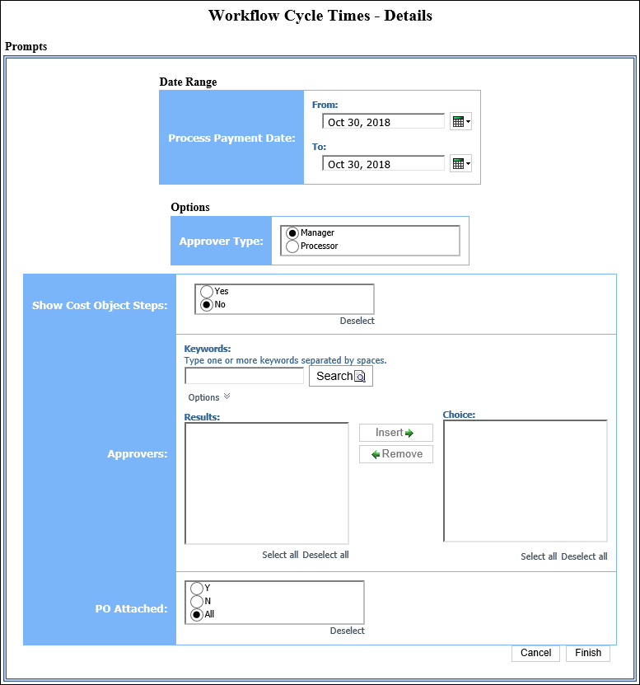

Report Output
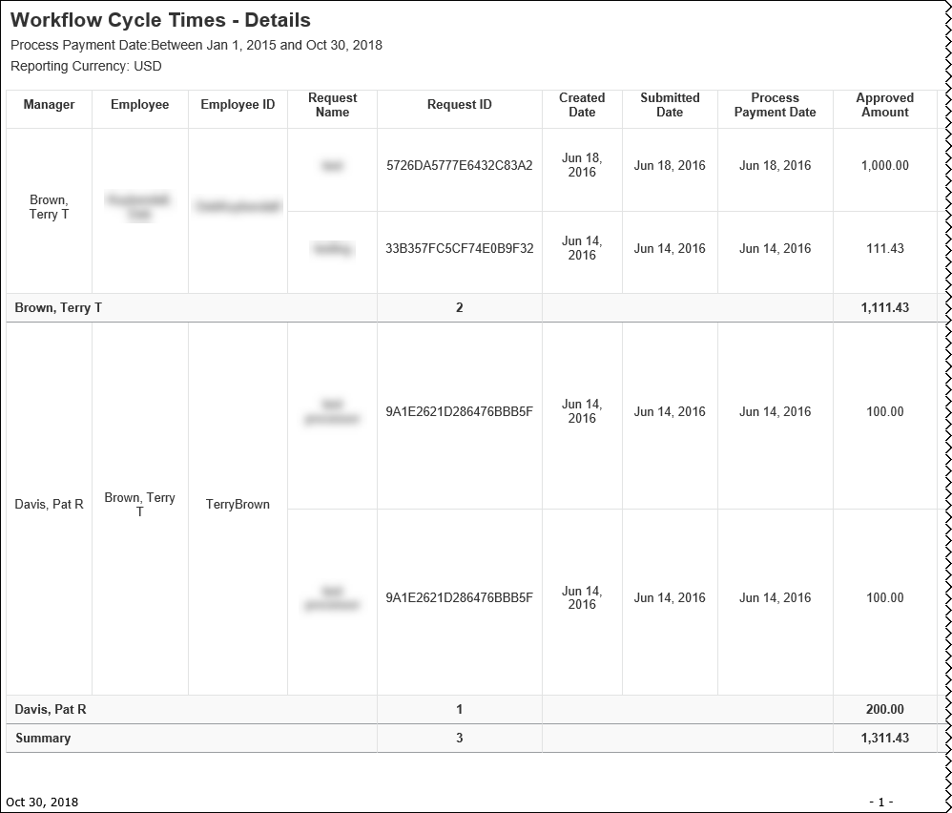
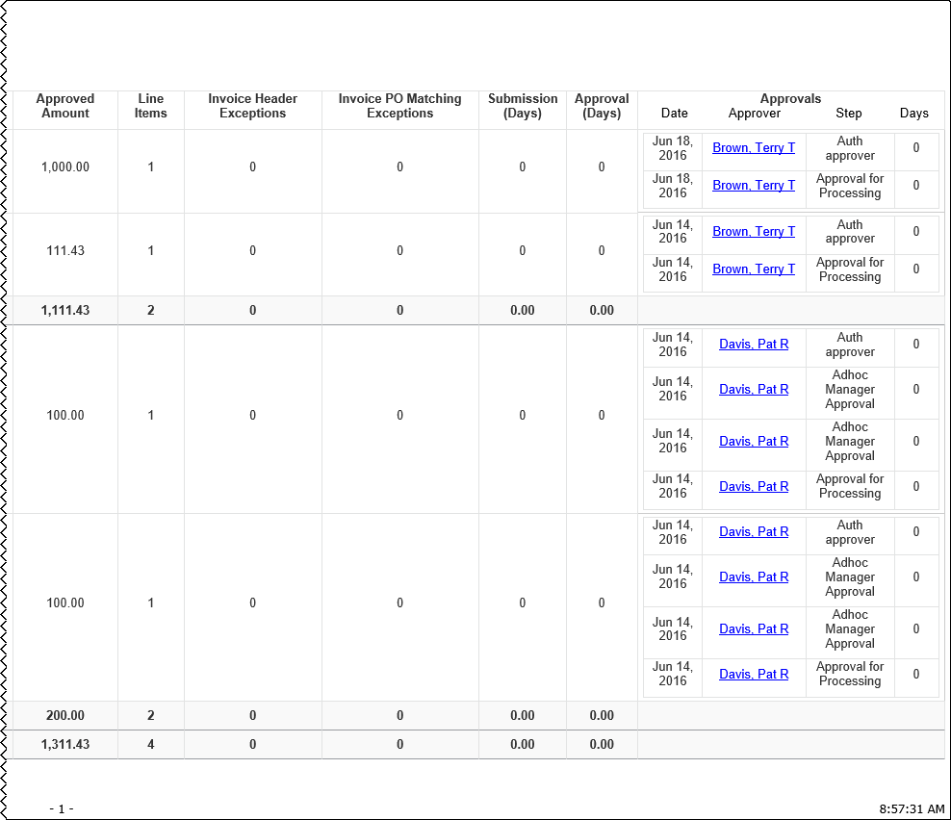

Report Header and Footer
Data Item Label/Name | Data Item Expression | Data Item Description
Process Payment Date | ParamDisplayValue('ProcessPaymentDateParam') | Displays the date range from the Process Payment Date prompt on the Prompts page
Reporting Currency | [Main].[Reporting Currency] | Displays the currency code in which the reporting currency is shown (for example, USD, CAD, GBP)
N/A | AsOfDate() | Displays the date the report was run
N/A | PageNumber() | Displays the page number of the corresponding page
N/A | AsOfTime() | Displays the time the report was run

Report Data Items
Data Item Label | Data Item Name | Data Item Expression | Data Item Description
Approver | <Approver> | [Approvers].[Approver] | Displays the approver
Employee | <Employee> | [Request Details].[Requesting Employee] | Displays the employee
Employee ID | <Employee ID> | [Request Details].[Requesting Employee ID] | Displays the employee ID
Request Name | <Request Name> | [Request Details].[Request Name] | Displays the request name
Request ID | <Request ID> | [Request Details].[Request ID] | Displays the request ID
Created Date | <Created Date> | [Request Details].[Created Date] | Displays the created date
Submitted Date | <Last Submitted Date> | [Request Details].[Last Submitted Date] | Displays the submitted date
Process Payment Date | <Process Payment Date> | [Request Details].[Process Payment Date] | Displays the process payment date
Approved Amount | <Total Approved Amount (rpt)> | [Request Details].[Total Approved Amount (rpt)] | Displays the approved amount
Invoice Header Exceptions | <Number of Exceptions> | [Request Details].[Number of Exceptions] | Displays invoice header exceptions
Invoice PO Matching Exceptions | <Invoice PO Matching Exceptions> | [Request Details].[Invoice PO Matching Exceptions] | Displays the invoice PO matching exceptions
Submission (Days) | <Submission (Days)> | [Request Details].[Submission Time (Days)] | Displays the submission (days)
Approval (Days) | <Approval (Days)> | [Request Details].[Submission to Extraction Time (Days)] | Displays the approval (days)
Date | <Approval Date> | [Invoice].[Payment Request Workflow Trail].[Step Action Date/Time] | Displays the date
Approver | <Approver> | [Invoice].[Payment Request Workflow Trail].[Employee Assigned to Step] | Displays the approver
Step | <Step> | [Invoice].[Payment Request Workflow Trail].[Step] | Displays the workflow step
Days | <Approver Time> | _days_between([Invoice].[Payment Request Workflow Trail].[Step Action Date/Time],[Invoice].[Payment Request Workflow Trail].[Step Entry Date/Time]) | Displays the days
Aggregate(Request ID) | <Aggregate(Request ID)> | [Request ID] | Displays the aggregate (request ID)
Total(Number of Line Items) | <Total(Number of Line Items)> | [Number of Line Items] | displays the total (number of line items)

Report: Workflow Cycle Times – Summary by Manager
Available to:  Analysis  Intelligence
This report provides a summary of workflow cycle times by manager; manager name is clickable for drill-through.

Report Prompts
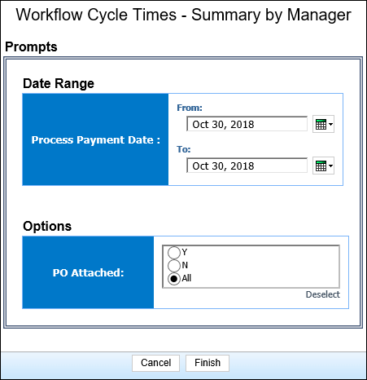

Report Output
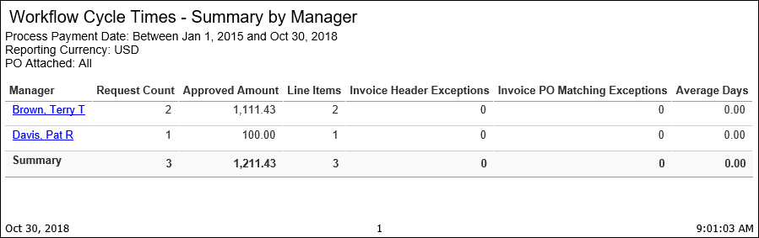

Report Header and Footer
Data Item Label/Name | Data Item Expression | Data Item Description
Process Payment Date | ParamDisplayValue('ProcessPaymentDateParam') | Displays the date range from the Process Payment Date prompt on the Prompts page
Reporting Currency | [Main].[Reporting Currency] | Displays the currency code in which the reporting currency is shown (for example, USD, CAD, GBP)
N/A | AsOfDate() | Displays the date the report was run
N/A | PageNumber() | Displays the page number of the corresponding page
N/A | AsOfTime() | Displays the time the report was run

Report Data Items
Data Item Label | Data Item Name | Data Item Expression | Data Item Description
Manager | <Employee Assigned to Step> | [Workflow].[Employee Assigned to Step] | Displays the manager
Request Count | <Request Count> | [Report].[Request Key] | Displays the request count
Approved Amount | <Total Approved Amount (rpt)> | [Report].[Total Approved Amount (rpt)] | Displays the approved amount
Line Items | <Number of Line Items> | [Report].[Number of Line Items] | Displays the line items
Invoice Header Exceptions | <Number of Exceptions> | [Report].[Number of Exceptions] | Displays the invoice header exceptions
Invoice PO Matching Exceptions | <Invoice PO Matching Exceptions> | [Report].[Invoice PO Matching Exceptions] | Displays the invoice PO matching exceptions
Average Days | <Average Time> | average([Approver Time] for [Employee Assigned to Step]) | Displays the average days

Report: Workflow Cycle Times – Summary by Processor
Available to:  Analysis  Intelligence
This report provides a summary of workflow cycle times by processor; processor name is clickable for drill-through.

Report Prompts
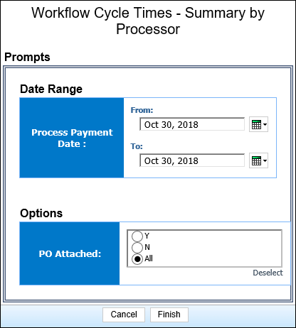

Report Output
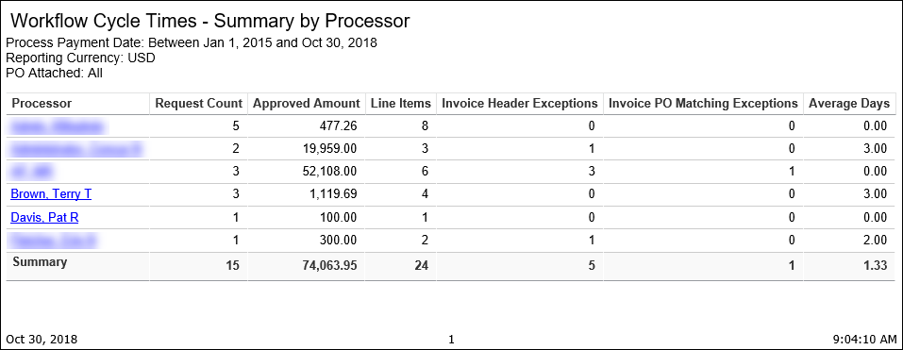

Report Header and Footer
Data Item Label/Name | Data Item Expression | Data Item Description
Process Payment Date | ParamDisplayValue('ProcessPaymentDateParam') | Displays the date range from the Process Payment Date prompt on the Prompts page
Reporting Currency | [Main].[Reporting Currency] | Displays the currency code in which the reporting currency is shown (for example, USD, CAD, GBP)
N/A | AsOfDate() | Displays the date the report was run
N/A | PageNumber() | Displays the page number of the corresponding page
N/A | AsOfTime() | Displays the time the report was run

Report Data Items
Data Item Label | Data Item Name | Data Item Expression | Data Item Description
Processor | <Employee Assigned to Step> | [Workflow].[Employee Assigned to Step] | Displays the processor
Request Count | <Request Count> | [Report].[Request Key] | Displays the request count
Approved Amount | <Total Approved Amount (rpt)> | [Report].[Total Approved Amount (rpt)] | Displays the approved amount
Line Items | <Number of Line Items> | [Report].[Number of Line Items] | Displays the line items
Invoice Header Exceptions | <Number of Exceptions> | [Report].[Number of Exceptions] | Displays the invoice header exceptions
Invoice PO Matching Exceptions | <Invoice PO Matching Exceptions> | [Report].[Invoice PO Matching Exceptions] | Displays the invoice PO matching exceptions
Average Days | <Average Time> | average([Approver Time] for [Employee Assigned to Step]) | Displays the average days

☼

