Table of Contents
Chapter 3: Folder – Administration 3-1
Report: Accounting Reconciliation 3-1
Available to:  Analysis  Intelligence 3-1
Uses:  Expense Data  Travel / TripLink Data 3-1
Report: Authorized Approver Details 3-3
Available to:  Analysis  Intelligence 3-3
Uses:  Expense Data  Travel / TripLink Data 3-3
Report: Bank Statement Reconciliation 3-6
Available to:  Analysis  Intelligence 3-6
Uses:  Expense Data  Travel / TripLink Data 3-6
Report: Billed Transaction Reconciliation - Detail (Calendar Month) 3-8
Available to:  Analysis  Intelligence 3-8
Uses:  Expense Data  Travel / TripLink Data 3-8
Report: Billed Transaction Reconciliation - (Calendar Month) 3-10
Available to:  Analysis  Intelligence 3-10
Uses:  Expense Data  Travel / TripLink Data 3-10
Report: Employee Bank Account Status 3-12
Available to:  Analysis  Intelligence 3-12
Uses:  Expense Data  Travel / TripLink Data 3-12
Report: Employee Details 3-14
Available to:  Analysis  Intelligence 3-14
Uses:  Expense Data  Travel / TripLink Data 3-14
Report: Employee Roles 3-16
Available to:  Analysis  Intelligence 3-16
Uses:  Expense Data  Travel / TripLink Data 3-16
Report: Expense and Travel Overview 3-20
Available to:  Analysis  Intelligence 3-20
Uses:  Expense Data  Travel / TripLink Data 3-20
Report: Expense Reports By Country 3-26
Available to:  Analysis  Intelligence 3-26
Uses:  Expense Data  Travel / TripLink Data 3-26
Report: Invoice Billed Transaction Reconciliation - Detail (Calendar Month) 3-28
Available to:  Analysis  Intelligence 3-28
Uses:  Invoice Data  Travel / TripLink Data 3-28
Report: Invoice Billed Transaction Reconciliation - (Calendar Month) 3-29
Available to:  Analysis  Intelligence 3-29
Uses:  Invoice Data  Travel / TripLink Data 3-29
Report: System Activity Report 3-31
Available to:  Analysis  Intelligence 3-31
Uses:  Expense Data  Travel / TripLink Data 3-31
Report: Travel Rule Class 3-37
Available to:  Analysis  Intelligence 3-37
Uses:  Expense Data  Travel / TripLink Data 3-37
Report: TripIt Expense Authorizations by Employee 3-40
Available to:  Analysis  Intelligence 3-40
Uses:  Expense Data  Travel / TripLink Data 3-40
Report: TripIt Travel Authorizations by Employee 3-42
Available to:  Analysis  Intelligence 3-42
Uses:  Expense Data  Travel / TripLink Data 3-42
Report: User Rating Summary - Travel 3-44
Available to:  Analysis  Intelligence 3-44
Uses:  Expense Data  Travel / TripLink Data 3-44

Revision History
Date | Notes / Comments / Changes
January 21, 2022 | Updated the copyright year; no other changes; cover date not updated
August 9, 2021 | Removed the Report: User Rating Summary – Expense section. The User Rating Summary – Expense report was removed from the Analysis - Standard Reports > Administration and Intelligence - Standard Reports > Administration folders on August 1, 2021.
July 17, 2021 | Added "SAP" before some references to "Concur" for accurate branding.
February 20, 2021 | Updated the copyright year; no other changes
September 19, 2020 | Updated the report image for the Employee Details report. The Country label was renamed to Country/Region.
January 8, 2020 | Changed copyright; no other content changes
February 9, 2019 | Removed references to Insight Premium from the guide and updated copyright
December 8, 2018 | Added additional information about report prompts and reports to the following reports:  - Employee Roles  - Expense Reports by Country  - System Activity Report  - Travel Rule Class  - TripIt Expense Authorizations by Employee  - TripIt Travel Authorizations by Employee  - User Rating Summary – Expense  - User Rating Summary – Travel
July 21, 2018 | Updated image of the Prompts page for the Employee Details report
January 13 2018 | Changed copyright; no other content changes
November 4 2017 | Added the System Activity Report
September 18 2017 | Updated two of the Expense and Travel Overview report images to show the new bar graphs that replaced the former pie charts
March 18 2017 | Updated the prompt information for the Authorized Approver Details report
December 15 2016 | Changed copyright; no other content changes
November 18 2016 | Updated report images to match the current application
July 8 2016 | Updated the Authorized Approver Details report
June 21 2016 | Added:  - Report: Authorized Approver Details  Removed:  - Report: Travel Points Detail  - Report: Travel Points Summary
March 23 2016 | Changed the text under the heading from Travel Data to Travel / TripLink Data; no other content changes
August 14 2015 | Moved from single book to individual "chapters" – no content changes

Folder – Administration

Report: Accounting Reconciliation
Available to:  Analysis  Intelligence
Uses:  Expense Data  Travel / TripLink Data
This report provides administrators visibility into report payees, which Concur Pay created payment demands, that have been extracted to their accounting system in a given accounting extract job, but have not been paid yet.

Report Prompts
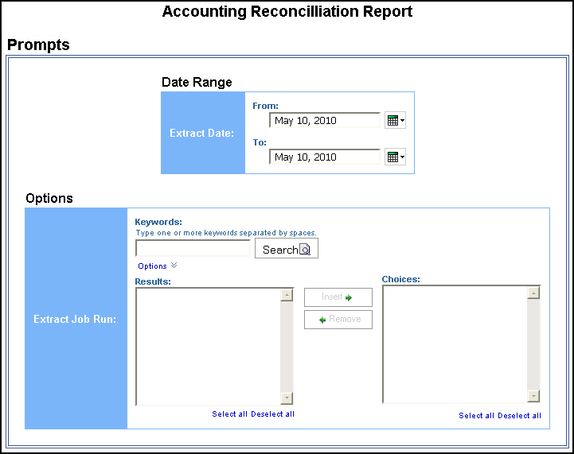

Report Output
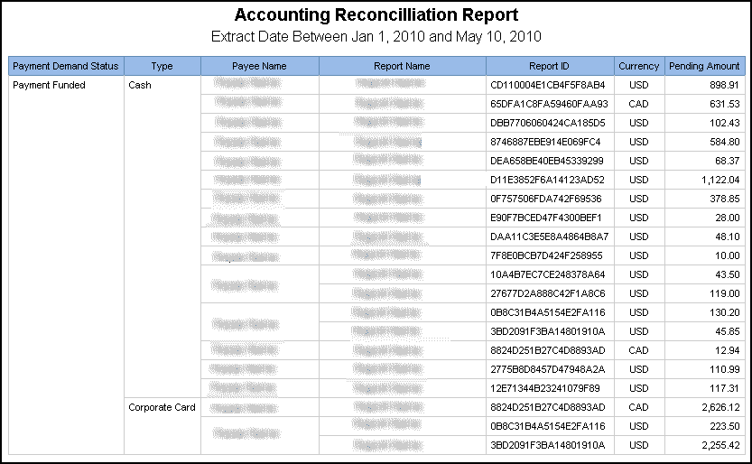

Report: Authorized Approver Details
Available to:  Analysis  Intelligence
Uses:  Expense Data  Travel / TripLink Data
This report provides administrators a list of all Authorized Approvers and Cost Object Approvers, as well as their associated groups, limits, etc.

Report Prompts
The report user selects the approver type and hierarchy 1. Also required to generate the report, the report user must enter the cost center or select either the hierarchy 2 level or the hierarchy 3 level.
If the Hierarchy 1 prompt is empty, the Prompts page for the Authorized Approver Details report only requires users to select an approver type from the Approver Type prompt to generate the report.

About the Approver Type Prompt
For Authorized Approvers, the report user selects one of the following approver types:
- Expense Report
- Payment Request
- Purchase Request
- Request
For Cost Object Approvers, the report user selects one of the following approver types:
- Report Cost Object
- Payment Request Cost Object
- Purchase Request Cost Object
- Request Cost Object

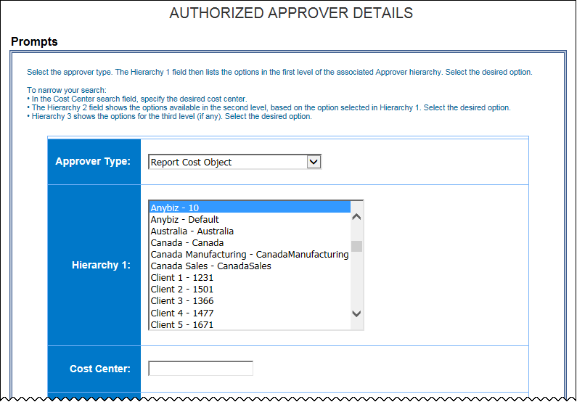
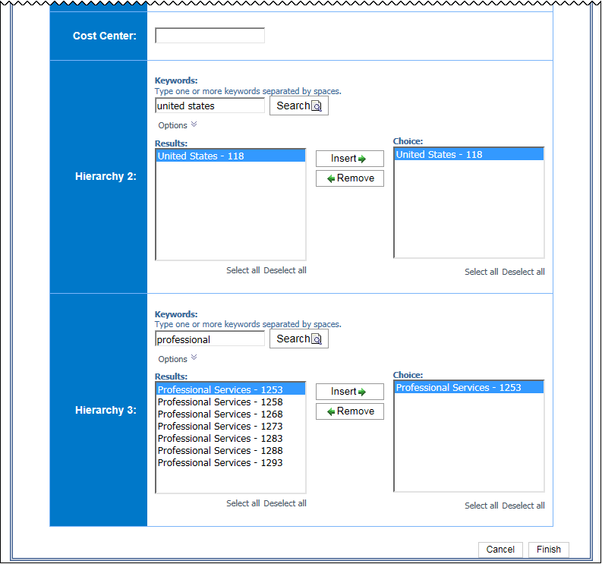

Report Output
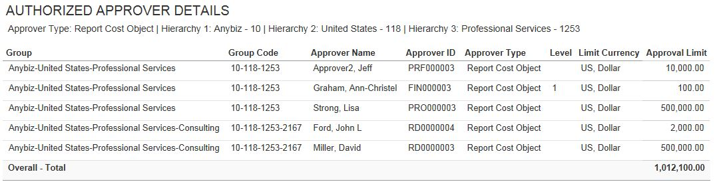
Actual payee names and report names appear in the report output

Report: Bank Statement Reconciliation
Available to:  Analysis  Intelligence
Uses:  Expense Data  Travel / TripLink Data
This report provides administrators visibility into the report payees paid for a given funding account withdrawal.

Report Prompts
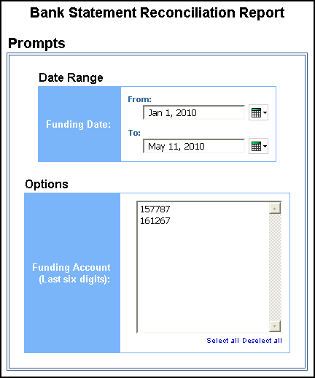

Report Output
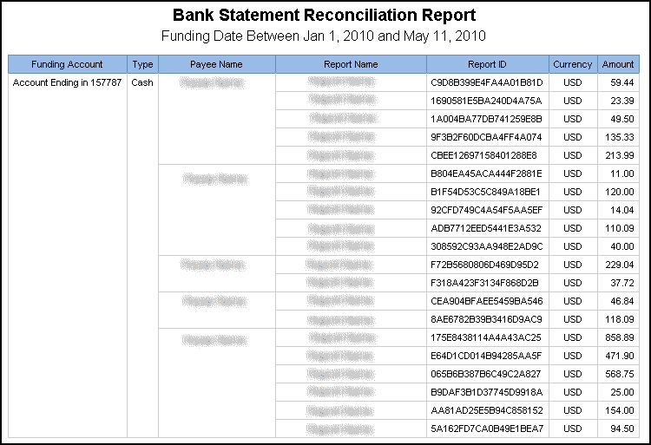

Report: Billed Transaction Reconciliation - Detail (Calendar Month)
Available to:  Analysis  Intelligence
Uses:  Expense Data  Travel / TripLink Data
This report allows clients to reconcile their invoices using Analysis/Intelligence. Note the following:
- The billing cycle follows the calendar month.
- We calculate the total number of transactions off the Billing query subject.
- This report includes all submitted reports (including deleted reports).
- This report can be executed in two ways. It is a drill through from Billed Transaction Reconciliation (Calendar Month). It can also be run as a stand-alone report.
- This report does not include centrally billed statement transactions.

Report Prompts
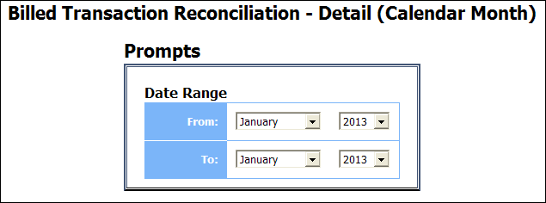

Report Output
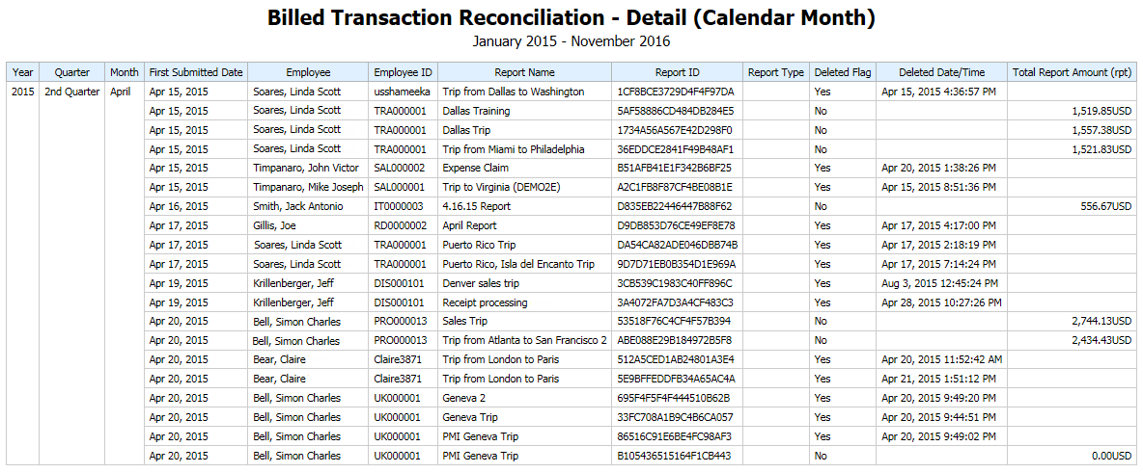

Report: Billed Transaction Reconciliation - (Calendar Month)
Available to:  Analysis  Intelligence
Uses:  Expense Data  Travel / TripLink Data
This report allows clients to reconcile their invoices using Analysis/Intelligence. Note the following:
- The billing cycle follows the calendar month.
- We calculate the total number of transactions off the Billing query subject.
- This report includes all submitted reports (including deleted reports).
- This report does not include centrally billed statement transactions.

Report Prompts
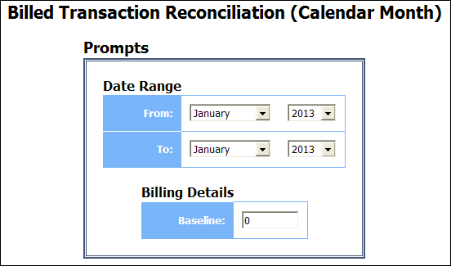

Report Output
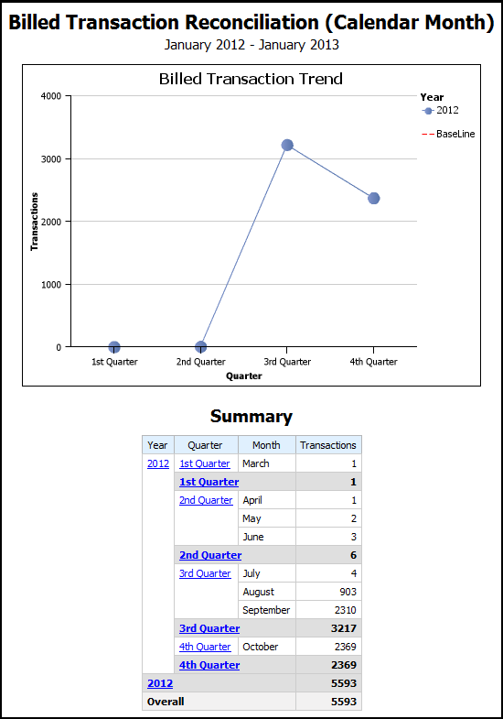

Report: Employee Bank Account Status
Available to:  Analysis  Intelligence
Uses:  Expense Data  Travel / TripLink Data
This report provides administrators visibility into employees for a given Employee Group with bank accounts with errant data or who do not have active bank accounts.

Report Prompts
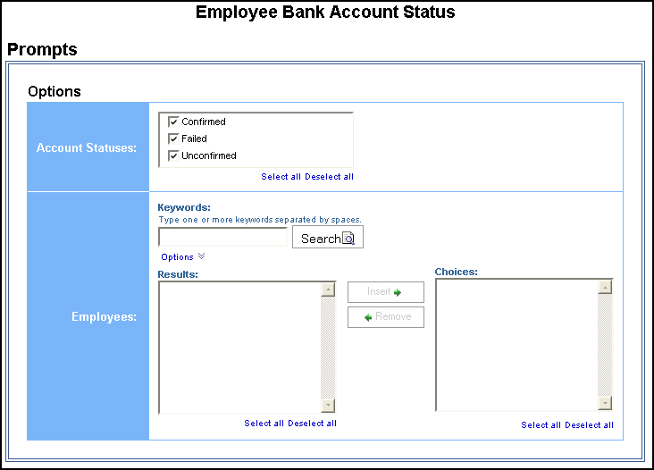

Report Output
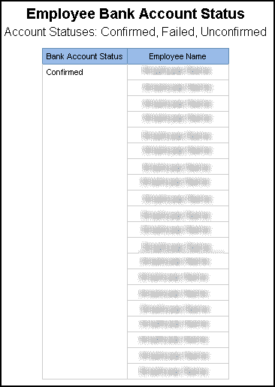

Report: Employee Details
Available to:  Analysis  Intelligence
Uses:  Expense Data  Travel / TripLink Data
This report provides basic information about employees, their approvers, organizational units, and custom fields that may be populated. It is useful as a reference to look up values populated in some of the configurable fields that are managed by other SAP Concur solutions. It is also useful to modify the column heading literals to indicate how the custom field was configured (for example, org unit 3 contains department).

Report Prompts
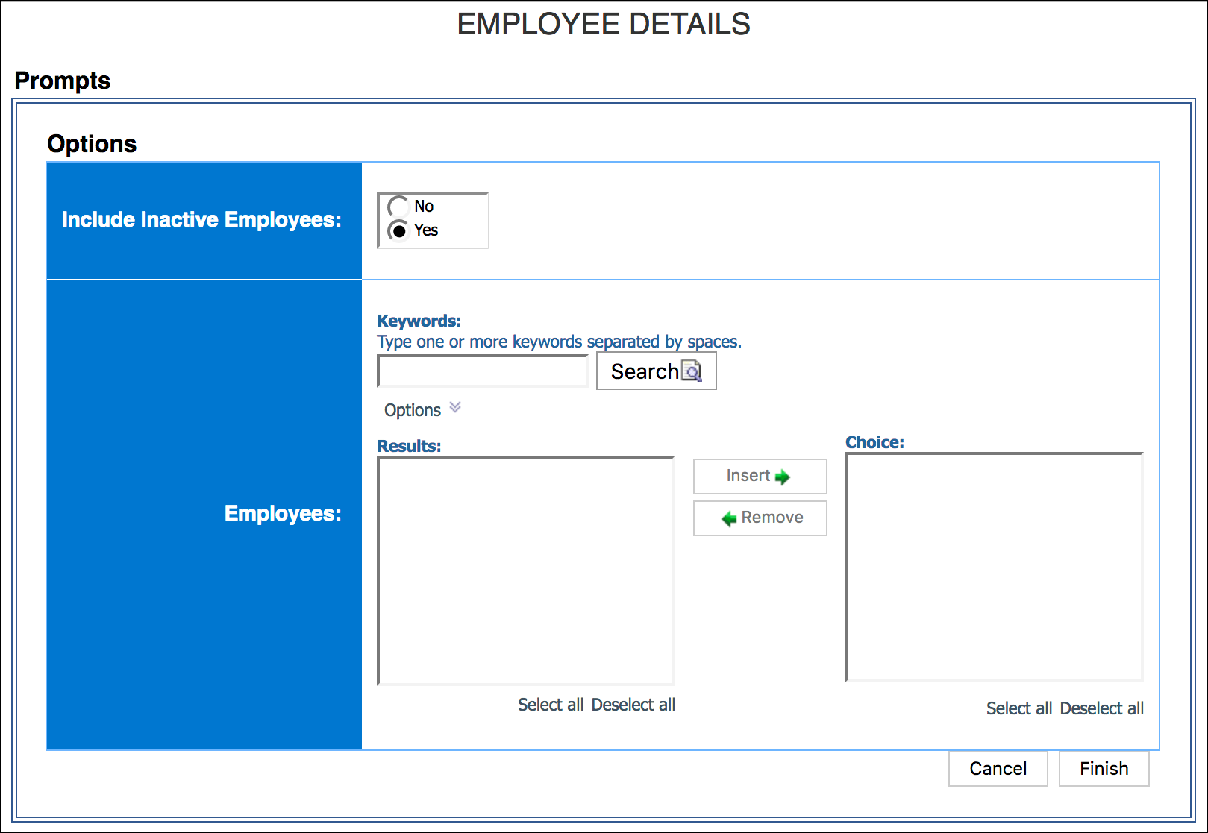

Report Output
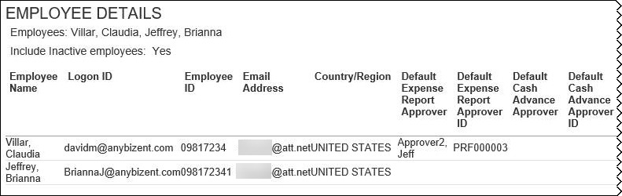
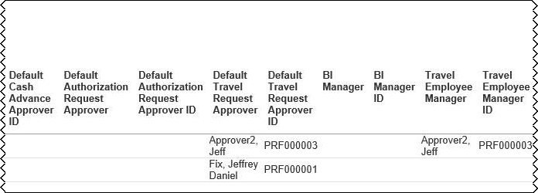
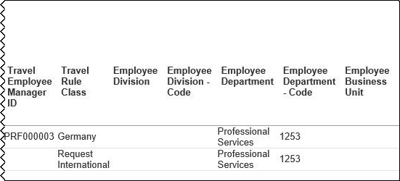

Report: Employee Roles
Available to:  Analysis  Intelligence
Uses:  Expense Data  Travel / TripLink Data
This report lists all employees and all roles. You can search for specific employees (to list the associated roles) or roles (to list the associated employees). You can group by employee or role.
- IMPORTANT: You may also see "secondary" roles. Those roles are not yet in use.

Report Prompts
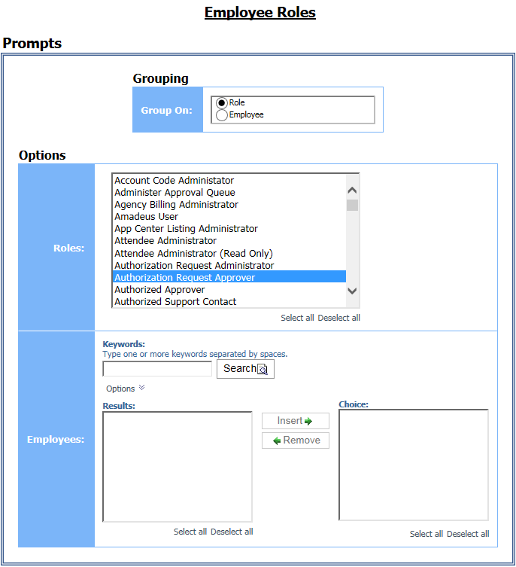

Grouping Prompt
- Group On: Used to select whether to group the report by role or employee

Options Prompts
- Roles: Used to filter the report by the role(s) assigned to the employees
- Employees: Used to filter the report by the employee name

Report Output
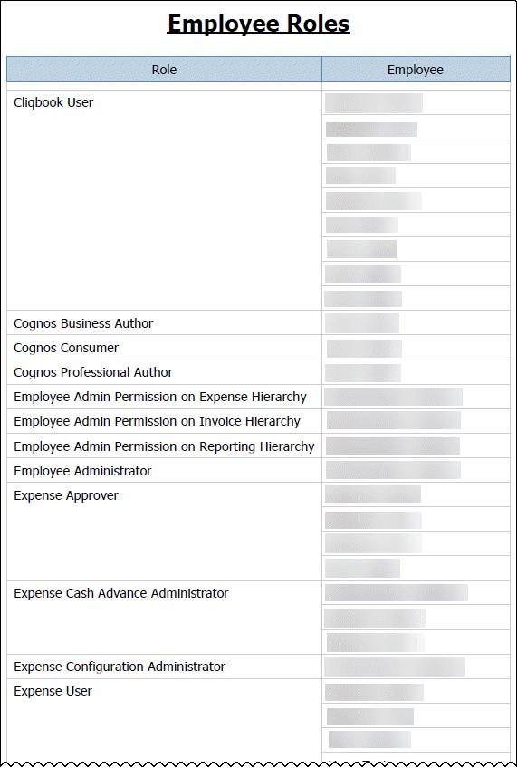

Report Header and Footer
Data Item Label/Name | Data Item Expression | Data Item Description
Roles | ' '+ParamDisplayValue('Role Name') | Displays the employee role(s) from the Roles prompt on the Prompts page
N/A | AsOfDate() | Displays the date the report was run
N/A | PageNumber() | Displays the page number of the corresponding page
N/A | AsOfTime() | Displays the time the report was run

Report Data Items
Data Item Label | Data Item Name | Data Item Expression | Data Item Description
Role/Employee | <Primary Grouping> | if (?Grouping? = 'Employee') then ([Expense].[Employee Information].[Employee Name]) else ([Expense].[Employee Roles].[Role]) | Employee last name, first name, and middle initial if grouped by employee  Roles assigned to the employees if grouped by role
Role/Employee | <Secondary Grouping> | if (?Grouping? <> 'Employee') then ([Expense].[Employee Information].[Employee Name]) else ([Expense].[Employee Roles].[Role]) | Employee last name, first name, and middle initial if grouped by employee  Roles assigned to the employees if grouped by role

Report: Expense and Travel Overview
Available to:  Analysis  Intelligence
Uses:  Expense Data  Travel / TripLink Data
This report is a combination of multiple individual metrics that all executive level users to quickly view travel and expense metrics in a single view.

Report Prompts
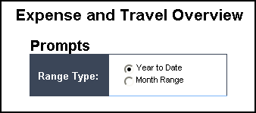

Report Output
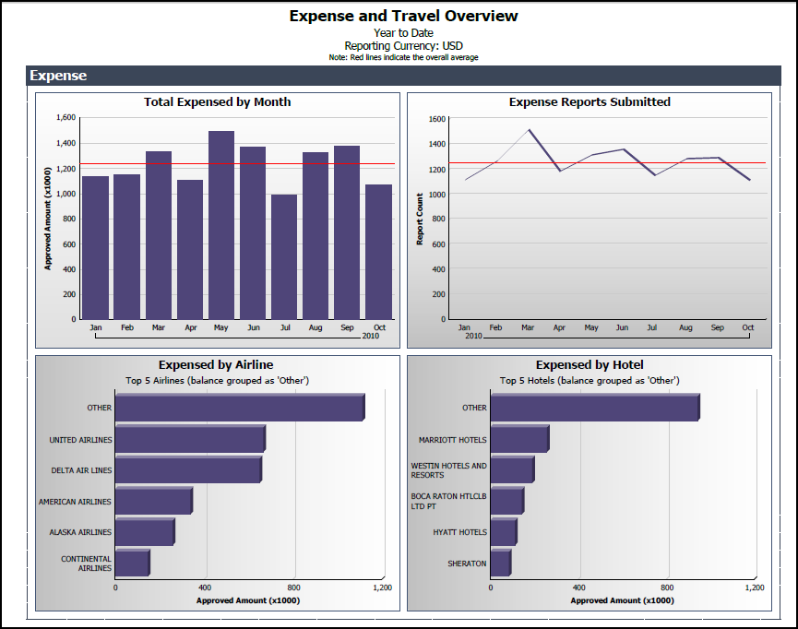
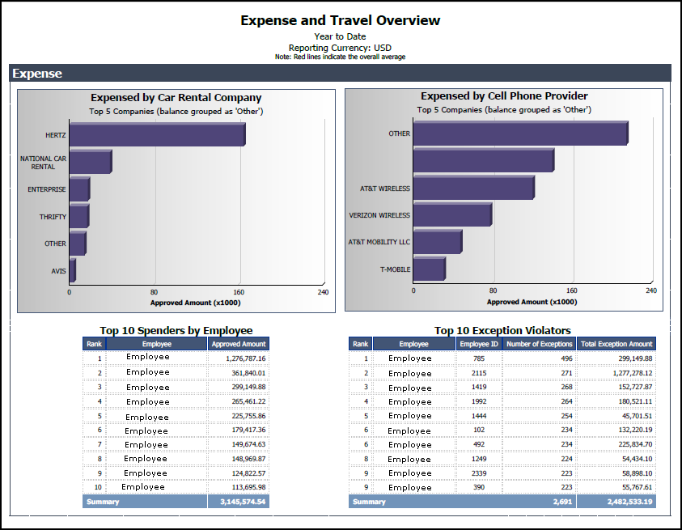
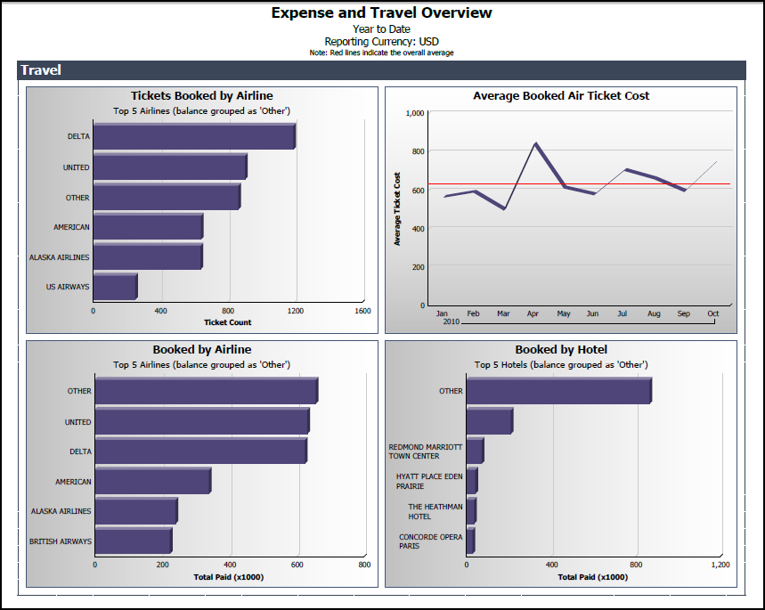

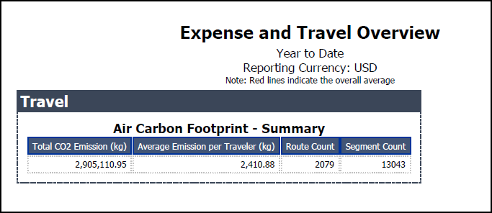

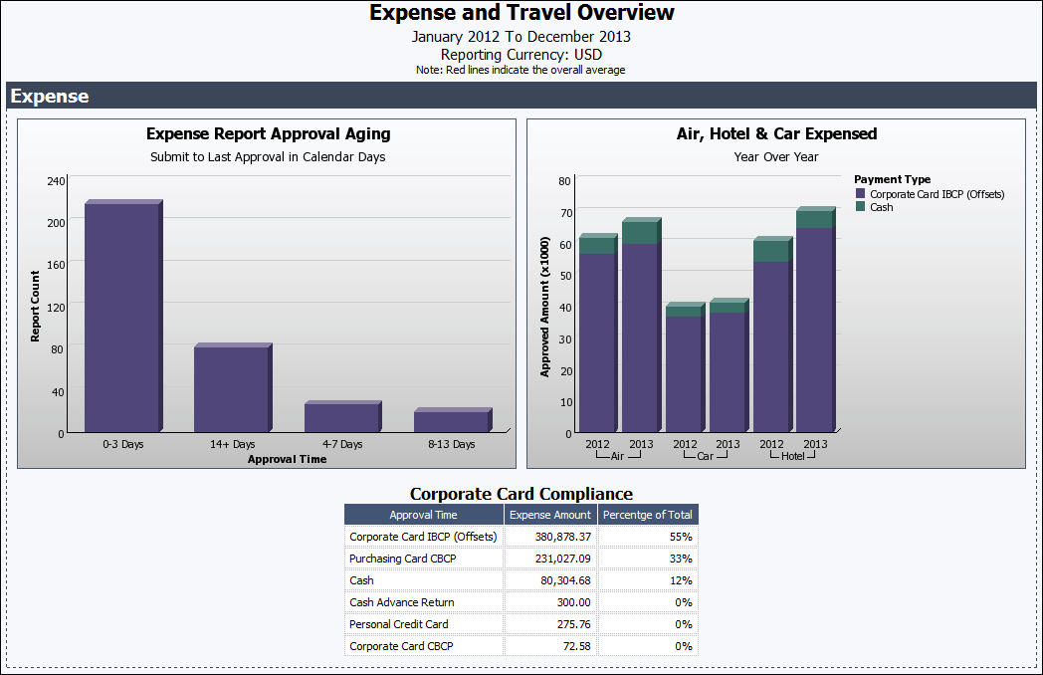

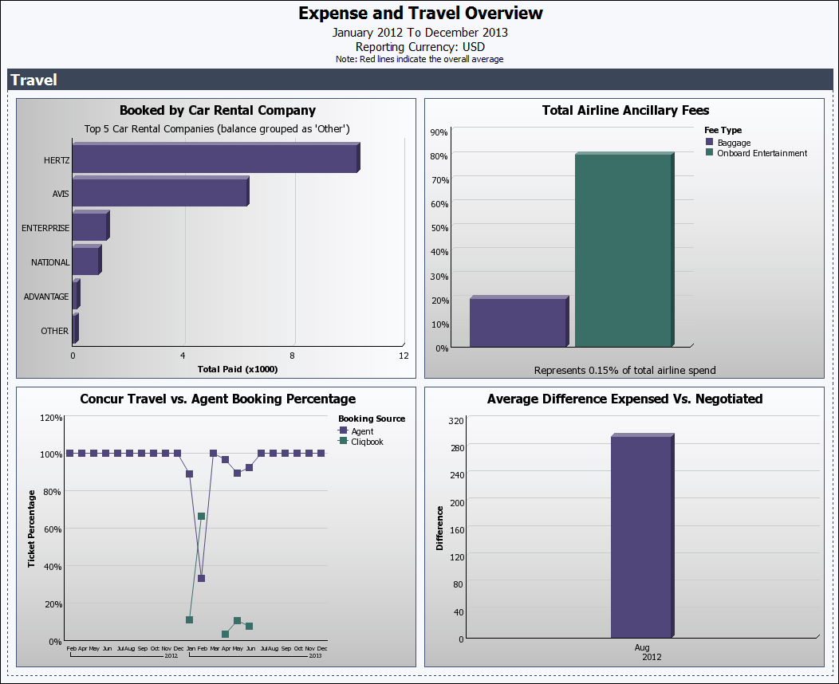

Report: Expense Reports By Country
Available to:  Analysis  Intelligence
Uses:  Expense Data  Travel / TripLink Data
This report displays the total number of expense reports filed on a country-by-country basis.

Report Prompts
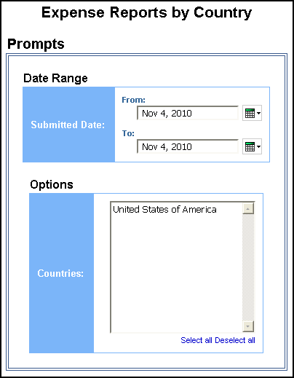

Date Range Prompt
- Submitted Date: Used to filter the report by the date range that the expense report was submitted for approval

Options Prompt
- Countries: Used to filter the report by the employee country(ies)

Report Output
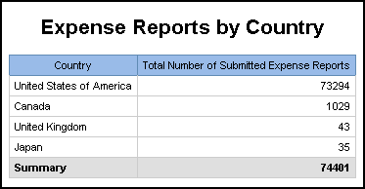

Report Header and Footer
Data Item Label/Name | Data Item Expression | Data Item Description
N/A | AsOfDate() | Displays the date the report was run
N/A | PageNumber() | Displays the page number of the corresponding page
N/A | AsOfTime() | Displays the time the report was run

Report Data Items
Data Item Label | Data Item Name | Data Item Expression | Data Item Description
Country | <Country (of Employee)> | [Expense].[Report Header Information].[Country (of Employee)] | Employee country  NOTE: Typically, this information copies down from the employee record; however, depending on a client's configuration of the report header form, it is possible that the Country could be different from the employee's assigned country.
Total Number of Submitted Expense Reports | <Report Count> | [Expense].[Report Header Information].[Report Key] | Unique system-assigned key that identifies the expense report

Report: Invoice Billed Transaction Reconciliation - Detail (Calendar Month)
Available to:  Analysis  Intelligence
Uses:  Invoice Data  Travel / TripLink Data
This report will allow users to match the Invoice transactions with the billing invoice from SAP Concur, similar to the Billed Transaction Reconciliation - Details reports in Expense. This report can be executed in two ways. It is a drill through from Invoice Billed Transaction Reconciliation (Calendar Month). It can also be run as a stand-alone report.

Report Prompts
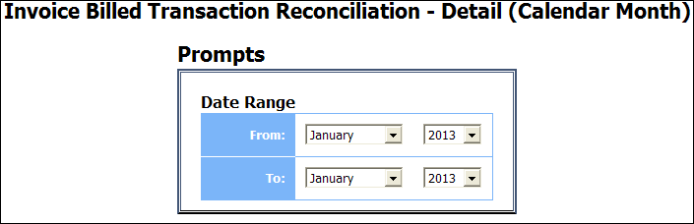

Report Output
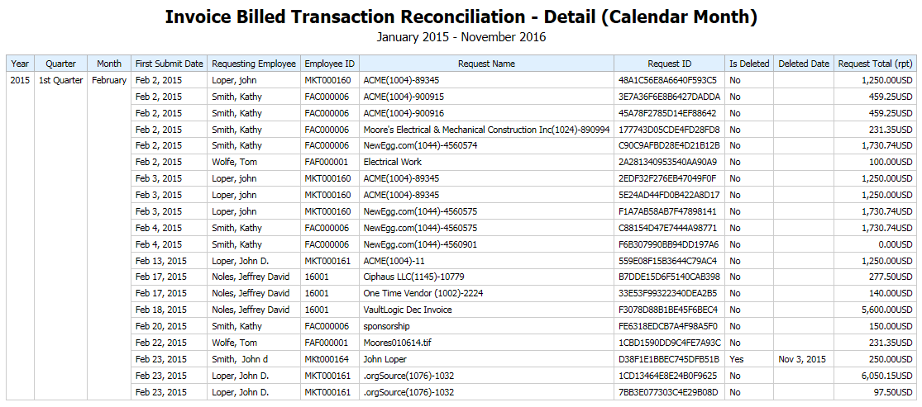

Report: Invoice Billed Transaction Reconciliation - (Calendar Month)
Available to:  Analysis  Intelligence
Uses:  Invoice Data  Travel / TripLink Data
This report will allow the user to match the Invoice transactions with the billing invoice from SAP Concur, similar to the Billed Transaction Reconciliation reports for Expense.

Report Prompts
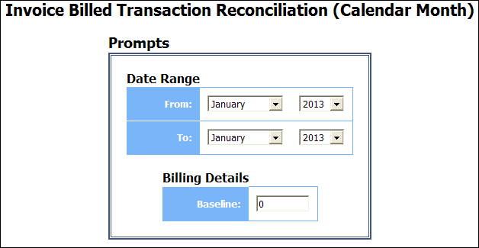

Report Output
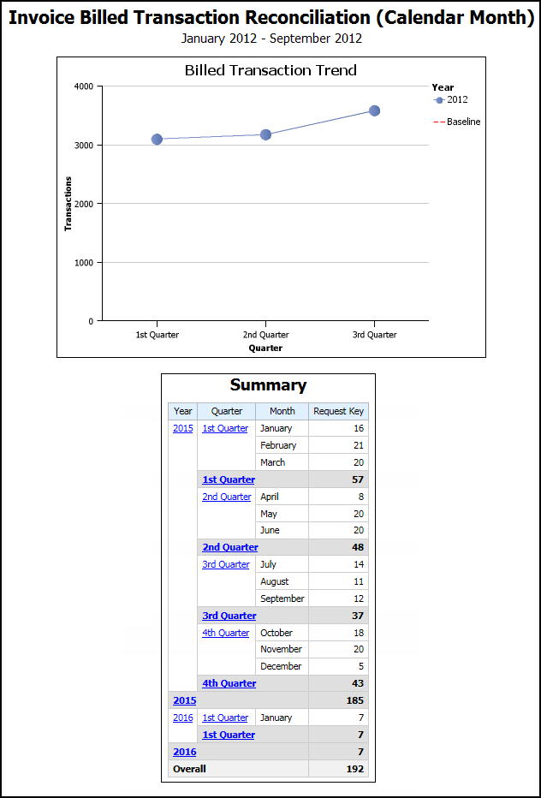

Report: System Activity Report
Available to:  Analysis  Intelligence
Uses:  Expense Data  Travel / TripLink Data
This report displays the system activity for Expense Reports during a specific time period.
Activity Count on the report is based on the number of activities, such as Report Created, Report First Submitted, Report Last Submitted, Report First Approved, Report Sent for Payment, or Report Paid, that occurred during the selected date and time range. Activity Count is not based on the number of expense reports that were touched during the selected time period.

Report Prompts
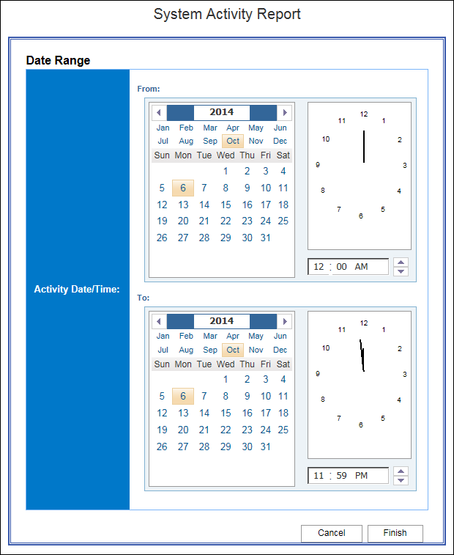

Date Range Prompt
- Activity Date/Time: Used to filter the report by the date range that expense reports were created, first submitted for approval, last submitted for approval, first approved, sent for payment, or paid

Report Output
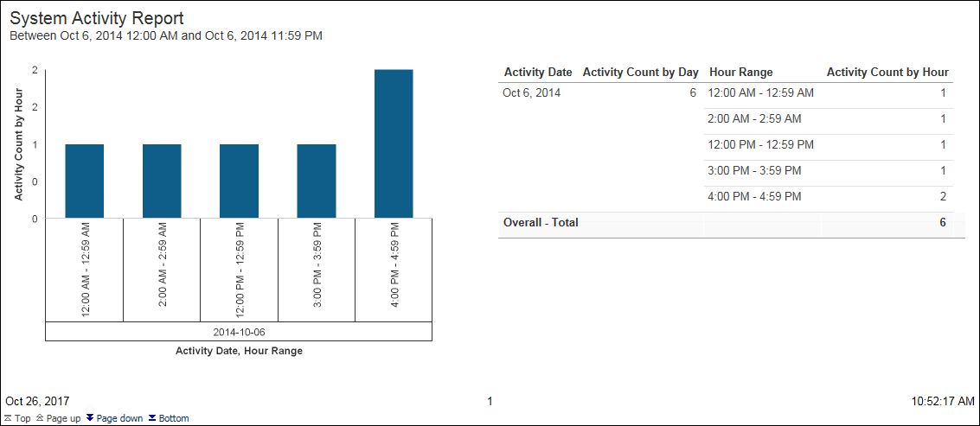
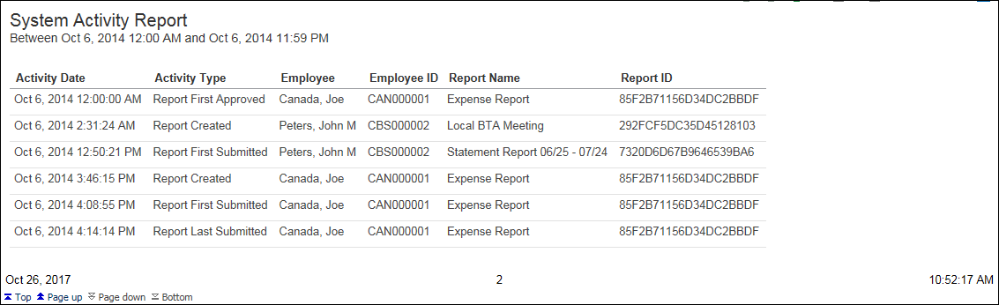

Report Header and Footer
Data Item Label/Name | Data Item Expression | Data Item Description
N/A | ParamDisplayValue('p_submittedDate') | Displays the date range from the Activity Date/Time prompt on the Prompts page

Report Data Items

System Activity
Data Item Label | Data Item Name | Data Item Expression | Data Item Description
Activity Count by Hour | <Activity Count by Hour> | Count ([Report ID] for [Activity Date], [Hour]) | Count of reports by hour that were created, first submitted for approval, last submitted for approval, first approved, sent for payment, or paid
Activity Date, Hour Range | <#Activity Date#>  <#Hour Range#> | cast([Activity Date TS] as date)  Case when [Hour] ='0' then '12:00 AM - 12:59 AM'  when [Hour] ='1' then '1:00 AM - 1:59 AM'  when [Hour] ='2' then '2:00 AM - 2:59 AM'  when [Hour] ='3' then '3:00 AM - 3:59 AM'  when [Hour] ='4' then '4:00 AM - 4:59 AM'  when [Hour] ='5' then '5:00 AM - 5:59 AM'  when [Hour] ='6' then '6:00 AM - 6:59 AM'  when [Hour] ='7' then '7:00 AM - 7:59 AM'  when [Hour] ='8' then '8:00 AM - 8:59 AM'  when [Hour] ='9' then '9:00 AM - 9:59 AM'  when [Hour] ='10' then '10:00 AM - 10:59 AM'  when [Hour] ='11' then '11:00 AM - 11:59 AM'  when [Hour] ='12' then '12:00 PM - 12:59 PM'  when [Hour] ='13' then '1:00 PM - 1:59 PM'  when [Hour] ='14' then '2:00 PM - 2:59 PM'  when [Hour] ='15' then '3:00 PM - 3:59 PM'  when [Hour] ='16' then '4:00 PM - 4:59 PM'  when [Hour] ='17' then '5:00 PM - 5:59 PM'  when [Hour] ='18' then '6:00 PM - 6:59 PM'  when [Hour] ='19' then '7:00 PM - 7:59 PM'  when [Hour] ='20' then '8:00 PM - 8:59 PM'  when [Hour] ='21' then '9:00 PM - 9:59 PM'  when [Hour] ='22' then '10:00 PM - 10:59 PM'  when [Hour] ='23' then '11:00 PM - 11:59 PM'  else null  end | Every one-hour range for a 24-hour period
Activity Date | <Activity Date> | cast([Activity Date TS] as date) | Date that a report was created, first submitted for approval, last submitted for approval, first approved, sent for payment, or paid
Activity Count by Day | <Activity Count by Day> | count ([Report ID] for [Activity Date]) | Count of reports by day that were created, first submitted for approval, last submitted for approval, first approved, sent for payment, or paid
Hour Range | <Hour Range> | Case when [Hour] ='0' then '12:00 AM - 12:59 AM'  when [Hour] ='1' then '1:00 AM - 1:59 AM'  when [Hour] ='2' then '2:00 AM - 2:59 AM'  when [Hour] ='3' then '3:00 AM - 3:59 AM'  when [Hour] ='4' then '4:00 AM - 4:59 AM'  when [Hour] ='5' then '5:00 AM - 5:59 AM'  when [Hour] ='6' then '6:00 AM - 6:59 AM'  when [Hour] ='7' then '7:00 AM - 7:59 AM'  when [Hour] ='8' then '8:00 AM - 8:59 AM'  when [Hour] ='9' then '9:00 AM - 9:59 AM'  when [Hour] ='10' then '10:00 AM - 10:59 AM'  when [Hour] ='11' then '11:00 AM - 11:59 AM'  when [Hour] ='12' then '12:00 PM - 12:59 PM'  when [Hour] ='13' then '1:00 PM - 1:59 PM'  when [Hour] ='14' then '2:00 PM - 2:59 PM'  when [Hour] ='15' then '3:00 PM - 3:59 PM'  when [Hour] ='16' then '4:00 PM - 4:59 PM'  when [Hour] ='17' then '5:00 PM - 5:59 PM'  when [Hour] ='18' then '6:00 PM - 6:59 PM'  when [Hour] ='19' then '7:00 PM - 7:59 PM'  when [Hour] ='20' then '8:00 PM - 8:59 PM'  when [Hour] ='21' then '9:00 PM - 9:59 PM'  when [Hour] ='22' then '10:00 PM - 10:59 PM'  when [Hour] ='23' then '11:00 PM - 11:59 PM'  else null  end | Every one-hour range for a 24-hour period
Activity Count by Hour | <Activity Count by Hour> | Count ([Report ID] for [Activity Date], [Hour]) | Count of reports by hour that were created, first submitted for approval, last submitted for approval, first approved, sent for payment, or paid

System Activity – Detail
Data Item Label | Data Item Name | Data Item Expression | Data Item Description
Activity Date | <Activity Date TS> | [Union1].[Activity Date TS] | Date that a report was created, first submitted for approval, last submitted for approval, first approved, sent for payment, or paid
Activity Type | <Activity Type> | [Union1].[Activity Type] | Type of report activity; i.e. created, first submitted for approval, last submitted for approval, first approved, sent for payment, or paid
Employee | <Employee> | [Expense].[Report Header Information].[Employee] | Employee last name, first name, and middle initial
Employee ID | <Employee ID> | [Expense].[Report Header Information].[Employee ID] | Unique number or code that identifies the employee
Report Name | <Report Name> | [Expense].[Report Header Information].[Report Name] | Employee-entered name of the expense report
Report ID | <Report ID> | [Expense].[Report Header Information].[Report ID] | Unique system-assigned code that identifies the expense report

Report: Travel Rule Class
Available to:  Analysis  Intelligence
Uses:  Expense Data  Travel / TripLink Data
This report lists all employees associated with travel configurations and travel rule classes. It can be used to validate that employees are associated with the correct configuration choices while implementing the system or while implementing new configuration options. This helps the travel manager determine which travelers must adhere to the rules of a given travel class.

Report Prompts
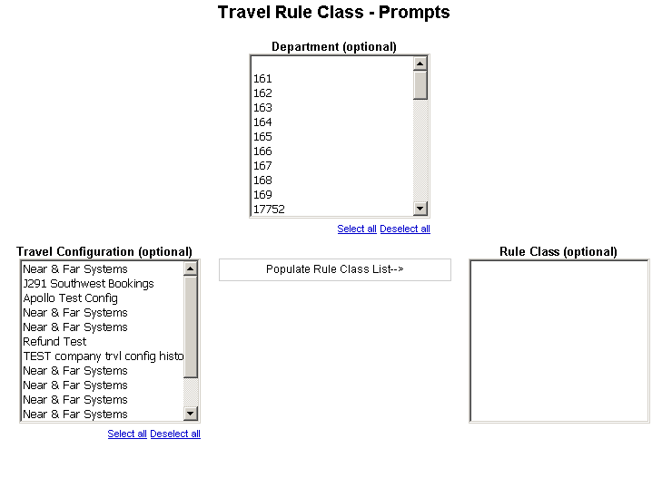
- Department (optional): Used to filter the report by the department(s) of the employees booking the trips
- Travel Configuration (optional): Used to filter the report by the travel configuration(s) used by the employees booking the trips
- Populate Rule Class List: Used to populate a list of rule classes used by the employees booking the trips
- Rule Class (optional): Used to filter the report by the rule class(es) used by the employees booking the trips

Report Output
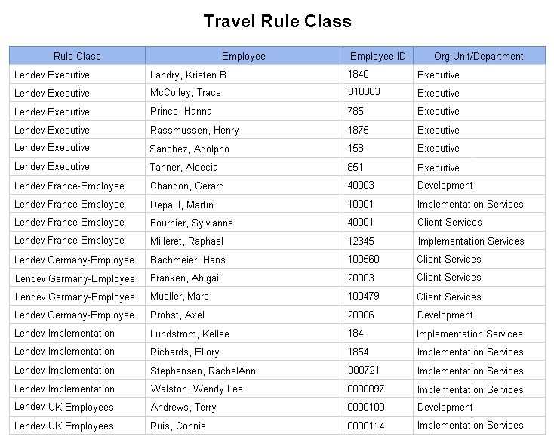

Report Header and Footer
Data Item Label/Name | Data Item Expression | Data Item Description
N/A | AsOfDate() | Displays the date the report was run
N/A | PageNumber() | Displays the page number of the corresponding page
N/A | AsOfTime() | Displays the time the report was run

Report Data Items
Data Item Label | Data Item Name | Data Item Expression | Data Item Description
Rule Class | <Rule Class> | [Travel].[Trips].[Rule Class] | Rule class used by the employee booking the trip
Employee | <Employee> | [Travel].[Trips].[Employee Last Name] + ', ' + [Travel].[Trips].[Employee First Name] | Legal last name and first name for the traveling employee (for example, Smith, John)
Employee ID | <Employee ID> | [Travel].[Trips].[Employee ID] | Employee ID of the employee who booked the trip
Org Unit/Department | <Organizational Unit> | [Travel].[Trips].[Organizational Unit] | Organizational unit associated to the employee taking the trip

Report: TripIt Expense Authorizations by Employee
Available to:  Analysis  Intelligence
Uses:  Expense Data  Travel / TripLink Data
This report allows integrated Expense only clients to view which employees at their company have enabled TripIt integration.

Report Prompts
None.

Report Output
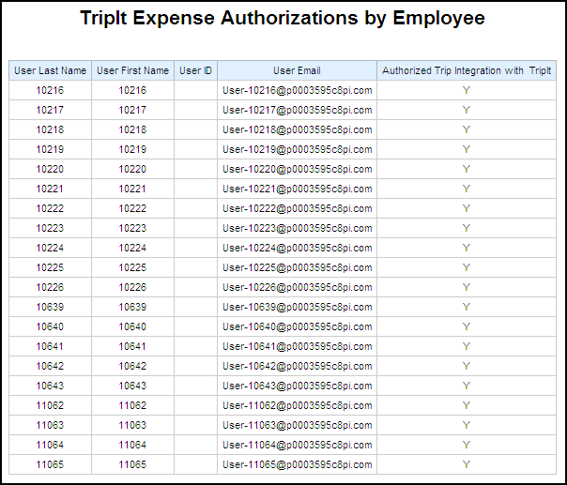

Report Header and Footer
Data Item Label/Name | Data Item Expression | Data Item Description
N/A | AsOfDate() | Displays the date the report was run
N/A | PageNumber() | Displays the page number of the corresponding page
N/A | AsOfTime() | Displays the time the report was run

Report Data Items
Data Item Label | Data Item Name | Data Item Expression | Data Item Description
User Last Name | <Last Name> | [Expense].[Employee Information].[Last Name] | Employee last name
User First Name | <First Name> | [Expense].[Employee Information].[First Name] | Employee first name
User ID | <Travel Logon ID> | [Expense].[Employee Information].[Travel Logon ID] | Employee Expense user ID
User Email | <Email Address> | [Expense].[Employee Information].[Email Address] | Employee email address
Authorized Trip Integration with Tripit | <Link Expense to TripIt> | [Expense].[Employee Information].[Link Expense to TripIt] | Y or N to indicate if the user has enabled TripIt integration

Report: TripIt Travel Authorizations by Employee
Available to:  Analysis  Intelligence
Uses:  Expense Data  Travel / TripLink Data
This report allows integrated Travel and Expense clients to view which employees at their company have enabled TripIt integration for Travel.

Report Prompts
None.

Report Output
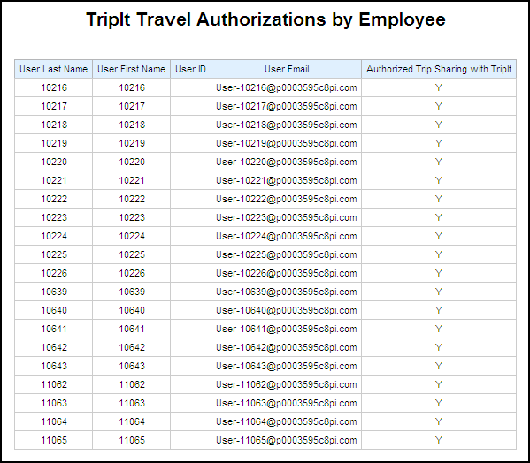

Report Header and Footer
Data Item Label/Name | Data Item Expression | Data Item Description
N/A | AsOfDate() | Displays the date the report was run
N/A | PageNumber() | Displays the page number of the corresponding page
N/A | AsOfTime() | Displays the time the report was run

Report Data Items
Data Item Label | Data Item Name | Data Item Expression | Data Item Description
User Last Name | <Last Name> | [Expense].[Employee Information].[Last Name] | Employee last name
User First Name | <First Name> | [Expense].[Employee Information].[First Name] | Employee first name
User ID | <Travel Logon ID> | [Expense].[Employee Information].[Travel Logon ID] | Employee Travel and Expense user ID
User Email | <Email Address> | [Expense].[Employee Information].[Email Address] | Employee email address
Authorized Trip Sharing with TripIt | <Link Travel to TripIt> | [Expense].[Employee Information].[Link Travel to TripIt] | Y or N to indicate if the user has enabled TripIt integration for Travel

Report: User Rating Summary - Travel
Available to:  Analysis  Intelligence
Uses:  Expense Data  Travel / TripLink Data
This report allows clients to see how satisfied their users are with Concur Travel. Armed with direct feedback, Travel Managers can identify consistent pain points and make policy changes to provide a better user experience.

Report Prompts
The report user can select the date range and elect to see all feedback or only the feedback with comments.
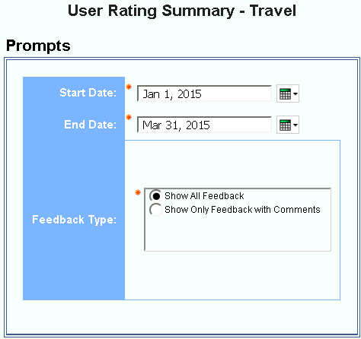
- Start Date: Used to filter the report by a defined start date that the survey was taken by the user
- End Date: Used to filter the report by a defined end date that the survey was taken by the user
- Feedback Type: Used to select whether to show all feedback or show only feedback with comments”

Report Output
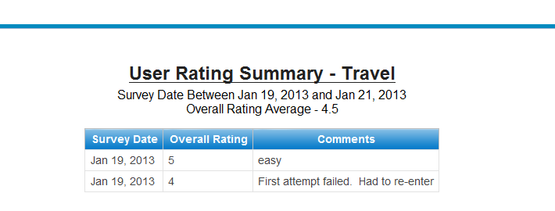

Report Header and Footer
Data Item Label/Name | Data Item Expression | Data Item Description
Survey Date between | ParamDisplayValue('p_StartDate')+' ' and ' '+ParamDisplayValue('p_EndDate') | Displays the date range from the Start Date and End Date prompts on the Prompts page
Overall Rating Average | average([All].[Overall Rating] for report) | Displays the average of the Overall Rating total of the report

Report Data Items
Data Item Label | Data Item Name | Data Item Expression | Data Item Description
Survey Date | <Survey Date> | [Travel].[User Rating Information].[Survey Date] | Date the survey was taken by the user
Overall Rating | <Overall Rating> | [Travel].[User Rating Information].[Overall Rating] | Overall rating provided by end users after booking
Comments | <Comments> | ([Travel].[User Rating Information].[Comments]) | User added comments

☼

