Table of Contents
Chapter 2: Folder – Accrual 2-1
Report: Expense Accrual 2-1
Available to:  Analysis  Intelligence 2-1
Uses:  Expense Data  Travel / TripLink Data 2-1
Report: Expense Accrual by Date Range 2-9
Available to:  Analysis  Intelligence 2-9
Uses:  Expense Data  Travel / TripLink Data 2-9
Report: Top Employees with Unassigned or Unsubmitted CC Transactions 2-15
Available to:  Analysis  Intelligence 2-15
Uses:  Expense Data  Travel / TripLink Data 2-15
Report: Unassigned Credit Card Transactions 2-20
Available to:  Analysis  Intelligence 2-20
Uses:  Expense Data  Travel / TripLink Data 2-20

Revision History
Date | Notes / Comments / Changes
January 21, 2022 | Updated the copyright year; no other changes; cover date not updated
February 20, 2021 | Updated the copyright year; no other changes
September 19, 2020 | Updated the Prompts page and report images for the Expense Accrual and Expense Accrual by Date Range reports. The Country and Countries labels were renamed to Country/Region and Countries/Region.
January 8, 2020 | Changed copyright; no other content changes
February 9, 2019 | Removed references to Insight Premium from the guide
January 12, 2019 | Changed the copyright and updated the Prompts page image for the Expense Accrual and Expense Accrual by Date Range reports to include the new blank selection for the Countries prompt
December 8, 2018 | Added additional information about report prompts and reports to the reports  in the Accrual folder
January 13, 2018 | Changed copyright; no other content changes
December 15 2016 | Changed copyright; no other content changes
March 23 2016 | Changed the text under the heading from Travel Data to Travel / TripLink Data; no other content changes
August 14 2015 | Moved from single book to individual "chapters" – no content changes

Folder – Accrual

Report: Expense Accrual
Available to:  Analysis  Intelligence
Uses:  Expense Data  Travel / TripLink Data
This report shows all transactions that have not been assigned to an expense report or have been assigned to an expense report that has not yet been paid. It provides visibility to financial professionals within the organization regarding outstanding liabilities and potential future cash requirements.

Report Prompts
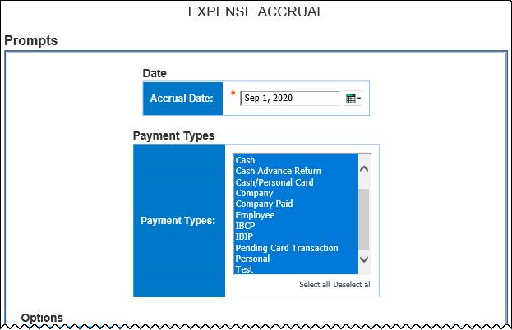
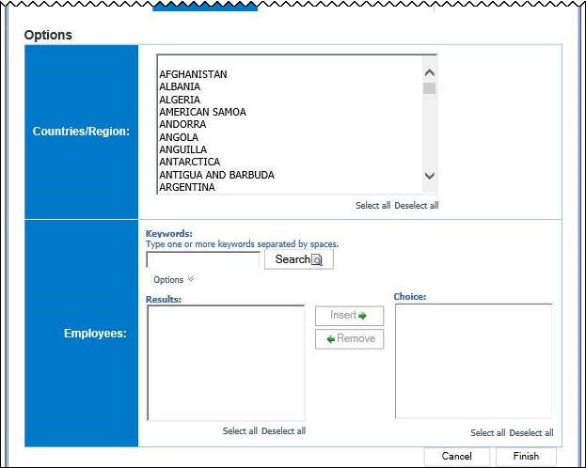

Date Prompt
- Accrual Date: Used to filter the report by the date range that the transactions were accrued

Payment Types Prompt
- Payment Types: Used to filter the report by the method(s) by which the employees paid for the expenses

Options Prompts
- Countries/Region: Used to filter the report by the country(ies)/region(s) where the expenses were incurred
- Employees: Used to filter the report by the name of employee(s) who booked trips

Report Output
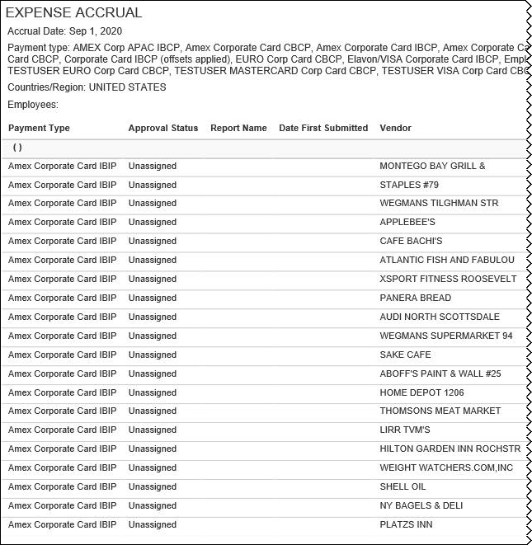
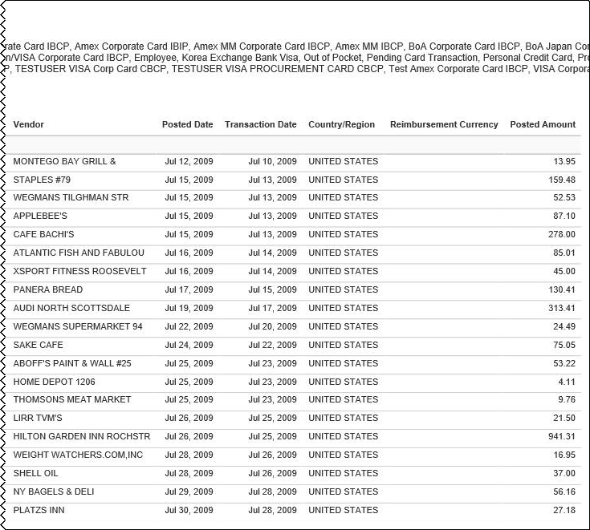

Report Header and Footer
Data Item Label/Name | Data Item Expression | Data Item Description
Accrual Date | ParamDisplayValue('AccrualDate') | Displays the date range from the Accrual Date prompt on the Prompts page
Payment Type | ' '+ParamDisplayValue('PaymentType') | Displays the payment type(s) from the Payment Types prompt on the Prompts page
Countries/Region | ' '+ParamDisplayValue('countryParam') | Displays the country(ies)/region(s) from the Countries/Region prompt on the Prompts page
Employees | ' '+ParamDisplayValue('Employee') | Displays the employee name(s) from the Employees prompt on the Prompts page
N/A | AsOfDate() | Displays the date the report was run
N/A | PageNumber() | Displays the page number of the corresponding page
N/A | AsOfTime() | Displays the time the report was run

Report Data Items
Data Item Label | Data Item Name | Data Item Expression | Data Item Description
Payment Type | <Payment Type> | [Union1].[Payment Type] | Method by which the employee paid for the expense, such as cash or a credit card
Payment Type | <Payment Type> | [Expense].[Entry Information].[Payment Type], [Expense].[Credit Card Accounts].[Payment Type]
Approval Status | <Approval Status> | [Union1].[Approval Status] | Status of the expense report in the approval process
Approval Status | <Approval Status> | v[Expense].[Report Dates and Statuses].[Approval Status], case  WHEN # sq($runLocale )# = 'zh-cn' THEN '未分配'  WHEN # sq($runLocale )# = 'zh-tw' THEN '未指派'  WHEN # sq($runLocale )# = 'en' THEN 'Unassigned'  WHEN # sq($runLocale )# = 'en-gb' THEN 'Unassigned'  WHEN # sq($runLocale )# = 'fr' THEN 'Non affecté'  WHEN # sq($runLocale )# = 'de' THEN 'Nicht zugewiesen'  WHEN # sq($runLocale )# = 'ja' THEN '未割り当て'  WHEN # sq($runLocale )# = 'it' THEN 'Non assegnato'  WHEN # sq($runLocale )# = 'ko' THEN '지정 안 됨'  WHEN # sq($runLocale )# = 'sv' THEN 'Ej tilldelad'  WHEN # sq($runLocale )# = 'nl' THEN 'Niet-toegewezen'  WHEN # sq($runLocale )# ='cs' then 'Nepřiřazeno'  WHEN # sq($runLocale )# ='pt-BR' then 'Sem atribuição'  WHEN # sq($runLocale )# ='es' then 'No asignado'  else 'Unassigned'  end | Status of the expense report in the approval process
Report Name | <Report Name> | [Union1].[Report Name] | Employee-entered name of the expense report
Report Name | <Report Name> | [Expense].[Report Header Information].[Report Name] | Employee-entered name of the expense report
Date First Submitted | <Date First Submitted> | [Union1].[Date First Submitted] | Date that the expense report was first submitted for approval  NOTE: If the report was returned to the employee and had to be resubmitted, this date is the date the report was first submitted.
Date First Submitted | <Date First Submitted> | [Expense].[Report Dates and Statuses].[First Submitted Date]
Vendor | <Merchant> | [Union1].[Merchant] | Vendor associated with the expense
Vendor | <Merchant> | [Expense].[Entry Information].[Vendor], [Expense].[Credit Card Transactions].[Merchant] | Vendor associated with the expense
Posted Date | <Posted Date> | [Union1].[Posted Date] | Date the transaction was posted to the credit card's systems
Posted Date | <Posted Date> | [Expense].[Credit Card Transactions].[Posted Date], [Expense].[Credit Card Transactions].[Posted Date] | Date the transaction was posted to the credit card's systems
Transaction Date | <Transaction Date> | [Union1].[Transaction Date] | Date that the expense was incurred
Transaction Date | <Transaction Date> | [Expense].[Entry Information].[Transaction Date], [Expense].[Credit Card Transactions].[Transaction Date] | Date that the expense was incurred
Country/Region | <Country> | [Union1].[Country] | Country/Region where the expense was incurred
Country/Region | <Country> | [Expense].[Entry Information].[Country] | Country/Region where the expense was incurred
Reimbursement Currency | <Reimbursement Currency> | [Union1].[Reimbursement Currency] | Currency in which the employee is reimbursed
Reimbursement Currency | <Reimbursement Currency> | [Expense].[Entry Information].[Reimbursement Currency], [Expense].[Credit Card Transactions].[Reimbursement Currency] | Currency in which the employee is reimbursed
Posted Amount | <Posted Amount> | [Union1].[Posted Date] | Amount of the expense, converted as needed to the employee's reimbursement currency
Posted Amount | <Posted Amount> | [Expense].[Entry Information].[Expense Amount (reimbursement currency)], CASE  WHEN [Expense].[Credit Card Accounts].[Employee Key] = -1  THEN [Expense].[Credit Card Transactions].[Posted Amount (credit card currency)]  ELSE [Expense].[Credit Card Transactions].[Posted Amount (reimbursement currency)]  END
N/A | <Employee + Employee ID> | [Union1].[Employee]+' ('+[Union1].[Employee ID]+')' | Employee last name, first name, and middle initial + Unique number or code that identifies the employee
N/A | <Employee + Employee ID> | [Expense].[Report Header Information].[Employee] + [Expense].[Report Header Information].[Employee ID], [Expense].[Credit Card Accounts].[Employee] + [Expense].[Credit Card Accounts].[Employee ID]

Report: Expense Accrual by Date Range
Available to:  Analysis  Intelligence
Uses:  Expense Data  Travel / TripLink Data
This report shows all transactions that are not been assigned to an expense report or have been assigned to an expense report that has not yet been paid over a user-defined date range. It provides visibility to financial professionals within the organization regarding outstanding liabilities and potential future cash requirements.

Report Prompts
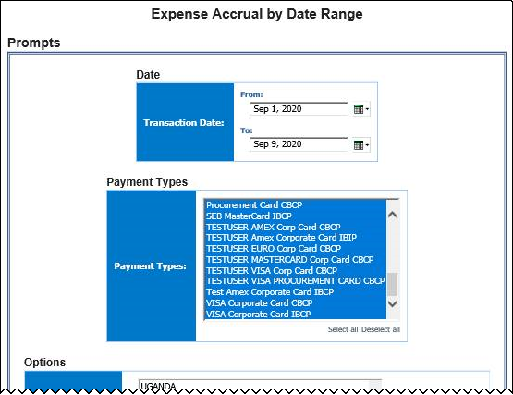
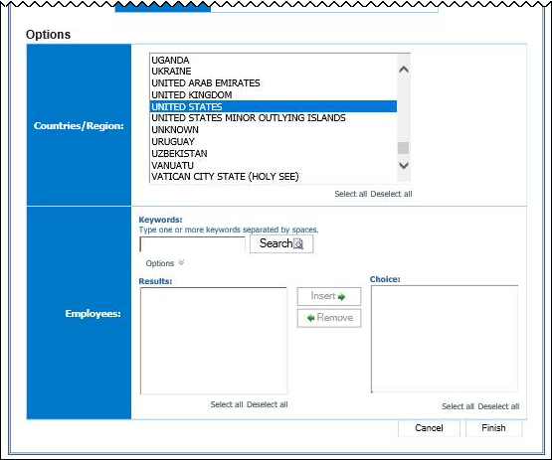

Date Prompt
- Transaction Date: Used to filter the report by the date range that the transactions were incurred

Payment Types Prompt
- Payment Types: Used to filter the report by the method(s) by which the employees paid for the expenses

Options Prompts
- Countries/Region: Used to filter the report by the country(ies)/region(s) where the expenses were incurred
- Employees: Used to filter the report by the name of employee(s) who booked trips

Report Output
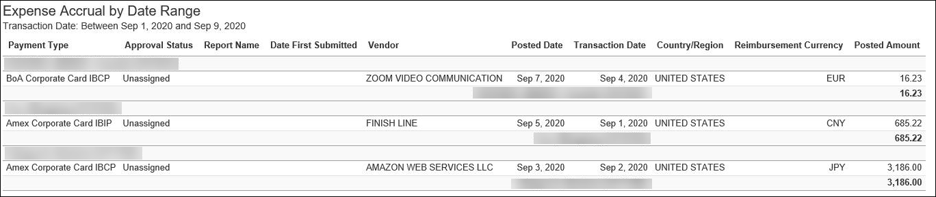

Report Header and Footer
Data Item Label/Name | Data Item Expression | Data Item Description
Transaction Date | ParamDisplayValue('dateRangeParam') | Displays the date range from the Transaction Date prompt on the Prompts page
N/A | AsOfDate() | Displays the date the report was run
N/A | PageNumber() | Displays the page number of the corresponding page
N/A | AsOfTime() | Displays the time the report was run

Report Data Items
Data Item Label | Data Item Name | Data Item Expression | Data Item Description
N/A | <Employee + Employee ID> | [Union1].[Employee]+' ('+[Union1].[Employee ID]+')' | Employee last name, first name, and middle initial + Unique number or code that identifies the employee
N/A | <Employee + Employee ID> | [Expense].[Report Header Information].[Employee] + [Expense].[Report Header Information].[Employee ID], [Expense].[Credit Card Accounts].[Employee] + [Expense].[Credit Card Accounts].[Employee ID]
Payment Type | <Payment Type> | [Union1].[Payment Type] | Method by which the employee paid for the expense, such as cash or a credit card
Payment Type | <Payment Type> | [Expense].[Entry Information].[Payment Type], [Expense].[Credit Card Accounts].[Payment Type]
Approval Status | <Approval Status> | [Union1].[Approval Status] | Status of the expense report in the approval process
Approval Status | <Approval Status> | v[Expense].[Report Dates and Statuses].[Approval Status], case  WHEN # sq($runLocale )# = 'zh-cn' THEN '未分配'  WHEN # sq($runLocale )# = 'zh-tw' THEN '未指派'  WHEN # sq($runLocale )# = 'en' THEN 'Unassigned'  WHEN # sq($runLocale )# = 'en-gb' THEN 'Unassigned'  WHEN # sq($runLocale )# = 'fr' THEN 'Non affecté'  WHEN # sq($runLocale )# = 'de' THEN 'Nicht zugewiesen'  WHEN # sq($runLocale )# = 'ja' THEN '未割り当て'  WHEN # sq($runLocale )# = 'it' THEN 'Non assegnato'  WHEN # sq($runLocale )# = 'ko' THEN '지정 안 됨'  WHEN # sq($runLocale )# = 'sv' THEN 'Ej tilldelad'  WHEN # sq($runLocale )# = 'nl' THEN 'Niet-toegewezen'  WHEN # sq($runLocale )# ='cs' then 'Nepřiřazeno'  WHEN # sq($runLocale )# ='pt-BR' then 'Sem atribuição'  WHEN # sq($runLocale )# ='es' then 'No asignado'  else 'Unassigned'  end | Status of the expense report in the approval process
Report Name | <Report Name> | [Union1].[Report Name] | Employee-entered name of the expense report
Report Name | <Report Name> | [Expense].[Report Header Information].[Report Name] | Employee-entered name of the expense report
Date First Submitted | <Date First Submitted> | [Union1].[Date First Submitted] | Date that the expense report was first submitted for approval  NOTE: If the report was returned to the employee and had to be resubmitted, this date is the date the report was first submitted.
Date First Submitted | <Date First Submitted> | [Expense].[Report Dates and Statuses].[First Submitted Date]
Vendor | <Merchant> | [Union1].[Merchant] | Vendor associated with the expense
Vendor | <Merchant> | [Expense].[Entry Information].[Vendor], [Expense].[Credit Card Transactions].[Merchant] | Vendor associated with the expense
Posted Date | <Posted Date> | [Union1].[Posted Date] | Date the transaction was posted to the credit card's systems
Posted Date | <Posted Date> | [Expense].[Credit Card Transactions].[Posted Date], [Expense].[Credit Card Transactions].[Posted Date] | Date the transaction was posted to the credit card's systems
Transaction Date | <Transaction Date> | [Union1].[Transaction Date] | Date that the expense was incurred
Transaction Date | <Transaction Date> | [Expense].[Entry Information].[Transaction Date], [Expense].[Credit Card Transactions].[Transaction Date] | Date that the expense was incurred
Country/Region | <Country> | [Union1].[Country] | Country/Region where the expense was incurred
Country/Region | <Country> | [Expense].[Entry Information].[Country] | Country/Region where the expense was incurred
Reimbursement Currency | <Reimbursement Currency> | [Union1].[Reimbursement Currency] | Currency in which the employee is reimbursed
Reimbursement Currency | <Reimbursement Currency> | [Expense].[Entry Information].[Reimbursement Currency], [Expense].[Credit Card Transactions].[Reimbursement Currency] | Currency in which the employee is reimbursed
Posted Amount | <Posted Amount> | [Union1].[Posted Date] | Amount of the expense, converted as needed to the employee's reimbursement currency
Posted Amount | <Posted Amount> | [Expense].[Entry Information].[Expense Amount (reimbursement currency)], CASE  WHEN [Expense].[Credit Card Accounts].[Employee Key] = -1  THEN [Expense].[Credit Card Transactions].[Posted Amount (credit card currency)]  ELSE [Expense].[Credit Card Transactions].[Posted Amount (reimbursement currency)]  END

Report: Top Employees with Unassigned or Unsubmitted CC Transactions
Available to:  Analysis  Intelligence
Uses:  Expense Data  Travel / TripLink Data
This report lists the top ten employees with the highest amount of unassigned or unsubmitted company card transactions.

Report Prompts
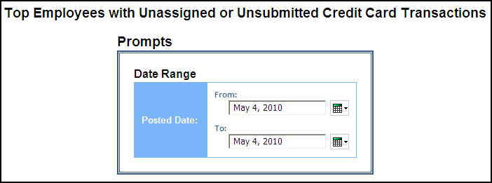

Date Range Prompt
- Posted Date: Used to filter the report by the date range that the transactions were posted to the credit card's systems

Report Output
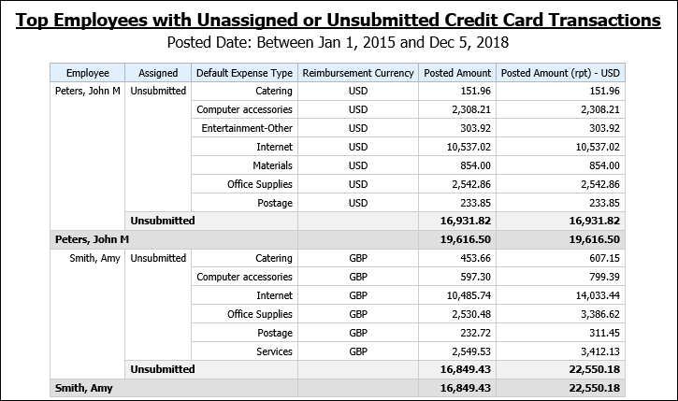

Report Header and Footer
Data Item Label/Name | Data Item Expression | Data Item Description
Posted Date | ParamDisplayValue('postedDateParam') | Displays the date range from the Posted Date prompt on the Prompts page

Report Data Items
Data Item Label | Data Item Name | Data Item Expression | Data Item Description
Employee | <Employee> | Unassigned:  if([Expense].[Credit Card Accounts].[Employee Key]= -1)  then ([Expense].[Credit Card Accounts].[Name on Card]) else ([Expense].[Credit Card Accounts].[Employee])  Unsubmitted:  [Expense].[Report Header Information].[Employee] | Unassigned:  Name on the corporate card, as supplied by the credit card vendor or the name of the employee to whom the card has been assigned  NOTE: Not all cards may be assigned to an employee.  Unsubmitted:  Employee last name, first name, and middle initial
Assigned | <Assigned> | case  WHEN # sq($runLocale )# = 'zh-cn' THEN '未分配'  WHEN # sq($runLocale )# = 'zh-tw' THEN '未指派'  WHEN # sq($runLocale )# = 'en-gb' THEN 'Unassigned'  WHEN # sq($runLocale )# = 'fr' THEN 'Non affecté'  WHEN # sq($runLocale )# = 'de' THEN 'Nicht zugewiesen'  WHEN # sq($runLocale )# = 'ja' THEN '未割り当て'  WHEN # sq($runLocale )# = 'it' THEN 'Non assegnato'  WHEN # sq($runLocale )# = 'ko' THEN '지정 안 됨'  WHEN # sq($runLocale )# = 'sv' THEN 'Ej tilldelad'  WHEN # sq($runLocale )# = 'nl' THEN 'Niet-toegewezen'  WHEN # sq($runLocale )# ='cs' then 'Nepřiřazeno'  WHEN # sq($runLocale )# ='pt-BR' then 'Sem atribuição'  WHEN # sq($runLocale )# ='es' then 'No asignado'  else 'Unassigned'  end | Indicates whether the expenses are “Unassigned” in the reporting country language
Default Expense Type | <Default Expense Type> | Unassigned:  [Expense].[Credit Card Transactions].[Default Expense Type]  Unsubmitted:  [Expense].[Entry Information].[Expense Type] | Unassigned:  Default expense type associated with the merchant on the transaction  NOTE: Employees may change the default expense type after they assign the credit card transaction to and expense report.  Unsubmitted:  Expense type assigned to the expense
Reimbursement Currency | <Reimbursement Currency> | [Expense].[Credit Card Transactions].[Reimbursement Currency] | Currency in which the employee was reimbursed
Posted Amount | <Posted Amount> | Unassigned:  [Expense].[Credit Card Transactions].[Posted Amount (reimbursement currency)]  Unsubmitted:  [Expense].[Entry Information].[Expense Amount (reimbursement currency)] | Unassigned:  Transaction amount converted, as needed, from the transaction currency to the currency in which the employee is reimbursed  Unsubmitted:  Currency in which the employee is reimbursed
Posted Amount (rpt) - <Reporting Currency> | <Posted Amount (rpt)> | Unassigned:  [Expense].[Credit Card Transactions].[Posted Amount (reporting currency)]  Unsubmitted:  [Expense].[Entry Information].[Expense Amount (rpt)] | Unassigned:  Transaction amount converted, as needed, from the transaction currency to the reporting currency  Unsubmitted:  Amount of the expense, converted as needed to the reporting currency

Report: Unassigned Credit Card Transactions
Available to:  Analysis  Intelligence
Uses:  Expense Data  Travel / TripLink Data
This report lists all unassigned credit card transactions.

Report Prompts
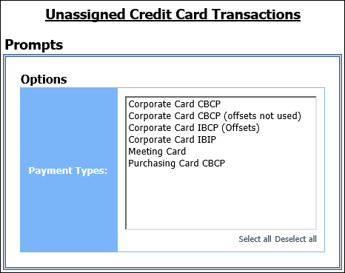

Options Prompt
- Payment Types: Used to filter the report by the method(s) by which the employees paid for the expenses

Report Output
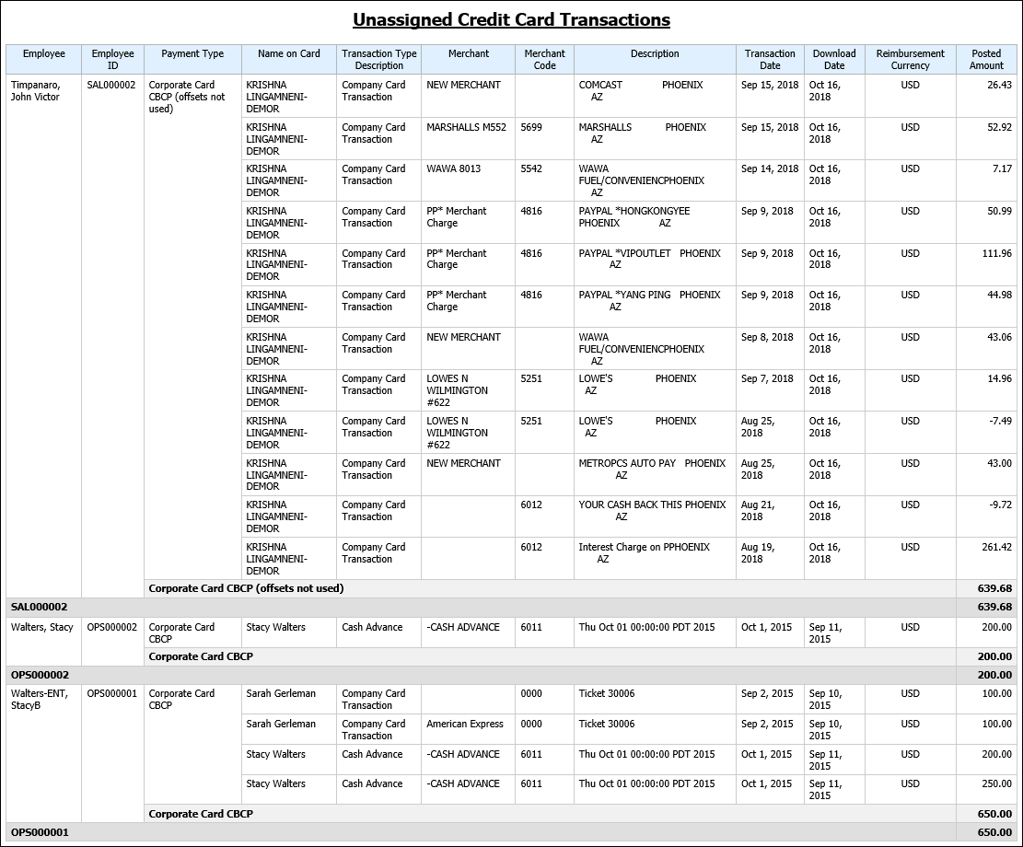

Report Header and Footer
Data Item Label/Name | Data Item Expression | Data Item Description
N/A | AsOfDate() | Displays the date the report was run
N/A | PageNumber() | Displays the page number of the corresponding page
N/A | AsOfTime() | Displays the time the report was run

Report Data Items
Data Item Label | Data Item Name | Data Item Expression | Data Item Description
Employee | <Employee> | [Expense].[Credit Card Accounts].[Employee] | Name of the employee to whom the card has been assigned  NOTE: Not all cards may be assigned to an employee.
Employee ID | <Employee ID> | [Expense].[Credit Card Accounts].[Employee ID] | Unique code or number that identifies the employee assigned to the card  NOTE: Not all cards may be assigned to an employee.
Payment Type | <Payment Type> | [Expense].[Credit Card Accounts].[Payment Type] | Type of card used for the transaction, for example, AMEX Corporate Card
Name on Card | <Name on Card> | [Expense].[Credit Card Accounts].[Name on Card] | Name on the corporate card, as supplied by the credit card vendor
Transaction Type Description | <Transaction Type Description> | [Expense].[Credit Card Transactions].[Transaction Type Name] | Name of the transaction type:  - Charge  - Payment  - Cash Advance  - Credit
Merchant | <Merchant> | [Expense].[Credit Card Transactions].[Merchant] | Name of the merchant, or vendor, with whom the transaction was conducted
Merchant Code | <Merchant Code> | [Expense].[Credit Card Transactions].[Merchant Code] | Code that identifies the merchant
Description | <Description> | [Expense].[Credit Card Transactions].[Description] | Further description of the transaction
Transaction Date | <Transaction Date> | [Expense].[Credit Card Transactions].[Transaction Date] | Date the transaction was incurred
Download Date | <Download Date> | [Expense].[Credit Card Transactions].[Download Date] | Date the transaction was imported into Concur Expense
Reimbursement Currency | <Reimbursement Currency> | [Expense].[Credit Card Transactions].[Reimbursement Currency] | Currency in which the employee was reimbursed
Posted Amount | <Posted Amount> | CASE  WHEN [Expense].[Credit Card Accounts].[Employee Key] = -1  THEN [Expense].[Credit Card Transactions].[Posted Amount (credit card currency)]  ELSE [Expense].[Credit Card Transactions].[Posted Amount (reimbursement currency)]  END | Transaction amount converted, as needed, from the transaction currency to the credit card's currency or from the transaction currency to the currency in which the employee is reimbursed

☼

