
Standard Edition: Analytics Essentials and Analytics
Dashboards and Reports Catalog

Last Revised: March 18, 2021
Applies to these SAP Concur solutions:
S Expense
 Professional/Premium edition
 Integrated with Professional/Premium Travel
 Using TripLink
S Standard edition
 Integrated with Standard Travel
 Using TripLink

Table of Contents
Analytics Essentials and Analytics – Catalog 1
Section 1: Overview 1
Analytics Offerings 1
Two Guides 1
Data – Near Real Time 2
Permissions 2
Section 2: Dashboards – General Information 2
Essentials and Analytics 2
Types of Dashboards 3
Section 3: Persona Dashboard – Expense Overview Dashboard 4
Navigate to Expense Overview Dashboard 4
Expense Overview Dashboard – Default Tiles 5
Dashboard Tile: Spend 5
Dashboard Tile: Accruals 6
Dashboard Tile: Total Policy Exceptions 7
Dashboard Tile: Top 5 Spend by Category 8
Dashboard Tile: Top 5 Entry Exceptions by Category 10
Dashboard Tile: Top 10 Spenders 11
Dashboard Tile: Top 10 Users by Exception Count 12
Section 4: Persona Dashboard – Invoice Overview Dashboard 13
Navigate to Invoice Overview Dashboard 13
Invoice Overview Dashboard – Default Tiles 14
Dashboard Tile: Invoice Spend 14
Dashboard Tile: Invoice Accruals 15
Dashboard Tile: Top 5 Invoice Spend by Category 15
Dashboard Tile: Top 5 Invoice Spend by Expense Types 17
Dashboard Tile: Top 5 Invoice Spend by Vendors 18
Section 5: Persona Dashboard – Travel Overview Dashboard 19
Navigate to Travel Overview Dashboard 20
Travel Overview Dashboard – Default Tiles 20
Dashboard Tile: Expensed Travel 21
Dashboard Tile: Booked Travel 21
Dashboard Tile: Future Booked Travel 21
Dashboard Tile: Travel Accruals 22
Section 6: Persona Dashboard – Financial Administrator Overview 23
Navigate to Financial Administrator Dashboard 23
Financial Administrator Dashboard – Default Tiles 24
Section 7: Additional Persona Dashboard Tiles (Analytics Only) 24
Available Dashboard Tiles 24
Dashboard Tile: Accruals by Employee 24
Dashboard Tile: Executive Briefing - Total Reports Created 26
Dashboard Tile: Payment Methods 27
Dashboard Tile: Policy Exceptions by Approver or Employee 29
Dashboard Tile: Spend by Employee or Vendor 30
Dashboard Tile: Spend Change by Category 32
Dashboard Tile: Spend Summary Trends 33
Dashboard Tile: Top 5 Spend by Expense 34
Dashboard Tile: Top 5 Spend by Vendor 36
Section 8: Functional Dashboard – Spend Analysis 37
Navigate to Spend Analysis Dashboard 37
Dynamic Data 38
Section 9: Reports 39
Essentials and Analytics 39
View a Report 39
Reports – Descriptions 41
Report: Allocation Details 41
Report: Attendee Details 42
Report: Billed Transaction Reconciliation - Details 43
Report: Credit Card Transactions 45
Report: Employee Details 46
Report: Employee Roles 47
Report: Expense Accrual 48
Report: Expense Entry Analysis Details 49
Report: Expense Exception Analysis - Report Entry Level 50
Report: Expense Exception Analysis - Report Level 52
Report: Expense Report Totals 53
Report: Invoice Accrual 54
Report: Invoice Aging 56
Report: Travel Booking Details 57
Report: Unassigned Credit Card Transactions 58

Revision History
 | Notes/Comments/Changes
January 21, 2022 | Updated the copyright year; no other changes; cover date not updated
March 18, 2021 | Updated the Employee Roles report information
March 31, 2020 | Added information about the new Executive Briefing: Total Reports Created tile
January 31, 2020 | Modifications throughout  Removed the following Hipmunk dashboard and reports:  - Hipmunk Travel Overview Dashboard  - Hipmunk Offered Savings Report  - Hipmunk Search Usage Report
December 20, 2019 | Added the following tiles:  - Top 5 Spend by Vendor tile  - Spend by Employee or Vendor tile
November 1, 2019 | Added information about:  - Top 5 Spend by Expense Tile  The following tiles and report are no longer supported:  - Hipmunk Offered Savings Details report  - Hipmunk Offered Savings tile  Hipmunk Offered Savings Trend tile
September 17, 2019 | Modifications throughout
June 25, 2019 | Added the information about the following:  - Hipmunk Travel Overview Dashboard  - Dashboard Tile: Hipmunk Utilization
June 5, 2019 | Added the following two new Hipmunk Dashboard tiles:  - Hipmunk Offering Savings Trend  - Hipmunk Registrations
May 2, 2019 | Added the information about the following:  - Hipmunk Offered Savings Dashboard Tile  - Hipmunk Offered Savings Details Report  - Hipmunk Search Usage Details Report
April 3, 2019 | Modifications throughout
March 28, 2019 | Added the Attendee Details report information
March 5, 2019 | Updated the Future Booked Travel tile information
January 25, 2019 | Updated the Travel Booking Details report information
December 13, 2018 | Added information about the new Quarter to Date option
December 3, 2018 | Existing user guide split into:  - Standard Edition: Analytics Essentials and Analytics User Guide  - Standard Edition: Analytics Essentials and Analytics Dashboards and Reports Catalog
November 15, 2018 | Modifications throughout
November 13, 2018 | Modifications throughout
November 9, 2018 | Added information about:  - Travel Dashboard  - Travel Booking Details Report
October 25, 2018 | Modifications throughout  Added information about:  - Analytics help documentation
September 20, 2018 | Added information about:  - Invoice dashboard  - Allocations Details report
September 6, 2018 | Added the Reports – Personalized Standard Reports (Analytics Essentials Only) section
August 21, 2018 | Modifications throughout
July 20, 2018 | Modifications throughout
July 17, 2018 | Modifications throughout  Added information about:  - Dashboard/Report sharing  - Invoice Aging report
May 1, 2018 | Modifications throughout
January 22, 2018 | Removed the DRAFT watermark; changed the copyright; no content changes; no change to the rev date on the cover
November 27, 2017 | Initial publication

Analytics Essentials and Analytics – Catalog
NOTE: Multiple SAP Concur product versions and UI themes are available, so this content might contain images or procedures that do not precisely match your implementation. For example, when SAP Fiori UI themes are implemented, home page navigation is consolidated under the SAP Concur Home menu.

Overview

Analytics Offerings
Analytics Essentials is a no-cost reporting option that is available to clients using SAP Concur's Standard Edition if they have not already purchased SAP Concur's Intelligence product. Essentials users can:
- View all standard dashboards and reports
- Use selected Actionable Analytics notifications/alerts
Analytics is a purchased product that is available to clients using SAP Concur's Standard Edition if they have not already purchased SAP Concur's Intelligence product. Analytics users can:
- View all standard dashboards as well as create custom dashboards
- View all standard reports as well as create and schedule custom reports
- Share custom dashboards and reports with the rest of the company
- Use all Actionable Analytics notifications/alerts
The features described in the guide apply to both Essentials and Analytics users unless otherwise noted.

Two Guides
There are two guides available for Analytics Essentials and Analytics:
- Analytics Essentials and Analytics Dashboards and Reports Catalog: This guide provides samples of all of the dashboards and reports.
- Analytics Essentials and Analytics User Guide: This guide provides information about permissions; locating, customizing, filtering, searching, saving, scheduling, etc. the dashboards/reports; and Actionable Analytics.
Click in the upper-right corner of the page to access the guides and release notes.
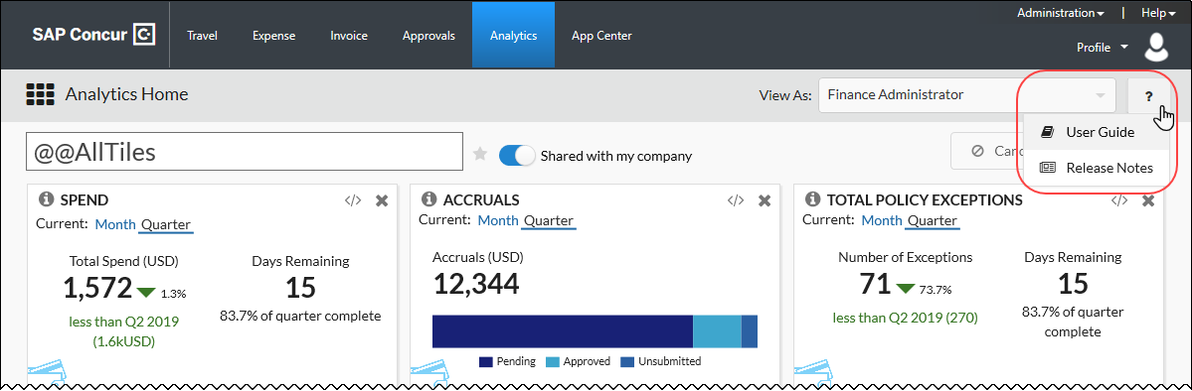

Data – Near Real Time
The data for the dashboards and reports is refreshed near real-time. Approximately every 15 minutes, data is collected from the transactional database and then the dashboards and reports are updated.

Permissions
- Refer to the Analytics Essentials and Analytics User Guide for information about the required permissions.

Dashboards – General Information

Essentials and Analytics
Essentials users can view all standard dashboards.
Analytics users can view all standard dashboards and create custom dashboards.
- Refer to the Analytics Essentials and Analytics User Guide for information about customizing dashboards, searching, and icons.

Types of Dashboards
The dashboards provide a graphic view of spend, accruals, exceptions, etc.
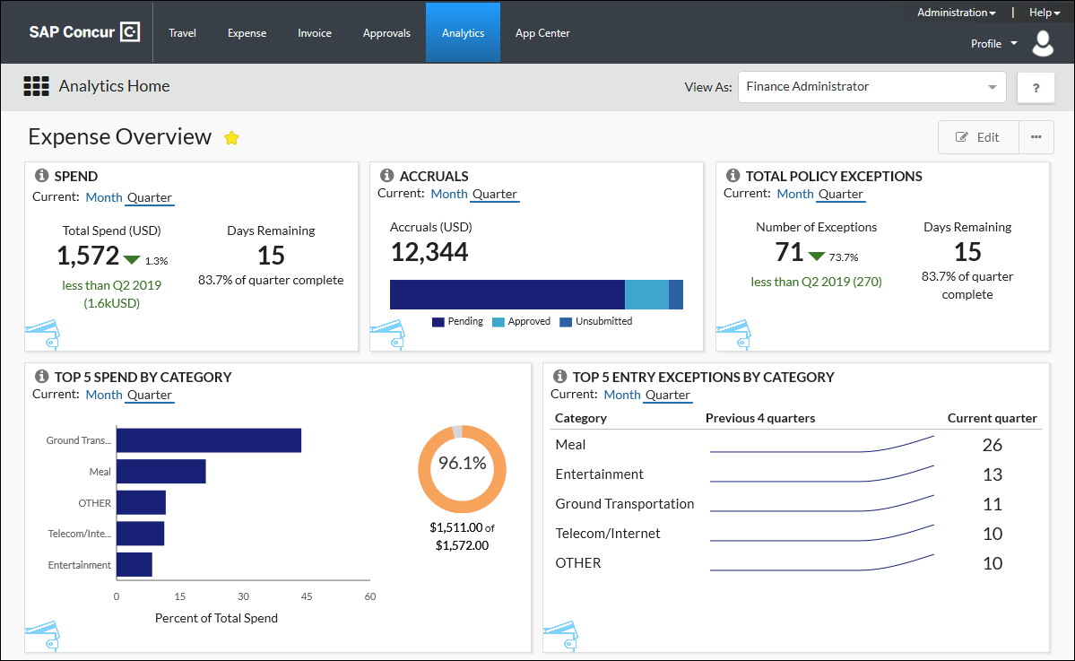
There are two types of dashboards:
- Persona: A "persona" dashboard is a set of graphic tiles that are designed for specific people in the company – like Department Managers or the company's Financial Administrator – so they can track the data that best applies to them.
- Functional: A "functional" dashboard focuses on specific data (like spend), includes a report tile, and is dynamic. When the report tile on the dashboard is modified (filtered), the associated graphic tiles reflect the modifications.
There are several dashboards:
Dashboard | Type | Description
Expense Overview | Persona | This dashboard is designed for the Department Manager to be able to track their department expenditures.
Invoice Overview | Persona | This dashboard is designed for the Department Manager to be able to track their department invoices.
Financial Administrator Overview | Persona | This dashboard is designed for the company's Financial Administrator to be able to track the company's expenditures.
Spend Analysis | Functional | This dashboard has several related graphic tiles. Changing filtering options affects all tiles.
Details about the dashboards are provided on the following pages.

Persona Dashboard – Expense Overview Dashboard
This dashboard provides a graphic view of Expense spend, Expense accruals, etc.

Navigate to Expense Overview Dashboard
To navigate to the Expense Overview dashboard - in the main menu - the user can click All or Expense to access the dashboard.
This dashboard is only visible if the user's company has Expense enabled.
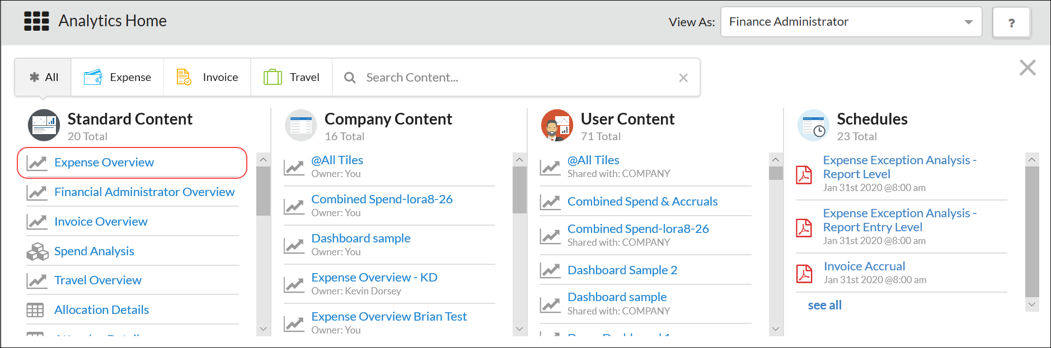

Expense Overview Dashboard – Default Tiles
The tiles described below appear by default on the Expense Overview dashboard. These default tiles can be viewed by all Essential users and viewed and edited by all Analytics users.
- Refer to the Analytics Essentials and Analytics User Guide for information about customizing dashboards.

Dashboard Tile: Spend
This tile shows the total spend incurred so far for the current selected period (month or quarter) and compares it to the spend in the last comparable period. The total spend includes only paid transactions. Accruals and unsubmitted transactions are not included.
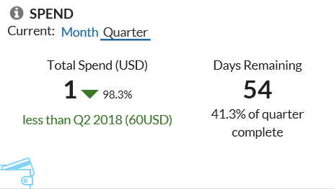
The Total Spend section shows the percentage and the total of change (amount) from the current period to the previous period. Total spend increases when expense reports are processed for payment.
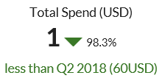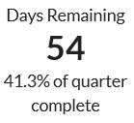
Color indicators:
- Green text indicates that spend in the current period is less than the previous period.
- Red text indicates that spend in the current period is greater than the previous period.
The Days Remaining section displays the number of days remaining in the current period and the percentage of the remaining current period.

Dashboard Tile: Accruals
This tile shows outstanding accruals, including:
- Total amount of unpaid expense reports
- Total amount and number of unsubmitted card transactions
The tile shows the amount of accruals (by month or quarter) in each of the accrual statuses. The percentage per status is calculated based on the total accrual amount.
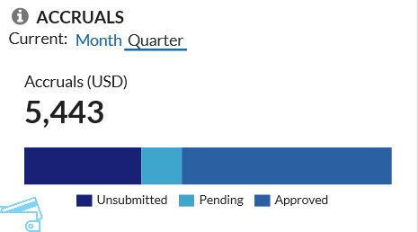
When expense reports are processed for payment, this number will decrease as accrued dollars are transferred from "accruals" to "spend."
The accruals total breakdown includes:
- Unsubmitted: When a user saves an expense report without submitting the expense report, the amount is classified as unsubmitted.
- Pending: When a user submits an expense report, the expense report amount is classified as pending.
- Approved: When a user submits an expense report for approval and it is approved by the approver, the approved amount is classified as approved.
The tooltip shows the total spend and the total number of transactions in each status.
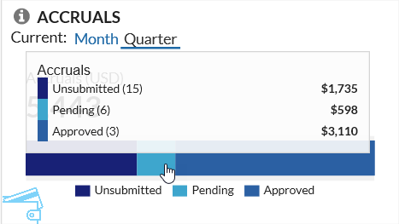

Dashboard Tile: Total Policy Exceptions
This tile shows the total number of policy exceptions (entry-level and report-level combined; by month or quarter) on expense reports submitted by employees. This includes submitted expenses reports that have been returned to an employee by the approver.
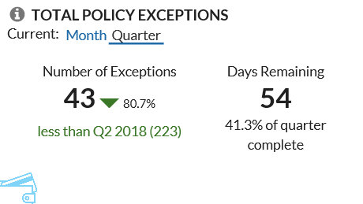
The count in the Number of Exceptions section increases when expense reports are submitted, with any entry-level and report-level policy exceptions.
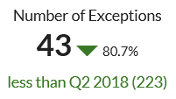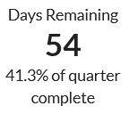
Color indicators:
- Green text indicates that the number of exceptions in the current period is less than the previous period.
- Red text indicates that the number of exceptions in the current period is greater than the previous period.
The Days Remaining section displays the number of days remaining in the current period and the percentage of the remaining current period.

Dashboard Tile: Top 5 Spend by Category
This tile shows the top 5 spend categories by percentage (by month or quarter) and provides additional details about each category.
This metric assists customers with understanding compliance and overall employee satisfaction with the expense policy.
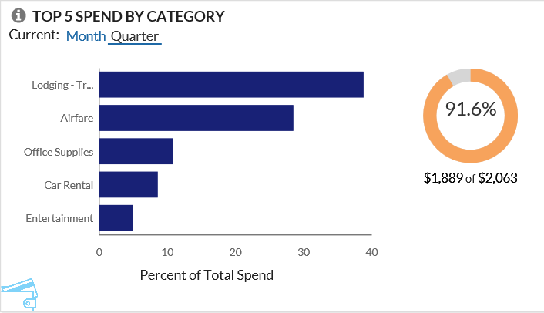
Each bar (category) has a tooltip. This tooltip shows the total spend for each category and the percentage of the total spend it represents by the selected period.
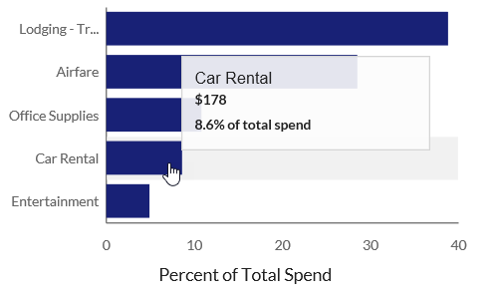
On the right side of the page is a graphic that shows how much these categories represent – as a percentage – of total spend.
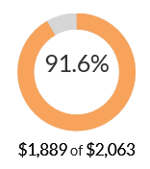

Dashboard Tile: Top 5 Entry Exceptions by Category
This tile shows the changes in policy exception compliance over the past 10 (completed) months or 4 (completed) quarters for all exceptions and the top 5 spend categories. In addition, it also shows the top 5 spend categories by exceptions over the last 12 months.
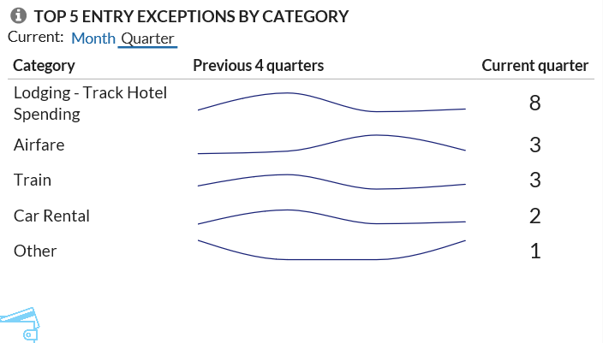
The Category section shows the top 5 categories for the selected period.
The trend lines in Previous 4 quarters or Previous 10 months section shows the previous – not the current – month or quarter.
Each bar (category) has a tooltip. This tooltip shows the total exceptions.
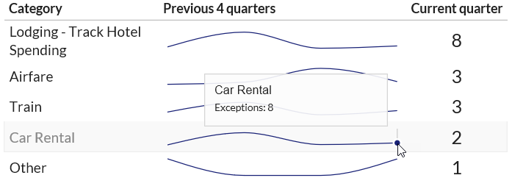
The Current Quarter/Month section shows the total exception count for the current month or quarter.

Dashboard Tile: Top 10 Spenders
This tile shows the ten employees with the highest transaction amounts.
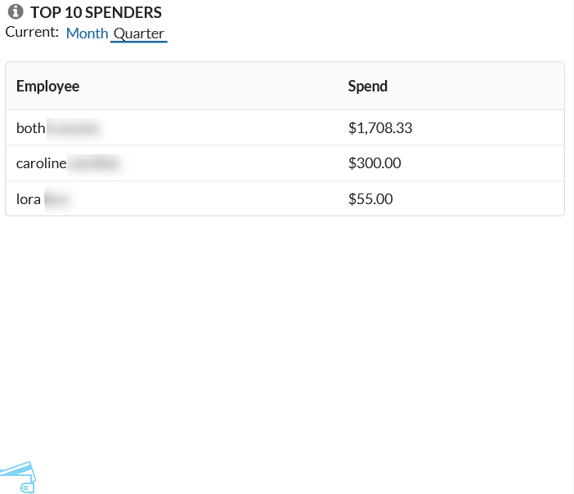

Dashboard Tile: Top 10 Users by Exception Count
This tile shows the ten employees with the highest number of audit rule exceptions.
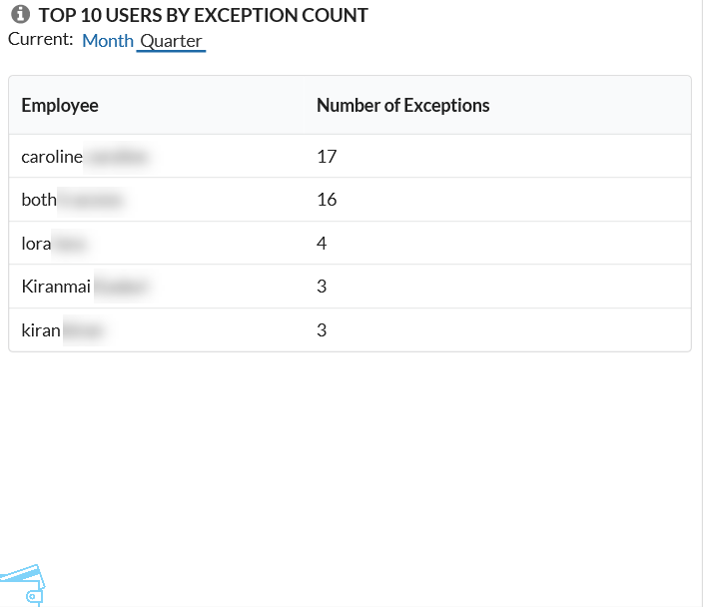

Persona Dashboard – Invoice Overview Dashboard
This dashboard provides a graphic view of Invoice spend, Invoice accruals, etc.
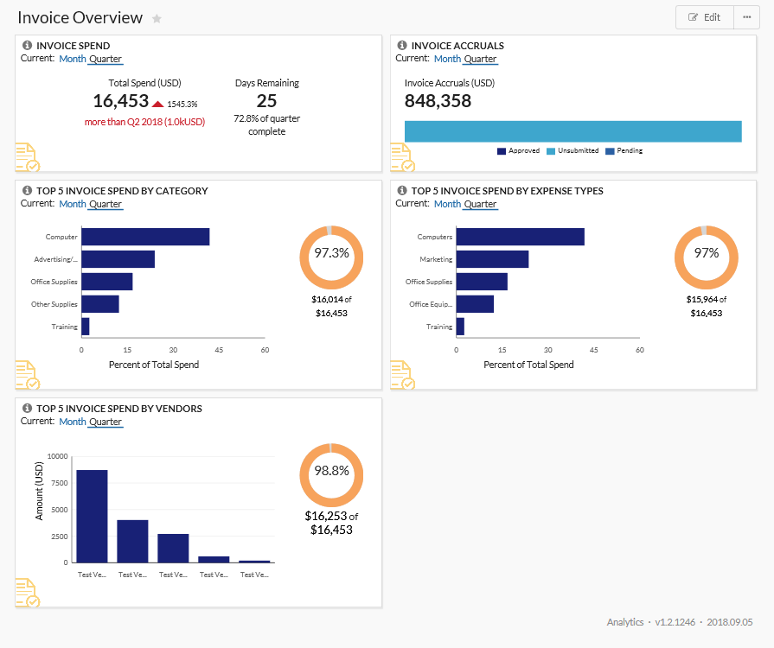

Navigate to Invoice Overview Dashboard
To navigate to the Invoice Overview dashboard - in the main menu - the user can click All or Invoice to access the dashboard.
This dashboard is only visible if the user's company has Invoice enabled.
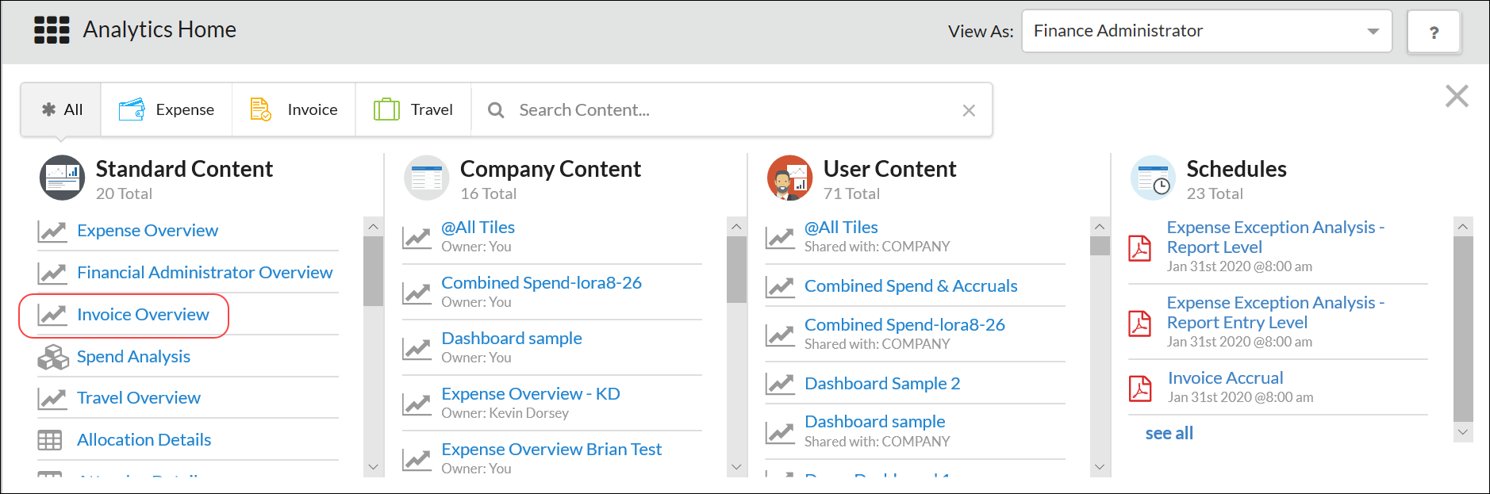

Invoice Overview Dashboard – Default Tiles
The tiles described below appear by default on the Standard Invoice dashboard. These default tiles can be viewed by all Essential users and viewed and edited by all Analytics users.
- Refer to the Analytics Essentials and Analytics User Guide for information about customizing dashboards.

Dashboard Tile: Invoice Spend
This tile shows total invoice spend incurred so far for this period compared to the spend at this point in the last comparable period.
Spend includes invoices that have been paid. Accruals and unsubmitted invoices are not included.
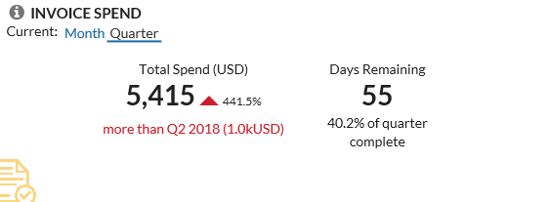

Dashboard Tile: Invoice Accruals
This tile shows the accrual amounts, which include all unsubmitted invoices as well as invoices that have not yet been paid.
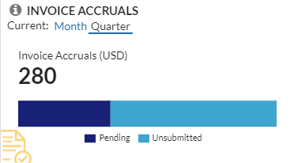
This tooltip shows the number of invoices that have not yet been paid, as well as the total amount of the invoices within that category.
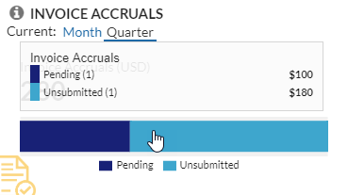

Dashboard Tile: Top 5 Invoice Spend by Category
This tile shows the top five invoice categories by total spend for the selected period (month, quarter).
Spend includes invoices that have been paid. Accruals and unsubmitted invoices are not included.
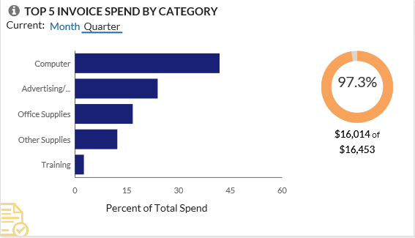
This tooltip shows the total spend for each category and the percentage of the total spend it represents by the selected period.
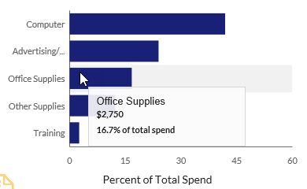
This graphic shows how much these categories represent – as a percentage – of total spend.
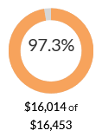

Dashboard Tile: Top 5 Invoice Spend by Expense Types
This tile shows the top five invoice expense types by total spend for the selected period (month, quarter).
Spend includes invoices that have been paid. Accruals and unsubmitted invoices are not included.
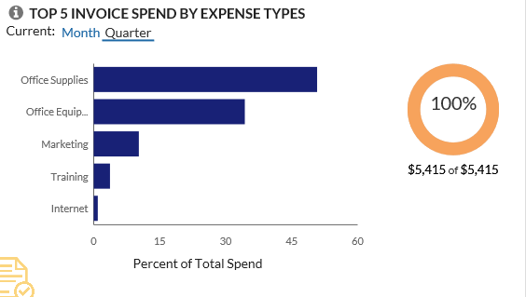
This tooltip shows the amount of invoice spend spent and the percentage of invoice total spend by expense type.
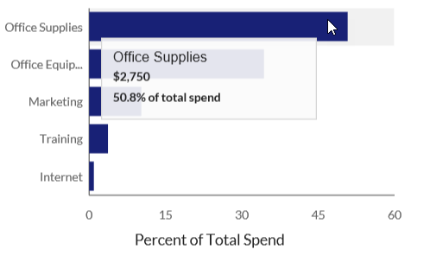
On the right side of the page is a graphic that shows how much these expense types represent – as a percentage – of total spend.
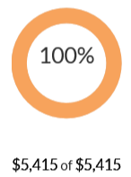

Dashboard Tile: Top 5 Invoice Spend by Vendors
This tile shows the top five invoice vendors by total spend for the selected period (month, quarter).
Spend includes invoices that have been paid. Accruals and unsubmitted invoices are not included.
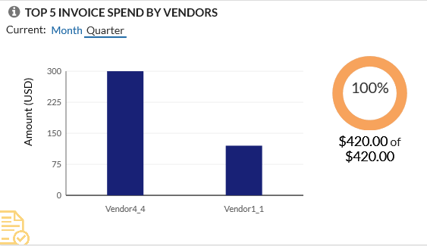
This tooltip shows the total amount of invoice spend and number of invoices by vendor.
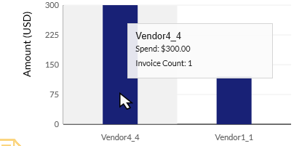
On the right side of the page is a graphic that shows how much these vendors represent – as a percentage – of total spend.
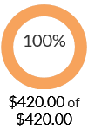

Persona Dashboard – Travel Overview Dashboard
This dashboard provides a graphic view of Travel spend, Travel accruals, etc.
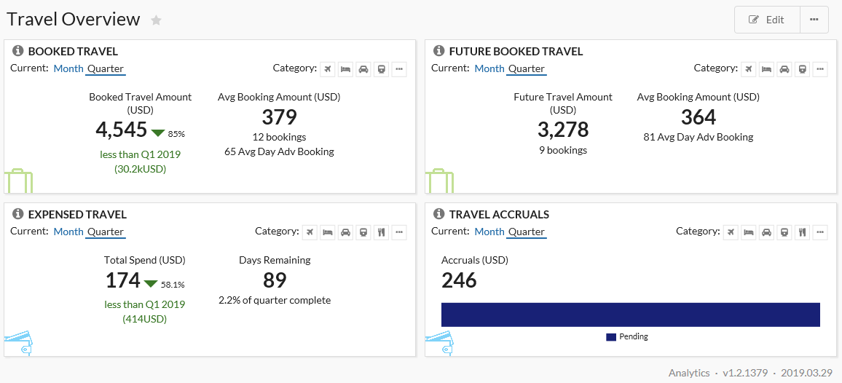

Navigate to Travel Overview Dashboard
To navigate to the Travel Overview dashboard - in the main menu - the user can click All or Travel to access the dashboard.
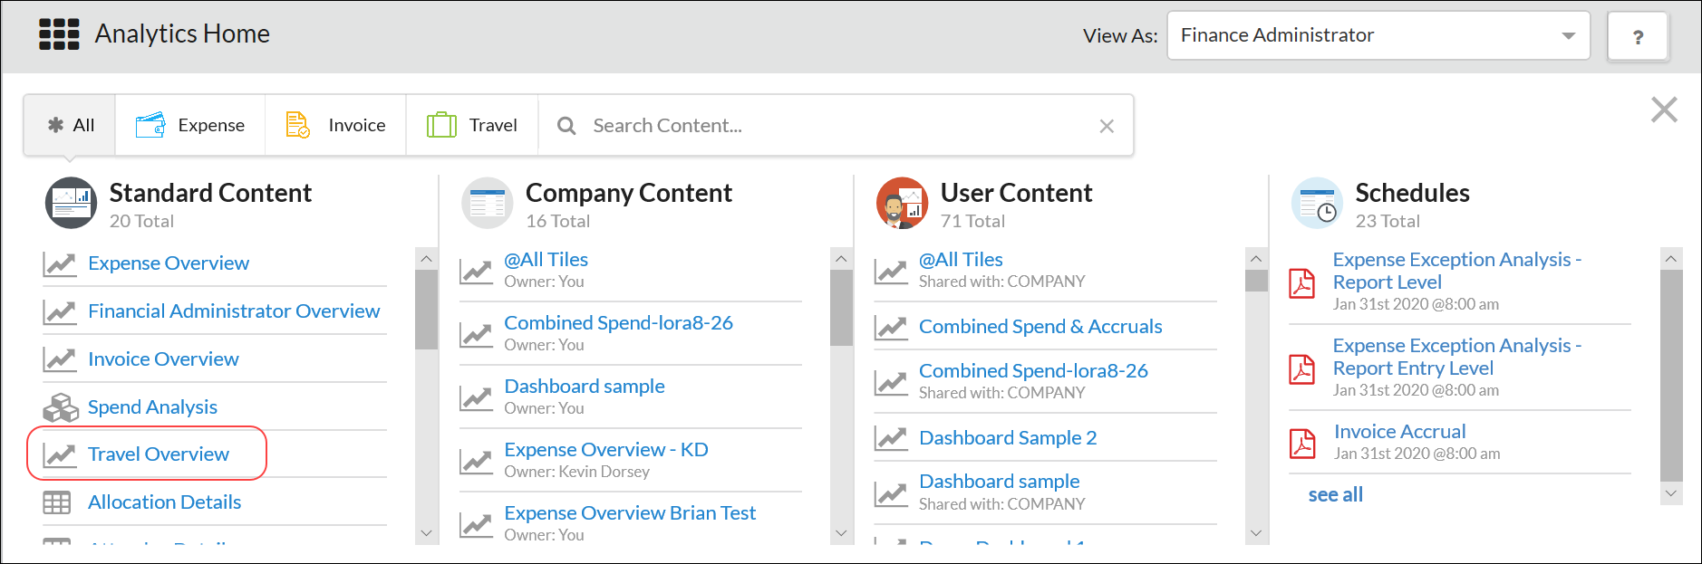
This dashboard is only visible if the user's company has Travel enabled.

Travel Overview Dashboard – Default Tiles
The tiles described below appear by default on the Travel Overview dashboard. These default tiles can be viewed by all Essential users and viewed and edited by all Analytics users.
- Refer to the Analytics Essentials and Analytics User Guide for information about customizing dashboards.

Dashboard Tile: Expensed Travel
This tile shows total expensed travel spend incurred so far for this period compared to the travel spend at this point in the last comparable period.
Spend includes travel expenses that have been paid. Accruals and unsubmitted travel expenses are not included.
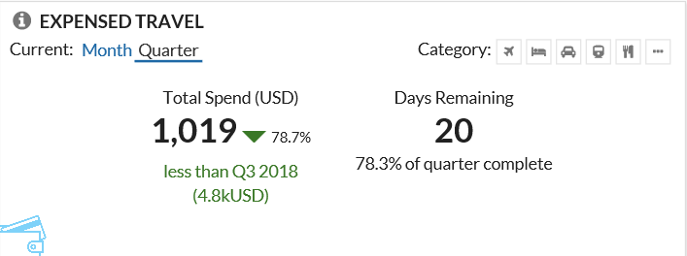
By default, the total spend shown on this tile represents all categories.

Dashboard Tile: Booked Travel
This tile shows booked travel by travel-related categories and selected period (month, quarter).
It also shows the average booking amount, number of bookings, and the average days advance booking for the selected period (month, quarter).
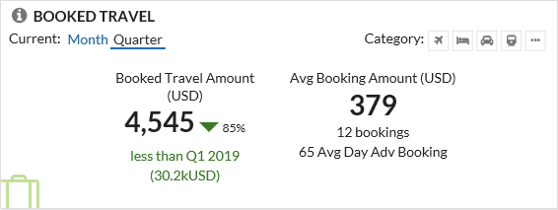

Dashboard Tile: Future Booked Travel
This tile shows future booked travel by travel-related categories and selected period (month, quarter).
It also shows the average booking amount, number of bookings, and the average days advance booking for the selected period (month, quarter).
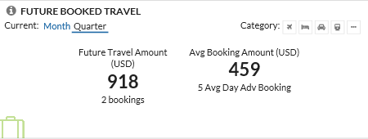
By default, the future booked travel shown on this tile represents all categories.

Dashboard Tile: Travel Accruals
This tile shows the total amount outstanding as accruals in travel-related categories for the selected period (month, quarter).
Accrual amounts include all unsubmitted card transactions as well as expense reports that have not yet been paid.
Travel tiles use the travel date in order to correspond with supplier reporting.
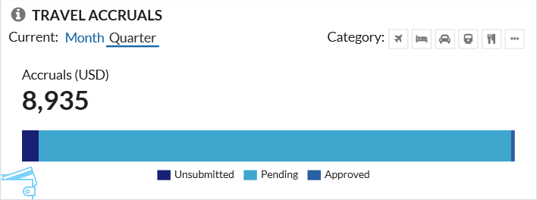
By default, the accrual amounts shown on this tile represents all categories.

Persona Dashboard – Financial Administrator Overview
This dashboard is designed for the company's Financial Administrator to be able to track the company's expenditures.
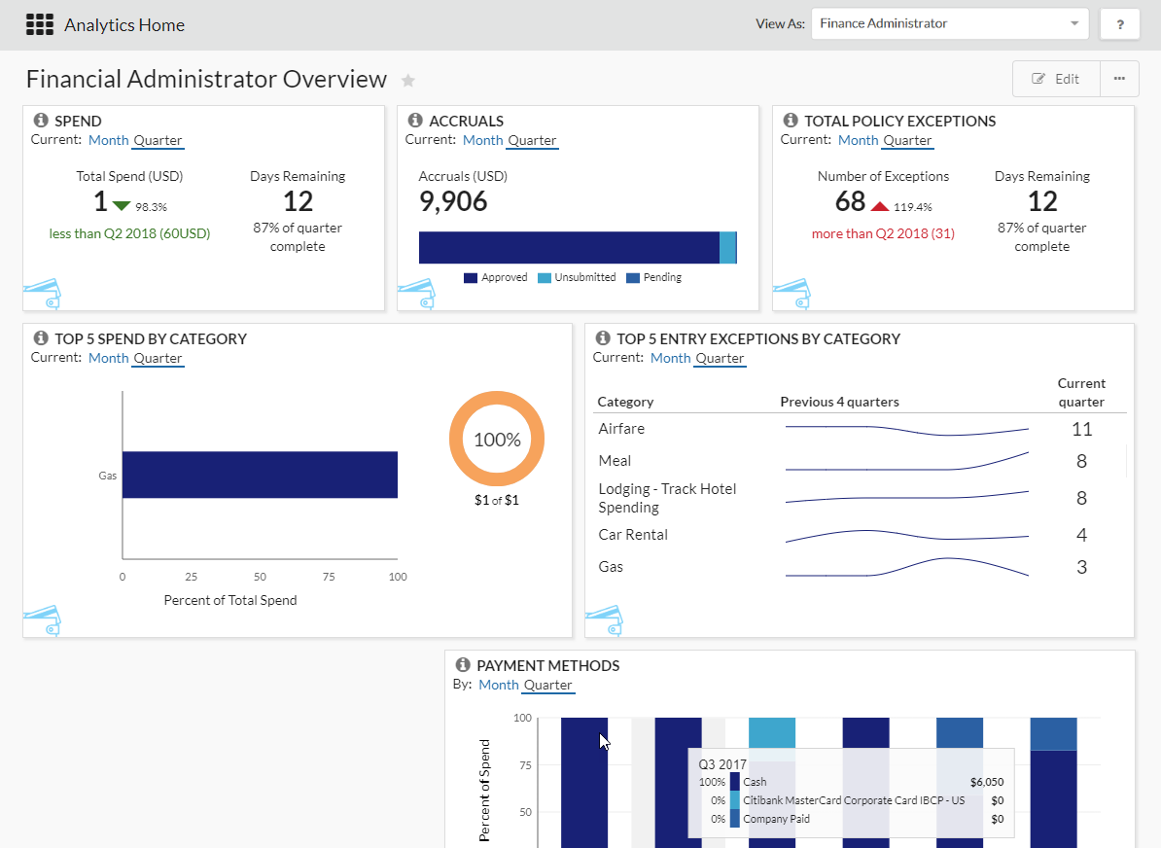

Navigate to Financial Administrator Dashboard
To navigate to the Financial Administrator Overview dashboard - in the main menu - the user can click All or Expense, to access the dashboard.
This dashboard is only visible to users who are provided the Financial Administrator permission, as described in the Permissions section of this guide.
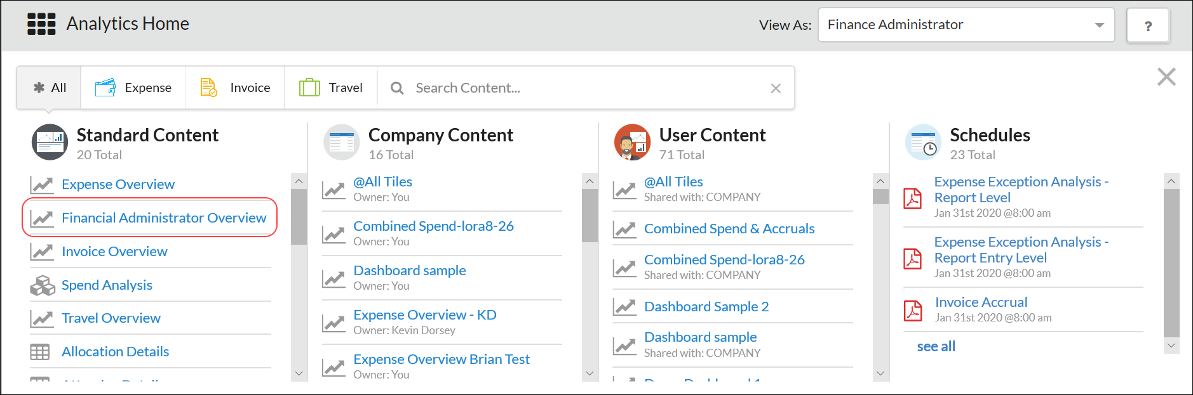

Financial Administrator Dashboard – Default Tiles
The default tiles are:
- Spend
- Accruals
- Total Policy Exceptions
- Top 5 Spend by Category
- Top 5 Entry Exceptions by Category
- Payment Methods
- For descriptions, refer to the Expense Overview Dashboard – Default Tiles section of this guide.

Additional Persona Dashboard Tiles (Analytics Only)
These dashboard tiles are not part of the default dashboards, but they can be added to a dashboard. The ability to add tiles to a dashboard is available only to Analytics users
- Refer to the Analytics Essentials and Analytics User Guide for information about customizing dashboards.

Available Dashboard Tiles

Dashboard Tile: Accruals by Employee
This tile shows up to 12 employees by total outstanding accrual amount by:
- Unsubmitted
- Pending manager approval
- Approved but not yet paid
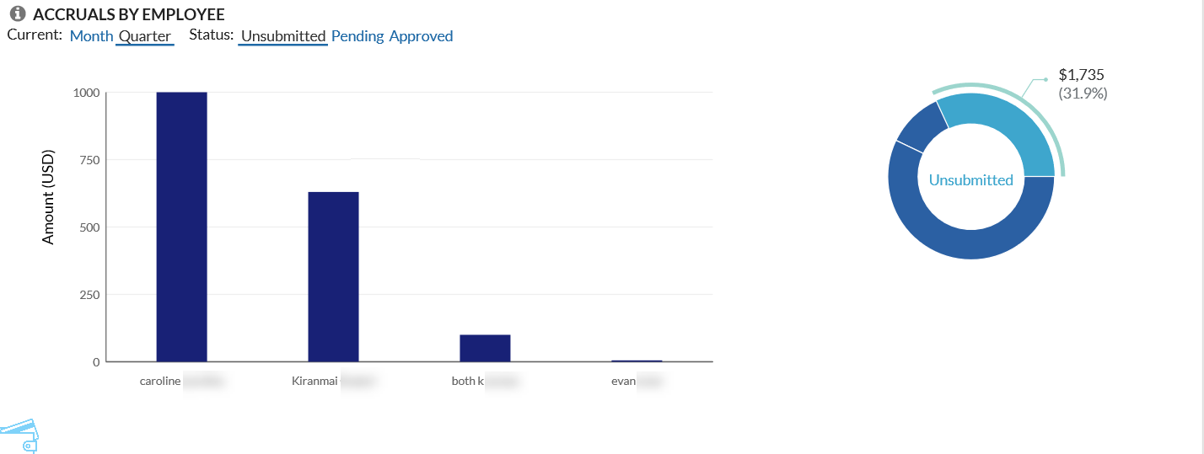
This tooltip shows the amount and number of transactions by employee.
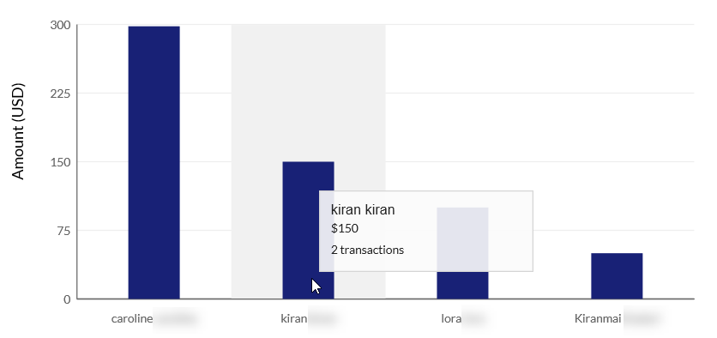
On the right side of the page is a graphic that shows how much these statuses represent – as a percentage – of total accruals.
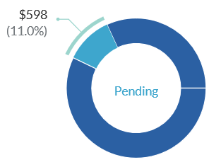

Dashboard Tile: Executive Briefing - Total Reports Created
This tile provides information about the total reports created for the selected period (month, quarter).
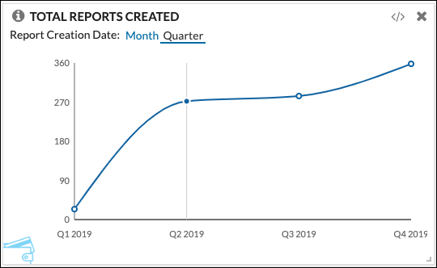
This tooltip shows the total report count for the period.
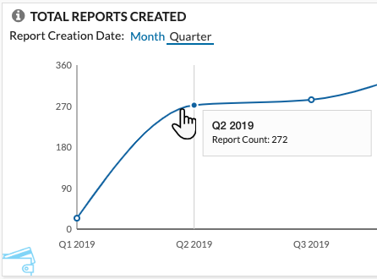
Reports created and then deleted are included in the count.

Dashboard Tile: Payment Methods
This tile shows spend totals grouped by payment type for the past 12 months or 6 quarters. This allows a company that wants to increase adoption of corporate card adoption to track usage.
Submitted transactions as well as paid and unpaid approved expenses are included on this tile. Rejected, unsubmitted, and non-card transactions are not included.
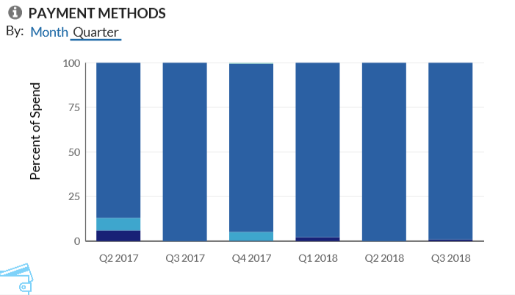
This tooltip shows the total spend by payment type within the selected period.
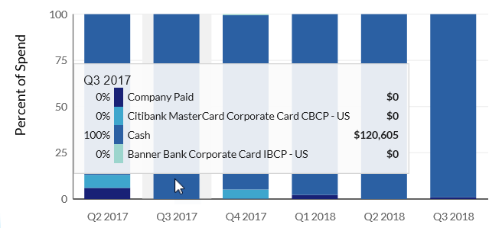

Dashboard Tile: Policy Exceptions by Approver or Employee
This tile shows the number of policy exceptions, grouped by approver or employee.
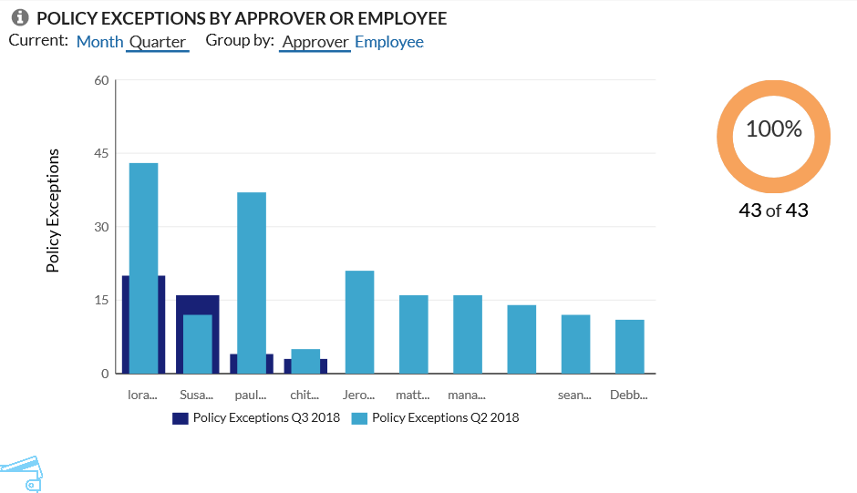
This tooltip shows the detail for each employee.
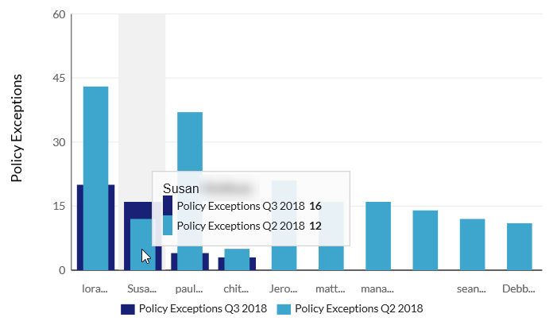
On the right side of the page is a graphic that shows how much these exceptions represent – as a percentage – of total spend.
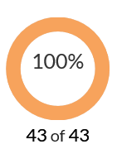

Dashboard Tile: Spend by Employee or Vendor
This tile allows users to view spend by Spend Category (For example: Air, Car, Lodging, Transportation, etc.) by Month or Quarter for a specific Employee or Vendor (Airline, Rental Car Agency, etc.)
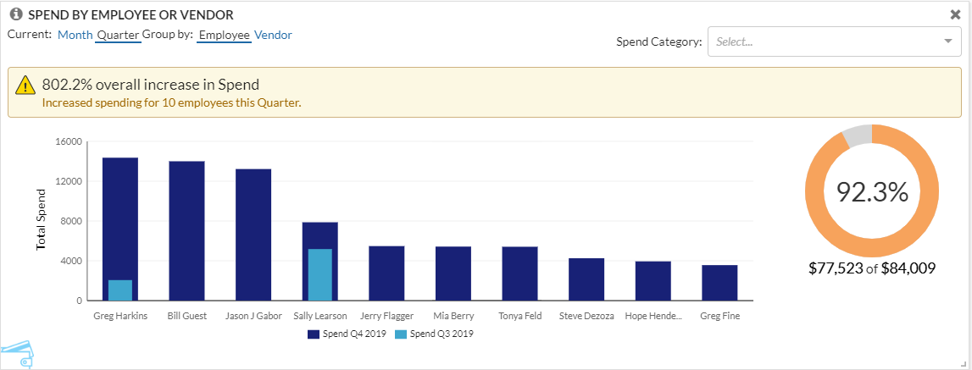
This tooltip shows spend by employee – for the Spend Category: All Categories - and the percent of total spend compared to the last period.
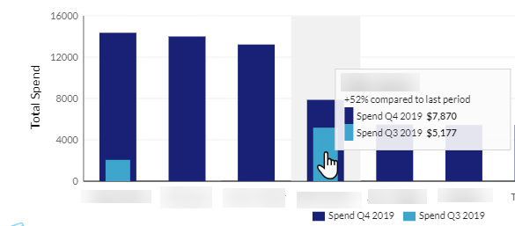
This tooltip shows spend by vendor – for the Spend Category: All Categories - and the percent of total spend compared to the last period.
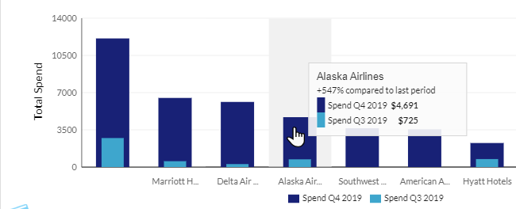
This graphic shows spend as a percentage of total spend.
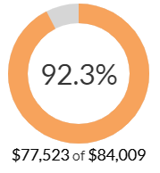
This notification appears when total spend – which is the actual spend plus accrual – for the current period exceeds a specified percentage of a company’s specified threshold for employees. (The example in the image below uses the calendar quarter for the current period.)
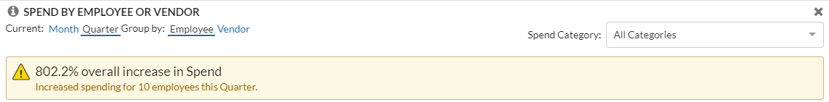
This notification appears when total spend – which is the actual spend plus accrual – for the current period exceeds a specified percentage of a company’s specified threshold for vendors. (The example in the image below uses the calendar quarter for the current period.)
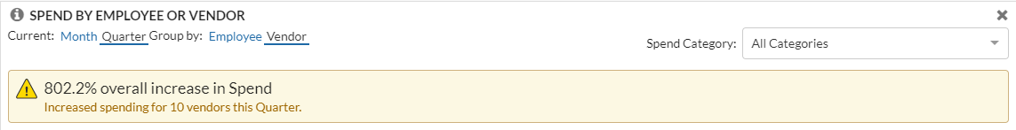

Dashboard Tile: Spend Change by Category
This tile shows the total spend incurred so far for this period by spend categories by:
- Top spend: Spend amount incurred for each category
- Most change: Spend amount change between current and previous periods
Total spend includes only paid transactions. Accruals and unsubmitted transactions are not included.
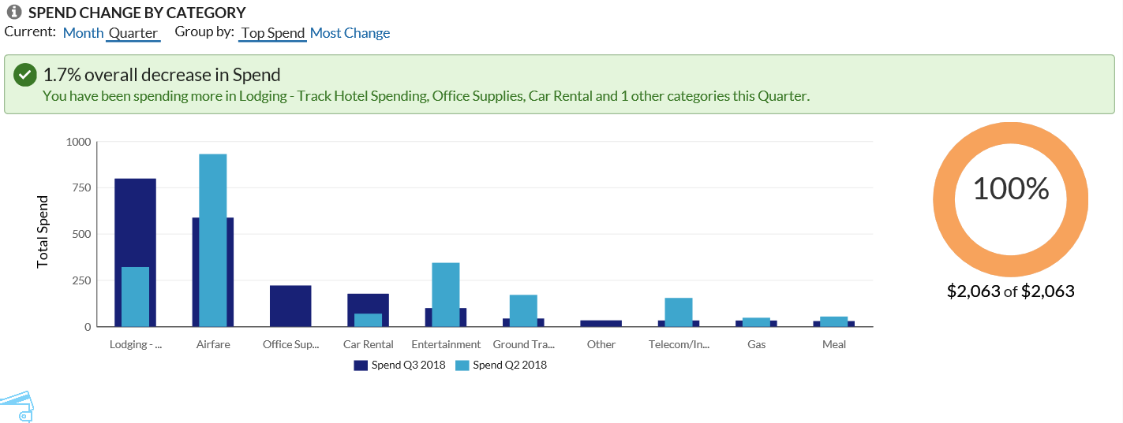
This tooltip shows the comparison of the amount for this quarter/month vs last quarter/month.
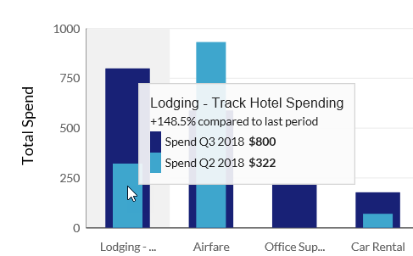
On the right side of the page is a graphic that shows how much these categories represent – as a percentage – of total spend.
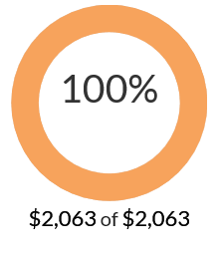

Dashboard Tile: Spend Summary Trends
This tile shows historic trends and changes in spend over the last 12 months or 6 quarters.
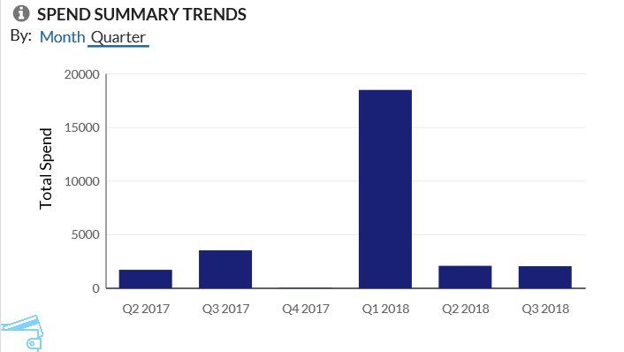
This tooltip shows the total spend for the selected period.
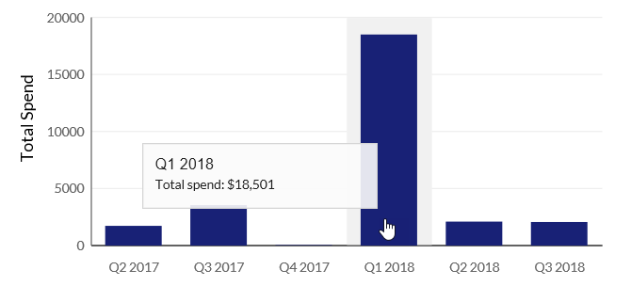

Dashboard Tile: Top 5 Spend by Expense
This tile shows the top five expense types by spend for the selected period (month, quarter).
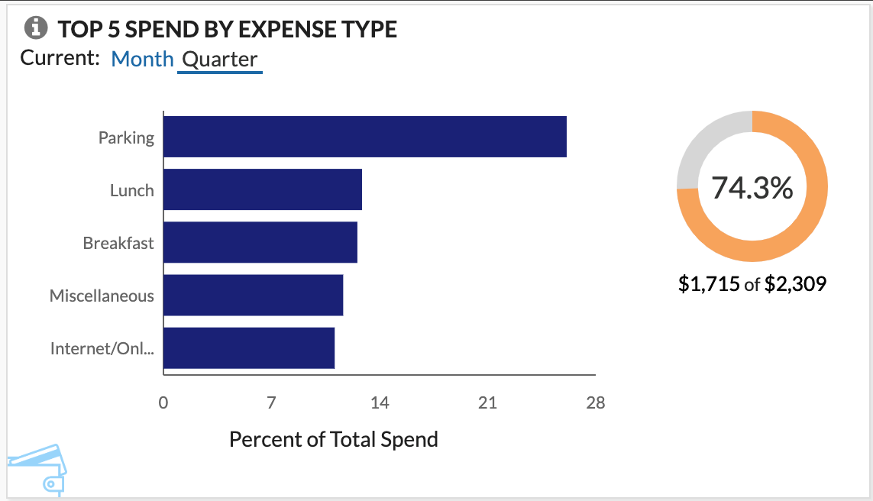
This tooltip shows spend for the expense type and the percent of total spend for the period.
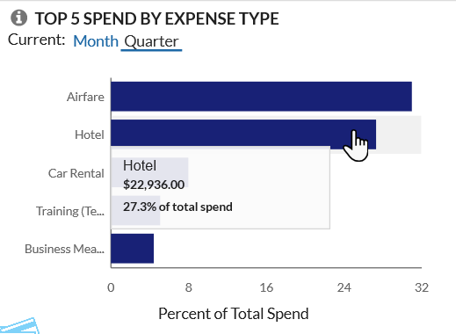
This graphic shows spend as a percentage of total spend.
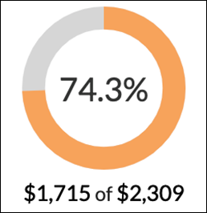

Dashboard Tile: Top 5 Spend by Vendor
This tile shows the top five spend by vendor for the selected period (month, quarter).
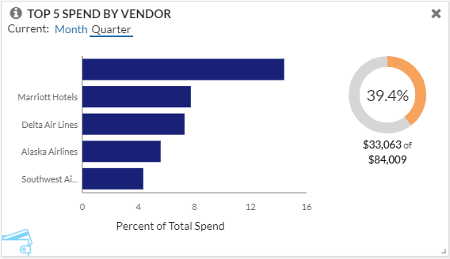
This tooltip shows spend by vendor and the percent of total spend for the period.
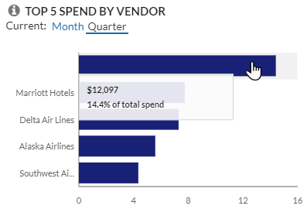
This graphic shows spend as a percentage of total spend.
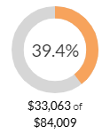

Functional Dashboard – Spend Analysis
A "functional" dashboard focuses on specific data (like spend), includes a report tile, and is dynamic. When the report tile on the dashboard is modified (filtered), the associated graphic tiles are updated to reflect the modifications.

Navigate to Spend Analysis Dashboard
To navigate to the Spend Analysis dashboard - in the main menu - the user can click All, Expense, or Invoice to access the dashboard.
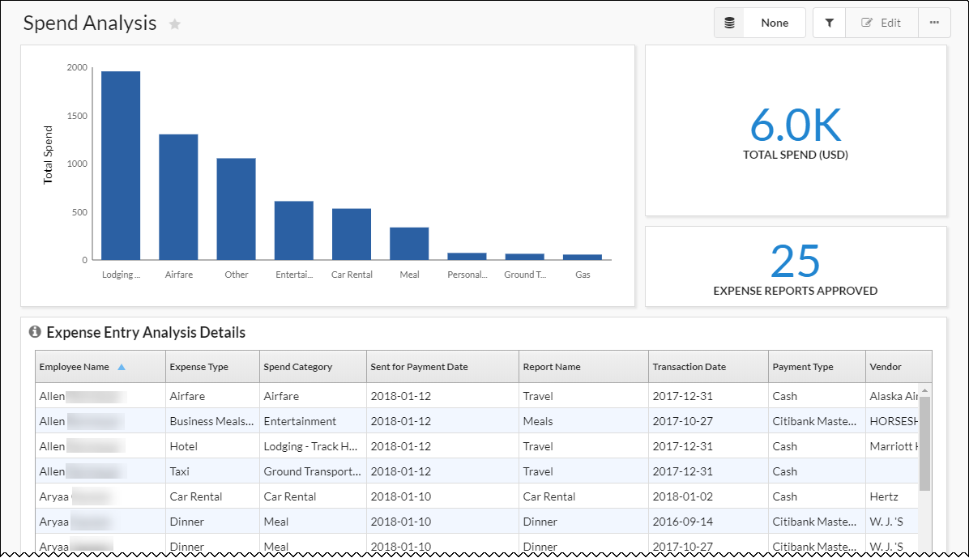
The four tiles on the Spend Analysis dashboard are:
- Spend Analysis - Summary
- Spend Analysis - Spend
- Spend Analysis - Expense Reports Approved
- Spend Analysis - Expense Entries (Expense Entry Analysis Details report)
This tooltip shows the detail for each expense type.
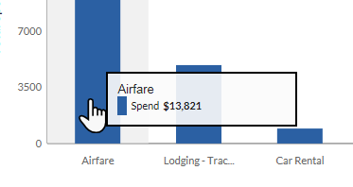
Note the following about the graphic tiles:
- They are available only on the Spend Analysis dashboard; they cannot be added to any other dashboard.
- They can be moved or resized but they cannot be added to or removed from the dashboard.
- They are dynamic; they change based on the filters used on the report tile.

Dynamic Data
For example, the dashboard below shows the spend data for all employees.
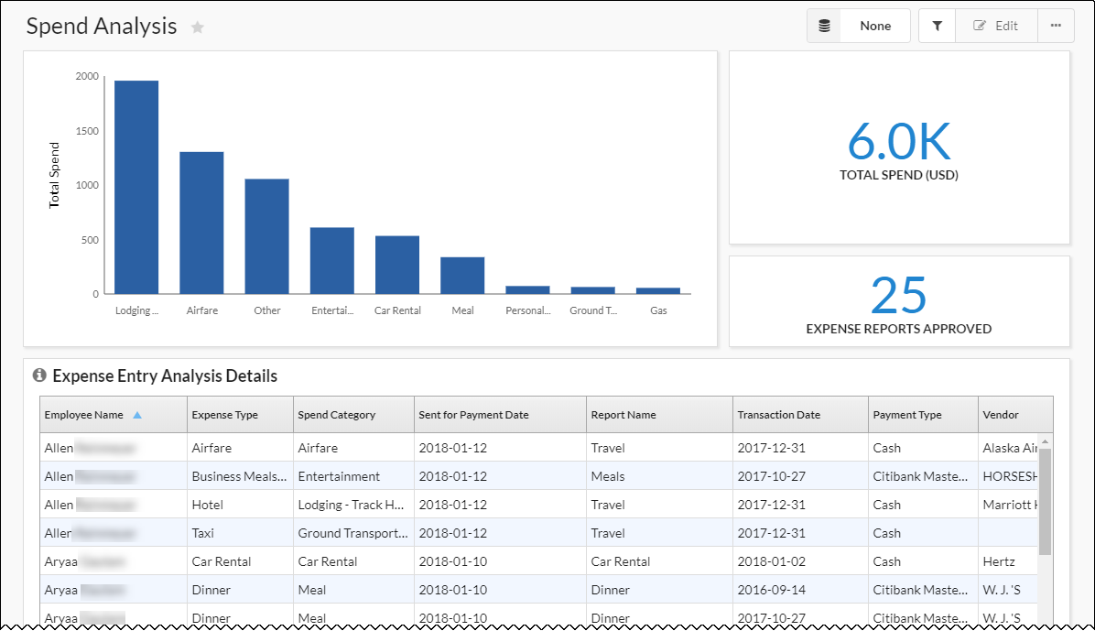
When the data in the report is filtered, the graphic tiles change accordingly. For example, in this case, the data is filtered to include only one employee.
- Refer to the Analytics Essentials and Analytics User Guide for information about customizing dashboards.
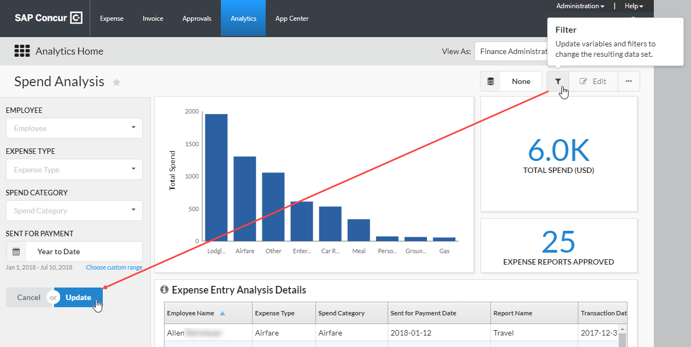
When you click Update, the tiles change accordingly, reflecting the filtered data.

Reports

Essentials and Analytics
Essentials users can view, filter, group, export, and sort all standard reports.
Only Analysis users can view, filter, group, export, share, and sort all standard reports as well as author (customize) and schedule reports.
- Refer to the Analytics Essentials and Analytics User Guide for information about customizing, exporting, scheduling, etc. reports.

View a Report
To view a report:
- Click the menu 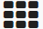 icon in the upper-left corner of the page. The menu slides down.
On the menu, the Standard Content option appears for all users. The remaining options appear only for Analytics users.
Analytics view:
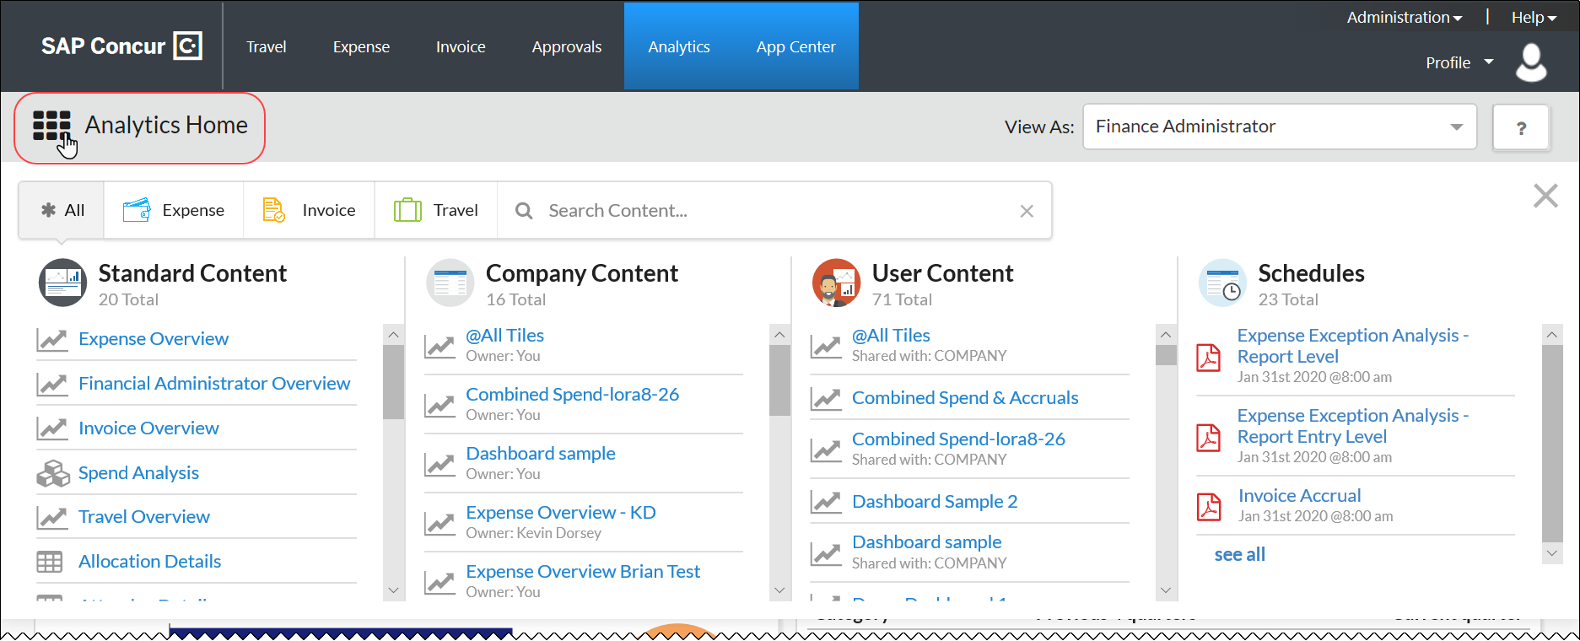
Essentials view:
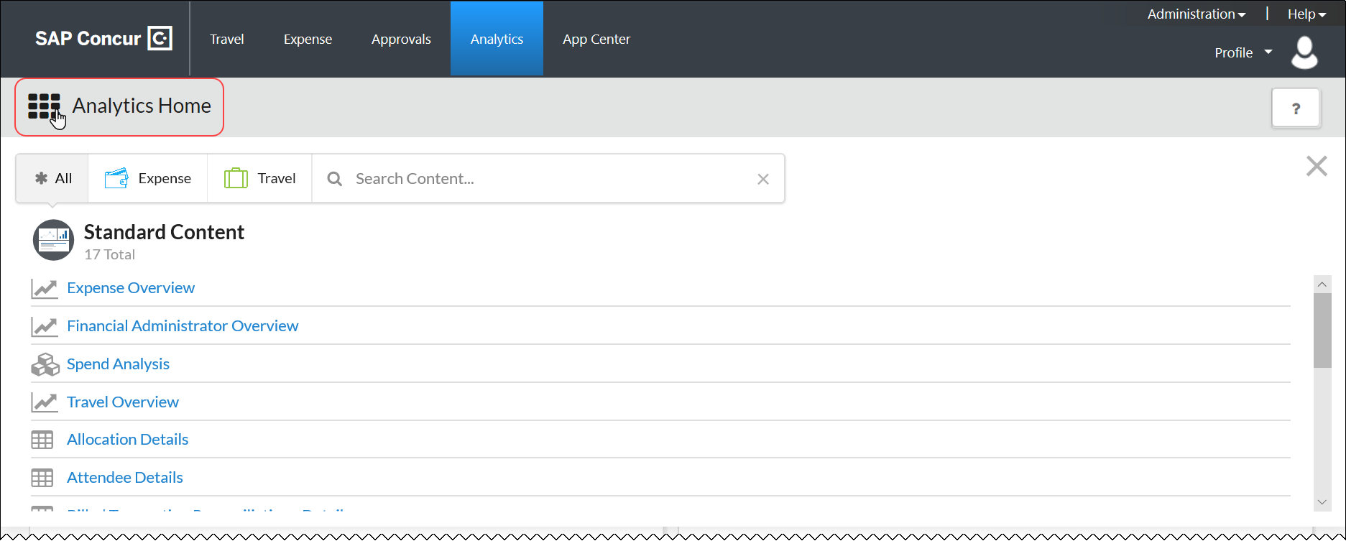
- Select the desired report.
- To view a standard report, select from the reports in the Standard Content column.
- To view a shared report (available to Analytics users only; described on the following pages), select from the Company Content section of the menu.
- To view a custom report (available to Analytics users only; described on the following pages), select from the User Content section of the menu.
- Refer to the Analytics Essentials and Analytics User Guide for information about customizing and sharing reports.

Reports – Descriptions

Report: Allocation Details
This report allows a user to create a detailed view of expense allocations by adding company-defined cost tracking fields (for example, department, cost center, project, and so on) to the report.
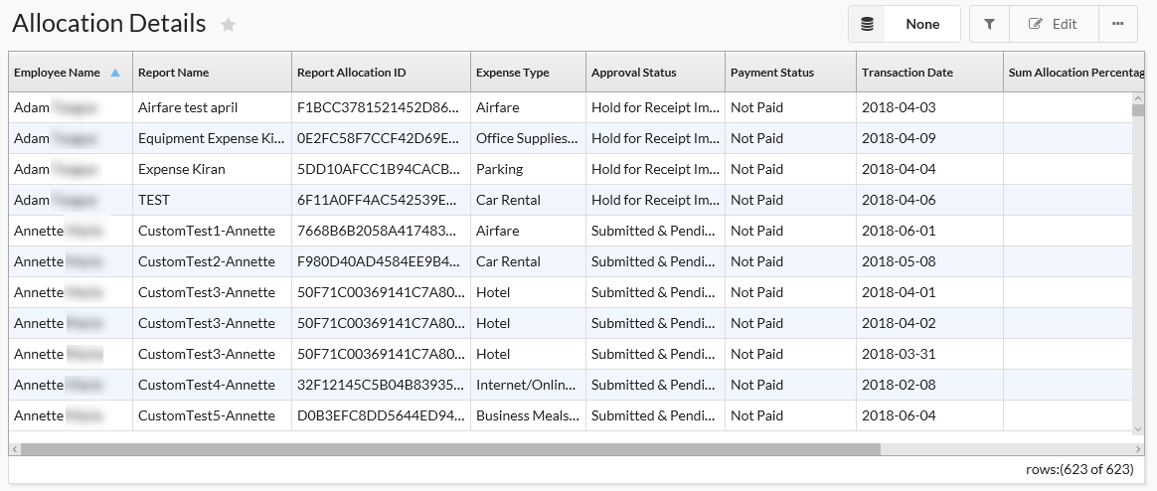
Filter the data by:
- Employee Name
- Expense Type
- Approval Status
- Payment Status
- Transaction Date, including:
- Current Year
- Year to Date
- Last Year
- Current Quarter
- Quarter to Date
- Last Quarter
- Current Month
- Month to Date
- Last Month
- Current Week
- Week to Date
- Last Week
- Remaining Month
- Remaining Quarter
- Last 12 Months
- Last 4 Quarters
- Last 6 Months
- Last 6 Quarters
The Quarter by Date filter appears - by default - as the date option. The user can change the date filter to another date option manually if desired.
Group the data by:
- Employee Name
- Report Name
- Expense Type

Report: Attendee Details
This report shows the spending by employees and attendee information for expenses that have associated attendees, typically for meal or entertainment expense types.
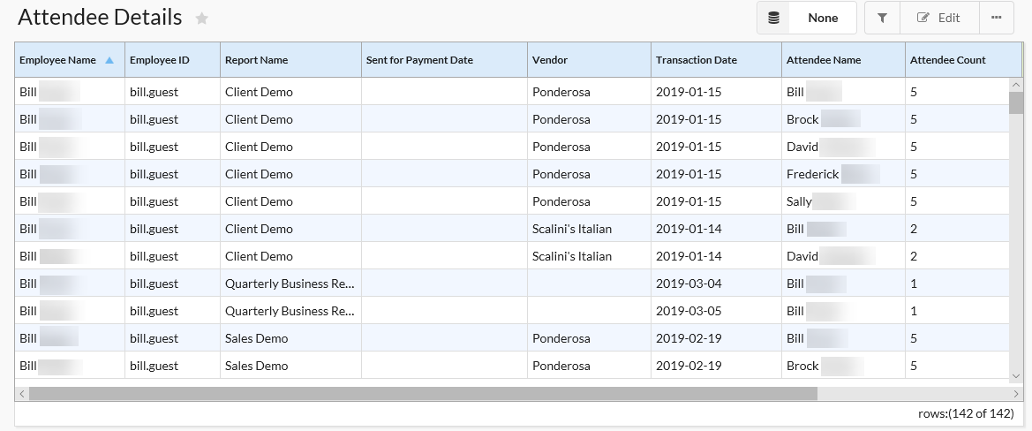
Filter the data by:
- Transaction Date, including:
- Current Year
- Year to Date
- Last Year
- Current Quarter
- Quarter to Date
- Last Quarter
- Current Month
- Month to Date
- Last Month
- Current Week
- Week to Date
- Last Week
- Remaining Month
- Remaining Quarter
- Last 12 Months
- Last 4 Quarters
- Last 6 Months
- Last 6 Quarters
The Quarter by Date filter appears - by default - as the date option. The user can change the date filter to another date option manually if desired.
- Employee Name
- Attendee Name
Group the data by:
- Employee Name
- Report Name

Report: Billed Transaction Reconciliation - Details
This report lists details to match submitted reports to their Concur Invoice.
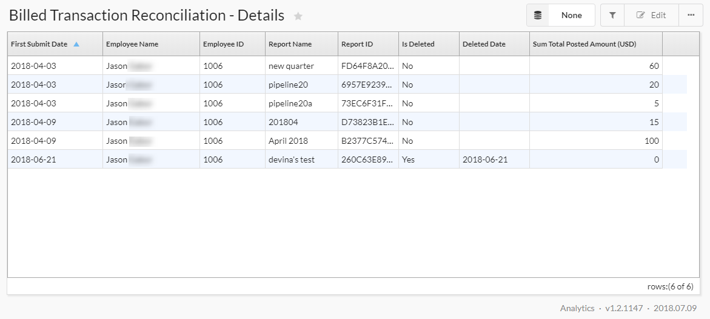
Filter the data by:
- First Submitted Date, including:
- Current Year
- Year to Date
- Last Year
- Current Quarter
- Quarter to Date
- Last Quarter
- Current Month
- Month to Date
- Last Month
- Current Week
- Week to Date
- Last Week
- Remaining Month
- Remaining Quarter
- Last 12 Months
- Last 4 Quarters
- Last 6 Months
- Last 6 Quarters
The Quarter by Date filter appears - by default - as the date option. The user can change the date filter to another date option manually if desired.
Group the data by:
- Employee Name
- Report Name

Report: Credit Card Transactions
This report lists credit card transaction details imported into Concur Expense.
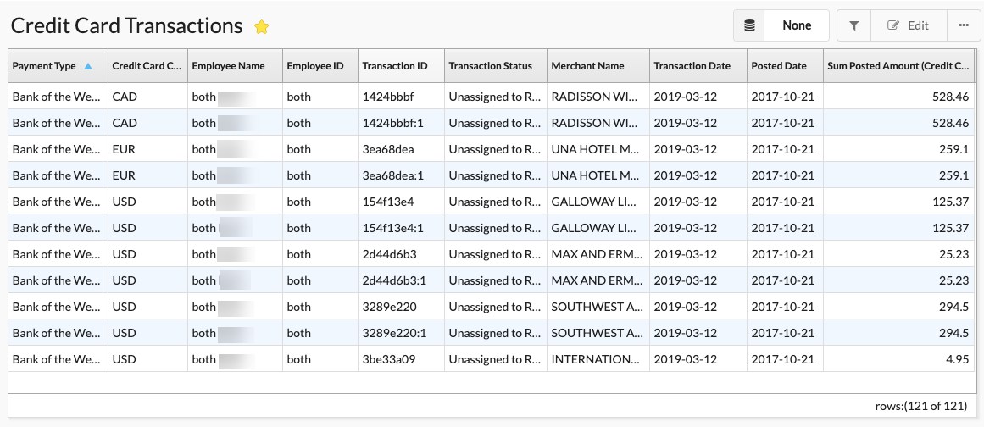
Filter the data by:
- Payment Type
- Employee Name
- Transaction Status
- Posted Date, including:
- Current Year
- Year to Date
- Last Year
- Current Quarter
- Quarter to Date
- Last Quarter
- Current Month
- Month to Date
- Last Month
- Current Week
- Week to Date
- Last Week
- Remaining Month
- Remaining Quarter
- Last 12 Months
- Last 4 Quarters
- Last 6 Months
- Last 6 Quarters
The Quarter by Date filter appears - by default - as the date option. The user can change the date filter to another date option manually if desired.
Group the data by:
- Employee Name
- Payment Type

Report: Employee Details
This report lists all the employees in a company along with their default approvers. This report is useful as a reference to look up values populated in some of the configurable fields that are managed by other SAP Concur solutions.
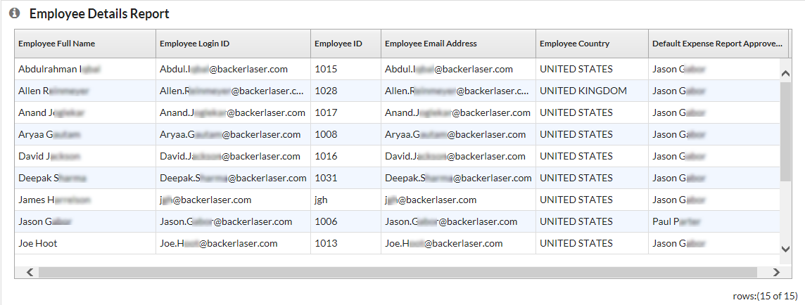
Filter the data by:
- Employee Name
- Is Active
Group the data by:
- BI Manager
- Employee Country

Report: Employee Roles
This report lists all employees and all roles. You can search for specific employees (to list the associated roles) or roles (to list the associated employees).
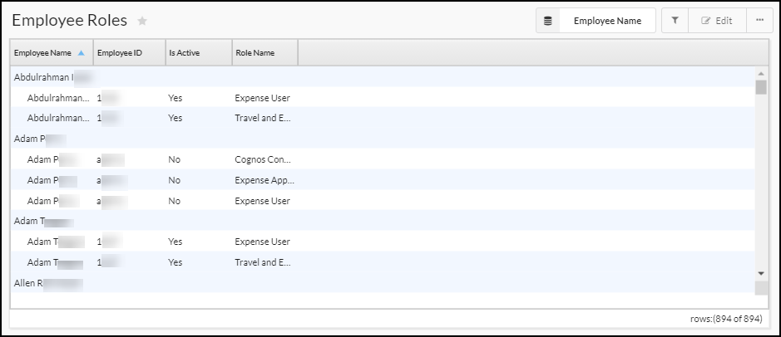
Filter the data by:
- Is Active
- Role Name
- Employee Name
Group the data by:
- Employee Name
- Employee ID
- Role Name

Report: Expense Accrual
This report lists expense reports that are unsubmitted as well as reports that have not yet been paid.
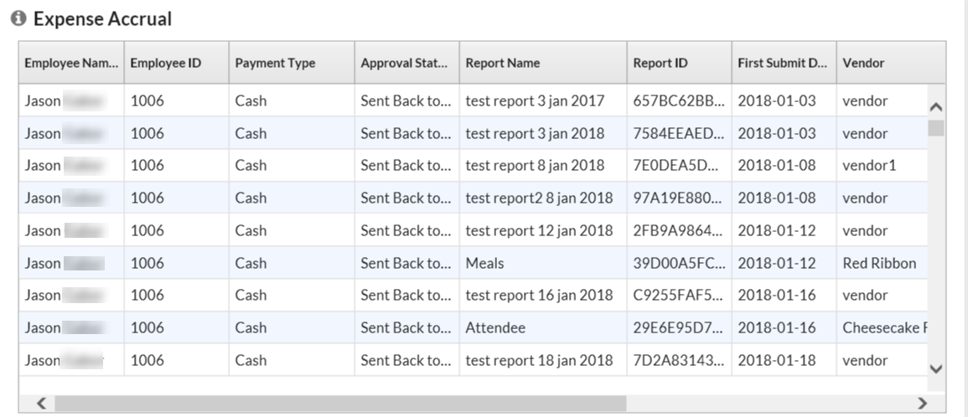
Filter the data by:
- Employee Name
- Payment Type
- Transaction Date, including:
- Current Year
- Year to Date
- Last Year
- Current Quarter
- Quarter to Date
- Last Quarter
- Current Month
- Month to Date
- Last Month
- Current Week
- Week to Date
- Last Week
- Remaining Month
- Remaining Quarter
- Last 12 Months
- Last 4 Quarters
- Last 6 Months
- Last 6 Quarters
The Quarter by Date filter appears - by default - as the date option. The user can change the date filter to another date option manually if desired.
- Country
Group the data by:
- Employee Name
- Report Name

Report: Expense Entry Analysis Details
This report provides expense entry-level transaction details, including expense type, payment type, and amount. The purpose of this report is to provide details on past expense transactions for review or reconciliation with accounting.
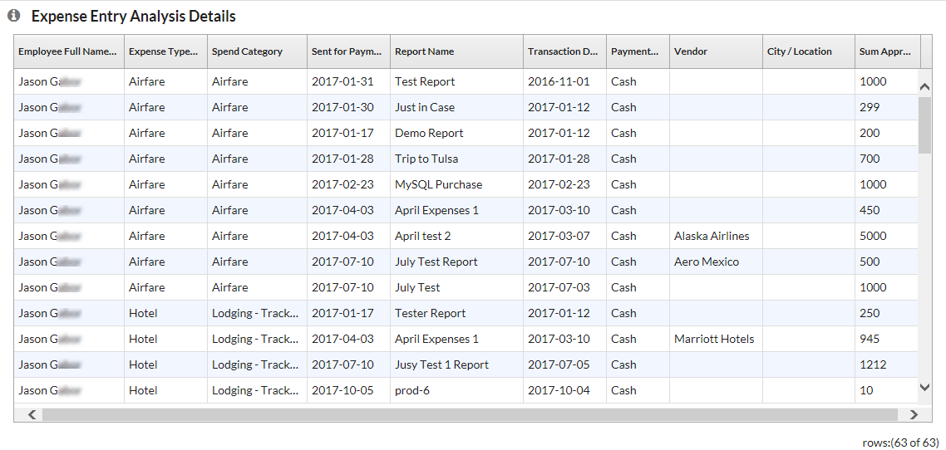
Filter the data by:
- Employee
- Expense Type
- Spend Category
- Sent for Payment, including:
- Current Year
- Year to Date
- Last Year
- Current Quarter
- Quarter to Date
- Last Quarter
- Current Month
- Month to Date
- Last Month
- Current Week
- Week to Date
- Last Week
- Remaining Month
- Remaining Quarter
- Last 12 Months
- Last 4 Quarters
- Last 6 Months
- Last 6 Quarters
The Quarter by Date filter appears - by default - as the date option. The user can change the date filter to another date option manually if desired.
Group the data by:
- Employee
- Expense Type
- Report Name

Report: Expense Exception Analysis - Report Entry Level
This report provides details on entry-level exceptions and expense compliance issues for each employee and expense report based on a date range.
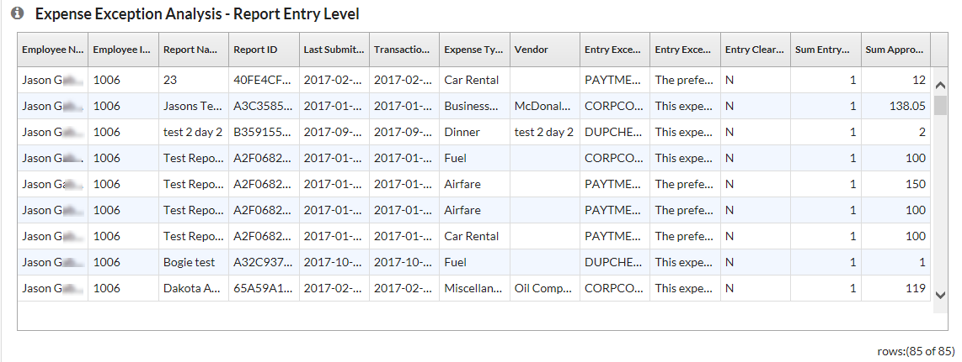
Filter the data by:
- Employee Name
- Last Submitted Date, including:
- Current Year
- Year to Date
- Last Year
- Current Quarter
- Quarter to Date
- Last Quarter
- Current Month
- Month to Date
- Last Month
- Current Week
- Week to Date
- Last Week
- Remaining Month
- Remaining Quarter
- Last 12 Months
- Last 4 Quarters
- Last 6 Months
- Last 6 Quarters
The Quarter by Date filter appears - by default - as the date option. The user can change the date filter to another date option manually if desired.
- Entry Exception Code
- Entry Exception Text
Group the data by:
- Employee Name
- Report Name
- Entry Exception Text

Report: Expense Exception Analysis - Report Level
This report provides details on report-level exceptions and expense compliance issues for each employee and expense report based on a date range.
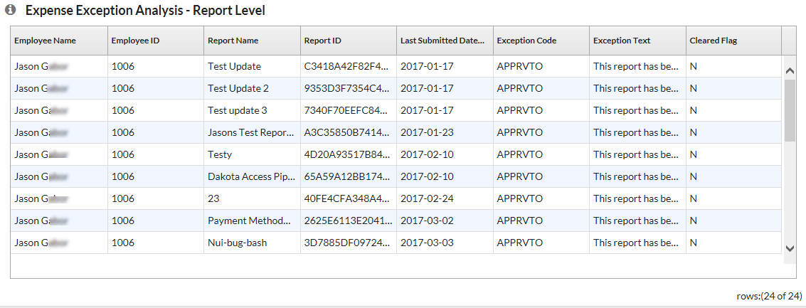
Filter the data by:
- Last Submitted Date, including:
- Current Year
- Year to Date
- Last Year
- Current Quarter
- Quarter to Date
- Last Quarter
- Current Month
- Month to Date
- Last Month
- Current Week
- Week to Date
- Last Week
- Remaining Month
- Remaining Quarter
- Last 12 Months
- Last 4 Quarters
- Last 6 Months
- Last 6 Quarters
The Quarter by Date filter appears - by default - as the date option. The user can change the date filter to another date option manually if desired.
Group the data by:
- Employee Name
- Report Name
- Exception Text

Report: Expense Report Totals
This report lists expense report information and amounts for all submitted reports.
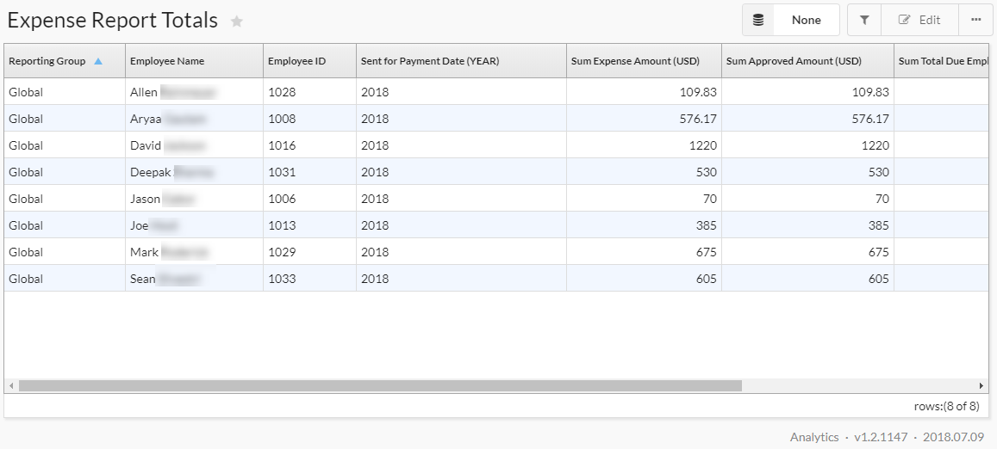
Filter the data by:
- Sent for Payment Date, including:
- Current Year
- Year to Date
- Last Year
- Current Quarter
- Quarter to Date
- Last Quarter
- Current Month
- Month to Date
- Last Month
- Current Week
- Week to Date
- Last Week
- Remaining Month
- Remaining Quarter
- Last 12 Months
- Last 4 Quarters
- Last 6 Months
- Last 6 Quarters
The Quarter by Date filter appears - by default - as the date option. The user can change the date filter to another date option manually if desired.
Group the data by:
- Employee Name
- Reporting Group
- Sent for Payment Year

Report: Invoice Accrual
This report lists invoices that are unsubmitted as well as invoices that have not yet been paid.
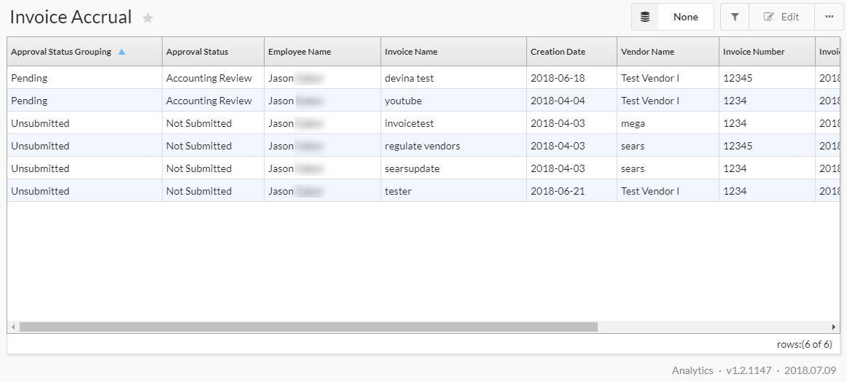
Filter the data by:
- Approval Status Grouping
- Approval Status
- Employee Name
- Vendor Name
- Invoice Date, including:
- Current Year
- Year to Date
- Last Year
- Current Quarter
- Quarter to Date
- Last Quarter
- Current Month
- Month to Date
- Last Month
- Current Week
- Week to Date
- Last Week
- Remaining Month
- Remaining Quarter
- Last 12 Months
- Last 4 Quarters
- Last 6 Months
- Last 6 Quarters
The Quarter by Date filter appears - by default - as the date option. The user can change the date filter to another date option manually if desired.
Group the data by:
- Approval Status Grouping
- Approval Status
- Employee Name
- Vendor Name

Report: Invoice Aging
This report provides a detailed view of unpaid invoices and how long since they have been issued.
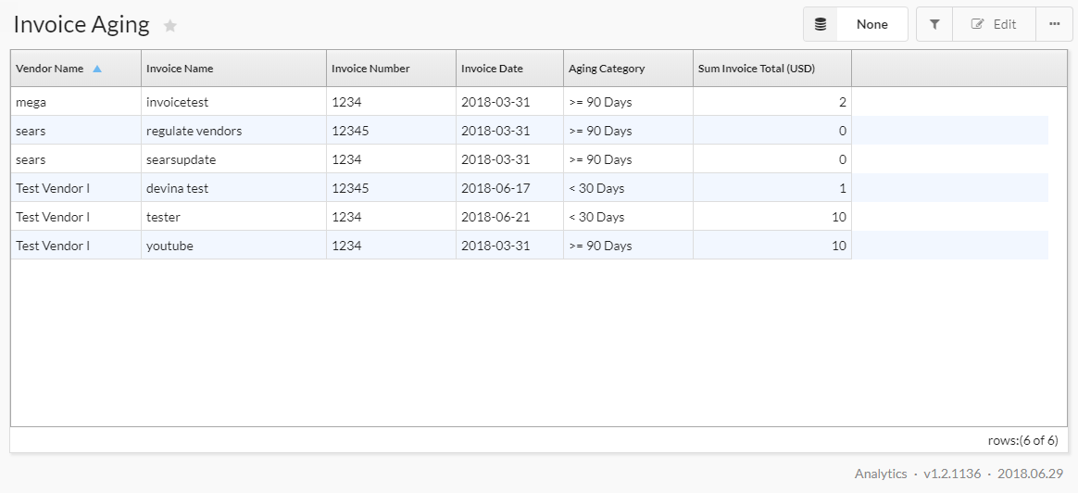
Filter the data by:
- Invoice Date, including:
- Current Year
- Year to Date
- Last Year
- Current Quarter
- Quarter to Date
- Last Quarter
- Current Month
- Month to Date
- Last Month
- Current Week
- Week to Date
- Last Week
- Remaining Month
- Remaining Quarter
- Last 12 Months
- Last 4 Quarters
- Last 6 Months
- Last 6 Quarters
The Quarter by Date filter appears - by default - as the date option. The user can change the date filter to another date option manually if desired.
- Vendor Name
- Aging Category
Group the data by:
- Vendor Name
- Aging Category

Report: Travel Booking Details
This report provides a detailed list of employee travel bookings.
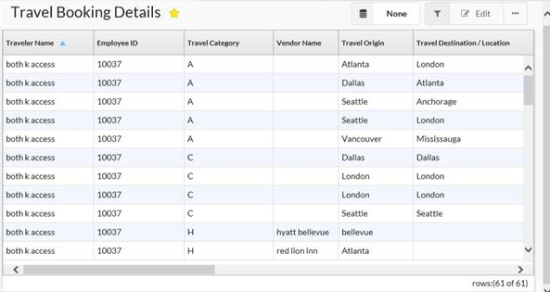
Filter the data by:
- Travel Start Date, including:
- Current Year
- Year to Date
- Last Year
- Current Quarter
- Quarter to Date
- Last Quarter
- Current Month
- Month to Date
- Last Month
- Current Week
- Week to Date
- Last Week
- Remaining Month
- Remaining Quarter
- Last 12 Months
- Last 4 Quarters
- Last 6 Months
- Last 6 Quarters
The Quarter by Date filter appears - by default - as the date option. The user can change the date filter to another date option manually if desired.
- Traveler Name
- Travel Category
- Vendor Name
- Booking Source

Report: Unassigned Credit Card Transactions
This report provides a detailed list of outstanding credit card transactions.
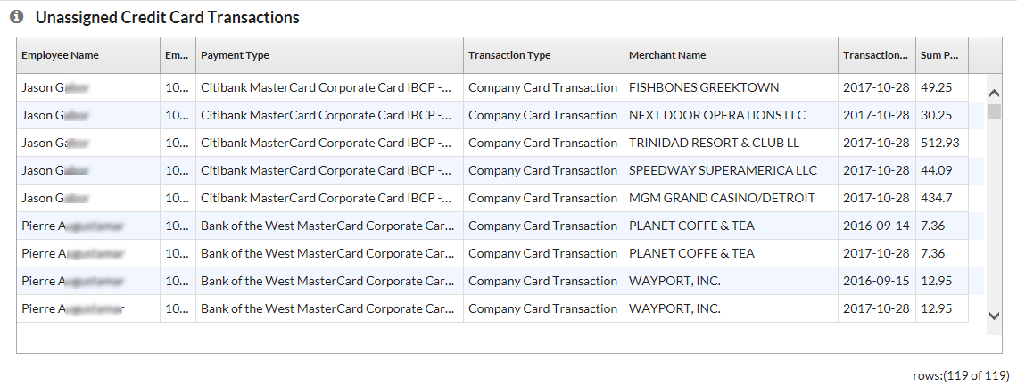
Filter the data by:
- Employee Name
- Payment Type
Group the data by:
- Employee Name
- Payment Type
☼

