

Applies to these SAP Concur solutions:

£ Expense  
£ Professional/Premium edition  
£ Standard edition

S Travel   
S Professional/Premium edition  
    S Integrated with Professional/Premium Expense  
    S Integrated with Professional/Premium Request  
    S Stand-alone  
£ Standard edition  
    £ Integrated with Standard Expense  
    £ Stand-alone

£ Invoice   
£ Professional/Premium edition  
£ Standard edition

£ Request   
£ Professional/Premium edition  
£ Standard edition

Travel: Company Administration

User Guide

Last Updated: March 13, 2024

Table of Contents

Company Administration 1

Section 1: About this Guide 1

Section 2: Introduction to Company Admin 1

Section 3: Company Administration Section 2

Approval Queues 3

Overview 3

Reassign a Trip Awaiting Approval to a Different Manager 3

Billing Administrator 4

Overview 4

View Invoices 4

Company Locations 5

Overview 5

Geocode 5

Create a New Company Location 6

Edit a Company Location 7

Delete a Company Location 7

Org Unit Admin 8

Overview 8

Create an Organization Unit 8

Edit or Delete an Organization Unit 9

Assign an Organization Unit to a User 9

Report Admin 9

Text Customization 9

Overview 9

Considerations for Customizing Text 9

Customize Profile Text 10

Security Keys 11

Overview 11

Modify Security Keys 12

Password Administration 13

Manage Custom Fields 13

Overview 13

Considerations for Creating Custom Fields 14

Add a New User Field 15

Add a New Trip Field 18

Work with Itinerary Rules 26

Calendar Integration Admin 28

Company Settings 29

Login URL Manager 29

Overview 29

Add a URL 29

New Concur Travel Experience 30

Section 4: User Administration Section 31

User Administration and Add User – Travel Only 31

Overview 31

Search for Users 31

View User Details 33

Add Users 33

Unified User Admin – Travel & Expense 38

Overview 38

Self-Registration Setup and Approvals 38

Send Mobile Instructions 38

User Permissions 39

Overview 39

Considerations for Assigning Permissions 46

Manage Permissions by Permission Name 47

Manage Permissions by Group or Rule Class 48

Manage Permissions by User 49

Company Groups 50

Overview 50

Create a New User Group 50

View and Modify Group Membership 51

Section 5: Travel Administration Section 52

Travel Administration 52

Corporate Ghost Cards 52

Overview 52

Add a New Corporate Credit Card 52

Grant Corporate Card Access by Corporate Card Name 57

Grant Corporate Card Access by Users and Groups 58

Remove Corporate Card Access 59

E-Receipt Admin 59

Travel Admin 59

Travel Admin – Travel Policy 60

Travel Admin – Policy Violations Reasons 60

Travel Admin – Travelfusion Suppliers 60

Travel Admin – Vendor FoID Admin 60

Travel Admin – Travel Vendor Exclusions 60

Travel Admin – Custom Text 60

Travel Admin – Regional Hotel Rates 60

Travel Admin – Travel Alternatives 60

Travel Reporting 61

Overview 61

Run a Travel Report 61

Travel Templates 62

Overview 62

Create a Travel Template 62

Edit a Travel Template 67

Delete a Travel Template 68

Credit Card BIN Restrictions 68

Overview 68

Create Credit Card BIN Restrictions 69

Delete a Credit Card BIN Restriction 69

Unused Tickets 70

Meeting Center Admin 70

Section 6: Appendix A – Find the Travel Service Guides & Fact Sheets 71

Section 7: Appendix B – Company Link Administrator 72

Section 8: Appendix C – Integrated with Request: Rule Actions 72

Revision History

| Date | Notes / Comments / Changes | |
| --- | --- | --- |
| March 13, 2024 | Removed any yellow highlight throughout. | |
| February 22, 2024 | Updated *New Concur Travel Experience* information. | |
| October 25, 2023 | Replaced instructions in Password Administration with link to new *DRAFT: Shared: SAP Concur Password Policy Settings Setup Guide* | |
| September 1, 2023 | Added **New Concur Travel Experience** instructions for Company Admin role | |
| May 24, 2023 | Updates to *Approval Queues.* | |
| April 26, 2023 | Finalized information on new car experience | |
| January 30, 2023 | Updated draft to reflect changes for the initial release of the new Car experience. | |
| May 27, 2022 | Updated an instance of "Nickname" to "Preferred Name". Cover date not updated. | |
| January 26, 2022 | Updated the copyright year; no other changes; cover date not updated | |
| January 28, 2021 | Updated *Manage Custom Fields* topic under *Company Administration Section* | |
| December 14, 2020 | Updated descriptions for display settings of custom fields in the *Company Administration* section | |
| March 19, 2020 | Added permission definitions for Approve then Book and Authorized Support Contact to *User Permissions* section | |
| February 14, 2020 | Updated the copyright; no other changes; cover date not updated | |
| May 15, 2019 | Removed information about password hints and security questions | |
| May 3, 2019 | Clarifies other permissions | |
| May 2, 2019 | Updated the definition for the User Admin (Read Only) permission | |
| February 28, 2019 | Added the description for the Agency Billing Administrator permission | |
| January 22, 2019 | Changed a reference to the Regional Hotel Rates TSG | |
| January 16, 2019 | Added the definition for the Data Retention Administrator role | |
| June 26, 2018 | Corrected a reference to Google maps | |
| May 29, 2018 | Removed **Company Admin – Company Settings:** Refer to *Company Settings Travel Service Guide*  Added information for these permissions:   * User Admin (Read Only) * Virtual Payment Administrator | |
| May 21, 2018 | Removed references to the Privacy Agreement Statement | |
| March 30, 2018 | Added notes about best practice of not using custom fields for sensitive or personal data. | |
| February 23, 2018 | Added: **NOTE:** The login name must be unique across all Concur products. If a login name is currently in use in any Concur product, it cannot be assigned again unless the original occurrence is changed. For example, assume that a login name was assigned in error. That login name can only be used again if an admin (either manually or via import) renames the original occurrence, allowing the login name to be used again. | |
| February 18, 2018 | Removed these sections; created new Travel Service Guides:   * **Travel Admin – Regional Hotel Rates**: Refer to: * *Regional Hotel Rates Travel Service Guide* * **Travel Admin - Travel Vendor Exclusions**: Refer to: * *Approvals, Rules, and Classes/Policies Travel Service Guide*   **For Travel Admin – Vendor FoID Admin**, do not use. | |
| January 25, 2018 | Updated to include the changes for the January 2018 release: | |
| **Section** | **Description/Action** |
| Company Settings | Corporate Privacy Agreement Re-acknowledgement |
| January 2, 2018 | Removed these sections; created new Travel Service Guides:   * **Travel Admin – Travel Policy:** Refer to: * *Approvals, Rules, and Classes/Policies Travel Service Guide* * *Lowest Logical Fare (LLF) / Benchmark Lowest Airfare Travel Service Guide* * *Configurable Message Boards Travel Service Guide* * **Travel Admin - Policy Violation Reasons:** Refer to: * *Approvals, Rules, and Classes/Policies Travel Service Guide* * **Travel Admin - Travelfusion Suppliers:** Refer to: * *Travelfusion Travel Service Guide*. * **Travel Admin - Travel Vendor Exclusions:** Refer to: * *Travel Vendor Exclusions Travel Service Guide* | |
| Older revision history has been removed. | | |

# Company Administration

## About this Guide

The information in this guide applies to Company Administration feature in Travel as well as Travel & Expense. For consistency, the Travel service will be referred to as "Travel" in this guide.

*This guide contains information that describes the new Concur Travel experience for Car, Hotel, and Air. This information will be displayed in notes or indicated with "new experience" as these features are released.*

1. Multiple SAP Concur product versions and UI themes are available, so this content might contain images or procedures that do not precisely match your implementation. For example, when SAP Fiori UI themes are implemented, home page navigation is consolidated under the SAP Concur Home menu.

## Introduction to Company Admin

Use the **Company Administration** section in Travel to manage company options, user data, and travel booking settings. You can access Company Administration by clicking the **Administration** link at the top of any Travel page.

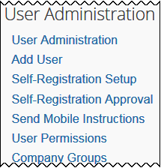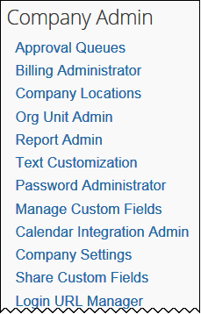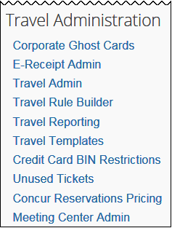On the **Company Administration** page, you can access different sections by using the left-side menu. Company Administration is organized in three sections.

Log in to Travel - Access Company Admin

**Travel Administration** allows you to manage settings for travel booking.

**User Administration** allows you to manage user settings and information.

**Company Admin** allows you to manage company-wide settings and preferences.

1. To log in to Travel and access Company Admin:
2. Access the Travel login page.
3. Type your user name in the **User Name** field.
4. Type your password in the **Password** field.
5. Remember the password is case sensitive.
6. Click **Login**.
7. On any Travel page, click **Administration** in the menu.

## Company Administration Section

The **Company Administration** section allows management of company-wide settings and preferences including:

| Setting Options | Function |
| --- | --- |
| Approval Queues | Reassign trip approvals to different managers |
| Billing Administrator | View travel bills in Travel |
| Company Locations | Set up company locations |
| Org Unit Admin | Set up organization units for your company |
| Report Admin | Provide access to reports |
| Text Customization | Customize text that appears on the user's profile page |
| Security Keys | (not shown on the menu above) |
| Password Administration | Manage password resets |
| Manage Custom Fields | Create custom fields for user records and trip bookings |
| Calendar Integration Admin | Automatically add trip data into user calendars |
| Company Settings | * For complete details, refer to the *Company Settings Travel Service Guide*. |
| Share Custom Fields | * For complete details, refer to the *Hotel Service Content Suppliers Travel Service Guide*. |
| Login URL Manager | Manage general company settings |
| New Concur Travel Experience | Options to manage preferences for the new Concur Travel experience for Air, Hotel, and/or Rental Car bookings |

Each option is described on the following pages.

* **IMPORTANT:** Before modifying the information in any of the above sections, please consult your company's Travel Agency.

Hidden text...keep this ­ and the 2 next blank para marks – here for the automatic header/footer

### Approval Queues

#### Overview

Use the **Approval Queues** option to reassign bookings awaiting approval with one manager, to a different manager. This is helpful if a manager is absent and, therefore, unable to approve trips.

1. This feature should not be used for clients using Concur Request for their trip approvals.

#### Reassign a Trip Awaiting Approval to a Different Manager

1. To reassign a trip waiting approval to a different manager:
2. In the **Company Admin** section of the left menu, click **Approval Queues**. This page appears.

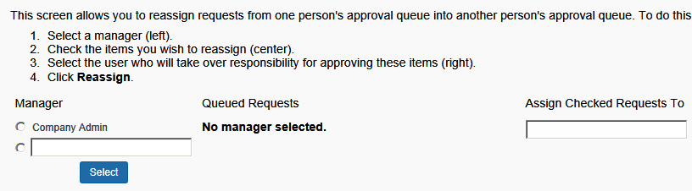

1. Type the manager's name whose approvals you wish to reassign.
2. Click **Select**. A list of the approvals appears.

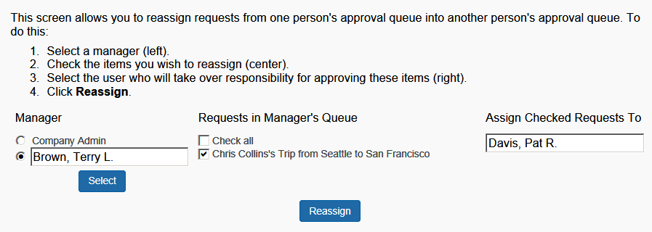

1. In the **All** **Queued Requests** area, click the request(s) you want to reassign to a different manager or select (enable) the **Check all** box.
2. Type the name of the approver who will receive the items.
3. Click **Reassign**. The trip is then reassigned to the new manager, who can approve or reject it.

### Billing Administrator

#### Overview

Use the **Billing Administrator** option to see your recent bills from Concur. This area provides the actual dollar amount and the number of transactions based on transactions processed in Travel.

You might receive your bills from your travel agency, not from Concur. In that case, please contact your travel agency for more information on billing.

1. The **Billing Administrator** option is intended for Direct Clients and TMCs only. ***Reseller Clients should not use this feature.***

#### View Invoices

1. To view invoices:
2. In the **Company Admin** section of the left menu, click **Billing Administrator**. This page appears.

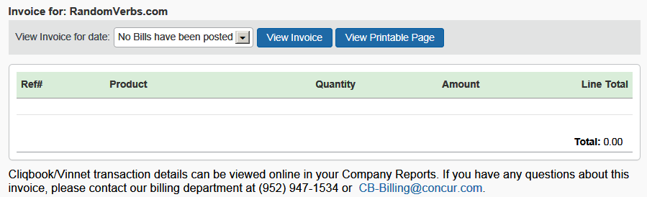

1. In the **View Invoice for date** dropdown menu, select a month to view invoices from prior months.
2. Then, either:

* Click **View Invoice** to display an invoice.  
  – or –
* Click **View Printable Page** to display a printer-friendly version of an invoice.

### Company Locations

#### Overview

Use the **Company Locations** option to set up company locations for your organization. There are several uses for company locations:

* You can assign users to company locations in order to automatically add a work address to their user record. Users have the ability to update their own home or work addresses in their profile.
* Users can use company locations to search for hotels in Travel. When users search for a hotel using company location, they can choose from this list of locations.
* If a car rental vendor provides car delivery and collection, the company location is the drop-off and pick-up point.

1. This feature is available for all GDSs except Worldspan.

#### Geocode

*Geocoding* is the process of assigning latitude and longitude to a point, based on street addresses, city, state, and zip code. In Travel, theGeocoding option adds the latitude and longitude to a company location. This enables users to search for hotels by company location.

**Best Practice tips:**

* It is not required to add zip code when adding company locations, however results will be more accurate if zip code is included.
* For best results, do not include suite or floor numbers with the street address. You can enter this information after you geocode but before you save to include it as part of the address.
* When entering company locations, enter the addresses consistently. The company location list is in alpha order by country code. Then, they are listed by city, state, and location name. If you enter the state for one location but not for another, they will appear under separate headings in the locations list.
* For addresses containing the number (#) sign, change this to the word *Number* or abbreviation *No*. The map provider may not recognize the # sign.

#### Create a New Company Location

1. To create a new company location:
2. In the **Company Admin** section of the left menu, click **Company Locations**. This page appears.

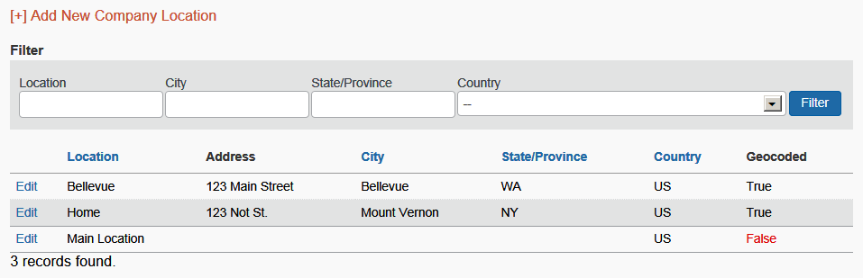

1. Click the **Add New Company Location** link. This page appears.

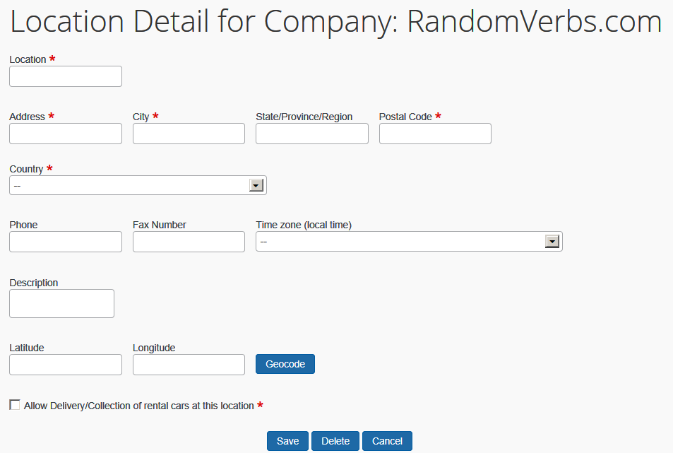

1. Complete the following fields:

| Field | Description/Action |
| --- | --- |
| Location | Enter a name for the location that will be relevant to the user. This name will appear when selecting locations to find a hotel. |
| Address, City,  State, Province, Region | Enter the address for the location. |
| Zip/Postal Code | Enter the ZIP or postal code for more accurate geocoding. |
| Phone, Fax Number, Time Zone | Enter or select as appropriate. |
| Country | Select the appropriate country for the location. |
| Geocode | Click this button to add the latitude and longitude for the location. If there is more than one possible result, Travel might show choices in a popup box. Select the choice that most closely matches the location you are trying to enter. |
| Allow Delivery/ Collection of rental cars at this location | ***All GDSs except Worldspan***  ***NOTE (for new Car experience):*** *This feature is supported for GDS Amadeus, and Hertz and Sixt Direct Content in the new Car experience.*  Select as appropriate.  This check box will not appear unless car delivery and collection has been enabled for at least one travel configuration (**Travel System Admin**, on the **Car Connectors** section of the travel configuration) and:   * For Sixt, a valid discount number is present. * For vendors that are not direct connect, the vendor code must be entered in the **Allow delivery and collection for the following car rental chains** field. |

1. Click **Save**.

#### Edit a Company Location

1. To edit a location:
2. In the **Company Admin** section of the left menu, click **Company Locations**.
3. Click the **Edit** link next to a location.
4. Edit the address for the location. (All fields are described in the section above about adding a location.)
5. Click **Save**.

#### Delete a Company Location

1. To delete a location:
2. In the **Company Admin** section of the left menu, click **Company Locations**.
3. Click the **Edit** link next to a location.
4. Click **Delete**.

### Org Unit Admin

#### Overview

Use the **Org Unit Admin** option to create departments or organization units for your company. Creating organization units makes it easier to manage users. For example, if you create and assign organization units, you can later sort or filter users by unit to update information and report data.

* **IMPORTANT:** Some travel agencies use the Org Units to manage company-level profile information in Travel. Consult with your travel agency before modifying Org Units to prevent disabling the service for all your travelers.

#### Create an Organization Unit

1. To create an organization unit:
2. In the **Company Admin** section of the left menu, click **Org Unit Admin**. This page appears.

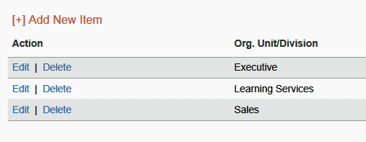

1. Click **Add New Item**.

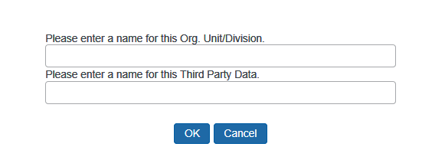

1. In the **Please enter a name for this Org. Unit/Division** field, enter the name for the organization unit.
2. Click **OK**. The new organization unit appears in the list.

#### Edit or Delete an Organization Unit

1. To edit or delete an organization unit:
2. In the **Company Admin** section of the left menu, click **Org Unit Admin**.
3. In the list, locate the organization unit to be renamed or deleted.
4. In the **Action** column:

* Click **Edit** to enter a new name.   
  – or -
* Click **Delete**.

#### Assign an Organization Unit to a User

1. To assign an organization unit:
2. In the **User Administration** section of the left menu, click **User Administration**.
3. Search for the user to assign to an organization unit.
4. Click the name of the user (link) to open their record.
5. In the **Org Unit/Division** dropdown menu, click the organization unit for the user.
6. Click **Save**.

### Report Admin

For complete information about travel reports, refer to the *Travel Reporting User Guide*.

### Text Customization

#### Overview

Use the **Text Customization** option to customize the text that appears at the top of the user's profile page. For example, you can include messages here to the user about filling in or modifying their profile, including warnings about required fields.

#### Considerations for Customizing Text

Using the **Text Customization** option to enter a customized message for a particular travel configuration or company-wide. If you choose company-wide, the customized text will appear for any configuration that does not already have customized text applied.

On the **Text Customization** page:

* If you select (enable) the **Use Default** check box, Travel will show the following default message in the language you choose.   
    
  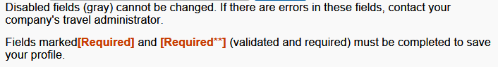
* If you clear (disable) the **Use Default** check box, you can choose a language and enter your own message.

#### Customize Profile Text

1. To add custom text:
2. In the **Company Admin** section of the left menu, click **Text Customization**. This page appears.

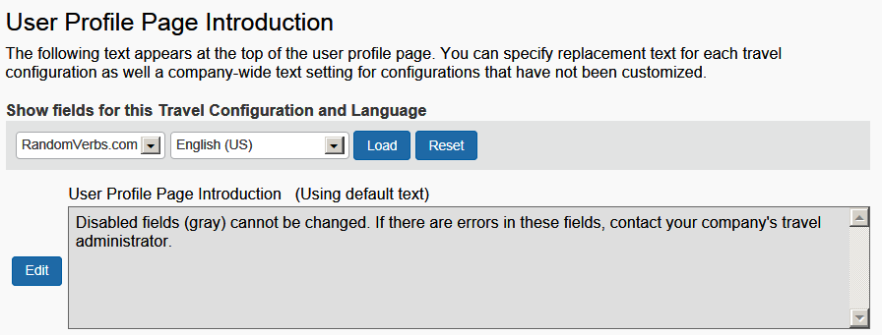

1. Click **Edit**. The page expands.

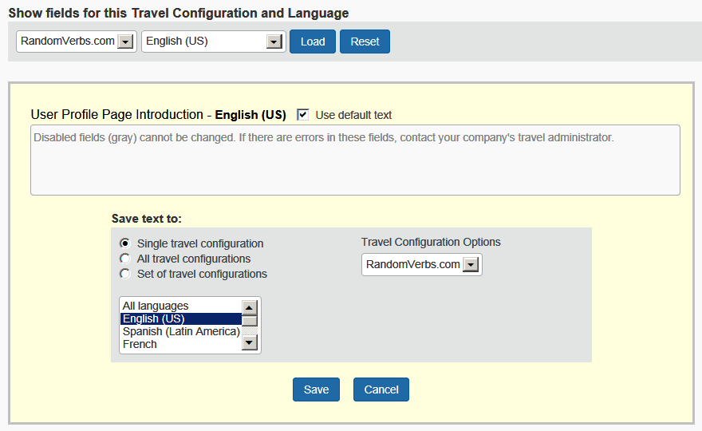

1. To make changes, clear the **Use default text** check box.

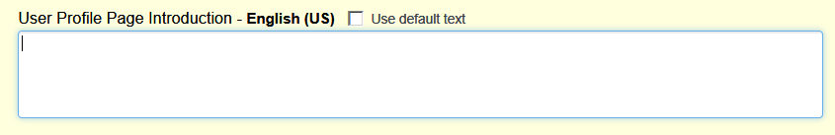

1. Enter the desired text.
2. Select the configuration and the language.
3. Click **Save**.

### Security Keys

#### Overview

Use the **Security Keys** option for Single Sign-On (SSO) authentication. You can use Security Keys to secure special applications in Travel such as single sign-on and Meeting Center sign-on.

If you want to create a security key or require additional information on setting up or using this feature, please contact your TMC or Concur Client Support.

1. The **Security Keys** link is available only if your company uses SSO.

#### Modify Security Keys

1. To modify security keys:
2. In the **Company Admin** section of the left menu, click **Security Keys**. This page appears.

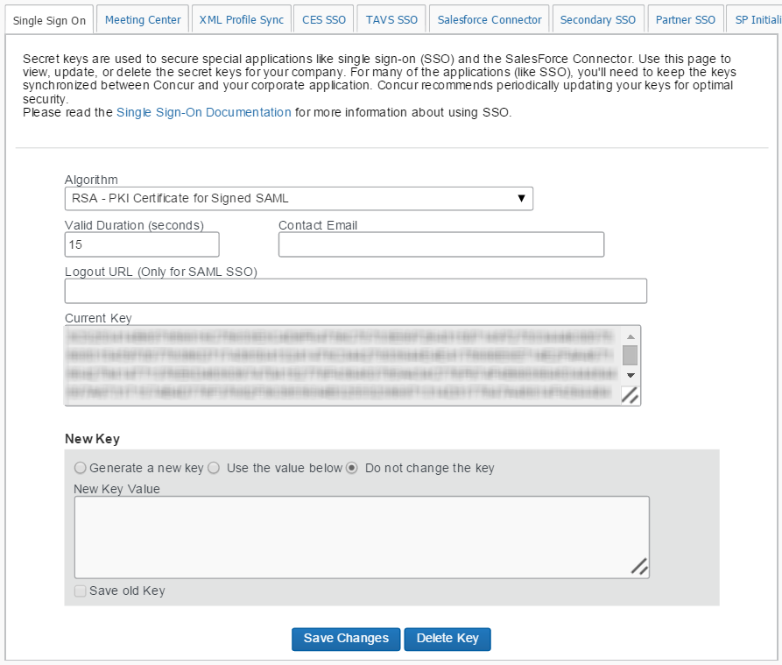

1. Complete the following fields.

| Field | Description/Action |
| --- | --- |
| Algorithm | Select as appropriate. |
| Valid Duration (seconds) | Enter the duration in seconds. |
| Contact Email | Enter an email address. This email address will be provided by your administrator. |
| Logout URL | Enter as appropriate. |
| New Key | Click one of the following:   * Generate a new key * Use the value below   If you are generating a new key, enter it in the field provided. |

1. Click **Save Changes**.

### Password Administration

Refer to the [*Shared: Password Policy Settings Setup Guide*](https://www.concurtraining.com/customers/tech_pubs/Docs/_Current/SG_Shr/SG_Shr_Password_Policy_Settings.pdf) for instructions on the new Sign-In Settings page and SAP Concur password policy settings, effective October 18, 2023.

### Manage Custom Fields

1. Best practice is to ***not*** allow personal, sensitive, or uniquely identifying information in custom fields.

#### Overview

Use the **Manage Custom Fields** option to customize the following types of fields.

* **IMPORTANT:** Because certain travel agencies use custom fields to pass information into the booking system, you should not modify these fields unless you first verify with your travel agency or Concur Client Support. If you do not verify first, you risk causing serious issues with profiles and itineraries in the agency booking system.

| Field type | Description/Action |
| --- | --- |
| User fields | User fields appear on the **User Profile** page.  Specify the field name and the type of information that can be entered in the field. |
| Trip fields | Trip fields appear during the process of booking a trip.  Specify the field name and the type of information that can be entered in the field. You can also choose whether trip fields will appear to the user at the beginning or end of the booking process and whether the fields are required.  **Using If / Then logic:** When defining or editing a custom trip field, you can also select another custom trip field/value combination to control when to ask the secondary question. This means Concur can ask a user a question, such as "What is the purpose of your trip?" and the answer to that question can drive a secondary question. For example, if the answer to the question is "Meeting travel" then you can ask the user "Which meeting are you attending?" |

#### Considerations for Creating Custom Fields

1. Best practice is to ***not*** allow personal, sensitive, or uniquely identifying information in custom fields.

##### Treatment of Existing Data

When you create new custom fields, you must consider how existing data might be affected. Travel will treat existing data as follows:

* If you assign valid values where there were none before, existing data will not be affected but may not display correctly.
* If you change values in a list that are in use, existing data will be updated.
* If you delete a value from a list, existing data with that value will be cleared.
* If you change the data type to numeric, any non-numeric data will be left unaffected until the next time you edit that employee, at which time a valid value must be entered.

##### Determining Types of Fields

For each new custom field, determine the field type. The following are available.

| Field type | Description/Action |
| --- | --- |
| Text/Drop-Down | Creates a text or dropdown menu  For this field type:   1. Set the number of characters available in the **Maximum Length** field. 2. Choose whether to enter optional values.  * If you leave this blank, the user will be able to type information into the field. * If you enter optional values, those values appear to the user in a list. * For 200 items or fewer, the list is a dropdown list. * If more than 200 items, the list becomes a look-up list where the user types a few letters and the results appear.   **NOTE:** There is no maximum to the number of items you can add.   1. To enter optional values, enter the option name and stored value and then click **Add**. 2. Use the **Up**, **Down**, **Change**, and **Delete** buttons to modify the values. |
| Long Text | Creates a text field  For this field type, set the number of characters available in the **Maximum Length** field. Users will be able to type in the field up to the maximum length and will not be presented with a dropdown menu. |
| Number | Creates a numeric field  For this field type, enter optional values if you want users to choose from a dropdown menu. If you leave the optional values blank, users will be able to type any number into the field. Optional values are restricted to numbers only. |
| Yes/No | Creates a check box that users can select (enable) or clear (disable). |

##### Order of Display

By default, fields display to the user in alphabetical order, except a field that depends on another field's value will always appear ***after*** the field on which it depends, regardless of their respective titles.

#### Add a New User Field

1. Best practice is to ***not*** allow personal, sensitive, or uniquely identifying information in custom fields.
2. To add a user field:
3. In the **Company Admin** section of the left menu, click **Manage Custom Fields**. This page appears.

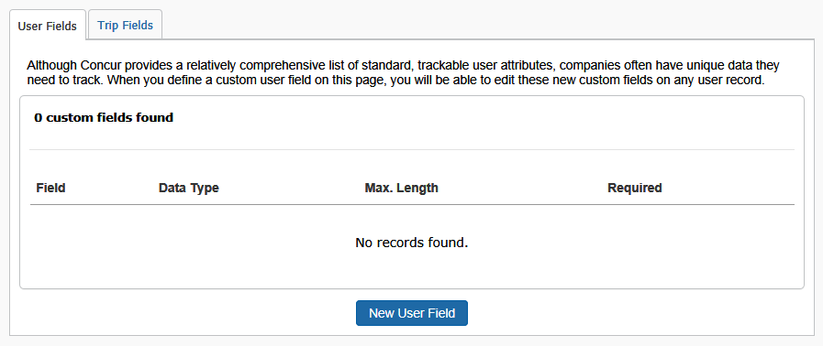

1. Click the **User Fields** tab (if it is not already selected).
2. Click **New User Field**. This page appears.

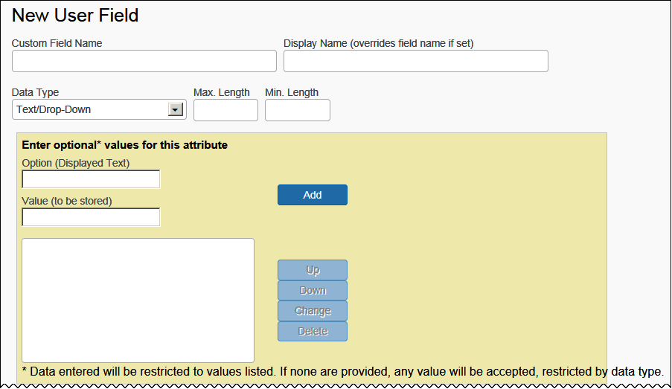

This is the first part of this section. The remainder of this section is described on the following pages.

1. Complete the following fields.

| Field | Description/Action |
| --- | --- |
| Custom Field Name | Enter the name for the field. This name will appear on the **User Fields** tab so that you can edit the custom field.  **NOTE:** Best practice is to ***not*** allow personal, sensitive, or uniquely identifying information in custom fields. |
| Display Name | Enter a display name.   * The display name will appear on the **User Profile** page. * The display name will appear in parentheses on the **User Fields** tab. * If you do not enter a display name, the Custom Field Name will appear on the **User Profile** page. |
| Data Type | Choose a data type and the associated fields.   * Refer to *Determining Types of Fields* above. |
| Enter optional values for the attribute | Enter as desired.  **NOTE:** The **Value (to be stored)** field must be unique. |
| Send to Sabre Profiles  (not shown on the screen sample above) | This field appears only if Sabre Profiles has been activated using the **Sabre Profiles Enabled** field (**Administration > Travel > Travel System Admin > View Travel Agencies** in the left menu).   * Refer to the *Sabre Profiles Travel Service Guide*. |

1. Scroll down (or over) to the next section.

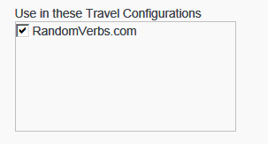

| Field | Description/Action |
| --- | --- |
| **Travel Configurations** | |
| Use in these Travel Configurations | Select the appropriate travel configurations. |

1. Scroll down to the next section.

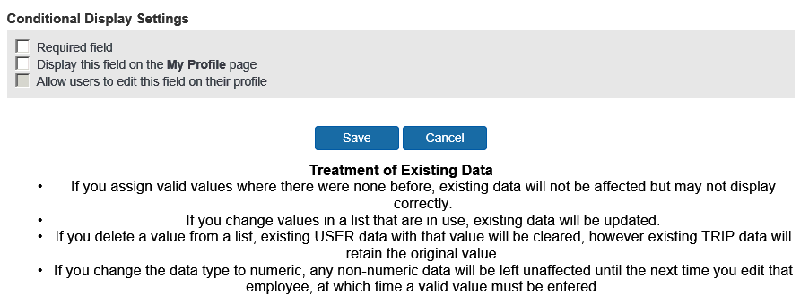

| Field | Description/Action |
| --- | --- |
| **Conditional Display Settings** | |
| Required field | Select (enable) this check box to make the field required.  This check box is not available for the Yes/No field type, since users should be able to either select (enable) the check box or leave it clear (disabled).  If you select (enable) this check box for Text/Drop Down, Long Text, or Number field types, the other two display options will be automatically selected (enabled), and they cannot be cleared. |
| Display this field on the My Profile page | Select (enable) this check box to make this field appear on users' profile pages.  If you clear (disable) this check box, the custom field will appear only to administrators in the user record; the user will not be able to view or edit this field in the profile. |
| Allow users to edit this field on their profile | Select (enable) this check box to allow users to edit the contents of this field on their profile pages.  If you clear (disable) this check box, the field will appear to users but will be grey and not available for editing. Administrators will be able to edit the field in the user record. |
| **Reporting** | |
| Reporting Field Name  (not shown on the screen sample above) | Use this section to map your custom fields to dedicated fields in the Concur Data Warehouse Model.  **NOTES:** This section of the page appears ***only*** for clients with the DW Archive module and the DW Reporting Archive module property set to true. |

1. Click **Save**.

#### Add a New Trip Field

1. Best practice is to ***not*** allow personal, sensitive, or uniquely identifying information in custom fields.
2. To add a trip field:
3. In the **Company Admin** section of the left menu, click **Manage Custom Fields**. This page appears.



1. Click the **Trip Fields** tab.
2. Click **New Trip Field**. This page appears.

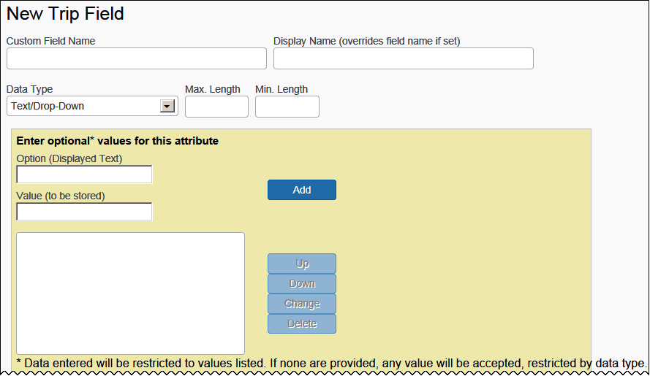

This is the top portion of the page. The remainder of the page is discussed in *Working with Itinerary Rules* on the following pages.

1. Complete the following fields.

| Field | Description/Action |
| --- | --- |
| Custom Field Name | Enter the name for the field. This name will appear on the **Trip Fields** tab so that you can edit the custom field.  **NOTE:** Best practice is to ***not*** allow personal, sensitive, or uniquely identifying information in custom fields. |
| Display Name | Enter a display name, if desired.   * Users will see the display name during the booking process. * The display name will appear in parentheses on the **Trip Fields** tab. * If you do not enter a display name, the Custom Field Name will appear during booking. |
| Data Type | Choose a data type and the associated fields.   * Refer to *Determining Types of Fields* above. |
| **Enter optional values for the attribute** | |
| Option, Value, Add, Up, Down, etc. | Enter/Use as desired. |

1. Scroll down (or over) to the next section.

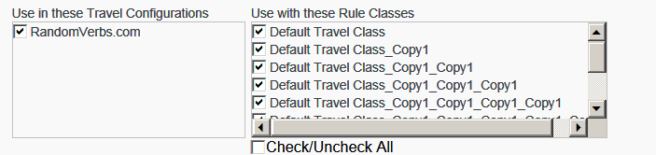

| Field | Description/Action |
| --- | --- |
| **Use in these Travel Configurations** | |
| <configurations> | Select the appropriate travel configuration(s). |
| **Use in these Rule Classes** | |
| <classes> | Select the appropriate rule class(es).  Rule-class-connections to custom fields are independent of travel configuration connections; a custom attribute does not have to link to a travel configuration in order to be tied to rule classes within that configuration. Either configuration or class can associate trip fields.  **IMPORTANT:** This feature is not available for companies that use customized stored procedures for custom fields (custom work had to be done to pull specific data). In these instances, the **Use with these Rule Classes** list will ***not*** appear on the **Edit Trip Field** page. |

1. Scroll down to the next section.

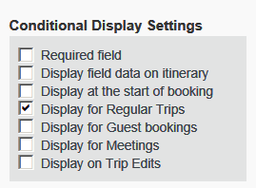

| Field | Description/Action | |
| --- | --- | --- |
| **Conditional Display Settings** | | |
| Required field | | Select (enable) this check box to make the field required.  This option is not available for the Yes/No field type, since users should be able to either select (enable) the check box or leave it clear (disabled).  If you do select (enable) this check box, the user will not be able to continue through the booking process until they enter or chose a value in the field.   1. **Display for Regular Trips**, **Display for Guest Bookings**, and **Display for Meetings** check boxes define the use cases in which a trip custom field should display. If none of these check boxes are enabled, the trip custom field will not display, even if the **Required** check box is enabled. |
| Display field data on itinerary | | Select (enable) this check box to see the custom field data appear on the itinerary. |
| Display at the start of booking | | Select (enable) this check box to display the trip custom field at the beginning when booking a workflow. |
| Display for Regular Trips  Display for Guest bookings  Display for Meetings | | Select (enable) this check box to determine the types of bookings that display the custom field.   1. These check boxes define the use cases in which a trip custom field should be displayed. If none of them are enabled, the trip custom field will not display, even if one of the **Required**, **Display field data on itinerary** or **Display at the start of booking** check boxes are enabled. |
| Display for Trip Edits | | Select (enable) this check box to display the custom trip fields on the **Trip Confirmation** page that appears for pre- and post-ticket changes. By making these fields available here, the user can make any desired changes.  After a trip change (where the fields are shown for air/car/hotel changes):     1. The custom trip fields display on the **Trip Confirmation** page even if the **Display at the start of booking** check box is selected (enabled). 2. For a trip custom field to display on the **Trip Confirmation** page, besides enabling the **Display on trip edits** option, you must also enable **Display for Regular Trips** and/or **Display for Guest Bookings**. |
| **Reporting** | | |
| Reporting Field Name  (not shown on the screen sample above) | | Use this section to map your custom fields to dedicated fields in the Concur Data Warehouse Model.  **NOTE:** This section of the page appears ***only*** for clients with the DW Archive module and the DW Reporting Archive module property set to true. | |

1. Scroll down to the next section.

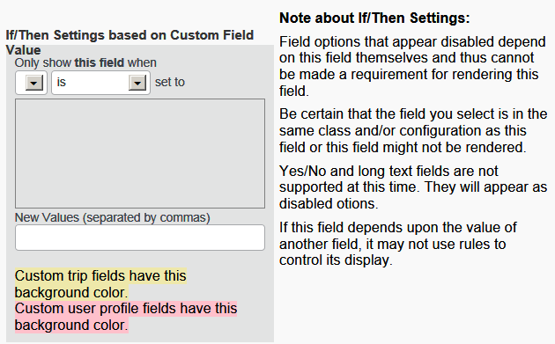

| Field | Description/Action | | |
| --- | --- | --- | --- |
| **If/Then Settings** | | |
| <all fields> | | Refer to *Using If / Then Logic* below. |

1. Scroll down to the next section.

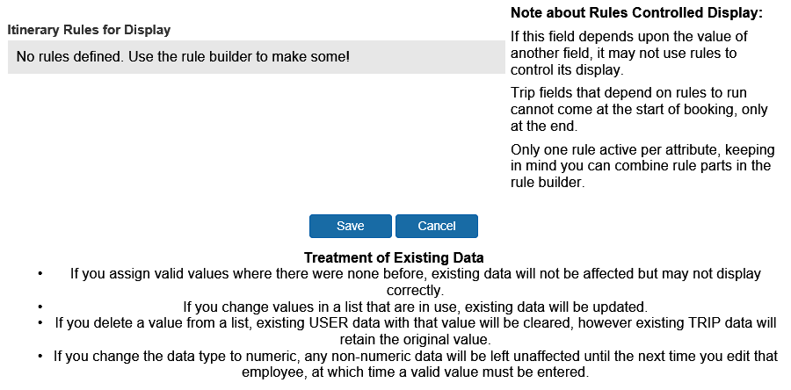

| Field | Description/Action | | |
| --- | --- | --- | --- |
| **Itinerary Rules for Display** | | |
| <all fields> | | Refer to *Itinerary Rules* below. |

1. Click **Save**.

##### Using If / Then Logic

When defining or editing a custom trip field, you can select another custom trip field/value combination to control when to ask a secondary question. For example, SAP Concur can ask the user a question, such as "What is the purpose of your trip?" If the answer to the question is "Meeting" then Concur will ask the user "What is the name of the meeting?"

You can also use this area to display custom trip fields (questions asked during the booking process) based on the value of a custom profile fields. For example, you could drive a question during the booking process for only the travelers with a business unit of Marketing. This avoids having to create separate travel classes or configurations to have different questions asked of different travelers.

Note the following:

* Yes/No and Long Text fields cannot currently be used to control the display of other fields.
* ***Both*** custom trip fields must exist before the if/then logic can be set up.
* For display of a trip custom field based on a value in a profile custom field, that profile custom field in the user profile of the traveler MUST contain a value. Display of a trip custom field only if a profile custom field does NOT contain any value is currently not a supported use case.
* Display of a trip custom field based on a value in a profile custom field is currently not supported with the **has a value** or **has no value** options. Instead, use options **is** or **is not**.

1. To use if / then logic with trip fields:
2. Follow normal steps, such as defining the field name and display names (if needed), identifying which configurations or travel classes this field will apply to, and defining whether it will be a text box or dropdown.

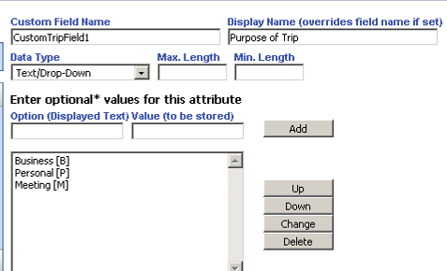

1. Create a second custom trip field asking for a meeting name. This one was set up so the user can simply type in the meeting name.

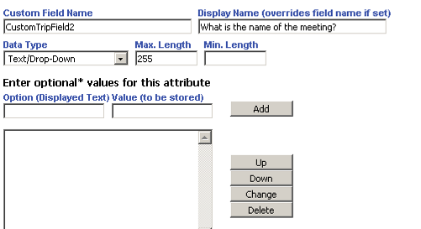

1. Edit the second custom trip field to set up the if/then logic. In this case, to only display custom field 2 if custom trip field 1 is set to Meeting.

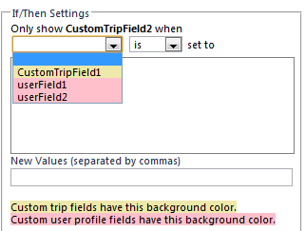

1. You can select multiple options here if needed.
2. ***Be sure to save before moving forward.***

#### Work with Itinerary Rules

You can configure custom trip attributes to trigger based on itinerary rules, allowing you to drive questions asked during the booking process based on the type of travel booked.

In this process, you must:

* First, set up the itinerary rule triggers.
* Then, update the custom trip field.

##### Travel Rule Builder

1. To set up the itinerary rule triggers:
2. In the **Travel Administration** section of the left menu, click **Travel Rule Builder**.
3. Click the *Custom Trip Attributes – Itinerary* rule group.
4. Click **Add**.

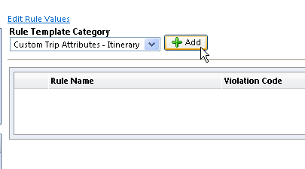

All of the regular itinerary-level rules will be available ­– except **All Trips** – you do not need a rule to show a custom trip field for all trips.

1. Click **Save**. The new rule appears.

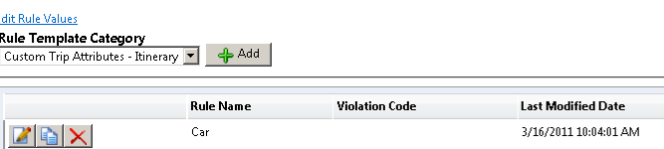

##### Manage Custom Fields

1. To update the custom trip field:
2. In the **Company Admin** section of the left menu, click **Manage Custom Fields**, then the **Trip Fields** tab.
3. Click **New Trip Field**.

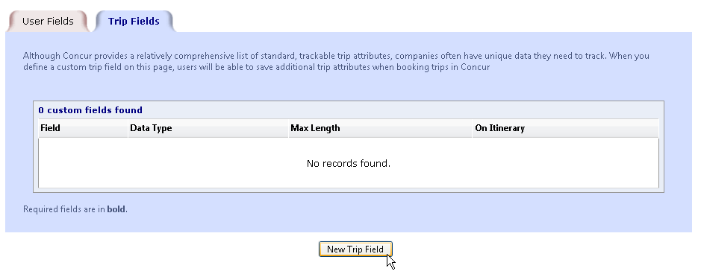

1. Configure the trip field to include the itinerary attribute by selecting the check box in the new **Itinerary Rules for Display** section.

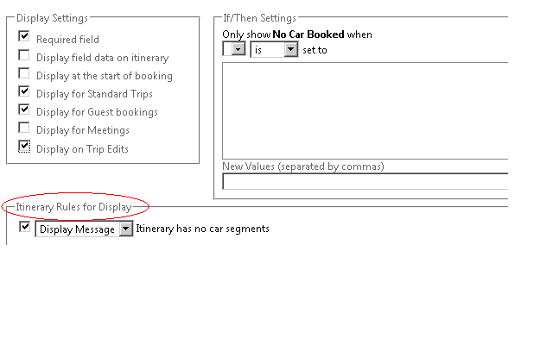

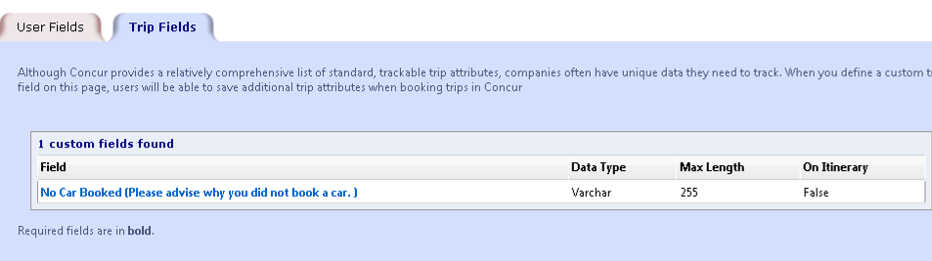

1. You may also update the PNR template to write the data to the PNR if needed. Click **Administration** **> Travel > Travel System Admin >** **Finishing Template Editor** (**Profile & Finishing** section of the left menu).

Note the following:

* Itinerary rules are only available for questions asked at the end of the booking process based on the itinerary selected. If you choose to display at the start of the booking, the trip field deactivates.
* Itinerary rules cannot work in conjunction with if/then conditions. If you enable if/then conditions, the itinerary rules deactivate.
* You cannot combine multiple rules; only one rule per trip field is allowed. If multiple rules exist, the last one selected will be the one utilized.
* All other options within the custom trip field configuration are possible. You can assign it to specific travel configurations or travel classes, determine whether or not the field is required as well as whether it should be a dropdown or text field.
* We have added help text to explain these limitations:

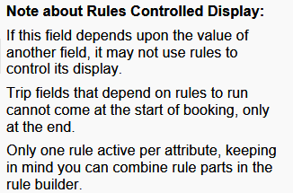

### Calendar Integration Admin

Refer to the *Calendar Integration Travel Service Guide*.

### Company Settings

Refer to the *Company Settings Travel Service Guide*.

### Login URL Manager

Use the **Login URL Manager** option to manage general company settings.

#### Overview

The Concur login URL can be modified to include a logout URL. So, when a user logs out of Concur Travel & Expense, they are redirected to the other URL.

For example, with this URL <https://www.concursolutions.com/default.asp?loginurl=http://www.google.com> upon logout, the user is redirected to [www.google.com](http://www.google.com).

Concur has a global list of allowed URLs to be used for logout redirection. If a client wants to control the URL that should be called after logout, the client can set up one or more URLs to be allowed in a list of the company-specific logout URL. Once set up, only the URLs in the company-specific list are allowed. If the company-specific list is empty, the global Concur list of the allowed URLs will be used.

The following forms of links are allowed for logout redirections:

[http://www.concursoulution.com/**verify_login.asp**?**loginurl=**http://www.corpsite.com/something1/something2&<sso_query_string](http://www.concursoulution.com/verify_login.asp?loginurl=http://www.corpsite.com/something1/something2&%3csso_query_string)>

[http://www.concursoulution.com/**default.asp**?**loginurl=**http://www.corpsite.com/something1/something2](http://www.concursoulution.com/default.asp?loginurl=http://www.corpsite.com/something1/something2)

[http://www.concursoulution.com/**default2.asp**?**loginurl=**http://www.corpsite.com/something1/something2](http://www.concursoulution.com/default2.asp?loginurl=http://www.corpsite.com/something1/something2)

#### Add a URL

1. To add a URL:
2. In the **Company Admin** section of the left menu, click **Login URL Management**.

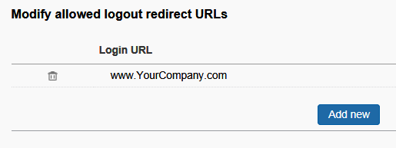

1. Enter one or more URLs that should be allowed for redirection when added to the login URL.

The global Concur list grows based on requested URL by clients. It can be tested as follows: if an URL will be added to the login URL for logout redirection and the login page will not show, the logout URL is not part of the global list.

### New Concur Travel Experience

To access the **Manage New Concur Travel Experience Preferences** page, click **Home > Company Admin > New Concur Travel Experience.** Once the Company Administrator accesses this page, they will have options to manage their preferences for the new Concur Travel experience for Air, Hotel, and/or Rental Car bookings. The default setting is **Enabled**. To change the setting, uncheck the box or boxes and click **Save**.

**Opt-In for all example**:

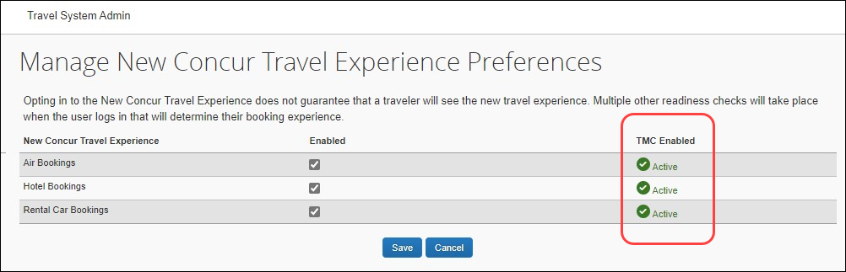

**Opt-Out example**:

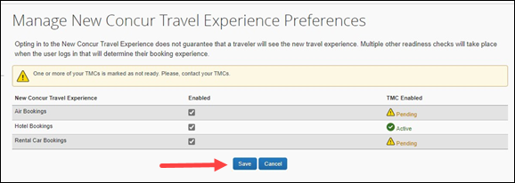

The TMCs readiness displays in the **TMC Enabled** column. If one or more TMCs has disabled one or more of the new Concur Travel booking experiences, their readiness will be noted as **Pending**. If you have any questions about your TMC’s readiness, please contact them directly.

**Manage Preferences at the Travel Configuration Level:**

Click **Company Level Preference** to expand the section and select the name of the travel configuration on the list.

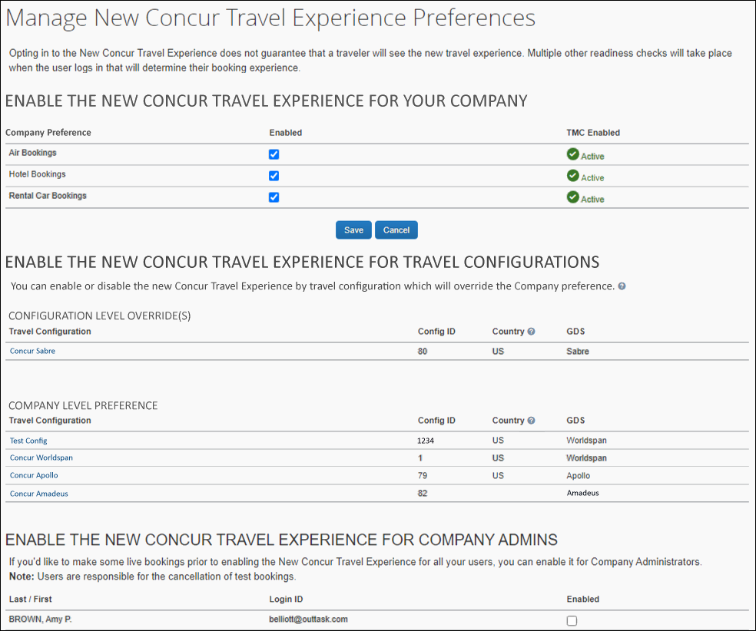

The **Manage New Concur Travel Experience Preferences** screen displays. This will allow the Company Administrator to select or unselect the **Air Bookings**, **Hotel Bookings**, and **Rental Car Bookings** options to enable or disable it for the new Concur Travel experience. Click **Save** once the options are selected.

1. Any changes made at the travel configuration level will override the preference set at the company level.

Travel configurations with overrides display first in the **Configuration Level Override(s)** section, followed by **Company Level**.

1. To Remove an Override on a Travel Configuration:
2. Click the name of the travel configuration.
3. Click the **Use** **Company Preference** button. The **Manage New Concur Travel Experience Preferences** page displays. The travel configuration that was overridden now appears in the section that uses the Company Level preference.

## User Administration Section

The **User Administration** section includes:

| Feature | Description/Action |
| --- | --- |
| User Administration and Add User | Add users to Travel  **NOTE:** This guide provides information for Travel clients as well as Travel & Expense clients. |
| Self-Registration Setup and Approvals | Allows users to self-register for events |
| Send Mobile Instructions | Send mobile instructions to users |
| User Permissions | Assign permissions to users |
| Company Groups | Create and manage groups |

Each is described on the following pages.

### User Administration and Add User – Travel Only

#### Overview

Use the **User Administration** and **Add User** options to add users, change passwords, and manage other information for Travel users.

This section of this guide describes the fields that are available for each user. You can create custom fields to store data, as needed, using the **Manage Custom Fields** section in this guide.

1. Many companies limit the records that a user can edit. If you are using Expense, please be aware of the fields that you are allowed to edit. If you are unsure, please check with your Travel or Expense implementation consultant or Concur Client Support.

#### Search for Users

It is useful to be able to search for specific users when you need to review user information or make updates to user records. In User Administration, you can search for users by specifying the following criteria. You can choose criteria in any or all of these fields to filter for the specific users you need.

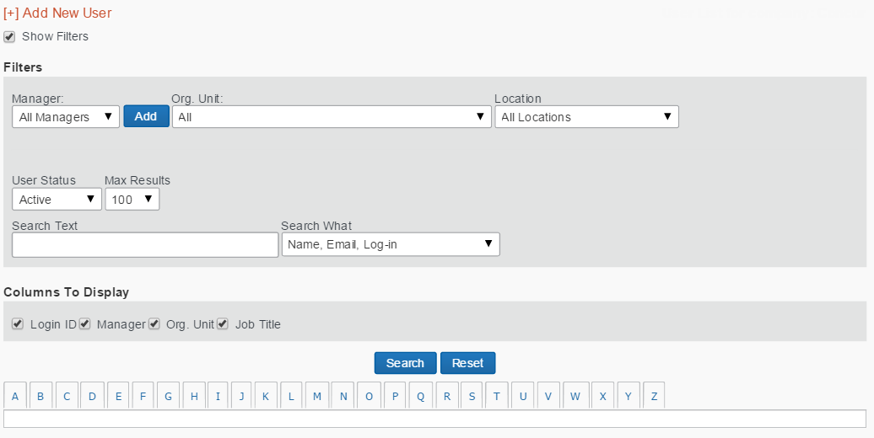

| Search Criteria | Description/Action |
| --- | --- |
| Manager | Choose to search by manager. This field will work only if you have created login IDs for your managers. Click the dropdown arrow for this field to see a list of available managers.  If the manager does not appear, click **Add** to add that person's name into the list. When you click **Add**, a search box appears that allows you to search for the person. Search using any part of their first or last name, and then select the person. Once you select a manager from this box, the person's name will appear in the list in the future. |
| Org. Unit | If you set up organization units for your company, you can choose to search by this field. Click the dropdown arrow for this field to see a list of available organization units. |
| Location | If you set up locations for your company, you can choose to search by this field. This field will work only if you have company locations loaded on the site. Click the dropdown arrow for the field to see a list of available locations. |
| User Status | Choose to search by the user's status – either active (currently using Travel) or inactive (not using Travel). Users cannot be deleted in Travel, only inactivated, so administrators always have access to a user's information. |
| Search Text | Use this field to type in a name or any part of a name. Entries in this field are not case-sensitive. |

#### View User Details

1. To view user details:
2. In the **User Administration** section of the left menu, click **User Administration**.
3. Select (enable) the **Show Filters** check box to view the search fields.
4. Enter the search criteria.
5. Click **Search**.
6. In the results list, click the name of the user (link) that you want to review.
7. On the **User Detail** page, review the user's information.
8. Make any required updates.
9. Click **Save**.

#### Add Users

1. To add a user:
2. In the **User Administration** section of the left menu, click **Add User**.
3. You can also add new users from the **User Administration** page by clicking **Add New User**. You can also import users from other sources. For more information on importing users, contact your administrator.

This page appears.

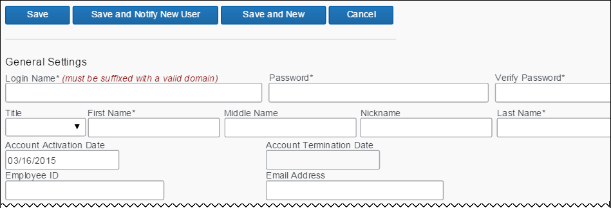

This is the first part of this section. The remainder of this section is described on the following pages.

1. In the first section of the page, complete the following fields.

| Field | Description/Action |
| --- | --- |
| Login Name* | Enter the user's name for logging in to Travel.  **NOTES:**   * ***ONLY*** the following special characters are allowed: hyphen, at symbol, period, and underscore. ( - @ . _) * Leading and trailing spaces are permitted. Verify that you have not entered one in error. * The login name must be unique across all Concur products. If a login name is currently in use in any Concur product, it cannot be assigned again unless the original occurrence is changed. For example, assume that a login name was assigned in error. That login name can only be used again if an admin (either manually or via import) renames the original occurrence, allowing the login name to be used again. |
| Password* and Verify Password* | Enter the password for logging in to Travel.  This is the field to use if you want to reset a password as well.  If you reset a password to the user's Login name, the system will automatically prompt the user to change it the next time they log in to Travel. |
| Title, First Name*, Middle Name, Last Name*, Suffix | Enter or select (enable) as appropriate.  **IMPORTANT!** The user's name should always be the name that appears on their identification for travel purposes. |
| Account Activation Date | Enter (or select using the calendar) the date the user record was created, either in User Administration or through a synchronization with the Global Distribution System (GDS). |
| Account Termination Date | Enter (or select using the calendar) the date the user will stop using Travel.  If someone is leaving the company or will no longer be traveling, set this date to the last date the person will use Travel. You can set this to a date in the past to deactivate someone immediately. |
| Employee ID | Enter the user's employee ID number. |
| Email Address | Enter the user's email address.  Keep in mind that all notifications sent through Travel will be sent to this email address. |

1. Scroll down to the next section.

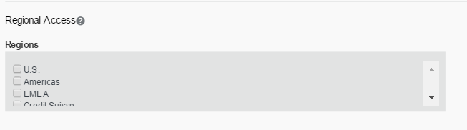

| Field | Description/Action |
| --- | --- |
| Regional Access | This section appears, depending on your company's configuration.  A company can be locked down to one region. If this user is allowed to administer, then select one or more regions as appropriate. |

1. Scroll down to the next section.

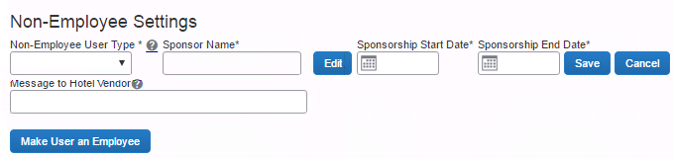

| Field | Description/Action |
| --- | --- |
| Non-Employee Settings | These fields are used for the Sponsored Guest User feature.   * Refer to the *Sponsored Guest User* *Travel Service Guide*. |

1. Scroll down to the next section.

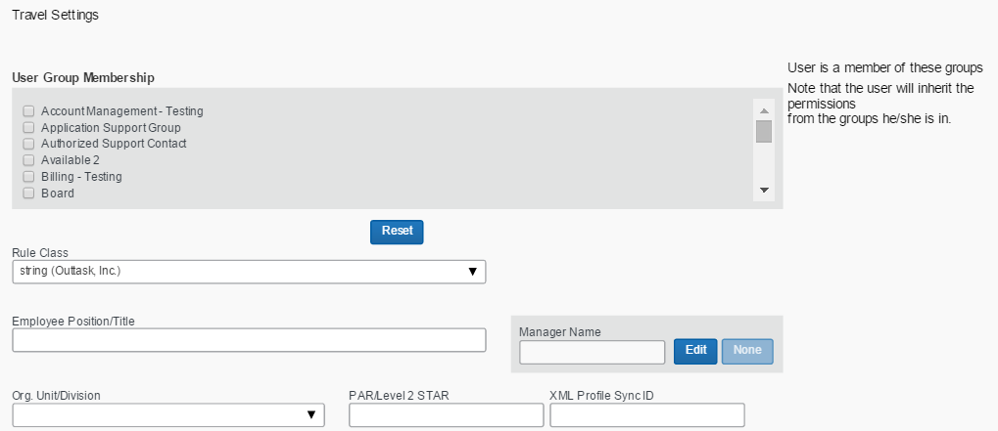

| Field | Description/Action |
| --- | --- |
| User Group Membership | Click one or more groups.  The user will inherit the permissions from the groups they are assigned to. |
| Rule Class | Click the user's rule class.  Travel will automatically assign the class designated as the default. |
| Employee Position/ Title | Enter the user's job title. |
| Manager Name | Click the user's manager's name.  If you are planning to use approvals or notifications, every user should have a manager displayed in this field. Click **Edit** to search for and select a manager.  If approvals or notifications are not used or will be handled by a designated travel approver, it is not necessary to select a manager in this field.  **NOTE:** The manager name you enter here is ***only*** for trip approvals. If your company uses Concur Travel & Expense, select the user's Expense approver using the **Approvers** link in the **Expense and Invoice Settings** section of the page (only appears for Expense users). |
| Org. Unit/Division | Click the user's organizational unit or division. |
| PAR/Level 2 STAR | The user’s profile name on the GDS |
| XML Profile Sync ID | The ID that synchronizes the profile with the profile in the TMC. |

1. Scroll down to the nextsection.

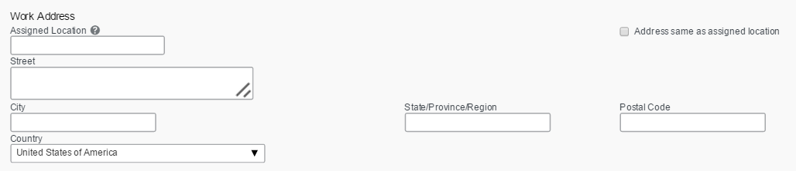

Enter the user's work location.

By selecting the **Address same as assigned location** check box, this field can be automatically filled in with the address you set up for each location.

1. Scroll down to the nextsection.

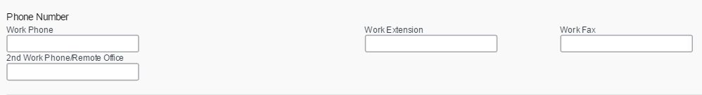

Enter the user's work phone numbers.

1. Scroll down to the nextsection.

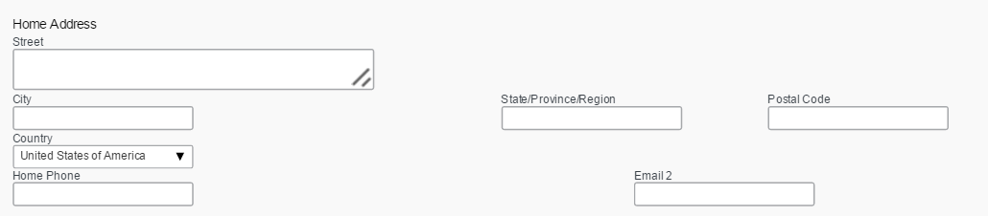

Enter the user's home address and phone number.

1. Scroll down to the **Custom Fields** section, if there is one. Complete as required.
2. Then:

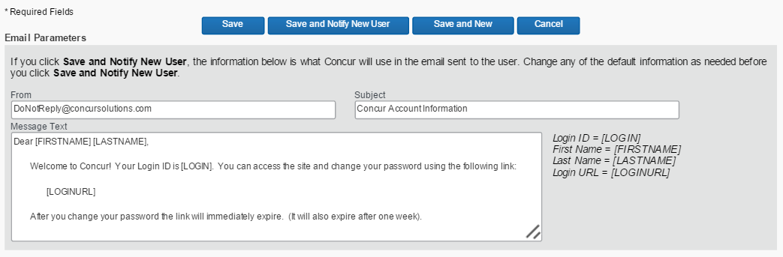

* Click **Save** to save this user.  
  - or -
* Click **Save and New** to save this user and add a new one.  
  - or –
* If you want to notify the new user via email:
* Edit the information in the **Email Parameters** section, if desired.
* Click **Save and Notify New User**.

Note the following about the **Email Parameters** section:

* The **Save and Notify New User** button and **Email Parameters** section appear ***only*** for new employees. They are not available when the admin modifies existing user information.
* The default email information appears and the admin can edit the **From**, **Subject**, and **Message Text** portion of the email as desired.
* Concur will default the "From" email address to the email1 of the administrator who is creating the new user.
* The **Message Text** section supports up to 1,000 characters, which includes spaces.
* There is no mechanism to permanently edit the information that appears by default. If the admin wants to make changes, they must change it for each new user.

### Unified User Admin – Travel & Expense

#### Overview

The **User Administration** page is used by Travel or Expense Administrators to add new users, assign user roles, and modify user profiles. The User Administration page contains the fields used on the Employee Profile form in Expense and/or the Travel Preferences fields from Travel. The fields displayed will vary depending on the user role selected for the new user.

Access the *User Guide* on the Concur Support Portal.

### Self-Registration Setup and Approvals

Refer to the *Self-Registration Travel Service Guide*.

### Send Mobile Instructions

Use the **Send Mobile Instructions** option to select one or more Concur users and email the Concur Mobile download and login instructions. This email is the same as the one that the user generates on the Mobile Registration page.

This feature is available to admins with any of these permissions:

* User Administration
* Employee Maintenance
* User Admin (Read Only)

To send the emails:

1. In the **User Administration** section of the left menu, click **Send Mobile Instructions**.
2. To locate a particular user, type part of the user's name or email address in the **Find in name and/or email** field and click **Search**.
3. Select (enable) the **Exclude mobile users** check box to ***not*** show users who have already logged in to Concur for Mobile or have registered a PIN.
4. Select the desired users. The selected users appear at the bottom of the page.

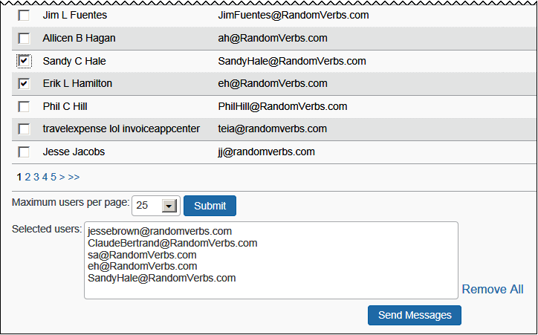

1. Review for accuracy and click **Send Messages**.

### User Permissions

#### Overview

Use the **User Permissions** option to assign permissions to individual users, groups of users, users in a rule class, or to everyone in your company. The available permissions are determined by your travel configuration. You can:

* Grant access to particular features in Travel, such as Travel Administration and Reports.
* Verify the permissions available to a person or a group.

The following table describes the available permissions in Travel.

| Permission | Description/Action |
| --- | --- |
| App Center Listing Administrator | The user assigned this role can submit App Center listings. This role is only assigned by SAP Concur to certain App Center partners. |
| Administer Approval Queue | Allows users to reassign approval requests  You can assign this permission by itself. |
| Agency Billing Administrator | Allows users to access agency billing administration |
| Approve then Book | Allows users to enable travel booking from an approved request   * For more information, refer the [*Travel Release Notes, February 2020*](http://techpubs.concur.concurtech.org/TravelDocs/ReleaseNotes/2020/02(Feb)/Tra_RN_2020_02(Feb)_int_3final_u2.pdf) |
| Authorized Support Contact (ASC) | Allows user to request configuration changes and enable/disable features under My Profile in the SAP Concur support portal.   * For more information, refer to the [*Travel Release Notes, January 2019*](http://techpubs.concur.concurtech.org/TravelDocs/ReleaseNotes/2019/01(Jan)/TRA_RN_2019_01(Jan)_int_prof_3FINAL_u1.pdf) |
| Billing Administrator | Allows users to view bills from SAP Concur  You must assign this permission with one other administration permission. |
| Company Administration | Automatically assigns:   * Administer Approval Queue * Billing Administrator * Company Locations Administration * Corporate Ghost Cards * E-receipt Admin * Group and Shared Resources Administration * Managed Meeting Center Admin (ONLY if the Third Party Meeting Module has been enabled) * Organization Unit Administration * Permission Administrator * Report Admin * Travel Policy Administrator * User Administration * Web Services Admin   **NOTE:** When you also select the User Administration permission, the **User Permissions** link becomes available in Company Administration. |
| Company Discount Administrator | Allows users to add site-level discounts  This feature is available to the user when you select this permission and the **Allow Discount Editing** option has been enabled in the Company Travel Configuration for the customer site.   * Refer to the *Travel System Admin User Guide*.   This permission must be combined with the Travel Policy Administrator permission. |
| Company Link Administrator | Allows customers/TMCs the ability to include/exclude links, redirect links, and add new links to the Travel Tools page   * Refer to the *Company Link Administrator Travel Service Guide*. |
| Company Locations and Maps | Allows users to enter locations for travelers to use when searching for hotels or off-airport car locations |
| Concur Meeting Accountant | Allows users to add credit cards to a meeting and download payment files  **NOTE:** This permission will appear only if you have enabled Meeting via the new site setup work order. |
| Concur Meeting Admin | Allows users to access Meeting administration; allows Meeting administration ***with*** the Concur registration module  **NOTE:** This permission will appear only if you have enabled Meeting via the new site setup work order. |
| Concur Meeting Planner | Allows users to access ***all*** Meeting pages ***except***:   * Travel > Agency Settings * Travel > Form of Payment * Tracking > Payment (the **Edit** link is hidden from within the Payment page) |
| Corporate Ghost Card Administrator | Allows user access to the **Corporate Ghost Cards** link on the **Company Admin** page  **NOTE:** The **Company Groups** link and the links in the **Group Administration** section are always present for anyone with administrative privileges, but users can only edit (not add) groups they own if they do not also have the Group and Shared Resources Administration permission. |
| Custom Field Administrator | Allows user access to the **Manage Custom Fields** link on the **Company Admin** page  **NOTE:** The **Company Groups** link and the links in the **Group Administration** section are always present for anyone with administrative privileges, but users can only edit (not add) groups they own if they do not also have the Group and Shared Resources Administration permission. |
| Data Retention Administrator | Allows users access the **Data Retention** link on the **Company Admin** page and the **Hold User** and **Purge User** buttons in **User Administration**. |
| Employee Maintenance | Allows users to update, modify, and delete – but not create – a new user in User Admin  This role is ideal for clients seeking tighter fraud control. |
| Group and Shared Resources Administration | Allows users to view and modify groups  You can assign this permission by itself.  **NOTE:** If a user owns a group or is in a group that owns a group, the user will not be able to modify that group without this permission. Ownership of a group provides no additional access. |
| Guest Booking | Allows users to create reservations for non-profiled travelers   * Refer to the *Sponsored Guest User Travel Service Guide* and the *Non-Profiled Travel Travel Service Guide*. |
| Import Data Administrator | Allows the user to import data from a customer site, instead of logging into the agency site and selecting **Administration** **>** **Travel** **>** **Travel System Admin** **>** **Import Data** |
| Localization Admin / Localization User | Localization Admin is assigned only ***to*** SAP Concur employees.  Localization User is assigned only ***by*** a Localization Admin. |
| Manifest Administrator | Allows users to perform a multi-user clone  This role allows companies to determine who should manage travel on behalf of a large group. |
| Meeting Center Developer Third Party | Allows users to test screens and documentation for a third-party meeting product with XML integration  **NOTE:** This permission appears only if you have enabled Concur Meeting via the new site setup work order. |
| Online Order Form Access | Used by TMCs to allow its agents to access to the online order form  **NOTE:** This permission is visible only when the Concur Travel Reseller module is given to the TMC by Concur.   * Refer to the *Online Order Form Travel Service Guide*. |
| Organization Unit Administration | Allows users to create and edit organizational units  You can assign this permission by itself. |
| Password Manager | Allows users to update passwords for Travel users  User will have read-only access to the following fields on the **User Details** page in User Administration: Title, First Name, Middle Name, Preferred Name, Last Name, Suffix, and Email.  **Preventing Access:** A module property is available to restrict this role from changing passwords - contact SAP Concur directly to have the *Password Access Restriction* feature activated.  **NOTE:** The users with Travel and either Expense or Invoice have one password for all applications. When any of the Password Manager roles changes a password, it changes for all applications. |
| Permission Administrator | Allows the user to assign user permissions  **NOTE:** This role is automatically assigned when the Role Administrator role is assigned via Expense, Invoice, and Request. |
| Profile sync administrator | Allows users to update and retrieve passwords from the **Profile Sync Configuration** page |
| Profile User | Allows users to update their profile only and not have access to the Travel booking wizard.  **NOTE:** When a site is created, the 'ALL' group is automatically added to the Travel Wizard User permission. You must manually remove the 'ALL' group from this permission if you do not want travelers to have access to update both their profile and make a reservation.  Make sure the Project team has access to the booking wizard for testing purposes by creating another Group for that team, and granting the appropriate permissions. |
| Report Admin | Allows users to determine who has access to reports   * Refer to the *Travel Reporting User Guide*.   You can assign this permission by itself. |
| Report User | Allows users to view reports  You must assign this permission in order for users to view company reports; however, you must also assign individual reports in the Report Admin.   * Refer to the *Travel Reporting User Guide*.   You can assign this permission by itself. |
| Self-assigning Assistant | Allows users to assign themselves as an assistant  If you assign this permission to a user or group, those users can select a traveler to assist. |
| Self-Registration Approver | Allows users to approve the self-registrations within their own company   * Refer to the *Self-Registration Travel Service Guide*. |
| Sponsor | Allows users to be searched for and assigned as the sponsor for the guest user   * Refer to the *Sponsored Guest User Travel Service Guide*. |
| Travel Agent | Allows users to access Concur Expert Agent (XA), if you have also assigned the Company Administration permission  With this permission:   * The **Travel System Admin** link may be displayed but will only provide data based on the backend setup. * The **Import Data** link will appear within Company Administration. |
| Travel Meeting Center Admin Third Party | Allows users to use a third-party meeting product with XML integration administrator screens; allows Meeting administration ***without*** the SAP Concur registration module  **NOTE:** This permission will appear only if you have enabled Meeting via the new site setup work order. |
| Travel Meeting Center User | Allows users to access meetings to which they are invited  **NOTE:** This permission will appear only if you have enabled Meeting via the new site setup work order. |
| Travel Policy Administrator | Allows users to administer Travel Policy  You can assign this permission by itself.  Assigning this permission also provides access to:   * E-Receipt Admin * Travel Admin * Travel Rule Builder * Travel Reporting * Travel Templates (administering for all users) * Credit Card BIN Restrictions * Unused Tickets * Meeting Center Admin **NOTE:** This link appears if you have assigned Meetings Admin permission or Travel Meeting Center Admin Third Party permission. * Manage Corporate Discounts **NOTE:** This link appears if you have assigned both this permission and the Company Discount Administrator permission. |
| Travel Wizard User | Allows users to access to the profile and booking wizard to make online reservations  This permission is automatically assigned to ALL (group). |
| UI Preview | Allows users to preview the *enhanced* user interface |
| User Administration | Allows users to modify and add users  You can assign this permission by itself.  Assigning this permission also provides access to:   * Add User * Self-Registration Setup * Self-Registration Approval * Send Mobile Instructions * Company Groups   **NOTE:** A user assigned the User Administration permission will be able to see but not use **Company Groups** (**User Administration** section of the left menu) unless the user is also assigned the Group and Shared Resources Administration permission. |
| User Admin (Read Only) | Allows users to view but not change ***any*** user information, including passwords; the user can view using the User Admin page but cannot access the user's profile  **NOTE:** If the user also has Employee Maintenance or Sponsor permission, those permissions take precedence this permission. |
| Virtual Payment Administrator | Allows users to manage Virtual Payments (Conferma)   * Refer to the *Virtual Payment (Conferma) Travel Service Guide*. |
| Web Services Administrator | The user assigned this role can:   * Access the **Partner Application Administration** page to register or enable partner applications to access the company’s data using the SAP Concur web services. The partner applications are required for some integrations, and do not appear in the SAP Concur App Center. * Access the **Manage User Apps** page to restrict the User applications in the SAP Concur App Center for their company's users. * Enable Enterprise partner applications within the SAP Concur App Center * For more information, refer to the *Shared: App Center Administrator User Guide*. |
| zAuto-Cancel User | Used primarily to test general functionality in Concur Travel  Reservations made by users with this permission:   * Will not have custom PNR finishing remarks added * Will not be queued to any queues defined in the Agency Configuration * Will not show in reports * Will be auto-canceled in the GDS after 4 hours |
| zDemo/Training/ Practice User | Used primarily to test the integration between Concur Travel and other Concur products  Reservations made by users with this permission:   * Will generate “demo” e-tickets and e-receipts * Will not have custom PNR finishing remarks added * Will not be queued to any queues defined in the Agency Configuration * Will not show in reports * Will be auto-canceled in the GDS after 4 hours   When applied to a login ID, Concur's standard invoicing practices will apply unless you utilize the non-invoiced policies.   * Access additional information to the Concur Support Portal.   **NOTE:** In emergency situations, you can use the *agent claimed* remark to prevent bookings made with Z Demo permission from being auto-cancelled. |

#### Considerations for Assigning Permissions

You will choose whether to assign permissions by permissions, groups, rule classes, or users.

* If you choose *Permissions*, you will see a list of permissions in the **Permission Name** dropdown menu at the top of the page. You can then select a permission and specify the users, groups, and/or rule classes that will be assigned to the permission.
* If you choose *Groups*, *Rule Classes*, or *Users*, you will see a list of groups/rule classes/users in the dropdown menu at the top of the page. You can then select a group/rule class/user and specify the permissions to be assigned.

All methods accomplish the goal of assigning permissions to users. You will determine which method works best for you.

#### Manage Permissions by Permission Name

1. To manage permissions by permission name:
2. In the **User Administration** section of the left menu, click **User Permissions**. This page appears.

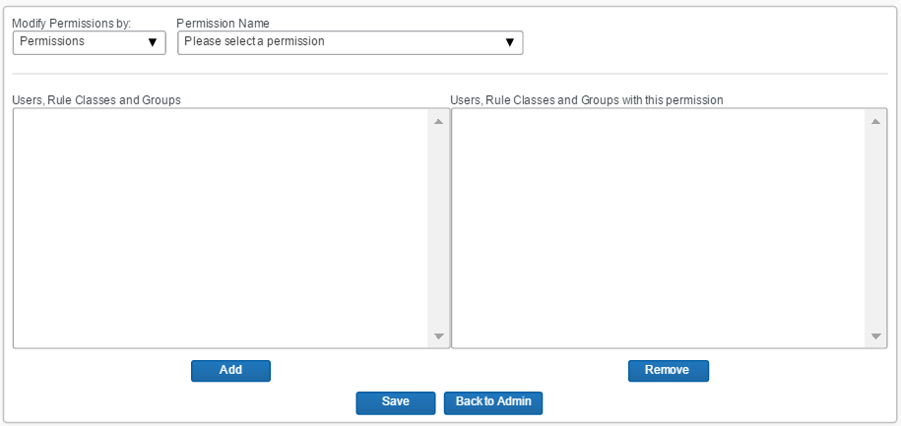

1. In the **Modify Permissions by** list, click *Permissions* (if it is not already selected).
2. In the **Permission Name** list, select the desired permission.

You will see:

* On the left side of the page – the existing users, rule classes, and groups.
* On the right side of the page – the existing users, rule classes, and groups with the selected permission.

1. To add a permission:

* On the left side, select the desired user, rule class, or group.
* Click **Add**.

Notes about selecting:

* Hold down the CTRL key to select multiple names.
* Hold down the SHIFT key to select a range of names.
* If you want a permission to be available to all of your users, click **ALL (group)**.
* Administrator roles cannot be assigned to the ALL group.

1. To remove a permission:

* On the right side, select the desired user, rule class, or group.
* Click **Remove**.

1. Click **Save**.

#### Manage Permissions by Group or Rule Class

1. To manage permissions by group or rule class:
2. In the **User Administration** section of the left menu, click **User Permissions**.
3. In the **Modify Permissions by** list, click *Groups* or *Rule Classes*.

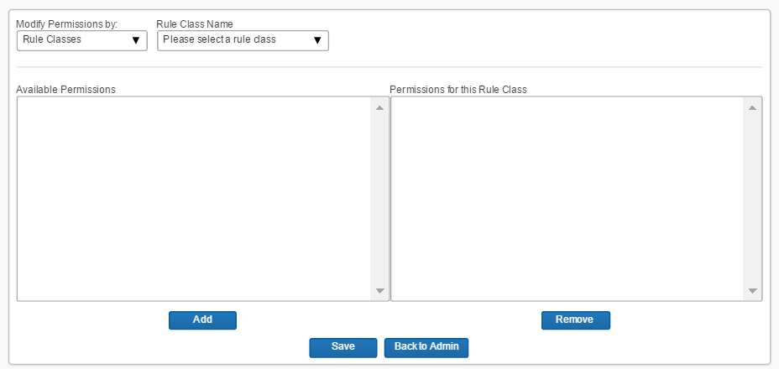

1. In the **Group** (or **Rule Class**) **Name** list, select the desired group (or rule class).

You will see:

* On the left side of the page – the available permissions for the groups (or rules classes).
* On the right side of the page – the permissions already assigned to this group (or rule class).

1. To add a permission:

* On the left side, select the desired permission.
* Click **Add**.

Notes about selecting:

* Hold down the CTRL key to select multiple permissions.
* Hold down the SHIFT key to select a range of permissions.

1. To remove a permission:

* On the right side, select the desired permission.
* Click **Remove**.

1. Click **Save**.

#### Manage Permissions by User

1. To manage permissions by user:
2. In the **User Administration** section of the left menu, click **User Permissions**.
3. In the **Modify Permissions by** list, click *Users*.

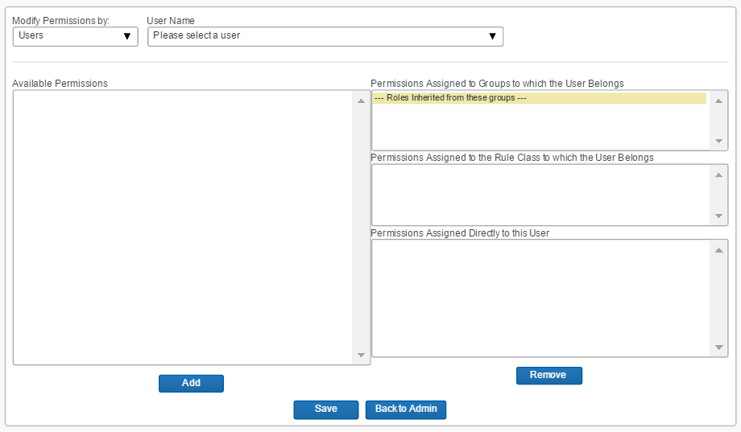

1. In the **User Name** list, select the desired user.

You will see:

* On the left side of the page – the available permissions for the selected user.
* On the right side of the page –
* the permissions inherited from groups to which the user belongs
* the permissions inherited from the rule class to which the user belongs
* the permissions assigned directly to the user

1. To add a permission:

* On the left side, select the desired permission.
* Click **Add**.

Notes about selecting:

* Hold down the CTRL key to select multiple permissions.
* Hold down the SHIFT key to select a range of permissions.

1. To remove a permission:

* On the right side, select the desired permission (from the third section).
* Click **Remove**.

1. Click **Save**.

### Company Groups

#### Overview

Users will inherit the permissions from the groups they are assigned to. Use the **Company Groups** option to create new groups and maintain group membership.

Typically, you create the user, create the group, and then add the user to the group, if needed. You can also assign users to groups in User Administration. If the group is already created, when a new user is added in User Administration, the user can be added to a group immediately.

#### Create a New User Group

1. To create a new group:
2. In the **User Administration** section of the left menu, click **Company Groups**. This page appears.

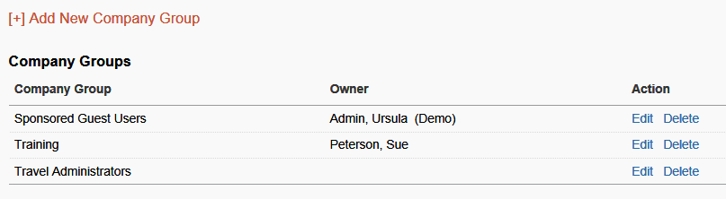

1. Click **Add New Company Group**. This page appears.

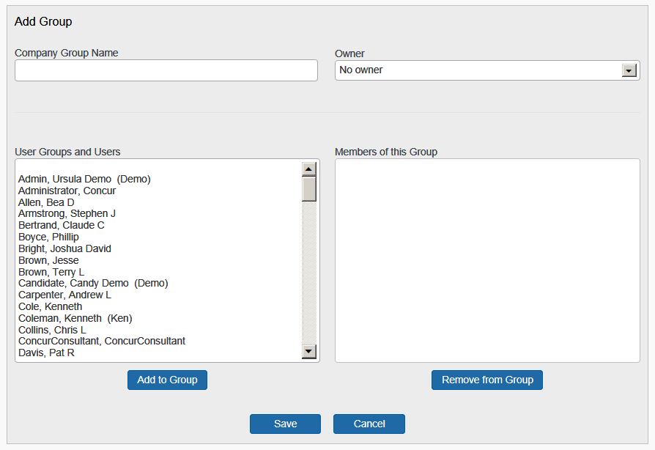

1. Complete the following fields.

| Field | Description/Action |
| --- | --- |
| Company Group Name | Enter the name for the group. |
| User Groups and Users | Click the names of the users to assign to this group.   * Hold down the CTRL key to select multiple names. * Hold down the SHIFT key to select a range of names. |
| Add | Click this button to add. |

1. Click **Save**.

#### View and Modify Group Membership

1. To view or modify groups:
2. In the **User Administration** section of the left menu, click **Company Groups**. You will see a list of groups created for your company.
3. Click **Edit** next to the company group name that you want to view or modify. You will see a list of users who belong to this group in the **Members of this Group** field.
4. To add users:

* In the **User Groups and Users field**, click the users who you want to add to the group.
* Click **Add**.

1. To remove users:

* In the **Members of this Group** field, click the users who you want to remove from the group.
* Click **Remove**.

1. Click **Save**.

## Travel Administration Section

### Travel Administration

The **Travel Administration** section is described on the following pages.

### Corporate Ghost Cards

#### Overview

Use the **Corporate Ghost Cards** option to add and assign corporate credit cards.

#### Add a New Corporate Credit Card

1. To add a new card:
2. In the **Travel Administration** section of the left menu, click **Corporate Ghost Cards**. This page appears.

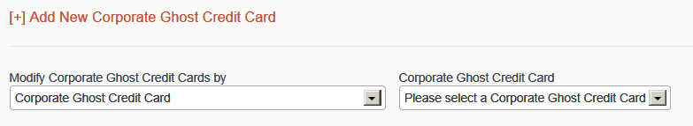

1. Click **Add New Corporate Ghost Credit Card**. This page appears.

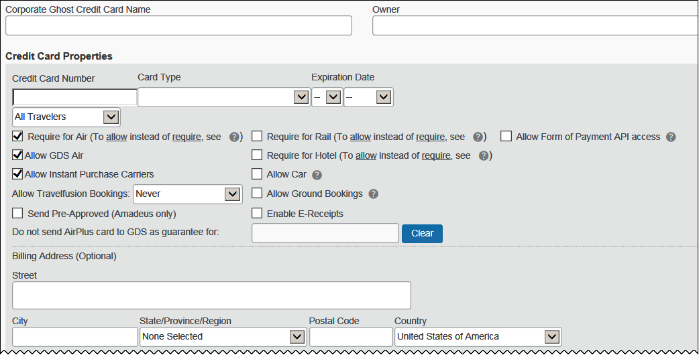

This is the first part of this section. The remainder of this section is described on the following pages.

1. Complete the following fields.

| Field | Description/Action |
| --- | --- |
| Corporate Ghost Credit Card Name | Enter the name for the card.  **NOTE:** The card name cannot contain special characters. |
| Owner | ***Leave blank; this field is no longer used.*** |
| **Credit Card Properties** | |
| Credit Card Number | Enter the card number.  Do not enter dashes, spaces or periods – only the number. |
| Card Type | Click the appropriate card type. |
| Expiration Date | Select the expiration date.  **NOTE:** Travel assumes that the expiration date is the ***last*** day of the selected month. For example, if you select February 2016, then the expiration date is February 28 2016. |
| (drop list) | Click one of the following:   * All Travelers: Applies to employees and guest travelers * Guest Travelers only |
| Require for Air  Require for Rail  Require for Hotel | Select (enable) the check box to require this card used.  *Allow* instead of *require*: If travelers should be *allowed* to choose between a personal card and a ghost card, contact your agency or Concur Support to enable the travel configuration setting **Allow users to choose a personal credit card even if they have a custom corporate card**. If travelers are allowed to choose because of that setting, the corporate ghost card will be the default form of payment unless the **Force users to choose a credit card** setting is also enabled. |
| Allow GDS Air  Allow Car  Allow Ground Bookings | Select (enable) the check boxes as appropriate.  If you allow the ghost card to be used for anything other than air, the traveler will see the ghost card as a form of payment option. If the traveler has entered a personal card and made that card the default card for cars or hotels, that form of payment will be used automatically. |
| Allow Instant Purchase Carriers | Select (enable) the check box to allow corporate ghost cards to be used for instant purchase and guaranteed ticketing bookings. |
| Allow Travelfusion Bookings | Click one of the following:   * **Never:** Don’t allow this card to be used for Travelfusion * **If CVV is not required:** Only allow this card to be used if the vendor does not require CVV verification * **Always:** Always allow this card to be used |
| Send Pre-Approved (Amadeus only) | Select (enable) this check box to add N0000 to the form of payment CC element in the Amadeus PNR.  Example: FP CCAXXXXXXXXXXXX1000/1214/**N0000**   * **N:** Manual Approval Indicator * **0000:**  Placeholder for a manual approval code   Once the agency has received a manual approval code (for example, by phone or with a credit card terminal), the placeholders can be replaced by the actual manual approval code. |
| Do not send AirPlus card to GDS as guarantee for | Click in the field. The list appears.  Select the vendors (such as Avis, Budget, and Enterprise) that do not accept do not accept AirPlus as the form of guarantee in the PNR. For these vendors, sending AirPlus as the form of payment may cause the booking to fail.  **NOTE:** AirPlus is accepted by Avis, Hertz, Sixt, Europcar, and Enterprise in many European countries. The countries in which AirPlus is accepted for rental car booking is subject to change. Please contact your local AirPlus representative to request the actual AirPlus Rental Car acceptance information. |
| Enable E-Receipts | Select (enable) the check box to allow Travel to accept e-receipts. |
| Allow Form of Payment API access | Select (enable) the check box to allow corporate ghost cards to be passed to third-party vendors, such as TripLink vendors and fulfillment TMCs |
| **Billing Address section** | |
| Street, City, State, Province, Region, Zip/Postal Code, Country | Enter as appropriate. |

1. Depending on the card type (Amex, AirPlus, etc.), there may be additional fields to complete.
2. Scroll down to the next section.

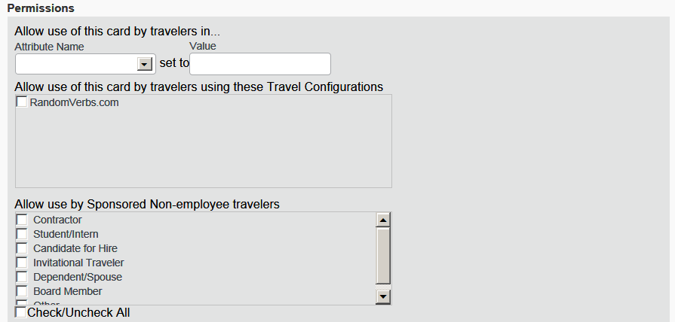

| Field | Description/Action |
| --- | --- |
| Allow use of this card by travelers in...  Attribute Name (User custom field) | Click the attribute name associated with this ghost card. Any user with a match in any of these fields can use this card.  Any or all of these fields appear based on module settings. If you want to use these options but the fields do not appear, contact Concur Client Support.  **NOTE:** To assign a single corporate ghost card to three cost centers (for example), create three corporate ghost cards with the same card number and then assign each one to a single cost center. |
| Allow use of this card by travelers using these Travel Configurations | Select one or more travel configurations, if desired. Any traveler in the selected configuration(s) will be able to use this ghost card.  **NOTE:** If a site has divisional view turned on, then the administrator will see only the travel configurations pointing to their agency unless the administrator has the global permission. |
| Allow use by Sponsored Non-employee travelers | Click the type of sponsored user.   * Refer to the *Sponsored Guest User Travel Service Guide* and the *Non-Profiled Travel Travel Service Guide*. |

1. Scroll down to the next section.

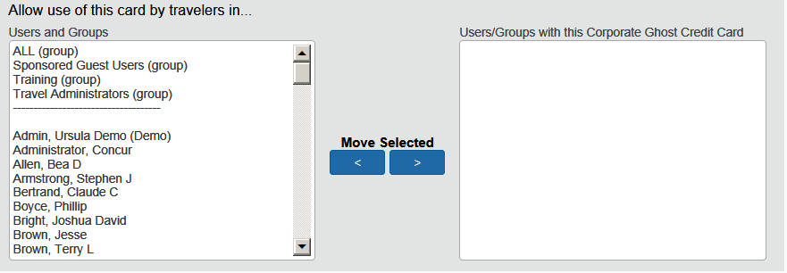

| Field | Description/Action |
| --- | --- |
| Users and Groups | Click the users or groups that will have permission to use this card.   * Hold down the CTRL key to select multiple names. * Hold down the SHIFT key to select a range of names. * If you want a corporate card to be available to all of your users, click **ALL (group)**. |
| Move Selected | Click the right-facing arrow. The selected users or groups appear in the **Users/Groups with this Corporate Credit Card** field and they will now have access to this card. |

1. Click **Save**.

##### AirPlus DBI Field Mapping

* For more information, refer to the *AirPlus Company Account Travel Service Guide*.

#### Grant Corporate Card Access by Corporate Card Name

1. To grant access by card name:
2. In the **Travel Administration** section of the left menu, click **Corporate Ghost Cards**.
3. In the **Modify Corporate Ghost Credit Cards by** dropdown menu, click *Corporate Credit Card* (if it is not already selected).
4. Complete the following fields.

| Field | Description/Action |
| --- | --- |
| Corporate Ghost Credit Card | Click the name of the corporate card to be assigned. The page refreshes; the card information displays.  You will see:   * A list of all your groups and users in the **Users and Groups** field on the left side of the page * A list of users who currently have access to the selected corporate card in the **Users/Groups with this Corporate Credit Card** field on the right side of the page |
| Users and Groups | Click the names of people or groups who should be assigned to the selected corporate card.   * Hold down the CTRL key to select multiple names. * Hold down the SHIFT key to select a range of names. * If you want a corporate card to be available to all of your users, click **ALL (group)**. |
| Move Selected | Click the right-facing arrow. |

1. Click **Save**.

#### Grant Corporate Card Access by Users and Groups

1. To grant access by user or group:
2. In the **Travel Administration** section of the left menu, click **Corporate Ghost Cards**.
3. In the **Modify Corporate Ghost Credit Cards** by dropdown, click *Groups* or *Users*. The page refreshes; the second list now contains groups or users.

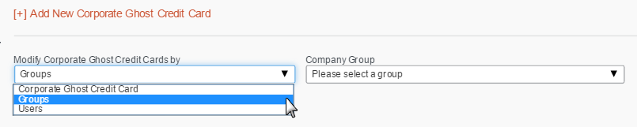

1. Complete the following fields.

| Field | Description/Action |
| --- | --- |
| Company Group  User | Click the user or group that will be assigned the cards.  You will see:   * A list of corporate cards in the **Available Corporate Ghost Credit Cards** field on the left side of the page * A list of corporate cards to which this user or group currently has access in the **Corporate Ghost Credit Cards for this User/Group** field on the right side of the page  The gray box at the top of this field displays corporate cards that are assigned to a user because he or she is a member of a group. Corporate cards that you assign to ALL (group) will appear in this list for every user. |
| Available Corporate Ghost Credit Cards | Click the corporate cards for this user or group.   * Hold down the CTRL key to select multiple corporate cards. * Hold down the SHIFT key to select a range of corporate cards. |
| Move Selected | Click the right-facing arrow. |

1. Click **Save**.

#### Remove Corporate Card Access

1. To remove access:
2. In the **Travel Administration** section of the left menu, click **Corporate Ghost Cards**.
3. Complete the following fields.

| Field | Description/Action |
| --- | --- |
| Modify Corporate Ghost Credit Cards by | Click *Corporate Credit Card*, *Groups,* or *Users* depending on how you want to access the assigned corporate cards. |
| Users/Groups with this Corporate Ghost Credit Card  Corporate Ghost Credit Cards for this User/Group | Click the corporate cards or users/groups to be removed. |
| Move Selected | Click the left-facing arrow. |

1. Click **Save**.

### E-Receipt Admin

Refer to the *E-Receipts Travel Service Guide*.

### Travel Admin

Use the **Travel Admin** section to manage certain settings for travel booking, including the following.





### Travel Admin – Travel Policy

Refer to these Travel Service Guides:  
  
 *- Approvals, Rules, and Classes/Policies Travel Service Guide   
  
 - Lowest Logical Fare (LLF) / Benchmark Lowest Airfare Travel Service Guide  
  
 - Configurable Message Boards Travel Service Guide*

### Travel Admin – Policy Violations Reasons

Refer to the *Approvals, Rules, and Classes/Policies Travel Service Guide*.

### Travel Admin – Travelfusion Suppliers

Refer to the *Travelfusion* *Travel Service Guide*.

### Travel Admin – Vendor FoID Admin

Do not use this option.

### Travel Admin – Travel Vendor Exclusions

Refer to the *Approvals, Rules, and Classes/Policies Travel Service Guide*.

### Travel Admin – Custom Text

Refer to the *Custom Text Travel Service Guide*.

### Travel Admin – Regional Hotel Rates

Refer to the *Regional Hotel Rates Travel Service Guide*.

### Travel Admin – Travel Alternatives

Refer to the *Green Support Travel Service Guide*.

### Travel Reporting

#### Overview

Use the **Travel Reporting** option to run a travel report that displays a list of trips. Additional reports are available in the **Reports** section of Travel – Company Administration.

#### Run a Travel Report

1. To run a report:
2. In the **Travel Administration** section of the left menu, click **Travel Reporting**. This page appears.

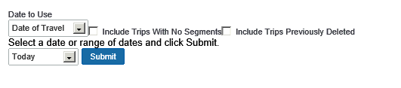

1. Complete the following fields.

| Field | Description/Action |
| --- | --- |
| Date to Use | Click *Date of Travel* or *Date of Booking*. |
| Include Trips with No Segments  Include Trips Previously Deleted | Select (enable) these check boxes as needed. |
| Select a date or range of dates | Define a date range for the report. |

1. Click **Submit**.

Access additional information to the Concur Support Portal.

### Travel Templates

#### Overview

Use the **Travel Templates** option to create a "template" trip for users who repeat the same trip.

Travelers can use a template but they can cannot edit or delete these templates.

#### Create a Travel Template

1. To create a template:
2. In the **Travel Administration** section of the left menu, click **Travel Templates**. This page appears.

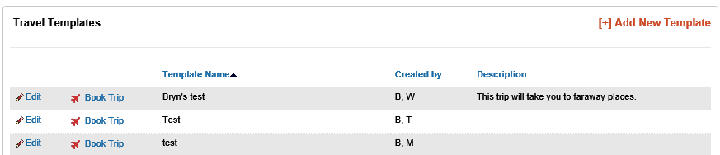

1. Click **Add New Template**. This page appears.

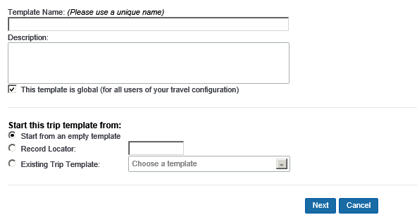

1. Complete the following fields.

| Field | Description/Action |
| --- | --- |
| Template Name | Enter a unique name for the template. |
| Description | Enter a description for the template that describes the available trip to users. |
| This template is global (for all users of your travel configuration) | Select (enable) this check box if this template should be available to everyone within your configuration. |
| Start this trip template from | Click one of the following:   * Start from an empty template * **Record Locator** and then enter a record locator * Existing Trip Template |

1. Using *Start from an empty template*, click **Next**. This page appears.

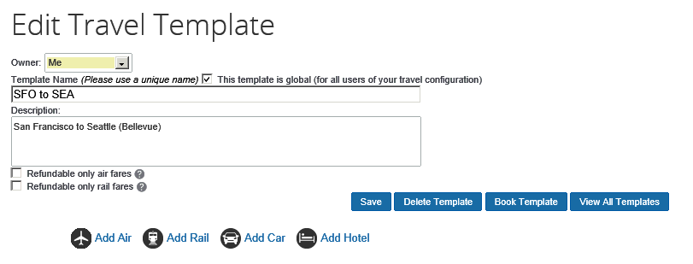

1. The **Refundable only rail fares** check box appears if Deutsche Bahn or SNCF are configured.
2. To include air, click **Add Air**.

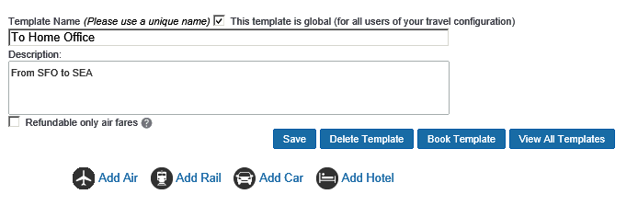

* Either:
* Click **General Search** and enter the cities and preferred times for the travel template.

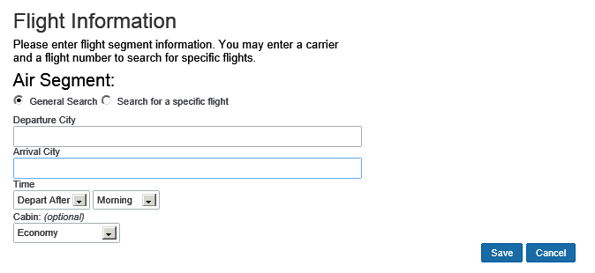

* Click **Search for a specific flight** and enter the carrier and flight number.

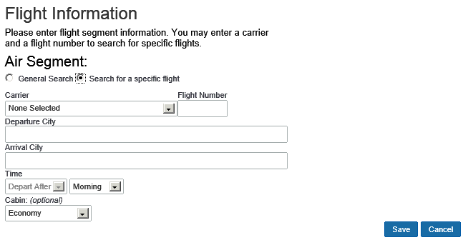

* Click **Save**.

1. To include rail, click **Add Rail**.



Note the following:

* This feature can be used only for Amtrak, Deutsche Bahn, and SNCF. (Only Amtrak is shown in the sample below.)
* You cannot mix rail segments of different vendors.
* After adding the second SNCF or Deutsche Bahn segment, the **Add Rail** button no longer appears. Multi-segment trips are not supported for SNCF or Deutsche Bahn.
* For Deutsche Bahn and SNCF, you are allowed to create valid round trips, like A to B and B to A. "Open jaw" style trips are not currently possible.

This page appears.

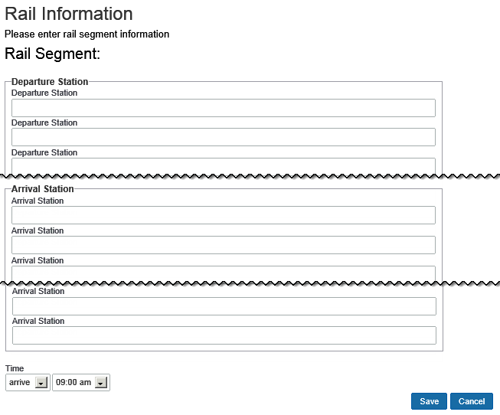

* Select the vendor, the stations, and departure or arrival times.
* Click **Save**.

1. To include car rental, click **Add Car**.



This page appears.

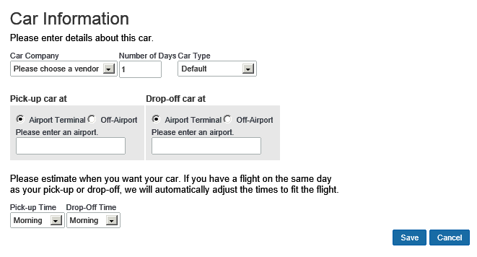

* Enter the vendor, airport, number of nights you need the vehicle, and car type.
* Click **Save**.

1. To include hotel, click **Add Hotel**.



This page appears.

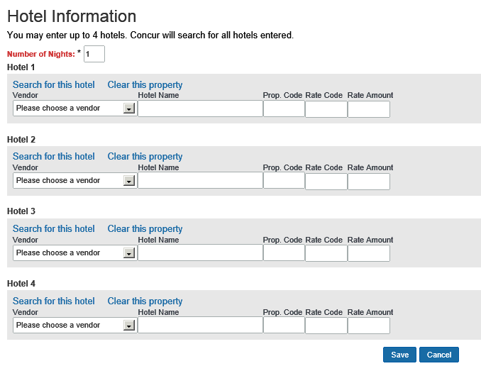

* You can choose up to four hotels to include in the template.
* Enter the vendor and hotel name, if you know this information.
* If you want to search for a specific hotel, click the **Search for this hotel** link.
* Click **Save**.

1. On the **Edit Travel Template** page, click **Save** to save the template.

#### Edit a Travel Template

1. To edit a template:
2. In the **Travel Administration** section of the left menu, click **Travel Templates**.
3. Click **Edit** next to the travel template to update.
4. Modify the content. (The fields are described in the section above about adding a template.)
5. Click **Save**.

#### Delete a Travel Template

1. To delete a template:
2. In the **Travel Administration** section of the left menu, click **Travel Templates**.
3. Click **Edit** next to the travel template to delete.
4. On the **Edit Travel Template** page, click **Delete Template**.

### Credit Card BIN Restrictions

#### Overview

Use the **Credit Card BIN Restrictions** option to limit credit cards your users can enter. When you set credit card BIN restrictions, users will receive an error message if they try to enter a personal credit card, or any credit card that does not match the BIN numbers you specify. You can create a maximum of 40 restrictions.

If you set:

* **Single:** Users can enter only cards that start with that BIN number.
* **Multiple:** Users can enter card numbers that start with any of the BIN numbers.
* **No restrictions:** Users can enter credit cards with any valid credit card number.

#### Create Credit Card BIN Restrictions

1. To create BIN restrictions:
2. In the **Travel Administration** section of the left menu, click **Credit Card BIN Restrictions**. This page appears.

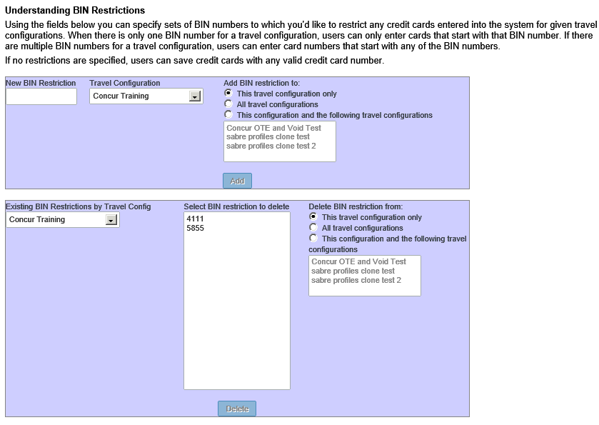

1. In the **New BIN Restriction** field, enter the BIN number that applies to users in the travel configuration.
2. If you have more than one travel configuration, in the **Travel Configuration** dropdown menu, click the appropriate travel configuration.
3. Click **Add**. The BIN number appears in the list on the lower half of the page.

#### Delete a Credit Card BIN Restriction

1. To delete a BIN restriction:
2. In the **Travel Administration** section of the left menu, click **Credit Card BIN Restrictions**.
3. In the **Select BIN restriction to delete** field, click the BIN restriction that you want to remove.
4. Click **Delete**.

### Unused Tickets

For complete details, refer to the *Unused Tickets Travel Service Guide*.

### Meeting Center Admin

Refer to the *Third-Party Meeting Registration Travel Service Guide*.

## Appendix A – Find the Travel Service Guides & Fact Sheets

Travel Service Guides are mentioned throughout this guide.

* If you have the proper permissions, you can access them using the Concur Support Portal.
* If you have ***any*** type of Travel "admin" permission, you can access them through online Help in Travel.

Click **Help** **>** **Travel Administration Help**. Then, click the **Travel Service Guides & Fact Sheets** link.

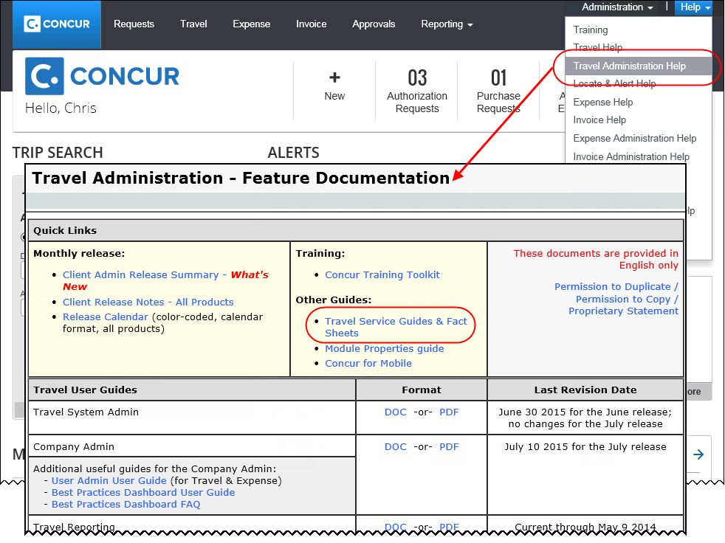

You can find release notes, admin summaries, and other information here, too.

## Appendix B – Company Link Administrator

Refer to the *Company Link Administrator Travel Service Guide*.

## Appendix C – Integrated with Request: Rule Actions

Refer to the *Approvals, Rules, and Classes/Policies Travel Service Guide*.

**☼**