SAP Concur Release Notes
Concur Travel
Concur Professional/Premium and Concur Standard
Month | Audience
Release Date: January 20, 2024  Update 2: Friday, January 26 | SAP Concur Client FINAL

** FINAL **
The enhancements and changes described in this document may or may not be included in this release. SAP Concur reserves the right to postpone implementation of – or completely remove – any enhancement/change mentioned here.
The DRAFT and FINAL release notes contain information about Concur Professional/Premium and Concur Standard.
Each note contains a table that which indicates if the enhancement/change applies to Professional and/or Standard.

Contents
Release Notes 1
Administration 1
New Concur Travel Experience: Approval Queue Support 1
Car 2
New Concur Travel Experience: Sort by Lowest Emissions in Car Search Results (Professional Travel Only) 2
Miscellaneous 4
**Ongoing** New Concur Travel Experience: Feature Exclusions, Limitations & Changed Behavior (Professional Edition Only) 4
New Concur Travel Experience: Vacation Reassignment Support (Professional Edition Only) 5
Rail 7
SNCF Decommission (Travelport Configurations Only) 7
Planned Changes 9
Administration 9
**Planned Changes** New Concur Travel Experience: Changes to Approval Deadline Logic (Professional Edition Only) 9
Flight 11
**Planned Changes** New Concur Travel Experience: Include Accommodation Option on the Flight Search Tab (Professional Edition Only) 11
**Planned Changes** New Concur Travel Experience: Deep Link Support (Professional Edition Only) 14
Hotel 16
**Planned Changes** New Concur Travel Experience: Configuration for Custom Hotel Sourcing (Professional Edition Only) 16
Hotel, Rail 20
**Planned Changes** New Concur Travel Experience: Last Four Digits on Form of Payment Displayed (Professional Edition Only) 20
Miscellaneous 21
**Planned Changes** Profile Enhancement for Gender Inclusivity 21
**Planned Changes** New Concur Travel Experience: Skip Search Action (Professional Edition Only) 24
**Planned Changes** New Concur Travel Experience: Trip History (Professional Edition Only) 26
**Planned Changes** Decommission of Two-Manager Approval Setting (Professional Edition Only) 29
**Planned Changes** Travel Profile API 2.0 Gender Diversity Support 30
Rail 31
**Planned Changes** Trainline Decommission for Apollo and Worldspan Configurations 31
**Planned Changes** New Concur Travel Experience: Renfe and Trainline - Train Options Turned Down (Professional Edition Only) 32
**Planned Changes** New Concur Travel Experience: Renfe and Trainline - Least Cost Logical Fare Support (Professional Edition Only) 34
**Planned Changes** New Concur Travel Experience: Book and Approve Request Support for Trainline (Professional Edition Only) 36
**Planned Changes** New Concur Travel Experience: Renfe and Trainline Support for Multiple Rail Connectors (Professional Edition Only) 38
**Planned Changes** New Concur Travel Experience: Renfe and Trainline Configurable Message Boards (Professional Edition Only) 39
**Planned Changes** New Concur Travel Experience: Renfe and Trainline New Supported Rules (Professional Edition Only) 42
**Planned Changes** New Concur Travel Experience: Renfe Multiple Violation Reasons (Professional Edition Only) 45
**Planned Changes** New Concur Travel Experience: Renfe User Interface Changes to Workflow Pages and Emails (Professional Edition Only) 47
**Planned Changes** New Concur Travel Experience: Trainline Migration (Professional Edition Only) 49
**Planned Changes** New Concur Travel Experience: Choose Your Rule Class (Professional Edition Only) 54
**Planned Changes** New Concur Travel Experience: Standalone Approval Enhancement (Professional Travel Only) 56
Travel Operations / Technical Essentials 57
**Planned Changes** Decommission of Credit Card Datapoints in Profile and PNR Finishing Templates 57
**Planned Changes** Decommission of Travel Configuration Agency Processing Fee Form of Payment for Land Only/Non-GDS Reservations Setting 62
**Planned Changes** Sabre Enhanced Form of Payment (FOP Wallet) 64
**Planned Changes** New Concur Travel Experience: Manage Preferences at Travel Configuration Level 66
**Planned Changes** New Concur Travel Experience: Sabre’s Price Quote - Enhancement to Provide More Accurate Fare at Booking 69
Client Notifications 71
Accessibility 71
Accessibility Updates 71
Gender Diversity 71
Documentation for New Concur Travel Experience 71
Online Help Updates in the SAP Help Portal 71
In-Product User Assistance 72
Client Customized Content 72
Subprocessors 73
SAP Concur Non-Affiliated Subprocessors 73
Supported Browsers 73
Supported Browsers and Changes to Support 73
Additional Release Notes and Other Technical Documentation 74
Online Help 74
SAP Concur Support Portal – Selected Users 74
Legal Disclaimer
The information in this presentation is confidential and proprietary to SAP SE or an SAP affiliate company and may not be disclosed without the permission of SAP SE or the respective SAP affiliate company. This presentation is not subject to your license agreement or any other service or subscription agreement with SAP SE or its affiliated companies. SAP SE and its affiliated companies have no obligation to pursue any course of business outlined in this document or any related presentation, or to develop or release any functionality mentioned therein. This document, or any related presentation and SAP SE or an SAP affiliate company’s strategy and possible future developments, products and or platforms directions and functionality are all subject to change and may be changed by SAP SE and its affiliated companies at any time for any reason without notice. The information in this document is not a commitment, promise or legal obligation to deliver any material, code or functionality. This document is provided without a warranty of any kind, either express or implied, including but not limited to, the implied warranties of merchantability, fitness for a particular purpose, or non-infringement. This document is for informational purposes and may not be incorporated into a contract. SAP SE and its affiliated companies assume no responsibility for errors or omissions in this document, except if such damages were caused by SAP SE or an SAP affiliate company’s willful misconduct or gross negligence.
All forward-looking statements are subject to various risks and uncertainties that could cause actual results to differ materially from expectations. Readers are cautioned not to place undue reliance on these forward-looking statements, which speak only as of their dates, and they should not be relied upon in making purchasing decisions.

Release Notes

Administration

New Concur Travel Experience: Approval Queue Support

Prof | Stan |   Edition
X | X | On: Impacts end users who use this feature/vendor; no configuration/setup by agency/ admin; cannot be turned OFF (example: new icons or rate display, new Amtrak feature)
 |  | Available for use: No impact to end users unless/until configuration/setup by agency/admin (described below) (example: new rule, new Travelfusion airline)
 |  | Other: Refer to the release note below
 |  | Does not apply to this edition
Source / Solution Suggestion
GDS
Direct Connect
Other
X | EMEA Data Center |  |  | Scan impact
X | North America Data Center |  |  | UI impact
 | China Data Center |  |  | File finishing impact
 | All data centers |  |  | Profile/Profile API/3rd Party XML Sync Impact
Affected Documentation
TSGs
Fact Sheets
Admin Guides
Other

Overview
Administrators are sometimes required to reassign a trip to an alternate approver queue if the current approver is absent and unable to approve or reject the trip. This feature is available in the legacy Concur Travel experience; it is now available in the new Concur Travel experience.

User/Customer Benefit
This feature allows administrators to reassign trip approval to their staff, ensuring that a trip is added to a specified approval queue, approvers receive all appropriate notifications, and bookings are processed without delays.

Administrator Experience
This feature operates in the new Concur Travel experience as it does in the legacy experience. No functional changes have been made.

Configuration for Professional and Standard Travel
This feature is enabled by default. There are no configuration steps.

Car

New Concur Travel Experience: Sort by Lowest Emissions in Car Search Results (Professional Travel Only)

Prof | Stan |   Edition
X |  | On: Impacts end users who use this feature/vendor; no configuration/setup by agency/ admin; cannot be turned OFF (example: new icons or rate display)
 |  | Available for use: No impact to end users unless/until configuration/setup by agency/admin (described below) (example: new rule, new Travelfusion airline)
 |  | Other: Refer to the release note below
 | X | Does not apply to this edition
Source
GDS |  | Amadeus, Sabre
Direct Connect |  | Car Connector (Hertz and Sixt)
Other
X | EMEA Data Center |  | X | Scan impact
X | North America Data Center |  | X | UI impact
 | China Data Center |  |  | File finishing impact
 | All data centers |  |  | Profile/Profile API/3rd Party XML Sync Impact
Affected Documentation
TSGs
Fact Sheets
Admin Guides
Other |  | Concur Travel Professional Edition End User Help

Overview
With this release, Concur Travel introduces a new sort option for Car search results. Users will now be able to sort search results by Lowest Emissions.

User/Customer Benefit
This sort option has been introduced to allow customers the ability to sort results based on more sustainable factors.

End User Experience
To sort the search results by Lowest Emissions, first enter your search criteria. Once the results appear, under Sort By, click the Category dropdown.
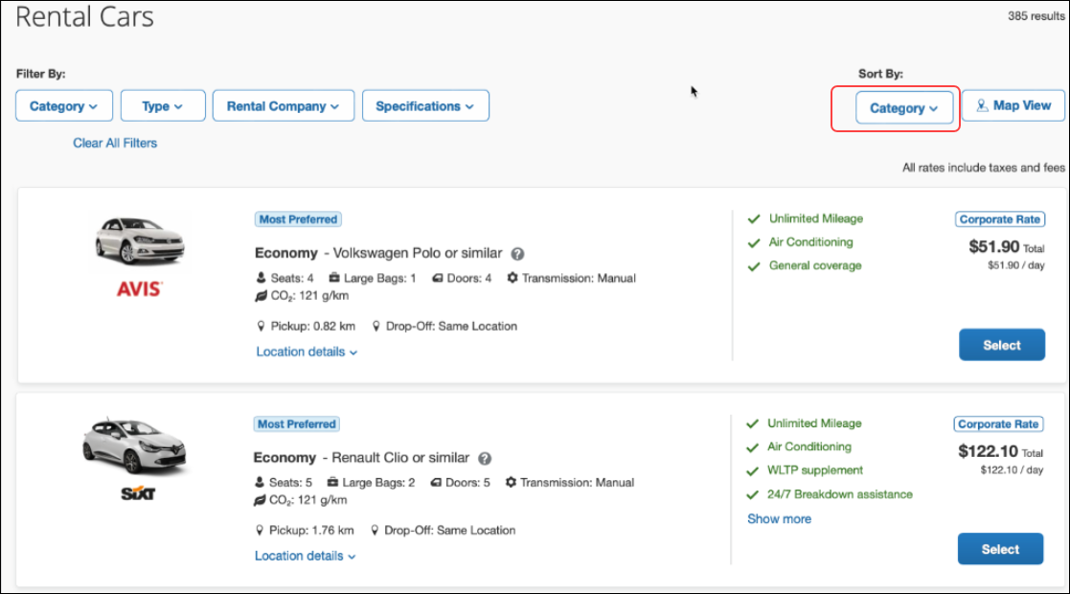
This will display all of the sort options and Lowest Emissions can be selected from this list.
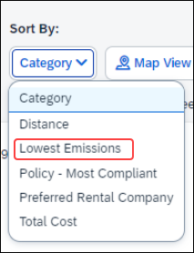

Configuration for Professional and Standard Travel
This feature is enabled by default. There are no configuration steps.

Miscellaneous

**Ongoing** New Concur Travel Experience: Feature Exclusions, Limitations & Changed Behavior (Professional Edition Only)

Information First Published | Information Last Modified | Feature Target Release Date
September 15, 2023 | November 9, 2023 | TBD
Any changes since the previous monthly release are highlighted in yellow in this release note.

Overview
SAP Concur continues to build and develop a leading corporate travel booking tool through the new Concur Travel experience. SAP Concur is delivering this through phased software releases, while limiting the impact on customers and travelers.
- All customers and travelers can continue to use Concur Travel, which will support all existing capabilities.
- Travelers will continue to use their same URLs, logins, passwords, and mobile application. No specific traveler access change is required.
- The system is designed so that if a traveler were to book something not yet supported, they would be directed to the current booking flow they already know and use. Over time, as those capabilities are added to the new experience, redirects will be less frequent.
For customers that want to see the Q4 2023 release of the new Concur Travel experience:
- The customer’s servicing TMC must have acknowledged support for bookings made through the new Concur Travel experience.
- Customers must be eligible, based on content sources, policies, and configuration settings, as described in the linked document below.
Customers will automatically receive the Q4 2023 release of the new Concur Travel experience unless the customer or their TMC chooses to opt out.

User/Customer Benefit
With all the changes in user experience to address the current industry capabilities and traveler expectations, some policy rules or features may no longer be relevant. These will be decommissioned over time and will be outlined in the linked document below.

End-User Experience
Every company, travel program, and traveler is different, so SAP Concur wants to ensure that you have the information to understand when it’s the right time to implement the new booking experience in your organization.
Continue to check this release note as SAP Concur will update it regularly with additional details as development continues.
For more information about disclaimers, exclusions, limitations, and more, please refer to the New Concur Travel Experience: Exclusions, Limitations, Redirects & Enhancements document.

Configuration for Professional Travel
For configuration instructions, please refer to individual release notes.

New Concur Travel Experience: Vacation Reassignment Support (Professional Edition Only)

Prof | Stan |   Edition
X |  | On: Impacts end users who use this feature/vendor; no configuration/setup by agency/ admin; cannot be turned OFF (example: new icons or rate display)
 |  | Available for use: No impact to end users unless/until configuration/setup by agency/admin (described below) (example: new rule, new Travelfusion airline)
X |  | Other: Refer to the release note below
 | X | Does not apply to this edition
Source
GDS
Direct Connect
Other
X | EMEA Data Center |  |  | Scan impact
X | North America Data Center |  | X | UI impact
 | China Data Center |  |  | File finishing impact
 | All data centers |  |  | Profile/Profile API/3rd Party XML Sync Impact
Affected Documentation
TSGs |  | Travel Vacation Reassignment Travel Service Guide
Fact Sheets
Admin Guides
Other

Overview
Approvers occasionally need the ability to reassign their approver status to an alternate approver for a given amount of time. This is typically done when they know they will be on vacation, traveling for work, on sick leave, or just generally will be unable to perform their approval duties.
This feature allows them to temporarily reassign approver responsibility and then claim responsibility back when they return.
This is a legacy Concur Travel feature, which is now available for use in the new Concur Travel experience.

User/Customer Benefit
This feature allows for flexibility and ensures that approvals will not be delayed due to an approver’s absence.

End-User Experience
This feature can be enabled by clicking Settings > Other Settings and selecting Travel Vacation Reassignment.
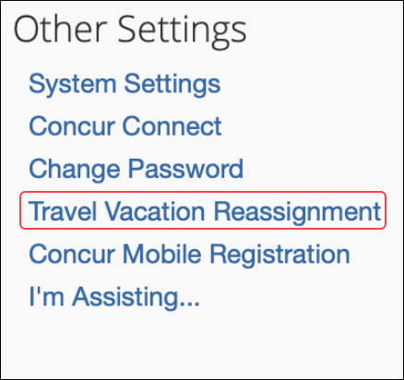
On the Travel Vacation Reassignment page, select the user who will temporarily approve requests and then click Submit.
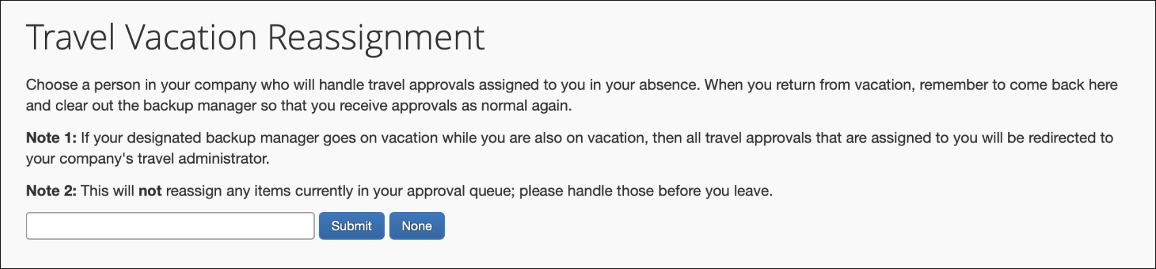
The name of the temporary approver and their e-mail address will display, along with the conditions for their role as temporary approver. Select the dates required for the approver. Select the permissions for the delegate by enabling the applicable checkboxes. A delegate with no checkboxes enabled will not have sufficient access to perform the approvals.
Once the delegate approval term is over, they should be cleared from this section so that the correct approver will receive the requests.

Configuration for Professional Travel
For both Professional and Standard Travel, the Travel Vacation Reassignment feature is activated via a module property, which is managed by SAP Concur. Customers and fulfillment travel agency partners must submit a support ticket to request the feature. This is a configuration-level module property, so if there are multiple configurations for your site, be sure to indicate which ones should have this enabled. For those indicated, SAP Concur will set the Allow Vacation Reassign module property to True.

Rail

SNCF Decommission (Travelport Configurations Only)

Prof | Stan | Å Å Edition
 |  | On: Impacts end users who use this feature/vendor; no configuration/setup by agency/ admin; cannot be turned OFF (example: new icons or rate display, new Amtrak feature)
 |  | Available for use: No impact to end users unless/until configuration/setup by agency/admin (described below) (example: new rule, new Travelfusion airline)
X | X | Other: Refer to the release note below
 |  | Does not apply to this edition
Source / Solution Suggestion
GDS
Direct Connect |  | SNCF
Other
X | EMEA Data Center |  |  | Scan impact
X | North America Data Center |  |  | UI impact
 | China Data Center |  |  | File finishing impact
 | All data centers |  |  | Profile/Profile API/3rd Party XML Sync Impact
Affected Documentation
TSGs |  | SNCF Direct Connect
Fact Sheets
Admin Guides
Other

Overview
Concur Travel currently provides travelers the ability to book trains via SNCF. This feature is supported for Amadeus, Sabre, Galileo and Apollo travel configurations.
Due to changing technological requirements, both Travelport and SAP Concur are working towards a new method of booking and enabling SNCF bookings in Concur Travel. As of January 8, 2024, the current method of booking SCNF has been automatically disabled and is no longer visible for any Travelport travel configurations. Updates will be provided, when available, regarding a new method to accommodate Travelport customers.
The SNCF direct connection will remain available for Amadeus and Sabre travel configurations.

User/Customer Benefit
Periodically, under-supported third-party features may be removed to ensure usability standards are maintained. This feature is not fully supported and is therefore decommissioned.

End-User Experience
Existing Rail itineraries will remain visible in Concur Travel under Upcoming Trips. Also, the historical data will be maintained for reporting purposes.

Configuration for Professional and Standard Travel
No additional steps are required by administrators to support this change. However, SAP Concur recommends that clients provide messaging within Concur Travel to inform travelers.

Planned Changes
The items in this section are targeted for future releases. SAP Concur solutions reserves the right to postpone implementation of – or completely remove – any enhancement or change mentioned here.
The planned changes listed in this document are specific to this product. For information about planned site-wide or shared changes that might impact your SAP Concur solutions, refer to the Shared Changes Release Notes.

Administration

**Planned Changes** New Concur Travel Experience: Changes to Approval Deadline Logic (Professional Edition Only)

Information First Published | Information Last Modified | Feature Target Release Date
December 2023 | January 12, 2024 | February 2024
Any changes since the previous monthly release are highlighted in yellow in this release note.

Prof | Stan | Å Å Edition
 |  | On: Impacts end users who use this feature/vendor; no configuration/setup by agency/ admin; cannot be turned OFF (example: new icons or rate display, new Amtrak feature)
 |  | Available for use: No impact to end users unless/until configuration/setup by agency/admin (described below) (example: new rule, new Travelfusion airline)
X |  | Other: Refer to the release note below
 | X | Does not apply to this edition
Source / Solution Suggestion
GDS
Direct Connect
Other
X | EMEA Data Center |  |  | Scan impact
X | North America Data Center |  |  | UI impact
 | China Data Center |  |  | File finishing impact
 | All data centers |  |  | Profile/Profile API/3rd Party XML Sync Impact
Affected Documentation
TSGs
Fact Sheets
Admin Guides
Other

Overview
Targeted for February 2024, the method with which an approval deadline is calculated will change. This will allow for an approver to process a trip. If unprocessed, the trip will be auto cancelled.

User/Customer Benefit
This change is being made to provide a more consistent approval deadline behavior between SAP Concur products.

End-User Experience
Currently in the new Concur Travel experience when a booking is either non-refundable, instant purchase, or same day booking, the approval deadline is not calculated. If the approver does not take any action, the trip will remain live in the system and the traveler must contact the travel agency to cancel the booking.
With this update, an approval deadline will be calculated irrespective of the trip content. For a booking with non-refundable or instant purchase content, the approval deadline will be calculated as the booking start date, less one day.
The trip approval deadline will still be the sooner of all the booking's individual booking times. Please refer to the examples below:
Any trip with only one Flight booking, where the booking has a deadline:
- Soonest of either Booking 1 Deadline or Agency Time, less 2 hours.
Any trip with only one booking, where the booking does not have a deadline:
- Trip start, less 1 day.
Any trip with two bookings (one of which is Flight and the other is not), where all the bookings have a deadline:
- The soonest of either Booking 1 Flight Deadline or Agency Time, less 2 hours
- Booking 2 Deadline, less 2 hours
- The soonest of either a. or b.
Any trip with two bookings (one of which is Flight, and the other is not), where the first booking has a deadline, and the second booking does not have a deadline:
- The soonest of Booking 1 Deadline, or Agency Time, less 2 hours
- Trip start, less 1 day.
- The soonest of either a. or b.
For same day bookings, the Trip Start Time less 2 hours will be used. If the approval deadline is in the past, the trip will be automatically cancelled immediately after booking. The traveler will be warned of the cancellation on the Confirmation page.
If the assigned approver does not take action by the approval deadline, the trip will be sent for auto-cancelation. However, if the trip cannot be cancelled or has at least one booking that is not fully refundable, the trip will not be canceled but sent for finishing instead.

Configuration for Professional and Standard Travel
No additional steps are required by administrators to support this change. However, SAP Concur recommends that clients provide messaging within Concur Travel to inform travelers of these changes.

Flight

**Planned Changes** New Concur Travel Experience: Include Accommodation Option on the Flight Search Tab (Professional Edition Only)

Information First Published | Information Last Modified | Feature Target Release Date
November 2023 | January 19, 2024 | February 2024
Any changes since the previous monthly release are highlighted in yellow in this release note.

Prof | Stan |   Edition
 |  | On: Impacts end users who use this feature/vendor; no configuration/setup by agency/ admin; cannot be turned OFF (example: new icons or rate display)
 |  | Available for use: No impact to end users unless/until configuration/setup by agency/admin (described below) (example: new rule, new Travelfusion airline)
X |  | Other: Refer to the release note below
 | X | Does not apply to this edition
Source
GDS
Direct Connect
Other
X | EMEA Data Center |  |  | Scan impact
X | North America Data Center |  | X | UI impact
 | China Data Center |  |  | File finishing impact
 | All data centers |  |  | Profile/Profile API/3rd Party XML Sync Impact
Affected Documentation
TSGs
Fact Sheets
Admin Guides
Other |  | Concur Travel Professional Edition End User Help

Overview
Users creating a trip itinerary can include flights, hotel, car and rail reservations, all within the same trip. Targeted for February 2024, a more streamlined approach will be available. When entering a flight search on the Flight Search tab, they can simultaneously include a search for accommodations.

User/Customer Benefit
Upcoming changes to the Concur Travel user interface will help minimize the number of steps required to complete the trip booking process.

End-User Experience
The Flight Search tab now includes the Include Accommodation option.
Once a user has entered their flight search conditions on the Flight Search tab, the Include Accommodation checkbox will be enabled. The user interface will update to display accommodations search options.
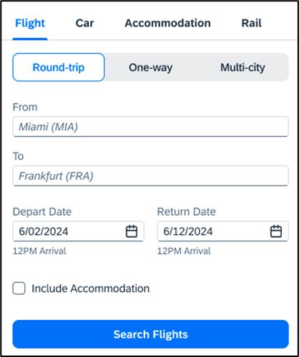
Once a user clicks Search Flights, the user interface will update to display the Flight search results. The user will then select their flight and click Book and Continue. The user interface will then display the accommodations results.
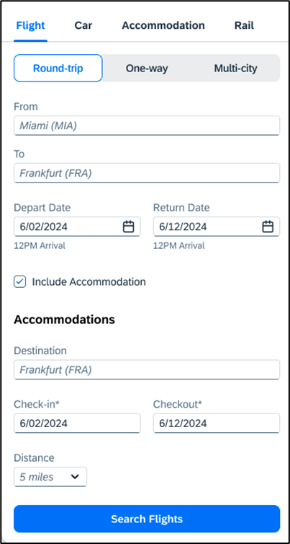
The user will select their accommodations and again click Book and Continue. The user interface will display the Finalize screen where the user can confirm the trip.
If the user edits their flight search query during this process, the results of the original accommodations query will display to the user. This is consistent with legacy Concur Travel behavior.

Configuration for Professional Travel
This feature is enabled by default. There are no configuration steps.
If the Hide Hotel Tab module property is enabled, users will not see the Include Accommodation option and will not be able to add accommodations to their flight search.

**Planned Changes** New Concur Travel Experience: Deep Link Support (Professional Edition Only)

Information First Published | Information Last Modified | Feature Target Release Date
January 2024 | -- | February 2024
Any changes since the previous monthly release are highlighted in yellow in this release note.

Prof | Stan |   Edition
 |  | On: Impacts end users who use this feature/vendor; no configuration/setup by agency/ admin; cannot be turned OFF (example: new icons or rate display)
 |  | Available for use: No impact to end users unless/until configuration/setup by agency/admin (described below) (example: new rule, new Travelfusion airline)
X |  | Other: Refer to the release note below
 | X | Does not apply to this edition
Source
GDS
Direct Connect
Other
X | EMEA Data Center |  |  | Scan impact
X | North America Data Center |  |  | UI impact
 | China Data Center |  |  | File finishing impact
 | All data centers |  |  | Profile/Profile API/3rd Party XML Sync Impact
Affected Documentation
TSGs
Fact Sheets
Admin Guides
Other |  | Concur Travel Professional Edition End User Help

Overview
Targeted for February 2024, Concur Travel will support deep link URLs. By providing URL parameters, customers and partners will be able to create a deep link which will direct end users to an SAP Concur search results page. They will then be able to proceed with booking without going through the Concur Travel home page to fill out the Search tool.

User/Customer Benefit
This feature enables clients and partners to incorporate Concur Travel into the journey maps they design for their end users. Developers can leverage the deep link to allow a user to skip the Concur home page and Search tool.

End-User Experience
Deep links are generated by customers and partners for their employees. When the end user clicks a provided deep link, they will be redirected to the SAP Concur Sign In page.
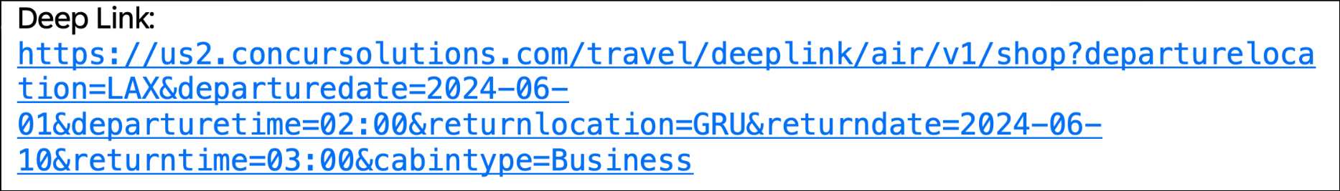
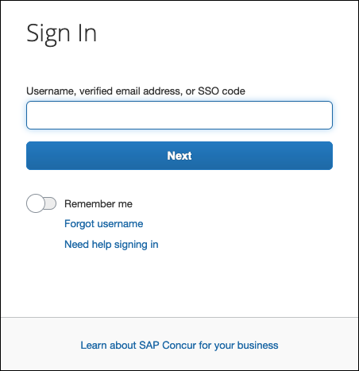
Once signed in, the user is immediately presented with a search results page, displaying the flight results for the criteria configured within the deep link. This provides a more streamlined booking experience for the user, which does not require the user to enter search criteria.
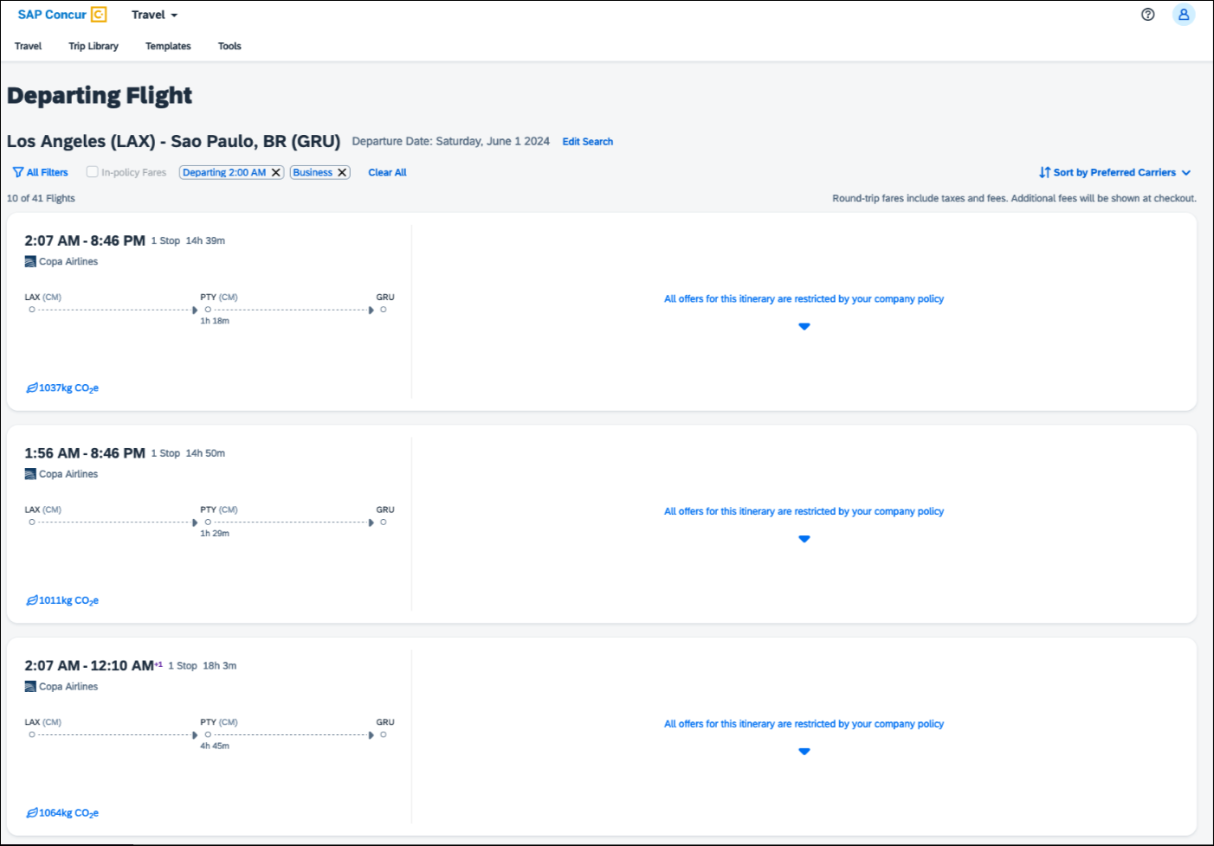
This integration will only work for users using a single rule class. It will not be possible to specify multiple rule classes.
Deep links can also be distributed amongst colleagues to share information for booked flights in case they also need to make the same trip.

Configuration for Professional Travel
This feature is enabled by default. There are no configuration steps.

Hotel

**Planned Changes** New Concur Travel Experience: Configuration for Custom Hotel Sourcing (Professional Edition Only)

Information First Published | Information Last Modified | Feature Target Release Date
March 2023 | January 19, 2024 | February 2024
Any changes since the previous monthly release are highlighted in yellow in this release note.

Prof | Stan |   Edition
 |  | On: Impacts end users who use this feature/vendor; no configuration/setup by agency/ admin; cannot be turned OFF (example: new icons or rate display)
 |  | Available for use: No impact to end users unless/until configuration/setup by agency/admin (described below) (example: new rule, new Travelfusion airline)
X |  | Other: Refer to the release note below
 | X | Does not apply to this edition
Source
GDS |  | N/A
Direct Connect |  | Custom Hotel Source providers (TBD)
Other
 | EMEA Data Center |  |  | Scan impact
 | North America Data Center |  |  | UI impact
 | China Data Center |  |  | File finishing impact
 | All data centers |  |  | Profile/Profile API/3rd Party XML Sync Impact
Affected Documentation
TSGs
Fact Sheets
Admin Guides
Other

Overview
Recently, SAP Concur released the new Hotel booking experience for customers connected to Sabre and for customers connected to one of our participating Custom Hotel Source (CHS) providers. With this integration, customers can experience:
- An intuitive and personalized design, with an easy-to-use interface.
- Seamless content normalization, aggregation and servicing.
- Mobile and web content parity.

User/Customer Benefit
The new Concur Travel Hotel booking experience offers a specific feature set for customers.
- Time Savings: The booking workflow will be streamlined so fewer steps are required.
- Omni search: Once the user enters the first few characters of their search criteria, the system will update to provide a list of suggested options from which the user can select.
- Sustainability: Property information will include the sustainability certifications or programs to which the property belongs, a sustainability score, and carbon emissions data. Additional property filter options will include electric car charging stations and sustainability certifications to help users make more sustainable choices. Users will be able to sort properties based on their sustainability score and emissions.
- Search results with lead rate: The property search results will be presented with one lead rate so the user can quickly compare the lowest rate available at multiple properties.
- Hotel Details: A list of the rates available at a specific property, together with cancellation policy details, room amenities and images, will be available to the user.

Configuration for Professional Travel

Custom Hotel Source Providers
For customers interested in using Custom Hotel Source providers as their source for hotel content, re-enablement is required.
To configure:
- Click Administration > Travel (on the sub-menu) > Travel System Admin and select the desired client travel configuration.
Depending on your permissions, the page may appear immediately after you click Administration or Travel.
There are now two different Hotel Connector sections of the Travel Configuration page. One is to support the new hotel connectors and is called Hotel Connectors – Hotel Service v4. The other is the existing hotel connector section.
- When enabling a new connector, it is essential that any current direct connect remains enabled otherwise customers will not be able to make bookings in the current Concur Travel experience. This means that a current HSv2 configuration needs to remain enabled on HSv2, and on HSv4 once migrated. The HSv2 connection will not allow new bookings but will provide access to previously booked reservations for servicing. Any servicing will continue as it is today using the Online Booking Tool (OBT).
- The administrator will be able to select the default connection type within the new section.
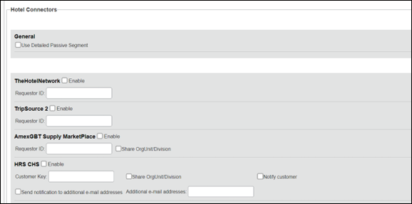
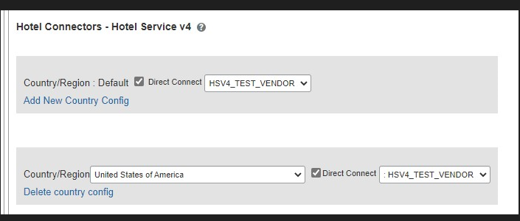

Passive PNR for Direct Content
To configure:
- Go to Administration > Travel (on the sub-menu) > Travel System Admin and select the desired client travel configuration.
Depending on your permissions, the page may appear immediately after you click Administration or Travel.
- On the Travel Configuration page, under GDS PNR Options, go to the activation checkboxes.
- Under Defaults for Specific non-GDS vendors, select the New Custom Hotel Source checkbox. The default for this field is Use the default specified above. Select the Write passive segments for non-GDS content if I have not specified a default for the specific vendor in the table below checkbox.

Travel Arranger Flow
The Travel Arranger feature will be supported for Hotel.
For more information on how to book a hotel as a Travel Arranger, see the Travel Arranger View Travel Service Guide.
The Travel Arranger Name appears on the new Trip Overview page.

Hotel, Rail

**Planned Changes** New Concur Travel Experience: Last Four Digits on Form of Payment Displayed (Professional Edition Only)

Information First Published | Information Last Modified | Feature Target Release Date
December 2023 | -- | February 2024
Any changes since the previous monthly release are highlighted in yellow in this release note.

Prof | Stan | Å Å Edition
 |  | On: Impacts end users who use this feature/vendor; no configuration/setup by agency/ admin; cannot be turned OFF (example: new icons or rate display, new Amtrak feature)
 |  | Available for use: No impact to end users unless/until configuration/setup by agency/admin (described below) (example: new rule, new Travelfusion airline)
X |  | Other: Refer to the release note below
 | X | Does not apply to this edition
Source / Solution Suggestion
GDS
Direct Connect |  | Trainline
Other
X | EMEA Data Center |  |  | Scan impact
X | North America Data Center |  |  | UI impact
 | China Data Center |  |  | File finishing impact
 | All data centers |  |  | Profile/Profile API/3rd Party XML Sync Impact
Affected Documentation
TSGs |  | Trainline Direct Connect Travel Service Guide
Fact Sheets
Admin Guides
Other

Overview
Targeted for February 2024, the last four digits of a traveler’s credit card will display on several screens during Trainline bookings. Trainline requires the display of the last four digits of the traveler’s credit card for API certification. This feature will be applied to Trainline and Renfe bookings on web and mobile, and Hotel bookings on the web.
This change is also planned for Air and Car verticals in future releases..

User/Customer Benefit
For Trainline bookings, users are required to provide the same form of payment (FOP) at the train station kiosk that was used to purchase their tickets, in order to retrieve their tickets. This update is being implemented to improve the customer experience.

End-User Experience
The last four digits of the user’s credit card will display on different pages during the Trainline booking process.
These include:
- Finalize page
- Trip Overview page
- Confirmation E-Mail
- Cancellation E-Mail
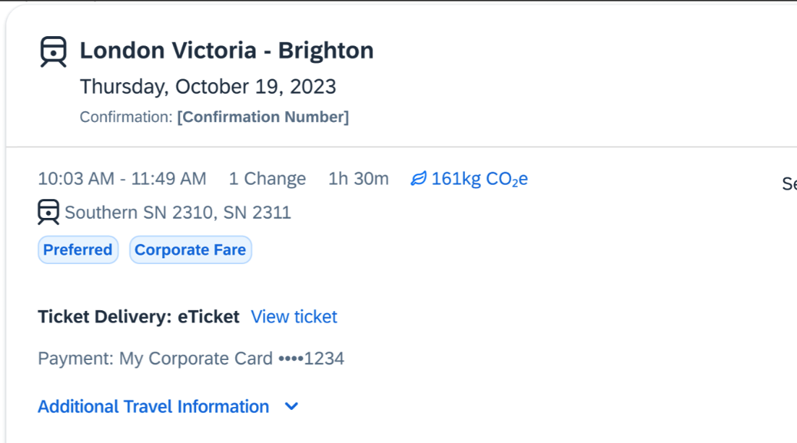

Configuration for Professional and Standard Travel
This feature is enabled by default. There are no configuration steps.

Miscellaneous

**Planned Changes** Profile Enhancement for Gender Inclusivity

Information First Published | Information Last Modified | Feature Target Release Date
January 2024 | -- | March 2024
Any changes since the previous monthly release are highlighted in yellow in this release note.

Prof | Stan |   Edition
X | X | On: Impacts end users who use this feature/vendor; no configuration/setup by agency/ admin; cannot be turned OFF (example: new icons or rate display)
 |  | Available for use: No impact to end users unless/until configuration/setup by agency/admin (described below) (example: new rule, new Travelfusion airline)
 |  | Other: Refer to the release note below
 |  | Does not apply to this edition
Source
GDS |  | Amadeus, Apollo, Sabre, Travelport+ Worldspan
Direct Connect |  | Southwest
Other
X | EMEA Data Center |  |  | Scan impact
X | North America Data Center |  |  | UI impact
 | China Data Center |  |  | File finishing impact
 | All data centers |  |  | Profile/Profile API/3rd Party XML Sync Impact
Affected Documentation
TSGs |  | Transportation Security Administration (TSA) Requirements
Fact Sheets
Admin Guides
Other

Overview
In the upcoming March release, Concur Travel will enhance the Transportation Security Administration (TSA) Secure Flight section under the Concur Travel Profile page to support two new gender options: Unspecified (X) and Undisclosed (U). With this change, users can now select from four different options in the Concur Travel Profile:
- Male (M)
- Female (F)
- Unspecified (X)
- Undisclosed (U)
The new Gender values Unspecified (X) and Undisclosed (U) are also supported on the Travel Profile API 2.0. For more details, please refer to the Travel Profile API 2.0 Gender Diversity Support release note in this document.
The information that appears in the Concur Travel Profile is based on the For information required by the TSA for travel to/from the USA setting. It is described in the configuration information section of the Transportation Security Administration (TSA) Requirements Travel Service Guide. To locate, refer to Additional Release Notes and Other Technical Documentation in these release notes.
When the When to send TSA-required data to air carriers setting is set to send information, Concur Travel will send the TSA fields data, including gender, to the vendors. If a booking is made in one of the Global Distribution Systems (GDSs), and when the carrier does not accept Unspecified (X) and Undisclosed (U), the carrier may add information to the reservation to inform the travel agency that a change to the reservation is required. Concur Travel recommends that Agency fulfilment partners add automation to their mid-office tools to identify and contact users in such situations. Concur Travel recommends that users check the country requirements before booking and to check their reservation for required changes a few days before the trip.
Inclusive Gender types Unspecified (X) and Undisclosed (U) will sync between a Concur profile and Sabre Profiles.
Inclusive Gender types Unspecified (X) and Undisclosed (U) will be synced between a Concur profile and Amadeus, Apollo, Travelport+, and Worldspan GDS profile by using the new datapoint Gender_Inclusive with Concur Profile Templates.
Inclusive Gender types Unspecified (X) and Undisclosed (U) will be available for use in Finishing Templates using the new datapoint Gender_Inclusive.
Concur Travel will send Inclusive Gender types Unspecified (X) and Undisclosed (U) to the GDS PNR when sending TSA Secure Flight, Redress, and Known Traveler Number (KTN) special service request (SSR) data for air reservations.
All GDS systems will accept the Inclusive Gender codes Unspecified (X) and Undisclosed (U) for SSR messages without error, however, no validation is done with the airline being booked. If the airline booked in the PNR does not support the Inclusive Gender codes Unspecified (X) and Undisclosed (U), they are required to reject the SSR message. GDS partners advised that airlines are required to follow the IATA Airline Industry Reservations Interline Message (AIRIMP) guidelines when rejecting the SSR message. Please refer to IATA for the most updated information regarding these rules and the format in which the airline should respond.
- Concur Travel will not monitor or act on any SSR messages rejected by the airline. Customers will need to seek a mid-office solution if they wish to automate monitoring for these SSR messages.

User/Customer Benefit
Non-binary travelers will be able to use the two new inclusive gender selections, Unspecified (X) and Undisclosed (U).

End-User Experience
When the For information required by the TSA for travel to/from the USA field setting is set to show information in Concur Travel Profile, users will be able to select one of the four options from a Gender dropdown:
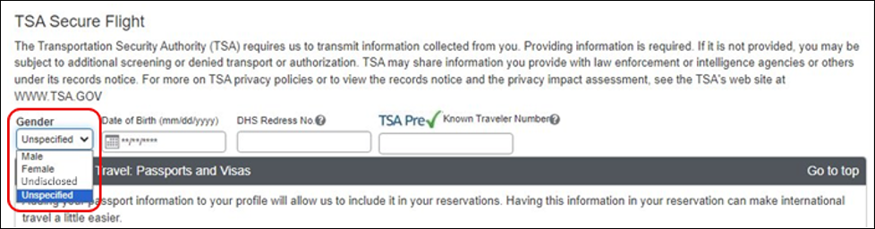
When no information is stored in Concur Travel Profile, the information will be collected during check out when required.

Configuration for Professional and Standard Travel
This feature is enabled by default. There are no configuration steps.

**Planned Changes** New Concur Travel Experience: Skip Search Action (Professional Edition Only)

Information First Published | Information Last Modified | Feature Target Release Date
October 6, 2023 | January 19, 2024 | February 2024
Any changes since the previous monthly release are highlighted in yellow in this release note.

Prof | Stan |   Edition
X |  | On: Impacts end users who use this feature/vendor; no configuration/setup by agency/ admin; cannot be turned OFF (example: new icons or rate display)
 |  | Available for use: No impact to end users unless/until configuration/setup by agency/admin (described below) (example: new rule, new Travelfusion airline)
X |  | Other: Refer to the release note below
 | X | Does not apply to this edition
Source
GDS |  | Sabre, Car Connector
Direct Connect
Other
X | EMEA Data Center |  |  | Scan impact
X | North America Data Center |  | X | UI impact
 | China Data Center |  |  | File finishing impact
 | All data centers |  |  | Profile/Profile API/3rd Party XML Sync Impact
Affected Documentation
TSGs
Fact Sheets
Admin Guides
Other |  | Concur Travel Professional Edition End User Help

Overview
Targeted for the February release, the Skip Search action will be available for the new Concur Travel experience. This feature will allow a user to discard the search workflow for a trip segment and return to one of three UI pages, depending on the previous workflow.

User/Customer Benefit
This feature is comparable to existing components in the current Concur Travel shopping experience. It provides the user a one-click method of returning to their trip booking workflow, should they decide not to complete a search and book option.

End-User Experience
The Skip Search link will allow a user to discard the search workflow for a trip segment, returning the user to one of three UI pages, depending on the previous workflow.
For example, if a user decides to book a flight reservation, searches for a flight, and then decides NOT to book a flight, they will click Skip Search.
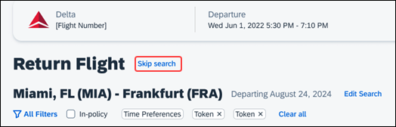
The Skip search option will behave as follows:
- If there is an existing booking for the given trip, but it is not yet finalized, then the user will be redirected to the Finalize page.
- If there is an existing booking for the given trip and it was previously finalized, then the user will be redirected to the Trip Overview page.
- If there is no existing booking or trip, then the user will be redirected to the SAP Concur Travel home page.

Configuration for Professional Travel
This feature is enabled by default. There are no configuration steps.

**Planned Changes** New Concur Travel Experience: Trip History (Professional Edition Only)

Information First Published | Information Last Modified | Feature Target Release Date
December 2023 | -- | March 2024
Any changes since the previous monthly release are highlighted in yellow in this release note.

Prof | Stan |   Edition
X |  | On: Impacts end users who use this feature/vendor; no configuration/setup by agency/ admin; cannot be turned OFF (example: new icons or rate display)
 |  | Available for use: No impact to end users unless/until configuration/setup by agency/admin (described below) (example: new rule, new Travelfusion airline)
X |  | Other: Refer to the release note below
 | X | Does not apply to this edition
Source
GDS |  | Sabre, Car Connector
Direct Connect
Other
X | EMEA Data Center |  |  | Scan impact
X | North America Data Center |  | X | UI impact
 | China Data Center |  |  | File finishing impact
 | All data centers |  |  | Profile/Profile API/3rd Party XML Sync Impact
Affected Documentation
TSGs
Fact Sheets
Admin Guides
Other |  | Concur Travel Professional Edition End User Help

Overview
Targeted for the March 2024 release, the Trip History feature will be available for the new Concur Travel experience. This feature will provide all access to detailed historical records of all trips associated with an account.
Trips which include bookings from both the legacy and new Concur Travel experience will be included only in the legacy Trip History, on the web application.
Trips which include bookings from only the new Concur Travel experience will be included within the new experience Trip History, on both web and mobile applications.

User/Customer Benefit
This feature will provide greater clarity and confidence in the details of the Concur Travel booking experience, allowing users to search for and reference trip details more quickly and easily. This will allow users to avoid having to request information via a support case.
Users and arrangers will be able to see the Trip History tab on the Trip Overview page. TMCs, Support Agents, and SAP Concur representatives will be able to see the history via Support Tools, which will be included in a future release.

End-User Experience
Historical data will include:
- the original details of the trip and the travel provider, for example, airlines, hotels, locations etc.
- all edits to a trip
- the identity of the person performing each action taken on the trip
- dates and time stamps
- ticket and confirmation numbers
- approvals and rejections
- policy violations
- detailed trip costs
- specific details of travel providers
To access trip histories:
- On the Trip Overview page, click the Trip History tab.
- The Trip History tab will display all the events that took place for the trip in either ascending or descending chronological sort order, such as Creation, Cancellation, Approval etc.
- To expand the content and see additional details, click the arrow icon next to the event.
This is a preliminary mockup. Details may change closer to the release date.
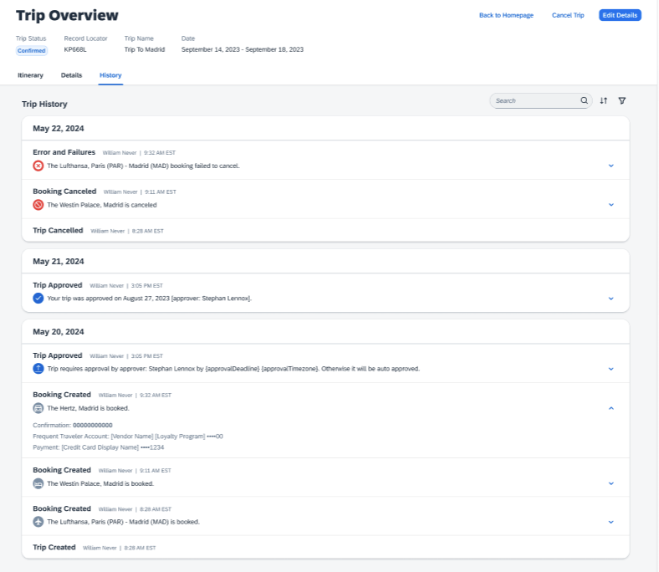

Configuration for Professional Travel
This feature is enabled by default. There are no configuration steps.

**Planned Changes** Decommission of Two-Manager Approval Setting (Professional Edition Only)

Information First Published | Information Last Modified | Feature Target Release Date
August 11, 2023 | January 19, 2024 | TBD 2024
Any changes since the previous monthly release are highlighted in yellow in this release note.

Prof | Stan |   Edition
X |  | On: Impacts end users who use this feature/vendor; no configuration/setup by agency/ admin; cannot be turned OFF (example: new icons or rate display)
 |  | Available for use: No impact to end users unless/until configuration/setup by agency/admin (described below) (example: new rule, new Travelfusion airline)
 |  | Other: Refer to the release note below
 | X | Does not apply to this edition
Source
GDS
Direct Connect
Other
X | EMEA Data Center |  |  | Scan impact
X | North America Data Center |  | X | UI impact
 | China Data Center |  |  | File finishing impact
 | All data centers |  |  | Profile/Profile API/3rd Party XML Sync Impact
Affected Documentation
TSGs
Fact Sheets
Admin Guides
Other

Overview
Targeted for a future release in the legacy Concur Travel experience, the two-manager approval flow will no longer be supported. In the legacy Concur Travel experience, all clients with a two-manager approval flow will be migrated to a one manager approval flow.

User/Customer Benefit
This change is being initiated to simplify and streamline the approval flow in the legacy Concur Travel experience. It also provides more options when working with Concur Request.

End-User Experience
When choosing an approver, the user will only be able to request the approval flow be directed to one manager and not two.
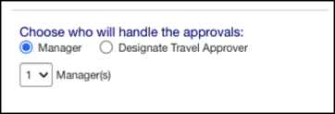

Configuration for Professional Travel
This feature is enabled by default. There are no configuration steps.

**Planned Changes** Travel Profile API 2.0 Gender Diversity Support

Information First Published | Information Last Modified | Feature Target Release Date
September 8, 2023 | January 19, 2024 | Q1 2024
Any changes since the previous monthly release are highlighted in yellow in this release note.

Prof | Stan |   Edition
 |  | On: Impacts end users who use this feature/vendor; no configuration/setup by agency/ admin; cannot be turned OFF (example: new icons or rate display)
 |  | Available for use: No impact to end users unless/until configuration/setup by agency/admin (described below) (example: new rule, new Travelfusion airline)
X | X | Other: Refer to the release note below
 |  | Does not apply to this edition
Source
GDS
Direct Connect
Other
 | EMEA Data Center |  |  | Scan impact
 | North America Data Center |  |  | UI impact
 | China Data Center |  |  | File finishing impact
 | All data centers |  | X | Profile/Profile API/3rd Party XML Sync Impact
Affected Documentation
TSGs
Fact Sheets
Admin Guides
Other |  | SAP Concur Developer Center

Overview
With the SAP Concur commitment to Gender Diversity initiatives, changes are planned for the Travel Profile API 2.0, specifically in adding support for two new Gender values: Unknown and Unspecified.
Partners must update their systems in order to use the updated API.

User/Customer Benefit
This change is being initiated to support partners and customers for the purposes of updating their systems to support the new gender values.

Configuration for Professional Travel
This feature is enabled by default. There are no configuration steps.

Rail

**Planned Changes** Trainline Decommission for Apollo and Worldspan Configurations

Information First Published | Information Last Modified | Feature Target Release Date
January 2024 | -- | Q1 2024
Any changes since the previous monthly release are highlighted in yellow in this release note.

Prof | Stan | Å Å Edition
 |  | On: Impacts end users who use this feature/vendor; no configuration/setup by agency/ admin; cannot be turned OFF (example: new icons or rate display, new Amtrak feature)
 |  | Available for use: No impact to end users unless/until configuration/setup by agency/admin (described below) (example: new rule, new Travelfusion airline)
X | X | Other: Refer to the release note below
 |  | Does not apply to this edition
Source / Solution Suggestion
GDS
Direct Connect |  | UK Rail (Trainline)
Other
X | EMEA Data Center |  |  | Scan impact
X | North America Data Center |  |  | UI impact
 | China Data Center |  |  | File finishing impact
 | All data centers |  |  | Profile/Profile API/3rd Party XML Sync Impact
Affected Documentation
TSGs |  | Trainline Direct Connect Travel Service Guide
Fact Sheets
Admin Guides
Other

Overview
Concur Travel currently provides travelers the ability to book trains via Trainline for the UK market. The solution is supported for Amadeus, Sabre, Galileo, Apollo and Worldspan travel configurations.
Due to changing contractual obligations, SAP Concur and Travelport have jointly decided to decommission the current direct connection to Concur Travel in Q1 2024. The UK Rail (Trainline) direct connect will be automatically disabled and no longer visible for any Travelport travel configurations.

User/Customer Benefit
Periodically, under-supported third-party features may be removed to ensure usability standards are maintained. This feature is not fully supported and will therefore be decommissioned.

End-User Experience
Existing Rail itineraries will remain visible in Concur Travel under Upcoming Trips. Historical data will also be kept for reporting.

Configuration for Professional and Standard Travel
No additional steps are required by administrators to support this change. However, SAP Concur recommends that clients provide messaging within Concur Travel to inform travelers.

**Planned Changes** New Concur Travel Experience: Renfe and Trainline - Train Options Turned Down (Professional Edition Only)

Information First Published | Information Last Modified | Feature Target Release Date
December 2023 | -- | Q1 2024
Any changes since the previous monthly release are highlighted in yellow in this release note.

Prof | Stan | Å Å Edition
 |  | On: Impacts end users who use this feature/vendor; no configuration/setup by agency/ admin; cannot be turned OFF (example: new icons or rate display, new Amtrak feature)
X |  | Available for use: No impact to end users unless/until configuration/setup by agency/admin (described below) (example: new rule, new Travelfusion airline)
 |  | Other: Refer to the release note below
 | X | Does not apply to this edition
Source / Solution Suggestion
GDS
Direct Connect |  | Renfe, Trainline
Other
X | EMEA Data Center |  |  | Scan impact
X | North America Data Center |  |  | UI impact
 | China Data Center |  |  | File finishing impact
 | All data centers |  |  | Profile/Profile API/3rd Party XML Sync Impact
Affected Documentation
TSGs |  | Renfe Direct Connect Travel Service Guide
Fact Sheets
Admin Guides
Other |  | Module Properties

Overview
If an out-of-policy fare is chosen by the user when creating a booking, the options not chosen will be captured and displayed, both to the user and to the approvers. This allows the approver to view the alternatives that were not selected.

User/Customer Benefit
The updates to the Policy section for Rail provide a more cohesive Concur Travel experience. They will allow for the visibility of available fares not chosen when creating out-of-policy bookings.

End-User Experience
When booking out-of-policy, a list of Train Options Turned Down will display. This list will be available to the user on the Review and Book page within the Travel Policy section. For approvers, the Train Options Turned Down will be available in the approver view and in the approver e-mail.
When Least Cost Logical Fare (LLF) is enabled but not chosen during a booking, the first option in the list is a declined LLF. The other list items will be the remaining in-policy offers or best available offers that have not been chosen.
The maximum number of Train Options Turned Down displayed is limited to ten in the new Concur Travel experience.

Configuration for Professional Travel
This feature will be enabled by default. There are no configuration steps.
The default number of options turned down is 10 (depending on fare availability). Administrators can configure the number of displayed fares using the Limit options turned down for Approval module property.
The module property setting is also applicable to Flight bookings. It is not only specific to Rail bookings.

**Planned Changes** New Concur Travel Experience: Renfe and Trainline - Least Cost Logical Fare Support (Professional Edition Only)

Information First Published | Information Last Modified | Feature Target Release Date
December 2023 | -- | Q1 2024
Any changes since the previous monthly release are highlighted in yellow in this release note.

Prof | Stan | Å Å Edition
 |  | On: Impacts end users who use this feature/vendor; no configuration/setup by agency/ admin; cannot be turned OFF (example: new icons or rate display, new Amtrak feature)
X |  | Available for use: No impact to end users unless/until configuration/setup by agency/admin (described below) (example: new rule, new Travelfusion airline)
 |  | Other: Refer to the release note below
 | X | Does not apply to this edition
Source / Solution Suggestion
GDS
Direct Connect |  | Renfe, Trainline
Other
X | EMEA Data Center |  |  | Scan impact
X | North America Data Center |  |  | UI impact
 | China Data Center |  |  | File finishing impact
 | All data centers |  |  | Profile/Profile API/3rd Party XML Sync Impact
Affected Documentation
TSGs |  | Renfe Direct Connect Travel Service Guide, Lowest Logical Fare (LLF) / Benchmark Lowest Airfare
Fact Sheets
Admin Guides
Other

Overview
Targeted for release in Q1 2024, Concur Travel plans to introduce the support of the Least Cost Logical Fare (LLF) for Rail bookings in the new Concur Travel experience.

User/Customer Benefit
The calculation of the Least Cost Logical Fare (LLF) is based on criteria and travel policy rules set by the company administrator. These options will be highlighted as the best choices for the users to select during the train search.

End-User Experience
If configured, Concur Travel calculates the Least Cost Logical Fare (LLF) based on criteria defined by the customer. LLFs are identified on the Search results page with a star icon. If configured, LLF will display per class of service. The same icon is used for all classes of service.
The LLF will also be visible with the same icon in the Train Options Turned Down list to both the user and the approver.

Configuration for Professional Travel
Least Cost Logical Fare is calculated for Rail only if the Include Rail setting in the LLF calculation definition is set to Yes. Administrators can make this change by going to the Travel Policy Administration page and editing Flight travel policy rules.
LLF per fare class of service is a new LLF configuration only applicable to the new Concur Travel experience. The new configuration will enable administrators to have a Least Cost Logical Fare per class of service. This is different than the current system where the LLF is always in the lowest class of service that is available in the search results.
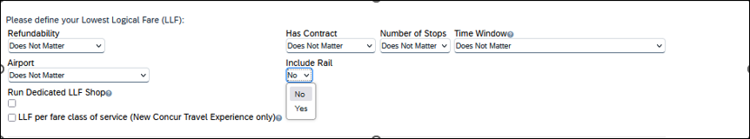

Limitations
Delayed LLF calculation configuration on Company Travel Configuration page:
- Enforce LLF based on user’s chosen fare: Initially, the display of additional screen will not be supported. This functionality may be added later. A banner message will display at the top of the Search Results page that will read: “Additional policy will be calculated based on the time of your selected fare”. Delayed LLF will be calculated after the user has selected their fare (for example, if return fares are chosen after the selection of an inbound fare), and all fares will be evaluated against any delayed LLF based travel policy rules. Users will see all policy rule violations on the Review and Book page for the moment, this may be revised in the future.
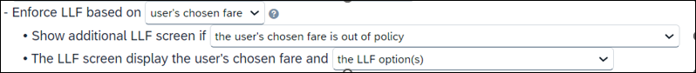
- Enforce LLF based on hybrid: Initially, Hybrid LLF will be calculated based on the search window. Additional search options triggering calculation based on a user’s search are not yet supported.
The Run Dedicated LLF Shop LLF configuration option is not supported in the new Concur Travel experience due to changes in the overall search process.
Mark LLF fare/s with icon LLF configuration option is no longer support in the new Concur Travel experience. The icon will always display.
Travel administrators for configurations where Renfe or Trainline rail connectors are enabled and who set LLF criteria for Rail should revisit their current LLF related policy rules to ensure rules are configured correctly for their needs.
All configuration settings are applied for both Flight and Rail bookings if LLF is enabled for Rail.

**Planned Changes** New Concur Travel Experience: Book and Approve Request Support for Trainline (Professional Edition Only)

Information First Published | Information Last Modified | Feature Target Release Date
November 2023 | December 2023 | February 2024
Any changes since the previous monthly release are highlighted in yellow in this release note.

Prof | Stan | Å Å Edition
 |  | On: Impacts end users who use this feature/vendor; configuration/setup needed by agency/ admin; can be turned OFF (example: new icons or rate display, new Amtrak feature)
 |  | Available for use: No impact to end users unless/until configuration/setup by agency/admin (described below) (example: new rule, new Travelfusion airline)
X |  | Other: Refer to the release note below
 | X | Does not apply to this edition
Source / Solution Suggestion
GDS
Direct Connect |  | Trainline
Other
X | EMEA Data Center |  |  | Scan impact
X | North America Data Center |  | X | UI impact
 | China Data Center |  |  | File finishing impact
 | All data centers |  |  | Profile/Profile API/3rd Party XML Sync Impact
Affected Documentation
TSGs |  | Trainline Direct Connect Travel Service Guide
Fact Sheets
Admin Guides
Other

Overview
Targeted for February 2024, Concur Travel will introduce support for Book then Approve Request for Trainline customers. This integration will be available in the new Concur Travel experience only.

User/Customer Benefit
This functionality will be introduced to provide a smoother booking process for the customer.

End-User Experience
When booking a Trainline trip, the user will be directed to the Request header to confirm the trip and submit the request. The request approver can then approve, reject, or send this back.
This functionality to always create a Request is based on rules and configurations.
Currently, if a client has enabled Request Integration and Trainline, they will not be able to enable any other vertical (Air, Car, or Hotel) in the new Concur Travel experience. This will be corrected in a subsequent release.
This integration for Request will only apply to the new Concur Travel experience and Trainline bookings. If this is combined with any other element of Concur Travel (Flight, Car etc.) this function will not apply.

Configuration for Professional and Standard Travel
To enable the Request Booking Switch
- Click Administration > Travel, then, select Travel System Admin.
- Locate the desired company. In the Wizard Options section of the Travel Configuration page, select Enable Travel Request Integration. This must be selected to use the booking switch feature.
- Select Enable Request Booking Switch.

**Planned Changes** New Concur Travel Experience: Renfe and Trainline Support for Multiple Rail Connectors (Professional Edition Only)

Information First Published | Information Last Modified | Feature Target Release Date
December 2023 | -- | Q1 2024
Any changes since the previous monthly release are highlighted in yellow in this release note.

Prof | Stan | Å Å Edition
 |  | On: Impacts end users who use this feature/vendor; no configuration/setup by agency/ admin; cannot be turned OFF (example: new icons or rate display, new Amtrak feature)
X |  | Available for use: No impact to end users unless/until configuration/setup by agency/admin (described below) (example: new rule, new Travelfusion airline)
 |  | Other: Refer to the release note below
 | X | Does not apply to this edition
Source / Solution Suggestion
GDS
Direct Connect |  | Renfe, Trainline
Other
X | EMEA Data Center |  |  | Scan impact
X | North America Data Center |  |  | UI impact
 | China Data Center |  |  | File finishing impact
 | All data centers |  |  | Profile/Profile API/3rd Party XML Sync Impact
Affected Documentation
TSGs |  | Renfe Direct Connect
Fact Sheets
Admin Guides |  | Travel System Admin Guide
Other

Overview
Concur Travel offers multiple rail connectors. In an upcoming release, support will be added for any rail connectors offered by Concur Travel to be enabled with Renfe.

User/Customer Benefit
This change will provide administrators with the opportunity to enable a wider rail offering to their users on one travel configuration in the new Concur Travel experience.

End-User Experience
End users will be able to book with any of the enabled rail connectors.
For travel configurations where only rail connectors in the New Concur Travel Experience are enabled, vendor selection by the user will not be necessary.
For travel configurations combining current and New Concur Travel Experience rail connectors, the user can select the vendor from a dropdown.

Configuration for Professional Travel
No additional steps are required by administrators to support this change.
Any new rail connectors can be added or removed on the Company Travel Configuration page.
Currently when Renfe is enabled alongside any additional rail connector, only Renfe is available to the end users. With the upcoming release, if any additional rail connector is enabled, it will become available to end users. Administrators should check their Company Travel Configuration settings.

**Planned Changes** New Concur Travel Experience: Renfe and Trainline Configurable Message Boards (Professional Edition Only)

Information First Published | Information Last Modified | Feature Target Release Date
December 2023 | -- | Q1 2024
Any changes since the previous monthly release are highlighted in yellow in this release note.

Prof | Stan | Å Å Edition
 |  | On: Impacts end users who use this feature/vendor; no configuration/setup by agency/ admin; cannot be turned OFF (example: new icons or rate display, new Amtrak feature)
X |  | Available for use: No impact to end users unless/until configuration/setup by agency/admin (described below) (example: new rule, new Travelfusion airline)
 |  | Other: Refer to the release note below
 | X | Does not apply to this edition
Source / Solution Suggestion
GDS
Direct Connect |  | Renfe, Trainline
Other
X | EMEA Data Center |  |  | Scan impact
X | North America Data Center |  |  | UI impact
 | China Data Center |  |  | File finishing impact
 | All data centers |  |  | Profile/Profile API/3rd Party XML Sync Impact
Affected Documentation
TSGs |  | Renfe Direct Connect, Configurable Message Boards Travel Service Guide
Fact Sheets
Admin Guides
Other

Overview
The Configurable Message Boards allow clients to influence end user behavior with dynamic, rule based, messaging. The new Concur Travel experience for Rail will support new placements with this release.

User/Customer Benefit
Configurable Message Boards provide administrators with the opportunity to configure informative custom messaging for specific scenarios based on policy rules to their end users.

End-User Experience
Messages will be display on the shop page. They can appear inline:
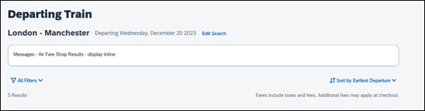
Or in a popup:
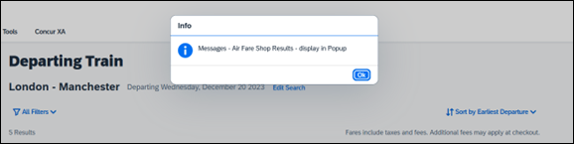

Configuration for Professional Travel
In the Travel Policy Administration section, rules can be configured under Messages - Air Fare Shop Results:
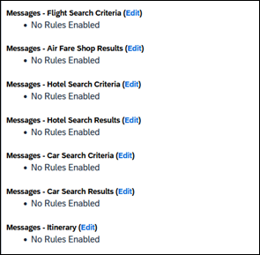
Support for configurable message boards is limited to the web user interface. Rich text including formatting and hyperlinks will be supported.
Any message entered manually by an administrator is not localized. If a message is not set up by an administrator, the localized rule will display to the user.
It is not possible to configure configurable message boards separately for Rail and Flight bookings. If configured, messaging will display for both.

**Planned Changes** New Concur Travel Experience: Renfe and Trainline New Supported Rules (Professional Edition Only)

Information First Published | Information Last Modified | Feature Target Release Date
November 2023 | December 2023 | February 2024
Any changes since the previous monthly release are highlighted in yellow in this release note.

Prof | Stan | Å Å Edition
 |  | On: Impacts end users who use this feature/vendor; no configuration/setup by agency/ admin; cannot be turned OFF (example: new icons or rate display, new Amtrak feature)
 |  | Available for use: No impact to end users unless/until configuration/setup by agency/admin (described below) (example: new rule, new Travelfusion airline)
X |  | Other: Refer to the release note below
 | X | Does not apply to this edition
Source / Solution Suggestion
GDS
Direct Connect
Other
X | EMEA Data Center |  |  | Scan impact
X | North America Data Center |  |  | UI impact
 | China Data Center |  |  | File finishing impact
 | All data centers |  |  | Profile/Profile API/3rd Party XML Sync Impact
Affected Documentation
TSGs |  | Renfe Direct Connect
Fact Sheets
Admin Guides
Other

Overview
Targeted for February 2024, new rules will be supported for Renfe and Trainline to match the legacy Concur Travel experience. This will require Renfe clients to update their rule class setup.

User/Customer Benefit
To provide a more effective and consistent user experience, the Renfe rules will be updated for the new Concur Travel experience.

End-User Experience
The following rules will be supported in the new Concur Travel experience.

Group | Rule
Flight | Flight Number [condition] [FlightNumber]
 | Flight Number is in the list of [FlightNumber]
 | Air Fare is [condition] [currency][money]
 | Air Fare is [condition] the least cost logical airfare plus [difference] [currencyOrPercent]
 | Air Fare is [condition] the least cost [numStops]-stop fare [plusMinus] [difference]
 | Air Base Fare is [condition] [currency][money]
 | One or more fare basis codes contain [FareBasisText]
 | Flight depart time is [condition] [Time]
 | Flight departure date/time is [condition] [Date] at [Time]
 | Flight departure date/time on [leg] leg [condition] [Date] at [Time]
 | Flight departs on [DayOfWeekCodes]
 | Carrier is preferred
 | Marketing airline is in [CarrierList]
 | Operating airline is in [CarrierList]
 | Any segment carried by [CarrierList]
 | Any flight is in region [Region]
 | All Flights are within the region: Europe + UK
 | Flight Departure Country/Region is [CountryList]
 | All Flights are within the country/region: [CountryList]
 | Flight is booked less than [DaysAdvance] days in advance
 | Flight is booked less than [HoursAdvance] hours in advance
 | Any leg duration [condition] that of the user's selected flights plus [minutes] minutes, [incExcLayovers] layovers
 | Any leg duration [condition] that of the shortest duration for that leg in the inventory plus [minutes] minutes, [incExcLayovers] layovers
 | Shortest Flight duration between two most distant airports is [condition] [minutes] minutes, [incExcLayovers] layovers
 | Flight duration of all flights in a segment (excluding layovers) is [condition] [Duration] minutes
 | Flight duration for any single flight is [condition] [Duration] minutes
 | User did not request refundable fares only
 | Fare is not from the Reservation System
 | Fare is not a web fare
 | Fare uses class of service [ClassList]
 | Fare uses cabin class in list [CabinList]
 | Air Carrier is not an Instant Purchase carrier
 | Search results contain one or more of these vendors: [VendorList]
 | Results do not contain preferred vendors
 | Trip duration [condition] [DaysLong] days
 | Time spent at destination is [condition] [DaysLong] days
 | The least cost logical airfare is on one of [CarrierList]
 | Layover duration on any segment is [condition] [minutes] minutes
 | Number of stops in the least cost logical fare is [condition] [numStops] stops
 | Number of stops is [condition] the number of stops in the least cost logical fare
 | Booking source is [Source]
 | Booking source is not [Source]
 | Non-refundable airfare is [condition] the [discountContract] fare plus [currency] [money] [currencyOrPercent]
Rail | Number of train changes is [condition] [NumTrainChanges] and train carrier is in [CarrierList]
 | Rail is [PreferredList]
 | Rail is not [PreferredList]
 | Trip duration [condition] [DaysLong] days
 | Rail fare description contains [DescriptionList]
 | Train is from source [Vendor] and Operating Carrier in [CarrierList]
 | Train is from source [Vendor] and train type in [TrainTypeList]
View more fares (will be applied at initial search) | Fare in cabin classes: [CabinList] is [condition] the least cost logical airfare plus [difference] [currencyOrPercent]
 | Refundable fare in cabin classes: [CabinList] is [condition] the least cost logical airfare plus [difference] [currencyOrPercent]
 | Refundable fare in cabin classes: [CabinList] is [condition] the cheapest fare in flight plus [difference] [currencyOrPercent]
 | Fare in cabin classes: [CabinList] is [condition] the cheapest refundable fare in flight plus [difference] [currencyOrPercent]
 | First leg departure City is [CityCodeList]
 | First leg departure City is not [CityCodeList]
 | First leg arrival City is [CityCodeList]
 | First leg arrival City is not [CityCodeList]
 | User requested Area Airports and flights do not depart from/return to the same airport
 | Airline is [CarrierList] and brand name is [BrandedFareNameList]
 | One or more fare basis codes contain [FareBasisText]
 | One or more fare basis codes do not contain [FareBasisText]
Class of service (unique from flight group) | Cabin classes allowed: [CabinClasses]
 | Leg duration [condition] that of the shortest option available plus [minutes] minutes, [incExcLayovers] layovers
 | Waitlist cabin(s) are available and allowed

Configuration for Professional and Standard Travel
No additional steps are required by administrators to support this change. However, SAP Concur recommends that clients provide messaging within Concur Travel to inform travelers of the updated rule set.

**Planned Changes** New Concur Travel Experience: Renfe Multiple Violation Reasons (Professional Edition Only)

Information First Published | Information Last Modified | Feature Target Release Date
December 2023 | -- | Q1 2024
Any changes since the previous monthly release are highlighted in yellow in this release note.

Prof | Stan | Å Å Edition
 |  | On: Impacts end users who use this feature/vendor; no configuration/setup by agency/ admin; cannot be turned OFF (example: new icons or rate display, new Amtrak feature)
X |  | Available for use: No impact to end users unless/until configuration/setup by agency/admin (described below) (example: new rule, new Travelfusion airline)
 |  | Other: Refer to the release note below
 | X | Does not apply to this edition
Source / Solution Suggestion
GDS
Direct Connect |  | Renfe
Other
X | EMEA Data Center |  |  | Scan impact
X | North America Data Center |  |  | UI impact
 | China Data Center |  |  | File finishing impact
 | All data centers |  |  | Profile/Profile API/3rd Party XML Sync Impact
Affected Documentation
TSGs |  | Renfe Direct Connect
Fact Sheets
Admin Guides |  | Travel System Admin Guide
Other

Overview
For bookings of out-of-policy fares, users are required to select a policy violation reason. An upcoming release will introduce support for Allow Multiple Violation Reason Codes for Renfe.

User/Customer Benefit
The updates to the Policy section for rail will provide a more cohesive Concur Travel experience. They allow for improved visibility of violated policy rules and the ability to provide multiple violation reasons for rail bookings.

End-User Experience
If Allow Multiple Violation Reason Codes is enabled and multiple travel policy rules are violated, a user may be requested to select multiple violation reasons on the Review and Book page if different policy violation reason types are configured for the rules.
The user interface will display a list all the policy rules violated, grouped by the rule action.
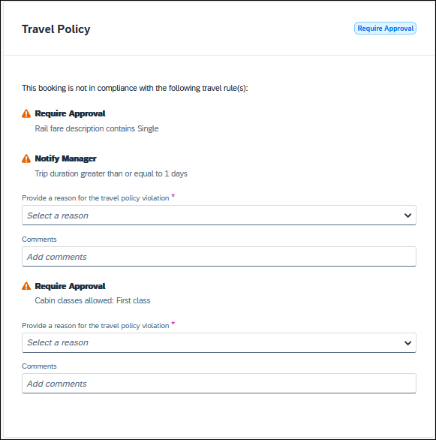

Configuration for Professional Travel
No additional steps are required by administrators to support this change.
Allow Multiple Violation Reason Codes can be enabled on the Company Travel Configuration page.
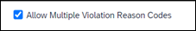
The setting is applicable to all bookings when enabled. It is not specific to rail bookings.

**Planned Changes** New Concur Travel Experience: Renfe User Interface Changes to Workflow Pages and Emails (Professional Edition Only)

Information First Published | Information Last Modified | Feature Target Release Date
November 2023 | December 2023 | Q1 2024
Any changes since the previous monthly release are highlighted in yellow in this release note.

Prof | Stan | Å Å Edition
 |  | On: Impacts end users who use this feature/vendor; no configuration/setup by agency/ admin; cannot be turned OFF (example: new icons or rate display, new Amtrak feature)
 |  | Available for use: No impact to end users unless/until configuration/setup by agency/admin (described below) (example: new rule, new Travelfusion airline)
X |  | Other: Refer to the release note below
 | X | Does not apply to this edition
Source / Solution Suggestion
GDS
Direct Connect |  | Renfe
Other
X | EMEA Data Center |  |  | Scan impact
X | North America Data Center |  |  | UI impact
 | China Data Center |  |  | File finishing impact
 | All data centers |  |  | Profile/Profile API/3rd Party XML Sync Impact
Affected Documentation
TSGs |  | Renfe Direct Connect
Fact Sheets
Admin Guides
Other

Overview
Targeted for Q1 2024, there will be changes to the view of the Renfe user interface. These changes will affect Shop and Review and Book pages.

User/Customer Benefit
To provide a more consistent user experience, some Renfe pages will be updated to resemble Flight pages.

End-User Experience
These updates will apply mostly to the Shop result and Review and Book pages.
Changes to the search results display:
- New horizontal display of the search results: Up to four fares will display as the initial search results. All remaining available fare options will display upon expanding the itinerary.
- Updated Fare Rules and Restrictions pop-up window.
- Updated Filter options.
- Updated Sort options.
- Support display of Preference label.
- Display of fares in the configured currency instead of vendor currency.
Changes to Review and Book page:
- Updated display of itinerary.
- New display of Total Cost card to align with the display on following Trip pages and Email.
- Updated display of itinerary on Finalize and Trip Overview pages.
Changes to Confirmation Email:
- Updated display of itinerary
- Previously links to download ticket (PDF and Phone Wallet) was displayed in the body of the confirmation email. In the updated confirmation email tickets will be attached to the email as attached files.
Changes to Approver email:
- The approver email will have a better look and feel to match the rest of the product.
More details will be included in subsequent release notes.

Configuration for Professional Travel
For any features requiring configuration steps by administrators the details will be shared closer to the date. General user interface changes will require no additional enablement.

**Planned Changes** New Concur Travel Experience: Trainline Migration (Professional Edition Only)

Information First Published | Information Last Modified | Feature Target Release Date
November 2023 | December 2023 | Q1 2024
Any changes since the previous monthly release are highlighted in yellow in this release note.

Prof | Stan | Å Å Edition
 |  | On: Impacts end users who use this feature/vendor; no configuration/setup by agency/ admin; cannot be turned OFF (example: new icons or rate display, new Amtrak feature)
 |  | Available for use: No impact to end users unless/until configuration/setup by agency/admin (described below) (example: new rule, new Travelfusion airline)
X |  | Other: Refer to the release note below
 | X | Does not apply to this edition
Source / Solution Suggestion
GDS
Direct Connect |  | Trainline
Other
X | EMEA Data Center |  |  | Scan impact
X | North America Data Center |  | X | UI impact
 | China Data Center |  |  | File finishing impact
 | All data centers |  |  | Profile/Profile API/3rd Party XML Sync Impact
Affected Documentation
TSGs |  | Trainline Direct Connect
Fact Sheets
Admin Guides
Other

Overview
Concur Travel provides travelers in the UK market with the ability to book trains via Trainline. Trainline plans to decommission their current connection to Concur Travel in Q1 2024.
SAP Concur will work towards supporting Trainline’s new connection. As part of this effort, SAP Concur plans to enable the new Concur Travel Experience for Trainline existing customers.

User/Customer Benefit
The new Concur Travel rail booking experience together with the new Trainline connection will bring clients the following benefits:
- New user interface
- Reduced number of steps to complete the booking.
- Support for eTicket delivery option.
- Support for UK Rail bookings on mobile application.
- Support for multiple Advantage Cards (Railcards) in user profile.

End-User Experience
The end-user booking workflow will include search, book, and itinerary review. The release introduces a reduced set of features.

Trainline Migration Differences
As SAP Concur migrates UK Rail (Trainline) to the new Trainline connection and the new Concur Travel experience, users might see some differences in the behavior compared to the current experience.
The following items will not yet be supported with the new Rail booking experience. Monitor future release notes for changes relating to these.

Product Area | Feature/Setting | Setting Location | Setting/Feature details | Additional Information
Traveler selection | Guest Traveler bookings | User Permission | Guest traveler bookings are disabled | A guest traveler or sponsored guest booking are not yet supported.  Users will see a message “Rail booking for a guest is not available at this time” in the Rail search widget when accessing Rail tab as a guest.
Content | Air/Rail Tab Search: Mixed Air/Rail | N/A | UK Rail search results are not available via Air/Rail tab | Air/Rail comparison is not yet supported for the new rail booking experience.  Users must use the Rail tab to search for UK Rail (Trainline) content.
Content | Global distribution system  (passive segments/finishing) | Travel Configuration | Global distribution system (GDS) supported for UK Rail: Amadeus, Sabre, Galileo | UK Rail will be unavailable for clients with travel configurations on Apollo and Worldspan
Content | Edition | Company | Standard Edition | UK Rail will be unavailable for clients with Concur Travel Standard edition in the new Rail booking experience.
Rail-specific | Arrive by | Travel Configuration | Search by arrival time | Search by arrival time is not supported for UK Rail in the new Rail booking experience yet.  Users will be able to search by departure time for UK Rail.
Rail-specific | Multi-passenger booking | Travel Configuration | “Max Number of companions” feature | “Max Number of companions” feature will not be supported for UK Rail in the new Rail booking experience.
Rail-specific | Promotional code | N/A | Promotional code in the search widget | Promotional code will not be supported for UK Rail in the new Rail booking experience.
Rail-specific | Custom passive template | Travel System Admin > Passive Template Editor |  | Custom passive template will not be supported for the new Rail booking experience.  Standard passive segments will continue to be supported for UK Rail for Amadeus, Sabre and Galileo.
Profile | Loyalty Card | User Profile |  | Loyalty Cards will not be supported for UK Rail in the new Rail booking experience.  Users with UK Rail loyalty program in their profile will be able to search and book UK Rail content. Their UK Rail frequent traveler program will not be sent to Trainline with the booking.
Integration | Concur Request | Travel Configuration  Request module | Approve then Book flow | “Approve then Book flow” is not yet supported for UK Rail in the new rail booking experience for UK Rail.
Integration | Concur Request | Travel Configuration  Request module | Book then Approve flow | “Book then Approve” flow will be supported with limitations.
Travel Policy | Least Cost Logical Fare | Travel Configuration | Enforce LLF based on hybrid | Hybrid LLF will be calculated based on the search window only with initial release. Additional search options triggering calculation based on user’s search window not supported yet.
Travel Policy | Least Cost Logical Fare | Travel Configuration | Enforce LLF based on user’s chosen fare | Display of additional screen will not yet be supported. Users will see all policy rule violations for delayed LLF on the Review and Book page instead of on a separate screen.
Changes in behavior

Product Area | Feature/Setting | Setting Location | Setting/Feature details | Additional Information
Payments | Ghost Card | Travel Administration > Corporate Ghost Cards |  | Ghost Card payment will not require a security code on the Review and Book page.
Profile | Date of Birth | Profile > International Travel: Passports and Visas | Date of birth is required for UK Rail search. | If the date of birth is missing, users will see a message with the request to update their profile before they can continue with their search.
Rail-specific | View More Fares | N/A | “View More Fares” link is not available for the new Rail details booking experience. | Up to four fares will display directly as the initial search results. All remaining available fare options will display upon expanding the itinerary.
Rail-specific | Class selection | Travel Administration > Travel Policy | Class selection is not available in the search widget for the new Rail booking experience | Users will be able to use filters (if applicable) in the search results.
Rail-specific | Search by price/schedule |  | Search by price/schedule is not available in the search widget for the new Rail booking experience | Users will be able to use filters in the search results in the new Rail booking experience.
Rail-specific | Delivery options | N/A | Delivery options displayed on the Review and Book page | Delivery options supported for UK Rail are limited to eTicket and Kiosk.

Configuration for Professional Travel
SAP Concur is planning to migrate existing customers to Trainline's new connection to ensure continuous support of UK Rail in Concur Travel.
No additional steps are required by administrators to support this change. However, SAP Concur recommends that clients provide messaging within Concur Travel to inform travelers.

**Planned Changes** New Concur Travel Experience: Choose Your Rule Class (Professional Edition Only)

Information First Published | Information Last Modified | Feature Target Release Date
January 2024 | -- | Q1 2024
Any changes since the previous monthly release are highlighted in yellow in this release note.

Prof | Stan | Å Å Edition
 |  | On: Impacts end users who use this feature/vendor; no configuration/setup by agency/ admin; cannot be turned OFF (example: new icons or rate display, new Amtrak feature)
 |  | Available for use: No impact to end users unless/until configuration/setup by agency/admin (described below) (example: new rule, new Travelfusion airline)
X |  | Other: Refer to the release note below
 | X | Does not apply to this edition
Source / Solution Suggestion
GDS
Direct Connect |  | Trainline, Renfe
Other
X | EMEA Data Center |  |  | Scan impact
X | North America Data Center |  | X | UI impact
 | China Data Center |  |  | File finishing impact
 | All data centers |  |  | Profile/Profile API/3rd Party XML Sync Impact
Affected Documentation
TSGs
Fact Sheets
Admin Guides |  | Travel System Admin User Guide
Other

Overview
In the Rule Class Options section of Travel System Admin, administrators will be able to configure their travel sites to do the following:
- allow users to select from a rule class tied to this travel configuration.
- allow users to select a rule class tied to same agency.
- force users to select a rule when making a reservation.
- display a custom rule class label and
- opt out a rule class from displaying in the dropdown.

User/Customer Benefit
This setting allows users to select which rules are suitable for the trip they are booking.

Administrator Experience
The administrator will be able to:
- enable the options User can select from rule classes tied to this configuration or User can select from rule classes tied to same agency.
- create a custom rule class label.
- select the Force selection of a rule class checkbox.
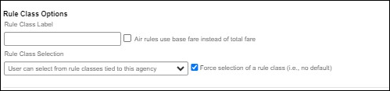
- select the Choose Rule Class Opt Out checkbox to remove the display of a rule class.
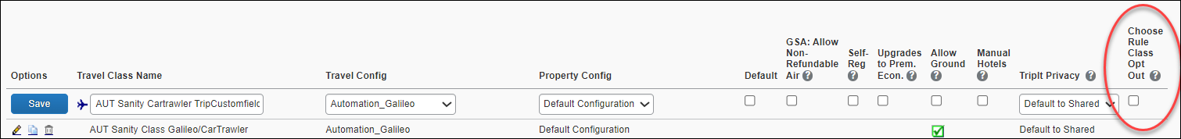
- display a custom message if the user does not select a rule class when required.

End-User Experience
The user will see a dropdown on the home page that contains rule classes associated with their travel configuration, excluding a rule class that has been opted out. If the force rule class is enabled, then users will see a blinking yellow outline that surrounds the dropdown. If the user does not select a rule (when required), they will be prompted to select a rule class.

Configuration for Professional Travel
Refer to the Administrator Experience section for set up details. No additional steps are required by administrators to support this change.

**Planned Changes** New Concur Travel Experience: Standalone Approval Enhancement (Professional Travel Only)

Information First Published | Information Last Modified | Feature Target Release Date
January 2024 | January 19, 2024 | February 2024
Any changes since the previous monthly release are highlighted in yellow in this release note.

Prof | Stan | Å Å Edition
 |  | On: Impacts end users who use this feature/vendor; no configuration/setup by agency/ admin; cannot be turned OFF (example: new icons or rate display, new Amtrak feature)
 |  | Available for use: No impact to end users unless/until configuration/setup by agency/admin (described below) (example: new rule, new Travelfusion airline)
X |  | Other: Refer to the release note below
 | X | Does not apply to this edition
Source / Solution Suggestion
GDS |  | Applies to all GDSs
Direct Connect |  | Applies to all Direct Connects
Other
X | EMEA Data Center |  |  | Scan impact
X | North America Data Center |  |  | UI impact
 | China Data Center |  |  | File finishing impact
 | All data centers |  |  | Profile/Profile API/3rd Party XML Sync Impact
Affected Documentation
TSGs |  | Renfe Direct Connect, Trainline Direct Connect
Fact Sheets
Admin Guides
Other

Overview
With this change, SAP Concur will support standalone approvals for Renfe, as it does for all other verticals and rail vendors. Require Approval and Require Passive Approval rules will no longer be downgraded.
In the legacy Concur Travel experience, if the Require Approval or Require Passive Approval rules are broken, and the approver either rejects or does not take action on the trip by the approval deadline, the trip is:
- auto cancelled, for certain vendors where bookings are fully refundable and can be cancelled (for example, GDS Air bookings, before ticketing).
- auto finalized, allowing for trip fulfilment for certain vendors where bookings are not fully refundable or cancellation isn't possible (for example, Renfe bookings).
- neither auto-canceled nor auto-finalized, where the trip is left unactioned in Concur Travel (for example, for Trainline bookings).
With the February release, for trips including only bookings made with the new Concur Travel experience, if the Require Approval or Require Passive Approval rules are broken, and the approver either rejects or does not action the trip by the trip approval deadline, Concur Travel will check all bookings on the trip for refundability, regardless of their vendor. With this change, the trip will be:
- auto cancelled, for all content sources where all bookings are fully refundable (for example, GDS Air before ticketing, or a Renfe trip with a fully refundable booking), or
- auto finalized, allowing for trip fulfilment for all content sources that contain at least one booking that is not fully refundable or cannot be cancelled (for example, one trip that includes a Trainline booking, as this content cannot yet be cancelled in Concur Travel, or one trip that includes a partially refundable Renfe booking).

User/Customer Benefit
To provide a more effective and consistent user experience, the Renfe rules will be updated for the new Concur Travel experience. The existing limitation will be removed.

Configuration for Professional and Standard Travel
No additional steps are required by administrators to support this change.

Travel Operations / Technical Essentials

**Planned Changes** Decommission of Credit Card Datapoints in Profile and PNR Finishing Templates

Information First Published | Information Last Modified | Feature Target Release Date
January 12, 2024 | -- | April 2024
Any changes since the previous monthly release are highlighted in yellow in this release note.

Prof | Stan |   Edition
X | X | On: Impacts end users who use this feature/vendor; no configuration/setup by agency/ admin; cannot be turned OFF (example: new icons or rate display, new Amtrak feature)
 |  | Available for use: No impact to end users unless/until configuration/setup by agency/admin (described below) (example: new rule, new Travelfusion airline)
X |  | Other: Refer to the release note below
 |  | Does not apply to this edition
Source / Solution Suggestion
GDS |  | Sabre, Amadeus, Apollo, Worldspan, Travelport+ (Galileo)
Direct Connect
Other
X | EMEA Data Center |  |  | Scan impact
X | North America Data Center |  | X | UI impact
 | China Data Center |  |  | File finishing impact
 | All data centers |  |  | Profile/Profile API/3rd Party XML Sync Impact
Affected Documentation
TSGs
Fact Sheets
Admin Guides
Other

Overview
The GDS systems are changing how credit cards are managed in Passenger Name Records (PNRs), resulting in several changes needed within Concur Travel. One of the GDS-imposed changes is the anonymization and removal of credit card data in all areas of the PNR except for the designated Form of Payment (FOP) field or FOP Wallet. In preparation for this change, Concur Travel will be decommissioning Profile and PNR Finishing Template datapoints for credit card numbers and expiration dates. Concur Travel will be decommissioning Profile and PNR Finishing Template data points for credit card numbers and expiration dates in preparation for this change.
Concur Travel will be migrating to Sabre’s Enhanced Form of Payment (FOP Wallet) and will be adding the traveler-selected form of payment for each booking type to the FOP Wallet (*FOP) along with the applicable Use Type code. Please see the Sabre Enhanced Form of Payment release note for more information. For all other GDS systems, Concur Travel will continue to transmit credit card information to the compliant form of payment field already in place in the PNR today.
- Due to the highly customizable nature of PNR Finishing Templates, Concur Travel can only provide general guidance for making updates and cannot ensure that finishing will run successfully if these datapoints are not removed before their retirement.

User/Customer Benefit
SAP Concur sees this as one of the first of many industry-wide efforts to better secure sensitive user data, creating higher confidence in the travel purchasing process and reducing financial risk for users and companies alike.
SAP Concur is recommending that customers and TMCs work together to identify any scenarios where the Profile or PNR Finishing templates are used to transmit credit card data to the GDS systems in non-compliant fields of the GDS profile and/or PNR. Customers who need credit card data transmitted to the IUR/A.I.R./MIR file for back-office processing will need to seek a mid-office solution to address their needs.

End-User Experience
The following datapoint examples should help TMCs and customers determine if changes are needed to their Concur Travel instance.

Profile Template Datapoint Examples
The following is a list of profile template datapoints which include credit card numbers or expiration dates; this list may not be comprehensive. TMCs/Customers should review their Profile Templates. If templates are using one of the credit card elements, these should be removed:
- Air_credit_card_number car_credit_card_number
- ghost_air_credit_card_number
- ghost_car_credit_card_number
- ghost_hotel_credit_card_number
- hotel_credit_card_number
- personal_air_credit_card_number
- personal_car_credit_card_number
- personal_hotel_credit_card_number
- car_expiration_date
- ghost_air_expiration_date
- ghost_car_expiration_date
- ghost_card_expiration
- ghost_card_number
- ghost_hotel_expiration_date
- hotel_expiration_date
- personal_air_expiration_date
- personal_car_expiration_date
- personal_hotel_expiration_date
- ycal_ghost_card_expiration
- ycal_ghost_card_number
Example of a Profile Template line configured to transmit a credit card number:
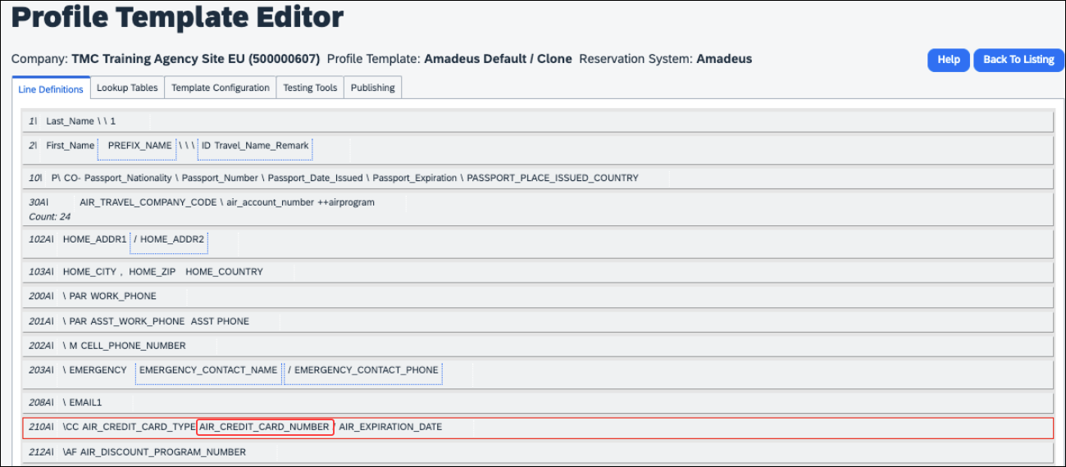

PNR Finishing Template Examples
TMCs or customers should review their PNR Finishing Templates. If templates are using one of the credit card elements, these should be removed.
Credit Card Finishing Template Datapoints:
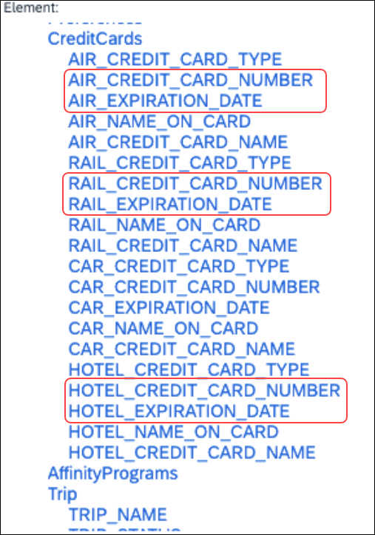
Customers using Conferma Pay for hotel virtual cards should review their PNR Finishing Templates. If templates are using one of the credit card elements, these should be removed:
- Virtual_Hotel_Credit_Card_Number
- Virtual_Hotel_Expiration_Date
Finishing Template Datapoints for Conferma Pay:
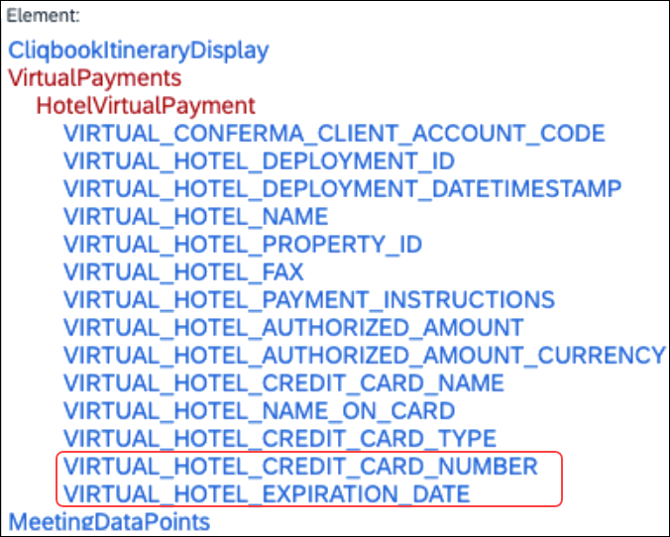

Configuration for Professional and Standard Travel
This feature is enabled by default. There are no configuration steps.
For more information, refer to the Sabre Enhanced Form of Payment release note. To locate, refer to Additional Release Notes and Other Technical Documentation in these release notes.

**Planned Changes** Decommission of Travel Configuration Agency Processing Fee Form of Payment for Land Only/Non-GDS Reservations Setting

Information First Published | Information Last Modified | Feature Target Release Date
January 12, 2024 | January 19, 2024 | April 2024
Any changes since the previous monthly release are highlighted in yellow in this release note.

Prof | Stan |   Edition
X | X | On: Impacts end users who use this feature/vendor; no configuration/setup by agency/ admin; cannot be turned OFF (example: new icons or rate display)
 |  | Available for use: No impact to end users unless/until configuration/setup by agency/admin (described below) (example: new rule, new Travelfusion airline)
X |  | Other: Refer to the release note below
 |  | Does not apply to this edition
Source
GDS
Direct Connect
Other
X | EMEA Data Center |  |  | Scan impact
X | North America Data Center |  | X | UI impact
 | China Data Center |  |  | File finishing impact
 | All data centers |  |  | Profile/Profile API/3rd Party XML Sync Impact
Affected Documentation
TSGs |  | Travel System Admin Guide
Fact Sheets
Admin Guides
Other

Overview
Concur Travel is removing the Agency Processing Fee Form of Payment for Land Only/Non-GDS Reservations configuration setting from Travel Configurations. Any credit card data that is currently stored in these fields will be removed.

User/Customer Benefit
The GDS are making changes to the way credit cards are entered into the Passenger Name Record (PNR), resulting in several changes needed within Concur Travel. Form of payment (FOP) will need to be written in a specific format, depending on its use. This means that all FOP features require updating and reformatting. Based on these changes, SAP Concur is recommending that customers and TMCs work together on how to manage TMC service fees outside of the booking process. One benefit to this change is the avoidance of PNR template updates for a process that has no impact to the online booking process.

End-User Experience
The previous setting will be removed from the Travel Configurations page and will no longer be visible. Configurations using the following options will have the setting automatically changed to None:
- Always write user selected credit card (default)
- Always write user selected air/rail card
- Always write air/rail ghost card
- Always write air/rail profiled card
- Always use this card
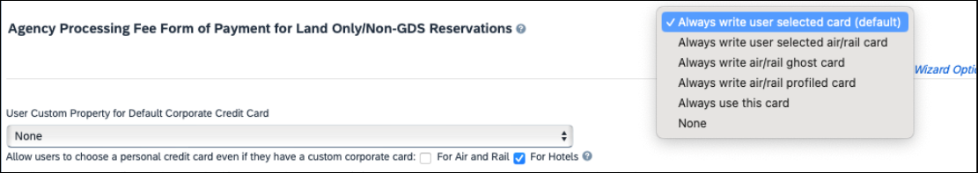
Depending on the customer configuration settings, the user-selected FOP or the company default FOP will be added to the Sabre FOP Wallet with the new Use Type code to identify the FOP selected for Flight, Rail, Car, and Hotel booking types. This applies to itineraries that include flight, land-only bookings, and non-GDS bookings originating from Concur Travel. Otherwise, no FOP will be added to GDS PNRs for non-GDS or land-only bookings. Clients who require this functionality will need to seek a mid-office solution.

Configuration for Professional Travel
This feature is enabled by default. There are no configuration steps.

**Planned Changes** Sabre Enhanced Form of Payment (FOP Wallet)

Information First Published | Information Last Modified | Feature Target Release Date
January 12, 2024 | January 19, 2024 | April 2024
Any changes since the previous monthly release are highlighted in yellow in this release note.

Prof | Stan |   Edition
X | X | On: Impacts end users who use this feature/vendor; no configuration/setup by agency/ admin; cannot be turned OFF (example: new icons or rate display, new Amtrak feature)
 |  | Available for use: No impact to end users unless/until configuration/setup by agency/admin (described below) (example: new rule, new Travelfusion airline)
 |  | Other: Refer to the release note below
 |  | Does not apply to this edition
Source / Solution Suggestion
GDS |  | Sabre
Direct Connect
Other
X | EMEA Data Center |  |  | Scan impact
X | North America Data Center |  |  | UI impact
 | China Data Center |  |  | File finishing impact
 | All data centers |  |  | Profile/Profile API/3rd Party XML Sync Impact
Affected Documentation
TSGs
Fact Sheets
Admin Guides
Other

Overview
Sabre is decommissioning their legacy 5-Remarks Form of Payment Field (5-*VI444333322221111¥05/26) as of Q3 2024. All Sabre customers are required to migrate to Sabre’s Enhanced Form of Payment also known as FOP Wallet (*FOP). For compliance, Sabre is also anonymizing and removing credit card data from all non-compliant fields in the PNR. They are rolling this anonymization and removal process out in phases, with the final phase to be completed by June 2024. This change will also require a new process for sending credit card data to back-office systems.
Please refer to the following Sabre SAN messages for more details:
- SAN 16643 - Sunset of PNR Form of Payment Field 5-Remarks
- SAN 16331 - Payment Card Anonymization & Removal in PNR Fields
- SAN 17007 - Form of Payment Wallet (FOP) New Use Type for Interface Records
- SAN 17009 - Interface User Record (IUR) - New MX Record for Form of Payment Wallet
Concur Travel will migrate to the FOP Wallet in preparation for this mandate.

User/Customer Benefit
Concur Travel will add the traveler-selected form of payment chosen at the time of booking for every reservation type (Flight, Car, Hotel, and Rail) to the FOP Wallet in the Sabre PNR along with the appropriate Use Type code. (for example, UAL=Air, UCR=CAR, UHL=Hotel, and URL=Rail)

End-User Experience
Example: FOP Wallet
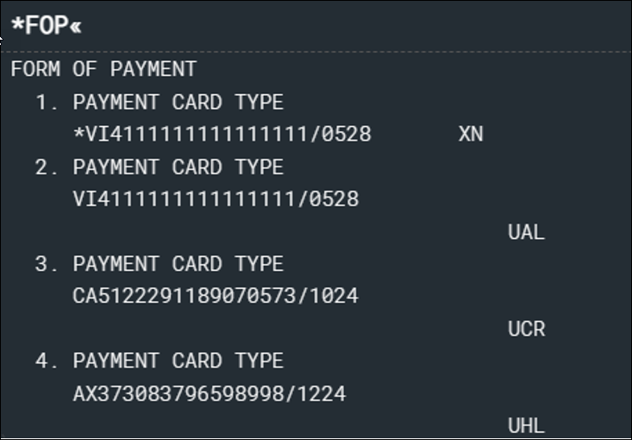

Configuration for Professional and Standard Travel
This feature requires Sabre customers to self-activate Passenger Name Association, which includes the FOP Wallet by using the TJR keyword PNAPNR. It is important to note that once this TJR setting is activated, it cannot be deactivated.
The form of payment updates will automatically be enabled by default in Concur Travel. If a Sabre customer has not yet activated the FOP Wallet, then Concur Travel will automatically revert to the legacy FOP field prior to Sabre’s activation deadline. There are no configuration steps in Concur Travel.
For more information, refer to the following Sabre SAN notifications:
- SAN 16643 - Sunset of PNR Form of Payment Field 5-Remarks
- SAN 16331 - Payment Card Anonymization & Removal in PNR Fields
- SAN 17007 - Form of Payment Wallet (FOP) New Use Type for Interface Records
- SAN 17009 - Interface User Record (IUR) - New MX Record for Form of Payment Wallet

**Planned Changes** New Concur Travel Experience: Manage Preferences at Travel Configuration Level

Information First Published | Information Last Modified | Feature Target Release Date
January 12, 2024 | -- | January 31, 2024
Any changes since the previous monthly release are highlighted in yellow in this release note.

Prof | Stan |   Edition
X |  | On: Impacts end users who use this feature/vendor; no configuration/setup by agency/ admin; cannot be turned OFF (example: new icons or rate display)
 |  | Available for use: No impact to end users unless/until configuration/setup by agency/admin (described below) (example: new rule, new Travelfusion airline)
X |  | Other: Refer to the release note below
 | X | Does not apply to this edition
Source
GDS |  | Sabre, Car Connector
Direct Connect
Other
X | EMEA Data Center |  |  | Scan impact
X | North America Data Center |  | X | UI impact
 | China Data Center |  |  | File finishing impact
 | All data centers |  |  | Profile/Profile API/3rd Party XML Sync Impact
Affected Documentation
TSGs
Fact Sheets
Admin Guides
Other

Overview
Company Administrators and TMCs will be able to manage their new Concur Travel experience preference at the Travel Configuration level, in addition to managing their preference at the company level. Administrators will be able to opt in or out of Flight, Rental Car and Hotel new travel experiences by Travel Configuration.

User/Customer Benefit
This change will provide the ability to enable the new Concur Travel experience at the Travel Configuration level. This will give administrators more flexibility to adopt the new experience as it is ready.

Administrator Experience
Administrators will see a new section on the Manage New Concur Travel Experience Preferences page. Any changes made at the travel configuration level will override the preference set at the Company level.
To manage the preference for a Travel Configuration, click Company Level Preference to expand the section, and select the name of the travel configuration on the list. Another window will appear where you can choose to enable or disable the new travel experience for Air, Rental Car or Hotel.
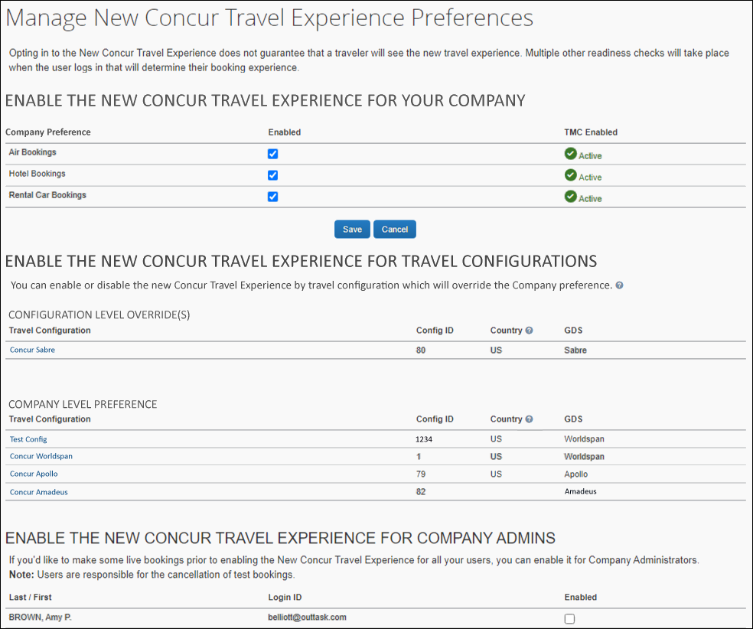
Once selected, click Save.
Travel configurations that have overrides will display first in the Configuration Level Override(s) section.
Travel Configurations that are using the Company Preference will appear below.
To remove an override on a Travel Configuration, click the name of the travel configuration. Another window will appear. Click the Use Company Preference button. The user is returned to the Manage New Concur Travel Experience Preferences page. The travel configuration that was overridden will appear in the section that is using the Company Level Preference.
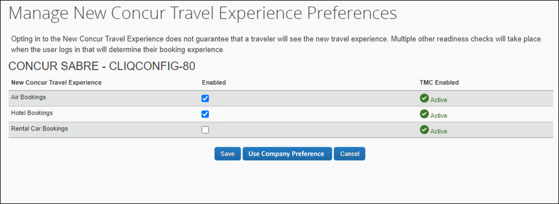
Opting in or out of the new Concur Travel experience does not guarantee that a traveler will see the new experience. Multiple other readiness checks will take place when the traveler logs in that will determine their booking experience.

Configuration for Professional Travel
For configuration steps, please refer to the Administrator Experience section of this release note.

**Planned Changes** New Concur Travel Experience: Sabre’s Price Quote - Enhancement to Provide More Accurate Fare at Booking

Information First Published | Information Last Modified | Feature Target Release Date
November 3, 2023 | January 12, 2024 | June 30, 2024
Any changes since the previous monthly release are highlighted in yellow in this release note.

Prof | Stan |   Edition
X |  | On: Impacts end users who use this feature/vendor; no configuration/setup by agency/ admin; cannot be turned OFF (example: new icons or rate display)
 |  | Available for use: No impact to end users unless/until configuration/setup by agency/admin (described below) (example: new rule, new Travelfusion airline)
X |  | Other: Refer to the release note below
 | X | Does not apply to this edition
Source
GDS |  | Sabre, Car Connector
Direct Connect
Other
X | EMEA Data Center |  |  | Scan impact
X | North America Data Center |  | X | UI impact
 | China Data Center |  |  | File finishing impact
 | All data centers |  |  | Profile/Profile API/3rd Party XML Sync Impact
Affected Documentation
TSGs
Fact Sheets
Admin Guides
Other

Overview
SAP Concur plans to add Price Quote (PQ) modifiers into the new Concur Travel experience process for accuracy purposes.

User/Customer Benefit
This change will be implemented to enhance accuracy and reduce price jump situations such that the stored price always matches the price offered in the shopping response.

End-User Experience
When storing the price quote, the following qualifiers will be added:
- XO (forced passenger type to avoid shifting to ADT when not using ADT),
- P(passenger type),
- A (validating carrier) and
- ZZ (fare basis)
In addition, SAP Concur will change the SNAP code qualifier from I to AC*.
New Pricing Command Line:
WPAC*GLD03¥S1*BRMAINCABIN*ZZXAVUA0ML¥S2*BRMAINCABIN*ZZXAVNA0ME¥RY/CA¥AUA¥PADT¥XO¥RQ
New PQ Line:
PQ 1 AC*GLD03¥S1*BRMAINCABIN*ZZXAVUA0ML¥S2*BRMAINCABIN*ZZXAVNA0ME¥AUA¥PADT¥XO¥RQ
Current PQ line:
WPIGLD03¥S1*BRMAINCABIN¥S2*BRMAINCABIN¥RQ

Configuration for Professional Travel
This feature is enabled by default. There are no configuration steps.

Client Notifications

Accessibility

Accessibility Updates
SAP implements changes to better meet current Web Content Accessibility Guidelines (WCAG). Information about accessibility-related changes made to SAP Concur solutions is published on a quarterly basis. You can review the quarterly updates on the Accessibility Updates page.

Gender Diversity
SAP Concur is committed to supporting gender diversity. Over time we plan to implement product changes to help ensure that SAP Concur solutions support gender non-binary users. These changes will include but are not limited to support for preferred names, non-binary gender options in travel preferences, and non-binary titles.
These planned changes reflect SAP's commitment to supporting gender diversity and enable gender non-binary users to enter consistent information when making travel arrangements and entering personal information into SAP Concur solutions.
Timelines and details about these ongoing changes will be provided in the SAP Concur release notes.

Documentation for New Concur Travel Experience

Online Help Updates in the SAP Help Portal

Overview
Online end user help documentation for the new Concur Travel experience, beginning with the Renfe Direct Connect enhancements from the November release, are indicated with “New Workflow” text at the end of topic titles.
Also, on the Implement tab of the Concur Travel product page in the SAP Help Portal, there is a new Travel Services Help. This will become the new home for Travel Service Guides type documentation.

User/Customer Benefit
The “New Workflow” text is intended to help you distinguish between the existing experience and the redesigned experience for Concur Travel.

End-User Experience
When accessing the Concur Travel End User Help, you can see which topics are specific to the Concur Travel experience as they contain the suffix "New Workflow".
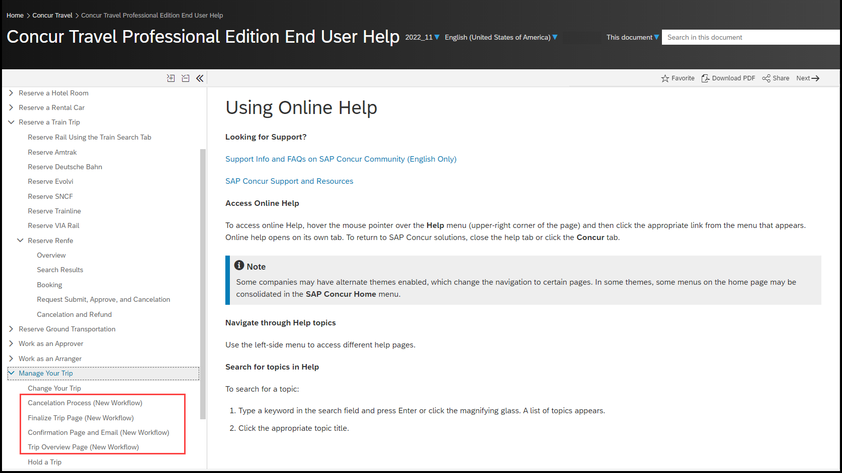

Configuration for Professional and Standard Travel
This feature is enabled by default. There are no configuration steps.

In-Product User Assistance

Client Customized Content
If your company creates customized content for SAP Concur solutions through a user assistance tool such as SAP Enable Now or Concur User Assistant by WalkMe, the changes described in these release notes might affect your customized content. SAP Concur recommends reviewing the monthly release notes for all of your SAP Concur solutions as well as the Shared Changes Release Notes to confirm whether any of the planned or released changes might impact your internal, customized content.
If any changes in a release impact your content, work with your internal teams to update your content accordingly.

Subprocessors

SAP Concur Non-Affiliated Subprocessors
The list of non-affiliated subprocessors is available from the SAP Sub-processors / Data Transfer Factsheets page.
To access the SAP Concur Sub-processors List:
- Click the following link to navigate to the SAP Sub-processors / Data Transfer Factsheets page:
SAP Sub-processors / Data Transfer Factsheets
- Sign in to the SAP Support Portal using your Support User ID (S-user) and password.
SAP customers must sign in to the SAP Support Portal using their Support User ID (S-user) and password. For information about S-User IDs, refer to Your New Support User ID (S-user) and to the Learn All About S-User IDs blog post.
- On the SAP Sub-processors / Data Transfer Factsheets page, type "Concur" in the Search field.
- In the Title column, click SAP Concur Sub-processors List.
If you have questions or comments, please reach out to: Privacy-Request@Concur.com

Supported Browsers

Supported Browsers and Changes to Support
For information about supported browsers and planned changes to supported browsers, refer to the Concur Travel & Expense Supported Configurations guide.
When changes to browser support are planned, information about those changes will also appear in the Shared Changes Release Notes.

Additional Release Notes and Other Technical Documentation

Online Help
You can access release notes, setup guides, user guides, admin summaries, supported configurations, and other resources via the in-product Help menu or directly on the SAP Help Portal.
To access the full set of documentation for your product, use the links in the SAP Concur Help menu, or visit the SAP Concur solutions page.
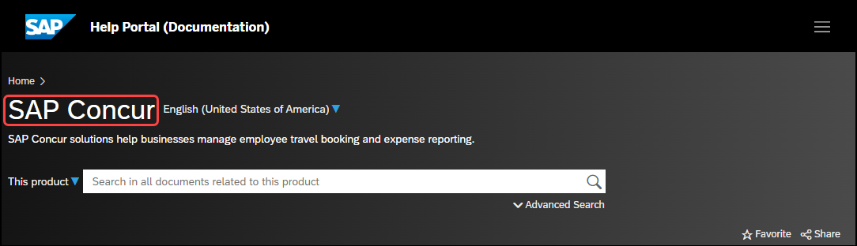

SAP Concur Support Portal – Selected Users
Access release notes, webinars, and other technical documentation on the SAP Concur support portal.
If you have the required permissions, Contact Support is available on the SAP Concur Help menu and in the SAP Concur page footer.
Click Contact Support to access the SAP Concur support portal, then click Resources.
- Click Release/Tech Info for release notes, technical documents, etc.
- Click Webinars for recorded and live webinars.

© 2024 SAP SE or an SAP affiliate company. All rights reserved.
No part of this publication may be reproduced or transmitted in any form or for any purpose without the express permission of SAP SE or an SAP affiliate company.
SAP and other SAP products and services mentioned herein as well as their respective logos are trademarks or registered trademarks of SAP SE (or an SAP affiliate company) in Germany and other countries. Please see http://global12.sap.com/corporate-en/legal/copyright/index.epx for additional trademark information and notices.
Some software products marketed by SAP SE and its distributors contain proprietary software components of other software vendors.
National product specifications may vary.
These materials are provided by SAP SE or an SAP affiliate company for informational purposes only, without representation or warranty of any kind, and SAP SE or its affiliated companies shall not be liable for errors or omissions with respect to the materials. The only warranties for SAP SE or SAP affiliate company products and services are those that are set forth in the express warranty statements accompanying such products and services, if any. Nothing herein should be construed as constituting an additional warranty.
In particular, SAP SE or its affiliated companies have no obligation to pursue any course of business outlined in this document or any related presentation, or to develop or release any functionality mentioned therein. This document, or any related presentation, and SAP SE’s or its affiliated companies’ strategy and possible future developments, products, and/or platform directions and functionality are all subject to change and may be changed by SAP SE or its affiliated companies at any time for any reason without notice. The information in this document is not a commitment, promise, or legal obligation to deliver any material, code, or functionality. All forward-looking statements are subject to various risks and uncertainties that could cause actual results to differ materially from expectations. Readers are cautioned not to place undue reliance on these forward-looking statements, which speak only as of their dates, and they should not be relied upon in making purchasing decisions.

