SAP Concur Release Notes
Concur Travel
Concur Professional/Premium and Concur Standard
Month | Audience
Release Date: May 20, 2023  Update 1: May 23, 2023 | SAP Concur Client FINAL

** FINAL**
The enhancements and changes described in this document may or may not be included in this release. SAP Concur reserves the right to postpone implementation of – or completely remove – any enhancement/change mentioned here.
The DRAFT and FINAL release notes contain information about Concur Professional/Premium and Concur Standard.
Each note contains a table that which indicates if the enhancement/change applies to Professional and/or Standard.

Contents
Release Notes 1
Car 1
New Concur Travel Car Experience 1
CLQ-89867: New Rental Car Experience: Updates to Reduced Feature Set 1
CLQ-89784 New Rental Car Experience: Delivery and Collection 12
Flight 18
CLQ 89825: Concur Profile Synchronization with Sabre Profiles Update: Migration of Known Traveler and Redress Numbers to Official Documents 18
Hotel 25
CLQ-89840 Hotel Content Suppliers: CDS Migration to Hotel Service v2 (May 2) 25
Car and Rail 26
CLQ-89826: New Concur Travel Experience: Finalize Trip Page and Required Fields Behavior (Professional Edition Only) 26
CLQ-89868: New Concur Travel Experience: Change to Display of Total Cost for Cancelled Trips and Bookings (Professional Edition Only) 31
Rail 37
CLQ-89865: New Rail Experience: BookingSource Value in PNR Remarks for Renfe (Professional Edition Only) 37
CLQ-89849 Renfe, Support of Custom Text for Search (Professional Edition Only) 39
CLQ-89850 Renfe, Support of Custom Text for Train Shop (Professional Edition Only) 41
CLQ-89848 Renfe, New Rail Experience: Changes to Review and Book Page, Traveler Information (Professional Edition Only) 43
Travel Operations / Technical Essentials 45
CLQ-89856 SNCF API (PAO) Migration – Additional Information (Date Change) 45
Planned Changes 47
Flight 47
**Planned Changes** CLQ-89869: Flight Options Turned Down 47
Hotel and Trip Management 49
**Planned Changes** CLQ-89870: Travel Policy Section Updates in New Concur Travel Experience 49
Hotel 53
**Planned Changes** CLQ-89822 New Hotel Experience (Custom Hotel Source Only): Overview 53
**Planned Changes** CLQ-89822 New Hotel Experience: Search for a Hotel 54
**Planned Changes** CLQ-89822 New Hotel Experience: Review and Book 65
**Planned Changes** CLQ-89822 New Hotel Experience: Finalize and Confirm Booking 72
**Planned Changes** CLQ-89822 New Hotel Experience: Completed Trip Overview 77
**Planned Changes** CLQ-89822 New Hotel Experience: Cancellation 80
**Planned Changes** CLQ-89822 New Hotel Experience: Configuration for Custom Hotel Sourcing 83
**Planned Changes** CLQ-89822 New Hotel Experience: Reduced Feature Set 86
Rail 92
**Planned Changes** CLQ-89871: SNCF – Thalys Migration (Jun 9) 92
**Planned Changes** CLQ-89787 SNCF API (PAO) Migration 94
Travel Operations / Technical Essentials 98
**Planned Changes** CLQ-89787 SNCF API (PAO) Migration 98
Client Notifications 100
Accessibility 100
Accessibility Updates 100
Documentation for New Concur Travel Experience 100
Online Help Updates in the SAP Help Portal 100
In-Product User Assistance 101
Client Customized Content 101
Subprocessors 102
SAP Concur Non-Affiliated Subprocessors 102
Supported Browsers 102
Supported Browsers and Changes to Support 102
Additional Release Notes and Other Technical Documentation 103
Online Help 103
SAP Concur Support Portal – Selected Users 103
Legal Disclaimer
The information in this presentation is confidential and proprietary to SAP SE or an SAP affiliate company and may not be disclosed without the permission of SAP SE or the respective SAP affiliate company. This presentation is not subject to your license agreement or any other service or subscription agreement with SAP SE or its affiliated companies. SAP SE and its affiliated companies have no obligation to pursue any course of business outlined in this document or any related presentation, or to develop or release any functionality mentioned therein. This document, or any related presentation and SAP SE or an SAP affiliate company’s strategy and possible future developments, products and or platforms directions and functionality are all subject to change and may be changed by SAP SE and its affiliated companies at any time for any reason without notice. The information in this document is not a commitment, promise or legal obligation to deliver any material, code or functionality. This document is provided without a warranty of any kind, either express or implied, including but not limited to, the implied warranties of merchantability, fitness for a particular purpose, or non-infringement. This document is for informational purposes and may not be incorporated into a contract. SAP SE and its affiliated companies assume no responsibility for errors or omissions in this document, except if such damages were caused by SAP SE or an SAP affiliate company’s willful misconduct or gross negligence.
All forward-looking statements are subject to various risks and uncertainties that could cause actual results to differ materially from expectations. Readers are cautioned not to place undue reliance on these forward-looking statements, which speak only as of their dates, and they should not be relied upon in making purchasing decisions.

Release Notes

Car

New Concur Travel Car Experience
If you are participating in the initial release of the new Concur Travel car experience, your SAP Concur representative can provide draft GDS PNR documentation upon request.

New Rental Car Experience: Updates to Reduced Feature Set

Prof | Stan |   Edition
X | X | On: Impacts end users who use this feature/vendor; no configuration/setup by agency/ admin; cannot be turned OFF (example: new icons or rate display)
 |  | Available for use: No impact to end users unless/until configuration/setup by agency/admin (described below) (example: new rule, new Travelfusion airline)
X | X | Other: Refer to the release note below
 |  | Does not apply to this edition
Source
GDS
Direct Connect
Other
X | EMEA Data Center |  |  | Scan impact
X | North America Data Center |  |  | UI impact
 | China Data Center |  |  | File finishing impact
 | All data centers |  |  | Profile/Profile API/3rd Party XML Sync Impact
Affected Documentation
TSGs
Fact Sheets
Admin Guides
Other
The new rental car workflow in Concur Travel cannot be activated via a setting within Concur Travel. As a reduced set of features are available in this first release, potential customers will be determined programmatically and informed when eligible for migration.

Limitations Removed with this Release
Previously, cancellation of Car Connector content (Hertz / Sixt) from a trip that included other booking types (for example, flight and hotel) on Concur Mobile was not possible. With this release, this cancellation scenario is now supported.
Previously, the Show Add Air on Existing Itineraries setting was not supported. With this release, if the setting is enabled, a user can add a flight to an existing car booking that was booked using the new Car experience.

End-User Experience: Add a flight
If the Show Add Air on Existing Itineraries setting is enabled, a user will see an Add Flight button on the Finalize page and the Trip Overview page.
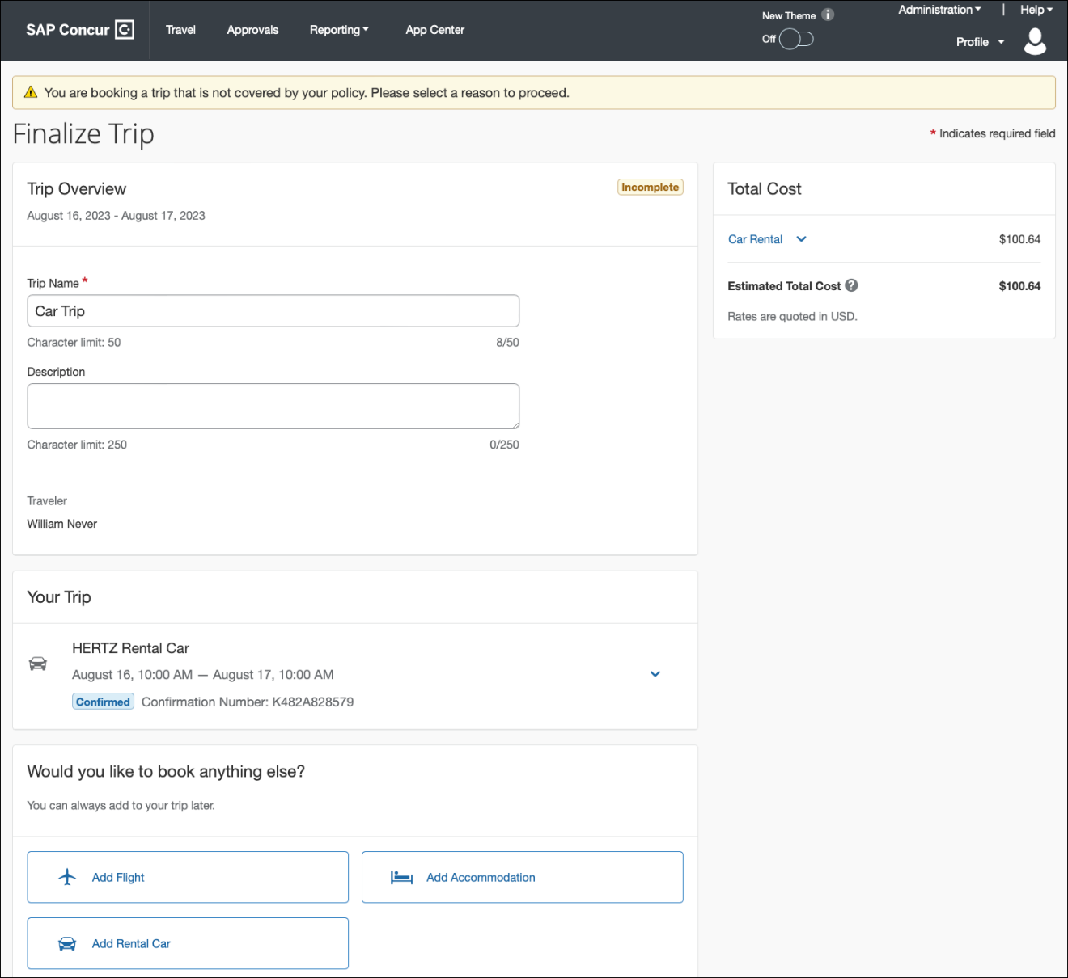
The list of known limitations below was updated accordingly.

Remaining Known Limitations
The following items are either not yet supported with the new car rental booking experience or are supported with limitations. Please monitor future release notes for changes relating to these items.

Product Area | Feature/ Setting | Setting Location | Setting Requirement | Additional Information
Traveler selection | Guest Traveler bookings | Travel Configuration | Guest traveler bookings are disabled | A guest traveler or sponsored guest booking are not supported yet.
Content | Global Distribution System (GDS) | Agency Configuration | Amadeus only | Sabre and Travelport GDSs are not yet supported for the new car experience.
Integrations | Concur Request | Travel configuration | Enable Request Integration not enabled
Travel Policy | Car Rule Enforcement Levels | Company Administration > Travel Admin | Allow  Log for reports,  Notify manager,  Show but do not allow,  Hide results | ”Allow” enforcement level is supported but Display Message (Message when matched) portion is not.  For car category rules, Show but do not Allow is treated as Hide Results with the first release
Travel Policy | Itinerary Rule Enforcement Levels | Company Administration > Travel Admin | Allow  Log for reports,  Notify manager,  Require Approval,  Require Passive Approval | Show but do not allow and Hide results are not supported for Itinerary rules, as these enforcement levels are result-dependent; Itinerary rules are applied during checkout.  Require Approval and Require passive approval rules will be downgraded to Notify manager
Travel Policy | Concur Travel’s Native Approval Process | Company Administration > Travel Admin | Car rules cannot use:  Require Approval,  Require Passive Approval,  Require Pre-Approval & Log,  Require Pre-Approval & Notify | If any of the following rules are set up for Car  Require Approval,  Require Passive Approval,  Require Pre-Approval & Log,  Require Pre-Approval & Notify -  these rules will be ignored and will not show as violations to the user.  This also applies to any trip level rules.
Travel Policy | Car Rule Parts | Company Administration > Travel Rule Builder / Travel Admin | Car vendor is one of [CarVendorList]  Car vendor is not one of [CarVendorList]  Car vendor is not preferred  Car dropped off in country/region [CountryList]  Car not picked up in country/region [CountryList]  Car picked up in country/region [CountryList]  Car type is one of [CarClassList]  Car rate [condition] [currency][money] per day  Car rate of [CarClass1] is [condition] than that of [CarClass2] [plusMinus] [difference] [currencyOrPercent]  Car not picked up or dropped off in country/region [CountryList]  Car vendor is preferred  Car rate is [condition] the lowest rate available plus [difference] [currencyOrPercent] | Any other configured car rule parts will not be enforced.  Any other car rule parts will not show as violations to the user.
Travel Policy | Car Rule Parts | Company Administration > Travel Rule Builder / Travel Admin | Car search results contain a preferred vendor  Car search results do not contain a preferred vendor  Car type is not one of [CarClassList]  Car total cost [condition] [currency][money]  Car not picked up or dropped off in region [Region]  Car pick-up location is in the list [CityCodeList]  Car picked up or dropped off in region [Region]  Car total cost is [condition] the lowest total cost available plus [difference] [currencyOrPercent]  Car picked up in region [Region]  Search results contain one or more of these vendors: [VendorList]  Car total cost of [CarClass1] is [condition] than that of [CarClass2] [plusMinus] [difference] [currencyOrPercent]  Car size exceeds company preferred size of [CarClass] | Any other configured car rule parts will not be enforced.  Any other car rule parts will not show as violations to the user.
Travel Policy | Itinerary Rule Parts | Company Administration > Travel Rule Builder / Travel Admin | Itinerary booked [condition] [DaysAdvance] days in advance  Trip duration [condition] [DaysLong] days  Itinerary has no Hotel segments  Itinerary has hotel segments  Total Itinerary cost is [condition] [currency][money] Allowed Itinerary Cost  Itinerary has car segments  Itinerary has no car segments  Trip booked between [DayOfWeek1] at [Time1] and [DayOfWeek2] at [Time2]  Trip not booked between [DayOfWeek1] at [Time1] and [DayOfWeek2] at [Time2] | Any other rule parts will not be enforced.  Any other trip rule parts will not show as violations to the user.
Travel Policy | Violation Reason Types | Company Administration > Travel Admin > Policy Violation Reasons | General  Train  Car  Hotel  Itinerary | Reasons from any other reason type categories will not display
Travel Policy | Rule Class Selection + Force selection of a rule class | Travel Configuration | Only a user’s default rule class is supported | If enabled, users would see the rule class selection field on the search, but any selection by the user would not be honored.
Trip Management | Custom Trip Fields | Company Administration > Manage Custom Fields | If/Then Settings cannot be enabled
Trip Management | Custom Trip Fields | Company Administration > Manage Custom Fields | Display for Edits cannot be enabled | Custom Trip Fields with this setting enabled will display again for user review/input when changing or adding a booking to a trip. This setting is not yet honored in the new Concur Travel experience.
Payments | Require credit card for car reservations | Travel configuration | This setting must be enabled
Payments | Agency Processing Fee Form of Payment for Land Only / Non-GDS Reservations | Travel configuration | Always write user-selected card must be enabled
Car-Specific | Discount Codes / Numbers | Manage Corporate Discounts | Corporate Discount number is entered | A rental car availability only works with an existing corporate discount number in combination with loaded corporate rates.  Rate codes do not yet apply.  Public rates do not display yet.
Car-Specific | Preference ranks | Manage Corporate Discounts | Preferred, Less Preferred or Most Preferred | Vendors marked as not preferred will not be checked for availability.
Car-Specific | User Preferences | User Profile |  | No car rental preferences from the user profile are applying.
Car-Specific | Special Equipment | Travel Configuration/  User Profile |  | No special equipment additions are supported yet.
Car-Specific | Car Custom Text | Company Administration > Travel Admin > Custom Text | The following Car custom text categories are not yet supported:  Car Search  Car Results  Car Rules on Itinerary  Car Rules Violation  Car Rules Violation Explain Why  Car Rules Violation Logging | No custom text is displayed in the Car booking workflow and on the Finalize Trip, and Trip Overview pages.
Car-Specific | Always run a General Shop Request for Car Searches | Travel Configuration | Customers who do not have negotiated car rental discounts should not use the new car rental booking experience yet.  Customers who have car rental vendor discounts configured will only see results from those vendors. | This feature triggers a car search request to content providers for any car rental vendors which do not have a configured discount code.  Due to the broad range of vendors returned and added GDS scans, SAP Concur is currently evaluating this feature. Until such time as a decision has been made, this will not be part of the new Concur Travel experience.
Car-specific | Travel Vendor Exclusion | Company Administration > Travel Admin > Travel Policy Administration |  | Travel Vendor Exclusions are not supported.
Car-specific | Direct Billing | Company Admin > Manage Corporate Discounts | Customers who use direct billing should not use the new car rental booking experience yet. | Direct billing is not supported.
Car-specific | Travel Discounts By Org Unit | Module Properties | Customers who use org-unit level discounts should not use the new car rental booking experience yet. | Org-unit level discounts are not supported.
Car-specific | Allow automatic reservations of | Travel Configuration | The setting Allow automatic reservations of has no effect if the new car rental booking experience is enabled. | The check box Automatically reserve this car will not show on the Flight search tab if the new car rental booking experience is enabled, even if setting Allow automatic reservations of is enabled.
Car-specific | N/A | N/A |  | The check box Pick-up / Drop-off car at airport will not show on the Flight search tab if the new car rental booking experience is enabled.
Trip Management | View Trip History | N/A | N/A | History Notes are not yet available on the Trip Overview page in the new Concur Travel experience.  SAP Concur is planning to launch this feature with a future release.
Trip Management | Print Itinerary | N/A | N/A | The Print Itinerary feature is not available on the Trip Overview page in the new Concur Travel experience.
Trip Management | E-mail itinerary | N/A | N/A | The Email Itinerary feature is not available on the Trip Overview page in the new Concur Travel experience.
Trip Management | Open in Outlook | N/A | N/A | The Open in Outlook feature is not available on the Trip Overview page in the new Concur Travel experience.
Trip Management | Create Template / Clone Trip / Share Trip | Travel Configuration | Clone Trip enabled | The features Create Template, Clone Trip and Share Trip are not available on the Trip Overview page in the new Concur Travel experience.  Please see Changes in Product Behavior below for information on product behavior for these features in the existing experience for trips that contain bookings created in the new Concur Travel experience.
Trip Management | Change of booking | N/A | N/A | Change of booking is not yet supported for the new rental car booking experience; however, users are able to cancel and rebook using the new experience.  Change of rental car bookings offline by a TMC are not recommended; the trip cost on the itinerary in SAP Concur will not yet be updated in case of any price change.
Trip Management | Customization of email subject lines | Travel Configuration | Travel Reservation Email Subject  Cancellation Email Subject | These two settings, which allow to customize the subject line of confirmation and cancellation emails and to add record locator, trip name and departure date do not apply to confirmation and cancellation emails sent out for trips booked in the new Concur Travel experience.

Changes in Product Behavior
The following features are supported for customers using the new car booking experience, however, behavior can be modified or may use legacy functionality.

Opt-Out Settings for Confirmation and Cancellation Emails
The opt-out settings from the User Profile or System Settings for Confirmation and Cancellation emails do not apply to emails sent out in the new Concur Travel experience. The Contact? setting in the email section of the user profile does apply. Emails are only sent to addresses for which the Contact? setting is enabled.

Confirmation Emails
While confirmation emails are sent for bookings made via the new car experience, these emails will not yet include an .ics calendar attachment yet.

Allow automatic reservations Of
For customers that have automatic car reservations enabled, Concur Travel uses the current car booking logic and only the Amadeus content source.
Custom trip fields – Checkbox Fields
In the regular booking experience of Concur Travel, checkboxes are not selected by default. Users can complete the booking without selecting a checkbox, even when it is a required field. The unselected box is saved and recorded for reporting.
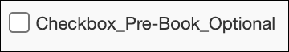
In the new Concur Travel experience, checkboxes display by default in an undetermined state (first screenshot). If the field is required, the box must be enabled or disabled to continue.
Undetermined:
Disabled:
Enabled:

Custom trip fields – display on itinerary
All trip custom fields and values entered or selected during the booking workflow will display by default on the Details tab of the Trip Overview page, regardless of the Display on Itinerary setting for trip custom fields. Trip custom fields and values entered or selected during the workflow will not be included in confirmation or cancellation emails, regardless of the Display on Itinerary setting for trip custom fields.

Travel Templates, Trip Sharing / Cloning
Car Connector content is not supported for booking from a travel template, a shared trip, or a cloned trip. The travel template works for other trip content as per regular logic, but the Car Connector content is ignored. It is possible to add Car Connector content to a booked trip from a template, in a separate operation.
Booking of Amadeus car content from a travel template, a shared trip, or a cloned trip is supported. The content is booked according to the regular workflow, even if the new Concur Travel workflow is enabled.
Support Contact Section
On the Confirmation Page and the Trip Overview page, a section with Support Contact information displays, if configured. The new Concur Travel experience does not support html in the form fields.

Force Users to Choose a Credit Card
For the new car booking experience, this travel configuration setting is no longer used. When a user has more than one credit card allowed for use, the form of payment selection dropdown will not default to a card; it will be blank. The user is required to select a card before proceeding.
For more information on this user experience, please refer to the New Rental Car Experience: Review and Book section, Payment subsection in these release notes.

New Rental Car Experience: Delivery and Collection

Prof | Stan |   Edition
X | X | On: Impacts end users who use this feature/vendor; no configuration/setup by agency/ admin; cannot be turned OFF (example: new icons or rate display)
 |  | Available for use: No impact to end users unless/until configuration/setup by agency/admin (described below) (example: new rule, new Travelfusion airline)
 |  | Other: Refer to the release note below
 |  | Does not apply to this edition
Source
GDS
Direct Connect
Other
X | EMEA Data Center |  |  | Scan impact
X | North America Data Center |  |  | UI impact
 | China Data Center |  |  | File finishing impact
 | All data centers |  |  | Profile/Profile API/3rd Party XML Sync Impact
Affected Documentation
TSGs
Fact Sheets
Admin Guides
Other |  | Online Help

Overview
Delivery and Collection is not included in this release, which is limited to participating Amadeus TMC partners.
Sixt and Hertz Direct content will be offered via SAP Concur’ s new Car Connector program. For this reason, these connectors require re-enablement for customers who are interested in using these channels. Full feature parity is guaranteed across the content channels.

Configuration for Professional Travel

Delivery and Collection Feature
The customer must first negotiate the Car Delivery and Collection service with their contract car vendor. The associated corporate discount number must be entered in the discount area. This process must be completed for each desired car vendor.
Delivery and Collection is available for all address options. Customers who would like to use this feature with the current release should contact their rental car partner and ensure all addresses are allowed for this service. Different fees could apply depending on the addresses the end user would select.
If Delivery and Collection is enabled in the travel configuration the following checkboxes show up in the Rental Car Search.
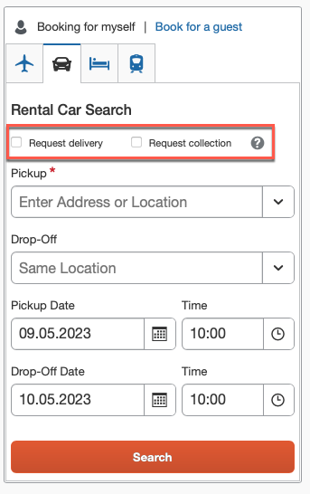
The following displays a configuration where only company locations are enabled to display in the search results.
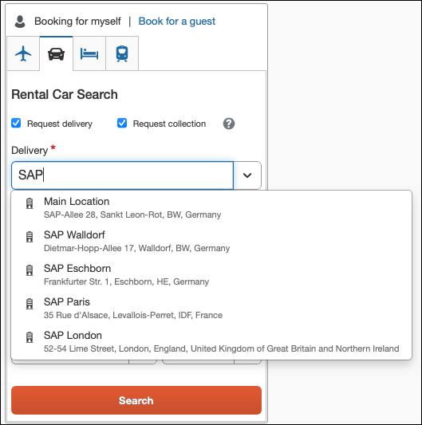
Alternatively, the configuration can be set to display all locations and addresses:
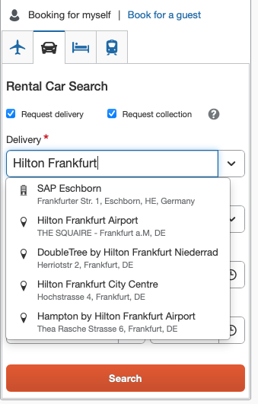
In the search results it is indicated that Delivery and Collection is considered
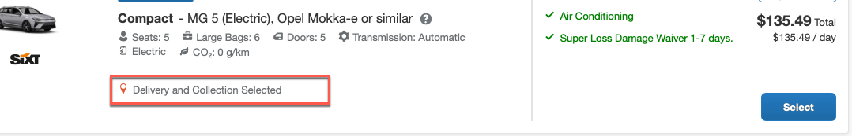
On the Review and Book page the Delivery and Collection addresses are shown. If the Delivery and Collection addresses are different, this will also display on the Review and Book page.
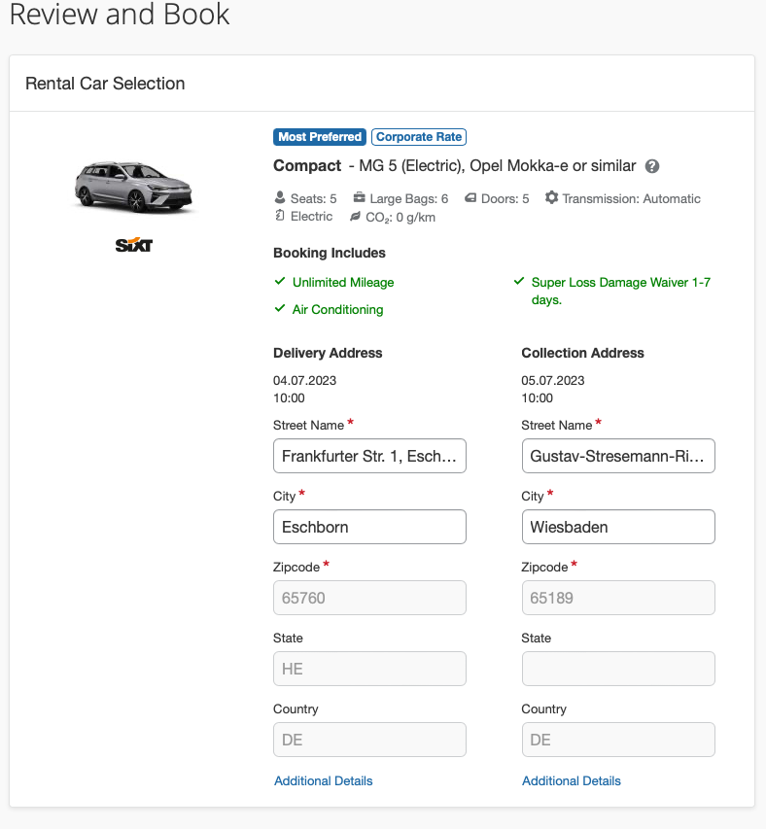
To configure:
- Go to Administration > Travel (on the sub-menu) > Travel System Admin and select the desired client travel configuration.
Depending on your permissions, the page may appear immediately after you click Administration or Travel.
- On the travel configuration page, go to Car Search Options. When enabling Delivery and Collection for only company locations, the following should be used.
When enabling Delivery and Collection for all addresses, including company locations, the following should be used.
Home Addresses will not be taken from the user profile. If Delivery and Collection is requested for a Home Address the address needs to be entered as Delivery and/or Collection address in the car serach widget.
- Make the appropriate choices and select all rental car companies for which Delivery and Collection has been negotiated.
Regardless of the activated content channels, only this setting must be configured in order to enable the Delivery and Collection feature.

Flight

Concur Profile Synchronization with Sabre Profiles Update: Migration of Known Traveler and Redress Numbers to Official Documents

Prof | Stan |   Edition
 |  | On: Impacts end users who use this feature/vendor; no configuration/setup by agency/ admin; cannot be turned OFF (example: new icons or rate display)
 |  | Available for use: No impact to end users unless/until configuration/setup by agency/admin (described below) (example: new rule, new Travelfusion airline)
X | X | Other: Refer to the release note below
 |  | Does not apply to this edition
Source
GDS |  | Sabre
Direct Connect
Other
X | EMEA Data Center |  |  | Scan impact
X | North America Data Center |  |  | UI impact
 | China Data Center |  |  | File finishing impact
 | All data centers |  |  | Profile/Profile API/3rd Party XML Sync Impact
Affected Documentation
TSGs |  | Sabre Profiles Travel Service Guide  TSA Service Guide
Fact Sheets
Admin Guides
Other

Overview
A recent Industry Mandate requires that DOCO SSR messages include an Issuing Country Code (previously advised in Sabre SAN 16382). Sabre Profiles is therefore sunsetting the current data attributes for Traveler Information>Redress Number and Traveler Information>Known Traveler Number from the application schema and Sabre Red 360 (refer to Sabre SAN 16886).
To support this mandate, Sabre requires that the current Traveler Secure Flight-related data stored in the Traveler Information subject area be migrated to the Official Documents subject area. The migration of this data must be completed by July 22, 2023.
Concur Travel is now synching Known Traveler (KTN) and Redress numbers from Concur Profiles to Official Documents>Redress Number and Official Documents>Known Traveler Number within Sabre Profiles. To support customers during this transition period, Concur Travel will continue to synchronize this data to the Traveler Information subject area until the July 22, 2023, deadline.
To migrate this data to the new area in Sabre Profiles, SAP Concur has completed a should synchronization of all Concur profiles to Sabre that contain a KTN or Redress number.
- To ensure that KTN and Redress numbers continue to move into Sabre PNRs, Sabre Profiles administrators are required to make new changes to the Sabre Advanced Formats in the Sabre Template. Please carefully review the Administrator Experience section of this release note for step-by-step instructions.

User/Customer Benefit
This update ensures that the traveler’s TSA data continues to synchronize to Sabre Profiles and successfully copy over to the PNR during the booking process, whether booking in Concur Travel or when booking offline reservations.

FAQ
Q. My TMC uses Advanced Formats in Sabre Templates to move KTN and Redress numbers into a PNR. Does this change require Sabre Profiles administrators to make any additional updates?
A. Yes. Please carefully review the Administrator Experience section for step-by-step instructions.
Q. My company or TMC doesn’t use Sabre Profiles Templates. Does this change how KTN and Redress numbers are moved to a PNR via Sabre PNR Builder?
A. Yes. You will need to use the Other PNR Move Data subject area in Sabre Profiles. Please refer to the most recent update to Sabre SAN 16886 (published May 5, 2023) for instructions.
Q. My company or TMC doesn’t use Sabre Profiles. Does this change impact how my KTN or Redress number is added to my air reservations made through Concur Travel?
A. No. Concur Travel will continue to manually add a KTN or Redress Number to all air reservations when a traveler’s Concur profile contains a KTN or Redress number and the Company Travel Configuration is configured to send TSA data.
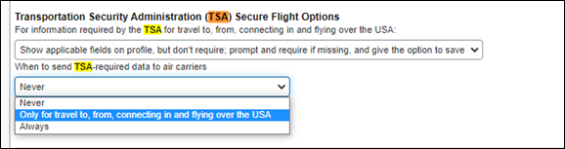
Concur Travel supports numbers issued by the US Government for travel to, from, connecting in, and flying over the US. The country code, US, is automatically appended to the TSA SSR for Known Traveler and Redress numbers.
- For more information on how to update the Company Travel Configuration for when to send TSA data, refer to the TSA Travel Service Guide. To locate, refer to Additional Release Notes and Other Technical Documentation in these release notes.
Q. Why is it important that all updates be completed by the July 22, 2023, deadline?
A. Once Sabre Profiles removes the KTN and Redress data fields from the Traveler Information section in Sabre Red 360, existing Sabre Advanced Formats for moving KTN and Redress numbers into the Sabre PNR will no longer work.
Q. What if I need an additional Passport, KTN, or Redress number added to my profile?
A. Concur Travel supports numbers issued by the US Government for travel to, from, connecting in, and flying over the US. Your primary Passport, KTN, and Redress number should always be added and modified in your Concur Profile. Once your primary numbers have been added to your Concur Profile your TMC can add additional Passport, KTN, or Redress numbers in Sabre Profiles. Concur Travel will not overwrite this data as long as your primary numbers are entered in your Concur profile first.
For updated information on what profile data syncs between Concur Travel and Sabre Profiles, refer to the Mapping and FAQ sections of the Sabre Profiles Travel Service Guide and TSA Travel Service Guide. To locate, refer to Additional Release Notes and Other Technical Documentation in these release notes.
Q. Are there any additional administrative changes to consider?
A. Beginning in Q32021 Sabre began creating two separate PNRs for American Airlines bookings, one for TMCs and another for AA operations. The most impactful result of this change is that all SSRs, OSIs, DOCS, DOCO, CTCM, and ALL carrier messaging formats are now preceded by the customary “3” and no longer the special handling for AA using “4”. The AA SSR and OSI requests are now stored in the General Facts section of the Sabre TMC PNR and sent to AA via teletype (same process as any other Sabre GDS participating carrier today). Due to this change, 4DOCO Sabre Advanced Formats for KTN and Redress numbers should no longer be used. Concur Travel recommends that Sabre Administrators remove these Sabre Advanced Formats from existing Sabre Templates if this has not already been completed.

Administrator Experience
If your company is using Sabre Advanced Formats in your Sabre Template to copy Known Traveler and Redress numbers into a PNR, your company Sabre Profile Administrator will need to update the Sabre Advanced Formats for both Known Traveler and Redress numbers associated with the applicable PNR Builder. The update to these Sabre Advanced Formats must be completed by July 22, 2023.
To update the Sabre Advanced Formats:
- From the Sabre Profiles Administration tab in Sabre Red 360, open your Primary Sabre Template and click Advanced Sabre Formats List from the left navigation menu.
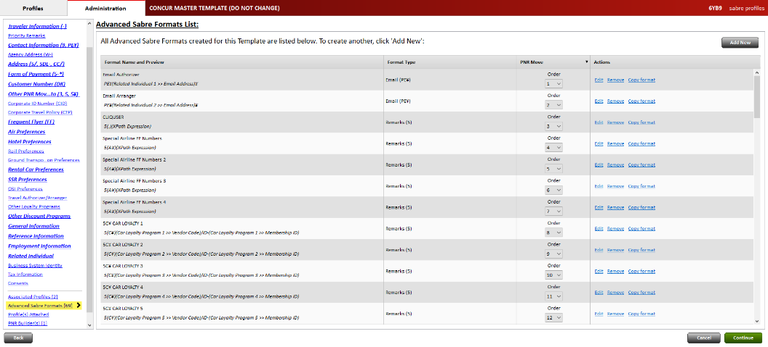
- Locate the DOCO format for Known Traveler Number. Click Edit on the line you need to update.
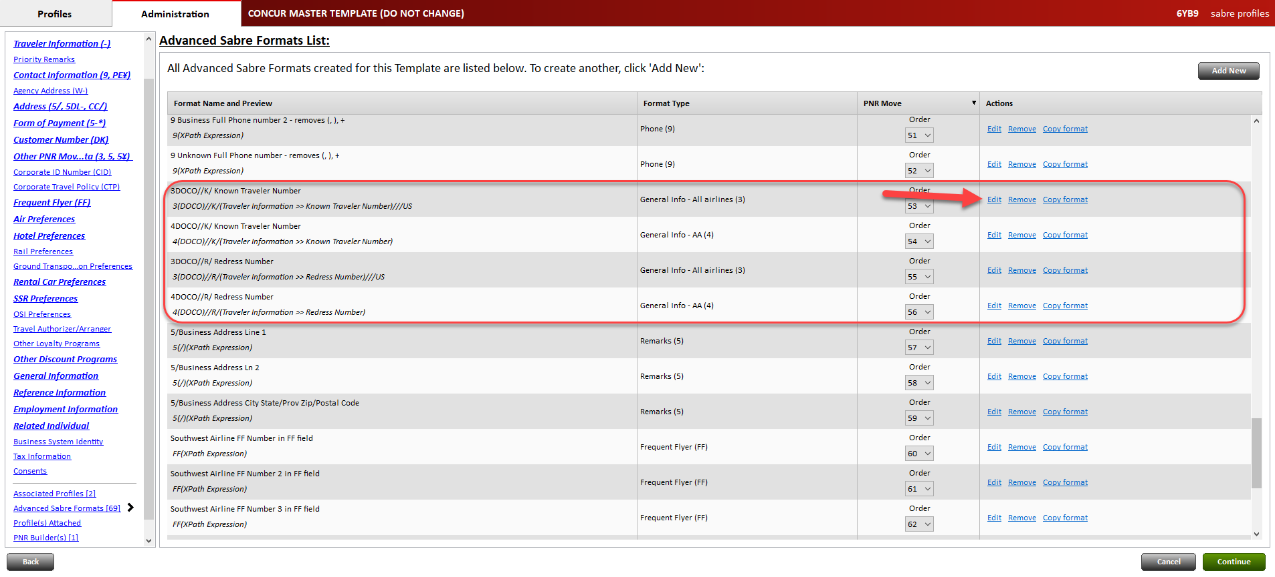
- At the top right corner, click Add conditions.
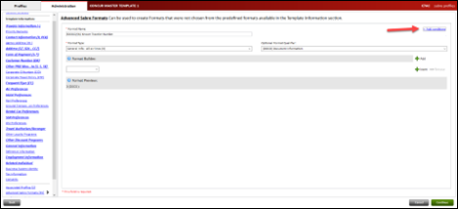
- Select XPath Expression.
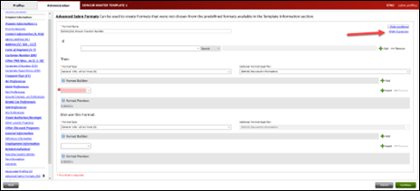
- In the XPath Expression box, enter the following for Known Traveler Number if:
(string(//Profile/Traveler/Customer/Document[@OrderSequenceNo="1"]/@DocTypeCode="KTID")) then concat("//K/", (//Profile/Traveler/Customer/Document[@OrderSequenceNo="1" and @DocTypeCode="KTID"]/@DocID), "///", (//Profile/Traveler/Customer/Document[@OrderSequenceNo="1"and @DocTypeCode="KTID"]/@DocIssueCountryCode)) else ""
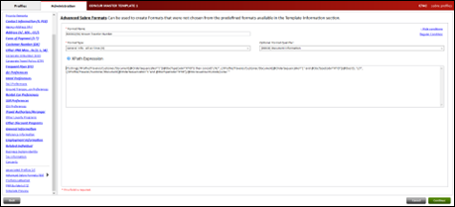
- Repeat steps 1-4 for Redress Number.
- In the XPath Expression box, enter the following for Redress Number, if:
(string(//Profile/Traveler/Customer/Document[@OrderSequenceNo="1"]/@DocTypeCode="RDNR")) then concat("//R/", (//Profile/Traveler/Customer/Document[@OrderSequenceNo="1" and @DocTypeCode="RDNR"]/@DocID), "///", (//Profile/Traveler/Customer/Document[@OrderSequenceNo="1"and @DocTypeCode="RDNR"]/@DocIssueCountryCode)) else ""
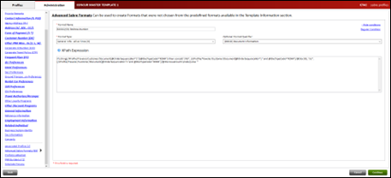
- From the left navigation menu, click Template Preview
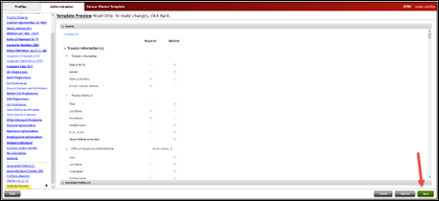
- Click Save. These updates will duplicate automatically in your linked Shared Templates.

Configuration for Professional and Standard Travel
This feature is enabled by default. There are no configuration steps.
For more information, refer to the Sabre Profiles Travel Service Guide and TSA Travel Service Guide. To locate, refer to Additional Release Notes and Other Technical Documentation in these release notes.

Hotel

Hotel Content Suppliers: CDS Migration to Hotel Service v2 (May 2)

Prof | Stan |   Edition
X | X | On: Impacts end users who use this feature/vendor; no configuration/setup by agency/ admin; cannot be turned OFF (example: new icons or rate display)
 |  | Available for use: No impact to end users unless/until configuration/setup by agency/admin (described below) (example: new rule, new Travelfusion airline)
 |  | Other: Refer to the release note below
 |  | Does not apply to this edition
Source
GDS |  | CDS
Direct Connect
Other
X | EMEA Data Center |  |  | Scan impact
X | North America Data Center |  | X | UI impact
 | China Data Center |  |  | File finishing impact
 | All data centers |  |  | Profile/Profile API/3rd Party XML Sync Impact
Affected Documentation
TSGs |  | Hotel Service Travel Service Guide
Fact Sheets
Admin Guides
Other

Overview
Since May 2, 2023, SAP Concur Travel has updated CDS from using Hotel Service v1 to Hotel Service v2.

User/Customer Benefit
Travelers configured to see CDS content are able to shop, book, and cancel hotels provided by CDS through Hotel Service v2, available for all markets. Hotel details and image galleries are present when hotels are sourced by CDS, where those features were not available via Hotel Service v1. By utilizing Hotel Service v2, CDS GROUPE is now able to offer content via mobile and will begin supporting additional Custom Fields.
For more information about Hotel Service v2 features, please refer to the Hotel Service Travel Service Guide.

Configuration for Professional and Standard Travel
No configuration is necessary. These updates are auto-on for all sites with configuration to use CDS via Hotel Service v2.

Car and Rail

New Concur Travel Experience: Finalize Trip Page and Required Fields Behavior (Professional Edition Only)

Prof | Stan | Edition
X |  | On: Impacts end users who use this feature/vendor; no configuration/setup by agency/ admin; cannot be turned OFF (example: new icons or rate display)
 |  | Available for use: No impact to end users unless/until configuration/setup by agency/admin (described below) (example: new rule, new Travelfusion airline)
 |  | Other: Refer to the release note below
 |  | Does not apply to this edition
Source
GDS |  | Amadeus
Direct Connect |  | Renfe, Car Connector
Other
X | EMEA Data Center |  |  | Scan impact
X | North America Data Center |  |  | UI impact
 | China Data Center |  |  | File finishing impact
 | All data centers |  |  | Profile/Profile API/3rd Party XML Sync Impact
Affected Documentation
TSGs
Fact Sheets
Admin Guides
Other

Overview
With the current experience, when adding a booking on the Finalize Trip page without filling in required fields in sections Travel Policy and/or Additional Information, the action will be blocked until the required fields are filled in.
With this release, it is possible to add a booking on the Finalize Trip page without filling in any required fields in the Travel Policy and/or Additional Information sections. The fields display in the workflow again after adding the booking and must be filled in then (if required).

User/Customer Benefit
Users are no longer prevented from adding a booking to an existing trip due to missing input in required fields. They can still fill in required fields at the end of the workflow.

End-User Experience

Previous Experience
On the Finalize Trip page, after clicking Add Accommodation or Add Rental Car and without filling in required fields in sections Travel Policy and/or Additional Information, a user could not add a booking until the required fields were filled in.
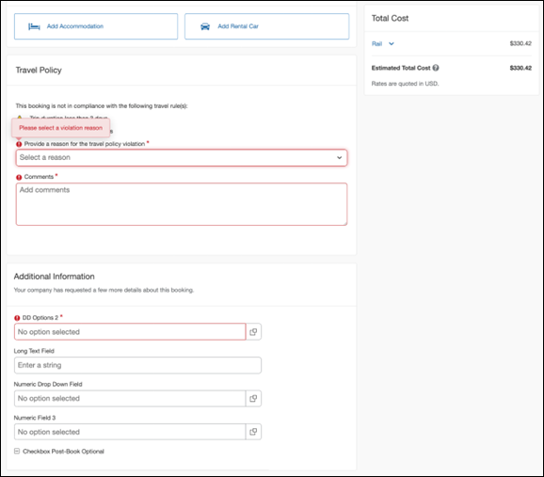
Values entered on the Finalize Trip page in the Additional Information section were pre-filled on the Trip Booking Information page after having added the booking.
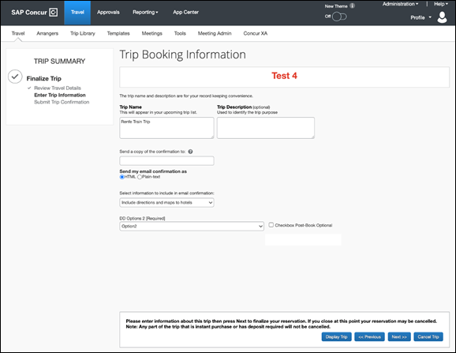

New Experience
It is possible to add a booking on the Finalize Trip page by clicking on Add Accommodation or Add Rental Car without filling in any required fields in sections Travel Policy and/or Additional Information. The fields display in the workflow again after adding the booking and must be filled in then (if required).
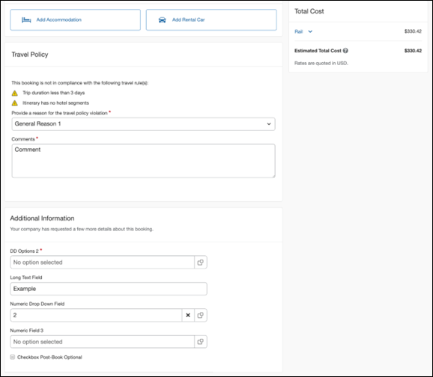
Fields that are filled out on the Finalize Trip page are not pre-populated on the Trip Booking Information page after adding the additional booking. Values must be entered on this page (again) if the fields are required. SAP Concur is planning to pre-populate field values with a future release.
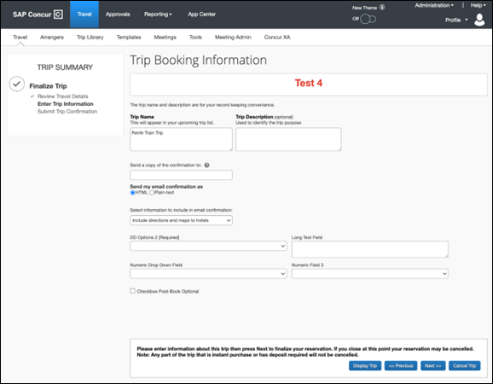
When adding a booking from the Trip Overview page, instead of the Trip Booking Information page the Trip Confirmation page will display after adding the booking. This page only displays trip custom fields for which Display on Trip Edits setting displays. Values previously entered for these fields will be prepopulated.
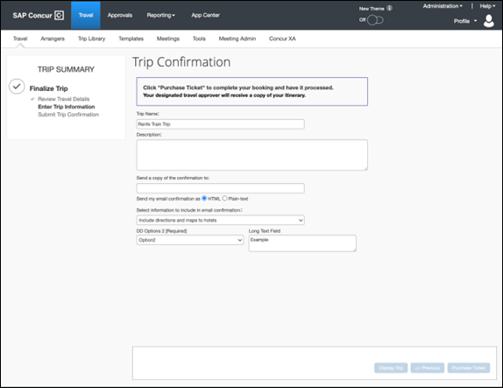

Configuration for Professional Travel
This feature is enabled by default. There are no configuration steps.
Online help documentation for this feature will be made available upon release.

New Concur Travel Experience: Change to Display of Total Cost for Cancelled Trips and Bookings (Professional Edition Only)

Prof | Stan | Edition
 |  | On: Impacts end users who use this feature/vendor; no configuration/setup by agency/ admin; cannot be turned OFF (example: new icons or rate display)
X |  | Available for use: No impact to end users unless/until configuration/setup by agency/admin (described below) (example: new rule, new Travelfusion airline)
 |  | Other: Refer to the release note below
 |  | Does not apply to this edition
Source
GDS
Direct Connect |  | Renfe, Car Connector
Other
X | EMEA Data Center |  |  | Scan impact
X | North America Data Center |  |  | UI impact
 | China Data Center |  | X | File finishing impact
 | All data centers |  |  | Profile/Profile API/3rd Party XML Sync Impact
Affected Documentation
TSGs
Fact Sheets
Admin Guides
Other

Overview
The display of Total Cost for cancelled trips and cancelled bookings within an active trip will change. With this release, costs for cancelled bookings will no longer display.
If a booking is cancelled within an active trip, the Total Cost is updated to exclude the cost of the cancelled booking.

User/Customer Benefit
The actual cost of the trip displays without including the cost of the cancelled booking.

End-User Experience

Previous Experience
The Total Cost section included cancelled bookings, which were labeled as Canceled:
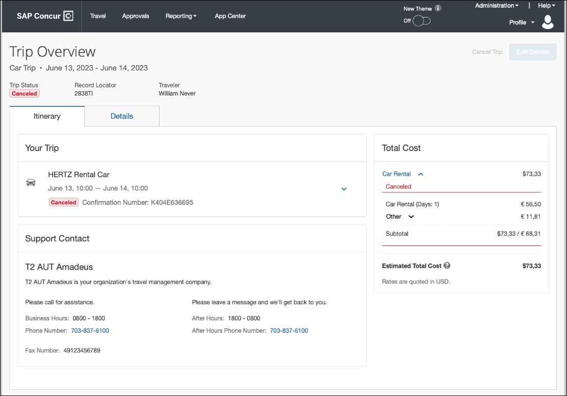

New Experience
Booking Cancellation
The Total Cost now shows only the cost for the remaining bookings. Any cost of cancelled bookings is removed.
Trip Overview page prior to cancellation of a car booking:
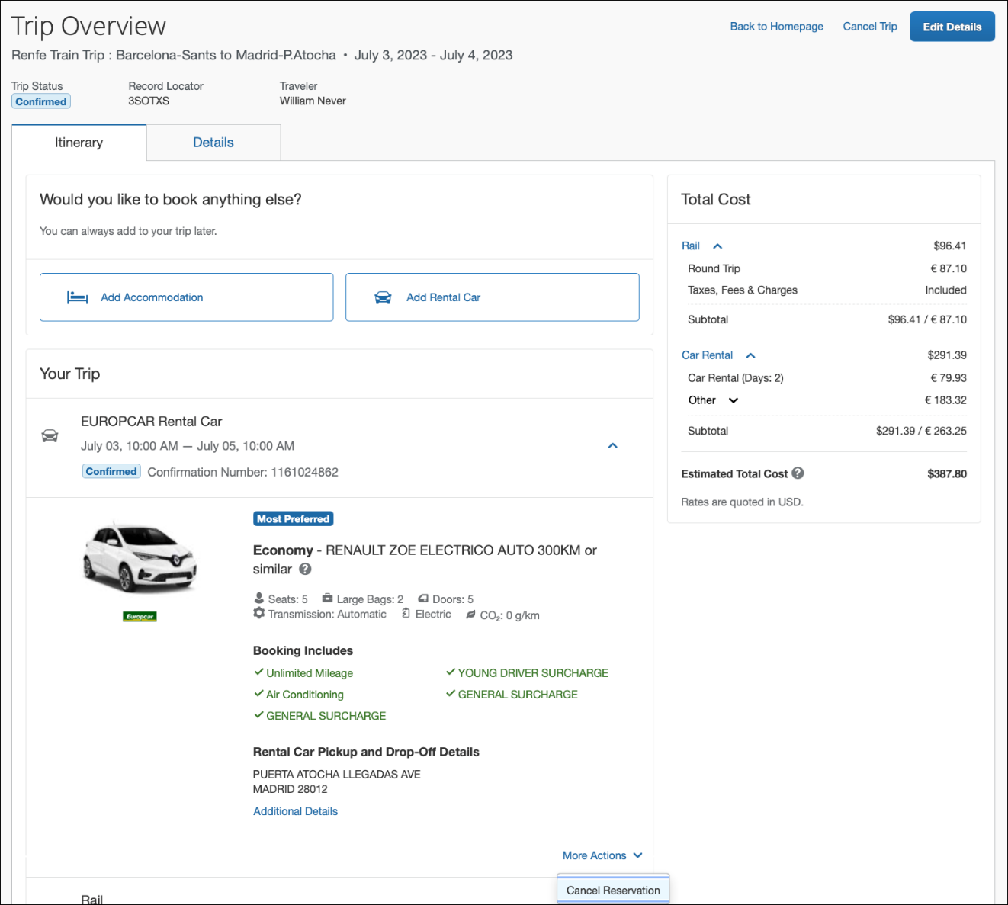
Trip Overview page after cancellation of a car booking:
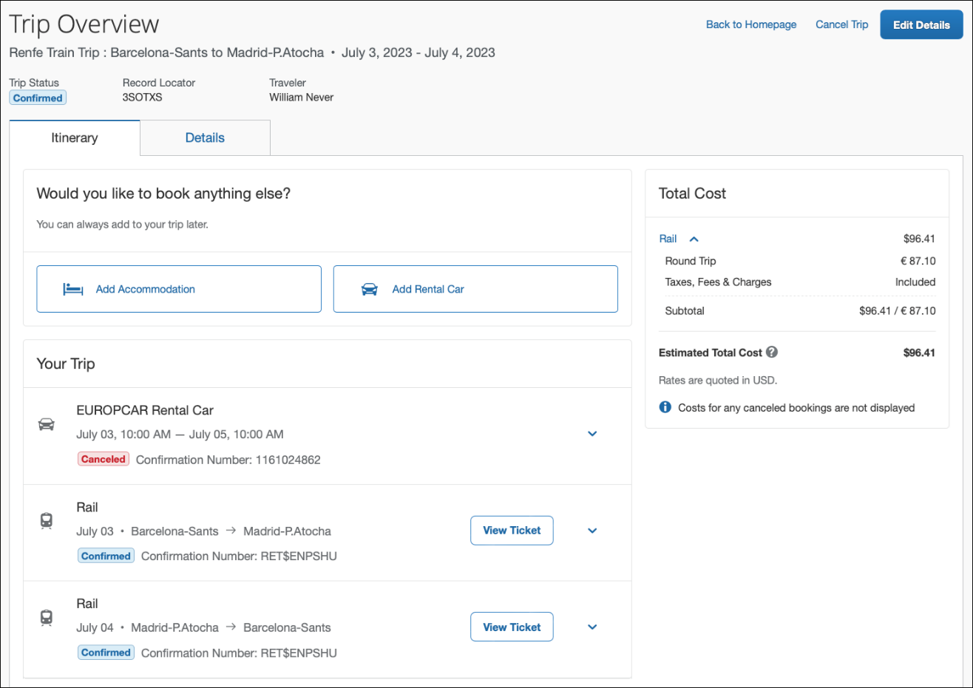
Trip Cancellation:
The Total Cost shows a total of zero in the user’s configured currency.
A disclaimer text shows that costs for cancelled bookings are not displayed.
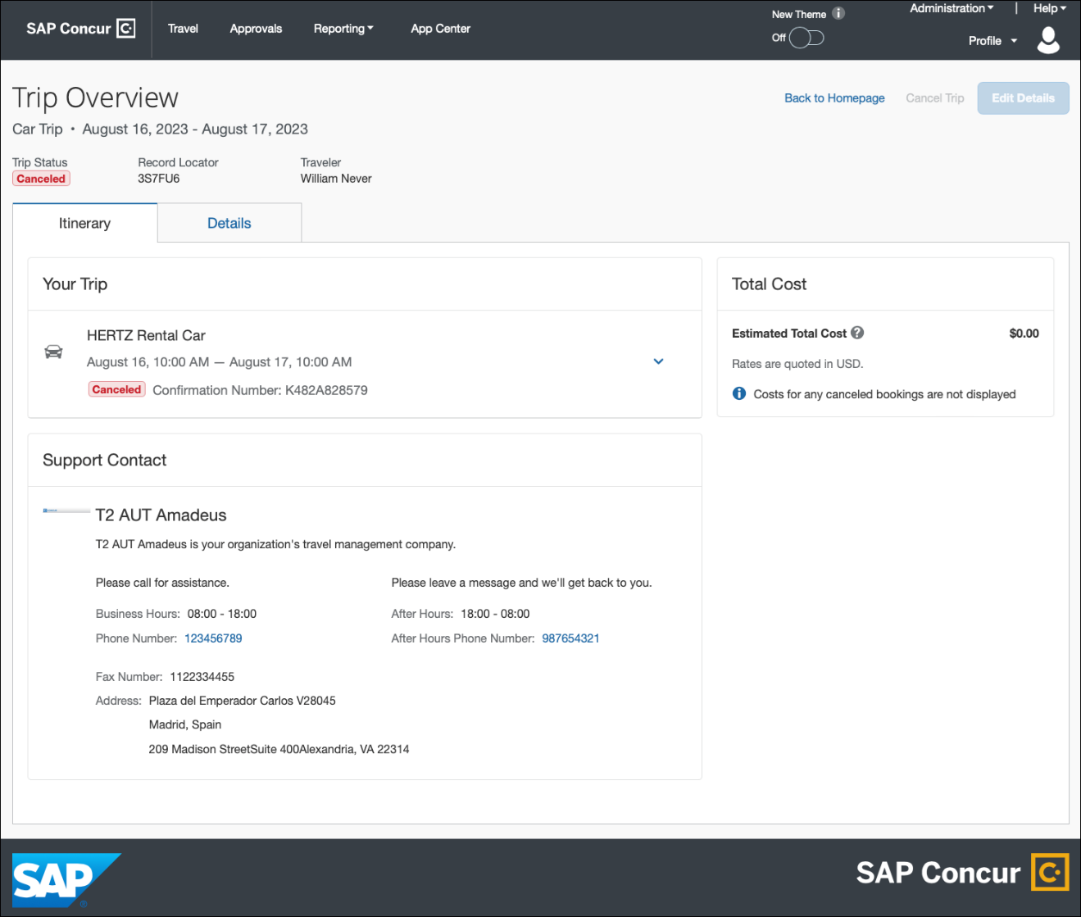
Cancellation Email:
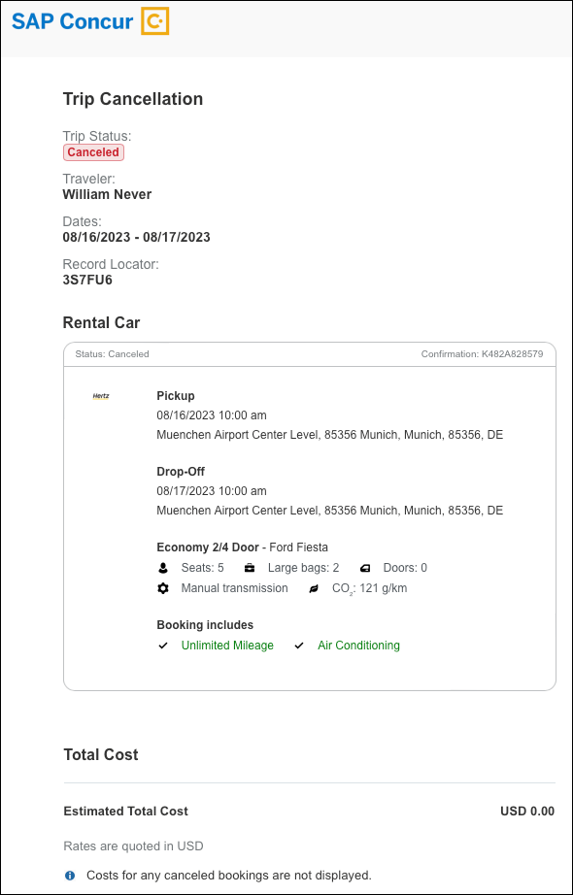

Configuration for Professional Travel
This feature is enabled by default. There are no configuration steps.
Online help documentation for this feature will be made available upon release.

Rail

New Rail Experience: BookingSource Value in PNR Remarks for Renfe (Professional Edition Only)

Prof | Stan | Edition
 |  | On: Impacts end users who use this feature/vendor; no configuration/setup by agency/ admin; cannot be turned OFF (example: new icons or rate display)
X |  | Available for use: No impact to end users unless/until configuration/setup by agency/admin (described below) (example: new rule, new Travelfusion airline)
 |  | Other: Refer to the release note below
 |  | Does not apply to this edition
Source
GDS
Direct Connect |  | Renfe,
Other
X | EMEA Data Center |  |  | Scan impact
X | North America Data Center |  |  | UI impact
 | China Data Center |  | X | File finishing impact
 | All data centers |  |  | Profile/Profile API/3rd Party XML Sync Impact
Affected Documentation
TSGs
Fact Sheets
Admin Guides
Other

Overview
To improve the user experience with the finishing template, the BookingSource and BookingSourceUpper values used for Renfe bookings will change as follows:
Path: PNRFinishData / AlternateSourceBookingData / AlternateSourceBookingData / BookingSource
Current value: TravelT2
New value: Renfe,
Path: PNRFinishData / AlternateSourceBookingData / AlternateSourceBookingData / BookingSourceUpper
Current value: TRAVELT2
New value: RENFE
The following shows the path in the finishing template with the current value:
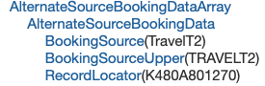
This change will not impact the path PNRFinishData / T2DataPoints / Rail / Segment / Leg / Vendor / VendorName. The value ‘RENFE’ will remain.
Previously, one and the same generic value could indicate the booking source for all booking done in the new Concur Travel experience.

User/Customer Benefit
With this change, the booking source used is more clearly outlined in the PNR, compared to a previously used generic value.

End-User Experience
These changes cause no visible impact to the user. All changes relate only to PNR finishing and apply only if the described paths are used in the setup of the PNR finishing template.

Configuration for Professional Travel
This feature is enabled by default. There are no configuration steps.

Renfe, Support of Custom Text for Search (Professional Edition Only)

Prof | Stan |   Edition
 |  | On: Impacts end users who use this feature/vendor; no configuration/setup by agency/ admin; cannot be turned OFF (example: new icons or rate display)
X |  | Available for use: No impact to end users unless/until configuration/setup by agency/admin (described below) (example: new rule, new Travelfusion airline)
 |  | Other: Refer to the release note below
 |  | Does not apply to this edition
Source
GDS
Direct Connect |  | Renfe Direct Connect
Other
X | EMEA Data Center |  |  | Scan impact
X | North America Data Center |  |  | UI impact
 | China Data Center |  |  | File finishing impact
 | All data centers |  |  | Profile/Profile API/3rd Party XML Sync Impact
Affected Documentation
TSGs |  | Custom Text
Fact Sheets
Admin Guides
Other |  | Renfe Direct Connect

Overview
In Concur Travel, a new Custom Text feature is available for the Renfe Train Search page. It allows custom messaging to display to end users on the Train Search page of the booking process.
This feature is available for web only with formatting limited to plain text. Further enhancements to this feature will be announced via future release notes when available.

End-User Experience
If Custom Text for Train Search page is configured, the feature displays below the travel icons at the top of the page. If Custom Text is longer than three lines, the Show More option displays.
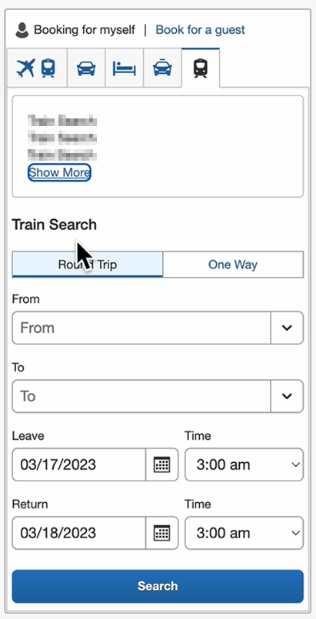

Configuration for Professional Travel
This feature must be enabled under the Custom Text tab in the Travel Administration section of Train Search. Only plain text is supported with this release.
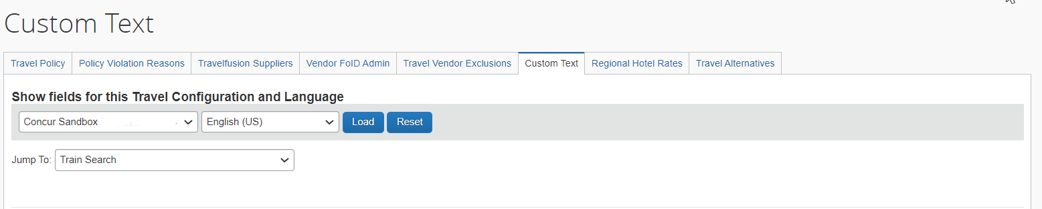
For more information on the configuration steps, refer to Custom Text Travel Service Guide.

Renfe, Support of Custom Text for Train Shop (Professional Edition Only)

Prof | Stan |   Edition
 |  | On: Impacts end users who use this feature/vendor; no configuration/setup by agency/ admin; cannot be turned OFF (example: new icons or rate display)
X |  | Available for use: No impact to end users unless/until configuration/setup by agency/admin (described below) (example: new rule, new Travelfusion airline)
 |  | Other: Refer to the release note below
 |  | Does not apply to this edition
Source
GDS
Direct Connect |  | Renfe Direct Connect
Other
X | EMEA Data Center |  |  | Scan impact
X | North America Data Center |  |  | UI impact
 | China Data Center |  |  | File finishing impact
 | All data centers |  |  | Profile/Profile API/3rd Party XML Sync Impact
Affected Documentation
TSGs |  | Custom Text
Fact Sheets
Admin Guides
Other |  | Renfe Direct Connect

Overview
In Concur Travel, a new Custom Text feature will be available for the Renfe Train Shop page. It will allow custom messaging to display to end users on the Train Shop page of the booking process.
This feature will be available for web only with formatting limited to plain text. Further enhancements to this feature will be announced via future release notes when available.

End-User Experience
If Custom Text for Train Shop page is configured, the feature displays at the top of the page. If Custom Text is longer than three lines, the Show More option displays.
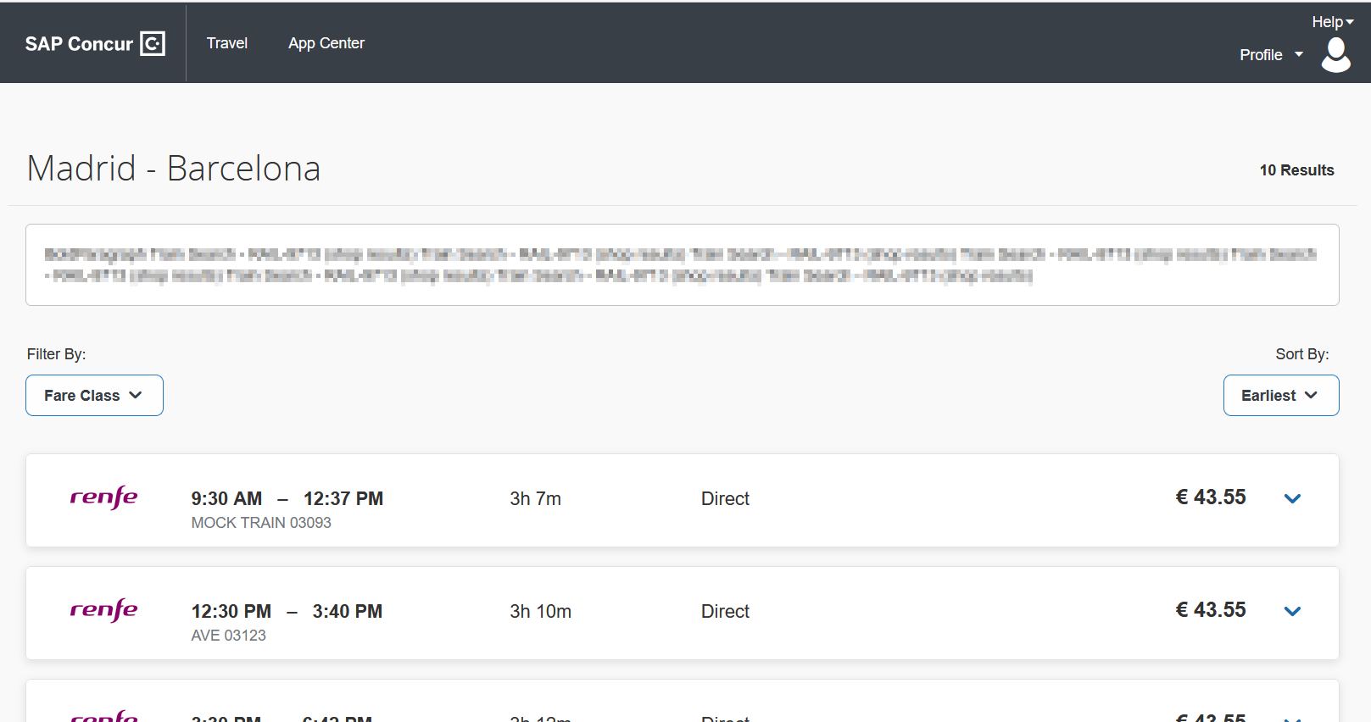

Configuration for Professional Travel
This feature must be enabled under the Custom Text tab in Travel Administration section of Train Schedule. Only plain text is supported for Custom Text with this release.
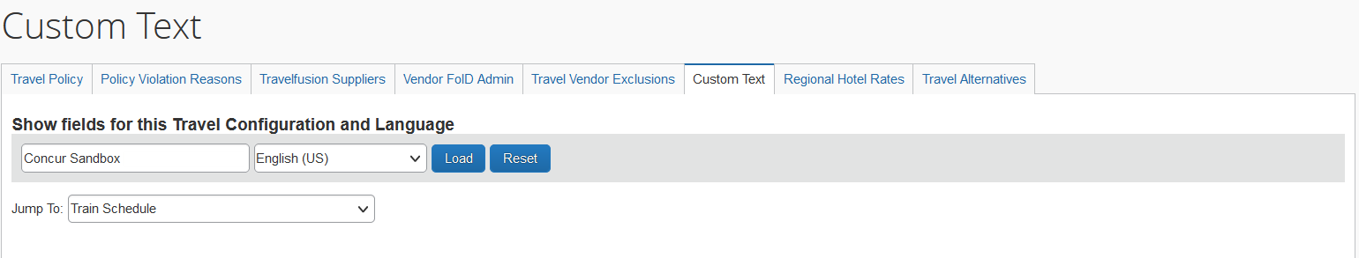
For more information on the configuration steps, refer to the Custom Text Travel Service Guide.

Renfe, New Rail Experience: Changes to Review and Book Page, Traveler Information (Professional Edition Only)

Prof | Stan |   Edition
X |  | On: Impacts end users who use this feature/vendor; no configuration/setup by agency/ admin; cannot be turned OFF (example: new icons or rate display)
 |  | Available for use: No impact to end users unless/until configuration/setup by agency/admin (described below) (example: new rule, new Travelfusion airline)
 |  | Other: Refer to the release note below
 |  | Does not apply to this edition
Source
GDS
Direct Connect |  | Renfe
Other
X | EMEA Data Center |  |  | Scan impact
X | North America Data Center |  |  | UI impact
 | China Data Center |  |  | File finishing impact
 | All data centers |  |  | Profile/Profile API/3rd Party XML Sync Impact
Affected Documentation
TSGs
Fact Sheets |  | Renfe Direct Connect
Admin Guides
Other

Overview
The Concur Travel Review and Book page is now updated to include the Traveler Information section, to align with an upcoming release of the new car booking experience. The Loyalty Program section is now included as part of the Traveler Information section and has been renamed to Frequent Traveler Account.
No functional changes have been made to the Renfe rail booking experience.

End-User Experience
Currently, the Traveler Information section is not part of the Review and Book page. Only the Loyalty Program section is available, which allows users to select their frequent traveler program.
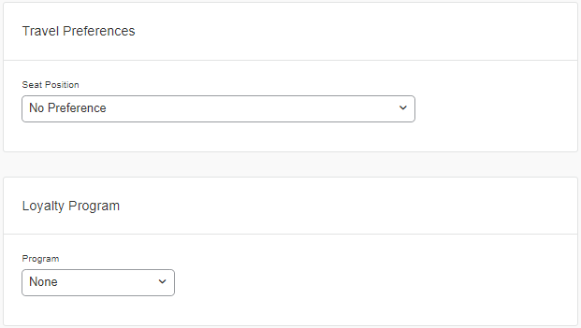
With the new booking experience, the Traveler Information section is added to the Review and Book page. The Loyalty Program section is now included in the Traveler Information section. The Loyalty Program section is renamed to Frequent Traveler Account.
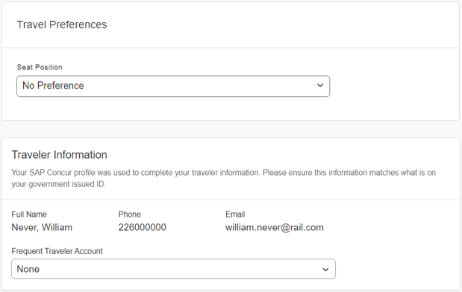

Configuration for Professional Travel
This feature is enabled by default. There are no configuration steps.
For more information, see the Renfe Direct Connect help topics in the Concur Travel Services Help (English Only) in the SAP Help portal.

Travel Operations / Technical Essentials

SNCF API (PAO) Migration – Additional Information (Date Change)

Prof | Stan | Å Å Edition
X | X | On: Impacts end users who use this feature/vendor; no configuration/setup by agency/ admin; cannot be turned OFF (example: new icons or rate display, new Amtrak feature)
 |  | Available for use: No impact to end users unless/until configuration/setup by agency/admin (described below) (example: new rule, new Travelfusion airline)
 |  | Other: Refer to the release note below
 |  | Does not apply to this edition
Source / Solution Suggestion
GDS
Direct Connect |  | SNCF PAO Direct Connect
Other
X | EMEA Data Center |  |  | Scan impact
X | North America Data Center |  |  | UI impact
 | China Data Center |  |  | File finishing impact
 | All data centers |  |  | Profile/Profile API/3rd Party XML Sync Impact
Affected Documentation
TSGs |  | SNCF PAO Direct Connect TSG (available with release)
Fact Sheets
Admin Guides
Other

Overview
SNCF is planning to replace the inventory hosting SNCF offer. Following the SNCF announcement on the postponing the opening of the new inventory, the original migration date of April 4 has been delayed. Further updates will be shared in future release notes.
In preparation for migration completion, SNCF [PAO] settings have been updated with the SNCF PCC field. This will allow users to establish branch access from a new SNCF PCC (previously known as Resarail PCC) of the travel agency to SAP Concur’s SNCF PCC (B930).

Previous Experience
SNCF and SNCF (PAO) are enabled in the travel configuration page under the Rail Connectors section.

New Experience (in Interim)
SNCF and SNCF (PAO) are enabled in the travel configuration page under the Rail Connectors section. The SNCF (PAO) settings is updated with the SNCF PCC field.
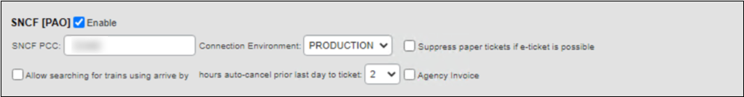
The Resarail PCC field and its existing value has been automatically moved to the SNCF (PAO) rail connector as SNCF PCC. For further information, refer to the Planned Changes > Travel Operations / Technical Essentials section of these release notes.

Planned Changes
The items in this section are targeted for future releases. SAP Concur solutions reserves the right to postpone implementation of – or completely remove – any enhancement or change mentioned here.
The planned changes listed in this document are specific to this product. For information about planned site-wide or shared changes that might impact your SAP Concur solutions, refer to the Shared Changes Release Notes.

Flight

**Planned Changes** Flight Options Turned Down

Information First Published | Information Last Modified | Feature Target Release Date
May 2023 | -- | Q3 2023
Any changes since the previous monthly release are highlighted in yellow in this release note.

Prof | Stan |   Edition
X | X | On: Impacts end users who use this feature/vendor
 |  | Available for use: No impact to end users unless/until configuration/setup by agency/admin (described below) (example: new rule, new Travelfusion airline)
 |  | Other: Refer to the release note below
 |  | Does not apply to this edition
Source
GDS |  | CDS
Direct Connect
Other
X | EMEA Data Center |  |  | Scan impact
X | North America Data Center |  | X | UI impact
 | China Data Center |  |  | File finishing impact
 | All data centers |  |  | Profile/Profile API/3rd Party XML Sync Impact
Affected Documentation
TSGs
Fact Sheets
Admin Guides
Other

Overview
Targeted for Q3 2023, in the New Air experience, when an approver has a trip pending approval, the approver’s e-mail and approver’s view will show the options presented to the traveler, but not chosen. This allows the approver to make an informed decision when approving or rejecting a trip.
These options will also display at the time of booking the flight.

User/Customer Benefit
When a flight is booked out of policy, three options which could have been selected will display. If more options are configured to display, a link to navigate to the approver’s view can show up to ten options.

End-User Experience
The approver will see the itinerary displayed in the following email format.
Approver Email:
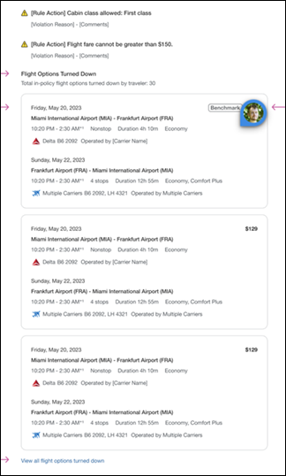
If the Limit options turned down for Approval module property is not setup, a maximum of ten options will be presented, even if the value is set to greater than ten.

Configuration for Professional and Standard Travel
The number of displayed options can be configured by the Limit options turned down for Approval module property. If it is not configured, a maximum of ten options will display.

Hotel and Trip Management

**Planned Changes** Travel Policy Section Updates in New Concur Travel Experience

Information First Published | Information Last Modified | Feature Target Release Date
May 2023 | -- | TBD
Any changes since the previous monthly release are highlighted in yellow in this release note.

Prof | Stan |   Edition
X | X | On: Impacts end users who use this feature/vendor
 |  | Available for use: No impact to end users unless/until configuration/setup by agency/admin (described below) (example: new rule, new Travelfusion airline)
 |  | Other: Refer to the release note below
 |  | Does not apply to this edition
Source
GDS |  | CDS
Direct Connect
Other
X | EMEA Data Center |  |  | Scan impact
X | North America Data Center |  | X | UI impact
 | China Data Center |  |  | File finishing impact
 | All data centers |  |  | Profile/Profile API/3rd Party XML Sync Impact
Affected Documentation
TSGs
Fact Sheets
Admin Guides
Other

Overview
Targeted for Q2 2023 in new Concur Travel experience for Hotel and Trip, when a traveler books a trip that is out of policy the Travel Policy section will show all the rules violated by the traveler. The approver email and approver view will also be updated accordingly.

User/Customer Benefit
This new information will enable the traveler to select the violation reasons based on all the rules violated.
The approver can then decide to approve or reject trips that are pending approval accordingly.

End-User Experience
Travel Policy Section Updates:
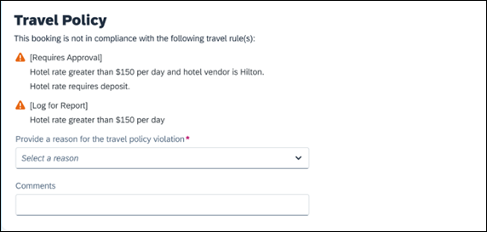
Approver’s Email:
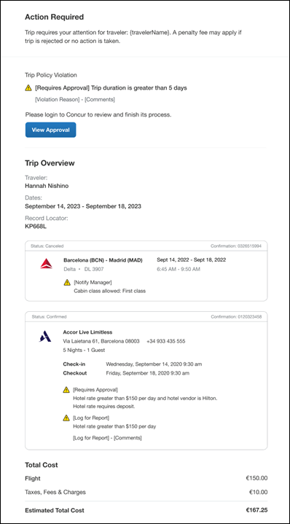
Approver’s View:
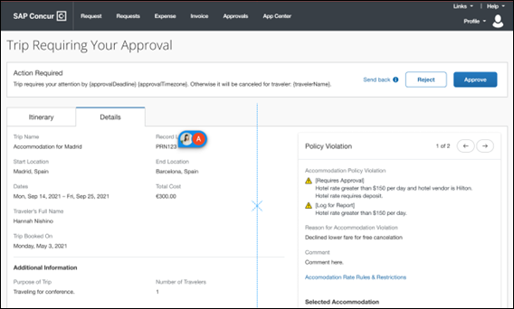

Configuration for Professional and Standard Travel
This feature will be enabled by default. SAP Concur will make these changes automatically.

Hotel

**Planned Changes** New Hotel Experience (Custom Hotel Source Only): Overview

Information First Published | Information Last Modified | Feature Target Release Date
March 2023 | -- | Q2 2023
Any changes since the previous monthly release are highlighted in yellow in this release note.

Prof | Stan |   Edition
 |  | On: Impacts end users who use this feature/vendor; no configuration/setup by agency/ admin; cannot be turned OFF (example: new icons or rate display)
 |  | Available for use: No impact to end users unless/until configuration/setup by agency/admin (described below) (example: new rule, new Travelfusion airline)
X | X | Other: Refer to the release note below
 |  | Does not apply to this edition
Source
GDS |  | N/A
Direct Connect |  | Custom Hotel Source providers (TBD)
Other
 | EMEA Data Center |  |  | Scan impact
 | North America Data Center |  |  | UI impact
 | China Data Center |  |  | File finishing impact
 | All data centers |  |  | Profile/Profile API/3rd Party XML Sync Impact
Affected Documentation
TSGs
Fact Sheets
Admin Guides
Other

Overview
Targeted for the Q2 of 2023, Concur Travel will introduce a new hotel booking experience. This first release is limited to customers connected to one of our participating Custom Hotel Source (CHS) providers. With this integration, customers can experience:
- An intuitive and personalized design, with an easy-to-use experience.
- Seamless content normalization, aggregation and servicing.
- Mobile and Web content parity.

User/Customer Benefit
The new Concur Travel hotel booking experience is available with a specific feature set for customers open to explore the changes.
- Time Savings: The booking workflow has been streamlined so the user has fewer pages to complete.
- Omni search: The user enters in the first few characters of their search criteria and selects their location option from the dropdown list of suggestions.
- Sustainability: Allows end users to see what sustainability certifications or programs the property belongs to. Additional filter options on properties that have electric car charging stations and sustainability certifications to help promote more sustainable choices.
- Search results with lead rate: The property search results are presented with one lead rate so user can quickly compare the lowest rate available at multiple properties.
- Hotel Details: User can see a list of the rates available at a specific property together with cancellation policy details, room amenities and images.

**Planned Changes** New Hotel Experience: Search for a Hotel

Information First Published | Information Last Modified | Feature Target Release Date
March 2023 | -- | Q2 2023
Any changes since the previous monthly release are highlighted in yellow in this release note.

Prof | Stan |   Edition
 |  | On: Impacts end users who use this feature/vendor; no configuration/setup by agency/ admin; cannot be turned OFF (example: new icons or rate display)
 |  | Available for use: No impact to end users unless/until configuration/setup by agency/admin (described below) (example: new rule, new Travelfusion airline)
X | X | Other: Refer to the release note below
 |  | Does not apply to this edition
Source
GDS |  | N/A
Direct Connect |  | Custom Hotel Source providers (TBD)
Other
 | EMEA Data Center |  |  | Scan impact
 | North America Data Center |  |  | UI impact
 | China Data Center |  |  | File finishing impact
 | All data centers |  |  | Profile/Profile API/3rd Party XML Sync Impact
Affected Documentation
TSGs
Fact Sheets
Admin Guides
Other

End-User Experience: Search for a Hotel
The search options include a free text field for the property location. As the user begins to type the preferred location, the “omni search” will suggest matching options for cities, airports, hotels, etc. Search results will display icons to signify the different types of location, for example hotels display with a bed icon.
Check In date will pre-populate with today's date. Check Out date will pre-populate with tomorrow's date. To change these dates, the user clicks the calendar icon.
A default radius of five miles or five kilometers is applied, depending on the units configured in the user profile. Users can change the radius in increments of 5 up to a maximum of 100. The travel configuration settings for Default Search Radius and Search radius for corporate (preferred) hotels will determine the area in which to search for properties.
Any custom text that has been set up for the Search page appears below the travel icons at the top of the page.
Example of Hotel search results:
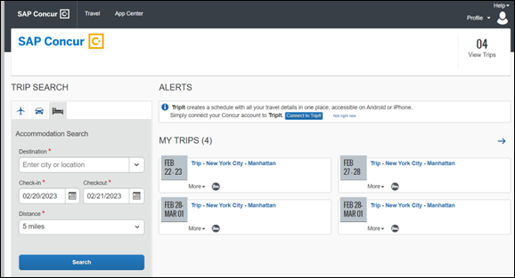

End-User Experience: Hotel Search results
Once the user has entered their search criteria and clicked Search, the results will display. The Number of Hotels to Shop setting no longer applies as Concur Travel will support up to 200 properties with a lead rate in the Search response.
Any property that supports e-receipts will have an E-receipts enabled label next to the Preferred label.
Preferred properties are labelled as either Most Preferred, More Preferred or Preferred. The preference levels returned by the content source provider always take precedence over levels defined in Concur Travel.
The Manage Corporate Discount preference levels in Concur Travel configuration and policy rules that use Preferred List options for this release remain as Most Preferred, Preferred, Less Preferred and Not Preferred. These are mapped as follows:
- Most Preferred to Most Preferred
- Preferred to More Preferred
- Less Preferred to Preferred
- Not Preferred will not be mapped and will be ignored
If policy rules are created using these labels, the policy violation text displayed to the user will contain the current label.
Accommodations results will display a list of properties and a simplified map view.
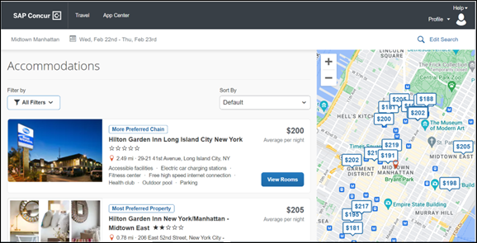

Edit Search
At the top of the page, Concur Travel displays the entered search data. To change the data, click Edit Search.

Filter Options
The offered filter sections are Hotel Amenities, Brand and Sustainability.
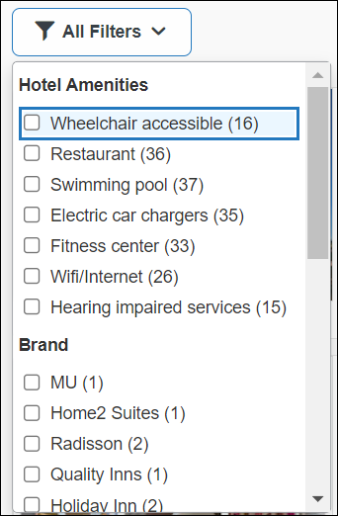

Sorting Options
The sorting options include Default, Distance, Preferred Level, Price Low to High and Price High to Low. Concur Travel cannot determine the order in which the CHS provider first returns the results because Hotel Sort Default setting will no longer be available. The user can re-sort the results using the dropdown and can go back to the original sort order at any time by selecting Default in the dropdown.
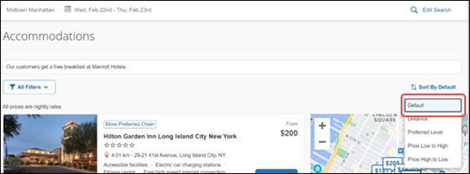

Hotel Details
The Hotel Details page will provide details of the property together with the room rates. Where applicable, there will be details of the sustainability certification of the property, together with a link for the user to view more details of the certification. If the hotel is a preferred property or a preferred chain, the preferred label will display above the hotel name.
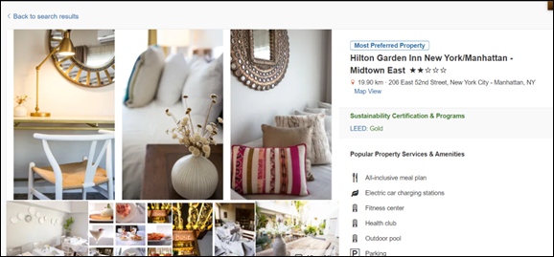
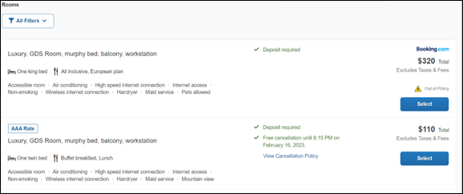

Property Amenities
The most popular property amenities and services will display at the top of the page. For more information, the user can click View More to go to the bottom of the page where the hotel amenities and services will be listed.
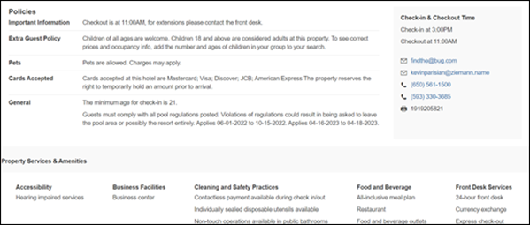

Property Images
At the top of the Property Images page, an image gallery is provided that the user can scroll through to view all the images and any descriptive information that applies.

Filters
The user can:
- Filter out rates that require pre-payment or are non-refundable.
- Filter by accessible rooms.

Rate Type Categories
Rate types selected in the User Profile, such as AAA or GOV, are sent in the request to the content provider. If no rate types are selected in the user profile, they are filtered out of any response from the provider.

Room Amenities
Listed next to each rate are the room details, amenities, bed type, and any meal plan type.
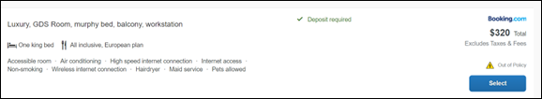

Total Price
The total price displayed may be inclusive or exclusive of taxes, depending on the location of the user. This is determined by the content provider. Text below each price indicates whether taxes and fees are included or excluded.
The booking source will display above the price when returned by the provider. This can be a logo or a name.

Travel Policy
When a hotel rate violates a policy rule, the rate will display with a warning icon. Click the icon to see more information on the policy rules that apply. When the Hide Results rule is applied to a specific property, that hotel property will not appear in the search results.
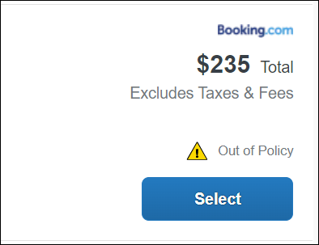
Show but do not allow and Hide results are not supported for Itinerary rules, as these enforcement levels are result-dependent. Itinerary rules are applied during checkout.

Cancellation Policy
Cancellation policy details will display, for example "Free Cancellation until September 20". For more information, the user can click View Cancellation Policy.
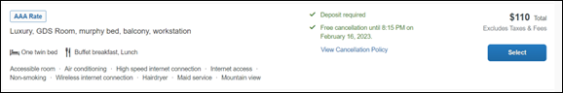

Map View – Search Results
The new map view on the search results page will provide information and an additional filer. When the user clicks a pin, they are directed to that property in the search results. The pins contain the lead rate for the property. Company locations will display in the map via a small red icon.
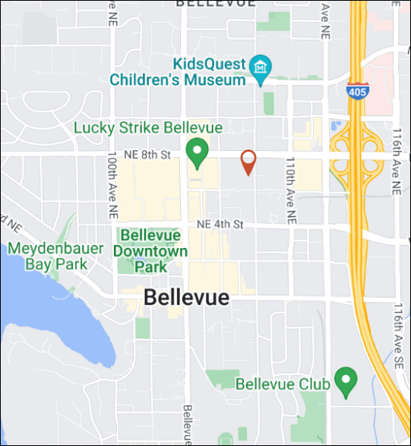
The zoom option is available so the user can focus on areas for more details.
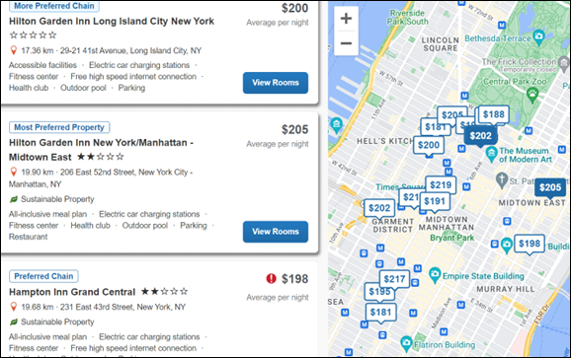
In case of overlapping pins, the number of locations will display. Click the pin to zoom, until separate pins display clearly.

Map View – Property Details
When the user clicks on Map View on the Details page, a map showing an icon denotes the location of the property. To display the property name and address, click the icon.
There is a zoom option within the map so the user can zoom in or out.
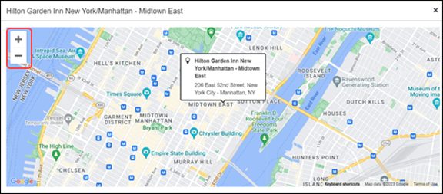

**Planned Changes** New Hotel Experience: Review and Book

Information First Published | Information Last Modified | Feature Target Release Date
March 2023 | May 03, 2023 | Q2 2023
Any changes since the previous monthly release are highlighted in yellow in this release note.

Prof | Stan |   Edition
 |  | On: Impacts end users who use this feature/vendor; no configuration/setup by agency/ admin; cannot be turned OFF (example: new icons or rate display)
 |  | Available for use: No impact to end users unless/until configuration/setup by agency/admin (described below) (example: new rule, new Travelfusion airline)
X | X | Other: Refer to the release note below
 |  | Does not apply to this edition
Source
GDS |  | N/A
Direct Connect |  | Custom Hotel Source providers (TBD)
Other
 | EMEA Data Center |  |  | Scan impact
 | North America Data Center |  |  | UI impact
 | China Data Center |  |  | File finishing impact
 | All data centers |  |  | Profile/Profile API/3rd Party XML Sync Impact
Affected Documentation
TSGs
Fact Sheets
Admin Guides
Other

End-User Experience: Review and Book
The Review and Book page combines all relevant information for the user to review before completing the booking. All hotel selection related information is presented on the page, including the property details, the room and rate information, and the guest details.
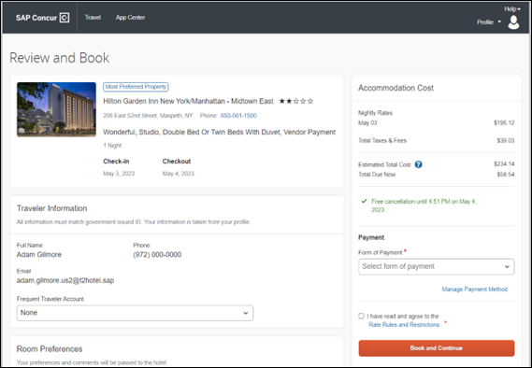

Cost Section
Within the cost section, the estimated total amount after nightly rate breakdown, taxes, and fees will display in the configured currency of the traveler. There is also a Total Due Now amount, which will be zero for postpaid rates; the total rate less any fees for prepaid rates, or the deposit amount where a deposit is required for the booking.
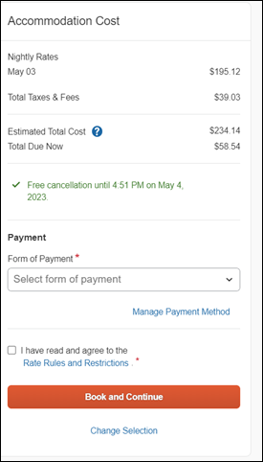

Payment
In the Accommodation Cost section on the Review and Book page, the user will select their form of payment. Form of Payment is a required field. It will not have a default option.
The Form of Payment list may display available corporate ghost cards, personal credit cards, and virtual payments. The specific payments list options are determined by the options configured by and for the user.
- A corporate ghost card with the Required for Hotel admin setting will display to the user, but the user will not be able to select this option.
- A corporate ghost card with the Allow for Hotel setting enabled allows users to choose between a personal credit card or the configured corporate ghost card.
- A Vendor Provided Virtual Payment option may be available, if offered by the CHS provider. This is only available if a corporate ghost card is not configured with the Required for Hotel setting.
- When a credit card with CVV code is required by the CHS provider, only credit cards with CVV codes can be selected. Corporate ghost cards will be excluded because they do not have CVV codes.
- Personal credit cards saved in the user’s Concur Travel profile may be selected.
- Vendor-provided virtual payments may be selected.
The Accommodation Cost section may also include links to allow the user to Manage Payment Method stored in their profile.
Users can add new personal cards or update existing personal credit cards by clicking Manage Payment Method. The user will be redirected to the Travel Profile page to update the card. They will see the Review and Book page after saving changes.
The Manage Payment Method will be enabled in the module properties. Allow users to Add New Credit Cards must be set to True. Hide Travel Profile must be set to False. If incorrectly configured, the user will not see the Manage Payment Method link, or an error message will display when the user clicks the link and cannot make updates.
When a hotel requires a credit card with a CVV number to make the booking, users must select a personal credit card from their profile. A CVV number field is mandatory.
The CVV entry does not apply when the user has selected the provider’s virtual card option. No CVV is needed when using the provider's virtual payment option.
If a corporate ghost card is configured as Required for Hotel and a CVV number is required by the property, then an error message will display to the user, as a cvv number cannot be used with a ghost card.
The Concur Travel configuration setting Force users to choose a credit card is no longer available. When a user has more than one credit card, the user will be required to choose from the Form of Payment dropdown list.
The Concur Travel configuration setting Agency Processing Fee Form of Payment for Land Only/Non-GDS Reservations determines the credit card account written to the form of payment line in the GDS Passenger Name Record for this booking. The default setting is always write the user selected card, which will select the last card used during a booking.
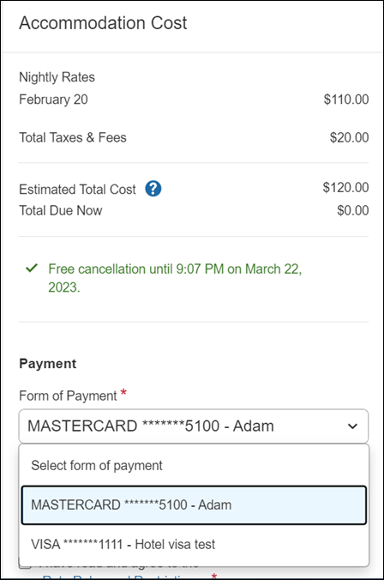
To change settings for Allow users to choose a personal credit card even if they have a custom corporate card, Require for Hotel, Agency Processing Fee Form of Payment for Land Only/Non-GDS Reservations, or to change how corporate ghost cards are assigned, refer to the Form of Payment Travel Service Guide. To change Allow users to add new personal credit cards to their Concur Travel profile settings, refer to the Module Properties Guide.

Room Preferences
The Hotel Preferences section provides an opportunity to transfer comments to the hotel property as part of the booking. Only alpha numeric entries will be accepted in this field.
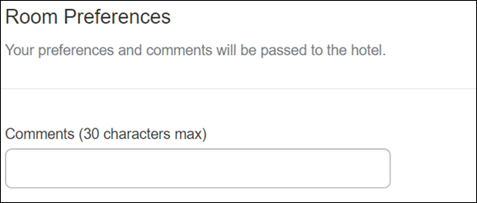

Traveler Information
The Traveler Information section reflects the traveler data that is necessary to complete the booking. This information will be sent to the suppliers. If the traveler has loyalty cards stored in their user profile, these are pre-populated in the dropdown menu for selection, if they apply to the property being booked.
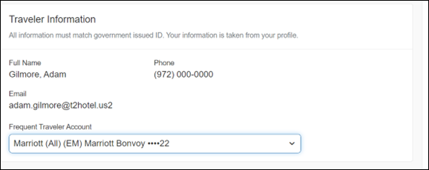

Travel Policy
This section appears if the user has selected an offer which violates their company travel policy. The rules that have been violated are shown and a travel policy violation reason can then be selected from the dropdown, and/or provide additional justification via the Comments box.
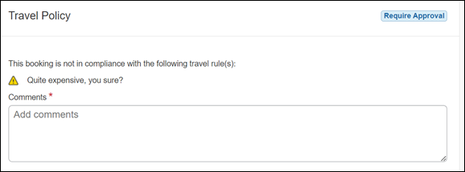

Pre-Book Custom Fields
Trip custom fields in Concur Travel can be set up to collect information during the booking process. These fields are often used to collect information for the clients’ internal accounting process or for reporting purposes. They can be configured to show at the beginning or end of the booking process. If added at the beginning of the booking process, they are located within the Additional Information section on the Review and Book page.
Example:
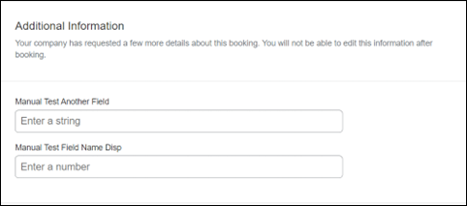

Rate Rules and Restrictions
The traveler is required to click the Rules and Restrictions hyperlink and read the supplier’s conditions. Then they can click the I have read and agree to the Rate Rules and Restrictions checkbox.
Once the traveler has completed all the necessary information, they can click Book and Continue
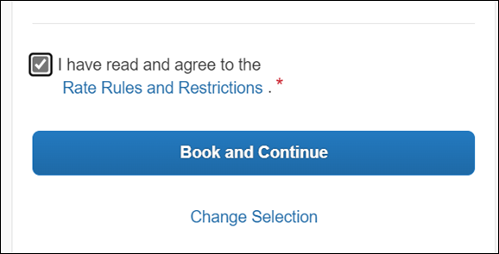

**Planned Changes** New Hotel Experience: Finalize and Confirm Booking

Information First Published | Information Last Modified | Feature Target Release Date
March 2023 | -- | Q2 2023
Any changes since the previous monthly release are highlighted in yellow in this release note.

Prof | Stan |   Edition
 |  | On: Impacts end users who use this feature/vendor; no configuration/setup by agency/ admin; cannot be turned OFF (example: new icons or rate display)
 |  | Available for use: No impact to end users unless/until configuration/setup by agency/admin (described below) (example: new rule, new Travelfusion airline)
X | X | Other: Refer to the release note below
 |  | Does not apply to this edition
Source
GDS |  | N/A
Direct Connect |  | Custom Hotel Source providers (TBD)
Other
 | EMEA Data Center |  |  | Scan impact
 | North America Data Center |  |  | UI impact
 | China Data Center |  |  | File finishing impact
 | All data centers |  |  | Profile/Profile API/3rd Party XML Sync Impact
Affected Documentation
TSGs
Fact Sheets
Admin Guides
Other

End-User Experience: Finalize Trip
The Finalize Trip page in the hotel workflow allows the user to enter a different name for the trip and provide a description. When expanding the hotel segment, all details about the newly created reservation become visible again.
The purpose of this intermediate step is to present an overview of all reserved bookings, apply trip level policy rules, allow the user to enter trip-related custom fields, and use approval workflows after the user has added all required bookings to a trip. Currently supported booking types include rail and car.
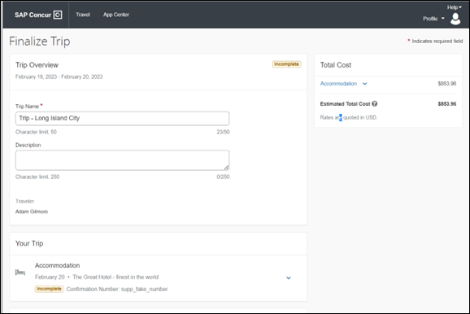

Add Bookings
To add other bookings, users can click Add Accommodation and Add Rental Car.
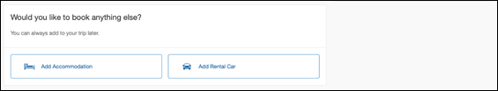

Travel Policy
The Travel Policy section informs the travelers about violated policy rules and provides an opportunity to select a reason and/or add a comment.
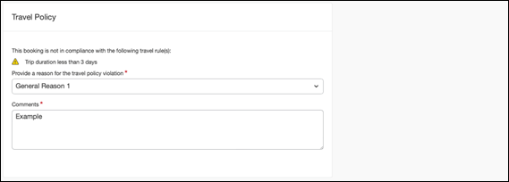

Trip Custom Fields
Trip custom fields in Concur Travel can be set up to collect information during the booking process. The fields are often used to collect information for the clients’ internal accounting process or for reporting purposes. They can be configured to show at the start or towards the end of the booking process.
Trip custom fields configured to display towards the end of the booking workflow will be shown on the Finalize Trip page in the Additional Information section.
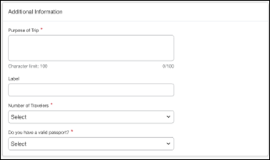

Cancel Trip
If a traveler wants to stop the booking, they can click the Cancel Trip at the bottom of the page. Please refer to the details in the Cancellation section.
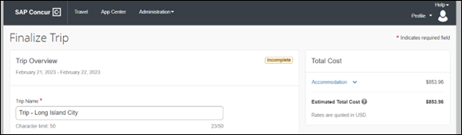
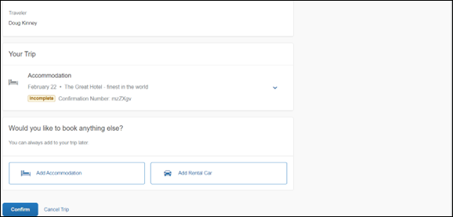

End-User Experience: Confirmation
Click Confirm on the Finalize Trip page to display the Confirmation page.
This page provides an overview of all existing bookings in a user’s trip and displays support contact data. This is configured by your SAP Concur administrator.
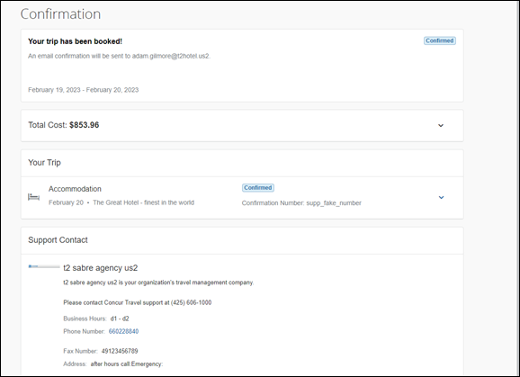
The Confirmation page includes:
- A display of the current trip state, as part of the header section.
- The email address of the confirmation recipient.
- A section that displays the Total Cost. This section is collapsed by default and can be expanded to review detailed rate information per booking.
- A Your Trip section where each booking displays as collapsed by default but can be expanded to review details (such as number of nights and number of guests for a hotel booking).
- A Support Contact section will display support contact data. This is configured by your SAP Concur administrator.
The user will be able to see the trip booked on the homepage under Upcoming Trips. At the same time, an email confirmation will be sent to the traveler.

Manager Notification
If the booking policy that is violated requires management notification, an email is sent to the manager.

**Planned Changes** New Hotel Experience: Completed Trip Overview

Information First Published | Information Last Modified | Feature Target Release Date
March 2023 | May 03, 2023 | Q2 2023
Any changes since the previous monthly release are highlighted in yellow in this release note.

Prof | Stan |   Edition
 |  | On: Impacts end users who use this feature/vendor; no configuration/setup by agency/ admin; cannot be turned OFF (example: new icons or rate display)
 |  | Available for use: No impact to end users unless/until configuration/setup by agency/admin (described below) (example: new rule, new Travelfusion airline)
X | X | Other: Refer to the release note below
 |  | Does not apply to this edition
Source
GDS |  | N/A
Direct Connect |  | Custom Hotel Source providers (TBD)
Other
 | EMEA Data Center |  |  | Scan impact
 | North America Data Center |  |  | UI impact
 | China Data Center |  |  | File finishing impact
 | All data centers |  |  | Profile/Profile API/3rd Party XML Sync Impact
Affected Documentation
TSGs
Fact Sheets
Admin Guides
Other

End-User Experience: View Hotel booking (Trip Overview)
The Trip Overview page allows you to review and manage a booked trip at any time. Cancelled trips can be reviewed, but no longer managed.
Example:
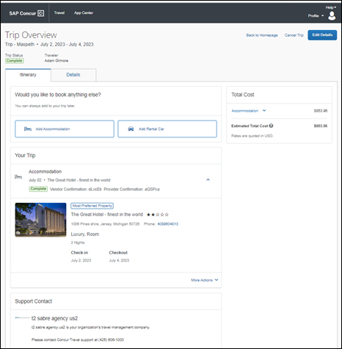

Header Section
Below the page header are the trip name and travel dates. The top section of the page will display:
- Trip status.
- Record locator (if trip contains content booked through travel agency channels).
- Traveler name.
- Booker name (if the booker is a different person than the traveler – see the Travel Arranger section).
- Trip description (if a description was added by the booker).
At the top right corner of the page, there is a link to cancel the trip and a button to edit details such as the default trip name and trip description.

Cost Section
At the right of the Trip Overview page, there is a Cost section to review estimated total trip cost and detailed costs per booking. The cost section floats on the page while scrolling, so it remains visible whether you review the upper or lower part of the page.

Itinerary Tab
At the top of this tab, there are Add Rental Car and Add Accommodation buttons for users to add another booking to the trip. Configuration is required by your SAP Concur administrator to hide these buttons.
The Your Trip section will display each booking with its confirmation numbers. Each booking in this section will display as expanded by default to review details such as number of nights and rate description.
At the bottom of the page, the Support Contact section will display support contact data; configuration is required by your SAP Concur administrator.

Details Tab
On this tab you will be able to review additional trip-related information.
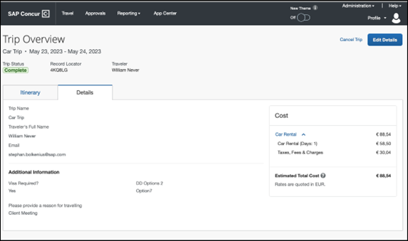
This tab will display:
- The trip name.
- The traveler's name.
- The traveler's email address to which the confirmation email is sent.
- The trip description (if added).
- Field names and values selected or entered during the booking workflow in the Additional Information section. Configuration is required by your SAP Concur administrator.

Cancellation
The Cancel Trip link will redirect users to the Confirm Cancellation page to start the trip cancellation.

Add a Booking
The Add Accommodation or Add Car actions will redirect users to the search and book flow for each service.

**Planned Changes** New Hotel Experience: Cancellation

Information First Published | Information Last Modified | Feature Target Release Date
March 2023 | -- | Q2 2023
Any changes since the previous monthly release are highlighted in yellow in this release note.

Prof | Stan |   Edition
 |  | On: Impacts end users who use this feature/vendor; no configuration/setup by agency/ admin; cannot be turned OFF (example: new icons or rate display)
 |  | Available for use: No impact to end users unless/until configuration/setup by agency/admin (described below) (example: new rule, new Travelfusion airline)
X | X | Other: Refer to the release note below
 |  | Does not apply to this edition
Source
GDS |  | N/A
Direct Connect |  | Custom Hotel Source providers (TBD)
Other
 | EMEA Data Center |  |  | Scan impact
 | North America Data Center |  |  | UI impact
 | China Data Center |  |  | File finishing impact
 | All data centers |  |  | Profile/Profile API/3rd Party XML Sync Impact
Affected Documentation
TSGs
Fact Sheets
Admin Guides
Other

End-User Experience: Cancellation
Depending on the place from which the trip cancellation starts and the trip content, the cancellation flows may vary as follows:
- When users click Cancel Trip on the Finalize Trip page, the Trip Overview page will redirect them to the Confirm Cancellation page that contains a link to the Terms and Conditions for review. Confirmation of the cancellation on this page will redirect users to the Trip Overview page where the trip is indicated as Cancelled.
- When users click Cancel in the Trip Library (web app), Trip List (mobile app), Upcoming Trips or My Trips sections, a popup will display with a link to the Terms and Conditions for review.
- For a trip that only contains content booked in the new Concur Travel experience, users will be redirected to the Trip Overview page where the trip is indicated as Cancelled.
- For a trip that contains other content than what was booked in the new ConcurTravel experience, users will be redirected to the regular cancellation confirmation page.
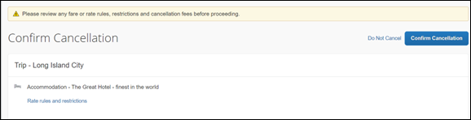
For scenarios 1 and scenario 2a, the following is an example of where the user will be redirected to upon confirming cancellation:
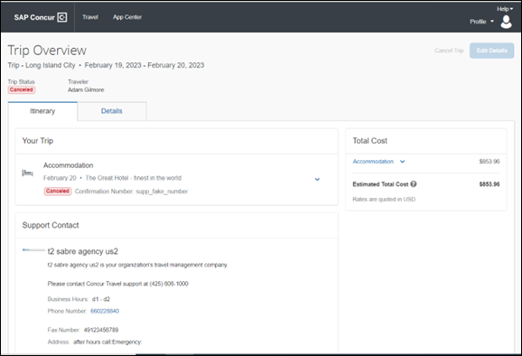

**Planned Changes** New Hotel Experience: Configuration for Custom Hotel Sourcing

Information First Published | Information Last Modified | Feature Target Release Date
March 2023 | -- | Q2 2023
Any changes since the previous monthly release are highlighted in yellow in this release note.

Prof | Stan |   Edition
 |  | On: Impacts end users who use this feature/vendor; no configuration/setup by agency/ admin; cannot be turned OFF (example: new icons or rate display)
 |  | Available for use: No impact to end users unless/until configuration/setup by agency/admin (described below) (example: new rule, new Travelfusion airline)
X | X | Other: Refer to the release note below
 |  | Does not apply to this edition
Source
GDS |  | N/A
Direct Connect |  | Custom Hotel Source providers (TBD)
Other
 | EMEA Data Center |  |  | Scan impact
 | North America Data Center |  |  | UI impact
 | China Data Center |  |  | File finishing impact
 | All data centers |  |  | Profile/Profile API/3rd Party XML Sync Impact
Affected Documentation
TSGs
Fact Sheets
Admin Guides
Other

Configuration for Professional Travel

Custom Hotel Source Providers
Hotel content will only be available from Custom Hotel Source providers. This requires re-enablement for customers who are interested in using these channels.
To configure:
- Click Administration > Travel (on the sub-menu) > Travel System Admin and select the desired client travel configuration.
Depending on your permissions, the page may appear immediately after you click Administration or Travel.
There are now two different Hotel Connector sections of the travel configuration page. One is to support the new hotel connectors and is called Hotel Connectors – Hotel Service v4. The other is the existing hotel connector section.
When enabling a new connector, it is essential that any current direct connect remains enabled otherwise customers will not be able to make bookings in the current Concur Travel experience. This means that a current HSv2 configuration needs to remain enabled on HSv2, and on HSv4 once migrated. The HSv2 connection will not allow new bookings but will provide access to previously booked reservations for servicing. Any servicing will continue as it is today using the Online Booking Tool (OBT).
- The administrator will be able to select the default connection type within the new section. Although GDS is presented as an option, there is no GDS content available with this release.
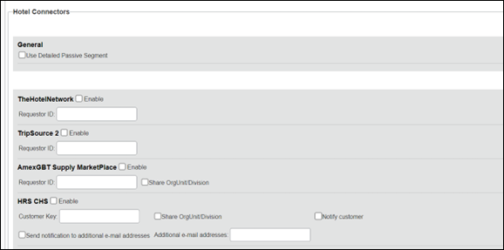
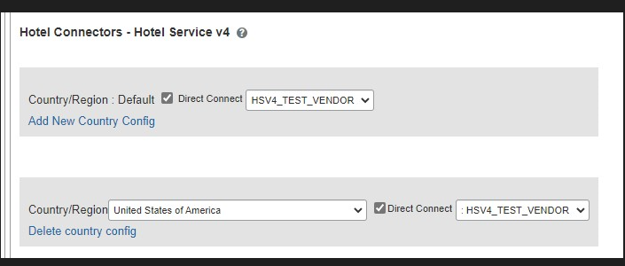

Passive PNR for Direct Content
To configure:
- Go to Administration > Travel (on the sub-menu) > Travel System Admin and select the desired client travel configuration.
Depending on your permissions, the page may appear immediately after you click Administration or Travel.
- On the Travel Configuration page, under GDS PNR Options, go to the activation checkboxes.
- Under Defaults for Specific non-GDS vendors, select the New Custom Hotel Source checkbox. The default for this field is Use the default specified above. Select the Write passive segments for non-GDS content if I have not specified a default for the specific vendor in the table below checkbox.

Travel arranger flow
The Travel Arranger flow will be supported for Hotel.
For more information on how to book a hotel as a Travel Arranger, see the Travel Arranger View Travel Service Guide.
The Travel Arranger Name appears on the new Trip Overview.

**Planned Changes** New Hotel Experience: Reduced Feature Set

Information First Published | Information Last Modified | Feature Target Release Date
March 2023 | May 03, 2023 | Q2 2023
Any changes since the previous monthly release are highlighted in yellow in this release note.

Prof | Stan |   Edition
 |  | On: Impacts end users who use this feature/vendor; no configuration/setup by agency/ admin; cannot be turned OFF (example: new icons or rate display)
 |  | Available for use: No impact to end users unless/until configuration/setup by agency/admin (described below) (example: new rule, new Travelfusion airline)
X | X | Other: Refer to the release note below
 |  | Does not apply to this edition
Source
GDS |  | N/A
Direct Connect |  | Custom Hotel Source providers (TBD)
Other
 | EMEA Data Center |  |  | Scan impact
 | North America Data Center |  |  | UI impact
 | China Data Center |  |  | File finishing impact
 | All data centers |  |  | Profile/Profile API/3rd Party XML Sync Impact
Affected Documentation
TSGs
Fact Sheets
Admin Guides
Other
The activation of the new hotel workflow though Concur Travel will not be possible via a setting within Concur Travel. As a reduced set of features will be available in the first release, customers will be determined and informed when eligible for migration.

Known Limitations
The following items are not yet supported with the new hotel booking experience. Monitor future release notes for changes relating to these limitations.

Product Area | Feature/Setting | Setting Location | Setting/Feature details | Additional Information
Traveler selection | Guest Traveler bookings | Travel Configuration | Guest traveler bookings are disabled | A guest traveler or sponsored guest booking are not supported yet.
Content | Hotel connectors | Agency Configuration | Custom Hotel Source Direct Connects only
Integrations | Concur Request | Travel configuration | Enable Request Integration unchecked
Travel Policy | Hotel rule Enforcement Levels | Company Administration > Travel Admin | Display Message not supported | No message is displayed to the user.
Travel Policy | Concur Travel’s Native Approval Process | Company Administration > Travel Admin | Hotel rules cannot use:  Require Pre-Approval & Log  Require Pre-approval & Notify | These rules will not be enforced if set up.
Travel Policy | Hotel Rule Parts | Company Administration > Travel Rule Builder / Travel Admin | Hotel Rate is [condition] the government hotel level per diem rate [plusMinus] [money] [currencyOrPercent]  Hotel Rate is [condition] the government location based per diem rate [plusMinus] [money] [currencyOrPercent]  Hotel Rate is [condition] the location rate or [currency] [money]  Hotel Rate is [condition] the price-to-beat  Hotel Rate is from the Reservation System  Hotel Rate is not from the Reservation System  Other rate descriptions at this hotel contain any of the text '[DescriptionList]'  Hotel has rates from source [Source]  Hotel has no rates from source [Source] | All other configured hotel rules will be supported
Travel Policy | Hotel rule Parts | Company Administration > Travel Rule Builder / Travel Admin | No Fedrooms or FEMA policy rules are supported. | If these are set up they will not be applied.
Travel Policy | Itinerary Rule Parts | Company Administration > Travel Rule Builder / Travel Admin | The following three Itinerary rules will be the only ones supported for the first release of the new Hotel experience:  Itinerary booked [condition] [DaysAdvance] days in advance  Trip duration [condition] [DaysLong] days  Itinerary has no Hotel segments | All other Itinerary rule parts will not be enforced.
Travel Policy | Violation Reason Types | Company Administration > Travel Admin > Policy Violation Reasons | General  Air  Train  Car  Hotel  Itinerary | Reasons from any other reason type categories will not display.
Travel Policy | Rule Class Selection and Force selection of a rule class | Travel Configuration | Only a user’s default rule class is supported | If enabled, users will see the rule class selection field on the search, but any selection by the user would not be honored.
Custom Fields | Custom Trip Fields | Company Administration > Manage Custom Fields | If/Then Settings cannot be enabled.
Custom Fields | Custom Trip Fields | Company Administration > Manage Custom Fields | Display for Edits cannot be enabled
Payments | Use A.I.D.A if Company Account is not accepted | Travel Configuration |  | AIDA cards not supported for Release 1 Hotels
Payments | Virtual Payments |  |  | Virtual cards generated through SAP Concur/Conferma will not be an option for customers to use for hotel bookings.
Hotel-specific | Hotel check in date prompt for arrival after midnight | Travel configuration |  | No prompt appears when searching for a hotel.
Hotel-specific | Government features |  | Hotel Per-Diems and Fedrooms not supported. | Any per diems set up will not be applied.
Hotel-specific | Direct Billing | Company Admin > Manage Corporate Discounts |  | Customers who use direct billing should not use the new hotel booking experience yet.
Hotel-specific | User supplied hotels | Travel Admin>Travel Policy>Edit Classes | Allows users to add their own hotel booked outside of Concur Travel. | Manual hotels cannot be booked. The I will book a hotel later as a user-supplied option configuration setting is not supported. If this is set, no popup will appear to allow customer to add their own hotel.
Hotel-specific | Allow hotel bookings using cards that expire before trip date | Module Properties | Allowed users to book hotels with credit card that expired before check in date | An error is received if user attempts to book a hotel with a credit card that expires before the check in date
Hotel-specific | Enable Hotel Streaming on Mobile | Module Properties | With hotel streaming, users see the rates and hotel images as the information is retrieved. If True, hotel streaming is enabled for the mobile app. If False, results are presented all at once, after all search results are collected | There is no longer any rate streaming in Hotels. All results appear at once.
Hotel-specific | Auto-check Find a Hotel for Air Searches | Module Properties | If True, the Find a Hotel checkbox on the Flight Search tab of the travel wizard is automatically selected. | The checkbox is not automatically selected.
Hotel Specific | “Find a Hotel” | Appears under Air Search | When selected, the Hotel search page appears automatically after Air segment is booked | User has to “Add Hotel” after booking the Air segment rather than have the Hotel Search appear automatically once they complete the Air search
Hotel-specific | Hotel Sort Default | Travel Configuration | Allows Admin to determine the default sort order of properties returned in Search results | The sort order is always the order in which the provider returns it.
Hotel-specific | Apollo GDS |  |  | Configurations using Apollo GDS will not be able to migrate to the new Hotel experience
Hotel specific | Currency change | Search page | Allows a user to change the currency that the hotel rates appear in | Users will only be able to see the hotel rates in the currency set up in their configuration
Trip Management | Change of booking | N/A | N/A | Change of booking is not yet supported for the new hotel booking experience.

Changes in Product Behavior
While the following items will be supported for the new hotel booking experience, behavior will change for the following items:

Opt-Out Setting for Confirmation and Cancellation Emails
The opt-out settings from the User Profile or System Settings for Confirmation and Cancellation emails do not apply to emails sent out in the new Concur Travel experience. The Contact? setting in the email section of the user profile does apply. Emails are only sent to addresses for which Contact? is enabled.

Confirmation Emails
While confirmation emails will be sent for bookings made via the new hotel experience, these emails will not yet include an .ics calendar attachment.

Custom trip fields – display at start
Custom trip fields configured with the Display at start of booking setting selected will be shown on the Additional Information section of the Review and Book page. Custom fields for which the Display at start of booking setting is not enabled will be shown on the Additional Information section of the Finalize Trip page.
Custom trip fields – Checkbox Fields
In the regular booking experience of Concur Travel, checkboxes are not selected by default. Users can complete the booking without selecting a checkbox, even when it is a required field. The box not being selected is saved and recorded for reporting.
In the new Concur Travel experience, checkboxes display by default in an undetermined state, as shown in the previous screenshot. If the field is required, the box must be enabled or disabled to continue.
Undetermined:
Disabled:
Enabled:

Custom trip fields – display on itinerary
Regardless of the Display on Itinerary setting, all trip custom fields configured during the booking workflow will display by default on the Details tab of the Trip Overview page. Trip custom fields configured during the workflow will not be included in confirmation or cancellation emails.

Travel templates, Trip Sharing/Cloning
Hotel connector content is not supported for booking from a travel template, a shared trip, or a cloned trip. The travel template will work for other trip content as per regular logic, but the Hotel connector content will be ignored. It is possible to add Hotel connector content to a trip booked from a template after booking, in a separate operation.
Support Contact Section
On the Confirmation Page and the Trip Overview page, a section with Support Contact information displays, if configured. The new Concur Travel experience does not support html in the form field.

Rail

**Planned Changes** SNCF – Thalys Migration (Jun 9)

Information First Published | Information Last Modified | Feature Target Release Date
May 2023 | -- | June 9
Any changes since the previous monthly release are highlighted in yellow in this release note.

Prof | Stan | Å Å Edition
X | X | On: Impacts end users who use this feature/vendor; no configuration/setup by agency/ admin; cannot be turned OFF (example: new icons or rate display, new Amtrak feature)
 |  | Available for use: No impact to end users unless/until configuration/setup by agency/admin (described below) (example: new rule, new Travelfusion airline)
 |  | Other: Refer to the release note below
 |  | Does not apply to this edition
Source / Solution Suggestion
GDS
Direct Connect |  | SNCF Direct Connect
Other
X | EMEA Data Center |  |  | Scan impact
X | North America Data Center |  |  | UI impact
 | China Data Center |  |  | File finishing impact
 | All data centers |  |  | Profile/Profile API/3rd Party XML Sync Impact
Affected Documentation
TSGs |  | SNCF Direct Connect TSG
Fact Sheets
Admin Guides
Other

Overview
SNCF has announced that Thalys will join Eurostar in the S3 passenger inventory in Q2 2023. This inventory is called S3 Eurostar.
SNCF plans the transition period for the sales and circulation of Thalys trains. During this period, it will be possible to reserve Thalys trains in Resarail and S3 Eurostar, depending on the departure date.
Targetted for June 9, 2023, SAP Concur will start connecting to PAO for Thalys trains. SNCF will return Thalys trains from Resarail or S3 Eurostar as applicable.
After August 31, Thalys trains will only be available in S3 Eurostar via PAO API (this is subject to change).
Users attempting to book Thalys trains in June, prior to the planned change, with the departure date at the beginning of September may receive an error. The recommendation is to postpone such bookings until after the implementation.

End-User Experience
The booking steps for self-booked and arranger-booked trips will remain the same. The traveler will however have to select the SNCF [TER + Eurostar + Thalys] option from the dropdown to search for Thalys trains.

Previous Experience
After logging into Concur Travel and selecting the Rail tab, the traveler sees the following dropdown for SNCF:
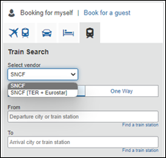
The traveler needs to select SNCF to search for Thalys.

New Experience
The traveler continues seeing the dropdown. The user needs to select SNCF [TER + Eurostar +Thalys] to search for Thalys trains.
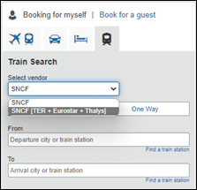

Configuration for Professional and Standard Travel
This feature will be enabled by default. SAP Concur will make these changes automatically.

**Planned Changes** SNCF API (PAO) Migration

Information First Published | Information Last Modified | Feature Target Release Date
December 2022 | -- | TBD
Any changes since the previous monthly release are highlighted in yellow in this release note.

Prof | Stan | Å Å Edition
X | X | On: Impacts end users who use this feature/vendor; no configuration/setup by agency/ admin; cannot be turned OFF (example: new icons or rate display)
 |  | Available for use: No impact to end users unless/until configuration/setup by agency/admin (described below) (example: new rule, new Travelfusion airline)
 |  | Other: Refer to the release note below
 |  | Does not apply to this edition
Source
GDS
Direct Connect |  | SNCF PAO Direct Connect
Other
X | EMEA Data Center |  |  | Scan impact
X | North America Data Center |  |  | UI impact
 | China Data Center |  |  | File finishing impact
 | All data centers |  |  | Profile/Profile API/3rd Party XML Sync Impact
Affected Documentation
TSGs |  | SNCF PAO Direct Connect TSG (available with release)
Fact Sheets
Admin Guides
Other

Overview
In March 2020, SAP Concur performed a partial migration of SNCF customers to the SNCF PAO API with the goal of offering our customers whole Regional Train and Eurostar content.
Due to upcoming changes planned by SNCF, SAP Concur will continue with the migration to SNCF PAO. The targeted date for release will be communicated in the future.

User/Customer Benefit
The SNCF content will be available via the SNCF PAO API. Migrated customers will no longer need to enable both connectors, SNCF and SNCF (PAO), in their configurations. Migrated users will no longer need to select between SNCF and SNCF [TER + Eurostar] before they initiate their search.

End-User Experience
The booking steps for self-booked and arranger booked trips will remain the same. The traveler will no longer be asked to select between the SNCF and SNCF [TER + Eurostar] option from the dropdown before searching for SNCF.

Previous Experience
After logging into Concur Travel, by selecting the Rail tab, the traveler sees the following dropdown for SNCF:
Example:
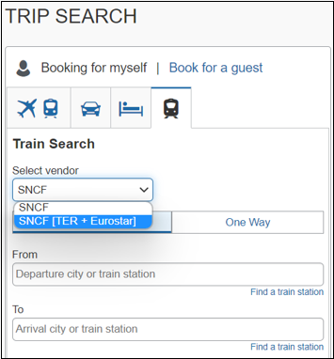

New Experience
After the migration is completed, the traveler will only see the SNCF option. The dropdown will not display as all SNCF content will be available via the PAO API.
Example:
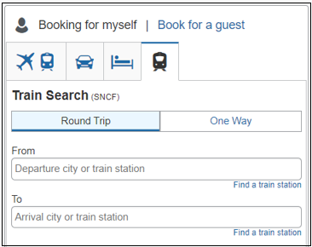

Known Limitations
Until further notice, the following features will be not supported or supported with limitations for migrated customers.
- The multi-passenger booking feature will not be supported for migrated customers.
- Eurostar will not support seat preferences or selection.
- Combining TGV and TER segments in one reservation might lead to additional work on the travel agency side for specific reservations. To prevent this situation, the recommendation for travelers with a middle name having either the SNCF loyalty or advantage card is to ask SNCF to not store their middle name in their database.

Configuration for Professional and Standard Travel
This feature will be enabled by default. SAP Concur will make these changes automatically.

Previous Experience
SNCF and SNCF (PAO) are enabled in the travel configuration page under the Rail Connectors section.

New Experience
Once the migration is completed, only the SNCF (PAO) rail connector will remain available in the travel configuration page.

Travel Operations / Technical Essentials

**Planned Changes** SNCF API (PAO) Migration

Information First Published | Information Last Modified | Feature Target Release Date
December 2022 | -- | TBD
Any changes since the previous monthly release are highlighted in yellow in this release note.

Prof | Stan | Å Å Edition
X | X | On: Impacts end users who use this feature/vendor; no configuration/setup by agency/ admin; cannot be turned OFF (example: new icons or rate display)
 |  | Available for use: No impact to end users unless/until configuration/setup by agency/admin (described below) (example: new rule, new Travelfusion airline)
 |  | Other: Refer to the release note below
 |  | Does not apply to this edition
Source
GDS
Direct Connect |  | SNCF PAO Direct Connect
Other
X | EMEA Data Center |  |  | Scan impact
X | North America Data Center |  |  | UI impact
 | China Data Center |  |  | File finishing impact
 | All data centers |  |  | Profile/Profile API/3rd Party XML Sync Impact
Affected Documentation
TSGs |  | SNCF PAO Direct Connect TSG (available with release)
Fact Sheets
Admin Guides
Other

Overview
SNCF (PAO) utilizes the French PCC (B930) for Concur Travel. The branch access will remain opened for existing SNCF PCC (previously known as Resarail PCC) in France.
Travel agencies outside of France with SNCF PCC will need to establish branch access from SNCF PCC to the SAP Concur SNCF PCC B930. This will ensure that these agencies can continue servicing SNCF reservations created in Concur Travel.
The following SAP Concur PCCs will not be supported with SNCF PAO:
- UK: C870
- Belgium: H060
- Switzerland: F460
- Netherlands: H070
When granting branch B access, refer to the following:

GDS | Command to grant branch access to B930
Amadeus | R//W/TAA yourSNCFPCC $BB930
In addition to granting branch access from your agency's SNCF PCC to SAP Concur's SNCF PCC, you must also execute the JGU/RAI-2C command on your Amadeus terminal. This will allow your Amadeus Office ID to identify SNCF as a rail provider. Failure to execute this one-time command will result in your seeing SECURED PNR whenever you attempt to search for an SNCF booking created in Concur Travel, even if it was correctly queued to your agency's SNCF PCC.

Client Notifications

Accessibility

Accessibility Updates
SAP implements changes to better meet current Web Content Accessibility Guidelines (WCAG). Information about accessibility-related changes made to SAP Concur solutions is published on a quarterly basis. You can review the quarterly updates on the Accessibility Updates page.

Documentation for New Concur Travel Experience

Online Help Updates in the SAP Help Portal

Overview
Online end user help documentation for the new Concur Travel experience, beginning with the Renfe Direct Connect enhancements from the November release, are indicated with “New Workflow” text at the end of topic titles.
Also, on the Implement tab of the Concur Travel product page in the SAP Help Portal, there is a new Travel Services Help. This will become the new home for Travel Service Guides type documentation.

User/Customer Benefit
The “New Workflow” text is intended to help you distinguish between the existing experience and the redesigned experience for Concur Travel.

End-User Experience
When accessing the Concur Travel End User Help, you can see which topics are specific to the Concur Travel experience as they contain the suffix "New Workflow".
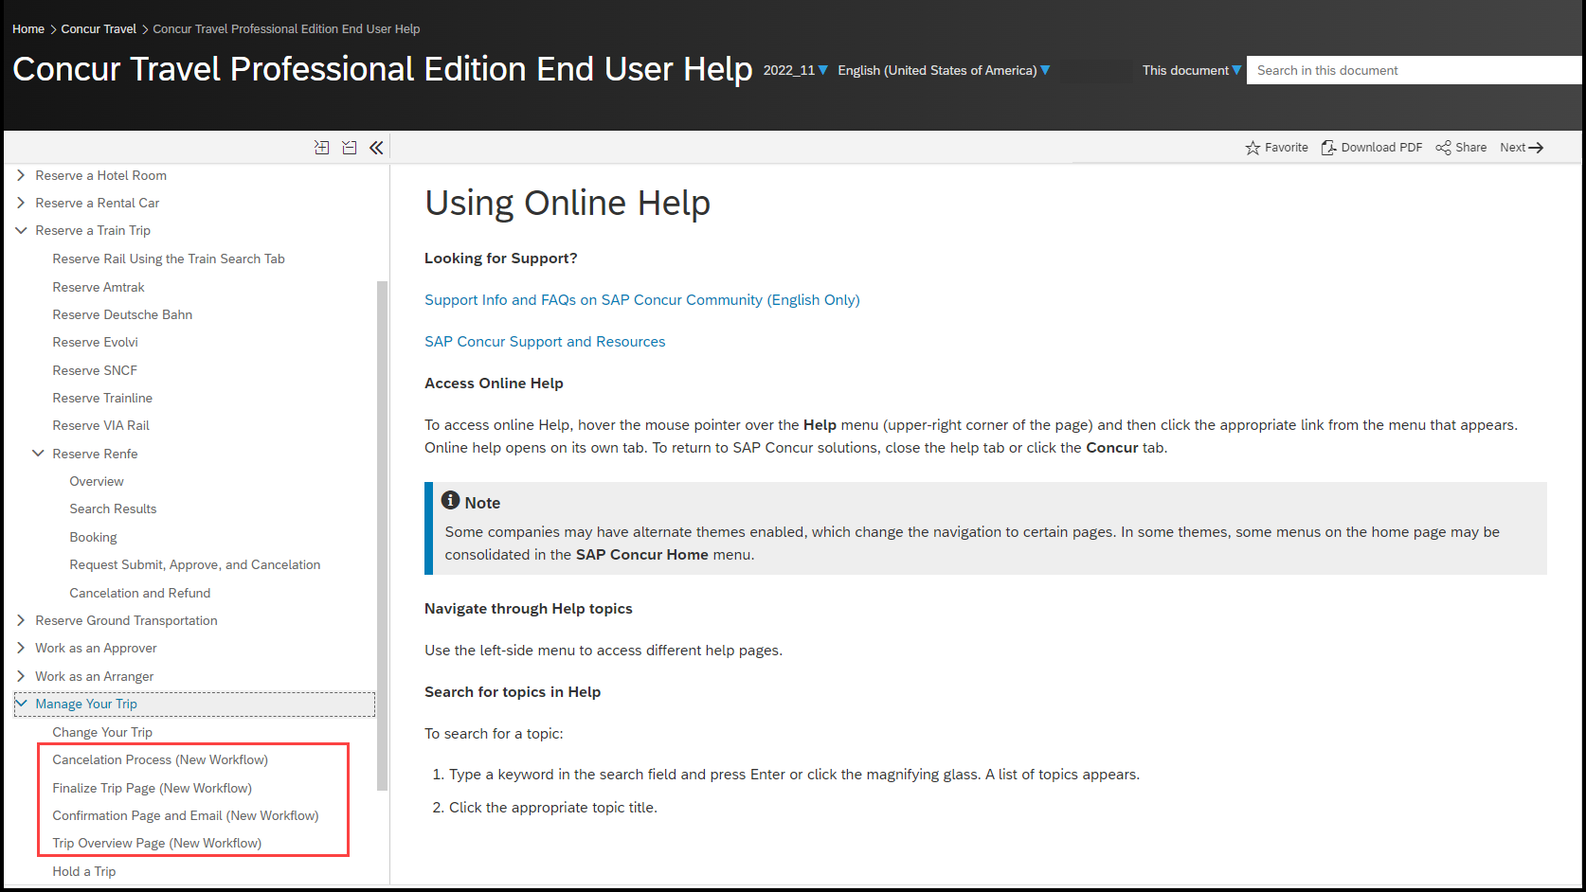

Configuration for Professional and Standard Travel
This feature is enabled by default. There are no configuration steps.

In-Product User Assistance

Client Customized Content
If your company creates customized content for SAP Concur solutions through a user assistance tool such as SAP Enable Now or Concur User Assistant by WalkMe, the changes described in these release notes might affect your customized content. SAP Concur recommends reviewing the monthly release notes for all of your SAP Concur solutions as well as the Shared Changes Release Notes to confirm whether any of the planned or released changes might impact your internal, customized content.
If any changes in a release impact your content, work with your internal teams to update your content accordingly.

Subprocessors

SAP Concur Non-Affiliated Subprocessors
The list of non-affiliated subprocessors is available from the SAP Sub-processors / Data Transfer Factsheets page.
To access the SAP Concur Sub-processors List:
- Click the following link to navigate to the SAP Sub-processors / Data Transfer Factsheets page:
SAP Sub-processors / Data Transfer Factsheets
- Sign in to the SAP Support Portal using your Support User ID (S-user) and password.
SAP customers must sign in to the SAP Support Portal using their Support User ID (S-user) and password. For information about S-User IDs, refer to Your New Support User ID (S-user) and to the Learn All About S-User IDs blog post.
- On the SAP Sub-processors / Data Transfer Factsheets page, type "Concur" in the Search field.
- In the Title column, click SAP Concur Sub-processors List.
If you have questions or comments, please reach out to: Privacy-Request@Concur.com

Supported Browsers

Supported Browsers and Changes to Support
For information about supported browsers and planned changes to supported browsers, refer to the Concur Travel & Expense Supported Configurations guide.
When changes to browser support are planned, information about those changes will also appear in the Shared Changes Release Notes.

Additional Release Notes and Other Technical Documentation

Online Help
You can access release notes, setup guides, user guides, admin summaries, supported configurations, and other resources via the in-product Help menu or directly on the SAP Help Portal.
To access the full set of documentation for your product, use the links in the SAP Concur Help menu, or visit the SAP Concur solutions page.
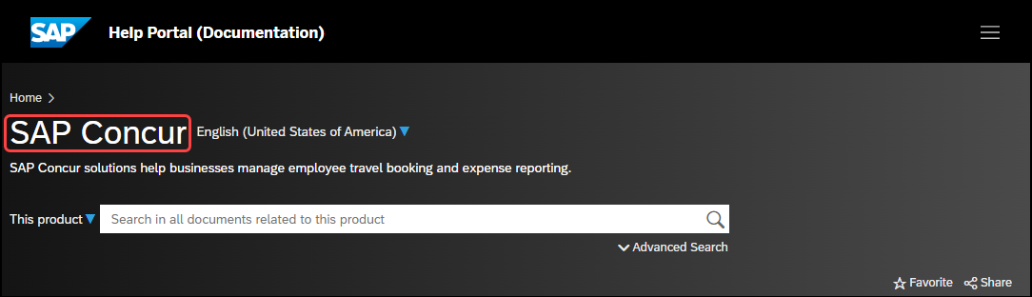

SAP Concur Support Portal – Selected Users
Access release notes, webinars, and other technical documentation on the SAP Concur support portal.
If you have the required permissions, Contact Support is available on the SAP Concur Help menu and in the SAP Concur page footer.
Click Contact Support to access the SAP Concur support portal, then click Resources.
- Click Release/Tech Info for release notes, technical documents, etc.
- Click Webinars for recorded and live webinars.

© 2023 SAP SE or an SAP affiliate company. All rights reserved.
No part of this publication may be reproduced or transmitted in any form or for any purpose without the express permission of SAP SE or an SAP affiliate company.
SAP and other SAP products and services mentioned herein as well as their respective logos are trademarks or registered trademarks of SAP SE (or an SAP affiliate company) in Germany and other countries. Please see http://global12.sap.com/corporate-en/legal/copyright/index.epx for additional trademark information and notices.
Some software products marketed by SAP SE and its distributors contain proprietary software components of other software vendors.
National product specifications may vary.
These materials are provided by SAP SE or an SAP affiliate company for informational purposes only, without representation or warranty of any kind, and SAP SE or its affiliated companies shall not be liable for errors or omissions with respect to the materials. The only warranties for SAP SE or SAP affiliate company products and services are those that are set forth in the express warranty statements accompanying such products and services, if any. Nothing herein should be construed as constituting an additional warranty.
In particular, SAP SE or its affiliated companies have no obligation to pursue any course of business outlined in this document or any related presentation, or to develop or release any functionality mentioned therein. This document, or any related presentation, and SAP SE’s or its affiliated companies’ strategy and possible future developments, products, and/or platform directions and functionality are all subject to change and may be changed by SAP SE or its affiliated companies at any time for any reason without notice. The information in this document is not a commitment, promise, or legal obligation to deliver any material, code, or functionality. All forward-looking statements are subject to various risks and uncertainties that could cause actual results to differ materially from expectations. Readers are cautioned not to place undue reliance on these forward-looking statements, which speak only as of their dates, and they should not be relied upon in making purchasing decisions.

