SAP Concur Release Notes
Concur Travel
Concur Professional/Premium and Concur Standard
Month | Audience
Release Date: March 18, 2023  Update 2: Wednesday, March 29 | SAP Concur Client FINAL

** FINAL **
The enhancements and changes described in this document may or may not be included in this release. SAP Concur reserves the right to postpone implementation of – or completely remove – any enhancement/change mentioned here.
The DRAFT and FINAL release notes contain information about Concur Professional/Premium and Concur Standard.
Each note contains a table that which indicates if the enhancement/change applies to Professional and/or Standard.
Contents
Release Notes 1
Administration 1
Croatian Change of Currency 1
Flight 2
American Airlines New Distribution Capability (NDC) Content 2
Miscellaneous 7
Preferred Name Display (En-US only) 7
Travel Operations / Technical Essentials 12
Renfe RVR SFTP Endpoint Decommission (Professional Edition Only) (Mar 30) 12
SNCF API (PAO) Migration – Update 13
Planned Changes 15
Car 15
New Concur Travel Car Experience 15
**Planned Changes** New Rental Car Experience (Amadeus Only): Overview 15
**Planned Changes** New Rental Car Experience: Search for a Car Rental 17
**Planned Changes** New Rental Car Experience: Review and Book 26
**Planned Changes** New Rental Car Experience: Finalize and Confirm Booking 37
**Planned Changes** New Rental Car Experience: Completed Trip Overview 44
**Planned Changes** New Rental Car Experience: Cancellation 50
**Planned Changes** New Rental Car Experience: Configuration for Hertz and Sixt 53
**Planned Changes** New Rental Car Experience: Reduced Feature Set 55
**Planned Changes** New Rental Car Experience: Delivery and Collection 64
**Planned Changes** New Rental Car Experience: Support of Corporate and Non-Corporate Rates (Public and Leisure) 65
Hotel 72
**Planned Changes** New Hotel Experience (Custom Hotel Source Only): Overview 72
**Planned Changes** New Hotel Experience: Search for a Hotel 73
**Planned Changes** New Hotel Experience: Review and Book 84
**Planned Changes** New Hotel Experience: Finalize and Confirm Booking 91
**Planned Changes** New Hotel Experience: Completed Trip Overview 96
**Planned Changes** New Hotel Experience: Cancellation 99
**Planned Changes** New Hotel Experience: Configuration for Custom Hotel Sourcing 101
**Planned Changes** New Hotel Experience: Reduced Feature Set 103
Rail 110
**Planned Changes** SNCF API (PAO) Migration 110
Travel Operations / Technical Essentials 114
**Planned Changes** SNCF API (PAO) Migration 114
Client Notifications 116
Accessibility 116
Accessibility Updates 116
Documentation for New Concur Travel Experience 116
Online Help Updates in the SAP Help Portal 116
Sub-processors 117
SAP Concur Non-Affiliated Sub-processors 117
Supported Browsers 118
Supported Browsers and Changes to Support 118
Additional Release Notes and Other Technical Documentation 119
Online Help – Admins 119
SAP Concur Support Portal – Selected Users 120
Legal Disclaimer
The information in this presentation is confidential and proprietary to SAP SE or an SAP affiliate company and may not be disclosed without the permission of SAP SE or the respective SAP affiliate company. This presentation is not subject to your license agreement or any other service or subscription agreement with SAP SE or its affiliated companies. SAP SE and its affiliated companies have no obligation to pursue any course of business outlined in this document or any related presentation, or to develop or release any functionality mentioned therein. This document, or any related presentation and SAP SE or an SAP affiliate company’s strategy and possible future developments, products and or platforms directions and functionality are all subject to change and may be changed by SAP SE and its affiliated companies at any time for any reason without notice. The information in this document is not a commitment, promise or legal obligation to deliver any material, code or functionality. This document is provided without a warranty of any kind, either express or implied, including but not limited to, the implied warranties of merchantability, fitness for a particular purpose, or non-infringement. This document is for informational purposes and may not be incorporated into a contract. SAP SE and its affiliated companies assume no responsibility for errors or omissions in this document, except if such damages were caused by SAP SE or an SAP affiliate company’s willful misconduct or gross negligence.
All forward-looking statements are subject to various risks and uncertainties that could cause actual results to differ materially from expectations. Readers are cautioned not to place undue reliance on these forward-looking statements, which speak only as of their dates, and they should not be relied upon in making purchasing decisions.

Release Notes

Administration

Croatian Change of Currency

Prof | Stan |   Edition
X | X | On: Impacts end users who use this feature/vendor; no configuration/setup by agency/ admin; cannot be turned OFF (example: new icons or rate display)
 |  | Available for use: No impact to end users unless/until configuration/setup by agency/admin (described below) (example: new rule, new Travelfusion airline)
 |  | Other: Refer to the release note below
 |  | Does not apply to this edition
Source
GDS |  | All
Direct Connect |  | N/A
Other
X | EMEA Data Center |  |  | Scan impact
X | North America Data Center |  | X | UI impact
 | China Data Center |  |  | File finishing impact
 | All data centers |  |  | Profile/Profile API/3rd Party XML Sync Impact
Affected Documentation
TSGs
Fact Sheets
Admin Guides |  | Travel System Admin
Other

Overview
Croatia adopted the Euro as its currency on January 1, 2023.With the February release, SAP Concur is making necessary changes to Concur Travel to set Euro as the currency for Croatia.

User/Customer Benefit
Users can now see Euro (€) as the currency for Croatia in Concur Travel.

Configuration for Professional and Standard Travel
Changes were made to Administration > Travel (on the sub-menu) > Travel System Admin (access the desired client travel configuration) > Agency Ticketing Country/Currency. The setting will be updated as follows:
Example:
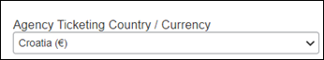
This setting was automatically updated. There are no configuration steps needed.
For more information, refer to the Travel System Admin User Guide. To locate, refer to Additional Release Notes and Other Technical Documentation in these release notes.

Flight

American Airlines New Distribution Capability (NDC) Content

Prof | Stan |   Edition
 |  | On: Impacts end users who use this feature/vendor; no configuration/setup by agency/ admin; cannot be turned OFF (example: new icons or rate display)
X | X | Available for use: No impact to end users unless/until configuration/setup by agency/admin (described below) (example: new rule, new Travelfusion airline)
 |  | Other: Refer to the release note below
 |  | Does not apply to this edition
Source
GDS
Direct Connect |  | Travelfusion
Other
X | EMEA Data Center |  |  | Scan impact
X | North America Data Center |  | X | UI impact
 | China Data Center |  | X | File finishing impact
 | All data centers |  |  | Profile/Profile API/3rd Party XML Sync Impact
Affected Documentation
TSGs |  | Travelfusion / New Distribution Capability (NDC), Travelfusion Direct Connect
Fact Sheets
Admin Guides
Other

Overview
Airlines are increasingly utilizing the IATA New Distribution Capability (NDC) API Schema because it gives them more control over how they offer products compared to legacy Global Distribution Systems (GDS-EDIFACT).
As part of the SAP Concur commitment to ensuring clients have access to all relevant content including NDC-sourced content, last year, SAP Concur introduced American Airlines NDC content via Concur Select Access (Travelfusion) available from January 25, 2022.
Based on the changing market requirements, SAP Concur made a significant update to the American Airlines NDC connection. The bookings will now be ticketed on the TMC’s own ticket stock (neutral ticketing) instead of the previously available direct airline ticketing. Customers and/or TMCs, whose credentials were issued on or before January 2023, must obtain new credential set by the airline.
How bookings are serviced will also change. Travelers or travel arrangers can contact their TMC to request changes to a booking. Refer to the Known Limitations section in this release note for further details.
To provide travelers with an optimal user experience when booking air travel, SAP Concur prohibits mixing an airline’s content from a GDS and Travelfusion in a Concur Travel air shopping display. Customers who currently want access to NDC-sourced fares for a particular airline in Concur Travel should access all the fares from those carriers through Travelfusion.
For detailed information on this capability or instructions on obtaining new credentials, refer to the Travelfusion/New Distribution Capability Travel Service Guide. For detailed information about the functional integration of Travelfusion Direct Connect, refer to the Travelfusion Direct Connect Travel Service Guide. To locate, refer to Additional Release Notes and Other Technical Documentation in these release notes.

User/Customer Benefit
In some markets, airlines provide differentiated content (for example, brands, bundles, ancillaries, or fares) than is available in the GDS.
Customers can access the relevant content using Select Access to ensure users can book the right type of product depending on the travel scenario. For example, American Airlines’ Main Plus: Complimentary Seats + Bag are normally only available through the NDC channel. Select Access allows clients to book these types of fares when it meets their needs.

End-User Experience
Example: Shop by Fares
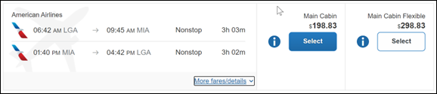
Example: Expanded Display
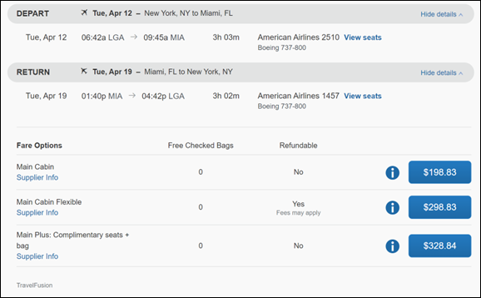
Example: Flight Options
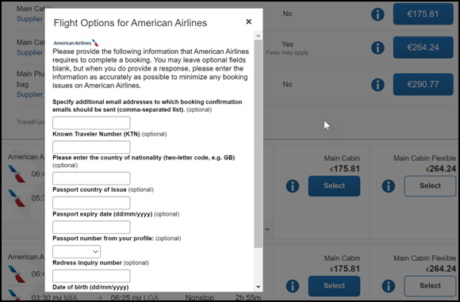

Configuration for Professional and Standard Travel
To proceed with American Airlines bookings via Travelfusion, American Airlines must be enabled in the travel configuration. For a successful implementation, follow the instructions for Travelfusion general configuration, administrative settings, the specifically desired airline content, and select the American checkbox.
The Agency Fulfillment Partners must add their ARC/IATA Agency Number on the Travel System Admin > Travel Agency Detail (Agency Booking Configuration) page in order to grant access for the customers’ bookings with Travelfusion tools.
For more information, refer to the Travelfusion Direct Connect and Travelfusion/New Distribution Capability (NDC) Travel Service Guides. To locate, refer to Additional Release Notes and Other Technical Documentation in these release notes.
For additional reference, review the SAP Concur blog article How to Access American Airlines Fares in Concur Travel if American Removes them from the EDIFACT GDS.
These steps are covered in detail in the Travelfusion Direct Connect and Travelfusion/New Distribution Capability (NDC) Travel Service Guides:
- Enabling Travelfusion by TMC/Client
- Inhibiting the airline content in the GDS response (Required by Concur Travel policy to ensure a satisfactory user experience)
- Adding required and optional credentials (for example, IATA #, PCC, etc.) to receive the airline content via Travelfusion
- Enabling the airline as a supplier to be searched in Travelfusion
- PNR Finishing
- Application of Travel Policy rules (Approvals, Rules, and Classes/Policies Travel Services Guide)

Known Limitations
Note the following:
- The traveler will receive notifications and updates directly from the airline in case of schedule changes. The Concur Travel itinerary will not receive airline updates after the initial booking is posted to the itinerary.
- Travelers will receive booking confirmation from the airline.
- Multi-segment shop and book is not supported.
- Solution supports credit card and ghost card forms of payment only.
- Since Travelfusion bookings in Concur Travel are instant purchase bookings, the reservations cannot be put on hold.
- Bookings cannot be voided or cancelled in Concur Travel; however, travelers can cancel on the American Airlines website. Concur Travel users can also manage their cancellation requests directly with their TMC.
- Changes to a booking cannot be managed in Concur Travel or the American Airlines website. Travelers can manage the booking changes with their TMC.

Miscellaneous

Preferred Name Display (En-US only)

Prof | Stan |   Edition
X | X | On: Impacts end users who use this feature/vendor; no configuration/setup by agency/ admin; cannot be turned OFF (example: new icons or rate display)
 |  | Available for use: No impact to end users unless/until configuration/setup by agency/admin (described below) (example: new rule, new Travelfusion airline)
 |  | Other: Refer to the release note below
 |  | Does not apply to this edition
Source
GDS
Direct Connect
Other
 | EMEA Data Center |  |  | Scan impact
X | North America Data Center |  |  | UI impact
 | China Data Center |  |  | File finishing impact
 | All data centers |  |  | Profile/Profile API/3rd Party XML Sync Impact
Affected Documentation
TSGs
Fact Sheets
Admin Guides
Other

Overview
With this release, the user has the option to display their preferred name instead of their default legal name. This feature affects the following areas:
- Travel Arranger View.
- Delegate Flow or Travel Assistants.
- Itinerary e-mails.
- Trip Approvals Widget.
- TripLink e-mail changes.
This feature is available for users whose language is set to US English.

User/Customer Benefit
These changes reflect SAP's commitment to supporting gender diversity by enabling gender non-binary users to enter consistent information when making travel arrangements and entering information in SAP Concur solutions.

End-User Experience
Previously, a user's legal name was displayed automatically. With this feature, a preferred name can be shown instead. If a user's preferred name is not enabled in the system, their legal name will continue to display.

To Configure
For preferred name to display, in My Profile-Personal Information a name must be entered in the Preferred Name field.
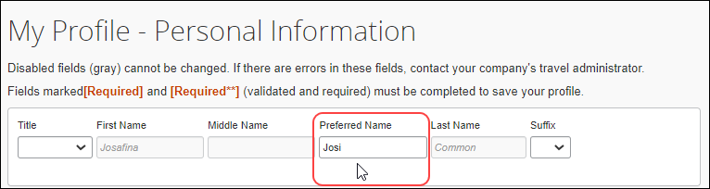
Once this field is populated, the user's preferred name will display instead of their legal name.

Travel Arranger
Previously in the Travel Arranger View, only the client’s legal name was displayed.
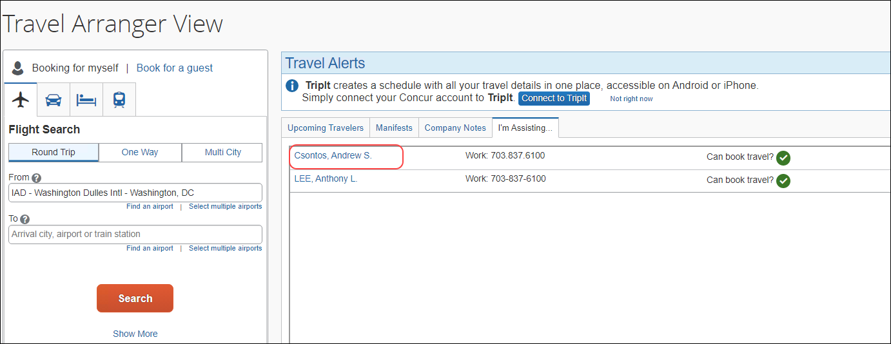
Once a client’s preferred name is added, this name automatically displays.
Delegate flow or Travel Assistants
The preferred name of the person you are choosing to assist now shows in the Acting as other user dropdown. Autocomplete results will populate based on the preferred name entry.
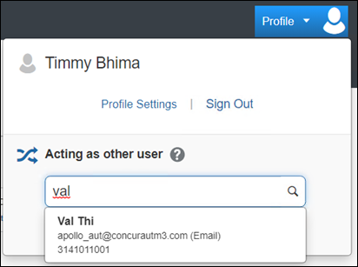
When a delegate or assistant selects one of the results from the Acting as other user list, you will see preferred name in place of the first name.
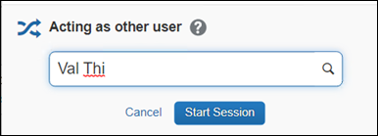

Itinerary e-mails
The subject line in system generated e-mail notifications can now show preferred name. This is enabled for traveler, delegate, and approver e-mails.
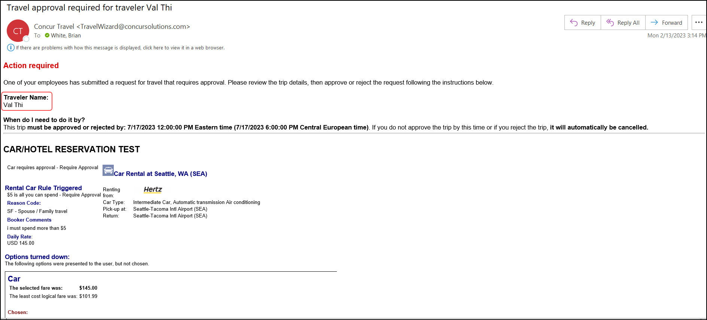
Trip Approvals Widget
In Trip Approvals, preferred name can appear instead of legal name where available.
In Request Status History, this new feature is visible in the Submitted By, Requires Approval By, and Request Created By fields.
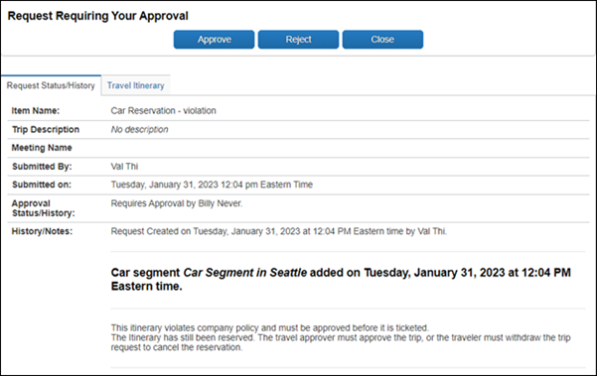

TripLink E-Mail Changes (January 31)
TripLink e-mails for Your Concur Account Connections have been adjusted.
When preferred name is enabled, it appears in e-mails related to Your Concur Account Connections.
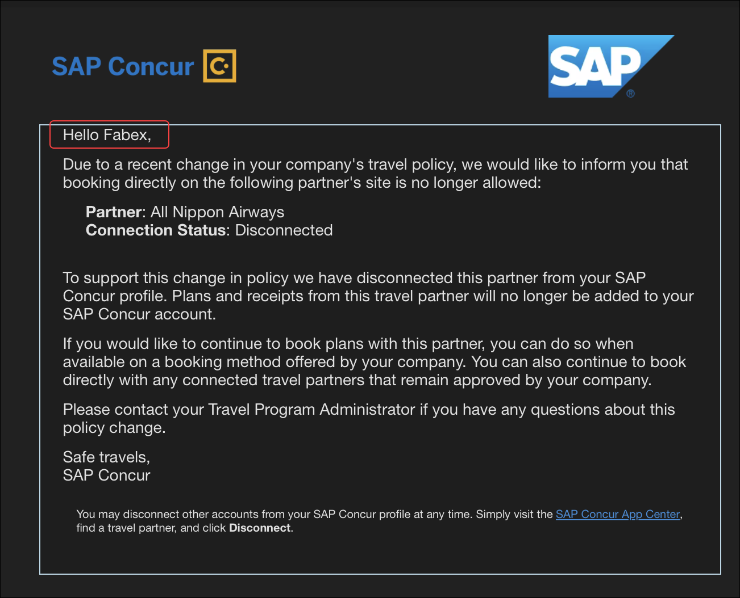

Configuration for Professional and Standard Travel
This feature is enabled by default. There are no configuration steps.
For more information, refer to the Preferred Name and Nonbinary Gender Options fact sheet. To locate, refer to Additional Release Notes and Other Technical Documentation in these release notes.

Travel Operations / Technical Essentials

Renfe RVR SFTP Endpoint Decommission (Professional Edition Only) (Mar 30)

Prof | Stan | Edition
X |  | On: Impacts end users who use this feature/vendor; no configuration/setup by agency/ admin; cannot be turned OFF (example: new icons or rate display)
 |  | Available for use: No impact to end users unless/until configuration/setup by agency/admin (described below) (example: new rule, new Travelfusion airline)
 |  | Other: Refer to the release note below
 |  | Does not apply to this edition
Source
GDS
Direct Connect |  | Renfe
Other
X | EMEA Data Center |  |  | Scan impact
X | North America Data Center |  |  | UI impact
 | China Data Center |  |  | File finishing impact
 | All data centers |  |  | Profile/Profile API/3rd Party XML Sync Impact
Affected Documentation
TSGs
Fact Sheets |  | Renfe RVR Service & Specification
Admin Guides
Other

Overview
RVR (Registro de Ventas) is a Renfe sale register which contains all the booking and cancellation details that TMCs need for invoicing purposes. All RVR files created for a TMC’s clients are stored in a specific folder reflecting the TMC name. The files should be downloaded from the SAP Concur server and, once downloaded, the TMC should delete the files.
With AWS migration completed, the legacy SFTP endpoints of the RVR service are expected to be decommissioned on March 30, 2023.
Affected SFTP endpoints:
- EU: rvr-sftp.eu.travel.concursolutions.com
- US: rvr-sftp.us.travel.concursolutions.com
TMCs should verify that any remaining records have been downloaded and deleted from the server before the decommission deadline of March 30, 2023, as access will be denied after this date.
TMCs should also adjust their processes to stop accessing the above endpoints. This change does not impact the EU2 and US2 SFTP endpoints:
- EU2: rvr-eu2.concursolutions.com
- US2: rvr-us2.concursolutions.com

End-User Experience
Changes will not affect End-User experience.

Configuration for Professional Travel
There are no configuration steps needed within Concur Travel as these changes affect TMC processes only.

SNCF API (PAO) Migration – Update

Prof | Stan | Å Å Edition
X | X | On: Impacts end users who use this feature/vendor; no configuration/setup by agency/ admin; cannot be turned OFF (example: new icons or rate display, new Amtrak feature)
 |  | Available for use: No impact to end users unless/until configuration/setup by agency/admin (described below) (example: new rule, new Travelfusion airline)
 |  | Other: Refer to the release note below
 |  | Does not apply to this edition
Source / Solution Suggestion
GDS
Direct Connect |  | SNCF PAO Direct Connect
Other
X | EMEA Data Center |  |  | Scan impact
X | North America Data Center |  |  | UI impact
 | China Data Center |  |  | File finishing impact
 | All data centers |  |  | Profile/Profile API/3rd Party XML Sync Impact
Affected Documentation
TSGs |  | SNCF PAO Direct Connect TSG (available with release)
Fact Sheets
Admin Guides
Other

Overview
SNCF is planning to replace the inventory hosting SNCF offer. Following the SNCF announcement on the postponing the opening of the new inventory, the original migration date of April 4 has been delayed. Further updates will be shared in future release notes.
In preparation for migration completion, SNCF [PAO] settings have been updated with the SNCF PCC field. This will allow users to establish branch access from a new SNCF PCC (previously known as Resarail PCC) of the travel agency to SAP Concur’s SNCF PCC (B930).

Previous Experience
SNCF and SNCF (PAO) are enabled in the travel configuration page under the Rail Connectors section.

New Experience (in Interim)
SNCF and SNCF (PAO) are enabled in the travel configuration page under the Rail Connectors section. The SNCF (PAO) settings is updated with the SNCF PCC field.
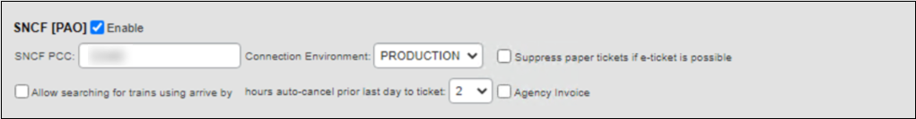
The Resarail PCC field and its existing value has been automatically moved to the SNCF (PAO) rail connector as SNCF PCC. For further information, refer to the Travel Operations / Technical Essentials area of these release notes.

Planned Changes
The items in this section are targeted for future releases. SAP Concur solutions reserves the right to postpone implementation of – or completely remove – any enhancement or change mentioned here.
The planned changes listed in this document are specific to this product. For information about planned site-wide or shared changes that might impact your SAP Concur solutions, refer to the Shared Changes Release Notes.

Car

New Concur Travel Car Experience
If you are participating in the initial release of the new Concur Travel car experience, your SAP Concur representative can provide draft GDS PNR documentation upon request.

**Planned Changes** New Rental Car Experience (Amadeus Only): Overview

Information First Published | Information Last Modified | Feature Target Release Date
December 2023 | February 23, 2023 | TBD
Any changes since the previous monthly release are highlighted in yellow in this release note.

Prof | Stan |   Edition
 |  | On: Impacts end users who use this feature/vendor; no configuration/setup by agency/ admin; cannot be turned OFF (example: new icons or rate display)
 |  | Available for use: No impact to end users unless/until configuration/setup by agency/admin (described below) (example: new rule, new Travelfusion airline)
X | X | Other: Refer to the release note below
 |  | Does not apply to this edition
Source
GDS |  | Amadeus
Direct Connect
Other
 | EMEA Data Center |  |  | Scan impact
 | North America Data Center |  |  | UI impact
 | China Data Center |  |  | File finishing impact
 | All data centers |  |  | Profile/Profile API/3rd Party XML Sync Impact
Affected Documentation
TSGs
Fact Sheets
Admin Guides
Other

Overview
Targeted for 2023, Concur Travel will introduce a new rental car booking experience. This first release is limited to participating Amadeus TMC partners. With this integration, customers can experience:
- An intuitive and personalized design, with an easy-to-use experience.
- Seamless GDS and non-GDS content normalization, aggregation and servicing.
- Mobile and web content parity.

User/Customer Benefit
The new Concur Travel rental car booking experience is available with a specific feature set for customers open to explore the changes.
- Time Savings: The user is getting through the booking experience faster with less pages to go through.
- Delivery and Collection: Select the Delivery and Collection service right up front with a choice of any favorite address and discover the compact and smooth booking experience.
- Sustainability: Let end users consider the environmental footprint by comparing carbon dioxide (CO2) emissions between offered vehicles. Additional filter options on hybrid and electric cars help promote more sustainable choices.
- Merged on-airport and off-airport search: No matter where the user requires a rental car, all text entries are recognized, and location suggestions are provided. All activated rental car companies with negotiated packages are comparable. Details such as included services will display next to total rates with taxes and fees.
- Localized content: When a rental car location exists in the GDS, it exists in Concur Travel. Locations are offered in real-time, with the most up-to-date location details as provided by the GDS.

**Planned Changes** New Rental Car Experience: Search for a Car Rental

Information First Published | Information Last Modified | Feature Target Release Date
December 2023 | February 24, 2023 | TBD
Any changes since the previous monthly release are highlighted in yellow in this release note.

Prof | Stan |   Edition
 |  | On: Impacts end users who use this feature/vendor; no configuration/setup by agency/ admin; cannot be turned OFF (example: new icons or rate display)
 |  | Available for use: No impact to end users unless/until configuration/setup by agency/admin (described below) (example: new rule, new Travelfusion airline)
X | X | Other: Refer to the release note below
 |  | Does not apply to this edition
Source
GDS |  | Amadeus
Direct Connect
Other
 | EMEA Data Center |  |  | Scan impact
 | North America Data Center |  |  | UI impact
 | China Data Center |  |  | File finishing impact
 | All data centers |  |  | Profile/Profile API/3rd Party XML Sync Impact
Affected Documentation
TSGs
Fact Sheets
Admin Guides
Other

End-User Experience: Search for a Car Rental
The search options include a free text entry field for the pick-up location and when required, the drop-off location. Whether the user is searching for an on-airport or off-airport rental car location, they can type the preferred location. The “omni search” functionality will suggest matching options for cities, airports, company locations, business addresses, railway stations, points of interest and general addresses.
To search for a company address, type the name in the Search field and matching results will appear in the dropdown.
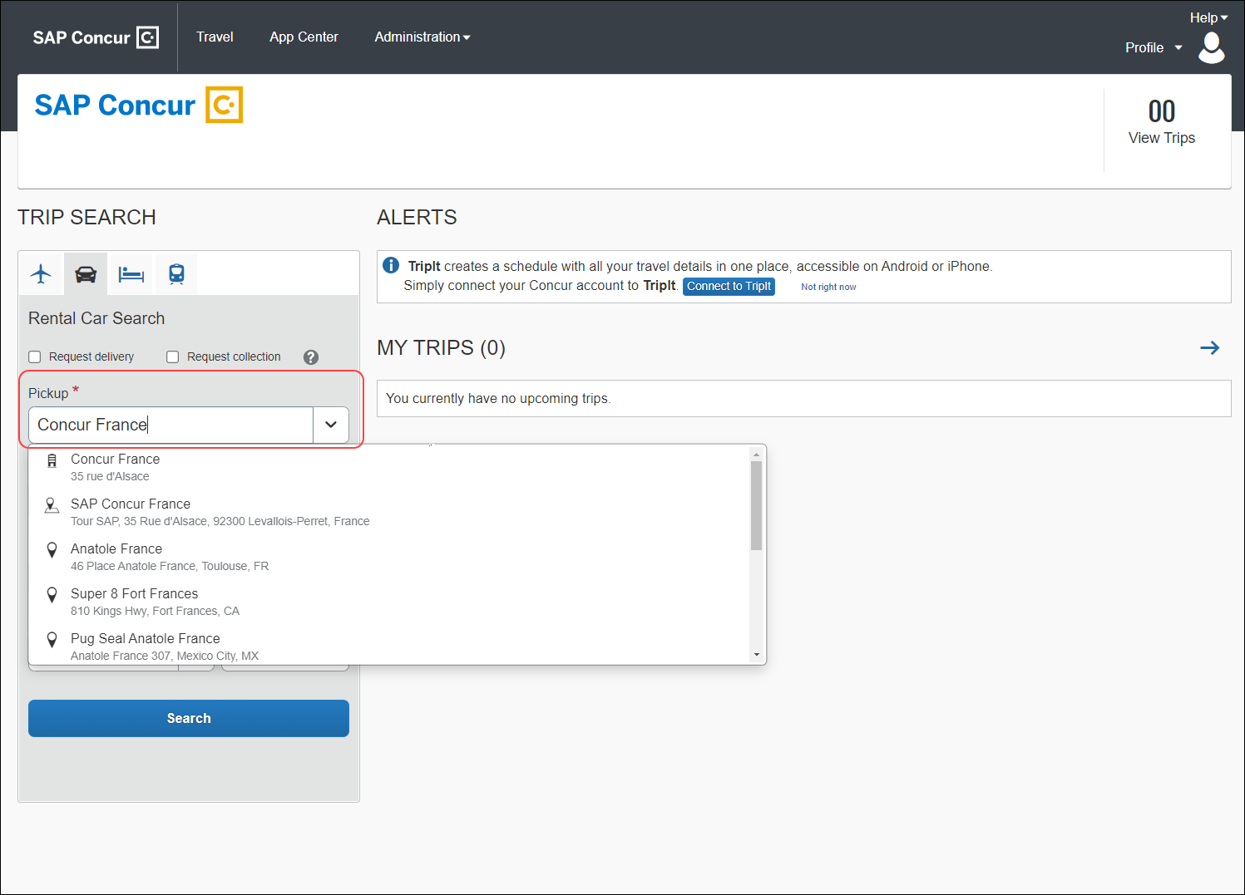
Pickup and drop-off dates are always pre-populated by tomorrow's date and day after tomorrow, respectively. The default time is set to 10:00 AM.
If the delivery and collection service has been activated by the Travel System Admin, equivalent checkboxes become visible within the Search field. The end user can request this service as part of their initial search request.

Car Search
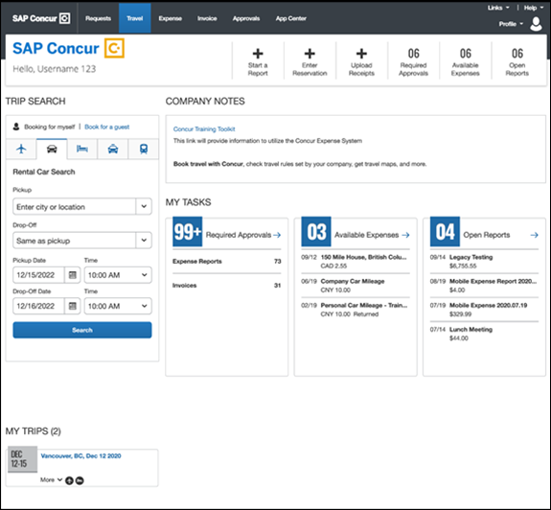

Car Search with Delivery and Collection Enabled
The delivery and collection service will be limited to customers with a corporate discount number and a corresponding agreement with rental car partners.
This service will be available for Amadeus content in the same way as for all providers connected listed under the Car Connector options within the Travel Configuration.
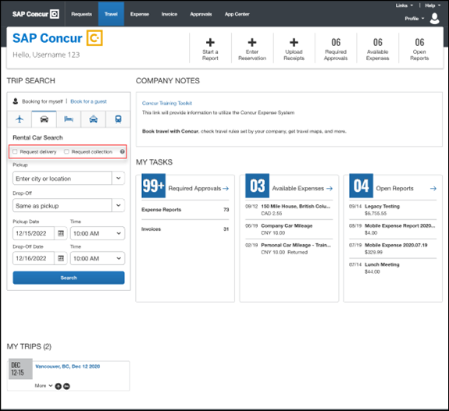

End-User Experience: Select a Car Rental
Once the user has entered their search criteria and clicked Search, the search results display.
When a Car Connector rental car provider is enabled the content will not be returned from the GDS side for this particular rental car provider. This is to avoid the duplication of rates.
In the first iteration of the new rental car experience, a corporate discount number must be used. This is mandatory to retrieve rates within Concur Travel. Future releases will lift this limitation gradually.
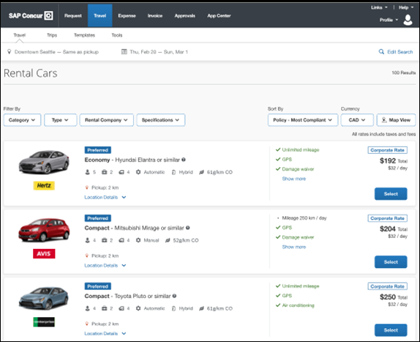

Edit Search
At the top of the page, Concur Travel presents the entered search data and provides an option to change the search criteria again with Edit Search.
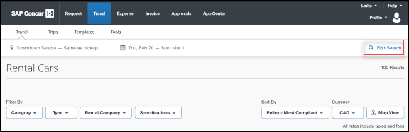

Filter Options
Users can filter the search by car category, car type, rental company, and specifications (transmission type, hybrid, or electric).
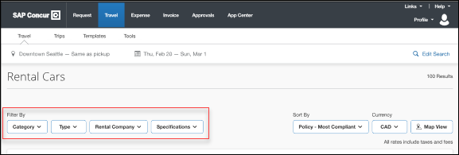

Sorting Options
The sorting options include Total Cost, Distance, Policy - Most Compliant, and Preferred Rental Car Company.
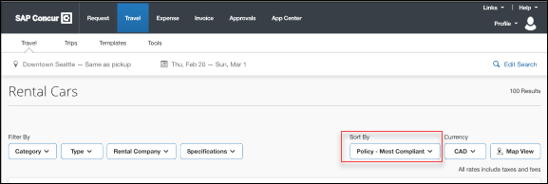

Car Features
The focus of the page is set to the result list which shows consistent information across the car offers. The vehicle-related information includes number of seats, bags, and doors, transmission, fuel type, and carbon dioxide emission values.
The carbon dioxide (CO2) emissions are retrieved from a table provided by the ACRISS organization which contains values in g/km NEDC. Calculations in other measurement units are unavailable. Future considerations on where to retrieve the data from on a global level are under evaluation.
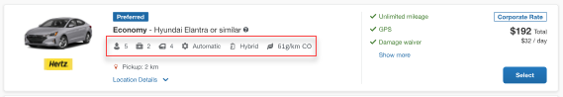

Corporate Rates
The corporate rates, highlighted via a label, include specific negotiated ancillaries which will display to the user to compare all included services between the offers. A new experience is the comparison between rental car locations and suppliers in general. To show the most relevant results, the system limits the displayed locations to a maximum of 5 nearest rental car locations per supplier.
In the initial release of the new rental car workflow only corporate rates are supported.
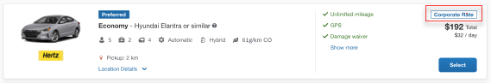

Location Details
For airport rentals, it is indicated when a shuttle transfer is required to get to the rental car location. All displayed locations are evaluated based on their opening hours, out-of-hours service, availability and delivery and collection service, if applicable. Also, the airport terminal information is provided (when available from the external content channels) within the location details section.
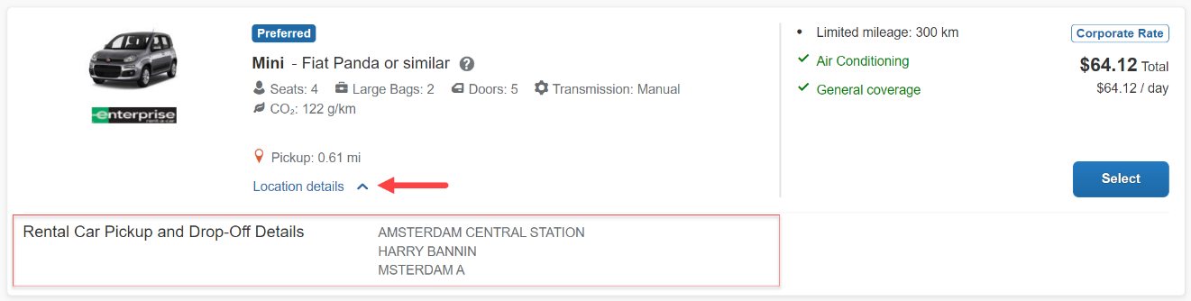

Total Price
Total prices always display in comparison to the daily rates. All displayed rates include all taxes and fees.
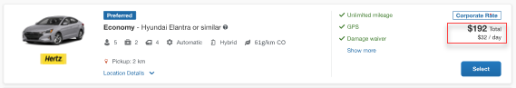

Travel Policy
When a rental car offer violates a policy rule, the segment is marked with a corresponding warning icon. Click the icon to see more information on the policy rules that apply.
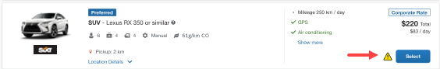

Delivery and Collection
When a user searches for car rentals using the delivery and collection service, this is indicated on the individual search results.
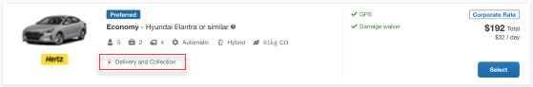

Map View
The new result map view has an informational purpose and represents an additional filter option. Click a pin to see the location address, opening hours, and the total price for the cheapest available car. The distance to the search center is indicated as well as the company’s preference level for that car rental vendor. Company locations display on the map via a small icon.
To access rental car locations, click Map View to display the map.
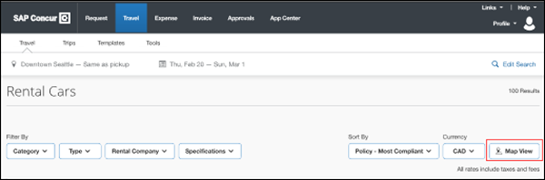
In case of overlapping pins, the number of locations will display. Click the pin to automatically zoom the view of the map, until separate pins display clearly.
Select a specific rental car location on the map to return to the result page and show only offers connected to this pick-up location.
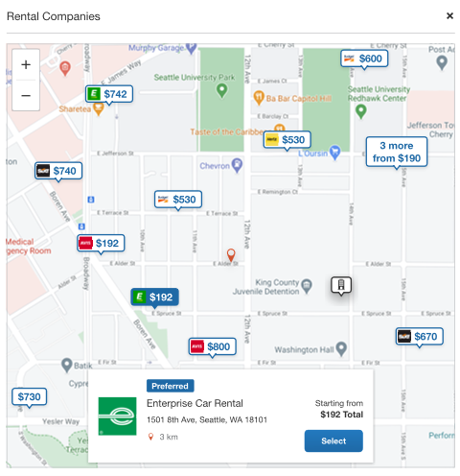

**Planned Changes** New Rental Car Experience: Review and Book

Information First Published | Information Last Modified | Feature Target Release Date
December 2023 | March 6, 2023 | TBD
Any changes since the previous monthly release are highlighted in yellow in this release note.

Prof | Stan |   Edition
 |  | On: Impacts end users who use this feature/vendor; no configuration/setup by agency/ admin; cannot be turned OFF (example: new icons or rate display)
 |  | Available for use: No impact to end users unless/until configuration/setup by agency/admin (described below) (example: new rule, new Travelfusion airline)
X | X | Other: Refer to the release note below
 |  | Does not apply to this edition
Source
GDS |  | Amadeus
Direct Connect
Other
 | EMEA Data Center |  |  | Scan impact
 | North America Data Center |  |  | UI impact
 | China Data Center |  |  | File finishing impact
 | All data centers |  |  | Profile/Profile API/3rd Party XML Sync Impact
Affected Documentation
TSGs
Fact Sheets
Admin Guides
Other

End-User Experience: Review and Book
The Review and Book page combines all relevant information before the user has completed the booking. All car selection related information is shown, listing all car attributes plus insurance and other services connected to the selected rate.
Example:
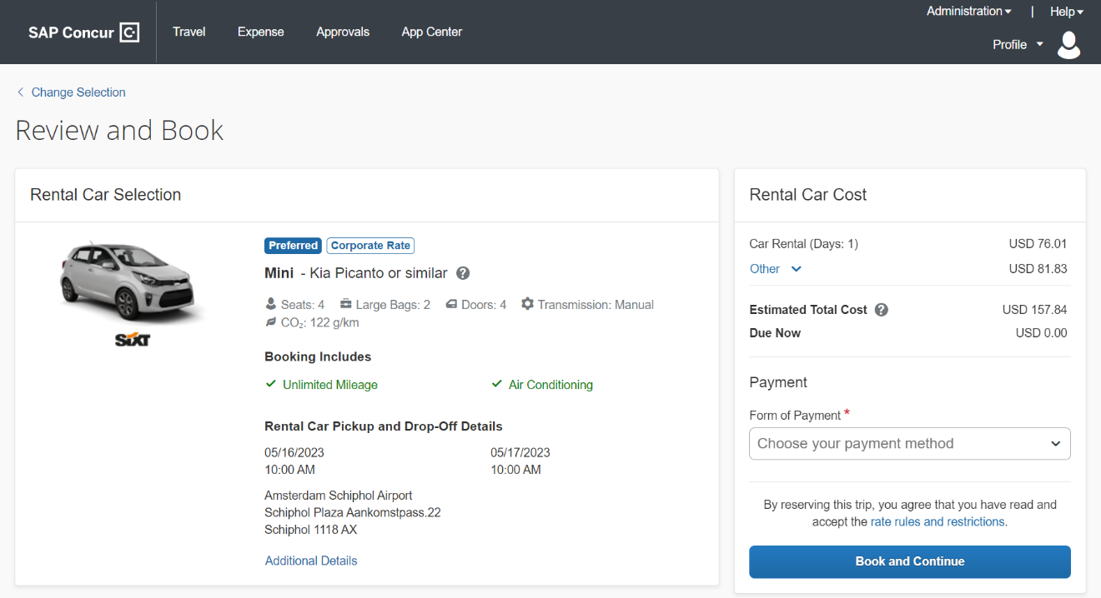

Additional Details
The Additional Details popup contains information on pickup and drop-off address, hours of operation, shuttle, terminal information if available, and directions on how to get to the location. As Concur Travel supports out-of-hour rentals in the new rental car booking experience, the corresponding hours of operation or an alternative informational text will display.
Example of popup window:
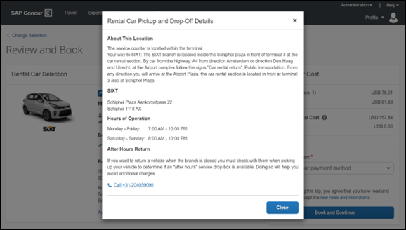

Cost Section
Within the cost section, when booking a post-pay or corporate rate, the total price is shown in the configuration currency of the traveler. A list of all included taxes, fees, surcharges, special equipment types and insurances becomes visible when expanding Others within the cost section.
Example:
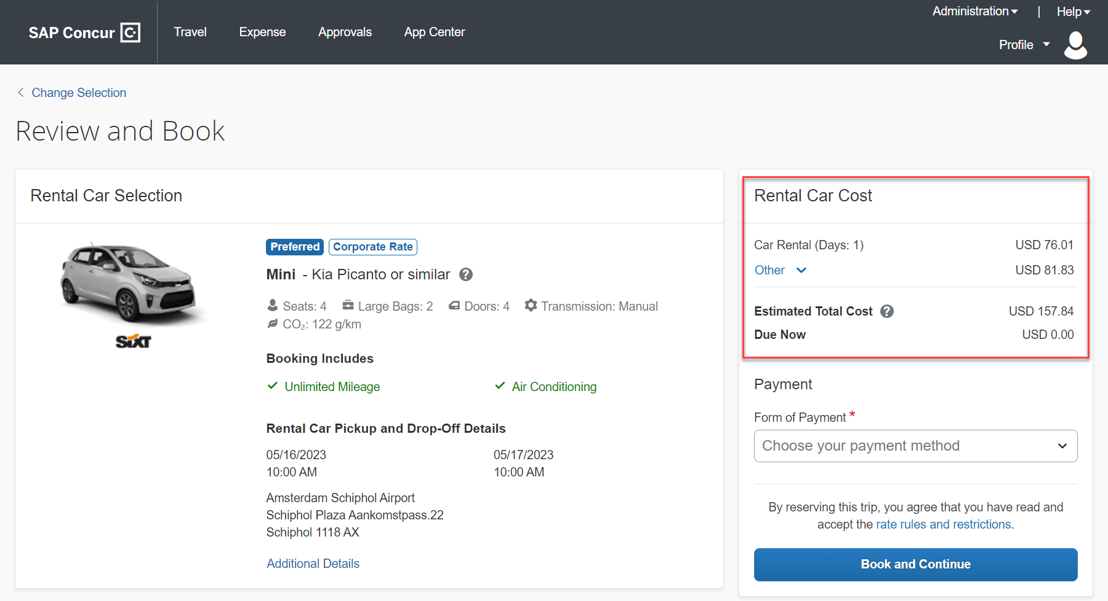

Car Preferences
The Rental Car Preferences section allows users to comment on the rental car location directly as part of the booking. Given the special character limitations of some external content channels, only alpha-numeric entries are accepted.
Example:
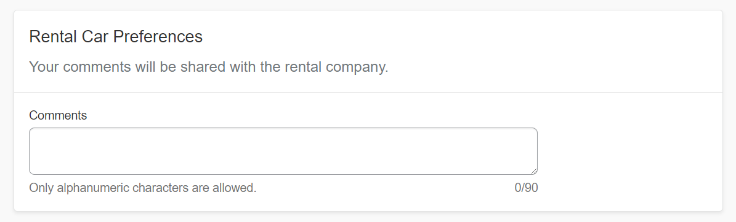

Traveler Information
The Traveler Information section will show the user data that is used to complete the booking and the data that is also transferred to the suppliers. It is possible to select a specific loyalty card from the user profile. When a loyalty card program is stored in the user profile, matching the selected vendor offer, Concur Travel will automatically fill out this frequent traveler card.
For all airport rentals, Concur Travel will display a flight number entry field. This information is important for the rental car companies to track changes of pick-up times related to flight delays.
This field must be filled out with the airline two-letter-code and the flight number itself without any spaces in between.
Example:

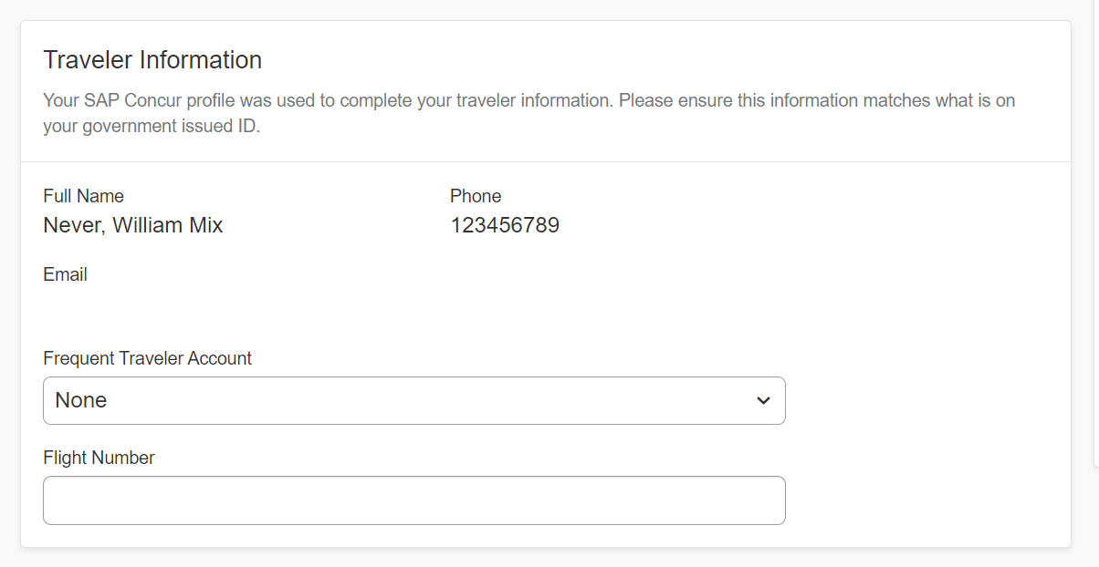

Travel Policy
This section appears if the user has selected an offer which violates their company travel policy. The user will be shown which rule(s) were broken, able to select a travel policy violation reason from the dropdown, and/or provide additional justification via a Comments box.
Example:
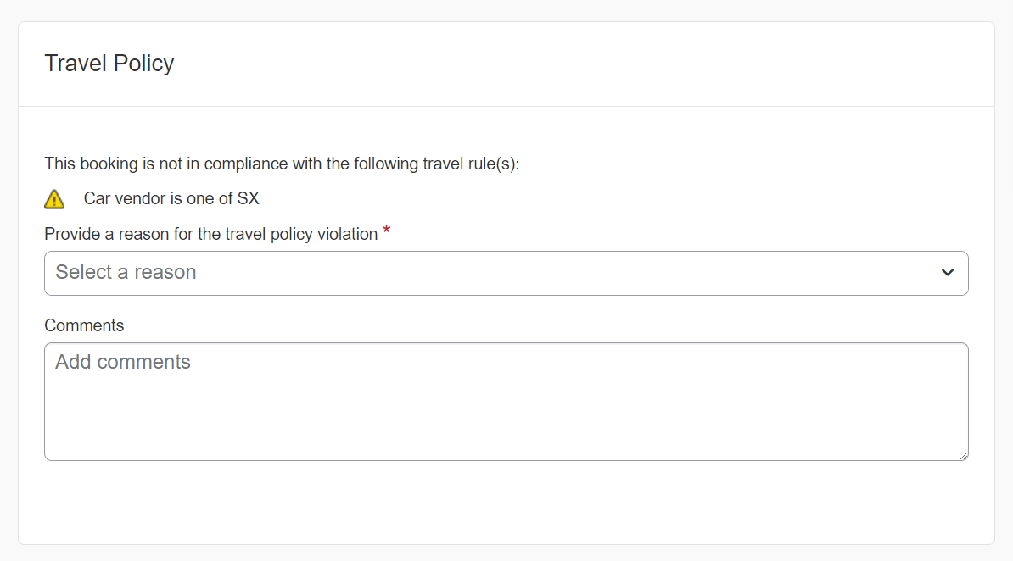

Pre-Book Trip Custom Fields
Trip custom fields in Concur Travel can be set up to collect information during the booking process. These fields are often used to collect information for the clients’ internal accounting process or for reporting purposes. They can be configured to show at the beginning or end of the booking process. If Display at the start of booking is configured, this will display in the Additional Information section and the Review and Book page in the new Concur Travel experience.
Example:

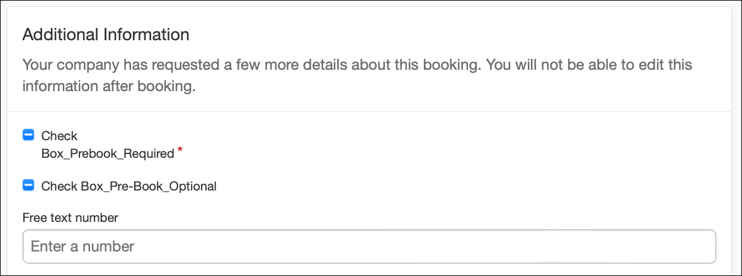

Payment
The payment selection displays in the Rental Car Cost section on the Review and Book page when a credit card form of payment is needed to complete the booking. The payment selection is a required field.
Selecting a credit card is required with the new rental car workflow. Limitations will be removed with further releases.
Example:
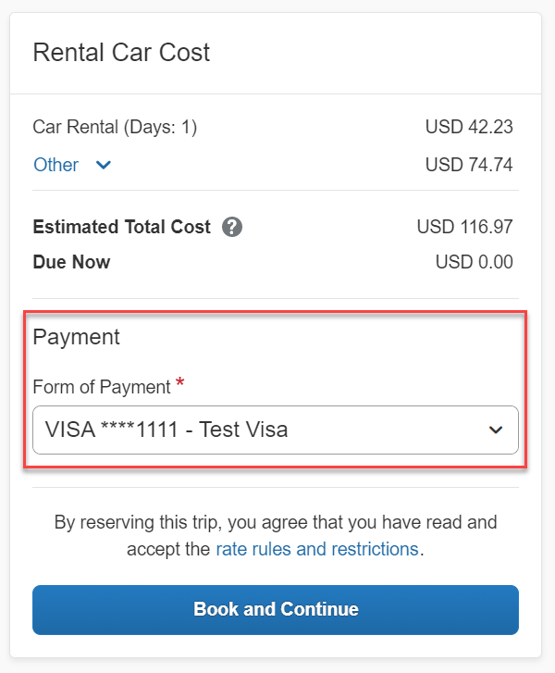
The user is shown a list of available credit cards to select from, based on configuration. There is no default option pre-selected, and the user is prompted to Choose your payment method. To complete the booking, complete all required fields and click Book and Continue.
If the user attempts to book and continue without selecting a credit card, the following alert banner displays across the top of the page: “This trip was not booked. Please fix the indicated errors and try again.” Also, the required payment selection is highlighted to bring focus to the missing information.
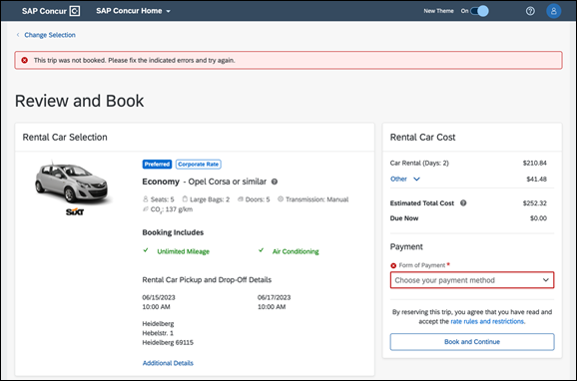
There are three conditions which can cause payment selection to display:
- The content source indicates that a credit card is required to complete the booking.
- The travel configuration setting Require Credit card for Car Reservations option is enabled.
- The travel configuration setting Agency Processing Fee Form of Payment for Land Only/Non-GDS Reservations option is enabled and set to Always write user-selected card.
The choices shown in the payment selection display are determined by:
- The Corporate Ghost Cards which are set to Allow for Car and assigned to the user.
- The personal credit cards that a user has saved in their Concur Travel profile.
To change settings for Require credit card for car reservations, Corporate Ghost Cards for Car, Agency Processing Fee Form of Payment for Land Only/Non-GDS Reservations, or to change how corporate ghost cards are assigned, refer to the Form of Payment Travel Service Guide. To change Allow users to add new personal credit cards to their Concur Travel profile settings, refer to the Module Properties Guide.
As part of the new Concur Travel experience, administrative setting validation is improved. For this reason, it’s possible a configuration could be set to require a credit card yet have no cards available for the user to select. If this occurs, the user will see this error message:
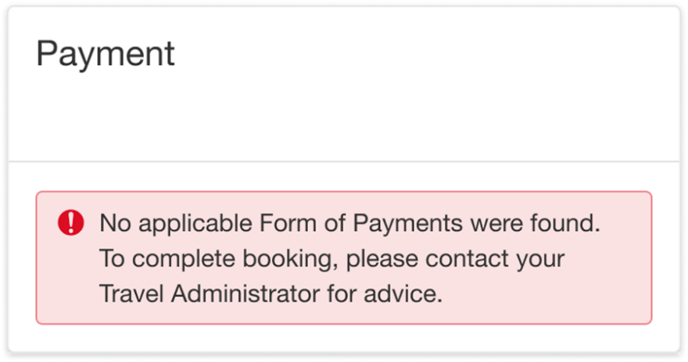
The user can then:
- Add a new personal credit card to their Concur Travel Profile and re-attempt their booking.
- Contact their Travel Management Company to complete the booking or investigate why a Corporate Ghost Card is not configured.

Rate Rules and Restrictions
The supplier’s rate rules and restrictions are shown via the link at the bottom of the page. The user must select the I have read and agree to the Rate Rules and Restrictions checkbox before they click Book and Continue.
Example:
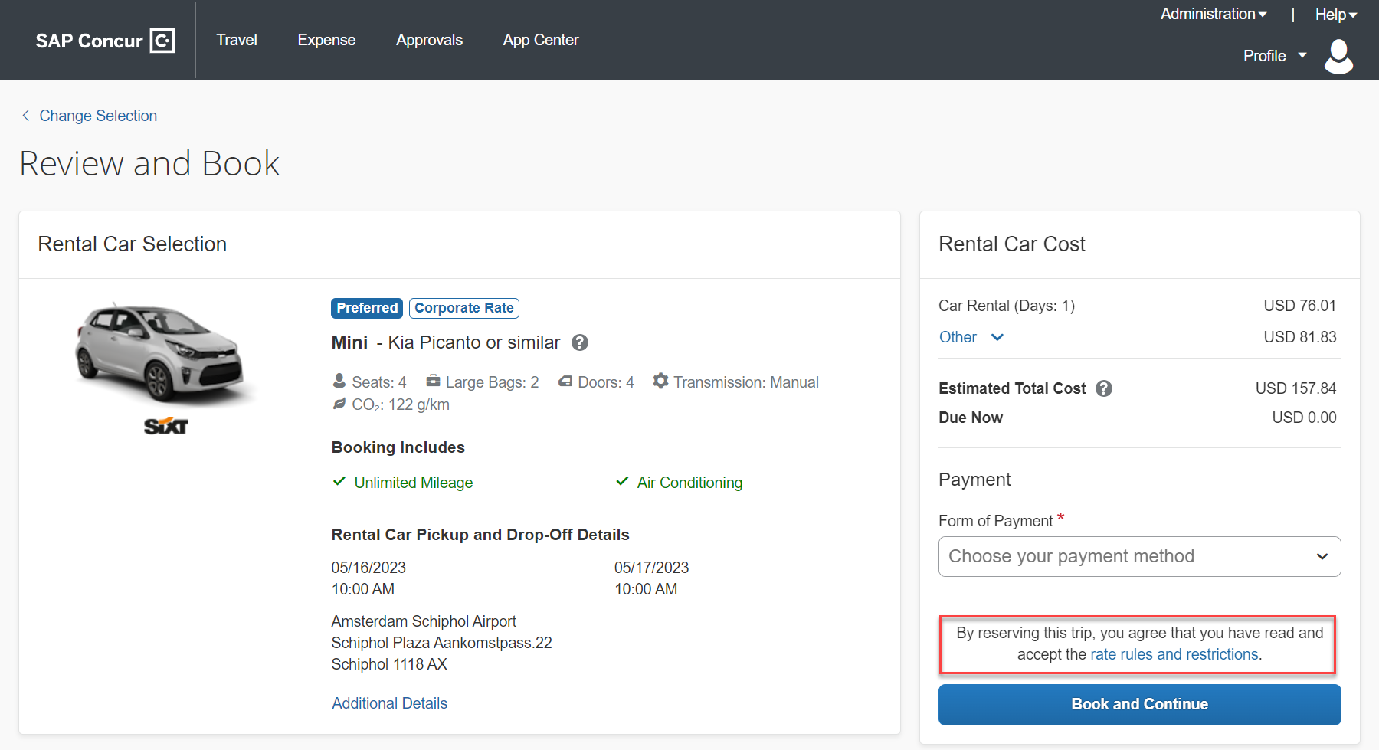

**Planned Changes** New Rental Car Experience: Finalize and Confirm Booking

Information First Published | Information Last Modified | Feature Target Release Date
December 2023 | March 6, 2023 | TBD
Any changes since the previous monthly release are highlighted in yellow in this release note.

Prof | Stan |   Edition
 |  | On: Impacts end users who use this feature/vendor; no configuration/setup by agency/ admin; cannot be turned OFF (example: new icons or rate display)
 |  | Available for use: No impact to end users unless/until configuration/setup by agency/admin (described below) (example: new rule, new Travelfusion airline)
X | X | Other: Refer to the release note below
 |  | Does not apply to this edition
Source
GDS |  | Amadeus
Direct Connect
Other
 | EMEA Data Center |  |  | Scan impact
 | North America Data Center |  |  | UI impact
 | China Data Center |  |  | File finishing impact
 | All data centers |  |  | Profile/Profile API/3rd Party XML Sync Impact
Affected Documentation
TSGs
Fact Sheets
Admin Guides
Other

End-User Experience: Finalize Trip
The Finalize Trip page in the rental car workflow allows the user to enter a different name for the trip and provide a description. When expanding the car segment, all details about the newly created reservation becomes visible.
The purpose of this intermediate step is to present an overview of all reserved bookings, apply trip level policy rules, allow the user to enter trip-related custom fields, or add another booking to the trip. Bookings currently apply to rail and will soon apply to car. Later releases of the new Concur Travel experience will also apply to air and hotel.
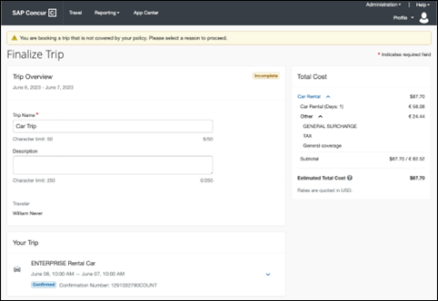

Add Bookings
For adding further bookings, dedicated buttons such as Add Accommodation and Add Rental Car are positioned centrally on the page. When adding a reservation, the user will see a page allowing them to enter search criteria.
When adding a rental car, the new search fields will not be pre-populated. A corresponding solution will be implemented with future releases
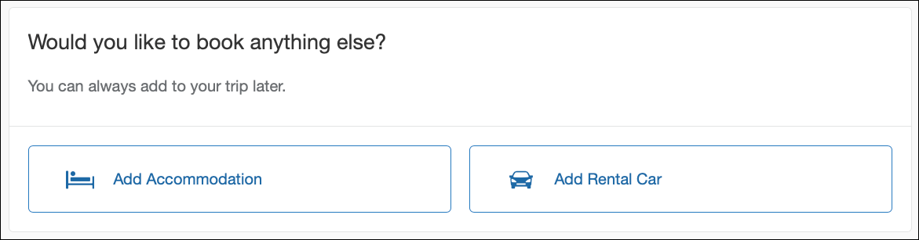

Travel Policy
For policy violation on Trip level, the Travel Policy section informs the users about triggered policy rules and provides an opportunity to select a reason and/or add a comment.
Example:
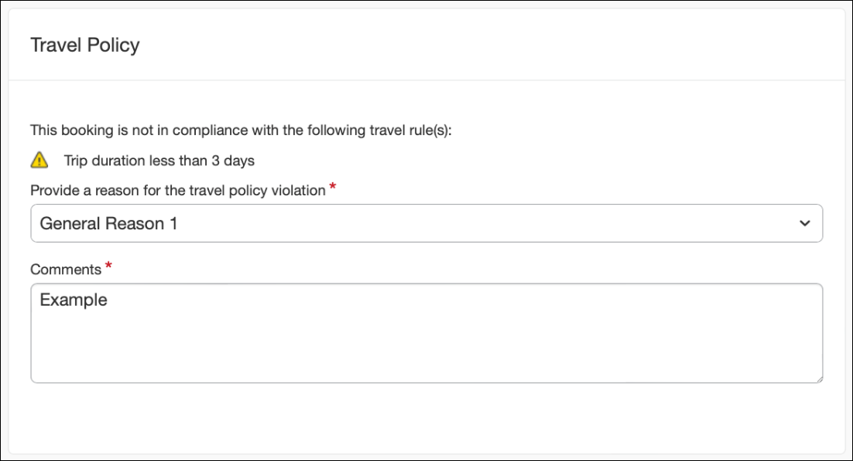

Post-Book Trip Custom Fields
Trip custom fields in Concur Travel can be set up to collect information during the booking process. The fields are often used to collect information for the clients’ internal accounting process or for reporting purposes. They can be configured to show at the start or towards the end of the booking process.
When the Display at the start of booking setting is disabled, trip custom fields will display within the Additional Information section on the Finalize Trip page.
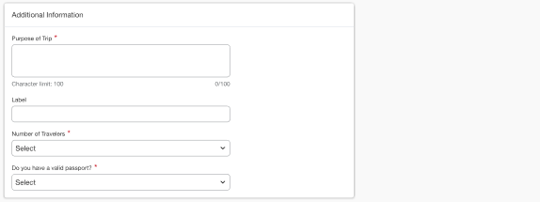

Cancel Trip
In case a user no longer wants to book, they can click Cancel Trip which redirects them to the Confirm Cancellation page. Refer to the details in the Cancellation section.
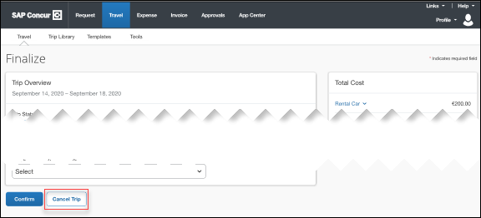

End-User Experience: Confirmation
Click Confirm on the Finalize Trip page; the Confirmation page displays.
This page provides an overview of all existing bookings in your trip and displays support contact data; configuration is required by your SAP Concur administrator.
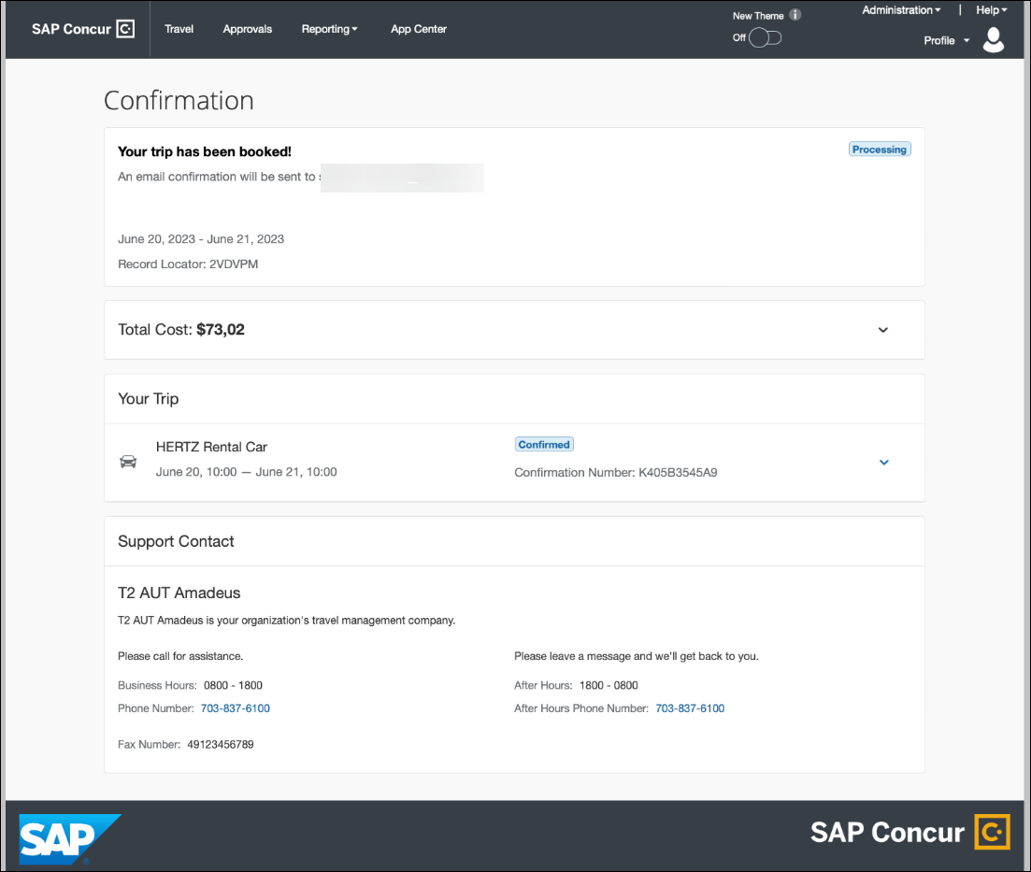
The Confirmation page includes:
- A display of the current trip state, as part of the header section.
- The email address of the confirmation recipient.
- A section that displays the total cost of the trip; this section is collapsed by default and can be expanded to review detailed rate information per booking.
- A Your Trip section where each booking displays as collapsed by default but can be expanded to review details (such as number of seats and doors for a rental car booking).
- A Support Contact section will display support contact data (Configuration required by your SAP Concur administrator).
The user can see the trip booked on the homepage under upcoming trips. At the same time, an email confirmation will be sent to the traveler.

Manager Notification
If the booking violated policy such that the manager needs to be notified, an email will be sent to the manager.
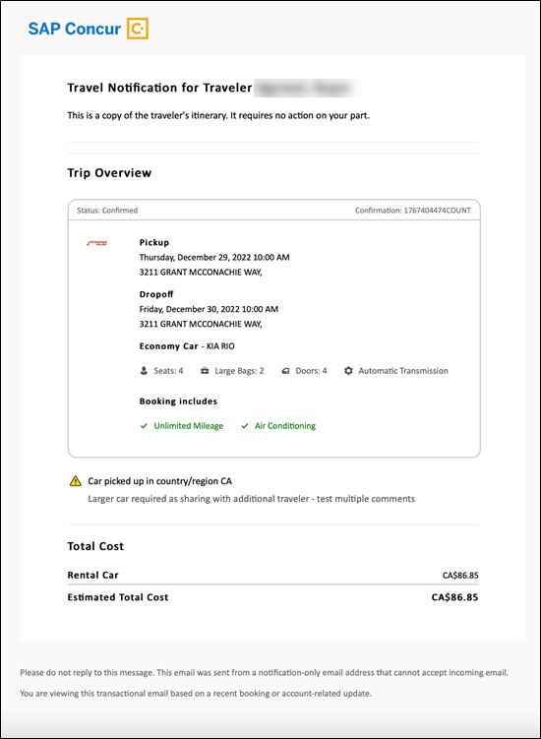

**Planned Changes** New Rental Car Experience: Completed Trip Overview

Information First Published | Information Last Modified | Feature Target Release Date
December 2023 | March 6, 2023 | TBD
Any changes since the previous monthly release are highlighted in yellow in this release note.

Prof | Stan |   Edition
 |  | On: Impacts end users who use this feature/vendor; no configuration/setup by agency/ admin; cannot be turned OFF (example: new icons or rate display)
 |  | Available for use: No impact to end users unless/until configuration/setup by agency/admin (described below) (example: new rule, new Travelfusion airline)
X | X | Other: Refer to the release note below
 |  | Does not apply to this edition
Source
GDS |  | Amadeus
Direct Connect
Other
 | EMEA Data Center |  |  | Scan impact
 | North America Data Center |  |  | UI impact
 | China Data Center |  |  | File finishing impact
 | All data centers |  |  | Profile/Profile API/3rd Party XML Sync Impact
Affected Documentation
TSGs
Fact Sheets
Admin Guides
Other

End-User Experience: View Car Rental (Trip Overview)
The Trip Overview page allows you to review and manage a booked trip at any time. Cancelled trips can be reviewed, but no longer managed.
Example:
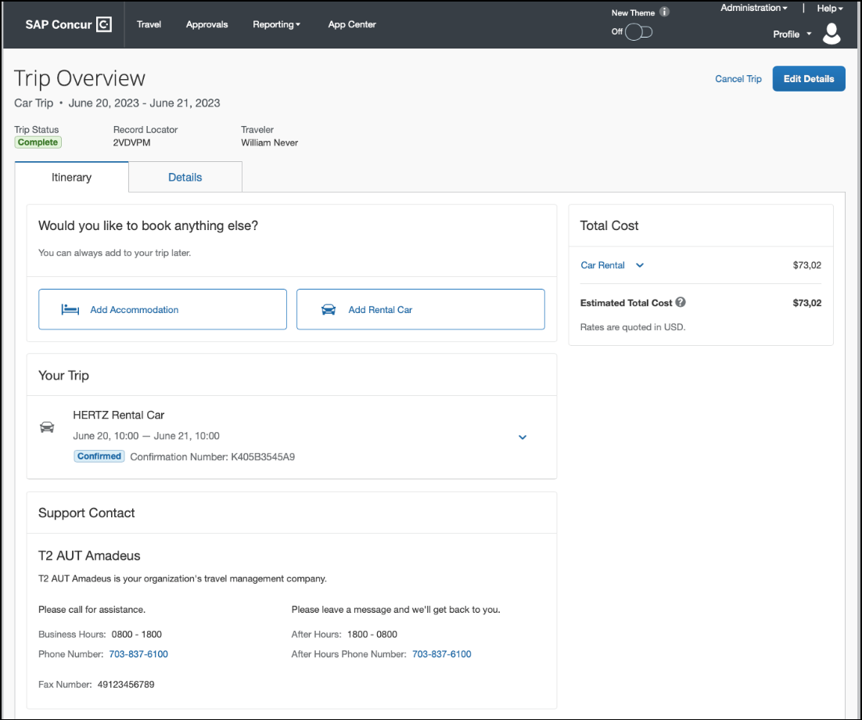
Example:
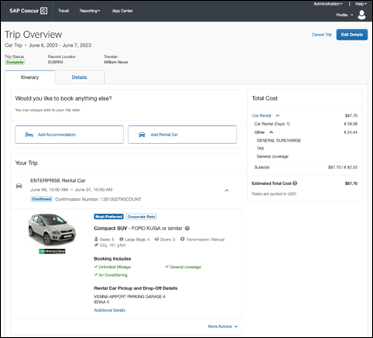

Header Section
Below the page header are the trip name and travel dates. The top section of the page displays:
- Trip status
- Record locator (if trip contains content booked through travel agency channels)
- Traveler name
- Booker name (if the booker is a different person than the traveler)
- Trip description (if a description was added by the booker)
At the top right corner of the page, there is a link to cancel the trip and a button to edit details such as the default trip name and trip description.

Cost Section
At the right of the Trip Overview page, there is a Cost section to review estimated total trip cost and detailed costs per booking. The cost section will float on the page while scrolling, so it remains visible whether you review the upper or lower part of the page.

Itinerary Tab
At the top of this tab, there is Add Rental Car and Add Accommodation buttons for users to add another booking to the trip. Configuration is required by your SAP Concur administrator to hide those buttons.
The Your Trip section will display each booking with its confirmation number. Each booking in this section displays as expanded by default to review details such as number of seats or doors in case of a rental car booking.
At the bottom of the page, the Support Contact section displays support contact data; configuration is required by your SAP Concur administrator.

Details Tab
On this tab you can review additional trip-related information.
Example:
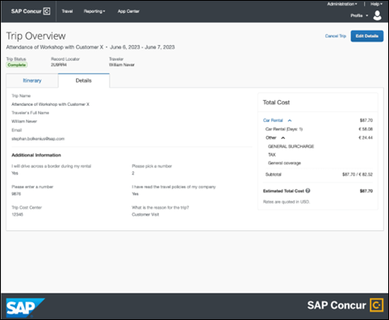
This tab displays:
- The trip name.
- The traveler's name.
- The traveler's email address to which the confirmation email is sent.
- The trip description (if added).
- Field names and values selected or entered during the booking workflow in the Additional Information section. Configuration is required by your SAP Concur administrator.

Cancellation
The Cancel Trip link will redirect users to the Confirm Cancellation page to start the trip cancellation.
The More Actions menu includes a Cancel Reservation link that will redirect users to the Confirm Cancellation page to start the booking cancellation.
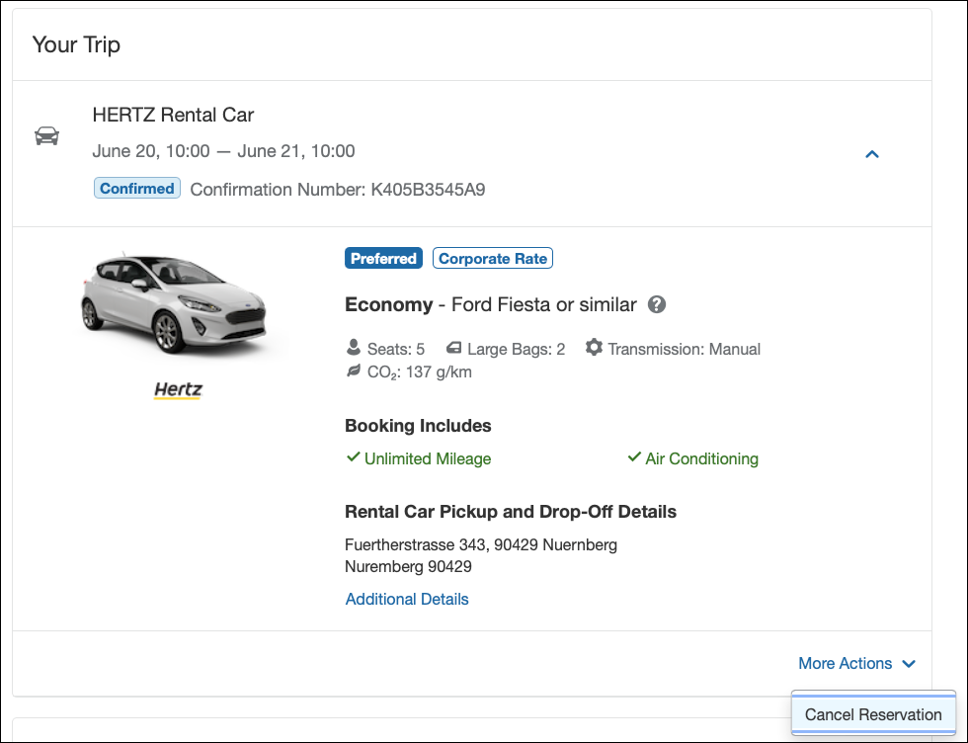

Add a Booking
The Add Accommodation or Add Car actions will redirect users to the search and book flow for the respective service.

**Planned Changes** New Rental Car Experience: Cancellation

Information First Published | Information Last Modified | Feature Target Release Date
December 2023 | February 23, 2023 | TBD
Any changes since the previous monthly release are highlighted in yellow in this release note.

Prof | Stan |   Edition
 |  | On: Impacts end users who use this feature/vendor; no configuration/setup by agency/ admin; cannot be turned OFF (example: new icons or rate display)
 |  | Available for use: No impact to end users unless/until configuration/setup by agency/admin (described below) (example: new rule, new Travelfusion airline)
X | X | Other: Refer to the release note below
 |  | Does not apply to this edition
Source
GDS
Direct Connect
Other
 | EMEA Data Center |  |  | Scan impact
 | North America Data Center |  |  | UI impact
 | China Data Center |  |  | File finishing impact
 | All data centers |  |  | Profile/Profile API/3rd Party XML Sync Impact
Affected Documentation
TSGs
Fact Sheets
Admin Guides
Other

End-User Experience: Cancellation
Depending on the place from which the trip cancellation starts and the trip content, the cancellation flows may vary as follows in these scenarios:
- When users click Cancel Trip on the Finalize Trip page, the Trip Overview page will redirect them to the Confirm Cancellation page that contains a link to the Terms and Conditions for review. Confirmation of the cancel action on this page will redirect users to the Trip Overview page where the trip is indicated as Cancelled.
- When users click the Cancel link in the trip library (web app) or trip list (mobile app), on the Upcoming Trips tab or the My Trips section, both of which are available on the homepage in the Web app, a popup will display with a link to the Terms and Conditions for review.
- For a trip that only contains content booked in the new Concur Travel experience, users will be redirected to the Trip Overview page where the trip is indicated as Cancelled.
- For a trip that contains other content than what was booked in the new Concur Travel experience, users will be redirected to the regular cancellation confirmation page.
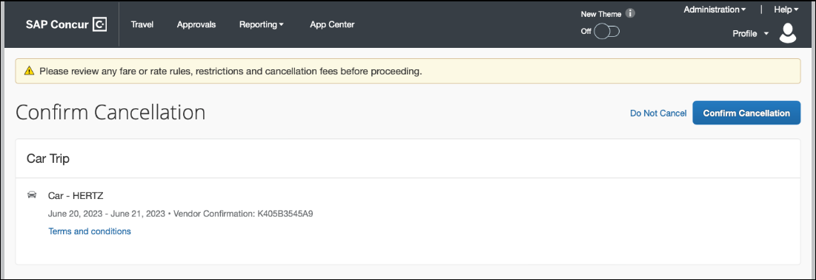
For scenario 1 and scenario 2a , the following is an example of where the user will be redirected to upon confirming cancellation. The cost section will label the cost block corresponding to all cancelled bookings as Canceled:
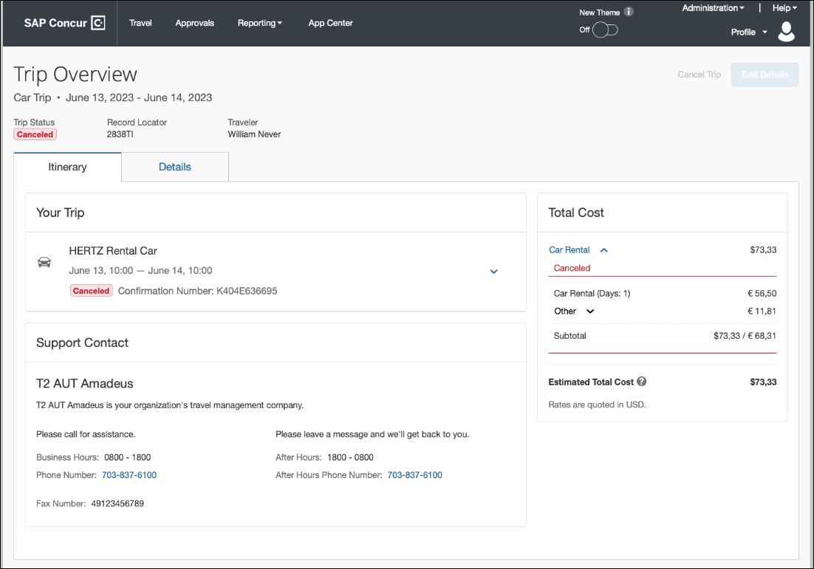

**Planned Changes** New Rental Car Experience: Configuration for Hertz and Sixt

Information First Published | Information Last Modified | Feature Target Release Date
December 2023 | February 24, 2023 | TBD
Any changes since the previous monthly release are highlighted in yellow in this release note.

Prof | Stan |   Edition
 |  | On: Impacts end users who use this feature/vendor; no configuration/setup by agency/ admin; cannot be turned OFF (example: new icons or rate display)
 |  | Available for use: No impact to end users unless/until configuration/setup by agency/admin (described below) (example: new rule, new Travelfusion airline)
X | X | Other: Refer to the release note below
 |  | Does not apply to this edition
Source
GDS
Direct Connect
Other
 | EMEA Data Center |  |  | Scan impact
 | North America Data Center |  |  | UI impact
 | China Data Center |  |  | File finishing impact
 | All data centers |  |  | Profile/Profile API/3rd Party XML Sync Impact
Affected Documentation
TSGs
Fact Sheets
Admin Guides
Other

Overview
Sixt and Hertz Direct content will be offered via SAP Concur’s new Car Connector program. For this reason, these connectors require re-enablement for customers who are interested in using these channels. Full feature parity is guaranteed across the content channels.

Configuration for Professional Travel

Hertz And Sixt Direct Content
To configure:
- Click Administration > Travel (on the sub-menu) > Travel System Admin and select the desired client travel configuration.
Depending on your permissions, the page may appear immediately after you click Administration or Travel.
- In the Car Connector section of the travel configuration page, locate the Hertz and Sixt activation checkboxes.
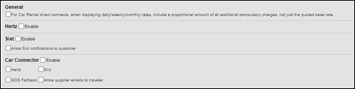
The GDS Fallback and Allow supplier emails to traveler options will be supported with future releases. These checkboxes do not create any action in the initial release for the new rental car workflow.

Hertz and Sixt Passive PNR for Direct Content
To configure:
- Go to Administration > Travel (on the sub-menu) > Travel System Admin and select the desired client travel configuration.
Depending on your permissions, the page may appear immediately after you click Administration or Travel.
- Under GDS PNR Options of the travel configuration page, go to the activation checkboxes.
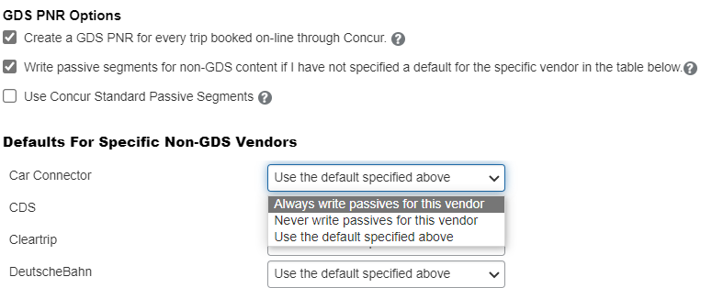
A new dropdown selection will be introduced in order to specify whether passive PNRs for Hertz and Sixt via Car Connector shall be created with each booking or not.

**Planned Changes** New Rental Car Experience: Reduced Feature Set

Information First Published | Information Last Modified | Feature Target Release Date
December 2023 | March 6, 2023 | TBD
Any changes since the previous monthly release are highlighted in yellow in this release note.

Prof | Stan |   Edition
X | X | On: Impacts end users who use this feature/vendor; no configuration/setup by agency/ admin; cannot be turned OFF (example: new icons or rate display)
 |  | Available for use: No impact to end users unless/until configuration/setup by agency/admin (described below) (example: new rule, new Travelfusion airline)
X | X | Other: Refer to the release note below
 |  | Does not apply to this edition
Source
GDS
Direct Connect
Other
X | EMEA Data Center |  |  | Scan impact
X | North America Data Center |  |  | UI impact
 | China Data Center |  |  | File finishing impact
 | All data centers |  |  | Profile/Profile API/3rd Party XML Sync Impact
Affected Documentation
TSGs
Fact Sheets
Admin Guides
Other
The activation of the new rental car workflow though Concur Travel is not possible via a setting within Concur Travel. As a reduced set of features will be available in the first release, potential customers will be determined programmatically and informed when eligible for migration.

Known Limitations
The following items are either not yet supported with the new car rental booking experience or are supported with limitations. Please monitor future release notes for changes relating to these items.

Product Area | Feature/Setting | Setting Location | Setting Requirement | Additional Information
Traveler selection | Guest Traveler bookings | Travel Configuration | Guest traveler bookings are disabled | A guest traveler or sponsored guest booking are not supported yet.
Content | Global Distribution System (GDS) | Agency Configuration | Amadeus only | Sabre and Travelport GDSs are not yet supported for the new car experience.
Integrations | Concur Request | Travel configuration | Enable Request Integration not enabled
Travel Policy | Car Rule Enforcement Levels | Company Administration > Travel Admin | Allow  Log for reports,  Notify manager,  Show but do not allow,  Hide results | ”Allow” enforcement level is supported but Display Message (Message when matched) portion is not.  For car category rules, Show but do not Allow is treated as Hide Results with the first release
Travel Policy | Itinerary Rule Enforcement Levels | Company Administration > Travel Admin | Allow  Log for reports,  Notify manager,  Require Approval,  Require Passive Approval | Show but do not allow and Hide results are not supported for Itinerary rules, as these enforcement levels are result-dependent; Itinerary rules are applied during checkout.  Require Approval and Require passive approval rules will be downgraded to Notify manager
Travel Policy | Concur Travel’s Native Approval Process | Company Administration > Travel Admin | Car rules cannot use:  Require Approval,  Require Passive Approval,  Require Pre-Approval & Log,  Require Pre-Approval & Notify | If any of the following rules are set up for Car  Require Approval,  Require Passive Approval,  Require Pre-Approval & Log,  Require Pre-Approval & Notify -  these rules will be ignored and will not show as violations to the user.  This also applies to any trip level rules.
Travel Policy | Car Rule Parts | Company Administration > Travel Rule Builder / Travel Admin | Car vendor is one of [CarVendorList]  Car vendor is not one of [CarVendorList]  Car vendor is not preferred  Car dropped off in country/region [CountryList]  Car not picked up in country/region [CountryList]  Car picked up in country/region [CountryList]  Car type is one of [CarClassList] | Any other configured car rule parts will not be enforced.  Any other car rule parts will not show as violations to the user.
Travel Policy | Itinerary Rule Parts | Company Administration > Travel Rule Builder / Travel Admin | Itinerary booked [condition] [DaysAdvance] days in advance  Trip duration [condition] [DaysLong] days  Itinerary has no Hotel segments | Any other rule parts will not be enforced.  Any other trip rule parts will not show as violations to the user.
Travel Policy | Violation Reason Types | Company Administration > Travel Admin > Policy Violation Reasons | General  Train  Car  Hotel  Itinerary | Reasons from any other reason type categories will not be displayed.
Travel Policy | Rule Class Selection + Force selection of a rule class | Travel Configuration | Only a user’s default rule class is supported | If enabled, users would see the rule class selection field on the search, but any selection by the user would not be honored.
Trip Management | Custom Trip Fields | Company Administration > Manage Custom Fields | If/Then Settings cannot be enabled
Trip Management | Custom Trip Fields | Company Administration > Manage Custom Fields | Display for Edits cannot be enabled | Custom Trip Fields with this setting enabled will display again for user review/input when changing or adding a booking to a trip. This setting is not yet honored in the new Concur Travel experience.
Payments | Require credit card for car reservations | Travel configuration | This setting must be enabled
Payments | Agency Processing Fee Form of Payment for Land Only/Non-GDS Reservations | Travel configuration | Always write user-selected card must be enabled
Car-Specific | Discount Codes/Numbers | Manage Corporate Discounts | Corporate Discount number is entered | A rental car availability only works with an existing corporate discount number in combination with loaded corporate rates.  Rate codes do not yet apply.  Public rates do not display yet.
Car-Specific | Preference ranks | Manage Corporate Discounts | Preferred, Less Preferred or Most Preferred | Vendors marked as not preferred will not be checked for availability.
Car-Specific | User Preferences | User Profile |  | No car rental preferences from the user profile are applying.
Car-Specific | Special Equipment | Travel Configuration/User Profile |  | No special equipment additions are supported yet.
Car-Specific | Car Custom Text | Company Administration > Travel Admin > Custom Text | The following Car custom text categories are not yet supported:  Car Search  Car Results  Car Rules on Itinerary  Car Rules Violation  Car Rules Violation Explain Why  Car Rules Violation Logging | No custom text is displayed in the Car booking workflow and on the Finalize Trip, and Trip Overview pages.
Car-Specific | Always run a General Shop Request for Car Searches | Travel Configuration | Customers who do not have negotiated car rental discounts should not use the new car rental booking experience yet.  Customers who have car rental vendor discounts configured will only see results from those vendors. | This feature triggers a car search request to content providers for any car rental vendors which do not have a configured discount code.  Due to the broad range of vendors returned and added GDS scans, SAP Concur is currently evaluating this feature. Until such time as a decision has been made, this will not be part of the new Concur Travel experience.
Car-specific | Travel Vendor Exclusion | Company Administration > Travel Admin >  Travel Policy Administration |  | Travel Vendor Exclusions are not supported.
Car-specific | Direct Billing | Company Admin > Manage Corporate Discounts | Customers who use direct billing should not use the new car rental booking experience yet. | Direct billing is not supported.
Car-specific | Travel Discounts By Org Unit | Module Properties | Customers who use org-unit level discounts should not use the new car rental booking experience yet. | Org-unit level discounts are not supported.
Trip Management | Show Add Air on Existing Itineraries | Travel Configuration |  | When a user makes a car booking using the new experience, the Add Air link will not be shown yet.  SAP Concur is planning to launch this feature with an upcoming release.
Trip Management | View Trip History | N/A | N/A | History Notes are not yet available on the Trip Overview page in the new Concur Travel experience.  SAP Concur is planning to launch this feature with a future release.
Trip Management | Print Itinerary | N/A | N/A | The Print Itinerary feature is not available on the Trip Overview page in the new Concur Travel experience.
Trip Management | E-mail itinerary | N/A | N/A | The Email Itinerary feature is not available on the Trip Overview page in the new Concur Travel experience.
Trip Management | Open in Outlook | N/A | N/A | The Open in Outlook feature is not available on the Trip Overview page in the new Concur Travel experience.
Trip Management | Create Template / Clone Trip / Share Trip | Travel Configuration | Clone Trip enabled | The features Create Template, Clone Trip and Share Trip are not available on the Trip Overview page in the new Concur Travel experience.  Please see chapter Changes in product behavior below for information on product behavior for these features in the classic experience for trips that contain bookings booked in the new Concur Travel experience.
Trip Management | Change of booking | N/A | N/A | Change of booking is not yet supported for the new rental car booking experience; however, users are able to cancel and rebook using the new experience.  Change of rental car bookings offline by a TMC are not recommended; the trip cost on the itinerary in SAP Concur will not yet be updated in case of any price change.
Trip Management | MOBILE: Cancellation of Car Connector content (Hertz / Sixt) from a Trip including other booking types (for example, flight, hotel) | Travel Configuration | Car Connector content (Hertz / Sixt) enabled on travel config page | Access the SAP Concur Web application to cancel the booking if not possible on the Mobile app.  The limitation for booking cancellation on Concur Mobile only applies to the mentioned scenario. Booking cancellation of Amadeus-sourced content and booking cancellation of Car Connector content from an itinerary that does not include further bookings is supported.
Trip Management | Customization of email subject lines | Travel Configuration | Travel Reservation Email Subject  Cancellation Email Subject | These two settings, which allow to customize the subject line of confirmation and cancellation emails and to add record locator, trip name and departure date do not apply to confirmation and cancellation emails sent out for trips booked in the new Concur Travel experience.

Changes in Product Behavior
The following features are supported for customers using the new car booking experience, but behavior may be changed or may be utilizing legacy functionality.

Opt-Out Settings for Confirmation and Cancellation Emails
The opt-out settings from the User Profile or System Settings for Confirmation and Cancellation emails do not apply to emails sent out in the new Concur Travel experience. The setting Contact? in the email section of the user profile does apply. Emails are only sent to addresses for which Contact? is enabled.

Confirmation Emails
While confirmation emails will be sent for bookings made via the new car experience, these emails will not include an .ics calendar attachment yet.

Allow automatic reservations Of
For customers that have automatic car reservations enabled, Concur Travel will utilize the current car booking logic and only the Amadeus content source.

Custom trip fields – display at start
Custom trip fields configured to Display at start of booking will be shown on the Review and Book page in the Additional Information section. Custom field for which checkbox Display at start of booking is not enabled will be shown on the Finalize Trip page in the Additional Information section.
Custom trip fields – Checkbox Fields
In the regular booking experience of Concur Travel, checkboxes are not selected by default. Users can complete the booking without selecting a checkbox, even when it is a required field. The box not being selected is saved and recorded for reporting.
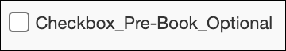
In the new Concur Travel experience, checkboxes display by default in an undetermined state (first screenshot). If the field is required, the box must be enabled or disabled to continue.
Undetermined:
Disabled:
Enabled:

Custom trip fields – display on itinerary
All trip custom fields and values entered or selected during the booking workflow will display by default on the Details tab of the Trip Overview page, regardless of the setting Display on Itinerary for trip custom fields. Trip custom fields and values entered or selected during the workflow will not be included in confirmation or cancellation emails, regardless of the setting Display on Itinerary for trip custom fields.

Travel Templates, Trip Sharing / Cloning
Car Connector content is not supported for booking from a travel template, a shared trip, or a cloned trip. The travel template will work for other trip content as per regular logic, but the Car Connector content will be ignored. It is possible to add Car Connector content to a booked trip from a template, in a separate operation.
Booking of Amadeus car content from a travel template, a shared trip, or a cloned trip is supported. The content will be booked according to the regular workflow, even if the new Concur Travel workflow is enabled.
Support Contact Section
On the Confirmation Page and the Trip Overview page, a section with Support Contact information displays, if configured. The new Concur Travel experience does not support html in the form fields.

Force Users to Choose a Credit Card
For the new car booking experience, this travel configuration setting is no longer used. When a user has more than one credit card allowed for use, the form of payment selection dropdown will not default to a card; it will be blank. The user is required to select a card before proceeding.
For more information on this user experience, please refer to the New Rental Car Experience: Review and Book section, Payment subsection earlier in these release notes.

**Planned Changes** New Rental Car Experience: Delivery and Collection

Information First Published | Information Last Modified | Feature Target Release Date
December 2022 | February 23, 2023 | TBD
Any changes since the previous monthly release are highlighted in yellow in this release note.

Prof | Stan |   Edition
X | X | On: Impacts end users who use this feature/vendor; no configuration/setup by agency/ admin; cannot be turned OFF (example: new icons or rate display)
 |  | Available for use: No impact to end users unless/until configuration/setup by agency/admin (described below) (example: new rule, new Travelfusion airline)
 |  | Other: Refer to the release note below
 |  | Does not apply to this edition
Source
GDS
Direct Connect
Other
X | EMEA Data Center |  |  | Scan impact
X | North America Data Center |  |  | UI impact
 | China Data Center |  |  | File finishing impact
 | All data centers |  |  | Profile/Profile API/3rd Party XML Sync Impact
Affected Documentation
TSGs
Fact Sheets
Admin Guides
Other |  | Online Help

Overview
Delivery and Collection will not be part of the first release which is limited to participating Amadeus TMC partners
Sixt and Hertz Direct content will be offered via SAP Concur’s new Car Connector program. For this reason, these connectors require re-enablement for customers who are interested in using these channels. Full feature parity is guaranteed across the content channels.

Configuration for Professional Travel

Delivery and Collection Feature
The customer must first negotiate the Car Delivery and Collection service with their contract car vendor. The associated corporate discount number must be entered in the discount area. This process must be completed for each desired car vendor.
Delivery and Collection will be available for all address options. Customers who would like to use this feature with the current release should contact their rental car partner and ensure all addresses are allowed for this service. Different fees could apply depending on the addresses the end user would select.
To configure:
- Go to Administration > Travel (on the sub-menu) > Travel System Admin and select the desired client travel configuration.
Depending on your permissions, the page may appear immediately after you click Administration or Travel.
- On the travel configuration page, go to Car Search Options.
- Make the appropriate choices and select all rental car companies for which Delivery and Collection has been negotiated.
Regardless of the activated content channels, only this setting must be configured in order to enable the Delivery and Collection feature.

**Planned Changes** New Rental Car Experience: Support of Corporate and Non-Corporate Rates (Public and Leisure)

Information First Published | Information Last Modified | Feature Target Release Date
March, 2023 | March 16, 2023 | TBD
Any changes since the previous monthly release are highlighted in yellow in this release note.

Prof | Stan |   Edition
X | X | On: Impacts end users who use this feature/vendor; no configuration/setup by agency/ admin; cannot be turned OFF (example: new icons or rate display)
 |  | Available for use: No impact to end users unless/until configuration/setup by agency/admin (described below) (example: new rule, new Travelfusion airline)
 |  | Other: Refer to the release note below
 |  | Does not apply to this edition
Source
GDS |  | Amadeus
Direct Connect
Other
X | EMEA Data Center |  |  | Scan impact
X | North America Data Center |  |  | UI impact
 | China Data Center |  |  | File finishing impact
 | All data centers |  |  | Profile/Profile API/3rd Party XML Sync Impact
Affected Documentation
TSGs
Fact Sheets
Admin Guides
Other

Overview
Initially, the Amadeus GDS search, and the display of rental car rates was limited to corporate rates only. If no negotiated corporate rates were available for a corporate ID, there were no results. SAP Concur will extend the configuration options to allow a search and display of corporate rates only or search or display of all corporate and non-corporate rates (public and leisure) in web and mobile app.
The Amadeus GDS will only return corporate rates when Concur Travel explicitly requests corporate rates only. In these cases, the rates can be labeled as Corporate Rate in the user interface. Concur Travel is unable to label rates because the GDS does not indicate which rates are corporate or non-corporate. This setting applies to Amadeus GDS only. For suppliers connected via Car Connector, Concur Travel will continue to support corporate rates only. This new setting will not impact the regular Concur Travel experience.

End-User Experience
If the configuration is set to allow Corporate rates only, the user will see the Corporate Rate label in the display.
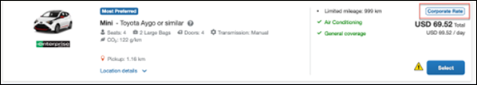
Example of Corporate Rates on the Review and Book page:
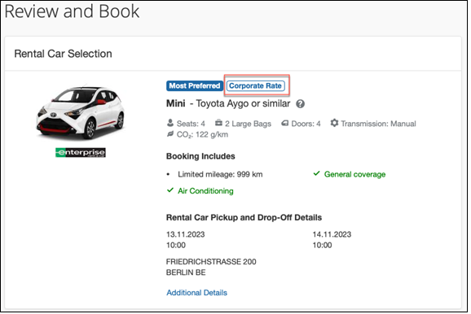
Example of Corporate Rate on the Trip Confirmation page:
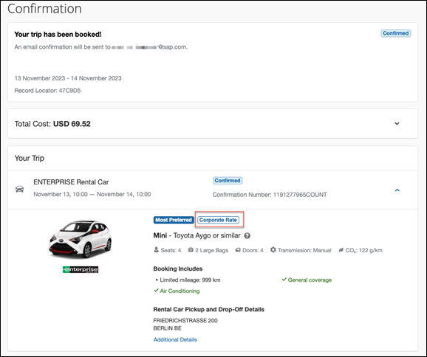
If the configuration is set to All Rates (corporate and non-corporate) the user will not see a corporate label for any rate in the user interface.
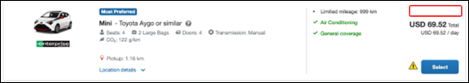
Example of the Review and Book page without corporate rate label:
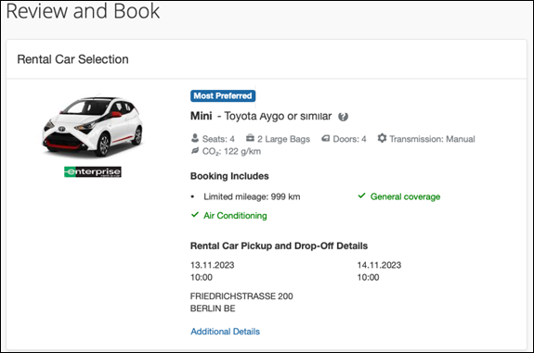
Example of the Trip Confirmation page without the corporate rate label:
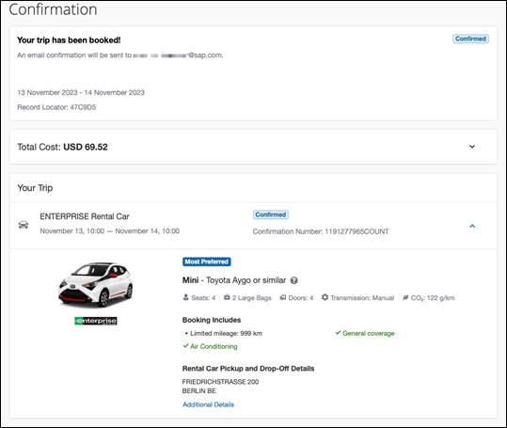

Configuration for Professional Travel
Discounts can be accessed via Travel System Administrator and Company Administrator (if the user has the proper permissions).
To access discounts via Travel System Admin:
- Click Administration > Travel (on the sub-menu) > Travel System Admin.
Depending on your permissions, the page may appear immediately after you click Administration or Travel.
- In the Company-Specific Configuration section of the left menu, click Manage Corporate Discounts.
- Select the desired company and click Choose.
- Select the desired configuration and click Choose.
To access discounts via Company Admin:
- Click Administration > Company (on the sub-menu) > Company Admin.
- In the Travel Administration section of the left menu, click Manage Corporate Discounts.
- Select the desired company and click Choose.
- Select the desired configuration and click Choose.
- Navigate to the Car Suppliers Discount section.
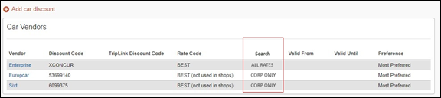
- Select from the Vendor dropdown and set the Search for option to Corporate Rates Only or leave as the default All Rates.
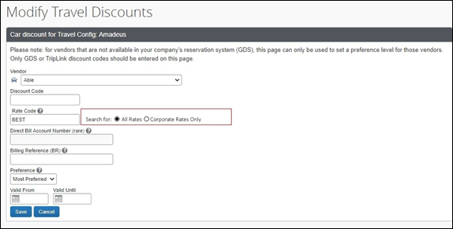

Hotel

**Planned Changes** New Hotel Experience (Custom Hotel Source Only): Overview

Information First Published | Information Last Modified | Feature Target Release Date
March 2023 | -- | Q2 2023
Any changes since the previous monthly release are highlighted in yellow in this release note.

Prof | Stan |   Edition
 |  | On: Impacts end users who use this feature/vendor; no configuration/setup by agency/ admin; cannot be turned OFF (example: new icons or rate display)
 |  | Available for use: No impact to end users unless/until configuration/setup by agency/admin (described below) (example: new rule, new Travelfusion airline)
X | X | Other: Refer to the release note below
 |  | Does not apply to this edition
Source
GDS
Direct Connect
Other
 | EMEA Data Center |  |  | Scan impact
 | North America Data Center |  |  | UI impact
 | China Data Center |  |  | File finishing impact
 | All data centers |  |  | Profile/Profile API/3rd Party XML Sync Impact
Affected Documentation
TSGs
Fact Sheets
Admin Guides
Other

Overview
Targeted for the Q2 of 2023, Concur Travel will introduce a new hotel booking experience. This first release is limited to customers connected to one of our participating Custom Hotel Source (CHS) providers. With this integration, customers can experience:
- An intuitive and personalized design, with an easy-to-use experience.
- Seamless content normalization, aggregation and servicing.
- Mobile and Web content parity.

User/Customer Benefit
The new Concur Travel hotel booking experience is available with a specific feature set for customers open to explore the changes.
- Time Savings: The booking workflow has been streamlined so the user has fewer pages to complete.
- Omni search: The user simply types in the first few characters of their search criteria and selects their location option from the dropdown list of suggestions.
- Sustainability: Allows end users to see what sustainability certifications or programs the property belongs to. Additional filter options on properties that have electric car charging stations and sustainability certifications to help promote more sustainable choices.
- Search results with lead rate: The property search results are presented with one lead rate so user can quickly compare the lowest rate available at multiple properties.
- Hotel Details: User can see a list of the rates available at a specific property together with cancellation policy details, room amenities and images.

**Planned Changes** New Hotel Experience: Search for a Hotel

Information First Published | Information Last Modified | Feature Target Release Date
March 2023 | -- | Q2 2023
Any changes since the previous monthly release are highlighted in yellow in this release note.

Prof | Stan |   Edition
 |  | On: Impacts end users who use this feature/vendor; no configuration/setup by agency/ admin; cannot be turned OFF (example: new icons or rate display)
 |  | Available for use: No impact to end users unless/until configuration/setup by agency/admin (described below) (example: new rule, new Travelfusion airline)
X | X | Other: Refer to the release note below
 |  | Does not apply to this edition
Source
GDS
Direct Connect
Other
 | EMEA Data Center |  |  | Scan impact
 | North America Data Center |  |  | UI impact
 | China Data Center |  |  | File finishing impact
 | All data centers |  |  | Profile/Profile API/3rd Party XML Sync Impact
Affected Documentation
TSGs
Fact Sheets
Admin Guides
Other

End-User Experience: Search for a Hotel
The search options include a free text field for the property location. As the user begins to type the preferred location, the “omni search” will suggest matching options for cities, airports, hotels, etc. Search results will display icons to signify the different types of location, for example hotels display with a bed icon.
Check In date will pre-populate with today's date. Check Out date will pre-populate with tomorrow's date. To change these dates, the user clicks the calendar icon.
A default radius of five miles or five kilometers is applied, depending on the units configured in the user profile. Users can change the radius in increments of 5 up to a maximum of 100. The travel configuration settings for Default Search Radius and Search radius for corporate (preferred) hotels will determine the area in which to search for properties.
Any custom text that has been set up for the Search page appears just underneath the travel icons at the top of the page.
Example of Hotel search results:
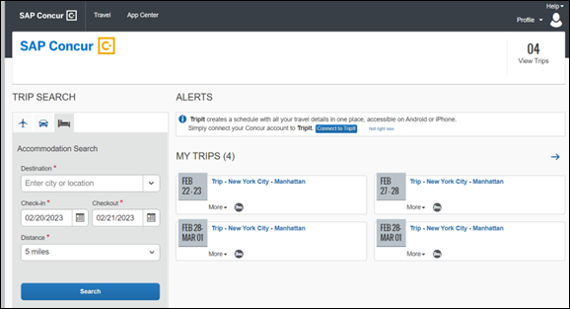

End-User Experience: Hotel Search results
Once the user has entered their search criteria and clicked Search, the results will display. The Number of Hotels to Shop setting no longer applies as Concur Travel will support up to 200 properties with a lead rate in the Search response.
Any property that supports e-receipts will have an E-receipts enabled label next to the Preferred label.
Preferred properties are labelled as either Most Preferred, More Preferred or Preferred. The preference levels returned by the content source provider always take precedence over levels defined in Concur Travel.
The Manage Corporate Discount preference levels in Concur Travel configuration and policy rules that use Preferred List options for this release remain as Most Preferred, Preferred, Less Preferred and Not Preferred. These are mapped as follows:
- Most Preferred to Most Preferred
- Preferred to More Preferred
- Less Preferred to Preferred
- Not Preferred will not be mapped and will be ignored
If policy rules are created using these labels, the policy violation text displayed to the user will contain the current label.
Accommodations results will display a list of properties and a simplified map view.
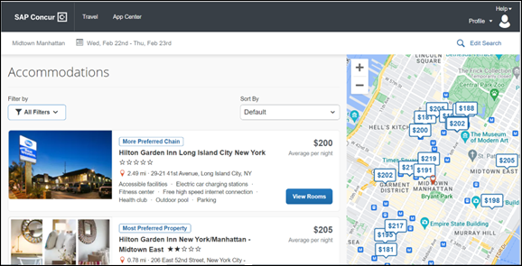

Edit Search
At the top of the page, Concur Travel displays the entered search data. To change the data, click Edit Search.

Filter Options
The offered filter sections are Hotel Amenities, Brand and Sustainability.
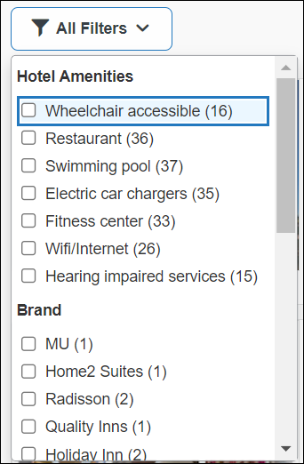

Sorting Options
The sorting options include Default, Distance, Preferred Level, Price Low to High and Price High to Low. Concur Travel cannot determine the order in which the CHS provider first returns the results because Hotel Sort Default setting will no longer be available. The user can re-sort the results using the dropdown and can go back to the original sort order at any time by selecting Default in the dropdown.
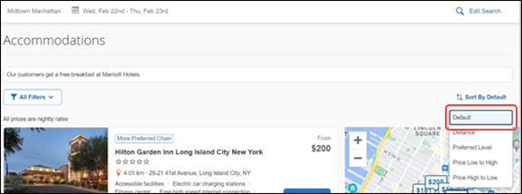

hotel details
The focus of the Hotel Details page is to provide details of the property together with the room rates. Where applicable, there are details of the sustainability certification of the property, together with a link for the user to view more details of the certification. If the hotel is a preferred property or a preferred chain, the preferred label will display above the hotel name.
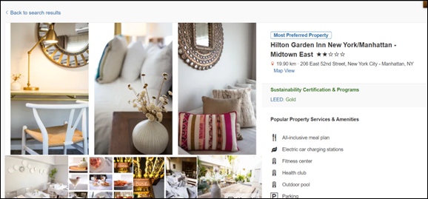
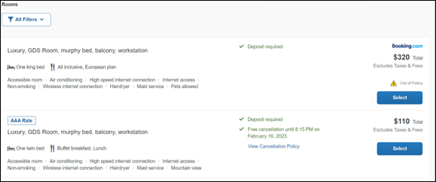

property amenities
The most popular property amenities and services will display at the top of the page. For more information, the user can click View More which navigates to the bottom of the page where all the hotel amenities and services will be listed.
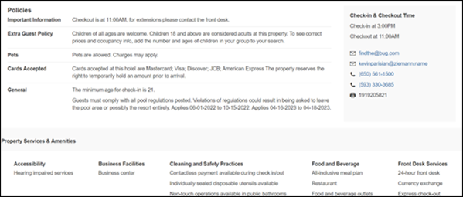

property images
At the top of the Property Images page, an image gallery is provided that the user can scroll through to view all the images and any descriptive information that applies.

filters
The user can:
- Filter out rates that require pre-payment or are non-refundable.
- Filter by accessible rooms.

rate type categories
Rate types selected in the User Profile, such as AAA or GOV, are sent in the request to the content provider. If no rate types are selected in the user profile, they are filtered out of any response from the provider.

room amenities
Listed next to each rate are the room details, amenities, bed type, and any meal plan type.
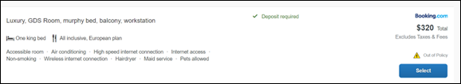

Total Price
The total price displayed may be inclusive or exclusive of taxes, depending on the location of the user. This is determined by the content provider. Text below each price indicates whether taxes and fees are included or excluded.
The booking source will display above the price when returned by the provider. This can be a logo or a name.

travel policy
When a hotel rate violates a policy rule, the rate will display with a warning icon. Click the icon to see more information on the policy rules that apply. When the Hide Results rule is applied to a specific property, that hotel property will not appear in the search results.
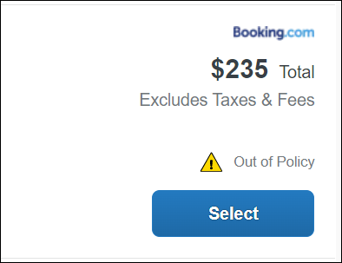
Show but do not allow and Hide results are not supported for Itinerary rules, as these enforcement levels are result-dependent. Itinerary rules are applied during checkout.

cancellation policy
Cancellation policy details will display, for example "Free Cancellation until September 20". For more information, the user may click View Cancellation Policy.
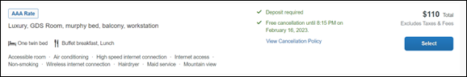

Map View – Search Results
The new map view on the search results page will provide information and an additional filer. When the user clicks a pin, they are directed to that property in the search results. The pins contain the lead rate for the property. Company locations will display in the map via a small red icon.
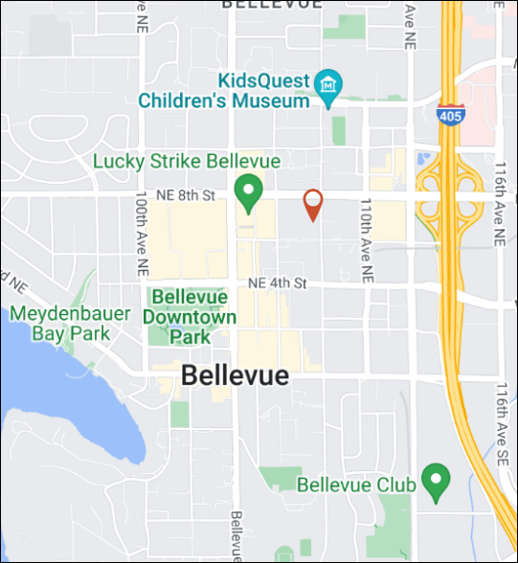
The zoom option is available so the user can focus on areas for more details.
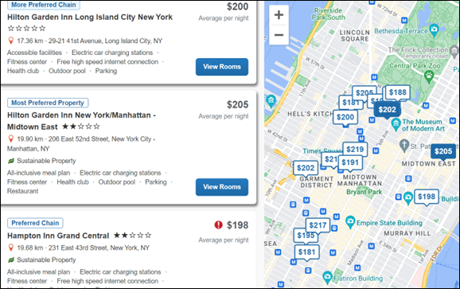
In case of overlapping pins, the number of locations will display. Click the pin to zoom, until separate pins display clearly.

Map View – Property Details
When the user clicks on Map View on the Details page, a map showing an icon denotes the location of the property. To display the property name and address, click the icon.
There is a zoom option within the map so the user can zoom in or out.
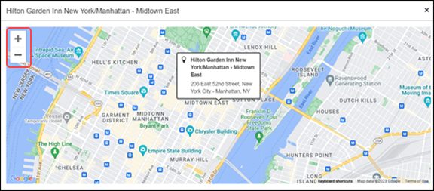

**Planned Changes** New Hotel Experience: Review and Book

Information First Published | Information Last Modified | Feature Target Release Date
March 2023 | -- | Q2 2023
Any changes since the previous monthly release are highlighted in yellow in this release note.

Prof | Stan |   Edition
 |  | On: Impacts end users who use this feature/vendor; no configuration/setup by agency/ admin; cannot be turned OFF (example: new icons or rate display)
 |  | Available for use: No impact to end users unless/until configuration/setup by agency/admin (described below) (example: new rule, new Travelfusion airline)
X | X | Other: Refer to the release note below
 |  | Does not apply to this edition
Source
GDS
Direct Connect
Other
 | EMEA Data Center |  |  | Scan impact
 | North America Data Center |  |  | UI impact
 | China Data Center |  |  | File finishing impact
 | All data centers |  |  | Profile/Profile API/3rd Party XML Sync Impact
Affected Documentation
TSGs
Fact Sheets
Admin Guides
Other

End-User Experience: Review and Book
The Review and Book page combines all relevant information for the user to review before completing the booking. All hotel selection related information is presented on the page, including the property details, the room and rate information, and the guest details.
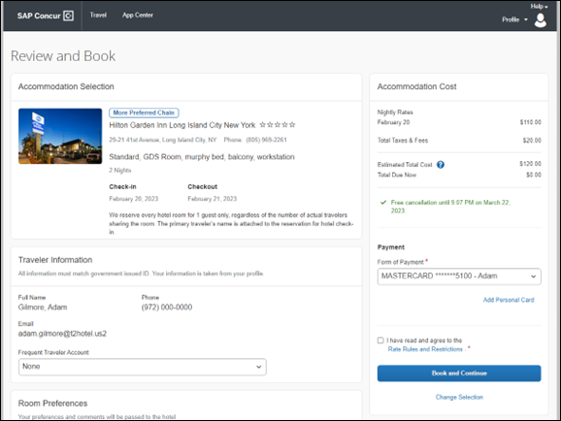

Cost Section
Within the cost section, the estimated total amount after nightly rate breakdown, taxes, and fees will display in the configured currency of the traveler. There is also a Total Due Now amount, which will be zero for postpaid rates; the total rate less any fees for prepaid rates, or the deposit amount where a deposit is required for the booking.
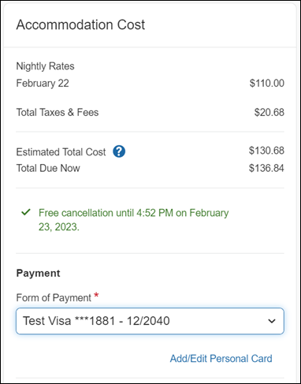

Payment
In the Accommodation Cost section on the Review and Book page for the user to select their form of payment. The payment selection is a required field. It will not have a default option selected, and the user will be prompted to Select form of payment.
The payment selection list may display available corporate ghost cards, personal credit cards, and virtual payments. The specific payments list items are determined by:
- A corporate ghost card with the Required for Hotel admin setting will display for the user, but the user will not be able to make a selection.
- The Travel Configuration setting Allow users to choose a personal credit card even if they have a custom corporate card. When enabled, any corporate ghost card will Allow for Hotel will display for the user.
- When offered by the CHS provider, a Vendor Provided Virtual Payment may be available, if there is not also a corporate ghost card set as Required for Hotel.
- When a credit card with CVV code is required by the CHS provider, only credit cards with CVV codes can be selected. Corporate ghost cards will be excluded because they do not have CVV codes.
- Personal credit cards saved in their Concur Travel profile credit cards section may be selected. Vendor-provided virtual payments may be selected.
The Accommodation Cost section may also include links to allow the user to Add/Edit Personal Card stored in their profile.
Users can add new personal cards or update existing personal credit cards by clicking Add/Edit Personal Card. The user will be redirected to the Travel Profile page to update the card. They will see the Review and Book page after saving changes.
The Add/Edit Personal Card will be enabled in the module properties. Allow users to Add New Credit Cards must be set to True. Hide Travel Profile must be set to False. If incorrectly configured, the user will not see the Add/Edit Personal Card link, or an error message will display when the user clicks the link and cannot make updates.
When a hotel requires a credit card with a CVV number to make the booking, users must select a personal credit card from their profile. A CVV number field is mandatory.
The CVV entry does not apply when the user has selected the provider’s virtual card option. No CVV is needed when using the provider's virtual payment option.
If a corporate ghost card is configured as Required for Hotel and a CVV number is required by the property, then an error message will display to the user, as this represents misconfiguration.
The travel configuration setting Force users to choose a credit card is no longer used. When a user has more than one card, the user will be required to choose from Select form of payment dropdown.
The travel configuration setting Agency Processing Fee Form of Payment for Land Only/Non-GDS Reservations determines the credit card account written to the form of payment line in the GDS Passenger Name Record for this booking. The default setting is always write the user selected card, which will select the last card used during a booking.
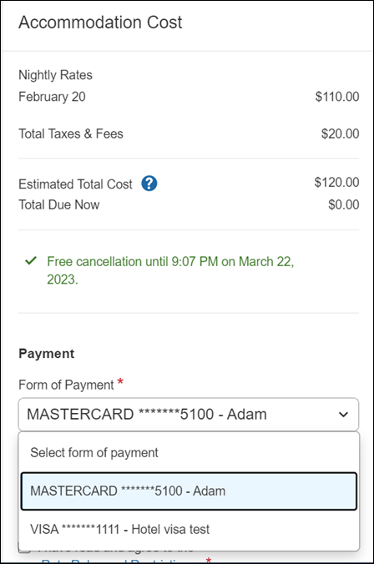
To change settings for Allow users to choose a personal credit card even if they have a custom corporate card, Require for Hotel, Agency Processing Fee Form of Payment for Land Only/Non-GDS Reservations, or to change how corporate ghost cards are assigned, refer to the Form of Payment Travel Service Guide. To change Allow users to add new personal credit cards to their Concur Travel profile settings, refer to the Module Properties Guide.

Room Preferences
The Hotel Preferences section provides an opportunity to transfer comments to the hotel property as part of the booking. Only alpha numeric entries will be accepted in this field.
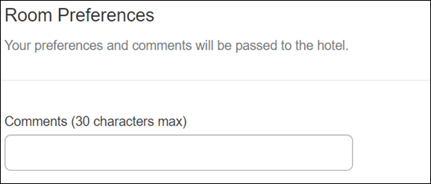

Traveler Information
The Traveler Information section reflects the traveler data that is necessary to complete the booking. This information will be sent to the suppliers. If the traveler has loyalty cards stored in their user profile, these are pre-populated in the dropdown menu for selection, if they apply to the property being booked.
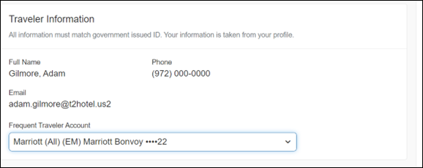

Travel Policy
This section appears if the user has selected an offer which violates their company travel policy. The rules that have been violated are shown and a travel policy violation reason can then be selected from the dropdown, and/or provide additional justification via the Comments box.
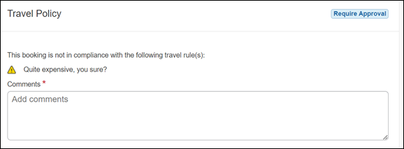

Pre-Book Custom Fields
Trip custom fields in Concur Travel can be set up to collect information during the booking process. These fields are often used to collect information for the clients’ internal accounting process or for reporting purposes. They can be configured to show at the beginning or end of the booking process. If added at the beginning of the booking process, they are located within the Additional Information section on the Review and Book page.
Image to be included in subsequent update.

Rate Rules and Restrictions
The traveler is required click the Rules and Restrictions hyperlink and read the supplier’s conditions. Then they can click the I have read and agree to the Rate Rules and Restrictions checkbox.
Once the traveler has completed all the necessary information, they can click Book and Continue
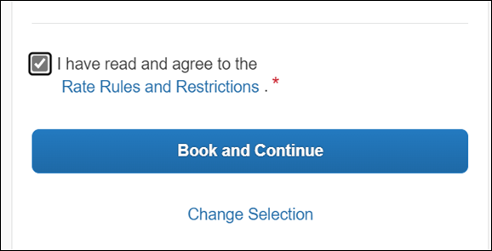

**Planned Changes** New Hotel Experience: Finalize and Confirm Booking

Information First Published | Information Last Modified | Feature Target Release Date
March 2023 | -- | Q2 2023
Any changes since the previous monthly release are highlighted in yellow in this release note.

Prof | Stan |   Edition
 |  | On: Impacts end users who use this feature/vendor; no configuration/setup by agency/ admin; cannot be turned OFF (example: new icons or rate display)
 |  | Available for use: No impact to end users unless/until configuration/setup by agency/admin (described below) (example: new rule, new Travelfusion airline)
X | X | Other: Refer to the release note below
 |  | Does not apply to this edition
Source
GDS
Direct Connect
Other
 | EMEA Data Center |  |  | Scan impact
 | North America Data Center |  |  | UI impact
 | China Data Center |  |  | File finishing impact
 | All data centers |  |  | Profile/Profile API/3rd Party XML Sync Impact
Affected Documentation
TSGs
Fact Sheets
Admin Guides
Other

End-User Experience: Finalize Trip
The Finalize Trip page in the hotel workflow allows the user to enter a different name for the trip and provide a description. When expanding the hotel segment, all details about the newly created reservation become visible again.
The purpose of this intermediate step is to present an overview of all reserved bookings, apply trip level policy rules, allow the user to enter trip-related custom fields, and use approval workflows after the user has added all required bookings to a trip. Currently supported booking types include rail and car.
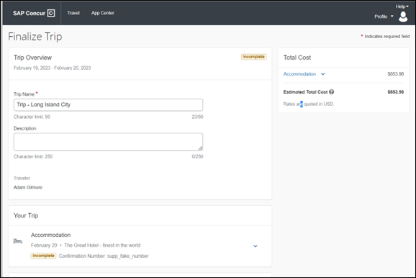

Add Bookings
To add other bookings, users can click Add Accommodation and Add Rental Car.
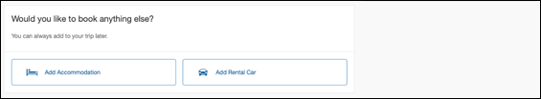

Travel Policy
The Travel Policy section informs the travelers about violated policy rules and provides an opportunity to select a reason and/or add a comment.
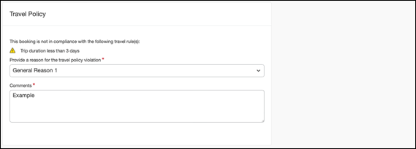

Trip Custom Fields
Trip custom fields in Concur Travel can be set up to collect information during the booking process. The fields are often used to collect information for the clients’ internal accounting process or for reporting purposes. They can be configured to show at the start or towards the end of the booking process.
Trip custom fields configured to display towards the end of the booking workflow will be shown on the Finalize Trip page in the Additional Information section.
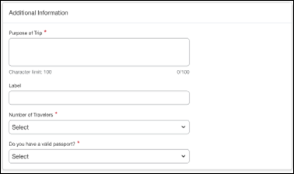

Cancel Trip
If a traveler wants to stop the booking, they can click the Cancel Trip at the bottom of the page. Please refer to the details in the Cancellation section.
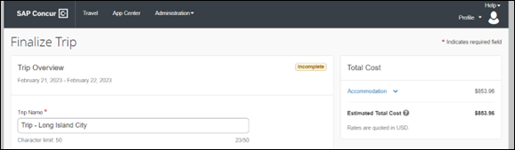
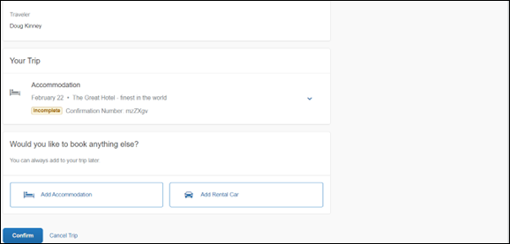

End-User Experience: Confirmation
Click Confirm on the Finalize Trip page to display the Confirmation page.
This page provides an overview of all existing bookings in a user’s trip and displays support contact data. This is configured by your SAP Concur administrator.
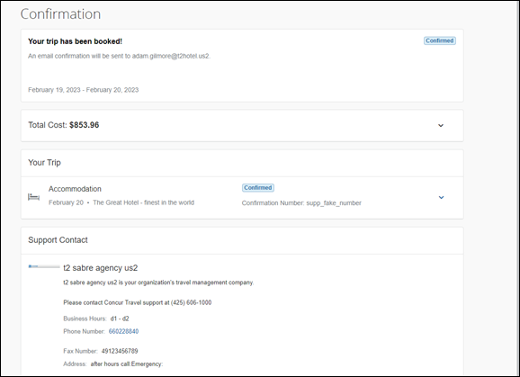
The Confirmation page includes:
- A display of the current trip state, as part of the header section.
- The email address of the confirmation recipient.
- A section that displays the Total Cost. This section is collapsed by default and can be expanded to review detailed rate information per booking.
- A Your Trip section where each booking displays as collapsed by default but can be expanded to review details (such as number of nights and number of guests for a hotel booking).
- A Support Contact section will display support contact data. This is configured by your SAP Concur administrator.
The user will be able to see the trip booked on the homepage under Upcoming Trips. At the same time, an email confirmation will be sent to the traveler.

Manager Notification
If the booking policy that is violated requires management notification, an email is sent to the manager.
Image to be included in subsequent update

**Planned Changes** New Hotel Experience: Completed Trip Overview

Information First Published | Information Last Modified | Feature Target Release Date
March 2023 | -- | Q2 2023
Any changes since the previous monthly release are highlighted in yellow in this release note.

Prof | Stan |   Edition
 |  | On: Impacts end users who use this feature/vendor; no configuration/setup by agency/ admin; cannot be turned OFF (example: new icons or rate display)
 |  | Available for use: No impact to end users unless/until configuration/setup by agency/admin (described below) (example: new rule, new Travelfusion airline)
X | X | Other: Refer to the release note below
 |  | Does not apply to this edition
Source
GDS
Direct Connect
Other
 | EMEA Data Center |  |  | Scan impact
 | North America Data Center |  |  | UI impact
 | China Data Center |  |  | File finishing impact
 | All data centers |  |  | Profile/Profile API/3rd Party XML Sync Impact
Affected Documentation
TSGs
Fact Sheets
Admin Guides
Other

End-User Experience: View Hotel booking (Trip Overview)
The Trip Overview page allows you to review and manage a booked trip at any time. Cancelled trips can be reviewed, but no longer managed.
Image to be included in subsequent update

Header Section
Below the page header are the trip name and travel dates. The top section of the page will display:
- Trip status.
- Record locator (if trip contains content booked through travel agency channels).
- Traveler name.
- Booker name (if the booker is a different person than the traveler – see the Travel Arranger section).
- Trip description (if a description was added by the booker).
At the top right corner of the page, there is a link to cancel the trip and a button to edit details such as the default trip name and trip description.

Cost Section
At the right of the Trip Overview page, there is a Cost section to review estimated total trip cost and detailed costs per booking. The cost section floats on the page while scrolling, so it remains visible whether you review the upper or lower part of the page.

Itinerary Tab
At the top of this tab, there are Add Rental Car and Add Accommodation buttons for users to add another booking to the trip. Configuration is required by your SAP Concur administrator to hide these buttons.
The Your Trip section will display each booking with its confirmation numbers. Each booking in this section will display as expanded by default to review details such as number of nights and rate description.
At the bottom of the page, the Support Contact section will display support contact data; configuration is required by your SAP Concur administrator.

Details Tab
On this tab you will be able to review additional trip-related information.
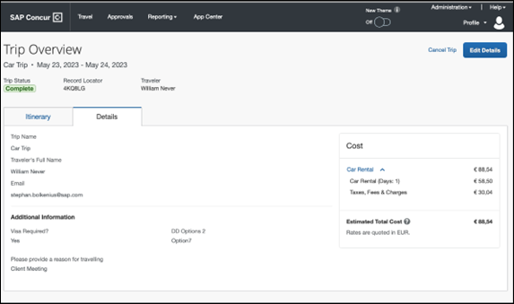
This tab will display:
- The trip name.
- The traveler's name.
- The traveler's email address to which the confirmation email is sent.
- The trip description (if added).
- Field names and values selected or entered during the booking workflow in the Additional Information section. Configuration is required by your SAP Concur administrator.

Cancellation
The Cancel Trip link will redirect users to the Confirm Cancellation page to start the trip cancellation.

Add a Booking
The Add Accommodation or Add Car actions will redirect users to the search and book flow for each service.

**Planned Changes** New Hotel Experience: Cancellation

Information First Published | Information Last Modified | Feature Target Release Date
March 2023 | -- | Q2 2023
Any changes since the previous monthly release are highlighted in yellow in this release note.

Prof | Stan |   Edition
 |  | On: Impacts end users who use this feature/vendor; no configuration/setup by agency/ admin; cannot be turned OFF (example: new icons or rate display)
 |  | Available for use: No impact to end users unless/until configuration/setup by agency/admin (described below) (example: new rule, new Travelfusion airline)
X | X | Other: Refer to the release note below
 |  | Does not apply to this edition
Source
GDS
Direct Connect
Other
 | EMEA Data Center |  |  | Scan impact
 | North America Data Center |  |  | UI impact
 | China Data Center |  |  | File finishing impact
 | All data centers |  |  | Profile/Profile API/3rd Party XML Sync Impact
Affected Documentation
TSGs
Fact Sheets
Admin Guides
Other

End-User Experience: Cancellation
Depending on the place from which the trip cancellation starts and the trip content, the cancellation flows may vary as follows:
- When users click Cancel Trip on the Finalize Trip page, the Trip Overview page will redirect them to the Confirm Cancellation page that contains a link to the Terms and Conditions for review. Confirmation of the cancellation on this page will redirect users to the Trip Overview page where the trip is indicated as Cancelled.
- When users click Cancel in the Trip Library (web app), Trip List (mobile app), Upcoming Trips or My Trips sections, a popup will display with a link to the Terms and Conditions for review.
- For a trip that only contains content booked in the new Concur Travel experience, users will be redirected to the Trip Overview page where the trip is indicated as Cancelled.
- For a trip that contains other content than what was booked in the new ConcurTravel experience, users will be redirected to the regular cancellation confirmation page.
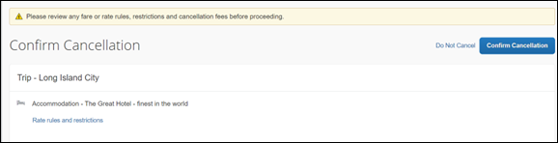
For scenarios 1 and scenario 2a above, the following is an example of where the user will be redirected to upon confirming cancellation:
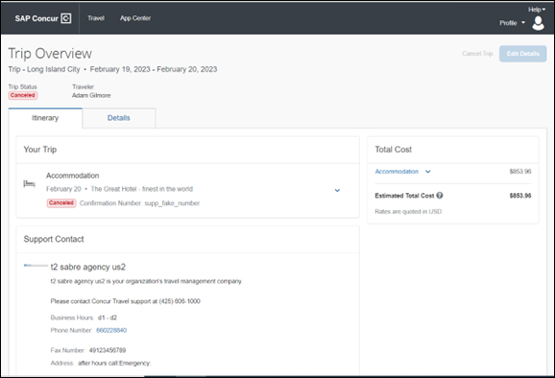

**Planned Changes** New Hotel Experience: Configuration for Custom Hotel Sourcing

Information First Published | Information Last Modified | Feature Target Release Date
March 2023 | -- | Q2 2023
Any changes since the previous monthly release are highlighted in yellow in this release note.

Prof | Stan |   Edition
 |  | On: Impacts end users who use this feature/vendor; no configuration/setup by agency/ admin; cannot be turned OFF (example: new icons or rate display)
 |  | Available for use: No impact to end users unless/until configuration/setup by agency/admin (described below) (example: new rule, new Travelfusion airline)
X | X | Other: Refer to the release note below
 |  | Does not apply to this edition
Source
GDS
Direct Connect
Other
 | EMEA Data Center |  |  | Scan impact
 | North America Data Center |  |  | UI impact
 | China Data Center |  |  | File finishing impact
 | All data centers |  |  | Profile/Profile API/3rd Party XML Sync Impact
Affected Documentation
TSGs
Fact Sheets
Admin Guides
Other

Configuration for Professional Travel

Custom Hotel Source Providers
Hotel content will only be available from Custom Hotel Source providers. This requires re-enablement for customers who are interested in using these channels.
To configure:
- Click Administration > Travel (on the sub-menu) > Travel System Admin and select the desired client travel configuration.
Depending on your permissions, the page may appear immediately after you click Administration or Travel.
- There are now two different Hotel Connector sections of the travel configuration page. One is to support the new hotel connectors and is called Hotel Connectors – Hotel Service v4. The other is the existing hotel connector section.
When enabling a new connector, it is essential that any current direct connect remains enabled otherwise customers will not be able to make bookings in the current Concur Travel experience. This means that a current HSv2 configuration needs to remain enabled on HSv2, and on HSv4 once migrated. The HSv2 connection will not allow new bookings but will provide access to previously booked reservations for servicing. Any servicing will continue as it is today using the Online Booking Tool (OBT).
- The administrator will be able to select the default connection type within the new section. Although GDS is presented as an option, there is no GDS content available with this release.
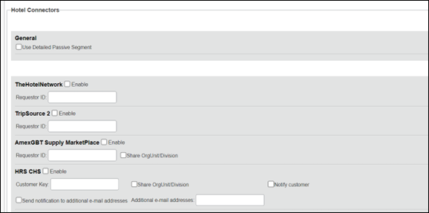
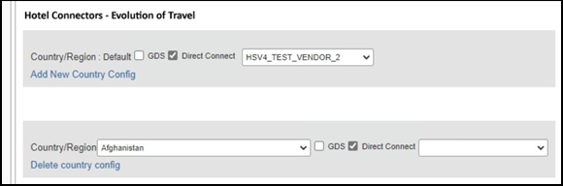

Passive PNR for Direct Content
To configure:
- Go to Administration > Travel (on the sub-menu) > Travel System Admin and select the desired client travel configuration.
Depending on your permissions, the page may appear immediately after you click Administration or Travel.
- Under GDS PNR Options of the travel configuration page, go to the activation checkboxes.
- Select New Custom Hotel Source in the list under Defaults for Specific non-GDS vendors. This defaults to Use the default specified above. Select Write passive segments for non-GDS content if I have not specified a default for the specific vendor in the table below.
Image to be included in subsequent update

Travel arranger flow
The Travel Arranger flow will be supported for Hotel. Full details of how to book a hotel as a Travel Arranger are in Travel Arranger View Travel Service Guide.
The Travel Arranger Name appears on the new Trip Overview.
Image to be included in subsequent update

**Planned Changes** New Hotel Experience: Reduced Feature Set

Information First Published | Information Last Modified | Feature Target Release Date
March 2023 | -- | Q2 2023
Any changes since the previous monthly release are highlighted in yellow in this release note.

Prof | Stan |   Edition
 |  | On: Impacts end users who use this feature/vendor; no configuration/setup by agency/ admin; cannot be turned OFF (example: new icons or rate display)
 |  | Available for use: No impact to end users unless/until configuration/setup by agency/admin (described below) (example: new rule, new Travelfusion airline)
X | X | Other: Refer to the release note below
 |  | Does not apply to this edition
Source
GDS
Direct Connect
Other
 | EMEA Data Center |  |  | Scan impact
 | North America Data Center |  |  | UI impact
 | China Data Center |  |  | File finishing impact
 | All data centers |  |  | Profile/Profile API/3rd Party XML Sync Impact
Affected Documentation
TSGs
Fact Sheets
Admin Guides
Other
The activation of the new hotel workflow though Concur Travel will not be possible via a setting within Concur Travel. As a reduced set of features will be available in the first release, customers will be determined and informed when eligible for migration.

Known Limitations
The following items are not yet supported with the new hotel booking experience. Monitor future release notes for changes relating to these limitations.

Product Area | Feature/Setting | Setting Location | Setting/Feature details | Additional Information
Traveler selection | Guest Traveler bookings | Travel Configuration | Guest traveler bookings are disabled | A guest traveler or sponsored guest booking are not supported yet.
Content | Hotel connectors | Agency Configuration | Custom Hotel Source Direct Connects only
Integrations | Concur Request | Travel configuration | Enable Request Integration unchecked
Travel Policy | Hotel rule Enforcement Levels | Company Administration > Travel Admin | Display Message not supported | No message is displayed to the user.
Travel Policy | Concur Travel’s Native Approval Process | Company Administration > Travel Admin | Hotel rules cannot use:  Require Pre-Approval & Log  Require Pre-approval & Notify | These rules will not be enforced if set up.
Travel Policy | Hotel Rule Parts | Company Administration > Travel Rule Builder / Travel Admin | Hotel Rate is [condition] the government hotel level per diem rate [plusMinus] [money] [currencyOrPercent]  Hotel Rate is [condition] the government location based per diem rate [plusMinus] [money] [currencyOrPercent]  Hotel Rate is [condition] the location rate or [currency] [money]  Hotel Rate is [condition] the price-to-beat  Hotel Rate is from the Reservation System  Hotel Rate is not from the Reservation System  Other rate descriptions at this hotel contain any of the text '[DescriptionList]'  Hotel has rates from source [Source]  Hotel has no rates from source [Source] | All other configured hotel rules will be supported
Travel Policy | Hotel rule Parts | Company Administration > Travel Rule Builder / Travel Admin | No Fedrooms or FEMA policy rules are supported. | If these are set up they will not be applied.
Travel Policy | Itinerary Rule Parts | Company Administration > Travel Rule Builder / Travel Admin | The following three Itinerary rules will be the only ones supported for the first release of the new Hotel experience:  Itinerary booked [condition] [DaysAdvance] days in advance  Trip duration [condition] [DaysLong] days  Itinerary has no Hotel segments | All other Itinerary rule parts will not be enforced.
Travel Policy | Violation Reason Types | Company Administration > Travel Admin > Policy Violation Reasons | General  Air  Train  Car  Hotel  Itinerary | Reasons from any other reason type categories will not be displayed.
Travel Policy | Rule Class Selection and Force selection of a rule class | Travel Configuration | Only a user’s default rule class is supported | If enabled, users will see the rule class selection field on the search, but any selection by the user would not be honored.
Custom Fields | Custom Trip Fields | Company Administration > Manage Custom Fields | If/Then Settings cannot be enabled.
Custom Fields | Custom Trip Fields | Company Administration > Manage Custom Fields | Display for Edits cannot be enabled
Payments | Use A.I.D.A if Company Account is not accepted | Travel Configuration |  | AIDA cards not supported for Release 1 Hotels
Payments | Virtual Payments |  |  | Virtual cards generated through SAP Concur/Conferma will not be an option for customers to use for hotel bookings.
Hotel-specific | Hotel check in date prompt for arrival after midnight | Travel configuration |  | No prompt appears when searching for a hotel.
Hotel-specific | Government features |  | Hotel Per-Diems and Fedrooms not supported. | Any per diems set up will not be applied.
Hotel-specific | Direct Billing | Company Admin > Manage Corporate Discounts |  | Customers who use direct billing should not use the new hotel booking experience yet.
Hotel-specific | User supplied hotels | Travel Admin>Travel Policy>Edit Classes | Allows users to add their own hotel booked outside of Concur Travel. | Manual hotels cannot be booked. Configuration setting I will book a hotel later as a user-supplied option is not supported. If this is set, no popup will appear to allow customer to add their own hotel.
Hotel-specific | Allow hotel bookings using cards that expire before trip date | Module Properties | Allowed users to book hotels with credit card that expired before check in date | An error is received if user attempts to book a hotel with a credit card that expires before the check in date
Hotel-specific | Enable Hotel Streaming on Mobile | Module Properties | With hotel streaming, users see the rates and hotel images as the information is retrieved. If True, hotel streaming is enabled for the mobile app. If False, results are presented all at once, after all search results are collected | There is no longer any rate streaming in Hotels. All results appear at once.
Hotel-specific | Auto-check Find a Hotel for Air Searches | Module Properties | If True, the Find a Hotel checkbox on the Flight Search tab of the travel wizard is automatically selected. | The checkbox is not automatically selected.
Hotel-specific | Hotel Sort Default | Travel Configuration | Allows Admin to determine the default sort order of properties returned in Search results | The sort order is always the order in which the provider returns it.
Trip Management | Show Add Air on Existing Itineraries | Travel Configuration |  | When a user makes a hotel booking using the new experience, the Add Air link will not be shown yet.
Trip Management | Change of booking | N/A | N/A | Change of booking is not yet supported for the new hotel booking experience.

Changes in Product Behavior
While the following items will be supported for the new hotel booking experience, behavior will change for the following items.

Opt-Out Setting for Confirmation and Cancellation Emails
The opt-out settings from the User Profile or System Settings for Confirmation and Cancellation emails do not apply to emails sent out in the new Concur Travel experience. The setting Contact? in the email section of the user profile does apply. Emails are only sent to addresses for which Contact? is enabled.

Confirmation Emails
While confirmation emails will be sent for bookings made via the new hotel experience, these emails will not yet include an .ics calendar attachment.

Custom trip fields – display at start
Custom trip fields configured to Display at start of booking will be shown on the Review and Book page in the Additional Information section. Custom fields for which checkbox Display at start of booking is not enabled will be shown on the Finalize Trip page in the Additional Information section.
Custom trip fields – Checkbox Fields
In the regular booking experience of Concur Travel, checkboxes are not selected by default. Users can complete the booking without selecting a checkbox, even when it is a required field. The box not being selected is saved and recorded for reporting.
In the new Concur Travel experience, checkboxes display by default in an undetermined state (first screenshot). If the field is required, the box must be enabled or disabled to continue.
Undetermined:
Disabled:
Enabled:

Custom trip fields – display on itinerary
Regardless of the Display on Itinerary setting, all trip custom fields configured during the booking workflow will display by default on the Details tab of the Trip Overview page. Trip custom fields configured during the workflow will not be included in confirmation or cancellation emails.

Travel templates, Trip Sharing/Cloning
Hotel connector content is not supported for booking from a travel template, a shared trip, or a cloned trip. The travel template will work for other trip content as per regular logic, but the Hotel connector content will be ignored. It is possible to add Hotel connector content to a trip booked from a template after booking, in a separate operation.
Support Contact Section
On the Confirmation Page and the Trip Overview page, a section with Support Contact information displays, if configured. The new Concur Travel experience does not support html in the form field.

Rail

**Planned Changes** SNCF API (PAO) Migration

Information First Published | Information Last Modified | Feature Target Release Date
December 2022 | -- | TBD
Any changes since the previous monthly release are highlighted in yellow in this release note.

Prof | Stan | Å Å Edition
X | X | On: Impacts end users who use this feature/vendor; no configuration/setup by agency/ admin; cannot be turned OFF (example: new icons or rate display)
 |  | Available for use: No impact to end users unless/until configuration/setup by agency/admin (described below) (example: new rule, new Travelfusion airline)
 |  | Other: Refer to the release note below
 |  | Does not apply to this edition
Source
GDS
Direct Connect |  | SNCF PAO Direct Connect
Other
X | EMEA Data Center |  |  | Scan impact
X | North America Data Center |  |  | UI impact
 | China Data Center |  |  | File finishing impact
 | All data centers |  |  | Profile/Profile API/3rd Party XML Sync Impact
Affected Documentation
TSGs |  | SNCF PAO Direct Connect TSG (available with release)
Fact Sheets
Admin Guides
Other

Overview
In March 2020, SAP Concur performed a partial migration of SNCF customers to the SNCF PAO API with the goal of offering our customers whole Regional Train and Eurostar content.
Due to upcoming changes planned by SNCF, SAP Concur will continue with the migration to SNCF PAO. The targeted date for release will be communicated in the future.

User/Customer Benefit
The SNCF content will be available via the SNCF PAO API. Migrated customers will no longer need to enable both connectors, SNCF and SNCF (PAO), in their configurations. Migrated users will no longer need to select between SNCF and SNCF [TER + Eurostar] before they initiate their search.

End-User Experience
The booking steps for self-booked and arranger booked trips will remain the same. The traveler will no longer be asked to select between the SNCF and SNCF [TER + Eurostar] option from the dropdown before searching for SNCF.

Previous Experience
After logging into Concur Travel, by selecting the Rail tab, the traveler sees the following dropdown for SNCF:
Example:
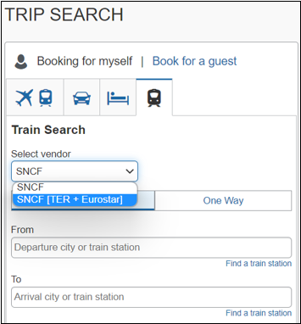

New Experience
After the migration is completed, the traveler will only see the SNCF option. The dropdown will not display as all SNCF content will be available via the PAO API.
Example:
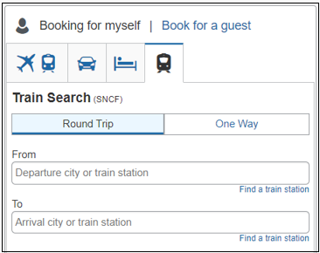

Known Limitations
Until further notice, the following features will be not supported or supported with limitations for migrated customers.
- The multi-passenger booking feature will not be supported for migrated customers.
- Eurostar will not support seat preferences or selection.
- Combing TGV and TER segments in one reservation might lead to additional work on the travel agency side for specific reservations. To prevent this situation, the recommendation for the travelers with a middle name holding SNCF loyalty or advantage card is to ask SNCF to not store their middle name in their database.

Configuration for Professional and Standard Travel
This feature will be enabled by default. SAP Concur will make these changes automatically.

Previous Experience
SNCF and SNCF (PAO) are enabled in the travel configuration page under the Rail Connectors section.

New Experience
Once the migration is completed, only the SNCF (PAO) rail connector will remain available in the travel configuration page.

Travel Operations / Technical Essentials

**Planned Changes** SNCF API (PAO) Migration

Information First Published | Information Last Modified | Feature Target Release Date
December 2022 | -- | TBD
Any changes since the previous monthly release are highlighted in yellow in this release note.

Prof | Stan | Å Å Edition
X | X | On: Impacts end users who use this feature/vendor; no configuration/setup by agency/ admin; cannot be turned OFF (example: new icons or rate display)
 |  | Available for use: No impact to end users unless/until configuration/setup by agency/admin (described below) (example: new rule, new Travelfusion airline)
 |  | Other: Refer to the release note below
 |  | Does not apply to this edition
Source
GDS
Direct Connect |  | SNCF PAO Direct Connect
Other
X | EMEA Data Center |  |  | Scan impact
X | North America Data Center |  |  | UI impact
 | China Data Center |  |  | File finishing impact
 | All data centers |  |  | Profile/Profile API/3rd Party XML Sync Impact
Affected Documentation
TSGs |  | SNCF PAO Direct Connect TSG (available with release)
Fact Sheets
Admin Guides
Other

Overview
SNCF (PAO) utilizes the French PCC (B930) for Concur Travel. The branch access will remain opened for existing SNCF PCC (previously known as Resarail PCC) in France.
Travel agencies outside of France with SNCF PCC will need to establish branch access from SNCF PCC to the SAP Concur SNCF PCC B930. This will ensure that these agencies can continue servicing SNCF reservations created in Concur Travel.
The following SAP Concur PCCs will not be supported with SNCF PAO:
- UK: C870
- Belgium: H060
- Switzerland: F460
- Netherlands: H070
When granting branch B access, refer to the following:

GDS | Command to grant branch access to B930
Amadeus | R//W/TAA yourSNCFPCC $BB930
In addition to granting branch access from your agency's SNCF PCC to SAP Concur's SNCF PCC, you must also execute the JGU/RAI-2C command on your Amadeus terminal. This will allow your Amadeus Office ID to identify SNCF as a rail provider. Failure to execute this one-time command will result in your seeing SECURED PNR whenever you attempt to search for an SNCF booking created in Concur Travel, even if it was correctly queued to your agency's SNCF PCC.

Client Notifications

Accessibility

Accessibility Updates
SAP implements changes to better meet current Web Content Accessibility Guidelines (WCAG). Information about accessibility-related changes made to SAP Concur solutions is published on a quarterly basis. You can review the quarterly updates on the Accessibility Updates page.

Documentation for New Concur Travel Experience

Online Help Updates in the SAP Help Portal

Overview
Online end user help documentation for the new Concur Travel experience, beginning with the Renfe Direct Connect enhancements from the November release, are indicated with “New Workflow” text at the end of topic titles.
Also, on the Implement tab of the Concur Travel product page in the SAP Help Portal, there is a new Travel Services Help. This will become the new home for Travel Service Guides type documentation.

User/Customer Benefit
The “New Workflow” text is intended to help you distinguish between the existing experience and the redesigned experience for Concur Travel.

End-User Experience
When accessing the Concur Travel End User Help, you can see which topics are specific to the Concur Travel experience as they contain the suffix "New Workflow".
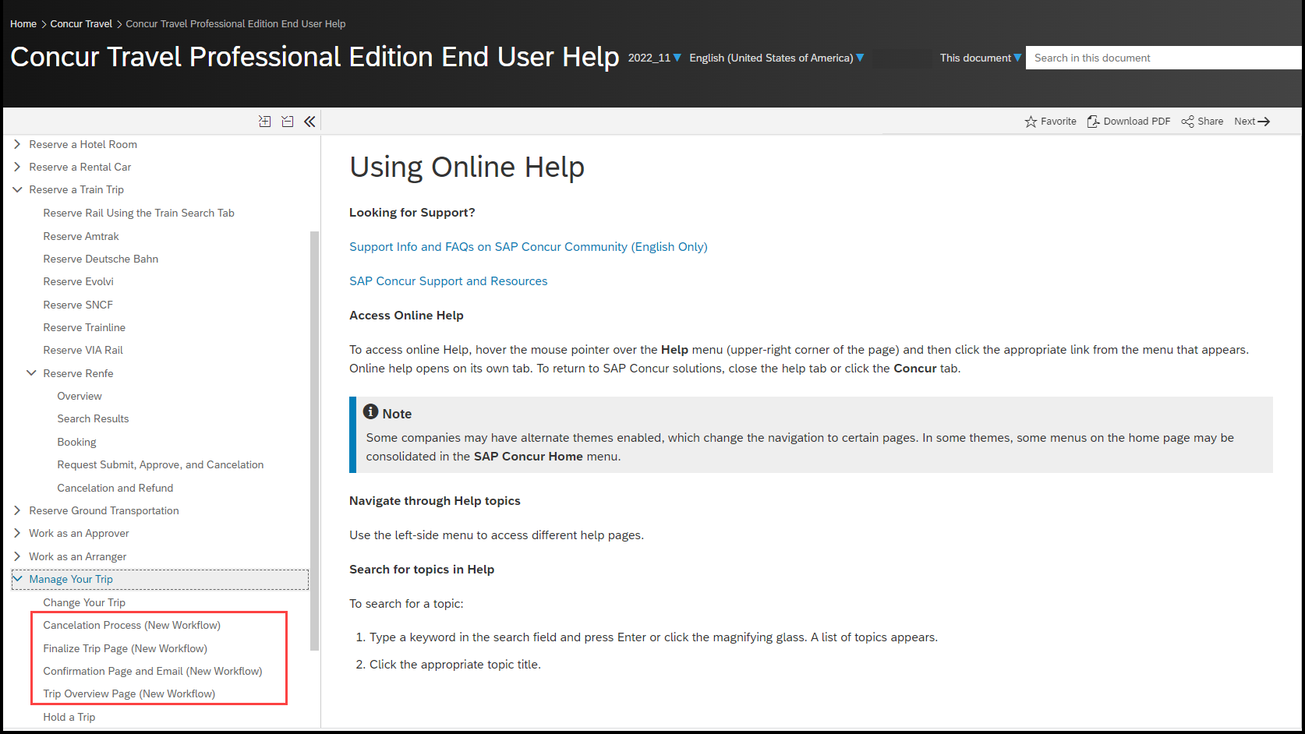

Configuration for Professional and Standard Travel
This feature is enabled by default. There are no configuration steps.

Sub-processors

SAP Concur Non-Affiliated Sub-processors
The list of non-affiliated sub-processors is available from the SAP Sub-processors / Data Transfer Factsheets page.
To access the SAP Concur Sub-processors List:
- Click the following link to navigate to the SAP Sub-processors / Data Transfer Factsheets page:
SAP Sub-processors / Data Transfer Factsheets
- Sign in to the SAP Support Portal using your Support User ID (S-user) and password.
SAP customers must sign in to the SAP Support Portal using their Support User ID (S-user) and password. For information about S-User IDs, refer to Your New Support User ID (S-user) and to the Learn All About S-User IDs blog post.
- On the SAP Sub-processors / Data Transfer Factsheets page, type "Concur" in the Search field.
- In the Title column, click SAP Concur Sub-processors List.
If you have questions or comments, please reach out to: Privacy-Request@Concur.com

Supported Browsers

Supported Browsers and Changes to Support
For information about supported browsers and planned changes to supported browsers, refer to the Concur Travel & Expense Supported Configurations guide.
When changes to browser support are planned, information about those changes will also appear in the Shared Changes Release Notes.

Additional Release Notes and Other Technical Documentation

Online Help – Admins
Any user with any "admin" role can access release notes, setup guides, user guides, admin summaries, monthly browser certifications, supported configurations, and other resources via online Help.
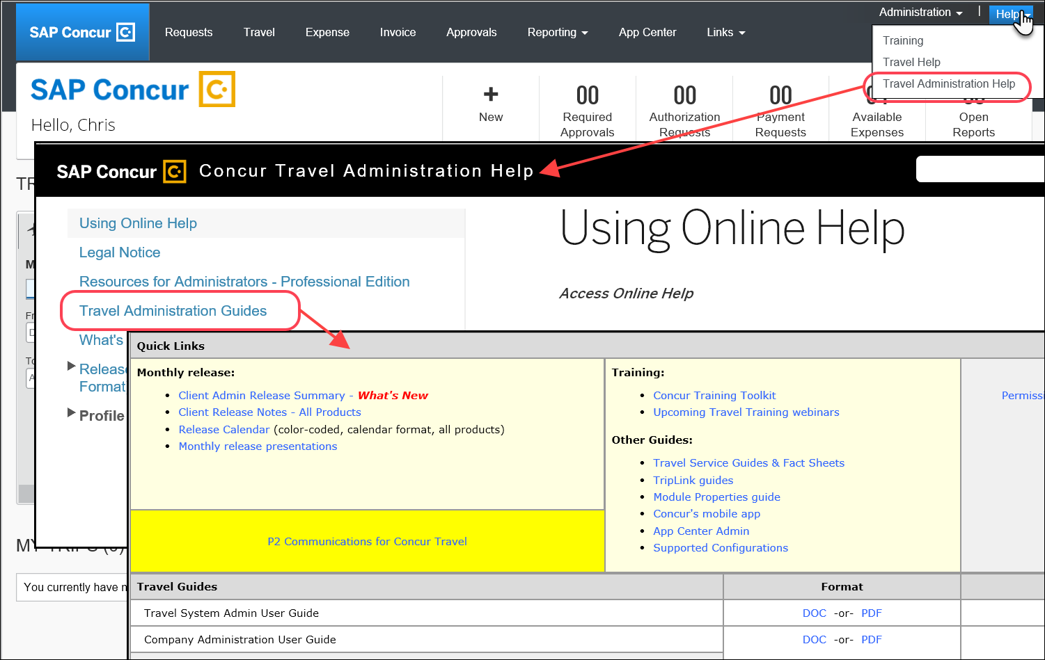

SAP Concur Support Portal – Selected Users
Access release notes, webinars, and other technical documentation on the SAP Concur support portal.
If you have the proper permissions, the Contact Support appears on the Help menu. Click to access the SAP Concur support portal, then click Resources.
- Click Release/Tech Info for release notes, technical documents, etc.
- Click Webinars for recorded and live webinars.
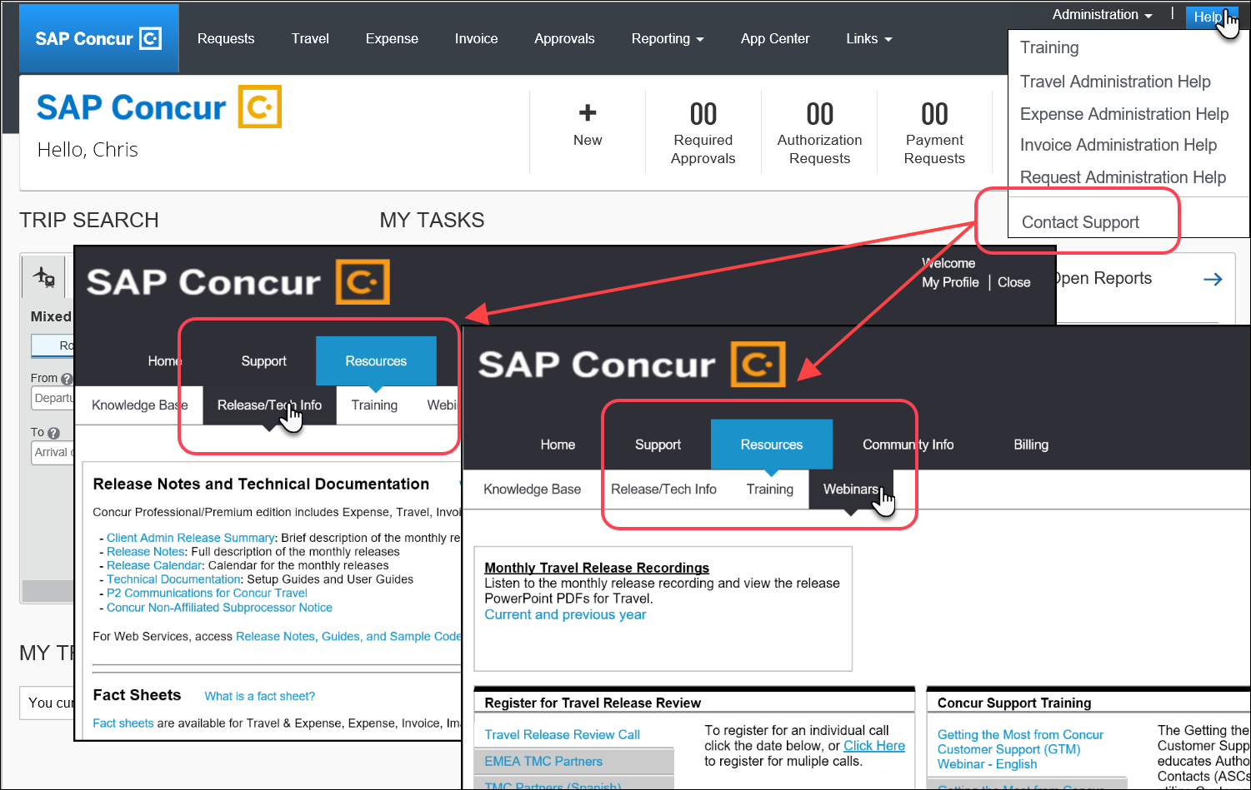

© 2023 SAP SE or an SAP affiliate company. All rights reserved.
No part of this publication may be reproduced or transmitted in any form or for any purpose without the express permission of SAP SE or an SAP affiliate company.
SAP and other SAP products and services mentioned herein as well as their respective logos are trademarks or registered trademarks of SAP SE (or an SAP affiliate company) in Germany and other countries. Please see http://global12.sap.com/corporate-en/legal/copyright/index.epx for additional trademark information and notices.
Some software products marketed by SAP SE and its distributors contain proprietary software components of other software vendors.
National product specifications may vary.
These materials are provided by SAP SE or an SAP affiliate company for informational purposes only, without representation or warranty of any kind, and SAP SE or its affiliated companies shall not be liable for errors or omissions with respect to the materials. The only warranties for SAP SE or SAP affiliate company products and services are those that are set forth in the express warranty statements accompanying such products and services, if any. Nothing herein should be construed as constituting an additional warranty.
In particular, SAP SE or its affiliated companies have no obligation to pursue any course of business outlined in this document or any related presentation, or to develop or release any functionality mentioned therein. This document, or any related presentation, and SAP SE’s or its affiliated companies’ strategy and possible future developments, products, and/or platform directions and functionality are all subject to change and may be changed by SAP SE or its affiliated companies at any time for any reason without notice. The information in this document is not a commitment, promise, or legal obligation to deliver any material, code, or functionality. All forward-looking statements are subject to various risks and uncertainties that could cause actual results to differ materially from expectations. Readers are cautioned not to place undue reliance on these forward-looking statements, which speak only as of their dates, and they should not be relied upon in making purchasing decisions.

