SAP Concur Release Notes
Concur Travel
Concur Professional/Premium and Concur Standard
Month | Audience
Release Date: January 21, 2023  Update #1: Friday, January 27 | SAP Concur Client FINAL

** FINAL **
The enhancements and changes described in this document may or may not be included in this release. SAP Concur reserves the right to postpone implementation of – or completely remove – any enhancement/change mentioned here.
The DRAFT and FINAL release notes contain information about Concur Professional/Premium and Concur Standard.
Each note contains a table that which indicates if the enhancement/change applies to Professional and/or Standard.

Contents
Release Notes 1
Flight 1
Travelfusion – Aer Lingus Supplier Update (January 31) 1
Documentation for New Concur Travel Experience 3
**Ongoing** Online Help Updates in the SAP Help Portal 3
Train 4
Renfe Review and Book page (Professional Edition Only) 4
Swedish Rail Decommission 7
New Concur Travel Experience - Changes to Cancel Flow from Trip Library (Professional Edition Only) 8
New Concur Travel Experience - Changes to Cancel Trip page (Professional Edition Only) 12
New Concur Travel Experience - Changes to Dialog with Cancel Conditions (Professional Edition Only) 14
Travel Operations / Technical Essentials 16
Planned Changes 17
Administration 17
**Planned Changes** Croatian Change of Currency 17
Car 18
**Planned Changes** New Rental Car Experience (Amadeus Only): Overview 18
**Planned Changes** New Rental Car Experience: Search for a Car Rental 19
**Planned Changes** New Rental Car Experience: Review and Book 29
**Planned Changes** New Rental Car Experience: Finalize and Confirm Booking 35
**Planned Changes** New Rental Car Experience: Completed Trip Overview 41
**Planned Changes** New Rental Car Experience: Cancellation 44
**Planned Changes** New Rental Car Experience: Configuration for Hertz, Sixt, and Delivery and Collection 45
**Planned Changes** New Rental Car Experience: Reduced Feature Set 48
Flight 53
**Planned Changes** Sabre Profiles Update for Known Traveler and Redress Numbers 53
Rail 56
**Planned Changes** VIA Rail Decommission 56
**Planned Changes** SNCF API (PAO) Migration 58
Client Notifications 60
Accessibility 60
Accessibility Updates 60
Subprocessors 60
SAP Concur Non-Affiliated Subprocessors 60
Supported Browsers 61
Supported Browsers and Changes to Support 61
Additional Release Notes and Other Technical Documentation 62
Online Help 62
SAP Concur Support Portal – Selected Users 62
Legal Disclaimer
The information in this presentation is confidential and proprietary to SAP SE or an SAP affiliate company and may not be disclosed without the permission of SAP SE or the respective SAP affiliate company. This presentation is not subject to your license agreement or any other service or subscription agreement with SAP SE or its affiliated companies. SAP SE and its affiliated companies have no obligation to pursue any course of business outlined in this document or any related presentation, or to develop or release any functionality mentioned therein. This document, or any related presentation and SAP SE or an SAP affiliate company’s strategy and possible future developments, products and or platforms directions and functionality are all subject to change and may be changed by SAP SE and its affiliated companies at any time for any reason without notice. The information in this document is not a commitment, promise or legal obligation to deliver any material, code or functionality. This document is provided without a warranty of any kind, either express or implied, including but not limited to, the implied warranties of merchantability, fitness for a particular purpose, or non-infringement. This document is for informational purposes and may not be incorporated into a contract. SAP SE and its affiliated companies assume no responsibility for errors or omissions in this document, except if such damages were caused by SAP SE or an SAP affiliate company’s willful misconduct or gross negligence.
All forward-looking statements are subject to various risks and uncertainties that could cause actual results to differ materially from expectations. Readers are cautioned not to place undue reliance on these forward-looking statements, which speak only as of their dates, and they should not be relied upon in making purchasing decisions.

Release Notes

Flight

Travelfusion – Aer Lingus Supplier Update (January 31)

Prof | Stan |   Edition
X | X | On: Impacts end users who use this feature/vendor; no configuration/setup by agency/ admin; cannot be turned OFF (example: new icons or rate display, new Amtrak feature)
 |  | Available for use: No impact to end users unless/until configuration/setup by agency/admin (described below) (example: new rule, new Travelfusion airline)
 |  | Other: Refer to the release note below
 |  | Does not apply to this edition
Source / Solution Suggestion
GDS
Direct Connect |  | Travelfusion
Solution ID
Other
X | EMEA Data Center |  |  | Scan impact
X | North America Data Center |  |  | UI impact
 | China Data Center |  |  | File finishing impact
 | All data centers |  |  | Profile/Profile API/3rd Party XML Sync Impact
Affected Documentation
TSGs |  | Travelfusion Direct Connect Travel Service Guide
Fact Sheets
Admin Guides
Other

Overview
As of April 2022, customers have been able to choose between the legacy Aer Lingus and the new Aer Lingus (B2B) connections via Travelfusion in Concur Travel.
Since the Aer Lingus (B2B) supplier offers greater support and stability than the legacy Aer Lingus supplier, SAP Concur will discontinue supporting the legacy Aer Lingus supplier connector as of January 31, 2023. Customers must complete the migration to the new supplier prior to this date in order to keep Aer Lingus direct connect content in Concur Travel. Detailed migration steps are included in the Configuration for Professional and Standard Travel section of this release note.

User/Customer Benefit
By switching to the Aer Lingus (B2B) supplier connector, users will now experience a more stable and reliable booking flow with less booking failures, compared to the legacy supplier connector. Customers may obtain their own credential set from Air Lingus, if they have negotiated content with the airline. The Aer Lingus (B2B) connection works with or without credentials; users can book published fares without credentials.

End-User Experience
The shop and book flows between the two suppliers are almost identical. Users can request express boarding via the Flight Options popup when using the B2B connection.

Configuration for Professional and Standard Travel
To migrate from the legacy Aer Lingus supplier to the Aer Lingus (B2B) supplier, the legacy supplier must be disabled. The new Aer Lingus (B2B) connection must be enabled in the Concur Travel configuration.
Please follow the general configuration and administrative settings instructions on Travelfusion and on the specifically desired airline content for a successful implementation.
These steps are covered in detail in the Travelfusion Direct Connect Travel Service Guide:
- Disabling the “Aer Lingus” supplier connector.
- Enabling the “Aer Lingus (B2B)” supplier connector.
- Adding credentials to receive the negotiated content via Travelfusion (optional).
For more information, refer to the Travelfusion Direct Connect Travel Service Guide. To locate, refer to Additional Release Notes and Other Technical Documentation in these release note.

Documentation for New Concur Travel Experience

**Ongoing** Online Help Updates in the SAP Help Portal

Overview
Online end user help documentation for the new Concur Travel experience, beginning with the Renfe Direct Connect enhancements from the November release, are indicated with “New Workflow” text at the end of topic titles.
Also, on the Implement tab of the Concur Travel product page in the SAP Help Portal, there is a new Travel Services Help. This will become the new home for Travel Service Guides type documentation.

User/Customer Benefit
The “New Workflow” text is intended to help you distinguish between the existing experience and the redesigned experience for Concur Travel.

End-User Experience
When accessing the Concur Travel End User Help, you can see which topics are specific to the Concur Travel experience as they contain the suffix "New Workflow".
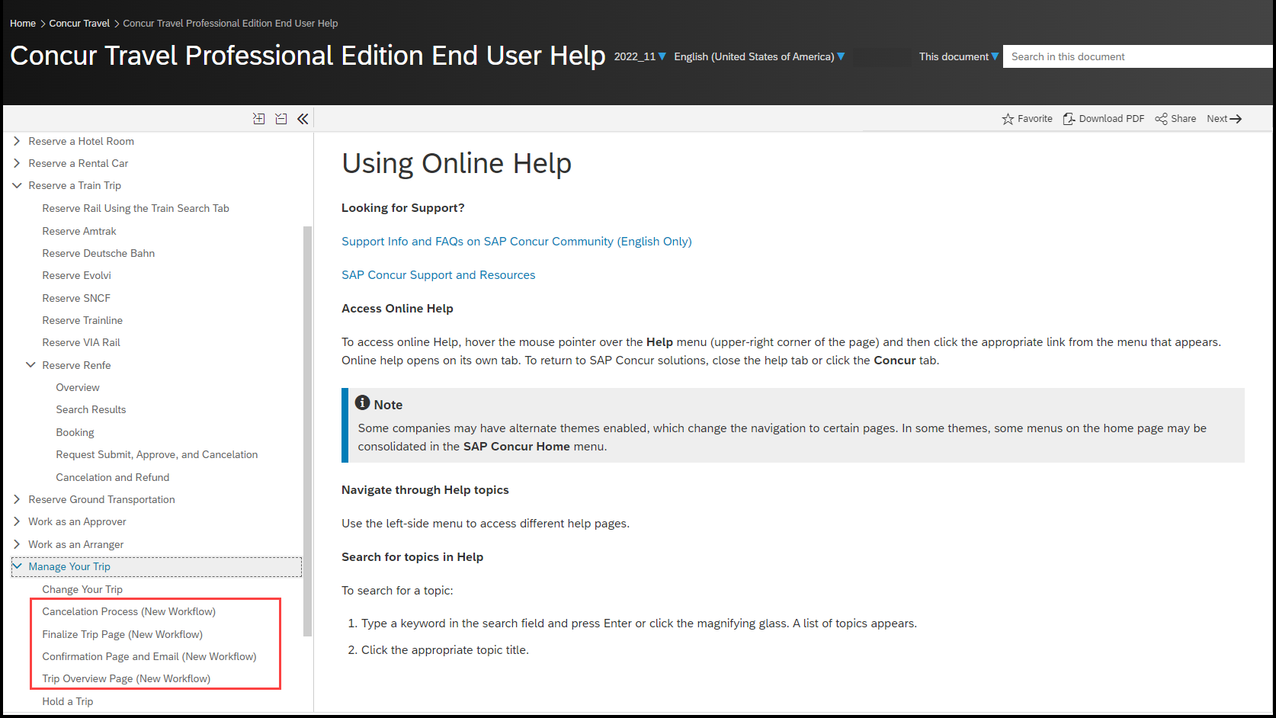

Configuration for Professional and Standard Travel
This feature is enabled by default. There are no configuration steps.

Train

Renfe Review and Book page (Professional Edition Only)

Prof | Stan | Å Å Edition
X |  | On: Impacts end users who use this feature/vendor; no configuration/setup by agency/ admin; cannot be turned OFF (example: new icons or rate display, new Amtrak feature)
 |  | Available for use: No impact to end users unless/until configuration/setup by agency/admin (described below) (example: new rule, new Travelfusion airline)
 |  | Other: Refer to the release note below
 |  | Does not apply to this edition
Source / Solution Suggestion
GDS
Direct Connect |  | Renfe
Solution ID
Other
X | EMEA Data Center |  |  | Scan impact
X | North America Data Center |  |  | UI impact
 | China Data Center |  |  | File finishing impact
 | All data centers |  |  | Profile/Profile API/3rd Party XML Sync Impact
Affected Documentation
TSGs
Fact Sheets
Admin Guides
Other |  | Online Help

Overview
The page layout of Total Cost and Form of Payment sections on the Review and Book page are changing slightly to align with an upcoming release of the new rental car booking experience.
There are no functional changes for the Renfe booking experience.

End-User Experience
Currently, the Total Cost and Form of Payment sections display at the bottom of the Review and Book page.
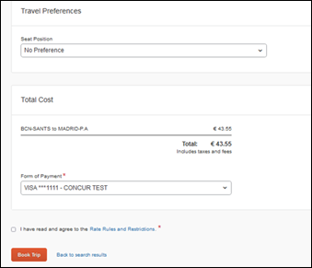
The new layout will display the Total Cost and Form of Payment information in the top right corner of the page.
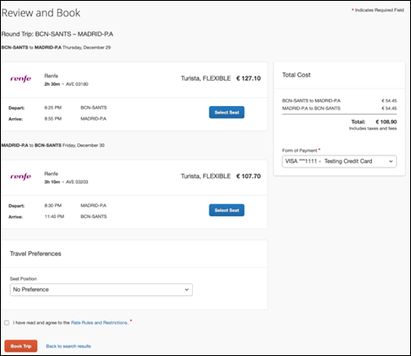

Configuration for Professional Travel
This feature is enabled by default. There are no configuration steps.

Swedish Rail Decommission

Prof | Stan | Å Å Edition
X | X | On: Impacts end users who use this feature/vendor; no configuration/setup by agency/ admin; cannot be turned OFF (example: new icons or rate display, new Amtrak feature)
 |  | Available for use: No impact to end users unless/until configuration/setup by agency/admin (described below) (example: new rule, new Travelfusion airline)
X | X | Other: Refer to the release note below
 |  | Does not apply to this edition
Source / Solution Suggestion
GDS
Direct Connect
Solution ID
Other
X | EMEA Data Center |  |  | Scan impact
X | North America Data Center |  |  | UI impact
 | China Data Center |  |  | File finishing impact
 | All data centers |  |  | Profile/Profile API/3rd Party XML Sync Impact
Affected Documentation
TSGs
Fact Sheets
Admin Guides
Other

Overview
Concur Travel currently provides travelers the ability to book tickets for Swedish Rail via SilverRail. SilverRail brings access to Swedish Rail (SJ) services and integrates rail bookings with the corporate reporting and account process.
Assessments of our current Swedish Rail Connection via SilverRail have resulted in the conclusion that solutions for longstanding operational and technical challenges require a new technical and functional integration of our Swedish Rail Connection.
SAP Concur is evaluating a new solution, resulting in a more automated end-to-end experience that will further benefit customers and TMCs.
SAP Concur decommissioned the current Swedish Rail direct connection to Concur Travel on December 31, 2022. Swedish Rail has been automatically disabled and no longer visible for any travel configurations.
If clients have subscriptions to Concur TripLink and TripIt Pro, they can forward their Swedish Rail itineraries to plans@tripit.com so that their trips can be imported into Concur Travel. These itineraries will display under Upcoming Trips.
Affected clients may work with their travel agency to explore other options to book Swedish Rail outside Concur Travel.

User/Customer Benefit
Periodically, under-supported third-party features may be removed to ensure usability standards are maintained. This feature is not fully supported and will therefore be decommissioned.

End-User Experience
Existing Rail itineraries will remain visible in Concur Travel under Upcoming Trips. Also, the historical data will be kept for reporting.

Configuration for Professional and Standard Travel
No additional steps are required by administrators to support this change. However, SAP Concur recommends that clients provide messaging within Concur Travel to inform travelers.

New Concur Travel Experience - Changes to Cancel Flow from Trip Library (Professional Edition Only)

Prof | Stan | Å Å Edition
X |  | On: Impacts end users who use this feature/vendor; no configuration/setup by agency/ admin; cannot be turned OFF (example: new icons or rate display, new Amtrak feature)
 |  | Available for use: No impact to end users unless/until configuration/setup by agency/admin (described below) (example: new rule, new Travelfusion airline)
 |  | Other: Refer to the release note below
 |  | Does not apply to this edition
Source / Solution Suggestion
GDS
Direct Connect |  | Renfe
Solution ID
Other
X | EMEA Data Center |  |  | Scan impact
X | North America Data Center |  |  | UI impact
 | China Data Center |  |  | File finishing impact
 | All data centers |  |  | Profile/Profile API/3rd Party XML Sync Impact
Affected Documentation
TSGs
Fact Sheets
Admin Guides
Other |  | Online Help

Overview
Users who want to cancel their Renfe trip can do so from links within a number of locations: Trip Library, Upcoming Trips tab, My Trips section, or Travel Details page.
From the Finalize Trip page and the Trip Overview page, you can click Cancel Trip to redirect you to the Confirm Cancellation page.
When cancelling a trip that contains only content booked in the new Concur Travel experience (as in.a Renfe booking) from My Trips, Trip Library or Upcoming Trips, a dialog with Renfe cancel conditions was displayed instead of the Confirm Cancellation page. With this release, users will be redirected to the Confirm Cancellation page when initiating cancellation of any trip containing only content booked in the new Concur Travel experience also when canceling from My Trips, Trip Library or Upcoming Trips.
For trips consisting of both content booked in the new Concur Travel experience and content booked in the regular experience, the existing trip cancel flow will remain unchanged and the known dialog with Renfe cancel conditions will display.

User/Customer Benefit
More cancellation scenarios will be routed through the new, Confirm Cancellation page.

End-User Experience
Cancel Trip is accessible though the Trip Library and Upcoming Trip tabs.
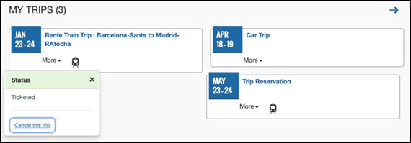
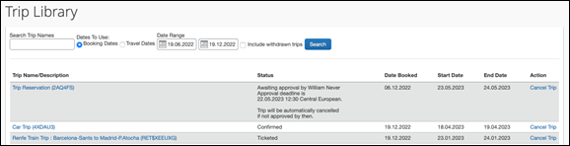
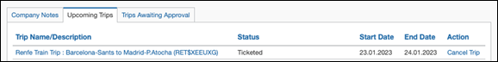

PREVIOUS EXPERIENCE
The link redirects to the Confirm Cancellation dialog.
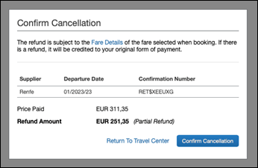

NEW EXPERIENCE
The link will redirect to the Confirm Cancellation page. This page will display the refund amount (if applicable) and a link to display the Fare Rules and Restrictions page.
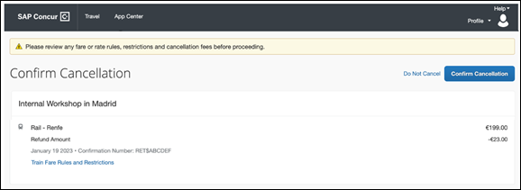
The Do Not Cancel link will redirect the user to the page from which the cancel action was initiated.
When you click Confirm Cancellation it will cancel the trip and redirect you to the Trip Overview page, where the cancelled trip displays.
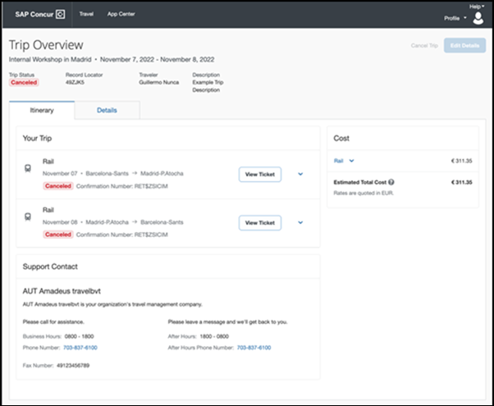

Configuration for Professional Travel
This feature is enabled by default. There are no configuration steps.
Online help documentation for this feature will be made available upon release.

New Concur Travel Experience - Changes to Cancel Trip page (Professional Edition Only)

Prof | Stan | Å Å Edition
X |  | On: Impacts end users who use this feature/vendor; no configuration/setup by agency/ admin; cannot be turned OFF (example: new icons or rate display, new Amtrak feature)
 |  | Available for use: No impact to end users unless/until configuration/setup by agency/admin (described below) (example: new rule, new Travelfusion airline)
 |  | Other: Refer to the release note below
 |  | Does not apply to this edition
Source / Solution Suggestion
GDS
Direct Connect |  | Renfe
Solution ID
Other
X | EMEA Data Center |  |  | Scan impact
X | North America Data Center |  |  | UI impact
 | China Data Center |  |  | File finishing impact
 | All data centers |  |  | Profile/Profile API/3rd Party XML Sync Impact
Affected Documentation
TSGs
Fact Sheets
Admin Guides
Other |  | Online Help

Overview
In this release, the wording on the Cancel Trip page will change slightly. There are no other changes to the page.

User/Customer Benefit
The wording on the Cancel Trip page has been adapted to support a future feature that will be introduced with the new Concur Travel experience.
Cancellation of an individual booking is not supported for Renfe rail.

End-User Experience
Users cancelling a trip booked in the new Concur Travel experience from the Finalize Trip page or the Trip Overview page are currently redirected to the Cancel Trip page as shown in the following image.
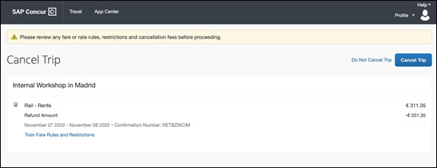
The Cancel Trip page title is renamed to Confirm Cancellation
The Do Not Cancel Trip link is re-labeled to Do Not Cancel
The Cancel Trip button is re-labeled Confirm Cancellation

Configuration for Professional Travel
This feature is enabled by default. There are no configuration steps.
Online help documentation for this feature will be made available upon release.

New Concur Travel Experience - Changes to Dialog with Cancel Conditions (Professional Edition Only)

Prof | Stan | Å Å Edition
X |  | On: Impacts end users who use this feature/vendor; no configuration/setup by agency/ admin; cannot be turned OFF (example: new icons or rate display, new Amtrak feature)
 |  | Available for use: No impact to end users unless/until configuration/setup by agency/admin (described below) (example: new rule, new Travelfusion airline)
 |  | Other: Refer to the release note below
 |  | Does not apply to this edition
Source / Solution Suggestion
GDS
Direct Connect |  | Renfe
Solution ID
Other
X | EMEA Data Center |  |  | Scan impact
X | North America Data Center |  |  | UI impact
 | China Data Center |  |  | File finishing impact
 | All data centers |  |  | Profile/Profile API/3rd Party XML Sync Impact
Affected Documentation
TSGs
Fact Sheets
Admin Guides
Other |  | Online Help

Overview
The structure and wording on the cancel conditions feature will change slightly. There are no other changes to this feature.

User/Customer Benefit
The structure and wording of this feature have been adapted to support future content for an upcoming release of a new rental car booking experience.
There are no functional changes for the Renfe rail cancellation process.

End-User Experience
Users canceling a trip with bookings from the new Concur Travel experience and bookings from the regular experience currently see the following Confirmation Cancellation dialog with cancel conditions for Renfe rail.
The text in the by-line below the header contains the following changes:
- Supplier is renamed to Vendor
- Departure Date is renamed to Start Date
- End Date is added
- Record Locator is added to display a PNR record locator (if available)
- Confirmation Number is renamed Vendor Confirmation
- Terms and Conditions is added. This column contains the Fare Details link previously displayed in the by-line to the header.
- The data points on Price Paid and Refund Amount are moved into the table.
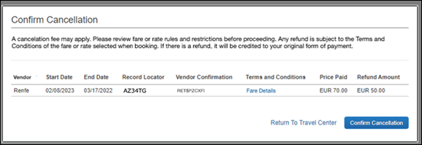

Configuration for Professional Travel
This feature is enabled by default. There are no configuration steps.
Online help documentation for this feature will be made available upon release.

Travel Operations / Technical Essentials
If you are participating in the initial release of the new Concur Travel car experience, your SAP Concur representative can provide draft GDS PNR documentation upon request.

Planned Changes
The items in this section are targeted for future releases. SAP Concur solutions reserves the right to postpone implementation of – or completely remove – any enhancement or change mentioned here.
The planned changes listed in this document are specific to this product. For information about planned site-wide or shared changes that might impact your SAP Concur solutions, refer to the Shared Changes Release Notes.

Administration

**Planned Changes** Croatian Change of Currency

Information First Published | Information Last Modified | Feature Target Release Date
January 2023 | January 27, 2023 | Q1 2023
Any changes since the previous monthly release are highlighted in yellow in this release note.

Prof | Stan |   Edition
X | X | On: Impacts end users who use this feature/vendor; no configuration/setup by agency/ admin; cannot be turned OFF (example: new icons or rate display, new Amtrak feature)
 |  | Available for use: No impact to end users unless/until configuration/setup by agency/admin (described below) (example: new rule, new Travelfusion airline)
 |  | Other: Refer to the release note below
 |  | Does not apply to this edition
Source / Solution Suggestion
GDS |  | All
Direct Connect |  | N/A
Solution ID
Other
X | EMEA Data Center |  |  | Scan impact
X | North America Data Center |  | X | UI impact
 | China Data Center |  |  | File finishing impact
 | All data centers |  |  | Profile/Profile API/3rd Party XML Sync Impact
Affected Documentation
TSGs |  | Travel System Admin
Fact Sheets
Admin Guides
Other

Overview
Croatia adopted the Euro as its currency on January 1, 2023.Targeting the February release, SAP Concur will be making necessary changes to Concur Travel to set Euro as the currency for Croatia.

User/Customer Benefit
Users will be able to accurately see Euro (€) as the currency in for Croatia in Concur Travel.

Configuration for Professional and Standard Travel
Changes are being made to Administration > Travel (on the sub-menu) > Travel System Admin (access the desired client travel configuration) > Agency Ticketing Country/Currency list so that it will display Croatia (HRK).
Example:
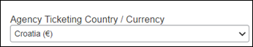
This setting will be automatically updated. There are no configuration steps needed.
For more information, refer to the Travel System Admin User Guide. To locate, refer to Additional Release Notes and Other Technical Documentation in these release notes.

Car

**Planned Changes** New Rental Car Experience (Amadeus Only): Overview

Information First Published | Information Last Modified | Feature Target Release Date
December 2023 | January 27, 2023 | Q1 2023
Any changes since the previous monthly release are highlighted in yellow in this release note.

Overview
Targeted for the first quarter of 2023, Concur Travel will introduce a new rental car booking experience. This first release is limited to participating Amadeus TMC partners. With this integration, customers can experience:
- An intuitive and personalized design, with an easy-to-use experience.
- Seamless GDS and non-GDS content normalization, aggregation and servicing.
- Mobile and Web content parity.

User/Customer Benefit
The new Concur Travel rental car booking experience is available with a specific feature set for customers open to explore the changes.
- Time Savings: The user is getting through the booking experience faster with less pages to go through.
- Delivery and Collection: Select the Delivery and Collection service right up front with a choice of any favorite address and discover the compact and smooth booking experience.
- Sustainability: Let end users consider the environmental footprint by comparing carbon dioxide (CO2) emissions between offered vehicles. Additional filter options on hybrid and electric cars help promote more sustainable choices.
- Merged on-airport and off-airport search: No matter where the user requires a rental car, all text entries will be recognized, and location suggestions are provided. All activated rental car companies with negotiated packages will be comparable. Details such as included services will display next to total rates with taxes and fees.
- Localized content: When a rental car location exists in the GDS, it exists in Concur Travel. Locations will be offered in real-time, with the most up-to-date location details as provided by the GDS.

**Planned Changes** New Rental Car Experience: Search for a Car Rental

Information First Published | Information Last Modified | Feature Target Release Date
December 2023 | January 27 2023 | Q1 2023
Any changes since the previous monthly release are highlighted in yellow in this release note.

End-User Experience: Search for a Car Rental
The search options include a free text entry field for the pick-up location and when required, the drop-off location. No matter if the user is searching for an on-airport or off-airport rental car location, the user starts typing the preferred location. The “omni search” functionality will suggest matching options for cities, airports, company locations, business addresses, railway stations, points of interest and general addresses.
To search for a company address, type the name into the search bar and it should appear in the dropdown.
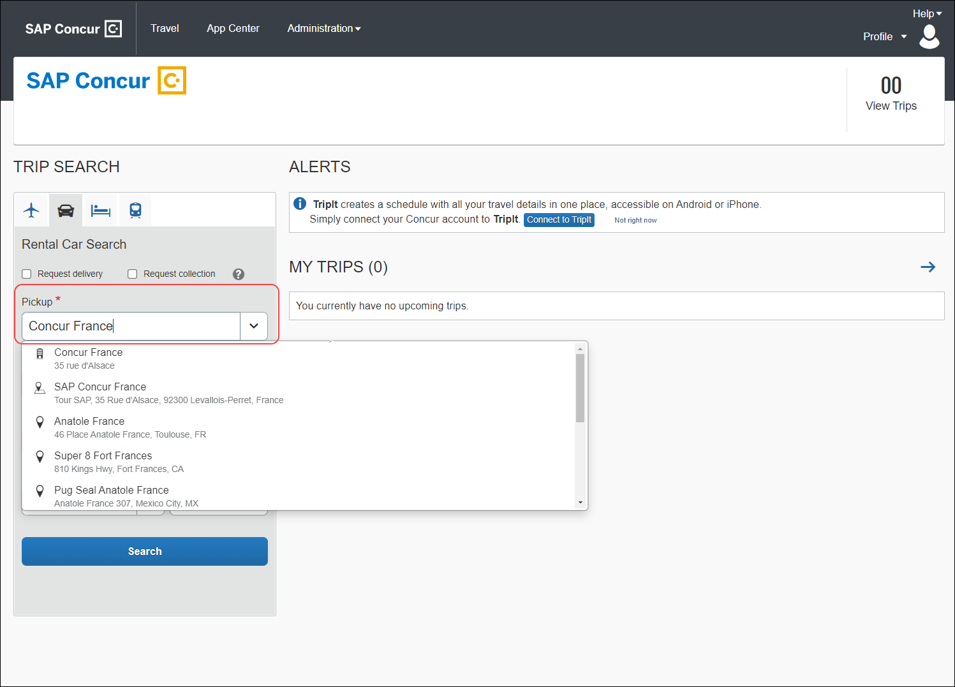
Pickup and drop-off date are always pre-populated by tomorrow's date and day after tomorrow, respectively. The default time is set to 10:00 AM.
If the delivery and collection service has been activated by the Travel System Admin, equivalent checkboxes become visible within the Rental Car search tool. The end user can request this service as part of their initial search request.

Car Search
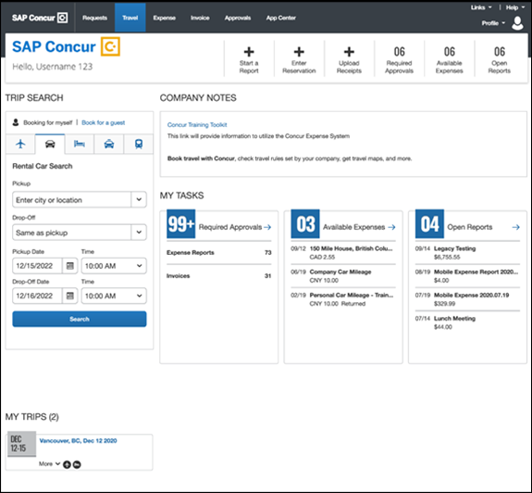

Car Search with Delivery and Collection Enabled
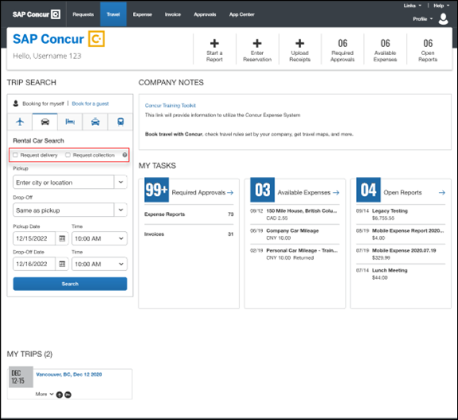

End-User Experience: Select a Car Rental
Once the user has entered their search criteria and clicked Search, the search results display.
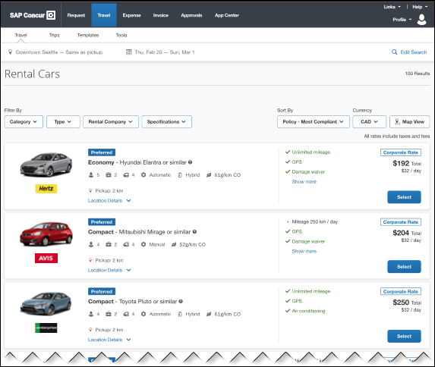

Edit Search
At the top of the page, Concur Travel presents the entered search data and provides an option to change the search criteria again.
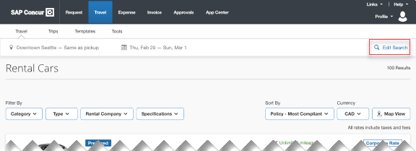

Filter Options
The offered filter sections are car category, car type, vendor, and specifications (transmission type, hybrid/electric).
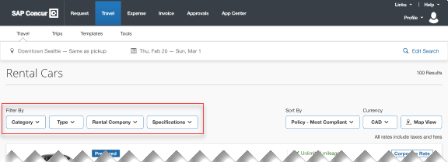

Sorting Options
The sorting orders are reduced to sort by Total Cost, Distance, Policy - Most Compliant and Preferred Rental Car Company.
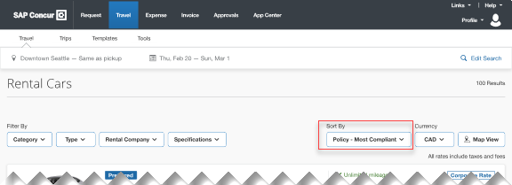

Car Features
The emphasis of the page is set on the result list which shows consistent information across the car offers. The vehicle-related information contains information on number of seats, bags, and doors, as well as transmission, fuel type, and carbon dioxide emission values.
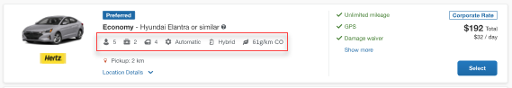

Corporate Rates
The corporate rates, highlighted via a label, include specific negotiated ancillaries which will display to the user to compare all included services between the offers. A new experience is the comparison between rental car locations and suppliers in general. To show the most relevant results, the system limits the displayed locations to a maximum of 5 closest rental car locations per supplier.
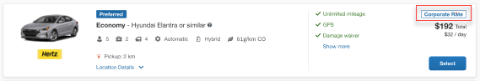

Location Details
For airport rentals, it is indicated when a shuttle transfer is required to get to the rental car location. All displayed locations are evaluated based on their opening hours, out-of-hours service, availability and delivery and collection service, if applicable. Also, the airport terminal information will be provided (when available from the external content channels) within the location details section.
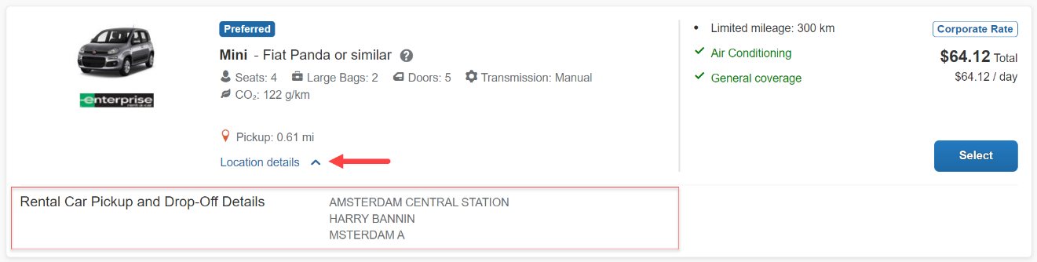

Total Price
Total prices are always displayed in comparison to the daily rates. All rates displayed always include all taxes and fees.
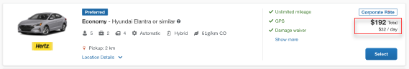

Travel Policy
When a rental car offer violates a policy rule, the segment is marked with a corresponding exclamation mark or warning icon. Click the icon to see more information on the policy rules that apply.
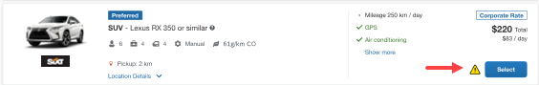

Delivery and Collection
When a user searches for car rentals using the delivery and collection service, this will be indicated on the individual search results.
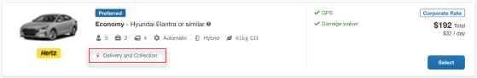

Map View
The new result map view has an informational purpose and represents an additional filter option. Click a pin to see the location address, opening hours, and the total price for the cheapest available car. The distance to the search center is indicated as well as the company’s preference level for that car rental vendor. Company locations are displayed on the map via a small icon.
To access rental car locations, click Map View to display the map.
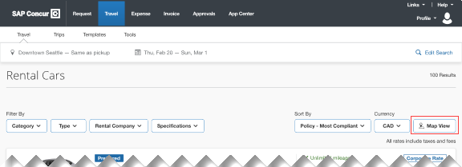
In case of overlapping pins, the number of locations will display. Click the pin to automatically zoom the view of the map, until separate pins display clearly.
Select a specific rental car location on the map to return to the result page and show only offers connected to this pick-up location.
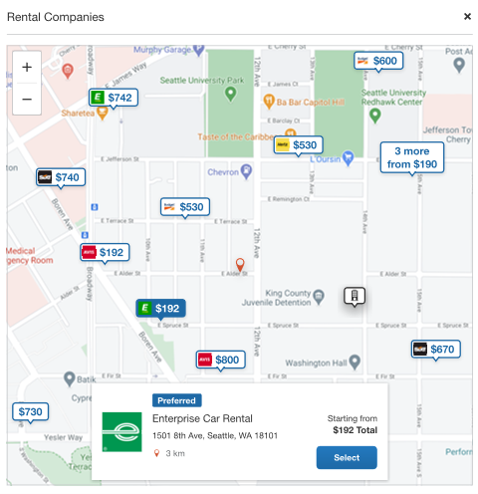

**Planned Changes** New Rental Car Experience: Review and Book

Information First Published | Information Last Modified | Feature Target Release Date
December 2023 | January 2023 | Q1 2023
Any changes since the previous monthly release are highlighted in yellow in this release note.

End-User Experience: Review and Book
The Review and Book page combines all relevant information before the user has completed the booking. All car selection related information will be shown, listing all car attributes plus insurance and other services connected to the selected rate
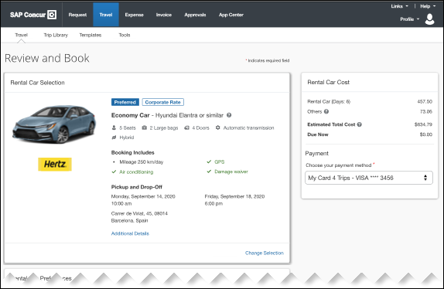

Additional Details
The Additional Details popup contains information on pickup and drop-off address, hours of operation, shuttle, terminal information if available, and directions on how to get to the location. As Concur Travel supports out-of-hour rentals in the new rental car booking experience, the corresponding hours of operation or an alternative informational text will display.
Image to be included in subsequent update.

Cost Section
Within the cost section, when booking a post-pay or corporate rate, the total price will be shown in the configuration currency of the traveler. A list of all included taxes, fees, surcharges, special equipment types and insurances becomes visible when expanding Others within the cost section.
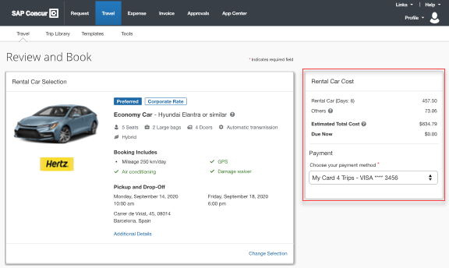

Car Preferences
The Rental Car Preferences section allows users to comment on the rental car location directly as part of the booking. Given the special character limitations of some external content channels, only alpha-numeric entries are accepted.
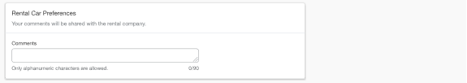

Traveler Information
The Traveler Information section will show the user data that is used to complete the booking and the data that is also transferred to the suppliers. It is possible to select a specific loyalty card from the user profile. When a loyalty card program is stored in the user profile, matching the selected vendor offer, Concur Travel will automatically fill out this frequent traveler card.
For all airport rentals, Concur Travel will display a flight number entry field. This information is important for the rental car companies to track changes of pick-up times related to flight delays.
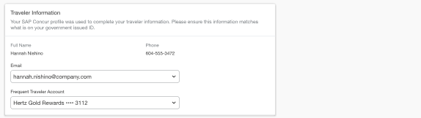

Travel Policy
This section appears if the user has selected an offer which violates their company travel policy. The user will be shown which rule(s) were broken, able to select a travel policy violation reason from the dropdown, and/or provide additional justification via a Comments box.
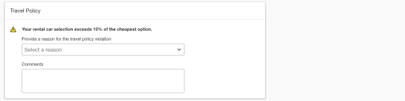

Pre-Book Custom Fields
Trip custom fields in Concur Travel can be set up to collect information during the booking process. These fields are often used to collect information for the clients’ internal accounting process or for reporting purposes. They can be configured to show at the beginning or end of the booking process and will be located within the Additional Information section on the Review and Book page.
Image to be included in subsequent update.

Payment
The payment selection will display in the Rental Car Cost section on the Review and Book page when a credit card form of payment is needed to complete the booking. The payment selection is a required field.
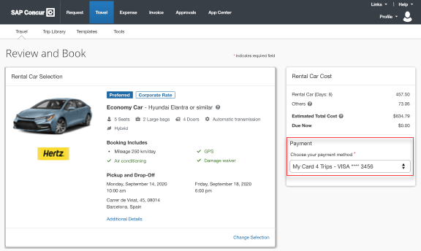
The user is shown a list of available credit cards to select from, based on configuration. There is no default option pre-selected, and the user is prompted to Choose your payment method. To complete the booking, complete all required fields and click Book and Continue.
If the user attempts to book and continue without selecting a credit card, the following alert banner displays across the top of the page: “This trip was not booked. Please fix the indicated errors and try again.” Also, the required payment selection is highlighted to bring focus to the missing information.
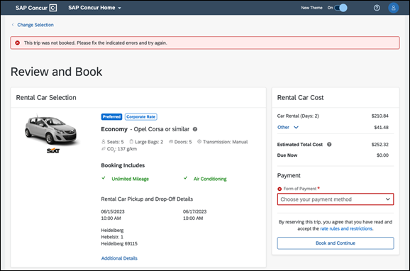
There are three conditions which can cause payment selection to display:
- The content source indicates that a credit card is required to complete the booking.
- The travel configuration setting Require Credit card for Car Reservations option is enabled.
- The travel configuration setting Agency Processing Fee Form of Payment for Land Only/Non-GDS Reservations option is enabled and set to Always write user-selected card.
The choices shown in the payment selection display are determined by:
- The Corporate Ghost Cards which are set to Allow for Car and assigned to the user
- The personal credit cards that a user has saved in their Concur Travel profile
To change settings for Require credit card for car reservations, Corporate Ghost Cards for Car, Agency Processing Fee Form of Payment for Land Only/Non-GDS Reservations, or to change how corporate ghost cards are assigned, refer to the Form of Payment Travel Service Guide. To change Allow users to add new personal credit cards to their Concur Travel profile settings, refer to the Module Properties Guide.
As part of the new Concur Travel experience, administrative setting validation is improved. For this reason, it’s possible a configuration could be set to require a credit card yet have no cards available for the user to select. If this occurs, the user will see this error message:
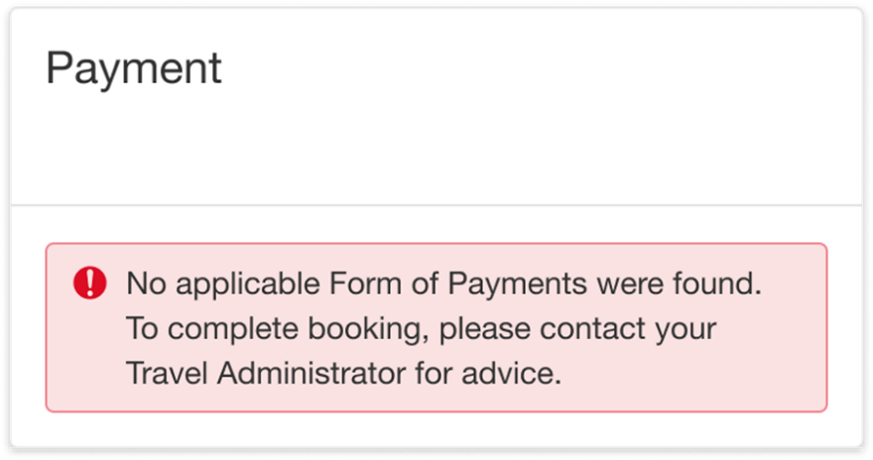
The user can then:
- Add a new personal credit card to their Concur Travel Profile and re-attempt their booking.
- Contact their Travel Management Company to complete the booking and/or investigate why a Corporate Ghost Card is not configured.

Rate Rules and Restrictions
The supplier’s rate rules and restrictions will be shown via the link at the bottom of the page.
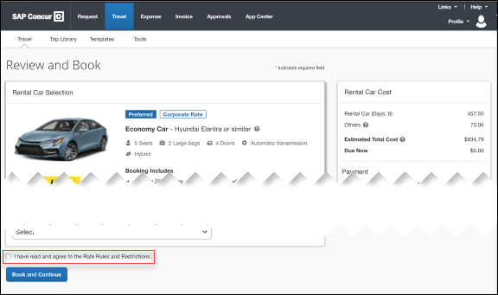

**Planned Changes** New Rental Car Experience: Finalize and Confirm Booking

Information First Published | Information Last Modified | Feature Target Release Date
December 2022 | January 27, 2023 | Q1 2023
Any changes since the previous monthly release are highlighted in yellow in this release note.

End-User Experience: Finalize Trip
The Finalize Trip page in the rental car workflow will allow the user to enter a different name for the trip and provide a description. When expanding the car segment, all details about the newly created reservation will become visible again.
The purpose of this intermediate step is to present an overview of all reserved bookings, to apply trip level policy rules, to allow the user to enter trip-related custom fields, and to use approval workflows after the user has added all required bookings to a common trip. Bookings currently apply to rail and will soon apply to car. Later releases of the new Concur Travel experience will also apply to air and hotel.
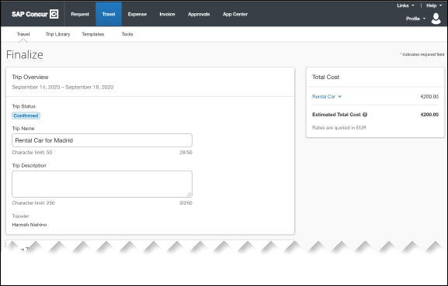

Add Bookings
For adding further bookings, dedicated buttons are positioned centrally on the page. When adding a reservation, the user will see a page allowing them to enter search criteria.
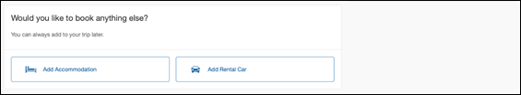

Travel Policy
For policy violation on Trip level, the Travel Policy section will inform the users about triggered policy rules and provides an opportunity to select a reason and/or add a comment.
Example:

Trip Custom Fields
Trip custom fields in Concur Travel can be set up to collect information during the booking process. The fields are often used to collect information for the clients’ internal accounting process or for reporting purposes. They can be configured to show at the start or towards the end of the booking process.
Trip custom fields configured to display towards the end of the booking workflow are shown on the Finalize Trip page in the Additional Information section.
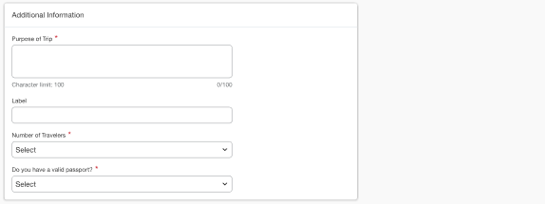

Cancel Trip
In case a user would like to abort the booking, the trip cancellation will be triggered via the equivalent link at the bottom of the page. Please refer to the details in the Cancellation section.
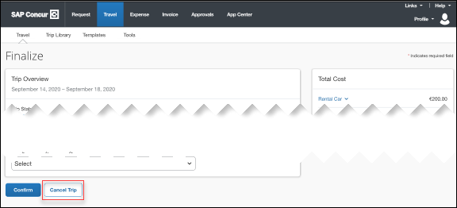

End User Experience: Confirmation
Click Confirm on the Finalize Trip page; the Confirmation page will display.
This page provides an overview of all existing bookings in your trip and displays support contact data; configuration is required by your SAP Concur administrator.
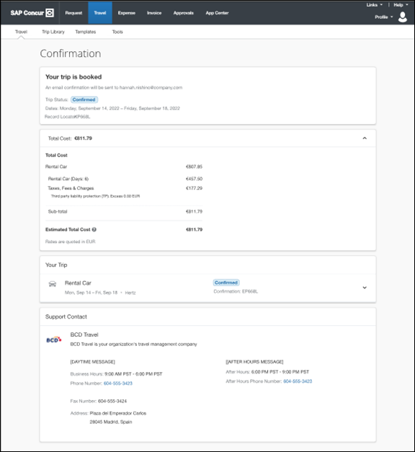
The Confirmation page includes:
- A display of the current trip state, as part of the header section.
- The email address of the confirmation recipient.
- A section that displays the total cost of the trip; this section is collapsed by default and can be expanded to review detailed rate information per booking.
- A Your Trip section where each booking displays as collapsed by default but can be expanded to review details (such as number of seats and doors for a rental car booking).
- A Support Contact section will display support contact data (Configuration required by your SAP Concur administrator).
The user will be able to see the trip booked on the homepage under upcoming trips. At the same time, an email confirmation will be sent to the traveler.

Manager Notification
If the booking violated policy such that the manager needs to be notified, an email will be sent to the manager.
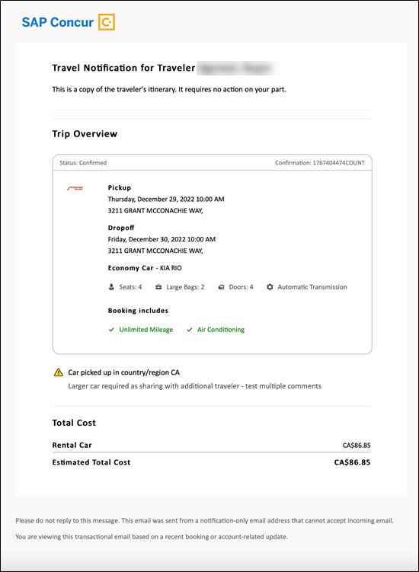

**Planned Changes** New Rental Car Experience: Completed Trip Overview

Information First Published | Information Last Modified | Feature Target Release Date
December 2022 | -- | Q1 2023
Any changes since the previous monthly release are highlighted in yellow in this release note.

End-User Experience: View Car Rental (Trip Overview)
The Trip Overview page allows you to review and manage a booked trip at any time. Cancelled trips can be reviewed, but no longer managed.
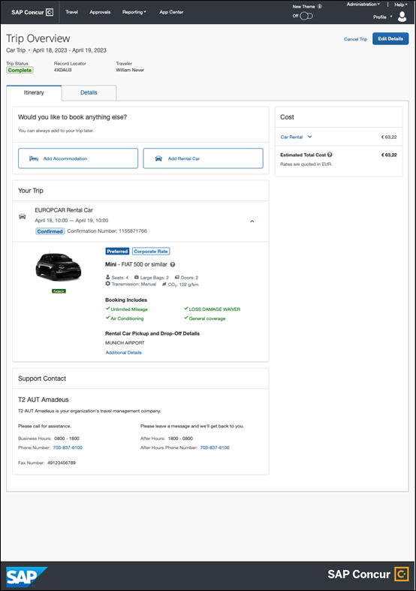

Header Section
Below the page header are the trip name and travel dates. The top section of the page will display:
- Trip status
- Record locator (if trip contains content booked through travel agency channels)
- Traveler name
- Booker name (if the booker is a different person than the traveler)
- Trip description (if a description was added by the booker)
At the top right corner of the page, there will be a link to cancel the trip and a button to edit details such as the default trip name and trip description.

Cost Section
At the right of the Trip Overview page, there will be a Cost section to review estimated total trip cost and detailed costs per booking. The cost section will float on the page while scrolling, so it remains visible whether you review the upper or lower part of the page.

Itinerary Tab
At the top of this tab, there will be Add Rental Car and Add Accommodation buttons for users to add another booking to the trip. Configuration will be required by your SAP Concur administrator to hide those buttons.
The Your Trip section will display each booking with its confirmation number. Each booking in this section displays as expanded by default to review details such as number of seats or doors in case of a rental car booking.
At the bottom of the page, the Support Contact section displays support contact data; configuration is required by your SAP Concur admin.

Details Tab
On this tab you can review additional trip-related information.
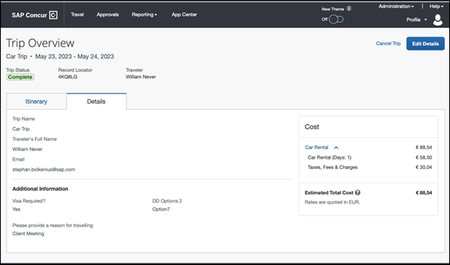
This tab displays:
- The trip name.
- The traveler's name.
- The traveler's email address to which the confirmation email is sent.
- The trip description (if added).
- Field names and values selected or entered during the booking workflow in the Additional Information section. Configuration is required by your SAP Concur administrator.

Cancellation
The Cancel Trip link will redirect users to the Confirm Cancellation page to start the trip cancellation.

Add a Booking
The Add Accommodation or Add Car actions will redirect users to the search and book flow for the respective service.

**Planned Changes** New Rental Car Experience: Cancellation

Information First Published | Information Last Modified | Feature Target Release Date
December 2022 | -- | Q1 2023
Any changes since the previous monthly release are highlighted in yellow in this release note.

End-User Experience: Cancellation
Depending on the place from which the trip cancellation starts and the trip content, the cancellation workflow may vary as follows:
- When users click Cancel Trip on the Finalize Trip page, the Trip Overview page will redirect them to the Confirm Cancellation page that contains a link to the Terms and Conditions for review. Confirmation of the cancellation on this page will redirect users to the Trip Overview page where the trip is indicated as Cancelled.
- When users click the Cancel link in the trip library (web app) or trip list (mobile app), on the Upcoming Trips tab or the My Trips section, both of which are available on the homepage in the Web app, a popup will display with a link to the Terms and Conditions for review.
- For a trip that only contains content booked in the new Concur Travel experience, users will be redirected to the Trip Overview page where the trip is indicated as Cancelled.
- For a trip that contains content other than what was booked in the evolution of Travel experience, users will be redirected to the regular cancellation confirmation page.
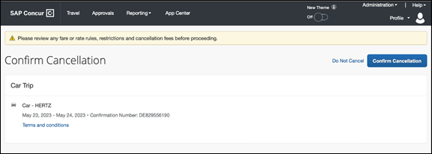
For scenario 1 and scenario 2a , the following is an example of the user will be redirected to upon confirming cancellation:
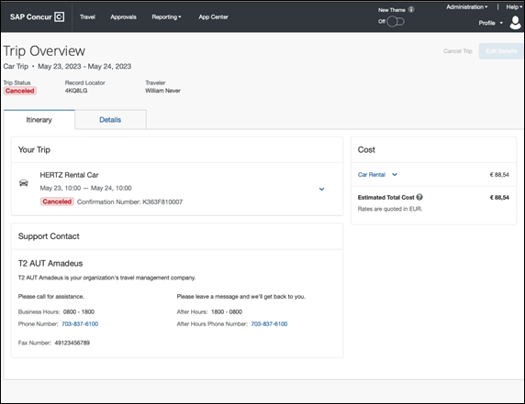

**Planned Changes** New Rental Car Experience: Configuration for Hertz, Sixt, and Delivery and Collection

Information First Published | Information Last Modified | Feature Target Release Date
December 2022 | -- | Q1 2023
Any changes since the previous monthly release are highlighted in yellow in this release note.

Overview
Sixt and Hertz Direct content will be offered via SAP Concur’s new Car Connector program. For this reason, these connectors require re-enablement for customers who are interested in using these channels. Full feature parity is guaranteed across the content channels.

Configuration for Professional Travel

HERTZ AND SIXT DIRECT CONTENT
To configure:
- Click Administration > Travel (on the sub-menu) > Travel System Admin and select the desired client travel configuration.
Depending on your permissions, the page may appear immediately after you click Administration or Travel.
- In the Car Connector section of the travel configuration page, locate the Hertz and Sixt activation checkboxes.
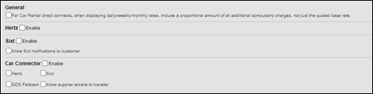

Hertz and Sixt Passive PNR for Direct Content
To configure:
- Go to Administration > Travel (on the sub-menu) > Travel System Admin and select the desired client travel configuration.
Depending on your permissions, the page may appear immediately after you click Administration or Travel.
- Under GDS PNR Options of the travel configuration page, go to the activation checkboxes.
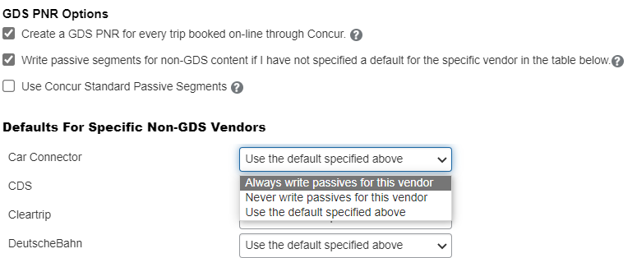
A new dropdown selection is introduced in order to specify whether passive PNRs for Hertz and Sixt via Car Connector shall be created with each booking or not.

Delivery and Collection Feature
The customer must first negotiate the Car Delivery and Collection service with their contract car vendor. The associated corporate discount number must be entered in the discount area. This process must be completed for each desired car vendor.
Delivery and Collection is available for all address options. Customers who would like to use this feature with the current release should contact their rental car partner and ensure all addresses are allowed for this service. Different fees could apply depending on the addresses the end user would select.
To configure:
- Go to Administration > Travel (on the sub-menu) > Travel System Admin and select the desired client travel configuration.
Depending on your permissions, the page may appear immediately after you click Administration or Travel.
- On the travel configuration page, go to Car Search Options.
- Make the appropriate choices and select all rental car companies for which Delivery and Collection has been negotiated.
Regardless of the activated content channels, only this setting must be configured in order to enable the Delivery and Collection feature.

**Planned Changes** New Rental Car Experience: Reduced Feature Set

Information First Published | Information Last Modified | Feature Target Release Date
January 2023 | January 27, 2023 | Q1 2023
Any changes since the previous monthly release are highlighted in yellow in this release note.
The activation of the new rental car workflow though Concur Travel is not possible via a setting within Concur Travel. As a reduced set of features will be available in the first release, potential customers will be determined programmatically and informed when eligible for migration.

Known Limitations
The following items are either not yet supported with the new car rental booking experience, or are supported with limitations. Please monitor future release notes for changes relating to these items.

Product Area | Feature/Setting | Setting Location | Setting Requirement | Additional Information
Content | Global Distribution System (GDS) | Agency Configuration | Amadeus only | Sabre and Travelport GDSs are not yet supported for the new car experience.
Integrations | Concur Request | Travel configuration | “Enable Request Integration” unchecked
Travel Policy | Car Rule Enforcement Levels | Company Administration > Travel Admin | Allow  Log for reports  Notify manager  Show but do not allow  Hide results | ”Allow” enforcement level is supported but Display Message (Message when matched) portion is not.  For Car category rules, “Show but do not Allow” is treated as “Hide Results” with the first release
Travel Policy | Itinerary Rule Enforcement Levels | Company Administration > Travel Admin | Allow  Log for reports  Notify manager  Require Approval  Require Passive Approval | “Show but do not allow” and “Hide results” are not supported for Itinerary rules, as these enforcement levels are result-dependent; Itinerary rules are applied during checkout.  Require Approval and Require passive approval rules will be downgraded to Notify manager
Travel Policy | Concur Travel’s Native Approval Process | Company Administration > Travel Admin | Car rules cannot use:  Require Approval  Require Passive Approval  Require Pre-Approval & Log  Require Pre-Approval & Notify | If any of the following rules are set up for Car  Require Approval  Require Passive Approval  Require Pre-Approval & Log  Require Pre-Approval & Notify  These rules will be ignored and will not show as violations to the user.  This also applies to any trip level rules.
Travel Policy | Car Rule Parts | Company Administration > Travel Rule Builder / Travel Admin | Car vendor is one of [CarVendorList]  Car vendor is not one of [CarVendorList]  Car vendor is not preferred  Car dropped off in country/region [CountryList]  Car not picked up in country/region [CountryList]  Car picked up in country/region [CountryList]  Car type is one of [CarClassList] | Any other configured car rule parts will not be enforced.  Any other car rule parts will not show as violations to the user.
Travel Policy | Itinerary Rule Parts | Company Administration > Travel Rule Builder / Travel Admin | Itinerary booked [condition] [DaysAdvance] days in advance  Trip duration [condition] [DaysLong] days  Itinerary has no Hotel segments | Any other rule parts will not be enforced.  Any other trip rule parts will not be show as violations to the user.
Travel Policy | Violation Reason Types | Company Administration > Travel Admin > Policy Violation Reasons | General  Train  Car  Hotel  Itinerary | Reasons from any other reason type categories will not be displayed.
Travel Policy | Rule Class Selection + Force selection of a rule class | Travel Configuration | Only a user’s default rule class is supported | If enabled, users would see the rule class selection field on the search, but any selection by the user would not be honored.
Trip Management | Custom Trip Fields | Company Administration > Manage Custom Fields | If/Then Settings cannot be enabled
Trip Management | Custom Trip Fields | Company Administration > Manage Custom Fields | “Display for Edits” cannot be enabled
Payments | Require credit card for car reservations | Travel configuration | This setting must be enabled
Payments | Force users to choose a credit card | Travel configuration | This setting must be enabled
Payments | Agency Processing Fee Form of Payment for Land Only/Non-GDS Reservations | Travel configuration | “Always write user-selected card” must be enabled
Car-Specific | Car Custom Text | Company Administration > Travel Admin > Custom Text |  | No CAR custom text is displayed.
Car-Specific | Always run a General Shop Request for Car Searches | Travel Configuration | Customers who do not have negotiated car rental discounts should not use the new car rental booking experience yet.  Customers who have car rental vendor discounts configured will only see results from those vendors. | This feature triggers a car search request to content providers for any car rental vendors which do not have a configured discount code.  Due to the broad range of vendors returned and added GDS scans, Concur is currently evaluating this feature. Until such time as a decision has been made, this will not be part of evolution of Travel.
Car-specific | Direct Billing | Company Admin > Manage Corporate Discounts | Customers who use direct billing should not use the new car rental booking experience yet.
Trip Management | Show "Add Air" On Existing Itineraries | Travel Configuration |  | When a user makes a car booking using the new experience, the “Add Air” link will not be shown yet.
Trip Management | Change of booking | N/A | N/A | Change of booking is not yet supported for the new rental car booking experience;however, users are able to cancel and rebook using the new experience.  Change of rental car bookings offline by a TMC are not recommended; the trip cost on the itinerary in Concur will not yet be updated in case of any price change.

Changes in Product Behavior
The following features are supported for customers using the new car booking experience, but behavior may be changed or may be utilizing legacy functionality.

Confirmation Emails
While confirmation emails will be sent for bookings made via the new car experience, these emails will not include an .ics calendar attachment yet.

Allow automatic reservations of…
For customers that have automatic car reservations enabled, Concur Travel will utilize the current car booking logic and only the Amadeus content source.

Custom trip fields – display at start
Custom trip fields configured to “Display at start of booking” will be shown on the Review and Book page in the Additional Information section. Custom field for which check box “Display at start of booking” is not enabled will be shown on the Finalize Trip page in the Additional Information section.

Custom trip fields – display on itinerary
All trip custom fields and values entered/selected during the booking workflow will display by default on the Details tab of the Trip Overview page, regardless of the setting „Display on Itinerary“ for trip custom fields. Trip custom fields and values entered/selected during the workflow will not be included in confirmation or cancellation emails, regardless of the setting “Display on Itinerary” for trip custom fields

Trip Sharing/Cloning
For customers who have trip sharing/cloning enabled, Concur Travel will utilize the current car booking logic and only the Amadeus content source.

Flight

**Planned Changes** Sabre Profiles Update for Known Traveler and Redress Numbers

Information First Published | Information Last Modified | Feature Target Release Date
October 2022 | December 15, 2022 | February 15, 2023
Any changes since the previous monthly release are highlighted in yellow in this release note.

Prof | Stan |   Edition
 |  | On: Impacts end users who use this feature/vendor; no configuration/setup by agency/ admin; cannot be turned OFF (example: new icons or rate display, new Amtrak feature)
 |  | Available for use: No impact to end users unless/until configuration/setup by agency/admin (described below) (example: new rule, new Travelfusion airline)
X | X | Other: Refer to the release note below
 |  | Does not apply to this edition
Source / Solution Suggestion
GDS |  | Sabre
Direct Connect
Solution ID
Other
X | EMEA Data Center |  |  | Scan impact
X | North America Data Center |  |  | UI impact
 | China Data Center |  |  | File finishing impact
 | All data centers |  |  | Profile/Profile API/3rd Party XML Sync Impact
Affected Documentation
TSGs |  | Sabre Profiles Travel Service Guide
Fact Sheets
Admin Guides
Other

Overview
Targeted for February 15, 2023, Sabre will release an update to support the Industry Mandate-SSR DOCO Modification (refer to Sabre SAN 16382). This update requires the issuing country code to be included with all Known Traveler and Redress numbers when adding a traveler’s TSA data to a PNR.
Currently, Concur Travel sends the TSA DOCO data directly to the PNR, including the default issuing country of “US”, whenever an air booking includes the traveler’s Known Traveler or Redress number.
Concur Travel syncs Known Traveler and Redress numbers to the Traveler Information section of Sabre Profiles.

User/Customer Benefit
This update will ensure that a traveler’s Sabre Profile data is successfully copied to the PNR during the booking process.

Admin Experience
There are two ways that Known Traveler and Redress numbers can be copied to the PNR from Sabre Profiles.
- If your company is using the Sabre PNR Builder to copy Known Traveler and Redress numbers into a PNR, Sabre will automatically add a default issuing country code of “US” when this data is stored in the Traveler Information section and selected to be copied to a PNR.
Sabre previously communicated in SAN 16382 that the Known Traveler number, stored in the Traveler Information section, did not include the default Country Code “US” when copied to the PNR. Sabre has since released an enhancement and a default country code of “US” is now included.
- If your company is using Sabre Advanced Formats in your Sabre Template to copy Known Traveler and Redress numbers into a PNR, your company Sabre Profile administrator will need to update the Sabre Advanced Formats for both Known Traveler and Redress numbers.
To update the Sabre Advanced Formats:
- From the Administration tab, open your Primary Sabre Template and click Advanced Sabre Formats List from the left navigation menu.
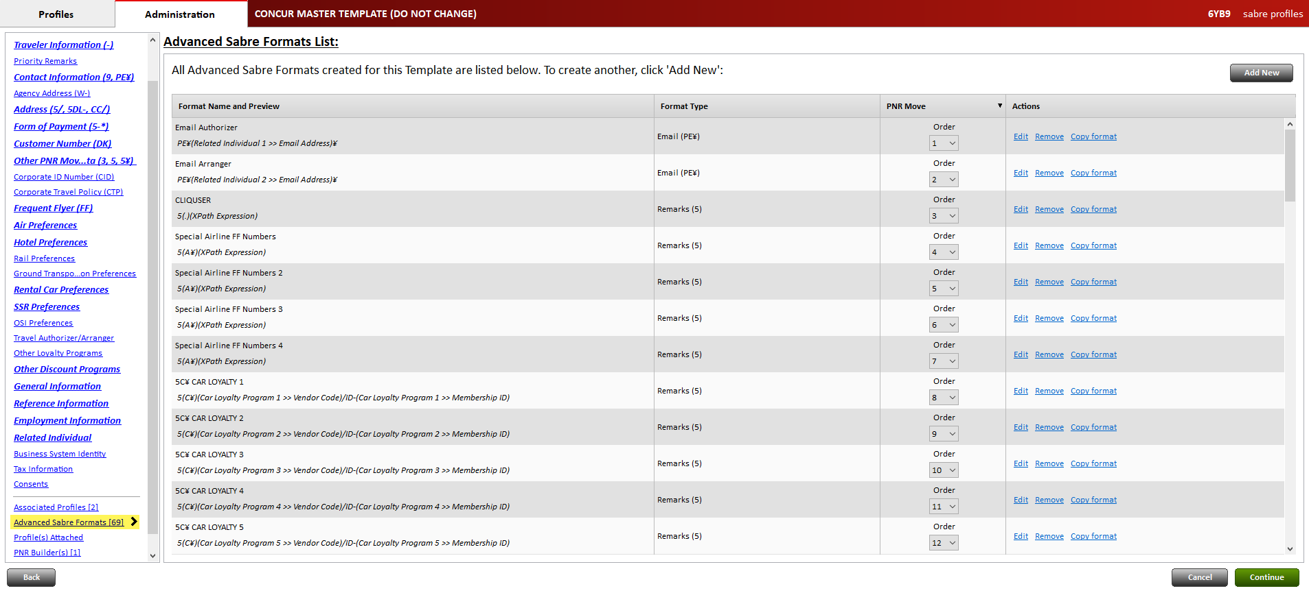
- Locate the DOCO formats for Known Traveler. Click Edit for the applicable line.
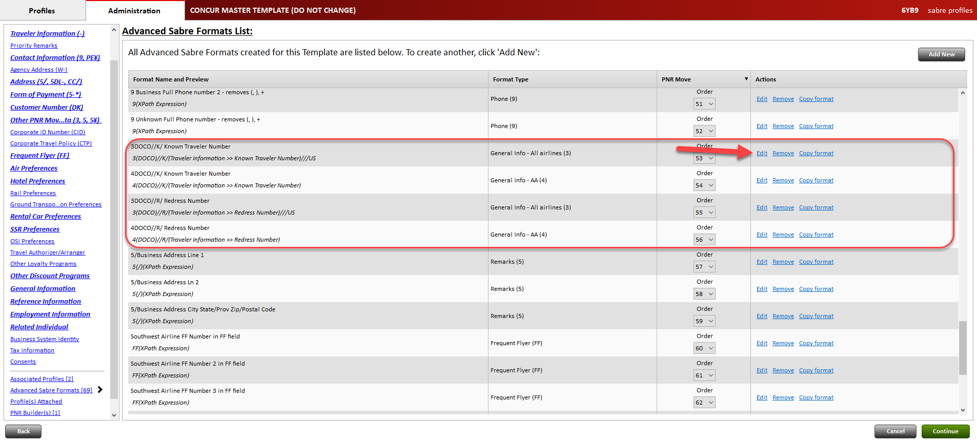
- In the Format builder section, click Add.
- Select Add Fixed Text from the left dropdown field.
- Enter ///US in the text field provided.
- Repeat the same steps for Redress Number.
- From the left navigation menu, click Template Preview
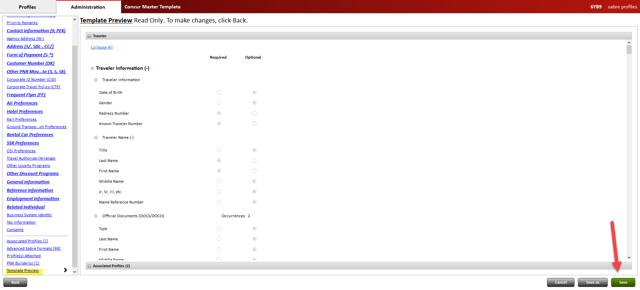
- Click Save. These updates are automatically included in your linked Shared Templates.

Configuration for Professional and Standard Travel
This feature is enabled by default. There are no configuration steps.
For more information, refer to the Sabre Profiles Travel Service Guide. To locate, refer to Additional Release Notes and Other Technical Documentation in these release notes.

Rail

**Planned Changes** VIA Rail Decommission

Information First Published | Information Last Modified | Feature Target Release Date
June 2022 | -- | February 13, 2023
Any changes since the previous monthly release are highlighted in yellow in this release note.

Prof | Stan | Å Å Edition
X | X | On: Impacts end users who use this feature/vendor; no configuration/setup by agency/ admin; cannot be turned OFF (example: new icons or rate display, new Amtrak feature)
 |  | Available for use: No impact to end users unless/until configuration/setup by agency/admin (described below) (example: new rule, new Travelfusion airline)
X | X | Other: Refer to the release note below
 |  | Does not apply to this edition
Source / Solution Suggestion
GDS
Direct Connect |  | VIA Rail
Solution ID
Other
X | EMEA Data Center |  |  | Scan impact
X | North America Data Center |  |  | UI impact
 | China Data Center |  |  | File finishing impact
 | All data centers |  |  | Profile/Profile API/3rd Party XML Sync Impact
Affected Documentation
TSGs |  | VIA Rail Travel Service Guide
Fact Sheets
Admin Guides
Other

Overview
Concur Travel currently provides travelers the ability to book transfers via VIA Rail. VIA Rail brings access to VIA Rail Canada services and integrates rail bookings with the corporate reporting and account process. SAP Concur offers Canadian rail content within Concur Travel through a punch out connection to VIA Rail, enabling users to book train tickets in Canada.
Due to changing technological and security requirements, both Via Rail Canada and SAP Concur have jointly decided to decommission the current VIA Rail direct connection to Concur Travel on February 13, 2023. VIA Rail will be automatically disabled and no longer visible for any travel configurations.
If clients have subscriptions to Concur TripLink and TripIt Pro, they can forward their VIA Rail itineraries to plans@tripit.com so that their trips can be imported into Concur Travel. These itineraries will display under Upcoming Trips.
Affected clients may work with their travel agency to explore the option to book VIA Rail via AccesRail in Concur Travel. SAP Concur recommends clients to reach out to their travel agency to confirm whether all required agreements are in place to use this option. Please note that once AccesRail is enabled, AccesRail content (other Rail vendors such as Deutsche Bahn, Renfe, etc.) will become available in Concur Travel.

User/Customer Benefit
Periodically, under-supported third-party features may be removed to ensure usability standards are maintained. This feature is not fully supported and will therefore be decommissioned.

End-User Experience
Existing Rail itineraries will remain visible in Concur Travel under Upcoming Trips. Also, the historical data will be kept for reporting.
The option to cancel a rail booking will continue to display after February 13, 2023, but with an error message. For all required changes to a booking, the traveler is advised to contact the rail supplier mentioned on the Trip Itinerary overview. Travelers may contact VIA Rail Canada at service@viarail.ca or speak with a station service manager. Travel Agents may contact VIA Rail Canada Business Development Manager or Agency Support at tradedesk@viarail.ca or call 1 (800) 361-8010.

Configuration for Professional and Standard Travel
No additional steps are required by administrators to support this change. However, SAP Concur recommends that clients provide messaging within Concur Travel to inform travelers.
For more information, refer to the VIA Rail Travel Service Guide. To locate, refer to Additional Release Notes and Other Technical Documentation in these release notes

**Planned Changes** SNCF API (PAO) Migration

Information First Published | Information Last Modified | Feature Target Release Date
December 2022 | -- | Q1 2023
Any changes since the previous monthly release are highlighted in yellow in this release note.

Prof | Stan | Å Å Edition
X | X | On: Impacts end users who use this feature/vendor; no configuration/setup by agency/ admin; cannot be turned OFF (example: new icons or rate display, new Amtrak feature)
 |  | Available for use: No impact to end users unless/until configuration/setup by agency/admin (described below) (example: new rule, new Travelfusion airline)
 |  | Other: Refer to the release note below
 |  | Does not apply to this edition
Source / Solution Suggestion
GDS
Direct Connect |  | SNCF PAO Direct Connect
Solution ID
Other
X | EMEA Data Center |  |  | Scan impact
X | North America Data Center |  |  | UI impact
 | China Data Center |  |  | File finishing impact
 | All data centers |  |  | Profile/Profile API/3rd Party XML Sync Impact
Affected Documentation
TSGs |  | SNCF PAO Direct Connect TSG (available with release)
Fact Sheets
Admin Guides
Other

Overview
In March 2020, SAP Concur performed a partial migration of SNCF customers to the SNCF PAO API with the goal of offering our customers whole Regional Train and Eurostar content.
Due to upcoming changes planned by SNCF, SAP Concur will continue with the migration to SNCF PAO. The targeted date for release is Q1 2023. This is subject to change.

User/Customer Benefit
The SNCF content will be available via the SNCF PAO API. Migrated customers will no longer need to enable both connectors, SNCF and SNCF [PAO], in their configurations. Migrated users will no longer need to switch between SNCF and SNCF [TER + Eurostar] before they initiate their search.

End-User Experience
The booking steps for self-booked and arranger-booked trips will remain the same. Further details will be provided with upcoming releases.
The multi-passenger booking feature will not be supported for migrated customers.

Configuration for Professional and Standard Travel
This feature will be enabled by default. SAP Concur will make these changes automatically.

Client Notifications

Accessibility

Accessibility Updates
SAP implements changes to better meet current Web Content Accessibility Guidelines (WCAG). Information about accessibility-related changes made to SAP Concur solutions is published on a quarterly basis. You can review the quarterly updates on the Accessibility Updates page.

Subprocessors

SAP Concur Non-Affiliated Subprocessors
The list of non-affiliated subprocessors is available from the SAP Sub-processors / Data Transfer Factsheets page.
To access the SAP Concur Sub-processors List:
- Click the following link to navigate to the SAP Sub-processors / Data Transfer Factsheets page:
SAP Sub-processors / Data Transfer Factsheets
- Sign in to the SAP Support Portal using your Support User ID (S-user) and password.
SAP customers must sign in to the SAP Support Portal using their Support User ID (S-user) and password. For information about S-User IDs, refer to Your New Support User ID (S-user) and to the Learn All About S-User IDs blog post.
- On the SAP Sub-processors / Data Transfer Factsheets page, type "Concur" in the Search field.
- In the Title column, click SAP Concur Sub-processors List.
If you have questions or comments, please reach out to: Privacy-Request@Concur.com

Supported Browsers

Supported Browsers and Changes to Support
For information about supported browsers and planned changes to supported browsers, refer to the Concur Travel & Expense Supported Configurations guide.
When changes to browser support are planned, information about those changes will also appear in the Shared Changes Release Notes.

Additional Release Notes and Other Technical Documentation

Online Help
Any user can access release notes, setup guides, user guides, admin summaries, monthly browser certifications, supported configurations, and other resources via online Help or directly on the SAP Help Portal.
Use the links in the Help menu in the app, or search for your SAP Concur product (Concur Expense, Concur Invoice, Concur Request, or Concur Travel) on the SAP Help Portal (https://help.sap.com) to view the full set of documentation for your product.

SAP Concur Support Portal – Selected Users
Access release notes, webinars, and other technical documentation on the SAP Concur support portal.
If you have the proper permissions, the Contact Support appears on the Help menu. Click to access the SAP Concur support portal, then click Resources.
- Click Release/Tech Info for release notes, technical documents, etc.
- Click Webinars for recorded and live webinars.
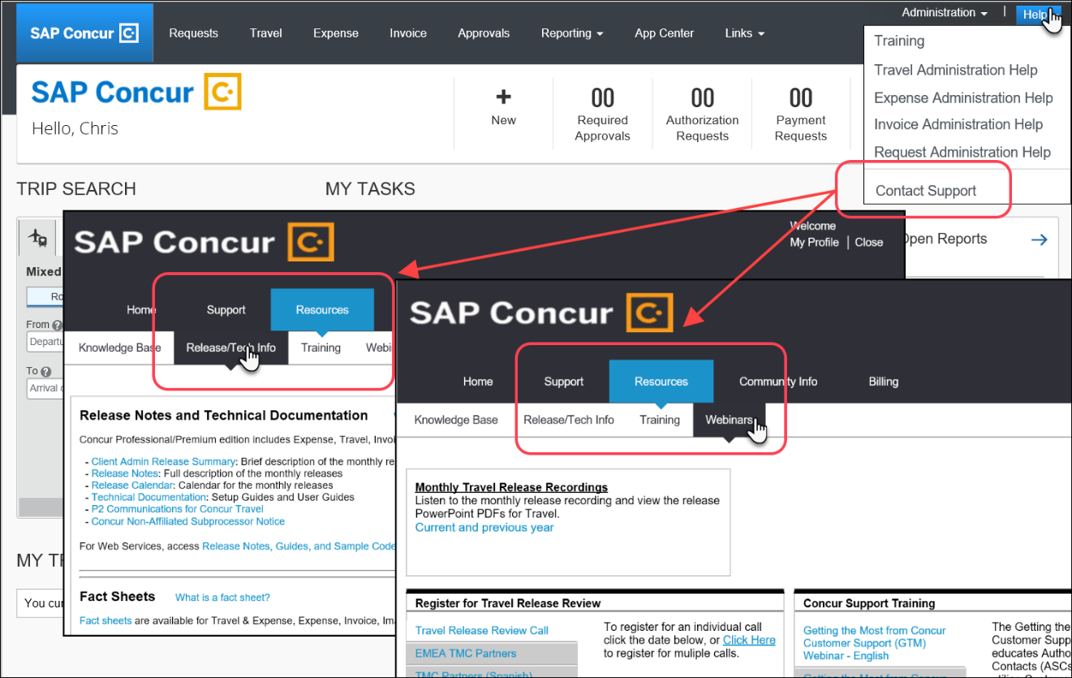

© 2023 SAP SE or an SAP affiliate company. All rights reserved.
No part of this publication may be reproduced or transmitted in any form or for any purpose without the express permission of SAP SE or an SAP affiliate company.
SAP and other SAP products and services mentioned herein as well as their respective logos are trademarks or registered trademarks of SAP SE (or an SAP affiliate company) in Germany and other countries. Please see http://global12.sap.com/corporate-en/legal/copyright/index.epx for additional trademark information and notices.
Some software products marketed by SAP SE and its distributors contain proprietary software components of other software vendors.
National product specifications may vary.
These materials are provided by SAP SE or an SAP affiliate company for informational purposes only, without representation or warranty of any kind, and SAP SE or its affiliated companies shall not be liable for errors or omissions with respect to the materials. The only warranties for SAP SE or SAP affiliate company products and services are those that are set forth in the express warranty statements accompanying such products and services, if any. Nothing herein should be construed as constituting an additional warranty.
In particular, SAP SE or its affiliated companies have no obligation to pursue any course of business outlined in this document or any related presentation, or to develop or release any functionality mentioned therein. This document, or any related presentation, and SAP SE’s or its affiliated companies’ strategy and possible future developments, products, and/or platform directions and functionality are all subject to change and may be changed by SAP SE or its affiliated companies at any time for any reason without notice. The information in this document is not a commitment, promise, or legal obligation to deliver any material, code, or functionality. All forward-looking statements are subject to various risks and uncertainties that could cause actual results to differ materially from expectations. Readers are cautioned not to place undue reliance on these forward-looking statements, which speak only as of their dates, and they should not be relied upon in making purchasing decisions.

