Travel: Apollo and Galileo Setup
Instructions
Applies to Concur Travel:
Professional/Premium edition
TMC Partners
Direct Customers
Standard edition
TMC Partners
Direct Customers

Last Revised: August 19, 2022

Contents
Apollo and Galileo Setup Instructions 2
Section 1: Overview 2
Section 2: Provide Access to the Apollo/Galileo PCC 2
Section 3: Setup Service Bureau Emulation 3
Section 4: Setup Travelport Booking Feed (TBF) 3
Step 1: Email Travelport 4
Concur Service Bureau PCCs by GDS and Concur Data Center 4
Email Template 4
Step 2: *TBF Table Configuration 4
Additional Information 5

Revision History
Date |  | Revision Notes/Comments
August 19, 2022 | Updated table in Step 1: Email Travelport topic of Setup Travelport Booking Feed (TBF) section
January 14, 2022 | Updated the copyright year; no other changes; cover date not updated
April 14, 2021 | Updated the copyright year; no other changes; cover date not updated
December 4, 2020 | Updated link in Service Bureau Emulation section
March 12, 2020 | Initial publication

Apollo and Galileo Setup Instructions

Overview
This document outlines the step required for agency reseller partners implementing corporate customers on Apollo or Galileo GDS.

Provide Access to the Apollo/Galileo PCC
SAP Concur uses the Galileo Web Services platform to communicate with Travelport for both Apollo and Galileo GDS access. If a client implementation requires use of a new PCC, agency partners will need to request a Host Access Profile (HAP) from Travelport.
To make the request
- Notify your Travelport Account Executive of the new implementation and request a HAP. You will need to provide the PCC as part of the request.
- Travelport Account Executive will process the request and provide the HAP information to you.
- Enter the HAP in the Agency Configuration, as shown below, or provide it to your Implementation contact if you are not directly responsible for Concur Travel setup.
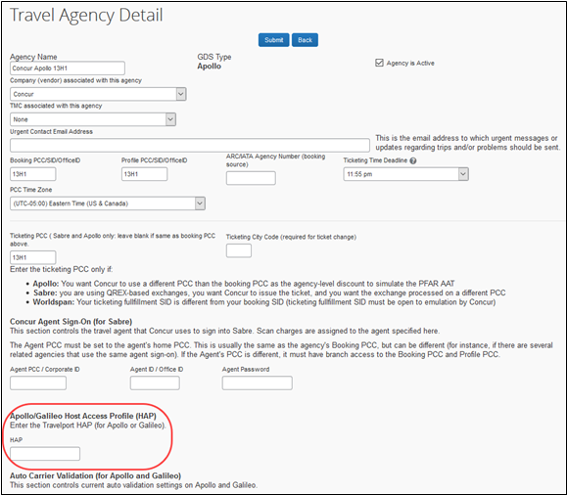

Setup Service Bureau Emulation
Complete and Submit the Travelport Emulation form.

Setup Travelport Booking Feed (TBF)
Concur requires the use of TBF for all Apollo and Galileo agency configurations in lieu of the Report Queue used for other GDSs. Please note that TBF only replaces the Report Queue functionality for Concur Travel. It does not replace the Offline Approval Queue.
There are two steps to set up TBF for an Apollo or Galileo PCC:
- Email a request to Travelport to configure your PCC to send messages to Concur’s message queue.
- Set the TBF triggers to define which PNR events send a notification to Concur’s message queue.

Step 1: Email Travelport
This section provides instructions for requesting TBF configuration from Travelport.
SAP Concur has separate message queues for each Concur data center. You are strongly encouraged to not configure a single PCC to send messages to multiple Concur data centers. When a single PCC is configured in TBF to send messages to both Concur commercial data centers, each data center gets unnecessary messages that it cannot process. Dismissing these unnecessary messages slows down reporting for all clients.

Concur Service Bureau PCCs by GDS and Concur Data Center
Concur Data Center | Apollo | Galileo
US Commercial | 16Y3 | 78ZU
EU Commercial | 2YV9 | 5QE7
Concur Government Edition (US) | 2C5H | N/A
Concur Cloud for Public Sector (CCPS) | 2AA5 | 04V

Email Template
To: TTO.BOMSTBF@travelport.com
Subject: TBF REQUEST
Body:
Please add <GDS> PCC <your PCC> to the next available Concur TBF message queue in <Concur PCC from the table above>.

Thank You,
<Your Name>

Step 2: *TBF Table Configuration
The TBF table may be accessed by entering *TBF in the booking PCC for Concur Travel bookings, in Apollo/Galileo GDS. The TBF table will be displayed with “Y” and “N” next to the TBF settings, indicating which events will generate a message to the configured TBF message queue. For new implementations, the TBF service team will set these for you when building connectivity to SAP Concur’s TBF queue.
Please follow the below suggested for SAP Concur’s TBF queue. If you have any questions, please reach out to your Travel Solutions or Implementation partner at SAP Concur.
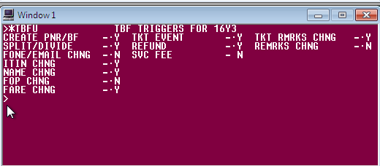

Additional Information
- PNRs must contain remarks to allow Concur Travel to determine which company and user they belong to. Refer to the Reporting Requirements documents in the Agency Partners Toolkit for remark formats.
- If offline bookings are created in a different PCC than the one that Concur Travel uses, you must configure TBF in that PCC as well.
- When opening a ticket about offline data not appearing in Concur Travel, please include the TBF message queues that the PCC is configured to send data to as well as a screen shot of the *TBF table.
- Travelport manages which message queue your PCC will send data to. If you have multiple PCCs they might be configured to different TBF message queues.

