SAP Concur Release Notes
Shared Changes
Includes cross-product and site-wide changes for:
Professional Edition, Standard Edition, and Small Business Edition
Month | Audience
Release Date: January 19, 2024  Initial Post: Friday, January 19, 2024 | Client FINAL
Contents
Release Notes 1
Home Page 2
**Ongoing ** SAP Concur Homepage Changes 2
All Products | All Editions 2
In-Product Help 4
Link to Service Description Guide to be Removed from Help 4
All Products | All Editions 4
Profile Settings / Security 6
**Ongoing** Temporary Security Changes to User Profile 6
Travel, Expense, Invoice, Request | Professional & Standard 6
SAP Concur Integrations 7
Microsoft Dynamics 365 Business Central Fields Updated 7
Expense, Invoice | Professional & Standard 7
SAP Cloud Identity Services into SAP Concur 9
Expense, Invoice, Request, Travel & Expense | Professional & Standard 9
SAP Concur User Assistance 10
**Ongoing** Links From the SAP Concur Solutions UI to Product Documentation Being Removed 10
All Products | All Editions 10
Translations Available for Security Content 12
All Products | All Editions 12
SAP Fiori Themes 13
**Ongoing** SAP Fiori Horizon Themes for Concur Mobile and Web 13
All Products | All Editions 13
Planned Changes 18
Authentication 18
**Planned Changes** HMAC Authentication to be Decommissioned 18
All Products | All Editions 18
Import/Extract 19
**Planned Changes** User Data Extract Feature 19
Travel w/Expense, Expense, Invoice, Request | Professional & Standard 19
SAP Concur 20
**Planned Changes** New SAP Concur Brand Logo 20
All Products | All Editions 20
SAP Concur User Assistance 21
**Planned Changes** SAP Concur Product Documentation Moving to the SAP Help Portal 21
All Product | All Editions 21
Sign-In Page 24
**Planned Changes** Hide/Show Password Icon 24
All Products | All Editions 24
Client Notifications 25
Accessibility 25
Accessibility Enhancements 25
Gender Diversity 25
In-Product User Assistance 25
Client Customized Content 25
Subprocessors 26
SAP Concur Non-Affiliated Subprocessors 26
Supported Browsers 26
Supported Browsers and Changes to Support 26
Additional Release Notes and Other Technical Documentation 27
Online Help 27
SAP Concur Support Portal – Selected Users 27
Legal Disclaimer
The information in this presentation is confidential and proprietary to SAP SE or an SAP affiliate company and may not be disclosed without the permission of SAP SE or the respective SAP affiliate company. This presentation is not subject to your license agreement or any other service or subscription agreement with SAP SE or its affiliated companies. SAP SE and its affiliated companies have no obligation to pursue any course of business outlined in this document or any related presentation, or to develop or release any functionality mentioned therein. This document, or any related presentation and SAP SE or an SAP affiliate company’s strategy and possible future developments, products and or platforms directions and functionality are all subject to change and may be changed by SAP SE and its affiliated companies at any time for any reason without notice. The information in this document is not a commitment, promise or legal obligation to deliver any material, code or functionality. This document is provided without a warranty of any kind, either express or implied, including but not limited to, the implied warranties of merchantability, fitness for a particular purpose, or non-infringement. This document is for informational purposes and may not be incorporated into a contract. SAP SE and its affiliated companies assume no responsibility for errors or omissions in this document, except if such damages were caused by SAP SE or an SAP affiliate company’s willful misconduct or gross negligence.
All forward-looking statements are subject to various risks and uncertainties that could cause actual results to differ materially from expectations. Readers are cautioned not to place undue reliance on these forward-looking statements, which speak only as of their dates, and they should not be relied upon in making purchasing decisions.

Release Notes
This document contains shared release notes and planned changes. Shared release notes and planned changes document features and changes that apply to SAP Concur solutions site-wide or to multiple SAP Concur products and services. They include but are not limited to:
- Security-related features and changes such as annual security certificate renewals and changes in support for security ciphers and protocols.
- Site-wide UI features and changes such as changes to the home page, changes to the site header or footer, or the implementation of new site-wide UI themes.
- Sign-in process features and changes such as the addition or removal of sign-in features, URL changes, and domain name changes.
- Production and test environment features and changes.
- Global settings or administration page features and changes such as the addition of new site-wide settings or changes to the design of the administration pages.
- Changes to processes such as where and when release notes are published.
For New Features and Changes that apply to a single product and/or service see the release notes for that product or service. Links to the product and service-specific release notes can be found on the following pages:
- Professional Edition
- Standard Edition

Home Page

**Ongoing ** SAP Concur Homepage Changes

Information First Published | Information Last Modified | Feature Target Release Date
December 4, 2020 | January 19, 2024 | Q4 2021 – January/February 2024
Any changes since the previous monthly release are highlighted in yellow in this release note.
Applies to:

All Products | All Editions

Overview
In Q4, 2021, SAP Concur began redirecting clients to a new homepage. The appearance of the new homepage is identical to the previous SAP Concur homepage. The new homepage has enhanced functionality when services become temporarily unavailable.
The roll out of the new homepage is phased:
Phase 1: In October of 2021, SAP Concur began redirecting Concur Expense, Concur Invoice, and Concur Request clients in the US Datacenter to the new homepage.
Phase 2: In December 2021, SAP Concur began redirecting Concur Expense, Concur Invoice, and Concur Request clients in the EU Datacenter to the new homepage.
Phase 3: In late January/early February 2024, SAP Concur will begin redirecting the remaining clients in the US and EU datacenters to the new homepage. The remaining clients include those with Concur Travel standalone or Concur Travel with Expense, Invoice, and/or Request.

Business Purpose / Client Benefit
This change ensures that the SAP Concur homepage is available even when some services are unavailable and improves the consistency of the sign in experience.

What the User Sees
With the old homepage, when a user signs into their SAP Concur products, they see their homepage.
The appearance of the homepage varies depending on which products and services are enabled for the client and the permissions assigned to the user.
Example Home Page
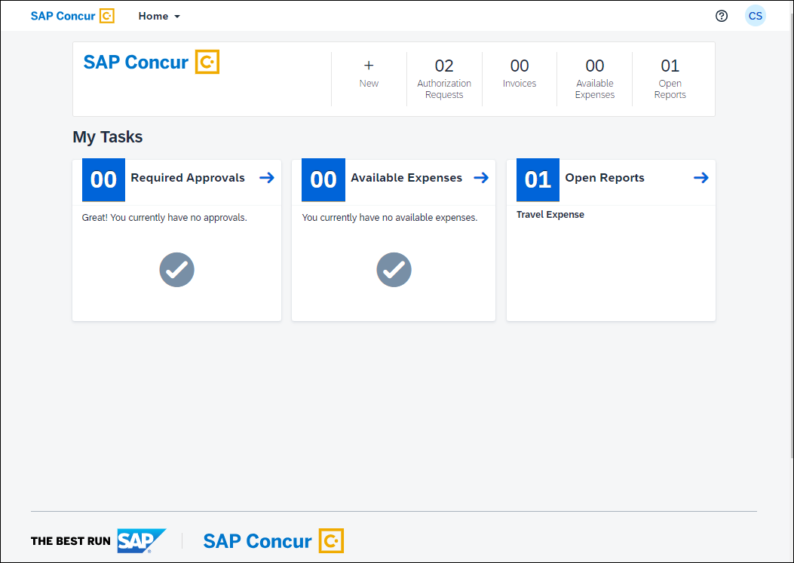
If some products or services are unavailable while other products and services are up and running, a modified version of the user’s homepage similar to the following appears:
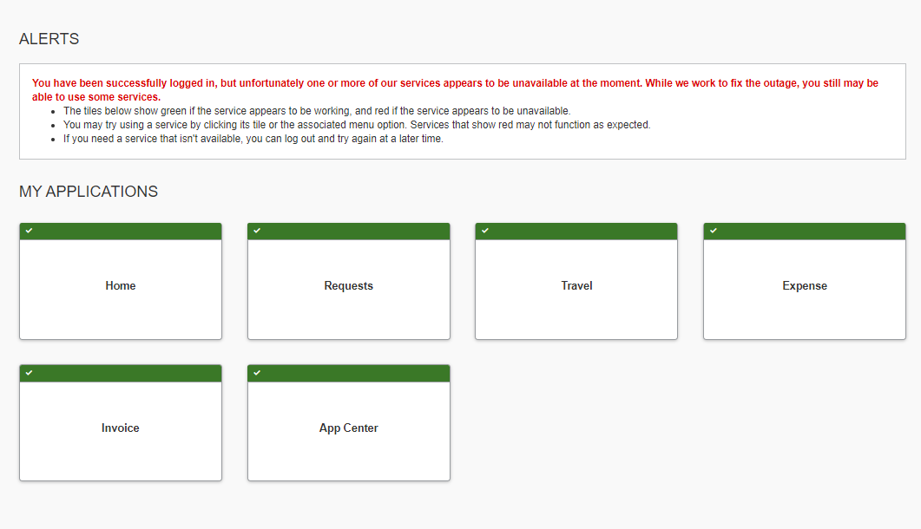
After a client is migrated to the new homepage, if one or more services are unavailable, when a user signs in to their SAP Concur products, they will see the usual homepage, but if the user navigates to a page for a service that is unavailable, they will see a page similar to the following:
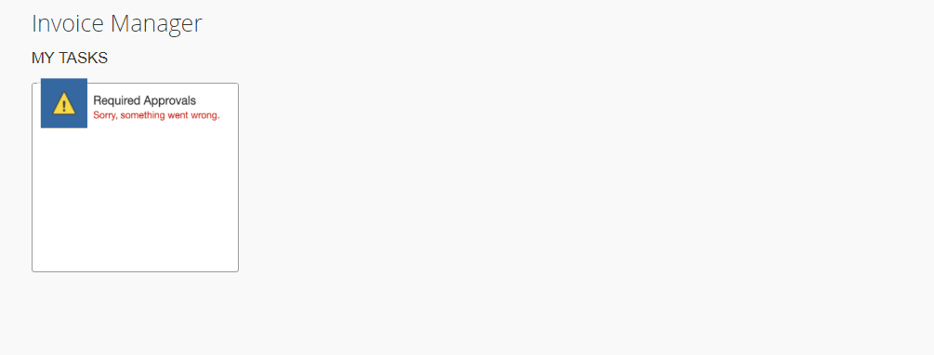
After migration to the new homepage, if all services are available, this change is transparent to the user and they see a homepage that is identical to the pre-migration homepage.

Configuration / Feature Activation
This change occurs automatically; there are no configuration or activation steps.

In-Product Help

Link to Service Description Guide to be Removed from Help

Information First Published | Information Last Modified | Feature Target Release Date
December 1, 2023 | January 12, 2024 | January 16 – 19, 2024
Any changes since the previous monthly release are highlighted in yellow in this release note.
Applies to:

All Products | All Editions

Overview
Between January 16 and January 19, 2024, SAP Concur will remove the link to the Service Description Guide from the Help menu in SAP Concur solutions.

Business Purpose / Client Benefit
The SAP Concur Service Description guide is now available from the SAP Trust Center, so the link within SAP Concur Solutions is no longer necessary.

End-User Experience
The end user will no longer see a link to the SAP Concur Service Description Guide in Help.
Before Example
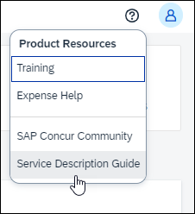
After Example
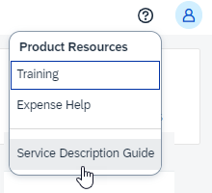

Configuration / Feature Activation
This change will occur automatically.

Profile Settings / Security

**Ongoing** Temporary Security Changes to User Profile

Information First Published | Information Last Modified | Feature Target Release Date
July 6, 2023 | December 8, 2023 | June 28, 2023
Any changes since the previous monthly release are highlighted in yellow in this release note.
Applies to:

Travel, Expense, Invoice, Request | Professional & Standard

Overview
The evolving cybersecurity landscape requires that SAP Concur temporarily adopt the following security measures when editing the following profile options for an end-user:

End User Experience
Email 1
- If an end user changes an email address in the Email Addresses section of the My Profile - Personal Information page, a confirmation email is sent to both the old and updated email addresses. For example, if a user changes the email address associated with Email 1, a confirmation email is sent to both the previous (changed) and new Email 1 addresses. And if the Email 2 email address is changed, a confirmation email is sent to both the old and new Email 2 email addresses.
- Existing profile settings that prevent the email change notification from being sent are ignored and the emails are sent to the end-user as stated in the previous bullet.
Last Name
- End users who sign in via SSO: End users who sign in to SAP Concur Solutions via SSO can update the Last Name field on the My Profile - Personal Information page.
- End users who sign in using a username and password: The system prevents users who sign in using a username and password from updating the Last Name field on the My Profile - Personal Information page. An administrator can change the information in the Last Name field through the User Administration page.

Administrator Experience
- Administrators can still change the Last Name field of a user’s profile through the User Administration page.
- Administrators can also continue to update the Last Name field of a user’s profile through the Concur API, import file, and feed options.

Business Purpose / Client Benefit
These changes help to ensure the integrity of SAP Concur client data.

Accounts Disabled by SAP Concur
During routine monitoring activities, SAP Concur may notice abnormal changes to user profiles including name, primary email address, secondary email address, and potentially fraudulent travel bookings. The accounts within your environment that may be linked to fraudulent activity may be disabled. To reenable these accounts, please work directly with your account administrator, or SAP Concur Support. We encourage all clients to adhere to strong password security measures and configurations. For further information, please visit the Password Security article on the SAP Help Portal Password Security | SAP Help Portal.

Configuration / Feature Activation
This security change is enforced by default for all applicable products. No change to this behavior is available to the client at this time and the client will be notified of any changes they may need to make in a future release.
- IMPORTANT: These changes are temporary and will be reversed in the future: clients will be informed of these changes in a subsequent release.

SAP Concur Integrations

Microsoft Dynamics 365 Business Central Fields Updated

Information First Published | Information Last Modified | Feature Target Release Date
January 19, 2024 | -- | Late 2023
Any changes since the previous monthly release are highlighted in yellow in this release note.
Applies to:

Expense, Invoice | Professional & Standard

Overview
For clients with the Microsoft Dynamics 365 Business Central integration with SAP Concur, the accounting fields on the Accounting page have been updated.
For more information, refer to the Shared: Microsoft Dynamics 365 Business Central Integration setup guide.

Business Purpose / Client Benefit
The updated fields better support the Microsoft Dynamics 365 Business Central integration with SAP Concur solutions.

Admin Experience
When the admin navigates to the Accounting page in SAP Concur solutions, they see the new field labels.
Example of Previous Fields
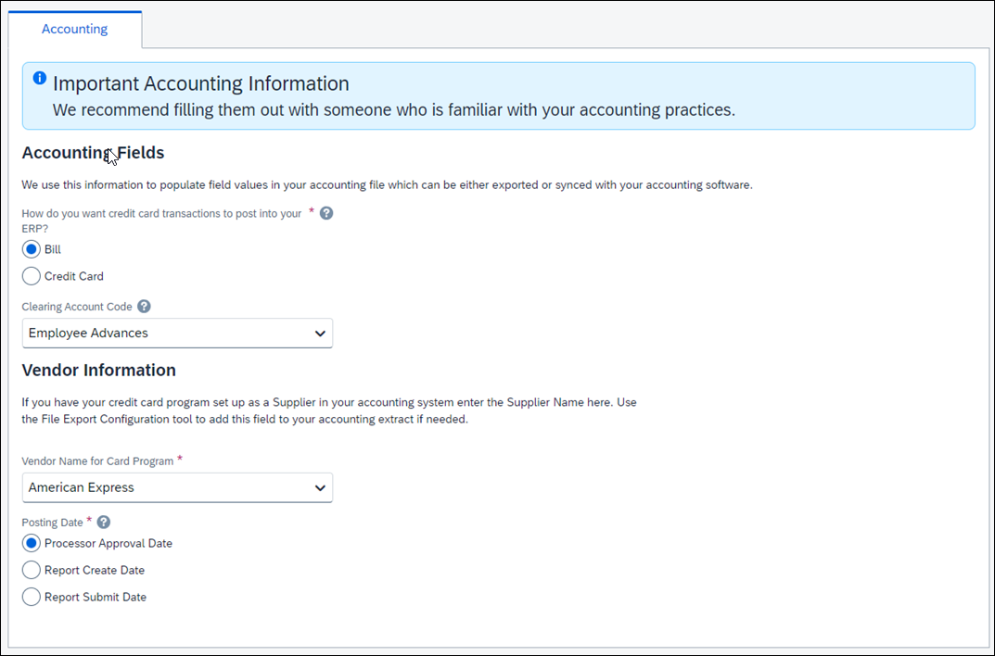
Example of Updated Fields
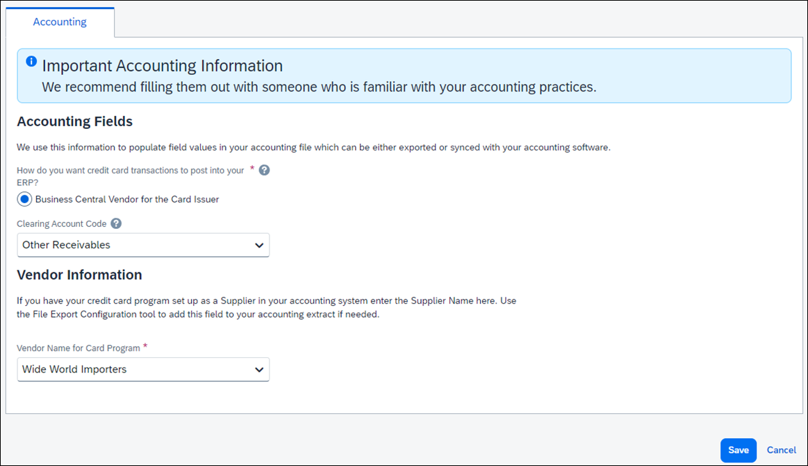

Configuration / Feature Activation
This change occurred automatically.

SAP Cloud Identity Services into SAP Concur

Information First Published | Information Last Modified | Feature Target Release Date
November 9, 2023 | January 19, 2024 | Phase 1 - January 16, 2024
Any changes since the previous monthly release are highlighted in yellow in this release note.

Applies to:

Expense, Invoice, Request, Travel & Expense | Professional & Standard

Overview
SAP is making it easier for you to integrate identity and access management (IAM) between systems. As of January 16, 2024, SAP Cloud Identity Services, including Identity Authentication and Identity Provisioning, are now available to SAP Concur customers who have purchased one of the SAP cloud solutions which bundle Identity Authentication and Identity Provisioning. The goal is to provide a seamless single sign-on (SSO) experience across SAP systems while ensuring that system and data access are secure. Both customers who use their own identity provider (third-party IdP) and those who don't have their own IdP can integrate with SAP Cloud Identity Services.
The provisioning of a tenant with Identity Authentication and Identity Provisioning services is triggered when a customer creates a case. Before creating a case, customers need to check with their SAP Concur account team to determine if they are eligible for provisioning of a tenant with Identity Authentication and Identity Provisioning services.
Once the tenant provisioning is completed, the customer can complete the configuration of Identity Authentication as SSO for SAP Concur and Identity Provisioning for SAP Concur as a target system from within the SAP Cloud Identity Services administration console.
You must create a case to set up Identity Authentication and Identity Provisioning tenant provisioning for your SAP Concur entity even if you already have existing Identity Authentication and Identity Provisioning tenants from other SAP solutions.
For customers that have an existing tenant with Identity Authentication and Identity Provisioning services, the tenant will be reused. With the Identity Authentication and Identity Provisioning services, customers can configure Identity Authentication as single sign-on for centralized authentication and Identity Provisioning for seamless user management with SAP Concur products. This configuration will enable the creation and provisioning of users, as well as single sign-on (SSO) functionality to all SAP business applications.
This process supports the following configurations:
New or existing Concur Expense, Concur Request, Concur Invoice, and/or Concur Travel & Expense customers that have at least one existing tenant of SAP Cloud Identity Services
Concur Travel-only is not supported for Phase 1.

Business Purpose / Client Benefit
Identity Authentication enables authentication and SSO for users in the cloud, simplifying user experience. Business users in cross-application business scenarios will only need to log in once versus maintaining a login for each application. Identity Authentication offers centralized security for authentication and SSO for protecting system-to-system communication.
Identity Provisioning manages identity lifecycle processes seamlessly by allowing clients to provision identities/users from a source system to SAP Concur. Maintaining users in multiple systems across a heterogeneous landscape will be obsolete.
Identity Provisioning is a centrally administered user management and identity provisioning service which is key for an end-to-end integration. Global User ID (or User UUID) is a unique id that helps to integrate user-related data across system boundaries seamlessly. Global User ID can either be created by the customer using Identity Authentication or it can be provided by the customer. Customers will benefit from the simple configuration and the central user management.

Configuration / Feature Activation
This integration is available for new or existing SAP Concur customers with Professional Edition or Standard Edition that also have existing SAP Cloud Identity Services.
For more information about SAP Cloud Identity Services into SAP Concur, including information about creating a case, refer to the SAP Concur Bundle and SAP Concur Integration Scenario topics in the SAP Help Portal.

SAP Concur User Assistance

**Ongoing** Links From the SAP Concur Solutions UI to Product Documentation Being Removed

Information First Published | Information Last Modified | Feature Target Release Date
May 12, 2023 | January 12, 2024 | Ongoing in 2023-2024
Any changes since the previous monthly release are highlighted in yellow in this release note.
Applies to:

All Products | All Editions

Overview
Some pages in the SAP Concur solutions UI include links to product documentation or other content. In June 2023, SAP Concur began removing these links. Work to remove the links will continue in 2024.
The SAP Help Portal is the central source for all product documentation, release notes, and other content. SAP Concur clients can use the SAP Concur page on the SAP Help Portal to find the complete library of SAP Concur solutions documentation.

Business Purpose / Client Benefit
Because the links to product documentation from the SAP Concur solutions UI point to English-only content, the experience is not optimal for users that view the UI in languages other than English. In addition, direct links to a single document prevent the user from viewing and navigating the entire content library.
To align with SAP best practices, in June 2023, SAP Concur began removing direct links from the SAP Concur solutions UI that point to product documentation on concurtraining.com. This process will continue in 2024.

Admin and End-User Experience
SAP Concur solutions UI pages with links to product documentation will be updated to remove the links.
Example
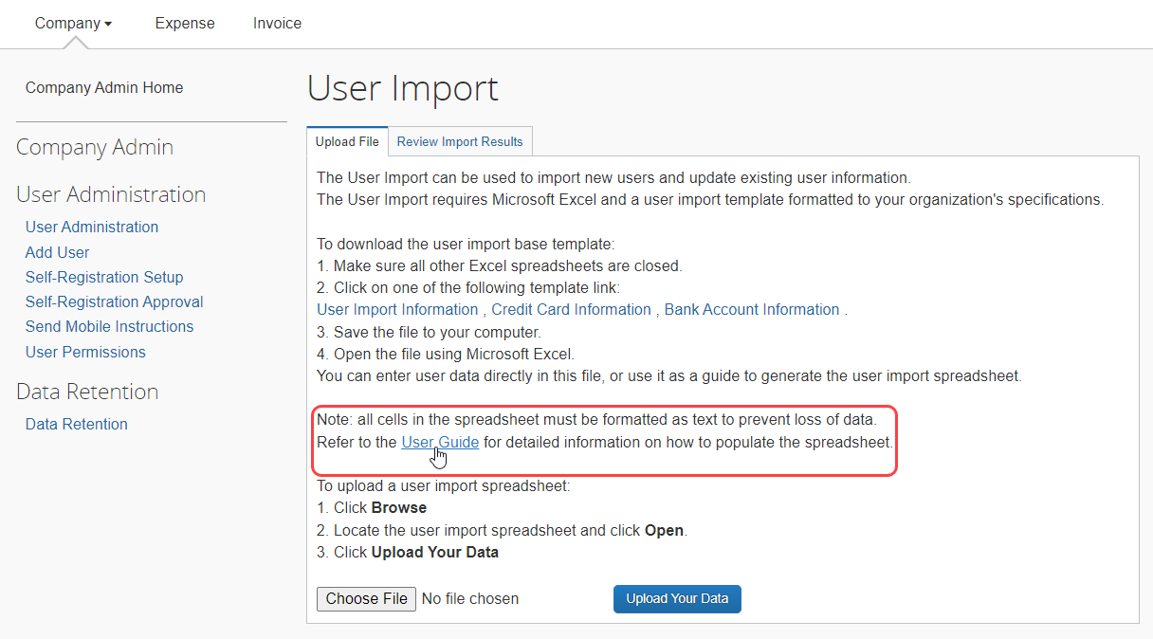

Configuration / Feature Activation
This change is being made in phases, starting in 2023 and continuing in 2024.

Translations Available for Security Content

Information First Published | Information Last Modified | Feature Target Release Date
January 19, 2024 | -- | February 5, 2024
Any changes since the previous monthly release are highlighted in yellow in this release note.
Applies to:

All Products | All Editions

Overview
When the January translations are published, typically two weeks after the English content is published, the Protect Your SAP Concur Cloud deliverable will be available in six additional languages:
- Chinese Simplified
- French
- German
- Japanese
- Portuguese for Brazil
- Spanish

Business Purpose / Client Benefit
This change improves the usability of the content.

End-User Experience
When a customer chooses a language from the language list, the content on the page will be presented in the chosen language.
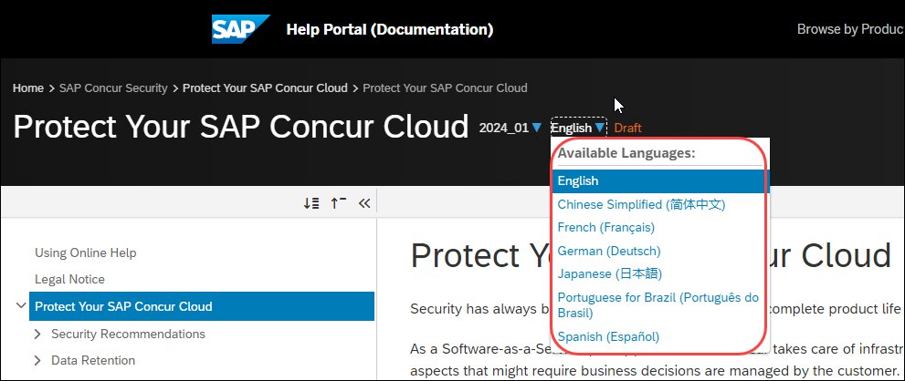

Configuration / Feature Activation
This change occurs automatically.

SAP Fiori Themes

**Ongoing** SAP Fiori Horizon Themes for Concur Mobile and Web

Information First Published | Information Last Modified | Feature Target Release Date
February 10, 2023 | January 19, 2024 | Phased release: May 2023 through April 10, 2024
Any changes since the previous monthly release are highlighted in yellow in this release note.
Applies to:

All Products | All Editions

Overview
SAP Concur has adopted the SAP Fiori with Horizon visual design theme family as the default appearance for SAP Concur solutions.
Implementation of the SAP Fiori with Horizon visual design theme impacts the look and feel of SAP Concur solutions by updating fonts, font sizes, icons, colors, and shapes. In addition, in both the SAP Concur mobile and web UI, navigation from the home page is slightly modified.
Introduction of the new design themes has been phased beginning on May 20, 2023. SAP Concur plans to fully implement the new themes, decommissioning the current, legacy (Gateway) theme, on April 10, 2024.
The legacy (Gateway) theme is not available to new clients. New clients automatically default to the Fiori for Horizon Morning Horizon theme.

Business Purpose / Client Benefit
These changes improve the overall user experience, better support accessibility features, and help provide a consistent user experience across all SAP products.

Admin Experience

Mobile
SAP Concur has implemented SAP Fiori with Horizon in the Mobile app.

Web UI
SAP Concur began implementing SAP Fiori with Horizon themes in phases beginning in May 2023:
Phase 1 – May 20, 2023, and June 22, 2023: On May 20, 2023, SAP Concur implemented Theme Settings for SAP Concur Professional edition clients and for most Standard edition clients. On June 22, 2023, Theme Settings were enabled for the remaining Standard edition clients.
During phase 1, admins with the required permissions accessed Theme Settings to choose between the following options:
- Legacy Concur UI: End users only see the legacy Concur Gateway theme.
- Legacy Concur UI and Fiori Horizon: End users see the legacy Concur Gateway theme by default. On the Profile Settings > System Settings page, they can choose between the Concur Gateway theme, Morning Horizon, Evening Horizon, and high contrast themes.
- Fiori Horizon: End users see Morning Horizon by default. On the Profile Settings > System Settings page they can choose between the Morning Horizon, Evening Horizon, and high contrast themes.
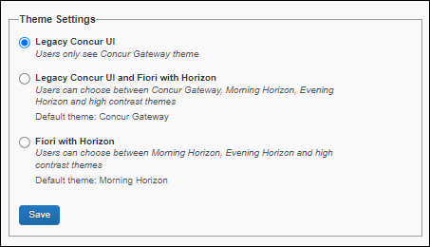
Phase 2 – Beginning October 2, 2023: On October 2, 2023, SAP Concur began setting Morning Horizon as the default SAP Concur UI theme for most clients.
Clients in the China Datacenter entered Phase 2 on January 8, 2024. As of January 8, 2024, these clients will proceed to Phase 3 on April 10, 2024, as documented in the sections that follow.
New clients automatically default to the Morning Horizon theme. Existing SAP Concur client admins have access to Theme Settings and can revert to the legacy Concur Gateway theme.
Admins for preexisting Concur entities can choose either the legacy Concur Gateway theme or SAP Horizon for Fiori themes. A hybrid option that enables both sets of themes is not available.
Phase 3 – April 10, 2024: SAP Concur plans to decommission the legacy Concur Gateway theme. When it is decommissioned, Morning Horizon will become the default theme and end users will be able to choose between Morning Horizon, Evening Horizon, and high contrast themes. The Gateway theme and Theme Settings will no longer be available. Users who have not yet enabled Horizon for Fiori themes will automatically be switch to Morning Horizon.
Clients with SAP Fiori Quartz themes: On October 2, 2023, SAP Concur will decommission the SAP Fiori 3 Quartz themes and clients with SAP Fiori 3 Quartz themes will automatically default to the SAP Fiori with Horizon visual themes.

Implementation Schedule for Clients with Concur Budget
Currently, some screens in Budget are not fully compatible with Horizon for Fiori themes.
This does not impact SAP Concur mobile app. Budget clients already have access to the new theme on the mobile app.
To address this issue, clients with Budget will be migrated to the new themes on the following schedule:
Phase 1 – October 2023: During phase 1, Budget clients can opt in to the Horizon for Fiori themes. The opt-in phase will last approximately 90 days.
Phase 2 – January 8, 2024: on January 8, 2024, Morning Horizon will become the default SAP Concur UI theme for clients with Budget. The process of updating all existing SAP Concur clients to the new default setting might take some time.
New clients with Budget will automatically default to the Morning Horizon theme. The legacy (Gateway) theme is not available to new clients.
When Morning Horizon becomes the default UI theme for clients with Budget in January, existing SAP Concur client admins will have access to Theme Settings and will be able to revert to the legacy Concur Gateway theme.
As of January 8, when Morning Horizon becomes the default UI theme for clients with Budget, there will no longer be a hybrid option in Theme Settings. Client must configure either the legacy (Gateway) theme or the default Horizon for Fiori themes.
Phase 3 – April 10, 2024: On April 10, 2024, SAP Concur plans to decommission the legacy Concur Gateway theme for all clients, including clients with Budget. When it is decommissioned, Morning Horizon will become the default theme and end users will be able to choose between Morning Horizon, Evening Horizon, and high contrast themes.

TMC Experience
The Theme Settings page is available in Global View.

End User Experience
With the SAP Fiori with Horizon visual design themes, the overall look of SAP Concur solutions is updated with new fonts, icons, colors, and shape design.

Legacy Page Design Example
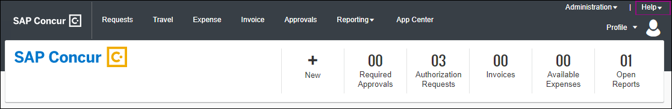

SAP Fiori With Horizon Design Example
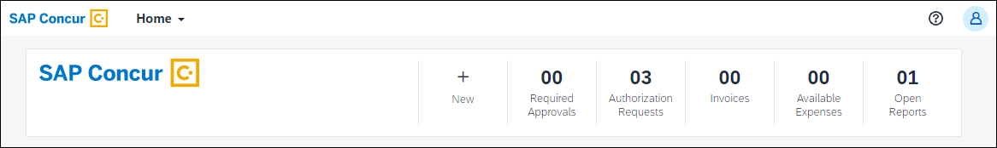
Navigation from the SAP Concur home page is also slightly modified so that it is simpler and more consistent with other SAP products.

Legacy Home Page Navigation
With the legacy theme, navigation from the home page relies on product tabs and the Administration menu.

SAP Fiori With Horizon Home Page Navigation
With the SAP Fiori with Horizon visual design theme, navigation from the Concur home page to Concur product and administration pages is consolidated in the Home menu.
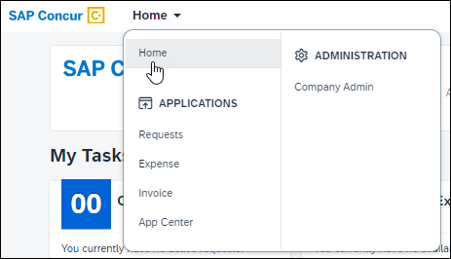

Configuration / Feature Activation
SAP Concur is implementing these changes through a phased approach that began in May 2023 and is targeted to be completed in April 2024.

Planned Changes
The following features and changes are targeted for future releases. SAP Concur solutions reserves the right to postpone implementation of – or completely remove – any enhancement/change mentioned here.

Authentication

**Planned Changes** HMAC Authentication to be Decommissioned

Information First Published | Information Last Modified | Feature Target Release Date
December 1, 2023 | -- | Q3 2024
Any changes since the previous monthly release are highlighted in yellow in this release note.
Applies to:

All Products | All Editions

Overview
SAP Concur support for Hash-Based Message Authentication Code (HMAC) was deprecated in July 2021. In Q3 of 2024 the HMAC service will be decommissioned and authentication to SAP Concur solutions through HMAC will no longer work.
SAP Concur provides a Single Sign-On self-service option that enables client admins to setup their SAML v2 connections without involving an SAP Concur support representative. SAML v2 supports the use of multiple identity providers.
For more information about the Single Sign-On self-service option, refer to the Shared: Single Sign-On Overview and the Shared: Single Sign-On Setup Guide.

Action Required
If you are already using SSO or another supported authentication method other than HMAC, you do not need to take any action.
If you are using only HMAC to access SAP Concur solutions, to avoid disruption of service, you must update your authentication method before HMAC is decommissioned in Q3 of 2024.
If users attempt to authenticate to SAP Concur solutions through HMAC after the HMAC service is decommissioned in Q3 of 2024, they will be denied access.

Business Purpose / Client Benefit
This change provides better security and improved support for users logging in to SAP Concur products and services.

Configuration / Feature Activation
This change will occur automatically.
More information about this change will be provided in future release notes.

Import/Extract

**Planned Changes** User Data Extract Feature

Information First Published | Information Last Modified | Feature Target Release Date
January 19, 2024 | -- | Future Release
Any changes since the previous monthly release are highlighted in yellow in this release note.
Applies to:

Travel w/Expense, Expense, Invoice, Request | Professional & Standard

Overview
In a future release, SAP Concur plans to implement a feature that enables a company administrator with either the Import/Extract Administrator or Import/Extract Monitor role to extract user data. The user data extract feature will be available from the User Data Extracts tab on the Import/Extract Monitor and Import/Extract Administrator pages.
With the January 2024 release, in preparation for the release of the user data extract feature, the User Data Extracts tab was added to the Import/Extract Monitor and Import/Extract Administrator pages and is visible to administrators with permission to view those pages. This tab is not currently functional.

Business Purpose / Client Benefit
When it becomes available, the user data extract feature will enable client administrators to request and download user data without requiring that they contact SAP Concur support for assistance.

Configuration / Feature Activation
This change will occur automatically; The new tab and future feature are only visible to client administrators with the required roles.
More information about this feature will be added in future release notes.

SAP Concur

**Planned Changes** New SAP Concur Brand Logo

Information First Published | Information Last Modified | Feature Target Release Date
January 12, 2024 | -- | February 16, 2024
Any changes since the previous monthly release are highlighted in yellow in this release note.
Applies to:

All Products | All Editions

Overview
On February 16, 2024, SAP plans to update the SAP Concur brand logo. The new logo will appear in all UI themes including the legacy Concur Gateway theme and all SAP Fiori with Horizon themes for SAP Concur.

Business Purpose / Client Benefit
With this update, the SAP Concur logo will better align with SAP branding.

User Experience
Users will see the updated logo in the SAP Concur UI.
The SAP Concur logo differs slightly depending on the part of the UI you are viewing and the configured visual theme. For example, the background color will change if you switch from Fiori for Horizon Morning to Fiori for Horizon Evening.
Current Logo Example
Updated Logo Example

Configuration / Feature Activation
This change occurs automatically.
SAP Concur will make this change on February 16, 2024, however, it might take a few days for the change to be deployed to all data centers.

SAP Concur User Assistance

**Planned Changes** SAP Concur Product Documentation Moving to the SAP Help Portal

Information First Published | Information Last Modified | Feature Target Release Date
June 9, 2023 | September 15, 2023 | Q3 2024
Any changes since the previous monthly release are highlighted in yellow in this release note.
Applies to:

All Product | All Editions

Overview
Currently, most SAP Concur product documentation is published to concurtraining.com. SAP Concur User Assistance is targeting the third quarter of 2024 to publish all product documentation (such as setup and user guides) to the SAP Help Portal.
Some SAP Concur product documentation, such as the monthly admin summaries and end user help topics, is already published to the SAP Help Portal. The SAP Help Portal also provides links to the product documentation published to concurtraining.com so clients are encouraged to bookmark and start using the SAP Help Portal now to access product documentation.
- IMPORTANT: In 2024, after the product documentation is moved to the SAP Help Portal, links and bookmarks that point to the tech_pubs folder on concurtraining.com will stop working. Please update your links and bookmarks to the SAP Help Portal (https://help.sap.com/docs/SAP_CONCUR).

Business Purpose / Client Benefit
The SAP Help Portal has improved search capabilities and there is a mechanism for clients to provide feedback. This change also aligns with SAP best practices for the publication of product documentation and prepares the content for future user assistance innovations.

Admin Experience
The SAP Concur solutions setup guides, user guides, and fact sheets will continue to be available from the concurtraining.com landing pages until the product documentation is moved to the SAP Help Portal.
Admins can find links to the full SAP Concur product documentation library from the SAP Help Portal.
Please be aware that during this transition there will be procedures and images that do not precisely match your implementation. For example, when SAP Fiori UI themes are implemented, home page navigation is consolidated under the SAP Concur Home menu.
For more information, refer to the SAP Fiori with Horizon Visual Theme for SAP Concur Solutions FAQ.

Action Item
Ensure that you update any custom configuration that you may have that references the tech_pubs folder on concurtraining.com (https://www.concurtraining.com/customers/tech_pubs/*) to point to the SAP Help Portal (https://help.sap.com/docs/SAP_CONCUR) instead. Custom configuration that may be impacted by this change can come from several sources such as Training Admin, Company Info, and the new travel experience Configurable Message Boards.

End-User Experience
End users who access help topics from within SAP Concur solutions will not experience any changes because those help topics are already available from the SAP Help Portal through links provided in the products.

Downloading PDFs
Content available from the SAP Help Portal can be selected and downloaded as a custom PDF file. From the SAP Help Portal, click Download PDF > Create Custom PDF, select the desired topics from the left navigation pane, and click Create PDF.
For a video that includes these clicks, refer to the Using Online Help topic available from the SAP Help Portal.

Example
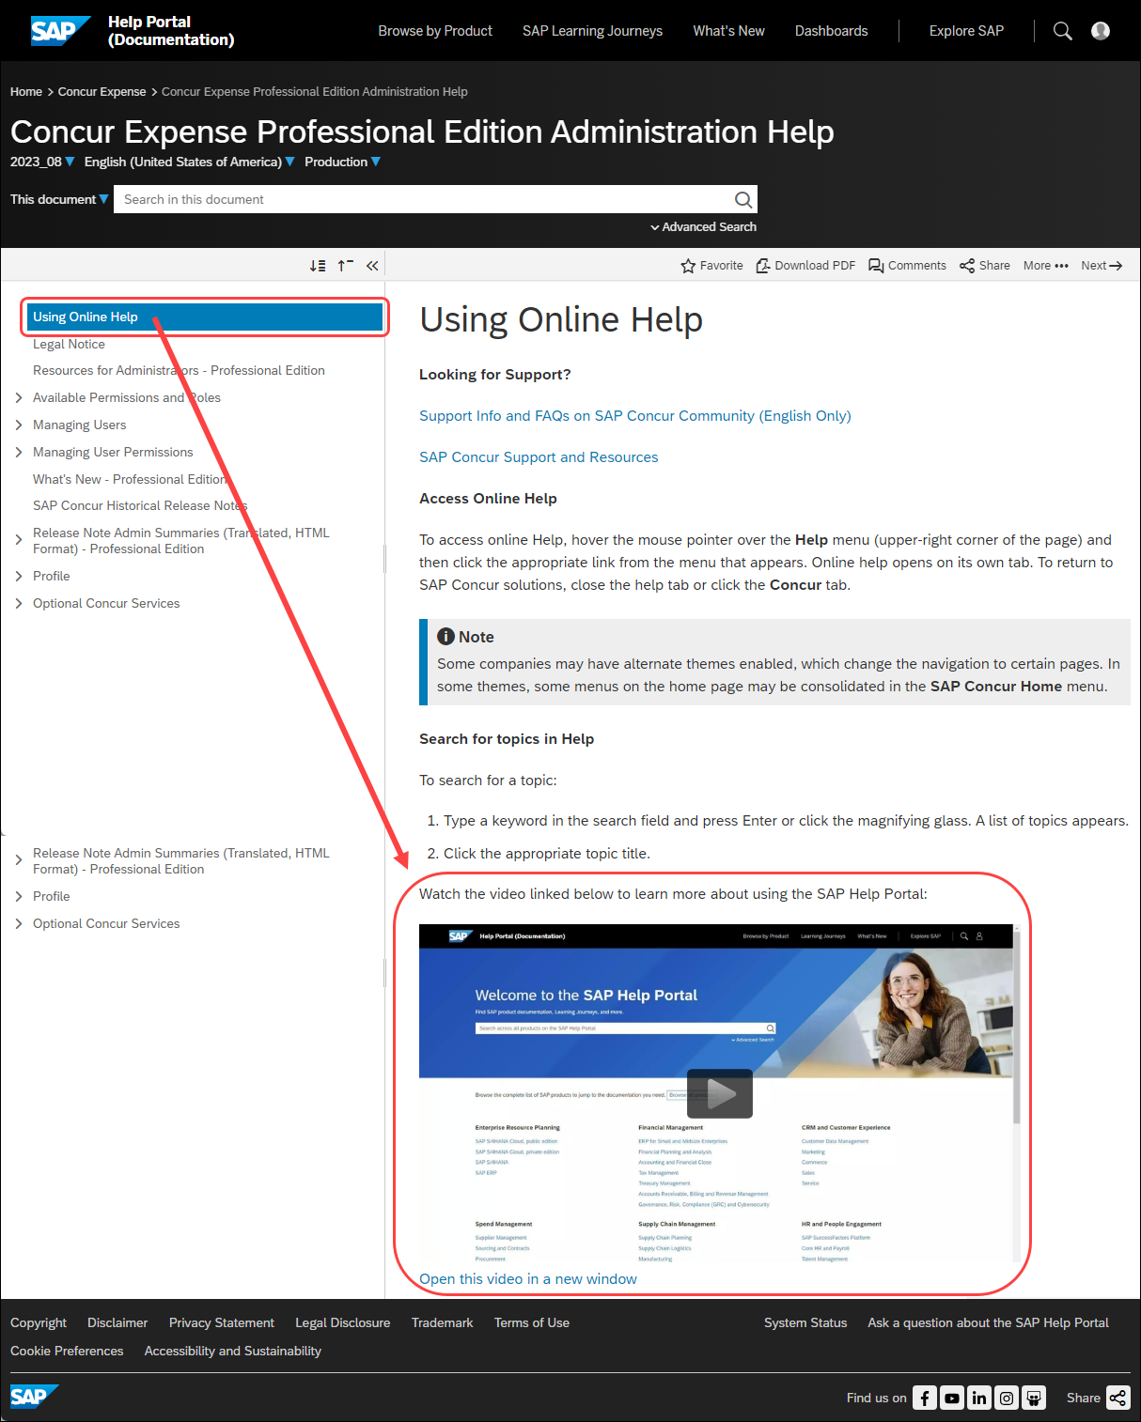

Configuration / Feature Activation
The location change will happen automatically; there are no configuration or activation steps.
The exact date that the product documentation will be available from the SAP Help Portal will be provided in future release notes.

Sign-In Page

**Planned Changes** Hide/Show Password Icon

Information First Published | Information Last Modified | Feature Target Release Date
January 12, 2024 | -- | Q1 2024
Any changes since the previous monthly release are highlighted in yellow in this release note.
Applies to:

All Products | All Editions

Overview
In Q1 of 2024, SAP Concur plans to add an icon to the SAP Concur Sign-In page that will enable users to hide or show their password when they enter it during sign in.

Business Purpose / Client Benefit
This change enables users to view the password they are entering to ensure it is correct or hide the password to ensure it cannot be seen by others.

End-User Experience
Users will see an “eye” icon near the password field. Clicking the icon will hide (display as asterisks) or show their password.
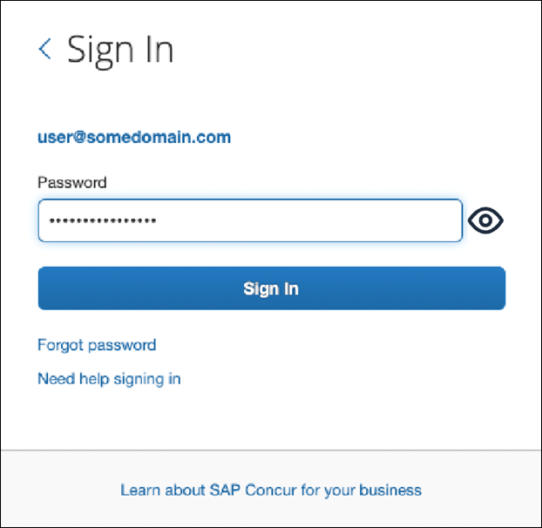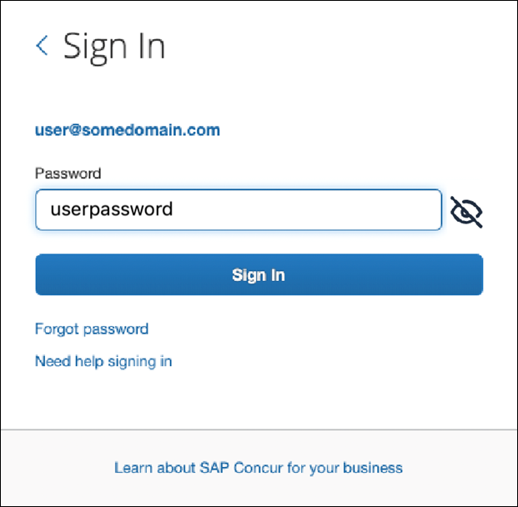

Configuration / Feature Activation
This change occurs automatically.

Client Notifications

Accessibility

Accessibility Enhancements
SAP implements changes to better meet current Web Content Accessibility Guidelines (WCAG). Information about accessibility-related changes made to SAP Concur solutions is published on a quarterly basis. You can review the quarterly updates on the Accessibility Updates page.

Gender Diversity
SAP Concur is committed to supporting gender diversity. Over time we plan to implement product changes to help ensure that SAP Concur solutions support gender non-binary users. These changes will include but are not limited to support for preferred names, non-binary gender options in travel preferences, and non-binary titles.
These planned changes reflect SAP's commitment to supporting gender diversity and enable gender non-binary users to enter consistent information when making travel arrangements and entering personal information into SAP Concur solutions.
Timelines and details about these ongoing changes will be provided in the SAP Concur release notes.

In-Product User Assistance

Client Customized Content
If your company creates customized content for SAP Concur solutions through a user assistance tool such as SAP Enable Now or Concur User Assistant by WalkMe, the changes described in these release notes might affect your customized content. SAP Concur recommends reviewing the monthly release notes for all of your SAP Concur solutions as well as the Shared Changes Release Notes to confirm whether any of the planned or released changes might impact your internal, customized content.
If any changes in a release impact your content, work with your internal teams to update your content accordingly.

Subprocessors

SAP Concur Non-Affiliated Subprocessors
The list of non-affiliated subprocessors is available from the SAP Sub-processors / Data Transfer Factsheets page.
To access the SAP Concur Sub-processors List:
- Click the following link to navigate to the SAP Sub-processors / Data Transfer Factsheets page:
SAP Sub-processors / Data Transfer Factsheets
- Sign in to the SAP Support Portal using your Support User ID (S-user) and password.
SAP customers must sign in to the SAP Support Portal using their Support User ID (S-user) and password. For information about S-User IDs, Your New Support User ID (S-user) and to the Learn All About S-User IDs blog post.
- On the SAP Sub-processors / Data Transfer Factsheets page, type "Concur" in the Search field.
- In the Title column, click SAP Concur Sub-processors List.
If you have questions or comments, please reach out to: Privacy-Request@Concur.com

Supported Browsers

Supported Browsers and Changes to Support
When changes to browser support are planned, information about those changes will also appear in the Shared Planned Changes release notes.
For information about supported browsers and planned changes to supported browsers, refer to the Concur Travel & Expense Supported Configurations guide.

Additional Release Notes and Other Technical Documentation

Online Help
You can access release notes, setup guides, user guides, admin summaries, supported configurations, and other resources via the in-product Help menu or directly on the SAP Help Portal.
To access the full set of documentation for your product, use the links in the SAP Concur Help menu, or visit the SAP Concur solutions page.
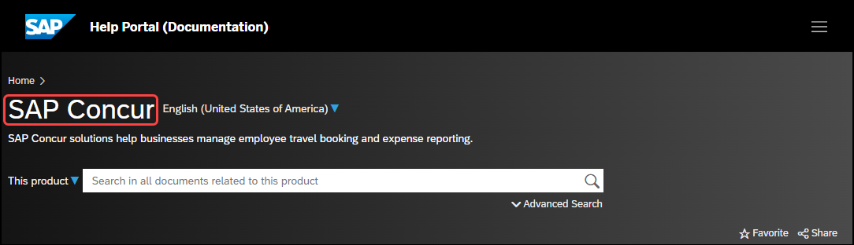

SAP Concur Support Portal – Selected Users
Access release notes, webinars, and other technical documentation on the SAP Concur support portal.
If you have the required permissions, Contact Support is available on the SAP Concur Help menu and in the SAP Concur page footer.
Click Contact Support to access the SAP Concur support portal, then click Resources.
- Click Release/Tech Info for release notes, technical documents, etc.
- Click Webinars for recorded and live webinars.
© 2024 SAP SE or an SAP affiliate company. All rights reserved.
No part of this publication may be reproduced or transmitted in any form or for any purpose without the express permission of SAP SE or an SAP affiliate company.
SAP and other SAP products and services mentioned herein as well as their respective logos are trademarks or registered trademarks of SAP SE (or an SAP affiliate company) in Germany and other countries. Please see http://global12.sap.com/corporate-en/legal/copyright/index.epx for additional trademark information and notices.
Some software products marketed by SAP SE and its distributors contain proprietary software components of other software vendors.
National product specifications may vary.
These materials are provided by SAP SE or an SAP affiliate company for informational purposes only, without representation or warranty of any kind, and SAP SE or its affiliated companies shall not be liable for errors or omissions with respect to the materials. The only warranties for SAP SE or SAP affiliate company products and services are those that are set forth in the express warranty statements accompanying such products and services, if any. Nothing herein should be construed as constituting an additional warranty.
In particular, SAP SE or its affiliated companies have no obligation to pursue any course of business outlined in this document or any related presentation, or to develop or release any functionality mentioned therein. This document, or any related presentation, and SAP SE’s or its affiliated companies’ strategy and possible future developments, products, and/or platform directions and functionality are all subject to change and may be changed by SAP SE or its affiliated companies at any time for any reason without notice. The information in this document is not a commitment, promise, or legal obligation to deliver any material, code, or functionality. All forward-looking statements are subject to various risks and uncertainties that could cause actual results to differ materially from expectations. Readers are cautioned not to place undue reliance on these forward-looking statements, which speak only as of their dates, and they should not be relied upon in making purchasing decisions.

