Mobile App User Guide  Drive  Last Revised: July 5, 2023 | This guide describes the current version, which is shown on the "Introduction" guide. |  | Applies to these mobile devices:  Yes: iPhone  Yes: iPad  Yes: Android
IMPORTANT: Be aware that your company's configuration may not allow for all of the features described here. Generally, if a feature is not available in your configuration of the web version of SAP Concur, then it is not available in the mobile app.
Drive is the SAP Concur service with an automatic distance capture tool that allows the user to track business mileage for reimbursement. Mileage is tracked by using the iOS and Android location services.  Drive enables users to:  - Document, report, and be reimbursed for distance driven  - Improve mileage reporting, and help with compliance, and audit readiness  - Proactively manage and standardize expense reporting  - Flag each segment of their drive as business or personal when Auto Capturing Mode is enabled and accurately track distance driven  - Use smart sensors to track when their vehicle is in motion and to capture distance from their mobile device  - Turn mileage logs into expense line items in Concur Expense with one click  - Enable Auto Capturing Mode to automatically capture driving distance on their schedule or manually start and stop distance capture per trip |  | Drive 2  iPhone 3  Track Mileage Automatically 3  SetTrack Mileage Manually 7  Enable Traffic Mode 10  Access Drive Help 11  Android 12  Track Mileage Automatically 12  Track Mileage Manually 14  Enable Traffic Mode 17  Access Drive Help 18  iPad 19  Track Mileage Automatically 19  Track Mileage Manually 21  Enable Traffic Mode 23  Access Drive Help 24
Please Note:
- The SAP Concur app for iOS and Android supports universal links, i.e. links that navigate directly to the app if it is installed or to the website if not.
- Such links are included in notification emails from SAP Concur related to the expense report changes.
- Universal link support for customers own use is currently not supported.
- Some security solutions may block the links embedded into email from opening the app directly. The proper exceptions for the security policy should be configured for SAP Concur universal link URLs (pattern to match:https://*.concursolutions.com/*). Known cases are:
- MDM/MAM policy that prescribes to open any link tapped in Outlook mobile app only in specified browser.
- Outlook mail server phishing protection that wraps all link embedded into e-mails to open the safety check service first.

Drive
If the user's company uses Drive, they can automatically use GPS to track their travel – either manually or automatically – on their mobile device.
The SAP Concur mobile app captures their route data - which is available in Concur Expense and on the mobile app - where they can select the segments to add to an expense report.

iPhone

Track Mileage Automatically
Use Mileage on the home screen to set up the day and time (for example, Monday through Friday, 8 AM to 5 PM) for which the app will automatically track your trips by detecting car movement.
Screen(s) | Description/Action
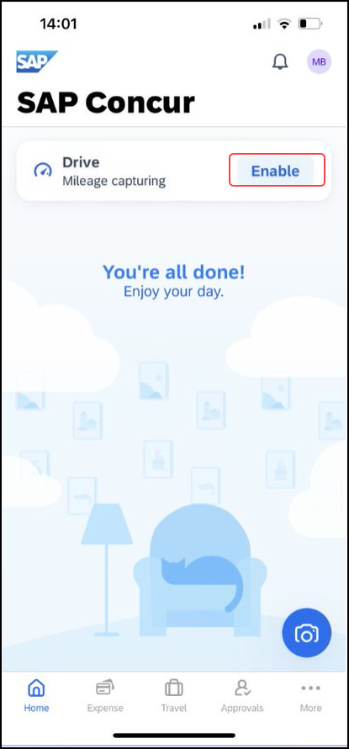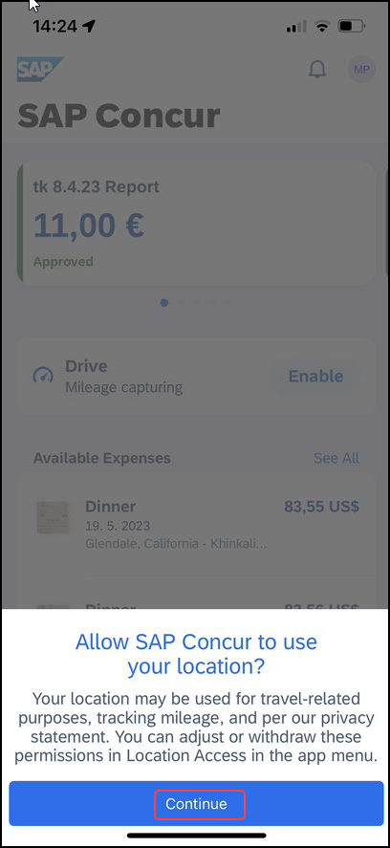 | To set Drive to track distance automatically:  1) Drive is always available on the main screen.  2) Tap Enable.  3) A screen requesting to use location will appear. Tap Continue.
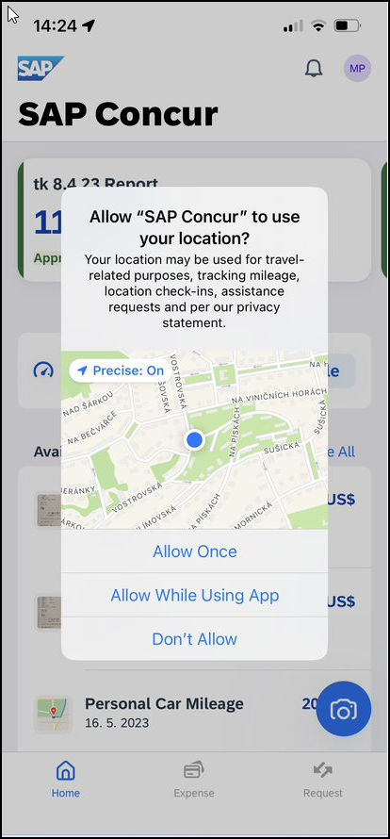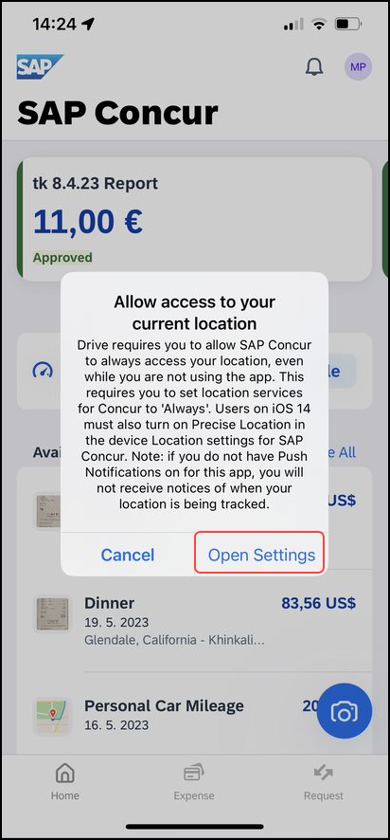 | 4) Choose the preference for location sharing. Drive requires access to location, which can be adjusted iby tapping Open Settings.
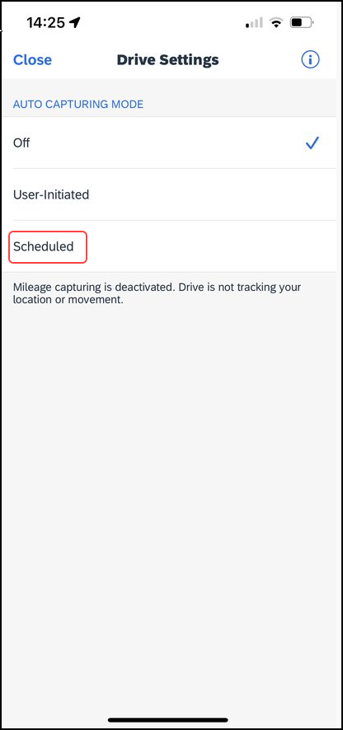 | 5) On the Drive Settings screen, tap Scheduled.
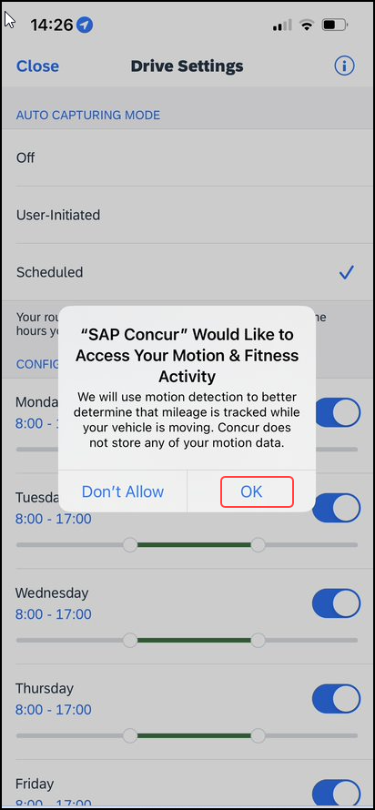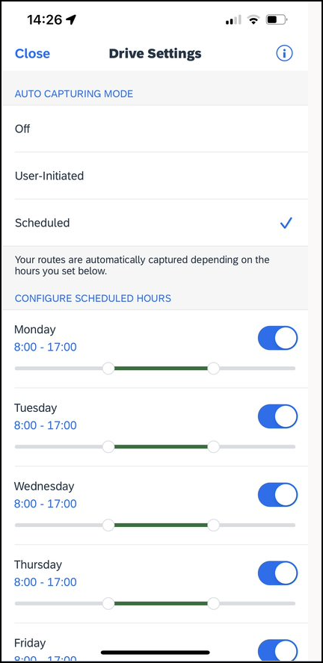 | 4) A prompt will appear to track motion to more accurately track mileage. Select OK.  5) Make the desired selections and then tap Close to return to the home screen.  NOTE: Drive will track distance automatically during the times the user has selected.

SetTrack Mileage Manually
Use Mileage on the home screen to initiate GPS tracking manually with a click of a button and then stop when you want your trip to end.
Screen(s) | Description/Action
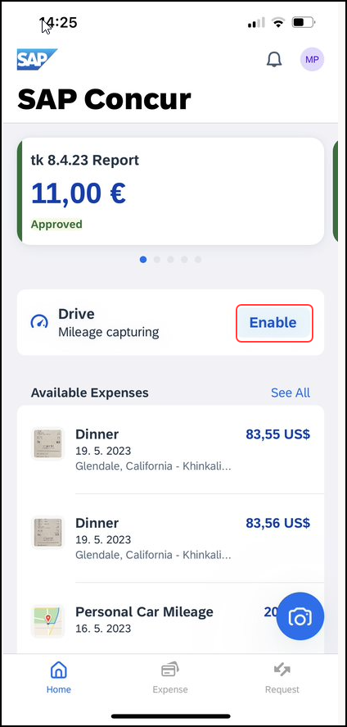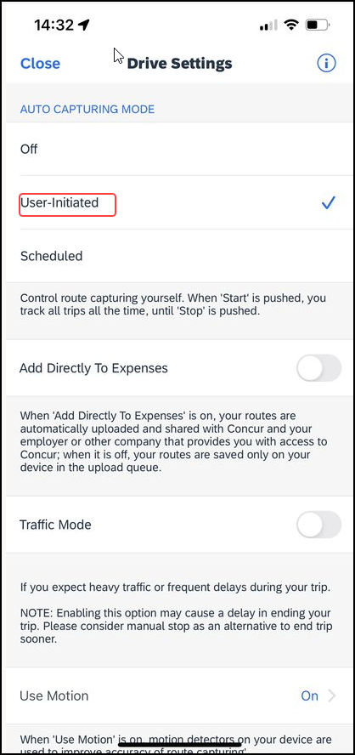 | To use Drive to track distance manually:  1) Once Drive is enabled, Mileage capturing will be visible on the home screen. Tap Enable to choose the correct setting.  2) On the menu that appears, tap Start. (This option appears if User-Initiated is selected in Settings.)
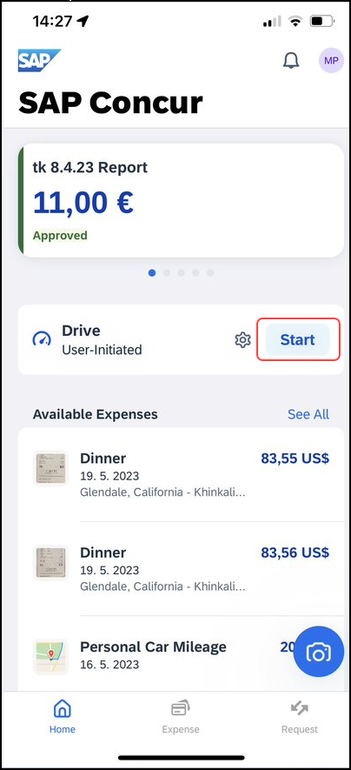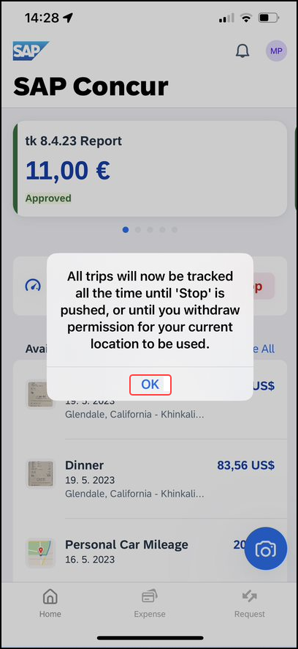 | 3) When done, on the home screen, select Start to start tracking the mileage manually.  4) A prompt will appear to inform that the miles are now being tracked manually. Tap OK to clear.
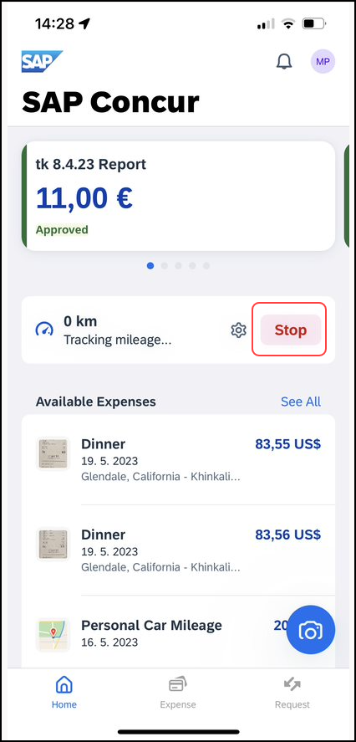 | 5) On the home menu, tap Stop once trip is complete.

Enable Traffic Mode
Use the Traffic Mode option to increase the time allowance to terminate a trip - when detecting no movement - from 7 minutes (default) to 15 minutes.
The Traffic Mode option is disabled by default and your selection is saved as part of the local profile settings.

Screen(s) | Description/Action
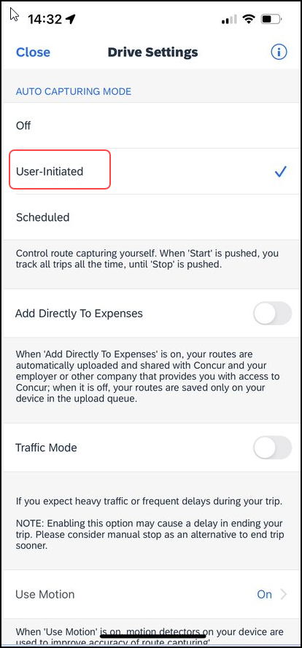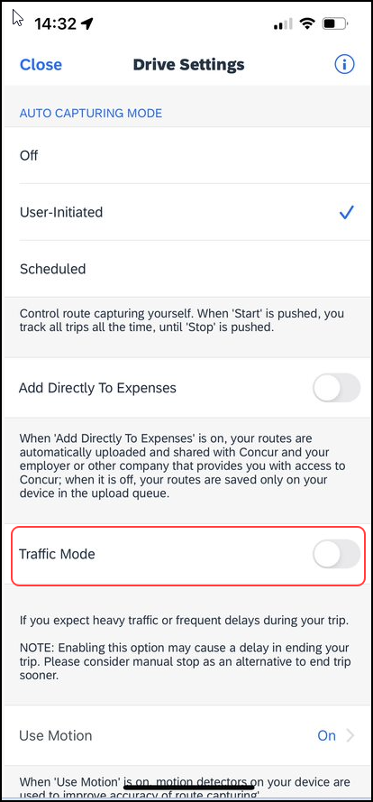 | To enable Traffic Mode:  1) On the home screen, tap Drive.  2) Within the widget, tap Enable.  3) On the Drive Settings screen, select User-Initiated and then swipe the Traffic Mode toggle to the right.  NOTE: Enabling this option may cause a delay in ending the user's trip. The user can use the manual stop option as an alternative to end their trip sooner.

Access Drive Help
Use the information icon to gain easy access to tips on how to use Drive.
Screen(s) | Description/Action
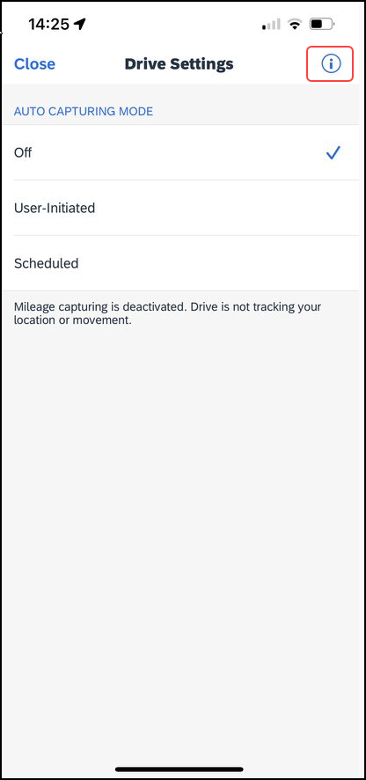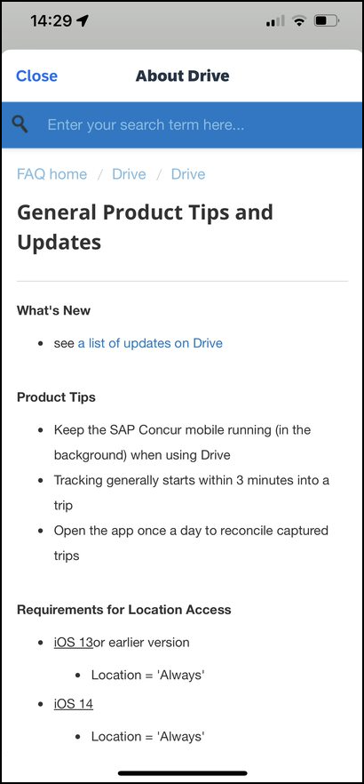 | To access Drive help:  1) On the home screen, tap Drive.  2) Within the widget, tap Enable.  3) On the Drive Settings screen, tap the information icon (upper-right corner).  The About Drive screen appears with the Product Tips, What's New, More FAQs, and How Drive Works sections.  NOTE: If your mobile device is offline, the About Drive screen will appear blank and you will not be able to access the Drive help.

Android

Track Mileage Automatically
Use Mileage on the home screen to set up the day and time (for example, Monday through Friday, 8 AM to 5 PM) for which the app will automatically track your trips by detecting car movement.
Screen(s) | Description/Action
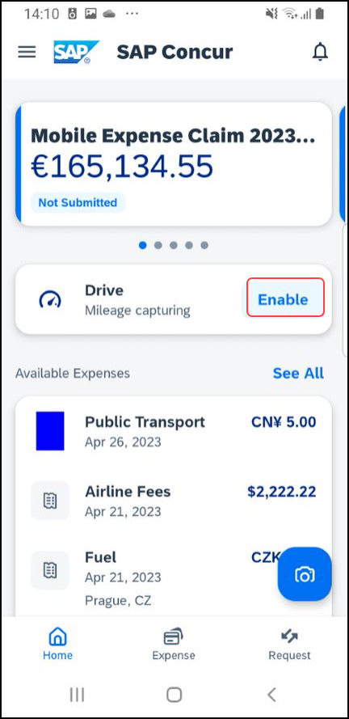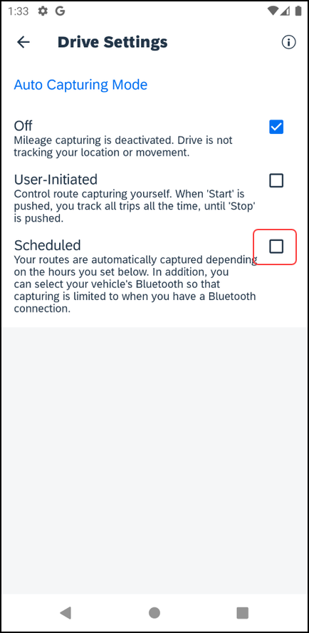 | To set Drive to track distance automatically:  1) Drive is always available on the home screen.  2) Tap Enable.  3) On the Drive Settings screen, select Scheduled.
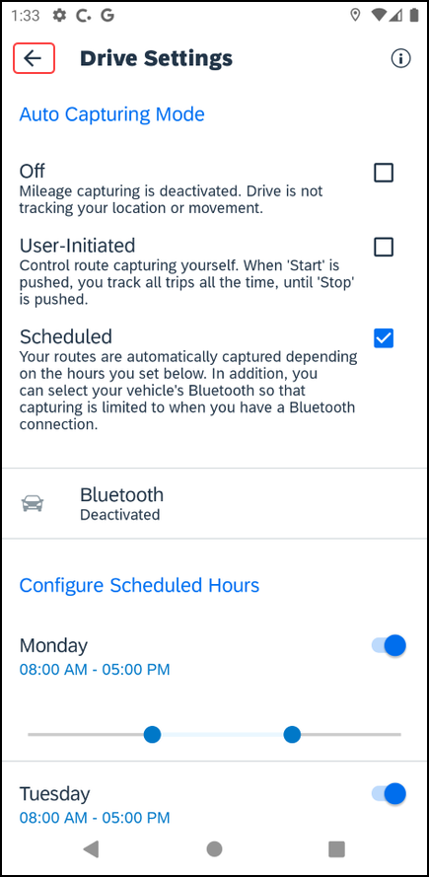 | The scheduled settings appear on the Drive Settings screen.  4) Make the desired selections and then tap (upper-left corner) to return to the home screen.  NOTE: Drive will track distance automatically during the times the user has selected.

Track Mileage Manually
Use Mileage on the home screen to initiate GPS tracking manually with a click of a button and then stop when you want your trip to end.
Screen(s) | Description/Action
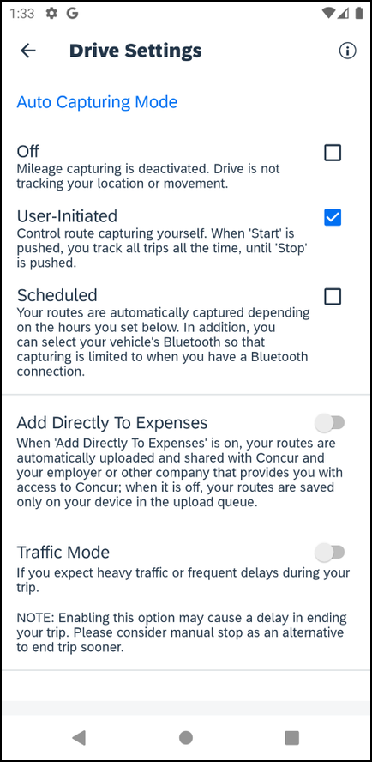 | To use Drive to track distance manually:  1) Tap Drive.  2) On the Drive Settings, make sure that User Initiated is selected.
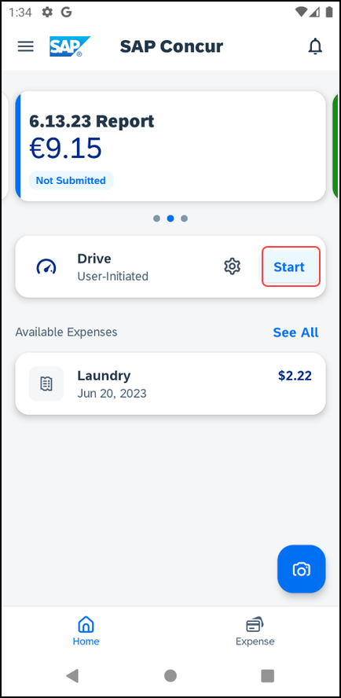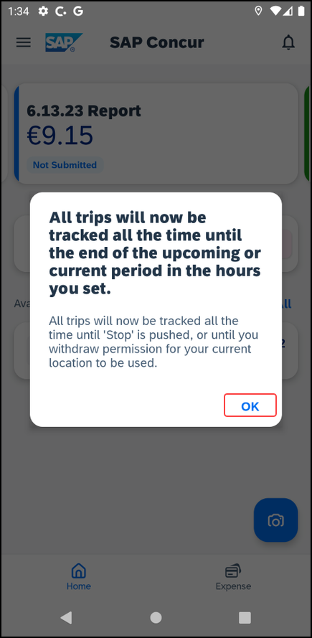 | 3) When done, on the home screen, tap Start.  4) A warning message will appear. Tap OK.
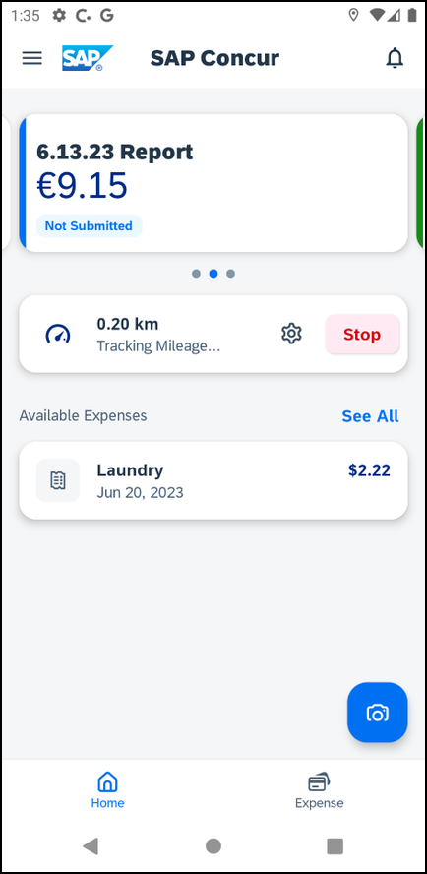 | 5) To stop tracking, tap Stop on the home screen.

Enable Traffic Mode
Use the Traffic Mode option to increase the time allowance to terminate a trip - when detecting no movement - from 7 minutes (default) to 15 minutes.
The Traffic Mode option is disabled by default and your selection is saved as part of the local profile settings.

Screen(s) | Description/Action
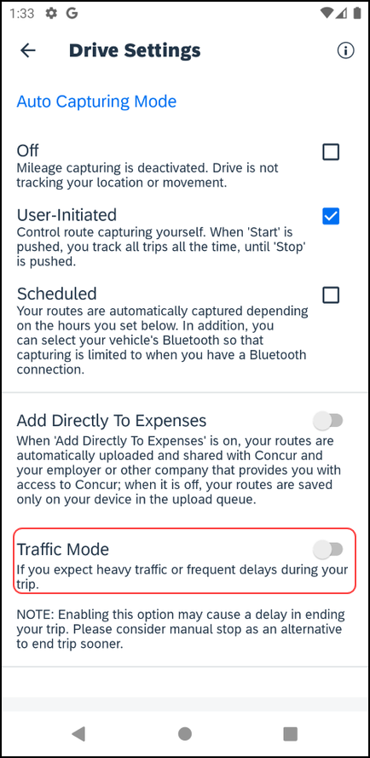 | To enable Traffic Mode:  1) On the home screen, tap Drive and then Enable.  2) On the Drive Settings screen select User Initiated and Traffic Mode.  NOTE: Enabling this option may cause a delay in ending the user's trip. The user can use the manual stop option as an alternative to end their trip sooner.

Access Drive Help
Use the information icon to gain easy access to tips on how to use Drive.
Screen(s) | Description/Action
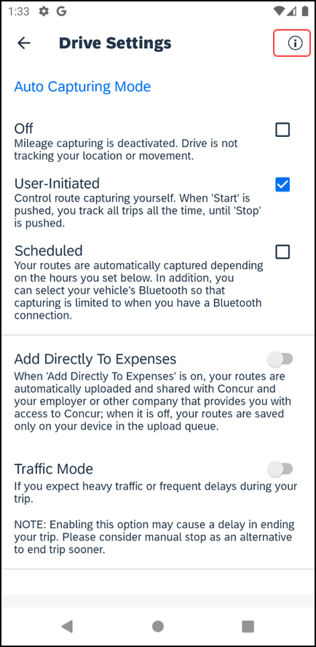 | To access Drive help:  1) On the home screen, tap Drive and then Enable.  2) On the Drive Settings screen, tap the icon (upper-right corner).  The About Drive screen appears with the Product Tips, What's New, More FAQs, and How Drive Works sections.  NOTE: If your mobile device is offline, the About Drive screen will appear blank and you will not be able to access the Drive help.

iPad

Track Mileage Automatically
Use Mileage on the home screen to set up the day and time (for example, Monday through Friday, 8 AM to 5 PM) for which the app will automatically track your trips by detecting car movement.
Screen(s) | Description/Action
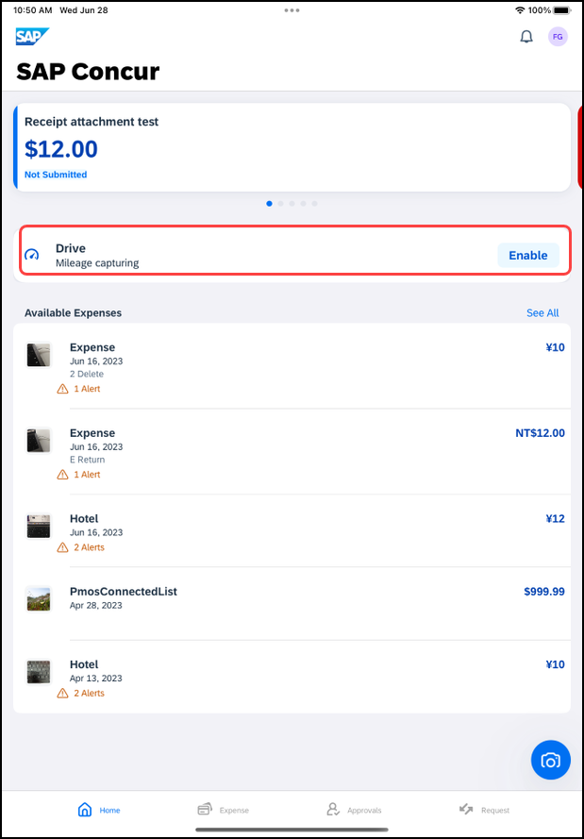 | To set Drive to track distance automatically:  1) Drive is always available on the main screen.  2) Tap Enable.  3) A screen requesting to use location will appear. Tap Continue.
3) On the Drive Settings screen, tap Scheduled.
The scheduled settings appear on the Drive Settings screen.
4) Make the desired selections and then tap Close to return to the home screen.
NOTE: Drive will track distance automatically during the times the user has selected.

Track Mileage Manually
Use Mileage on the home screen to initiate GPS tracking manually with a click of a button and then stop when you want your trip to end.
Screen(s) | Description/Action
To use Drive to track distance manually:
1) Once Drive is enabled, Mileage capturing will be visible on the home screen. Tap Enable to choose the correct setting.
2) On the menu that appears, tap Start. (This option appears if User-Initiated is selected in Settings.)
2) On the menu that appears, tap Start. (This option appears if User-Initiated is selected in Settings.)
3) When done, tap Mileage (lower-right corner) again.
4) On the menu, tap Stop.

Enable Traffic Mode
Use the Traffic Mode option to increase the time allowance to terminate a trip - when detecting no movement - from 7 minutes (default) to 15 minutes.
The Traffic Mode option is disabled by default and your selection is saved as part of the local profile settings.

Screen(s) | Description/Action
To enable Traffic Mode:
1) On the home screen, tap Drive.
2) Within the widget, tap Enable.
3) On the Drive Settings screen, select User-Initiated and then swipe the Traffic Mode toggle to the right.
NOTE: Enabling this option may cause a delay in ending the user's trip. The user can use the manual stop option as an alternative to end their trip sooner.

Access Drive Help
Use the icon to gain easy access to tips on how to use Drive.
Screen(s) | Description/Action
To access Drive help:
1) On the home screen, tap Drive.
2) Within the widget, tap Enable.
3) On the Drive Settings screen, tap the information icon (upper-right corner).
The About Drive screen appears with the Product Tips, What's New, More FAQs, and How Drive Works sections.
NOTE: If your mobile device is offline, the About Drive screen will appear blank and you will not be able to access the Drive help.

☼

