 | Mobile App User Guide  SAP Concur Fapiao Capture  A mini app within the WeChat™ app  Last Revised: October 24, 2022 |  | NOTE: The mini app user interface will appear and respond similarly across the iOS and Android platforms. | Applies to these mobile devices:  Yes: iPhone  Yes: iPad  Yes: Android
 | IMPORTANT: Be aware that your company's configuration may not allow for all the features described here. Generally, if a feature is not available in your configuration of the web version of SAP Concur, then it is not available in the mobile app.
The SAP Concur Fapiao Capture mini app - within the WeChat™* app - provides the ability to capture and upload a fapiao** to an expense according to Chinese regulatory or government authorities.  The mini app provides the following benefits for mobile users:  - A fapiao solution in compliance with the State Taxation Administration of the People's Republic of China and as provided by the merchant  - A quicker and more efficient reimbursement and VAT reporting process  - The ability to capture VAT fapiao and non-VAT fapiao documents  - A faster way to capture and merge multiple documents into one e-receipt transaction  * WeChat™ - developed by Tencent – is a Chinese social media, mobile payment, and messaging app.  ** A fapiao is a legal receipt required for business transactions, employee reimbursement, and VAT deduction. A fapiao is issued by the State Taxation Administration of the People's Republic of China but is provided by the merchant.  Note: If a company administrator needs to use this feature and does not have the proper permissions, they should contact the company's SAP Concur administrator.  Note: This feature is currently available for the Greater China market only. |  | Sign In 2  Sign into SAP Concur Fapiao Capture Mini App 2  Sign in via email passcode 5  Capture 6  Capture a Fapiao With the Camera 7  Capture a Fapiao From Existing Photos 9  Capture Multiple Fapiaos From Existing Photos 10  Scan a QR Code to Capture a VAT Fapiao 12  Capture a VAT Fapiao From the WeChat™ Wallet 14  Capture a VAT Fapiao From chats in WeChat™ 16  Attachment 18  Add an Attachment to a Fapiao 18  Delete 19  Delete a Verfied Fapiao 19  Select Multiple Fapiaos 20  Delete Multiple Fapiaos 21  Exceptions 22  Unkown Fapiao Type Exception 22  Fapiao With Incorrect Data 24  Submission of Fapiao on its issued date 25  Notice from Tax Bureau 26  Submit 27  Send a Single Fapiao to Concur Expense 28  Send Multiple Fapiaos to Concur Expense 29  View Fapiaos Sent to Concur Expense 30  View Submitted Fapiaos in Concur Expense 31  View Certified Fapiao Icon 32  More Options 32  Settings 32  Access Allowed Purchasers 32  Allow OCR or QR for E-Fapaio 35  Access the FAQ 38  Access the Feature Updates 39  Sign Out of the SAP Concur Fapiao Capture Mini App 40  Exit the SAP Concur Fapiao Capture Mini App 41
Please Note:
- The SAP Concur app for iOS and Android supports universal links, i.e. links that navigate directly to the app if it is installed or to the website if not.
- Such links are included in notification emails from SAP Concur related to the expense report changes.
- Universal link support for customers own use is currently not supported.
- Some security solutions may block the links embedded into email from opening the app directly. The proper exceptions for the security policy should be configured for SAP Concur universal link URLs (pattern to match: https://*.concursolutions.com/*). Known cases are:
- MDM/MAM policy that prescribes to open any link tapped in Outlook mobile app only in specified browser.
- Outlook mail server phishing protection that wraps all link embedded into e-mails to open the safety check service first.

Sign In

Sign into SAP Concur Fapiao Capture Mini App
You can sign into the SAP Concur Fapiao Capture mini app, by opening the WeChat™ app on your iPhone and then searching for the SAP Concur 发票助手 within the WeChat™ app.

Screen(s) | Description/Action
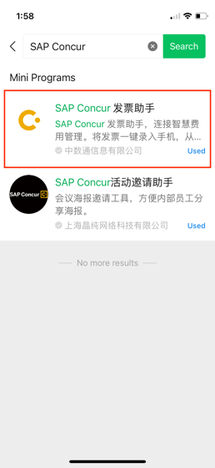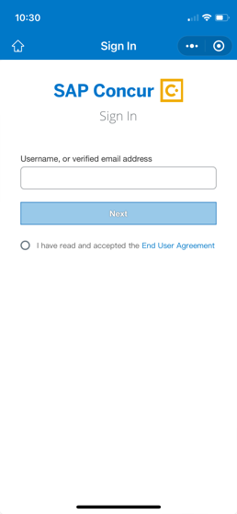 | To sign into the SAP Concur Fapiao Capture mini app:  1) On your iPhone screen, tap the WeChat™ logo.  2) On the WeChat™ home screen, enter SAP Concur 发票助手 in the search field.  NOTE: If you have previously used the mini app, you can also find it by swiping down from top of the WeChat™ home screen to view the mini app list.  3) On the search results screen, tap SAP Concur 发票助手.
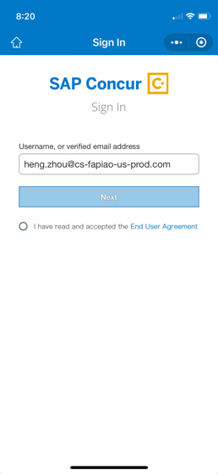 | 1) On the Sign in with SAP Concur screen, enter your username in the Username field and tap Continue.  2) Tap the radio button to accept the End User Agreement  NOTE: You use the same username to sign into all SAP Concur apps.
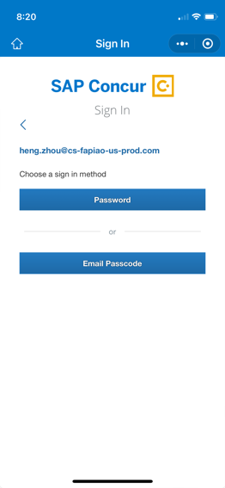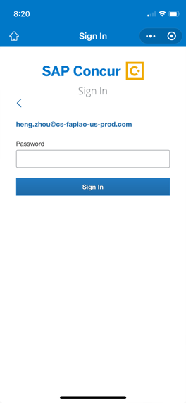  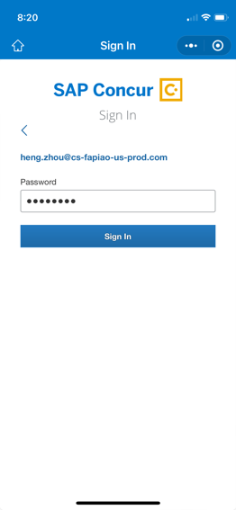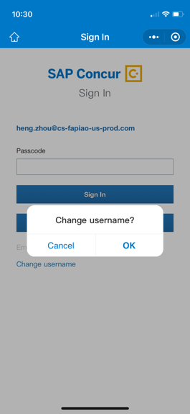 | You can sign in by entering your password or having a passcode emailed to you.  To sign in with your password:  1 Tap ’Password’ to enter the password page.  2. Enter your password and tap ‘Sign In’ to enter the system.  If you want to sign in with a different username, tap the back button.  NOTE: If this is your first time signing into the SAP Concur Fapiao Capture mini app, an onboarding tutorial will appear on the SAP Concur 发票助手 screen.

Sign in via email passcode
Screen(s) | Description/Action
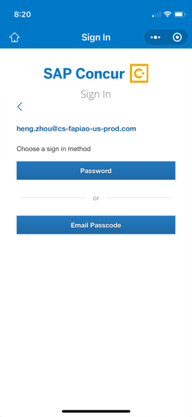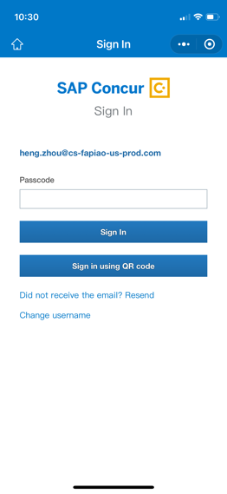 | If you don’t know your password, you can sign in via email passcode as follows:  - Tap ‘Email Passcode’ to trigger an email to your inbox. The email will be sent to the first email address you entered in your Concur profile.  - Retrieve the passcode contained in the email.  - Enter the passcode in the SAP Concur Fapiao Capture mini app.  - Tap ‘Sign In’.  Note: The passcode is valid for 24 hours.
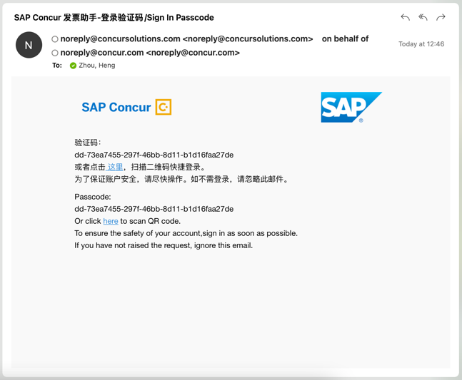 | You can also tap ‘here’ to get the QR code, which will be displayed on a webpage.
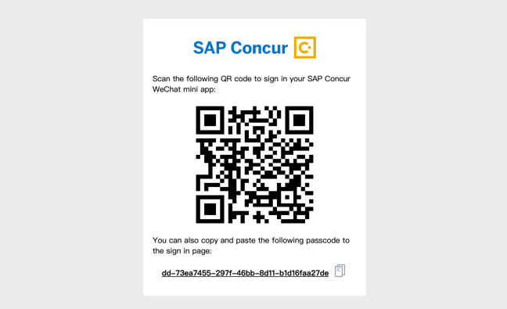 | Then, on your mobile phone, tap ‘Sign in using QR code’ to scan it from the webpage.
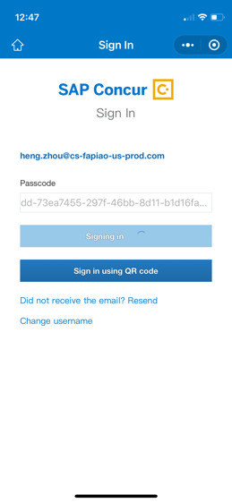 | NOTE: If this is your first time signing into the SAP Concur Fapiao Capture mini app, an onboarding tutorial will appear on the SAP Concur 发票助手 screen.

Capture
You can capture the following supported fapiaos in the SAP Concur Fapiao Capture mini app:
- General VAT fapiao in paper form
- General VAT- Roll fapiao in paper form
- Special VAT fapiao in paper form
- Special VAT fapiao in PDF form
- General VAT fapiao in electronic form as stored in the WeChat™ Wallet
- General VAT fapiao in PDF form
- General VAT fapiao in OFD form
- Official China Rail tickets
- Official airline tickets issued by China Aviation
- Official taxi fapiao
- Official fix amount fapiao
- Receipt in electronic form as stored in the WeChat™ Wallet
- Toll fee fapiao

Capture a Fapiao With the Camera
You can capture a fapiao in the SAP Concur Fapiao Capture mini app, by using the camera on your iPhone.
Screen(s) | Description/Action
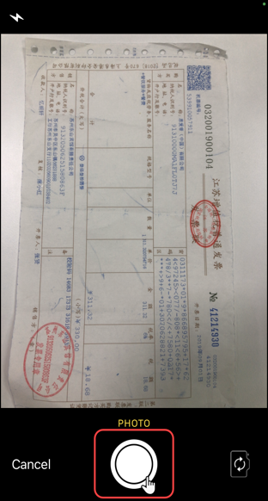 | To capture a fapiao in the SAP Concur Fapiao Capture mini app:  1) On the SAP Concur 发票助手 screen, tap (lower-left corner).  2) On the camera screen, tap .
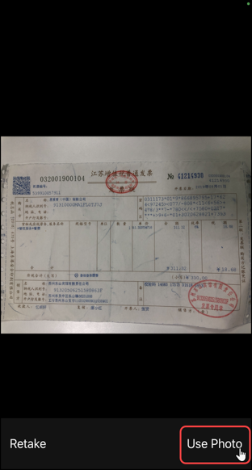 | 3 On the next camera screen, tap Use Photo (lower-right corner).  4) From the SAP Concur 发票助手 screen, on the To Be Sent tab, Fapiao Capture verifies and extracts the fapiao information from the captured photo.
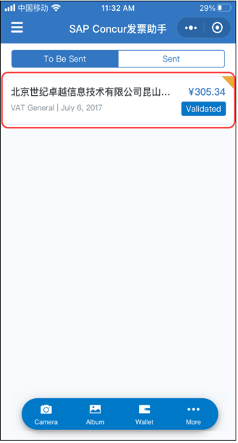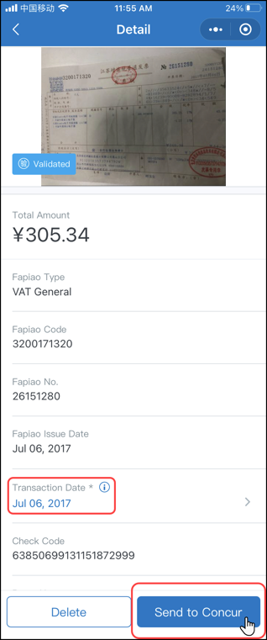 | Once the system has finished verifying the fapiao, the verified fapiao appears on the To be Sent tab on the SAP Concur发票助手screen.  For VAT fapiaos, the【验】stamp implies that a validation has been performed against the State Taxation Administration of the People's Republic of China.  5) On the To Be Sent tab, tap on the desired verified fapiao.  6) On the Detail screen:  - Fill in the fields (if any) and make the desired selections.  - Tap Send to Concur (bottom of the screen).  NOTE: For VAT fapiao, you can edit only the Transaction Date field. While for non-VAT fapiao (taxi, air, train etc.), you can edit all of the fields.  7) When done, tap Send to Concur to submit the verified fapiao to Concur Expense.

Capture a Fapiao From Existing Photos
You can capture a fapiao from existing photos on the Recents screen in the SAP Concur Fapiao Capture mini app.
Screen(s) | Description/Action
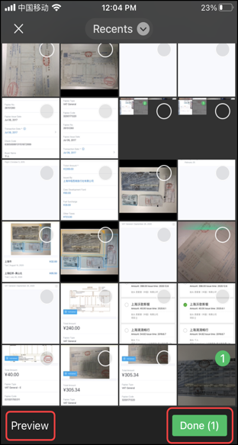 | To capture a fapiao from existing photos on the Receipts screen:  1) On the SAP Concur 发票助手 screen, tap .  2) On the Recents screen, you can do the following:  - Tap the desired existing photo  - Tap Preview to preview the selected fapiao photo  - Tap Done to capture the existing fapiao photo  - Tap Cancel to exit the Recents screen  NOTE: The Done button displays the amount of selected fapiao photos in parenthesis.
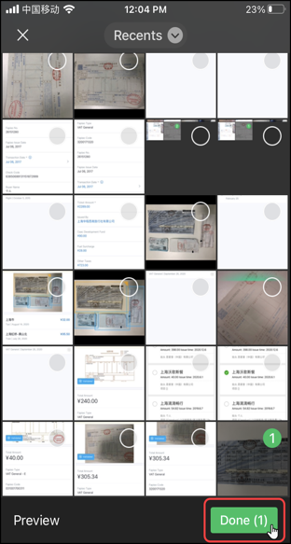 | 3) Once the desired fapiao photo is selected on the Recents screen, tap Done.  4) From the SAP Concur 发票助手 screen, on the To Be Sent tab, Fapiao Capture verifies and extracts the fapiao information from the captured photo.
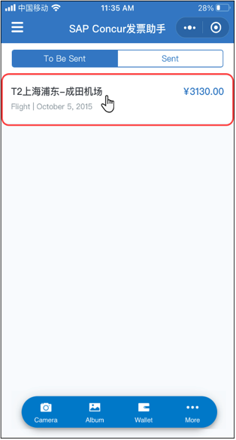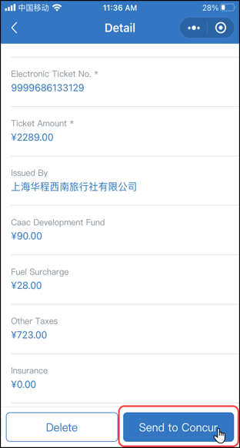 | Once the system has verified the fapiao, the information appears on the To Be Sent tab on the SAP Concur 发票助手 screen.  5) On To Be Sent tab, tap on the desired verified fapiao.  6) On the Detail screen:  - Fill in the fields (if any) and make the desired selections  - Tap Send to Concur (bottom of the screen)  7) When done, tap Send to Concur to submit the verified fapiao to Concur Expense.

Capture Multiple Fapiaos From Existing Photos
You can capture a multiple fapiaos from existing photos on the Recents screen in the SAP Concur Fapiao Capture mini app.
Screen(s) | Description/Action
To capture multiple fapiaos from existing photos on the Receipts screen:
1) On the SAP Concur 发票助手 screen, tap .
2) On the Recents screen, select the desired photos and then tap Done.
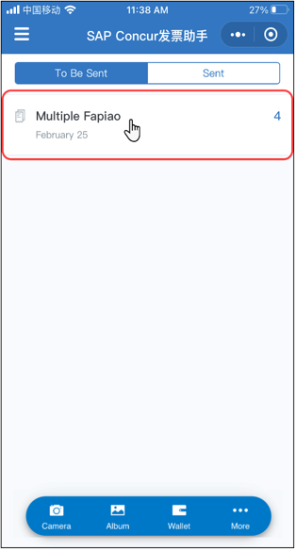 | 3) From the SAP Concur 发票助手 screen, on the To Be Sent tab, Fapiao Capture verifies and extracts the fapiao information from the captured photo.  Once the system has verified the multiple fapiao, the information then appears on the To Be Sent tab on the SAP Concur 发票助手 screen.  4) On the To Be Sent tab, tap on the desired verified fapiao.
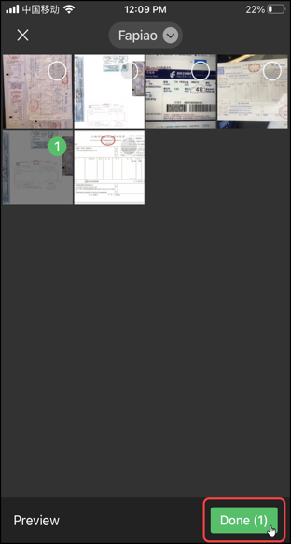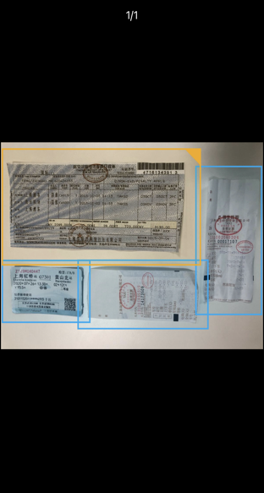 | 5) On the Multiple Fapiao screen, you can:  - Tap the photo (top of the screen) to view the full screen of multiple verified fapiao photos  - Tap the desired verified fapiao to view/edit the fapiao details on the Detail screen  - Swipe the desired verified fapiao to the left to delete it
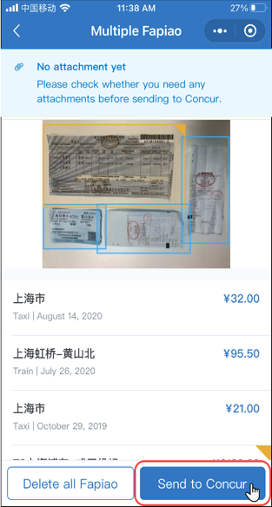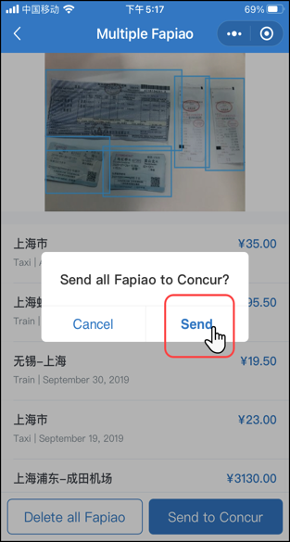 | 6) When done, tap Send to Concur to submit the multiple verified fapiao information to Concur Expense.

Scan a QR Code to Capture a VAT Fapiao
You can scan a QR code to capture a VAT fapiao in the SAP Concur Fapiao Capture mini app.
Screen(s) | Description/Action
To scan a QR code to capture a VAT fapiao:
1) On the SAP Concur 发票助手 screen, tap .
2) Select Import from scanning QR code.
3) On the camera screen,
you can do the following:
- Scan the VAT fapiao QR code
- Tap to go to the Recents screen
- Tap to go back to the SAP Concur 发票助手 screen
NOTE: The QR code scan option is not available for non-VAT fapiaos.
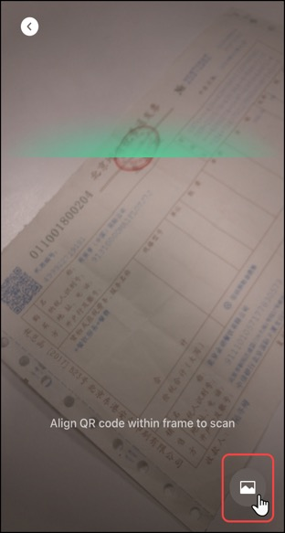 | 3) Once the VAT fapiao QR Code has been scanned, tap to go to the Recents screen.  4) From the SAP Concur 发票助手 screen, on the To Be Sent tab, Fapiao Capture verifies and extracts the fapiao information from the captured photo.
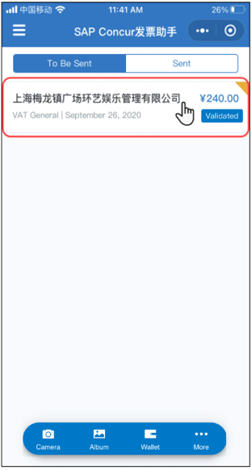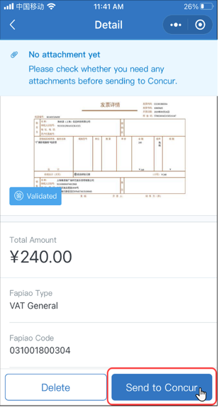 | Once the system has finished verifying the fapiao, the verified fapiao appears on the To be Sent tab on the SAP Concur发票助手 screen.  For VAT fapiaos, the【验】stamp implies that a validation has been performed against the State Taxation Administration of the People's Republic of China.  5) On the To Be Sent tab, tap on the desired verified fapiao.  On the Detail screen:  - Fill in the fields (if any) and make the desired selections  - Tap Send to Concur (bottom of the screen)  6) When done, tap Send to Concur to submit the verified fapiao to Concur Expense.

Capture a VAT Fapiao From the WeChat™ Wallet
You can capture a VAT fapiao in the SAP Concur Fapiao Capture mini app via the WeChat™ Wallet.
Screen(s) | Description/Action
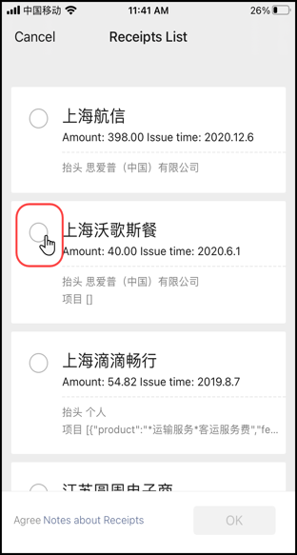 | To capture a VAT fapiao via the WeChat™ Wallet:  1) On the SAP Concur 发票助手 screen, tap .  2) On the SAP Concur 发票助手 Apply window, tap Allow to obtain your electronic fapiao from the WeChat™ Wallet.  NOTE: The SAP Concur 发票助手 Apply window only appears the first time you capture a VAT fapiao via the WeChat™ Wallet.  3) On the Receipts List screen, select the desired receipt.
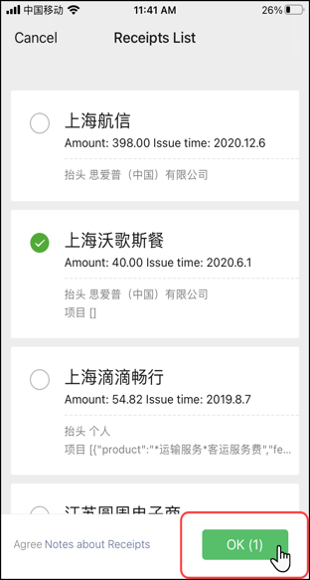 | 4) On the Receipts List screen, tap OK (lower-right corner).  NOTE: The OK button displays the amount of selected receipts in parenthesis.  5) From the SAP Concur 发票助手 screen, on the To Be Sent tab, Fapiao Capture verifies and extracts the fapiao information from the original file.  Once the system has finished verifying the fapiao, the verified fapiao appears on the To be Sent tab on the SAP Concur发票助手 screen.  For VAT fapiaos, the【验】stamp implies that a validation has been performed against the State Taxation Administration of the People's Republic of China.
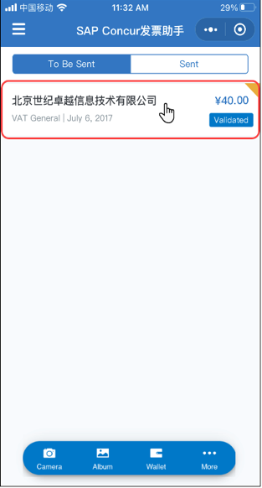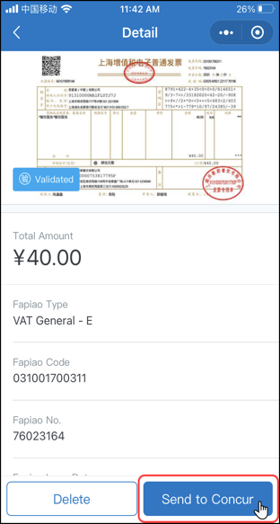 | 6) On the To Be Sent tab, tap on the desired verified fapiao.  7) On the Detail screen:  - Fill in the fields (if any) and make the desired selections  - Tap Send to Concur (bottom of the screen)  8) When done, tap Send to Concur to submit the verified fapiao to Concur Expense.

Capture a VAT Fapiao From chats in WeChat™
You can capture a VAT fapiao in the SAP Concur Fapiao Capture mini app via the chats in WeChat™. This procedure is applicable for PDF and OFD formats available in the chats of WeChat™.
Screen(s) | Description/Action
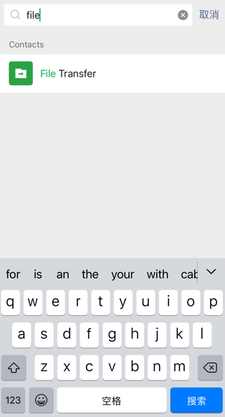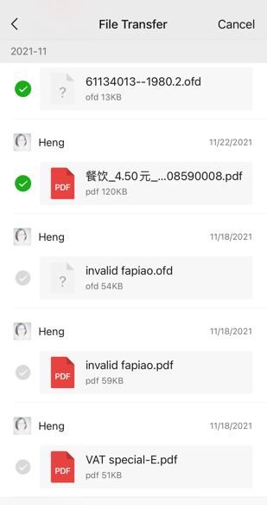 | To capture a VAT fapiao via the WeChat™ chat conversation:  1) On the SAP Concur 发票助手 screen, tap .  2) Select Import from chat(PDF/OFD).  3) Select the required chat conversation.  4) Select the desired PDF/OFD file.  NOTE: You can select multiple files in the same chat conversation.
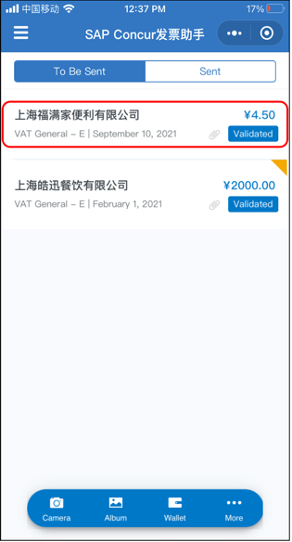 | 5) From the SAP Concur 发票助手 screen, on the To Be Sent tab, Fapiao Capture verifies and extracts the fapiao information from the imported PDF/OFD file.  Once the system has finished verifying the fapiao, the verified fapiao appears on the To be Sent tab on the SAP Concur发票助手 screen.  For VAT fapiaos, the【验】stamp implies that a validation has been performed against the State Taxation Administration of the People's Republic of China.  6)On the To Be Sent tab, tap on the desired verified fapiao.
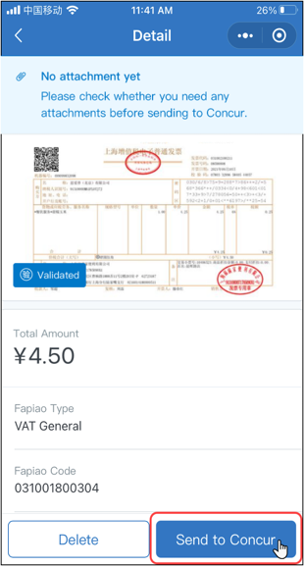 | 6) On the Detail screen:  - Fill in the fields (if any) and make the desired selections  - Tap Send to Concur (bottom of the screen)  7) When done, tap Send to Concur to submit the verified fapiao to Concur Expense.
Note: You can find the uploaded PDF/ODF files in Concur Expense. For more information refer to Concur documentation.

Attachment

Add an Attachment to a Fapiao
You can add four attachments at most to a fapiao in the SAP Concur Fapiao Capture mini app.
Screen(s) | Description/Action
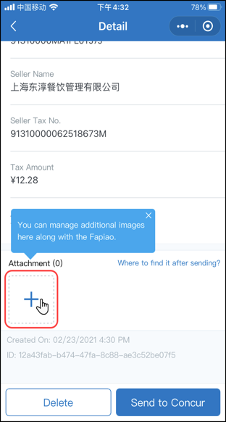 | To add an attachment to a fapiao:  1) From the SAP Concur 发票助手 screen, on the To Be Sent tab, tap on the desired verified fapiao.  2) On the Detail screen, tap (lower-right corner).  3) On the window, you can either tap:  - Camera  -or-  - Gallery  -or-  - Cancel  NOTE: For this example, we will tap Gallery to attach a receipt to a fapiao transaction.
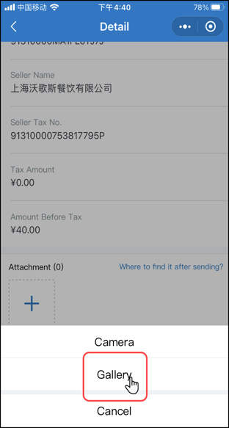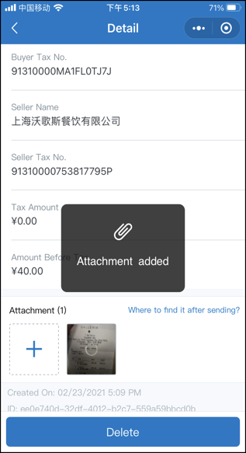 | 4) On the window, tap Gallery.  5) On the Recents screen, select the desired attachment.  Fapiao Capture processes the attachment.  Once Fapiao Capture processes the receipt attachment, a message appears – on the Attachment screen - confirming the attachment was added.

Delete

Delete a Verfied Fapiao
You can delete a verified fapiao – only before sending it to Concur Expense - in the SAP Concur Fapiao Capture mini app.
Screen(s) | Description/Action
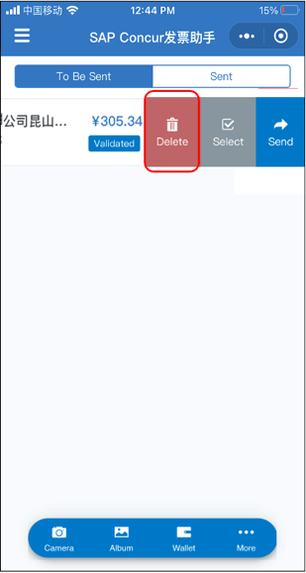 | To delete a verified fapiao:  1) From the SAP Concur 发票助手, on the To Be Sent tab, swipe the desired verified fapiao to the left.  2) Tap Delete.
 | The verified fapiao no longer appears on the To Be Sent tab on the SAP Concur 发票助手 screen.

Select Multiple Fapiaos
You can select multiple fapiaos that are validated and non-validated in the SAP Concur Fapiao Capture mini app.
Screen(s) | Description/Action
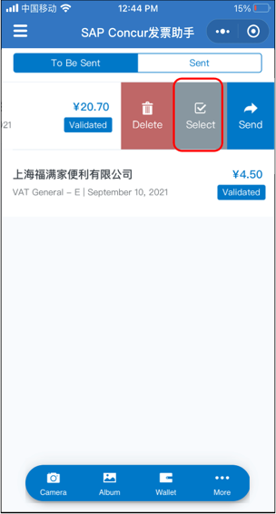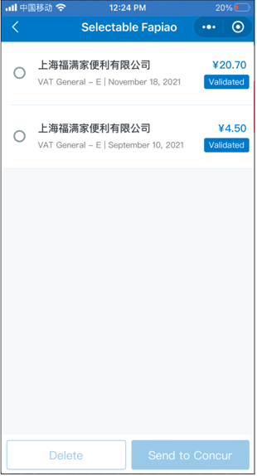 | To select multiple fapiaos:  1) From the SAP Concur 发票助手, on the To Be Sent tab, swipe any fapiao to the left.  2) Tap Select.  Multiple selections on the left for all the displayed fapiaos appears.
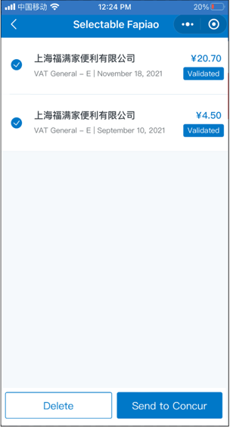 | 3) On the Selectable Fapiao screen, select any of the desired fapiaos to delete or send.  4)Tap Delete to delete the fapiaos at once or tap Send to Concur to send the fapiaos to concur at once.

Delete Multiple Fapiaos
You can delete multiple fapiaos – only before sending them to Concur Expense - in the SAP Concur Fapiao Capture mini app.
Screen(s) | Description/Action
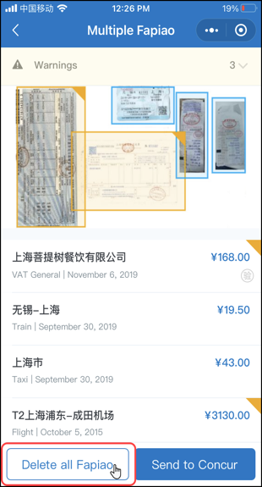 | To delete multiple fapiaos:  1) From the SAP Concur 发票助手 screen, on the To Be Sent tab, tap on the desired multiple fapiao.  2) On the Multiple Fapiao screen, tap Delete all Fapiao (lower-left corner).
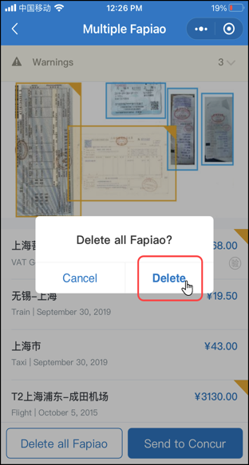 | 3) On the Delete all Fapiao? window, tap Delete.  The multiple fapiao no longer appear on the To Be Sent tab on the SAP Concur 发票助手 screen.

Exceptions

Unkown Fapiao Type Exception
Screen(s) | Description/Action
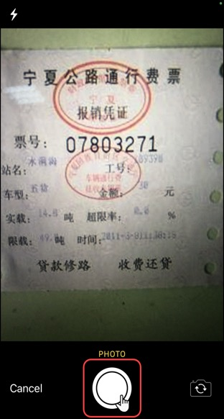 | To view an unknown fapiao type exception:  1) On the SAP Concur 发票助手 screen, tap (lower-left corner).  2) On the camera screen, tap .
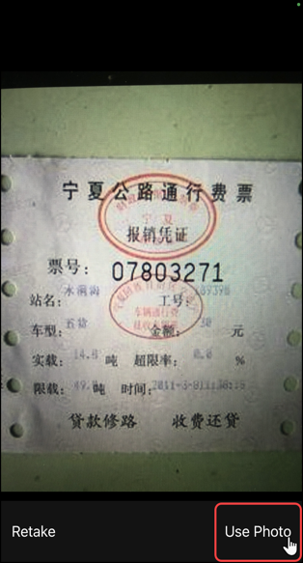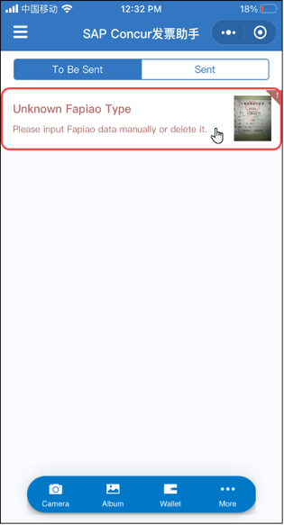 | 3) On the next camera screen, tap Use Photo (lower-right corner).  4) On the SAP Concur 发票助手 screen, Fapiao Capture attempts to verify the captured photo.  Once the system has failed to verify the fapiao, an *unknown fapiao type exception appears on the To Be Sent tab on the SAP Concur 发票助手 screen, indicating an unknown fapiao type.  5) From the SAP Concur 发票助手 screen, on the To Be Sent tab, tap on the desired fapiao type.  NOTE: In this example, the unknown fapiao is a fixed amount fapiao.
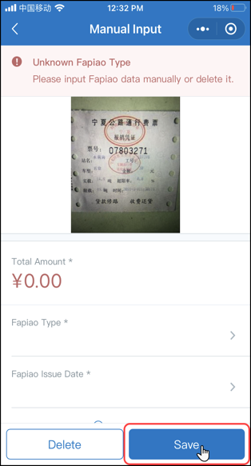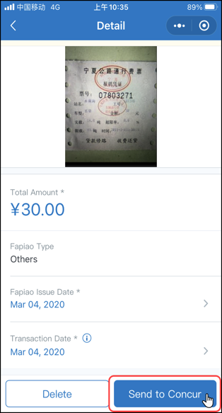 | 6) On the Manual Input screen, fill in the fields (if any), make the desired selections, and then tap Save (lower-right corner).  *Unknown fapiaos include:  - Electronic VAT fapiao in OFD format, including both general and special VAT  - Fixed amount fapiao  - Vehicle sales fapiao  - Freight Special fapiao  - Traffic fee fapiao  - Secondhand vehicle fapiao  NOTE: If a fapiao is unknown, you can manually input the information, or swipe left - on the unknown fapiao - to delete it and then submit it via the mobile app or the web version of the app.  NOTE: Once the unknown fapiao has been saved, you can send it to Concur Expense.  7) On the Detail screen, tap Send to Concur.
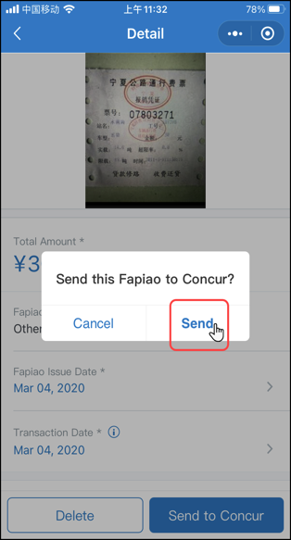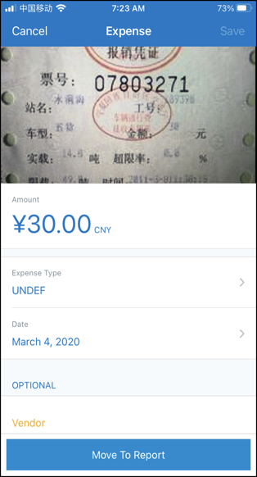 | 8) On the menu, tap Send.  Once the fapiao has been sent to Concur Expense, you can view it in the SAP Concur mobile app.  For further information on viewing submitted fapiaos in the mobile app, refer to the View Submitted Fapiaos in Concur Expense section of this guide.

Fapiao With Incorrect Data
Screen(s) | Description/Action
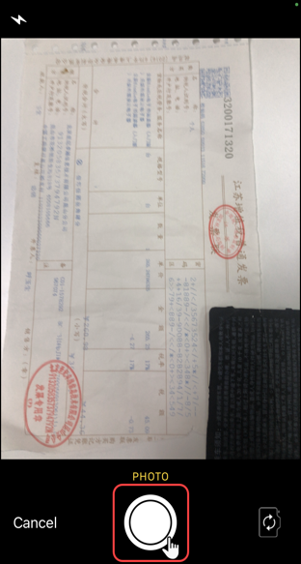 | To view a fapiao with an incorrect data exception:  1) On the SAP Concur 发票助手 screen, tap (lower-left corner).  2) On the camera screen, tap .  3) On the next camera screen, tap Use Photo (lower-right corner).  4) On the SAP Concur 发票助手 screen, Fapiao Capture fails to verify the captured photo.  Once the system has failed to verify the fapiao, the unverified fapiao appears on the To Be Sent tab on the SAP Concur 发票助手 screen.
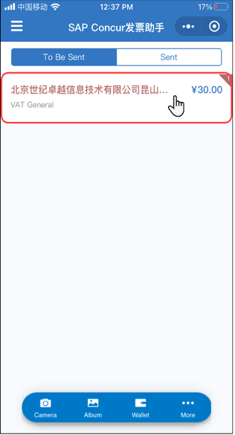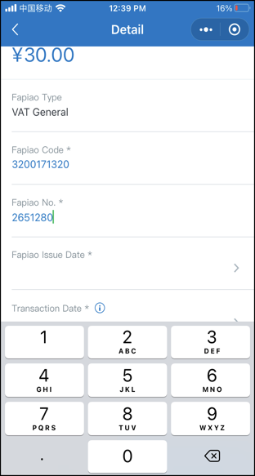 | 5) On the To Be Sent tab, tap the desired fapiao.  The Detail screen appears with an alert detailing a fapiao with an incorrect data exception at the top of the screen.  NOTE: In this example, the fapiao details need to be manually updated to correct the data.  6) On the Detail screen, fill in the correct details.
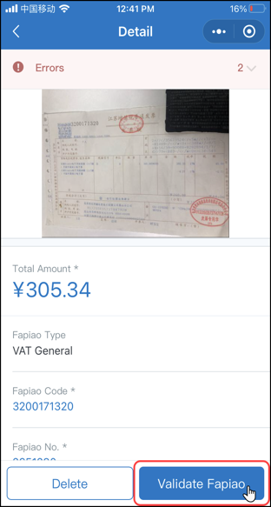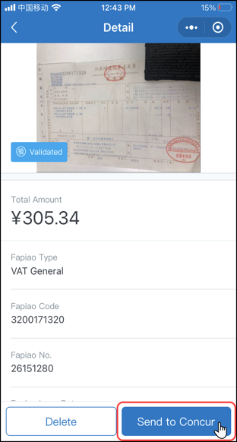 | 7) On the Detail screen, tap Validate Fapiao (bottom of the screen).  8) From the SAP Concur 发票助手 screen, on the To Be Sent tab, Fapiao Capture verifies and extracts the fapiao information from the captured photo.  Once the system has finished verifying the fapiao, the verified fapiao appears on the To be Sent tab on the SAP Concur发票助手 screen.  For VAT fapiaos, the【验】stamp implies that a validation has been performed against the State Taxation Administration of the People's Republic of China  9) On the Detail screen, tap Send to Concur to submit the verified fapiao to Concur Expense.

Submission of Fapiao on its issued date
The fapiao uploaded on the same day of its issued date cannot be validated immediately. The data usually appears in the tax bureau’s database on the next day.
(s) Screen | Description/Action
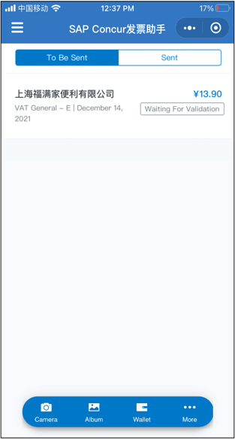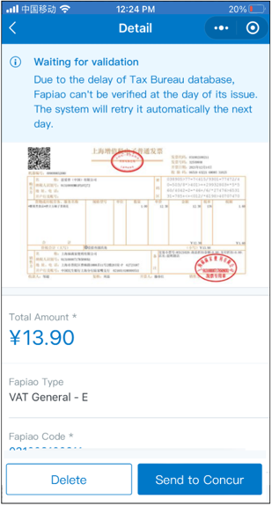 | To process the fapiao on its issued date:  1) On the To Be Sent tab, tap th4e desired expense.  NOTE: The Waiting For Validation message implies that the fapiao on its issued date cannot be validated for the time being.  2) The Detail screen appears with an alert detailing a fapiao cannot be validated at its issued date.  NOTE: The system will perform the validation automatically the next day. The validation result will be updated the next day.
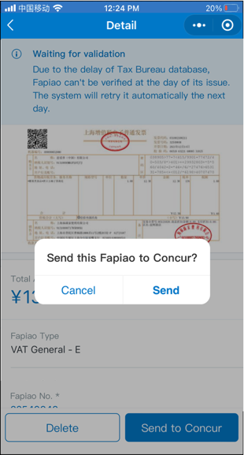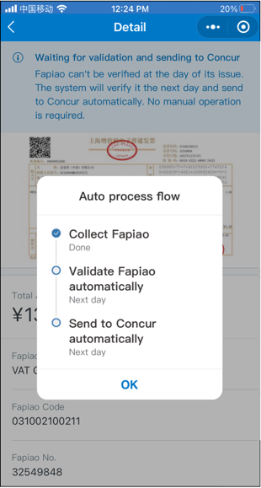 | 3) On the Detail screen, tap Send to perform auto-validation the next day. The system will send the fapiao to Concur if it can be successfully validated. The warning message will be updated accordingly.  4) On the Send this Fapiao to Concur? window, tap Send.  5) On the Auto process flow window, you can review the following fapiao capture process steps:  - Collect Fapiao  - Validate Fapiao automatically (Next day)  - Send to Concur automatically (Next day)  6) Tap OK after reviewing the fapiao capture process steps.  NOTE: Please ensure the attachments are in place before tapping Send. You cannot modify or delete the fapiao after you send the fapiaos.

Notice from Tax Bureau
The system displays a warning message if there is an upgrade from Tax Bureau. This upgrade may or may not impact the city you live in but the warning message is visible to all users.

The warning message appears as a banner on the top of the main screen. It shows the scheduled date for the tax upgrade.
You can tap here to see a detailed information on the tax upgrade.
Note: It is recommended to go through the detailed information of the warning message as the tax upgrade details can be different for different cities.
NOTE: The validation process is halted during the tax upgrade period. You can upload your fapiaos, but they cannot be validated.

Submit
Before sending a VAT fapiao to Concur Expense, SAP Concur executes the following action:
- A validation is performed against the State Taxation Administration of the People's Republic of China
- A duplication check is performed
NOTE: SAP cannot guarantee the compliance of fapiao receipts - if you are not using the SAP Concur mini app in the WeChat™ mobile app - to capture and upload receipts to Concur Expense.

Send a Single Fapiao to Concur Expense
You can send a single fapiao to Concur Expense from the SAP Concur Fapiao Capture mini app.
Screen(s) | Description/Action
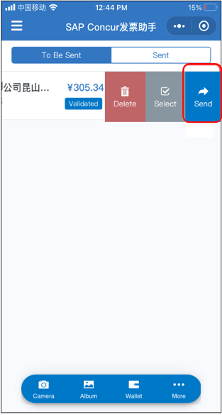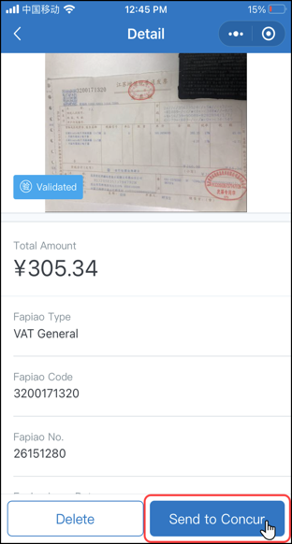 | To send a single fapiao to Concur Expense:  1) From the SAP Concur 发票助手 screen, on the To Be Sent tab, swipe the desired verified fapiao to the left.  2) Tap Send.  3) On the Detail screen, tap Send to Concur.
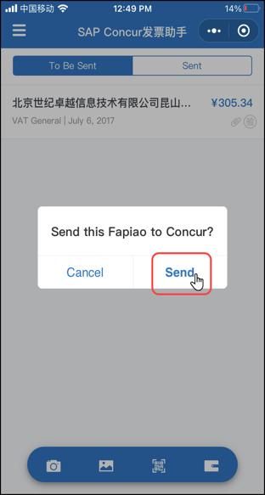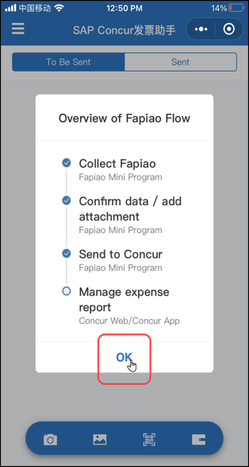 | 4) On the Send this Fapiao to Concur? window, tap Send.  5) On the Overview of Fapiao Flow window, you can review the following fapiao capture process steps:  - Collect Fapiao  - Concur data / add attachment  - Send to Concur  - Manage expense report  6) Once done with reviewing the fapiao capture process steps, tap OK.  NOTE: After submission, the original uploaded file (PDF/OFD) can be downloaded in Concur web.

Send Multiple Fapiaos to Concur Expense
You can send multiple fapiaos to Concur Expense from the SAP Concur Fapiao Capture mini app.
Screen(s) | Description/Action
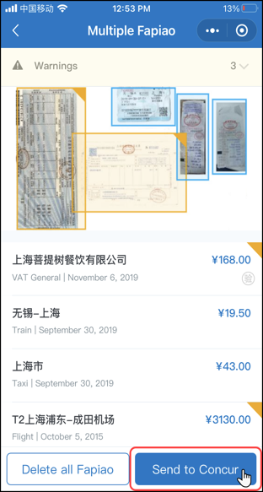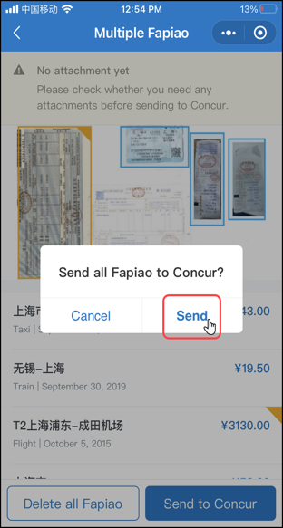 | To send multiple fapiaos to Concur Expense:  1) From the SAP Concur 发票助手 screen, on the To Be Sent tab, tap the desired multiple fapiao.  3) On the Multiple Fapiao screen, tap Send to Concur.  4) On the Send multiple Fapiao to Concur? window, tap Send.
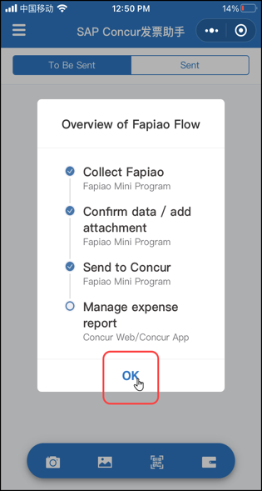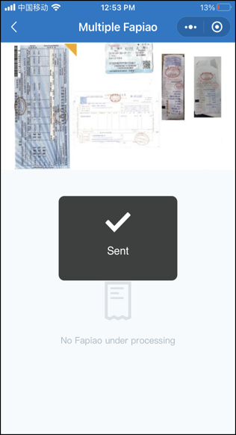 | 5) On the Overview of Fapiao Flow window, you can review the following fapiao capture process steps:  - Collect Fapiao  - Concur data / add attachment  - Send to Concur  - Manage expense report  6) Once done with reviewing the fapiao capture process steps, tap OK.  A message appears on the Multiple Fapiao screen indicating the multiple fapiao has been sent to Concur Expense.

View Fapiaos Sent to Concur Expense
You can view verified fapiaos previously sent to Concur Expense in the SAP Concur Fapiao Capture mini app.
Screen(s) | Description/Action
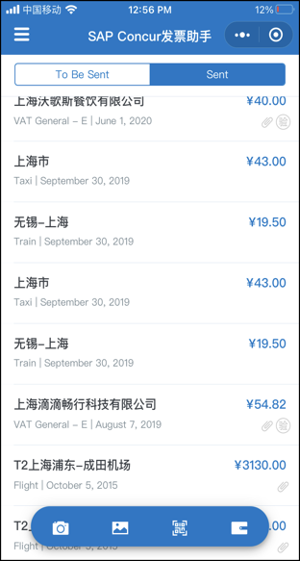 | To view the verified fapiaos previously sent to Concur Expense:  - On the SAP Concur 发票助手 screen, tap the Sent tab.  The Sent tab appears with a list of fapiaos previously sent to Concur Expense.

View Submitted Fapiaos in Concur Expense
You can view submitted fapiaos - in Concur Expense - within the SAP Concur mobile app.
NOTE: You will need to sign into the SAP Concur mobile app to view the submitted fapiaos in Concur Expense within the mobile app.
Screen(s) | Description/Action
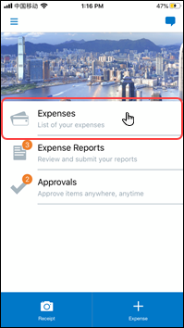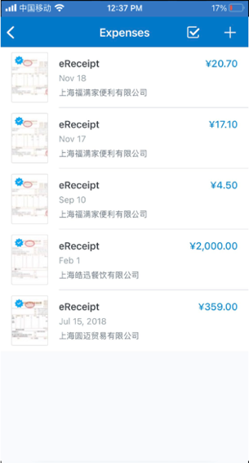 | To view submitted fapiaos in Concur Expense:  1) On the SAP Concur 发票助手 screen, tap Expenses.  2) On the Expenses screen, tap the desired fapiao.
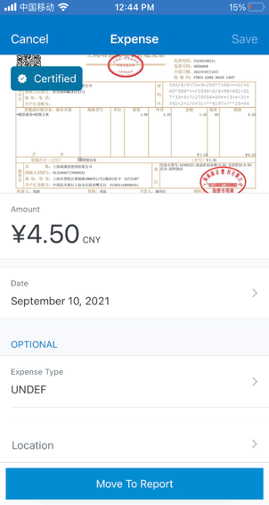 | The Expense screen appears with the fapiao information displayed at the top of the screen.

View Certified Fapiao Icon
Screen(s) | Description/Action
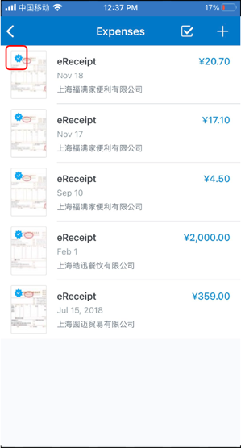 | If a fapiao is certified, you will see a certified icon in expense reports, expenses, and receipts indicating that the fapiao is validated from the original records in the SAP Concur Fapiao mini app within the WeChat™* app.

More Options

Settings

Access Allowed Purchasers

Configure the Allowed Purchasers Option
You can manage the Allowed Purchasers configuration option of the SAP Concur Fapiao Capture mini app.
NOTE: Only users with the Expense Processor or Processor Manager roles can manage the configuration of the mini app.
Screen(s) | Description/Action
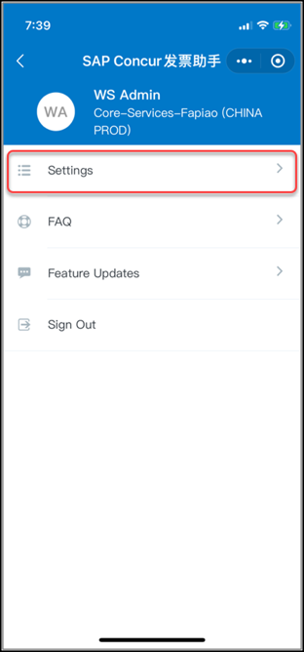  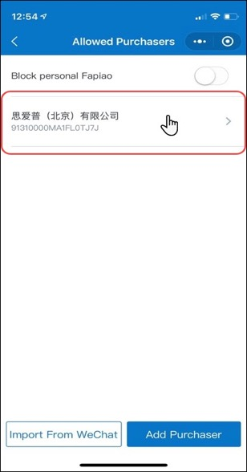 | To manage the Allowed Purchasers option:  1) On the SAP Concur 发票助手 settings screen, tap Allowed Purchasers.  2) On the Allowed Purchasers screen, you can do the following:  - Block personal Fapiao: Once this setting is enabled, the mini program no longer sends personal Fapiao to Concur Expense.  NOTE: By default, the SAP Concur Fapiao Capture mini app allows fapiao with any purchaser names.  - Import From WeChat:  You can import existing purchaser names from WeChat directly. After it is added to the list, you can still edit the purchaser information.  - Add Purchaser: You can add a new purchaser.  - Tap on the desired purchaser.  NOTE: The Company Name and Tax ID * fields need to be filled out before saving the new purchaser's details.
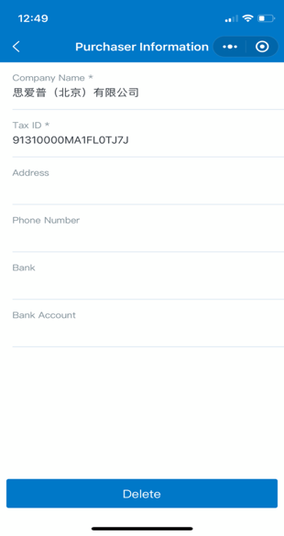 | The Purchaser Information screen appears with the purchaser's details.  NOTE: You can tap Delete (bottom of the screen) to remove the purchaser's information for the mini app.

Work With the Allowed Purchasers Option
Once the allowed purchasers are setup in the configuration, the system will check corresponding information for every fapiao which will apply to all employee side. An error message appears if the purchaser’s name is not in the allowed list.
NOTE: Users are unable to process the fapiao in the mini program.
Screen(s) | Description/Action
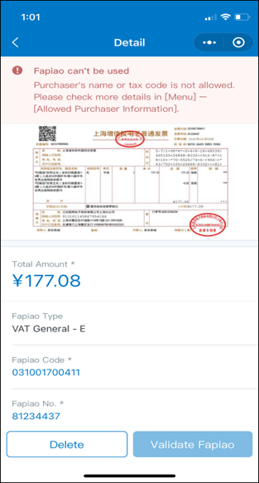 | To work with the Allowed Purchasers option:  1) Tap Delete to delete the file.  NOTE: If the mini app shows an error message indicating that the purchaser’s name is not allowed and that the fapiao cannot be used, you can only delete the fapiao.  The Validate Fapiao button is disabled.

Allow OCR or QR for E-Fapaio

Configure E-Fapiao Upload Method
The Allow OCR or QR for E-Fapiao option lets you enable or disable the upload of e-fapiao as an image or by scanning the QR code. This is dependent on the company’s regulation. If your company requires you to upload the original e-fapiao file, then this option will be disabled.
NOTE: Only users with Expense Processor or Processor Manager roles can manage this configuration.

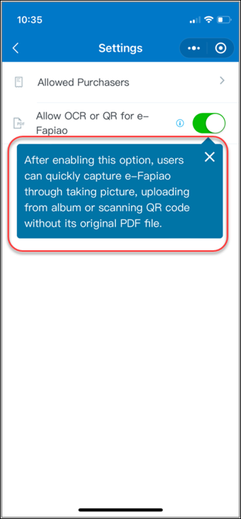 | To manage the Allow OCR or QR for e-Fapiao setting.  - On the SAP Concur 发票助手 Settings screen, enable or disable the Allow OCR or QR for e-Fapiao option.  NOTE: Enabling this option will allow you to upload e-fapiaos through an image or by scanning the QR code without the original file. If this option is disabled, you need to upload the original PDF or OFD format files.  NOTE: By default, this option will always be enabled. Users who have Expense Processor or Processor Manager roles can disable or enable this functionality.  A message is displayed when you enable the option.

Work with E-Fapiao Upload Method
Disabling the Allow OCR or QR for e-fapiao option will trigger the system to check the upload source for all the e-fapiaos that the user uploads. An error message appears if the fapiao is not original and the file is not validated.

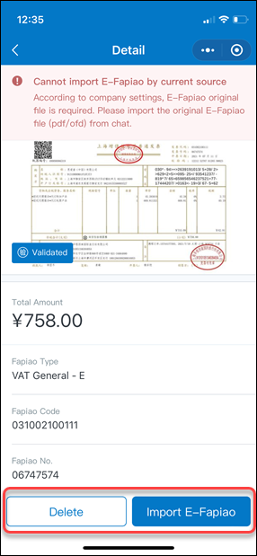 | To manage images or scanned copies of e-Fapiao:  The system will show an error message indicating that an original file is required if you haven’t uploaded the original e-fapiao.  There are two options to manage an e-fapiao uploaded as an image or as a QR scanned copy.  1) Tap Delete to delete the uploaded file.  2) Tap Import E-Fapiao to upload the original e-fapiao.

Access the FAQ
You can access the FAQ to view help topics
Screen(s) | Description/Action
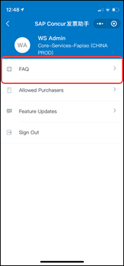 | To access the FAQ:  1) On the SAP Concur 发票助手 screen, tap (upper-left corner).  2) On the SAP Concur 发票助手 screen, tap FAQ.
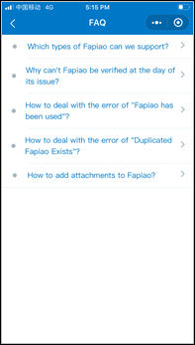 | The FAQ screen appears.

Access the Feature Updates
You can access the Feature Updates in the SAP Concur Fapiao Capture mini app.
Screen(s) | Description/Action
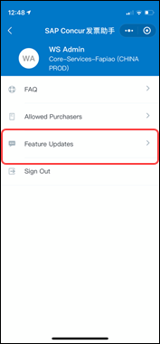 | To access the Feature Updates:  1) On the SAP Concur 发票助手 screen, tap (upper-left corner).  2) On the SAP Concur 发票助手 screen, tap Feature Updates.
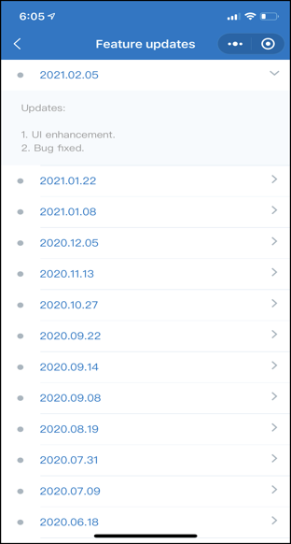 | The Features updates screen appears.

Sign Out of the SAP Concur Fapiao Capture Mini App
You can sign out of the SAP Concur Fapiao Capture mini app within the WeChat™ app.
Screen(s) | Description/Action
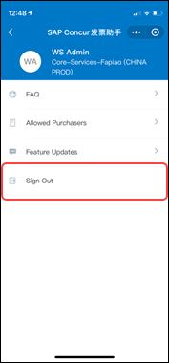 | To sign out of the SAP Concur Fapiao Capture mini app:  1) On the SAP Concur 发票助手 screen, tap (upper-left corner).  2) On the SAP Concur 发票助手 screen, tap Sign Out.
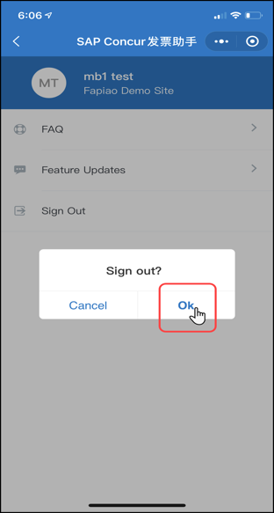 | 3) On the Sign out? window, tap Ok.  You have now signed out of the SAP Concur Fapiao Capture mini app.

Exit the SAP Concur Fapiao Capture Mini App
You can exit the SAP Concur Fapiao Capture mini app within the WeChat™ app.
Screen(s) | Description/Action
To exit the SAP, Concur Fapiao Capture mini app:
- On the SAP Concur 发票助手 screen, tap (upper-right corner).
You have now exited the mini app.

☼

