Mobile App User Guide | Current version and Last revision date
Introduction: iPhone | Version 10.10 – April 23, 2024

Collection of Guides
IMPORTANT: These documents describe the features that are available using the mobile app. However, be aware that your company's configuration may not allow for all of the features described in these documents. Generally, if a feature is not available in your configuration of the web version of SAP Concur, then it is not available in the mobile app.
The Mobile App User Guide is a collection of several documents.
- This guide includes information about:
- Overview
- Download / Sign In
- Settings / Get Help / Leave Feedback
- There are additional guides for these features/services:
- Travel
- Expense
- Invoice
- Request
- Budget
- Drive (and an additional FAQ)
- ExpenseIt (and an additional FAQ)
- Fapiao Capture
- Fapiao Capture (Chinese Version)
- Receipts
Please Note:
- The SAP Concur app for iOS and Android supports universal links, i.e. links that navigate directly to the app if it is installed or to the website if not.
- Such links are included in notification emails from SAP Concur related to the expense report changes.
- Universal link support for customers own use is currently not supported.
- Some security solutions may block the links embedded into email from opening the app directly. The proper exceptions for the security policy should be configured for SAP Concur universal link URLs (pattern to match: https://*.concursolutions.com/*). Known cases are:
- MDM/MAM policy that prescribes to open any link tapped in Outlook mobile app only in specified browser.
- Outlook mail server phishing protection that wraps all link embedded into e-mails to open the safety check service first.

Overview
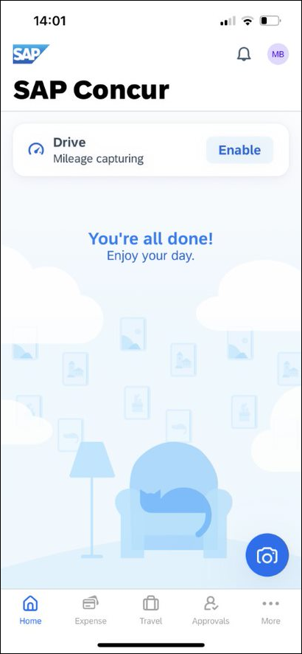You can use SAP Concur on your mobile device to assist with your Expense, Travel, Invoice, and Request needs. Because you are using your mobile device, you can access your information in a cab, in a meeting, at the restaurant – where your laptop is not available or is too cumbersome.
You can check your itinerary; book a flight, rental car, Amtrak, or hotel; get directions from your current location. You can enter out-of-pocket expenses real-time and take a picture of the associated receipt; create, submit, and check the status of your expense reports…and much more.
If you are an approver, you can approve expense reports, requests, payment requests (Invoice), etc.
THIS GUIDE - This series of guides provides brief "how to" steps. It assumes that the user already knows how to use the web version of SAP Concur and already understands the concepts of Expense (expenses, itemizations, attendees, etc.), Travel (booking, rules, etc.), Invoice (payment requests, purchase requests, etc.), the approval process, and so on. It also assumes that the user is generally familiar with their mobile device.
These guides are available in DOC and PDF format. You can use the DOC as a starting point for your own training materials.
Both are available in online Help (end user and admin) in the web version of SAP Concur.

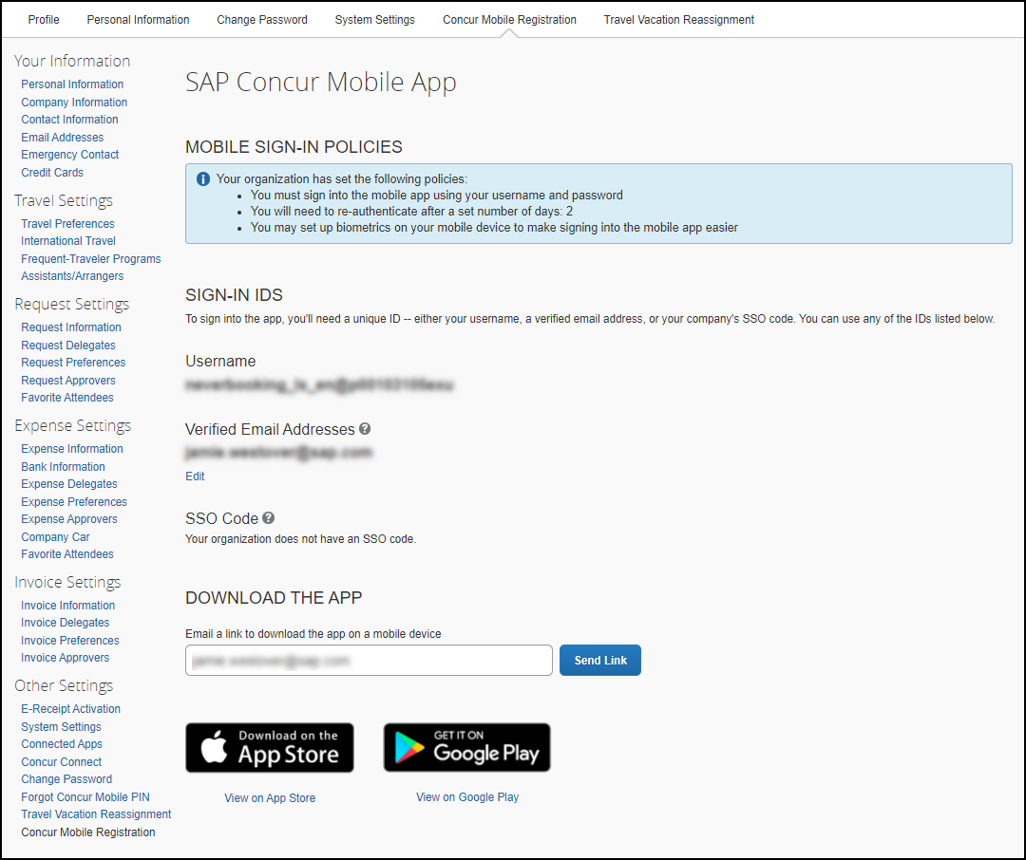Download
The Concur Mobile Registration link appears on the Profile menu in the web version of SAP Concur. Two reasons to use this page:
- You can download the app or you can use this page to request a link.
- When you log in to the app, depending on your company's configuration, you can use the same login credentials that you use for the web version of SAP Concur or you can use Single Sign On (known as SSO). (If your company uses SSO, this page will be slightly different.)

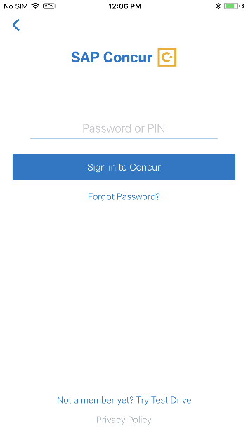Sign In
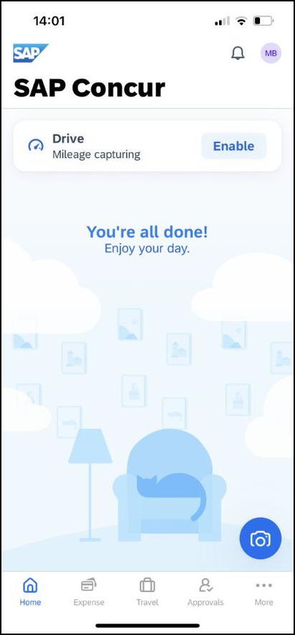Tap in your device apps list. Then, on the Sign in to Concur screen, enter your verified work email or your SAP Concur (web version) username. Tap Next. On the next screen, enter your password and tap Sign In to Concur.
NOTE: You will need to verify your email address – in the web version of SAP Concur click Profile > Profile Settings > Your Information > Email Addresses - if you are signing into the SAP Concur mobile app with your email address instead of username.
– or –
Tap if your company uses SSO to access the SAP Concur mobile app.
NOTE: SAP Concur will not let you sign in if your device does not have a passcode or if your device has been compromised (modified to remove manufacturer restrictions).
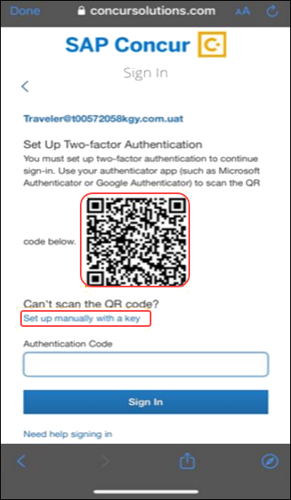You must set up two-factor authentication to continue signing in.
To add your SAP Concur account to the authenticator app, scan the QR code on the Sign In page. You can also use an authenticator app (such as Microsoft Authenticator or Google Authenticator) to scan the QR code. If you can’t scan the QR code, select the Set up manually with a key link.
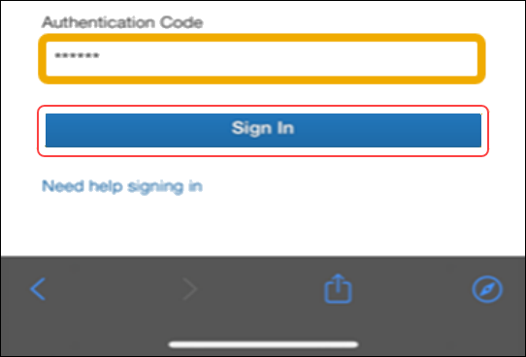Copy the six-digit code that was generated from the app into the Authentication Code field, and then press Sign In.
For more information, please review the Shared: SAP Concur Two Factor Authentication Setup Guide.

Permissions
The home screen provides access to your trips, expenses, expense reports, approvals, and more.
The options that are available on the home screen vary depending on your permissions. For example, if you can access Expense on the web version of SAP Concur, then you can access Expense in the mobile app. The same applies to other SAP Concur services.

Settings / Help / Feedback

Settings
Use settings for the following:
- Save your username
- Automatically sign in
- Turn on Touch ID
- Turn on Face ID
- Send an error log to SAP Concur
- Clear the cache
- Reset to the factory defaults
- Sign out

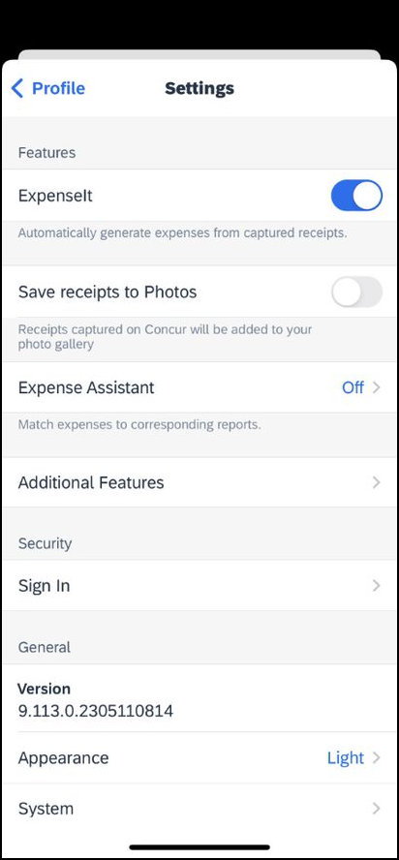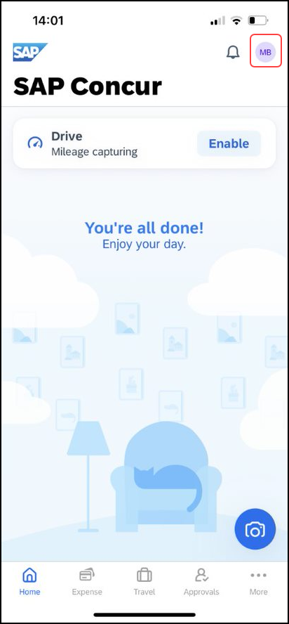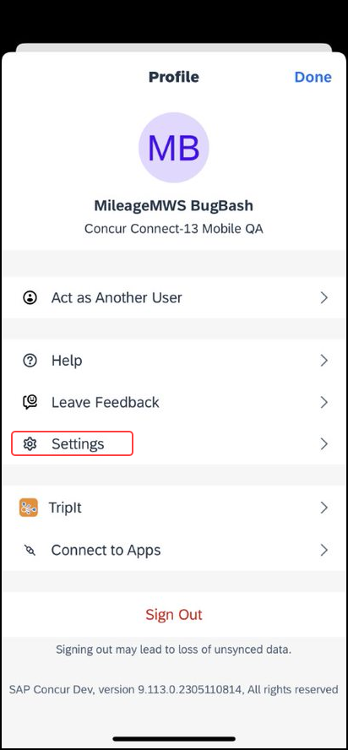
Get Help
Use Help on the menu screen to search for help topics or find helpful articles.
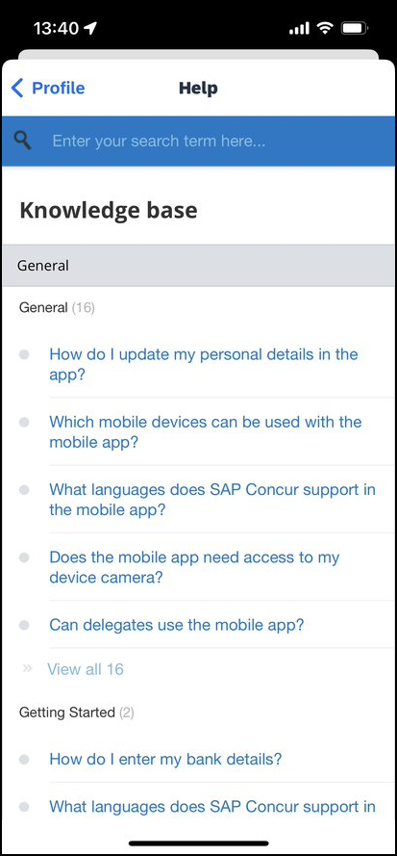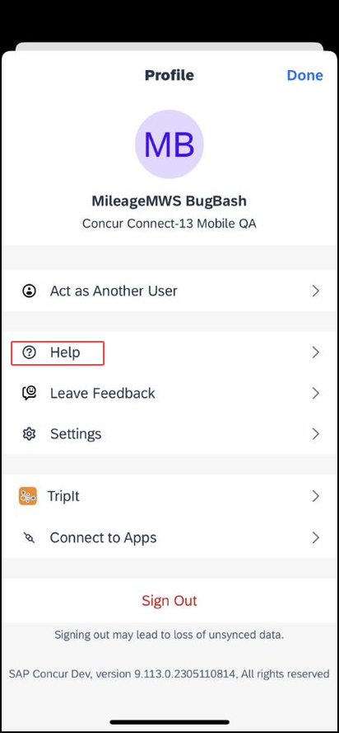

Leave Feedback
1) On the menu screen, tap Leave Feedback.
2) On the Feedback screen, enter the desired feedback.
3) Tap Submit.
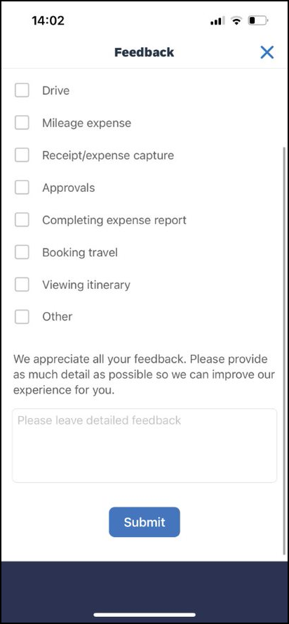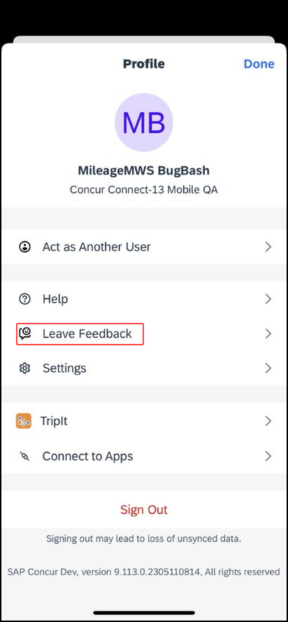Use Leave Feedback on the menu screen to send feedback.

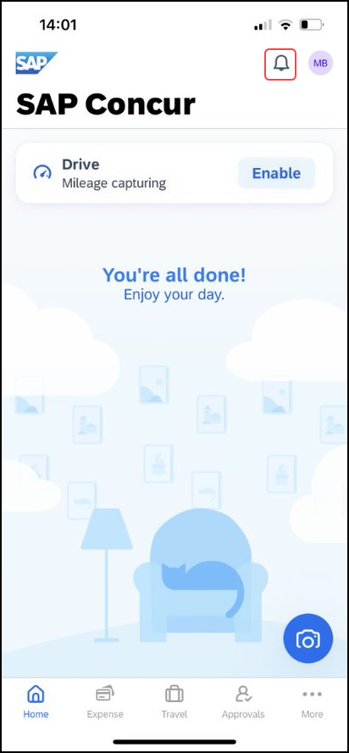Message Center
Use the Message Center (upper-right corner) to access direct messages from SAP Concur.

☼

