
Shared : SAP Integration with Concur Solutions for SAP S/4HANA Cloud
Setup Guide for Professional Edition
Last Revised: February 24, 2024
Applies to these SAP Concur solutions:
 Expense
 Professional/Premium edition
 Standard edition
 Travel
 Professional/Premium edition
 Standard edition
 Invoice
 Professional/Premium edition
 Standard edition
 Request
 Professional/Premium edition
 Standard edition
Table of Contents
1 Permissions 1
2 Overview 1
2.1 Features 2
2.2 Exclusions 3
2.3 Definitions 4
2.4 Source Data 4
2.4.1 Cost Object 4
2.4.1.1 (Concur Expense Only) Enhanced WBS Element Search 5
2.5 Financial Posting 6
2.5.1 Overview 6
2.5.2 Process 6
2.5.2.1 (Concur Expense Only) Delta Posting After Initial Post 7
2.6 Configuration Overview 8
2.7 Available SAP Documentation 8
2.7.1 SAP S/4HANA Cloud 8
2.8 Available SAP Concur Documentation 9
2.8.1 Concur Expense Professional Edition Setup and User Guides 9
2.8.2 Concur Invoice Professional Edition Setup and User Guides 9
3 What the Expense User Sees 9
3.1 Expense Report/Cash Advance Audit Trail 10
3.2 Reopen Expense Report 10
3.3 Process Reports Page 11
3.3.1 Financial Posting Failed Query 14
3.3.2 Financial Integration Enabled Column 14
3.4 Cash Advance Admin Page 15
4 What the Invoice User Sees 16
4.1 Invoice Audit Trail 17
4.2 Invoices Ready for Processing Page 17
5 Prerequisites 17
5.1 SAP Concur Prerequisites 17
5.2 SAP S/4HANA Cloud Configuration Prerequisites 18
5.2.1 Prior to SAP Setup 18
6 Configuration 18
6.1 Overview 18
6.2 Integration Settings and Group Configuration 19
6.2.1 Step 1: Configure the Integration Settings 19
6.2.2 Step 2: Configure Integration Gateway Authentication 19
6.2.3 Step 3: Update Group Configurations (Concur Expense Only) 19
6.2.3.1 (Optional) Enable Delta Posting 20
6.2.4 Step 4: Update Workflow Configurations (Concur Invoice Only) 23
6.2.5 Step 5: (Optional) Enable Enhanced WBS Element Search (Concur Expense Only) 24
6.2.5.1 Update SAP ICS Application 24
6.2.5.2 Create Application Connector 25
6.2.5.3 Add Launch External URL Field to the Form 25
6.3 Concur Expense and Concur Invoice Configuration 26
6.3.1 Source Data Replication Configuration 27
6.3.1.1 Step 1: Create the Cost Objects List 27
6.3.1.2 Step 2: Assign the Cost Object List to the Forms 28
6.3.1.3 Step 3: Complete the SAP Configuration 29
6.3.2 Financial Posting Configuration 29
6.3.2.1 Step 1: Update all Expense Types With Valid SAP Account Codes 29
6.3.2.2 Step 2: Update Tax Configuration in Concur Expense to Match SAP Tax Fields (Concur Expense Only) 29
6.3.2.3 Step 3: Configure all SAP Clearing Accounts (Concur Expense Only) 31
6.3.2.4 Step 4: Enable Tax Code Field Mapping (Concur Invoice Only) 33
6.3.2.5 Step 5: Verify the Processor Workflow Step (Concur Expense Only) 34
6.3.2.6 Step 6: Create the Processor Query 35
6.3.2.7 Step 7: Configure Liability Account Codes (Invoice Pay Only) 35
6.3.2.8 Step 8: (Optional) Using the IsReopened Report Attribute with Delta Posting (Concur Expense Only) 36
6.3.2.9 Step 9: (Optional) Enable the Non-Domestic Tax Feature (Concur Expense Only) 37
6.3.2.10 Step 10: (Optional) Rename the Payment Status to Posted 39
6.3.2.11 Step 11: (Optional) Configure Test Users 39
6.3.2.12 Step 12: (Optional) Configure the Payment Confirmation Workflow Step (Concur Expense Only) 40
7 Creating a Support Case 40
7.1.1 Reviewing the Audit Trail 40
7.1.2 Creating a Support Case 41
7.1.2.1 Deactivating the Integration 42
7.1.3 Creating an Enable Delta Posting Case 42

Revision History
Date | Notes/Comments/Changes
February 24, 2024 | Updated the following sections:  - 2.5.2 Process  - 3.4 Cash Advance Admin Page
January 19, 2024 | Updated the following section:  2.2 Exclusions
December 9, 2023 | Added the following section:  - 6.3.2.8 (Optional) Using the IsReopened Report Attribute with Delta Posting (Concur Expense Only)  Updated the following sections:  - 2. Overview  - 2.5.2.1 (Concur Expense Only) Delta Posting After Initial Post
October 14, 2023 | Updated the guide to add the Concur Invoice integration details.
March 13, 2023 | Updated the following sections:  - 2.4.2 Enhanced WBS Element Search  - 5.2.4 Step 4: (Optional) Enable Enhanced WBS Element Search
February 24, 2023 | Updated the following section:  - 5.2.4 Step 4: (Optional) Enable Enhanced WBS Element Search
February 18, 2023 | Added the following sections:  - 2.4.2 Enhanced WBS Element Search  - 5.2.3.2 Enable Enhanced WBS Element Search
April 26, 2022 | Updated the following sections:  - 5.1 Overview  - 5.2 Integration Settings and Group Configuration
April 6, 2022 | Updated the following section:  - 6.1.2.1 Deactivating the Integration
March 21, 2022 | Updated the following section:  - 5.2.1 Configure the Integration Settings
February 1, 2022 | Added new section:  - 2.2 Exclusions  Added information that a DPA must be signed as a pre-requisite.
January 12, 2022 | Updated the copyright year; no other changes; cover date not updated
December 11, 2021 | Updated the following sections:  - 2.4.2.1 Delta Posting After Initial Post  - 5.2.4.1 Enable Delta Posting
June 11, 2021 | Updated the field visibility in the following section:  - 5.2.4.1 Enable Delta Posting
April 22, 2021 | Updated following sections:  - 2.4.2.1 Delta Posting After Initial Post  - 5.3.2.9 Step 9: (Optional) Configure the Payment Confirmation Workflow Step
March 30, 2021 | Updated authentication model information, in the following sections:  - 5.2.3.1 Creating the Consumer Gateway Credentials  - 5.2.3.2 Creating the API Gateway Credentials
January 29, 2021 | Updated to include the Payment Confirmation functionality, in the following sections:  - 2.1 Features  - 2.4.2 Process  - 5.3.2.9 Step 9: (Optional) Configure the Payment Confirmation Workflow Step
January 27, 2021 | Added new section:  - 6.1.1 Reviewing the Audit Trail  Updated the following sections:  - 2.6.1 SAP S/4HANA Cloud (CE)  - 5.3.2.7 Step 7: (Optional) Rename the Payment Status from Sent for Payment to Posted  - 6.1.2 Creating a Support Case  - 6.1.3 Creating an Enable Delta Posting Case
January 21, 2021 | Added new section:  - 3.3.2 Financial Integration Enabled Column
December 16, 2020 | Moved delta posting case information to new section:  - 6.1.2 Enable Delta Posting Case
December 8, 2020 | Updated the Case Type in the following section:  - 5.2.4.1 Enable Delta Posting
October 5, 2020 | Updated the following section with note about Payroll Integration:  - 5.2.4.1 Enable Delta Posting
September 25, 2020 | Added new section:  - 3.2 Reopen Expense Report  Updated the following sections:  - 2.4.2.1 Delta Posting After Initial Post  - 5.2.4.1 Enable Delta Posting
September 19, 2020 | Renamed Master Data to Source Data, added the following sections:  - 2.4.2.1 Delta Posting After Initial Post  - 5.2.4.1 Enable Delta Posting
May 7, 2020 | Renamed the Authorization Request check box to Request on the guide’s title page; cover date not updated
March 4, 2020 | Minor update: Changed references to Expense Pay Classic to Expense Pay to match current branding.
February 5, 2020 | Added information that Cash Advance Record Return Amount functionality is not available with financial integration.
February 7, 2019 | Updated the following section:  - 5.2.3 Step 3: Configure Integration Gateway Authentication
January 4, 2019 | Updated the product names, and updated the following sections:  - 4.2.1 Prior to SAP Setup  - 5.2.3 Step 3: Configure Integration Gateway Authentication
May 29 2018 | Changed the check boxes on the front cover; no other changes; cover date not updated
January 23 2018 | New guide. This guide contains content for SAP S/4HANA Cloud. There is now a separate guide for the SAP ERP: On-Premise and S/4HANA: On-Premise financial systems, titled Expense: SAP ICS for SAP ERP: On-Premise and S/4HANA: On-Premise Setup Guide for SAP Concur Professional Edition.

SAP Integration with Concur Solutions for SAP S/4HANA Cloud
NOTE: Multiple SAP Concur product versions and UI themes are available, so this content might contain images or procedures that do not precisely match your implementation. For example, when SAP Fiori UI themes are implemented, home page navigation is consolidated under the SAP Concur Home menu.

Permissions
NOTE: Multiple SAP Concur product versions and UI themes are available, so this content might contain images or procedures that do not precisely match your implementation. For example, when SAP Fiori UI themes are implemented, home page navigation is consolidated under the SAP Concur Home menu.
A company administrator may or may not have the correct permissions to use this feature. The administrator may have limited permissions, for example, they can affect only certain groups and/or use only certain options (view but not create or edit).
If a company administrator needs to use this feature and does not have the proper permissions, they should contact the company's SAP Concur administrator.
Also, the administrator should be aware that some of the tasks described in this guide can be completed only by SAP Concur. In this case, the client must initiate a service request with SAP Concur Client Support.

Overview
The SAP ICS for SAP S/4HANA Cloud allows clients to connect their Concur Expense and/or Concur Invoice service to their SAP financial system. The integration supports source data replication and financial posting.
Concur Expense and Concur Invoice are generically referred to as the SAP Concur solutions in this guide. Any information that is specific to one solution is marked.
Clients that are using the source data replication load their cost object and vendor data from SAP S/4HANA Cloud to their SAP Concur solution during the implementation. This data is updated in the SAP Concur solution by the integration on a client-specified schedule.
The cost object data replication may be completed two different ways:
- Existing Concur Clients: The configurability of the SAP Concur solutions means that existing clients may be using a variety of fields to capture the cost object data. In the ICS, the relevant fields in the SAP Concur solution are mapped to the supported SAP cost object fields. The supported SAP fields are: Logical System, Company Code, Business Area, Country, Controlling Area, Cost Object Type, and Cost Object ID.
- New Concur Clients: New clients use the default field mapping in the SAP Concur solutions and SAP S/4HANA Cloud for the cost objects and may add custom fields that map to the supported SAP fields if necessary.
Clients that are using the financial posting queue expense reports, cash advances, and invoices that are ready to be posted in the SAP Concur solution, then the ICS requests them at the scheduled intervals, using APIs from the SAP Concur Platform. The integration manages the transmission of financial data from the SAP Concur solution to SAP S/4HANA Cloud, and the transmission of status information from SAP S/4HANA Cloud to the SAP Concur solution. The client will see financial posting status information in the audit trail of the expense report, cash advance, or invoice.
The ICS can synchronize the following types of information between the SAP Concur solutions and SAP S/4HANA Cloud:
- Expense Reports: Concur Expense → SAP S/4HANA Cloud
- Expense Report Posting Status: SAP S/4HANA Cloud → Concur Expense and/or Concur Invoice
- Cash Advances: Concur Expense → SAP S/4HANA Cloud
- Invoices: Concur Invoice → SAP S/4HANA Cloud
- Invoice Posting Status: SAP S/4HANA Cloud → Concur Invoice
- Cost Object Data: SAP S/4HANA Cloud → Concur Expense and/or Concur Invoice
- Vendor Source Data: SAP S/4HANA Cloud → Concur Invoice
The following functionality is also supported by the integration:
- Expense Pay
- Invoice Pay

Features
The integration resolves a common issue with the accounting extract- the inability to change reports, cash advances, or invoices once they have been extracted. The standard accounting extract process locks reports/advances/invoices when it extracts them, making it impossible to make corrections in the SAP Concur solution after the extract. The integration provides a more responsive system, adding the financial posting to the report/invoice workflow. The report/invoice is posted to the financial system but is not marked as extracted in the SAP Concur solution. Any problems with posting appear in the SAP Concur solution, where they can be identified and corrected. Once the data is corrected, the reports/invoices can be queued again, to post successfully in SAP S/4HANA Cloud. After receiving the confirmation from the ICS that the posting was successful, the SAP Concur solution updates the report/invoice payment status to Posted (if configured).
The customer can configure a payment confirmation step in the SAP system, which will move expense reports to the Payment Confirmed workflow step after the payments are complete in the SAP system. This functionality is only available for expense reports and requires configuration in Concur Expense.
- For more information, refer to the 6.3.2.12 Step 12: (Optional) Configure the Payment Confirmation Workflow Step section of this guide.
The integration works with Concur Expense Professional/Premium Edition and Concur Invoice Professional/Premium Edition. The integration allows clients to:
- Send cost object data from SAP S/4HANA Cloud to the SAP Concur solution, keeping the SAP Concur solution up to date with the latest information.
During implementation, clients decide which cost objects to include in the integration.
- Pay expense reports, cash advances, and invoices using their SAP financial system, without using a bridge program to move the data from the accounting extract to the financial system.
- Move data from the SAP Concur solutions to SAP S/4HANA Cloud, and receive feedback from SAP S/4HANA Cloud, at a client-specified frequency.
- View SAP S/4HANA Cloud posting status in the SAP Concur solution, including posting details such as the document number and, if a posting failed, a description of why that posting failed. This information appears in the audit trail of the expense report, cash advance, or invoice.
- View payment confirmation status for expense reports in Concur Expense, if enabled.
- Specify which Expense groups will be reimbursed using the financial integration in Group Configurations.
- Specify which Invoice groups will be reimbursed using the financial integration in Workflows.

Exclusions
The following functionality is not supported by the SAP ICS for SAP S/4HANA Cloud:
- Payment Types with Offsets: Company Paid, IBCP with Offsets, CBCP with Offsets
- Cash Advance Record Return Amount
- Invoices with VAT/GST tax **
- Invoice attachments
- PO Synchronization
- Goods Receipts Synchronization
- Invoice Payment Confirmation
- Vendor Group mapping
- Invoice Correction Processing (e.g. Credit Memo) ** ​
- Purchase Order Invoice Posting **​
** These business cases can be supported using a BAdI (Business Add-In). For more information refer to this SAP Note: SAP ICS: SAP Integration with Concur Invoice.

Definitions
Financial Documents: Expense reports, cash advances, and invoices are converted into financial documents in the SAP Concur solution. A financial document corresponds to an Accounts Payable (AP) entry, a voucher, or a transaction. Each financial document is assigned a Document Identifier (ID), which is used to identify the document in the SAP financial system and returned in the ICS feedback to the SAP Concur solution. The ICS queries the SAP Concur solution for all available financial documents on the specified schedule.
One expense report generally is represented by one financial document. Some circumstances may cause the integration to create mutiple financial documents for a single report (new GL, intercompany process).
Source Data: The Source Data includes cost object, vendor, and purchase order information. The cost object list items are a combination of the standard fields and SAP cost object types.
Posting Types: The posting types correspond to the Concur Expense payment types for the transactions. The different posting types will be applied to SAP S/4HANA Cloud as follows:
Posting Type | Debit | Credit (offset)
Cash, IBIP | Expense GL | AP Employee Vendor
Company Paid | Expense GL | GL Clearing Account
- For more information about Concur Expense payment types, refer to the Expense: Payment Types Setup Guide.

Source Data
Clients can choose to enable source data replication using the ICS. If the clients enable this feature, the Cost Object data is sent from SAP S/4HANA Cloud to the SAP Concur solution.

Cost Object
The ICS uses a connected list in the SAP Concur solution to structure the cost object data from SAP S/4HANA Cloud. The upper levels of the connected list can contain these levels for structuring:
- Logical System
- Company Code
- Business Area
- Country
The bottom levels of the connected list contain the cost objects themselves. The integration supports the following cost objects:
- Cost Centers
- Internal Orders
- Project Work Breakdown Structure Elements
- Project Tasks
- Networks
- Network Activities
- Sales Order Items
- For a list of cost objects supported by your SAP solution, refer to the relevant documentation in the 2.7 Available SAP Documentation section of this guide.
During implementation, the client decides which cost object data to include in the integration. This cost object information is sent from SAP S/4HANA Cloud to the SAP Concur solution, where it is stored as a connected list. During implementation, the connected list is created in the SAP Concur solution, and the list items are sent from SAP S/4HANA Cloud to the SAP Concur solution. After the implementation, the list items are updated on a schedule selected by the client.

(Concur Expense Only) Enhanced WBS Element Search
The Enhanced Work Breakdown Structure (WBS) element search allows employees to search SAP S/4HANA Cloud for their relevant cost objects while filling out an expense report. SAP clients store and maintain their WBS element data in SAP S/4HANA Cloud. The logic of WBS elements can be complex and include a significant amount of data, so the Enhanced WBS element search feature between SAP S/4HANA Cloud and Concur Expense allows customers to bring their WBS elements directly into Concur Expense without first having to replicate the full data set through ICS. The Enhanced WBS element search is available at the Expense Report Header, Expense Entry, and Allocation levels.
The Enhanced WBS element search leverages the SAP Concur Launch External URL callout to open a dialog while the end-user is completing their expense report in Concur Expense. The dialog opens an SAP S/4HANA app Enhanced WBS Element Search that allows the end-user to select their WBS element, which is automatically populated into their expense.
The Enhanced WBS element search is available for SAP customers with Concur Expense, Professional Edition, ICS, and SAP S/4HANA Cloud. The Enhanced WBS element search works in both the mobile and the web versions of Concur Expense.
- For more information, refer to the 6.2.5 Step 5: Enable Enhanced WBS Element Search section of this guide.

Financial Posting

Overview
Clients can choose to enable financial posting using the SAP ICS for SAP S/4HANA Cloud. If the clients enable this feature, the ICS requests the expense/invoice information from the SAP Concur solution, then sends feedback to the SAP Concur solution, to confirm receipt of the information and to provide posting status.

Process
Once expense reports, cash advances, or invoices reach the status of Approved for Payment, they are converted to financial documents and added to the processing queue. The financial posting process is initiated at a client-configurable interval by SAP S/4HANA Cloud. When the SAP Concur solution receives the request from the ICS, the SAP Concur solution provides all the financial documents in the processing queue. The ICS returns an acknowledgement if the documents were all received successfully. The reports/invoices are not allowed to be recalled by the processor once they have been requested by SAP S/4HANA Cloud.
After receiving the successful receipt of documents message, the SAP Concur solution marks the documents as sent and removes them from the financial posting queue. SAP S/4HANA Cloud processes the financial postings and sends confirmations for each document. The confirmation includes success information, or error codes for any financial documents that failed to post.
If the financial document failed to post, the report/invoice is updated with the error message and can be recalled by the processor. The processor can then modify the report/invoice to fix the issues, and mark it as Approved for Payment again. The report/invoice is then added to the financial posting queue again.
Any cash advances that failed to post will be unavailable to assign to expense reports until they are corrected and successfully posted.
All reports/invoices that posted successfully are updated in the SAP Concur solution with the success message and are set to the payment status of Posted.
The Posted payment status must be configured during implementation. For more information, refer to the 6. Configuration section of this guide.
Expense reports may have a final workflow step configured, called Payment Confirmed. If this feature is enabled in both SAP ECC or SAP S/4HANA and in Concur Expense, the integration will add entries to the report audit trail as payments to each report payee are confirmed in SAP ECC or SAP S/4HANA. Once all the payees for the report are confirmed as paid, the expense report moves to the final workflow step of Payment Confirmed.
- For more information, refer to the 6.3.2.12 Step 12: (Optional) Configure the Payment Confirmation Workflow Step (Expense Only) section of this guide.

(Concur Expense Only) Delta Posting After Initial Post
Clients using the NextGen UI for Concur Expense and SAP ICS for SAP S/4HANA Cloud can allow employees to reopen and resubmit previously posted expense reports. The end user may reopen a report in order to make corrections, then ICS transfers the corrections to SAP S/4HANA Cloud. Not all expense reports are eligible for delta posting. Eligible reports meet the following conditions:
- The NextGen UI for Concur Expense is enabled for the user (individually or by group)
- The report has reached the end of payment workflow (Sent for Payment or Payment Confirmed, based on customer workflow configuration)
- Less than 90 days has elapsed from the last time the report was successfully posted in SAP S/4HANA Cloud
- The report was created after the feature was enabled
- The report is not paid by Expense Pay
- The report was not created by the Company Bill Statement feature
- The report does not contain custom field calculation formulas or validation rules
- The report does not have a cash advance applied
- If using SAP ICS Payroll integration, the payroll feedback loop for the report must be complete
If this feature is enabled and the report is eligible for delta posting, the user will see a Reopen Report button on the expense report page. After reopening the report, the end user can modify selected expense report content based on one of three assigned level permissions, then resubmit it.
- For more information, refer to the 6.2.3.1 Enable Delta Posting section of this guide.
Concur Expense consolidates the receipt images attached to the report under a single ID. If the end user adds an additional image to the expense report, and does not make any other changes, the report will not be processed as a delta posting as the attachment ID remains unchanged. After adding a new image to the report, the user must make an additional change to the report to trigger the delta posting process.
Once resubmitted, the expense report goes through an approval workflow again. The Concur Admin can use the IsReopened audit rule and workflow Report object attribute to create an alternate audit rule or workflow for reopened reports.
- For more information, refer to the (Optional) Using the IsReopened Report Attribute with Delta Posting section of this guide.
The approvers and processors can take the Send Back or Approve actions on the report but cannot make any other changes.
When the report is approved, Concur Expense creates correcting expense entries and places them in the financial posting queue. Then the integration transfers and reposts the financial documents to SAP S/4HANA Cloud. This handles the reversal of the original posting and ensures the final posting includes any corrections to the expense report. This feature requires ICS and is not available for any reports extracted using the Standard Accounting Extract.
- For more information, refer to the 3.2 Reopen Expense Report and 6.2.3.1 Enable Delta Posting sections of this guide.
- After implementation, delta posting can be enabled by submitting a support case. Refer to the 7.1.3 Creating an Enable Delta Posting Case section of this guide for more information.

Configuration Overview
During the initial configuration calls, SAP Concur Implementation creates the gateway configuration required for the integration. SAP Concur Implementation configures the SAP Concur solution and SAP S/4HANA Cloud. Once the configuration is complete, SAP Concur Implementation tests the integration, and may create test users in the SAP Concur solution if necessary. If the tests succeed, SAP Concur Implementation schedules and activates the integration.
- For Concur Expense and Concur Invoice configuration details, refer to the 6. Configuration section of this guide.
- For SAP S/4HANA Cloud configuration details, refer to the guides listed in the 2.7 Available SAP Documentation section of this guide.

Available SAP Documentation
This guide focuses on the tasks required to configure the SAP ICS for SAP S/4HANA Cloud in the SAP Concur solution. The SAP financial systems have separate documentation that details their configuration process. Refer to the SAP guides for further information about your financial system configuration.

SAP S/4HANA Cloud
To access the configuration information:
- On the SAP Concur Integration tab, click SAP Concur Integration Setup.
- Follow the instructions on the screen.
Additionally, there are SAP Notes available:
- 2922806 - FAQ: General Information about the Concur Integration
- 2914977 - FAQ: Concur Certificates, Authentication, and Connectivity
- 2923196 - FAQ: Financial Posting in the Concur Integration
- 2924469 - FAQ: Concur Integration (S/4HANA Cloud Essentials)
- 2388587 - FAQ: Concur Integration (On-Premise and Cloud Extended)
- 3377219 - FAQ: Concur Invoice Integration

Available SAP Concur Documentation
Full details about the configuration pages are available in the Concur Expense Setup Guides. The relevant guide is referenced in each configuration step.

Concur Expense Professional Edition Setup and User Guides
Concur Expense Product Page - SAP Help Portal

Concur Invoice Professional Edition Setup and User Guides
Concur Invoice Product Page - SAP Help Portal

What the Expense User Sees
In Concur Expense, the integration functionality will appear to the user in multiple places:
- Expense report and cash advance audit trail
- Process Reports page
- Cash Advance Admin page

Expense Report/Cash Advance Audit Trail
The report/advance audit trail includes the posting status once the posting feedback has been returned from SAP S/4HANA Cloud. The user clicks Details > Audit Trail to view the audit trail.
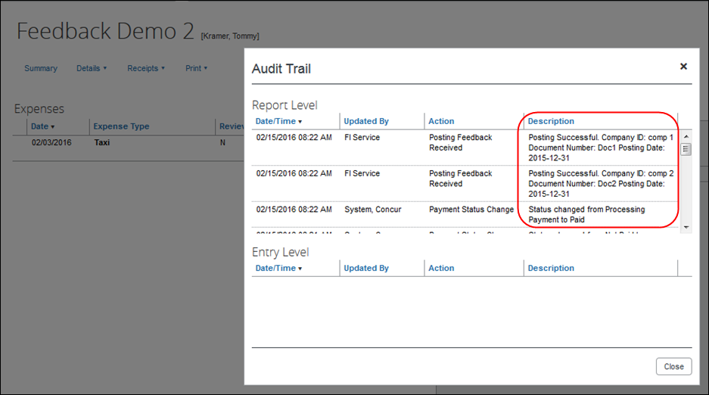

Reopen Expense Report
If the Delta Posting feature is enabled, and the expense report meets the eligibility requirements for the feature, the user will see a button labeled Reopen Report on the expense report page.
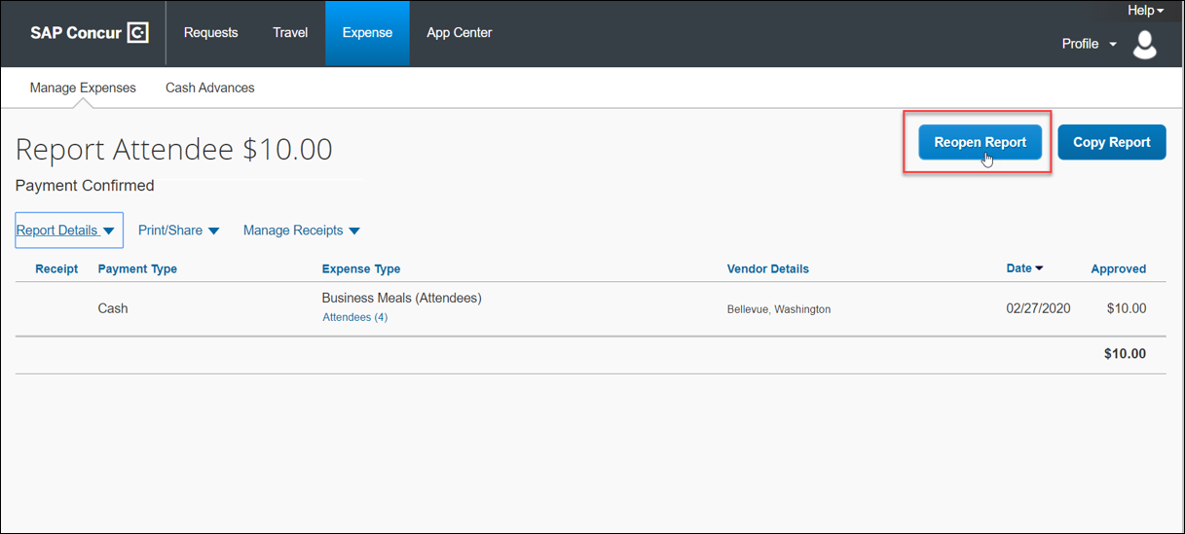
The user will only be able to modify a subset of the expense report fields. When done modifying the report, they submit it as usual.
- For more information about the Delta Posting feature, refer to the 2.5.2.1 Delta Posting After Initial Post section of this guide.

Process Reports Page
The Expense Processor approves the report for payment as usual. The user’s Expense group determines which reports are paid by the SAP ICS for SAP S/4HANA Cloud. After approval, the expense report is placed in the financial posting queue. The integration timing and frequency are configurable per client, in SAP S/4HANA Cloud. Once the financial posting is complete, the processor will see the posting feedback on the Process Reports page.
Reports that posted successfully will show the payment status Posted (if configured, otherwise the payment status will be Sent for Payment), and show the details of the financial posting in the audit trail. The audit trail message includes the Company ID, the Document ID, and the Posting Date.
Reports that failed to post will show an exception and the payment status Financial Posting Failed.
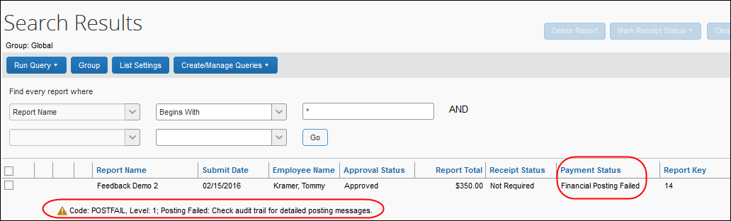
The processor can view the audit trail for the report to see the details of the posting failure. In this example, the report failed to post for two reasons. The audit trail message includes the Company ID, the Document ID, and the details of the failure.
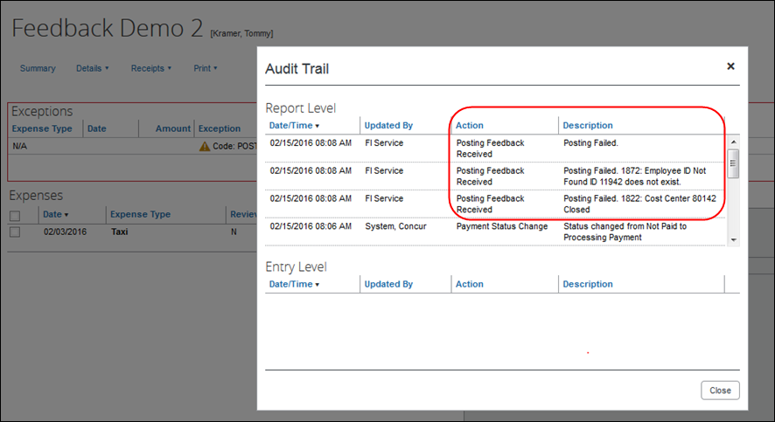
The processor recalls the report, in order to make changes to it.
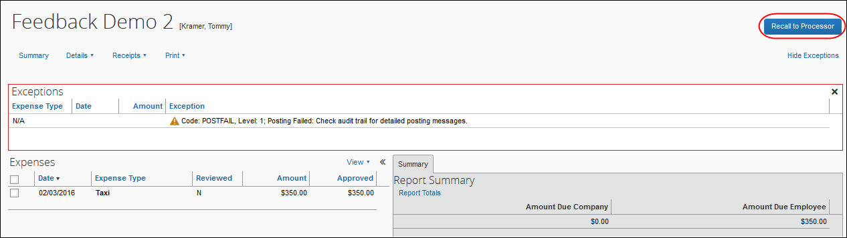
Then the processor works with the Concur Expense and SAP S/4HANA Cloud administrators to resolve the issues. In this example, the Concur Expense administrator would update the user’s employee ID, while the SAP S/4HANA Cloud administrator would confirm the correct cost center to select. Then the processor would select the correct Cost Center on the expense entry or report header. Once the processor has updated the report, they approve it for payment again.
When the expense report is sent to the queue for financial posting, the employee information is pulled directly from the user’s profile. The integration does not use employee data that has been copied down into the expense report header or expense entry fields.
When the report is successfully posted, the integration sets the report’s payment status to Posted (if configured, otherwise the payment status will be Sent for Payment).
- For more information, refer to the 6.3.2.10 Step 10: (Optional) Rename the Payment Status to Posted section of this guide.
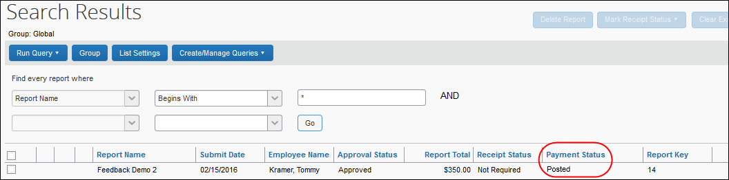
Expense reports can optionally use the Payment Confirmation workflow step to perform an additional update. If enabled in the SAP financial system and Concur Expense, the integration provides additional information in the report audit trail as the report payees are paid by the SAP system. Once all the report payees are paid, the integration moves the report to the Payment Confirmed payment status.
The processor can create a query to find reports that have financial integration enabled.
- For more information, refer to the 6.3.2.6 Step 6: Create the Processor Query section of this guide.

Financial Posting Failed Query
Concur Expense has a query on the Process Reports page, Reports Financial Posting Failed, for clients with the integration. This query can be used by the processor to quickly locate all reports with the payment status of Financial Posting Failed.
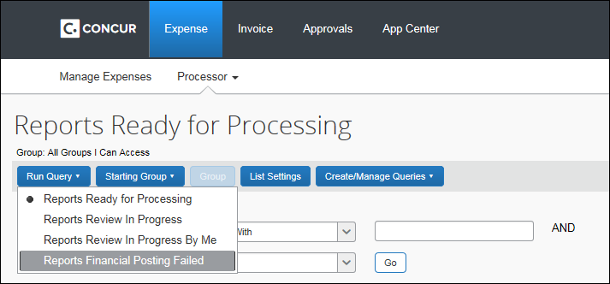

Financial Integration Enabled Column
A column labeled Financial Integration Enabled can be added to the Process Reports page, using the List Settings options.
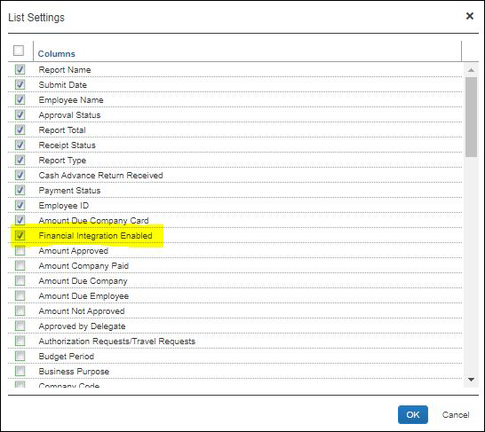
Once enabled, this column indicates which reports are configured to be processed using the Financial Integration Service.
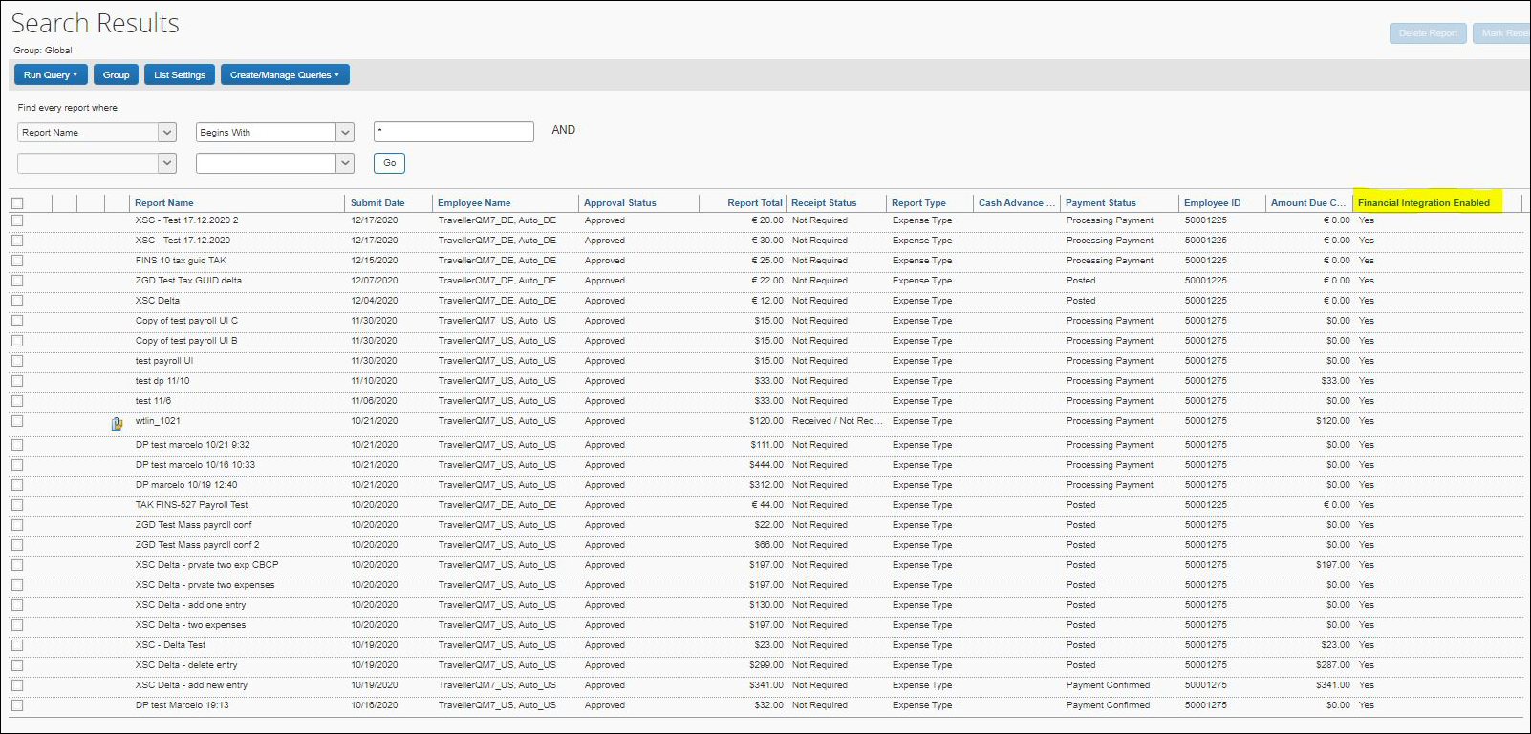

Cash Advance Admin Page
The Record Return Amount feature is not supported by financial integration. If financial integration is enabled, the Record Return Amount button will not appear on the Cash Advance Admin page.
The Cash Advance administrator creates and issues the advances as usual. When the ICS is enabled, the Cash Advance Admin page includes an option for the Failed Cash Advances status in the Cash Advance Status list.
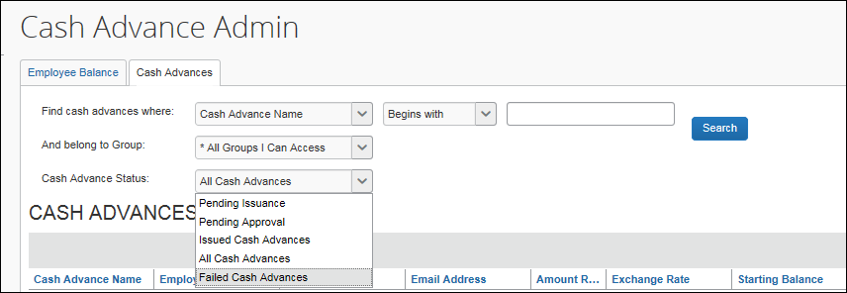
The page displays a new column, FI Status, when financial integration is enabled.
For any cash advances that are in the Failed status, the Cash Advance administrator can change some fields on the cash advance. The administrator clicks the cash advance name to view the details.
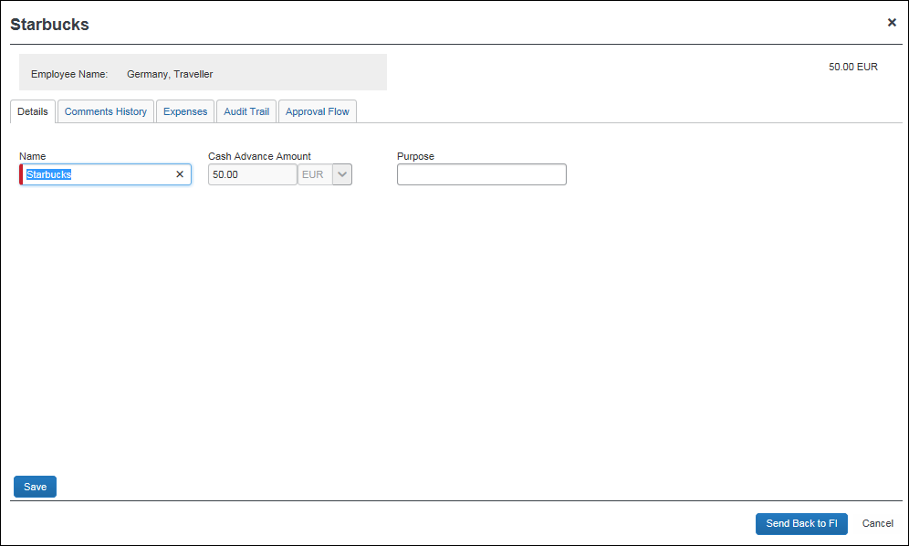
Once any incorrect field values are fixed, the Cash Advance administrator can resend the advance to the financial document queue using the Send Back to FI button.
Cash advances with a Failed status will be unavailable to assign to expense reports until they are corrected and successfully posted.

What the Invoice User Sees
In Concur Invoice, the integration functionality will appear to the end user in multiple places:
- Invoice audit trail
- Invoices Ready for Processing page

Invoice Audit Trail
The invoice audit trail includes the posting status once the posting feedback has been returned from the SAP financial system. The user clicks Details > Audit Trail to view the audit trail. Invoices that posted successfully will show the payment status Posted (if configured, otherwise the payment status will be Extracted),
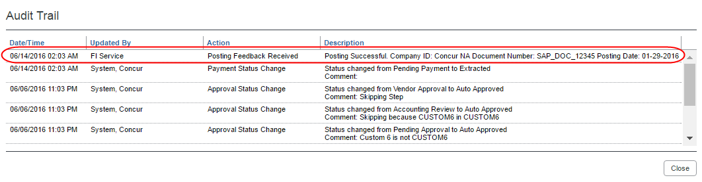

Invoices Ready for Processing Page
The Invoice Processor approves the request for payment as usual. The user’s Invoice workflow determines which requests are paid by the integration. After approval, the request is placed in the financial posting queue. The integration timing and frequency are configurable per client, in the SAP financial system. Once the financial posting is complete, the processor will see the posting feedback on the Invoices Ready for Processing page.

Prerequisites

SAP Concur Prerequisites
The client must:
- Have signed a Data Protection Agreement (DPA)
- Be an existing SAP Concur client, with one of the following SAP Concur solutions:
- Concur Expense Professional/Premium Edition
- Concur Invoice, Professional/Premium Edition
- Be an existing SAP client, with one of the following SAP financial systems:
- Concur Expense:
- SAP S/4HANA Cloud, private edition
- SAP S/4HANA Cloud, public edition
- Concur Invoice:
- SAP S/4HANA Cloud, private edition
- The SAP Concur administrator who will be setting up the integration must have one of the following user roles:
- Unrestricted Expense Configuration Administrator
- Unrestricted Invoice Configuration Administrator

SAP S/4HANA Cloud Configuration Prerequisites
Refer to the 2.7 Available SAP Documentation section of this guide for the full details for SAP S/4HANA Cloud.

Prior to SAP Setup
Prior to beginning the configuration steps in SAP S/4HANA Cloud, you should complete the following tasks in the SAP Concur solution:
- Complete the 5.2 Integration Settings and Group Configuration and relevant 5.3 Concur Expense and Concur Invoice Configuration steps in this guide.
- Collect the following information from the SAP Concur system:
- Company Code custom field ID (varies by client)
- Field information for any fields that will be mapped to SAP fields, including SAP Concur Code values if necessary
- For more information, refer to the 6.3.1 Source Data Replication Configuration section of this guide.
- List name for cost object list (created during 6.3.1.1 Step 1: Create the Cost Objects List)
- Determine how frequently you want the integration to run. The source data replication and financial integrations can be set to different schedules, if necessary. Schedule the replication runs in your SAP solution as described in the respective SAP Integration Guide.
- The following information will be provided by your SAP Concur Implementation Consultant:
- Concur Company ID
- Authentication information

Configuration

Overview
The SAP ICS for SAP S/4HANA Cloud installation/configuration requires configuration steps in both the SAP Concur solution and SAP S/4HANA Cloud. This guide contains information about the configuration and activation steps for the integration in the SAP Concur solution.
- For information about the configuration in SAP, refer to the 2.7 Available SAP Documentation section of this guide.

Integration Settings and Group Configuration
The SAP Concur Implementation consultant performs many, if not all, of the following steps, depending on the client’s SAP Concur configuration.

Step 1: Configure the Integration Settings
The SAP Concur Implementation consultant creates the Client ID (App ID) and Client Secret using the OAuth 2.0 Application Management tool.

Step 2: Configure Integration Gateway Authentication
The API gateway manages the access to the SAP Concur APIs. The authentication credentials for this gateway are configured using an SAP Concur Internal tool.
The SAP Concur Implementation consultant will provide the following authentication information for you to use in SAP S/4HANA Cloud:
- Client ID (App ID)
- Client Secret
- Company UUID
- Request token or refresh token
- Company ID

Step 3: Update Group Configurations (Concur Expense Only)
The Concur Expense administrator selects which users are reimbursed with the financial posting integration in Administration > Expense > Group Configurations.
This setting is only visible to SAP Concur Internal users who log in to the company as SAP ConcurAdmin from HMC.
For the desired expense groups, select the Enable Financial Integration setting.
Once this setting is selected, the expense reports for the group members that are approved for payment:
- Will begin to go to the Financial Integration queue
- Will not be included in any extract files
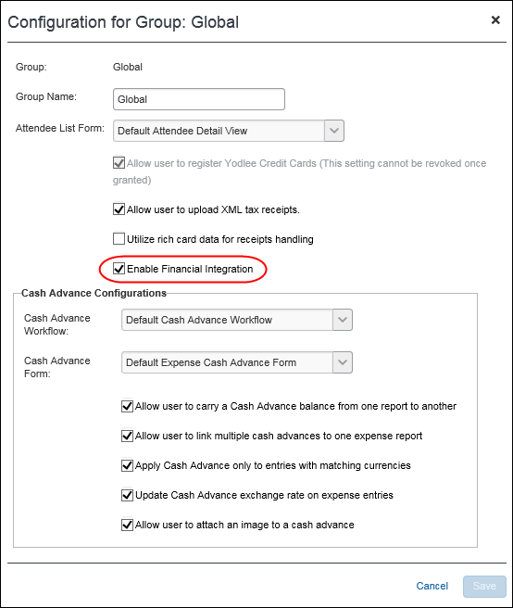

(Optional) Enable Delta Posting
Clients using the NextGen UI for Concur Expense and the SAP ICS for SAP ECC and SAP S/4HANA may enable delta posting and assign one of three levels on the Configuration for Group page. This setting can only be enabled if the Expense group has the Enable Financial Integration setting selected.
If you are adding this functionality after moving from Implementation to Production, you will need to submit a support ticket to SAP Concur Support. For more information, refer to the 7.1.3 Creating an Enable Delta Posting Case section of this guide.
Enable Delta Posting configuration includes the following steps:
- For the desired Expense groups, select the Enable Delta Posting setting.
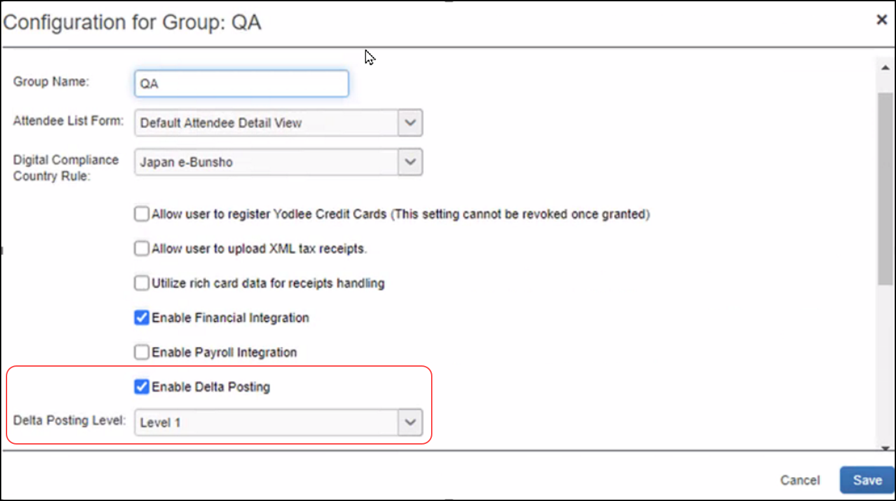
This setting is only visible to users with the Expense Configuration Administrator user role.
Payroll Integration is compatible but not required to use the Delta Posting feature. If the client is using both Payroll Integration and Delta Posting, the payroll posting feedback loop must be completed for a report before the user can reopen it.
- Select the desired level in the Delta Posting Level field.
Three separate configuration levels allow companies to control which actions the end-user can perform in a reopened report. These levels are available at the Group level, meaning that users assigned the same group are assigned the same level.
Level One
Level One allows the end user to:
- Modify the custom and org unit fields on the expense report (report header, report entry, and entry itemization levels)
- Add or append a receipt image
- Modify all allocation fields, including adding and deleting entire allocations or adjusting allocation percentages. All edits to allocations must still equal the original entry amount – level one users cannot make changes which impact entry amounts on the report
The end-user cannot:
- Delete the only entry in a report
- Delete the entire report
- Delete images from paid entries
- Modify travel allowance details
- Modify attendee information in the following ways:
- Modify non-custom attendee fields
- Modify amounts per attendee
- Add/Delete attendees
Level Two
Level Two allows the end user to:
- Modify all eligible fields on the expense report (report header, report entry, and entry itemization levels) including amount
- Modify all allocation fields, including adding and deleting entire allocations or adjusting allocation percentages. Level two users can make allocation changes which impact the entry amount
- Add or append a receipt image
- Modify attendee information in the following ways:
- Modify all eligible attendee fields
- Modify amounts per attendee
- Add/Delete attendees
The end user cannot:
- Delete the only entry in a report
- Delete the entire report
- Delete images from paid entries
- Modify travel allowance details
- Add or delete itemizations or parent entries
Level Three
Level Three allows the end user to:
- Add or delete entries on the report, including allocation and itemization entries
- Move entries to another report
- Modify all eligible fields on the expense report (report header, report entry, and entry itemization, and entry allocation levels) including amount
- Modify all allocation fields, including adding and deleting entire allocations or adjusting allocation percentages. Level three users can make allocation changes which impact the entry amount
- Add or append a receipt image
- Modify travel itinerary and travel allowance information
If the customer is using the Travel Allowance Service, the Level Three configuration allows the associated travel allowance to be modified using the Travel Allowance UI, after the report has been reopened.
- Modify attendee information in the following ways:
- Modify all eligible attendee fields
- Modify amounts per attendee
- Add/Delete attendees
The end user cannot:
- Delete the only entry in a report
- Delete the entire report
- Delete images from paid entries
- Modify itineraries or travel allowances which impact other itineraries and reports sharing the same date range
- For more information, refer to the 2.5.2.1 Delta Posting After Initial Post section of this guide.

Step 4: Update Workflow Configurations (Concur Invoice Only)
The SAP Concur administrator selects which users are reimbursed with the financial posting integration in Administration > Invoice > Workflow.
For the desired workflows, select the Send to Financial ERP as part of the final processor step setting.
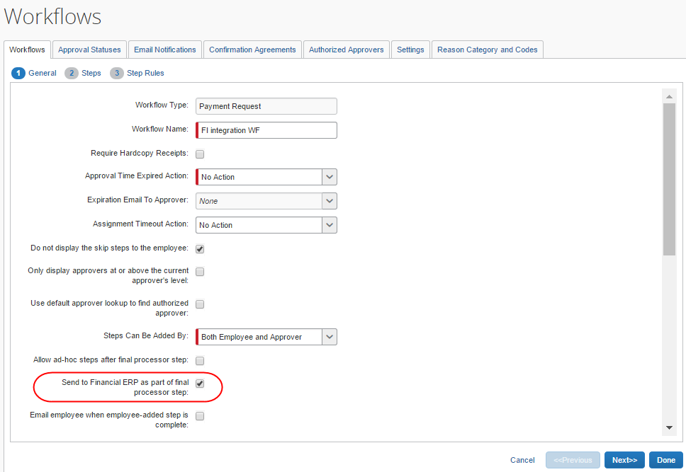
Once this setting is selected, the invoices for the workflow that are approved for payment will begin to go to the Financial Integration queue. These invoices are not included in any extract files.
- For more information, refer to the Concur Invoice: Workflow – General Information Setup Guide.

Step 5: (Optional) Enable Enhanced WBS Element Search (Concur Expense Only)
The SAP Concur Service Delivery Team or your partner will complete the following configuration.

Update SAP ICS Application
This configuration step is completed by the SAP Concur Service Delivery team using the OAuth 2.0 Application Management tool. SAP partners should submit a PSD support case to SAP Concur to complete this step.

Create Application Connector
To create and configure the application connector:
- Navigate to Administration > Company > Web Services > Manage Application Connector.
- Click New.
- Enter the field values:
Field | Definition
Name | Enter any descriptive name. For example, “LEU for WBS element search”.
Description | Enter any description.
Host Name | Enter the URI of the financial integration system.
User Name | Enter any value that does not correspond to an actual user.
Password | Enter any value.
- Click Test Connection.
- Click Save.
- In the Services section, select Launch External URL.
- Click Configure.
- Enter the field values:
Field | Definition
Endpoint | Enter “ui#ConcurProject-search”.
Client ID | Enter the Client ID of your ICS OAuth application.
Redirect URL | Enter the URI of the financial integration system.
- Click OK.
- Click Save.

Add Launch External URL Field to the Form
In Administration > Expense > Expense Admin > Forms and Fields, update the desired form type (Expense Report Header, Expense Entry, or Expense Allocation) using the Fields tab to configure a field for this feature. Use the following field values:
Field | Definition
Field Name | Enter “Enhanced WBS Element Search”.
Control Type | Select “Launch URL (Single-line)”.
Application Connector | Select the application connector you configured for the Enhanced WBS element search.
Popup Width | Enter ”800”.
Popup Height | Enter ”800”.
Then use the Form Fields tab to add the newly configured field to your form.
- For more information, refer to the Expense: Forms and Fields Setup Guide.

Concur Expense and Concur Invoice Configuration
The integration configuration in the SAP Concur solution varies depending on whether the client is an existing SAP Concur client or a new SAP Concur client.
Existing SAP Concur clients mostly take note of their SAP Concur solution configuration and use that information to map the SAP Concur solution fields to fields in SAP S/4HANA Cloud.
New clients complete all the configuration steps listed in this section.
Certain SAP Concur solution configurations are necessary to work with SAP S/4HANA Cloud. The SAP Concur Implementation Consultant will review and configure these areas as necessary. The following is an overview of the configuration steps. The full details appear below.
Source Data Replication configuration includes the following steps:
- Create a new list for the cost objects.
- Assign the cost object list to the necessary forms.
- Complete the integration configuration steps in SAP S/4HANA Cloud.
Financial Posting configuration includes the following steps:
- Update all Expense Types with valid SAP G/L account codes.
- Update the Tax Configuration in Concur Expense to match SAP tax fields. (Concur Expense only)
- Configure an SAP Clearing Account for the payment types in use. (Concur Expense only)
- Enable Tax Code Field Mapping. (Concur Invoice only)
- Verify the processor workflow step. (Concur Expense only)
- Create the processor query.
- Configure Liability Account Codes. (Invoice Pay only)
- (Optional) Enable the Non-Domestic tax feature. (Concur Expense only)
- (Optional) Rename the payment status to Posted.
- (Optional) Configure test users.
- (Optional) Configure the Payment Confirmation workflow step. (Concur Expense only)

Source Data Replication Configuration

Step 1: Create the Cost Objects List
For new clients that are using source data replication, the Concur Expense administrator must create a new list to work with SAP S/4HANA Cloud, mapping to the Org Unit 1-4 fields:
Form Field Name | Column Name
System | ORG_UNIT_1
Company | ORG_UNIT_2
Cost Object Type | ORG_UNIT_3
Cost Object ID | ORG_UNIT_4
If the client wants to deviate from this approach, and their SAP solution allows them to configure the integration, they also must configure the field mapping in the SAP solution.
For existing SAP Concur clients, the administrator should take note of which fields are currently configured or available for mapping to the SAP cost objects. The field mapping in SAP S/4HANA Cloud requires the following information:
- The SAP Concur Form Type
- The SAP Concur Column Name
The Column Name is entered in the SAP Concur Field ID field in the SAP Add-ons when mapping data between the SAP Concur solution and SAP S/4HANA Cloud. The Column Name value must be modified to remove the underscores and change the capitalization to capitalize the first letter of each word.
Example: The Employee First Name field in the SAP Concur solution has the Column Name of FIRST_NAME, in Forms and Fields. In SAP S/4HANA Cloud, the SAP Concur Field ID for this field should be FirstName.
- The SAP Concur Field Name
- For more information, refer to the Expense: Forms and Fields Setup Guide.
The list items and values will be sent from SAP S/4HANA Cloud to the SAP Concur solution once the SAP financial system is configured.
In Administration > Expense/Invoice > List Management, create a new list. The list name will be used when configuring SAP S/4HANA Cloud.
- For more information, refer to the Shared: List Management Setup Guide.

Step 2: Assign the Cost Object List to the Forms
In Administration > Expense/Invoice > Forms and Fields, add the new list to the following forms:
- Employee (the list should be added the Employee form used by the Global group) The cost object list field Access Rights should be set to:
- Employee: Read-Only
- Employee Administrator Role: Modify
- All other roles: Read-Only or Hidden
- Expense Report Header/Payment Request Header (these list fields copy down from the Employee level) The cost object list field access rights should be set to Read-Only or Hidden for all user roles.
- Expense Report Allocation/Payment Request Allocation (these list fields copy down from the Report/Payment Request Header level) The cost object list field access rights should be set to Read-Only or Hidden for all user roles.
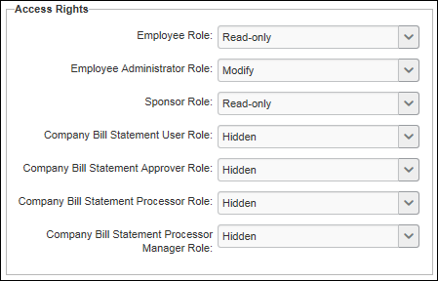
In Administration > Expense/Invoice > Forms and Fields > Connected List Definitions, configure the connected list definition.
For existing clients, map the connected list to the client’s configured cost object fields.
For new clients, map the connected list to the Org Unit 1-4 fields. For the Expense Report/Payment Request Header form, select Copy Down as the Default Value Type, and choose the Employee field as the copy down source. For the Expense Report/Payment Request Allocation form, select Copy Down as the Default Value Type, and choose the Expense Report/Payment Request Header field as the copy down source.
In Administration > Expense/Invoice > Policies, verify that the necessary policies use the updated forms.
- For more information, refer to the Concur Expense: Forms and Fields Setup Guide, Expense: Policies Setup Guide, Concur Invoice: Forms and Fields Setup Guide, and Concur Invoice: Policies Setup Guide.

Step 3: Complete the SAP Configuration
For information about the configuration in SAP, refer to the respective guides in the 2.7 Available SAP Documentation section of this guide.

Financial Posting Configuration

Step 1: Update all Expense Types With Valid SAP Account Codes
In Administration > Expense/Invoice > Accounting Administration > Account Codes, assign valid SAP G/L account codes to the expense types in use.
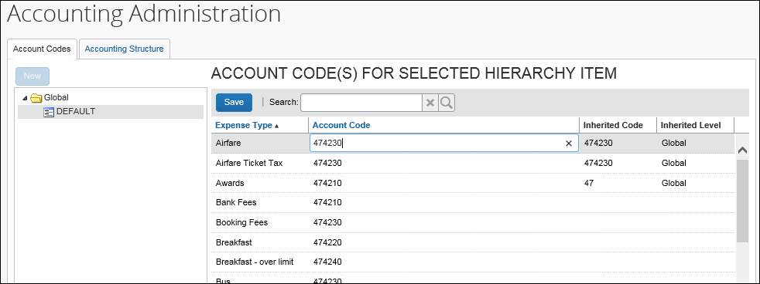
- For more information, refer to the respective SAP guide in the 2.7 Available SAP Documentation section, the Expense: Account Codes Setup Guide, and the Concur Invoice: Account Codes Setup Guide.

Step 2: Update Tax Configuration in Concur Expense to Match SAP Tax Fields (Concur Expense Only)
In Administration > Expense > Tax Administration > Tax & Reclaim Groups, configure the Tax Reclaim Code to be the SAP Tax Code valid for your SAP financial system.
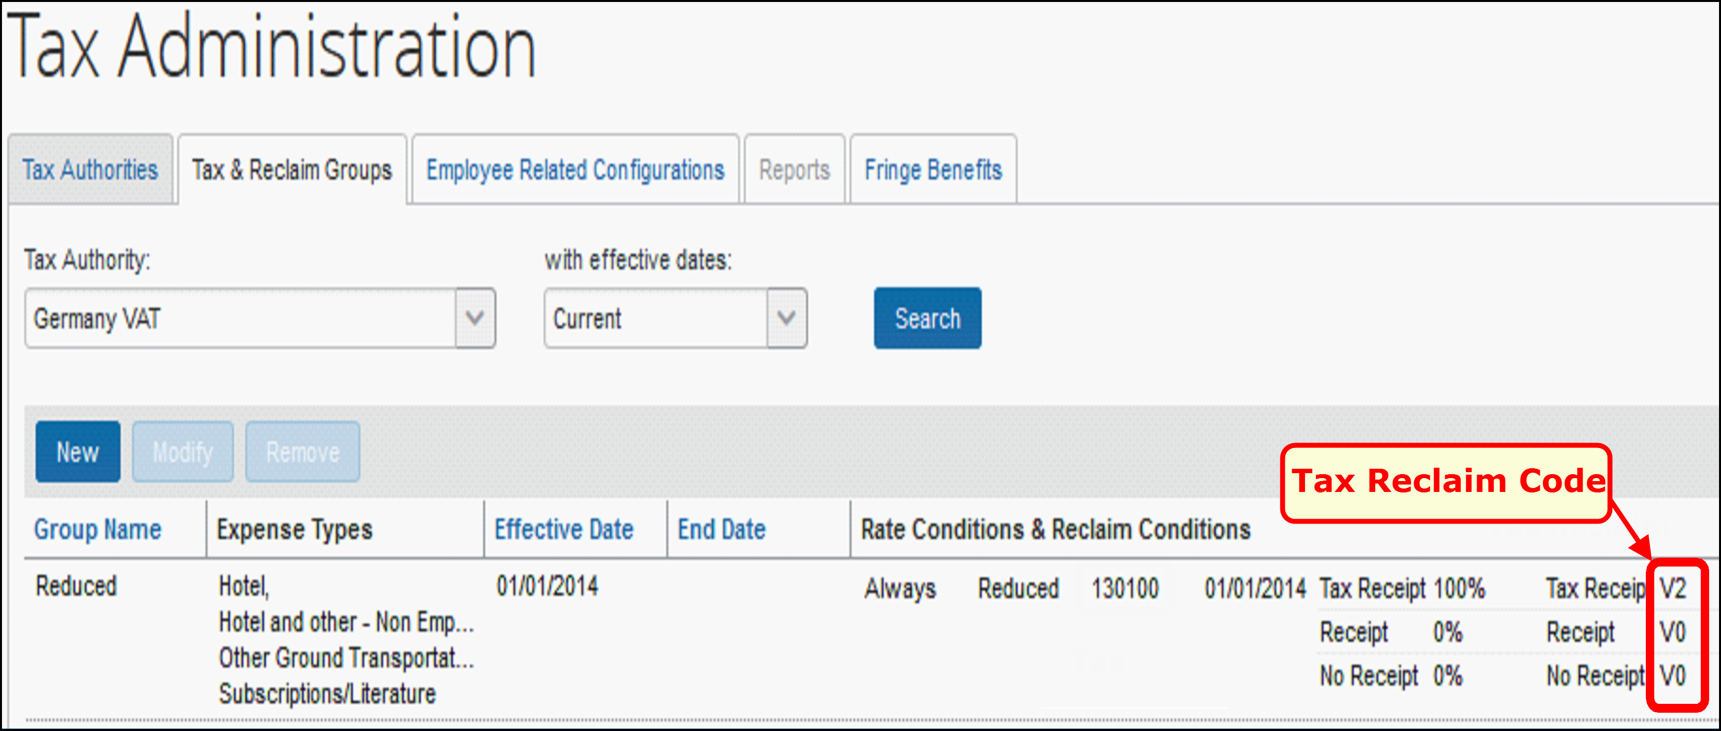
- For more information, refer to the respective SAP guide in the 2.7 Available SAP Documentation section, and to the Expense: Value Added Tax (VAT)/ Tax Administration Setup Guide.

Canadian Tax Configuration
This configuration is only required if your SAP financial system has been released for the integration with Concur Expense in Canada.
Clients who use Canadian tax authorities must perform an additional configuration step. In Administration > Expense > Tax Administration > Tax & Reclaim Groups, configure the Tax Code to be the SAP Condition Type for Canada.
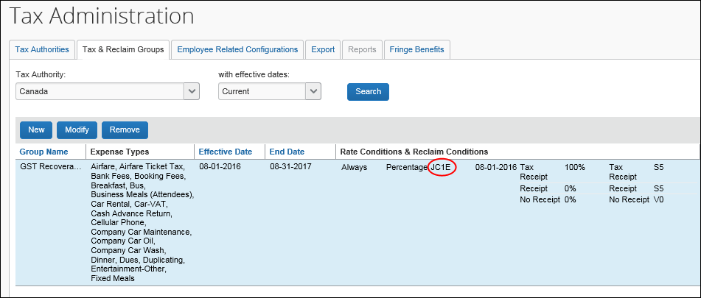
The SAP Condition Type is configured in SAP.

Step 3: Configure all SAP Clearing Accounts (Concur Expense Only)

Configure Expense Payment Types
In Administration > Expense > Payment Types, enter the SAP Clearing Account Code for any Company Paid, IBCP, or CBCP payment types that are supported by your financial system.
Offsets are not supported by the integration.
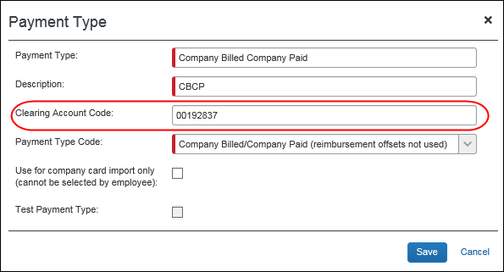
- For more information, refer to the Expense: Payment Types Setup Guide.

Configure Company Card Accounts
If you have Clearing Accounts that apply to specific individual cards, on the Manage Accounts tab of the Company Card Admin page, modify all CBCP card accounts to have a valid SAP Clearing Account Code.
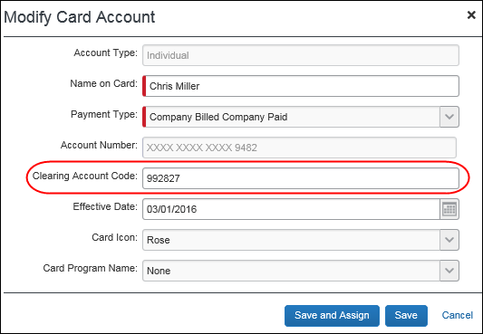
- For more information, refer to the Expense: Company Card Admin User Guide.

Configure Expense Pay Batch Accounting (Expense Pay Only)
If you use Expense Pay and your SAP solution supports this configuration, you must configure the Liability Account Code for the Expense Pay Employee batches to have a valid SAP Clearing Account Code.
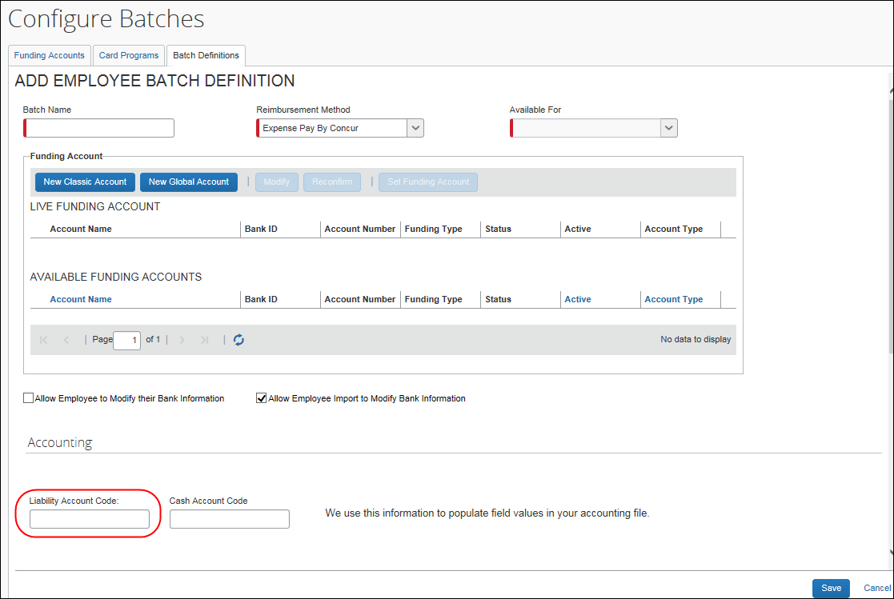
- For more information, refer to the Expense: Payment Manager for Expense Pay Classic User Guide.

Step 4: Enable Tax Code Field Mapping (Concur Invoice Only)
To support financial integration for tax codes, clients can define which custom field they use as a Tax Code field, so that an external financial system knows which field represents the tax code in Concur Invoice.
This feature is only applicable to existing clients.
The admin will see an option, Custom field being used to define line item Tax Code value, in Invoice Settings where they can select one of 20 custom fields to use as the Tax Code value.
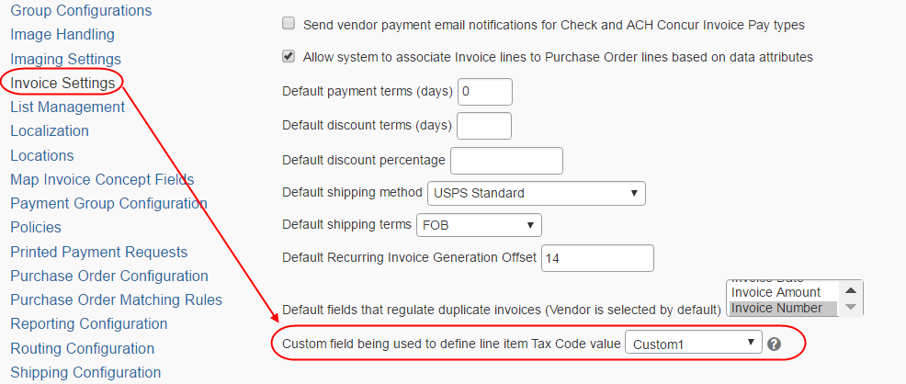
To access this option, click Administration > Invoice > Invoice Settings (left menu).
For more information, refer to the Concur Invoice: Invoice Settings Setup Guide.

Step 5: Verify the Processor Workflow Step (Concur Expense Only)
In Administration > Expense > Workflows, verify that the workflow contains a processor step prior to the Processing Payment step. All employees using the Financial Posting must have an expense report workflow that includes a Processor step after approval. This allows the reports to return to the processor if they fail the financial posting. The Processor workflow step may be configured as a skip step, if necessary.
- For more information, refer to the Expense: Workflow – General Information Setup Guide.

Step 6: Create the Processor Query

Concur Expense
In Expense > Process Reports, create a processor query to find reports using the financial integration, using the Report data object, and the Financial Integration Enabled field. This query finds all reports using financial integration, regardless of status.
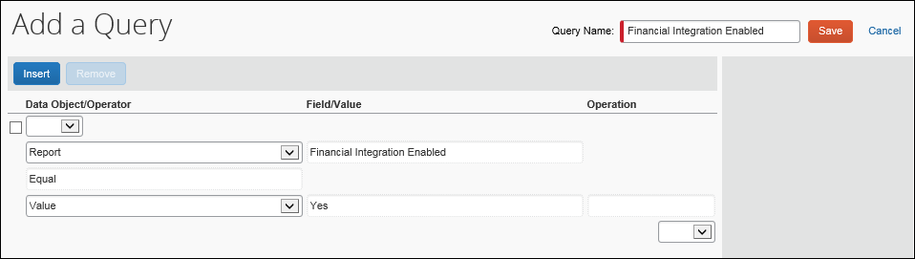
The Financial Integration adds a new default query to the Process Reports page, titled Reports Financial Posting Failed, which is used to view reports that failed to post.

Concur Invoice
In Invoice > Processor > Process Requests, create a processor query to find invoices that use financial integration by using the Request data object, and the Financial Integration Enabled field.
- For more information, refer to the Concur Invoice: Invoice Processor User Guide.

Step 7: Configure Liability Account Codes (Invoice Pay Only)
Clients who use Invoice Pay can pay invoices in SAP Concur by using ACH or Check payment types and have the transaction data sent to their SAP Financial system.
For this feature to work, clients must enter the liability account code in the Liability Account field of the Funding Account page in Payment Manager.
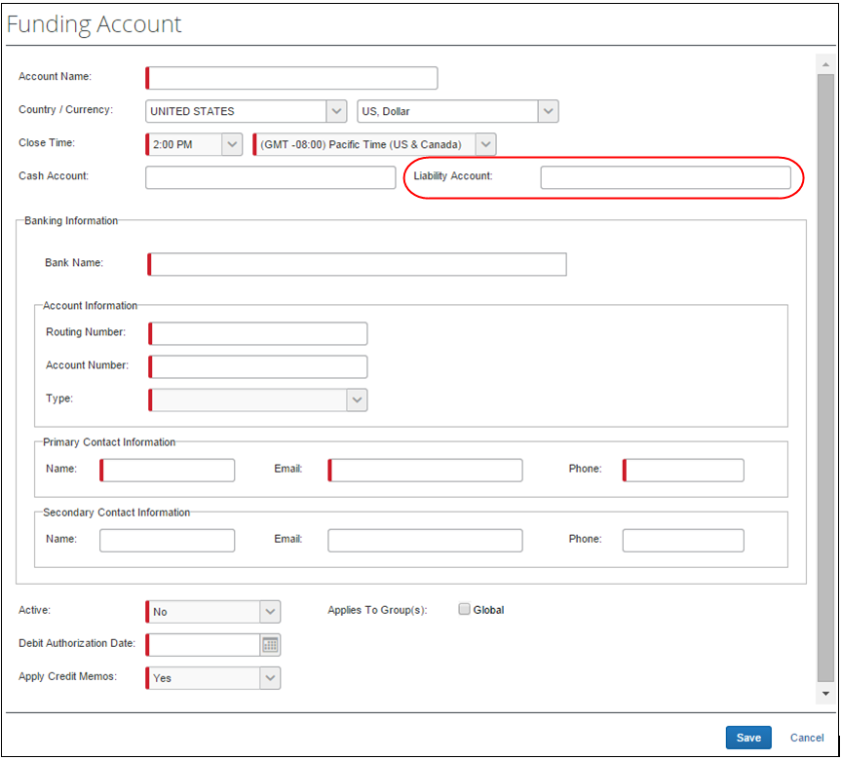
If clients prefer to use the extract to transfer data to their system, this is still available.
- For more information, refer to the Invoice: Invoice Pay User Guide.

Step 8: (Optional) Using the IsReopened Report Attribute with Delta Posting (Concur Expense Only)
Customers that use the delta posting functionality can create audit rules and workflow conditions that apply to the expense reports reopened during the delta posting process. The attribute IsReopened is available for the Report object in the audit rule and workflow condition editors.
- For more information, refer to the Expense: Audit Rules Setup Guide and Expense: Workflow – General Information Setup Guide.

Step 9: (Optional) Enable the Non-Domestic Tax Feature (Concur Expense Only)
Complete these configuration steps if the company captures VAT.
In Administration > Expense > Site Settings, select (enable) the Non Domestic Tax Enabled check box. Set the Non Domestic Tax Field to Custom 38.
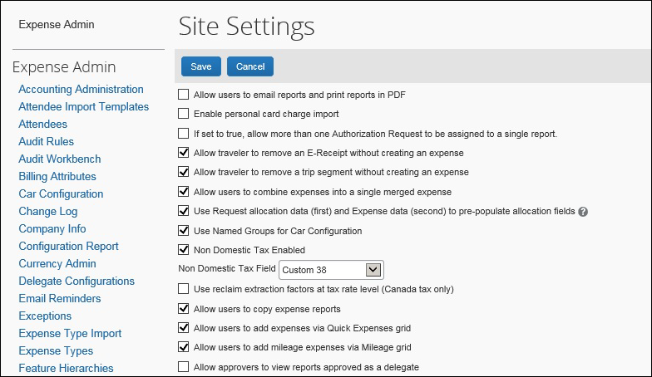
In Administration > Expense > Tax Administration > Tax Authorities, enter your Non Domestic Code. When the two site settings above are configured, this code will be applied to non-domestic spend.
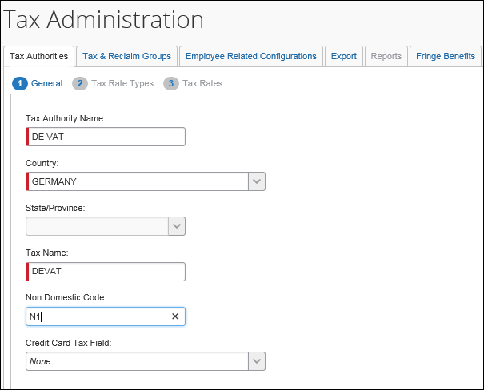

Step 10: (Optional) Rename the Payment Status to Posted

Concur Expense
In Administration > Expense > Workflows > Expense Report Approval Statuses, update the existing Sent for Payment status as follows:
Field | Value
Status | Posted
Action Text | Post
Description | Report has been posted to financial system
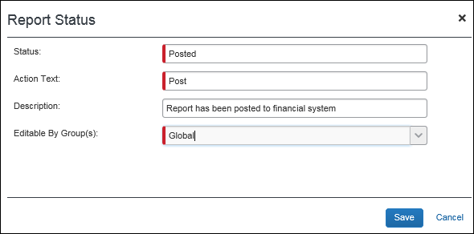

Concur Invoice
In Administration > Invoice > Workflows > Approval Statuses > Invoice, update the existing Extracted status as follows:
Field | Value
Status | Posted
Action Text | Post
Description | Invoice has been posted to financial system

Step 11: (Optional) Configure Test Users
Users who are configured as test users can be used to test the integration. Any reports or cash advances from test users will be sent to the SAP S/4HANA Cloud test system rather than production.
In Administration > Company > Company Admin > User Administration > User Information, the administrator creates the users and selects the Is a Test User check box for the test user accounts. The test users can then be configured to use the integration, including adding them to the SAP S/4HANA Cloud test system.
- For more information, refer to the Shared: Test User Setup Guide and the relevant SAP guide in the 2.7 Available SAP Documentation section.

Step 12: (Optional) Configure the Payment Confirmation Workflow Step (Concur Expense Only)
In Administration > Expense > Workflows, select (enable) the Include the Payment Confirmation step setting for the desired workflow.
Payment confirmation must also be enabled in SAP S/4HANA Cloud Edition in order for this feature to function correctly. Refer to the SAP ERP documentation for more information.
Payment Confirmation is not supported by the SAP Payroll integration.
- For more information, refer to the Expense: Workflow – General Information Setup Guide or the Expense: Payroll Integration Setup Guide.

Creating a Support Case

Reviewing the Audit Trail
Before creating a support case, review the report/advance/invoice audit trail to determine the cause of the error.
For expense reports and cash advances, click Details > Audit Trail to view the audit trail.
For invoices, click Details > Audit Trail to view the audit trail.
Most issues result from incorrect account codes or vendor codes. Compare your SAP Concur solution configuration with the SAP system configuration to verify that the codes are correct.
If no information appears in the audit trail, but the financial document does not show in the SAP ERP, create a support case.

Creating a Support Case
The SAP ICS for SAP S/4HANA Cloud connects your SAP Concur solution and SAP systems and is therefore supported by both SAP Concur Support and SAP Support.
To avoid unnecessary delays during incident handling, please proceed as follows:
In which system does the problem originate?
- SAP: If you suspect the cause is in the SAP system, create a support ticket as described in the respective SAP integration setup guide, or in this SAP Note: 1296527 - How to create a support incident (contact SAP Product Support)
If the issue relates to you SAP Concur solution after all, the SAP support team opens a case in the SAP Concur support system. The new case is created under the authorized support contact (ASC) for your SAP Concur solution, with the original ticket owner copied. The original SAP ticket is closed with a reference to the SAP Concur system and the email address of the person who initially created the ticket. The email address is needed to keep the ticket creator informed about the status.
- SAP Concur solution: If you suspect the cause is in the SAP Concur solution and you are the SAP Concur Administrator, create a support case by navigating to Help > Contact Support in your SAP Concur system. If you are not an ASC, contact your SAP Concur Administrator, who will create the Support case for SAP Concur support to manage. The ASC is able to add you as a cc on the case so you can track the case status.
- If you are not sure what is causing the problem, please create the ticket in the SAP system first, following the instructions above.
In your support ticket, include the following information:
- Expected behavior of the integration
- Actual behavior of the integration
- Time and date of the issue
- Expense Report ID, Cash Advance ID, Invoice ID, or Employee ID, if applicable

Deactivating the Integration
Create a support case to deactivate the integration. This step should only be performed when replacing the integration or retiring the SAP ICS for SAP S/4HANA Cloud.

Creating an Enable Delta Posting Case
If you are adding delta posting functionality after moving from Implementation to Production, you will need to submit a support case to SAP Concur Support. Use the following values:
Topic: Expense
Subject: SAP ICS – Delta Posting Activation
Case Type: SAP Integration (ICS)
Description (include the following):
- Expense Group(s) to have Delta Posting enabled
- Level to apply to the Expense Group
- Indicate Concur PROD or Concur TEST, as appropriate

