
Expense: SAP ICS for SAP Business ByDesign
Setup Guide for Professional Edition
Last Revised: April 26, 2022
Applies to these SAP Concur solutions:
 Expense
 Professional/Premium edition
 Standard edition
 Travel
 Professional/Premium edition
 Standard edition
 Invoice
 Professional/Premium edition
 Standard edition
 Authorization Request
 Professional/Premium edition
 Standard edition

Table of Contents
1 Permissions 1
2 Overview 1
2.1 Features 2
2.1.1 Supported Countries 2
2.2 Exclusions 3
2.3 Definitions 3
2.4 Master Data 3
2.4.1 Employee 4
2.4.1.1 Employee Manager Configuration 4
2.4.2 Cost Object 4
2.5 Financial Posting 5
2.5.1 Overview 5
2.5.2 Process 5
2.6 Configuration Overview 5
2.7 Available SAP Documentation 6
2.7.1 SAP Business ByDesign Documentation 6
2.8 Available SAP Concur Documentation 6
2.8.1 Expense Professional Edition Setup and User Guides 6
3 What the User Sees 6
3.1 Expense Report Audit Trail 7
3.2 Process Reports Page 7
3.2.1 Financial Posting Failed Query 10
3.2.2 Financial Integration Enabled Column 11
3.3 Cash Advance Admin Page 12
4 Prerequisites 13
4.1 SAP Concur Prerequisites 13
4.2 SAP Prerequisites 13
4.2.1 Prior to SAP Business ByDesign Setup 13
5 Configuration 14
5.1 Overview 14
5.2 Integration Settings and Group Configuration 14
5.2.1 Step 1: Configure the Integration Settings 14
5.2.2 Step 2: Configure Integration Gateway Authentication 14
5.2.3 Step 3: Update Group Configurations 14
5.3 Concur Expense Configuration 15
5.3.1 Master Data Exchange Configuration 16
5.3.1.1 Step 1: Create the Cost Objects List 16
5.3.1.2 Step 2: Assign the Cost Object List to the Forms 17
5.3.1.3 Step 3: Complete the SAP Business ByDesign Configuration 19
5.3.2 Financial Posting Configuration 19
5.3.2.1 Step 1: Update all Expense Types With Valid SAP Account Codes 19
5.3.2.2 Step 2: Update Tax Configuration in SAP Concur 19
5.3.2.3 Step 3: Configure all SAP Business ByDesign Clearing Accounts 22
5.3.2.4 Step 4: Verify the Processor Workflow Step 23
5.3.2.5 Step 5: Create the Processor Query 24
5.3.2.6 Step 6: Update Expense Car Form 25
5.3.2.7 Step 7: (Optional) Rename the Payment Status from Sent for Payment to Posted 26
5.3.2.8 Step 9: (Optional) Configure Test Users 26
6 Creating a Support Case 27
6.1 Reviewing the Audit Trail 27
6.2 Creating a Support Case 27
6.2.1 Deactivating the Integration 28

Revision History
Date | Notes/Comments/Changes
April 26, 2022 | Updated the following sections:  - 5.1 Overview  - 5.2 Integration Settings and Group Configuration
April 5, 2022 | Updated the following section:  - 6.2.1 Deactivating the Integration
March 29, 2022 | Updated the following sections:  - 2 Overview  - 2.2 Exclusions  - 2.4.1 Employee
March 21, 2022 | Updated the following sections:  - 5.2.1 Configure the Integration Settings  - 5.2.3.1 Creating the Consumer Gateway Credentials
February 1, 2022 | Added new section:  - 2.2 Exclusions  Added information that a DPA must be signed as a pre-requisite.
January 12, 2022 | Updated the copyright year; no other changes; cover date not updated
February 23, 2021 | Negative CBCP charges are now supported, removed information about creating audit rule to prevent them.
January 27, 2021 | Added new sections:  - 2.3.1.1 Employee Manager Configuration  - 6.1.1 Reviewing the Audit Trail  Update the following sections:  - 5.3.2.8 Step 8: (Optional) Rename the Payment Status from Sent for Payment to Posted  - 6.1.2 Creating a Support Case
January 21, 2021 | Added new section:  - 3.3.2 Financial Integration Enabled Column
February 5, 2020 | Added information that Cash Advance Record Return Amount functionality is not available with financial integration.
January 3, 2019 | Updated the following sections:  - 2. Overview  Added the following section:  - 3.3 Cash Advance Admin Page
December 18, 2018 | Updated the following sections:  - 2.5 Configuration Overview  - 4.2.1 Prior to SAP Setup  - 5.2.3 Step 3: Configure Authentication Gateway Information  - 5.3.1.1 Step 1: Create the Cost Objects List  Added the following sections:  - 5.3.2.7 Step 7: Create Audit Rule to Prevent Negative CBCP Charges From Posting
November 29, 2018 | Updated the following sections:  - 2 Overview  - 2.5 Configuration Overview  - 4.2.1 Prior to SAP Setup  - 5.2 Integration Settings and Group Configuration  - 5.2.3 Step 3: Configure Integration Gateway Authentication  - 5.3.1.1 Step 1: Create the Cost Objects List  Added the following section:  - 5.3.2.7 Step 7: Create Audit Rule to Prevent Negative CBCP Charges From Posting  Renumbered the following sections:  5.3.2.8 Step 8: (Optional) Rename the Approval Status from Paid to Posted  5.3.2.9 Step 9: (Optional) Configure Test Users
November 8, 2018 | Updated the following sections:  - 5.2.3 Step 3: Register Partner Application  - 5.3.1.2 Step 2: Assign the Cost Object List to the Forms  - 5.3.2.2 Step 2: Update Tax Configuration in SAP Concur  Added the following section:  - 5.3.2.6 Step 6: Update Expense Car Form
October 2, 2018 | Updated guide for general availability.
July 26, 2018 | Removed references to Business One.
January 4, 2018 | New document.

SAP ICS for SAP Business ByDesign
NOTE: Multiple SAP Concur product versions and UI themes are available, so this content might contain images or procedures that do not precisely match your implementation. For example, when SAP Fiori UI themes are implemented, home page navigation is consolidated under the SAP Concur Home menu.

Permissions
A company administrator may or may not have the correct permissions to use this feature. The administrator may have limited permissions, for example, they can affect only certain groups and/or use only certain options (view but not create or edit).
If a company administrator needs to use this feature and does not have the proper permissions, they should contact the company's Concur Expense administrator.
Also, the administrator should be aware that some of the tasks described in this guide can be completed only by SAP Concur internal staff. In this case, the client must initiate a service request with SAP Concur Client Support.

Overview
SAP ICS stands for SAP Integration with Concur Solutions. The SAP ICS for SAP Business ByDesign allows clients to connect Concur Expense Professional/Premium Edition to their SAP enterprise management solution. The integration supports master data exchange and financial posting.
SAP offers integration solutions to integrate Concur Expense with several SAP enterprise management solutions. This guide describes the integration configuration for SAP Business ByDesign.
Clients that are using the master data exchange load their employee and cost object data from SAP Business ByDesign to Concur Expense during the implementation. This data is updated in Concur Expense by the integration on a client-specified schedule.
Clients that are using the financial posting queue expense reports and cash advances that are ready to be posted in Concur Expense, then SAP Business ByDesign requests them at the scheduled intervals, using APIs from the SAP Concur Platform. The ICS manages the transmission of expense data from Concur Expense to SAP Business ByDesign, and the transmission of status information from SAP Business ByDesign to Concur Expense. The client will see financial posting status information in the audit trail of the expense report or cash advance.
The SAP ICS for SAP Business ByDesign can synchronize the following types of information between Concur Expense and SAP Business ByDesign:
- Cost Object Data: SAP Business ByDesign → Concur Expense
- Employee Data: SAP Business ByDesign → Concur Expense
- Expense Reports: Concur Expense → SAP Business ByDesign
- Cash Advances: Concur Expense → SAP Business ByDesign
- Expense Report Posting Status: SAP Business ByDesign → Concur Expense
- Cash Advance Posting Status: SAP Business ByDesign → Concur Expense

Features
The ICS resolves a common issue with the accounting extract- the inability to change reports once they have been extracted. The standard accounting extract process locks reports when it extracts them, making it impossible to make corrections in Concur Expense after the extract. The ICS provides a more responsive system, adding the financial posting to the report workflow. The report is posted to the financial system but is not marked as extracted in Concur Expense. Any problems with posting appear in Concur Expense, where they can be identified and corrected. Once the data is corrected, the reports can be queued again, to post successfully in SAP Business ByDesign. After receiving the confirmation from SAP Business ByDesign that the posting was successful, Concur Expense updates the report payment status to Posted.
The integration works with Concur Expense (Professional/Premium Edition). The integration allows clients to:
- Send employee data from SAP Business ByDesign to Concur Expense, keeping Concur Expense user profiles up to date with the latest employee information.
- Send cost object data from SAP Business ByDesign to Concur Expense, keeping Concur Expense up to date with the latest information.
- Pay expense reports and cash advances using SAP Business ByDesign, without using a bridge program to move the data from the accounting extract to the financial system.
- Transfer financial documents from Concur Expense to SAP Business ByDesign and receive processing feedback from SAP Business ByDesign at a client-specified frequency.
- View SAP Business ByDesign posting status in Concur Expense, including posting details such as the posting date, the company, and if a posting failed, a description of why that posting failed. This information appears in the audit trail of the expense report or cash advance.
- Specify which Expense groups will be reimbursed using the financial integration in Group Configurations.

Supported Countries
The SAP ICS for SAP Business ByDesign is released for Germany, United Kingdom, and United States of America. The implementation for other countries is possible but SAP cannot be held responsible in case the financial postings do not comply with the tax rules and regulations in other countries.

Exclusions
The following functionality is not supported by the SAP ICS for SAP Business ByDesign:
- Individual Bill/Company Pay (IBCP) Payment Type
- Payment Types with Offsets: Company Paid, IBCP with Offsets, CBCP with Offsets
- Expense Pay
- Cash Advance Record Return Amount
- Testing functionality in an SAP Concur Test type entity

Definitions
Financial Documents: Concur Expense expense reports and cash advances are converted into financial documents. A financial document corresponds to an Accounts Payable (AP) entry, a voucher, or a transaction. Each financial document is assigned a Document Identifier (ID), which is used to identify the document in SAP Business ByDesign and returned in the feedback to Concur Expense. SAP Business ByDesign queries Concur Expense for all available financial documents on the specified schedule.
One expense report generally is represented by one financial document. Some circumstances may cause the integration to create mutiple financial documents for a single report (new GL, intercompany process).
Master Data: The Master Data includes employee and cost object information. The employee master data includes user and employee information stored in SAP Business ByDesign, combined with the employee information stored in Concur Expense. The cost object list items are imported from SAP Business ByDesign.
Posting Types: The posting types correspond to the Concur Expense payment types for the transactions. The different posting types will be applied to SAP Business ByDesign as follows:
Posting Type | Debit | Credit (offset)
Cash, IBIP | Expense GL | AP Employee
Company Billed/Company Paid (reimbursement offsets not used) | Expense GL | Business Partner account
Company Paid | Expense GL | GL Account for other liabilities
- For more information about Concur Expense payment types, refer to the Expense: Payment Types Setup Guide.

Master Data
Clients can choose to enable master data exchange using the SAP ICS for SAP Business ByDesign. If the clients enable this feature, the Employee and Cost Object data is sent from SAP Business ByDesign to Concur Expense.

Employee
During the implementation of the integration, the employee data is sent from SAP Business ByDesign to Concur Expense, to combine with the Concur Expense employee information. Clients can choose to start with employees from select SAP Business ByDesign companies and add employees from additional SAP Business ByDesign companies as they roll out the integration. After the implementation, the employee data is updated on a schedule selected by the client. The employee data is always sent from SAP Business ByDesign to Concur Expense. New users should always be added in SAP Business ByDesign and changes to replication-relevant fields of existing users should also always be carried out in SAP Business ByDesign.
On the initial user export, SAP Business ByDesign’s employee replication sets a default value for Custom21 (value: Group 1) and Ledger Code (value: DEFAULT). Subsequent user exports do not include values for Custom21 or Ledger Code for already replicated users, to avoid overwriting the change if the user’s group or ledger were updated in Concur Expense.

Employee Manager Configuration
The employee’s approving manager for expense reports can be assigned in SAP Business ByDesign and will be updated in Concur Expense with the employee data replication.
The integration does not support assigning the employee’s cash advance approver in SAP Business ByDesign. You must configure the cash advance approver in Concur Expense.

Cost Object
The SAP ICS for SAP Business ByDesign uses a connected list named ByDCostObject in Concur Expense to structure the cost object data from SAP Business ByDesign. The connected list has the following structure:
Level 1: Logical System
Level 2: Company
Level 3: Cost Object Type
Level 4: Cost Object ID
Levels 3 and 4 of the connected list contain the cost objects themselves with their type and their ID. These fields are mapped to the Org Unit 1-4 fields in Concur Expense.
This cost object information is sent from SAP Business ByDesign to Concur Expense, where it is stored as a connected list. During implementation, the SAP Concur Implementation consultant creates the connected list in Concur Expense, and the list items are sent from SAP Business ByDesign to Concur Expense. After the implementation, the list items are updated on a schedule selected by the client.
- For more information, refer to the 5.3 Concur Expense Configuration section of this guide.

Financial Posting

Overview
Clients can choose to enable financial posting using the SAP ICS for SAP Business ByDesign. If the clients enable this feature, SAP Business ByDesign requests the expense information from Concur Expense, then sends feedback to Concur Expense, to confirm receipt of the information and to provide posting status.

Process
Once expense reports reach the status of Approved for Payment, they are converted to financial documents and added to the processing queue. The financial posting process is initiated at a client-configurable interval by SAP Business ByDesign. When Concur Expense receives the request from SAP Business ByDesign, Concur Expense provides all the financial documents in the processing queue. SAP Business ByDesign returns an acknowledgement if the documents were all received successfully. The expense reports or cash advances in Concur Expense are not allowed to be recalled by the processor once they have been requested by SAP Business ByDesign.
After receiving the successful receipt of documents message, Concur Expense marks the documents and will not provide them again. SAP Business ByDesign processes the financial postings and sends confirmations for each document. The confirmation includes success information, or error codes for any financial documents that failed to post.
If the financial document failed to post in SAP Business ByDesign, the expense report or cash advance is updated with the error message in Concur Expense and can be recalled by the processor. The processor can then modify the report to fix the issues, and mark it as Approved for Payment again. This allows the report to be added to the queue for SAP Business ByDesign to request again.
All expense reports or cash advances that posted successfully are updated in Concur Expense with the success message and are set to the payment status of Posted (if configured, otherwise the payment status will be Sent for Payment).
The Posted payment status must be configured during implementation. For more information, refer to the 5. Configuration section of this guide.

Configuration Overview
During the initial configuration calls, SAP Concur Implementation creates the gateway configuration required for the integration. SAP Concur Implementation configures Concur Expense and SAP Business ByDesign. Once the configuration is complete, SAP Concur Implementation tests the integration, and may create test users in Concur Expense if necessary. If the tests succeed, SAP Concur Implementation schedules and activates the integration.
- For Concur Expense configuration details, refer to the 5. Configuration section of this guide.
- For SAP Business ByDesign configuration details, refer to the appropriate documentation in the 2.7 Available SAP Documentation section of this guide.

Available SAP Documentation
This guide focuses on the tasks required to configure the SAP ICS for SAP Business ByDesign in the Concur Expense system. The SAP financial systems have separate documentation that details their configuration process. Refer to the SAP guides for further information about your financial system configuration.

SAP Business ByDesign Documentation
SAP Business ByDesign clients can access a separate SAP Business ByDesign and Concur Integration Guide directly from their ByDesign system. This document describes all required configuration steps in SAP Business ByDesign. It also explains those configuration activities in SAP Concur the Concur Implementation Project Manager does together with the client. This means there is a partial overlap between the SAP Business ByDesign Integration Guide and this guide.
The SAP Business ByDesign Integration Guide is available in the SAP Business ByDesign Help Center.

Available SAP Concur Documentation
Full details about the configuration pages are available in the Concur Expense Setup Guides. The relevant guide is referenced in each configuration step.

Expense Professional Edition Setup and User Guides
http://www.concurtraining.com/customers/tech_pubs/_Docs_ExpHelp.htm

What the User Sees
In Concur Expense, the integration functionality will appear to the end user in multiple places:
- Expense report audit trail
- Process Reports page

Expense Report Audit Trail
The report audit trail includes the posting status once the posting feedback has been returned from SAP Business ByDesign. The user clicks Details > Audit Trail to view the audit trail.
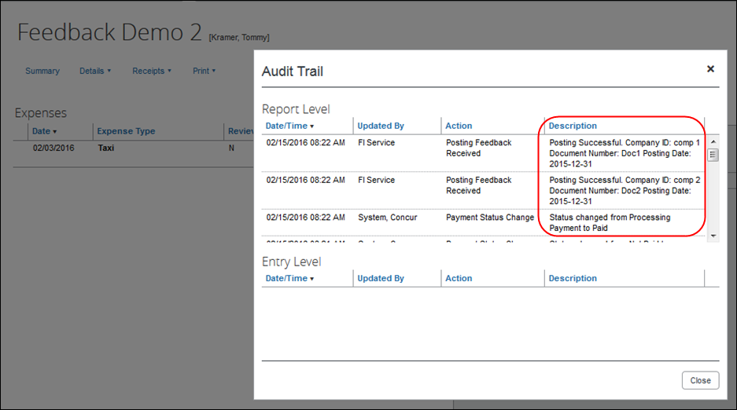

Process Reports Page
The Expense Processor approves the report for payment as usual. The user’s Expense group determines which reports are paid by the SAP ICS for SAP Business ByDesign. After approval, the expense report is placed in the financial posting queue. The integration timing and frequency are configurable per client, in SAP Business ByDesign. Once the financial posting is complete, the processor will see the posting feedback on the Process Reports page.
Reports that posted successfully will show the payment status Posted (if configured, otherwise the payment status will be Sent for Payment) and show the details of the financial posting in the audit trail. The audit trail message includes the Company ID, the Document ID, and the Posting Date.
Reports that failed to post will show an exception and the payment status Financial Posting Failed.
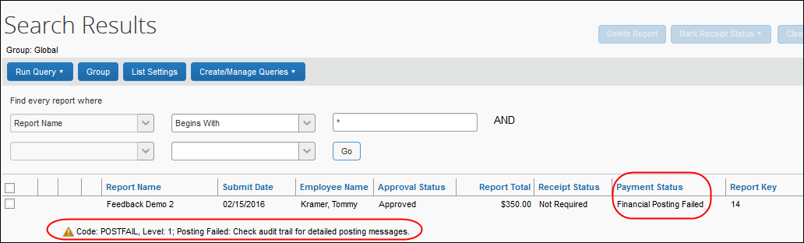
The processor can view the audit trail for the report to see the details of the posting failure. In this example, the report failed to post for two reasons. The audit trail message includes the Company ID, the Document ID, and the details of the failure.
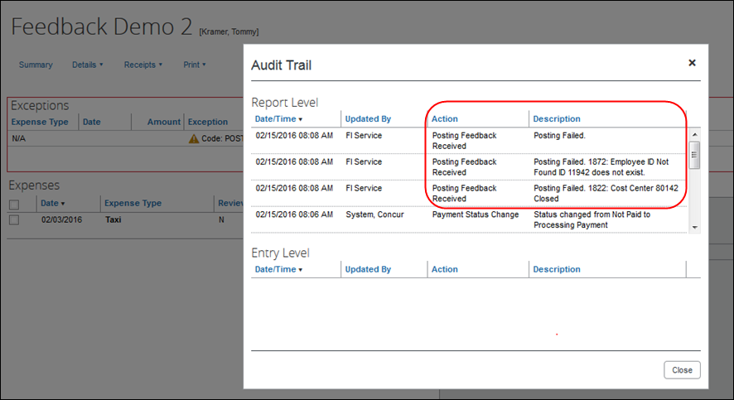
The processor recalls the report, in order to make changes to it.
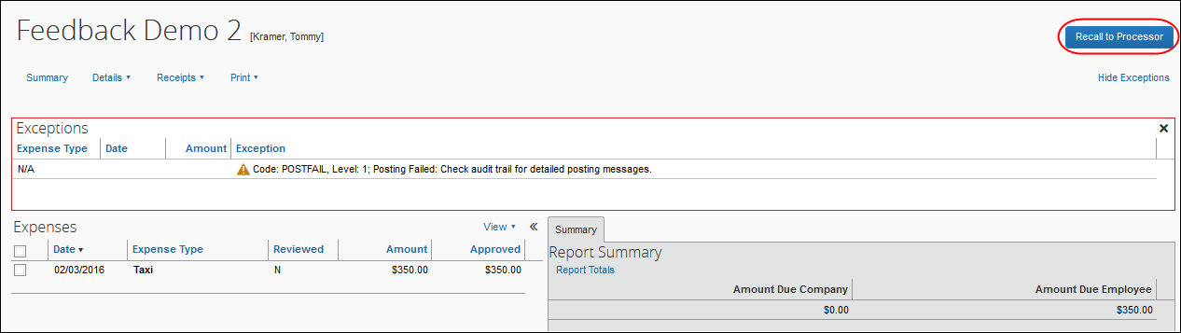
Then the processor works with the Concur Expense and SAP Business ByDesign accountant or administrator to resolve the issues. In this example, the SAP Business ByDesign administrator would manually trigger a replication of all changed employee records to update the user profiles in Concur Expense and the SAP Business ByDesign accountant could reopen the cost center. Alternately, the Concur Expense processor can send the expense report back to the employee who would then pick a different cost center for the cost allocation. Once the root causes for the posting error(s) have been fixed, the expense report can be submitted and approved again.
When the expense report is sent to the queue for financial posting, the employee information is pulled directly from the user’s profile. The integration does not use employee data that has been copied down into the expense report header or expense entry fields.
When the report is successfully posted, the integration sets the report’s payment status to Posted (if configured, otherwise the payment status will be Sent for Payment).
- For more information, refer to the 6.3.2.8 Step 8: (Optional) Rename the Payment Status from Sent for Payment to Posted section of this guide.
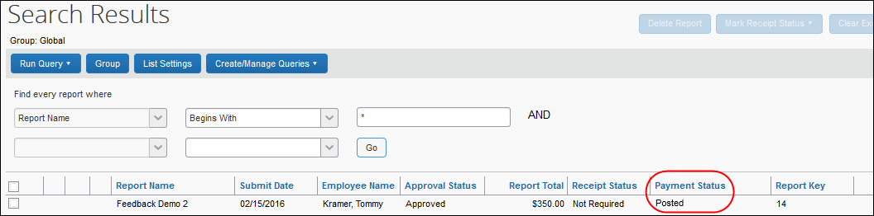
The processor can create a custom query to find reports that have financial integration enabled.
- For more information, refer to the 6.3.2.6 Step 6: Create the Processor Query section of this guide.

Financial Posting Failed Query
Concur Expense provides a query, Reports Financial Posting Failed, on the Process Reports page for clients with the integration. This query can be used by the processor to quickly locate all reports with the payment status of Financial Posting Failed.
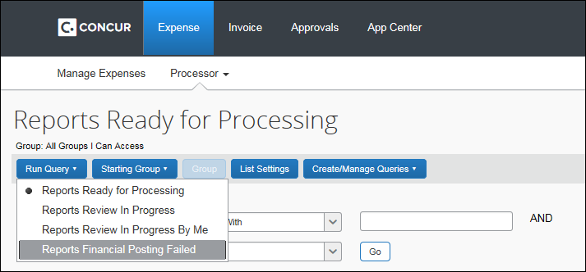

Financial Integration Enabled Column
A column labeled Financial Integration Enabled can be added to the Process Reports page, using the List Settings options.
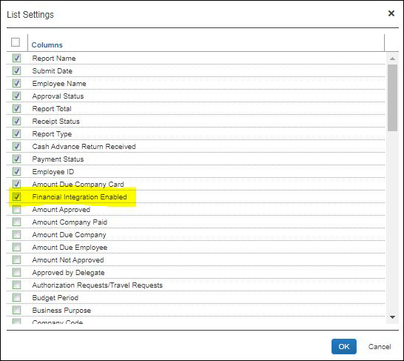
Once enabled, this column indicates which reports are configured to be processed using the Financial Integration Service.
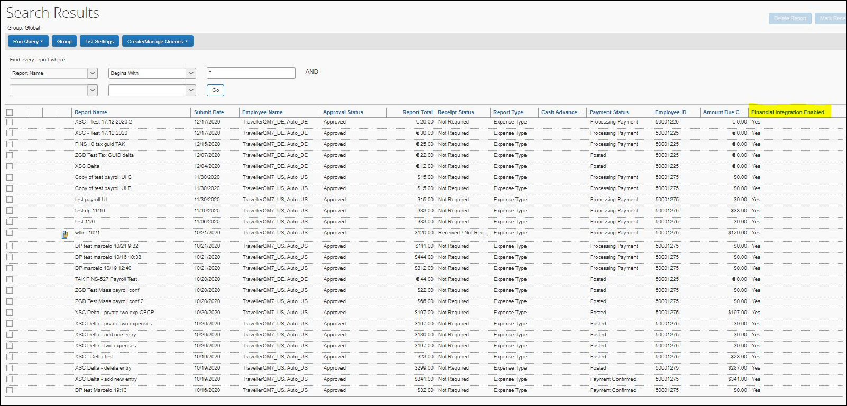

Cash Advance Admin Page
The Record Return Amount feature is not supported by financial integration. If financial integration is enabled, the Record Return Amount button will not appear on the Cash Advance Admin page.
The Cash Advance administrator creates and issues the advances as usual. The Cash Advance Admin page now includes an option for Failed Cash Advance status in the Cash Advance Status list.
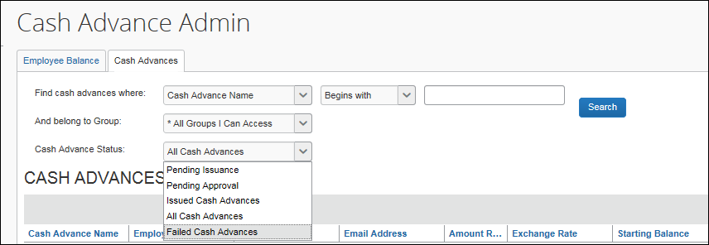
The page displays a new column, FI Status, when financial integration is enabled.
For any cash advances that are in the Failed status, the Cash Advance administrator can change some fields on the cash advance. The administrator clicks the cash advance name to view the details.
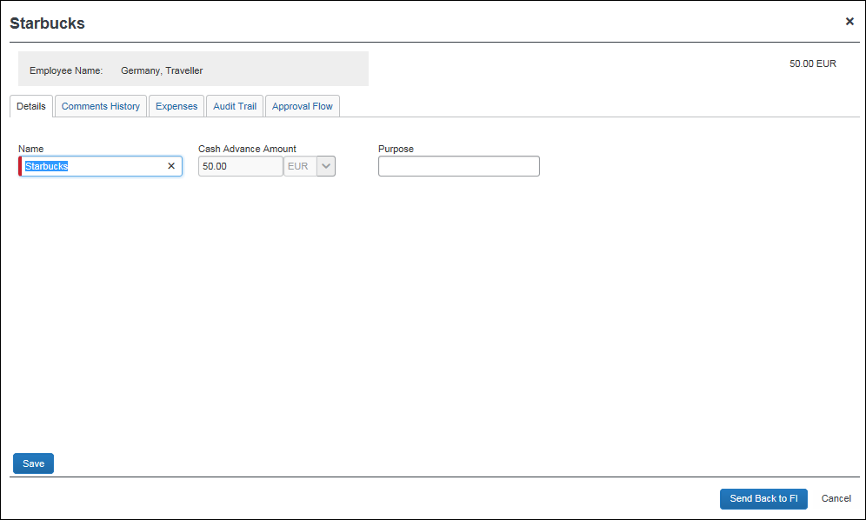
Once any incorrect field values are fixed, the Cash Advance administrator can resend the advance to the financial integration by clicking the Send Back to FI button.

Prerequisites

SAP Concur Prerequisites
The client must:
- Have signed a Data Protection Agreement (DPA)
- Be an existing SAP Concur client, with Concur Expense Professional/Premium Edition
- Be an existing SAP client, with SAP Business ByDesign
- The Concur Expense administrator who will be setting up the integration must have the unrestricted Expense Configuration Administrator user role

SAP Prerequisites
The SAP financial system prerequisites vary depending on the financial system you use. Refer to the 2.7 Available SAP Documentation section of this guide for the full details for SAP Business ByDesign.

Prior to SAP Business ByDesign Setup
Prior to beginning the configuration steps in SAP Business ByDesign, you should complete the following tasks in Concur Expense:
- Complete the 5.2 Integration Settings and Group Configuration and relevant 5.3 Concur Expense Configuration steps in this guide.
- Collect the following information from the Concur Expense system:
- Company Code custom field ID (varies by client)
- Field information for any fields that will be mapped to SAP Business ByDesign fields, including Concur Code values if necessary
- For more information, refer to the 6.3.1 Master Data Exchange Configuration section of this guide.
- Determine how frequently you want the integration to run. The master data exchange and financial integrations can be set to different schedules, if necessary. Schedule the replication runs in SAP Business ByDesign as described in the respective guide.
- The following information will be provided by your SAP Concur Implementation Consultant:
- Concur Company ID
- Authentication information for the integration

Configuration

Overview
The SAP ICS for SAP Business ByDesign installation/configuration requires configuration steps in both Concur Expense and SAP Business ByDesign. This guide contains information about the configuration and activation steps for the integration in Concur Expense.
- For information about the configuration in SAP Business ByDesign, refer to the 2.7 Available SAP Documentation section of this guide.

Integration Settings and Group Configuration
The SAP Concur Implementation consultant performs many, if not all, of the following steps, depending on the client’s SAP Concur configuration.

Step 1: Configure the Integration Settings
The SAP Concur Implementation consultant creates the Client ID (App ID) and Client Secret using the OAuth 2.0 Application Management tool.

Step 2: Configure Integration Gateway Authentication
The API gateway manages the access to the SAP Concur APIs. The authentication credentials for this gateway are configured using an SAP Concur Internal tool.
The SAP Concur Implementation consultant will provide the following authentication information for you to use in SAP Business ByDesign:
- Client ID (App ID)
- Client Secret
- Company UUID
- Request token
- Company ID

Step 3: Update Group Configurations
The SAP Concur administrator selects which users are reimbursed with the financial posting integration in Administration > Expense > Group Configurations.
This setting is only visible to SAP Concur Internal users who sign in to the company as ConcurAdmin from HMC.
For the desired expense groups, select the Enable Financial Integration setting.
Once this setting is selected, the expense reports for the group members that are approved for payment:
- Will begin to go to the Financial Integration queue
- Will not be included in any extract files
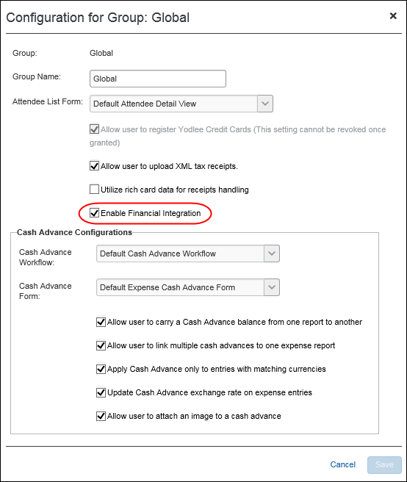

Concur Expense Configuration
Certain Concur Expense configurations are necessary to work with SAP Business ByDesign. The SAP Concur Implementation Consultant will review and configure these areas as necessary. The following is an overview of the configuration steps. The full details appear below.
Master Data Exchange configuration includes the following steps:
- Create a new list for the cost objects.
- Assign the cost object list to the necessary forms.
- Complete the integration configuration steps in SAP Business ByDesign.
Financial Posting configuration requires the following steps:
- Update all Expense Types with valid SAP Business ByDesign account codes.
- Update the Tax Configuration in SAP Concur.
- Configure an SAP Business ByDesign Clearing Account for the payment types in use.
- Verify the processor workflow step.
- Create the processor query.
- Update Expense Car form.
- (Optional) Rename the payment status from Sent for Payment to Posted.
- (Optional) Configure test users.

Master Data Exchange Configuration

Step 1: Create the Cost Objects List
The SAP Concur administrator creates a new cost object list for the integration. The list items and values will be sent from SAP Business ByDesign to Concur Expense once the SAP Business ByDesign system is configured.
The list structure SAP Business ByDesign will send contains the following levels:
- Level 1: Source system ID and source system name
- Level 2: Company ID and company name
- Level 3: Cost object type (CC = cost center, PRO = project task, SRV = service order item, SLS = Sales Order Items, CUST = Customer Contract Items) and description of the cost object type
- Level 4: Cost object ID and cost object name
Depending on client configuration, one of the following situations will apply:
- This is a net new installation and no connected list for cost objects has been created yet.
In Administration > Expense > List Management, create a new connected list, named ByDCostObject (required name). The client will enter this list name in the cost object replication configuration in SAP Business ByDesign.
- For more information, refer to the Shared: List Management Setup Guide.
- The client is already using a connected list for cost objects whose structure is compatible with the four levels described above.
Rename this list to ByDCostObject. The client will enter this list name in the cost object replication configuration in SAP Business ByDesign. For more details, refer to the chapter “Configure Companies and Cost Object Types for Cost Object Replication” in the SAP Business ByDesign and Concur Integration Guide.
- The client is already using a connected list for cost objects whose structure is not compatible with the four levels described above.
The client should discuss with an SAP Concur Technical Consultant the following options:
- Reconfiguration of Concur Expense to become compatible with the four-level list.
- Usage of SAP Cloud Platform Integration services (or any other middleware solution) to transform the four-level list coming from SAP Business ByDesign into the list format that is being used in Concur Expense.

Step 2: Assign the Cost Object List to the Forms
In Administration > Expense > Forms and Fields, add the new list to the following forms:
- Employee (the list should be added to the Employee form used by the Global group) The cost object list field Access Rights should be set to:
- Employee: Read-Only
- Employee Administrator Role: Modify
- All other roles: Read-Only or Hidden
- Expense Report Header (these list fields copy down from the Employee level) The cost object list field access rights should be set to Read-Only or Hidden for all user roles.
- Expense Report Allocation (these list fields copy down from the Report Header level) The cost object list field access rights should be set to Read-Only or Hidden for all user roles.
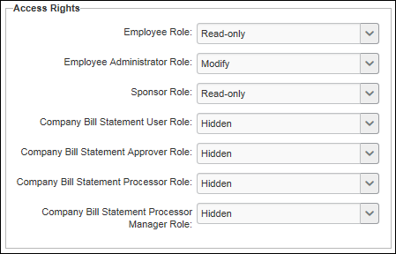
Configure the connected list definitions for the different form types. In Administration > Expense > Forms and Fields > Connected List Definitions, configure the connected list definition for the different for types.
For the Employee and Expense Report Header forms, map the connected list to the Org Unit 1-4 fields as follows:
Level 1 (Org Unit 1): Logical System
Level 2 (Org Unit 2): Company
Level 3 (Org Unit 3): Cost Object Type
Level 4 (Org Unit 4): Cost Object ID
For the Expense Allocation form, map the connected list to the Custom 1-4 fields as follows:
Level 1 (Custom 1): Logical System
Level 2 (Custom 2): Company
Level 3 (Custom 3): Cost Object Type
Level 4 (Custom 4): Cost Object ID
For the Expense Report Header form, select Copy Down as the Default Value Type, and choose the Employee field as the copy down source.
For the Expense Report Allocation form, select Copy Down as the Default Value Type, and choose the Report Header field as the copy down source.
In Administration > Expense > Policies, verify that the necessary policies use the updated forms.
- For more information, refer to the Expense: Forms and Fields Setup Guide and Expense: Policies Setup Guide.

Step 3: Complete the SAP Business ByDesign Configuration
For information about the configuration in SAP Business ByDesign, refer to the 2.7 Available SAP Documentation section of this guide.

Financial Posting Configuration

Step 1: Update all Expense Types With Valid SAP Account Codes
In Administration > Expense > Accounting Administration > Account Codes, assign valid SAP Business ByDesign codes to the expense types in use. Use the Group ID in the Groups for General Expenses ledger.
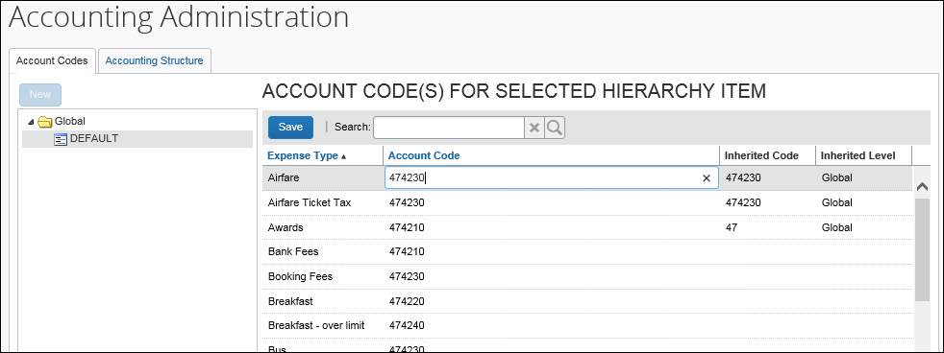
- For more information about the SAP Concur configuration, refer to the Expense: Account Codes Setup Guide.
- For more information about the SAP Business ByDesign configuration, refer to the section 2.7 Available SAP Documentation.

Step 2: Update Tax Configuration in SAP Concur
The Concur Expense Tax & Reclaim group functionality calculates VAT for the Receipt or No Receipt reclaim codes even when the Reclaim Amount is zero. This is incompatible with SAP Business ByDesign and must be accounted for in the Concur Expense tax configuration.
In Administration > Expense > Tax Administration > Tax & Reclaim Groups:
- Configure the tax authorities to include the Receipt and No Receipt reclaim codes only in the Zero tax group. This prevents Concur Expense from calculating any tax.
- Add the Personal Car Mileage expense type to the Zero tax group, as this expense type also calculates tax.
- Configure the Tax Reclaim Code to be the SAP Tax Code. For example, SAP Business ByDesign uses 1,2,3, etc.
SAP Business ByDesign will look at Tax Posted Amount, not Tax Reclaim Amount. If SAP Business ByDesign is not expecting tax (perhaps because the receipt status is “Receipt” instead of “No Receipt”) the posting will fail if an amount has been calculated in the Tax Reclaim Amount.
- For more information, refer to the Expense: Value Added Tax (VAT)/ Tax Administration Setup Guide.
- For more information about the SAP Business ByDesign configuration, refer to the section 2.7 Available SAP Documentation.

Enable the Non-Domestic Tax Feature
Complete these configuration steps if the company captures VAT.
In Administration > Expense > Site Settings, select (enable) the Non Domestic Tax Enabled check box. Set the Non Domestic Tax Field to Custom 38.
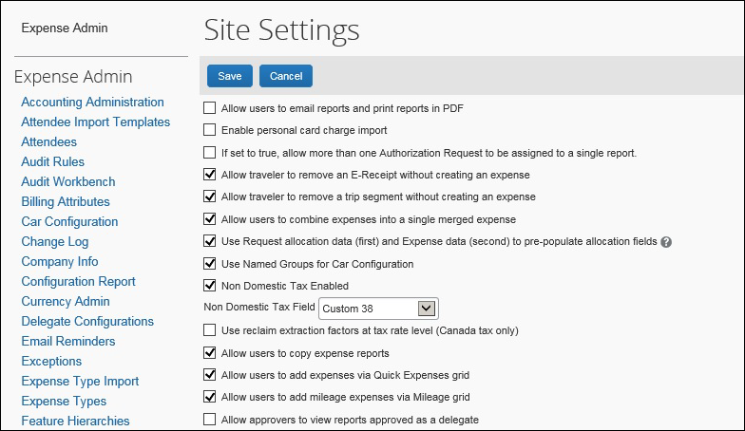
In Administration > Expense > Tax Administration > Tax Authorities, enter your Non Domestic Code. When the two site settings above are configured, this code will be applied to non-domestic spend.
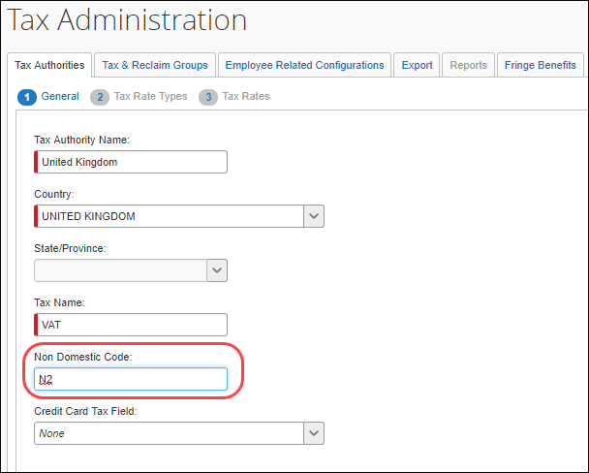
In Administration > Expense > Tax Administration > Employee Related Configurations, select (enable) the Only Calculate Domestic check box for those countries where you have entered a Non-Domestic Code.
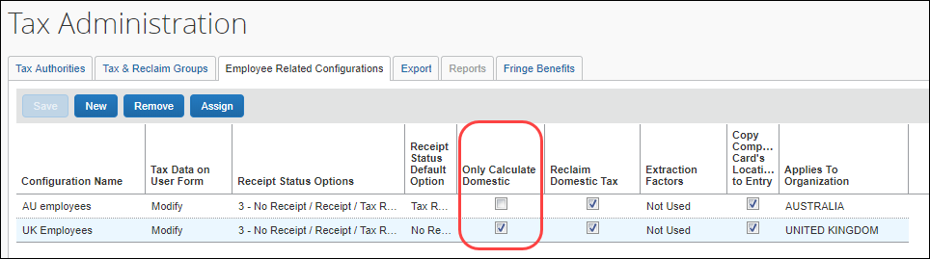

Step 3: Configure all SAP Business ByDesign Clearing Accounts

Configure Payment Types
In Administration > Expense > Payment Types, enter the SAP Business ByDesign Clearing Account Code for any Company Paid payment types.
IBCP and Offsets are not supported by this integration.
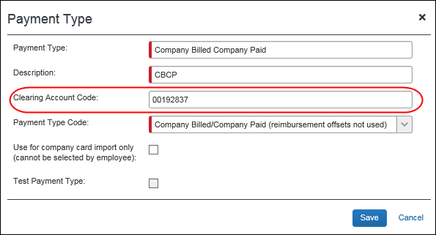
- For more information, refer to the Expense: Payment Types Setup Guide.
- For more information about the SAP Business ByDesign configuration, refer to the section 2.7 Available SAP Documentation.

Configure Company Card Accounts
If you have Clearing Accounts that apply to specific individual cards, on the Manage Accounts tab of the Company Card Admin page, modify all CBCP card accounts to have a valid SAP Business ByDesign Clearing Account Code.
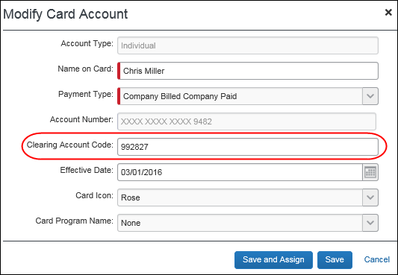
- For more information, refer to the Expense: Company Card Admin User Guide.

Step 4: Verify the Processor Workflow Step
In Administration > Expense > Workflows, verify that the workflow contains a processor step prior to the Processing Payment step. All employees using the SAP ICS financial posting must have an expense report workflow that includes a Processor step after approval. This allows the reports to return to the processor if they fail the financial posting. The Processor workflow step may be configured as a skip step, if necessary.
- For more information, refer to the Expense: Workflow – General Information Setup Guide.

Step 5: Create the Processor Query
In Expense > Process Reports, create a processor query to find reports using the financial integration, using the Report data object, and the Financial Integration Enabled field. This query finds all reports using financial integration, regardless of status.
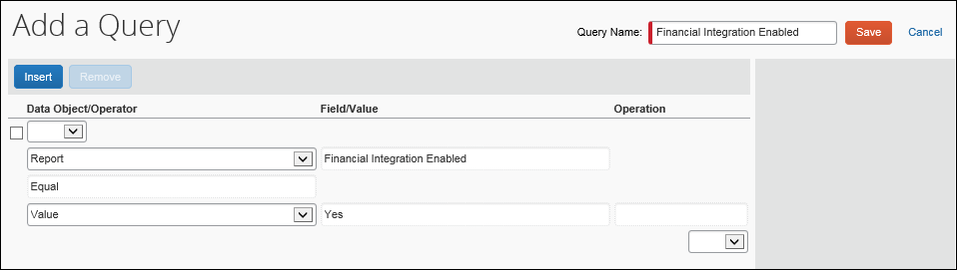
The Financial Integration adds a new default query to the Process Reports page, titled Reports Financial Posting Failed, which is used to view reports that failed to post.

Step 6: Update Expense Car Form
In Administration > Expense > Forms and Fields, update the Expense Car form to include the City of Purchase field.
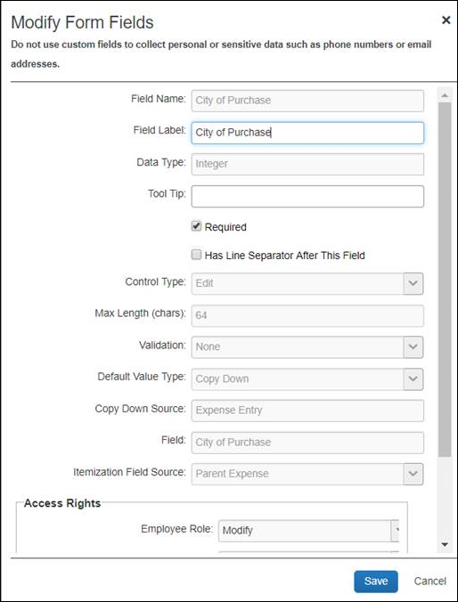
- For more information, refer to the Expense: Forms and Fields Setup Guide.

Step 7: (Optional) Rename the Payment Status from Sent for Payment to Posted
In Administration > Expense > Workflows > Expense Report Approval Statuses, update the existing Sent for Payment status as follows:
Field | Value
Status | Posted
Action Text | Post
Description | Report has been posted to financial system
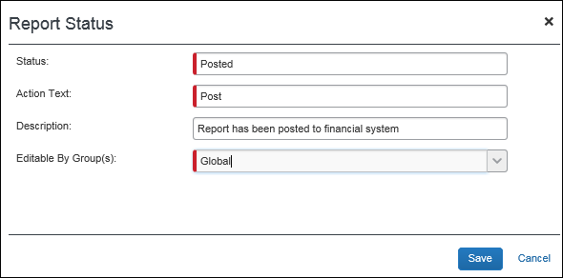
- For more information, refer to the Expense: Workflow – General Information Setup Guide.

Step 9: (Optional) Configure Test Users
Users who are configured as test users can be used to test the integration. Any reports from test users will be sent to the SAP Business ByDesign test system rather than production.
In Administration > Company > Company Admin > User Adminstration > User Information, the administrator creates the users and selects the Is a Test User check box for the test user accounts. The test users can then be configured to use the integration, including adding them to the SAP Business ByDesign system.
- For more information, refer to the Shared: Test User Setup Guide and 2.7 Available SAP Documentation.

Creating a Support Case

Reviewing the Audit Trail
Before creating a support case, review the report/advance audit trail to determine the cause of the error.
For expense reports and cash advances, click Details > Audit Trail to view the audit trail.
Most issues result from incorrect account codes or vendor codes. Compare your Concur Expense configuration with the SAP Business ByDesign system configuration to verify that the codes are correct.
If no information appears in the audit trail, but the financial document does not show in SAP Business ByDesign, create a support case.

Creating a Support Case
The SAP ICS for SAP Business ByDesign connects your Concur Expense and SAP Business ByDesign systems and is therefore supported by both SAP Concur and SAP.
To avoid unnecessary delays during incident handling, please proceed as follows:
In which system does the problem originate?
- SAP: If you suspect the cause is in SAP Business ByDesign, create a support ticket as described in the respective SAP integration setup guide, or in this SAP Note: 1296527 - How to create a support incident (contact SAP Product Support) - SAP ONE Support Launchpad - SAP ONE Support Launchpad
If the issue relates to Concur Expense after all, the SAP support team opens a case in the Concur Expense support system. The new case is created under the authorized support contact (ASC) for Concur Expense, with the original ticket owner copied. The original SAP ticket is closed with a reference to the Concur Expense system and the email address of the person who initially created the ticket. The email address is needed to keep the ticket creator informed about the status.
- Concur Expense: If you suspect the cause is in the Concur Expense system and you are the Concur Expense Administrator, create a support case by navigating to Help > Contact Support in Concur Expense. If you are not an ASC for Concur Expense, contact your Concur Expense Administrator, who will create the Support case for SAP Concur Support to manage. The ASC is able to add you as a cc on the case so you can track the case status.
- If you are not sure what is causing the problem, please create the ticket in the SAP system first, following the instructions above.
In your support ticket, include the following information:
- Expected behavior of the integration
- Actual behavior of the integration
- Time and date of the issue
- Expense Report ID, Cash Advance Name, or Employee ID, if applicable

Deactivating the Integration
Create a support case to deactivate the integration. This step should only be performed when replacing the integration or retiring the SAP ICS for SAP Business ByDesign.
☼

