SAP Concur Release Notes
Concur Expense Professional / Premium
Month | Audience
Release Date: March 23, 2024  Initial Post: March 22, 2024 | Client FINAL

Contents
Release Notes 1
Expense Pay 1
Additional AMEX Corporate Card Programs Now Supported for Europe 1
Verify 3
Audit Profile: Quick Start Profiles 3
Traveler Name Check Update 4
Planned Changes 6
Company Card 6
**Planned Changes** Enhancements to the Manage Transactions Screen 6
**Planned Changes** Updates to New Card Account Pending Assignment Email 8
Expense Pay 10
**Planned Changes** Enhanced User Interface in Payment Manager 10
Localization 11
**Planned Changes** Removal of Expense Types Descriptions 11
Miscellaneous 13
**Planned Changes** Keyboard Shortcuts for Expense Screens 13
Reports 15
**Planned Changes** Preferred Name for Expense Submitter 15
Client Notifications 16
Accessibility 16
Accessibility Updates 16
Gender Diversity 16
Gender Diversity Planned Features and Changes 16
In-Product User Assistance 16
Client Customized Content 16
Subprocessors 17
SAP Concur Non-Affiliated Subprocessors 17
Supported Browsers 17
Supported Browsers and Changes to Support 17
Additional Release Notes and Other Technical Documentation 18
Online Help 18
SAP Concur Support Portal – Selected Users 18
Cases 19
Check Support Case Status 19

Legal Disclaimer
The information in this presentation is confidential and proprietary to SAP SE or an SAP affiliate company and may not be disclosed without the permission of SAP SE or the respective SAP affiliate company. This presentation is not subject to your license agreement or any other service or subscription agreement with SAP SE or its affiliated companies. SAP SE and its affiliated companies have no obligation to pursue any course of business outlined in this document or any related presentation, or to develop or release any functionality mentioned therein. This document, or any related presentation and SAP SE or an SAP affiliate company’s strategy and possible future developments, products and or platforms directions and functionality are all subject to change and may be changed by SAP SE and its affiliated companies at any time for any reason without notice. The information in this document is not a commitment, promise or legal obligation to deliver any material, code or functionality. This document is provided without a warranty of any kind, either express or implied, including but not limited to, the implied warranties of merchantability, fitness for a particular purpose, or non-infringement. This document is for informational purposes and may not be incorporated into a contract. SAP SE and its affiliated companies assume no responsibility for errors or omissions in this document, except if such damages were caused by SAP SE or an SAP affiliate company’s willful misconduct or gross negligence.
All forward-looking statements are subject to various risks and uncertainties that could cause actual results to differ materially from expectations. Readers are cautioned not to place undue reliance on these forward-looking statements, which speak only as of their dates, and they should not be relied upon in making purchasing decisions.

Release Notes
This document contains the release notes for Concur Expense professional edition.
Features and changes that apply to SAP Concur site-wide or to multiple products/services are documented in the Shared Changes Release Notes. For information about site-wide or shared changes in this release that might impact your SAP Concur solutions, refer to the Shared Changes Release Notes.

Expense Pay

Additional AMEX Corporate Card Programs Now Supported for Europe

Overview
Expense Payment Manager now supports reimbursement for the following AMEX corporate credit card programs issued out of Europe:
- American Express – EMEA – Czechia (CZK)
- American Express – EMEA – Norway (NOK)
- American Express – EMEA – Poland (PLN)

Business Purpose / Client Benefit
This update allows end users to automate the reimbursement process for corporate AMEX cards in these countries/currencies and can expedite the processing of credit card expenses.

Administrator Experience
These additional credit card programs are available to reimbursement admins on the Manager > Configure Batches > Card Programs (tab) > Add New Card Program page.
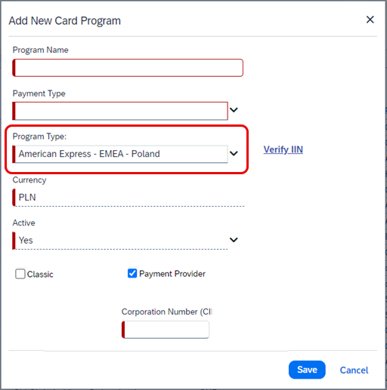

End-User Experience
You will have to setup the card program and configure a card batch in the Configure Batches area of Payment Manager. To complete setting up the card program, request the Corporation Number (CID) from your AMEX representative, to enter in the corresponding field when setting up the card program.

Configuration / Feature Activation
The change occurs automatically; there are no additional configuration steps.

Verify

Audit Profile: Quick Start Profiles

Overview
Currently, users manually configure Checks when creating Audit Profiles. From March 22 to March 24, a new feature will be available. Users can select Add Essential Checks to expedite the creation of profiles. This change will also be applicable to existing profiles where previously no checks were added.

Business Purpose / Client Benefit
This feature is being introduced to streamline the profile creation process and to avoid inconsistencies in different user profiles.

Administrator Experience
Currently, when a profile is being created, a user must select Add Check and add each check to the profile individually. This new feature enhances efficiency by adding default checks to each profile. Existing profiles which currently have no checks included, can also have checks added by clicking Add Essential Checks.
Selecting Add Essential Checks automatically adds the following checks to the profile:
- Incorrect Date
- Incorrect Amount
- Illegible receipt
- Expense type
- Duplicate receipt
Example
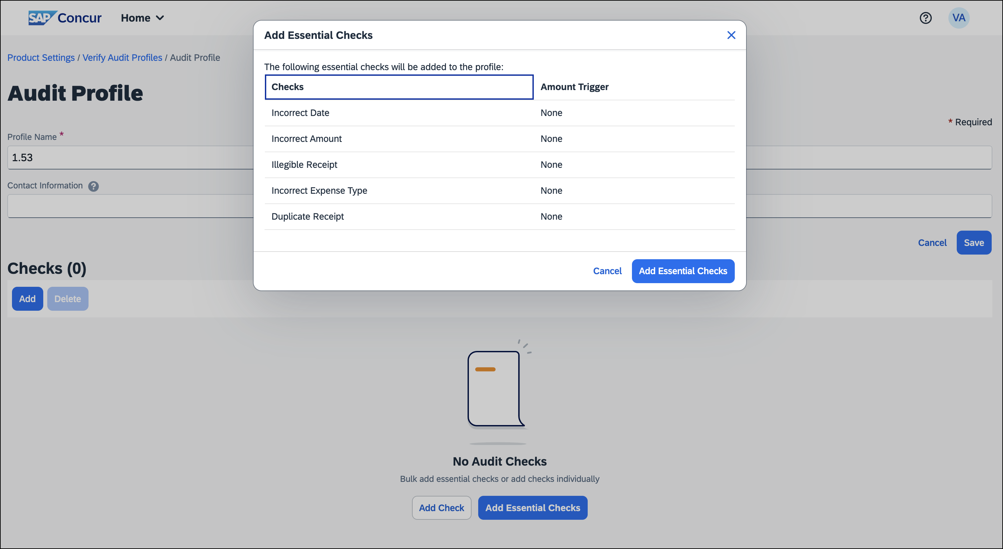
Check values can also be updated by the administrator at any time, after these essential checks are added.

Configuration / Feature Activation
The change occurs automatically; there are no additional configuration steps.

Traveler Name Check Update

Overview
Currently, the description of the traveler name check indicates that SAP Concur validates for an exact match of the traveler’s name on the receipt. However, the check only confirms the presence of a traveler name.
SAP Concur will update the descriptions to accurately represent the true function of this check.

Business Purpose / Client Benefit
This change is being made to align the description with the functionality of the check.

Administrator Experience
Between March 22 and March 24, SAP Concur will update the check description of Traveler Name check to better reflect its functionality. This ensures the information provided matches the actual validation of the check.
Previously, the description read “We review the receipt and attempt to determine the traveler name. We compare the name on the receipt to the name from the expense report and will raise an exception if we suspect they don't match.”
The updated description will read “We review the receipt and attempt to identify if a traveler name is present. We will raise an exception if a name is not present.”

Configuration / Feature Activation
The change occurs automatically; there are no additional configuration steps.

Planned Changes
The items in this section are targeted for future releases. SAP Concur reserves the right to postpone implementation of – or completely remove – any enhancement/change mentioned here.
The planned changes listed in this document are specific to this product. For information about planned site-wide or shared changes that might impact your SAP Concur solutions, refer to the Shared Changes Release Notes.

Company Card

**Planned Changes** Enhancements to the Manage Transactions Screen

Information First Published | Information Last Modified | Feature Target Release Date
March 2024 | -- | April 14, 2024
Any changes since the previous monthly release are highlighted in yellow in this release note.

Overview
On April 14th, enhancements to the Manage Transactions screen will be available to the Company Card administrator for evaluation. These changes will be visible by default and the administrator may work with the new user interface and then decide to revert to the earlier version or continue with the newer version which will become the default user interface in an upcoming release.
More feature information will be available in an upcoming release note.

Business Purpose / Client Benefit
This feature improves the company card experience by automatically displaying search results from the previous 30 days with the ability to perform a more complex search that displays hidden, visible, duplicate, and expensed transactions in a column order view familiar to administrators working in a financial statement format.

Administrator Experience
The Company Card administrator will see the simple search format of employee transactions of the previous 30 days. Transactions that are both hidden and visible to employees (including transactions that are already on an expense report) will be returned.
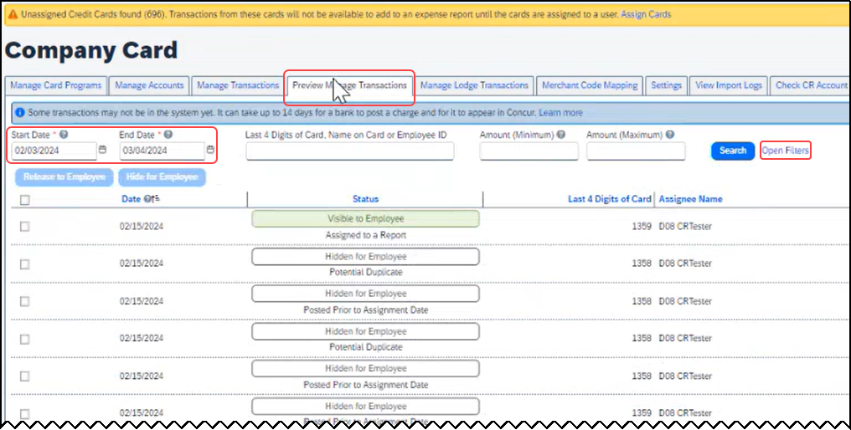
From this simple format, the administrator clicks Open Filters to refine the search:
The Last 4 Digits… search now combines the logic for all the potential typed values:
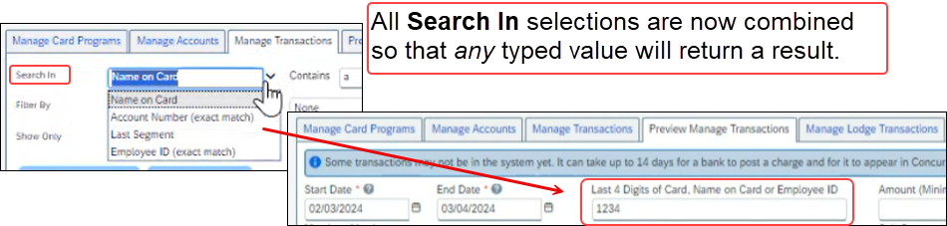
Duplicate transactions are displayed using the Potential Duplicate attribute, and the informational window includes a link to release the transaction to the employee:
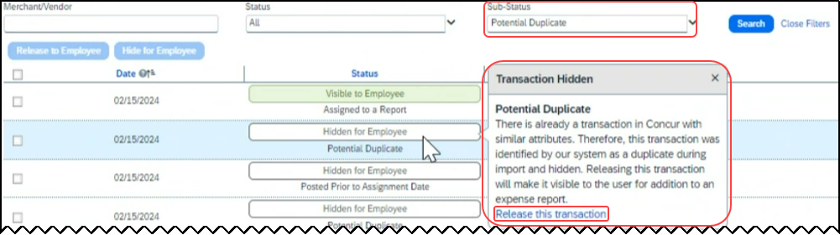
Transactions both already assigned to a report or posted prior to assignment date are clearly marked. For some status types, hovering a cursor opens an informational window describing the condition, action, and links to take action as needed:
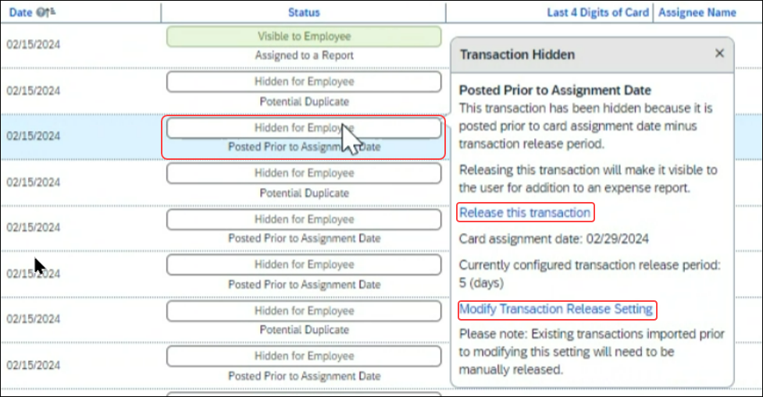

Moving Between the Two Manage Transactions Windows
In the figures above both the Manage Transactions and Preview Manage Transactions tabs are shown for clarity. Only a single tab will be displayed for the benefit of the administrator, who may move from the new user interface to the original interface using the Revert to prior experience link.

Configuration / Feature Activation
The change to the new user interface is visible by default and the administrator may revert to the original interface as needed. Note the new interface will display at any time the administrator moves from the screen and back again in a single session.

**Planned Changes** Updates to New Card Account Pending Assignment Email

Information First Published | Information Last Modified | Feature Target Release Date
March 2024 | -- | April 4, 2024
Any changes since the previous monthly release are highlighted in yellow in this release note.

Overview
On April 4th, the email notifying the client of unassigned card accounts that require assignment will be changed. At that time, the text will be modified and a link to assign the accounts will be provided directly in the body of the email.

Business Purpose / Client Benefit
This feature improves the company card experience by clearly describing the error, the required action, and directing the administrator to the page using a link.

Administrator Experience
The Company Card administrator will see a modified email detailing the results of the card import.
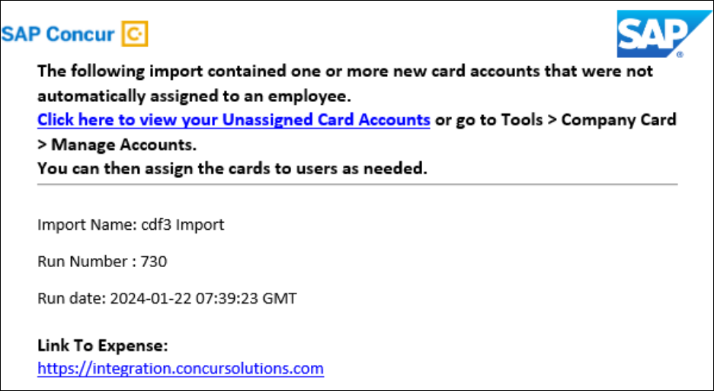
In that email, modified text explaining that the import has unassigned card accounts that require assignment will be seen and a link that opens the Manage Accounts page where the unassigned accounts are listed will be available.
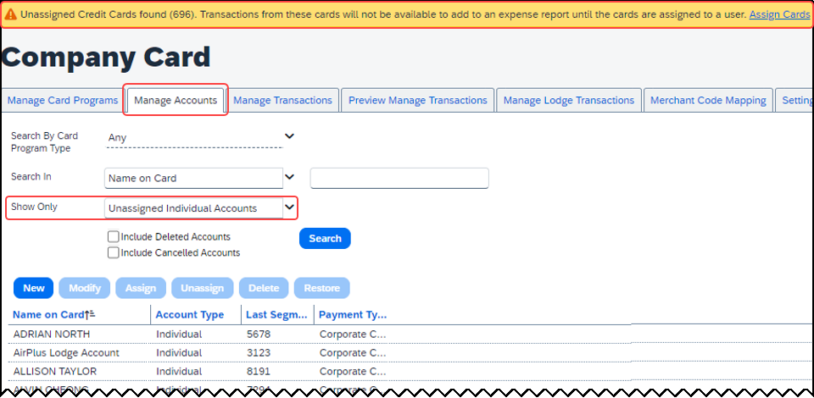
Clicking Assign Cards (upper-right corner) lets the administrator begin this task.

Configuration / Feature Activation
The change will occur automatically; there are no additional configuration steps.

Expense Pay

**Planned Changes** Enhanced User Interface in Payment Manager

Information First Published | Information Last Modified | Feature Target Release Date
March 2024 | -- | April 2024
Any changes since the previous monthly release are highlighted in yellow in this release note.

Overview
In an upcoming release, SAP Concur will enhance the Funding Accounts and View Funding screens to provide easier access to relevant information and to remove outdated elements from the user interface.

Business Purpose / Client Benefit
This feature will provide faster access to relevant information on screen in a simplified manner and reduces the number of clicks required to view the necessary information.

Administrator Experience
Navigate to the Payment Manager > Configure Batches > Funding Account screen to see the following updates:
- The Bank ID column will display the term Provider Account instead of Global Account.
- The Account Number column will not be populated with the Provider Account ID for Convera accounts.
- Removed the following columns: Pay Cycle, Funding Type, On Hold, Active Date, and Test as they are no longer in use or don't provide useful information.
- Added a new column labeled Provider. It will display the provider name Worldline or Convera, based on which provider was selected in the account.
Navigate to the Payment Manager > Monitor Batches > View Funding screen to see the following updates:
- Rearranged the Global Funding tab to be placed first as it contains more relevant information. The other two tabs Direct Debit and Pre Fund are no longer in use and hence, they will be removed from the UI.
- The Global Funding tab will be renamed to Provider Funding Amounts.
- The Bank Statements tab will be removed as it will not be in use any longer.

Configuration / Feature Activation
The change occurs automatically; there are no additional configuration steps.

Localization

**Planned Changes** Removal of Expense Types Descriptions

Information First Published | Information Last Modified | Feature Target Release Date
March 2024 | -- | April 12, 2024
Any changes since the previous monthly release are highlighted in yellow in this release note.

Overview
As of April 12th, 2024, SAP Concur will deprecate the descriptions for expense types. Currently, there is no possibility to set the descriptions for expense types in the Concur user interface or APIs, but these descriptions do display in the Localization tab in Concur Expense settings.
However, the localized text is not used within SAP Concur.

Business Purpose / Client Benefit
This feature prepares the client who uses the localization area for expense types for future feature enhancements.

Administrator Experience
In the Administration > Expense > Expense Admin > Localization tab, administrators will no longer see the contents in the Description and Source Value columns. All default descriptions (and any translated values) will be removed.
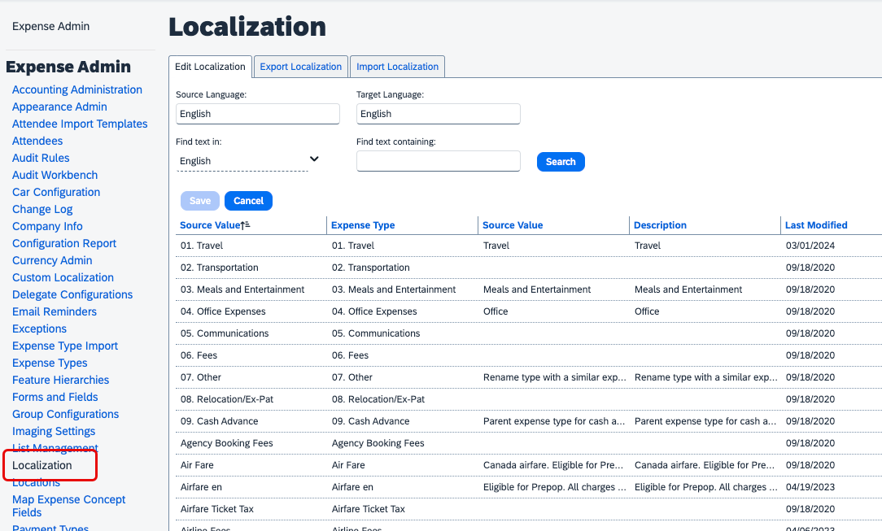
Administrators must save any translations or texts that was used in the localization area for expense types.

Configuration / Feature Activation
The change occurs automatically; there are no additional configuration steps.

Miscellaneous

**Planned Changes** Keyboard Shortcuts for Expense Screens
Information First Published | Information Last Modified | Feature Target Release Date
March 8, 2024 | -- | March 26, 2024
Any changes since the previous monthly release are highlighted in yellow in this release note.

Overview
Targeted for March 26th, 2024, SAP Concur will enable convenient keyboard shortcuts in selective Concur Expense screens such as Expense Home, Report Page, and Expense Entry Page.
This feature will currently be available in English only.

Business Purpose / Client Benefit
This update will offer users a more convenient way to navigate the expense application faster, ultimately improving productivity, efficiency, and user satisfaction.

End-User Experience
On selective Expense screens such as Expense Home, Report Page, and Expense Entry Page, press SHIFT + / to view the available shortcuts and to toggle the keyboard shortcuts ON or OFF.
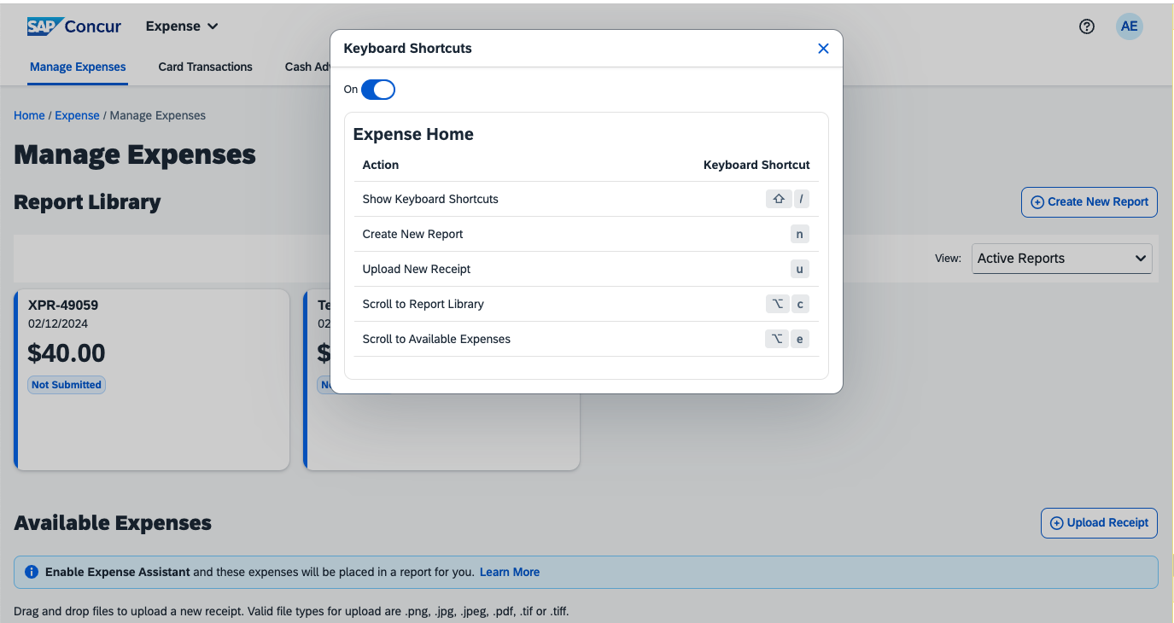
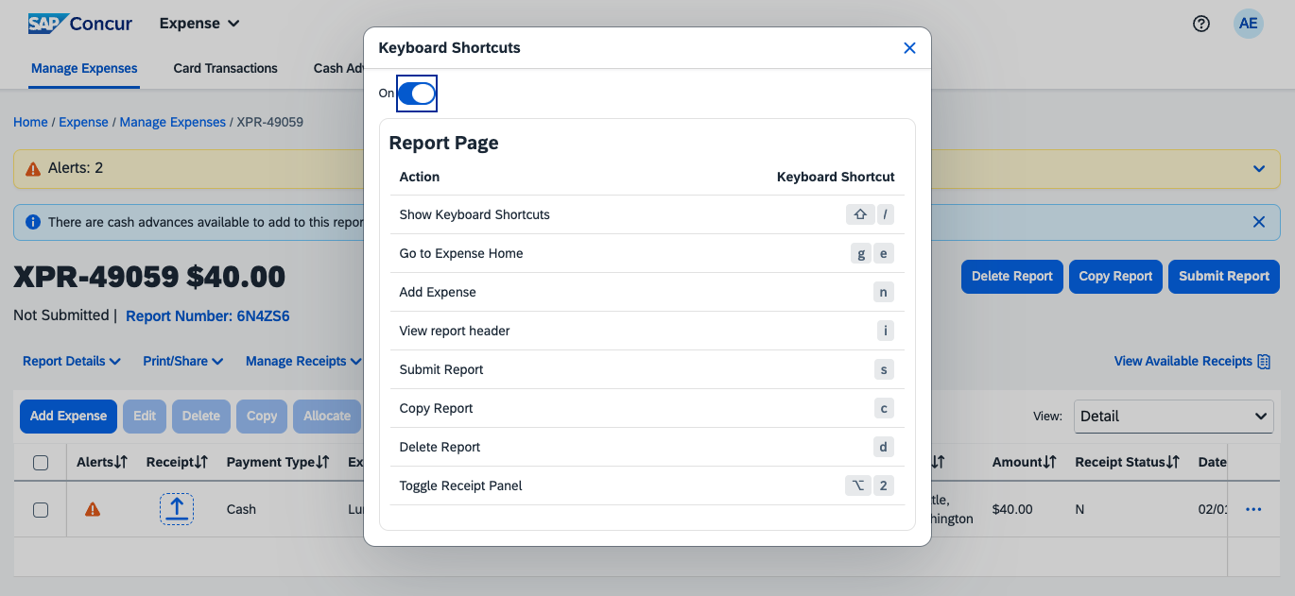
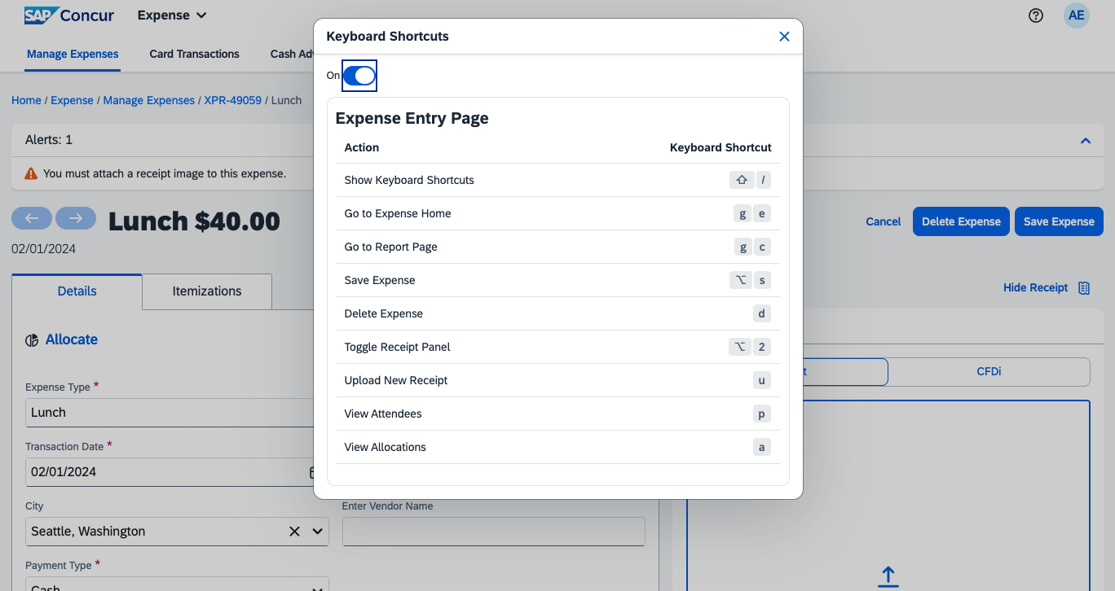

Configuration / Feature Activation
The change occurs automatically; there are no additional configuration steps.

Reports

**Planned Changes** Preferred Name for Expense Submitter
Information First Published | Information Last Modified | Feature Target Release Date
March 15, 2024 | -- | Q2, 2024
Any changes since the previous monthly release are highlighted in yellow in this release note.

Overview
Targeted for the second quarter of 2024, Concur Expense will support preferred names for users submitting expenses. The users will be able to view the preferred name that has been setup for approvers, company attendees, and other elements that display a name field, if the preferred name has been configured for the user.
Today, in Concur Expense, users can set a preferred name for themselves. In the second quarter of 2024, Concur will display the preferred name for approvers, company attendees, and other names that an expense submitter will see in the system.
For example, if a user with expense approver permissions has specified a preferred name, this preferred name will display to users submitting expenses, when selecting an approver, or when viewing the timeline for an expense report.
Similarly, if another user in the same company has specified a preferred name in Concur Expense, an expense submitter will see the preferred name when searching for an attendee, and when the user has been added as an attendee to an expense.

Benefit
This update will offer users the flexibility to set up their own preferred names at work, compared to using their given first names and improves user satisfaction.

End-User Experience
The user who is an expense submitter will see the preferred names that is configured for other employees that they interact with in the system, if their locale supports preferred name. This preferred name will appear in places where the users may have seen the given name of the employee previously.

Configuration / Feature Activation
The change occurs automatically; there are no additional configuration steps.

Client Notifications

Accessibility

Accessibility Updates
SAP implements changes to better meet current Web Content Accessibility Guidelines (WCAG). Information about accessibility-related changes made to SAP Concur solutions is published on a quarterly basis. You can review the quarterly updates on the Accessibility Updates page.

Gender Diversity

Gender Diversity Planned Features and Changes
SAP Concur is committed to supporting gender diversity. Over time we plan to implement product changes to help ensure that SAP Concur solutions support gender non-binary users. These changes will include but are not limited to support for preferred names, non-binary gender options in travel preferences, and non-binary titles.
These planned changes reflect SAP's commitment to supporting gender diversity and enable gender non-binary users to enter consistent information when making travel arrangements and entering personal information into SAP Concur solutions.
Timelines and details about these ongoing changes will be provided in the SAP Concur release notes.

In-Product User Assistance

Client Customized Content
If your company creates customized content for SAP Concur solutions through a user assistance tool such as SAP Enable Now or Concur User Assistant by WalkMe, the changes described in these release notes might affect your customized content. SAP Concur recommends reviewing the monthly release notes for all of your SAP Concur solutions as well as the Shared Changes Release Notes to confirm whether any of the planned or released changes might impact your internal, customized content.
If any changes in a release impact your content, work with your internal teams to update your content accordingly.

Subprocessors

SAP Concur Non-Affiliated Subprocessors
The list of non-affiliated subprocessors is available from the SAP Sub-processors / Data Transfer Factsheets page.
To access the SAP Concur Sub-processors List:
- Click the following link to navigate to the SAP Sub-processors / Data Transfer Factsheets page:
SAP Sub-processors / Data Transfer Factsheets
- Sign in to the SAP Support Portal using your Support User ID (S-user) and password.
SAP customers must sign in to the SAP Support Portal using their Support User ID (S-user) and password. For information about S-User IDs, refer to Your New Support User ID (S-user) and to the Learn All About S-User IDs blog post.
- On the SAP Sub-processors / Data Transfer Factsheets page, type "Concur" in the Search field.
- In the Title column, click SAP Concur Sub-processors List.
If you have questions or comments, please reach out to: Privacy-Request@Concur.com

Supported Browsers

Supported Browsers and Changes to Support
For information about supported browsers and planned changes to supported browsers, refer to the Concur Travel & Expense Supported Configurations guide.
When changes to browser support are planned, information about those changes will also appear in the Shared Changes Release Notes.

Additional Release Notes and Other Technical Documentation

Online Help
You can access release notes, setup guides, user guides, admin summaries, supported configurations, and other resources via the in-product Help menu or directly on the SAP Help Portal.
To access the full set of documentation for your product, use the links in the SAP Concur Help menu, or visit the SAP Concur solutions page.
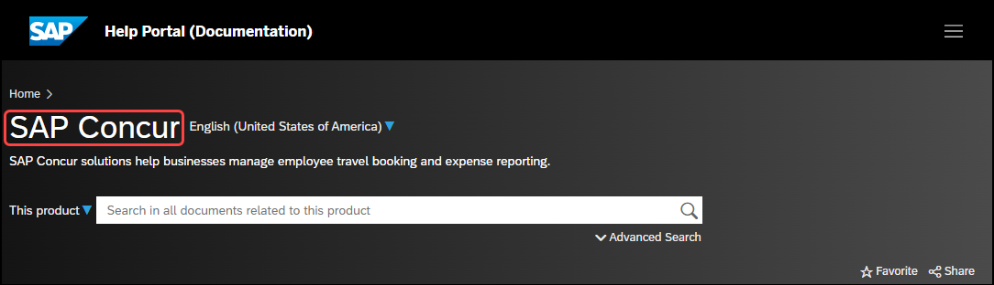

SAP Concur Support Portal – Selected Users
Access release notes, webinars, and other technical documentation on the SAP Concur support portal.
If you have the required permissions, Contact Support is available on the SAP Concur Help menu, and in the SAP Concur page footer.
Click Contact Support to access the SAP Concur support portal, then click Resources.
- Click Release/Tech Info for release notes, technical documents, etc.
- Click Webinars for recorded and live webinars.

Cases

Check Support Case Status
The steps in this procedure provide instructions for checking whether a case is resolved.
To check the status of a submitted case
- Log on to https://concursolutions.com/portal.asp.
- Click Help > Contact Support.
If you do not have the option to contact SAP Concur support under the Help menu, then your company has chosen to support the SAP Concur service internally. Please contact your internal support desk for assistance.
- Click Support > View Cases.
- In the table, view the desired type of cases based on the View list selection. Search results are limited to each company's own cases.

© 2024 SAP SE or an SAP affiliate company. All rights reserved.
No part of this publication may be reproduced or transmitted in any form or for any purpose without the express permission of SAP SE or an SAP affiliate company.
SAP and other SAP products and services mentioned herein as well as their respective logos are trademarks or registered trademarks of SAP SE (or an SAP affiliate company) in Germany and other countries. Please see http://global12.sap.com/corporate-en/legal/copyright/index.epx for additional trademark information and notices.
Some software products marketed by SAP SE and its distributors contain proprietary software components of other software vendors.
National product specifications may vary.
These materials are provided by SAP SE or an SAP affiliate company for informational purposes only, without representation or warranty of any kind, and SAP SE or its affiliated companies shall not be liable for errors or omissions with respect to the materials. The only warranties for SAP SE or SAP affiliate company products and services are those that are set forth in the express warranty statements accompanying such products and services, if any. Nothing herein should be construed as constituting an additional warranty.
In particular, SAP SE or its affiliated companies have no obligation to pursue any course of business outlined in this document or any related presentation, or to develop or release any functionality mentioned therein. This document, or any related presentation, and SAP SE’s or its affiliated companies’ strategy and possible future developments, products, and/or platform directions and functionality are all subject to change and may be changed by SAP SE or its affiliated companies at any time for any reason without notice. The information in this document is not a commitment, promise, or legal obligation to deliver any material, code, or functionality. All forward-looking statements are subject to various risks and uncertainties that could cause actual results to differ materially from expectations. Readers are cautioned not to place undue reliance on these forward-looking statements, which speak only as of their dates, and they should not be relied upon in making purchasing decisions.

