SAP Concur Release Notes
Concur Expense Professional / Premium
Month | Audience
Release Date: February 24, 2024  Initial Post: February 23, 2024 | Client FINAL

Contents
Release Notes 1
Cards 1
Retirement of Batch File Option for Unsupported Card Programs 1
Yodlee Reauthentication Refresh Frequency 2
Expense Types 3
Recovering And Displaying Deactivated Expense Types 3
Mileage Service 5
Delegate Administrator May Reset Initial Distance Mileage for Personal Car 5
Miscellaneous 6
Enhancing Additional Fields with Most Recently Used (MRU) Feature 6
New Action Column Available in Expense Screens 7
Update to the Report Status Indicator 10
Planned Changes 11
Cash Advance 11
**Planned Changes** FIS / ICS Client Cash Advance Improvements 11
Client Notifications 13
Accessibility 13
Accessibility Updates 13
Gender Diversity 13
Gender Diversity Planned Features and Changes 13
In-Product User Assistance 13
Client Customized Content 13
Subprocessors 14
SAP Concur Non-Affiliated Subprocessors 14
Supported Browsers 14
Supported Browsers and Changes to Support 14
Additional Release Notes and Other Technical Documentation 15
Online Help 15
SAP Concur Support Portal – Selected Users 15
Cases 16
Check Support Case Status 16

Legal Disclaimer
The information in this presentation is confidential and proprietary to SAP SE or an SAP affiliate company and may not be disclosed without the permission of SAP SE or the respective SAP affiliate company. This presentation is not subject to your license agreement or any other service or subscription agreement with SAP SE or its affiliated companies. SAP SE and its affiliated companies have no obligation to pursue any course of business outlined in this document or any related presentation, or to develop or release any functionality mentioned therein. This document, or any related presentation and SAP SE or an SAP affiliate company’s strategy and possible future developments, products and or platforms directions and functionality are all subject to change and may be changed by SAP SE and its affiliated companies at any time for any reason without notice. The information in this document is not a commitment, promise or legal obligation to deliver any material, code or functionality. This document is provided without a warranty of any kind, either express or implied, including but not limited to, the implied warranties of merchantability, fitness for a particular purpose, or non-infringement. This document is for informational purposes and may not be incorporated into a contract. SAP SE and its affiliated companies assume no responsibility for errors or omissions in this document, except if such damages were caused by SAP SE or an SAP affiliate company’s willful misconduct or gross negligence.
All forward-looking statements are subject to various risks and uncertainties that could cause actual results to differ materially from expectations. Readers are cautioned not to place undue reliance on these forward-looking statements, which speak only as of their dates, and they should not be relied upon in making purchasing decisions.

Release Notes
This document contains the release notes for Concur Expense professional edition.
Features and changes that apply to SAP Concur site-wide or to multiple products/services are documented in the Shared Changes Release Notes. For information about site-wide or shared changes in this release that might impact your SAP Concur solutions, refer to the Shared Changes Release Notes.

Cards

Retirement of Batch File Option for Unsupported Card Programs

Overview
With this release, any bank card issuers not currently supported by SAP Concur will no longer have the option of using the Batch File option. Instead, these issuers will be asked to use the new Payment Card Integration service-based option instead.
This action does not mean a retirement of the Batch File method for card issuers already integrated using the batch file option.

Business Purpose / Client Benefit
This feature change directs clients to a superior solution for their upcoming card program integrations by retiring the older method of batch file jobs.

The Payment Card Integration Service
The Payment Card Integration service was released in September of 2023. This API-based service lets clients working with participating financial institutions use the SAP Concur App Center to link their corporate and business card types directly to the Concur Expense product’s Card functionality.
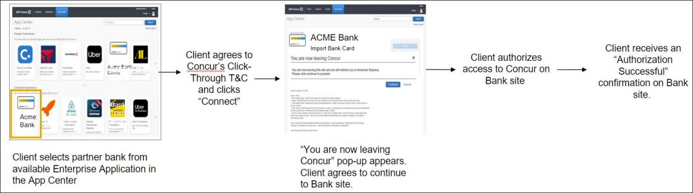
This means any card issuer a client would like to use that is not currently integrated with SAP Concur (or does not provide data via the major card associations) will need to use the service-based method instead.

Administrator Experience
Clients working with a bank not yet integrated with the Payment Card Integration service will need to work together with their bank and account manager to determine if integration via Payment Card Integration service is possible.

Configuration / Feature Activation
These changes are automatically available; there are no configuration or activation steps.
For more information, refer to the section Cards – Announcing the Payment Card Integration Service in the September 2023 SAP Concur Release Notes.

Yodlee Reauthentication Refresh Frequency

Overview
This release note provides information to users of Yodlee on the need to periodically reauthorize the cards that are connected to SAP Concur via Yodlee to avoid interruptions to their personal card transactions flow.

Business Purpose
By sharing this information, customers can better anticipate when they will need to reauthorize their cards, improving overall experience and reducing potential disruptions.

End-User Experience
There are no changes to the user interface, but you may experience an interruption in the personal card transactions flow if you fail to reauthorize the cards within the required period. Contact your administrator for information on the banks and their respective reauthorization timelines.

Administrator Experience
For more information on banks and their reauthorization timelines, see Open Banking Token Expiry Dates.

Configuration / Feature Activation
The change occurs automatically; there are no additional configuration steps.

Expense Types

Recovering And Displaying Deactivated Expense Types

Overview
As of February 24th, 2024, Concur Expense allows you to retain an unused expense type by simply deactivating it instead of deleting it. The status of an expense type is now displayed. The status Yes and No indicates the expense type is active or inactive, respectively.
The expense types listing is sorted based on their active status. Much like active expense types, inactive expense types can be modified and can be set to active, or even be reactivated with a different name.

Business Purpose
This update facilitates the administrator in the recovery of a deleted expense type and reconfiguration of the same if required.

Administrator Experience
In the Expense Admin > Expense Types screen, the Remove button is now replaced with the Activate or Deactivate button (based on the activation context of the expense type). To activate or deactivate an expense type, select the expense type, and click Activate or Deactivate. A confirmation dialog pops up.
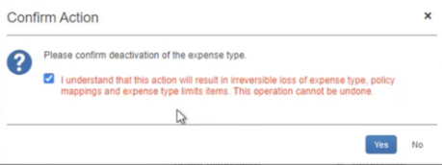
Click Yes to proceed.
Deactivating an expense type always involves the loss of a certain amount of data. Please read the confirmation text carefully before proceeding.
Filter expense types listing to display only active expense types or select the Display inactive expense types checkbox to view all expense types. A new column Active displays the status of the expense types available using Yes (Active) and No (Inactive) indicators.
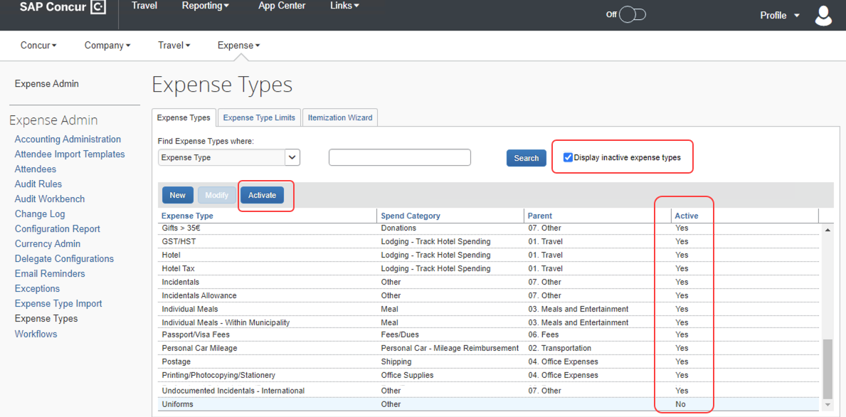
View a log of all the modifications made to an expense type in the Administration > Expense > Change Log (left menu) screen.
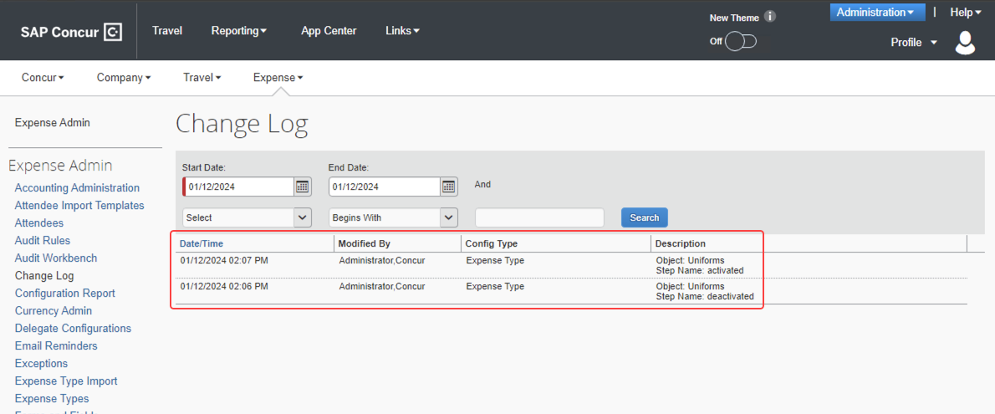

Configuration / Feature Activation
The change occurs automatically; there are no additional configuration steps.

Mileage Service

Delegate Administrator May Reset Initial Distance Mileage for Personal Car

Overview
With this release, the Expense Configuration administrator (Unrestricted) delegating for a user will now be able to adjust the existing mileage on the user’s personal car directly using the Distance to date field in the Vehicle Configuration page.
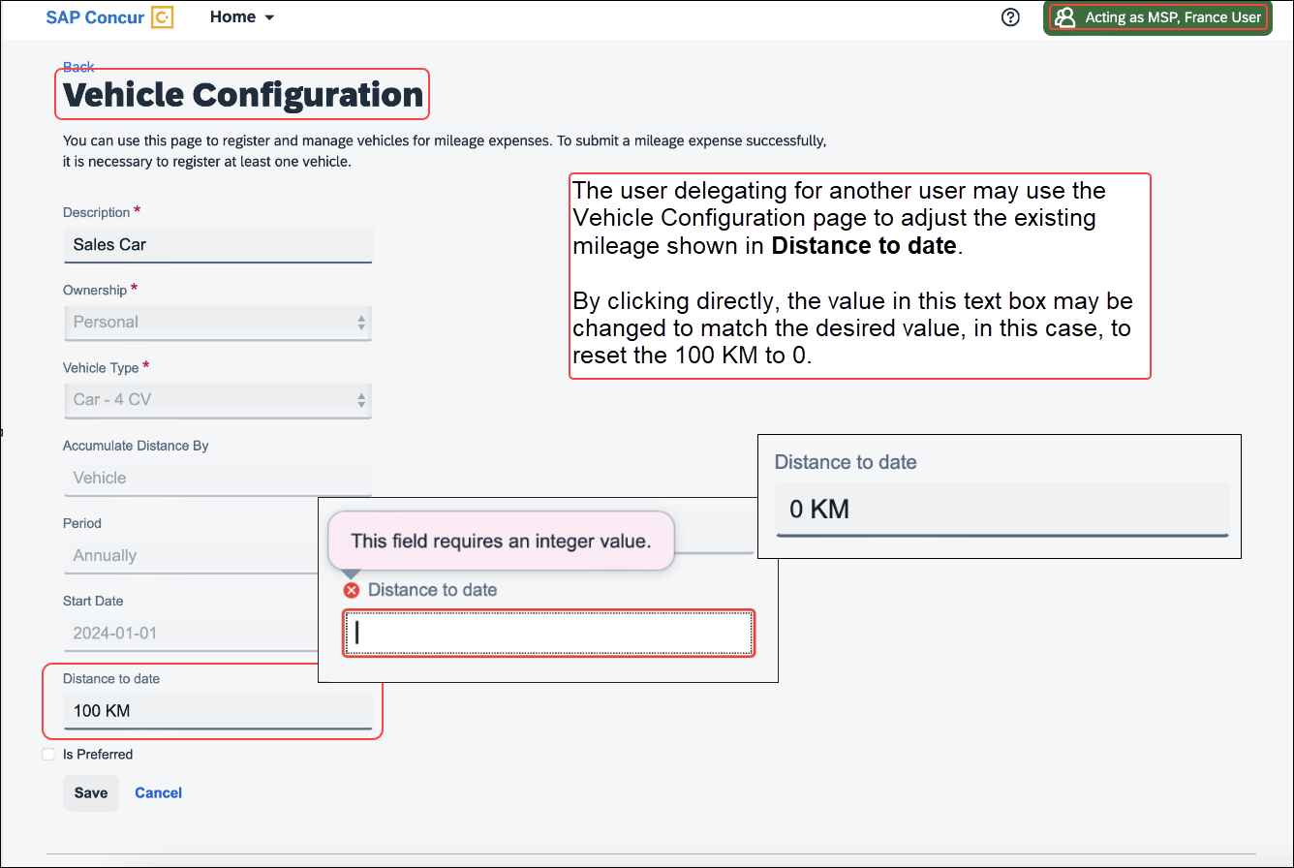
By clicking the value directly, the current mileage attributed to the user’s car may be adjusted as needed.

Business Purpose / Client Benefit
This feature change closes a functionality gap between the legacy and service versions of the Mileage feature.

Administrator Experience
The administrator delegating for a user clicks Profile Settings and navigates to the Vehicle Configuration page to access the selected car. Next, they click the Distance to date field to enter a new mileage amount for that user.

Configuration / Feature Activation
These changes are automatically available after January 24, 2024; there are no configuration or activation steps.

Miscellaneous

Enhancing Additional Fields with Most Recently Used (MRU) Feature

Overview
With this release, we are excited to announce the enablement of Most Recently Used (MRU) feature for location field, lists, and connected lists in the multi-edit dialog for expense entries in an expense report.
This feature has been implemented based on customer feedback to simplify the selection process for frequently used values in the multi-edit dialog.

Business Purpose
The enablement of MRU for location and list fields in the multi-edit dialog enhances the user experience by making it easier to access frequently used values, improving efficiency when creating or editing expense reports.

Administrator Experience
Users will now see most recently used values for location and any list/connected list fields in the multi-edit dialog, simplifying the selection process and reducing manual effort when entering data in the multi-edit dialog.
This feature is automatically available; there are no additional configuration or activation steps required for administrators.

Configuration / Feature Activation
The change occurs automatically; there are no additional configuration steps.

New Action Column Available in Expense Screens

Overview
As of February 20th, 2024, users can use two new action columns, indicated by and , to perform single click actions or multiple actions such as edit, copy, or delete on the Expense screens, such as editing expense, itemizations, allocations, or travel diaries.
None of the existing functionalities are removed with this release:
- The user can click the row to open the expense details.
- The user can select multiple rows to edit common fields for all the selected expenses.

Business Purpose / Client Benefit
This update allows users to execute actions easily and improves user experience for keyboard and screen reader users.

End-User Experience
All the existing Expense screens where you can perform actions have a new actions column. This column will always be visible. A dropdown list displays all the actions that you can perform by selecting a single row of data.
A button link displays for single actions. For multiple actions, a See more () button displays with a dropdown list embedded in it.
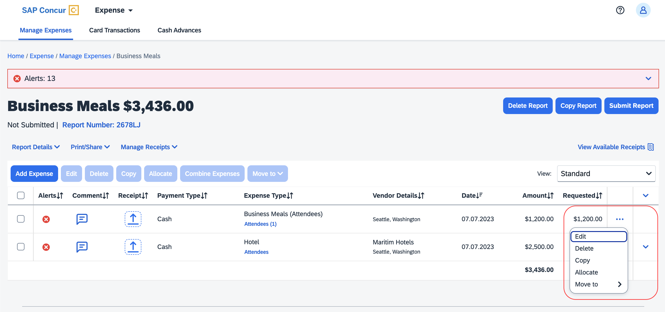
The updated Expense screens and their actions are:
- Reports list
- View
- Available Expenses
- View
- Delete
- Move To
- Available Expenses > Add Expense
- View
- Add to Report
- Cash Advance
- Remove
- Request
- Remove
- Attendees
- Remove
- Create Group
- Attendees Favorite Group
- Add
- Remove
- Recent Attendees
- Add
- Attendees Group
- Add
- Allocations
- Edit
- Remove
- Report Entries
- Edit
- Delete
- Copy
- Allocate
- Move to
- Report Entries (once the report is submitted)
- View
- Itemizations List
- Edit
- Delete
- Allocate
- Copy
- Itemizations List (once the report is submitted)
- View
- Travel Diary
- Edit
- Delete

For Example
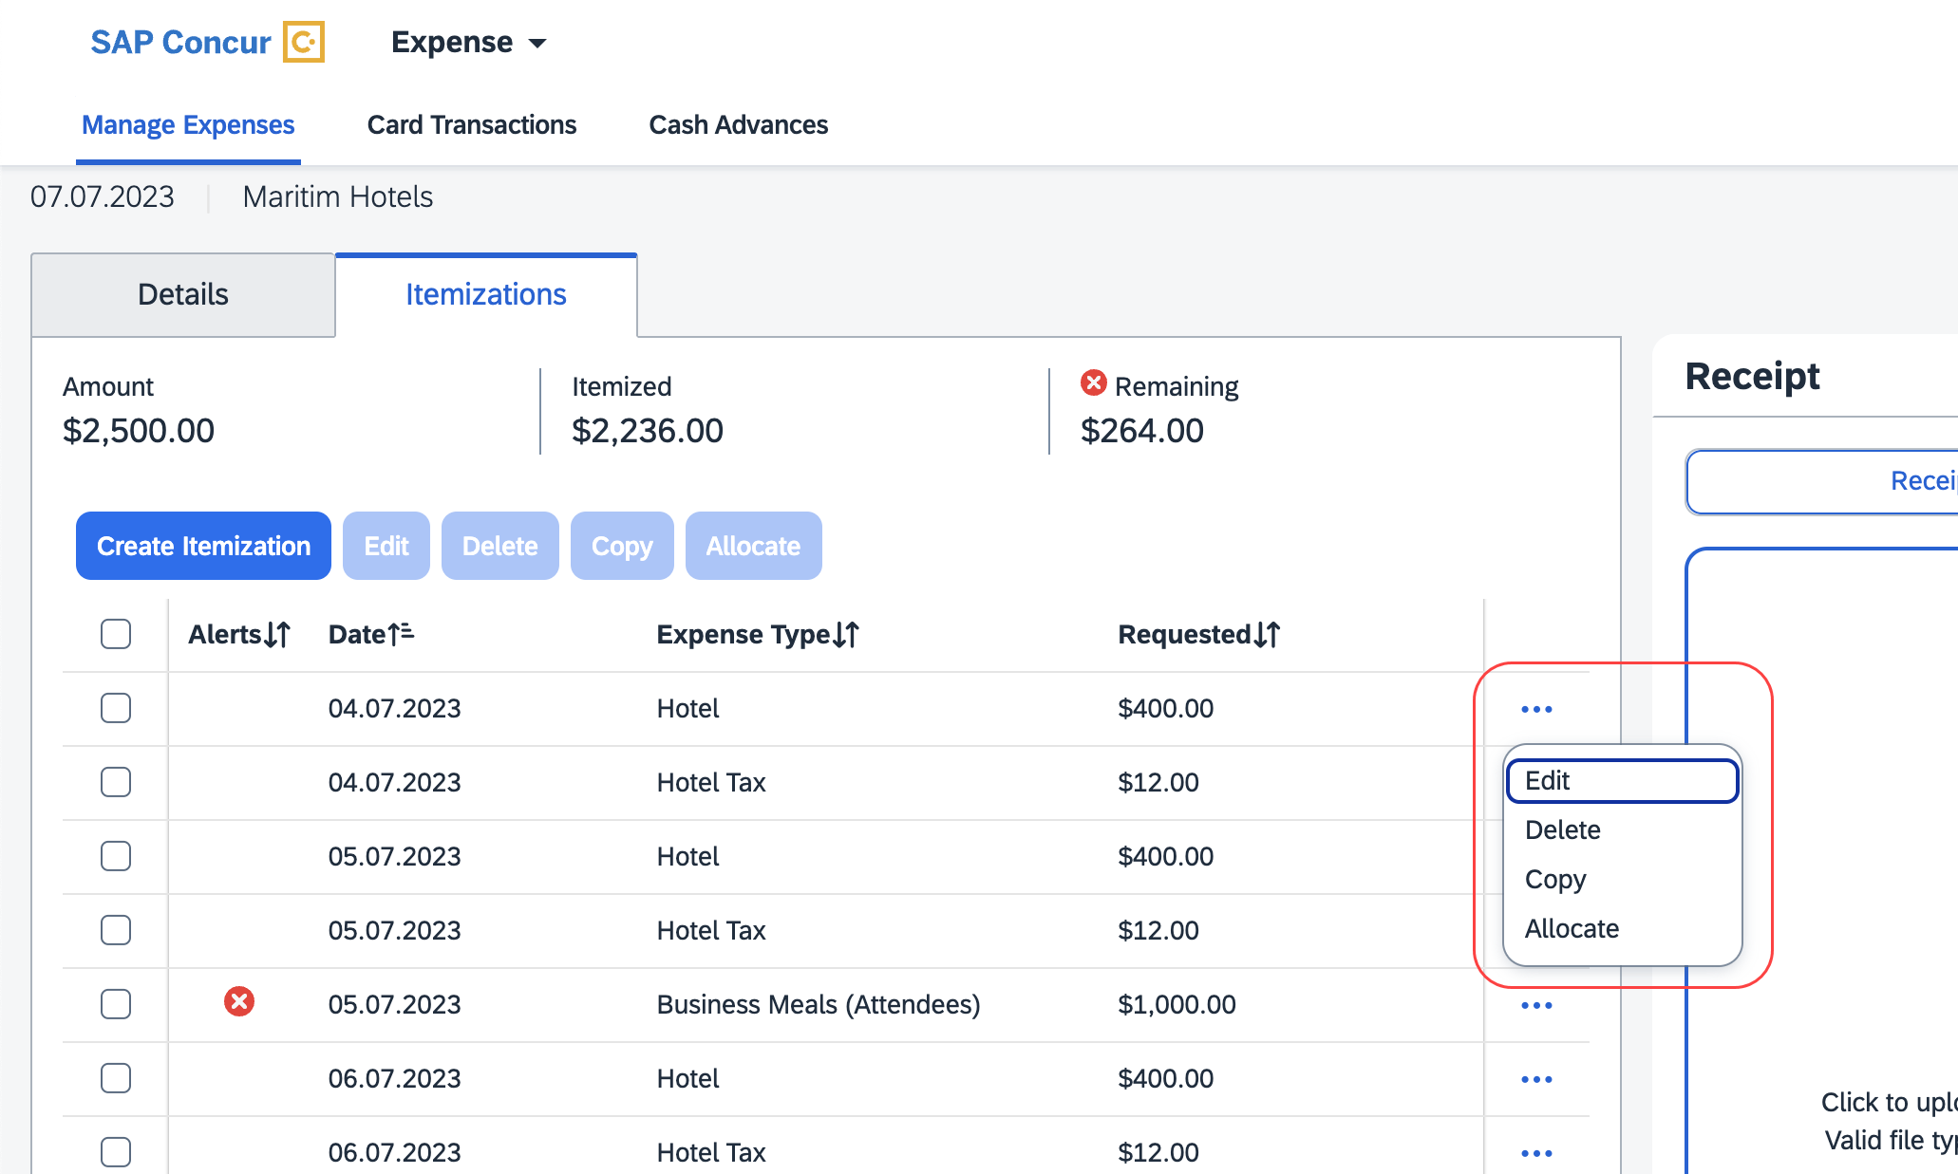
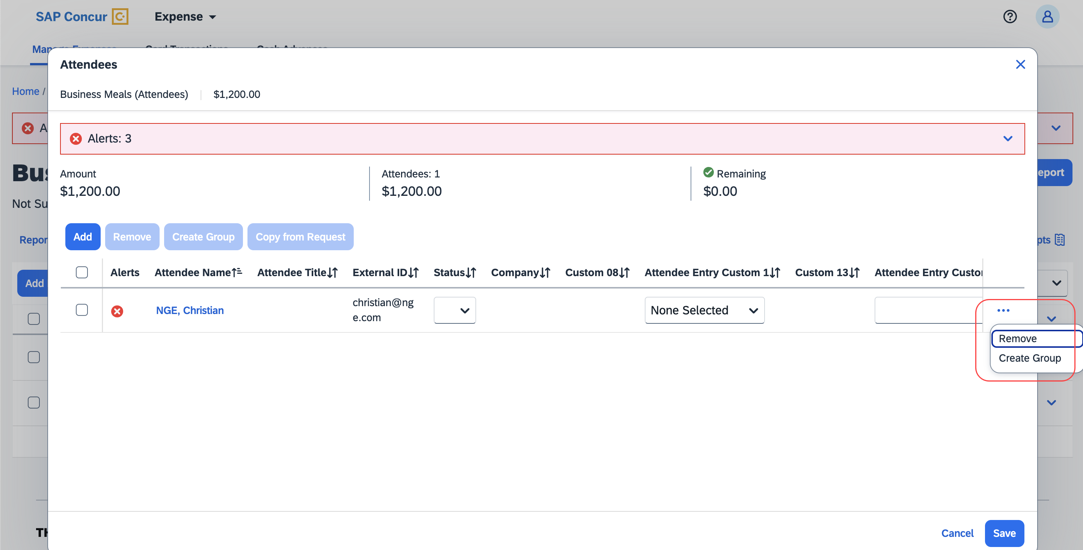

Configuration / Feature Activation
The change occurs automatically; there are no additional configuration steps.

Update to the Report Status Indicator

Overview
The rectangular indicator that shows the status of an expense report is now updated. With the change, this indicator is more prominent and easier to read than the prior version.

Business Purpose / Client Benefit
This feature improves the user’s accessibility to the status information of the expense report by providing greater visibility.

End-User Experience
The end-user will now see, in selected screens, a solid color background and white text in the tiles that display the status of the expense report.
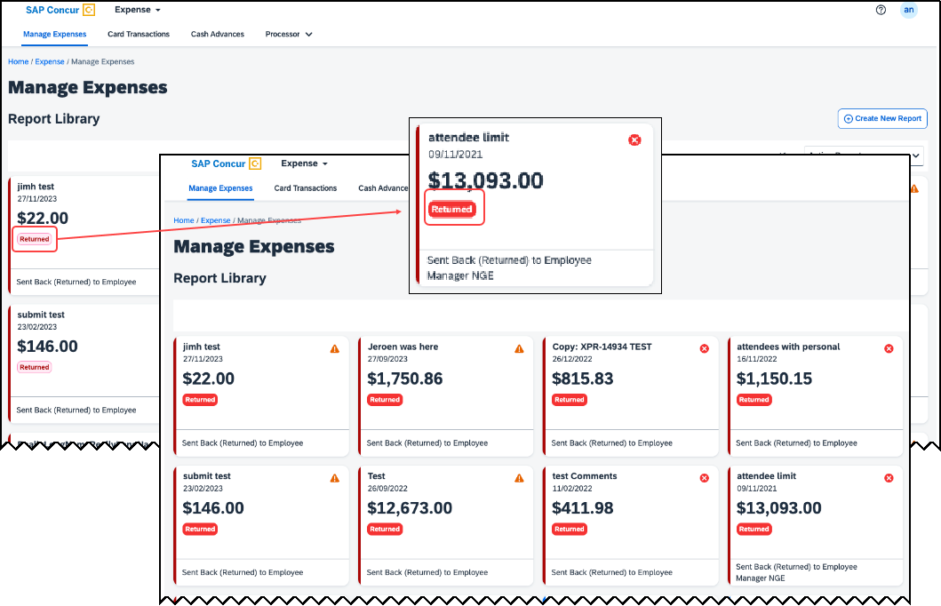

Configuration / Feature Activation
These changes are automatically available after January 30, 2024; there are no configuration or activation steps.

Planned Changes
The items in this section are targeted for future releases. SAP Concur reserves the right to postpone implementation of – or completely remove – any enhancement/change mentioned here.
The planned changes listed in this document are specific to this product. For information about planned site-wide or shared changes that might impact your SAP Concur solutions, refer to the Shared Changes Release Notes.

Cash Advance

**Planned Changes** FIS / ICS Client Cash Advance Improvements

Information First Published | Information Last Modified | Feature Target Release Date
February, 2024 | -- | February 15, 2024
Any changes since the previous monthly release are highlighted in yellow in this release note.

Overview
Two changes to the Cash Advance feature will be available in an upcoming release. These changes apply to clients using the Cash Advance feature in combination with either the Financial Integration Services (FIS) API with client web services or SAP ICS.
- Cash Advance Pass or Fail Check and Filter: If a cash advance fails to be posted to the financial system, it will be filtered from the user’s view and be unavailable for addition to their expense report(s).
- Automatic Status Change to Complete: Once a cash advance is fully utilized it will be automatically changed from a status of Issued to a status of Complete.

Business Purpose / Client Benefit
These feature changes simplify cash advance functionality by listing only valid advances for addition to a report and clarifying the status of an advance that is fully utilized.

End-User Experience
The end-user adding a cash advance to their expense report(s) will now see only those advances that are successfully posted to the financial system. There are no changes to the user interface.

Administrator Experience
The Cash Advance administrator will see a status change for a fully utilized cash advance from Issued to Complete when working with advances in the tool.

Configuration / Feature Activation
These changes are automatically available after February 15, 2024; there are no configuration or activation steps.
For more information, refer to the Concur Expense: Cash Advance Setup guide.

Client Notifications

Accessibility

Accessibility Updates
SAP implements changes to better meet current Web Content Accessibility Guidelines (WCAG). Information about accessibility-related changes made to SAP Concur solutions is published on a quarterly basis. You can review the quarterly updates on the Accessibility Updates page.

Gender Diversity

Gender Diversity Planned Features and Changes
SAP Concur is committed to supporting gender diversity. Over time we plan to implement product changes to help ensure that SAP Concur solutions support gender non-binary users. These changes will include but are not limited to support for preferred names, non-binary gender options in travel preferences, and non-binary titles.
These planned changes reflect SAP's commitment to supporting gender diversity and enable gender non-binary users to enter consistent information when making travel arrangements and entering personal information into SAP Concur solutions.
Timelines and details about these ongoing changes will be provided in the SAP Concur release notes.

In-Product User Assistance

Client Customized Content
If your company creates customized content for SAP Concur solutions through a user assistance tool such as SAP Enable Now or Concur User Assistant by WalkMe, the changes described in these release notes might affect your customized content. SAP Concur recommends reviewing the monthly release notes for all of your SAP Concur solutions as well as the Shared Changes Release Notes to confirm whether any of the planned or released changes might impact your internal, customized content.
If any changes in a release impact your content, work with your internal teams to update your content accordingly.

Subprocessors

SAP Concur Non-Affiliated Subprocessors
The list of non-affiliated subprocessors is available from the SAP Sub-processors / Data Transfer Factsheets page.
To access the SAP Concur Sub-processors List:
- Click the following link to navigate to the SAP Sub-processors / Data Transfer Factsheets page:
SAP Sub-processors / Data Transfer Factsheets
- Sign in to the SAP Support Portal using your Support User ID (S-user) and password.
SAP customers must sign in to the SAP Support Portal using their Support User ID (S-user) and password. For information about S-User IDs, refer to Your New Support User ID (S-user) and to the Learn All About S-User IDs blog post.
- On the SAP Sub-processors / Data Transfer Factsheets page, type "Concur" in the Search field.
- In the Title column, click SAP Concur Sub-processors List.
If you have questions or comments, please reach out to: Privacy-Request@Concur.com

Supported Browsers

Supported Browsers and Changes to Support
For information about supported browsers and planned changes to supported browsers, refer to the Concur Travel & Expense Supported Configurations guide.
When changes to browser support are planned, information about those changes will also appear in the Shared Changes Release Notes.

Additional Release Notes and Other Technical Documentation

Online Help
You can access release notes, setup guides, user guides, admin summaries, supported configurations, and other resources via the in-product Help menu or directly on the SAP Help Portal.
To access the full set of documentation for your product, use the links in the SAP Concur Help menu, or visit the SAP Concur solutions page.
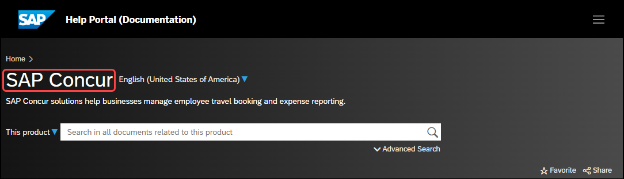

SAP Concur Support Portal – Selected Users
Access release notes, webinars, and other technical documentation on the SAP Concur support portal.
If you have the required permissions, Contact Support is available on the SAP Concur Help menu, and in the SAP Concur page footer.
Click Contact Support to access the SAP Concur support portal, then click Resources.
- Click Release/Tech Info for release notes, technical documents, etc.
- Click Webinars for recorded and live webinars.

Cases

Check Support Case Status
The steps in this procedure provide instructions for checking whether a case is resolved.
To check the status of a submitted case
- Log on to https://concursolutions.com/portal.asp.
- Click Help > Contact Support.
If you do not have the option to contact SAP Concur support under the Help menu, then your company has chosen to support the SAP Concur service internally. Please contact your internal support desk for assistance.
- Click Support > View Cases.
- In the table, view the desired type of cases based on the View list selection. Search results are limited to each company's own cases.

© 2024 SAP SE or an SAP affiliate company. All rights reserved.
No part of this publication may be reproduced or transmitted in any form or for any purpose without the express permission of SAP SE or an SAP affiliate company.
SAP and other SAP products and services mentioned herein as well as their respective logos are trademarks or registered trademarks of SAP SE (or an SAP affiliate company) in Germany and other countries. Please see http://global12.sap.com/corporate-en/legal/copyright/index.epx for additional trademark information and notices.
Some software products marketed by SAP SE and its distributors contain proprietary software components of other software vendors.
National product specifications may vary.
These materials are provided by SAP SE or an SAP affiliate company for informational purposes only, without representation or warranty of any kind, and SAP SE or its affiliated companies shall not be liable for errors or omissions with respect to the materials. The only warranties for SAP SE or SAP affiliate company products and services are those that are set forth in the express warranty statements accompanying such products and services, if any. Nothing herein should be construed as constituting an additional warranty.
In particular, SAP SE or its affiliated companies have no obligation to pursue any course of business outlined in this document or any related presentation, or to develop or release any functionality mentioned therein. This document, or any related presentation, and SAP SE’s or its affiliated companies’ strategy and possible future developments, products, and/or platform directions and functionality are all subject to change and may be changed by SAP SE or its affiliated companies at any time for any reason without notice. The information in this document is not a commitment, promise, or legal obligation to deliver any material, code, or functionality. All forward-looking statements are subject to various risks and uncertainties that could cause actual results to differ materially from expectations. Readers are cautioned not to place undue reliance on these forward-looking statements, which speak only as of their dates, and they should not be relied upon in making purchasing decisions.

