
Concur Invoice: Purchase Order Matching
User Guide

Last Revised: October 4, 2019
Applies to these SAP Concur solutions:
 Concur Expense
 Professional/Premium edition
 Standard edition
 Concur Travel
 Professional/Premium edition
 Standard edition
 Concur Invoice
 Professional/Premium edition
 Standard edition
 Concur Request
 Professional/Premium edition
 Standard edition

Table of Contents
Section 1: Permissions 1
Section 2: Overview: Purchase Order (PO) 1
Required Roles 2
Concur Receiving Roles 2
Additional Roles 3
PO-Based Invoice Lifecycle 3
How a PO-Based Invoice Is Processed 4
Establish PO Match "To Be" Model 5
PO-Based Invoice Quick Tour 6
Matching Summary Tab 6
Purchase Order Tab 10
Invoice Tab 12
Section 3: PO Association and Policy 12
Associate PO to Invoice During Manual Invoice Creation 13
Associate PO to Invoice by Using Capture Processing 13
Associate Invoice With Multiple Purchase Orders 14
Enable and Disable Line Item Level PO 15
PO Line Item Association 17
View and Manage Multiple POs 18
Associate by Using Imports (Web Services, ONP, and E-Invoicing) 22
Associate an Invoice to a Different PO 22
Automatically Associate Invoices With Purchase Orders 23
Change a PO-Based Invoice Policy to a Non-PO Based Invoice Policy 23
Match Rules and Match Status 25
Understand the Match Status Assigned to an Invoice 25
When Are Match Rules Run? 26
Section 4: Concur Receiving 27
Add a Receipt 28
Edit a Receipt 30
Delete a Receipt 30
Add a Receipt Image 31
View a Receipt Image 32
Delete a Receipt Image 34
Purchase Order Import for Receiving 36
Section 5: PO-Based Invoices 36
Create a PO-Based Invoice 36
Create PO-Based Invoice Line Items 37
The Automatic Copy Down to Invoice Option 37
The Copy Items from PO Option 38
Invoice Lists 39
Use the Bulk Submit Action 39
Filter the View 40
Resolve Exceptions 40
How to Deal With Exceptions Using Matching Rules Options 44
Understand Line Item Match Rule Application 44
Correct Line Item Matching to Match Invoice and PO 45
Correct Overall Number of Line Items to Match the PO 45
Extra Line Items 46
When Exceptions Cannot be Cleared 46
Exceptions and Three-Way Matching Rules 46
Receipt Association and Three-Way Matching 50
Send a PO-Based Invoice to a Purchasing User to Resolve Issues 50
Return PO-Based Invoice to Assigner 52
Switch Tax Mode 54
Use the Tax Field at Both the Invoice and Line Item Levels 54
Submit a PO-Based Invoice 56
View the Invoice Image 57
View All Invoices Associated with the PO 57
Quantities and Amounts Freed up on Voided PO-Based Invoices 58
Section 6: Workflow and Approval Routing 58
Best Practice: Workflow for PO-Based Invoices 58
Approval Timeout Actions 59
Section 7: Processor Role 59
Processor: Search for and View Invoices by Their PO Number 60
Processor: Edit the Invoice 63
Processor: Resolve Exceptions 63
Section 8: Invoice Purchasing User Role 63
Additional Information and Restrictions on the Purchasing User Role 64
Section 9: PO Import 64
Use the PO Web Service Import 65
Section 10: Quantity Receipt Import for Three-Way Matching 65
Section 11: PO Extract 65
Section 12: PO-Based Invoices That Should Not Be Matched 66
Revision History
Date |  |  | Notes/Comments/Changes
October 31, 2022 |  | Minor updates; cover date not updated.
January 21, 2022 |  | Updated the copyright year; no other changes; cover date not updated
March 4, 2021 |  | Updated the copyright year; no other changes; cover date not updated
December 9, 2020 |  | Minor edit; no content change.
April 20, 2020 |  | Renamed the Authorization Request check box to Request on the guide’s title page; cover date not updated
January 7, 2020 |  | Updated the copyright; no other changes; cover date not updated
October 4, 2019 |  | Updated a number of procedures.
September 21, 2019 |  | Added information about behavior change when manually adding PO-based invoice line items and added procedures for view invoices and POs.
August 17, 2019 |  | Added information about quantities and amounts freed up on voided PO-based invoices.
June 8, 2019 |  | Updated images in the "View all invoices associated with the PO" section to reflect UI changes. Did not update cover date.
April 13, 2019 |  | Changed the term "payment request" to "invoice" as part of the new user experience for Concur Invoice including images.
March 16, 2019 |  | Added a note regarding the new All Purchase Orders list page for Purchasing Admins in the March release. Updated "payment request" to "invoice". Replaced "SAP Concur's" with "SAP Concur".
February 1, 2019 |  | Updated the copyright; no other changes; cover date not updated
October 24, 2018 |  | Renamed Concur to SAP Concur where applicable. Performed minor edits; no other content changes.
April 11, 2018 |  | Changed the check boxes on the front cover; no other changes; cover date not updated
January 25, 2018 |  | Updated the copyright; no other changes; cover date not updated
October 14, 2017 |  | Added information about the new Receipt User role and the possibility of using custom fields for receipts of goods.
September 16, 2017 |  | Added information about the new search area in the Matching Summary tab.
September 12, 2017 |  | Corrected statement in the Receipt Association and Three-Way Matching section.
July 29, 2017 |  | Changed name of Central Receiving role to Central Receiver.
June 24, 2017 |  | Added information about Central Receiving role.
April 22, 2017 |  | Added information about users not being able to edit or delete receipts associated to an invoice.
December 13, 2016 |  | Changed copyright and cover; no other content changes.
November 4, 2016 |  | Added information about the Concur Receiving feature.
August 12, 2016 |  | Updated Purchase Order tab image and added information about warning when non-blocking purchase order matching errors occur.
April 15, 2016 |  | Updated with information about the following:  - Automatically associating payment requests and purchase orders  - Multiple Purchase Orders
February 19, 2016 |  | Updated with the Three-Way Matching feature.
June 12, 2015 |  | Updated the images to the enhanced UI and made general updates to the content. In addition, added information about the redesign of the Matching Summary, Payment Request, and Purchase Order tabs.
January 16, 2015 |  | Added information about line item identification.
October 17, 2014 |  | A purchase order extract is now available, and can be re-extracted based on system detection of changes at the header, line item, or allocations levels
September 17, 2014 | Added information about the two user interfaces; no other content changes
December 14, 2012 | Updates related to the Purchasing User  Made rebranding and/or copyright changes; no content changes
October 19, 2012 | Update with information about ability to configure copy down action at the PO header, line item, and allocation levels to the PR.
February 17, 2012 |  | Update with information about new Purchase Order overnight import job.
October 21, 2011 |  | Various updates to this guide.
September 15, 2011 |  | New User Guide.

Purchase Order
NOTE: Multiple SAP Concur product versions and UI themes are available, so this content might contain images or procedures that do not precisely match your implementation. For example, when SAP Fiori UI themes are implemented, home page navigation is consolidated under the SAP Concur Home menu.

Permissions
A company administrator might not have the correct permissions to use this feature. The administrator might have limited permissions, for example, they can affect only certain groups and/or use only certain options (view but not create or edit).
If a company administrator needs to use this feature and does not have the proper permissions, they should contact the company's SAP Concur administrator.
In addition, the administrator should be aware that some of the tasks described in this guide can be completed only by SAP Concur staff. In this case, the client must initiate a service request with SAP Concur support.

Overview: Purchase Order (PO)
Purchase Order (PO) Matching helps companies maintain control by verifying and approving any discrepancies before paying Suppliers, such as limiting payment to the quoted price, terms, and quantity ordered.
To achieve this, matching rules associated to the policy instruct the system how to react when a variance is detected between the invoice and the PO.
Rules serve to flag invoices that should not enter the workflow until unresolved (non-matching) issues are addressed, while allowing other associated invoices to continue if no issues are found.
Concur Invoice offers three types of matching methods:
- Two-Way Matching: Matching between invoices and purchase orders (no receipt)
- Three-Way Matching: Matching between invoices and purchase orders and received quantities
- Receipt Confirmation: Matching between invoices and purchase orders (including receipt confirmation that the order has been fully received)
The two-way matching verifies that purchase order and invoice information match whereas the three-way matching allows clients to match invoices with purchase orders and received quantities (of goods) before the invoices are processed and paid. The Receipt Confirmation method allows clients to match invoices with purchase orders including a receipt confirmation that items ordered have been received (Concur Invoice does not check quantity of orders).
- For more information about the Receipt Confirmation method, refer to the Concur Invoice: Receipt Confirmation Setup Guide.

Required Roles
Only the Invoice Configuration administrator can access and configure the Purchase Order Matching Rules feature.

Concur Receiving Roles
This table shows roles in Concur Invoice working with Concur Receiving and what they can and cannot do.
Role | What the User Can/Cannot Do | Where? | Conditions
Purchase Order Processor | Can add, edit, and delete receipts and receipt images. | In the transmitted purchase order. | None.
Invoice Processor | Can add, edit, and delete receipts and receipt images. | In Purchase Order tab of the opened invoice. | None.
Purchase Request User | Can add, edit, and delete receipts and receipt images | In the transmitted purchase order. | The admin must have selected (enabled) the Allow Purchase Request Owners to Edit their own Purchase Orders option in Invoice Settings. Alternatively, the user can have the Receipt User role.
Invoice User | Can add, edit, and delete receipts and receipt images. | In the Purchase Order tab of the opened invoice. | None.
Central Receiver | Can add, edit, and delete receipts and receipt images for all purchase orders in their group.  Cannot transmit and process purchase orders or invoices. | In the transmitted purchase order. | The Concur Receiving feature must be activated.
Receipt User | Can add, edit, and delete receipts and receipt images.  Can only add, edit, and delete receipt data for their own purchase orders. | In the transmitted purchase order. | The Concur Receiving feature must be activated.
For clients who import purchase orders on entities that do not have the Purchase Request feature enabled, a user who is assigned the Purchase Order Processor or Purchase Order Processor (Audit) role can see a list of imported purchase orders by navigating to the Requests > All Purchase Orders page.

Additional Roles
AP User: Used for sites relying on back-office personnel to code their invoices and handle assignment and reassignment of invoices.
Invoice User: Can create invoices and assign these to an Invoice Owner, and, also, submit invoices.
Invoice Purchasing User: Restricted from creation or submission of invoices but is granted Modify access to selected fields. Typically, a specialist for updating invoices with incorrect totals, unit amounts, and similar.

PO-Based Invoice Lifecycle
The following image shows an example of a non-inventory PO process.
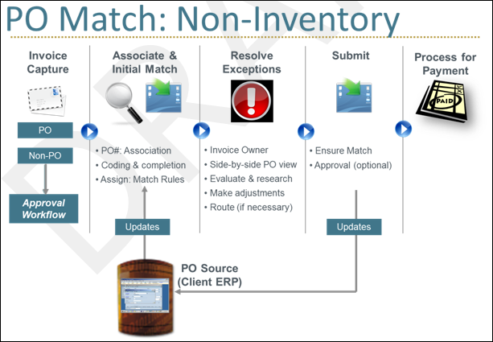

How a PO-Based Invoice Is Processed
- Invoice Capture
- PO and non-PO invoices can be captured centrally
- Non-PO invoices route through the normal Approval Workflow
- Association and Initial Match
- PO invoices are associated to the PO, based on the entered PO number
- For centralized organizations, AP Users first complete invoice coding
- Concur Invoice has a real-time copy of PO data from client ERP (via web service)
- Match Rules are run for the first time when the Invoice Owner is established (Assign), and exceptions are flagged
- Match Rules (just like Audit or Workflow Rules) are configurable by the client, including tolerance levels
- Resolve Exceptions
- Invoice Owner reviews and resolves exceptions
- The system expedites resolution with complete visibility into the associated PO, and a side-by-side view for easy comparison
- Invoice Owner adjusts if policy allows, and if necessary, routes to other employees (such as Purchasing) for questions or edits
- Back office has visibility and traceability for all invoices in the system
- Submit
- All exceptions must be resolved prior to PO-based invoice submission
- Additional approvals can occur, but due to PO pre-approval, most companies route invoices directly to back-office
- Any PO updates, such as status, or amount changes (if allowed), are communicated back to ERP via extract
- Process for Payment
- The invoice is moved to final processing and payment
For three-way matching, invoices can be matched with purchase orders and received quantities (of goods) before they are processed and paid.

Establish PO Match "To Be" Model
Handling Purchase Orders can involve several roles and departments, and the change to matching within Concur Invoice might involve some business process reengineering. Therefore, it is important to work with your SAP Concur representative to map your current process to a "To Be" model within Concur Invoice. The flow below shows a high-level Best Practices model and outlines key considerations.
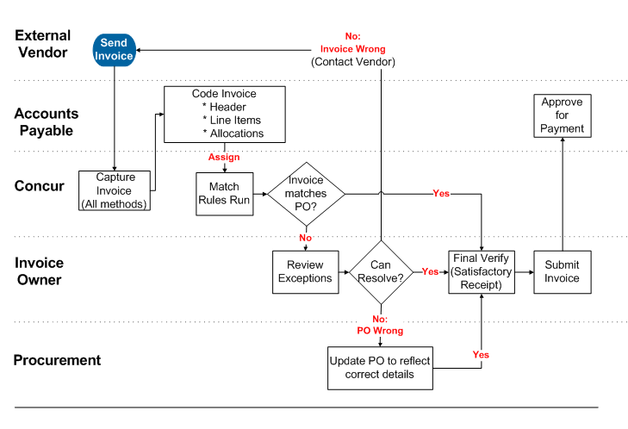
NOTES:
- Code Invoices: ALTERNATIVE - The Invoice Owner can create and/or code the invoice.
- Can Resolve?: ALTERNATIVE - Invoice Owner can a) edit the current invoice to resolve the exceptions (aka "short-pay"), or contact vendor to issue corrected invoice or credit memo.
- No PO Wrong: ALTERNATIVE - Procurement can either a) make edits only within the client system, treating Concur Invoice as a convenient work list and communication tool (recommended if PO changes require approval), or b) make edits directly within Concur Invoice (via Purchasing User, policy with rights for Invoice Owner, Back office, etc.), which are sent to client system via web service.
- Final Verify: All invoices regardless of match status are routed to the Invoice Owner. User has opportunity to verify satisfactory receipt at an overall invoice level and can quickly dispatch perfect matches from the list view. If line level receiving required, must be done in another system (client ERP).
- Submit Invoice: PO invoices can go through additional approval levels, though most clients choose to route directly to Accounting Review.

PO-Based Invoice Quick Tour
The Matching Summary view brings together all aspects of the invoice in a single view with options to drill into the invoice, the purchase order, or take actions.
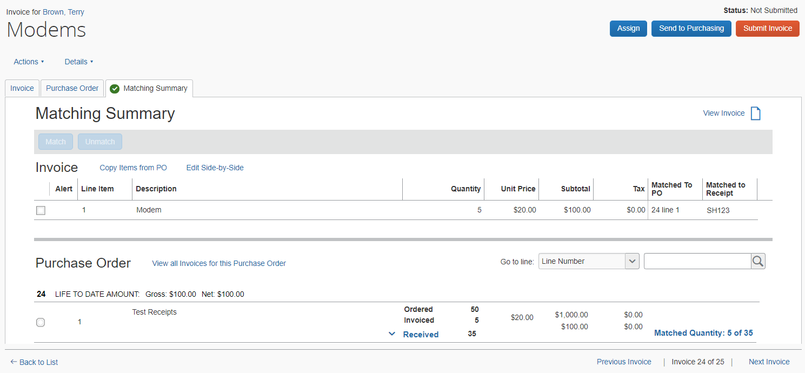

Matching Summary Tab
This comprehensive view includes:
- Matching Exceptions section, listing all current exceptions
- Line Item Summary section with key fields for both invoice and PO (and receipts if the PO is part of three-way matching). This includes the ability to match and unmatch (previously called change association) line items
If the client has selected the Allow system to associate invoice lines to Purchase Order lines based on data attributes option in Invoice Settings, Concur Invoice performs line item identification based on data attributes instead of by sequence.
- Line search: Users can perform a contained search for a line item number, description, or supplier part number by selecting one of these in the Go to line list and then entering search criteria in the search field
- Side by Side view of invoice, PO, and associated invoice image, including Previous and Next buttons allowing for easy navigation between vendor, header, and each line item
- Ability to view all invoices that share the same PO Number
- Additional actions, such as Submit Invoice, Assign, Unassign, and View Invoice
In addition, Invoice and Purchase Order tabs display, respectively, the invoice and PO in their entirety. Edits can be made based on field access configuration.

Matching Line Items
The user matches one set of line items at a time by selecting one or more invoice line items and one matching PO line item, and then clicking the Match button. Alternatively, the user can right-click to perform the matching.
Image showing two-way matching:
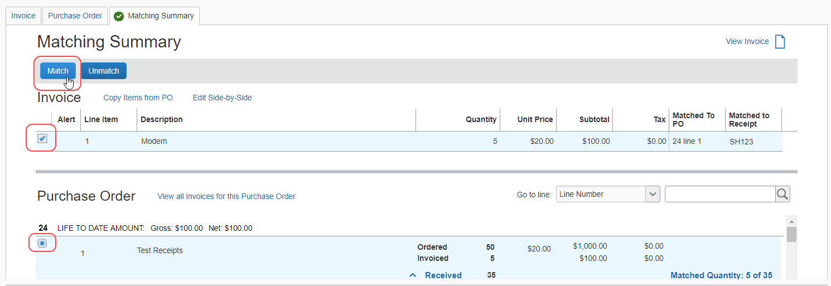
Image showing three-way matching:
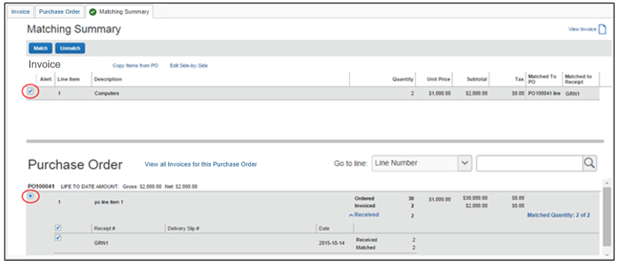
When a user clicks a line item of an invoice or purchase order, which has not been matched, the selected line item will be highlighted, and the corresponding check box will be selected automatically. The system will then enable the Match button.
For three-way matching, the user can see the receipt information in the Matching Summary tab and in the Purchase Order tab of the invoice detail view.
The receipt information for each PO line is nested within the corresponding PO line, and consists of Receipt #, Delivery Slip #, Date, and Quantity.
Concur Invoice will highlight matched PO line items and receipts when a user selects an invoice line item.
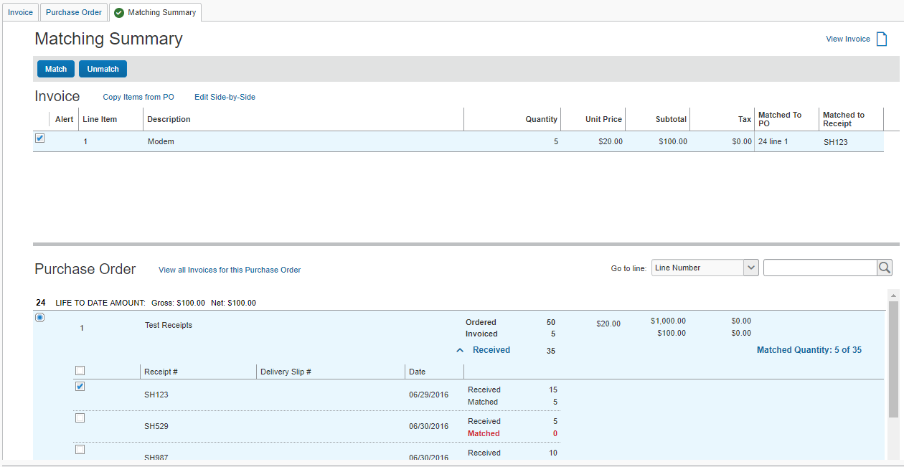

View an Invoice
To view an invoice:
- Click Invoice and select the relevant view.
- Open the invoice by clicking it.
- On the Matching Summary tab, click the View Invoice icon. The invoice images appear.

View All Invoices for This Purchase Order
To view an invoice:
- On the My Invoices page, open the invoice in detailed view.
- On the Matching Summary tab, click the View all Invoices for this Purchase Order link.
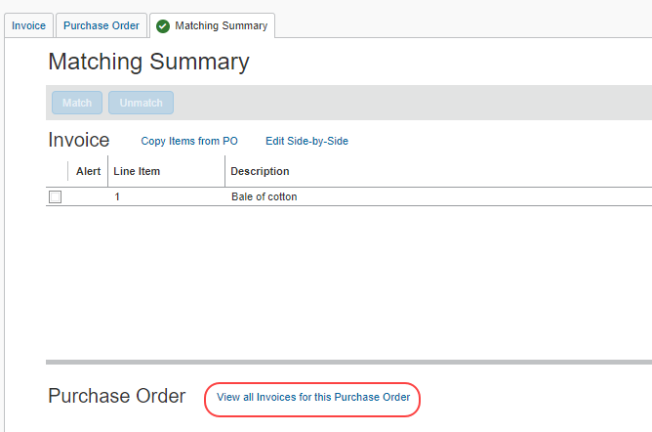
The Invoices matched to this Purchase Order page appears.
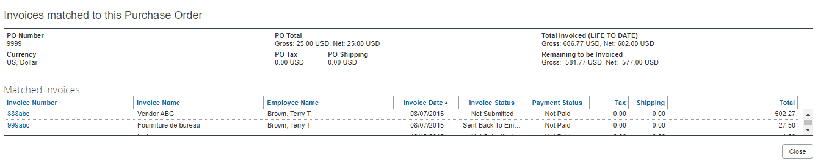

Purchase Order Tab
Concur Invoice is an invoice-based system, aimed at creating and routing invoices. It does not create and route purchase orders. Purchase order data is made available through an import from the client system of record.
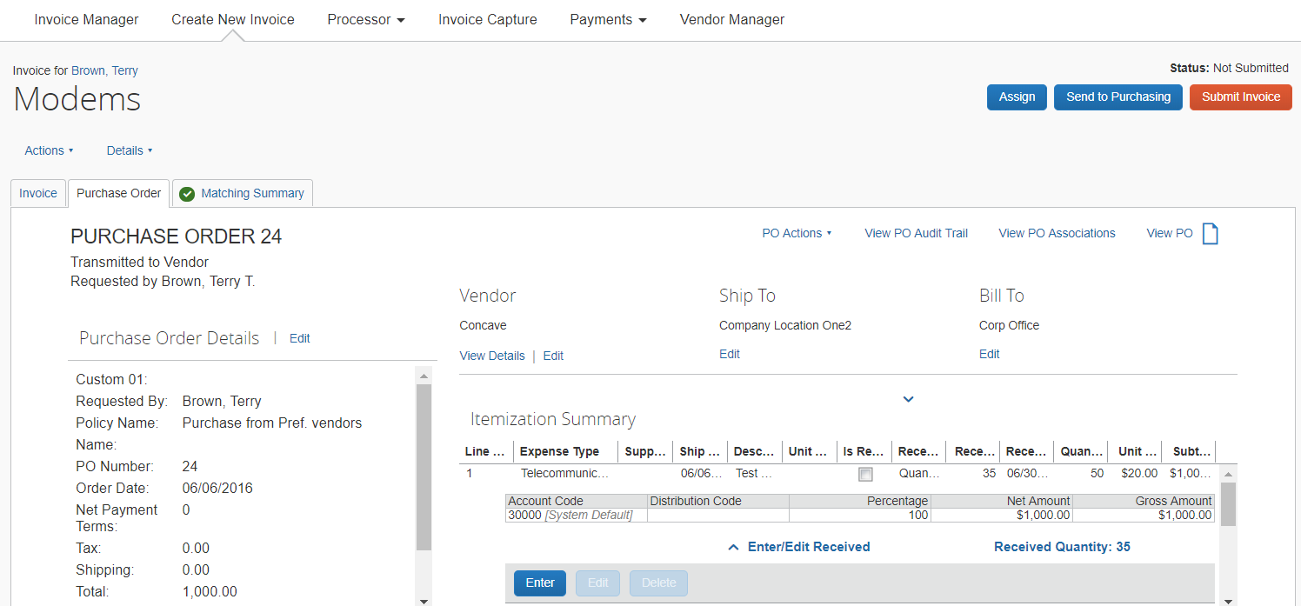
The Purchase Order tab provides comparison information necessary to resolve exceptions. Clients can take the following approaches:
- Keep PO data read-only within Concur Invoice, and make changes only in the PO system of record
- This is appropriate in cases where PO changes require extensive re-approval (since the system does not route POs in workflow). It also minimizes the PO updates to be communicated back to the client via the PO Extract.
- Allow edits to PO data within Concur Invoice
- This has the benefit of expediting and streamlining exception handling. It is appropriate where Purchasing, and at some companies, even Invoice Owners, can independently correct POs. The PO Extract is used to communicate data updates to the client.
- For more information, refer to the PO Import and PO Extract sections in this guide.

Edit a PO
To edit a PO:
- Click Invoice and then select the relevant view.
- On the Purchase Order tab, click the desired Edit link to edit the PO.
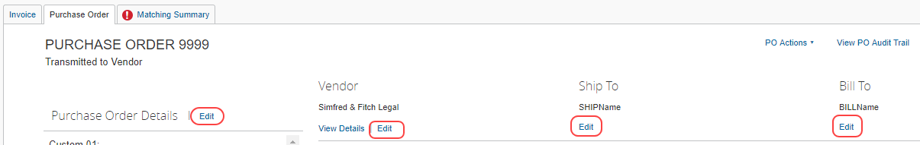
- Click Save where applicable.

View a PO
To view a PO:
- Click Invoice and then select the relevant view.
- On the Purchase Order tab, click the View PO icon.
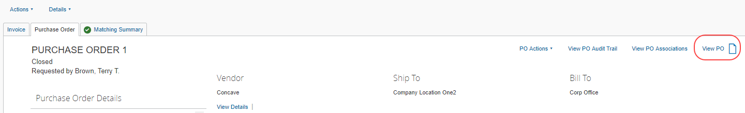
The PO images appear.

View PO Associations
To view PO associations:
- Open the desired PO-based invoice by clicking Invoice and selecting the relevant view.
- On the Purchase Order tab, click the View PO Associations.
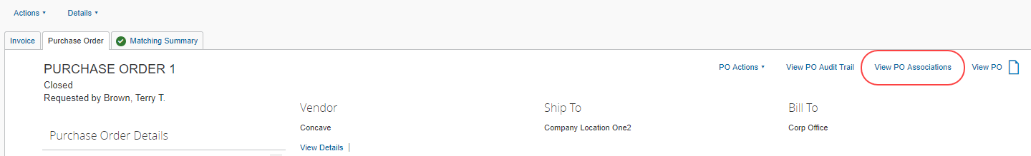
The Purchase Order Associations page appears showing information about purchase order associations to purchase requests and invoices.
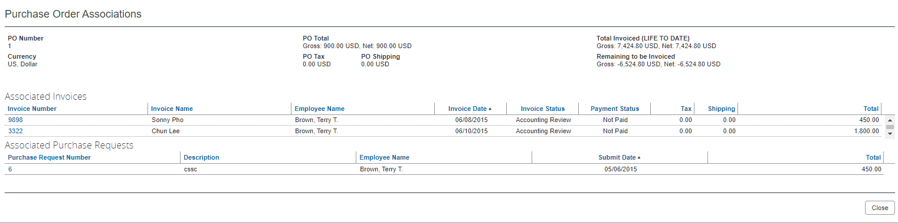

Invoice Tab
The Invoice tab contains all the information about the invoice(s) associated to the purchase order.

PO Association and Policy
Whenever an invoice has a value entered for PO Number, which matches that of a PO in the Concur Invoice, the invoice is associated to the PO. This can happen during invoice creation, or when it is changed to this state for an existing invoice.
A user cannot directly specify a policy for a PO-based invoice, using the normal Change Policy action. Instead, when an invoice is associated to a PO, the system applies the correct forms and workflow, based on the shared invoice/PO policy driven by the associated PO number, as shown in the following figure.
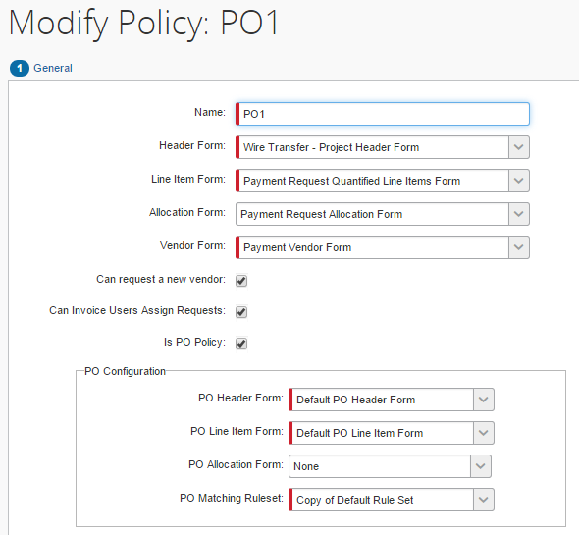
- For more information, refer to Policies: The Purchase Order Policies section in the Concur Invoice: Invoice Purchase Order Matching Setup Guide.

Associate PO to Invoice During Manual Invoice Creation
When creating an invoice within the user interface, typing the number of the PO automatically applies the PO policy via the PO. Changing the PO number can change the policy if the PO to which the new number associates the invoice also uses a different policy than that used by the prior PO.

Associate PO to Invoice by Using Capture Processing
When the system processes an invoice through Capture Processing, the PO number appears in the PO Number field on the Verification page of Invoice Capture. The PO number captured will carry over to Concur Invoice regardless. However, the key is that any PO-related validation will not occur, unless the captured PO number can be associated to a PO in the Concur Invoice system. If there is a valid association, then copy down and match rule validation will occur; if not, the system will still carry the PO number to the invoice, without any additional copy downs or ability to match.
To access the Verification page, click Invoice > Invoice Capture, and then click Verification.
Verification Page
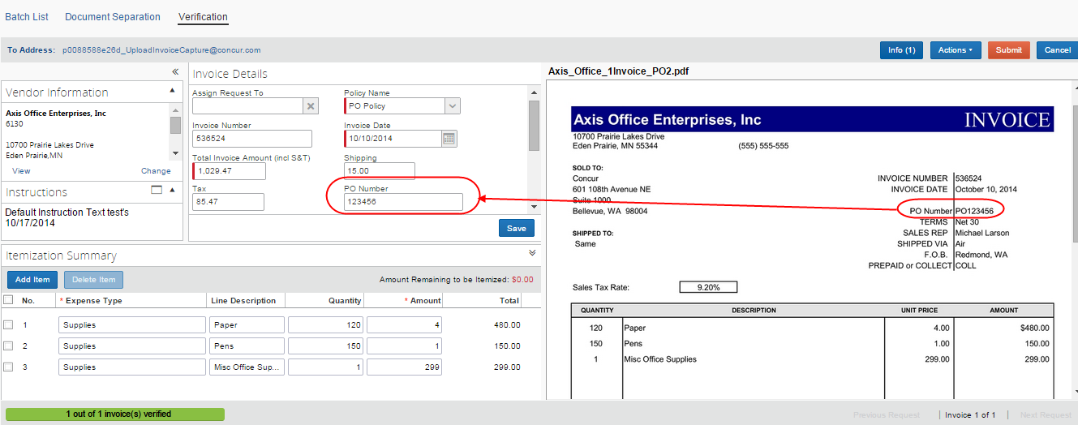
Detailed view of the Verification page showing the PO Number field:
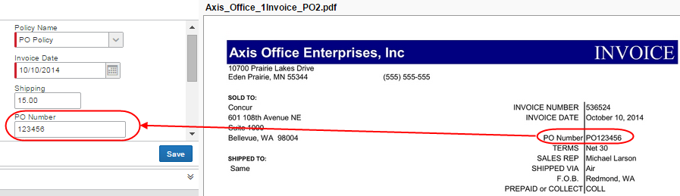

Associate Invoice With Multiple Purchase Orders
Concur Invoice can process invoices that are associated with multiple purchase orders, which might be useful for clients who only want to receive one invoice for several purchase orders that are tied to that particular invoice.
Some clients will get a mix of invoices with some invoices referencing a purchase order number at the header level and with some invoices referencing purchase order numbers at the line item level where each line item’s PO number could be different.
With the Multiple Purchase Orders feature, Concur Invoice supports the ability to associate a purchase order number at the invoice line item level.
Companies with this feature can:
- Enable PO numbers at the line item level
- Disable PO numbers at the line item level
- Change the associated PO number for an invoice line item on the Invoice tab
- View each PO associated to a specific invoice on the Purchase Order tab
The administrator needs to activate this feature in the Forms and Fields tool before users can work with multiple purchase orders.

Enable and Disable Line Item Level PO
The Multiple Purchase Orders feature provides employees with the Enable Line Level PO command in the Actions menu for an invoice (provided the Multiple Purchase Orders feature has been activated by SAP Concur staff). The user selects one purchase order number from which to create an invoice from the Purchase Order Number list on the Create New Invoice page. This PO number will serve as the primary PO number for all header PO-based copy-downs. Then the user selects the Enable Line Level PO option, and can manually add PO numbers at the line level in the Invoice tab. With this option selected (enabled), the user has indicated that it is a multiple PO invoice, and the PO number field at the line level becomes visible and editable. When the user adds a line item, the primary PO is defaulted as the first line’s PO. Users can change this line level PO number, and when the user creates additional line items, the previous line’s PO number is defaulted to the new line.
If the user changes the PO number:
- At the header level: The user is notified that any header copy-downs will also be changed if he/she proceeds to make the change. Line item level PO numbers will be unchanged
- At the line item level: That line item’s PO number will be changed, and the default for the next line will be the new PO number if the next line does not already have a PO number
Users can view all the POs belonging to a specific invoice in the Purchase Order tab, and to match invoice lines to PO lines belonging to different POs, a user needs to go into the Matching Summary tab.
If a purchase order is changed or updated, Concur Invoice will check if this PO is associated to any invoice line items. When the PO is saved, Concur Invoice will run configured matching rules against existing associated invoices.
Should the user wish to disable the Multiple Purchase Order functionality, he/she can do so by selecting the Disable Line Level PO command in the Actions menu.
To enable line item level PO:
- Click Invoice > Create New Invoice.
- On the Create New Invoice page that appears, in the Purchase Order Search field, start typing in a PO number, and then select the PO number that you want to use.
- On the Enter Invoice Details page, in the Actions menu, click Enable Line Level PO.
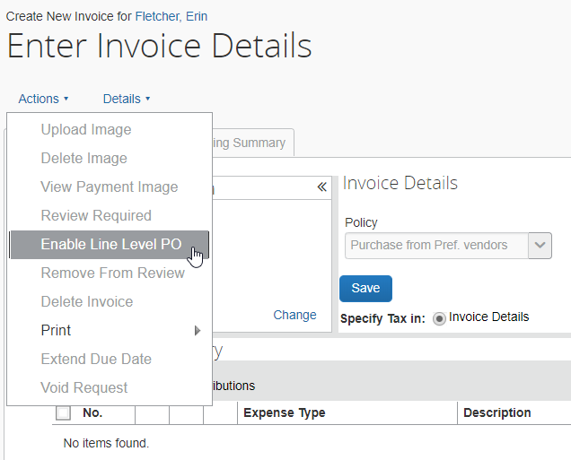
The Purchase Order Number column is added to the line item level.
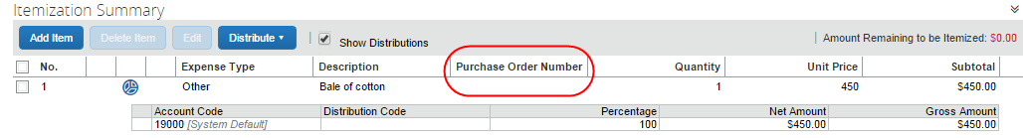
To disable line item level PO:
- Open the desired invoice.
- In the Actions menu, click Disable Line Level PO.
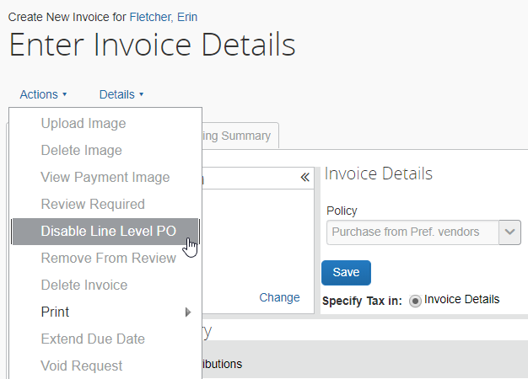
- In the Please Confirm window that appears, click Yes.
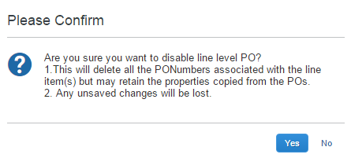
Please ensure that you really want to delete all purchase order numbers associated with the line item in question.

PO Line Item Association
If an invoice is associated to multiple purchase orders, the system creates a link between each invoice line and its corresponding PO. The PO number is then used for line association between the invoice line and the appropriate line of the PO. If the client has selected to use auto line association, this logic will be used for multiple POs as well.
Line item level PO-based copy-downs will occur from the associated PO line items.
Invoice line items that do not have a PO number will not be associated to a PO line item by the system.
If the user needs to change the associated PO number for an invoice line item, they will be able to do so in the Invoice tab.

View and Manage Multiple POs
Users can view and manage multiple POs in the Purchase Order tab and Matching Summary tab.
Purchase Order Tab
On the Purchase Order tab, the user will be able to select each purchase order tied to a specific invoice in a list.
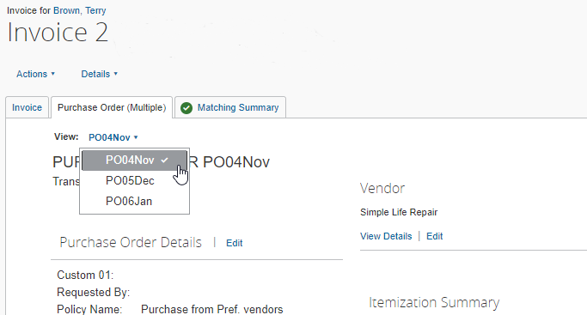
Once the user has selected a purchase order, they can view the details of the purchase order and work with it as usual.
To view and manage multiple purchase orders:
- Open the desired purchase order.
- Click on the Purchase Order tab.
- In the list, select the purchase order you want to view or work with.

Matching Summary Tab
On the Matching Summary tab, in the Purchase Order list, users will see the header level purchase order as default.
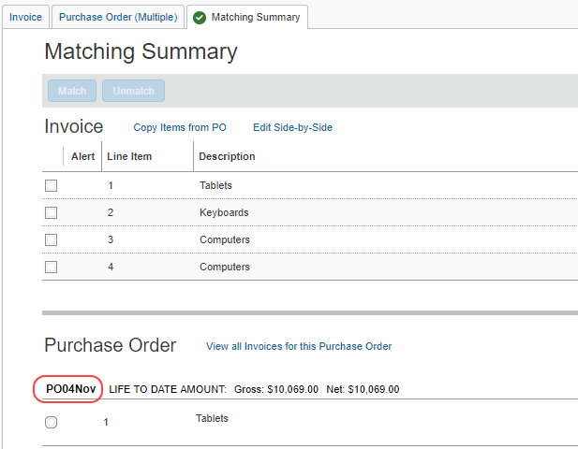
Once the user clicks on a line item purchase order in the Invoice list, the purchase order matched to that invoice shows in the Purchase Order list.
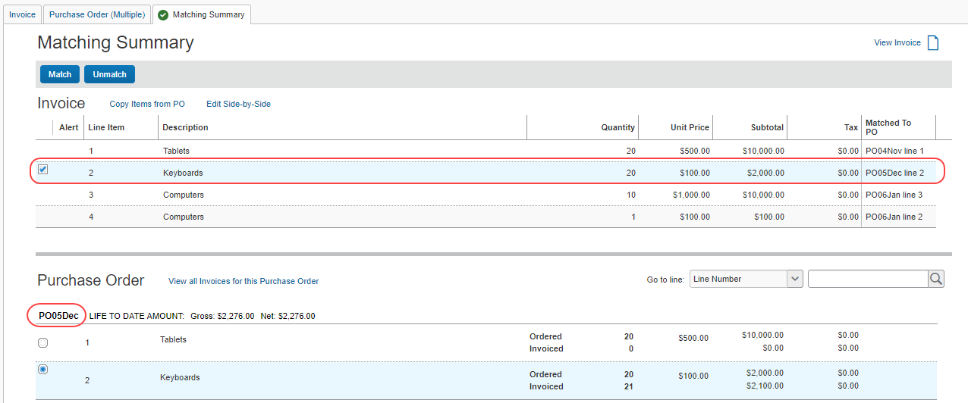

Line Search
Users can perform a contained search for a line item number, description, or supplier part number by using the new line search area. The user can select a line search option in the Go to line list, and then enter search criteria in the search field.
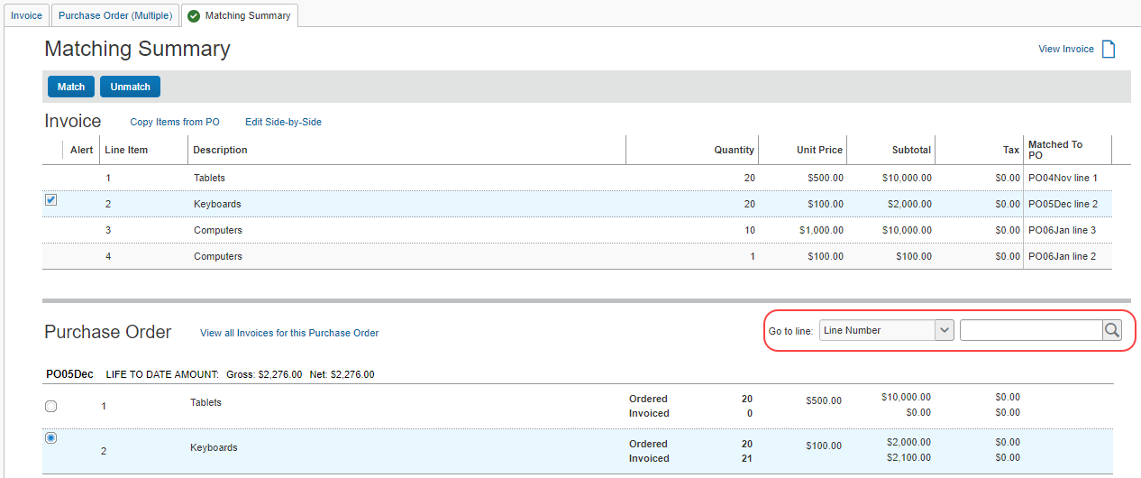

Copy Items from PO
In the Copy Items from PO window, the user will be able to see all lines of the purchase order tied to the specific invoice with which he/she is working. The line search field available on the Matching Summary tab is also available in the Copy Items from PO window where users can select the Line Number or Description option in the Go to line list.
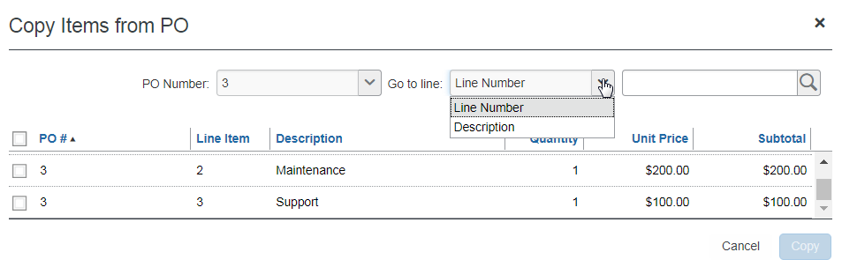
To copy items from a PO:
- Click Invoice and then select the relevant view.
- Open the invoice by clicking it.
- On the Matching Summary page, click the Copy Items from PO link.
- Select the items you would like to copy and then click Copy.

Edit Side by Side
In the Side-by-Side Editor window, the user or processor will see a list with all purchase orders tied to the invoice in question. By selecting one of the purchase orders from the list, the user or processor will see the purchase order header data in the Purchase Order section. This means that the purchase order header data will change depending on purchase order selected in the list, whereas the invoice details stay the same.
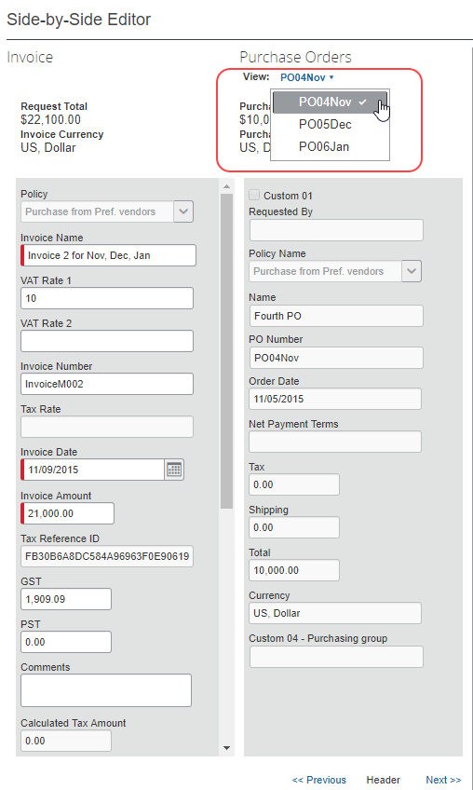
To edit in side-by-side view:
- Open the desired purchase order and click the Matching Summary tab.
- Click Edit Side-by-Side. The Side-by-Side Editor window appears.
- Edit the fields you would like to update.
- Click Save.

Associate by Using Imports (Web Services, ONP, and E-Invoicing)
The Payment Request import is the vehicle for any e-Invoices, whether from a supplier network or directly from the client to Concur Invoice.
The PO Import is the vehicle to communicate PO data to Concur Invoice from the client ERP.
For the Payment Request import, one of the following identifiers can be used to associate an invoice to a PO:
- Purchase Order Number: If specified, the system assigns the policy associated with the PO.
- OR -
- External ID: Unique identifier attribute of a policy, used to specify which policy to use.
When using these imports, the policy associated with the imported PO has precedence over the policy (if any) associated with the imported invoice. In general, a invoice's specified policy will be overridden by the PO policy upon association, if the policies are not the same.
- For more information, refer to the following documents of the Concur Invoice: Import and Extract File Specifications:
- Payment Request Import V2 (Current)
- Purchase Order Import
- For more information about importing POs, refer to the PO Import section in this document.

Associate an Invoice to a Different PO
You can associate an invoice to a different PO if it is, for example, incorrectly associated.
To associate an invoice to a different PO:
- Click Invoice and then open the desired invoice.
- Click the Invoice tab.
- In the PO number field, type the new PO number.
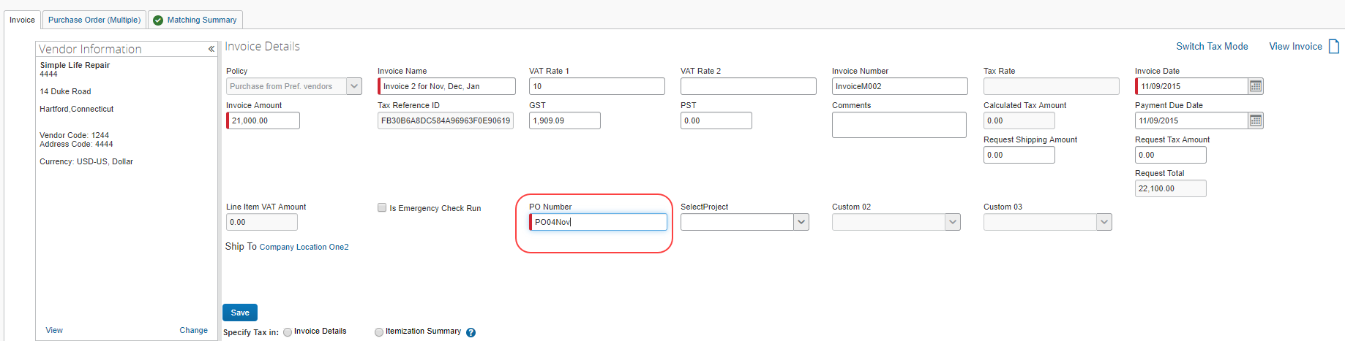
- Click Save.

Automatically Associate Invoices With Purchase Orders
If an invoice has one line item and a purchase order has one line item, Concur Invoice will automatically associate the invoice line with the PO line.

Change a PO-Based Invoice Policy to a Non-PO Based Invoice Policy
If an invoice is incorrectly associated to a PO, but is a non-PO based invoice, it can be reclassified. In the process of reclassifying, the user is asked to choose a non-PO policy they have access to for that invoice.
To change a PO-based invoice policy to a Non-PO based invoice policy:
- In the My Invoices page, select one or more PO-based invoices to be changed.
- In the Actions menu, click Change to Non-PO.
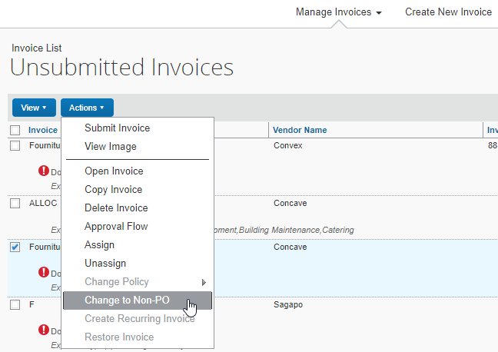
- In the Select a Policy window, select the new policy for the PO-based invoice.
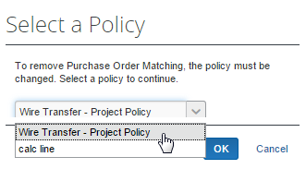
- Click OK.
The invoice might also require reassignment to another user. If so, be sure the invoice is in an unsubmitted state and that the new owner has access to the new policy. Then, open the invoice and use the Assign button to reassign the invoice to the new owner, adding an (optional) comment in the Comment field.
If it does not require reassignment, unassigning the invoice allows the AP User or other back-office personnel to perform the reassignment.

Match Rules and Match Status
Match Rules are configurable, similar to Audit and Workflow rules and can include condition-based rule groups within the overall matching rule set. They can be specified at the Header, Vendor, or Line Item level, and can be applied on a one-to-one basis between the current invoice and the PO, as well as a "Life-to-Date" basis that looks at all invoice in the system sharing the same PO Number. Match Rules that run and fail result in exceptions being applied to the PO-based invoice.
Multiple match rule sets include more complex matching by including additional condition-based rules. Adding detailed condition rules lets a company add custom project, division, or spend type fields to forms, then specify these fields as unique identifiers within the rule definition that, when found by the matching rule set, are analyzed according to the conditions specified in the overall matching rule set.
This results in a single rule set that can be executed across different PO types with confidence that attributes within the PO and invoice will trigger a rule to execute based entirely on the unique attributes.
- For information about configuring matching rule sets, refer to Purchase Order Matching Rules in the Concur Invoice: Invoice Purchase Order Matching Setup Guide.

Understand the Match Status Assigned to an Invoice
Match Status is an attribute of an invoice, and is determined by:
- Successful association to a PO
- AND -
- Presence of any match exceptions
Match Status displays on the My Invoices, Approve Invoice, Assign Invoice, and Processor List pages. The table below shows all possible Match Status types.
Status Name | Description
Matched | The invoice is associated to a PO and has no exceptions (note that several invoices can match a single PO).
Does Not Match | The invoice is associated to a PO and has one or more exceptions (note that several invoices can match a single PO).
Waiting for PO | The invoice is using a PO policy but the PO number on the invoice does not match any corresponding number on a PO.  This can happen when the PO Number value in a PO-based invoice is changed, causing the invoice association to a PO to be broken, and a new association not yet made.
Pending Match | The invoice is using a PO policy and is associated to a PO, but not assigned to a user.  This can happen if the invoice is newly created and not yet assigned, or if an existing invoice is assigned to a user without adequate policy rights (in which case the invoice is given a status of Unassigned and will be processed by AP).
Missing PO Number | The invoice is using a PO policy but is missing the PO number that associates it to a PO.  This can happen when the Payment Request import record has a value for External ID specified, but the purchase order number (PO #) field is blank in the feed.
No Match Required | The invoice uses a non-PO policy or has been deleted.

When Are Match Rules Run?
Matching rules are first run when:
- An invoice is both successfully associated to a PO
- AND -
- The invoice is in an assigned state (by any method, such as the Payment Request Import, Vendor to Employee rules assignment, AP User assigning to Invoice Owner, one Invoice Owner to another, etc.).
For three-way matching, invoices must, in addition to be associated with purchase orders, also be associated to received quantities (of goods).
When these two things are true, rules are re-run whenever relevant changes are made to the invoice or to the PO. This includes:
- On Header save and Line Item delete, save, and line sequence change
- Changing Invoice Owner, Vendor, or reassigning an invoice
- Upon PO import, if the import identifies a matching invoice in Concur Invoice that had not been previously associated to a PO
- Upon receipt import for invoices associated to the PO
Rules are rerun for the changes listed above regardless of workflow status. This applies whether the invoice is pending an Invoice Owner, Approver, or Processor.
The PO matching status of the invoice will be written to the Audit Trail whenever it changes.
Rules cannot be run if an invoice:
- Has been extracted
- Is part of a payment demand
- Has a status of Unassigned
- For more information about payment demands and their effect on running rules, refer to the Concur Invoice: Invoice Pay User Guide.

Concur Receiving
In a typical purchasing process, the buyer orders goods from the supplier by issuing a purchase order. The supplier delivers the goods with a document detailing the goods that are shipped (Delivery Slip Note/Bill of Lading). The buyer receives the goods and records the receipt by creating a Goods Receipt Note. The supplier then invoices the buyer for the items they have shipped. The buyer reconciles the invoice against the ordered and received items and then processes the invoice for payment.
This section describes how to enter quantity receipt data manually into the Concur Invoice product. This is beneficial for clients who can receive receipts in Concur Invoice and use three-way matching to give them more control over their invoice process.
Invoice Users, Invoice Processors, and PO Processors can enter, edit, and delete receipts, and add, view, and delete receipt images. In addition, Invoice Users (who are also Invoice Owners) and Invoice Processors can manage receipts at any time in the workflow process within Concur Invoice.
Provided the admin has selected (enabled) the Allow Purchase Request Owners to Edit their own Purchase Orders option in Invoice Settings or added the Receipt User role in User Permissions, the Purchase Request User will be able to add, edit, and delete receipts and add, view and delete receipt images.
If the Purchase Request User becomes the owner of the invoice as well as the purchase request, then they can add/change/delete receipts on the invoice (through the Purchase Order tab) when they submit the invoice. For this to work, the Assign invoice to Purchase Request Owner option must be selected (enabled) in Invoice Settings, or the invoice must be manually assigned to the user.
When Purchase Request Owners create a new item, they will be able to specify if the item requires quantity receipts or not in the Receipt Type list. The default will be None for services and Quantity Receipts for goods.
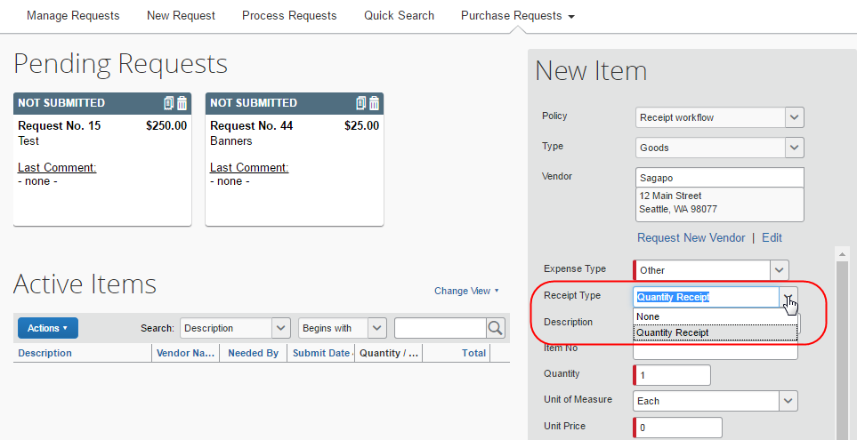
- For more information about the user permission roles when working with the Concur Receiving feature, refer to the Concur Receiving Roles section in this document.

Add a Receipt
Invoice Owners, Invoice Processors, PO Processors, and Purchase Request Owners (who can edit their own purchase orders) can open transmitted purchase orders and add receipts at the line item of the purchase orders.
To add a receipt:
- Open the desired purchase order and then click the Purchase Order tab.
- In the Itemization Summary section, click the Enter button. The Enter Received Goods window appears.
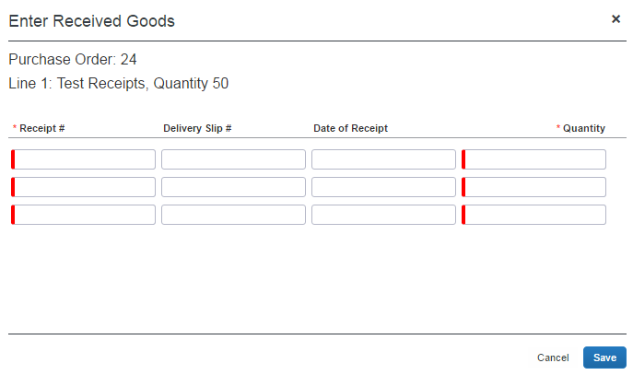
- In the Enter Received Goods window, complete the required fields and any other field that you would like to fill in.
Field | Description/Action
Receipt # | (Required) Enter the receipt number of the goods that you received.
Delivery Slip # | (Optional) Enter the Delivery Slip Number of the goods that you received.
Date of Receipt | (Optional) Enter the date when you received the goods. If left blank, today’s date is used.
Quantity | (Required) Enter the quantity of goods that you have received. The quantities are incremental.
Custom 1-10 | (Optional) Enter relevant information depending on what you want to input in your custom field. There are 10 custom fields available.  NOTE: These fields will only appear if the admin has added them to the Purchase Order Receipt form.
- Click Save.

Edit a Receipt
Invoice Owners, Invoice Processors, PO Processors, and Purchase Request Owners (who can edit their own purchase orders) can open transmitted purchase orders and edit receipts at the line item of the purchase orders.
If a receipt is associated with an invoice, a user will not be able to edit the receipt and the Edit button will be disabled. If a user needs to make changes to an invoice, they need to first unassociated the receipt to the invoice.
To edit a receipt:
- Open the desired purchase order and then click the Purchase Order tab.
- In the Itemization Summary section, select the receipt that you would like to edit, and then click the Edit button. The Edit Received Goods window appears.
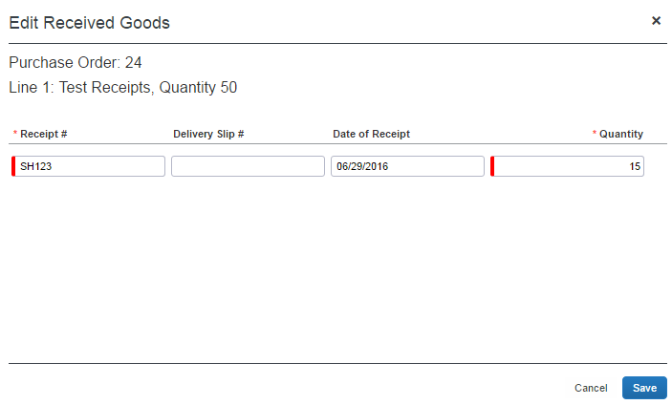
- Edit desired fields, and then click Save.

Delete a Receipt
Invoice Owners, Invoice Processors, PO Processors, and Purchase Request Owners (who can edit their own purchase orders) can open transmitted purchase orders and delete receipts at the line item of the purchase orders.
If a receipt is associated with an invoice, a user will not be able to delete the receipt and the Delete button will be disabled. If a user needs to make changes to an invoice, they need to first unassociated the receipt to the invoice.
To delete a receipt:
- Open the desired purchase order and then click the Purchase Order tab.
- In the Itemization Summary section, select the receipt that you would like to delete, and then click the Delete button. The Do you want to delete the follow Received entries? window appears.
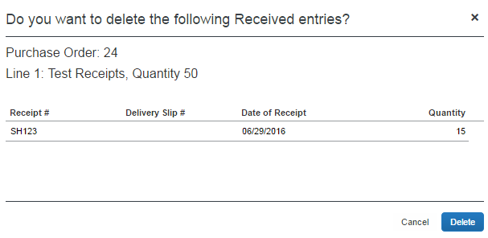
- Click Delete.

Add a Receipt Image
Invoice Owners, Invoice Processors, PO Processors, and Purchase Request Owners (who can edit their own purchase orders) can open transmitted purchase orders and add receipt images at the line item of the purchase orders. Only one image ID can be associated with a receipt. Additional uploaded receipts are appended to the same image.
To add a receipt image:
- Open the desired purchase order and then click the Purchase Order tab.
- In the Itemization Summary section, click the  icon of the receipt to which you would like to add a receipt image. The Upload Image window appears.
- Click Browse to locate the receipt you want to attach.
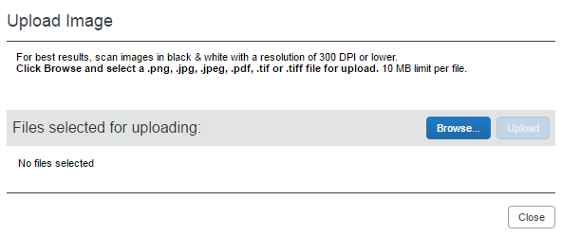
- Click Open or double-click the receipt image.
- Click Upload and then Close.
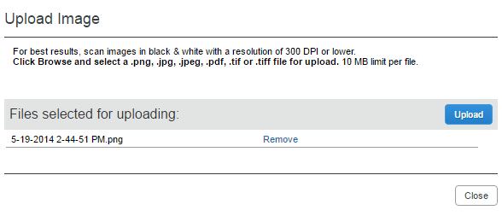

View a Receipt Image
Invoice Owners, Invoice Processors, PO Processors, and Purchase Request Owners (who can edit their own purchase orders) can open transmitted purchase orders and view receipt images of the purchase order.
To view a receipt image:
- Open the desired purchase order and then click the Purchase Order tab.
- In the Itemization Summary section, click the  icon of the receipt you would like to view. The Purchase Order Receipt Image window appears.
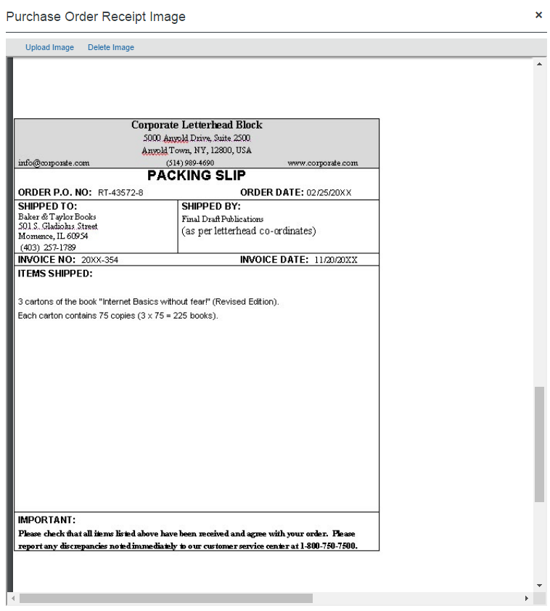
Review the receipt image and then close the window by clicking the x in the top-right corner.
You can also upload receipt images from this window by clicking the Upload Images link.
In the Purchase Order Receipt Image window receipt images can be rotated, downloaded, printed, zoomed in and out, and fitted to page.
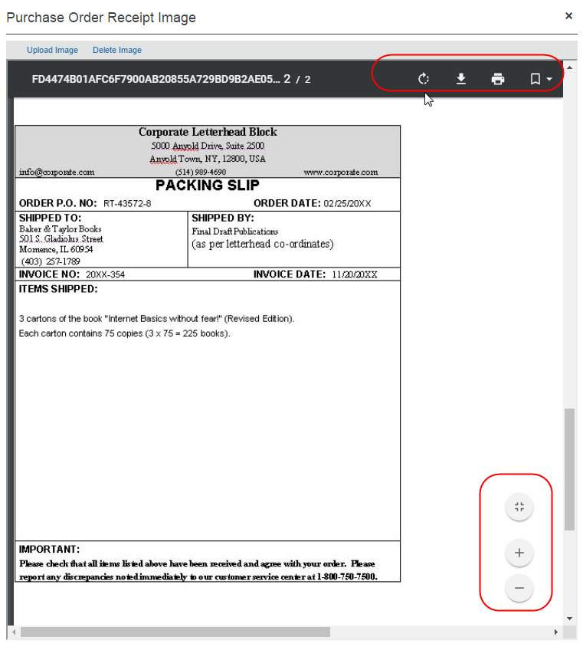

Delete a Receipt Image
Invoice Owners, Invoice Processors, PO Processors, and Purchase Request Owners (who can edit their own purchase orders) can open transmitted purchase orders and delete receipt images of the purchase orders.
To delete a receipt image:
- Open the desired purchase order and then click the Purchase Order tab.
- In the Itemization Summary section, click the icon of the receipt you would like to delete. The Purchase Order Receipt Image window appears.
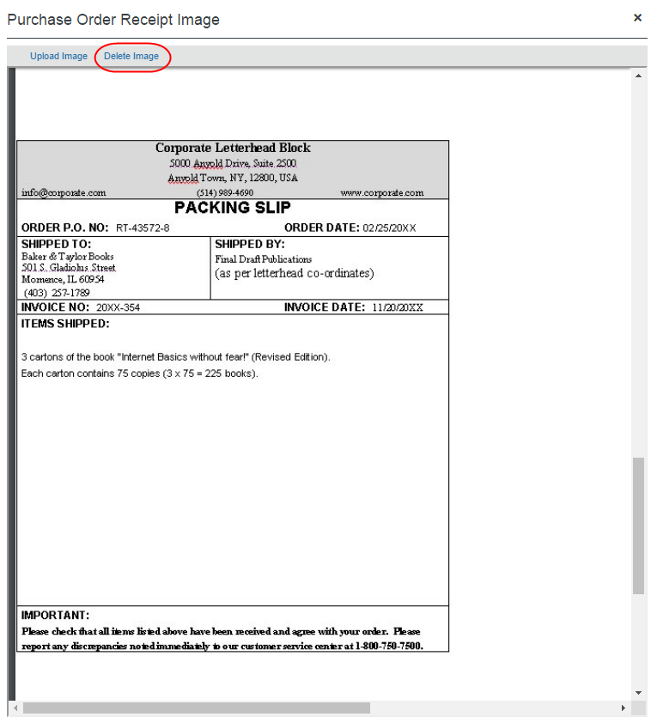
- Click Delete Image.

Purchase Order Import for Receiving
The Receipt Type is supported at the header and line item level of the Purchase Order Import.
- For more information, refer to PO Association and Policy section of this document.

PO-Based Invoices
A PO-based invoice is virtually identical to a non-PO invoice type. The same functions, such as Audit Trail and Approval Flow, workflow actions like Submit and Unassign, and working with images, are available. The primary difference is that since the invoice is associated to a PO, and is part of the PO policy type, the system will apply those match rules that have been associated with the PO policy.

Create a PO-Based Invoice
The first step is associating the invoice to a PO by entering a value in the Purchase Order Number field. The invoice is then completed just as any other invoice.
To create the PO-based invoice:
- Click Invoice > Create New Invoice. The Create New Invoice page appears.
- In the Purchase Order Search field, type the PO number, and then select the correct PO from the list that displays. This associates the new invoice to the PO in the system.
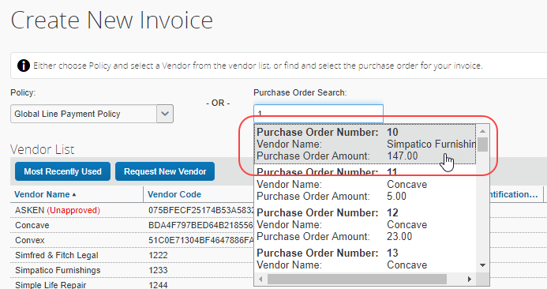
- On the Enter Invoice Details page that appears, continue to enter data just as you would for any other invoice.
TIP: Open the Purchase Order tab to review line item sequence and match that sequence to your line items as you enter them.
If no matching PO is found, the invoice cannot be created as a PO-based invoice. You must either determine why the PO has not been imported into the system or if the number you are using is incorrect.
The Purchase Order Number field only displays if a minimum of at least one active policy is of type PO. It will not display for clients who have not configured any PO policies.
- For more information, refer to PO Association and Policy section of this document.

Create PO-Based Invoice Line Items
When filling out (or coding) the PO-based invoice, there are situations when the invoice will arrive fully formed (such as an e-invoice). In other situations, such as manual entry, adding multiple line items can be time-consuming.

The Automatic Copy Down to Invoice Option
A data-rich invoice can be leveraged to automatically copy down header, line item, or allocation data from the PO directly to the associated fields on the PO-based invoice. This feature is ideal for clients who regularly allocate their POs and want to systematically preserve this cost ownership and distibution data in the PO-based invoice.
When users add PO-based invoice line items manually, the information is not copied down and defaulted to the PO line items until the matching process is completed.
How It Works
This is done by configuring the PR fields to copy down from the specified field on a form using options available when the user selects Copy Down for Default Value Type in Forms and Fields > Fields > Modify Fields.
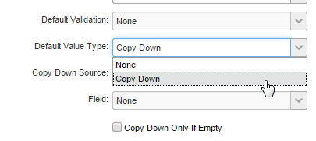
Configure Selective Copy Down by Field
The client can choose the best source of information, the PO or the invoice, using the Copy Down Only If Empty option. In its default state of disabled, the option prevents the PO field from overwriting data on copy down to the associated field at the PR level. Enabled, the field data at the PO level is copied over the data in the PR field.
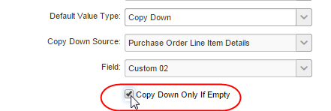
- For more information, refer to Concur Invoice: Purchase Order Setup Guide and the Concur Invoice: Forms and Fields Setup Guide.

The Copy Items from PO Option
An efficient way to create line items is to use the Copy Items from PO option in the Matching Summary tab. This will copy all selected line item information from the PO into the invoice.
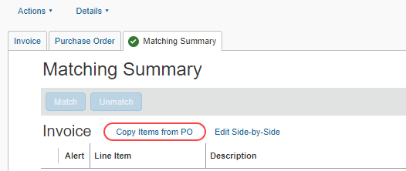
This serves as a starting point from which the user visually compares the invoice line items to the invoice image, checking for and adjusting any discrepancies. For example, rather than typing in 20 line items, the user might instead use the copy function, note that line 14’s invoices unit price is different than the PO, and make that one adjustment.
If line items already exist on an invoice, and a copy is performed, the PO-originating line items will be added net new to the invoice. The existing invoice lines will not be overwritten or automatically deleted. This enables the user to retain, edit, and delete the new combined set as appropriate.

Invoice Lists
The Invoice Owner clicks My Invoice to display the default Unsubmitted Invoices list, showing all invoices, both PO-based and non-PO based.
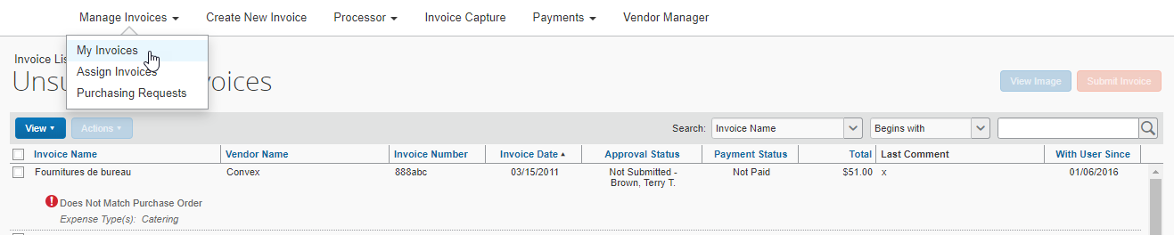
PO-based invoices are clearly marked by match status type and color indicator.
- For more information, refer to the Match Status section in this document.
All PO-based invoices, regardless of match status, start the workflow pending the Invoice Owner. This allows Invoice Owners to perform a "soft receipt" check on quality of goods and services received. For example, even if a PO and invoice have a status of Matched, the goods might have arrived late, damaged, or otherwise in a state that merits review and reduced payment.
"Straight-through processing," in which the invoice bypasses the Invoice Owner under certain conditions, is not yet available for PO-based invoices, but might be added in future releases, based on specific client feedback.

Use the Bulk Submit Action
It is easy to dispatch matched PO-based invoices quickly by using the Bulk Submit action. Select one or more invoices, and then choose Submit Invoice from the Actions menu.
TIP: The availability of the Submit Invoice command or button is a visual indicator that the selected group of invoices can all be submitted. If it is not active, one or more of the invoices requires corrections, such as first resolving match exceptions.
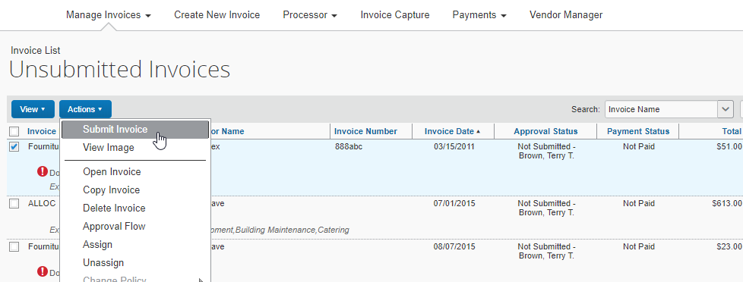

Filter the View
The Invoice List page view of PO-based invoices can be filtered by invoice type (non-PO or PO) and by match status, but invoices cannot be searched based purely on the attributes of their associated PO's, for example, PO Name, Description or Order Date.
The user can filter the view to PO-based invoice types based on their status (Matched, Pending, etc.) using the View menu command Unsubmitted Purchase Order Requests and the submenu that displays when you point to that command.
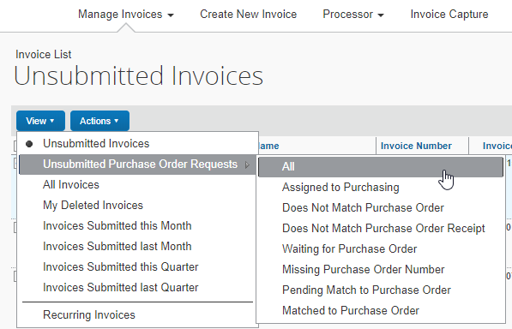
This view and the options described above are available to the user in the Approve Invoices and Processor List pages as well. PO Number is an invoice field, but it can only be searched on in Processor and not in Invoice Owner or Approver list type pages.

Resolve Exceptions
Matching rule sets expose discrepancies between POs and invoices and create corresponding exceptions. When this occurs, the Invoice Owner’s goal is to identify and resolve these exceptions.
You can configure your matching rules to allow submission despite an exception, and you can display a custom message when the exception triggers. For more information, refer to the Concur Invoice: Purchasing Order Setup Guide.
For example, suppose a company has a match rule, which include Line Item Unit Price.
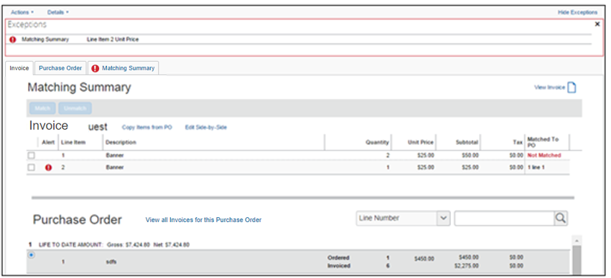
In the Exceptions section, the Invoice Owner notes the exception of the Line Item Price. A visual comparison of the PO and invoice line item summaries confirms the difference in unit price. To investigate further, the Invoice Owner clicks Edit Side-by-Side to display the Side-by-Side Editor window.
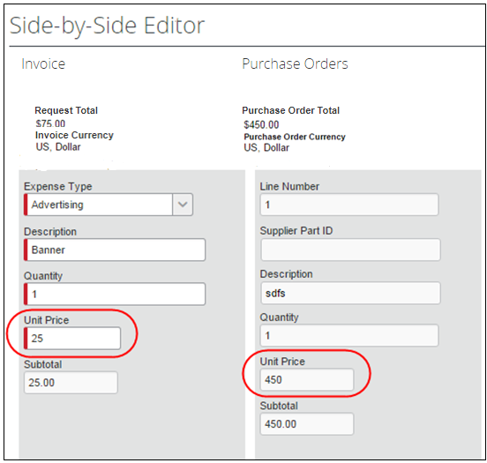
The Invoice Owner sees that the vendor has invoiced $25 Unit Price, whereas the PO Unit Price is $450. They can now resolve the exception, based on the root cause as well as their company policy.
If the invoice is incorrect and:
- If company policy is to "short-pay": The client will have configured relevant invoice fields to be editable, and the Invoice Owner will edit the invoice unit price to match the PO.
- If company policy is to require corrected invoices: The client will have configured relevant invoice fields to be read-only, and the Invoice Owner will contact the supplier to request a new invoice. When this arrives, they will delete the incorrect invoice and proceed with the new invoice.
If the PO is incorrect, and:
- If company policy has a dedicated Purchasing user (that is, the Invoice Purchasing User role) with rights to edit the PO forms: The PO is sent to this user using the Send To Purchasing button available when viewing the PO in detailed format. This user edits the PO as needed using guiding comments provided by the user, and then returns the PO to the user when done.
- If company policy allows Invoice Owners to change POs: The client will have configured relevant fields to be editable, and the Invoice Owner will edit the PO unit price to match the invoice.
- If company policy only allows Purchasing (or another department) to change POs: The client will have configured relevant PO fields to be read-only, and
- The Invoice Owner will explain in the Comment field what change needs to be performed and return the invoice to their AP department by unassigning it. AP will reassign the PO to the correct employee.
- The Invoice Owner will directly reassign the PO to another Invoice Owner, Purchasing User (see above), or the AP User employee within that department, explaining in the Comment field on reassignment what change needs to be performed.
TIP: Comments might be optional. Ensure that you notify your users if you must have a comment included in this action.
- For more information, refer to the Invoice Purchasing User Role section in this document.
When an invoice has only non-blocking purchase order matching errors, the icon on the Matching Summary tab and the icon on the Invoice list will show a warning (a yellow triangle) indicating that there is an error. However, the invoice can still be matched.
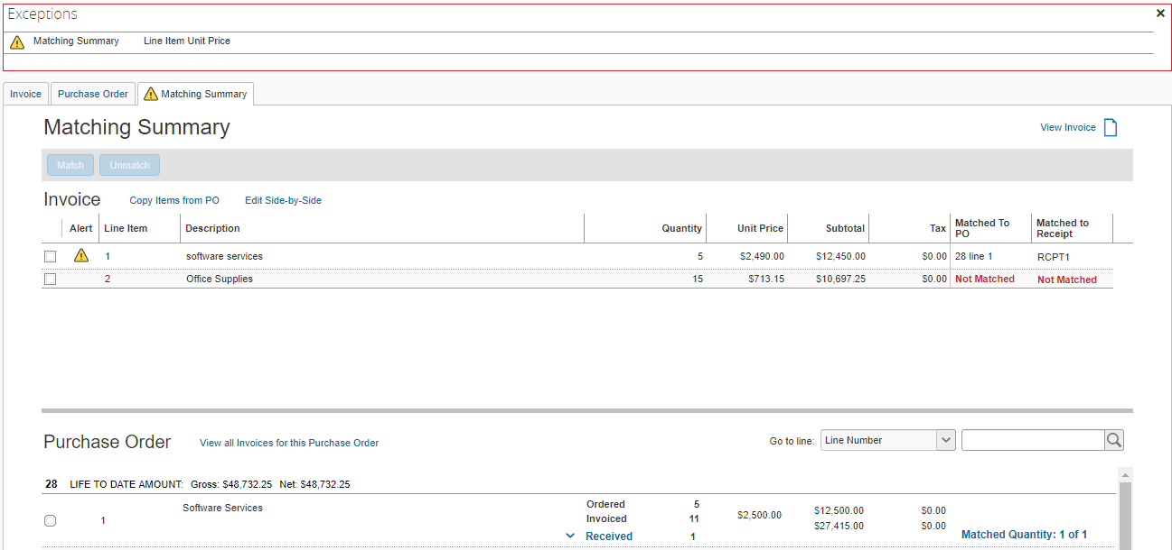
Once the exception is resolved, the Invoice Owner can then submit the PO-based invoice.

How to Deal With Exceptions Using Matching Rules Options
Matching rule sets can be configured to include options that let you submit a PO even if it has an exception, and to create a rule-specific custom message that displays when the exception occurs. By allowing submission, the exception can be dealt with in a timely manner without the PO being delayed. A custom message can include text that instructs the user on how to proceed when this exception occurs.
Both options are available to the Invoice administration on the Rules tab when configuring the matching rule set.
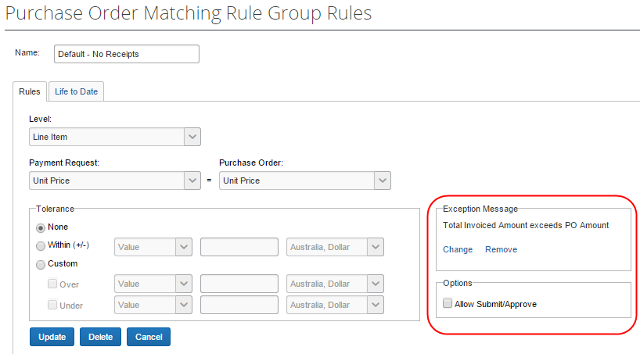
- For more information, refer to the Refining the Rules: Allowing Submission Despite Tolerance and Refining the Rules: Including an Exception Message section in the Concur Invoice: Purchase Order Setup Guide.

Understand Line Item Match Rule Application
Concur Invoice can perform line item identification in two different ways, either by sequence or by data attributes.
If the client uses line item identification by sequence, line item match rules operate by comparing values for like Line Number value types. For example, Concur Invoice compares Request Line Number 1 to PO Line Number 1.
Sometimes the system generates exceptions erroneously, because the overall number of line items, or their sequential order, is incorrect. Adjust the line items as outlined below.
- For more information about line item identification by data attributes, refer to the Concur Invoice: Purchase Order Matching Setup Guide and the Concur Invoice: Invoice Settings Setup Guide.

Correct Line Item Matching to Match Invoice and PO
In this scenario, the invoice has the correct line items, but they are out of sequence compared to the PO. When corrected, no changes are seen in the user interface other than the removal of those exceptions generated by the mismatching line items.
When a user clicks a line item of an invoice or PO, which has already been matched, the Unmatch button will be enabled for the matched purchase request line item.
The easiest way to match an invoice with a purchase order is to select the desired invoice and purchase order, and then click the Match button.
If the user needs to unmatch a single line item, he/she can do so by selecting that line item and click Unmatch.
To change the line item matching of the invoice:
- Click Invoice > My Invoices.
- On the Invoice List page, double-click the desired invoice to open it.
- Click the Matching Summary tab.
- Select the line items that you want to match, and then click Match.
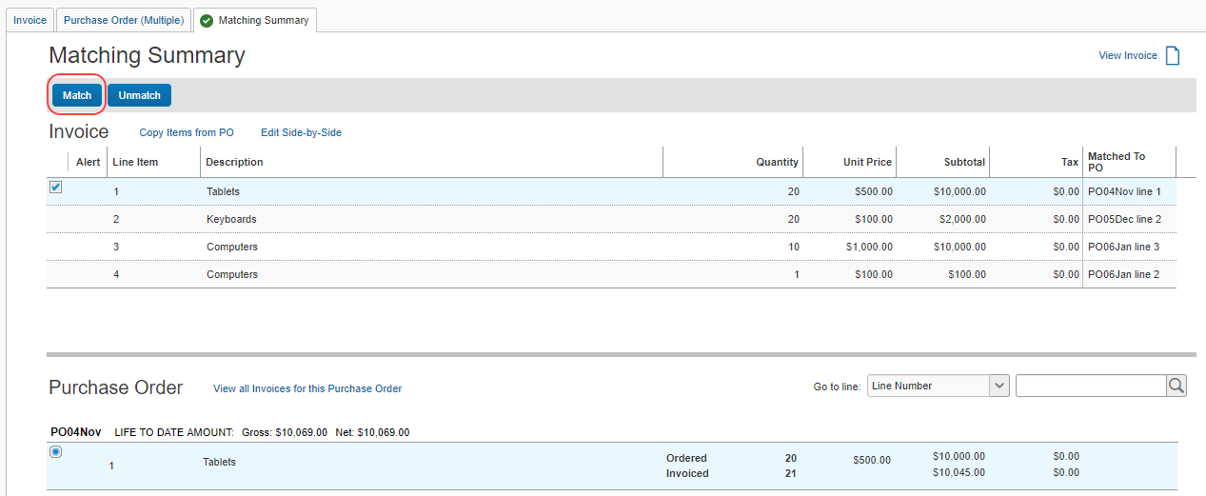
The line items are now matched, and the exceptions resolved.

Correct Overall Number of Line Items to Match the PO
In this scenario, the invoice has a different overall number of line items, compared to the PO. For example, the PO has four separate line items totaling $1,000. However, the vendor issues an invoice with all four items collapsed into a single $1,000 line item.
Here, the invoice must be adjusted to match the PO by adding three additional line items to the invoice. Now, with the four lines in identical sequence (and having correct sub-amounts), the invoice and PO will match.

Extra Line Items
The system will only run line item match rules against line items that share a invoice/PO counterpart, per the line number. It will not run rules against extra or "stand-alone" line items. For example, if a PO has Line Item 1 for $1,000 and Line Item 2 for $300, and the invoice has only Line Item 1 for $1,300, match rules will run on Line 1 only, not on Line 2, as it has no counterpart.
Use the instructions above to adjust line item number or sequence if necessary.
In some situations (if client policy allows), a user can purposely create an extra line item to "even up" overall totals and achieve a Matched status. For example, they can add an extra stand-alone negative invoice line item, or a positive PO line item, to account for a trivial, small dollar shipping charge or tax rate discrepancy.

When Exceptions Cannot be Cleared
If the Invoice Owner cannot clear all exceptions, they can take the following actions:
- Send to Purchasing User: A user with the Invoice Purchasing User role has permissions to clear exceptions. Use the Send to Purchasing button to search for and send to this user, along with comments about the issues with the PO.
- Wait: If a vendor must generate a new invoice, the owner can simply wait until the new invoice arrives and the original has been deleted from the system.
- Unassign: Hand the invoice ownership back to the AP User by unassigning the invoice from the owner - returning this to the general pool frees the AP User to re-code the invoice or assign it to the correct party.
- Send Back: If an Approver or Processor, use the Send Back feature to return the invoice back to the Invoice Owner who can remove the exception(s).
- Assign directly to another employee: Reassign the invoice directly to an employee with the correct permissions (such as another Invoice User or the Invoice Purchasing User) to clear the exceptions, who should then assign the invoice back to the Invoice Owner for review.

Exceptions and Three-Way Matching Rules
With three-way matching, three purchase order matching rules are available. SAP Concur recommends that clients use both these rules to get the most out of this feature.

The Line Item – Receipt: Line Quantity Rule
The Line Quantity rule compares the quantity of the invoice line with the available quantity on the associated receipts and throws an exception if there are not enough received quantities within the associated receipts to fill the invoice.
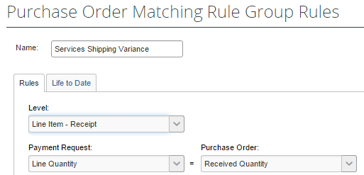
Example
Let us assume that we have the following setup:
PO
Line1: Ordered Quantity is 30
Receipts
GRN#1: Received Quantity is 10
GRN#2: Received Quantity is 10
GRN#3: Received Quantity is 10
Invoice 1
Line 1: Quantity is 30
If user associates Invoice Line 1 to just GRN#1, then the Line Item-Receipt rule will throw an exception, as GRN #1 does not have enough quantities for Invoice Line 1.

The Line Item – Receipt: Receipt Associated Rule
The Receipt Associated rule throws an exception if any invoice line is associated to a PO line but does not have an associated receipt.
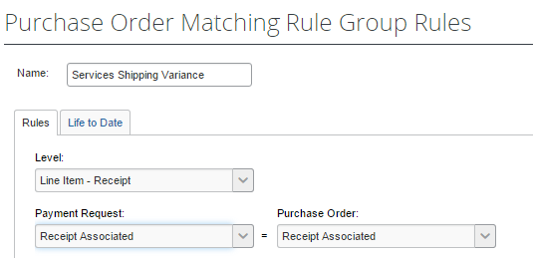
Example
Let us assume that we have the following setup:
PO
Line 1: Ordered Quantity is 10
Line 2: Ordered Quantity is 15
Line 3: Ordered Quantity is 20
Receipts
GRN#1 for PO line 1: Received Quantity is 10
GRN#2 for PO line 2: Received Quantity is 15
Invoices
Invoice 1:
Line 1 quantity is 10
Line 1 quantity is 15
Line 1 quantity is 20
The system will associate Invoice 1: Line 1 to PO 1: Line 1 and GRN #1.
The system will associate Invoice 1: Line 2 to PO 1: Line 2 and GRN #2.
The system will associate Invoice 1: Line 3 to PO 1: Line 3, but will not associate Line 3 to a GRN, as no corresponding GRN is available. The Receipt Associated rule will throw an exception on this invoice line. This exception appears as "Does not Match Purchase Order/Receipt" on the Invoice List page.

The Matched Against Received Quantities Rule
The Matched Against Received Quantities rule is a Life-To-Date rule that compares the total quantities invoiced (based on quantities matched) against the total quantities on the associated receipts.
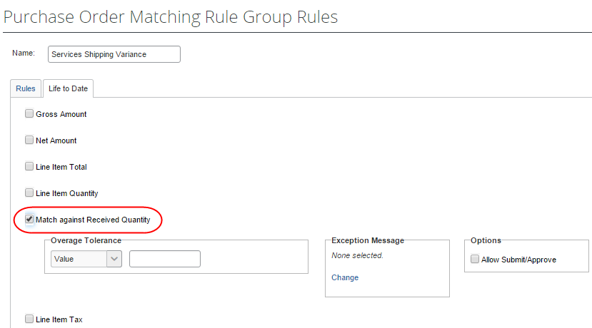
Example
Let us assume that we have the following:
PO
Line 1: Ordered Quantity is 30
Receipts
GRN#1: Received Quantity is 20
Invoices
Invoice 1: Line 1 quantity is 10
Invoice 2: Line 1 quantity is 10
Invoice 3: Line 1 quantity is 10
The system will associate Invoice 1: Line 1 and Invoice 2: Line 1 to GRN #1. The system will not associate Invoice 3: Line 1 to a receipt, as there are no available receipts to associate for this invoice. However, if a user associates Invoice 3: Line 1 to GRN#1, the Life-to-Date rule will fire and throw an exception on all three invoices.

Receipt Association and Three-Way Matching
Concur Invoice will automatically try to associate incoming invoice line to available receipts on the associated PO lines in a sequential order, filling each invoice line with available quantities from GRN #1, GRN #2, and so on. However, for invoices where the client has specified the Delivery Slip Number, Concur Invoice will associate it to the GRN that has the same DSN. If Concur Invoice does not find a GRN with the same DSN, it will not revert to the sequential association logic but will instead leave the invoice unassociated to the GRNs.
DSN is available as a field on both the Payment Request Header form and on the Payment Request Details form. The detail-level DSN is currently a read-only field and automatically copies down the value that is provided in the header DNS field, which means that all lines of the invoice must have the same DSN.

Send a PO-Based Invoice to a Purchasing User to Resolve Issues
When a PO-based invoice has issues that must be addressed by a user with rights to change values, the unsubmitted invoice can be sent to the Invoice Purchasing User. The user assigned this role, when configured with forms and fields’ rights, can adjust the invoice as required based on these field access rights, and reassign back to the originator who sent the invoice initially. Built-in protections prevent this user from either creating or submitting the invoice, preventing fraud.
To send a PO-based invoice to a Purchasing User:
- On the Invoice List page, select a PO-based invoice and open it.
- Click Send to Purchasing.
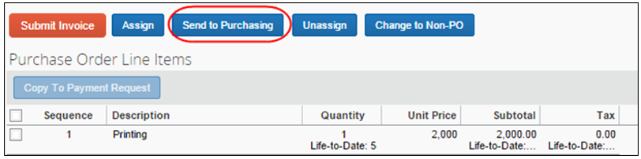
- In the Choose Employee field, search for the user by typing their name.
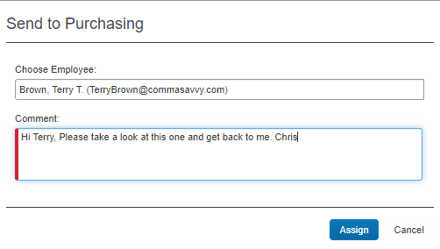
- In the Comment field, add a comment (required) to assist the purchasing user.
- Click Assign. The PO based invoice will be sent to the purchasing user.
Processor View
The processor can identify PO-based invoices sent to Purchasing by an icon and text that appears when hovering over the icon in the Processor list view.
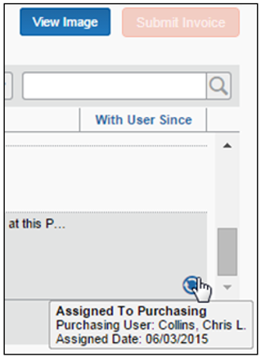

Return PO-Based Invoice to Assigner
When Purchasing has received the invoice and performed the necessary changes, the purchasing user returns the invoice to the user who sent it to the purchasing user originally.
To return the PO-based invoice to the assigner:
- In the Manage Invoices menu, click Purchasing Requests.
- On the Invoices Assigned to you page, select the invoice and then do one of the following:
- Click Actions > Send Back From Purchasing
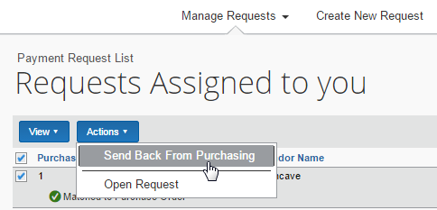
- Click Send Back From Purchasing
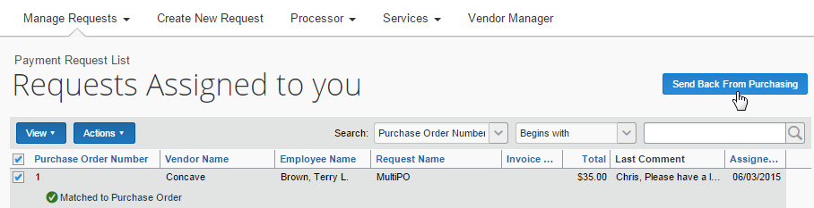
- (Optional) Add a comment to explain the actions taken.
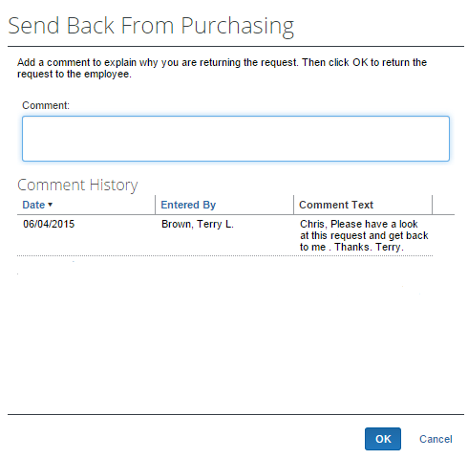
- Click OK. The invoice will automatically be sent back to the user who sent the invoice.

Switch Tax Mode
The Tax field allows the Invoice user to enter tax at both the invoice and the line item levels, or either one as the user chooses. This field can handle different tax rates within a single invoice, such as Sales and Use tax rates in the U.S., and the Value Added Tax in other countries. This line-item Tax field is available in the Payment Request import, the Standard Accounting Extract, and for use in the Audit Rules and Processor Queries as well.

Use the Tax Field at Both the Invoice and Line Item Levels
Some clients will only need to enter tax at the header level, while others will only enter at the line item level. Clients who need to use both should consider adding both the header Tax field and the line item Tax field. If a client configuration includes Tax fields added at both header and line item levels, a Switch Tax Mode button appears on the Invoice page, and end-users can click it to switch between the header and line item "tax edit modes."
The invoice user can only use one Tax field, either at the header or line item level, per invoice.
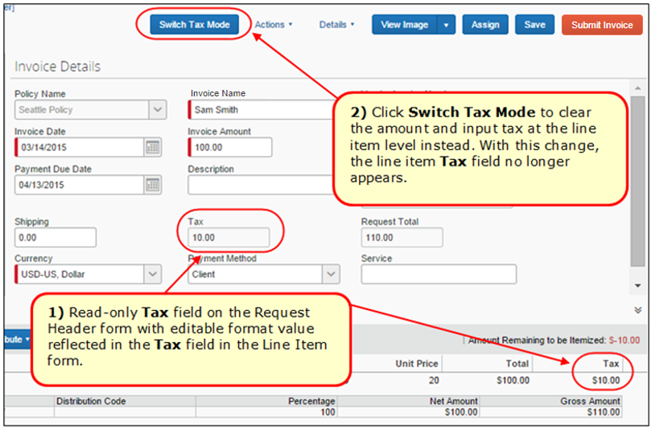
The figures below assume that tax field configuration has been added at both header and line item levels. Therefore, the Switch Tax Mode button is displayed.
Example 1: Header Tax Edit Mode
Focus switched to header "tax edit" mode.
In this mode, you can edit the header field and the line item field is not displayed.
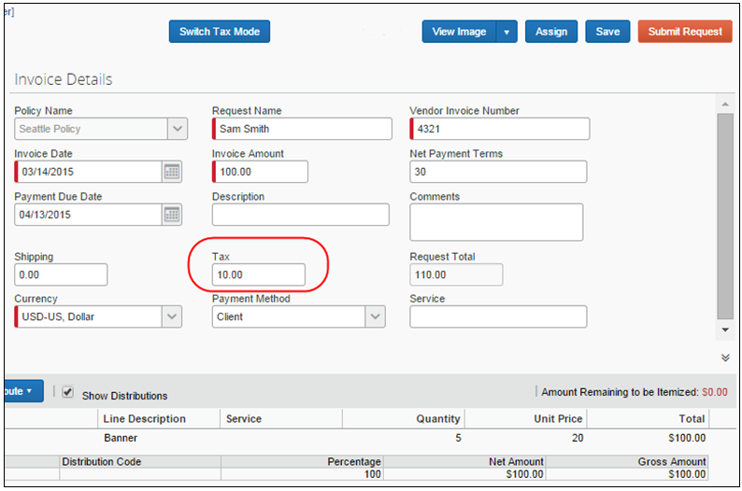
Example 2: Line Item Tax Edit Mode
Focus switched to line item "tax edit" mode.
In this mode, the header field is read-only, and you can edit the line item fields.
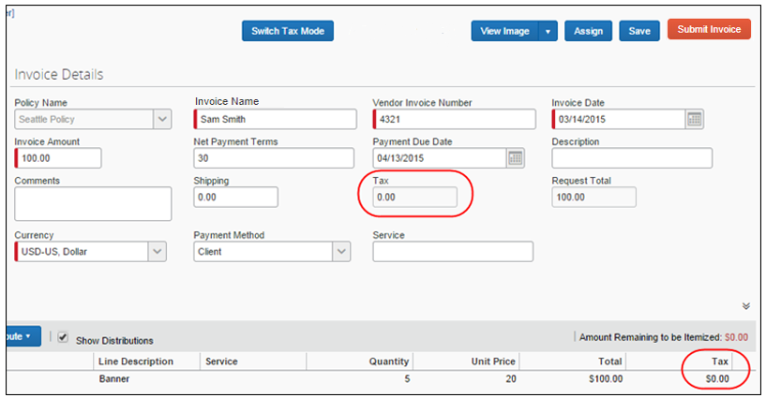

Submit a PO-Based Invoice
A PO-based invoice is submitted just as any standard invoice; there are no special actions required for this invoice type.
To submit a PO-based invoice:
- From the Unsubmitted Invoices page, select an invoice to submit.
- Click the Submit Invoice button or the command in the Action menu.
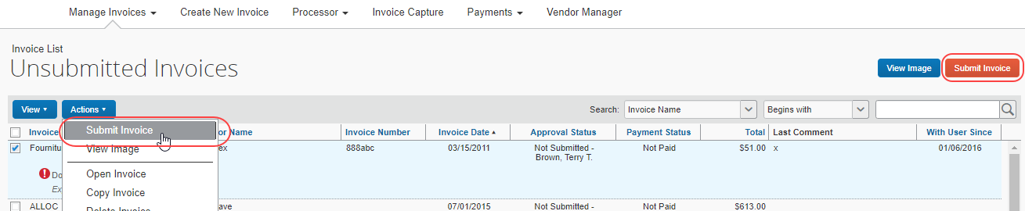

View the Invoice Image
The original invoice provided by the vendor can be displayed for viewing when reconciling or verifying the data on the invoice or PO. You can display the image using:
- The Unsubmitted Invoices Page: This default list view lets the user click either the View Image button or the command of the same name in the Actions menu:
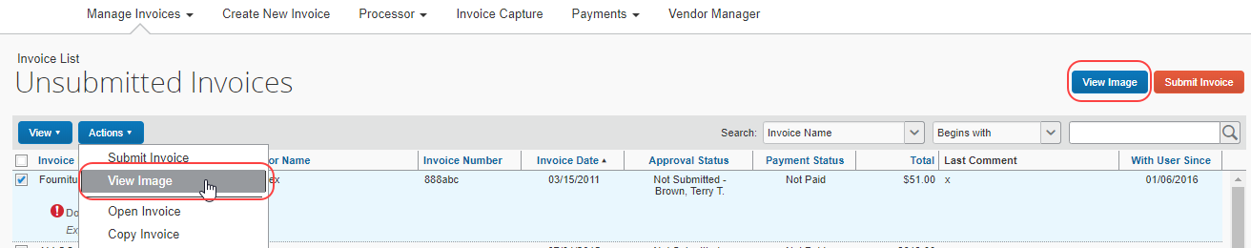
- The Matching Summary Tab: Open an invoice to display it in this default view, then click View Invoice:
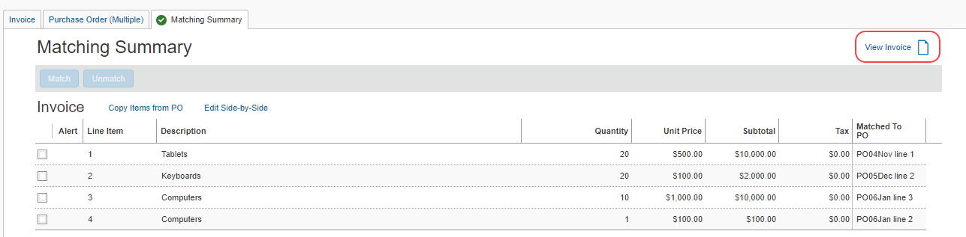

View All Invoices Associated with the PO
More than one invoice can be associated with a single PO. The system lets the Invoice Owner or Processor see all invoices in a single list view.
To view all invoices associated with a PO:
- On the My Invoices (or Invoices Ready for Processing) page, open the invoice in detail view.
- In the Matching Summary tab, click View all Invoices for this Purchase Order link.
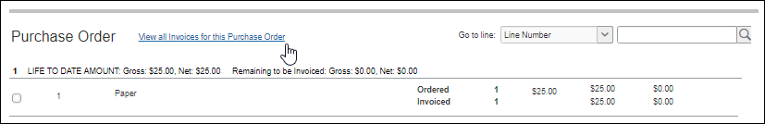
The Invoices matched to this Purchase Order window appears. You cannot edit anything in this window. It is for reference only.
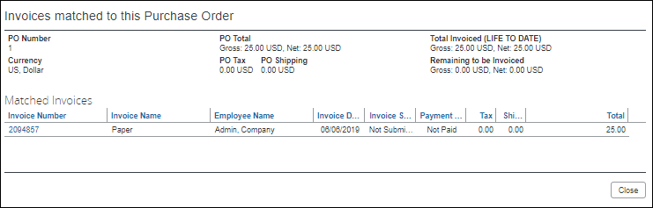
- Click Close when done reviewing the information to return to the Matching Summary tab.

Quantities and Amounts Freed up on Voided PO-Based Invoices
Voided invoices remain associated with the PO, but the goods receipt quantities and amounts are freed up to be invoiced on a replacement invoice. While Concur Invoice shows those voided invoices, they fully umatch the lines for re-invoicing. When a new invoice is created, it will have the same purchase order referenced on it.

Workflow and Approval Routing
All workflow options available for non-PO policies are also available to a PO-based invoice policy. This includes options such as workflow rules and Authorized Approvers.

Best Practice: Workflow for PO-Based Invoices
Since most companies have already achieved sufficient approval on the PO, as long as the invoice matches the PO, additional invoice approval can be eliminated (or kept to a minimum). Best practice is to configure workflow as minimal, by progressing immediately to the Processor. However, some companies opt to facilitate "budget reminders," and route PO-based invoices over a large amount to an approver to give them additional budget insight.
- For more information, refer to Workflow: The Default PO Payment Workflow section in the Concur Invoice: Purchase Order Setup Guide.
- For more information, refer to Concur Invoice: Workflows – General Information Setup Guide.

Approval Timeout Actions
Approval timeout ensures no invoice is idled due to lack of approval. This action applies to all invoices regardless of type. When the timeout that has been configured is reached, the PO-based invoice is automatically given a status of Unassigned, the status is logged in the Audit Trail, and the invoice is returned to the AP User's queue.
When a PO-based invoice times out it is given a status of Unassigned; this invoice type will not be automatically submitted as is the behavior of non-PO invoice types.
- For more information, refer to Concur Invoice: Workflows – General Information Setup Guide.

Processor Role
When approving, the Processor can draw on features specific to this type of invoice, including:
- Search for PO-based invoices by querying for their associated Purchase Order Number, Invoice Number, or Request Number value
- Side-by-side edit view of PO and invoice for vendor, header, and line item editing
- Ability to change the sequence and number of line items in the invoice to match those of the PO
- Ability to clear exceptions that prevent matching
- Ability to send the PO to the Purchasing User via the Send To Purchasing button
Processors who work with multiple purchase orders will be able to perform the same task as the user, when working in the Purchase Order tab and Matching Summary tab. For more information, refer to the View and Manage Multiple Purchase Orders section in this document.

Processor: Search for and View Invoices by Their PO Number
The Purchase Order Number attribute is unique and can return one or more invoices associated with their PO. To view these in the Processor view, a search function using the Go To button is available.
Searching for an invoice using the Go To function:
- Click Invoice > Processor > Process Invoices.
- On the Invoices Ready for Processing page, click Go To.
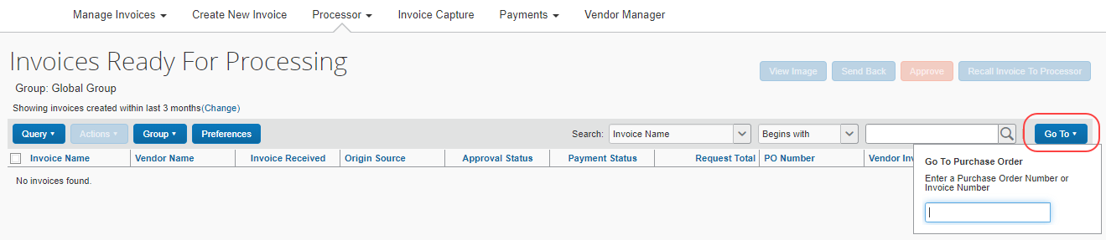
- In the field that appears, type in the order number, invoice number, or invoice number associated with the PO you are searching for. When a match is found, the system returns one (or more) PO-based invoices.
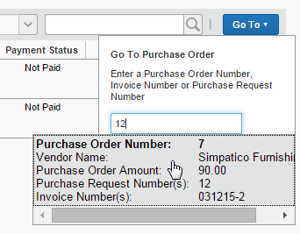
- Open the PO-based invoice for viewing by clicking it directly (only one can be opened at a time).
Add the PO Number Column to the Processor View
For viewing, the PO Number column is added to the grid view, allowing a sort by number view to quickly sort and identify these invoices.
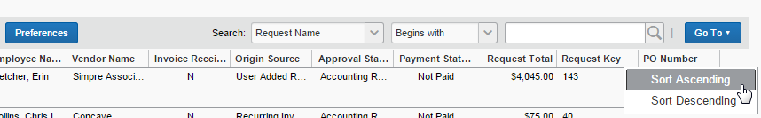
To do this, use the Preferences button in this view to open the Preferences window (shown below) and add the PO Number (or preferred identifying column) to the grid view.
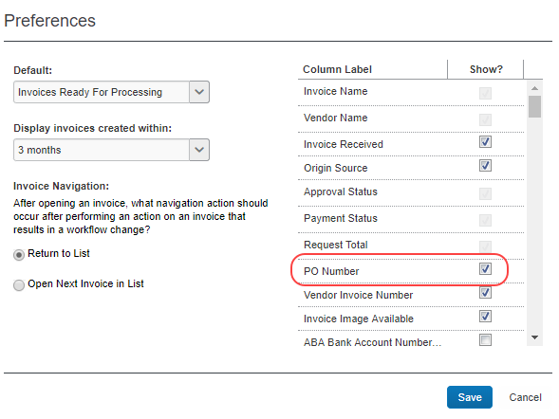
Search for a PO-Based Invoice Using a Custom Query
Creating a query can eliminate tiresome repetition whenever the same search criterion is used repeatedly to return PO-based invoices.
Searching for a PO-based invoice by creating a custom query:
- Click Invoice > Processor > Process Invoices.
- On the Invoices Ready for Processing page, click Query > New Query.
- Create the query as shown in the following figure below.
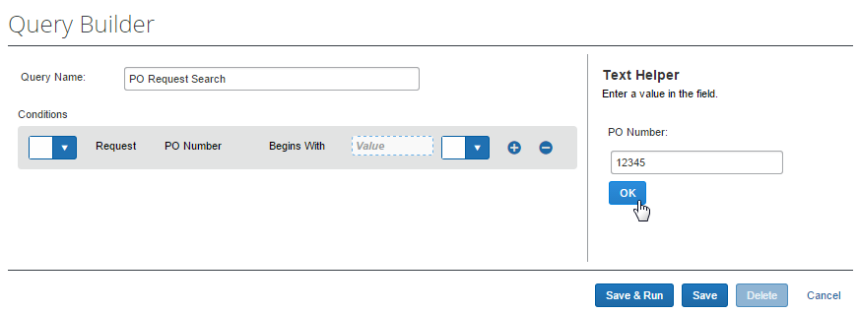
- Click Save (or Save & Run to return all PO-based invoices using that number).
- The query is saved and can be run by clicking the query directly.
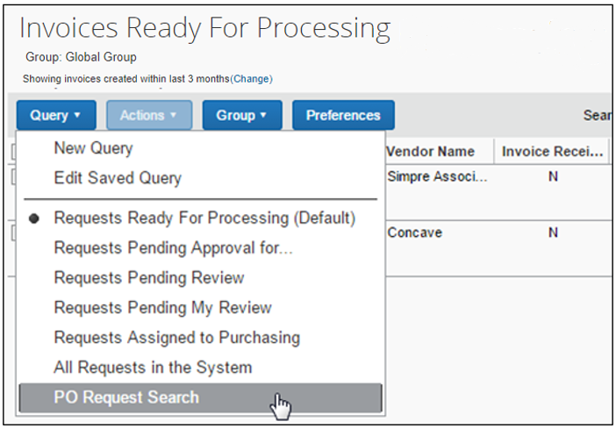

Processor: Edit the Invoice
A PO-based invoice might need adjusting prior to approval. The Processor has the option of sending the PO-based invoice back to the Invoice Owner or a specified Purchasing User with directions in the Comment field explaining the required changes. Otherwise, the Processor can adjust the PO-based invoice as needed.
- For more information, refer to the Edit the PO-Based Invoice section in this document.

Processor: Resolve Exceptions
Because a PO-based invoice typically cannot be submitted or approved while it has exceptions (unless configured so in matching rule sets), it is rare that a non-Invoice Owner role (such as Processor or Approver) will see a PO-based invoice with match exceptions. However, this can occur in the following cases:
- Processor or Approver makes an edit that causes the previously matched PO-based invoice to have exceptions.
- New PO updates are applied by the PO import. For example, suppose PO#123 had a total of $1,000. Its associated invoice had a status of Matched and was submitted. While pending an approver, the import updated PO#123 to a total of $800. An amount-based exception would occur.
In either case, the user would need to correct the exceptions (either by making edits if their role allowed, or by sending back to the Invoice Owner for corrections) before the PO-based invoice could be approved.
If company policy allows, the Processor typically resolves exceptions just as the Invoice Owner would, except this is done from the Invoices Ready for Processing page.
- For more information, refer to the Resolve Exceptions and the When are Match Rules Run? sections in this document.

Invoice Purchasing User Role
The Invoice Purchasing User role is virtually identical to the Invoice Owner role. They can search for and view PO-based invoices within their own Purchasing-specific pages and can be assigned PO-based invoices by other users. However, this role does not have the rights to create or submit PO-based invoices. Instead, this role can be configured via policy to act as the sole user with permissions to review and edit form field data at the header, allocation, and line item levels.
For example, the Purchasing User might be granted rights through their policy to review and modify the Total or Unit Price form fields at the line item level, or terms or discount values at the header level. This model minimizes the possibility of fraud as the user is essentially firewalled from the overall process, being limited to inter-workflow data modification. It also allows a specialist to perform these tasks for the Invoice Owner who can point out the problems but turn to another user to correct them.
On reassignment, a comment might not be required. If a comment is desired, instruct users to always enter a comment on ownership transfer.
Configure Modify Rights for the Purchasing User Role
The ability to allow the Purchasing User to review and edit form fields is tied to setup of forms and fields in policies. When configuring form fields, the administrator can grant this role Modify rights not provided to other roles as shown in the figure below.
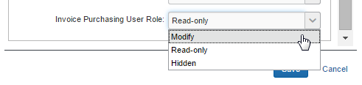
- For more information about setting up forms and form fields for your users, refer to the Concur Invoice: Purchase Request and Purchase Order Setup Guide.

Additional Information and Restrictions on the Purchasing User Role
The Purchasing User role includes the following additional restrictions:
- Assignment is limited to unsubmitted PO-based invoices from the original owner.
- PO-based invoices assigned to this role by the AP User must be assigned back to that same AP User.
- If the Purchasing User is also an Invoice Owner, they can be assigned a PO-based invoice by another Invoice Owner but can only work with that PO-based invoice in their role as a Purchasing User, without submit rights.
- This role cannot change the invoice owner on a PO-based invoice.
- Email notifications to the purchasing reviewer are set using Preferences.

PO Import
Purchase orders are imported into Concur Invoice using one of two methods:
- Overnight Purchase Order Import:
Like the Vendor import or Payment Request import, this import is scheduled for execution on a regular schedule set by the client and SAP Concur.
- Concur Connect "Purchase Order" web service API:
This import is available by contacting SAP Concur directly to have Advantage Services activate the Concur Connect module for the client entity. Once this is done, the user accesses the service by clicking Concur Connect on the Concur Invoice menu.
All information required to use this API to import your purchase orders is available at the Concur Connect platform (click here or type http://developer.concur.com/ in your browser window).

Use the PO Web Service Import
Complete documentation, including samples, is available at the Concur Connect site once the client has signed up for the service. The developer can then decide to create their own partner application to interface with the API, or contact SAP Concur support to have a custom application created for them.

Quantity Receipt Import for Three-Way Matching
Before clients can start to use the Three-Way Matching feature, they need to import the Quantity Receipt file, which they can do through an FTP import or through the API. The receipt information that clients import into Concur Invoice enables the system to associate and validate incoming invoice lines. The associated receipt information is then available for extract through the Standard Accounting Extract.
If clients need to use three-way matching and receipt confirmation, they should use both the Receipt Confirmation Import and the Quantity Receipt Import.
- For more information, refer to the Purchase Order Receipt Import Version 1 (Receipt Confirmation) and Purchase Order Receipt Import Version 2 (Quantity Receipt for Three-Way Match) documents of the Concur Invoice: Import and Extract File Specifications guide.

PO Extract
A PO extract is available. The extract is comprised of an overnight job set up by the client in consultation with SAP Concur staff. This functionality extends to re-extraction based on any changes to the original, previously extracted PO.
- For more information, refer to Concur Invoice: Purchase Order Extract Specification.

PO-Based Invoices That Should Not Be Matched
In some cases, a client will use Concur Invoice to capture and route PO-based invoices but will not want matching to be performed on them. For example, they might have a set of inventory-related POs, which require receiving and matching to be performed within the ERP PO module (not Concur Invoice).
The most common benefits of using Concur Invoice in this way are standardizing capture methods, as well as consolidating images and reporting data in one system. Clients commonly choose a workflow for these invoices that routes straight to Processor, extracts the invoice, and then performs the match in the ERP.
In cases like these, set up the invoices to use a non-PO policy. In this way, no matching will be performed in Concur Invoice.
When creating a PO-based invoice, enter the PO Number on the Request Header form. Do not enter it in the Purchase Order Number field on the Create New Invoice page. The latter approach will look for a matching PO number in Concur Invoice, which will not exist.
☼

